14.1 Float, in three parts
Chapter 14 · section 14.1

Fill every gap. Each word list holds one word more than there are gaps.
Chapter 14, section by section
Each stage leads to the next.
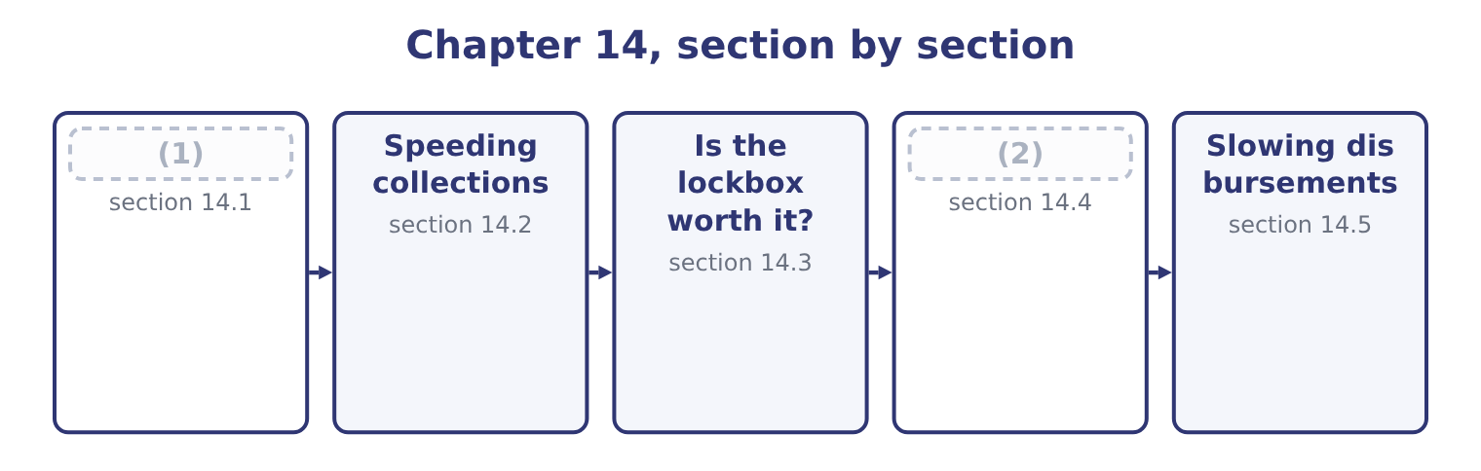
word list
Float, in three parts · usable funds · Compensating balances

Summary 1 gaps 3–14
Float is the delay (3) one party's (4) and the other's. Collection float works against the company; disbursement float works for it; net float is the (5) , and a company with more of the (6) than the first has a bank balance larger than its own ledger shows. Collection float has three (7) and each is attacked (8) . Mail float is the time from the customer (9) the payment to the company receiving it. It is attacked by moving the receiving point closer to the customer, which is what a lockbox does, or by removing the post from the process (10) with an electronic (11) . Processing float is the time from receipt to deposit: (12) , recording, (13) the deposit, taking it to the bank. It is attacked by (14) the bank do the work, which again is a lockbox, or by direct credit to the account.
word list
records · components · preparing · difference · differently · short-dated · second · between · transfer · entirely · opening · having · sending

Summary 2 gaps 15–21
Availability float, also (15) clearing float, is the time from deposit to the funds (16) usable. It is attacked by (17) in a bank where the item will clear fastest, and it has largely shrunk in markets where electronic clearing has (18) paper. Disbursement float is the same three (19) on the paying side, seen from the other end. A (20) posted on the last (21) day, drawn on a bank where it will take time to clear, leaves the company's money in the company's account longer.
word list
delays · candidate · replaced · cheque · depositing · called · becoming · permitted

Worked example: what a day of float is worth to Orontes

Summary 3 gaps 22–33
Orontes (22) 42,000,000 ÷ 365 = 115,068 a day on (23) . Removing one day of collection float releases $115,068 of cash permanently — not once, but permanently, (24) every subsequent day's (25) arrive a day earlier too. A lockbox arrangement (26) mail and processing float by three days releases 115,068 × 3 = 345,204. At the 4 per cent Orontes could earn on (27) securities, that released cash is worth 345,204 × 0.04 = 13,808 a year, for ever, against (28) the arrangement costs. The released amount is a stock and the benefit is a flow, and (29) the two is the (30) error on this outcome. Three days of float is a (31) release of $345,204 into the bank account; the (32) benefit is only the return earned on it. A (33) who compares $345,204 with an annual bank fee has compared a balance with a rent.
word list
collections · short-dated · average · classic · one-off · Availability · collects · recurring · because · cutting · whatever · confusing · candidate

The components of float
Component | The delay | Who it favours | What shortens it
Mail float | Customer posts to company receives | The customer | (34)
Processing float | Receipt to deposit | Neither | (35)
Availability float | (36) | The bank | Faster-clearing instruments
Disbursement float | (37) | The company | Nothing; the company wants it long

word list
Bank processing, direct credit · Customer posts to company receives · Deposit to usable funds · Company pays to funds leave · A lockbox near the customer

The English this section uses, and its Arabic
Each term sits against what it means.
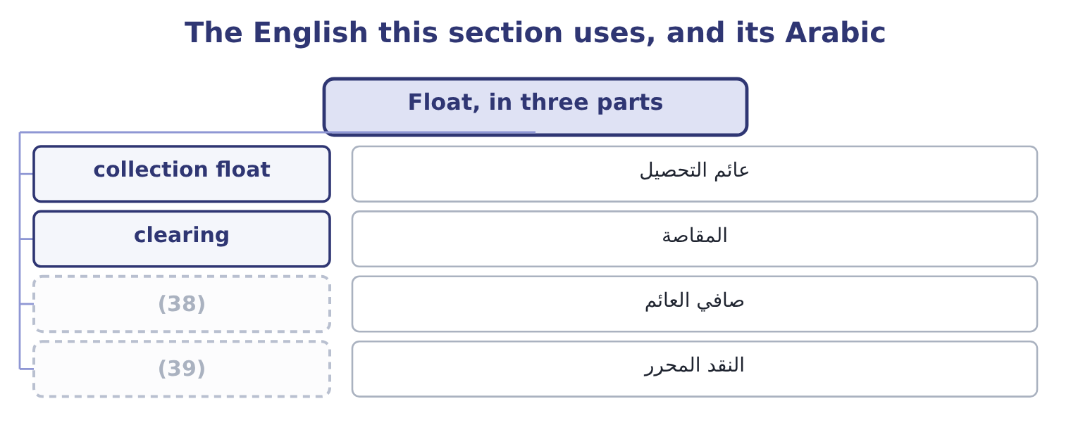
word list
net float · concentration banking · released cash

The English this sheet uses, and its Arabic
English (exam term) | Arabic
collection float | عائم التحصيل
clearing | المقاصة
net float | صافي العائم
released cash | النقد المحرر

Answer key · 14.1 Float, in three parts

1 Float, in three parts | 21 permitted
2 Compensating balances | 22 collects
3 between | 23 average
4 records | 24 because
5 difference | 25 collections
6 second | 26 cutting
7 components | 27 short-dated
8 differently | 28 whatever
9 sending | 29 confusing
10 entirely | 30 classic
11 transfer | 31 one-off
12 opening | 32 recurring
13 preparing | 33 candidate
14 having | 34 A lockbox near the customer
15 called | 35 Bank processing, direct credit
16 becoming | 36 Deposit to usable funds
17 depositing | 37 Company pays to funds leave
18 replaced | 38 net float
19 delays | 39 released cash
20 cheque

the summaries in full
Summary 1 Float is the delay between one party's records and the other's. Collection float works against the company; disbursement float works for it; net float is the difference, and a company with more of the second than the first has a bank balance larger than its own ledger shows. Collection float has three components and each is attacked differently. Mail float is the time from the customer sending the payment to the company receiving it. It is attacked by moving the receiving point closer to the customer, which is what a lockbox does, or by removing the post from the process entirely with an electronic transfer. Processing float is the time from receipt to deposit: opening, recording, preparing the deposit, taking it to the bank. It is attacked by having the bank do the work, which again is a lockbox, or by direct credit to the account.
Summary 2 Availability float, also called clearing float, is the time from deposit to the funds becoming usable. It is attacked by depositing in a bank where the item will clear fastest, and it has largely shrunk in markets where electronic clearing has replaced paper. Disbursement float is the same three delays on the paying side, seen from the other end. A cheque posted on the last permitted day, drawn on a bank where it will take time to clear, leaves the company's money in the company's account longer.
Summary 3 Orontes collects 42,000,000 ÷ 365 = 115,068 a day on average. Removing one day of collection float releases $115,068 of cash permanently — not once, but permanently, because every subsequent day's collections arrive a day earlier too. A lockbox arrangement cutting mail and processing float by three days releases 115,068 × 3 = 345,204. At the 4 per cent Orontes could earn on short-dated securities, that released cash is worth 345,204 × 0.04 = 13,808 a year, for ever, against whatever the arrangement costs. The released amount is a stock and the benefit is a flow, and confusing the two is the classic error on this outcome. Three days of float is a one-off release of $345,204 into the bank account; the recurring benefit is only the return earned on it. A candidate who compares $345,204 with an annual bank fee has compared a balance with a rent.

14.2 Speeding collections
Chapter 14 · section 14.2

Fill every gap. Each word list holds one word more than there are gaps.
Summary 1 gaps 1–12
Six (1) , and the exam expects them named and (2) . A lockbox is a post office box in a city near a group of customers, (3) several times a day by a bank that opens the mail, (4) the cheques and reports the details to the company. It removes most of the mail float, because the box is (5) , and all of the processing float, because the bank does the work. Electronic funds transfer removes mail and processing float (6) , and most of the (7) float. Where a customer will pay (8) , every other method is (9) . A preauthorised debit lets the company draw the (10) amount from the (11) account on the due date. It is standard for regular payments — rent, (12) , instalments — and it removes the decision to pay from the payer, which is its advantage and the reason some customers resist it.
word list
delivery · deposits · distinguished · inferior · subscriptions · entirely · customer's · agreed · methods · closer · emptied · availability · electronically

Summary 2 gaps 13–24
Concentration banking moves the money from many local (13) into one. A company with (14) collects locally, each branch banking where its customers are, and the balances are swept daily into a (15) concentration account. Three (16) follow: the total idle balance is far smaller than the sum of many local (17) ; the one large balance can be invested on better terms than many small ones; and the company borrows once rather than in several places. The transfers (18) are made by (19) transfer cheque or, more usually now, by electronic transfer. Prompt and (20) invoicing is the cheapest method of all and the most often (21) . An invoice issued three days after (22) is paid three days later, and an invoice with an error (23) the whole clock. A discount for early settlement buys speed with (24) .
word list
delivery · restarts · branches · neglected · accounts · benefits · Concentration · themselves · single · depository · accurate · minimums · margin

Six ways to collect faster
Method | Float removed | Typical cost | Best suited to
Lockbox | Mail and processing | (25) | Many cheques from a wide area
Electronic funds transfer | Nearly all | A small transaction fee | (26)
Preauthorised debit | Nearly all | A small fee | (27)
Concentration banking | None directly; it frees balances | Transfer fees | (28)
Prompt invoicing | The company's own delay | Nothing | (29)
Settlement discount | Days of credit | (30) | Sellers with high margins

word list
A percentage of the invoice · Any customer willing to use it · A fee per item or a monthly fee · preauthorised debit · Everybody · Regular, repeating amounts · Companies with many locations

The English this section uses, and its Arabic
Each term sits against what it means.
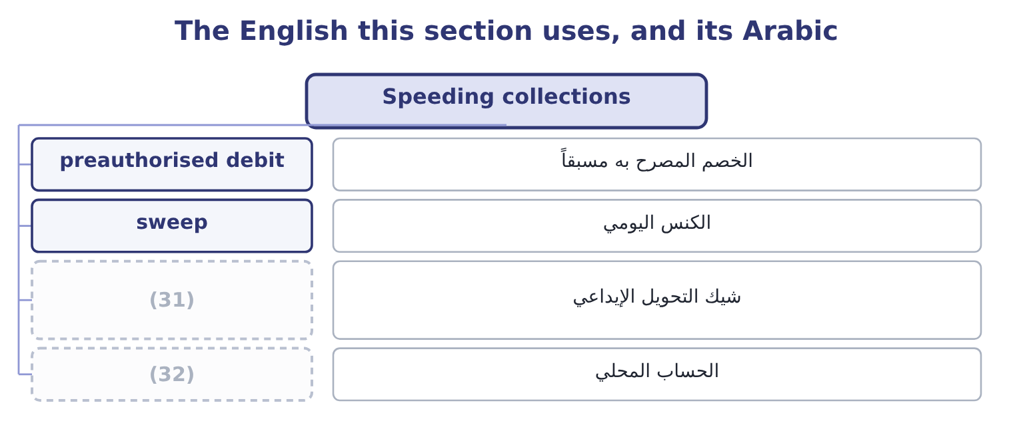
word list
concentration banking · local account · depository transfer cheque

The English this sheet uses, and its Arabic
English (exam term) | Arabic
preauthorised debit | الخصم المصرح به مسبقاً
sweep | الكنس اليومي
depository transfer cheque | شيك التحويل الإيداعي
local account | الحساب المحلي

Answer key · 14.2 Speeding collections

1 methods | 17 minimums
2 distinguished | 18 themselves
3 emptied | 19 depository
4 deposits | 20 accurate
5 closer | 21 neglected
6 entirely | 22 delivery
7 availability | 23 restarts
8 electronically | 24 margin
9 inferior | 25 A fee per item or a monthly fee
10 agreed | 26 Any customer willing to use it
11 customer's | 27 Regular, repeating amounts
12 subscriptions | 28 Companies with many locations
13 accounts | 29 Everybody
14 branches | 30 A percentage of the invoice
15 single | 31 depository transfer cheque
16 benefits | 32 local account

the summaries in full
Summary 1 Six methods, and the exam expects them named and distinguished. A lockbox is a post office box in a city near a group of customers, emptied several times a day by a bank that opens the mail, deposits the cheques and reports the details to the company. It removes most of the mail float, because the box is closer, and all of the processing float, because the bank does the work. Electronic funds transfer removes mail and processing float entirely, and most of the availability float. Where a customer will pay electronically, every other method is inferior. A preauthorised debit lets the company draw the agreed amount from the customer's account on the due date. It is standard for regular payments — rent, subscriptions, instalments — and it removes the decision to pay from the payer, which is its advantage and the reason some customers resist it.
Summary 2 Concentration banking moves the money from many local accounts into one. A company with branches collects locally, each branch banking where its customers are, and the balances are swept daily into a single concentration account. Three benefits follow: the total idle balance is far smaller than the sum of many local minimums; the one large balance can be invested on better terms than many small ones; and the company borrows once rather than in several places. The transfers themselves are made by depository transfer cheque or, more usually now, by electronic transfer. Prompt and accurate invoicing is the cheapest method of all and the most often neglected. An invoice issued three days after delivery is paid three days later, and an invoice with an error restarts the whole clock. A discount for early settlement buys speed with margin.

14.3 Is the lockbox worth it?
Chapter 14 · section 14.3

Fill every gap. Each word list holds one word more than there are gaps.
Summary 1 gaps 1–2
The (1) is a small net present value and the exam sets it often. Compare the recurring benefit of the cash released with the recurring cost of the (2) .
word list
overdraft · calculation · service

Worked example: the lockbox decision

Summary 2 gaps 3–14
A company (3) $200,000 a day (4) its central (5) . A bank offers a (6) network that would cut total float by 2.5 days. The bank (7) $0.35 an item and the company (8) 60,000 items a year. The company can earn 5 per cent on released funds. Two (9) change the answer and both appear in (10) . If the bank asks for a (11) balance instead of a fee, the cost is the return (12) on that balance, computed as in section 14.4. And if the company has borrowings (13) , the benefit should be computed at its borrowing rate rather than at its investment rate, because the released cash repays debt rather than buying (14) — and at Orontes's 6 per cent rather than 4, the same release is worth half as much again.
word list
forgone · outstanding · compensating · Orontes's · collects · questions · through · refinements · securities · office · charges · receives · lockbox

The lockbox template
Line | Computation | This case
Daily collections | Given | 200,000
Days of float removed | (15) | 2.5
Cash released | (16) | 500,000
Annual benefit | (17) | 25,000
Annual cost | Fee per item times items, or a monthly fee | 21,000
Net annual benefit | Benefit less cost | 4,000

word list
Given · Daily collections times days · local account · Released cash times the rate

Stock against flow, and which rate

Summary 3 gaps 18–21
The cash released is a (18) stock. The benefit is the return on it, which is a flow. Compare flows with flows. Use the borrowing rate where the company is borrowing, and the investment rate where it is not. The (19) wording decides. Where the (20) is per item, (21) by the number of items a year, not by the number of days.
word list
one-off · charge · multiply · overdraft · question's

The English this section uses, and its Arabic
Each term sits against what it means.
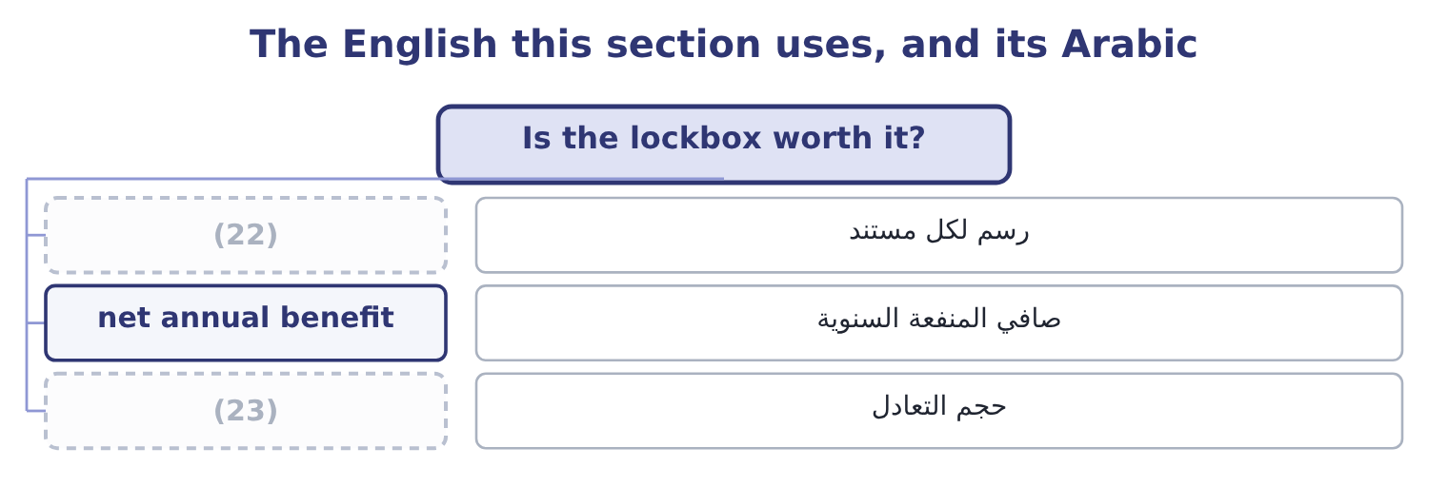
word list
collection float · break-even volume · per-item fee

The English this sheet uses, and its Arabic
English (exam term) | Arabic
per-item fee | رسم لكل مستند
net annual benefit | صافي المنفعة السنوية
break-even volume | حجم التعادل

Answer key · 14.3 Is the lockbox worth it?

1 calculation | 13 outstanding
2 service | 14 securities
3 collects | 15 Given
4 through | 16 Daily collections times days
5 office | 17 Released cash times the rate
6 lockbox | 18 one-off
7 charges | 19 question's
8 receives | 20 charge
9 refinements | 21 multiply
10 questions | 22 per-item fee
11 compensating | 23 break-even volume
12 forgone

the summaries in full
Summary 1 The calculation is a small net present value and the exam sets it often. Compare the recurring benefit of the cash released with the recurring cost of the service.
Summary 2 A company collects $200,000 a day through its central office. A bank offers a lockbox network that would cut total float by 2.5 days. The bank charges $0.35 an item and the company receives 60,000 items a year. The company can earn 5 per cent on released funds. Two refinements change the answer and both appear in questions. If the bank asks for a compensating balance instead of a fee, the cost is the return forgone on that balance, computed as in section 14.4. And if the company has borrowings outstanding, the benefit should be computed at its borrowing rate rather than at its investment rate, because the released cash repays debt rather than buying securities — and at Orontes's 6 per cent rather than 4, the same release is worth half as much again.
Summary 3 The cash released is a one-off stock. The benefit is the return on it, which is a flow. Compare flows with flows. Use the borrowing rate where the company is borrowing, and the investment rate where it is not. The question's wording decides. Where the charge is per item, multiply by the number of items a year, not by the number of days.

14.4 Compensating balances
Chapter 14 · section 14.4

Fill every gap. Each word list holds one word more than there are gaps.
Summary 1 gaps 1–4
A bank may be paid in fees or in balances. A compensating balance is a sum the (1) agrees to keep in a (2) account, from which the bank earns by (3) it on, and its effect is to raise the effective cost of (4) it is attached to.
word list
lending · Orontes's · whatever · borrower · non-interest-bearing

Worked example: what a compensating balance costs

Summary 2 gaps 5–16
A company (5) $2,000,000 at a stated 8 per cent and must keep a compensating balance of 10 per cent of the loan. What it (6) has. Interest is (7) on the whole loan: 2,000,000 × 0.08 = 160,000. The stated rate was never the rate. Two (8) can change the (9) and the exam uses both. If the company would in any case have held $200,000 in that account for (10) purposes, the (11) costs nothing extra and the effective rate stays at 8 per cent. And if the balance earns some interest, only the (12) against the (13) rate is a cost. Read the (14) for which case it (15) . Compensating balances also attach to services rather than loans: a bank may provide a (16) or a concentration network free in exchange for balances left with it. The comparison is then between the fee it would otherwise charge and the return forgone on the balance, and the arithmetic is identical.
word list
market · requirement · charged · transaction · answer · describes · lockbox · shortfall · question · actually · borrows · adjustments · Orontes's

Fees against balances
Arrangement | What the company gives up | Cost if it would hold the balance anyway | Visible in the accounts?
A fee | Cash | (17) | Yes, as an expense
A compensating balance | (18) | Nothing | No; it appears as cash

word list
The fee, in full · Yes, as an expense · The use of a balance

Summary 3 gaps 19–24
That last column (19) why balances are popular with managers and disliked by analysts: a fee is an expense that shows, and a balance is a (20) on an asset that does not — which is why the notes disclose compensating balance (21) , and why a reader of Book 1's (22) ratios would want to know whether any of (23) $7,302,100 was (24) in this way.
word list
Orontes's · restricted · explains · requirements · Interest · restriction · liquidity

The English this section uses, and its Arabic
Each term sits against what it means.
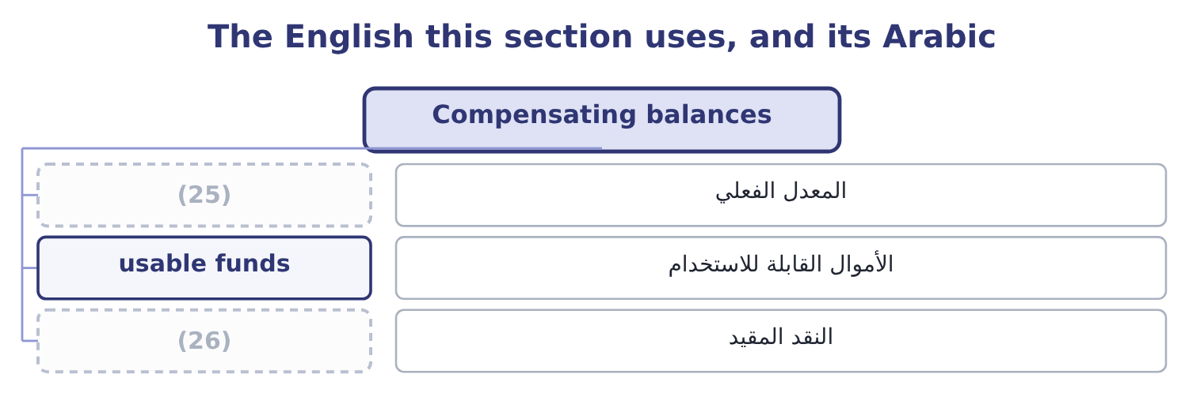
word list
zero-balance account · restricted cash · effective rate

The English this sheet uses, and its Arabic
English (exam term) | Arabic
effective rate | المعدل الفعلي
usable funds | الأموال القابلة للاستخدام
restricted cash | النقد المقيد

Answer key · 14.4 Compensating balances

1 borrower | 14 question
2 non-interest-bearing | 15 describes
3 lending | 16 lockbox
4 whatever | 17 The fee, in full
5 borrows | 18 The use of a balance
6 actually | 19 explains
7 charged | 20 restriction
8 adjustments | 21 requirements
9 answer | 22 liquidity
10 transaction | 23 Orontes's
11 requirement | 24 restricted
12 shortfall | 25 effective rate
13 market | 26 restricted cash

the summaries in full
Summary 1 A bank may be paid in fees or in balances. A compensating balance is a sum the borrower agrees to keep in a non-interest-bearing account, from which the bank earns by lending it on, and its effect is to raise the effective cost of whatever it is attached to.
Summary 2 A company borrows $2,000,000 at a stated 8 per cent and must keep a compensating balance of 10 per cent of the loan. What it actually has. Interest is charged on the whole loan: 2,000,000 × 0.08 = 160,000. The stated rate was never the rate. Two adjustments can change the answer and the exam uses both. If the company would in any case have held $200,000 in that account for transaction purposes, the requirement costs nothing extra and the effective rate stays at 8 per cent. And if the balance earns some interest, only the shortfall against the market rate is a cost. Read the question for which case it describes. Compensating balances also attach to services rather than loans: a bank may provide a lockbox or a concentration network free in exchange for balances left with it. The comparison is then between the fee it would otherwise charge and the return forgone on the balance, and the arithmetic is identical.
Summary 3 That last column explains why balances are popular with managers and disliked by analysts: a fee is an expense that shows, and a balance is a restriction on an asset that does not — which is why the notes disclose compensating balance requirements, and why a reader of Book 1's liquidity ratios would want to know whether any of Orontes's $7,302,100 was restricted in this way.

14.5 Slowing disbursements
Chapter 14 · section 14.5

Fill every gap. Each word list holds one word more than there are gaps.
Summary 1 gaps 1–12
The (1) image, and the one where the line between good management and sharp practice has to be drawn (2) . (3) methods, which the exam (4) . Pay on the due date, not before. An (5) on 30-day terms should be paid on day 30. (6) on day 12 because the approval (7) to finish then is a free loan to the supplier. One payment run from one account is easier to control, to time and to fund than (8) made by several (9) . Use a zero-balance account. Each disbursement account is kept at nil, and the master account funds it each day with (10) the amount of cheques (11) . No idle balances sit waiting in the payment (12) . The bank notifies the company early each morning of the exact total that will clear that day, so the treasurer funds that amount and invests everything else — the practice that makes a zero-balance structure usable.
word list
Paying · locations · exactly · expects · payments · presenting · explicitly · something · happened · Legitimate · invoice · mirror · accounts

Summary 2 gaps 13–24
Use a (13) draft, which is (14) to the company for approval before it is paid, (15) a day and giving a control point (16) fraud. (17) a single payment run a week rather than daily, which slows payment on (18) by a few days and costs nothing. Methods that cross the line, and the exam has a view. (19) drawing cheques on a distant bank to extend (20) time — remote disbursement — is legal in most places and is regarded as an abuse by banks and by the professional codes. Delaying payment past agreed terms without (21) is not float management; it is (22) taking credit. Mailing on a Friday (23) so that the item cannot be (24) until Tuesday is a decision the company should be willing to describe to the supplier.
word list
processed · clearing · Consider · afternoon · presented · average · adding · against · unilaterally · agreement · proportion · Deliberately · payable-through

Summary 3 gaps 25–32
The overdraft system (25) here because it changes the (26) . In markets where (27) are normal, a company holds no cash at all: the account runs negative during the month, interest is charged daily on the balance, and the whole (28) of minimum balances and daily funding is replaced by a limit and a rate. That is (29) and simpler than holding (30) cash, and it is why a treasurer in such a market manages the limit rather than the balance. (31) $240,000 overdraft is this (32) arriving unplanned rather than chosen.
word list
cheaper · Barada's · apparatus · question · belongs · arrangement · precautionary · overdrafts · suspended

Price the float

Your turn: float and its price (complete the blanks)
Item | Data | Answer
Cash released by a lockbox | (33) | ________
Annual benefit of that release | At a 6 per cent borrowing rate | ________
Annual cost of the lockbox | (34) | ________
Net annual benefit |  | ________
Usable funds on a loan | 3,000,000 at 9 per cent, 15 per cent compensating balance | ________
Effective rate on that loan |  | ________

word list
0.40 an item, 55,000 items · Effective rate on that loan · Daily collections 150,000, float cut 3 days

"Float"

Summary 4 gaps 35–43
English float in (35) means the money in (36) between two sets of records, and the metaphor is of (37) suspended between two states. The word does three other jobs in finance that a (38) meets in the same syllabus: a company floats when it lists its shares, so a flotation is an issue and flotation costs are its fees; a floating rate is one that resets; and the free float is the (39) of a company's shares (40) to trade. Four (41) , one word, no (42) in sense. Where English is (43) , read the noun next to it.
word list
available · treasury · ambiguous · candidate · meanings · proportion · overlap · without · something · transit

"Float"
Item | Answer
Cash released by a lockbox | (44)
Annual benefit of that release | 27,000: 450,000 × 0.06 = 27,000, computed at the borrowing rate because the cash repays debt.
Annual cost of the lockbox | 22,000: 0.40 × 55,000 = 22,000.
Net annual benefit | (45)
Usable funds on the loan | 2,550,000: 3,000,000 × 0.85 = 2,550,000.
Effective rate on that loan | 10.59 per cent: interest is 3,000,000 × 0.09 = 270,000, and 270,000 ÷ 2,550,000 = 10.59 per cent.
What it tells you | The lockbox clears its cost by 5,000 a year, which is worth having and is not large; the compensating balance adds more than a point and a h

word list
2,550,000: 3,000,000 × 0.85 = 2,550,000. · 450,000: 150,000 × 3 = 450,000. · 5,000: 27,000 − 22,000 = 5,000.

The words this section uses
Each term sits against what it means, and an instance of it.
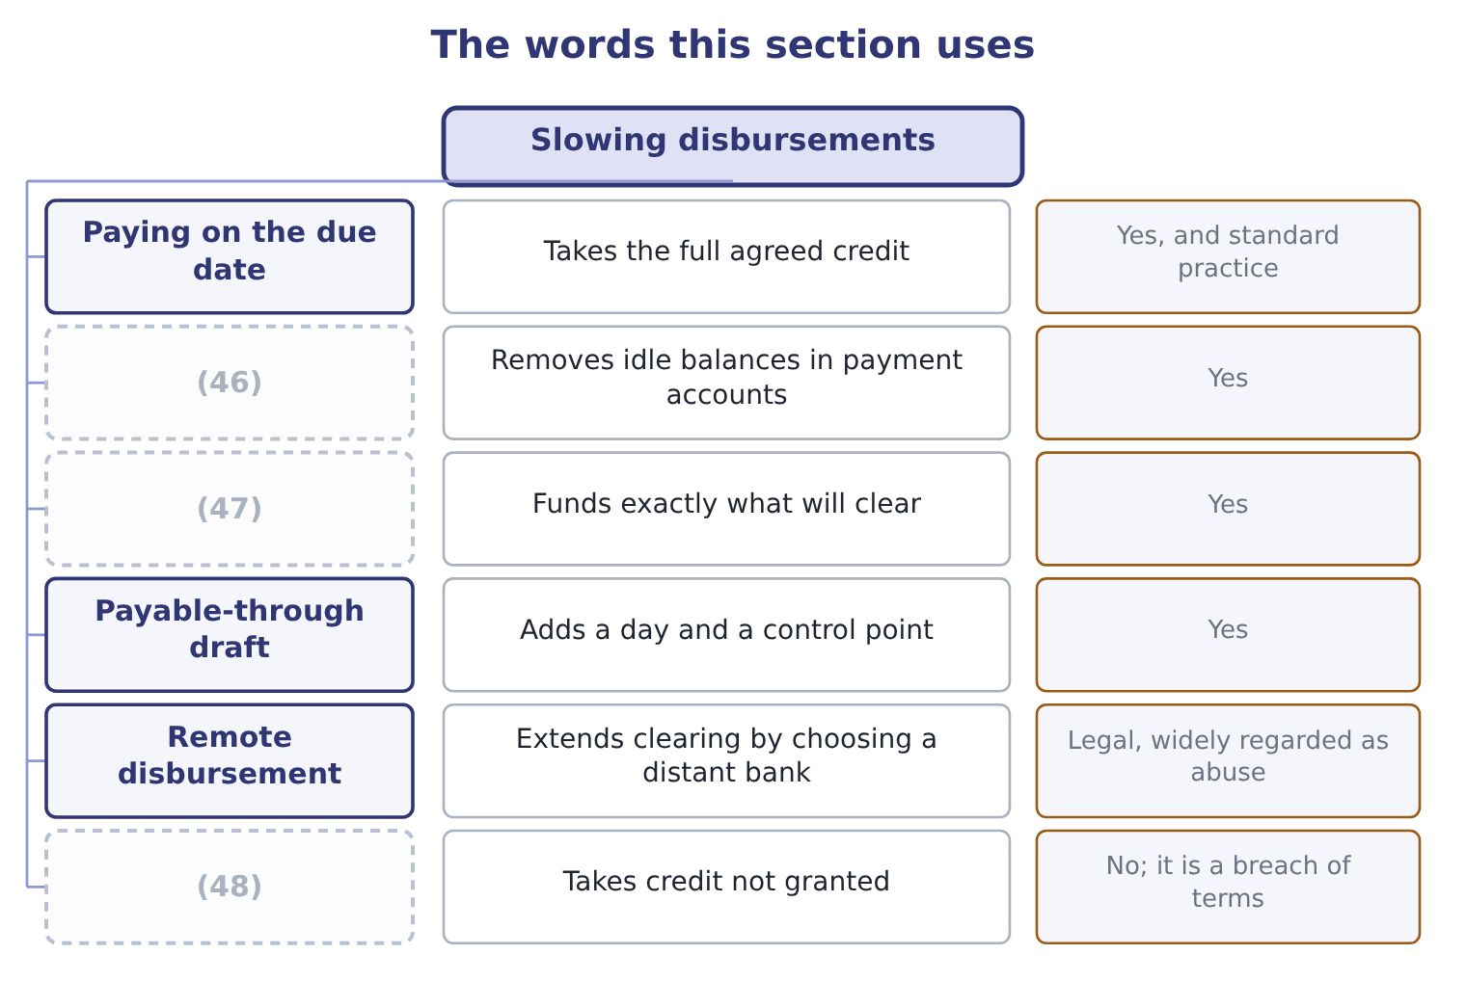
word list
Controlled disbursement · Zero-balance accounts · Paying late without agreement · due date

The English this sheet uses, and its Arabic
English (exam term) | Arabic
payment run | دفعة السداد
remote disbursement | الصرف من بنك بعيد
overdraft limit | حد السحب على المكشوف
due date | تاريخ الاستحقاق

Answer key · 14.5 Slowing disbursements

1 mirror | 25 belongs
2 explicitly | 26 question
3 Legitimate | 27 overdrafts
4 expects | 28 apparatus
5 invoice | 29 cheaper
6 Paying | 30 precautionary
7 happened | 31 Barada's
8 payments | 32 arrangement
9 locations | 33 Daily collections 150,000, float cut 3 days
10 exactly | 34 0.40 an item, 55,000 items
11 presenting | 35 treasury
12 accounts | 36 transit
13 payable-through | 37 something
14 presented | 38 candidate
15 adding | 39 proportion
16 against | 40 available
17 Consider | 41 meanings
18 average | 42 overlap
19 Deliberately | 43 ambiguous
20 clearing | 44 450,000: 150,000 × 3 = 450,000.
21 agreement | 45 5,000: 27,000 − 22,000 = 5,000.
22 unilaterally | 46 Zero-balance accounts
23 afternoon | 47 Controlled disbursement
24 processed | 48 Paying late without agreement

the summaries in full
Summary 1 The mirror image, and the one where the line between good management and sharp practice has to be drawn explicitly. Legitimate methods, which the exam expects. Pay on the due date, not before. An invoice on 30-day terms should be paid on day 30. Paying on day 12 because the approval happened to finish then is a free loan to the supplier. One payment run from one account is easier to control, to time and to fund than payments made by several locations. Use a zero-balance account. Each disbursement account is kept at nil, and the master account funds it each day with exactly the amount of cheques presenting. No idle balances sit waiting in the payment accounts. The bank notifies the company early each morning of the exact total that will clear that day, so the treasurer funds that amount and invests everything else — the practice that makes a zero-balance structure usable.
Summary 2 Use a payable-through draft, which is presented to the company for approval before it is paid, adding a day and giving a control point against fraud. Consider a single payment run a week rather than daily, which slows payment on average by a few days and costs nothing. Methods that cross the line, and the exam has a view. Deliberately drawing cheques on a distant bank to extend clearing time — remote disbursement — is legal in most places and is regarded as an abuse by banks and by the professional codes. Delaying payment past agreed terms without agreement is not float management; it is unilaterally taking credit. Mailing on a Friday afternoon so that the item cannot be processed until Tuesday is a decision the company should be willing to describe to the supplier.
Summary 3 The overdraft system belongs here because it changes the question. In markets where overdrafts are normal, a company holds no cash at all: the account runs negative during the month, interest is charged daily on the balance, and the whole apparatus of minimum balances and daily funding is replaced by a limit and a rate. That is cheaper and simpler than holding precautionary cash, and it is why a treasurer in such a market manages the limit rather than the balance. Barada's $240,000 overdraft is this arrangement arriving unplanned rather than chosen.
Summary 4 English float in treasury means the money in transit between two sets of records, and the metaphor is of something suspended between two states. The word does three other jobs in finance that a candidate meets in the same syllabus: a company floats when it lists its shares, so a flotation is an issue and flotation costs are its fees; a floating rate is one that resets; and the free float is the proportion of a company's shares available to trade. Four meanings, one word, no overlap in sense. Where English is ambiguous, read the noun next to it.

