15.1 Why a company holds securities rather than cash
Chapter 15 · section 15.1

Fill every gap. Each word list holds one word more than there are gaps.
Chapter 15, section by section
Each stage leads to the next.
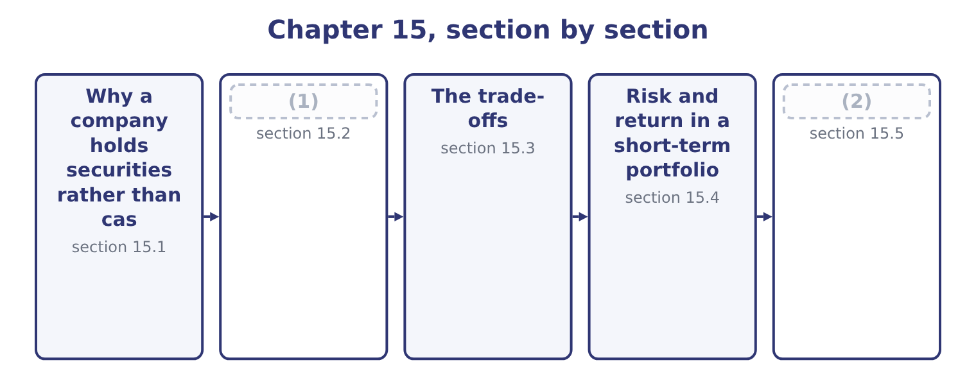
word list
section 15.2 · Building Orontes's portfolio · The instruments

Summary 1 gaps 3–14
Four (3) , and the exam asks for them in these terms. As a (4) for cash. Money needed within the year earns (5) while it waits, and the only (6) is that it can be realised when the day comes. This is the (7) use and the one (8) has. As a store (9) a known future payment. A tax (10) in March, a bond maturing in (11) , a capital project's third payment in July: each is a known amount on a known date, and a security maturing on that date funds it exactly, with no risk that a sale is needed at a bad moment. As a buffer for the (12) , which is the (13) motive. As a home for seasonal (14) . A company that collects in three months and spends through twelve has a predictable rise and fall, and the peak sits in securities until it drains away. Note what marketable securities are not for. They are not an investment portfolio: a treasury department buying equities with working capital is speculating with money the business needs, however good the equities.
word list
precautionary · Orontes · surpluses · against · instalment · largest · reasons · something · securities · unexpected · requirement · September · substitute

The English this section uses, and its Arabic
Each term sits against what it means.
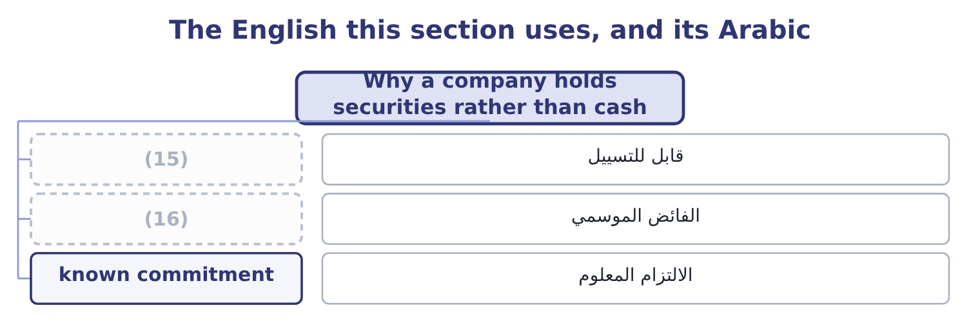
word list
seasonal surplus · realisable · tax-equivalent yield

The English this sheet uses, and its Arabic
English (exam term) | Arabic
realisable | قابل للتسييل
seasonal surplus | الفائض الموسمي
known commitment | الالتزام المعلوم

Answer key · 15.1 Why a company holds securities rather than cash

1 The instruments | 9 against
2 Building Orontes's portfolio | 10 instalment
3 reasons | 11 September
4 substitute | 12 unexpected
5 something | 13 precautionary
6 requirement | 14 surpluses
7 largest | 15 realisable
8 Orontes | 16 seasonal surplus

the summaries in full
Summary 1 Four reasons, and the exam asks for them in these terms. As a substitute for cash. Money needed within the year earns something while it waits, and the only requirement is that it can be realised when the day comes. This is the largest use and the one Orontes has. As a store against a known future payment. A tax instalment in March, a bond maturing in September, a capital project's third payment in July: each is a known amount on a known date, and a security maturing on that date funds it exactly, with no risk that a sale is needed at a bad moment. As a buffer for the unexpected, which is the precautionary motive. As a home for seasonal surpluses. A company that collects in three months and spends through twelve has a predictable rise and fall, and the peak sits in securities until it drains away. Note what marketable securities are not for. They are not an investment portfolio: a treasury department buying equities with working capital is speculating with money the business needs, however good the equities.

15.2 The instruments
Chapter 15 · section 15.2

Fill every gap. Each word list holds one word more than there are gaps.
Summary 1 gaps 1–12
The money market (1) a short list, and the exam names it. Treasury bills are short-term (2) of the government, issued at a discount and (3) at face value, with maturities of a few weeks to a year. They carry no credit risk in their own currency and the (4) secondary market of any instrument, which makes them the benchmark against which (5) else is priced. Treasury notes and treasury bonds are the same issuer at (6) maturities — notes to about ten years, bonds (7) . They are not money market instruments, but a note with three months left to run (8) like one, and a (9) buys them in the secondary market for exactly that reason. Commercial paper is (10) short-term (11) by a large company, issued at a discount, usually for up to 270 days. It pays more than a treasury bill because it (12) the issuer's credit risk, and it is rated.
word list
redeemed · Certificates · beyond · deepest · behaves · treasurer · offers · unsecured · obligations · carries · longer · everything · borrowing

Summary 2 gaps 13–23
Certificates of deposit are time deposits with a bank, evidenced by a (13) certificate so that they can be sold before maturity. They pay interest (14) than being issued at a discount. Repurchase (15) are sales of securities with an agreement to buy them back at a stated price on a stated date, usually overnight. (16) they are secured loans: the lender holds the securities as (17) and earns the (18) between the two prices. They are the (19) way to employ cash for one night. Bankers' (20) are time drafts drawn on and accepted by a bank, (21) to finance trade. The bank's acceptance makes the instrument the bank's obligation, so it is (22) and trades at a small (23) over treasury bills.
word list
originally · agreements · secured · collateral · spread · standard · acceptances · high-quality · difference · Economically · rather · negotiable

Summary 3 gaps 24–30
Money market funds pool many such instruments and offer daily access. They give a small company the (24) and the professional (25) it could not arrange itself, for a (26) fee. Municipal securities, in the United States, are issued by states and local authorities and their interest is exempt from federal income tax, which changes the (27) entirely — section 15.3 does the (28) . (29) deposits are dollar deposits held outside the United States, which pay slightly more because they fall outside domestic banking (30) .
word list
Eurodollar · diversification · regulation · against · management · arithmetic · comparison · selection

The money market instruments
Instrument | Issuer | Typical maturity | Credit risk | Yield against a treasury bill
Treasury bill | Government | Up to 1 year | (31) | The benchmark
Commercial paper | (32) | Up to 270 days | The issuer's | Higher
Certificate of deposit | Banks | 1 month to 1 year | The bank's | Higher
Repurchase agreement | (33) | (34) | Low; collateralised | Close to the benchmark
Banker's acceptance | (35) | 30 to 180 days | The bank's | (36)
Money market fund | (37) | Daily access | (38) | Lower, after fees
Municipal security | States and local authorities | Any | The authority's | Lower before tax, higher after

word list
None in its own currency · reinvestment risk · Overnight to weeks · Large companies · A bank, on a trade draft · Slightly higher · Dealers and banks · Diversified · A fund manager

The English this section uses, and its Arabic
Each term sits against what it means.
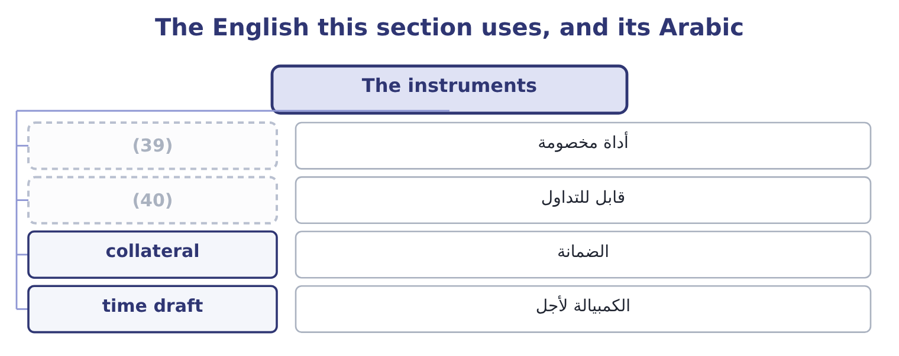
word list
negotiable · discount instrument · treasury bill

The English this sheet uses, and its Arabic
English (exam term) | Arabic
discount instrument | أداة مخصومة
negotiable | قابل للتداول
collateral | الضمانة
time draft | الكمبيالة لأجل

Answer key · 15.2 The instruments

1 offers | 21 originally
2 obligations | 22 high-quality
3 redeemed | 23 spread
4 deepest | 24 diversification
5 everything | 25 selection
6 longer | 26 management
7 beyond | 27 comparison
8 behaves | 28 arithmetic
9 treasurer | 29 Eurodollar
10 unsecured | 30 regulation
11 borrowing | 31 None in its own currency
12 carries | 32 Large companies
13 negotiable | 33 Dealers and banks
14 rather | 34 Overnight to weeks
15 agreements | 35 A bank, on a trade draft
16 Economically | 36 Slightly higher
17 collateral | 37 A fund manager
18 difference | 38 Diversified
19 standard | 39 discount instrument
20 acceptances | 40 negotiable

the summaries in full
Summary 1 The money market offers a short list, and the exam names it. Treasury bills are short-term obligations of the government, issued at a discount and redeemed at face value, with maturities of a few weeks to a year. They carry no credit risk in their own currency and the deepest secondary market of any instrument, which makes them the benchmark against which everything else is priced. Treasury notes and treasury bonds are the same issuer at longer maturities — notes to about ten years, bonds beyond. They are not money market instruments, but a note with three months left to run behaves like one, and a treasurer buys them in the secondary market for exactly that reason. Commercial paper is unsecured short-term borrowing by a large company, issued at a discount, usually for up to 270 days. It pays more than a treasury bill because it carries the issuer's credit risk, and it is rated.
Summary 2 Certificates of deposit are time deposits with a bank, evidenced by a negotiable certificate so that they can be sold before maturity. They pay interest rather than being issued at a discount. Repurchase agreements are sales of securities with an agreement to buy them back at a stated price on a stated date, usually overnight. Economically they are secured loans: the lender holds the securities as collateral and earns the difference between the two prices. They are the standard way to employ cash for one night. Bankers' acceptances are time drafts drawn on and accepted by a bank, originally to finance trade. The bank's acceptance makes the instrument the bank's obligation, so it is high-quality and trades at a small spread over treasury bills.
Summary 3 Money market funds pool many such instruments and offer daily access. They give a small company the diversification and the professional selection it could not arrange itself, for a management fee. Municipal securities, in the United States, are issued by states and local authorities and their interest is exempt from federal income tax, which changes the comparison entirely — section 15.3 does the arithmetic. Eurodollar deposits are dollar deposits held outside the United States, which pay slightly more because they fall outside domestic banking regulation.

15.3 The trade-offs
Chapter 15 · section 15.3

Fill every gap. Each word list holds one word more than there are gaps.
Summary 1 gaps 1–12
Five (1) decide a selection and they pull (2) each other. The outcome names them and the exam's (3) are always about which one is being (4) . Safety, meaning the risk that the (5) is not returned. For working capital this is close to (6) : the money is needed, so a security that might not pay is (7) whatever its yield. Treasury bills are safest, bank (8) next, corporate paper after. Marketability or (9) , meaning how (10) the instrument can be sold at a price close to its value. A treasury bill can be sold in any size in minutes; a (11) of deposit from a small bank may take a day and a (12) in price. Note that marketability is not the same as maturity: a thirty-year treasury bond is highly marketable and has a long maturity, while a three-month deposit at a small bank may be unmarketable and short.
word list
concession · quickly · against · certificate · instruments · unusable · whatever · sacrificed · variables · principal · liquidity · absolute · questions

Summary 2 gaps 13–24
Yield, which rises as the other four (13) . A yield materially above the benchmark is always (14) for something, and the (15) job is to identify. Maturity, which brings two (16) risks. Interest rate risk: a longer instrument falls (17) if rates rise and the money has to be raised early by (18) . And reinvestment risk, the (19) : a short instrument has to be (20) over at whatever rate exists then. Where interest on an instrument is tax-exempt, its (21) yield is not (22) with a taxable one. The tax-equivalent yield puts them on the same basis: a municipal security yielding 3.0 per cent, for a company (23) 25 per cent, is worth 3.0 ÷ 0.75 = 4.00 per cent of taxable yield. Anything taxable yielding less than 4.00 per cent is (24) to that municipal, and anything above it is better.
word list
separate · quickly · worsen · stated · paying · compensation · inferior · comparable · treasurer's · rolled · mirror · further · selling

Worked example: comparing three instruments

Summary 3 gaps 25–36
A $1,000,000 bill with 90 days to run is (25) at $985,000. The gain is 1,000,000 − 985,000 = 15,000, which over the (26) is 15,000 ÷ 985,000 = 1.52 per cent. There are 365 ÷ 90 = 4.0556 such periods in a year, so the (27) yield is about 1.52 × 4.0556 = 6.17 per cent. A municipal at 4.8 per cent, tax-exempt. Its taxable equivalent at a 25 per cent rate is 4.8 ÷ 0.75 = 6.40 per cent. Commercial paper at 6.5 per cent, taxable, from an A-rated (28) . On yield alone the commercial paper wins, by 0.10 (29) over the municipal and 0.33 over the bill. On safety the bill wins (30) . On marketability the bill wins again, and the municipal is the (31) of the three. For a (32) working capital the (33) answer is usually the bill, and the (34) the exam is really asking is (35) a third of a point a year — on $1,000,000 that is $3,300 — is worth the credit risk of an A-rated corporate and the loss of (36) marketability. For money that must be there, it is not.
word list
company's · offered · question · whether · correct · bond-equivalent · outright · issuer · treasurer's · weakest · points · period · same-day

What each choice costs
Choose more | And you give up | Measured by
Yield | (37) | The spread over treasury bills
Safety | Yield | (38)
Marketability | Yield | (39)
A longer maturity | Price stability | (40)
A shorter maturity | Certainty of future rate | Reinvestment risk
A tax-exempt instrument | (41) | The tax-equivalent comparison

word list
Pre-tax yield · The same spread, forgone · Duration, from Chapter 4 · Certainty of future rate · A smaller spread again · Safety, marketability, or both

The English this section uses, and its Arabic
Each term sits against what it means.
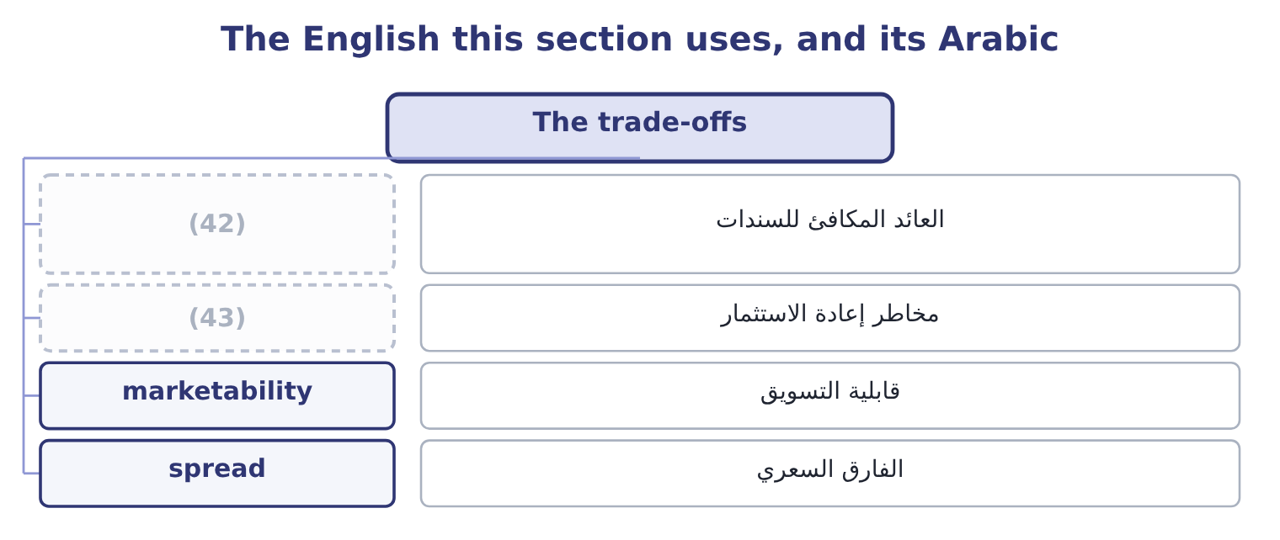
word list
reinvestment risk · matched instrument · bond-equivalent yield

The English this sheet uses, and its Arabic
English (exam term) | Arabic
bond-equivalent yield | العائد المكافئ للسندات
reinvestment risk | مخاطر إعادة الاستثمار
marketability | قابلية التسويق
spread | الفارق السعري

Answer key · 15.3 The trade-offs

1 variables | 23 paying
2 against | 24 inferior
3 questions | 25 offered
4 sacrificed | 26 period
5 principal | 27 bond-equivalent
6 absolute | 28 issuer
7 unusable | 29 points
8 instruments | 30 outright
9 liquidity | 31 weakest
10 quickly | 32 company's
11 certificate | 33 correct
12 concession | 34 question
13 worsen | 35 whether
14 compensation | 36 same-day
15 treasurer's | 37 Safety, marketability, or both
16 separate | 38 The same spread, forgone
17 further | 39 A smaller spread again
18 selling | 40 Duration, from Chapter 4
19 mirror | 41 Pre-tax yield
20 rolled | 42 bond-equivalent yield
21 stated | 43 reinvestment risk
22 comparable

the summaries in full
Summary 1 Five variables decide a selection and they pull against each other. The outcome names them and the exam's questions are always about which one is being sacrificed. Safety, meaning the risk that the principal is not returned. For working capital this is close to absolute: the money is needed, so a security that might not pay is unusable whatever its yield. Treasury bills are safest, bank instruments next, corporate paper after. Marketability or liquidity, meaning how quickly the instrument can be sold at a price close to its value. A treasury bill can be sold in any size in minutes; a certificate of deposit from a small bank may take a day and a concession in price. Note that marketability is not the same as maturity: a thirty-year treasury bond is highly marketable and has a long maturity, while a three-month deposit at a small bank may be unmarketable and short.
Summary 2 Yield, which rises as the other four worsen. A yield materially above the benchmark is always compensation for something, and the treasurer's job is to identify. Maturity, which brings two separate risks. Interest rate risk: a longer instrument falls further if rates rise and the money has to be raised early by selling. And reinvestment risk, the mirror: a short instrument has to be rolled over at whatever rate exists then. Where interest on an instrument is tax-exempt, its stated yield is not comparable with a taxable one. The tax-equivalent yield puts them on the same basis: a municipal security yielding 3.0 per cent, for a company paying 25 per cent, is worth 3.0 ÷ 0.75 = 4.00 per cent of taxable yield. Anything taxable yielding less than 4.00 per cent is inferior to that municipal, and anything above it is better.
Summary 3 A $1,000,000 bill with 90 days to run is offered at $985,000. The gain is 1,000,000 − 985,000 = 15,000, which over the period is 15,000 ÷ 985,000 = 1.52 per cent. There are 365 ÷ 90 = 4.0556 such periods in a year, so the bond-equivalent yield is about 1.52 × 4.0556 = 6.17 per cent. A municipal at 4.8 per cent, tax-exempt. Its taxable equivalent at a 25 per cent rate is 4.8 ÷ 0.75 = 6.40 per cent. Commercial paper at 6.5 per cent, taxable, from an A-rated issuer. On yield alone the commercial paper wins, by 0.10 points over the municipal and 0.33 over the bill. On safety the bill wins outright. On marketability the bill wins again, and the municipal is the weakest of the three. For a company's working capital the correct answer is usually the bill, and the question the exam is really asking is whether a third of a point a year — on $1,000,000 that is $3,300 — is worth the credit risk of an A-rated corporate and the loss of same-day marketability. For money that must be there, it is not.

15.4 Risk and return in a short-term portfolio
Chapter 15 · section 15.4

Fill every gap. Each word list holds one word more than there are gaps.
Summary 1 gaps 1–12
A (1) portfolio is where that (2) meets a constraint which overrides it: the money is spoken for. The constraint works like this. A (3) portfolio exists to be spent. If it falls in value, the company does not have the option of waiting for (4) , because the (5) it was held against falls due on a date. So the first filter is not (6) at all; it is (7) the instrument will be worth its full value on the day the money is needed. (8) that survives that filter is then (9) on yield. Two (10) follow, and both appear in (11) . Maturity matching buys instruments that (12) on the dates the forecast says the money is needed. It removes interest rate risk entirely for that money, because nothing has to be sold: the instrument simply matures. It is the strategy for known commitments.
word list
principle · payment · mature · questions · strategies · recovery · average · return · ranked · working-capital · whether · Everything · short-term

Summary 2 gaps 13–23
Laddering (13) the portfolio across a series of maturities — three, six, nine and twelve months — so that (14) matures regularly and the average yield is higher than a (15) of very short instruments would give. It is the strategy for the part of the (16) whose timing is (17) , and it reduces (18) risk by never rolling the whole portfolio at one rate. Both are forms of the same (19) : let the cash forecast of, rather than (20) maturities by the yield curve and (21) . Three risks (22) and should be named in any (23) . Credit risk, which is managed by quality limits — a policy that nothing below A-1 or P-1 may be bought, and that no single issuer may exceed a stated share of the portfolio.
word list
reinvestment · maximise · something · hoping · discipline · spreads · balance · succession · uncertain · answer · remain · choosing

Summary 3 gaps 24–31
Interest rate risk, which maturity matching removes for (24) money and laddering reduces for the rest. (25) risk, which is the risk that an instrument cannot be sold when an (26) need arises, and which is managed by (27) a tranche of the portfolio in treasury bills or an (28) fund regardless of yield. A written (29) policy that states those limits is the control the exam expects a (30) accountant to recommend, because a treasury (31) left to maximise yield will eventually find an instrument that does.
word list
unforeseen · management · investment · rolling · overnight · keeping · department · matched · Liquidity

The English this section uses, and its Arabic
Each term sits against what it means.
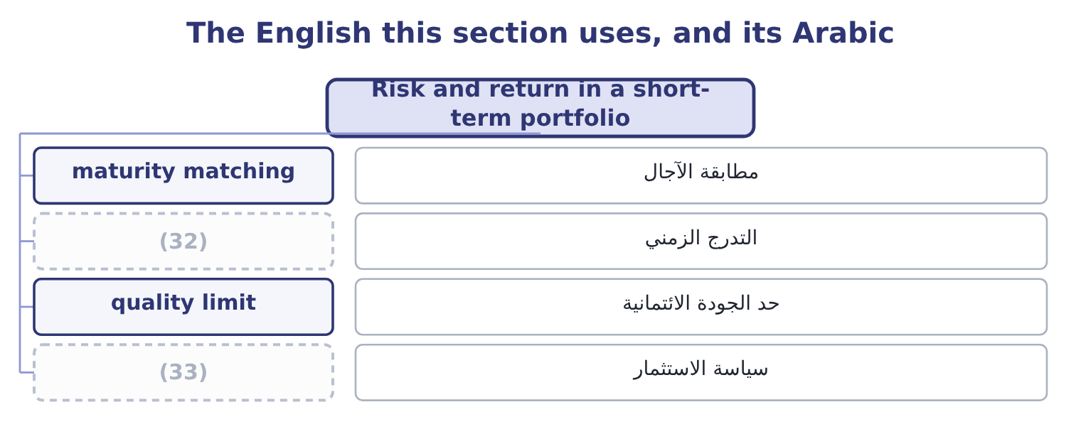
word list
marketable security · investment policy · laddering

The English this sheet uses, and its Arabic
English (exam term) | Arabic
maturity matching | مطابقة الآجال
laddering | التدرج الزمني
quality limit | حد الجودة الائتمانية
investment policy | سياسة الاستثمار

Answer key · 15.4 Risk and return in a short-term portfolio

1 short-term | 18 reinvestment
2 principle | 19 discipline
3 working-capital | 20 choosing
4 recovery | 21 hoping
5 payment | 22 remain
6 return | 23 answer
7 whether | 24 matched
8 Everything | 25 Liquidity
9 ranked | 26 unforeseen
10 strategies | 27 keeping
11 questions | 28 overnight
12 mature | 29 investment
13 spreads | 30 management
14 something | 31 department
15 succession | 32 laddering
16 balance | 33 investment policy
17 uncertain

the summaries in full
Summary 1 A short-term portfolio is where that principle meets a constraint which overrides it: the money is spoken for. The constraint works like this. A working-capital portfolio exists to be spent. If it falls in value, the company does not have the option of waiting for recovery, because the payment it was held against falls due on a date. So the first filter is not return at all; it is whether the instrument will be worth its full value on the day the money is needed. Everything that survives that filter is then ranked on yield. Two strategies follow, and both appear in questions. Maturity matching buys instruments that mature on the dates the forecast says the money is needed. It removes interest rate risk entirely for that money, because nothing has to be sold: the instrument simply matures. It is the strategy for known commitments.
Summary 2 Laddering spreads the portfolio across a series of maturities — three, six, nine and twelve months — so that something matures regularly and the average yield is higher than a succession of very short instruments would give. It is the strategy for the part of the balance whose timing is uncertain, and it reduces reinvestment risk by never rolling the whole portfolio at one rate. Both are forms of the same discipline: let the cash forecast of, rather than choosing maturities by the yield curve and hoping. Three risks remain and should be named in any answer. Credit risk, which is managed by quality limits — a policy that nothing below A-1 or P-1 may be bought, and that no single issuer may exceed a stated share of the portfolio.
Summary 3 Interest rate risk, which maturity matching removes for matched money and laddering reduces for the rest. Liquidity risk, which is the risk that an instrument cannot be sold when an unforeseen need arises, and which is managed by keeping a tranche of the portfolio in treasury bills or an overnight fund regardless of yield. A written investment policy that states those limits is the control the exam expects a management accountant to recommend, because a treasury department left to maximise yield will eventually find an instrument that does.

15.5 Building Orontes's portfolio
Chapter 15 · section 15.5

Fill every gap. Each word list holds one word more than there are gaps.
Summary 1 gaps 1–12
Put the chapter to work. The surplus is 7,302,100 − 2,900,000 = 4,402,100. The known (1) come first. Two (2) need $6,000,000 over four quarters, of which the first (3) fall within this surplus. Each instalment is matched: a treasury bill or a government note (4) in the month the payment is due, bought today at a price that fixes the yield and (5) no sale. What is left is (6) . Divide the (7) balance across three, six, nine and (8) maturities, so that a tranche matures every quarter and the yield exceeds what an overnight account would pay. A liquidity tranche sits inside the ladder, not beside it: a portion held in treasury bills or an overnight (9) agreement, available the same day, sized against the (10) motive. At the 4 per cent available on (11) government paper, the surplus earns 4,402,100 × 0.04 = 176,084 a year that the company earned (12) on in 2025.
word list
twelve-month · projects · requires · commitments · maturing · precautionary · repurchase · unmatched · short-dated · negotiable · laddered · instalments · nothing

Summary 2 gaps 13–22
Against (13) net income of $2,969,100 that is about six per cent of a year's profit, (14) with no risk to the principal, no change to the (15) and no capital (16) — which is why treasury (17) is the part of (18) with the highest return on effort, and the part most often left undone. What it does not change. The $176,084 is real and it is not a (19) for the $840,000 of gross margin Book 1 found the company (20) away each year. Ranking (21) by size, as Book 1's last chapter (22) , puts the margin first and this second. Both are worth doing and only one of them is easy.
word list
obtained · finance · business · management · investment · Orontes's · findings · collateral · insisted · giving · substitute

Select and compare

Your turn: comparing instruments (complete the blanks)
Instrument | Data | Answer
Treasury bill | 500,000 face, bought at 492,500, 90 days | (23)
The same bill | Annualised | ________
Municipal security | 3.6 per cent, tax-exempt | (24)
Commercial paper | (25) | After-tax yield: ________
Which to buy for a payment due in 90 days |  | ________
Annual return on a 4,402,100 surplus at 4 per cent |  | ________

word list
Municipal, tax-equivalent yield · 5.1 per cent, taxable, A-rated · Tax-equivalent yield: ________ · Period return: ________

"Security"

Summary 3 gaps 26–29
English security was the false (26) of Book 2, where it meant both an instrument and a (27) . Here a third sense appears that is easier to miss: in the phrase safety of principal, the quality a (28) wants, English avoids the word security (29) and uses safety, because security would be ambiguous.
word list
friend · altogether · collateral · treasurer · instrument

"Security"
Instrument | Answer
Treasury bill, period return | 1.52 per cent: the gain is 500,000 − 492,500 = 7,500, and 7,500 ÷ 492,500 = 1.52 per cent.
The same bill, annualised | About 6.17 per cent: there are 365 ÷ 90 = 4.0556 periods in a year, and 1.52 × 4.0556 = 6.17 per cent.
Municipal, tax-equivalent yield | (30)
Commercial paper, after-tax yield | (31)
Which to buy for a payment in 90 days | (32) : it matures exactly when the money is needed, carries no credit risk, and on these figures its annualised 6.17 per cent be
Return on a 4,402,100 surplus at 4 per cent | 176,084: 4,402,100 × 0.04 = 176,084.

word list
4.80 per cent: 3.6 ÷ 0.75 = 4.80 per cent. · certificate of deposit · 3.825 per cent: 5.1 × 0.75 = 3.825 per cent. · The treasury bill

The English this section uses, and its Arabic
Each term sits against what it means.
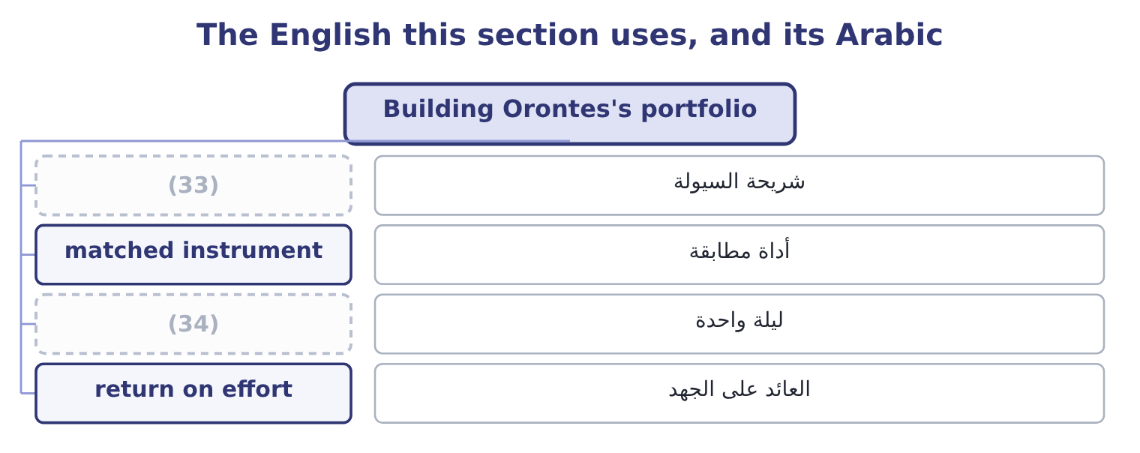
word list
discount instrument · overnight · liquidity tranche

The English this sheet uses, and its Arabic
English (exam term) | Arabic
liquidity tranche | شريحة السيولة
matched instrument | أداة مطابقة
overnight | ليلة واحدة
return on effort | العائد على الجهد

Answer key · 15.5 Building Orontes's portfolio

1 commitments | 18 finance
2 projects | 19 substitute
3 instalments | 20 giving
4 maturing | 21 findings
5 requires | 22 insisted
6 laddered | 23 Period return: ________
7 unmatched | 24 Tax-equivalent yield: ________
8 twelve-month | 25 5.1 per cent, taxable, A-rated
9 repurchase | 26 friend
10 precautionary | 27 collateral
11 short-dated | 28 treasurer
12 nothing | 29 altogether
13 Orontes's | 30 4.80 per cent: 3.6 ÷ 0.75 = 4.80 per cent.
14 obtained | 31 3.825 per cent: 5.1 × 0.75 = 3.825 per cent.
15 business | 32 The treasury bill
16 investment | 33 liquidity tranche
17 management | 34 overnight

the summaries in full
Summary 1 Put the chapter to work. The surplus is 7,302,100 − 2,900,000 = 4,402,100. The known commitments come first. Two projects need $6,000,000 over four quarters, of which the first instalments fall within this surplus. Each instalment is matched: a treasury bill or a government note maturing in the month the payment is due, bought today at a price that fixes the yield and requires no sale. What is left is laddered. Divide the unmatched balance across three, six, nine and twelve-month maturities, so that a tranche matures every quarter and the yield exceeds what an overnight account would pay. A liquidity tranche sits inside the ladder, not beside it: a portion held in treasury bills or an overnight repurchase agreement, available the same day, sized against the precautionary motive. At the 4 per cent available on short-dated government paper, the surplus earns 4,402,100 × 0.04 = 176,084 a year that the company earned nothing on in 2025.
Summary 2 Against Orontes's net income of $2,969,100 that is about six per cent of a year's profit, obtained with no risk to the principal, no change to the business and no capital investment — which is why treasury management is the part of finance with the highest return on effort, and the part most often left undone. What it does not change. The $176,084 is real and it is not a substitute for the $840,000 of gross margin Book 1 found the company giving away each year. Ranking findings by size, as Book 1's last chapter insisted, puts the margin first and this second. Both are worth doing and only one of them is easy.
Summary 3 English security was the false friend of Book 2, where it meant both an instrument and a collateral. Here a third sense appears that is easier to miss: in the phrase safety of principal, the quality a treasurer wants, English avoids the word security altogether and uses safety, because security would be ambiguous.

