16.1 What sets the level of receivables
Chapter 16 · section 16.1

Fill every gap. Each word list holds one word more than there are gaps.
Chapter 16, section by section
Each stage leads to the next.
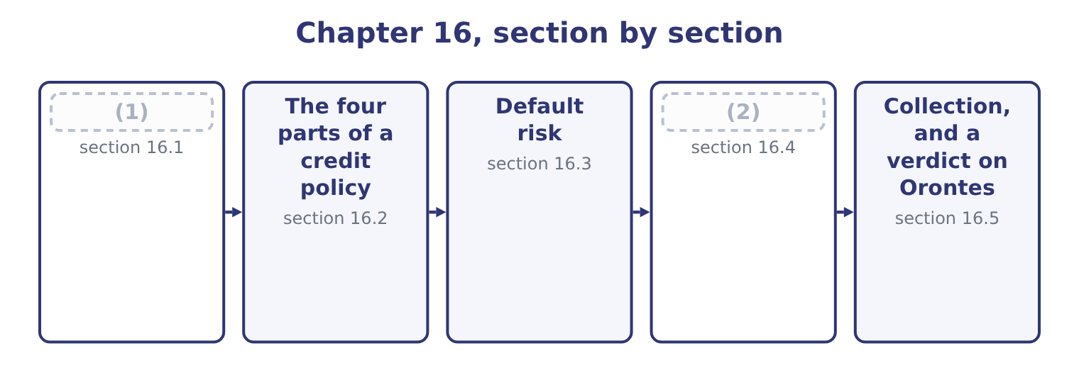
word list
What sets the level of receivables · Testing a change in credit policy · Collection, and a verdict on Orontes

Summary 1 gaps 3–14
Receivables are the (3) of two things only: how much is sold on credit, and how long it takes to (4) . (5) that influences the level works (6) one of those two. More sales on the same terms means more receivables, in proportion. This is the largest factor and the least (7) , which is why the ratio measures — days (8) , turnover — strip it out. The credit terms (9) . Terms of net 45 (10) half as much again in receivables as net 30, on the same sales. This is the (11) own decision and the (12) of section 16.4. The mix of customers. Large (13) pay slowly and reliably; small shops pay quickly or not at all; (14) bodies pay slowest of all and never default. A change in the customer mix changes the collection period without any change in policy.
word list
product · subject · outstanding · offered · government · interesting · retailers · through · write-off · Everything · collect · produce · company's

Summary 2 gaps 15–23
How quickly an (15) account is chased, by whom, and with what (16) . Two companies with (17) terms can have collection periods a (18) apart. (19) and industry (20) . A supplier to a (21) business is paid after the harvest, (22) the invoice says. A company whose (23) all offer 60 days cannot offer 30 and keep its customers. Discounts for early settlement. A discount buys days with margin, and the proportion of customers who take it determines how many days are bought. In a downturn, every customer pays more slowly and more of them fail, and the collection period lengthens without anybody deciding anything.
word list
identical · competitors · practice · harvest-driven · settlement · fortnight · whatever · consequence · overdue · Seasonality

What moves the receivable balance
Every item belongs to exactly one group.
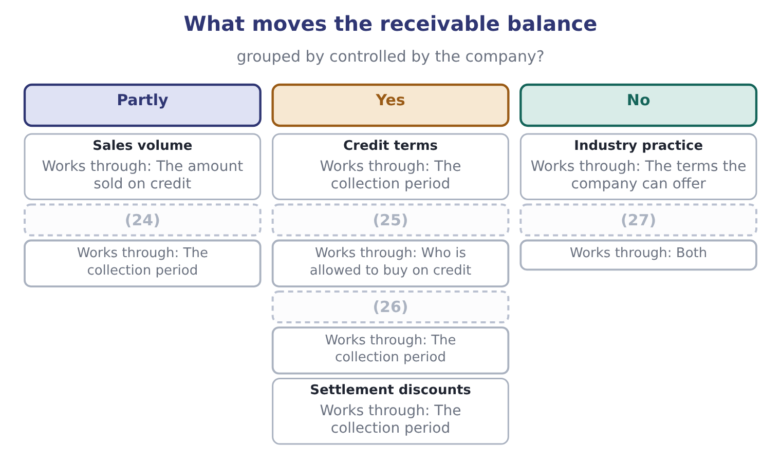
word list
The economy · Customer mix · credit policy · Collection effort · Credit standards

The English this section uses, and its Arabic
Each term sits against what it means.
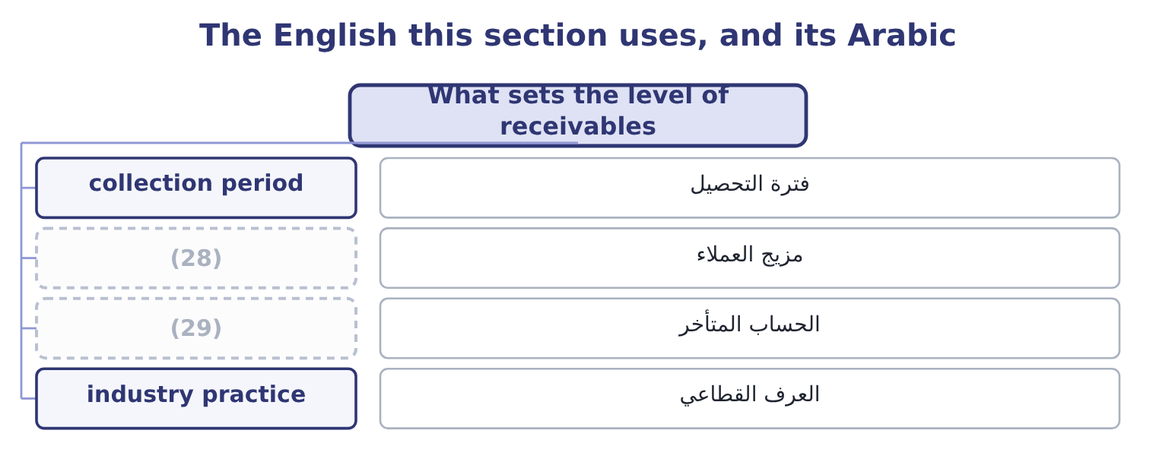
word list
contribution margin · customer mix · overdue account

The English this sheet uses, and its Arabic
English (exam term) | Arabic
collection period | فترة التحصيل
customer mix | مزيج العملاء
overdue account | الحساب المتأخر
industry practice | العرف القطاعي

Answer key · 16.1 What sets the level of receivables

1 What sets the level of receivables | 16 consequence
2 Testing a change in credit policy | 17 identical
3 product | 18 fortnight
4 collect | 19 Seasonality
5 Everything | 20 practice
6 through | 21 harvest-driven
7 interesting | 22 whatever
8 outstanding | 23 competitors
9 offered | 24 Customer mix
10 produce | 25 Credit standards
11 company's | 26 Collection effort
12 subject | 27 The economy
13 retailers | 28 customer mix
14 government | 29 overdue account
15 overdue

the summaries in full
Summary 1 Receivables are the product of two things only: how much is sold on credit, and how long it takes to collect. Everything that influences the level works through one of those two. More sales on the same terms means more receivables, in proportion. This is the largest factor and the least interesting, which is why the ratio measures — days outstanding, turnover — strip it out. The credit terms offered. Terms of net 45 produce half as much again in receivables as net 30, on the same sales. This is the company's own decision and the subject of section 16.4. The mix of customers. Large retailers pay slowly and reliably; small shops pay quickly or not at all; government bodies pay slowest of all and never default. A change in the customer mix changes the collection period without any change in policy.
Summary 2 How quickly an overdue account is chased, by whom, and with what consequence. Two companies with identical terms can have collection periods a fortnight apart. Seasonality and industry practice. A supplier to a harvest-driven business is paid after the harvest, whatever the invoice says. A company whose competitors all offer 60 days cannot offer 30 and keep its customers. Discounts for early settlement. A discount buys days with margin, and the proportion of customers who take it determines how many days are bought. In a downturn, every customer pays more slowly and more of them fail, and the collection period lengthens without anybody deciding anything.

16.2 The four parts of a credit policy
Chapter 16 · section 16.2

Fill every gap. Each word list holds one word more than there are gaps.
Summary 1 gaps 1–12
A credit policy has four (1) , and a question that asks about "an (2) credit policy" is (3) which of them to move. Credit standards decide who is (4) credit at all. They are set by the risk the company will accept, and (5) by the five Cs: (6) , meaning the customer's (7) to pay as shown by its record; capacity, its ability to pay out of cash flow; capital, the equity behind it; (8) , what could be taken if it failed; and conditions, the state of its industry and the economy. The sources are trade references, bank references, published (9) , a credit agency's report, and the company's own (10) . Credit terms decide how long and on what conditions. The (11) notation is read as follows: "2/10, net 30" means two per cent may be (12) if payment is made within ten days, and the full amount is due in thirty.
word list
asking · character · granted · standard · willingness · statements · optimal · collateral · deducted · financing · experience · assessed · elements

Summary 2 gaps 13–23
Collection policy decides what happens when an account goes past due: the (13) , the reminder, the (14) call, the stop on further supply, the collection agency, the lawyer. Each step costs money and each risks the customer (15) , so the sequence is a policy and not an (16) . The (17) decides how much (18) the company will give up to be paid sooner. The (19) , which is the (20) idea, is where the marginal benefit of relaxing a policy equals its marginal cost. Relaxing standards wins customers and adds bad debts. (21) terms wins sales and adds (22) cost. (23) collection keeps customers and lengthens the period. Every move has a gain and a cost, and the analysis of section 16.4 is how they are compared.
word list
examinable · Softening · telephone · relationship · compared · statement · financing · discount · optimum · improvisation · Lengthening · margin

The English this section uses, and its Arabic
Each term sits against what it means.
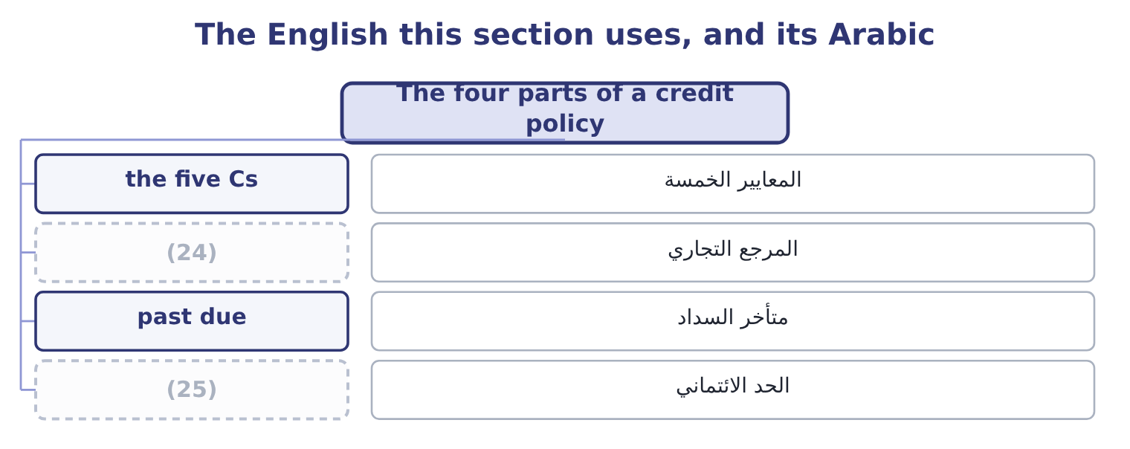
word list
past due · trade reference · credit limit

The English this sheet uses, and its Arabic
English (exam term) | Arabic
the five Cs | المعايير الخمسة
trade reference | المرجع التجاري
past due | متأخر السداد
credit limit | الحد الائتماني

Answer key · 16.2 The four parts of a credit policy

1 elements | 14 telephone
2 optimal | 15 relationship
3 asking | 16 improvisation
4 granted | 17 discount
5 assessed | 18 margin
6 character | 19 optimum
7 willingness | 20 examinable
8 collateral | 21 Lengthening
9 statements | 22 financing
10 experience | 23 Softening
11 standard | 24 trade reference
12 deducted | 25 credit limit
13 statement

the summaries in full
Summary 1 A credit policy has four elements, and a question that asks about "an optimal credit policy" is asking which of them to move. Credit standards decide who is granted credit at all. They are set by the risk the company will accept, and assessed by the five Cs: character, meaning the customer's willingness to pay as shown by its record; capacity, its ability to pay out of cash flow; capital, the equity behind it; collateral, what could be taken if it failed; and conditions, the state of its industry and the economy. The sources are trade references, bank references, published statements, a credit agency's report, and the company's own experience. Credit terms decide how long and on what conditions. The standard notation is read as follows: "2/10, net 30" means two per cent may be deducted if payment is made within ten days, and the full amount is due in thirty.
Summary 2 Collection policy decides what happens when an account goes past due: the statement, the reminder, the telephone call, the stop on further supply, the collection agency, the lawyer. Each step costs money and each risks the customer relationship, so the sequence is a policy and not an improvisation. The discount decides how much margin the company will give up to be paid sooner. The optimum, which is the examinable idea, is where the marginal benefit of relaxing a policy equals its marginal cost. Relaxing standards wins customers and adds bad debts. Lengthening terms wins sales and adds financing cost. Softening collection keeps customers and lengthens the period. Every move has a gain and a cost, and the analysis of section 16.4 is how they are compared.

16.3 Default risk
Chapter 16 · section 16.3

Fill every gap. Each word list holds one word more than there are gaps.
Summary 1 gaps 1–12
Default risk is the risk that a customer does not pay what it owes, in full or at all. It is the price of (1) on credit, it can be reduced and never removed, and the exam wants it (2) rather than (3) . Three (4) measure it. The ageing (5) sorts the receivable book by how long each balance has been (6) : current, 1 to 30 days past due, 31 to 60, 61 to 90, over 90. It is the instrument Book 1 said a days-outstanding figure cannot (7) , because an average of 34.3 days is consistent with (8) paying on time and with one large account at 120 days. The pattern of (9) between the (10) is the early warning. The allowance for credit losses is the (11) estimate of what will not be (12) , charged to the income statement as a credit loss expense.
word list
assigns · collected · measured · replace · columns · everybody · company's · described · outstanding · movement · schedule · selling · instruments

Summary 2 gaps 13–24
Orontes's allowance is $156,000 against a gross book of $4,300,000, which is 156,000 ÷ 4,300,000 = 3.63 per cent — held (13) against 3.59 per cent a year (14) , which Book 1 read as consistent. Credit (15) assigns a number to a customer from its (16) and its history, and sets a credit limit from the score. It makes (17) consistent and fast, and it is only as good as the data (18) it. Four ways to (19) the risk, each with a cost. Tighter (20) , which lose sales. Security: a personal (21) , a letter of credit, a (22) of title clause, a deposit. Each costs the customer (23) and may lose the sale. Credit (24) , which transfers the risk for a premium. Factoring, which sells the receivable outright. Book 1 found a $15,000 loss on sale of receivables in Orontes's income statement, which is this decision already taken for part of the book.
word list
behind · steady · earlier · standards · characteristics · reduce · days-outstanding · decisions · scoring · guarantee · retention · insurance · something

An ageing schedule, and the reading
Each stage leads to the next.
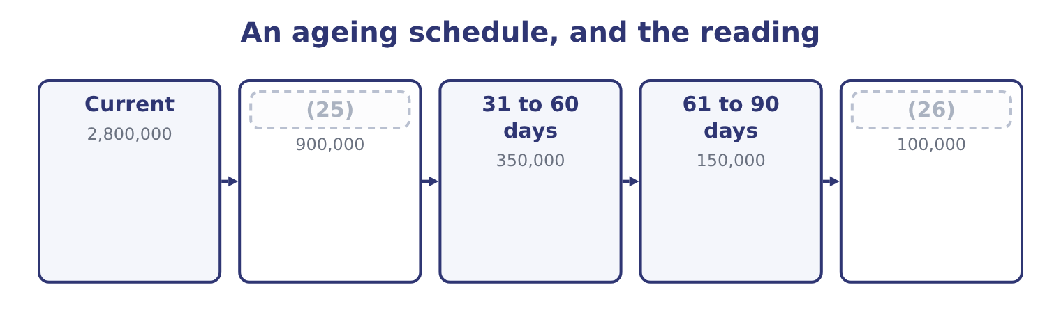
word list
retention of title · 1 to 30 days past due · Over 90 days

The English this section uses, and its Arabic
Each term sits against what it means.
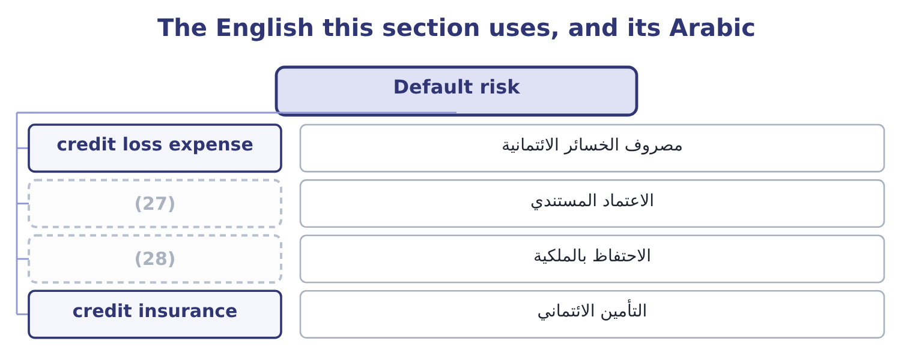
word list
letter of credit · stop on supply · retention of title

The English this sheet uses, and its Arabic
English (exam term) | Arabic
credit loss expense | مصروف الخسائر الائتمانية
letter of credit | الاعتماد المستندي
retention of title | الاحتفاظ بالملكية
credit insurance | التأمين الائتماني

Answer key · 16.3 Default risk

1 selling | 15 scoring
2 measured | 16 characteristics
3 described | 17 decisions
4 instruments | 18 behind
5 schedule | 19 reduce
6 outstanding | 20 standards
7 replace | 21 guarantee
8 everybody | 22 retention
9 movement | 23 something
10 columns | 24 insurance
11 company's | 25 1 to 30 days past due
12 collected | 26 Over 90 days
13 steady | 27 letter of credit
14 earlier | 28 retention of title

the summaries in full
Summary 1 Default risk is the risk that a customer does not pay what it owes, in full or at all. It is the price of selling on credit, it can be reduced and never removed, and the exam wants it measured rather than described. Three instruments measure it. The ageing schedule sorts the receivable book by how long each balance has been outstanding: current, 1 to 30 days past due, 31 to 60, 61 to 90, over 90. It is the instrument Book 1 said a days-outstanding figure cannot replace, because an average of 34.3 days is consistent with everybody paying on time and with one large account at 120 days. The pattern of movement between the columns is the early warning. The allowance for credit losses is the company's estimate of what will not be collected, charged to the income statement as a credit loss expense.
Summary 2 Orontes's allowance is $156,000 against a gross book of $4,300,000, which is 156,000 ÷ 4,300,000 = 3.63 per cent — held steady against 3.59 per cent a year earlier, which Book 1 read as consistent. Credit scoring assigns a number to a customer from its characteristics and its history, and sets a credit limit from the score. It makes decisions consistent and fast, and it is only as good as the data behind it. Four ways to reduce the risk, each with a cost. Tighter standards, which lose sales. Security: a personal guarantee, a letter of credit, a retention of title clause, a deposit. Each costs the customer something and may lose the sale. Credit insurance, which transfers the risk for a premium. Factoring, which sells the receivable outright. Book 1 found a $15,000 loss on sale of receivables in Orontes's income statement, which is this decision already taken for part of the book.

16.4 Testing a change in credit policy
Chapter 16 · section 16.4

Fill every gap. Each word list holds one word more than there are gaps.
Summary 1 gaps 1–2
This is the (1) the outcome names and the exam sets. The (2) never varies: compare the incremental gain with the incremental cost, counting only what changes.
word list
calculation · investment · structure

Worked example: lengthening the terms from 30 to 45 days

Summary 2 gaps 3–8
Orontes's sales (3) proposes moving from net 30 to net 45. Sales are expected to rise from $42,000,000 to $45,000,000. The contribution margin on the extra sales is 40 per cent, so (4) costs are 60 per cent. Receivables are expected to run at the new 45 days. Bad debts on the new (5) are expected at 4 per cent of those sales. The carrying cost of money is the company's cost of (6) of 9.04 per cent. The extra sales are 45,000,000 − 42,000,000 = 3,000,000, and at a 40 per cent contribution margin they add 3,000,000 × 0.40 = 1,200,000 of contribution. Fixed costs do not change, so that is the gross benefit. The extra investment in receivables. At 45 days, the book (7) 45,000,000 × 45 ÷ 365 = 5,547,945 (8) the present $4,144,000, an increase of 5,547,945 − 4,144,000 = 1,403,945.
word list
capital · business · against · director · variable · becomes · Tightening

Summary 3 gaps 9–18
The company's own money in that increase is its cost, not its (9) price, so at a 60 per cent variable-cost ratio the investment is 1,403,945 × 0.60 = 842,367. The cost of carrying it. Four per cent of the new sales: 3,000,000 × 0.04 = 120,000. The (10) should be accepted. Notice which (11) did the work. The gain is large because the contribution margin is high and fixed costs do not change; the costs are small because money is cheap (12) to a 40 per cent margin. Reverse (13) and the answer (14) : at a 10 per cent contribution margin the gain would be $300,000 and the costs would still be (15) $200,000, and at a 20 per cent cost of money the carrying cost alone would be $168,473. The (16) version of this (17) is always a test of whether the (18) knows which figures to vary.
word list
exam's · nearly · question · either · reverses · shorten · proposal · candidate · numbers · selling · relative

The credit policy template
Line | Computation | This case
Increase in sales | New sales less old | 3,000,000
Increase in contribution | Times the contribution margin | 1,200,000
New receivable balance | New sales times new days, over 365 | 5,547,945
Increase in receivables | (19) | 1,403,945
Investment in that increase | (20) | 842,367
Carrying cost | (21) | (76,150)
Additional bad debts | (22) | (120,000)
Net benefit |  | 1,003,850

word list
Times the variable-cost ratio · New balance less old · New sales times the expected rate · Times the cost of money · Times the contribution margin

Summary 4 gaps 23–33
The same (23) tests every other change, with one line (24) . Tightening (25) : sales fall, contribution falls, receivables fall, bad debts fall. (26) if the bad debts and carrying cost saved (27) the contribution lost. (28) a discount of 2/10 on terms of net 30, where 60 per cent of customers take it: the cost is 0.02 × 0.60 × 45,000,000 = 540,000 a year of margin, and the benefit is the carrying cost saved on a shorter collection period plus any (29) in bad debts. On these figures the discount is (30) and would have to (31) the period by a great deal to pay. Tightening collection: the cost is the collection (32) plus any customers lost; the benefit is a shorter period and fewer (33) .
word list
reduction · expenditure · proposes · standards · exceed · altered · shorten · write-offs · template · Offering · expensive · Accept

The English this section uses, and its Arabic
Each term sits against what it means.
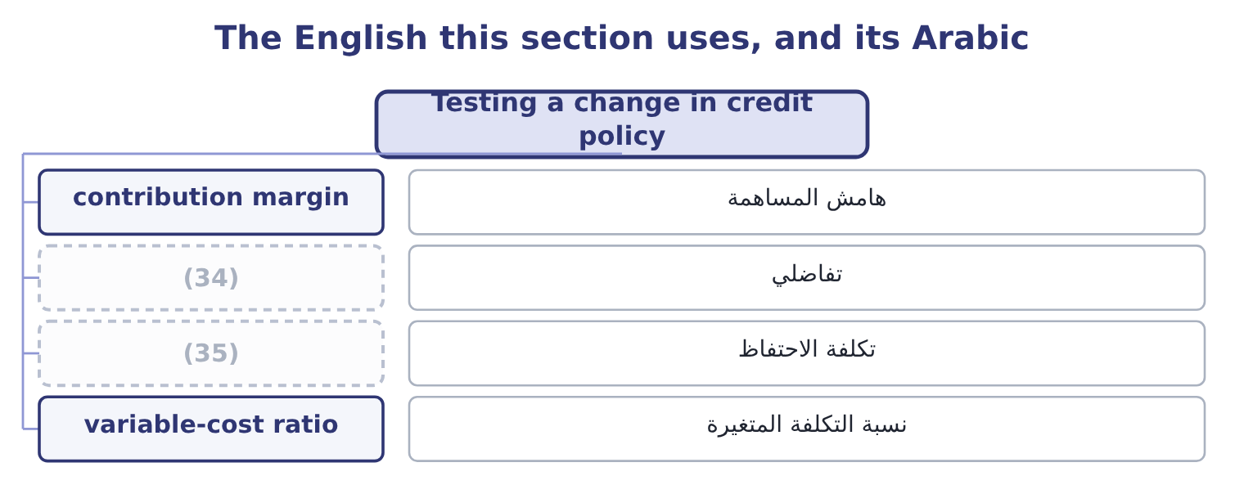
word list
carrying cost · write-off · incremental

The English this sheet uses, and its Arabic
English (exam term) | Arabic
contribution margin | هامش المساهمة
incremental | تفاضلي
carrying cost | تكلفة الاحتفاظ
variable-cost ratio | نسبة التكلفة المتغيرة

Answer key · 16.4 Testing a change in credit policy

1 calculation | 19 New balance less old
2 structure | 20 Times the variable-cost ratio
3 director | 21 Times the cost of money
4 variable | 22 New sales times the expected rate
5 business | 23 template
6 capital | 24 altered
7 becomes | 25 standards
8 against | 26 Accept
9 selling | 27 exceed
10 proposal | 28 Offering
11 numbers | 29 reduction
12 relative | 30 expensive
13 either | 31 shorten
14 reverses | 32 expenditure
15 nearly | 33 write-offs
16 exam's | 34 incremental
17 question | 35 carrying cost
18 candidate

the summaries in full
Summary 1 This is the calculation the outcome names and the exam sets. The structure never varies: compare the incremental gain with the incremental cost, counting only what changes.
Summary 2 Orontes's sales director proposes moving from net 30 to net 45. Sales are expected to rise from $42,000,000 to $45,000,000. The contribution margin on the extra sales is 40 per cent, so variable costs are 60 per cent. Receivables are expected to run at the new 45 days. Bad debts on the new business are expected at 4 per cent of those sales. The carrying cost of money is the company's cost of capital of 9.04 per cent. The extra sales are 45,000,000 − 42,000,000 = 3,000,000, and at a 40 per cent contribution margin they add 3,000,000 × 0.40 = 1,200,000 of contribution. Fixed costs do not change, so that is the gross benefit. The extra investment in receivables. At 45 days, the book becomes 45,000,000 × 45 ÷ 365 = 5,547,945 against the present $4,144,000, an increase of 5,547,945 − 4,144,000 = 1,403,945.
Summary 3 The company's own money in that increase is its cost, not its selling price, so at a 60 per cent variable-cost ratio the investment is 1,403,945 × 0.60 = 842,367. The cost of carrying it. Four per cent of the new sales: 3,000,000 × 0.04 = 120,000. The proposal should be accepted. Notice which numbers did the work. The gain is large because the contribution margin is high and fixed costs do not change; the costs are small because money is cheap relative to a 40 per cent margin. Reverse either and the answer reverses: at a 10 per cent contribution margin the gain would be $300,000 and the costs would still be nearly $200,000, and at a 20 per cent cost of money the carrying cost alone would be $168,473. The exam's version of this question is always a test of whether the candidate knows which figures to vary.
Summary 4 The same template tests every other change, with one line altered. Tightening standards: sales fall, contribution falls, receivables fall, bad debts fall. Accept if the bad debts and carrying cost saved exceed the contribution lost. Offering a discount of 2/10 on terms of net 30, where 60 per cent of customers take it: the cost is 0.02 × 0.60 × 45,000,000 = 540,000 a year of margin, and the benefit is the carrying cost saved on a shorter collection period plus any reduction in bad debts. On these figures the discount is expensive and would have to shorten the period by a great deal to pay. Tightening collection: the cost is the collection expenditure plus any customers lost; the benefit is a shorter period and fewer write-offs.

16.5 Collection, and a verdict on Orontes
Chapter 16 · section 16.5

Fill every gap. Each word list holds one word more than there are gaps.
Summary 1 gaps 1–12
Collection policy is the part of credit (1) that is executed rather than decided, and three (2) govern it. Act early and (3) . An account that is three days overdue is a (4) matter; the same account at ninety days is a (5) . The cost of the first (6) is trivial and its effect is large, which is why the ageing (7) is reviewed weekly rather than monthly. (8) the collection decision from the sales (9) . A sales (10) paid on revenue is the wrong person to stop a (11) supply, and a credit function that reports to sales will not do it either. The exam treats this as a control (12) , which it is. Escalate by steps that are agreed in advance. Statement, reminder, call, stop on supply, final demand, agency, legal action — with the authority for each step and the days at which it triggers written down, so that the decision to continue supplying a slow payer is taken deliberately.
word list
dispute · representative · contact · question · schedule · management · customer's · clerical · consistently · principles · Separate · relationship · facility

Summary 2 gaps 13–24
Now the (13) on Orontes. Its days sales (14) is 34.3 against terms the company (15) as about 30: four days of slippage, which on daily sales of $115,068 is 115,068 × 4 = 460,272 of money the terms say should be in the bank. Its (16) ratio is steady and its credit loss (17) of $63,000 is modest. Its receivables grew more (18) than its sales. The book is well run. The finding is therefore not a problem but an (19) , and it is the one section 16.4 quantified: a company with a 35 per cent gross margin, a cost of money near 9 per cent and (20) bad debts is a company that should probably be selling more on credit rather than less. The $1,003,850 of net benefit in the worked example is larger than the $840,000 of lost gross margin that Book 1 ranked as the (21) first finding — and it is the first idea in two books that would (22) address that finding, because it buys volume without cutting price. That is the note on which the (23) chapters turn from (24) cost to creating value.
word list
controlling · verdict · slowly · company's · describes · working-capital · opportunity · well-controlled · actually · reduction · expense · outstanding · allowance

Test a tightening

Your turn: tightening credit standards (complete the blanks)
Item | Data | Answer
Sales lost | Sales fall from 20,000,000 to 18,500,000 | 1,500,000: 20,000,000 − 18,500,000 = 1,500,000.
Contribution lost | Contribution margin 30 per cent | (25)
New receivable balance | 25 days on the new sales | (26)
Old receivable balance | 2,400,000 | 2,400,000, as given.
Reduction in receivables |  | (27)
Investment released | (28) | 793,014: 1,132,877 × 0.70 = 793,014.
Carrying cost saved | Cost of money 10 per cent | (29)
Bad debts saved | (30) | 75,000: 1,500,000 × 0.05 = 75,000.
Decision |  | Reject the tightening. The savings are 79,301 + 75,000 = 154,301 against 450,000 of contribution lost, so the company would be 295,699 a yea

word list
Variable-cost ratio 70 per cent · 5 per cent of the lost sales · Sales fall from 20,000,000 to 18,500,000 · 1,267,123: 18,500,000 × 25 ÷ 365 = 1,267,123. · 79,301: 793,014 × 0.10 = 79,301. · 450,000: 1,500,000 × 0.30 = 450,000. · 1,132,877: 2,400,000 − 1,267,123 = 1,132,877.

"Credit"

Summary 3 gaps 31–37
English credit is one of the most (31) words in the whole (32) . It is the (33) a seller grants a buyer, as in credit terms. It is the (34) side of a double entry, as in debit and credit. It is a reduction in tax, as in a tax credit. It is a (35) , as in credit risk. And to credit an account is to increase a (36) or reduce an asset, which is the (37) of what a customer means by getting credit.
word list
overloaded · right-hand · verdict · liability · facility · rating · opposite · syllabus

The English this section uses, and its Arabic
Each term sits against what it means.
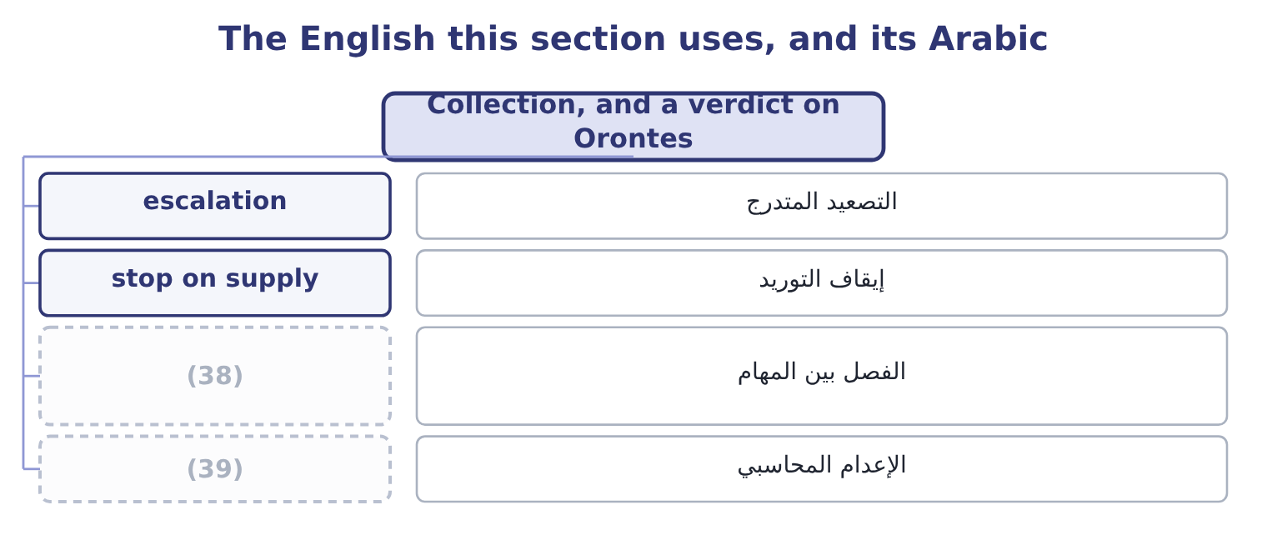
word list
segregation of duties · default risk · write-off

The English this sheet uses, and its Arabic
English (exam term) | Arabic
escalation | التصعيد المتدرج
stop on supply | إيقاف التوريد
segregation of duties | الفصل بين المهام
write-off | الإعدام المحاسبي

Answer key · 16.5 Collection, and a verdict on Orontes

1 management | 21 company's
2 principles | 22 actually
3 consistently | 23 working-capital
4 clerical | 24 controlling
5 dispute | 25 450,000: 1,500,000 × 0.30 = 450,000.
6 contact | 26 1,267,123: 18,500,000 × 25 ÷ 365 = 1,267,123.
7 schedule | 27 1,132,877: 2,400,000 − 1,267,123 = 1,132,877.
8 Separate | 28 Variable-cost ratio 70 per cent
9 relationship | 29 79,301: 793,014 × 0.10 = 79,301.
10 representative | 30 5 per cent of the lost sales
11 customer's | 31 overloaded
12 question | 32 syllabus
13 verdict | 33 facility
14 outstanding | 34 right-hand
15 describes | 35 rating
16 allowance | 36 liability
17 expense | 37 opposite
18 slowly | 38 segregation of duties
19 opportunity | 39 write-off
20 well-controlled

the summaries in full
Summary 1 Collection policy is the part of credit management that is executed rather than decided, and three principles govern it. Act early and consistently. An account that is three days overdue is a clerical matter; the same account at ninety days is a dispute. The cost of the first contact is trivial and its effect is large, which is why the ageing schedule is reviewed weekly rather than monthly. Separate the collection decision from the sales relationship. A sales representative paid on revenue is the wrong person to stop a customer's supply, and a credit function that reports to sales will not do it either. The exam treats this as a control question, which it is. Escalate by steps that are agreed in advance. Statement, reminder, call, stop on supply, final demand, agency, legal action — with the authority for each step and the days at which it triggers written down, so that the decision to continue supplying a slow payer is taken deliberately.
Summary 2 Now the verdict on Orontes. Its days sales outstanding is 34.3 against terms the company describes as about 30: four days of slippage, which on daily sales of $115,068 is 115,068 × 4 = 460,272 of money the terms say should be in the bank. Its allowance ratio is steady and its credit loss expense of $63,000 is modest. Its receivables grew more slowly than its sales. The book is well run. The finding is therefore not a problem but an opportunity, and it is the one section 16.4 quantified: a company with a 35 per cent gross margin, a cost of money near 9 per cent and well-controlled bad debts is a company that should probably be selling more on credit rather than less. The $1,003,850 of net benefit in the worked example is larger than the $840,000 of lost gross margin that Book 1 ranked as the company's first finding — and it is the first idea in two books that would actually address that finding, because it buys volume without cutting price. That is the note on which the working-capital chapters turn from controlling cost to creating value.
Summary 3 English credit is one of the most overloaded words in the whole syllabus. It is the facility a seller grants a buyer, as in credit terms. It is the right-hand side of a double entry, as in debit and credit. It is a reduction in tax, as in a tax credit. It is a rating, as in credit risk. And to credit an account is to increase a liability or reduce an asset, which is the opposite of what a customer means by getting credit.

