17.1 Why inventory is held
Chapter 17 · section 17.1

Fill every gap. Each word list holds one word more than there are gaps.
Chapter 17, section by section
Each stage leads to the next.
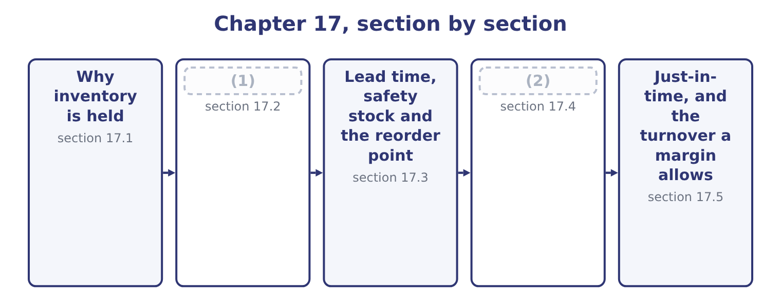
word list
Why inventory is held · The three costs · How much to order

Summary 1 gaps 3–14
Four reasons, and the exam asks for them by name. To meet demand that is not perfectly (3) . A customer who wants (4) today will buy it from (5) who has it. The stock held for this reason is the buffer, and its size depends on how (6) the demand is and on how (7) a lost sale is. To (8) the stages of a (9) . A mill that stops when the roaster stops is a mill that runs at the (10) worst day. Work in (11) between the stages lets each run at its own (12) . This is the reason (13) attacks most (14) , by removing the need rather than the stock. To obtain quantity discounts and reduce ordering effort. Buying in larger lots costs less per unit in both price and administration, and the saving is paid for in storage and funding — which is exactly the trade-off the economic order quantity resolves.
word list
attacks · directly · something · just-in-time · somebody · rhythm · progress · predictable · process · variable · expensive · decouple · roaster's

Summary 2 gaps 15–22
To guard (15) price rises or supply (16) . A company whose input is (17) , imported, or subject to a (18) price may hold more than it needs now (19) it expects to need it later at a worse price. Orontes (20) sesame is this case. What sets the level, beyond the reasons, is a short list: the (21) of demand, the length and (22) of the lead time, the cost of a stockout, the cost of money, the shelf life of the goods, and the terms available from suppliers.
word list
because · importing · suppliers · seasonal · predictability · volatile · reliability · against · interruptions

The English this section uses, and its Arabic
Each term sits against what it means.
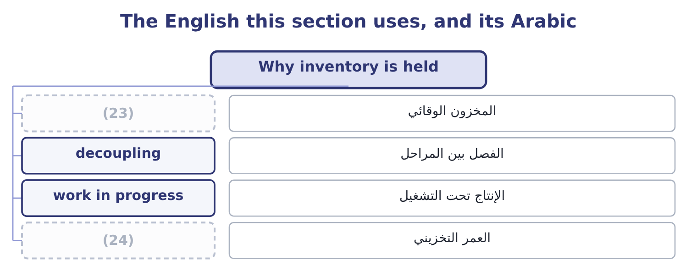
word list
buffer stock · lead time · shelf life

The English this sheet uses, and its Arabic
English (exam term) | Arabic
buffer stock | المخزون الوقائي
decoupling | الفصل بين المراحل
work in progress | الإنتاج تحت التشغيل
shelf life | العمر التخزيني

Answer key · 17.1 Why inventory is held

1 The three costs | 13 just-in-time
2 How much to order | 14 directly
3 predictable | 15 against
4 something | 16 interruptions
5 somebody | 17 seasonal
6 variable | 18 volatile
7 expensive | 19 because
8 decouple | 20 importing
9 process | 21 predictability
10 roaster's | 22 reliability
11 progress | 23 buffer stock
12 rhythm | 24 shelf life

the summaries in full
Summary 1 Four reasons, and the exam asks for them by name. To meet demand that is not perfectly predictable. A customer who wants something today will buy it from somebody who has it. The stock held for this reason is the buffer, and its size depends on how variable the demand is and on how expensive a lost sale is. To decouple the stages of a process. A mill that stops when the roaster stops is a mill that runs at the roaster's worst day. Work in progress between the stages lets each run at its own rhythm. This is the reason just-in-time attacks most directly, by removing the need rather than the stock. To obtain quantity discounts and reduce ordering effort. Buying in larger lots costs less per unit in both price and administration, and the saving is paid for in storage and funding — which is exactly the trade-off the economic order quantity resolves.
Summary 2 To guard against price rises or supply interruptions. A company whose input is seasonal, imported, or subject to a volatile price may hold more than it needs now because it expects to need it later at a worse price. Orontes importing sesame is this case. What sets the level, beyond the reasons, is a short list: the predictability of demand, the length and reliability of the lead time, the cost of a stockout, the cost of money, the shelf life of the goods, and the terms available from suppliers.

17.2 The three costs
Chapter 17 · section 17.2

Fill every gap. Each word list holds one word more than there are gaps.
Summary 1 gaps 1–12
Carrying costs rise with the quantity held. They are the cost of funding the money in the stock, which is the largest item; storage, (1) and insurance; (2) from theft and damage; and obsolescence. They are usually expressed as an amount per unit per year, or as a (3) of the unit cost — twenty to (4) per cent a year is a common figure once funding, storage and obsolescence are added. Ordering costs fall with the quantity held, (5) a larger order means fewer (6) . They are the (7) cost of raising and receiving an order, the inspection, the transport where it does not vary with quantity, and for a (8) the cost of setting up a production run. Stockout costs arise when the stock runs out: the lost contribution on the sale, the (9) freight to get goods urgently, the idle production line, and the customer who goes elsewhere (10) . They are the hardest to measure and usually the largest, which is why they are estimated rather than (11) and why companies hold more stock than any formula (12) .
word list
percentage · manufacturer · formula · because · computed · suggests · expedited · permanently · twenty-five · handling · administrative · orders · shrinkage

Three costs, three directions
Cost | What it contains | As order quantity rises | How it is measured
Carrying | (13) | Rises | Per unit a year
Ordering | Administration, inspection, set-up | Falls | (14)
Stockout | (15) | Falls, then flattens | Estimated

word list
Funding, storage, insurance, obsolescence · Lost contribution, expediting, lost customers · square root · Per order

Which cost is which

Summary 2 gaps 16–22
Funding the stock is a carrying cost, not an ordering cost, (16) the invoice is paid. A set-up cost in a (17) behaves exactly as an ordering cost does, and the economic order quantity formula is used for production (18) with the set-up cost in place of the ordering cost. Quantity (19) are not in the basic formula. Where a (20) offers one, (21) the total cost at the economic order quantity and at each discount break and (22) them.
word list
however · factory · discounts · question · funding · batches · compute · compare

The English this section uses, and its Arabic
Each term sits against what it means.
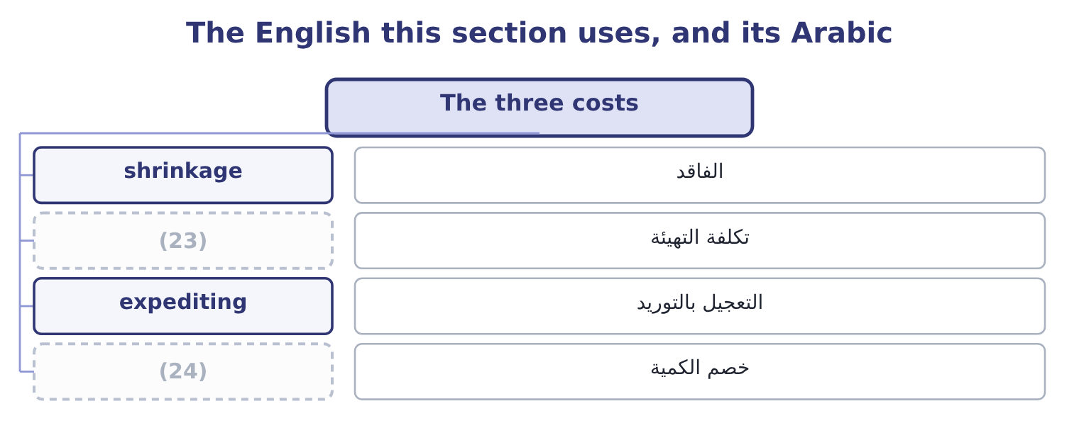
word list
safety stock · set-up cost · quantity discount

The English this sheet uses, and its Arabic
English (exam term) | Arabic
shrinkage | الفاقد
set-up cost | تكلفة التهيئة
expediting | التعجيل بالتوريد
quantity discount | خصم الكمية

Answer key · 17.2 The three costs

1 handling | 13 Funding, storage, insurance, obsolescence
2 shrinkage | 14 Per order
3 percentage | 15 Lost contribution, expediting, lost customers
4 twenty-five | 16 however
5 because | 17 factory
6 orders | 18 batches
7 administrative | 19 discounts
8 manufacturer | 20 question
9 expedited | 21 compute
10 permanently | 22 compare
11 computed | 23 set-up cost
12 suggests | 24 quantity discount

the summaries in full
Summary 1 Carrying costs rise with the quantity held. They are the cost of funding the money in the stock, which is the largest item; storage, handling and insurance; shrinkage from theft and damage; and obsolescence. They are usually expressed as an amount per unit per year, or as a percentage of the unit cost — twenty to twenty-five per cent a year is a common figure once funding, storage and obsolescence are added. Ordering costs fall with the quantity held, because a larger order means fewer orders. They are the administrative cost of raising and receiving an order, the inspection, the transport where it does not vary with quantity, and for a manufacturer the cost of setting up a production run. Stockout costs arise when the stock runs out: the lost contribution on the sale, the expedited freight to get goods urgently, the idle production line, and the customer who goes elsewhere permanently. They are the hardest to measure and usually the largest, which is why they are estimated rather than computed and why companies hold more stock than any formula suggests.
Summary 2 Funding the stock is a carrying cost, not an ordering cost, however the invoice is paid. A set-up cost in a factory behaves exactly as an ordering cost does, and the economic order quantity formula is used for production batches with the set-up cost in place of the ordering cost. Quantity discounts are not in the basic formula. Where a question offers one, compute the total cost at the economic order quantity and at each discount break and compare them.

17.3 Lead time, safety stock and the reorder point
Chapter 17 · section 17.3

Fill every gap. Each word list holds one word more than there are gaps.
Summary 1 gaps 1–10
Lead time is the (1) between placing an order and (2) the goods. It is why a company (3) wait until the shelf is empty: an order placed on the day of the stockout (4) a week after it. The reorder point is the stock level at which the next order is placed. In the (5) case it is the (6) that will be used during the lead time: daily usage times lead time in days. Safety stock is the buffer held (7) the two things that go wrong — demand (8) than expected during the lead time, and a lead time (9) than expected. (10) it to the reorder point gives the full rule.
word list
working · arrives · longer · higher · simplest · against · interval · cannot · quantity · receiving · Adding

Worked example: when to order

Summary 2 gaps 11–19
A company uses 10,000 units a year over 250 working days, which is 10,000 ÷ 250 = 40 units a day. Five working days, so the usage during the lead time is 40 × 5 = 200 units. Demand is (11) and the supplier is occasionally late, so the company holds 100 units of safety stock — about two and a half days of usage. The safety stock is held all the time and used occasionally, so it is a (12) addition to the (13) stock and its whole cost is a carrying cost: at $4 a unit a year, 100 × 4 = 400 a year. That is the price of the (14) , and it should be (15) with the cost of the (16) it prevents. Where a question gives the (17) of a stockout at each level of safety stock and the cost of one, the (18) is the level at which the expected stockout cost plus the carrying cost is (19) .
word list
protection · stockouts · average · lowest · permanent · probability · compared · question · variable · answer

What moves the reorder point
Every item belongs to exactly one group.
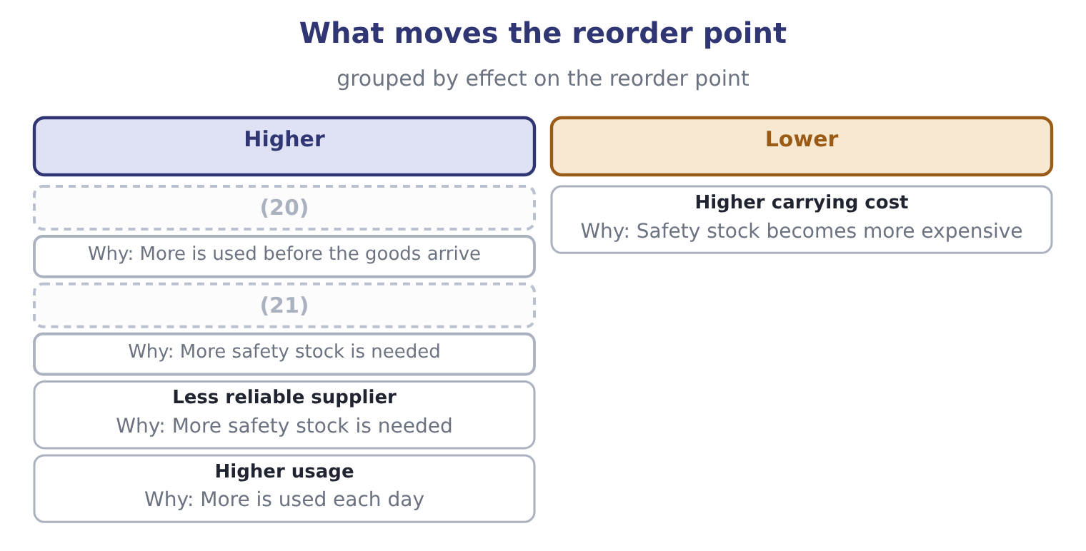
word list
Longer lead time · More variable demand · work in progress

The English this section uses, and its Arabic
Each term sits against what it means.
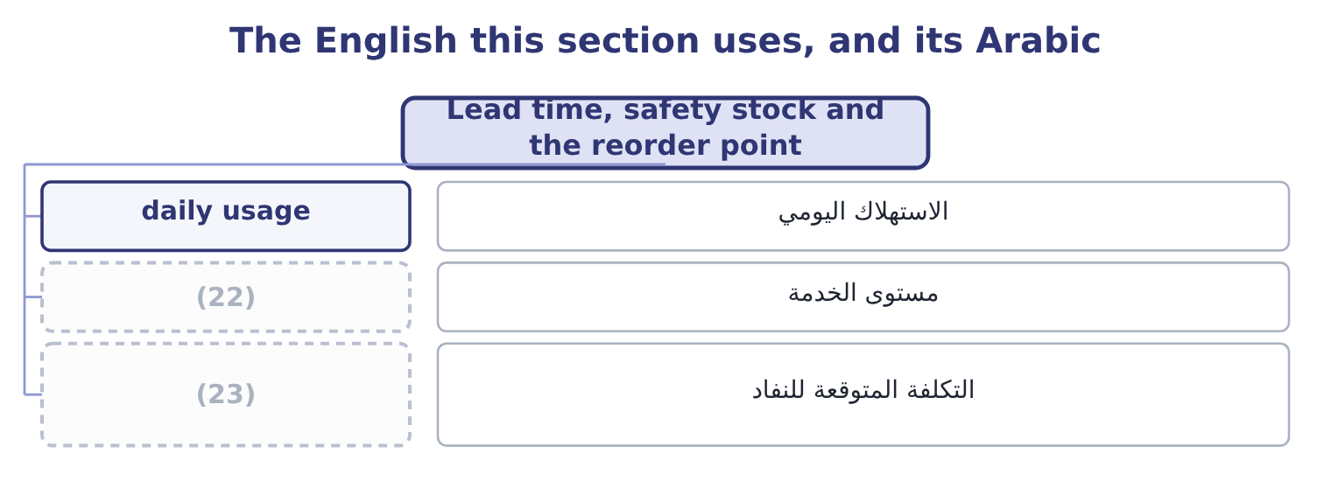
word list
buffer stock · expected stockout cost · service level

The English this sheet uses, and its Arabic
English (exam term) | Arabic
daily usage | الاستهلاك اليومي
service level | مستوى الخدمة
expected stockout cost | التكلفة المتوقعة للنفاد

Answer key · 17.3 Lead time, safety stock and the reorder point

1 interval | 13 average
2 receiving | 14 protection
3 cannot | 15 compared
4 arrives | 16 stockouts
5 simplest | 17 probability
6 quantity | 18 answer
7 against | 19 lowest
8 higher | 20 Longer lead time
9 longer | 21 More variable demand
10 Adding | 22 service level
11 variable | 23 expected stockout cost
12 permanent

the summaries in full
Summary 1 Lead time is the interval between placing an order and receiving the goods. It is why a company cannot wait until the shelf is empty: an order placed on the day of the stockout arrives a week after it. The reorder point is the stock level at which the next order is placed. In the simplest case it is the quantity that will be used during the lead time: daily usage times lead time in days. Safety stock is the buffer held against the two things that go wrong — demand higher than expected during the lead time, and a lead time longer than expected. Adding it to the reorder point gives the full rule.
Summary 2 A company uses 10,000 units a year over 250 working days, which is 10,000 ÷ 250 = 40 units a day. Five working days, so the usage during the lead time is 40 × 5 = 200 units. Demand is variable and the supplier is occasionally late, so the company holds 100 units of safety stock — about two and a half days of usage. The safety stock is held all the time and used occasionally, so it is a permanent addition to the average stock and its whole cost is a carrying cost: at $4 a unit a year, 100 × 4 = 400 a year. That is the price of the protection, and it should be compared with the cost of the stockouts it prevents. Where a question gives the probability of a stockout at each level of safety stock and the cost of one, the answer is the level at which the expected stockout cost plus the carrying cost is lowest.

17.4 How much to order
Chapter 17 · section 17.4

Fill every gap. Each word list holds one word more than there are gaps.
Summary 1 gaps 1–5
The (1) order quantity is the order size at which the total of carrying and ordering costs is (2) . It comes from a formula the exam does not (3) to be derived: twice the annual demand times the cost of (4) one order, (5) by the carrying cost of one unit for a year, all under a square root.
word list
divided · lowest · economic · placing · require · direction

Worked example: the economic order quantity

Summary 2 gaps 6–17
Annual demand is 10,000 units, each order costs $50 to place, and carrying one unit for a year costs $4. Twice the demand times the ordering cost: 2 × 10,000 × 50 = 1,000,000. (6) by the carrying cost. At 500 units an order, the company (7) 10,000 ÷ 500 = 20 (8) a year, costing 20 × 50 = 1,000. Its (9) stock is half the order quantity, 500 ÷ 2 = 250 units, costing 250 × 4 = 1,000 to carry. Total cost is 1,000 + 1,000 = 2,000 a year. The two costs are equal at the (10) , and that is not a (11) : it is a property of the formula and a quick way to (12) an answer. It is also why the total cost curve is flat near the bottom — ordering 450 or 550 units (13) of 500 costs only a few dollars more a year — which matters in (14) , because it means the (15) precision is not worth (16) over while its (17) is worth following.
word list
agonising · verify · orders · optimum · places · average · direction · practice · instead · formula's · assumptions · Divide · coincidence

Summary 3 gaps 18–26
The (18) asks how a change in one (19) affects the answer, and the square root (20) the rule: every input moves the order quantity by its own square root. Double the demand and the order quantity rises by about 41 per cent, not 100, because the square root of two is about 1.41. This is why a company twice the size does not hold twice the stock, and it is the (21) most examinable (22) of the formula. Double the ordering cost and the quantity rises by the same 41 per cent: with an ordering cost of $100, the (23) becomes 2 × 10,000 × 100 = 2,000,000, and dividing by 4 and (24) the root gives about 707 units. Double the carrying cost and the quantity falls by about 29 per cent, to about 354 units, because dividing by two (25) a square root (26) by about 0.71.
word list
supplies · outcome · multiplies · numerator · variable · inside · property · taking · single · consequence

What a change does to the economic order quantity
Every item belongs to exactly one group.
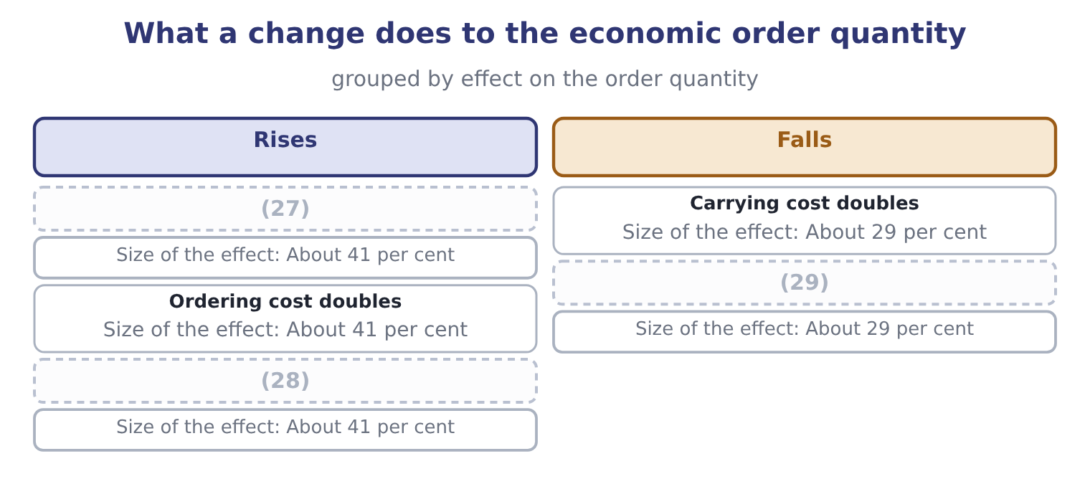
word list
Demand doubles · reorder point · All three double together · Demand falls by half

Summary 4 gaps 30–38
The assumptions are examinable in their own right, because every one of them fails (30) . Demand is assumed constant and known; the lead time is assumed constant; the ordering cost per order and the carrying cost per unit are assumed fixed; no quantity (31) exist; and the whole order (32) at once. A (33) that varies any of these is asking whether the (34) knows the model's limits — and the (35) answer is that the formula gives the right order of (36) , that the cost curve is flat near its (37) , and that the assumptions matter less than the (38) of comparing the two costs.
word list
discipline · standard · somewhere · minimum · practice · candidate · discounts · arrives · question · magnitude

The English this section uses, and its Arabic
Each term sits against what it means.
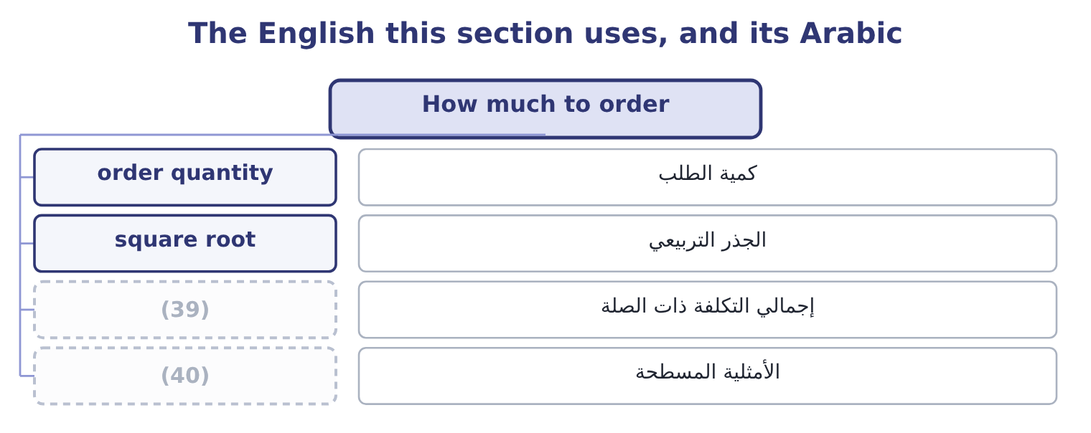
word list
flat optimum · total relevant cost · economic order quantity

The English this sheet uses, and its Arabic
English (exam term) | Arabic
order quantity | كمية الطلب
square root | الجذر التربيعي
total relevant cost | إجمالي التكلفة ذات الصلة
flat optimum | الأمثلية المسطحة

Answer key · 17.4 How much to order

1 economic | 21 single
2 lowest | 22 consequence
3 require | 23 numerator
4 placing | 24 taking
5 divided | 25 inside
6 Divide | 26 multiplies
7 places | 27 Demand doubles
8 orders | 28 All three double together
9 average | 29 Demand falls by half
10 optimum | 30 somewhere
11 coincidence | 31 discounts
12 verify | 32 arrives
13 instead | 33 question
14 practice | 34 candidate
15 formula's | 35 standard
16 agonising | 36 magnitude
17 direction | 37 minimum
18 outcome | 38 discipline
19 variable | 39 total relevant cost
20 supplies | 40 flat optimum

the summaries in full
Summary 1 The economic order quantity is the order size at which the total of carrying and ordering costs is lowest. It comes from a formula the exam does not require to be derived: twice the annual demand times the cost of placing one order, divided by the carrying cost of one unit for a year, all under a square root.
Summary 2 Annual demand is 10,000 units, each order costs $50 to place, and carrying one unit for a year costs $4. Twice the demand times the ordering cost: 2 × 10,000 × 50 = 1,000,000. Divide by the carrying cost. At 500 units an order, the company places 10,000 ÷ 500 = 20 orders a year, costing 20 × 50 = 1,000. Its average stock is half the order quantity, 500 ÷ 2 = 250 units, costing 250 × 4 = 1,000 to carry. Total cost is 1,000 + 1,000 = 2,000 a year. The two costs are equal at the optimum, and that is not a coincidence: it is a property of the formula and a quick way to verify an answer. It is also why the total cost curve is flat near the bottom — ordering 450 or 550 units instead of 500 costs only a few dollars more a year — which matters in practice, because it means the formula's precision is not worth agonising over while its direction is worth following.
Summary 3 The outcome asks how a change in one variable affects the answer, and the square root supplies the rule: every input moves the order quantity by its own square root. Double the demand and the order quantity rises by about 41 per cent, not 100, because the square root of two is about 1.41. This is why a company twice the size does not hold twice the stock, and it is the single most examinable consequence of the formula. Double the ordering cost and the quantity rises by the same 41 per cent: with an ordering cost of $100, the numerator becomes 2 × 10,000 × 100 = 2,000,000, and dividing by 4 and taking the root gives about 707 units. Double the carrying cost and the quantity falls by about 29 per cent, to about 354 units, because dividing by two inside a square root multiplies by about 0.71.
Summary 4 The assumptions are examinable in their own right, because every one of them fails somewhere. Demand is assumed constant and known; the lead time is assumed constant; the ordering cost per order and the carrying cost per unit are assumed fixed; no quantity discounts exist; and the whole order arrives at once. A question that varies any of these is asking whether the candidate knows the model's limits — and the standard answer is that the formula gives the right order of magnitude, that the cost curve is flat near its minimum, and that the assumptions matter less than the discipline of comparing the two costs.

17.5 Just-in-time, and the turnover a margin allows
Chapter 17 · section 17.5

Fill every gap. Each word list holds one word more than there are gaps.
Summary 1 gaps 1–12
Just-in-time is the (1) that stock held to (2) a process is a symptom, and that the process should be fixed instead. Materials arrive as they are needed, in small (3) , from suppliers close by and (4) committed; production is pulled by demand rather than pushed by a schedule; and the buffer between stages is removed so that any problem stops the line and has to be solved rather than absorbed. What it (5) is examinable. Inventory falls, often by most of it, (6) the funding and the space. Quality (7) , because a (8) cannot hide in a pile of stock. (9) and write-downs fall. And the (10) exposes problems — an (11) machine, a supplier who is sometimes late — that stock was concealing. What it requires is equally examinable, and it is the reason just-in-time is not (12) .
word list
contractually · protect · achieves · Obsolescence · improves · defect · discipline · between · quantities · universal · releasing · proposition · unreliable

Summary 2 gaps 13–24
Reliable suppliers, (13) close, and few of them. Short set-up times, so that small (14) are economic, which is the same as saying that the ordering cost in section 17.4 has been (15) down. And a (16) to stop the line, which is a cultural matter more than a (17) one. The risks are the mirror: a single (18) failure, a transport (19) , a natural disaster or a pandemic stops a line that has no buffer, and the saving of years can be lost in a month. The exam (20) both halves. Inventory turnover and gross margin tend to move in opposite (21) across businesses. A supermarket turns its stock (22) times a year on a gross margin near 25 per cent; a jeweller turns it twice on a margin near 50. Each is viable because the product of the two is enough: turnover times margin is a crude measure of the gross profit earned on each dollar (23) in stock, and businesses survive at many (24) of the pair.
word list
willingness · disruption · technical · geographically · supplier's · directions · invested · Barada's · batches · thirty · expects · combinations · engineered

Summary 3 gaps 25–33
The practical (25) are two. A company comparing its turnover with (26) must compare (27) at the same time, or it is comparing two different business models — which is (28) what Book 1 warned about when it set (29) 14 per cent gross margin against (30) 35. And a company that wants to raise its turnover by (31) stock must ask what that does to its margin: if the stock cut causes stockouts, (32) to recover the (33) , or expedited freight, the turnover will rise and the margin will fall, and the company will be no better off.
word list
margins · cutting · exactly · consequences · Barada's · customers · improves · discounting · Orontes's · another's

Turnover and margin across businesses
Business | Inventory turnover | Gross margin | Why the combination works
Supermarket | (34) | About 25% | Volume and speed; nothing sits
Orontes, a food manufacturer | 11.49 times | 35.0% | (35)
Barada, a distributor | 9.00 times | 14.0% | (36)
Jeweller | About 2 times | (37) | Slow, high-value, bought rarely

word list
Slow, high-value, bought rarely · About 50% · Thin margin, and the stockroom is the business · A moderate cycle at a fair margin · About 30 times

Order and reorder

Your turn: inventory arithmetic (complete the blanks)
Item | Data | Answer
Daily usage | 18,000 units a year over 300 days | (38) : 18,000 ÷ 300 = 60.
Usage during the lead time | (39) | 480 units: 60 × 8 = 480.
Reorder point | Safety stock 240 units | 720 units: 480 + 240 = 720.
Economic order quantity | Ordering cost 40, carrying cost 5 a unit a year | (40) : 2 × 18,000 × 40 = 1,440,000, and 1,440,000 ÷ 5 = 288,000, whose square root is about 537.
Orders a year |  | (41) : 18,000 ÷ 537 = 33.5.
Total relevant cost | Ordering plus carrying at the optimum | (42) : ordering is 33.5 × 40 = 1,340 and carrying is half of 537 at 5 a unit, which is about 1,343.

word list
60 units · Slow, high-value, bought rarely · 537 units · Lead time 8 days · About 34 · About 2,683

"Stock"

Summary 4 gaps 43–52
English stock means two (43) different things in these two books, and the two (44) sit in adjacent (45) . Inventory is called stock in British usage, so (46) , stock turn and safety stock all concern goods. Shares are called stock in American usage, so common stock, (47) stock and stock dividend all concern (48) . The exam, written in American English, uses stock for shares and inventory for goods, and a (49) who learned the British sense must read (50) : a stock dividend has nothing to do with the (51) . Note the one (52) of the goods sense in American usage: a company is said to be out of stock, never out of inventory.
word list
chapters · candidate · carefully · entirely · survival · stockout · preferred · written · warehouse · meanings · equity

The English this section uses, and its Arabic
Each term sits against what it means.
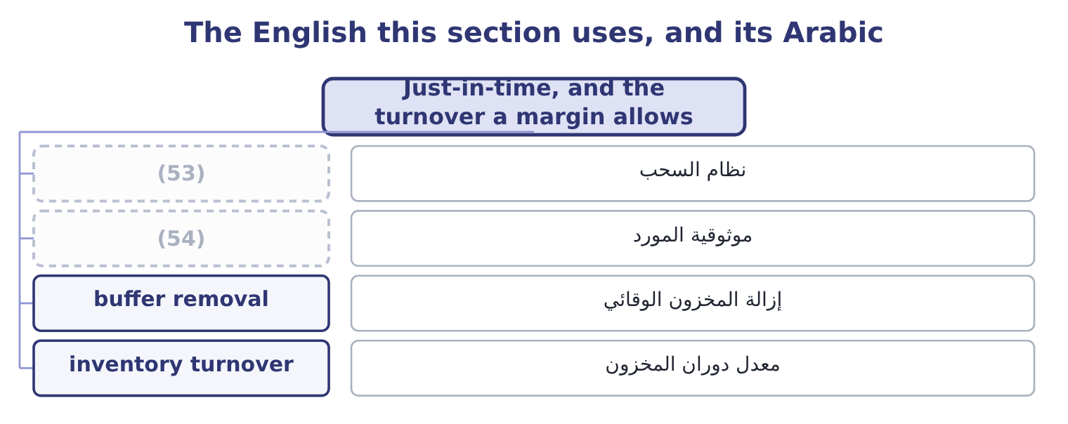
word list
order quantity · supplier reliability · pull system

The English this sheet uses, and its Arabic
English (exam term) | Arabic
pull system | نظام السحب
supplier reliability | موثوقية المورد
buffer removal | إزالة المخزون الوقائي
inventory turnover | معدل دوران المخزون

Answer key · 17.5 Just-in-time, and the turnover a margin allows

1 proposition | 28 exactly
2 protect | 29 Barada's
3 quantities | 30 Orontes's
4 contractually | 31 cutting
5 achieves | 32 discounting
6 releasing | 33 customers
7 improves | 34 About 30 times
8 defect | 35 A moderate cycle at a fair margin
9 Obsolescence | 36 Thin margin, and the stockroom is the business
10 discipline | 37 About 50%
11 unreliable | 38 60 units
12 universal | 39 Lead time 8 days
13 geographically | 40 537 units
14 batches | 41 About 34
15 engineered | 42 About 2,683
16 willingness | 43 entirely
17 technical | 44 meanings
18 supplier's | 45 chapters
19 disruption | 46 stockout
20 expects | 47 preferred
21 directions | 48 equity
22 thirty | 49 candidate
23 invested | 50 carefully
24 combinations | 51 warehouse
25 consequences | 52 survival
26 another's | 53 pull system
27 margins | 54 supplier reliability

the summaries in full
Summary 1 Just-in-time is the proposition that stock held to protect a process is a symptom, and that the process should be fixed instead. Materials arrive as they are needed, in small quantities, from suppliers close by and contractually committed; production is pulled by demand rather than pushed by a schedule; and the buffer between stages is removed so that any problem stops the line and has to be solved rather than absorbed. What it achieves is examinable. Inventory falls, often by most of it, releasing the funding and the space. Quality improves, because a defect cannot hide in a pile of stock. Obsolescence and write-downs fall. And the discipline exposes problems — an unreliable machine, a supplier who is sometimes late — that stock was concealing. What it requires is equally examinable, and it is the reason just-in-time is not universal.
Summary 2 Reliable suppliers, geographically close, and few of them. Short set-up times, so that small batches are economic, which is the same as saying that the ordering cost in section 17.4 has been engineered down. And a willingness to stop the line, which is a cultural matter more than a technical one. The risks are the mirror: a single supplier's failure, a transport disruption, a natural disaster or a pandemic stops a line that has no buffer, and the saving of years can be lost in a month. The exam expects both halves. Inventory turnover and gross margin tend to move in opposite directions across businesses. A supermarket turns its stock thirty times a year on a gross margin near 25 per cent; a jeweller turns it twice on a margin near 50. Each is viable because the product of the two is enough: turnover times margin is a crude measure of the gross profit earned on each dollar invested in stock, and businesses survive at many combinations of the pair.
Summary 3 The practical consequences are two. A company comparing its turnover with another's must compare margins at the same time, or it is comparing two different business models — which is exactly what Book 1 warned about when it set Barada's 14 per cent gross margin against Orontes's 35. And a company that wants to raise its turnover by cutting stock must ask what that does to its margin: if the stock cut causes stockouts, discounting to recover the customers, or expedited freight, the turnover will rise and the margin will fall, and the company will be no better off.
Summary 4 English stock means two entirely different things in these two books, and the two meanings sit in adjacent chapters. Inventory is called stock in British usage, so stockout, stock turn and safety stock all concern goods. Shares are called stock in American usage, so common stock, preferred stock and stock dividend all concern equity. The exam, written in American English, uses stock for shares and inventory for goods, and a candidate who learned the British sense must read carefully: a stock dividend has nothing to do with the warehouse. Note the one survival of the goods sense in American usage: a company is said to be out of stock, never out of inventory.

