18.1 How much to fund short
Chapter 18 · section 18.1

Fill every gap. Each word list holds one word more than there are gaps.
Chapter 18, section by section
Each stage leads to the next.
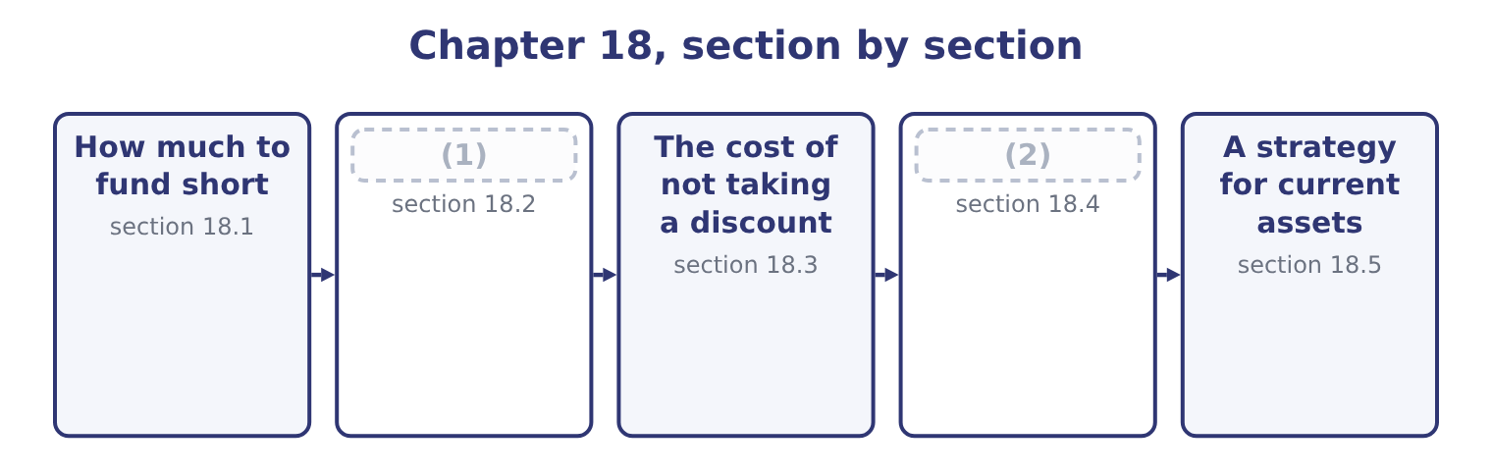
word list
warehouse receipt · What a bank facility and a factor really cost · The sources

Summary 1 gaps 3–14
Some (3) assets are permanent — the stock a company never goes below, the (4) book that never (5) — and some are seasonal, rising and (6) with the year. The financing (7) is which kind of money funds. Three (8) , and the exam names all three. The maturity matching or (9) approach funds permanent assets, (10) the permanent part of working capital, with long-term money, and seasonal assets with short-term money that is repaid as the season unwinds. It is the textbook (11) : each asset is financed over its own life, so nothing has to be (12) before it has turned into cash. The aggressive approach funds some of the permanent requirement with short-term money. It is (13) , because the yield curve usually slopes upward, and riskier in two ways: the rate can rise at every (14) , and the facility may not be renewed at all when it matters.
word list
benchmark · hedging · including · rollover · falling · policies · arrived · refinanced · receivable · question · empties · current · cheaper

Summary 2 gaps 15–26
Barada's overdraft funding a (15) larger stockroom is the aggressive approach arrived at by (16) . The conservative approach funds all of the permanent requirement and part of the seasonal with long-term money, so that in the (17) the company holds (18) cash. It costs more and removes (19) risk almost (20) . (21) , with $6,400,000 of long-term debt, no short-term (22) and $7,302,100 of cash, is at this end. The choice is a risk (23) , which is what the (24) means by the effect of risk on financing policy. A company with volatile cash flows, thin coverage or a covenant near its limit should sit (25) ; one with stable flows, wide coverage and a committed facility can afford to sit (26) . The cost of being wrong is asymmetric: an aggressive policy saves a fraction of a point most years and fails completely in the year credit tightens.
word list
Orontes · long-term · conservatively · aggressively · surplus · accident · entirely · refinancing · borrowings · trough · decision · permanently · outcome

Three financing policies
Policy | Permanent assets funded with | Seasonal assets funded with | Cost | Risk
Maturity matching | Long-term money | Short-term money | Moderate | Moderate
Aggressive | (27) | Short-term money | Lower | (28)
Conservative | Long-term money | (29) | Higher | Lower

word list
factoring · Partly short-term money · Partly long-term money · Higher

The English this section uses, and its Arabic
Each term sits against what it means.
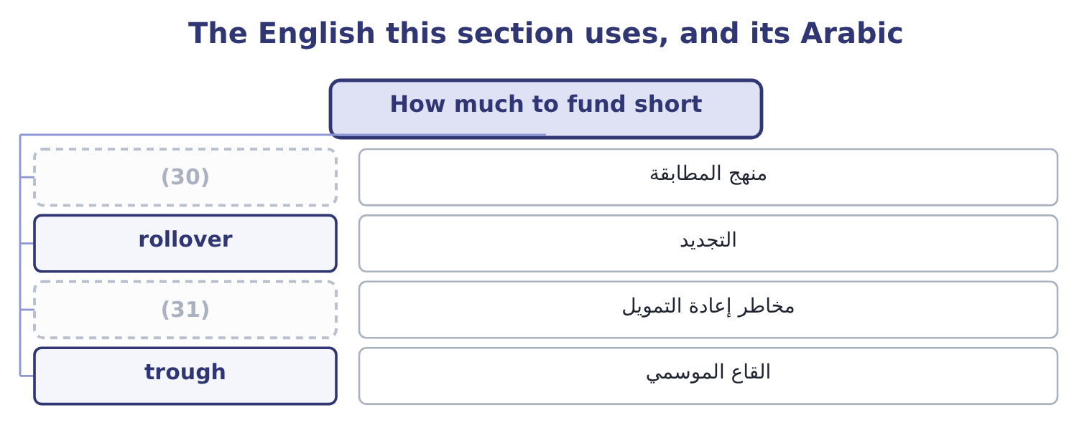
word list
refinancing risk · hedging approach · trade credit

The English this sheet uses, and its Arabic
English (exam term) | Arabic
hedging approach | منهج المطابقة
rollover | التجديد
refinancing risk | مخاطر إعادة التمويل
trough | القاع الموسمي

Answer key · 18.1 How much to fund short

1 The sources | 17 trough
2 What a bank facility and a factor really cost | 18 surplus
3 current | 19 refinancing
4 receivable | 20 entirely
5 empties | 21 Orontes
6 falling | 22 borrowings
7 question | 23 decision
8 policies | 24 outcome
9 hedging | 25 conservatively
10 including | 26 aggressively
11 benchmark | 27 Partly short-term money
12 refinanced | 28 Higher
13 cheaper | 29 Partly long-term money
14 rollover | 30 hedging approach
15 permanently | 31 refinancing risk
16 accident

the summaries in full
Summary 1 Some current assets are permanent — the stock a company never goes below, the receivable book that never empties — and some are seasonal, rising and falling with the year. The financing question is which kind of money funds. Three policies, and the exam names all three. The maturity matching or hedging approach funds permanent assets, including the permanent part of working capital, with long-term money, and seasonal assets with short-term money that is repaid as the season unwinds. It is the textbook benchmark: each asset is financed over its own life, so nothing has to be refinanced before it has turned into cash. The aggressive approach funds some of the permanent requirement with short-term money. It is cheaper, because the yield curve usually slopes upward, and riskier in two ways: the rate can rise at every rollover, and the facility may not be renewed at all when it matters.
Summary 2 Barada's overdraft funding a permanently larger stockroom is the aggressive approach arrived at by accident. The conservative approach funds all of the permanent requirement and part of the seasonal with long-term money, so that in the trough the company holds surplus cash. It costs more and removes refinancing risk almost entirely. Orontes, with $6,400,000 of long-term debt, no short-term borrowings and $7,302,100 of cash, is at this end. The choice is a risk decision, which is what the outcome means by the effect of risk on financing policy. A company with volatile cash flows, thin coverage or a covenant near its limit should sit conservatively; one with stable flows, wide coverage and a committed facility can afford to sit aggressively. The cost of being wrong is asymmetric: an aggressive policy saves a fraction of a point most years and fails completely in the year credit tightens.

18.2 The sources
Chapter 18 · section 18.2

Fill every gap. Each word list holds one word more than there are gaps.
Summary 1 gaps 1–12
Six (1) of short-term credit, and the exam expects each (2) . Trade credit is the (3) and the least (4) . A (5) offering 30 days is lending the company the value of the goods for a month, and (6) $2,050,000 of accounts payable is that loan. It arises (7) with purchases, requires no (8) , and is free — unless a discount is being forgone, which section 18.3 prices and which makes it the most expensive money in the chapter. A line of credit is an (9) under which a bank will lend up to a limit, usually for a year, usually (10) annually. An uncommitted line is a (11) of intent the bank may withdraw; a committed line is a (12) obligation, for which the bank charges a commitment fee on the undrawn part. The difference matters exactly when it matters: in a downturn.
word list
largest · arrangement · reviewed · sources · examined · negotiation · keeping · described · automatically · Orontes's · contractual · supplier · statement

Summary 2 gaps 13–24
Revolving credit is a committed facility over (13) years that can be drawn, repaid and (14) . It is the most (15) short-term money and the most expensive, (16) both a margin and a commitment fee. A short-term bank loan is a single (17) for a fixed period, repaid at the end or in (18) , often secured. Commercial paper is unsecured short-term borrowing sold (19) into the money market by companies of good credit standing, in large (20) , for up to 270 days. It is (21) than a bank loan for (22) that can use it, and it is unreliable in a crisis because the buyers simply stop buying. A $5,000,000 issue for 90 days at 5.5 per cent costs 5,000,000 × 0.055 × 90 ÷ 365 = 67,808. Secured borrowing uses the current assets (23) . Pledging receivables borrows against them while keeping them; (24) sells them outright, which section 18.4 prices. Inventory may be used through a floating charge, a warehouse receipt, or a trust receipt where the goods are identifiable.
word list
amounts · instalments · arrangement · reliable · cheaper · redrawn · directly · factoring · advance · carrying · several · issuers · themselves

Six sources of short-term credit
Source | Cost | Reliability | Best for
Trade credit | (25) | High, within terms | Everyday purchasing
Uncommitted line | Low margin, no fee | (26) | Occasional small needs
Committed line | (27) | High | Seasonal peaks
Revolving credit | Margin plus a fee, over years | (28) | A standing facility
Commercial paper | Lowest, for good credits | Low in a crisis | (29)
Secured borrowing | (30) | Moderate | Companies without unsecured capacity

word list
Margin plus a commitment fee · Free, unless a discount is forgone · annualised rate · Higher, plus administration · Highest · Large, frequent needs · Low in a downturn

The English this section uses, and its Arabic
Each term sits against what it means.
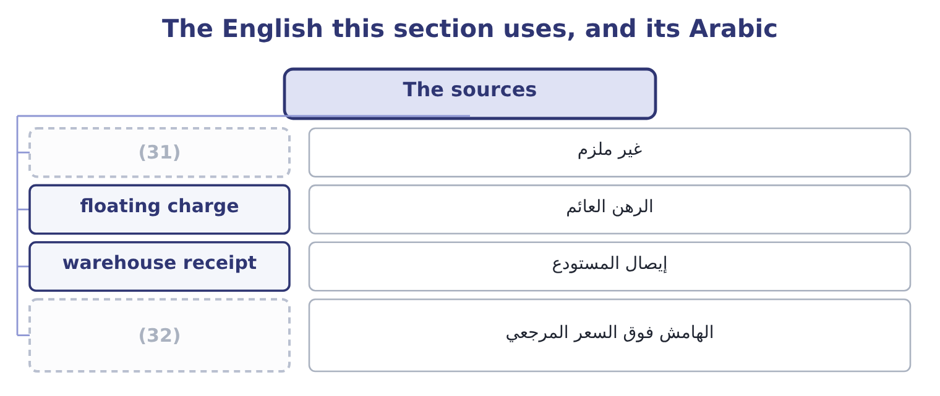
word list
margin over a reference rate · uncommitted · commitment fee

The English this sheet uses, and its Arabic
English (exam term) | Arabic
uncommitted | غير ملزم
floating charge | الرهن العائم
warehouse receipt | إيصال المستودع
margin over a reference rate | الهامش فوق السعر المرجعي

Answer key · 18.2 The sources

1 sources | 17 advance
2 described | 18 instalments
3 largest | 19 directly
4 examined | 20 amounts
5 supplier | 21 cheaper
6 Orontes's | 22 issuers
7 automatically | 23 themselves
8 negotiation | 24 factoring
9 arrangement | 25 Free, unless a discount is forgone
10 reviewed | 26 Low in a downturn
11 statement | 27 Margin plus a commitment fee
12 contractual | 28 Highest
13 several | 29 Large, frequent needs
14 redrawn | 30 Higher, plus administration
15 reliable | 31 uncommitted
16 carrying | 32 margin over a reference rate

the summaries in full
Summary 1 Six sources of short-term credit, and the exam expects each described. Trade credit is the largest and the least examined. A supplier offering 30 days is lending the company the value of the goods for a month, and Orontes's $2,050,000 of accounts payable is that loan. It arises automatically with purchases, requires no negotiation, and is free — unless a discount is being forgone, which section 18.3 prices and which makes it the most expensive money in the chapter. A line of credit is an arrangement under which a bank will lend up to a limit, usually for a year, usually reviewed annually. An uncommitted line is a statement of intent the bank may withdraw; a committed line is a contractual obligation, for which the bank charges a commitment fee on the undrawn part. The difference matters exactly when it matters: in a downturn.
Summary 2 Revolving credit is a committed facility over several years that can be drawn, repaid and redrawn. It is the most reliable short-term money and the most expensive, carrying both a margin and a commitment fee. A short-term bank loan is a single advance for a fixed period, repaid at the end or in instalments, often secured. Commercial paper is unsecured short-term borrowing sold directly into the money market by companies of good credit standing, in large amounts, for up to 270 days. It is cheaper than a bank loan for issuers that can use it, and it is unreliable in a crisis because the buyers simply stop buying. A $5,000,000 issue for 90 days at 5.5 per cent costs 5,000,000 × 0.055 × 90 ÷ 365 = 67,808. Secured borrowing uses the current assets themselves. Pledging receivables borrows against them while keeping them; factoring sells them outright, which section 18.4 prices. Inventory may be used through a floating charge, a warehouse receipt, or a trust receipt where the goods are identifiable.

18.3 The cost of not taking a discount
Chapter 18 · section 18.3

Fill every gap. Each word list holds one word more than there are gaps.
Summary 1 gaps 1–4
A supplier offering 2/10, net 30 is (1) an offer with a price. Pay on day 10 and pay 98 per cent; pay on day 30 and pay 100. The company that pays on day 30 has (2) 98 for twenty days and (3) 100, and the exam wants that (4) as an annual rate.
word list
trough · expressed · making · borrowed · repaid

Worked example: what 2/10, net 30 really costs

Summary 2 gaps 5–13
The rate for the period. The discount (5) is 2 on the 98 that would have been paid: 2 ÷ 98 = 2.04 per cent for the twenty days of extra credit. The (6) of periods. The extra credit runs from day 10 to day 30, which is twenty days, so there are 365 ÷ 20 = 18.25 such periods in a year. (7) borrows from its bank at 6 per cent. Paying on day 30 (8) of day 10 costs it 37.2 per cent a year — six times as much. A company with a facility (9) should always take the discount and draw on the facility to do it. The (10) is sensitive to both terms, and the exam (11) them. On 1/10, net 30 the cost is 1 ÷ 99 = 1.01 per cent for twenty days, which is 1.01 × 18.25 = 18.4 per cent a year — still far above any borrowing rate. On 2/10, net 60 the extra credit is fifty days, so the periods are 365 ÷ 50 = 7.3 and the cost is 2.04 × 7.3 = 14.9 per cent. The longer the net period, the (12) it is to forgo the discount, (13) the borrowing lasts longer for the same fee.
word list
because · cheaper · transaction · available · number · Orontes · forgone · arithmetic · varies · instead

What forgoing a discount costs a year
The bars are drawn to scale.
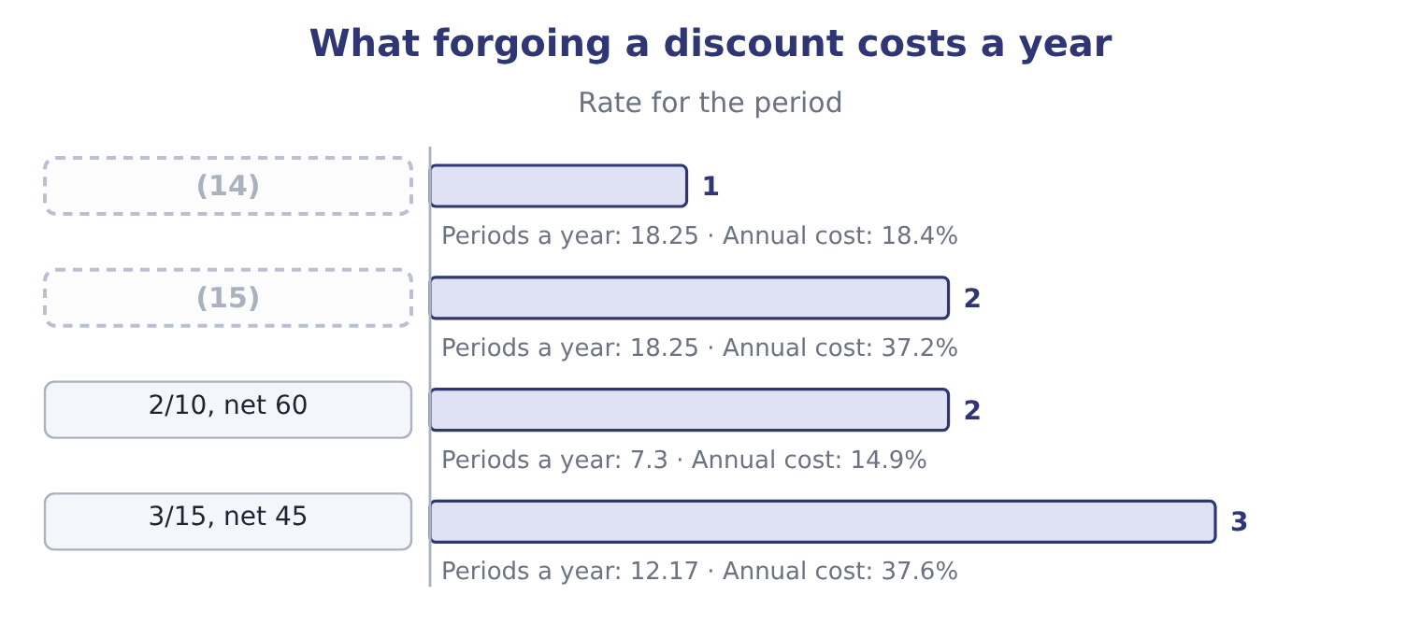
word list
line of credit · 1/10, net 30 · 2/10, net 30

Summary 3 gaps 16–23
Two (16) follow for the two sides of the (17) . For the buyer: take the discount unless there is (18) no money and no facility, in which case the company has a (19) problem that the discount decision merely reveals. And where a supplier is paid late anyway, the (20) rate falls, which is the unspoken reason (21) is common —. A seller offering 2/10 net 30 is paying about 37 per cent (22) to be paid twenty days earlier, which is only sensible if the (23) is losing the sale or funding at a comparable rate.
word list
annualised · funding · transaction · financing · alternative · genuinely · stretching · consequences · effective

The English this section uses, and its Arabic
Each term sits against what it means.
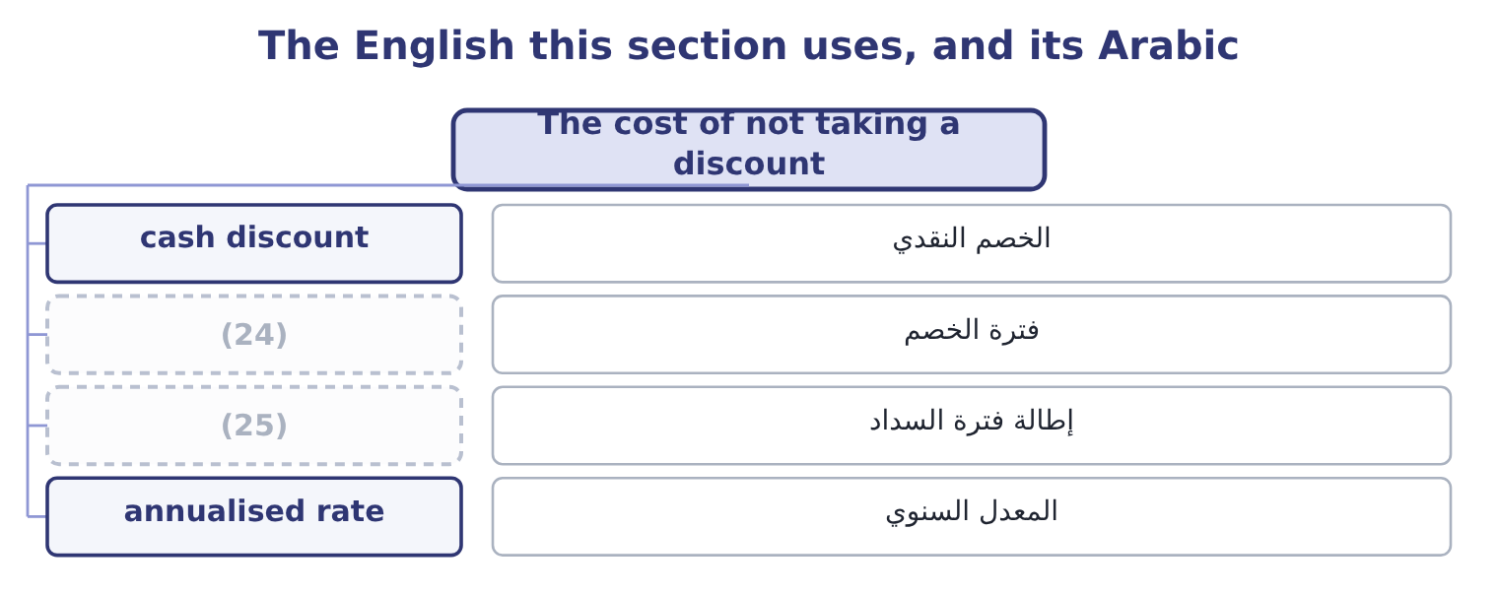
word list
discount period · annualised rate · stretching payables

The English this sheet uses, and its Arabic
English (exam term) | Arabic
cash discount | الخصم النقدي
discount period | فترة الخصم
stretching payables | إطالة فترة السداد
annualised rate | المعدل السنوي

Answer key · 18.3 The cost of not taking a discount

1 making | 14 1/10, net 30
2 borrowed | 15 2/10, net 30
3 repaid | 16 consequences
4 expressed | 17 transaction
5 forgone | 18 genuinely
6 number | 19 financing
7 Orontes | 20 effective
8 instead | 21 stretching
9 available | 22 annualised
10 arithmetic | 23 alternative
11 varies | 24 discount period
12 cheaper | 25 stretching payables
13 because

the summaries in full
Summary 1 A supplier offering 2/10, net 30 is making an offer with a price. Pay on day 10 and pay 98 per cent; pay on day 30 and pay 100. The company that pays on day 30 has borrowed 98 for twenty days and repaid 100, and the exam wants that expressed as an annual rate.
Summary 2 The rate for the period. The discount forgone is 2 on the 98 that would have been paid: 2 ÷ 98 = 2.04 per cent for the twenty days of extra credit. The number of periods. The extra credit runs from day 10 to day 30, which is twenty days, so there are 365 ÷ 20 = 18.25 such periods in a year. Orontes borrows from its bank at 6 per cent. Paying on day 30 instead of day 10 costs it 37.2 per cent a year — six times as much. A company with a facility available should always take the discount and draw on the facility to do it. The arithmetic is sensitive to both terms, and the exam varies them. On 1/10, net 30 the cost is 1 ÷ 99 = 1.01 per cent for twenty days, which is 1.01 × 18.25 = 18.4 per cent a year — still far above any borrowing rate. On 2/10, net 60 the extra credit is fifty days, so the periods are 365 ÷ 50 = 7.3 and the cost is 2.04 × 7.3 = 14.9 per cent. The longer the net period, the cheaper it is to forgo the discount, because the borrowing lasts longer for the same fee.
Summary 3 Two consequences follow for the two sides of the transaction. For the buyer: take the discount unless there is genuinely no money and no facility, in which case the company has a financing problem that the discount decision merely reveals. And where a supplier is paid late anyway, the effective rate falls, which is the unspoken reason stretching is common —. A seller offering 2/10 net 30 is paying about 37 per cent annualised to be paid twenty days earlier, which is only sensible if the alternative is losing the sale or funding at a comparable rate.

18.4 What a bank facility and a factor really cost
Chapter 18 · section 18.4

Fill every gap. Each word list holds one word more than there are gaps.
Summary 1 gaps 1–12
Three (1) complete the pricing of (2) money, and each turns a quoted rate into an effective one. A loan with a (3) balance: interest is charged on the whole loan and only part of it is usable, so the effective rate is the interest (4) by the usable funds. A line with a commitment fee. The fee is charged on the undrawn (5) , so the effective cost (6) on how much of the line is used. A (7) loan, where the interest is (8) in advance. (9) $1,000,000 at 8 per cent on this basis gives (10) of 1,000,000 − 80,000 = 920,000, and the effective rate is 80,000 ÷ 920,000 = 8.70 per cent rather than 8. A company (11) a $5,000,000 (12) line at 7 per cent, with a commitment fee of 0.5 per cent on the undrawn part, and draws an average of $3,000,000 through the year.
word list
committed · pledging · portion · arranges · depends · Borrowing · compensating · discount · short-term · divided · calculations · proceeds · deducted

Summary 2 gaps 13–16
Interest is 3,000,000 × 0.07 = 210,000 and the fee is 2,000,000 × 0.005 = 10,000, so the total is 210,000 + 10,000 = 220,000. The effective rate on the money used. A factor (13) to buy $1,000,000 of receivables with an average age of 45 days, (14) a 2 per cent fee and (15) 80 per cent of the face value at 10 per cent a year. The fee is 1,000,000 × 0.02 = 20,000; the advance is 1,000,000 × 0.80 = 800,000, and the interest on it for 45 days is 800,000 × 0.10 × 45 ÷ 365 = 9,863. The total cost is 20,000 + 9,863 = 29,863 on $800,000 of money for 45 days, which is 29,863 ÷ 800,000 = 3.73 per cent for the (16) , or about 30.3 per cent a year.
word list
period · Borrowing · offers · advancing · charging

Summary 3 gaps 17–26
Thirty per cent looks (17) beside a 7.33 per cent bank line, and (18) it is not, which is the point of the comparison. (19) without recourse (20) the default risk; it removes the cost of running a credit and (21) department, which can be a large part of the fee; and it is (22) to companies whose credit standing gives them no bank line at all. The right comparison is (23) not the rate alone but the rate less the costs and risks the factor absorbs — and Book 1 found a $15,000 loss on sale of receivables in (24) own income (25) , which is this (26) already taken for a small part of the book.
word list
Orontes's · therefore · decision · charged · sometimes · indefensible · transfers · statement · available · collection · Factoring

Turning a quoted rate into an effective one
Every item belongs to exactly one group.
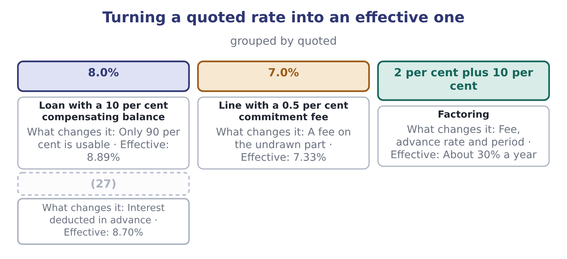
word list
discount period · Discount loan

The English this section uses, and its Arabic
Each term sits against what it means.
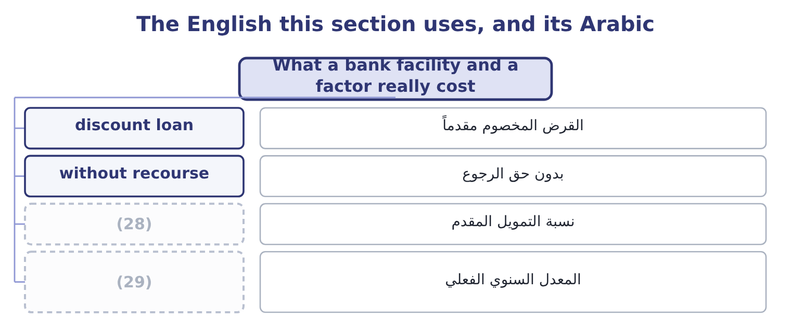
word list
discount period · effective annual rate · advance rate

The English this sheet uses, and its Arabic
English (exam term) | Arabic
discount loan | القرض المخصوم مقدماً
without recourse | بدون حق الرجوع
advance rate | نسبة التمويل المقدم
effective annual rate | المعدل السنوي الفعلي

Answer key · 18.4 What a bank facility and a factor really cost

1 calculations | 16 period
2 short-term | 17 indefensible
3 compensating | 18 sometimes
4 divided | 19 Factoring
5 portion | 20 transfers
6 depends | 21 collection
7 discount | 22 available
8 deducted | 23 therefore
9 Borrowing | 24 Orontes's
10 proceeds | 25 statement
11 arranges | 26 decision
12 committed | 27 Discount loan
13 offers | 28 advance rate
14 charging | 29 effective annual rate
15 advancing

the summaries in full
Summary 1 Three calculations complete the pricing of short-term money, and each turns a quoted rate into an effective one. A loan with a compensating balance: interest is charged on the whole loan and only part of it is usable, so the effective rate is the interest divided by the usable funds. A line with a commitment fee. The fee is charged on the undrawn portion, so the effective cost depends on how much of the line is used. A discount loan, where the interest is deducted in advance. Borrowing $1,000,000 at 8 per cent on this basis gives proceeds of 1,000,000 − 80,000 = 920,000, and the effective rate is 80,000 ÷ 920,000 = 8.70 per cent rather than 8. A company arranges a $5,000,000 committed line at 7 per cent, with a commitment fee of 0.5 per cent on the undrawn part, and draws an average of $3,000,000 through the year.
Summary 2 Interest is 3,000,000 × 0.07 = 210,000 and the fee is 2,000,000 × 0.005 = 10,000, so the total is 210,000 + 10,000 = 220,000. The effective rate on the money used. A factor offers to buy $1,000,000 of receivables with an average age of 45 days, charging a 2 per cent fee and advancing 80 per cent of the face value at 10 per cent a year. The fee is 1,000,000 × 0.02 = 20,000; the advance is 1,000,000 × 0.80 = 800,000, and the interest on it for 45 days is 800,000 × 0.10 × 45 ÷ 365 = 9,863. The total cost is 20,000 + 9,863 = 29,863 on $800,000 of money for 45 days, which is 29,863 ÷ 800,000 = 3.73 per cent for the period, or about 30.3 per cent a year.
Summary 3 Thirty per cent looks indefensible beside a 7.33 per cent bank line, and sometimes it is not, which is the point of the comparison. Factoring without recourse transfers the default risk; it removes the cost of running a credit and collection department, which can be a large part of the fee; and it is available to companies whose credit standing gives them no bank line at all. The right comparison is therefore not the rate alone but the rate less the costs and risks the factor absorbs — and Book 1 found a $15,000 loss on sale of receivables in Orontes's own income statement, which is this decision already taken for a small part of the book.

18.5 A strategy for current assets
Chapter 18 · section 18.5

Fill every gap. Each word list holds one word more than there are gaps.
Summary 1 gaps 1–12
The last (1) of Book 2 asks for a recommendation, which means the whole of the (2) section arranged into an (3) . Four steps make one. Step one: size the (4) . (5) the permanent core from the seasonal peak, using the cash (6) . The permanent core is funded long; the peak is funded short, by a facility arranged (7) it is needed. Step two: price every component. The cost of working capital is the sum of the (8) , the carrying costs of stock, the credit losses, the discounts forgone and the interest not earned on idle (9) — and the single most (10) error is to count only the first. (11) own bill reads: $272,640 to fund the trade cycle, $292,084 of interest forgone on idle cash, $63,000 of credit losses, and (12) discounts it does not take.
word list
management · Orontes's · whatever · outcome · argument · Separate · common · requirement · forecast · before · funding · working-capital · balances

Summary 2 gaps 13–23
Step three: attack the (13) in order of what they are worth. Book 1's (14) , applied here, ranks the items by money (15) than by ease. For Orontes the order is: put the idle cash to work, which is worth about $176,084 a year with no risk; take every (16) discount, because forgoing one costs 37.2 per cent against a 6 per cent facility; and consider (17) customer terms. Step four: match the (18) to the risk. A company with a (19) gross margin and a (20) to respect should not also be carrying (21) risk on its permanent assets. Orontes can afford to be slightly less (22) than it is; Barada cannot afford to be as aggressive as it has (23) become.
word list
releases · rollover · policy · falling · accidentally · supplier · components · discipline · lengthening · covenant · conservative · rather

A current-asset strategy for Orontes
Component | Position today | Recommendation | Worth a year
Cash | (24) | Hold 30 days of payments; place the rest to maturity dates | About 176,084
Marketable securities | 42,000 | Build a matched and laddered portfolio | (25)
Receivables | (26) | Lengthen terms selectively to win volume | Over 1,000,000 of contribution
Inventory | 2,450,000 at 31.8 days | (27) | Nil, and a risk if cut
Payables | 2,050,000 | Take every discount offered; pay on the due date (28) | The discounts, at 37 per cent each
Short-term debt | None | Arrange a committed line for seasonal peaks | (29)

word list
Hold; it is already tight against sales growth · Insurance, at a commitment fee · 2,000,000 at 9 per cent, deducted in advance · 4,144,000 at 34.3 days · 7,302,100, earning nothing · Included above · otherwise

Summary 3 gaps 30–38
One (30) closes the book. Every recommendation above (31) a cost or releases a (32) , and the total of all of them is (33) than the single finding Book 1 ranked first: the $840,000 a year of gross margin the company has given away over three years. Working capital is where a management accountant can act (34) , and that is (35) why it must not become where a management accountant acts (36) . The order of the four steps is right; so is their place in a (37) order that (38) with what the company sells and at what price.
word list
warning · conservative · improves · instead · larger · quickly · exactly · balance · smaller · begins

Price the short-term money

Your turn: the real cost of short-term credit (complete the blanks)
Item | Data | Answer
Cost of forgoing a discount | (39) | ________
Discount loan proceeds | 2,000,000 at 9 per cent, deducted in advance | ________
Effective rate on that loan |  | ________
Line with a commitment fee | 4,000,000 at 6.5 per cent, 0.4 per cent on the undrawn part, average draw 2,500,000 | ________
Effective rate on the money used |  | ________
Commercial paper interest | (40) | ________

word list
5,000,000 for 90 days at 5.5 per cent · Terms 2/10, net 40 · Effective rate on that loan

"Credit line"

Summary 4 gaps 41–49
English line of credit and credit line are the same thing, and both mean a facility a (41) may draw on. The word line is a (42) of a limit drawn, not of a queue, and nothing in the phrase says (43) the bank is (44) to lend — which is why the words committed and (45) have to be added and why the (46) is worth more than the margin. Note the related trap: drawdown is taking money under a facility, and drawdown in (47) management is a fall in the value of a portfolio — two (48) senses that appear in the same (49) .
word list
falling · difference · metaphor · uncommitted · unconnected · obliged · investment · examination · borrower · whether

"Credit line"
Item | Answer
Cost of forgoing 2/10, net 40 | (50) : the rate is 2 ÷ 98 = 2.04 per cent for thirty days, and there are 365 ÷ 30 = 12.17 periods, so 2.04 × 12.17 = 24
Discount loan proceeds | 1,820,000: the interest is 2,000,000 × 0.09 = 180,000, and 2,000,000 − 180,000 = 1,820,000.
Effective rate on that loan | (51)
Line with a commitment fee | 168,500: interest is 2,500,000 × 0.065 = 162,500 and the fee is 1,500,000 × 0.004 = 6,000, so 162,500 + 6,000 = 168,500.
Effective rate on the money used | 6.74 per cent: 168,500 ÷ 2,500,000 = 6.74 per cent.
Commercial paper interest | 67,808: 5,000,000 × 0.055 × 90 ÷ 365 = 67,808.
What it tells you | Every quoted rate (52) the real one, and the discount forgone is dearer than all four borrowings put together — which is the practica

word list
9.89 per cent: 180,000 ÷ 1,820,000 = 9.89 per cent. · understated · About 24.8 per cent a year · Component

The English this section uses, and its Arabic
Each term sits against what it means.
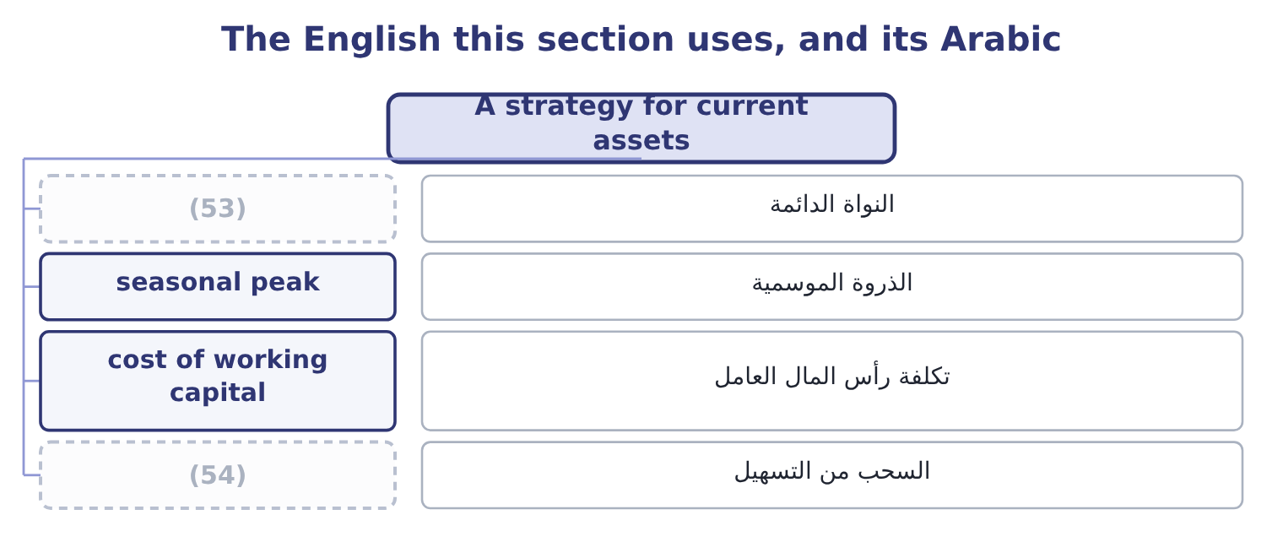
word list
الذروة الموسمية · drawdown · permanent core

The English this sheet uses, and its Arabic
English (exam term) | Arabic
permanent core | النواة الدائمة
seasonal peak | الذروة الموسمية
cost of working capital | تكلفة رأس المال العامل
drawdown | السحب من التسهيل

Answer key · 18.5 A strategy for current assets

1 outcome | 28 otherwise
2 working-capital | 29 Insurance, at a commitment fee
3 argument | 30 warning
4 requirement | 31 improves
5 Separate | 32 balance
6 forecast | 33 smaller
7 before | 34 quickly
8 funding | 35 exactly
9 balances | 36 instead
10 common | 37 larger
11 Orontes's | 38 begins
12 whatever | 39 Terms 2/10, net 40
13 components | 40 5,000,000 for 90 days at 5.5 per cent
14 discipline | 41 borrower
15 rather | 42 metaphor
16 supplier | 43 whether
17 lengthening | 44 obliged
18 policy | 45 uncommitted
19 falling | 46 difference
20 covenant | 47 investment
21 rollover | 48 unconnected
22 conservative | 49 examination
23 accidentally | 50 About 24.8 per cent a year
24 7,302,100, earning nothing | 51 9.89 per cent: 180,000 ÷ 1,820,000 = 9.89 per cent.
25 Included above | 52 understated
26 4,144,000 at 34.3 days | 53 permanent core
27 Hold; it is already tight against sales growth | 54 drawdown

the summaries in full
Summary 1 The last outcome of Book 2 asks for a recommendation, which means the whole of the working-capital section arranged into an argument. Four steps make one. Step one: size the requirement. Separate the permanent core from the seasonal peak, using the cash forecast. The permanent core is funded long; the peak is funded short, by a facility arranged before it is needed. Step two: price every component. The cost of working capital is the sum of the funding, the carrying costs of stock, the credit losses, the discounts forgone and the interest not earned on idle balances — and the single most common error is to count only the first. Orontes's own bill reads: $272,640 to fund the trade cycle, $292,084 of interest forgone on idle cash, $63,000 of credit losses, and whatever discounts it does not take.
Summary 2 Step three: attack the components in order of what they are worth. Book 1's discipline, applied here, ranks the items by money rather than by ease. For Orontes the order is: put the idle cash to work, which is worth about $176,084 a year with no risk; take every supplier discount, because forgoing one costs 37.2 per cent against a 6 per cent facility; and consider lengthening customer terms. Step four: match the policy to the risk. A company with a falling gross margin and a covenant to respect should not also be carrying rollover risk on its permanent assets. Orontes can afford to be slightly less conservative than it is; Barada cannot afford to be as aggressive as it has accidentally become.
Summary 3 One warning closes the book. Every recommendation above improves a cost or releases a balance, and the total of all of them is smaller than the single finding Book 1 ranked first: the $840,000 a year of gross margin the company has given away over three years. Working capital is where a management accountant can act quickly, and that is exactly why it must not become where a management accountant acts instead. The order of the four steps is right; so is their place in a larger order that begins with what the company sells and at what price.
Summary 4 English line of credit and credit line are the same thing, and both mean a facility a borrower may draw on. The word line is a metaphor of a limit drawn, not of a queue, and nothing in the phrase says whether the bank is obliged to lend — which is why the words committed and uncommitted have to be added and why the difference is worth more than the margin. Note the related trap: drawdown is taking money under a facility, and drawdown in investment management is a fall in the value of a portfolio — two unconnected senses that appear in the same examination.

