1.1 The second reading
Chapter 1 · section 1.1

Fill every gap. Each word list holds one word more than there are gaps.
Chapter 1, section by section
Each stage leads to the next.
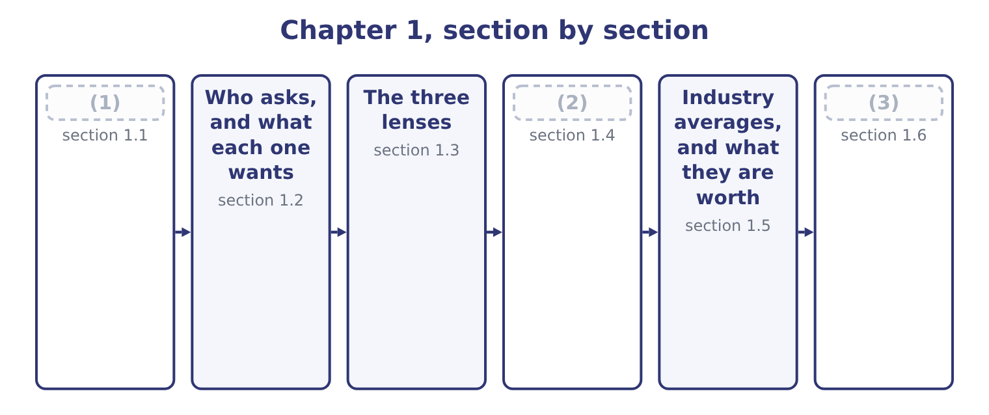
word list
The second reading · The company every ratio is calculated from · Industry averages, and what they are worth · Where the numbers come from

Summary 1 gaps 4–15
A set of financial (4) is a record of what (5) . Reading it a second time turns that record into a (6) about what is (7) to happen next. The two (8) use the same paper and ask opposite (9) . Nothing in the second reading is (10) . A ratio is not a measurement the way a (11) is a measurement. It is a comparison, and a comparison only means something (12) something else: the same company last year, a competitor, the industry, or a (13) the company set itself. A (14) ratio of 3.3 is neither good nor bad until you know what it was a year ago and what a food (15) normally carries. That is the first rule of financial statement analysis, and it is the one candidates forget under exam pressure. A number alone answers nothing.
word list
certain · likely · judgment · happened · manufacturer · target · weight · questions · readings · against · liquidity · statements · current

A ratio needs a comparison

Summary 2 gaps 16–20
A (16) that gives you one ratio and asks whether the company is (17) is testing whether you know that you cannot say. When the exam asks for an (18) , it will give you a comparison: a prior year, a competitor, or an industry figure. Watch the (19) of the comparison. A higher inventory turnover is usually better; a higher (20) is usually worse.
word list
healthy · interpretation · days-sales-outstanding · direction · question · notes

Answer key · 1.1 The second reading

1 The second reading | 11 weight
2 Where the numbers come from | 12 against
3 The company every ratio is calculated from | 13 target
4 statements | 14 current
5 happened | 15 manufacturer
6 judgment | 16 question
7 likely | 17 healthy
8 readings | 18 interpretation
9 questions | 19 direction
10 certain | 20 days-sales-outstanding

the summaries in full
Summary 1 A set of financial statements is a record of what happened. Reading it a second time turns that record into a judgment about what is likely to happen next. The two readings use the same paper and ask opposite questions. Nothing in the second reading is certain. A ratio is not a measurement the way a weight is a measurement. It is a comparison, and a comparison only means something against something else: the same company last year, a competitor, the industry, or a target the company set itself. A current ratio of 3.3 is neither good nor bad until you know what it was a year ago and what a food manufacturer normally carries. That is the first rule of financial statement analysis, and it is the one candidates forget under exam pressure. A number alone answers nothing.
Summary 2 A question that gives you one ratio and asks whether the company is healthy is testing whether you know that you cannot say. When the exam asks for an interpretation, it will give you a comparison: a prior year, a competitor, or an industry figure. Watch the direction of the comparison. A higher inventory turnover is usually better; a higher days-sales-outstanding is usually worse.

1.2 Who asks, and what each one wants
Chapter 1 · section 1.2

Fill every gap. Each word list holds one word more than there are gaps.
Summary 1 gaps 1–2
The same (1) are read by people who want different things from them. The analysis follows the question, so the first thing to settle is whose question you are (2) .
word list
statements · answering · borrowing

Who reads the statements a second time, and what each looks for
Reader | The question | Looks first at
A bank lending for 90 days | Will the cash be there when the note falls due? | Liquidity ratios and the cash cycle
A bank lending for ten years | Will the company still exist, and can it carry the interest? | (3)
A shareholder | Is the return on my money worth the risk? | (4)
An acquirer | What is this business worth to me? | (5)
A supplier granting credit | Will I be paid, and how slowly? | (6)
Management | Which part of the business is dragging? | (7)

word list
Segment margins and asset turnover · Leverage and coverage ratios · Days purchases in accounts payable · Cash flows, margins, asset turnover · management's discussion and analysis · ROE, margins, earnings per share

Summary 2 gaps 8–13
A lender and a shareholder can read the same (8) sheet and reach opposite (9) about the same fact. Heavy borrowing (10) the lender, because it ranks ahead of him only in part and raises the chance of (11) . The same borrowing can please the shareholder, because interest is (12) than equity and the (13) belongs to him. You will meet that disagreement again in, where capital structure is measured.
word list
surplus · follows · balance · worries · cheaper · default · conclusions

The word "analysis"

Summary 3 gaps 14–16
English divides the work into named (14) , and the exam uses the names: (15) analysis, vertical analysis, ratio analysis, variation analysis. Learn the names as labels for (16) , not as synonyms for thinking about the numbers.
word list
horizontal · techniques · because · procedures

The English this section uses, and its Arabic
Each term sits against what it means.
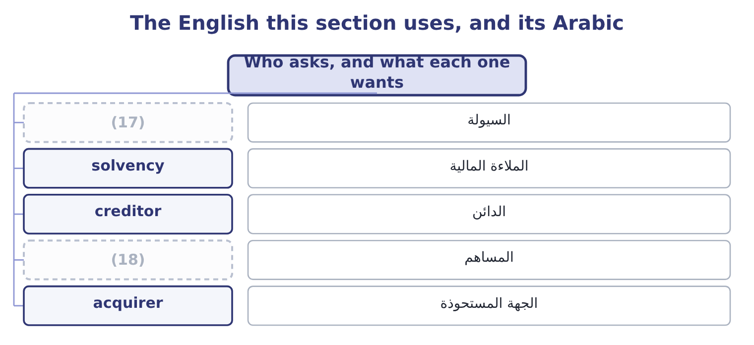
word list
shareholder · median · liquidity

The English this sheet uses, and its Arabic
English (exam term) | Arabic
liquidity | السيولة
solvency | الملاءة المالية
creditor | الدائن
shareholder | المساهم
acquirer | الجهة المستحوذة

Answer key · 1.2 Who asks, and what each one wants

1 statements | 10 worries
2 answering | 11 default
3 Leverage and coverage ratios | 12 cheaper
4 ROE, margins, earnings per share | 13 surplus
5 Cash flows, margins, asset turnover | 14 techniques
6 Days purchases in accounts payable | 15 horizontal
7 Segment margins and asset turnover | 16 procedures
8 balance | 17 liquidity
9 conclusions | 18 shareholder

the summaries in full
Summary 1 The same statements are read by people who want different things from them. The analysis follows the question, so the first thing to settle is whose question you are answering.
Summary 2 A lender and a shareholder can read the same balance sheet and reach opposite conclusions about the same fact. Heavy borrowing worries the lender, because it ranks ahead of him only in part and raises the chance of default. The same borrowing can please the shareholder, because interest is cheaper than equity and the surplus belongs to him. You will meet that disagreement again in, where capital structure is measured.
Summary 3 English divides the work into named techniques, and the exam uses the names: horizontal analysis, vertical analysis, ratio analysis, variation analysis. Learn the names as labels for procedures, not as synonyms for thinking about the numbers.

1.3 The three lenses
Chapter 1 · section 1.3

Fill every gap. Each word list holds one word more than there are gaps.
Summary 1 gaps 1–10
There are only three (1) you can do to a (2) statement to make it speak, and the first five (3) take them in turn. The first is to turn every line into a percentage of one total. On the balance sheet every line becomes a percentage of total assets; on the (4) statement every line becomes a percentage of net sales. This is a common-size statement, and because the (5) run down the (6) it is also called vertical analysis. It lets you compare a company with one ten times its size, because both (7) 100 per cent. The (8) is to compare each line with (9) in an earlier year. Every item is (10) against the same item in a base year, so you can see what has moved and by how much.
word list
column · expressed · percentages · become · itself · second · things · financial · income · chapters · creditor

Summary 2 gaps 11–15
Because the (11) runs across the page it is called horizontal analysis. The third is to (12) one line by another. That is a ratio, and the rest of the book is ratios: (13) of them in Section A alone, (14) by what they are for. (15) ratios in, leverage in, activity in, profitability in, market ratios.
word list
twenty-five · divide · comparison · analysis · Liquidity · grouped

The three lenses, and what each one is for
Lens | What it does | Also called | Answers
Common-size | (16) | Vertical analysis | What is this company made of?
Trend | Divides every line by the same line in a base year | Horizontal analysis | (17)
Ratio | Divides one line by another | Ratio analysis | (18)

word list
Divides every line by one total · How do the parts relate? · What is this company made of? · What has changed?

Summary 3 gaps 19–24
The three are not (19) . An (20) uses all of them on the same (21) , and each one raises the (22) the next one answers. Common-size analysis shows that cost of goods sold is 65 per cent of sales; trend analysis shows that it was 62 per cent two years ago; ratio analysis shows that inventory (23) fell at the same time, which (24) where the extra cost went.
word list
suggests · question · statements · turnover · alternatives · compare · analyst

Worked example: three lenses on one line

Summary 4 gaps 25–28
Orontes's inventory at (25) 31, 2025 is $2,450,000, and total assets are $31,672,600. The common-size figure is 2,450,000 ÷ 31,672,600 = 7.74 per cent. Inventory is a small part of what Orontes owns. A year earlier, inventory was $2,300,000. The trend figure is 2,450,000 ÷ 2,300,000 = 1.065, so inventory rose by 6.5 per cent. Cost of goods sold for 2025 is $27,300,000. The ratio is 27,300,000 ÷ 2,450,000 = 11.14 times, so Orontes turns its inventory about (26) times a year. Each step used the same line and a (27) partner: a total, an earlier year, and another statement. The three answers are about size, about (28) , and about speed, and none of them could be read off the balance sheet alone.
word list
movement · statement · eleven · different · December

The English this section uses, and its Arabic
Each term sits against what it means.
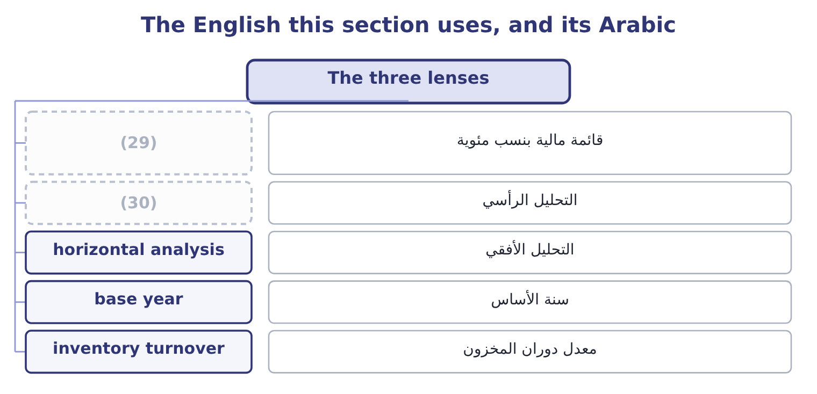
word list
vertical analysis · base year · common-size statement

The English this sheet uses, and its Arabic
English (exam term) | Arabic
common-size statement | قائمة مالية بنسب مئوية
vertical analysis | التحليل الرأسي
horizontal analysis | التحليل الأفقي
base year | سنة الأساس
inventory turnover | معدل دوران المخزون

Answer key · 1.3 The three lenses

1 things | 16 Divides every line by one total
2 financial | 17 What has changed?
3 chapters | 18 How do the parts relate?
4 income | 19 alternatives
5 percentages | 20 analyst
6 column | 21 statements
7 become | 22 question
8 second | 23 turnover
9 itself | 24 suggests
10 expressed | 25 December
11 comparison | 26 eleven
12 divide | 27 different
13 twenty-five | 28 movement
14 grouped | 29 common-size statement
15 Liquidity | 30 vertical analysis

the summaries in full
Summary 1 There are only three things you can do to a financial statement to make it speak, and the first five chapters take them in turn. The first is to turn every line into a percentage of one total. On the balance sheet every line becomes a percentage of total assets; on the income statement every line becomes a percentage of net sales. This is a common-size statement, and because the percentages run down the column it is also called vertical analysis. It lets you compare a company with one ten times its size, because both become 100 per cent. The second is to compare each line with itself in an earlier year. Every item is expressed against the same item in a base year, so you can see what has moved and by how much.
Summary 2 Because the comparison runs across the page it is called horizontal analysis. The third is to divide one line by another. That is a ratio, and the rest of the book is ratios: twenty-five of them in Section A alone, grouped by what they are for. Liquidity ratios in, leverage in, activity in, profitability in, market ratios.
Summary 3 The three are not alternatives. An analyst uses all of them on the same statements, and each one raises the question the next one answers. Common-size analysis shows that cost of goods sold is 65 per cent of sales; trend analysis shows that it was 62 per cent two years ago; ratio analysis shows that inventory turnover fell at the same time, which suggests where the extra cost went.
Summary 4 Orontes's inventory at December 31, 2025 is $2,450,000, and total assets are $31,672,600. The common-size figure is 2,450,000 ÷ 31,672,600 = 7.74 per cent. Inventory is a small part of what Orontes owns. A year earlier, inventory was $2,300,000. The trend figure is 2,450,000 ÷ 2,300,000 = 1.065, so inventory rose by 6.5 per cent. Cost of goods sold for 2025 is $27,300,000. The ratio is 27,300,000 ÷ 2,450,000 = 11.14 times, so Orontes turns its inventory about eleven times a year. Each step used the same line and a different partner: a total, an earlier year, and another statement. The three answers are about size, about movement, and about speed, and none of them could be read off the balance sheet alone.

1.4 Where the numbers come from
Chapter 1 · section 1.4

Fill every gap. Each word list holds one word more than there are gaps.
Summary 1 gaps 1–4
For a (1) company you (2) what you are given. For a company whose shares are (3) traded in the United States, a great deal is (4) , and the exam expects you to know what each document is called and what is in it.
word list
evidence · published · analyze · private · publicly

Summary 2 gaps 5–14
All of the (5) above are public and free. In the United States they are held in EDGAR, the (6) and Exchange (7) electronic filing database, and anyone can read them. That matters for the exam because a (8) about where an analyst would find segment (9) , or officer compensation, has a definite answer. Two parts of the 10-K (10) naming. (11) discussion and analysis, usually called MD&A, is where management explains the results in words: why revenue moved, what the (12) position is, what capital commitments exist. The notes to the statements carry the (13) policies, the detail behind the summarized lines, and the (14) . Part 1 taught you to prepare the notes; here they are evidence.
word list
contingencies · liquidity · information · Management's · Securities · accounting · Commission's · deserve · question · filings · benchmark

Which document?

Summary 3 gaps 15–18
Officer and director compensation is in the proxy (15) , not the 10-K. A (16) figure comes from the 10-Q, and it is unaudited. A single major event between reports is (17) on a Form 8-K. (18) measures such as adjusted EBITDA usually come from a press release, not from the audited statements.
word list
Exchange · announced · quarterly · Non-GAAP · statement

The words this section uses
Each term sits against what it means, and an instance of it.
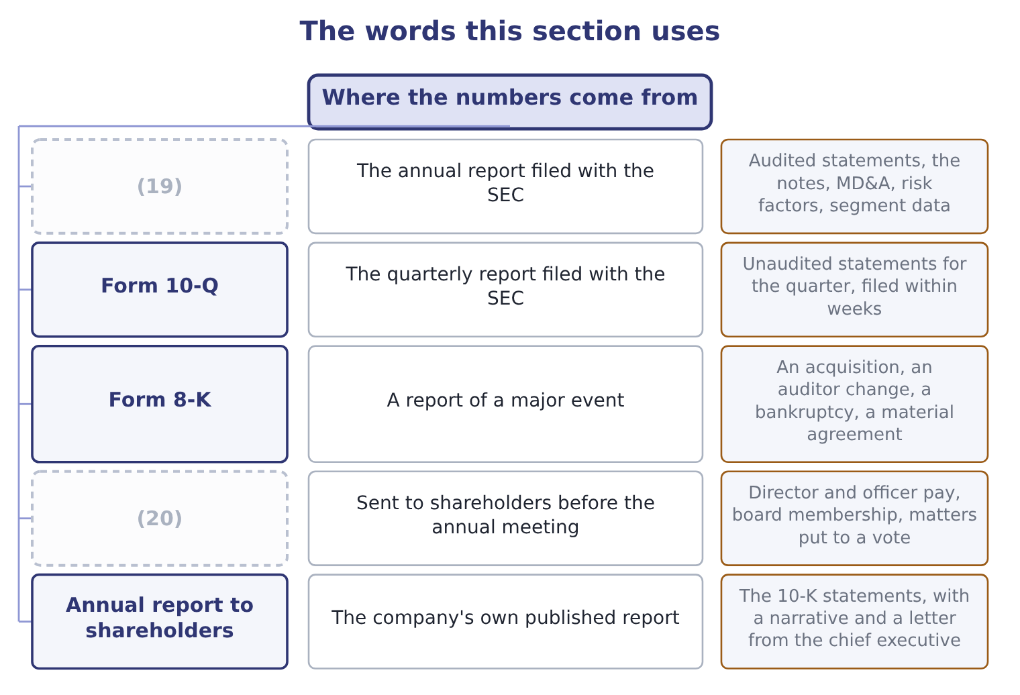
word list
industry average · Form 10-K · Proxy statement

The English this sheet uses, and its Arabic
English (exam term) | Arabic
Form 10-K | التقرير السنوي للهيئة
Form 10-Q | التقرير الربعي
Form 8-K | تقرير الأحداث الجوهرية
proxy statement | بيان التفويض
notes | الإيضاحات المتممة
segment information | معلومات القطاعات

Answer key · 1.4 Where the numbers come from

1 private | 11 Management's
2 analyze | 12 liquidity
3 publicly | 13 accounting
4 published | 14 contingencies
5 filings | 15 statement
6 Securities | 16 quarterly
7 Commission's | 17 announced
8 question | 18 Non-GAAP
9 information | 19 Form 10-K
10 deserve | 20 Proxy statement

the summaries in full
Summary 1 For a private company you analyze what you are given. For a company whose shares are publicly traded in the United States, a great deal is published, and the exam expects you to know what each document is called and what is in it.
Summary 2 All of the filings above are public and free. In the United States they are held in EDGAR, the Securities and Exchange Commission's electronic filing database, and anyone can read them. That matters for the exam because a question about where an analyst would find segment information, or officer compensation, has a definite answer. Two parts of the 10-K deserve naming. Management's discussion and analysis, usually called MD&A, is where management explains the results in words: why revenue moved, what the liquidity position is, what capital commitments exist. The notes to the statements carry the accounting policies, the detail behind the summarized lines, and the contingencies. Part 1 taught you to prepare the notes; here they are evidence.
Summary 3 Officer and director compensation is in the proxy statement, not the 10-K. A quarterly figure comes from the 10-Q, and it is unaudited. A single major event between reports is announced on a Form 8-K. Non-GAAP measures such as adjusted EBITDA usually come from a press release, not from the audited statements.

1.5 Industry averages, and what they are worth
Chapter 1 · section 1.5

Fill every gap. Each word list holds one word more than there are gaps.
Summary 1 gaps 1–3
A (1) own history is the easiest comparison, because you have it. The (2) and more useful comparison is with other companies doing the same thing. For that you need industry (3) , and those are published too.
word list
company's · Studies · harder · figures

Summary 2 gaps 4–15
An industry average is a comparison, not a (4) . Three things limit it, and the exam tests all three. The first is that the industry (5) may not fit. (6) presses olive oil, mills tahini and (7) juice. A food (8) average covers companies that do none of those things, and a company that does all three sits in no single (9) . The (10) is that the companies in the average may use different (11) . One uses LIFO and another FIFO; one (12) its plant and another owns it. Part 1 (13) you how far two sets of (14) can differ while both follow the rules. The third is that an average hides its own (15) . Half the industry is on one side of it. A company at the average is not thereby safe, and a company away from the average is not thereby wrong: it may be better, or it may be doing something the average does not describe.
word list
easiest · second · target · Orontes · classification · taught · category · accounting · manufacturing · leases · spread · statements · bottles

Average, mean, median, norm

Summary 3 gaps 16–18
English "industry average" is loose: a published figure may be a mean, a median, or an upper and lower quartile. Read the (16) own definition. (17) Studies, for example, reports (18) as well as a median, and the quartile is often the more useful comparison.
word list
something · publication's · Statement · quartiles

The words this section uses
Each term sits against what it means.
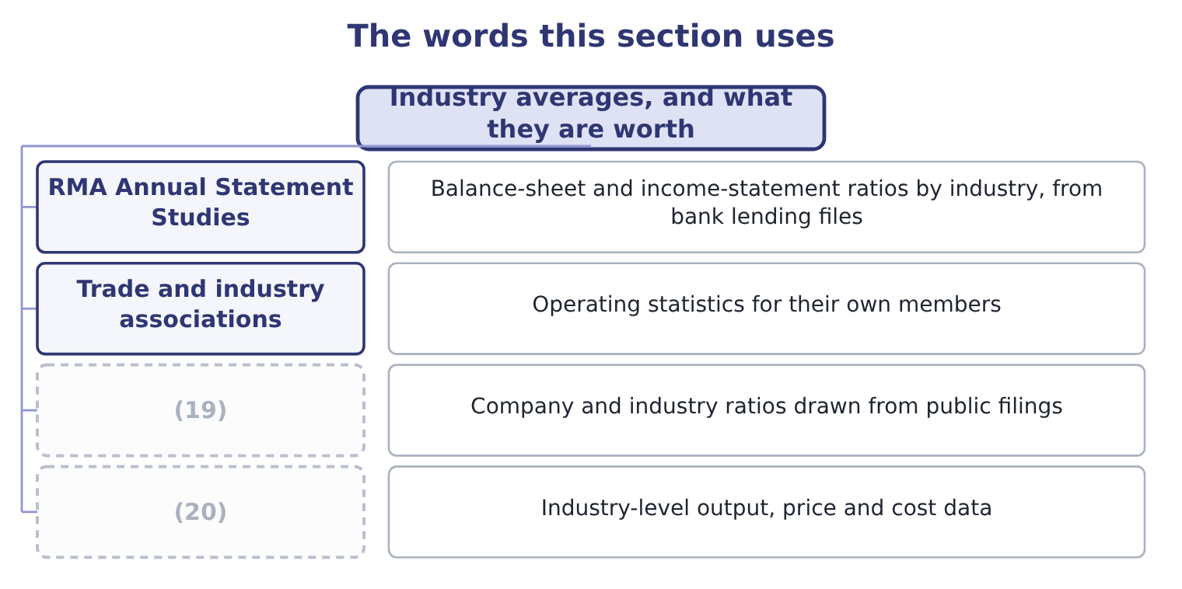
word list
Commercial data services · Government statistical agencies · financial statement analysis

The English this sheet uses, and its Arabic
English (exam term) | Arabic
industry average | متوسط القطاع
benchmark | معيار المقارنة
peer group | مجموعة النظراء
median | الوسيط
quartile | الربيع الإحصائي

Answer key · 1.5 Industry averages, and what they are worth

1 company's | 11 accounting
2 harder | 12 leases
3 figures | 13 taught
4 target | 14 statements
5 classification | 15 spread
6 Orontes | 16 publication's
7 bottles | 17 Statement
8 manufacturing | 18 quartiles
9 category | 19 Commercial data services
10 second | 20 Government statistical agencies

the summaries in full
Summary 1 A company's own history is the easiest comparison, because you have it. The harder and more useful comparison is with other companies doing the same thing. For that you need industry figures, and those are published too.
Summary 2 An industry average is a comparison, not a target. Three things limit it, and the exam tests all three. The first is that the industry classification may not fit. Orontes presses olive oil, mills tahini and bottles juice. A food manufacturing average covers companies that do none of those things, and a company that does all three sits in no single category. The second is that the companies in the average may use different accounting. One uses LIFO and another FIFO; one leases its plant and another owns it. Part 1 taught you how far two sets of statements can differ while both follow the rules. The third is that an average hides its own spread. Half the industry is on one side of it. A company at the average is not thereby safe, and a company away from the average is not thereby wrong: it may be better, or it may be doing something the average does not describe.
Summary 3 English "industry average" is loose: a published figure may be a mean, a median, or an upper and lower quartile. Read the publication's own definition. Statement Studies, for example, reports quartiles as well as a median, and the quartile is often the more useful comparison.

1.6 The company every ratio is calculated from
Chapter 1 · section 1.6

Fill every gap. Each word list holds one word more than there are gaps.
Summary 1 gaps 1–6
Orontes Foods, Inc. presses olive oil and mills tahini in Amman, makes frozen (1) in Dubai, and sells through (2) across the Levant and the Gulf. Its three (3) are Oils, Tahini & Spreads, and (4) . You (5) its statements in Part 1. The full statements are (6) in, and every ratio ahead is calculated from them, so any figure you do not recognize can be traced back to a line you wrote yourself.
word list
investment · reproduced · Beverages · divisions · pastries · distributors · prepared

Orontes Foods, Inc. — the three statements in summary (whole USD)
Item | 2025 | 2024
Total current assets | 14,188,100 | 8,380,000
TOTAL ASSETS | 31,672,600 | 26,445,000
(7) | 4,280,000 | 3,570,000
(8) | 11,279,625 | 10,070,000
(9) | 20,392,975 | 16,375,000
(10) | 42,000,000
Cost of goods sold | (27,300,000)
Operating income | 4,176,000
Net income | 2,969,100
(11) | 7,531,100

word list
Total stockholders' equity · Total current liabilities · Total liabilities · Net cash provided by operating activities · Net sales · Net income

Summary 2 gaps 12–21
Two (12) of the 2025 (13) will occupy several chapters. Cash rose from $2,100,000 to $7,302,100, which is a very large movement for a company of this size and has to be (14) before any (15) ratio is believed. And operating income carries (16) losses of $2,724,000, which is a real (17) but not one that recurs every year. The other companies of Part 1 come with it. Barada Wholesale, Inc. is the (18) whose own statements you worked on, and it supplies the (19) practice at the end of most chapters. Jordan Glass Co. is the bottle (20) Orontes holds an (21) investment. Levant Commerce Bank lends to Orontes, and Gulf Factor Co. buys its receivables.
word list
impairment · explained · supplier · equity-method · features · distributor · liquidity · charge · figures · solvency · case-style

Analyze the company you are given

Summary 3 gaps 22–24
Exam (22) give you the statements or the ratios they want used. Do not (23) what you think you know about the industry. If a question gives both a prior year and an industry figure, the answer (24) turns on one of them.
word list
benchmark · usually · import · questions

Answer key · 1.6 The company every ratio is calculated from

1 pastries | 13 figures
2 distributors | 14 explained
3 divisions | 15 liquidity
4 Beverages | 16 impairment
5 prepared | 17 charge
6 reproduced | 18 distributor
7 Total current liabilities | 19 case-style
8 Total liabilities | 20 supplier
9 Total stockholders' equity | 21 equity-method
10 Net sales | 22 questions
11 Net cash provided by operating activities | 23 import
12 features | 24 usually

the summaries in full
Summary 1 Orontes Foods, Inc. presses olive oil and mills tahini in Amman, makes frozen pastries in Dubai, and sells through distributors across the Levant and the Gulf. Its three divisions are Oils, Tahini & Spreads, and Beverages. You prepared its statements in Part 1. The full statements are reproduced in, and every ratio ahead is calculated from them, so any figure you do not recognize can be traced back to a line you wrote yourself.
Summary 2 Two features of the 2025 figures will occupy several chapters. Cash rose from $2,100,000 to $7,302,100, which is a very large movement for a company of this size and has to be explained before any liquidity ratio is believed. And operating income carries impairment losses of $2,724,000, which is a real charge but not one that recurs every year. The other companies of Part 1 come with it. Barada Wholesale, Inc. is the distributor whose own statements you worked on, and it supplies the case-style practice at the end of most chapters. Jordan Glass Co. is the bottle supplier Orontes holds an equity-method investment. Levant Commerce Bank lends to Orontes, and Gulf Factor Co. buys its receivables.
Summary 3 Exam questions give you the statements or the ratios they want used. Do not import what you think you know about the industry. If a question gives both a prior year and an industry figure, the answer usually turns on one of them.

2.1 One total as a hundred
Chapter 2 · section 2.1

Fill every gap. Each word list holds one word more than there are gaps.
Chapter 2, section by section
Each stage leads to the next.
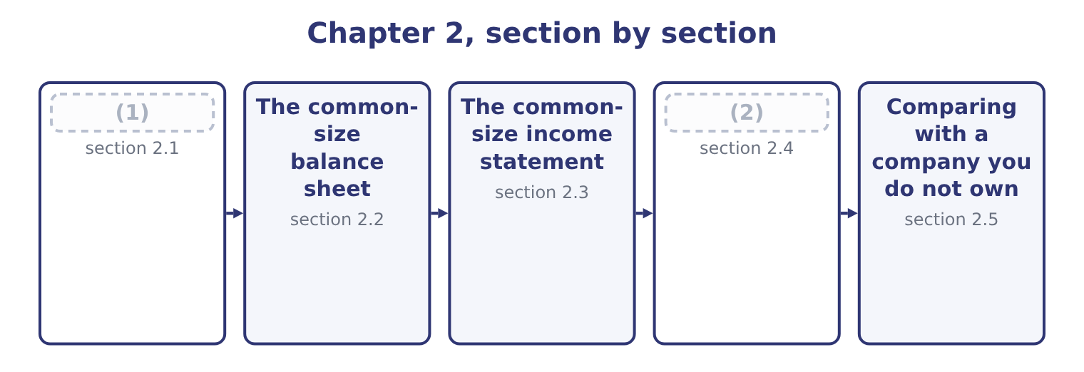
word list
One total as a hundred · The common-size income statement · Reading the two statements together

Summary 1 gaps 3–14
A common-size statement sets one line of the statement to 100 per cent and (3) every other line as a percentage of it. The (4) of base is fixed by (5) , and the exam (6) it. For the balance sheet the base is total assets. Every asset, every liability and every equity line is divided by total assets. (7) assets equal (8) plus equity, the liability and equity side also adds to 100 per cent, so the two sides (9) equal in percentage terms as they were in (10) . For the income statement the base is net sales. Every cost, every (11) and net income (12) is divided by net sales. The result is read as what (13) to each sales dollar: so many cents go to the cost of the goods, so many to selling and (14) , so many survive as profit.
word list
remain · convention · expresses · liabilities · expects · choice · depreciation · subtotal · administration · itself · Because · dollars · happens

The base is not negotiable

Summary 2 gaps 15–22
Balance sheet: total assets. Not total equity, not (15) assets, not the (16) line. Income statement: net sales. Not gross profit, not total revenue (17) other income, not net income. When a (18) gives you other income or interest income, those are (19) against net sales too, even though they are not sales. A common-size statement for one year, (20) alone, tells you the shape of the company. Two years side by side tell you whether the shape is (21) , and that is usually the more useful reading. Both appear in the (22) below.
word list
changing · expressed · question · convention · largest · figures · standing · including · current

The English this section uses, and its Arabic
Each term sits against what it means.
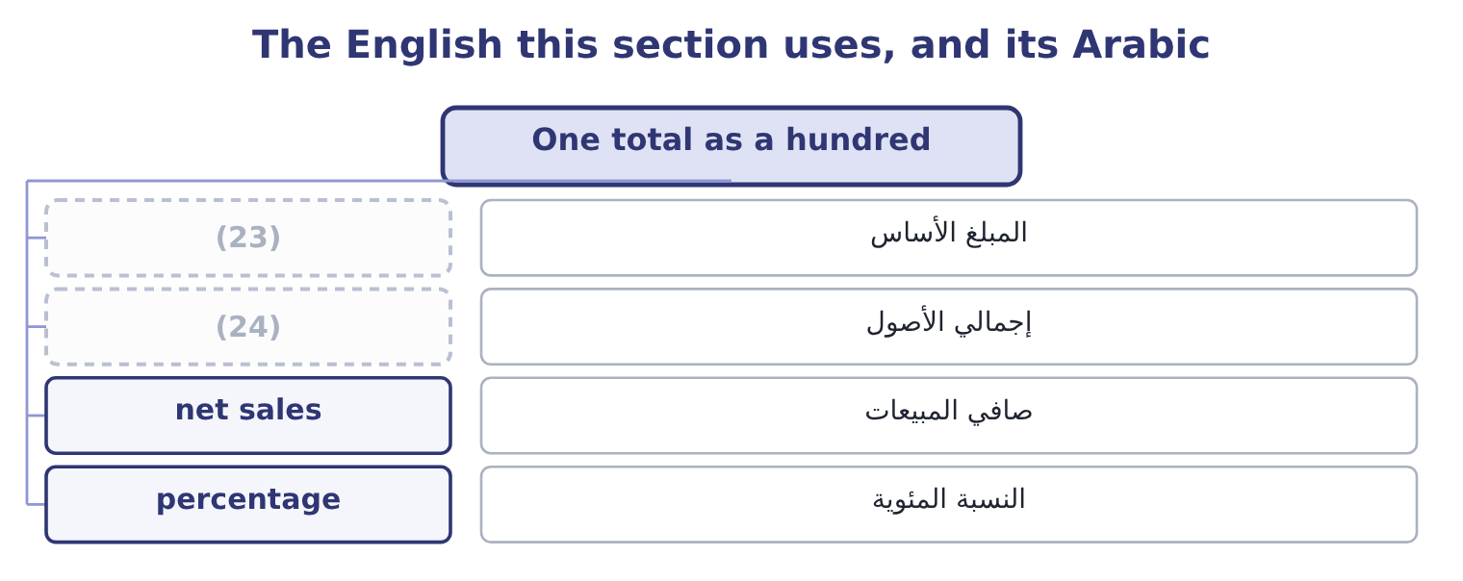
word list
المبلغ الأساس · total assets · base amount

The English this sheet uses, and its Arabic
English (exam term) | Arabic
base amount | المبلغ الأساس
total assets | إجمالي الأصول
net sales | صافي المبيعات
percentage | النسبة المئوية

Answer key · 2.1 One total as a hundred

1 One total as a hundred | 13 happens
2 Reading the two statements together | 14 administration
3 expresses | 15 current
4 choice | 16 largest
5 convention | 17 including
6 expects | 18 question
7 Because | 19 expressed
8 liabilities | 20 standing
9 remain | 21 changing
10 dollars | 22 figures
11 subtotal | 23 base amount
12 itself | 24 total assets

the summaries in full
Summary 1 A common-size statement sets one line of the statement to 100 per cent and expresses every other line as a percentage of it. The choice of base is fixed by convention, and the exam expects it. For the balance sheet the base is total assets. Every asset, every liability and every equity line is divided by total assets. Because assets equal liabilities plus equity, the liability and equity side also adds to 100 per cent, so the two sides remain equal in percentage terms as they were in dollars. For the income statement the base is net sales. Every cost, every subtotal and net income itself is divided by net sales. The result is read as what happens to each sales dollar: so many cents go to the cost of the goods, so many to selling and administration, so many survive as profit.
Summary 2 Balance sheet: total assets. Not total equity, not current assets, not the largest line. Income statement: net sales. Not gross profit, not total revenue including other income, not net income. When a question gives you other income or interest income, those are expressed against net sales too, even though they are not sales. A common-size statement for one year, standing alone, tells you the shape of the company. Two years side by side tell you whether the shape is changing, and that is usually the more useful reading. Both appear in the figures below.

2.2 The common-size balance sheet
Chapter 2 · section 2.2

Fill every gap. Each word list holds one word more than there are gaps.
Every percentage is the dollar amount divided by total assets for that year.
Orontes Foods, Inc. — common-size balance sheets at December 31 (percentage of total assets)
Orontes Foods Inc. (whole USD) | 2025 | % | 2024 | %
Cash | 7,302,100 | 23.1 | 2,100,000 | 7.9
(1) | 42,000 | 0.1 | 40,000 | 0.2
Accounts receivable, net | 4,144,000 | 13.1 | 3,760,000 | 14.2
Inventory | 2,450,000 | 7.7 | 2,300,000 | 8.7
Prepaid expenses | 204,000 | 0.6 | 180,000 | 0.7
Assets held for sale | 46,000 | 0.1 | — | —
Total current assets | 14,188,100 | 44.8 | 8,380,000 | 31.7
Debt securities | 88,500 | 0.3 | 90,000 | 0.3
(2) | 27,000 | 0.1 | 25,000 | 0.1
Equity-method investments | 1,807,000 | 5.7 | 500,000 | 1.9
(3) | 14,802,000 | 46.7 | 16,000,000 | 60.5
Brand (indefinite-lived) | 260,000 | 0.8 | 300,000 | 1.1
Goodwill | 300,000 | 0.9 | 950,000 | 3.6
Other noncurrent assets | 200,000 | 0.6 | 200,000 | 0.8
TOTAL ASSETS | 31,672,600 | 100.0 | 26,445,000 | 100.0
Accounts payable | 2,050,000 | 6.5 | 1,900,000 | 7.2
Accrued liabilities | 900,000 | 2.8 | 850,000 | 3.2
(4) | 350,000 | 1.1 | 300,000 | 1.1
(5) | 180,000 | 0.6 | 120,000 | 0.5
Dividends payable | 400,000 | 1.3 | — | —
(6) | 400,000 | 1.3 | 400,000 | 1.5
Total current liabilities | 4,280,000 | 13.5 | 3,570,000 | 13.5
Long-term debt, less current portion | 6,000,000 | 18.9 | 5,600,000 | 21.2
(7) | 999,625 | 3.2 | 900,000 | 3.4
Total liabilities | 11,279,625 | 35.6 | 10,070,000 | 38.1
(8) | 8,100,000 | 25.6 | 8,000,000 | 30.3
(9) | 5,400,000 | 17.0 | 4,000,000 | 15.1
Retained earnings | 6,894,100 | 21.8 | 4,375,000 | 16.5
(10) | 20,392,975 | 64.4 | 16,375,000 | 61.9
TOTAL LIABILITIES AND EQUITY | 31,672,600 | 100.0 | 26,445,000 | 100.0

word list
Accounts payable · Current portion of long-term debt · Property, plant and equipment, net · Additional paid-in capital · Trading securities · Contract liabilities · Equity securities · Deferred tax liability · Income taxes payable · Common stock, $1 par · Total stockholders' equity

Summary 1 gaps 11–20
Four (11) in that column are worth (12) , and each one (13) a chapter later. The asset mix moved. Current assets were 31.7 per cent of the company and are now 44.8 per cent. Property, plant and equipment fell from 60.5 per cent to 46.7 per cent. Orontes did not sell a (14) : the dollar amount of PP&E fell by only $1,198,000, while total assets grew. Most of the shift is cash. Cash (15) as a proportion. It was 7.9 per cent of total assets and is now 23.1 per cent. Nearly a (16) of this company is now cash. That is (17) a company storing up for (18) , or a company that cannot find (19) to do with its money. The capital (20) barely moved. Total liabilities fell from 38.1 per cent to 35.6 per cent and equity rose from 61.9 to 64.4.
word list
factory · either · things · readings · structure · tripled · anything · something · becomes · quarter · naming

Summary 2 gaps 21–25
Orontes is financed about (21) by its owners, and that did not (22) much in a year when the (23) sheet grew by a fifth. It was 3.6 per cent of assets and is now 0.9 per cent, because of the (24) you recorded in Part 1. A (25) who did not know that would see only the percentage and would have to go to the notes.
word list
change · structure · balance · two-thirds · impairment · reader

Worked example: three lines of the common-size column

Summary 3 gaps 26–31
Round to one decimal, as the whole column does. Note that the base (26) : each year is divided by its own total, never by the (27) total. Total current liabilities, both years. The dollar amount rose by $710,000 and the percentage did not move at all. Step 3 is the point of the (28) . In (29) , current liabilities grew. As a share of the company they stood still, because the company grew by the same proportion. The two (30) are both true and they answer (31) questions.
word list
different · readings · earlier · technique · questions · changed · dollars

Complete the common-size column

Total assets for 2025 are $31,672,600. Fill in the rest, to one decimal place.

Your turn: the 2025 common-size column (complete the blanks)
Line | Amount | Per cent of total assets
Accounts receivable, net | 4,144,000 | 13.1
Inventory | 2,450,000 | (32) : 2,450,000 ÷ 31,672,600.
Equity-method investments | 1,807,000 | 5.7 per cent: 1,807,000 ÷ 31,672,600.
Long-term debt, less current portion | 6,000,000 | (33) : 6,000,000 ÷ 31,672,600.
Retained earnings | 6,894,100 | 21.8 per cent: 6,894,100 ÷ 31,672,600.

word list
7.7 per cent · 21.8 per cent · 18.9 per cent

The English this section uses, and its Arabic
Each term sits against what it means.
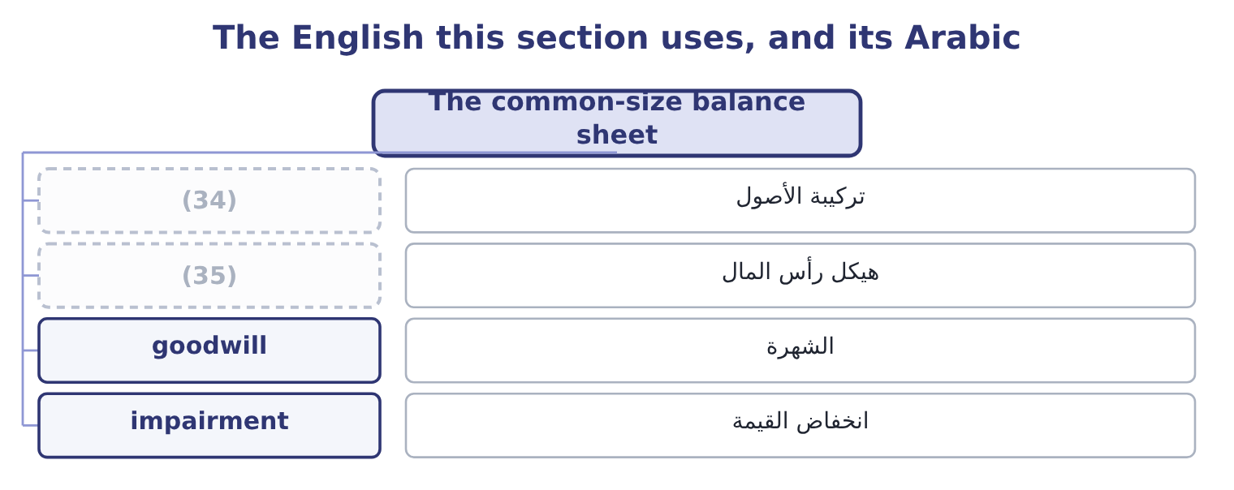
word list
base amount · capital structure · asset mix

The English this sheet uses, and its Arabic
English (exam term) | Arabic
asset mix | تركيبة الأصول
capital structure | هيكل رأس المال
goodwill | الشهرة
impairment | انخفاض القيمة

Answer key · 2.2 The common-size balance sheet

1 Trading securities | 19 anything
2 Equity securities | 20 structure
3 Property, plant and equipment, net | 21 two-thirds
4 Income taxes payable | 22 change
5 Contract liabilities | 23 balance
6 Current portion of long-term debt | 24 impairment
7 Deferred tax liability | 25 reader
8 Common stock, $1 par | 26 changed
9 Additional paid-in capital | 27 earlier
10 Total stockholders' equity | 28 technique
11 things | 29 dollars
12 naming | 30 readings
13 becomes | 31 different
14 factory | 32 7.7 per cent
15 tripled | 33 18.9 per cent
16 quarter | 34 asset mix
17 either | 35 capital structure
18 something

the summaries in full
Summary 1 Four things in that column are worth naming, and each one becomes a chapter later. The asset mix moved. Current assets were 31.7 per cent of the company and are now 44.8 per cent. Property, plant and equipment fell from 60.5 per cent to 46.7 per cent. Orontes did not sell a factory: the dollar amount of PP&E fell by only $1,198,000, while total assets grew. Most of the shift is cash. Cash tripled as a proportion. It was 7.9 per cent of total assets and is now 23.1 per cent. Nearly a quarter of this company is now cash. That is either a company storing up for something, or a company that cannot find anything to do with its money. The capital structure barely moved. Total liabilities fell from 38.1 per cent to 35.6 per cent and equity rose from 61.9 to 64.4.
Summary 2 Orontes is financed about two-thirds by its owners, and that did not change much in a year when the balance sheet grew by a fifth. It was 3.6 per cent of assets and is now 0.9 per cent, because of the impairment you recorded in Part 1. A reader who did not know that would see only the percentage and would have to go to the notes.
Summary 3 Round to one decimal, as the whole column does. Note that the base changed: each year is divided by its own total, never by the earlier total. Total current liabilities, both years. The dollar amount rose by $710,000 and the percentage did not move at all. Step 3 is the point of the technique. In dollars, current liabilities grew. As a share of the company they stood still, because the company grew by the same proportion. The two readings are both true and they answer different questions.

2.3 The common-size income statement
Chapter 2 · section 2.3

Fill every gap. Each word list holds one word more than there are gaps.
Summary 1 gaps 1–2
On the income (1) the base is net sales, and the (2) reads as the fate of each sales dollar.
word list
statement · column · dollars

Orontes Foods, Inc. — common-size income statement, year ended December 31, 2025 (percentage of net sales)
Orontes Foods Inc. (whole USD) | 2025 | %
Net sales | 42,000,000 | 100.0
Cost of goods sold | (27,300,000) | (65.0)
Gross profit | 14,700,000 | 35.0
Selling, general and administrative | (7,237,000) | (17.2)
(3) | (63,000) | (0.1)
Research and development | (500,000) | (1.2)
(4) | (2,724,000) | (6.5)
(5) | (10,524,000) | (25.1)
Operating income | 4,176,000 | 9.9
Interest expense | (390,000) | (0.9)
Equity-method income | 177,000 | 0.4
(6) | (217,200) | (0.5)
(7) | 3,958,800 | 9.4
Income tax expense | (989,700) | (2.4)
Net income | 2,969,100 | 7.1

word list
Total other income and (expense) · Net sales · Income before income taxes · Credit loss expense · Total operating expenses · Impairment losses

Summary 2 gaps 8–19
Read it as a (8) . Of every dollar Orontes sold, 65 cents went to the cost of the goods (9) and 35 cents (10) as gross profit. Of that 35 cents, 17 went to selling and (11) and 6.5 cents went to the impairment. Nine point nine cents (12) as operating income, and after interest and tax, seven cents (13) net income. The impairment line is why this statement has to be read (14) . A reader (15) Orontes with another food (16) would see operating income of 9.9 per cent and might conclude that Orontes is the weaker business. But 6.5 of the 25.1 (17) of operating expense is a write-down of (18) and a brand, which will not happen again next year. Without it, operating income would have been 6,900,000 ÷ 42,000,000 = 16.4 per cent. Which of the two (19) to use is a real question, not a trick.
word list
remained · themselves · points · possible · figures · administration · goodwill · comparing · sentence · manufacturer · became · carefully · survived

Percentages of a negative number

Summary 3 gaps 20–23
Costs are shown in parentheses on the statement and their (20) are shown in parentheses too. Do not change the sign (21) down a column. Gross profit percentage is gross profit over net sales, not cost of goods sold over net sales. Those two add to 100. If a question gives you a common-size income statement and asks for a dollar (22) , you need net sales. Without the base you (23) go back.
word list
cannot · manufacturer · halfway · percentages · amount

Worked example: going back from percentages to dollars

Summary 4 gaps 24–30
A (24) common-size income statement shows gross profit of 28.0 per cent and net sales of $55,000,000. Gross profit in dollars is 55,000,000 × 0.28 = 15,400,000. Its cost of goods sold is (25) 100.0 − 28.0 = 72.0 per cent of sales, or 55,000,000 × 0.72 = 39,600,000. (26) with Orontes, whose gross profit is 35.0 per cent. On $42,000,000 of sales that is 42,000,000 × 0.35 = 14,700,000. The competitor sells more and earns less gross profit in dollars: $15,400,000 (27) $14,700,000 on sales a third (28) . The common-size column made the (29) possible; the dollars make it (30) .
word list
against · larger · manufacturer · concrete · competitor's · Compare · comparison · therefore

The English this section uses, and its Arabic
Each term sits against what it means.
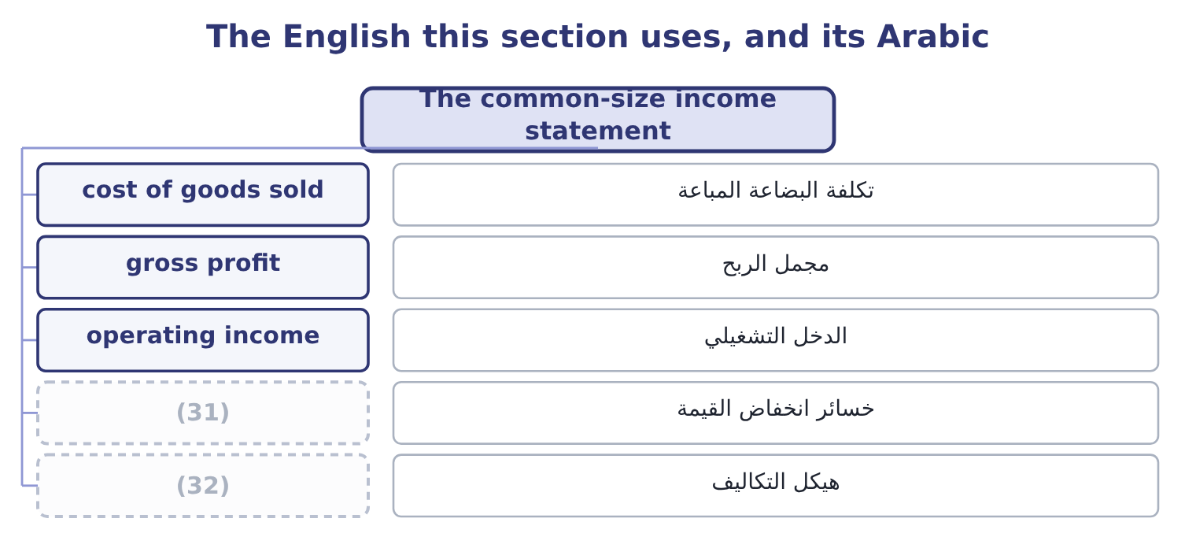
word list
fixed cost · impairment losses · cost structure

The English this sheet uses, and its Arabic
English (exam term) | Arabic
cost of goods sold | تكلفة البضاعة المباعة
gross profit | مجمل الربح
operating income | الدخل التشغيلي
impairment losses | خسائر انخفاض القيمة
cost structure | هيكل التكاليف

Answer key · 2.3 The common-size income statement

1 statement | 17 points
2 column | 18 goodwill
3 Credit loss expense | 19 figures
4 Impairment losses | 20 percentages
5 Total operating expenses | 21 halfway
6 Total other income and (expense) | 22 amount
7 Income before income taxes | 23 cannot
8 sentence | 24 competitor's
9 themselves | 25 therefore
10 remained | 26 Compare
11 administration | 27 against
12 survived | 28 larger
13 became | 29 comparison
14 carefully | 30 concrete
15 comparing | 31 impairment losses
16 manufacturer | 32 cost structure

the summaries in full
Summary 1 On the income statement the base is net sales, and the column reads as the fate of each sales dollar.
Summary 2 Read it as a sentence. Of every dollar Orontes sold, 65 cents went to the cost of the goods themselves and 35 cents remained as gross profit. Of that 35 cents, 17 went to selling and administration and 6.5 cents went to the impairment. Nine point nine cents survived as operating income, and after interest and tax, seven cents became net income. The impairment line is why this statement has to be read carefully. A reader comparing Orontes with another food manufacturer would see operating income of 9.9 per cent and might conclude that Orontes is the weaker business. But 6.5 of the 25.1 points of operating expense is a write-down of goodwill and a brand, which will not happen again next year. Without it, operating income would have been 6,900,000 ÷ 42,000,000 = 16.4 per cent. Which of the two figures to use is a real question, not a trick.
Summary 3 Costs are shown in parentheses on the statement and their percentages are shown in parentheses too. Do not change the sign halfway down a column. Gross profit percentage is gross profit over net sales, not cost of goods sold over net sales. Those two add to 100. If a question gives you a common-size income statement and asks for a dollar amount, you need net sales. Without the base you cannot go back.
Summary 4 A competitor's common-size income statement shows gross profit of 28.0 per cent and net sales of $55,000,000. Gross profit in dollars is 55,000,000 × 0.28 = 15,400,000. Its cost of goods sold is therefore 100.0 − 28.0 = 72.0 per cent of sales, or 55,000,000 × 0.72 = 39,600,000. Compare with Orontes, whose gross profit is 35.0 per cent. On $42,000,000 of sales that is 42,000,000 × 0.35 = 14,700,000. The competitor sells more and earns less gross profit in dollars: $15,400,000 against $14,700,000 on sales a third larger. The common-size column made the comparison possible; the dollars make it concrete.

2.4 Reading the two statements together
Chapter 2 · section 2.4

Fill every gap. Each word list holds one word more than there are gaps.
Summary 1 gaps 1–12
Each statement (1) a different (2) , and the two (3) answer a third. The balance sheet column says what the company is made. The income statement column says what (4) to a sale. Put them side by side and you can see (5) the shape of the assets (6) the shape of the costs. Orontes keeps 46.7 per cent of its assets in plant. A company with that much plant has (7) fixed costs, and you would expect the cost of goods sold to (8) depreciation and factory (9) that do not fall when sales fall. Part 1 (10) depreciation of $2,100,000 for the year, which is 5.0 per cent of net sales. That is the link: half a (11) of every ten in sales is a charge the company owes to assets it bought years ago, (12) this year's sales turn out to be.
word list
recorded · matches · question · whether · financial · overhead · whatever · answers · substantial · together · contain · happens · dollar

What a pair of common-size columns suggests
On the balance sheet | On the income statement | What the pair suggests
A large share in plant | A large share in cost of goods sold that does not move with sales | (13)
A large share in receivables | (14) | Selling to customers who pay slowly or not at all
A large share in inventory | (15) | Goods that are not selling, discounted to move
A large share in cash | Interest and dividend income that is small | (16)
A large share in equity | (17) | Financed by owners, so little fixed charge

word list
Interest and dividend income that is small · Fixed costs: profit swings hard with volume · A credit loss expense that is rising · A falling gross profit margin · A small interest expense · Cash earning almost nothing

Summary 2 gaps 18–20
The fifth row (18) Orontes. Equity is 64.4 per cent of the balance sheet and interest expense is 0.9 per cent of sales: $390,000 against (19) income of $4,176,000. The company is carrying very little fixed (20) cost.
word list
describes · operating · comparability · financial

"Margin" in English

Summary 3 gaps 21–23
English uses margin for (21) different things: gross profit margin, (22) margin, margin of safety, and the margin a broker lends against. In Section A, margin always means a (23) of sales unless the words say otherwise.
word list
depreciation · percentage · contribution · several

The English this section uses, and its Arabic
Each term sits against what it means.
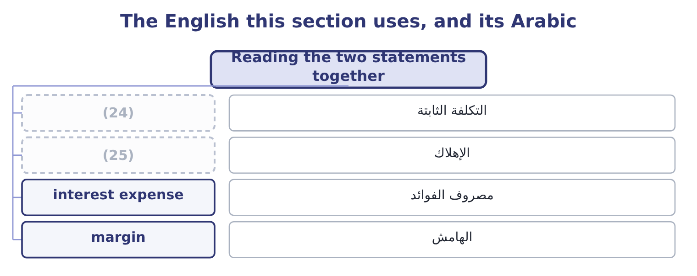
word list
total assets · depreciation · fixed cost

The English this sheet uses, and its Arabic
English (exam term) | Arabic
fixed cost | التكلفة الثابتة
depreciation | الإهلاك
interest expense | مصروف الفوائد
margin | الهامش

Answer key · 2.4 Reading the two statements together

1 answers | 14 A credit loss expense that is rising
2 question | 15 A falling gross profit margin
3 together | 16 Cash earning almost nothing
4 happens | 17 A small interest expense
5 whether | 18 describes
6 matches | 19 operating
7 substantial | 20 financial
8 contain | 21 several
9 overhead | 22 contribution
10 recorded | 23 percentage
11 dollar | 24 fixed cost
12 whatever | 25 depreciation
13 Fixed costs: profit swings hard with volume

the summaries in full
Summary 1 Each statement answers a different question, and the two together answer a third. The balance sheet column says what the company is made. The income statement column says what happens to a sale. Put them side by side and you can see whether the shape of the assets matches the shape of the costs. Orontes keeps 46.7 per cent of its assets in plant. A company with that much plant has substantial fixed costs, and you would expect the cost of goods sold to contain depreciation and factory overhead that do not fall when sales fall. Part 1 recorded depreciation of $2,100,000 for the year, which is 5.0 per cent of net sales. That is the link: half a dollar of every ten in sales is a charge the company owes to assets it bought years ago, whatever this year's sales turn out to be.
Summary 2 The fifth row describes Orontes. Equity is 64.4 per cent of the balance sheet and interest expense is 0.9 per cent of sales: $390,000 against operating income of $4,176,000. The company is carrying very little fixed financial cost.
Summary 3 English uses margin for several different things: gross profit margin, contribution margin, margin of safety, and the margin a broker lends against. In Section A, margin always means a percentage of sales unless the words say otherwise.

2.5 Comparing with a company you do not own
Chapter 2 · section 2.5

Fill every gap. Each word list holds one word more than there are gaps.
Summary 1 gaps 1–4
The (1) to make a common-size statement is to compare. Orontes against itself last year is the easy (2) . Orontes against Barada Wholesale is the (3) one, because Barada is a distributor and Orontes is a manufacturer, and the (4) of the two businesses are different in ways the percentages expose at once.
word list
instructive · shapes · Barada's · comparison · reason

Orontes and Barada, selected common-size lines, 2025
Line | Orontes (manufacturer) | Barada (distributor)
Inventory, per cent of total assets | 7.7 | 34.0
Property, plant and equipment, per cent of total assets | 46.7 | 9.0
(5) | 13.1 | 28.0
(6) | 65.0 | 84.0
(7) | 35.0 | 16.0

word list
Accounts receivable, per cent of total assets · Property, plant and equipment, per cent of total assets · Gross profit, per cent of net sales · Cost of goods sold, per cent of net sales

Summary 2 gaps 8–18
Nothing in that table says one company is (8) run than the other. It says they are different businesses. A distributor buys (9) goods and resells them, so its cost of goods sold is most of its sales and its gross margin is thin; it carries little plant and a great deal of stock and (10) . A manufacturer (11) raw material, so it earns a wider margin and ties its money up in (12) . This is the (13) the common-size statement (14) . The percentages are a (15) , and the judgment comes (16) , from knowing what the business does. (17) Barada's 16 per cent gross margin with Orontes's 35 per cent and (18) that Barada is failing would be a serious error, and it is one the exam tests.
word list
discipline · better · description · finished · afterwards · machinery · receivables · converts · Comparing · teaches · concluding · knowing

Comparable means comparable

Summary 3 gaps 19–22
Compare a company with companies in the same business, or with itself. Where the businesses (19) , say what the difference is before drawing a (20) from the percentages. A difference in (21) policy — LIFO against FIFO, leased plant against owned plant — changes the percentages without (22) the business.
word list
differ · accounting · distributor · conclusion · changing

The English this section uses, and its Arabic
Each term sits against what it means.
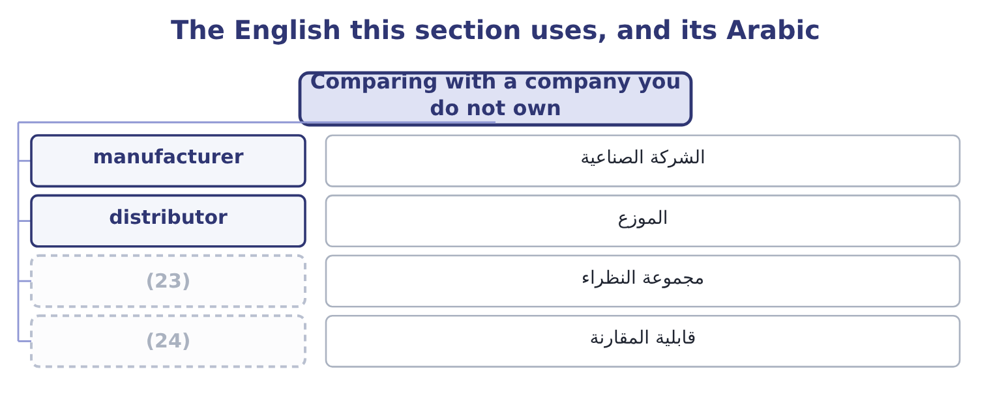
word list
peer group · cost structure · comparability

The English this sheet uses, and its Arabic
English (exam term) | Arabic
manufacturer | الشركة الصناعية
distributor | الموزع
peer group | مجموعة النظراء
comparability | قابلية المقارنة

Answer key · 2.5 Comparing with a company you do not own

1 reason | 13 discipline
2 comparison | 14 teaches
3 instructive | 15 description
4 shapes | 16 afterwards
5 Accounts receivable, per cent of total assets | 17 Comparing
6 Cost of goods sold, per cent of net sales | 18 concluding
7 Gross profit, per cent of net sales | 19 differ
8 better | 20 conclusion
9 finished | 21 accounting
10 receivables | 22 changing
11 converts | 23 peer group
12 machinery | 24 comparability

the summaries in full
Summary 1 The reason to make a common-size statement is to compare. Orontes against itself last year is the easy comparison. Orontes against Barada Wholesale is the instructive one, because Barada is a distributor and Orontes is a manufacturer, and the shapes of the two businesses are different in ways the percentages expose at once.
Summary 2 Nothing in that table says one company is better run than the other. It says they are different businesses. A distributor buys finished goods and resells them, so its cost of goods sold is most of its sales and its gross margin is thin; it carries little plant and a great deal of stock and receivables. A manufacturer converts raw material, so it earns a wider margin and ties its money up in machinery. This is the discipline the common-size statement teaches. The percentages are a description, and the judgment comes afterwards, from knowing what the business does. Comparing Barada's 16 per cent gross margin with Orontes's 35 per cent and concluding that Barada is failing would be a serious error, and it is one the exam tests.
Summary 3 Compare a company with companies in the same business, or with itself. Where the businesses differ, say what the difference is before drawing a conclusion from the percentages. A difference in accounting policy — LIFO against FIFO, leased plant against owned plant — changes the percentages without changing the business.

3.1 Three ways to state a difference
Chapter 3 · section 3.1

Fill every gap. Each word list holds one word more than there are gaps.
Chapter 3, section by section
Each stage leads to the next.
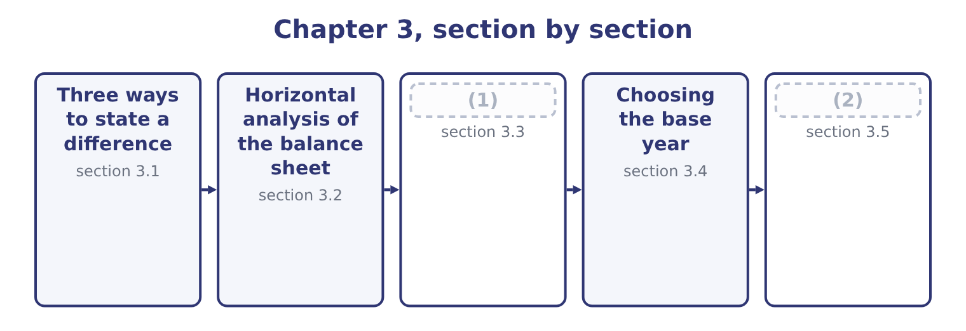
word list
Three ways to state a difference · Horizontal analysis of the income statement · What horizontal analysis cannot do

Summary 1 gaps 3–11
Take one line and two years. There are three (3) ways to say how it moved, and the exam uses all three. The absolute change is the later amount minus the earlier one, in (4) . Orontes's cash rose by 7,302,100 − 2,100,000 = 5,202,100 (5) . This is the figure that (6) when you are asking (7) the movement is large enough to care about. The percentage change is the absolute change (8) by the earlier amount. For cash that is 5,202,100 ÷ 2,100,000 = 247.7 per cent. This is the figure that lets you compare (9) in lines of very different size. The trend index sets the base year to 100 and (10) every later year (11) it. Cash at the end of 2025 is 7,302,100 ÷ 2,100,000 = 347.7 on a 2024 base of 100. The index and the percentage change say the same thing: an index of 347.7 is a rise of 247.7 per cent.
word list
expresses · dollars · honest · matters · whether · anything · currency · movements · against · divided

The denominator is the earlier year

Summary 2 gaps 12–16
Percentage change (12) by the earlier amount, not the later one and not the (13) . An index of 347.7 means a rise of 247.7 per cent. (14) 100 to get the change. A percentage change cannot be calculated when the earlier amount is zero, and it is (15) when the earlier amount is negative. Say "not (16) " rather than inventing a figure.
word list
average · meaningful · dollars · meaningless · Subtract · divides

Three statements of one movement
Measure | How it is calculated | Orontes cash | What it is good for
Absolute change | Later − earlier | 5,202,100 | (17)
Percentage change | (Later − earlier) ÷ earlier | 247.7 per cent | (18)
Trend index | (19) | 347.7 | Following one line over several years

word list
Following one line over several years · Is the movement big enough to matter? · Comparing lines of different size · Later ÷ base, × 100

Summary 3 gaps 20–26
A large percentage on a small line is the commonest way for (20) analysis to (21) . Orontes's assets held for sale went from nothing to $46,000, which is an (22) percentage rise on a line that is (23) of one per cent of the company. Trading (24) rose 5.0 per cent, on $40,000. Neither tells you (25) . The (26) is to read the absolute change and the percentage change together, and the exam sets questions that punish reading only one.
word list
securities · anything · matters · infinite · one-tenth · discipline · horizontal · mislead

The English this section uses, and its Arabic
Each term sits against what it means.
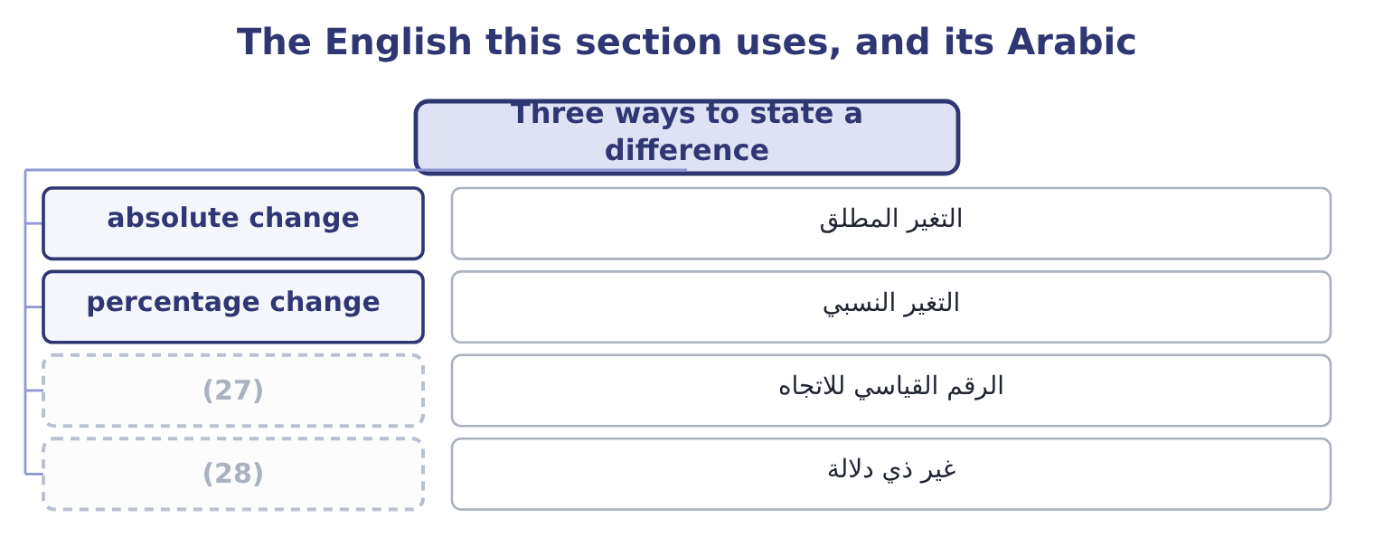
word list
absolute change · not meaningful · trend index

The English this sheet uses, and its Arabic
English (exam term) | Arabic
absolute change | التغير المطلق
percentage change | التغير النسبي
trend index | الرقم القياسي للاتجاه
not meaningful | غير ذي دلالة

Answer key · 3.1 Three ways to state a difference

1 Horizontal analysis of the income statement | 15 meaningless
2 What horizontal analysis cannot do | 16 meaningful
3 honest | 17 Is the movement big enough to matter?
4 currency | 18 Comparing lines of different size
5 dollars | 19 Later ÷ base, × 100
6 matters | 20 horizontal
7 whether | 21 mislead
8 divided | 22 infinite
9 movements | 23 one-tenth
10 expresses | 24 securities
11 against | 25 anything
12 divides | 26 discipline
13 average | 27 trend index
14 Subtract | 28 not meaningful

the summaries in full
Summary 1 Take one line and two years. There are three honest ways to say how it moved, and the exam uses all three. The absolute change is the later amount minus the earlier one, in currency. Orontes's cash rose by 7,302,100 − 2,100,000 = 5,202,100 dollars. This is the figure that matters when you are asking whether the movement is large enough to care about. The percentage change is the absolute change divided by the earlier amount. For cash that is 5,202,100 ÷ 2,100,000 = 247.7 per cent. This is the figure that lets you compare movements in lines of very different size. The trend index sets the base year to 100 and expresses every later year against it. Cash at the end of 2025 is 7,302,100 ÷ 2,100,000 = 347.7 on a 2024 base of 100. The index and the percentage change say the same thing: an index of 347.7 is a rise of 247.7 per cent.
Summary 2 Percentage change divides by the earlier amount, not the later one and not the average. An index of 347.7 means a rise of 247.7 per cent. Subtract 100 to get the change. A percentage change cannot be calculated when the earlier amount is zero, and it is meaningless when the earlier amount is negative. Say "not meaningful" rather than inventing a figure.
Summary 3 A large percentage on a small line is the commonest way for horizontal analysis to mislead. Orontes's assets held for sale went from nothing to $46,000, which is an infinite percentage rise on a line that is one-tenth of one per cent of the company. Trading securities rose 5.0 per cent, on $40,000. Neither tells you anything. The discipline is to read the absolute change and the percentage change together, and the exam sets questions that punish reading only one.

3.2 Horizontal analysis of the balance sheet
Chapter 3 · section 3.2

Fill every gap. Each word list holds one word more than there are gaps.
Read it with the common-size column: the two answer different questions about the same statement.
Orontes Foods, Inc. — horizontal analysis of the balance sheet, 2025 against 2024
Line | 2025 | 2024 | Change | Per cent
Cash | 7,302,100 | 2,100,000 | 5,202,100 | 247.7
(1) | 42,000 | 40,000 | 2,000 | 5.0
Accounts receivable, net | 4,144,000 | 3,760,000 | 384,000 | 10.2
Inventory | 2,450,000 | 2,300,000 | 150,000 | 6.5
Prepaid expenses | 204,000 | 180,000 | 24,000 | 13.3
Total current assets | 14,188,100 | 8,380,000 | 5,808,100 | 69.3
(2) | 1,807,000 | 500,000 | 1,307,000 | 261.4
(3) | 14,802,000 | 16,000,000 | (1,198,000) | (7.5)
Goodwill | 300,000 | 950,000 | (650,000) | (68.4)
TOTAL ASSETS | 31,672,600 | 26,445,000 | 5,227,600 | 19.8
(4) | 2,050,000 | 1,900,000 | 150,000 | 7.9
(5) | 900,000 | 850,000 | 50,000 | 5.9
(6) | 4,280,000 | 3,570,000 | 710,000 | 19.9
Long-term debt, less current portion | 6,000,000 | 5,600,000 | 400,000 | 7.1
Total liabilities | 11,279,625 | 10,070,000 | 1,209,625 | 12.0
Common stock, $1 par | 8,100,000 | 8,000,000 | 100,000 | 1.3
Additional paid-in capital | 5,400,000 | 4,000,000 | 1,400,000 | 35.0
Retained earnings | 6,894,100 | 4,375,000 | 2,519,100 | 57.6
Total stockholders' equity | 20,392,975 | 16,375,000 | 4,017,975 | 24.5

word list
Total current liabilities · Accounts payable · Property, plant and equipment, net · Total current assets · Equity-method investments · Trading securities · Accrued liabilities

Summary 1 gaps 7–18
The company grew by 19.8 per cent in a year, and the (7) column says where the (8) came from and where it went. It came from three places. (9) generated cash: retained earnings rose by $2,519,100, which is net (10) of $2,969,100 less the (11) declared. (12) put money: common stock and additional paid-in capital together rose by $1,500,000. And the bank lent a (13) more: long-term debt rose by $400,000. It went into two places. Cash, by far: $5,202,100 of the $5,227,600 (14) in total assets is cash. And an (15) : the equity-method holding rose by $1,307,000, which was the (16) of the stake in Jordan Glass Co. Plant fell by $1,198,000, which is the year's (17) of $2,100,000 less the $3,000,000 of new equipment, less the (18) amount of what was sold.
word list
purchase · Operations · horizontal · investment · little · income · carrying · depreciation · Owners · growth · increase · additional · dividends

Summary 2 gaps 19–24
Goodwill fell by $650,000 because of the (19) . (20) in the percentage column is as (21) as the two (22) entries read together. Total assets rose 19.8 per cent; total liabilities rose 12.0 per cent; equity rose 24.5 per cent. The company grew and (23) less reliant on (24) at the same time, which is what the common-size column showed from the other side when liabilities fell from 38.1 to 35.6 per cent of assets.
word list
impairment · largest · Nothing · borrowing · depreciation · became · instructive

Worked example: one line, three statements

Summary 3 gaps 25–31
Accounts receivable, net: 4,144,000 − 3,760,000 = 384,000. The company is owed $384,000 more than a year ago. Receivables grew by about a tenth. Total assets grew 19.8 per cent, so receivables grew more (25) than the company. That is why the common-size column showed receivables (26) from 14.2 per cent of assets to 13.1 per cent. Three (27) , one fact: receivables rose in (28) , rose by a tenth, and fell as a share of the company. All three are true, and a (29) who has only one of them can be (30) by any of the (31) .
word list
reader · numbers · slowly · rounding · dollars · others · misled · falling

Complete the horizontal columns

Fill in the absolute change and the percentage change, rounding the percentage to one decimal.
Your turn: the horizontal columns (complete the blanks)
Every item belongs to exactly one group.
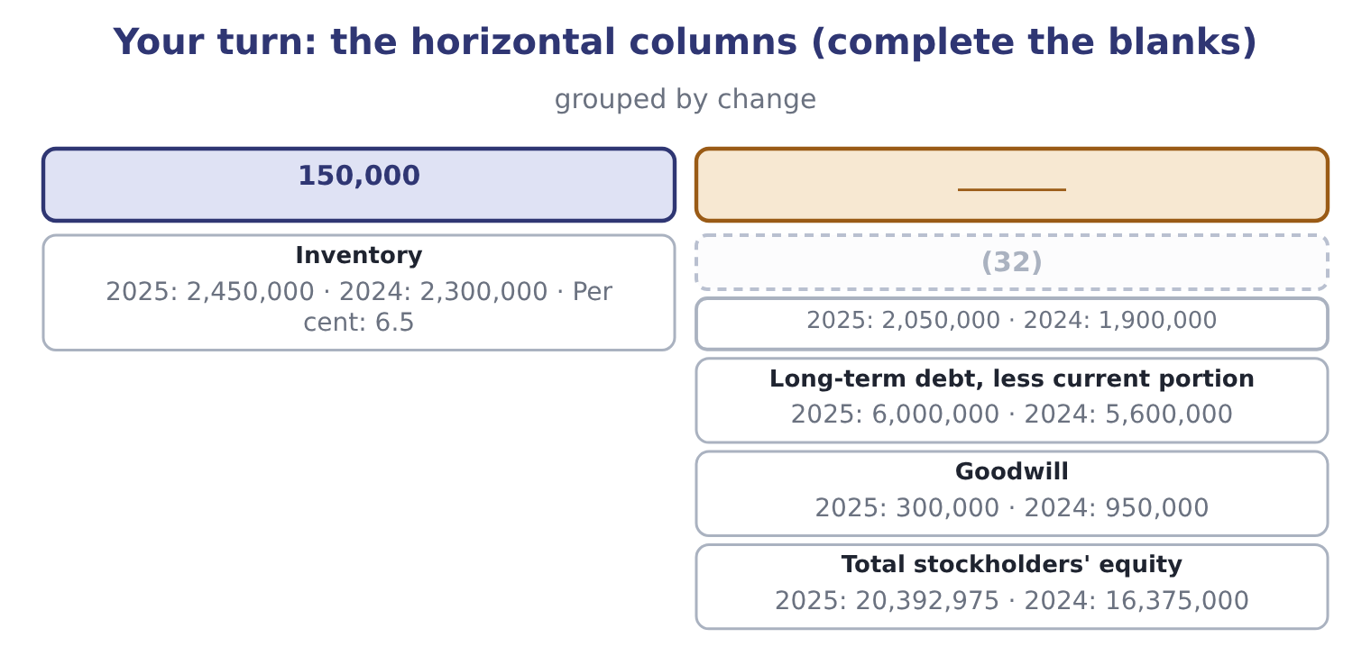
word list
Accounts payable · accounting change

The English this section uses, and its Arabic
Each term sits against what it means.
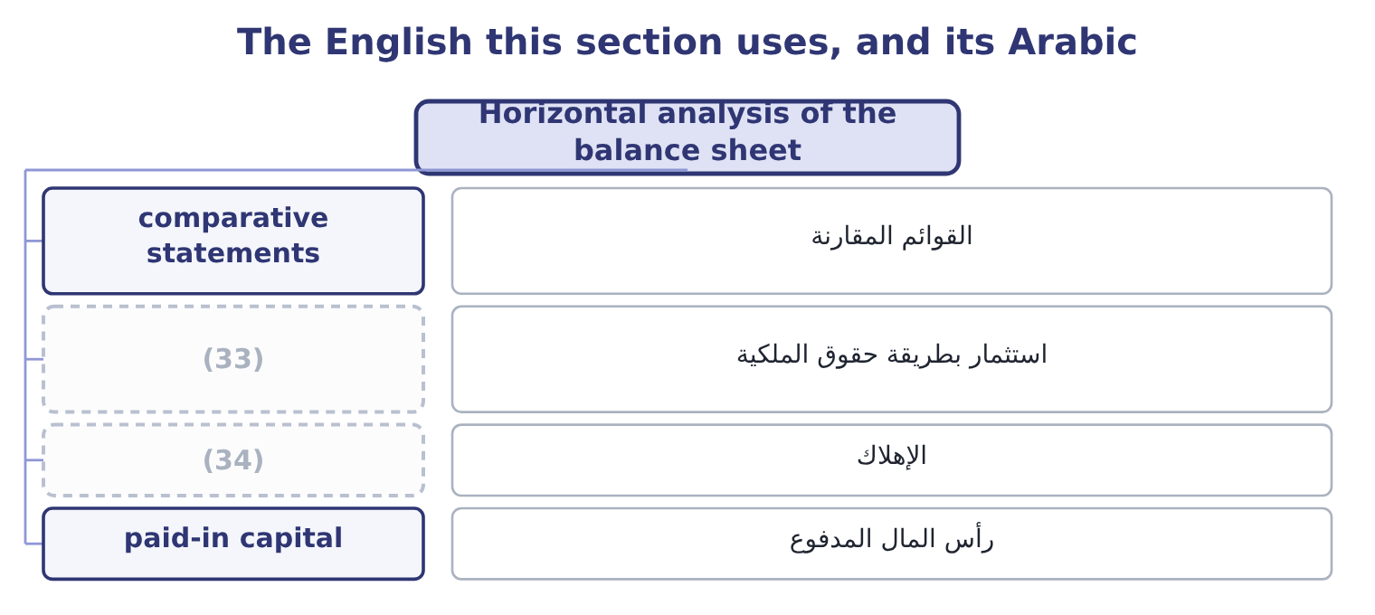
word list
non-recurring item · equity-method investment · depreciation

The English this sheet uses, and its Arabic
English (exam term) | Arabic
comparative statements | القوائم المقارنة
equity-method investment | استثمار بطريقة حقوق الملكية
depreciation | الإهلاك
paid-in capital | رأس المال المدفوع

Answer key · 3.2 Horizontal analysis of the balance sheet

1 Trading securities | 18 carrying
2 Equity-method investments | 19 impairment
3 Property, plant and equipment, net | 20 Nothing
4 Accounts payable | 21 instructive
5 Accrued liabilities | 22 largest
6 Total current liabilities | 23 became
7 horizontal | 24 borrowing
8 growth | 25 slowly
9 Operations | 26 falling
10 income | 27 numbers
11 dividends | 28 dollars
12 Owners | 29 reader
13 little | 30 misled
14 increase | 31 others
15 investment | 32 Accounts payable
16 purchase | 33 equity-method investment
17 depreciation | 34 depreciation

the summaries in full
Summary 1 The company grew by 19.8 per cent in a year, and the horizontal column says where the growth came from and where it went. It came from three places. Operations generated cash: retained earnings rose by $2,519,100, which is net income of $2,969,100 less the dividends declared. Owners put money: common stock and additional paid-in capital together rose by $1,500,000. And the bank lent a little more: long-term debt rose by $400,000. It went into two places. Cash, by far: $5,202,100 of the $5,227,600 increase in total assets is cash. And an investment: the equity-method holding rose by $1,307,000, which was the purchase of the stake in Jordan Glass Co. Plant fell by $1,198,000, which is the year's depreciation of $2,100,000 less the $3,000,000 of new equipment, less the carrying amount of what was sold.
Summary 2 Goodwill fell by $650,000 because of the impairment. Nothing in the percentage column is as instructive as the two largest entries read together. Total assets rose 19.8 per cent; total liabilities rose 12.0 per cent; equity rose 24.5 per cent. The company grew and became less reliant on borrowing at the same time, which is what the common-size column showed from the other side when liabilities fell from 38.1 to 35.6 per cent of assets.
Summary 3 Accounts receivable, net: 4,144,000 − 3,760,000 = 384,000. The company is owed $384,000 more than a year ago. Receivables grew by about a tenth. Total assets grew 19.8 per cent, so receivables grew more slowly than the company. That is why the common-size column showed receivables falling from 14.2 per cent of assets to 13.1 per cent. Three numbers, one fact: receivables rose in dollars, rose by a tenth, and fell as a share of the company. All three are true, and a reader who has only one of them can be misled by any of the others.

3.3 Horizontal analysis of the income statement
Chapter 3 · section 3.3

Fill every gap. Each word list holds one word more than there are gaps.
Summary 1 gaps 1–2
A balance sheet comes with one (1) . An income statement is (2) shown for three years, and three years is the minimum from which an analyst will read a direction.
word list
comparative · comparability · usually

Orontes Foods, Inc. — income statement, three years (whole USD)
Line | 2025 | 2024 | 2023
Net sales | 42,000,000 | 36,400,000 | 32,000,000
(3) | (27,300,000) | (23,296,000) | (20,160,000)
Gross profit | 14,700,000 | 13,104,000 | 11,840,000
(4) | (10,524,000) | (9,100,000) | (8,320,000)
(5) | 4,176,000 | 4,004,000 | 3,520,000
Net income | 2,969,100 | 2,598,000 | 2,320,000

word list
Operating income · Net income · Total operating expenses · Cost of goods sold

Orontes Foods, Inc. — income statement trends
Line | 2024 change | 2025 change | Index 2023 = 100, at 2025
Net sales | 13.8 | 15.4 | 131.2
Cost of goods sold | 15.6 | 17.2 | 135.4
(6) | 10.7 | 12.2 | 124.2
Total operating expenses | 9.4 | 15.6 | 126.5
(7) | 13.8 | 4.3 | 118.6
(8) | 12.0 | 14.3 | 128.0

word list
Operating income · Gross profit · Net income · absolute change

Summary 2 gaps 9–13
Now the statement (9) . Sales grew 13.8 per cent and then 15.4 per cent: a company (10) . But cost of goods sold grew faster in both years, 15.6 and then 17.2 per cent, so gross profit grew more slowly than sales. That is the whole story of the common-size margin falling from 37.0 per cent in 2023 to 36.0 and then 35.0 per cent. Operating income grew 13.8 per cent in 2024 and only 4.3 per cent in 2025, far (11) than sales. The (12) is in the operating expenses, which rose 15.6 per cent in 2025 — and most of that rise is the impairment. Take the impairment out and the picture changes (13) , which is why.
word list
reason · picture · slower · accelerating · completely · speaks

Read the lines against each other

Summary 3 gaps 14–17
A cost growing faster than sales means a falling margin, every time. You do not need the common-size statement to see it. A (14) growing more slowly than the line above it means (15) between them grew faster. When one year (16) a trend, find the line that broke it before (17) the trend.
word list
something · breaks · explaining · subtotal · analyst

"Trend" and "tendency"

Summary 4 gaps 18–21
English trend means the direction of a (18) over time, and it carries no (19) : a trend can be bad. What English does not allow is using trend of a single (20) between two (21) . Two numbers give a change; three or more give a trend.
word list
series · movement · points · something · judgment

The English this section uses, and its Arabic
Each term sits against what it means.
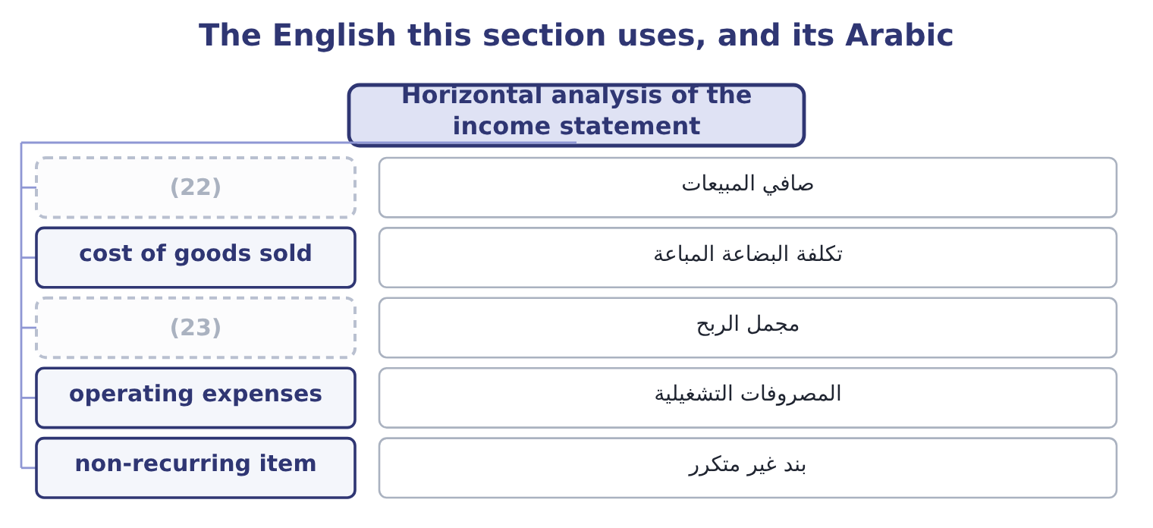
word list
net sales · non-recurring item · gross profit

The English this sheet uses, and its Arabic
English (exam term) | Arabic
net sales | صافي المبيعات
cost of goods sold | تكلفة البضاعة المباعة
gross profit | مجمل الربح
operating expenses | المصروفات التشغيلية
non-recurring item | بند غير متكرر

Answer key · 3.3 Horizontal analysis of the income statement

1 comparative | 13 completely
2 usually | 14 subtotal
3 Cost of goods sold | 15 something
4 Total operating expenses | 16 breaks
5 Operating income | 17 explaining
6 Gross profit | 18 series
7 Operating income | 19 judgment
8 Net income | 20 movement
9 speaks | 21 points
10 accelerating | 22 net sales
11 slower | 23 gross profit
12 reason

the summaries in full
Summary 1 A balance sheet comes with one comparative. An income statement is usually shown for three years, and three years is the minimum from which an analyst will read a direction.
Summary 2 Now the statement speaks. Sales grew 13.8 per cent and then 15.4 per cent: a company accelerating. But cost of goods sold grew faster in both years, 15.6 and then 17.2 per cent, so gross profit grew more slowly than sales. That is the whole story of the common-size margin falling from 37.0 per cent in 2023 to 36.0 and then 35.0 per cent. Operating income grew 13.8 per cent in 2024 and only 4.3 per cent in 2025, far slower than sales. The reason is in the operating expenses, which rose 15.6 per cent in 2025 — and most of that rise is the impairment. Take the impairment out and the picture changes completely, which is why.
Summary 3 A cost growing faster than sales means a falling margin, every time. You do not need the common-size statement to see it. A subtotal growing more slowly than the line above it means something between them grew faster. When one year breaks a trend, find the line that broke it before explaining the trend.
Summary 4 English trend means the direction of a series over time, and it carries no judgment: a trend can be bad. What English does not allow is using trend of a single movement between two points. Two numbers give a change; three or more give a trend.

3.4 Choosing the base year
Chapter 3 · section 3.4

Fill every gap. Each word list holds one word more than there are gaps.
Summary 1 gaps 1–12
The index depends (1) on which year is set to 100, and the choice is not (2) . A base year should be (3) . If the base year was a year of strike, flood, (4) or impairment, every later index is measured against a (5) figure and every later year looks better or worse than it is. Had Orontes used 2025 as its base, the impairment would sit in the (6) and the next three years of operating income would all show handsome growth for no reason (7) to trading. A base year should be far enough back to show a cycle and close enough to be (8) . Three to five years is the usual range. Ten years back the business may be a (9) business; one year back there is no trend to. A base year must be restated when the company (10) . If a prior year is restated for a change in (11) principle or for an error, the index must use the restated figure, or the series mixes two (12) bases.
word list
question · connected · entirely · measurement · denominator · different · restates · acquisition · comparable · distorted · neutral · accounting · normal

Orontes operating income on two different bases
Name each line from how it moves.
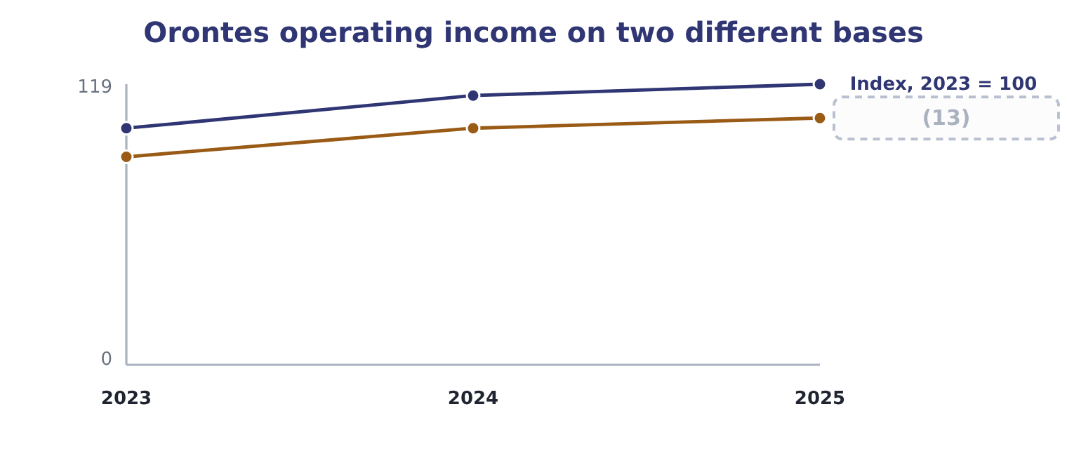
word list
cost of goods sold · Index, 2024 = 100

Summary 2 gaps 14–17
Both (14) are correct and (15) is a trick. The first says operating income is up 18.6 per cent over two years; the (16) says it is up 4.3 per cent over one. An (17) states the base with the index, every time, because an index without its base is not a number.
word list
correct · analyst · second · columns · neither

State the base

Summary 3 gaps 18–21
An index means (18) without its base year, and an exam answer that gives one without the other is (19) . If a (20) changes the base, every index in the series changes. A base year with an unusual event in it (21) the whole series; say so rather than reading the trend.
word list
distorts · nothing · operating · incomplete · question

The English this section uses, and its Arabic
Each term sits against what it means.
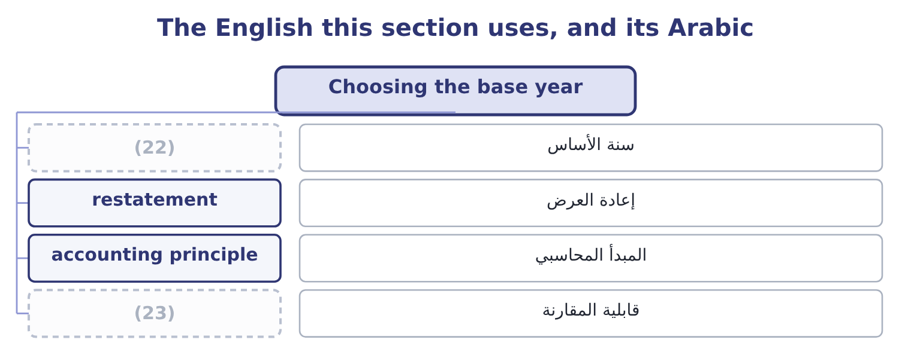
word list
net sales · base year · comparability

The English this sheet uses, and its Arabic
English (exam term) | Arabic
base year | سنة الأساس
restatement | إعادة العرض
accounting principle | المبدأ المحاسبي
comparability | قابلية المقارنة

Answer key · 3.4 Choosing the base year

1 entirely | 13 Index, 2024 = 100
2 neutral | 14 columns
3 normal | 15 neither
4 acquisition | 16 second
5 distorted | 17 analyst
6 denominator | 18 nothing
7 connected | 19 incomplete
8 comparable | 20 question
9 different | 21 distorts
10 restates | 22 base year
11 accounting | 23 comparability
12 measurement

the summaries in full
Summary 1 The index depends entirely on which year is set to 100, and the choice is not neutral. A base year should be normal. If the base year was a year of strike, flood, acquisition or impairment, every later index is measured against a distorted figure and every later year looks better or worse than it is. Had Orontes used 2025 as its base, the impairment would sit in the denominator and the next three years of operating income would all show handsome growth for no reason connected to trading. A base year should be far enough back to show a cycle and close enough to be comparable. Three to five years is the usual range. Ten years back the business may be a different business; one year back there is no trend to. A base year must be restated when the company restates. If a prior year is restated for a change in accounting principle or for an error, the index must use the restated figure, or the series mixes two measurement bases.
Summary 2 Both columns are correct and neither is a trick. The first says operating income is up 18.6 per cent over two years; the second says it is up 4.3 per cent over one. An analyst states the base with the index, every time, because an index without its base is not a number.
Summary 3 An index means nothing without its base year, and an exam answer that gives one without the other is incomplete. If a question changes the base, every index in the series changes. A base year with an unusual event in it distorts the whole series; say so rather than reading the trend.

3.5 What horizontal analysis cannot do
Chapter 3 · section 3.5

Fill every gap. Each word list holds one word more than there are gaps.
Summary 1 gaps 1–12
Horizontal (1) compares a company with itself, and that is both its (2) and its limit. It cannot tell you whether the level is right. (3) sales grew 15.4 per cent. Whether that is good (4) on whether the market grew 5 per cent or 30 per cent, and the (5) do not say. It cannot (6) price from volume. A 15.4 per cent rise in sales may be 15.4 per cent more jars, or the same jars at a 15.4 per cent (7) price, or any (8) . It cannot (9) a change of accounting. If the company moved from FIFO to LIFO during the series, the cost of goods sold line is (10) two ways and the percentage change across the break is not a change in the (11) . And it cannot cope with a negative or zero base. A company whose operating income moved from a loss of $500,000 to a profit of $500,000 has no meaningful percentage change: the (12) gives −200 per cent, which says nothing. Write "not meaningful" and give the absolute change.
word list
statements · higher · percentage · strength · survive · arithmetic · separate · analysis · combination · depends · business · Orontes's · measured

Four things a horizontal column will not tell you
Limit | The question it raises | Where it is answered
The level may still be wrong | (13) | Industry data, Chapter 1
Price and volume are mixed | Did we sell more, or charge more? | (14)
An accounting change breaks the series | (15) | Chapter 18
A zero or negative base | (16) | Report the absolute change instead

word list
Long-term debt, less current portion · How did the market move? · Chapter 4, and Chapter 18 on inflation · Is this the same measurement? · What does a percentage mean here?

Item — Answer
Item | Answer
Accounts payable | (17) : 150,000 ÷ 1,900,000.
Long-term debt, less current portion | 400,000 and 7.1 per cent: 400,000 ÷ 5,600,000.
Goodwill | (650,000) and (68.4) per cent: 650,000 ÷ 950,000, shown as a fall.
Total stockholders' equity | (18) : 4,017,975 ÷ 16,375,000.

word list
150,000 and 7.9 per cent · 4,017,975 and 24.5 per cent · A zero or negative base

The English this section uses, and its Arabic
Each term sits against what it means.
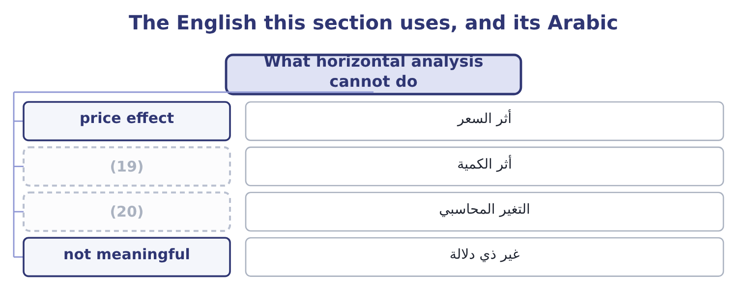
word list
volume effect · accounting change · year-over-year change

The English this sheet uses, and its Arabic
English (exam term) | Arabic
price effect | أثر السعر
volume effect | أثر الكمية
accounting change | التغير المحاسبي
not meaningful | غير ذي دلالة

Answer key · 3.5 What horizontal analysis cannot do

1 analysis | 11 business
2 strength | 12 arithmetic
3 Orontes's | 13 How did the market move?
4 depends | 14 Chapter 4, and Chapter 18 on inflation
5 statements | 15 Is this the same measurement?
6 separate | 16 What does a percentage mean here?
7 higher | 17 150,000 and 7.9 per cent
8 combination | 18 4,017,975 and 24.5 per cent
9 survive | 19 volume effect
10 measured | 20 accounting change

the summaries in full
Summary 1 Horizontal analysis compares a company with itself, and that is both its strength and its limit. It cannot tell you whether the level is right. Orontes's sales grew 15.4 per cent. Whether that is good depends on whether the market grew 5 per cent or 30 per cent, and the statements do not say. It cannot separate price from volume. A 15.4 per cent rise in sales may be 15.4 per cent more jars, or the same jars at a 15.4 per cent higher price, or any combination. It cannot survive a change of accounting. If the company moved from FIFO to LIFO during the series, the cost of goods sold line is measured two ways and the percentage change across the break is not a change in the business. And it cannot cope with a negative or zero base. A company whose operating income moved from a loss of $500,000 to a profit of $500,000 has no meaningful percentage change: the arithmetic gives −200 per cent, which says nothing. Write "not meaningful" and give the absolute change.

4.1 The growth rate of a line
Chapter 4 · section 4.1

Fill every gap. Each word list holds one word more than there are gaps.
Chapter 4, section by section
Each stage leads to the next.
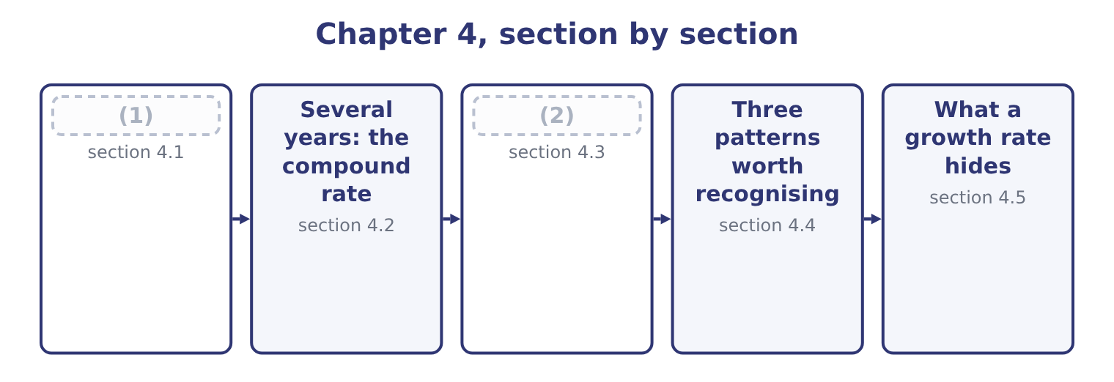
word list
margin squeeze · Variation analysis · The growth rate of a line

Summary 1 gaps 3–7
The growth rate of a line item for one (3) is the change (4) by the opening amount. Orontes's net sales went from $36,400,000 to $42,000,000. The growth rate is 5,600,000 ÷ 36,400,000 = 15.4 per cent. The year (5) , sales went from $32,000,000 to $36,400,000, a growth rate of 4,400,000 ÷ 32,000,000 = 13.8 per cent. Every line has a growth rate, and the exam asks for them on the balance sheet as (6) as on the income (7) .
word list
before · readily · divided · period · statement · translation

Orontes Foods, Inc. — growth rates of selected lines
Every item belongs to exactly one group.
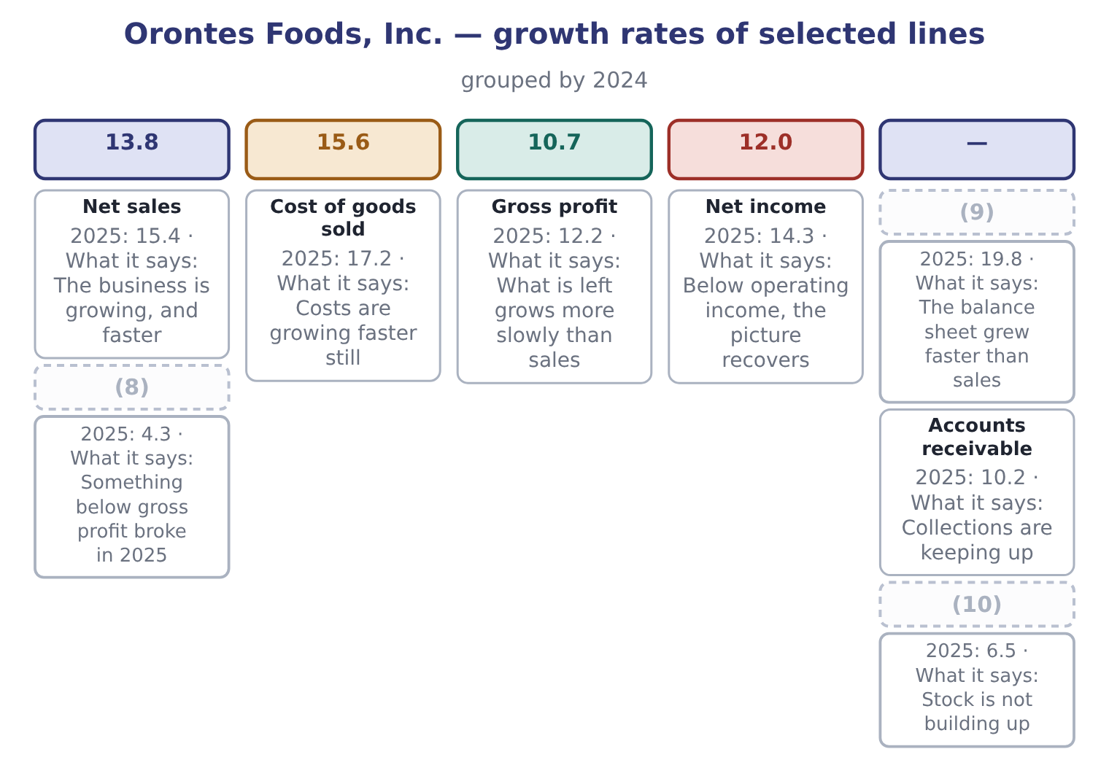
word list
Inventory · Net sales · Total assets · Operating income

Summary 2 gaps 11–18
Two (11) come straight off that figure, and (12) needs another (13) . Total assets grew 19.8 per cent while sales grew 15.4 per cent. A company whose balance sheet grows faster than its sales is using more assets to (14) each dollar of (15) . Here the cause is known: it is the cash. Net income grew faster than operating income. That is (16) , and it happens (17) the lines below operating income — interest, the (18) share of Jordan Glass, and the tax charge — moved in Orontes's favour.
word list
calculation · revenue · equity-method · because · readings · operating · neither · unusual · produce

Growth of a line against growth of its base

Summary 3 gaps 19–22
A line growing faster than sales is a line becoming a larger share of sales. A (19) line growing faster than total assets is a line becoming a larger share of the company. A growth rate on a small line can be huge and still not (20) . (21) ask what the (22) amount is.
word list
absolute · balance-sheet · matter · Always · readily

The English this section uses, and its Arabic
Each term sits against what it means.
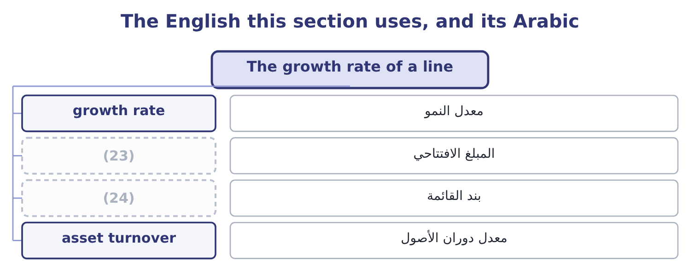
word list
opening amount · line item · arithmetic mean

The English this sheet uses, and its Arabic
English (exam term) | Arabic
growth rate | معدل النمو
opening amount | المبلغ الافتتاحي
line item | بند القائمة
asset turnover | معدل دوران الأصول

Answer key · 4.1 The growth rate of a line

1 The growth rate of a line | 13 calculation
2 Variation analysis | 14 produce
3 period | 15 revenue
4 divided | 16 unusual
5 before | 17 because
6 readily | 18 equity-method
7 statement | 19 balance-sheet
8 Operating income | 20 matter
9 Total assets | 21 Always
10 Inventory | 22 absolute
11 readings | 23 opening amount
12 neither | 24 line item

the summaries in full
Summary 1 The growth rate of a line item for one period is the change divided by the opening amount. Orontes's net sales went from $36,400,000 to $42,000,000. The growth rate is 5,600,000 ÷ 36,400,000 = 15.4 per cent. The year before, sales went from $32,000,000 to $36,400,000, a growth rate of 4,400,000 ÷ 32,000,000 = 13.8 per cent. Every line has a growth rate, and the exam asks for them on the balance sheet as readily as on the income statement.
Summary 2 Two readings come straight off that figure, and neither needs another calculation. Total assets grew 19.8 per cent while sales grew 15.4 per cent. A company whose balance sheet grows faster than its sales is using more assets to produce each dollar of revenue. Here the cause is known: it is the cash. Net income grew faster than operating income. That is unusual, and it happens because the lines below operating income — interest, the equity-method share of Jordan Glass, and the tax charge — moved in Orontes's favour.
Summary 3 A line growing faster than sales is a line becoming a larger share of sales. A balance-sheet line growing faster than total assets is a line becoming a larger share of the company. A growth rate on a small line can be huge and still not matter. Always ask what the absolute amount is.

4.2 Several years: the compound rate
Chapter 4 · section 4.2

Fill every gap. Each word list holds one word more than there are gaps.
Summary 1 gaps 1–10
Two annual rates of 13.8 and 15.4 per cent do not average to one rate by adding them and (1) . That is the commonest (2) error in this part of the (3) , and the exam tests it (4) . The reason is that growth compounds. A line that grows 13.8 per cent and then 15.4 per cent has not grown 29.2 per cent, and it has not grown at 14.6 per cent a year in the sense that the simple average (5) . It has grown by a factor of 1.138 × 1.154, and the rate that (6) the same result in two equal steps is the square root of that factor. The (7) is the compound annual growth rate, (8) written CAGR. CAGR = ( (9) value ÷ beginning value) (10) to the power of 1 ÷ n, minus 1.
word list
suggests · Orontes · usually · arithmetical · directly · syllabus · ending · halving · raised · measure · produces

Worked example: the CAGR of Orontes sales

Summary 2 gaps 11–15
The beginning and the end. Sales in 2023 were $32,000,000 and in 2025 were $42,000,000. There are two periods (11) them, not three: 2023 to 2024, and 2024 to 2025. Sales are 1.3125 times what they were. The rate per (12) . The square root of 1.3125 is 1.1456, so the CAGR is 14.56 per cent. Grow 32,000,000 by 14.56 per cent twice: 32,000,000 × 1.1456 = 36,659,200, and 36,659,200 × 1.1456 = 41,996,780, which is 42,000,000 to the nearest (13) . The simple average of 13.8 and 15.4 is 14.6 per cent, close here (14) the two rates are close; the two (15) sharply when the rates are far apart or when one is negative.
word list
period · because · rounding · diverge · between · directly

Two companies, the same simple average, different results
The bars are drawn to scale.
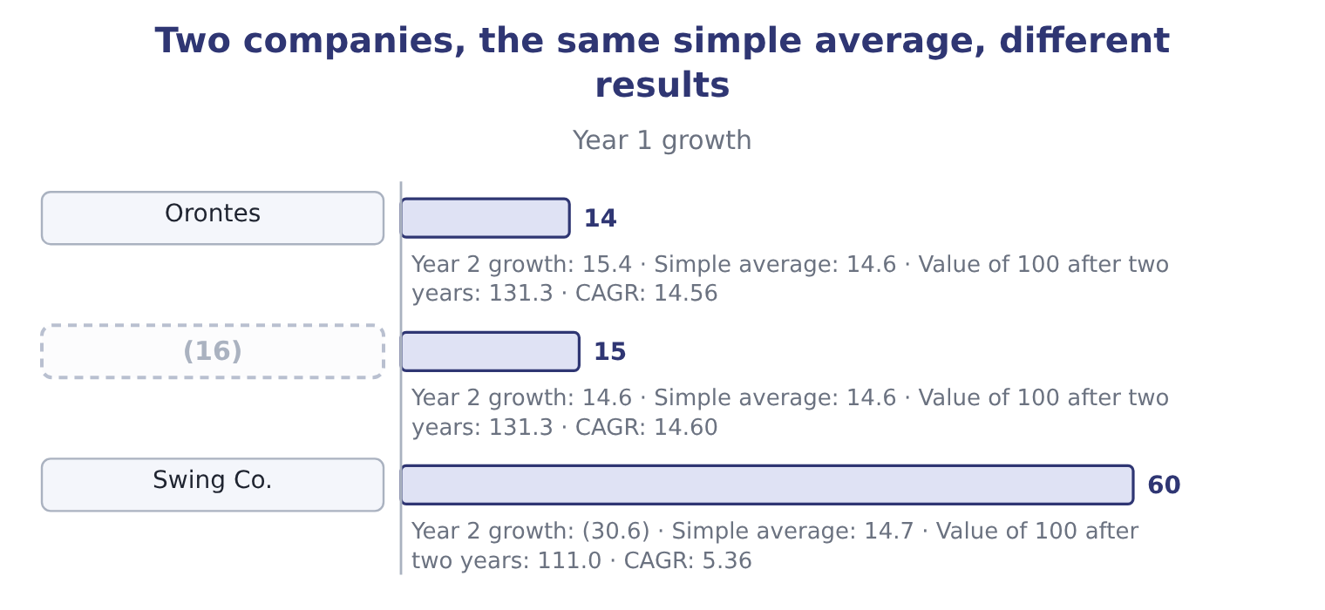
word list
Steady Co. · Swing Co.

Summary 3 gaps 17–19
Swing Co. shows the point. Its simple average is (17) higher than (18) , and $100 invested in it is worth $111.00 after two years (19) $131.30 in Orontes. The simple average of a series of growth rates is not the growth of the series.
word list
Orontes's · figures · slightly · against

Counting the periods

Summary 4 gaps 20–24
The (20) is 1 divided by the number of PERIODS, not the number of data points. Three annual (21) give two periods. A CAGR (22) a smooth path that the company did not actually follow. It is a (23) , not a history. A CAGR cannot be (24) when the beginning value is zero or negative, for the same reason a percentage change cannot.
word list
figures · exponent · summary · describes · calculated · history

"Compound" in English

Summary 5 gaps 25–28
English compound as a verb means to build on itself: (25) compounds, growth compounds. Do not (26) it with English compound as a noun, (27) a mixture, or with a compound journal entry, which is one entry with several lines. The exam uses all three (28) in Part 1 and Part 2.
word list
meaning · interest · written · confuse · senses

The English this section uses, and its Arabic
Each term sits against what it means.
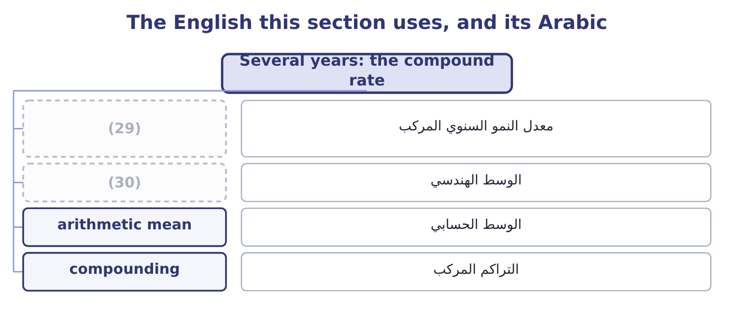
word list
margin squeeze · geometric mean · compound annual growth rate

The English this sheet uses, and its Arabic
English (exam term) | Arabic
compound annual growth rate | معدل النمو السنوي المركب
geometric mean | الوسط الهندسي
arithmetic mean | الوسط الحسابي
compounding | التراكم المركب

Answer key · 4.2 Several years: the compound rate

1 halving | 16 Steady Co.
2 arithmetical | 17 slightly
3 syllabus | 18 Orontes's
4 directly | 19 against
5 suggests | 20 exponent
6 produces | 21 figures
7 measure | 22 describes
8 usually | 23 summary
9 ending | 24 calculated
10 raised | 25 interest
11 between | 26 confuse
12 period | 27 meaning
13 rounding | 28 senses
14 because | 29 compound annual growth rate
15 diverge | 30 geometric mean

the summaries in full
Summary 1 Two annual rates of 13.8 and 15.4 per cent do not average to one rate by adding them and halving. That is the commonest arithmetical error in this part of the syllabus, and the exam tests it directly. The reason is that growth compounds. A line that grows 13.8 per cent and then 15.4 per cent has not grown 29.2 per cent, and it has not grown at 14.6 per cent a year in the sense that the simple average suggests. It has grown by a factor of 1.138 × 1.154, and the rate that produces the same result in two equal steps is the square root of that factor. The measure is the compound annual growth rate, usually written CAGR. CAGR = (ending value ÷ beginning value) raised to the power of 1 ÷ n, minus 1.
Summary 2 The beginning and the end. Sales in 2023 were $32,000,000 and in 2025 were $42,000,000. There are two periods between them, not three: 2023 to 2024, and 2024 to 2025. Sales are 1.3125 times what they were. The rate per period. The square root of 1.3125 is 1.1456, so the CAGR is 14.56 per cent. Grow 32,000,000 by 14.56 per cent twice: 32,000,000 × 1.1456 = 36,659,200, and 36,659,200 × 1.1456 = 41,996,780, which is 42,000,000 to the nearest rounding. The simple average of 13.8 and 15.4 is 14.6 per cent, close here because the two rates are close; the two diverge sharply when the rates are far apart or when one is negative.
Summary 3 Swing Co. shows the point. Its simple average is slightly higher than Orontes's, and $100 invested in it is worth $111.00 after two years against $131.30 in Orontes. The simple average of a series of growth rates is not the growth of the series.
Summary 4 The exponent is 1 divided by the number of PERIODS, not the number of data points. Three annual figures give two periods. A CAGR describes a smooth path that the company did not actually follow. It is a summary, not a history. A CAGR cannot be calculated when the beginning value is zero or negative, for the same reason a percentage change cannot.
Summary 5 English compound as a verb means to build on itself: interest compounds, growth compounds. Do not confuse it with English compound as a noun, meaning a mixture, or with a compound journal entry, which is one entry with several lines. The exam uses all three senses in Part 1 and Part 2.

4.3 Variation analysis
Chapter 4 · section 4.3

Fill every gap. Each word list holds one word more than there are gaps.
Summary 1 gaps 1–12
Variation analysis is the name the (1) Outcome Statements give to the calculation and (2) of percentage change over time. It is the technique of, used (3) on a chosen set of lines rather than on the whole statement. The (4) has three steps, and the third is the one (5) skip. First, (6) the lines. Not every line: the ones that drive the (7) . For a (8) they are usually sales, cost of goods sold, the main operating expenses, inventory, (9) and payables. Second, (10) the variation. The percentage change, year by year, and the (11) rate over the (12) . Third, explain each variation that is out of line with the others. A variation that matches the rest of the statement needs no explanation; a variation that does not is the finding.
word list
Learning · matches · manufacturer · method · receivables · compute · candidates · compound · deliberately · series · choose · business · interpretation

Orontes Foods, Inc. — variation analysis, 2023 to 2025
Line | 2023 | 2025 | Variation over two years | CAGR
Net sales | 32,000,000 | 42,000,000 | 31.2 per cent | 14.56
Cost of goods sold | 20,160,000 | 27,300,000 | 35.4 per cent | 16.38
Gross profit | 11,840,000 | 14,700,000 | (13) | 11.43
Total operating expenses | 8,320,000 | 10,524,000 | 26.5 per cent | 12.48
Operating income | 3,520,000 | 4,176,000 | (14) | 8.91
Net income | 2,320,000 | 2,969,100 | 28.0 per cent | 13.14

word list
24.2 per cent · 26.5 per cent · 18.6 per cent

Summary 2 gaps 15–24
Three (15) fall out of the third step. Cost of goods sold is out of line, and it is the (16) finding of the book so far. It grew at 16.38 per cent against sales at 14.56 per cent. (17) else on the income statement is (18) . Operating income is out of line in the other (19) , growing at 8.91 per cent, (20) than gross profit. The operating expenses grew (21) than gross profit, and the (22) is most of why. Net income is out of line with operating income, growing at 13.14 per cent against 8.91. Below the operating line, (23) is helping. An analyst would now go and find it rather than (24) anything.
word list
findings · impairment · direction · expenses · conclude · consequence · slower · faster · something · central · Everything

Worked example: explaining one variation

Summary 3 gaps 25–36
Find the line that is out of step. Over 2023 to 2025 sales grew 31.2 per cent and cost of goods sold grew 35.4 per cent. Every other line on the income statement is (25) of those two. Had cost of goods sold grown at the same 31.2 per cent as sales, it would be 20,160,000 × 1.312 = 26,449,920 (26) of 27,300,000. The (27) is 27,300,000 − 26,449,920 = 850,080 of cost that (28) alone does not (29) for. Say what it is worth. That $850,080 is gross profit (30) did not earn, on an (31) gross profit of $14,700,000. It is about 5.8 per cent of the gross profit the company made, and it is the whole of the margin (32) from 37.0 per cent to 35.0 per cent. The two statements agree. The (33) column said the margin fell two points; the variation analysis says the same fall is worth $850,080 at this (34) volume. A (35) asked to act needs the second figure, (36) two percentage points is not a sum of money and $850,080 is.
word list
common-size · growth · Orontes · manager · because · decline · growing · downstream · difference · account · year's · instead · actual

The English this section uses, and its Arabic
Each term sits against what it means.
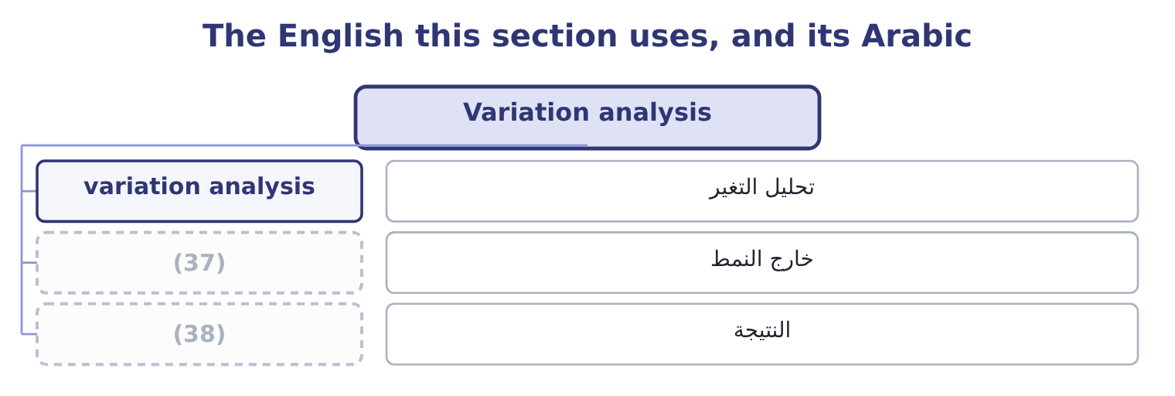
word list
driver · finding · out of line

Answer key · 4.3 Variation analysis

1 Learning | 20 slower
2 interpretation | 21 faster
3 deliberately | 22 impairment
4 method | 23 something
5 candidates | 24 conclude
6 choose | 25 downstream
7 business | 26 instead
8 manufacturer | 27 difference
9 receivables | 28 growth
10 compute | 29 account
11 compound | 30 Orontes
12 series | 31 actual
13 24.2 per cent | 32 decline
14 18.6 per cent | 33 common-size
15 findings | 34 year's
16 central | 35 manager
17 Everything | 36 because
18 consequence | 37 out of line
19 direction | 38 finding

the summaries in full
Summary 1 Variation analysis is the name the Learning Outcome Statements give to the calculation and interpretation of percentage change over time. It is the technique of, used deliberately on a chosen set of lines rather than on the whole statement. The method has three steps, and the third is the one candidates skip. First, choose the lines. Not every line: the ones that drive the business. For a manufacturer they are usually sales, cost of goods sold, the main operating expenses, inventory, receivables and payables. Second, compute the variation. The percentage change, year by year, and the compound rate over the series. Third, explain each variation that is out of line with the others. A variation that matches the rest of the statement needs no explanation; a variation that does not is the finding.
Summary 2 Three findings fall out of the third step. Cost of goods sold is out of line, and it is the central finding of the book so far. It grew at 16.38 per cent against sales at 14.56 per cent. Everything else on the income statement is consequence. Operating income is out of line in the other direction, growing at 8.91 per cent, slower than gross profit. The operating expenses grew faster than gross profit, and the impairment is most of why. Net income is out of line with operating income, growing at 13.14 per cent against 8.91. Below the operating line, something is helping. An analyst would now go and find it rather than conclude anything.
Summary 3 Find the line that is out of step. Over 2023 to 2025 sales grew 31.2 per cent and cost of goods sold grew 35.4 per cent. Every other line on the income statement is downstream of those two. Had cost of goods sold grown at the same 31.2 per cent as sales, it would be 20,160,000 × 1.312 = 26,449,920 instead of 27,300,000. The difference is 27,300,000 − 26,449,920 = 850,080 of cost that growth alone does not account for. Say what it is worth. That $850,080 is gross profit Orontes did not earn, on an actual gross profit of $14,700,000. It is about 5.8 per cent of the gross profit the company made, and it is the whole of the margin decline from 37.0 per cent to 35.0 per cent. The two statements agree. The common-size column said the margin fell two points; the variation analysis says the same fall is worth $850,080 at this year's volume. A manager asked to act needs the second figure, because two percentage points is not a sum of money and $850,080 is.

4.4 Three patterns worth recognising
Chapter 4 · section 4.4

Fill every gap. Each word list holds one word more than there are gaps.
Summary 1 gaps 1–12
Most variation (1) end in one of three (2) , and naming them saves time. The margin squeeze is Orontes's pattern: sales growing, a cost line growing faster, and every (3) below it growing more (4) than sales. The cause is upstream — purchase prices, product mix, (5) — and the remedy is a pricing or sourcing decision, not a (6) one. The working-capital leak is (7) pattern: sales growing (8) while receivables and inventory grow sharply. The income (9) looks adequate and the cash does not (10) . The cause is (11) of the sale, in collection and in stock. The one-off distortion is the pattern of Orontes's operating income in 2025: a single line (12) so far that it breaks the series on its own. The test is whether removing it restores the pattern. Take out the impairment of $2,724,000 and operating income grows 15.4 per cent in 2025 rather than 4.3, which is sales growth exactly; the series was never broken, one line was.
word list
analyses · moving · discounting · patterns · cost-cutting · statement · arrive · modestly · slowly · purchase · subtotal · downstream · Barada's

Three patterns a variation analysis ends in
Pattern | What the figures look like | Where the cause is | What settles it
Margin squeeze | Sales grow; a cost line grows faster | Pricing, mix or sourcing | (13)
Working-capital leak | Sales grow a little; receivables and inventory grow a lot | Collection and stockholding | (14)
One-off distortion | One line breaks the series alone | (15) | Does removing it restore the pattern?

word list
A single event · Total stockholders' equity · Days outstanding and days in inventory · The gross margin, year by year

Your turn: variation analysis of the balance sheet (complete the blanks)
Line | 2024 | 2025 | Variation
Total current assets | 8,380,000 | 14,188,100 | 69.3 per cent
Total current liabilities | 3,570,000 | 4,280,000 | (16) : 710,000 ÷ 3,570,000.
Total liabilities | 10,070,000 | 11,279,625 | (17) : 1,209,625 ÷ 10,070,000.
Total stockholders' equity | 16,375,000 | 20,392,975 | 24.5 per cent: 4,017,975 ÷ 16,375,000.
TOTAL ASSETS | 26,445,000 | 31,672,600 | (18) : 5,227,600 ÷ 26,445,000.

word list
19.8 per cent · 12.0 per cent · A single event · 19.9 per cent

The English this section uses, and its Arabic
Each term sits against what it means.
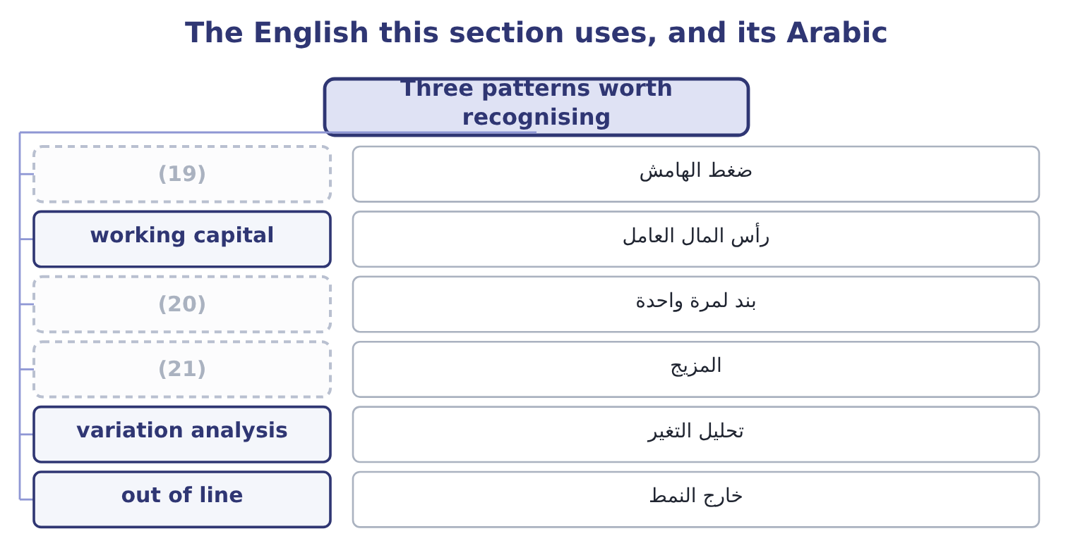
word list
nominal · one-off item · mix · margin squeeze

The English this sheet uses, and its Arabic
English (exam term) | Arabic
margin squeeze | ضغط الهامش
working capital | رأس المال العامل
one-off item | بند لمرة واحدة
mix | المزيج
variation analysis | تحليل التغير
out of line | خارج النمط
driver | المحرك
finding | النتيجة

Answer key · 4.4 Three patterns worth recognising

1 analyses | 12 moving
2 patterns | 13 The gross margin, year by year
3 subtotal | 14 Days outstanding and days in inventory
4 slowly | 15 A single event
5 discounting | 16 19.9 per cent
6 cost-cutting | 17 12.0 per cent
7 Barada's | 18 19.8 per cent
8 modestly | 19 margin squeeze
9 statement | 20 one-off item
10 arrive | 21 mix
11 downstream

the summaries in full
Summary 1 Most variation analyses end in one of three patterns, and naming them saves time. The margin squeeze is Orontes's pattern: sales growing, a cost line growing faster, and every subtotal below it growing more slowly than sales. The cause is upstream — purchase prices, product mix, discounting — and the remedy is a pricing or sourcing decision, not a cost-cutting one. The working-capital leak is Barada's pattern: sales growing modestly while receivables and inventory grow sharply. The income statement looks adequate and the cash does not arrive. The cause is downstream of the sale, in collection and in stock. The one-off distortion is the pattern of Orontes's operating income in 2025: a single line moving so far that it breaks the series on its own. The test is whether removing it restores the pattern. Take out the impairment of $2,724,000 and operating income grows 15.4 per cent in 2025 rather than 4.3, which is sales growth exactly; the series was never broken, one line was.

4.5 What a growth rate hides
Chapter 4 · section 4.5

Fill every gap. Each word list holds one word more than there are gaps.
Summary 1 gaps 1–12
A growth rate is one number (1) for a year of (2) , and four things (3) inside it. Sales grew 15.4 per cent. That is more jars, or (4) jars, or both. Nothing in the (5) statements (6) them, and the two have opposite (7) : more jars at the same price means the business is winning customers; the same jars at a higher price may mean only that costs were passed on. An (8) looks for unit data in the MD&A or the segment note. Acquisition and organic growth. A company that buys (9) company grows. Orontes's (10) investment in Jordan Glass rose by $1,307,000, and if that had been a controlling stake the (11) sales would have jumped without a single extra jar being sold. Growth that comes from buying is called (12) , and growth from the existing business is organic.
word list
financial · analyst · inorganic · separates · standing · trading · consolidated · dearer · implications · disappear · another · equity-method · improved

Summary 2 gaps 13–18
The exam expects the (13) . A company (14) into the Gulf and the Levant (15) in dollars. If a (16) currency weakens, the same local sales (17) into fewer dollars and the growth rate falls with no change in the business. A (18) rise in prices lifts every money figure. In a year of 10 per cent inflation, growth of 15.4 per cent is about 5 per cent in real terms.
word list
usually · translate · distinction · general · customer's · reports · selling

Four things a growth rate does not separate
What is hidden | The question to ask | Where to look
Price against volume | Did we sell more, or charge more? | (19)
Organic against acquired | (20) | Acquisitions note, cash flow statement
Currency | Would the rate be the same in local currency? | (21)
Inflation | What is the real rate? | (22)

word list
A price index, Chapter 18 · What is the real rate? · Segment note, Chapter 18 · Did the existing business grow? · MD&A, segment note, unit data

Real against nominal

Summary 3 gaps 23–25
A growth rate from the statements is (23) : it includes inflation. A real growth rate (24) inflation. If a question gives you an inflation rate, it (25) wants the real figure. Growth from an acquisition is not evidence that the business improved.
word list
usually · expects · subtracts · nominal

The English this section uses, and its Arabic
Each term sits against what it means.
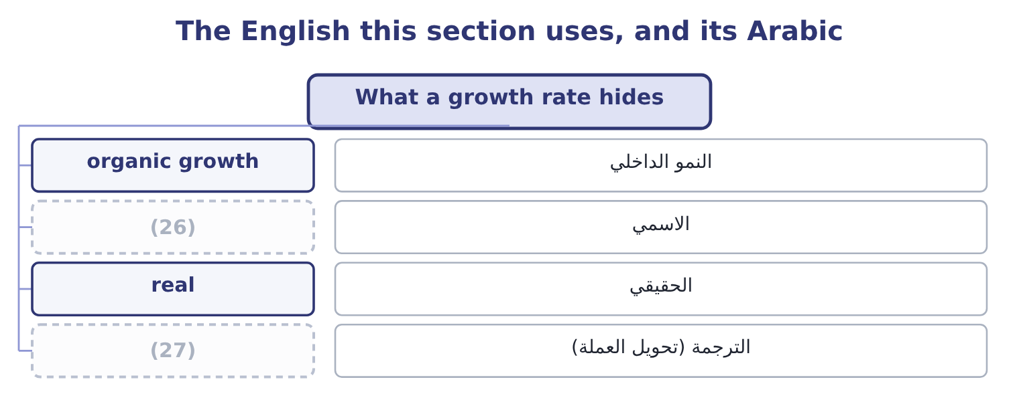
word list
translation · finding · nominal

The English this sheet uses, and its Arabic
English (exam term) | Arabic
organic growth | النمو الداخلي
nominal | الاسمي
real | الحقيقي
translation | الترجمة (تحويل العملة)

Answer key · 4.5 What a growth rate hides

1 standing | 15 reports
2 trading | 16 customer's
3 disappear | 17 translate
4 dearer | 18 general
5 financial | 19 MD&A, segment note, unit data
6 separates | 20 Did the existing business grow?
7 implications | 21 Segment note, Chapter 18
8 analyst | 22 A price index, Chapter 18
9 another | 23 nominal
10 equity-method | 24 subtracts
11 consolidated | 25 usually
12 inorganic | 26 nominal
13 distinction | 27 translation
14 selling

the summaries in full
Summary 1 A growth rate is one number standing for a year of trading, and four things disappear inside it. Sales grew 15.4 per cent. That is more jars, or dearer jars, or both. Nothing in the financial statements separates them, and the two have opposite implications: more jars at the same price means the business is winning customers; the same jars at a higher price may mean only that costs were passed on. An analyst looks for unit data in the MD&A or the segment note. Acquisition and organic growth. A company that buys another company grows. Orontes's equity-method investment in Jordan Glass rose by $1,307,000, and if that had been a controlling stake the consolidated sales would have jumped without a single extra jar being sold. Growth that comes from buying is called inorganic, and growth from the existing business is organic.
Summary 2 The exam expects the distinction. A company selling into the Gulf and the Levant reports in dollars. If a customer's currency weakens, the same local sales translate into fewer dollars and the growth rate falls with no change in the business. A general rise in prices lifts every money figure. In a year of 10 per cent inflation, growth of 15.4 per cent is about 5 per cent in real terms.
Summary 3 A growth rate from the statements is nominal: it includes inflation. A real growth rate subtracts inflation. If a question gives you an inflation rate, it usually wants the real figure. Growth from an acquisition is not evidence that the business improved.

5.1 From a number to a finding
Chapter 5 · section 5.1

Fill every gap. Each word list holds one word more than there are gaps.
Chapter 5, section by section
Each stage leads to the next.
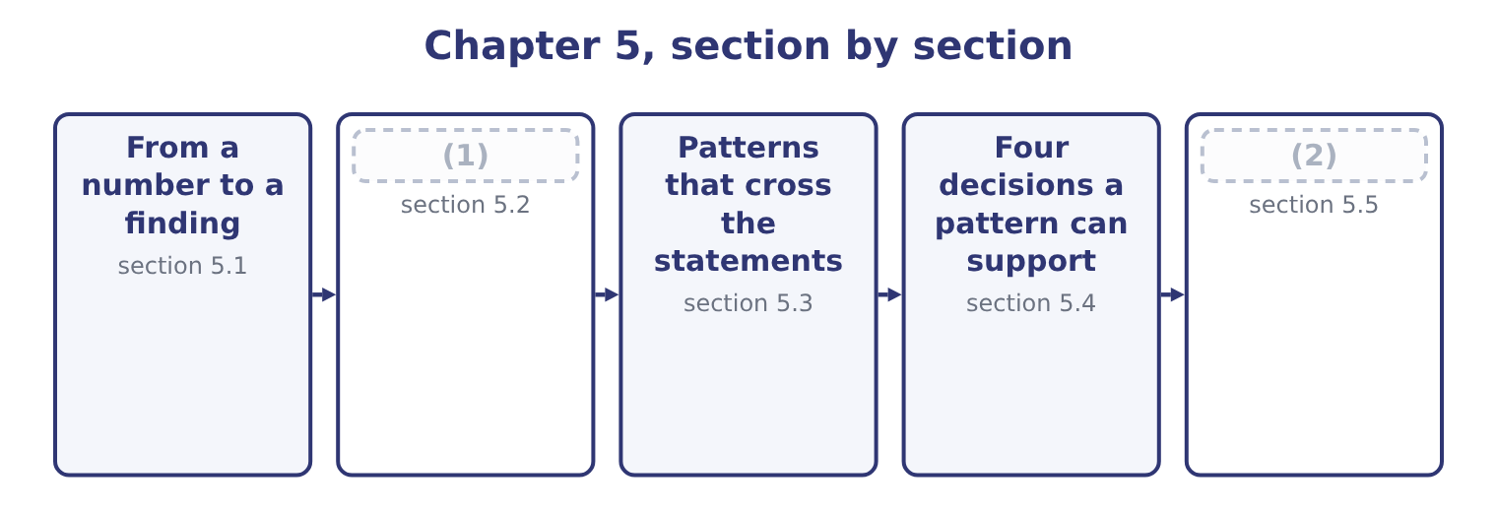
word list
free cash flow · The pattern in the cash · Writing it down

Summary 1 gaps 3–14
A finding has four parts, and an (3) that leaves one out is (4) . It names the movement. Not "costs rose" but "cost of goods sold rose from 63.0 to 65.0 per cent of sales over two years". It sizes the movement in money. Two percentage (5) of a $42,000,000 sales base is $840,000 a year. A (6) cannot act on a percentage; he can act on a sum. It is (7) by a second figure. One (8) can be an error, a (9) or an accident of (10) . A finding stands when two (11) figures point the same way. It names where the cause must be. Not the cause itself — the statements rarely give that — but the part of the (12) in which the cause must lie. A falling gross margin is upstream of the factory gate: purchase prices, product mix, or (13) . It is not in selling and (14) , because those sit below gross profit.
word list
corroborated · reclassification · incomplete · evidence · administration · answer · timing · points · independent · business · number · discounting · manager

One finding, in four parts
Part | For Orontes
The movement | Cost of goods sold rose from 63.0 to 65.0 per cent of net sales, 2023 to 2025
Its size | About $840,000 a year at 2025 sales; $850,080 (15) against sales growth
The corroboration | Gross profit grew at 11.43 per cent against sales at 14.56 per cent over the same period
Where the cause must be | Above gross profit: purchase prices, product mix, or selling price

word list
measured · corroboration

A finding, not a calculation

Summary 2 gaps 16–20
An exam (16) that asks you to " (17) " wants the movement, its size, and what it (18) — not the percentage alone. Corroboration means a second figure that is not (19) derived from the first. Gross margin and cost of goods sold percentage are the same fact twice. Never name a cause the statements do not (20) . Name the place the cause must be.
word list
implies · support · manager · analyse · question · arithmetically

The English this section uses, and its Arabic
Each term sits against what it means.
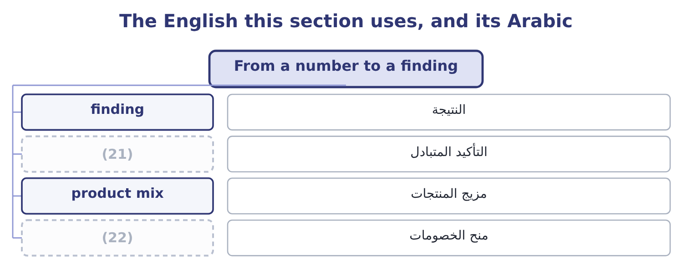
word list
discounting · finding · corroboration

The English this sheet uses, and its Arabic
English (exam term) | Arabic
finding | النتيجة
corroboration | التأكيد المتبادل
product mix | مزيج المنتجات
discounting | منح الخصومات

Answer key · 5.1 From a number to a finding

1 The pattern in the cash | 12 business
2 Writing it down | 13 discounting
3 answer | 14 administration
4 incomplete | 15 measured
5 points | 16 question
6 manager | 17 analyse
7 corroborated | 18 implies
8 number | 19 arithmetically
9 reclassification | 20 support
10 timing | 21 corroboration
11 independent | 22 discounting

the summaries in full
Summary 1 A finding has four parts, and an answer that leaves one out is incomplete. It names the movement. Not "costs rose" but "cost of goods sold rose from 63.0 to 65.0 per cent of sales over two years". It sizes the movement in money. Two percentage points of a $42,000,000 sales base is $840,000 a year. A manager cannot act on a percentage; he can act on a sum. It is corroborated by a second figure. One number can be an error, a reclassification or an accident of timing. A finding stands when two independent figures point the same way. It names where the cause must be. Not the cause itself — the statements rarely give that — but the part of the business in which the cause must lie. A falling gross margin is upstream of the factory gate: purchase prices, product mix, or discounting. It is not in selling and administration, because those sit below gross profit.
Summary 2 An exam question that asks you to "analyse" wants the movement, its size, and what it implies — not the percentage alone. Corroboration means a second figure that is not arithmetically derived from the first. Gross margin and cost of goods sold percentage are the same fact twice. Never name a cause the statements do not support. Name the place the cause must be.

5.2 The pattern in the cash
Chapter 5 · section 5.2

Fill every gap. Each word list holds one word more than there are gaps.
Summary 1 gaps 1–2
The largest single movement in (1) 2025 statements is cash, which rose by $5,202,100 to become 23.1 per cent of the company. The statement of cash flows (2) it.
word list
finding · Orontes's · explains

Orontes Foods, Inc. — where the cash came from and went, 2025
Source or use | Amount | Comment
Net cash provided by operating activities | 7,531,100 | Well above net income of 2,969,100
Purchases of property, plant and equipment | (3,000,000) | Replacing and extending the plant
Investment in Jordan Glass Co. | (1,200,000) | (3)
Net cash used in investing activities | (4,179,000)
Issuance of common stock | 1,500,000 | (4)
Proceeds from bank note | 800,000
Repayment of long-term debt | (400,000)
Dividends paid | (50,000) | (5)
Net cash provided by financing activities | 1,850,000
Net increase in cash | 5,202,100

word list
Well above net income of 2,969,100 · A stake in the bottle supplier · Against 450,000 declared · New shares to existing owners

Summary 2 gaps 6–17
Now the (6) can be stated. Operating cash flow of $7,531,100 against net income of $2,969,100 is two and a half times earnings, and the gap is the non-cash charges: (7) of $2,100,000 and the (8) of $2,724,000. Those two alone are 2,100,000 + 2,724,000 = 4,824,000, which is most of the (9) . The company earned far more cash than its income statement (10) , because a large part of its reported cost this year was a (11) of assets bought years ago. Operating cash flow of $7,531,100 against capital expenditure of $3,000,000 (12) 7,531,100 − 3,000,000 = 4,531,100 of free cash flow. Orontes spent $1,200,000 of it on the Jordan Glass stake and $450,000 on dividends declared, and put most of the rest in the bank. That is the (13) . Orontes is not short of money and it is not (14) for want of an (15) : it invested in plant and in a supplier during the year, and it still finished with a quarter of its balance sheet in cash. The (16) for a manager is why it also raised $1,500,000 of new equity and $800,000 of new debt in a year when it (17) $7,531,100 from trading. A company does not normally raise money it does not need, and the reason will be in the board minutes rather than in the statements.
word list
pattern · stakeholder · leaves · difference · question · finding · depreciation · generated · write-down · hoarding · suggests · impairment · alternative

Worked example: free cash flow and what it says

Summary 3 gaps 18–24
Operating cash flow less capital expenditure: 7,531,100 − 3,000,000 = 4,531,100. Dividends declared were $450,000, so dividend cover on a cash basis is 4,531,100 ÷ 450,000 = 10.07 times. The dividend is not under (18) on any view. Total debt is the long-term portion plus the (19) portion: 6,000,000 + 400,000 = 6,400,000. One year of free cash flow would repay 4,531,100 ÷ 6,400,000 = 70.8 per cent of it. Three uses of one number, each (20) a different (21) . The (22) asks whether the dividend is safe; the (23) asks how long repayment would take; the board asks what is left to (24) .
word list
lender · statements · invest · stakeholder · shareholder · threat · answering · current

The English this section uses, and its Arabic
Each term sits against what it means.
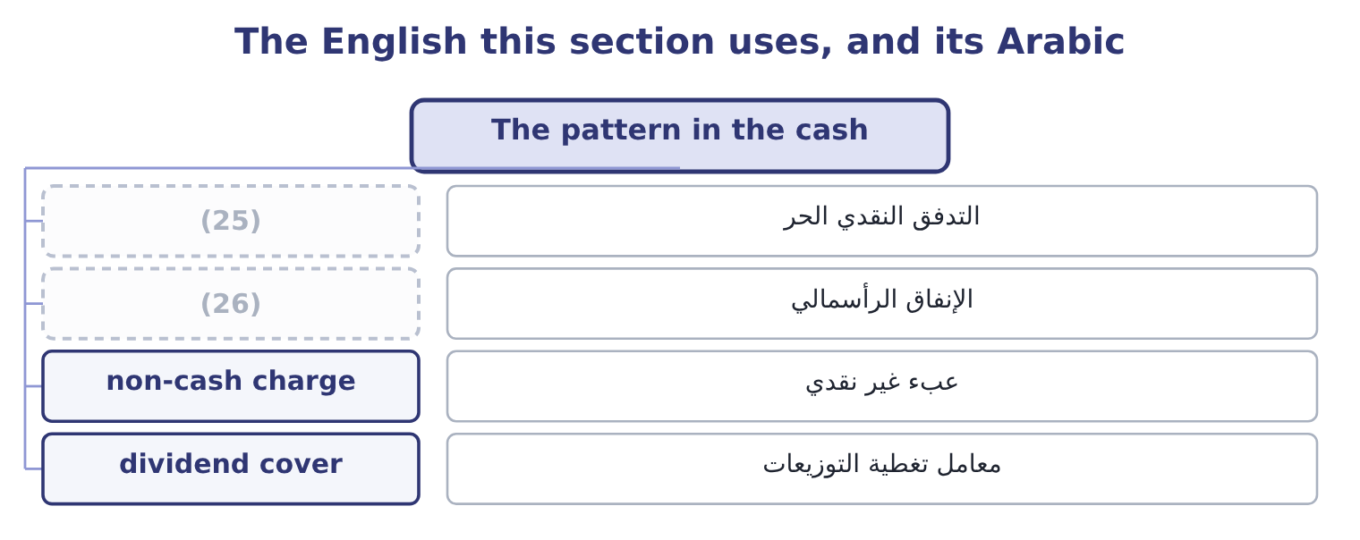
word list
written answer · capital expenditure · free cash flow

The English this sheet uses, and its Arabic
English (exam term) | Arabic
free cash flow | التدفق النقدي الحر
capital expenditure | الإنفاق الرأسمالي
non-cash charge | عبء غير نقدي
dividend cover | معامل تغطية التوزيعات

Answer key · 5.2 The pattern in the cash

1 Orontes's | 14 hoarding
2 explains | 15 alternative
3 A stake in the bottle supplier | 16 question
4 New shares to existing owners | 17 generated
5 Against 450,000 declared | 18 threat
6 pattern | 19 current
7 depreciation | 20 answering
8 impairment | 21 stakeholder
9 difference | 22 shareholder
10 suggests | 23 lender
11 write-down | 24 invest
12 leaves | 25 free cash flow
13 finding | 26 capital expenditure

the summaries in full
Summary 1 The largest single movement in Orontes's 2025 statements is cash, which rose by $5,202,100 to become 23.1 per cent of the company. The statement of cash flows explains it.
Summary 2 Now the pattern can be stated. Operating cash flow of $7,531,100 against net income of $2,969,100 is two and a half times earnings, and the gap is the non-cash charges: depreciation of $2,100,000 and the impairment of $2,724,000. Those two alone are 2,100,000 + 2,724,000 = 4,824,000, which is most of the difference. The company earned far more cash than its income statement suggests, because a large part of its reported cost this year was a write-down of assets bought years ago. Operating cash flow of $7,531,100 against capital expenditure of $3,000,000 leaves 7,531,100 − 3,000,000 = 4,531,100 of free cash flow. Orontes spent $1,200,000 of it on the Jordan Glass stake and $450,000 on dividends declared, and put most of the rest in the bank. That is the finding. Orontes is not short of money and it is not hoarding for want of an alternative: it invested in plant and in a supplier during the year, and it still finished with a quarter of its balance sheet in cash. The question for a manager is why it also raised $1,500,000 of new equity and $800,000 of new debt in a year when it generated $7,531,100 from trading. A company does not normally raise money it does not need, and the reason will be in the board minutes rather than in the statements.
Summary 3 Operating cash flow less capital expenditure: 7,531,100 − 3,000,000 = 4,531,100. Dividends declared were $450,000, so dividend cover on a cash basis is 4,531,100 ÷ 450,000 = 10.07 times. The dividend is not under threat on any view. Total debt is the long-term portion plus the current portion: 6,000,000 + 400,000 = 6,400,000. One year of free cash flow would repay 4,531,100 ÷ 6,400,000 = 70.8 per cent of it. Three uses of one number, each answering a different stakeholder. The shareholder asks whether the dividend is safe; the lender asks how long repayment would take; the board asks what is left to invest.

5.3 Patterns that cross the statements
Chapter 5 · section 5.3

Fill every gap. Each word list holds one word more than there are gaps.
Summary 1 gaps 1–2
The most (1) findings come from a movement in one statement that (2) a movement in another.
word list
trained · reliable · explains

Patterns that cross from one statement to another
On the income statement | On the balance sheet | On the cash flow statement | What it means
Sales rising | Receivables rising faster | (3) | Sales are being made on terms that are not being collected
Sales flat | Inventory rising | Operating cash flow falling | (4)
Profit rising | Payables rising sharply | (5) | Profit is being funded by suppliers, which cannot continue
Profit falling | (6) | Depreciation unchanged | Fixed costs are holding while revenue weakens
A large one-off charge | (7) | Operating cash flow unaffected | The charge is non-cash: earnings fell and cash did not

word list
Plant unchanged · Operating cash flow rising · Goods are not selling and cash is going into stock · The written-down asset smaller · Operating cash flow flat or falling · non-cash charge

Summary 2 gaps 8–15
The last row is (8) exactly. The (9) of $2,724,000 cut operating income to $4,176,000 and left operating cash flow (10) at $7,531,100, because no money moved. An analyst who read only the income statement would record a bad year; an analyst who read only the cash flow statement would record an (11) one. Both are (12) the same company. The first row is (13) , from the case. Sales up 11 per cent, receivables up 38 per cent and an (14) where there was none: a (15) pattern, and the one a credit officer is trained to.
word list
reading · untouched · excellent · impairment · classic · movement · Barada · Orontes · overdraft

Two statements beat one

Summary 3 gaps 16–20
A (16) that gives you both an income statement and a cash flow statement is usually testing whether you noticed they (17) . Profit without cash is the pattern to be (18) . Cash without profit, as here, is usually a non-cash charge and is less (19) . The balance sheet is where the difference between the two (20) .
word list
suspicious · disagree · question · alarming · accumulates · non-cash

"Quality" of earnings

Summary 4 gaps 21–22
English says earnings quality, and quality here does not mean good: it means how closely (21) profit tracks cash and how likely it is to repeat. (22) earnings may be small.
word list
High-quality · corroboration · reported

The English this section uses, and its Arabic
Each term sits against what it means.
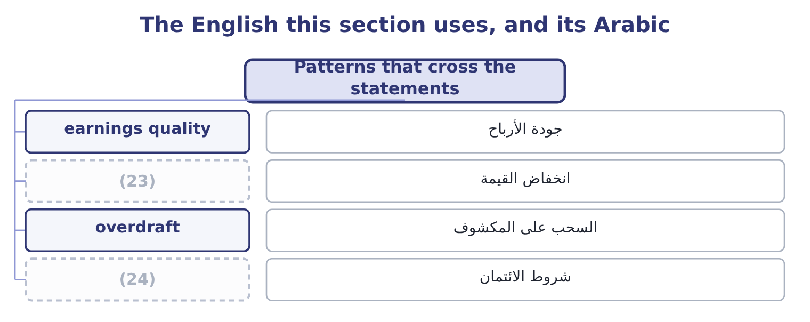
word list
non-cash charge · credit terms · impairment

The English this sheet uses, and its Arabic
English (exam term) | Arabic
earnings quality | جودة الأرباح
impairment | انخفاض القيمة
overdraft | السحب على المكشوف
credit terms | شروط الائتمان

Answer key · 5.3 Patterns that cross the statements

1 reliable | 13 Barada
2 explains | 14 overdraft
3 Operating cash flow flat or falling | 15 classic
4 Goods are not selling and cash is going into stock | 16 question
5 Operating cash flow rising | 17 disagree
6 Plant unchanged | 18 suspicious
7 The written-down asset smaller | 19 alarming
8 Orontes | 20 accumulates
9 impairment | 21 reported
10 untouched | 22 High-quality
11 excellent | 23 impairment
12 reading | 24 credit terms

the summaries in full
Summary 1 The most reliable findings come from a movement in one statement that explains a movement in another.
Summary 2 The last row is Orontes exactly. The impairment of $2,724,000 cut operating income to $4,176,000 and left operating cash flow untouched at $7,531,100, because no money moved. An analyst who read only the income statement would record a bad year; an analyst who read only the cash flow statement would record an excellent one. Both are reading the same company. The first row is Barada, from the case. Sales up 11 per cent, receivables up 38 per cent and an overdraft where there was none: a classic pattern, and the one a credit officer is trained to.
Summary 3 A question that gives you both an income statement and a cash flow statement is usually testing whether you noticed they disagree. Profit without cash is the pattern to be suspicious. Cash without profit, as here, is usually a non-cash charge and is less alarming. The balance sheet is where the difference between the two accumulates.
Summary 4 English says earnings quality, and quality here does not mean good: it means how closely reported profit tracks cash and how likely it is to repeat. High-quality earnings may be small.

5.4 Four decisions a pattern can support
Chapter 5 · section 5.4

Fill every gap. Each word list holds one word more than there are gaps.
A finding is useful when someone can act on it.
From pattern to decision
Pattern | The decision it supports | The figure it turns on
Cost of goods sold growing faster than sales | (1) | $850,080 of gross profit forgone
Cash at 23.1 per cent of assets | (2) | Free cash flow of $4,531,100
Equity at 64.4 per cent of assets | Borrow to fund the next expansion | (3)
Impairment of goodwill and a brand | Review what else was bought at a premium | (4)

word list
Reprice, change mix, or renegotiate supply · Goodwill down from 950,000 to 300,000 · Interest cover of 11.15 times · Invest it, repay debt, or return it to owners · Review what else was bought at a premium

Summary 1 gaps 5–14
Each row is a decision a board can take at its next (5) . That is the standard an exam answer is held to at Level C: not a (6) of the statements, but a (7) with a number behind it. Two (8) belong here, and the exam tests both. A pattern is (9) , not proof. The margin decline may be (10) : a company buying market share prices below its old margin on (11) . The statements cannot (12) a squeeze from a (13) , and an analyst says so. A decision has a cost the statements do not show. Returning cash to owners forgoes the next (14) . The figures bound the decision; they do not make it.
word list
strategy · recommendation · description · acquisition · meeting · evidence · purpose · distinguish · deliberate · Orontes's · cautions

Worked example: sizing a repricing decision

Summary 2 gaps 15–23
Orontes's gross margin fell from 37.0 per cent in 2023 to 35.0 per cent in 2025, a loss of two (15) points. What (16) it is worth. Two points of the 2025 sales base: 42,000,000 × 0.02 = 840,000 of (17) gross profit a year. To recover two points by price alone, Orontes must raise prices about 3.1 per cent, (18) a price rise adds to both sales and gross profit while cost of goods sold stays where it is. Whether the market (19) that is not in the statements. The (20) gives the board the size of the prize, $840,000, and the size of the price move (21) , about 3 per cent. The decision about whether (22) will pay it (23) to the people who sell to them.
word list
because · accepts · recovering · customers · analysis · needed · percentage · belongs · additional · recommendation

The English this section uses, and its Arabic
Each term sits against what it means.
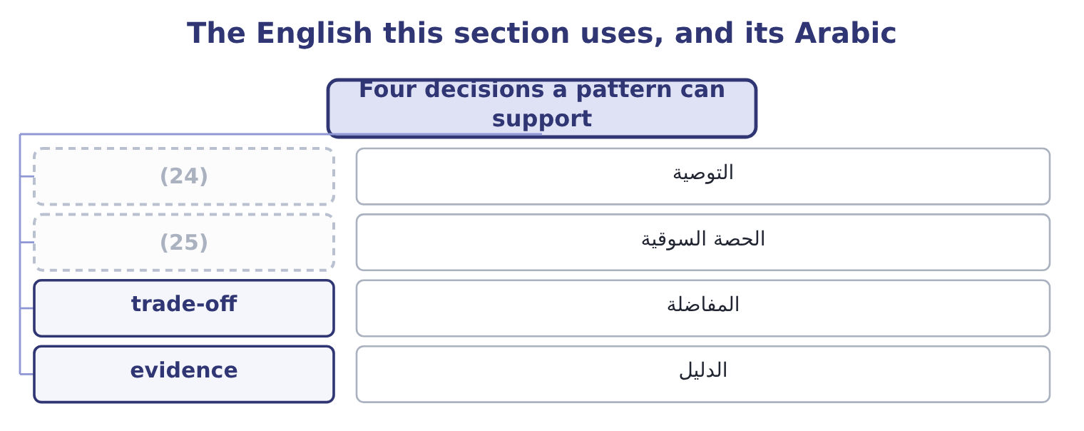
word list
root cause · recommendation · market share

The English this sheet uses, and its Arabic
English (exam term) | Arabic
recommendation | التوصية
market share | الحصة السوقية
trade-off | المفاضلة
evidence | الدليل

Answer key · 5.4 Four decisions a pattern can support

1 Reprice, change mix, or renegotiate supply | 14 acquisition
2 Invest it, repay debt, or return it to owners | 15 percentage
3 Interest cover of 11.15 times | 16 recovering
4 Goodwill down from 950,000 to 300,000 | 17 additional
5 meeting | 18 because
6 description | 19 accepts
7 recommendation | 20 analysis
8 cautions | 21 needed
9 evidence | 22 customers
10 deliberate | 23 belongs
11 purpose | 24 recommendation
12 distinguish | 25 market share
13 strategy

the summaries in full
Summary 1 Each row is a decision a board can take at its next meeting. That is the standard an exam answer is held to at Level C: not a description of the statements, but a recommendation with a number behind it. Two cautions belong here, and the exam tests both. A pattern is evidence, not proof. The margin decline may be deliberate: a company buying market share prices below its old margin on purpose. The statements cannot distinguish a squeeze from a strategy, and an analyst says so. A decision has a cost the statements do not show. Returning cash to owners forgoes the next acquisition. The figures bound the decision; they do not make it.
Summary 2 Orontes's gross margin fell from 37.0 per cent in 2023 to 35.0 per cent in 2025, a loss of two percentage points. What recovering it is worth. Two points of the 2025 sales base: 42,000,000 × 0.02 = 840,000 of additional gross profit a year. To recover two points by price alone, Orontes must raise prices about 3.1 per cent, because a price rise adds to both sales and gross profit while cost of goods sold stays where it is. Whether the market accepts that is not in the statements. The analysis gives the board the size of the prize, $840,000, and the size of the price move needed, about 3 per cent. The decision about whether customers will pay it belongs to the people who sell to them.

5.5 Writing it down
Chapter 5 · section 5.5

Fill every gap. Each word list holds one word more than there are gaps.
An analyst's output is a short piece of writing.
Build the finding

Complete the other two, for the pattern in Orontes's cash.
Your turn: complete the finding (complete the blanks)
Part | Entry
The movement | Cash rose from 7.9 to 23.1 per cent of total assets during 2025
Its size | Cash rose by $5,202,100, from $2,100,000 to $7,302,100, in a company whose total assets are $31,672,600.
The corroboration | Free cash flow of $4,531,100: operating cash flow of $7,531,100 less capital expenditure of $3,000,000. The rise is funded by trading, not b
Where the cause must be | (1) cash flow, which at 7,531,100 exceeded net income by two and a half times

word list
Operating · overdraft

Summary 1 gaps 2–6
A good (2) names the movement in its first sentence, sizes it in the second, (3) it in the third and places the cause in the fourth. That is four sentences, and four sentences is (4) enough. Candidates lose marks by describing the calculation instead of its (5) , and by naming a cause the statements do not (6) .
word list
actionable · paragraph · consequence · corroborates · support · usually

What a written answer must contain

Summary 2 gaps 7–8
The movement, with the (7) . A second figure that (8) it. Where the cause must lie, and what would settle it.
word list
supports · figures · consequence

The English this section uses, and its Arabic
Each term sits against what it means.
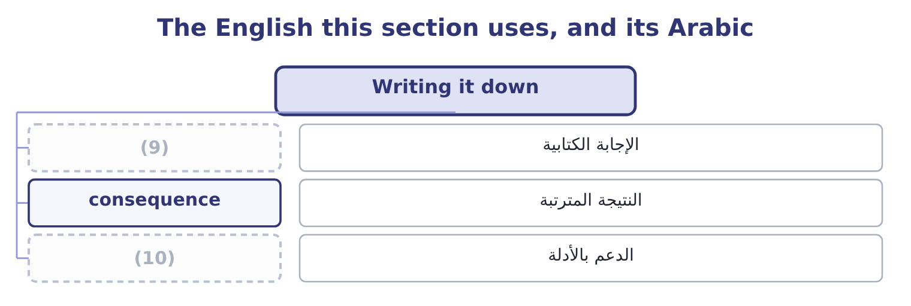
word list
capital expenditure · written answer · support

The English this sheet uses, and its Arabic
English (exam term) | Arabic
written answer | الإجابة الكتابية
consequence | النتيجة المترتبة
support | الدعم بالأدلة

Answer key · 5.5 Writing it down

1 Operating | 6 support
2 paragraph | 7 figures
3 corroborates | 8 supports
4 usually | 9 written answer
5 consequence | 10 support

the summaries in full
Summary 1 A good paragraph names the movement in its first sentence, sizes it in the second, corroborates it in the third and places the cause in the fourth. That is four sentences, and four sentences is usually enough. Candidates lose marks by describing the calculation instead of its consequence, and by naming a cause the statements do not support.
Summary 2 The movement, with the figures. A second figure that supports it. Where the cause must lie, and what would settle it.

6.1 The five ratios
Chapter 6 · section 6.1

Fill every gap. Each word list holds one word more than there are gaps.
Chapter 6, section by section
Each stage leads to the next.
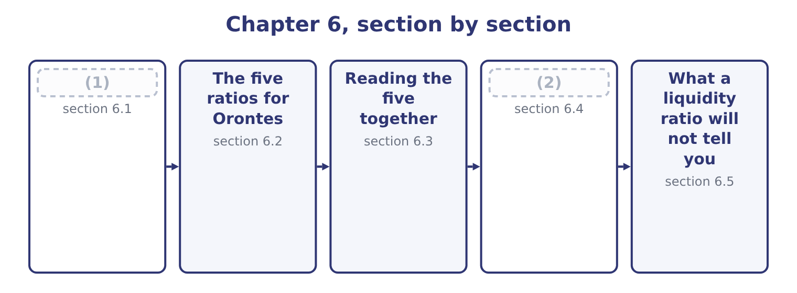
word list
Reading the five together · The five ratios · The liquidity of current liabilities

Summary 1 gaps 3–14
All five (3) something the company can pay with by something it has to pay. They differ in the (4) , and the differences are a ladder of (5) severity. The current ratio divides total current assets by total current liabilities. It (6) everything the (7) allows, including inventory that has not been sold and (8) that will never be cash at all. The quick ratio, also called the (9) ratio, removes inventory and prepaid expenses. What is left is cash, marketable securities and receivables: the assets that become cash (10) first having to be sold to a (11) . The cash ratio removes receivables too. Only cash and marketable securities count. This is the ratio for a company whose customers may not pay on time. The cash flow ratio divides (12) cash flow for the year by current liabilities at the end of it. It asks a (13) question from the other four: not what the company holds, but what it (14) .
word list
operating · prepayments · seasonal · numerator · generates · different · without · increasing · customer · divide · counts · acid-test · classification

Summary 2 gaps 15–17
The net working capital ratio divides net working capital — current assets less current liabilities — by total assets. It expresses the (15) as a share of the whole company (16) than as a multiple of the (17) .
word list
obligations · cushion · including · rather

The five liquidity ratios
Every item belongs to exactly one group.
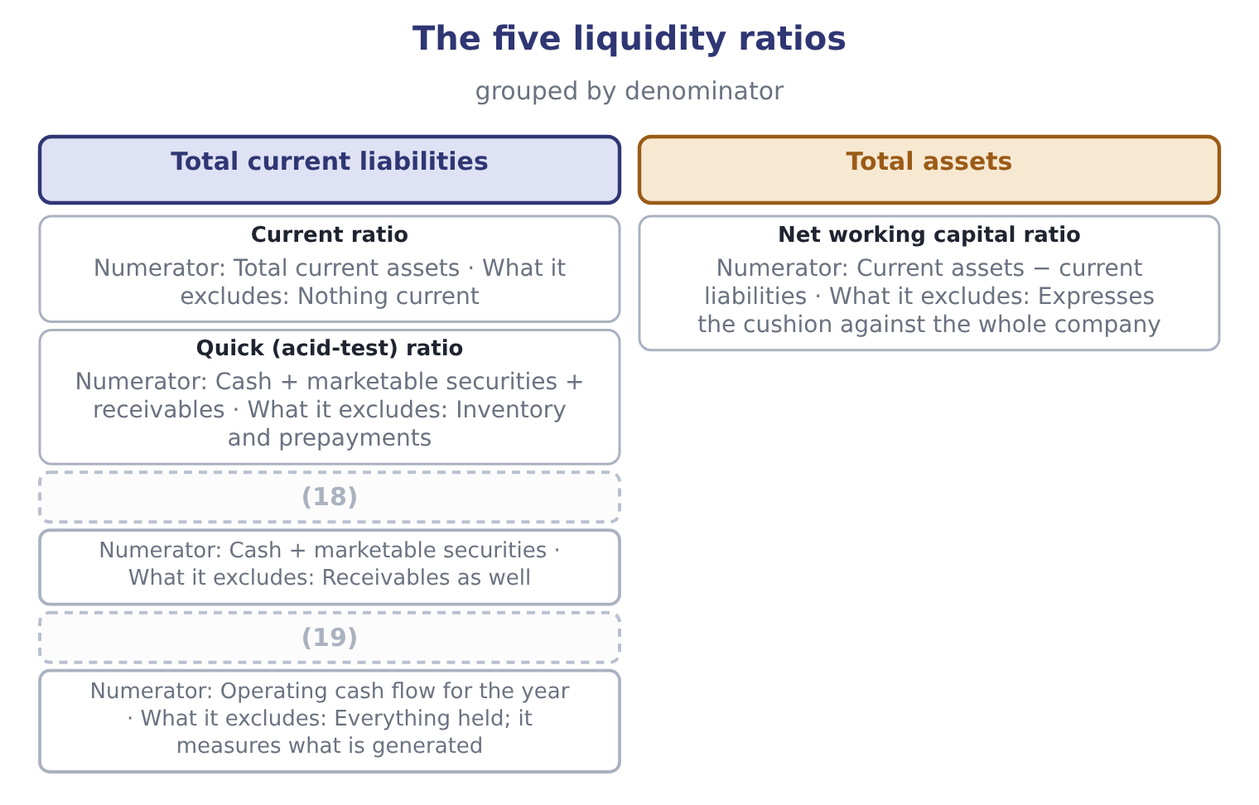
word list
Cash ratio · Cash flow ratio · interim statements

Which assets are quick?

Summary 3 gaps 20–24
Quick assets are cash, marketable securities and net receivables. Inventory is never quick, (20) fast it sells. Prepaid expenses are never quick, (21) they turn into (22) and not into cash. The cash flow ratio uses the cash flow for the YEAR (23) liabilities at a POINT. That mismatch is (24) and is how the ratio is defined.
word list
expense · divides · because · deliberate · against · however

The English this section uses, and its Arabic
Each term sits against what it means.
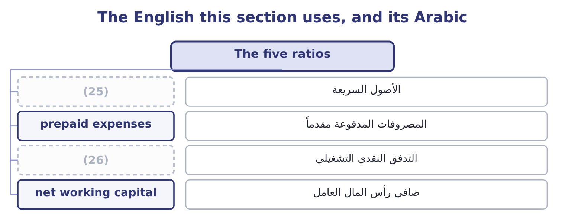
word list
operating cash flow · prepaid expenses · quick assets

The English this sheet uses, and its Arabic
English (exam term) | Arabic
quick assets | الأصول السريعة
prepaid expenses | المصروفات المدفوعة مقدماً
operating cash flow | التدفق النقدي التشغيلي
net working capital | صافي رأس المال العامل

Answer key · 6.1 The five ratios

1 The five ratios | 14 generates
2 The liquidity of current liabilities | 15 cushion
3 divide | 16 rather
4 numerator | 17 obligations
5 increasing | 18 Cash ratio
6 counts | 19 Cash flow ratio
7 classification | 20 however
8 prepayments | 21 because
9 acid-test | 22 expense
10 without | 23 against
11 customer | 24 deliberate
12 operating | 25 quick assets
13 different | 26 operating cash flow

the summaries in full
Summary 1 All five divide something the company can pay with by something it has to pay. They differ in the numerator, and the differences are a ladder of increasing severity. The current ratio divides total current assets by total current liabilities. It counts everything the classification allows, including inventory that has not been sold and prepayments that will never be cash at all. The quick ratio, also called the acid-test ratio, removes inventory and prepaid expenses. What is left is cash, marketable securities and receivables: the assets that become cash without first having to be sold to a customer. The cash ratio removes receivables too. Only cash and marketable securities count. This is the ratio for a company whose customers may not pay on time. The cash flow ratio divides operating cash flow for the year by current liabilities at the end of it. It asks a different question from the other four: not what the company holds, but what it generates.
Summary 2 The net working capital ratio divides net working capital — current assets less current liabilities — by total assets. It expresses the cushion as a share of the whole company rather than as a multiple of the obligations.
Summary 3 Quick assets are cash, marketable securities and net receivables. Inventory is never quick, however fast it sells. Prepaid expenses are never quick, because they turn into expense and not into cash. The cash flow ratio uses the cash flow for the YEAR against liabilities at a POINT. That mismatch is deliberate and is how the ratio is defined.

6.2 The five ratios for Orontes
Chapter 6 · section 6.2

Fill every gap. Each word list holds one word more than there are gaps.
Summary 1 gaps 1–2
The 2024 cash flow ratio cannot be (1) , because Part 1 (2) one statement of cash flows.
word list
numerator · calculated · published

Orontes Foods, Inc. — the five liquidity ratios
The bars are drawn to scale.
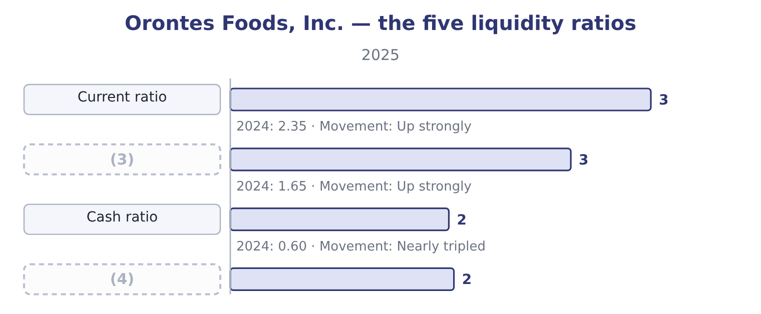
word list
Cash flow ratio · Quick (acid-test) ratio · operating cash flow

Summary 2 gaps 5–9
The (5) behind each is worth (6) once. The current ratio is 14,188,100 ÷ 4,280,000 = 3.31 for 2025, and 8,380,000 ÷ 3,570,000 = 2.35 for 2024. Quick assets for 2025 are cash of $7,302,100, trading securities of $42,000 and net receivables of $4,144,000: 7,302,100 + 42,000 = 7,344,100, and 7,344,100 + 4,144,000 = 11,488,100. The quick ratio is 11,488,100 ÷ 4,280,000 = 2.68. The cash ratio uses only the first two: 7,344,100 ÷ 4,280,000 = 1.72. The cash flow ratio is operating cash flow over current liabilities: 7,531,100 ÷ 4,280,000 = 1.76. Net working capital is 14,188,100 − 4,280,000 = 9,908,100, and the net working capital ratio is 9,908,100 ÷ 31,672,600 = 0.313. Every one of the five rose (7) , and every one of them rose for the same (8) : the $5,202,100 of cash that,531,100. This is what (9) looks.
word list
corroboration · sharply · seeing · reason · seasonal · arithmetic

Summary 3 gaps 10–15
Five ratios computed from four different (10) all move together, because one (11) fact moved. The cash ratio is the (12) one. At 1.72, (13) holds more cash and marketable securities than its (14) current liabilities. It could settle (15) it owes within a year, today, out of the bank account, and have $3,064,100 left over: 7,344,100 − 4,280,000 = 3,064,100. Very few manufacturers are in that position.
word list
Orontes · striking · numerators · entire · together · underlying · everything

Worked example: the five ratios from one balance sheet

Summary 4 gaps 16–21
Quick assets: cash $7,302,100 plus trading securities $42,000 plus receivables $4,144,000, (16) $11,488,100. Cash and securities alone: $7,344,100. Operating cash flow: $7,531,100. One (17) for four of them. Total current liabilities $4,280,000. And the fifth uses total assets: 9,908,100 ÷ 31,672,600 = 0.313. The ratios must fall in order: current ≥ quick ≥ cash, because each (18) is a subset of the one (19) . If your quick ratio ever (20) your current ratio, you have included (21) you should not have.
word list
numerator · something · denominator · giving · securities · before · exceeds

The five ratios for Barada

Compute the first three ratios.
Your turn: Barada's liquidity ratios (complete the blanks)
Item | Amount
Cash | 180,000
Marketable securities | 20,000
Accounts receivable, net | 1,960,000
Inventory | 2,380,000
Prepaid expenses | 60,000
Total current assets | 4,600,000
Total current liabilities | 2,300,000
Current ratio | 2.00: 4,600,000 ÷ 2,300,000.
Quick ratio | (22) : cash 180,000 plus securities 20,000 plus receivables 1,960,000 is 2,160,000, divided by 2,300,000.
Cash ratio | (23) : 200,000 ÷ 2,300,000.

word list
seasonal · 0.94 · 0.09

The English this section uses, and its Arabic
Each term sits against what it means.
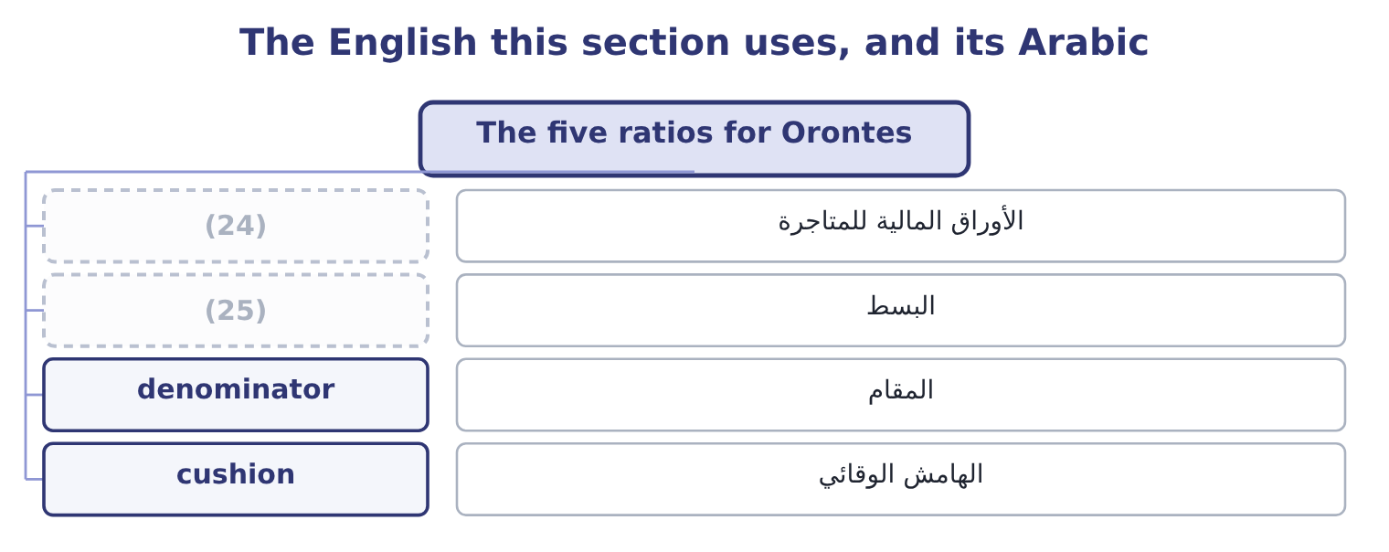
word list
trading securities · numerator · quick assets

The English this sheet uses, and its Arabic
English (exam term) | Arabic
trading securities | الأوراق المالية للمتاجرة
numerator | البسط
denominator | المقام
cushion | الهامش الوقائي

Answer key · 6.2 The five ratios for Orontes

1 calculated | 14 entire
2 published | 15 everything
3 Quick (acid-test) ratio | 16 giving
4 Cash flow ratio | 17 denominator
5 arithmetic | 18 numerator
6 seeing | 19 before
7 sharply | 20 exceeds
8 reason | 21 something
9 corroboration | 22 0.94
10 numerators | 23 0.09
11 underlying | 24 trading securities
12 striking | 25 numerator
13 Orontes

the summaries in full
Summary 1 The 2024 cash flow ratio cannot be calculated, because Part 1 published one statement of cash flows.
Summary 2 The arithmetic behind each is worth seeing once. The current ratio is 14,188,100 ÷ 4,280,000 = 3.31 for 2025, and 8,380,000 ÷ 3,570,000 = 2.35 for 2024. Quick assets for 2025 are cash of $7,302,100, trading securities of $42,000 and net receivables of $4,144,000: 7,302,100 + 42,000 = 7,344,100, and 7,344,100 + 4,144,000 = 11,488,100. The quick ratio is 11,488,100 ÷ 4,280,000 = 2.68. The cash ratio uses only the first two: 7,344,100 ÷ 4,280,000 = 1.72. The cash flow ratio is operating cash flow over current liabilities: 7,531,100 ÷ 4,280,000 = 1.76. Net working capital is 14,188,100 − 4,280,000 = 9,908,100, and the net working capital ratio is 9,908,100 ÷ 31,672,600 = 0.313. Every one of the five rose sharply, and every one of them rose for the same reason: the $5,202,100 of cash that,531,100. This is what corroboration looks.
Summary 3 Five ratios computed from four different numerators all move together, because one underlying fact moved. The cash ratio is the striking one. At 1.72, Orontes holds more cash and marketable securities than its entire current liabilities. It could settle everything it owes within a year, today, out of the bank account, and have $3,064,100 left over: 7,344,100 − 4,280,000 = 3,064,100. Very few manufacturers are in that position.
Summary 4 Quick assets: cash $7,302,100 plus trading securities $42,000 plus receivables $4,144,000, giving $11,488,100. Cash and securities alone: $7,344,100. Operating cash flow: $7,531,100. One denominator for four of them. Total current liabilities $4,280,000. And the fifth uses total assets: 9,908,100 ÷ 31,672,600 = 0.313. The ratios must fall in order: current ≥ quick ≥ cash, because each numerator is a subset of the one before. If your quick ratio ever exceeds your current ratio, you have included something you should not have.

6.3 Reading the five together
Chapter 6 · section 6.3

Fill every gap. Each word list holds one word more than there are gaps.
Summary 1 gaps 1–12
No single liquidity ratio is (1) , and the exam sets questions in which two of the five point in different (2) . When that happens, the (3) between them is itself the (4) . A high current ratio with a low quick ratio means the current assets are mostly inventory. That is the (5) position: Barada's inventory is 34 per cent of its total assets, so its current ratio (6) and its quick ratio tells the truth. A (7) financing a (8) stock build will look at the quick ratio and at how fast the stock moves, which is. A high quick ratio with a low cash ratio means the quick assets are mostly receivables. That is a company whose liquidity depends on its (9) paying, and the ageing (10) matters more than the ratio. A (11) current ratio with a weak cash flow ratio means the company holds enough but is not (12) .
word list
lender · seasonal · difference · generating · healthy · schedule · sufficient · distributor's · happens · flatters · directions · finding · customers

Summary 2 gaps 13–16
The fourth row is (13) . All five ratios rose (14) , the cash flow ratio at 1.76 confirms that the stock is being (15) by trading rather than by borrowing, and the (16) question is no longer whether the company can pay but what it should do with the surplus.
word list
whether · analytical · replenished · Orontes · together

Higher is not always better

Summary 3 gaps 17–21
A current ratio that keeps rising can mean (17) receivables or unsold stock. Look at what the (18) is made. A very high cash ratio is idle money. The exam treats cash (19) nothing as a cost. A ratio below 1.0 is not (20) a failure. A company with fast inventory (21) and slow payables can operate below 1.0 for years.
word list
numerator · earning · healthy · turnover · automatically · uncollected

The words this section uses
Each term sits against what it means, and an instance of it.
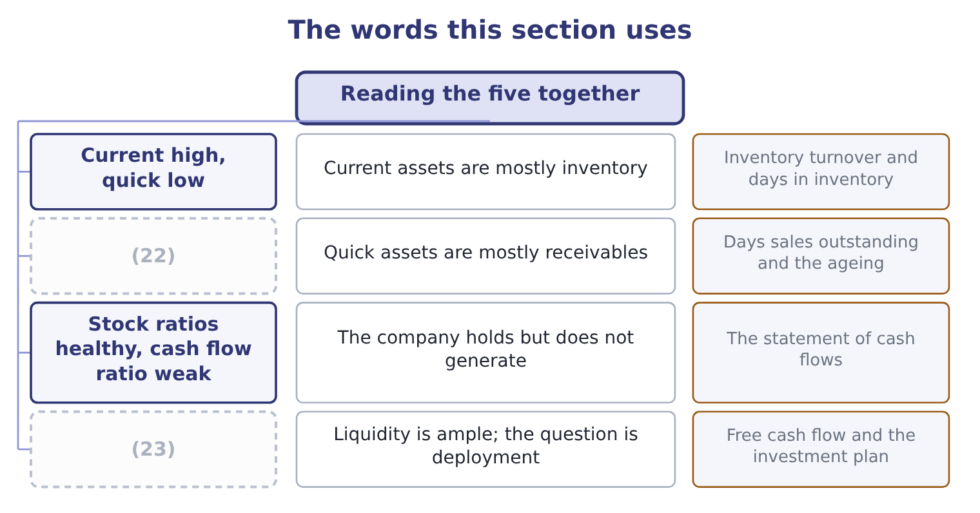
word list
Quick high, cash low · All five high and rising · Current assets are mostly inventory

The English this sheet uses, and its Arabic
English (exam term) | Arabic
ageing schedule | جدول أعمار الذمم
idle cash | النقد العاطل
seasonal | موسمي
deployment | توظيف الأموال

Answer key · 6.3 Reading the five together

1 sufficient | 13 Orontes
2 directions | 14 together
3 difference | 15 replenished
4 finding | 16 analytical
5 distributor's | 17 uncollected
6 flatters | 18 numerator
7 lender | 19 earning
8 seasonal | 20 automatically
9 customers | 21 turnover
10 schedule | 22 Quick high, cash low
11 healthy | 23 All five high and rising
12 generating

the summaries in full
Summary 1 No single liquidity ratio is sufficient, and the exam sets questions in which two of the five point in different directions. When that happens, the difference between them is itself the finding. A high current ratio with a low quick ratio means the current assets are mostly inventory. That is the distributor's position: Barada's inventory is 34 per cent of its total assets, so its current ratio flatters and its quick ratio tells the truth. A lender financing a seasonal stock build will look at the quick ratio and at how fast the stock moves, which is. A high quick ratio with a low cash ratio means the quick assets are mostly receivables. That is a company whose liquidity depends on its customers paying, and the ageing schedule matters more than the ratio. A healthy current ratio with a weak cash flow ratio means the company holds enough but is not generating.
Summary 2 The fourth row is Orontes. All five ratios rose together, the cash flow ratio at 1.76 confirms that the stock is being replenished by trading rather than by borrowing, and the analytical question is no longer whether the company can pay but what it should do with the surplus.
Summary 3 A current ratio that keeps rising can mean uncollected receivables or unsold stock. Look at what the numerator is made. A very high cash ratio is idle money. The exam treats cash earning nothing as a cost. A ratio below 1.0 is not automatically a failure. A company with fast inventory turnover and slow payables can operate below 1.0 for years.

6.4 The liquidity of current liabilities
Chapter 6 · section 6.4

Fill every gap. Each word list holds one word more than there are gaps.
Summary 1 gaps 1–5
The syllabus asks (1) for an understanding of the (2) of current liabilities, and the phrase repays attention. Current liabilities are not a single block (3) due at the same (4) . They differ in when they must be paid, in whether they must be paid in cash at all, and in whether the (5) can demand payment early.
word list
liquidity · moment · specifically · falling · decision · creditor

Orontes Foods, Inc. — current liabilities by how they will be settled
The bars are drawn to scale.
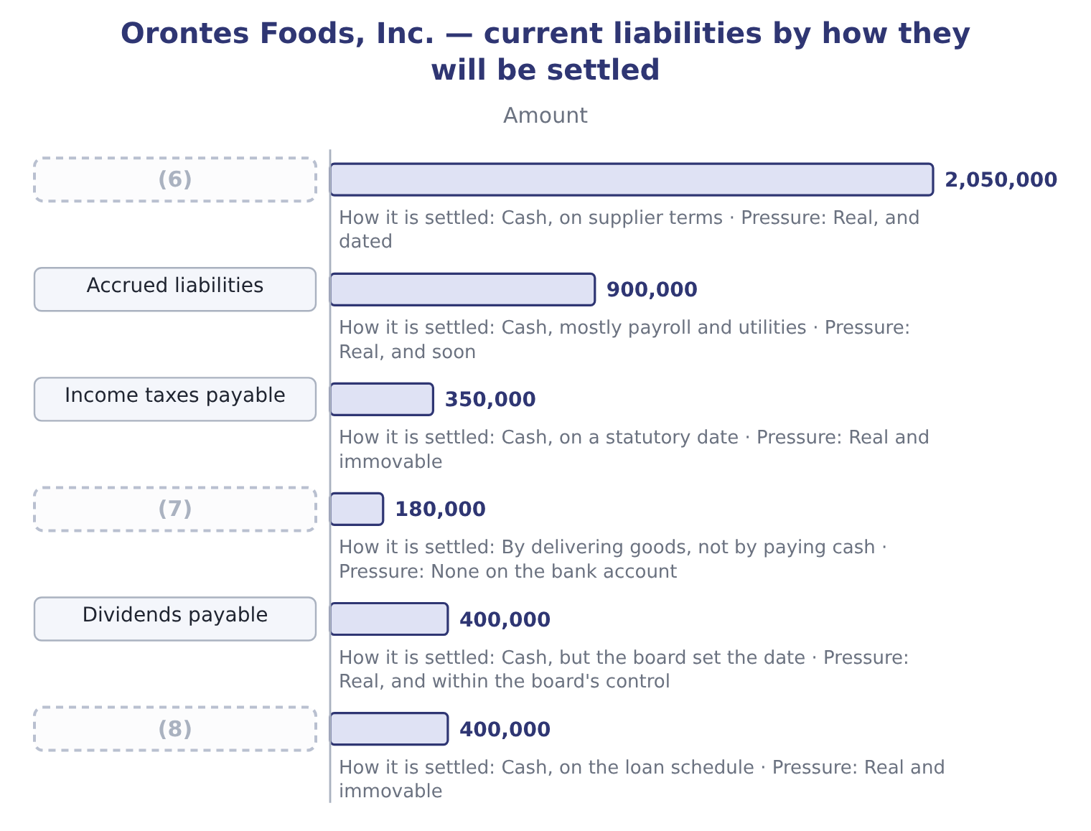
word list
Contract liabilities · Accounts payable · Current portion of long-term debt · marketable securities

Summary 2 gaps 9–20
Two of those lines behave quite (9) from the rest. Contract liabilities of $180,000 are what Part 1 (10) unearned revenue. They are (11) by shipping (12) , not by paying money. A ratio that counts them as a claim on cash (13) the pressure on the bank (14) . (15) payable of $400,000 are a real obligation, but the board declared them and chose the payment date. A company under pressure can, and does, defer the next (16) . Note what Orontes did: it declared $450,000 and paid only $50,000, (17) $400,000 on the (18) sheet at year end. That single (19) raised current liabilities by $400,000 and pushed the current ratio down from what it would (20) have been. Take both out and the picture changes: 4,280,000 − 180,000 = 4,100,000 of liabilities requiring cash, and 4,100,000 − 400,000 = 3,700,000 of liabilities requiring cash on a date Orontes does not control.
word list
overstates · discharged · leaving · Dividends · Deferred · otherwise · balance · tahini · account · declaration · called · decision · differently

Summary 3 gaps 21–24
Against cash and (21) of $7,344,100 that is a cash ratio on the (22) base of 7,344,100 ÷ 3,700,000 = 1.98. Nobody (23) that ratio and the exam will not ask for it by name. The point is the reasoning: the (24) is a classification, and a classification can be interrogated.
word list
denominator · stricter · declaration · securities · publishes

Not every current liability wants cash

Summary 4 gaps 25–29
Contract liabilities and unearned revenue are settled by (25) . Deferred tax is not a current liability at all; all deferred taxes are (26) . Debt (27) on demand is current (28) the lender's (29) , which is a rule you met in Part 1 and which cuts the other way: it adds pressure the ratio should show.
word list
noncurrent · decision · callable · performance · intentions · whatever

"Current" is a classification, not a fact

Summary 5 gaps 30–33
English current liability is a (30) classification: a label the (31) attach. The label does not say the money leaves (32) ; it says the obligation is expected to be settled within a year or the (33) cycle. Candidates lose marks by reading the label as a statement about timing within the year.
word list
cushion · operating · tomorrow · standards · defined

The English this section uses, and its Arabic
Each term sits against what it means.
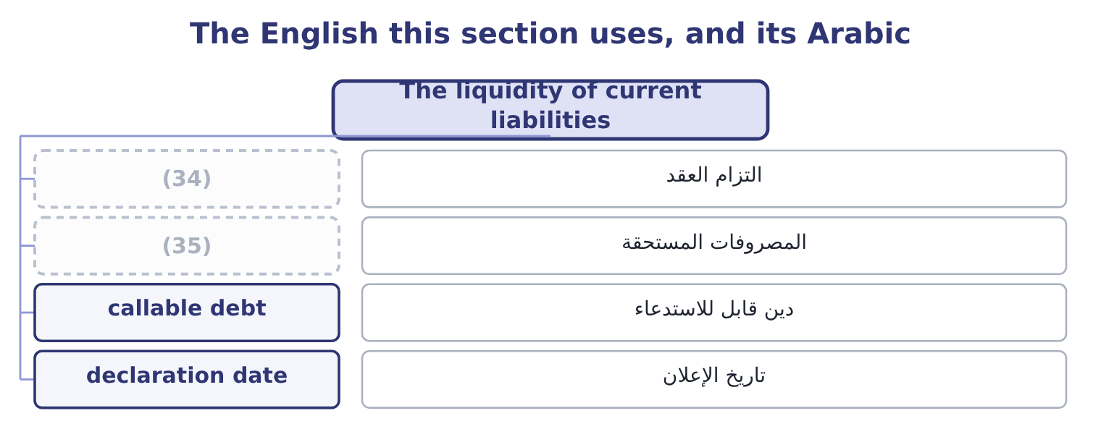
word list
quick assets · contract liability · accrued liabilities

The English this sheet uses, and its Arabic
English (exam term) | Arabic
contract liability | التزام العقد
accrued liabilities | المصروفات المستحقة
callable debt | دين قابل للاستدعاء
declaration date | تاريخ الإعلان

Answer key · 6.4 The liquidity of current liabilities

1 specifically | 19 decision
2 liquidity | 20 otherwise
3 falling | 21 securities
4 moment | 22 stricter
5 creditor | 23 publishes
6 Accounts payable | 24 denominator
7 Contract liabilities | 25 performance
8 Current portion of long-term debt | 26 noncurrent
9 differently | 27 callable
10 called | 28 whatever
11 discharged | 29 intentions
12 tahini | 30 defined
13 overstates | 31 standards
14 account | 32 tomorrow
15 Dividends | 33 operating
16 declaration | 34 contract liability
17 leaving | 35 accrued liabilities
18 balance

the summaries in full
Summary 1 The syllabus asks specifically for an understanding of the liquidity of current liabilities, and the phrase repays attention. Current liabilities are not a single block falling due at the same moment. They differ in when they must be paid, in whether they must be paid in cash at all, and in whether the creditor can demand payment early.
Summary 2 Two of those lines behave quite differently from the rest. Contract liabilities of $180,000 are what Part 1 called unearned revenue. They are discharged by shipping tahini, not by paying money. A ratio that counts them as a claim on cash overstates the pressure on the bank account. Dividends payable of $400,000 are a real obligation, but the board declared them and chose the payment date. A company under pressure can, and does, defer the next declaration. Note what Orontes did: it declared $450,000 and paid only $50,000, leaving $400,000 on the balance sheet at year end. That single decision raised current liabilities by $400,000 and pushed the current ratio down from what it would otherwise have been. Take both out and the picture changes: 4,280,000 − 180,000 = 4,100,000 of liabilities requiring cash, and 4,100,000 − 400,000 = 3,700,000 of liabilities requiring cash on a date Orontes does not control.
Summary 3 Against cash and securities of $7,344,100 that is a cash ratio on the stricter base of 7,344,100 ÷ 3,700,000 = 1.98. Nobody publishes that ratio and the exam will not ask for it by name. The point is the reasoning: the denominator is a classification, and a classification can be interrogated.
Summary 4 Contract liabilities and unearned revenue are settled by performance. Deferred tax is not a current liability at all; all deferred taxes are noncurrent. Debt callable on demand is current whatever the lender's intentions, which is a rule you met in Part 1 and which cuts the other way: it adds pressure the ratio should show.
Summary 5 English current liability is a defined classification: a label the standards attach. The label does not say the money leaves tomorrow; it says the obligation is expected to be settled within a year or the operating cycle. Candidates lose marks by reading the label as a statement about timing within the year.

6.5 What a liquidity ratio will not tell you
Chapter 6 · section 6.5

Fill every gap. Each word list holds one word more than there are gaps.
Summary 1 gaps 1–12
Four limits, all (1) . A ratio is a photograph of one day. A company can (2) its affairs so that the photograph (3) : paying down a payable just before the year end with cash it (4) re-borrows, or (5) a purchase. This is window dressing, and the clue is a ratio that moves (6) at the year end and reverts. A ratio says nothing about the quality of the assets (7) . (8) that will not be (9) and inventory that will not sell are both inside the current ratio at full value until someone writes them down. Part 1 taught you the (10) rules. A ratio says nothing about undrawn credit. A company with a current ratio of 1.0 and a (11) and unused facility of $5,000,000 is in a (12) position than one with a ratio of 2.0 and no facility.
word list
Receivables · examinable · counted · stronger · immediately · flatters · sharply · delaying · arrange · committed · write-down · current · collected

Summary 2 gaps 13–16
The facility is (13) in the notes, not in the ratio. A ratio says nothing about the operating cycle (14) it. A (15) collects in cash and pays its suppliers in sixty days; it runs a current ratio below 1.0 (16) and is never short.
word list
permanently · supermarket · disclosed · dressing · behind

Four limits of a liquidity ratio
Limit | The clue | Where it is resolved
One day only; window dressing is possible | (17) | Interim statements; the cash flow statement
Asset quality is assumed | A rising ratio with a rising ageing | (18)
Undrawn credit is invisible | The notes on borrowings | (19)
The operating cycle is ignored | (20) | Chapter 12, the cash cycle

word list
Chapter 17, earnings quality · A sharp year-end movement that reverts · Chapter 12, the cash cycle · An industry that always runs below 1.0 · The commitments note

The English this section uses, and its Arabic
Each term sits against what it means.
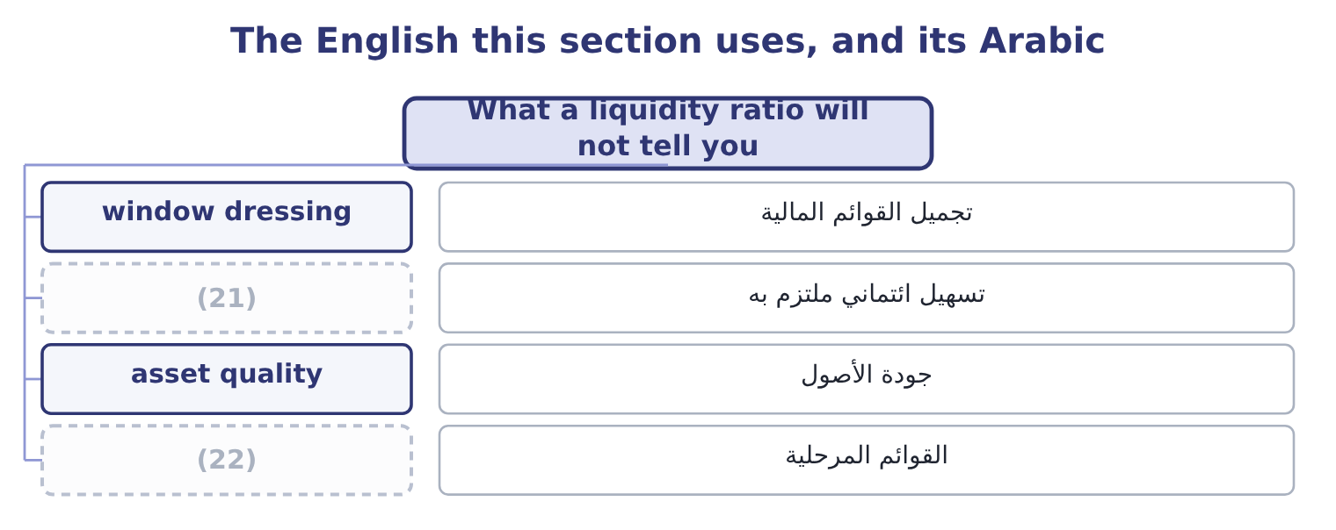
word list
interim statements · committed facility · asset quality

The English this sheet uses, and its Arabic
English (exam term) | Arabic
window dressing | تجميل القوائم المالية
committed facility | تسهيل ائتماني ملتزم به
asset quality | جودة الأصول
interim statements | القوائم المرحلية

Answer key · 6.5 What a liquidity ratio will not tell you

1 examinable | 12 stronger
2 arrange | 13 disclosed
3 flatters | 14 behind
4 immediately | 15 supermarket
5 delaying | 16 permanently
6 sharply | 17 A sharp year-end movement that reverts
7 counted | 18 Chapter 17, earnings quality
8 Receivables | 19 The commitments note
9 collected | 20 An industry that always runs below 1.0
10 write-down | 21 committed facility
11 committed | 22 interim statements

the summaries in full
Summary 1 Four limits, all examinable. A ratio is a photograph of one day. A company can arrange its affairs so that the photograph flatters: paying down a payable just before the year end with cash it immediately re-borrows, or delaying a purchase. This is window dressing, and the clue is a ratio that moves sharply at the year end and reverts. A ratio says nothing about the quality of the assets counted. Receivables that will not be collected and inventory that will not sell are both inside the current ratio at full value until someone writes them down. Part 1 taught you the write-down rules. A ratio says nothing about undrawn credit. A company with a current ratio of 1.0 and a committed and unused facility of $5,000,000 is in a stronger position than one with a ratio of 2.0 and no facility.
Summary 2 The facility is disclosed in the notes, not in the ratio. A ratio says nothing about the operating cycle behind it. A supermarket collects in cash and pays its suppliers in sixty days; it runs a current ratio below 1.0 permanently and is never short.

7.1 The rule for an equal change
Chapter 7 · section 7.1

Fill every gap. Each word list holds one word more than there are gaps.
Chapter 7, section by section
Each stage leads to the next.
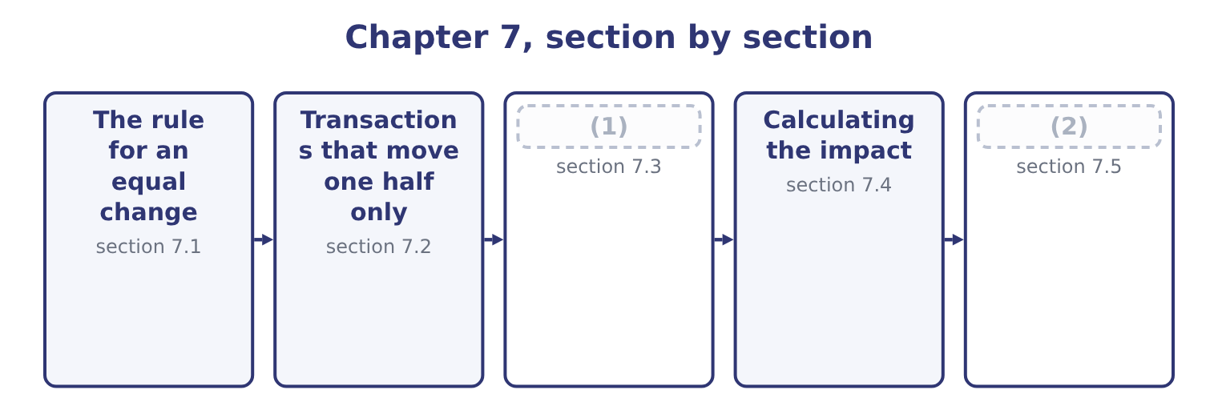
word list
The effect of unit sales · Using the method honestly · allowance for credit losses

Summary 1 gaps 3–8
Take a ratio of a over b, and add the same amount d to both. If a is (3) than b, the ratio is above 1, and adding d to both moves it towards 1, which means it falls. If a is less than b, the ratio is below 1, and adding d to both moves it towards 1, which means it rises. (4) d from both does the (5) : it moves the ratio away from 1. That single rule (6) most of the exam's (7) about the current ratio, because the commonest (8) change current assets and current liabilities by the same amount.
word list
opposite · greater · answers · transactions · Subtracting · liabilities · questions

An equal change in both halves
Starting ratio | Add the same amount to both | Subtract the same amount from both
Above 1.0 | Falls, towards 1.0 | (9)
Exactly 1.0 | No change | No change
Below 1.0 | (10) | Falls, away from 1.0

word list
allowance for credit losses · Rises, towards 1.0 · Rises, away from 1.0

Summary 2 gaps 11–14
Orontes's current ratio is 3.31, which is above 1. So buying (11) on credit, which adds the same amount to current assets and current liabilities, (12) Orontes's current ratio. Paying a supplier, which (13) the same amount from both, raises it. A company with a current ratio of 0.80 would see exactly the (14) .
word list
towards · lowers · subtracts · inventory · reverse

Direction depends on where you start

Summary 3 gaps 15–20
Never (15) "the current ratio rises when you pay a payable" (16) knowing whether the ratio is above or below 1. A transaction that leaves both halves unchanged leaves the ratio unchanged, (17) large the amounts: (18) a receivable in cash moves money inside current assets. Working capital — the (19) , not the ratio — is unchanged by an equal change in both, and (20) by a transaction that touches only one.
word list
collecting · difference · accounts · without · changed · however · answer

Worked example: paying a supplier

Summary 4 gaps 21–24
Current assets $14,188,100 and current liabilities $4,280,000, so the current ratio is 14,188,100 ÷ 4,280,000 = 3.31. Pay $500,000 of (21) payable in cash. Both halves fall by $500,000: 14,188,100 − 500,000 = 13,688,100 and 4,280,000 − 500,000 = 3,780,000. Working capital is unchanged: it was 14,188,100 − 4,280,000 = 9,908,100 and it is now 13,688,100 − 3,780,000 = 9,908,100. The company is no (22) off; the ratio (23) moved away from 1 because both halves (24) .
word list
accounts · transactions · simply · shrank · better

The English this section uses, and its Arabic
Each term sits against what it means.
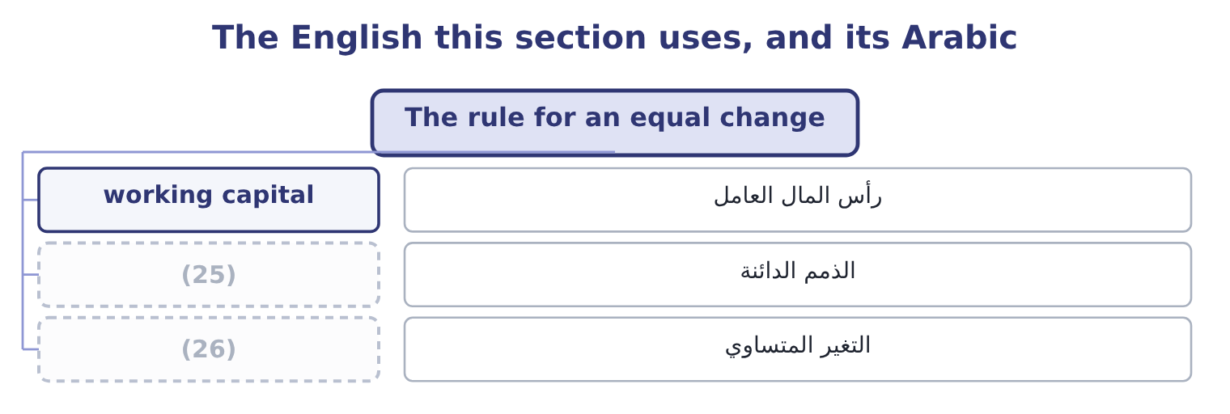
word list
الذمم الدائنة · equal change · accounts payable

The English this sheet uses, and its Arabic
English (exam term) | Arabic
working capital | رأس المال العامل
accounts payable | الذمم الدائنة
equal change | التغير المتساوي

Answer key · 7.1 The rule for an equal change

1 The effect of unit sales | 14 reverse
2 Using the method honestly | 15 answer
3 greater | 16 without
4 Subtracting | 17 however
5 opposite | 18 collecting
6 answers | 19 difference
7 questions | 20 changed
8 transactions | 21 accounts
9 Rises, away from 1.0 | 22 better
10 Rises, towards 1.0 | 23 simply
11 inventory | 24 shrank
12 lowers | 25 accounts payable
13 subtracts | 26 equal change

the summaries in full
Summary 1 Take a ratio of a over b, and add the same amount d to both. If a is greater than b, the ratio is above 1, and adding d to both moves it towards 1, which means it falls. If a is less than b, the ratio is below 1, and adding d to both moves it towards 1, which means it rises. Subtracting d from both does the opposite: it moves the ratio away from 1. That single rule answers most of the exam's questions about the current ratio, because the commonest transactions change current assets and current liabilities by the same amount.
Summary 2 Orontes's current ratio is 3.31, which is above 1. So buying inventory on credit, which adds the same amount to current assets and current liabilities, lowers Orontes's current ratio. Paying a supplier, which subtracts the same amount from both, raises it. A company with a current ratio of 0.80 would see exactly the reverse.
Summary 3 Never answer "the current ratio rises when you pay a payable" without knowing whether the ratio is above or below 1. A transaction that leaves both halves unchanged leaves the ratio unchanged, however large the amounts: collecting a receivable in cash moves money inside current assets. Working capital — the difference, not the ratio — is unchanged by an equal change in both, and changed by a transaction that touches only one.
Summary 4 Current assets $14,188,100 and current liabilities $4,280,000, so the current ratio is 14,188,100 ÷ 4,280,000 = 3.31. Pay $500,000 of accounts payable in cash. Both halves fall by $500,000: 14,188,100 − 500,000 = 13,688,100 and 4,280,000 − 500,000 = 3,780,000. Working capital is unchanged: it was 14,188,100 − 4,280,000 = 9,908,100 and it is now 13,688,100 − 3,780,000 = 9,908,100. The company is no better off; the ratio simply moved away from 1 because both halves shrank.

7.2 Transactions that move one half only
Chapter 7 · section 7.2

Fill every gap. Each word list holds one word more than there are gaps.
Summary 1 gaps 1–12
The other family of (1) touches one half of the fraction and not the other, and those always move the ratio in the obvious (2) . (3) shares for cash adds to current assets and nothing to current liabilities: every liquidity ratio rises and working capital rises by the full amount. Buying (4) for cash subtracts from current assets and (5) current liabilities alone: every ratio falls. The company is not weaker in any deep sense — it (6) cash for a (7) — but it is less liquid, and that is what the ratios are for. Borrowing (8) adds cash and adds a (9) liability: the liquidity ratios rise. Borrowing (10) adds cash and adds a current liability, which is the (11) case. Writing off a bad debt reduces (12) and reduces the allowance, so the net receivable does not move at all. This one catches candidates every time: the write-off was already provided for, so nothing in any ratio changes.
word list
leaves · machine · equipment · long-term · direction · short-term · Borrowing · receivables · swapped · Issuing · equal-change · noncurrent · transactions

Effect of common transactions, current ratio above 1.0
Every item belongs to exactly one group.
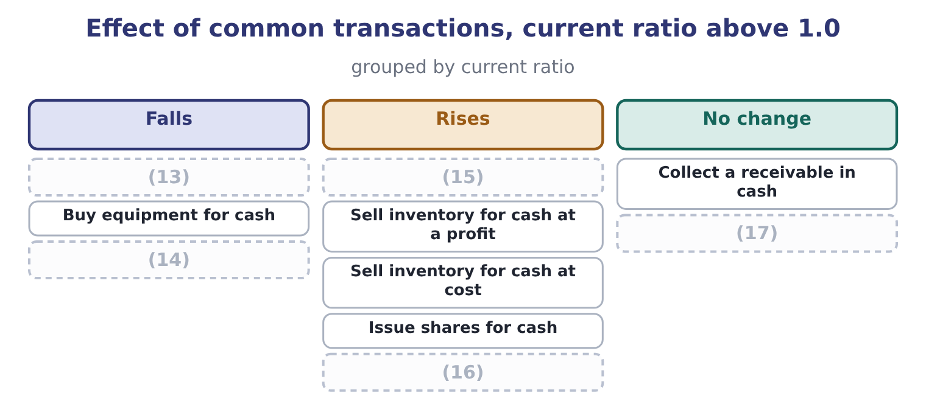
word list
Collect a receivable in cash · Write off a bad debt, fully provided · Buy inventory on credit · Borrow long-term for cash · Declare a dividend, unpaid · Pay a supplier in cash

Summary 2 gaps 18–29
Three rows in that figure (18) a second look. Paying a (19) raises the current ratio and lowers the cash ratio. The cash (20) numerator is cash and (21) only, so it loses the whole payment while the (22) loses the same amount; starting from 1.72, which is above 1, the (23) from both should raise it — but the numerator falls by the full $500,000 while it is smaller than the (24) numerator, so the effect is (25) . Work it: 7,344,100 − 500,000 = 6,844,100 over 3,780,000 is 1.81. The figure says "falls" for a company whose cash ratio is below 1, which is the (26) case, and that is why the row is worth (27) against your own starting point rather than (28) . Selling (29) at a profit raises working capital; selling it at cost does not.
word list
checking · supplier · inventory · ordinary · Selling · securities · reward · ratio's · denominator · subtraction · memorised · different · current-asset

Summary 3 gaps 30–33
Current assets rise by the profit in the first case and (30) change form in the second. Declaring a dividend lowers every ratio even though no money has moved, (31) a current liability (32) . (33) did exactly this with $400,000 at the end of 2025.
word list
checking · because · Orontes · appears · merely

The three that catch people

Summary 4 gaps 34–36
Writing off a fully provided bad debt changes nothing: the allowance already (34) the net receivable. Declaring a dividend changes the ratios (35) any cash moves. (36) a receivable changes the cash ratio and not the current or quick ratio.
word list
ratio's · Collecting · reduced · before

The English this section uses, and its Arabic
Each term sits against what it means.
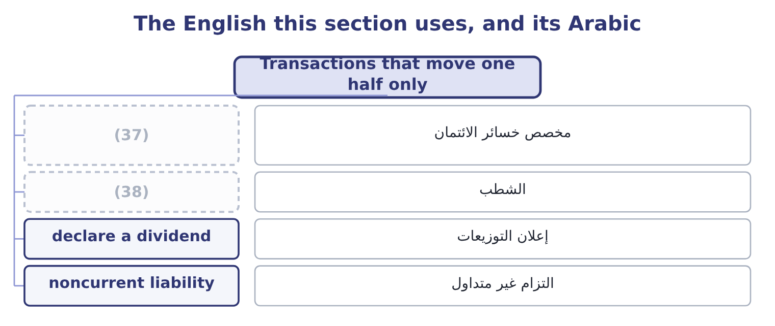
word list
numerator effect · allowance for credit losses · write-off

The English this sheet uses, and its Arabic
English (exam term) | Arabic
allowance for credit losses | مخصص خسائر الائتمان
write-off | الشطب
declare a dividend | إعلان التوزيعات
noncurrent liability | التزام غير متداول

Answer key · 7.2 Transactions that move one half only

1 transactions | 20 ratio's
2 direction | 21 securities
3 Issuing | 22 denominator
4 equipment | 23 subtraction
5 leaves | 24 current-asset
6 swapped | 25 different
7 machine | 26 ordinary
8 long-term | 27 checking
9 noncurrent | 28 memorised
10 short-term | 29 inventory
11 equal-change | 30 merely
12 receivables | 31 because
13 Buy inventory on credit | 32 appears
14 Declare a dividend, unpaid | 33 Orontes
15 Pay a supplier in cash | 34 reduced
16 Borrow long-term for cash | 35 before
17 Write off a bad debt, fully provided | 36 Collecting
18 reward | 37 allowance for credit losses
19 supplier | 38 write-off

the summaries in full
Summary 1 The other family of transactions touches one half of the fraction and not the other, and those always move the ratio in the obvious direction. Issuing shares for cash adds to current assets and nothing to current liabilities: every liquidity ratio rises and working capital rises by the full amount. Buying equipment for cash subtracts from current assets and leaves current liabilities alone: every ratio falls. The company is not weaker in any deep sense — it swapped cash for a machine — but it is less liquid, and that is what the ratios are for. Borrowing long-term adds cash and adds a noncurrent liability: the liquidity ratios rise. Borrowing short-term adds cash and adds a current liability, which is the equal-change case. Writing off a bad debt reduces receivables and reduces the allowance, so the net receivable does not move at all. This one catches candidates every time: the write-off was already provided for, so nothing in any ratio changes.
Summary 2 Three rows in that figure reward a second look. Paying a supplier raises the current ratio and lowers the cash ratio. The cash ratio's numerator is cash and securities only, so it loses the whole payment while the denominator loses the same amount; starting from 1.72, which is above 1, the subtraction from both should raise it — but the numerator falls by the full $500,000 while it is smaller than the current-asset numerator, so the effect is different. Work it: 7,344,100 − 500,000 = 6,844,100 over 3,780,000 is 1.81. The figure says "falls" for a company whose cash ratio is below 1, which is the ordinary case, and that is why the row is worth checking against your own starting point rather than memorised. Selling inventory at a profit raises working capital; selling it at cost does not.
Summary 3 Current assets rise by the profit in the first case and merely change form in the second. Declaring a dividend lowers every ratio even though no money has moved, because a current liability appears. Orontes did exactly this with $400,000 at the end of 2025.
Summary 4 Writing off a fully provided bad debt changes nothing: the allowance already reduced the net receivable. Declaring a dividend changes the ratios before any cash moves. Collecting a receivable changes the cash ratio and not the current or quick ratio.

7.3 The effect of unit sales
Chapter 7 · section 7.3

Fill every gap. Each word list holds one word more than there are gaps.
Summary 1 gaps 1–12
The (1) names unit sales alongside the (2) elements, and that is a (3) kind of movement. A change in (4) works through the (5) rather than (6) on one line. More units sold, on credit, at a profit. Inventory falls by the cost; receivables rise by the selling price. Current assets rise by the profit. The current ratio rises, the quick ratio rises more because the (7) gains the whole receivable and loses nothing, and the cash ratio does not move until the customer pays. More units sold, for cash, at a profit. The same, but the cash ratio rises too. Current assets are (8) in total if (9) continues — the money moves from cash into stock — so the current ratio holds while the quick ratio falls. That (10) is the early signal of the (11) leak of, and it appears in the quick ratio before it appears (12) else.
word list
numerator · unchanged · divergence · syllabus · anywhere · working-capital · different · statements · continues · balance-sheet · production · landing · volume

Summary 2 gaps 13–18
More units sold without any (13) in price, when the company must buy stock to supply them. Receivables and inventory both rise, payables rise to fund the stock, and cash falls because the (14) to the supplier comes before the (15) from the customer. A growing company can become less liquid (16) because it is growing, and a lender who (17) credit at that moment can end a sound (18) .
word list
refuses · increase · business · receivables · payment · receipt · precisely

One additional sale on credit, cost 60 and price 100
Every item belongs to exactly one group.
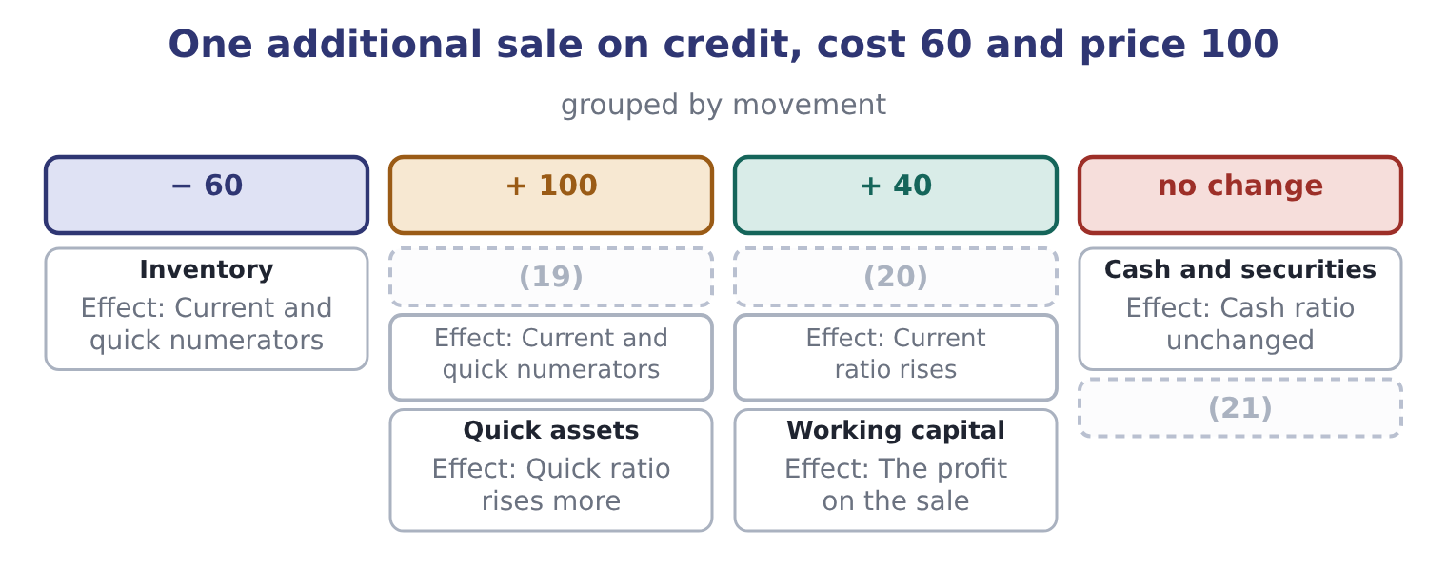
word list
Accounts receivable · Current assets · Current liabilities · accounts payable

Worked example: growth that consumes liquidity

Summary 3 gaps 22–25
Orontes wins a Gulf order and must hold an extra $800,000 of stock to supply it, bought on 30-day supplier terms, selling at $1,200,000 on 60-day customer terms. At the end of month one, the stock is bought and nothing is sold: inventory up $800,000 and payables up $800,000. Current assets 14,188,100 + 800,000 = 14,988,100 and current liabilities 4,280,000 + 800,000 = 5,080,000. The current ratio is 14,988,100 ÷ 5,080,000 = 2.95, down from 3.31. At the end of month two, the supplier is paid and the goods are sold on credit: cash down $800,000, inventory down $800,000, receivables up $1,200,000, payables down $800,000. Current assets are 14,988,100 − 1,600,000 = 13,388,100, plus the receivable of 1,200,000, (22) $14,588,100; current liabilities are back to $4,280,000. The ratio is 14,588,100 ÷ 4,280,000 = 3.41. The ratio fell to 2.95 and then (23) above where it began, because the sale was (24) . The dip is real and it is when the company needs its credit line. A lender reading only the (25) ratio sees none of this.
word list
giving · write-off · year-end · profitable · recovered

The English this section uses, and its Arabic
Each term sits against what it means.
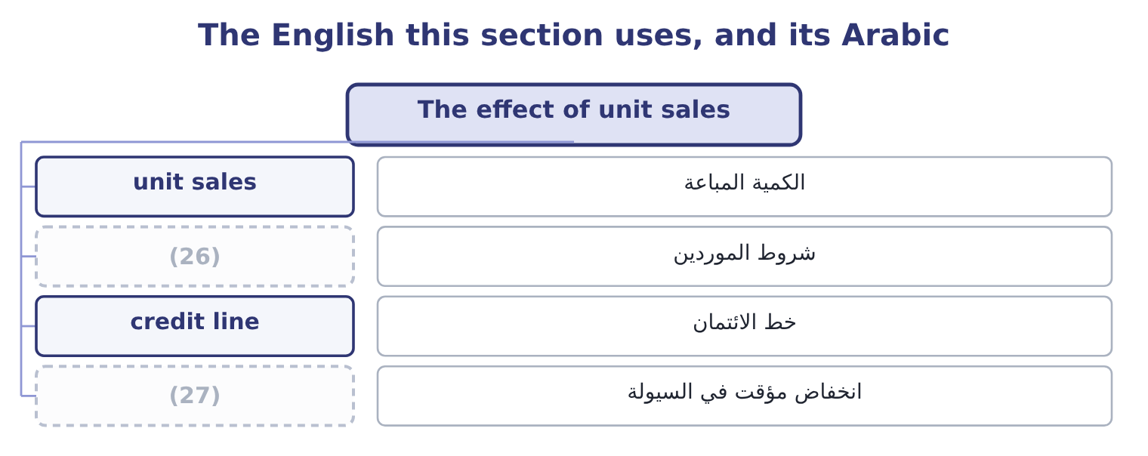
word list
working capital · liquidity dip · supplier terms

The English this sheet uses, and its Arabic
English (exam term) | Arabic
unit sales | الكمية المباعة
supplier terms | شروط الموردين
credit line | خط الائتمان
liquidity dip | انخفاض مؤقت في السيولة

Answer key · 7.3 The effect of unit sales

1 syllabus | 15 receipt
2 balance-sheet | 16 precisely
3 different | 17 refuses
4 volume | 18 business
5 statements | 19 Accounts receivable
6 landing | 20 Current assets
7 numerator | 21 Current liabilities
8 unchanged | 22 giving
9 production | 23 recovered
10 divergence | 24 profitable
11 working-capital | 25 year-end
12 anywhere | 26 supplier terms
13 increase | 27 liquidity dip
14 payment

the summaries in full
Summary 1 The syllabus names unit sales alongside the balance-sheet elements, and that is a different kind of movement. A change in volume works through the statements rather than landing on one line. More units sold, on credit, at a profit. Inventory falls by the cost; receivables rise by the selling price. Current assets rise by the profit. The current ratio rises, the quick ratio rises more because the numerator gains the whole receivable and loses nothing, and the cash ratio does not move until the customer pays. More units sold, for cash, at a profit. The same, but the cash ratio rises too. Current assets are unchanged in total if production continues — the money moves from cash into stock — so the current ratio holds while the quick ratio falls. That divergence is the early signal of the working-capital leak of, and it appears in the quick ratio before it appears anywhere else.
Summary 2 More units sold without any increase in price, when the company must buy stock to supply them. Receivables and inventory both rise, payables rise to fund the stock, and cash falls because the payment to the supplier comes before the receipt from the customer. A growing company can become less liquid precisely because it is growing, and a lender who refuses credit at that moment can end a sound business.
Summary 3 Orontes wins a Gulf order and must hold an extra $800,000 of stock to supply it, bought on 30-day supplier terms, selling at $1,200,000 on 60-day customer terms. At the end of month one, the stock is bought and nothing is sold: inventory up $800,000 and payables up $800,000. Current assets 14,188,100 + 800,000 = 14,988,100 and current liabilities 4,280,000 + 800,000 = 5,080,000. The current ratio is 14,988,100 ÷ 5,080,000 = 2.95, down from 3.31. At the end of month two, the supplier is paid and the goods are sold on credit: cash down $800,000, inventory down $800,000, receivables up $1,200,000, payables down $800,000. Current assets are 14,988,100 − 1,600,000 = 13,388,100, plus the receivable of 1,200,000, giving $14,588,100; current liabilities are back to $4,280,000. The ratio is 14,588,100 ÷ 4,280,000 = 3.41. The ratio fell to 2.95 and then recovered above where it began, because the sale was profitable. The dip is real and it is when the company needs its credit line. A lender reading only the year-end ratio sees none of this.

7.4 Calculating the impact
Chapter 7 · section 7.4

Fill every gap. Each word list holds one word more than there are gaps.
Summary 1 gaps 1–2
The exam asks for the (1) and not just the (2) , and the method is always the same three steps: restate the numerator, restate the denominator, divide.
word list
direction · without · impact

Four transactions

Summary 2 gaps 3–4
Orontes starts with current assets of $14,188,100, current (3) of $4,280,000 and a current ratio of 3.31. Compute the ratio after each one, taken (4) .
word list
current · separately · liabilities

Your turn: the current ratio after each transaction (complete the blanks)
Every item belongs to exactly one group.
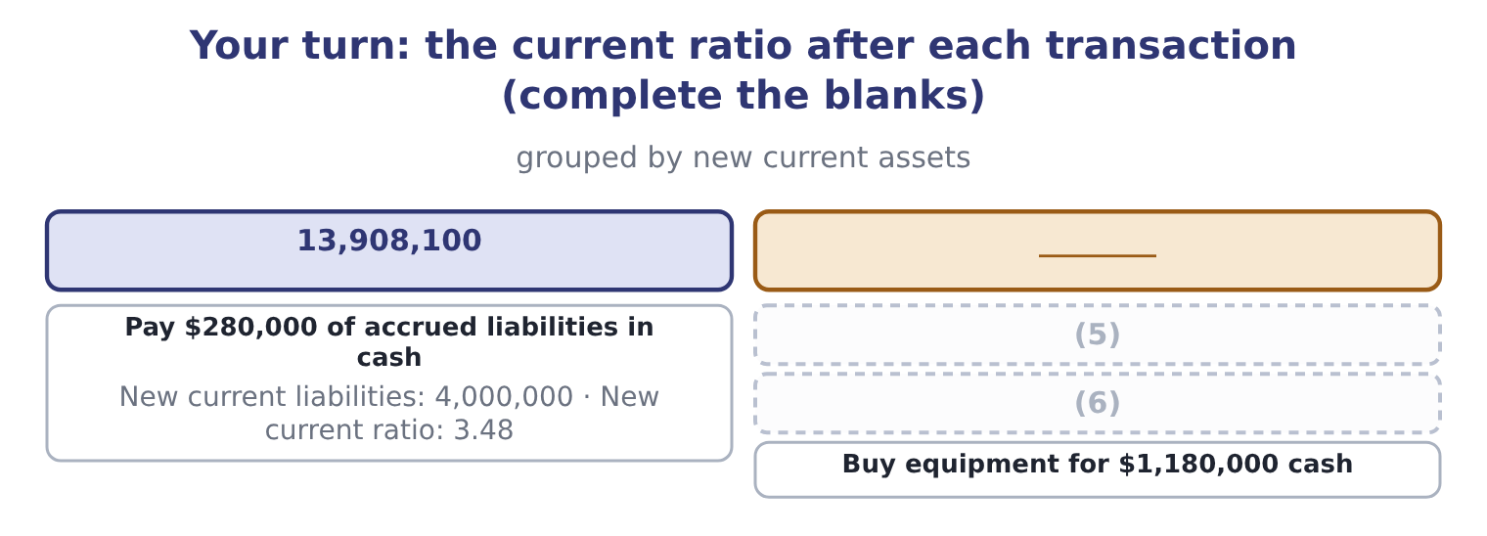
word list
Buy $720,000 of inventory on credit · Buy equipment for $1,180,000 cash · Issue shares for $1,000,000 cash

Summary 3 gaps 7–17
Two (7) are worth knowing. Where a (8) affects the quick ratio (9) from the current ratio, the exam usually wants both. Buying (10) on credit lowers the current ratio by adding to both halves, and lowers the quick ratio much more sharply, because the numerator does not gain (11) at all while the denominator grows. Where a (12) gives a target, work (13) . If Orontes wanted a current ratio of (14) 4.00 by paying down payables, the amount x (15) (14,188,100 − x) ÷ (4,280,000 − x) = 4.00. (16) out: 14,188,100 − x = 17,120,000 − 4x, so 3x = 2,931,900 and x = 977,300. Orontes would pay $977,300. The (17) is worth practising because the exam sets it regularly.
word list
inventory · satisfies · anything · backwards · exactly · regularly · refinements · transaction · arithmetic · Multiplying · differently · question

Working backwards to a target ratio

Summary 4 gaps 18–20
Set up the (18) with the unknown in both halves and solve; do not guess and check. Check the answer is (19) : you cannot pay down more payables than you have cash or than you owe. A target achieved by paying down payables is a target achieved without (20) the business.
word list
improving · write-off · possible · equation

The English this section uses, and its Arabic
Each term sits against what it means.
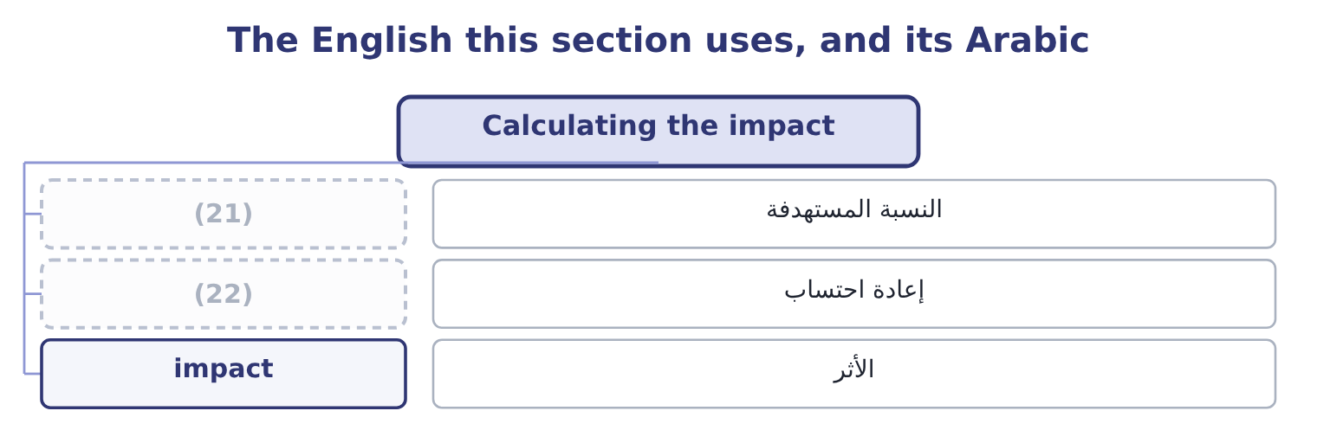
word list
liquidity dip · restate · target ratio

The English this sheet uses, and its Arabic
English (exam term) | Arabic
target ratio | النسبة المستهدفة
restate | إعادة احتساب
impact | الأثر

Answer key · 7.4 Calculating the impact

1 impact | 12 question
2 direction | 13 backwards
3 liabilities | 14 exactly
4 separately | 15 satisfies
5 Buy $720,000 of inventory on credit | 16 Multiplying
6 Issue shares for $1,000,000 cash | 17 arithmetic
7 refinements | 18 equation
8 transaction | 19 possible
9 differently | 20 improving
10 inventory | 21 target ratio
11 anything | 22 restate

the summaries in full
Summary 1 The exam asks for the impact and not just the direction, and the method is always the same three steps: restate the numerator, restate the denominator, divide.
Summary 2 Orontes starts with current assets of $14,188,100, current liabilities of $4,280,000 and a current ratio of 3.31. Compute the ratio after each one, taken separately.
Summary 3 Two refinements are worth knowing. Where a transaction affects the quick ratio differently from the current ratio, the exam usually wants both. Buying inventory on credit lowers the current ratio by adding to both halves, and lowers the quick ratio much more sharply, because the numerator does not gain anything at all while the denominator grows. Where a question gives a target, work backwards. If Orontes wanted a current ratio of exactly 4.00 by paying down payables, the amount x satisfies (14,188,100 − x) ÷ (4,280,000 − x) = 4.00. Multiplying out: 14,188,100 − x = 17,120,000 − 4x, so 3x = 2,931,900 and x = 977,300. Orontes would pay $977,300. The arithmetic is worth practising because the exam sets it regularly.
Summary 4 Set up the equation with the unknown in both halves and solve; do not guess and check. Check the answer is possible: you cannot pay down more payables than you have cash or than you owe. A target achieved by paying down payables is a target achieved without improving the business.

7.5 Using the method honestly
Chapter 7 · section 7.5

Fill every gap. Each word list holds one word more than there are gaps.
Summary 1 gaps 1–11
Paying down (1) just before the reporting date raises the current ratio of any company whose ratio is above 1, and leaves working capital (2) . (3) a purchase does the same. (4) a borrowing as noncurrent when a waiver was obtained after the reporting date is the Part 1 version of the same (5) . The (6) are three. Look at (7) dates, because a ratio that moves and (8) is suspect. Look at the cash flow ratio, which is a flow over the whole year and cannot be (9) on one day. And look at working capital in dollars beside the ratio, because the manoeuvres that move the ratio usually leave working capital exactly where it was — which is the (10) possible signal that nothing (11) .
word list
clearest · untouched · working-capital · manoeuvre · Classifying · Delaying · several · happened · arranged · reverts · defences · payables

Improving a ratio without improving the business
Every item belongs to exactly one group.
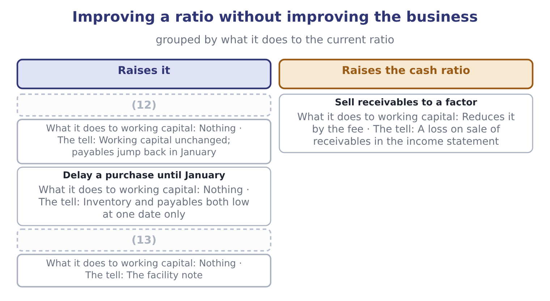
word list
Pay down payables at the year end · Delay a purchase until January · Draw less of a credit line at the year end

Summary 2 gaps 14–18
The last row is one Orontes (14) did: its income (15) carries a loss on sale of receivables of $15,000, which is the fee paid to Gulf Factor Co. The (16) turned receivables into cash, improved the cash ratio, and cost $15,000. (17) that was worth doing is a (18) question, and Book 2 answers it.
word list
Whether · actually · statement · impact · working-capital · transaction

Item — Answer
Item | Answer
Buy $720,000 of inventory on credit | (19)
Issue shares for $1,000,000 cash | 15,188,100 and 4,280,000, giving 3.55.
Buy equipment for $1,180,000 cash | (20)

word list
15,188,100 and 4,280,000, giving 3.55. · 14,908,100 and 5,000,000, giving 2.98. · 13,008,100 and 4,280,000, giving 3.04.

The English this section uses, and its Arabic
Each term sits against what it means.
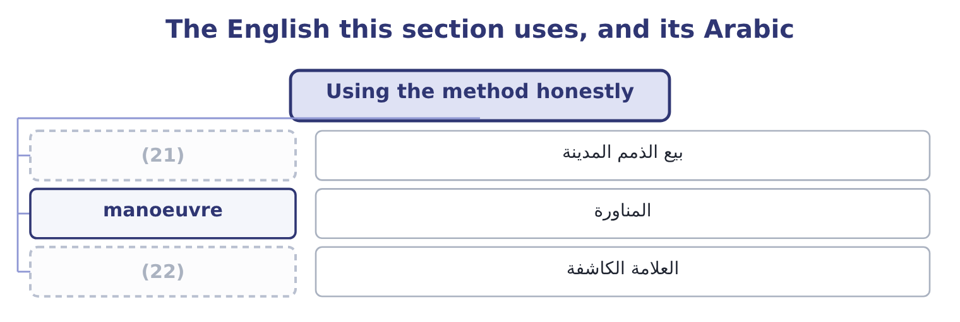
word list
write-off · tell · factoring

The English this sheet uses, and its Arabic
English (exam term) | Arabic
factoring | بيع الذمم المدينة
manoeuvre | المناورة
tell | العلامة الكاشفة

Answer key · 7.5 Using the method honestly

1 payables | 12 Pay down payables at the year end
2 untouched | 13 Draw less of a credit line at the year end
3 Delaying | 14 actually
4 Classifying | 15 statement
5 manoeuvre | 16 transaction
6 defences | 17 Whether
7 several | 18 working-capital
8 reverts | 19 14,908,100 and 5,000,000, giving 2.98.
9 arranged | 20 13,008,100 and 4,280,000, giving 3.04.
10 clearest | 21 factoring
11 happened | 22 tell

the summaries in full
Summary 1 Paying down payables just before the reporting date raises the current ratio of any company whose ratio is above 1, and leaves working capital untouched. Delaying a purchase does the same. Classifying a borrowing as noncurrent when a waiver was obtained after the reporting date is the Part 1 version of the same manoeuvre. The defences are three. Look at several dates, because a ratio that moves and reverts is suspect. Look at the cash flow ratio, which is a flow over the whole year and cannot be arranged on one day. And look at working capital in dollars beside the ratio, because the manoeuvres that move the ratio usually leave working capital exactly where it was — which is the clearest possible signal that nothing happened.
Summary 2 The last row is one Orontes actually did: its income statement carries a loss on sale of receivables of $15,000, which is the fee paid to Gulf Factor Co. The transaction turned receivables into cash, improved the cash ratio, and cost $15,000. Whether that was worth doing is a working-capital question, and Book 2 answers it.

8.1 Solvency against liquidity
Chapter 8 · section 8.1

Fill every gap. Each word list holds one word more than there are gaps.
Chapter 8, section by section
Each stage leads to the next.
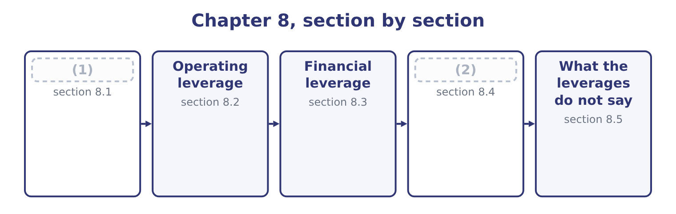
word list
The two together · Solvency against liquidity · debt service

Summary 1 gaps 3–14
Liquidity is about the next (3) months and about current assets (4) current liabilities. Solvency is about the whole (5) sheet and the whole life of the obligations. The two are (6) with different ratios and answer to different people. A (7) granting 30-day terms cares about liquidity. A (8) lending for ten years cares about solvency. Two (9) are worth naming because the exam sets them. A company sells assets, holds the (10) in cash, and still owes more than the business can ever earn. Its current ratio is (11) on the day the receiver is appointed. A company with no debt, (12) plant and a cash squeeze caused by one slow customer. It is in difficulty and it is not insolvent, and the remedy is a credit line rather than a (13) . Orontes is (14) both. Its liquidity ratios are.
word list
excellent · measured · comfortably · restructuring · proceeds · twelve · bondholder · asymmetry · combinations · balance · against · substantial · supplier

The two words are not interchangeable

Summary 2 gaps 15–19
A question about (15) debts "as they fall due" over the (16) year is liquidity. A question about the (17) to meet obligations over the long term, or about the debt-to-equity ratio, is solvency. (18) has a second, legal meaning — liabilities (19) assets — and the exam sometimes uses it. Read which is meant.
word list
meaning · ability · Insolvency · exceeding · coming · paying

Liquidity and solvency
 | Liquidity | Solvency
The question | Can the company pay what falls due soon? | (20)
The horizon | Up to one year, or the operating cycle | (21)
The ratios | (22) | Debt-to-equity, debt-to-assets, interest cover, fixed charge cover
Who asks | (23) | Bondholders, long-term lenders, shareholders
A failure looks like | (24) | Cannot service the debt; the business is worth less than it owes

word list
Cannot meet a payroll · Current, quick, cash, cash flow, net working capital · Can it meet all obligations over their lives? · Suppliers, short-term lenders · Up to one year, or the operating cycle · The life of the debt

The English this section uses, and its Arabic
Each term sits against what it means.
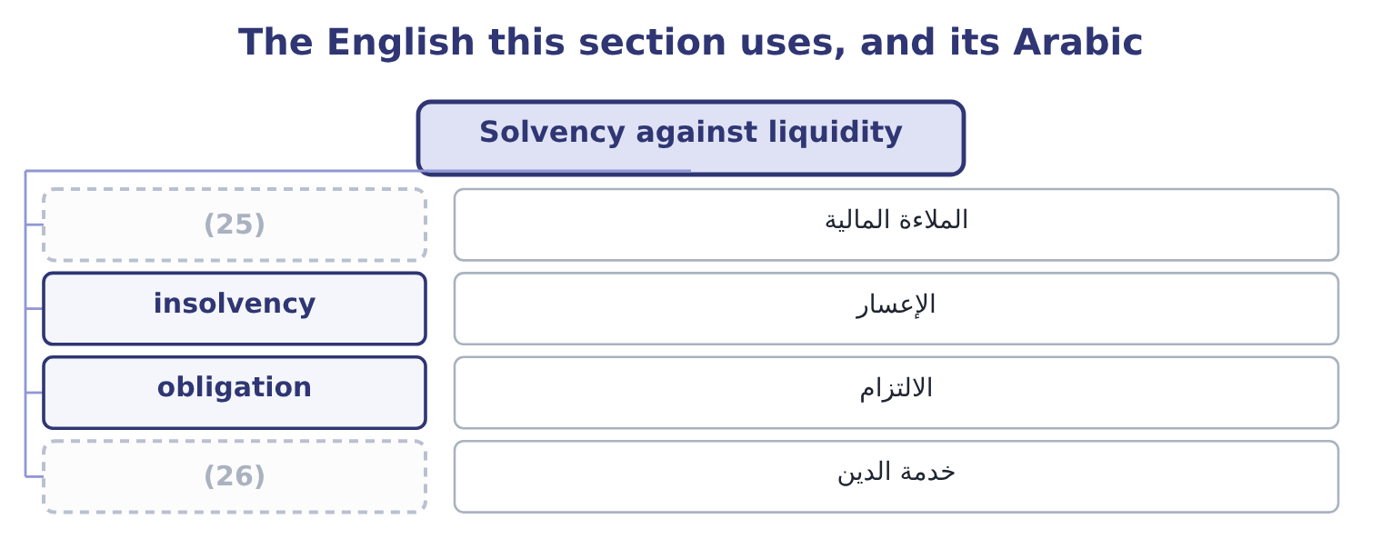
word list
debt service · combined leverage · solvency

The English this sheet uses, and its Arabic
English (exam term) | Arabic
solvency | الملاءة المالية
insolvency | الإعسار
obligation | الالتزام
debt service | خدمة الدين

Answer key · 8.1 Solvency against liquidity

1 Solvency against liquidity | 14 comfortably
2 The two together | 15 paying
3 twelve | 16 coming
4 against | 17 ability
5 balance | 18 Insolvency
6 measured | 19 exceeding
7 supplier | 20 Can it meet all obligations over their lives?
8 bondholder | 21 The life of the debt
9 combinations | 22 Current, quick, cash, cash flow, net working capital
10 proceeds | 23 Suppliers, short-term lenders
11 excellent | 24 Cannot meet a payroll
12 substantial | 25 solvency
13 restructuring | 26 debt service

the summaries in full
Summary 1 Liquidity is about the next twelve months and about current assets against current liabilities. Solvency is about the whole balance sheet and the whole life of the obligations. The two are measured with different ratios and answer to different people. A supplier granting 30-day terms cares about liquidity. A bondholder lending for ten years cares about solvency. Two combinations are worth naming because the exam sets them. A company sells assets, holds the proceeds in cash, and still owes more than the business can ever earn. Its current ratio is excellent on the day the receiver is appointed. A company with no debt, substantial plant and a cash squeeze caused by one slow customer. It is in difficulty and it is not insolvent, and the remedy is a credit line rather than a restructuring. Orontes is comfortably both. Its liquidity ratios are.
Summary 2 A question about paying debts "as they fall due" over the coming year is liquidity. A question about the ability to meet obligations over the long term, or about the debt-to-equity ratio, is solvency. Insolvency has a second, legal meaning — liabilities exceeding assets — and the exam sometimes uses it. Read which is meant.

8.2 Operating leverage
Chapter 8 · section 8.2

Fill every gap. Each word list holds one word more than there are gaps.
Summary 1 gaps 1–10
Operating leverage is the (1) of fixed operating costs on operating income. A company whose costs are mostly fixed sees its operating income swing far more than its sales; a company whose costs are mostly variable sees the two move (2) . The (3) is the degree of operating leverage, (4) DOL. It is the percentage change in operating income divided by the percentage change in sales, and at a given level of sales it can be computed (5) as the contribution margin divided by operating income. (6) total operating cost in 2025 was cost of goods sold of $27,300,000 plus operating (7) of $10,524,000, which is 27,300,000 + 10,524,000 = 37,824,000. Its cost (8) split that into variable costs of $25,200,000 and fixed costs of $12,624,000. Contribution margin is (9) 42,000,000 − 25,200,000 = 16,800,000, and operating income is 16,800,000 − 12,624,000 = 4,176,000, which is the figure on the income (10) . The degree of operating leverage is 16,800,000 ÷ 4,176,000 = 4.02.
word list
Orontes's · asymmetry · accountants · statement · directly · written · expenses · effect · therefore · measure · together

Worked example: what a DOL of 4.02 means

Summary 2 gaps 11–18
Read it as a multiplier. A 1 per cent change in sales produces a 4.02 per cent change in operating income, in the same (11) . Sales rise 10 per cent to $46,200,000. Variable costs rise 10 per cent to $27,720,000. Contribution is 46,200,000 − 27,720,000 = 18,480,000; fixed costs are (12) , so operating income is 18,480,000 − 12,624,000 = 5,856,000. The change is 5,856,000 − 4,176,000 = 1,680,000, which on 4,176,000 is 40.2 per cent — ten times 4.02, as (13) . Sales fall 10 per cent and operating income falls 40.2 per cent, to $2,496,000. The multiplier works both ways, and that is the risk. A company at this level of operating leverage loses a (14) of its operating income on a 6 per cent fall in sales. For Orontes the cause is (15) on the balance sheet: 46.7 per cent of its (16) are plant, and plant produces (17) whether or not (18) is sold.
word list
quarter · unchanged · structure · anything · direction · predicted · visible · assets · depreciation

Orontes operating income at three sales levels, DOL 4.02
The bars are drawn to scale.
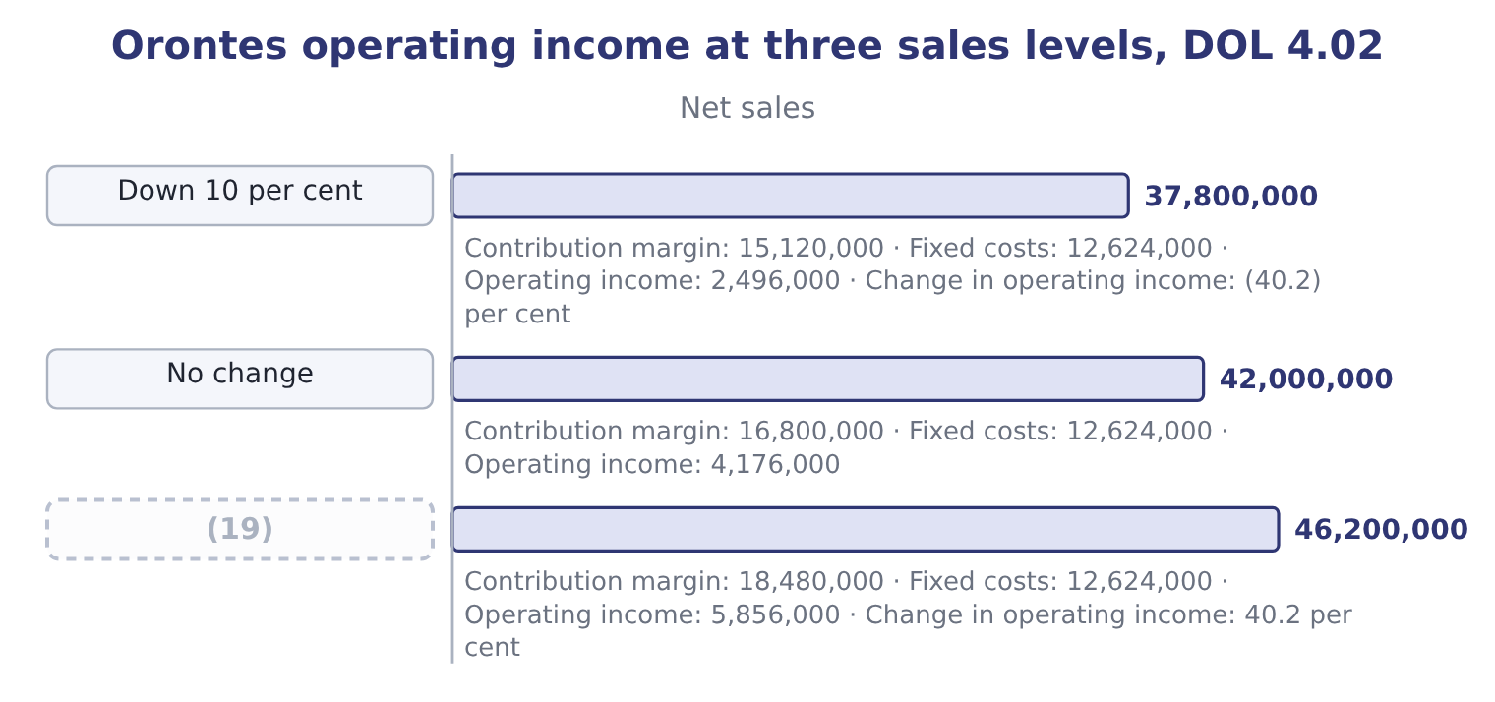
word list
Up 10 per cent · Down 10 per cent

DOL moves as sales move

Summary 3 gaps 20–25
The degree of operating leverage is computed at one level of sales and (20) as sales change. It is highest near (21) and falls as sales rise above it. DOL uses the contribution margin, not gross profit. Gross profit (22) all cost of goods sold, (23) the fixed part. A high DOL is not bad. It is a (24) of a cost structure, and it rewards growth exactly as much as it (25) decline.
word list
breakeven · description · including · deducts · produces · punishes · changes

The English this section uses, and its Arabic
Each term sits against what it means.
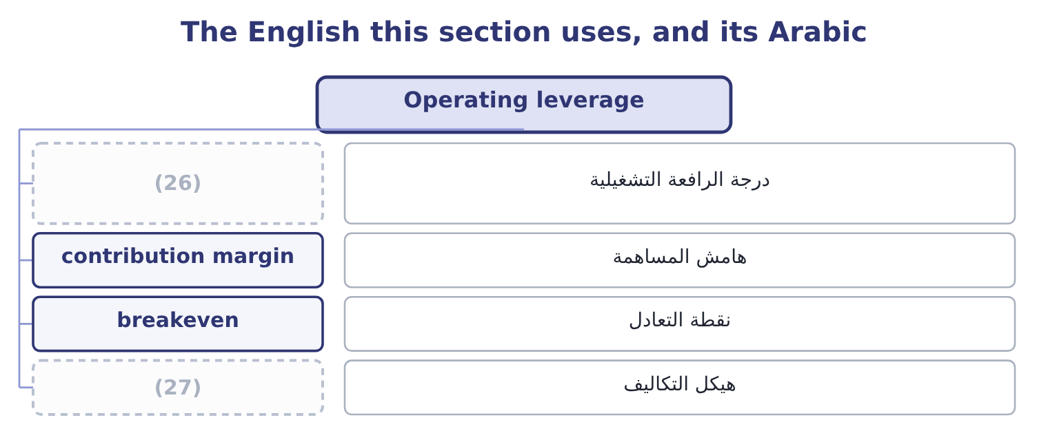
word list
step cost · degree of operating leverage · cost structure

The English this sheet uses, and its Arabic
English (exam term) | Arabic
degree of operating leverage | درجة الرافعة التشغيلية
contribution margin | هامش المساهمة
breakeven | نقطة التعادل
cost structure | هيكل التكاليف

Answer key · 8.2 Operating leverage

1 effect | 15 visible
2 together | 16 assets
3 measure | 17 depreciation
4 written | 18 anything
5 directly | 19 Up 10 per cent
6 Orontes's | 20 changes
7 expenses | 21 breakeven
8 accountants | 22 deducts
9 therefore | 23 including
10 statement | 24 description
11 direction | 25 punishes
12 unchanged | 26 degree of operating leverage
13 predicted | 27 cost structure
14 quarter

the summaries in full
Summary 1 Operating leverage is the effect of fixed operating costs on operating income. A company whose costs are mostly fixed sees its operating income swing far more than its sales; a company whose costs are mostly variable sees the two move together. The measure is the degree of operating leverage, written DOL. It is the percentage change in operating income divided by the percentage change in sales, and at a given level of sales it can be computed directly as the contribution margin divided by operating income. Orontes's total operating cost in 2025 was cost of goods sold of $27,300,000 plus operating expenses of $10,524,000, which is 27,300,000 + 10,524,000 = 37,824,000. Its cost accountants split that into variable costs of $25,200,000 and fixed costs of $12,624,000. Contribution margin is therefore 42,000,000 − 25,200,000 = 16,800,000, and operating income is 16,800,000 − 12,624,000 = 4,176,000, which is the figure on the income statement. The degree of operating leverage is 16,800,000 ÷ 4,176,000 = 4.02.
Summary 2 Read it as a multiplier. A 1 per cent change in sales produces a 4.02 per cent change in operating income, in the same direction. Sales rise 10 per cent to $46,200,000. Variable costs rise 10 per cent to $27,720,000. Contribution is 46,200,000 − 27,720,000 = 18,480,000; fixed costs are unchanged, so operating income is 18,480,000 − 12,624,000 = 5,856,000. The change is 5,856,000 − 4,176,000 = 1,680,000, which on 4,176,000 is 40.2 per cent — ten times 4.02, as predicted. Sales fall 10 per cent and operating income falls 40.2 per cent, to $2,496,000. The multiplier works both ways, and that is the risk. A company at this level of operating leverage loses a quarter of its operating income on a 6 per cent fall in sales. For Orontes the cause is visible on the balance sheet: 46.7 per cent of its assets are plant, and plant produces depreciation whether or not anything is sold.
Summary 3 The degree of operating leverage is computed at one level of sales and changes as sales change. It is highest near breakeven and falls as sales rise above it. DOL uses the contribution margin, not gross profit. Gross profit deducts all cost of goods sold, including the fixed part. A high DOL is not bad. It is a description of a cost structure, and it rewards growth exactly as much as it punishes decline.

8.3 Financial leverage
Chapter 8 · section 8.3

Fill every gap. Each word list holds one word more than there are gaps.
Summary 1 gaps 1–11
Financial leverage is the same idea (1) to the financing. Interest is a fixed charge: it is owed (2) or not the company (3) anything. So a change in operating income (4) a larger change in what is left for the (5) . The (6) is the degree of financial leverage, (7) DFL. It is the percentage change in net income, or in earnings per share, divided by the percentage change in operating income. At a given level it is (8) as earnings before interest and taxes divided by earnings before interest and taxes less interest. (9) earnings before interest and taxes is income before income taxes of $3,958,800 plus interest expense of $390,000, which is 3,958,800 + 390,000 = 4,348,800. The degree of financial leverage is 4,348,800 ÷ 3,958,800 = 1.10. A DFL of 1.10 is very low, and it says what: Orontes (10) very little, so the fixed charge is small and the (11) effect is small with it.
word list
magnification · applied · computed · produces · shareholders · earned · Orontes's · measure · written · whether · magnifying · borrows

Summary 2 gaps 12–15
A company (12) half by debt might carry a DFL of 1.8 or 2.0. Note what does not appear in the (13) . Tax does not, because tax is proportional and a proportional charge does not (14) anything. (15) of principal do not, because they are not an expense. Only the interest matters.
word list
magnify · Repayments · formula · shareholders · financed

Worked example: DFL at two capital structures

Summary 3 gaps 16–19
EBIT $4,348,800, interest $390,000. A 10 per cent change in EBIT (16) pre-tax income by 11.0 per cent. If Orontes (17) $12,000,000 more at 6 per cent, interest would rise by 12,000,000 × 0.06 = 720,000 to 390,000 + 720,000 = 1,110,000. Then DFL = 4,348,800 ÷ 3,238,800 = 1.34. The same 10 per cent change in EBIT would now move pre-tax income by 13.4 per cent. The (18) did not change; only the financing did. More debt, more (19) , in both directions.
word list
borrowed · magnification · business · Financial · changes

The English this section uses, and its Arabic
Each term sits against what it means.
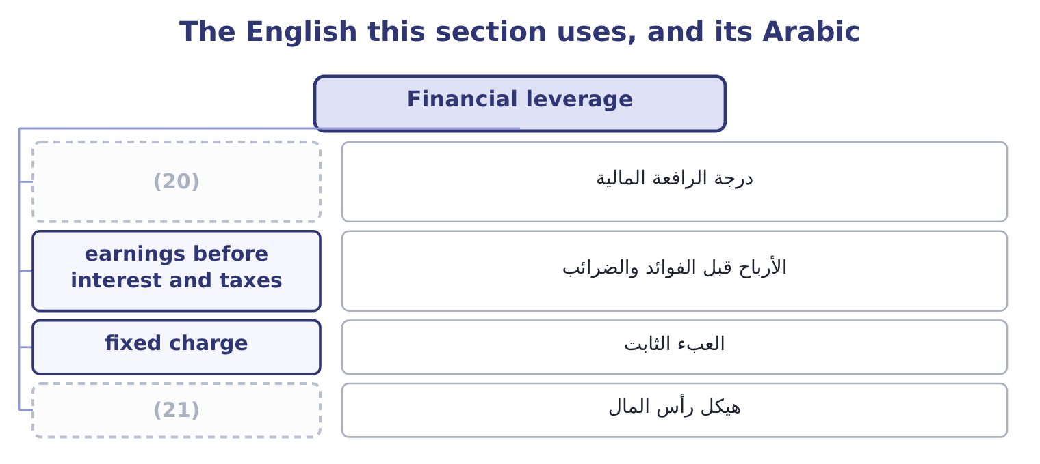
word list
degree of financial leverage · contribution margin · capital structure

The English this sheet uses, and its Arabic
English (exam term) | Arabic
degree of financial leverage | درجة الرافعة المالية
earnings before interest and taxes | الأرباح قبل الفوائد والضرائب
fixed charge | العبء الثابت
capital structure | هيكل رأس المال

Answer key · 8.3 Financial leverage

1 applied | 12 financed
2 whether | 13 formula
3 earned | 14 magnify
4 produces | 15 Repayments
5 shareholders | 16 changes
6 measure | 17 borrowed
7 written | 18 business
8 computed | 19 magnification
9 Orontes's | 20 degree of financial leverage
10 borrows | 21 capital structure
11 magnifying

the summaries in full
Summary 1 Financial leverage is the same idea applied to the financing. Interest is a fixed charge: it is owed whether or not the company earned anything. So a change in operating income produces a larger change in what is left for the shareholders. The measure is the degree of financial leverage, written DFL. It is the percentage change in net income, or in earnings per share, divided by the percentage change in operating income. At a given level it is computed as earnings before interest and taxes divided by earnings before interest and taxes less interest. Orontes's earnings before interest and taxes is income before income taxes of $3,958,800 plus interest expense of $390,000, which is 3,958,800 + 390,000 = 4,348,800. The degree of financial leverage is 4,348,800 ÷ 3,958,800 = 1.10. A DFL of 1.10 is very low, and it says what: Orontes borrows very little, so the fixed charge is small and the magnifying effect is small with it.
Summary 2 A company financed half by debt might carry a DFL of 1.8 or 2.0. Note what does not appear in the formula. Tax does not, because tax is proportional and a proportional charge does not magnify anything. Repayments of principal do not, because they are not an expense. Only the interest matters.
Summary 3 EBIT $4,348,800, interest $390,000. A 10 per cent change in EBIT changes pre-tax income by 11.0 per cent. If Orontes borrowed $12,000,000 more at 6 per cent, interest would rise by 12,000,000 × 0.06 = 720,000 to 390,000 + 720,000 = 1,110,000. Then DFL = 4,348,800 ÷ 3,238,800 = 1.34. The same 10 per cent change in EBIT would now move pre-tax income by 13.4 per cent. The business did not change; only the financing did. More debt, more magnification, in both directions.

8.4 The two together
Chapter 8 · section 8.4

Fill every gap. Each word list holds one word more than there are gaps.
Summary 1 gaps 1–5
The two (1) multiply. A change in sales is (2) first by the fixed operating costs and then by the fixed (3) charge, and the (4) is the degree of total, or combined, leverage. For Orontes: 4.02 × 1.10 = 4.42. A 1 per cent change in sales (5) about a 4.42 per cent change in income before tax.
word list
leverages · meaning · produces · magnified · product · financing

Orontes: a 10 per cent fall in sales, traced down the statement
Every item belongs to exactly one group.
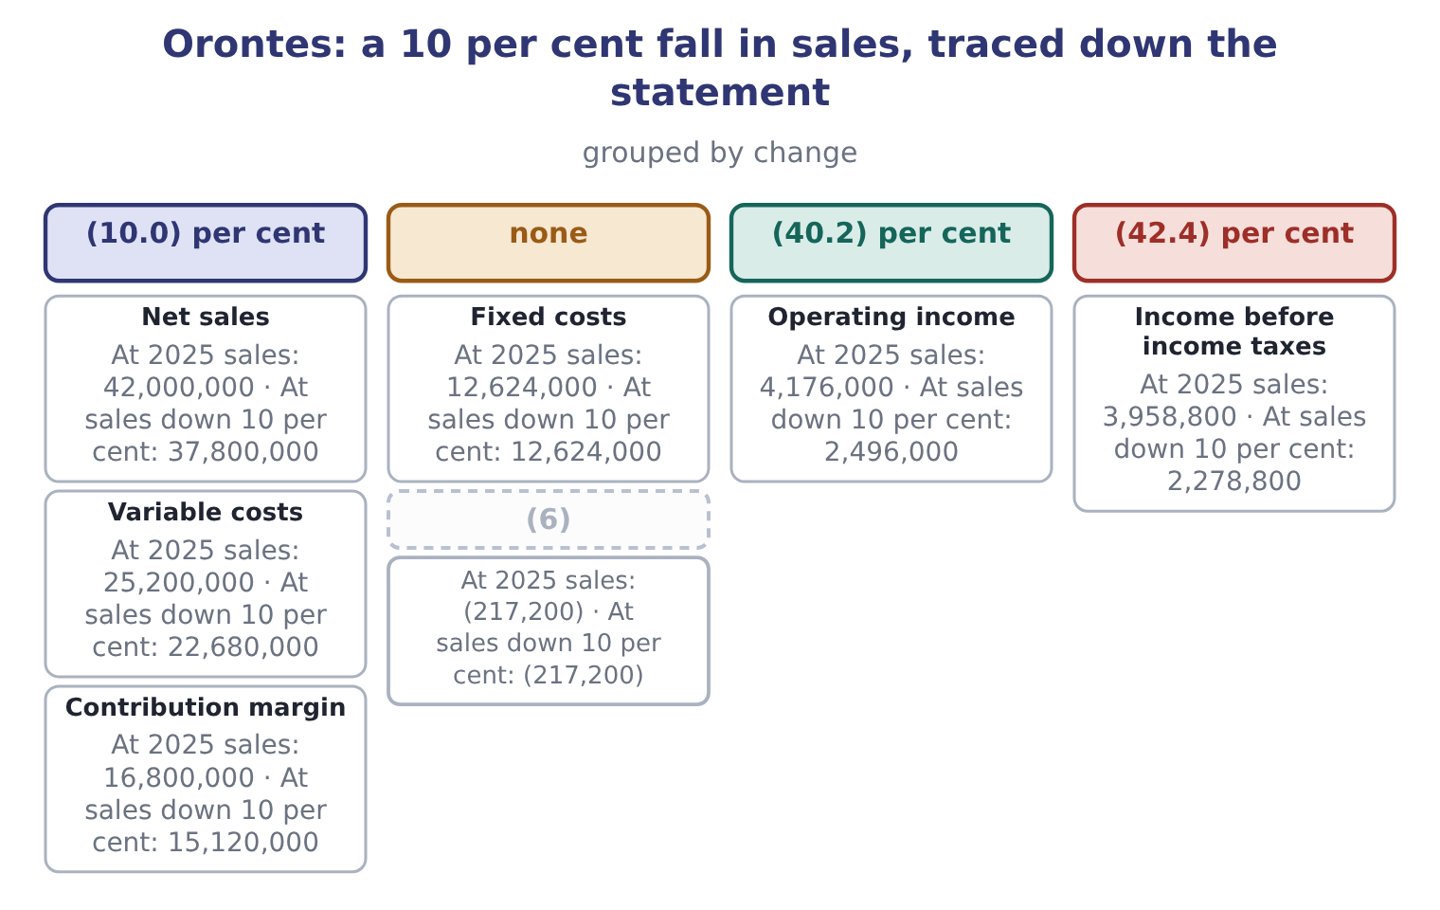
word list
Income before income taxes · Interest and other, net

Summary 2 gaps 7–18
Ten per cent off the top becomes (7) per cent off the (8) . That is the (9) the board has to (10) before it decides anything about either cost structure or borrowing, and it is why. The exam's point is usually the (11) of the two (12) . Operating leverage is largely given: a (13) has plant and a distributor does not, and changing it means changing what the business is. Financial leverage is (14) : the board can borrow or not, this quarter, by (15) . So two companies with the same operating leverage can carry very (16) total leverage, and the (17) is a decision somebody made. Orontes sits in the lower left. Its operating income swings hard with volume, and (18) it has almost no debt the swing stops there. A company in the lower right with the same plant and $20,000,000 of borrowing would face the same 40.2 per cent fall in operating income with interest of over a million to find out of it.
word list
because · resolution · manufacturer · difference · forty-two · asymmetry · solvency · understand · choices · arithmetic · bottom · different · chosen

Compute the three leverages

Your turn: Jordan Glass Co., 2025 (complete the blanks)
Item | Amount
Net sales | 9,000,000
Variable costs | 3,600,000
Contribution margin | 5,400,000
Fixed costs | 3,600,000
Operating income | 1,800,000
Interest expense | 600,000
Degree of operating leverage | 3.00: 5,400,000 ÷ 1,800,000.
Degree of financial leverage | (19) : EBIT of 1,800,000 ÷ (1,800,000 − 600,000).
Combined leverage | (20) : 3.00 × 1.50.

word list
1.50 · magnification · 4.50

"Leverage" and "gearing"

Summary 3 gaps 21–23
American English says leverage; British English often says gearing, and the exam uses leverage (21) . Note that English also uses leverage as a verb in business writing, meaning to make use of (22) . That sense never (23) in the exam.
word list
resolution · throughout · appears · something

Four positions
 | Low financial leverage | High financial leverage
Low operating leverage | Stable: a distributor financed by equity | (24) : fixed charges on a flexible business
High operating leverage | (25) | Dangerous: both magnifiers at once

word list
Orontes: swings with volume, no fixed charge · Moderate · degree of financial leverage

The English this section uses, and its Arabic
Each term sits against what it means.
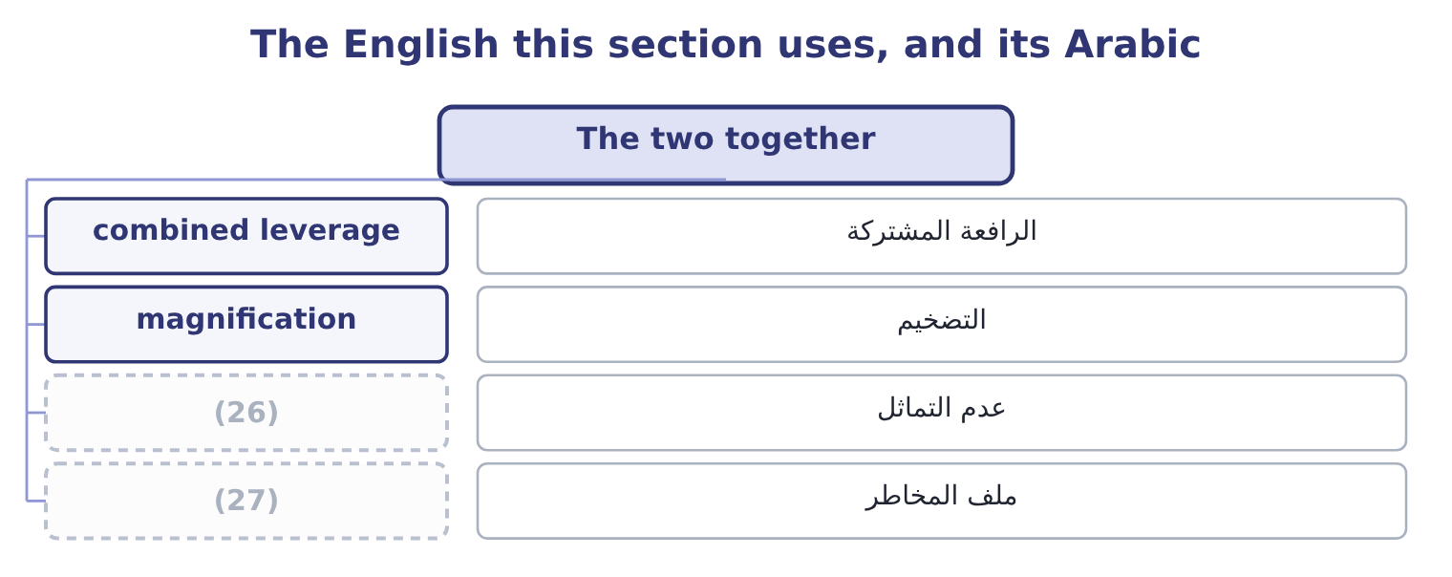
word list
risk profile · asymmetry · financial leverage

The English this sheet uses, and its Arabic
English (exam term) | Arabic
combined leverage | الرافعة المشتركة
magnification | التضخيم
asymmetry | عدم التماثل
risk profile | ملف المخاطر

Answer key · 8.4 The two together

1 leverages | 15 resolution
2 magnified | 16 different
3 financing | 17 difference
4 product | 18 because
5 produces | 19 1.50
6 Interest and other, net | 20 4.50
7 forty-two | 21 throughout
8 bottom | 22 something
9 arithmetic | 23 appears
10 understand | 24 Moderate
11 asymmetry | 25 Orontes: swings with volume, no fixed charge
12 choices | 26 asymmetry
13 manufacturer | 27 risk profile
14 chosen

the summaries in full
Summary 1 The two leverages multiply. A change in sales is magnified first by the fixed operating costs and then by the fixed financing charge, and the product is the degree of total, or combined, leverage. For Orontes: 4.02 × 1.10 = 4.42. A 1 per cent change in sales produces about a 4.42 per cent change in income before tax.
Summary 2 Ten per cent off the top becomes forty-two per cent off the bottom. That is the arithmetic the board has to understand before it decides anything about either cost structure or borrowing, and it is why. The exam's point is usually the asymmetry of the two choices. Operating leverage is largely given: a manufacturer has plant and a distributor does not, and changing it means changing what the business is. Financial leverage is chosen: the board can borrow or not, this quarter, by resolution. So two companies with the same operating leverage can carry very different total leverage, and the difference is a decision somebody made. Orontes sits in the lower left. Its operating income swings hard with volume, and because it has almost no debt the swing stops there. A company in the lower right with the same plant and $20,000,000 of borrowing would face the same 40.2 per cent fall in operating income with interest of over a million to find out of it.
Summary 3 American English says leverage; British English often says gearing, and the exam uses leverage throughout. Note that English also uses leverage as a verb in business writing, meaning to make use of something. That sense never appears in the exam.

8.5 What the leverages do not say
Chapter 8 · section 8.5

Fill every gap. Each word list holds one word more than there are gaps.
Summary 1 gaps 1–12
Three (1) , and the exam uses all three. A degree of leverage is a point (2) . Both are (3) at one level of sales and both change as sales change. A DOL of 4.02 is true at $42,000,000 of sales and not at $30,000,000, where it would be far (4) . The exam (5) gives two sales levels precisely to test this. A leverage figure says nothing about (6) . A DOL of 4.02 tells you what (7) if sales fall 10 per cent; it does not tell you whether they will. The risk is the product of the (8) and the likelihood, and the statements give only the first. A leverage figure (9) the cost split holds. Fixed costs are fixed only within a range of (10) . A fall in volume large enough to close a line turns a fixed cost into an (11) one, and a rise large enough to need a second shift adds a step. Part 1 called this the (12) range.
word list
magnification · happens · relevant · asymmetry · higher · computed · assumes · sometimes · activity · estimate · avoidable · limits · probability

The words this section uses
Each term sits against what it means, and an instance of it.
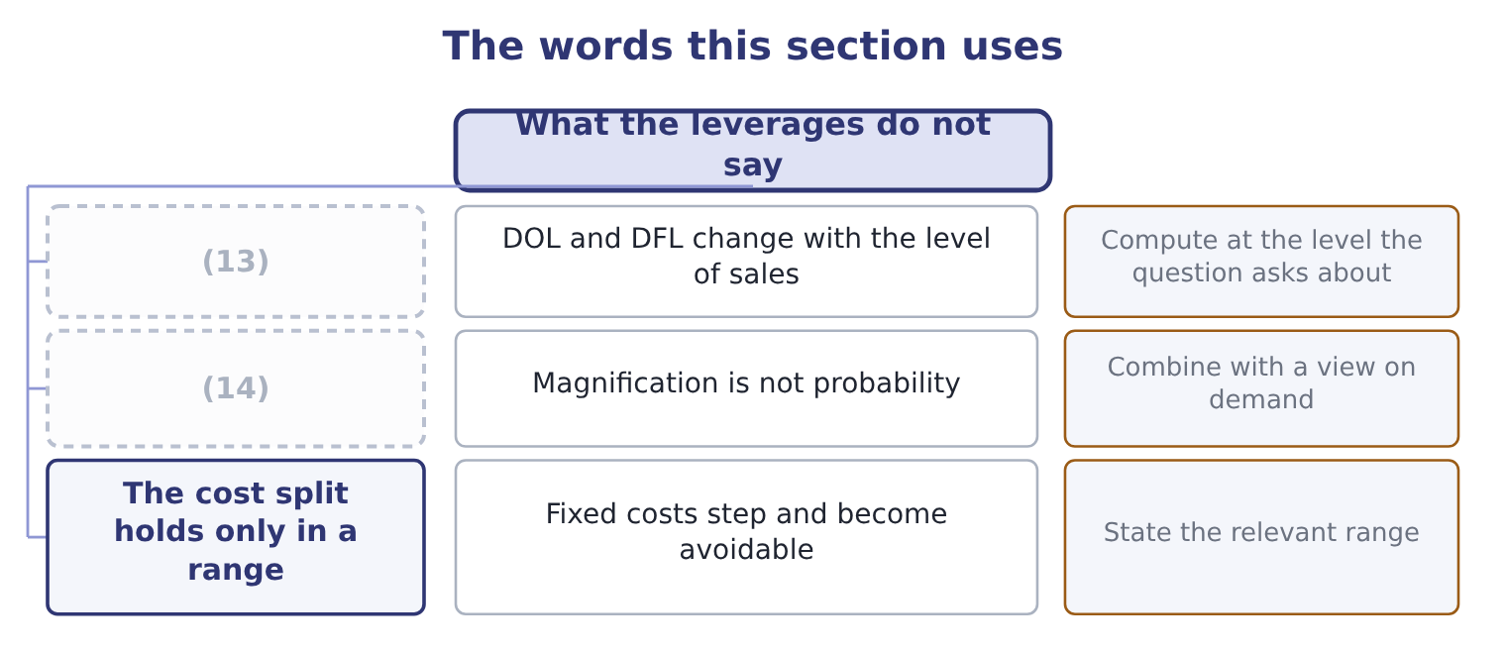
word list
Magnification is not probability · Says nothing about likelihood · A point estimate

The English this sheet uses, and its Arabic
English (exam term) | Arabic
relevant range | المدى الملائم
point estimate | التقدير عند نقطة
step cost | التكلفة المتدرجة
likelihood | الاحتمالية

Answer key · 8.5 What the leverages do not say

1 limits | 8 magnification
2 estimate | 9 assumes
3 computed | 10 activity
4 higher | 11 avoidable
5 sometimes | 12 relevant
6 probability | 13 A point estimate
7 happens | 14 Says nothing about likelihood

the summaries in full
Summary 1 Three limits, and the exam uses all three. A degree of leverage is a point estimate. Both are computed at one level of sales and both change as sales change. A DOL of 4.02 is true at $42,000,000 of sales and not at $30,000,000, where it would be far higher. The exam sometimes gives two sales levels precisely to test this. A leverage figure says nothing about probability. A DOL of 4.02 tells you what happens if sales fall 10 per cent; it does not tell you whether they will. The risk is the product of the magnification and the likelihood, and the statements give only the first. A leverage figure assumes the cost split holds. Fixed costs are fixed only within a range of activity. A fall in volume large enough to close a line turns a fixed cost into an avoidable one, and a rise large enough to need a second shift adds a step. Part 1 called this the relevant range.

9.1 The four ratios
Chapter 9 · section 9.1

Fill every gap. Each word list holds one word more than there are gaps.
Chapter 9, section by section
Each stage leads to the next.
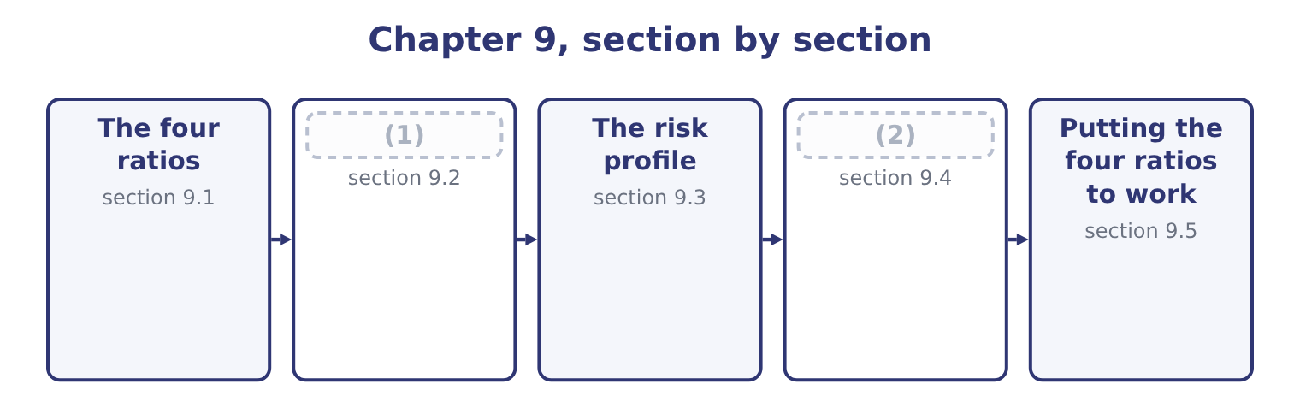
word list
Covenants and the composition of the debt · Putting the four ratios to work · What a change in the composition does

Summary 1 gaps 3–14
Each of the four (3) a measure of debt by a measure of what supports it. The debt-to-equity ratio is total liabilities divided by total stockholders' equity. It asks how many dollars of other (4) money the company (5) for each dollar of the (6) '. The long-term debt-to-equity ratio uses only long-term debt in the (7) . It removes the trade payables and accruals that arise from trading rather than from a (8) decision, so it (9) the borrowing the board chose. The (10) ratio is total liabilities divided by total assets. It asks what share of (11) the company owns is financed by (12) . The equity multiplier, which the Learning Outcome (13) also call the (14) leverage ratio, is total assets divided by total stockholders' equity. It asks how many dollars of assets each dollar of equity supports.
word list
debt-to-total-assets · everything · people's · divides · creditors · magnitude · numerator · financial · isolates · owners · Statements · financing · carries

Orontes Foods, Inc. — the capital structure ratios
The bars are drawn to scale.
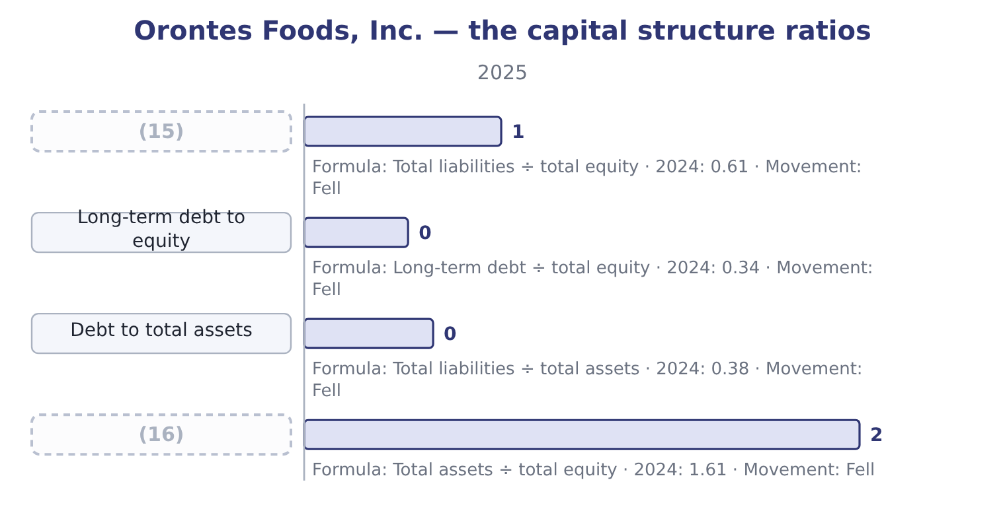
word list
retained earnings · Equity multiplier · Debt to equity

Summary 2 gaps 17–23
The (17) for 2025. Debt to equity is 11,279,625 ÷ 20,392,975 = 0.55. Long-term debt to equity is 6,000,000 ÷ 20,392,975 = 0.29. Debt to total assets is 11,279,625 ÷ 31,672,600 = 0.36. The equity multiplier is 31,672,600 ÷ 20,392,975 = 1.55. All four fell, and they fell for one (18) : equity grew 24.5 per cent while liabilities grew 12.0 per cent. (19) financed its (20) mainly out of (21) profit and a share issue. The (22) structure is (23) and became more so.
word list
retained · capital · restate · reason · conservative · arithmetic · Orontes · growth

Which debt is in the numerator?

Summary 3 gaps 24–27
Debt to equity (24) uses TOTAL liabilities, (25) payables and accruals. Long-term debt to equity uses only the long-term borrowing. (26) the current portion is included varies; the exam states which it wants. Debt to total assets and the equity multiplier both use total liabilities, one (27) assets and one through equity.
word list
including · against · normally · Whether · Learning

Worked example: the four ratios are one fact

Summary 4 gaps 28–30
Start from debt to total assets, 0.36. That means equity to total assets is 1.00 − 0.36 = 0.64. Debt to equity follows. The equity multiplier follows too. Three ratios, one (28) split of 36 per cent debt and 64 per cent equity. If an exam question gives you any one of the three, you can (29) the other two without further (30) , and that is a question the exam sets.
word list
trading · produce · underlying · information

The English this section uses, and its Arabic
Each term sits against what it means.
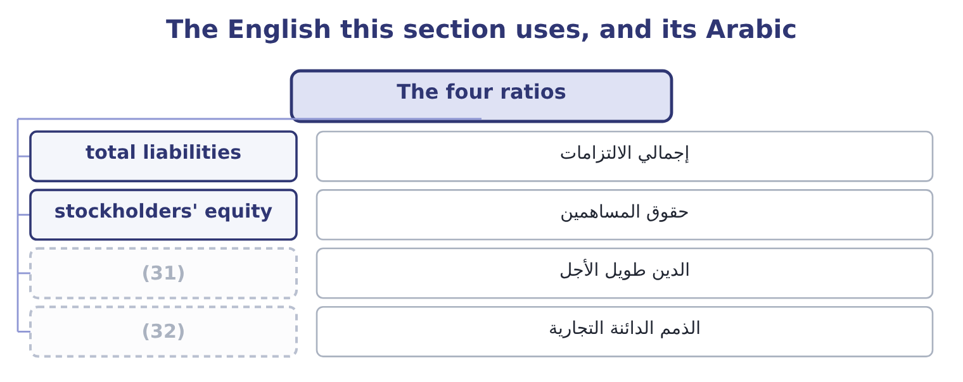
word list
trade payables · debt-to-total-assets ratio · long-term debt

The English this sheet uses, and its Arabic
English (exam term) | Arabic
total liabilities | إجمالي الالتزامات
stockholders' equity | حقوق المساهمين
long-term debt | الدين طويل الأجل
trade payables | الذمم الدائنة التجارية

Answer key · 9.1 The four ratios

1 What a change in the composition does | 17 arithmetic
2 Covenants and the composition of the debt | 18 reason
3 divides | 19 Orontes
4 people's | 20 growth
5 carries | 21 retained
6 owners | 22 capital
7 numerator | 23 conservative
8 financing | 24 normally
9 isolates | 25 including
10 debt-to-total-assets | 26 Whether
11 everything | 27 against
12 creditors | 28 underlying
13 Statements | 29 produce
14 financial | 30 information
15 Debt to equity | 31 long-term debt
16 Equity multiplier | 32 trade payables

the summaries in full
Summary 1 Each of the four divides a measure of debt by a measure of what supports it. The debt-to-equity ratio is total liabilities divided by total stockholders' equity. It asks how many dollars of other people's money the company carries for each dollar of the owners'. The long-term debt-to-equity ratio uses only long-term debt in the numerator. It removes the trade payables and accruals that arise from trading rather than from a financing decision, so it isolates the borrowing the board chose. The debt-to-total-assets ratio is total liabilities divided by total assets. It asks what share of everything the company owns is financed by creditors. The equity multiplier, which the Learning Outcome Statements also call the financial leverage ratio, is total assets divided by total stockholders' equity. It asks how many dollars of assets each dollar of equity supports.
Summary 2 The arithmetic for 2025. Debt to equity is 11,279,625 ÷ 20,392,975 = 0.55. Long-term debt to equity is 6,000,000 ÷ 20,392,975 = 0.29. Debt to total assets is 11,279,625 ÷ 31,672,600 = 0.36. The equity multiplier is 31,672,600 ÷ 20,392,975 = 1.55. All four fell, and they fell for one reason: equity grew 24.5 per cent while liabilities grew 12.0 per cent. Orontes financed its growth mainly out of retained profit and a share issue. The capital structure is conservative and became more so.
Summary 3 Debt to equity normally uses TOTAL liabilities, including payables and accruals. Long-term debt to equity uses only the long-term borrowing. Whether the current portion is included varies; the exam states which it wants. Debt to total assets and the equity multiplier both use total liabilities, one against assets and one through equity.
Summary 4 Start from debt to total assets, 0.36. That means equity to total assets is 1.00 − 0.36 = 0.64. Debt to equity follows. The equity multiplier follows too. Three ratios, one underlying split of 36 per cent debt and 64 per cent equity. If an exam question gives you any one of the three, you can produce the other two without further information, and that is a question the exam sets.

9.2 What a change in the composition does
Chapter 9 · section 9.2

Fill every gap. Each word list holds one word more than there are gaps.
Summary 1 gaps 1–10
The syllabus asks for the effect on capital structure and solvency of a change in the (1) of debt against equity, and the method is to (2) the balance sheet and (3) . Three (4) cover most of what the exam asks. Borrowing to buy an asset raises liabilities and assets by the same (5) and leaves equity alone. Every one of the four ratios rises. Borrowing to buy back shares raises liabilities, reduces equity, and leaves total assets (6) unchanged. The ratios rise much more (7) , because the numerator grows while the denominator (8) . (9) shares to repay debt does the (10) of the second: liabilities fall, equity rises, assets are unchanged. All four ratios fall.
word list
roughly · recompute · transactions · shrinks · sharply · composition · reverse · amount · restate · Issuing · statements

Three financing decisions, from Orontes's 2025 position
Every item belongs to exactly one group.
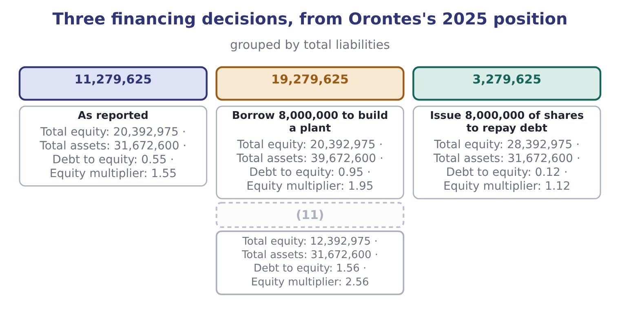
word list
Borrow 8,000,000 to build a plant · Borrow 8,000,000 to buy back shares

Summary 2 gaps 12–22
The second row is the one to (12) . The same $8,000,000 of borrowing takes debt to equity from 0.55 to 0.95 when it buys an asset, and to 1.56 when it buys back shares — (13) twice as far — because a (14) removes equity from the denominator at the same time as it adds debt to the numerator. Boards do this (15) , and a lender reading the (16) afterwards sees a (17) company. Note what does not change in the second row. The (18) is the same: the same plant, the same (19) , the same operating (20) . What (21) is who has a claim on it and in what order. That is the whole of a capital structure decision, and Book 2 takes it up as a decision rather than a (22) .
word list
measurement · buy-back · business · statements · changed · nearly · understand · deliberately · income · customers · numerator · different

Buying an asset is not the same as buying back shares

Summary 3 gaps 23–26
Borrowing to (23) raises both (24) of the balance sheet. Borrowing to (25) raises liabilities and reduces equity, so the ratios move about twice as far. Retained earnings raise equity without any (26) at all, which is why a profitable company deleverages by standing still.
word list
halves · distribute · shrinks · transaction · invest

The English this section uses, and its Arabic
Each term sits against what it means.
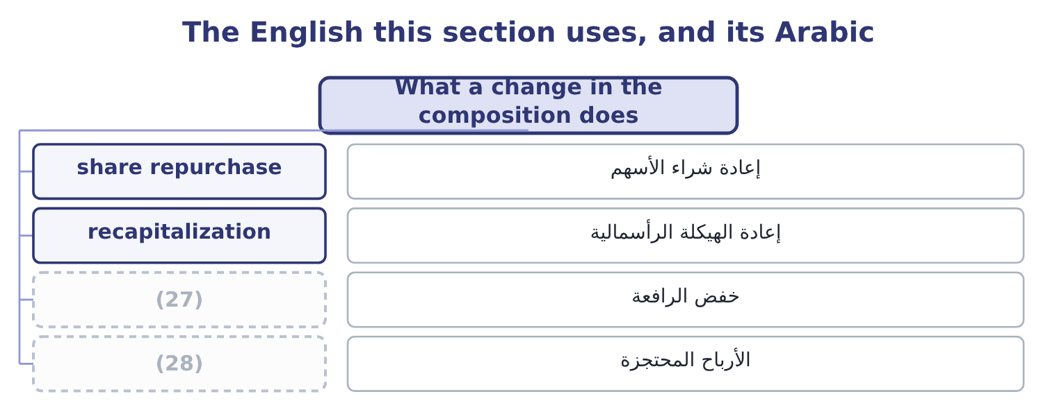
word list
deleverage · retained earnings · magnitude

The English this sheet uses, and its Arabic
English (exam term) | Arabic
share repurchase | إعادة شراء الأسهم
recapitalization | إعادة الهيكلة الرأسمالية
deleverage | خفض الرافعة
retained earnings | الأرباح المحتجزة

Answer key · 9.2 What a change in the composition does

1 composition | 15 deliberately
2 restate | 16 statements
3 recompute | 17 different
4 transactions | 18 business
5 amount | 19 customers
6 roughly | 20 income
7 sharply | 21 changed
8 shrinks | 22 measurement
9 Issuing | 23 invest
10 reverse | 24 halves
11 Borrow 8,000,000 to buy back shares | 25 distribute
12 understand | 26 transaction
13 nearly | 27 deleverage
14 buy-back | 28 retained earnings

the summaries in full
Summary 1 The syllabus asks for the effect on capital structure and solvency of a change in the composition of debt against equity, and the method is to restate the balance sheet and recompute. Three transactions cover most of what the exam asks. Borrowing to buy an asset raises liabilities and assets by the same amount and leaves equity alone. Every one of the four ratios rises. Borrowing to buy back shares raises liabilities, reduces equity, and leaves total assets roughly unchanged. The ratios rise much more sharply, because the numerator grows while the denominator shrinks. Issuing shares to repay debt does the reverse of the second: liabilities fall, equity rises, assets are unchanged. All four ratios fall.
Summary 2 The second row is the one to understand. The same $8,000,000 of borrowing takes debt to equity from 0.55 to 0.95 when it buys an asset, and to 1.56 when it buys back shares — nearly twice as far — because a buy-back removes equity from the denominator at the same time as it adds debt to the numerator. Boards do this deliberately, and a lender reading the statements afterwards sees a different company. Note what does not change in the second row. The business is the same: the same plant, the same customers, the same operating income. What changed is who has a claim on it and in what order. That is the whole of a capital structure decision, and Book 2 takes it up as a decision rather than a measurement.
Summary 3 Borrowing to invest raises both halves of the balance sheet. Borrowing to distribute raises liabilities and reduces equity, so the ratios move about twice as far. Retained earnings raise equity without any transaction at all, which is why a profitable company deleverages by standing still.

9.3 The risk profile
Chapter 9 · section 9.3

Fill every gap. Each word list holds one word more than there are gaps.
Summary 1 gaps 1–9
A capital structure decision changes three things about a company, and the exam asks about all three. It changes who bears the loss first. Equity (1) losses before debt does. A company financed 90 per cent by equity can lose a great deal before a (2) is at risk; a company financed 90 per cent by debt (3) . It changes the fixed charge. Interest must be paid in a bad year. Dividends need not: the board can simply not (4) one, as Orontes could have (5) in 2025. That (6) is the heart of (7) risk. It changes the return to the owners when things go well. Borrowing at 6 per cent to earn 12 per cent leaves the (8) for the shareholders, so (9) raises return on equity as long as the company earns more than its interest.
word list
breach · absorbs · lender · declare · difference · chosen · leverage · asymmetry · financial · cannot

Summary 2 gaps 10–19
The tax row is the one that makes the decision (10) difficult. Interest (11) taxable income and dividends do not, so debt is cheaper after tax than its interest rate (12) . Orontes pays interest of $390,000; at its (13) tax rate of about 25 per cent, the (14) cost is roughly 390,000 × 0.75 = 292,500. Book 2 (15) this as the cost of capital. Debt is 36 per cent of assets, the equity (16) is 1.55, and.15 times. The board has room to (17) and has not used it. Whether that is (18) or timidity is the question, because an (19) balance sheet also holds the return on equity down.
word list
reduces · breach · develops · genuinely · suggests · multiplier · effective · prudence · unlevered · after-tax · borrow

Worked example: what the unused capacity is worth

Summary 3 gaps 20–31
Suppose Orontes (20) enough to take debt to total assets to 0.50, the level many food (21) carry. Total assets would have to be financed half by debt. On the present balance sheet that means (22) of 31,672,600 × 0.50 = 15,836,300, against the present 11,279,625. The (23) borrowing is 15,836,300 − 11,279,625 = 4,556,675. At 6 per cent the extra interest is about 4,556,675 × 0.06 = 273,401, against (24) before interest and taxes of $4,348,800. Interest cover would fall from 11.15 times to about 4,348,800 ÷ 663,401 = 6.56 times, which is still (25) . Orontes could raise over four and a half (26) dollars without (27) its interest cover below six and a half times. That is what a (28) capital structure buys: not (29) for its own sake, but the (30) to act when (31) is worth acting on.
word list
earnings · million · conservative · taking · manufacturers · safety · strong · borrowed · liabilities · something · additional · develops · ability

What more debt does
 | More debt | More equity
Fixed charge | Rises; must be paid in a bad year | (32)
Return to owners in a good year | Higher | (33)
Loss borne by owners in a bad year | (34) | Smaller
Control | (35) | Diluted among more shareholders
Tax | Interest is deductible | (36)
Who is at risk first | Equity, then debt | (37)

word list
Larger, proportionately · None; dividends are discretionary · Diluted among more shareholders · Dividends are not · Lower · Equity, and there is more of it · Unchanged

The English this section uses, and its Arabic
Each term sits against what it means.
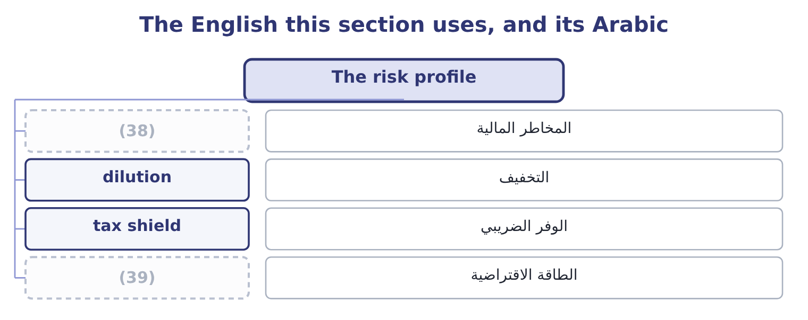
word list
financial risk · debt-to-equity ratio · borrowing capacity

The English this sheet uses, and its Arabic
English (exam term) | Arabic
financial risk | المخاطر المالية
dilution | التخفيف
tax shield | الوفر الضريبي
borrowing capacity | الطاقة الاقتراضية

Answer key · 9.3 The risk profile

1 absorbs | 21 manufacturers
2 lender | 22 liabilities
3 cannot | 23 additional
4 declare | 24 earnings
5 chosen | 25 strong
6 asymmetry | 26 million
7 financial | 27 taking
8 difference | 28 conservative
9 leverage | 29 safety
10 genuinely | 30 ability
11 reduces | 31 something
12 suggests | 32 None; dividends are discretionary
13 effective | 33 Lower
14 after-tax | 34 Larger, proportionately
15 develops | 35 Unchanged
16 multiplier | 36 Dividends are not
17 borrow | 37 Equity, and there is more of it
18 prudence | 38 financial risk
19 unlevered | 39 borrowing capacity
20 borrowed

the summaries in full
Summary 1 A capital structure decision changes three things about a company, and the exam asks about all three. It changes who bears the loss first. Equity absorbs losses before debt does. A company financed 90 per cent by equity can lose a great deal before a lender is at risk; a company financed 90 per cent by debt cannot. It changes the fixed charge. Interest must be paid in a bad year. Dividends need not: the board can simply not declare one, as Orontes could have chosen in 2025. That asymmetry is the heart of financial risk. It changes the return to the owners when things go well. Borrowing at 6 per cent to earn 12 per cent leaves the difference for the shareholders, so leverage raises return on equity as long as the company earns more than its interest.
Summary 2 The tax row is the one that makes the decision genuinely difficult. Interest reduces taxable income and dividends do not, so debt is cheaper after tax than its interest rate suggests. Orontes pays interest of $390,000; at its effective tax rate of about 25 per cent, the after-tax cost is roughly 390,000 × 0.75 = 292,500. Book 2 develops this as the cost of capital. Debt is 36 per cent of assets, the equity multiplier is 1.55, and.15 times. The board has room to borrow and has not used it. Whether that is prudence or timidity is the question, because an unlevered balance sheet also holds the return on equity down.
Summary 3 Suppose Orontes borrowed enough to take debt to total assets to 0.50, the level many food manufacturers carry. Total assets would have to be financed half by debt. On the present balance sheet that means liabilities of 31,672,600 × 0.50 = 15,836,300, against the present 11,279,625. The additional borrowing is 15,836,300 − 11,279,625 = 4,556,675. At 6 per cent the extra interest is about 4,556,675 × 0.06 = 273,401, against earnings before interest and taxes of $4,348,800. Interest cover would fall from 11.15 times to about 4,348,800 ÷ 663,401 = 6.56 times, which is still strong. Orontes could raise over four and a half million dollars without taking its interest cover below six and a half times. That is what a conservative capital structure buys: not safety for its own sake, but the ability to act when something is worth acting on.

9.4 Covenants and the composition of the debt
Chapter 9 · section 9.4

Fill every gap. Each word list holds one word more than there are gaps.
Summary 1 gaps 1–12
A leverage ratio is not only an (1) measure. It is often a term of the loan, and that gives it (2) . A covenant is a promise in a loan agreement, and the (3) are expressed as leverage and (4) ratios: debt to equity not above a stated figure, interest cover not below one. Part 1 recorded exactly this for Barada: at (5) 31 it had broken a (6) covenant on its note, and the bank waived the breach on January 20 before the statements were issued. You (7) there what the waiver did to the classification; here the point is what the covenant does to the company. A breach (8) makes the loan (9) on demand. That turns long-term debt into a current (10) and can wreck a (11) position overnight, which is why a company close to a covenant limit manages towards it. The (12) of, and so is the timing of a share issue.
word list
usually · debt-to-equity · liquidity · commonest · repayable · December · learned · consequences · measures · English · coverage · analyst's · liability

Reading the debt, not just the ratio
Every item belongs to exactly one group.
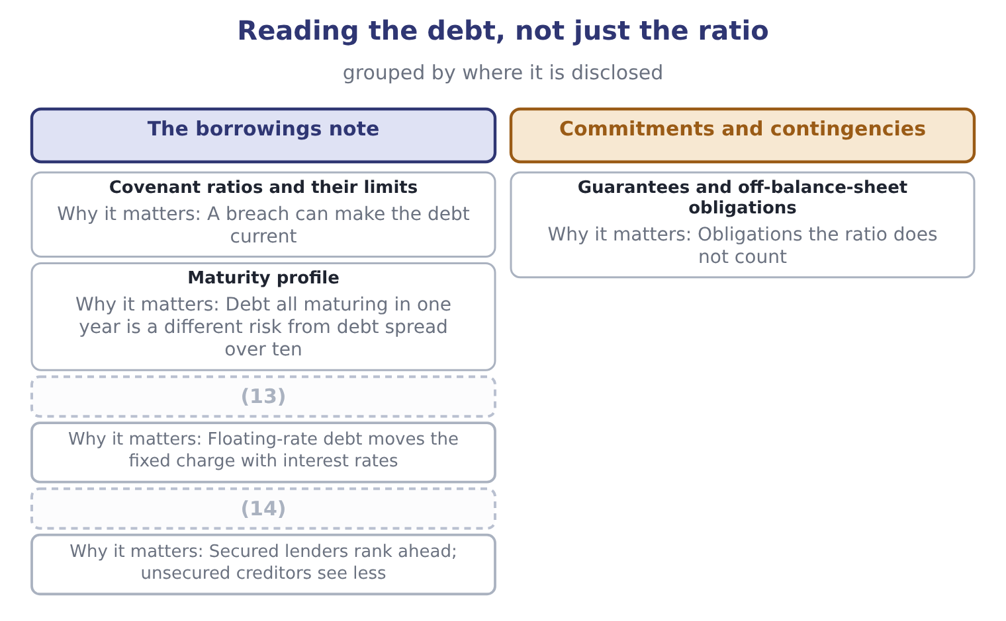
word list
debt-to-equity ratio · Security given · Fixed or floating rate

Summary 2 gaps 15–18
Orontes's own note, as Part 1 recorded, (15) $6,000,000 of long-term debt and $400,000 of it due (16) the year. The (17) profile is (18) and the cover is wide. Barada's is neither, which is the difference between the two companies that the ratios alone understate.
word list
gentle · within · manages · carries · maturity

The ratio and the agreement

Summary 3 gaps 19–22
A covenant may (19) debt or equity (20) from the published ratio. Read the (21) in the agreement. A waiver obtained after the (22) date does not change the classification under IFRS, and does under U.S. GAAP where the agreement is in place before the statements are issued.
word list
reporting · differently · breach · definition · define

"Covenant"

Summary 4 gaps 23–26
In (23) English a covenant is a (24) promise. In a loan agreement it is a specific (25) , and the exam uses it only in that sense. Note the pair of adjectives the exam uses: an (26) covenant requires the borrower to do something, and a negative covenant forbids something.
word list
manages · ordinary · undertaking · affirmative · solemn

The English this section uses, and its Arabic
Each term sits against what it means.
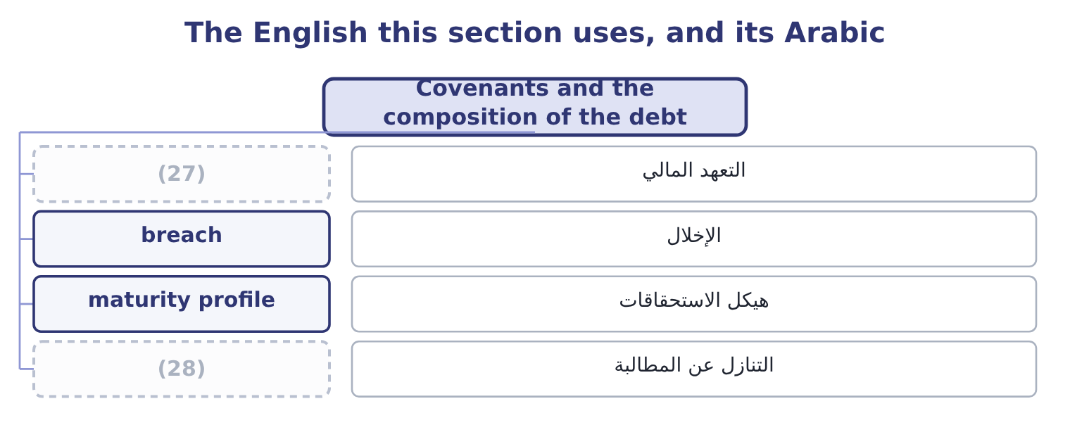
word list
covenant · waiver · magnitude

The English this sheet uses, and its Arabic
English (exam term) | Arabic
covenant | التعهد المالي
breach | الإخلال
maturity profile | هيكل الاستحقاقات
waiver | التنازل عن المطالبة

Answer key · 9.4 Covenants and the composition of the debt

1 analyst's | 15 carries
2 consequences | 16 within
3 commonest | 17 maturity
4 coverage | 18 gentle
5 December | 19 define
6 debt-to-equity | 20 differently
7 learned | 21 definition
8 usually | 22 reporting
9 repayable | 23 ordinary
10 liability | 24 solemn
11 liquidity | 25 undertaking
12 measures | 26 affirmative
13 Fixed or floating rate | 27 covenant
14 Security given | 28 waiver

the summaries in full
Summary 1 A leverage ratio is not only an analyst's measure. It is often a term of the loan, and that gives it consequences. A covenant is a promise in a loan agreement, and the commonest are expressed as leverage and coverage ratios: debt to equity not above a stated figure, interest cover not below one. Part 1 recorded exactly this for Barada: at December 31 it had broken a debt-to-equity covenant on its note, and the bank waived the breach on January 20 before the statements were issued. You learned there what the waiver did to the classification; here the point is what the covenant does to the company. A breach usually makes the loan repayable on demand. That turns long-term debt into a current liability and can wreck a liquidity position overnight, which is why a company close to a covenant limit manages towards it. The measures of, and so is the timing of a share issue.
Summary 2 Orontes's own note, as Part 1 recorded, carries $6,000,000 of long-term debt and $400,000 of it due within the year. The maturity profile is gentle and the cover is wide. Barada's is neither, which is the difference between the two companies that the ratios alone understate.
Summary 3 A covenant may define debt or equity differently from the published ratio. Read the definition in the agreement. A waiver obtained after the reporting date does not change the classification under IFRS, and does under U.S. GAAP where the agreement is in place before the statements are issued.
Summary 4 In ordinary English a covenant is a solemn promise. In a loan agreement it is a specific undertaking, and the exam uses it only in that sense. Note the pair of adjectives the exam uses: an affirmative covenant requires the borrower to do something, and a negative covenant forbids something.

9.5 Putting the four ratios to work
Chapter 9 · section 9.5

Fill every gap. Each word list holds one word more than there are gaps.
Recompute the ratios after a decision

Compute the four ratios.
Your turn: after a debt-funded buy-back (complete the blanks)
Item | Amount
Total liabilities | 17,279,625
Total stockholders' equity | 14,392,975
Total assets | 31,672,600
Long-term debt | 12,000,000
Debt to equity | 1.20: 17,279,625 ÷ 14,392,975.
Long-term debt to equity | (1) : 12,000,000 ÷ 14,392,975.
Debt to total assets | (2) : 17,279,625 ÷ 31,672,600.
Equity multiplier | 2.20: 31,672,600 ÷ 14,392,975.

word list
0.83 · 0.55 · waiver

Summary 1 gaps 3–7
Two habits (3) a Level C answer from a Level B one. State the (4) and the size. Say who the (5) is for. The same movement reassures a (6) expecting a higher return on equity and worries a bondholder whose cushion has halved. An answer that does not name the reader has not (7) .
word list
separate · covenant · finished · shareholder · direction · change

The English this section uses, and its Arabic
Each term sits against what it means.
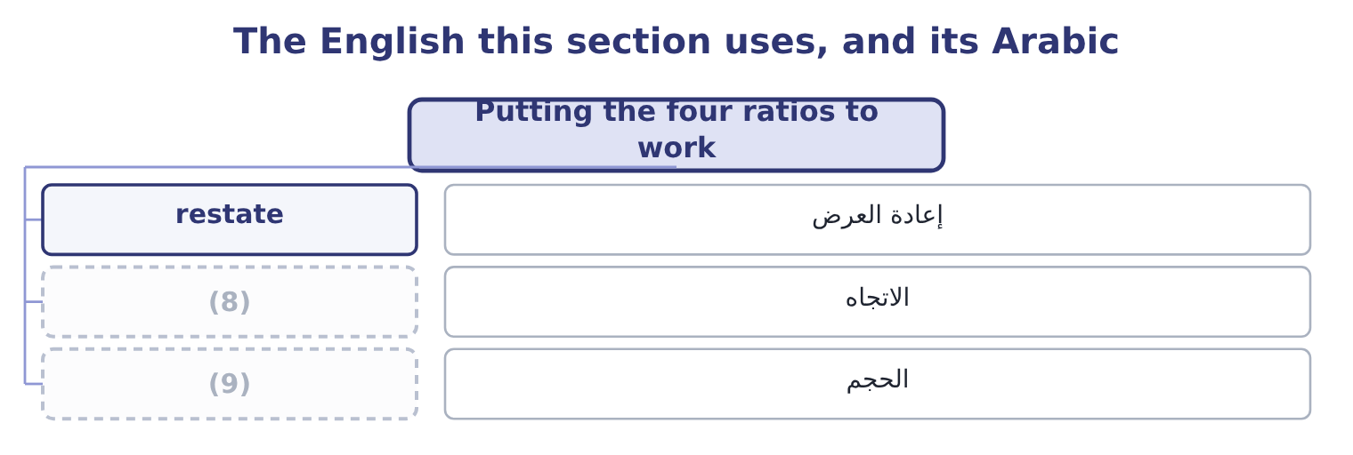
word list
direction · magnitude · الحجم

The English this sheet uses, and its Arabic
English (exam term) | Arabic
restate | إعادة العرض
direction | الاتجاه
magnitude | الحجم

Answer key · 9.5 Putting the four ratios to work

1 0.83 | 6 shareholder
2 0.55 | 7 finished
3 separate | 8 direction
4 direction | 9 magnitude
5 change

the summaries in full
Summary 1 Two habits separate a Level C answer from a Level B one. State the direction and the size. Say who the change is for. The same movement reassures a shareholder expecting a higher return on equity and worries a bondholder whose cushion has halved. An answer that does not name the reader has not finished.

10.1 Times interest earned
Chapter 10 · section 10.1

Fill every gap. Each word list holds one word more than there are gaps.
Chapter 10, section by section
Each stage leads to the next.
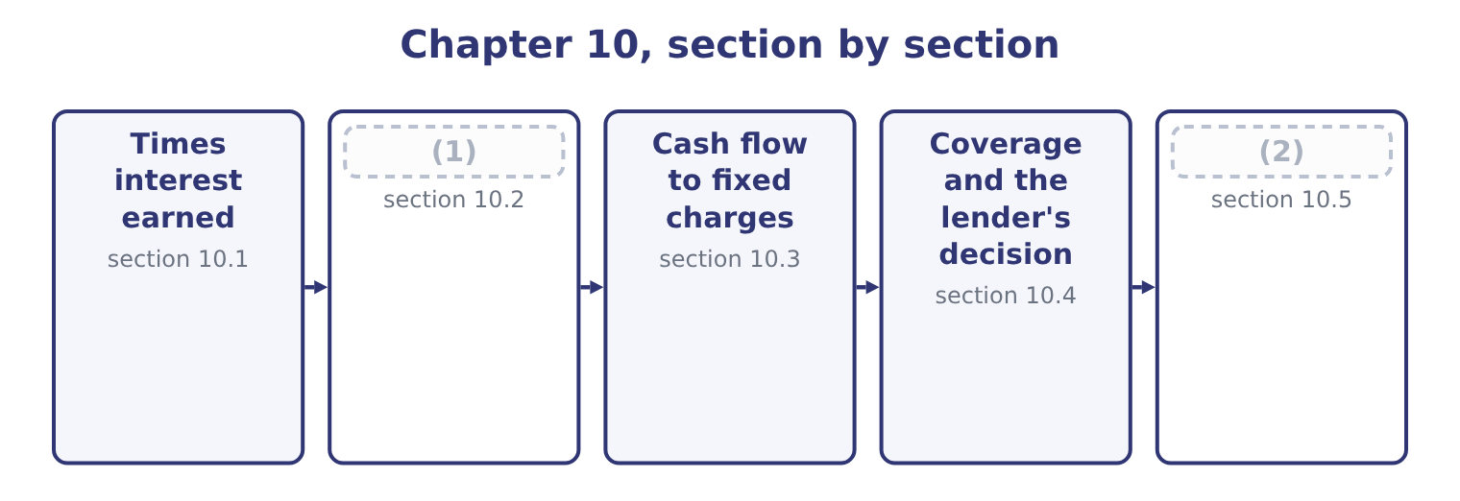
word list
What coverage ratios miss · operating lease rentals · Fixed charge coverage

Summary 1 gaps 3–14
Interest coverage, also (3) times interest earned, (4) earnings before interest and taxes by interest expense. It asks how many times over the year's earnings would pay the year's interest. Interest is added back to the (5) because the question is how much is (6) to pay it. Tax is added back because interest is (7) before tax is (8) : a company does not have to earn the tax on money it pays as interest. For Orontes, earnings before interest and taxes is income before income taxes of $3,958,800 plus interest expense of $390,000, which is 3,958,800 + 390,000 = 4,348,800. Interest coverage is (9) 4,348,800 ÷ 390,000 = 11.15 times. (10) times is a (11) figure. Lenders (12) look for three or four times as a minimum and write (13) at two or two and a half. Orontes's earnings could fall by more than (14) before the interest became difficult to find.
word list
divides · computed · nine-tenths · therefore · covenants · deducted · numerator · commonly · Capitalized · Eleven · strong · available · called

What goes in the numerator

Summary 2 gaps 15–19
Earnings before interest and taxes, not net income and not operating income. Operating income (15) other income and expense, and the exam is (16) . Interest expense in the (17) is the gross (18) , not interest net of interest income. (19) interest is included in some definitions. If a question gives it to you, it wants it included.
word list
specific · Capitalized · excludes · against · denominator · charge

Worked example: coverage after borrowing

Summary 3 gaps 20–28
EBIT $4,348,800 (20) interest of $390,000 is 11.15 times. Orontes (21) $12,000,000 at 6 per cent. Extra interest is 12,000,000 × 0.06 = 720,000, so total interest (22) 390,000 + 720,000 = 1,110,000. If the (23) adds nothing to EBIT in the first year, coverage is 4,348,800 ÷ 1,110,000 = 3.92 times. The same company, the same earnings, and coverage down from 11.15 to 3.92 — from the top to the (24) of the usual (25) range. That is the real (26) of a borrowing (27) , and it is why a lender reads this ratio before the (28) ratios.
word list
borrows · middle · becomes · decision · covenant · excludes · project · content · leverage · against

The words this section uses
Each term sits against what it means, and an instance of it.
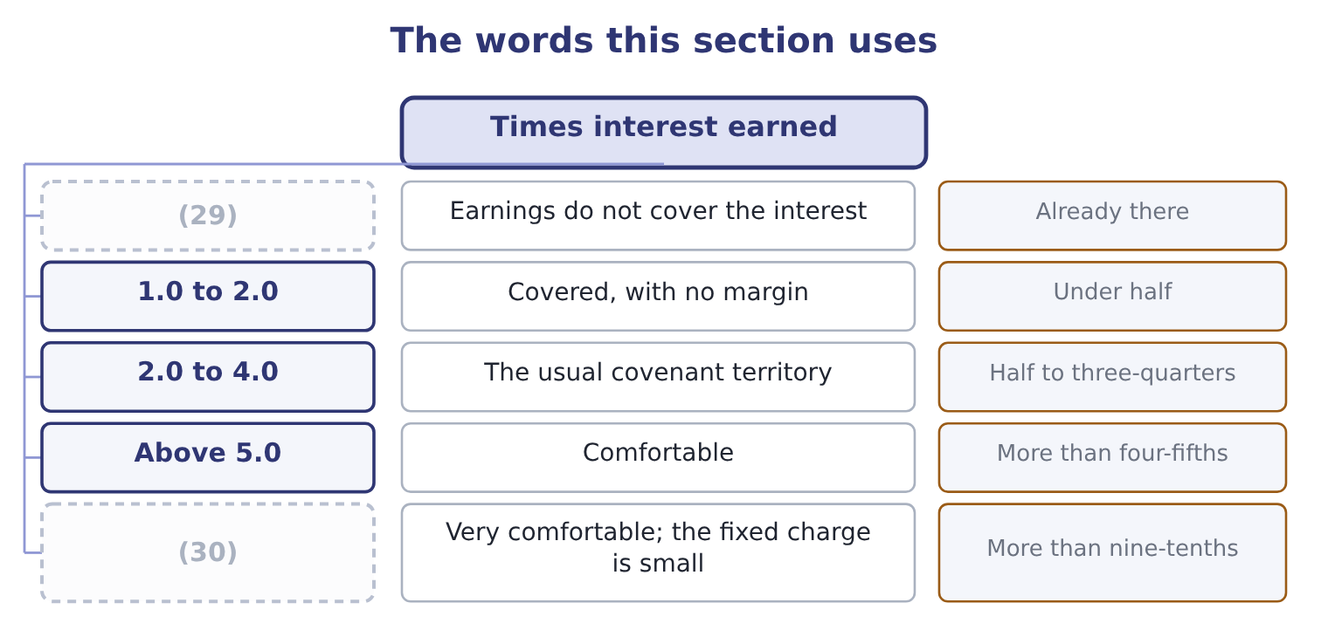
word list
covenant limit · Orontes, 11.15 · Below 1.0

The English this sheet uses, and its Arabic
English (exam term) | Arabic
interest expense | مصروف الفوائد
capitalized interest | الفوائد المرسملة
margin of safety | هامش الأمان
covenant limit | حد التعهد المالي

Answer key · 10.1 Times interest earned

1 Fixed charge coverage | 16 specific
2 What coverage ratios miss | 17 denominator
3 called | 18 charge
4 divides | 19 Capitalized
5 numerator | 20 against
6 available | 21 borrows
7 deducted | 22 becomes
8 computed | 23 project
9 therefore | 24 middle
10 Eleven | 25 covenant
11 strong | 26 content
12 commonly | 27 decision
13 covenants | 28 leverage
14 nine-tenths | 29 Below 1.0
15 excludes | 30 Orontes, 11.15

the summaries in full
Summary 1 Interest coverage, also called times interest earned, divides earnings before interest and taxes by interest expense. It asks how many times over the year's earnings would pay the year's interest. Interest is added back to the numerator because the question is how much is available to pay it. Tax is added back because interest is deducted before tax is computed: a company does not have to earn the tax on money it pays as interest. For Orontes, earnings before interest and taxes is income before income taxes of $3,958,800 plus interest expense of $390,000, which is 3,958,800 + 390,000 = 4,348,800. Interest coverage is therefore 4,348,800 ÷ 390,000 = 11.15 times. Eleven times is a strong figure. Lenders commonly look for three or four times as a minimum and write covenants at two or two and a half. Orontes's earnings could fall by more than nine-tenths before the interest became difficult to find.
Summary 2 Earnings before interest and taxes, not net income and not operating income. Operating income excludes other income and expense, and the exam is specific. Interest expense in the denominator is the gross charge, not interest net of interest income. Capitalized interest is included in some definitions. If a question gives it to you, it wants it included.
Summary 3 EBIT $4,348,800 against interest of $390,000 is 11.15 times. Orontes borrows $12,000,000 at 6 per cent. Extra interest is 12,000,000 × 0.06 = 720,000, so total interest becomes 390,000 + 720,000 = 1,110,000. If the project adds nothing to EBIT in the first year, coverage is 4,348,800 ÷ 1,110,000 = 3.92 times. The same company, the same earnings, and coverage down from 11.15 to 3.92 — from the top to the middle of the usual covenant range. That is the real content of a borrowing decision, and it is why a lender reads this ratio before the leverage ratios.

10.2 Fixed charge coverage
Chapter 10 · section 10.2

Fill every gap. Each word list holds one word more than there are gaps.
Summary 1 gaps 1–12
Interest is not the only charge a company must meet (1) happens. Rent under an operating lease must be paid. So must the lease payments on (2) , preferred (3) in some definitions, and in many (4) the principal (5) too. Fixed charge coverage, which the Learning Outcome (6) also call earnings to fixed charges, widens the ratio to take those. The (7) form adds the interest element of lease rentals to both the numerator and the denominator, because that element was (8) in arriving at earnings and has to be added back before it is counted as a charge. Orontes pays operating lease rentals of $240,000 a year on its Gulf (9) . The (10) treatment takes one-third of a (11) as its interest element, which here is 240,000 ÷ 3 = 80,000. Fixed charges are (12) interest of $390,000 plus the lease element of $80,000: 390,000 + 80,000 = 470,000.
word list
therefore · warehouses · dividends · conventional · equipment · rental · instalments · deducted · standard · Statements · agreements · charges · whatever

Summary 2 gaps 13–21
The numerator is EBIT plus the same lease element: 4,348,800 + 80,000 = 4,428,800. Fixed charge coverage is 4,428,800 ÷ 470,000 = 9.42 times. Fixed charge coverage is (13) the lower of the two, because the denominator widens by more, (14) , than the numerator. The gap (15) them is the (16) of how much of a (17) fixed burden is (18) other than interest. For Orontes the gap is small, because it owns most of its plant. For a (19) that leases every store, the gap is (20) , and a lender who looked only at interest coverage would badly (21) it.
word list
proportionately · misjudge · always · retailer · between · something · company's · measure · enormous · preferred

Fixed charge coverage traps

Summary 3 gaps 22–26
Add the lease element to BOTH (22) . (23) it only to the denominator (24) the ratio. A preferred dividend, where a (25) includes it, must be grossed up for tax: it is paid out of (26) income, so the pre-tax earnings needed are the dividend divided by one minus the tax rate. Principal repayments are included in some definitions and not in others.
word list
halves · understates · includes · question · Adding · after-tax

"Charge" in English

Summary 4 gaps 27–28
English charge has several (27) senses: an expense in the income statement, an (28) to pay, and a security given over an asset.
word list
accounting · conventional · obligation

Orontes: interest coverage and fixed charge coverage
 | Numerator | Denominator | Ratio
Interest coverage | (29) | Interest 390,000 | 11.15
Fixed charge coverage | EBIT plus lease element 4,428,800 | (30) | 9.42

word list
earnings before interest and taxes · EBIT 4,348,800 · Interest plus lease element 470,000

The English this section uses, and its Arabic
Each term sits against what it means.
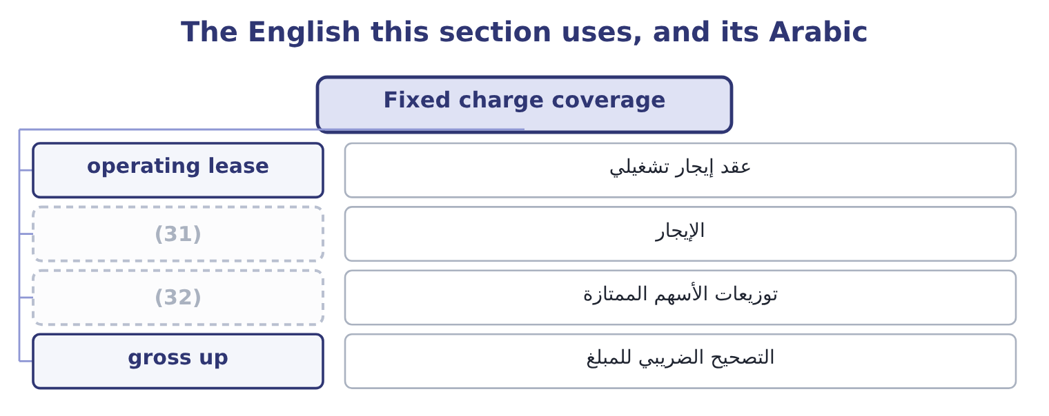
word list
preferred dividend · rental · covenant limit

The English this sheet uses, and its Arabic
English (exam term) | Arabic
operating lease | عقد إيجار تشغيلي
rental | الإيجار
preferred dividend | توزيعات الأسهم الممتازة
gross up | التصحيح الضريبي للمبلغ

Answer key · 10.2 Fixed charge coverage

1 whatever | 17 company's
2 equipment | 18 something
3 dividends | 19 retailer
4 agreements | 20 enormous
5 instalments | 21 misjudge
6 Statements | 22 halves
7 standard | 23 Adding
8 deducted | 24 understates
9 warehouses | 25 question
10 conventional | 26 after-tax
11 rental | 27 accounting
12 therefore | 28 obligation
13 always | 29 EBIT 4,348,800
14 proportionately | 30 Interest plus lease element 470,000
15 between | 31 rental
16 measure | 32 preferred dividend

the summaries in full
Summary 1 Interest is not the only charge a company must meet whatever happens. Rent under an operating lease must be paid. So must the lease payments on equipment, preferred dividends in some definitions, and in many agreements the principal instalments too. Fixed charge coverage, which the Learning Outcome Statements also call earnings to fixed charges, widens the ratio to take those. The standard form adds the interest element of lease rentals to both the numerator and the denominator, because that element was deducted in arriving at earnings and has to be added back before it is counted as a charge. Orontes pays operating lease rentals of $240,000 a year on its Gulf warehouses. The conventional treatment takes one-third of a rental as its interest element, which here is 240,000 ÷ 3 = 80,000. Fixed charges are therefore interest of $390,000 plus the lease element of $80,000: 390,000 + 80,000 = 470,000.
Summary 2 The numerator is EBIT plus the same lease element: 4,348,800 + 80,000 = 4,428,800. Fixed charge coverage is 4,428,800 ÷ 470,000 = 9.42 times. Fixed charge coverage is always the lower of the two, because the denominator widens by more, proportionately, than the numerator. The gap between them is the measure of how much of a company's fixed burden is something other than interest. For Orontes the gap is small, because it owns most of its plant. For a retailer that leases every store, the gap is enormous, and a lender who looked only at interest coverage would badly misjudge it.
Summary 3 Add the lease element to BOTH halves. Adding it only to the denominator understates the ratio. A preferred dividend, where a question includes it, must be grossed up for tax: it is paid out of after-tax income, so the pre-tax earnings needed are the dividend divided by one minus the tax rate. Principal repayments are included in some definitions and not in others.
Summary 4 English charge has several accounting senses: an expense in the income statement, an obligation to pay, and a security given over an asset.

10.3 Cash flow to fixed charges
Chapter 10 · section 10.3

Fill every gap. Each word list holds one word more than there are gaps.
Summary 1 gaps 1–9
Earnings are an (1) measure and the fixed charges are paid in money. A company can (2) earnings that cover its interest (3) and still not have the cash, because the earnings are in receivables and inventory. The third ratio (4) that risk by (5) earnings with cash. Cash flow to fixed charges (6) operating cash flow, before the fixed charges and before tax, by the fixed charges. In practice the (7) is operating cash flow as reported, plus the fixed charges that were deducted in arriving at it, plus income taxes paid. Orontes's operating cash flow for 2025 is $7,531,100. It paid interest of $390,000 and income taxes of $839,700, both of which are deducted in arriving at that figure under U.S. GAAP, and the lease (8) of $80,000 is inside the (9) expense.
word list
comfortably · expense · accounting · element · removes · report · rental · numerator · divides · replacing

Summary 2 gaps 10–14
Cash flow to fixed charges is 8,840,800 ÷ 470,000 = 18.81 times. That is very nearly twice the (10) figure, and the reason is the one: Orontes's earnings this year carry a large (11) charge. The (12) of $2,724,000 (13) EBIT and took no cash. On a cash basis the company covers its fixed charges (14) times over.
word list
reduced · impairment · nineteen · earnings-based · non-cash · reported

Orontes: the three coverage ratios
The bars are drawn to scale.
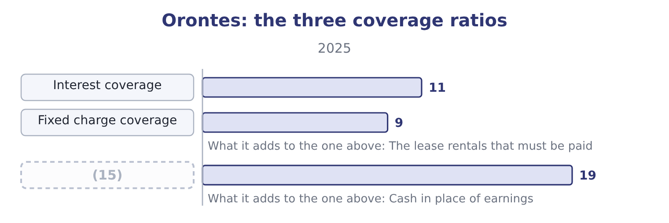
word list
margin of safety · Cash flow to fixed charges

Summary 3 gaps 16–19
A lender reads them in that order and pays most (16) to the third, because the third is what (17) arrives in the bank. When the third is far below the first, earnings are not (18) to cash and the lender is being told (19) the leverage ratios cannot say.
word list
attention · converting · something · numerator · actually

Worked example: when cash coverage is the lower figure

Summary 4 gaps 20–27
Suppose a company (20) EBIT of $5,000,000 and interest of $1,000,000, so interest coverage is 5.00 times. But receivables rose $3,000,000 and inventory rose $1,500,000 (21) the year, so operating cash flow is only $1,200,000. Cash coverage, (22) back interest of $1,000,000 and taxes paid of $400,000, is 2,600,000 ÷ 1,000,000 = 2.60 times. Coverage of 5.00 on earnings and 2.60 on cash (23) a company whose profit is (24) in working capital. Orontes is the (25) case: 11.15 on earnings and 18.81 on cash. The (26) of the gap is the (27) , not its size.
word list
reports · adding · sitting · finding · describes · during · something · opposite · direction

The English this section uses, and its Arabic
Each term sits against what it means.
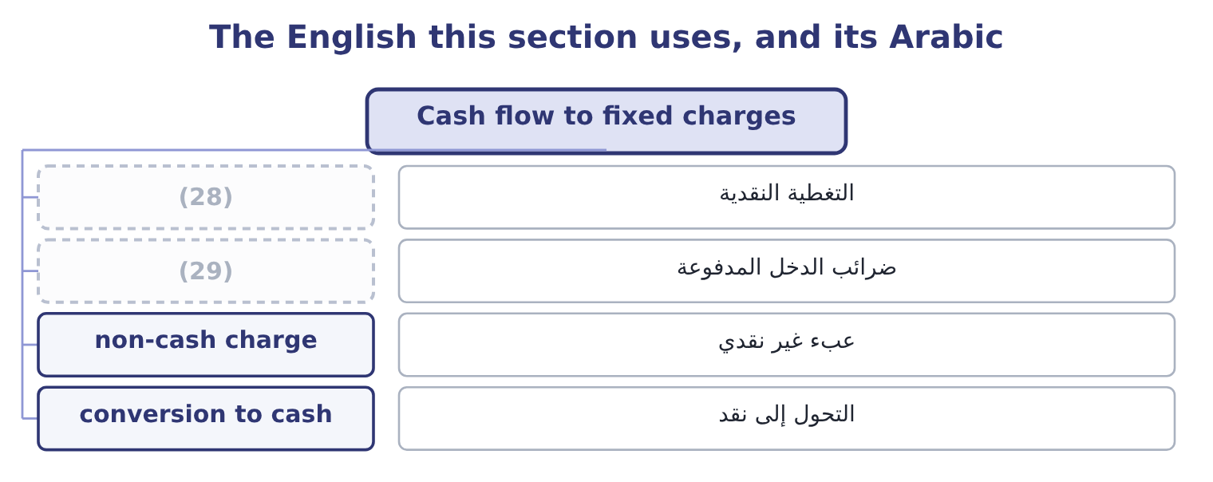
word list
operating lease rentals · cash coverage · income taxes paid

The English this sheet uses, and its Arabic
English (exam term) | Arabic
cash coverage | التغطية النقدية
income taxes paid | ضرائب الدخل المدفوعة
non-cash charge | عبء غير نقدي
conversion to cash | التحول إلى نقد

Answer key · 10.3 Cash flow to fixed charges

1 accounting | 16 attention
2 report | 17 actually
3 comfortably | 18 converting
4 removes | 19 something
5 replacing | 20 reports
6 divides | 21 during
7 numerator | 22 adding
8 element | 23 describes
9 rental | 24 sitting
10 earnings-based | 25 opposite
11 non-cash | 26 direction
12 impairment | 27 finding
13 reduced | 28 cash coverage
14 nineteen | 29 income taxes paid
15 Cash flow to fixed charges

the summaries in full
Summary 1 Earnings are an accounting measure and the fixed charges are paid in money. A company can report earnings that cover its interest comfortably and still not have the cash, because the earnings are in receivables and inventory. The third ratio removes that risk by replacing earnings with cash. Cash flow to fixed charges divides operating cash flow, before the fixed charges and before tax, by the fixed charges. In practice the numerator is operating cash flow as reported, plus the fixed charges that were deducted in arriving at it, plus income taxes paid. Orontes's operating cash flow for 2025 is $7,531,100. It paid interest of $390,000 and income taxes of $839,700, both of which are deducted in arriving at that figure under U.S. GAAP, and the lease element of $80,000 is inside the rental expense.
Summary 2 Cash flow to fixed charges is 8,840,800 ÷ 470,000 = 18.81 times. That is very nearly twice the earnings-based figure, and the reason is the one: Orontes's earnings this year carry a large non-cash charge. The impairment of $2,724,000 reduced EBIT and took no cash. On a cash basis the company covers its fixed charges nineteen times over.
Summary 3 A lender reads them in that order and pays most attention to the third, because the third is what actually arrives in the bank. When the third is far below the first, earnings are not converting to cash and the lender is being told something the leverage ratios cannot say.
Summary 4 Suppose a company reports EBIT of $5,000,000 and interest of $1,000,000, so interest coverage is 5.00 times. But receivables rose $3,000,000 and inventory rose $1,500,000 during the year, so operating cash flow is only $1,200,000. Cash coverage, adding back interest of $1,000,000 and taxes paid of $400,000, is 2,600,000 ÷ 1,000,000 = 2.60 times. Coverage of 5.00 on earnings and 2.60 on cash describes a company whose profit is sitting in working capital. Orontes is the opposite case: 11.15 on earnings and 18.81 on cash. The direction of the gap is the finding, not its size.

10.4 Coverage and the lender's decision
Chapter 10 · section 10.4

Fill every gap. Each word list holds one word more than there are gaps.
Summary 1 gaps 1–12
A lender uses the three ratios (1) , and it uses them forwards rather than (2) . The historical figure (3) the starting point. Orontes (4) interest 11.15 times today. The pro forma figure is what (5) . The lender (6) coverage on the (7) it is being asked to grant, at the interest rate it would charge, assuming the project contributes nothing in the first year. That was the (8) example of section 10.1: 3.92 times. The stressed figure (9) it. The lender then (10) the operating leverage. (11) DOL is 4.02, so a 10 per cent fall in sales cuts operating (12) 40.2 per cent. Take EBIT down by the same proportion, to about 2,600,000, and coverage on the enlarged interest becomes roughly 2,600,000 ÷ 1,110,000 = 2.34 times. That is the number the credit committee argues about.
word list
income · covers · Orontes's · establishes · matters · worked · recomputes · backwards · decides · together · facility · becomes · applies

Build the lender's three figures

Your turn: coverage as a lender computes it (complete the blanks)
Basis | EBIT | Interest | Coverage
As reported, 2025 | 4,348,800 | 390,000 | 11.15
After borrowing 12,000,000 at 6 per cent | 4,348,800 | ________ | ________
Stressed: sales down 10 per cent, DOL 4.02 | 2,600,000 | 1,110,000 | (13)

word list
Coverage 2.34: 2,600,000 ÷ 1,110,000. · earnings before interest and taxes

Summary 2 gaps 14–17
Note the (14) the exercise exposes. The leverage ratios.55 to about 2.14 — a change a (15) might welcome. The coverage ratio moves from 11.15 to 2.34 under stress, which is the same (16) seen from the lender's side. Neither party is wrong; they are measuring different risks with different (17) .
word list
interest · asymmetry · decision · instruments · shareholder

Coverage is forward-looking

Summary 3 gaps 18–21
A question that gives you a (18) borrowing wants the coverage AFTER it, not (19) . If the question gives you a (20) of operating leverage and a fall in sales, it wants the stressed figure. Assume a project contributes nothing in its first year unless the question says (21) .
word list
otherwise · before · backwards · proposed · degree

The English this section uses, and its Arabic
Each term sits against what it means.
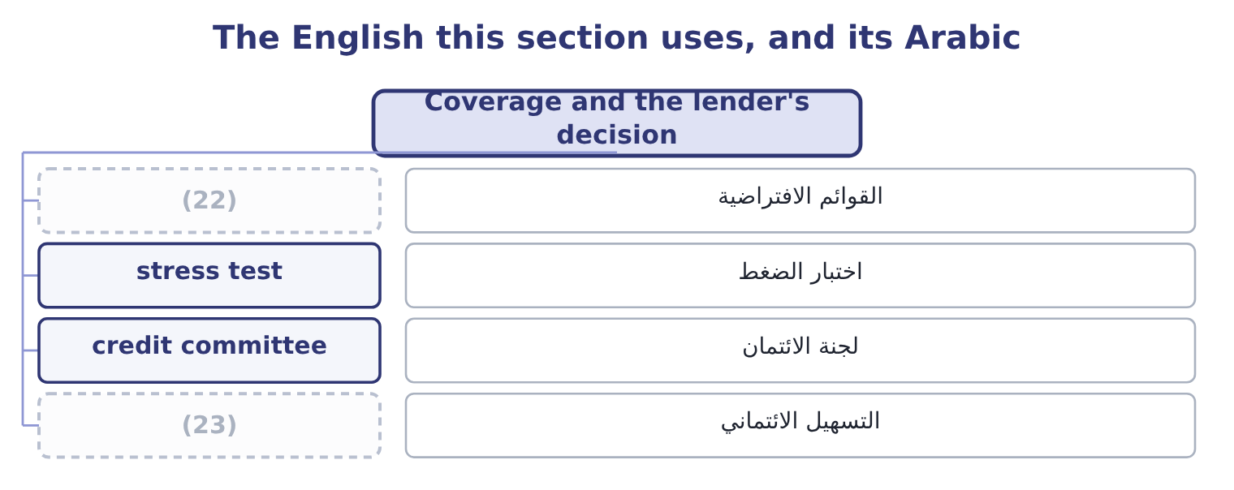
word list
pro forma · facility · credit committee

The English this sheet uses, and its Arabic
English (exam term) | Arabic
pro forma | القوائم الافتراضية
stress test | اختبار الضغط
credit committee | لجنة الائتمان
facility | التسهيل الائتماني

Answer key · 10.4 Coverage and the lender's decision

1 together | 13 Coverage 2.34: 2,600,000 ÷ 1,110,000.
2 backwards | 14 asymmetry
3 establishes | 15 shareholder
4 covers | 16 decision
5 matters | 17 instruments
6 recomputes | 18 proposed
7 facility | 19 before
8 worked | 20 degree
9 decides | 21 otherwise
10 applies | 22 pro forma
11 Orontes's | 23 facility
12 income

the summaries in full
Summary 1 A lender uses the three ratios together, and it uses them forwards rather than backwards. The historical figure establishes the starting point. Orontes covers interest 11.15 times today. The pro forma figure is what matters. The lender recomputes coverage on the facility it is being asked to grant, at the interest rate it would charge, assuming the project contributes nothing in the first year. That was the worked example of section 10.1: 3.92 times. The stressed figure decides it. The lender then applies the operating leverage. Orontes's DOL is 4.02, so a 10 per cent fall in sales cuts operating income 40.2 per cent. Take EBIT down by the same proportion, to about 2,600,000, and coverage on the enlarged interest becomes roughly 2,600,000 ÷ 1,110,000 = 2.34 times. That is the number the credit committee argues about.
Summary 2 Note the asymmetry the exercise exposes. The leverage ratios.55 to about 2.14 — a change a shareholder might welcome. The coverage ratio moves from 11.15 to 2.34 under stress, which is the same decision seen from the lender's side. Neither party is wrong; they are measuring different risks with different instruments.
Summary 3 A question that gives you a proposed borrowing wants the coverage AFTER it, not before. If the question gives you a degree of operating leverage and a fall in sales, it wants the stressed figure. Assume a project contributes nothing in its first year unless the question says otherwise.

10.5 What coverage ratios miss
Chapter 10 · section 10.5

Fill every gap. Each word list holds one word more than there are gaps.
Summary 1 gaps 1–10
Three things, all (1) . They (2) one year. A ratio of 11.15 computed on a year (3) a large one-off gain says less than the same ratio computed on three years. Where the exam gives a series, use it. They (4) the charge is the charge. Floating-rate debt changes the denominator without any (5) by the company, and a covenant tested (6) can be breached by an (7) movement alone. They (8) when the principal falls due. A company covering interest fifteen times with the whole principal (9) in eighteen months is in more danger than one covering it four times over a (10) schedule. The ratio sees the interest and not the maturity, which is why.
word list
measure · assume · repayable · ignore · examinable · twenty-year · computed · interest-rate · decision · quarterly · containing

Three things a coverage ratio does not see
Limit | Why it matters | Where it is answered
One year of earnings | A one-off gain or charge distorts it | (11)
The rate may move | Floating-rate debt changes the denominator | (12)
The maturity is invisible | (13) | The maturity profile, Chapter 9

word list
The borrowings note · Use a series; Chapter 17 on earnings quality · Floating-rate debt changes the denominator · Interest is covered; the principal still falls due

The English this section uses, and its Arabic
Each term sits against what it means.
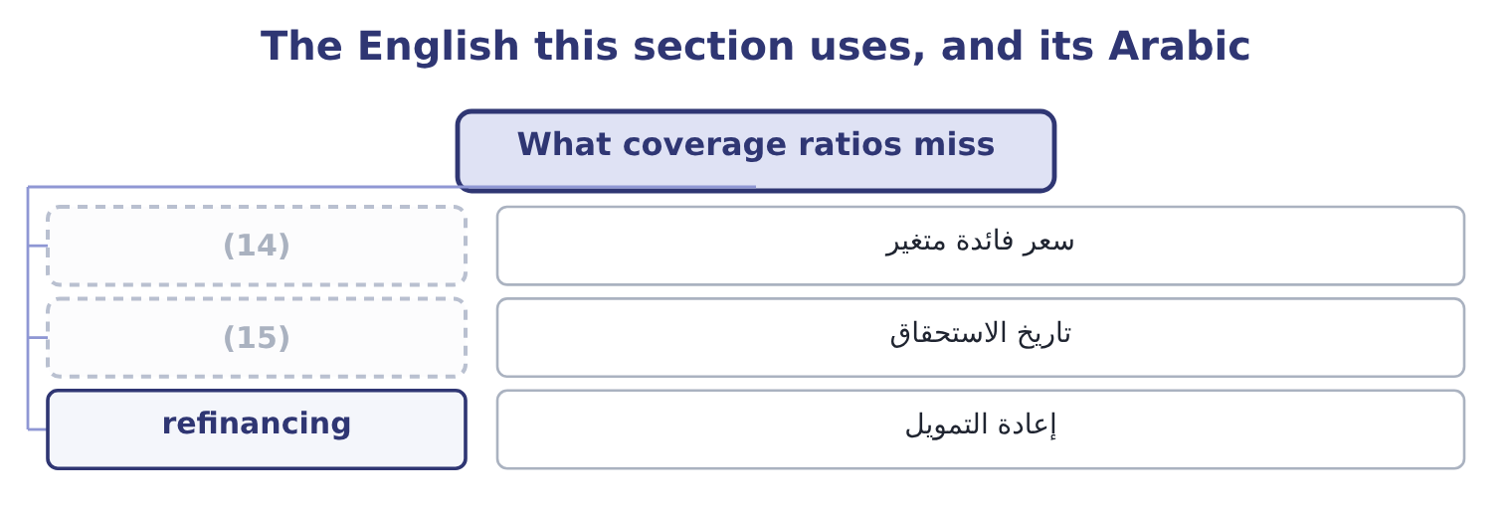
word list
maturity · floating rate · preferred dividend

The English this sheet uses, and its Arabic
English (exam term) | Arabic
floating rate | سعر فائدة متغير
maturity | تاريخ الاستحقاق
refinancing | إعادة التمويل

Answer key · 10.5 What coverage ratios miss

1 examinable | 9 repayable
2 measure | 10 twenty-year
3 containing | 11 Use a series; Chapter 17 on earnings quality
4 assume | 12 The borrowings note
5 decision | 13 Interest is covered; the principal still falls due
6 quarterly | 14 floating rate
7 interest-rate | 15 maturity
8 ignore

the summaries in full
Summary 1 Three things, all examinable. They measure one year. A ratio of 11.15 computed on a year containing a large one-off gain says less than the same ratio computed on three years. Where the exam gives a series, use it. They assume the charge is the charge. Floating-rate debt changes the denominator without any decision by the company, and a covenant tested quarterly can be breached by an interest-rate movement alone. They ignore when the principal falls due. A company covering interest fifteen times with the whole principal repayable in eighteen months is in more danger than one covering it four times over a twenty-year schedule. The ratio sees the interest and not the maturity, which is why.

11.1 Why the balance is averaged
Chapter 11 · section 11.1

Fill every gap. Each word list holds one word more than there are gaps.
Chapter 11, section by section
Each stage leads to the next.
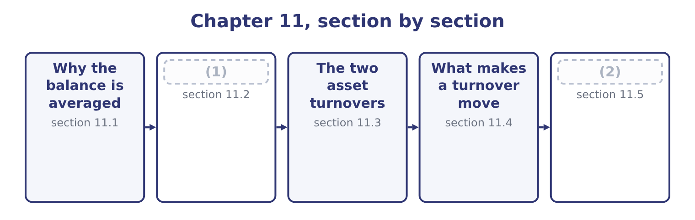
word list
The two asset turnovers · The three working-capital turnovers · Reading the five together

Summary 1 gaps 3–14
Every turnover ratio puts a flow over a balance, and the two are measured (3) . Net sales (4) across twelve months; accounts receivable is a (5) of 31 December. (6) one by the other (7) a year with a day. The (8) is to average the (9) and closing balances. For (10) receivables that is 4,144,000 + 3,760,000 = 7,904,000, (11) : 7,904,000 ÷ 2 = 3,952,000. The average is a crude (12) and the exam knows it. For a (13) business the two year-end balances may both be (14) — a toy manufacturer's receivables in January say nothing about its receivables in November — and a monthly average would be better if the data existed. Where an exam question gives only a closing balance, use it and say what you have done.
word list
opening · halved · business · Dividing · photograph · correction · unrepresentative · convention · differently · seasonal · compares · happened · Orontes's

The five turnover ratios
Ratio | Numerator | Denominator | Measures
Accounts receivable turnover | Net credit sales | Average accounts receivable | (15)
Inventory turnover | Cost of goods sold | (16) | How often the stock is sold
Accounts payable turnover | Purchases | (17) | How often the suppliers are paid
Total asset turnover | Net sales | Average total assets | (18)
Fixed asset turnover | Net sales | (19) | Sales produced per dollar of plant

word list
Average net fixed assets · Average accounts payable · How often the receivables are collected · Average inventory · Sales produced per dollar of assets · Average total assets

Summary 2 gaps 20–28
Three of the (20) repay attention. Receivable turnover (21) use credit sales, not total sales, (22) cash sales never (23) receivables. Few companies (24) the split, so net sales is used in (25) and the exam accepts it — but if a question gives you the credit (26) , use it. Inventory turnover uses cost of goods sold, not sales. Inventory is (27) at cost, so the numerator must be at cost too. Payable turnover uses purchases, not cost of goods sold. Purchases are cost of goods sold (28) for the movement in inventory: what was sold, plus what was added to the shelf, less what was taken from it.
word list
become · adjusted · disclose · practice · numerators · Payables · should · carried · because · proportion

Match the numerator to the balance

Summary 3 gaps 29–31
Inventory is at cost, so the numerator is cost of goods sold. (29) arise from purchases, so the numerator is purchases, not cost of goods sold. (30) arise from credit sales, so the numerator is credit sales where the (31) gives them.
word list
Receivables · Payables · question · numerators

The English this section uses, and its Arabic
Each term sits against what it means.
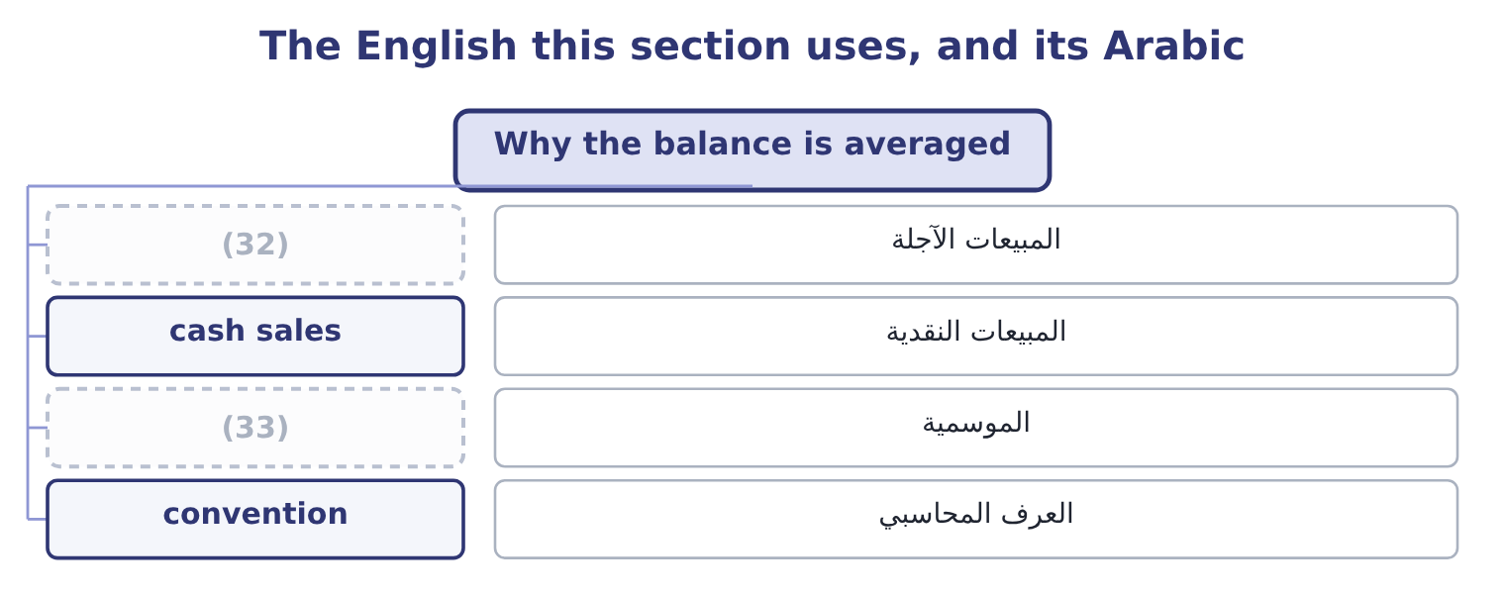
word list
credit sales · seasonality · collection

The English this sheet uses, and its Arabic
English (exam term) | Arabic
credit sales | المبيعات الآجلة
cash sales | المبيعات النقدية
seasonality | الموسمية
convention | العرف المحاسبي

Answer key · 11.1 Why the balance is averaged

1 The three working-capital turnovers | 18 Sales produced per dollar of assets
2 Reading the five together | 19 Average net fixed assets
3 differently | 20 numerators
4 happened | 21 should
5 photograph | 22 because
6 Dividing | 23 become
7 compares | 24 disclose
8 convention | 25 practice
9 opening | 26 proportion
10 Orontes's | 27 carried
11 halved | 28 adjusted
12 correction | 29 Payables
13 seasonal | 30 Receivables
14 unrepresentative | 31 question
15 How often the receivables are collected | 32 credit sales
16 Average inventory | 33 seasonality
17 Average accounts payable

the summaries in full
Summary 1 Every turnover ratio puts a flow over a balance, and the two are measured differently. Net sales happened across twelve months; accounts receivable is a photograph of 31 December. Dividing one by the other compares a year with a day. The convention is to average the opening and closing balances. For Orontes's receivables that is 4,144,000 + 3,760,000 = 7,904,000, halved: 7,904,000 ÷ 2 = 3,952,000. The average is a crude correction and the exam knows it. For a seasonal business the two year-end balances may both be unrepresentative — a toy manufacturer's receivables in January say nothing about its receivables in November — and a monthly average would be better if the data existed. Where an exam question gives only a closing balance, use it and say what you have done.
Summary 2 Three of the numerators repay attention. Receivable turnover should use credit sales, not total sales, because cash sales never become receivables. Few companies disclose the split, so net sales is used in practice and the exam accepts it — but if a question gives you the credit proportion, use it. Inventory turnover uses cost of goods sold, not sales. Inventory is carried at cost, so the numerator must be at cost too. Payable turnover uses purchases, not cost of goods sold. Purchases are cost of goods sold adjusted for the movement in inventory: what was sold, plus what was added to the shelf, less what was taken from it.
Summary 3 Inventory is at cost, so the numerator is cost of goods sold. Payables arise from purchases, so the numerator is purchases, not cost of goods sold. Receivables arise from credit sales, so the numerator is credit sales where the question gives them.

11.2 The three working-capital turnovers
Chapter 11 · section 11.2

Fill every gap. Each word list holds one word more than there are gaps.
Orontes Foods, Inc. — working-capital turnovers, 2025
The bars are drawn to scale.
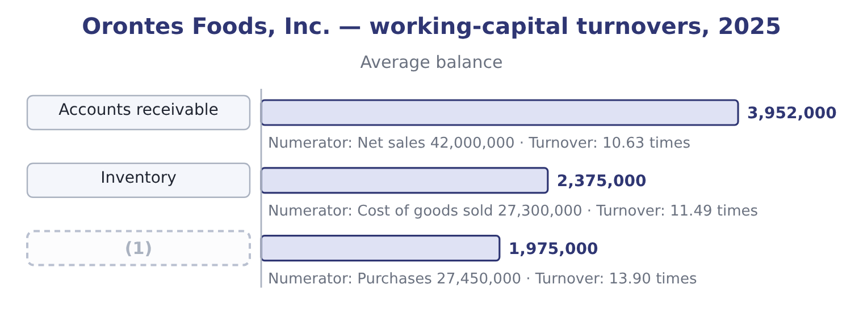
word list
Accounts payable · stretch suppliers

Summary 1 gaps 2–5
Average (2) are (4,144,000 + 3,760,000) ÷ 2 = 3,952,000, and 42,000,000 ÷ 3,952,000 = 10.63. Average inventory is (2,450,000 + 2,300,000) ÷ 2 = 2,375,000, and 27,300,000 ÷ 2,375,000 = 11.49. (3) are cost of goods sold plus the (4) in inventory: 27,300,000 + 150,000 = 27,450,000, where the 150,000 is 2,450,000 − 2,300,000. Average (5) are (2,050,000 + 1,900,000) ÷ 2 = 1,975,000, and 27,450,000 ÷ 1,975,000 = 13.90.
word list
receivables · payables · increase · together · Purchases

Worked example: purchases from cost of goods sold

Summary 2 gaps 6–17
Opening inventory plus purchases less closing inventory (6) cost of goods sold. (7) : purchases equal cost of goods sold plus closing inventory less opening inventory. Inventory rose, so Orontes (8) more than it sold: purchases exceed cost of goods sold by (9) the increase, $150,000. Had inventory (10) , purchases would have been less than cost of goods sold. A (11) who writes purchases equal to cost of goods sold has assumed inventory did not move, and the exam sets the question (12) because inventory did. The three (13) read together say (14) the liquidity ratios did not. Orontes pays its (15) faster than it collects from its (16) : payables turn 13.90 times against receivables at 10.63. Every day of that (17) is a day Orontes finances out of its own money. Inventory turning 11.49 times is brisk for a food manufacturer, and it corroborates the common-size finding.7 per cent of assets. Nothing is sitting on the shelf.
word list
precisely · bought · figures · something · candidate · fallen · difference · customers · suppliers · Rearranged · exactly · equals · Purchases

The English this section uses, and its Arabic
Each term sits against what it means.
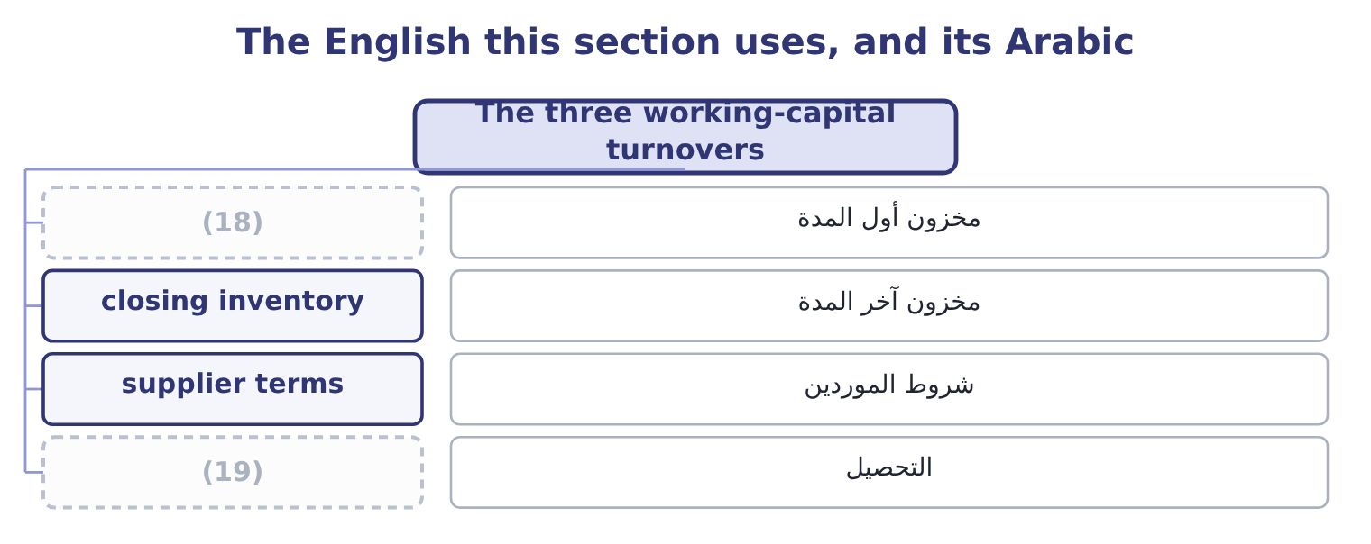
word list
utility · opening inventory · collection

The English this sheet uses, and its Arabic
English (exam term) | Arabic
opening inventory | مخزون أول المدة
closing inventory | مخزون آخر المدة
supplier terms | شروط الموردين
collection | التحصيل

Answer key · 11.2 The three working-capital turnovers

1 Accounts payable | 11 candidate
2 receivables | 12 precisely
3 Purchases | 13 figures
4 increase | 14 something
5 payables | 15 suppliers
6 equals | 16 customers
7 Rearranged | 17 difference
8 bought | 18 opening inventory
9 exactly | 19 collection
10 fallen

the summaries in full
Summary 1 Average receivables are (4,144,000 + 3,760,000) ÷ 2 = 3,952,000, and 42,000,000 ÷ 3,952,000 = 10.63. Average inventory is (2,450,000 + 2,300,000) ÷ 2 = 2,375,000, and 27,300,000 ÷ 2,375,000 = 11.49. Purchases are cost of goods sold plus the increase in inventory: 27,300,000 + 150,000 = 27,450,000, where the 150,000 is 2,450,000 − 2,300,000. Average payables are (2,050,000 + 1,900,000) ÷ 2 = 1,975,000, and 27,450,000 ÷ 1,975,000 = 13.90.
Summary 2 Opening inventory plus purchases less closing inventory equals cost of goods sold. Rearranged: purchases equal cost of goods sold plus closing inventory less opening inventory. Inventory rose, so Orontes bought more than it sold: purchases exceed cost of goods sold by exactly the increase, $150,000. Had inventory fallen, purchases would have been less than cost of goods sold. A candidate who writes purchases equal to cost of goods sold has assumed inventory did not move, and the exam sets the question precisely because inventory did. The three figures read together say something the liquidity ratios did not. Orontes pays its suppliers faster than it collects from its customers: payables turn 13.90 times against receivables at 10.63. Every day of that difference is a day Orontes finances out of its own money. Inventory turning 11.49 times is brisk for a food manufacturer, and it corroborates the common-size finding.7 per cent of assets. Nothing is sitting on the shelf.

11.3 The two asset turnovers
Chapter 11 · section 11.3

Fill every gap. Each word list holds one word more than there are gaps.
Summary 1 gaps 1–4
The same idea (1) to the whole balance sheet asks how much revenue the company (2) from what it owns. Total asset turnover is net sales divided by average total assets. For Orontes: average total assets are (31,672,600 + 26,445,000) ÷ 2 = 29,058,800, and 42,000,000 ÷ 29,058,800 = 1.45 times. Fixed asset turnover is net sales divided by average net (3) , plant and (4) . Average net PP&E is (14,802,000 + 16,000,000) ÷ 2 = 15,401,000, and 42,000,000 ÷ 15,401,000 = 2.73 times.
word list
property · shareholders' · applied · extracts · equipment

Asset turnover across three businesses
Business | Total asset turnover | Why
A manufacturer such as Orontes | About 1.5 | Heavy plant; each dollar of assets (5) about a dollar and a half of sales
A distributor such as Barada | (6) | Little plant; assets are stock and receivables, which move
A utility | (7) | Enormous fixed assets with a regulated revenue

word list
Below 0.5 · supports · receivables · About 3.0

Summary 2 gaps 8–16
Two (8) follow for Orontes. Total asset turnover of 1.45 is low for a food manufacturer, and the (9) is: 23.1 per cent of the assets are cash, which produces no sales at all. Strip the cash out and the ratio on operating assets would be far (10) . An (11) would say so, because the ratio as published (12) how hard the operating assets work. Fixed asset turnover of 2.73 is the figure that (13) the factory, and it rose (14) the year: plant fell $1,198,000 while sales rose 15.4 per cent. The plant is being worked harder, which is (15) with a company whose operating (16) is 4.02.
word list
applied · analyst · reason · describes · understates · consistent · leverage · readings · higher · during

Cash and asset turnover

Summary 3 gaps 17–23
Idle cash lowers total asset turnover (17) any change in (18) . Say so when the balance sheet shows a large cash (19) . Fixed asset turnover rises when assets are old and heavily (20) , because the denominator is net of accumulated (21) . A high ratio can mean an (22) factory or an (23) one. Leased assets that are on the balance sheet are in the denominator; a company that leases and expenses rentals has a smaller denominator and a flattering ratio.
word list
efficient · exhausted · holding · without · equipment · depreciated · depreciation · operations

Worked example: turnover without the cash

Summary 4 gaps 24–27
Cash was $7,302,100 at the end of 2025 and $2,100,000 at the end of 2024, so the average is (7,302,100 + 2,100,000) ÷ 2 = 4,701,050. Turnover on operating assets. Nearly (24) of a turn is (25) by the cash balance. (26) figure is wrong: 1.45 is what the (27) ' money produces and 1.72 is what the business produces. An answer that gives both, and says which is which, is a Level C answer.
word list
shareholders · Neither · three-tenths · exhausted · hidden

The English this section uses, and its Arabic
Each term sits against what it means.
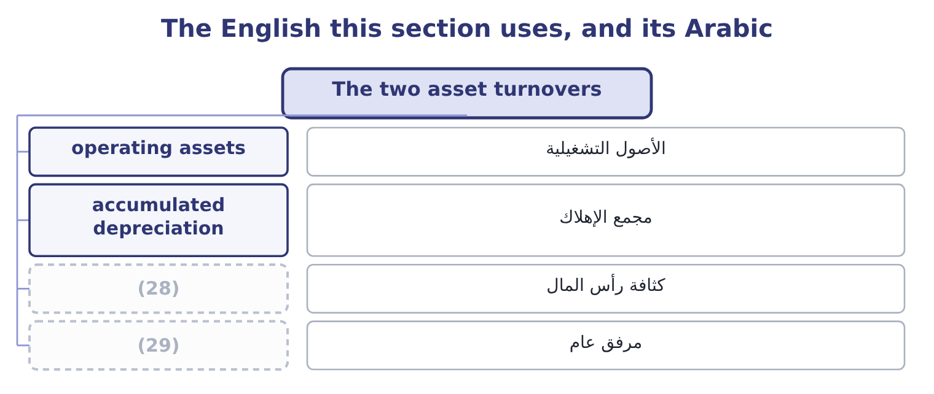
word list
capital intensity · utility · write-off

The English this sheet uses, and its Arabic
English (exam term) | Arabic
operating assets | الأصول التشغيلية
accumulated depreciation | مجمع الإهلاك
capital intensity | كثافة رأس المال
utility | مرفق عام

Answer key · 11.3 The two asset turnovers

1 applied | 16 leverage
2 extracts | 17 without
3 property | 18 operations
4 equipment | 19 holding
5 supports | 20 depreciated
6 About 3.0 | 21 depreciation
7 Below 0.5 | 22 efficient
8 readings | 23 exhausted
9 reason | 24 three-tenths
10 higher | 25 hidden
11 analyst | 26 Neither
12 understates | 27 shareholders
13 describes | 28 capital intensity
14 during | 29 utility
15 consistent

the summaries in full
Summary 1 The same idea applied to the whole balance sheet asks how much revenue the company extracts from what it owns. Total asset turnover is net sales divided by average total assets. For Orontes: average total assets are (31,672,600 + 26,445,000) ÷ 2 = 29,058,800, and 42,000,000 ÷ 29,058,800 = 1.45 times. Fixed asset turnover is net sales divided by average net property, plant and equipment. Average net PP&E is (14,802,000 + 16,000,000) ÷ 2 = 15,401,000, and 42,000,000 ÷ 15,401,000 = 2.73 times.
Summary 2 Two readings follow for Orontes. Total asset turnover of 1.45 is low for a food manufacturer, and the reason is: 23.1 per cent of the assets are cash, which produces no sales at all. Strip the cash out and the ratio on operating assets would be far higher. An analyst would say so, because the ratio as published understates how hard the operating assets work. Fixed asset turnover of 2.73 is the figure that describes the factory, and it rose during the year: plant fell $1,198,000 while sales rose 15.4 per cent. The plant is being worked harder, which is consistent with a company whose operating leverage is 4.02.
Summary 3 Idle cash lowers total asset turnover without any change in operations. Say so when the balance sheet shows a large cash holding. Fixed asset turnover rises when assets are old and heavily depreciated, because the denominator is net of accumulated depreciation. A high ratio can mean an efficient factory or an exhausted one. Leased assets that are on the balance sheet are in the denominator; a company that leases and expenses rentals has a smaller denominator and a flattering ratio.
Summary 4 Cash was $7,302,100 at the end of 2025 and $2,100,000 at the end of 2024, so the average is (7,302,100 + 2,100,000) ÷ 2 = 4,701,050. Turnover on operating assets. Nearly three-tenths of a turn is hidden by the cash balance. Neither figure is wrong: 1.45 is what the shareholders' money produces and 1.72 is what the business produces. An answer that gives both, and says which is which, is a Level C answer.

11.4 What makes a turnover move
Chapter 11 · section 11.4

Fill every gap. Each word list holds one word more than there are gaps.
Summary 1 gaps 1–2
A turnover is a (1) , so it moves when the flow moves, when the balance moves, or when both move at (2) rates.
word list
different · fraction · English

Why a turnover moves
Ratio | Rises when | Falls when
Receivables | Collection tightens; (3) grow; a large customer settles early | Terms are extended to win sales; a customer stops paying; sales are made late in the year
Inventory | Stock is cut; demand rises; obsolete stock is written off | Stock is built for a season; goods stop selling; a (4) is deferred
Payables | (5) | The company stretches suppliers; a dispute delays payment
Total assets | (6) | Cash accumulates; a large asset is bought before it produces
Fixed assets | Sales rise; plant depreciates | (7)

word list
write-down · closing inventory · Sales rise; assets are sold or written down · The company pays faster; a discount is taken · New plant is commissioned before it produces · cash sales

Summary 2 gaps 8–15
Two of those entries are the same event seen from (8) sides, and (9) are regularly caught by them. (10) off obsolete stock raises inventory turnover. The (11) falls and the numerator is (12) , so a company that finally clears its dead stock reports an improvement in efficiency. The improvement is in the (13) and not in the (14) . Buying a new plant lowers fixed asset turnover in the year it is commissioned and raises it (15) . A falling ratio in a year of heavy capital expenditure is expected and is not a finding.
word list
seasonality · Writing · denominator · afterwards · unaffected · measure · opposite · candidates · business

Compute Barada's turnovers

Compute the three working-capital turnovers.

Your turn: Barada's turnovers (complete the blanks)
Item | Amount
Net sales | 21,978,000
Cost of goods sold | 18,900,000
Average accounts receivable | 1,830,000
Average inventory | 2,100,000
Average accounts payable | 1,400,000
Purchases (inventory rose 280,000) | 19,180,000
Accounts receivable turnover | (16) : 21,978,000 ÷ 1,830,000.
Inventory turnover | (17) : 18,900,000 ÷ 2,100,000.
Accounts payable turnover | 13.70 times: 19,180,000 ÷ 1,400,000.

word list
12.01 times · 9.00 times · operating assets

"Turnover" has two meanings

Summary 3 gaps 18–20
In (18) English and on the CMA exam, turnover means the number of times a balance is replaced in a year. In British English, turnover also means revenue: a (19) annual turnover is its sales. The exam (20) means the first.
word list
always · expenditure · American · company's

The English this section uses, and its Arabic
Each term sits against what it means.
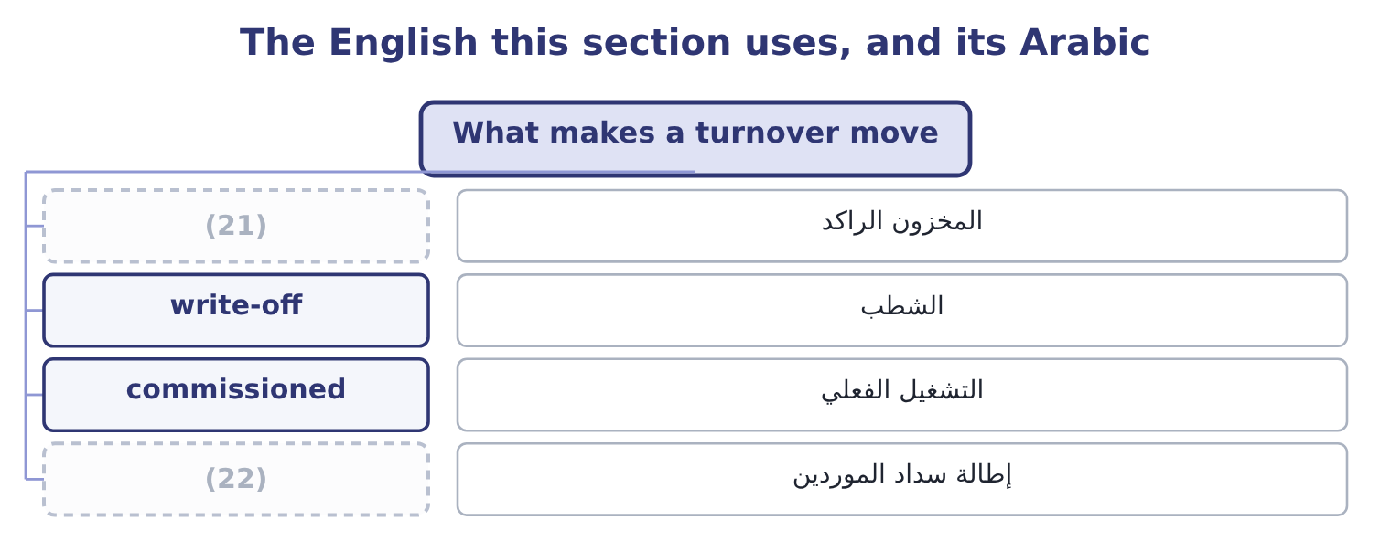
word list
credit sales · stretch suppliers · obsolete stock

The English this sheet uses, and its Arabic
English (exam term) | Arabic
obsolete stock | المخزون الراكد
write-off | الشطب
commissioned | التشغيل الفعلي
stretch suppliers | إطالة سداد الموردين

Answer key · 11.4 What makes a turnover move

1 fraction | 12 unaffected
2 different | 13 measure
3 cash sales | 14 business
4 write-down | 15 afterwards
5 The company pays faster; a discount is taken | 16 12.01 times
6 Sales rise; assets are sold or written down | 17 9.00 times
7 New plant is commissioned before it produces | 18 American
8 opposite | 19 company's
9 candidates | 20 always
10 Writing | 21 obsolete stock
11 denominator | 22 stretch suppliers

the summaries in full
Summary 1 A turnover is a fraction, so it moves when the flow moves, when the balance moves, or when both move at different rates.
Summary 2 Two of those entries are the same event seen from opposite sides, and candidates are regularly caught by them. Writing off obsolete stock raises inventory turnover. The denominator falls and the numerator is unaffected, so a company that finally clears its dead stock reports an improvement in efficiency. The improvement is in the measure and not in the business. Buying a new plant lowers fixed asset turnover in the year it is commissioned and raises it afterwards. A falling ratio in a year of heavy capital expenditure is expected and is not a finding.
Summary 3 In American English and on the CMA exam, turnover means the number of times a balance is replaced in a year. In British English, turnover also means revenue: a company's annual turnover is its sales. The exam always means the first.

11.5 Reading the five together
Chapter 11 · section 11.5

Fill every gap. Each word list holds one word more than there are gaps.
Summary 1 gaps 1–10
The (1) corroborate one (2) and they corroborate the liquidity ratios, and a Level C answer uses the (3) . Receivables turnover of 10.63 against a current ratio of 3.31. The current ratio is high and the receivables are (4) , so the high ratio is not uncollected debts. Had receivables turnover been 4 or 5, the same current ratio would have meant something very (5) . Inventory turnover of 11.49 against inventory at 7.7 per cent of assets. Both say the same thing: (6) money is tied up in stock and what is there moves. Total asset turnover of 1.45 against cash at 23.1 per cent of assets. These point in opposite (7) and the cash (8) the turnover, which is the (9) . Payables turnover of 13.90 against receivables at 10.63. (10) funds the gap.
word list
little · cross-checks · Orontes · another · uncollected · finding · different · moving · explains · turnovers · directions

Cross-checks between the turnovers and the earlier ratios
Turnover | Check it against | What agreement means | What disagreement means
Receivables | (11) | Liquidity is real | A high current ratio is uncollected debts
Inventory | (12) | Stock is under control | Stock is accumulating
Payables | The cash ratio | The company pays from strength | (13)
Total assets | (14) | Assets are working | Something large is idle
Fixed assets | (15) | Capacity matches sales | New capacity is not yet producing

word list
The common-size balance sheet · The current and quick ratios · The company is stretching suppliers · Capital expenditure in the cash flow statement · The company pays from strength · Inventory as a share of assets

The English this section uses, and its Arabic
Each term sits against what it means.
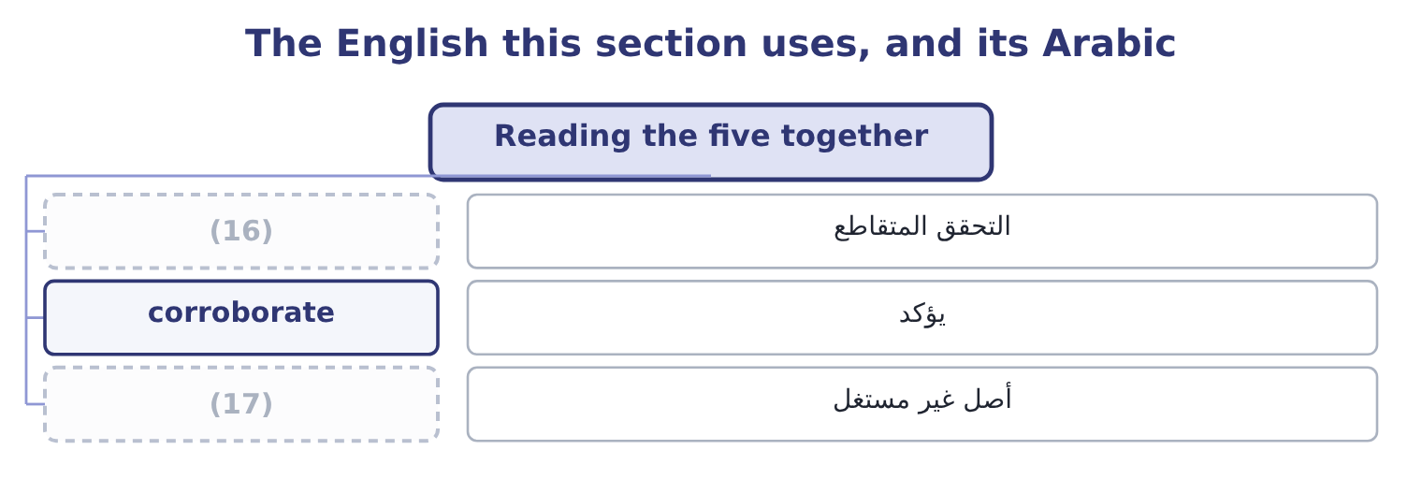
word list
average balance · idle asset · cross-check

The English this sheet uses, and its Arabic
English (exam term) | Arabic
cross-check | التحقق المتقاطع
corroborate | يؤكد
idle asset | أصل غير مستغل

Answer key · 11.5 Reading the five together

1 turnovers | 10 Orontes
2 another | 11 The current and quick ratios
3 cross-checks | 12 Inventory as a share of assets
4 moving | 13 The company is stretching suppliers
5 different | 14 The common-size balance sheet
6 little | 15 Capital expenditure in the cash flow statement
7 directions | 16 cross-check
8 explains | 17 idle asset
9 finding

the summaries in full
Summary 1 The turnovers corroborate one another and they corroborate the liquidity ratios, and a Level C answer uses the cross-checks. Receivables turnover of 10.63 against a current ratio of 3.31. The current ratio is high and the receivables are moving, so the high ratio is not uncollected debts. Had receivables turnover been 4 or 5, the same current ratio would have meant something very different. Inventory turnover of 11.49 against inventory at 7.7 per cent of assets. Both say the same thing: little money is tied up in stock and what is there moves. Total asset turnover of 1.45 against cash at 23.1 per cent of assets. These point in opposite directions and the cash explains the turnover, which is the finding. Payables turnover of 13.90 against receivables at 10.63. Orontes funds the gap.

12.1 From times to days
Chapter 12 · section 12.1

Fill every gap. Each word list holds one word more than there are gaps.
Chapter 12, section by section
Each stage leads to the next.
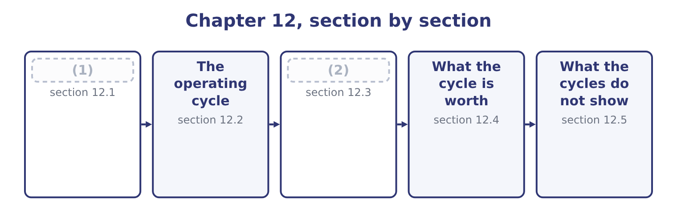
word list
The cash cycle · days sales outstanding · From times to days

Summary 1 gaps 3–14
A turnover says how many times a year a balance is (3) . Dividing 365 by it gives the average (4) of days the balance sits there. Days sales (5) , usually written DSO, is 365 divided by receivables turnover. For (6) : 365 ÷ 10.63 = 34.3 days. Days sales in inventory, written DSI, is 365 divided by inventory turnover: 365 ÷ 11.49 = 31.8 days. Days purchases in (7) payable, written DPO, is 365 divided by (8) turnover: 365 ÷ 13.90 = 26.3 days. Two (9) matter before the arithmetic is (10) . Some (11) supply a year-end balance and some an average of (12) and closing; a day-count built on a year-end balance measures that one day, while a day-count built on an average measures the year, and in a growing company the two differ by the better part of a week. And where a question gives a 360-day year rather than 365, every day-count (13) : 360 ÷ 10.63 = 33.9 days rather than 34.3. (14) convention is wrong, and an answer that states which one it used cannot be marked down for it.
word list
opening · Neither · conventions · payables · number · trusted · spread · shortens · outstanding · Orontes · replaced · accounts · questions

Summary 2 gaps 15–18
The same (15) can be reached without (16) the turnover at all, by dividing the average balance by the daily flow. Daily sales are 42,000,000 ÷ 365 = 115,068, and average receivables of 3,952,000 divided by that is 34.3 days. The two (17) are the same arithmetic written in a (18) order, and the exam uses both.
word list
computing · routes · figures · different · trusted

Orontes Foods, Inc. — the three day-counts, 2025
The bars are drawn to scale.
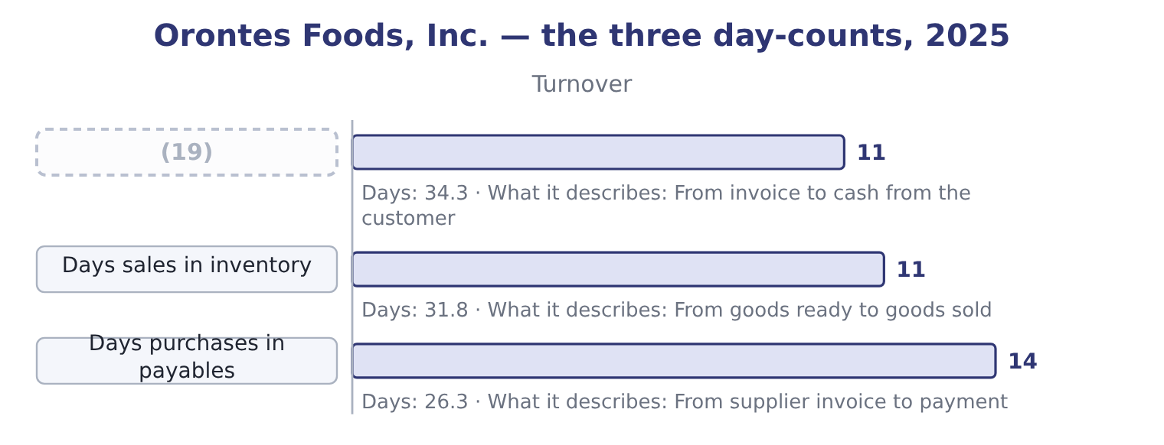
word list
Days sales outstanding · work in progress

Which denominator for which day-count

Summary 3 gaps 20–22
DSO divides by daily (20) sales. DSI divides by daily cost of goods sold. DPO divides by daily purchases. Some texts use 360 days rather than 365. The exam states which; if it does not, use 365 and say so. A day-count is an average. (21) days does not mean every (22) pays on day 34.
word list
Thirty-four · customer · credit · Orontes

The English this section uses, and its Arabic
Each term sits against what it means.
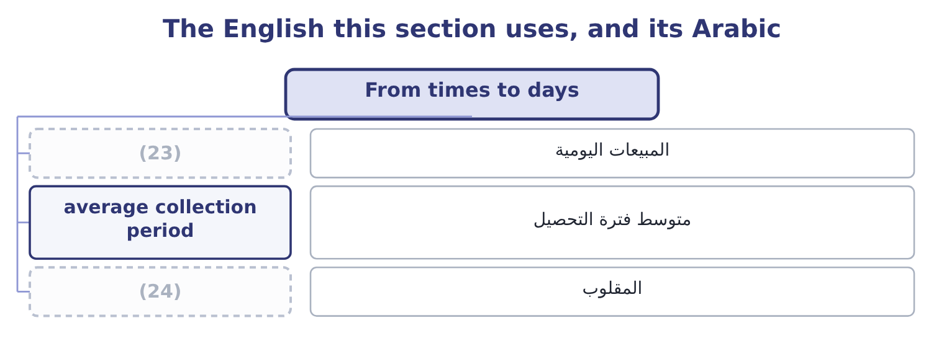
word list
reciprocal · daily sales · المبيعات اليومية

The English this sheet uses, and its Arabic
English (exam term) | Arabic
daily sales | المبيعات اليومية
average collection period | متوسط فترة التحصيل
reciprocal | المقلوب

Answer key · 12.1 From times to days

1 From times to days | 13 shortens
2 The cash cycle | 14 Neither
3 replaced | 15 figures
4 number | 16 computing
5 outstanding | 17 routes
6 Orontes | 18 different
7 accounts | 19 Days sales outstanding
8 payables | 20 credit
9 conventions | 21 Thirty-four
10 trusted | 22 customer
11 questions | 23 daily sales
12 opening | 24 reciprocal

the summaries in full
Summary 1 A turnover says how many times a year a balance is replaced. Dividing 365 by it gives the average number of days the balance sits there. Days sales outstanding, usually written DSO, is 365 divided by receivables turnover. For Orontes: 365 ÷ 10.63 = 34.3 days. Days sales in inventory, written DSI, is 365 divided by inventory turnover: 365 ÷ 11.49 = 31.8 days. Days purchases in accounts payable, written DPO, is 365 divided by payables turnover: 365 ÷ 13.90 = 26.3 days. Two conventions matter before the arithmetic is trusted. Some questions supply a year-end balance and some an average of opening and closing; a day-count built on a year-end balance measures that one day, while a day-count built on an average measures the year, and in a growing company the two differ by the better part of a week. And where a question gives a 360-day year rather than 365, every day-count shortens: 360 ÷ 10.63 = 33.9 days rather than 34.3. Neither convention is wrong, and an answer that states which one it used cannot be marked down for it.
Summary 2 The same figures can be reached without computing the turnover at all, by dividing the average balance by the daily flow. Daily sales are 42,000,000 ÷ 365 = 115,068, and average receivables of 3,952,000 divided by that is 34.3 days. The two routes are the same arithmetic written in a different order, and the exam uses both.
Summary 3 DSO divides by daily credit sales. DSI divides by daily cost of goods sold. DPO divides by daily purchases. Some texts use 360 days rather than 365. The exam states which; if it does not, use 365 and say so. A day-count is an average. Thirty-four days does not mean every customer pays on day 34.

12.2 The operating cycle
Chapter 12 · section 12.2

Fill every gap. Each word list holds one word more than there are gaps.
Summary 1 gaps 1–12
The operating cycle is the time from (1) for goods to (2) the cash from selling them. It is days sales in inventory plus days sales (3) . For Orontes: 31.8 + 34.3 = 66.1 days. That is the figure Part 1 (4) . Money spent on sesame today comes back as cash from a customer about sixty-six days later, on average, and during those sixty-six days it is (5) money and not (6) for anything else. The operating cycle also decides a (7) rule you learned in Part 1. An asset is current if it will be (8) within one year or within the operating cycle, (9) is longer. (10) cycle is 66 days, far (11) than a year, so Orontes uses the year. A (12) with a three-year cycle uses the three years, and its work in progress is a current asset even though it will sit there for thirty months.
word list
collecting · available · inventory · shipbuilder · somebody's · outstanding · classification · paying · shorter · Orontes's · realised · whichever · quoted

Orontes's operating cycle, 2025
Stage | Days | Running total
Goods held in inventory | 31.8 | 31.8
Customer takes to pay | 34.3 | 66.1
Operating cycle |  | (13)

word list
66.1 days · funding cost

Worked example: what the operating cycle costs

Summary 2 gaps 14–25
Cost of goods sold is $27,300,000 a year, which is 27,300,000 ÷ 365 = 74,795 a day. The money in the cycle. Sixty-six days of it: 74,795 × 66.1 = 4,943,949. (14) five million dollars is (15) the cycle at any (16) . Check it (17) the balance sheet. Inventory of $2,450,000 plus (18) of $4,144,000 is 2,450,000 + 4,144,000 = 6,594,000. The two figures differ because the receivable carries the selling price and the (19) was costed at cost; both are correct (20) of the same (21) on different bases, and the exam accepts either where it says which it wants. Either way the order of (22) is the same, and the point is that the cycle is not an (23) . (24) it by one day frees about (25) thousand dollars at cost.
word list
lock-up · measures · receivables · Roughly · against · Orontes's · seventy-five · Shortening · moment · day-count · inside · magnitude · abstraction

The English this section uses, and its Arabic
Each term sits against what it means.
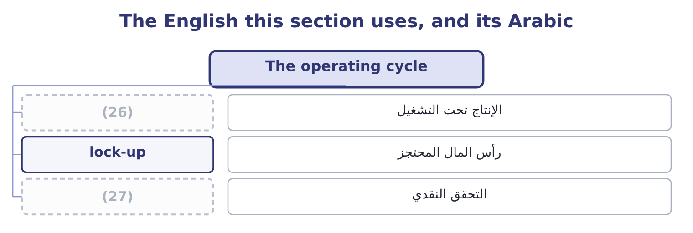
word list
realisation · reciprocal · work in progress

The English this sheet uses, and its Arabic
English (exam term) | Arabic
work in progress | الإنتاج تحت التشغيل
lock-up | رأس المال المحتجز
realisation | التحقق النقدي

Answer key · 12.2 The operating cycle

1 paying | 15 inside
2 collecting | 16 moment
3 outstanding | 17 against
4 quoted | 18 receivables
5 somebody's | 19 day-count
6 available | 20 measures
7 classification | 21 lock-up
8 realised | 22 magnitude
9 whichever | 23 abstraction
10 Orontes's | 24 Shortening
11 shorter | 25 seventy-five
12 shipbuilder | 26 work in progress
13 66.1 days | 27 realisation
14 Roughly

the summaries in full
Summary 1 The operating cycle is the time from paying for goods to collecting the cash from selling them. It is days sales in inventory plus days sales outstanding. For Orontes: 31.8 + 34.3 = 66.1 days. That is the figure Part 1 quoted. Money spent on sesame today comes back as cash from a customer about sixty-six days later, on average, and during those sixty-six days it is somebody's money and not available for anything else. The operating cycle also decides a classification rule you learned in Part 1. An asset is current if it will be realised within one year or within the operating cycle, whichever is longer. Orontes's cycle is 66 days, far shorter than a year, so Orontes uses the year. A shipbuilder with a three-year cycle uses the three years, and its work in progress is a current asset even though it will sit there for thirty months.
Summary 2 Cost of goods sold is $27,300,000 a year, which is 27,300,000 ÷ 365 = 74,795 a day. The money in the cycle. Sixty-six days of it: 74,795 × 66.1 = 4,943,949. Roughly five million dollars is inside the cycle at any moment. Check it against the balance sheet. Inventory of $2,450,000 plus receivables of $4,144,000 is 2,450,000 + 4,144,000 = 6,594,000. The two figures differ because the receivable carries the selling price and the day-count was costed at cost; both are correct measures of the same lock-up on different bases, and the exam accepts either where it says which it wants. Either way the order of magnitude is the same, and the point is that the cycle is not an abstraction. Shortening it by one day frees about seventy-five thousand dollars at cost.

12.3 The cash cycle
Chapter 12 · section 12.3

Fill every gap. Each word list holds one word more than there are gaps.
Summary 1 gaps 1–5
The operating cycle (1) the company pays for its goods on the day it (2) them. It does not: suppliers give credit, and the days of that credit are days the company does not have to fund. The cash cycle, also called the cash (3) cycle, is the operating cycle less days purchases in payables. For Orontes: 66.1 − 26.3 = 39.8 days. So Orontes funds about forty days. Its suppliers fund (4) of the sixty-six, and the company (5) funds the rest.
word list
twenty-six · settlement · itself · receives · assumes · conversion

Orontes: from operating cycle to cash cycle
Component | Days | Effect
Days sales in inventory | 31.8 | Adds to the lock-up
Days sales outstanding | 34.3 | (6)
Operating cycle | 66.1 | (7)
Days purchases in payables | (26.3) | Funded by suppliers
Cash cycle | 39.8 | (8)

word list
Adds to the lock-up · Total lock-up · Funded by the company · trade working capital

Summary 2 gaps 9–15
A negative cash cycle is (9) and is the strongest (10) position there is. A supermarket sells for cash, so its DSO is near zero; it turns its stock in about twenty days; and it pays its suppliers in sixty. Twenty plus (11) less sixty is minus forty days: the supermarket is (12) by its suppliers and holds the (13) ' money for forty days before passing it on. That is why such (14) can run a current ratio below 1.0 (15) .
word list
businesses · permanently · nothing · possible · working-capital · customers · financed · manager

The cash cycle across three businesses
The bars are drawn to scale.
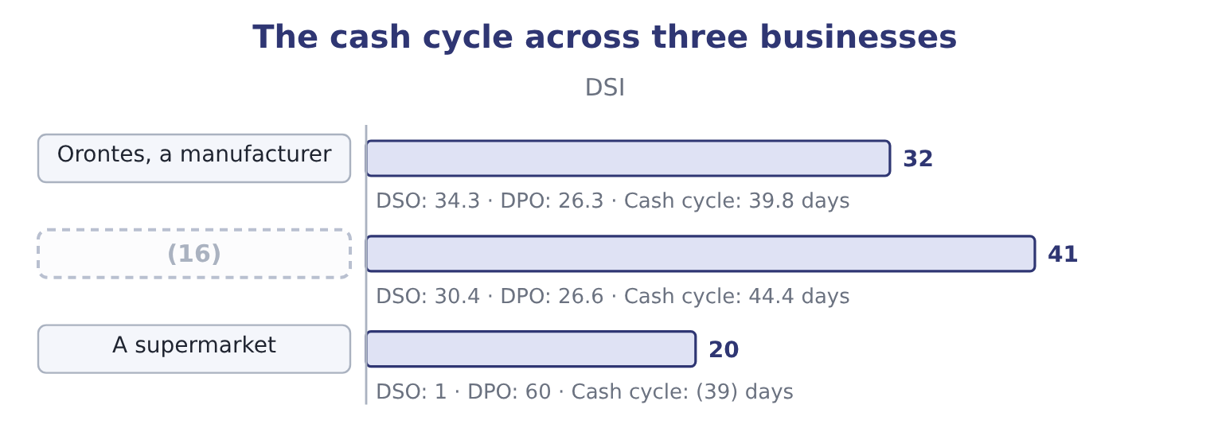
word list
Barada, a distributor · trade working capital

The sign and the direction

Summary 3 gaps 17–21
A (17) cash cycle is better. A negative cash cycle is better still. (18) DPO shortens the cash cycle and may cost supplier goodwill or a settlement discount. The exam treats this as a (19) , not a free gain. A cash cycle computed from year-end balances is a (20) . For a (21) business compute it at more than one date if the data allows.
word list
payables · shorter · seasonal · snapshot · trade-off · Lengthening

Worked example: shortening the cycle three ways

Summary 4 gaps 22–30
Collect five days (22) . DSO falls from 34.3 to 29.3 and the cash cycle from 39.8 to 34.8 days. At daily sales of $115,068 that releases 115,068 × 5 = 575,340 of (23) . Hold five days less stock. DSI falls from 31.8 to 26.8 and the cycle to 34.8 days again. At daily cost of goods sold of $74,795 that releases 74,795 × 5 = 373,975. Take five more days to pay. DPO rises from 26.3 to 31.3 and the cycle falls to 34.8 days once more. At daily purchases of about $75,205 that releases (24) 376,000. Three different (25) , the same five days off the cycle, and three different amounts of cash (26) , because each day is (27) at a different daily flow. A manager (28) between them needs the money figures, not the (29) , and that is the point of the (30) .
word list
valued · position · day-counts · choosing · released · actions · roughly · exercise · faster · receivables

The English this section uses, and its Arabic
Each term sits against what it means.
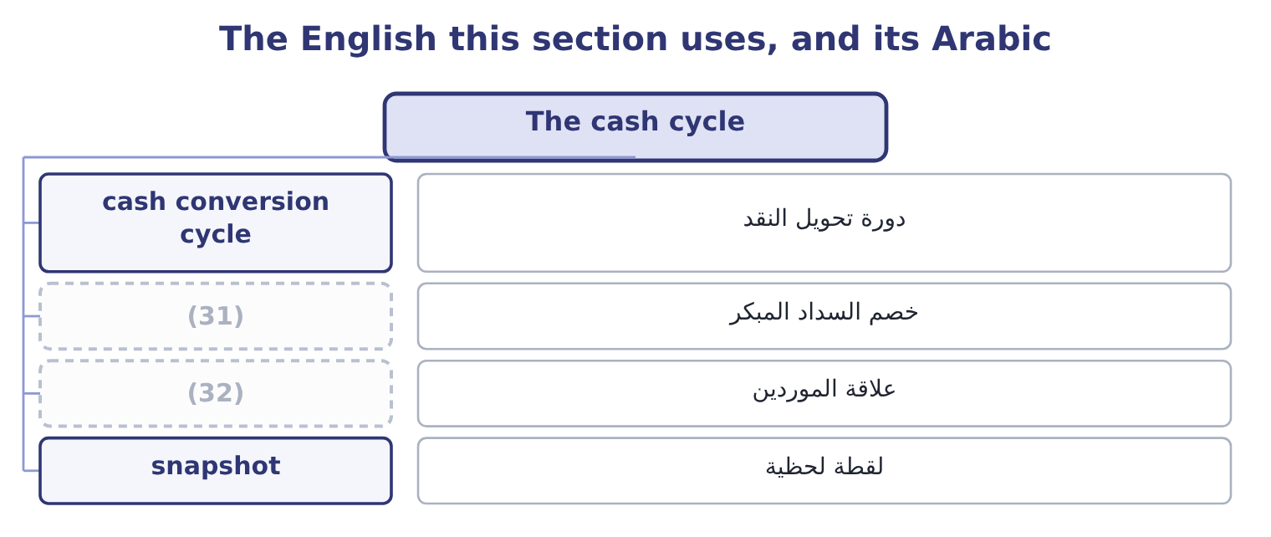
word list
supplier goodwill · daily sales · settlement discount

The English this sheet uses, and its Arabic
English (exam term) | Arabic
cash conversion cycle | دورة تحويل النقد
settlement discount | خصم السداد المبكر
supplier goodwill | علاقة الموردين
snapshot | لقطة لحظية

Answer key · 12.3 The cash cycle

1 assumes | 17 shorter
2 receives | 18 Lengthening
3 conversion | 19 trade-off
4 twenty-six | 20 snapshot
5 itself | 21 seasonal
6 Adds to the lock-up | 22 faster
7 Total lock-up | 23 receivables
8 Funded by the company | 24 roughly
9 possible | 25 actions
10 working-capital | 26 released
11 nothing | 27 valued
12 financed | 28 choosing
13 customers | 29 day-counts
14 businesses | 30 exercise
15 permanently | 31 settlement discount
16 Barada, a distributor | 32 supplier goodwill

the summaries in full
Summary 1 The operating cycle assumes the company pays for its goods on the day it receives them. It does not: suppliers give credit, and the days of that credit are days the company does not have to fund. The cash cycle, also called the cash conversion cycle, is the operating cycle less days purchases in payables. For Orontes: 66.1 − 26.3 = 39.8 days. So Orontes funds about forty days. Its suppliers fund twenty-six of the sixty-six, and the company itself funds the rest.
Summary 2 A negative cash cycle is possible and is the strongest working-capital position there is. A supermarket sells for cash, so its DSO is near zero; it turns its stock in about twenty days; and it pays its suppliers in sixty. Twenty plus nothing less sixty is minus forty days: the supermarket is financed by its suppliers and holds the customers' money for forty days before passing it on. That is why such businesses can run a current ratio below 1.0 permanently.
Summary 3 A shorter cash cycle is better. A negative cash cycle is better still. Lengthening DPO shortens the cash cycle and may cost supplier goodwill or a settlement discount. The exam treats this as a trade-off, not a free gain. A cash cycle computed from year-end balances is a snapshot. For a seasonal business compute it at more than one date if the data allows.
Summary 4 Collect five days faster. DSO falls from 34.3 to 29.3 and the cash cycle from 39.8 to 34.8 days. At daily sales of $115,068 that releases 115,068 × 5 = 575,340 of receivables. Hold five days less stock. DSI falls from 31.8 to 26.8 and the cycle to 34.8 days again. At daily cost of goods sold of $74,795 that releases 74,795 × 5 = 373,975. Take five more days to pay. DPO rises from 26.3 to 31.3 and the cycle falls to 34.8 days once more. At daily purchases of about $75,205 that releases roughly 376,000. Three different actions, the same five days off the cycle, and three different amounts of cash released, because each day is valued at a different daily flow. A manager choosing between them needs the money figures, not the day-counts, and that is the point of the exercise.

12.4 What the cycle is worth
Chapter 12 · section 12.4

Fill every gap. Each word list holds one word more than there are gaps.
Summary 1 gaps 1–12
A day of the cash cycle is a sum of money, and the exam expects the (1) . The (2) version values a day at the daily cost of sales, because that is what is (3) . For Orontes a day is $74,795, so the whole (4) cycle is about 74,795 × 39.8 = 2,976,841 of funding. A (5) version builds it from the (6) sheet. Trade working capital is (7) plus inventory less (8) : 4,144,000 + 2,450,000 = 6,594,000, and 6,594,000 − 2,050,000 = 4,544,000. That is what Orontes (9) has tied up in trade at the year end. The two differ because the first costs (10) at cost and the second (11) the receivable at its selling price. (12) is acceptable; what is not acceptable is to mix them. What the number is for is the next question.
word list
receivables · conversion · carries · simplest · funded · balance · forty-day · Either · fuller · Orontes · everything · actually · payables

Summary 2 gaps 13–18
Orontes funds $4,544,000 of trade working capital. At the 6 per cent it pays Levant (13) Bank, that funding costs about 4,544,000 × 0.06 = 272,640 a year. (14) the cash cycle by ten days would (15) roughly a quarter of it and save about $68,000 a year — which is a real sum and a (16) one than the $840,000 the margin decline. (17) the two side by side is what (18) findings means.
word list
findings · release · Shortening · smaller · ranking · Putting · Commerce

Build Barada's cycle

Compute the three day-counts and the two cycles.
Your turn: Barada's cycles (complete the blanks)
The bars are drawn to scale.
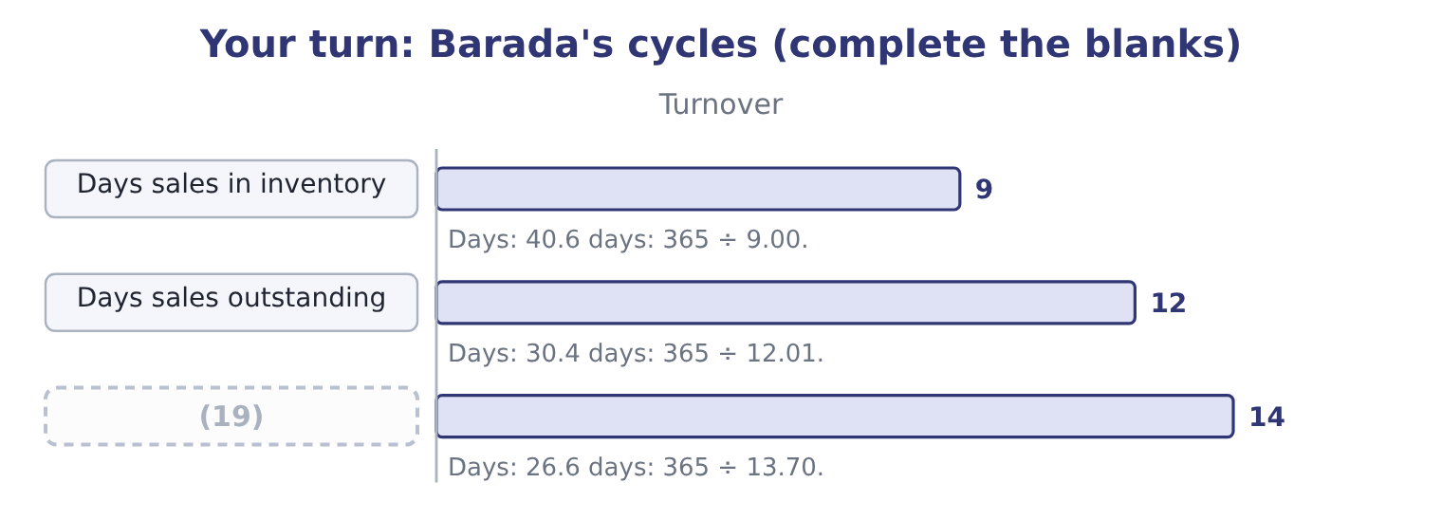
word list
Days purchases in payables · days sales in inventory

"Outstanding"

Summary 3 gaps 20–22
English outstanding has two (20) senses: excellent, and not yet (21) . In days sales outstanding it is the second — the sales still owed to the company. A (22) who reads the phrase as praise will misread the ratio entirely.
word list
candidate · opposite-feeling · working · settled

The English this section uses, and its Arabic
Each term sits against what it means.
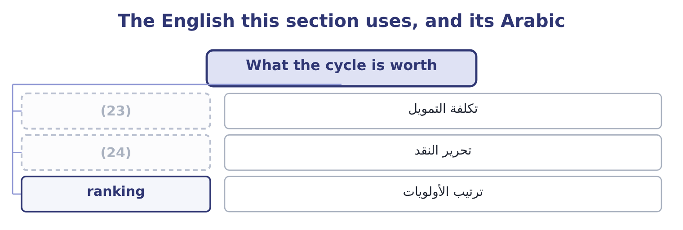
word list
days sales outstanding · funding cost · release of cash

The English this sheet uses, and its Arabic
English (exam term) | Arabic
funding cost | تكلفة التمويل
release of cash | تحرير النقد
ranking | ترتيب الأولويات

Answer key · 12.4 What the cycle is worth

1 conversion | 13 Commerce
2 simplest | 14 Shortening
3 funded | 15 release
4 forty-day | 16 smaller
5 fuller | 17 Putting
6 balance | 18 ranking
7 receivables | 19 Days purchases in payables
8 payables | 20 opposite-feeling
9 actually | 21 settled
10 everything | 22 candidate
11 carries | 23 funding cost
12 Either | 24 release of cash

the summaries in full
Summary 1 A day of the cash cycle is a sum of money, and the exam expects the conversion. The simplest version values a day at the daily cost of sales, because that is what is funded. For Orontes a day is $74,795, so the whole forty-day cycle is about 74,795 × 39.8 = 2,976,841 of funding. A fuller version builds it from the balance sheet. Trade working capital is receivables plus inventory less payables: 4,144,000 + 2,450,000 = 6,594,000, and 6,594,000 − 2,050,000 = 4,544,000. That is what Orontes actually has tied up in trade at the year end. The two differ because the first costs everything at cost and the second carries the receivable at its selling price. Either is acceptable; what is not acceptable is to mix them. What the number is for is the next question.
Summary 2 Orontes funds $4,544,000 of trade working capital. At the 6 per cent it pays Levant Commerce Bank, that funding costs about 4,544,000 × 0.06 = 272,640 a year. Shortening the cash cycle by ten days would release roughly a quarter of it and save about $68,000 a year — which is a real sum and a smaller one than the $840,000 the margin decline. Putting the two side by side is what ranking findings means.
Summary 3 English outstanding has two opposite-feeling senses: excellent, and not yet settled. In days sales outstanding it is the second — the sales still owed to the company. A candidate who reads the phrase as praise will misread the ratio entirely.

12.5 What the cycles do not show
Chapter 12 · section 12.5

Fill every gap. Each word list holds one word more than there are gaps.
Summary 1 gaps 1–8
Three limits, each (1) , and a fourth worth (2) . An average hides its spread. A DSO of 34.3 days is (3) with every customer paying on day 34 and with most paying on day 20 and one large one paying on day 120. The ageing schedule (4) the two and the ratio cannot. A cycle computed at a year end is a (5) of the quietest day. Many companies (6) a year end at the bottom of their season (7) because stock and receivables are low then. A seasonal business (8) be measured at several dates.
word list
knowing · consistent · should · several · precisely · snapshot · examinable · choose · separates

Worked example: the same company measured twice

Summary 2 gaps 9–20
Ghab Mills, a flour (9) , closes its year in (10) , when the harvest has been sold and the silos are empty. Inventory is $1,200,000 and daily cost of goods sold is $20,000, so days sales in inventory is 1,200,000 ÷ 20,000 = 60.0 days. In (11) , just after the harvest, inventory is $3,000,000. The same daily flow gives 3,000,000 ÷ 20,000 = 150.0 days. The year as a whole. The average of the twelve (12) balances is $2,100,000, which gives 2,100,000 ÷ 20,000 = 105.0 days. Three (13) figures for one year, (14) from 60 to 150 days. The (15) accounts will show the 60, and an (16) who stops there will (17) Ghab Mills holds a little over half the stock it really (18) through the year. Where monthly data (19) , use it; where it does not, say which date the figure comes from and whether that date (20) the company.
word list
believe · published · analyst · February · month-end · carries · September · exists · flatters · seasonal · defensible · running · miller

Summary 3 gaps 21–32
A short cycle can be bought. Factoring receivables shortens DSO (21) and costs a fee, which is the loss on sale of receivables of $15,000 in (22) own income statement. Stretching (23) shortens the cycle and may cost a (24) discount worth far more than the funding saved. The cycle (25) the position and not how it was (26) . A fourth limit is (27) than the other three. The cycle is built from three ratios, and each of them has a (28) the company (29) . Purchases are rarely disclosed and must be (30) from cost of goods sold and the (31) in stock, so days purchases in payables inherits whatever error is in that estimate. Credit sales are rarely disclosed separately either, so days sales (32) is usually computed on total sales and understates the true collection period for any company with a cash counter. None of this is a reason to abandon the cycle. It is a reason to compare a company with itself over several years, where one convention runs through every figure, before comparing it with a competitor whose conventions cannot be seen.
word list
movement · month-end · suppliers · Orontes's · immediately · quieter · outstanding · chooses · denominator · reached · estimated · measures · settlement

Three things the cycles do not show
Limit | Why it matters | What answers it
An average hides its spread | (33) | The ageing schedule
A year end is one day | A seasonal business is measured at its quietest | (34)
A short cycle can be bought | (35) | The fee, and the discount forgone

word list
Several dates, or a monthly average · Factoring and stretching both shorten it at a price · A seasonal business is measured at its quietest · One slow customer can hide inside a good average

The English this section uses, and its Arabic
Each term sits against what it means.
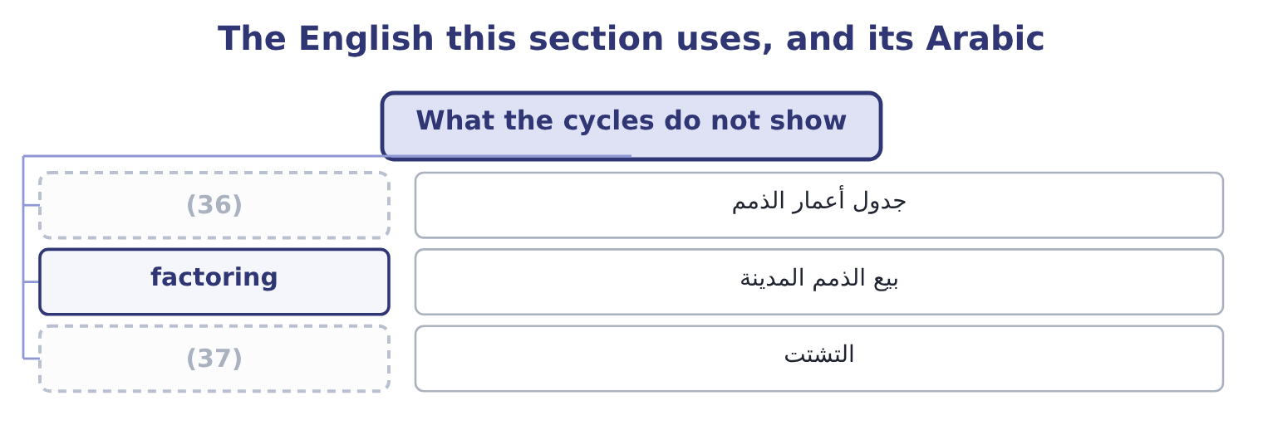
word list
spread · ageing schedule · lock-up

The English this sheet uses, and its Arabic
English (exam term) | Arabic
ageing schedule | جدول أعمار الذمم
factoring | بيع الذمم المدينة
spread | التشتت

Answer key · 12.5 What the cycles do not show

1 examinable | 20 flatters
2 knowing | 21 immediately
3 consistent | 22 Orontes's
4 separates | 23 suppliers
5 snapshot | 24 settlement
6 choose | 25 measures
7 precisely | 26 reached
8 should | 27 quieter
9 miller | 28 denominator
10 February | 29 chooses
11 September | 30 estimated
12 month-end | 31 movement
13 defensible | 32 outstanding
14 running | 33 One slow customer can hide inside a good average
15 published | 34 Several dates, or a monthly average
16 analyst | 35 Factoring and stretching both shorten it at a price
17 believe | 36 ageing schedule
18 carries | 37 spread
19 exists

the summaries in full
Summary 1 Three limits, each examinable, and a fourth worth knowing. An average hides its spread. A DSO of 34.3 days is consistent with every customer paying on day 34 and with most paying on day 20 and one large one paying on day 120. The ageing schedule separates the two and the ratio cannot. A cycle computed at a year end is a snapshot of the quietest day. Many companies choose a year end at the bottom of their season precisely because stock and receivables are low then. A seasonal business should be measured at several dates.
Summary 2 Ghab Mills, a flour miller, closes its year in February, when the harvest has been sold and the silos are empty. Inventory is $1,200,000 and daily cost of goods sold is $20,000, so days sales in inventory is 1,200,000 ÷ 20,000 = 60.0 days. In September, just after the harvest, inventory is $3,000,000. The same daily flow gives 3,000,000 ÷ 20,000 = 150.0 days. The year as a whole. The average of the twelve month-end balances is $2,100,000, which gives 2,100,000 ÷ 20,000 = 105.0 days. Three defensible figures for one year, running from 60 to 150 days. The published accounts will show the 60, and an analyst who stops there will believe Ghab Mills holds a little over half the stock it really carries through the year. Where monthly data exists, use it; where it does not, say which date the figure comes from and whether that date flatters the company.
Summary 3 A short cycle can be bought. Factoring receivables shortens DSO immediately and costs a fee, which is the loss on sale of receivables of $15,000 in Orontes's own income statement. Stretching suppliers shortens the cycle and may cost a settlement discount worth far more than the funding saved. The cycle measures the position and not how it was reached. A fourth limit is quieter than the other three. The cycle is built from three ratios, and each of them has a denominator the company chooses. Purchases are rarely disclosed and must be estimated from cost of goods sold and the movement in stock, so days purchases in payables inherits whatever error is in that estimate. Credit sales are rarely disclosed separately either, so days sales outstanding is usually computed on total sales and understates the true collection period for any company with a cash counter. None of this is a reason to abandon the cycle. It is a reason to compare a company with itself over several years, where one convention runs through every figure, before comparing it with a competitor whose conventions cannot be seen.

13.1 The four margins and where they come from
Chapter 13 · section 13.1

Fill every gap. Each word list holds one word more than there are gaps.
Chapter 13, section by section
Each stage leads to the next.
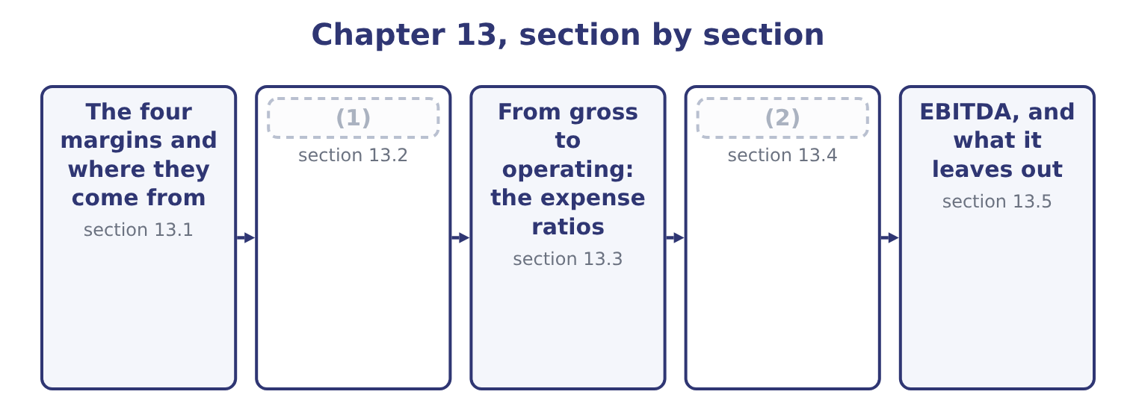
word list
Gross margin and the cost of sales · The four margins and where they come from · From operating to net: what sits below the lin

Summary 1 gaps 3–11
A margin is a profit figure over net sales. The numerator changes; the (3) never does. Gross profit margin is gross profit over net sales. Gross profit is what is left of the selling price after the cost of the goods (4) , so the gross margin is the margin of the trade. For Orontes, gross profit is 42,000,000 − 27,300,000 = 14,700,000, and the margin is 14,700,000 ÷ 42,000,000 = 35.0 per cent. Operating profit margin is operating income over net sales. Operating income is gross profit less the operating (5) — selling, (6) , research, (7) losses and any (8) — so this margin is the margin of the business as a business, before (9) to do with how it is (10) or taxed. For Orontes: 4,176,000 ÷ 42,000,000 = 9.94 per cent, which (11) to 9.9.
word list
financed · rounds · expenses · anything · impairment · denominator · interchangeable · themselves · administration · credit

Summary 2 gaps 12–20
Net profit margin is net income over net sales. It is the last line over the first, so (12) that happened in the year is (13) it: interest, (14) income, one-off gains and losses, and tax. For Orontes: 2,969,100 ÷ 42,000,000 = 7.07 per cent, or 7.1 to one (15) . (16) margin is earnings before interest, taxes, (17) and amortisation over net sales. It adds back to operating profit the (18) that do not move cash in the year, and section 13.5 builds it (19) , because it is the only one of the four whose numerator is not printed on the face of the (20) .
word list
everything · expenses · decimal · EBITDA · statement · depreciation · inside · investment · charges · properly

Orontes Foods, Inc. — the four margins, 2025
The bars are drawn to scale.
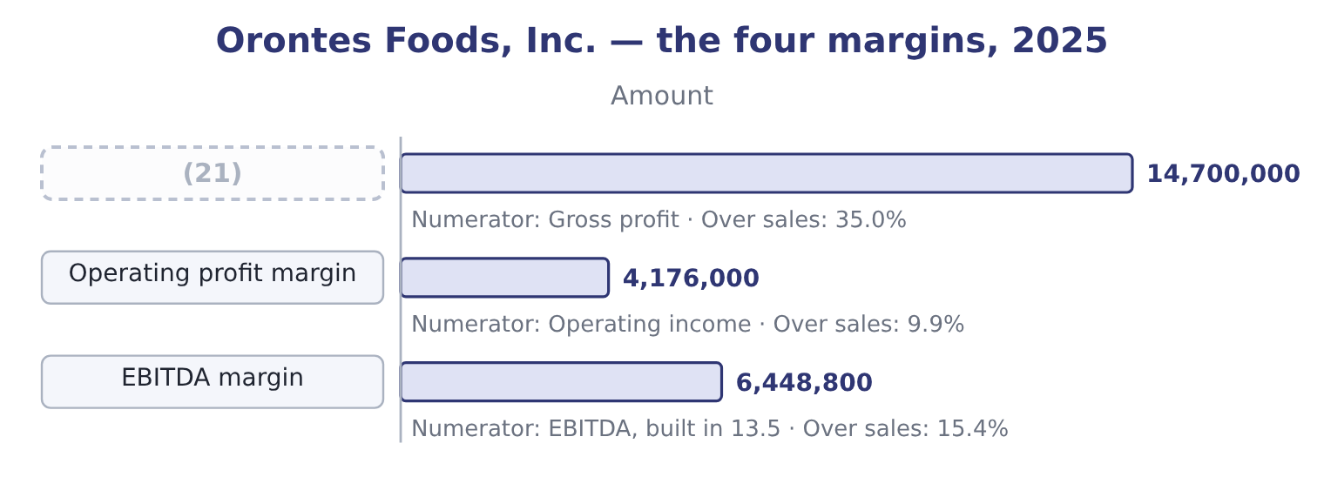
word list
net profit margin · Gross profit margin

Summary 3 gaps 22–26
Read down that column and the (22) is obvious. (23) cents of every sales dollar (24) the cost of goods; ten cents survive the running of the company; seven cents reach the owners. The two gaps — (25) points between gross and operating, three points between operating and net — are where the (26) are.
word list
Thirty-five · questions · decimal · staircase · survives · twenty-five

One denominator, four numerators

Summary 4 gaps 27–33
Every margin (27) by net sales, not by gross sales, not by total revenue (28) other income, and not by assets. A profit over assets is a (29) , which is, not a margin. Operating income (30) interest and tax by (31) . A (32) who deducts interest before computing the operating margin has computed something else. A margin is a percentage. A markup is a percentage of cost. A 35 per cent gross margin is a markup of about 54 per cent, and the two are not (33) .
word list
candidate · including · construction · everything · return · divides · excludes · interchangeable

The English this section uses, and its Arabic
Each term sits against what it means.
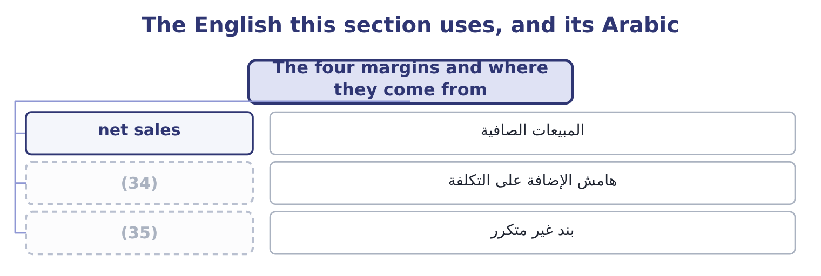
word list
statutory rate · one-off item · markup

The English this sheet uses, and its Arabic
English (exam term) | Arabic
net sales | المبيعات الصافية
markup | هامش الإضافة على التكلفة
one-off item | بند غير متكرر

Answer key · 13.1 The four margins and where they come from

1 Gross margin and the cost of sales | 19 properly
2 From operating to net: what sits below the lin | 20 statement
3 denominator | 21 Gross profit margin
4 themselves | 22 staircase
5 expenses | 23 Thirty-five
6 administration | 24 survives
7 credit | 25 twenty-five
8 impairment | 26 questions
9 anything | 27 divides
10 financed | 28 including
11 rounds | 29 return
12 everything | 30 excludes
13 inside | 31 construction
14 investment | 32 candidate
15 decimal | 33 interchangeable
16 EBITDA | 34 markup
17 depreciation | 35 one-off item
18 charges

the summaries in full
Summary 1 A margin is a profit figure over net sales. The numerator changes; the denominator never does. Gross profit margin is gross profit over net sales. Gross profit is what is left of the selling price after the cost of the goods themselves, so the gross margin is the margin of the trade. For Orontes, gross profit is 42,000,000 − 27,300,000 = 14,700,000, and the margin is 14,700,000 ÷ 42,000,000 = 35.0 per cent. Operating profit margin is operating income over net sales. Operating income is gross profit less the operating expenses — selling, administration, research, credit losses and any impairment — so this margin is the margin of the business as a business, before anything to do with how it is financed or taxed. For Orontes: 4,176,000 ÷ 42,000,000 = 9.94 per cent, which rounds to 9.9.
Summary 2 Net profit margin is net income over net sales. It is the last line over the first, so everything that happened in the year is inside it: interest, investment income, one-off gains and losses, and tax. For Orontes: 2,969,100 ÷ 42,000,000 = 7.07 per cent, or 7.1 to one decimal. EBITDA margin is earnings before interest, taxes, depreciation and amortisation over net sales. It adds back to operating profit the charges that do not move cash in the year, and section 13.5 builds it properly, because it is the only one of the four whose numerator is not printed on the face of the statement.
Summary 3 Read down that column and the staircase is obvious. Thirty-five cents of every sales dollar survives the cost of goods; ten cents survive the running of the company; seven cents reach the owners. The two gaps — twenty-five points between gross and operating, three points between operating and net — are where the questions are.
Summary 4 Every margin divides by net sales, not by gross sales, not by total revenue including other income, and not by assets. A profit over assets is a return, which is, not a margin. Operating income excludes interest and tax by construction. A candidate who deducts interest before computing the operating margin has computed something else. A margin is a percentage. A markup is a percentage of cost. A 35 per cent gross margin is a markup of about 54 per cent, and the two are not interchangeable.

13.2 Gross margin and the cost of sales
Chapter 13 · section 13.2

Fill every gap. Each word list holds one word more than there are gaps.
Summary 1 gaps 1–12
The gross margin and the (1) ratio are the same fact (2) twice. Orontes's cost of goods sold is 27,300,000 ÷ 42,000,000 = 65.0 per cent of sales, and what is left is the 35.0 per cent gross margin. Whenever the exam asks what happened to a gross margin, the answer is always (3) that happened to one of those two (4) , and there are only four candidates. A price rise lifts the margin; a (5) campaign lowers it. The volume sold may be (6) . A rise in the cost of (7) , freight or (8) lowers the margin unless the price rises with it. Selling more of a (9) line and less of a fat one lowers the average margin although no single (10) margin has moved. This is the cause candidates (11) . (12) and inventory method. Under last-in, first-out, rising prices push the newest and highest costs into cost of sales and depress the margin, while first-in, first-out leaves them in inventory. A write-down of stock passes through cost of sales as well.
word list
forget · thin-margin · sesame · percentages · written · happened · Costing · something · unchanged · product's · discount · packaging · cost-of-sales

Orontes: the three margins, 2023 to 2025
Name each line from how it moves.
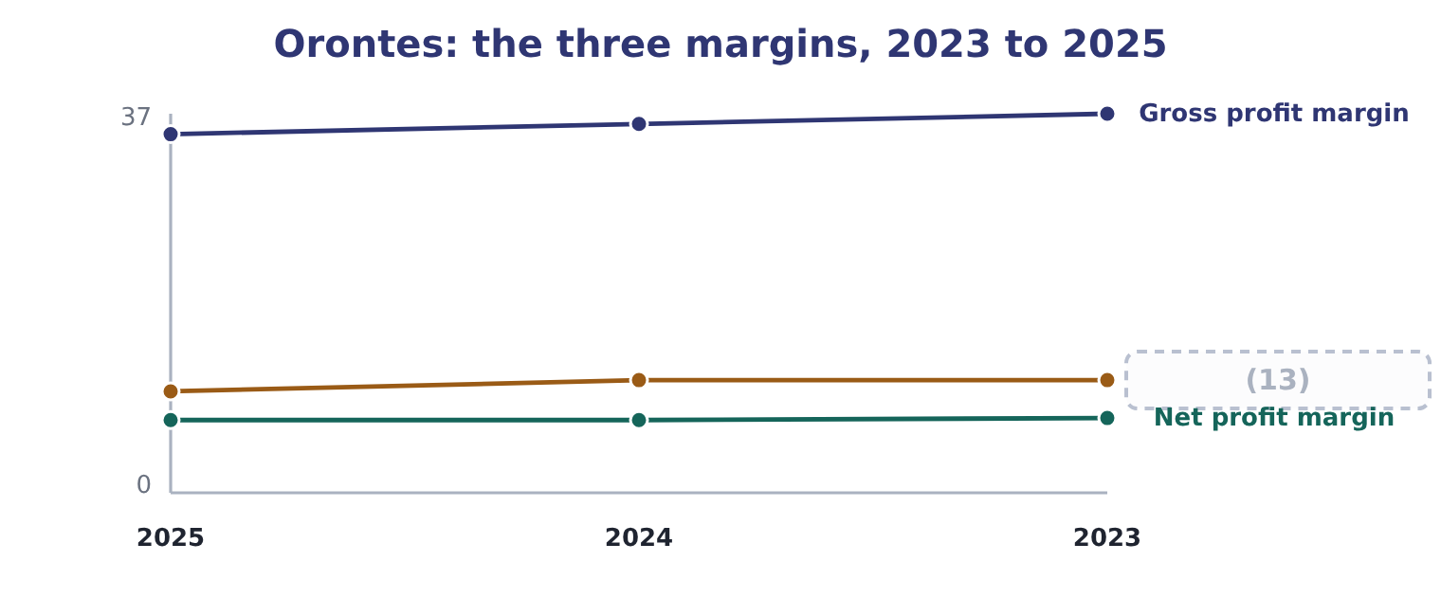
word list
cost of sales · Operating profit margin

Summary 2 gaps 14–16
The gross margins come (14) from the three income (15) : 11,840,000 ÷ 32,000,000 = 37.0 per cent in 2023, 13,104,000 ÷ 36,400,000 = 36.0 per cent in 2024 and 35.0 per cent in 2025. Sales rose every year and the margin fell every year, which is the (16) of growth bought with price.
word list
changed · straight · statements · signature

Worked example: what two points of gross margin are worth

Summary 3 gaps 17–28
The size of the slip. The gross margin was 37.0 per cent in 2023 and is 35.0 per cent in 2025: 37.0 − 35.0 = 2.0 points. Two points of the 2025 sales figure is 42,000,000 × 0.02 = 840,000. Had Orontes held its 2023 margin, gross profit would have been $840,000 higher, and (17) no operating (18) would have (19) , so would operating income. (20) what Orontes earns. Net income for the year is $2,969,100, so the lost margin is 840,000 ÷ 2,969,100 = 28.29 per cent of the profit the company (21) made. The slip is one point a year and (22) small. (23) in money it is the (24) single finding in the whole of Book 1 — larger than the $272,640 a year the trade (25) capital costs to fund, and larger than anything the (26) chapters turned up. A (27) move in the biggest (28) on the statement beats a large move in a small one, every time.
word list
Expressed · changed · liquidity · sounds · actually · largest · working · expense · operating · Against · percentage · because · two-point

A margin can fall while profit rises

Summary 4 gaps 29–34
Orontes's gross profit rose from $11,840,000 to $14,700,000 over the three years while the gross margin fell. Volume did the work; the rate got worse. An answer that says profit fell is (29) wrong. It is the (30) of it. The (31) is a price, a cost, a mix or a method. Where the (32) gives no mix (33) , say that mix is a possible cause rather than (34) a price war.
word list
explanation · asserting · depreciation · arithmetic · information · simply · question

The English this section uses, and its Arabic
Each term sits against what it means.
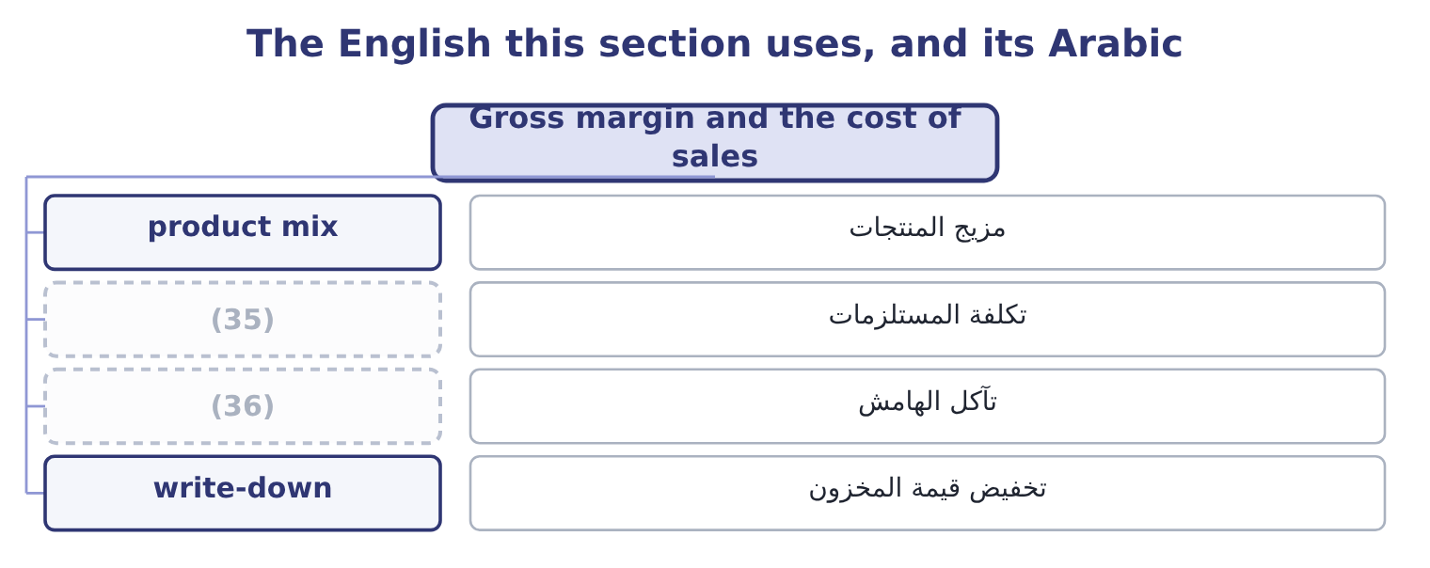
word list
product mix · margin erosion · input cost

The English this sheet uses, and its Arabic
English (exam term) | Arabic
product mix | مزيج المنتجات
input cost | تكلفة المستلزمات
margin erosion | تآكل الهامش
write-down | تخفيض قيمة المخزون

Answer key · 13.2 Gross margin and the cost of sales

1 cost-of-sales | 19 changed
2 written | 20 Against
3 something | 21 actually
4 percentages | 22 sounds
5 discount | 23 Expressed
6 unchanged | 24 largest
7 sesame | 25 working
8 packaging | 26 liquidity
9 thin-margin | 27 two-point
10 product's | 28 percentage
11 forget | 29 simply
12 Costing | 30 arithmetic
13 Operating profit margin | 31 explanation
14 straight | 32 question
15 statements | 33 information
16 signature | 34 asserting
17 because | 35 input cost
18 expense | 36 margin erosion

the summaries in full
Summary 1 The gross margin and the cost-of-sales ratio are the same fact written twice. Orontes's cost of goods sold is 27,300,000 ÷ 42,000,000 = 65.0 per cent of sales, and what is left is the 35.0 per cent gross margin. Whenever the exam asks what happened to a gross margin, the answer is always something that happened to one of those two percentages, and there are only four candidates. A price rise lifts the margin; a discount campaign lowers it. The volume sold may be unchanged. A rise in the cost of sesame, freight or packaging lowers the margin unless the price rises with it. Selling more of a thin-margin line and less of a fat one lowers the average margin although no single product's margin has moved. This is the cause candidates forget. Costing and inventory method. Under last-in, first-out, rising prices push the newest and highest costs into cost of sales and depress the margin, while first-in, first-out leaves them in inventory. A write-down of stock passes through cost of sales as well.
Summary 2 The gross margins come straight from the three income statements: 11,840,000 ÷ 32,000,000 = 37.0 per cent in 2023, 13,104,000 ÷ 36,400,000 = 36.0 per cent in 2024 and 35.0 per cent in 2025. Sales rose every year and the margin fell every year, which is the signature of growth bought with price.
Summary 3 The size of the slip. The gross margin was 37.0 per cent in 2023 and is 35.0 per cent in 2025: 37.0 − 35.0 = 2.0 points. Two points of the 2025 sales figure is 42,000,000 × 0.02 = 840,000. Had Orontes held its 2023 margin, gross profit would have been $840,000 higher, and because no operating expense would have changed, so would operating income. Against what Orontes earns. Net income for the year is $2,969,100, so the lost margin is 840,000 ÷ 2,969,100 = 28.29 per cent of the profit the company actually made. The slip is one point a year and sounds small. Expressed in money it is the largest single finding in the whole of Book 1 — larger than the $272,640 a year the trade working capital costs to fund, and larger than anything the liquidity chapters turned up. A two-point move in the biggest percentage on the statement beats a large move in a small one, every time.
Summary 4 Orontes's gross profit rose from $11,840,000 to $14,700,000 over the three years while the gross margin fell. Volume did the work; the rate got worse. An answer that says profit fell is simply wrong. It is the arithmetic of it. The explanation is a price, a cost, a mix or a method. Where the question gives no mix information, say that mix is a possible cause rather than asserting a price war.

13.3 From gross to operating: the expense ratios
Chapter 13 · section 13.3

Fill every gap. Each word list holds one word more than there are gaps.
Summary 1 gaps 1–8
Twenty-five points of Orontes's sales dollar disappear (1) gross profit and operating income. They disappear into one line, total operating expenses, and the ratio of that line to sales is the (2) number to track. Orontes's operating expenses are 10,524,000 ÷ 42,000,000 = 25.06 per cent of sales in 2025. In 2024 they were 9,100,000 ÷ 36,400,000 = 25.0 per cent and in 2023 8,320,000 ÷ 32,000,000 = 26.0 per cent. On the face of it the company has held its (3) steady while (4) , which is the opposite of the (5) story and would be good news. It is not what happened. The 2025 figure (6) an impairment loss of $2,724,000, which is 2,724,000 ÷ 42,000,000 = 6.49 per cent of sales on its own and did not occur in either (7) year. Strip it out and the (8) reverses.
word list
contains · earlier · gross-margin · second · growing · comparison · between · expenses · overheads

Orontes: operating expenses with and without the impairment
Measure | 2025 as reported | 2025 excluding impairment | 2024
Operating expenses | 10,524,000 | 7,800,000 | 9,100,000
(9) | 25.06% | 18.57% | 25.0%
Operating income | 4,176,000 | 6,900,000 | 4,004,000
Operating margin | 9.9% | 16.4% | 11.0%

word list
As a percentage of sales · Input cost rises, price unchanged

Worked example: the operating margin without the one-off

Summary 2 gaps 10–21
Remove the charge from the expenses. Add it back to profit. Read the two (10) . Orontes lost two points of gross margin and (11) six and a half points of operating margin by spending (12) less on running the (13) . Both are real; the reported operating margin of 9.9 per cent shows (14) , because a (15) charge of $2,724,000 sits on top of them. The adjusted figure is the better (16) of the year's trading and the reported figure is the one that happened. The exam wants both, in that order, with the (17) named. (18) only the adjusted margin is what the term non-GAAP measure was invented to describe. The (19) that links the two margins is worth stating once, because it is the shape of every question on this outcome. The operating margin is the gross margin less the operating expense ratio: 35.0 − 25.06 = 9.94 per cent. So there are exactly two ways for an operating margin to move, and a (20) answer says which of the two did it, and by how much. In 2025 both moved and in opposite (21) : the gross margin took one point off and the expense ratio, loaded with the impairment, took a further point.
word list
business · Orontes's · arithmetic · adjustment · single · complete · proportionately · Presenting · gained · neither · description · directions · together

What moves the operating margin
Every item belongs to exactly one group.
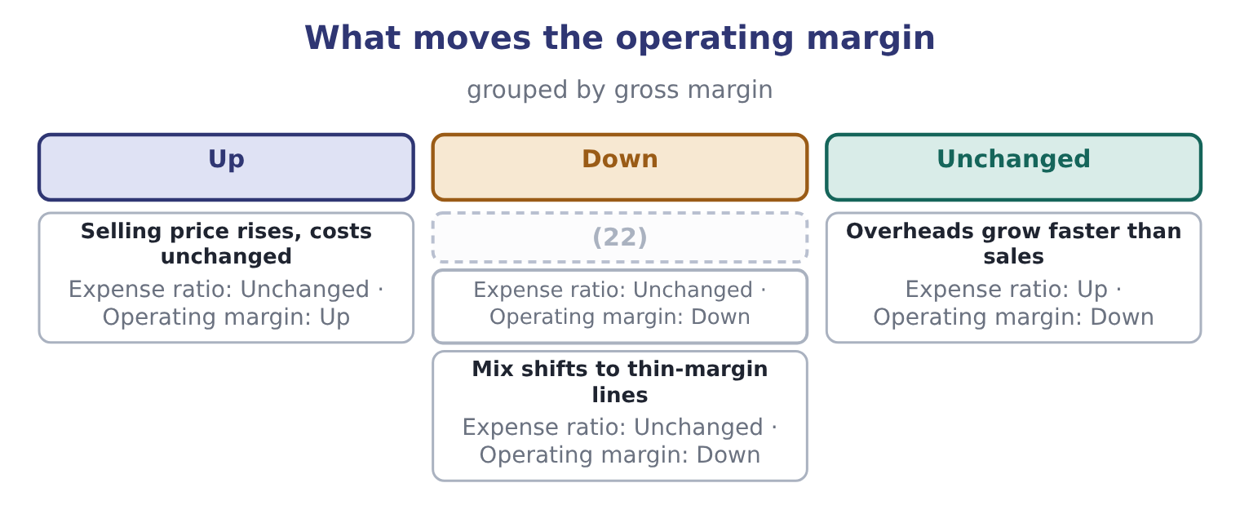
word list
Input cost rises, price unchanged · Mix shifts to thin-margin lines

Which expenses are operating expenses

Summary 3 gaps 23–29
Interest is not an operating expense; it is a (23) cost, and it (24) below operating income. Tax is not an operating expense either. An impairment loss is an operating expense under both GAAP and IFRS, (25) unusual it is. It cannot be (26) from the reported operating margin, only disclosed (27) . A (28) expense is an operating expense of the period it is (29) in, not an asset, and cutting it raises this year's operating margin at the cost of later years.
word list
operating · however · belongs · excluded · research · separately · incurred · financing

The English this section uses, and its Arabic
Each term sits against what it means.
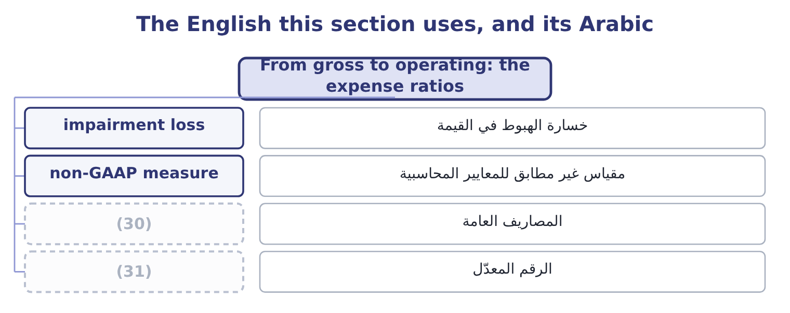
word list
adjusted figure · write-down · overhead

The English this sheet uses, and its Arabic
English (exam term) | Arabic
impairment loss | خسارة الهبوط في القيمة
non-GAAP measure | مقياس غير مطابق للمعايير المحاسبية
overhead | المصاريف العامة
adjusted figure | الرقم المعدّل

Answer key · 13.3 From gross to operating: the expense ratios

1 between | 17 adjustment
2 second | 18 Presenting
3 overheads | 19 arithmetic
4 growing | 20 complete
5 gross-margin | 21 directions
6 contains | 22 Input cost rises, price unchanged
7 earlier | 23 financing
8 comparison | 24 belongs
9 As a percentage of sales | 25 however
10 together | 26 excluded
11 gained | 27 separately
12 proportionately | 28 research
13 business | 29 incurred
14 neither | 30 overhead
15 single | 31 adjusted figure
16 description

the summaries in full
Summary 1 Twenty-five points of Orontes's sales dollar disappear between gross profit and operating income. They disappear into one line, total operating expenses, and the ratio of that line to sales is the second number to track. Orontes's operating expenses are 10,524,000 ÷ 42,000,000 = 25.06 per cent of sales in 2025. In 2024 they were 9,100,000 ÷ 36,400,000 = 25.0 per cent and in 2023 8,320,000 ÷ 32,000,000 = 26.0 per cent. On the face of it the company has held its overheads steady while growing, which is the opposite of the gross-margin story and would be good news. It is not what happened. The 2025 figure contains an impairment loss of $2,724,000, which is 2,724,000 ÷ 42,000,000 = 6.49 per cent of sales on its own and did not occur in either earlier year. Strip it out and the comparison reverses.
Summary 2 Remove the charge from the expenses. Add it back to profit. Read the two together. Orontes lost two points of gross margin and gained six and a half points of operating margin by spending proportionately less on running the business. Both are real; the reported operating margin of 9.9 per cent shows neither, because a single charge of $2,724,000 sits on top of them. The adjusted figure is the better description of the year's trading and the reported figure is the one that happened. The exam wants both, in that order, with the adjustment named. Presenting only the adjusted margin is what the term non-GAAP measure was invented to describe. The arithmetic that links the two margins is worth stating once, because it is the shape of every question on this outcome. The operating margin is the gross margin less the operating expense ratio: 35.0 − 25.06 = 9.94 per cent. So there are exactly two ways for an operating margin to move, and a complete answer says which of the two did it, and by how much. In 2025 both moved and in opposite directions: the gross margin took one point off and the expense ratio, loaded with the impairment, took a further point.
Summary 3 Interest is not an operating expense; it is a financing cost, and it belongs below operating income. Tax is not an operating expense either. An impairment loss is an operating expense under both GAAP and IFRS, however unusual it is. It cannot be excluded from the reported operating margin, only disclosed separately. A research expense is an operating expense of the period it is incurred in, not an asset, and cutting it raises this year's operating margin at the cost of later years.

13.4 From operating to net: what sits below the line
Chapter 13 · section 13.4

Fill every gap. Each word list holds one word more than there are gaps.
Summary 1 gaps 1–6
Three points of sales (1) Orontes's operating margin from its net margin, and three things cause them: the financing cost, the (2) items, and tax. Start with the total of the other income and expense section, which is a net cost of $217,200: 4,176,000 − 217,200 = 3,958,800 of income before income taxes. Inside that net figure, interest expense of $390,000 is the only large item, and it is (3) by $177,000 of equity-method income from (4) Glass Co. and a (5) of small gains and (6) . Orontes's income tax expense is $989,700, so its effective tax rate is 989,700 ÷ 3,958,800 = 25.0 per cent. What is left is net income of $2,969,100.
word list
separate · pre-tax · offset · losses · Jordan · non-operating · handful

Orontes: from operating margin to net margin, 2025
Step | Amount | Over sales
(7) | 4,176,000 | 9.9%
(8) | (217,200) | (0.5)%
Income before income taxes | 3,958,800 | 9.4%
Income tax expense | (989,700) | (2.4)%
(9) | 2,969,100 | 7.1%

word list
net profit margin · Net income · Other income and expense, net · Operating income

Summary 2 gaps 10–13
This is why the net margin is the least useful of the three for judging trading, and the most useful for judging the year. Orontes's net margin held at about 7.1 per cent across 2024 and 2025 — 2,598,000 ÷ 36,400,000 = 7.14 per cent then and 7.07 per cent now — while the operating margin fell more than a point. Two things held it up: the equity-method income, which has (10) to do with (11) food, and a lower effective tax rate. (12) will do so (13) again.
word list
Neither · selling · Orontes's · reliably · nothing

The net margin moves for reasons that are not trading

Summary 3 gaps 14–19
A company can report a better net margin on worse trading, (14) a tax refund, a gain on a (15) , or a fall in interest rates. The effective tax rate is tax expense over (16) income, not the (17) rate. A (18) between them has a cause, and the tax note gives it. Where a question gives you a one-off gain inside net income, say so before (19) net margins across years.
word list
pre-tax · depreciation · comparing · through · difference · disposal · statutory

The English this section uses, and its Arabic
Each term sits against what it means.
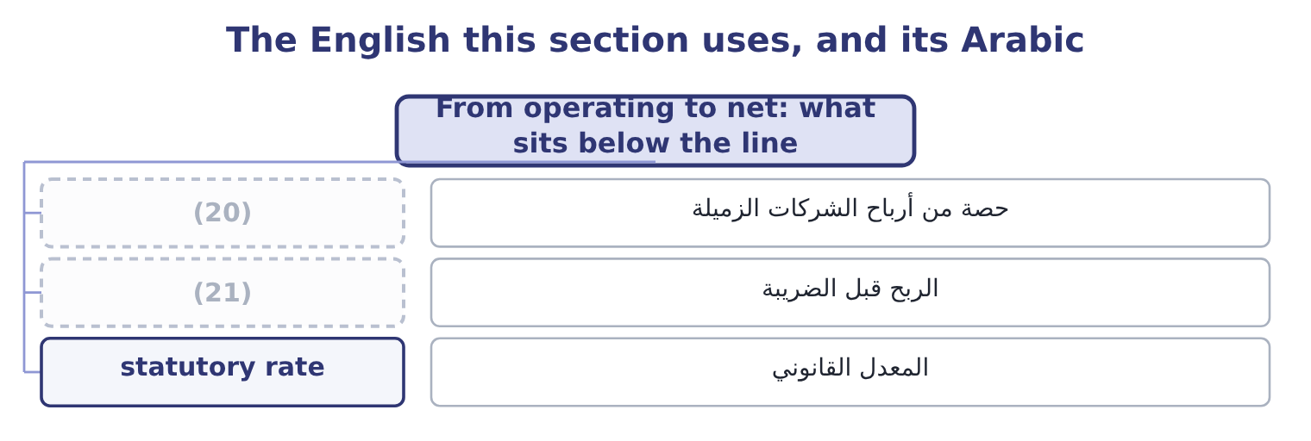
word list
adjusted EBITDA · pre-tax income · equity-method income

The English this sheet uses, and its Arabic
English (exam term) | Arabic
equity-method income | حصة من أرباح الشركات الزميلة
pre-tax income | الربح قبل الضريبة
statutory rate | المعدل القانوني

Answer key · 13.4 From operating to net: what sits below the line

1 separate | 12 Neither
2 non-operating | 13 reliably
3 offset | 14 through
4 Jordan | 15 disposal
5 handful | 16 pre-tax
6 losses | 17 statutory
7 Operating income | 18 difference
8 Other income and expense, net | 19 comparing
9 Net income | 20 equity-method income
10 nothing | 21 pre-tax income
11 selling

the summaries in full
Summary 1 Three points of sales separate Orontes's operating margin from its net margin, and three things cause them: the financing cost, the non-operating items, and tax. Start with the total of the other income and expense section, which is a net cost of $217,200: 4,176,000 − 217,200 = 3,958,800 of income before income taxes. Inside that net figure, interest expense of $390,000 is the only large item, and it is offset by $177,000 of equity-method income from Jordan Glass Co. and a handful of small gains and losses. Orontes's income tax expense is $989,700, so its effective tax rate is 989,700 ÷ 3,958,800 = 25.0 per cent. What is left is net income of $2,969,100.
Summary 2 This is why the net margin is the least useful of the three for judging trading, and the most useful for judging the year. Orontes's net margin held at about 7.1 per cent across 2024 and 2025 — 2,598,000 ÷ 36,400,000 = 7.14 per cent then and 7.07 per cent now — while the operating margin fell more than a point. Two things held it up: the equity-method income, which has nothing to do with selling food, and a lower effective tax rate. Neither will do so reliably again.
Summary 3 A company can report a better net margin on worse trading, through a tax refund, a gain on a disposal, or a fall in interest rates. The effective tax rate is tax expense over pre-tax income, not the statutory rate. A difference between them has a cause, and the tax note gives it. Where a question gives you a one-off gain inside net income, say so before comparing net margins across years.

13.5 EBITDA, and what it leaves out
Chapter 13 · section 13.5

Fill every gap. Each word list holds one word more than there are gaps.
Summary 1 gaps 1–12
EBITDA is earnings before interest, taxes, depreciation and amortisation. It is not a line of any income statement, which is why it has to be built, and the exam (1) the build. Start from earnings before interest and taxes: 3,958,800 + 390,000 = 4,348,800. Then add back the depreciation (2) for the year, which the cash flow statement gives as $2,100,000: 4,348,800 + 2,100,000 = 6,448,800. Orontes has no amortisation of (3) to add. The EBITDA margin is (4) 6,448,800 ÷ 42,000,000 = 15.35 per cent, or 15.4. What EBITDA is for is (5) between companies whose (6) and asset bases differ. Two food (7) of the same size, one owning its plant and one (8) it, one financed with debt and one with equity, will report very different net margins and (9) EBITDA margins, (10) EBITDA removes exactly the (11) that are not about making and (12) food. What EBITDA is not is cash flow, and it is not profit.
word list
selling · manufacturers · similar · because · differences · leasing · charged · markup · intangibles · therefore · expects · financing · comparison

Orontes: building EBITDA, and the claims it steps over
Step | Amount | Note
Income before income taxes | 3,958,800 | (13)
Add interest expense | 390,000 | (14)
Add depreciation | 2,100,000 | From the cash flow statement
EBITDA | 6,448,800 | 15.4% of sales
Less capital expenditure | (3,000,000) | The plant has to be replaced
Less interest paid | (390,000) | The lenders have to be paid
Less income taxes paid | (839,700) | (15)
What is left | 2,219,100 | (16)

word list
5.3% of sales · input cost · The tax authority has to be paid · As reported · Gives EBIT of 4,348,800

Summary 2 gaps 17–28
The last line is the point of the figure: 6,448,800 − 3,000,000 − 390,000 − 839,700 = 2,219,100. Adding back depreciation does not make the plant last longer, and Orontes spent $3,000,000 on (17) , plant and (18) in the year against a depreciation charge of $2,100,000. A company that quotes its EBITDA margin and not its capital expenditure is (19) the half of the (20) that suits it. There is one more trap, and it is the common one in (21) . Many companies report (22) EBITDA, adding back anything they (23) unusual. On Orontes's (24) that would mean adding the (25) : 6,448,800 + 2,724,000 = 9,172,800, which is 9,172,800 ÷ 42,000,000 = 21.84 per cent of sales. The same year, the same (26) , and a margin of 21.8 per cent (27) of 7.1. Both numbers are (28) correct. Only one of them is net income.
word list
arithmetically · adjusted · depreciation · practice · sentence · consider · statements · property · equipment · impairment · instead · figures · quoting

Build Barada's four margins

Compute the four margins.
Your turn: Barada's margins (complete the blanks)
Every item belongs to exactly one group.
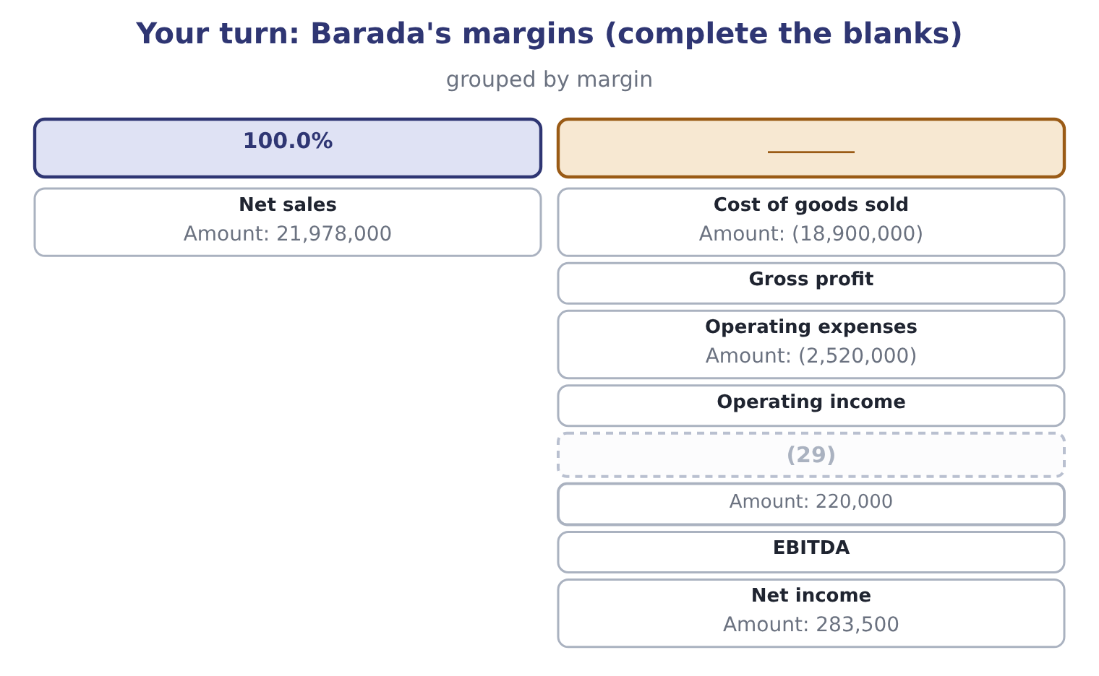
word list
Depreciation for the year · Cost of goods sold

"Margin"

Summary 3 gaps 30–34
English margin is used for three different things in (30) : a percentage of sales, as here; the cash a broker (31) against a position; and the edge of anything. In the phrase gross profit margin it is always the percentage, and a (32) who reads a margin call into a margin (33) question has lost the thread (34) .
word list
property · candidate · analysis · entirely · finance · requires

"Margin"
Item | Answer
Cost of goods sold | (35) : 18,900,000 ÷ 21,978,000.
Gross profit | 3,078,000, from 21,978,000 − 18,900,000 = 3,078,000; the margin is 3,078,000 ÷ 21,978,000 = 14.0 per cent.
Operating expenses | 11.5 per cent of sales: 2,520,000 ÷ 21,978,000.
Operating income | 558,000, from 3,078,000 − 2,520,000 = 558,000; the margin is 558,000 ÷ 21,978,000 = 2.54 per cent.
Depreciation | (36) : 220,000 ÷ 21,978,000.
EBITDA | 778,000, from 558,000 + 220,000 = 778,000; the margin is 778,000 ÷ 21,978,000 = 3.54 per cent.
Net income | (37)
What it tells you | A distributor's margins are a different order of magnitude from a manufacturer's: 14.0 per cent gross against Orontes's 35.0, and 1.29 per c

word list
1.0 per cent of sales · The net margin is 283,500 ÷ 21,978,000 = 1.29 per cent. · From the cash flow statement · 86.0 per cent of sales

The English this section uses, and its Arabic
Each term sits against what it means.
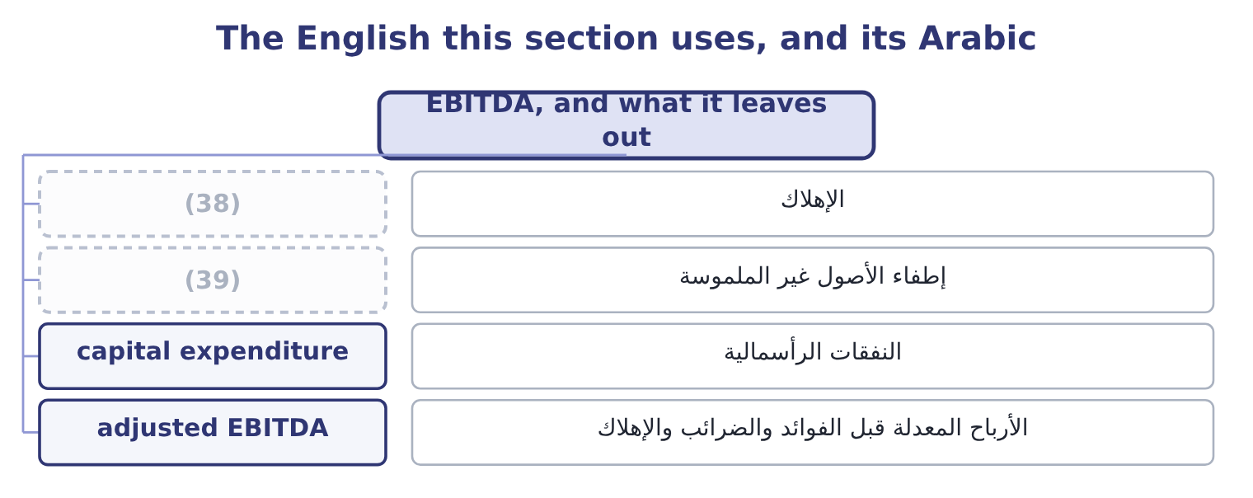
word list
overhead · amortisation · depreciation

The English this sheet uses, and its Arabic
English (exam term) | Arabic
depreciation | الإهلاك
amortisation | إطفاء الأصول غير الملموسة
capital expenditure | النفقات الرأسمالية
adjusted EBITDA | الأرباح المعدلة قبل الفوائد والضرائب والإهلاك

Answer key · 13.5 EBITDA, and what it leaves out

1 expects | 21 practice
2 charged | 22 adjusted
3 intangibles | 23 consider
4 therefore | 24 figures
5 comparison | 25 impairment
6 financing | 26 statements
7 manufacturers | 27 instead
8 leasing | 28 arithmetically
9 similar | 29 Depreciation for the year
10 because | 30 finance
11 differences | 31 requires
12 selling | 32 candidate
13 As reported | 33 analysis
14 Gives EBIT of 4,348,800 | 34 entirely
15 The tax authority has to be paid | 35 86.0 per cent of sales
16 5.3% of sales | 36 1.0 per cent of sales
17 property | 37 The net margin is 283,500 ÷ 21,978,000 = 1.29 per cent.
18 equipment | 38 depreciation
19 quoting | 39 amortisation
20 sentence

the summaries in full
Summary 1 EBITDA is earnings before interest, taxes, depreciation and amortisation. It is not a line of any income statement, which is why it has to be built, and the exam expects the build. Start from earnings before interest and taxes: 3,958,800 + 390,000 = 4,348,800. Then add back the depreciation charged for the year, which the cash flow statement gives as $2,100,000: 4,348,800 + 2,100,000 = 6,448,800. Orontes has no amortisation of intangibles to add. The EBITDA margin is therefore 6,448,800 ÷ 42,000,000 = 15.35 per cent, or 15.4. What EBITDA is for is comparison between companies whose financing and asset bases differ. Two food manufacturers of the same size, one owning its plant and one leasing it, one financed with debt and one with equity, will report very different net margins and similar EBITDA margins, because EBITDA removes exactly the differences that are not about making and selling food. What EBITDA is not is cash flow, and it is not profit.
Summary 2 The last line is the point of the figure: 6,448,800 − 3,000,000 − 390,000 − 839,700 = 2,219,100. Adding back depreciation does not make the plant last longer, and Orontes spent $3,000,000 on property, plant and equipment in the year against a depreciation charge of $2,100,000. A company that quotes its EBITDA margin and not its capital expenditure is quoting the half of the sentence that suits it. There is one more trap, and it is the common one in practice. Many companies report adjusted EBITDA, adding back anything they consider unusual. On Orontes's figures that would mean adding the impairment: 6,448,800 + 2,724,000 = 9,172,800, which is 9,172,800 ÷ 42,000,000 = 21.84 per cent of sales. The same year, the same statements, and a margin of 21.8 per cent instead of 7.1. Both numbers are arithmetically correct. Only one of them is net income.
Summary 3 English margin is used for three different things in finance: a percentage of sales, as here; the cash a broker requires against a position; and the edge of anything. In the phrase gross profit margin it is always the percentage, and a candidate who reads a margin call into a margin analysis question has lost the thread entirely.

14.1 Return on assets
Chapter 14 · section 14.1

Fill every gap. Each word list holds one word more than there are gaps.
Chapter 14, section by section
Each stage leads to the next.
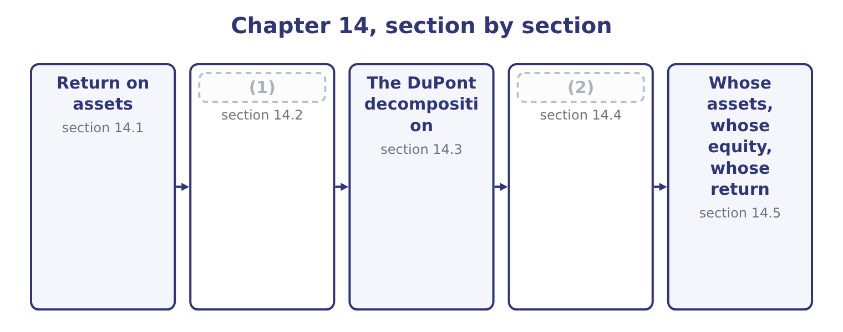
word list
Return on equity · Return on assets · The five-factor decomposition

Summary 1 gaps 3–14
Return on assets is profit over the assets (3) to earn it. (4) net income for 2025 is $2,969,100. Its assets, (5) , were not one figure (6) the year: they began at $26,445,000 and ended at $31,672,600, because the company raised equity and bought plant as the year went on. (7) a flow by a closing balance (8) a whole year's earnings with the assets of the last day. The (9) that answers this is the average: 31,672,600 + 26,445,000 = 58,117,600, and half of that is $29,058,800. Return on assets is (10) 2,969,100 ÷ 29,058,800 = 10.22 per cent, or 10.2 to one (11) . Ten cents of profit a year for every (12) of assets. That is the whole of what the ratio says, and it is enough to compare Orontes with another food (13) , with its own last year, and with the cost of the money that funds those assets — which at the 6 per cent Orontes pays Levant Commerce Bank means the assets earn (14) more than they cost to finance, and that is the test that matters.
word list
Orontes's · Dividing · manufacturer · though · compares · magnitudes · during · employed · decimal · therefore · dollar · comfortably · convention

Orontes Foods, Inc. — return on assets, 2025
Element | Amount | Source
Net income | 2,969,100 | (15)
Total assets, end of 2025 | 31,672,600 | (16)
Total assets, end of 2024 | 26,445,000 | Balance sheet
Average total assets | 29,058,800 | (17)
Return on assets | 10.22% | Net income over average assets

word list
Half the sum of the two · Net income over average assets · Balance sheet · Income statement

Summary 2 gaps 18–29
Now the (18) half of this outcome: what happens to the return when one element of the (19) changes. Work it by (20) which of the two parts of the fraction the change touches, and in which (21) . A change that reduces profit alone lowers the return. A rise in the cost of (22) , a larger credit loss (23) , a higher effective tax rate. A change that (24) assets alone lowers the return. Buying plant, (25) inventory, letting (26) run. A change that touches both may do either, and the (27) decides. (28) an asset off reduces assets, which helps the ratio, and reduces profit, which hurts it; which effect wins (29) on the size of the write-off against the size of each total. A change that touches neither leaves the return alone. Paying a dividend that was already declared, refinancing debt at the same amount, issuing shares and holding the cash — the last of these raises assets, so it does lower the return, and candidates who answer otherwise have forgotten that cash is an asset.
word list
direction · expense · statements · receivables · arithmetic · forgotten · examinable · Writing · asking · sesame · increases · building · depends

Summary 3 gaps 30–41
Suppose Orontes (30) a further $1,000,000 of (31) at the very end of 2025, (32) at its 25 per cent effective rate: 1,000,000 × 0.25 = 250,000 of tax (33) , so net income falls by 750,000 to 2,969,100 − 750,000 = 2,219,100. (34) assets fall to 31,672,600 − 1,000,000 = 30,672,600, so the average becomes half of 26,445,000 + 30,672,600 = 57,117,600, which is 28,558,800. Return on assets becomes 2,219,100 ÷ 28,558,800 = 7.77 per cent, against 10.22 per cent (35) . Both parts of the fraction fell and the return still fell (36) , because profit fell by a (37) while average assets fell by less than two per cent. That is the general rule for a write-off: the (38) is always the smaller number, so a charge of a given size moves it (39) more. An exam answer that says "assets fall, so the return rises" has the (40) right and the (41) wrong.
word list
sharply · impairs · deductible · magnitudes · numerator · before · proportionately · building · relief · mechanism · Ending · goodwill · quarter

Average or closing

Summary 4 gaps 42–46
Where the question gives two balance (42) , use the average, and say that you have. Where it gives one, use the closing figure and say that too. The average of two year ends is itself a rough (43) . A company that bought its plant in (44) has carried those assets for a month, and the average (45) them as carried for six. Return on assets uses total assets, not net assets and not (46) assets, unless the question says otherwise. Section 14.5 is about what happens when it does.
word list
operating · treats · December · sheets · measure · happens

The English this section uses, and its Arabic
Each term sits against what it means.
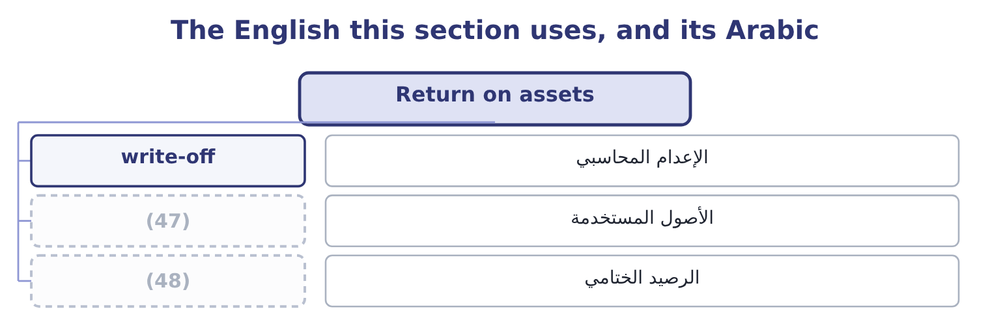
word list
assets employed · equity multiplier · closing balance

The English this sheet uses, and its Arabic
English (exam term) | Arabic
write-off | الإعدام المحاسبي
assets employed | الأصول المستخدمة
closing balance | الرصيد الختامي

Answer key · 14.1 Return on assets

1 Return on equity | 25 building
2 The five-factor decomposition | 26 receivables
3 employed | 27 arithmetic
4 Orontes's | 28 Writing
5 though | 29 depends
6 during | 30 impairs
7 Dividing | 31 goodwill
8 compares | 32 deductible
9 convention | 33 relief
10 therefore | 34 Ending
11 decimal | 35 before
12 dollar | 36 sharply
13 manufacturer | 37 quarter
14 comfortably | 38 numerator
15 Income statement | 39 proportionately
16 Balance sheet | 40 mechanism
17 Half the sum of the two | 41 magnitudes
18 examinable | 42 sheets
19 statements | 43 measure
20 asking | 44 December
21 direction | 45 treats
22 sesame | 46 operating
23 expense | 47 assets employed
24 increases | 48 closing balance

the summaries in full
Summary 1 Return on assets is profit over the assets employed to earn it. Orontes's net income for 2025 is $2,969,100. Its assets, though, were not one figure during the year: they began at $26,445,000 and ended at $31,672,600, because the company raised equity and bought plant as the year went on. Dividing a flow by a closing balance compares a whole year's earnings with the assets of the last day. The convention that answers this is the average: 31,672,600 + 26,445,000 = 58,117,600, and half of that is $29,058,800. Return on assets is therefore 2,969,100 ÷ 29,058,800 = 10.22 per cent, or 10.2 to one decimal. Ten cents of profit a year for every dollar of assets. That is the whole of what the ratio says, and it is enough to compare Orontes with another food manufacturer, with its own last year, and with the cost of the money that funds those assets — which at the 6 per cent Orontes pays Levant Commerce Bank means the assets earn comfortably more than they cost to finance, and that is the test that matters.
Summary 2 Now the examinable half of this outcome: what happens to the return when one element of the statements changes. Work it by asking which of the two parts of the fraction the change touches, and in which direction. A change that reduces profit alone lowers the return. A rise in the cost of sesame, a larger credit loss expense, a higher effective tax rate. A change that increases assets alone lowers the return. Buying plant, building inventory, letting receivables run. A change that touches both may do either, and the arithmetic decides. Writing an asset off reduces assets, which helps the ratio, and reduces profit, which hurts it; which effect wins depends on the size of the write-off against the size of each total. A change that touches neither leaves the return alone. Paying a dividend that was already declared, refinancing debt at the same amount, issuing shares and holding the cash — the last of these raises assets, so it does lower the return, and candidates who answer otherwise have forgotten that cash is an asset.
Summary 3 Suppose Orontes impairs a further $1,000,000 of goodwill at the very end of 2025, deductible at its 25 per cent effective rate: 1,000,000 × 0.25 = 250,000 of tax relief, so net income falls by 750,000 to 2,969,100 − 750,000 = 2,219,100. Ending assets fall to 31,672,600 − 1,000,000 = 30,672,600, so the average becomes half of 26,445,000 + 30,672,600 = 57,117,600, which is 28,558,800. Return on assets becomes 2,219,100 ÷ 28,558,800 = 7.77 per cent, against 10.22 per cent before. Both parts of the fraction fell and the return still fell sharply, because profit fell by a quarter while average assets fell by less than two per cent. That is the general rule for a write-off: the numerator is always the smaller number, so a charge of a given size moves it proportionately more. An exam answer that says "assets fall, so the return rises" has the mechanism right and the magnitudes wrong.
Summary 4 Where the question gives two balance sheets, use the average, and say that you have. Where it gives one, use the closing figure and say that too. The average of two year ends is itself a rough measure. A company that bought its plant in December has carried those assets for a month, and the average treats them as carried for six. Return on assets uses total assets, not net assets and not operating assets, unless the question says otherwise. Section 14.5 is about what happens when it does.

14.2 Return on equity
Chapter 14 · section 14.2

Fill every gap. Each word list holds one word more than there are gaps.
Summary 1 gaps 1–12
Return on equity is profit over the owners' money. Orontes's equity began the year at $16,375,000 and ended at $20,392,975, so the average is half of 20,392,975 + 16,375,000 = 36,767,975, which is $18,383,988. Return on equity is 2,969,100 ÷ 18,383,988 = 16.15 per cent. On the closing (1) instead it is 2,969,100 ÷ 20,392,975 = 14.56 per cent. The two (2) by more than a point and a half, and the (3) is the $1,500,000 share issue and the $1,400,000 of (4) paid-in capital that came with it: equity grew by a (5) during the year, so the (6) of which equity to divide by is not a (7) . Why is the return on equity higher than the return on assets? (8) some of the assets are funded by (9) else. Orontes's $31,672,600 of assets are funded by $11,279,625 of liabilities and $20,392,975 of equity, so the owners put up about (10) of the money and keep all of the profit that the whole of it earns, after paying the lenders their fixed (11) . That is the (12) of leverage.
word list
replacing · additional · differ · somebody · arithmetic · question · interest · two-thirds · balance · quarter · reason · quibble · Because

Orontes: the two returns, and the gap between them
Measure | 2025 | Basis | What it measures
Return on assets | 10.22% | (13) | The business
Return on equity | 16.15% | (14) | The owners' share
Return on equity, closing basis | 14.56% | Net income over closing equity | (15)
Gap, assets to equity | (16) | The effect of the liabilities | Leverage

word list
Net income over average equity · The same, measured at one date · 5.93 points · preferred dividends · Net income over average assets

Return on equity rewards debt until it does not

Summary 2 gaps 17–23
A company can raise its return on equity by (17) equity with debt, and nothing about the business (18) when it does. Return on equity for a (19) company with negative equity is a positive number and is (20) . (21) look at the two parts before (22) the ratio. Preferred (23) are deducted from net income before computing the return to common equity, and preferred stock is excluded from the equity. Orontes has no preferred stock; many exam questions do.
word list
meaningless · quibble · quoting · improves · replacing · Always · loss-making · dividends

The English this section uses, and its Arabic
Each term sits against what it means.
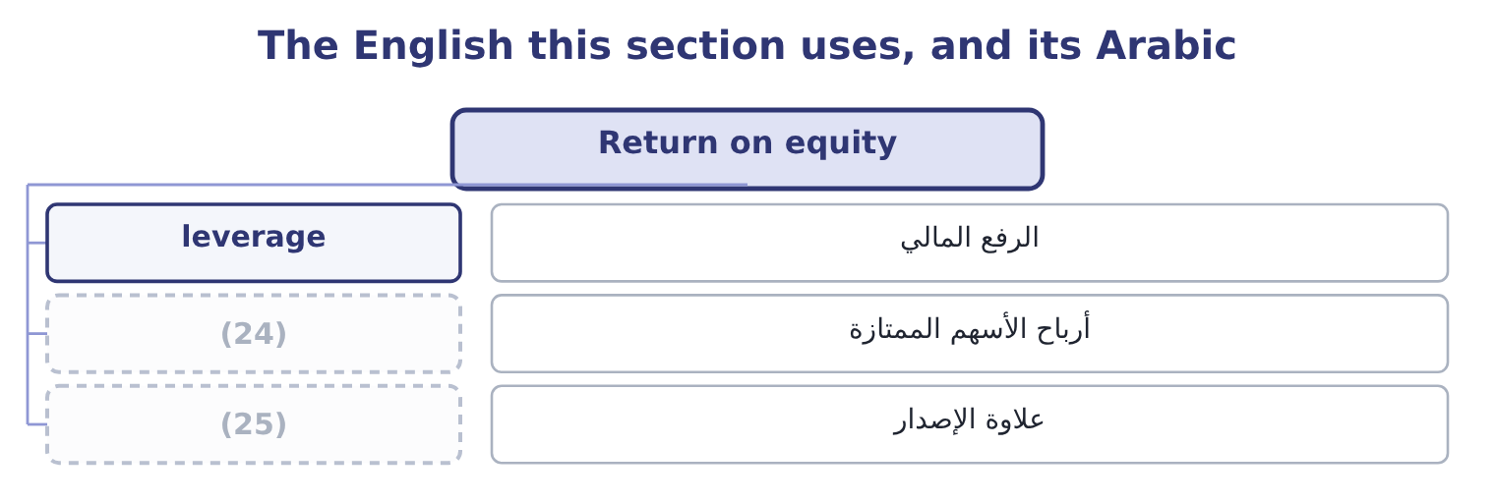
word list
burden ratio · paid-in capital · preferred dividends

The English this sheet uses, and its Arabic
English (exam term) | Arabic
leverage | الرفع المالي
preferred dividends | أرباح الأسهم الممتازة
paid-in capital | علاوة الإصدار

Answer key · 14.2 Return on equity

1 balance | 14 Net income over average equity
2 differ | 15 The same, measured at one date
3 reason | 16 5.93 points
4 additional | 17 replacing
5 quarter | 18 improves
6 question | 19 loss-making
7 quibble | 20 meaningless
8 Because | 21 Always
9 somebody | 22 quoting
10 two-thirds | 23 dividends
11 interest | 24 preferred dividends
12 arithmetic | 25 paid-in capital
13 Net income over average assets

the summaries in full
Summary 1 Return on equity is profit over the owners' money. Orontes's equity began the year at $16,375,000 and ended at $20,392,975, so the average is half of 20,392,975 + 16,375,000 = 36,767,975, which is $18,383,988. Return on equity is 2,969,100 ÷ 18,383,988 = 16.15 per cent. On the closing balance instead it is 2,969,100 ÷ 20,392,975 = 14.56 per cent. The two differ by more than a point and a half, and the reason is the $1,500,000 share issue and the $1,400,000 of additional paid-in capital that came with it: equity grew by a quarter during the year, so the question of which equity to divide by is not a quibble. Why is the return on equity higher than the return on assets? Because some of the assets are funded by somebody else. Orontes's $31,672,600 of assets are funded by $11,279,625 of liabilities and $20,392,975 of equity, so the owners put up about two-thirds of the money and keep all of the profit that the whole of it earns, after paying the lenders their fixed interest. That is the arithmetic of leverage.
Summary 2 A company can raise its return on equity by replacing equity with debt, and nothing about the business improves when it does. Return on equity for a loss-making company with negative equity is a positive number and is meaningless. Always look at the two parts before quoting the ratio. Preferred dividends are deducted from net income before computing the return to common equity, and preferred stock is excluded from the equity. Orontes has no preferred stock; many exam questions do.

14.3 The DuPont decomposition
Chapter 14 · section 14.3

Fill every gap. Each word list holds one word more than there are gaps.
Summary 1 gaps 1–6
The (1) decomposition is a piece of cancelling. Write the return on equity as three fractions multiplied together and every (2) term cancels, (3) net income over equity, which is where you (4) . What the three fractions buy is a (5) . Net income over sales is the net profit margin: how profitable each sale is. Sales over average assets is the total asset turnover: how hard the assets work. Average assets over average equity is the equity multiplier: how much of the assets the owners had to fund. For Orontes, the net margin is 7.07 per cent, the asset turnover is 42,000,000 ÷ 29,058,800 = 1.4453 times, and the equity multiplier on average balances is 29,058,800 ÷ 18,383,988 = 1.5807. Multiply them: 7.07 × 1.4453 × 1.5807 = 16.15 per cent, which is the return on equity computed (6) in section 14.2.
word list
intermediate · leaving · leverage · directly · diagnosis · DuPont · started

Summary 2 gaps 7–8
The first two factors multiply to the return on assets: 7.07 × 1.4453 = 10.22 per cent. So the (7) version is return on assets times the equity multiplier: 10.22 × 1.5807 = 16.15 per cent. The exam asks for (8) .
word list
directly · either · two-factor

Orontes: the three-factor DuPont decomposition, 2025
Factor | Computation | Value | Question it answers
Net profit margin | (9) | 7.07% | How profitable is a sale?
Total asset turnover | (10) | 1.4453 | How hard do the assets work?
Equity multiplier | (11) | 1.5807 | How much is funded by others?
Return on equity | The three multiplied | 16.15% | (12)

word list
Orontes, a manufacturer · 42,000,000 over 29,058,800 · 2,969,100 over 42,000,000 · What do the owners earn? · 29,058,800 over 18,383,988

Summary 3 gaps 13–14
The point of the (13) is that two companies with the same return on equity can be (14) different businesses, and the three factors say.
word list
completely · leaving · decomposition

The same return reached three ways
The bars are drawn to scale.
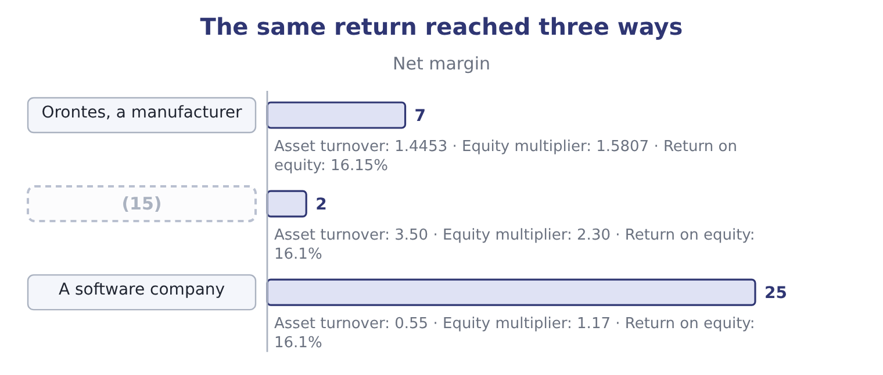
word list
non-controlling interest · A supermarket

Summary 4 gaps 16–23
Three (16) returns and no two of these companies would be run the same way. The (17) lives on turnover and would be (18) by a week of empty shelves. The (19) company lives on margin and could lose a third of it and still show a (20) return. Orontes sits (21) them. A (22) told to raise the return on equity needs to know which of the three factors is the one with room in it, and that is a question about the (23) , not about the ratio.
word list
between · decent · leverage · manager · destroyed · business · identical · supermarket · software

The multiplier is not a target

Summary 5 gaps 24–32
Raising the equity multiplier (24) raises the return on equity in the (25) . It does so by (26) debt, which adds the fixed (27) . The exam (28) a return raised this way as a different kind of return. The three factors must use (29) bases. If the multiplier uses average assets, the turnover must use average assets too, or the cancelling fails and the (30) will not equal the return. An equity multiplier computed on (31) balances is 31,672,600 over 20,392,975, which is 1.55 — the figure. It is not wrong; it is a different basis, and it (32) with a closing-basis return.
word list
belongs · closing · arithmetic · consistent · computed · treats · always · product · interest · adding

The English this section uses, and its Arabic
Each term sits against what it means.
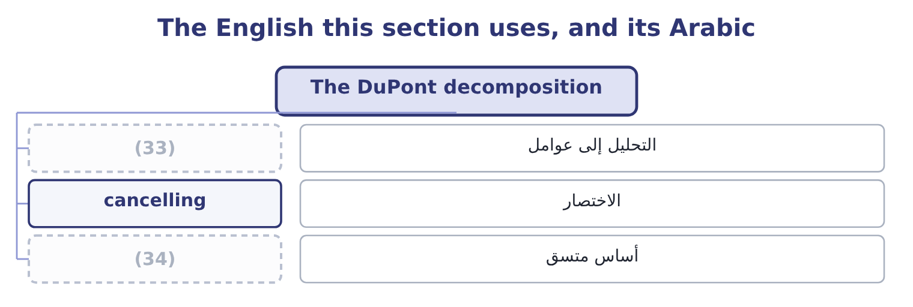
word list
cancelling · consistent basis · decomposition

The English this sheet uses, and its Arabic
English (exam term) | Arabic
decomposition | التحليل إلى عوامل
cancelling | الاختصار
consistent basis | أساس متسق

Answer key · 14.3 The DuPont decomposition

1 DuPont | 18 destroyed
2 intermediate | 19 software
3 leaving | 20 decent
4 started | 21 between
5 diagnosis | 22 manager
6 directly | 23 business
7 two-factor | 24 always
8 either | 25 arithmetic
9 2,969,100 over 42,000,000 | 26 adding
10 42,000,000 over 29,058,800 | 27 interest
11 29,058,800 over 18,383,988 | 28 treats
12 What do the owners earn? | 29 consistent
13 decomposition | 30 product
14 completely | 31 closing
15 A supermarket | 32 belongs
16 identical | 33 decomposition
17 supermarket | 34 consistent basis

the summaries in full
Summary 1 The DuPont decomposition is a piece of cancelling. Write the return on equity as three fractions multiplied together and every intermediate term cancels, leaving net income over equity, which is where you started. What the three fractions buy is a diagnosis. Net income over sales is the net profit margin: how profitable each sale is. Sales over average assets is the total asset turnover: how hard the assets work. Average assets over average equity is the equity multiplier: how much of the assets the owners had to fund. For Orontes, the net margin is 7.07 per cent, the asset turnover is 42,000,000 ÷ 29,058,800 = 1.4453 times, and the equity multiplier on average balances is 29,058,800 ÷ 18,383,988 = 1.5807. Multiply them: 7.07 × 1.4453 × 1.5807 = 16.15 per cent, which is the return on equity computed directly in section 14.2.
Summary 2 The first two factors multiply to the return on assets: 7.07 × 1.4453 = 10.22 per cent. So the two-factor version is return on assets times the equity multiplier: 10.22 × 1.5807 = 16.15 per cent. The exam asks for either.
Summary 3 The point of the decomposition is that two companies with the same return on equity can be completely different businesses, and the three factors say.
Summary 4 Three identical returns and no two of these companies would be run the same way. The supermarket lives on turnover and would be destroyed by a week of empty shelves. The software company lives on margin and could lose a third of it and still show a decent return. Orontes sits between them. A manager told to raise the return on equity needs to know which of the three factors is the one with room in it, and that is a question about the business, not about the ratio.
Summary 5 Raising the equity multiplier always raises the return on equity in the arithmetic. It does so by adding debt, which adds the fixed interest. The exam treats a return raised this way as a different kind of return. The three factors must use consistent bases. If the multiplier uses average assets, the turnover must use average assets too, or the cancelling fails and the product will not equal the return. An equity multiplier computed on closing balances is 31,672,600 over 20,392,975, which is 1.55 — the figure. It is not wrong; it is a different basis, and it belongs with a closing-basis return.

14.4 The five-factor decomposition
Chapter 14 · section 14.4

Fill every gap. Each word list holds one word more than there are gaps.
Summary 1 gaps 1–12
The three-factor version hides two (1) inside the net margin: the interest the company pays and the tax it pays. (2) them out gives the five-factor (3) , which the exam also names, and which is the version a finance director actually uses. Start at the top of the income (4) and work down. The operating margin on an (5) basis is 4,348,800 ÷ 42,000,000 = 10.35 per cent. The interest burden ratio is pre-tax income over EBIT, which measures how much of the operating (6) survives the (7) : 3,958,800 ÷ 4,348,800 = 91.03 per cent. The tax burden ratio is net income over pre-tax income, which measures how much survives the tax (8) : 2,969,100 ÷ 3,958,800 = 75.0 per cent. The (9) two factors are the turnover and the multiplier, (10) . (11) the operating side first: 10.35 × 1.4453 × 1.5807 = 23.65 per cent. That is what the (12) would earn if there were no interest and no tax. Then apply the two burdens: 23.65 × 0.9103 × 0.7500 = 16.14 per cent, the return on equity again, give or take the rounding.
word list
unchanged · Splitting · authority · decomposition · remaining · earnings-before-interest-and-taxes · owners · lenders · profit · cancelling · things · Multiply · statement

Orontes: the five-factor decomposition, 2025
Factor | Computation | Value | What a change in it means
Tax burden | Net income over pre-tax income | 75.0% | (13)
Interest burden | Pre-tax income over EBIT | 91.03% | (14)
Operating margin | (15) | 10.35% | Trading
Asset turnover | (16) | 1.4453 | Asset efficiency
Equity multiplier | Average assets over average equity | 1.5807 | Funding mix

word list
The cost of the debt · Sales over average assets · EBIT over sales · average total assets · A tax change, not a trading change

Summary 2 gaps 17–25
Read the five together and the (17) question becomes (18) in a way the three-factor version cannot show. Debt (19) twice and in opposite (20) : it raises the equity multiplier, which helps, and it lowers the interest burden ratio, which hurts. Orontes keeps 91 cents of each operating dollar after interest and (21) its asset base by 1.58, so on these figures the trade is clearly (22) . Push the debt far (23) and the interest burden falls (24) than the multiplier rises, and the return on equity turns down. That is the same (25) , reached from the other end.
word list
enters · multiplies · worthwhile · directions · leverage · break-even · enough · visible · faster · together

The English this section uses, and its Arabic
Each term sits against what it means.
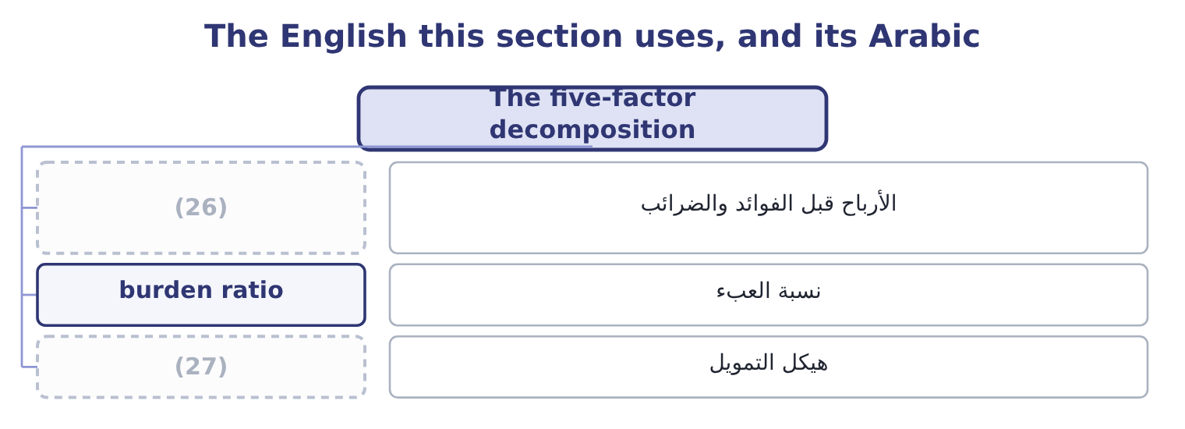
word list
assets employed · funding mix · earnings before interest and taxes

The English this sheet uses, and its Arabic
English (exam term) | Arabic
earnings before interest and taxes | الأرباح قبل الفوائد والضرائب
burden ratio | نسبة العبء
funding mix | هيكل التمويل

Answer key · 14.4 The five-factor decomposition

1 things | 15 EBIT over sales
2 Splitting | 16 Sales over average assets
3 decomposition | 17 leverage
4 statement | 18 visible
5 earnings-before-interest-and-taxes | 19 enters
6 profit | 20 directions
7 lenders | 21 multiplies
8 authority | 22 worthwhile
9 remaining | 23 enough
10 unchanged | 24 faster
11 Multiply | 25 break-even
12 owners | 26 earnings before interest and taxes
13 A tax change, not a trading change | 27 funding mix
14 The cost of the debt

the summaries in full
Summary 1 The three-factor version hides two things inside the net margin: the interest the company pays and the tax it pays. Splitting them out gives the five-factor decomposition, which the exam also names, and which is the version a finance director actually uses. Start at the top of the income statement and work down. The operating margin on an earnings-before-interest-and-taxes basis is 4,348,800 ÷ 42,000,000 = 10.35 per cent. The interest burden ratio is pre-tax income over EBIT, which measures how much of the operating profit survives the lenders: 3,958,800 ÷ 4,348,800 = 91.03 per cent. The tax burden ratio is net income over pre-tax income, which measures how much survives the tax authority: 2,969,100 ÷ 3,958,800 = 75.0 per cent. The remaining two factors are the turnover and the multiplier, unchanged. Multiply the operating side first: 10.35 × 1.4453 × 1.5807 = 23.65 per cent. That is what the owners would earn if there were no interest and no tax. Then apply the two burdens: 23.65 × 0.9103 × 0.7500 = 16.14 per cent, the return on equity again, give or take the rounding.
Summary 2 Read the five together and the leverage question becomes visible in a way the three-factor version cannot show. Debt enters twice and in opposite directions: it raises the equity multiplier, which helps, and it lowers the interest burden ratio, which hurts. Orontes keeps 91 cents of each operating dollar after interest and multiplies its asset base by 1.58, so on these figures the trade is clearly worthwhile. Push the debt far enough and the interest burden falls faster than the multiplier rises, and the return on equity turns down. That is the same break-even, reached from the other end.

14.5 Whose assets, whose equity, whose return
Chapter 14 · section 14.5

Fill every gap. Each word list holds one word more than there are gaps.
Summary 1 gaps 1–11
A (1) who computes a return on assets of 10.22 per cent and an analyst who computes 14.97 per cent for the same company in the same year may both be right. The ratio has three parts and each of them is defined by (2) rather than by a (3) . Net income is the usual numerator and it is not the only one. Net income is (4) after interest, which is a (5) to one of the two (6) that funded the assets, so (7) it by all of the assets mixes two bases. Adding back the (8) interest repairs that: 390,000 × 0.75 = 292,500, so the numerator (9) 2,969,100 + 292,500 = 3,261,600 and the return is 3,261,600 ÷ 29,058,800 = 11.22 per cent. An analyst who wants a (10) measure uses EBIT (11) : 4,348,800 ÷ 29,058,800 = 14.97 per cent.
word list
struck · groups · becomes · convention · instead · after-tax · pre-financing · dividing · standard · payment · candidate · compulsory

Summary 2 gaps 12–23
All three are (12) return on assets in print. (13) or closing is the first choice, and it moved Orontes's return on equity by a point and a half in section 14.2. Then: total assets, or only the assets used in the (14) ? Orontes holds $1,807,000 of (15) investments, $115,500 of (16) and $46,000 of assets held for sale, none of which (17) any of its operating profit. (18) them out gives a return on operating assets, which is (19) and is a better measure of the trade. Gross or net of accumulated (20) is a third choice, and it (21) : Orontes's plant cost $26,790,000 and stands at $14,802,000, so a return computed on gross plant is barely half the one computed on net. Total equity includes accumulated other (22) income, which for Orontes is a negative $1,125 and so changes nothing, but for a company with large currency or pension reserves can swing the (23) by a tenth.
word list
denominator · higher · securities · comprehensive · Average · produces · business · equity-method · matters · depreciation · reduces · Taking · called

Summary 3 gaps 24–28
Preferred stock is (24) excluded, with its (25) taken out of the numerator. Where a group has (26) it does not wholly own, the (27) interest is part of consolidated equity and no part of the parent shareholders' equity, and the two returns differ. Treasury stock reduces equity and (28) raises the return, which is a point.
word list
normally · non-controlling · subsidiaries · dividends · therefore · compulsory

One company, one year, five returns on assets
Every item belongs to exactly one group.
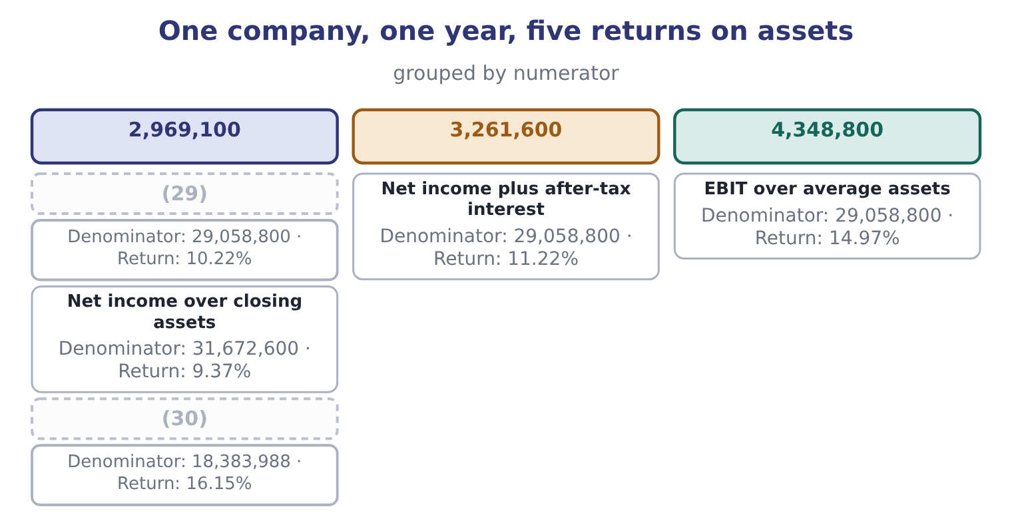
word list
Net income over average equity, for contrast · Net income plus after-tax interest · Net income over average assets

Summary 4 gaps 31–33
None of this makes the ratio (31) . It makes three rules (32) . State the definition you used. Use the same definition on both sides of every (33) . And when a published figure disagrees with yours, find the definition before you find a fault.
word list
compulsory · accumulated · comparison · useless

Decompose Barada's return

Only one balance sheet is available, so use closing balances throughout.

Your turn: Barada's returns (complete the blanks)
Item | Amount or ratio
Net sales | 21,978,000
Net income | 283,500
Total assets | 7,000,000
Total equity | 3,100,000
Net profit margin | (34) : 283,500 ÷ 21,978,000.
Total asset turnover | 3.14 times: 21,978,000 ÷ 7,000,000.
Equity multiplier | 2.2581: 7,000,000 ÷ 3,100,000.
Return on assets | (35) : 283,500 ÷ 7,000,000.
Return on equity | (36) : 283,500 ÷ 3,100,000, and the same figure from the decomposition, 1.29 × 3.14 × 2.2581 = 9.15.

word list
1.29 per cent · 4.05 per cent · tax burden ratio · 9.15 per cent

"Return"

Summary 5 gaps 37–39
English return does duty for three ideas that the exam keeps apart: a rate of profit, as in return on assets; the act of giving (37) back, as in a return of (38) ; and a filed (39) , as in a tax return.
word list
something · document · capital · nothing

The English this section uses, and its Arabic
Each term sits against what it means.
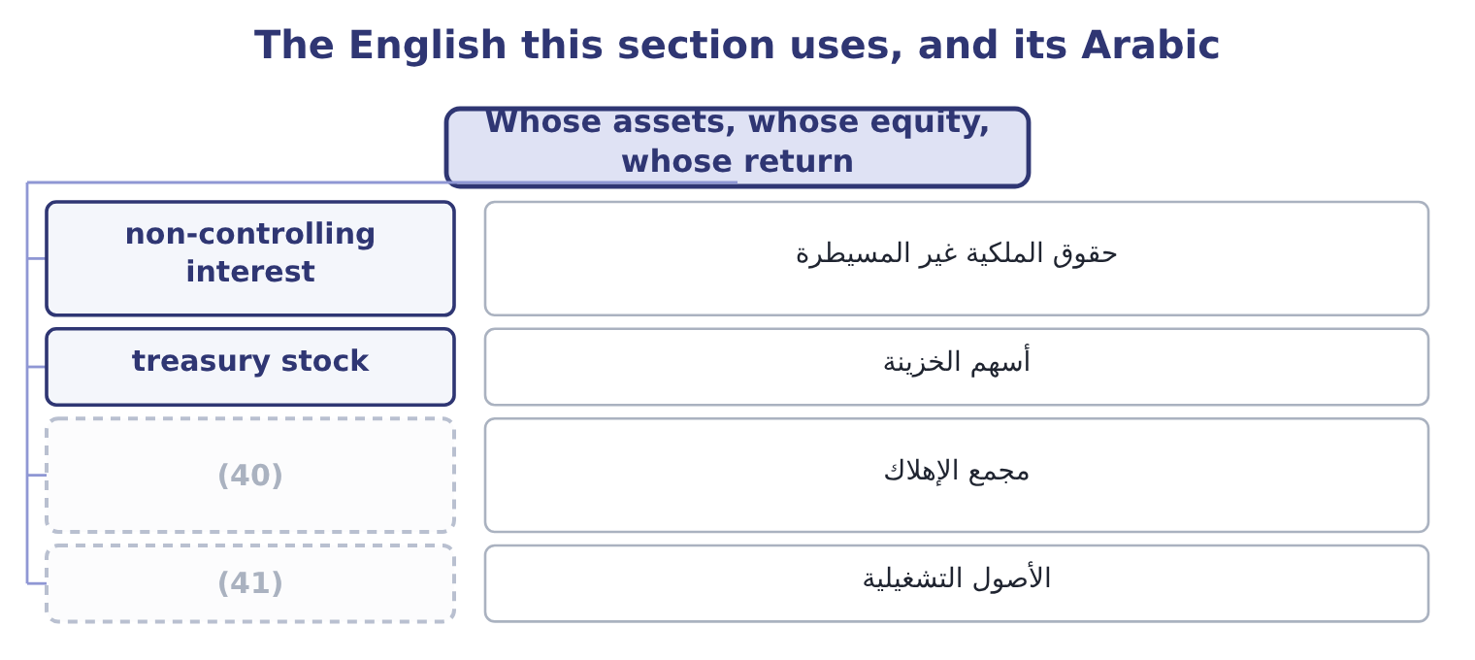
word list
assets employed · accumulated depreciation · operating assets

The English this sheet uses, and its Arabic
English (exam term) | Arabic
non-controlling interest | حقوق الملكية غير المسيطرة
treasury stock | أسهم الخزينة
accumulated depreciation | مجمع الإهلاك
operating assets | الأصول التشغيلية

Answer key · 14.5 Whose assets, whose equity, whose return

1 candidate | 22 comprehensive
2 convention | 23 denominator
3 standard | 24 normally
4 struck | 25 dividends
5 payment | 26 subsidiaries
6 groups | 27 non-controlling
7 dividing | 28 therefore
8 after-tax | 29 Net income over average assets
9 becomes | 30 Net income over average equity, for contrast
10 pre-financing | 31 useless
11 instead | 32 compulsory
12 called | 33 comparison
13 Average | 34 1.29 per cent
14 business | 35 4.05 per cent
15 equity-method | 36 9.15 per cent
16 securities | 37 something
17 produces | 38 capital
18 Taking | 39 document
19 higher | 40 accumulated depreciation
20 depreciation | 41 operating assets
21 matters

the summaries in full
Summary 1 A candidate who computes a return on assets of 10.22 per cent and an analyst who computes 14.97 per cent for the same company in the same year may both be right. The ratio has three parts and each of them is defined by convention rather than by a standard. Net income is the usual numerator and it is not the only one. Net income is struck after interest, which is a payment to one of the two groups that funded the assets, so dividing it by all of the assets mixes two bases. Adding back the after-tax interest repairs that: 390,000 × 0.75 = 292,500, so the numerator becomes 2,969,100 + 292,500 = 3,261,600 and the return is 3,261,600 ÷ 29,058,800 = 11.22 per cent. An analyst who wants a pre-financing measure uses EBIT instead: 4,348,800 ÷ 29,058,800 = 14.97 per cent.
Summary 2 All three are called return on assets in print. Average or closing is the first choice, and it moved Orontes's return on equity by a point and a half in section 14.2. Then: total assets, or only the assets used in the business? Orontes holds $1,807,000 of equity-method investments, $115,500 of securities and $46,000 of assets held for sale, none of which produces any of its operating profit. Taking them out gives a return on operating assets, which is higher and is a better measure of the trade. Gross or net of accumulated depreciation is a third choice, and it matters: Orontes's plant cost $26,790,000 and stands at $14,802,000, so a return computed on gross plant is barely half the one computed on net. Total equity includes accumulated other comprehensive income, which for Orontes is a negative $1,125 and so changes nothing, but for a company with large currency or pension reserves can swing the denominator by a tenth.
Summary 3 Preferred stock is normally excluded, with its dividends taken out of the numerator. Where a group has subsidiaries it does not wholly own, the non-controlling interest is part of consolidated equity and no part of the parent shareholders' equity, and the two returns differ. Treasury stock reduces equity and therefore raises the return, which is a point.
Summary 4 None of this makes the ratio useless. It makes three rules compulsory. State the definition you used. Use the same definition on both sides of every comparison. And when a published figure disagrees with yours, find the definition before you find a fault.
Summary 5 English return does duty for three ideas that the exam keeps apart: a rate of profit, as in return on assets; the act of giving something back, as in a return of capital; and a filed document, as in a tax return.

15.1 Sustainable growth: what the business can fund itself
Chapter 15 · section 15.1

Fill every gap. Each word list holds one word more than there are gaps.
Chapter 15, section by section
Each stage leads to the next.
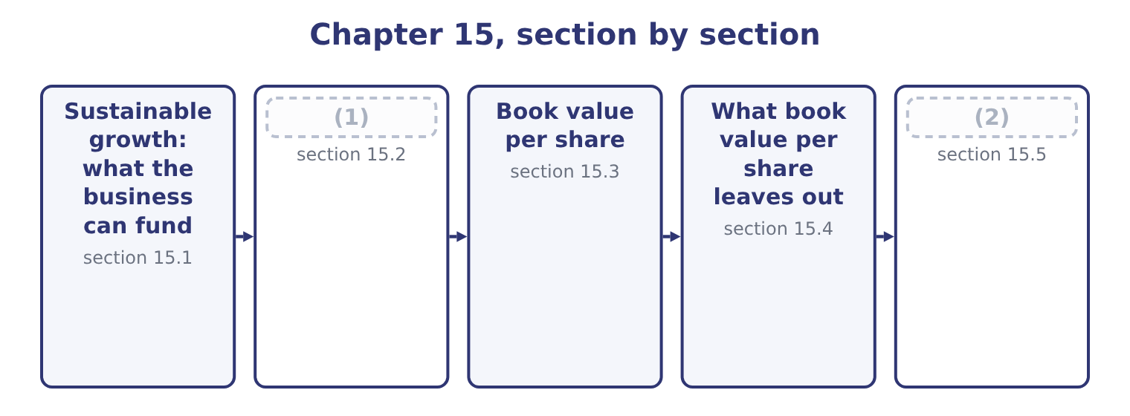
word list
What book value per share leaves out · Market value, and the profit the accountants d · Growing faster than that, and growing slower

Summary 1 gaps 3–14
A company (3) a fifth more next year needs a fifth more (4) and a fifth more (5) , and sooner or later a fifth more plant. There are only four (6) the money can come: profit the company keeps, new debt, new equity, or a (7) in the way the business works. The sustainable growth rate asks how fast the company can grow on the first of those alone, holding its (8) policies constant — the same (9) ratio, the same payout, the same margins, the same asset turnover. The (10) is short. Sustainable growth (11) the return on equity (12) by the proportion of profit retained. The retention ratio is one minus the payout. Orontes declared dividends of 50,000 + 400,000 = 450,000 in 2025 — the $50,000 paid in cash (13) the year and the $400,000 still payable at (14) 31 — so the payout ratio is 450,000 ÷ 2,969,100 = 15.16 per cent and the retention ratio is 100.0 − 15.16 = 84.84 per cent.
word list
during · financial · December · debt-to-equity · answer · change · selling · receivables · cleanest · multiplied · places · equals · inventory

Summary 2 gaps 15–21
At the (15) return on equity of 16.15 per cent, sustainable growth is 16.15 × 0.8484 = 13.70 per cent. You can see the same thing (16) in the statement of retained earnings, which is where the retained profit (17) lands: 4,375,000 + 2,969,100 − 450,000 = 6,894,100, the retained earnings figure on the 2025 (18) sheet. Equity grew by that retention, and if (19) about the business or its (20) mix changed, the business could support about 13.7 per cent more of (21) .
word list
funding · beginning-equity · nothing · average-equity · balance · happening · everything · physically

Orontes Foods, Inc. — sustainable growth, 2025
Element | Figure | Source
Net income | 2,969,100 | (22)
Dividends declared | 450,000 | (23)
Payout ratio | 15.16% | Dividends over net income
Retention ratio | 84.84% | One less the payout
Return on equity | 16.15% | (24)
Sustainable growth rate | 13.70% | Return on equity times retention

word list
Income statement · par value · Chapter 14, average basis · Paid 50,000, payable 400,000

Which return on equity goes into the growth rate

Summary 3 gaps 25–32
The formula is (25) to the equity basis, and the exam is (26) when it matters. On closing equity (27) return is 14.56 per cent, giving 14.56 × 0.8484 = 12.35 per cent. On (28) equity it is 2,969,100 ÷ 16,375,000 = 18.13 per cent, giving 18.13 × 0.8484 = 15.38 per cent. The beginning-equity version has the (29) logic — this year's profit on the equity the company (30) with — and the widest spread of (31) . Dividends declared, not dividends paid, (32) in the payout ratio. Orontes paid only $50,000 in cash and declared nine times.
word list
explicit · cleanest · started · sensitive · Orontes's · declared · answers · belong · beginning

The English this section uses, and its Arabic
Each term sits against what it means.
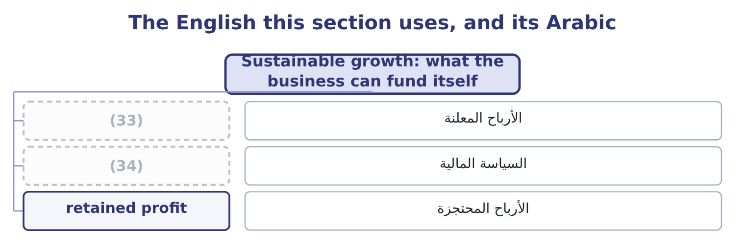
word list
financial policy · dividends declared · value creation

The English this sheet uses, and its Arabic
English (exam term) | Arabic
dividends declared | الأرباح المعلنة
financial policy | السياسة المالية
retained profit | الأرباح المحتجزة

Answer key · 15.1 Sustainable growth: what the business can fund itself

1 Growing faster than that, and growing slower | 18 balance
2 Market value, and the profit the accountants d | 19 nothing
3 selling | 20 funding
4 inventory | 21 everything
5 receivables | 22 Income statement
6 places | 23 Paid 50,000, payable 400,000
7 change | 24 Chapter 14, average basis
8 financial | 25 sensitive
9 debt-to-equity | 26 explicit
10 answer | 27 Orontes's
11 equals | 28 beginning
12 multiplied | 29 cleanest
13 during | 30 started
14 December | 31 answers
15 average-equity | 32 belong
16 happening | 33 dividends declared
17 physically | 34 financial policy

the summaries in full
Summary 1 A company selling a fifth more next year needs a fifth more inventory and a fifth more receivables, and sooner or later a fifth more plant. There are only four places the money can come: profit the company keeps, new debt, new equity, or a change in the way the business works. The sustainable growth rate asks how fast the company can grow on the first of those alone, holding its financial policies constant — the same debt-to-equity ratio, the same payout, the same margins, the same asset turnover. The answer is short. Sustainable growth equals the return on equity multiplied by the proportion of profit retained. The retention ratio is one minus the payout. Orontes declared dividends of 50,000 + 400,000 = 450,000 in 2025 — the $50,000 paid in cash during the year and the $400,000 still payable at December 31 — so the payout ratio is 450,000 ÷ 2,969,100 = 15.16 per cent and the retention ratio is 100.0 − 15.16 = 84.84 per cent.
Summary 2 At the average-equity return on equity of 16.15 per cent, sustainable growth is 16.15 × 0.8484 = 13.70 per cent. You can see the same thing happening in the statement of retained earnings, which is where the retained profit physically lands: 4,375,000 + 2,969,100 − 450,000 = 6,894,100, the retained earnings figure on the 2025 balance sheet. Equity grew by that retention, and if nothing about the business or its funding mix changed, the business could support about 13.7 per cent more of everything.
Summary 3 The formula is sensitive to the equity basis, and the exam is explicit when it matters. On closing equity Orontes's return is 14.56 per cent, giving 14.56 × 0.8484 = 12.35 per cent. On beginning equity it is 2,969,100 ÷ 16,375,000 = 18.13 per cent, giving 18.13 × 0.8484 = 15.38 per cent. The beginning-equity version has the cleanest logic — this year's profit on the equity the company started with — and the widest spread of answers. Dividends declared, not dividends paid, belong in the payout ratio. Orontes paid only $50,000 in cash and declared nine times.

15.2 Growing faster than that, and growing slower
Chapter 15 · section 15.2

Fill every gap. Each word list holds one word more than there are gaps.
Summary 1 gaps 1–12
Orontes's sales grew 42,000,000 − 36,400,000 = 5,600,000 in 2025, which is 5,600,000 ÷ 36,400,000 = 15.38 per cent, against a sustainable rate of 13.70 per cent. The company grew faster than its own profit could fund, and the (1) show exactly where the (2) came: a $1,500,000 share issue, $1,400,000 of (3) paid-in capital, and an $800,000 bank note. But the growth was (4) from outside, and that cannot be repeated (5) without either more (6) or more debt. A company growing faster than its sustainable rate has four (7) , and the exam (8) you to name them rather than simply observe the gap. Raise the sustainable rate through the (9) . A better margin or a faster asset (10) raises the return on equity and (11) the growth the company can fund. This is the only route that costs (12) .
word list
expects · business · repeated · additional · statements · indefinitely · turnover · part-funded · difference · nothing · issues · therefore · choices

Summary 2 gaps 13–24
Raise it through (13) . Cut the (14) , which raises retention (15) . Orontes (16) 84.84 per cent already, so there is (17) room; a company paying out half its profit has a great deal. Issue equity, as Orontes did, or (18) , which raises the equity (19) and with it the return on equity — and the risk. (20) , and it is what (21) anyway to a company that will not do the other three: the overdraft arrives first and the decision is taken for it. That last case is Barada's, and you have seen it twice already. Barada's sales grew 11 per cent while it retained (22) it earned on a return on equity of 9.15 per cent. Eleven against nine, year after year, is the whole (23) of the inventory up 41 per cent, the (24) up 38 per cent, and the overdraft of $240,000 where there was none.
word list
happens · directly · receivables · little · explanation · multiplier · Unfashionable · everything · borrow · retains · payout · policy · business

Growth against sustainable growth
The bars are drawn to scale.
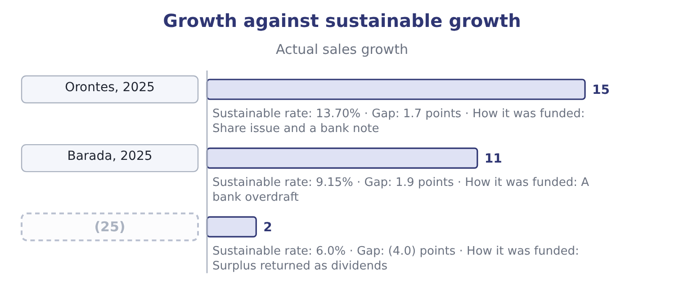
word list
sustainable growth rate · A mature utility

Summary 3 gaps 26–37
The third row is the (26) problem and it is (27) too. A company growing more slowly than it can fund (28) cash it has no use for, which lowers its return on assets — the point section 14.1 made about issuing shares and holding the (29) . The remedy is a larger dividend, a (30) , or an acquisition, and Book 3 takes that decision (31) . Return on equity on the beginning equity of $16,375,000 is 2,969,100 ÷ 16,375,000 = 18.13 per cent, and the retention ratio is 84.84 per cent. On the (32) basis Orontes grew at its sustainable rate, and on the (33) basis it grew faster than it. The two bases disagree (34) because the share issue (35) in the middle of the year — the average basis counts half of the new money as if it had been there all along, and the beginning basis counts none of it. This is not a trick of (36) ; it is the (37) the exam names the basis.
word list
accumulates · business · beginning-equity · proceeds · average-equity · precisely · opposite · landed · examinable · reason · properly · buyback · arithmetic

Summary 4 gaps 38–42
For a company that has not issued or (38) shares, the three answers are close (39) and the choice does not (40) . For Orontes in 2025 the spread is 12.35 to 15.38 per cent, and an answer that quotes one figure without naming its basis cannot be (41) by the marker or by (42) else.
word list
repurchased · together · anybody · matter · problem · checked

The English this section uses, and its Arabic
Each term sits against what it means.
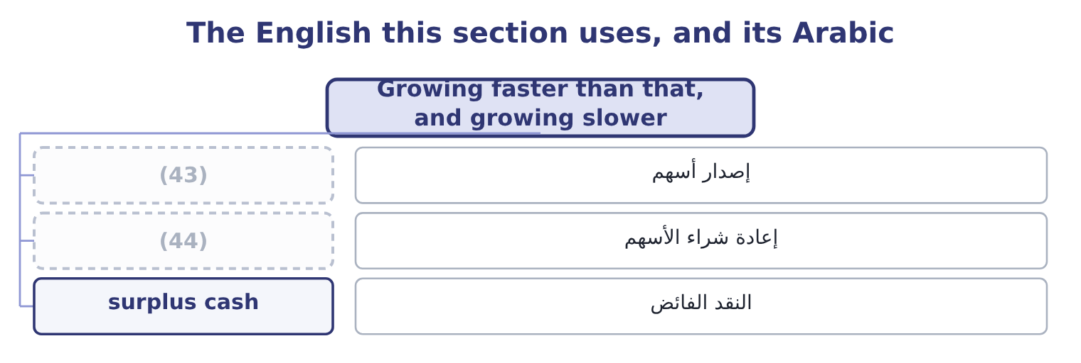
word list
buyback · share issue · required return

The English this sheet uses, and its Arabic
English (exam term) | Arabic
share issue | إصدار أسهم
buyback | إعادة شراء الأسهم
surplus cash | النقد الفائض

Answer key · 15.2 Growing faster than that, and growing slower

1 statements | 23 explanation
2 difference | 24 receivables
3 additional | 25 A mature utility
4 part-funded | 26 opposite
5 indefinitely | 27 examinable
6 issues | 28 accumulates
7 choices | 29 proceeds
8 expects | 30 buyback
9 business | 31 properly
10 turnover | 32 beginning-equity
11 therefore | 33 average-equity
12 nothing | 34 precisely
13 policy | 35 landed
14 payout | 36 arithmetic
15 directly | 37 reason
16 retains | 38 repurchased
17 little | 39 together
18 borrow | 40 matter
19 multiplier | 41 checked
20 Unfashionable | 42 anybody
21 happens | 43 share issue
22 everything | 44 buyback

the summaries in full
Summary 1 Orontes's sales grew 42,000,000 − 36,400,000 = 5,600,000 in 2025, which is 5,600,000 ÷ 36,400,000 = 15.38 per cent, against a sustainable rate of 13.70 per cent. The company grew faster than its own profit could fund, and the statements show exactly where the difference came: a $1,500,000 share issue, $1,400,000 of additional paid-in capital, and an $800,000 bank note. But the growth was part-funded from outside, and that cannot be repeated indefinitely without either more issues or more debt. A company growing faster than its sustainable rate has four choices, and the exam expects you to name them rather than simply observe the gap. Raise the sustainable rate through the business. A better margin or a faster asset turnover raises the return on equity and therefore the growth the company can fund. This is the only route that costs nothing.
Summary 2 Raise it through policy. Cut the payout, which raises retention directly. Orontes retains 84.84 per cent already, so there is little room; a company paying out half its profit has a great deal. Issue equity, as Orontes did, or borrow, which raises the equity multiplier and with it the return on equity — and the risk. Unfashionable, and it is what happens anyway to a company that will not do the other three: the overdraft arrives first and the decision is taken for it. That last case is Barada's, and you have seen it twice already. Barada's sales grew 11 per cent while it retained everything it earned on a return on equity of 9.15 per cent. Eleven against nine, year after year, is the whole explanation of the inventory up 41 per cent, the receivables up 38 per cent, and the overdraft of $240,000 where there was none.
Summary 3 The third row is the opposite problem and it is examinable too. A company growing more slowly than it can fund accumulates cash it has no use for, which lowers its return on assets — the point section 14.1 made about issuing shares and holding the proceeds. The remedy is a larger dividend, a buyback, or an acquisition, and Book 3 takes that decision properly. Return on equity on the beginning equity of $16,375,000 is 2,969,100 ÷ 16,375,000 = 18.13 per cent, and the retention ratio is 84.84 per cent. On the beginning-equity basis Orontes grew at its sustainable rate, and on the average-equity basis it grew faster than it. The two bases disagree precisely because the share issue landed in the middle of the year — the average basis counts half of the new money as if it had been there all along, and the beginning basis counts none of it. This is not a trick of arithmetic; it is the reason the exam names the basis.
Summary 4 For a company that has not issued or repurchased shares, the three answers are close together and the choice does not matter. For Orontes in 2025 the spread is 12.35 to 15.38 per cent, and an answer that quotes one figure without naming its basis cannot be checked by the marker or by anybody else.

15.3 Book value per share
Chapter 15 · section 15.3

Fill every gap. Each word list holds one word more than there are gaps.
Summary 1 gaps 1–12
Book value per share is total stockholders' equity (1) by the shares outstanding at the same date. It is what the accountants say the (2) own, per share, after every (3) . (4) equity at December 31, 2025 is $20,392,975 and 8,100,000 shares are issued and outstanding, so book value per share is 20,392,975 ÷ 8,100,000 = 2.5177. A year (5) it was 16,375,000 ÷ 8,000,000 = 2.0469. Three points of (6) before the (7) . Use shares outstanding at the balance sheet date, not the weighted average. The weighted average (8) to earnings per share, which is a flow over a period; book value is a balance at a date, and so is the share count that goes with it. Treasury shares are not outstanding. They reduce equity and they reduce the share count, and because they are normally (9) above book value they usually raise book value per share — a point that trips (10) who expect a (11) to lower it. Where preferred stock (12) , deduct it. Book value per common share is equity less the preferred claim, over the common shares.
word list
exists · candidates · shareholders · buyback · belongs · interpretation · Averaging · Orontes's · divided · earlier · repurchased · mechanics · liability

Orontes: book value per share
Element | 2025 | 2024
Total stockholders' equity | 20,392,975 | 16,375,000
(13) | 8,100,000 | 8,000,000
Book value per share | 2.5177 | 2.0469

word list
cost of equity capital · Shares issued and outstanding

Summary 2 gaps 14–19
Book value per share rose by about 23 per cent in a year, from (14) profit and from the share issue, which was (15) well above book. For a bank or an (16) , which hold mostly (17) assets carried at or near fair value, that figure would be close to a real (18) of worth. For a food (19) it is not, and the next section says why.
word list
priced · measure · closing · financial · insurer · retained · manufacturer

Which share count, which equity

Summary 3 gaps 20–25
Shares issued is not (20) shares outstanding: the (21) is treasury stock. Orontes has none, so for Orontes the two are the same and the exam may still ask. Book value per share uses the (22) equity. (23) it is an error — there is no period for a balance to be averaged over. Earnings per share and book value per share use (24) share counts on (25) .
word list
always · purpose · difference · closing · manufacturer · different · Averaging

The English this section uses, and its Arabic
Each term sits against what it means.
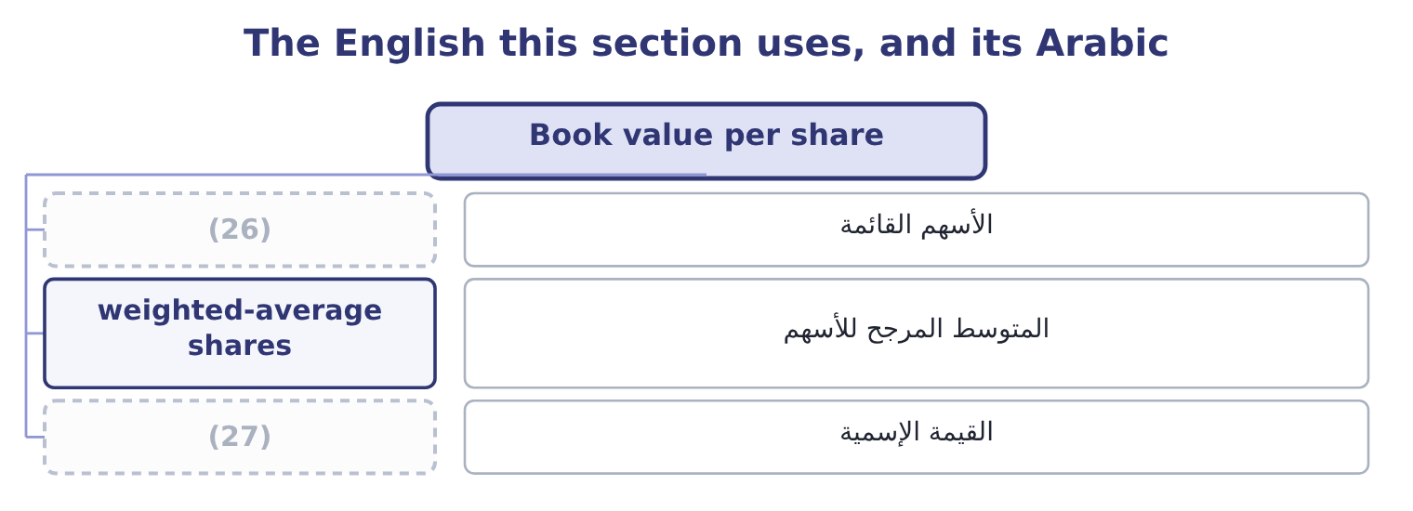
word list
par value · القيمة الإسمية · shares outstanding

The English this sheet uses, and its Arabic
English (exam term) | Arabic
shares outstanding | الأسهم القائمة
weighted-average shares | المتوسط المرجح للأسهم
par value | القيمة الإسمية

Answer key · 15.3 Book value per share

1 divided | 15 priced
2 shareholders | 16 insurer
3 liability | 17 financial
4 Orontes's | 18 measure
5 earlier | 19 manufacturer
6 mechanics | 20 always
7 interpretation | 21 difference
8 belongs | 22 closing
9 repurchased | 23 Averaging
10 candidates | 24 different
11 buyback | 25 purpose
12 exists | 26 shares outstanding
13 Shares issued and outstanding | 27 par value
14 retained

the summaries in full
Summary 1 Book value per share is total stockholders' equity divided by the shares outstanding at the same date. It is what the accountants say the shareholders own, per share, after every liability. Orontes's equity at December 31, 2025 is $20,392,975 and 8,100,000 shares are issued and outstanding, so book value per share is 20,392,975 ÷ 8,100,000 = 2.5177. A year earlier it was 16,375,000 ÷ 8,000,000 = 2.0469. Three points of mechanics before the interpretation. Use shares outstanding at the balance sheet date, not the weighted average. The weighted average belongs to earnings per share, which is a flow over a period; book value is a balance at a date, and so is the share count that goes with it. Treasury shares are not outstanding. They reduce equity and they reduce the share count, and because they are normally repurchased above book value they usually raise book value per share — a point that trips candidates who expect a buyback to lower it. Where preferred stock exists, deduct it. Book value per common share is equity less the preferred claim, over the common shares.
Summary 2 Book value per share rose by about 23 per cent in a year, from retained profit and from the share issue, which was priced well above book. For a bank or an insurer, which hold mostly financial assets carried at or near fair value, that figure would be close to a real measure of worth. For a food manufacturer it is not, and the next section says why.
Summary 3 Shares issued is not always shares outstanding: the difference is treasury stock. Orontes has none, so for Orontes the two are the same and the exam may still ask. Book value per share uses the closing equity. Averaging it is an error — there is no period for a balance to be averaged over. Earnings per share and book value per share use different share counts on purpose.

15.4 What book value per share leaves out
Chapter 15 · section 15.4

Fill every gap. Each word list holds one word more than there are gaps.
Summary 1 gaps 1–12
Orontes's (1) change hands at $9.25. Its book value per share is $2.5177. The market says a share is worth (2) four times what the balance sheet says, and the (3) is not that one of them is wrong. It is that they measure (4) things, and the gap is the sum of (5) the balance sheet is not designed to carry. (6) is carried at what it cost less (7) depreciation. Orontes's plant cost $26,790,000 and stands at $14,802,000; land (8) thirty years ago stands at its 1990s price. Under IFRS a company may (9) ; under US GAAP it may not. Intangibles the company built. Orontes's brand is on the balance sheet at $260,000 (10) it was acquired. The recipes, the customer (11) , the trained (12) and the reputation that make the brand worth anything were built internally, and internally generated intangibles are not recognised at all.
word list
revalue · everything · bought · Property · workforce · different · reason · acquired · because · nearly · shares · relationships · accumulated

Summary 2 gaps 13–22
A (13) company's whole value sits in this gap, which is why its market-to-book ratio runs in double (14) . Goodwill, which is only ever (15) . Acquired goodwill is recognised and then tested for (16) . It can fall and can never rise. Orontes's goodwill went from $950,000 to $300,000 in 2025 (17) exactly that (18) . What the future holds. The market price (19) expected future cash flows. The balance sheet records past (20) . A company whose (21) are expected to double trades far above book; a company expected to shrink trades below it, and a market-to-book ratio under 1.0 is the market saying the assets are worth less in this company's hands than their (22) amount.
word list
mechanism · depreciation · figures · profits · discounts · software · impairment · downhill · through · carrying · transactions

Why book value per share understates a going concern
What is missing | Why | Orontes's evidence
Current values | (23) | Plant at 14,802,000 against a cost of 26,790,000
Internally built intangibles | Not recognised under GAAP | (24)
Rising goodwill | Only tested downwards | (25)
Expected future profit | (26) | A share price of 9.25 against a book value of 2.5177

word list
Goodwill fell from 950,000 to 300,000 · The balance sheet is a record, not a forecast · Brand at 260,000; recipes and reputation at nil · Plant at 14,802,000 against a cost of 26,790,000 · Assets at cost less depreciation

The English this section uses, and its Arabic
Each term sits against what it means.
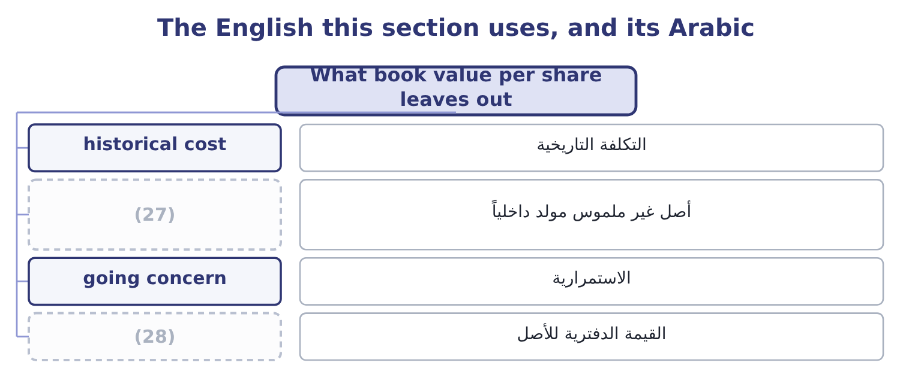
word list
market value · carrying amount · internally generated intangible

The English this sheet uses, and its Arabic
English (exam term) | Arabic
historical cost | التكلفة التاريخية
internally generated intangible | أصل غير ملموس مولد داخلياً
going concern | الاستمرارية
carrying amount | القيمة الدفترية للأصل

Answer key · 15.4 What book value per share leaves out

1 shares | 15 downhill
2 nearly | 16 impairment
3 reason | 17 through
4 different | 18 mechanism
5 everything | 19 discounts
6 Property | 20 transactions
7 accumulated | 21 profits
8 bought | 22 carrying
9 revalue | 23 Assets at cost less depreciation
10 because | 24 Brand at 260,000; recipes and reputation at nil
11 relationships | 25 Goodwill fell from 950,000 to 300,000
12 workforce | 26 The balance sheet is a record, not a forecast
13 software | 27 internally generated intangible
14 figures | 28 carrying amount

the summaries in full
Summary 1 Orontes's shares change hands at $9.25. Its book value per share is $2.5177. The market says a share is worth nearly four times what the balance sheet says, and the reason is not that one of them is wrong. It is that they measure different things, and the gap is the sum of everything the balance sheet is not designed to carry. Property is carried at what it cost less accumulated depreciation. Orontes's plant cost $26,790,000 and stands at $14,802,000; land bought thirty years ago stands at its 1990s price. Under IFRS a company may revalue; under US GAAP it may not. Intangibles the company built. Orontes's brand is on the balance sheet at $260,000 because it was acquired. The recipes, the customer relationships, the trained workforce and the reputation that make the brand worth anything were built internally, and internally generated intangibles are not recognised at all.
Summary 2 A software company's whole value sits in this gap, which is why its market-to-book ratio runs in double figures. Goodwill, which is only ever downhill. Acquired goodwill is recognised and then tested for impairment. It can fall and can never rise. Orontes's goodwill went from $950,000 to $300,000 in 2025 through exactly that mechanism. What the future holds. The market price discounts expected future cash flows. The balance sheet records past transactions. A company whose profits are expected to double trades far above book; a company expected to shrink trades below it, and a market-to-book ratio under 1.0 is the market saying the assets are worth less in this company's hands than their carrying amount.

15.5 Market value, and the profit the accountants do not charge for
Chapter 15 · section 15.5

Fill every gap. Each word list holds one word more than there are gaps.
Summary 1 gaps 1–12
Market value per share is the price. Market (1) is the price times the shares: 8,100,000 × 9.25 = 74,925,000. Against a book equity of $20,392,975, the market adds 74,925,000 − 20,392,975 = 54,532,025 of value that no statement (2) . The ratio of the two is the market-to-book ratio: 9.25 ÷ 2.5177 = 3.67 for 2025, and 7.80 ÷ 2.0469 = 3.81 for 2024. The (3) fell slightly while the price rose, because book value rose faster. Now the second (4) this outcome requires, and the one (5) find least (6) . Accounting profit is revenue less the costs the standards require to be (7) . Economic profit is revenue less all costs, (8) the cost of the equity capital (9) — which the standards never charge, because equity has no (10) cost and so no (11) is recorded. That (12) is large.
word list
capitalisation · employed · familiar · including · distinction · expense · contractual · recognised · candidates · omission · records · multiple · revenue

Summary 2 gaps 13–15
Orontes's (13) are charged for in the income statement, at $390,000 of interest. Its (14) , who put up $18,383,988 on average, are charged nothing at all, although they could have invested the money (15) .
word list
lenders · shareholders · elsewhere · manufacturer

Worked example: Orontes's economic profit

Summary 3 gaps 16–27
Net income for 2025 is $2,969,100, (16) after interest and after tax, and it is the profit every ratio in Book 1 has used. The charge the (17) omit. (18) a shareholder in a food (19) of this risk requires 10 per cent. On average equity the charge is 18,383,988 × 0.10 = 1,838,399. Orontes earned about 1.1 (20) dollars more than the (21) its owners require. The sign is what (22) . A positive economic profit means the company is creating value and the market-to-book ratio above 1.0 is (23) ; a negative one means the company earns an accounting profit while (24) value, which is (25) the case a market-to-book ratio below 1.0 describes. Note also the (26) test: a return on equity of 16.15 per cent against a required 10 per cent is the same statement as a positive economic profit, (27) as a rate instead of an amount.
word list
Economic · justified · consistency · destroying · million · Suppose · precisely · expressed · struck · minimum · manufacturer · matters · statements

Barada's growth and its book value

Compute the missing items.

Your turn: Barada's growth and book value (complete the blanks)
Item | Amount or ratio
Net income | 283,500
Total equity | 3,100,000
(28) | 1,000,000
(29) | nil
Sales, 2025 | 21,978,000
Sales, 2024 | 19,800,000
Return on equity, closing basis | ________
Retention ratio | ________
Sustainable growth rate | ________
Actual sales growth | ________
Book value per share | ________
(30) | ________

word list
Shares outstanding · Actual sales growth · Dividends declared · Market-to-book, at the investor's implied price of 6.00

"Value"

Summary 4 gaps 31–34
English value carries no built-in basis: book value, market value, fair value, net (31) value and present value are five (32) numbers for one asset, and the word alone tells the reader nothing. The (33) habit is to name the basis every time. A marker cannot (34) an answer written that way.
word list
misread · different · realisable · professional · Orontes

"Value"
Item | Answer
Return on equity, closing basis | (35) : 283,500 ÷ 3,100,000.
Retention ratio | (36)
Sustainable growth rate | 9.15 per cent: 9.15 × 1.00 = 9.15.
Actual sales growth | 11.0 per cent: 21,978,000 − 19,800,000 = 2,178,000, and 2,178,000 ÷ 19,800,000 = 11.0 per cent.
Book value per share | 3.10: 3,100,000 ÷ 1,000,000.
Market-to-book | (37) : 6.00 ÷ 3.10, where the price comes from 6,000,000 ÷ 1,000,000 = 6.00.
What it tells you | Barada grows about two points a year faster than it can fund, retains everything, and pays no dividend, so the gap can only go on the overdr

word list
3.10 · 9.15 per cent · 1.9355 · 100 per cent, because no dividend was declared.

The English this section uses, and its Arabic
Each term sits against what it means.
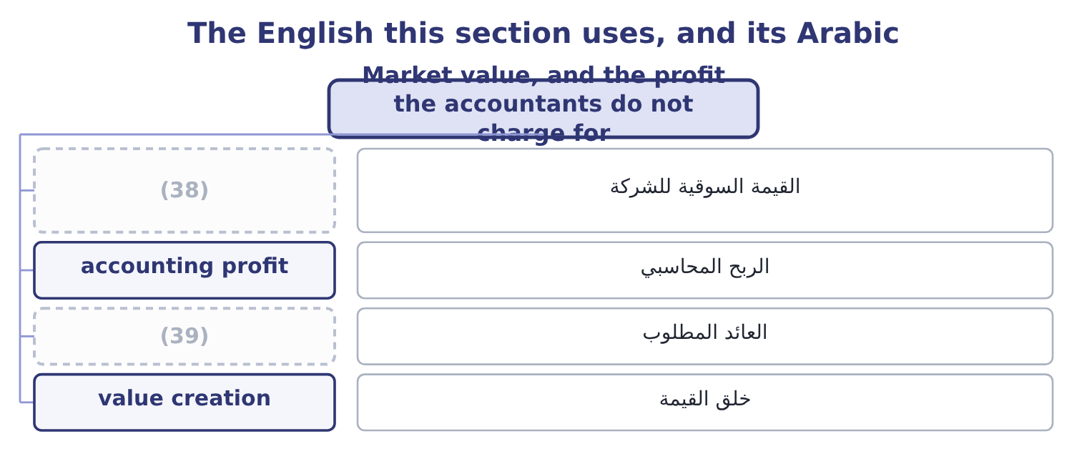
word list
carrying amount · required return · market capitalisation

The English this sheet uses, and its Arabic
English (exam term) | Arabic
market capitalisation | القيمة السوقية للشركة
accounting profit | الربح المحاسبي
required return | العائد المطلوب
value creation | خلق القيمة

Answer key · 15.5 Market value, and the profit the accountants do not charge for

1 capitalisation | 21 minimum
2 records | 22 matters
3 multiple | 23 justified
4 distinction | 24 destroying
5 candidates | 25 precisely
6 familiar | 26 consistency
7 recognised | 27 expressed
8 including | 28 Shares outstanding
9 employed | 29 Dividends declared
10 contractual | 30 Market-to-book, at the investor's implied price of 6.00
11 expense | 31 realisable
12 omission | 32 different
13 lenders | 33 professional
14 shareholders | 34 misread
15 elsewhere | 35 9.15 per cent
16 struck | 36 100 per cent, because no dividend was declared.
17 statements | 37 1.9355
18 Suppose | 38 market capitalisation
19 manufacturer | 39 required return
20 million

the summaries in full
Summary 1 Market value per share is the price. Market capitalisation is the price times the shares: 8,100,000 × 9.25 = 74,925,000. Against a book equity of $20,392,975, the market adds 74,925,000 − 20,392,975 = 54,532,025 of value that no statement records. The ratio of the two is the market-to-book ratio: 9.25 ÷ 2.5177 = 3.67 for 2025, and 7.80 ÷ 2.0469 = 3.81 for 2024. The multiple fell slightly while the price rose, because book value rose faster. Now the second distinction this outcome requires, and the one candidates find least familiar. Accounting profit is revenue less the costs the standards require to be recognised. Economic profit is revenue less all costs, including the cost of the equity capital employed — which the standards never charge, because equity has no contractual cost and so no expense is recorded. That omission is large.
Summary 2 Orontes's lenders are charged for in the income statement, at $390,000 of interest. Its shareholders, who put up $18,383,988 on average, are charged nothing at all, although they could have invested the money elsewhere.
Summary 3 Net income for 2025 is $2,969,100, struck after interest and after tax, and it is the profit every ratio in Book 1 has used. The charge the statements omit. Suppose a shareholder in a food manufacturer of this risk requires 10 per cent. On average equity the charge is 18,383,988 × 0.10 = 1,838,399. Orontes earned about 1.1 million dollars more than the minimum its owners require. The sign is what matters. A positive economic profit means the company is creating value and the market-to-book ratio above 1.0 is justified; a negative one means the company earns an accounting profit while destroying value, which is precisely the case a market-to-book ratio below 1.0 describes. Note also the consistency test: a return on equity of 16.15 per cent against a required 10 per cent is the same statement as a positive economic profit, expressed as a rate instead of an amount.
Summary 4 English value carries no built-in basis: book value, market value, fair value, net realisable value and present value are five different numbers for one asset, and the word alone tells the reader nothing. The professional habit is to name the basis every time. A marker cannot misread an answer written that way.

16.1 Earnings per share
Chapter 16 · section 16.1

Fill every gap. Each word list holds one word more than there are gaps.
Chapter 16, section by section
Each stage leads to the next.
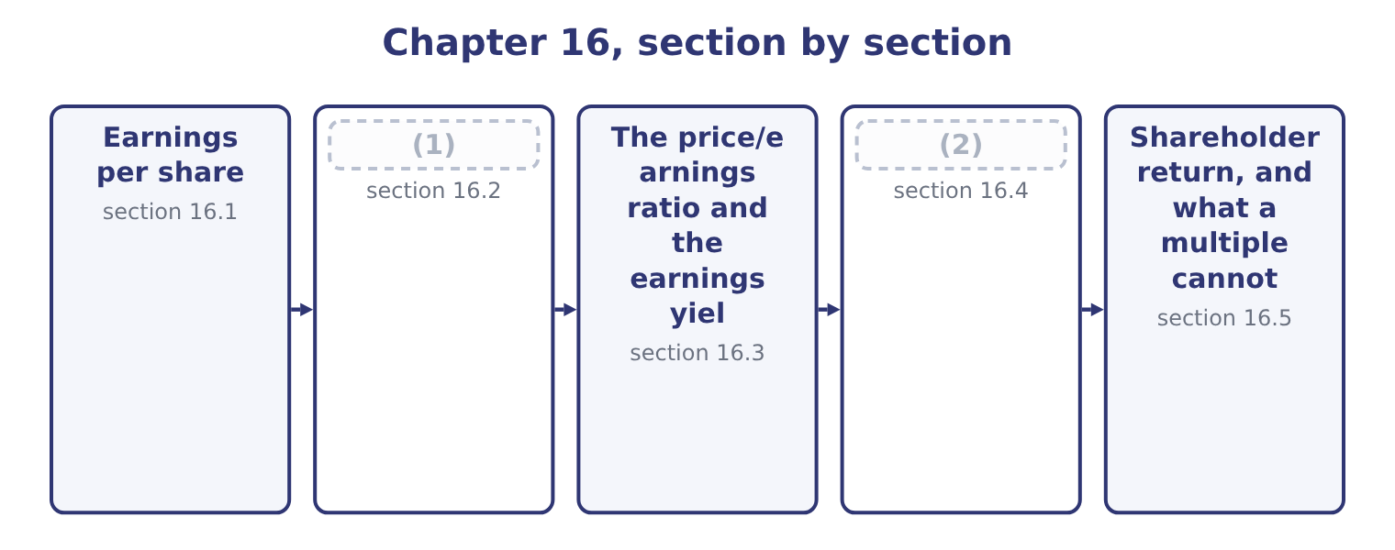
word list
Diluted earnings per share · Dividend yield and payout · basic earnings per share

Summary 1 gaps 3–13
Basic earnings per share is the profit attributable to common shareholders (3) by the weighted-average (4) of common shares outstanding (5) the period. Two words in that (6) do the work. Attributable means after any preferred (7) , because a preferred dividend is not the common shareholders' profit; Orontes has no preferred stock, so its whole net income of $2,969,100 is attributable. Weighted-average means each share counts for the (8) of the year it was outstanding, because a share issued in (9) did not help earn the (10) profit. Orontes began 2025 with 8,000,000 shares and ended with 8,100,000, the 100,000 new shares (11) been issued on January 2. Each was outstanding for 364 of the 365 days: 100,000 × 364 ÷ 365 = 99,726, and the weighted (12) is 8,000,000 + 99,726 = 8,099,726 — the figure on the face of the income statement. So basic earnings per share is 2,969,100 ÷ 8,099,726 = 0.3666, which the (13) present as $0.37.
word list
divided · presented · fraction · December · statements · dividends · average · sentence · during · number · year's · having

Orontes Foods, Inc. — basic earnings per share, 2025
Element | Figure | Note
Net income | 2,969,100 | (14)
Shares at January 1 | 8,000,000 | Outstanding all year
Shares issued January 2 | 100,000 | (15)
Weighted-average shares | 8,099,726 | (16)
Basic earnings per share | 0.3666 | Presented as 0.37

word list
8,000,000 plus 99,726 · potential common share · Outstanding 364 days · No preferred stock, so all of it is attributable

The share count is where the marks are

Summary 2 gaps 17–23
A share split or a stock dividend is applied (17) to every period presented, because no cash came in and nothing was earned (18) . A share issue for cash is weighted from its date. (19) shares are excluded from the moment they are (20) , weighted in the same way. Earnings per share is the one ratio the (21) define and (22) on the face of the income statement. Every other ratio in Book 1 is an analyst's (23) .
word list
average · require · differently · repurchased · retrospectively · standards · construction · Treasury

The English this section uses, and its Arabic
Each term sits against what it means.
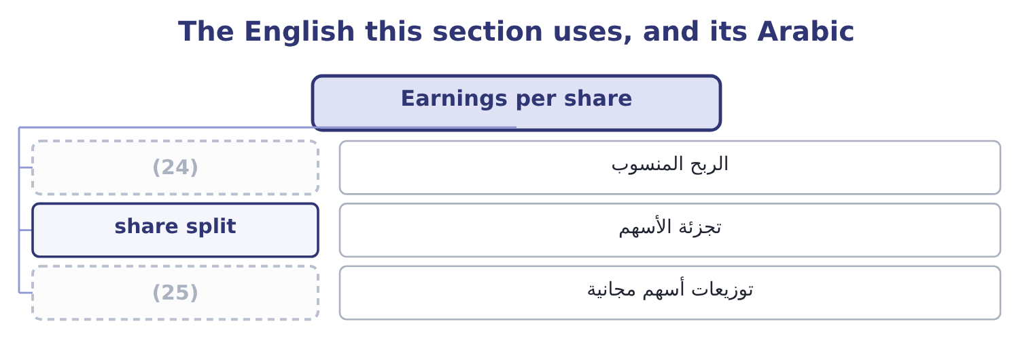
word list
mature company · attributable profit · stock dividend

The English this sheet uses, and its Arabic
English (exam term) | Arabic
attributable profit | الربح المنسوب
share split | تجزئة الأسهم
stock dividend | توزيعات أسهم مجانية

Answer key · 16.1 Earnings per share

1 Diluted earnings per share | 14 No preferred stock, so all of it is attributable
2 Dividend yield and payout | 15 Outstanding 364 days
3 divided | 16 8,000,000 plus 99,726
4 number | 17 retrospectively
5 during | 18 differently
6 sentence | 19 Treasury
7 dividends | 20 repurchased
8 fraction | 21 standards
9 December | 22 require
10 year's | 23 construction
11 having | 24 attributable profit
12 average | 25 stock dividend
13 statements

the summaries in full
Summary 1 Basic earnings per share is the profit attributable to common shareholders divided by the weighted-average number of common shares outstanding during the period. Two words in that sentence do the work. Attributable means after any preferred dividends, because a preferred dividend is not the common shareholders' profit; Orontes has no preferred stock, so its whole net income of $2,969,100 is attributable. Weighted-average means each share counts for the fraction of the year it was outstanding, because a share issued in December did not help earn the year's profit. Orontes began 2025 with 8,000,000 shares and ended with 8,100,000, the 100,000 new shares having been issued on January 2. Each was outstanding for 364 of the 365 days: 100,000 × 364 ÷ 365 = 99,726, and the weighted average is 8,000,000 + 99,726 = 8,099,726 — the figure on the face of the income statement. So basic earnings per share is 2,969,100 ÷ 8,099,726 = 0.3666, which the statements present as $0.37.
Summary 2 A share split or a stock dividend is applied retrospectively to every period presented, because no cash came in and nothing was earned differently. A share issue for cash is weighted from its date. Treasury shares are excluded from the moment they are repurchased, weighted in the same way. Earnings per share is the one ratio the standards define and require on the face of the income statement. Every other ratio in Book 1 is an analyst's construction.

16.2 Diluted earnings per share
Chapter 16 · section 16.2

Fill every gap. Each word list holds one word more than there are gaps.
Summary 1 gaps 1–11
Diluted earnings per share asks what the figure would have been if everything that could become a common share had become one. Convertible bonds, convertible preferred stock, options and warrants are all potential common shares, and a company that has issued them has (1) away part of each (2) dollar of profit. Orontes reports the same figure for basic and diluted, which tells you it has no potential common shares outstanding. Most (3) companies do, so the exam tests the (4) on figures the question (5) . Two (6) cover almost everything. The treasury stock method, for options and warrants. Assume they are (7) at their exercise price and that the company uses the proceeds to buy its own shares back at the average market price. The net new shares are the (8) . The if-converted method, for convertible debt and convertible preferred. Assume (9) at the start of the period. Add the shares that would be issued, and add back to the numerator the interest after tax, or the preferred (10) , that would no (11) be paid.
word list
exercised · listed · conversion · methods · difference · future · mechanics · longer · antidilutive · dividend · supplies · promised

Worked example: two kinds of dilution

Summary 2 gaps 12–16
Options, by the treasury stock method. Suppose Orontes had 500,000 options outstanding at an exercise price of $5.00, with an average market price of $9.25. The proceeds would be 500,000 × 5.00 = 2,500,000, which buys back 2,500,000 ÷ 9.25 = 270,270 shares, so the net new shares are 500,000 − 270,270 = 229,730. Diluted shares are 8,099,726 + 229,730 = 8,329,456, and diluted earnings per share is 2,969,100 ÷ 8,329,456 = 0.3565. A convertible bond, by the if-converted method. Suppose (12) Orontes had $2,000,000 of 5 per cent convertible bonds (13) for 400,000 shares. The interest saved is 2,000,000 × 0.05 = 100,000, and after tax at the (14) 25 per cent (15) rate that is 100,000 × 0.75 = 75,000. The numerator (16) 2,969,100 + 75,000 = 3,044,100 and the share count 8,099,726 + 400,000 = 8,499,726, so diluted earnings per share is 3,044,100 ÷ 8,499,726 = 0.3581.
word list
instead · effective · security · exchangeable · becomes · company's

Summary 3 gaps 17–27
Test each for (17) . A security is only included if it (18) earnings per share. The bond adds 75,000 of (19) for 400,000 shares, which is 75,000 ÷ 400,000 = 0.1875 a share, below the basic figure of 0.3666, so it (20) and must be included. Had the bond (21) a high enough (22) that its per-share effect exceeded 0.3666, (23) it would raise earnings per share, and an antidilutive security is (24) . Both figures are below the basic 0.3666, which is the whole point: diluted earnings per share can never be (25) than basic. Where a question gives several (26) , rank them by their per-share effect, include them (27) first, and stop at the one that stops reducing the figure.
word list
higher · including · reduces · cheapest · income · coupon · carried · company's · instruments · excluded · dilutes · dilution

The two dilution methods
Every item belongs to exactly one group.
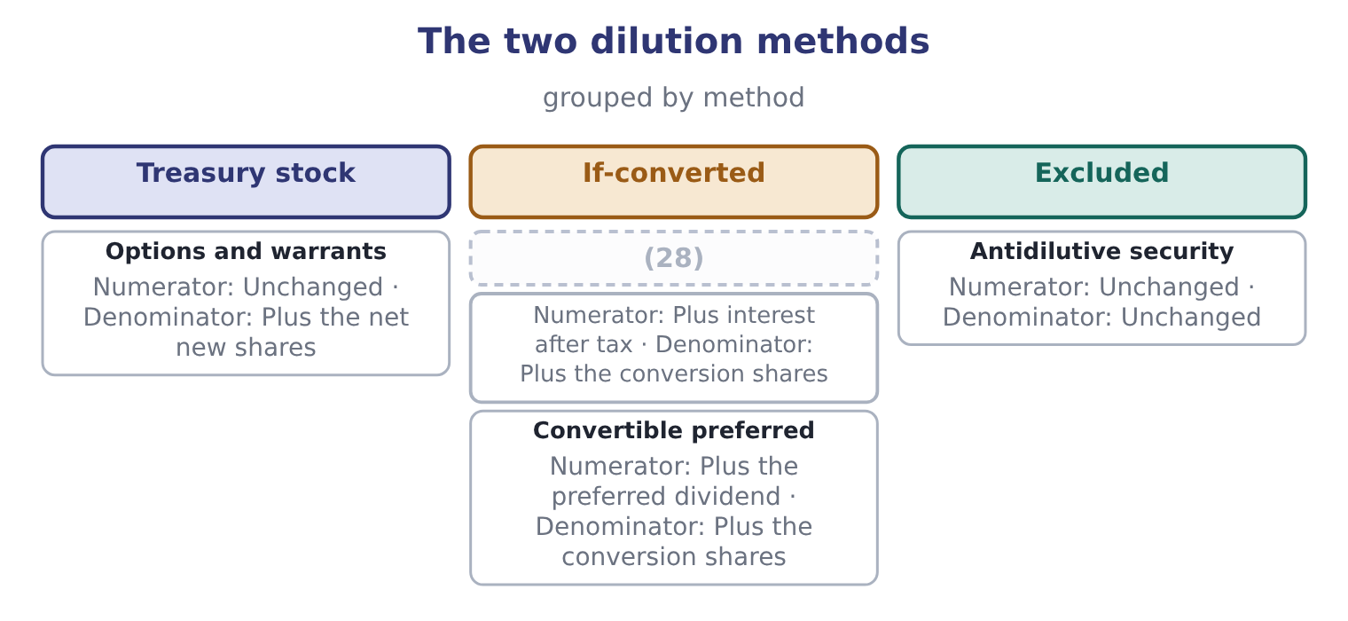
word list
capital gain · Convertible debt

Dilution has a direction

Summary 4 gaps 29–34
Diluted earnings per share is (29) less than or equal to basic. A (30) diluted figure above the basic one means an antidilutive security has been included by (31) . A loss changes the (32) of the test: when the company reports a loss, potential shares reduce the loss per share and are (33) antidilutive, so diluted equals basic. The treasury stock method uses the average market price for the period, not the (34) price.
word list
closing · always · Suppose · computed · therefore · mistake · direction

The English this section uses, and its Arabic
Each term sits against what it means.
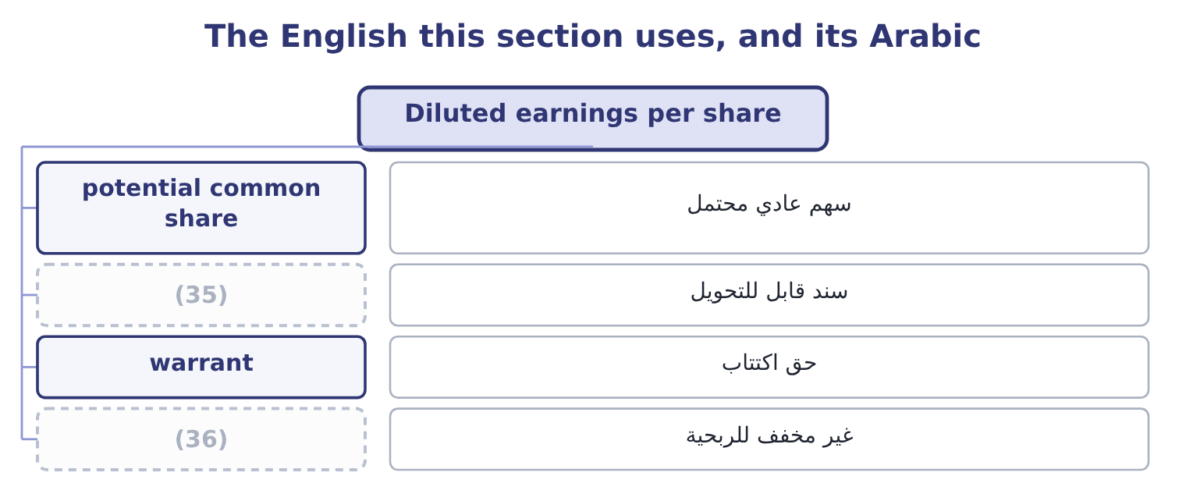
word list
mature company · convertible bond · antidilutive

The English this sheet uses, and its Arabic
English (exam term) | Arabic
potential common share | سهم عادي محتمل
convertible bond | سند قابل للتحويل
warrant | حق اكتتاب
antidilutive | غير مخفف للربحية

Answer key · 16.2 Diluted earnings per share

1 promised | 19 income
2 future | 20 dilutes
3 listed | 21 carried
4 mechanics | 22 coupon
5 supplies | 23 including
6 methods | 24 excluded
7 exercised | 25 higher
8 difference | 26 instruments
9 conversion | 27 cheapest
10 dividend | 28 Convertible debt
11 longer | 29 always
12 instead | 30 computed
13 exchangeable | 31 mistake
14 company's | 32 direction
15 effective | 33 therefore
16 becomes | 34 closing
17 dilution | 35 convertible bond
18 reduces | 36 antidilutive

the summaries in full
Summary 1 Diluted earnings per share asks what the figure would have been if everything that could become a common share had become one. Convertible bonds, convertible preferred stock, options and warrants are all potential common shares, and a company that has issued them has promised away part of each future dollar of profit. Orontes reports the same figure for basic and diluted, which tells you it has no potential common shares outstanding. Most listed companies do, so the exam tests the mechanics on figures the question supplies. Two methods cover almost everything. The treasury stock method, for options and warrants. Assume they are exercised at their exercise price and that the company uses the proceeds to buy its own shares back at the average market price. The net new shares are the difference. The if-converted method, for convertible debt and convertible preferred. Assume conversion at the start of the period. Add the shares that would be issued, and add back to the numerator the interest after tax, or the preferred dividend, that would no longer be paid.
Summary 2 Options, by the treasury stock method. Suppose Orontes had 500,000 options outstanding at an exercise price of $5.00, with an average market price of $9.25. The proceeds would be 500,000 × 5.00 = 2,500,000, which buys back 2,500,000 ÷ 9.25 = 270,270 shares, so the net new shares are 500,000 − 270,270 = 229,730. Diluted shares are 8,099,726 + 229,730 = 8,329,456, and diluted earnings per share is 2,969,100 ÷ 8,329,456 = 0.3565. A convertible bond, by the if-converted method. Suppose instead Orontes had $2,000,000 of 5 per cent convertible bonds exchangeable for 400,000 shares. The interest saved is 2,000,000 × 0.05 = 100,000, and after tax at the company's 25 per cent effective rate that is 100,000 × 0.75 = 75,000. The numerator becomes 2,969,100 + 75,000 = 3,044,100 and the share count 8,099,726 + 400,000 = 8,499,726, so diluted earnings per share is 3,044,100 ÷ 8,499,726 = 0.3581.
Summary 3 Test each for dilution. A security is only included if it reduces earnings per share. The bond adds 75,000 of income for 400,000 shares, which is 75,000 ÷ 400,000 = 0.1875 a share, below the basic figure of 0.3666, so it dilutes and must be included. Had the bond carried a high enough coupon that its per-share effect exceeded 0.3666, including it would raise earnings per share, and an antidilutive security is excluded. Both figures are below the basic 0.3666, which is the whole point: diluted earnings per share can never be higher than basic. Where a question gives several instruments, rank them by their per-share effect, include them cheapest first, and stop at the one that stops reducing the figure.
Summary 4 Diluted earnings per share is always less than or equal to basic. A computed diluted figure above the basic one means an antidilutive security has been included by mistake. A loss changes the direction of the test: when the company reports a loss, potential shares reduce the loss per share and are therefore antidilutive, so diluted equals basic. The treasury stock method uses the average market price for the period, not the closing price.

16.3 The price/earnings ratio and the earnings yield
Chapter 16 · section 16.3

Fill every gap. Each word list holds one word more than there are gaps.
Summary 1 gaps 1–12
The price/earnings ratio is the market price of a share (1) by its earnings per share. For Orontes: 9.25 ÷ 0.3666 = 25.23. Read it two ways, and the exam uses both. (2) , the market is paying 25.23 (3) for each dollar of last (4) earnings, or about twenty-five years of earnings at this level. (5) , a high multiple is the market (6) it expects earnings to grow, or that it regards them as (7) , or both; a low multiple is the market (8) decline, or (9) a discount for risk. The earnings yield is the same (10) inverted: earnings per share over price, 0.3666 ÷ 9.25 = 3.96 per cent. It is the more useful form when (11) a share with a bond, because a bond is quoted as a yield and a 3.96 per cent earnings yield can be set (12) against the 6 per cent Orontes pays its own bank.
word list
twenty-five · directly · Arithmetically · low-risk · relationship · expecting · comparing · dollars · saying · demanding · Economically · divided · year's

Orontes: the market ratios, 2025 and 2024
The bars are drawn to scale.
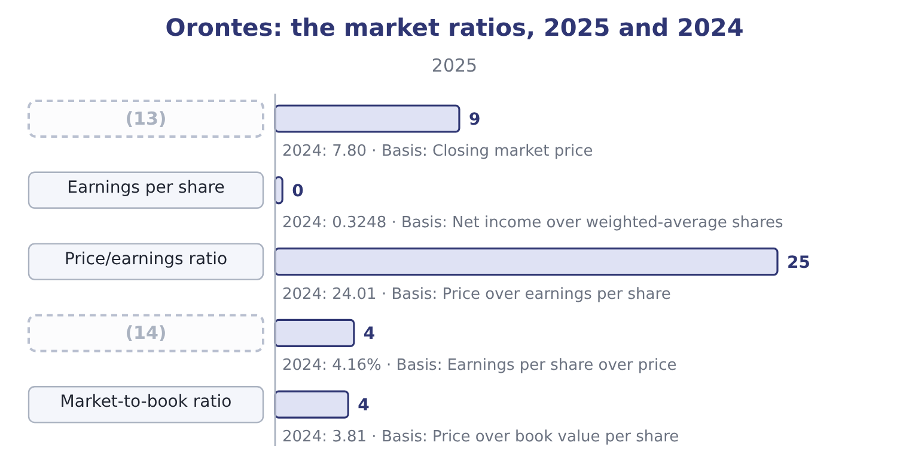
word list
Share price · shareholder return · Earnings yield

Summary 2 gaps 15–21
A multiple of twenty-five on a food (15) growing sales at 15 per cent a year is a price that (16) the growth (17) . (18) : the growth has been (19) with two points of gross margin, and the market multiple has risen while the margin fell. That is not a (20) ; it is the single most useful sentence an analyst can write about Orontes, and it comes from putting a market ratio next to an (21) one.
word list
manufacturer · negative · accounting · bought · assumes · Nothing · continues · prediction

Which earnings in the price/earnings ratio

Summary 3 gaps 22–27
A (22) multiple uses the last reported year. A forward multiple uses a forecast. They are not (23) , and a question that gives you a forecast expects the forward figure. Diluted earnings per share is the (24) denominator for a company with (25) common shares, because it is the more prudent figure. A (26) company has no meaningful price/earnings ratio. The ratio is left blank rather than reported as a (27) number.
word list
trailing · conventional · potential · growing · loss-making · comparable · negative

The English this section uses, and its Arabic
Each term sits against what it means.
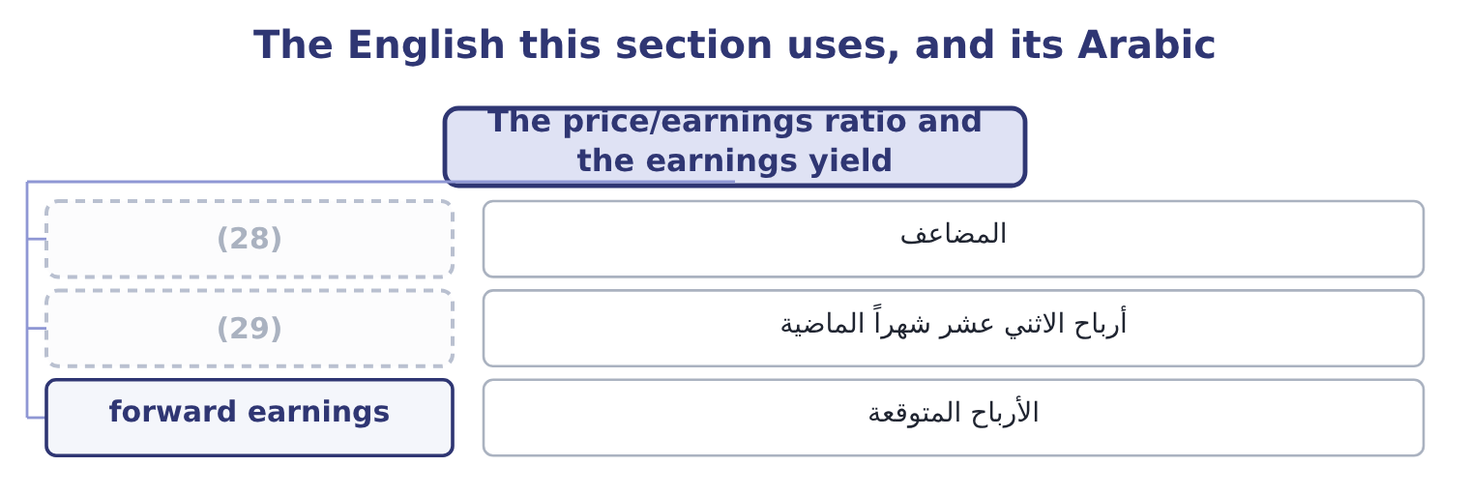
word list
multiple · earnings yield · trailing earnings

The English this sheet uses, and its Arabic
English (exam term) | Arabic
multiple | المضاعف
trailing earnings | أرباح الاثني عشر شهراً الماضية
forward earnings | الأرباح المتوقعة

Answer key · 16.3 The price/earnings ratio and the earnings yield

1 divided | 16 assumes
2 Arithmetically | 17 continues
3 dollars | 18 Nothing
4 year's | 19 bought
5 Economically | 20 prediction
6 saying | 21 accounting
7 low-risk | 22 trailing
8 expecting | 23 comparable
9 demanding | 24 conventional
10 relationship | 25 potential
11 comparing | 26 loss-making
12 directly | 27 negative
13 Share price | 28 multiple
14 Earnings yield | 29 trailing earnings
15 manufacturer

the summaries in full
Summary 1 The price/earnings ratio is the market price of a share divided by its earnings per share. For Orontes: 9.25 ÷ 0.3666 = 25.23. Read it two ways, and the exam uses both. Arithmetically, the market is paying 25.23 dollars for each dollar of last year's earnings, or about twenty-five years of earnings at this level. Economically, a high multiple is the market saying it expects earnings to grow, or that it regards them as low-risk, or both; a low multiple is the market expecting decline, or demanding a discount for risk. The earnings yield is the same relationship inverted: earnings per share over price, 0.3666 ÷ 9.25 = 3.96 per cent. It is the more useful form when comparing a share with a bond, because a bond is quoted as a yield and a 3.96 per cent earnings yield can be set directly against the 6 per cent Orontes pays its own bank.
Summary 2 A multiple of twenty-five on a food manufacturer growing sales at 15 per cent a year is a price that assumes the growth continues. Nothing: the growth has been bought with two points of gross margin, and the market multiple has risen while the margin fell. That is not a prediction; it is the single most useful sentence an analyst can write about Orontes, and it comes from putting a market ratio next to an accounting one.
Summary 3 A trailing multiple uses the last reported year. A forward multiple uses a forecast. They are not comparable, and a question that gives you a forecast expects the forward figure. Diluted earnings per share is the conventional denominator for a company with potential common shares, because it is the more prudent figure. A loss-making company has no meaningful price/earnings ratio. The ratio is left blank rather than reported as a negative number.

16.4 Dividend yield and payout
Chapter 16 · section 16.4

Fill every gap. Each word list holds one word more than there are gaps.
Summary 1 gaps 1–8
The dividend per share is dividends declared over the shares that will (1) them: 450,000 ÷ 8,100,000 = 0.0556. The dividend yield is that over the price: 0.0556 ÷ 9.25 = 0.60 per cent. An Orontes (2) receives six-tenths of one per cent a year in cash, which is next to (3) , and expects the rest of the return in the share price. The dividend payout ratio is dividends over earnings.16 per cent from the (4) and which comes to the same thing per share: 0.0556 ÷ 0.3666 = 15.17 per cent, the small (5) being the share count — the dividend is declared on the 8,100,000 shares in issue and the earnings are (6) by the 8,099,726 (7) average. The three are one (8) looked at from three sides.
word list
nothing · totals · shareholder · difference · weighted · receive · statement · sentiment · divided

Orontes: how the dividend ratios fit together
Measure | Computation | 2025 | What it tells the owner
Dividend per share | 450,000 over 8,100,000 | 0.0556 | (9)
Dividend yield | (10) | 0.60% | The cash return on the price
Dividend payout ratio | 0.0556 over 0.3666 | 15.17% | (11)
Retention ratio | (12) | 84.84% | What the company keeps to grow

word list
What arrives in cash · The share of profit handed over · 0.0556 over 9.25 · One less the payout · The cash return on the price

Summary 2 gaps 13–19
A low yield with a high retention is a growth (13) profile, and it is (14) with everything else in Book 1: Orontes retains 84.84 per cent because it needs the money to fund 13.70 per cent growth. A (15) utility shows the (16) — a 5 per cent yield, a 70 per cent payout, and growth of 2 per cent. (17) pattern is (18) . What matters is whether the pattern matches the (19) , and whether the company can keep it.
word list
mature · Neither · expects · business · consistent · company's · better · opposite

Yield is on price, payout is on earnings

Summary 3 gaps 20–26
The dividend yield divides by the share price; the payout ratio divides by earnings. (20) the dividend by book value or by the par value is a (21) slip and gives a (22) figure. A company can pay a dividend it has not (23) : a payout ratio above 100 per cent means the dividend came out of reserves or out of (24) , which is a (25) worth stating. The declared dividend, not the paid dividend, (26) both ratios. Orontes paid $50,000 of cash and declared $450,000.
word list
meaningless · common · borrowings · earned · drives · finding · utility · Dividing

The English this section uses, and its Arabic
Each term sits against what it means.
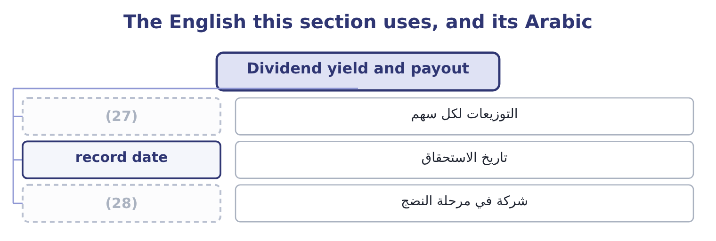
word list
mature company · attributable profit · dividend per share

The English this sheet uses, and its Arabic
English (exam term) | Arabic
dividend per share | التوزيعات لكل سهم
record date | تاريخ الاستحقاق
mature company | شركة في مرحلة النضج

Answer key · 16.4 Dividend yield and payout

1 receive | 15 mature
2 shareholder | 16 opposite
3 nothing | 17 Neither
4 totals | 18 better
5 difference | 19 business
6 divided | 20 Dividing
7 weighted | 21 common
8 statement | 22 meaningless
9 What arrives in cash | 23 earned
10 0.0556 over 9.25 | 24 borrowings
11 The share of profit handed over | 25 finding
12 One less the payout | 26 drives
13 company's | 27 dividend per share
14 consistent | 28 mature company

the summaries in full
Summary 1 The dividend per share is dividends declared over the shares that will receive them: 450,000 ÷ 8,100,000 = 0.0556. The dividend yield is that over the price: 0.0556 ÷ 9.25 = 0.60 per cent. An Orontes shareholder receives six-tenths of one per cent a year in cash, which is next to nothing, and expects the rest of the return in the share price. The dividend payout ratio is dividends over earnings.16 per cent from the totals and which comes to the same thing per share: 0.0556 ÷ 0.3666 = 15.17 per cent, the small difference being the share count — the dividend is declared on the 8,100,000 shares in issue and the earnings are divided by the 8,099,726 weighted average. The three are one statement looked at from three sides.
Summary 2 A low yield with a high retention is a growth company's profile, and it is consistent with everything else in Book 1: Orontes retains 84.84 per cent because it needs the money to fund 13.70 per cent growth. A mature utility shows the opposite — a 5 per cent yield, a 70 per cent payout, and growth of 2 per cent. Neither pattern is better. What matters is whether the pattern matches the business, and whether the company can keep it.
Summary 3 The dividend yield divides by the share price; the payout ratio divides by earnings. Dividing the dividend by book value or by the par value is a common slip and gives a meaningless figure. A company can pay a dividend it has not earned: a payout ratio above 100 per cent means the dividend came out of reserves or out of borrowings, which is a finding worth stating. The declared dividend, not the paid dividend, drives both ratios. Orontes paid $50,000 of cash and declared $450,000.

16.5 Shareholder return, and what a multiple cannot say
Chapter 16 · section 16.5

Fill every gap. Each word list holds one word more than there are gaps.
Summary 1 gaps 1–12
A (1) return for a year is the dividend (2) plus the change in the price, over the price at the start. For an Orontes shareholder in 2025 the price gain is 9.25 − 7.80 = 1.45 and the dividend is 0.0556, so the total is 1.45 + 0.0556 = 1.5056, and the return is 1.5056 ÷ 7.80 = 19.30 per cent. That is the figure an owner (3) earned, and it is worth (4) against the three (5) Book 1 has computed from the (6) : a return on (7) of 10.22 per cent, a return on (8) of 16.15 per cent, and now a shareholder return of 19.30 per cent. They answer (9) questions. The first two ask what the company earned on the money (10) in it; the third asks what the market paid the shareholder, which depends on the (11) results and on a change in (12) the company does not control.
word list
returns · invested · accounts · sentiment · assets · shareholder's · company's · setting · actually · received · equity · different · dividend

Orontes: four returns for one year
The bars are drawn to scale.
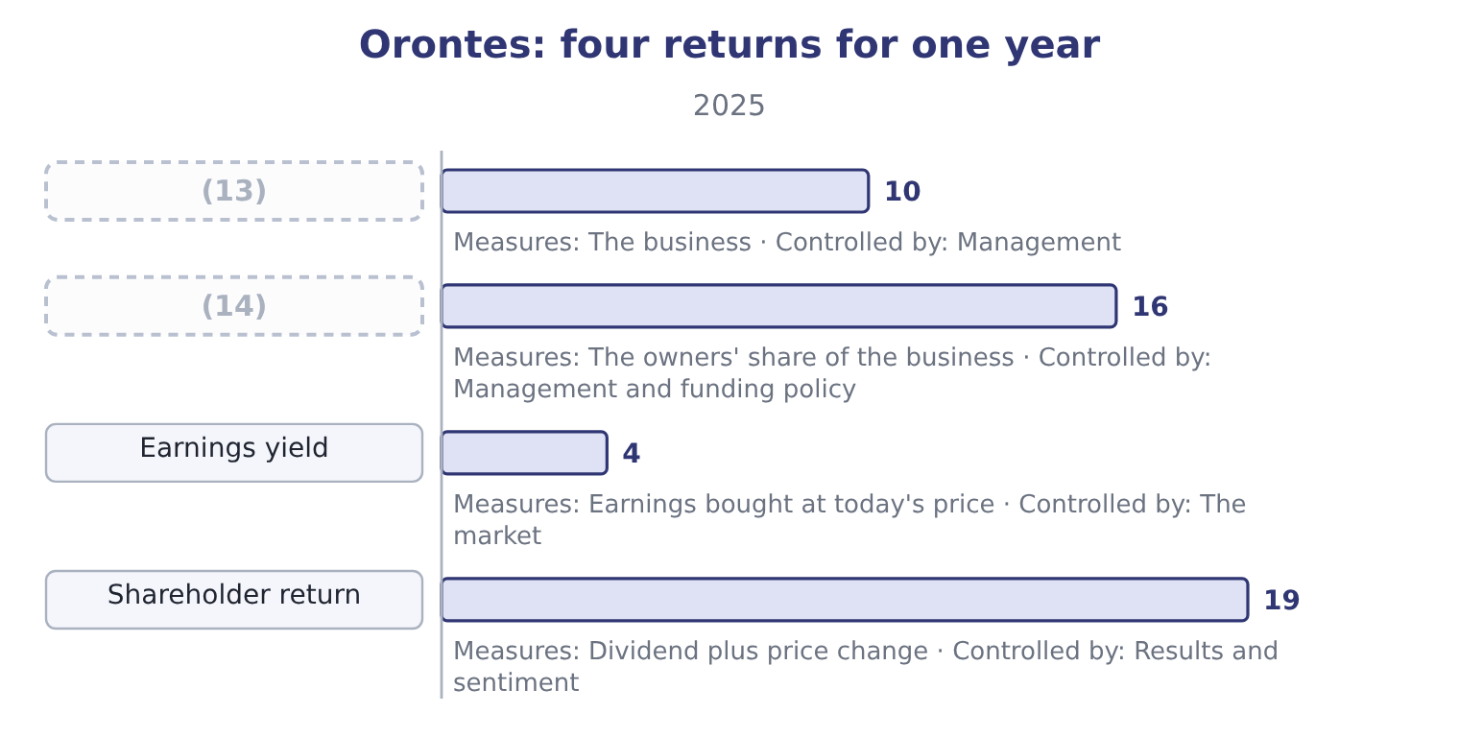
word list
Return on equity · Return on assets · potential common share

Summary 2 gaps 15–24
Three (15) of the market ratios close the chapter, and all three are (16) . The (17) is an accounting (18) . A price/earnings ratio of 25.23 computed on earnings that (19) a one-off gain is not a multiple of anything (20) . The (21) is a price on one day. (22) multiple of 25.23 uses the (23) 31 close. A week (24) or later it would differ, and nothing about the company would have changed. A multiple is a comparison and not a value. Twenty-five times earnings is high against a food manufacturer and low against a software company. The ratio is the beginning of a valuation question, which Book 2 answers properly with the dividend discount model and the relative-valuation multiples.
word list
repeatable · nothing · limits · numerator · denominator · include · earlier · Orontes's · examinable · December · number

Barada's market ratios

Compute the market ratios.
Your turn: Barada's market ratios (complete the blanks)
Item | Amount or ratio
Net income | 283,500
Shares outstanding | 1,000,000
Implied price per share | 6.00
Book value per share | 3.10
Dividends declared | nil
Earnings per share | (25) : 283,500 ÷ 1,000,000.
Price/earnings ratio | 21.16: 6.00 ÷ 0.2835.
Earnings yield | 4.73 per cent: 0.2835 ÷ 6.00.
Dividend yield | Nil, because no dividend was declared.
Market-to-book ratio | (26) : 6.00 ÷ 3.10.

word list
0.2835 · 21.16 · 1.9355

"Yield"

Summary 3 gaps 27–31
English yield in finance always means an income expressed as a (27) of a price or a (28) — a dividend yield, an earnings yield, a bond's yield to maturity. It never means the amount (29) . Note the trap in both English and (30) : a yield rises when the price falls, so a share whose yield has (31) may simply have had a bad year.
word list
expressed · principal · French · percentage · itself · improved

The English this section uses, and its Arabic
Each term sits against what it means.
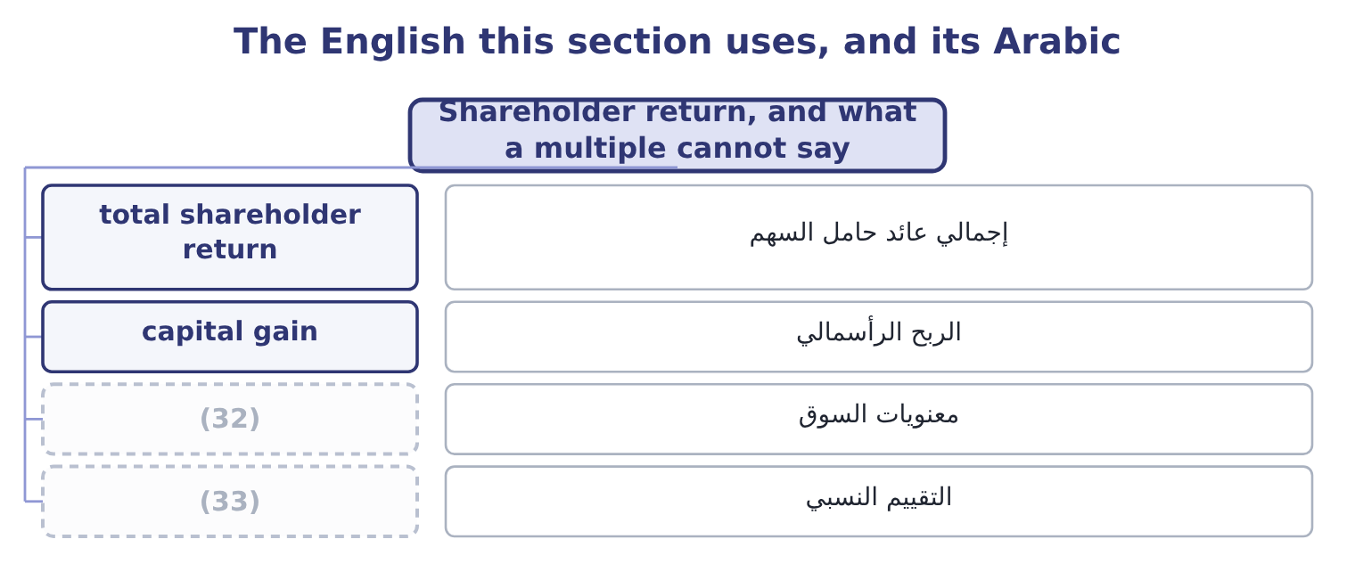
word list
sentiment · earnings yield · relative valuation

The English this sheet uses, and its Arabic
English (exam term) | Arabic
total shareholder return | إجمالي عائد حامل السهم
capital gain | الربح الرأسمالي
sentiment | معنويات السوق
relative valuation | التقييم النسبي

Answer key · 16.5 Shareholder return, and what a multiple cannot say

1 shareholder's | 18 number
2 received | 19 include
3 actually | 20 repeatable
4 setting | 21 numerator
5 returns | 22 Orontes's
6 accounts | 23 December
7 assets | 24 earlier
8 equity | 25 0.2835
9 different | 26 1.9355
10 invested | 27 percentage
11 company's | 28 principal
12 sentiment | 29 itself
13 Return on assets | 30 French
14 Return on equity | 31 improved
15 limits | 32 sentiment
16 examinable | 33 relative valuation
17 denominator

the summaries in full
Summary 1 A shareholder's return for a year is the dividend received plus the change in the price, over the price at the start. For an Orontes shareholder in 2025 the price gain is 9.25 − 7.80 = 1.45 and the dividend is 0.0556, so the total is 1.45 + 0.0556 = 1.5056, and the return is 1.5056 ÷ 7.80 = 19.30 per cent. That is the figure an owner actually earned, and it is worth setting against the three returns Book 1 has computed from the accounts: a return on assets of 10.22 per cent, a return on equity of 16.15 per cent, and now a shareholder return of 19.30 per cent. They answer different questions. The first two ask what the company earned on the money invested in it; the third asks what the market paid the shareholder, which depends on the company's results and on a change in sentiment the company does not control.
Summary 2 Three limits of the market ratios close the chapter, and all three are examinable. The denominator is an accounting number. A price/earnings ratio of 25.23 computed on earnings that include a one-off gain is not a multiple of anything repeatable. The numerator is a price on one day. Orontes's multiple of 25.23 uses the December 31 close. A week earlier or later it would differ, and nothing about the company would have changed. A multiple is a comparison and not a value. Twenty-five times earnings is high against a food manufacturer and low against a software company. The ratio is the beginning of a valuation question, which Book 2 answers properly with the dividend discount model and the relative-valuation multiples.
Summary 3 English yield in finance always means an income expressed as a percentage of a price or a principal — a dividend yield, an earnings yield, a bond's yield to maturity. It never means the amount itself. Note the trap in both English and French: a yield rises when the price falls, so a share whose yield has improved may simply have had a bad year.

17.1 Measuring income: four things that shape the number
Chapter 17 · section 17.1

Fill every gap. Each word list holds one word more than there are gaps.
Chapter 17, section by section
Each stage leads to the next.
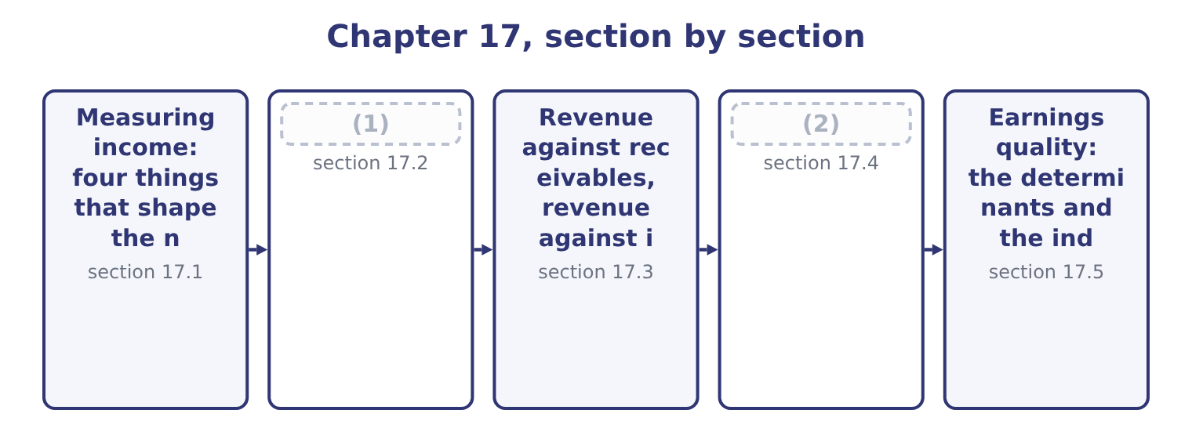
word list
Measuring income: four things that shape the n · The source, the stability and the trend of rev · When the recognition or the measurement change

Summary 1 gaps 3–14
Four (3) sit between the (4) of a year and the (5) reported for it, and the exam names all four. Orontes's (6) contain an (7) for credit losses of $156,000, a depreciation charge of $2,100,000 that depends on assumed useful lives, a deferred tax (8) of $999,625 built on expected future rates, and an impairment of $2,724,000 that rests on a forecast of what a brand and a plant will earn. None of these is a fact and all of them are in net income. Within the standards there are choices: first-in, (9) or weighted average for inventory; straight line or an (10) basis for depreciation; whether a cost is (11) or expensed. Two identical companies choosing (12) report different profits, and the exam tests the direction of the (13) rather than the (14) .
word list
identical · bookkeeping · economics · difference · profit · differently · capitalised · forces · first-out · statements · allowance · liability · accelerated

Summary 2 gaps 15–25
Incentives to (15) , or not to. (16) is rewarded on reported results, borrows against covenants written on reported ratios, and is judged by (17) ' forecasts of reported earnings. Where an estimate has a range, the incentives are not (18) . A company that must keep a (19) covenant at 1.50 — Barada's (20) . The needs of different users. A (21) wants to know whether the (22) will be paid and prefers conservatism. A (23) wants to know what the (24) will earn and prefers neutrality. A tax (25) wants a figure computed under its own rules. The same transaction serves all three badly if it is measured for only one, which is why the standards aim at neutrality rather than at any user's preference.
word list
situation · lender · interest · analysts · debt-to-equity · shareholder · neutral · authority · disclose · Management · reported · business

Four forces on a reported profit
Force | How it enters | Orontes's evidence
Estimates | (26) | Impairment of 2,724,000 on a forecast
Method choices | (27) | Straight-line depreciation of 2,100,000
Disclosure incentives | Covenants, bonuses, forecasts | (28)
Different users | (29) | One statement serving all three

word list
Covenants, bonuses, forecasts · Inventory, depreciation, capitalisation · A bank note with covenants, per Chapter 9 · Allowances, lives, impairment, tax · Lenders, owners, tax authorities

An estimate is not an error

Summary 3 gaps 30–35
A change in estimate is accounted for (30) and never restated. A change in accounting principle is applied (31) . An error is (32) by restating the prior periods. Conservatism is not neutrality. A persistently conservative estimate understates income now and overstates it later, and the exam treats a reversal of an (33) as a quality problem too. A disclosed estimate is better than an (34) one whatever its value. The note (35) more than the number.
word list
over-provision · undisclosed · prospectively · matters · corrected · inventory · retrospectively

The English this section uses, and its Arabic
Each term sits against what it means.
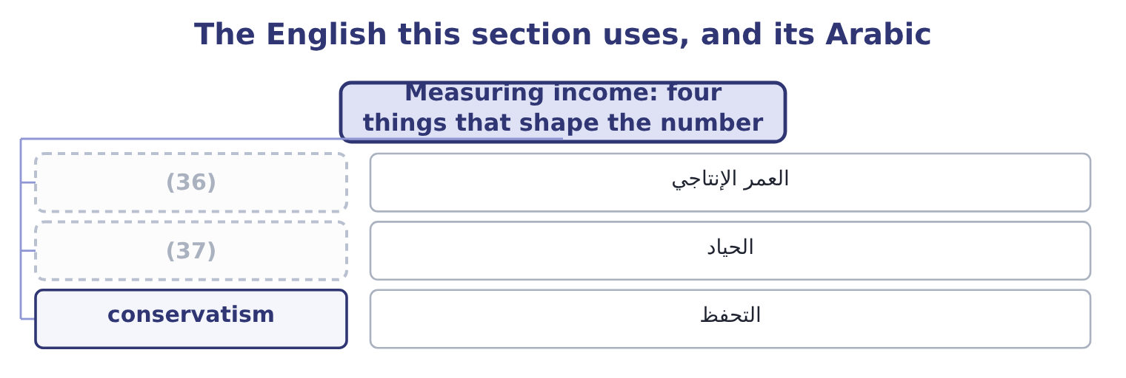
word list
useful life · accrual accounting · neutrality

The English this sheet uses, and its Arabic
English (exam term) | Arabic
useful life | العمر الإنتاجي
neutrality | الحياد
conservatism | التحفظ

Answer key · 17.1 Measuring income: four things that shape the number

1 The source, the stability and the trend of rev | 20 situation
2 When the recognition or the measurement change | 21 lender
3 forces | 22 interest
4 economics | 23 shareholder
5 profit | 24 business
6 statements | 25 authority
7 allowance | 26 Allowances, lives, impairment, tax
8 liability | 27 Inventory, depreciation, capitalisation
9 first-out | 28 A bank note with covenants, per Chapter 9
10 accelerated | 29 Lenders, owners, tax authorities
11 capitalised | 30 prospectively
12 differently | 31 retrospectively
13 difference | 32 corrected
14 bookkeeping | 33 over-provision
15 disclose | 34 undisclosed
16 Management | 35 matters
17 analysts | 36 useful life
18 neutral | 37 neutrality
19 debt-to-equity

the summaries in full
Summary 1 Four forces sit between the economics of a year and the profit reported for it, and the exam names all four. Orontes's statements contain an allowance for credit losses of $156,000, a depreciation charge of $2,100,000 that depends on assumed useful lives, a deferred tax liability of $999,625 built on expected future rates, and an impairment of $2,724,000 that rests on a forecast of what a brand and a plant will earn. None of these is a fact and all of them are in net income. Within the standards there are choices: first-in, first-out or weighted average for inventory; straight line or an accelerated basis for depreciation; whether a cost is capitalised or expensed. Two identical companies choosing differently report different profits, and the exam tests the direction of the difference rather than the bookkeeping.
Summary 2 Incentives to disclose, or not to. Management is rewarded on reported results, borrows against covenants written on reported ratios, and is judged by analysts' forecasts of reported earnings. Where an estimate has a range, the incentives are not neutral. A company that must keep a debt-to-equity covenant at 1.50 — Barada's situation. The needs of different users. A lender wants to know whether the interest will be paid and prefers conservatism. A shareholder wants to know what the business will earn and prefers neutrality. A tax authority wants a figure computed under its own rules. The same transaction serves all three badly if it is measured for only one, which is why the standards aim at neutrality rather than at any user's preference.
Summary 3 A change in estimate is accounted for prospectively and never restated. A change in accounting principle is applied retrospectively. An error is corrected by restating the prior periods. Conservatism is not neutrality. A persistently conservative estimate understates income now and overstates it later, and the exam treats a reversal of an over-provision as a quality problem too. A disclosed estimate is better than an undisclosed one whatever its value. The note matters more than the number.

17.2 The source, the stability and the trend of revenue
Chapter 17 · section 17.2

Fill every gap. Each word list holds one word more than there are gaps.
Summary 1 gaps 1–12
Revenue is the top line and the most (1) number in the (2) , because every other line (3) on it and because it is the (4) to flatter. Three (5) settle its quality. Where does it come from? Revenue from many customers in several markets is worth more than the same amount from one customer, because the loss of one customer is (6) . Revenue from a (7) contract is worth more than revenue from a spot sale. Revenue earned as principal is a (8) thing from a commission earned as agent, even where the amount is identical. How stable is it? Recurring revenue — (9) , maintenance, (10) — repeats without being won again. One-off revenue does not. A company (11) a record year on a single large order has a (12) next year that its income statement does not show.
word list
depends · different · repeats · questions · reporting · problem · subscriptions · consumables · easiest · examined · long-term · survivable · statements

Summary 2 gaps 13–21
Which way is it (13) , and how? A (14) trend built on volume is worth more than the same trend built on price, and both are worth more than one built on terms — longer credit, (15) return rights, (16) to pull next (17) orders into this one. For (18) the trend is clear and the quality of it is not (19) . Sales rose from $32,000,000 to $36,400,000 to $42,000,000, and the gross margin fell from 37.0 to 36.0 to 35.0 per cent. Growth bought with price is real growth and it is the least (20) kind, because the price (21) stays when the volume goes.
word list
moving · flattering · Orontes · rising · generous · quarter's · receivables · concession · durable · discounts

Three questions about a revenue figure
Question | High quality | Low quality | Where to look
Source | (22) | One customer, one market | The segment and concentration notes
Stability | Recurring, contracted | One-off orders, spot sales | (23)
Trend | Volume growth at a held margin | (24) | The gross margin against the growth rate

word list
Many customers, several markets · The segment and concentration notes · Growth bought with price or terms · The revenue note and the contract liabilities

Gross or net, principal or agent

Summary 3 gaps 25–33
A company (25) as agent reports only its commission. (26) a business that bills customers $10,000,000 and keeps $1,000,000, passing the rest to a (27) . As principal it reports revenue of $10,000,000 at a 10 per cent margin; as agent it reports revenue of $1,000,000 at a 100 per cent margin. Net income is identical and every (28) ratio differs by a (29) of ten. Revenue growth from an (30) is not organic growth. The exam expects the (31) to be stated. A record revenue figure says (32) about quality on its own. The segment note, the margin and the (33) say the rest.
word list
revenue-based · nothing · acquisition · Consider · supplier · receivables · depends · acting · distinction · factor

The English this section uses, and its Arabic
Each term sits against what it means.
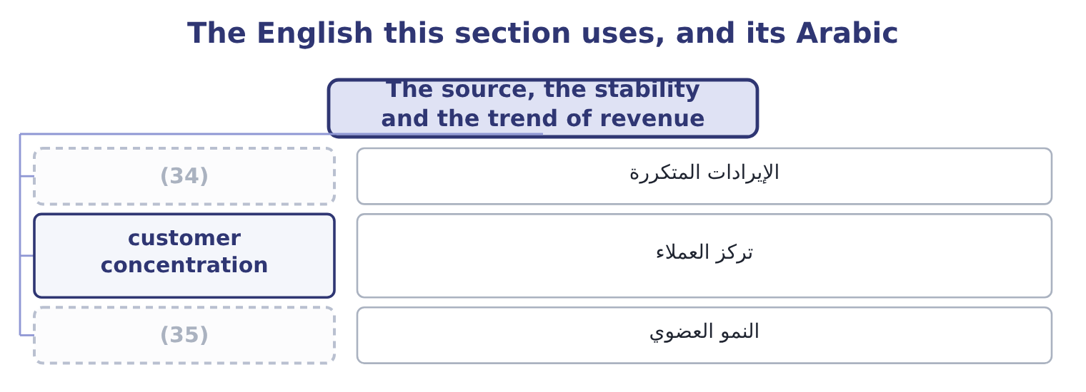
word list
تركز العملاء · recurring revenue · organic growth

The English this sheet uses, and its Arabic
English (exam term) | Arabic
recurring revenue | الإيرادات المتكررة
customer concentration | تركز العملاء
organic growth | النمو العضوي

Answer key · 17.2 The source, the stability and the trend of revenue

1 examined | 19 flattering
2 statements | 20 durable
3 depends | 21 concession
4 easiest | 22 Many customers, several markets
5 questions | 23 The revenue note and the contract liabilities
6 survivable | 24 Growth bought with price or terms
7 long-term | 25 acting
8 different | 26 Consider
9 subscriptions | 27 supplier
10 consumables | 28 revenue-based
11 reporting | 29 factor
12 problem | 30 acquisition
13 moving | 31 distinction
14 rising | 32 nothing
15 generous | 33 receivables
16 discounts | 34 recurring revenue
17 quarter's | 35 organic growth
18 Orontes

the summaries in full
Summary 1 Revenue is the top line and the most examined number in the statements, because every other line depends on it and because it is the easiest to flatter. Three questions settle its quality. Where does it come from? Revenue from many customers in several markets is worth more than the same amount from one customer, because the loss of one customer is survivable. Revenue from a long-term contract is worth more than revenue from a spot sale. Revenue earned as principal is a different thing from a commission earned as agent, even where the amount is identical. How stable is it? Recurring revenue — subscriptions, maintenance, consumables — repeats without being won again. One-off revenue does not. A company reporting a record year on a single large order has a problem next year that its income statement does not show.
Summary 2 Which way is it moving, and how? A rising trend built on volume is worth more than the same trend built on price, and both are worth more than one built on terms — longer credit, generous return rights, discounts to pull next quarter's orders into this one. For Orontes the trend is clear and the quality of it is not flattering. Sales rose from $32,000,000 to $36,400,000 to $42,000,000, and the gross margin fell from 37.0 to 36.0 to 35.0 per cent. Growth bought with price is real growth and it is the least durable kind, because the price concession stays when the volume goes.
Summary 3 A company acting as agent reports only its commission. Consider a business that bills customers $10,000,000 and keeps $1,000,000, passing the rest to a supplier. As principal it reports revenue of $10,000,000 at a 10 per cent margin; as agent it reports revenue of $1,000,000 at a 100 per cent margin. Net income is identical and every revenue-based ratio differs by a factor of ten. Revenue growth from an acquisition is not organic growth. The exam expects the distinction to be stated. A record revenue figure says nothing about quality on its own. The segment note, the margin and the receivables say the rest.

17.3 Revenue against receivables, revenue against inventory
Chapter 17 · section 17.3

Fill every gap. Each word list holds one word more than there are gaps.
Summary 1 gaps 1–12
This is the most (1) idea in the chapter and the one most often tested with (2) . Revenue, receivables and inventory are (3) linked: a genuine sale (4) a receivable that turns into cash, and it removes inventory. So the three should grow at (5) the same rate, and when they do not, the (6) is the finding. Receivables growing faster than revenue means one of three things: the company has (7) its credit terms, its (8) have slowed down, or some of the revenue was never going to be collected. All three reduce the (9) of the reported revenue, and all three show up in days sales (10) . Inventory growing faster than revenue means the company has built stock that it has not yet sold — because it (11) demand that has not (12) , or because demand has already fallen. Either way, next year carries a risk of a write-down, which passes through cost of sales and hits the gross margin.
word list
because · creates · expects · numbers · arrived · outstanding · mechanically · customers · practical · broadly · quality · extended · divergence

Summary 2 gaps 13–15
Orontes passes this test. Sales rose 15.38 per cent; (13) receivable rose $384,000 on an opening $3,760,000, which is 384,000 ÷ 3,760,000 = 10.21 per cent; and inventory rose $150,000 on an opening $2,300,000, or 150,000 ÷ 2,300,000 = 6.52 per cent. Both balances grew more (14) than sales, which is the healthy (15) and means the company collected and sold faster in 2025 than in 2024.
word list
slowly · accounts · direction · broadly

Revenue against the balances it should move with
Company | Sales growth | Receivables growth | Inventory growth | Reading
Orontes, 2025 | 15.38% | 10.21% | 6.52% | (16)
Barada, 2025 | 11.0% | 38% | 41% | Balances grew three to four times faster

word list
Balances grew slower than sales · allowance for credit losses

Summary 3 gaps 17–28
Barada fails it, and this is the same finding that.94. One company, one (17) , five ways of (18) it. That is what a ratio (19) is for. Orontes's receivables are (20) net of an allowance of $156,000 in 2025 and $140,000 in 2024, so the gross (21) are 4,144,000 + 156,000 = 4,300,000 and 3,760,000 + 140,000 = 3,900,000. The allowance as a proportion. The allowance has been held at about the same proportion of the book while the book grew, which is consistent and is what a (22) hopes to. The (23) would have been the finding. An allowance (24) as a proportion of a (25) growing receivable book is one of the classic ways to lift reported profit: the credit loss expense is lower, net income is higher, and nothing has to be (26) . Orontes's credit loss expense of $63,000 (27) a growing book is (28) but the allowance ratio held, so the two facts are consistent and there is no finding here.
word list
invented · extended · falling · against · system · figures · modest · stated · reader · rapidly · seeing · problem · alternative

The English this section uses, and its Arabic
Each term sits against what it means.
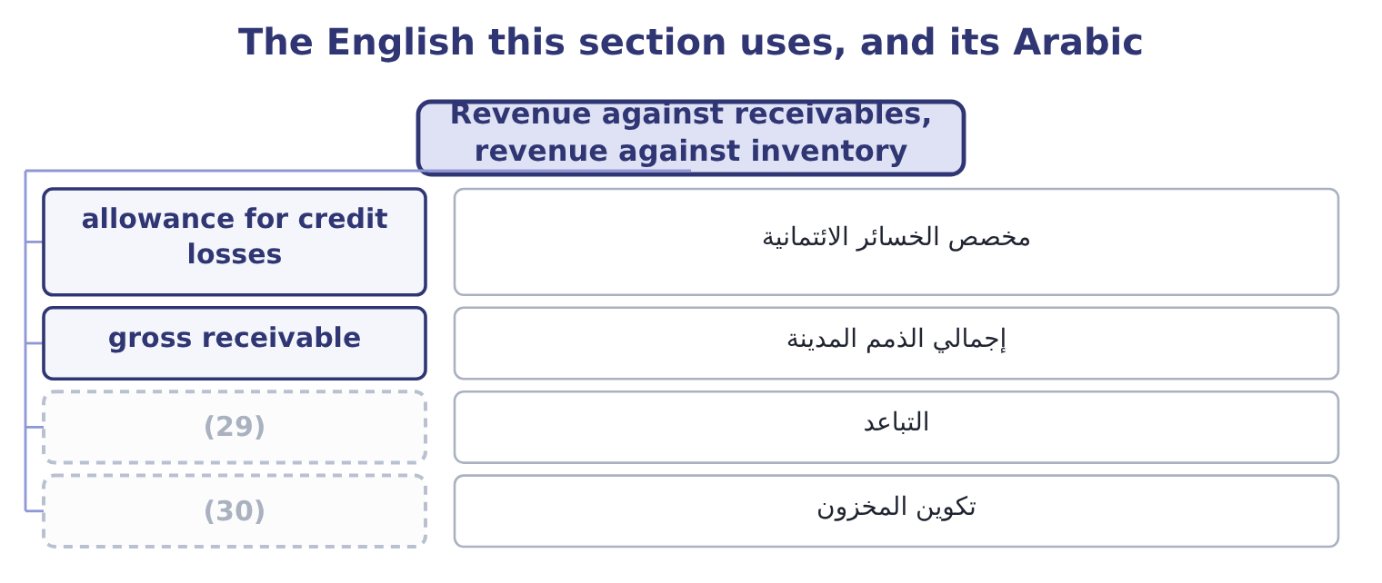
word list
bill-and-hold · stock build · divergence

The English this sheet uses, and its Arabic
English (exam term) | Arabic
allowance for credit losses | مخصص الخسائر الائتمانية
gross receivable | إجمالي الذمم المدينة
divergence | التباعد
stock build | تكوين المخزون

Answer key · 17.3 Revenue against receivables, revenue against inventory

1 practical | 16 Balances grew slower than sales
2 numbers | 17 problem
3 mechanically | 18 seeing
4 creates | 19 system
5 broadly | 20 stated
6 divergence | 21 figures
7 extended | 22 reader
8 customers | 23 alternative
9 quality | 24 falling
10 outstanding | 25 rapidly
11 expects | 26 invented
12 arrived | 27 against
13 accounts | 28 modest
14 slowly | 29 divergence
15 direction | 30 stock build

the summaries in full
Summary 1 This is the most practical idea in the chapter and the one most often tested with numbers. Revenue, receivables and inventory are mechanically linked: a genuine sale creates a receivable that turns into cash, and it removes inventory. So the three should grow at broadly the same rate, and when they do not, the divergence is the finding. Receivables growing faster than revenue means one of three things: the company has extended its credit terms, its customers have slowed down, or some of the revenue was never going to be collected. All three reduce the quality of the reported revenue, and all three show up in days sales outstanding. Inventory growing faster than revenue means the company has built stock that it has not yet sold — because it expects demand that has not arrived, or because demand has already fallen. Either way, next year carries a risk of a write-down, which passes through cost of sales and hits the gross margin.
Summary 2 Orontes passes this test. Sales rose 15.38 per cent; accounts receivable rose $384,000 on an opening $3,760,000, which is 384,000 ÷ 3,760,000 = 10.21 per cent; and inventory rose $150,000 on an opening $2,300,000, or 150,000 ÷ 2,300,000 = 6.52 per cent. Both balances grew more slowly than sales, which is the healthy direction and means the company collected and sold faster in 2025 than in 2024.
Summary 3 Barada fails it, and this is the same finding that.94. One company, one problem, five ways of seeing it. That is what a ratio system is for. Orontes's receivables are stated net of an allowance of $156,000 in 2025 and $140,000 in 2024, so the gross figures are 4,144,000 + 156,000 = 4,300,000 and 3,760,000 + 140,000 = 3,900,000. The allowance as a proportion. The allowance has been held at about the same proportion of the book while the book grew, which is consistent and is what a reader hopes to. The alternative would have been the finding. An allowance falling as a proportion of a rapidly growing receivable book is one of the classic ways to lift reported profit: the credit loss expense is lower, net income is higher, and nothing has to be invented. Orontes's credit loss expense of $63,000 against a growing book is modest but the allowance ratio held, so the two facts are consistent and there is no finding here.

17.4 When the recognition or the measurement changes
Chapter 17 · section 17.4

Fill every gap. Each word list holds one word more than there are gaps.
Summary 1 gaps 1–12
A change in how revenue is recognised or (1) changes the top line without anything (2) in the business, and the exam asks for the effect on revenue, on profit and on the (3) . Three kinds of change come up. (4) at delivery rather than at (5) , or over the life of a contract rather than at its start, moves revenue between periods. The year of the change gains or loses; the total over the life of the contract is the same. A change in the (6) of variable consideration. Revenue is recognised net of expected returns, rebates, (7) and penalties. (8) the estimate of returns (9) revenue now. A change in the (10) conclusion. This changes the gross (11) with no effect on profit at all, as section 17.2 showed, and it is the change with the (12) effect on every ratio.
word list
measurement · Raising · Recognising · largest · measured · happening · reduces · principal-or-agent · ratios · discounts · turnover · shipment · amount

Worked example: a bigger returns provision

Summary 2 gaps 13–24
Suppose Orontes (13) that expected returns on its 2025 sales are $200,000 (14) than it first (15) . Revenue is recognised net of expected returns, so revenue falls to 42,000,000 − 200,000 = 41,800,000. The gross profit falls by the same $200,000 less the cost of the goods coming back, and at the (16) 25 per cent (17) tax rate the (18) effect is, (19) , 200,000 × 0.75 = 150,000, so net income falls to 2,969,100 − 150,000 = 2,819,100. The net margin becomes 2,819,100 ÷ 41,800,000 = 6.74 per cent against 7.07 per cent; the asset (20) falls because sales fell; the return on assets falls because profit fell more in (21) . Earnings per share falls to about 0.3480 and the price/earnings ratio rises at an unchanged price. One estimate, (22) by less than half of one per cent of sales, moves the net margin by a third of a point and every return with it. That is the (23) the phrase earnings quality is about, and it is why a reader goes to the note on estimates before (24) a single ratio.
word list
sensitivity · approximately · estimated · effective · higher · company's · computing · proportion · turnover · revised · Raising · concludes · after-tax

Three changes to revenue, and what each moves
Change | Revenue | Net income | Margin | Where it shows
Timing of recognition | (25) | (26) | Both move | Contract liabilities
Variable consideration estimate | Falls or rises now | Falls or rises now | Both move | (27)
Principal to agent | Falls sharply | Unchanged | (28) | The revenue policy note

word list
expected returns · Moves with it · Moves between periods · The estimates note · Rises sharply

The direction of a contract liability

Summary 3 gaps 29–36
Cash received before (29) is a contract (30) , not revenue. (31) contract liabilities rose from $120,000 to $180,000, which means it holds more customer money against goods not yet (32) — revenue deferred into 2026, and a small sign of quality rather than a problem. A change in revenue recognition policy is a change in (33) principle and is applied (34) . A change in an estimate of returns is (35) . Where the (36) gives a tax rate, state the profit effect after tax. Where it does not, state it before tax and say so.
word list
performance · retrospectively · liability · delivered · Orontes's · question · accounting · prospective · estimate

The English this section uses, and its Arabic
Each term sits against what it means.
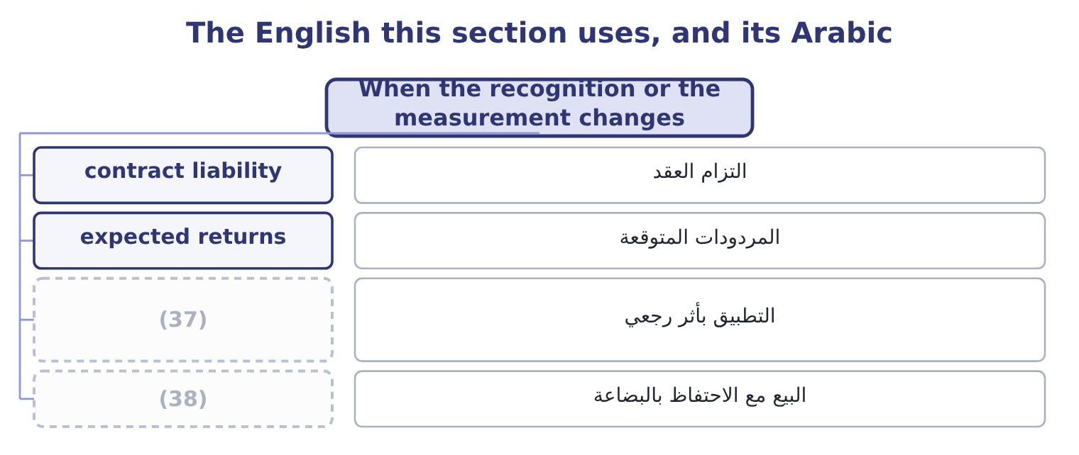
word list
bill-and-hold · retrospective application · divergence

The English this sheet uses, and its Arabic
English (exam term) | Arabic
contract liability | التزام العقد
expected returns | المردودات المتوقعة
retrospective application | التطبيق بأثر رجعي
bill-and-hold | البيع مع الاحتفاظ بالبضاعة

Answer key · 17.4 When the recognition or the measurement changes

1 measured | 20 turnover
2 happening | 21 proportion
3 ratios | 22 revised
4 Recognising | 23 sensitivity
5 shipment | 24 computing
6 measurement | 25 Moves between periods
7 discounts | 26 Moves with it
8 Raising | 27 The estimates note
9 reduces | 28 Rises sharply
10 principal-or-agent | 29 performance
11 amount | 30 liability
12 largest | 31 Orontes's
13 concludes | 32 delivered
14 higher | 33 accounting
15 estimated | 34 retrospectively
16 company's | 35 prospective
17 effective | 36 question
18 after-tax | 37 retrospective application
19 approximately | 38 bill-and-hold

the summaries in full
Summary 1 A change in how revenue is recognised or measured changes the top line without anything happening in the business, and the exam asks for the effect on revenue, on profit and on the ratios. Three kinds of change come up. Recognising at delivery rather than at shipment, or over the life of a contract rather than at its start, moves revenue between periods. The year of the change gains or loses; the total over the life of the contract is the same. A change in the measurement of variable consideration. Revenue is recognised net of expected returns, rebates, discounts and penalties. Raising the estimate of returns reduces revenue now. A change in the principal-or-agent conclusion. This changes the gross amount with no effect on profit at all, as section 17.2 showed, and it is the change with the largest effect on every ratio.
Summary 2 Suppose Orontes concludes that expected returns on its 2025 sales are $200,000 higher than it first estimated. Revenue is recognised net of expected returns, so revenue falls to 42,000,000 − 200,000 = 41,800,000. The gross profit falls by the same $200,000 less the cost of the goods coming back, and at the company's 25 per cent effective tax rate the after-tax effect is, approximately, 200,000 × 0.75 = 150,000, so net income falls to 2,969,100 − 150,000 = 2,819,100. The net margin becomes 2,819,100 ÷ 41,800,000 = 6.74 per cent against 7.07 per cent; the asset turnover falls because sales fell; the return on assets falls because profit fell more in proportion. Earnings per share falls to about 0.3480 and the price/earnings ratio rises at an unchanged price. One estimate, revised by less than half of one per cent of sales, moves the net margin by a third of a point and every return with it. That is the sensitivity the phrase earnings quality is about, and it is why a reader goes to the note on estimates before computing a single ratio.
Summary 3 Cash received before performance is a contract liability, not revenue. Orontes's contract liabilities rose from $120,000 to $180,000, which means it holds more customer money against goods not yet delivered — revenue deferred into 2026, and a small sign of quality rather than a problem. A change in revenue recognition policy is a change in accounting principle and is applied retrospectively. A change in an estimate of returns is prospective. Where the question gives a tax rate, state the profit effect after tax. Where it does not, state it before tax and say so.

17.5 Earnings quality: the determinants and the indicators
Chapter 17 · section 17.5

Fill every gap. Each word list holds one word more than there are gaps.
Summary 1 gaps 1–12
Earnings quality is how well this year's reported profit (1) next year's cash. (2) earnings are (3) , backed by cash, and produced by the business the company says it is. (4) earnings are none of those things, and the (5) are not wrong in either case. The (6) — what makes earnings high or low quality — are three. Does the item repeat? A sale (7) ; a gain on the sale of (8) does not. Orontes's net income (9) $3,000 of gain on disposal and $177,000 of (10) income, neither of which comes from selling food. Does the profit turn into cash? Orontes's cash from operations is $7,531,100 against net income of $2,969,100, which is 7,531,100 ÷ 2,969,100 = 2.54 times. A ratio above one is the healthy direction, and 2.54 is strong — (11) ,824,000 of the gap is simply (12) and the impairment, so the figure flatters the company a little. How much of the profit rests on estimates that management chose? The impairment of $2,724,000 is the largest discretionary item in Orontes's 2025 statements, and it works in the unusual direction: it reduced this year's profit, which lowers the base for every future comparison. The indicators — what a reader looks at — are the practical half of the outcome.
word list
Low-quality · High-quality · accounts · contains · repeats · equipment · equity-method · Orontes · persistent · depreciation · determinants · predicts · although

Indicators of earnings quality
Indicator | Healthy | A warning | Orontes, 2025
Cash from operations against net income | Above 1.0 | (13) | 2.54 times
Receivables growth against revenue growth | (14) | Faster | 10.21% against 15.38%
Inventory growth against revenue growth | Slower | Faster | (15)
Share of profit from one-off items | Small | Large | (16)
Gross margin trend | Held or rising | Falling while sales rise | (17)
Allowance ratios | Steady | Falling as the book grows | (18)

word list
Slower · Falling three years running · 3.63% against 3.59% · Below 1.0, or falling · 6.52% against 15.38% · conservatism · 180,000 of 2,969,100

Summary 2 gaps 19–23
Five of the six are healthy and one is not, and the one that is not is the (19) . That is a fair (20) on Orontes: a company whose earnings are (21) and whose working (22) is well run, growing by giving away margin, and (23) a large discretionary charge in the year under review.
word list
verdict · carrying · bill-and-hold · capital · cash-backed · finding

Judge Barada's earnings quality

Summary 3 gaps 24–25
Mark each (24) healthy or a warning, and say what the (25) as a whole means.
word list
pattern · comparison · indicator

Your turn: Barada's earnings quality (complete the blanks)
Indicator | Barada | Healthy or warning
Sales growth | 11.0% | ________
Receivables growth | 38% | ________
Inventory growth | 41% | ________
Payables growth | 9% | ________
Bank overdraft | (26) | ________
Net margin | 1.29% | ________
Overall reading |  | ________

word list
240,000, from nil · persistence of earnings

"Quality"

Summary 4 gaps 27–31
English quality in earnings quality does not mean how large the earnings are or how good the company is. It means how far the reported figure can be (27) on to repeat and to turn into cash. A company with low earnings of high quality is a better (28) than one with high earnings of low quality, and (29) who read the word as a (30) for size answer the question (31) .
word list
backwards · investment · synonym · pattern · relied · candidates

"Quality"
Indicator | Answer
Sales growth | (32) : modest growth, and healthy in itself.
Receivables growth | 38 per cent: a warning, more than three times the sales growth.
Inventory growth | 41 per cent: a warning, and the source of a possible write-down.
Payables growth | (33) : a warning in context — Barada is paying suppliers as before while funding a much larger stock and receivable book.
Bank overdraft | A warning: the funding gap has arrived on the balance sheet.
Net margin | (34) : thin, and leaves no room to absorb a write-down.
Overall reading | Low quality. Reported profit is not matched by cash: the growth in receivables and inventory, funded by an overdraft rather than by supplier

word list
9 per cent · 3.63% against 3.59% · 1.29 per cent · 11.0 per cent

The English this section uses, and its Arabic
Each term sits against what it means.
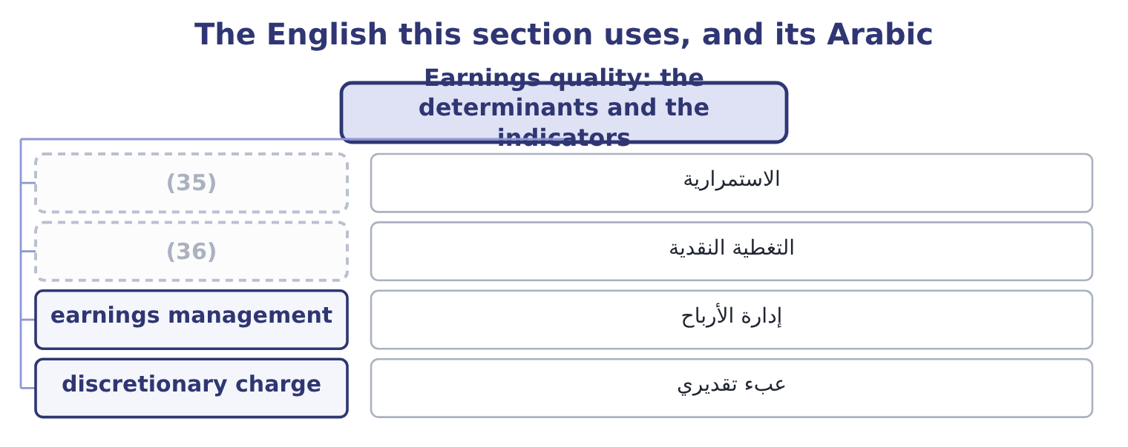
word list
useful life · cash backing · persistence

The English this sheet uses, and its Arabic
English (exam term) | Arabic
persistence | الاستمرارية
cash backing | التغطية النقدية
earnings management | إدارة الأرباح
discretionary charge | عبء تقديري

Answer key · 17.5 Earnings quality: the determinants and the indicators

1 predicts | 19 finding
2 High-quality | 20 verdict
3 persistent | 21 cash-backed
4 Low-quality | 22 capital
5 accounts | 23 carrying
6 determinants | 24 indicator
7 repeats | 25 pattern
8 equipment | 26 240,000, from nil
9 contains | 27 relied
10 equity-method | 28 investment
11 although | 29 candidates
12 depreciation | 30 synonym
13 Below 1.0, or falling | 31 backwards
14 Slower | 32 11.0 per cent
15 6.52% against 15.38% | 33 9 per cent
16 180,000 of 2,969,100 | 34 1.29 per cent
17 Falling three years running | 35 persistence
18 3.63% against 3.59% | 36 cash backing

the summaries in full
Summary 1 Earnings quality is how well this year's reported profit predicts next year's cash. High-quality earnings are persistent, backed by cash, and produced by the business the company says it is. Low-quality earnings are none of those things, and the accounts are not wrong in either case. The determinants — what makes earnings high or low quality — are three. Does the item repeat? A sale repeats; a gain on the sale of equipment does not. Orontes's net income contains $3,000 of gain on disposal and $177,000 of equity-method income, neither of which comes from selling food. Does the profit turn into cash? Orontes's cash from operations is $7,531,100 against net income of $2,969,100, which is 7,531,100 ÷ 2,969,100 = 2.54 times. A ratio above one is the healthy direction, and 2.54 is strong — although,824,000 of the gap is simply depreciation and the impairment, so the figure flatters the company a little. How much of the profit rests on estimates that management chose? The impairment of $2,724,000 is the largest discretionary item in Orontes's 2025 statements, and it works in the unusual direction: it reduced this year's profit, which lowers the base for every future comparison. The indicators — what a reader looks at — are the practical half of the outcome.
Summary 2 Five of the six are healthy and one is not, and the one that is not is the finding. That is a fair verdict on Orontes: a company whose earnings are cash-backed and whose working capital is well run, growing by giving away margin, and carrying a large discretionary charge in the year under review.
Summary 3 Mark each indicator healthy or a warning, and say what the pattern as a whole means.
Summary 4 English quality in earnings quality does not mean how large the earnings are or how good the company is. It means how far the reported figure can be relied on to repeat and to turn into cash. A company with low earnings of high quality is a better investment than one with high earnings of low quality, and candidates who read the word as a synonym for size answer the question backwards.

18.1 Foreign operations and the exchange rate
Chapter 18 · section 18.1

Fill every gap. Each word list holds one word more than there are gaps.
Chapter 18, section by section
Each stage leads to the next.
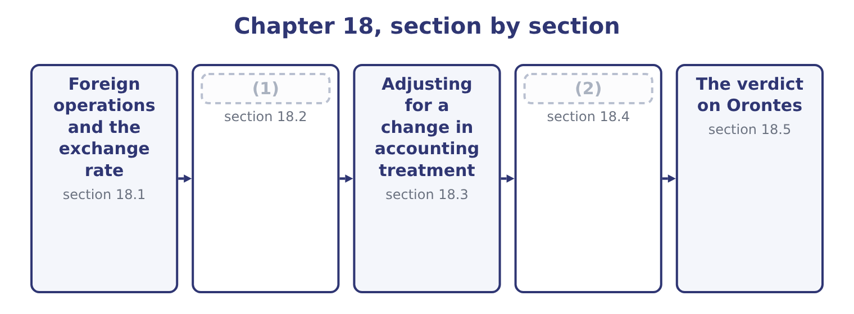
word list
verdict · The limitations of ratio analysis · Inflation

Summary 1 gaps 3–14
A company with a subsidiary abroad must (3) that subsidiary's (4) in the currency the group reports. (5) about the subsidiary (6) in the process, and almost every ratio can. Start with the term the exam (7) . The functional currency is the currency of the primary economic (8) in which an entity (9) — the one in which it prices its goods, pays its staff and holds its cash. It is a (10) of fact, not of (11) . The (12) currency is the one the group reports in, which for (13) is the US dollar. Where the subsidiary's functional currency is its own local currency, the (14) rate method applies. Assets and liabilities are translated at the closing rate, income and expenses at the average rate for the period, and equity at historical rates. The imbalance this creates does not go through profit: it accumulates in other comprehensive income as a cumulative translation adjustment, and it is the reason the equity section of a group balance sheet carries a reserve that nobody earned.
word list
choice · operates · question · current · changes · environment · verdict · presentation · results · defines · Nothing · express · Orontes

Summary 2 gaps 15–19
Where the functional currency is the (15) — a subsidiary that is merely a shell (16) in dollars — the temporal method applies instead. Monetary items are (17) at the closing rate, (18) items stay at historical rates, and the gain or loss goes through net income. That is the distinction that matters for earnings volatility: translation is quiet and (19) is noisy.
word list
business · remeasured · non-monetary · operating · parent's · remeasurement

Worked example: the same subsidiary, two exchange rates

Summary 3 gaps 20–30
A subsidiary reports sales of 10,000,000 dinars, net income of 1,000,000 dinars and total assets of 5,000,000 dinars. In a year when the dinar is (20) at $0.70, sales translate at 10,000,000 × 0.70 = 7,000,000 and assets at 5,000,000 × 0.70 = 3,500,000, so asset turnover is 7,000,000 ÷ 3,500,000 = 2.00 times. In the next year the dinar (21) $0.65 and closes at $0.60, the subsidiary's local figures (22) . Sales translate at 10,000,000 × 0.65 = 6,500,000 and assets at 5,000,000 × 0.60 = 3,000,000. Asset turnover (23) 6,500,000 ÷ 3,000,000 = 2.17 times, (24) 2.00 the year (25) . The subsidiary sold the same goods to the same (26) with the same assets, and its reported asset turnover rose 8 per cent. The cause is (27) that the income statement is translated at an average rate and the balance sheet at a closing rate, so a currency that moved (28) the year puts the two (29) of every mixed ratio on (30) bases.
word list
customers · during · halves · process · before · averages · stable · becomes · purely · unchanged · against · different

Summary 4 gaps 31–34
Ratios built entirely within the income statement — every margin in, (31) the numerator and the (32) move together. Ratios built entirely within the balance sheet are (33) for the same reason. It is the mixed ratios, which is to say every turnover and every (34) , that move.
word list
verdict · because · unaffected · return · denominator

Which ratios a rate change moves
Every item belongs to exactly one group.
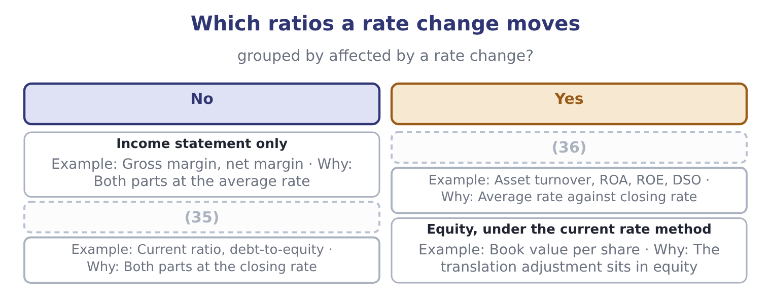
word list
Mixed · Balance sheet only · non-financial factor

Summary 5 gaps 37–44
The last (37) point of this outcome is (38) . Reported earnings that swing with a currency are earnings that (39) did not cause and cannot control, and the response is (40) : companies hedge, and they hedge the reported number as well as the economic (41) . (42) in turn discount (43) earnings, so a group whose profit moves with the dinar trades at a lower multiple than one whose profit does not — which is a cost of the volatility, not of the business. Book 2 prices the (44) used to manage it.
word list
predictable · instruments · volatile · management · examinable · Investors · behavioural · carries · exposure

The English this section uses, and its Arabic
Each term sits against what it means.
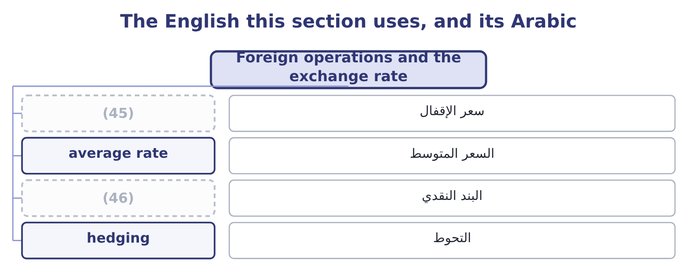
word list
monetary item · closing rate · سعر الإقفال

The English this sheet uses, and its Arabic
English (exam term) | Arabic
closing rate | سعر الإقفال
average rate | السعر المتوسط
monetary item | البند النقدي
hedging | التحوط

Answer key · 18.1 Foreign operations and the exchange rate

1 Inflation | 24 against
2 The limitations of ratio analysis | 25 before
3 express | 26 customers
4 results | 27 purely
5 Nothing | 28 during
6 changes | 29 halves
7 defines | 30 different
8 environment | 31 because
9 operates | 32 denominator
10 question | 33 unaffected
11 choice | 34 return
12 presentation | 35 Balance sheet only
13 Orontes | 36 Mixed
14 current | 37 examinable
15 parent's | 38 behavioural
16 operating | 39 management
17 remeasured | 40 predictable
18 non-monetary | 41 exposure
19 remeasurement | 42 Investors
20 stable | 43 volatile
21 averages | 44 instruments
22 unchanged | 45 closing rate
23 becomes | 46 monetary item

the summaries in full
Summary 1 A company with a subsidiary abroad must express that subsidiary's results in the currency the group reports. Nothing about the subsidiary changes in the process, and almost every ratio can. Start with the term the exam defines. The functional currency is the currency of the primary economic environment in which an entity operates — the one in which it prices its goods, pays its staff and holds its cash. It is a question of fact, not of choice. The presentation currency is the one the group reports in, which for Orontes is the US dollar. Where the subsidiary's functional currency is its own local currency, the current rate method applies. Assets and liabilities are translated at the closing rate, income and expenses at the average rate for the period, and equity at historical rates. The imbalance this creates does not go through profit: it accumulates in other comprehensive income as a cumulative translation adjustment, and it is the reason the equity section of a group balance sheet carries a reserve that nobody earned.
Summary 2 Where the functional currency is the parent's — a subsidiary that is merely a shell operating in dollars — the temporal method applies instead. Monetary items are remeasured at the closing rate, non-monetary items stay at historical rates, and the gain or loss goes through net income. That is the distinction that matters for earnings volatility: translation is quiet and remeasurement is noisy.
Summary 3 A subsidiary reports sales of 10,000,000 dinars, net income of 1,000,000 dinars and total assets of 5,000,000 dinars. In a year when the dinar is stable at $0.70, sales translate at 10,000,000 × 0.70 = 7,000,000 and assets at 5,000,000 × 0.70 = 3,500,000, so asset turnover is 7,000,000 ÷ 3,500,000 = 2.00 times. In the next year the dinar averages $0.65 and closes at $0.60, the subsidiary's local figures unchanged. Sales translate at 10,000,000 × 0.65 = 6,500,000 and assets at 5,000,000 × 0.60 = 3,000,000. Asset turnover becomes 6,500,000 ÷ 3,000,000 = 2.17 times, against 2.00 the year before. The subsidiary sold the same goods to the same customers with the same assets, and its reported asset turnover rose 8 per cent. The cause is purely that the income statement is translated at an average rate and the balance sheet at a closing rate, so a currency that moved during the year puts the two halves of every mixed ratio on different bases.
Summary 4 Ratios built entirely within the income statement — every margin in, because the numerator and the denominator move together. Ratios built entirely within the balance sheet are unaffected for the same reason. It is the mixed ratios, which is to say every turnover and every return, that move.
Summary 5 The last examinable point of this outcome is behavioural. Reported earnings that swing with a currency are earnings that management did not cause and cannot control, and the response is predictable: companies hedge, and they hedge the reported number as well as the economic exposure. Investors in turn discount volatile earnings, so a group whose profit moves with the dinar trades at a lower multiple than one whose profit does not — which is a cost of the volatility, not of the business. Book 2 prices the instruments used to manage it.

18.2 Inflation
Chapter 18 · section 18.2

Fill every gap. Each word list holds one word more than there are gaps.
Summary 1 gaps 1–12
Inflation does to time what a (1) does to distance: it makes two numbers that look comparable (2) . A (3) sheet carried at historical cost mixes dollars of many (4) , and the older the asset the more the mixing matters. Four (5) follow, and the exam asks for their (6) . Assets are understated, so every ratio with assets in the (7) is overstated. Return on assets looks (8) than it is; asset (9) looks faster than it is. (10) own plant stands at $14,802,000 against a cost of $26,790,000, and the cost (11) is in the dollars of the years in which it was spent. Depreciation is understated, so profit is overstated. A charge computed on what an asset cost does not (12) for what the replacement will cost. The company reports a profit and distributes some of it, and then finds the replacement unaffordable.
word list
balance · turnover · Orontes's · currency · vintages · better · Last-in · incomparable · denominator · direction · provide · distortions · itself

Summary 2 gaps 13–22
Inventory profits are not profits. Under (13) , first-out, the cost of sales (14) the oldest costs and the gross margin (15) the holding gain on stock that (16) sat there. (17) , first-out (18) current costs against current prices and reports a lower and more honest margin — which is why the choice of inventory method matters most in exactly the periods when inflation is high. Debt is repaid in (19) money, so the (20) gains and the lender loses. Debt ratios computed on historical amounts (21) how light an old fixed-rate borrowing has become, and a company with long-dated fixed-rate debt and (22) assets is the one inflation treats most kindly.
word list
borrower · Last-in · understate · cheaper · matches · carries · includes · merely · first-in · short-lived · amounts

Worked example: one company, two price levels

Summary 3 gaps 23–34
A company (23) its plant for 10,000,000 ten years ago, (24) it over ten years at 1,000,000 a year, and reports a profit of 2,000,000 on net assets now (25) at 5,000,000. Return on assets is 2,000,000 ÷ 5,000,000 = 40.0 per cent. (26) the plant today would cost 18,000,000, so the (27) honest depreciation charge is 1,800,000 and the asset base (28) to current prices is 9,000,000. Profit (29) 2,000,000 − 800,000 = 1,200,000. A return of 40 per cent and a return of 13 per cent for the same company in the same year, and the (30) is entirely the price level. Nothing in US GAAP (31) the second figure, and the first one is what every (32) will carry. This is why a long series of returns on assets for a (33) company is one of the least reliable (34) in analysis, and why an analyst comparing a company that renewed its plant last year with one that renewed it in 2005 is not comparing like with.
word list
database · capital-intensive · bought · restated · becomes · requires · Replacing · standing · difference · comparisons · economically · current · depreciates

What inflation does to the ratios
Every item belongs to exactly one group.
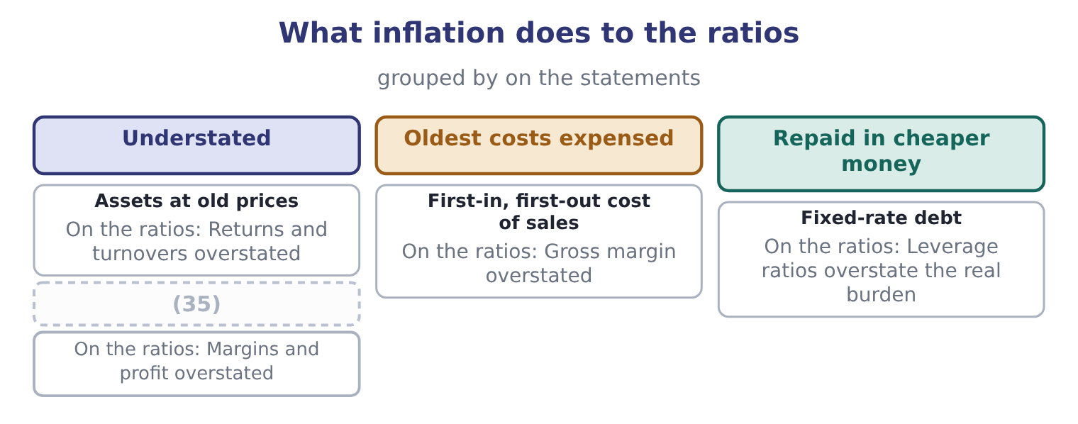
word list
Depreciation on old cost · change in accounting principle

The English this section uses, and its Arabic
Each term sits against what it means.
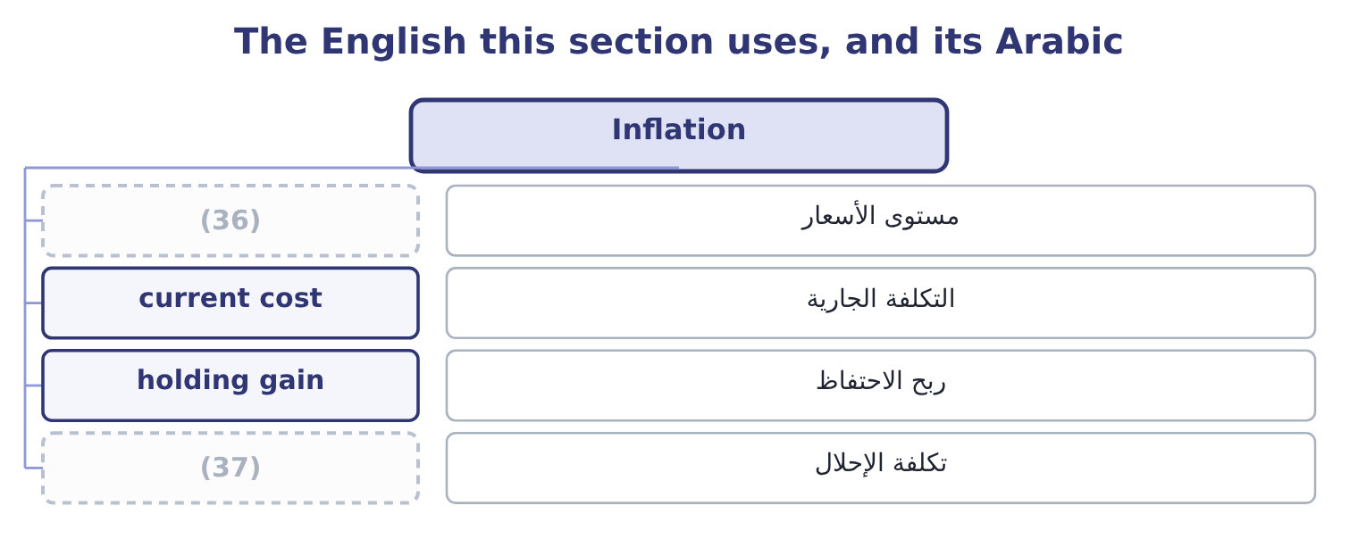
word list
replacement cost · price level · presentation currency

The English this sheet uses, and its Arabic
English (exam term) | Arabic
price level | مستوى الأسعار
current cost | التكلفة الجارية
holding gain | ربح الاحتفاظ
replacement cost | تكلفة الإحلال

Answer key · 18.2 Inflation

1 currency | 20 borrower
2 incomparable | 21 understate
3 balance | 22 short-lived
4 vintages | 23 bought
5 distortions | 24 depreciates
6 direction | 25 standing
7 denominator | 26 Replacing
8 better | 27 economically
9 turnover | 28 restated
10 Orontes's | 29 becomes
11 itself | 30 difference
12 provide | 31 requires
13 first-in | 32 database
14 carries | 33 capital-intensive
15 includes | 34 comparisons
16 merely | 35 Depreciation on old cost
17 Last-in | 36 price level
18 matches | 37 replacement cost
19 cheaper

the summaries in full
Summary 1 Inflation does to time what a currency does to distance: it makes two numbers that look comparable incomparable. A balance sheet carried at historical cost mixes dollars of many vintages, and the older the asset the more the mixing matters. Four distortions follow, and the exam asks for their direction. Assets are understated, so every ratio with assets in the denominator is overstated. Return on assets looks better than it is; asset turnover looks faster than it is. Orontes's own plant stands at $14,802,000 against a cost of $26,790,000, and the cost itself is in the dollars of the years in which it was spent. Depreciation is understated, so profit is overstated. A charge computed on what an asset cost does not provide for what the replacement will cost. The company reports a profit and distributes some of it, and then finds the replacement unaffordable.
Summary 2 Inventory profits are not profits. Under first-in, first-out, the cost of sales carries the oldest costs and the gross margin includes the holding gain on stock that merely sat there. Last-in, first-out matches current costs against current prices and reports a lower and more honest margin — which is why the choice of inventory method matters most in exactly the periods when inflation is high. Debt is repaid in cheaper money, so the borrower gains and the lender loses. Debt ratios computed on historical amounts understate how light an old fixed-rate borrowing has become, and a company with long-dated fixed-rate debt and short-lived assets is the one inflation treats most kindly.
Summary 3 A company bought its plant for 10,000,000 ten years ago, depreciates it over ten years at 1,000,000 a year, and reports a profit of 2,000,000 on net assets now standing at 5,000,000. Return on assets is 2,000,000 ÷ 5,000,000 = 40.0 per cent. Replacing the plant today would cost 18,000,000, so the economically honest depreciation charge is 1,800,000 and the asset base restated to current prices is 9,000,000. Profit becomes 2,000,000 − 800,000 = 1,200,000. A return of 40 per cent and a return of 13 per cent for the same company in the same year, and the difference is entirely the price level. Nothing in US GAAP requires the second figure, and the first one is what every database will carry. This is why a long series of returns on assets for a capital-intensive company is one of the least reliable comparisons in analysis, and why an analyst comparing a company that renewed its plant last year with one that renewed it in 2005 is not comparing like with.

18.3 Adjusting for a change in accounting treatment
Chapter 18 · section 18.3

Fill every gap. Each word list holds one word more than there are gaps.
Summary 1 gaps 1–12
The third way a ratio moves without the (1) moving is that the company (2) how it measures (3) . A change in accounting principle — first-in, first-out to weighted average, one (4) policy to another — is applied (5) . Every prior (6) presented is restated as though the new principle had always been used, and the (7) effect on periods before those presented goes to opening (8) earnings. For the analyst the work is already done: the comparatives in the current statements are on the new basis, and the trap is (9) them with figures taken from an older annual report, which are on the old one. A change in accounting estimate — a useful life, an allowance, a warranty (10) — is applied (11) . So the comparatives are on the old estimate and the current year is on the new one, and the analyst must adjust if the change is large (12) to matter.
word list
prospectively · cumulative · business · Orontes · retained · provision · revenue · changes · comparing · period · enough · something · retrospectively

Summary 2 gaps 13–24
The note (13) the effect; the statements do not (14) it. The (15) of an error is applied by (16) the prior periods affected and disclosing the fact. A restatement is a signal in its own right, (17) of its size: it says the control (18) failed once. (19) Orontes changed from first-in, first-out to weighted average for 2025, and the effect is to raise cost of goods sold by $300,000 and to lower (20) inventory by the same amount. Gross (21) becomes 14,700,000 − 300,000 = 14,400,000, so the gross margin is 14,400,000 ÷ 42,000,000 = 34.29 per cent against the 35.0 (22) . Inventory becomes 2,450,000 − 300,000 = 2,150,000. The ratios that move, and their (23) . The gross margin falls. Inventory (24) rises on both counts, because cost of sales is larger and the average inventory smaller.
word list
closing · discloses · independent · compare · correction · turnover · profit · direction · separate · environment · reported · Suppose · restating

Summary 3 gaps 25–34
Days sales in inventory (25) falls. The current ratio falls, because current (26) are $300,000 lower against unchanged current (27) . Net (28) falls by 300,000 × 0.75 = 225,000 after tax, so every margin and every (29) falls with it. Six ratios moved and the company (30) , made and sold (31) the same goods. Because this is a change in principle, the comparatives would also be restated, so a reader working only from the 2025 statements sees a (32) series — and a reader who takes 2024 from last year's annual report and 2025 from this one sees a margin (33) that never happened. That is the practical reason the outcome is (34) .
word list
happened · bought · liabilities · exactly · therefore · income · assets · collapse · consistent · return · examinable

Three kinds of change, three treatments
Kind of change | Treatment | What the analyst must do | Example
Accounting principle | Retrospective restatement | (35) | Inventory method
Accounting estimate | Prospective | (36) | Useful life, allowance
Error | (37) | Treat the restatement itself as a finding | A misstatement corrected

word list
Restate and disclose · Use the restated comparatives, not the old report · Adjust for the change where it is material · Useful life, allowance

The direction of an adjustment

Summary 4 gaps 38–42
Write down the two (38) of the ratio before and after the change and compare them (39) . A ratio with both parts (40) can move either way, and only the (41) decide. Where a change is retrospective, the comparatives in the current statements are already on the new basis. Where it is prospective, they are not. A restatement for an error is never a (42) event, however small the amount.
word list
separately · verdict · halves · falling · neutral · proportions

The English this section uses, and its Arabic
Each term sits against what it means.
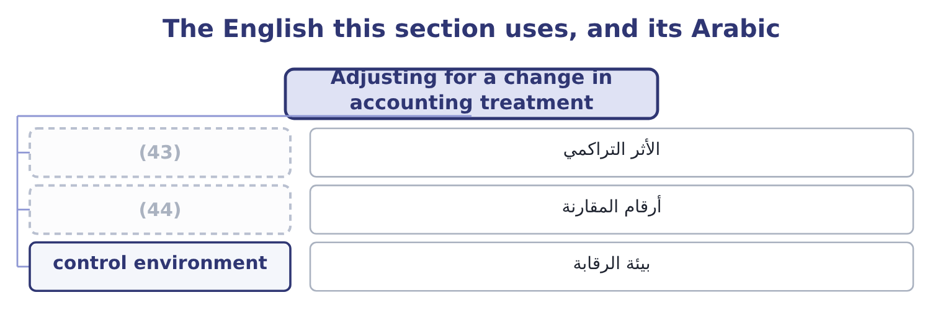
word list
cumulative effect · average rate · comparative figures

The English this sheet uses, and its Arabic
English (exam term) | Arabic
cumulative effect | الأثر التراكمي
comparative figures | أرقام المقارنة
control environment | بيئة الرقابة

Answer key · 18.3 Adjusting for a change in accounting treatment

1 business | 23 direction
2 changes | 24 turnover
3 something | 25 therefore
4 revenue | 26 assets
5 retrospectively | 27 liabilities
6 period | 28 income
7 cumulative | 29 return
8 retained | 30 bought
9 comparing | 31 exactly
10 provision | 32 consistent
11 prospectively | 33 collapse
12 enough | 34 examinable
13 discloses | 35 Use the restated comparatives, not the old report
14 separate | 36 Adjust for the change where it is material
15 correction | 37 Restate and disclose
16 restating | 38 halves
17 independent | 39 separately
18 environment | 40 falling
19 Suppose | 41 proportions
20 closing | 42 neutral
21 profit | 43 cumulative effect
22 reported | 44 comparative figures

the summaries in full
Summary 1 The third way a ratio moves without the business moving is that the company changes how it measures something. A change in accounting principle — first-in, first-out to weighted average, one revenue policy to another — is applied retrospectively. Every prior period presented is restated as though the new principle had always been used, and the cumulative effect on periods before those presented goes to opening retained earnings. For the analyst the work is already done: the comparatives in the current statements are on the new basis, and the trap is comparing them with figures taken from an older annual report, which are on the old one. A change in accounting estimate — a useful life, an allowance, a warranty provision — is applied prospectively. So the comparatives are on the old estimate and the current year is on the new one, and the analyst must adjust if the change is large enough to matter.
Summary 2 The note discloses the effect; the statements do not separate it. The correction of an error is applied by restating the prior periods affected and disclosing the fact. A restatement is a signal in its own right, independent of its size: it says the control environment failed once. Suppose Orontes changed from first-in, first-out to weighted average for 2025, and the effect is to raise cost of goods sold by $300,000 and to lower closing inventory by the same amount. Gross profit becomes 14,700,000 − 300,000 = 14,400,000, so the gross margin is 14,400,000 ÷ 42,000,000 = 34.29 per cent against the 35.0 reported. Inventory becomes 2,450,000 − 300,000 = 2,150,000. The ratios that move, and their direction. The gross margin falls. Inventory turnover rises on both counts, because cost of sales is larger and the average inventory smaller.
Summary 3 Days sales in inventory therefore falls. The current ratio falls, because current assets are $300,000 lower against unchanged current liabilities. Net income falls by 300,000 × 0.75 = 225,000 after tax, so every margin and every return falls with it. Six ratios moved and the company bought, made and sold exactly the same goods. Because this is a change in principle, the comparatives would also be restated, so a reader working only from the 2025 statements sees a consistent series — and a reader who takes 2024 from last year's annual report and 2025 from this one sees a margin collapse that never happened. That is the practical reason the outcome is examinable.
Summary 4 Write down the two halves of the ratio before and after the change and compare them separately. A ratio with both parts falling can move either way, and only the proportions decide. Where a change is retrospective, the comparatives in the current statements are already on the new basis. Where it is prospective, they are not. A restatement for an error is never a neutral event, however small the amount.

18.4 The limitations of ratio analysis
Chapter 18 · section 18.4

Fill every gap. Each word list holds one word more than there are gaps.
Summary 1 gaps 1–12
The limitations are (1) as a list, and the list is short (2) to learn. Each entry below has appeared in Book 1 as a worked (3) rather than as an (4) . No single ratio means (5) . A current ratio of 3.31 is a fact and not a verdict. A ratio needs a benchmark. Against last year, against a (6) , against a (7) , against the (8) . Barada's 16 per cent gross margin against Orontes's 35 is a difference of business, not of (9) . (10) policies differ between companies. Inventory method, depreciation basis, capitalisation policy, and the whole of the (11) difference. Section 18.3 moved six of Orontes's own ratios with one policy change. A balance sheet is one day. Seasonal (12) are measured at their quietest point, and, 105 and 150 days of inventory depending on the date chosen.
word list
businesses · customer's · anything · GAAP-against-IFRS · competitor · competence · problem · covenant · enough · assertion · examinable · Accounting · industry

Summary 2 gaps 13–20
Every figure in Book 1 (13) a year that has ended. Definitions are not (14) . Averages hide their spread. Window dressing is (15) . A company can repay a loan on the last day of the year and (16) it on the first day of the next, which lifts the current ratio and (17) nothing. Non-financial factors are absent. The quality of (18) , the strength of the brand, the state of the plant, a key (19) intentions, a lawsuit. None of them is in a ratio, and any of them can (20) more than all the ratios.
word list
describes · management · matter · competitor · customer's · possible · standardised · changes · redraw

Nine limitations, and where Book 1 met each
Limitation | Where it appeared
No single ratio is a verdict | (21)
A ratio needs a benchmark | Chapter 2, Barada against Orontes
Policies differ | (22)
A balance sheet is one day | (23)
Ratios are historical | Chapter 16, the only forward number is the price
Definitions are not standard | (24)
Averages hide spread | (25)
Window dressing | Chapter 6, the year-end repayment
Non-financial factors are absent | Chapter 18, this list

word list
Chapter 12, the seasonal miller · Chapter 14, four returns on assets · Section 18.3, the inventory method · Chapter 2, Barada against Orontes · Chapter 12, the ageing schedule · Chapter 6, the current ratio

Say the limitation that bites

Summary 3 gaps 26–31
A question asking for the limitations of ratio (26) wants the ones (27) to the data given, not a (28) . Where the question hands you one balance sheet date for a seasonal business, the limitation that bites is the date. Where it hands you two companies with (29) inventory methods, it is the policy difference. A limitation is not a reason to (30) to answer. State the (31) , then state what would change it.
word list
analysis · finding · different · examinable · recital · relevant · decline

The English this section uses, and its Arabic
Each term sits against what it means.
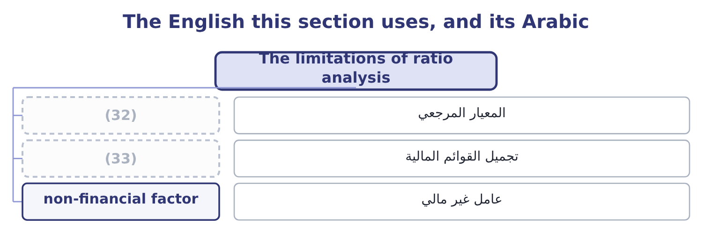
word list
historical cost · window dressing · benchmark

The English this sheet uses, and its Arabic
English (exam term) | Arabic
benchmark | المعيار المرجعي
window dressing | تجميل القوائم المالية
non-financial factor | عامل غير مالي

Answer key · 18.4 The limitations of ratio analysis

1 examinable | 18 management
2 enough | 19 customer's
3 problem | 20 matter
4 assertion | 21 Chapter 6, the current ratio
5 anything | 22 Section 18.3, the inventory method
6 competitor | 23 Chapter 12, the seasonal miller
7 covenant | 24 Chapter 14, four returns on assets
8 industry | 25 Chapter 12, the ageing schedule
9 competence | 26 analysis
10 Accounting | 27 relevant
11 GAAP-against-IFRS | 28 recital
12 businesses | 29 different
13 describes | 30 decline
14 standardised | 31 finding
15 possible | 32 benchmark
16 redraw | 33 window dressing
17 changes

the summaries in full
Summary 1 The limitations are examinable as a list, and the list is short enough to learn. Each entry below has appeared in Book 1 as a worked problem rather than as an assertion. No single ratio means anything. A current ratio of 3.31 is a fact and not a verdict. A ratio needs a benchmark. Against last year, against a competitor, against a covenant, against the industry. Barada's 16 per cent gross margin against Orontes's 35 is a difference of business, not of competence. Accounting policies differ between companies. Inventory method, depreciation basis, capitalisation policy, and the whole of the GAAP-against-IFRS difference. Section 18.3 moved six of Orontes's own ratios with one policy change. A balance sheet is one day. Seasonal businesses are measured at their quietest point, and, 105 and 150 days of inventory depending on the date chosen.
Summary 2 Every figure in Book 1 describes a year that has ended. Definitions are not standardised. Averages hide their spread. Window dressing is possible. A company can repay a loan on the last day of the year and redraw it on the first day of the next, which lifts the current ratio and changes nothing. Non-financial factors are absent. The quality of management, the strength of the brand, the state of the plant, a key customer's intentions, a lawsuit. None of them is in a ratio, and any of them can matter more than all the ratios.
Summary 3 A question asking for the limitations of ratio analysis wants the ones relevant to the data given, not a recital. Where the question hands you one balance sheet date for a seasonal business, the limitation that bites is the date. Where it hands you two companies with different inventory methods, it is the policy difference. A limitation is not a reason to decline to answer. State the finding, then state what would change it.

18.5 The verdict on Orontes
Chapter 18 · section 18.5

Fill every gap. Each word list holds one word more than there are gaps.
Summary 1 gaps 1–12
This is the outcome the whole book has been for: a judgment on a company's (1) strength and performance, built from many ratios and (2) in a form somebody can act on. Three rules make the (3) between an answer and a list. Rank the findings by what they are worth. A (4) gross margin move on $42,000,000 of sales is $840,000 a year; the trade working capital (5) ,640 a year. The first (6) in the first (7) and the second does not. (8) the position from the performance. The balance sheet says how strong the company is now. The income (9) says how well it is trading. They can (10) , and Orontes is a company where they do. Say what would change the verdict. A verdict with no (11) test is an (12) .
word list
support · stated · opinion · financial · difference · funding · disagree · two-point · belongs · sentence · Separate · expressed · statement

Orontes Foods, Inc. — the evidence, 2025
Area | Key ratios | Reading
Liquidity | Current 3.31, quick 2.68, cash 1.72 | (13)
Cash generation | (14) | Strong
Solvency | (15) | Conservative
Coverage | Interest cover 11.15, fixed charge 9.42 | Wide
Working capital | Cash cycle 39.8 days, DSO 34.3 | (16)
Margins | (17) | Gross margin falling three years running
Returns | ROA 10.22%, ROE 16.15% | (18)
Growth | (19) | Part-funded from outside
Market | (20) | Priced for growth that costs margin

word list
Debt-to-equity 0.55, debt-to-assets 0.36 · Gross 35.0%, operating 9.9%, net 7.1% · Good, and flattered by the growth · P/E 25.23, market-to-book 3.67 · Cash flow ratio 1.76, cash backing 2.54 times · Well run, improving · Strong, and stronger than 2024 · Receivables up 38%, inventory up 41%, overdraft 240,000 · Sales 15.38% against a sustainable 13.70%

Summary 2 gaps 21–32
Orontes is (21) strong and its trading is (22) in one specific, (23) way. The strength is not in doubt. It holds $7,302,100 of cash, (24) its current liabilities 3.31 times and its interest 11.15 times, (25) total liabilities of only $11,279,625 against equity of $20,392,975, and (26) its profit into cash 2.54 times over. Its working capital is better run than a year ago on every (27) . On the (28) of the balance sheet alone, this company could borrow (29) million dollars (30) . The deterioration is in the gross margin, and it is the only finding in the book worth $840,000 a year. Sales have risen 31 per cent in two years and the gross margin has (31) from 37.0 per cent to 35.0, which means the growth was (32) with price. Price concessions are permanent in a way volume gains are not.
word list
measure · tomorrow · bought · fallen · covers · measurable · converts · deteriorating · carries · evidence · financially · several · performance

Summary 3 gaps 33–44
Meanwhile the market has raised its multiple from 24.01 to 25.23, so the share price now embodies an (33) of continued growth that the margin trend does not (34) . Two (35) findings belong in the same answer. The company grew (36) than it can fund and (37) the gap with a $1,500,000 share issue and an $800,000 note, which is sound once and not a (38) . And 2025 contains a (39) impairment of $2,724,000, which depresses the reported operating margin to 9.9 per cent against an underlying 16.4 — so the reported deterioration overstates the trading decline, while the margin finding (40) nothing. What would change the verdict. A gross margin of 36 per cent or better in 2026 on continued volume growth would settle the matter in the company's favour: it would show the concessions were an entry price into new (41) rather than a permanent (42) . A margin of 34 per cent would confirm the opposite and would, at an (43) multiple of 25, make the share price (44) .
word list
expectation · understates · support · discretionary · indefensible · repricing · closed · policy · continued · secondary · faster · unchanged · customers

Reach a verdict on Barada

Write the verdict in three sentences: the position, the performance, and the test.

Your turn: Barada's evidence (complete the verdict)
Area | Barada | Your reading
Liquidity | Current 2.00, quick 0.94 | ________
Working capital | (45) | ________
Solvency | Debt-to-equity 1.26, covenant limit 1.50 | ________
Margins | (46) | ________
Growth | Sales 11.0% against a sustainable 9.15% | ________
Earnings quality | (47) | ________
Verdict |  | ________

word list
Cash cycle 44.4 days, DSI 40.6 · Gross 14.0%, net 1.29% · Receivables up 38%, inventory up 41%, overdraft 240,000 · Priced for growth that costs margin

"Material"

Summary 4 gaps 48–53
English (48) in accounting does not mean physical or important in a general sense: it means large enough that its omission or (49) could change a user's decision. It is a threshold, and it is (50) relative to the (51) . The exam uses the word in its accounting sense every time, and a (52) who reads it as important loses the threshold idea that makes it (53) .
word list
misstatement · deliberately · trading · material · candidate · useful · entity

"Material"
Area | Answer
Liquidity | Adequate on the current ratio of 2.00 and weak behind it: a quick ratio of 0.94 means Barada cannot meet its current liabilities without sel
Working capital | Poorly run and getting worse. A 44.4-day cash cycle on a 40.6-day inventory period is the profile of a (54) whose stockroom is growin
Solvency | Tight. At 1.26 against a covenant limit of 1.50 there is room, but the $1,500,000 the company wants would take it to 1.74 and breach the cov
Margins | Thin by nature and (55) : 14.0 per cent gross against 16.0 two years ago, and 1.29 per cent net leaves no margin for error.
Growth | Above the sustainable rate by about two points a year, with no dividend to cut and no equity raised, so the gap goes on the overdraft.
Earnings quality | Low. Receivables up 38 per cent and inventory up 41 per cent on sales up 11 means the reported profit is sitting in working capital rather t
Verdict | The position is weak behind an adequate-looking current ratio, the performance is a thin and thinning margin on growth the company cannot fu

word list
Reading · thinning · distributor

The English this section uses, and its Arabic
Each term sits against what it means.
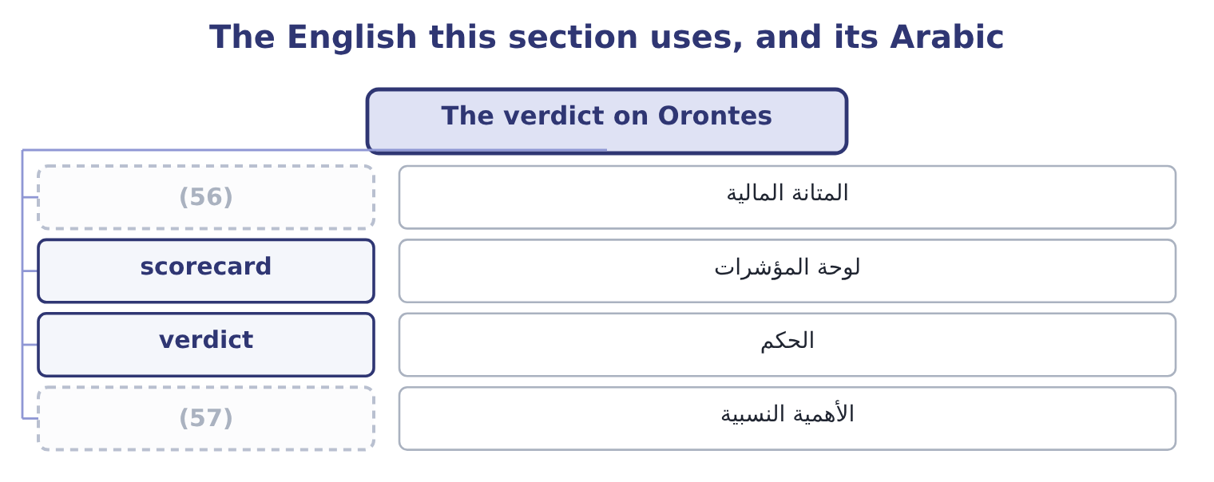
word list
الأهمية النسبية · materiality · financial strength

The English this sheet uses, and its Arabic
English (exam term) | Arabic
financial strength | المتانة المالية
scorecard | لوحة المؤشرات
verdict | الحكم
materiality | الأهمية النسبية

Answer key · 18.5 The verdict on Orontes

1 financial | 30 tomorrow
2 expressed | 31 fallen
3 difference | 32 bought
4 two-point | 33 expectation
5 funding | 34 support
6 belongs | 35 secondary
7 sentence | 36 faster
8 Separate | 37 closed
9 statement | 38 policy
10 disagree | 39 discretionary
11 stated | 40 understates
12 opinion | 41 customers
13 Strong, and stronger than 2024 | 42 repricing
14 Cash flow ratio 1.76, cash backing 2.54 times | 43 unchanged
15 Debt-to-equity 0.55, debt-to-assets 0.36 | 44 indefensible
16 Well run, improving | 45 Cash cycle 44.4 days, DSI 40.6
17 Gross 35.0%, operating 9.9%, net 7.1% | 46 Gross 14.0%, net 1.29%
18 Good, and flattered by the growth | 47 Receivables up 38%, inventory up 41%, overdraft 240,000
19 Sales 15.38% against a sustainable 13.70% | 48 material
20 P/E 25.23, market-to-book 3.67 | 49 misstatement
21 financially | 50 deliberately
22 deteriorating | 51 entity
23 measurable | 52 candidate
24 covers | 53 useful
25 carries | 54 distributor
26 converts | 55 thinning
27 measure | 56 financial strength
28 evidence | 57 materiality
29 several

the summaries in full
Summary 1 This is the outcome the whole book has been for: a judgment on a company's financial strength and performance, built from many ratios and expressed in a form somebody can act on. Three rules make the difference between an answer and a list. Rank the findings by what they are worth. A two-point gross margin move on $42,000,000 of sales is $840,000 a year; the trade working capital funding,640 a year. The first belongs in the first sentence and the second does not. Separate the position from the performance. The balance sheet says how strong the company is now. The income statement says how well it is trading. They can disagree, and Orontes is a company where they do. Say what would change the verdict. A verdict with no stated test is an opinion.
Summary 2 Orontes is financially strong and its trading is deteriorating in one specific, measurable way. The strength is not in doubt. It holds $7,302,100 of cash, covers its current liabilities 3.31 times and its interest 11.15 times, carries total liabilities of only $11,279,625 against equity of $20,392,975, and converts its profit into cash 2.54 times over. Its working capital is better run than a year ago on every measure. On the evidence of the balance sheet alone, this company could borrow several million dollars tomorrow. The deterioration is in the gross margin, and it is the only finding in the book worth $840,000 a year. Sales have risen 31 per cent in two years and the gross margin has fallen from 37.0 per cent to 35.0, which means the growth was bought with price. Price concessions are permanent in a way volume gains are not.
Summary 3 Meanwhile the market has raised its multiple from 24.01 to 25.23, so the share price now embodies an expectation of continued growth that the margin trend does not support. Two secondary findings belong in the same answer. The company grew faster than it can fund and closed the gap with a $1,500,000 share issue and an $800,000 note, which is sound once and not a policy. And 2025 contains a discretionary impairment of $2,724,000, which depresses the reported operating margin to 9.9 per cent against an underlying 16.4 — so the reported deterioration overstates the trading decline, while the margin finding understates nothing. What would change the verdict. A gross margin of 36 per cent or better in 2026 on continued volume growth would settle the matter in the company's favour: it would show the concessions were an entry price into new customers rather than a permanent repricing. A margin of 34 per cent would confirm the opposite and would, at an unchanged multiple of 25, make the share price indefensible.
Summary 4 English material in accounting does not mean physical or important in a general sense: it means large enough that its omission or misstatement could change a user's decision. It is a threshold, and it is deliberately relative to the entity. The exam uses the word in its accounting sense every time, and a candidate who reads it as important loses the threshold idea that makes it useful.

