1.1 Rates of return
Chapter 1 · section 1.1

Fill every gap. Each word list holds one word more than there are gaps.
Chapter 1, section by section
Each stage leads to the next.
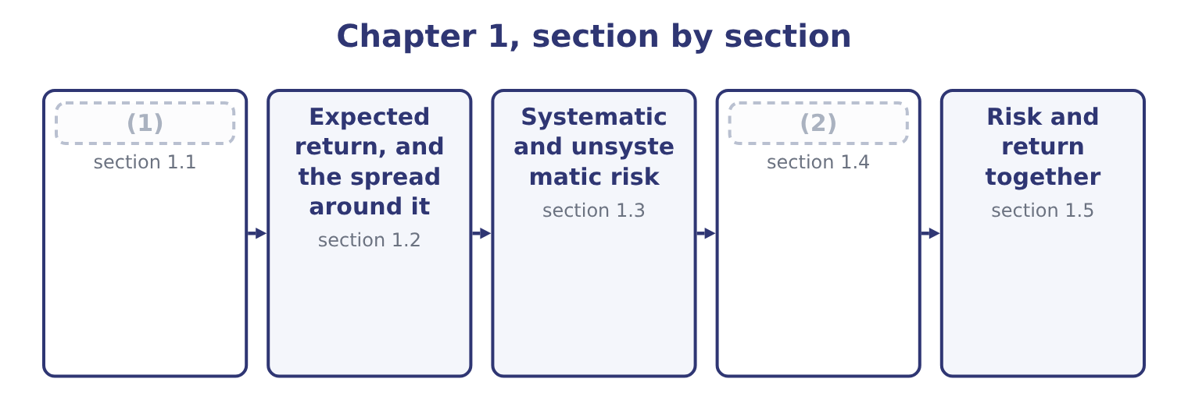
word list
Risk and return together · The four risks a treasurer names · Rates of return

Summary 1 gaps 3–11
A rate of return is what was earned, over what was put in, over a (3) period. The three parts of that (4) are where the marks are. The holding period return is the (5) and the one the exam uses most. It is the income (6) plus the change in value, over the value at the start. For an Orontes (7) in 2025: the price rose 9.25 − 7.80 = 1.45 and the (8) was 0.0556, so the return is 1.45 + 0.0556 = 1.5056 on an opening 7.80, which is 1.5056 ÷ 7.80 = 19.30 per cent. Where the period is not a year, the return has to be annualised before it can be (9) with anything. A return of 19.30 per cent over two years is not 19.30 per cent a year; (10) makes it 1.1930 (11) to the power of one half, which is 9.22 per cent a year.
word list
sentence · received · compared · through · compounding · dividend · simplest · shareholder · raised · stated

Summary 2 gaps 12–21
Where the period is (12) than a year the same (13) runs the other way: 2 per cent over a quarter (14) to 8.24 per cent a year, not 8. (15) a series of returns has the same trap in a (16) form. The arithmetic mean of +40 per cent and −30 per cent is 5 per cent, and an investor who lived through those two years has lost money: 1.40 × 0.70 = 0.98, so one (17) became 98 cents and the true compound return is about minus 1 per cent a year. The geometric mean is the (18) figure for a series of returns actually earned; the arithmetic mean is the right figure for a single period drawn at (19) from the same distribution, which is why both (20) in the exam and why the question (21) says.
word list
Averaging · always · honest · dollar · appear · sharper · shorter · compounds · random · relationship · holding

Four rates of return, and when each is right
Measure | Computation | Use it for
Holding period return | Income plus price change, over opening value | (22)
Annualised return | The holding period return compounded to a year | (23)
Arithmetic mean | The simple average of the periods | (24)
Geometric mean | (25) | What an investor actually earned

word list
Comparing periods of different lengths · One period, any length · Income plus price change, over opening value · One period drawn from the same distribution · The compound rate that links start to finish

Summary 3 gaps 26–32
Finally, a return (26) in money of the day is a nominal return, and what it buys (27) on inflation. The real return (28) one by the other: at 19.30 per cent nominal and 4 per cent inflation, 1.1930 ÷ 1.04 = 1.1471, so the real return is 14.71 per cent. The approximation that every (29) reaches for, 19.30 − 4.00 = 15.30 per cent, is close (30) at these rates and wrong by a (31) point when rates are high — which is (32) when the question asks.
word list
depends · shareholder · quoted · exactly · percentage · enough · candidate · divides

Say which period and which basis

Summary 4 gaps 33–36
A return with no period attached is (33) . Geometric for a series lived through, arithmetic for a single (34) period. The question will tell you; the (35) will not. Nominal less inflation is an approximation. Where the question gives both rates to one decimal, use the (36) .
word list
meaningless · expected · figures · nominal · division

The English this section uses, and its Arabic
Each term sits against what it means.
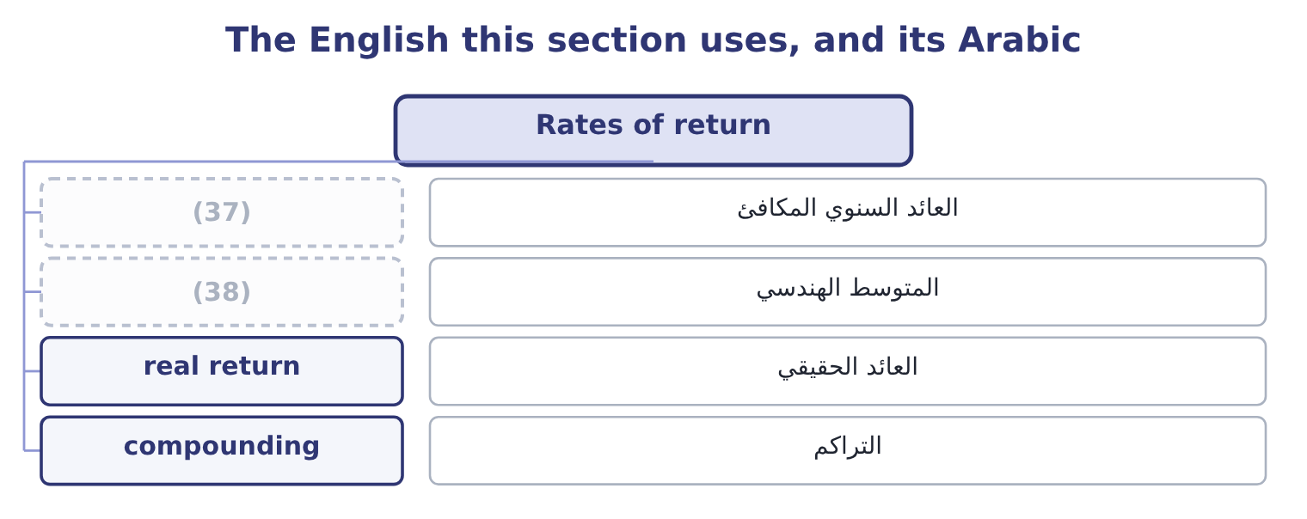
word list
geometric mean · annualised return · standard deviation

The English this sheet uses, and its Arabic
English (exam term) | Arabic
annualised return | العائد السنوي المكافئ
geometric mean | المتوسط الهندسي
real return | العائد الحقيقي
compounding | التراكم

Answer key · 1.1 Rates of return

1 Rates of return | 20 appear
2 The four risks a treasurer names | 21 always
3 stated | 22 One period, any length
4 sentence | 23 Comparing periods of different lengths
5 simplest | 24 One period drawn from the same distribution
6 received | 25 The compound rate that links start to finish
7 shareholder | 26 quoted
8 dividend | 27 depends
9 compared | 28 divides
10 compounding | 29 candidate
11 raised | 30 enough
12 shorter | 31 percentage
13 relationship | 32 exactly
14 compounds | 33 meaningless
15 Averaging | 34 expected
16 sharper | 35 figures
17 dollar | 36 division
18 honest | 37 annualised return
19 random | 38 geometric mean

the summaries in full
Summary 1 A rate of return is what was earned, over what was put in, over a stated period. The three parts of that sentence are where the marks are. The holding period return is the simplest and the one the exam uses most. It is the income received plus the change in value, over the value at the start. For an Orontes shareholder in 2025: the price rose 9.25 − 7.80 = 1.45 and the dividend was 0.0556, so the return is 1.45 + 0.0556 = 1.5056 on an opening 7.80, which is 1.5056 ÷ 7.80 = 19.30 per cent. Where the period is not a year, the return has to be annualised before it can be compared with anything. A return of 19.30 per cent over two years is not 19.30 per cent a year; compounding makes it 1.1930 raised to the power of one half, which is 9.22 per cent a year.
Summary 2 Where the period is shorter than a year the same relationship runs the other way: 2 per cent over a quarter compounds to 8.24 per cent a year, not 8. Averaging a series of returns has the same trap in a sharper form. The arithmetic mean of +40 per cent and −30 per cent is 5 per cent, and an investor who lived through those two years has lost money: 1.40 × 0.70 = 0.98, so one dollar became 98 cents and the true compound return is about minus 1 per cent a year. The geometric mean is the honest figure for a series of returns actually earned; the arithmetic mean is the right figure for a single period drawn at random from the same distribution, which is why both appear in the exam and why the question always says.
Summary 3 Finally, a return quoted in money of the day is a nominal return, and what it buys depends on inflation. The real return divides one by the other: at 19.30 per cent nominal and 4 per cent inflation, 1.1930 ÷ 1.04 = 1.1471, so the real return is 14.71 per cent. The approximation that every candidate reaches for, 19.30 − 4.00 = 15.30 per cent, is close enough at these rates and wrong by a percentage point when rates are high — which is exactly when the question asks.
Summary 4 A return with no period attached is meaningless. Geometric for a series lived through, arithmetic for a single expected period. The question will tell you; the figures will not. Nominal less inflation is an approximation. Where the question gives both rates to one decimal, use the division.

1.2 Expected return, and the spread around it
Chapter 1 · section 1.2

Fill every gap. Each word list holds one word more than there are gaps.
Summary 1 gaps 1–10
A return that has happened is a fact. A return that has not happened yet is a distribution, and the exam (1) it with a short list of outcomes and their probabilities. The expected return is the (2) average of the outcomes. (3) a project whose return is 25 per cent if the (4) is good, 10 per cent if it is (5) and minus 5 per cent if it fails, with probabilities of 0.2, 0.5 and 0.3. Then 0.2 × 25 = 5.0, 0.5 × 10 = 5.0 and 0.3 × 5 = 1.5 in the other (6) , so the expected return is 5.0 + 5.0 − 1.5 = 8.5 per cent. (7) earns 8.5 per cent. The expected return is the centre of the distribution and not a (8) of any single year, which is why it must (9) be quoted with a (10) of how wide the distribution is.
word list
harvest · ordinary · Consider · measure · Nobody · describes · whenever · probability-weighted · direction · forecast · always

Worked example: the spread, and what it is worth knowing

Summary 2 gaps 11–19
Each (11) distance from the 8.5 per cent (12) : 25.0 − 8.5 = 16.5, then 10.0 − 8.5 = 1.5, then an outcome of minus 5 which is 13.5 below the mean. Square each deviation and weight it by its (13) : 0.2 × 272.25 = 54.45, 0.5 × 2.25 = 1.125 and 0.3 × 182.25 = 54.675. The three add to 110.25. The standard deviation and the coefficient of variation. The square root of 110.25 is 10.5 (14) points. (15) against the expected return, the coefficient of variation is 10.5 ÷ 8.5 = 1.24. Two projects with the same expected return are not the same project. The standard deviation says how far a single year is (16) to fall from the centre; the coefficient of variation (17) that spread by the size of the return, which is what lets a small project be (18) with a large one. The exam asks for the coefficient whenever the two projects (19) in size, and for the standard deviation whenever they do not.
word list
outcome's · scales · distance · probability · percentage · likely · differ · compared · Expressed · expectation

The expected return and its spread
The bars are drawn to scale.
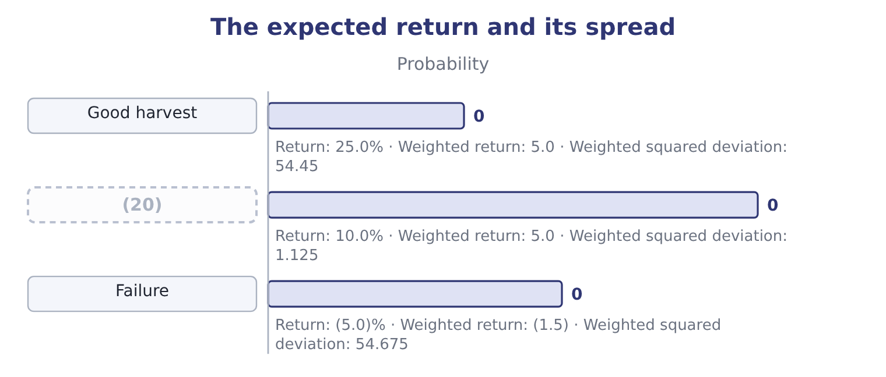
word list
Ordinary · hedge

The English this section uses, and its Arabic
Each term sits against what it means.
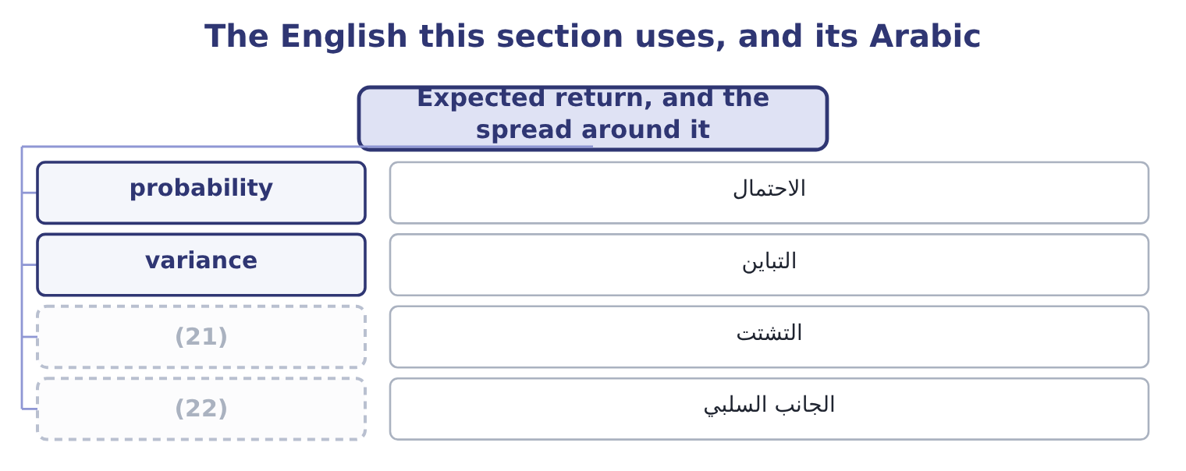
word list
downside · probability · dispersion

The English this sheet uses, and its Arabic
English (exam term) | Arabic
probability | الاحتمال
variance | التباين
dispersion | التشتت
downside | الجانب السلبي

Answer key · 1.2 Expected return, and the spread around it

1 describes | 12 expectation
2 probability-weighted | 13 probability
3 Consider | 14 percentage
4 harvest | 15 Expressed
5 ordinary | 16 likely
6 direction | 17 scales
7 Nobody | 18 compared
8 forecast | 19 differ
9 always | 20 Ordinary
10 measure | 21 dispersion
11 outcome's | 22 downside

the summaries in full
Summary 1 A return that has happened is a fact. A return that has not happened yet is a distribution, and the exam describes it with a short list of outcomes and their probabilities. The expected return is the probability-weighted average of the outcomes. Consider a project whose return is 25 per cent if the harvest is good, 10 per cent if it is ordinary and minus 5 per cent if it fails, with probabilities of 0.2, 0.5 and 0.3. Then 0.2 × 25 = 5.0, 0.5 × 10 = 5.0 and 0.3 × 5 = 1.5 in the other direction, so the expected return is 5.0 + 5.0 − 1.5 = 8.5 per cent. Nobody earns 8.5 per cent. The expected return is the centre of the distribution and not a forecast of any single year, which is why it must always be quoted with a measure of how wide the distribution is.
Summary 2 Each outcome's distance from the 8.5 per cent expectation: 25.0 − 8.5 = 16.5, then 10.0 − 8.5 = 1.5, then an outcome of minus 5 which is 13.5 below the mean. Square each deviation and weight it by its probability: 0.2 × 272.25 = 54.45, 0.5 × 2.25 = 1.125 and 0.3 × 182.25 = 54.675. The three add to 110.25. The standard deviation and the coefficient of variation. The square root of 110.25 is 10.5 percentage points. Expressed against the expected return, the coefficient of variation is 10.5 ÷ 8.5 = 1.24. Two projects with the same expected return are not the same project. The standard deviation says how far a single year is likely to fall from the centre; the coefficient of variation scales that spread by the size of the return, which is what lets a small project be compared with a large one. The exam asks for the coefficient whenever the two projects differ in size, and for the standard deviation whenever they do not.

1.3 Systematic and unsystematic risk
Chapter 1 · section 1.3

Fill every gap. Each word list holds one word more than there are gaps.
Summary 1 gaps 1–12
Not all risk is the same kind, and the difference (1) whether an investor is paid for carrying it. Unsystematic risk, also called company-specific or diversifiable risk, belongs to one company or one (2) . A fire in (3) plant, a recall of one product, the loss of its largest customer, a strike, a lawsuit, the (4) of a chief executive. These (5) are independent across companies: a fire at Orontes tells you (6) about a fire at a glass works in Amman. Systematic risk, also called market risk or non-diversifiable risk, belongs to the (7) . A rise in (8) rates, a recession, a tax change, a war, a (9) crisis. Every company is affected, in (10) degrees but in the same (11) . The (12) is the most important sentence in Section B. Because unsystematic risk is independent across companies, holding many companies at once makes most of it disappear: the fire at one is offset by the good year at another.
word list
nothing · consequence · events · economy · interest · different · currency · decides · industry · departure · Orontes's · company's · direction

Summary 2 gaps 13–21
Systematic risk cannot be (13) by holding more companies, because it moves them all (14) . So an investor who can diversify will not pay to avoid unsystematic risk — and will not be paid for (15) it. Only systematic risk (16) a reward. A (17) management sees it (18) , and the exam tests the difference. A diversified (19) does not care about the fire; the chief executive, the (20) and the lender very much do, because they cannot diversify their exposure to this one company. That is why companies buy insurance and (21) currencies when, on a strict reading of portfolio theory, their shareholders need neither.
word list
carries · differently · removed · company's · hedge · shareholder · bearing · together · non-diversifiable · workforce

Diversifiable means unpaid

Summary 3 gaps 22–26
A risk that can be diversified away earns no premium, however (22) it is to the company carrying it. Diversification (23) unsystematic risk; it does not (24) risk. A portfolio of a (25) shares still falls in a recession. The (26) is about the source of the risk, not its size. A large company-specific risk is still unsystematic.
word list
reduces · frightening · hundred · distinction · bearing · eliminate

The two kinds of risk
 | Unsystematic risk | Systematic risk
Also called | (27) | Market risk, non-diversifiable
Examples | Fire, recall, strike, lawsuit, a lost customer | (28)
Removable by diversification? | Yes, almost entirely | No
Rewarded by the market? | No | Yes
Who still cares | (29) | Everybody

word list
Company-specific, diversifiable · Managers, employees, lenders · Recession, rates, inflation, tax, war · credit risk

The English this section uses, and its Arabic
Each term sits against what it means.
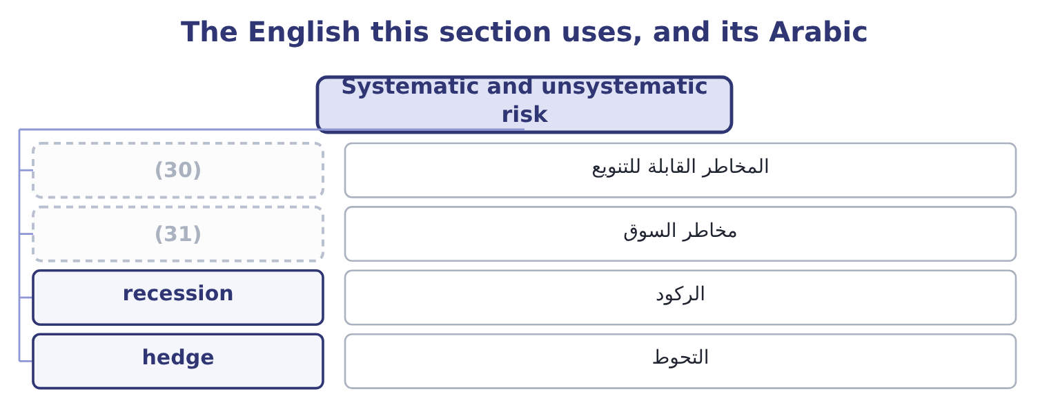
word list
market risk · standard deviation · diversifiable risk

The English this sheet uses, and its Arabic
English (exam term) | Arabic
diversifiable risk | المخاطر القابلة للتنويع
market risk | مخاطر السوق
recession | الركود
hedge | التحوط

Answer key · 1.3 Systematic and unsystematic risk

1 decides | 17 company's
2 industry | 18 differently
3 Orontes's | 19 shareholder
4 departure | 20 workforce
5 events | 21 hedge
6 nothing | 22 frightening
7 economy | 23 reduces
8 interest | 24 eliminate
9 currency | 25 hundred
10 different | 26 distinction
11 direction | 27 Company-specific, diversifiable
12 consequence | 28 Recession, rates, inflation, tax, war
13 removed | 29 Managers, employees, lenders
14 together | 30 diversifiable risk
15 bearing | 31 market risk
16 carries

the summaries in full
Summary 1 Not all risk is the same kind, and the difference decides whether an investor is paid for carrying it. Unsystematic risk, also called company-specific or diversifiable risk, belongs to one company or one industry. A fire in Orontes's plant, a recall of one product, the loss of its largest customer, a strike, a lawsuit, the departure of a chief executive. These events are independent across companies: a fire at Orontes tells you nothing about a fire at a glass works in Amman. Systematic risk, also called market risk or non-diversifiable risk, belongs to the economy. A rise in interest rates, a recession, a tax change, a war, a currency crisis. Every company is affected, in different degrees but in the same direction. The consequence is the most important sentence in Section B. Because unsystematic risk is independent across companies, holding many companies at once makes most of it disappear: the fire at one is offset by the good year at another.
Summary 2 Systematic risk cannot be removed by holding more companies, because it moves them all together. So an investor who can diversify will not pay to avoid unsystematic risk — and will not be paid for bearing it. Only systematic risk carries a reward. A company's management sees it differently, and the exam tests the difference. A diversified shareholder does not care about the fire; the chief executive, the workforce and the lender very much do, because they cannot diversify their exposure to this one company. That is why companies buy insurance and hedge currencies when, on a strict reading of portfolio theory, their shareholders need neither.
Summary 3 A risk that can be diversified away earns no premium, however frightening it is to the company carrying it. Diversification reduces unsystematic risk; it does not eliminate risk. A portfolio of a hundred shares still falls in a recession. The distinction is about the source of the risk, not its size. A large company-specific risk is still unsystematic.

1.4 The four risks a treasurer names
Chapter 1 · section 1.4

Fill every gap. Each word list holds one word more than there are gaps.
Summary 1 gaps 1–12
The (1) names four risks (2) , and each of them can be (3) at in Orontes's own statements. Credit risk is the risk that (4) who owes money does not pay. Orontes carries $4,144,000 of receivables net of an allowance of $156,000, which is the (5) own estimate of the credit risk it is running on its (6) . A (7) carries the same risk the other way round, which is why. Foreign exchange risk is the risk that a rate moves against a position. Orontes (8) sesame, so a fall in the (9) raises its input cost and (10) the gross margin that Book 1 spent a chapter on. There are three kinds, and the exam separates them: (11) exposure on a contract already struck, translation exposure on the statements of a foreign subsidiary, and economic exposure on the long-run (12) of the business.
word list
company's · pointed · dollar · somebody · squeezes · transaction · lender · exchange · outcome · imports · specifically · competitiveness · customers

Summary 2 gaps 13–21
Interest rate risk is the risk that a change in rates (13) the value of an instrument or the cost of a (14) . Orontes has $6,000,000 of long-term debt and $400,000 of it due (15) the year, so a rate rise reaches it at (16) rather than (17) . A (18) meets the same risk as a fall in price. Market risk, in the (19) sense used here, is the risk that the price of a traded instrument moves. Orontes holds $42,000 of trading securities and $88,500 of debt securities, and the $4,000 of (20) gains in its income (21) is market risk showing up in reported profit.
word list
business · unrealised · immediately · narrow · borrowing · statement · within · bondholder · refinancing · changes

Four risks, and where each one touches Orontes
Risk | What it is | Orontes's exposure | Managed by
Credit risk | (22) | Receivables of 4,144,000 | Credit policy, allowance, factoring
Foreign exchange risk | A rate moves against a position | Imported sesame; any foreign sale | (23)
Interest rate risk | (24) | 6,000,000 of long-term debt | Fixed rates, swaps, maturity choice
Market risk | A traded price moves | 42,000 of trading securities | (25)

word list
A counterparty does not pay · Rates change value or cost · Receivables of 4,144,000 · Position size, maturity, quality · Forwards, matching, pricing

The English this section uses, and its Arabic
Each term sits against what it means.
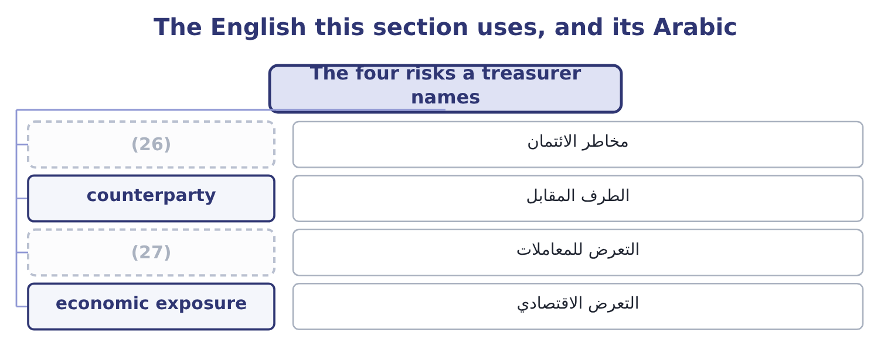
word list
diversifiable risk · credit risk · transaction exposure

The English this sheet uses, and its Arabic
English (exam term) | Arabic
credit risk | مخاطر الائتمان
counterparty | الطرف المقابل
transaction exposure | التعرض للمعاملات
economic exposure | التعرض الاقتصادي

Answer key · 1.4 The four risks a treasurer names

1 outcome | 15 within
2 specifically | 16 refinancing
3 pointed | 17 immediately
4 somebody | 18 bondholder
5 company's | 19 narrow
6 customers | 20 unrealised
7 lender | 21 statement
8 imports | 22 A counterparty does not pay
9 dollar | 23 Forwards, matching, pricing
10 squeezes | 24 Rates change value or cost
11 transaction | 25 Position size, maturity, quality
12 competitiveness | 26 credit risk
13 changes | 27 transaction exposure
14 borrowing

the summaries in full
Summary 1 The outcome names four risks specifically, and each of them can be pointed at in Orontes's own statements. Credit risk is the risk that somebody who owes money does not pay. Orontes carries $4,144,000 of receivables net of an allowance of $156,000, which is the company's own estimate of the credit risk it is running on its customers. A lender carries the same risk the other way round, which is why. Foreign exchange risk is the risk that a rate moves against a position. Orontes imports sesame, so a fall in the dollar raises its input cost and squeezes the gross margin that Book 1 spent a chapter on. There are three kinds, and the exam separates them: transaction exposure on a contract already struck, translation exposure on the statements of a foreign subsidiary, and economic exposure on the long-run competitiveness of the business.
Summary 2 Interest rate risk is the risk that a change in rates changes the value of an instrument or the cost of a borrowing. Orontes has $6,000,000 of long-term debt and $400,000 of it due within the year, so a rate rise reaches it at refinancing rather than immediately. A bondholder meets the same risk as a fall in price. Market risk, in the narrow sense used here, is the risk that the price of a traded instrument moves. Orontes holds $42,000 of trading securities and $88,500 of debt securities, and the $4,000 of unrealised gains in its income statement is market risk showing up in reported profit.

1.5 Risk and return together
Chapter 1 · section 1.5

Fill every gap. Each word list holds one word more than there are gaps.
Summary 1 gaps 1–12
The (1) between risk and return is not a (2) observed in the data. It is a (3) for a market to clear. If two assets (4) the same return and one was riskier, nobody would hold the riskier one, and its price would fall until its return rose enough to (5) a buyer. Risk and return move (6) because prices make them. A required return is a risk-free rate plus a premium for the risk (7) . The risk-free rate is what a lender earns with no credit risk and no (8) uncertainty over the period — in (9) a government security of matching maturity. It (10) for two things only: waiting, and expected inflation. The risk premium is (11) else, and it is (12) to the asset. A corporate bond pays more than a treasury because the company may default.
word list
relationship · compensates · reinvestment · specific · attract · everything · tendency · practice · condition · offered · shareholders · carried · together

Summary 2 gaps 13–21
A share pays more than the company's own bond because the (13) is paid last. A small company pays more than a large one, and an (14) asset more than a liquid one. Orontes's own (15) show the ladder. The company (16) from Levant (17) Bank at 6 per cent. Book 1 charged its shareholders 10 per cent as a required return when it (18) economic profit, and the shareholders (19) earned 19.30 per cent in 2025. The gap between 6 and 10 is the price of (20) behind the lender; the gap between 10 and 19.30 is the year (21) out well.
word list
statements · shareholder · computed · illiquid · standing · risk-averse · actually · Commerce · turning · borrows

The required-return ladder
Claim | Required return | Why it sits there
Government security | 3% to 4% | (22)
Senior secured bank debt | 6% | (23)
Unsecured corporate bond | 7% to 8% | (24)
Preferred stock | 9% | Paid after debt; dividend not contractual
Common equity | 10% and above | (25)

word list
Waiting and expected inflation only · Default risk, with security and covenants · Default risk, no security · Geometric mean of +50% then −40% · Paid last, and only what is left

Summary 3 gaps 26–35
Two (26) close the chapter, and both are (27) . The first is that a company's cost of capital is its (28) ' required return seen from the other side. Every rate in that ladder is a cost to Orontes and a return to (29) . The second is that risk (30) is a matter of degree, not of (31) . A risk-averse investor is not one who (32) risk; it is one who (33) compensation for it. An investor who required no compensation would be (34) , and an investor who paid for risk would be (35) — which is a fair description of a lottery ticket and of nothing a company should be doing with its shareholders' money.
word list
refuses · somebody · risk-neutral · examined · principle · expected · investors · aversion · consequences · risk-seeking · requires

Compute the returns and the spread

Your turn: returns and risk (complete the blanks)
Item | Data | Answer
Holding period return | (36) | 19.00 per cent: 23.00 − 20.00 = 3.00 of price gain, plus 0.80 of dividend, and 3.80 ÷ 20.00 = 19.00 per cent.
Real return | Nominal 12.0 per cent, inflation 5.0 per cent | (37) : 1.1200 ÷ 1.05 = 1.0667.
Geometric mean of +50% then −40% | (38) | A loss: 1.50 × 0.60 = 0.90, so one dollar became 90 cents, about minus 5.1 per cent a year.
Expected return | 30% at 0.3, 10% at 0.4, (10)% at 0.3 | (39) : 0.3 × 30 = 9.0, 0.4 × 10 = 4.0, and 0.3 × 10 = 3.0 in the other direction, so 9.0 + 4.0 − 3.0 = 10.0.
Standard deviation | The same three outcomes | 15.49 points: the weighted squared deviations are 0.3 × 400 = 120, nil for the middle outcome, and 0.3 × 400 = 120, giving a variance of 240
Coefficient of variation | The same three outcomes | (40) : 15.49 ÷ 10.0.

word list
Two years · 10.0 per cent · 6.67 per cent · 1.549 · Bought 20.00, dividend 0.80, sold 23.00 · Paid after debt; dividend not contractual

"Risk"

Summary 4 gaps 41–46
English risk in finance is neutral: it means the (41) of possible outcomes, good and bad alike, and an asset whose return might be far above (42) is risky in exactly the sense meant here. (43) English uses the word only for the bad half, and that is the reading (44) import by mistake. Note the phrase risk-averse: it does not mean (45) risk, it means (46) payment for it.
word list
requiring · candidates · expectations · refusing · Everyday · statements · dispersion

The English this section uses, and its Arabic
Each term sits against what it means.
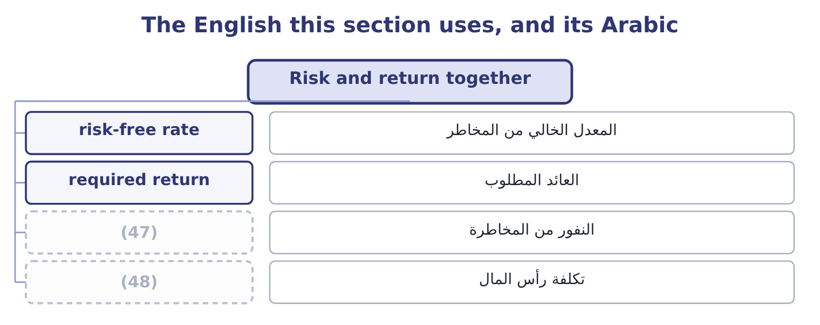
word list
risk aversion · cost of capital · العائد المطلوب

The English this sheet uses, and its Arabic
English (exam term) | Arabic
risk-free rate | المعدل الخالي من المخاطر
required return | العائد المطلوب
risk aversion | النفور من المخاطرة
cost of capital | تكلفة رأس المال

Answer key · 1.5 Risk and return together

1 relationship | 25 Paid last, and only what is left
2 tendency | 26 consequences
3 condition | 27 examined
4 offered | 28 investors
5 attract | 29 somebody
6 together | 30 aversion
7 carried | 31 principle
8 reinvestment | 32 refuses
9 practice | 33 requires
10 compensates | 34 risk-neutral
11 everything | 35 risk-seeking
12 specific | 36 Bought 20.00, dividend 0.80, sold 23.00
13 shareholder | 37 6.67 per cent
14 illiquid | 38 Two years
15 statements | 39 10.0 per cent
16 borrows | 40 1.549
17 Commerce | 41 dispersion
18 computed | 42 expectations
19 actually | 43 Everyday
20 standing | 44 candidates
21 turning | 45 refusing
22 Waiting and expected inflation only | 46 requiring
23 Default risk, with security and covenants | 47 risk aversion
24 Default risk, no security | 48 cost of capital

the summaries in full
Summary 1 The relationship between risk and return is not a tendency observed in the data. It is a condition for a market to clear. If two assets offered the same return and one was riskier, nobody would hold the riskier one, and its price would fall until its return rose enough to attract a buyer. Risk and return move together because prices make them. A required return is a risk-free rate plus a premium for the risk carried. The risk-free rate is what a lender earns with no credit risk and no reinvestment uncertainty over the period — in practice a government security of matching maturity. It compensates for two things only: waiting, and expected inflation. The risk premium is everything else, and it is specific to the asset. A corporate bond pays more than a treasury because the company may default.
Summary 2 A share pays more than the company's own bond because the shareholder is paid last. A small company pays more than a large one, and an illiquid asset more than a liquid one. Orontes's own statements show the ladder. The company borrows from Levant Commerce Bank at 6 per cent. Book 1 charged its shareholders 10 per cent as a required return when it computed economic profit, and the shareholders actually earned 19.30 per cent in 2025. The gap between 6 and 10 is the price of standing behind the lender; the gap between 10 and 19.30 is the year turning out well.
Summary 3 Two consequences close the chapter, and both are examined. The first is that a company's cost of capital is its investors' required return seen from the other side. Every rate in that ladder is a cost to Orontes and a return to somebody. The second is that risk aversion is a matter of degree, not of principle. A risk-averse investor is not one who refuses risk; it is one who requires compensation for it. An investor who required no compensation would be risk-neutral, and an investor who paid for risk would be risk-seeking — which is a fair description of a lottery ticket and of nothing a company should be doing with its shareholders' money.
Summary 4 English risk in finance is neutral: it means the dispersion of possible outcomes, good and bad alike, and an asset whose return might be far above expectations is risky in exactly the sense meant here. Everyday English uses the word only for the bad half, and that is the reading candidates import by mistake. Note the phrase risk-averse: it does not mean refusing risk, it means requiring payment for it.

2.1 From one security to a portfolio
Chapter 2 · section 2.1

Fill every gap. Each word list holds one word more than there are gaps.
Chapter 2, section by section
Each stage leads to the next.
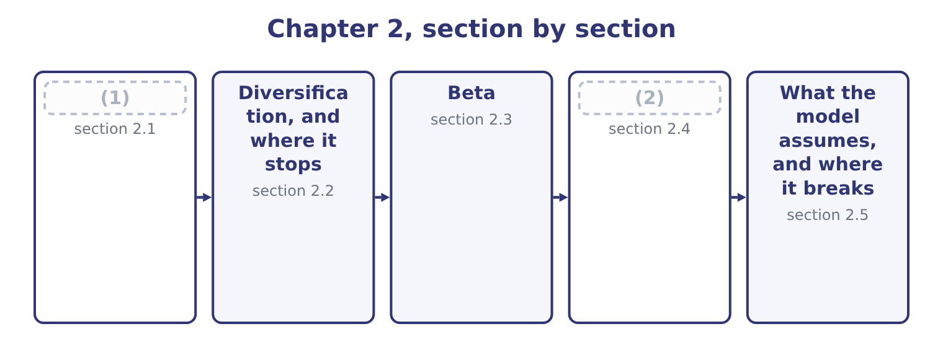
word list
From one security to a portfolio · Diversification, and where it stops · The Capital Asset Pricing Model

Summary 1 gaps 3–11
The expected return of a portfolio is the weighted average of the expected (3) of what is in it. Put 60 per cent of the money into a share expected to return 12 per cent and 40 per cent into one expected to return 8 per cent: 0.6 × 12 = 7.2 and 0.4 × 8 = 3.2, so the portfolio (4) 7.2 + 3.2 = 10.4 per cent. The risk of a portfolio is not the weighted average of the risks, and that (5) fact is the (6) of modern finance. It is less, (7) the two assets move in (8) step. The (9) is that when one is having a bad year the other may be having a good one, and the two (10) cancel. How much they cancel is (11) by the correlation coefficient, which runs from minus one to plus one.
word list
single · returns · reason · expects · measured · foundation · perfect · floor · unless · partly

Summary 2 gaps 12–13
At plus one the two move in exact (12) and nothing cancels. At zero they are (13) . At minus one they are mirror images and, in the right proportions, cancel exactly.
word list
unrelated · proportion · expects

Worked example: the same two shares, three correlations

Summary 3 gaps 14–19
Sixty per cent in a share with a standard deviation of 20 points and forty per cent in one with 10 points. The contributions are 0.6 × 20 = 12 and 0.4 × 10 = 4. Nothing (14) , so the portfolio's standard deviation is the weighted average: 12 + 4 = 16 points. The squared contributions add (15) : 12 squared is 144 and 4 squared is 16, so the variance is 144 + 16 = 160 and the standard deviation is 12.65 points. The contributions offset (16) : 12 − 4 = 8 points. The expected return is 10.4 per cent in all three cases, (17) correlation does not touch the return. Only the risk moved, from 16 points to 8, and the (18) paid nothing for the improvement. That free improvement is what the word (19) means, and it is the only free thing in finance.
word list
weight · directly · investor · because · offsets · instead · diversification

One portfolio, three correlations
The bars are drawn to scale.
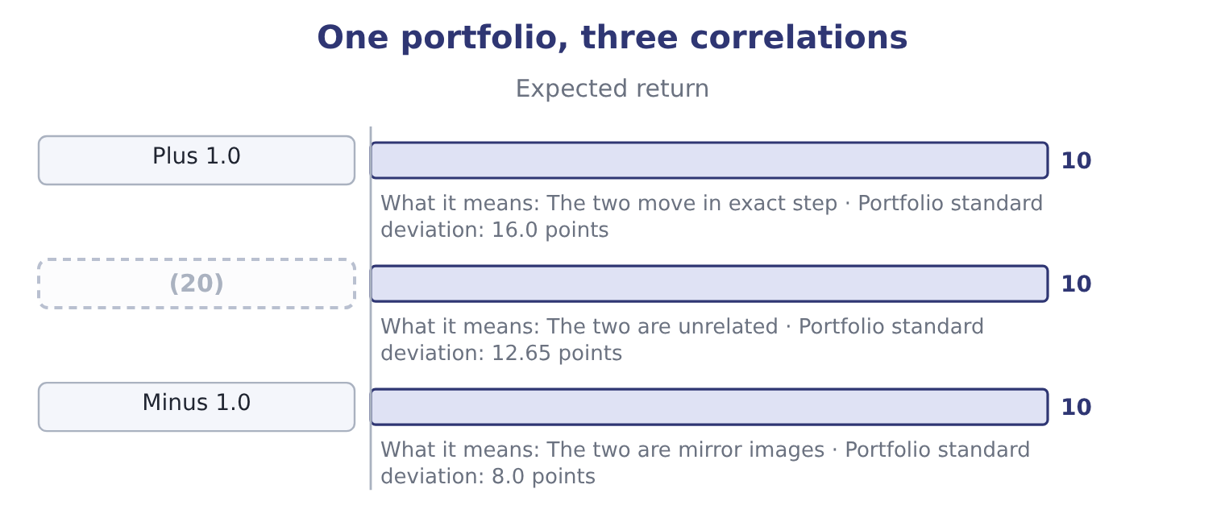
word list
Zero · equilibrium

Returns average, risks do not

Summary 4 gaps 21–25
A portfolio's expected return is (21) the weighted average. Its standard deviation is the weighted average only at a correlation of exactly plus one, and is lower (22) . Correlation of zero does not mean no risk. The variance still adds. Covariance and correlation measure the same (23) . The correlation coefficient is the covariance scaled to run (24) minus one and plus one, which is why the exam (25) it.
word list
between · otherwise · quotes · relationship · regression · always

The English this section uses, and its Arabic
Each term sits against what it means.
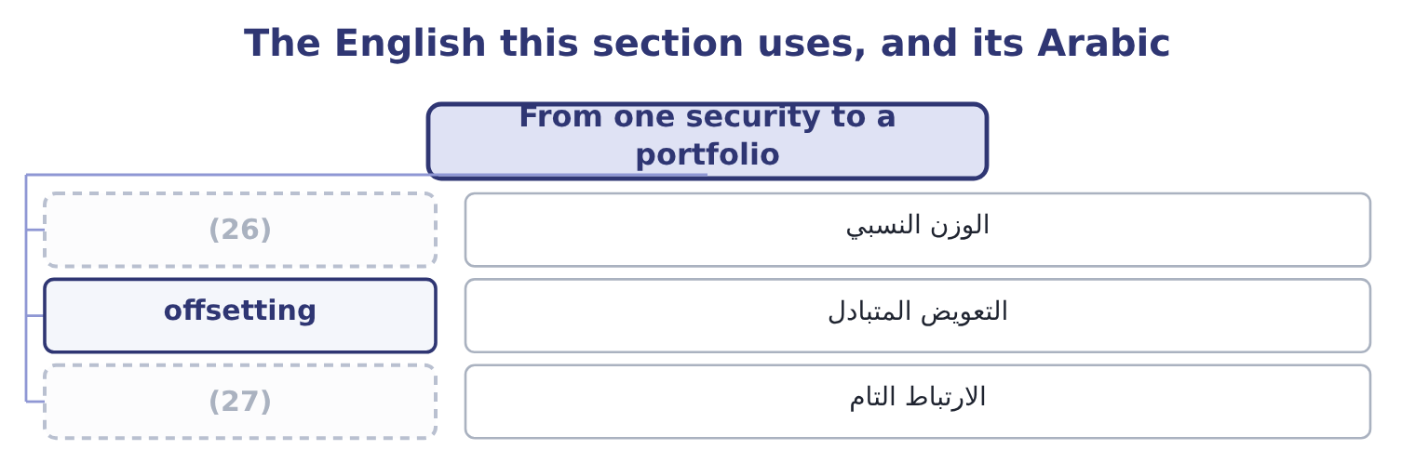
word list
الوزن النسبي · perfect correlation · weight

The English this sheet uses, and its Arabic
English (exam term) | Arabic
weight | الوزن النسبي
offsetting | التعويض المتبادل
perfect correlation | الارتباط التام

Answer key · 2.1 From one security to a portfolio

1 From one security to a portfolio | 15 instead
2 The Capital Asset Pricing Model | 16 directly
3 returns | 17 because
4 expects | 18 investor
5 single | 19 diversification
6 foundation | 20 Zero
7 unless | 21 always
8 perfect | 22 otherwise
9 reason | 23 relationship
10 partly | 24 between
11 measured | 25 quotes
12 proportion | 26 weight
13 unrelated | 27 perfect correlation
14 offsets

the summaries in full
Summary 1 The expected return of a portfolio is the weighted average of the expected returns of what is in it. Put 60 per cent of the money into a share expected to return 12 per cent and 40 per cent into one expected to return 8 per cent: 0.6 × 12 = 7.2 and 0.4 × 8 = 3.2, so the portfolio expects 7.2 + 3.2 = 10.4 per cent. The risk of a portfolio is not the weighted average of the risks, and that single fact is the foundation of modern finance. It is less, unless the two assets move in perfect step. The reason is that when one is having a bad year the other may be having a good one, and the two partly cancel. How much they cancel is measured by the correlation coefficient, which runs from minus one to plus one.
Summary 2 At plus one the two move in exact proportion and nothing cancels. At zero they are unrelated. At minus one they are mirror images and, in the right proportions, cancel exactly.
Summary 3 Sixty per cent in a share with a standard deviation of 20 points and forty per cent in one with 10 points. The contributions are 0.6 × 20 = 12 and 0.4 × 10 = 4. Nothing offsets, so the portfolio's standard deviation is the weighted average: 12 + 4 = 16 points. The squared contributions add instead: 12 squared is 144 and 4 squared is 16, so the variance is 144 + 16 = 160 and the standard deviation is 12.65 points. The contributions offset directly: 12 − 4 = 8 points. The expected return is 10.4 per cent in all three cases, because correlation does not touch the return. Only the risk moved, from 16 points to 8, and the investor paid nothing for the improvement. That free improvement is what the word diversification means, and it is the only free thing in finance.
Summary 4 A portfolio's expected return is always the weighted average. Its standard deviation is the weighted average only at a correlation of exactly plus one, and is lower otherwise. Correlation of zero does not mean no risk. The variance still adds. Covariance and correlation measure the same relationship. The correlation coefficient is the covariance scaled to run between minus one and plus one, which is why the exam quotes it.

2.2 Diversification, and where it stops
Chapter 2 · section 2.2

Fill every gap. Each word list holds one word more than there are gaps.
Summary 1 gaps 1–12
Add a third share to the two, then a tenth, then a (1) . Each new (2) brings its own company-specific risk and partly cancels the others', and the (3) standard deviation falls — quickly at first and then more slowly. It does not fall to zero. What is left when the company-specific risk has gone is the part every share has in (4) , which is the market (5) . A portfolio of fifty shares still falls in a recession, (6) a recession is not a company-specific event. The (7) numbers are worth (8) . Most of the (9) arrives within the first (10) or twenty holdings; beyond thirty, adding names changes very little. The risk that remains is the (11) risk of, and it is the floor. Three things limit diversification in (12) , and the exam names them.
word list
holding · fifteen · systematic · remembering · common · portfolio's · itself · conditions · fiftieth · benefit · practice · because · practical

Summary 2 gaps 13–22
Correlation is (13) low within one market. Shares in the same country and the same industry move together, so a portfolio of twenty food (14) is far less (15) than a portfolio of twenty companies in twenty industries. Diversification across (16) works until it is (17) . (18) holdings reduce risk in normal conditions, and (19) rise sharply in a crisis, which is when the protection was wanted. A company (20) on its own account is not doing its (21) a favour. A shareholder can buy shares in a glass works (22) and more cheaply than Orontes can buy the glass works. That is the standard objection to conglomerate acquisitions, and Book 3 returns to it.
word list
needed · manufacturers · diversified · correlations · rarely · shareholders · borders · diversifying · diversification · International · directly

What happens as holdings are added
Number of holdings | Total risk | What has gone | What remains
1 | (23) | Nothing | All company risk and all market risk
10 | Much lower | (24) | Market risk and some company risk
30 | Near the floor | (25) | Market risk
100 | (26) | All company-specific risk | Market risk only

word list
Most company-specific risk · sensitivity · Almost all company-specific risk · Highest · At the floor

The English this section uses, and its Arabic
Each term sits against what it means.
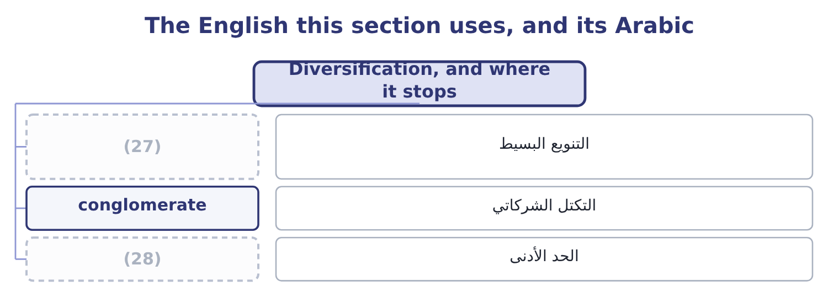
word list
covariance · floor · naive diversification

The English this sheet uses, and its Arabic
English (exam term) | Arabic
naive diversification | التنويع البسيط
conglomerate | التكتل الشركاتي
floor | الحد الأدنى

Answer key · 2.2 Diversification, and where it stops

1 fiftieth | 15 diversified
2 holding | 16 borders
3 portfolio's | 17 needed
4 common | 18 International
5 itself | 19 correlations
6 because | 20 diversifying
7 practical | 21 shareholders
8 remembering | 22 directly
9 benefit | 23 Highest
10 fifteen | 24 Most company-specific risk
11 systematic | 25 Almost all company-specific risk
12 practice | 26 At the floor
13 rarely | 27 naive diversification
14 manufacturers | 28 floor

the summaries in full
Summary 1 Add a third share to the two, then a tenth, then a fiftieth. Each new holding brings its own company-specific risk and partly cancels the others', and the portfolio's standard deviation falls — quickly at first and then more slowly. It does not fall to zero. What is left when the company-specific risk has gone is the part every share has in common, which is the market itself. A portfolio of fifty shares still falls in a recession, because a recession is not a company-specific event. The practical numbers are worth remembering. Most of the benefit arrives within the first fifteen or twenty holdings; beyond thirty, adding names changes very little. The risk that remains is the systematic risk of, and it is the floor. Three things limit diversification in practice, and the exam names them.
Summary 2 Correlation is rarely low within one market. Shares in the same country and the same industry move together, so a portfolio of twenty food manufacturers is far less diversified than a portfolio of twenty companies in twenty industries. Diversification across borders works until it is needed. International holdings reduce risk in normal conditions, and correlations rise sharply in a crisis, which is when the protection was wanted. A company diversifying on its own account is not doing its shareholders a favour. A shareholder can buy shares in a glass works directly and more cheaply than Orontes can buy the glass works. That is the standard objection to conglomerate acquisitions, and Book 3 returns to it.

2.3 Beta
Chapter 2 · section 2.3

Fill every gap. Each word list holds one word more than there are gaps.
Summary 1 gaps 1–8
If the only risk that is (1) is the part that moves with the market, then what has to be (2) is how much a given share moves with the market. That measure is beta. Beta is the sensitivity of a security's return to the return on the market as a whole. The market portfolio has a beta of 1.0 by (3) . A share with a beta of 1.5 tends to rise 15 per cent when the market rises 10 and to fall 15 when it falls 10. A share with a beta of 0.5 moves half as far in each (4) . A beta below zero is rare and means the share tends to move against the market. Three (5) matter and all three are (6) . Beta measures (7) risk only. A company can have enormous (8) risk and a low beta, because its risks have nothing to do with the economy.
word list
measured · direction · risk-free · definition · rewarded · systematic · examined · properties · company-specific

Summary 2 gaps 9–20
A gold miner is the (9) example and a (10) company in a trial is (11) . Betas are (12) additive. The beta of a portfolio is the weighted average of the betas in it: half in a share of beta 0.9 and half in one of 1.5 gives 0.5 × 0.9 = 0.45 and 0.5 × 1.5 = 0.75, so the portfolio beta is 0.45 + 0.75 = 1.20. Beta is (13) by the business and by the (14) . A company whose sales swing with the economy has a higher beta than one whose sales do not — which is why a food (15) like Orontes, (16) a staple, has a beta below 1.0 while a car maker has one above. Debt (17) it further, because the fixed interest (18) whatever the business does. That is the degree of (19) leverage of Book 1, seen in the (20) measure.
word list
driven · pharmaceutical · weighted-average · another · magnifies · standard · financial · raises · financing · conglomerate · selling · market's · manufacturer

Worked example: what a change in beta does to a price

Summary 3 gaps 21–31
A share pays a dividend of 0.60 next year, (21) at 4 per cent a year for ever. Its beta is 0.90, the (22) rate is 4 per cent and the market is (23) to return 10 per cent. The market premium is 10.0 − 4.0 = 6.0 points, and at a beta of 0.90 the premium (24) is 0.90 × 6.0 = 5.4 points, so the required return is 9.4 per cent. (25) the company (26) heavily and its beta rises to 1.20. The premium becomes 1.20 × 6.0 = 7.2 points and the required return 11.2 per cent, so the price becomes 0.60 ÷ 0.072 = 8.33. Nothing about the dividend (27) . The share fell 25 per cent because the market now (28) more to hold it, and the only thing that moved was the sensitivity of its (29) to the economy. That is the whole of what the (30) means by the (31) of a change in beta on a security's price.
word list
expected · requires · risk-free · average · impact · outcome · earned · growing · returns · borrows · changed · Suppose

What a beta says
Beta | Behaviour against the market | Typical business | Required return at rf 4%, premium 6%
1.60 | (32) | Construction, luxury goods | 13.6%
1.00 | Moves with the market | The market portfolio | 10.0%
0.90 | (33) | Food manufacturing | 9.4%
0.40 | Moves far less | (34) | 6.4%

word list
Regulated utility · risk-adjusted return · Moves 60 per cent further · Moves slightly less

The English this section uses, and its Arabic
Each term sits against what it means.
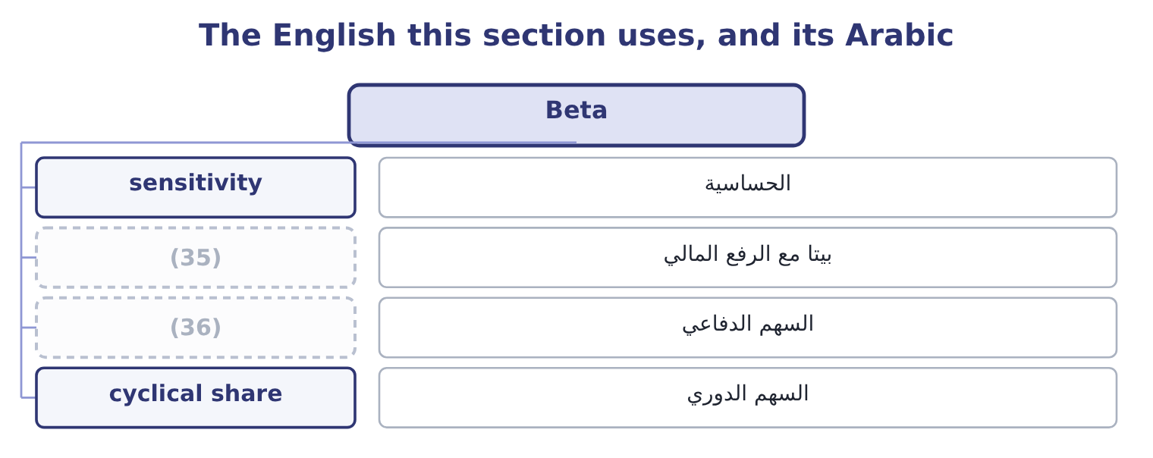
word list
السهم الدوري · levered beta · defensive share

The English this sheet uses, and its Arabic
English (exam term) | Arabic
sensitivity | الحساسية
levered beta | بيتا مع الرفع المالي
defensive share | السهم الدفاعي
cyclical share | السهم الدوري

Answer key · 2.3 Beta

1 rewarded | 19 financial
2 measured | 20 market's
3 definition | 21 growing
4 direction | 22 risk-free
5 properties | 23 expected
6 examined | 24 earned
7 systematic | 25 Suppose
8 company-specific | 26 borrows
9 standard | 27 changed
10 pharmaceutical | 28 requires
11 another | 29 returns
12 weighted-average | 30 outcome
13 driven | 31 impact
14 financing | 32 Moves 60 per cent further
15 manufacturer | 33 Moves slightly less
16 selling | 34 Regulated utility
17 raises | 35 levered beta
18 magnifies | 36 defensive share

the summaries in full
Summary 1 If the only risk that is rewarded is the part that moves with the market, then what has to be measured is how much a given share moves with the market. That measure is beta. Beta is the sensitivity of a security's return to the return on the market as a whole. The market portfolio has a beta of 1.0 by definition. A share with a beta of 1.5 tends to rise 15 per cent when the market rises 10 and to fall 15 when it falls 10. A share with a beta of 0.5 moves half as far in each direction. A beta below zero is rare and means the share tends to move against the market. Three properties matter and all three are examined. Beta measures systematic risk only. A company can have enormous company-specific risk and a low beta, because its risks have nothing to do with the economy.
Summary 2 A gold miner is the standard example and a pharmaceutical company in a trial is another. Betas are weighted-average additive. The beta of a portfolio is the weighted average of the betas in it: half in a share of beta 0.9 and half in one of 1.5 gives 0.5 × 0.9 = 0.45 and 0.5 × 1.5 = 0.75, so the portfolio beta is 0.45 + 0.75 = 1.20. Beta is driven by the business and by the financing. A company whose sales swing with the economy has a higher beta than one whose sales do not — which is why a food manufacturer like Orontes, selling a staple, has a beta below 1.0 while a car maker has one above. Debt raises it further, because the fixed interest magnifies whatever the business does. That is the degree of financial leverage of Book 1, seen in the market's measure.
Summary 3 A share pays a dividend of 0.60 next year, growing at 4 per cent a year for ever. Its beta is 0.90, the risk-free rate is 4 per cent and the market is expected to return 10 per cent. The market premium is 10.0 − 4.0 = 6.0 points, and at a beta of 0.90 the premium earned is 0.90 × 6.0 = 5.4 points, so the required return is 9.4 per cent. Suppose the company borrows heavily and its beta rises to 1.20. The premium becomes 1.20 × 6.0 = 7.2 points and the required return 11.2 per cent, so the price becomes 0.60 ÷ 0.072 = 8.33. Nothing about the dividend changed. The share fell 25 per cent because the market now requires more to hold it, and the only thing that moved was the sensitivity of its returns to the economy. That is the whole of what the outcome means by the impact of a change in beta on a security's price.

2.4 The Capital Asset Pricing Model
Chapter 2 · section 2.4

Fill every gap. Each word list holds one word more than there are gaps.
Summary 1 gaps 1–11
The model (1) the required return on any security as the risk-free rate plus beta times the market risk premium. Each of the three (2) is a question in (3) . The risk-free rate is a (4) security of (5) maturity. The market risk premium is the extra return the market as a whole is expected to earn over that rate, which is estimated from long runs of history and (6) quoted between four and six points. Beta is estimated by (7) the security's returns on the (8) , usually over five years of (9) data. Apply it to Orontes. At a risk-free rate of 4 per cent, a market premium of 6 points and a beta of 0.90, the premium (10) is 0.90 × 6.0 = 5.4 points and the required return on (11) equity is 9.4 per cent.
word list
monthly · inputs · matching · earned · typically · shareholders · states · regressing · itself · market's · government · Orontes's

Summary 2 gaps 12–23
Book 1 charged its (12) 10 per cent when it (13) economic profit, and said at the time that the figure would be (14) later. This is the (15) , and the two are close enough that the (16) there — a positive economic profit of about 1.1 million dollars — (17) either number. Drawn as a line, with beta on one axis and required return on the other, the model is the security market line. Its (18) is the risk-free rate and its slope is the market risk premium. Every (19) priced security sits on the line. A security above it (20) more return than its risk (21) and is a buy; one below it is a sell — and the act of buying and (22) moves prices until it sits on the line again, which is what the model means by (23) .
word list
requires · shareholders · correctly · equilibrium · intercept · justified · selling · outcome · conclusion · survives · computed · offers · justification

The security market line at a 4 per cent risk-free rate and a 6-point premium
The bars are drawn to scale.
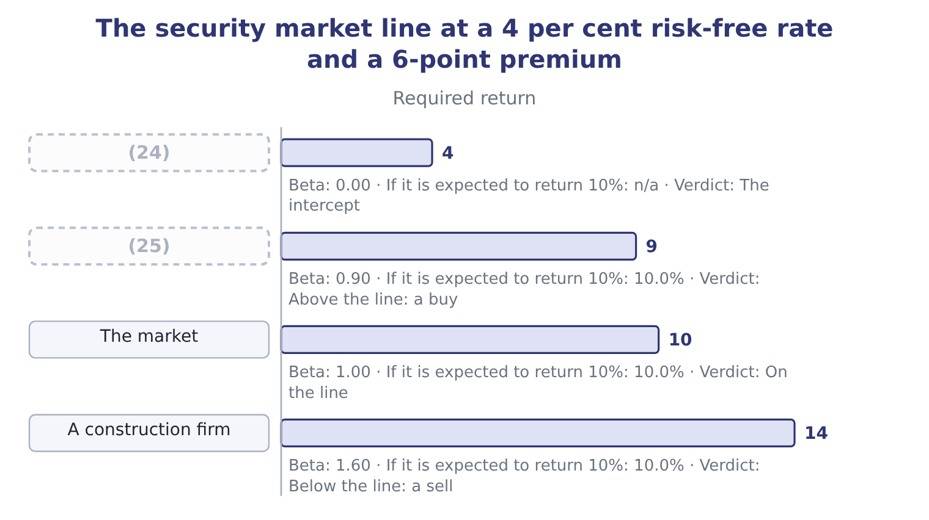
word list
Treasury bill · Orontes · defensive share

Expected against required

Summary 3 gaps 26–33
The CAPM gives the required return — what the risk (26) . The expected return is what the (27) thinks the security will (28) . The comparison of the two is the (29) decision, and a question that gives you both is asking for (30) that comparison. The market risk premium is the market return less the risk-free rate, not the market return. (31) beta by the whole market return is the commonest (32) error on this (33) . A beta of zero gives the risk-free rate, not a zero return.
word list
deliver · Multiplying · expected · arithmetic · exactly · deserves · investment · outcome · analyst

The English this section uses, and its Arabic
Each term sits against what it means.
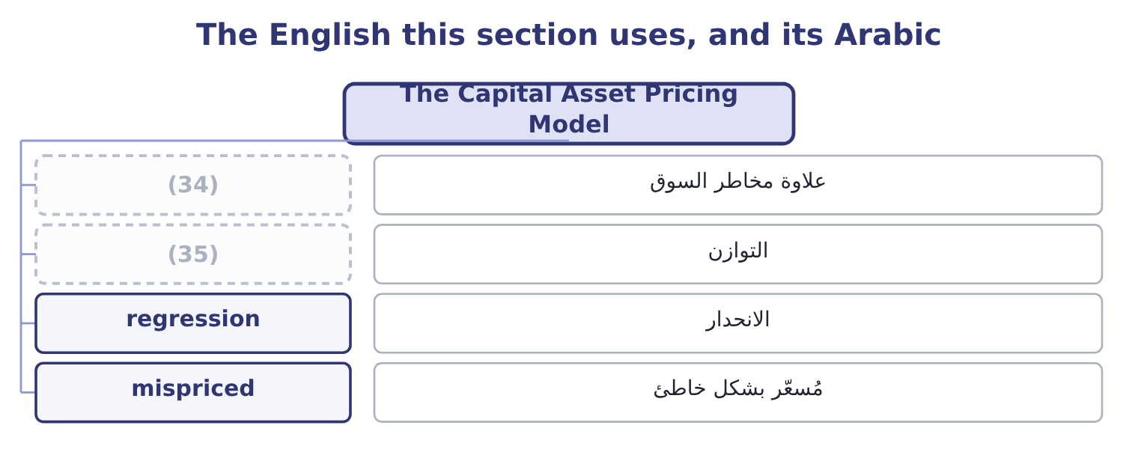
word list
portfolio · equilibrium · market risk premium

The English this sheet uses, and its Arabic
English (exam term) | Arabic
market risk premium | علاوة مخاطر السوق
equilibrium | التوازن
regression | الانحدار
mispriced | مُسعّر بشكل خاطئ

Answer key · 2.4 The Capital Asset Pricing Model

1 states | 19 correctly
2 inputs | 20 offers
3 itself | 21 requires
4 government | 22 selling
5 matching | 23 equilibrium
6 typically | 24 Treasury bill
7 regressing | 25 Orontes
8 market's | 26 deserves
9 monthly | 27 analyst
10 earned | 28 deliver
11 Orontes's | 29 investment
12 shareholders | 30 exactly
13 computed | 31 Multiplying
14 justified | 32 arithmetic
15 justification | 33 outcome
16 conclusion | 34 market risk premium
17 survives | 35 equilibrium
18 intercept

the summaries in full
Summary 1 The model states the required return on any security as the risk-free rate plus beta times the market risk premium. Each of the three inputs is a question in itself. The risk-free rate is a government security of matching maturity. The market risk premium is the extra return the market as a whole is expected to earn over that rate, which is estimated from long runs of history and typically quoted between four and six points. Beta is estimated by regressing the security's returns on the market's, usually over five years of monthly data. Apply it to Orontes. At a risk-free rate of 4 per cent, a market premium of 6 points and a beta of 0.90, the premium earned is 0.90 × 6.0 = 5.4 points and the required return on Orontes's equity is 9.4 per cent.
Summary 2 Book 1 charged its shareholders 10 per cent when it computed economic profit, and said at the time that the figure would be justified later. This is the justification, and the two are close enough that the conclusion there — a positive economic profit of about 1.1 million dollars — survives either number. Drawn as a line, with beta on one axis and required return on the other, the model is the security market line. Its intercept is the risk-free rate and its slope is the market risk premium. Every correctly priced security sits on the line. A security above it offers more return than its risk requires and is a buy; one below it is a sell — and the act of buying and selling moves prices until it sits on the line again, which is what the model means by equilibrium.
Summary 3 The CAPM gives the required return — what the risk deserves. The expected return is what the analyst thinks the security will deliver. The comparison of the two is the investment decision, and a question that gives you both is asking for exactly that comparison. The market risk premium is the market return less the risk-free rate, not the market return. Multiplying beta by the whole market return is the commonest arithmetic error on this outcome. A beta of zero gives the risk-free rate, not a zero return.

2.5 What the model assumes, and where it breaks
Chapter 2 · section 2.5

Fill every gap. Each word list holds one word more than there are gaps.
Summary 1 gaps 1–12
The CAPM is used (1) and believed nowhere (2) , and the exam expects both halves. The assumptions are (3) . Investors are rational and (4) , hold diversified portfolios, agree about the expected returns and risks of everything, can borrow and lend freely at the risk-free rate, pay no taxes or (5) costs, and act over one period. None of these is true. The measurement (6) are worse than the assumptions. The market (7) should contain every risky asset in the world, including property, private (8) and human capital; in practice an index of large listed shares stands in for it. Beta is estimated from the past and is (9) : a beta measured over the last five years may (10) a company that no longer exists in that form. And the market risk premium cannot be observed at all, only estimated, with (11) estimates ranging from about three points to about seven — a spread that moves a required return by four points and a (12) by far more.
word list
valuation · completely · portfolio · reputable · strong · describe · transaction · unstable · problems · businesses · pricing · risk-averse · everywhere

Summary 2 gaps 13–22
What (13) all that is the structure, which is why the model is still (14) . Return should rise with risk; only (15) risk should be rewarded; and the compensation for risk should be proportional to the (16) . (17) exist — multi-factor models adding size, value and momentum factors, and the arbitrage pricing theory, which allows several sources of (18) risk — and all of them keep that structure and refine the measurement. For a (19) , three practical rules (20) . Use the model when the (21) gives you its three inputs. State the inputs you used. And treat the output as a required return for a decision, not as a (22) of next year.
word list
follow · prediction · Alternatives · proxy · systematic · candidate · survives · question · sensitivity · non-diversifiable · taught

Apply the model

Summary 3 gaps 23–24
Complete the (23) , taking the (24) rate as 3 per cent and the expected market return as 9 per cent.
word list
blanks · risk-free · portfolio

Your turn: required returns (complete the blanks)
The bars are drawn to scale.
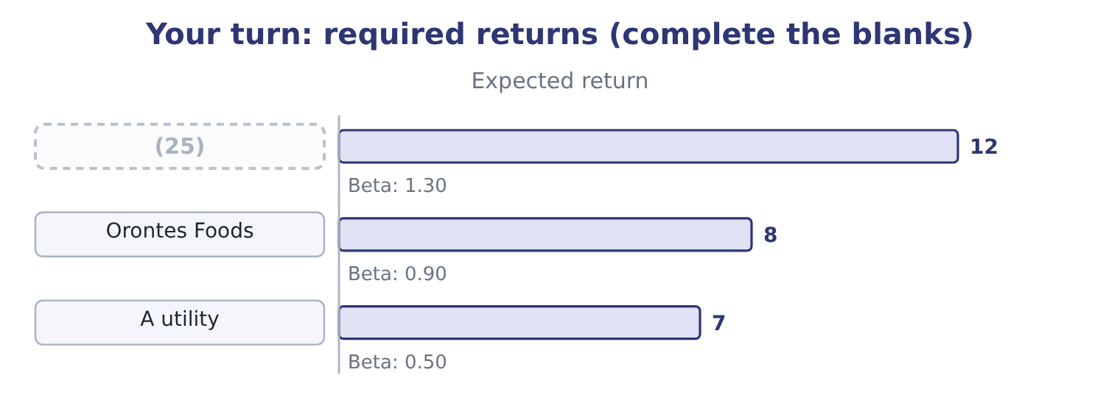
word list
Barada Wholesale · correlation coefficient

"Expected"

Summary 4 gaps 26–32
English expected in finance means the (26) average of the (27) , not what anybody (28) in the ordinary sense and not what is (29) . An expected return of 8.5 per cent can be an outcome that cannot occur at all, as it was. Note the pairing the exam relies on: expected return against required return, where the first is a (30) and the second is a (31) , and reading either as the other reverses the (32) conclusion.
word list
anticipates · probability-weighted · likely · outcomes · ranging · forecast · standard · buy-or-sell

The English this section uses, and its Arabic
Each term sits against what it means.
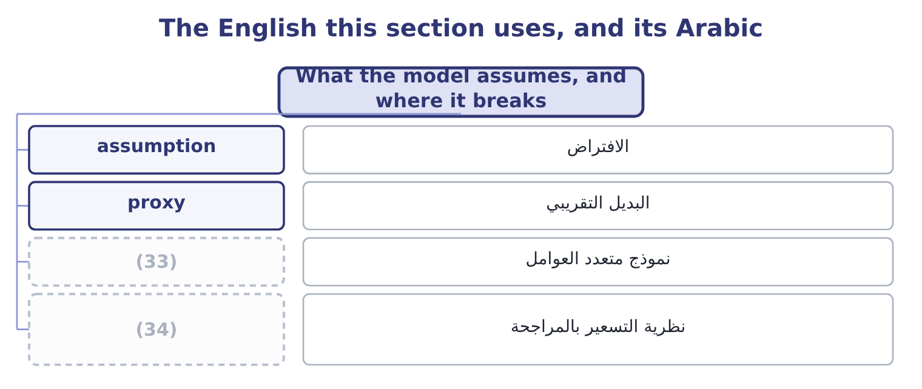
word list
multi-factor model · market portfolio · arbitrage pricing theory

The English this sheet uses, and its Arabic
English (exam term) | Arabic
assumption | الافتراض
proxy | البديل التقريبي
multi-factor model | نموذج متعدد العوامل
arbitrage pricing theory | نظرية التسعير بالمراجحة

Answer key · 2.5 What the model assumes, and where it breaks

1 everywhere | 18 systematic
2 completely | 19 candidate
3 strong | 20 follow
4 risk-averse | 21 question
5 transaction | 22 prediction
6 problems | 23 blanks
7 portfolio | 24 risk-free
8 businesses | 25 Barada Wholesale
9 unstable | 26 probability-weighted
10 describe | 27 outcomes
11 reputable | 28 anticipates
12 valuation | 29 likely
13 survives | 30 forecast
14 taught | 31 standard
15 non-diversifiable | 32 buy-or-sell
16 sensitivity | 33 multi-factor model
17 Alternatives | 34 arbitrage pricing theory

the summaries in full
Summary 1 The CAPM is used everywhere and believed nowhere completely, and the exam expects both halves. The assumptions are strong. Investors are rational and risk-averse, hold diversified portfolios, agree about the expected returns and risks of everything, can borrow and lend freely at the risk-free rate, pay no taxes or transaction costs, and act over one period. None of these is true. The measurement problems are worse than the assumptions. The market portfolio should contain every risky asset in the world, including property, private businesses and human capital; in practice an index of large listed shares stands in for it. Beta is estimated from the past and is unstable: a beta measured over the last five years may describe a company that no longer exists in that form. And the market risk premium cannot be observed at all, only estimated, with reputable estimates ranging from about three points to about seven — a spread that moves a required return by four points and a valuation by far more.
Summary 2 What survives all that is the structure, which is why the model is still taught. Return should rise with risk; only non-diversifiable risk should be rewarded; and the compensation for risk should be proportional to the sensitivity. Alternatives exist — multi-factor models adding size, value and momentum factors, and the arbitrage pricing theory, which allows several sources of systematic risk — and all of them keep that structure and refine the measurement. For a candidate, three practical rules follow. Use the model when the question gives you its three inputs. State the inputs you used. And treat the output as a required return for a decision, not as a prediction of next year.
Summary 3 Complete the blanks, taking the risk-free rate as 3 per cent and the expected market return as 9 per cent.
Summary 4 English expected in finance means the probability-weighted average of the outcomes, not what anybody anticipates in the ordinary sense and not what is likely. An expected return of 8.5 per cent can be an outcome that cannot occur at all, as it was. Note the pairing the exam relies on: expected return against required return, where the first is a forecast and the second is a standard, and reading either as the other reverses the buy-or-sell conclusion.

3.1 The term structure of interest rates
Chapter 3 · section 3.1

Fill every gap. Each word list holds one word more than there are gaps.
Chapter 3, section by section
Each stage leads to the next.
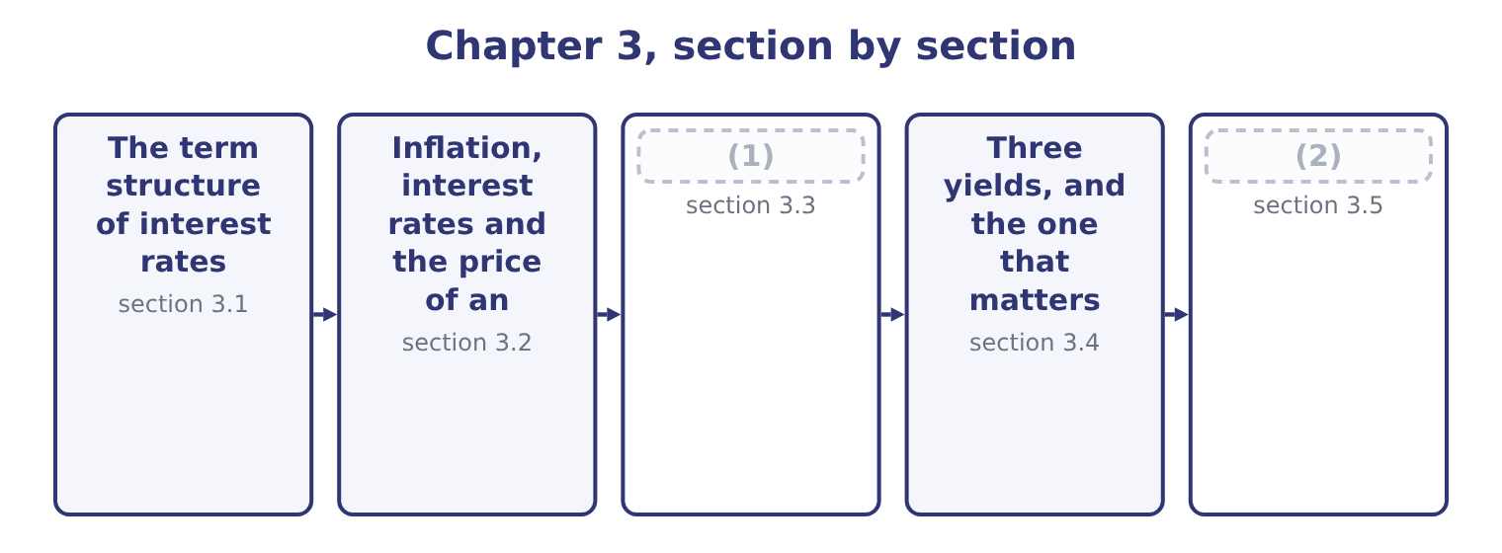
word list
The term structure of interest rates · What a bond is · Reading the structure as a borrower

Summary 1 gaps 3–13
Plot the yield on government securities (3) their maturity and the (4) is the yield curve. It is normally upward-sloping: a (5) security yields more than a one-year one. It can be flat, and (6) it inverts, with short rates above long ones. Three (7) explain the shape, and the exam names all three. The expectations theory says long rates are (8) of expected (9) short rates. If one-year money costs 4 per cent now and is expected to cost 6 per cent next year, then (10) money must cost about the same as (11) over: 1.04 × 1.06 = 1.1024, which is about 4.99 per cent a year. On this theory an upward-sloping curve means the market expects rates to rise, and an inverted curve means it expects them to fall — which is why an (12) is watched as a recession signal, since rates fall when the (13) weakens.
word list
economy · theories · occasionally · against · quality · two-year · result · inversion · ten-year · future · rolling · averages

Summary 2 gaps 14–23
The liquidity (14) theory adds that lenders (15) tying money up and (16) a premium for length, so the curve slopes upward even when no change in rates is expected. This (17) why upward slopes are the normal case rather than the (18) one. The market (19) theory says that borrowers and lenders have preferred (20) — a pension fund wants (21) assets, a company financing stock wants ninety-day money — and that rates in each segment are set by supply and demand there. On this theory the curve can take any shape at all, and a large government issue at one maturity can move that part of the curve (22) telling you (23) about expectations.
word list
require · thirty-year · anything · explains · without · segmentation · maturity · preference · maturities · occasional · dislike

Three yield curves and what each is taken to mean
Shape | Short rates | Long rates | Usual reading
Upward-sloping | Lower | (24) | Normal: a term premium, or rates expected to rise
Flat | Equal | Equal | (25)
Inverted | Higher | Lower | (26)

word list
premium · Higher · Rates expected to hold; a turning point · Rates expected to fall; often a recession signal

Summary 3 gaps 27–31
The curve moves for the (27) the outcome asks about. A central bank raising its policy rate lifts the short end (28) . A rise in expected (29) lifts the whole curve, and the long end most. A (30) to safety in a crisis pushes money into government securities and pushes long yields down. And a government (31) heavily at one maturity lifts that segment.
word list
flight · inflation · directly · borrowing · government · reasons

Yield curve questions are about direction

Summary 4 gaps 32–37
The exam (32) asks you to draw a curve. It asks what a stated change does to it, or what a stated shape (33) . A curve is drawn for one credit (34) , normally government. A (35) curve sits above it by the credit spread, and the spread itself widens in a downturn. An inverted curve is a signal, not a (36) . It (37) nothing on its own.
word list
securities · corporate · implies · mechanism · rarely · quality · predicts

The English this section uses, and its Arabic
Each term sits against what it means.
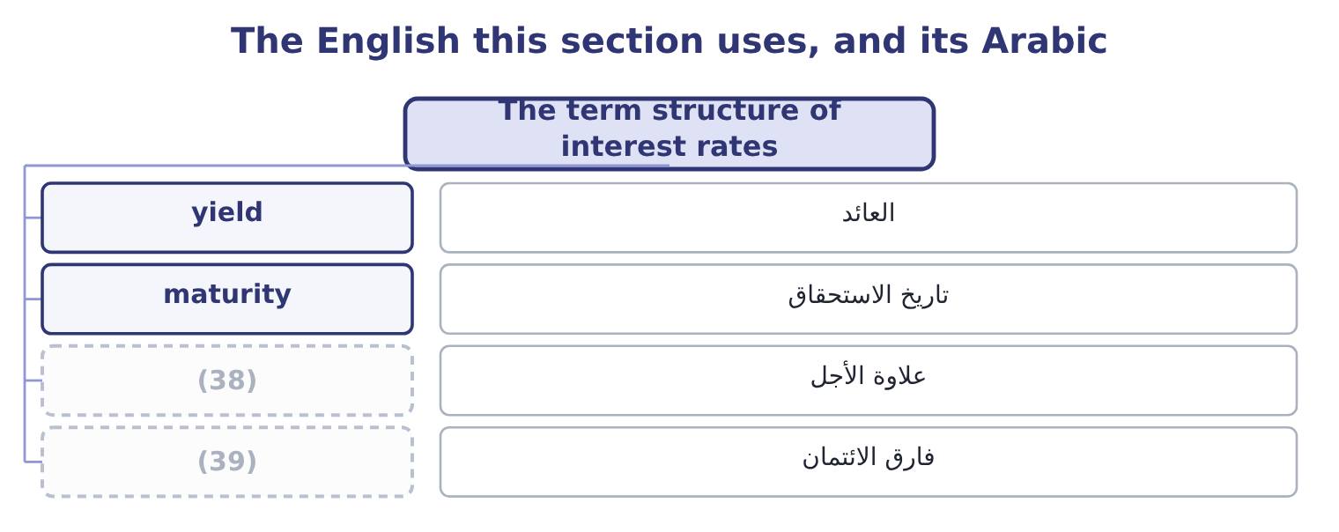
word list
تاريخ الاستحقاق · credit spread · term premium

The English this sheet uses, and its Arabic
English (exam term) | Arabic
yield | العائد
maturity | تاريخ الاستحقاق
term premium | علاوة الأجل
credit spread | فارق الائتمان

Answer key · 3.1 The term structure of interest rates

1 What a bond is | 21 thirty-year
2 Reading the structure as a borrower | 22 without
3 against | 23 anything
4 result | 24 Higher
5 ten-year | 25 Rates expected to hold; a turning point
6 occasionally | 26 Rates expected to fall; often a recession signal
7 theories | 27 reasons
8 averages | 28 directly
9 future | 29 inflation
10 two-year | 30 flight
11 rolling | 31 borrowing
12 inversion | 32 rarely
13 economy | 33 implies
14 preference | 34 quality
15 dislike | 35 corporate
16 require | 36 mechanism
17 explains | 37 predicts
18 occasional | 38 term premium
19 segmentation | 39 credit spread
20 maturities

the summaries in full
Summary 1 Plot the yield on government securities against their maturity and the result is the yield curve. It is normally upward-sloping: a ten-year security yields more than a one-year one. It can be flat, and occasionally it inverts, with short rates above long ones. Three theories explain the shape, and the exam names all three. The expectations theory says long rates are averages of expected future short rates. If one-year money costs 4 per cent now and is expected to cost 6 per cent next year, then two-year money must cost about the same as rolling over: 1.04 × 1.06 = 1.1024, which is about 4.99 per cent a year. On this theory an upward-sloping curve means the market expects rates to rise, and an inverted curve means it expects them to fall — which is why an inversion is watched as a recession signal, since rates fall when the economy weakens.
Summary 2 The liquidity preference theory adds that lenders dislike tying money up and require a premium for length, so the curve slopes upward even when no change in rates is expected. This explains why upward slopes are the normal case rather than the occasional one. The market segmentation theory says that borrowers and lenders have preferred maturities — a pension fund wants thirty-year assets, a company financing stock wants ninety-day money — and that rates in each segment are set by supply and demand there. On this theory the curve can take any shape at all, and a large government issue at one maturity can move that part of the curve without telling you anything about expectations.
Summary 3 The curve moves for the reasons the outcome asks about. A central bank raising its policy rate lifts the short end directly. A rise in expected inflation lifts the whole curve, and the long end most. A flight to safety in a crisis pushes money into government securities and pushes long yields down. And a government borrowing heavily at one maturity lifts that segment.
Summary 4 The exam rarely asks you to draw a curve. It asks what a stated change does to it, or what a stated shape implies. A curve is drawn for one credit quality, normally government. A corporate curve sits above it by the credit spread, and the spread itself widens in a downturn. An inverted curve is a signal, not a mechanism. It predicts nothing on its own.

3.2 Inflation, interest rates and the price of an instrument
Chapter 3 · section 3.2

Fill every gap. Each word list holds one word more than there are gaps.
Summary 1 gaps 1–12
A lender gives up money now and gets money back later. If prices rise in between, the money that comes back buys less, so the lender requires compensation for the loss (1) any compensation for risk. That is why every nominal (2) rate contains an inflation expectation. The relationship is the Fisher effect, and it is (3) rather than (4) . A lender (5) a real return of 2 per cent who (6) inflation of 3 per cent requires 1.02 × 1.03 = 1.0506, that is 5.06 per cent. The (7) everybody uses, 2.0 + 3.0 = 5.0 per cent, is close at low rates and wrong by a full point at the rates of a (8) economy. Two (9) matter for the exam. Only expected inflation is in the rate. Inflation that was not expected (10) wealth: between a borrower and a lender at a fixed rate, (11) inflation makes the borrower better off and the lender worse off, because the fixed payments are made in cheaper money. That is the point Book 1, (12) from the other side.
word list
transfers · consequences · high-inflation · reached · approximation · unexpected · interest · multiplicative · before · wanting · additive · promised · expects

Summary 2 gaps 13–23
A (13) in the expectation moves prices now. A fixed-rate instrument promises fixed (14) . If the (15) required return rises, the only thing that can (16) is the price, and it falls. If the required return falls, the price rises. This (17) relationship between rates and the price of a (18) instrument is the most important (19) fact in Section B. A (20) bond with a par value of $1,000 and a 6 per cent (21) coupon pays $60 a year and $1,000 at the end. Rates equal the coupon. If the market requires 6 per cent, the promised payments are worth (22) what the bond promises to repay and the bond trades at par, $1,000. If the market now requires 7 per cent, (23) will pay $1,000 for a 6 per cent coupon when a new bond pays 7.
word list
five-year · inverse · exactly · amounts · because · mechanical · fixed-income · nobody · market's · change · adjust · annual

Summary 3 gaps 24–29
The price falls until the total return (24) : a little under $960 on these terms, and the bond trades at a discount. If the market requires 5 per cent, the 6 per cent coupon is worth (25) and the price rises above par, to a little over $1,040. The bond trades at a premium. (26) about the issuer (27) in any of the three cases. The coupon is fixed, the maturity is fixed, and the price did all the (28) . The yield to maturity — the rate that makes the promised payments worth the market price — is 6, 7 and 5 per cent in the three cases, and it is the number a buyer (29) earns.
word list
moving · actually · having · matches · changed · discount · Nothing

Price, coupon and the market rate
Market required return | Price against par | Called | Coupon rate against yield
Below the coupon rate | Above par | (30) | Coupon higher than yield
Equal to the coupon rate | At par | (31) | Coupon equals yield
Above the coupon rate | (32) | A discount bond | Coupon lower than yield

word list
A premium bond · Above par · Below par · A par bond

Summary 4 gaps 33–39
Inflation (33) shares as well, and less (34) . A company whose prices rise with inflation (35) the cost on and its nominal earnings grow; one locked into fixed (36) prices does not. Higher nominal rates also raise the discount rate (37) to those earnings, which (38) the value of a given stream. Which effect (39) is an empirical question and the exam treats shares as a partial inflation hedge: better than a fixed-rate bond, worse than an asset whose price moves with the price level directly.
word list
applied · passes · reaches · promised · selling · dominates · lowers · predictably

The English this section uses, and its Arabic
Each term sits against what it means.
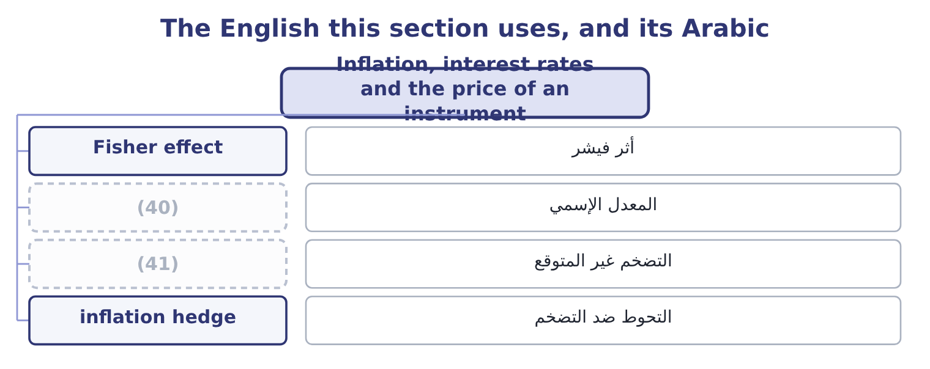
word list
term premium · nominal rate · unexpected inflation

The English this sheet uses, and its Arabic
English (exam term) | Arabic
Fisher effect | أثر فيشر
nominal rate | المعدل الإسمي
unexpected inflation | التضخم غير المتوقع
inflation hedge | التحوط ضد التضخم

Answer key · 3.2 Inflation, interest rates and the price of an instrument

1 before | 22 exactly
2 interest | 23 nobody
3 multiplicative | 24 matches
4 additive | 25 having
5 wanting | 26 Nothing
6 expects | 27 changed
7 approximation | 28 moving
8 high-inflation | 29 actually
9 consequences | 30 A premium bond
10 transfers | 31 A par bond
11 unexpected | 32 Below par
12 reached | 33 reaches
13 change | 34 predictably
14 amounts | 35 passes
15 market's | 36 selling
16 adjust | 37 applied
17 inverse | 38 lowers
18 fixed-income | 39 dominates
19 mechanical | 40 nominal rate
20 five-year | 41 unexpected inflation
21 annual

the summaries in full
Summary 1 A lender gives up money now and gets money back later. If prices rise in between, the money that comes back buys less, so the lender requires compensation for the loss before any compensation for risk. That is why every nominal interest rate contains an inflation expectation. The relationship is the Fisher effect, and it is multiplicative rather than additive. A lender wanting a real return of 2 per cent who expects inflation of 3 per cent requires 1.02 × 1.03 = 1.0506, that is 5.06 per cent. The approximation everybody uses, 2.0 + 3.0 = 5.0 per cent, is close at low rates and wrong by a full point at the rates of a high-inflation economy. Two consequences matter for the exam. Only expected inflation is in the rate. Inflation that was not expected transfers wealth: between a borrower and a lender at a fixed rate, unexpected inflation makes the borrower better off and the lender worse off, because the fixed payments are made in cheaper money. That is the point Book 1, reached from the other side.
Summary 2 A change in the expectation moves prices now. A fixed-rate instrument promises fixed amounts. If the market's required return rises, the only thing that can adjust is the price, and it falls. If the required return falls, the price rises. This inverse relationship between rates and the price of a fixed-income instrument is the most important mechanical fact in Section B. A five-year bond with a par value of $1,000 and a 6 per cent annual coupon pays $60 a year and $1,000 at the end. Rates equal the coupon. If the market requires 6 per cent, the promised payments are worth exactly what the bond promises to repay and the bond trades at par, $1,000. If the market now requires 7 per cent, nobody will pay $1,000 for a 6 per cent coupon when a new bond pays 7.
Summary 3 The price falls until the total return matches: a little under $960 on these terms, and the bond trades at a discount. If the market requires 5 per cent, the 6 per cent coupon is worth having and the price rises above par, to a little over $1,040. The bond trades at a premium. Nothing about the issuer changed in any of the three cases. The coupon is fixed, the maturity is fixed, and the price did all the moving. The yield to maturity — the rate that makes the promised payments worth the market price — is 6, 7 and 5 per cent in the three cases, and it is the number a buyer actually earns.
Summary 4 Inflation reaches shares as well, and less predictably. A company whose prices rise with inflation passes the cost on and its nominal earnings grow; one locked into fixed selling prices does not. Higher nominal rates also raise the discount rate applied to those earnings, which lowers the value of a given stream. Which effect dominates is an empirical question and the exam treats shares as a partial inflation hedge: better than a fixed-rate bond, worse than an asset whose price moves with the price level directly.

3.3 What a bond is
Chapter 3 · section 3.3

Fill every gap. Each word list holds one word more than there are gaps.
Summary 1 gaps 1–12
A bond is a contract to pay stated (1) on stated dates. (2) else about it is a feature, and the exam asks for the (3) by name. Par value, also (4) face value or principal, is the amount repaid at maturity and the base on which the coupon is (5) . The (6) is $1,000 in the (7) States. Maturity is the date the principal is repaid. (8) paper runs to a year, notes to about ten, bonds beyond that; the terms overlap and the exam uses (9) the question says. The coupon rate is the (10) interest as a (11) of par. A 6 per cent coupon on a $1,000 bond pays $60 a year, usually in two instalments of $30. A (12) bond pays nothing until maturity and is sold at a deep discount, so the whole return is the rise to par.
word list
features · zero-coupon · percentage · Everything · insurance · called · computed · amounts · convention · annual · whatever · United · Short-term

Summary 2 gaps 13–24
A (13) note resets its coupon (14) against a reference rate, which removes most of the price risk and gives the holder rate risk instead. (15) provisions say how and when the principal comes back. A call provision lets the issuer repay early, (16) at a stated premium above par, and it is (17) to the issuer and costly to the holder: the issuer will call when rates have fallen, which is exactly when the holder would rather keep the bond. A put provision is the mirror image, (18) the holder (19) early repayment. A sinking fund (20) the issuer to retire part of the issue each year, which reduces the risk of a single large repayment and is usually (21) by holders. (22) bonds mature in instalments by (23) . Conversion provisions let the holder (24) the bond for a fixed number of shares.
word list
demand · letting · floating-rate · exchange · normally · requires · Serial · welcomed · principal · periodically · valuable · Redemption · design

Summary 3 gaps 25–36
The option is worth something, so a (25) carries a lower coupon than the same (26) ordinary debt. Covenants are promises in the (27) , which is the contract (28) the issuer and the trustee acting for the holders. (29) covenants require the issuer to do something: maintain insurance, supply audited (30) , keep a current ratio above a stated figure. Negative covenants forbid something: further (31) beyond a stated debt-to-equity ratio, the sale of major assets, (32) beyond a limit. Book 1 met one of these when Barada (33) a debt-to-equity (34) at 1.50 and the bank waived it. (35) ranks the claim. A mortgage bond is secured on named property; a (36) is unsecured and relies on the general credit of the issuer; subordinated debt stands behind other debt in a liquidation. The weaker the claim, the higher the coupon.
word list
debenture · Affirmative · covenant · between · indenture · convertible · company's · premium · dividends · breached · borrowing · statements · Security

The anatomy of a bond
Every item belongs to exactly one group.
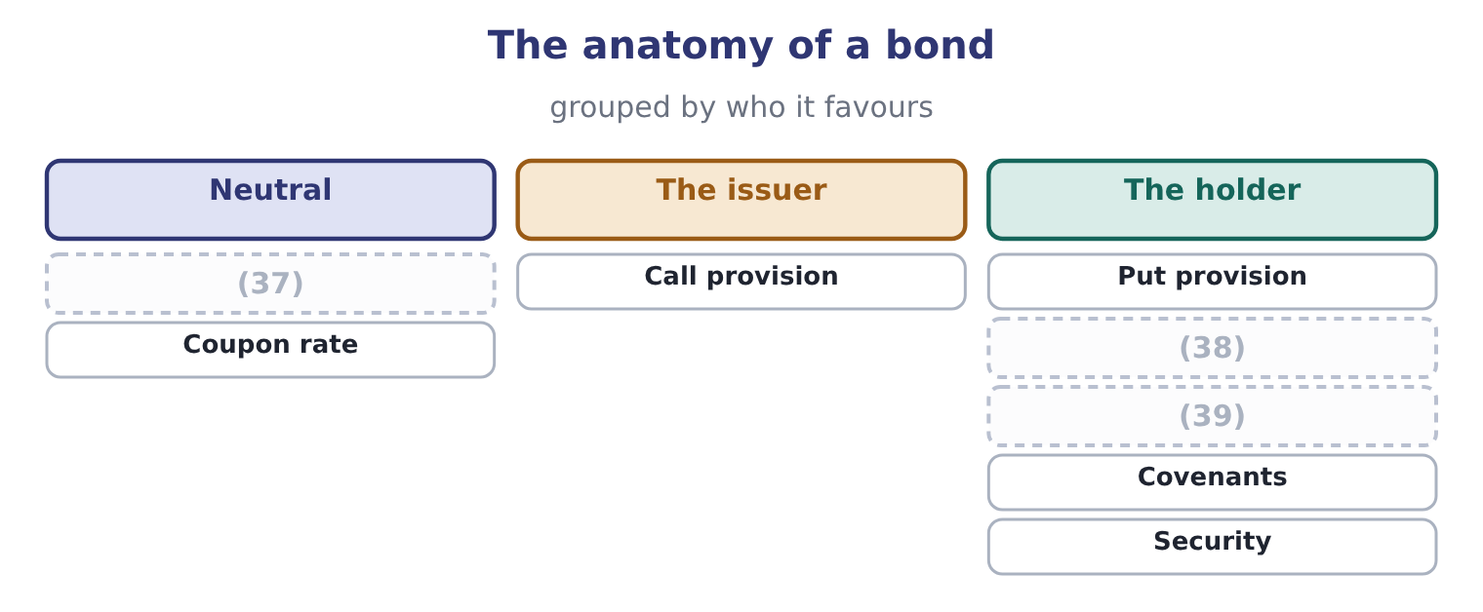
word list
Sinking fund · Conversion · Par value and maturity · indenture

Coupon rate is not yield

Summary 4 gaps 40–45
The coupon rate is fixed at issue and never (40) . The current yield is the coupon over the current price. The yield to maturity is the return (41) by a buyer (42) to maturity, and it is the one that (43) "what does this bond pay now". A call provision (44) the coupon the issuer must offer, because it takes something from the holder. A sinking fund and a conversion right lower it, because they give something. A bond (45) at a discount has a yield above its coupon rate; at a premium, below.
word list
answers · holding · earned · discount · trading · changes · raises

The English this section uses, and its Arabic
Each term sits against what it means.
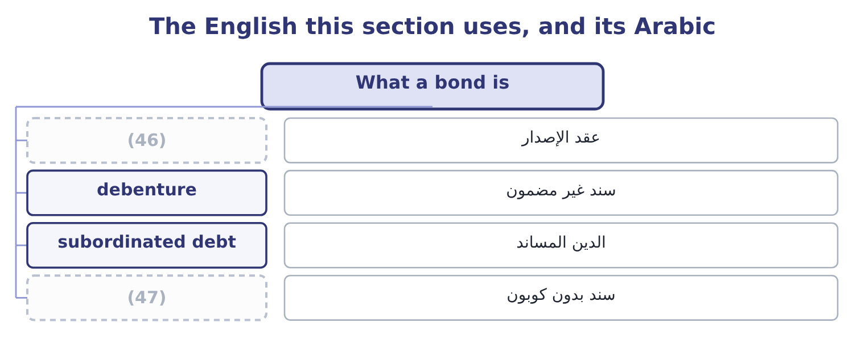
word list
indenture · subordinated debt · zero-coupon bond

The English this sheet uses, and its Arabic
English (exam term) | Arabic
indenture | عقد الإصدار
debenture | سند غير مضمون
subordinated debt | الدين المساند
zero-coupon bond | سند بدون كوبون

Answer key · 3.3 What a bond is

1 amounts | 25 convertible
2 Everything | 26 company's
3 features | 27 indenture
4 called | 28 between
5 computed | 29 Affirmative
6 convention | 30 statements
7 United | 31 borrowing
8 Short-term | 32 dividends
9 whatever | 33 breached
10 annual | 34 covenant
11 percentage | 35 Security
12 zero-coupon | 36 debenture
13 floating-rate | 37 Par value and maturity
14 periodically | 38 Sinking fund
15 Redemption | 39 Conversion
16 normally | 40 changes
17 valuable | 41 earned
18 letting | 42 holding
19 demand | 43 answers
20 requires | 44 raises
21 welcomed | 45 trading
22 Serial | 46 indenture
23 design | 47 zero-coupon bond
24 exchange

the summaries in full
Summary 1 A bond is a contract to pay stated amounts on stated dates. Everything else about it is a feature, and the exam asks for the features by name. Par value, also called face value or principal, is the amount repaid at maturity and the base on which the coupon is computed. The convention is $1,000 in the United States. Maturity is the date the principal is repaid. Short-term paper runs to a year, notes to about ten, bonds beyond that; the terms overlap and the exam uses whatever the question says. The coupon rate is the annual interest as a percentage of par. A 6 per cent coupon on a $1,000 bond pays $60 a year, usually in two instalments of $30. A zero-coupon bond pays nothing until maturity and is sold at a deep discount, so the whole return is the rise to par.
Summary 2 A floating-rate note resets its coupon periodically against a reference rate, which removes most of the price risk and gives the holder rate risk instead. Redemption provisions say how and when the principal comes back. A call provision lets the issuer repay early, normally at a stated premium above par, and it is valuable to the issuer and costly to the holder: the issuer will call when rates have fallen, which is exactly when the holder would rather keep the bond. A put provision is the mirror image, letting the holder demand early repayment. A sinking fund requires the issuer to retire part of the issue each year, which reduces the risk of a single large repayment and is usually welcomed by holders. Serial bonds mature in instalments by design. Conversion provisions let the holder exchange the bond for a fixed number of shares.
Summary 3 The option is worth something, so a convertible carries a lower coupon than the same company's ordinary debt. Covenants are promises in the indenture, which is the contract between the issuer and the trustee acting for the holders. Affirmative covenants require the issuer to do something: maintain insurance, supply audited statements, keep a current ratio above a stated figure. Negative covenants forbid something: further borrowing beyond a stated debt-to-equity ratio, the sale of major assets, dividends beyond a limit. Book 1 met one of these when Barada breached a debt-to-equity covenant at 1.50 and the bank waived it. Security ranks the claim. A mortgage bond is secured on named property; a debenture is unsecured and relies on the general credit of the issuer; subordinated debt stands behind other debt in a liquidation. The weaker the claim, the higher the coupon.
Summary 4 The coupon rate is fixed at issue and never changes. The current yield is the coupon over the current price. The yield to maturity is the return earned by a buyer holding to maturity, and it is the one that answers "what does this bond pay now". A call provision raises the coupon the issuer must offer, because it takes something from the holder. A sinking fund and a conversion right lower it, because they give something. A bond trading at a discount has a yield above its coupon rate; at a premium, below.

3.4 Three yields, and the one that matters
Chapter 3 · section 3.4

Fill every gap. Each word list holds one word more than there are gaps.
Summary 1 gaps 1–12
A bond (1) at $950 with a 6 per cent coupon and five years to run has three rates (2) to it, and the exam will use all three in one question. The coupon rate is 6 per cent, fixed at issue on the par value. It tells you the cash (3) , $60 a year, and (4) about what a buyer earns. The current yield is the coupon over the market price: 60 ÷ 950 = 6.32 per cent. It is a quick measure of the cash return and it ignores the $50 the (5) will gain when $1,000 is (6) . The yield to maturity is the rate that makes all the (7) payments worth (8) $950 today. It is found properly by trial or by a calculator, and the exam accepts a standard (9) : the annual coupon plus the annual (10) of the discount, over the average of par and price. Here the discount is 1,000 − 950 = 50 (11) over five years, which is 10 a year, so the (12) is 60 + 10 = 70; the average of par and price is 975; and the yield is 70 ÷ 975 = 7.18 per cent. So the same bond pays 6, 6.32 or 7.18 per cent depending on which question is being asked, and only the last is the return a buyer earns by holding to maturity.
word list
promised · payment · approximation · numerator · spread · nothing · holder · repaid · amortisation · attached · quoted · collateral · exactly

Summary 2 gaps 13–17
Two more yields appear in (13) on callable bonds. The yield to call (14) the same thing to the call date at the call price, and the (15) figure to quote on a callable bond trading above par is the lower of yield to maturity and yield to call. The (16) yield assumes a sale before maturity at an (17) price.
word list
computes · prudent · questions · assumed · realised · indenture

Four yields on one bond
Measure | What it divides | On this bond | What it ignores
Coupon rate | Coupon over par | 6.00% | (18)
Current yield | Coupon over price | 6.32% | (19)
Yield to maturity | All payments over price | 7.18% | (20)
Yield to call | (21) | Depends on the call terms | What happens if it is not called

word list
Payments to the call date · The gain to par at maturity · Reinvestment risk · call provision · The market price entirely

The English this section uses, and its Arabic
Each term sits against what it means.
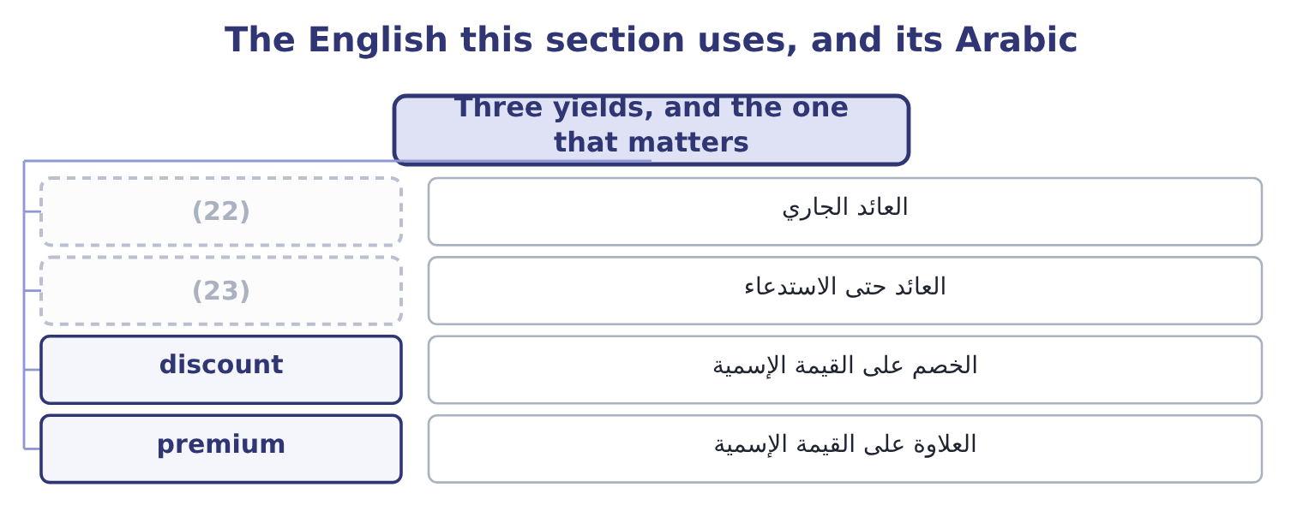
word list
maturity matching · current yield · yield to call

The English this sheet uses, and its Arabic
English (exam term) | Arabic
current yield | العائد الجاري
yield to call | العائد حتى الاستدعاء
discount | الخصم على القيمة الإسمية
premium | العلاوة على القيمة الإسمية

Answer key · 3.4 Three yields, and the one that matters

1 quoted | 13 questions
2 attached | 14 computes
3 payment | 15 prudent
4 nothing | 16 realised
5 holder | 17 assumed
6 repaid | 18 The market price entirely
7 promised | 19 The gain to par at maturity
8 exactly | 20 Reinvestment risk
9 approximation | 21 Payments to the call date
10 amortisation | 22 current yield
11 spread | 23 yield to call
12 numerator

the summaries in full
Summary 1 A bond quoted at $950 with a 6 per cent coupon and five years to run has three rates attached to it, and the exam will use all three in one question. The coupon rate is 6 per cent, fixed at issue on the par value. It tells you the cash payment, $60 a year, and nothing about what a buyer earns. The current yield is the coupon over the market price: 60 ÷ 950 = 6.32 per cent. It is a quick measure of the cash return and it ignores the $50 the holder will gain when $1,000 is repaid. The yield to maturity is the rate that makes all the promised payments worth exactly $950 today. It is found properly by trial or by a calculator, and the exam accepts a standard approximation: the annual coupon plus the annual amortisation of the discount, over the average of par and price. Here the discount is 1,000 − 950 = 50 spread over five years, which is 10 a year, so the numerator is 60 + 10 = 70; the average of par and price is 975; and the yield is 70 ÷ 975 = 7.18 per cent. So the same bond pays 6, 6.32 or 7.18 per cent depending on which question is being asked, and only the last is the return a buyer earns by holding to maturity.
Summary 2 Two more yields appear in questions on callable bonds. The yield to call computes the same thing to the call date at the call price, and the prudent figure to quote on a callable bond trading above par is the lower of yield to maturity and yield to call. The realised yield assumes a sale before maturity at an assumed price.

3.5 Reading the structure as a borrower
Chapter 3 · section 3.5

Fill every gap. Each word list holds one word more than there are gaps.
Summary 1 gaps 1–12
Everything above is written from the (1) side. Turn it round, because a (2) works for the issuer. The maturity (3) is the first decision, and it is a (4) the exam states as a rule. Borrowing short is usually (5) , because the curve usually slopes upward, and it exposes the company to refinancing at (6) rate prevails when the loan falls due. Borrowing long costs more and fixes the cost. The (7) principle —, so that a refinancing never (8) before the asset has paid for itself. Orontes's own (9) reads cleanly against that rule. It carries $6,000,000 of (10) debt against $14,802,000 of net property, plant and (11) , with only $400,000 falling due within the year, and it has $7,302,100 of cash. Its plant is funded long, its working capital is funded by (12) and by its own cash, and its refinancing risk in any one year is small.
word list
cheaper · maturity-matching · inflation · candidate · position · suppliers · whatever · lender's · arrives · trade-off · equipment · choice · long-term

Summary 2 gaps 13–24
Book 1 (13) the maturity (14) gentle; this is what gentle means. The (15) decision is fixed against (16) . (17) debt makes the cost certain and the value of the (18) move with rates. Floating-rate debt keeps the value near par and makes the cost (19) . A company whose revenue rises with inflation can carry floating-rate debt more (20) than one whose revenue is (21) fixed, because its receipts and its payments move together. The third decision is what to give away. Every feature in section 3.3 that favours the (22) lowers the coupon, and every feature that favours the issuer (23) it. A company that wants the right to (24) cheaply pays for it in the coupon from the first day; a company that accepts tight covenants is paid for them in the same way, and then has to live inside them. Barada, whose covenant at 1.50 was already breached when it wanted to borrow, is the illustration of what living inside them means.
word list
liability · second · profile · holder · contractually · raises · comfortably · called · floating · Fixed-rate · uncertain · refinance · already

Read the curve and the bond

Your turn: rates and a bond (complete the blanks)
Item | Data | Answer
One-year government yield | 3.0% | (25)
Ten-year government yield | 5.0% | n/a
Shape of the curve |  | ________
Orontes's ten-year borrowing cost, at a 2-point credit spread |  | ________
Nominal rate wanted | (26) | ________
A bond's current yield | 7% coupon, $1,000 par, priced at $875 | ________
Its approximate yield to maturity | (27) | ________

word list
n/a · Real 2.5%, expected inflation 4.0% · Four years to run · zero-coupon bond

"Security"

Summary 3 gaps 28–33
English security in finance means two (28) things. A security is a tradable financial (29) — a share, a bond, a bill. Security, uncountable, is the (30) a lender takes. A secured bond is (31) a security with security, and the sentence is not a joke but a standard (32) . The exam uses both English senses freely, and the one meant is always clear from (33) the word takes an article.
word list
instrument · therefore · unrelated · collateral · whether · covenant · description

"Security"
Item | Answer
Shape of the curve | Upward-sloping: the ten-year yield of 5.0 per cent is two points above the one-year 3.0 per cent.
Orontes's ten-year borrowing cost | About 7.0 per cent: 5.0 + 2.0 = 7.0.
Nominal rate wanted | (34) : 1.025 × 1.04 = 1.066.
Current yield | (35)
Approximate yield to maturity | About 10.8 per cent: the discount is 1,000 − 875 = 125 over four years, which is 31.25 a year, so the numerator is 70 + 31.25 = 101.25 and t
What it tells you | The bond's 7 per cent coupon says almost (36) about what a buyer earns. At $875 the buyer earns about 10.8 per cent, which is three point

word list
6.6 per cent · n/a · 8.00 per cent: 70 ÷ 875 = 8.00 per cent. · nothing

The English this section uses, and its Arabic
Each term sits against what it means.
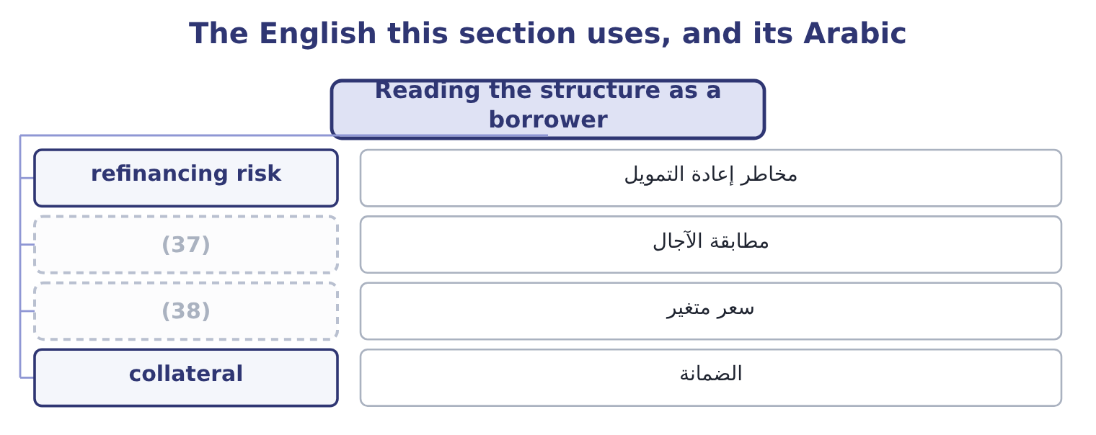
word list
maturity matching · floating rate · سعر متغير

The English this sheet uses, and its Arabic
English (exam term) | Arabic
refinancing risk | مخاطر إعادة التمويل
maturity matching | مطابقة الآجال
floating rate | سعر متغير
collateral | الضمانة

Answer key · 3.5 Reading the structure as a borrower

1 lender's | 20 comfortably
2 candidate | 21 contractually
3 choice | 22 holder
4 trade-off | 23 raises
5 cheaper | 24 refinance
6 whatever | 25 n/a
7 maturity-matching | 26 Real 2.5%, expected inflation 4.0%
8 arrives | 27 Four years to run
9 position | 28 unrelated
10 long-term | 29 instrument
11 equipment | 30 collateral
12 suppliers | 31 therefore
13 called | 32 description
14 profile | 33 whether
15 second | 34 6.6 per cent
16 floating | 35 8.00 per cent: 70 ÷ 875 = 8.00 per cent.
17 Fixed-rate | 36 nothing
18 liability | 37 maturity matching
19 uncertain | 38 floating rate

the summaries in full
Summary 1 Everything above is written from the lender's side. Turn it round, because a candidate works for the issuer. The maturity choice is the first decision, and it is a trade-off the exam states as a rule. Borrowing short is usually cheaper, because the curve usually slopes upward, and it exposes the company to refinancing at whatever rate prevails when the loan falls due. Borrowing long costs more and fixes the cost. The maturity-matching principle —, so that a refinancing never arrives before the asset has paid for itself. Orontes's own position reads cleanly against that rule. It carries $6,000,000 of long-term debt against $14,802,000 of net property, plant and equipment, with only $400,000 falling due within the year, and it has $7,302,100 of cash. Its plant is funded long, its working capital is funded by suppliers and by its own cash, and its refinancing risk in any one year is small.
Summary 2 Book 1 called the maturity profile gentle; this is what gentle means. The second decision is fixed against floating. Fixed-rate debt makes the cost certain and the value of the liability move with rates. Floating-rate debt keeps the value near par and makes the cost uncertain. A company whose revenue rises with inflation can carry floating-rate debt more comfortably than one whose revenue is contractually fixed, because its receipts and its payments move together. The third decision is what to give away. Every feature in section 3.3 that favours the holder lowers the coupon, and every feature that favours the issuer raises it. A company that wants the right to refinance cheaply pays for it in the coupon from the first day; a company that accepts tight covenants is paid for them in the same way, and then has to live inside them. Barada, whose covenant at 1.50 was already breached when it wanted to borrow, is the illustration of what living inside them means.
Summary 3 English security in finance means two unrelated things. A security is a tradable financial instrument — a share, a bond, a bill. Security, uncountable, is the collateral a lender takes. A secured bond is therefore a security with security, and the sentence is not a joke but a standard description. The exam uses both English senses freely, and the one meant is always clear from whether the word takes an article.

4.1 Valuing a bond by discounting
Chapter 4 · section 4.1

Fill every gap. Each word list holds one word more than there are gaps.
Chapter 4, section by section
Each stage leads to the next.
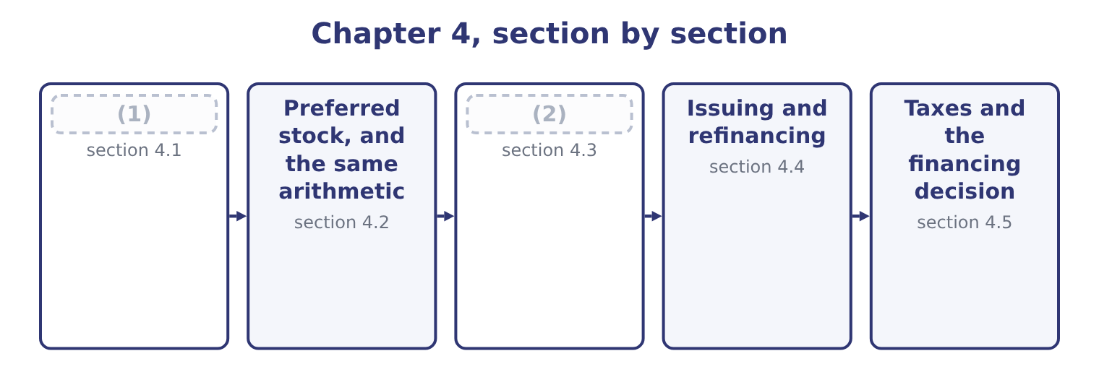
word list
section 4.1 · Duration · Valuing a bond by discounting

Summary 1 gaps 3–9
A (3) bond with a par value of $1,000 and a 6 per cent (4) coupon promises $60 at the end of each of five years and $1,000 at the end of the fifth. Its value is what those promises are worth today at the rate the market requires. Two present-value tools do all the work. The annuity factor converts a stream of equal (5) into a single present value; at 7 per cent for five years it is 4.1002. The present-value factor converts a single (6) amount; at 7 per cent for five years it is 0.7130. So at a required return of 7 per cent: the coupons are worth 60 × 4.1002 = 246.01, the principal is worth 1,000 × 0.7130 = 713.00, and the bond is worth 246.01 + 713.00 = 959.01. That is the "a (7) under $960" of, and the $41 (8) against par is the market's (9) for a coupon one point below what it now requires.
word list
annual · because · future · amounts · little · shortfall · charge · five-year

Summary 2 gaps 10–13
At a required return of 5 per cent the same two steps give a (10) answer: the annuity factor is 4.3295 and the present-value factor 0.7835, so the coupons are worth 60 × 4.3295 = 259.77, the principal 1,000 × 0.7835 = 783.50, and the bond 259.77 + 783.50 = 1,043.27. The bond trades at a (11) because its coupon is (12) than the market now (13) .
word list
immunisation · offers · different · premium · better

One bond, two required returns
Component | At 7 per cent | At 5 per cent
Annuity factor, five years | 4.1002 | 4.3295
(14) | 246.01 | 259.77
(15) | 0.7130 | 0.7835
Present value of the principal | 713.00 | 783.50
(16) | 959.01 | 1,043.27

word list
Present value of the coupons · Annuity factor, five years · Value of the bond · Present-value factor, five years

Summary 3 gaps 17–28
Three (17) points are (18) often. (19) coupons halve the (20) and the rate and double the periods. A 6 per cent bond paying twice a year, valued at a required 7 per cent, is thirty (21) for ten periods (22) at 3.5 per cent. The discount rate is the market's required return on this risk, not the coupon rate and not the (23) own view of (24) . For a (25) bond it is the (26) yield for that maturity plus a credit spread. Price and yield move (27) , always, and the (28) is curved rather than straight. A fall in yields raises the price slightly more than an equal rise in yields lowers it, which is the property called convexity and is why duration, which assumes a straight line, is an approximation.
word list
mechanical · corporate · itself · company's · participating · examined · inversely · payment · Semi-annual · discounted · dollars · government · relationship

The English this section uses, and its Arabic
Each term sits against what it means.
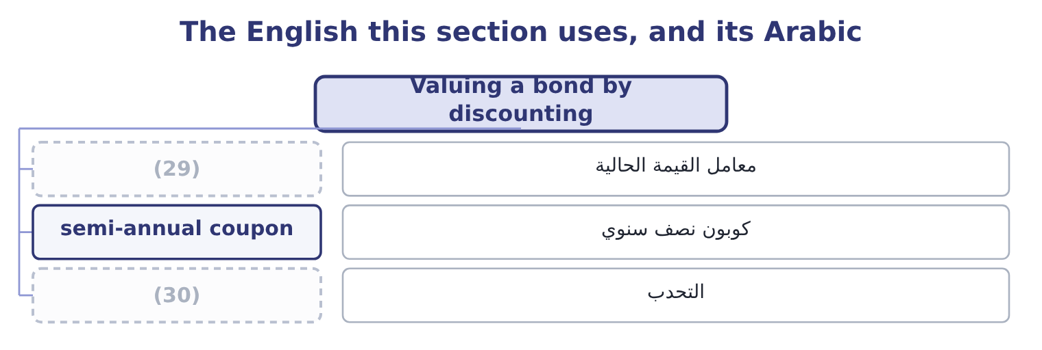
word list
present-value factor · convexity · payback

The English this sheet uses, and its Arabic
English (exam term) | Arabic
present-value factor | معامل القيمة الحالية
semi-annual coupon | كوبون نصف سنوي
convexity | التحدب

Answer key · 4.1 Valuing a bond by discounting

1 Valuing a bond by discounting | 16 Value of the bond
2 Duration | 17 mechanical
3 five-year | 18 examined
4 annual | 19 Semi-annual
5 amounts | 20 payment
6 future | 21 dollars
7 little | 22 discounted
8 shortfall | 23 company's
9 charge | 24 itself
10 different | 25 corporate
11 premium | 26 government
12 better | 27 inversely
13 offers | 28 relationship
14 Present value of the coupons | 29 present-value factor
15 Present-value factor, five years | 30 convexity

the summaries in full
Summary 1 A five-year bond with a par value of $1,000 and a 6 per cent annual coupon promises $60 at the end of each of five years and $1,000 at the end of the fifth. Its value is what those promises are worth today at the rate the market requires. Two present-value tools do all the work. The annuity factor converts a stream of equal amounts into a single present value; at 7 per cent for five years it is 4.1002. The present-value factor converts a single future amount; at 7 per cent for five years it is 0.7130. So at a required return of 7 per cent: the coupons are worth 60 × 4.1002 = 246.01, the principal is worth 1,000 × 0.7130 = 713.00, and the bond is worth 246.01 + 713.00 = 959.01. That is the "a little under $960" of, and the $41 shortfall against par is the market's charge for a coupon one point below what it now requires.
Summary 2 At a required return of 5 per cent the same two steps give a different answer: the annuity factor is 4.3295 and the present-value factor 0.7835, so the coupons are worth 60 × 4.3295 = 259.77, the principal 1,000 × 0.7835 = 783.50, and the bond 259.77 + 783.50 = 1,043.27. The bond trades at a premium because its coupon is better than the market now offers.
Summary 3 Three mechanical points are examined often. Semi-annual coupons halve the payment and the rate and double the periods. A 6 per cent bond paying twice a year, valued at a required 7 per cent, is thirty dollars for ten periods discounted at 3.5 per cent. The discount rate is the market's required return on this risk, not the coupon rate and not the company's own view of itself. For a corporate bond it is the government yield for that maturity plus a credit spread. Price and yield move inversely, always, and the relationship is curved rather than straight. A fall in yields raises the price slightly more than an equal rise in yields lowers it, which is the property called convexity and is why duration, which assumes a straight line, is an approximation.

4.2 Preferred stock, and the same arithmetic
Chapter 4 · section 4.2

Fill every gap. Each word list holds one word more than there are gaps.
Summary 1 gaps 1–12
Preferred stock pays a fixed dividend and (1) has no maturity, so it is a perpetuity: a stream of equal (2) that never stops. The (3) value of a perpetuity is the payment (4) by the required return. A preferred share (5) $5.00 a year, where the market (6) 8 per cent for that risk, is worth 5.00 ÷ 0.08 = 62.50. If the required return rises to 10 per cent the same share is worth 5.00 ÷ 0.10 = 50.00. There is no principal to come back, so the price carries the entire (7) — which makes preferred stock more (8) to rates than most bonds, a point section 4.3 will make precisely. The features of preferred stock follow from its (9) between debt and (10) . A cumulative preferred share carries (11) any dividend not paid, and nothing may go to the common (12) until the arrears are cleared.
word list
position · balance · divided · present · equity · forward · payments · sensitive · paying · normally · shareholders · adjustment · requires

Summary 2 gaps 13–19
A (13) preferred share shares in (14) beyond its fixed rate. Both features raise what a buyer will pay and lower the rate the (15) has to offer. Note what the perpetuity (16) assumes and what the exam does with it. It assumes the payment is fixed and (17) for ever, so it suits preferred stock exactly, a long-dated bond (18) , and a common share not at all until a growth rate is built. That is the (19) of the next chapter.
word list
subject · issuer · formula · arrears · continues · participating · approximately · profits

Three instruments, one method
Instrument | Payment pattern | Valuation | Sensitivity to rates
Bond | Coupons, then principal | (20) | Moderate: the principal anchors it
Preferred stock | A fixed dividend for ever | Payment over required return | (21) : nothing anchors it
Common stock | (22) | Payment over the return less growth | Highest

word list
Annuity plus a lump sum · High · A growing dividend for ever · price sensitivity

Perpetuities and the rate

Summary 3 gaps 23–28
In a perpetuity the rate must be (23) as a decimal and must match the payment (24) . An (25) dividend over a (26) rate is a figure twelve times too large. Preferred stock has no maturity and (27) no yield to maturity. Its yield is (28) dividend over price. A cumulative preferred dividend in arrears is not a liability on the balance sheet; it is disclosed, and it blocks the common dividend.
word list
period · required · monthly · simply · therefore · expressed · annual

The English this section uses, and its Arabic
Each term sits against what it means.
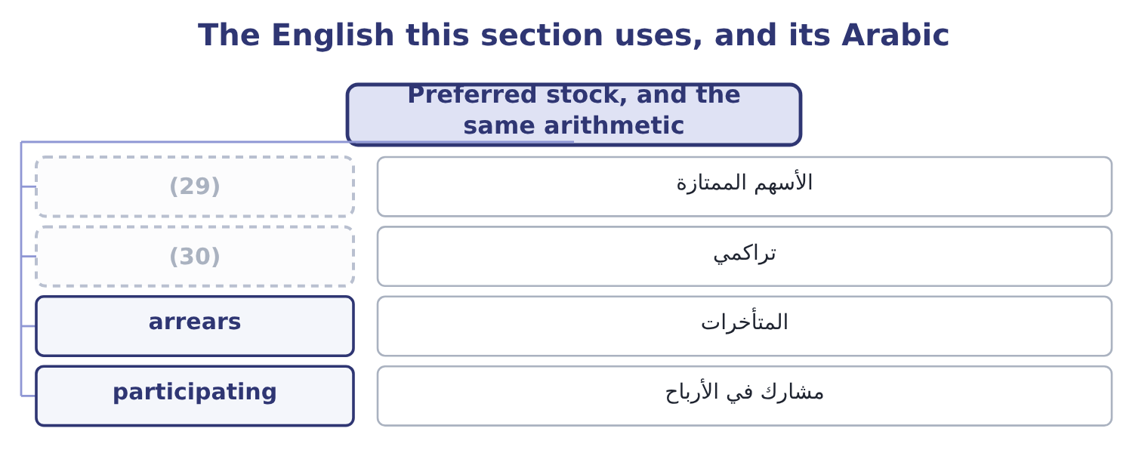
word list
after-tax cost · cumulative · preferred stock

The English this sheet uses, and its Arabic
English (exam term) | Arabic
preferred stock | الأسهم الممتازة
cumulative | تراكمي
arrears | المتأخرات
participating | مشارك في الأرباح

Answer key · 4.2 Preferred stock, and the same arithmetic

1 normally | 16 formula
2 payments | 17 continues
3 present | 18 approximately
4 divided | 19 subject
5 paying | 20 Annuity plus a lump sum
6 requires | 21 High
7 adjustment | 22 A growing dividend for ever
8 sensitive | 23 expressed
9 position | 24 period
10 equity | 25 annual
11 forward | 26 monthly
12 shareholders | 27 therefore
13 participating | 28 simply
14 profits | 29 preferred stock
15 issuer | 30 cumulative

the summaries in full
Summary 1 Preferred stock pays a fixed dividend and normally has no maturity, so it is a perpetuity: a stream of equal payments that never stops. The present value of a perpetuity is the payment divided by the required return. A preferred share paying $5.00 a year, where the market requires 8 per cent for that risk, is worth 5.00 ÷ 0.08 = 62.50. If the required return rises to 10 per cent the same share is worth 5.00 ÷ 0.10 = 50.00. There is no principal to come back, so the price carries the entire adjustment — which makes preferred stock more sensitive to rates than most bonds, a point section 4.3 will make precisely. The features of preferred stock follow from its position between debt and equity. A cumulative preferred share carries forward any dividend not paid, and nothing may go to the common shareholders until the arrears are cleared.
Summary 2 A participating preferred share shares in profits beyond its fixed rate. Both features raise what a buyer will pay and lower the rate the issuer has to offer. Note what the perpetuity formula assumes and what the exam does with it. It assumes the payment is fixed and continues for ever, so it suits preferred stock exactly, a long-dated bond approximately, and a common share not at all until a growth rate is built. That is the subject of the next chapter.
Summary 3 In a perpetuity the rate must be expressed as a decimal and must match the payment period. An annual dividend over a monthly rate is a figure twelve times too large. Preferred stock has no maturity and therefore no yield to maturity. Its yield is simply dividend over price. A cumulative preferred dividend in arrears is not a liability on the balance sheet; it is disclosed, and it blocks the common dividend.

4.3 Duration
Chapter 4 · section 4.3

Fill every gap. Each word list holds one word more than there are gaps.
Summary 1 gaps 1–10
Everybody knows a long bond moves more than a short one when rates change. Duration says how much more, in a (1) number. Macaulay duration is the weighted average time to receive the bond's cash flows, where each time is weighted by the present value of the payment (2) then. A (3) bond pays once, so its duration (4) its maturity. A coupon bond (5) some money (6) , so its duration is always (7) than its maturity. (8) duration converts that into a price sensitivity: it is the Macaulay duration divided by one plus the (9) return per period, and it estimates the (10) change in price for a one-point change in yield.
word list
single · equals · Modified · required · returns · zero-coupon · sensitivity · percentage · earlier · shorter · received

Worked example: the five-year bond, measured

Summary 2 gaps 11–22
Discounting the five (11) at 7 per cent gives present (12) of 56.07, 52.41, 48.98, 45.77 and 755.79, which add to the price of 959.01. Almost (13) of the bond's value sits in the final payment. (14) each year by its share of the price gives a weighted average of about 4.45 years, (15) a maturity of five. The (16) pull it. The (17) is slightly (18) , and knowing why is the mark. Duration assumes the (19) line is straight; it is curved, so the true fall is a little smaller than duration (20) and the true rise on a fall in yields a little larger. The curvature is (21) , and it always works in the (22) favour. For a one-point move the difference is small; for a five-point move on a long bond it is large.
word list
pessimistic · knowing · convexity · values · predicts · price-yield · against · payments · coupons · holder's · four-fifths · estimate · Weighting

What makes a bond more sensitive to rates
Every item belongs to exactly one group.
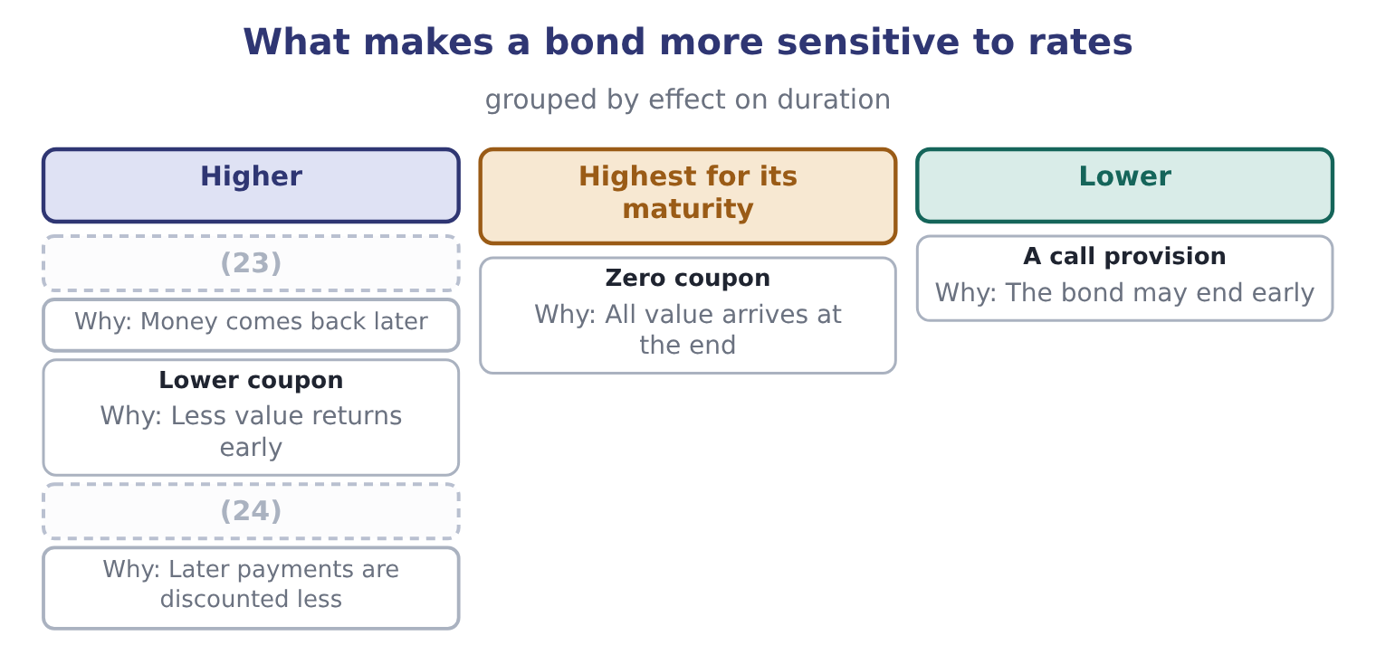
word list
preferred stock · Lower yield · Longer maturity

Summary 3 gaps 25–31
Duration is used for three (25) , and the exam names all three. It (26) the rate sensitivity of two bonds in one number. It estimates the price (27) of a stated rate move. And it allows a (28) to be matched to a (29) — an insurer with claims expected in seven years holds assets of duration seven, so that a rate move changes the value of both sides together. That last use is called (30) and it is the (31) duration exists.
word list
portfolio · immunisation · Everybody · compares · effect · liability · things · reason

The English this section uses, and its Arabic
Each term sits against what it means.
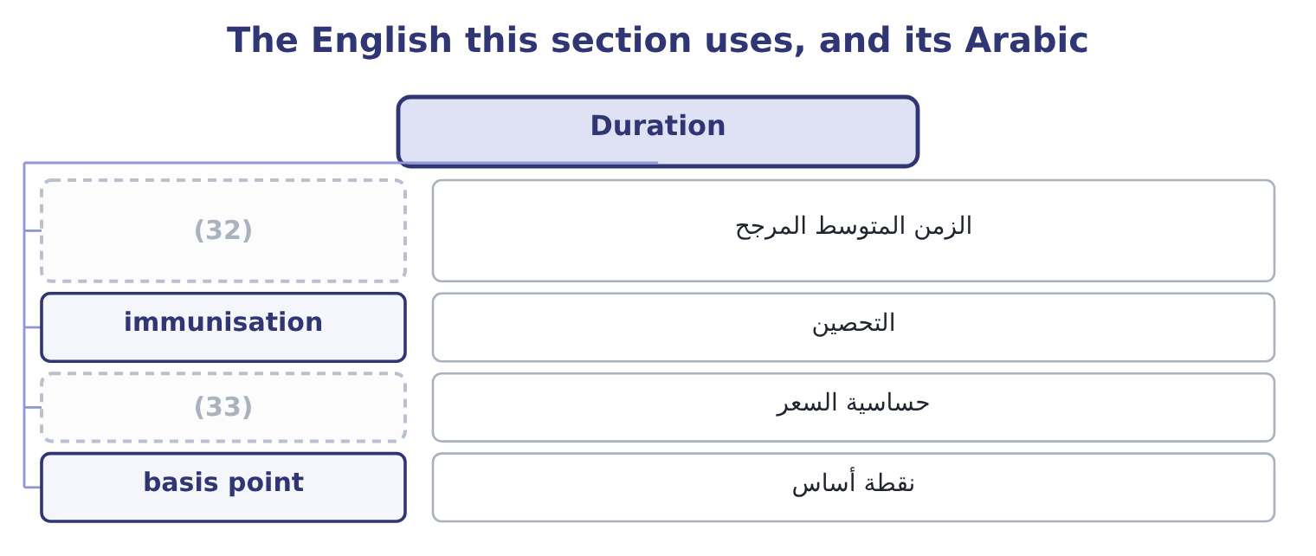
word list
preferred stock · price sensitivity · weighted average time

The English this sheet uses, and its Arabic
English (exam term) | Arabic
weighted average time | الزمن المتوسط المرجح
immunisation | التحصين
price sensitivity | حساسية السعر
basis point | نقطة أساس

Answer key · 4.3 Duration

1 single | 18 pessimistic
2 received | 19 price-yield
3 zero-coupon | 20 predicts
4 equals | 21 convexity
5 returns | 22 holder's
6 earlier | 23 Longer maturity
7 shorter | 24 Lower yield
8 Modified | 25 things
9 required | 26 compares
10 percentage | 27 effect
11 payments | 28 portfolio
12 values | 29 liability
13 four-fifths | 30 immunisation
14 Weighting | 31 reason
15 against | 32 weighted average time
16 coupons | 33 price sensitivity
17 estimate

the summaries in full
Summary 1 Everybody knows a long bond moves more than a short one when rates change. Duration says how much more, in a single number. Macaulay duration is the weighted average time to receive the bond's cash flows, where each time is weighted by the present value of the payment received then. A zero-coupon bond pays once, so its duration equals its maturity. A coupon bond returns some money earlier, so its duration is always shorter than its maturity. Modified duration converts that into a price sensitivity: it is the Macaulay duration divided by one plus the required return per period, and it estimates the percentage change in price for a one-point change in yield.
Summary 2 Discounting the five payments at 7 per cent gives present values of 56.07, 52.41, 48.98, 45.77 and 755.79, which add to the price of 959.01. Almost four-fifths of the bond's value sits in the final payment. Weighting each year by its share of the price gives a weighted average of about 4.45 years, against a maturity of five. The coupons pull it. The estimate is slightly pessimistic, and knowing why is the mark. Duration assumes the price-yield line is straight; it is curved, so the true fall is a little smaller than duration predicts and the true rise on a fall in yields a little larger. The curvature is convexity, and it always works in the holder's favour. For a one-point move the difference is small; for a five-point move on a long bond it is large.
Summary 3 Duration is used for three things, and the exam names all three. It compares the rate sensitivity of two bonds in one number. It estimates the price effect of a stated rate move. And it allows a portfolio to be matched to a liability — an insurer with claims expected in seven years holds assets of duration seven, so that a rate move changes the value of both sides together. That last use is called immunisation and it is the reason duration exists.

4.4 Issuing and refinancing
Chapter 4 · section 4.4

Fill every gap. Each word list holds one word more than there are gaps.
Summary 1 gaps 1–12
Now the (1) side. A company (2) to issue debt faces four (3) , and the exam asks them in (4) : how much, for how long, on what terms, and (5) what route. The route is a choice between a public issue, which is registered, (6) by an investment bank, rated by an agency and sold to many holders, and a private (7) with a small number of institutions, which is quicker and cheaper to arrange and carries tighter covenants and a slightly higher rate. Below a certain size the fixed costs of a public issue cannot be (8) , which is why most (9) companies borrow from banks and institutions rather than from the bond market. The refinancing decision is a (10) the exam sets often, and the (11) never changes. A company with an existing bond at a high (12) can call it, pay the call premium, pay the costs of issuing a new bond, and save the interest difference for the remaining life.
word list
issuer's · coupon · through · deciding · underwritten · mid-sized · calculation · justified · combination · after-tax · questions · structure · placement

Worked example: a refinancing that works

Summary 2 gaps 13–19
A company has $10,000,000 of bonds (13) at 8 per cent with five years to run. It can issue new five-year bonds at 6 per cent. The existing bonds are callable at 103, so the call premium is 3 per cent of par, and issuing the new bonds costs $200,000. Two points on ten (14) : 10,000,000 × 0.02 = 200,000 a year before tax. At a 25 per cent tax rate the interest saved is worth 200,000 × 0.75 = 150,000 a year after tax, (15) the interest was deductible. The call premium is 10,000,000 × 0.03 = 300,000 and the issue costs are 200,000, so 300,000 + 200,000 = 500,000 before tax. Both are deductible, so the after-tax cost is 500,000 × 0.75 = 375,000. (16) properly at the (17) after-tax cost of debt the net present value is (18) , and the refinancing (19) go ahead.
word list
company's · perpetuity · Discounted · outstanding · should · because · positive · million

Summary 3 gaps 20–25
Three (20) would reverse the (21) and all three are (22) . If only two years (23) , the saving would not cover the cost. If the new issue were at a (24) rate, the 6 per cent would be today's rate and not a five-year (25) . And if the existing bond were not callable, there would be no decision to take at all — which is why.
word list
carries · conclusion · commitment · things · examinable · remained · floating

The refinancing template
Line | This case | Note
Annual interest saved, before tax | 200,000 | The rate difference on the principal
Annual interest saved, after tax | 150,000 | (26)
Call premium | 300,000 | (27)
Issue costs of the new bonds | 200,000 | (28)
Total cost after tax | 375,000 | Both costs are deductible
Payback | 2.50 years | (29)

word list
weighted average time · A percentage of par, stated in the indenture · Interest is deductible, so the saving is taxed · Against five years of remaining life · Underwriting, legal, rating

The English this section uses, and its Arabic
Each term sits against what it means.
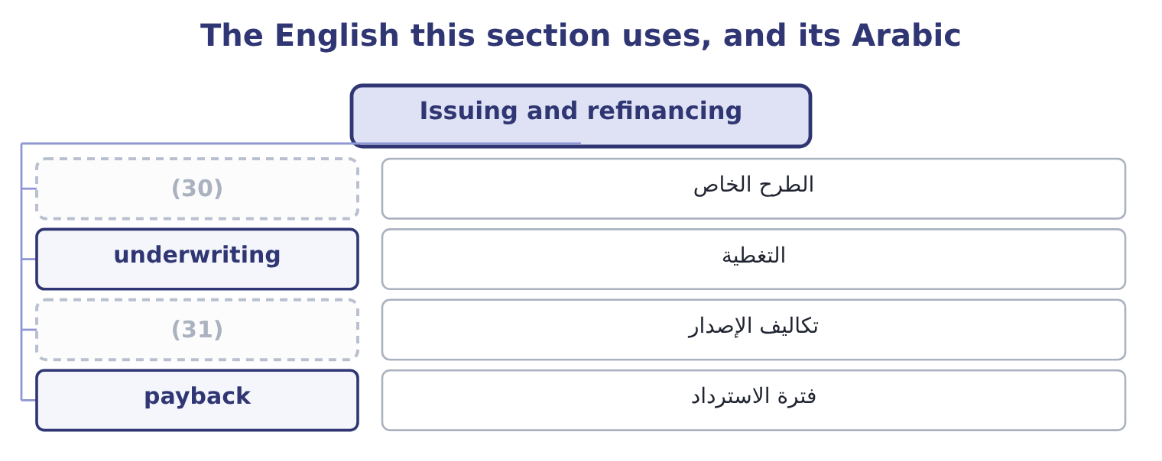
word list
modified duration · issue costs · private placement

The English this sheet uses, and its Arabic
English (exam term) | Arabic
private placement | الطرح الخاص
underwriting | التغطية
issue costs | تكاليف الإصدار
payback | فترة الاسترداد

Answer key · 4.4 Issuing and refinancing

1 issuer's | 17 company's
2 deciding | 18 positive
3 questions | 19 should
4 combination | 20 things
5 through | 21 conclusion
6 underwritten | 22 examinable
7 placement | 23 remained
8 justified | 24 floating
9 mid-sized | 25 commitment
10 calculation | 26 Interest is deductible, so the saving is taxed
11 structure | 27 A percentage of par, stated in the indenture
12 coupon | 28 Underwriting, legal, rating
13 outstanding | 29 Against five years of remaining life
14 million | 30 private placement
15 because | 31 issue costs
16 Discounted

the summaries in full
Summary 1 Now the issuer's side. A company deciding to issue debt faces four questions, and the exam asks them in combination: how much, for how long, on what terms, and through what route. The route is a choice between a public issue, which is registered, underwritten by an investment bank, rated by an agency and sold to many holders, and a private placement with a small number of institutions, which is quicker and cheaper to arrange and carries tighter covenants and a slightly higher rate. Below a certain size the fixed costs of a public issue cannot be justified, which is why most mid-sized companies borrow from banks and institutions rather than from the bond market. The refinancing decision is a calculation the exam sets often, and the structure never changes. A company with an existing bond at a high coupon can call it, pay the call premium, pay the costs of issuing a new bond, and save the interest difference for the remaining life.
Summary 2 A company has $10,000,000 of bonds outstanding at 8 per cent with five years to run. It can issue new five-year bonds at 6 per cent. The existing bonds are callable at 103, so the call premium is 3 per cent of par, and issuing the new bonds costs $200,000. Two points on ten million: 10,000,000 × 0.02 = 200,000 a year before tax. At a 25 per cent tax rate the interest saved is worth 200,000 × 0.75 = 150,000 a year after tax, because the interest was deductible. The call premium is 10,000,000 × 0.03 = 300,000 and the issue costs are 200,000, so 300,000 + 200,000 = 500,000 before tax. Both are deductible, so the after-tax cost is 500,000 × 0.75 = 375,000. Discounted properly at the company's after-tax cost of debt the net present value is positive, and the refinancing should go ahead.
Summary 3 Three things would reverse the conclusion and all three are examinable. If only two years remained, the saving would not cover the cost. If the new issue were at a floating rate, the 6 per cent would be today's rate and not a five-year commitment. And if the existing bond were not callable, there would be no decision to take at all — which is why.

4.5 Taxes and the financing decision
Chapter 4 · section 4.5

Fill every gap. Each word list holds one word more than there are gaps.
Summary 1 gaps 1–12
Interest is deductible and (1) are not. That single (2) shapes capital structure (3) , and the exam tests it in three forms. The after-tax cost of debt. A company borrowing at 6 per cent with a 25 per cent tax rate bears 6.0 × 0.75 = 4.5 per cent, because each dollar of interest (4) taxable income by a dollar. (5) $390,000 of interest is worth 390,000 × 0.25 = 97,500 a year in tax saved, and that (6) is called the interest tax shield. Equity has no (7) shield: a dividend is paid out of profit that has (8) been taxed. So on a pure tax (9) , debt is the (10) funding and a company (11) use as much of it as it can — which is (12) wrong, and the reason it is wrong is the whole of capital structure theory.
word list
Orontes's · already · plainly · saving · dividends · asymmetry · should · reduces · equivalent · everywhere · argument · cheaper · credits

Summary 2 gaps 13–24
Beyond some level of borrowing, the costs of (13) distress grow faster than the shield: lenders demand more, suppliers shorten terms, customers worry about (14) , management spends its time on the bank. The (15) is where the marginal value of the shield equals the marginal cost of distress, and no (16) locates it. The shield is worth (17) to a company with no taxable profit. A company making losses, or sheltered by large (18) or tax credits, cannot use the (19) , so debt costs it the full 6 per cent. This is the standard reason a (20) company leases rather than buys, and: the lessor has the taxable profit and can use the (21) , so it prices the lease to share some of the benefit. Two (22) tax points belong here because (23) pair them with the above. A premium or discount on issue is (24) for tax over the life of the bond rather than deducted at once. And in a refinancing, the unamortised issue costs of the old bond are normally deductible when it is retired, which improves the arithmetic of section 4.4 slightly.
word list
allowances · further · questions · after-tax · amortised · financial · loss-making · warranties · optimum · nothing · deduction · depreciation · formula

What the tax system does to each source of money
The bars are drawn to scale.
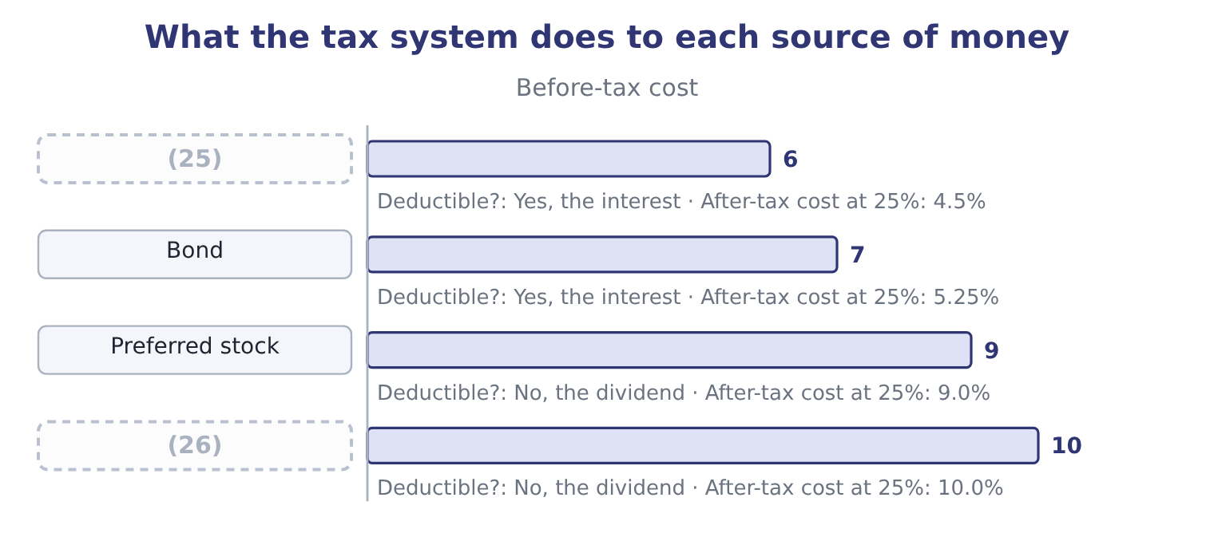
word list
Common equity · Bank debt · semi-annual coupon

Value, measure and refinance

Your turn: valuation, duration and refinancing (complete the blanks)
Item | Data | Answer
Value of a bond | 4 years, 1,000 par, 5% coupon, required 6%; annuity factor 3.4651, PV factor 0.7921 | 965.35: the coupons are 50 × 3.4651 = 173.26 and the principal 1,000 × 0.7921 = 792.10, so 173.26 + 792.10 = 965.36, which rounds to 965.35
Value of a preferred share | Dividend 4.00, required 10% | (27)
Modified duration | Macaulay 3.72 years, required return 6% | (28)
Price fall on a one-point rise | (29) | About 33.88: 965.40 × 0.0351 = 33.89, so the price falls to about 931.50.
After-tax cost of a 7% bond | (30) | 5.25 per cent: 7.0 × 0.75 = 5.25.
Refinancing payback | (31) | 3.00 years: 270,000 ÷ 90,000 = 3.00.

word list
Dividend 4.00, required 10% · Tax rate 25% · 3.51: 3.72 ÷ 1.06 = 3.51. · Saves 90,000 a year after tax, costs 270,000 after tax · On a price of 965.40 · 40.00: 4.00 ÷ 0.10 = 40.00.

"Discount"

Summary 3 gaps 32–36
To discount a cash flow is to (32) its present value. A bond at a discount (33) below par. A (34) discount is a price (35) for early payment. The three are related only by the idea of something being reduced, and a candidate who reads the wrong one has misread the question rather than the (36) .
word list
compute · calculation · settlement · trades · reduction · plainly

The English this section uses, and its Arabic
Each term sits against what it means.
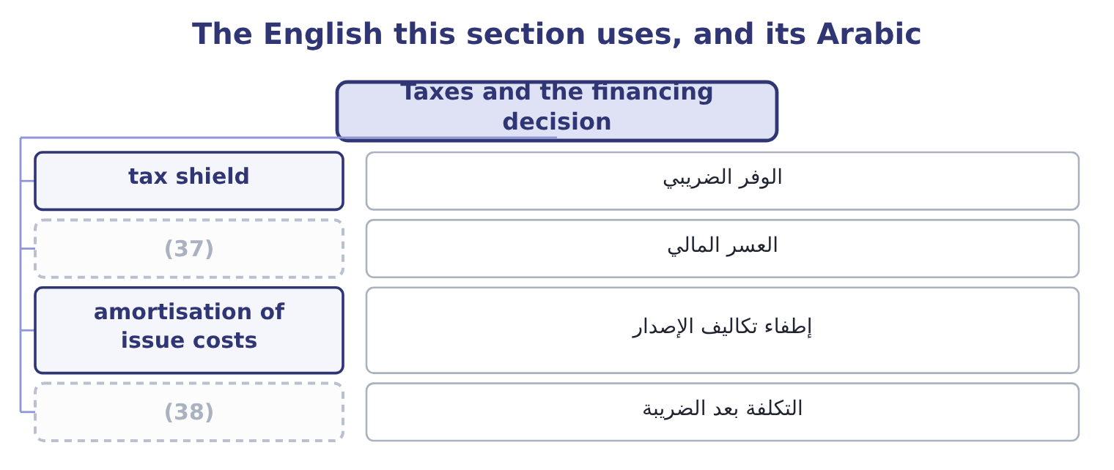
word list
after-tax cost · present value · financial distress

The English this sheet uses, and its Arabic
English (exam term) | Arabic
tax shield | الوفر الضريبي
financial distress | العسر المالي
amortisation of issue costs | إطفاء تكاليف الإصدار
after-tax cost | التكلفة بعد الضريبة

Answer key · 4.5 Taxes and the financing decision

1 dividends | 20 loss-making
2 asymmetry | 21 allowances
3 everywhere | 22 further
4 reduces | 23 questions
5 Orontes's | 24 amortised
6 saving | 25 Bank debt
7 equivalent | 26 Common equity
8 already | 27 40.00: 4.00 ÷ 0.10 = 40.00.
9 argument | 28 3.51: 3.72 ÷ 1.06 = 3.51.
10 cheaper | 29 On a price of 965.40
11 should | 30 Tax rate 25%
12 plainly | 31 Saves 90,000 a year after tax, costs 270,000 after tax
13 financial | 32 compute
14 warranties | 33 trades
15 optimum | 34 settlement
16 formula | 35 reduction
17 nothing | 36 calculation
18 depreciation | 37 financial distress
19 deduction | 38 after-tax cost

the summaries in full
Summary 1 Interest is deductible and dividends are not. That single asymmetry shapes capital structure everywhere, and the exam tests it in three forms. The after-tax cost of debt. A company borrowing at 6 per cent with a 25 per cent tax rate bears 6.0 × 0.75 = 4.5 per cent, because each dollar of interest reduces taxable income by a dollar. Orontes's $390,000 of interest is worth 390,000 × 0.25 = 97,500 a year in tax saved, and that saving is called the interest tax shield. Equity has no equivalent shield: a dividend is paid out of profit that has already been taxed. So on a pure tax argument, debt is the cheaper funding and a company should use as much of it as it can — which is plainly wrong, and the reason it is wrong is the whole of capital structure theory.
Summary 2 Beyond some level of borrowing, the costs of financial distress grow faster than the shield: lenders demand more, suppliers shorten terms, customers worry about warranties, management spends its time on the bank. The optimum is where the marginal value of the shield equals the marginal cost of distress, and no formula locates it. The shield is worth nothing to a company with no taxable profit. A company making losses, or sheltered by large depreciation or tax credits, cannot use the deduction, so debt costs it the full 6 per cent. This is the standard reason a loss-making company leases rather than buys, and: the lessor has the taxable profit and can use the allowances, so it prices the lease to share some of the benefit. Two further tax points belong here because questions pair them with the above. A premium or discount on issue is amortised for tax over the life of the bond rather than deducted at once. And in a refinancing, the unamortised issue costs of the old bond are normally deductible when it is retired, which improves the arithmetic of section 4.4 slightly.
Summary 3 To discount a cash flow is to compute its present value. A bond at a discount trades below par. A settlement discount is a price reduction for early payment. The three are related only by the idea of something being reduced, and a candidate who reads the wrong one has misread the question rather than the calculation.

5.1 Common stock
Chapter 5 · section 5.1

Fill every gap. Each word list holds one word more than there are gaps.
Chapter 5, section by section
Each stage leads to the next.
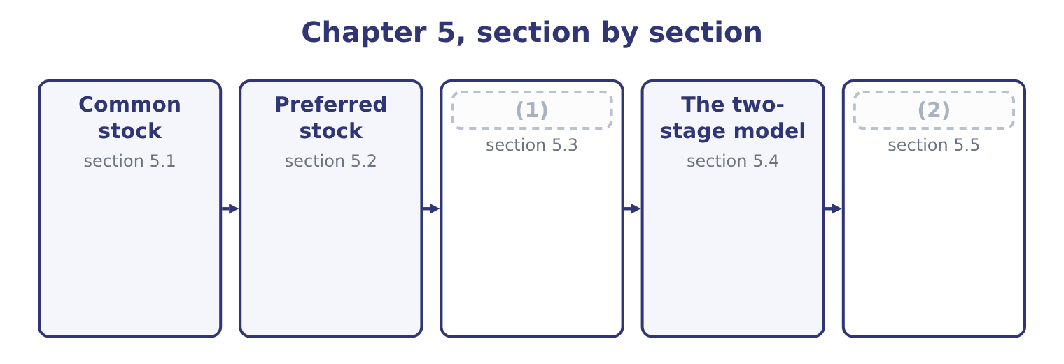
word list
Preferred stock · The constant growth dividend discount model · Relative valuation

Summary 1 gaps 3–14
A common share is an (3) interest, and five (4) define it. It is a residual claim. The common shareholder is paid after (5) , suppliers, lenders and preferred (6) , in good years and in a liquidation alike. That is why equity carries the highest (7) return in the ladder of, and why it has no (8) : the residue can be very large. It carries limited (9) . A shareholder can lose what was paid for the share and no more, which is the (10) that makes public companies (11) . One share, one vote is the normal (12) , used to elect directors and approve major (13) . Dual-class structures give some shares more votes than others, which lets founders keep (14) with a minority of the economics, and which the exam treats as a governance risk rather than a defect. It may carry a pre-emptive right, which entitles existing holders to subscribe for new shares before outsiders, in proportion to what they hold, so that their percentage is not diluted without their consent. It is described by a share count with four different meanings, and questions exploit the difference.
word list
arrangement · employees · liability · different · ceiling · ownership · invention · transactions · possible · shareholders · characteristics · control · required

Summary 2 gaps 15–23
Shares (15) are the maximum the (16) permits. Shares issued are those ever sold. Treasury shares are issued shares the company has (17) back. Shares outstanding are issued less treasury, and they are the ones that vote and receive (18) . Orontes has 8,100,000 issued and outstanding and no treasury stock, which is why Book 1 could use one figure (19) . Par value, (20) , is a legal (21) in modern practice. (22) shares carry a $1 par value, so $8,100,000 sits in common stock and $5,400,000 in (23) paid-in capital, and the split between the two columns tells a reader nothing about the company.
word list
authorised · Orontes's · bought · formality · dividends · described · finally · charter · throughout · additional

Common against preferred
Feature | Common stock | Preferred stock
Claim on income | (24) | Fixed dividend, ahead of common
Claim in liquidation | Last | (25)
Dividend | (26) | Fixed, and often cumulative
Votes | Normally one a share | Normally none
Upside | Unlimited | (27)
Maturity | None | (28)

word list
Ahead of common, behind all debt · Residual, after everybody · Capped at the fixed dividend · Discretionary · None, unless callable or redeemable · sensitivity

The English this section uses, and its Arabic
Each term sits against what it means.
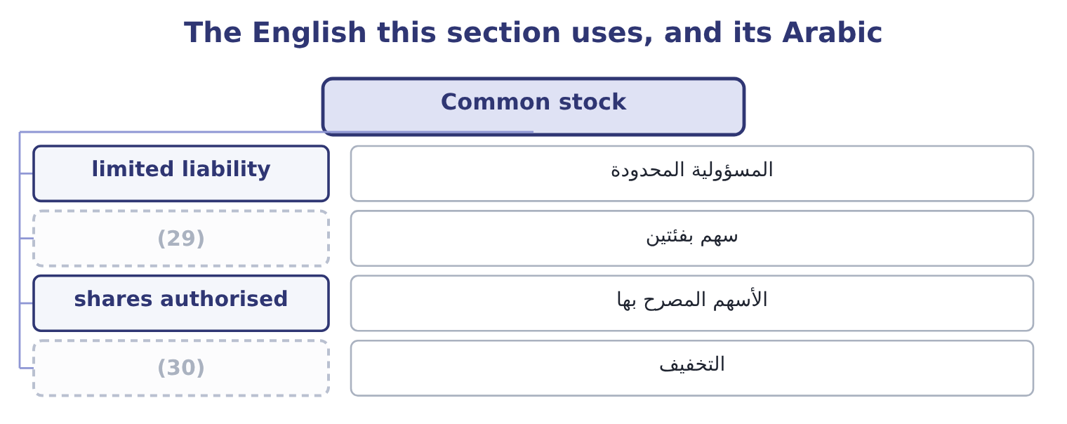
word list
dilution · المسؤولية المحدودة · dual-class share

The English this sheet uses, and its Arabic
English (exam term) | Arabic
limited liability | المسؤولية المحدودة
dual-class share | سهم بفئتين
shares authorised | الأسهم المصرح بها
dilution | التخفيف

Answer key · 5.1 Common stock

1 The constant growth dividend discount model | 16 charter
2 Relative valuation | 17 bought
3 ownership | 18 dividends
4 characteristics | 19 throughout
5 employees | 20 finally
6 shareholders | 21 formality
7 required | 22 Orontes's
8 ceiling | 23 additional
9 liability | 24 Residual, after everybody
10 invention | 25 Ahead of common, behind all debt
11 possible | 26 Discretionary
12 arrangement | 27 Capped at the fixed dividend
13 transactions | 28 None, unless callable or redeemable
14 control | 29 dual-class share
15 authorised | 30 dilution

the summaries in full
Summary 1 A common share is an ownership interest, and five characteristics define it. It is a residual claim. The common shareholder is paid after employees, suppliers, lenders and preferred shareholders, in good years and in a liquidation alike. That is why equity carries the highest required return in the ladder of, and why it has no ceiling: the residue can be very large. It carries limited liability. A shareholder can lose what was paid for the share and no more, which is the invention that makes public companies possible. One share, one vote is the normal arrangement, used to elect directors and approve major transactions. Dual-class structures give some shares more votes than others, which lets founders keep control with a minority of the economics, and which the exam treats as a governance risk rather than a defect. It may carry a pre-emptive right, which entitles existing holders to subscribe for new shares before outsiders, in proportion to what they hold, so that their percentage is not diluted without their consent. It is described by a share count with four different meanings, and questions exploit the difference.
Summary 2 Shares authorised are the maximum the charter permits. Shares issued are those ever sold. Treasury shares are issued shares the company has bought back. Shares outstanding are issued less treasury, and they are the ones that vote and receive dividends. Orontes has 8,100,000 issued and outstanding and no treasury stock, which is why Book 1 could use one figure throughout. Par value, finally, is a legal formality in modern practice. Orontes's shares carry a $1 par value, so $8,100,000 sits in common stock and $5,400,000 in additional paid-in capital, and the split between the two columns tells a reader nothing about the company.

5.2 Preferred stock
Chapter 5 · section 5.2

Fill every gap. Each word list holds one word more than there are gaps.
Summary 1 gaps 1–12
Preferred stock sits (1) debt and equity and takes (2) from both, which is why the exam calls it a hybrid. From debt it takes a fixed payment and (3) . The dividend is stated as a (4) of par or as an (5) , it does not rise when profits rise, and it must be paid in full before any common dividend. In a (6) the preferred holder ranks ahead of the common and behind every (7) . From equity it takes (8) and permanence. The dividend is (9) , not owed: missing it is not a default and cannot force the company into (10) . There is usually no (11) . And the payment is not deductible for tax: a 9 per cent preferred costs 9 per cent after tax, while a 9 per cent bond costs 6.75. The variants are (12) by name.
word list
liquidation · examinable · percentage · bankruptcy · creditor · amount · characteristics · declared · holder's · priority · maturity · between · discretion

Summary 2 gaps 13–24
Cumulative preferred carries unpaid dividends forward as arrears that block the common dividend; (13) does not, and is (14) cheaper for the issuer and worse for the holder. (15) preferred takes its fixed dividend and then shares in (16) profits. (17) preferred can be (18) for common shares. Callable or (19) preferred can be bought back by the issuer at a stated price, which caps the (20) gain. Valuation is the (21) : the dividend over the (22) return. A $100 par 9 per cent preferred pays $9.00 a year, and if the market requires 10 per cent for that risk it is worth 9.00 ÷ 0.10 = 90.00. If the market requires 8 per cent it is worth 9.00 ÷ 0.08 = 112.50. Why issue it at all, given that it costs more after tax than debt? Three (23) the exam accepts. It carries no (24) and no default risk, so it does not restrict the company or threaten it.
word list
missing · correspondingly · holder's · redeemable · perpetuity · covenants · non-cumulative · further · reasons · Participating · required · Convertible · exchanged

Summary 3 gaps 25–26
Rating agencies and lenders treat part of it as equity, so it (25) borrowing capacity. And it (26) money without giving away votes.
word list
raises · preserves · reasons

What each preferred feature does
Every item belongs to exactly one group.
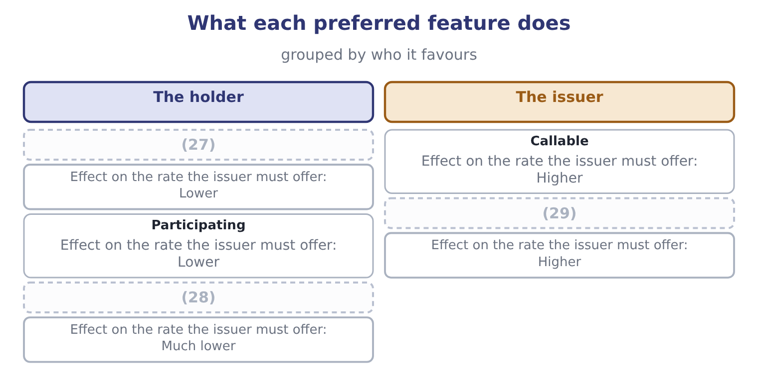
word list
Convertible · Arrears carried forward · relative valuation · Arrears lost if unpaid

Preferred is not debt

Summary 4 gaps 30–36
A (30) preferred dividend is not a default and creates no (31) on the balance sheet. It creates arrears, (32) in the notes, which block the common dividend. Preferred dividends are deducted from net income before (33) per share, and preferred stock is deducted from equity before book value per common share. The preferred dividend is not deductible for tax. (34) a 9 per cent preferred with a 9 per cent bond without (35) for tax is the (36) error.
word list
liability · adjusting · earnings · missed · standard · Comparing · disclosed · preserves

The English this section uses, and its Arabic
Each term sits against what it means.
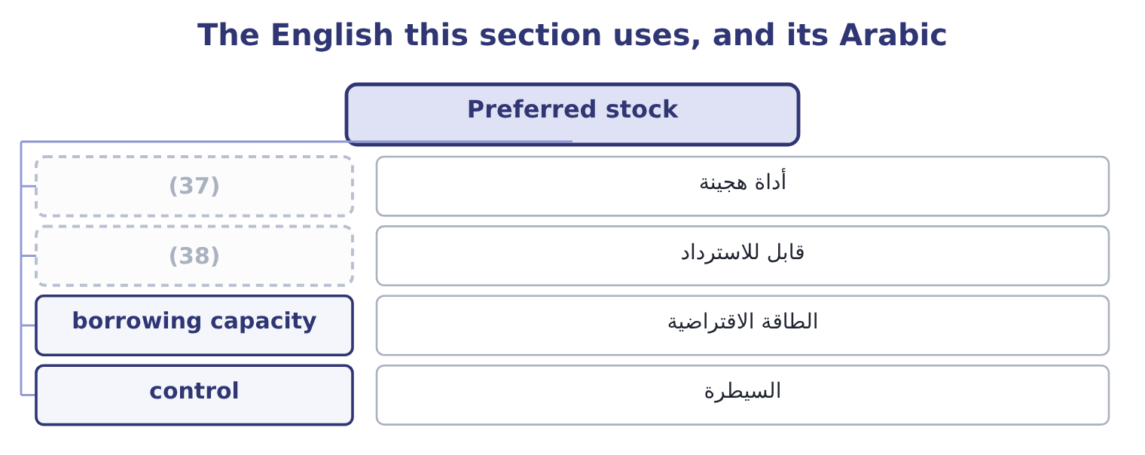
word list
قابل للاسترداد · redeemable · hybrid security

The English this sheet uses, and its Arabic
English (exam term) | Arabic
hybrid security | أداة هجينة
redeemable | قابل للاسترداد
borrowing capacity | الطاقة الاقتراضية
control | السيطرة

Answer key · 5.2 Preferred stock

1 between | 20 holder's
2 characteristics | 21 perpetuity
3 priority | 22 required
4 percentage | 23 reasons
5 amount | 24 covenants
6 liquidation | 25 preserves
7 creditor | 26 raises
8 discretion | 27 Arrears carried forward
9 declared | 28 Convertible
10 bankruptcy | 29 Arrears lost if unpaid
11 maturity | 30 missed
12 examinable | 31 liability
13 non-cumulative | 32 disclosed
14 correspondingly | 33 earnings
15 Participating | 34 Comparing
16 further | 35 adjusting
17 Convertible | 36 standard
18 exchanged | 37 hybrid security
19 redeemable | 38 redeemable

the summaries in full
Summary 1 Preferred stock sits between debt and equity and takes characteristics from both, which is why the exam calls it a hybrid. From debt it takes a fixed payment and priority. The dividend is stated as a percentage of par or as an amount, it does not rise when profits rise, and it must be paid in full before any common dividend. In a liquidation the preferred holder ranks ahead of the common and behind every creditor. From equity it takes discretion and permanence. The dividend is declared, not owed: missing it is not a default and cannot force the company into bankruptcy. There is usually no maturity. And the payment is not deductible for tax: a 9 per cent preferred costs 9 per cent after tax, while a 9 per cent bond costs 6.75. The variants are examinable by name.
Summary 2 Cumulative preferred carries unpaid dividends forward as arrears that block the common dividend; non-cumulative does not, and is correspondingly cheaper for the issuer and worse for the holder. Participating preferred takes its fixed dividend and then shares in further profits. Convertible preferred can be exchanged for common shares. Callable or redeemable preferred can be bought back by the issuer at a stated price, which caps the holder's gain. Valuation is the perpetuity: the dividend over the required return. A $100 par 9 per cent preferred pays $9.00 a year, and if the market requires 10 per cent for that risk it is worth 9.00 ÷ 0.10 = 90.00. If the market requires 8 per cent it is worth 9.00 ÷ 0.08 = 112.50. Why issue it at all, given that it costs more after tax than debt? Three reasons the exam accepts. It carries no covenants and no default risk, so it does not restrict the company or threaten it.
Summary 3 Rating agencies and lenders treat part of it as equity, so it preserves borrowing capacity. And it raises money without giving away votes.
Summary 4 A missed preferred dividend is not a default and creates no liability on the balance sheet. It creates arrears, disclosed in the notes, which block the common dividend. Preferred dividends are deducted from net income before earnings per share, and preferred stock is deducted from equity before book value per common share. The preferred dividend is not deductible for tax. Comparing a 9 per cent preferred with a 9 per cent bond without adjusting for tax is the standard error.

5.3 The constant growth dividend discount model
Chapter 5 · section 5.3

Fill every gap. Each word list holds one word more than there are gaps.
Summary 1 gaps 1–12
A share is worth the (1) value of its dividends. Since the dividends go on for ever and are (2) to grow, the sum has a short (3) form: next year's dividend (4) by the required return less the growth rate. Three inputs, each a (5) . Next year's dividend is this year's grown by one (6) . Orontes paid $0.0556 a share for 2025, so at a 4 per cent growth rate next year's is 0.0556 × 1.04 = 0.0578. The required return comes: 9.4 per cent for Orontes. The growth rate is the hard one. The (7) estimate is the (8) growth rate of Book 1: the return on equity times the (9) ratio. For Orontes that is 13.70 per cent, which is larger than the required return — and the formula (10) , because the denominator goes (11) . That is not an arithmetic (12) .
word list
sustainable · period · retention · question · expected · accident · divided · present · business · negative · standard · collapses · closed

Summary 2 gaps 13–17
No company can grow (13) than the return (14) require of it for ever; if it could, it would (15) be larger than the economy. The constant growth model (16) a long-run growth rate, and a long-run rate cannot exceed the growth of the economy the company sells into, which is why the exam's (17) are usually between 2 and 6 per cent.
word list
standard · faster · investors · figures · eventually · demands

Worked example: what the market is assuming about Orontes

Summary 3 gaps 18–29
Value Orontes on a 4 per cent long-run growth rate. Next year's dividend is $0.0578 and the denominator is 9.4 − 4.0 = 5.4 points, so the value is 0.0578 ÷ 0.054 = 1.07 a share. (18) with the market. The (19) trade at $9.25, nearly nine times the model's answer. Nothing is wrong with the arithmetic; what is wrong is (20) a dividend of 15 per cent of (21) as the whole of what the (22) will receive. Run the model (23) instead. If the price is right and the required return is 9.4 per cent, the growth rate the market must be (24) is the required return less the dividend yield: the yield is 0.0578 ÷ 9.25 = 0.62 per cent, so the (25) growth is 9.4 − 0.62 = 8.78 per cent a year, for ever. That is the (26) form of the model and the one the exam (27) . Asking what growth a price implies turns an (28) valuation into a testable claim: is 8.78 per cent a year for ever plausible for a food (29) whose gross margin has fallen three years running? Book 1's verdict says it is not, and the model has just converted that verdict into a number.
word list
negative · backwards · manufacturer · rewards · useful · shareholder · treating · implied · earnings · shares · Compare · assuming · unanswerable

The same dividend at four growth rates, required return 9.4 per cent
Growth rate | Denominator | Next year's dividend | Value a share
2.0% | 7.4 points | 0.0567 | 0.77
4.0% | 5.4 points | 0.0578 | 1.07
6.0% | (30) | 0.0589 | 1.73
8.0% | (31) | 0.0600 | 4.29

word list
3.4 points · shares authorised · 1.4 points

Summary 4 gaps 32–36
The model's (32) are examinable in their own right. It cannot value a company that pays no dividend. It is (33) sensitive to the growth rate, as the figure shows: two points of growth nearly (34) the answer. It (35) the growth rate to be below the required return. And it assumes growth is constant for ever, which no (36) is.
word list
business · requires · extremely · doubles · dilution · weaknesses

The English this section uses, and its Arabic
Each term sits against what it means.
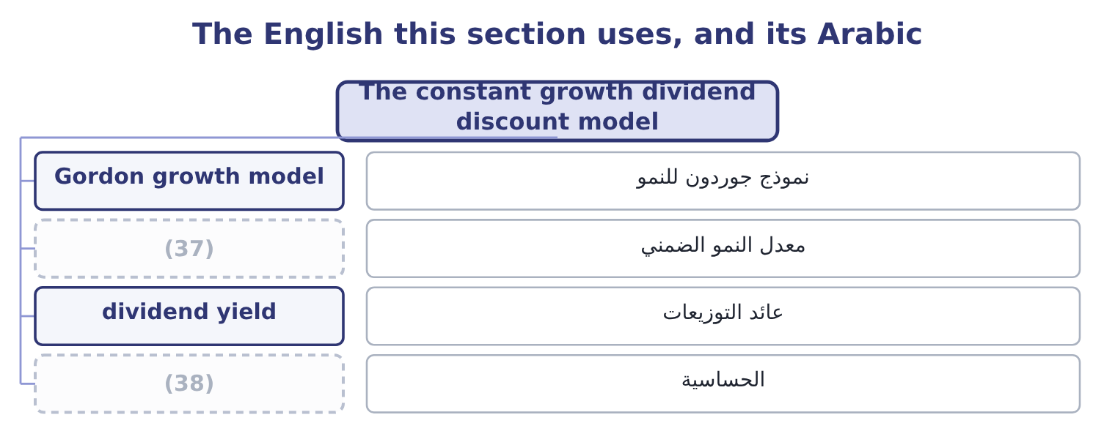
word list
shares authorised · sensitivity · implied growth rate

The English this sheet uses, and its Arabic
English (exam term) | Arabic
Gordon growth model | نموذج جوردون للنمو
implied growth rate | معدل النمو الضمني
dividend yield | عائد التوزيعات
sensitivity | الحساسية

Answer key · 5.3 The constant growth dividend discount model

1 present | 20 treating
2 expected | 21 earnings
3 closed | 22 shareholder
4 divided | 23 backwards
5 question | 24 assuming
6 period | 25 implied
7 standard | 26 useful
8 sustainable | 27 rewards
9 retention | 28 unanswerable
10 collapses | 29 manufacturer
11 negative | 30 3.4 points
12 accident | 31 1.4 points
13 faster | 32 weaknesses
14 investors | 33 extremely
15 eventually | 34 doubles
16 demands | 35 requires
17 figures | 36 business
18 Compare | 37 implied growth rate
19 shares | 38 sensitivity

the summaries in full
Summary 1 A share is worth the present value of its dividends. Since the dividends go on for ever and are expected to grow, the sum has a short closed form: next year's dividend divided by the required return less the growth rate. Three inputs, each a question. Next year's dividend is this year's grown by one period. Orontes paid $0.0556 a share for 2025, so at a 4 per cent growth rate next year's is 0.0556 × 1.04 = 0.0578. The required return comes: 9.4 per cent for Orontes. The growth rate is the hard one. The standard estimate is the sustainable growth rate of Book 1: the return on equity times the retention ratio. For Orontes that is 13.70 per cent, which is larger than the required return — and the formula collapses, because the denominator goes negative. That is not an arithmetic accident.
Summary 2 No company can grow faster than the return investors require of it for ever; if it could, it would eventually be larger than the economy. The constant growth model demands a long-run growth rate, and a long-run rate cannot exceed the growth of the economy the company sells into, which is why the exam's figures are usually between 2 and 6 per cent.
Summary 3 Value Orontes on a 4 per cent long-run growth rate. Next year's dividend is $0.0578 and the denominator is 9.4 − 4.0 = 5.4 points, so the value is 0.0578 ÷ 0.054 = 1.07 a share. Compare with the market. The shares trade at $9.25, nearly nine times the model's answer. Nothing is wrong with the arithmetic; what is wrong is treating a dividend of 15 per cent of earnings as the whole of what the shareholder will receive. Run the model backwards instead. If the price is right and the required return is 9.4 per cent, the growth rate the market must be assuming is the required return less the dividend yield: the yield is 0.0578 ÷ 9.25 = 0.62 per cent, so the implied growth is 9.4 − 0.62 = 8.78 per cent a year, for ever. That is the useful form of the model and the one the exam rewards. Asking what growth a price implies turns an unanswerable valuation into a testable claim: is 8.78 per cent a year for ever plausible for a food manufacturer whose gross margin has fallen three years running? Book 1's verdict says it is not, and the model has just converted that verdict into a number.
Summary 4 The model's weaknesses are examinable in their own right. It cannot value a company that pays no dividend. It is extremely sensitive to the growth rate, as the figure shows: two points of growth nearly doubles the answer. It requires the growth rate to be below the required return. And it assumes growth is constant for ever, which no business is.

5.4 The two-stage model
Chapter 5 · section 5.4

Fill every gap. Each word list holds one word more than there are gaps.
Summary 1 gaps 1–4
Real companies grow fast for a while and then slow down, as (1) arrives and the (2) fills. The two-stage model says so (3) : a period of high growth with each dividend discounted (4) , then a constant-growth phase valued by the formula of section 5.3 and discounted back as a single terminal value.
word list
explicitly · perpetuity · individually · competition · market

Worked example: two stages

Summary 2 gaps 5–16
A company has just paid a dividend of $2.00. It will grow at 15 per cent for two years and at 5 per cent for ever after. The (5) return is 10 per cent. Year one: 2.00 × 1.15 = 2.30. Year two: 2.30 × 1.15 = 2.6450. Year three, the first of the slow phase: 2.6450 × 1.05 = 2.7773. At the end of year two the (6) stream is a constant-growth (7) worth 2.7773 ÷ 0.05 = 55.546. Discount (8) to today. Year one: 2.30 ÷ 1.10 = 2.0909. Year two (9) both the dividend and the terminal value: 2.6450 + 55.546 = 58.191, and 58.191 ÷ 1.21 = 48.09. The share is worth 2.0909 + 48.09 = 50.18. Note where the value sits: more than (10) per cent of it is in the terminal value, which rests (11) on an assumed 5 per cent for ever. That is true of (12) every two-stage (13) and it is the first thing to say when (14) one. The (15) phase that the analysis spent all its effort (16) contributed four per cent of the answer.
word list
valuation · presenting · carries · ninety-five · entirely · forecasting · high-growth · control · remaining · required · perpetuity · everything · almost

The two-stage model, step by step
The bars are drawn to scale.
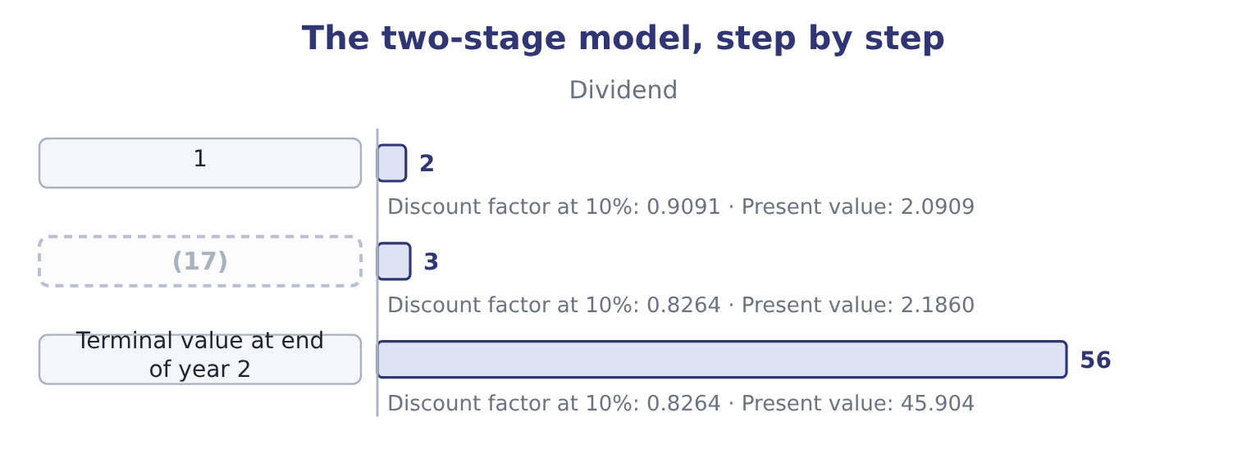
word list
2 · sensitivity

Summary 3 gaps 18–21
The same logic (18) . A (19) model adds a (20) phase in which growth declines gradually, which is more realistic and adds no new idea. Where a company pays no dividend at all, the same machinery is applied to free cash flow instead, which Book 3 develops for capital projects and (21) .
word list
acquisitions · transition · extends · three-stage · valuation

The English this section uses, and its Arabic
Each term sits against what it means.
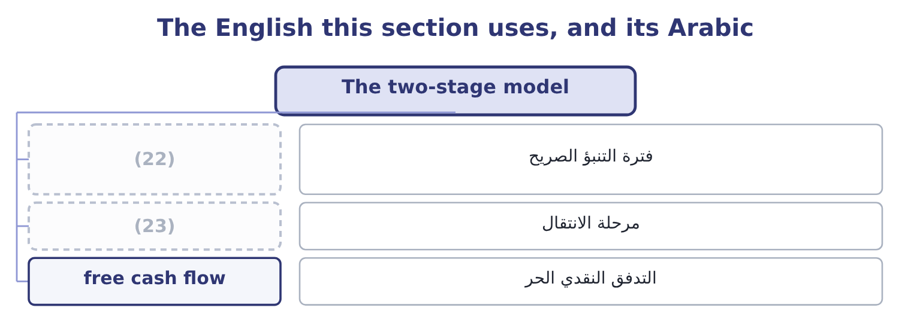
word list
Gordon growth model · explicit forecast period · transition phase

The English this sheet uses, and its Arabic
English (exam term) | Arabic
explicit forecast period | فترة التنبؤ الصريح
transition phase | مرحلة الانتقال
free cash flow | التدفق النقدي الحر

Answer key · 5.4 The two-stage model

1 competition | 13 valuation
2 market | 14 presenting
3 explicitly | 15 high-growth
4 individually | 16 forecasting
5 required | 17 2
6 remaining | 18 extends
7 perpetuity | 19 three-stage
8 everything | 20 transition
9 carries | 21 acquisitions
10 ninety-five | 22 explicit forecast period
11 entirely | 23 transition phase
12 almost

the summaries in full
Summary 1 Real companies grow fast for a while and then slow down, as competition arrives and the market fills. The two-stage model says so explicitly: a period of high growth with each dividend discounted individually, then a constant-growth phase valued by the formula of section 5.3 and discounted back as a single terminal value.
Summary 2 A company has just paid a dividend of $2.00. It will grow at 15 per cent for two years and at 5 per cent for ever after. The required return is 10 per cent. Year one: 2.00 × 1.15 = 2.30. Year two: 2.30 × 1.15 = 2.6450. Year three, the first of the slow phase: 2.6450 × 1.05 = 2.7773. At the end of year two the remaining stream is a constant-growth perpetuity worth 2.7773 ÷ 0.05 = 55.546. Discount everything to today. Year one: 2.30 ÷ 1.10 = 2.0909. Year two carries both the dividend and the terminal value: 2.6450 + 55.546 = 58.191, and 58.191 ÷ 1.21 = 48.09. The share is worth 2.0909 + 48.09 = 50.18. Note where the value sits: more than ninety-five per cent of it is in the terminal value, which rests entirely on an assumed 5 per cent for ever. That is true of almost every two-stage valuation and it is the first thing to say when presenting one. The high-growth phase that the analysis spent all its effort forecasting contributed four per cent of the answer.
Summary 3 The same logic extends. A three-stage model adds a transition phase in which growth declines gradually, which is more realistic and adds no new idea. Where a company pays no dividend at all, the same machinery is applied to free cash flow instead, which Book 3 develops for capital projects and acquisitions.

5.5 Relative valuation
Chapter 5 · section 5.5

Fill every gap. Each word list holds one word more than there are gaps.
Summary 1 gaps 1–12
The (1) to discounting is (2) : value a company at what the market pays for similar companies, using a multiple of (3) the companies share. The price/earnings ratio is the (4) one. Take the multiple at which comparable companies trade, (5) by the subject (6) earnings per share, and that is the implied value. If food (7) of Orontes's size trade at 18 times earnings, Orontes's implied value is 18 × 0.3666 = 6.60 a share, against a market price of $9.25. (8) the market (9) Orontes is better than its peers, or it is dear. The market-to-book ratio (10) price with net assets. It is most useful where assets are carried near their current values, which is why it is the (11) multiple for banks and (12) and a weak one for a company whose value is in brands and recipes.
word list
manufacturers · alternative · standard · multiply · something · Either · comparison · insurers · compares · warning · common · company's · thinks

Summary 2 gaps 13–19
The price/sales ratio (13) market capitalisation by (14) : 74,925,000 ÷ 42,000,000 = 1.78 for Orontes. Its use is the case the other two (15) handle — a company with no earnings, or with earnings (16) by a one-off such as the $2,724,000 (17) Book 1 spent a section on. Sales are harder to (18) than earnings, which is its second attraction, and it ignores (19) entirely, which is its fatal weakness: two companies with the same sales and different margins are not worth the same.
word list
revenue · profitability · divides · distorted · manipulate · company's · impairment · cannot

Three multiples, and when each is the right one
The bars are drawn to scale.
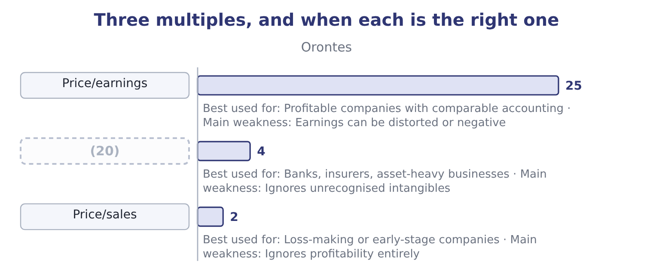
word list
Market/book · dilution

Summary 3 gaps 21–29
Three rules (21) the method and all three are (22) . The (23) must be genuinely comparable in (24) , size, growth and risk — Book 1's warning about (25) 14 per cent gross margin against Orontes's 35 is the same point. The (26) must be on the same basis, or the (27) are not measuring the same thing. And relative (28) tells you what the market pays today, not what a company is worth: a sector (29) at thirty times earnings gives a high answer for every company in it, and the method has no way of saying the sector is wrong.
word list
examined · against · comparables · accounting · govern · valuation · multiples · business · valued · Barada's

Value Barada's shares

Your turn: valuing Barada (complete the blanks)
Item | Data | Answer
Earnings per share | (30) | ________
Book value per share | Equity 3,100,000 | ________
Value on a constant growth model | Dividend just paid 0.10, growth 3%, required return 10.8% | ________
Value at a peer multiple | (31) | ________
Value at a peer market-to-book | Distributors trade at 1.2 times book | ________
Price/sales at the investor's 6.00 a share | (32) | ________

word list
Distributors trade at 14 times earnings · Sales 21,978,000 · 3.72: 1.2 × 3.10 = 3.72. · Net income 283,500 on 1,000,000 shares

"Equity"

Summary 4 gaps 33–40
English equity means three different (33) in these books. It is the (34) ' claim on a company, as in (35) ' equity. It is the shares (36) , as in an equity (37) . And in (38) English it means (39) , which is where the word came from and why courts of equity have nothing to do with shares. The exam uses the first two senses (40) and expects you to tell them apart from the context; the phrase cost of equity, for instance, means the return required on the ownership claim, not the price of a share.
word list
interchangeably · comparable · things · ordinary · investment · owners · stockholders · fairness · themselves

"Equity"
Item | Answer
Earnings per share | 0.2835: 283,500 ÷ 1,000,000.
Book value per share | (41) : 3,100,000 ÷ 1,000,000.
Constant growth value | 1.32: next year's dividend is 0.10 × 1.03 = 0.103, and 0.103 ÷ 0.078 = 1.32.
Value at a peer multiple | (42)
Value at a peer market-to-book | 3.72: 1.2 × 3.10 = 3.72.
Price/sales at 6.00 a share | 0.27: the market capitalisation is 1,000,000 × 6.00 = 6,000,000, and 6,000,000 ÷ 21,978,000 = 0.27.
What it tells you | Three of the four methods put Barada between about 3.70 and 4.00 a share, and the investor is offering 6.00. On these figures the offer is g

word list
3.10 · 3.97: 14 × 0.2835 = 3.97. · Distributors trade at 1.2 times book

The English this section uses, and its Arabic
Each term sits against what it means.
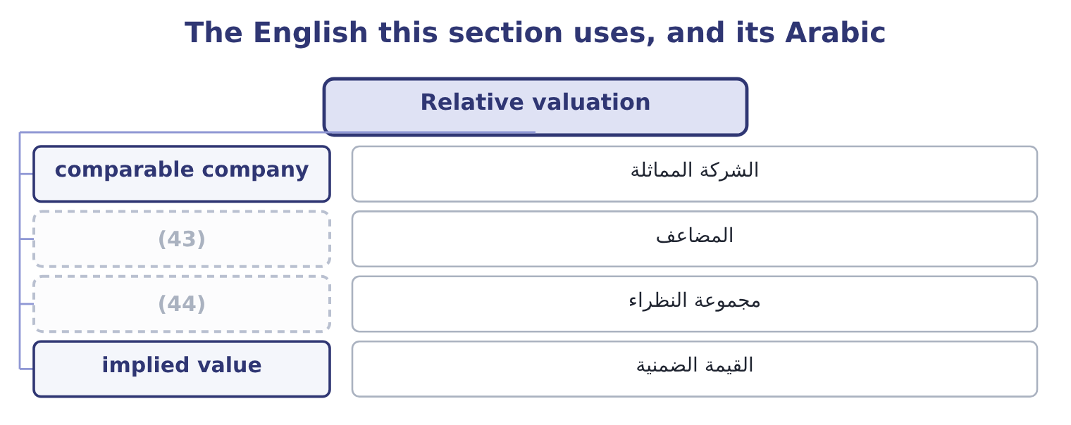
word list
terminal value · multiple · peer group

The English this sheet uses, and its Arabic
English (exam term) | Arabic
comparable company | الشركة المماثلة
multiple | المضاعف
peer group | مجموعة النظراء
implied value | القيمة الضمنية

Answer key · 5.5 Relative valuation

1 alternative | 23 comparables
2 comparison | 24 business
3 something | 25 Barada's
4 common | 26 accounting
5 multiply | 27 multiples
6 company's | 28 valuation
7 manufacturers | 29 valued
8 Either | 30 Net income 283,500 on 1,000,000 shares
9 thinks | 31 Distributors trade at 14 times earnings
10 compares | 32 Sales 21,978,000
11 standard | 33 things
12 insurers | 34 owners
13 divides | 35 stockholders
14 revenue | 36 themselves
15 cannot | 37 investment
16 distorted | 38 ordinary
17 impairment | 39 fairness
18 manipulate | 40 interchangeably
19 profitability | 41 3.10
20 Market/book | 42 3.97: 14 × 0.2835 = 3.97.
21 govern | 43 multiple
22 examined | 44 peer group

the summaries in full
Summary 1 The alternative to discounting is comparison: value a company at what the market pays for similar companies, using a multiple of something the companies share. The price/earnings ratio is the common one. Take the multiple at which comparable companies trade, multiply by the subject company's earnings per share, and that is the implied value. If food manufacturers of Orontes's size trade at 18 times earnings, Orontes's implied value is 18 × 0.3666 = 6.60 a share, against a market price of $9.25. Either the market thinks Orontes is better than its peers, or it is dear. The market-to-book ratio compares price with net assets. It is most useful where assets are carried near their current values, which is why it is the standard multiple for banks and insurers and a weak one for a company whose value is in brands and recipes.
Summary 2 The price/sales ratio divides market capitalisation by revenue: 74,925,000 ÷ 42,000,000 = 1.78 for Orontes. Its use is the case the other two cannot handle — a company with no earnings, or with earnings distorted by a one-off such as the $2,724,000 impairment Book 1 spent a section on. Sales are harder to manipulate than earnings, which is its second attraction, and it ignores profitability entirely, which is its fatal weakness: two companies with the same sales and different margins are not worth the same.
Summary 3 Three rules govern the method and all three are examined. The comparables must be genuinely comparable in business, size, growth and risk — Book 1's warning about Barada's 14 per cent gross margin against Orontes's 35 is the same point. The accounting must be on the same basis, or the multiples are not measuring the same thing. And relative valuation tells you what the market pays today, not what a company is worth: a sector valued at thirty times earnings gives a high answer for every company in it, and the method has no way of saying the sector is wrong.
Summary 4 English equity means three different things in these books. It is the owners' claim on a company, as in stockholders' equity. It is the shares themselves, as in an equity investment. And in ordinary English it means fairness, which is where the word came from and why courts of equity have nothing to do with shares. The exam uses the first two senses interchangeably and expects you to tell them apart from the context; the phrase cost of equity, for instance, means the return required on the ownership claim, not the price of a share.

6.1 What a derivative is, and what it is for
Chapter 6 · section 6.1

Fill every gap. Each word list holds one word more than there are gaps.
Chapter 6, section by section
Each stage leads to the next.
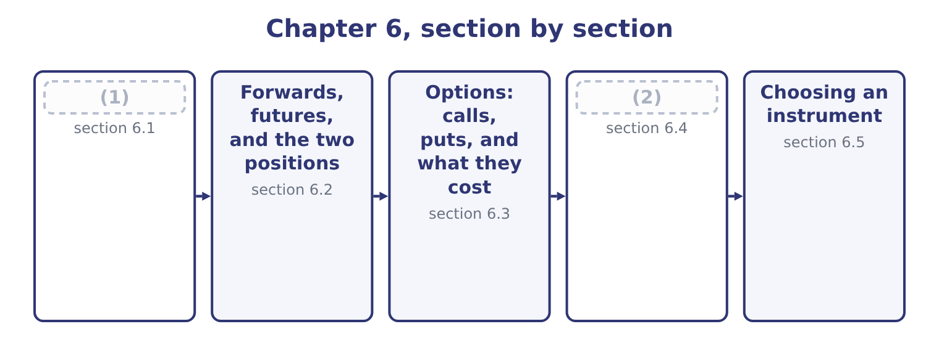
word list
Options: calls, puts, and what they cost · What a derivative is, and what it is for · What an option is worth

Summary 1 gaps 3–14
A derivative's value is (3) from an underlying — the asset, rate or index the contract (4) to. The contract (5) creates no new asset. If one party gains a dollar the other loses a dollar, which is why a derivatives (6) is called a (7) game, and why its total size says (8) about the wealth in it. Three uses, and the exam (9) them sharply. Hedging takes an (10) exposure and offsets it. (11) is already exposed to the sesame price by the simple fact of being a food (12) ; a contract to buy sesame forward at a fixed price cancels part of that exposure. A (13) gain on the contract is (14) by a loss on the underlying business, and the point is not to make money on the contract but to make the outcome certain.
word list
market · refers · separates · existing · itself · zero-sum · Orontes · matched · nothing · hedger's · derived · exposure · manufacturer

Summary 2 gaps 15–25
Speculation takes an exposure that did not exist. A (15) with no sesame business who buys the same contract has (16) a position in the sesame price. The (17) is identical; the purpose, and the risk, are the (18) . Arbitrage takes two prices for the same thing and locks in the difference. In theory it is (19) and in practice it is (20) so, and it is the force that keeps a derivative's price tied to its underlying. A fourth motive (21) naming because (22) use it: a derivative can change the form of a position (23) . Converting (24) debt to fixed by (25) the interest, rather than repaying one bond and issuing another, saves the whole cost of an issue —.
word list
swapping · created · opposite · questions · floating-rate · cheaply · underlying · nearly · deserves · trader · riskless · instrument

Three reasons to hold a derivative
Purpose | The underlying exposure | What the contract does | Risk after the trade
Hedging | (26) | Offsets it | Lower
Speculation | Does not exist | Creates it | (27)
Arbitrage | Two prices for one thing | Locks the difference | (28)

word list
Already exists · Higher · Close to nil · natural hedge

The same contract does opposite work

Summary 3 gaps 29–37
Whether a position is a hedge or a speculation (29) on what else the (30) owns, never on the contract. A (31) that describes a company buying a commodity forward for a commodity it does not use is (32) a speculation. A hedge (33) the upside with the (34) . A company that hedges and then (35) prices fall has paid for (36) , not made a mistake. Derivatives are off balance sheet in the sense that no asset is bought, and they are (37) at fair value under the standards. Part 1 covered the accounting; Section B covers the economics.
word list
watches · downside · removes · describing · exposed · depends · question · recognised · certainty · holder

The English this section uses, and its Arabic
Each term sits against what it means.
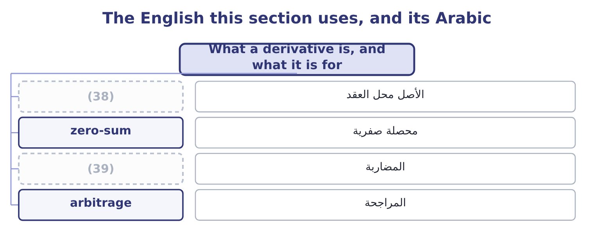
word list
speculation · volatility · underlying

The English this sheet uses, and its Arabic
English (exam term) | Arabic
underlying | الأصل محل العقد
zero-sum | محصلة صفرية
speculation | المضاربة
arbitrage | المراجحة

Answer key · 6.1 What a derivative is, and what it is for

1 What a derivative is, and what it is for | 21 deserves
2 What an option is worth | 22 questions
3 derived | 23 cheaply
4 refers | 24 floating-rate
5 itself | 25 swapping
6 market | 26 Already exists
7 zero-sum | 27 Higher
8 nothing | 28 Close to nil
9 separates | 29 depends
10 existing | 30 holder
11 Orontes | 31 question
12 manufacturer | 32 describing
13 hedger's | 33 removes
14 matched | 34 downside
15 trader | 35 watches
16 created | 36 certainty
17 instrument | 37 recognised
18 opposite | 38 underlying
19 riskless | 39 speculation
20 nearly

the summaries in full
Summary 1 A derivative's value is derived from an underlying — the asset, rate or index the contract refers to. The contract itself creates no new asset. If one party gains a dollar the other loses a dollar, which is why a derivatives market is called a zero-sum game, and why its total size says nothing about the wealth in it. Three uses, and the exam separates them sharply. Hedging takes an existing exposure and offsets it. Orontes is already exposed to the sesame price by the simple fact of being a food manufacturer; a contract to buy sesame forward at a fixed price cancels part of that exposure. A hedger's gain on the contract is matched by a loss on the underlying business, and the point is not to make money on the contract but to make the outcome certain.
Summary 2 Speculation takes an exposure that did not exist. A trader with no sesame business who buys the same contract has created a position in the sesame price. The instrument is identical; the purpose, and the risk, are the opposite. Arbitrage takes two prices for the same thing and locks in the difference. In theory it is riskless and in practice it is nearly so, and it is the force that keeps a derivative's price tied to its underlying. A fourth motive deserves naming because questions use it: a derivative can change the form of a position cheaply. Converting floating-rate debt to fixed by swapping the interest, rather than repaying one bond and issuing another, saves the whole cost of an issue —.
Summary 3 Whether a position is a hedge or a speculation depends on what else the holder owns, never on the contract. A question that describes a company buying a commodity forward for a commodity it does not use is describing a speculation. A hedge removes the upside with the downside. A company that hedges and then watches prices fall has paid for certainty, not made a mistake. Derivatives are off balance sheet in the sense that no asset is bought, and they are recognised at fair value under the standards. Part 1 covered the accounting; Section B covers the economics.

6.2 Forwards, futures, and the two positions
Chapter 6 · section 6.2

Fill every gap. Each word list holds one word more than there are gaps.
Summary 1 gaps 1–12
A forward contract is an agreement between two parties to buy or sell a stated quantity of (1) at a stated price on a stated (2) date. It is negotiated privately, so every term can be tailored, and it is settled once, at delivery. A futures contract is the same (3) , standardised and traded on an exchange. Quantity, (4) , delivery date and delivery point are fixed by the exchange; the only thing negotiated is the price. The (5) clearing house (6) between the two parties, so (7) takes the other's (8) risk, and both post margin: an initial (9) , and then a daily settlement of gains and (10) called marking to market. Those two (11) — customisation against (12) , one settlement against daily settlement — generate every other difference the exam asks for.
word list
exchange's · stands · future · promise · losses · contract · differences · standardisation · something · neither · deposit · quality · credit

Forwards against futures
Feature | Forward | Futures
Where traded | (13) | On an exchange
Terms | Negotiated and tailored | Standardised
Counterparty risk | On the other party | (14)
Margin | (15) | Initial and maintenance, settled daily
Settlement | (16) | Daily, by marking to market
Closing early | (17) | By an offsetting trade, easily
Typical user | (18) | A company or a trader wanting liquidity

word list
Once, at maturity · None usually · Privately, over the counter · On the clearing house · A company hedging a specific exposure · By agreement, or a new offsetting contract · By an offsetting trade, easily

Summary 2 gaps 19–24
The two (19) are simple and are tested (20) . The long position is the (21) : long means committed to buy, and a long gains when the price rises. The short position is the (22) : short means committed to sell, and a short gains when the price falls. A hedger (23) the position that offsets the (24) . Orontes buys sesame, so a price rise hurts it, so it goes long. A farmer sells sesame, so a price rise helps, so the farmer goes short — and the farmer and Orontes are the two sides of the same contract, each made safer by it.
word list
seller's · business · reaches · chooses · positions · buyer's · constantly

Worked example: Orontes fixes its sesame price

Summary 3 gaps 25–31
Orontes (25) to buy 1,000 tonnes of sesame in six months. The (26) price is $1,200 a tonne, so the expected cost is 1,000 × 1,200 = 1,200,000. A rise of a tenth would add $120,000 to cost of sales, which is more than a point of gross margin. The company buys 1,000 tonnes six months forward at $1,200. It is now long sesame futures and long the physical (27) , and the two (28) . Suppose sesame (29) $1,350. The physical purchase costs 1,350 − 1,200 = 150 a tonne more than planned, which is 150 × 1,000 = 150,000. The contract gains the (30) $150,000. Net cost: $1,200 a tonne, as planned. Suppose sesame falls to $1,100. The physical purchase is $100 a tonne (31) , saving $100,000, and the contract loses $100,000. Net cost: $1,200 a tonne, as planned.
word list
requirement · physical · expects · reaches · identical · cheaper · current · offset

Summary 4 gaps 32–40
In both (32) Orontes paid $1,200 a tonne, which is what hedging means. The company gave up a $100,000 (33) to avoid a $150,000 shock, and whether that is a good trade (34) on whether (35) is worth more to it than the (36) outcome — which for a company with a gross margin of 35 per cent and a bank (37) to respect, it (38) is. Had Orontes (39) futures rather than a forward, it would also have had to fund margin: at an initial margin of 5 per cent, 1,200,000 × 0.05 = 60,000 of cash tied up, plus whatever the daily (40) demanded.
word list
covenant · windfall · certainty · hedging · average · depends · generally · directions · bought · settlements

The English this section uses, and its Arabic
Each term sits against what it means.
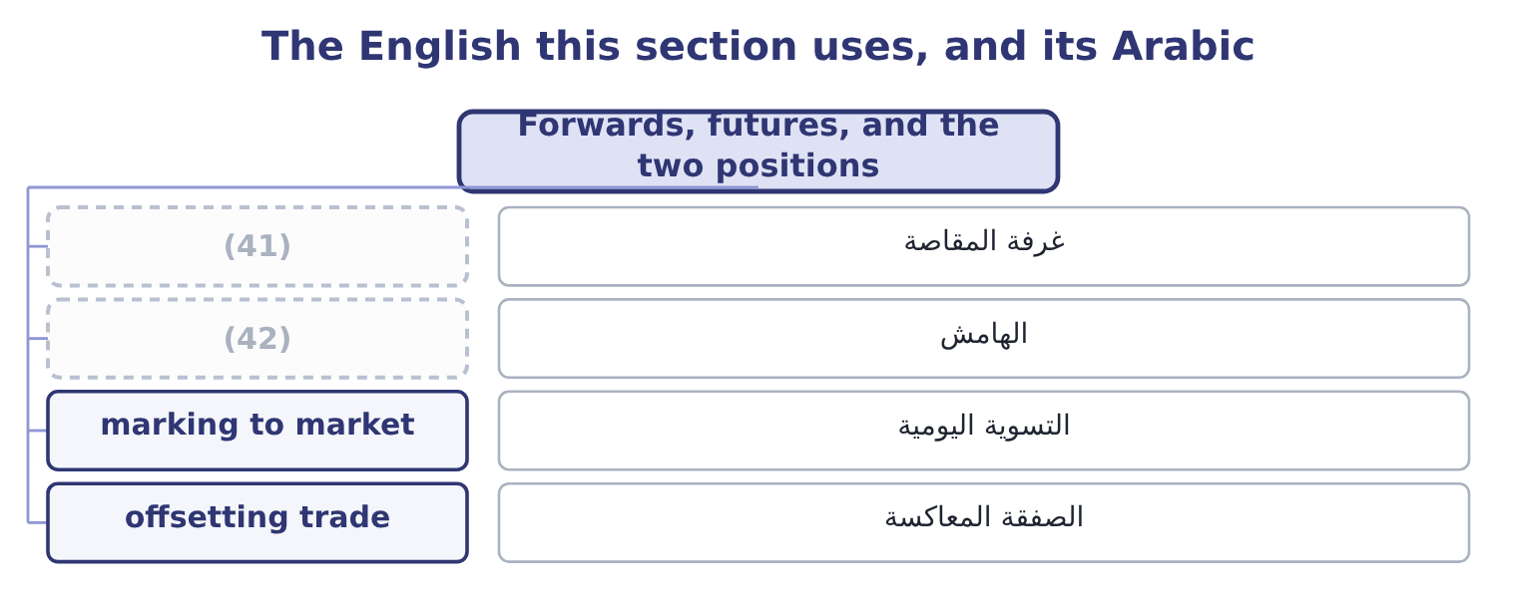
word list
clearing house · margin · intrinsic value

The English this sheet uses, and its Arabic
English (exam term) | Arabic
clearing house | غرفة المقاصة
margin | الهامش
marking to market | التسوية اليومية
offsetting trade | الصفقة المعاكسة

Answer key · 6.2 Forwards, futures, and the two positions

1 something | 22 seller's
2 future | 23 chooses
3 promise | 24 business
4 quality | 25 expects
5 exchange's | 26 current
6 stands | 27 requirement
7 neither | 28 offset
8 credit | 29 reaches
9 deposit | 30 identical
10 losses | 31 cheaper
11 differences | 32 directions
12 standardisation | 33 windfall
13 Privately, over the counter | 34 depends
14 On the clearing house | 35 certainty
15 None usually | 36 average
16 Once, at maturity | 37 covenant
17 By agreement, or a new offsetting contract | 38 generally
18 A company hedging a specific exposure | 39 bought
19 positions | 40 settlements
20 constantly | 41 clearing house
21 buyer's | 42 margin

the summaries in full
Summary 1 A forward contract is an agreement between two parties to buy or sell a stated quantity of something at a stated price on a stated future date. It is negotiated privately, so every term can be tailored, and it is settled once, at delivery. A futures contract is the same promise, standardised and traded on an exchange. Quantity, quality, delivery date and delivery point are fixed by the exchange; the only thing negotiated is the price. The exchange's clearing house stands between the two parties, so neither takes the other's credit risk, and both post margin: an initial deposit, and then a daily settlement of gains and losses called marking to market. Those two differences — customisation against standardisation, one settlement against daily settlement — generate every other difference the exam asks for.
Summary 2 The two positions are simple and are tested constantly. The long position is the buyer's: long means committed to buy, and a long gains when the price rises. The short position is the seller's: short means committed to sell, and a short gains when the price falls. A hedger chooses the position that offsets the business. Orontes buys sesame, so a price rise hurts it, so it goes long. A farmer sells sesame, so a price rise helps, so the farmer goes short — and the farmer and Orontes are the two sides of the same contract, each made safer by it.
Summary 3 Orontes expects to buy 1,000 tonnes of sesame in six months. The current price is $1,200 a tonne, so the expected cost is 1,000 × 1,200 = 1,200,000. A rise of a tenth would add $120,000 to cost of sales, which is more than a point of gross margin. The company buys 1,000 tonnes six months forward at $1,200. It is now long sesame futures and long the physical requirement, and the two offset. Suppose sesame reaches $1,350. The physical purchase costs 1,350 − 1,200 = 150 a tonne more than planned, which is 150 × 1,000 = 150,000. The contract gains the identical $150,000. Net cost: $1,200 a tonne, as planned. Suppose sesame falls to $1,100. The physical purchase is $100 a tonne cheaper, saving $100,000, and the contract loses $100,000. Net cost: $1,200 a tonne, as planned.
Summary 4 In both directions Orontes paid $1,200 a tonne, which is what hedging means. The company gave up a $100,000 windfall to avoid a $150,000 shock, and whether that is a good trade depends on whether certainty is worth more to it than the average outcome — which for a company with a gross margin of 35 per cent and a bank covenant to respect, it generally is. Had Orontes bought futures rather than a forward, it would also have had to fund margin: at an initial margin of 5 per cent, 1,200,000 × 0.05 = 60,000 of cash tied up, plus whatever the daily settlements demanded.

6.3 Options: calls, puts, and what they cost
Chapter 6 · section 6.3

Fill every gap. Each word list holds one word more than there are gaps.
Summary 1 gaps 1–7
That (1) word is the (2) , and it is why an option costs money up front and a forward does not. A call option gives its holder the right, but not the obligation, to buy the underlying at a stated price on or before a stated date. A put option gives the right to sell. The stated price is the strike price or (3) price. The date is the expiration. The money paid for the right is the premium, and it is paid (4) or not the option is ever used. Every option has two sides. The holder, who paid the premium, has a right and no obligation; the writer, who (5) it, has an obligation and no right. The (6) loss is limited to the premium and the gain is open-ended on a call; the (7) gain is limited to the premium and the loss is open-ended.
word list
difference · happens · holder's · received · exercise · single · writer's · whether

Summary 2 gaps 8–14
The exam checks that (8) more often than any other point in the chapter. Two (9) appear: an American option may be exercised at any time up to expiration, a European option only at expiration. The American style is worth at least as much, because it allows (10) the European allows and more. Intrinsic value is what the option would be worth if exercised (11) , and it is never negative. For a call it is the underlying price less the strike, or zero if that is negative. For a put it is the strike less the underlying price, or zero. An option with intrinsic value is in the money; with none and the underlying at the strike, at the money; with none and the underlying the wrong side, out of the money. Time value is the rest of the premium: what a buyer pays for the (12) that the option moves (13) into the money before expiration. Premium equals intrinsic value plus time value, (14) , and at expiration time value is zero so the premium equals the intrinsic value.
word list
out-of-the-money · styles · everything · chance · always · further · direction · immediately

Worked example: a call on sesame

Summary 3 gaps 15–24
Instead of a forward, Orontes buys a (15) call on 1,000 (16) of sesame with a strike of $1,250 a tonne, (17) a premium of $40 a tonne. At $1,350, the call is in the money: its intrinsic value is 1,350 − 1,250 = 100 a tonne, and after the premium the gain is 100 − 40 = 60 a tonne. Orontes (18) and its effective cost is $1,290 a tonne. At $1,100, the call is (19) and Orontes lets it (20) , losing the $40 premium and buying in the (21) at $1,100. Its effective cost is $1,140 a tonne — $60 better than the forward of section 6.2. The call buyer is better off than doing (22) above 1,250 + 40 = 1,290, and worse off below it by the premium. Compare the three (23) at the two (24) .
word list
tonnes · worthless · strategies · market · paying · out-of-the-money · expire · exercises · prices · nothing · six-month

Summary 4 gaps 25–28
Unhedged, Orontes pays $1,350 or $1,100. Forward, it pays $1,200 (25) way. Call, it pays $1,290 or $1,140. The option is the only one that caps the bad (26) and keeps the good one, and the premium of $40 a tonne — $40,000 in total — is exactly what that (27) costs. There is no free (28) .
word list
outcome · either · premium · version · asymmetry

One exposure, three strategies
Each stage leads to the next.
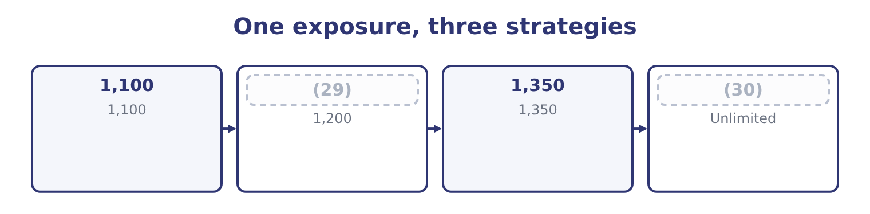
word list
basis risk · Worst case · 1,200

Who has the right, and who has the obligation

Summary 5 gaps 31–34
The holder of a call or a put has the right. The writer has the obligation and keeps the premium (31) happens. Intrinsic value is never negative. An (32) option has an intrinsic value of zero, not a negative one. A call is not the opposite of a put. The opposite of buying a call is (33) a call. Buying a put is a (34) position entirely.
word list
out-of-the-money · whatever · different · derivative · writing

Who holds the right, and who carries the obligation
Every item belongs to exactly one group.
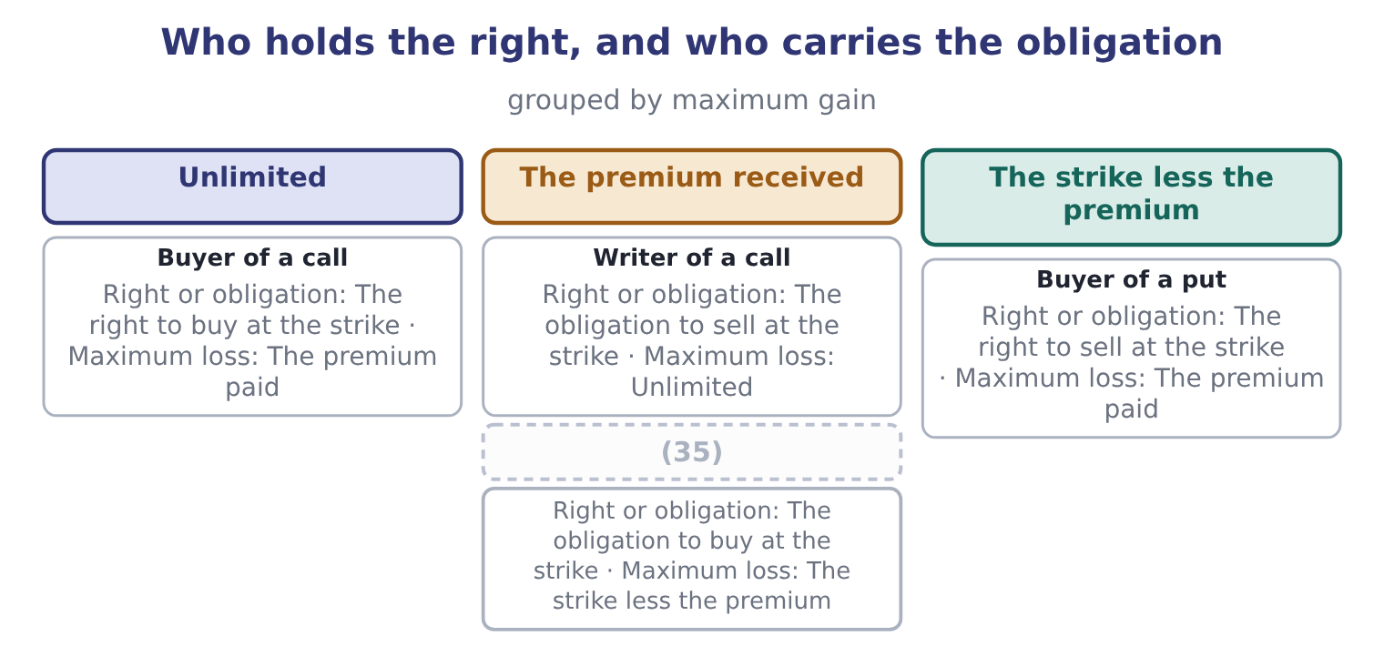
word list
Writer of a put · Buyer of a call

The English this section uses, and its Arabic
Each term sits against what it means.
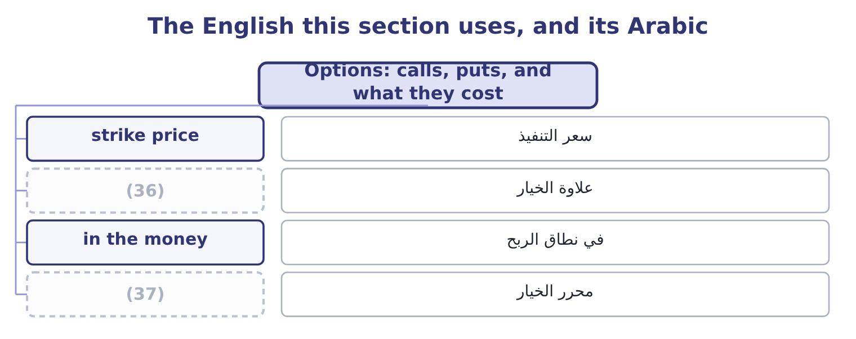
word list
premium · option writer · basis risk

The English this sheet uses, and its Arabic
English (exam term) | Arabic
strike price | سعر التنفيذ
premium | علاوة الخيار
in the money | في نطاق الربح
option writer | محرر الخيار

Answer key · 6.3 Options: calls, puts, and what they cost

1 single | 20 expire
2 difference | 21 market
3 exercise | 22 nothing
4 whether | 23 strategies
5 received | 24 prices
6 holder's | 25 either
7 writer's | 26 outcome
8 direction | 27 asymmetry
9 styles | 28 version
10 everything | 29 1,200
11 immediately | 30 Worst case
12 chance | 31 whatever
13 further | 32 out-of-the-money
14 always | 33 writing
15 six-month | 34 different
16 tonnes | 35 Writer of a put
17 paying | 36 premium
18 exercises | 37 option writer
19 worthless

the summaries in full
Summary 1 That single word is the difference, and it is why an option costs money up front and a forward does not. A call option gives its holder the right, but not the obligation, to buy the underlying at a stated price on or before a stated date. A put option gives the right to sell. The stated price is the strike price or exercise price. The date is the expiration. The money paid for the right is the premium, and it is paid whether or not the option is ever used. Every option has two sides. The holder, who paid the premium, has a right and no obligation; the writer, who received it, has an obligation and no right. The holder's loss is limited to the premium and the gain is open-ended on a call; the writer's gain is limited to the premium and the loss is open-ended.
Summary 2 The exam checks that direction more often than any other point in the chapter. Two styles appear: an American option may be exercised at any time up to expiration, a European option only at expiration. The American style is worth at least as much, because it allows everything the European allows and more. Intrinsic value is what the option would be worth if exercised immediately, and it is never negative. For a call it is the underlying price less the strike, or zero if that is negative. For a put it is the strike less the underlying price, or zero. An option with intrinsic value is in the money; with none and the underlying at the strike, at the money; with none and the underlying the wrong side, out of the money. Time value is the rest of the premium: what a buyer pays for the chance that the option moves further into the money before expiration. Premium equals intrinsic value plus time value, always, and at expiration time value is zero so the premium equals the intrinsic value.
Summary 3 Instead of a forward, Orontes buys a six-month call on 1,000 tonnes of sesame with a strike of $1,250 a tonne, paying a premium of $40 a tonne. At $1,350, the call is in the money: its intrinsic value is 1,350 − 1,250 = 100 a tonne, and after the premium the gain is 100 − 40 = 60 a tonne. Orontes exercises and its effective cost is $1,290 a tonne. At $1,100, the call is worthless and Orontes lets it expire, losing the $40 premium and buying in the market at $1,100. Its effective cost is $1,140 a tonne — $60 better than the forward of section 6.2. The call buyer is better off than doing nothing above 1,250 + 40 = 1,290, and worse off below it by the premium. Compare the three strategies at the two prices.
Summary 4 Unhedged, Orontes pays $1,350 or $1,100. Forward, it pays $1,200 either way. Call, it pays $1,290 or $1,140. The option is the only one that caps the bad outcome and keeps the good one, and the premium of $40 a tonne — $40,000 in total — is exactly what that asymmetry costs. There is no free version.
Summary 5 The holder of a call or a put has the right. The writer has the obligation and keeps the premium whatever happens. Intrinsic value is never negative. An out-of-the-money option has an intrinsic value of zero, not a negative one. A call is not the opposite of a put. The opposite of buying a call is writing a call. Buying a put is a different position entirely.

6.4 What an option is worth
Chapter 6 · section 6.4

Fill every gap. Each word list holds one word more than there are gaps.
Summary 1 gaps 1–12
Six (1) determine an (2) premium, and the (3) asks for the direction of each. (4) a call first. The price of the underlying. Higher is better for a call: more intrinsic value. Lower is better for a call, because the right to buy (5) is worth more. Higher is better for a put. More is better for both. Time is the chance of a (6) move, and since the (7) is capped at the premium, more chances can only help. Volatility of the underlying. More is better for both, and this is the one candidates find (8) . A more volatile underlying produces more extreme outcomes in both (9) , and the option holder keeps the good extremes and is protected from the bad ones. Volatility is therefore the variable option traders (10) trade. A higher rate is slightly better for a call, because the strike will be paid later and money paid later is worth less; slightly worse for a put, by the same (11) . Dividends on the underlying. A dividend lowers the share price on the (12) date, so expected dividends reduce a call's value and raise a put's.
word list
reasoning · directions · favourable · variables · ex-dividend · outcome · downside · counter-intuitive · Taking · option's · cheaply · relationships · actually

What moves an option premium
Every item belongs to exactly one group.
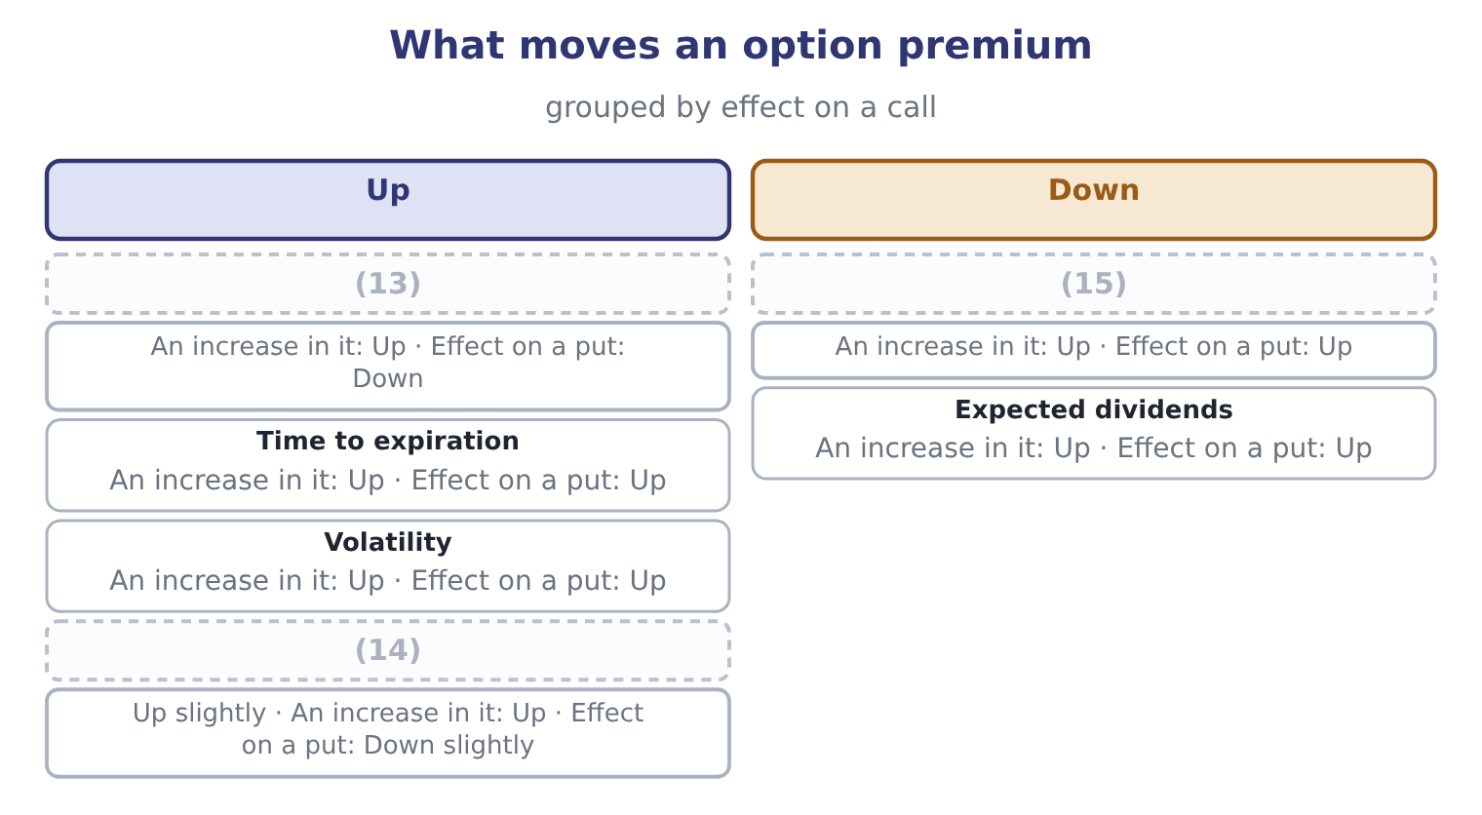
word list
Risk-free rate · Price of the underlying · Strike price · put-call parity

Summary 2 gaps 16–27
Two further (16) appear in questions. The premium can never be less than the intrinsic value, because anybody could (17) buy the option and (18) it at once for a (19) — the arbitrage of section 6.1 at work. And a call and a put with the same strike and (20) are linked to the underlying and a (21) bond by put-call parity, which is the formal (22) that the same payoff can be built two ways and must therefore cost the same. Note (23) what is not on the list. The expected (24) on the underlying is not there, and neither is (25) opinion about where the price is going. That is the (26) result at the heart of option pricing, and it holds because the option can be (27) by holding the underlying and borrowing, so its price is fixed by arbitrage rather than by forecasts.
word list
expiration · exercise · return · statement · derivative · replicated · anybody's · profit · risk-free · finally · otherwise · surprising · relationships

The English this section uses, and its Arabic
Each term sits against what it means.
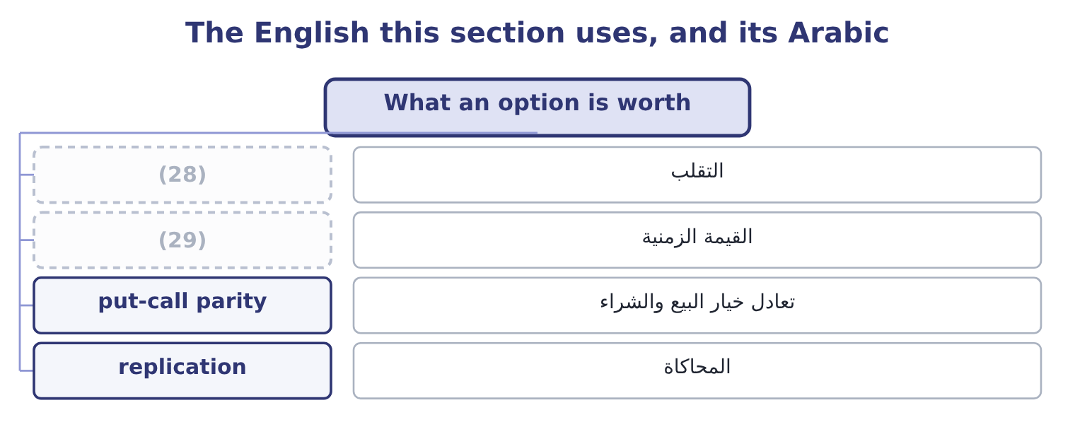
word list
premium · volatility · time value

The English this sheet uses, and its Arabic
English (exam term) | Arabic
volatility | التقلب
time value | القيمة الزمنية
put-call parity | تعادل خيار البيع والشراء
replication | المحاكاة

Answer key · 6.4 What an option is worth

1 variables | 16 relationships
2 option's | 17 otherwise
3 outcome | 18 exercise
4 Taking | 19 profit
5 cheaply | 20 expiration
6 favourable | 21 risk-free
7 downside | 22 statement
8 counter-intuitive | 23 finally
9 directions | 24 return
10 actually | 25 anybody's
11 reasoning | 26 surprising
12 ex-dividend | 27 replicated
13 Price of the underlying | 28 volatility
14 Risk-free rate | 29 time value
15 Strike price

the summaries in full
Summary 1 Six variables determine an option's premium, and the outcome asks for the direction of each. Taking a call first. The price of the underlying. Higher is better for a call: more intrinsic value. Lower is better for a call, because the right to buy cheaply is worth more. Higher is better for a put. More is better for both. Time is the chance of a favourable move, and since the downside is capped at the premium, more chances can only help. Volatility of the underlying. More is better for both, and this is the one candidates find counter-intuitive. A more volatile underlying produces more extreme outcomes in both directions, and the option holder keeps the good extremes and is protected from the bad ones. Volatility is therefore the variable option traders actually trade. A higher rate is slightly better for a call, because the strike will be paid later and money paid later is worth less; slightly worse for a put, by the same reasoning. Dividends on the underlying. A dividend lowers the share price on the ex-dividend date, so expected dividends reduce a call's value and raise a put's.
Summary 2 Two further relationships appear in questions. The premium can never be less than the intrinsic value, because anybody could otherwise buy the option and exercise it at once for a profit — the arbitrage of section 6.1 at work. And a call and a put with the same strike and expiration are linked to the underlying and a risk-free bond by put-call parity, which is the formal statement that the same payoff can be built two ways and must therefore cost the same. Note finally what is not on the list. The expected return on the underlying is not there, and neither is anybody's opinion about where the price is going. That is the surprising result at the heart of option pricing, and it holds because the option can be replicated by holding the underlying and borrowing, so its price is fixed by arbitrage rather than by forecasts.

6.5 Choosing an instrument
Chapter 6 · section 6.5

Fill every gap. Each word list holds one word more than there are gaps.
Summary 1 gaps 1–12
A (1) with an exposure has four honest answers and the exam expects the choice to be argued rather than (2) . Appropriate when the exposure is small against the business, when the company is (3) hedged because its costs and (4) move together, or when the cost of hedging exceeds the risk removed. Doing nothing is a (5) and should be (6) as one. Hedge with a forward or a future. Appropriate when the exposure is known in amount and (7) and the company wants (8) . It costs nothing up front and it removes the upside. (9) a forward when the amount or date is specific, a future when (10) and credit safety matter more than an exact fit. Hedge with an (11) . Appropriate when the exposure is uncertain — a tender that may not be won, a harvest that may not arrive — or when the company wants (12) and is willing to pay for keeping the upside. It costs a premium, and that premium is the whole of what distinguishes it from a forward.
word list
liquidity · treasurer · recorded · certainty · decision · Choose · revenues · inventory · protection · timing · naturally · asserted · option

Summary 2 gaps 13–24
Match the exposure inside the business: borrow in the (13) you earn, buy from a supplier whose price moves with your selling price, hold (14) as a hedge against a rising input cost. This is the cheapest hedge (15) and the exam rewards the (16) who mentions it first. Two (17) close the chapter. A hedge is (18) exact. If the (19) underlying is not precisely what the company buys — a sesame future against a specific grade, or a crude oil future against jet fuel — the two prices move together but not (20) , and the difference between them is basis risk, which no hedge of that kind removes. A hedge that becomes a (21) . A company that (22) more than its exposure, or keeps a contract after the exposure has gone, is speculating with the (23) ' money. Every famous (24) loss in corporate history began as an authorised hedging programme, and the control that prevents it is a policy limiting positions to documented exposures.
word list
rarely · inventory · contract's · identically · derivatives · warnings · available · shareholders · hedges · currency · becomes · speculation · candidate

Price the positions

Your turn: positions and values (complete the blanks)
Position | Data | Answer
Intrinsic value of a call | (25) | ________
Intrinsic value of a put | Strike 50, underlying 58 | ________
Time value of that call | (26) | ________
Breakeven for the call buyer |  | ________
Maximum loss of the call buyer |  | ________
Maximum loss of the call writer |  | ________
Position for a company that will SELL wheat in three months |  | ________

word list
natural hedge · Premium 11 · Strike 50, underlying 58

"Short"

Summary 3 gaps 27–34
English short in finance means (27) to deliver something you do not hold: a short position gains when prices fall. It has nothing to do with time, although (28) debt is a phrase in the same book, and nothing to do with a (29) , although a short seller may (30) one. Note the (31) pair: to cover a short is to close it by buying, and a short (32) is what happens when many shorts are forced to cover at once — both phrases appear in exam (33) on market mechanics without (34) .
word list
committed · short-term · hedging · questions · create · shortage · explanation · companion · squeeze

"Short"
Position | Answer
Intrinsic value of a call | (35)
Intrinsic value of a put | Nil: the strike is below the underlying, so exercising would sell at 50 something worth 58.
Time value of that call | 3: 11 − 8 = 3.
Breakeven for the call buyer | (36)
Maximum loss of the call buyer | 11, the premium paid.
Maximum loss of the call writer | Unlimited, because the underlying can rise without limit.
Position for a seller of wheat | Short: sell wheat futures, so that a fall in the wheat price is offset by a gain on the contract.

word list
61: 50 + 11 = 61. · 8: 58 − 50 = 8. · 3: 11 − 8 = 3.

The English this section uses, and its Arabic
Each term sits against what it means.
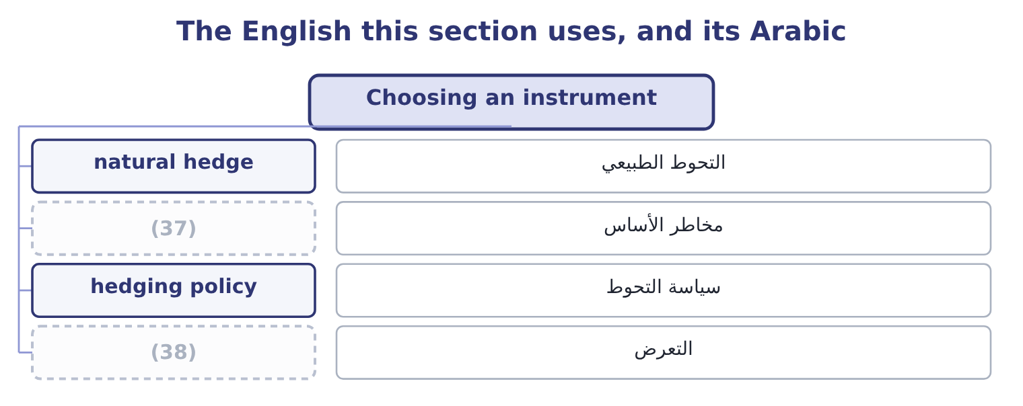
word list
exposure · basis risk · hedging policy

The English this sheet uses, and its Arabic
English (exam term) | Arabic
natural hedge | التحوط الطبيعي
basis risk | مخاطر الأساس
hedging policy | سياسة التحوط
exposure | التعرض

Answer key · 6.5 Choosing an instrument

1 treasurer | 20 identically
2 asserted | 21 speculation
3 naturally | 22 hedges
4 revenues | 23 shareholders
5 decision | 24 derivatives
6 recorded | 25 Strike 50, underlying 58
7 timing | 26 Premium 11
8 certainty | 27 committed
9 Choose | 28 short-term
10 liquidity | 29 shortage
11 option | 30 create
12 protection | 31 companion
13 currency | 32 squeeze
14 inventory | 33 questions
15 available | 34 explanation
16 candidate | 35 8: 58 − 50 = 8.
17 warnings | 36 61: 50 + 11 = 61.
18 rarely | 37 basis risk
19 contract's | 38 exposure

the summaries in full
Summary 1 A treasurer with an exposure has four honest answers and the exam expects the choice to be argued rather than asserted. Appropriate when the exposure is small against the business, when the company is naturally hedged because its costs and revenues move together, or when the cost of hedging exceeds the risk removed. Doing nothing is a decision and should be recorded as one. Hedge with a forward or a future. Appropriate when the exposure is known in amount and timing and the company wants certainty. It costs nothing up front and it removes the upside. Choose a forward when the amount or date is specific, a future when liquidity and credit safety matter more than an exact fit. Hedge with an option. Appropriate when the exposure is uncertain — a tender that may not be won, a harvest that may not arrive — or when the company wants protection and is willing to pay for keeping the upside. It costs a premium, and that premium is the whole of what distinguishes it from a forward.
Summary 2 Match the exposure inside the business: borrow in the currency you earn, buy from a supplier whose price moves with your selling price, hold inventory as a hedge against a rising input cost. This is the cheapest hedge available and the exam rewards the candidate who mentions it first. Two warnings close the chapter. A hedge is rarely exact. If the contract's underlying is not precisely what the company buys — a sesame future against a specific grade, or a crude oil future against jet fuel — the two prices move together but not identically, and the difference between them is basis risk, which no hedge of that kind removes. A hedge that becomes a speculation. A company that hedges more than its exposure, or keeps a contract after the exposure has gone, is speculating with the shareholders' money. Every famous derivatives loss in corporate history began as an authorised hedging programme, and the control that prevents it is a policy limiting positions to documented exposures.
Summary 3 English short in finance means committed to deliver something you do not hold: a short position gains when prices fall. It has nothing to do with time, although short-term debt is a phrase in the same book, and nothing to do with a shortage, although a short seller may create one. Note the companion pair: to cover a short is to close it by buying, and a short squeeze is what happens when many shorts are forced to cover at once — both phrases appear in exam questions on market mechanics without explanation.

7.1 Interest rate swaps
Chapter 7 · section 7.1

Fill every gap. Each word list holds one word more than there are gaps.
Chapter 7, section by section
Each stage leads to the next.
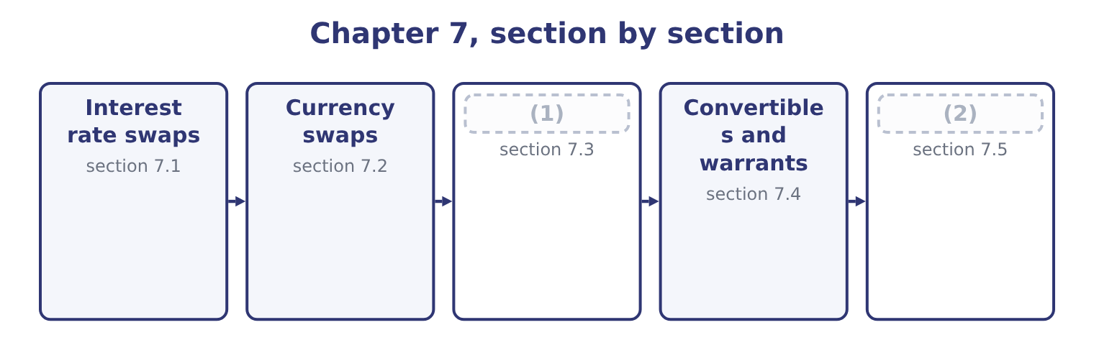
word list
Leases as a source of finance · Taxes, capital structure and investment · plain vanilla swap

Summary 1 gaps 3–14
An interest rate swap is an (3) between two parties to (4) interest payments on a notional principal for a stated period. One pays fixed and receives floating; the other does the (5) . The principal (6) is never exchanged, which is why it is called notional: it exists only to (7) the payments. The (8) are simple. A company with $10,000,000 of (9) debt agrees to pay 6 per cent fixed and (10) the floating rate. If the floating rate for a period is 4.5 per cent, the company pays 10,000,000 × 0.06 = 600,000 and receives 10,000,000 × 0.045 = 450,000, so it (11) 600,000 − 450,000 = 150,000 net. (12) it is paying 4.5 per cent to its own lender, which the swap (13) covers exactly. Its total cost is 6 per cent fixed, (14) the floating rate does.
word list
floating-rate · compute · mechanics · Meanwhile · exchange · opposite · agreement · receive · receipt · whatever · itself · difference · settles

Summary 2 gaps 15–26
Why not (15) borrow at a fixed rate in the first place? Three (16) the exam accepts. The company's (17) changed. The debt was issued years ago on a view of rates that no longer holds, and (18) a bond early costs a call (19) and issue costs. A swap (20) the exposure without (21) the debt. The company can borrow more (22) in one market than the other. This is the (23) advantage argument and it is the classic exam (24) . (25) a strong company can borrow fixed at 5.0 per cent or floating at the reference rate plus 0.3 points, while a weaker one pays fixed 7.0 per cent or floating plus 1.0 point. The strong company is better in both (26) , but it is better by 7.0 − 5.0 = 2.0 points in the fixed market and only by 1.0 − 0.3 = 0.7 points in the floating one.
word list
changes · touching · Suppose · repaying · markets · surplus · circumstances · cheaply · question · comparative · premium · reasons · simply

Summary 3 gaps 27–35
The (27) , 2.0 − 0.7 = 1.3 points, is a gain (28) to be shared: each borrows where its advantage is largest and they swap, and both end up paying less than they could have on their own. A swap can be (29) in days, costs no issue fees and can be reversed with an (30) swap. The risks are real and (31) . A swap (32) counterparty risk, since the other side may fail — which is why most swaps now clear (33) a central counterparty, as futures do. And a swap entered without a (34) exposure is a (35) on rates, exactly as a surplus hedge was.
word list
speculation · through · available · arranged · examinable · reversed · offsetting · carries · difference · matching

A swap that leaves both parties better off
Step | The strong company | The weaker company
Can borrow fixed at | 5.0% | 7.0%
Can borrow floating at | (36) | Reference + 1.0
Where its advantage is larger | Fixed, by 2.0 points | (37)
What it actually borrows | (38) | Floating at reference + 1.0
What it wants | Floating | Fixed
The swap | Receives fixed, pays floating | (39)
Total gain to be shared | 1.3 points | 1.3 points

word list
Floating at reference + 1.0 · Pays fixed, receives floating · Fixed at 5.0% · Floating, by the smaller gap · Reference + 0.3

The English this section uses, and its Arabic
Each term sits against what it means.
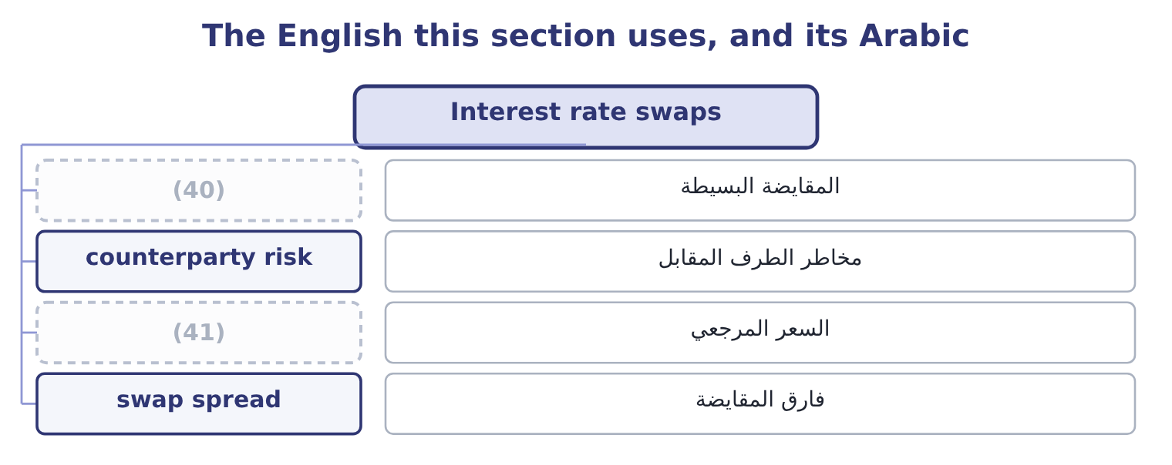
word list
counterparty risk · reference rate · plain vanilla swap

The English this sheet uses, and its Arabic
English (exam term) | Arabic
plain vanilla swap | المقايضة البسيطة
counterparty risk | مخاطر الطرف المقابل
reference rate | السعر المرجعي
swap spread | فارق المقايضة

Answer key · 7.1 Interest rate swaps

1 Leases as a source of finance | 22 cheaply
2 Taxes, capital structure and investment | 23 comparative
3 agreement | 24 question
4 exchange | 25 Suppose
5 opposite | 26 markets
6 itself | 27 difference
7 compute | 28 available
8 mechanics | 29 arranged
9 floating-rate | 30 offsetting
10 receive | 31 examinable
11 settles | 32 carries
12 Meanwhile | 33 through
13 receipt | 34 matching
14 whatever | 35 speculation
15 simply | 36 Reference + 0.3
16 reasons | 37 Floating, by the smaller gap
17 circumstances | 38 Fixed at 5.0%
18 repaying | 39 Pays fixed, receives floating
19 premium | 40 plain vanilla swap
20 changes | 41 reference rate
21 touching

the summaries in full
Summary 1 An interest rate swap is an agreement between two parties to exchange interest payments on a notional principal for a stated period. One pays fixed and receives floating; the other does the opposite. The principal itself is never exchanged, which is why it is called notional: it exists only to compute the payments. The mechanics are simple. A company with $10,000,000 of floating-rate debt agrees to pay 6 per cent fixed and receive the floating rate. If the floating rate for a period is 4.5 per cent, the company pays 10,000,000 × 0.06 = 600,000 and receives 10,000,000 × 0.045 = 450,000, so it settles 600,000 − 450,000 = 150,000 net. Meanwhile it is paying 4.5 per cent to its own lender, which the swap receipt covers exactly. Its total cost is 6 per cent fixed, whatever the floating rate does.
Summary 2 Why not simply borrow at a fixed rate in the first place? Three reasons the exam accepts. The company's circumstances changed. The debt was issued years ago on a view of rates that no longer holds, and repaying a bond early costs a call premium and issue costs. A swap changes the exposure without touching the debt. The company can borrow more cheaply in one market than the other. This is the comparative advantage argument and it is the classic exam question. Suppose a strong company can borrow fixed at 5.0 per cent or floating at the reference rate plus 0.3 points, while a weaker one pays fixed 7.0 per cent or floating plus 1.0 point. The strong company is better in both markets, but it is better by 7.0 − 5.0 = 2.0 points in the fixed market and only by 1.0 − 0.3 = 0.7 points in the floating one.
Summary 3 The difference, 2.0 − 0.7 = 1.3 points, is a gain available to be shared: each borrows where its advantage is largest and they swap, and both end up paying less than they could have on their own. A swap can be arranged in days, costs no issue fees and can be reversed with an offsetting swap. The risks are real and examinable. A swap carries counterparty risk, since the other side may fail — which is why most swaps now clear through a central counterparty, as futures do. And a swap entered without a matching exposure is a speculation on rates, exactly as a surplus hedge was.

7.2 Currency swaps
Chapter 7 · section 7.2

Fill every gap. Each word list holds one word more than there are gaps.
Summary 1 gaps 1–12
A currency swap (1) principal and interest in one currency for principal and interest in another. (2) an interest rate swap, the principal is exchanged — at the start, at the end, or both — because the two amounts are in different currencies and there is no way to net them. The use is (3) . A company that earns in one currency and has (4) in another has a mismatch: its debt service rises when the borrowing currency (5) , and the business does nothing to offset it. A currency swap converts the (6) into the currency the company earns, which is the (7) hedge. Two motives recur in (8) . A company may be able to borrow (9) in its home market and not at all in a market where it has just started (10) . It borrows at home, swaps into the foreign currency, and (11) the foreign debt from the foreign (12) .
word list
strengthens · natural · borrowed · questions · Unlike · operating · because · revenue · obligation · straightforward · services · cheaply · exchanges

Summary 2 gaps 13–22
A company with a long-term foreign (13) uses the swap so that both the asset and the (14) move with the same rate, so that a currency move changes the value of both (15) and the net (16) is stable. That is the (17) exposure of Book 1, (18) . The risks are the interest rate swap's risks plus one. Counterparty risk is larger, because the principal is exchanged and the amounts at stake are (19) than a stream of interest (20) . And the swap fixes the rate for its term, so a company whose foreign (21) shrink is left with a hedge larger than its exposure, which is a (22) it did not intend.
word list
speculation · translation · together · liability · position · investment · differences · cheaply · bigger · managed · operations

Two swaps
Feature | Interest rate swap | Currency swap
What is exchanged | (23) | Interest and principal
Principal | (24) | Exchanged, in two currencies
Main use | Change fixed to floating, or back | (25)
Main risk | Counterparty, and rate moves | (26)

word list
Change fixed to floating, or back · Interest payments only · Match debt to the currency earned · Counterparty, and currency moves · Notional, never exchanged

Notional against exchanged

Summary 3 gaps 27–33
An interest rate swap's principal is never exchanged. A currency swap's principal is. A (27) that says "the principal is exchanged at the start" has told you which swap it is. A swap does not change the (28) borrowing. The (29) loan stays on the (30) sheet and the swap sits (31) it. Both (32) to a swap can be better off, because they start from different costs in two markets. Nobody creates money; a gap in (33) pricing is shared.
word list
principal · beside · balance · question · relative · parties · original · underlying

The English this section uses, and its Arabic
Each term sits against what it means.
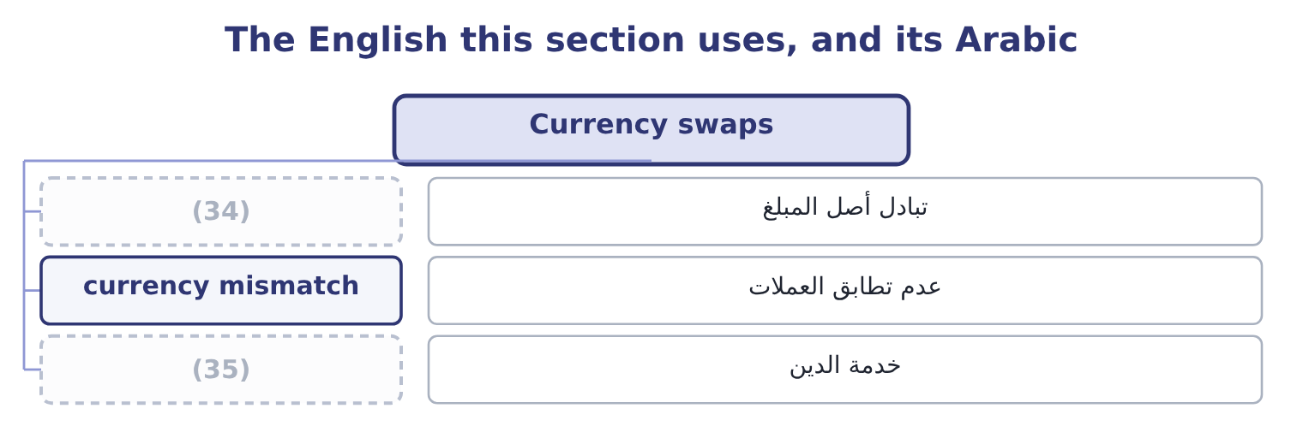
word list
notional principal · principal exchange · debt service

The English this sheet uses, and its Arabic
English (exam term) | Arabic
principal exchange | تبادل أصل المبلغ
currency mismatch | عدم تطابق العملات
debt service | خدمة الدين

Answer key · 7.2 Currency swaps

1 exchanges | 19 bigger
2 Unlike | 20 differences
3 straightforward | 21 operations
4 borrowed | 22 speculation
5 strengthens | 23 Interest payments only
6 obligation | 24 Notional, never exchanged
7 natural | 25 Match debt to the currency earned
8 questions | 26 Counterparty, and currency moves
9 cheaply | 27 question
10 operating | 28 underlying
11 services | 29 original
12 revenue | 30 balance
13 investment | 31 beside
14 liability | 32 parties
15 together | 33 relative
16 position | 34 principal exchange
17 translation | 35 debt service
18 managed

the summaries in full
Summary 1 A currency swap exchanges principal and interest in one currency for principal and interest in another. Unlike an interest rate swap, the principal is exchanged — at the start, at the end, or both — because the two amounts are in different currencies and there is no way to net them. The use is straightforward. A company that earns in one currency and has borrowed in another has a mismatch: its debt service rises when the borrowing currency strengthens, and the business does nothing to offset it. A currency swap converts the obligation into the currency the company earns, which is the natural hedge. Two motives recur in questions. A company may be able to borrow cheaply in its home market and not at all in a market where it has just started operating. It borrows at home, swaps into the foreign currency, and services the foreign debt from the foreign revenue.
Summary 2 A company with a long-term foreign investment uses the swap so that both the asset and the liability move with the same rate, so that a currency move changes the value of both together and the net position is stable. That is the translation exposure of Book 1, managed. The risks are the interest rate swap's risks plus one. Counterparty risk is larger, because the principal is exchanged and the amounts at stake are bigger than a stream of interest differences. And the swap fixes the rate for its term, so a company whose foreign operations shrink is left with a hedge larger than its exposure, which is a speculation it did not intend.
Summary 3 An interest rate swap's principal is never exchanged. A currency swap's principal is. A question that says "the principal is exchanged at the start" has told you which swap it is. A swap does not change the underlying borrowing. The original loan stays on the balance sheet and the swap sits beside it. Both parties to a swap can be better off, because they start from different costs in two markets. Nobody creates money; a gap in relative pricing is shared.

7.3 Leases as a source of finance
Chapter 7 · section 7.3

Fill every gap. Each word list holds one word more than there are gaps.
Summary 1 gaps 1–12
A lease is a (1) giving the use of an asset for a period in (2) for payments. As a (3) device it has one (4) feature: the company (5) the asset without paying for it at once, and the lessor keeps legal title. The accounting (6) Part 1 taught matters (7) as well. A finance lease transfers (8) all the risks and rewards of (9) — a long term relative to the asset's life, a bargain purchase option, present value of payments close to fair value — and it is (10) , so an asset and a liability both appear. An operating lease does not transfer those risks and, under current US GAAP, still produces a (11) asset and a lease liability on the balance sheet, with the expense (12) as a single operating cost rather than as interest and depreciation.
word list
commercially · substantially · capitalised · contract · presented · right-of-use · financing · obtains · available · exchange · ownership · distinction · defining

Summary 2 gaps 13–24
The (13) the exam expects are these. No large payment at the start, so the (14) own capital stays (15) . (16) for a company that cannot (17) . The lessor retains title, so its (18) is better secured than a (19) , and it will often provide for a weaker company at a rate no bank would offer. The tax (20) of the lessor. A lessor with taxable (21) can use the depreciation allowances; a (22) lessee cannot. The lessor prices the lease to keep part of that (23) and pass part to the lessee, so a lease can (24) be cheaper than borrowing for a company with no taxable income. This is the single most examinable reason to lease. Protection against obsolescence, where the lease is short and the asset is technology. Fewer covenants than a comparable loan, and faster arrangement.
word list
available · loss-making · company's · profits · genuinely · position · exposure · advantages · benefit · taxable · Access · borrow · lender's

Summary 3 gaps 25–31
The (25) are the mirror image. The (26) interest rate in a lease is usually higher than a secured loan's; the company has no (27) asset at the end unless it buys one; a long lease is a fixed (28) exactly as debt is, and the rating agencies and Book 1's (29) coverage ratio both treat it as such; and breaking a lease early is normally (30) . The point here is the list of (31) a company would want one.
word list
fixed-charge · reasons · obligation · expensive · payment · implicit · residual · disadvantages

The English this section uses, and its Arabic
Each term sits against what it means.
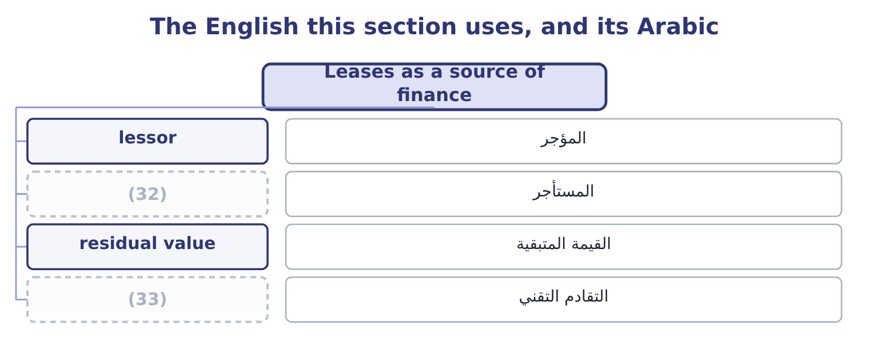
word list
المستأجر · obsolescence · lessee

The English this sheet uses, and its Arabic
English (exam term) | Arabic
lessor | المؤجر
lessee | المستأجر
residual value | القيمة المتبقية
obsolescence | التقادم التقني

Answer key · 7.3 Leases as a source of finance

1 contract | 18 exposure
2 exchange | 19 lender's
3 financing | 20 position
4 defining | 21 profits
5 obtains | 22 loss-making
6 distinction | 23 benefit
7 commercially | 24 genuinely
8 substantially | 25 disadvantages
9 ownership | 26 implicit
10 capitalised | 27 residual
11 right-of-use | 28 obligation
12 presented | 29 fixed-charge
13 advantages | 30 expensive
14 company's | 31 reasons
15 available | 32 lessee
16 Access | 33 obsolescence
17 borrow

the summaries in full
Summary 1 A lease is a contract giving the use of an asset for a period in exchange for payments. As a financing device it has one defining feature: the company obtains the asset without paying for it at once, and the lessor keeps legal title. The accounting distinction Part 1 taught matters commercially as well. A finance lease transfers substantially all the risks and rewards of ownership — a long term relative to the asset's life, a bargain purchase option, present value of payments close to fair value — and it is capitalised, so an asset and a liability both appear. An operating lease does not transfer those risks and, under current US GAAP, still produces a right-of-use asset and a lease liability on the balance sheet, with the expense presented as a single operating cost rather than as interest and depreciation.
Summary 2 The advantages the exam expects are these. No large payment at the start, so the company's own capital stays available. Access for a company that cannot borrow. The lessor retains title, so its exposure is better secured than a lender's, and it will often provide for a weaker company at a rate no bank would offer. The tax position of the lessor. A lessor with taxable profits can use the depreciation allowances; a loss-making lessee cannot. The lessor prices the lease to keep part of that benefit and pass part to the lessee, so a lease can genuinely be cheaper than borrowing for a company with no taxable income. This is the single most examinable reason to lease. Protection against obsolescence, where the lease is short and the asset is technology. Fewer covenants than a comparable loan, and faster arrangement.
Summary 3 The disadvantages are the mirror image. The implicit interest rate in a lease is usually higher than a secured loan's; the company has no residual asset at the end unless it buys one; a long lease is a fixed obligation exactly as debt is, and the rating agencies and Book 1's fixed-charge coverage ratio both treat it as such; and breaking a lease early is normally expensive. The point here is the list of reasons a company would want one.

7.4 Convertibles and warrants
Chapter 7 · section 7.4

Fill every gap. Each word list holds one word more than there are gaps.
Summary 1 gaps 1–10
A convertible bond is a bond that its holder may (1) for a fixed number of (2) shares. A warrant is a right to (3) for new shares at a stated price, usually (4) attached to a bond and then detachable and (5) separately. Both are debt with an equity option attached, and the (6) of both is the same. The conversion ratio is the number of shares a bond converts into. The conversion price is the par value (7) by that ratio: a $1,000 bond converting into 25 shares has a conversion price of 1,000 ÷ 25 = 40.00 a share. The conversion value is the ratio times the current share price: at $36 a share it is 25 × 36 = 900, and at $48 a share it is 25 × 48 = 1,200. A (8) market price is never below the higher of its conversion value and its value as a straight bond, because (9) floor can be (10) .
word list
arithmetic · subscribe · realised · issued · either · convertible's · traded · exchange · divided · expired · common

Worked example: what the convertible costs the issuer

Summary 2 gaps 11–15
A company issues $10,000,000 of convertible bonds at a 5 per cent coupon when its straight debt would cost 7 per cent. The saving is two (11) : 10,000,000 × 0.02 = 200,000 a year of (12) not paid. What was given away. At a conversion price of $40 (13) a current share price of $34, the holders may buy shares at $40 that the company could (14) have sold at the market price of (15) day they convert. The outcome if the shares do well. If the shares reach $60, holders convert: the company issues 250,000 shares for $10,000,000 of debt extinguished, which is $40 a share for stock worth $60. It has sold equity at a third below the market, and the cheap coupon over the life was the price it received for doing so.
word list
interest · whatever · realised · against · otherwise · points

Summary 3 gaps 16–24
The outcome if the shares do badly. If the shares stay at $30, (16) converts, the bonds are (17) at par, and the company has (18) at 5 per cent (19) of 7. The saving was real and the option expired (20) . A convertible is not cheap debt. It is debt sold (21) with a call option on the (22) own shares, and the discount on the coupon is the premium received for the option. Whether it was a good bargain is known only (23) , which is why the exam asks for the (24) rather than for a verdict.
word list
realised · company's · afterwards · mechanism · nobody · instead · borrowed · repaid · together · worthless

A convertible, measured
Measure | Computation | On a 1,000 bond converting into 25 shares
Conversion ratio | (25) | 25 shares
Conversion price | (26) | 40.00
Conversion value at a 36 share price | (27) | 900
Conversion value at a 48 share price | Ratio times price | 1,200
Straight bond value | Discounted at the straight rate | (28)
Market price | Never below the higher of the two floors | The higher of the above

word list
Below par if the coupon is below market · Par over the ratio · optimal capital structure · Ratio times price · Stated in the indenture

Summary 4 gaps 29–38
Warrants differ from (29) in three ways the exam tests. (30) a warrant brings new money into the company, because the holder pays the exercise price in cash; converting a bond brings none, since debt is (31) extinguished. A warrant is detachable and (32) separately, so the bond and the option can end in (33) hands. And warrants are usually (34) than the conversion (35) attached to bonds. A (36) intrinsic value works (37) as a call's: at an exercise price of $30 with the shares at $38, it is 38 − 30 = 8. Book 1, by the (38) method for a convertible and the treasury stock method for a warrant.
word list
exactly · Whether · longer-dated · rights · if-converted · warrant's · simply · Exercising · trades · different · convertibles

The English this section uses, and its Arabic
Each term sits against what it means.
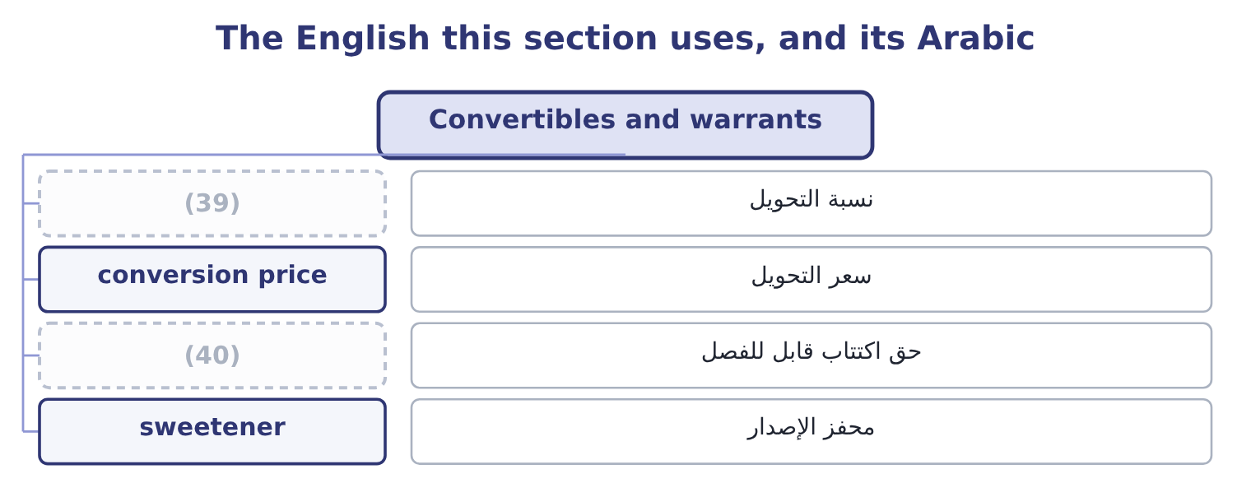
word list
محفز الإصدار · detachable warrant · conversion ratio

The English this sheet uses, and its Arabic
English (exam term) | Arabic
conversion ratio | نسبة التحويل
conversion price | سعر التحويل
detachable warrant | حق اكتتاب قابل للفصل
sweetener | محفز الإصدار

Answer key · 7.4 Convertibles and warrants

1 exchange | 21 together
2 common | 22 company's
3 subscribe | 23 afterwards
4 issued | 24 mechanism
5 traded | 25 Stated in the indenture
6 arithmetic | 26 Par over the ratio
7 divided | 27 Ratio times price
8 convertible's | 28 Below par if the coupon is below market
9 either | 29 convertibles
10 realised | 30 Exercising
11 points | 31 simply
12 interest | 32 trades
13 against | 33 different
14 otherwise | 34 longer-dated
15 whatever | 35 rights
16 nobody | 36 warrant's
17 repaid | 37 exactly
18 borrowed | 38 if-converted
19 instead | 39 conversion ratio
20 worthless | 40 detachable warrant

the summaries in full
Summary 1 A convertible bond is a bond that its holder may exchange for a fixed number of common shares. A warrant is a right to subscribe for new shares at a stated price, usually issued attached to a bond and then detachable and traded separately. Both are debt with an equity option attached, and the arithmetic of both is the same. The conversion ratio is the number of shares a bond converts into. The conversion price is the par value divided by that ratio: a $1,000 bond converting into 25 shares has a conversion price of 1,000 ÷ 25 = 40.00 a share. The conversion value is the ratio times the current share price: at $36 a share it is 25 × 36 = 900, and at $48 a share it is 25 × 48 = 1,200. A convertible's market price is never below the higher of its conversion value and its value as a straight bond, because either floor can be realised.
Summary 2 A company issues $10,000,000 of convertible bonds at a 5 per cent coupon when its straight debt would cost 7 per cent. The saving is two points: 10,000,000 × 0.02 = 200,000 a year of interest not paid. What was given away. At a conversion price of $40 against a current share price of $34, the holders may buy shares at $40 that the company could otherwise have sold at the market price of whatever day they convert. The outcome if the shares do well. If the shares reach $60, holders convert: the company issues 250,000 shares for $10,000,000 of debt extinguished, which is $40 a share for stock worth $60. It has sold equity at a third below the market, and the cheap coupon over the life was the price it received for doing so.
Summary 3 The outcome if the shares do badly. If the shares stay at $30, nobody converts, the bonds are repaid at par, and the company has borrowed at 5 per cent instead of 7. The saving was real and the option expired worthless. A convertible is not cheap debt. It is debt sold together with a call option on the company's own shares, and the discount on the coupon is the premium received for the option. Whether it was a good bargain is known only afterwards, which is why the exam asks for the mechanism rather than for a verdict.
Summary 4 Warrants differ from convertibles in three ways the exam tests. Exercising a warrant brings new money into the company, because the holder pays the exercise price in cash; converting a bond brings none, since debt is simply extinguished. A warrant is detachable and trades separately, so the bond and the option can end in different hands. And warrants are usually longer-dated than the conversion rights attached to bonds. A warrant's intrinsic value works exactly as a call's: at an exercise price of $30 with the shares at $38, it is 38 − 30 = 8. Book 1, by the if-converted method for a convertible and the treasury stock method for a warrant.

7.5 Taxes, capital structure and investment
Chapter 7 · section 7.5

Fill every gap. Each word list holds one word more than there are gaps.
Summary 1 gaps 1–12
The (1) asks how income taxes affect capital (2) and capital investment decisions, and the answer has four parts. The shield favours debt. Interest is deductible and dividends are not, so each (3) of interest saves the company its tax rate in cash. On $10,000,000 of debt at a 25 per cent rate, the whole shield is worth 10,000,000 × 0.25 = 2,500,000 in (4) value terms if the debt is permanent — the (5) textbook result, and the reason a tax (6) that favours one kind of money (7) how companies are (8) . Distress sets the limit. The shield is worth (9) to a company that (10) pay. Past some level of borrowing the expected costs of financial distress — a higher rate demanded by lenders, suppliers (11) terms, customers doubting warranties, (12) time consumed, and in the extreme the direct costs of a bankruptcy — rise faster than the shield grows.
word list
dollar · structure · consumed · cannot · tightening · present · changes · standard · management's · nothing · funded · system · outcome

Summary 2 gaps 13–24
The optimum is where the two margins meet, and it differs by (13) : a company with (14) cash flows and (15) assets can carry far more debt than one whose value is a brand and a (16) of research. Personal taxes work the other way. Interest received is usually taxed at a higher personal rate than dividends and capital gains, so (17) demand more for holding debt than the corporate shield alone would suggest, and part of the (18) advantage is given back. The exam mentions this as a (19) rather than asking for a (20) . Tax (21) investment decisions too, and in three (22) . Depreciation is deductible, so an asset (23) a tax shield of its own: (24) $2,100,000 depreciation charge saves 2,100,000 × 0.25 = 525,000 of tax a year, and that saving is a cash flow of the project that bought the asset.
word list
industry · investors · generates · pipeline · Orontes's · company-level · places · Personal · calculation · tangible · stable · reaches · qualification

Summary 3 gaps 25–32
Only after-tax cash flows are (25) , so a project's (26) and costs are taken net of tax. And the discount rate is the after-tax cost of capital, (27) the shield has (28) been counted there. The tax shield is not a reason to (29) a bad project. A project that earns less than its cost of capital (30) value whether or not it was financed with debt, and the (31) decision is separate from the investment decision. Mixing them is the most common error in Section B and Book 3 is built on (32) them apart.
word list
calculation · already · financing · revenues · discounted · keeping · because · destroys · prefer

Where tax touches the financing and investment decisions
Decision | The tax effect | Direction | Limit
Debt against equity | Interest deductible, dividends not | Favours debt | (33)
How much debt | The shield grows with the debt | (34) | The optimum, where margins meet
Which project | Cash flows are taken after tax | Lowers every return | (35)
Buying an asset | Depreciation is deductible | (36) | The asset's tax life
Leasing | The lessor uses the allowances | (37) | The lessor's pricing

word list
Favours leasing for a loss-maker · A separate shield · principal exchange · Distress costs · Favours more · None; it applies to all

Reshape a financing

Your turn: swaps, convertibles and tax (complete the blanks)
Item | Data | Answer
Net swap settlement | Pays 5.5% fixed, receives 4.0% floating, notional 8,000,000 | ________
Conversion price | 1,000 par bond converting into 20 shares | ________
Conversion value | At a share price of 56 | ________
Warrant intrinsic value | (38) | ________
Annual coupon saving on a convertible | (39) | ________
Permanent tax shield | (40) | ________

word list
Exercise price 30, share price 38 · 20,000,000 of debt at a 25 per cent tax rate · At a share price of 56 · 20,000,000 issued at 4.5% against straight debt at 6.5%

"Notional"

Summary 4 gaps 41–48
English notional in finance means a (41) amount used to (42) payments and never (43) paid — the notional principal of a swap. In (44) English it means imaginary or (45) , which is close enough to mislead: the notional amount is not imaginary, and the payments computed on it are (46) real. The practical (47) is in the exam: a question that gives you a notional principal of $10,000,000 is not telling you that anybody will pay ten million, only that the interest (48) is computed on it.
word list
consequence · compute · itself · difference · theoretical · entirely · ordinary · deductible · reference

"Notional"
Item | Answer
Net swap settlement | 120,000 paid: 8,000,000 × 0.055 = 440,000 paid and 8,000,000 × 0.040 = 320,000 received, so 440,000 − 320,000 = 120,000.
Conversion price | (49)
Conversion value | 1,120: 20 × 56 = 1,120.
Warrant intrinsic value | (50)
Annual coupon saving | (51)
Permanent tax shield | 5,000,000: 20,000,000 × 0.25 = 5,000,000.
What it tells you | Every line is a price for something given up. The swap payer has bought certainty at 1.5 points a year on these rates; the convertible issue

word list
50.00: 1,000 ÷ 20 = 50.00. · 400,000: 20,000,000 × 0.02 = 400,000. · The shield grows with the debt · 8: 38 − 30 = 8.

The English this section uses, and its Arabic
Each term sits against what it means.
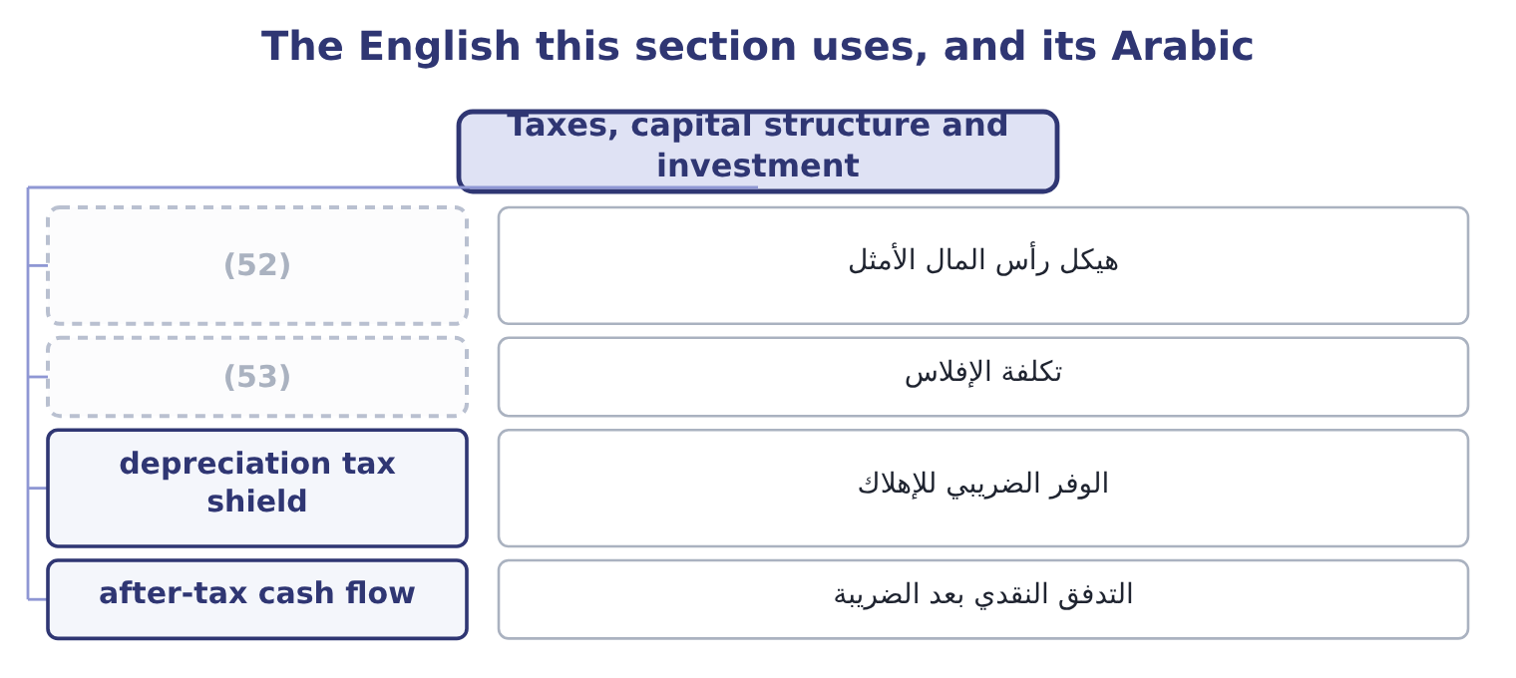
word list
notional principal · bankruptcy cost · optimal capital structure

The English this sheet uses, and its Arabic
English (exam term) | Arabic
optimal capital structure | هيكل رأس المال الأمثل
bankruptcy cost | تكلفة الإفلاس
depreciation tax shield | الوفر الضريبي للإهلاك
after-tax cash flow | التدفق النقدي بعد الضريبة

Answer key · 7.5 Taxes, capital structure and investment

1 outcome | 28 already
2 structure | 29 prefer
3 dollar | 30 destroys
4 present | 31 financing
5 standard | 32 keeping
6 system | 33 Distress costs
7 changes | 34 Favours more
8 funded | 35 None; it applies to all
9 nothing | 36 A separate shield
10 cannot | 37 Favours leasing for a loss-maker
11 tightening | 38 Exercise price 30, share price 38
12 management's | 39 20,000,000 issued at 4.5% against straight debt at 6.5%
13 industry | 40 20,000,000 of debt at a 25 per cent tax rate
14 stable | 41 reference
15 tangible | 42 compute
16 pipeline | 43 itself
17 investors | 44 ordinary
18 company-level | 45 theoretical
19 qualification | 46 entirely
20 calculation | 47 consequence
21 reaches | 48 difference
22 places | 49 50.00: 1,000 ÷ 20 = 50.00.
23 generates | 50 8: 38 − 30 = 8.
24 Orontes's | 51 400,000: 20,000,000 × 0.02 = 400,000.
25 discounted | 52 optimal capital structure
26 revenues | 53 bankruptcy cost
27 because

the summaries in full
Summary 1 The outcome asks how income taxes affect capital structure and capital investment decisions, and the answer has four parts. The shield favours debt. Interest is deductible and dividends are not, so each dollar of interest saves the company its tax rate in cash. On $10,000,000 of debt at a 25 per cent rate, the whole shield is worth 10,000,000 × 0.25 = 2,500,000 in present value terms if the debt is permanent — the standard textbook result, and the reason a tax system that favours one kind of money changes how companies are funded. Distress sets the limit. The shield is worth nothing to a company that cannot pay. Past some level of borrowing the expected costs of financial distress — a higher rate demanded by lenders, suppliers tightening terms, customers doubting warranties, management's time consumed, and in the extreme the direct costs of a bankruptcy — rise faster than the shield grows.
Summary 2 The optimum is where the two margins meet, and it differs by industry: a company with stable cash flows and tangible assets can carry far more debt than one whose value is a brand and a pipeline of research. Personal taxes work the other way. Interest received is usually taxed at a higher personal rate than dividends and capital gains, so investors demand more for holding debt than the corporate shield alone would suggest, and part of the company-level advantage is given back. The exam mentions this as a qualification rather than asking for a calculation. Tax reaches investment decisions too, and in three places. Depreciation is deductible, so an asset generates a tax shield of its own: Orontes's $2,100,000 depreciation charge saves 2,100,000 × 0.25 = 525,000 of tax a year, and that saving is a cash flow of the project that bought the asset.
Summary 3 Only after-tax cash flows are discounted, so a project's revenues and costs are taken net of tax. And the discount rate is the after-tax cost of capital, because the shield has already been counted there. The tax shield is not a reason to prefer a bad project. A project that earns less than its cost of capital destroys value whether or not it was financed with debt, and the financing decision is separate from the investment decision. Mixing them is the most common error in Section B and Book 3 is built on keeping them apart.
Summary 4 English notional in finance means a reference amount used to compute payments and never itself paid — the notional principal of a swap. In ordinary English it means imaginary or theoretical, which is close enough to mislead: the notional amount is not imaginary, and the payments computed on it are entirely real. The practical consequence is in the exam: a question that gives you a notional principal of $10,000,000 is not telling you that anybody will pay ten million, only that the interest difference is computed on it.

8.1 What the cost of capital is
Chapter 8 · section 8.1

Fill every gap. Each word list holds one word more than there are gaps.
Chapter 8, section by section
Each stage leads to the next.
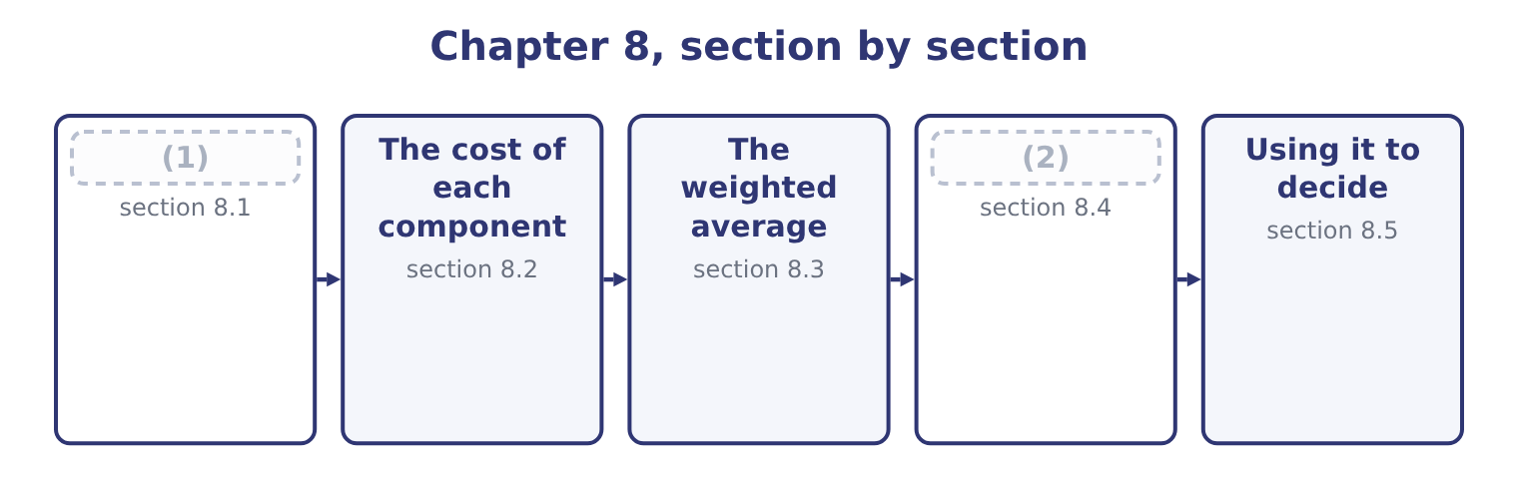
word list
The marginal cost of capital · What the cost of capital is · The cost of each component

Summary 1 gaps 3–14
The cost of capital is the return a company must earn on its (3) to leave its providers of money no worse off. It has three equivalent (4) , and the exam uses all three. Every (5) raised carries a price: (6) to a lender, a fixed dividend to a (7) holder, a required return to a (8) . The blend is what the company pays for the use of money. It is a required return. The same figures, seen from the (9) side, are what each (10) demands for the risk carried. It is an (11) cost. The providers could have put the same money into something else of the same risk. A company that earns less than that something else has (12) value, which is exactly the (13) profit of Book 1. Three uses follow, and the (14) names the first and last of them.
word list
opportunity · interest · outcome · economic · provider · investments · shareholder · irrelevant · investor's · dollar · descriptions · destroyed · preferred

Summary 2 gaps 15–25
As a (15) rate for investment. A project is worth (16) if it earns more than the money it (17) costs. Book 3 (18) the whole of capital (19) on that sentence. The (20) value of a future cash flow is (21) at the cost of capital, which is why every (22) . As the test of a capital structure. Different mixes of debt and equity produce different (23) averages, and the structure that (24) the average is the one that (25) the value of the company — because value is future cash discounted at that rate, and a lower rate gives a higher value. That is the whole of what the exam means by the use of the cost of capital in capital structure decisions.
word list
belongs · present · maximises · hurdle · valuation · weighted · computed · budgeting · builds · minimises · consumes · taking

Whose cost, and for what

Summary 3 gaps 26–32
The cost of capital (26) to the risk of the investment, not to the (27) own average risk. A food manufacturer (28) a software venture should not discount it at a food (29) rate. A project (30) with debt does not have (31) cost of capital. Financing and investment decisions are kept apart, and the project is discounted at the rate its own risk (32) . Historical rates are irrelevant. What matters is what money costs now, which section 8.4 develops.
word list
belongs · evaluating · requires · company's · debt's · descriptions · financed · manufacturer's

The English this section uses, and its Arabic
Each term sits against what it means.
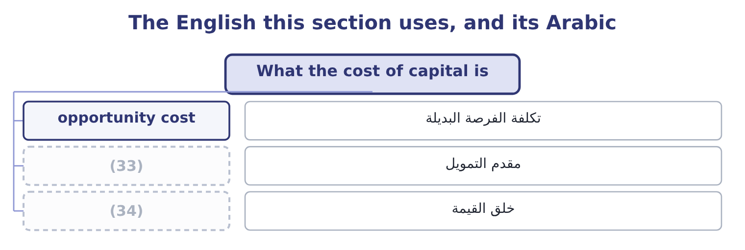
word list
value creation · capital structure · provider of capital

The English this sheet uses, and its Arabic
English (exam term) | Arabic
opportunity cost | تكلفة الفرصة البديلة
provider of capital | مقدم التمويل
value creation | خلق القيمة

Answer key · 8.1 What the cost of capital is

1 What the cost of capital is | 18 builds
2 The marginal cost of capital | 19 budgeting
3 investments | 20 present
4 descriptions | 21 computed
5 dollar | 22 valuation
6 interest | 23 weighted
7 preferred | 24 minimises
8 shareholder | 25 maximises
9 investor's | 26 belongs
10 provider | 27 company's
11 opportunity | 28 evaluating
12 destroyed | 29 manufacturer's
13 economic | 30 financed
14 outcome | 31 debt's
15 hurdle | 32 requires
16 taking | 33 provider of capital
17 consumes | 34 value creation

the summaries in full
Summary 1 The cost of capital is the return a company must earn on its investments to leave its providers of money no worse off. It has three equivalent descriptions, and the exam uses all three. Every dollar raised carries a price: interest to a lender, a fixed dividend to a preferred holder, a required return to a shareholder. The blend is what the company pays for the use of money. It is a required return. The same figures, seen from the investor's side, are what each provider demands for the risk carried. It is an opportunity cost. The providers could have put the same money into something else of the same risk. A company that earns less than that something else has destroyed value, which is exactly the economic profit of Book 1. Three uses follow, and the outcome names the first and last of them.
Summary 2 As a hurdle rate for investment. A project is worth taking if it earns more than the money it consumes costs. Book 3 builds the whole of capital budgeting on that sentence. The present value of a future cash flow is computed at the cost of capital, which is why every valuation. As the test of a capital structure. Different mixes of debt and equity produce different weighted averages, and the structure that minimises the average is the one that maximises the value of the company — because value is future cash discounted at that rate, and a lower rate gives a higher value. That is the whole of what the exam means by the use of the cost of capital in capital structure decisions.
Summary 3 The cost of capital belongs to the risk of the investment, not to the company's own average risk. A food manufacturer evaluating a software venture should not discount it at a food manufacturer's rate. A project financed with debt does not have debt's cost of capital. Financing and investment decisions are kept apart, and the project is discounted at the rate its own risk requires. Historical rates are irrelevant. What matters is what money costs now, which section 8.4 develops.

8.2 The cost of each component
Chapter 8 · section 8.2

Fill every gap. Each word list holds one word more than there are gaps.
Summary 1 gaps 1–12
Four (1) appear in exam (2) , and each has its own (3) . The cost of debt is the yield a (4) requires on the (5) debt today, not the coupon on debt (6) years ago and not the (7) rate in the notes. Because (8) is deductible it is taken after tax: a company (9) at 6.5 per cent with a 25 per cent tax rate bears 6.5 × 0.75 = 4.875 per cent. Where a bond trades at a (10) or a premium, the yield to (11) . The cost of preferred stock is the dividend over the price the company would (12) today, with no tax adjustment because preferred dividends are not deductible. A $100 par 9 per cent preferred that the market would buy at $95 costs 9.00 ÷ 95.00 = 9.47 per cent.
word list
schedule · company's · maturity · lender · receive · interest · discount · issued · average · components · borrowing · calculation · questions

Summary 2 gaps 13–24
The cost of retained earnings is the cost of equity: the shareholders' required return. Retained profit is not free (13) because no cheque is (14) . It (15) to the shareholders, who could have had it as a dividend and (16) it themselves, so its (17) cost is exactly what they (18) — 9.4 per cent for Orontes by the CAPM of, or the dividend yield plus the growth rate by the model. The cost of new common equity is (19) than the cost of retained earnings, by the (20) costs of issuing. If a share can be sold at $40 and the issue costs $2 a share, the company (21) $38 and must earn the shareholders' required return on $40 of (22) while holding $38. Using the dividend growth form: a $2.00 (23) dividend over the net (24) is 2.00 ÷ 38.00 = 5.26 per cent, plus a growth rate of 5 per cent, giving 10.26 per cent against 10.00 per cent for retained earnings on the same figures.
word list
receives · written · proceeds · opportunity · invested · flotation · belongs · merely · expected · expectations · require · higher · premium

The four component costs
Every item belongs to exactly one group.
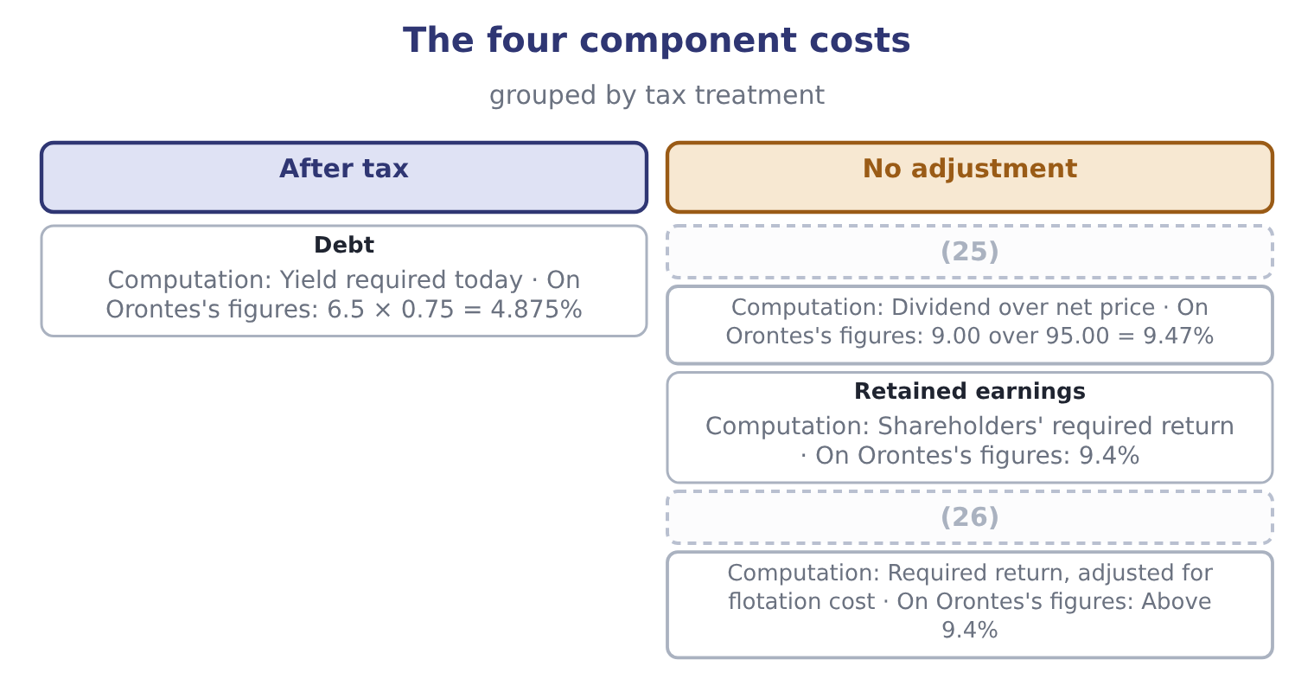
word list
opportunity cost · Preferred stock · New common equity

Three traps in the component costs

Summary 3 gaps 27–32
Only debt gets the tax adjustment. Preferred and common dividends are paid out of taxed profit. Retained earnings are not free. (27) them as costless is the (28) error in this topic and it makes every project look (29) . Use the (30) required return, not the (31) coupon. A company (32) 8 per cent on an old bond whose market yield is now 5 per cent has a cost of debt of 5, because that is what new money costs.
word list
commonest · historical · current · acceptable · flotation · paying · Treating

The English this section uses, and its Arabic
Each term sits against what it means.
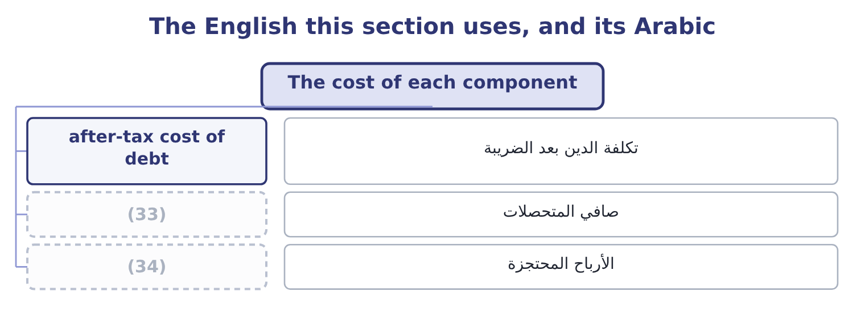
word list
flotation cost · net proceeds · retained earnings

The English this sheet uses, and its Arabic
English (exam term) | Arabic
after-tax cost of debt | تكلفة الدين بعد الضريبة
net proceeds | صافي المتحصلات
retained earnings | الأرباح المحتجزة

Answer key · 8.2 The cost of each component

1 components | 18 require
2 questions | 19 higher
3 calculation | 20 flotation
4 lender | 21 receives
5 company's | 22 expectations
6 issued | 23 expected
7 average | 24 proceeds
8 interest | 25 Preferred stock
9 borrowing | 26 New common equity
10 discount | 27 Treating
11 maturity | 28 commonest
12 receive | 29 acceptable
13 merely | 30 current
14 written | 31 historical
15 belongs | 32 paying
16 invested | 33 net proceeds
17 opportunity | 34 retained earnings

the summaries in full
Summary 1 Four components appear in exam questions, and each has its own calculation. The cost of debt is the yield a lender requires on the company's debt today, not the coupon on debt issued years ago and not the average rate in the notes. Because interest is deductible it is taken after tax: a company borrowing at 6.5 per cent with a 25 per cent tax rate bears 6.5 × 0.75 = 4.875 per cent. Where a bond trades at a discount or a premium, the yield to maturity. The cost of preferred stock is the dividend over the price the company would receive today, with no tax adjustment because preferred dividends are not deductible. A $100 par 9 per cent preferred that the market would buy at $95 costs 9.00 ÷ 95.00 = 9.47 per cent.
Summary 2 The cost of retained earnings is the cost of equity: the shareholders' required return. Retained profit is not free merely because no cheque is written. It belongs to the shareholders, who could have had it as a dividend and invested it themselves, so its opportunity cost is exactly what they require — 9.4 per cent for Orontes by the CAPM of, or the dividend yield plus the growth rate by the model. The cost of new common equity is higher than the cost of retained earnings, by the flotation costs of issuing. If a share can be sold at $40 and the issue costs $2 a share, the company receives $38 and must earn the shareholders' required return on $40 of expectations while holding $38. Using the dividend growth form: a $2.00 expected dividend over the net proceeds is 2.00 ÷ 38.00 = 5.26 per cent, plus a growth rate of 5 per cent, giving 10.26 per cent against 10.00 per cent for retained earnings on the same figures.
Summary 3 Only debt gets the tax adjustment. Preferred and common dividends are paid out of taxed profit. Retained earnings are not free. Treating them as costless is the commonest error in this topic and it makes every project look acceptable. Use the current required return, not the historical coupon. A company paying 8 per cent on an old bond whose market yield is now 5 per cent has a cost of debt of 5, because that is what new money costs.

8.3 The weighted average
Chapter 8 · section 8.3

Fill every gap. Each word list holds one word more than there are gaps.
Summary 1 gaps 1–12
Weight each component cost by the proportion of capital it (1) , and add. Two rules govern the (2) and both are (3) . Use market values, not book values. The cost of capital is about what (4) require on what they hold now, and what they hold is worth its market value. Book values (5) what was paid years ago. Use the (6) structure where the (7) gives one. A company (8) to move to 30 per cent debt should (9) projects at the cost of capital of that structure, because that is how the money will in fact be (10) over time. Equity is 8,100,000 shares at $9.25, which Book 1 computed as $74,925,000. Debt is $6,000,000 of (11) debt plus the $400,000 (12) portion, which is $6,400,000. Total capital is 74,925,000 + 6,400,000 = 81,325,000.
word list
current · represents · intending · investors · record · examined · evaluate · target · question · weights · long-term · raised · flattens

Summary 2 gaps 13–18
Equity is 74,925,000 ÷ 81,325,000 = 92.13 per cent of the total and debt is 6,400,000 ÷ 81,325,000 = 7.87 per cent. Equity at 9.4 per cent; debt at 6.5 per cent before tax, which is 6.5 × 0.75 = 4.875 per cent after. (13) that with Book 1's return on assets of 10.22 per cent: Orontes earns more on its assets than its capital costs, which is the same statement as the (14) economic profit computed there, and the same statement again as a (15) ratio of 3.67. Three (16) measures, one fact. Note also how (17) the cheap debt helps: at 7.87 per cent of the capital it pulls the average down by (18) a third of a point.
word list
positive · different · little · market-to-book · barely · Compare · arithmetic

The same two costs at four capital structures
Debt proportion | Equity proportion | Weighted average, at 4.875% debt and 9.4% equity | Note
0% | 100% | 9.40% | All equity
7.87% | 92.13% | 9.04% | (19)
30% | 70% | 8.04% | (20)
50% | 50% | 7.14% | Arithmetically, and not in practice

word list
Orontes today, on market values · Arithmetically, and not in practice · Before any rise in the cost of either

Summary 3 gaps 21–32
That figure also contains the (21) largest trap. It (22) to show that more debt always lowers the average, which would make a 100 per cent debt structure (23) . It does not, because the component costs are not (24) : as debt rises, lenders demand more and (25) demand much more, since their residual claim has become riskier. The true curve falls, (26) and then rises, and the (27) is at the bottom. The (28) in the figure holds the costs fixed, which is why the figure is wrong beyond a point and why the exam asks for the (29) rather than the number. On book values the (30) would differ. (31) book equity is $20,392,975 (32) the same $6,400,000 of debt, so debt is 6,400,000 ÷ 26,792,975 = 23.89 per cent of book capital and the average would be 0.7611 × 9.4 = 7.15 plus 0.2389 × 4.875 = 1.16, which is 7.15 + 1.16 = 8.31 per cent. Seventy basis points lower than the market-value figure, and wrong, because the shares are not worth book value and nobody requires a return on what was paid in 1998.
word list
Orontes's · answer · optimal · requires · against · constant · arithmetic · shareholders · explanation · flattens · optimum · appears · chapter's

The English this section uses, and its Arabic
Each term sits against what it means.
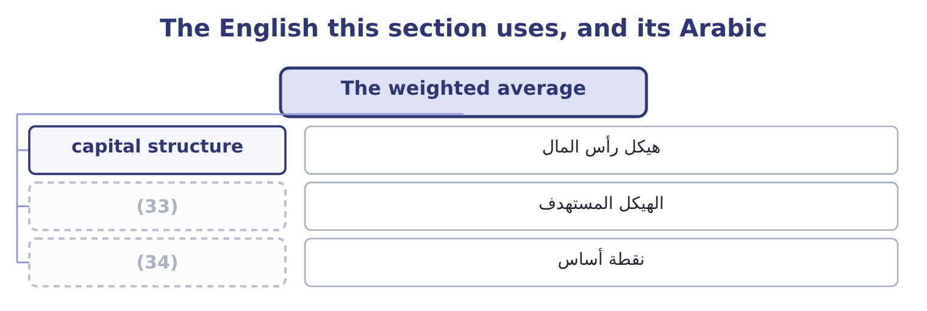
word list
target structure · flotation cost · basis point

The English this sheet uses, and its Arabic
English (exam term) | Arabic
capital structure | هيكل رأس المال
target structure | الهيكل المستهدف
basis point | نقطة أساس

Answer key · 8.3 The weighted average

1 represents | 18 barely
2 weights | 19 Orontes today, on market values
3 examined | 20 Before any rise in the cost of either
4 investors | 21 chapter's
5 record | 22 appears
6 target | 23 optimal
7 question | 24 constant
8 intending | 25 shareholders
9 evaluate | 26 flattens
10 raised | 27 optimum
11 long-term | 28 arithmetic
12 current | 29 explanation
13 Compare | 30 answer
14 positive | 31 Orontes's
15 market-to-book | 32 against
16 different | 33 target structure
17 little | 34 basis point

the summaries in full
Summary 1 Weight each component cost by the proportion of capital it represents, and add. Two rules govern the weights and both are examined. Use market values, not book values. The cost of capital is about what investors require on what they hold now, and what they hold is worth its market value. Book values record what was paid years ago. Use the target structure where the question gives one. A company intending to move to 30 per cent debt should evaluate projects at the cost of capital of that structure, because that is how the money will in fact be raised over time. Equity is 8,100,000 shares at $9.25, which Book 1 computed as $74,925,000. Debt is $6,000,000 of long-term debt plus the $400,000 current portion, which is $6,400,000. Total capital is 74,925,000 + 6,400,000 = 81,325,000.
Summary 2 Equity is 74,925,000 ÷ 81,325,000 = 92.13 per cent of the total and debt is 6,400,000 ÷ 81,325,000 = 7.87 per cent. Equity at 9.4 per cent; debt at 6.5 per cent before tax, which is 6.5 × 0.75 = 4.875 per cent after. Compare that with Book 1's return on assets of 10.22 per cent: Orontes earns more on its assets than its capital costs, which is the same statement as the positive economic profit computed there, and the same statement again as a market-to-book ratio of 3.67. Three different measures, one fact. Note also how little the cheap debt helps: at 7.87 per cent of the capital it pulls the average down by barely a third of a point.
Summary 3 That figure also contains the chapter's largest trap. It appears to show that more debt always lowers the average, which would make a 100 per cent debt structure optimal. It does not, because the component costs are not constant: as debt rises, lenders demand more and shareholders demand much more, since their residual claim has become riskier. The true curve falls, flattens and then rises, and the optimum is at the bottom. The arithmetic in the figure holds the costs fixed, which is why the figure is wrong beyond a point and why the exam asks for the explanation rather than the number. On book values the answer would differ. Orontes's book equity is $20,392,975 against the same $6,400,000 of debt, so debt is 6,400,000 ÷ 26,792,975 = 23.89 per cent of book capital and the average would be 0.7611 × 9.4 = 7.15 plus 0.2389 × 4.875 = 1.16, which is 7.15 + 1.16 = 8.31 per cent. Seventy basis points lower than the market-value figure, and wrong, because the shares are not worth book value and nobody requires a return on what was paid in 1998.

8.4 The marginal cost of capital
Chapter 8 · section 8.4

Fill every gap. Each word list holds one word more than there are gaps.
Summary 1 gaps 1–12
The weighted average computed in section 8.3 (1) the money a company (2) has. The (3) it faces is about money it does not have yet, and the next (4) may cost more than the last. The (5) is retained earnings. A company's (6) source of equity is the profit it has kept, because issuing new shares costs (7) fees. Once the retained earnings are (8) , further equity must be raised (9) and costs more. The same (10) in debt: a company can borrow a certain amount at its current rate and more only at a higher one, as lenders see the (11) rise. The point at which a component's cost steps up is a break point, and it is computed as the amount of the (12) source available, divided by that component's weight in the capital structure.
word list
describes · already · externally · exhausted · approve · dollar · leverage · reason · happens · cheaper · decision · flotation · cheapest

Worked example: a marginal cost schedule

Summary 2 gaps 13–24
The structure and the costs. A company (13) 60 per cent equity and 40 per cent debt. Its (14) cost of debt is 4.875 per cent. Retained earnings cost 9.4 per cent and new shares would cost 11.0 per cent. The cost below the break. The company has $4,800,000 of retained earnings available. Equity is 60 per cent of the structure, so the retained earnings (15) 4,800,000 ÷ 0.60 = 8,000,000 of total new capital (16) new shares are (17) . The cost above the break. The company's cost of capital is 7.59 per cent for the first eight (18) it raises and 8.55 per cent after that — one (19) , two answers, (20) on how much it (21) to invest. A (22) that gives you retained earnings and a target structure is (23) for exactly this (24) , and the second break, where the cost of debt steps up, is computed the same way from the debt side.
word list
number · question · million · earnings · intends · before · depending · schedule · needed · asking · after-tax · support · targets

A marginal cost of capital schedule
New capital raised | Source of the equity | Cost of equity | Weighted average
Up to 8,000,000 | Retained earnings | 9.4% | 7.59%
Above 8,000,000 | (25) | 11.0% | 8.55%

word list
provider of capital · New common shares

Summary 3 gaps 26–35
Why marginal (26) than historical. A company that (27) at 4 per cent five years ago and would pay 7 per cent today has a historical average cost that is lower than (28) available to it. (29) a new project at the historical figure would approve (30) that cannot in fact be funded (31) , because the money for them has to be raised at today's prices. The historical cost is a (32) of past decisions and the marginal cost is the price of the next one — and only decisions about the future can be (33) . The same logic appears (34) management (35) as the rule that sunk costs are irrelevant.
word list
record · projects · accounting · rather · borrowed · throughout · Discounting · issuing · anything · profitably · influenced

The English this section uses, and its Arabic
Each term sits against what it means.
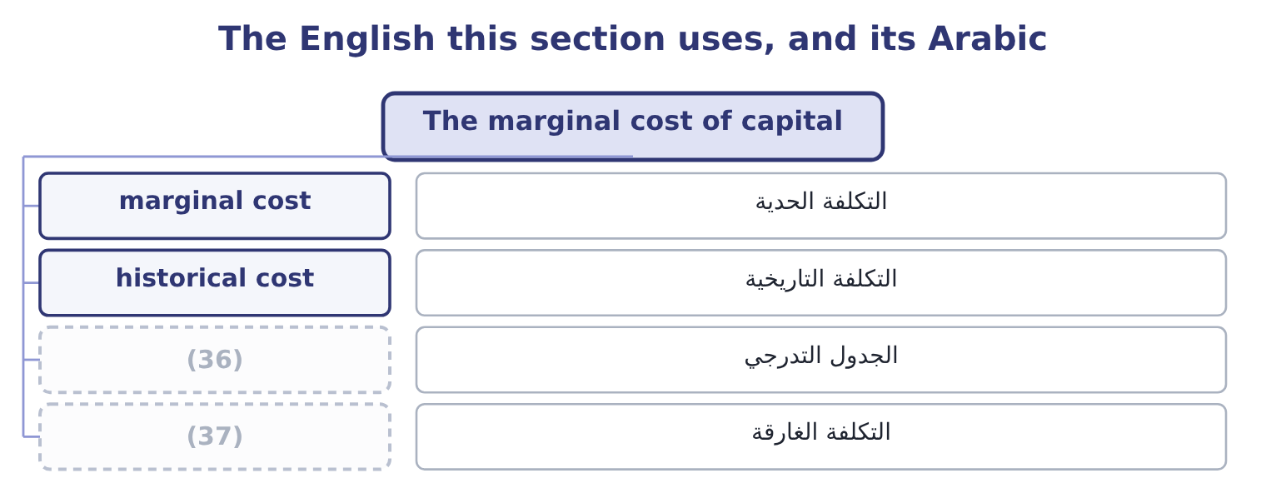
word list
sunk cost · schedule · value creation

The English this sheet uses, and its Arabic
English (exam term) | Arabic
marginal cost | التكلفة الحدية
historical cost | التكلفة التاريخية
schedule | الجدول التدرجي
sunk cost | التكلفة الغارقة

Answer key · 8.4 The marginal cost of capital

1 describes | 20 depending
2 already | 21 intends
3 decision | 22 question
4 dollar | 23 asking
5 reason | 24 schedule
6 cheapest | 25 New common shares
7 flotation | 26 rather
8 exhausted | 27 borrowed
9 externally | 28 anything
10 happens | 29 Discounting
11 leverage | 30 projects
12 cheaper | 31 profitably
13 targets | 32 record
14 after-tax | 33 influenced
15 support | 34 throughout
16 before | 35 accounting
17 needed | 36 schedule
18 million | 37 sunk cost
19 number

the summaries in full
Summary 1 The weighted average computed in section 8.3 describes the money a company already has. The decision it faces is about money it does not have yet, and the next dollar may cost more than the last. The reason is retained earnings. A company's cheapest source of equity is the profit it has kept, because issuing new shares costs flotation fees. Once the retained earnings are exhausted, further equity must be raised externally and costs more. The same happens in debt: a company can borrow a certain amount at its current rate and more only at a higher one, as lenders see the leverage rise. The point at which a component's cost steps up is a break point, and it is computed as the amount of the cheaper source available, divided by that component's weight in the capital structure.
Summary 2 The structure and the costs. A company targets 60 per cent equity and 40 per cent debt. Its after-tax cost of debt is 4.875 per cent. Retained earnings cost 9.4 per cent and new shares would cost 11.0 per cent. The cost below the break. The company has $4,800,000 of retained earnings available. Equity is 60 per cent of the structure, so the retained earnings support 4,800,000 ÷ 0.60 = 8,000,000 of total new capital before new shares are needed. The cost above the break. The company's cost of capital is 7.59 per cent for the first eight million it raises and 8.55 per cent after that — one number, two answers, depending on how much it intends to invest. A question that gives you retained earnings and a target structure is asking for exactly this schedule, and the second break, where the cost of debt steps up, is computed the same way from the debt side.
Summary 3 Why marginal rather than historical. A company that borrowed at 4 per cent five years ago and would pay 7 per cent today has a historical average cost that is lower than anything available to it. Discounting a new project at the historical figure would approve projects that cannot in fact be funded profitably, because the money for them has to be raised at today's prices. The historical cost is a record of past decisions and the marginal cost is the price of the next one — and only decisions about the future can be influenced. The same logic appears throughout management accounting as the rule that sunk costs are irrelevant.

8.5 Using it to decide
Chapter 8 · section 8.5

Fill every gap. Each word list holds one word more than there are gaps.
Summary 1 gaps 1–8
Put the marginal cost schedule beside the company's investment (1) and the capital budget (2) itself. Rank the available projects by their (3) rate of return, (4) first. Draw the marginal cost schedule (5) them. Every project whose return (6) the marginal cost of the money that would fund it is worth taking; the first project whose return falls below that cost is where the budget stops. The (7) is the company's optimal capital budget, and it moves when either curve moves: a better (8) set pushes it out, a rise in the cost of money pulls it.
word list
internal · highest · decides · across · opportunity · intersection · accepts · opportunities · exceeds

Where the capital budget stops
The bars are drawn to scale.
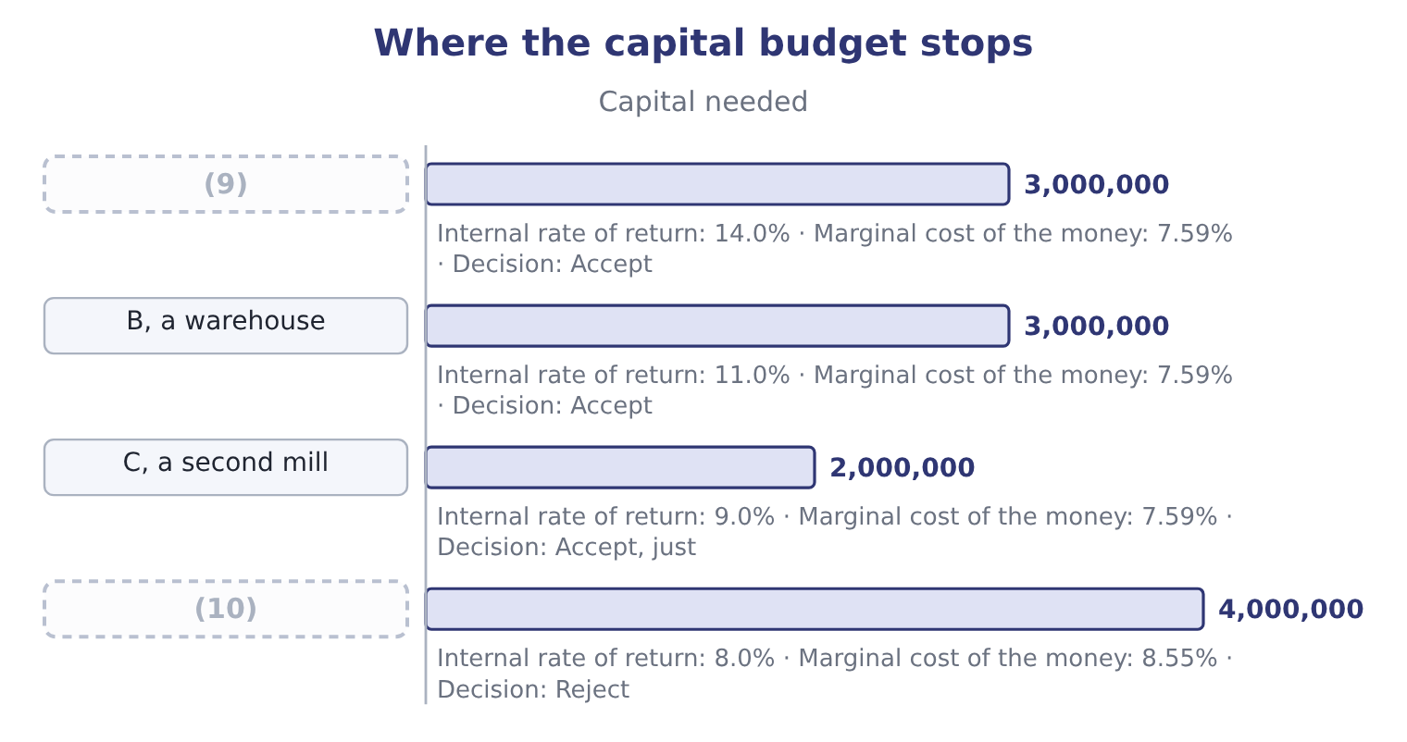
word list
A, a new roasting line · weighted average cost of capital · D, an export depot

Summary 2 gaps 11–22
Three (11) turn that simple (12) into the answer the exam wants. Risk (13) by project. The weighted average (14) the company's (15) risk. A project that is riskier should be (16) at more and a safer one at less, which is done either by (17) a beta for the project's industry and running the CAPM of, or by adding a risk adjustment to the company rate and saying so. A single company-wide rate (18) accepts risky projects and (19) safe ones. The (20) mix does not belong to the project. Project D is not (21) because it could be (22) with debt at 4.875 per cent. The company's structure applies to all of its projects together, and the alternative is a firm that accepts bad projects whenever it happens to have borrowing capacity. Capital may be rationed.
word list
funded · refinements · describes · differs · acceptable · discounted · rejects · picture · rationed · estimating · financing · systematically · existing

Summary 3 gaps 23–31
Where the amount available is fixed by (23) other than cost — a covenant, an (24) to dilute, a (25) limit — projects are ranked by value (26) for each dollar (27) rather than by return alone, and Book 3 (28) that properly. One last point (29) the loop with Book 1. (30) weighted average cost of capital is 9.04 per cent, its return on assets is 10.22 per cent, and its board set a target return on equity of 20 per cent in the case there. That target is not a cost of capital; it is an (31) .
word list
parent's · develops · something · unwillingness · invested · created · budgeting · closes · Orontes's · aspiration

Build a cost of capital

Your turn: a weighted average (complete the blanks)
Component | Data | Answer
Debt | (32) | ________ after tax
Preferred stock | (33) | ________
Common equity | (34) | ________
Weights | Debt 30%, preferred 10%, equity 60% | (35)
Weighted average cost of capital |  | ________
Break point | Retained earnings 6,000,000, equity weight 60% | ________

word list
after-tax cost of debt · 8.0% before tax, tax rate 25% · n/a · 7.00 dividend, price 80.00 · Risk-free 3%, beta 1.2, market premium 6 points

"Capital"

Summary 4 gaps 36–42
English capital means at least four (36) in these two books. It is the money a company (37) , as in cost of capital. It is the (38) ' stake, as in (39) capital. It is (40) assets, as in capital (41) . And capital (42) are where the first of these is raised. The practical warning for an exam: capital structure is about the money, capital budgeting is about the assets, and the two phrases differ by one word and belong to different decisions, as section 8.5 insisted.
word list
owners · long-lived · things · raises · practical · paid-in · markets · expenditure

"Capital"
Component | Answer
Debt | (43) : 8.0 × 0.75 = 6.0.
Preferred stock | (44)
Common equity | 10.2 per cent: the premium earned is 1.2 × 6.0 = 7.2 points on top of 3 per cent.
Weighted average cost of capital | 8.80 per cent: 0.30 × 6.0 = 1.80 from the debt, 0.10 × 8.75 = 0.875 from the preferred and 0.60 × 10.2 = 6.12 from the equity, so 1.80 + 0.8
Break point | (45)
What it tells you | The company can raise ten million at 8.80 per cent and must pay more after that, so a project returning 9 per cent is worth taking out of th

word list
8.0% before tax, tax rate 25% · 8.75 per cent: 7.00 ÷ 80.00 = 8.75 per cent. · 10,000,000: 6,000,000 ÷ 0.60 = 10,000,000. · 6.0 per cent after tax

The English this section uses, and its Arabic
Each term sits against what it means.
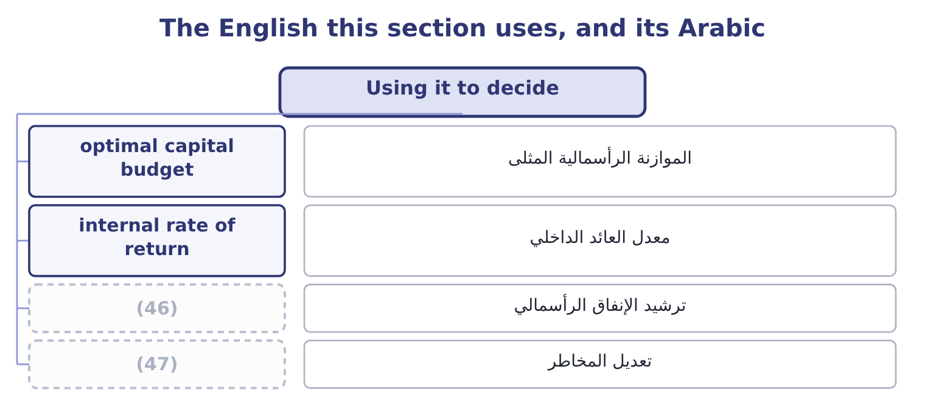
word list
value creation · risk adjustment · capital rationing

The English this sheet uses, and its Arabic
English (exam term) | Arabic
optimal capital budget | الموازنة الرأسمالية المثلى
internal rate of return | معدل العائد الداخلي
capital rationing | ترشيد الإنفاق الرأسمالي
risk adjustment | تعديل المخاطر

Answer key · 8.5 Using it to decide

1 opportunities | 25 parent's
2 decides | 26 created
3 internal | 27 invested
4 highest | 28 develops
5 across | 29 closes
6 exceeds | 30 Orontes's
7 intersection | 31 aspiration
8 opportunity | 32 8.0% before tax, tax rate 25%
9 A, a new roasting line | 33 7.00 dividend, price 80.00
10 D, an export depot | 34 Risk-free 3%, beta 1.2, market premium 6 points
11 refinements | 35 n/a
12 picture | 36 things
13 differs | 37 raises
14 describes | 38 owners
15 existing | 39 paid-in
16 discounted | 40 long-lived
17 estimating | 41 expenditure
18 systematically | 42 markets
19 rejects | 43 6.0 per cent after tax
20 financing | 44 8.75 per cent: 7.00 ÷ 80.00 = 8.75 per cent.
21 acceptable | 45 10,000,000: 6,000,000 ÷ 0.60 = 10,000,000.
22 funded | 46 capital rationing
23 something | 47 risk adjustment
24 unwillingness

the summaries in full
Summary 1 Put the marginal cost schedule beside the company's investment opportunities and the capital budget decides itself. Rank the available projects by their internal rate of return, highest first. Draw the marginal cost schedule across them. Every project whose return exceeds the marginal cost of the money that would fund it is worth taking; the first project whose return falls below that cost is where the budget stops. The intersection is the company's optimal capital budget, and it moves when either curve moves: a better opportunity set pushes it out, a rise in the cost of money pulls it.
Summary 2 Three refinements turn that simple picture into the answer the exam wants. Risk differs by project. The weighted average describes the company's existing risk. A project that is riskier should be discounted at more and a safer one at less, which is done either by estimating a beta for the project's industry and running the CAPM of, or by adding a risk adjustment to the company rate and saying so. A single company-wide rate systematically accepts risky projects and rejects safe ones. The financing mix does not belong to the project. Project D is not acceptable because it could be funded with debt at 4.875 per cent. The company's structure applies to all of its projects together, and the alternative is a firm that accepts bad projects whenever it happens to have borrowing capacity. Capital may be rationed.
Summary 3 Where the amount available is fixed by something other than cost — a covenant, an unwillingness to dilute, a parent's limit — projects are ranked by value created for each dollar invested rather than by return alone, and Book 3 develops that properly. One last point closes the loop with Book 1. Orontes's weighted average cost of capital is 9.04 per cent, its return on assets is 10.22 per cent, and its board set a target return on equity of 20 per cent in the case there. That target is not a cost of capital; it is an aspiration.
Summary 4 English capital means at least four things in these two books. It is the money a company raises, as in cost of capital. It is the owners' stake, as in paid-in capital. It is long-lived assets, as in capital expenditure. And capital markets are where the first of these is raised. The practical warning for an exam: capital structure is about the money, capital budgeting is about the assets, and the two phrases differ by one word and belong to different decisions, as section 8.5 insisted.

9.1 The markets
Chapter 9 · section 9.1

Fill every gap. Each word list holds one word more than there are gaps.
Chapter 9, section by section
Each stage leads to the next.
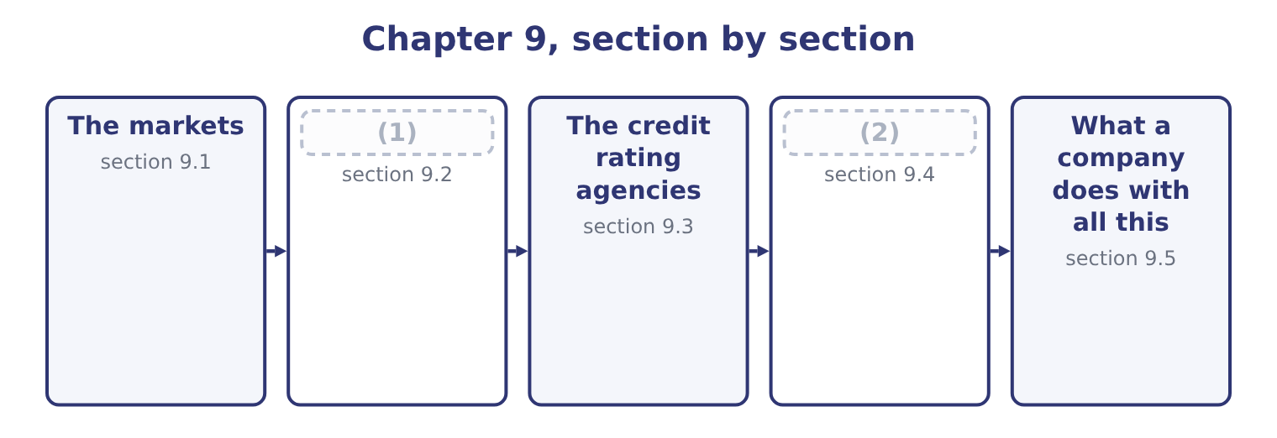
word list
Investment banks · investment grade · Market efficiency

Summary 1 gaps 3–14
Financial markets are (3) four ways, and the exam uses every one of them. The money market trades (4) maturing within a year: treasury bills, commercial paper, (5) of deposit, repurchase agreements. The capital market trades (6) claims: bonds and (7) . By (8) the money reaches the issuer. In the primary market a company sells new securities and receives the (9) : an initial public (10) , a bond issue, a rights issue. In the secondary market existing securities change hands between (11) and the company receives (12) . The secondary market (13) to the issuer all the same, because nobody would buy in the primary market (14) it, and because the secondary price sets the terms of the next primary issue. By how trading is organised. An exchange brings orders together in one place under one rule book, with listing requirements and a published price.
word list
offering · investors · instruments · classified · nothing · explain · shares · without · proceeds · longer · matters · whether · certificates

Summary 2 gaps 15–22
An (15) market is a network of dealers quoting bids and offers, which is where most bonds, most (16) and all swaps trade. An auction market matches buyers and sellers (17) ; a dealer market has an (18) who takes the other side of every trade and earns the spread between bid and offer. By who may (19) . Public markets are open to any investor and carry disclosure (20) . Private markets are restricted to (21) and wealthy (22) , with far less disclosure, which is why a private placement is quicker and cheaper to arrange than a public issue.
word list
participate · intermediary · obligations · individuals · institutions · over-the-counter · directly · currencies · receives

Four ways to classify a market
Classification | One side | The other side | Example of each
Maturity | Money market, under a year | Capital market, over a year | (23)
Issuance | Primary, new securities | Secondary, existing securities | (24)
Organisation | Exchange, centralised | (25) | A listed share; a swap
Access | Public, with disclosure | Private, restricted | (26)

word list
Money market, under a year · Treasury bills; corporate bonds · A listed bond; a private placement · An IPO; a trade on an exchange · Over the counter, dealer network

Summary 3 gaps 27–31
Three (27) explain why any of it (28) , and the exam asks for them. Markets move money from those who have it to those who can use it. They provide (29) , so that a long-term claim can be held by a (30) investor. And they (31) prices, which tell every company in the economy what its capital costs — the signal.
word list
short-term · functions · investors · exists · liquidity · produce

The English this section uses, and its Arabic
Each term sits against what it means.
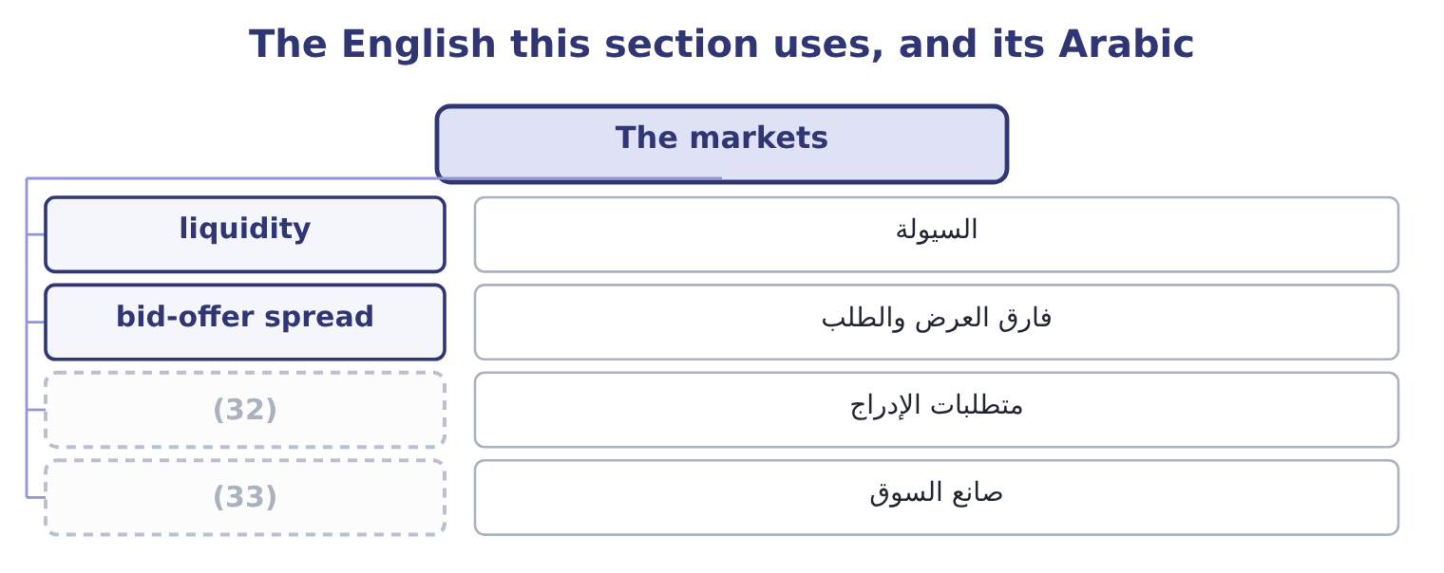
word list
market maker · firm commitment · listing requirement

The English this sheet uses, and its Arabic
English (exam term) | Arabic
liquidity | السيولة
bid-offer spread | فارق العرض والطلب
listing requirement | متطلبات الإدراج
market maker | صانع السوق

Answer key · 9.1 The markets

1 Market efficiency | 18 intermediary
2 Investment banks | 19 participate
3 classified | 20 obligations
4 instruments | 21 institutions
5 certificates | 22 individuals
6 longer | 23 Treasury bills; corporate bonds
7 shares | 24 An IPO; a trade on an exchange
8 whether | 25 Over the counter, dealer network
9 proceeds | 26 A listed bond; a private placement
10 offering | 27 functions
11 investors | 28 exists
12 nothing | 29 liquidity
13 matters | 30 short-term
14 without | 31 produce
15 over-the-counter | 32 listing requirement
16 currencies | 33 market maker
17 directly

the summaries in full
Summary 1 Financial markets are classified four ways, and the exam uses every one of them. The money market trades instruments maturing within a year: treasury bills, commercial paper, certificates of deposit, repurchase agreements. The capital market trades longer claims: bonds and shares. By whether the money reaches the issuer. In the primary market a company sells new securities and receives the proceeds: an initial public offering, a bond issue, a rights issue. In the secondary market existing securities change hands between investors and the company receives nothing. The secondary market matters to the issuer all the same, because nobody would buy in the primary market without it, and because the secondary price sets the terms of the next primary issue. By how trading is organised. An exchange brings orders together in one place under one rule book, with listing requirements and a published price.
Summary 2 An over-the-counter market is a network of dealers quoting bids and offers, which is where most bonds, most currencies and all swaps trade. An auction market matches buyers and sellers directly; a dealer market has an intermediary who takes the other side of every trade and earns the spread between bid and offer. By who may participate. Public markets are open to any investor and carry disclosure obligations. Private markets are restricted to institutions and wealthy individuals, with far less disclosure, which is why a private placement is quicker and cheaper to arrange than a public issue.
Summary 3 Three functions explain why any of it exists, and the exam asks for them. Markets move money from those who have it to those who can use it. They provide liquidity, so that a long-term claim can be held by a short-term investor. And they produce prices, which tell every company in the economy what its capital costs — the signal.

9.2 Market efficiency
Chapter 9 · section 9.2

Fill every gap. Each word list holds one word more than there are gaps.
Summary 1 gaps 1–12
A market is efficient when prices reflect the information available. The useful (1) of the idea names which information, and there are three. The weak form says prices reflect all past prices and trading volumes. If it holds, (2) charts of past prices cannot produce abnormal returns, because (3) a pattern would (4) is already in the price. Technical analysis is worthless under the weak form. The semi-strong form says prices reflect all (5) available information: past prices, published (6) statements, announcements, analysts' reports, news. If it holds, no amount of analysis of public information (7) abnormal returns, because (8) has already read it. Fundamental analysis of published statements is worthless under the semi-strong form — which is an (9) conclusion for a book whose first volume was (10) chapters of exactly. The strong form says prices reflect all information, public and private, (11) what the directors know and have not (12) .
word list
financial · version · eighteen · announced · whatever · produces · everyone · notch · predict · publicly · studying · uncomfortable · including

Summary 2 gaps 13–16
If it holds, even insiders cannot earn abnormal returns. Almost nobody (13) the strong form, and the (14) of insider trading laws is the clearest evidence that (15) do not either —. Each form (16) the weaker ones: semi-strong efficiency implies weak efficiency, and strong implies both.
word list
legislators · estimate · existence · contains · believes

Three forms of efficiency
Form | Prices reflect | What cannot work | Evidence
Weak | Past prices and volumes | Technical analysis, chart patterns | (17)
Semi-strong | All public information | (18) | Mostly supported; some anomalies
Strong | All information, public and private | (19) | Rejected; insiders do earn abnormal returns

word list
Fundamental analysis of published data · Rejected; insiders do earn abnormal returns · Strong: prices are close to a random walk · Even insider dealing

Summary 3 gaps 20–31
The evidence is mixed in a (20) way the exam (21) . Prices adjust to public announcements very fast, (22) within minutes, which (23) the semi-strong form. But documented anomalies persist: small companies have earned more than their risk appeared to justify, shares with low (24) ratios have (25) , prices drift in the direction of an earnings surprise for weeks after it. And (26) finance has catalogued the ways investors depart from the rational benchmark — (27) , anchoring on irrelevant numbers, herding into a rising market, selling winners and holding losers. Four practical (28) , and the exam asks for them. A company cannot (29) its share price by cosmetic (30) . If the market is semi-strong efficient, a change of (31) method that raises reported earnings and changes no cash flow will move nothing, because the note disclosing it is public too. This is the strongest argument for the earnings-quality work of Book 1: the market is looking through to the cash.
word list
strongest · specific · supports · overconfidence · outperformed · expects · consequences · behavioural · price-to-book · depreciation · improve · usually · accounting

Summary 4 gaps 32–42
The (32) of an issue is not a (33) of value. (34) for the share price to be high (35) the manager knows better than the market what the shares are worth. A (36) own share price is the best available (37) of its value, and the right response to a price that seems wrong is to ask what the market knows that you do not. And analysis is still worth doing, because the market is efficient as a (38) of analysts competing to find (39) . If (40) stopped analysing, prices would stop (41) anything. The paradox is genuine and the (42) is that analysis earns roughly what it costs — which is also why a candidate learns to do it.
word list
consequence · reflecting · finance · Waiting · mispricings · assumes · resolution · company's · timing · source · everybody · estimate

The English this section uses, and its Arabic
Each term sits against what it means.
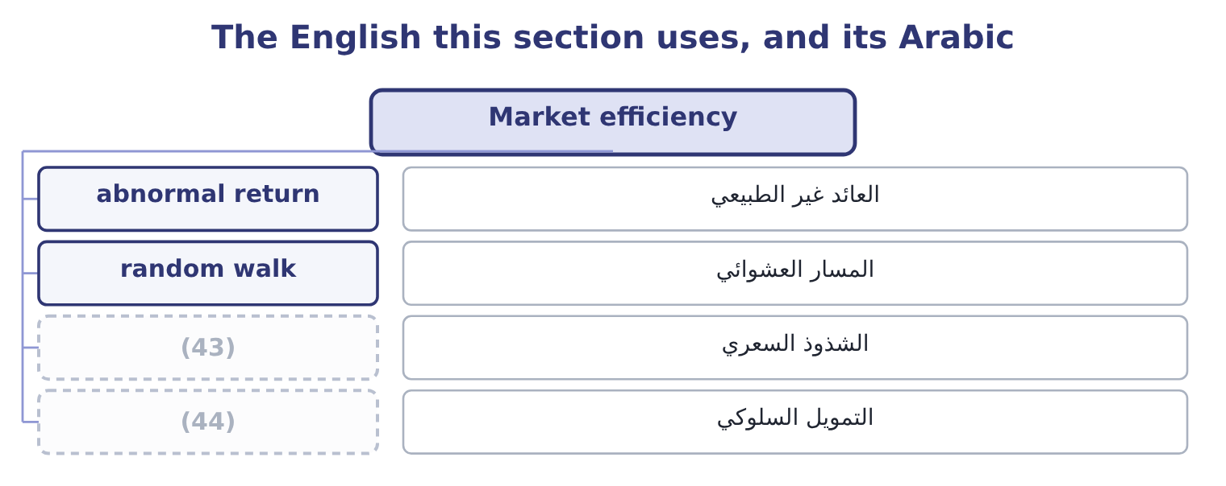
word list
anomaly · behavioural finance · mandate

The English this sheet uses, and its Arabic
English (exam term) | Arabic
abnormal return | العائد غير الطبيعي
random walk | المسار العشوائي
anomaly | الشذوذ السعري
behavioural finance | التمويل السلوكي

Answer key · 9.2 Market efficiency

1 version | 23 supports
2 studying | 24 price-to-book
3 whatever | 25 outperformed
4 predict | 26 behavioural
5 publicly | 27 overconfidence
6 financial | 28 consequences
7 produces | 29 improve
8 everyone | 30 accounting
9 uncomfortable | 31 depreciation
10 eighteen | 32 timing
11 including | 33 source
12 announced | 34 Waiting
13 believes | 35 assumes
14 existence | 36 company's
15 legislators | 37 estimate
16 contains | 38 consequence
17 Strong: prices are close to a random walk | 39 mispricings
18 Fundamental analysis of published data | 40 everybody
19 Even insider dealing | 41 reflecting
20 specific | 42 resolution
21 expects | 43 anomaly
22 usually | 44 behavioural finance

the summaries in full
Summary 1 A market is efficient when prices reflect the information available. The useful version of the idea names which information, and there are three. The weak form says prices reflect all past prices and trading volumes. If it holds, studying charts of past prices cannot produce abnormal returns, because whatever a pattern would predict is already in the price. Technical analysis is worthless under the weak form. The semi-strong form says prices reflect all publicly available information: past prices, published financial statements, announcements, analysts' reports, news. If it holds, no amount of analysis of public information produces abnormal returns, because everyone has already read it. Fundamental analysis of published statements is worthless under the semi-strong form — which is an uncomfortable conclusion for a book whose first volume was eighteen chapters of exactly. The strong form says prices reflect all information, public and private, including what the directors know and have not announced.
Summary 2 If it holds, even insiders cannot earn abnormal returns. Almost nobody believes the strong form, and the existence of insider trading laws is the clearest evidence that legislators do not either —. Each form contains the weaker ones: semi-strong efficiency implies weak efficiency, and strong implies both.
Summary 3 The evidence is mixed in a specific way the exam expects. Prices adjust to public announcements very fast, usually within minutes, which supports the semi-strong form. But documented anomalies persist: small companies have earned more than their risk appeared to justify, shares with low price-to-book ratios have outperformed, prices drift in the direction of an earnings surprise for weeks after it. And behavioural finance has catalogued the ways investors depart from the rational benchmark — overconfidence, anchoring on irrelevant numbers, herding into a rising market, selling winners and holding losers. Four practical consequences, and the exam asks for them. A company cannot improve its share price by cosmetic accounting. If the market is semi-strong efficient, a change of depreciation method that raises reported earnings and changes no cash flow will move nothing, because the note disclosing it is public too. This is the strongest argument for the earnings-quality work of Book 1: the market is looking through to the cash.
Summary 4 The timing of an issue is not a source of value. Waiting for the share price to be high assumes the manager knows better than the market what the shares are worth. A company's own share price is the best available estimate of its value, and the right response to a price that seems wrong is to ask what the market knows that you do not. And analysis is still worth doing, because the market is efficient as a consequence of analysts competing to find mispricings. If everybody stopped analysing, prices would stop reflecting anything. The paradox is genuine and the resolution is that analysis earns roughly what it costs — which is also why a candidate learns to do it.

9.3 The credit rating agencies
Chapter 9 · section 9.3

Fill every gap. Each word list holds one word more than there are gaps.
Summary 1 gaps 1–12
A rating is an opinion on the (1) that a borrower pays. The agencies publish it on a scale, and the scale has one division that matters more than all the (2) within it: investment grade, from the top down to BBB− or Baa3, and below that speculative grade, (3) high yield or junk. The division matters because of what sits on it. Many (4) investors — pension funds, insurers, money market funds — are restricted by their own rules or by regulation to (5) paper. A downgrade across that line does not merely raise a company's interest cost; it (6) a large part of the (7) of buyers for its bonds, all at once. That is why companies manage towards a rating target, and why Book 1's (8) and coverage ratios matter to a (9) . What the agencies look at is, with few additions, what Book 1 measured: leverage, coverage, margin stability, cash generation, the industry's (10) , the quality of the accounts, and the company's (11) as well as its ability to pay. Orontes would read well on most of them — interest coverage of 11.15 times, debt to assets of 0.36, and total debt of $6,400,000 against an EBITDA of $6,448,800, which is 6,400,000 ÷ 6,448,800 = 0.99 times, a ratio most agencies would call (12) for a food manufacturer.
word list
institutional · gradations · conservative · likelihood · cyclicality · investment-grade · mandate · covenants · willingness · removes · treasurer · universe · colloquially

Worked example: what a notch is worth

Summary 2 gaps 13–24
Suppose the market (13) 1.2 points over the (14) curve for an A rating, 2.0 points for BBB and 4.0 points for BB. One notch down, within investment grade. Moving from A to BBB costs 2.0 − 1.2 = 0.8 points. On the $5,000,000 (15) Orontes was (16) in, that is 5,000,000 × 0.008 = 40,000 a year. Moving from BBB to BB costs 4.0 − 2.0 = 2.0 points, which is 5,000,000 × 0.02 = 100,000 a year — and that (17) it, because some (18) will not be there at all. The steps are not equal, and the one that (19) from investment to speculative grade is the one to plan (20) . A company one notch above the line (21) its balance sheet (22) from one three notches above it, and that is a real cost of leverage that no (23) average cost of capital formula shows (24) .
word list
manages · government · considering · lenders · requires · differently · facility · crosses · Orontes · weighted · directly · understates · around

Summary 3 gaps 25–36
The (25) are examinable and (26) be stated fairly. The company being rated pays the agency, which is a (27) of interest, (28) it is managed. The alternative, an (29) model, failed because ratings leak and investors would not pay for what they could (30) free. An agency acts on (31) after the market has moved, so a downgrade often (32) what the bond price said weeks earlier. The (33) on structured (34) . In the financial crisis of 2007 and 2008, highly rated structured (35) defaulted in numbers that the ratings had said were close to impossible, and the models behind those ratings proved to rest on (36) about correlation that did not hold. A rating is not a recommendation. It is an opinion on default risk alone, and says nothing about whether a security is correctly priced for that risk.
word list
investor-pays · information · record · confirms · should · products · obtain · criticisms · conflict · assumptions · however · formula · securities

The rating scale, and what it changes
Every item belongs to exactly one group.
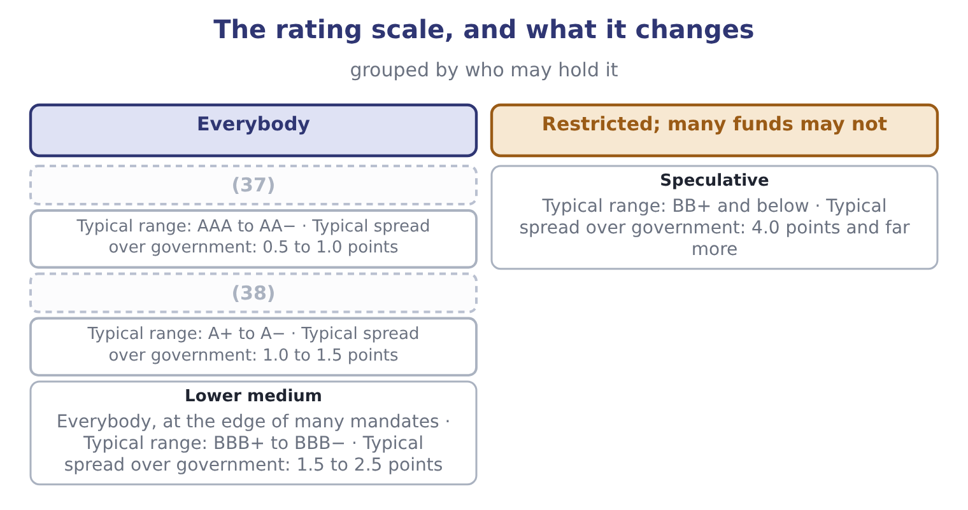
word list
capital market · High grade · Upper medium

The English this section uses, and its Arabic
Each term sits against what it means.
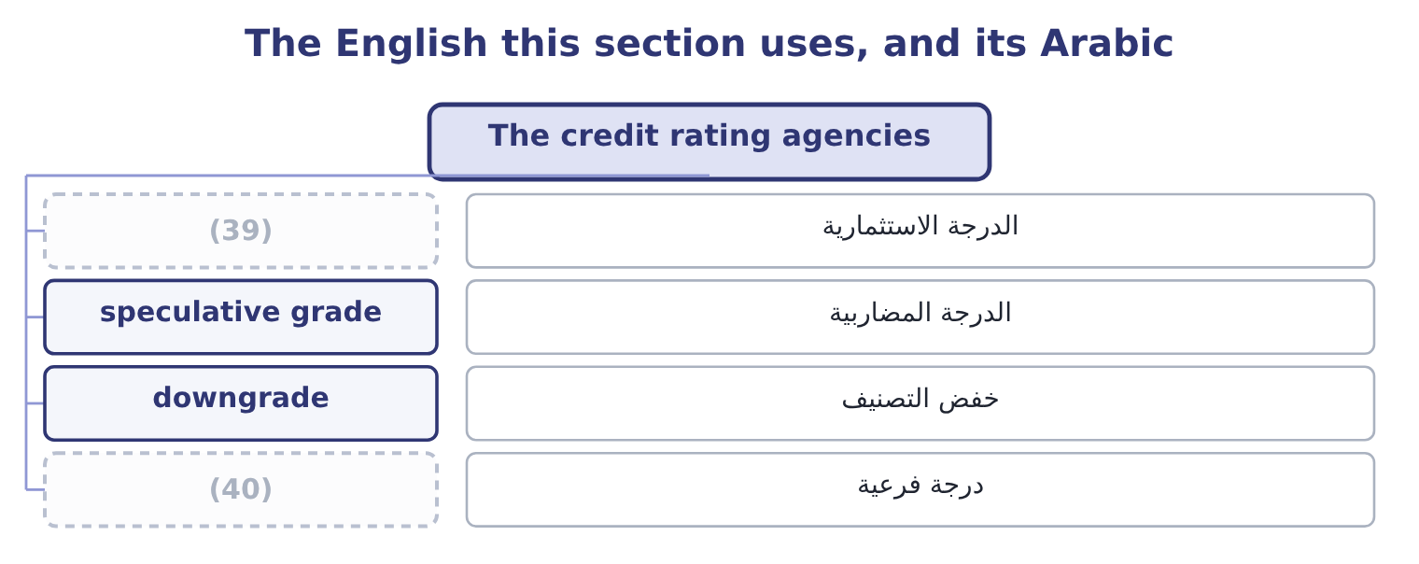
word list
investment grade · downgrade · notch

The English this sheet uses, and its Arabic
English (exam term) | Arabic
investment grade | الدرجة الاستثمارية
speculative grade | الدرجة المضاربية
downgrade | خفض التصنيف
notch | درجة فرعية

Answer key · 9.3 The credit rating agencies

1 likelihood | 21 manages
2 gradations | 22 differently
3 colloquially | 23 weighted
4 institutional | 24 directly
5 investment-grade | 25 criticisms
6 removes | 26 should
7 universe | 27 conflict
8 covenants | 28 however
9 treasurer | 29 investor-pays
10 cyclicality | 30 obtain
11 willingness | 31 information
12 conservative | 32 confirms
13 requires | 33 record
14 government | 34 products
15 facility | 35 securities
16 considering | 36 assumptions
17 understates | 37 High grade
18 lenders | 38 Upper medium
19 crosses | 39 investment grade
20 around | 40 notch

the summaries in full
Summary 1 A rating is an opinion on the likelihood that a borrower pays. The agencies publish it on a scale, and the scale has one division that matters more than all the gradations within it: investment grade, from the top down to BBB− or Baa3, and below that speculative grade, colloquially high yield or junk. The division matters because of what sits on it. Many institutional investors — pension funds, insurers, money market funds — are restricted by their own rules or by regulation to investment-grade paper. A downgrade across that line does not merely raise a company's interest cost; it removes a large part of the universe of buyers for its bonds, all at once. That is why companies manage towards a rating target, and why Book 1's covenants and coverage ratios matter to a treasurer. What the agencies look at is, with few additions, what Book 1 measured: leverage, coverage, margin stability, cash generation, the industry's cyclicality, the quality of the accounts, and the company's willingness as well as its ability to pay. Orontes would read well on most of them — interest coverage of 11.15 times, debt to assets of 0.36, and total debt of $6,400,000 against an EBITDA of $6,448,800, which is 6,400,000 ÷ 6,448,800 = 0.99 times, a ratio most agencies would call conservative for a food manufacturer.
Summary 2 Suppose the market requires 1.2 points over the government curve for an A rating, 2.0 points for BBB and 4.0 points for BB. One notch down, within investment grade. Moving from A to BBB costs 2.0 − 1.2 = 0.8 points. On the $5,000,000 facility Orontes was considering in, that is 5,000,000 × 0.008 = 40,000 a year. Moving from BBB to BB costs 4.0 − 2.0 = 2.0 points, which is 5,000,000 × 0.02 = 100,000 a year — and that understates it, because some lenders will not be there at all. The steps are not equal, and the one that crosses from investment to speculative grade is the one to plan around. A company one notch above the line manages its balance sheet differently from one three notches above it, and that is a real cost of leverage that no weighted average cost of capital formula shows directly.
Summary 3 The criticisms are examinable and should be stated fairly. The company being rated pays the agency, which is a conflict of interest, however it is managed. The alternative, an investor-pays model, failed because ratings leak and investors would not pay for what they could obtain free. An agency acts on information after the market has moved, so a downgrade often confirms what the bond price said weeks earlier. The record on structured products. In the financial crisis of 2007 and 2008, highly rated structured securities defaulted in numbers that the ratings had said were close to impossible, and the models behind those ratings proved to rest on assumptions about correlation that did not hold. A rating is not a recommendation. It is an opinion on default risk alone, and says nothing about whether a security is correctly priced for that risk.

9.4 Investment banks
Chapter 9 · section 9.4

Fill every gap. Each word list holds one word more than there are gaps.
Summary 1 gaps 1–10
An (1) bank stands between companies that want money and investors that have it, and it does so in four (2) that the exam names. Underwriting is the first. In a firm commitment underwriting the bank buys the whole issue from the company at an agreed price and (3) it, taking the risk that it (4) be sold at more. In a best efforts underwriting the bank (5) only to try, and the risk of an (6) issue stays with the company. A large issue is normally (7) , with a lead (8) and a group of banks (9) the risk and the distribution. The (10) is paid by the spread between what investors pay and what the company receives. On a $20,000,000 equity issue at a 6 per cent gross spread, the company receives 20,000,000 × 0.94 = 18,800,000 and the syndicate keeps 20,000,000 × 0.06 = 1,200,000.
word list
sharing · businesses · resells · syndicated · agrees · manager · undersubscribed · acquisitions · cannot · investment · underwriter

Summary 2 gaps 11–22
Spreads are far lower on bonds than on equity, and lower on a large issue than a small one, which is the (11) behind. Advisory is the second: mergers and (12) , defence against a hostile bid, valuations, fairness opinions for boards, (13) . The bank is paid a fee, (14) with a large part (15) on completion — which is itself a conflict, since the adviser is paid more if the deal happens. Trading and market making is the third. The bank quotes prices in (16) , holds inventory, and earns the bid-offer spread, which is what provides the liquidity section 9.1 listed as a (17) of markets. Research is the (18) . (19) publish on companies, which (20) trading and distribution. The conflict here is old and well (21) : an analyst's employer may be seeking underwriting business from the company being written about, and the (22) now required between research and underwriting exist because that conflict was once resolved the wrong way too often.
word list
function · arithmetic · acquisitions · documented · bid-offer · separations · contingent · securities · usually · supports · fourth · Analysts · restructurings

What an investment bank does, and how it is paid
Business | What it provides | How it is paid | The conflict to watch
Underwriting | Capital raised and risk taken | (23) | Pricing the issue to sell easily
Advisory | (24) | Fees, largely on completion | Paid more if the deal happens
Trading and market making | (25) | The bid-offer spread | Trading against clients
Research | Analysis and distribution | (26) | Covering companies that pay fees

word list
Valuation, negotiation, opinions · The gross spread · Indirectly, through the above · Liquidity and quoted prices · conflict of interest

Firm commitment against best efforts

Summary 3 gaps 27–35
In a firm commitment the bank (27) the risk of an (28) issue. In a best efforts arrangement the (29) does. A question (30) an issue that (31) to sell is asking which arrangement was in place. The underwriting spread is a cost of the issue, (32) from the proceeds. It is not an (33) of the period in the (34) sense; it reduces the capital raised. (35) — a first-day rise in the share price — is a cost to the company, not a success, because the difference is money the company could have raised and did not.
word list
carries · describing · written · ordinary · Underpricing · failed · expense · issuer · deducted · unsold

The English this section uses, and its Arabic
Each term sits against what it means.
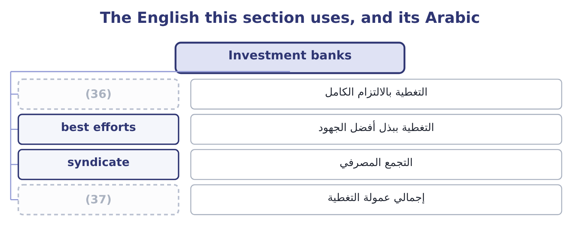
word list
firm commitment · gross spread · investment grade

The English this sheet uses, and its Arabic
English (exam term) | Arabic
firm commitment | التغطية بالالتزام الكامل
best efforts | التغطية ببذل أفضل الجهود
syndicate | التجمع المصرفي
gross spread | إجمالي عمولة التغطية

Answer key · 9.4 Investment banks

1 investment | 20 supports
2 businesses | 21 documented
3 resells | 22 separations
4 cannot | 23 The gross spread
5 agrees | 24 Valuation, negotiation, opinions
6 undersubscribed | 25 Liquidity and quoted prices
7 syndicated | 26 Indirectly, through the above
8 manager | 27 carries
9 sharing | 28 unsold
10 underwriter | 29 issuer
11 arithmetic | 30 describing
12 acquisitions | 31 failed
13 restructurings | 32 deducted
14 usually | 33 expense
15 contingent | 34 ordinary
16 securities | 35 Underpricing
17 function | 36 firm commitment
18 fourth | 37 gross spread
19 Analysts

the summaries in full
Summary 1 An investment bank stands between companies that want money and investors that have it, and it does so in four businesses that the exam names. Underwriting is the first. In a firm commitment underwriting the bank buys the whole issue from the company at an agreed price and resells it, taking the risk that it cannot be sold at more. In a best efforts underwriting the bank agrees only to try, and the risk of an undersubscribed issue stays with the company. A large issue is normally syndicated, with a lead manager and a group of banks sharing the risk and the distribution. The underwriter is paid by the spread between what investors pay and what the company receives. On a $20,000,000 equity issue at a 6 per cent gross spread, the company receives 20,000,000 × 0.94 = 18,800,000 and the syndicate keeps 20,000,000 × 0.06 = 1,200,000.
Summary 2 Spreads are far lower on bonds than on equity, and lower on a large issue than a small one, which is the arithmetic behind. Advisory is the second: mergers and acquisitions, defence against a hostile bid, valuations, fairness opinions for boards, restructurings. The bank is paid a fee, usually with a large part contingent on completion — which is itself a conflict, since the adviser is paid more if the deal happens. Trading and market making is the third. The bank quotes prices in securities, holds inventory, and earns the bid-offer spread, which is what provides the liquidity section 9.1 listed as a function of markets. Research is the fourth. Analysts publish on companies, which supports trading and distribution. The conflict here is old and well documented: an analyst's employer may be seeking underwriting business from the company being written about, and the separations now required between research and underwriting exist because that conflict was once resolved the wrong way too often.
Summary 3 In a firm commitment the bank carries the risk of an unsold issue. In a best efforts arrangement the issuer does. A question describing an issue that failed to sell is asking which arrangement was in place. The underwriting spread is a cost of the issue, deducted from the proceeds. It is not an expense of the period in the ordinary sense; it reduces the capital raised. Underpricing — a first-day rise in the share price — is a cost to the company, not a success, because the difference is money the company could have raised and did not.

9.5 What a company does with all this
Chapter 9 · section 9.5

Fill every gap. Each word list holds one word more than there are gaps.
Summary 1 gaps 1–12
Pull the four (1) together from the issuer's chair, which is where a (2) accountant sits. (3) the market that fits the size and the (4) . (5) needs belong in the money market. (6) needs belong in the capital market, publicly if the company is large and well known, (7) if it is not. Orontes, wanting $5,000,000, is (8) in the private and bank market and should not be paying for a public issue's (9) . (10) the market's (11) on price, and work on the thing behind it. If the shares trade at (12) times earnings while the gross margin falls, the lesson is about the margin, not about the market's judgment. Under semi-strong efficiency a company cannot talk its price up and can only change what the price is about. Manage the rating rather than the ratio.
word list
verdict · sections · meaning · Short-term · purpose · Accept · privately · twenty-five · Long-term · Choose · machinery · management · squarely

Summary 2 gaps 13–21
A (13) who understands that one (14) is worth 0.8 points and that (15) the investment-grade line is worth far more will set internal limits inside the covenant limits, which is why Book 1's chapter on coverage ended where it did. Use the (16) and price the (17) . An (18) is paid to sell the issue, which means it prefers a price that sells easily; an (19) is paid on (20) , which means it prefers a deal. Neither (21) is a reason to do without them, and both are reasons for a board to ask the question that the fee structure will not ask itself.
word list
notch · underwriter · completion · observation · adviser · crossing · conflict · treasurer · intermediary · judgment

Place each item

Classify or compute each.

Your turn: markets, ratings and fees (complete the blanks)
Item | Question | Answer
A 90-day treasury bill | Which market? | ________
A trade in listed shares between two investors | Primary or secondary? | ________
An interest rate swap | (22) | ________
A fund restricted to investment grade | What is the lowest rating it may hold? | ________
A 2-point spread widening on 8,000,000 of debt | (23) | ________
A 30,000,000 issue at a 5 per cent gross spread | (24) | ________
Chart patterns predicting prices | (25) | ________

word list
Which form of efficiency would this contradict? · Exchange or over the counter? · secondary market · Proceeds to the company · Annual cost

"Efficient"

Summary 3 gaps 26–32
English efficient in market efficiency does not mean well run, fast or cheap. It means that prices (26) information, and a market can be efficient in this sense while being slow, (27) and badly organised. The (28) sense is a false friend, and (29) who import it answer that a market with high (30) costs cannot be efficient — which does not follow. Note also the phrase efficient (31) : a third sense again, meaning the best risk-return (32) available.
word list
frontier · combinations · trading · everyday · expensive · reflect · Orontes · candidates

"Efficient"
Item | Answer
A 90-day treasury bill | The money market: it matures within a year.
A trade between two investors | (33)
An interest rate swap | Over the counter, through dealers, though most now clear (34) .
Lowest rating an investment-grade fund may hold | BBB− or Baa3, the bottom of investment grade.
A 2-point widening on 8,000,000 | 160,000 a year: 8,000,000 × 0.02 = 160,000.
A 30,000,000 issue at a 5 per cent spread | (35)
Chart patterns predicting prices | The weak form, which says past prices carry no further information.

word list
centrally · speculative grade · 28,500,000: 30,000,000 × 0.95 = 28,500,000. · Secondary: the company receives nothing.

The English this section uses, and its Arabic
Each term sits against what it means.
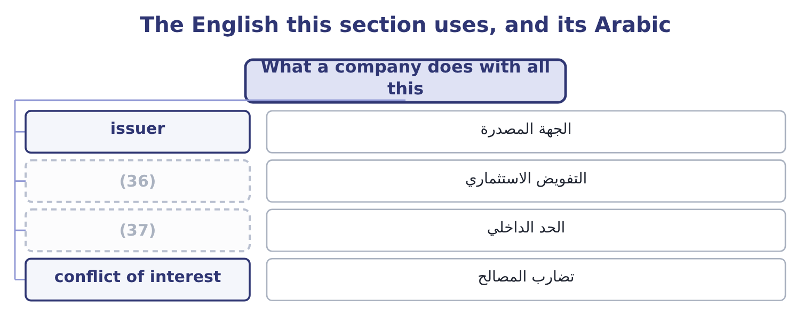
word list
mandate · internal limit · behavioural finance

The English this sheet uses, and its Arabic
English (exam term) | Arabic
issuer | الجهة المصدرة
mandate | التفويض الاستثماري
internal limit | الحد الداخلي
conflict of interest | تضارب المصالح

Answer key · 9.5 What a company does with all this

1 sections | 20 completion
2 management | 21 observation
3 Choose | 22 Exchange or over the counter?
4 purpose | 23 Annual cost
5 Short-term | 24 Proceeds to the company
6 Long-term | 25 Which form of efficiency would this contradict?
7 privately | 26 reflect
8 squarely | 27 expensive
9 machinery | 28 everyday
10 Accept | 29 candidates
11 verdict | 30 trading
12 twenty-five | 31 frontier
13 treasurer | 32 combinations
14 notch | 33 Secondary: the company receives nothing.
15 crossing | 34 centrally
16 intermediary | 35 28,500,000: 30,000,000 × 0.95 = 28,500,000.
17 conflict | 36 mandate
18 underwriter | 37 internal limit
19 adviser

the summaries in full
Summary 1 Pull the four sections together from the issuer's chair, which is where a management accountant sits. Choose the market that fits the size and the purpose. Short-term needs belong in the money market. Long-term needs belong in the capital market, publicly if the company is large and well known, privately if it is not. Orontes, wanting $5,000,000, is squarely in the private and bank market and should not be paying for a public issue's machinery. Accept the market's verdict on price, and work on the thing behind it. If the shares trade at twenty-five times earnings while the gross margin falls, the lesson is about the margin, not about the market's judgment. Under semi-strong efficiency a company cannot talk its price up and can only change what the price is about. Manage the rating rather than the ratio.
Summary 2 A treasurer who understands that one notch is worth 0.8 points and that crossing the investment-grade line is worth far more will set internal limits inside the covenant limits, which is why Book 1's chapter on coverage ended where it did. Use the intermediary and price the conflict. An underwriter is paid to sell the issue, which means it prefers a price that sells easily; an adviser is paid on completion, which means it prefers a deal. Neither observation is a reason to do without them, and both are reasons for a board to ask the question that the fee structure will not ask itself.
Summary 3 English efficient in market efficiency does not mean well run, fast or cheap. It means that prices reflect information, and a market can be efficient in this sense while being slow, expensive and badly organised. The everyday sense is a false friend, and candidates who import it answer that a market with high trading costs cannot be efficient — which does not follow. Note also the phrase efficient frontier: a third sense again, meaning the best risk-return combinations available.

10.1 The initial public offering
Chapter 10 · section 10.1

Fill every gap. Each word list holds one word more than there are gaps.
Chapter 10, section by section
Each stage leads to the next.
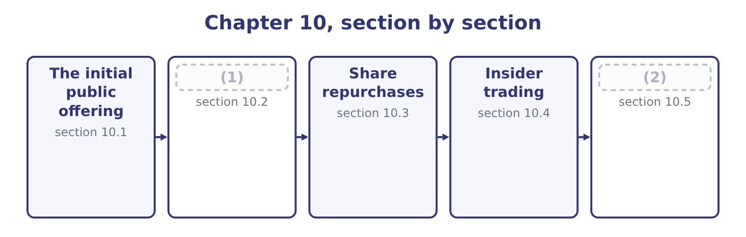
word list
Deciding, as Orontes · The initial public offering · Offerings after the first

Summary 1 gaps 3–14
An (3) public offering is the first sale of a company's shares to the public. Two things can happen at once in it, and the exam (4) them: the company may issue new shares, in which case it receives the money, and existing (5) may sell some of theirs, in which case they do. To raise (6) for growth that (7) profit cannot fund. To give the (8) and early investors a way out, which is often the real reason. To create a traded currency for (9) and for employee (10) . To raise the company's standing with (11) and lenders. And to establish a market price, which every (12) financing then (13) . The costs are large and (14) . A public company carries continuous disclosure obligations, quarterly scrutiny, governance requirements and the attention of people whose horizon is shorter than the business's.
word list
distinguishes · founders · permanent · acquisitions · references · retained · shareholders · subsequent · regulator · incentives · customers · capital · initial

Summary 2 gaps 15–26
Control is diluted and in (15) can be lost. The direct costs of the issue are heavy, and the indirect cost of underpricing is (16) still. The (17) has six stages. (18) the underwriters and agreeing the structure, which fixes the firm (19) or best efforts basis. Due diligence and the (20) statement, filed with the (21) regulator, from which the prospectus is drawn. The prospectus is the (22) on which the investors decide, and the (23) for what it says is the reason due diligence is thorough. The (24) , in which management presents to (25) investors over two or three weeks. (26) , in which the underwriters collect indications of how much each investor would buy at what price, and from which the demand curve is assembled. Pricing, the night before the offer, at a figure that the book says will clear with demand left over. Trading, followed by a lock-up period of typically ninety to a hundred and eighty days during which insiders may not sell, and often a stabilisation period in which the underwriter may support the price.
word list
institutional · roadshow · process · registration · extremis · securities · liability · heavier · Selecting · Book-building · commitment · document · standing

Worked example: what an offering costs

Summary 3 gaps 27–38
A company sells 5,000,000 new shares at $12.00. The gross (27) is 5,000,000 × 12.00 = 60,000,000. At a 7 per cent gross spread, the underwriters take 60,000,000 × 0.07 = 4,200,000, so the company receives 60,000,000 − 4,200,000 = 55,800,000, before legal, accounting and listing fees of (28) a further two (29) . The shares close their first day at $15.00. The company sold for $12.00 (30) the market (31) at $15.00, so the underpricing is 15.00 − 12.00 = 3.00 a share, which is 5,000,000 × 3.00 = 15,000,000 of value (32) from the company's existing (33) to the investors who were (34) stock. The indirect cost is three and a half times the direct one, and it is the part (35) puts in the fee table. Some underpricing is (36) — a discount is needed to persuade investors to take an unknown, and the underwriter needs the issue to sell — but the average first-day rise across decades of (37) is far larger than that (38) supports, and it is why the exam treats a large first-day pop as a question about the pricing rather than as good news.
word list
transferred · million · valued · perhaps · something · allocated · explanation · rational · owners · offerings · nobody · amount · document

What an initial public offering costs
Cost | How it arises | On this offering
Gross spread | The underwriting syndicate's fee | 4,200,000
Legal, accounting, listing | (39) | About 2,000,000
Underpricing | (40) | 15,000,000
Continuing costs | (41) | Every year thereafter

word list
Disclosure, governance, investor relations · The underwriting syndicate's fee · Advisers and the exchange · The first-day rise on shares already sold

The English this section uses, and its Arabic
Each term sits against what it means.
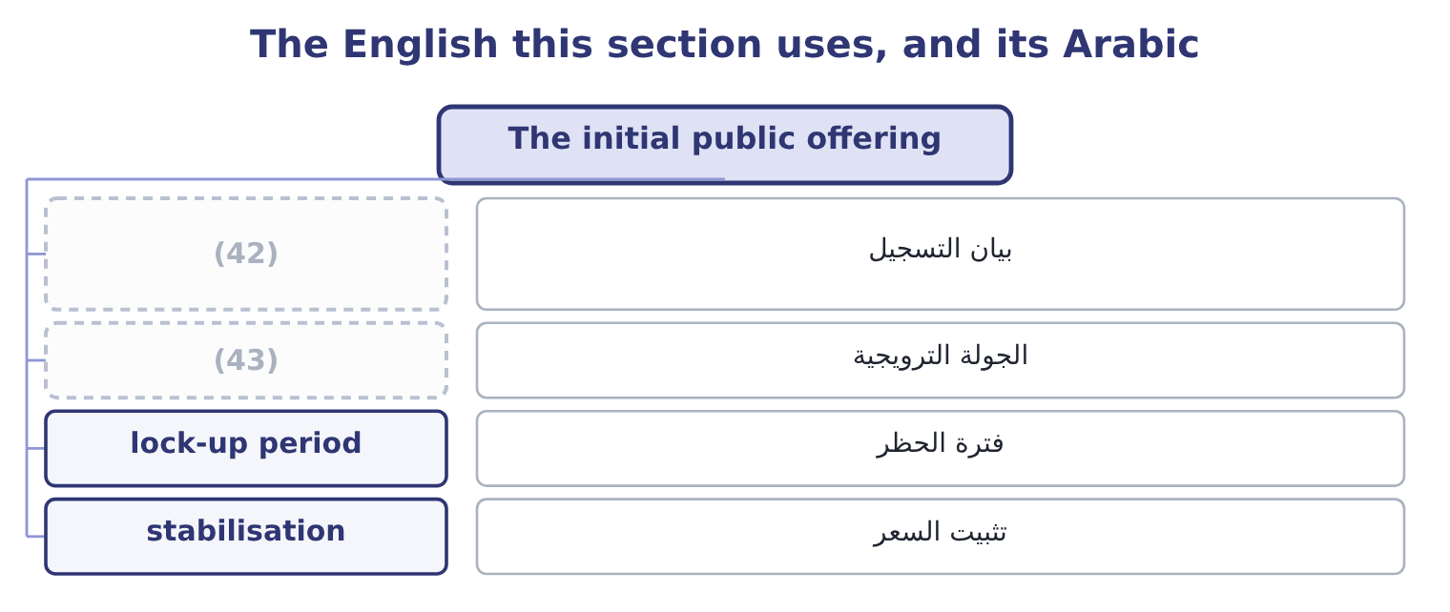
word list
underpricing · roadshow · registration statement

The English this sheet uses, and its Arabic
English (exam term) | Arabic
registration statement | بيان التسجيل
roadshow | الجولة الترويجية
lock-up period | فترة الحظر
stabilisation | تثبيت السعر

Answer key · 10.1 The initial public offering

1 Offerings after the first | 23 liability
2 Deciding, as Orontes | 24 roadshow
3 initial | 25 institutional
4 distinguishes | 26 Book-building
5 shareholders | 27 amount
6 capital | 28 perhaps
7 retained | 29 million
8 founders | 30 something
9 acquisitions | 31 valued
10 incentives | 32 transferred
11 customers | 33 owners
12 subsequent | 34 allocated
13 references | 35 nobody
14 permanent | 36 rational
15 extremis | 37 offerings
16 heavier | 38 explanation
17 process | 39 Advisers and the exchange
18 Selecting | 40 The first-day rise on shares already sold
19 commitment | 41 Disclosure, governance, investor relations
20 registration | 42 registration statement
21 securities | 43 roadshow
22 document

the summaries in full
Summary 1 An initial public offering is the first sale of a company's shares to the public. Two things can happen at once in it, and the exam distinguishes them: the company may issue new shares, in which case it receives the money, and existing shareholders may sell some of theirs, in which case they do. To raise capital for growth that retained profit cannot fund. To give the founders and early investors a way out, which is often the real reason. To create a traded currency for acquisitions and for employee incentives. To raise the company's standing with customers and lenders. And to establish a market price, which every subsequent financing then references. The costs are large and permanent. A public company carries continuous disclosure obligations, quarterly scrutiny, governance requirements and the attention of people whose horizon is shorter than the business's.
Summary 2 Control is diluted and in extremis can be lost. The direct costs of the issue are heavy, and the indirect cost of underpricing is heavier still. The process has six stages. Selecting the underwriters and agreeing the structure, which fixes the firm commitment or best efforts basis. Due diligence and the registration statement, filed with the securities regulator, from which the prospectus is drawn. The prospectus is the document on which the investors decide, and the liability for what it says is the reason due diligence is thorough. The roadshow, in which management presents to institutional investors over two or three weeks. Book-building, in which the underwriters collect indications of how much each investor would buy at what price, and from which the demand curve is assembled. Pricing, the night before the offer, at a figure that the book says will clear with demand left over. Trading, followed by a lock-up period of typically ninety to a hundred and eighty days during which insiders may not sell, and often a stabilisation period in which the underwriter may support the price.
Summary 3 A company sells 5,000,000 new shares at $12.00. The gross amount is 5,000,000 × 12.00 = 60,000,000. At a 7 per cent gross spread, the underwriters take 60,000,000 × 0.07 = 4,200,000, so the company receives 60,000,000 − 4,200,000 = 55,800,000, before legal, accounting and listing fees of perhaps a further two million. The shares close their first day at $15.00. The company sold for $12.00 something the market valued at $15.00, so the underpricing is 15.00 − 12.00 = 3.00 a share, which is 5,000,000 × 3.00 = 15,000,000 of value transferred from the company's existing owners to the investors who were allocated stock. The indirect cost is three and a half times the direct one, and it is the part nobody puts in the fee table. Some underpricing is rational — a discount is needed to persuade investors to take an unknown, and the underwriter needs the issue to sell — but the average first-day rise across decades of offerings is far larger than that explanation supports, and it is why the exam treats a large first-day pop as a question about the pricing rather than as good news.

10.2 Offerings after the first
Chapter 10 · section 10.2

Fill every gap. Each word list holds one word more than there are gaps.
Summary 1 gaps 1–12
A company that is already (1) can sell more shares, and the exam uses three terms for what (2) . A (3) or follow-on offering is any sale of shares by an already-listed company. A seasoned equity offering is the same thing, named for the fact that the shares are seasoned — already (4) , with a known price. A (5) offering, strictly, is a sale of existing shares by large (6) rather than new shares by the company. The (7) matters because no money (8) the company, and because a sale by (9) or a private equity owner (10) a signal that a sale of new shares does not. A rights issue offers new shares to existing shareholders in proportion to their (11) , usually at a discount to the market price, in order to honour the (12) right.
word list
pre-emptive · founders · subsequent · carries · happens · holdings · secondary · reaches · distinction · holders · trading · execution · listed

Summary 2 gaps 13–23
A (13) who takes up the rights keeps their proportion and (14) no dilution; one who sells the rights receives (15) for the dilution; one who does nothing loses. A shelf (16) allows a company to register an amount of (17) once and sell them in pieces over the following years whenever (18) suit, which lowers cost and speeds execution. The (19) of a follow-on is easier than an (20) offering, because the market has already set a price, but the signal is (21) . Under the (22) efficiency of, and the evidence is that share prices fall on the (23) of a new equity issue, typically by two or three per cent. The practical consequence for a treasurer is that equity is expensive in a way that no cost-of-capital calculation captures.
word list
pricing · distinction · harder · conditions · shareholder · suffers · compensation · securities · registration · initial · semi-strong · announcement

Four ways to sell shares after listing
Every item belongs to exactly one group.
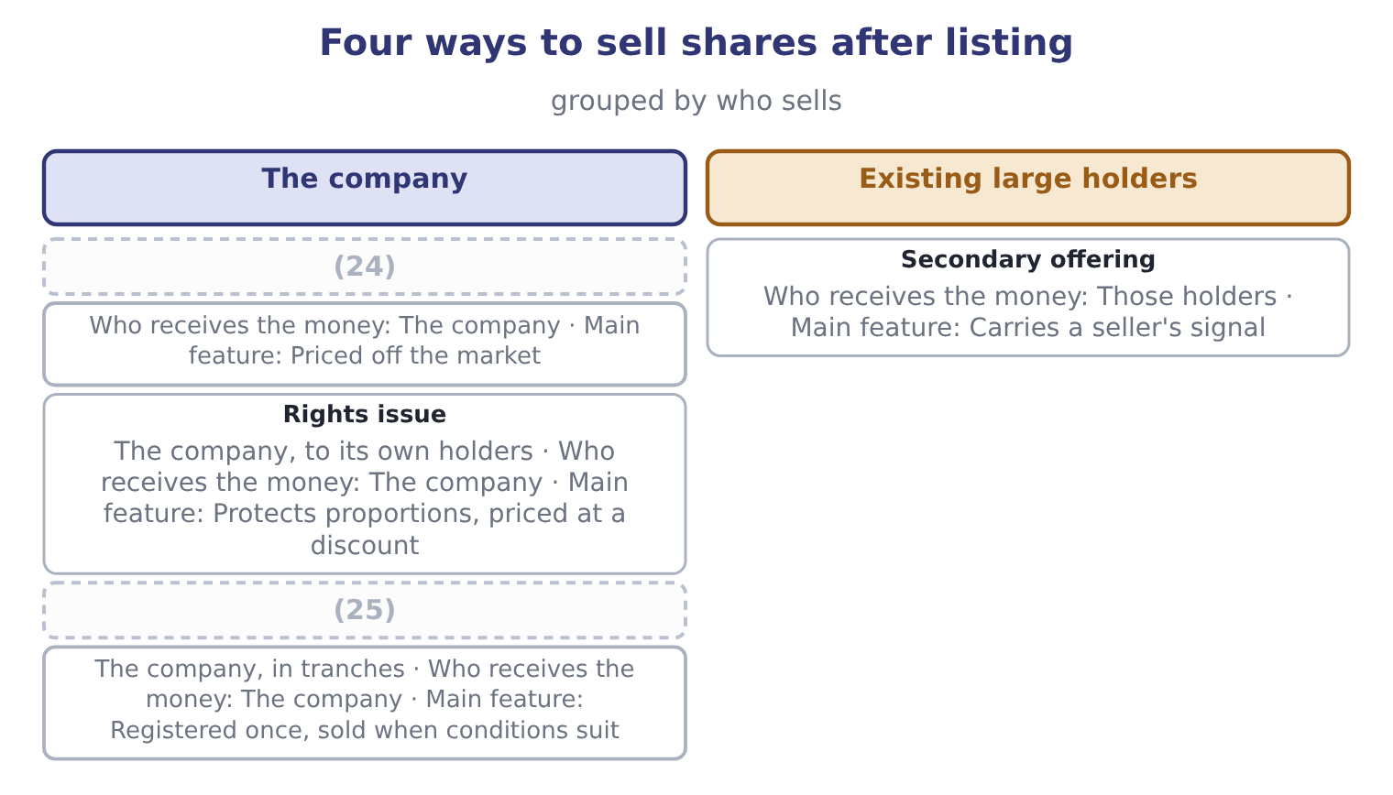
word list
insider trading · Follow-on (seasoned) offering · Shelf registration

The English this section uses, and its Arabic
Each term sits against what it means.
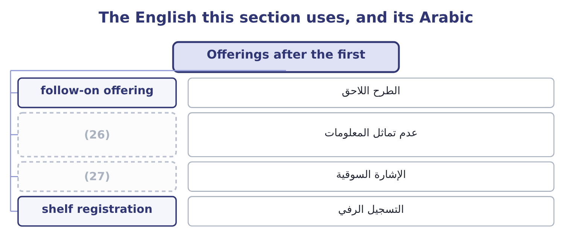
word list
signalling · information asymmetry · insider trading

The English this sheet uses, and its Arabic
English (exam term) | Arabic
follow-on offering | الطرح اللاحق
information asymmetry | عدم تماثل المعلومات
signalling | الإشارة السوقية
shelf registration | التسجيل الرفي

Answer key · 10.2 Offerings after the first

1 listed | 15 compensation
2 happens | 16 registration
3 subsequent | 17 securities
4 trading | 18 conditions
5 secondary | 19 pricing
6 holders | 20 initial
7 distinction | 21 harder
8 reaches | 22 semi-strong
9 founders | 23 announcement
10 carries | 24 Follow-on (seasoned) offering
11 holdings | 25 Shelf registration
12 pre-emptive | 26 information asymmetry
13 shareholder | 27 signalling
14 suffers

the summaries in full
Summary 1 A company that is already listed can sell more shares, and the exam uses three terms for what happens. A subsequent or follow-on offering is any sale of shares by an already-listed company. A seasoned equity offering is the same thing, named for the fact that the shares are seasoned — already trading, with a known price. A secondary offering, strictly, is a sale of existing shares by large holders rather than new shares by the company. The distinction matters because no money reaches the company, and because a sale by founders or a private equity owner carries a signal that a sale of new shares does not. A rights issue offers new shares to existing shareholders in proportion to their holdings, usually at a discount to the market price, in order to honour the pre-emptive right.
Summary 2 A shareholder who takes up the rights keeps their proportion and suffers no dilution; one who sells the rights receives compensation for the dilution; one who does nothing loses. A shelf registration allows a company to register an amount of securities once and sell them in pieces over the following years whenever conditions suit, which lowers cost and speeds execution. The pricing of a follow-on is easier than an initial offering, because the market has already set a price, but the signal is harder. Under the semi-strong efficiency of, and the evidence is that share prices fall on the announcement of a new equity issue, typically by two or three per cent. The practical consequence for a treasurer is that equity is expensive in a way that no cost-of-capital calculation captures.

10.3 Share repurchases
Chapter 10 · section 10.3

Fill every gap. Each word list holds one word more than there are gaps.
Summary 1 gaps 1–12
A repurchase is the company buying its own shares. The shares bought either become treasury stock, (1) to be reissued, or are (2) . Either way the share count falls and so does equity. Six reasons a company (3) , and the exam expects them named and (4) . To return cash it (5) use. A company generating more than its investment (6) need has three choices: hold the cash, which lowers the return on assets as Book 1 showed; raise the dividend, which the market expects to be maintained; or buy back shares, which carries no such (7) . (8) is the central (9) for a buyback over a dividend. To signal that the (10) believe the shares are (11) . Buying is the opposite of issuing, and the signal is read in the opposite direction: prices typically rise on a repurchase (12) .
word list
directors · undervalued · argument · repurchases · employee · available · cancelled · Flexibility · distinguished · expectation · opportunities · announcement · cannot

Summary 2 gaps 13–24
To (13) the capital (14) . A buyback funded with debt raises leverage (15) , moving the company (16) the optimum. To offset the (17) of employee share schemes, which is in practice the largest single use of repurchase (18) . To use the tax (19) . Where capital gains are taxed more lightly than dividends, or are deferred until the (20) chooses to sell, a repurchase delivers value more (21) than a dividend. To defend against a (22) , by reducing the free float and (23) the price. The methods differ and are (24) . An open-market repurchase buys gradually through the exchange over months, cheapest and least committing. A fixed-price tender offer invites all holders to sell a stated number at a stated price, usually at a premium. A Dutch auction tender invites holders to state the lowest price at which they will sell, and the company pays the lowest price that fills the order. And a targeted repurchase buys from one holder privately, which is the transaction that acquired the name greenmail when the holder was a hostile bidder being paid to go away.
word list
dilution · tax-efficiently · raising · takeover · structure · deliberately · treatment · privately · shareholder · programmes · change · towards · examinable

Worked example: Orontes buys back 500,000 shares

Summary 3 gaps 25–28
Orontes buys 500,000 of its 8,100,000 shares at the market price of $9.25, spending 500,000 × 9.25 = 4,625,000 of the $7,302,100 of cash on its (25) sheet. Cash falls to 7,302,100 − 4,625,000 = 2,677,100. Net income is (26) at $2,969,100 and the share count falls to 8,100,000 − 500,000 = 7,600,000, so earnings per share rises to 2,969,100 ÷ 7,600,000 = 0.3907 from 0.3666. Book value per share. Equity falls by the cash spent: 20,392,975 − 4,625,000 = 15,767,975, and book value per share (27) 15,767,975 ÷ 7,600,000 = 2.07, down from 2.5177 — because the shares were bought at (28) four times book. Return on equity rises to 2,969,100 ÷ 15,767,975 = 18.83 per cent from 16.15. Debt to equity rises to 11,279,625 ÷ 15,767,975 = 0.715 from 0.55. The current ratio falls, because $4,625,000 of current assets has gone.
word list
becomes · dividend · unchanged · nearly · balance

Summary 4 gaps 29–36
Earnings per share rose, return on equity rose, and nothing (29) happened to the (30) . That is the warning this example exists to give: a buyback (31) every per-share measure (32) , and an incentive scheme based on earnings per share can (33) be satisfied by spending cash rather than by trading better. The (34) to ask is the one: did the $4,625,000 earn more inside the company or returned to its owners? If Orontes has projects (35) more than 9.04 per cent, the buyback (36) value however good the ratios look.
word list
whatever · question · business · therefore · improves · destroyed · returning · auction · arithmetically

The English this section uses, and its Arabic
Each term sits against what it means.
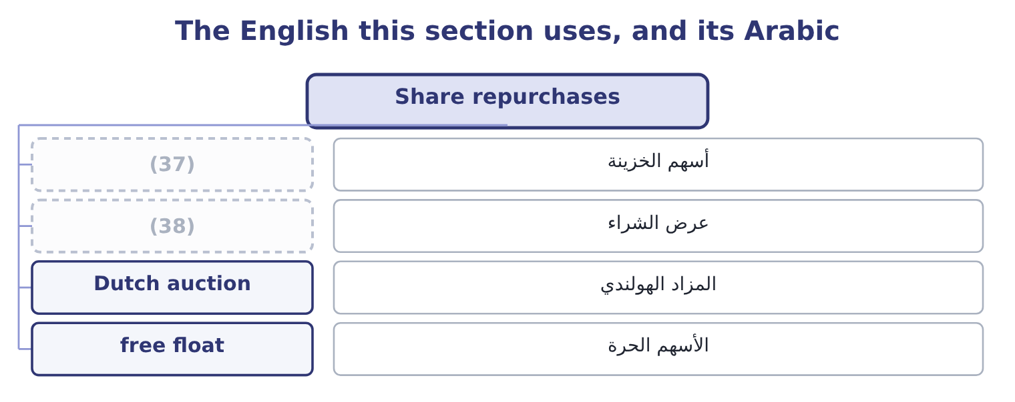
word list
registration statement · treasury stock · tender offer

The English this sheet uses, and its Arabic
English (exam term) | Arabic
treasury stock | أسهم الخزينة
tender offer | عرض الشراء
Dutch auction | المزاد الهولندي
free float | الأسهم الحرة

Answer key · 10.3 Share repurchases

1 available | 20 shareholder
2 cancelled | 21 tax-efficiently
3 repurchases | 22 takeover
4 distinguished | 23 raising
5 cannot | 24 examinable
6 opportunities | 25 balance
7 expectation | 26 unchanged
8 Flexibility | 27 becomes
9 argument | 28 nearly
10 directors | 29 whatever
11 undervalued | 30 business
12 announcement | 31 improves
13 change | 32 arithmetically
14 structure | 33 therefore
15 deliberately | 34 question
16 towards | 35 returning
17 dilution | 36 destroyed
18 programmes | 37 treasury stock
19 treatment | 38 tender offer

the summaries in full
Summary 1 A repurchase is the company buying its own shares. The shares bought either become treasury stock, available to be reissued, or are cancelled. Either way the share count falls and so does equity. Six reasons a company repurchases, and the exam expects them named and distinguished. To return cash it cannot use. A company generating more than its investment opportunities need has three choices: hold the cash, which lowers the return on assets as Book 1 showed; raise the dividend, which the market expects to be maintained; or buy back shares, which carries no such expectation. Flexibility is the central argument for a buyback over a dividend. To signal that the directors believe the shares are undervalued. Buying is the opposite of issuing, and the signal is read in the opposite direction: prices typically rise on a repurchase announcement.
Summary 2 To change the capital structure. A buyback funded with debt raises leverage deliberately, moving the company towards the optimum. To offset the dilution of employee share schemes, which is in practice the largest single use of repurchase programmes. To use the tax treatment. Where capital gains are taxed more lightly than dividends, or are deferred until the shareholder chooses to sell, a repurchase delivers value more tax-efficiently than a dividend. To defend against a takeover, by reducing the free float and raising the price. The methods differ and are examinable. An open-market repurchase buys gradually through the exchange over months, cheapest and least committing. A fixed-price tender offer invites all holders to sell a stated number at a stated price, usually at a premium. A Dutch auction tender invites holders to state the lowest price at which they will sell, and the company pays the lowest price that fills the order. And a targeted repurchase buys from one holder privately, which is the transaction that acquired the name greenmail when the holder was a hostile bidder being paid to go away.
Summary 3 Orontes buys 500,000 of its 8,100,000 shares at the market price of $9.25, spending 500,000 × 9.25 = 4,625,000 of the $7,302,100 of cash on its balance sheet. Cash falls to 7,302,100 − 4,625,000 = 2,677,100. Net income is unchanged at $2,969,100 and the share count falls to 8,100,000 − 500,000 = 7,600,000, so earnings per share rises to 2,969,100 ÷ 7,600,000 = 0.3907 from 0.3666. Book value per share. Equity falls by the cash spent: 20,392,975 − 4,625,000 = 15,767,975, and book value per share becomes 15,767,975 ÷ 7,600,000 = 2.07, down from 2.5177 — because the shares were bought at nearly four times book. Return on equity rises to 2,969,100 ÷ 15,767,975 = 18.83 per cent from 16.15. Debt to equity rises to 11,279,625 ÷ 15,767,975 = 0.715 from 0.55. The current ratio falls, because $4,625,000 of current assets has gone.
Summary 4 Earnings per share rose, return on equity rose, and nothing whatever happened to the business. That is the warning this example exists to give: a buyback improves every per-share measure arithmetically, and an incentive scheme based on earnings per share can therefore be satisfied by spending cash rather than by trading better. The question to ask is the one: did the $4,625,000 earn more inside the company or returned to its owners? If Orontes has projects returning more than 9.04 per cent, the buyback destroyed value however good the ratios look.

10.4 Insider trading
Chapter 10 · section 10.4

Fill every gap. Each word list holds one word more than there are gaps.
Summary 1 gaps 1–12
Insider trading is (1) in a company's (2) on the basis of material non-public information, by somebody who owes a duty with respect to that information. Three (3) define it and each is (4) . Material means the information would matter to a reasonable (5) decision — an earnings figure not yet announced, a merger in (6) , the loss of a major customer, a drug trial's result. (7) information is not caught (8) secret. Non-public means not yet (9) to the market. Once an announcement has been made and the market has had time to (10) it, the information is public and trading on it is lawful. A duty means the trader is an insider or has (11) one. (12) , officers and employees are classic insiders. So are temporary insiders — the lawyers, auditors, bankers and printers who receive the information to do their work. And so is a tippee, somebody given the information by an insider who breached a duty in telling them, where the tippee knew or should have known of the breach.
word list
however · negotiation · investor's · tested · disseminated · dealing · announced · securities · Directors · Immaterial · become · elements · absorb

Summary 2 gaps 13–22
Why it is (13) , which is the part of the outcome (14) answer weakly. Four (15) , and the first is the (16) . It is theft of information that (17) to the company and its (18) , used for private gain. It destroys (19) in the market. (20) who believe the game is rigged demand a higher return for (21) , which raises the cost of capital for every company — a harm to the whole economy, not only to the person on the other side of the trade. It harms the (22) directly. Somebody sold the shares the insider bought, at a price that did not reflect what the insider knew. It creates perverse incentives inside the company.
word list
candidates · shareholders · belongs · strongest · Investors · participating · illegal · assumes · confidence · reasons · counterparty

Summary 3 gaps 23–32
A manager who can trade on bad news has an (23) in bad news, and in (24) its announcement. The (25) and safe harbours are (26) . A (27) trading plan, adopted when the insider had no material non-public information and executed (28) , protects routine sales by executives. Trading after full public disclosure is lawful. And the (29) that require fair disclosure exist (30) to stop selective briefing of analysts, which would otherwise create insiders by the dozen. (31) efficiency says prices (32) reflect private information, in which case insider trading could not be profitable. The law assumes it is profitable. The law is right, which is the plainest available evidence that the strong form does not hold.
word list
interest · already · delaying · regulations · briefing · pre-arranged · automatically · Strong-form · defences · precisely · examinable

What makes trading unlawful
Element | Test | Example that meets it | Example that does not
Material | Would a reasonable investor care? | Unannounced earnings, a merger | (33)
Non-public | Has the market been told? | (34) | After it has been absorbed
Duty | Is the trader an insider or a tippee? | (35) | A stranger who worked it out from public data

word list
Before the announcement · A director, an auditor, a tipped friend · An internal reorganisation of departments · initial public offering

The English this section uses, and its Arabic
Each term sits against what it means.
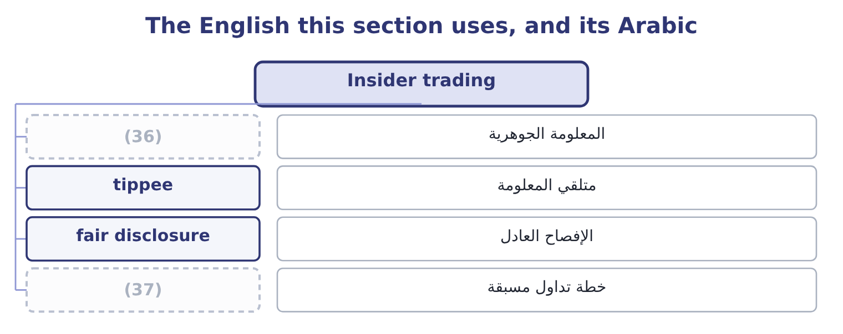
word list
material information · trading plan · insider trading

The English this sheet uses, and its Arabic
English (exam term) | Arabic
material information | المعلومة الجوهرية
tippee | متلقي المعلومة
fair disclosure | الإفصاح العادل
trading plan | خطة تداول مسبقة

Answer key · 10.4 Insider trading

1 dealing | 20 Investors
2 securities | 21 participating
3 elements | 22 counterparty
4 tested | 23 interest
5 investor's | 24 delaying
6 negotiation | 25 defences
7 Immaterial | 26 examinable
8 however | 27 pre-arranged
9 disseminated | 28 automatically
10 absorb | 29 regulations
11 become | 30 precisely
12 Directors | 31 Strong-form
13 illegal | 32 already
14 candidates | 33 An internal reorganisation of departments
15 reasons | 34 Before the announcement
16 strongest | 35 A director, an auditor, a tipped friend
17 belongs | 36 material information
18 shareholders | 37 trading plan
19 confidence

the summaries in full
Summary 1 Insider trading is dealing in a company's securities on the basis of material non-public information, by somebody who owes a duty with respect to that information. Three elements define it and each is tested. Material means the information would matter to a reasonable investor's decision — an earnings figure not yet announced, a merger in negotiation, the loss of a major customer, a drug trial's result. Immaterial information is not caught however secret. Non-public means not yet disseminated to the market. Once an announcement has been made and the market has had time to absorb it, the information is public and trading on it is lawful. A duty means the trader is an insider or has become one. Directors, officers and employees are classic insiders. So are temporary insiders — the lawyers, auditors, bankers and printers who receive the information to do their work. And so is a tippee, somebody given the information by an insider who breached a duty in telling them, where the tippee knew or should have known of the breach.
Summary 2 Why it is illegal, which is the part of the outcome candidates answer weakly. Four reasons, and the first is the strongest. It is theft of information that belongs to the company and its shareholders, used for private gain. It destroys confidence in the market. Investors who believe the game is rigged demand a higher return for participating, which raises the cost of capital for every company — a harm to the whole economy, not only to the person on the other side of the trade. It harms the counterparty directly. Somebody sold the shares the insider bought, at a price that did not reflect what the insider knew. It creates perverse incentives inside the company.
Summary 3 A manager who can trade on bad news has an interest in bad news, and in delaying its announcement. The defences and safe harbours are examinable. A pre-arranged trading plan, adopted when the insider had no material non-public information and executed automatically, protects routine sales by executives. Trading after full public disclosure is lawful. And the regulations that require fair disclosure exist precisely to stop selective briefing of analysts, which would otherwise create insiders by the dozen. Strong-form efficiency says prices already reflect private information, in which case insider trading could not be profitable. The law assumes it is profitable. The law is right, which is the plainest available evidence that the strong form does not hold.

10.5 Deciding, as Orontes
Chapter 10 · section 10.5

Fill every gap. Each word list holds one word more than there are gaps.
Summary 1 gaps 1–12
Put the chapter to work on the company. Orontes holds $7,302,100 of cash against total current (1) of $4,280,000 and a cash ratio of 1.72, which Book 1 called strong and faintly (2) . The (3) is 15.16 per cent and the dividend yield 0.60 per cent, which is a growth (4) profile. (5) it creates an (6) the company will be judged against for years. The (7) example showed what it would do to the ratios and what it would not do to the (8) . Two further (9) decide it. The shares trade at 3.67 times book and 25.23 times earnings, which is the price at which the company would be buying — a high price to pay for its own equity unless the (10) believe the market is (11) it, and Book 1's margin finding suggests the opposite. And the cash is partly a defence: a company whose gross margin is falling a point a year may need the $7,302,100 more than its (12) do.
word list
Raising · payout · excessive · liabilities · undervaluing · company's · directors · considerations · business · shareholders · worked · expectation · creates

Summary 2 gaps 13–17
The (13) that follows from the whole of Books 1 and 2 so far is: fund the (14) , leave the dividend where it is, and do not buy back shares at 3.67 times book while the margin is still falling. That is a (15) , and the marks in an exam are for the (16) , not for the (17) .
word list
reasoning · judgment · projects · undervaluing · recommendation · verdict

Classify and compute

Your turn: offerings, buybacks and insiders (complete the blanks)
Item | Question | Answer
4,000,000 shares at 15.00, 6 per cent spread | Proceeds to the company | ________
Those shares close at 18.00 on day one | Underpricing in total | ________
A founder sells 2,000,000 existing shares | (18) | ________
A company buys back 1,000,000 of 10,000,000 shares; net income 5,000,000 | New earnings per share | ________
An auditor trades before an unannounced merger | Lawful or not, and why? | ________
A trading plan adopted a year earlier executes a sale | (19) | ________

word list
Lawful or not, and why? · Proceeds to the company · Who receives the money?

"Offering"

Summary 3 gaps 20–25
English offering in finance means a sale of (20) , and the related words divide along lines that catch (21) out. An offer is what a bidder makes for a company; an offering is what a company makes to (22) ; and the offer price in a market (23) is the price at which a dealer will sell to you, which is the opposite of the bid. Read the (24) and the context before (25) which is meant.
word list
candidates · deciding · quotation · securities · shareholders · investors · preposition

"Offering"
Item | Answer
Proceeds to the company | 56,400,000: the gross is 4,000,000 × 15.00 = 60,000,000 and the spread 60,000,000 × 0.06 = 3,600,000, leaving 60,000,000 − 3,600,000 = 56,40
Underpricing in total | 12,000,000: the rise is 18.00 − 15.00 = 3.00 a share on 4,000,000 shares.
Who receives the money | (26) : this is a secondary sale of existing shares.
New earnings per share | (27)
The auditor's trade | (28) : the auditor is a temporary insider with material non-public information.
The trading plan | Lawful: it was adopted when the insider held no material non-public information and executes automatically.
What it tells you | The two costs of an offering are the one in the fee table and the one that is not, and on these figures the second is more than three times

word list
0.5556: 5,000,000 ÷ 9,000,000 = 0.5556. · Proceeds to the company · The founder, not the company · Unlawful

The English this section uses, and its Arabic
Each term sits against what it means.
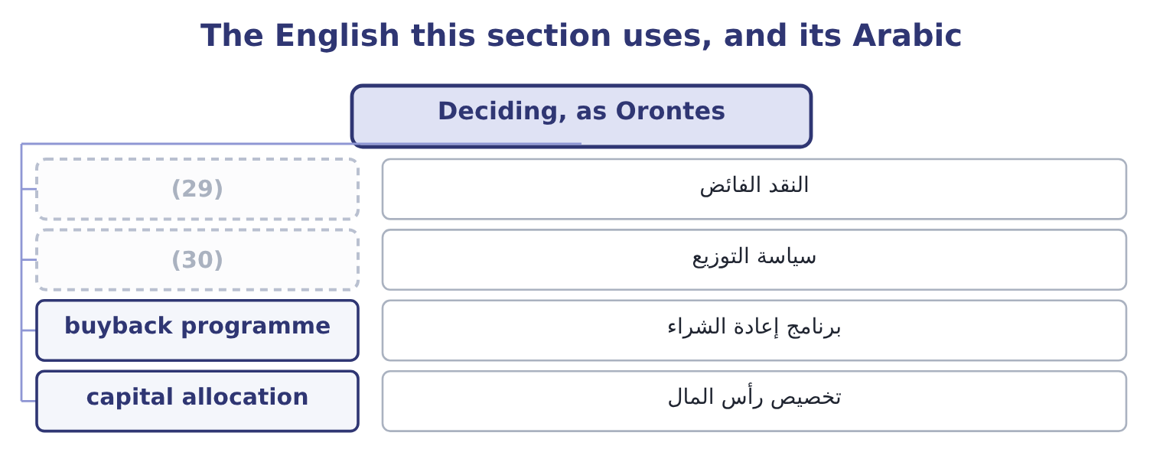
word list
payout policy · excess cash · registration statement

The English this sheet uses, and its Arabic
English (exam term) | Arabic
excess cash | النقد الفائض
payout policy | سياسة التوزيع
buyback programme | برنامج إعادة الشراء
capital allocation | تخصيص رأس المال

Answer key · 10.5 Deciding, as Orontes

1 liabilities | 16 reasoning
2 excessive | 17 verdict
3 payout | 18 Who receives the money?
4 company's | 19 Lawful or not, and why?
5 Raising | 20 securities
6 expectation | 21 candidates
7 worked | 22 investors
8 business | 23 quotation
9 considerations | 24 preposition
10 directors | 25 deciding
11 undervaluing | 26 The founder, not the company
12 shareholders | 27 0.5556: 5,000,000 ÷ 9,000,000 = 0.5556.
13 recommendation | 28 Unlawful
14 projects | 29 excess cash
15 judgment | 30 payout policy

the summaries in full
Summary 1 Put the chapter to work on the company. Orontes holds $7,302,100 of cash against total current liabilities of $4,280,000 and a cash ratio of 1.72, which Book 1 called strong and faintly excessive. The payout is 15.16 per cent and the dividend yield 0.60 per cent, which is a growth company's profile. Raising it creates an expectation the company will be judged against for years. The worked example showed what it would do to the ratios and what it would not do to the business. Two further considerations decide it. The shares trade at 3.67 times book and 25.23 times earnings, which is the price at which the company would be buying — a high price to pay for its own equity unless the directors believe the market is undervaluing it, and Book 1's margin finding suggests the opposite. And the cash is partly a defence: a company whose gross margin is falling a point a year may need the $7,302,100 more than its shareholders do.
Summary 2 The recommendation that follows from the whole of Books 1 and 2 so far is: fund the projects, leave the dividend where it is, and do not buy back shares at 3.67 times book while the margin is still falling. That is a judgment, and the marks in an exam are for the reasoning, not for the verdict.
Summary 3 English offering in finance means a sale of securities, and the related words divide along lines that catch candidates out. An offer is what a bidder makes for a company; an offering is what a company makes to investors; and the offer price in a market quotation is the price at which a dealer will sell to you, which is the opposite of the bid. Read the preposition and the context before deciding which is meant.

11.1 The kinds of dividend
Chapter 11 · section 11.1

Fill every gap. Each word list holds one word more than there are gaps.
Chapter 11, section by section
Each stage leads to the next.
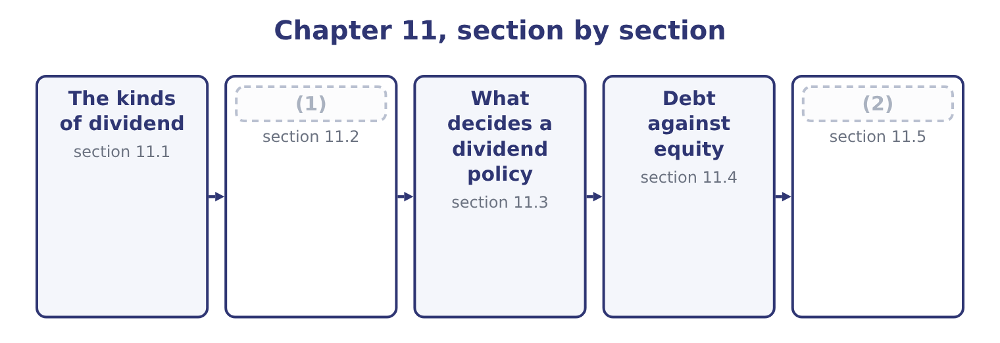
word list
What decides a dividend policy · How a dividend is paid · Leasing, and the net advantage to leasing

Summary 1 gaps 3–14
Four (3) appear in exam (4) and only the first moves cash. A cash dividend is a (5) out of retained earnings. It reduces cash and reduces equity by the same amount, and it does not touch the income (6) — a distribution is not an (7) . Orontes (8) $450,000 for 2025, of which $50,000 was paid in cash during the year and $400,000 stood as a dividend payable at (9) 31. A stock dividend is a distribution of additional shares. Nothing (10) the company. A holder of 100 shares who (11) a 10 per cent stock dividend holds 110 shares of a company worth exactly what it was worth before, so each share is worth (12) less. In the (13) , a small stock dividend transfers an amount from retained earnings to common stock and additional paid-in capital at the market value of the shares issued: on (14) 8,100,000 shares a 10 per cent stock dividend would issue 810,000 shares, and at $9.25 that is 810,000 × 9.25 = 7,492,500 moved within equity.
word list
December · receives · additional · statement · payment · proportionately · Orontes's · declared · distributions · accounts · expense · questions · leaves

Summary 2 gaps 15–26
Earnings per share falls (15) to 2,969,100 ÷ 8,910,000 = 0.3332. A stock split (16) each share into more shares. A (17) split on Orontes gives 16,200,000 shares, each worth about half as much, and earnings per share (18) 2,969,100 ÷ 16,200,000 = 0.1833. (19) a split changes the par value and transfers nothing; (20) it is identical to a stock dividend, and the reason both exist is a convention about size — a distribution of more than about a quarter is treated as a split. A property dividend (21) an asset rather than cash, and a (22) dividend returns capital rather than profit, which reduces paid-in capital and is a signal in its own right. Why issue shares that are worth nothing new? Three (23) the exam accepts. To bring a high share price into a range where small (24) trade more (25) . To signal (26) , since a board that splits usually expects the price to keep rising. And to conserve cash while appearing to distribute something, which is the least respectable of the three and the commonest.
word list
liquidating · mechanically · confidence · reasons · economically · exactly · two-for-one · distributes · easily · Accounting-wise · investors · becomes · divides

What each distribution changes
Every item belongs to exactly one group.
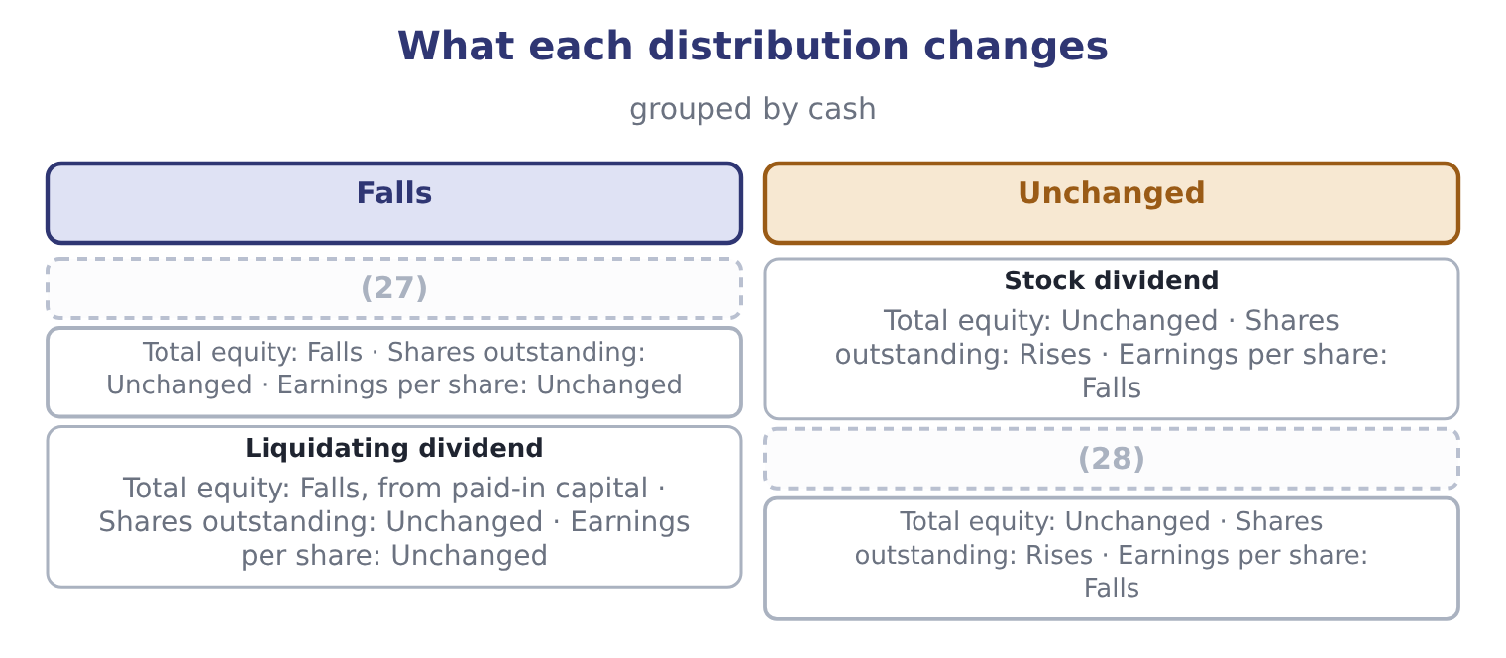
word list
irrelevance theory · Cash dividend · Stock split

The English this section uses, and its Arabic
Each term sits against what it means.
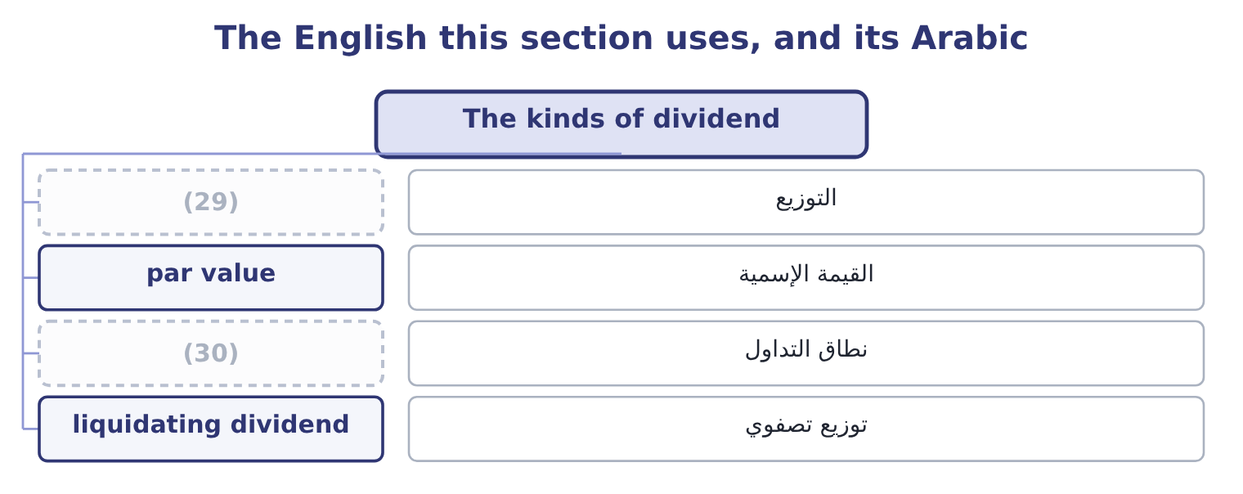
word list
distribution · trading range · dividend policy

The English this sheet uses, and its Arabic
English (exam term) | Arabic
distribution | التوزيع
par value | القيمة الإسمية
trading range | نطاق التداول
liquidating dividend | توزيع تصفوي

Answer key · 11.1 The kinds of dividend

1 How a dividend is paid | 16 divides
2 Leasing, and the net advantage to leasing | 17 two-for-one
3 distributions | 18 becomes
4 questions | 19 Accounting-wise
5 payment | 20 economically
6 statement | 21 distributes
7 expense | 22 liquidating
8 declared | 23 reasons
9 December | 24 investors
10 leaves | 25 easily
11 receives | 26 confidence
12 proportionately | 27 Cash dividend
13 accounts | 28 Stock split
14 Orontes's | 29 distribution
15 mechanically | 30 trading range

the summaries in full
Summary 1 Four distributions appear in exam questions and only the first moves cash. A cash dividend is a payment out of retained earnings. It reduces cash and reduces equity by the same amount, and it does not touch the income statement — a distribution is not an expense. Orontes declared $450,000 for 2025, of which $50,000 was paid in cash during the year and $400,000 stood as a dividend payable at December 31. A stock dividend is a distribution of additional shares. Nothing leaves the company. A holder of 100 shares who receives a 10 per cent stock dividend holds 110 shares of a company worth exactly what it was worth before, so each share is worth proportionately less. In the accounts, a small stock dividend transfers an amount from retained earnings to common stock and additional paid-in capital at the market value of the shares issued: on Orontes's 8,100,000 shares a 10 per cent stock dividend would issue 810,000 shares, and at $9.25 that is 810,000 × 9.25 = 7,492,500 moved within equity.
Summary 2 Earnings per share falls mechanically to 2,969,100 ÷ 8,910,000 = 0.3332. A stock split divides each share into more shares. A two-for-one split on Orontes gives 16,200,000 shares, each worth about half as much, and earnings per share becomes 2,969,100 ÷ 16,200,000 = 0.1833. Accounting-wise a split changes the par value and transfers nothing; economically it is identical to a stock dividend, and the reason both exist is a convention about size — a distribution of more than about a quarter is treated as a split. A property dividend distributes an asset rather than cash, and a liquidating dividend returns capital rather than profit, which reduces paid-in capital and is a signal in its own right. Why issue shares that are worth nothing new? Three reasons the exam accepts. To bring a high share price into a range where small investors trade more easily. To signal confidence, since a board that splits usually expects the price to keep rising. And to conserve cash while appearing to distribute something, which is the least respectable of the three and the commonest.

11.2 How a dividend is paid
Chapter 11 · section 11.2

Fill every gap. Each word list holds one word more than there are gaps.
Summary 1 gaps 1–9
Four dates (1) the process, and the exam asks which one matters. The declaration date is when the board declares the dividend. At that (2) a legal liability arises: Orontes's $400,000 dividend payable exists because the board declared before the year end and had not yet paid. The date of record is the date on which the company looks at its share register. (3) is on it receives the dividend. The ex-dividend date is one (4) day before the record date in most (5) , and it is the one that matters to an (6) . A share (7) on or after it does not carry the dividend. On the ex-dividend date the price falls by (8) the dividend, because the buyer no (9) receives it: Orontes's $9.25 share would open at about 9.25 − 0.0556 = 9.1944, before any other news.
word list
govern · markets · bought · longer · Whoever · business · approximately · moment · investor · payment

Summary 2 gaps 10–17
The payment date is when the cash goes out. For preferred stock the process is the same with one (10) . The preferred dividend must be declared and paid in full before any common dividend, and where the stock is cumulative, any (11) from earlier years must be (12) first. Preferred dividends are (13) at a fixed rate on par and are declared on a (14) cycle, so the (15) a board exercises over the common dividend (16) exists for the preferred — in (17) if not in law.
word list
arrears · addition · barely · practice · dividend · discretion · regular · usually · cleared

The four dates
Date | What happens | Effect
Declaration date | The board declares | (18)
Ex-dividend date | (19) | The price falls by about the dividend
Date of record | (20) | Holders on it will be paid
Payment date | The cash is sent | (21)

word list
Cash and the liability both fall · The shares trade without the dividend · A liability arises; equity falls · The register is read · net advantage to leasing

Which date, and which effect

Summary 3 gaps 22–26
The liability arises on declaration, not on payment. Orontes's (22) sheet carries $400,000 of dividends payable for exactly that reason. The price (23) on the ex-dividend date, not on the payment date. Buying the day before the (24) to capture the dividend gains nothing, because the price falls by it. A dividend is not an (25) and never reduces net income. It reduces (26) earnings.
word list
adjusts · ex-date · retained · expense · balance · payment

The English this section uses, and its Arabic
Each term sits against what it means.
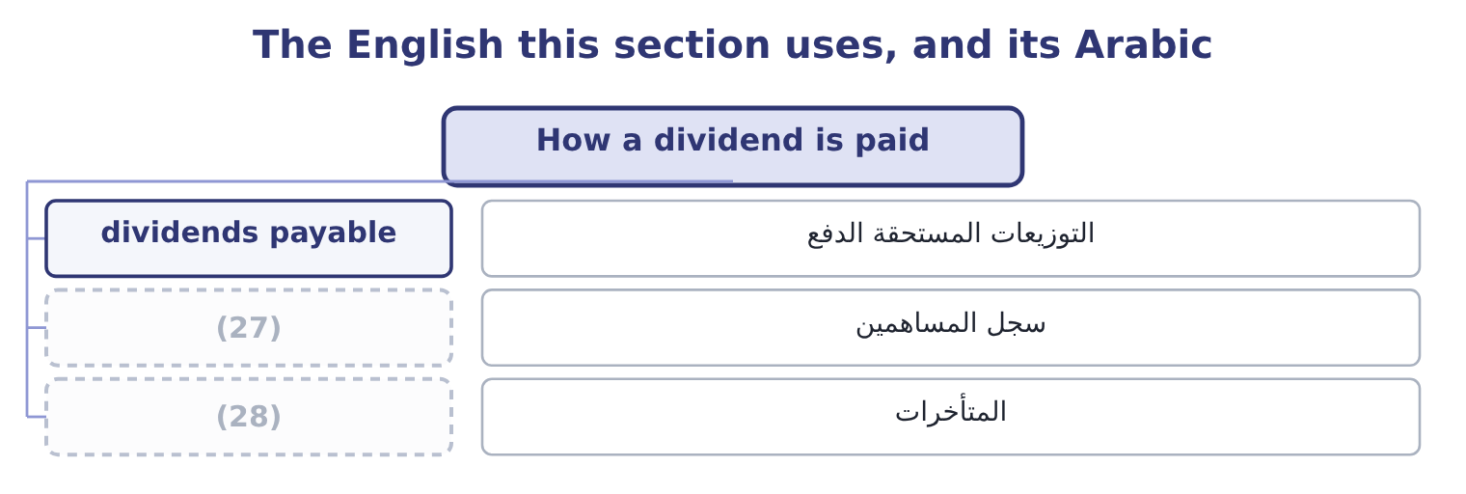
word list
payout policy · share register · arrears

The English this sheet uses, and its Arabic
English (exam term) | Arabic
dividends payable | التوزيعات المستحقة الدفع
share register | سجل المساهمين
arrears | المتأخرات

Answer key · 11.2 How a dividend is paid

1 govern | 15 discretion
2 moment | 16 barely
3 Whoever | 17 practice
4 business | 18 A liability arises; equity falls
5 markets | 19 The shares trade without the dividend
6 investor | 20 The register is read
7 bought | 21 Cash and the liability both fall
8 approximately | 22 balance
9 longer | 23 adjusts
10 addition | 24 ex-date
11 arrears | 25 expense
12 cleared | 26 retained
13 usually | 27 share register
14 regular | 28 arrears

the summaries in full
Summary 1 Four dates govern the process, and the exam asks which one matters. The declaration date is when the board declares the dividend. At that moment a legal liability arises: Orontes's $400,000 dividend payable exists because the board declared before the year end and had not yet paid. The date of record is the date on which the company looks at its share register. Whoever is on it receives the dividend. The ex-dividend date is one business day before the record date in most markets, and it is the one that matters to an investor. A share bought on or after it does not carry the dividend. On the ex-dividend date the price falls by approximately the dividend, because the buyer no longer receives it: Orontes's $9.25 share would open at about 9.25 − 0.0556 = 9.1944, before any other news.
Summary 2 The payment date is when the cash goes out. For preferred stock the process is the same with one addition. The preferred dividend must be declared and paid in full before any common dividend, and where the stock is cumulative, any arrears from earlier years must be cleared first. Preferred dividends are usually at a fixed rate on par and are declared on a regular cycle, so the discretion a board exercises over the common dividend barely exists for the preferred — in practice if not in law.
Summary 3 The liability arises on declaration, not on payment. Orontes's balance sheet carries $400,000 of dividends payable for exactly that reason. The price adjusts on the ex-dividend date, not on the payment date. Buying the day before the ex-date to capture the dividend gains nothing, because the price falls by it. A dividend is not an expense and never reduces net income. It reduces retained earnings.

11.3 What decides a dividend policy
Chapter 11 · section 11.3

Fill every gap. Each word list holds one word more than there are gaps.
Summary 1 gaps 1–12
A dividend policy is the rule a board (1) about how much of its profit to distribute. Eight factors (2) it, and the exam (3) them named. Legal and (4) constraints. (5) are limited by law to profits available for the purpose, and covenants in loan agreements often restrict them further — a lender that has just advanced money does not want it paid out to (6) . A dividend is paid in cash, not in profit. A company can be (7) and unable to pay, which is (8) Barada's position in Book 1: an overdraft where there was none, and the profit sitting in inventory. A company with projects (9) more than its cost of capital should retain; one (10) should distribute. (11) retains 84.84 per cent and has projects at 14 and 11 per cent against a cost of capital of 9.04, which is (12) .
word list
everything · influence · earning · shareholders · follows · consistent · precisely · expects · Distributions · Orontes · contractual · without · profitable

Summary 2 gaps 13–24
A large, listed, (13) company can pay out and raise money again (14) . A small (15) company cannot, so it retains. (16) and the signal. Boards (17) cutting dividends because a cut is read as bad news, so they raise only when the higher level can be (18) . The result is that dividends are (19) and lag earnings, and an (20) cut moves a share price far more than the cash involved would justify. Different investors want different things: a pension fund wants income, a taxpaying (21) in a high bracket may prefer capital gains, a growth investor wants (22) retained. A (23) existing holders have selected it partly for its policy, so changing the policy sells the company to a different clientele and the (24) is costly. Where dividends are taxed more heavily than capital gains, distribution is an expensive way to deliver value, which is the argument for the buyback. A dividend paid out may have to be raised again by issuing shares, which dilutes the existing holders. A family company protecting control retains instead.
word list
starting · unexpected · private · smoothed · sustained · transition · Stability · everything · company's · cheaply · well-rated · dislike · individual

Orontes's policy, tested against the factors
Every item belongs to exactly one group.
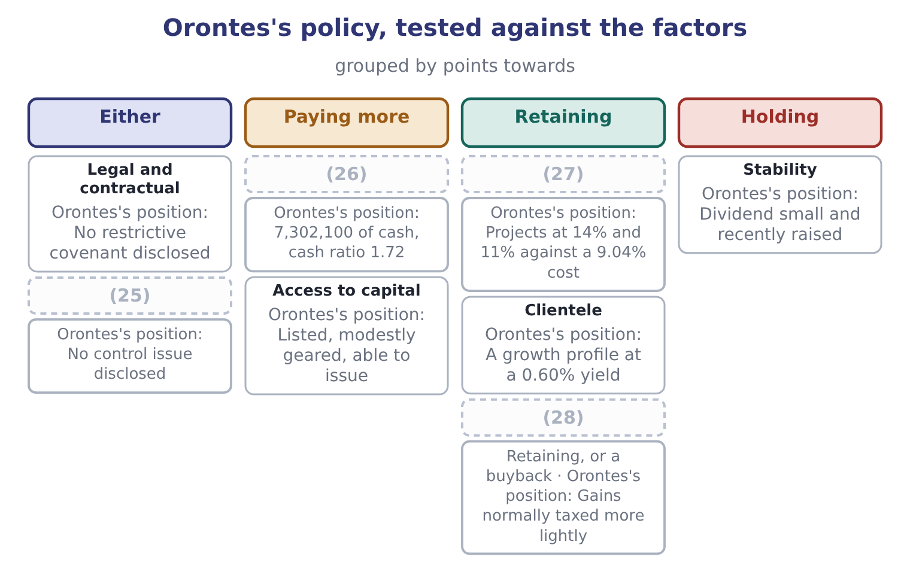
word list
Investment opportunities · stock dividend · Liquidity · Taxes · Control

Summary 3 gaps 29–38
Three (29) close the section and the exam names them. The irrelevance theory says that in a world with no taxes, no (30) costs and no (31) problems, dividend policy cannot affect value: a (32) wanting cash sells a share, and one not wanting it reinvests the dividend. The (33) view says investors prefer a certain dividend to an (34) capital gain and will pay more for a payer. And the (35) view says the policy (36) not for the cash but for what a change in it tells the market. The irrelevance theory is the correct (37) point and the real world's (38) are what give the other two their force.
word list
bird-in-the-hand · information · signalling · uncertain · shareholder · theories · taxpaying · matters · transaction · frictions · starting

The English this section uses, and its Arabic
Each term sits against what it means.
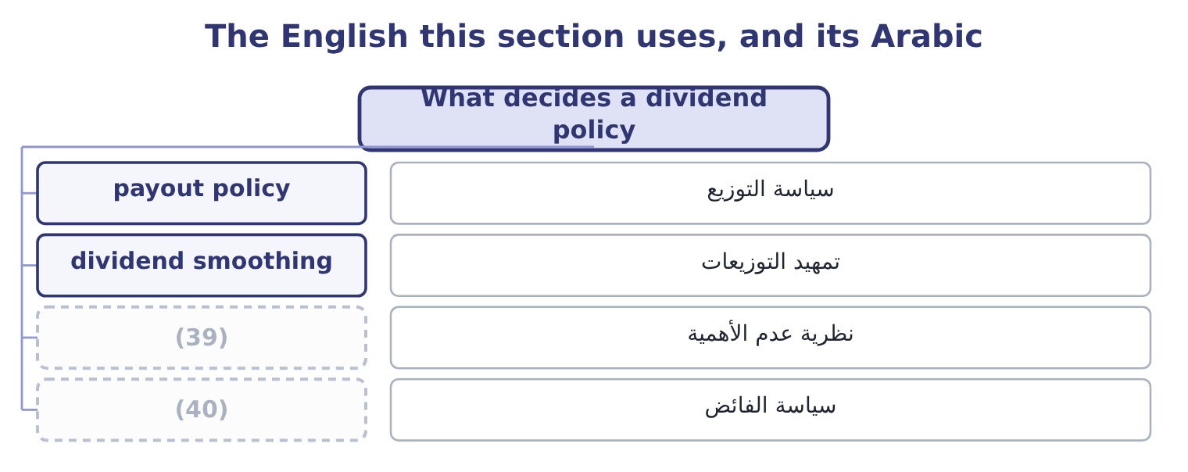
word list
irrelevance theory · residual policy · تمهيد التوزيعات

The English this sheet uses, and its Arabic
English (exam term) | Arabic
payout policy | سياسة التوزيع
dividend smoothing | تمهيد التوزيعات
irrelevance theory | نظرية عدم الأهمية
residual policy | سياسة الفائض

Answer key · 11.3 What decides a dividend policy

1 follows | 21 individual
2 influence | 22 everything
3 expects | 23 company's
4 contractual | 24 transition
5 Distributions | 25 Control
6 shareholders | 26 Liquidity
7 profitable | 27 Investment opportunities
8 precisely | 28 Taxes
9 earning | 29 theories
10 without | 30 transaction
11 Orontes | 31 information
12 consistent | 32 shareholder
13 well-rated | 33 bird-in-the-hand
14 cheaply | 34 uncertain
15 private | 35 signalling
16 Stability | 36 matters
17 dislike | 37 starting
18 sustained | 38 frictions
19 smoothed | 39 irrelevance theory
20 unexpected | 40 residual policy

the summaries in full
Summary 1 A dividend policy is the rule a board follows about how much of its profit to distribute. Eight factors influence it, and the exam expects them named. Legal and contractual constraints. Distributions are limited by law to profits available for the purpose, and covenants in loan agreements often restrict them further — a lender that has just advanced money does not want it paid out to shareholders. A dividend is paid in cash, not in profit. A company can be profitable and unable to pay, which is precisely Barada's position in Book 1: an overdraft where there was none, and the profit sitting in inventory. A company with projects earning more than its cost of capital should retain; one without should distribute. Orontes retains 84.84 per cent and has projects at 14 and 11 per cent against a cost of capital of 9.04, which is consistent.
Summary 2 A large, listed, well-rated company can pay out and raise money again cheaply. A small private company cannot, so it retains. Stability and the signal. Boards dislike cutting dividends because a cut is read as bad news, so they raise only when the higher level can be sustained. The result is that dividends are smoothed and lag earnings, and an unexpected cut moves a share price far more than the cash involved would justify. Different investors want different things: a pension fund wants income, a taxpaying individual in a high bracket may prefer capital gains, a growth investor wants everything retained. A company's existing holders have selected it partly for its policy, so changing the policy sells the company to a different clientele and the transition is costly. Where dividends are taxed more heavily than capital gains, distribution is an expensive way to deliver value, which is the argument for the buyback. A dividend paid out may have to be raised again by issuing shares, which dilutes the existing holders. A family company protecting control retains instead.
Summary 3 Three theories close the section and the exam names them. The irrelevance theory says that in a world with no taxes, no transaction costs and no information problems, dividend policy cannot affect value: a shareholder wanting cash sells a share, and one not wanting it reinvests the dividend. The bird-in-the-hand view says investors prefer a certain dividend to an uncertain capital gain and will pay more for a payer. And the signalling view says the policy matters not for the cash but for what a change in it tells the market. The irrelevance theory is the correct starting point and the real world's frictions are what give the other two their force.

11.4 Debt against equity
Chapter 11 · section 11.4

Fill every gap. Each word list holds one word more than there are gaps.
Summary 1 gaps 1–12
The choice between the two is the oldest question in (1) finance and the exam wants the (2) on both sides, not a verdict. Debt is cheaper, for two (3) . The (4) claim is safer, so the (5) return is lower, and the interest is deductible, so a 6.5 per cent rate costs 6.5 × 0.75 = 4.875 per cent after tax. It does not (6) ownership or votes. Its cost is fixed, so all the (7) of a good year (8) to the shareholders — the leverage of Book 1. And it imposes a (9) : a company that must meet interest payments cannot easily waste cash, which is a genuine argument and not only a (10) one. Debt is also (11) . The payments are compulsory, in bad years as in good. Covenants restrict what the company may do, as Barada (12) . It must be repaid or refinanced, which brings the refinancing risk. And past some level it raises the cost of everything, including equity, because the residual claim has become riskier.
word list
lender's · discipline · dilute · belongs · upside · reasons · dangerous · discovered · arguments · rhetorical · corporate · against · required

Summary 2 gaps 13–19
Equity has the mirror (13) . It never has to be repaid and its (14) is discretionary, so it absorbs a bad year instead of (15) it. It carries no covenants. It improves the credit standing, which makes the next (16) cheaper. But it is (17) , because the shareholders stand last and require the most; it is not deductible; it dilutes both ownership and control; and issuing it carries a (18) cost, because the market reads an issue as (19) view that the shares are fully valued.
word list
management's · borrowing · amplifying · properties · dividend · shareholders · expensive · signalling

Debt against equity
Dimension | Debt | Equity
Cost | (20) | Higher, and not deductible
Obligation | Fixed and compulsory | Discretionary
Maturity | Must be repaid or refinanced | Permanent
Control | (21) | Dilutes ownership and votes
Covenants | Usually restrictive | (22)
In a bad year | Amplifies the loss | (23)
Effect on credit standing | Worsens it | (24)
Signal on issue | (25) | Usually negative

word list
No dilution · Improves it · None · Neutral to positive · Absorbs it · Lower, and deductible · irrelevance theory

Summary 3 gaps 26–33
The (26) framework the exam rewards is a short (27) . How stable are the cash flows: stable flows (28) debt. How tangible are the assets: (29) secure on tangible assets. What is the (30) leverage against the (31) limits and against the rating target. What does the (32) tax position look like, since the shield is worth nothing to a (33) . What matters to the owners, since a family may value control above cost. And what is the maturity of the need: permanent capital should not be funded with money that must be refinanced in a year.
word list
covenant · existing · checklist · lenders · company's · practical · loss-maker · support · reasons

The English this section uses, and its Arabic
Each term sits against what it means.
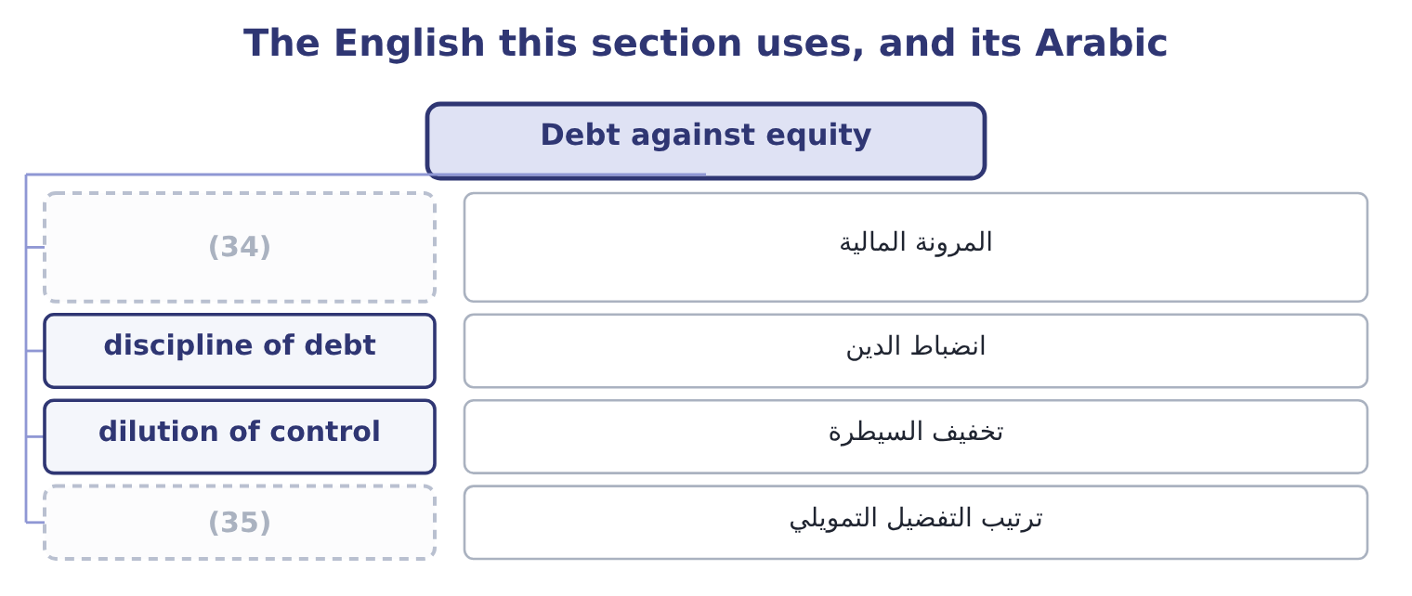
word list
dividend smoothing · pecking order · financial flexibility

The English this sheet uses, and its Arabic
English (exam term) | Arabic
financial flexibility | المرونة المالية
discipline of debt | انضباط الدين
dilution of control | تخفيف السيطرة
pecking order | ترتيب التفضيل التمويلي

Answer key · 11.4 Debt against equity

1 corporate | 19 management's
2 arguments | 20 Lower, and deductible
3 reasons | 21 No dilution
4 lender's | 22 None
5 required | 23 Absorbs it
6 dilute | 24 Improves it
7 upside | 25 Neutral to positive
8 belongs | 26 practical
9 discipline | 27 checklist
10 rhetorical | 28 support
11 dangerous | 29 lenders
12 discovered | 30 existing
13 properties | 31 covenant
14 dividend | 32 company's
15 amplifying | 33 loss-maker
16 borrowing | 34 financial flexibility
17 expensive | 35 pecking order
18 signalling

the summaries in full
Summary 1 The choice between the two is the oldest question in corporate finance and the exam wants the arguments on both sides, not a verdict. Debt is cheaper, for two reasons. The lender's claim is safer, so the required return is lower, and the interest is deductible, so a 6.5 per cent rate costs 6.5 × 0.75 = 4.875 per cent after tax. It does not dilute ownership or votes. Its cost is fixed, so all the upside of a good year belongs to the shareholders — the leverage of Book 1. And it imposes a discipline: a company that must meet interest payments cannot easily waste cash, which is a genuine argument and not only a rhetorical one. Debt is also dangerous. The payments are compulsory, in bad years as in good. Covenants restrict what the company may do, as Barada discovered. It must be repaid or refinanced, which brings the refinancing risk. And past some level it raises the cost of everything, including equity, because the residual claim has become riskier.
Summary 2 Equity has the mirror properties. It never has to be repaid and its dividend is discretionary, so it absorbs a bad year instead of amplifying it. It carries no covenants. It improves the credit standing, which makes the next borrowing cheaper. But it is expensive, because the shareholders stand last and require the most; it is not deductible; it dilutes both ownership and control; and issuing it carries a signalling cost, because the market reads an issue as management's view that the shares are fully valued.
Summary 3 The practical framework the exam rewards is a short checklist. How stable are the cash flows: stable flows support debt. How tangible are the assets: lenders secure on tangible assets. What is the existing leverage against the covenant limits and against the rating target. What does the company's tax position look like, since the shield is worth nothing to a loss-maker. What matters to the owners, since a family may value control above cost. And what is the maturity of the need: permanent capital should not be funded with money that must be refinanced in a year.

11.5 Leasing, and the net advantage to leasing
Chapter 11 · section 11.5

Fill every gap. Each word list holds one word more than there are gaps.
Summary 1 gaps 1–7
The comparison is (1) the same: lease the asset, or (2) the money and buy it. Both are ways of (3) the use of an asset without paying cash today, so the (4) decision — whether the asset is worth having at all — is settled first and separately. What remains is a financing comparison, and because it is a financing comparison it is (5) at the after-tax cost of debt, not at the (6) average cost of capital. That point (7) marks on its own.
word list
payment · discounted · obtaining · borrow · investment · weighted · always · carries

Worked example: the net advantage to leasing

Summary 2 gaps 8–15
A (8) line costs $1,000,000 to buy, lasts five years, and would be depreciated (9) to nil, which is $200,000 a year. (10) it can be leased for $240,000 a year for five years. The (11) tax rate is 25 per cent and it (12) at 8 per cent. The after-tax cost of debt is 8.0 × 0.75 = 6.0 per cent, and the (13) annuity factor at 6 per cent is 4.2124. The cost of leasing. Each lease payment is (14) , so it costs 240,000 × 0.75 = 180,000 after tax, and the present value of five of them is 180,000 × 4.2124 = 758,232. Leasing also (15) the depreciation allowances, which are worth 200,000 × 0.25 = 50,000 a year, with a present value of 50,000 × 4.2124 = 210,620. The total cost of leasing is 758,232 + 210,620 = 968,852.
word list
five-year · borrows · company's · Alternatively · payments · straight-line · roasting · forfeits · deductible

Summary 3 gaps 16–24
Borrowing and buying costs the purchase price of $1,000,000 today; the (16) on the borrowing is not counted separately, because (17) at the after-tax cost of debt has already (18) for the financing. The answer turned on two (19) : the lease payment and the tax (20) . At a tax rate of nil the depreciation shield would be worth (21) , the lease payments would cost their full $240,000, and the present value of leasing would be 240,000 × 4.2124 = 1,010,976 — more than buying. That is the point: leasing is (22) to the company that (23) use the allowances, and it is the (24) ability to use them that funds the rate.
word list
nothing · present · interest · attractive · cannot · accounted · position · numbers · lessor's · discounting

The net advantage to leasing, as a template
Line | This case | Note
After-tax lease payment a year | 180,000 | The payment less the tax saved on it
Present value of the lease payments | 758,232 | At the after-tax cost of debt
Depreciation shield forfeited a year | 50,000 | (25)
Present value of the shield forfeited | 210,620 | (26)
Total cost of leasing | 968,852 | (27)
Cost of buying | 1,000,000 | The purchase price
Net advantage to leasing | 31,148 | Buying less leasing

word list
The two added · Price 24.00, dividend 0.80 · At the same rate · Depreciation times the tax rate

Summary 4 gaps 28–34
Three (28) complete the method and appear in harder (29) . A (30) value the owner would keep is a cost of leasing, added to the lease side at its present value. (31) included in a lease is a saving, (32) . And where the lease is a finance lease recognised on the balance sheet, the comparison does not change — the accounting follows the economics rather than driving it, which is a sentence worth (33) for both parts of the (34) .
word list
financing · questions · Maintenance · residual · refinements · remembering · deducted · examination

Dividends and a lease

Your turn: distributions and leasing (complete the blanks)
Item | Data | Answer
Shares after a 20 per cent stock dividend | 5,000,000 shares now | (35)
Earnings per share after it | (36) | 0.3333: 2,000,000 ÷ 6,000,000 = 0.3333.
Price on the ex-dividend date | Price 24.00, dividend 0.80 | (37)
After-tax lease payment | Payment 300,000, tax rate 25% | (38)
Present value of five such payments | Annuity factor 4.2124 | 947,790: 225,000 × 4.2124 = 947,790.
Depreciation shield forfeited each year | (39) | 60,000: the annual depreciation is 1,200,000 ÷ 5 = 240,000, and 240,000 × 0.25 = 60,000.

word list
Cost of buying · 6,000,000: 5,000,000 × 1.20 = 6,000,000. · Asset 1,200,000 over five years, tax 25% · Net income 2,000,000 · 23.20: 24.00 − 0.80 = 23.20. · 225,000: 300,000 × 0.75 = 225,000.

"Dividend"

Summary 5 gaps 40–46
English dividend comes from the Latin for a thing to be divided, and in finance it means the share of profit (40) . (41) finance it survives in (42) , where the dividend is the number being divided — the same root, a different object. The (43) for an exam is the phrase dividend payout: it is a ratio of a (44) to earnings, not a payment. Note too that dividends (45) and dividends paid are different figures in the same year, as (46) $450,000 and $50,000 show.
word list
remembering · mathematics · distribution · distributed · declared · warning · Orontes's · Outside

The English this section uses, and its Arabic
Each term sits against what it means.
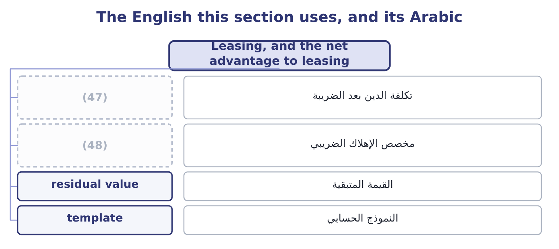
word list
stock dividend · depreciation allowance · after-tax cost of debt

The English this sheet uses, and its Arabic
English (exam term) | Arabic
after-tax cost of debt | تكلفة الدين بعد الضريبة
depreciation allowance | مخصص الإهلاك الضريبي
residual value | القيمة المتبقية
template | النموذج الحسابي

Answer key · 11.5 Leasing, and the net advantage to leasing

1 always | 25 Depreciation times the tax rate
2 borrow | 26 At the same rate
3 obtaining | 27 The two added
4 investment | 28 refinements
5 discounted | 29 questions
6 weighted | 30 residual
7 carries | 31 Maintenance
8 roasting | 32 deducted
9 straight-line | 33 remembering
10 Alternatively | 34 examination
11 company's | 35 6,000,000: 5,000,000 × 1.20 = 6,000,000.
12 borrows | 36 Net income 2,000,000
13 five-year | 37 23.20: 24.00 − 0.80 = 23.20.
14 deductible | 38 225,000: 300,000 × 0.75 = 225,000.
15 forfeits | 39 Asset 1,200,000 over five years, tax 25%
16 interest | 40 distributed
17 discounting | 41 Outside
18 accounted | 42 mathematics
19 numbers | 43 warning
20 position | 44 distribution
21 nothing | 45 declared
22 attractive | 46 Orontes's
23 cannot | 47 after-tax cost of debt
24 lessor's | 48 depreciation allowance

the summaries in full
Summary 1 The comparison is always the same: lease the asset, or borrow the money and buy it. Both are ways of obtaining the use of an asset without paying cash today, so the investment decision — whether the asset is worth having at all — is settled first and separately. What remains is a financing comparison, and because it is a financing comparison it is discounted at the after-tax cost of debt, not at the weighted average cost of capital. That point carries marks on its own.
Summary 2 A roasting line costs $1,000,000 to buy, lasts five years, and would be depreciated straight-line to nil, which is $200,000 a year. Alternatively it can be leased for $240,000 a year for five years. The company's tax rate is 25 per cent and it borrows at 8 per cent. The after-tax cost of debt is 8.0 × 0.75 = 6.0 per cent, and the five-year annuity factor at 6 per cent is 4.2124. The cost of leasing. Each lease payment is deductible, so it costs 240,000 × 0.75 = 180,000 after tax, and the present value of five of them is 180,000 × 4.2124 = 758,232. Leasing also forfeits the depreciation allowances, which are worth 200,000 × 0.25 = 50,000 a year, with a present value of 50,000 × 4.2124 = 210,620. The total cost of leasing is 758,232 + 210,620 = 968,852.
Summary 3 Borrowing and buying costs the purchase price of $1,000,000 today; the interest on the borrowing is not counted separately, because discounting at the after-tax cost of debt has already accounted for the financing. The answer turned on two numbers: the lease payment and the tax position. At a tax rate of nil the depreciation shield would be worth nothing, the lease payments would cost their full $240,000, and the present value of leasing would be 240,000 × 4.2124 = 1,010,976 — more than buying. That is the point: leasing is attractive to the company that cannot use the allowances, and it is the lessor's ability to use them that funds the rate.
Summary 4 Three refinements complete the method and appear in harder questions. A residual value the owner would keep is a cost of leasing, added to the lease side at its present value. Maintenance included in a lease is a saving, deducted. And where the lease is a finance lease recognised on the balance sheet, the comparison does not change — the accounting follows the economics rather than driving it, which is a sentence worth remembering for both parts of the examination.
Summary 5 English dividend comes from the Latin for a thing to be divided, and in finance it means the share of profit distributed. Outside finance it survives in mathematics, where the dividend is the number being divided — the same root, a different object. The warning for an exam is the phrase dividend payout: it is a ratio of a distribution to earnings, not a payment. Note too that dividends declared and dividends paid are different figures in the same year, as Orontes's $450,000 and $50,000 show.

12.1 What working capital is
Chapter 12 · section 12.1

Fill every gap. Each word list holds one word more than there are gaps.
Chapter 12, section by section
Each stage leads to the next.
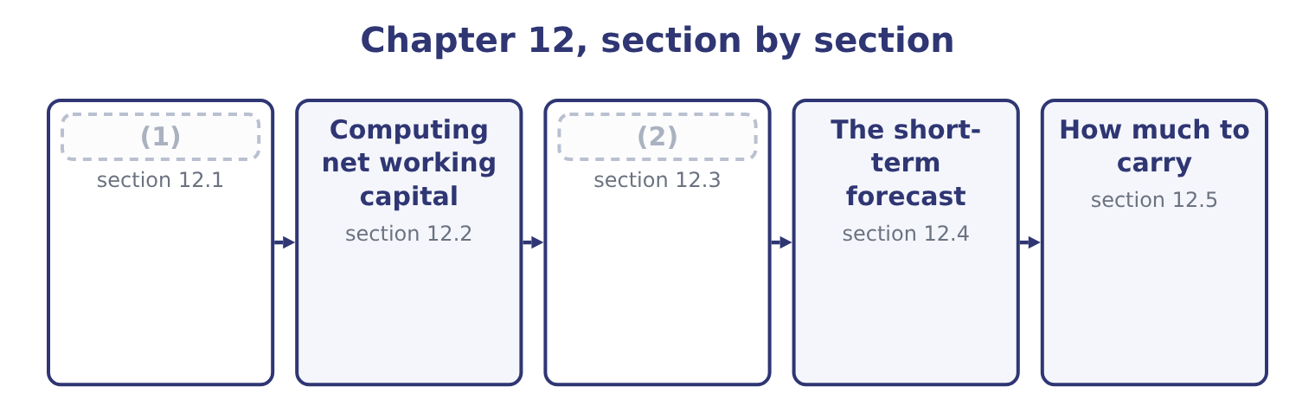
word list
What working capital costs · Computing net working capital · What working capital is

Summary 1 gaps 3–14
Working capital, in the broad sense, is the current assets of a business: the assets that will turn into cash within a year or within the (3) cycle if that is (4) . Net working capital is those assets less the current liabilities. The first measures what is tied up; the (5) measures how much of it the company has to fund (6) after its short-term (7) have done their part. The (8) are the lines of the current section of the (9) sheet. Marketable securities, which are cash held in a form that earns a (10) . Prepaid (11) , which are small and managed by nobody in (12) . Against those stand the current liabilities: accounts payable, which is (13) credit and the cheapest funding in the business; accrued liabilities; taxes payable; the current portion of long-term debt; and short-term (14) .
word list
creditors · operating · itself · longer · balance · sensitivity · particular · expenses · components · borrowings · supplier · return · second

Summary 2 gaps 15–26
Two (15) matter before any (16) . A business that never runs out of stock always has stock, so some part of its working capital is (17) invested even though the (18) items turn over (19) . That permanent core should be funded like any other (20) asset, with long-term money. The seasonal peak above it — the extra stock before a harvest, the extra receivables after it — is (21) and should be funded (22) . Gross against net, and trade against total. A (23) asking for working capital usually means current assets; one asking for net working capital means the (24) . Trade working capital narrows it again to receivables plus inventory less payables, (25) cash and short-term debt, and it is the figure that measures the trading cycle rather than the funding (26) .
word list
position · question · individual · excluding · long-lived · temporary · invested · permanently · constantly · arithmetic · distinctions · temporarily · difference

The components, and where each is managed
Component | Orontes, 2025 | Managed in | Governed by
Cash | 7,302,100 | Chapters 13 and 14 | (27)
Marketable securities | 42,000 | (28) | Safety, liquidity, yield
Accounts receivable | 4,144,000 | Chapter 16 | (29)
Inventory | 2,450,000 | (30) | Lead time and order quantity
Accounts payable | (2,050,000) | Chapter 18 | (31)
Short-term borrowing | (32) | Chapter 18 | The line of credit

word list
The cash budget · Chapter 15 · Terms and discounts · Credit policy · Chapter 18 · Nil at the year end · Chapter 17

The English this section uses, and its Arabic
Each term sits against what it means.
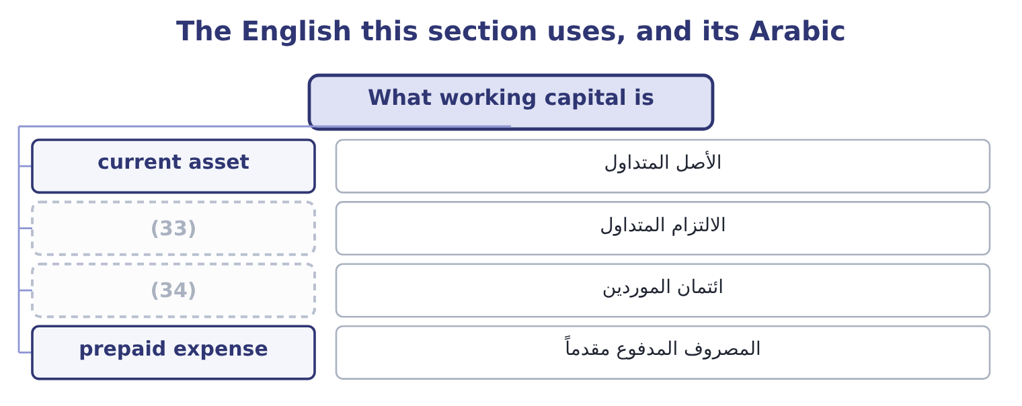
word list
supplier credit · current liability · working capital

The English this sheet uses, and its Arabic
English (exam term) | Arabic
current asset | الأصل المتداول
current liability | الالتزام المتداول
supplier credit | ائتمان الموردين
prepaid expense | المصروف المدفوع مقدماً

Answer key · 12.1 What working capital is

1 What working capital is | 18 individual
2 What working capital costs | 19 constantly
3 operating | 20 long-lived
4 longer | 21 temporary
5 second | 22 temporarily
6 itself | 23 question
7 creditors | 24 difference
8 components | 25 excluding
9 balance | 26 position
10 return | 27 The cash budget
11 expenses | 28 Chapter 15
12 particular | 29 Credit policy
13 supplier | 30 Chapter 17
14 borrowings | 31 Terms and discounts
15 distinctions | 32 Nil at the year end
16 arithmetic | 33 current liability
17 permanently | 34 supplier credit

the summaries in full
Summary 1 Working capital, in the broad sense, is the current assets of a business: the assets that will turn into cash within a year or within the operating cycle if that is longer. Net working capital is those assets less the current liabilities. The first measures what is tied up; the second measures how much of it the company has to fund itself after its short-term creditors have done their part. The components are the lines of the current section of the balance sheet. Marketable securities, which are cash held in a form that earns a return. Prepaid expenses, which are small and managed by nobody in particular. Against those stand the current liabilities: accounts payable, which is supplier credit and the cheapest funding in the business; accrued liabilities; taxes payable; the current portion of long-term debt; and short-term borrowings.
Summary 2 Two distinctions matter before any arithmetic. A business that never runs out of stock always has stock, so some part of its working capital is permanently invested even though the individual items turn over constantly. That permanent core should be funded like any other long-lived asset, with long-term money. The seasonal peak above it — the extra stock before a harvest, the extra receivables after it — is temporary and should be funded temporarily. Gross against net, and trade against total. A question asking for working capital usually means current assets; one asking for net working capital means the difference. Trade working capital narrows it again to receivables plus inventory less payables, excluding cash and short-term debt, and it is the figure that measures the trading cycle rather than the funding position.

12.2 Computing net working capital
Chapter 12 · section 12.2

Fill every gap. Each word list holds one word more than there are gaps.
Summary 1 gaps 1–12
Net working capital is total current assets less total current liabilities. For Orontes at (1) 31, 2025: 14,188,100 − 4,280,000 = 9,908,100. A year (2) it was 8,380,000 − 3,570,000 = 4,810,000. So net working capital more than (3) in a year: 9,908,100 − 4,810,000 = 5,098,100 of additional money locked into the (4) side of the (5) . Where did it come from, and was it well spent? The cash flow (6) answers the first (7) — a $1,500,000 share issue, an $800,000 bank note, and $7,531,100 of cash from (8) — and Book 1 answers the second: most of the (9) is cash, which rose from $2,100,000 to $7,302,100, and cash earning nothing is the least (10) asset a company can hold. Three ratios express the same balance (11) , and all three (12) in Book 1.
word list
earlier · statement · answers · appeared · business · doubled · question · December · differently · productive · operations · increase · short-term

Summary 2 gaps 13–17
The current ratio divides current assets by current liabilities: 14,188,100 ÷ 4,280,000 = 3.31 times. The net working capital ratio divides net working capital by total assets: 9,908,100 ÷ 31,672,600 = 31.3 per cent, which says that (13) a third of (14) Orontes owns is tied up short term. And the trade figure, (15) plus inventory less (16) , is $4,544,000 — less than half the net working capital, the (17) being the cash pile.
word list
everything · inventory · receivables · nearly · payables · difference

Worked example: what growth does to working capital

Summary 3 gaps 18–29
Trade working capital is (18) by sales. Orontes (19) $4,544,000 of it on sales of $42,000,000, which is 4,544,000 ÷ 42,000,000 = 10.82 per cent of sales. The requirement of growth. If sales grow 15 per cent next year and nothing about the cycle (20) , trade working capital grows with them: 4,544,000 × 0.15 = 681,600 of additional funding (21) , before a single dollar of new plant. Orontes (22) 84.84 per cent of a $2,969,100 profit, which is about $2,519,100 — (23) more than the $681,600 the growth demands. The company can fund its own (24) in working capital, which is what a (25) growth rate of 13.70 per cent meant in Book 1. Run the same arithmetic for (26) . Its trade working capital is a far higher (27) of its sales, because it is a (28) whose inventory is a third of its assets; its net margin is 1.29 per cent, so its retained profit is about $283,500; and its sales grew 11 per cent. The requirement exceeds the (29) , every year, and the gap went on the overdraft. The same two lines of arithmetic explain both companies.
word list
sustainable · expansion · retains · driven · required · spectrum · retention · distributor · changes · comfortably · carries · Barada · proportion

The English this section uses, and its Arabic
Each term sits against what it means.
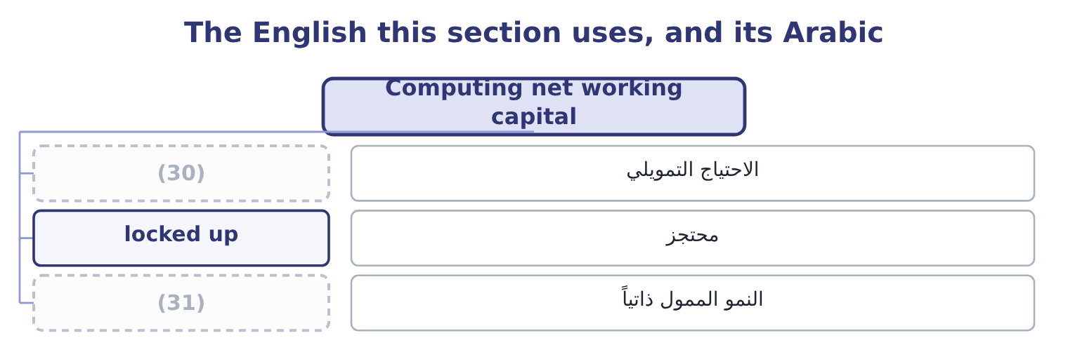
word list
self-funding growth · collection pattern · funding requirement

The English this sheet uses, and its Arabic
English (exam term) | Arabic
funding requirement | الاحتياج التمويلي
locked up | محتجز
self-funding growth | النمو الممول ذاتياً

Answer key · 12.2 Computing net working capital

1 December | 17 difference
2 earlier | 18 driven
3 doubled | 19 carries
4 short-term | 20 changes
5 business | 21 required
6 statement | 22 retains
7 question | 23 comfortably
8 operations | 24 expansion
9 increase | 25 sustainable
10 productive | 26 Barada
11 differently | 27 proportion
12 appeared | 28 distributor
13 nearly | 29 retention
14 everything | 30 funding requirement
15 receivables | 31 self-funding growth
16 payables

the summaries in full
Summary 1 Net working capital is total current assets less total current liabilities. For Orontes at December 31, 2025: 14,188,100 − 4,280,000 = 9,908,100. A year earlier it was 8,380,000 − 3,570,000 = 4,810,000. So net working capital more than doubled in a year: 9,908,100 − 4,810,000 = 5,098,100 of additional money locked into the short-term side of the business. Where did it come from, and was it well spent? The cash flow statement answers the first question — a $1,500,000 share issue, an $800,000 bank note, and $7,531,100 of cash from operations — and Book 1 answers the second: most of the increase is cash, which rose from $2,100,000 to $7,302,100, and cash earning nothing is the least productive asset a company can hold. Three ratios express the same balance differently, and all three appeared in Book 1.
Summary 2 The current ratio divides current assets by current liabilities: 14,188,100 ÷ 4,280,000 = 3.31 times. The net working capital ratio divides net working capital by total assets: 9,908,100 ÷ 31,672,600 = 31.3 per cent, which says that nearly a third of everything Orontes owns is tied up short term. And the trade figure, receivables plus inventory less payables, is $4,544,000 — less than half the net working capital, the difference being the cash pile.
Summary 3 Trade working capital is driven by sales. Orontes carries $4,544,000 of it on sales of $42,000,000, which is 4,544,000 ÷ 42,000,000 = 10.82 per cent of sales. The requirement of growth. If sales grow 15 per cent next year and nothing about the cycle changes, trade working capital grows with them: 4,544,000 × 0.15 = 681,600 of additional funding required, before a single dollar of new plant. Orontes retains 84.84 per cent of a $2,969,100 profit, which is about $2,519,100 — comfortably more than the $681,600 the growth demands. The company can fund its own expansion in working capital, which is what a sustainable growth rate of 13.70 per cent meant in Book 1. Run the same arithmetic for Barada. Its trade working capital is a far higher proportion of its sales, because it is a distributor whose inventory is a third of its assets; its net margin is 1.29 per cent, so its retained profit is about $283,500; and its sales grew 11 per cent. The requirement exceeds the retention, every year, and the gap went on the overdraft. The same two lines of arithmetic explain both companies.

12.3 What working capital costs
Chapter 12 · section 12.3

Fill every gap. Each word list holds one word more than there are gaps.
Summary 1 gaps 1–12
Money tied up in working capital has to be financed, and the (1) has a price. Book 1 (2) it: $4,544,000 of trade working capital (3) at the 6 per cent Orontes pays its bank costs about 4,544,000 × 0.06 = 272,640 a year. That is the (4) cost. Three more are real and less often (5) . The (6) cost of the cash. Orontes holds $7,302,100 in a (7) account. At the 4 per cent a (8) government (9) would pay, holding it idle forgoes 7,302,100 × 0.04 = 292,084 a year — more than the whole cost of funding the trade cycle. The risk cost of the inventory. Stock can be stolen, damaged, or made (10) by a change in demand, and (11) and storage are paid whether or not it sells. A (12) passes through cost of sales and lands on the gross margin.
word list
obsolete · security · Against · counted · current · computed · short-dated · write-down · visible · insurance · funded · financing · opportunity

Summary 2 gaps 13–24
The credit cost of the receivables. Some will not be paid. Orontes's (13) of $156,000 is its own (14) of that, and its credit loss expense of $63,000 is what the year actually cost. Against those costs stand the (15) , and this is the (16) every chapter from here to eighteen turns on. Inventory exists so that a customer who wants (17) can have it; cutting it too far loses sales and, at Orontes's degree of operating (18) of 4.02, a lost sale costs four times its margin in operating income. Receivables exist (19) customers will not buy without credit; (20) terms loses volume. Cash exists so that (21) can be met without borrowing in a hurry. So the question is never "how (22) working capital can we hold" but "where is the level at which the cost of holding more (23) the cost of holding less". Every one of the next six (24) answers that question for one component.
word list
allowance · estimate · because · write-down · tightening · something · obligations · exceeds · leverage · trade-off · little · chapters · benefits

The two sides of every working-capital decision
Component | Cost of holding more | Cost of holding less
Cash | Interest forgone | (25)
Marketable securities | A lower yield than long investments | (26)
Receivables | (27) | Lost sales to customers who need terms
Inventory | Funding, storage, obsolescence | (28)
Payables | (29) | Funding the gap yourself

word list
Less liquidity when it is needed · Lost settlement discounts, supplier goodwill · Funding, and credit losses · Stockouts, lost sales, expedited freight · Borrowing in a hurry, or missing a payment · Funding the gap yourself

The English this section uses, and its Arabic
Each term sits against what it means.
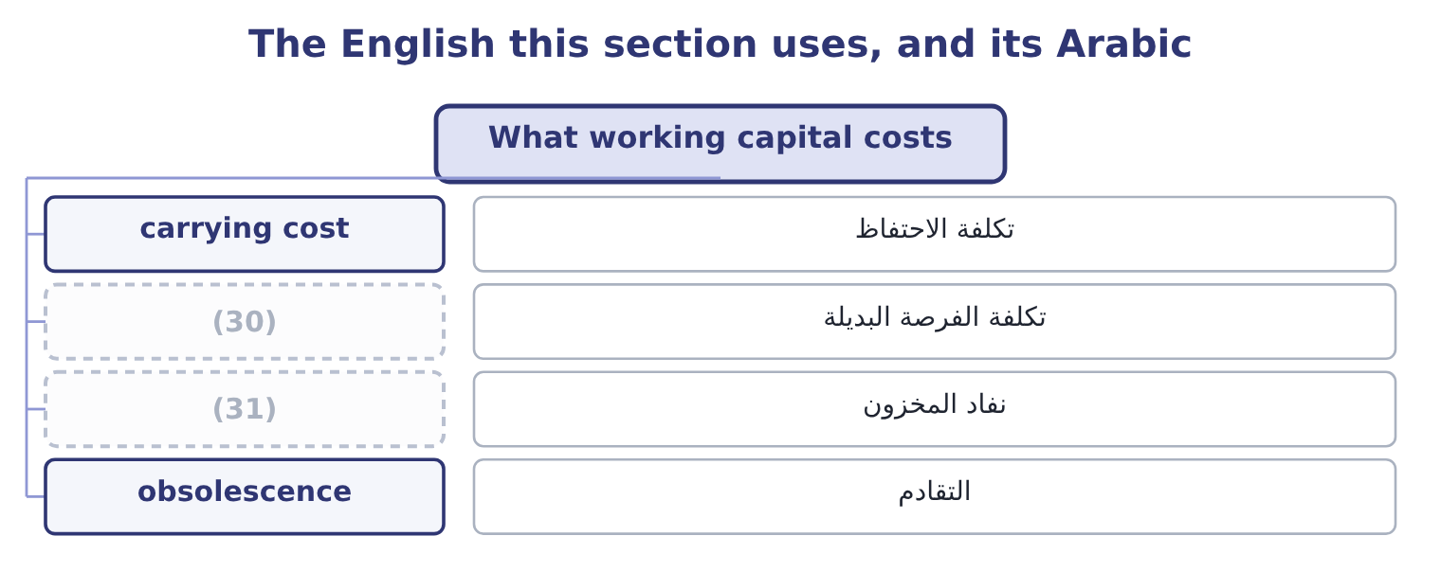
word list
stockout · carrying cost · opportunity cost

The English this sheet uses, and its Arabic
English (exam term) | Arabic
carrying cost | تكلفة الاحتفاظ
opportunity cost | تكلفة الفرصة البديلة
stockout | نفاد المخزون
obsolescence | التقادم

Answer key · 12.3 What working capital costs

1 financing | 17 something
2 computed | 18 leverage
3 funded | 19 because
4 visible | 20 tightening
5 counted | 21 obligations
6 opportunity | 22 little
7 current | 23 exceeds
8 short-dated | 24 chapters
9 security | 25 Borrowing in a hurry, or missing a payment
10 obsolete | 26 Less liquidity when it is needed
11 insurance | 27 Funding, and credit losses
12 write-down | 28 Stockouts, lost sales, expedited freight
13 allowance | 29 Lost settlement discounts, supplier goodwill
14 estimate | 30 opportunity cost
15 benefits | 31 stockout
16 trade-off

the summaries in full
Summary 1 Money tied up in working capital has to be financed, and the financing has a price. Book 1 computed it: $4,544,000 of trade working capital funded at the 6 per cent Orontes pays its bank costs about 4,544,000 × 0.06 = 272,640 a year. That is the visible cost. Three more are real and less often counted. The opportunity cost of the cash. Orontes holds $7,302,100 in a current account. At the 4 per cent a short-dated government security would pay, holding it idle forgoes 7,302,100 × 0.04 = 292,084 a year — more than the whole cost of funding the trade cycle. The risk cost of the inventory. Stock can be stolen, damaged, or made obsolete by a change in demand, and insurance and storage are paid whether or not it sells. A write-down passes through cost of sales and lands on the gross margin.
Summary 2 The credit cost of the receivables. Some will not be paid. Orontes's allowance of $156,000 is its own estimate of that, and its credit loss expense of $63,000 is what the year actually cost. Against those costs stand the benefits, and this is the trade-off every chapter from here to eighteen turns on. Inventory exists so that a customer who wants something can have it; cutting it too far loses sales and, at Orontes's degree of operating leverage of 4.02, a lost sale costs four times its margin in operating income. Receivables exist because customers will not buy without credit; tightening terms loses volume. Cash exists so that obligations can be met without borrowing in a hurry. So the question is never "how little working capital can we hold" but "where is the level at which the cost of holding more exceeds the cost of holding less". Every one of the next six chapters answers that question for one component.

12.4 The short-term forecast
Chapter 12 · section 12.4

Fill every gap. Each word list holds one word more than there are gaps.
Summary 1 gaps 1–12
Working capital is managed by (1) , and the instrument is the cash budget: a statement of (2) receipts and payments, period by period, usually monthly for a year and weekly or daily for the nearest weeks. What it does, and the (3) asks exactly this. It shows when, not (4) . An (5) profit forecast says the year will be (6) . A monthly cash forecast says that in March the company will be $900,000 short, (7) the harvest is paid for in February and the (8) pay in April. Only the (9) can be acted on. It sizes the (10) before they are needed. A line of credit (11) three months ahead of a seasonal peak is cheaper, larger and less (12) than one requested the week the overdraft appears. A bank asked to lend in a hurry charges for the hurry. It prices the alternatives.
word list
facilities · expected · because · customers · whether · conditional · second · profitable · forecasting · annual · outcome · overnight · negotiated

Summary 2 gaps 13–24
Once the (13) and its duration are known, the treasurer can compare borrowing, delaying a payment, (14) a collection, and deferring a capital project — which is the decision. It puts (15) cash to work. (16) that $2,000,000 will not be needed for four months means it can be placed for four months rather than left (17) , which is. It is a (18) as well as a plan. (19) the forecast with what (20) reveals which assumption was wrong — collections slower than assumed, a supplier paid earlier than agreed — and improves the next forecast. Three (21) make a forecast useful rather than (22) . A rolling horizon, re-cut every month so that twelve months are always in view rather than a budget that (23) to nothing by (24) . Sensitivity: a base case, and at least one case in which collections run a week slower, which is the single assumption that most often fails. And a reconciliation to the balance sheet, so that the forecast's closing receivables and inventory are the ones the sales and purchasing plans imply.
word list
spectrum · shortens · December · Knowing · surplus · accelerating · overnight · control · happened · Comparing · practices · ornamental · shortfall

A cash budget is not a forecast income statement

Summary 3 gaps 25–28
Sales are not receipts. A sale on 30-day terms is cash next month, and a (25) that gives a collection pattern is testing exactly. (26) never appears in a cash budget. Nor does any other (27) item. Capital (28) and dividends do appear, although neither is in the income statement.
word list
borrowing · expenditure · question · Depreciation · non-cash

The words this section uses
Each term sits against what it means, and an instance of it.
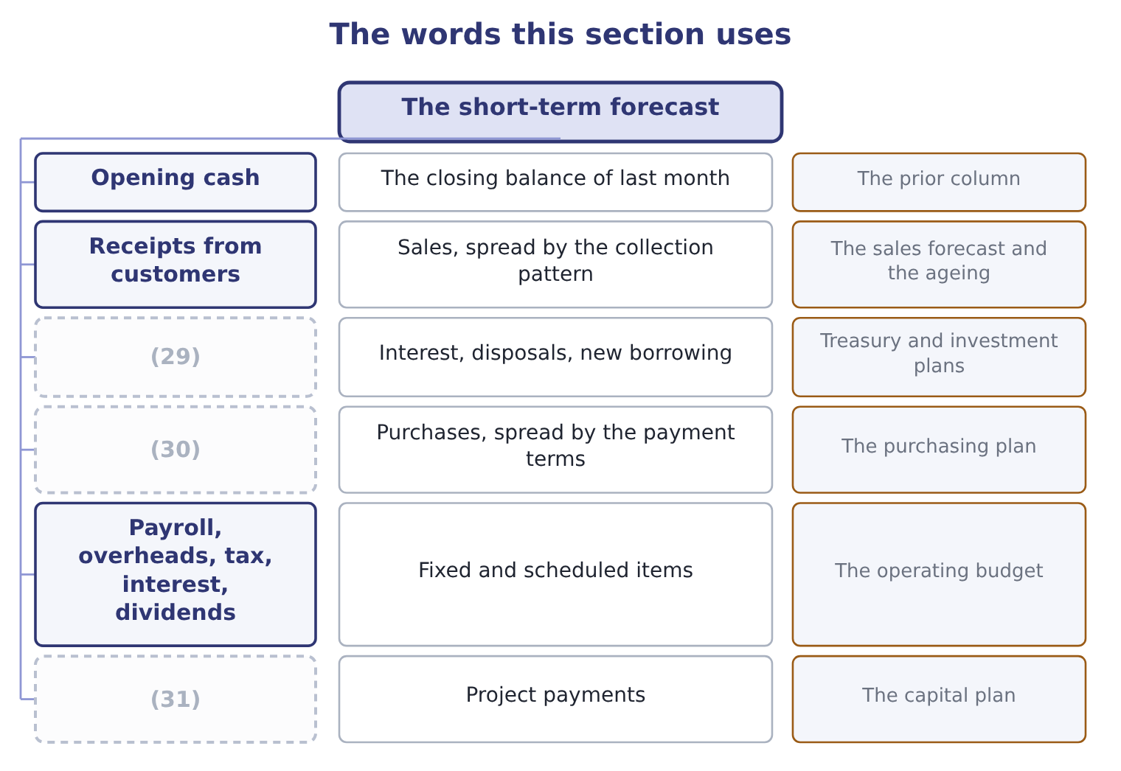
word list
Payments to suppliers · Other receipts · The prior column · Capital expenditure

The English this sheet uses, and its Arabic
English (exam term) | Arabic
collection pattern | نمط التحصيل
minimum cash balance | الحد الأدنى للرصيد النقدي
sensitivity | تحليل الحساسية
variance | الانحراف

Answer key · 12.4 The short-term forecast

1 forecasting | 17 overnight
2 expected | 18 control
3 outcome | 19 Comparing
4 whether | 20 happened
5 annual | 21 practices
6 profitable | 22 ornamental
7 because | 23 shortens
8 customers | 24 December
9 second | 25 question
10 facilities | 26 Depreciation
11 negotiated | 27 non-cash
12 conditional | 28 expenditure
13 shortfall | 29 Other receipts
14 accelerating | 30 Payments to suppliers
15 surplus | 31 Capital expenditure
16 Knowing

the summaries in full
Summary 1 Working capital is managed by forecasting, and the instrument is the cash budget: a statement of expected receipts and payments, period by period, usually monthly for a year and weekly or daily for the nearest weeks. What it does, and the outcome asks exactly this. It shows when, not whether. An annual profit forecast says the year will be profitable. A monthly cash forecast says that in March the company will be $900,000 short, because the harvest is paid for in February and the customers pay in April. Only the second can be acted on. It sizes the facilities before they are needed. A line of credit negotiated three months ahead of a seasonal peak is cheaper, larger and less conditional than one requested the week the overdraft appears. A bank asked to lend in a hurry charges for the hurry. It prices the alternatives.
Summary 2 Once the shortfall and its duration are known, the treasurer can compare borrowing, delaying a payment, accelerating a collection, and deferring a capital project — which is the decision. It puts surplus cash to work. Knowing that $2,000,000 will not be needed for four months means it can be placed for four months rather than left overnight, which is. It is a control as well as a plan. Comparing the forecast with what happened reveals which assumption was wrong — collections slower than assumed, a supplier paid earlier than agreed — and improves the next forecast. Three practices make a forecast useful rather than ornamental. A rolling horizon, re-cut every month so that twelve months are always in view rather than a budget that shortens to nothing by December. Sensitivity: a base case, and at least one case in which collections run a week slower, which is the single assumption that most often fails. And a reconciliation to the balance sheet, so that the forecast's closing receivables and inventory are the ones the sales and purchasing plans imply.
Summary 3 Sales are not receipts. A sale on 30-day terms is cash next month, and a question that gives a collection pattern is testing exactly. Depreciation never appears in a cash budget. Nor does any other non-cash item. Capital expenditure and dividends do appear, although neither is in the income statement.

12.5 How much to carry
Chapter 12 · section 12.5

Fill every gap. Each word list holds one word more than there are gaps.
Summary 1 gaps 1–12
A working capital policy is a choice about the level of current assets to hold for a given level of sales, and it runs along a (1) . A conservative policy holds high (2) of cash, stock and receivables. (3) are never turned away for lack of stock, (4) are paid promptly, the company is never short. It is safe and it is expensive: more funding, more storage, more (5) , and a lower return on assets, because the (6) is large. An (7) policy holds the (8) of each. The return on assets is higher and so is the risk of a (9) , a lost customer, or a (10) that cannot be made on the day it falls due. A (11) policy sits between them, and the exam's usual answer is that the right level depends on three things: the (12) of the business, the cost of running out, and the cost of money.
word list
aggressive · Customers · million · obsolescence · minimum · spectrum · variability · payment · stockout · levels · denominator · suppliers · moderate

Summary 2 gaps 13–22
A company with (13) demand and expensive (14) holds more; one with steady demand and cheap, quickly (15) stock holds less. (16) sits firmly on the conservative side and Book 1 said so: a current ratio of 3.31 against an (17) that would (18) run nearer 2.0, a cash ratio of 1.72, and a cash balance that grew by five million in one year. The company is safe, and section 12.3 (19) the safety at (20) $292,084 a year of forgone (21) on the cash alone. That is a (22) choice for a company whose gross margin is falling and whose board may want options — and it is a choice, which is the point, rather than something that happened.
word list
Orontes · stockouts · roughly · interest · priced · replaced · defensible · storage · industry · normally · volatile

Compute and judge

Your turn: working capital (complete the blanks)
Item | Data | Answer
Net working capital | Current assets 6,400,000, current liabilities 2,500,000 | ________
Current ratio | (23) | ________
Trade working capital | Receivables 2,100,000, inventory 1,800,000, payables 1,200,000 | ________
Cost of funding it at 7 per cent |  | ________
Extra funding needed if sales grow 20 per cent | (24) | ________
Retained profit available | Net income 900,000, payout 25 per cent | ________
Verdict |  | ________

word list
Trade working capital scales with sales · 189,000: 2,700,000 × 0.07 = 189,000. · The same figures

"Capital"

Summary 3 gaps 25–29
English working capital is a phrase in which (25) word means what it (26) means. The capital is not long-term funding, as in cost of capital or capital (27) ; it is the (28) money in the trading cycle. And working does not mean (29) ; it means circulating, in the old sense of a sum that works by turning over.
word list
neither · functioning · usually · short-term · expenditure · working

"Capital"
Item | Answer
Net working capital | 3,900,000: 6,400,000 − 2,500,000 = 3,900,000.
Current ratio | (30)
Trade working capital | 2,700,000: 2,100,000 + 1,800,000 = 3,900,000, less payables of 1,200,000.
Cost of funding it at 7 per cent | (31)
Extra funding if sales grow 20 per cent | (32)
Retained profit available | 675,000: 900,000 × 0.75 = 675,000.
Verdict | The growth is just affordable. Retained profit of 675,000 covers the 540,000 the working capital will absorb, with 135,000 left for everythi

word list
540,000: 2,700,000 × 0.20 = 540,000. · 2.56: 6,400,000 ÷ 2,500,000 = 2.56. · 189,000: 2,700,000 × 0.07 = 189,000. · Receivables 2,100,000, inventory 1,800,000, payables 1,200,000

The English this section uses, and its Arabic
Each term sits against what it means.
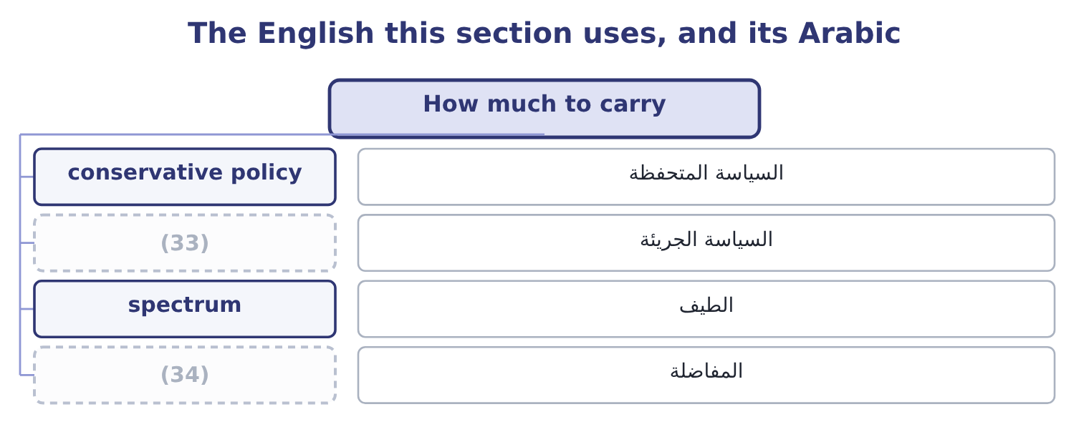
word list
trade-off · aggressive policy · السياسة الجريئة

The English this sheet uses, and its Arabic
English (exam term) | Arabic
conservative policy | السياسة المتحفظة
aggressive policy | السياسة الجريئة
spectrum | الطيف
trade-off | المفاضلة

Answer key · 12.5 How much to carry

1 spectrum | 18 normally
2 levels | 19 priced
3 Customers | 20 roughly
4 suppliers | 21 interest
5 obsolescence | 22 defensible
6 denominator | 23 The same figures
7 aggressive | 24 Trade working capital scales with sales
8 minimum | 25 neither
9 stockout | 26 usually
10 payment | 27 expenditure
11 moderate | 28 short-term
12 variability | 29 functioning
13 volatile | 30 2.56: 6,400,000 ÷ 2,500,000 = 2.56.
14 stockouts | 31 189,000: 2,700,000 × 0.07 = 189,000.
15 replaced | 32 540,000: 2,700,000 × 0.20 = 540,000.
16 Orontes | 33 aggressive policy
17 industry | 34 trade-off

the summaries in full
Summary 1 A working capital policy is a choice about the level of current assets to hold for a given level of sales, and it runs along a spectrum. A conservative policy holds high levels of cash, stock and receivables. Customers are never turned away for lack of stock, suppliers are paid promptly, the company is never short. It is safe and it is expensive: more funding, more storage, more obsolescence, and a lower return on assets, because the denominator is large. An aggressive policy holds the minimum of each. The return on assets is higher and so is the risk of a stockout, a lost customer, or a payment that cannot be made on the day it falls due. A moderate policy sits between them, and the exam's usual answer is that the right level depends on three things: the variability of the business, the cost of running out, and the cost of money.
Summary 2 A company with volatile demand and expensive stockouts holds more; one with steady demand and cheap, quickly replaced stock holds less. Orontes sits firmly on the conservative side and Book 1 said so: a current ratio of 3.31 against an industry that would normally run nearer 2.0, a cash ratio of 1.72, and a cash balance that grew by five million in one year. The company is safe, and section 12.3 priced the safety at roughly $292,084 a year of forgone interest on the cash alone. That is a defensible choice for a company whose gross margin is falling and whose board may want options — and it is a choice, which is the point, rather than something that happened.
Summary 3 English working capital is a phrase in which neither word means what it usually means. The capital is not long-term funding, as in cost of capital or capital expenditure; it is the short-term money in the trading cycle. And working does not mean functioning; it means circulating, in the old sense of a sum that works by turning over.

13.1 Three motives for holding cash
Chapter 13 · section 13.1

Fill every gap. Each word list holds one word more than there are gaps.
Chapter 13, section by section
Each stage leads to the next.
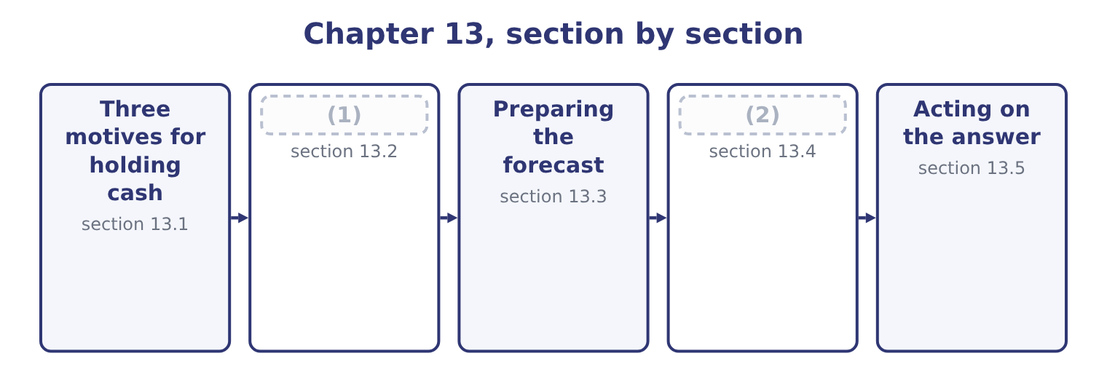
word list
What decides the level · Three motives for holding cash · Longer horizons and other methods

Summary 1 gaps 3–14
The classical (3) gives three (4) , and the exam asks for them by name. (5) and receipts do not (6) . Payroll falls due on a day, (7) on another, (8) pay when they pay, and a balance is needed so that the ordinary business of the month can be conducted without borrowing on a Tuesday to repay on a Thursday. The size of this requirement depends on the volume of (9) and on how well they can be timed. The unexpected happens: a customer fails, a machine breaks, a (10) is delayed, a tax (11) arrives. A buffer (12) the shock without (13) a sale of assets or a hurried loan. The size of this requirement depends on how variable the flows are and on how quickly the company could borrow instead — which is why a company with a committed, undrawn line of credit can hold less cash than one without, and the line is a (14) for the buffer.
word list
arrives · Payments · substitute · shipment · transactions · analysis · customers · absorbs · reasons · forcing · assessment · coincide · suppliers

Summary 2 gaps 15–26
Opportunities arrive at short notice: a (15) assets at a price, a (16) offering a large discount for a bulk purchase, a company for sale. Cash is the (17) to act, and a company with none (18) . In practice this is the motive most often given and least often true, since (19) cash is more usually the absence of a decision than the (20) for one. A fourth reason is (21) rather than classical and appears in questions (22) . A compensating balance is a minimum balance a bank (23) a borrower to keep in its account as a (24) of a loan or a line of credit. It is not (25) for use, so it is cash in form and not in substance, and it raises the effective cost of the borrowing — a (26) .
word list
supplier · surplus · preparation · offering · competitor's · calculation · cannot · requires · condition · available · ability · institutional · constantly

Why a company holds cash
Motive | What it funds | What increases it | What substitutes for it
Transaction | The timing gap in ordinary business | (27) | Better scheduling, faster collection
Precautionary | The unexpected | Variability of flows | (28)
Speculative | Opportunities at short notice | (29) | Rapid access to borrowing
Compensating balance | (30) | The terms of the facility | Negotiating a fee instead

word list
A strategy of acquisition · A committed line of credit · receipts and disbursements · A bank's requirement · Volume, and poor timing of flows

The English this section uses, and its Arabic
Each term sits against what it means.
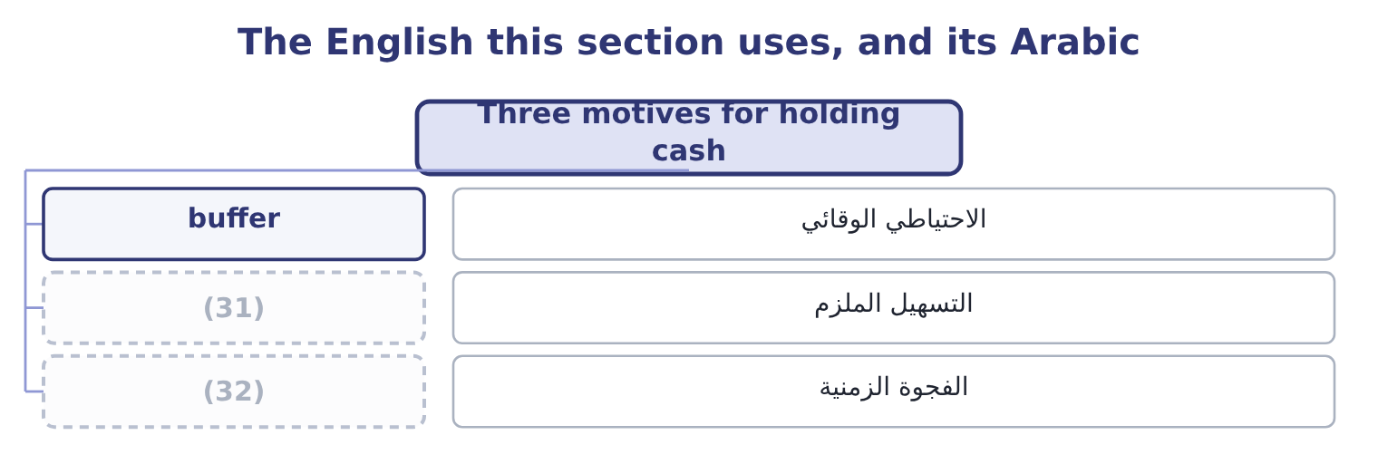
word list
الفجوة الزمنية · timing gap · committed facility

The English this sheet uses, and its Arabic
English (exam term) | Arabic
buffer | الاحتياطي الوقائي
committed facility | التسهيل الملزم
timing gap | الفجوة الزمنية

Answer key · 13.1 Three motives for holding cash

1 What decides the level | 17 ability
2 Longer horizons and other methods | 18 cannot
3 analysis | 19 surplus
4 reasons | 20 preparation
5 Payments | 21 institutional
6 coincide | 22 constantly
7 suppliers | 23 requires
8 customers | 24 condition
9 transactions | 25 available
10 shipment | 26 calculation
11 assessment | 27 Volume, and poor timing of flows
12 absorbs | 28 A committed line of credit
13 forcing | 29 A strategy of acquisition
14 substitute | 30 A bank's requirement
15 competitor's | 31 committed facility
16 supplier | 32 timing gap

the summaries in full
Summary 1 The classical analysis gives three reasons, and the exam asks for them by name. Payments and receipts do not coincide. Payroll falls due on a day, suppliers on another, customers pay when they pay, and a balance is needed so that the ordinary business of the month can be conducted without borrowing on a Tuesday to repay on a Thursday. The size of this requirement depends on the volume of transactions and on how well they can be timed. The unexpected happens: a customer fails, a machine breaks, a shipment is delayed, a tax assessment arrives. A buffer absorbs the shock without forcing a sale of assets or a hurried loan. The size of this requirement depends on how variable the flows are and on how quickly the company could borrow instead — which is why a company with a committed, undrawn line of credit can hold less cash than one without, and the line is a substitute for the buffer.
Summary 2 Opportunities arrive at short notice: a competitor's assets at a price, a supplier offering a large discount for a bulk purchase, a company for sale. Cash is the ability to act, and a company with none cannot. In practice this is the motive most often given and least often true, since surplus cash is more usually the absence of a decision than the preparation for one. A fourth reason is institutional rather than classical and appears in questions constantly. A compensating balance is a minimum balance a bank requires a borrower to keep in its account as a condition of a loan or a line of credit. It is not available for use, so it is cash in form and not in substance, and it raises the effective cost of the borrowing — a calculation.

13.2 What decides the level
Chapter 13 · section 13.2

Fill every gap. Each word list holds one word more than there are gaps.
Summary 1 gaps 1–12
Beyond the motives, seven (1) factors set the balance a company (2) , and the outcome asks for them. The (3) of the cash flows. A utility (4) monthly from a million households can hold very little; a (5) with four payments a year must hold a great deal. A (6) whose receipts arrive in three months of the year holds through the other nine, and the peak (7) , not the average, sizes the balance. A company with a committed facility and a (8) rating can treat the facility as its buffer. One whose borrowing is (9) , or whose rating is at the (10) boundary of, cannot, because the facility may not be there on the day it is wanted. The cost of being short. A missed payroll, a supplier who stops (11) , a covenant tested on a date — the more expensive the (12) , the larger the balance.
word list
delivering · uncommitted · requirement · collecting · carries · expressing · consequence · predictability · business · investment-grade · shipbuilder · strong · practical

Summary 2 gaps 13–21
The higher the return available on (13) securities, the more expensive it is to hold idle cash, and the harder a (14) works to invest it. At Orontes's $7,302,100 and a 4 per cent short rate, the cost of (15) is 7,302,100 × 0.04 = 292,084 a year. The (16) profile of the debt. A company with a large (17) in six months holds against it; one with (18) due for five years does not. Banking (19) and policy. (20) balances, minimum balances set by the board, and the number of accounts a group runs all raise the total held, which is why cash (21) —.
word list
concentration · instalment · Compensating · idleness · arrangements · nothing · short-term · repayment · maturity · treasurer

Worked example: how much cash is Orontes holding?

Summary 3 gaps 22–33
Orontes's cash operating payments in 2025 were (22) its cost of goods sold of $27,300,000 and its cash operating expenses, which are the $10,524,000 of total operating expenses less the $2,724,000 (23) , so 10,524,000 − 2,724,000 = 7,800,000. (24) that is 27,300,000 + 7,800,000 = 35,100,000 a year, or 35,100,000 ÷ 365 = 96,164 a day. The $7,302,100 balance is (25) 7,302,100 ÷ 96,164 = 75.9 days of operating payments. Two and a half months of payments in the bank, against a cash cycle of 39.8 days and a committed (26) with Levant (27) Bank, is a large buffer by any standard. A (28) with predictable flows and bank access would (29) run on a third of it. The (30) is not an error, and section 13.5 (31) to what should be done with it. The point of the (32) is that "is $7,302,100 a lot of cash?" is (33) and "is 75.9 days of payments a lot of cash?" is answerable, which is what expressing a balance in days of its own flow is for — the same move Book 1 made with receivables and inventory.
word list
broadly · manufacturer · calculation · Together · normally · therefore · Commerce · impairment · surplus · returns · delivering · relationship · unanswerable

The English this section uses, and its Arabic
Each term sits against what it means.
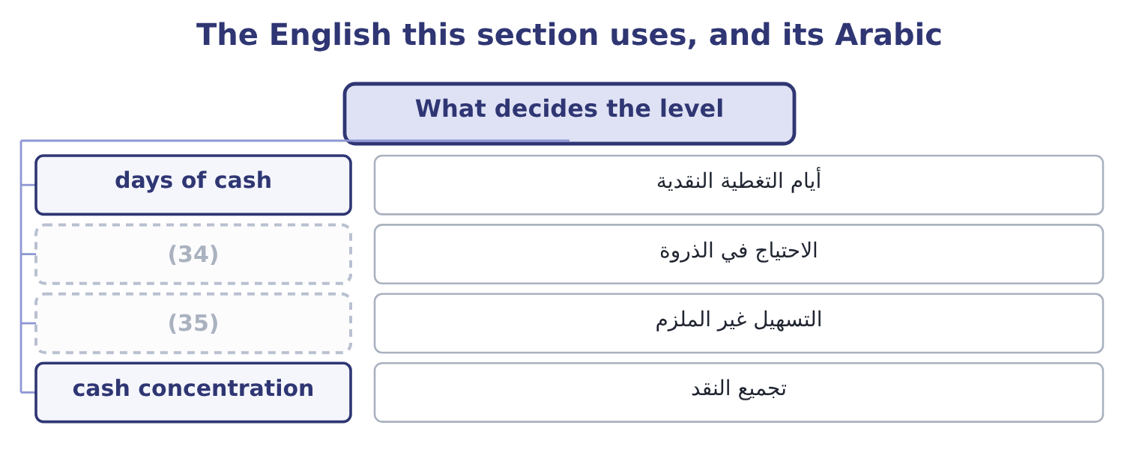
word list
compensating balance · uncommitted facility · peak requirement

The English this sheet uses, and its Arabic
English (exam term) | Arabic
days of cash | أيام التغطية النقدية
peak requirement | الاحتياج في الذروة
uncommitted facility | التسهيل غير الملزم
cash concentration | تجميع النقد

Answer key · 13.2 What decides the level

1 practical | 19 arrangements
2 carries | 20 Compensating
3 predictability | 21 concentration
4 collecting | 22 broadly
5 shipbuilder | 23 impairment
6 business | 24 Together
7 requirement | 25 therefore
8 strong | 26 relationship
9 uncommitted | 27 Commerce
10 investment-grade | 28 manufacturer
11 delivering | 29 normally
12 consequence | 30 surplus
13 short-term | 31 returns
14 treasurer | 32 calculation
15 idleness | 33 unanswerable
16 maturity | 34 peak requirement
17 repayment | 35 uncommitted facility
18 nothing

the summaries in full
Summary 1 Beyond the motives, seven practical factors set the balance a company carries, and the outcome asks for them. The predictability of the cash flows. A utility collecting monthly from a million households can hold very little; a shipbuilder with four payments a year must hold a great deal. A business whose receipts arrive in three months of the year holds through the other nine, and the peak requirement, not the average, sizes the balance. A company with a committed facility and a strong rating can treat the facility as its buffer. One whose borrowing is uncommitted, or whose rating is at the investment-grade boundary of, cannot, because the facility may not be there on the day it is wanted. The cost of being short. A missed payroll, a supplier who stops delivering, a covenant tested on a date — the more expensive the consequence, the larger the balance.
Summary 2 The higher the return available on short-term securities, the more expensive it is to hold idle cash, and the harder a treasurer works to invest it. At Orontes's $7,302,100 and a 4 per cent short rate, the cost of idleness is 7,302,100 × 0.04 = 292,084 a year. The maturity profile of the debt. A company with a large repayment in six months holds against it; one with nothing due for five years does not. Banking arrangements and policy. Compensating balances, minimum balances set by the board, and the number of accounts a group runs all raise the total held, which is why cash concentration —.
Summary 3 Orontes's cash operating payments in 2025 were broadly its cost of goods sold of $27,300,000 and its cash operating expenses, which are the $10,524,000 of total operating expenses less the $2,724,000 impairment, so 10,524,000 − 2,724,000 = 7,800,000. Together that is 27,300,000 + 7,800,000 = 35,100,000 a year, or 35,100,000 ÷ 365 = 96,164 a day. The $7,302,100 balance is therefore 7,302,100 ÷ 96,164 = 75.9 days of operating payments. Two and a half months of payments in the bank, against a cash cycle of 39.8 days and a committed relationship with Levant Commerce Bank, is a large buffer by any standard. A manufacturer with predictable flows and bank access would normally run on a third of it. The surplus is not an error, and section 13.5 returns to what should be done with it. The point of the calculation is that "is $7,302,100 a lot of cash?" is unanswerable and "is 75.9 days of payments a lot of cash?" is answerable, which is what expressing a balance in days of its own flow is for — the same move Book 1 made with receivables and inventory.

13.3 Preparing the forecast
Chapter 13 · section 13.3

Fill every gap. Each word list holds one word more than there are gaps.
Summary 1 gaps 1–9
The receipts and (1) method builds the forecast from the (2) themselves. It is the method the exam sets, and it has four steps. Forecast the sales, month by month. Convert sales into receipts using the collection pattern — the (3) collected in the month of sale, the month after, and so on, with an (4) for what is never collected. Forecast the payments: purchases, (5) by the supplier terms; payroll; overheads; tax; (6) ; dividends; capital (7) . Roll the balance (8) : opening cash plus receipts less payments is closing cash, which (9) next month's opening, and compare the result with the minimum balance the company has decided to hold.
word list
interest · converted · disbursements · expenditure · forward · allowance · becomes · transactions · dividends · proportions

Worked example: a month that needs a facility

Summary 2 gaps 10–13
January $800,000, February $1,000,000, March $1,400,000, April $1,200,000. (10) per cent is collected in the month of sale, 50 per cent in the following month, 28 per cent in the month after that, and 2 per cent is never collected. March receipts are (11) 0.20 × 1,400,000 = 280,000 from (12) own sales, 0.50 × 1,000,000 = 500,000 from February and 0.28 × 800,000 = 224,000 from January, which is 280,000 + 500,000 + 224,000 = 1,004,000. Purchases are 60 per cent of the following month's sales and are paid a month after purchase, so March pays for (13) purchases of 0.60 × 1,400,000 = 840,000. Payroll is $220,000, overheads $90,000, and a tax instalment of $150,000 falls due, so payments are 840,000 + 220,000 + 90,000 + 150,000 = 1,300,000. Opening cash is $300,000, so closing cash is 300,000 + 1,004,000 − 1,300,000 = 4,000.
word list
February's · March's · therefore · Twenty · dividends

Summary 3 gaps 14–22
Against a minimum balance policy of $250,000, the company is short by 250,000 − 4,000 = 246,000. The company is (14) in March — it sells $1,400,000 and its costs are far below that — and it is (15) out of money, (16) the sales growth means it is (17) for a larger February purchase while still (18) on a smaller January sale. That is the pattern of every growing (19) cash crisis, and the forecast found it two months before it (20) , which is long enough to arrange a (21) , collect faster, or delay the tax payment by (22) .
word list
paying · company's · nearly · facility · because · agreement · expenditure · collecting · happened · profitable

One month of a cash budget
Line | Computation | March
Opening cash | (23) | 300,000
Collections from March sales | 20% of 1,400,000 | 280,000
Collections from February sales | 50% of 1,000,000 | 500,000
Collections from January sales | (24) | 224,000
Total receipts |  | 1,004,000
Payment for February purchases | (25) | (840,000)
Payroll and overheads |  | (310,000)
Tax instalment |  | (150,000)
Closing cash | Opening plus receipts less payments | 4,000
Shortfall against a 250,000 minimum |  | (246,000)

word list
28% of 800,000 · Prior closing balance · line of credit · 60% of March sales, paid a month later

Three things that go wrong in a cash budget

Summary 4 gaps 26–31
Sales are not receipts. Apply the collection pattern, and (26) that the percentages must include the (27) part so they sum to 100. Purchases are not payments. Apply the supplier terms, and watch for a (28) in which purchases are a (29) of the following month's sales rather than the (30) month's. The minimum balance is not zero. The shortfall to be (31) is measured against the policy minimum, not against an empty account.
word list
pattern · question · uncollectable · percentage · current · remember · financed

The English this section uses, and its Arabic
Each term sits against what it means.
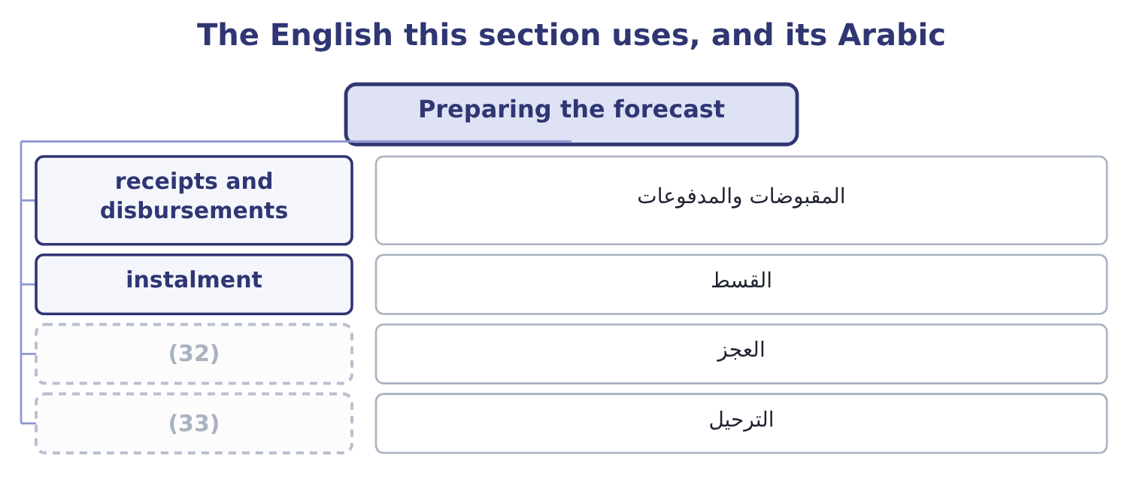
word list
roll forward · idle balance · shortfall

The English this sheet uses, and its Arabic
English (exam term) | Arabic
receipts and disbursements | المقبوضات والمدفوعات
instalment | القسط
shortfall | العجز
roll forward | الترحيل

Answer key · 13.3 Preparing the forecast

1 disbursements | 18 collecting
2 transactions | 19 company's
3 proportions | 20 happened
4 allowance | 21 facility
5 converted | 22 agreement
6 interest | 23 Prior closing balance
7 expenditure | 24 28% of 800,000
8 forward | 25 60% of March sales, paid a month later
9 becomes | 26 remember
10 Twenty | 27 uncollectable
11 therefore | 28 question
12 March's | 29 percentage
13 February's | 30 current
14 profitable | 31 financed
15 nearly | 32 shortfall
16 because | 33 roll forward
17 paying

the summaries in full
Summary 1 The receipts and disbursements method builds the forecast from the transactions themselves. It is the method the exam sets, and it has four steps. Forecast the sales, month by month. Convert sales into receipts using the collection pattern — the proportions collected in the month of sale, the month after, and so on, with an allowance for what is never collected. Forecast the payments: purchases, converted by the supplier terms; payroll; overheads; tax; interest; dividends; capital expenditure. Roll the balance forward: opening cash plus receipts less payments is closing cash, which becomes next month's opening, and compare the result with the minimum balance the company has decided to hold.
Summary 2 January $800,000, February $1,000,000, March $1,400,000, April $1,200,000. Twenty per cent is collected in the month of sale, 50 per cent in the following month, 28 per cent in the month after that, and 2 per cent is never collected. March receipts are therefore 0.20 × 1,400,000 = 280,000 from March's own sales, 0.50 × 1,000,000 = 500,000 from February and 0.28 × 800,000 = 224,000 from January, which is 280,000 + 500,000 + 224,000 = 1,004,000. Purchases are 60 per cent of the following month's sales and are paid a month after purchase, so March pays for February's purchases of 0.60 × 1,400,000 = 840,000. Payroll is $220,000, overheads $90,000, and a tax instalment of $150,000 falls due, so payments are 840,000 + 220,000 + 90,000 + 150,000 = 1,300,000. Opening cash is $300,000, so closing cash is 300,000 + 1,004,000 − 1,300,000 = 4,000.
Summary 3 Against a minimum balance policy of $250,000, the company is short by 250,000 − 4,000 = 246,000. The company is profitable in March — it sells $1,400,000 and its costs are far below that — and it is nearly out of money, because the sales growth means it is paying for a larger February purchase while still collecting on a smaller January sale. That is the pattern of every growing company's cash crisis, and the forecast found it two months before it happened, which is long enough to arrange a facility, collect faster, or delay the tax payment by agreement.
Summary 4 Sales are not receipts. Apply the collection pattern, and remember that the percentages must include the uncollectable part so they sum to 100. Purchases are not payments. Apply the supplier terms, and watch for a question in which purchases are a percentage of the following month's sales rather than the current month's. The minimum balance is not zero. The shortfall to be financed is measured against the policy minimum, not against an empty account.

13.4 Longer horizons and other methods
Chapter 13 · section 13.4

Fill every gap. Each word list holds one word more than there are gaps.
Summary 1 gaps 1–12
The receipts and disbursements method is exact and (1) : it needs a collection pattern, supplier terms and a payment (2) , and beyond a few months the detail is spurious. For a longer horizon the adjusted net income method is used instead, and it is the (3) cash flow statement of Part 1 run (4) . Start with forecast net income. Add back the non-cash charges — (5) , amortisation, (6) . Adjust for the expected movements in (7) capital: an increase in receivables or inventory is a use of cash, an increase in (8) a source. Deduct the planned capital (9) , the debt repayments and the (10) . What is left is the expected (11) in cash. The two methods answer different questions and the exam (12) them. The receipts method tells a treasurer which week needs a facility.
word list
dividends · depreciation · forecast · schedule · impairment · distinguishes · change · demanding · payables · indirect · working · forwards · expenditure

Summary 2 gaps 13–24
The adjusted net income method tells a board (13) next year's plan is fundable at all. A company needs both, at different (14) : daily for a (15) , weekly for a quarter, monthly for a year, annually for the plan. Three (16) improve any of them. (17) every month so that the view ahead never (18) . A base case, a case in which (19) run a week slower, and a case in which a large (20) fails. The second of these is the (21) that most often breaks, and (22) it is cheap. A (23) to the balance sheet. The (24) closing receivables should equal the sales not yet collected under the assumed pattern, and its closing inventory should equal the cover the purchasing plan implies. A forecast that does not reconcile contains an error that the cash line alone will hide.
word list
whether · collections · resolutions · customer · assumption · dividends · testing · Re-cut · reconciliation · fortnight · forecast's · techniques · shortens

Two forecasting methods
Feature | Receipts and disbursements | Adjusted net income
Built from | Individual flows and their timing | (25)
Horizon | (26) | Quarters to years
Answers | When will we be short, and by how much? | (27)
Needs | Collection pattern, supplier terms | (28)
Weakness | Spurious precision at long range | (29)

word list
A forecast income statement and balance sheet · Days to a few months · No detail about timing within a period · Is the plan fundable? · Individual flows and their timing · Forecast profit and balance movements

The English this section uses, and its Arabic
Each term sits against what it means.
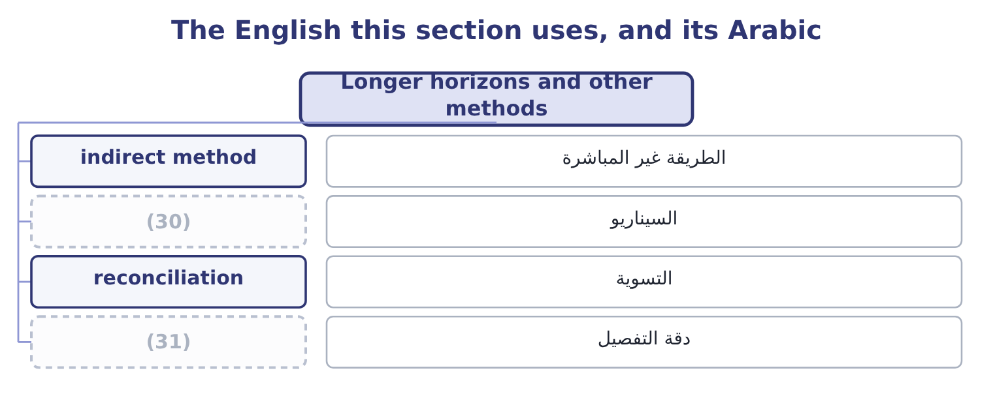
word list
reconciliation · resolution · scenario

The English this sheet uses, and its Arabic
English (exam term) | Arabic
indirect method | الطريقة غير المباشرة
scenario | السيناريو
reconciliation | التسوية
resolution | دقة التفصيل

Answer key · 13.4 Longer horizons and other methods

1 demanding | 17 Re-cut
2 schedule | 18 shortens
3 indirect | 19 collections
4 forwards | 20 customer
5 depreciation | 21 assumption
6 impairment | 22 testing
7 working | 23 reconciliation
8 payables | 24 forecast's
9 expenditure | 25 Forecast profit and balance movements
10 dividends | 26 Days to a few months
11 change | 27 Is the plan fundable?
12 distinguishes | 28 A forecast income statement and balance sheet
13 whether | 29 No detail about timing within a period
14 resolutions | 30 scenario
15 fortnight | 31 resolution
16 techniques

the summaries in full
Summary 1 The receipts and disbursements method is exact and demanding: it needs a collection pattern, supplier terms and a payment schedule, and beyond a few months the detail is spurious. For a longer horizon the adjusted net income method is used instead, and it is the indirect cash flow statement of Part 1 run forwards. Start with forecast net income. Add back the non-cash charges — depreciation, amortisation, impairment. Adjust for the expected movements in working capital: an increase in receivables or inventory is a use of cash, an increase in payables a source. Deduct the planned capital expenditure, the debt repayments and the dividends. What is left is the expected change in cash. The two methods answer different questions and the exam distinguishes them. The receipts method tells a treasurer which week needs a facility.
Summary 2 The adjusted net income method tells a board whether next year's plan is fundable at all. A company needs both, at different resolutions: daily for a fortnight, weekly for a quarter, monthly for a year, annually for the plan. Three techniques improve any of them. Re-cut every month so that the view ahead never shortens. A base case, a case in which collections run a week slower, and a case in which a large customer fails. The second of these is the assumption that most often breaks, and testing it is cheap. A reconciliation to the balance sheet. The forecast's closing receivables should equal the sales not yet collected under the assumed pattern, and its closing inventory should equal the cover the purchasing plan implies. A forecast that does not reconcile contains an error that the cash line alone will hide.

13.5 Acting on the answer
Chapter 13 · section 13.5

Fill every gap. Each word list holds one word more than there are gaps.
Summary 1 gaps 1–12
A forecast (1) one of two findings, and each has a short list of (2) . In order of preference: collect faster; slow payments within the terms agreed; draw on a (3) line of credit, which is why it was arranged; delay (4) spending, such as a capital project or a dividend; sell marketable securities; and only then negotiate new borrowing, which is the most expensive because it is the least prepared. In order of preference: fund the investment (5) ; repay expensive short-term debt; place the money in marketable securities matched to the date it will be needed; and, where the surplus is permanent rather than temporary, return it to (6) by the dividend or buyback. (7) $7,302,100 is a surplus by the measure of section 13.2 — 75.9 days of operating payments against a 39.8-day cash cycle and a bank (8) that works. The order above gives the answer Book 2 has been (9) towards: fund the two (10) at 14 and 11 per cent, which absorb $6,000,000; place the rest for the dates the forecast says it will be needed; and hold the dividend where it is until the gross margin has stopped falling. What should not happen is what (11) in 2025, which is that the balance grew by $5,202,100 and sat in a current account earning nothing while the (12) cost of capital ran at 9.04 per cent.
word list
company's · Orontes's · building · projects · happened · relationship · responses · current · committed · discretionary · produces · shareholders · opportunities

Build a month

Your turn: one month of a cash budget (complete the blanks)
Item | Data | Answer
Collections from June sales | (13) | 225,000: 0.25 × 900,000 = 225,000.
Collections from May sales | (14) | 440,000: 0.55 × 800,000 = 440,000.
Collections from April sales | April sales 700,000, 18 per cent collected two months after | (15)
Total receipts |  | 791,000: 225,000 + 440,000 + 126,000 = 791,000.
Payments | Suppliers 600,000, payroll 180,000, overheads 70,000 | (16)
Closing cash | Opening cash 120,000 | (17)
Shortfall against a 200,000 minimum |  | 139,000: 200,000 − 61,000 = 139,000.

word list
850,000: 600,000 + 180,000 + 70,000 = 850,000. · 440,000: 0.55 × 800,000 = 440,000. · 126,000: 0.18 × 700,000 = 126,000. · June sales 900,000, 25 per cent collected in month · 61,000: 120,000 + 791,000 − 850,000 = 61,000. · May sales 800,000, 55 per cent collected the month after

"Liquid"

Summary 2 gaps 18–25
English liquid in finance means (18) into cash quickly and without loss of value, and (19) is that quality. The metaphor is of (20) that flows, and it is used in three (21) senses that a (22) must keep apart: an asset is liquid if it can be sold quickly; a company is liquid if it can meet its (23) ; and a market is liquid if a large order can be (24) without moving the price. Note that illiquid never means (25) : a company can be solvent and illiquid.
word list
liquidity · stopped · related · executed · convertible · candidate · obligations · insolvent · something

The English this section uses, and its Arabic
Each term sits against what it means.
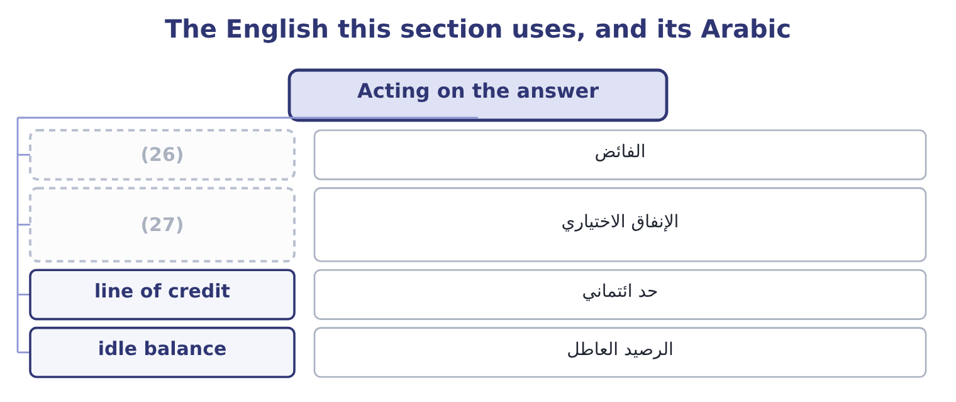
word list
buffer · discretionary spending · surplus

The English this sheet uses, and its Arabic
English (exam term) | Arabic
surplus | الفائض
discretionary spending | الإنفاق الاختياري
line of credit | حد ائتماني
idle balance | الرصيد العاطل

Answer key · 13.5 Acting on the answer

1 produces | 15 126,000: 0.18 × 700,000 = 126,000.
2 responses | 16 850,000: 600,000 + 180,000 + 70,000 = 850,000.
3 committed | 17 61,000: 120,000 + 791,000 − 850,000 = 61,000.
4 discretionary | 18 convertible
5 opportunities | 19 liquidity
6 shareholders | 20 something
7 Orontes's | 21 related
8 relationship | 22 candidate
9 building | 23 obligations
10 projects | 24 executed
11 happened | 25 insolvent
12 company's | 26 surplus
13 June sales 900,000, 25 per cent collected in month | 27 discretionary spending
14 May sales 800,000, 55 per cent collected the month after

the summaries in full
Summary 1 A forecast produces one of two findings, and each has a short list of responses. In order of preference: collect faster; slow payments within the terms agreed; draw on a committed line of credit, which is why it was arranged; delay discretionary spending, such as a capital project or a dividend; sell marketable securities; and only then negotiate new borrowing, which is the most expensive because it is the least prepared. In order of preference: fund the investment opportunities; repay expensive short-term debt; place the money in marketable securities matched to the date it will be needed; and, where the surplus is permanent rather than temporary, return it to shareholders by the dividend or buyback. Orontes's $7,302,100 is a surplus by the measure of section 13.2 — 75.9 days of operating payments against a 39.8-day cash cycle and a bank relationship that works. The order above gives the answer Book 2 has been building towards: fund the two projects at 14 and 11 per cent, which absorb $6,000,000; place the rest for the dates the forecast says it will be needed; and hold the dividend where it is until the gross margin has stopped falling. What should not happen is what happened in 2025, which is that the balance grew by $5,202,100 and sat in a current account earning nothing while the company's cost of capital ran at 9.04 per cent.
Summary 2 English liquid in finance means convertible into cash quickly and without loss of value, and liquidity is that quality. The metaphor is of something that flows, and it is used in three related senses that a candidate must keep apart: an asset is liquid if it can be sold quickly; a company is liquid if it can meet its obligations; and a market is liquid if a large order can be executed without moving the price. Note that illiquid never means insolvent: a company can be solvent and illiquid.

14.1 Float, in three parts
Chapter 14 · section 14.1

Fill every gap. Each word list holds one word more than there are gaps.
Chapter 14, section by section
Each stage leads to the next.
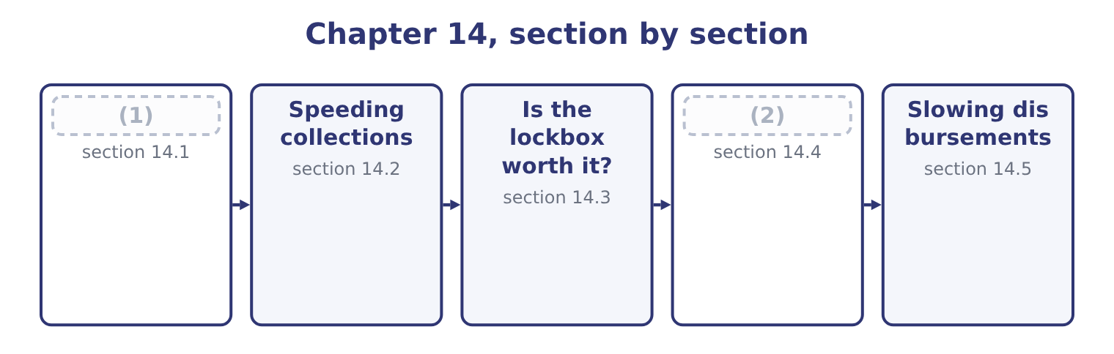
word list
Float, in three parts · usable funds · Compensating balances

Summary 1 gaps 3–14
Float is the delay (3) one party's (4) and the other's. Collection float works against the company; disbursement float works for it; net float is the (5) , and a company with more of the (6) than the first has a bank balance larger than its own ledger shows. Collection float has three (7) and each is attacked (8) . Mail float is the time from the customer (9) the payment to the company receiving it. It is attacked by moving the receiving point closer to the customer, which is what a lockbox does, or by removing the post from the process (10) with an electronic (11) . Processing float is the time from receipt to deposit: (12) , recording, (13) the deposit, taking it to the bank. It is attacked by (14) the bank do the work, which again is a lockbox, or by direct credit to the account.
word list
records · components · preparing · difference · differently · short-dated · second · between · transfer · entirely · opening · having · sending

Summary 2 gaps 15–21
Availability float, also (15) clearing float, is the time from deposit to the funds (16) usable. It is attacked by (17) in a bank where the item will clear fastest, and it has largely shrunk in markets where electronic clearing has (18) paper. Disbursement float is the same three (19) on the paying side, seen from the other end. A (20) posted on the last (21) day, drawn on a bank where it will take time to clear, leaves the company's money in the company's account longer.
word list
delays · candidate · replaced · cheque · depositing · called · becoming · permitted

Worked example: what a day of float is worth to Orontes

Summary 3 gaps 22–33
Orontes (22) 42,000,000 ÷ 365 = 115,068 a day on (23) . Removing one day of collection float releases $115,068 of cash permanently — not once, but permanently, (24) every subsequent day's (25) arrive a day earlier too. A lockbox arrangement (26) mail and processing float by three days releases 115,068 × 3 = 345,204. At the 4 per cent Orontes could earn on (27) securities, that released cash is worth 345,204 × 0.04 = 13,808 a year, for ever, against (28) the arrangement costs. The released amount is a stock and the benefit is a flow, and (29) the two is the (30) error on this outcome. Three days of float is a (31) release of $345,204 into the bank account; the (32) benefit is only the return earned on it. A (33) who compares $345,204 with an annual bank fee has compared a balance with a rent.
word list
collections · short-dated · average · classic · one-off · Availability · collects · recurring · because · cutting · whatever · confusing · candidate

The components of float
Component | The delay | Who it favours | What shortens it
Mail float | Customer posts to company receives | The customer | (34)
Processing float | Receipt to deposit | Neither | (35)
Availability float | (36) | The bank | Faster-clearing instruments
Disbursement float | (37) | The company | Nothing; the company wants it long

word list
Bank processing, direct credit · Customer posts to company receives · Deposit to usable funds · Company pays to funds leave · A lockbox near the customer

The English this section uses, and its Arabic
Each term sits against what it means.
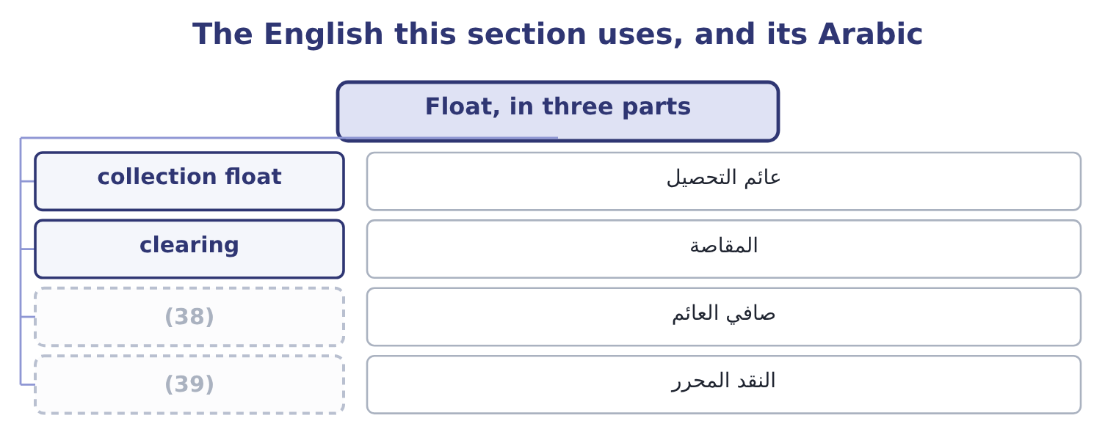
word list
net float · concentration banking · released cash

The English this sheet uses, and its Arabic
English (exam term) | Arabic
collection float | عائم التحصيل
clearing | المقاصة
net float | صافي العائم
released cash | النقد المحرر

Answer key · 14.1 Float, in three parts

1 Float, in three parts | 21 permitted
2 Compensating balances | 22 collects
3 between | 23 average
4 records | 24 because
5 difference | 25 collections
6 second | 26 cutting
7 components | 27 short-dated
8 differently | 28 whatever
9 sending | 29 confusing
10 entirely | 30 classic
11 transfer | 31 one-off
12 opening | 32 recurring
13 preparing | 33 candidate
14 having | 34 A lockbox near the customer
15 called | 35 Bank processing, direct credit
16 becoming | 36 Deposit to usable funds
17 depositing | 37 Company pays to funds leave
18 replaced | 38 net float
19 delays | 39 released cash
20 cheque

the summaries in full
Summary 1 Float is the delay between one party's records and the other's. Collection float works against the company; disbursement float works for it; net float is the difference, and a company with more of the second than the first has a bank balance larger than its own ledger shows. Collection float has three components and each is attacked differently. Mail float is the time from the customer sending the payment to the company receiving it. It is attacked by moving the receiving point closer to the customer, which is what a lockbox does, or by removing the post from the process entirely with an electronic transfer. Processing float is the time from receipt to deposit: opening, recording, preparing the deposit, taking it to the bank. It is attacked by having the bank do the work, which again is a lockbox, or by direct credit to the account.
Summary 2 Availability float, also called clearing float, is the time from deposit to the funds becoming usable. It is attacked by depositing in a bank where the item will clear fastest, and it has largely shrunk in markets where electronic clearing has replaced paper. Disbursement float is the same three delays on the paying side, seen from the other end. A cheque posted on the last permitted day, drawn on a bank where it will take time to clear, leaves the company's money in the company's account longer.
Summary 3 Orontes collects 42,000,000 ÷ 365 = 115,068 a day on average. Removing one day of collection float releases $115,068 of cash permanently — not once, but permanently, because every subsequent day's collections arrive a day earlier too. A lockbox arrangement cutting mail and processing float by three days releases 115,068 × 3 = 345,204. At the 4 per cent Orontes could earn on short-dated securities, that released cash is worth 345,204 × 0.04 = 13,808 a year, for ever, against whatever the arrangement costs. The released amount is a stock and the benefit is a flow, and confusing the two is the classic error on this outcome. Three days of float is a one-off release of $345,204 into the bank account; the recurring benefit is only the return earned on it. A candidate who compares $345,204 with an annual bank fee has compared a balance with a rent.

14.2 Speeding collections
Chapter 14 · section 14.2

Fill every gap. Each word list holds one word more than there are gaps.
Summary 1 gaps 1–12
Six (1) , and the exam expects them named and (2) . A lockbox is a post office box in a city near a group of customers, (3) several times a day by a bank that opens the mail, (4) the cheques and reports the details to the company. It removes most of the mail float, because the box is (5) , and all of the processing float, because the bank does the work. Electronic funds transfer removes mail and processing float (6) , and most of the (7) float. Where a customer will pay (8) , every other method is (9) . A preauthorised debit lets the company draw the (10) amount from the (11) account on the due date. It is standard for regular payments — rent, (12) , instalments — and it removes the decision to pay from the payer, which is its advantage and the reason some customers resist it.
word list
delivery · deposits · distinguished · inferior · subscriptions · entirely · customer's · agreed · methods · closer · emptied · availability · electronically

Summary 2 gaps 13–24
Concentration banking moves the money from many local (13) into one. A company with (14) collects locally, each branch banking where its customers are, and the balances are swept daily into a (15) concentration account. Three (16) follow: the total idle balance is far smaller than the sum of many local (17) ; the one large balance can be invested on better terms than many small ones; and the company borrows once rather than in several places. The transfers (18) are made by (19) transfer cheque or, more usually now, by electronic transfer. Prompt and (20) invoicing is the cheapest method of all and the most often (21) . An invoice issued three days after (22) is paid three days later, and an invoice with an error (23) the whole clock. A discount for early settlement buys speed with (24) .
word list
delivery · restarts · branches · neglected · accounts · benefits · Concentration · themselves · single · depository · accurate · minimums · margin

Six ways to collect faster
Method | Float removed | Typical cost | Best suited to
Lockbox | Mail and processing | (25) | Many cheques from a wide area
Electronic funds transfer | Nearly all | A small transaction fee | (26)
Preauthorised debit | Nearly all | A small fee | (27)
Concentration banking | None directly; it frees balances | Transfer fees | (28)
Prompt invoicing | The company's own delay | Nothing | (29)
Settlement discount | Days of credit | (30) | Sellers with high margins

word list
A percentage of the invoice · Any customer willing to use it · A fee per item or a monthly fee · preauthorised debit · Everybody · Regular, repeating amounts · Companies with many locations

The English this section uses, and its Arabic
Each term sits against what it means.
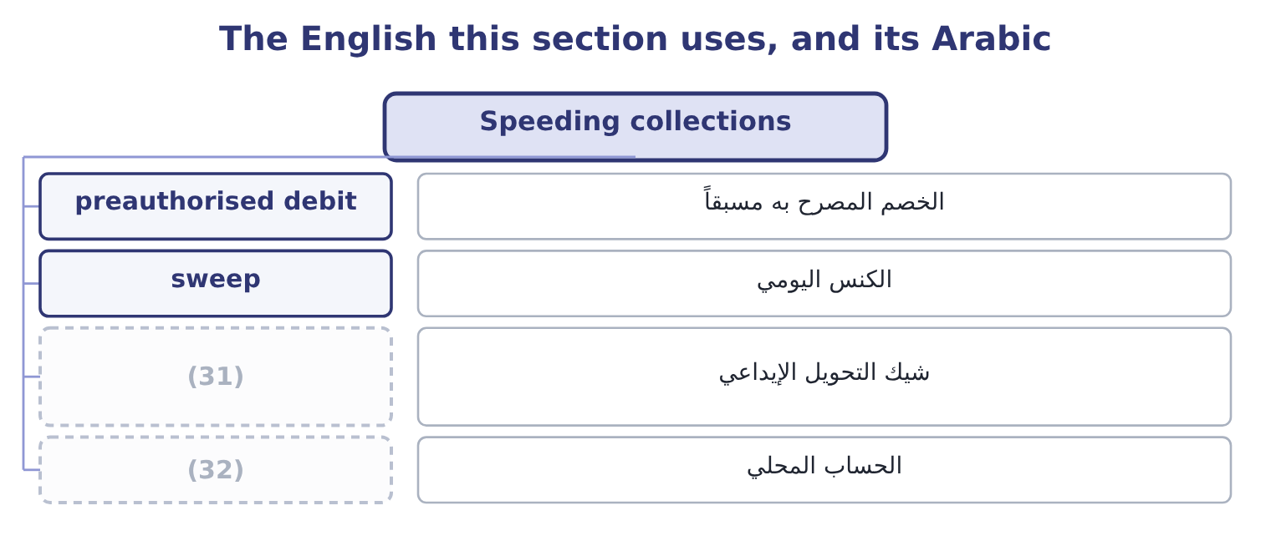
word list
concentration banking · local account · depository transfer cheque

The English this sheet uses, and its Arabic
English (exam term) | Arabic
preauthorised debit | الخصم المصرح به مسبقاً
sweep | الكنس اليومي
depository transfer cheque | شيك التحويل الإيداعي
local account | الحساب المحلي

Answer key · 14.2 Speeding collections

1 methods | 17 minimums
2 distinguished | 18 themselves
3 emptied | 19 depository
4 deposits | 20 accurate
5 closer | 21 neglected
6 entirely | 22 delivery
7 availability | 23 restarts
8 electronically | 24 margin
9 inferior | 25 A fee per item or a monthly fee
10 agreed | 26 Any customer willing to use it
11 customer's | 27 Regular, repeating amounts
12 subscriptions | 28 Companies with many locations
13 accounts | 29 Everybody
14 branches | 30 A percentage of the invoice
15 single | 31 depository transfer cheque
16 benefits | 32 local account

the summaries in full
Summary 1 Six methods, and the exam expects them named and distinguished. A lockbox is a post office box in a city near a group of customers, emptied several times a day by a bank that opens the mail, deposits the cheques and reports the details to the company. It removes most of the mail float, because the box is closer, and all of the processing float, because the bank does the work. Electronic funds transfer removes mail and processing float entirely, and most of the availability float. Where a customer will pay electronically, every other method is inferior. A preauthorised debit lets the company draw the agreed amount from the customer's account on the due date. It is standard for regular payments — rent, subscriptions, instalments — and it removes the decision to pay from the payer, which is its advantage and the reason some customers resist it.
Summary 2 Concentration banking moves the money from many local accounts into one. A company with branches collects locally, each branch banking where its customers are, and the balances are swept daily into a single concentration account. Three benefits follow: the total idle balance is far smaller than the sum of many local minimums; the one large balance can be invested on better terms than many small ones; and the company borrows once rather than in several places. The transfers themselves are made by depository transfer cheque or, more usually now, by electronic transfer. Prompt and accurate invoicing is the cheapest method of all and the most often neglected. An invoice issued three days after delivery is paid three days later, and an invoice with an error restarts the whole clock. A discount for early settlement buys speed with margin.

14.3 Is the lockbox worth it?
Chapter 14 · section 14.3

Fill every gap. Each word list holds one word more than there are gaps.
Summary 1 gaps 1–2
The (1) is a small net present value and the exam sets it often. Compare the recurring benefit of the cash released with the recurring cost of the (2) .
word list
overdraft · calculation · service

Worked example: the lockbox decision

Summary 2 gaps 3–14
A company (3) $200,000 a day (4) its central (5) . A bank offers a (6) network that would cut total float by 2.5 days. The bank (7) $0.35 an item and the company (8) 60,000 items a year. The company can earn 5 per cent on released funds. Two (9) change the answer and both appear in (10) . If the bank asks for a (11) balance instead of a fee, the cost is the return (12) on that balance, computed as in section 14.4. And if the company has borrowings (13) , the benefit should be computed at its borrowing rate rather than at its investment rate, because the released cash repays debt rather than buying (14) — and at Orontes's 6 per cent rather than 4, the same release is worth half as much again.
word list
forgone · outstanding · compensating · Orontes's · collects · questions · through · refinements · securities · office · charges · receives · lockbox

The lockbox template
Line | Computation | This case
Daily collections | Given | 200,000
Days of float removed | (15) | 2.5
Cash released | (16) | 500,000
Annual benefit | (17) | 25,000
Annual cost | Fee per item times items, or a monthly fee | 21,000
Net annual benefit | Benefit less cost | 4,000

word list
Given · Daily collections times days · local account · Released cash times the rate

Stock against flow, and which rate

Summary 3 gaps 18–21
The cash released is a (18) stock. The benefit is the return on it, which is a flow. Compare flows with flows. Use the borrowing rate where the company is borrowing, and the investment rate where it is not. The (19) wording decides. Where the (20) is per item, (21) by the number of items a year, not by the number of days.
word list
one-off · charge · multiply · overdraft · question's

The English this section uses, and its Arabic
Each term sits against what it means.
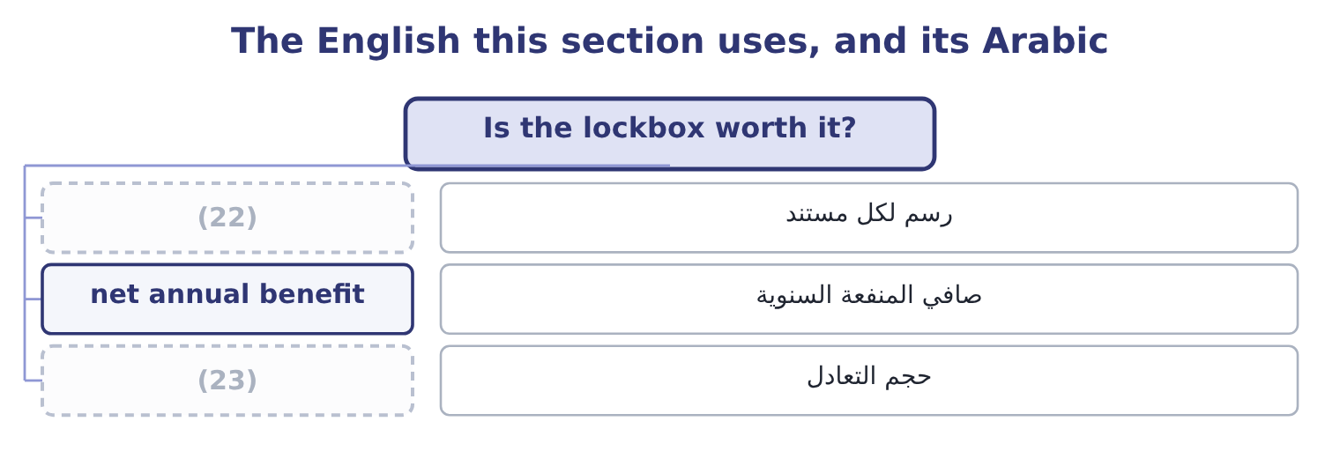
word list
collection float · break-even volume · per-item fee

The English this sheet uses, and its Arabic
English (exam term) | Arabic
per-item fee | رسم لكل مستند
net annual benefit | صافي المنفعة السنوية
break-even volume | حجم التعادل

Answer key · 14.3 Is the lockbox worth it?

1 calculation | 13 outstanding
2 service | 14 securities
3 collects | 15 Given
4 through | 16 Daily collections times days
5 office | 17 Released cash times the rate
6 lockbox | 18 one-off
7 charges | 19 question's
8 receives | 20 charge
9 refinements | 21 multiply
10 questions | 22 per-item fee
11 compensating | 23 break-even volume
12 forgone

the summaries in full
Summary 1 The calculation is a small net present value and the exam sets it often. Compare the recurring benefit of the cash released with the recurring cost of the service.
Summary 2 A company collects $200,000 a day through its central office. A bank offers a lockbox network that would cut total float by 2.5 days. The bank charges $0.35 an item and the company receives 60,000 items a year. The company can earn 5 per cent on released funds. Two refinements change the answer and both appear in questions. If the bank asks for a compensating balance instead of a fee, the cost is the return forgone on that balance, computed as in section 14.4. And if the company has borrowings outstanding, the benefit should be computed at its borrowing rate rather than at its investment rate, because the released cash repays debt rather than buying securities — and at Orontes's 6 per cent rather than 4, the same release is worth half as much again.
Summary 3 The cash released is a one-off stock. The benefit is the return on it, which is a flow. Compare flows with flows. Use the borrowing rate where the company is borrowing, and the investment rate where it is not. The question's wording decides. Where the charge is per item, multiply by the number of items a year, not by the number of days.

14.4 Compensating balances
Chapter 14 · section 14.4

Fill every gap. Each word list holds one word more than there are gaps.
Summary 1 gaps 1–4
A bank may be paid in fees or in balances. A compensating balance is a sum the (1) agrees to keep in a (2) account, from which the bank earns by (3) it on, and its effect is to raise the effective cost of (4) it is attached to.
word list
lending · Orontes's · whatever · borrower · non-interest-bearing

Worked example: what a compensating balance costs

Summary 2 gaps 5–16
A company (5) $2,000,000 at a stated 8 per cent and must keep a compensating balance of 10 per cent of the loan. What it (6) has. Interest is (7) on the whole loan: 2,000,000 × 0.08 = 160,000. The stated rate was never the rate. Two (8) can change the (9) and the exam uses both. If the company would in any case have held $200,000 in that account for (10) purposes, the (11) costs nothing extra and the effective rate stays at 8 per cent. And if the balance earns some interest, only the (12) against the (13) rate is a cost. Read the (14) for which case it (15) . Compensating balances also attach to services rather than loans: a bank may provide a (16) or a concentration network free in exchange for balances left with it. The comparison is then between the fee it would otherwise charge and the return forgone on the balance, and the arithmetic is identical.
word list
market · requirement · charged · transaction · answer · describes · lockbox · shortfall · question · actually · borrows · adjustments · Orontes's

Fees against balances
Arrangement | What the company gives up | Cost if it would hold the balance anyway | Visible in the accounts?
A fee | Cash | (17) | Yes, as an expense
A compensating balance | (18) | Nothing | No; it appears as cash

word list
The fee, in full · Yes, as an expense · The use of a balance

Summary 3 gaps 19–24
That last column (19) why balances are popular with managers and disliked by analysts: a fee is an expense that shows, and a balance is a (20) on an asset that does not — which is why the notes disclose compensating balance (21) , and why a reader of Book 1's (22) ratios would want to know whether any of (23) $7,302,100 was (24) in this way.
word list
Orontes's · restricted · explains · requirements · Interest · restriction · liquidity

The English this section uses, and its Arabic
Each term sits against what it means.
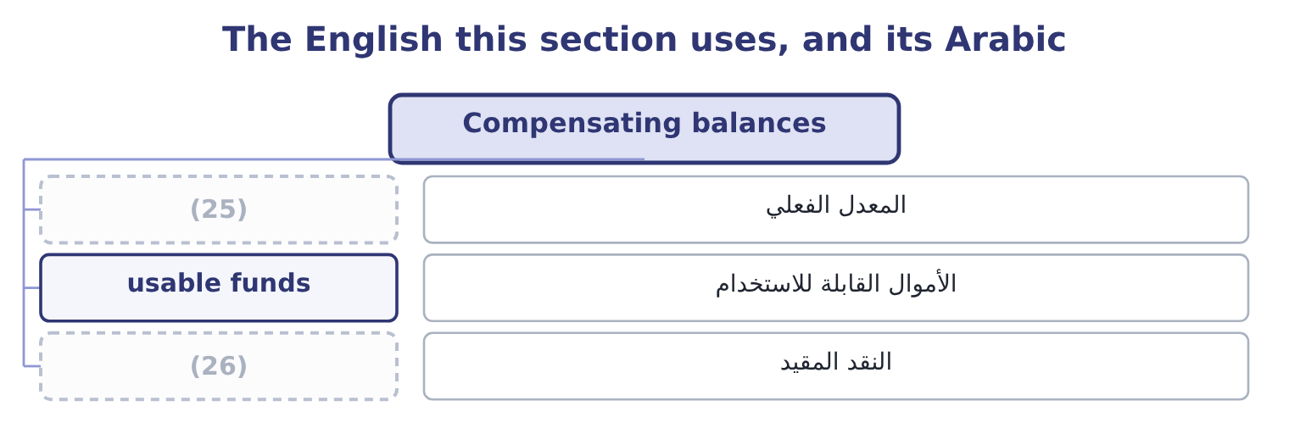
word list
zero-balance account · restricted cash · effective rate

The English this sheet uses, and its Arabic
English (exam term) | Arabic
effective rate | المعدل الفعلي
usable funds | الأموال القابلة للاستخدام
restricted cash | النقد المقيد

Answer key · 14.4 Compensating balances

1 borrower | 14 question
2 non-interest-bearing | 15 describes
3 lending | 16 lockbox
4 whatever | 17 The fee, in full
5 borrows | 18 The use of a balance
6 actually | 19 explains
7 charged | 20 restriction
8 adjustments | 21 requirements
9 answer | 22 liquidity
10 transaction | 23 Orontes's
11 requirement | 24 restricted
12 shortfall | 25 effective rate
13 market | 26 restricted cash

the summaries in full
Summary 1 A bank may be paid in fees or in balances. A compensating balance is a sum the borrower agrees to keep in a non-interest-bearing account, from which the bank earns by lending it on, and its effect is to raise the effective cost of whatever it is attached to.
Summary 2 A company borrows $2,000,000 at a stated 8 per cent and must keep a compensating balance of 10 per cent of the loan. What it actually has. Interest is charged on the whole loan: 2,000,000 × 0.08 = 160,000. The stated rate was never the rate. Two adjustments can change the answer and the exam uses both. If the company would in any case have held $200,000 in that account for transaction purposes, the requirement costs nothing extra and the effective rate stays at 8 per cent. And if the balance earns some interest, only the shortfall against the market rate is a cost. Read the question for which case it describes. Compensating balances also attach to services rather than loans: a bank may provide a lockbox or a concentration network free in exchange for balances left with it. The comparison is then between the fee it would otherwise charge and the return forgone on the balance, and the arithmetic is identical.
Summary 3 That last column explains why balances are popular with managers and disliked by analysts: a fee is an expense that shows, and a balance is a restriction on an asset that does not — which is why the notes disclose compensating balance requirements, and why a reader of Book 1's liquidity ratios would want to know whether any of Orontes's $7,302,100 was restricted in this way.

14.5 Slowing disbursements
Chapter 14 · section 14.5

Fill every gap. Each word list holds one word more than there are gaps.
Summary 1 gaps 1–12
The (1) image, and the one where the line between good management and sharp practice has to be drawn (2) . (3) methods, which the exam (4) . Pay on the due date, not before. An (5) on 30-day terms should be paid on day 30. (6) on day 12 because the approval (7) to finish then is a free loan to the supplier. One payment run from one account is easier to control, to time and to fund than (8) made by several (9) . Use a zero-balance account. Each disbursement account is kept at nil, and the master account funds it each day with (10) the amount of cheques (11) . No idle balances sit waiting in the payment (12) . The bank notifies the company early each morning of the exact total that will clear that day, so the treasurer funds that amount and invests everything else — the practice that makes a zero-balance structure usable.
word list
Paying · locations · exactly · expects · payments · presenting · explicitly · something · happened · Legitimate · invoice · mirror · accounts

Summary 2 gaps 13–24
Use a (13) draft, which is (14) to the company for approval before it is paid, (15) a day and giving a control point (16) fraud. (17) a single payment run a week rather than daily, which slows payment on (18) by a few days and costs nothing. Methods that cross the line, and the exam has a view. (19) drawing cheques on a distant bank to extend (20) time — remote disbursement — is legal in most places and is regarded as an abuse by banks and by the professional codes. Delaying payment past agreed terms without (21) is not float management; it is (22) taking credit. Mailing on a Friday (23) so that the item cannot be (24) until Tuesday is a decision the company should be willing to describe to the supplier.
word list
processed · clearing · Consider · afternoon · presented · average · adding · against · unilaterally · agreement · proportion · Deliberately · payable-through

Summary 3 gaps 25–32
The overdraft system (25) here because it changes the (26) . In markets where (27) are normal, a company holds no cash at all: the account runs negative during the month, interest is charged daily on the balance, and the whole (28) of minimum balances and daily funding is replaced by a limit and a rate. That is (29) and simpler than holding (30) cash, and it is why a treasurer in such a market manages the limit rather than the balance. (31) $240,000 overdraft is this (32) arriving unplanned rather than chosen.
word list
cheaper · Barada's · apparatus · question · belongs · arrangement · precautionary · overdrafts · suspended

Price the float

Your turn: float and its price (complete the blanks)
Item | Data | Answer
Cash released by a lockbox | (33) | ________
Annual benefit of that release | At a 6 per cent borrowing rate | ________
Annual cost of the lockbox | (34) | ________
Net annual benefit |  | ________
Usable funds on a loan | 3,000,000 at 9 per cent, 15 per cent compensating balance | ________
Effective rate on that loan |  | ________

word list
0.40 an item, 55,000 items · Effective rate on that loan · Daily collections 150,000, float cut 3 days

"Float"

Summary 4 gaps 35–43
English float in (35) means the money in (36) between two sets of records, and the metaphor is of (37) suspended between two states. The word does three other jobs in finance that a (38) meets in the same syllabus: a company floats when it lists its shares, so a flotation is an issue and flotation costs are its fees; a floating rate is one that resets; and the free float is the (39) of a company's shares (40) to trade. Four (41) , one word, no (42) in sense. Where English is (43) , read the noun next to it.
word list
available · treasury · ambiguous · candidate · meanings · proportion · overlap · without · something · transit

"Float"
Item | Answer
Cash released by a lockbox | (44)
Annual benefit of that release | 27,000: 450,000 × 0.06 = 27,000, computed at the borrowing rate because the cash repays debt.
Annual cost of the lockbox | 22,000: 0.40 × 55,000 = 22,000.
Net annual benefit | (45)
Usable funds on the loan | 2,550,000: 3,000,000 × 0.85 = 2,550,000.
Effective rate on that loan | 10.59 per cent: interest is 3,000,000 × 0.09 = 270,000, and 270,000 ÷ 2,550,000 = 10.59 per cent.
What it tells you | The lockbox clears its cost by 5,000 a year, which is worth having and is not large; the compensating balance adds more than a point and a h

word list
2,550,000: 3,000,000 × 0.85 = 2,550,000. · 450,000: 150,000 × 3 = 450,000. · 5,000: 27,000 − 22,000 = 5,000.

The words this section uses
Each term sits against what it means, and an instance of it.
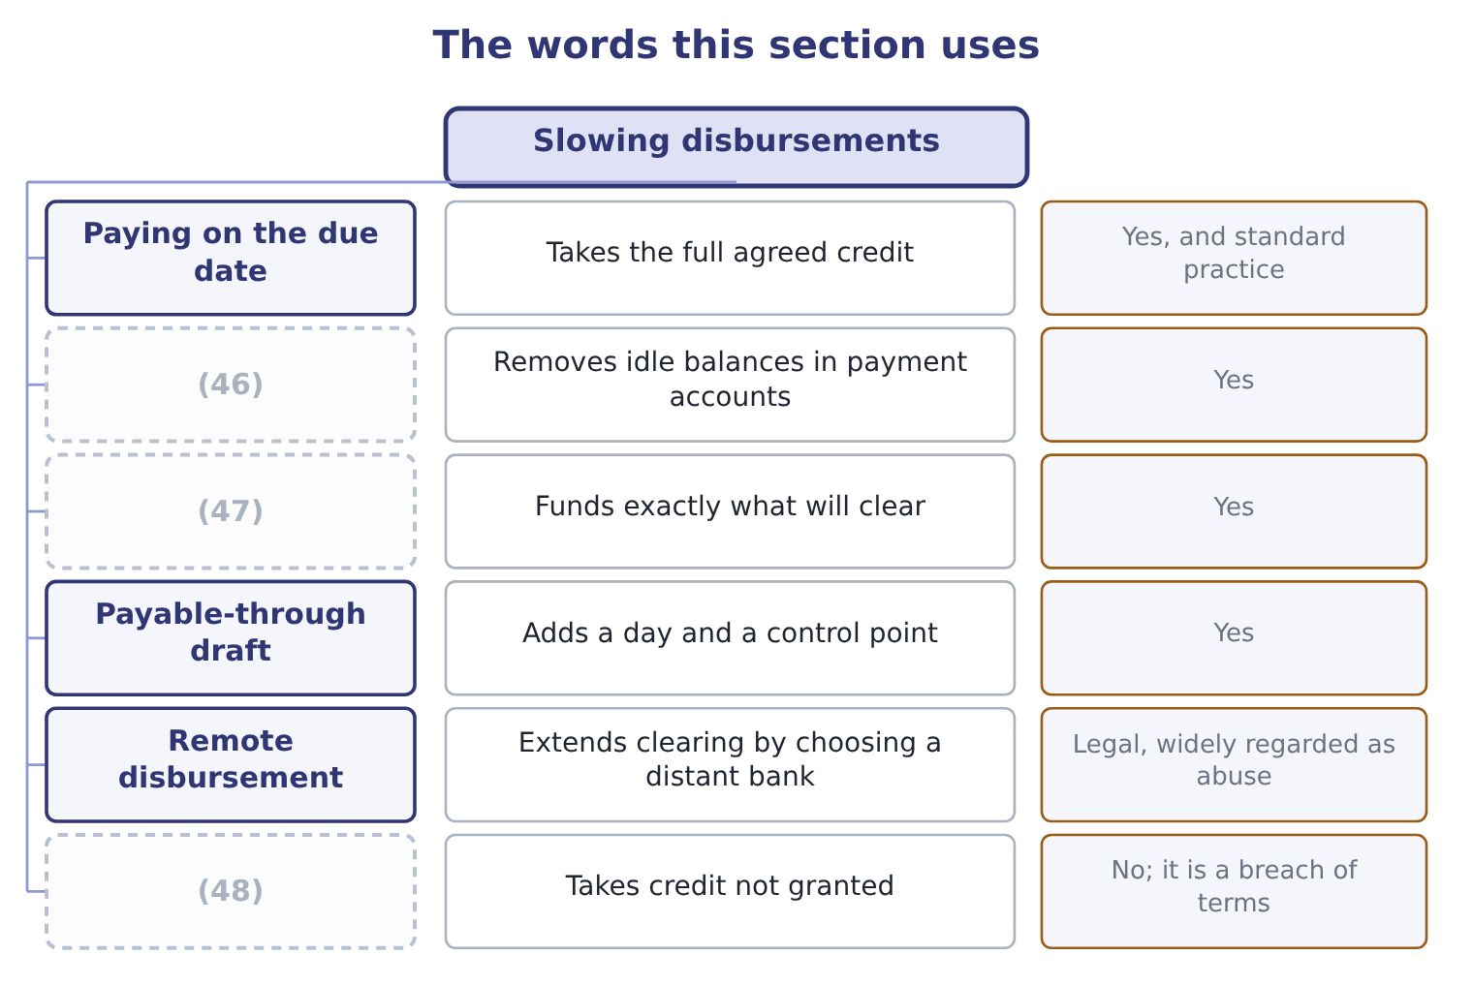
word list
Controlled disbursement · Zero-balance accounts · Paying late without agreement · due date

The English this sheet uses, and its Arabic
English (exam term) | Arabic
payment run | دفعة السداد
remote disbursement | الصرف من بنك بعيد
overdraft limit | حد السحب على المكشوف
due date | تاريخ الاستحقاق

Answer key · 14.5 Slowing disbursements

1 mirror | 25 belongs
2 explicitly | 26 question
3 Legitimate | 27 overdrafts
4 expects | 28 apparatus
5 invoice | 29 cheaper
6 Paying | 30 precautionary
7 happened | 31 Barada's
8 payments | 32 arrangement
9 locations | 33 Daily collections 150,000, float cut 3 days
10 exactly | 34 0.40 an item, 55,000 items
11 presenting | 35 treasury
12 accounts | 36 transit
13 payable-through | 37 something
14 presented | 38 candidate
15 adding | 39 proportion
16 against | 40 available
17 Consider | 41 meanings
18 average | 42 overlap
19 Deliberately | 43 ambiguous
20 clearing | 44 450,000: 150,000 × 3 = 450,000.
21 agreement | 45 5,000: 27,000 − 22,000 = 5,000.
22 unilaterally | 46 Zero-balance accounts
23 afternoon | 47 Controlled disbursement
24 processed | 48 Paying late without agreement

the summaries in full
Summary 1 The mirror image, and the one where the line between good management and sharp practice has to be drawn explicitly. Legitimate methods, which the exam expects. Pay on the due date, not before. An invoice on 30-day terms should be paid on day 30. Paying on day 12 because the approval happened to finish then is a free loan to the supplier. One payment run from one account is easier to control, to time and to fund than payments made by several locations. Use a zero-balance account. Each disbursement account is kept at nil, and the master account funds it each day with exactly the amount of cheques presenting. No idle balances sit waiting in the payment accounts. The bank notifies the company early each morning of the exact total that will clear that day, so the treasurer funds that amount and invests everything else — the practice that makes a zero-balance structure usable.
Summary 2 Use a payable-through draft, which is presented to the company for approval before it is paid, adding a day and giving a control point against fraud. Consider a single payment run a week rather than daily, which slows payment on average by a few days and costs nothing. Methods that cross the line, and the exam has a view. Deliberately drawing cheques on a distant bank to extend clearing time — remote disbursement — is legal in most places and is regarded as an abuse by banks and by the professional codes. Delaying payment past agreed terms without agreement is not float management; it is unilaterally taking credit. Mailing on a Friday afternoon so that the item cannot be processed until Tuesday is a decision the company should be willing to describe to the supplier.
Summary 3 The overdraft system belongs here because it changes the question. In markets where overdrafts are normal, a company holds no cash at all: the account runs negative during the month, interest is charged daily on the balance, and the whole apparatus of minimum balances and daily funding is replaced by a limit and a rate. That is cheaper and simpler than holding precautionary cash, and it is why a treasurer in such a market manages the limit rather than the balance. Barada's $240,000 overdraft is this arrangement arriving unplanned rather than chosen.
Summary 4 English float in treasury means the money in transit between two sets of records, and the metaphor is of something suspended between two states. The word does three other jobs in finance that a candidate meets in the same syllabus: a company floats when it lists its shares, so a flotation is an issue and flotation costs are its fees; a floating rate is one that resets; and the free float is the proportion of a company's shares available to trade. Four meanings, one word, no overlap in sense. Where English is ambiguous, read the noun next to it.

15.1 Why a company holds securities rather than cash
Chapter 15 · section 15.1

Fill every gap. Each word list holds one word more than there are gaps.
Chapter 15, section by section
Each stage leads to the next.
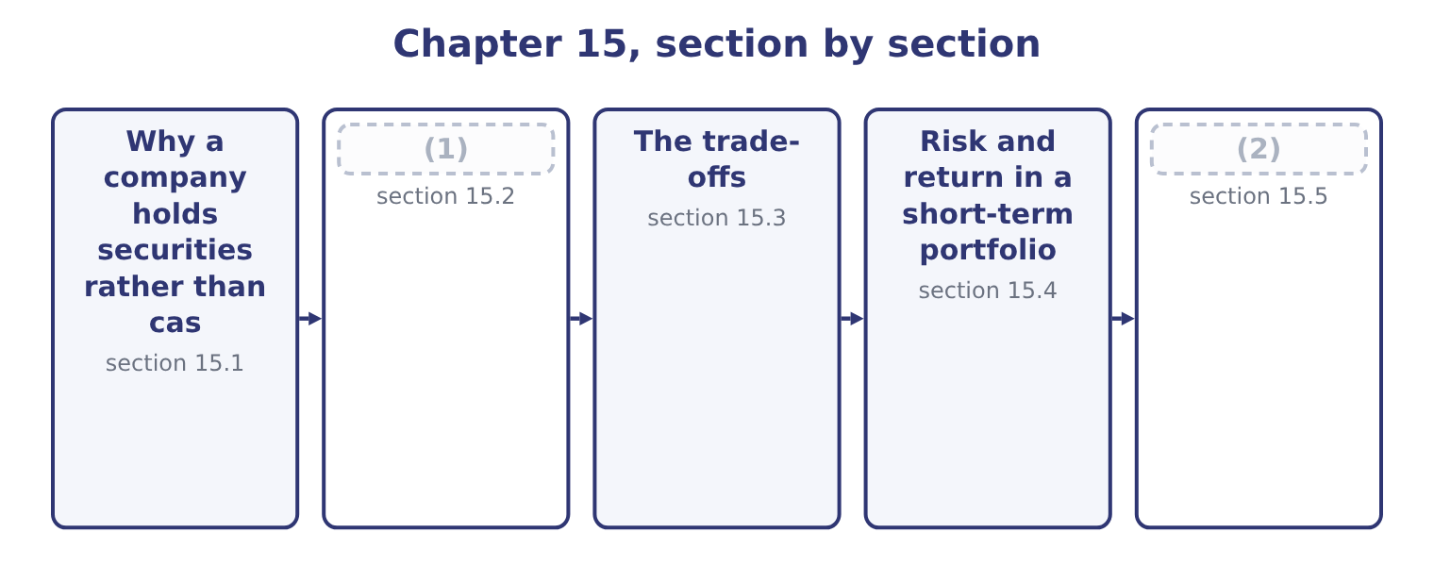
word list
section 15.2 · Building Orontes's portfolio · The instruments

Summary 1 gaps 3–14
Four (3) , and the exam asks for them in these terms. As a (4) for cash. Money needed within the year earns (5) while it waits, and the only (6) is that it can be realised when the day comes. This is the (7) use and the one (8) has. As a store (9) a known future payment. A tax (10) in March, a bond maturing in (11) , a capital project's third payment in July: each is a known amount on a known date, and a security maturing on that date funds it exactly, with no risk that a sale is needed at a bad moment. As a buffer for the (12) , which is the (13) motive. As a home for seasonal (14) . A company that collects in three months and spends through twelve has a predictable rise and fall, and the peak sits in securities until it drains away. Note what marketable securities are not for. They are not an investment portfolio: a treasury department buying equities with working capital is speculating with money the business needs, however good the equities.
word list
precautionary · Orontes · surpluses · against · instalment · largest · reasons · something · securities · unexpected · requirement · September · substitute

The English this section uses, and its Arabic
Each term sits against what it means.
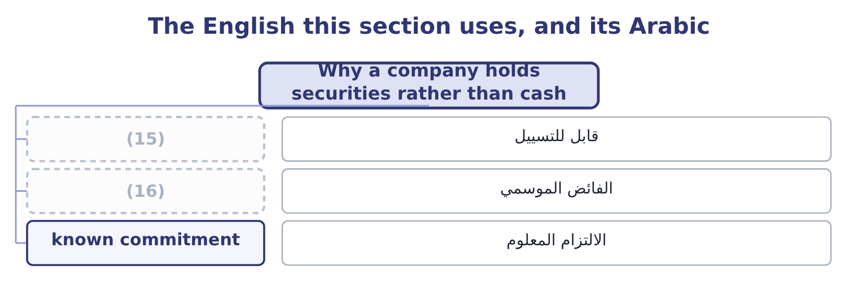
word list
seasonal surplus · realisable · tax-equivalent yield

The English this sheet uses, and its Arabic
English (exam term) | Arabic
realisable | قابل للتسييل
seasonal surplus | الفائض الموسمي
known commitment | الالتزام المعلوم

Answer key · 15.1 Why a company holds securities rather than cash

1 The instruments | 9 against
2 Building Orontes's portfolio | 10 instalment
3 reasons | 11 September
4 substitute | 12 unexpected
5 something | 13 precautionary
6 requirement | 14 surpluses
7 largest | 15 realisable
8 Orontes | 16 seasonal surplus

the summaries in full
Summary 1 Four reasons, and the exam asks for them in these terms. As a substitute for cash. Money needed within the year earns something while it waits, and the only requirement is that it can be realised when the day comes. This is the largest use and the one Orontes has. As a store against a known future payment. A tax instalment in March, a bond maturing in September, a capital project's third payment in July: each is a known amount on a known date, and a security maturing on that date funds it exactly, with no risk that a sale is needed at a bad moment. As a buffer for the unexpected, which is the precautionary motive. As a home for seasonal surpluses. A company that collects in three months and spends through twelve has a predictable rise and fall, and the peak sits in securities until it drains away. Note what marketable securities are not for. They are not an investment portfolio: a treasury department buying equities with working capital is speculating with money the business needs, however good the equities.

15.2 The instruments
Chapter 15 · section 15.2

Fill every gap. Each word list holds one word more than there are gaps.
Summary 1 gaps 1–12
The money market (1) a short list, and the exam names it. Treasury bills are short-term (2) of the government, issued at a discount and (3) at face value, with maturities of a few weeks to a year. They carry no credit risk in their own currency and the (4) secondary market of any instrument, which makes them the benchmark against which (5) else is priced. Treasury notes and treasury bonds are the same issuer at (6) maturities — notes to about ten years, bonds (7) . They are not money market instruments, but a note with three months left to run (8) like one, and a (9) buys them in the secondary market for exactly that reason. Commercial paper is (10) short-term (11) by a large company, issued at a discount, usually for up to 270 days. It pays more than a treasury bill because it (12) the issuer's credit risk, and it is rated.
word list
redeemed · Certificates · beyond · deepest · behaves · treasurer · offers · unsecured · obligations · carries · longer · everything · borrowing

Summary 2 gaps 13–23
Certificates of deposit are time deposits with a bank, evidenced by a (13) certificate so that they can be sold before maturity. They pay interest (14) than being issued at a discount. Repurchase (15) are sales of securities with an agreement to buy them back at a stated price on a stated date, usually overnight. (16) they are secured loans: the lender holds the securities as (17) and earns the (18) between the two prices. They are the (19) way to employ cash for one night. Bankers' (20) are time drafts drawn on and accepted by a bank, (21) to finance trade. The bank's acceptance makes the instrument the bank's obligation, so it is (22) and trades at a small (23) over treasury bills.
word list
originally · agreements · secured · collateral · spread · standard · acceptances · high-quality · difference · Economically · rather · negotiable

Summary 3 gaps 24–30
Money market funds pool many such instruments and offer daily access. They give a small company the (24) and the professional (25) it could not arrange itself, for a (26) fee. Municipal securities, in the United States, are issued by states and local authorities and their interest is exempt from federal income tax, which changes the (27) entirely — section 15.3 does the (28) . (29) deposits are dollar deposits held outside the United States, which pay slightly more because they fall outside domestic banking (30) .
word list
Eurodollar · diversification · regulation · against · management · arithmetic · comparison · selection

The money market instruments
Instrument | Issuer | Typical maturity | Credit risk | Yield against a treasury bill
Treasury bill | Government | Up to 1 year | (31) | The benchmark
Commercial paper | (32) | Up to 270 days | The issuer's | Higher
Certificate of deposit | Banks | 1 month to 1 year | The bank's | Higher
Repurchase agreement | (33) | (34) | Low; collateralised | Close to the benchmark
Banker's acceptance | (35) | 30 to 180 days | The bank's | (36)
Money market fund | (37) | Daily access | (38) | Lower, after fees
Municipal security | States and local authorities | Any | The authority's | Lower before tax, higher after

word list
None in its own currency · reinvestment risk · Overnight to weeks · Large companies · A bank, on a trade draft · Slightly higher · Dealers and banks · Diversified · A fund manager

The English this section uses, and its Arabic
Each term sits against what it means.
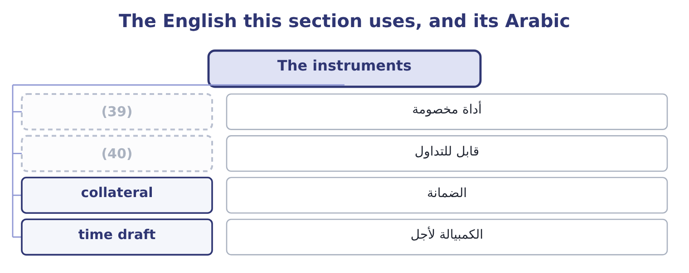
word list
negotiable · discount instrument · treasury bill

The English this sheet uses, and its Arabic
English (exam term) | Arabic
discount instrument | أداة مخصومة
negotiable | قابل للتداول
collateral | الضمانة
time draft | الكمبيالة لأجل

Answer key · 15.2 The instruments

1 offers | 21 originally
2 obligations | 22 high-quality
3 redeemed | 23 spread
4 deepest | 24 diversification
5 everything | 25 selection
6 longer | 26 management
7 beyond | 27 comparison
8 behaves | 28 arithmetic
9 treasurer | 29 Eurodollar
10 unsecured | 30 regulation
11 borrowing | 31 None in its own currency
12 carries | 32 Large companies
13 negotiable | 33 Dealers and banks
14 rather | 34 Overnight to weeks
15 agreements | 35 A bank, on a trade draft
16 Economically | 36 Slightly higher
17 collateral | 37 A fund manager
18 difference | 38 Diversified
19 standard | 39 discount instrument
20 acceptances | 40 negotiable

the summaries in full
Summary 1 The money market offers a short list, and the exam names it. Treasury bills are short-term obligations of the government, issued at a discount and redeemed at face value, with maturities of a few weeks to a year. They carry no credit risk in their own currency and the deepest secondary market of any instrument, which makes them the benchmark against which everything else is priced. Treasury notes and treasury bonds are the same issuer at longer maturities — notes to about ten years, bonds beyond. They are not money market instruments, but a note with three months left to run behaves like one, and a treasurer buys them in the secondary market for exactly that reason. Commercial paper is unsecured short-term borrowing by a large company, issued at a discount, usually for up to 270 days. It pays more than a treasury bill because it carries the issuer's credit risk, and it is rated.
Summary 2 Certificates of deposit are time deposits with a bank, evidenced by a negotiable certificate so that they can be sold before maturity. They pay interest rather than being issued at a discount. Repurchase agreements are sales of securities with an agreement to buy them back at a stated price on a stated date, usually overnight. Economically they are secured loans: the lender holds the securities as collateral and earns the difference between the two prices. They are the standard way to employ cash for one night. Bankers' acceptances are time drafts drawn on and accepted by a bank, originally to finance trade. The bank's acceptance makes the instrument the bank's obligation, so it is high-quality and trades at a small spread over treasury bills.
Summary 3 Money market funds pool many such instruments and offer daily access. They give a small company the diversification and the professional selection it could not arrange itself, for a management fee. Municipal securities, in the United States, are issued by states and local authorities and their interest is exempt from federal income tax, which changes the comparison entirely — section 15.3 does the arithmetic. Eurodollar deposits are dollar deposits held outside the United States, which pay slightly more because they fall outside domestic banking regulation.

15.3 The trade-offs
Chapter 15 · section 15.3

Fill every gap. Each word list holds one word more than there are gaps.
Summary 1 gaps 1–12
Five (1) decide a selection and they pull (2) each other. The outcome names them and the exam's (3) are always about which one is being (4) . Safety, meaning the risk that the (5) is not returned. For working capital this is close to (6) : the money is needed, so a security that might not pay is (7) whatever its yield. Treasury bills are safest, bank (8) next, corporate paper after. Marketability or (9) , meaning how (10) the instrument can be sold at a price close to its value. A treasury bill can be sold in any size in minutes; a (11) of deposit from a small bank may take a day and a (12) in price. Note that marketability is not the same as maturity: a thirty-year treasury bond is highly marketable and has a long maturity, while a three-month deposit at a small bank may be unmarketable and short.
word list
concession · quickly · against · certificate · instruments · unusable · whatever · sacrificed · variables · principal · liquidity · absolute · questions

Summary 2 gaps 13–24
Yield, which rises as the other four (13) . A yield materially above the benchmark is always (14) for something, and the (15) job is to identify. Maturity, which brings two (16) risks. Interest rate risk: a longer instrument falls (17) if rates rise and the money has to be raised early by (18) . And reinvestment risk, the (19) : a short instrument has to be (20) over at whatever rate exists then. Where interest on an instrument is tax-exempt, its (21) yield is not (22) with a taxable one. The tax-equivalent yield puts them on the same basis: a municipal security yielding 3.0 per cent, for a company (23) 25 per cent, is worth 3.0 ÷ 0.75 = 4.00 per cent of taxable yield. Anything taxable yielding less than 4.00 per cent is (24) to that municipal, and anything above it is better.
word list
separate · quickly · worsen · stated · paying · compensation · inferior · comparable · treasurer's · rolled · mirror · further · selling

Worked example: comparing three instruments

Summary 3 gaps 25–36
A $1,000,000 bill with 90 days to run is (25) at $985,000. The gain is 1,000,000 − 985,000 = 15,000, which over the (26) is 15,000 ÷ 985,000 = 1.52 per cent. There are 365 ÷ 90 = 4.0556 such periods in a year, so the (27) yield is about 1.52 × 4.0556 = 6.17 per cent. A municipal at 4.8 per cent, tax-exempt. Its taxable equivalent at a 25 per cent rate is 4.8 ÷ 0.75 = 6.40 per cent. Commercial paper at 6.5 per cent, taxable, from an A-rated (28) . On yield alone the commercial paper wins, by 0.10 (29) over the municipal and 0.33 over the bill. On safety the bill wins (30) . On marketability the bill wins again, and the municipal is the (31) of the three. For a (32) working capital the (33) answer is usually the bill, and the (34) the exam is really asking is (35) a third of a point a year — on $1,000,000 that is $3,300 — is worth the credit risk of an A-rated corporate and the loss of (36) marketability. For money that must be there, it is not.
word list
company's · offered · question · whether · correct · bond-equivalent · outright · issuer · treasurer's · weakest · points · period · same-day

What each choice costs
Choose more | And you give up | Measured by
Yield | (37) | The spread over treasury bills
Safety | Yield | (38)
Marketability | Yield | (39)
A longer maturity | Price stability | (40)
A shorter maturity | Certainty of future rate | Reinvestment risk
A tax-exempt instrument | (41) | The tax-equivalent comparison

word list
Pre-tax yield · The same spread, forgone · Duration, from Chapter 4 · Certainty of future rate · A smaller spread again · Safety, marketability, or both

The English this section uses, and its Arabic
Each term sits against what it means.
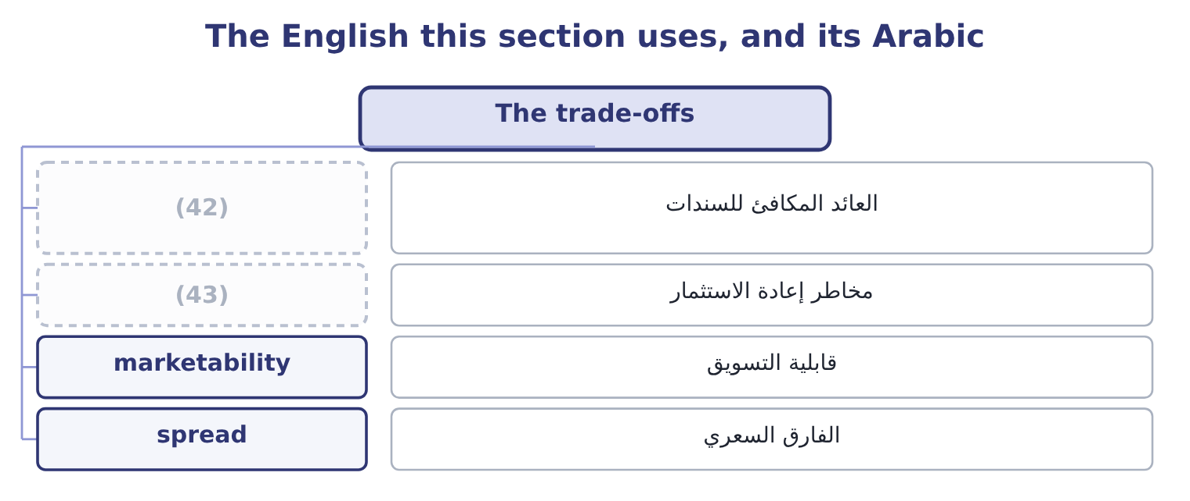
word list
reinvestment risk · matched instrument · bond-equivalent yield

The English this sheet uses, and its Arabic
English (exam term) | Arabic
bond-equivalent yield | العائد المكافئ للسندات
reinvestment risk | مخاطر إعادة الاستثمار
marketability | قابلية التسويق
spread | الفارق السعري

Answer key · 15.3 The trade-offs

1 variables | 23 paying
2 against | 24 inferior
3 questions | 25 offered
4 sacrificed | 26 period
5 principal | 27 bond-equivalent
6 absolute | 28 issuer
7 unusable | 29 points
8 instruments | 30 outright
9 liquidity | 31 weakest
10 quickly | 32 company's
11 certificate | 33 correct
12 concession | 34 question
13 worsen | 35 whether
14 compensation | 36 same-day
15 treasurer's | 37 Safety, marketability, or both
16 separate | 38 The same spread, forgone
17 further | 39 A smaller spread again
18 selling | 40 Duration, from Chapter 4
19 mirror | 41 Pre-tax yield
20 rolled | 42 bond-equivalent yield
21 stated | 43 reinvestment risk
22 comparable

the summaries in full
Summary 1 Five variables decide a selection and they pull against each other. The outcome names them and the exam's questions are always about which one is being sacrificed. Safety, meaning the risk that the principal is not returned. For working capital this is close to absolute: the money is needed, so a security that might not pay is unusable whatever its yield. Treasury bills are safest, bank instruments next, corporate paper after. Marketability or liquidity, meaning how quickly the instrument can be sold at a price close to its value. A treasury bill can be sold in any size in minutes; a certificate of deposit from a small bank may take a day and a concession in price. Note that marketability is not the same as maturity: a thirty-year treasury bond is highly marketable and has a long maturity, while a three-month deposit at a small bank may be unmarketable and short.
Summary 2 Yield, which rises as the other four worsen. A yield materially above the benchmark is always compensation for something, and the treasurer's job is to identify. Maturity, which brings two separate risks. Interest rate risk: a longer instrument falls further if rates rise and the money has to be raised early by selling. And reinvestment risk, the mirror: a short instrument has to be rolled over at whatever rate exists then. Where interest on an instrument is tax-exempt, its stated yield is not comparable with a taxable one. The tax-equivalent yield puts them on the same basis: a municipal security yielding 3.0 per cent, for a company paying 25 per cent, is worth 3.0 ÷ 0.75 = 4.00 per cent of taxable yield. Anything taxable yielding less than 4.00 per cent is inferior to that municipal, and anything above it is better.
Summary 3 A $1,000,000 bill with 90 days to run is offered at $985,000. The gain is 1,000,000 − 985,000 = 15,000, which over the period is 15,000 ÷ 985,000 = 1.52 per cent. There are 365 ÷ 90 = 4.0556 such periods in a year, so the bond-equivalent yield is about 1.52 × 4.0556 = 6.17 per cent. A municipal at 4.8 per cent, tax-exempt. Its taxable equivalent at a 25 per cent rate is 4.8 ÷ 0.75 = 6.40 per cent. Commercial paper at 6.5 per cent, taxable, from an A-rated issuer. On yield alone the commercial paper wins, by 0.10 points over the municipal and 0.33 over the bill. On safety the bill wins outright. On marketability the bill wins again, and the municipal is the weakest of the three. For a company's working capital the correct answer is usually the bill, and the question the exam is really asking is whether a third of a point a year — on $1,000,000 that is $3,300 — is worth the credit risk of an A-rated corporate and the loss of same-day marketability. For money that must be there, it is not.

15.4 Risk and return in a short-term portfolio
Chapter 15 · section 15.4

Fill every gap. Each word list holds one word more than there are gaps.
Summary 1 gaps 1–12
A (1) portfolio is where that (2) meets a constraint which overrides it: the money is spoken for. The constraint works like this. A (3) portfolio exists to be spent. If it falls in value, the company does not have the option of waiting for (4) , because the (5) it was held against falls due on a date. So the first filter is not (6) at all; it is (7) the instrument will be worth its full value on the day the money is needed. (8) that survives that filter is then (9) on yield. Two (10) follow, and both appear in (11) . Maturity matching buys instruments that (12) on the dates the forecast says the money is needed. It removes interest rate risk entirely for that money, because nothing has to be sold: the instrument simply matures. It is the strategy for known commitments.
word list
principle · payment · mature · questions · strategies · recovery · average · return · ranked · working-capital · whether · Everything · short-term

Summary 2 gaps 13–23
Laddering (13) the portfolio across a series of maturities — three, six, nine and twelve months — so that (14) matures regularly and the average yield is higher than a (15) of very short instruments would give. It is the strategy for the part of the (16) whose timing is (17) , and it reduces (18) risk by never rolling the whole portfolio at one rate. Both are forms of the same (19) : let the cash forecast of, rather than (20) maturities by the yield curve and (21) . Three risks (22) and should be named in any (23) . Credit risk, which is managed by quality limits — a policy that nothing below A-1 or P-1 may be bought, and that no single issuer may exceed a stated share of the portfolio.
word list
reinvestment · maximise · something · hoping · discipline · spreads · balance · succession · uncertain · answer · remain · choosing

Summary 3 gaps 24–31
Interest rate risk, which maturity matching removes for (24) money and laddering reduces for the rest. (25) risk, which is the risk that an instrument cannot be sold when an (26) need arises, and which is managed by (27) a tranche of the portfolio in treasury bills or an (28) fund regardless of yield. A written (29) policy that states those limits is the control the exam expects a (30) accountant to recommend, because a treasury (31) left to maximise yield will eventually find an instrument that does.
word list
unforeseen · management · investment · rolling · overnight · keeping · department · matched · Liquidity

The English this section uses, and its Arabic
Each term sits against what it means.
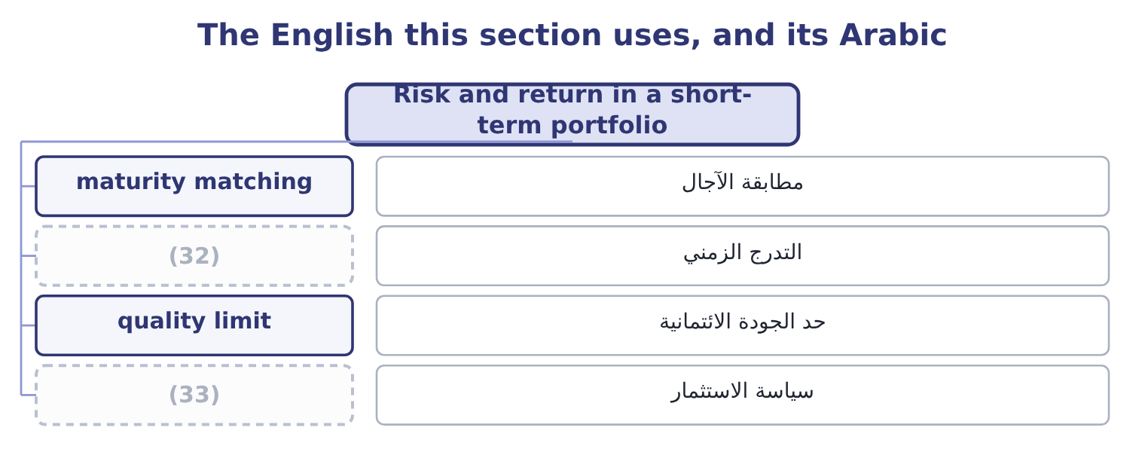
word list
marketable security · investment policy · laddering

The English this sheet uses, and its Arabic
English (exam term) | Arabic
maturity matching | مطابقة الآجال
laddering | التدرج الزمني
quality limit | حد الجودة الائتمانية
investment policy | سياسة الاستثمار

Answer key · 15.4 Risk and return in a short-term portfolio

1 short-term | 18 reinvestment
2 principle | 19 discipline
3 working-capital | 20 choosing
4 recovery | 21 hoping
5 payment | 22 remain
6 return | 23 answer
7 whether | 24 matched
8 Everything | 25 Liquidity
9 ranked | 26 unforeseen
10 strategies | 27 keeping
11 questions | 28 overnight
12 mature | 29 investment
13 spreads | 30 management
14 something | 31 department
15 succession | 32 laddering
16 balance | 33 investment policy
17 uncertain

the summaries in full
Summary 1 A short-term portfolio is where that principle meets a constraint which overrides it: the money is spoken for. The constraint works like this. A working-capital portfolio exists to be spent. If it falls in value, the company does not have the option of waiting for recovery, because the payment it was held against falls due on a date. So the first filter is not return at all; it is whether the instrument will be worth its full value on the day the money is needed. Everything that survives that filter is then ranked on yield. Two strategies follow, and both appear in questions. Maturity matching buys instruments that mature on the dates the forecast says the money is needed. It removes interest rate risk entirely for that money, because nothing has to be sold: the instrument simply matures. It is the strategy for known commitments.
Summary 2 Laddering spreads the portfolio across a series of maturities — three, six, nine and twelve months — so that something matures regularly and the average yield is higher than a succession of very short instruments would give. It is the strategy for the part of the balance whose timing is uncertain, and it reduces reinvestment risk by never rolling the whole portfolio at one rate. Both are forms of the same discipline: let the cash forecast of, rather than choosing maturities by the yield curve and hoping. Three risks remain and should be named in any answer. Credit risk, which is managed by quality limits — a policy that nothing below A-1 or P-1 may be bought, and that no single issuer may exceed a stated share of the portfolio.
Summary 3 Interest rate risk, which maturity matching removes for matched money and laddering reduces for the rest. Liquidity risk, which is the risk that an instrument cannot be sold when an unforeseen need arises, and which is managed by keeping a tranche of the portfolio in treasury bills or an overnight fund regardless of yield. A written investment policy that states those limits is the control the exam expects a management accountant to recommend, because a treasury department left to maximise yield will eventually find an instrument that does.

15.5 Building Orontes's portfolio
Chapter 15 · section 15.5

Fill every gap. Each word list holds one word more than there are gaps.
Summary 1 gaps 1–12
Put the chapter to work. The surplus is 7,302,100 − 2,900,000 = 4,402,100. The known (1) come first. Two (2) need $6,000,000 over four quarters, of which the first (3) fall within this surplus. Each instalment is matched: a treasury bill or a government note (4) in the month the payment is due, bought today at a price that fixes the yield and (5) no sale. What is left is (6) . Divide the (7) balance across three, six, nine and (8) maturities, so that a tranche matures every quarter and the yield exceeds what an overnight account would pay. A liquidity tranche sits inside the ladder, not beside it: a portion held in treasury bills or an overnight (9) agreement, available the same day, sized against the (10) motive. At the 4 per cent available on (11) government paper, the surplus earns 4,402,100 × 0.04 = 176,084 a year that the company earned (12) on in 2025.
word list
twelve-month · projects · requires · commitments · maturing · precautionary · repurchase · unmatched · short-dated · negotiable · laddered · instalments · nothing

Summary 2 gaps 13–22
Against (13) net income of $2,969,100 that is about six per cent of a year's profit, (14) with no risk to the principal, no change to the (15) and no capital (16) — which is why treasury (17) is the part of (18) with the highest return on effort, and the part most often left undone. What it does not change. The $176,084 is real and it is not a (19) for the $840,000 of gross margin Book 1 found the company (20) away each year. Ranking (21) by size, as Book 1's last chapter (22) , puts the margin first and this second. Both are worth doing and only one of them is easy.
word list
obtained · finance · business · management · investment · Orontes's · findings · collateral · insisted · giving · substitute

Select and compare

Your turn: comparing instruments (complete the blanks)
Instrument | Data | Answer
Treasury bill | 500,000 face, bought at 492,500, 90 days | (23)
The same bill | Annualised | ________
Municipal security | 3.6 per cent, tax-exempt | (24)
Commercial paper | (25) | After-tax yield: ________
Which to buy for a payment due in 90 days |  | ________
Annual return on a 4,402,100 surplus at 4 per cent |  | ________

word list
Municipal, tax-equivalent yield · 5.1 per cent, taxable, A-rated · Tax-equivalent yield: ________ · Period return: ________

"Security"

Summary 3 gaps 26–29
English security was the false (26) of Book 2, where it meant both an instrument and a (27) . Here a third sense appears that is easier to miss: in the phrase safety of principal, the quality a (28) wants, English avoids the word security (29) and uses safety, because security would be ambiguous.
word list
friend · altogether · collateral · treasurer · instrument

"Security"
Instrument | Answer
Treasury bill, period return | 1.52 per cent: the gain is 500,000 − 492,500 = 7,500, and 7,500 ÷ 492,500 = 1.52 per cent.
The same bill, annualised | About 6.17 per cent: there are 365 ÷ 90 = 4.0556 periods in a year, and 1.52 × 4.0556 = 6.17 per cent.
Municipal, tax-equivalent yield | (30)
Commercial paper, after-tax yield | (31)
Which to buy for a payment in 90 days | (32) : it matures exactly when the money is needed, carries no credit risk, and on these figures its annualised 6.17 per cent be
Return on a 4,402,100 surplus at 4 per cent | 176,084: 4,402,100 × 0.04 = 176,084.

word list
4.80 per cent: 3.6 ÷ 0.75 = 4.80 per cent. · certificate of deposit · 3.825 per cent: 5.1 × 0.75 = 3.825 per cent. · The treasury bill

The English this section uses, and its Arabic
Each term sits against what it means.
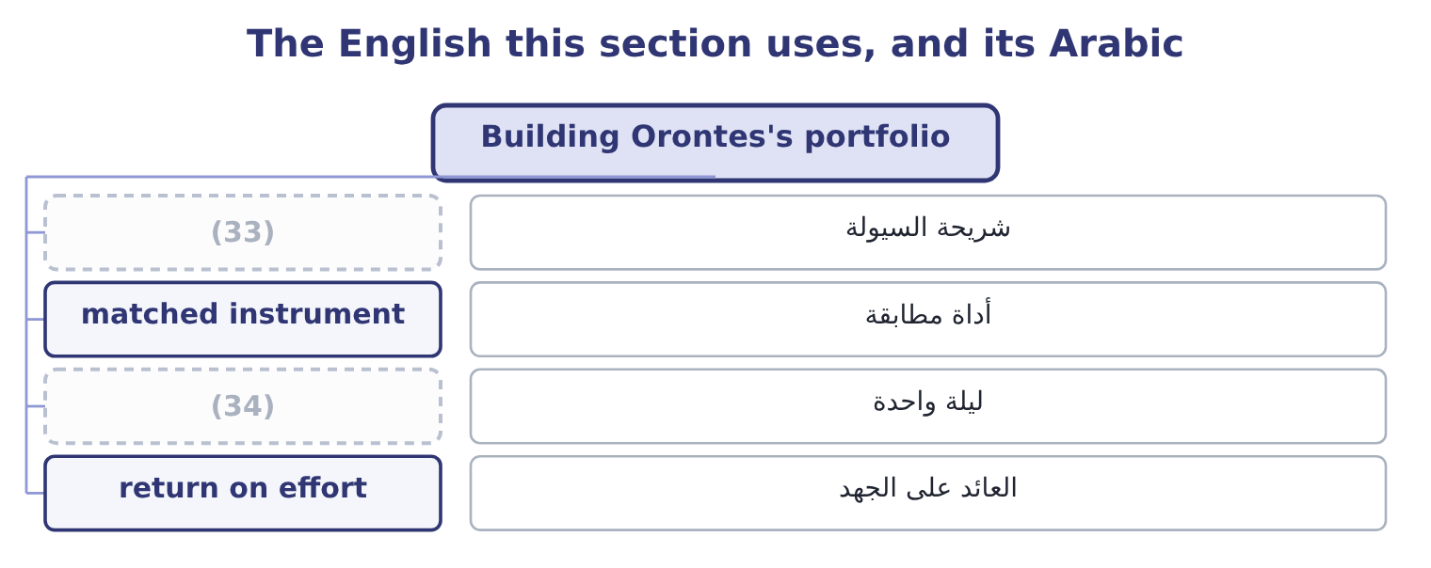
word list
discount instrument · overnight · liquidity tranche

The English this sheet uses, and its Arabic
English (exam term) | Arabic
liquidity tranche | شريحة السيولة
matched instrument | أداة مطابقة
overnight | ليلة واحدة
return on effort | العائد على الجهد

Answer key · 15.5 Building Orontes's portfolio

1 commitments | 18 finance
2 projects | 19 substitute
3 instalments | 20 giving
4 maturing | 21 findings
5 requires | 22 insisted
6 laddered | 23 Period return: ________
7 unmatched | 24 Tax-equivalent yield: ________
8 twelve-month | 25 5.1 per cent, taxable, A-rated
9 repurchase | 26 friend
10 precautionary | 27 collateral
11 short-dated | 28 treasurer
12 nothing | 29 altogether
13 Orontes's | 30 4.80 per cent: 3.6 ÷ 0.75 = 4.80 per cent.
14 obtained | 31 3.825 per cent: 5.1 × 0.75 = 3.825 per cent.
15 business | 32 The treasury bill
16 investment | 33 liquidity tranche
17 management | 34 overnight

the summaries in full
Summary 1 Put the chapter to work. The surplus is 7,302,100 − 2,900,000 = 4,402,100. The known commitments come first. Two projects need $6,000,000 over four quarters, of which the first instalments fall within this surplus. Each instalment is matched: a treasury bill or a government note maturing in the month the payment is due, bought today at a price that fixes the yield and requires no sale. What is left is laddered. Divide the unmatched balance across three, six, nine and twelve-month maturities, so that a tranche matures every quarter and the yield exceeds what an overnight account would pay. A liquidity tranche sits inside the ladder, not beside it: a portion held in treasury bills or an overnight repurchase agreement, available the same day, sized against the precautionary motive. At the 4 per cent available on short-dated government paper, the surplus earns 4,402,100 × 0.04 = 176,084 a year that the company earned nothing on in 2025.
Summary 2 Against Orontes's net income of $2,969,100 that is about six per cent of a year's profit, obtained with no risk to the principal, no change to the business and no capital investment — which is why treasury management is the part of finance with the highest return on effort, and the part most often left undone. What it does not change. The $176,084 is real and it is not a substitute for the $840,000 of gross margin Book 1 found the company giving away each year. Ranking findings by size, as Book 1's last chapter insisted, puts the margin first and this second. Both are worth doing and only one of them is easy.
Summary 3 English security was the false friend of Book 2, where it meant both an instrument and a collateral. Here a third sense appears that is easier to miss: in the phrase safety of principal, the quality a treasurer wants, English avoids the word security altogether and uses safety, because security would be ambiguous.

16.1 What sets the level of receivables
Chapter 16 · section 16.1

Fill every gap. Each word list holds one word more than there are gaps.
Chapter 16, section by section
Each stage leads to the next.
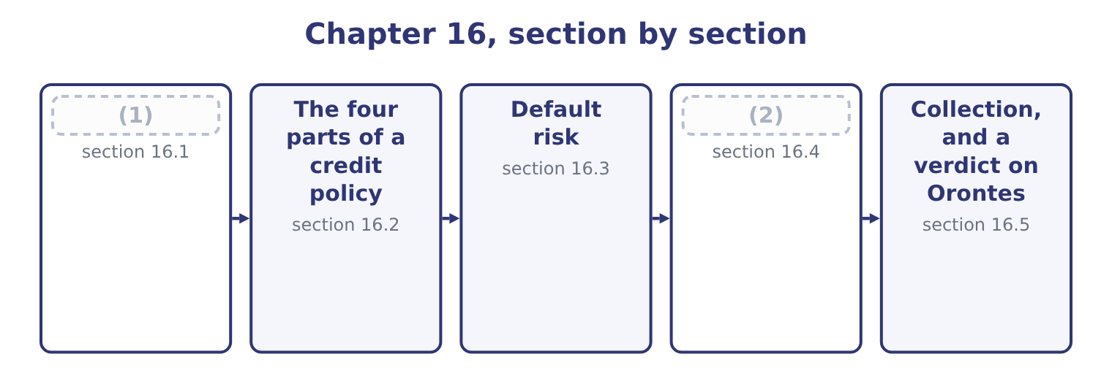
word list
What sets the level of receivables · Testing a change in credit policy · Collection, and a verdict on Orontes

Summary 1 gaps 3–14
Receivables are the (3) of two things only: how much is sold on credit, and how long it takes to (4) . (5) that influences the level works (6) one of those two. More sales on the same terms means more receivables, in proportion. This is the largest factor and the least (7) , which is why the ratio measures — days (8) , turnover — strip it out. The credit terms (9) . Terms of net 45 (10) half as much again in receivables as net 30, on the same sales. This is the (11) own decision and the (12) of section 16.4. The mix of customers. Large (13) pay slowly and reliably; small shops pay quickly or not at all; (14) bodies pay slowest of all and never default. A change in the customer mix changes the collection period without any change in policy.
word list
product · subject · outstanding · offered · government · interesting · retailers · through · write-off · Everything · collect · produce · company's

Summary 2 gaps 15–23
How quickly an (15) account is chased, by whom, and with what (16) . Two companies with (17) terms can have collection periods a (18) apart. (19) and industry (20) . A supplier to a (21) business is paid after the harvest, (22) the invoice says. A company whose (23) all offer 60 days cannot offer 30 and keep its customers. Discounts for early settlement. A discount buys days with margin, and the proportion of customers who take it determines how many days are bought. In a downturn, every customer pays more slowly and more of them fail, and the collection period lengthens without anybody deciding anything.
word list
identical · competitors · practice · harvest-driven · settlement · fortnight · whatever · consequence · overdue · Seasonality

What moves the receivable balance
Every item belongs to exactly one group.
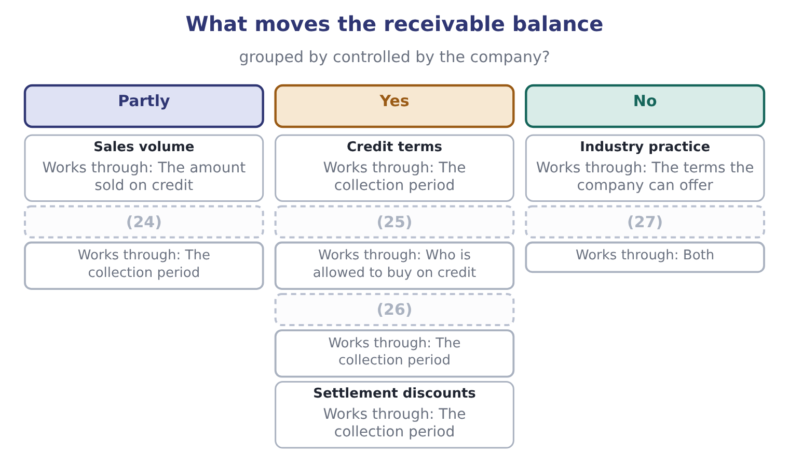
word list
The economy · Customer mix · credit policy · Collection effort · Credit standards

The English this section uses, and its Arabic
Each term sits against what it means.
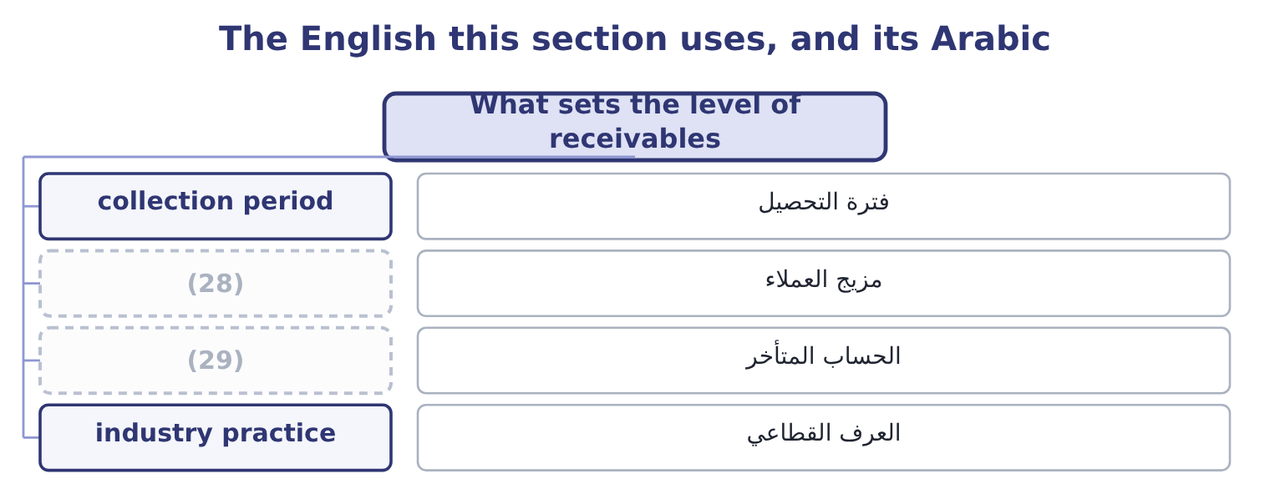
word list
contribution margin · customer mix · overdue account

The English this sheet uses, and its Arabic
English (exam term) | Arabic
collection period | فترة التحصيل
customer mix | مزيج العملاء
overdue account | الحساب المتأخر
industry practice | العرف القطاعي

Answer key · 16.1 What sets the level of receivables

1 What sets the level of receivables | 16 consequence
2 Testing a change in credit policy | 17 identical
3 product | 18 fortnight
4 collect | 19 Seasonality
5 Everything | 20 practice
6 through | 21 harvest-driven
7 interesting | 22 whatever
8 outstanding | 23 competitors
9 offered | 24 Customer mix
10 produce | 25 Credit standards
11 company's | 26 Collection effort
12 subject | 27 The economy
13 retailers | 28 customer mix
14 government | 29 overdue account
15 overdue

the summaries in full
Summary 1 Receivables are the product of two things only: how much is sold on credit, and how long it takes to collect. Everything that influences the level works through one of those two. More sales on the same terms means more receivables, in proportion. This is the largest factor and the least interesting, which is why the ratio measures — days outstanding, turnover — strip it out. The credit terms offered. Terms of net 45 produce half as much again in receivables as net 30, on the same sales. This is the company's own decision and the subject of section 16.4. The mix of customers. Large retailers pay slowly and reliably; small shops pay quickly or not at all; government bodies pay slowest of all and never default. A change in the customer mix changes the collection period without any change in policy.
Summary 2 How quickly an overdue account is chased, by whom, and with what consequence. Two companies with identical terms can have collection periods a fortnight apart. Seasonality and industry practice. A supplier to a harvest-driven business is paid after the harvest, whatever the invoice says. A company whose competitors all offer 60 days cannot offer 30 and keep its customers. Discounts for early settlement. A discount buys days with margin, and the proportion of customers who take it determines how many days are bought. In a downturn, every customer pays more slowly and more of them fail, and the collection period lengthens without anybody deciding anything.

16.2 The four parts of a credit policy
Chapter 16 · section 16.2

Fill every gap. Each word list holds one word more than there are gaps.
Summary 1 gaps 1–12
A credit policy has four (1) , and a question that asks about "an (2) credit policy" is (3) which of them to move. Credit standards decide who is (4) credit at all. They are set by the risk the company will accept, and (5) by the five Cs: (6) , meaning the customer's (7) to pay as shown by its record; capacity, its ability to pay out of cash flow; capital, the equity behind it; (8) , what could be taken if it failed; and conditions, the state of its industry and the economy. The sources are trade references, bank references, published (9) , a credit agency's report, and the company's own (10) . Credit terms decide how long and on what conditions. The (11) notation is read as follows: "2/10, net 30" means two per cent may be (12) if payment is made within ten days, and the full amount is due in thirty.
word list
asking · character · granted · standard · willingness · statements · optimal · collateral · deducted · financing · experience · assessed · elements

Summary 2 gaps 13–23
Collection policy decides what happens when an account goes past due: the (13) , the reminder, the (14) call, the stop on further supply, the collection agency, the lawyer. Each step costs money and each risks the customer (15) , so the sequence is a policy and not an (16) . The (17) decides how much (18) the company will give up to be paid sooner. The (19) , which is the (20) idea, is where the marginal benefit of relaxing a policy equals its marginal cost. Relaxing standards wins customers and adds bad debts. (21) terms wins sales and adds (22) cost. (23) collection keeps customers and lengthens the period. Every move has a gain and a cost, and the analysis of section 16.4 is how they are compared.
word list
examinable · Softening · telephone · relationship · compared · statement · financing · discount · optimum · improvisation · Lengthening · margin

The English this section uses, and its Arabic
Each term sits against what it means.
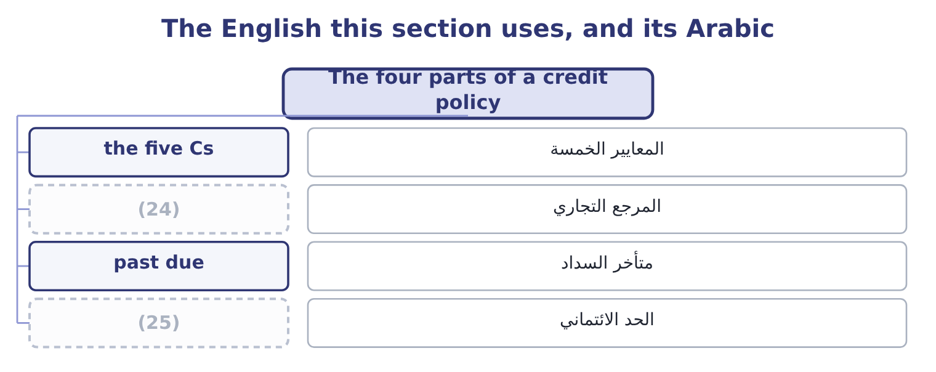
word list
past due · trade reference · credit limit

The English this sheet uses, and its Arabic
English (exam term) | Arabic
the five Cs | المعايير الخمسة
trade reference | المرجع التجاري
past due | متأخر السداد
credit limit | الحد الائتماني

Answer key · 16.2 The four parts of a credit policy

1 elements | 14 telephone
2 optimal | 15 relationship
3 asking | 16 improvisation
4 granted | 17 discount
5 assessed | 18 margin
6 character | 19 optimum
7 willingness | 20 examinable
8 collateral | 21 Lengthening
9 statements | 22 financing
10 experience | 23 Softening
11 standard | 24 trade reference
12 deducted | 25 credit limit
13 statement

the summaries in full
Summary 1 A credit policy has four elements, and a question that asks about "an optimal credit policy" is asking which of them to move. Credit standards decide who is granted credit at all. They are set by the risk the company will accept, and assessed by the five Cs: character, meaning the customer's willingness to pay as shown by its record; capacity, its ability to pay out of cash flow; capital, the equity behind it; collateral, what could be taken if it failed; and conditions, the state of its industry and the economy. The sources are trade references, bank references, published statements, a credit agency's report, and the company's own experience. Credit terms decide how long and on what conditions. The standard notation is read as follows: "2/10, net 30" means two per cent may be deducted if payment is made within ten days, and the full amount is due in thirty.
Summary 2 Collection policy decides what happens when an account goes past due: the statement, the reminder, the telephone call, the stop on further supply, the collection agency, the lawyer. Each step costs money and each risks the customer relationship, so the sequence is a policy and not an improvisation. The discount decides how much margin the company will give up to be paid sooner. The optimum, which is the examinable idea, is where the marginal benefit of relaxing a policy equals its marginal cost. Relaxing standards wins customers and adds bad debts. Lengthening terms wins sales and adds financing cost. Softening collection keeps customers and lengthens the period. Every move has a gain and a cost, and the analysis of section 16.4 is how they are compared.

16.3 Default risk
Chapter 16 · section 16.3

Fill every gap. Each word list holds one word more than there are gaps.
Summary 1 gaps 1–12
Default risk is the risk that a customer does not pay what it owes, in full or at all. It is the price of (1) on credit, it can be reduced and never removed, and the exam wants it (2) rather than (3) . Three (4) measure it. The ageing (5) sorts the receivable book by how long each balance has been (6) : current, 1 to 30 days past due, 31 to 60, 61 to 90, over 90. It is the instrument Book 1 said a days-outstanding figure cannot (7) , because an average of 34.3 days is consistent with (8) paying on time and with one large account at 120 days. The pattern of (9) between the (10) is the early warning. The allowance for credit losses is the (11) estimate of what will not be (12) , charged to the income statement as a credit loss expense.
word list
assigns · collected · measured · replace · columns · everybody · company's · described · outstanding · movement · schedule · selling · instruments

Summary 2 gaps 13–24
Orontes's allowance is $156,000 against a gross book of $4,300,000, which is 156,000 ÷ 4,300,000 = 3.63 per cent — held (13) against 3.59 per cent a year (14) , which Book 1 read as consistent. Credit (15) assigns a number to a customer from its (16) and its history, and sets a credit limit from the score. It makes (17) consistent and fast, and it is only as good as the data (18) it. Four ways to (19) the risk, each with a cost. Tighter (20) , which lose sales. Security: a personal (21) , a letter of credit, a (22) of title clause, a deposit. Each costs the customer (23) and may lose the sale. Credit (24) , which transfers the risk for a premium. Factoring, which sells the receivable outright. Book 1 found a $15,000 loss on sale of receivables in Orontes's income statement, which is this decision already taken for part of the book.
word list
behind · steady · earlier · standards · characteristics · reduce · days-outstanding · decisions · scoring · guarantee · retention · insurance · something

An ageing schedule, and the reading
Each stage leads to the next.
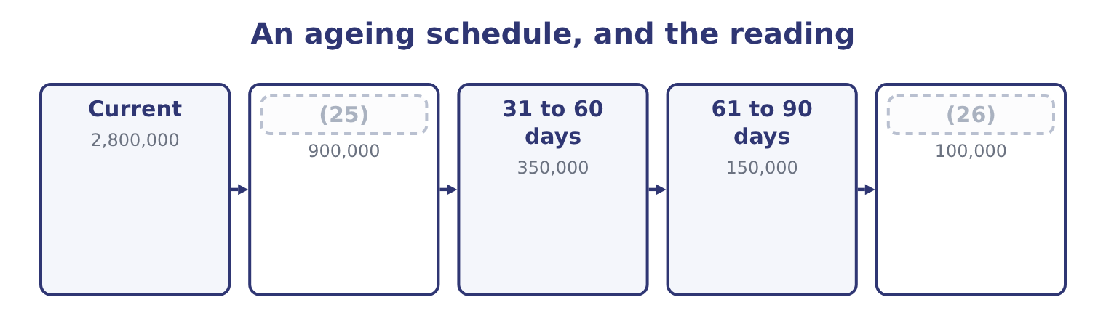
word list
retention of title · 1 to 30 days past due · Over 90 days

The English this section uses, and its Arabic
Each term sits against what it means.
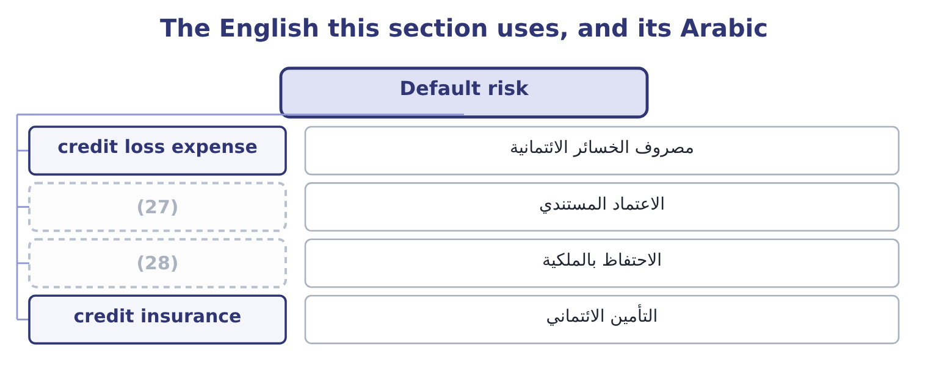
word list
letter of credit · stop on supply · retention of title

The English this sheet uses, and its Arabic
English (exam term) | Arabic
credit loss expense | مصروف الخسائر الائتمانية
letter of credit | الاعتماد المستندي
retention of title | الاحتفاظ بالملكية
credit insurance | التأمين الائتماني

Answer key · 16.3 Default risk

1 selling | 15 scoring
2 measured | 16 characteristics
3 described | 17 decisions
4 instruments | 18 behind
5 schedule | 19 reduce
6 outstanding | 20 standards
7 replace | 21 guarantee
8 everybody | 22 retention
9 movement | 23 something
10 columns | 24 insurance
11 company's | 25 1 to 30 days past due
12 collected | 26 Over 90 days
13 steady | 27 letter of credit
14 earlier | 28 retention of title

the summaries in full
Summary 1 Default risk is the risk that a customer does not pay what it owes, in full or at all. It is the price of selling on credit, it can be reduced and never removed, and the exam wants it measured rather than described. Three instruments measure it. The ageing schedule sorts the receivable book by how long each balance has been outstanding: current, 1 to 30 days past due, 31 to 60, 61 to 90, over 90. It is the instrument Book 1 said a days-outstanding figure cannot replace, because an average of 34.3 days is consistent with everybody paying on time and with one large account at 120 days. The pattern of movement between the columns is the early warning. The allowance for credit losses is the company's estimate of what will not be collected, charged to the income statement as a credit loss expense.
Summary 2 Orontes's allowance is $156,000 against a gross book of $4,300,000, which is 156,000 ÷ 4,300,000 = 3.63 per cent — held steady against 3.59 per cent a year earlier, which Book 1 read as consistent. Credit scoring assigns a number to a customer from its characteristics and its history, and sets a credit limit from the score. It makes decisions consistent and fast, and it is only as good as the data behind it. Four ways to reduce the risk, each with a cost. Tighter standards, which lose sales. Security: a personal guarantee, a letter of credit, a retention of title clause, a deposit. Each costs the customer something and may lose the sale. Credit insurance, which transfers the risk for a premium. Factoring, which sells the receivable outright. Book 1 found a $15,000 loss on sale of receivables in Orontes's income statement, which is this decision already taken for part of the book.

16.4 Testing a change in credit policy
Chapter 16 · section 16.4

Fill every gap. Each word list holds one word more than there are gaps.
Summary 1 gaps 1–2
This is the (1) the outcome names and the exam sets. The (2) never varies: compare the incremental gain with the incremental cost, counting only what changes.
word list
calculation · investment · structure

Worked example: lengthening the terms from 30 to 45 days

Summary 2 gaps 3–8
Orontes's sales (3) proposes moving from net 30 to net 45. Sales are expected to rise from $42,000,000 to $45,000,000. The contribution margin on the extra sales is 40 per cent, so (4) costs are 60 per cent. Receivables are expected to run at the new 45 days. Bad debts on the new (5) are expected at 4 per cent of those sales. The carrying cost of money is the company's cost of (6) of 9.04 per cent. The extra sales are 45,000,000 − 42,000,000 = 3,000,000, and at a 40 per cent contribution margin they add 3,000,000 × 0.40 = 1,200,000 of contribution. Fixed costs do not change, so that is the gross benefit. The extra investment in receivables. At 45 days, the book (7) 45,000,000 × 45 ÷ 365 = 5,547,945 (8) the present $4,144,000, an increase of 5,547,945 − 4,144,000 = 1,403,945.
word list
capital · business · against · director · variable · becomes · Tightening

Summary 3 gaps 9–18
The company's own money in that increase is its cost, not its (9) price, so at a 60 per cent variable-cost ratio the investment is 1,403,945 × 0.60 = 842,367. The cost of carrying it. Four per cent of the new sales: 3,000,000 × 0.04 = 120,000. The (10) should be accepted. Notice which (11) did the work. The gain is large because the contribution margin is high and fixed costs do not change; the costs are small because money is cheap (12) to a 40 per cent margin. Reverse (13) and the answer (14) : at a 10 per cent contribution margin the gain would be $300,000 and the costs would still be (15) $200,000, and at a 20 per cent cost of money the carrying cost alone would be $168,473. The (16) version of this (17) is always a test of whether the (18) knows which figures to vary.
word list
exam's · nearly · question · either · reverses · shorten · proposal · candidate · numbers · selling · relative

The credit policy template
Line | Computation | This case
Increase in sales | New sales less old | 3,000,000
Increase in contribution | Times the contribution margin | 1,200,000
New receivable balance | New sales times new days, over 365 | 5,547,945
Increase in receivables | (19) | 1,403,945
Investment in that increase | (20) | 842,367
Carrying cost | (21) | (76,150)
Additional bad debts | (22) | (120,000)
Net benefit |  | 1,003,850

word list
Times the variable-cost ratio · New balance less old · New sales times the expected rate · Times the cost of money · Times the contribution margin

Summary 4 gaps 23–33
The same (23) tests every other change, with one line (24) . Tightening (25) : sales fall, contribution falls, receivables fall, bad debts fall. (26) if the bad debts and carrying cost saved (27) the contribution lost. (28) a discount of 2/10 on terms of net 30, where 60 per cent of customers take it: the cost is 0.02 × 0.60 × 45,000,000 = 540,000 a year of margin, and the benefit is the carrying cost saved on a shorter collection period plus any (29) in bad debts. On these figures the discount is (30) and would have to (31) the period by a great deal to pay. Tightening collection: the cost is the collection (32) plus any customers lost; the benefit is a shorter period and fewer (33) .
word list
reduction · expenditure · proposes · standards · exceed · altered · shorten · write-offs · template · Offering · expensive · Accept

The English this section uses, and its Arabic
Each term sits against what it means.
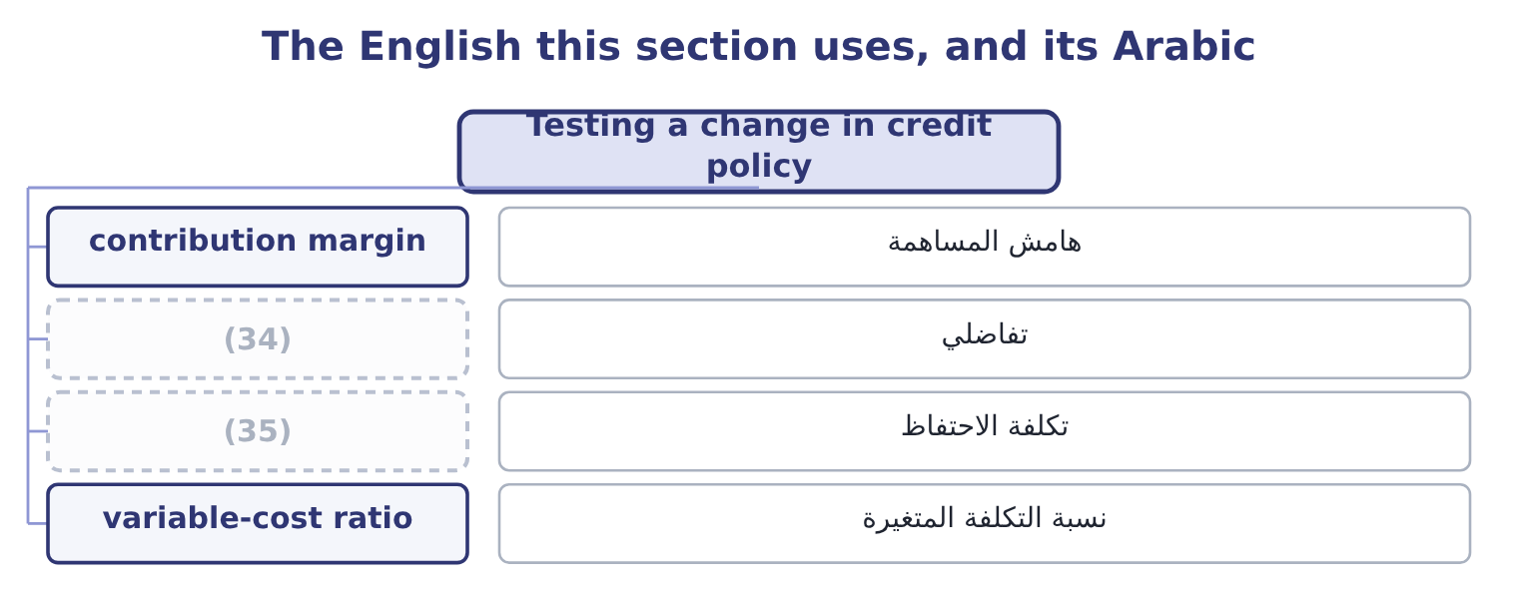
word list
carrying cost · write-off · incremental

The English this sheet uses, and its Arabic
English (exam term) | Arabic
contribution margin | هامش المساهمة
incremental | تفاضلي
carrying cost | تكلفة الاحتفاظ
variable-cost ratio | نسبة التكلفة المتغيرة

Answer key · 16.4 Testing a change in credit policy

1 calculation | 19 New balance less old
2 structure | 20 Times the variable-cost ratio
3 director | 21 Times the cost of money
4 variable | 22 New sales times the expected rate
5 business | 23 template
6 capital | 24 altered
7 becomes | 25 standards
8 against | 26 Accept
9 selling | 27 exceed
10 proposal | 28 Offering
11 numbers | 29 reduction
12 relative | 30 expensive
13 either | 31 shorten
14 reverses | 32 expenditure
15 nearly | 33 write-offs
16 exam's | 34 incremental
17 question | 35 carrying cost
18 candidate

the summaries in full
Summary 1 This is the calculation the outcome names and the exam sets. The structure never varies: compare the incremental gain with the incremental cost, counting only what changes.
Summary 2 Orontes's sales director proposes moving from net 30 to net 45. Sales are expected to rise from $42,000,000 to $45,000,000. The contribution margin on the extra sales is 40 per cent, so variable costs are 60 per cent. Receivables are expected to run at the new 45 days. Bad debts on the new business are expected at 4 per cent of those sales. The carrying cost of money is the company's cost of capital of 9.04 per cent. The extra sales are 45,000,000 − 42,000,000 = 3,000,000, and at a 40 per cent contribution margin they add 3,000,000 × 0.40 = 1,200,000 of contribution. Fixed costs do not change, so that is the gross benefit. The extra investment in receivables. At 45 days, the book becomes 45,000,000 × 45 ÷ 365 = 5,547,945 against the present $4,144,000, an increase of 5,547,945 − 4,144,000 = 1,403,945.
Summary 3 The company's own money in that increase is its cost, not its selling price, so at a 60 per cent variable-cost ratio the investment is 1,403,945 × 0.60 = 842,367. The cost of carrying it. Four per cent of the new sales: 3,000,000 × 0.04 = 120,000. The proposal should be accepted. Notice which numbers did the work. The gain is large because the contribution margin is high and fixed costs do not change; the costs are small because money is cheap relative to a 40 per cent margin. Reverse either and the answer reverses: at a 10 per cent contribution margin the gain would be $300,000 and the costs would still be nearly $200,000, and at a 20 per cent cost of money the carrying cost alone would be $168,473. The exam's version of this question is always a test of whether the candidate knows which figures to vary.
Summary 4 The same template tests every other change, with one line altered. Tightening standards: sales fall, contribution falls, receivables fall, bad debts fall. Accept if the bad debts and carrying cost saved exceed the contribution lost. Offering a discount of 2/10 on terms of net 30, where 60 per cent of customers take it: the cost is 0.02 × 0.60 × 45,000,000 = 540,000 a year of margin, and the benefit is the carrying cost saved on a shorter collection period plus any reduction in bad debts. On these figures the discount is expensive and would have to shorten the period by a great deal to pay. Tightening collection: the cost is the collection expenditure plus any customers lost; the benefit is a shorter period and fewer write-offs.

16.5 Collection, and a verdict on Orontes
Chapter 16 · section 16.5

Fill every gap. Each word list holds one word more than there are gaps.
Summary 1 gaps 1–12
Collection policy is the part of credit (1) that is executed rather than decided, and three (2) govern it. Act early and (3) . An account that is three days overdue is a (4) matter; the same account at ninety days is a (5) . The cost of the first (6) is trivial and its effect is large, which is why the ageing (7) is reviewed weekly rather than monthly. (8) the collection decision from the sales (9) . A sales (10) paid on revenue is the wrong person to stop a (11) supply, and a credit function that reports to sales will not do it either. The exam treats this as a control (12) , which it is. Escalate by steps that are agreed in advance. Statement, reminder, call, stop on supply, final demand, agency, legal action — with the authority for each step and the days at which it triggers written down, so that the decision to continue supplying a slow payer is taken deliberately.
word list
dispute · representative · contact · question · schedule · management · customer's · clerical · consistently · principles · Separate · relationship · facility

Summary 2 gaps 13–24
Now the (13) on Orontes. Its days sales (14) is 34.3 against terms the company (15) as about 30: four days of slippage, which on daily sales of $115,068 is 115,068 × 4 = 460,272 of money the terms say should be in the bank. Its (16) ratio is steady and its credit loss (17) of $63,000 is modest. Its receivables grew more (18) than its sales. The book is well run. The finding is therefore not a problem but an (19) , and it is the one section 16.4 quantified: a company with a 35 per cent gross margin, a cost of money near 9 per cent and (20) bad debts is a company that should probably be selling more on credit rather than less. The $1,003,850 of net benefit in the worked example is larger than the $840,000 of lost gross margin that Book 1 ranked as the (21) first finding — and it is the first idea in two books that would (22) address that finding, because it buys volume without cutting price. That is the note on which the (23) chapters turn from (24) cost to creating value.
word list
controlling · verdict · slowly · company's · describes · working-capital · opportunity · well-controlled · actually · reduction · expense · outstanding · allowance

Test a tightening

Your turn: tightening credit standards (complete the blanks)
Item | Data | Answer
Sales lost | Sales fall from 20,000,000 to 18,500,000 | 1,500,000: 20,000,000 − 18,500,000 = 1,500,000.
Contribution lost | Contribution margin 30 per cent | (25)
New receivable balance | 25 days on the new sales | (26)
Old receivable balance | 2,400,000 | 2,400,000, as given.
Reduction in receivables |  | (27)
Investment released | (28) | 793,014: 1,132,877 × 0.70 = 793,014.
Carrying cost saved | Cost of money 10 per cent | (29)
Bad debts saved | (30) | 75,000: 1,500,000 × 0.05 = 75,000.
Decision |  | Reject the tightening. The savings are 79,301 + 75,000 = 154,301 against 450,000 of contribution lost, so the company would be 295,699 a yea

word list
Variable-cost ratio 70 per cent · 5 per cent of the lost sales · Sales fall from 20,000,000 to 18,500,000 · 1,267,123: 18,500,000 × 25 ÷ 365 = 1,267,123. · 79,301: 793,014 × 0.10 = 79,301. · 450,000: 1,500,000 × 0.30 = 450,000. · 1,132,877: 2,400,000 − 1,267,123 = 1,132,877.

"Credit"

Summary 3 gaps 31–37
English credit is one of the most (31) words in the whole (32) . It is the (33) a seller grants a buyer, as in credit terms. It is the (34) side of a double entry, as in debit and credit. It is a reduction in tax, as in a tax credit. It is a (35) , as in credit risk. And to credit an account is to increase a (36) or reduce an asset, which is the (37) of what a customer means by getting credit.
word list
overloaded · right-hand · verdict · liability · facility · rating · opposite · syllabus

The English this section uses, and its Arabic
Each term sits against what it means.
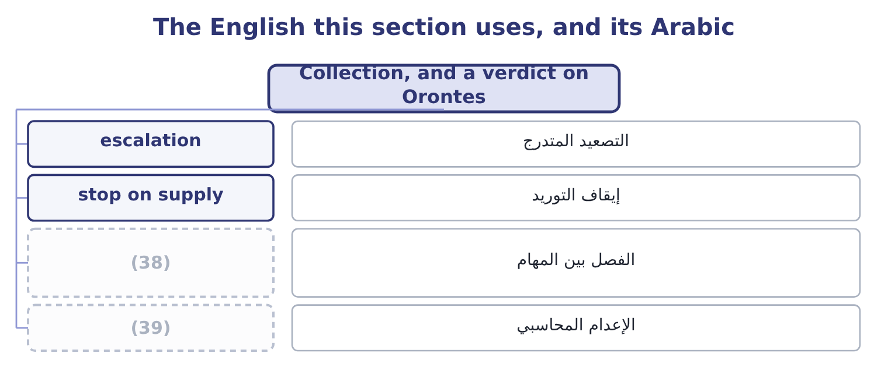
word list
segregation of duties · default risk · write-off

The English this sheet uses, and its Arabic
English (exam term) | Arabic
escalation | التصعيد المتدرج
stop on supply | إيقاف التوريد
segregation of duties | الفصل بين المهام
write-off | الإعدام المحاسبي

Answer key · 16.5 Collection, and a verdict on Orontes

1 management | 21 company's
2 principles | 22 actually
3 consistently | 23 working-capital
4 clerical | 24 controlling
5 dispute | 25 450,000: 1,500,000 × 0.30 = 450,000.
6 contact | 26 1,267,123: 18,500,000 × 25 ÷ 365 = 1,267,123.
7 schedule | 27 1,132,877: 2,400,000 − 1,267,123 = 1,132,877.
8 Separate | 28 Variable-cost ratio 70 per cent
9 relationship | 29 79,301: 793,014 × 0.10 = 79,301.
10 representative | 30 5 per cent of the lost sales
11 customer's | 31 overloaded
12 question | 32 syllabus
13 verdict | 33 facility
14 outstanding | 34 right-hand
15 describes | 35 rating
16 allowance | 36 liability
17 expense | 37 opposite
18 slowly | 38 segregation of duties
19 opportunity | 39 write-off
20 well-controlled

the summaries in full
Summary 1 Collection policy is the part of credit management that is executed rather than decided, and three principles govern it. Act early and consistently. An account that is three days overdue is a clerical matter; the same account at ninety days is a dispute. The cost of the first contact is trivial and its effect is large, which is why the ageing schedule is reviewed weekly rather than monthly. Separate the collection decision from the sales relationship. A sales representative paid on revenue is the wrong person to stop a customer's supply, and a credit function that reports to sales will not do it either. The exam treats this as a control question, which it is. Escalate by steps that are agreed in advance. Statement, reminder, call, stop on supply, final demand, agency, legal action — with the authority for each step and the days at which it triggers written down, so that the decision to continue supplying a slow payer is taken deliberately.
Summary 2 Now the verdict on Orontes. Its days sales outstanding is 34.3 against terms the company describes as about 30: four days of slippage, which on daily sales of $115,068 is 115,068 × 4 = 460,272 of money the terms say should be in the bank. Its allowance ratio is steady and its credit loss expense of $63,000 is modest. Its receivables grew more slowly than its sales. The book is well run. The finding is therefore not a problem but an opportunity, and it is the one section 16.4 quantified: a company with a 35 per cent gross margin, a cost of money near 9 per cent and well-controlled bad debts is a company that should probably be selling more on credit rather than less. The $1,003,850 of net benefit in the worked example is larger than the $840,000 of lost gross margin that Book 1 ranked as the company's first finding — and it is the first idea in two books that would actually address that finding, because it buys volume without cutting price. That is the note on which the working-capital chapters turn from controlling cost to creating value.
Summary 3 English credit is one of the most overloaded words in the whole syllabus. It is the facility a seller grants a buyer, as in credit terms. It is the right-hand side of a double entry, as in debit and credit. It is a reduction in tax, as in a tax credit. It is a rating, as in credit risk. And to credit an account is to increase a liability or reduce an asset, which is the opposite of what a customer means by getting credit.

17.1 Why inventory is held
Chapter 17 · section 17.1

Fill every gap. Each word list holds one word more than there are gaps.
Chapter 17, section by section
Each stage leads to the next.
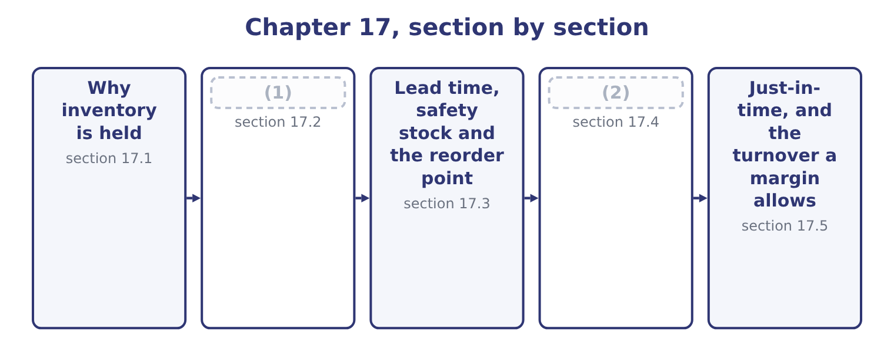
word list
Why inventory is held · The three costs · How much to order

Summary 1 gaps 3–14
Four reasons, and the exam asks for them by name. To meet demand that is not perfectly (3) . A customer who wants (4) today will buy it from (5) who has it. The stock held for this reason is the buffer, and its size depends on how (6) the demand is and on how (7) a lost sale is. To (8) the stages of a (9) . A mill that stops when the roaster stops is a mill that runs at the (10) worst day. Work in (11) between the stages lets each run at its own (12) . This is the reason (13) attacks most (14) , by removing the need rather than the stock. To obtain quantity discounts and reduce ordering effort. Buying in larger lots costs less per unit in both price and administration, and the saving is paid for in storage and funding — which is exactly the trade-off the economic order quantity resolves.
word list
attacks · directly · something · just-in-time · somebody · rhythm · progress · predictable · process · variable · expensive · decouple · roaster's

Summary 2 gaps 15–22
To guard (15) price rises or supply (16) . A company whose input is (17) , imported, or subject to a (18) price may hold more than it needs now (19) it expects to need it later at a worse price. Orontes (20) sesame is this case. What sets the level, beyond the reasons, is a short list: the (21) of demand, the length and (22) of the lead time, the cost of a stockout, the cost of money, the shelf life of the goods, and the terms available from suppliers.
word list
because · importing · suppliers · seasonal · predictability · volatile · reliability · against · interruptions

The English this section uses, and its Arabic
Each term sits against what it means.
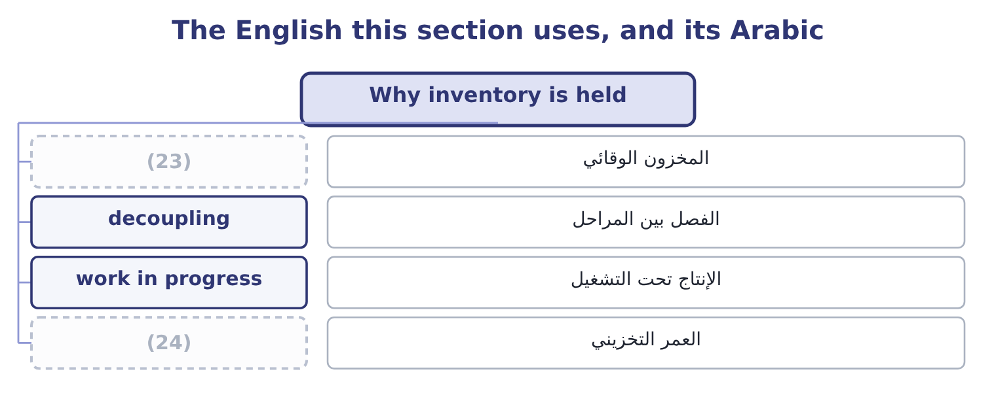
word list
buffer stock · lead time · shelf life

The English this sheet uses, and its Arabic
English (exam term) | Arabic
buffer stock | المخزون الوقائي
decoupling | الفصل بين المراحل
work in progress | الإنتاج تحت التشغيل
shelf life | العمر التخزيني

Answer key · 17.1 Why inventory is held

1 The three costs | 13 just-in-time
2 How much to order | 14 directly
3 predictable | 15 against
4 something | 16 interruptions
5 somebody | 17 seasonal
6 variable | 18 volatile
7 expensive | 19 because
8 decouple | 20 importing
9 process | 21 predictability
10 roaster's | 22 reliability
11 progress | 23 buffer stock
12 rhythm | 24 shelf life

the summaries in full
Summary 1 Four reasons, and the exam asks for them by name. To meet demand that is not perfectly predictable. A customer who wants something today will buy it from somebody who has it. The stock held for this reason is the buffer, and its size depends on how variable the demand is and on how expensive a lost sale is. To decouple the stages of a process. A mill that stops when the roaster stops is a mill that runs at the roaster's worst day. Work in progress between the stages lets each run at its own rhythm. This is the reason just-in-time attacks most directly, by removing the need rather than the stock. To obtain quantity discounts and reduce ordering effort. Buying in larger lots costs less per unit in both price and administration, and the saving is paid for in storage and funding — which is exactly the trade-off the economic order quantity resolves.
Summary 2 To guard against price rises or supply interruptions. A company whose input is seasonal, imported, or subject to a volatile price may hold more than it needs now because it expects to need it later at a worse price. Orontes importing sesame is this case. What sets the level, beyond the reasons, is a short list: the predictability of demand, the length and reliability of the lead time, the cost of a stockout, the cost of money, the shelf life of the goods, and the terms available from suppliers.

17.2 The three costs
Chapter 17 · section 17.2

Fill every gap. Each word list holds one word more than there are gaps.
Summary 1 gaps 1–12
Carrying costs rise with the quantity held. They are the cost of funding the money in the stock, which is the largest item; storage, (1) and insurance; (2) from theft and damage; and obsolescence. They are usually expressed as an amount per unit per year, or as a (3) of the unit cost — twenty to (4) per cent a year is a common figure once funding, storage and obsolescence are added. Ordering costs fall with the quantity held, (5) a larger order means fewer (6) . They are the (7) cost of raising and receiving an order, the inspection, the transport where it does not vary with quantity, and for a (8) the cost of setting up a production run. Stockout costs arise when the stock runs out: the lost contribution on the sale, the (9) freight to get goods urgently, the idle production line, and the customer who goes elsewhere (10) . They are the hardest to measure and usually the largest, which is why they are estimated rather than (11) and why companies hold more stock than any formula (12) .
word list
percentage · manufacturer · formula · because · computed · suggests · expedited · permanently · twenty-five · handling · administrative · orders · shrinkage

Three costs, three directions
Cost | What it contains | As order quantity rises | How it is measured
Carrying | (13) | Rises | Per unit a year
Ordering | Administration, inspection, set-up | Falls | (14)
Stockout | (15) | Falls, then flattens | Estimated

word list
Funding, storage, insurance, obsolescence · Lost contribution, expediting, lost customers · square root · Per order

Which cost is which

Summary 2 gaps 16–22
Funding the stock is a carrying cost, not an ordering cost, (16) the invoice is paid. A set-up cost in a (17) behaves exactly as an ordering cost does, and the economic order quantity formula is used for production (18) with the set-up cost in place of the ordering cost. Quantity (19) are not in the basic formula. Where a (20) offers one, (21) the total cost at the economic order quantity and at each discount break and (22) them.
word list
however · factory · discounts · question · funding · batches · compute · compare

The English this section uses, and its Arabic
Each term sits against what it means.
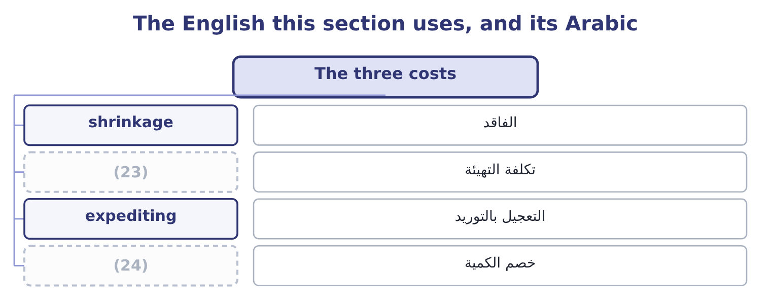
word list
safety stock · set-up cost · quantity discount

The English this sheet uses, and its Arabic
English (exam term) | Arabic
shrinkage | الفاقد
set-up cost | تكلفة التهيئة
expediting | التعجيل بالتوريد
quantity discount | خصم الكمية

Answer key · 17.2 The three costs

1 handling | 13 Funding, storage, insurance, obsolescence
2 shrinkage | 14 Per order
3 percentage | 15 Lost contribution, expediting, lost customers
4 twenty-five | 16 however
5 because | 17 factory
6 orders | 18 batches
7 administrative | 19 discounts
8 manufacturer | 20 question
9 expedited | 21 compute
10 permanently | 22 compare
11 computed | 23 set-up cost
12 suggests | 24 quantity discount

the summaries in full
Summary 1 Carrying costs rise with the quantity held. They are the cost of funding the money in the stock, which is the largest item; storage, handling and insurance; shrinkage from theft and damage; and obsolescence. They are usually expressed as an amount per unit per year, or as a percentage of the unit cost — twenty to twenty-five per cent a year is a common figure once funding, storage and obsolescence are added. Ordering costs fall with the quantity held, because a larger order means fewer orders. They are the administrative cost of raising and receiving an order, the inspection, the transport where it does not vary with quantity, and for a manufacturer the cost of setting up a production run. Stockout costs arise when the stock runs out: the lost contribution on the sale, the expedited freight to get goods urgently, the idle production line, and the customer who goes elsewhere permanently. They are the hardest to measure and usually the largest, which is why they are estimated rather than computed and why companies hold more stock than any formula suggests.
Summary 2 Funding the stock is a carrying cost, not an ordering cost, however the invoice is paid. A set-up cost in a factory behaves exactly as an ordering cost does, and the economic order quantity formula is used for production batches with the set-up cost in place of the ordering cost. Quantity discounts are not in the basic formula. Where a question offers one, compute the total cost at the economic order quantity and at each discount break and compare them.

17.3 Lead time, safety stock and the reorder point
Chapter 17 · section 17.3

Fill every gap. Each word list holds one word more than there are gaps.
Summary 1 gaps 1–10
Lead time is the (1) between placing an order and (2) the goods. It is why a company (3) wait until the shelf is empty: an order placed on the day of the stockout (4) a week after it. The reorder point is the stock level at which the next order is placed. In the (5) case it is the (6) that will be used during the lead time: daily usage times lead time in days. Safety stock is the buffer held (7) the two things that go wrong — demand (8) than expected during the lead time, and a lead time (9) than expected. (10) it to the reorder point gives the full rule.
word list
working · arrives · longer · higher · simplest · against · interval · cannot · quantity · receiving · Adding

Worked example: when to order

Summary 2 gaps 11–19
A company uses 10,000 units a year over 250 working days, which is 10,000 ÷ 250 = 40 units a day. Five working days, so the usage during the lead time is 40 × 5 = 200 units. Demand is (11) and the supplier is occasionally late, so the company holds 100 units of safety stock — about two and a half days of usage. The safety stock is held all the time and used occasionally, so it is a (12) addition to the (13) stock and its whole cost is a carrying cost: at $4 a unit a year, 100 × 4 = 400 a year. That is the price of the (14) , and it should be (15) with the cost of the (16) it prevents. Where a question gives the (17) of a stockout at each level of safety stock and the cost of one, the (18) is the level at which the expected stockout cost plus the carrying cost is (19) .
word list
protection · stockouts · average · lowest · permanent · probability · compared · question · variable · answer

What moves the reorder point
Every item belongs to exactly one group.
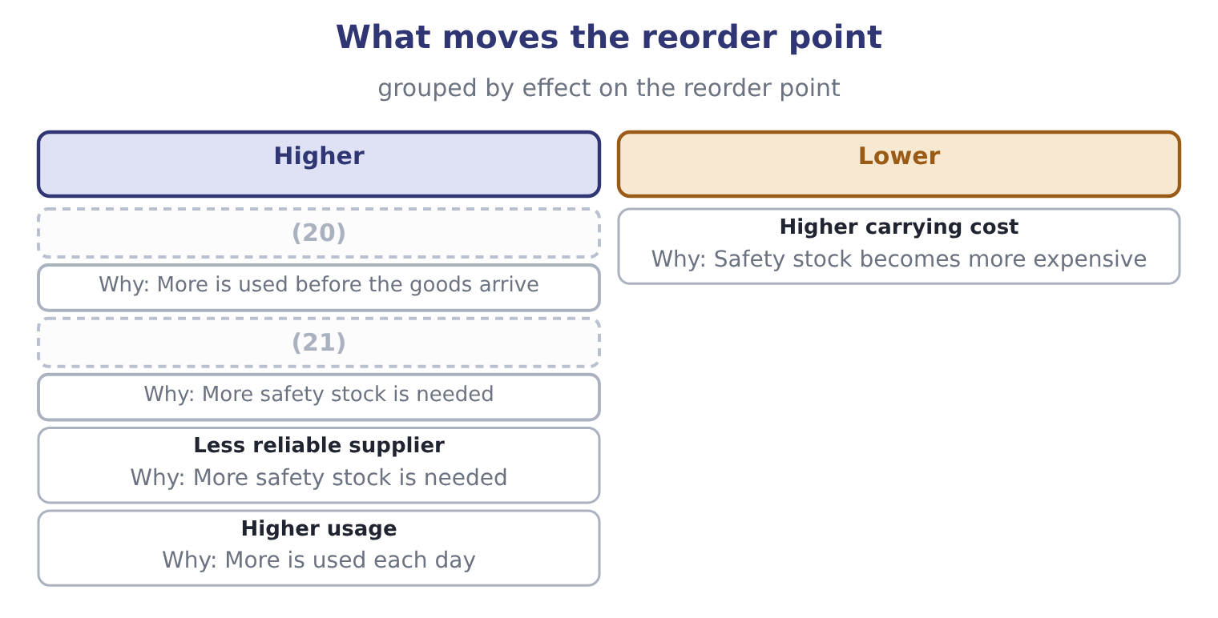
word list
Longer lead time · More variable demand · work in progress

The English this section uses, and its Arabic
Each term sits against what it means.
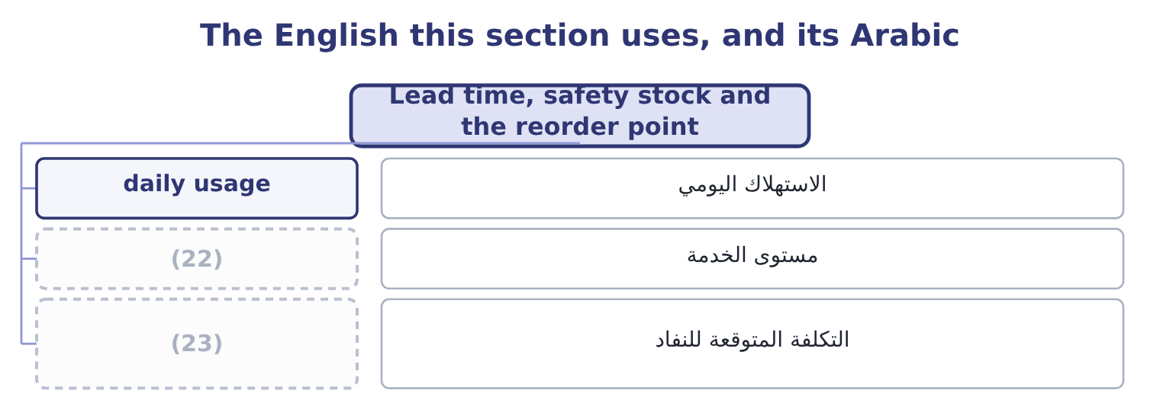
word list
buffer stock · expected stockout cost · service level

The English this sheet uses, and its Arabic
English (exam term) | Arabic
daily usage | الاستهلاك اليومي
service level | مستوى الخدمة
expected stockout cost | التكلفة المتوقعة للنفاد

Answer key · 17.3 Lead time, safety stock and the reorder point

1 interval | 13 average
2 receiving | 14 protection
3 cannot | 15 compared
4 arrives | 16 stockouts
5 simplest | 17 probability
6 quantity | 18 answer
7 against | 19 lowest
8 higher | 20 Longer lead time
9 longer | 21 More variable demand
10 Adding | 22 service level
11 variable | 23 expected stockout cost
12 permanent

the summaries in full
Summary 1 Lead time is the interval between placing an order and receiving the goods. It is why a company cannot wait until the shelf is empty: an order placed on the day of the stockout arrives a week after it. The reorder point is the stock level at which the next order is placed. In the simplest case it is the quantity that will be used during the lead time: daily usage times lead time in days. Safety stock is the buffer held against the two things that go wrong — demand higher than expected during the lead time, and a lead time longer than expected. Adding it to the reorder point gives the full rule.
Summary 2 A company uses 10,000 units a year over 250 working days, which is 10,000 ÷ 250 = 40 units a day. Five working days, so the usage during the lead time is 40 × 5 = 200 units. Demand is variable and the supplier is occasionally late, so the company holds 100 units of safety stock — about two and a half days of usage. The safety stock is held all the time and used occasionally, so it is a permanent addition to the average stock and its whole cost is a carrying cost: at $4 a unit a year, 100 × 4 = 400 a year. That is the price of the protection, and it should be compared with the cost of the stockouts it prevents. Where a question gives the probability of a stockout at each level of safety stock and the cost of one, the answer is the level at which the expected stockout cost plus the carrying cost is lowest.

17.4 How much to order
Chapter 17 · section 17.4

Fill every gap. Each word list holds one word more than there are gaps.
Summary 1 gaps 1–5
The (1) order quantity is the order size at which the total of carrying and ordering costs is (2) . It comes from a formula the exam does not (3) to be derived: twice the annual demand times the cost of (4) one order, (5) by the carrying cost of one unit for a year, all under a square root.
word list
divided · lowest · economic · placing · require · direction

Worked example: the economic order quantity

Summary 2 gaps 6–17
Annual demand is 10,000 units, each order costs $50 to place, and carrying one unit for a year costs $4. Twice the demand times the ordering cost: 2 × 10,000 × 50 = 1,000,000. (6) by the carrying cost. At 500 units an order, the company (7) 10,000 ÷ 500 = 20 (8) a year, costing 20 × 50 = 1,000. Its (9) stock is half the order quantity, 500 ÷ 2 = 250 units, costing 250 × 4 = 1,000 to carry. Total cost is 1,000 + 1,000 = 2,000 a year. The two costs are equal at the (10) , and that is not a (11) : it is a property of the formula and a quick way to (12) an answer. It is also why the total cost curve is flat near the bottom — ordering 450 or 550 units (13) of 500 costs only a few dollars more a year — which matters in (14) , because it means the (15) precision is not worth (16) over while its (17) is worth following.
word list
agonising · verify · orders · optimum · places · average · direction · practice · instead · formula's · assumptions · Divide · coincidence

Summary 3 gaps 18–26
The (18) asks how a change in one (19) affects the answer, and the square root (20) the rule: every input moves the order quantity by its own square root. Double the demand and the order quantity rises by about 41 per cent, not 100, because the square root of two is about 1.41. This is why a company twice the size does not hold twice the stock, and it is the (21) most examinable (22) of the formula. Double the ordering cost and the quantity rises by the same 41 per cent: with an ordering cost of $100, the (23) becomes 2 × 10,000 × 100 = 2,000,000, and dividing by 4 and (24) the root gives about 707 units. Double the carrying cost and the quantity falls by about 29 per cent, to about 354 units, because dividing by two (25) a square root (26) by about 0.71.
word list
supplies · outcome · multiplies · numerator · variable · inside · property · taking · single · consequence

What a change does to the economic order quantity
Every item belongs to exactly one group.
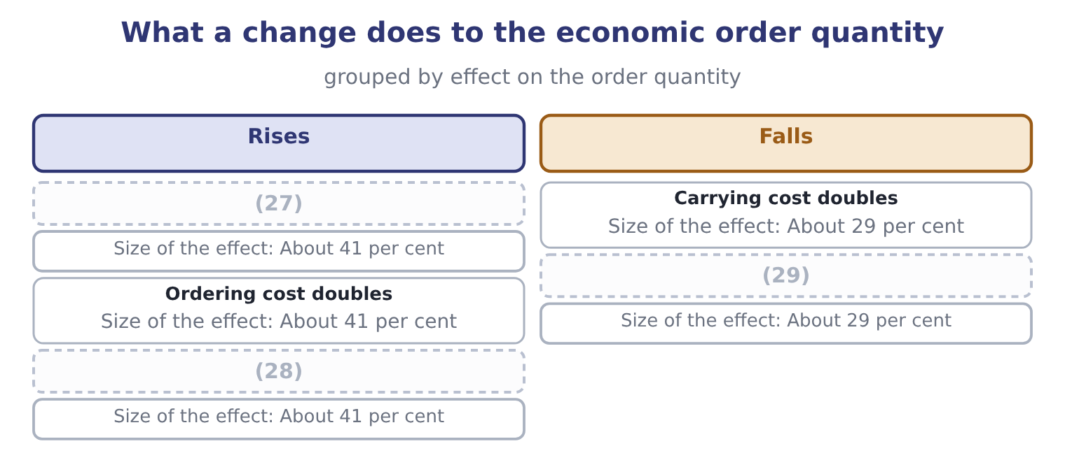
word list
Demand doubles · reorder point · All three double together · Demand falls by half

Summary 4 gaps 30–38
The assumptions are examinable in their own right, because every one of them fails (30) . Demand is assumed constant and known; the lead time is assumed constant; the ordering cost per order and the carrying cost per unit are assumed fixed; no quantity (31) exist; and the whole order (32) at once. A (33) that varies any of these is asking whether the (34) knows the model's limits — and the (35) answer is that the formula gives the right order of (36) , that the cost curve is flat near its (37) , and that the assumptions matter less than the (38) of comparing the two costs.
word list
discipline · standard · somewhere · minimum · practice · candidate · discounts · arrives · question · magnitude

The English this section uses, and its Arabic
Each term sits against what it means.
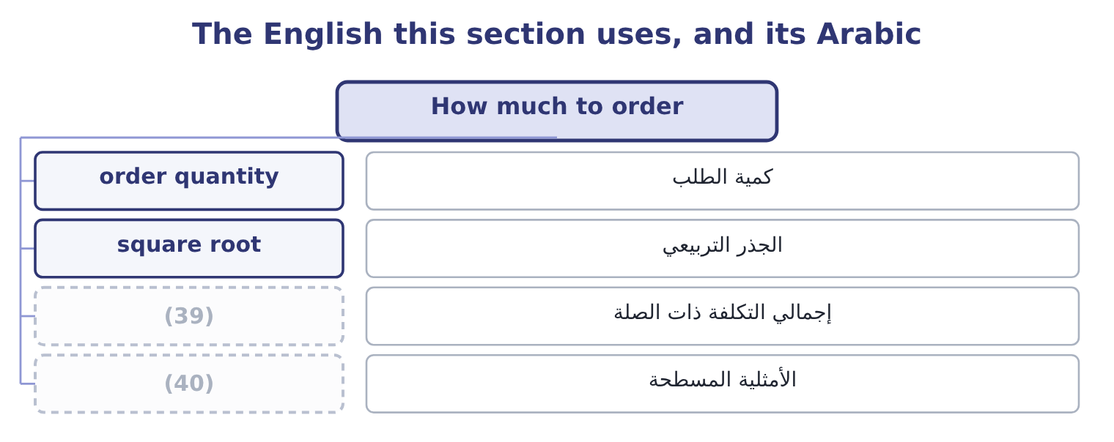
word list
flat optimum · total relevant cost · economic order quantity

The English this sheet uses, and its Arabic
English (exam term) | Arabic
order quantity | كمية الطلب
square root | الجذر التربيعي
total relevant cost | إجمالي التكلفة ذات الصلة
flat optimum | الأمثلية المسطحة

Answer key · 17.4 How much to order

1 economic | 21 single
2 lowest | 22 consequence
3 require | 23 numerator
4 placing | 24 taking
5 divided | 25 inside
6 Divide | 26 multiplies
7 places | 27 Demand doubles
8 orders | 28 All three double together
9 average | 29 Demand falls by half
10 optimum | 30 somewhere
11 coincidence | 31 discounts
12 verify | 32 arrives
13 instead | 33 question
14 practice | 34 candidate
15 formula's | 35 standard
16 agonising | 36 magnitude
17 direction | 37 minimum
18 outcome | 38 discipline
19 variable | 39 total relevant cost
20 supplies | 40 flat optimum

the summaries in full
Summary 1 The economic order quantity is the order size at which the total of carrying and ordering costs is lowest. It comes from a formula the exam does not require to be derived: twice the annual demand times the cost of placing one order, divided by the carrying cost of one unit for a year, all under a square root.
Summary 2 Annual demand is 10,000 units, each order costs $50 to place, and carrying one unit for a year costs $4. Twice the demand times the ordering cost: 2 × 10,000 × 50 = 1,000,000. Divide by the carrying cost. At 500 units an order, the company places 10,000 ÷ 500 = 20 orders a year, costing 20 × 50 = 1,000. Its average stock is half the order quantity, 500 ÷ 2 = 250 units, costing 250 × 4 = 1,000 to carry. Total cost is 1,000 + 1,000 = 2,000 a year. The two costs are equal at the optimum, and that is not a coincidence: it is a property of the formula and a quick way to verify an answer. It is also why the total cost curve is flat near the bottom — ordering 450 or 550 units instead of 500 costs only a few dollars more a year — which matters in practice, because it means the formula's precision is not worth agonising over while its direction is worth following.
Summary 3 The outcome asks how a change in one variable affects the answer, and the square root supplies the rule: every input moves the order quantity by its own square root. Double the demand and the order quantity rises by about 41 per cent, not 100, because the square root of two is about 1.41. This is why a company twice the size does not hold twice the stock, and it is the single most examinable consequence of the formula. Double the ordering cost and the quantity rises by the same 41 per cent: with an ordering cost of $100, the numerator becomes 2 × 10,000 × 100 = 2,000,000, and dividing by 4 and taking the root gives about 707 units. Double the carrying cost and the quantity falls by about 29 per cent, to about 354 units, because dividing by two inside a square root multiplies by about 0.71.
Summary 4 The assumptions are examinable in their own right, because every one of them fails somewhere. Demand is assumed constant and known; the lead time is assumed constant; the ordering cost per order and the carrying cost per unit are assumed fixed; no quantity discounts exist; and the whole order arrives at once. A question that varies any of these is asking whether the candidate knows the model's limits — and the standard answer is that the formula gives the right order of magnitude, that the cost curve is flat near its minimum, and that the assumptions matter less than the discipline of comparing the two costs.

17.5 Just-in-time, and the turnover a margin allows
Chapter 17 · section 17.5

Fill every gap. Each word list holds one word more than there are gaps.
Summary 1 gaps 1–12
Just-in-time is the (1) that stock held to (2) a process is a symptom, and that the process should be fixed instead. Materials arrive as they are needed, in small (3) , from suppliers close by and (4) committed; production is pulled by demand rather than pushed by a schedule; and the buffer between stages is removed so that any problem stops the line and has to be solved rather than absorbed. What it (5) is examinable. Inventory falls, often by most of it, (6) the funding and the space. Quality (7) , because a (8) cannot hide in a pile of stock. (9) and write-downs fall. And the (10) exposes problems — an (11) machine, a supplier who is sometimes late — that stock was concealing. What it requires is equally examinable, and it is the reason just-in-time is not (12) .
word list
contractually · protect · achieves · Obsolescence · improves · defect · discipline · between · quantities · universal · releasing · proposition · unreliable

Summary 2 gaps 13–24
Reliable suppliers, (13) close, and few of them. Short set-up times, so that small (14) are economic, which is the same as saying that the ordering cost in section 17.4 has been (15) down. And a (16) to stop the line, which is a cultural matter more than a (17) one. The risks are the mirror: a single (18) failure, a transport (19) , a natural disaster or a pandemic stops a line that has no buffer, and the saving of years can be lost in a month. The exam (20) both halves. Inventory turnover and gross margin tend to move in opposite (21) across businesses. A supermarket turns its stock (22) times a year on a gross margin near 25 per cent; a jeweller turns it twice on a margin near 50. Each is viable because the product of the two is enough: turnover times margin is a crude measure of the gross profit earned on each dollar (23) in stock, and businesses survive at many (24) of the pair.
word list
willingness · disruption · technical · geographically · supplier's · directions · invested · Barada's · batches · thirty · expects · combinations · engineered

Summary 3 gaps 25–33
The practical (25) are two. A company comparing its turnover with (26) must compare (27) at the same time, or it is comparing two different business models — which is (28) what Book 1 warned about when it set (29) 14 per cent gross margin against (30) 35. And a company that wants to raise its turnover by (31) stock must ask what that does to its margin: if the stock cut causes stockouts, (32) to recover the (33) , or expedited freight, the turnover will rise and the margin will fall, and the company will be no better off.
word list
margins · cutting · exactly · consequences · Barada's · customers · improves · discounting · Orontes's · another's

Turnover and margin across businesses
Business | Inventory turnover | Gross margin | Why the combination works
Supermarket | (34) | About 25% | Volume and speed; nothing sits
Orontes, a food manufacturer | 11.49 times | 35.0% | (35)
Barada, a distributor | 9.00 times | 14.0% | (36)
Jeweller | About 2 times | (37) | Slow, high-value, bought rarely

word list
Slow, high-value, bought rarely · About 50% · Thin margin, and the stockroom is the business · A moderate cycle at a fair margin · About 30 times

Order and reorder

Your turn: inventory arithmetic (complete the blanks)
Item | Data | Answer
Daily usage | 18,000 units a year over 300 days | (38) : 18,000 ÷ 300 = 60.
Usage during the lead time | (39) | 480 units: 60 × 8 = 480.
Reorder point | Safety stock 240 units | 720 units: 480 + 240 = 720.
Economic order quantity | Ordering cost 40, carrying cost 5 a unit a year | (40) : 2 × 18,000 × 40 = 1,440,000, and 1,440,000 ÷ 5 = 288,000, whose square root is about 537.
Orders a year |  | (41) : 18,000 ÷ 537 = 33.5.
Total relevant cost | Ordering plus carrying at the optimum | (42) : ordering is 33.5 × 40 = 1,340 and carrying is half of 537 at 5 a unit, which is about 1,343.

word list
60 units · Slow, high-value, bought rarely · 537 units · Lead time 8 days · About 34 · About 2,683

"Stock"

Summary 4 gaps 43–52
English stock means two (43) different things in these two books, and the two (44) sit in adjacent (45) . Inventory is called stock in British usage, so (46) , stock turn and safety stock all concern goods. Shares are called stock in American usage, so common stock, (47) stock and stock dividend all concern (48) . The exam, written in American English, uses stock for shares and inventory for goods, and a (49) who learned the British sense must read (50) : a stock dividend has nothing to do with the (51) . Note the one (52) of the goods sense in American usage: a company is said to be out of stock, never out of inventory.
word list
chapters · candidate · carefully · entirely · survival · stockout · preferred · written · warehouse · meanings · equity

The English this section uses, and its Arabic
Each term sits against what it means.
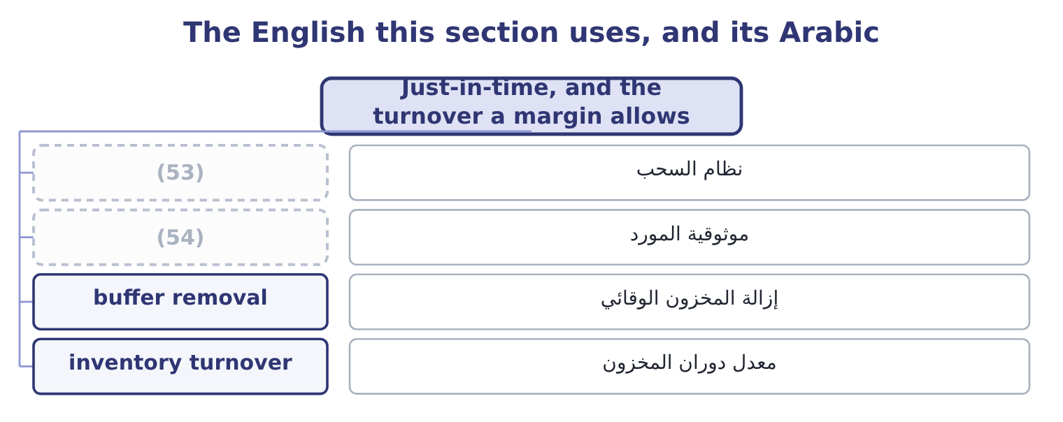
word list
order quantity · supplier reliability · pull system

The English this sheet uses, and its Arabic
English (exam term) | Arabic
pull system | نظام السحب
supplier reliability | موثوقية المورد
buffer removal | إزالة المخزون الوقائي
inventory turnover | معدل دوران المخزون

Answer key · 17.5 Just-in-time, and the turnover a margin allows

1 proposition | 28 exactly
2 protect | 29 Barada's
3 quantities | 30 Orontes's
4 contractually | 31 cutting
5 achieves | 32 discounting
6 releasing | 33 customers
7 improves | 34 About 30 times
8 defect | 35 A moderate cycle at a fair margin
9 Obsolescence | 36 Thin margin, and the stockroom is the business
10 discipline | 37 About 50%
11 unreliable | 38 60 units
12 universal | 39 Lead time 8 days
13 geographically | 40 537 units
14 batches | 41 About 34
15 engineered | 42 About 2,683
16 willingness | 43 entirely
17 technical | 44 meanings
18 supplier's | 45 chapters
19 disruption | 46 stockout
20 expects | 47 preferred
21 directions | 48 equity
22 thirty | 49 candidate
23 invested | 50 carefully
24 combinations | 51 warehouse
25 consequences | 52 survival
26 another's | 53 pull system
27 margins | 54 supplier reliability

the summaries in full
Summary 1 Just-in-time is the proposition that stock held to protect a process is a symptom, and that the process should be fixed instead. Materials arrive as they are needed, in small quantities, from suppliers close by and contractually committed; production is pulled by demand rather than pushed by a schedule; and the buffer between stages is removed so that any problem stops the line and has to be solved rather than absorbed. What it achieves is examinable. Inventory falls, often by most of it, releasing the funding and the space. Quality improves, because a defect cannot hide in a pile of stock. Obsolescence and write-downs fall. And the discipline exposes problems — an unreliable machine, a supplier who is sometimes late — that stock was concealing. What it requires is equally examinable, and it is the reason just-in-time is not universal.
Summary 2 Reliable suppliers, geographically close, and few of them. Short set-up times, so that small batches are economic, which is the same as saying that the ordering cost in section 17.4 has been engineered down. And a willingness to stop the line, which is a cultural matter more than a technical one. The risks are the mirror: a single supplier's failure, a transport disruption, a natural disaster or a pandemic stops a line that has no buffer, and the saving of years can be lost in a month. The exam expects both halves. Inventory turnover and gross margin tend to move in opposite directions across businesses. A supermarket turns its stock thirty times a year on a gross margin near 25 per cent; a jeweller turns it twice on a margin near 50. Each is viable because the product of the two is enough: turnover times margin is a crude measure of the gross profit earned on each dollar invested in stock, and businesses survive at many combinations of the pair.
Summary 3 The practical consequences are two. A company comparing its turnover with another's must compare margins at the same time, or it is comparing two different business models — which is exactly what Book 1 warned about when it set Barada's 14 per cent gross margin against Orontes's 35. And a company that wants to raise its turnover by cutting stock must ask what that does to its margin: if the stock cut causes stockouts, discounting to recover the customers, or expedited freight, the turnover will rise and the margin will fall, and the company will be no better off.
Summary 4 English stock means two entirely different things in these two books, and the two meanings sit in adjacent chapters. Inventory is called stock in British usage, so stockout, stock turn and safety stock all concern goods. Shares are called stock in American usage, so common stock, preferred stock and stock dividend all concern equity. The exam, written in American English, uses stock for shares and inventory for goods, and a candidate who learned the British sense must read carefully: a stock dividend has nothing to do with the warehouse. Note the one survival of the goods sense in American usage: a company is said to be out of stock, never out of inventory.

18.1 How much to fund short
Chapter 18 · section 18.1

Fill every gap. Each word list holds one word more than there are gaps.
Chapter 18, section by section
Each stage leads to the next.
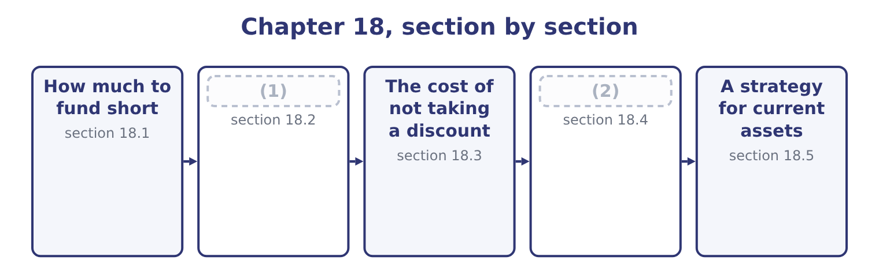
word list
warehouse receipt · What a bank facility and a factor really cost · The sources

Summary 1 gaps 3–14
Some (3) assets are permanent — the stock a company never goes below, the (4) book that never (5) — and some are seasonal, rising and (6) with the year. The financing (7) is which kind of money funds. Three (8) , and the exam names all three. The maturity matching or (9) approach funds permanent assets, (10) the permanent part of working capital, with long-term money, and seasonal assets with short-term money that is repaid as the season unwinds. It is the textbook (11) : each asset is financed over its own life, so nothing has to be (12) before it has turned into cash. The aggressive approach funds some of the permanent requirement with short-term money. It is (13) , because the yield curve usually slopes upward, and riskier in two ways: the rate can rise at every (14) , and the facility may not be renewed at all when it matters.
word list
benchmark · hedging · including · rollover · falling · policies · arrived · refinanced · receivable · question · empties · current · cheaper

Summary 2 gaps 15–26
Barada's overdraft funding a (15) larger stockroom is the aggressive approach arrived at by (16) . The conservative approach funds all of the permanent requirement and part of the seasonal with long-term money, so that in the (17) the company holds (18) cash. It costs more and removes (19) risk almost (20) . (21) , with $6,400,000 of long-term debt, no short-term (22) and $7,302,100 of cash, is at this end. The choice is a risk (23) , which is what the (24) means by the effect of risk on financing policy. A company with volatile cash flows, thin coverage or a covenant near its limit should sit (25) ; one with stable flows, wide coverage and a committed facility can afford to sit (26) . The cost of being wrong is asymmetric: an aggressive policy saves a fraction of a point most years and fails completely in the year credit tightens.
word list
Orontes · long-term · conservatively · aggressively · surplus · accident · entirely · refinancing · borrowings · trough · decision · permanently · outcome

Three financing policies
Policy | Permanent assets funded with | Seasonal assets funded with | Cost | Risk
Maturity matching | Long-term money | Short-term money | Moderate | Moderate
Aggressive | (27) | Short-term money | Lower | (28)
Conservative | Long-term money | (29) | Higher | Lower

word list
factoring · Partly short-term money · Partly long-term money · Higher

The English this section uses, and its Arabic
Each term sits against what it means.
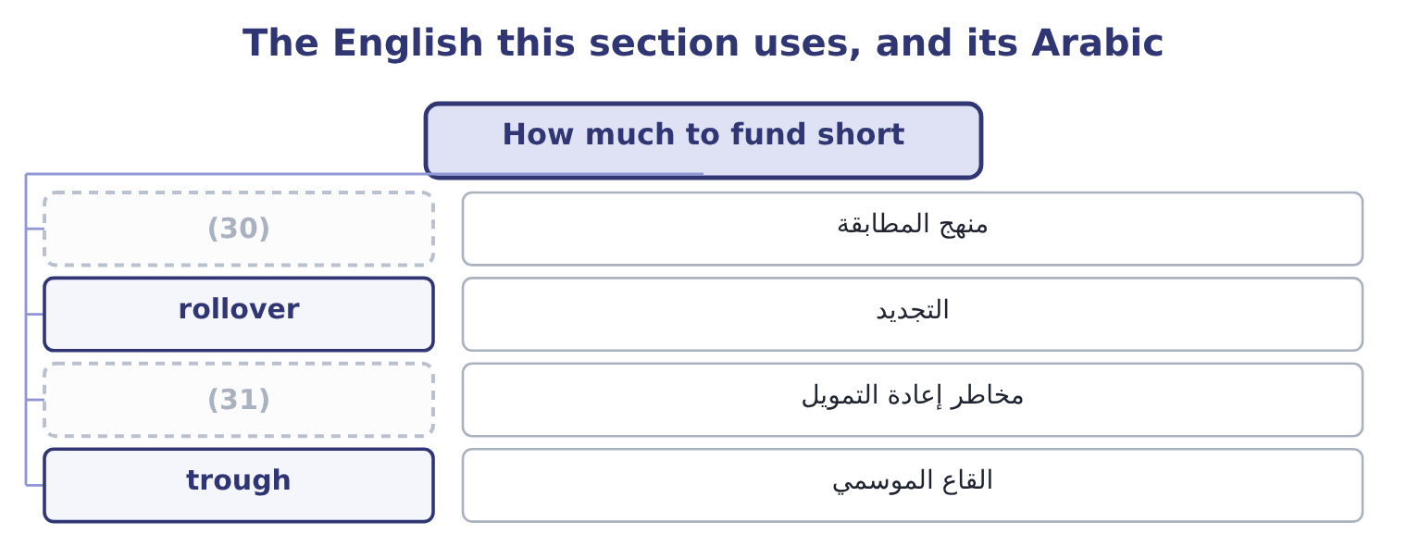
word list
refinancing risk · hedging approach · trade credit

The English this sheet uses, and its Arabic
English (exam term) | Arabic
hedging approach | منهج المطابقة
rollover | التجديد
refinancing risk | مخاطر إعادة التمويل
trough | القاع الموسمي

Answer key · 18.1 How much to fund short

1 The sources | 17 trough
2 What a bank facility and a factor really cost | 18 surplus
3 current | 19 refinancing
4 receivable | 20 entirely
5 empties | 21 Orontes
6 falling | 22 borrowings
7 question | 23 decision
8 policies | 24 outcome
9 hedging | 25 conservatively
10 including | 26 aggressively
11 benchmark | 27 Partly short-term money
12 refinanced | 28 Higher
13 cheaper | 29 Partly long-term money
14 rollover | 30 hedging approach
15 permanently | 31 refinancing risk
16 accident

the summaries in full
Summary 1 Some current assets are permanent — the stock a company never goes below, the receivable book that never empties — and some are seasonal, rising and falling with the year. The financing question is which kind of money funds. Three policies, and the exam names all three. The maturity matching or hedging approach funds permanent assets, including the permanent part of working capital, with long-term money, and seasonal assets with short-term money that is repaid as the season unwinds. It is the textbook benchmark: each asset is financed over its own life, so nothing has to be refinanced before it has turned into cash. The aggressive approach funds some of the permanent requirement with short-term money. It is cheaper, because the yield curve usually slopes upward, and riskier in two ways: the rate can rise at every rollover, and the facility may not be renewed at all when it matters.
Summary 2 Barada's overdraft funding a permanently larger stockroom is the aggressive approach arrived at by accident. The conservative approach funds all of the permanent requirement and part of the seasonal with long-term money, so that in the trough the company holds surplus cash. It costs more and removes refinancing risk almost entirely. Orontes, with $6,400,000 of long-term debt, no short-term borrowings and $7,302,100 of cash, is at this end. The choice is a risk decision, which is what the outcome means by the effect of risk on financing policy. A company with volatile cash flows, thin coverage or a covenant near its limit should sit conservatively; one with stable flows, wide coverage and a committed facility can afford to sit aggressively. The cost of being wrong is asymmetric: an aggressive policy saves a fraction of a point most years and fails completely in the year credit tightens.

18.2 The sources
Chapter 18 · section 18.2

Fill every gap. Each word list holds one word more than there are gaps.
Summary 1 gaps 1–12
Six (1) of short-term credit, and the exam expects each (2) . Trade credit is the (3) and the least (4) . A (5) offering 30 days is lending the company the value of the goods for a month, and (6) $2,050,000 of accounts payable is that loan. It arises (7) with purchases, requires no (8) , and is free — unless a discount is being forgone, which section 18.3 prices and which makes it the most expensive money in the chapter. A line of credit is an (9) under which a bank will lend up to a limit, usually for a year, usually (10) annually. An uncommitted line is a (11) of intent the bank may withdraw; a committed line is a (12) obligation, for which the bank charges a commitment fee on the undrawn part. The difference matters exactly when it matters: in a downturn.
word list
largest · arrangement · reviewed · sources · examined · negotiation · keeping · described · automatically · Orontes's · contractual · supplier · statement

Summary 2 gaps 13–24
Revolving credit is a committed facility over (13) years that can be drawn, repaid and (14) . It is the most (15) short-term money and the most expensive, (16) both a margin and a commitment fee. A short-term bank loan is a single (17) for a fixed period, repaid at the end or in (18) , often secured. Commercial paper is unsecured short-term borrowing sold (19) into the money market by companies of good credit standing, in large (20) , for up to 270 days. It is (21) than a bank loan for (22) that can use it, and it is unreliable in a crisis because the buyers simply stop buying. A $5,000,000 issue for 90 days at 5.5 per cent costs 5,000,000 × 0.055 × 90 ÷ 365 = 67,808. Secured borrowing uses the current assets (23) . Pledging receivables borrows against them while keeping them; (24) sells them outright, which section 18.4 prices. Inventory may be used through a floating charge, a warehouse receipt, or a trust receipt where the goods are identifiable.
word list
amounts · instalments · arrangement · reliable · cheaper · redrawn · directly · factoring · advance · carrying · several · issuers · themselves

Six sources of short-term credit
Source | Cost | Reliability | Best for
Trade credit | (25) | High, within terms | Everyday purchasing
Uncommitted line | Low margin, no fee | (26) | Occasional small needs
Committed line | (27) | High | Seasonal peaks
Revolving credit | Margin plus a fee, over years | (28) | A standing facility
Commercial paper | Lowest, for good credits | Low in a crisis | (29)
Secured borrowing | (30) | Moderate | Companies without unsecured capacity

word list
Margin plus a commitment fee · Free, unless a discount is forgone · annualised rate · Higher, plus administration · Highest · Large, frequent needs · Low in a downturn

The English this section uses, and its Arabic
Each term sits against what it means.
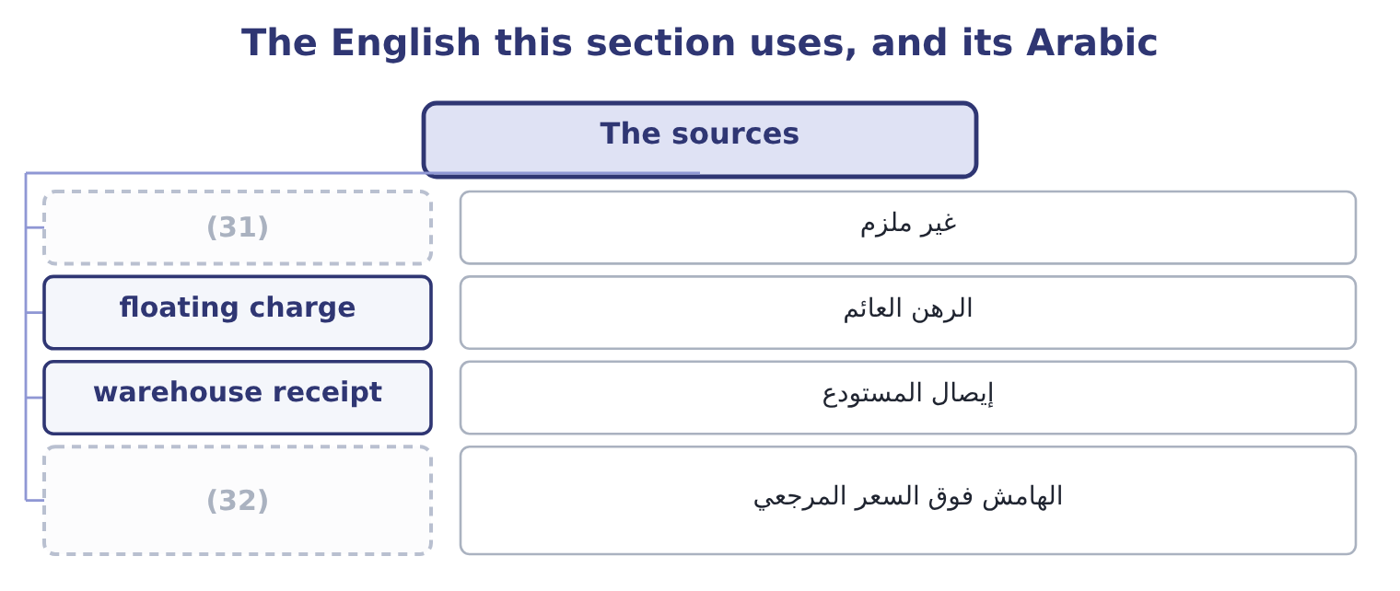
word list
margin over a reference rate · uncommitted · commitment fee

The English this sheet uses, and its Arabic
English (exam term) | Arabic
uncommitted | غير ملزم
floating charge | الرهن العائم
warehouse receipt | إيصال المستودع
margin over a reference rate | الهامش فوق السعر المرجعي

Answer key · 18.2 The sources

1 sources | 17 advance
2 described | 18 instalments
3 largest | 19 directly
4 examined | 20 amounts
5 supplier | 21 cheaper
6 Orontes's | 22 issuers
7 automatically | 23 themselves
8 negotiation | 24 factoring
9 arrangement | 25 Free, unless a discount is forgone
10 reviewed | 26 Low in a downturn
11 statement | 27 Margin plus a commitment fee
12 contractual | 28 Highest
13 several | 29 Large, frequent needs
14 redrawn | 30 Higher, plus administration
15 reliable | 31 uncommitted
16 carrying | 32 margin over a reference rate

the summaries in full
Summary 1 Six sources of short-term credit, and the exam expects each described. Trade credit is the largest and the least examined. A supplier offering 30 days is lending the company the value of the goods for a month, and Orontes's $2,050,000 of accounts payable is that loan. It arises automatically with purchases, requires no negotiation, and is free — unless a discount is being forgone, which section 18.3 prices and which makes it the most expensive money in the chapter. A line of credit is an arrangement under which a bank will lend up to a limit, usually for a year, usually reviewed annually. An uncommitted line is a statement of intent the bank may withdraw; a committed line is a contractual obligation, for which the bank charges a commitment fee on the undrawn part. The difference matters exactly when it matters: in a downturn.
Summary 2 Revolving credit is a committed facility over several years that can be drawn, repaid and redrawn. It is the most reliable short-term money and the most expensive, carrying both a margin and a commitment fee. A short-term bank loan is a single advance for a fixed period, repaid at the end or in instalments, often secured. Commercial paper is unsecured short-term borrowing sold directly into the money market by companies of good credit standing, in large amounts, for up to 270 days. It is cheaper than a bank loan for issuers that can use it, and it is unreliable in a crisis because the buyers simply stop buying. A $5,000,000 issue for 90 days at 5.5 per cent costs 5,000,000 × 0.055 × 90 ÷ 365 = 67,808. Secured borrowing uses the current assets themselves. Pledging receivables borrows against them while keeping them; factoring sells them outright, which section 18.4 prices. Inventory may be used through a floating charge, a warehouse receipt, or a trust receipt where the goods are identifiable.

18.3 The cost of not taking a discount
Chapter 18 · section 18.3

Fill every gap. Each word list holds one word more than there are gaps.
Summary 1 gaps 1–4
A supplier offering 2/10, net 30 is (1) an offer with a price. Pay on day 10 and pay 98 per cent; pay on day 30 and pay 100. The company that pays on day 30 has (2) 98 for twenty days and (3) 100, and the exam wants that (4) as an annual rate.
word list
trough · expressed · making · borrowed · repaid

Worked example: what 2/10, net 30 really costs

Summary 2 gaps 5–13
The rate for the period. The discount (5) is 2 on the 98 that would have been paid: 2 ÷ 98 = 2.04 per cent for the twenty days of extra credit. The (6) of periods. The extra credit runs from day 10 to day 30, which is twenty days, so there are 365 ÷ 20 = 18.25 such periods in a year. (7) borrows from its bank at 6 per cent. Paying on day 30 (8) of day 10 costs it 37.2 per cent a year — six times as much. A company with a facility (9) should always take the discount and draw on the facility to do it. The (10) is sensitive to both terms, and the exam (11) them. On 1/10, net 30 the cost is 1 ÷ 99 = 1.01 per cent for twenty days, which is 1.01 × 18.25 = 18.4 per cent a year — still far above any borrowing rate. On 2/10, net 60 the extra credit is fifty days, so the periods are 365 ÷ 50 = 7.3 and the cost is 2.04 × 7.3 = 14.9 per cent. The longer the net period, the (12) it is to forgo the discount, (13) the borrowing lasts longer for the same fee.
word list
because · cheaper · transaction · available · number · Orontes · forgone · arithmetic · varies · instead

What forgoing a discount costs a year
The bars are drawn to scale.
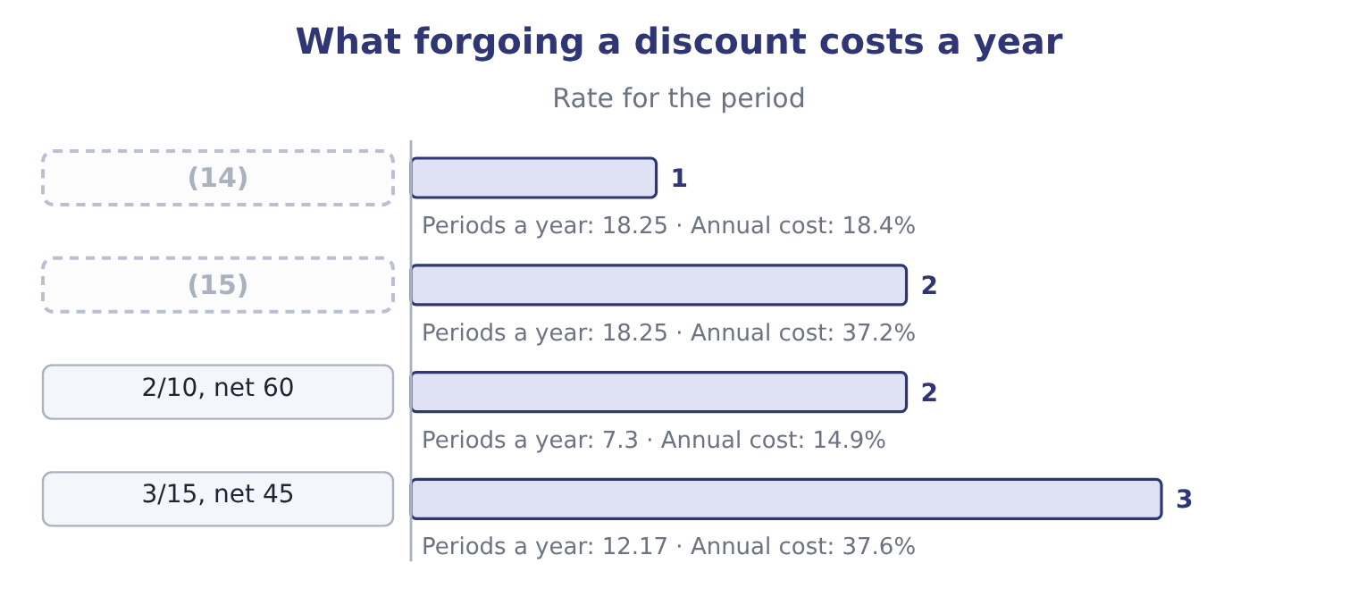
word list
line of credit · 1/10, net 30 · 2/10, net 30

Summary 3 gaps 16–23
Two (16) follow for the two sides of the (17) . For the buyer: take the discount unless there is (18) no money and no facility, in which case the company has a (19) problem that the discount decision merely reveals. And where a supplier is paid late anyway, the (20) rate falls, which is the unspoken reason (21) is common —. A seller offering 2/10 net 30 is paying about 37 per cent (22) to be paid twenty days earlier, which is only sensible if the (23) is losing the sale or funding at a comparable rate.
word list
annualised · funding · transaction · financing · alternative · genuinely · stretching · consequences · effective

The English this section uses, and its Arabic
Each term sits against what it means.
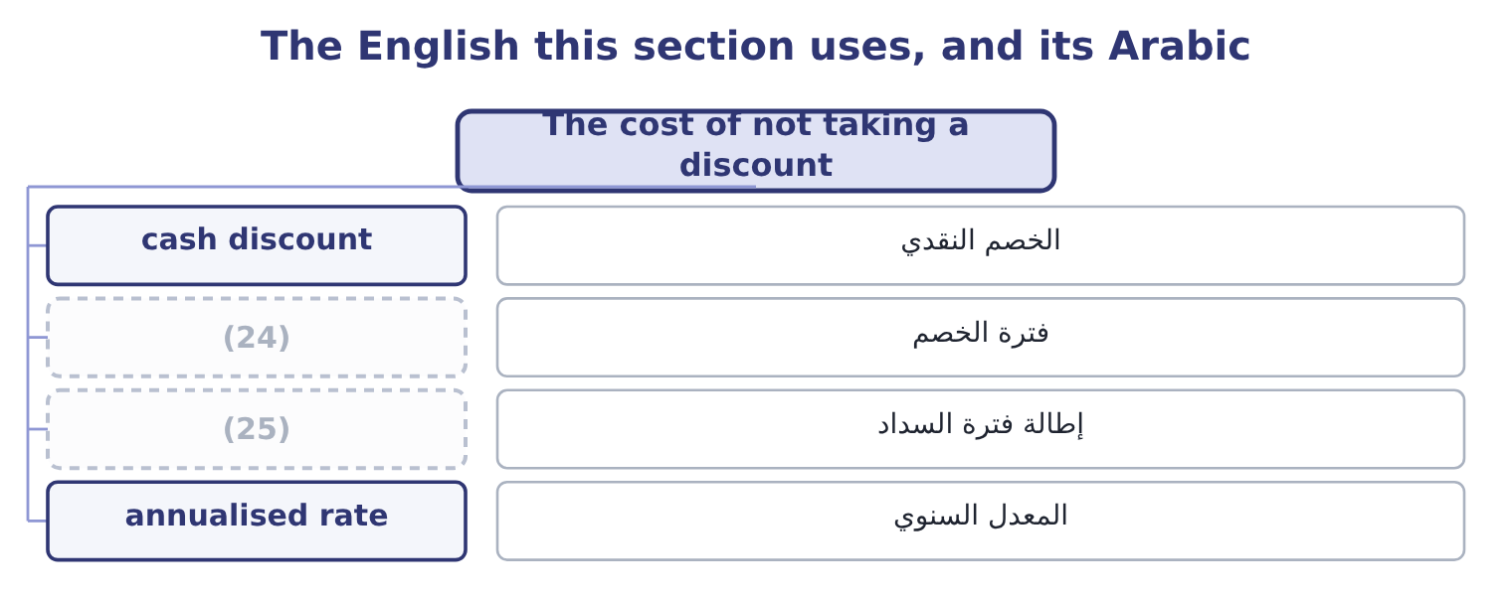
word list
discount period · annualised rate · stretching payables

The English this sheet uses, and its Arabic
English (exam term) | Arabic
cash discount | الخصم النقدي
discount period | فترة الخصم
stretching payables | إطالة فترة السداد
annualised rate | المعدل السنوي

Answer key · 18.3 The cost of not taking a discount

1 making | 14 1/10, net 30
2 borrowed | 15 2/10, net 30
3 repaid | 16 consequences
4 expressed | 17 transaction
5 forgone | 18 genuinely
6 number | 19 financing
7 Orontes | 20 effective
8 instead | 21 stretching
9 available | 22 annualised
10 arithmetic | 23 alternative
11 varies | 24 discount period
12 cheaper | 25 stretching payables
13 because

the summaries in full
Summary 1 A supplier offering 2/10, net 30 is making an offer with a price. Pay on day 10 and pay 98 per cent; pay on day 30 and pay 100. The company that pays on day 30 has borrowed 98 for twenty days and repaid 100, and the exam wants that expressed as an annual rate.
Summary 2 The rate for the period. The discount forgone is 2 on the 98 that would have been paid: 2 ÷ 98 = 2.04 per cent for the twenty days of extra credit. The number of periods. The extra credit runs from day 10 to day 30, which is twenty days, so there are 365 ÷ 20 = 18.25 such periods in a year. Orontes borrows from its bank at 6 per cent. Paying on day 30 instead of day 10 costs it 37.2 per cent a year — six times as much. A company with a facility available should always take the discount and draw on the facility to do it. The arithmetic is sensitive to both terms, and the exam varies them. On 1/10, net 30 the cost is 1 ÷ 99 = 1.01 per cent for twenty days, which is 1.01 × 18.25 = 18.4 per cent a year — still far above any borrowing rate. On 2/10, net 60 the extra credit is fifty days, so the periods are 365 ÷ 50 = 7.3 and the cost is 2.04 × 7.3 = 14.9 per cent. The longer the net period, the cheaper it is to forgo the discount, because the borrowing lasts longer for the same fee.
Summary 3 Two consequences follow for the two sides of the transaction. For the buyer: take the discount unless there is genuinely no money and no facility, in which case the company has a financing problem that the discount decision merely reveals. And where a supplier is paid late anyway, the effective rate falls, which is the unspoken reason stretching is common —. A seller offering 2/10 net 30 is paying about 37 per cent annualised to be paid twenty days earlier, which is only sensible if the alternative is losing the sale or funding at a comparable rate.

18.4 What a bank facility and a factor really cost
Chapter 18 · section 18.4

Fill every gap. Each word list holds one word more than there are gaps.
Summary 1 gaps 1–12
Three (1) complete the pricing of (2) money, and each turns a quoted rate into an effective one. A loan with a (3) balance: interest is charged on the whole loan and only part of it is usable, so the effective rate is the interest (4) by the usable funds. A line with a commitment fee. The fee is charged on the undrawn (5) , so the effective cost (6) on how much of the line is used. A (7) loan, where the interest is (8) in advance. (9) $1,000,000 at 8 per cent on this basis gives (10) of 1,000,000 − 80,000 = 920,000, and the effective rate is 80,000 ÷ 920,000 = 8.70 per cent rather than 8. A company (11) a $5,000,000 (12) line at 7 per cent, with a commitment fee of 0.5 per cent on the undrawn part, and draws an average of $3,000,000 through the year.
word list
committed · pledging · portion · arranges · depends · Borrowing · compensating · discount · short-term · divided · calculations · proceeds · deducted

Summary 2 gaps 13–16
Interest is 3,000,000 × 0.07 = 210,000 and the fee is 2,000,000 × 0.005 = 10,000, so the total is 210,000 + 10,000 = 220,000. The effective rate on the money used. A factor (13) to buy $1,000,000 of receivables with an average age of 45 days, (14) a 2 per cent fee and (15) 80 per cent of the face value at 10 per cent a year. The fee is 1,000,000 × 0.02 = 20,000; the advance is 1,000,000 × 0.80 = 800,000, and the interest on it for 45 days is 800,000 × 0.10 × 45 ÷ 365 = 9,863. The total cost is 20,000 + 9,863 = 29,863 on $800,000 of money for 45 days, which is 29,863 ÷ 800,000 = 3.73 per cent for the (16) , or about 30.3 per cent a year.
word list
period · Borrowing · offers · advancing · charging

Summary 3 gaps 17–26
Thirty per cent looks (17) beside a 7.33 per cent bank line, and (18) it is not, which is the point of the comparison. (19) without recourse (20) the default risk; it removes the cost of running a credit and (21) department, which can be a large part of the fee; and it is (22) to companies whose credit standing gives them no bank line at all. The right comparison is (23) not the rate alone but the rate less the costs and risks the factor absorbs — and Book 1 found a $15,000 loss on sale of receivables in (24) own income (25) , which is this (26) already taken for a small part of the book.
word list
Orontes's · therefore · decision · charged · sometimes · indefensible · transfers · statement · available · collection · Factoring

Turning a quoted rate into an effective one
Every item belongs to exactly one group.
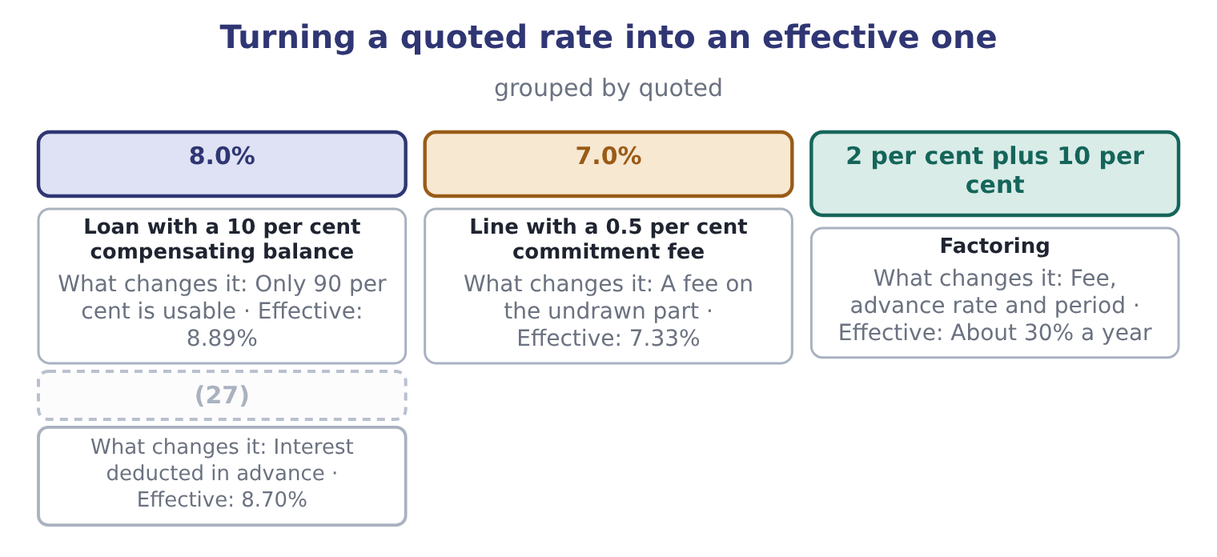
word list
discount period · Discount loan

The English this section uses, and its Arabic
Each term sits against what it means.
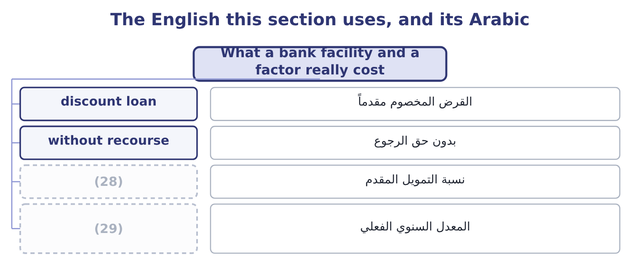
word list
discount period · effective annual rate · advance rate

The English this sheet uses, and its Arabic
English (exam term) | Arabic
discount loan | القرض المخصوم مقدماً
without recourse | بدون حق الرجوع
advance rate | نسبة التمويل المقدم
effective annual rate | المعدل السنوي الفعلي

Answer key · 18.4 What a bank facility and a factor really cost

1 calculations | 16 period
2 short-term | 17 indefensible
3 compensating | 18 sometimes
4 divided | 19 Factoring
5 portion | 20 transfers
6 depends | 21 collection
7 discount | 22 available
8 deducted | 23 therefore
9 Borrowing | 24 Orontes's
10 proceeds | 25 statement
11 arranges | 26 decision
12 committed | 27 Discount loan
13 offers | 28 advance rate
14 charging | 29 effective annual rate
15 advancing

the summaries in full
Summary 1 Three calculations complete the pricing of short-term money, and each turns a quoted rate into an effective one. A loan with a compensating balance: interest is charged on the whole loan and only part of it is usable, so the effective rate is the interest divided by the usable funds. A line with a commitment fee. The fee is charged on the undrawn portion, so the effective cost depends on how much of the line is used. A discount loan, where the interest is deducted in advance. Borrowing $1,000,000 at 8 per cent on this basis gives proceeds of 1,000,000 − 80,000 = 920,000, and the effective rate is 80,000 ÷ 920,000 = 8.70 per cent rather than 8. A company arranges a $5,000,000 committed line at 7 per cent, with a commitment fee of 0.5 per cent on the undrawn part, and draws an average of $3,000,000 through the year.
Summary 2 Interest is 3,000,000 × 0.07 = 210,000 and the fee is 2,000,000 × 0.005 = 10,000, so the total is 210,000 + 10,000 = 220,000. The effective rate on the money used. A factor offers to buy $1,000,000 of receivables with an average age of 45 days, charging a 2 per cent fee and advancing 80 per cent of the face value at 10 per cent a year. The fee is 1,000,000 × 0.02 = 20,000; the advance is 1,000,000 × 0.80 = 800,000, and the interest on it for 45 days is 800,000 × 0.10 × 45 ÷ 365 = 9,863. The total cost is 20,000 + 9,863 = 29,863 on $800,000 of money for 45 days, which is 29,863 ÷ 800,000 = 3.73 per cent for the period, or about 30.3 per cent a year.
Summary 3 Thirty per cent looks indefensible beside a 7.33 per cent bank line, and sometimes it is not, which is the point of the comparison. Factoring without recourse transfers the default risk; it removes the cost of running a credit and collection department, which can be a large part of the fee; and it is available to companies whose credit standing gives them no bank line at all. The right comparison is therefore not the rate alone but the rate less the costs and risks the factor absorbs — and Book 1 found a $15,000 loss on sale of receivables in Orontes's own income statement, which is this decision already taken for a small part of the book.

18.5 A strategy for current assets
Chapter 18 · section 18.5

Fill every gap. Each word list holds one word more than there are gaps.
Summary 1 gaps 1–12
The last (1) of Book 2 asks for a recommendation, which means the whole of the (2) section arranged into an (3) . Four steps make one. Step one: size the (4) . (5) the permanent core from the seasonal peak, using the cash (6) . The permanent core is funded long; the peak is funded short, by a facility arranged (7) it is needed. Step two: price every component. The cost of working capital is the sum of the (8) , the carrying costs of stock, the credit losses, the discounts forgone and the interest not earned on idle (9) — and the single most (10) error is to count only the first. (11) own bill reads: $272,640 to fund the trade cycle, $292,084 of interest forgone on idle cash, $63,000 of credit losses, and (12) discounts it does not take.
word list
management · Orontes's · whatever · outcome · argument · Separate · common · requirement · forecast · before · funding · working-capital · balances

Summary 2 gaps 13–23
Step three: attack the (13) in order of what they are worth. Book 1's (14) , applied here, ranks the items by money (15) than by ease. For Orontes the order is: put the idle cash to work, which is worth about $176,084 a year with no risk; take every (16) discount, because forgoing one costs 37.2 per cent against a 6 per cent facility; and consider (17) customer terms. Step four: match the (18) to the risk. A company with a (19) gross margin and a (20) to respect should not also be carrying (21) risk on its permanent assets. Orontes can afford to be slightly less (22) than it is; Barada cannot afford to be as aggressive as it has (23) become.
word list
releases · rollover · policy · falling · accidentally · supplier · components · discipline · lengthening · covenant · conservative · rather

A current-asset strategy for Orontes
Component | Position today | Recommendation | Worth a year
Cash | (24) | Hold 30 days of payments; place the rest to maturity dates | About 176,084
Marketable securities | 42,000 | Build a matched and laddered portfolio | (25)
Receivables | (26) | Lengthen terms selectively to win volume | Over 1,000,000 of contribution
Inventory | 2,450,000 at 31.8 days | (27) | Nil, and a risk if cut
Payables | 2,050,000 | Take every discount offered; pay on the due date (28) | The discounts, at 37 per cent each
Short-term debt | None | Arrange a committed line for seasonal peaks | (29)

word list
Hold; it is already tight against sales growth · Insurance, at a commitment fee · 2,000,000 at 9 per cent, deducted in advance · 4,144,000 at 34.3 days · 7,302,100, earning nothing · Included above · otherwise

Summary 3 gaps 30–38
One (30) closes the book. Every recommendation above (31) a cost or releases a (32) , and the total of all of them is (33) than the single finding Book 1 ranked first: the $840,000 a year of gross margin the company has given away over three years. Working capital is where a management accountant can act (34) , and that is (35) why it must not become where a management accountant acts (36) . The order of the four steps is right; so is their place in a (37) order that (38) with what the company sells and at what price.
word list
warning · conservative · improves · instead · larger · quickly · exactly · balance · smaller · begins

Price the short-term money

Your turn: the real cost of short-term credit (complete the blanks)
Item | Data | Answer
Cost of forgoing a discount | (39) | ________
Discount loan proceeds | 2,000,000 at 9 per cent, deducted in advance | ________
Effective rate on that loan |  | ________
Line with a commitment fee | 4,000,000 at 6.5 per cent, 0.4 per cent on the undrawn part, average draw 2,500,000 | ________
Effective rate on the money used |  | ________
Commercial paper interest | (40) | ________

word list
5,000,000 for 90 days at 5.5 per cent · Terms 2/10, net 40 · Effective rate on that loan

"Credit line"

Summary 4 gaps 41–49
English line of credit and credit line are the same thing, and both mean a facility a (41) may draw on. The word line is a (42) of a limit drawn, not of a queue, and nothing in the phrase says (43) the bank is (44) to lend — which is why the words committed and (45) have to be added and why the (46) is worth more than the margin. Note the related trap: drawdown is taking money under a facility, and drawdown in (47) management is a fall in the value of a portfolio — two (48) senses that appear in the same (49) .
word list
falling · difference · metaphor · uncommitted · unconnected · obliged · investment · examination · borrower · whether

"Credit line"
Item | Answer
Cost of forgoing 2/10, net 40 | (50) : the rate is 2 ÷ 98 = 2.04 per cent for thirty days, and there are 365 ÷ 30 = 12.17 periods, so 2.04 × 12.17 = 24
Discount loan proceeds | 1,820,000: the interest is 2,000,000 × 0.09 = 180,000, and 2,000,000 − 180,000 = 1,820,000.
Effective rate on that loan | (51)
Line with a commitment fee | 168,500: interest is 2,500,000 × 0.065 = 162,500 and the fee is 1,500,000 × 0.004 = 6,000, so 162,500 + 6,000 = 168,500.
Effective rate on the money used | 6.74 per cent: 168,500 ÷ 2,500,000 = 6.74 per cent.
Commercial paper interest | 67,808: 5,000,000 × 0.055 × 90 ÷ 365 = 67,808.
What it tells you | Every quoted rate (52) the real one, and the discount forgone is dearer than all four borrowings put together — which is the practica

word list
9.89 per cent: 180,000 ÷ 1,820,000 = 9.89 per cent. · understated · About 24.8 per cent a year · Component

The English this section uses, and its Arabic
Each term sits against what it means.
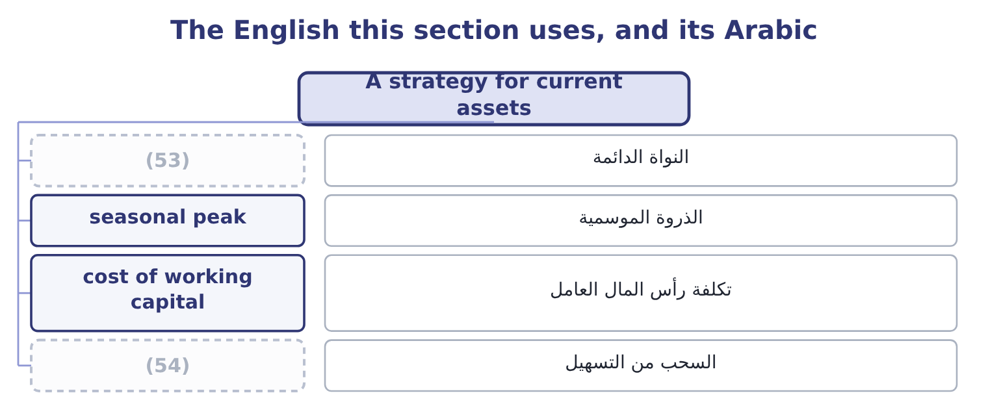
word list
الذروة الموسمية · drawdown · permanent core

The English this sheet uses, and its Arabic
English (exam term) | Arabic
permanent core | النواة الدائمة
seasonal peak | الذروة الموسمية
cost of working capital | تكلفة رأس المال العامل
drawdown | السحب من التسهيل

Answer key · 18.5 A strategy for current assets

1 outcome | 28 otherwise
2 working-capital | 29 Insurance, at a commitment fee
3 argument | 30 warning
4 requirement | 31 improves
5 Separate | 32 balance
6 forecast | 33 smaller
7 before | 34 quickly
8 funding | 35 exactly
9 balances | 36 instead
10 common | 37 larger
11 Orontes's | 38 begins
12 whatever | 39 Terms 2/10, net 40
13 components | 40 5,000,000 for 90 days at 5.5 per cent
14 discipline | 41 borrower
15 rather | 42 metaphor
16 supplier | 43 whether
17 lengthening | 44 obliged
18 policy | 45 uncommitted
19 falling | 46 difference
20 covenant | 47 investment
21 rollover | 48 unconnected
22 conservative | 49 examination
23 accidentally | 50 About 24.8 per cent a year
24 7,302,100, earning nothing | 51 9.89 per cent: 180,000 ÷ 1,820,000 = 9.89 per cent.
25 Included above | 52 understated
26 4,144,000 at 34.3 days | 53 permanent core
27 Hold; it is already tight against sales growth | 54 drawdown

the summaries in full
Summary 1 The last outcome of Book 2 asks for a recommendation, which means the whole of the working-capital section arranged into an argument. Four steps make one. Step one: size the requirement. Separate the permanent core from the seasonal peak, using the cash forecast. The permanent core is funded long; the peak is funded short, by a facility arranged before it is needed. Step two: price every component. The cost of working capital is the sum of the funding, the carrying costs of stock, the credit losses, the discounts forgone and the interest not earned on idle balances — and the single most common error is to count only the first. Orontes's own bill reads: $272,640 to fund the trade cycle, $292,084 of interest forgone on idle cash, $63,000 of credit losses, and whatever discounts it does not take.
Summary 2 Step three: attack the components in order of what they are worth. Book 1's discipline, applied here, ranks the items by money rather than by ease. For Orontes the order is: put the idle cash to work, which is worth about $176,084 a year with no risk; take every supplier discount, because forgoing one costs 37.2 per cent against a 6 per cent facility; and consider lengthening customer terms. Step four: match the policy to the risk. A company with a falling gross margin and a covenant to respect should not also be carrying rollover risk on its permanent assets. Orontes can afford to be slightly less conservative than it is; Barada cannot afford to be as aggressive as it has accidentally become.
Summary 3 One warning closes the book. Every recommendation above improves a cost or releases a balance, and the total of all of them is smaller than the single finding Book 1 ranked first: the $840,000 a year of gross margin the company has given away over three years. Working capital is where a management accountant can act quickly, and that is exactly why it must not become where a management accountant acts instead. The order of the four steps is right; so is their place in a larger order that begins with what the company sells and at what price.
Summary 4 English line of credit and credit line are the same thing, and both mean a facility a borrower may draw on. The word line is a metaphor of a limit drawn, not of a queue, and nothing in the phrase says whether the bank is obliged to lend — which is why the words committed and uncommitted have to be added and why the difference is worth more than the margin. Note the related trap: drawdown is taking money under a facility, and drawdown in investment management is a fall in the value of a portfolio — two unconnected senses that appear in the same examination.

