

CMA Part 1 · Volume 15
Earnings Per Share
Three handouts, one answer key. One line of the Learning Outcome Statements, and a whole chapter of intermediate accounting behind it.
These handouts are not notes to read. You write them. The words you supply are the summary, so a finished handout is a page you can revise from, in your own handwriting.
Work in pen. Do not look at the key until the whole handout is done — the key is written to explain the mistake, and you only get that benefit if you have made it first.
The three handouts
# | Handout | What it gives you
1 | Basic EPS and the Weighted Average Share Count | Northwind earned $510,000 on an average of 291,750 shares. The hard part is the 291,750, and Volume 8 already has every movement in it.
2 | Dilution: Options, Warrants and the Treasury Stock Method | 30,000 options at $6, when the shares average $9. Only 10,000 of them dilute anything, and the method shows why.
3 | Convertibles, the If-Converted Method, and Antidilution | Northwind’s basic $1.75 falls to $1.65 once the options and the bond go in. A third security would raise it, so it stays out.

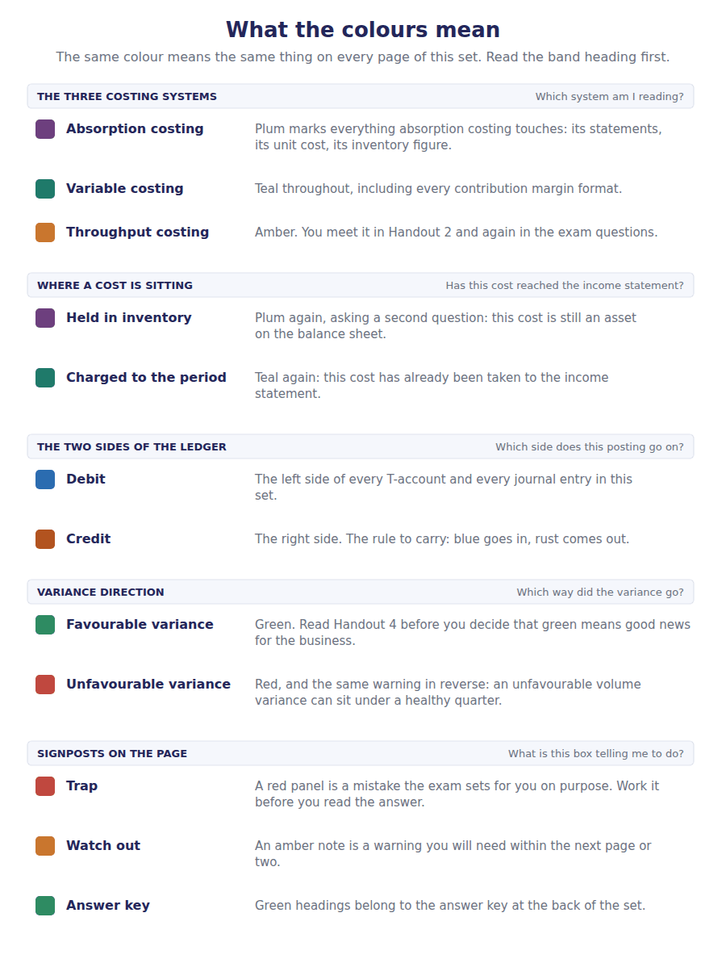
How to read the markers
Marker | Meaning
R1 | Teaching English. Short sentences. This is where a new idea arrives.
R2 | Textbook English. Longer sentences and passive verbs, as a textbook writes them.
R3 | Exam English. Exactly how the CMA exam phrases it, traps included.
Numbered rule | A space you fill in. The number matches the answer key.
Red table | A trap. Read it twice.

Handout 1 · Basic EPS and the Weighted Average Share Count
Northwind earned $510,000 on an average of 291,750 shares. The hard part is the 291,750, and Volume 8 already has every movement in it.
Volume 15 · Earnings Per Share · R1 moving to R2
LANGUAGE FOCUS
Register you are working in | R1 while the measure is being established, R2 once the weighting is being computed.
Say it exactly like this | weight shares by the months outstanding · deduct preferred dividends from net income · restate a share count retroactively · present earnings per share on the face of the statement · report a loss per share · reduce the denominator by a buy-back
Words that are not the same | basic / diluted · issued / outstanding · weighted / closing · retroactive / from the date of issue
Remember | Earnings per share does not use the closing share count. It uses the average, weighted by time. A stock dividend is not weighted from its date. It is applied to every period presented, as though it had always existed.

What you will be able to do when this handout is finished
- Say what earnings per share measures and why it is presented.
- Compute a weighted average share count.
- Deduct preferred dividends to get income available to common shareholders.
- Say which share changes are weighted and which are applied retroactively.
- Present earnings per share for each component of income.

One number, built from two
Earnings per share is the most quoted figure any company publishes, and it is the only ratio the standards require on the face of the income statement.
Northwind earned $510,000 in 20X4. Dividing by its 300,000 closing shares would give $1.70, and that figure would be wrong.
It would be wrong because 20,000 of those shares were issued on 1 April and did not earn for the whole year, and because 10,000 were bought back in July and 7,000 reissued in October.
Every one of those movements is in Volume 8. This handout weights them.

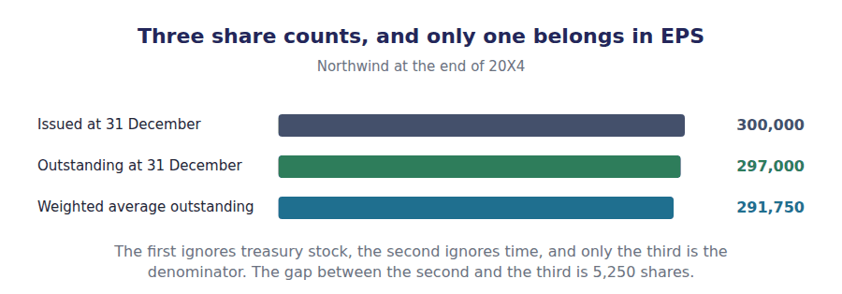
Part 1 · What the measure is for and why the denominator is weighted
Exercise 1A Read and complete. Write one word in each space.
OBJECTIVE | Say why earnings per share weights the share count by time.
YOU WILL NEED | Volume 8 Handout 1, for the share issue. · Volume 8 Handout 2, for the buy-back and the reissue.
HOW TO START | • Northwind issued 20,000 shares on 1 April. Ask how much of the year’s profit those shares were available to earn.  • The money raised by a share issue is only at work from the day it arrives.  • The last blank is what a buy-back does to earnings per share without the company earning anything more.

WORD BANK
added · deducted · falls · overstate · quarters · rises · understate
Not every word is used.

R1 Earnings per share divides the profit by the shares that earned it. A share issued on 1 April was only available to earn for nine months, so counting it as a whole share would ¹ the denominator and understate the result.
So each movement is weighted by the fraction of the year it was in force. 20,000 shares issued on 1 April count as 15,000, because nine months is three ² of a year.
The same reasoning runs backwards for a buy-back. 10,000 shares repurchased on 1 July are out of issue for six months, so 5,000 is ³ from the average.
Note what that does. A buy-back lowers the denominator and the company has earned nothing extra, so earnings per share ⁴ . Volume 8 warned about exactly this.
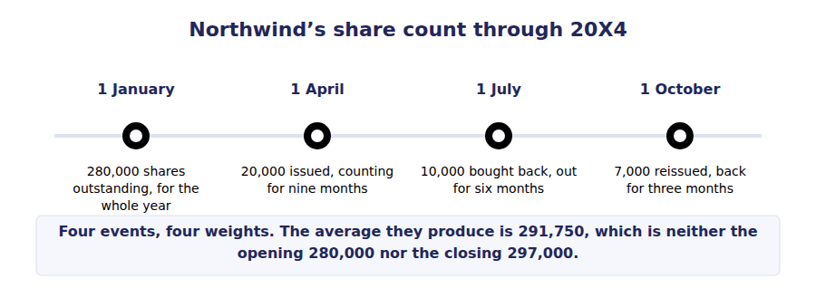
Part 2 · Computing the average Volume 8’s movements, weighted
Exercise 1B Complete the right-hand column, then total it.
OBJECTIVE | Compute the weighted average shares outstanding for 20X4.
YOU WILL NEED | Exercise 1A.
HOW TO START | • The opening 280,000 shares were outstanding all year, so their weight is 1.  • Each later movement is its share count times the months remaining over twelve.  • The buy-back row is negative. If your total comes out above 297,000 you have added it instead.

Movement in 20X4 | Shares | Months outstanding | Weighted
Outstanding at 1 January | 280,000 | 12 of 12
Issued 1 April | 20,000 | 9 of 12
Bought back 1 July | -10,000 | 6 of 12
Reissued 1 October | 7,000 | 3 of 12
Weighted average shares outstanding

1 | 2 | 3 | 4 | 5

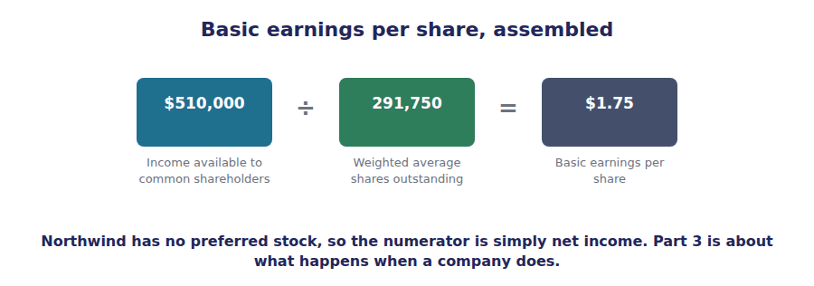
Part 3 · The numerator when preferred stock is in issue
R2 Northwind has only common stock, so its numerator is net income. A company with preferred stock must first deduct the preferred dividends, because that part of the profit belongs to someone else before the common shareholders see any of it.
Exercise 1C Read and complete. Write one word in each space.
OBJECTIVE | Deduct preferred dividends to find income available to common shareholders.
YOU WILL NEED | The paragraph above, and Volume 8 Handout 1 on dividends.
HOW TO START | • Suppose a company earns $500,000 and has preferred stock requiring $60,000 a year.  • The deduction depends on one feature of the preferred stock, and the exam always states it.  • The last blank is the kind of preferred stock whose unpaid dividends accumulate and must still be deducted.

WORD BANK
added · convertible · cumulative · declared · deducted · denominator · numerator
Not every word is used.

R2 Preferred shareholders are paid before common shareholders, so their dividend is not available to the common ones. It is ⁵ from net income before the division.
A company earning $500,000 with a $60,000 preferred requirement has $440,000 available to common shareholders, and it is that figure, not the $500,000, that becomes the ⁶ .
Whether the dividend has actually been declared may not matter. On ⁷ preferred stock the entitlement builds up whether or not a dividend is declared, so the year’s requirement is deducted either way.
On non-cumulative preferred stock only a dividend actually ⁸ is deducted, because nothing accumulates if the board passes it.
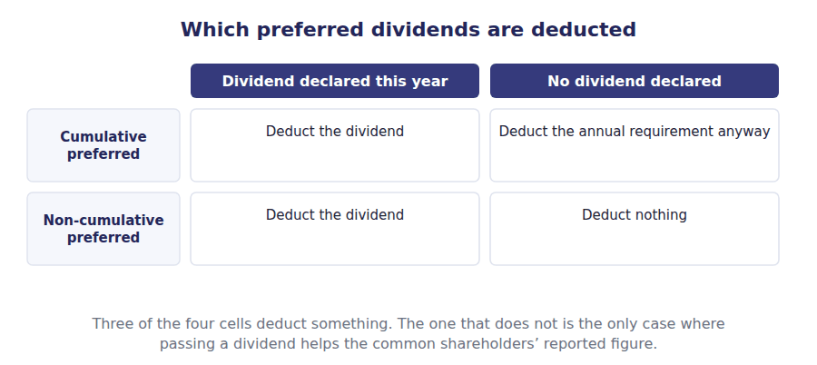
Part 4 · The changes that are not weighted stock dividends and splits
Exercise 1D Sort each change into the column it belongs in.
OBJECTIVE | Say which share changes are weighted and which apply to every period presented.
YOU WILL NEED | Exercise 1B, and Volume 8 Handout 3 on stock dividends and splits.
HOW TO START | • Ask of each change whether the company received anything for the new shares. Where it received nothing, a retroactive restatement is required.  • A share issue for cash brings in resources from a date; a stock dividend brings in nothing at all.  • If the share count doubles and nothing was received, every earlier figure has to be restated or the series is meaningless.

Change in the share count | WEIGHTED FROM ITS DATE | APPLIED RETROACTIVELY
1. Shares issued for cash on 1 April
2. A 10% stock dividend
3. A 2 for 1 stock split
4. Treasury shares bought back on 1 July
5. Shares issued to acquire a building
6. A reverse split

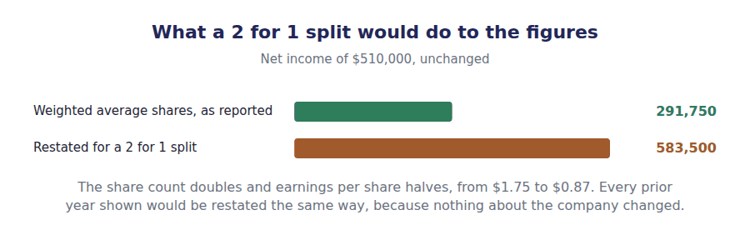
Part 5 · Presenting it one line for each component of income
Exercise 1E Complete the right-hand column. The same denominator serves every row.
OBJECTIVE | Present earnings per share for each component of income.
YOU WILL NEED | Exercise 1B, and Volume 9 Handout 3 on discontinued operations.
HOW TO START | • Use the 291,750 weighted average from Exercise 1B for every row.  • Volume 9 reported a loss from discontinued operations of $150,000 net of tax. It gets its own per-share line.  • The three per-share figures must add the same way the three income figures do.

Earnings per share for 20X4 | Amount | Per share
Income from continuing operations | $510,000
Loss from discontinued operations, net of tax | ($150,000)
Net income | $360,000

1 | 2 | 3

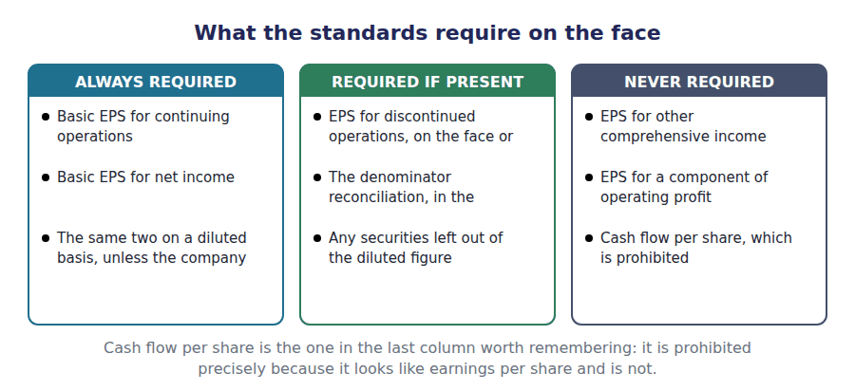
Watch out! Earnings per share uses net income, not comprehensive income. Volume 9 reported $534,000 of comprehensive income against $510,000 of net income, and the $24,000 difference never reaches any per-share figure.
Part 6 · Exam pitch the questions as the CMA sets them
1. [Level A] The denominator of basic earnings per share is:
(A) Shares issued at the year end
(B) Weighted average shares outstanding
(C) Shares outstanding at the year end
(D) Shares authorised
2. [Level A] A company has 280,000 shares outstanding all year and issues 20,000 more on 1 April. The weighted average is:
(A) 300,000
(B) 295,000
(C) 280,000
(D) 285,000
3. [Level B] Income available to common shareholders is net income less:
(A) Dividends declared on common stock
(B) Preferred dividends
(C) All dividends declared
(D) Interest on convertible debt
4. [Level B] A 2 for 1 stock split occurs in November. In computing earnings per share for the year it is:
(A) Weighted for the two months it was in force
(B) Applied to the whole year and to every prior year presented
(C) Ignored until the following year
(D) Weighted for ten months
5. [Level C] A company with cumulative preferred stock declares no preferred dividend this year. In computing EPS it:
(A) Deducts nothing
(B) Deducts the annual preferred requirement anyway
(C) Deducts twice the requirement
(D) Adds the requirement back
6. [Level C] Northwind repurchases shares and its earnings per share rises. This shows that:
(A) The company became more profitable
(B) The denominator fell while the numerator did not
(C) The share price rose
(D) A stock dividend was declared
7. [Level B] Which per-share figure may a company not present?
(A) Earnings per share from continuing operations
(B) Cash flow per share
(C) Earnings per share from discontinued operations
(D) Diluted earnings per common share
ADAPTIVE TIP Build the denominator before you touch the numerator, and lay the year out as a timeline with a weight against each movement. Almost every error on this topic is in the denominator, and almost every denominator error is a weight of 1 where it should have been a fraction.

Handout 2 · Dilution: Options, Warrants and the Treasury Stock Method
30,000 options at $6, when the shares average $9. Only 10,000 of them dilute anything, and the method shows why.
Volume 15 · Earnings Per Share · R2
LANGUAGE FOCUS
Register you are working in | R2 for the method, R3 for the classification, which the exam states in its own words.
Say it exactly like this | exercise an option at the strike price · apply the treasury stock method · assume the proceeds repurchase shares · add incremental shares to the denominator · exclude an antidilutive security · report a complex capital structure
Words that are not the same | basic / diluted · in the money / out of the money · strike price / average market price · shares issued / shares repurchased
Remember | The treasury stock method does not add all the option shares. It adds only the shares the exercise proceeds could not buy back. Options out of the money are not ignored because they are small. They are ignored because exercising them would raise the figure, not lower it.

What you will be able to do when this handout is finished
- Say what diluted earnings per share is for.
- Say when an option is dilutive.
- Apply the treasury stock method.
- Compute diluted earnings per share with options outstanding.
- Say which market price the method uses, and why.

Shares that do not exist yet
Northwind has granted 30,000 share options exercisable at $6. None has been exercised, so none of those shares is in Handout 1’s count of 291,750.
But they could be. The shares averaged $9 during the year, so every holder could have paid $6 for a share worth $9.
If they all had, there would be more shares sharing the same $510,000 of profit, and earnings per share would be lower.
Diluted earnings per share reports that worst case. This handout computes it for options; Handout 3 does convertibles.

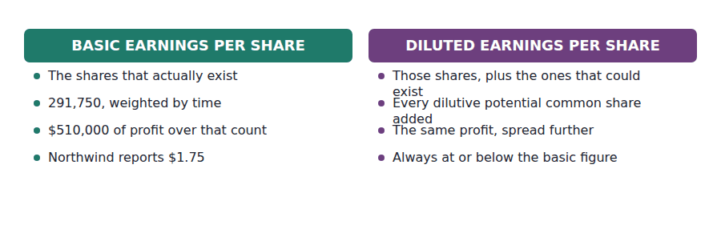
Part 1 · Why a second figure exists the shares that could be
Exercise 2A Read and complete. Write one word in each space.
OBJECTIVE | Say what diluted earnings per share measures and when it is required.
YOU WILL NEED | Handout 1 Exercise 1B, for the 291,750 weighted average.
HOW TO START | • A shareholder reading $1.75 wants to know whether that figure is safe from being spread further.  • Northwind’s 30,000 options are not shares yet, and the holders decide whether they ever become shares.  • The last blank is what a company with no such securities at all is said to have.

WORD BANK
basic · best · both · could · did · raise · worst
Not every word is used.

R2 Basic earnings per share counts the shares that exist. A reader also wants to know what the figure would be if every security that could become a share actually ¹ .
Each such security is a potential common share, and the second figure assumes they are all exercised or converted at the start of the period. It is a ² case rather than a forecast.
A company holding any of them has a complex capital structure and must report ³ figures. One with none of them has a simple structure and reports basic earnings per share alone.
The diluted figure can never be above the basic one. If adding a security would ⁴ earnings per share, it is left out, and Handout 3 explains that rule.
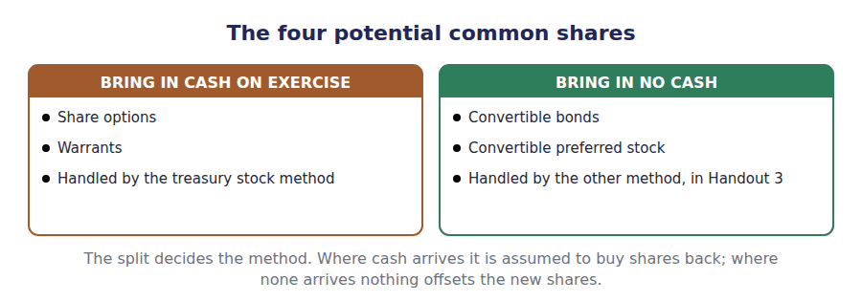
Part 2 · When an option dilutes and when it does nothing
Exercise 2B Read and complete. Write one word or figure in each space.
OBJECTIVE | Say when an option is dilutive and which price the test uses.
YOU WILL NEED | Exercise 2A.
HOW TO START | • Northwind’s options are exercisable at $6 and the shares averaged $9.  • Ask whether a holder would pay $6 for something worth less than that.  • The last blank is the price the method uses, and it is not the year-end price.

WORD BANK
average · closing · excluded · in · included · out · price
Not every word is used.

R2 An option is worth exercising only when the share is worth more than the exercise price. Northwind’s options cost $6 and the shares averaged $9, so they are ⁵ the money.
An option exercisable at $12 when the shares average $9 would never be exercised. It is out of the money, exercising it would raise the figure rather than lower it, and it is ⁶ from the computation altogether.
The comparison uses the ⁷ market price for the period rather than the price at the year end, because the earnings being divided were earned across the whole period.
That choice matters. A share that averaged $9 and closed at $5 would give one answer on the average and quite another on the closing ⁸ .
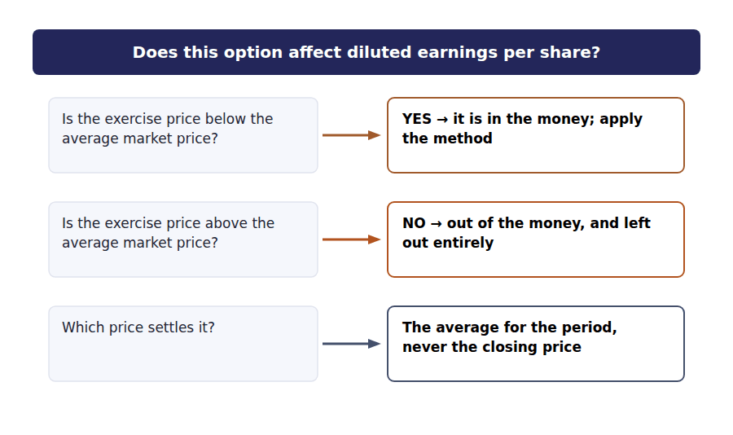
Part 3 · The treasury stock method assume exercise, then assume a buy-back
R2 Exercising an option does two things: it creates a share, and it hands the company cash. The method accounts for both. The new shares are added, and the cash is assumed to repurchase shares at the average market price, so only the difference increases the denominator.
Exercise 2C Complete the schedule. The option count is given.
OBJECTIVE | Apply the treasury stock method to Northwind’s options.
YOU WILL NEED | Exercise 2B, and the paragraph above.
HOW TO START | • The proceeds are 30,000 options at $6 each.  • That cash buys shares at the average price of $9, not at the exercise price.  • The incremental shares are the 30,000 issued less the number repurchased, and the answer should be a round figure.

The treasury stock method | Shares
Options outstanding, exercisable at $6 | 30,000
Cash the holders would pay on exercise
Shares that cash would buy back at the $9 average price
Incremental shares added to the denominator

1 | 2 | 3

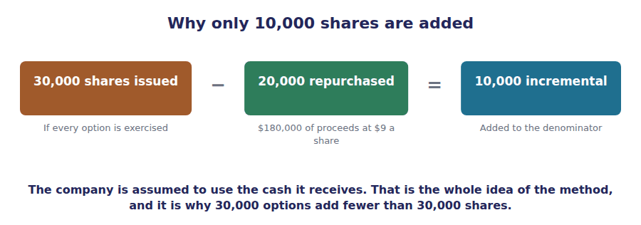
Part 4 · The diluted figure one denominator, adjusted
Exercise 2D Complete the grid. The numerator does not change.
OBJECTIVE | Compute diluted earnings per share with the options included.
YOU WILL NEED | Exercise 2C, and Handout 1 for the basic figure.
HOW TO START | • Options bring in cash and cost the company no interest, so nothing is added to the numerator.  • The denominator is the 291,750 weighted average plus the 10,000 incremental shares.  • Your diluted figure must come out below the basic $1.75. If it does not, check the direction of the adjustment.

Diluted EPS for 20X4 | Numerator | Denominator | Per share
Basic | $510,000 | 291,750
Add the incremental shares
Diluted, options only | $510,000

1 | 2 | 3 | 4 | 5 | 6

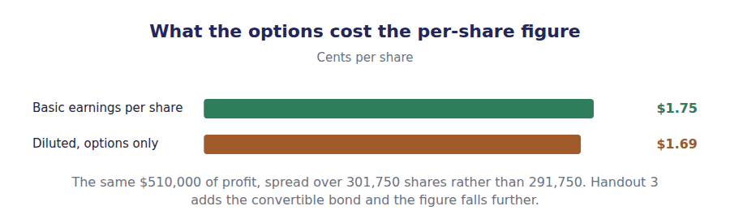
Watch out! The treasury stock method repurchases at the average market price and nothing else. A stem that gives you an exercise price, an average price and a closing price is giving you two figures you need and one you must not use.
Part 5 · Exam pitch the questions as the CMA sets them
1. [Level A] Diluted earnings per share assumes that:
(A) All potential common shares are exercised or converted
(B) All dilutive potential common shares are exercised or converted
(C) No potential common shares are exercised
(D) Half the potential common shares are exercised
2. [Level A] An option is dilutive when its exercise price is:
(A) Above the average market price
(B) Below the average market price
(C) Equal to the par value
(D) Below the closing market price
3. [Level B] Under the treasury stock method, the proceeds from assumed exercise are used to:
(A) Reduce the numerator
(B) Repurchase shares at the average market price
(C) Repurchase shares at the exercise price
(D) Pay a dividend
4. [Level B] 30,000 options at an exercise price of $6 are outstanding when the average market price is $9. The incremental shares are:
(A) 30,000
(B) 10,000
(C) 20,000
(D) Nil
5. [Level B] Options exercisable at $12 are outstanding when the shares average $9. In computing diluted earnings per share they are:
(A) Included, using the treasury stock method
(B) Excluded, because exercise would raise the figure
(C) Included at half weight
(D) Added to the numerator
6. [Level C] Applying the treasury stock method to Northwind’s options changes:
(A) The numerator only
(B) The denominator only
(C) Both the numerator and the denominator
(D) Neither
7. [Level C] A company with no options, warrants or convertible securities reports:
(A) Basic and diluted earnings per share, which will be equal
(B) Basic earnings per share only
(C) Diluted earnings per share only
(D) Neither figure
ADAPTIVE TIP Run the in-the-money test before you compute anything. An out-of-the-money option needs no method, no proceeds and no arithmetic — it is simply excluded, and a candidate who starts computing has already lost time on a question designed to be answered in one line.

Handout 3 · Convertibles, the If-Converted Method, and Antidilution
Northwind’s basic $1.75 falls to $1.65 once the options and the bond go in. A third security would raise it, so it stays out.
Volume 15 · Earnings Per Share · R2 moving to R3
LANGUAGE FOCUS
Register you are working in | R2 for the method, R3 for the antidilution test, which the exam sets as a ranking question.
Say it exactly like this | assume conversion at the start of the period · add back the after-tax interest · rank securities by incremental earnings per share · exclude an antidilutive security · convert preferred stock into common · adjust both the numerator and the denominator
Words that are not the same | treasury stock method / if-converted method · dilutive / antidilutive · incremental EPS / basic EPS · convertible bond / convertible preferred
Remember | Adding back the interest is not optional. If the bond had converted there would have been no interest, so the numerator must be restated too. Antidilutive does not mean unimportant. It means including the security would raise earnings per share, which the measure forbids.

What you will be able to do when this handout is finished
- Apply the if-converted method to a convertible bond.
- Say why the numerator changes and by how much.
- Compute incremental earnings per share for a security.
- Decide whether a security is dilutive or antidilutive.
- Compute diluted earnings per share with several securities.

A bond that could become shares
Volume 14 issued a $1,000,000 bond with a 6% coupon. Suppose it is convertible into 40,000 common shares.
If the holders convert, Northwind issues 40,000 shares and stops paying interest on the bond. Both halves of earnings per share move.
That is the difference from Handout 2. An option brings in cash and changes only the denominator; a convertible brings in nothing and changes both.
And a third security, a convertible preferred, would raise the figure rather than lower it. This handout explains why it is left out.

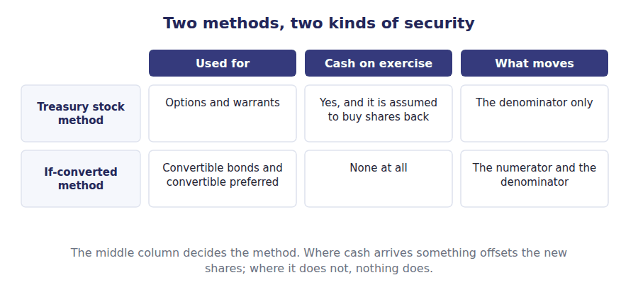
Part 1 · Why the numerator moves the interest that would not have been paid
Exercise 3A Read and complete. Write one word or figure in each space.
OBJECTIVE | Say why assuming conversion changes the numerator as well as the denominator.
YOU WILL NEED | Handout 2 Exercise 2C, on the treasury stock method. · Volume 14 Handout 3, for the bond’s year one interest.
HOW TO START | • If the bond had converted on the first day of the year, ask whether Northwind would have paid any interest on it.  • Volume 14 charged $73,612 of interest on that bond in year one.  • The last blank is why the full $73,612 is not added back, and the answer involves the tax.

WORD BANK
dividends · if-converted · increased · interest · reduced · tax · treasury
Not every word is used.

R2 The method assumes the bond converted on the first day of the period. If it had, Northwind would have issued 40,000 shares, and it would also have paid no ¹ on the bond at all.
So the $73,612 Volume 14 charged would not have been incurred, and profit would have been higher. The numerator is ² to reflect that.
Not by the whole $73,612, though. Interest is deductible, so saving it would also have cost $18,403 in extra ³ , and only the net $55,209 is added back.
The denominator rises by 40,000. Both halves of the fraction move, which is the whole difference between this method and the ⁴ stock method of Handout 2.
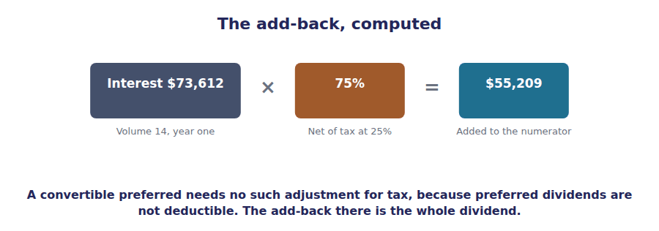
Part 2 · The test for dilution incremental earnings per share
R2 Each security is tested on its own before it is let in. Its numerator adjustment is divided by the shares it would add, and the result is compared with basic earnings per share. Below is dilutive; above is not.
Exercise 3B Complete the schedule. Two figures are given.
OBJECTIVE | Compute the incremental earnings per share of the convertible bond.
YOU WILL NEED | Exercise 3A, and the paragraph above.
HOW TO START | • The numerator adjustment is the $73,612 of interest net of 25% tax.  • Divide that by the 40,000 shares the conversion would create.  • Compare the answer with the basic $1.75. Below it means the security dilutes.

The if-converted method | Amount
Interest on the convertible bond for the year | $73,612
Less tax relief at 25%
Added back to the numerator
Shares issuable on conversion | 40,000
Incremental earnings per share

1 | 2 | 3

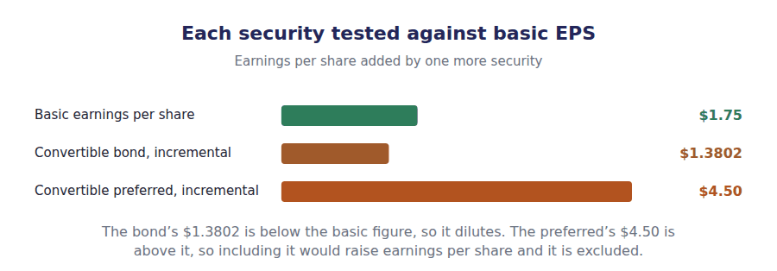
Part 3 · The security that stays out antidilution
Exercise 3C Complete the grid, then say which one is excluded.
OBJECTIVE | Decide which securities belong in the diluted figure.
YOU WILL NEED | Exercise 3B, and Handout 2 Exercise 2C.
HOW TO START | • The options add no income at all, so their incremental figure is nil and nothing can be lower than that.  • The convertible preferred requires a $90,000 dividend and would issue 20,000 shares.  • Compare each incremental figure with the basic $1.75, and remember that preferred dividends carry no tax relief.

WORD BANK
above · antidilutive · basic · below · diluted · dilutive · excluded · nil
Not every word is used.

R3 Each security is tested on its own before it is let in. Divide the income it would add back by the shares it would create, and compare the result with ⁵ earnings per share.
The convertible bond adds $55,209 of income and 40,000 shares, giving $1.3802. That is below the basic $1.75, so the bond lowers the figure and is ⁶ .
The convertible preferred adds $90,000 of dividend and only 20,000 shares, giving $4.50. That is ⁷ the basic figure, so including it would raise earnings per share.
A security of that kind is ⁸ . It is excluded from the computation entirely and disclosed instead, so a reader knows it exists without the figure being flattered by it.
The options need no such test. They add shares and no income at all, so their incremental figure is ⁹ and nothing can dilute more than that.
Security | Incremental EPS | Against basic of $1.75 | Included?
Options, 30,000 at $6
Convertible bond, 40,000 shares
Convertible preferred, 20,000 shares

1 | 2 | 3 | 4 | 5 | 6
7 | 8 | 9

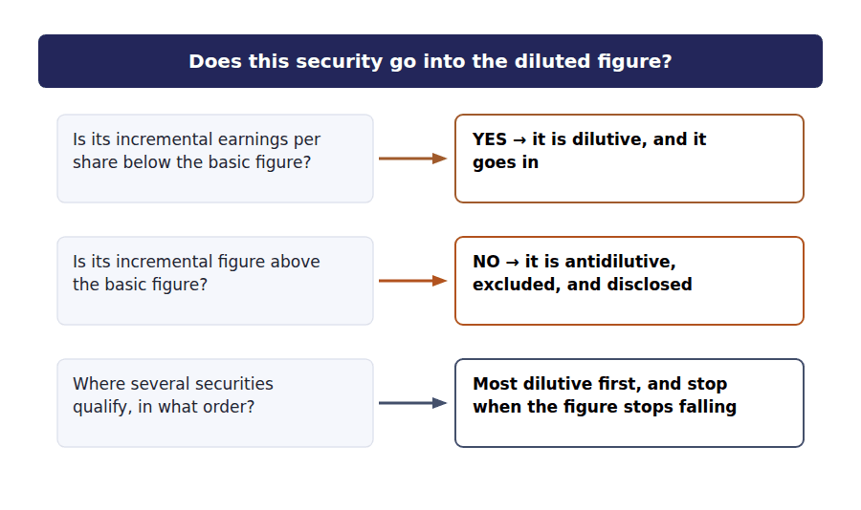
Part 4 · The whole computation two securities, one figure
Exercise 3D Complete the grid. Each row builds on the one above it.
OBJECTIVE | Compute diluted earnings per share with both dilutive securities.
YOU WILL NEED | Exercises 3B and 3C, and Handout 2 for the option shares.
HOW TO START | • Start from basic: $510,000 over 291,750.  • The options add 10,000 shares and nothing to the numerator; the bond adds 40,000 shares and $55,209.  • Check the figure falls at every step. If it rises you have included the preferred, which Exercise 3C excluded.

Diluted EPS for 20X4 | Numerator | Denominator | Per share
Basic | $510,000 | 291,750
Add the options |  | 10,000
Add the convertible bond |  | 40,000
Diluted earnings per share

1 | 2 | 3 | 4 | 5 | 6
7 | 8 | 9

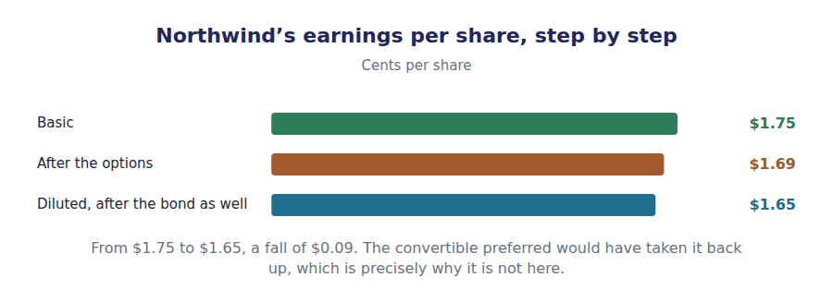
Part 5 · The order, and why it matters most dilutive first
Exercise 3E Sort each statement into the column that says whether it is true.
OBJECTIVE | Say why dilutive securities are included in order of their effect.
YOU WILL NEED | Exercise 3D.
HOW TO START | • Adding securities in a different order can give a different answer, which is why the standard fixes one.  • A security that is dilutive on its own can become antidilutive once others have already lowered the figure.  • One of the statements is about disclosure, which is required for the securities left out.

Statement about the order of inclusion | TRUE | FALSE
1. Securities are included from most dilutive to least
2. The order can change the final diluted figure
3. A security dilutive on its own can be antidilutive once others are in
4. Antidilutive securities are included at half weight
5. Securities excluded as antidilutive are disclosed
6. Diluted earnings per share can exceed basic earnings per share

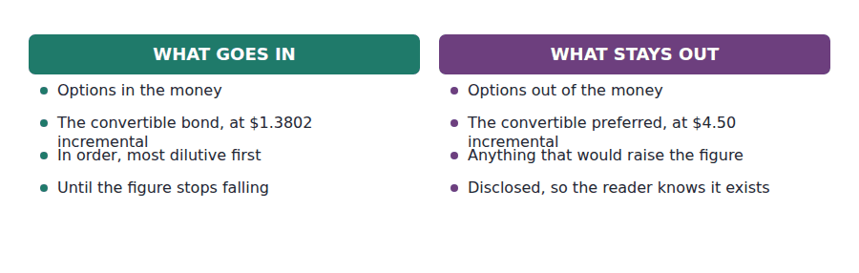
Watch out! Diluted earnings per share can never exceed basic. That is not a tendency but a rule, enforced by the antidilution test, and a computed answer above the basic figure is always an error rather than a result.
Part 6 · Exam pitch the questions as the CMA sets them
1. [Level A] Under the if-converted method, a convertible bond affects:
(A) The denominator only
(B) The numerator and the denominator
(C) The numerator only
(D) Neither
2. [Level B] A convertible bond carries $73,612 of interest for the year and the tax rate is 25%. The add-back to the numerator is:
(A) $73,612
(B) $55,209
(C) $18,403
(D) Nil
3. [Level B] A convertible preferred stock requires a dividend of $90,000 and would convert into 20,000 shares. Its incremental earnings per share is:
(A) $2.25
(B) $4.50
(C) $1.75
(D) Nil
4. [Level B] A security whose incremental earnings per share is above the basic figure is:
(A) Included first
(B) Excluded as antidilutive
(C) Included last
(D) Included at half weight
5. [Level C] Northwind’s basic earnings per share is $1.75 and its diluted figure is $1.65. A newly issued security has an incremental earnings per share of $1.50. It should be:
(A) Excluded, because $1.50 is above $1.65
(B) Included, because $1.50 is below the basic $1.75
(C) Excluded, because it is preferred stock
(D) Included only if it is in the money
6. [Level C] Dilutive securities are included in the computation:
(A) In the order they were issued
(B) From the most dilutive to the least
(C) From the least dilutive to the most
(D) In any order, since the answer is the same
7. [Level A] A company computes a diluted figure above its basic figure. This means:
(A) The company is highly profitable
(B) An antidilutive security has been included in error
(C) The securities were added in the wrong order
(D) The numerator was understated
ADAPTIVE TIP Compute each security’s incremental earnings per share before you compute anything else, and write them in a column beside the basic figure. That one list tells you which securities go in, in what order, and which the question put there to be left out.

Answer Key
Volume 15 · Handouts 1 to 3
Every answer carries the reason for it and the mistake it defeats.

Handout 1 · Basic EPS and the Weighted Average Share Count answers
Completed text and exercises
# | Answer | Why | The trap it defeats
1 | overstate | More shares than actually earned.
2 | quarters | Nine of twelve months.
3 | deducted | Out of issue, so out of the average.
4 | rises | A smaller denominator over the same profit. | Students read a rise in earnings per share as better performance. Half the time it is a smaller share count.
5 | deducted | Paid first, so not available to common.
6 | numerator | What is left for the common shareholders.
7 | cumulative | Unpaid entitlements accumulate. | Students deduct only declared dividends. On cumulative preferred the requirement is deducted whether declared or not.
8 | declared | Nothing accumulates, so nothing is owed.
Grid 1 | 1 WEIGHTED FROM ITS DATE 2 APPLIED RETROACTIVELY 3 APPLIED RETROACTIVELY 4 WEIGHTED FROM ITS DATE 5 WEIGHTED FROM ITS DATE 6 APPLIED RETROACTIVELY | The test is whether resources changed hands. A split and a stock dividend change only the number of pieces the same company is cut into.

Exam-pitch questions
# | Answer | Why | The trap it defeats
1 | (B) Weighted average shares outstanding | Averaged across the period and weighted by time. (C) ignores when the shares arrived, which on Northwind’s figures would change the denominator by 5,250 shares. | Level A
2 | (B) 295,000 | Nine of twelve months is a weight of 0.75, so 15,000 of the new shares count. (A) treats a share issued in April as though it had been there since January. | Level A
3 | (B) Preferred dividends | Only the preferred claim ranks ahead of the common shareholders. (A) is the common dividend, which is a distribution of what the measure is trying to express. | Level B
4 | (B) Applied to the whole year and to every prior year presented | No resources were received, so the restatement is retroactive and comparability is preserved. (A) applies the weighting rule meant for issues that bring in cash. | Level B
5 | (B) Deducts the annual preferred requirement anyway | A cumulative entitlement accumulates whether declared or not, so it is not available to common shareholders. (A) is the answer for non-cumulative preferred, and the exam states which kind it means. | Level C
6 | (B) The denominator fell while the numerator did not | A buy-back reduces the weighted average without earning anything more. (A) is exactly the inference the measure invites and the reason a reader should look at both halves of it. | Level C
7 | (B) Cash flow per share | Cash flow per share is prohibited, because it invites readers to treat it as a substitute for earnings per share when the two measure quite different things. | Level B

Exercise 1B · the weighted average, computed
Movement in 20X4 | Shares | Months outstanding | Weighted
Outstanding at 1 January | 280,000 | 12 of 12 | 280,000
Issued 1 April | 20,000 | 9 of 12 | 15,000
Bought back 1 July | -10,000 | 6 of 12 | -5,000
Reissued 1 October | 7,000 | 3 of 12 | 1,750
Weighted average shares outstanding |  |  | 291,750

Exercise 1E · the presentation
Earnings per share for 20X4 | Amount | Per share
Income from continuing operations | $510,000 | $1.75
Loss from discontinued operations, net of tax | ($150,000) | $-0.51
Net income | $360,000 | $1.23

R2 Every figure in the first table came from Volume 8: 280,000 shares at 1 January from Volume 1’s $280,000 of $1 par stock, the 20,000 issued in Handout 1, and the 10,000 bought back and 7,000 reissued in Handout 2. Only the four dates were added here.
R2 The weighted average of 291,750 sits between the opening 280,000 and the closing 297,000, which is the sanity check worth running. An answer outside that range has a sign error in it, usually on the buy-back line.

Handout 2 · Dilution: Options, Warrants and the Treasury Stock Method answers
Completed text and exercises
# | Answer | Why | The trap it defeats
1 | did | Every one of them, at once.
2 | worst | The floor, not the expectation.
3 | both | Two figures, on the face of the statement.
4 | raise | Then it is left out, as Handout 3 explains. | Students include every convertible security. Only the dilutive ones go in, and the test is arithmetic.
5 | in | Worth exercising, because the share is worth more.
6 | excluded | Exercising it would raise earnings per share.
7 | average | For the period, matching the earnings. | Students use the closing price. The average is the one consistent with a figure earned over the whole year.
8 | price | Two different answers from the same facts.

Exam-pitch questions
# | Answer | Why | The trap it defeats
1 | (B) All dilutive potential common shares are exercised or converted | Only the dilutive ones. (A) is the answer the word diluted suggests and it would let a security that raises the figure do so, which the whole measure exists to prevent. | Level A
2 | (B) Below the average market price | In the money against the average price for the period. (D) uses the closing price, which is the one price the method never uses. | Level A
3 | (B) Repurchase shares at the average market price | Repurchase at the average market price, which is why only the excess shares are added. (C) would repurchase exactly as many shares as were issued and show no dilution at all. | Level B
4 | (B) 10,000 | $180,000 of proceeds buys 20,000 shares at $9, so 30,000 less 20,000 is 10,000. (A) adds every option share and ignores the cash the company would receive. | Level B
5 | (B) Excluded, because exercise would raise the figure | Nobody pays $12 for a $9 share, and including them would raise the figure. (A) applies the method mechanically without first running the in-the-money test. | Level B
6 | (B) The denominator only | Options bring in cash and carry no interest or dividend, so nothing is added back to income. (C) is true of the convertible securities in Handout 3, and the contrast is the point. | Level C
7 | (B) Basic earnings per share only | That is a simple capital structure, and only the basic figure is required. (A) is defensible in arithmetic and is not what the standards ask for. | Level C

Exercise 2C · the treasury stock method, applied
The treasury stock method | Shares
Options outstanding, exercisable at $6 | 30,000
Cash the holders would pay on exercise | $180,000
Shares that cash would buy back at the $9 average price | 20,000
Incremental shares added to the denominator | 10,000

Exercise 2D · diluted earnings per share, options only
Diluted EPS for 20X4 | Numerator | Denominator | Per share
Basic | $510,000 | 291,750 | $1.75
Add the incremental shares | — | 10,000
Diluted, options only | $510,000 | 301,750 | $1.69

R2 The incremental 10,000 shares can be computed a second way as a check: the options are in the money by $3 on a $9 share, which is a third of the price, and a third of 30,000 options is 10,000. Where the arithmetic is clean that shortcut is faster than the schedule.
R2 Note that the numerator did not move. Options are the simple case precisely because exercising one brings in cash and costs the company nothing in income. Handout 3 takes the securities where that is not true.

Handout 3 · Convertibles, the If-Converted Method, and Antidilution answers
Completed text and exercises
# | Answer | Why | The trap it defeats
1 | interest | A converted bond pays nothing.
2 | increased | Profit would have been higher.
3 | tax | The saving is taxable, so add back the net figure. | Students add back the gross interest. The deduction would have been lost, so the add-back is net of tax.
4 | treasury | Options move one half; convertibles move both.
5 | basic | The benchmark is basic, not the running diluted figure.
6 | dilutive | Below basic, so it goes in.
7 | above | More income per share than the company already earns.
8 | antidilutive | It would raise the figure, so it stays out. | Students include every convertible security they are given. The test is arithmetic and it is run first.
9 | nil | No income added, so nothing over the shares.
Grid 1 | 1 TRUE 2 TRUE 3 TRUE 4 FALSE 5 TRUE 6 FALSE | The last is the rule the whole topic protects. If your diluted figure is above your basic one, a security has been included that should not have been.

Exam-pitch questions
# | Answer | Why | The trap it defeats
1 | (B) The numerator and the denominator | Conversion issues shares and stops the interest, so both move. (A) is the treasury stock method’s effect, and distinguishing the two is most of this handout. | Level A
2 | (B) $55,209 | $73,612 net of $18,403 tax relief is $55,209. (A) adds back the gross interest and forgets that the deduction would have been lost too. | Level B
3 | (B) $4.50 | $90,000 over 20,000 shares, with no tax adjustment because preferred dividends are not deductible. (A) applies a tax effect that does not exist here. | Level B
4 | (B) Excluded as antidilutive | Including it would raise the figure, which the measure forbids. (C) is the trap for a candidate who has learned the ordering rule and not the exclusion rule. | Level B
5 | (B) Included, because $1.50 is below the basic $1.75 | The test is against the basic figure, security by security, and the securities are then added in order. (A) tests against the diluted figure, which is the result rather than the benchmark. | Level C
6 | (B) From the most dilutive to the least | Most dilutive first, because the order changes the answer and the standard fixes one. (D) is false precisely because a security can turn antidilutive once others have lowered the figure. | Level C
7 | (B) An antidilutive security has been included in error | Diluted can never exceed basic, so the result is an error rather than a finding. (C) can change the answer and cannot push it above basic, because the exclusion test runs first. | Level A

Exercise 3B · the if-converted add-back
The if-converted method | Amount
Interest on the convertible bond for the year | $73,612
Less tax relief at 25% | ($18,403)
Added back to the numerator | $55,209
Shares issuable on conversion | 40,000
Incremental earnings per share | $1.3802

Exercise 3C · which securities qualify
Security | Incremental EPS | Against basic of $1.75 | Included?
Options, 30,000 at $6 | Nil | Below | Yes
Convertible bond, 40,000 shares | $1.3802 | Below | Yes
Convertible preferred, 20,000 shares | $4.50 | Above | No

Exercise 3D · diluted earnings per share, complete
Diluted EPS for 20X4 | Numerator | Denominator | Per share
Basic | $510,000 | 291,750 | $1.75
Add the options | — | 10,000 | $1.69
Add the convertible bond | $55,209 | 40,000 | $1.65
Diluted earnings per share | $565,209 | 341,750 | $1.65

R2 The options have an incremental earnings per share of nil, because they add shares and no income at all. Nothing can be more dilutive than that, which is why options always go in first when both kinds of security are present.
R2 The final figure of $1.65 against a basic $1.75 is a fall of $0.09, or about 5.4%. The convertible preferred would have taken it back above the basic figure, and the whole purpose of the incremental test is to notice that before including it.

Glossary
Every term in Volume 15, with the Arabic equivalent and the places it misleads
The third column is for recognition only. In the exam room you work in English.

Term | What it means in CMA English | بالعربية | Careful
antidilutive | Describing a security whose inclusion would raise earnings per share rather than lower it. | مضاد للتخفيف | Excluded from the diluted figure and disclosed, so a reader knows it exists.
basic earnings per share | Income available to common shareholders divided by the weighted average shares outstanding. | ربحية السهم الأساسية | Two figures, and the denominator is where almost every error happens.
complex capital structure | A capital structure containing securities that could become common shares. | هيكل رأس مال معقد | A company with one must report both basic and diluted figures. Northwind’s options make it one.
diluted earnings per share | Earnings per share computed as though every dilutive potential common share had been issued. | ربحية السهم المخففة | A worst case, not a forecast. It answers what the figure would have been had the holders all exercised.
if-converted method | The method for convertible securities: assume conversion at the start of the period, add the shares, and reverse the interest or dividend that would not have been paid. | طريقة الافتراض بالتحويل | Both halves of the fraction move, which is what distinguishes it from the treasury stock method.
in the money | Describing an option whose exercise price is below the market price of the share. | في النقد | Only options in the money are dilutive. The test uses the average price for the period, not the price at the year end.
income available to common shareholders | Net income less the dividends on preferred stock for the period. | الدخل المتاح لحملة الأسهم العادية | The numerator. Preferred dividends are deducted whether or not they were declared, if the preferred stock is cumulative.
incremental earnings per share | The effect a single security would have, computed as its numerator adjustment divided by the shares it would add. | ربحية السهم الإضافية | The test for dilution and the order of inclusion, both at once. Below basic is dilutive; above it is not.
potential common share | A security or contract that may entitle its holder to common shares. | سهم عادي محتمل | Options, warrants, convertible bonds and convertible preferred stock are the four the exam uses.
retroactive restatement | Applying a share change to every period presented as though it had always been in force. | إعادة العرض بأثر رجعي | Used for stock dividends and splits, which give no new resources to the company and must not break comparability.
simple capital structure | A capital structure with no securities that could convert into common shares. | هيكل رأس مال بسيط | A company with one reports basic earnings per share alone. Handouts 2 and 3 are about the other kind.
treasury stock method | The method for options and warrants: assume exercise, and assume the proceeds buy back shares at the average market price. | طريقة أسهم الخزينة | The repurchase is an assumption, not an event. No company actually does it.
weighted average shares outstanding | The share count averaged across the period, each change weighted by the part of the year it was in force. | المتوسط المرجح للأسهم القائمة | Not the opening count and not the closing count. A share issued on 1 October counts for a quarter of a share.

