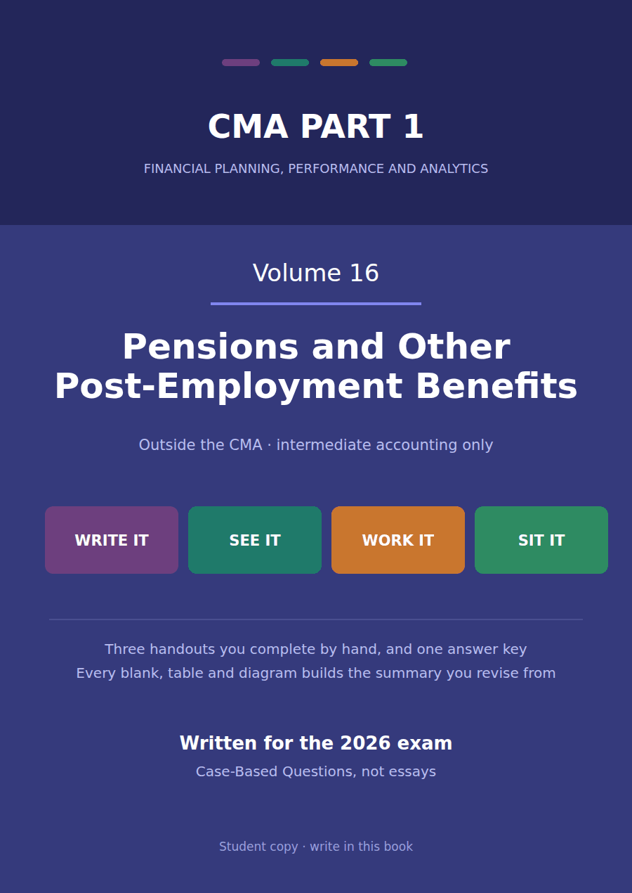

CMA Part 1 · Volume 16
Pensions and Other Post-Employment Benefits
Three handouts, one answer key. No CMA section asks for this. It is here because a course in intermediate accounting without it is not one.
These handouts are not notes to read. You write them. The words you supply are the summary, so a finished handout is a page you can revise from, in your own handwriting.
Work in pen. Do not look at the key until the whole handout is done — the key is written to explain the mistake, and you only get that benefit if you have made it first.
The three handouts
# | Handout | What it gives you
1 | The Promise, the Obligation and the Plan Assets | Northwind owes its retirees $2,400,000 and holds $2,000,000 to pay them with. The gap is the only figure that reaches the balance sheet.
2 | The Five Components of Net Periodic Pension Cost | Northwind contributed $200,000 to its plan and charged $170,000 to profit. Neither number explains the other.
3 | Funded Status on the Balance Sheet, and What Goes to OCI | Three large figures and one small one. The balance sheet reports the ($474,000), and the notes carry everything that explains it.

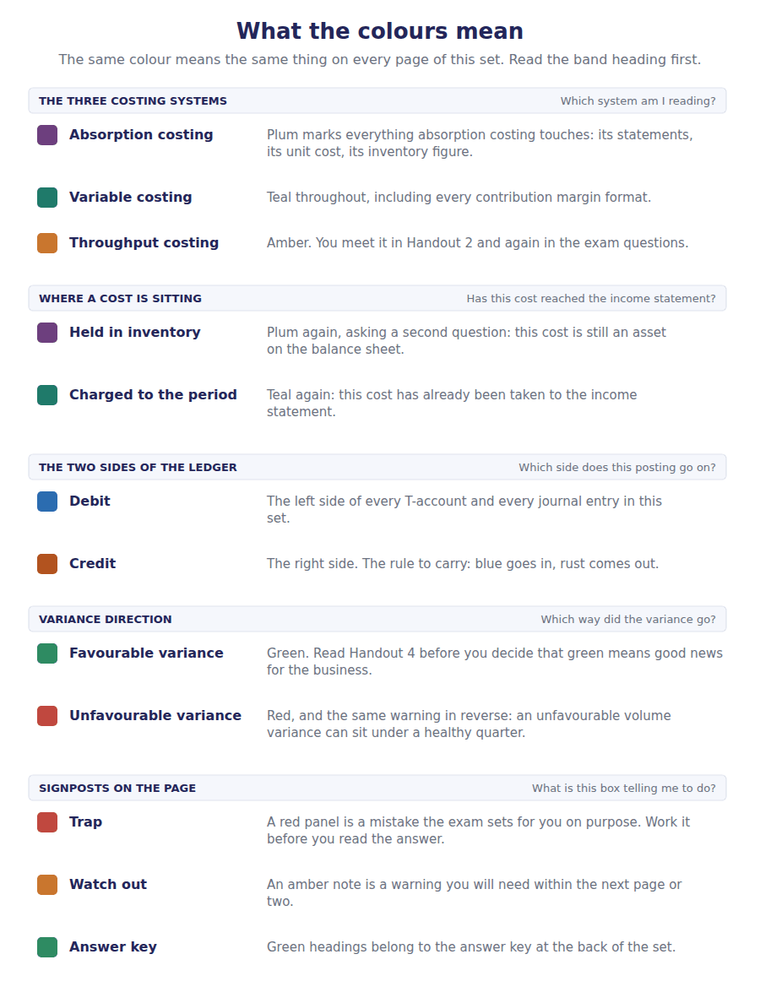
How to read the markers
Marker | Meaning
R1 | Teaching English. Short sentences. This is where a new idea arrives.
R2 | Textbook English. Longer sentences and passive verbs, as a textbook writes them.
R3 | Exam English. Exactly how the CMA exam phrases it, traps included.
Numbered rule | A space you fill in. The number matches the answer key.
Red table | A trap. Read it twice.

Handout 1 · The Promise, the Obligation and the Plan Assets
Northwind owes its retirees $2,400,000 and holds $2,000,000 to pay them with. The gap is the only figure that reaches the balance sheet.
Volume 16 · Pensions and Other Post-Employment Benefits · R1 moving to R2
LANGUAGE FOCUS
Register you are working in | R1 while the promise is being described, R2 once the two roll-forwards are being built.
Say it exactly like this | promise a benefit in retirement · fund a plan by contributing to it · measure an obligation actuarially · earn a return on plan assets · pay benefits out of the fund · report the funded status
Words that are not the same | defined contribution / defined benefit · obligation / plan assets · funded / underfunded · contribution / expense
Remember | Plan assets are not Northwind’s assets. They are held in a separate fund for the retirees and never appear among its own. A contribution is not the expense. The two are different numbers and Handout 2 computes the second.

What you will be able to do when this handout is finished
- Distinguish a defined contribution plan from a defined benefit one.
- Say who bears the investment risk under each.
- Roll the projected benefit obligation forward.
- Roll the plan assets forward.
- Compute the funded status of the plan.

A promise made thirty years early
Northwind promises its employees a pension based on their final salary and years of service. The promise is made now and the cash leaves decades later.
An actuary values what has already been earned at $2,400,000, and the fund set aside to pay it holds $2,000,000.
Neither figure appears on the balance sheet. Only the gap does: $400,000, reported as a liability because the plan is underfunded.
Volume 12 Handout 1 used these numbers to compare US GAAP with IFRS. This volume builds them.

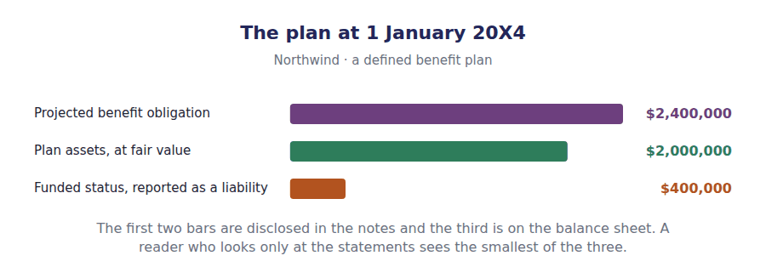
Part 1 · Two kinds of promise and who carries the risk
Exercise 1A Complete both right-hand columns.
OBJECTIVE | Distinguish the two kinds of plan and say who bears the risk under each.
YOU WILL NEED | Volume 1 Handout 2, on what makes something a liability.
HOW TO START | • Under one kind the employer’s obligation ends when the cheque is paid into the fund. Under the other it does not.  • Ask what happens if the fund’s investments perform badly, and who is worse off in each case.  • The last row follows from the others: only one of the two needs anybody to estimate anything.

 | Defined contribution | Defined benefit
What the employer promises
Who bears the investment risk
The annual expense
On the balance sheet
An actuary is needed

1 | 2 | 3 | 4 | 5 | 6
7 | 8 | 9

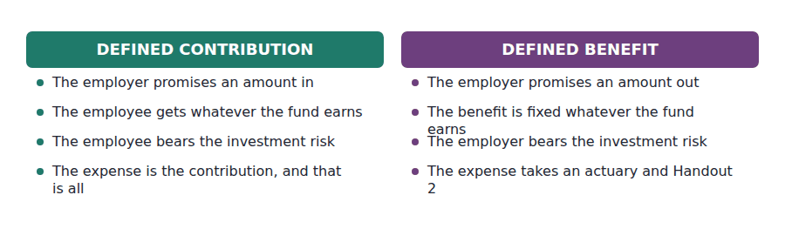
Part 2 · What is owed the obligation, rolled forward
R2 The obligation grows for two reasons every year. Employees earn another year of benefit, which is the service cost; and the whole balance comes one year closer to payment, so the discount unwinds, which is the interest cost. Benefits actually paid reduce it.
Exercise 1B Complete the schedule. Three figures are given.
OBJECTIVE | Roll the projected benefit obligation forward for the year.
YOU WILL NEED | The paragraph above, and Volume 13 Handout 1 on discounting.
HOW TO START | • Interest is 6% of the opening $2,400,000, exactly as it was on the lease liability in Volume 7.  • The plan was amended during the year, which added $60,000 for service employees had already given.  • Benefits paid reduce the obligation and the fund by the same $120,000, so watch for that figure again in Exercise 1C.

Projected benefit obligation, 20X4 | Amount
Balance at 1 January 20X4 | $2,400,000
Service cost for the year | $180,000
Interest on the obligation at 6%
Past service cost from the plan amendment | $60,000
Benefits paid to retirees | ($120,000)
Balance at 31 December 20X4

1 | 2

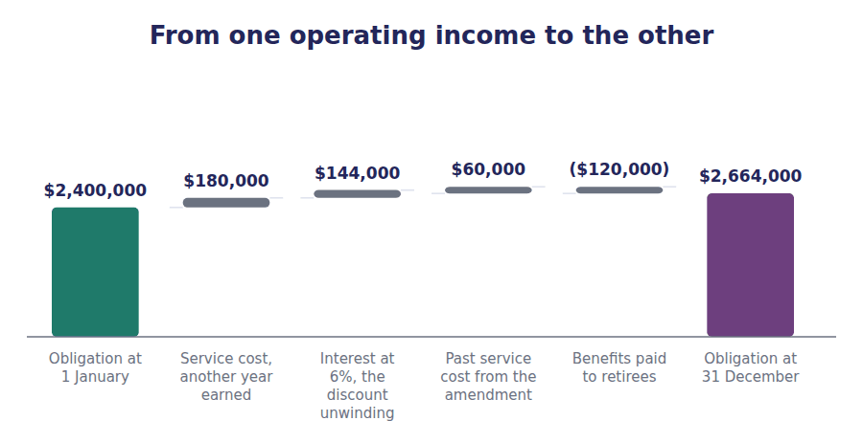
Part 3 · What is set aside the fund, rolled forward
Exercise 1C Read and complete, then complete the schedule underneath.
OBJECTIVE | Roll the plan assets forward and say why they are not Northwind’s assets.
YOU WILL NEED | Exercise 1B.
HOW TO START | • The fund grows by what it earns and by what Northwind pays in, and shrinks by what it pays out.  • The $120,000 of benefits paid appears in both schedules, reducing the obligation and the fund together.  • The last blank is why none of the $2,000,000 appears among Northwind’s own assets.

WORD BANK
added · earns · netted · nothing · owned · promised · separate
Not every word is used.

R2 The plan assets are held in a fund that is legally ¹ from Northwind. The company cannot spend them, cannot pledge them, and gets them back only in the rare case of a surplus on wind-up.
So they fail the definition of an asset of the company, and none of the $2,000,000 appears among its own. They are ² against the obligation instead, and only the difference is reported.
The fund grows by the return it ³ and by the contributions Northwind pays in, and falls by the benefits paid out. This year that is $110,000, $200,000 and $120,000.
Note that benefits paid reduce the fund and the obligation by the same amount, so paying a pensioner changes the funded status by ⁴ at all.
Plan assets, 20X4 | Amount
Fair value at 1 January 20X4 | $2,000,000
Actual return earned on the assets | $110,000
Contributions paid in by Northwind | $200,000
Benefits paid to retirees | ($120,000)
Fair value at 31 December 20X4

1

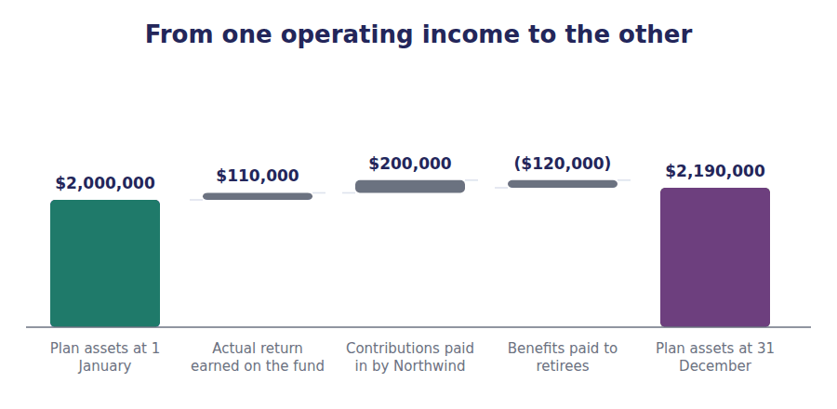
Part 4 · The one figure that is reported funded status
Exercise 1D Read and complete. Write one word or figure in each space.
OBJECTIVE | Compute the funded status at both ends of the year.
YOU WILL NEED | Exercises 1B and 1C.
HOW TO START | • Funded status is plan assets less the obligation, in that order, so an underfunded plan gives a negative figure.  • At 1 January it is $2,000,000 less $2,400,000.  • At 31 December use your two closing balances, and notice whether the position improved or worsened.

WORD BANK
asset · less · liability · narrowed · notes · plus · widened
Not every word is used.

R2 Funded status is plan assets ⁵ the obligation. At 1 January that is $2,000,000 less $2,400,000, a shortfall of $400,000.
By 31 December the obligation has grown to $2,664,000 and the fund to $2,190,000, so the shortfall has ⁶ to $474,000.
That single figure is what the balance sheet reports, as a ⁷ because the plan is underfunded. A plan in surplus would report an asset, subject to a limit on how much of a surplus can be recognised.
Neither the $2,664,000 nor the $2,190,000 appears on the face of anything. Both are given in the ⁸ , which is why a reader who ignores them sees only a fraction of what the company has promised.
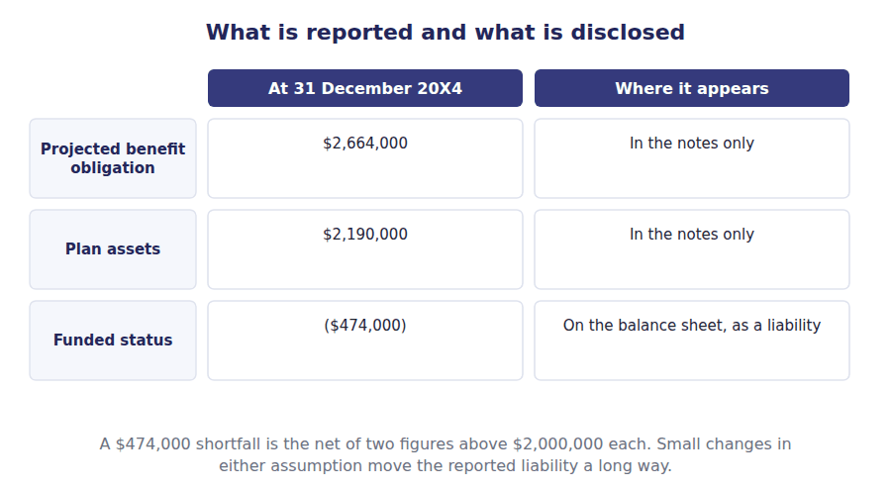
Part 5 · The assumptions behind the obligation where the estimate really lives
Exercise 1E Sort each change into the column that says what it does.
OBJECTIVE | Say which way each actuarial assumption pushes the obligation.
YOU WILL NEED | Exercise 1D, and Volume 13 Handout 1 on what a higher rate does to a present value.
HOW TO START | • The obligation is a present value, so a higher discount rate makes it smaller. That is Volume 13, not pensions.  • Anything that raises the benefits eventually payable raises the obligation: higher salaries, longer lives, more generous terms.  • One of the changes affects the fund rather than the obligation, and it is the one about investment returns.

Change in assumption | RAISES THE OBLIGATION | LOWERS IT | AFFECTS NEITHER
1. A higher discount rate
2. A higher expected rate of salary increase
3. Retirees living longer than assumed
4. A plan amendment improving benefits for past service
5. A higher expected return on plan assets
6. An employee leaving before their benefits vest

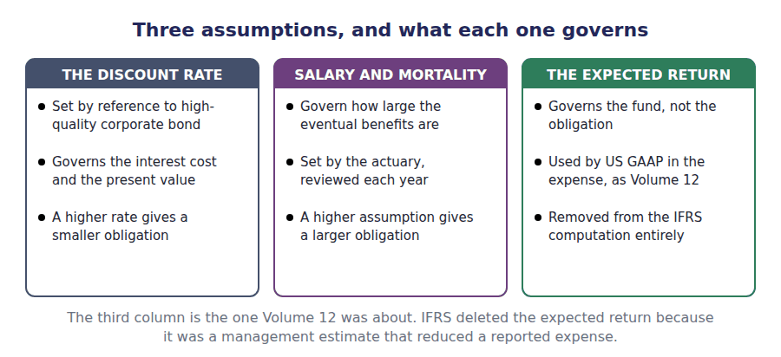
Watch out! Benefits paid reduce the obligation and the plan assets by the same amount. A question that gives you $120,000 of benefits paid and asks what happened to the funded status is asking for the word nothing.
Part 6 · Exam pitch the questions as an exam would set them
1. [Level A] Under a defined contribution plan, the investment risk is borne by:
(A) The employer
(B) The employee
(C) The actuary
(D) The trustee
2. [Level A] The projected benefit obligation is measured using:
(A) Current salary levels
(B) Expected future salary levels
(C) The vested benefits only
(D) The contributions paid to date
3. [Level B] Plan assets are reported:
(A) Among the employer’s investments
(B) Netted against the obligation, with only the funded status on the balance sheet
(C) As a receivable from the trustee
(D) Not at all, in the statements or the notes
4. [Level B] A plan has an obligation of $2,400,000 and assets of $2,000,000. The balance sheet reports:
(A) An asset of $2,000,000
(B) A liability of $400,000
(C) A liability of $2,400,000
(D) Nothing, because the plan is funded
5. [Level B] Interest cost on a pension obligation of $2,400,000 at a 6% discount rate is:
(A) $288,000
(B) $144,000
(C) $180,000
(D) $160,000
6. [Level C] An increase in the discount rate used to measure a pension obligation:
(A) Increases the obligation
(B) Decreases the obligation
(C) Has no effect on the obligation
(D) Increases the plan assets
7. [Level C] A company pays $120,000 of benefits to retirees out of the fund. The funded status:
(A) Improves by $120,000
(B) Is unchanged
(C) Worsens by $120,000
(D) Improves by the benefits net of tax
ADAPTIVE TIP Keep two schedules side by side for every pension question: the obligation and the fund. Almost every figure in the topic belongs to one of them, and the handful that appear in both — benefits paid above all — are where the marks are.

Handout 2 · The Five Components of Net Periodic Pension Cost
Northwind contributed $200,000 to its plan and charged $170,000 to profit. Neither number explains the other.
Volume 16 · Pensions and Other Post-Employment Benefits · R2
LANGUAGE FOCUS
Register you are working in | R2 throughout, with the corridor at R3 because the exam states the test in its own words.
Say it exactly like this | charge service cost to profit · unwind the discount on the obligation · offset the expected return against the cost · amortise prior service cost · apply the corridor test · defer a remeasurement in other comprehensive income
Words that are not the same | contribution / expense · expected return / actual return · prior service cost / service cost · inside the corridor / outside it
Remember | The pension expense is not the contribution. Northwind paid in $200,000 and charged $170,000. The expected return is not what the fund earned. It is what management assumed it would earn.

What you will be able to do when this handout is finished
- Name the five components of net periodic pension cost.
- Compute each one from the schedules of Handout 1.
- Say why the expected return is used rather than the actual return.
- Apply the corridor test to a net gain or loss.
- Say which components reach profit and which wait in equity.

Two numbers that are not the same
Northwind paid $200,000 into its pension fund this year. That is a cash flow, and it is decided by the trustees, the funding rules and what the company can afford.
The income statement charges $170,000. That is an accounting measure, and it is decided by five components that have nothing to do with what was paid.
Under a defined contribution plan the two figures would be the same number. Under a defined benefit plan they almost never are.
Volume 12 Handout 1 reported the $170,000 without deriving it. This handout derives it.

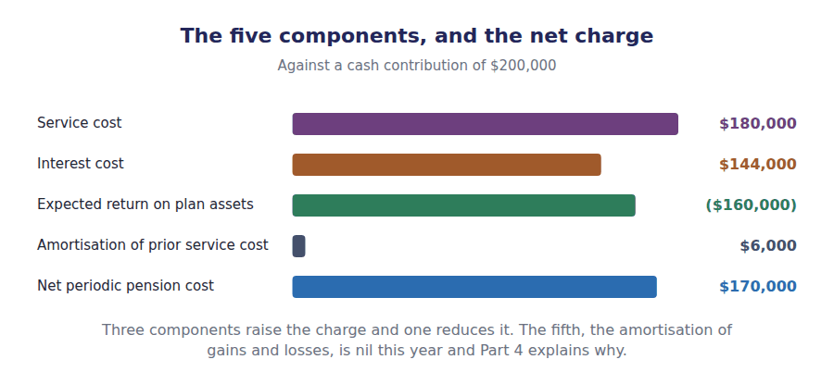
Part 1 · The three that are easy service, interest, and the return
Exercise 2A Read and complete. Write one word or figure in each space.
OBJECTIVE | Say what each of the first three components measures.
YOU WILL NEED | Handout 1 Exercises 1B and 1C, for the two roll-forwards.
HOW TO START | • Two of the three are already in your obligation schedule from Handout 1.  • The third is not in your plan assets schedule, and finding out why is the point of Part 2.  • The last blank is the direction the expected return pushes the charge.

WORD BANK
$144,000 · actual · increases · reduces · salary · work
Not every word is used.

R2 Service cost is the present value of the benefit employees earned by working this year. It is the only component that has anything to do with the ¹ done in the period, and it is $180,000.
Interest cost is the discount on the obligation unwinding as the payments come a year closer. At 6% on the opening $2,400,000 it is ² , and it is the same mechanism as Volume 7’s lease liability.
Both of those are in the obligation schedule you built in Handout 1. The third component comes from the other schedule: the fund is expected to meet part of the cost, so the expected return ³ the charge.
At 8% on $2,000,000 of plan assets that is $160,000. Taken together the three come to $164,000, and the fourth component takes it to $170,000.
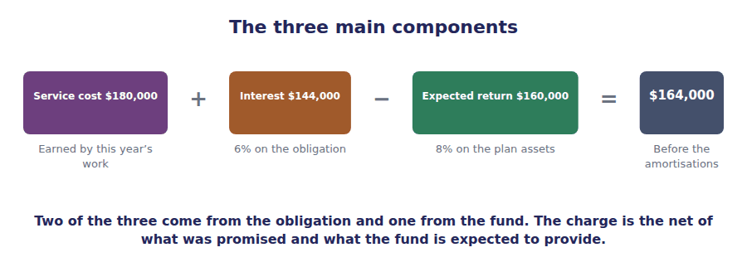
Part 2 · Expected, not actual and what happens to the difference
R2 The fund actually earned $110,000 this year and management expected $160,000. US GAAP uses the expected figure in the expense, so that a volatile market does not swing a reported profit. The $50,000 difference goes somewhere else.
Exercise 2B Read and complete. Write one word or figure in each space.
OBJECTIVE | Say why the expected return is used and where the difference goes.
YOU WILL NEED | The paragraph above, and Volume 9 Handout 2 on other comprehensive income.
HOW TO START | • A pension fund’s return swings with the market from year to year. Ask what that would do to a reported profit if it went straight through.  • Northwind expected $160,000 and earned $110,000, a shortfall of $50,000.  • The last blank is where that shortfall sits, and Volume 9 named it as the half of comprehensive income that bypasses profit.

WORD BANK
income · markets · operations · profit · smooth · volatile
Not every word is used.

R2 A pension fund’s return is volatile. Putting the actual figure into the expense would let a market movement swing the reported profit of a company whose ⁴ had not changed at all.
So US GAAP uses the expected return, a long-run assumption, and the expense becomes ⁵ . The actual return still determines what the fund is worth, which is why Handout 1’s schedule used it.
The difference between the two is a remeasurement. Northwind expected $160,000 and earned $110,000, so $50,000 of loss is set aside rather than charged.
It goes to other comprehensive ⁶ , where it joins any actuarial gains and losses on the obligation, and it may be amortised into profit in later years if the accumulated balance grows large enough.
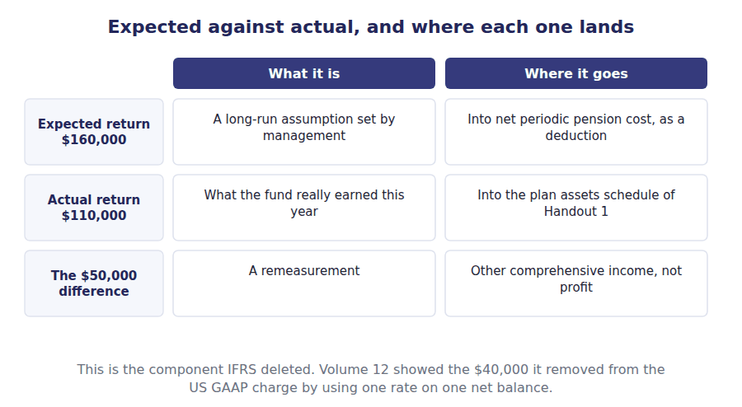
Part 3 · The plan amendment prior service cost, spread
Exercise 2C Read and complete. Write one word or figure in each space.
OBJECTIVE | Account for the prior service cost arising from the plan amendment.
YOU WILL NEED | Handout 1 Exercise 1B, where the amendment raised the obligation.
HOW TO START | • The amendment raised the obligation by $60,000 immediately, for service employees had already given.  • US GAAP does not charge that to profit at once. Ask what the company expects to get for it.  • The remaining service period is 10 years, and the last blank is what IFRS does with the same amount.

WORD BANK
$6,000 · amount · deferred · immediately · once · part · service
Not every word is used.

R2 The amendment improved benefits for service employees had already given, so the obligation rose by $60,000 the moment it was signed. Handout 1’s schedule shows the whole ⁷ .
The expense does not. US GAAP reasons that the company made the amendment to retain and motivate its employees, so the benefit of it accrues over their remaining ⁸ rather than on the day the board approved it.
So the $60,000 is set aside in other comprehensive income and brought into profit at $6,000 a year over 10 years. This year’s charge is ⁹ .
IFRS disagrees entirely and charges the whole $60,000 to profit at ¹⁰ , which Volume 12 identified as one of the three pension differences.
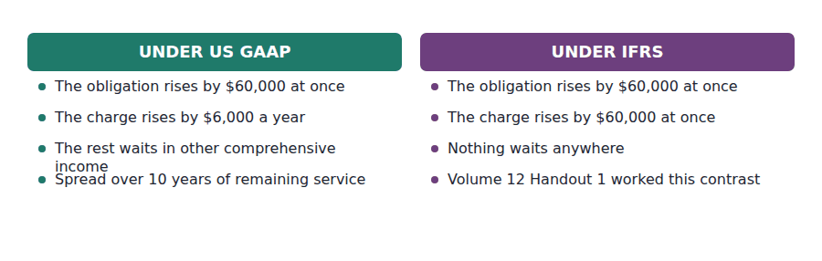
Part 4 · The corridor why the fifth component is nil this year
Exercise 2D Sort each statement into the column that says whether it is true.
OBJECTIVE | Apply the corridor test to Northwind’s net loss.
YOU WILL NEED | Exercise 2B, and Handout 1 for the two opening balances.
HOW TO START | • The corridor is ten per cent of the larger of the obligation and the plan assets. Work out which is larger first.  • Ten per cent of $2,400,000 is $240,000, and Northwind’s accumulated net loss is $50,000.  • Only the excess over the corridor is amortised, and here there is no excess at all.

Statement about the corridor | TRUE | FALSE
1. The corridor is ten per cent of the larger of the obligation and the plan assets
2. Northwind’s corridor is $240,000
3. Only the net loss in excess of the corridor is amortised
4. Northwind must amortise $50,000 this year
5. A net loss inside the corridor is never charged to profit while it stays there
6. IFRS applies the same corridor

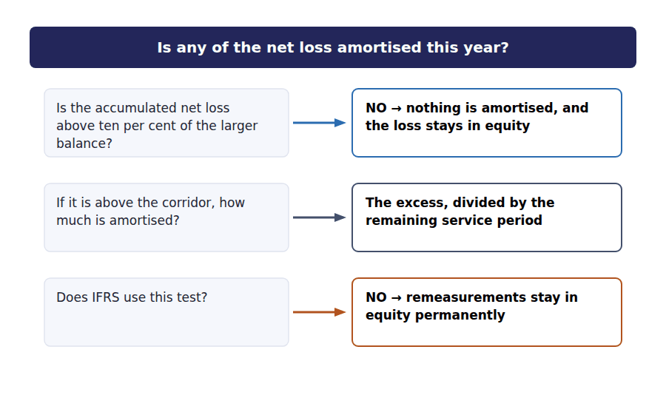
Part 5 · Assembling the charge five components, one figure
Exercise 2E Complete both grids. The second asks where each one goes.
OBJECTIVE | Compute net periodic pension cost and say where each component lands.
YOU WILL NEED | Exercises 2A, 2B, 2C and 2D.
HOW TO START | • Four of the five components have figures and the fifth is nil, as Exercise 2D established.  • Watch the sign on the expected return: it is the only component that reduces the charge.  • Your total must come to $170,000, which is what Volume 12 Handout 1 already reported.

Net periodic pension cost for 20X4 | Amount | Direction
Service cost — another year of benefit earned | $180,000
Interest cost — 6% on the $2,400,000 obligation
Expected return on plan assets at 8%
Amortisation of prior service cost, $60,000 over 10 years
Amortisation of net gains and losses, under the corridor
Net periodic pension cost

1 | 2 | 3 | 4 | 5 | 6
7 | 8 | 9

Component | Reaches profit? | Why
Service cost
Interest cost
Expected return on plan assets
The gap between expected and actual return
Prior service cost

1 | 2 | 3 | 4 | 5 | 6
7 | 8 | 9 | 10

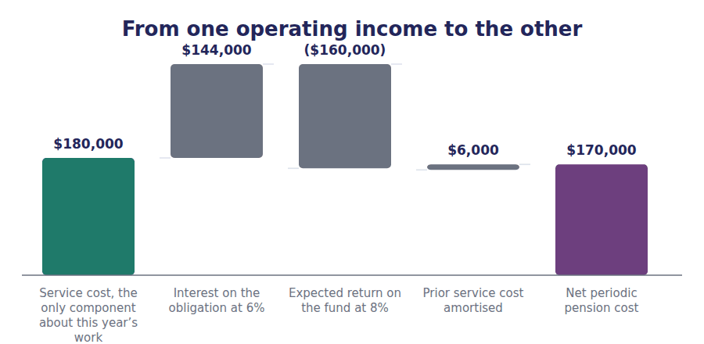
Watch out! The contribution and the expense are different numbers and neither determines the other. Northwind paid $200,000 into the fund and charged $170,000 to profit, and a question that offers you the contribution as the expense is offering the commonest distractor on the topic.
Part 6 · Exam pitch the questions as an exam would set them
1. [Level A] Service cost is:
(A) The cash paid into the pension fund
(B) The present value of the benefit earned by this year’s service
(C) The interest on the obligation
(D) The return expected on plan assets
2. [Level A] Net periodic pension cost is reduced by:
(A) Service cost
(B) The expected return on plan assets
(C) Interest cost
(D) Amortisation of prior service cost
3. [Level B] A plan has an obligation of $2,400,000 at a 6% discount rate and assets of $2,000,000 at a 8% expected return. Interest cost less expected return is:
(A) $304,000
(B) ($16,000)
(C) $144,000
(D) $160,000
4. [Level B] The difference between the expected and the actual return on plan assets is:
(A) Charged to profit immediately
(B) Recognised in other comprehensive income as a remeasurement
(C) Ignored
(D) Added to the contribution
5. [Level C] Under the corridor approach, net gains and losses are amortised:
(A) In full, every year
(B) Only to the extent they exceed ten per cent of the larger of the obligation and the plan assets
(C) Only when the plan is wound up
(D) Over ten years, regardless of size
6. [Level B] A plan amendment increases the obligation by $60,000 for past service. Under US GAAP the charge to profit in that year is:
(A) $60,000
(B) $6,000
(C) Nil
(D) $30,000
7. [Level C] A company contributes $200,000 to its plan and computes a net periodic pension cost of $170,000. The income statement charges:
(A) $200,000
(B) $170,000
(C) $30,000
(D) The larger of the two
ADAPTIVE TIP Write the five components as a list before you compute anything, with a plus or minus against each. Three add, one subtracts, and the fifth is usually nil. Most errors on this topic are sign errors on the expected return.

Handout 3 · Funded Status on the Balance Sheet, and What Goes to OCI
Three large figures and one small one. The balance sheet reports the ($474,000), and the notes carry everything that explains it.
Volume 16 · Pensions and Other Post-Employment Benefits · R2 moving to R3
LANGUAGE FOCUS
Register you are working in | R2 for the presentation, R3 for settlements and curtailments, which an exam states in its own terms.
Say it exactly like this | report the funded status on the balance sheet · defer a remeasurement in equity · amortise an accumulated loss into profit · settle part of an obligation · curtail a plan · disclose the gross figures in the notes
Words that are not the same | balance sheet / notes · profit / other comprehensive income · settlement / curtailment · recognised / deferred
Remember | Deferring an amount in other comprehensive income is not hiding it. The whole funded status is on the balance sheet either way. A curtailment is not a settlement. One reduces future service, the other discharges an existing obligation.

What you will be able to do when this handout is finished
- Report the funded status on the balance sheet.
- Say which pension figures reach profit and which reach equity.
- Roll the accumulated other comprehensive income balance forward.
- Distinguish a settlement from a curtailment.
- Say what a reader learns from the notes that the statements do not show.

Four numbers, one line
Handout 1 produced an obligation of $2,664,000 and plan assets of $2,190,000. Handout 2 produced a charge of $170,000 and a remeasurement of $50,000.
Only one of those reaches the balance sheet: the ($474,000) funded status, as a liability.
The charge goes to profit, the remeasurement and the unamortised prior service cost go to other comprehensive income, and the two gross figures go to the notes.
This handout places each one, and then deals with the two events that bring the deferred amounts forward.

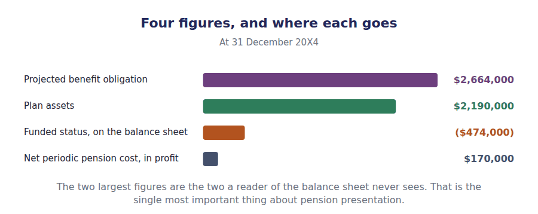
Part 1 · The balance sheet one line, and it is a net one
Exercise 3A Complete both right-hand columns.
OBJECTIVE | Place each pension figure in the statement where it belongs.
YOU WILL NEED | Handout 1 Exercise 1D, for the funded status. · Handout 2 Exercise 2E, for the charge and the remeasurement.
HOW TO START | • Two rows go to the notes, one to the balance sheet, one to profit and two to other comprehensive income.  • The last row is the accumulated balance of the two deferred amounts, and it belongs in equity.  • Check the signs: an underfunded plan gives a negative funded status.

Where the pension appears at 31 December 20X4 | Amount | Where
Projected benefit obligation | $2,664,000
Plan assets at fair value | $2,190,000
Funded status, reported as a liability
Net periodic pension cost | $170,000
Remeasurement loss on plan assets | $50,000
Prior service cost not yet amortised | $54,000
Accumulated in equity, awaiting amortisation

1 | 2 | 3 | 4 | 5 | 6
7 | 8

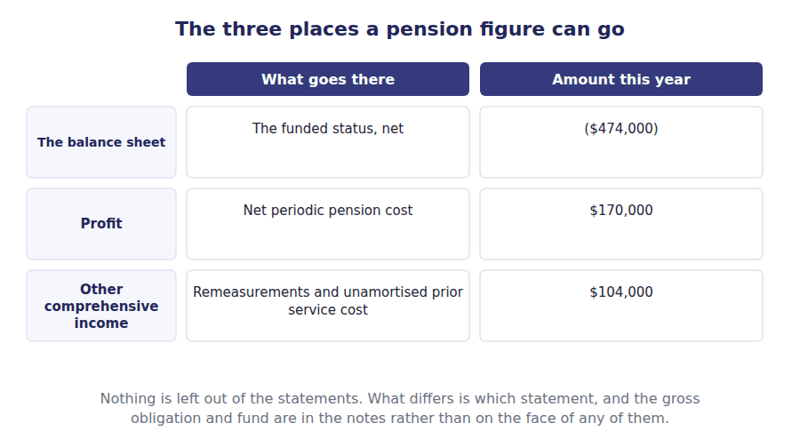
Part 2 · Why anything is deferred at all volatility, and the price of smoothing it
Exercise 3B Read and complete. Write one word or figure in each space.
OBJECTIVE | Say why some pension amounts are deferred in equity.
YOU WILL NEED | Handout 2 Exercises 2B and 2C. · Volume 9 Handout 2, on other comprehensive income.
HOW TO START | • A pension obligation measured on assumptions about salaries and mortality moves every year. Ask what charging all of that movement to profit would do.  • The $50,000 remeasurement and the $54,000 of unamortised prior service cost are both deferred.  • The last blank is what is not deferred, and it is the figure on the balance sheet.

WORD BANK
amortised · amount · control · funded · measure · profit · timing
Not every word is used.

R2 A pension obligation rests on assumptions about salaries, mortality and discount rates, and every one of them is revised each year. Charging the whole movement to profit would make the reported result swing on things management does not ¹ .
So two kinds of amount are set aside in other comprehensive income: remeasurements, which this year are $50,000, and the part of the prior service cost not yet ² , which is $54,000.
They are not lost. Both sit in accumulated other comprehensive income and are brought into ³ in later periods, the prior service cost on a schedule and the remeasurements through the corridor.
And nothing is hidden from the balance sheet. The full ($474,000) funded status is reported whatever has been deferred, because the deferral affects the ⁴ of the charge and never the liability.
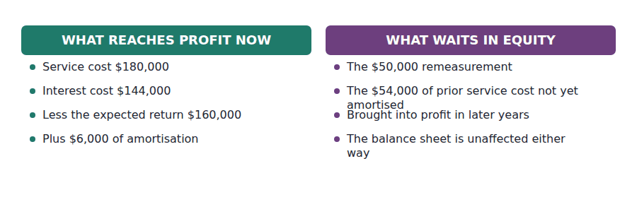
Part 3 · Two events that bring it forward settlement and curtailment
R3 Deferral assumes a future over which to spread the amount. Two events remove that future: a settlement discharges part of the obligation outright, and a curtailment cuts short the service the deferral was being spread over.
Exercise 3C Complete both right-hand columns.
OBJECTIVE | Distinguish a settlement from a curtailment and say what each one triggers.
YOU WILL NEED | The paragraph above, and Handout 2 Exercise 2C.
HOW TO START | • One of the two is about the obligation and the other is about future service.  • Buying annuities that discharge the pensions of retired employees is the classic settlement; closing a division is the classic curtailment.  • Two of the four rows are not settlements or curtailments at all, and one of those two changes no expense.

Event | What it is | Effect
Settlement
Curtailment
Plan amendment
Contribution

1 | 2 | 3 | 4 | 5 | 6
7 | 8

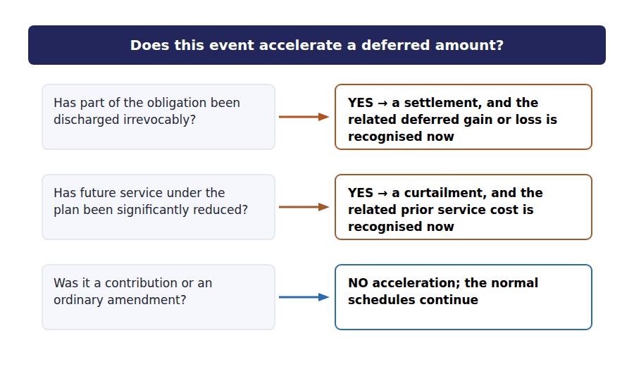
Part 4 · The other promise post-employment benefits that are not pensions
Exercise 3D Read and complete. Write one word in each space.
OBJECTIVE | Say how other post-employment benefits differ from pensions.
YOU WILL NEED | Exercise 3C.
HOW TO START | • Many employers promise retirees health cover as well as a pension. Ask whether the accounting model changes.  • What differs is not the model but the difficulty of the assumptions, and one of them in particular.  • The last blank is why these obligations are often larger than the pension itself.

WORD BANK
cost · different · larger · later · now · same · smaller
Not every word is used.

R2 An employer that promises retirees health cover has made the same kind of promise as a pension: a benefit payable later, in return for service given ⁵ .
So the model is the ⁶ . An obligation is measured, a fund is measured if one exists, the funded status goes on the balance sheet, and a five-component cost goes through profit.
What differs is the assumptions. Mortality can be forecast from long experience; medical ⁷ inflation cannot, and it has run well above general inflation for decades.
That is why these obligations are often ⁸ than the pension they sit beside, and why many employers have closed them to new entrants rather than keep promising them.
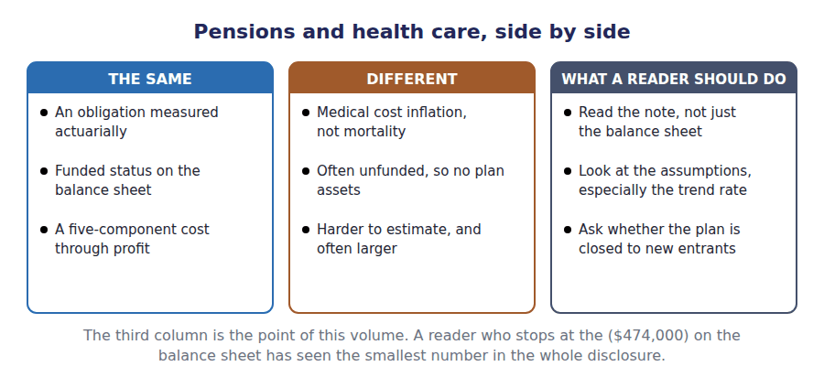
Watch out! The gross obligation and the plan assets are disclosed and not reported. A company with a $2,664,000 obligation and $2,190,000 of assets shows a $474,000 liability, and a reader who never opens the note has no idea of the scale of either.
Part 5 · Exam pitch the questions as an exam would set them
1. [Level A] The amount reported on the balance sheet for a defined benefit plan is:
(A) The projected benefit obligation
(B) The funded status of the plan
(C) The plan assets
(D) The net periodic pension cost
2. [Level B] A plan has an obligation of $2,664,000 and assets of $2,190,000. The balance sheet reports:
(A) An asset of $2,190,000
(B) A liability of $474,000
(C) A liability of $2,664,000
(D) Both figures, gross
3. [Level B] A remeasurement arising on plan assets is reported in:
(A) Profit for the period
(B) Other comprehensive income
(C) The balance sheet only
(D) The notes only
4. [Level C] A company buys annuities that irrevocably discharge the pensions of its retired employees. This is a:
(A) Curtailment
(B) Settlement
(C) Plan amendment
(D) Contribution
5. [Level C] A company closes a division, significantly reducing future service under its pension plan. This is a:
(A) Settlement
(B) Curtailment
(C) Remeasurement
(D) Contribution
6. [Level C] Deferring a remeasurement in other comprehensive income means that:
(A) The liability on the balance sheet is reduced
(B) The charge to profit is delayed but the liability is reported in full
(C) The amount is never recognised
(D) The obligation is remeasured in the following year
7. [Level B] Other post-employment benefits such as retiree health care are accounted for:
(A) As an expense when paid
(B) On the same model as a defined benefit pension
(C) As a contingency, disclosed only
(D) Only if the plan is funded
ADAPTIVE TIP Three statements, three figures: the funded status on the balance sheet, the net periodic cost in profit, and the remeasurements in other comprehensive income. If a question offers you the gross obligation as a balance sheet figure, it is offering the number that belongs in the notes.

Answer Key
Volume 16 · Handouts 1 to 3
Every answer carries the reason for it and the mistake it defeats.

Handout 1 · The Promise, the Obligation and the Plan Assets answers
Completed text and exercises
# | Answer | Why | The trap it defeats
1 | separate | A trust, outside the company.
2 | netted | One figure on the balance sheet, not two.
3 | earns | Actual return, whatever it turned out to be.
4 | nothing | Both sides fall by the same amount. | Students expect paying a pension to improve the position. It settles part of the obligation with part of the fund and leaves the gap where it was.
5 | less | Assets first, so underfunded is negative.
6 | widened | The obligation grew faster than the fund.
7 | liability | An underfunded plan is an obligation.
8 | notes | Disclosed, not on the face. | Students read the balance sheet figure as the whole pension story. It is the difference between two much larger numbers.
Grid 1 | 1 LOWERS IT 2 RAISES THE OBLIGATION 3 RAISES THE OBLIGATION 4 RAISES THE OBLIGATION 5 AFFECTS NEITHER 6 LOWERS IT | The discount rate is the one that catches people out. It is the only assumption on the list where a higher number gives a smaller obligation.

Exam-pitch questions
# | Answer | Why | The trap it defeats
1 | (B) The employee | The employer’s obligation ends with the contribution, so whatever the fund earns is the employee’s gain or loss. Under a defined benefit plan the position reverses entirely. | Level A
2 | (B) Expected future salary levels | Projected salaries are what make it the projected obligation, and what require an actuary. (C) is a narrower measure that excludes benefits the employer still expects to pay. | Level A
3 | (B) Netted against the obligation, with only the funded status on the balance sheet | Only the net figure reaches the balance sheet, and both gross figures are disclosed. (A) would report assets the company cannot use and does not control. | Level B
4 | (B) A liability of $400,000 | Funded status is assets less obligation, so $400,000 underfunded is a liability. (C) reports the gross obligation and ignores the fund set aside to meet it. | Level B
5 | (B) $144,000 | 6% of $2,400,000. It is the discount unwinding as the payments come one year closer, which is the same mechanism as Volume 7’s lease liability. | Level B
6 | (B) Decreases the obligation | A present value falls when the rate rises, exactly as in Volume 13. (A) is the instinct that a higher rate means more, which is true of an investment held and false of an obligation owed. | Level C
7 | (B) Is unchanged | The obligation and the fund both fall by $120,000, so the gap between them does not move. (A) is the error of looking at one schedule and not the other. | Level C

Exercise 1B · the obligation, rolled forward
Projected benefit obligation, 20X4 | Amount
Balance at 1 January 20X4 | $2,400,000
Service cost for the year | $180,000
Interest on the obligation at 6% | $144,000
Past service cost from the plan amendment | $60,000
Benefits paid to retirees | ($120,000)
Balance at 31 December 20X4 | $2,664,000

Exercise 1C · the plan assets, rolled forward
Plan assets, 20X4 | Amount
Fair value at 1 January 20X4 | $2,000,000
Actual return earned on the assets | $110,000
Contributions paid in by Northwind | $200,000
Benefits paid to retirees | ($120,000)
Fair value at 31 December 20X4 | $2,190,000

Exercise 1A · the two kinds of plan
 | Defined contribution | Defined benefit
What the employer promises | To pay in a stated amount | To pay a stated benefit in retirement
Who bears the investment risk | The employee | The employer
The annual expense | The contribution for the year | An actuarial computation, in Handout 2
On the balance sheet | Any unpaid contribution | The funded status of the plan
An actuary is needed | No | Yes

R2 The $120,000 of benefits paid is the only line that appears in both schedules, and it appears with the same sign in each. That is worth noticing: it is the reason paying a pension changes the reported liability by nothing at all.
R2 The closing funded status of ($474,000) is the figure Handout 3 puts on the balance sheet. Handout 2 computes the expense, which is a different number again: Volume 12 already reported it as $170,000 under US GAAP, and this volume derives it.

Handout 2 · The Five Components of Net Periodic Pension Cost answers
Completed text and exercises
# | Answer | Why | The trap it defeats
1 | work | This year’s service, and nothing else.
2 | $144,000 | 6% of $2,400,000.
3 | reduces | The fund pays part of it, so the employer charges less.
4 | operations | Nothing the business did changed.
5 | smooth | A long-run assumption, deliberately.
6 | income | The other half, from Volume 9. | Students expect the actual return in the expense. It is in the fund and not in the charge, which is the whole point of smoothing.
7 | amount | The obligation rose in full, immediately.
8 | service | The years the company expects to benefit.
9 | $6,000 | $60,000 over 10 years.
10 | once | In full, in the year of the amendment. | Students apply the US GAAP spreading under both frameworks. IFRS has no amortisation of prior service cost at all.
Grid 1 | 1 TRUE 2 TRUE 3 TRUE 4 FALSE 5 TRUE 6 FALSE | The fourth is the one the figures answer: a $50,000 loss against a $240,000 corridor leaves nothing to amortise, which is why that component is nil.

Exam-pitch questions
# | Answer | Why | The trap it defeats
1 | (B) The present value of the benefit earned by this year’s service | The only component that relates to work done in the period. (A) is the contribution, which is a funding decision rather than a measurement. | Level A
2 | (B) The expected return on plan assets | The fund is expected to meet part of the obligation, so the expected return is deducted. It is the only one of the five that reduces the charge. | Level A
3 | (B) ($16,000) | $144,000 less $160,000 is a net credit of ($16,000). (A) adds the two, which is the error of treating both as costs. | Level B
4 | (B) Recognised in other comprehensive income as a remeasurement | It is set aside so that market volatility does not swing reported profit. (A) is the treatment the actual return would get if the expected return were not used at all. | Level B
5 | (B) Only to the extent they exceed ten per cent of the larger of the obligation and the plan assets | Nothing inside the corridor is ever amortised, which is how plans carry unrecognised losses for years. (D) confuses the ten per cent threshold with a ten-year period. | Level C
6 | (B) $6,000 | $60,000 over the 10-year remaining service period. (A) is the IFRS answer, and the pair was one of Volume 12’s three pension differences. | Level B
7 | (B) $170,000 | The expense is the computed cost; the contribution is a cash flow and funds the obligation rather than measuring it. Under a defined contribution plan the two would be the same, which is exactly why the distinction is tested here. | Level C

Exercise 2E · the five components
Net periodic pension cost for 20X4 | Amount | Direction
Service cost — another year of benefit earned | $180,000 | Increases the cost
Interest cost — 6% on the $2,400,000 obligation | $144,000 | Increases the cost
Expected return on plan assets at 8% | ($160,000) | Reduces the cost
Amortisation of prior service cost, $60,000 over 10 years | $6,000 | Increases the cost
Amortisation of net gains and losses, under the corridor | Nil | Neither, this year
Net periodic pension cost | $170,000

Exercise 2E · where each component lands
Component | Reaches profit? | Why
Service cost | Yes, in full | Employees earned it this year
Interest cost | Yes, in full | The discount on the obligation unwound
Expected return on plan assets | Yes, as a deduction | The fund is expected to meet part of the cost
The gap between expected and actual return | No, to other comprehensive income | A remeasurement, amortised later if large enough
Prior service cost | Only the amortised part | The rest waits in other comprehensive income

R2 The $170,000 net charge is the figure Volume 12 Handout 1 reported under US GAAP and never derived. Its IFRS counterpart of $264,000 differs by $94,000, which is the $2,000,000 of plan assets at the two percentage points between the expected return and the discount rate, plus the $54,000 of prior service cost IFRS charges at once and US GAAP has not yet amortised.
R2 The fifth component is nil only because the accumulated net loss of $50,000 sits inside the $240,000 corridor. A year or two of poor returns would take it outside, and the component would start to bite without anything else about the plan having changed.

Handout 3 · Funded Status on the Balance Sheet, and What Goes to OCI answers
Completed text and exercises
# | Answer | Why | The trap it defeats
1 | control | Assumptions move; operations may not.
2 | amortised | The rest waits in equity.
3 | profit | Deferred, not deleted.
4 | timing | The liability is complete either way. | Students think deferral keeps the obligation off the balance sheet. It keeps the charge out of this year’s profit, which is a different thing.
5 | now | Earned by current service, paid later.
6 | same | One model, two kinds of promise.
7 | cost | The assumption nobody can forecast well.
8 | larger | Harder to forecast and often bigger. | Students expect a health promise to be a footnote. For some employers it exceeds the pension obligation.

Exam-pitch questions
# | Answer | Why | The trap it defeats
1 | (B) The funded status of the plan | Assets less obligation, as one net figure. (A) would report the obligation gross and ignore the fund set aside to meet it. | Level A
2 | (B) A liability of $474,000 | $2,190,000 less $2,664,000 is a shortfall of $474,000. (D) is how it is disclosed in the notes and not how it is reported on the face. | Level B
3 | (B) Other comprehensive income | Set aside so market volatility does not swing reported profit, and brought into profit later through the corridor. (D) would leave it out of the statements altogether. | Level B
4 | (B) Settlement | Part of the obligation is discharged for good, so the deferred amounts relating to it are recognised at once. A curtailment reduces future service instead, which is the pairing being tested. | Level C
5 | (B) Curtailment | The service over which prior service cost was being amortised has gone, so the remaining balance is recognised. (A) is the other half of the pair and concerns the obligation rather than future service. | Level C
6 | (B) The charge to profit is delayed but the liability is reported in full | Deferral affects the timing of the expense and never the funded status. (A) is the misunderstanding the whole handout exists to correct. | Level C
7 | (B) On the same model as a defined benefit pension | Same promise, same model, harder assumptions. (A) is pay-as-you-go accounting, which is exactly what the defined benefit model replaced because it reported nothing until the cash left. | Level B

Exercise 3A · where each figure is reported
Where the pension appears at 31 December 20X4 | Amount | Where
Projected benefit obligation | $2,664,000 | Notes only
Plan assets at fair value | $2,190,000 | Notes only
Funded status, reported as a liability | ($474,000) | Balance sheet
Net periodic pension cost | $170,000 | Income statement
Remeasurement loss on plan assets | $50,000 | Other comprehensive income
Prior service cost not yet amortised | $54,000 | Other comprehensive income
Accumulated in equity, awaiting amortisation | $104,000 | Accumulated OCI

Exercise 3C · settlements and curtailments
Event | What it is | Effect
Settlement | The employer discharges part of the obligation irrevocably | Recognise the related deferred gain or loss at once
Curtailment | Future service under the plan is significantly reduced | Recognise the related prior service cost at once
Plan amendment | Benefits are improved for past service | Obligation rises now; the cost is amortised
Contribution | Cash paid into the fund | Plan assets rise; the expense does not change

R2 The accumulated balance in equity is $104,000: the $50,000 remeasurement plus the $54,000 of prior service cost not yet amortised. Both will reach profit eventually, and neither affects the ($474,000) on the balance sheet in the meantime.
R2 This volume is outside the CMA, and it is the only one in the seventeen of which that is wholly true. It is here because Volume 12 Handout 1 compared a US GAAP pension charge of $170,000 with an IFRS one of $264,000, and a student who met those figures without ever building the plan behind them had been shown a contrast rather than taught a topic.

Glossary
Every term in Volume 16, with the Arabic equivalent and the places it misleads
The third column is for recognition only. In the exam room you work in English.

Term | What it means in CMA English | بالعربية | Careful
actuary | A specialist who estimates the obligation from assumptions about salaries, service, mortality and discount rates. | الخبير الاكتواري | The accountant does not compute the obligation. The exam expects you to know what the assumptions are and which way each one pushes.
amortisation of prior service cost | Spreading the cost of a plan amendment over the remaining service of the employees it benefited. | إطفاء تكلفة الخدمة السابقة | US GAAP spreads it; IFRS charges the whole amount at once, which was Volume 12’s sharpest pension difference.
corridor approach | A US GAAP accommodation under which net gains and losses are amortised into profit only to the extent they exceed ten per cent of the larger of the obligation and the plan assets. | نهج الممر | Nothing inside the corridor is ever amortised. It is why a plan can carry large unrecognised losses for years.
curtailment | An event that significantly reduces the future service of employees covered by a plan, such as closing a division. | التقليص | Prior service cost relating to the lost service is recognised immediately, for the same reason.
defined contribution plan | A plan under which the employer promises only to pay a stated amount into a fund. | خطة المساهمات المحددة | The simple case: the expense is the contribution, and nothing is measured actuarially.
funded status | Plan assets less the projected benefit obligation. | الوضع التمويلي للخطة | The single figure that reaches the balance sheet. Negative means underfunded, and a liability.
net periodic pension cost | The total charge for a defined benefit plan in a period, made up of five components. | تكلفة المعاش الدورية الصافية | A net figure, and two of its five components reduce it. The contribution paid into the fund is a different number entirely.
other post-employment benefits | Benefits other than pensions promised to retirees, most commonly health care. | منافع ما بعد التوظيف الأخرى | Accounted for on the same model as a pension, and often larger, because health costs are harder to forecast than mortality.
plan assets | The investments held in a separate fund from which the benefits will be paid. | أصول الخطة | Measured at fair value and held outside the employer. They are never reported among its own assets.
projected benefit obligation | The present value of the benefits employees have already earned, measured using expected future salary levels. | التزام المنافع المتوقعة | Present value, so Volume 13 is doing the work. The salary projection is what makes it an actuary’s figure rather than an accountant’s.
settlement | A transaction that irrevocably discharges part of a pension obligation, such as buying annuities for retirees. | التسوية | The deferred gains and losses relating to the part settled are recognised at once, because there is no longer a future over which to spread them.
vested benefits | Benefits an employee is entitled to keep whether or not they stay with the employer. | المنافع المكتسبة | A subset of the obligation. Benefits not yet vested are still included, because the employer expects most employees to stay.

