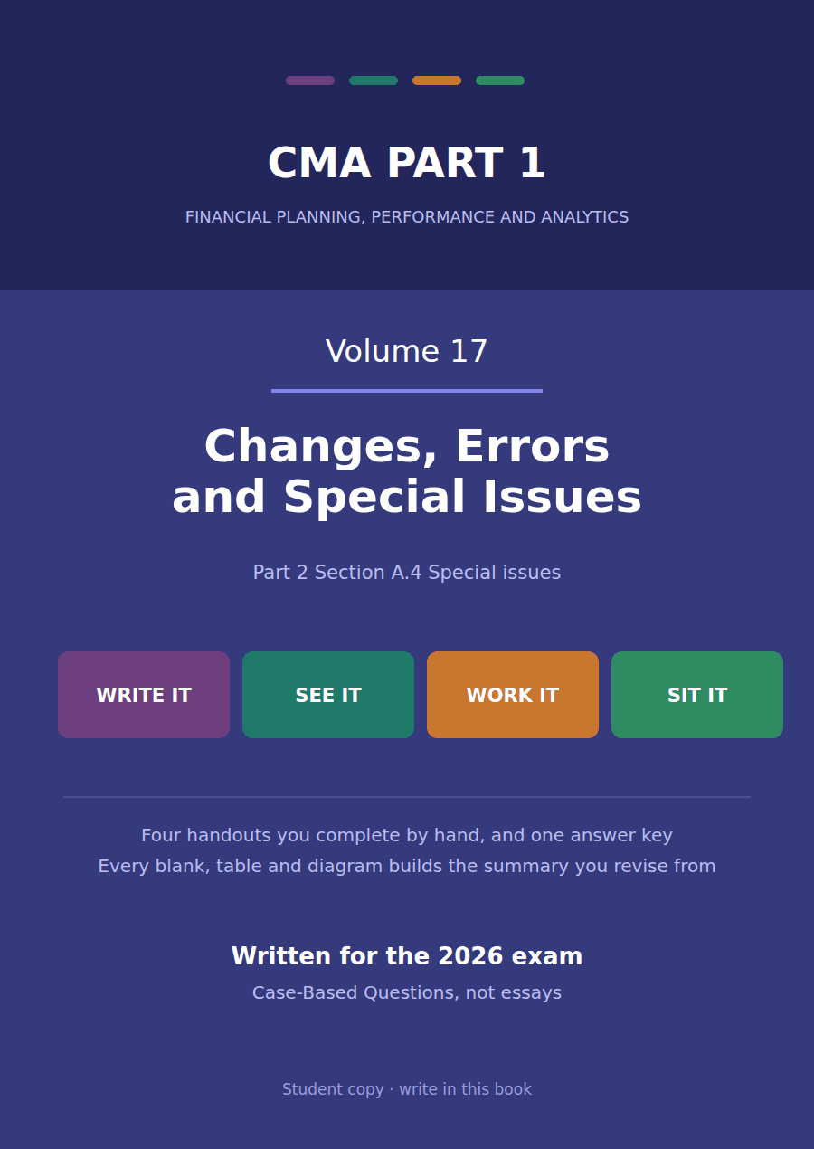

CMA Part 1 · Volume 17
Changes, Errors and Special Issues
Four handouts, one answer key. What to do when the numbers you already published turn out to be the wrong numbers.
These handouts are not notes to read. You write them. The words you supply are the summary, so a finished handout is a page you can revise from, in your own handwriting.
Work in pen. Do not look at the key until the whole handout is done — the key is written to explain the mistake, and you only get that benefit if you have made it first.
The four handouts
# | Handout | What it gives you
1 | Changes in Principle and Changes in Estimate | One change rewrites every prior year and the other touches none of them. Telling which is which is the whole handout.
2 | Correcting an Error and Restating the Comparatives | Northwind omitted $40,000 of depreciation in 20X3. Correcting it changes 20X4 profit by nothing at all.
3 | Functional Currency and Translating a Foreign Subsidiary | Lakeside Controls is worth $1,150,000 of net assets and $1,394,000 of equity. The $244,000 gap is the exchange rate, and it has to go somewhere.
4 | Earnings Quality: What the Numbers Do Not Say | Seventeen volumes of measurement, and one handout on how much to trust it. Northwind’s $510,000 of profit is a fact about an accounting system before it is a fact about a business.

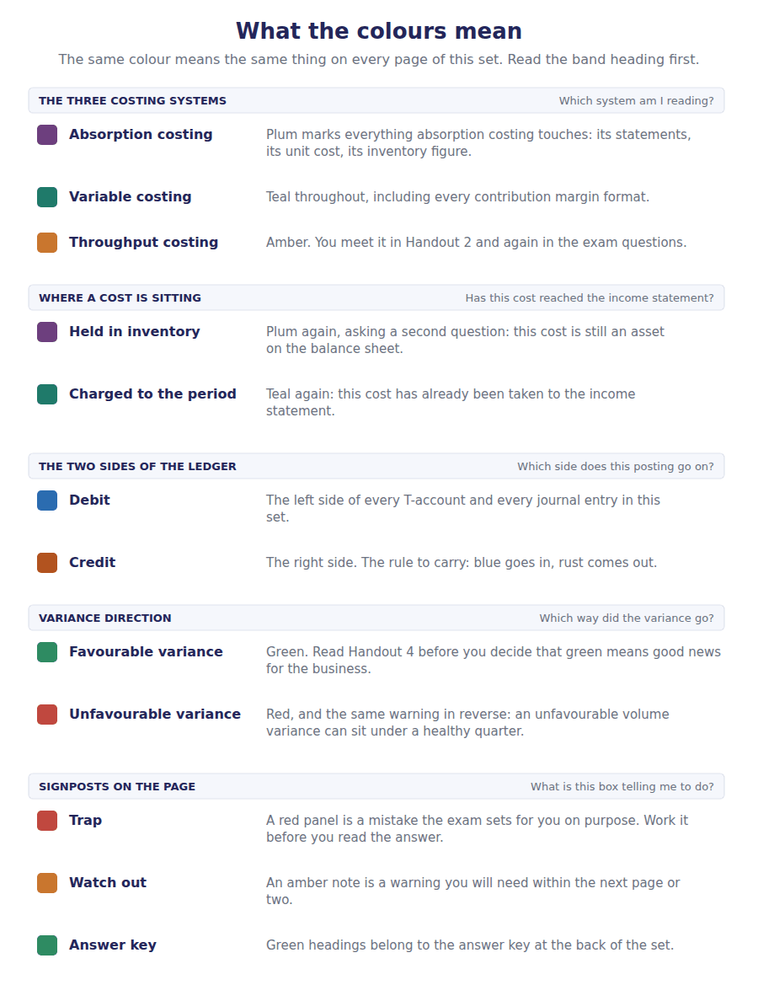
How to read the markers
Marker | Meaning
R1 | Teaching English. Short sentences. This is where a new idea arrives.
R2 | Textbook English. Longer sentences and passive verbs, as a textbook writes them.
R3 | Exam English. Exactly how the CMA exam phrases it, traps included.
Numbered rule | A space you fill in. The number matches the answer key.
Red table | A trap. Read it twice.

Handout 1 · Changes in Principle and Changes in Estimate
One change rewrites every prior year and the other touches none of them. Telling which is which is the whole handout.
Volume 17 · Changes, Errors and Special Issues · R2
LANGUAGE FOCUS
Register you are working in | R2 throughout, with the ratio consequences at R3 because Part 2 asks the question that way.
Say it exactly like this | change an accounting principle · apply a change retrospectively · restate the comparative periods · adjust opening retained earnings · revise an estimate prospectively · justify a change as preferable
Words that are not the same | principle / estimate · retrospective / prospective · restated / as reported · cumulative effect / current charge
Remember | A change in estimate is not an error. The original figure was right on the information then available. Retrospective application is not a restatement for a mistake. Nothing was wrong; the basis of measurement changed.

What you will be able to do when this handout is finished
- Distinguish a change in principle from a change in estimate.
- Apply a change in principle retrospectively.
- Compute the adjustment to opening retained earnings.
- Apply a change in estimate prospectively.
- Say what each kind of change does to the ratios a reader computes.

Two changes in one year
Northwind makes two changes in 20X4. It moves its inventory costing from FIFO to weighted average, and it revises the useful life of the machine Volume 5 depreciated.
Both change reported profit. Only one of them changes any previously published figure.
The inventory change replaces one acceptable method with another, so every prior year is restated as though the new method had always been used.
The machine’s life was an estimate made on the information then available. New information does not make the old figure wrong, so nothing is restated at all.

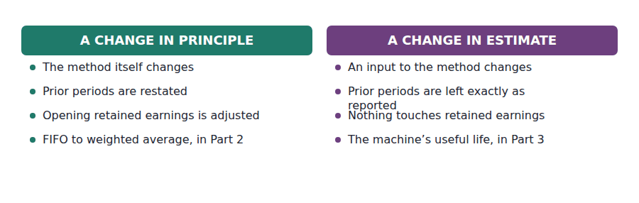
Part 1 · Which kind is it? the method, or an input to it
Exercise 1A Complete both right-hand columns.
OBJECTIVE | Distinguish a change in principle from a change in estimate.
YOU WILL NEED | Volume 4 Handout 4, on the cost flow assumptions. · Volume 5 Handout 1, on useful lives and residual values.
HOW TO START | • Ask of each change whether the rule changed or a number fed into the rule changed. The first calls for retrospective application and the second for prospective application.  • FIFO and weighted average are both acceptable methods, so moving between them changes the method.  • A useful life is an input to straight-line depreciation, and straight-line is still the method afterwards.

 | Change in principle | Change in estimate
What changed
Prior periods
Opening retained earnings
Applied
Northwind’s example

1 | 2 | 3 | 4 | 5 | 6
7 | 8 | 9 | 10

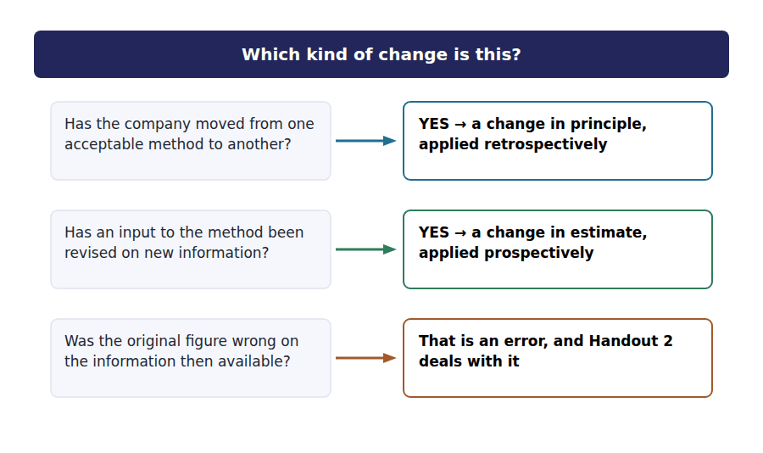
Part 2 · The principle change every prior year, rewritten
R2 Northwind’s closing inventory was $179,000 under FIFO and would have been $161,000 under weighted average. Volume 4 computed both. The change is applied as though weighted average had always been used, so the prior year’s figures are restated too.
Exercise 1B Complete the schedule. Both inventory figures are given.
OBJECTIVE | Compute the adjustment arising from the change in principle.
YOU WILL NEED | Volume 4 Handout 4, which computed both figures. · The paragraph above.
HOW TO START | • The two closing inventory figures differ by $18,000 before tax.  • Lower inventory means higher cost of goods sold and lower profit, so the adjustment reduces retained earnings.  • Tax relief at 25% reduces the net adjustment, which is what actually goes to opening retained earnings.

Changing from FIFO to weighted average | Amount
Closing inventory under FIFO, as reported | $179,000
Closing inventory under weighted average | $161,000
Reduction in inventory, before tax
Tax effect at 25%
Adjustment to opening retained earnings, net of tax

1 | 2 | 3

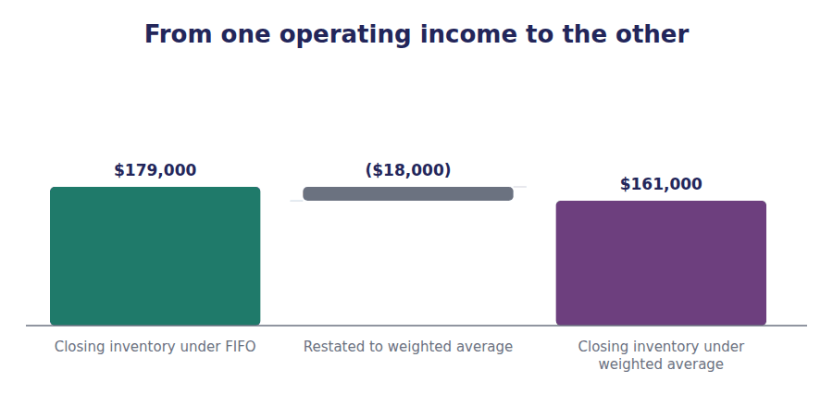
J1 The change from FIFO to weighted average, applied retrospectively at the start of the earliest period presented. The debit is to retained earnings, not to this year’s cost of goods sold.
Account | Debit | Credit
Retained Earnings
Deferred Tax Asset
Inventory

Part 3 · The estimate change this year and the next, and nothing before
Exercise 1C Read and complete, then complete the schedule underneath.
OBJECTIVE | Apply a change in estimate to the machine Volume 5 depreciated.
YOU WILL NEED | Volume 5 Handout 1, for the machine’s cost and original life.
HOW TO START | • The machine cost $500,000 and has been depreciated at $90,000 a year for 2 years.  • Take the carrying amount at the date of the revision, subtract the new residual value, and spread what is left over the new remaining life.  • The last blank is what happens to the $180,000 already charged in the two earlier years.

WORD BANK
$300,000 · future · past · prospectively · retrospectively · right · wrong
Not every word is used.

R2 Northwind now expects the machine to last 5 more years and to be worth $20,000 at the end, rather than the figures Volume 5 used. Those were estimates, and they were not ¹ when they were made.
So the $180,000 already charged stands, and nothing published is restated. The revision is applied ² , from the date the company changed its mind.
The carrying amount at that date is $320,000. Less the revised residual of $20,000, there is ³ left to depreciate.
Spread over 5 years that is $60,000 a year, against the $90,000 Volume 5 was charging. The whole of the change falls into this year and the ⁴ ones.
Revising the machine’s life after 2 years | Amount
Original cost of the machine | $500,000
Depreciation charged over 2 years at $90,000 | ($180,000)
Carrying amount at the date of the revision
Less the revised residual value | ($20,000)
To be depreciated over 5 more years
Revised annual charge

1 | 2 | 3

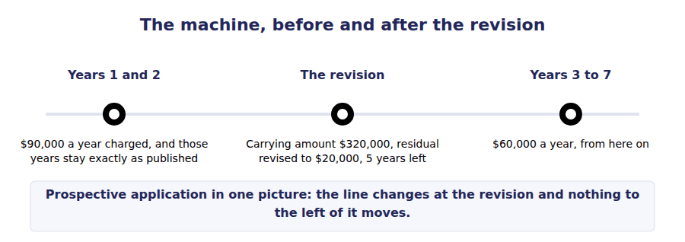
Part 4 · What a reader has to watch the ratios, and the comparison
Exercise 1D Sort each statement into the column that says whether it is true.
OBJECTIVE | Say what each kind of change does to the ratios a reader computes.
YOU WILL NEED | Exercises 1B and 1C. · Volume 4 Handout 7, on what a costing method does to the statements.
HOW TO START | • After a retrospective change both years are on the same basis, so a trend computed across them is meaningful.  • After a prospective change the years are on different bases, and nothing warns the reader except the note.  • One of the statements is about the disclosure that makes either change readable at all.

Statement about the effect on ratios | TRUE | FALSE
1. After a retrospective change, this year and last are comparable
2. After a prospective change, this year and last are on different bases
3. A change in estimate requires prior ratios to be recomputed
4. The note disclosing the change is what makes the figures readable
5. A change in principle can move a prior year’s reported profit
6. A change in estimate can move a prior year’s reported profit

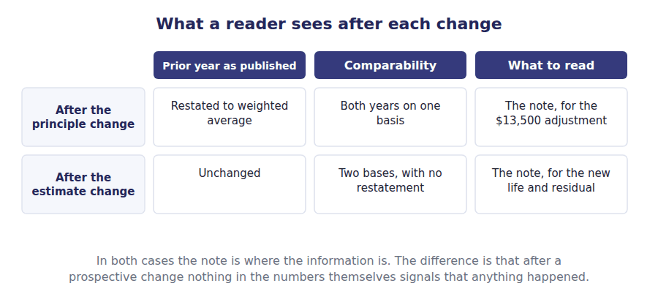
Part 5 · When a change is allowed at all preferability
Exercise 1E Read and complete. Write one word in each space.
OBJECTIVE | Say when a company may change an accounting principle.
YOU WILL NEED | Exercise 1D.
HOW TO START | • A company that could change method freely could choose its profit each year. Ask what stops that.  • The condition is a single word, and the company has to justify it in the notes.  • The last blank is the quality that the restatement requirement is protecting.

WORD BANK
choices · comparability · permitted · preferable · relevance · results · trend
Not every word is used.

R2 A company may not change principle whenever it suits. The new method must be ⁵ to the old one, and the company must say in what respect it is.
Without that condition a management could select whichever method flattered the year, and the figures would record its ⁶ rather than its performance.
The restatement requirement does the rest of the work. Because every prior year shown is restated, a change cannot create an apparent improvement in the ⁷ where none exists.
Together the two rules protect ⁸ , which Volume 1 named as one of the qualities that make financial information useful at all.
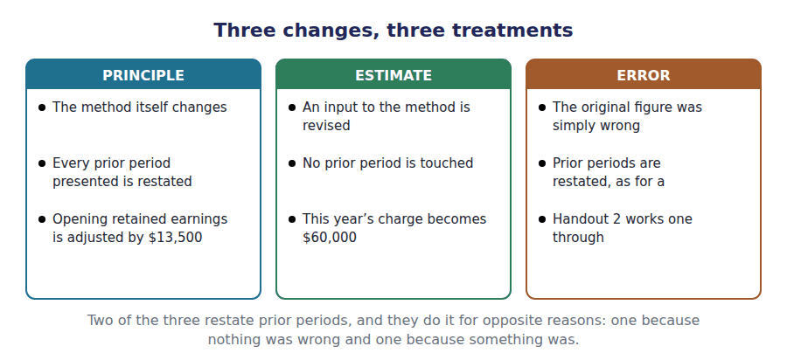
Watch out! A change in depreciation method is the trap on this topic. It looks like a change in principle and is treated as a change in estimate, because the method and the useful life are judged together as an estimate of how the asset is consumed. It is applied prospectively.
Part 6 · Exam pitch the questions as the CMA sets them
1. [Level A] A change in accounting principle is applied:
(A) Prospectively
(B) Retrospectively, restating prior periods
(C) To the current period only
(D) Only with regulatory approval
2. [Level A] A revision of the useful life of an asset is:
(A) A change in accounting principle
(B) A change in accounting estimate
(C) An error correction
(D) Not recognised
3. [Level B] The cumulative effect of a change in principle on periods before the earliest one presented is:
(A) Charged to current profit
(B) Adjusted against the opening balance of retained earnings
(C) Reported in other comprehensive income
(D) Disclosed only
4. [Level B] Northwind changes from FIFO to weighted average, reducing closing inventory by $18,000 before tax at a 25% rate. The adjustment to opening retained earnings is:
(A) $18,000
(B) $13,500
(C) $4,500
(D) Nil
5. [Level C] A machine carried at $320,000 with a revised residual of $20,000 and 5 years of remaining life is depreciated at:
(A) $90,000
(B) $60,000
(C) $64,000
(D) $100,000
6. [Level B] A company may change an accounting principle when:
(A) It wishes to improve reported profit
(B) The new principle is preferable and the reason is disclosed
(C) Its auditor suggests it
(D) At any time, provided the change is disclosed
7. [Level C] A company changes its depreciation method from straight-line to declining balance. This is treated as:
(A) A change in principle, applied retrospectively
(B) A change in estimate, applied prospectively
(C) An error correction
(D) A change in principle, applied prospectively
ADAPTIVE TIP Ask one question before anything else: did the rule change, or did a number fed into the rule change? Rule means retrospective and restatement; number means prospective and nothing touched. The depreciation method is the one exception and it goes with the numbers.

Handout 2 · Correcting an Error and Restating the Comparatives
Northwind omitted $40,000 of depreciation in 20X3. Correcting it changes 20X4 profit by nothing at all.
Volume 17 · Changes, Errors and Special Issues · R2 moving to R3
LANGUAGE FOCUS
Register you are working in | R2 for the correction, R3 for the comparison of all three kinds of change, which is how an exam sets it.
Say it exactly like this | correct an error of a prior period · restate the comparative figures · adjust the opening balance of retained earnings · disclose the nature of an error · identify a counterbalancing error · reissue restated statements
Words that are not the same | error / change in estimate · counterbalancing / non-counterbalancing · restated / as previously reported · current profit / opening retained earnings
Remember | An error correction is not a change in estimate. The old figure was wrong on information available at the time. Correcting a prior period error does not change the current year’s profit. It changes the opening balance it starts from.

What you will be able to do when this handout is finished
- Distinguish an error from a change in estimate.
- Correct a prior period error and restate the comparatives.
- Say why the correction does not touch current profit.
- Distinguish a counterbalancing error from one that is not.
- Compare all three kinds of change in one grid.

A year of depreciation nobody charged
An asset bought in 20X3 was recorded correctly and then never depreciated. $40,000 of depreciation that should have been charged in 20X3 was not.
This is not a change in estimate. The useful life was known, the policy was clear, and the charge was simply missed.
20X3 profit was therefore overstated by $30,000 after tax, and the asset is still carried $40,000 too high today.
Correcting it restates 20X3 and adjusts the opening balance of retained earnings. It leaves 20X4 profit exactly where it was.

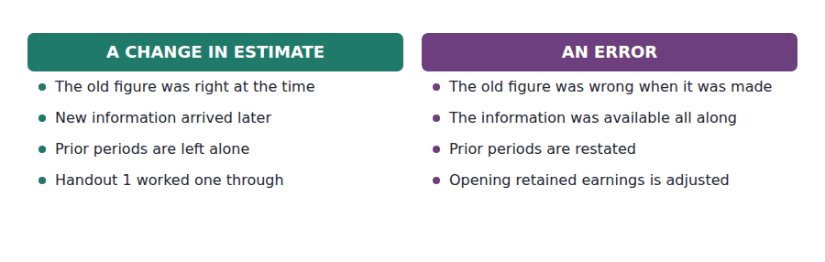
Part 1 · Error, or estimate? what was known at the time
Exercise 2A Read and complete. Write one word in each space.
OBJECTIVE | Distinguish an error from a change in estimate.
YOU WILL NEED | Handout 1 Exercise 1C, on the change in estimate.
HOW TO START | • Both produce a figure that turns out to differ from what was reported. Ask what the company knew when it reported it.  • Revising a useful life uses information that did not exist before. Omitting a charge uses information that did.  • The last blank is the balance the correction is taken to, and it is not this year’s profit.

WORD BANK
current · expected · incorrect · known · retained · revised · wrong
Not every word is used.

R2 The test is what was ¹ at the time. A company that revises a useful life is acting on information that did not exist when the original estimate was made.
A company that omits a depreciation charge had everything it needed to get it right. The figure was ² when it was published, and that makes it an error rather than a revision.
The consequence follows. A change in estimate touches no published figure; an error means a previously issued statement was ³ , so the comparative figures are restated.
And because the mistake belongs to 20X3, its correction goes to the opening balance of ⁴ earnings rather than to this year’s profit.
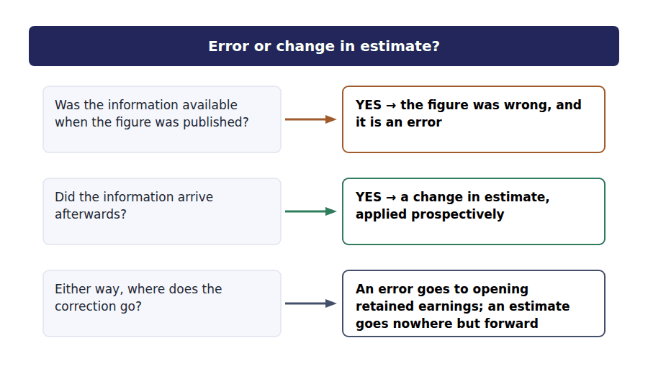
Part 2 · Correcting it and why this year does not move
Exercise 2B Complete the schedule, then record the entry underneath.
OBJECTIVE | Correct the omitted depreciation and restate the prior year.
YOU WILL NEED | Exercise 2A, and Volume 7 Handout 2 for the tax rate.
HOW TO START | • The $40,000 charge was missed, and it would have attracted tax relief at 25%.  • So 20X3 profit was overstated by the net $30,000, and that is what the opening balance has to be reduced by.  • The last row asks what happens to 20X4 profit, and the answer is the point of the exercise.

Depreciation of $40,000 omitted in 20X3 | Amount
Depreciation that should have been charged in 20X3 | $40,000
Tax relief at 25%
Overstatement of 20X3 profit, net of tax
Adjustment to opening retained earnings in 20X4
Effect on 20X4 profit

1 | 2 | 3 | 4

J1 The $40,000 of depreciation omitted in 20X3, corrected as a prior period adjustment. The debit is to retained earnings, because the year it belongs to is closed.
Account | Debit | Credit
Retained Earnings
Deferred Tax Asset
Accumulated Depreciation

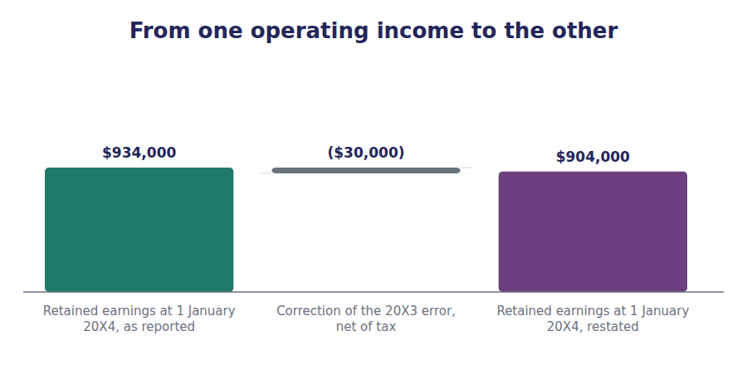
Part 3 · Errors that fix themselves and errors that do not
R2 Some errors reverse in the following year without anyone doing anything. An overstated closing inventory becomes an overstated opening inventory, which overstates cost of goods sold and understates the next year’s profit by the same amount.
Exercise 2C Complete both right-hand columns.
OBJECTIVE | Distinguish errors that counterbalance from those that do not.
YOU WILL NEED | The paragraph above.
HOW TO START | • Ask whether the error works its way out of the balance sheet by the end of the second year.  • Anything that misstates a year-end accrual or an inventory count usually counterbalances; anything that misstates an asset’s carrying amount does not.  • Even where the balance sheet rights itself, both income statements were wrong, which is why the first column is not the whole story.

WORD BANK
counterbalancing · does · not · overstates · permanent · understates · weakness
Not every word is used.

R2 An error that misstates a year-end accrual or an inventory count usually works itself out. An overstated closing inventory becomes an overstated opening inventory, which overstates cost of goods sold and ⁵ the following year’s profit by the same amount.
After two years the balance sheet is right again, and such an error is called ⁶ . The description applies to the balance sheet alone: both income statements carried a misstatement and nothing ever repairs them.
An omitted depreciation charge behaves differently. The asset stays overstated and the accumulated depreciation stays understated for as long as the asset is held, so the error does ⁷ counterbalance at all.
Either way the comparatives are restated. A company that waits for an error to unwind has left two published income statements wrong and may also have a material ⁸ in the control that let it through.
Error | Counterbalancing? | Still wrong after two years?
Closing inventory overstated
Accrued wages omitted
Depreciation omitted on an asset
A capital expenditure charged to repairs
Prepaid insurance not recorded

1 | 2 | 3 | 4 | 5 | 6
7 | 8 | 9 | 10

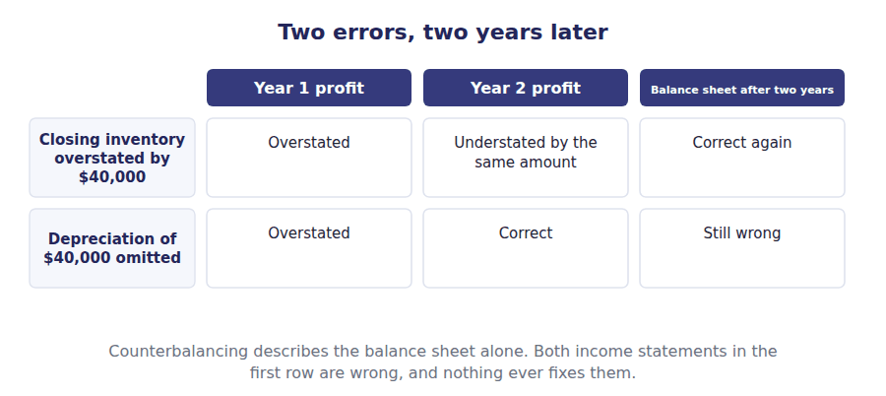
Part 4 · All three kinds together the comparison the exam asks for
Exercise 2D Complete all three columns.
OBJECTIVE | Compare a change in estimate, a change in principle and an error.
YOU WILL NEED | Handout 1 Exercise 1A, and Exercises 2A and 2B.
HOW TO START | • The first row separates the error from the other two in a single word.  • The second row separates the change in estimate from the other two, which is a different split.  • Every column requires disclosure, and the third asks what each one must disclose.

 | Change in estimate | Change in principle | Error
Was the old figure wrong?
Prior periods restated
Opening retained earnings
Disclosure required

1 | 2 | 3 | 4 | 5 | 6
7 | 8 | 9 | 10 | 11 | 12

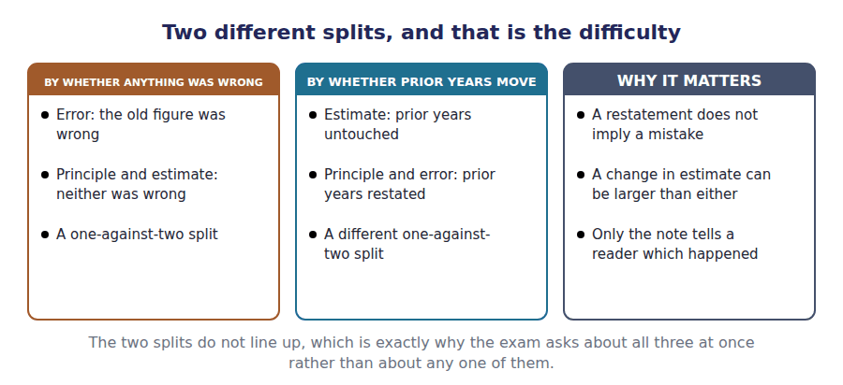
Part 5 · What an error says beyond its amount control, and the reader’s trust
Exercise 2E Sort each statement into the column that says whether it is true.
OBJECTIVE | Say what an error implies beyond the figure it misstated.
YOU WILL NEED | Exercise 2D.
HOW TO START | • A missed depreciation charge of $40,000 is a small figure against $4,990,000 of total assets. Ask whether that makes it unimportant.  • The same control failure that let one charge through could have let a much larger one through, which is what makes it a material weakness rather than a small mistake.  • One of the statements is about what a restatement does to a reader’s confidence, which is not an accounting question and is part of the answer.

Statement about an error | TRUE | FALSE
1. An error may be immaterial in amount and still signal a control failure
2. Correcting an error changes current year profit
3. The nature of the error must be disclosed
4. A restatement can affect a reader’s confidence beyond the figure corrected
5. A counterbalancing error needs no correction if two years have passed
6. Both the error and a change in principle require prior periods to be restated

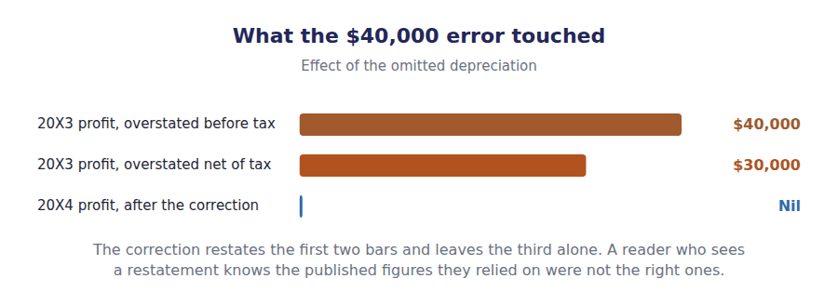
Watch out! Correcting a prior period error never changes current profit. If a question gives you an error from last year and offers an effect on this year’s net income, the answer is nil, and the amount in the stem is there for the opening retained earnings adjustment.
Part 6 · Exam pitch the questions as the CMA sets them
1. [Level A] The correction of an error in a prior period is reported as:
(A) A component of current year profit
(B) An adjustment to the opening balance of retained earnings
(C) Other comprehensive income
(D) A change in accounting estimate
2. [Level A] A company omits a depreciation charge that it had all the information to compute. This is:
(A) A change in accounting estimate
(B) An error
(C) A change in accounting principle
(D) Permitted if immaterial
3. [Level B] Depreciation of $40,000 was omitted last year and the tax rate is 25%. Opening retained earnings this year is adjusted by:
(A) $40,000
(B) $30,000
(C) $10,000
(D) Nil
4. [Level B] The effect of that correction on current year profit is:
(A) $30,000
(B) Nil
(C) $40,000
(D) ($30,000)
5. [Level C] Closing inventory is overstated at the end of year 1. By the end of year 2:
(A) Both years’ profits are correct
(B) The balance sheet is correct again but both income statements were wrong
(C) Only year 2 is wrong
(D) Nothing was ever wrong
6. [Level B] Which of the following requires prior periods to be restated?
(A) A change in accounting estimate only
(B) A change in accounting principle and an error correction
(C) An error correction only
(D) None of them
7. [Level C] An error is small in amount but arose because a control did not operate. The company should:
(A) Ignore it, because it is immaterial
(B) Correct it and consider what the control failure implies
(C) Treat it as a change in estimate
(D) Disclose it without correcting it
ADAPTIVE TIP For any correction question, write the year the mistake belongs to at the top of the page. If it is a closed year the adjustment goes to opening retained earnings and current profit does not move, and that one line answers most of what the exam asks here.

Handout 3 · Functional Currency and Translating a Foreign Subsidiary
Lakeside Controls is worth $1,150,000 of net assets and $1,394,000 of equity. The $244,000 gap is the exchange rate, and it has to go somewhere.
Volume 17 · Changes, Errors and Special Issues · R2 moving to R3
LANGUAGE FOCUS
Register you are working in | R2 for the mechanics, R3 for the choice of method, which the exam frames as a functional currency question.
Say it exactly like this | determine the functional currency · translate at the closing rate · translate equity at historical rates · carry a translation adjustment in equity · remeasure into the functional currency · recycle a translation adjustment on disposal
Words that are not the same | functional currency / reporting currency · current rate method / temporal method · translation / remeasurement · monetary / non-monetary
Remember | The functional currency is not chosen for convenience. It is determined from the facts of how the subsidiary operates. A translation adjustment is not a gain or a loss anyone made. It is the figure that makes a translated balance sheet balance.

What you will be able to do when this handout is finished
- Define the functional currency and say how it is determined.
- Translate a foreign subsidiary under the current rate method.
- Compute the cumulative translation adjustment.
- Distinguish translation from remeasurement.
- Say what a rate change does to the ratios a reader computes.

Lakeside moves abroad
Volume 10 consolidated Lakeside Controls, which Northwind controls 80% of. Suppose it operates abroad, in its own currency.
Its figures are the same ones Volume 10 used: assets of LC 1,600,000, net assets of LC 1,000,000 and profit of LC 120,000, all in local currency.
Northwind reports in dollars, so those figures have to be translated. Three different rates apply to three different parts of the statements: 1.25 historical, 1.20 average, 1.15 closing.
Because the rates differ, the translated balance sheet does not balance on its own. The figure that makes it balance is what this handout is about.

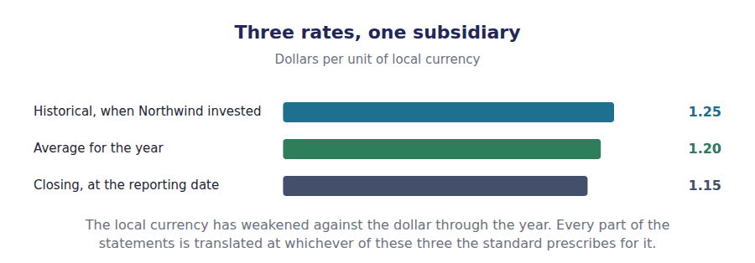
Part 1 · Which currency the subsidiary thinks in the functional currency
Exercise 3A Read and complete. Write one word in each space.
OBJECTIVE | Define the functional currency and say how it is determined.
YOU WILL NEED | Volume 10 Handout 1, on why a subsidiary is consolidated at all.
HOW TO START | • Ask which currency Lakeside Controls sells in, pays its staff in and borrows in.  • A company that does all of those locally is operating in its own economic environment, whatever currency its parent reports in.  • The last blank is what the determination decides, and it is not a presentational matter.

WORD BANK
chosen · currency · determined · dollars · environment · market · method
Not every word is used.

R2 The functional currency is the currency of the primary economic ¹ in which an entity operates: the one it sells in, pays its costs in, and raises its financing in.
It is determined from the facts rather than ² . A subsidiary that sells locally, employs locally and borrows locally has its own local currency as its functional currency, whatever Northwind reports in.
The reporting currency is a different thing. Northwind presents its consolidated statements in ³ , and every subsidiary’s figures have to arrive there somehow.
The determination matters because it decides the ⁴ . One method sends the difference to equity and the other sends it to profit, and nothing else about the facts changes.
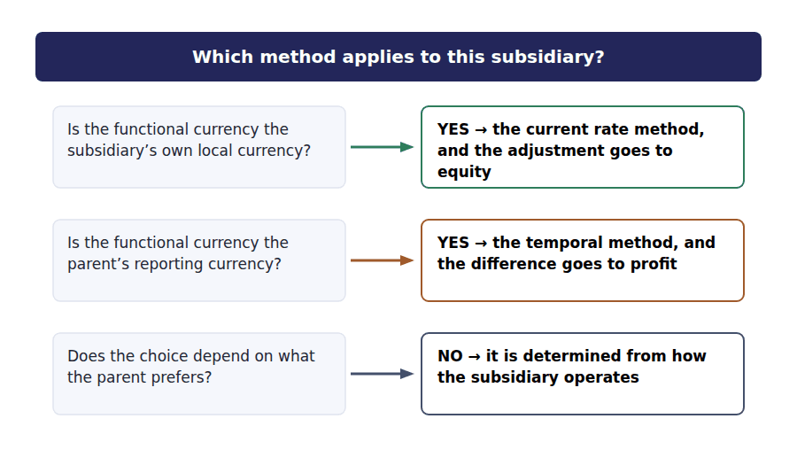
Part 2 · Translating it three rates, one balance sheet
R2 Under the current rate method, assets and liabilities are translated at the closing rate, because that is what they are worth now. Equity is translated at the historical rates at which it arose. Income is translated at the average rate for the year.
Exercise 3B Complete the grid. The local currency figures are given.
OBJECTIVE | Translate Lakeside Controls into dollars under the current rate method.
YOU WILL NEED | The paragraph above, and Volume 10 Handout 2 for the subsidiary’s own figures.
HOW TO START | • Assets and liabilities both take the closing rate of 1.15.  • Contributed capital takes the 1.25 historical rate, because that is what Northwind actually paid.  • The last row is not translated from anything. It is the figure that makes the two sides agree, and Exercise 3C explains it.

Lakeside Controls, translated | Local currency | Rate | Translated
Assets | LC 1,600,000
Liabilities | LC 600,000
Net assets | LC 1,000,000
Contributed capital | LC 1,000,000
Profit for the year | LC 120,000
Cumulative translation adjustment

1 | 2 | 3 | 4 | 5 | 6
7 | 8 | 9 | 10 | 11

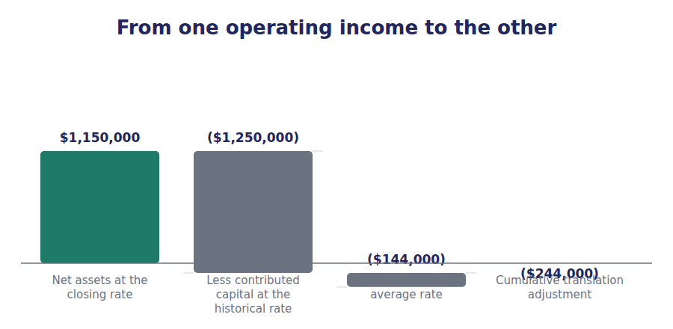
Part 3 · The figure that makes it balance the translation adjustment
Exercise 3C Read and complete. Write one word or figure in each space.
OBJECTIVE | Say what the cumulative translation adjustment is and where it goes.
YOU WILL NEED | Exercise 3B, and Volume 9 Handout 2 on other comprehensive income.
HOW TO START | • The net assets translated at 1.15 come to $1,150,000. The equity translated at its own rates comes to $1,394,000.  • Those two figures describe the same thing and they do not agree, because different rates were used.  • The last blank is where the difference is reported, and Volume 9 listed it as one of the four items that belong there.

WORD BANK
($244,000) · agree · differ · income · movement · profit · rate
Not every word is used.

R2 The net assets translated at the closing rate are $1,150,000. The equity that produced them, translated at its own rates, is $1,394,000. The two describe the same net assets and they ⁵ by $244,000.
Nothing is wrong. The difference arises because the rate at which Northwind invested was 1.25 and the rate at the year end is 1.15, and no transaction caused that ⁶ .
So the difference is recorded as a cumulative translation adjustment of ⁷ , which is exactly the figure that makes the translated balance sheet balance.
It goes to other comprehensive ⁸ and accumulates in equity. Volume 9 named it as one of the four items that bypass profit, and it stays there until the subsidiary is sold.
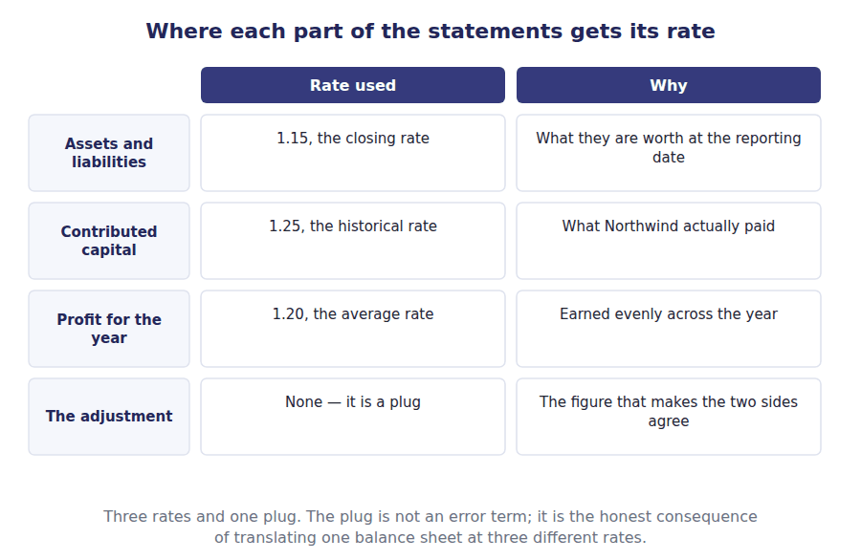
Part 4 · The other method remeasurement, and why it hits profit
Exercise 3D Complete both right-hand columns.
OBJECTIVE | Compare the current rate method with the temporal method.
YOU WILL NEED | Exercise 3C.
HOW TO START | • Under the temporal method only monetary items take the closing rate. Cash and receivables are monetary; inventory and equipment are not.  • Ask what it means that one method sends the balancing figure to profit and the other to equity.  • The last row is the condition that decides which method is used, and Exercise 3A established it.

Item | Current rate method | Temporal method
Assets and liabilities
Equity
Revenue and expenses
The balancing figure goes to
Used when the functional currency is

1 | 2 | 3 | 4 | 5 | 6
7 | 8 | 9

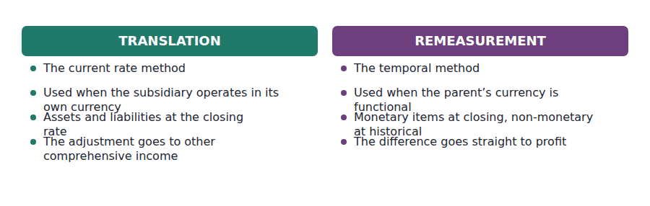
Part 5 · What a reader should notice the ratios, and the disposal
Exercise 3E Sort each statement into the column that says whether it is true.
OBJECTIVE | Say what a rate movement does to the ratios and what happens on disposal.
YOU WILL NEED | Exercise 3D, and Volume 9 Handout 2 on reclassification.
HOW TO START | • The local currency weakened from 1.25 to 1.15. Every asset and liability shrank in dollars and profit was translated at a rate between the two.  • A ratio of two translated figures may be unaffected if both were translated at the same rate.  • The last statement is about what happens to the accumulated adjustment when the subsidiary is eventually sold.

Statement about rate movements | TRUE | FALSE
1. A weakening local currency reduces the translated total assets
2. The debt-to-assets ratio of the subsidiary alone is unaffected, because both were translated at the closing rate
3. The translated profit margin is unaffected, because revenue and expenses use the same average rate
4. The cumulative translation adjustment reduces reported profit
5. The accumulated adjustment is reclassified into profit when the subsidiary is sold
6. A rate movement can change consolidated total assets without any transaction occurring

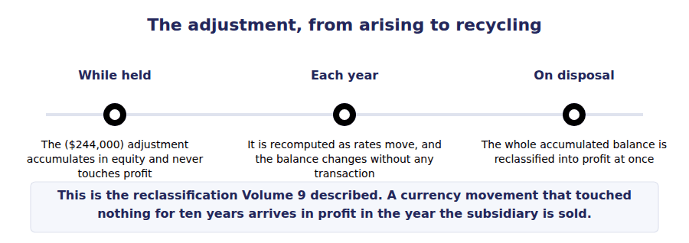
Watch out! The cumulative translation adjustment never reaches profit while the subsidiary is held, however large it grows. A question that offers a translation loss in the income statement is describing the temporal method, which applies only when the parent’s currency is the functional one.
Part 6 · Exam pitch the questions as the CMA sets them
1. [Level A] The functional currency of an entity is:
(A) The currency its parent reports in
(B) The currency of the primary economic environment in which it operates
(C) The currency chosen by management
(D) Always the local currency
2. [Level A] Under the current rate method, assets and liabilities are translated at:
(A) The historical rate
(B) The closing rate
(C) The average rate
(D) Monetary at closing and non-monetary at historical
3. [Level B] Under the current rate method, the translation adjustment is reported in:
(A) Profit for the period
(B) Other comprehensive income
(C) Retained earnings directly
(D) The notes only
4. [Level B] A subsidiary has net assets of $1,150,000 translated at the closing rate, against equity of $1,394,000 translated at historical and average rates. The cumulative translation adjustment is:
(A) $244,000
(B) ($244,000)
(C) Nil
(D) $1,150,000
5. [Level C] The temporal method is used when the functional currency is:
(A) The subsidiary’s local currency
(B) The parent’s reporting currency
(C) A third currency
(D) Whichever is more stable
6. [Level B] A local currency weakens during the year. The translated total assets of the foreign subsidiary:
(A) Rise
(B) Fall
(C) Are unchanged
(D) Change only if assets were bought or sold
7. [Level C] When a foreign subsidiary is sold, the accumulated translation adjustment relating to it is:
(A) Left in equity permanently
(B) Reclassified into profit
(C) Transferred to retained earnings without passing through profit
(D) Written off against goodwill
ADAPTIVE TIP Determine the functional currency before you translate anything. It decides the method, the method decides the rates, and the rates decide whether the difference lands in equity or in profit. A candidate who starts with the arithmetic has already guessed the hardest part.

Handout 4 · Earnings Quality: What the Numbers Do Not Say
Seventeen volumes of measurement, and one handout on how much to trust it. Northwind’s $510,000 of profit is a fact about an accounting system before it is a fact about a business.
Volume 17 · Changes, Errors and Special Issues · R3
LANGUAGE FOCUS
Register you are working in | R3 throughout. This is the exam’s own register, and by the last handout of the last volume the student should be reading it without help.
Say it exactly like this | assess the quality of reported earnings · manage earnings within the rules · reconcile profit to operating cash flow · distinguish accounting profit from economic profit · adjust ratios for inflation · read the accounting policies before the figures
Words that are not the same | accounting profit / economic profit · book value / market value · earnings quality / earnings management · cash / accruals
Remember | Low earnings quality does not mean the figures break the rules. Most of what the phrase describes is entirely permitted. Book value is not an estimate of market value and was never intended to be.

What you will be able to do when this handout is finished
- Say what earnings quality means and what signals it.
- Distinguish accounting profit from economic profit.
- Distinguish book value from market value.
- Say what inflation does to the reliability of a ratio.
- Identify the indicators of earnings management.

The last question, after sixteen volumes of answers
This course has measured a great deal. Revenue, inventory, depreciation, impairment, deferred tax, leases, pensions, consolidation and translation, all of it to the dollar.
Northwind earned $510,000. Every figure behind that number has been derived, checked and tied back to the statements it came from.
This handout asks the question none of that answers. How much of that $510,000 is a fact about the business, and how much is a fact about the choices made in measuring it?
The CMA asks it too, at Part 2 A.4, and it is the right place to finish.

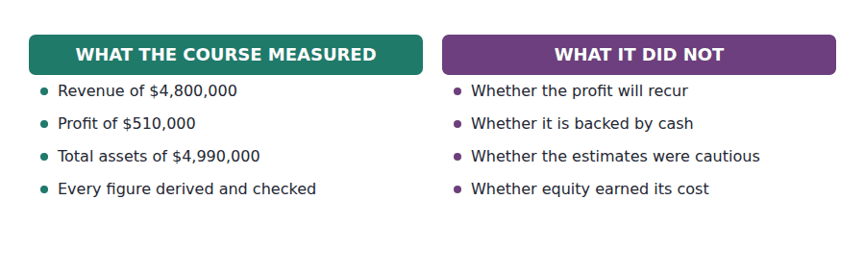
Part 1 · Profit against cash the first and best signal
Exercise 4A Read and complete. Write one word in each space.
OBJECTIVE | Say what distinguishes high quality earnings from low.
YOU WILL NEED | Volume 1 Handout 8, on the statement of cash flows. · Volume 9 Handout 1, on how expenses are recognised.
HOW TO START | • Profit is measured on the accrual basis and cash is not. Ask what it means when the two diverge year after year.  • Northwind reported $510,000 of profit and $708,000 of operating cash flow, which is the comfortable case.  • The last blank is the kind of profit that tells a reader least about next year.

WORD BANK
accruals · cash · expense · gain · improve · profit · recur
Not every word is used.

R3 Earnings quality is the degree to which a reported profit represents performance that will ¹ and is backed by cash. It is a judgement about a number, not another number.
The first signal is the relationship between profit and operating ² flow. Northwind reported $510,000 of profit and $708,000 of operating cash flow, and a company whose profit rises for three years while its operating cash flow does not is telling a reader something.
The gap between the two is the accruals, and every one of them is a judgement this course has taught: the allowance for credit losses, the warranty provision, the useful lives, the impairment tests. Large and growing ³ are the classic warning.
The second signal is the source. A profit made from recurring operations tells a reader about next year; one made from a disposal or a one-off ⁴ tells them about last Tuesday.
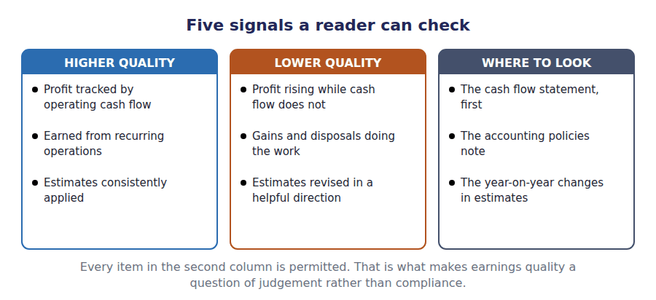
Part 2 · Two kinds of profit accounting and economic
Exercise 4B Read and complete. Write one word or figure in each space.
OBJECTIVE | Distinguish accounting profit from economic profit.
YOU WILL NEED | Exercise 4A, and Volume 14 Handout 5 on debt against equity finance.
HOW TO START | • Northwind charged $90,000 of interest on its debt. Ask whether it charged anything for the $2,670,000 of equity.  • Equity is not free. Its providers could have invested elsewhere and they expect a return for the risk.  • The last blank is what a company reporting an accounting profit and an economic loss has actually done.

WORD BANK
assets · cost · destroying · equity · gain · loss · return
Not every word is used.

R3 The income statement charges for debt and not for ⁵ . Northwind deducted $90,000 of interest and deducted nothing at all for the $2,670,000 its shareholders have tied up.
Economic profit charges for both. If shareholders require 10% on their $2,670,000, the charge would be $267,000, and the $510,000 of accounting profit would become an economic ⁶ .
Nothing in that computation is unorthodox and nothing in the accounts is wrong. The two measures simply answer different questions, and only one of them asks whether the capital employed earned its ⁷ .
A company that reports a profit every year and never covers the cost of its equity is ⁸ value while complying fully with every standard in this course.
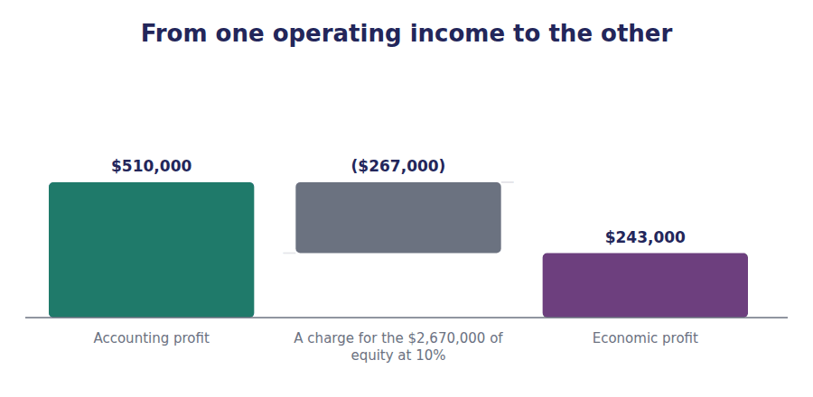
Part 3 · Two kinds of value book and market
Exercise 4C Complete both right-hand columns.
OBJECTIVE | Distinguish book value from market value.
YOU WILL NEED | Volume 8 Handout 1, for Northwind’s equity. · Volume 11 Handout 2, on the capitals that are not on any balance sheet.
HOW TO START | • Book value is what the standards measured. Ask what they deliberately left out.  • Volume 11 named three capitals that appear nowhere: human, social and natural.  • One of the two figures is audited and one of them changes on a day when the company does nothing at all.

 | Book value | Market value
What it measures
Northwind’s equity | $2,670,000
Includes internally generated intangibles
Changes when nothing happens
Audited

1 | 2 | 3 | 4 | 5 | 6
7 | 8 | 9

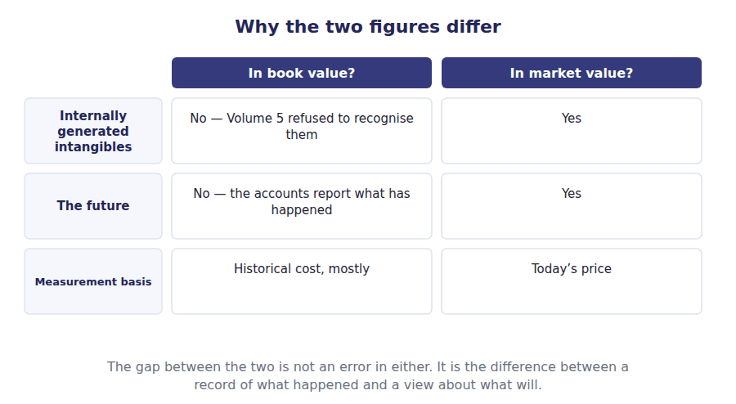
Part 4 · What inflation does to a ratio built from two dates
Exercise 4D Sort each statement into the column that says whether it is true.
OBJECTIVE | Say what inflation does to the reliability of a ratio.
YOU WILL NEED | Volume 4 Handout 4, on FIFO and LIFO in rising prices.
HOW TO START | • A ratio that divides a current figure by an old one is dividing dollars of two different sizes.  • Return on assets puts this year’s profit over assets bought over many years, which is exactly that problem.  • One of the statements is about LIFO, which Volume 4 showed moves old costs out of inventory and into cost of goods sold.

Statement about inflation and ratios | TRUE | FALSE
1. Return on assets is flattered when assets are carried at old costs
2. Comparing two companies of different ages is harder under inflation
3. LIFO gives a cost of goods sold closer to current prices than FIFO
4. Historical cost accounting is unaffected by inflation
5. A rising gross margin may reflect price rises rather than better buying
6. Inflation affects the balance sheet more than the income statement

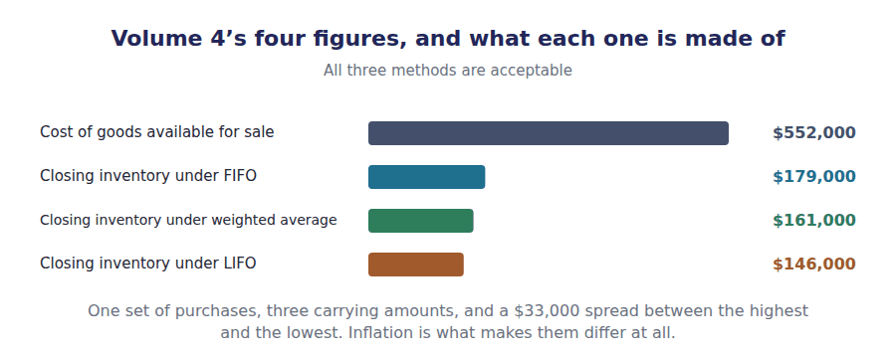
Part 5 · Reading a set of accounts sceptically the whole course, used
Exercise 4E Complete both right-hand columns.
OBJECTIVE | Identify the indicators of earnings management.
YOU WILL NEED | Exercises 4A to 4D, and any volume of this course.
HOW TO START | • Every row is a choice some volume of this course taught as legitimate. Ask what it looks like when it is used to a purpose.  • The estimates row is the one with the widest scope: credit losses, warranties, useful lives, impairment and pensions are all estimates.  • The last row is about whether a reader could check any of it, which is the condition for all the others mattering.

Indicator | Higher quality earnings | Lower quality earnings
Cash backing
Source
Estimates
Accruals
Disclosure

1 | 2 | 3 | 4 | 5 | 6
7 | 8 | 9 | 10

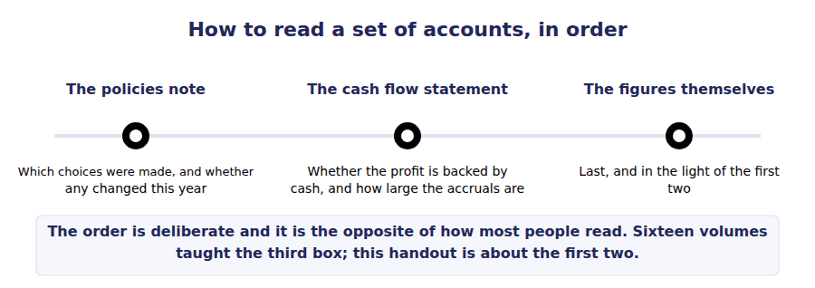
Watch out! Almost everything described here is permitted. Earnings management is a question of judgement within the rules, not of breaking them, and that is precisely why a reader needs the whole of this course to notice it happening.
Part 6 · Exam pitch the questions as the CMA sets them
1. [Level B] High quality earnings are best indicated by:
(A) A high growth rate
(B) Profit that is backed by operating cash flow and arises from recurring operations
(C) A large profit in absolute terms
(D) An unqualified audit opinion
2. [Level B] A company reports rising profit while operating cash flow falls for three consecutive years. This suggests:
(A) Strong earnings quality
(B) That accruals are doing an increasing share of the work
(C) That the company is growing
(D) An error in the cash flow statement
3. [Level C] Economic profit differs from accounting profit because it:
(A) Excludes interest
(B) Charges for the cost of equity capital
(C) Uses market values throughout
(D) Is computed before tax
4. [Level B] Book value differs from market value principally because book value:
(A) Is updated daily
(B) Omits internally generated intangibles and the market’s view of the future
(C) Includes a premium for control
(D) Is not audited
5. [Level C] Under inflation, a company holding old assets at historical cost will report a return on assets that is:
(A) Understated
(B) Overstated
(C) Unaffected
(D) Not determinable
6. [Level C] Which of the following is the best single place to begin assessing earnings quality?
(A) The auditor’s report
(B) The accounting policies note and the cash flow statement
(C) The chairman’s statement
(D) The five-year summary
7. [Level B] Earnings management, as the term is normally used, describes:
(A) Fraudulent misstatement of the accounts
(B) The use of permitted accounting choices to produce a desired result
(C) The correction of prior period errors
(D) A change in accounting principle
ADAPTIVE TIP Read the accounting policies before the figures, and the cash flow statement before the income statement. Sixteen volumes of this course taught you how the numbers are built; this one asks what was built into them, and the answer is always in the notes.

Answer Key
Volume 17 · Handouts 1 to 4
Every answer carries the reason for it and the mistake it defeats.

Handout 1 · Changes in Principle and Changes in Estimate answers
Completed text and exercises
# | Answer | Why | The trap it defeats
1 | wrong | Right on the information then available.
2 | prospectively | From now on, and no further back.
3 | $300,000 | $320,000 less $20,000.
4 | future | No restatement, ever. | Students restate prior depreciation. A change in estimate never reaches a published figure.
Grid 1 | 1 TRUE 2 TRUE 3 FALSE 4 TRUE 5 TRUE 6 FALSE | The last pair is the distinction in one line: only a change in principle can move a figure that has already been published.
5 | preferable | Justified, and disclosed as such.
6 | choices | Management’s decisions, not the business.
7 | trend | Both years move together.
8 | comparability | The quality the whole rule protects. | Students treat the restatement as busywork. It is what stops a method change manufacturing a trend.

Exam-pitch questions
# | Answer | Why | The trap it defeats
1 | (B) Retrospectively, restating prior periods | Every period presented is restated so the reader compares like with like. (A) is the treatment for a change in estimate, and the pair is the whole of A.4(c). | Level A
2 | (B) A change in accounting estimate | The method is unchanged; an input to it has been revised. (A) is the commonest wrong answer because the effect on the charge can be large. | Level A
3 | (B) Adjusted against the opening balance of retained earnings | It belongs to years that are no longer shown, so it adjusts the opening balance. (A) would charge this year with the results of a decade. | Level B
4 | (B) $13,500 | $18,000 less $4,500 of tax relief is $13,500. (A) ignores the tax, which the restatement must also reverse. | Level B
5 | (B) $60,000 | $320,000 less $20,000 over 5 years is $60,000. (C) forgets the residual value, and (A) is the old charge, which the revision replaces. | Level C
6 | (B) The new principle is preferable and the reason is disclosed | Preferability is the condition, and it must be justified. (D) drops the condition and would let a company select its result each year. | Level B
7 | (B) A change in estimate, applied prospectively | The method and the life are judged together as an estimate of how the asset is consumed, so the change is prospective. (A) is the answer the word method invites and is the single most reliable trap on this learning outcome. | Level C

Exercise 1B · the change in principle
Changing from FIFO to weighted average | Amount
Closing inventory under FIFO, as reported | $179,000
Closing inventory under weighted average | $161,000
Reduction in inventory, before tax | ($18,000)
Tax effect at 25% | $4,500
Adjustment to opening retained earnings, net of tax | ($13,500)

Exercise 1C · the change in estimate
Revising the machine’s life after 2 years | Amount
Original cost of the machine | $500,000
Depreciation charged over 2 years at $90,000 | ($180,000)
Carrying amount at the date of the revision | $320,000
Less the revised residual value | ($20,000)
To be depreciated over 5 more years | $300,000
Revised annual charge | $60,000

Exercise 1A · the two kinds of change
 | Change in principle | Change in estimate
What changed | The method itself | An input the method uses
Prior periods | Restated | Left alone
Opening retained earnings | Adjusted | Not adjusted
Applied | Retrospectively | Prospectively
Northwind’s example | FIFO to weighted average | The machine’s useful life

R2 Both figures in the first schedule came from Volume 4, which computed closing inventory at $179,000 under FIFO and $161,000 under weighted average without ever suggesting a company might move between them. The $18,000 difference is the whole of the retrospective adjustment, and $13,500 of it survives the tax.
R2 The second schedule starts from Volume 5’s own machine: $500,000 of cost and $90,000 a year of straight-line depreciation. Two years in, the carrying amount is $320,000 and the revision takes the charge from $90,000 to $60,000 without touching a published figure.

Handout 2 · Correcting an Error and Restating the Comparatives answers
Completed text and exercises
# | Answer | Why | The trap it defeats
1 | known | Available at the time, or not.
2 | wrong | Not merely different; wrong.
3 | incorrect | A published statement was misstated.
4 | retained | The year it belongs to is closed. | Students put the correction in current profit. That would make this year carry last year’s mistake.
5 | understates | The reverse of the first year.
6 | counterbalancing | The balance sheet rights itself.
7 | not | It stays wrong while the asset is held.
8 | weakness | The control question, separate from the amount. | Students treat a counterbalancing error as one that needs no action. Two income statements were wrong, and so, possibly, is a control.
Grid 1 | 1 TRUE 2 FALSE 3 TRUE 4 TRUE 5 FALSE 6 TRUE | The fifth is the trap. The balance sheet may be right again and both income statements are still wrong, so the comparatives still need restating.

Exam-pitch questions
# | Answer | Why | The trap it defeats
1 | (B) An adjustment to the opening balance of retained earnings | A prior period adjustment, because the mistake belongs to a year already closed. (A) would make this year carry last year’s error. | Level A
2 | (B) An error | The information was available, so the figure was wrong when published. (A) is the answer that would let any omission be reclassified as a revision. | Level A
3 | (B) $30,000 | $40,000 less $10,000 of tax relief is $30,000. (A) ignores the tax, which the restatement reverses along with the charge. | Level B
4 | (B) Nil | The error belongs to the prior year and is corrected there. Current profit is untouched, which is the single most tested point on this learning outcome. | Level B
5 | (B) The balance sheet is correct again but both income statements were wrong | Counterbalancing describes the balance sheet, not the income statements. (A) is the misreading the phrase self-correcting invites, and it is why the comparatives are still restated. | Level C
6 | (B) A change in accounting principle and an error correction | Both, for opposite reasons: one because nothing was wrong and comparability requires it, the other because something was. (C) misses the principle change entirely. | Level B
7 | (B) Correct it and consider what the control failure implies | The amount and the control implication are separate questions, and the same failure could have admitted a much larger error. (A) answers only the first of the two. | Level C

Exercise 2B · the error, corrected
Depreciation of $40,000 omitted in 20X3 | Amount
Depreciation that should have been charged in 20X3 | $40,000
Tax relief at 25% | ($10,000)
Overstatement of 20X3 profit, net of tax | $30,000
Adjustment to opening retained earnings in 20X4 | ($30,000)
Effect on 20X4 profit | Nil

Exercise 2C · which errors counterbalance
Error | Counterbalancing? | Still wrong after two years?
Closing inventory overstated | Yes | No
Accrued wages omitted | Yes | No
Depreciation omitted on an asset | No | Yes
A capital expenditure charged to repairs | No | Yes
Prepaid insurance not recorded | Yes | No

Exercise 2D · all three kinds of change
 | Change in estimate | Change in principle | Error
Was the old figure wrong? | No | No | Yes
Prior periods restated | No | Yes | Yes
Opening retained earnings | Untouched | Adjusted | Adjusted
Disclosure required | Yes | Yes, with the reason | Yes, and its nature

R2 The last row of the first schedule is the one that catches people out. The error was $40,000, the adjustment to opening retained earnings is $30,000, and the effect on 20X4 profit is nil. A question that offers any of the first two as an effect on this year is offering a figure from the right computation and the wrong year.
R2 The third schedule is worth re-reading as two separate splits rather than one. Only the error involves something having been wrong; only the change in estimate leaves prior periods alone. Those two lines do not divide the three the same way, and almost every question on A.4(c) lives in the gap between them.

Handout 3 · Functional Currency and Translating a Foreign Subsidiary answers
Completed text and exercises
# | Answer | Why | The trap it defeats
1 | environment | Where it really operates.
2 | chosen | A question of fact, not of policy. | Students treat the functional currency as an election. The standard lists indicators and the facts decide.
3 | dollars | One currency for the whole group.
4 | method | And therefore where the difference lands.
5 | differ | Different rates on the same net assets.
6 | movement | A rate moved; nobody traded.
7 | ($244,000) | $1,150,000 less $1,394,000.
8 | income | Other comprehensive income, as Volume 9 listed. | Students expect a currency loss in profit. Under the current rate method nothing about the translation reaches profit at all.
Grid 1 | 1 TRUE 2 TRUE 3 TRUE 4 FALSE 5 TRUE 6 TRUE | The fourth and the fifth together are the whole of it: the adjustment never touches profit while the subsidiary is held, and it all arrives at once when it is sold.

Exam-pitch questions
# | Answer | Why | The trap it defeats
1 | (B) The currency of the primary economic environment in which it operates | Determined from the facts of how the entity operates. (C) treats it as a policy choice, which is exactly what the standard’s list of indicators prevents. | Level A
2 | (B) The closing rate | What they are worth at the reporting date. (D) is the temporal method, and distinguishing the two is most of this learning outcome. | Level A
3 | (B) Other comprehensive income | It accumulates in equity and bypasses profit entirely. (A) is the temporal method’s treatment, which is why determining the functional currency comes first. | Level B
4 | (B) ($244,000) | $1,150,000 less $1,394,000 is ($244,000), a debit balance in equity. It is the figure that makes the translated balance sheet balance and nothing else. | Level B
5 | (B) The parent’s reporting currency | Where the parent’s currency is functional the subsidiary is treated as though it had transacted in that currency all along, so the difference is a real gain or loss and goes to profit. | Level C
6 | (B) Fall | Every asset is translated at a lower closing rate, so the consolidated total falls without any transaction. (D) is the intuition that a balance sheet only moves when something happens, and translation is the exception. | Level B
7 | (B) Reclassified into profit | It is recycled, which is what distinguishes it from the IFRS revaluation surplus Volume 9 named as the exception. Years of accumulated movement arrive in profit in one period. | Level C

Exercise 3B · Lakeside Controls, translated
Lakeside Controls, translated | Local currency | Rate | Translated
Assets | LC 1,600,000 | 1.15 | $1,840,000
Liabilities | LC 600,000 | 1.15 | $690,000
Net assets | LC 1,000,000 |  | $1,150,000
Contributed capital | LC 1,000,000 | 1.25 | $1,250,000
Profit for the year | LC 120,000 | 1.20 | $144,000
Cumulative translation adjustment |  |  | ($244,000)

Exercise 3D · the two methods
Item | Current rate method | Temporal method
Assets and liabilities | Closing rate | Monetary at closing; non-monetary at historical
Equity | Historical rate | Historical rate
Revenue and expenses | Average rate | Average, except those tied to non-monetary items
The balancing figure goes to | Other comprehensive income | Profit
Used when the functional currency is | The subsidiary’s local currency | The parent’s reporting currency

R2 The adjustment of ($244,000) is a plug and the checker treats it as one: it is computed as the net assets at the closing rate less the equity at its own rates, and the build asserts that the translated balance sheet balances. If it ever stopped balancing, the figure would be meaningless.
R2 Every local currency figure here is Volume 10’s. LC 1,600,000 of assets, LC 1,000,000 of net assets and LC 120,000 of profit were used there to compare three consolidation methods, and nothing has been added except three exchange rates.

Handout 4 · Earnings Quality: What the Numbers Do Not Say answers
Completed text and exercises
# | Answer | Why | The trap it defeats
1 | recur | Sustainable, not one-off.
2 | cash | The measure with no estimates in it.
3 | accruals | Every one of them a judgement. | Students read accruals as a technicality. They are where every estimate in sixteen volumes ends up.
4 | gain | Peripheral, as Volume 9 defined it.
5 | equity | Debt has a stated rate; equity does not.
6 | loss | Profitable by one measure, not the other.
7 | cost | The question the income statement never asks.
8 | destroying | Value, not profit. | Students equate profit with value creation. The income statement does not charge for equity, so it cannot answer that question.
Grid 1 | 1 TRUE 2 TRUE 3 TRUE 4 FALSE 5 TRUE 6 TRUE | The first is the one that matters most. An old asset base makes a mature company look more profitable than a new one doing exactly the same business.

Exam-pitch questions
# | Answer | Why | The trap it defeats
1 | (B) Profit that is backed by operating cash flow and arises from recurring operations | Cash backing and recurrence are the two determinants. (D) says the figures comply with the standards, which is a different and much weaker statement. | Level B
2 | (B) That accruals are doing an increasing share of the work | The widening gap is the accruals, every one of which is a judgement. (C) is possible and is exactly the explanation a sceptical reader tests rather than assumes. | Level B
3 | (B) Charges for the cost of equity capital | The income statement charges for debt and not for equity, so a company can report a profit and still not cover what its shareholders require. | Level C
4 | (B) Omits internally generated intangibles and the market’s view of the future | Volume 5 refused to recognise internally generated intangibles and the accounts record what has happened rather than what will. (D) reverses the position entirely. | Level B
5 | (B) Overstated | Current profit is divided by an old and therefore small asset base, which flatters the ratio. It is why comparing a mature company with a new one needs care that the figures themselves do not signal. | Level C
6 | (B) The accounting policies note and the cash flow statement | The policies say which choices were made and the cash flow statement shows how much of the profit is cash. (A) tells you the figures comply, which is where the question starts rather than ends. | Level C
7 | (B) The use of permitted accounting choices to produce a desired result | Mostly within the rules, which is what makes it hard to detect and why the exam asks about its indicators. (A) is a different matter entirely and is not what the phrase means. | Level B

Exercise 4C · book value against market value
 | Book value | Market value
What it measures | Historical cost less what has been used up | What buyers and sellers agree today
Northwind’s equity | $2,670,000 | Whatever the shares fetch
Includes internally generated intangibles | No | Yes
Changes when nothing happens | No | Yes, daily
Audited | Yes | No

Exercise 4E · the indicators of earnings quality
Indicator | Higher quality earnings | Lower quality earnings
Cash backing | Operating cash flow tracks profit | Profit rises while operating cash flow does not
Source | Recurring operations | Gains, disposals and one-off items
Estimates | Conservative, and consistently applied | Revised in whichever direction helps
Accruals | Small relative to cash flow | Large and growing
Disclosure | Clear enough to recompute the figures | Opaque, and changes are hard to trace

R2 Every row of the second table describes something this course taught as legitimate. The allowance for credit losses in Volume 3, the cost flow choice in Volume 4, the depreciation method in Volume 5, the impairment judgement in Volume 5 and Volume 12, the pension assumptions in Volume 16: each one is a choice, and each one moves the reported result.
R2 That is the note to end seventeen volumes on. The arithmetic in this course is exact and the checker has verified every identity in it on every build. What the arithmetic rests on is judgement, and no amount of checking can verify that. A reader who has worked through all of it knows where the judgements are, which is the only protection there is.

Glossary
Every term in Volume 17, with the Arabic equivalent and the places it misleads
The third column is for recognition only. In the exam room you work in English.

Term | What it means in CMA English | بالعربية | Careful
book value | The carrying amount of equity in the accounts: assets less liabilities as measured by the standards. | القيمة الدفترية | Historical cost less what has been consumed. It omits everything a company built rather than bought.
change in accounting estimate | A revision of an input to a method, in the light of new information. | التغير في التقدير المحاسبي | The commonest change by far, and the one that touches no prior period at all.
change in accounting principle | A move from one generally accepted accounting method to another. | التغير في السياسة المحاسبية | Permitted only where the new method is preferable, and a company must say why. The exam often tests that condition rather than the arithmetic.
counterbalancing error | An error that reverses itself in the following period, so that after two years the balance sheet is right again. | خطأ ذاتي التصحيح | The income statements of both years are still wrong. Self-correcting describes the balance sheet alone.
cumulative effect | The total effect of a change in principle on all periods before the earliest one presented. | الأثر التراكمي | Taken to the opening balance of retained earnings in the earliest period shown, not to current profit.
cumulative translation adjustment | The accumulated balance in equity arising from translating a foreign subsidiary. | فروق الترجمة المتراكمة | A plug, and an honest one: it is exactly the figure that makes the translated balance sheet balance.
current rate method | Translating assets and liabilities at the closing rate, equity at historical rates and income at the average rate. | طريقة السعر الجاري | Used where the subsidiary’s functional currency is its own local currency, which is the usual case.
earnings management | The use of accounting choices and estimates to produce a desired reported result. | إدارة الأرباح | Mostly legal, which is what makes it hard. Every volume in this course offered choices a management could use this way.
earnings quality | The degree to which reported earnings represent sustainable performance and are backed by cash. | جودة الأرباح | A judgement, not a measurement. The exam asks for its determinants rather than a number.
economic profit | The return after charging for all capital employed, including equity. | الربح الاقتصادي | Accounting profit charges for debt and not for equity, so a company can report a profit and destroy value.
functional currency | The currency of the primary economic environment in which an entity operates. | العملة الوظيفية | Determined from facts, not chosen. It decides which of the two methods applies, and so decides where the adjustment lands.
market value | What a company’s equity trades for. | القيمة السوقية | Includes the intangibles the accounts exclude, and the market’s view of the future. It moves when nothing has happened.
material weakness | A deficiency in internal control such that a material misstatement might not be prevented or detected. | ضعف جوهري في الرقابة | Why an error matters beyond its amount. A single error can signal a control that does not work.
misstatement | A figure in an issued statement that differs from what the standards require. | تحريف في القوائم | An error produces one. The size of the misstatement and the control failure behind it are two separate questions.
prior period adjustment | The correction of an error in previously issued statements, taken to the opening balance of retained earnings. | تسوية فترات سابقة | Never to current profit. A mistake belongs to the year it was made.
prospective application | Applying a change only to the current and future periods, leaving prior reports untouched. | التطبيق بأثر مستقبلي | Used for changes in estimate, because the old figures were not wrong when they were made.
remeasurement | Restating transactions and balances into the functional currency, with the difference taken to profit. | إعادة القياس بالعملة الوظيفية | Not the same as translation. Remeasurement reaches profit; translation does not.
reporting currency | The currency in which the group presents its consolidated statements. | عملة العرض | Northwind reports in dollars whatever currency its subsidiaries operate in.
restatement | Re-presenting previously issued figures on a corrected or a new basis. | إعادة عرض القوائم | A word with a reputation it only half deserves. A change in principle requires one and nothing was wrong; an error requires one and something was.
retrospective application | Applying a new principle to every period presented, as though it had always been used. | التطبيق بأثر رجعي | Comparability is the reason. A reader comparing two years must be comparing them on one basis.
temporal method | Remeasuring monetary items at the closing rate and non-monetary items at historical rates. | الطريقة الزمنية | Used where the functional currency is the parent’s. The balancing figure goes to profit, which is the difference that matters.

