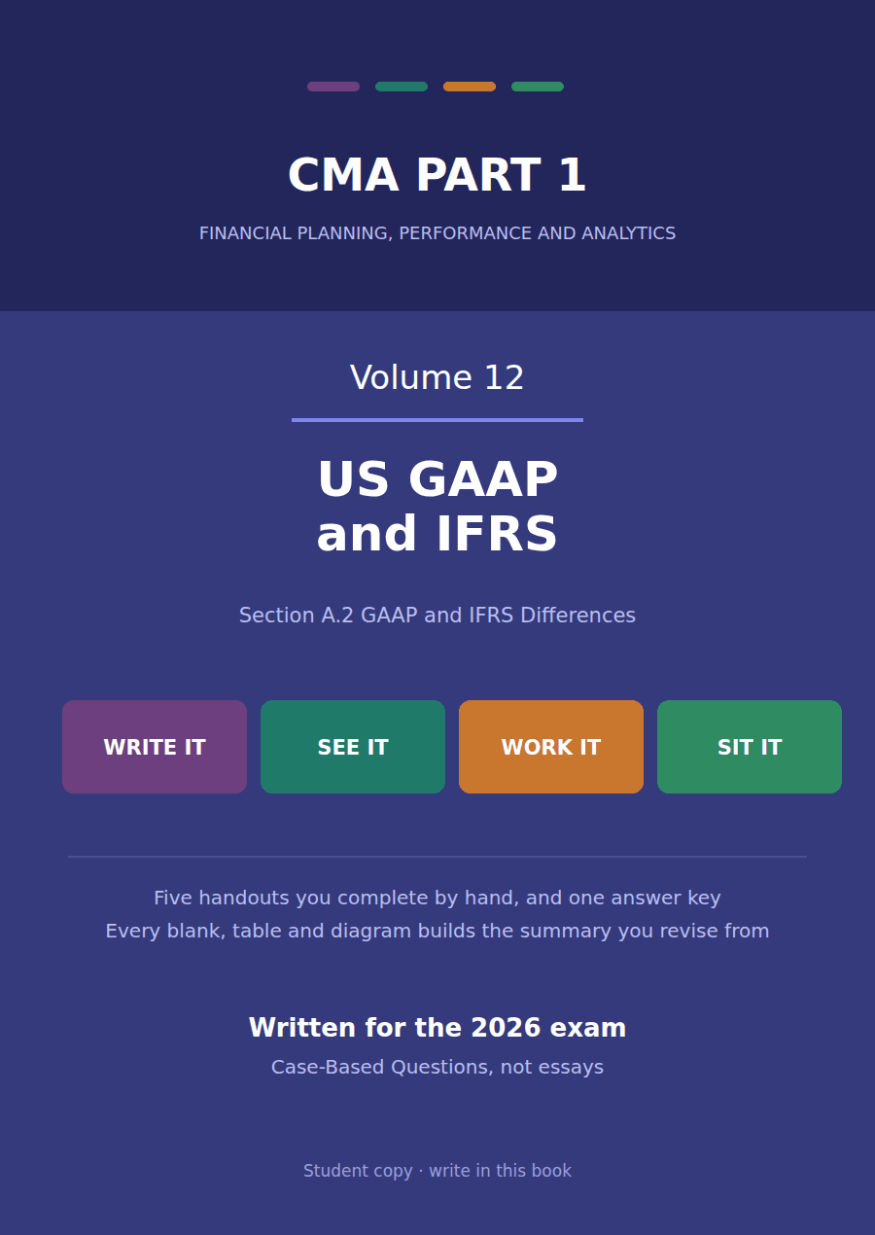

CMA Part 1 · Volume 12
US GAAP and IFRS
Five handouts, one answer key. The six named differences, each worked against a volume you have already completed.
These handouts are not notes to read. You write them. The words you supply are the summary, so a finished handout is a page you can revise from, in your own handwriting.
Work in pen. Do not look at the key until the whole handout is done — the key is written to explain the mistake, and you only get that benefit if you have made it first.
The five handouts
# | Handout | What it gives you
1 | Expense Recognition: Share-Based Payments and Employee Benefits | The same option award costs $90,000 in its first year under one framework and $165,000 under the other. Over three years both spend $270,000.
2 | Intangibles: Development Costs and Revaluation | Northwind spends $400,000 developing a sensor. One framework charges all of it to profit and the other carries $240,000 as an asset.
3 | Inventories: Costing, Valuation and Write-Downs | Three differences, and one of them explains why a company that switches frameworks may have to abandon its costing method altogether.
4 | Leases: the Lessee’s Two Models | Northwind’s warehouse floor is an operating lease under US GAAP and a finance lease in all but name under IFRS. The cash is identical and almost nothing else is.
5 | Long-Lived Assets and Impairment: Revaluation and Reversal | Volume 5 found no impairment on production line B. Under IFRS the same line carries a loss of $60,000, and the reason is one discount rate.

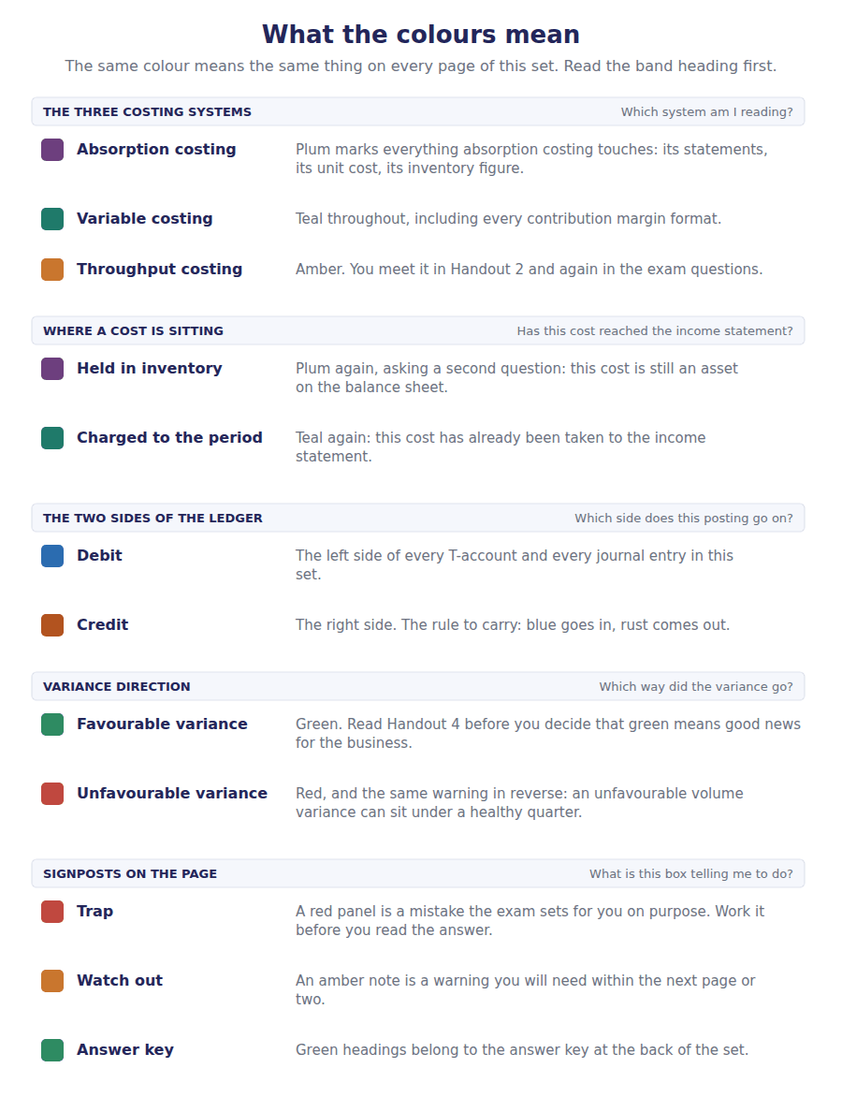
How to read the markers
Marker | Meaning
R1 | Teaching English. Short sentences. This is where a new idea arrives.
R2 | Textbook English. Longer sentences and passive verbs, as a textbook writes them.
R3 | Exam English. Exactly how the CMA exam phrases it, traps included.
Numbered rule | A space you fill in. The number matches the answer key.
Red table | A trap. Read it twice.

Handout 1 · Expense Recognition: Share-Based Payments and Employee Benefits
The same option award costs $90,000 in its first year under one framework and $165,000 under the other. Over three years both spend $270,000.
Volume 12 · US GAAP and IFRS · R2
LANGUAGE FOCUS
Register you are working in | R2 throughout. The exam register waits until the second half of the volume, once the pattern of these comparisons is familiar.
Say it exactly like this | recognise compensation cost over the vesting period · treat each tranche as a separate award · estimate forfeitures · measure the net defined benefit liability · charge past service cost immediately · recognise a remeasurement in other comprehensive income
Words that are not the same | straight-line / accelerated · tranche / award · expected return / discount rate · amortised / recognised immediately
Remember | Neither framework spends more in total. The grant-date fair value is the same $270,000 under both. A remeasurement in other comprehensive income is not a deferral under IFRS. It never reaches profit at all.

What you will be able to do when this handout is finished
- Say how each framework spreads the cost of a graded-vesting award.
- Compute the annual charge under both.
- Say how each framework treats forfeiture estimates.
- Compute net defined benefit cost under both.
- Say where a remeasurement and a past service cost go under each.

Two frameworks, one award
Northwind grants 90,000 share options worth $3 each at the grant date, so the award is worth $270,000 in total.
They vest in three equal instalments, one at the end of each of the next three years, which makes this a graded vesting award. The only condition is that the holder stays.
Both frameworks measure the award at the same $270,000. Both spend all of it. And in the first year one charges $90,000 and the other charges $165,000.
This handout works that difference, and then the larger one in pension accounting.

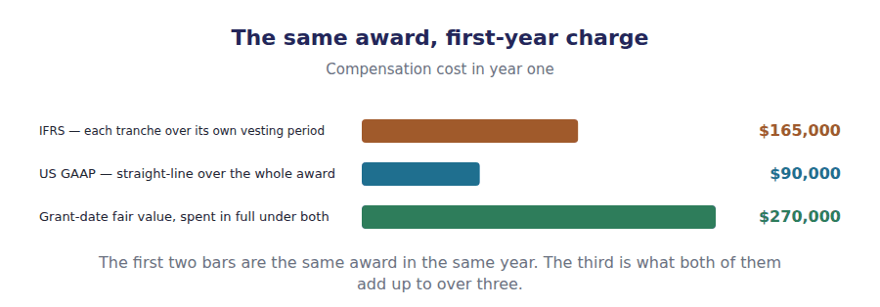
Part 1 · Spreading an option award one award or three
Exercise 1A Read and complete. Write one word in each space.
OBJECTIVE | Say how each framework spreads the cost of a graded-vesting award.
YOU WILL NEED | Volume 9 Handout 1, on systematic and rational allocation.
HOW TO START | • Ask how many awards there really are when three instalments vest on three different dates.  • If each instalment is its own award, the first has one year to be earned over and the third has three.  • The last blank is what happens to the total cost under the two approaches, and the answer is nothing.

WORD BANK
accelerated · are · charge · differ · front-loaded · straight-line · total
Not every word is used.

R2 Both frameworks measure the award at its grant-date fair value of $270,000 and recognise it over the period the employee earns it. The difference is how many awards they think there ¹ .
US GAAP permits an award whose only condition is continued service to be expensed on a ² basis over the whole vesting period, which gives $90,000 in each of the three years.
IFRS requires each instalment to be treated as a separate award. The first $90,000 is earned over one year, the second over two and the third over three, so the charge is ³ .
Year one therefore carries $165,000, year two $75,000 and year three $30,000. The ⁴ is the same $270,000 under both, because the same award was granted.
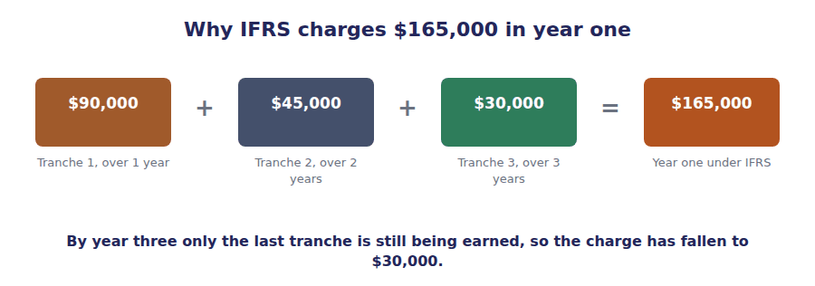
Part 2 · The two patterns, computed three years, two columns
Exercise 1B Complete the grid. Both columns must reach the same total.
OBJECTIVE | Compute the annual charge under both frameworks.
YOU WILL NEED | Exercise 1A.
HOW TO START | • The left column is $270,000 divided by three, the same in every year.  • The right column is $90,000 for the first tranche, $45,000 for the second and $30,000 for the third, added for each year they are still being earned.  • If your two totals differ, one of the tranche figures is wrong: both must come to $270,000.

Year | US GAAP, straight-line | IFRS, tranche by tranche
1
2
3
Total

1 | 2 | 3 | 4 | 5 | 6
7 | 8

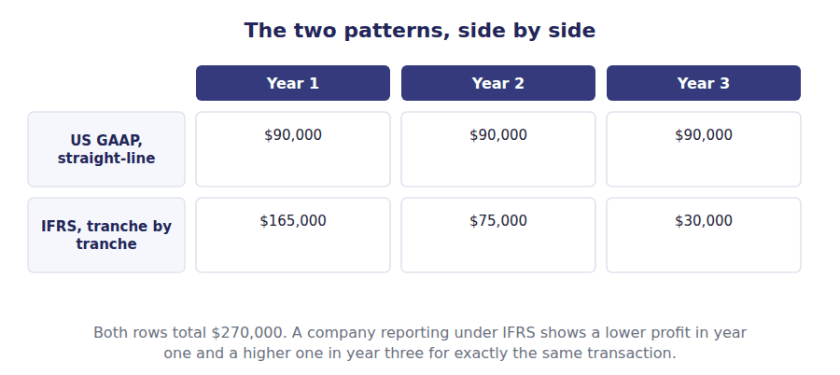
Part 3 · Two smaller differences forfeitures and deferred tax
Exercise 1C Sort each statement into the framework it describes.
OBJECTIVE | Say how each framework treats forfeiture estimates and the related deferred tax.
YOU WILL NEED | Exercise 1B, and Volume 7 Handout 4 on deferred tax assets.
HOW TO START | • One framework allows a company to wait and see how many options are forfeited; the other requires an estimate from the start.  • For deferred tax, one framework measures the asset on the compensation cost recognised and the other on the award’s intrinsic value at each reporting date.  • Two of the six statements are true of both frameworks.

Statement | US GAAP | IFRS | BOTH
1. Forfeitures may be accounted for as they occur, by policy choice
2. Forfeitures must be estimated at the grant date
3. The award is measured at its grant-date fair value
4. The deferred tax asset is measured on the compensation cost recognised
5. The deferred tax asset is remeasured on the award’s intrinsic value each period
6. The cost is recognised over the period the employee earns the award

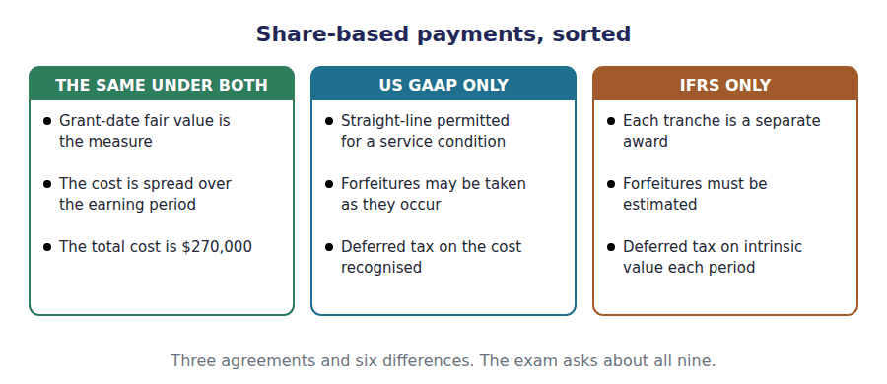
Part 4 · The pension cost where the frameworks part most sharply
R2 Northwind also operates a defined benefit plan, and it is there that the two frameworks part most sharply.
R2 Northwind’s plan has an obligation of $2,400,000 and assets of $2,000,000, so it is underfunded by $400,000. Service cost for the year is $180,000, the discount rate is 6%, and management expects 8% on the plan’s assets.
Exercise 1D Complete the grid. A dash means the framework has no such line.
OBJECTIVE | Compute the net defined benefit cost under both frameworks.
YOU WILL NEED | The paragraph above, and Volume 7 Handout 1 on how a liability unwinds.
HOW TO START | • US GAAP uses two gross figures: $144,000 on the obligation at 6%, and $160,000 expected on the assets at 8%.  • IFRS uses one net figure: the $400,000 net liability at the 6% discount rate.  • The past service cost of $60,000 is amortised over 10 years under one framework and charged in full under the other.

Net defined benefit cost for 20X4 | US GAAP | IFRS
Service cost for the year | $180,000 | $180,000
Interest on the obligation at 6%
Expected return on plan assets at 8%
Net interest on the net liability at 6%
Past service cost of $60,000
Charged to profit

1 | 2 | 3 | 4 | 5 | 6
7 | 8 | 9

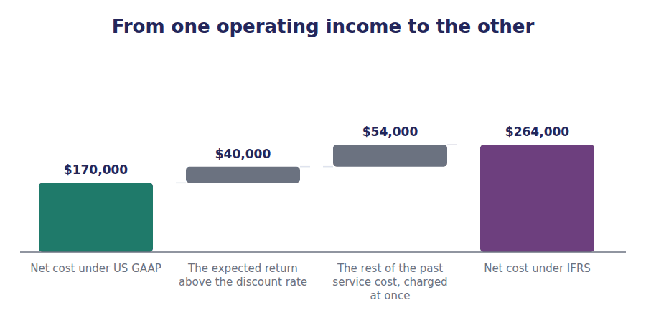
Part 5 · Where the rest of it goes remeasurements and the plan amendment
Exercise 1E Read and complete. Write one word in each space.
OBJECTIVE | Say where a remeasurement and a past service cost go under each framework.
YOU WILL NEED | Exercise 1D, and Volume 9 Handout 2 on reclassification.
HOW TO START | • An actuarial loss of $50,000 arose during the year. Ask which framework lets it reach profit eventually.  • Under one framework the amount sits in other comprehensive income and is amortised into profit; under the other it never leaves.  • The last blank is why the two net costs differ by $40,000, and it is a management estimate one framework no longer trusts.

WORD BANK
always · amortised · deferred · immediately · liability · never · return
Not every word is used.

R2 The actuarial loss of $50,000 is recognised in other comprehensive income under both frameworks. What happens next is the difference: under US GAAP it is ⁵ into profit over the remaining service period.
Under IFRS it stays where it is. A remeasurement is recognised in other comprehensive income and is ⁶ reclassified into profit, which is the exception Volume 9 named.
The $60,000 plan amendment divides them too. US GAAP amortises it, giving $6,000 a year for 10 years; IFRS charges the whole $60,000 to profit ⁷ .
And the $94,000 net cost difference is almost all the expected return. IFRS replaced a management estimate of 8% with the 6% discount rate on one net balance, so no ⁸ is estimated at all.
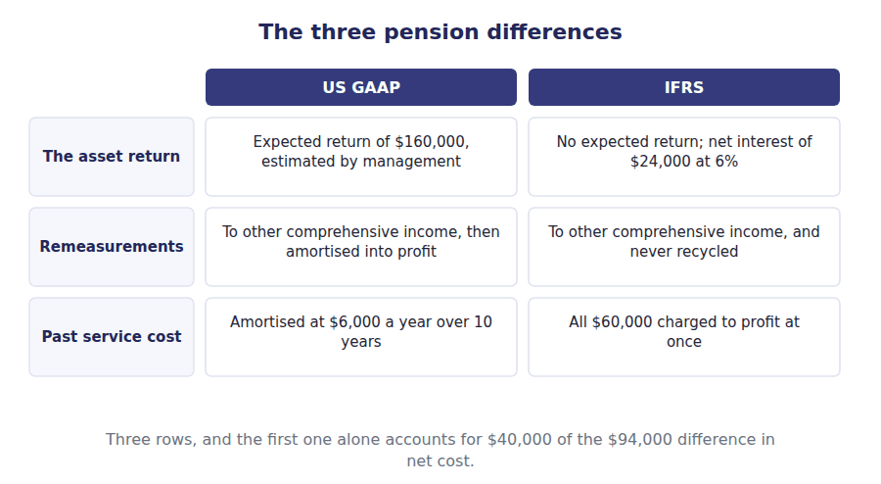
Watch out! IFRS removed the expected return because it was a management estimate that reduced a reported expense. A company expecting 8% rather than 6% on $2,000,000 of plan assets lowered its pension cost by $40,000 without anything happening, and that is the abuse the single net interest figure closes.
Part 6 · Exam pitch the questions as the CMA sets them
1. [Level A] An award of share options vesting in three equal annual instalments, with a service condition only, is expensed under IFRS:
(A) Straight-line over three years
(B) With each instalment treated as a separate award over its own vesting period
(C) In full at the grant date
(D) In full when the last instalment vests
2. [Level B] An award worth $270,000 vests in three equal annual instalments. The first-year charge under IFRS is:
(A) $90,000
(B) $165,000
(C) $270,000
(D) $30,000
3. [Level B] Over the full vesting period, total compensation cost under the two frameworks is:
(A) Higher under IFRS
(B) The same
(C) Higher under US GAAP
(D) Not comparable
4. [Level B] In computing net defined benefit cost, IFRS uses:
(A) Interest cost and an expected return on plan assets, separately
(B) Net interest on the net defined benefit liability at the discount rate
(C) The actual return on plan assets
(D) No interest element at all
5. [Level C] A plan has an obligation of $2,400,000 and assets of $2,000,000. The discount rate is 6% and management expects 8% on the assets. The difference between the two frameworks’ interest elements is:
(A) $24,000
(B) $40,000
(C) $144,000
(D) Nil
6. [Level C] An actuarial loss on a defined benefit obligation is recognised in other comprehensive income under IFRS and:
(A) Reclassified into profit over the remaining service period
(B) Never reclassified into profit
(C) Reclassified into profit when the plan is settled
(D) Charged directly to retained earnings
7. [Level B] A company amends its pension plan, increasing the obligation by $60,000 for employees’ past service. Under IFRS the amount charged to profit in the year of the amendment is:
(A) $6,000
(B) $60,000
(C) Nil
(D) $30,000
ADAPTIVE TIP Every difference in this volume has the same shape: the total is usually identical and the timing or the location differs. Before you compute anything, decide whether the question is about how much or about when, because half the distractors are the right answer to the other question.

Handout 2 · Intangibles: Development Costs and Revaluation
Northwind spends $400,000 developing a sensor. One framework charges all of it to profit and the other carries $240,000 as an asset.
Volume 12 · US GAAP and IFRS · R2
LANGUAGE FOCUS
Register you are working in | R2 throughout, with the six criteria drilled as a classification because the exam quotes them.
Say it exactly like this | establish technical feasibility · capitalise development expenditure · charge research to profit · carry an asset at fair value · credit a revaluation surplus · reverse a revaluation on disposal
Words that are not the same | research / development · cost model / revaluation model · expensed / capitalised · revaluation surplus / impairment loss
Remember | IFRS does not capitalise research. Only the development phase, and only once all six criteria are met. The revaluation model is not available for intangibles without an active market, which is most of them.

What you will be able to do when this handout is finished
- Say how each framework treats research and development spending.
- State the six criteria IFRS requires before development costs are capitalised.
- Compute the charge to profit under both frameworks.
- Say which measurement models each framework permits.
- Say where a revaluation increase and a decrease are recognised.

A sensor that took two years
Northwind spent $400,000 during 20X4 on a new sensor. The first $160,000 went on investigating whether the idea would work at all.
By mid-year it did work. The remaining $240,000 went on turning a working principle into a product the plant could make.
Under US GAAP the whole $400,000 is charged to profit. Under IFRS the second $240,000 is an intangible asset.
And once it is an asset, a second difference opens up: one framework will let Northwind revalue it and the other will not.

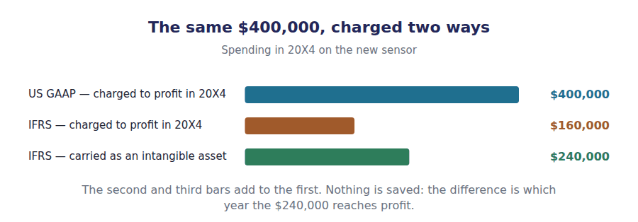
Part 1 · Research and development one phase agreed, one disputed
Exercise 2A Read and complete. Write one word in each space.
OBJECTIVE | Say how each framework treats research and development spending.
YOU WILL NEED | Volume 5 Handout 5, on recognising an intangible asset. · Volume 9 Handout 1, on immediate recognition.
HOW TO START | • Both frameworks agree completely about the first $160,000. Ask what is missing at that stage.  • Once the sensor works, the question becomes whether a future benefit can be identified. One framework says it can.  • The last blank is why US GAAP refuses to capitalise anyway, and it is a choice about comparability rather than about the facts.

WORD BANK
capitalised · higher · identified · measured · reliable · same · uncertain
Not every word is used.

R2 Both frameworks charge research to profit. At that stage nobody can say whether there will ever be a product, so no future benefit can be ¹ and Volume 9’s third basis applies: recognise it immediately.
Development is different. By then the sensor works, Northwind means to make it and the money spent can be measured, so a future benefit can be identified and IFRS requires the $240,000 to be ² .
US GAAP charges development to profit as well, with very few exceptions. The reason is not that the benefit is absent but that the judgement about when it arrives is too ³ to be comparable between companies.
So the whole $400,000 is expensed under US GAAP and only $160,000 under IFRS. Over the asset’s life the total charged is the ⁴ , because the capitalised amount is amortised.
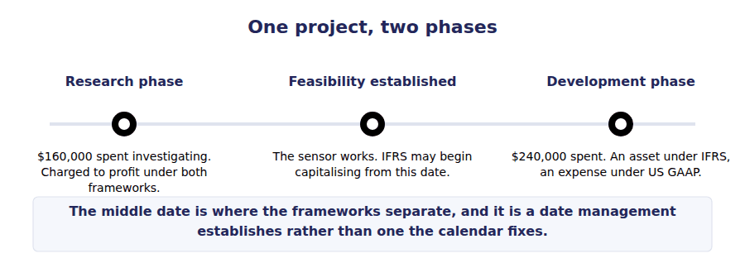
Part 2 · The six criteria all of them, not most of them
Exercise 2B Complete the right-hand column. Write Yes or No in each cell.
OBJECTIVE | State the six criteria IFRS requires before development costs may be capitalised.
YOU WILL NEED | Exercise 2A.
HOW TO START | • All six must be met. One failure means the spending is charged to profit however promising the project is.  • Two of the six are about the company rather than the asset: what it intends and what resources it has.  • Northwind meets all six for the sensor, which is why $240,000 is capitalised under IFRS.

The six development criteria | Met for the sensor?
Technical feasibility of completing the asset
Intention to complete it and use or sell it
Ability to use or sell it
It will generate probable future economic benefits
Adequate technical, financial and other resources to complete it
Ability to measure the expenditure reliably

1 | 2 | 3 | 4 | 5 | 6

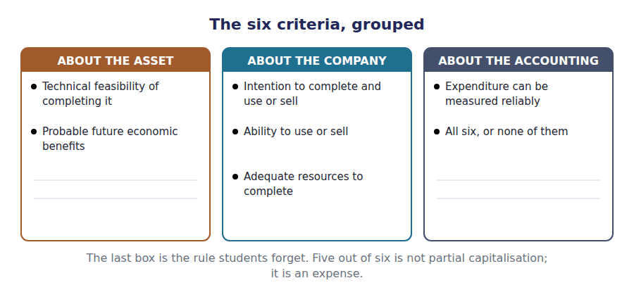
Part 3 · The charge to profit the two columns, computed
Exercise 2C Complete the grid. The two phases are given.
OBJECTIVE | Compute the charge to profit and the asset recognised under both frameworks.
YOU WILL NEED | Exercises 2A and 2B.
HOW TO START | • The research row is the same under both. Only the development row moves.  • Under US GAAP add the two phases together; under IFRS add only the research.  • The last row is nil under one framework and $240,000 under the other, and the two columns of each row must still account for the whole $400,000.

The $400,000 spent on the new sensor | US GAAP | IFRS
Research phase, before feasibility was established | $160,000 | $160,000
Development phase, after the six criteria were met
Charged to profit in 20X4
Recognised as an intangible asset

1 | 2 | 3 | 4 | 5 | 6

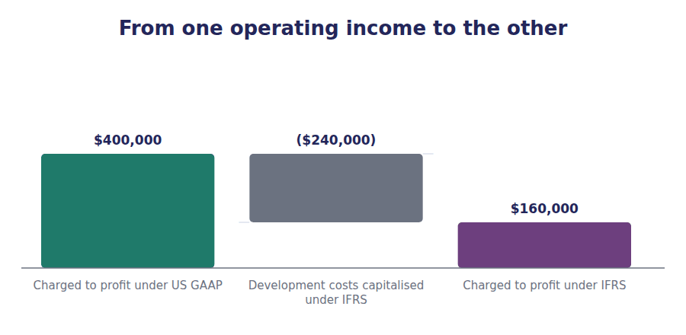
Part 4 · Measuring it afterwards cost, or fair value
R2 Once an intangible is on the balance sheet, a second difference opens. US GAAP permits one measurement model and IFRS permits two, though the second is available only where an active market lets fair value be determined, which for most intangibles it does not.
Exercise 2D Complete the grid where it is blank.
OBJECTIVE | Say which measurement models each framework permits and how each one treats a change in value.
YOU WILL NEED | Exercise 2C, and Volume 5 Handout 4 on impairment.
HOW TO START | • One of the two models is permitted under both frameworks, and it is the one Volume 5 used throughout.  • The increase row is the interesting one: under the cost model an increase is not recognised at all.  • The decrease row is where the models converge, and the condition in that cell matters.

 | Cost model | Revaluation model
Carried at | Cost less amortisation
Permitted under US GAAP | Yes
Permitted under IFRS | Yes
An increase goes to | Nowhere, it is not recognised
A decrease goes to | Profit, as an impairment

1 | 2 | 3 | 4 | 5 | 6
7

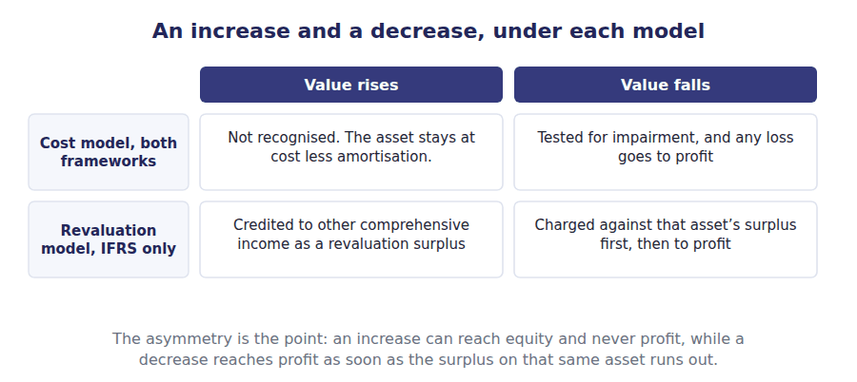
Part 5 · Why the choice is narrower than it looks the active market condition
Exercise 2E Read and complete. Write one word in each space.
OBJECTIVE | Say when the revaluation model is actually available for an intangible.
YOU WILL NEED | Exercise 2D.
HOW TO START | • Fair value has to come from somewhere. Ask what Northwind would look at to value its own sensor design.  • An asset unique to one company has no market price, because nothing comparable is traded.  • The last blank is where the surplus goes when a revalued asset is finally sold, and it does not pass through profit.

WORD BANK
active · earnings · liquid · mandatory · prefer · surplus · unavailable
Not every word is used.

R2 The revaluation model needs a fair value, and for an intangible that means an ⁵ market in which comparable assets are regularly traded.
Most intangibles have no such market. Northwind’s sensor design is specific to its own products, so nothing comparable is traded and no fair value can be determined. The model is therefore ⁶ to it, even under IFRS.
Where it is available, as for some licences and quotas, the whole class of assets must be revalued rather than the one asset the company would ⁷ to revalue.
And when a revalued asset is sold, the surplus sitting in equity is transferred within equity, usually to retained ⁸ . It never passes through profit, which is what Volume 9 meant by the exception to recycling.
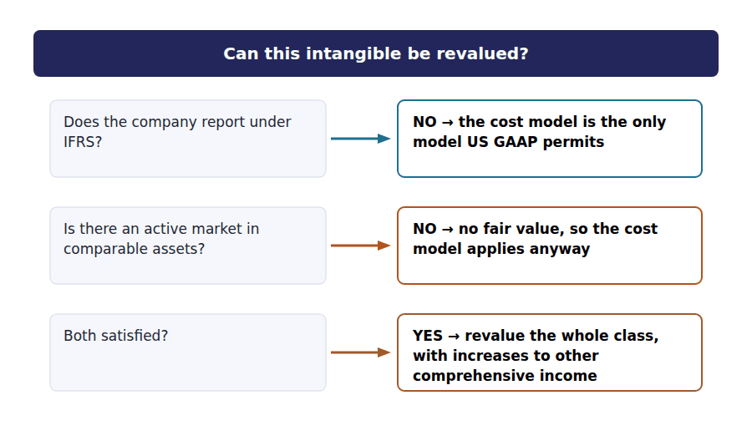
Watch out! IFRS capitalisation of development costs is mandatory once all six criteria are met, not an election. A question that offers a company the choice of capitalising or expensing under IFRS is offering a distractor, and the same question under US GAAP has no choice either.
Part 6 · Exam pitch the questions as the CMA sets them
1. [Level A] Research costs are:
(A) Capitalised under IFRS and expensed under US GAAP
(B) Expensed under both frameworks
(C) Capitalised under both frameworks
(D) Capitalised under US GAAP and expensed under IFRS
2. [Level B] A company spends $400,000 on a project, of which $240,000 relates to the development phase after all six IFRS criteria were met. Under IFRS the charge to profit is:
(A) $400,000
(B) $160,000
(C) Nil
(D) $240,000
3. [Level B] Under IFRS, capitalisation of development costs once all six criteria are met is:
(A) Permitted but not required
(B) Required
(C) Permitted only for listed companies
(D) Prohibited
4. [Level B] Which measurement models may be used for an intangible asset?
(A) The cost model under US GAAP; the cost or revaluation model under IFRS
(B) The revaluation model under both
(C) The cost model under both
(D) The revaluation model under US GAAP only
5. [Level B] An intangible carried under the IFRS revaluation model increases in value. The increase is recognised:
(A) In profit
(B) In other comprehensive income, as a revaluation surplus
(C) Directly in retained earnings
(D) Not at all
6. [Level C] A revalued intangible falls in value by more than the revaluation surplus previously recognised on it. The excess is:
(A) Charged against the surplus on other assets
(B) Charged to profit
(C) Not recognised
(D) Charged to retained earnings
7. [Level C] Northwind’s sensor design is specific to its own products. Under IFRS it:
(A) May be revalued, because IFRS permits the revaluation model
(B) Must be carried at cost, because there is no active market in comparable assets
(C) Must be revalued annually
(D) May be revalued only if the surplus is credited to profit
ADAPTIVE TIP On this learning outcome, two sentences cover most of the marks: research is expensed under both, and development is capitalised under IFRS when six criteria are met and expensed under US GAAP. Add that only IFRS permits revaluation, and only where an active market exists.

Handout 3 · Inventories: Costing, Valuation and Write-Downs
Three differences, and one of them explains why a company that switches frameworks may have to abandon its costing method altogether.
Volume 12 · US GAAP and IFRS · R2 moving to R3
LANGUAGE FOCUS
Register you are working in | R2 for the three differences, R3 for the comparison, which the exam sets as a find-the-difference question.
Say it exactly like this | value inventory at the lower of two figures · write inventory down to net realisable value · reverse a previous write-down · apply a costing method consistently · abandon the last-in first-out method · recapture a reserve on conversion
Words that are not the same | LIFO / FIFO · market / net realisable value · write-down / reversal · ceiling / floor
Remember | Net realisable value is not the selling price. It is the selling price less the costs of completing and selling. An IFRS reversal is not a revaluation. Inventory can be written back up only to what it originally cost.

What you will be able to do when this handout is finished
- Say which costing methods each framework permits.
- State the valuation rule each framework applies.
- Compute a carrying amount under both rules.
- Say whether a write-down may be reversed under each framework.
- Say what a company switching frameworks has to do about LIFO.

The same four items, valued twice
Volume 4 Handout 7 valued four of Northwind’s inventory items under the US GAAP market rule. All four cost $100.
Three differences separate the two frameworks here: which costing methods are allowed, which valuation rule applies, and whether a write-down can ever be undone.
The first of the three is the most consequential. A company reporting under IFRS may not use last-in, first-out at all, which for a US company changing frameworks is not a disclosure matter but a tax bill.
This handout works all three against the same four items.

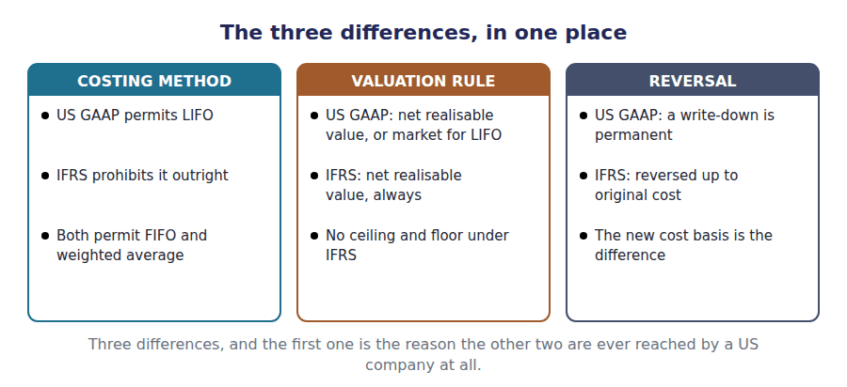
Part 1 · Which costing methods are allowed and what the prohibition costs
Exercise 3A Complete the right-hand column.
OBJECTIVE | Say which costing methods each framework permits.
YOU WILL NEED | Volume 4 Handout 4, on the cost flow assumptions.
HOW TO START | • Four of the five rows are identical under both frameworks.  • The row that differs is the one that assumes the newest goods are sold first.  • The last row is about using different methods for different kinds of inventory, and both frameworks allow it where the kinds really differ.

Costing method | US GAAP | IFRS
Specific identification | Permitted
First-in, first-out | Permitted
Weighted average cost | Permitted
Last-in, first-out | Permitted
A different method for different classes of inventory | Permitted

1 | 2 | 3 | 4 | 5

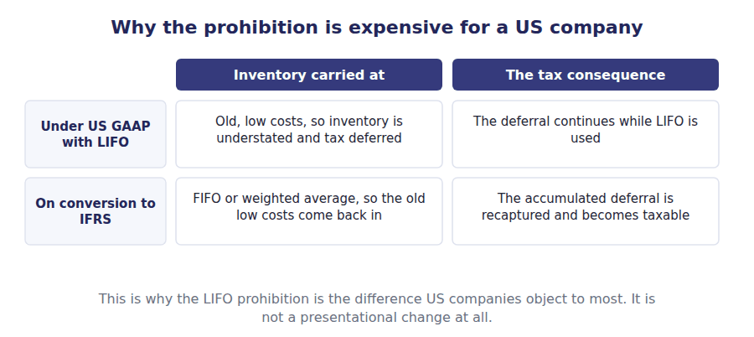
Part 2 · Which valuation rule applies net realisable value, or market
R2 IFRS values all inventory at the lower of cost and net realisable value. US GAAP does the same, except for inventory costed on LIFO or the retail method, where the lower of cost and market applies and market is replacement cost bounded by a ceiling and a floor.
Exercise 3B Read and complete. Write one word in each space.
OBJECTIVE | Say what each rule compares cost with, and why the bounds exist.
YOU WILL NEED | Volume 4 Handout 7, which worked the market rule. · The paragraph above.
HOW TO START | • The ceiling is the most a company could get for the item after selling costs, and it has a name of its own.  • The floor is that ceiling less the normal profit margin, which is the margin the company ordinarily earns on the item.  • The floor is the ceiling less the margin the company normally earns. Ask what would happen on the later sale without it.  • The last blank is what IFRS does with the two bounds, and the answer is that it has neither.

WORD BANK
both · historical · margin · neither · realisable · replacement · selling
Not every word is used.

R2 Both frameworks compare cost with a lower figure, and they differ in what that figure is. Under IFRS it is always net ¹ value: the selling price less the costs of completing and selling the item.
Under US GAAP the same rule applies, unless the inventory is costed on LIFO or the retail method. There the comparison is with market, which starts at ² cost and is then bounded.
The ceiling is net realisable value, because no company would carry an item above what it can get for it. The floor is that ceiling less the normal profit ³ , so that writing an item down does not manufacture a profit on the eventual sale.
IFRS has ⁴ bound, because it never uses replacement cost. One comparison, one figure, and a good deal less arithmetic.
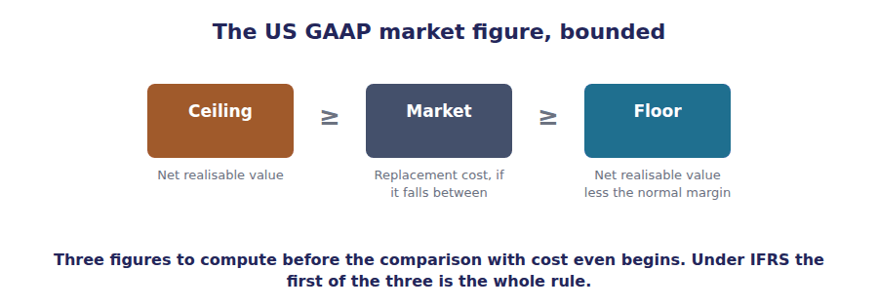
Part 3 · The four items, both ways where the rules disagree
Exercise 3C Complete both right-hand columns.
OBJECTIVE | Value each of four items under both rules.
YOU WILL NEED | Exercise 3B, and Volume 4 Handout 7 for the market computations.
HOW TO START | • The market column is the work you did in Volume 4: the bounded replacement cost, compared with the $100 cost.  • The net realisable value column is simpler. Compare cost with the ceiling alone and take the lower.  • Two of the four items come out the same under both rules, and two do not. Notice which two.

Item | Cost | Under LIFO, the market rule | Under FIFO, net realisable value
A · standard housing | $100
B · obsolete sensor | $100
C · damaged batch | $100
D · scarce controller | $100

1 | 2 | 3 | 4 | 5 | 6
7 | 8

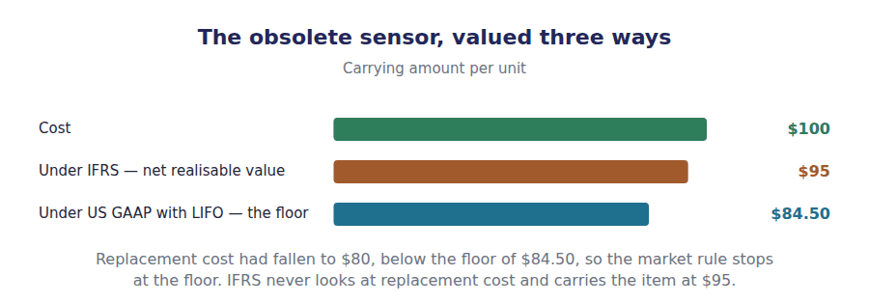
Part 4 · Undoing a write-down the third difference
Exercise 3D Read and complete. Write one word in each space.
OBJECTIVE | Say whether a write-down may be reversed under each framework.
YOU WILL NEED | Exercise 3C.
HOW TO START | • Suppose the obsolete sensor finds a buyer next year and its value recovers.  • Under one framework the written-down figure has become the item’s cost for all later purposes. Ask what that means for a recovery.  • The last blank is the limit on an IFRS reversal, and it is not fair value.

WORD BANK
basis · cost · disclosed · figure · higher · lower · reversed
Not every word is used.

R2 Suppose the sensor written down to $95 recovers its value next year. Under US GAAP nothing happens: the write-down established a new cost ⁵ , and the item can never be carried above it.
Under IFRS the write-down is ⁶ . The reason for it no longer applies, so the carrying amount is restored and the credit goes against cost of goods sold in the year of recovery.
The reversal is capped. Inventory may be written back up only as far as its original ⁷ of $100, never above it, because the IFRS rule remains the lower of cost and net realisable value.
So two companies holding identical goods can carry them at different amounts for years, and the one reporting under US GAAP will be the ⁸ of the two.
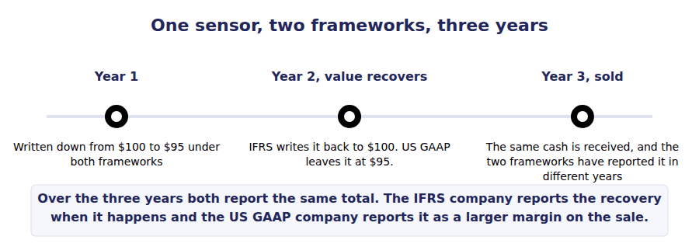
Part 5 · All three at once the comparison the exam asks for
Exercise 3E Complete both columns.
OBJECTIVE | Summarise all three inventory differences.
YOU WILL NEED | Exercises 3A, 3B and 3D.
HOW TO START | • The first row is a single word in each column.  • The second row has one framework with a condition attached and one without.  • The third row needs a qualification in one column, because the reversal is capped.

The three differences | US GAAP | IFRS
Is LIFO available?
The valuation rule
May a write-down be reversed?

1 | 2 | 3 | 4 | 5 | 6

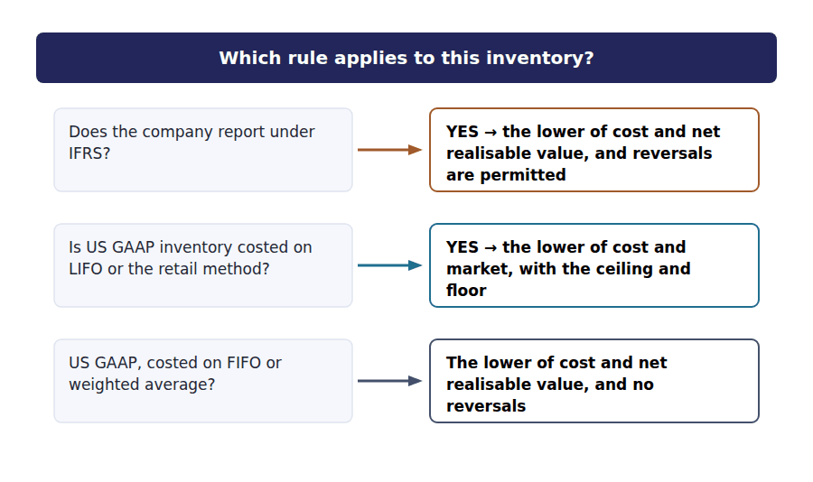
Watch out! The US GAAP market rule survives only for LIFO and retail inventories. A question that applies the ceiling and floor to a FIFO inventory under US GAAP has been set from an old textbook, and the answer it wants is the net realisable value one.
Part 6 · Exam pitch the questions as the CMA sets them
1. [Level A] Which inventory costing method is prohibited under IFRS?
(A) First-in, first-out
(B) Last-in, first-out
(C) Weighted average cost
(D) Specific identification
2. [Level A] Under IFRS, inventory is carried at:
(A) Cost
(B) The lower of cost and net realisable value
(C) The lower of cost and market
(D) Net realisable value
3. [Level B] An item costs $100, has a net realisable value of $95 and a replacement cost of $90. Under IFRS it is carried at:
(A) $90
(B) $95
(C) $100
(D) $84.50
4. [Level B] The same item under US GAAP, with the inventory costed on LIFO, is carried at:
(A) $95
(B) $90
(C) $100
(D) $84.50
5. [Level B] Inventory written down in one year recovers its value in the next. Under US GAAP the recovery is:
(A) Recognised, up to original cost
(B) Not recognised, because the write-down created a new cost basis
(C) Recognised in other comprehensive income
(D) Recognised only on sale of the inventory
6. [Level C] Under IFRS, a reversal of an inventory write-down is limited to:
(A) Fair value
(B) The inventory’s original cost
(C) Net realisable value at the reversal date
(D) The amount of the original write-down plus inflation
7. [Level C] A US company using LIFO converts to IFRS. The principal consequence is:
(A) A disclosure change only
(B) It must abandon LIFO, and the accumulated tax deferral is recaptured
(C) It may keep LIFO for tax and IFRS for reporting, with no effect
(D) Its inventory is revalued to fair value
ADAPTIVE TIP Learn the three in order: LIFO is out under IFRS, the rule is net realisable value under IFRS, and IFRS reverses write-downs up to cost. Then remember that US GAAP now uses net realisable value too, except for LIFO and retail, where the old ceiling and floor survive.

Handout 4 · Leases: the Lessee’s Two Models
Northwind’s warehouse floor is an operating lease under US GAAP and a finance lease in all but name under IFRS. The cash is identical and almost nothing else is.
Volume 12 · US GAAP and IFRS · R2 moving to R3
LANGUAGE FOCUS
Register you are working in | R2 for the mechanics, R3 for the comparison, which the exam asks as an effect-on-the-statements question.
Say it exactly like this | classify a lease as operating · apply a single lessee model · report a single lease cost · split a payment between interest and principal · elect the short-term exemption · elect the low-value exemption
Words that are not the same | dual model / single model · operating lease / finance lease · one lease cost / two charges · operating outflow / financing outflow
Remember | IFRS has not abolished the operating lease. It has abolished the lessee’s operating lease accounting, which is a different thing. The single model does not change the cash. The same $40,000 leaves the company in the same year under both frameworks.

What you will be able to do when this handout is finished
- State the one named lease difference between the frameworks.
- Report a lease under the US GAAP operating model.
- Report the same lease under the IFRS single model.
- Compare the income statement and cash flow effects.
- Say which recognition exemptions each framework offers.

The floor, reported twice
Volume 7 classified Northwind’s warehouse floor as an operating lease: 3 years at $40,000 a year, against a building with 40 years of life left.
Under US GAAP that classification matters. The lease produces one cost of $40,000 a year and nothing else.
Under IFRS the classification does not exist for a lessee. Every recognised lease is accounted for the way Volume 7 Handout 6 accounted for the machine: an asset amortised and a liability carrying interest.
So the same lease costs $40,000 in its first year under one framework and $42,608 under the other.

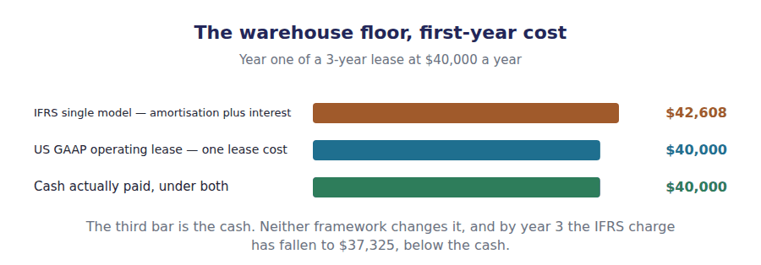
Part 1 · One model or two the difference stated
Exercise 4A Read and complete. Write one word in each space.
OBJECTIVE | State the lease difference between the two frameworks.
YOU WILL NEED | Volume 7 Handout 5, on the classification tests. · Volume 7 Handout 6, on the finance lease pattern.
HOW TO START | • Under US GAAP a lessee has to classify a lease before it can account for it. Ask whether an IFRS lessee has the same decision to make.  • If there is only one accounting treatment, the five tests of Volume 7 have nothing left to decide.  • The last blank is which of the two US GAAP treatments the single model resembles.

WORD BANK
dual · flat · front-loaded · interest · irrelevant · required · single
Not every word is used.

R2 US GAAP applies a ¹ model. A lessee classifies a lease as finance or operating using the five tests of Volume 7, and the two classes are then accounted for differently.
IFRS applies one treatment to every recognised lease, so a lessee has no classification decision to make at all. The five tests are ² to it.
The single treatment is the finance lease treatment. A right-of-use asset is amortised on a straight-line basis and the liability carries ³ on the effective interest method.
So every IFRS lease is ⁴ , including the ones US GAAP would have called operating, and only the lessor still classifies leases under IFRS.
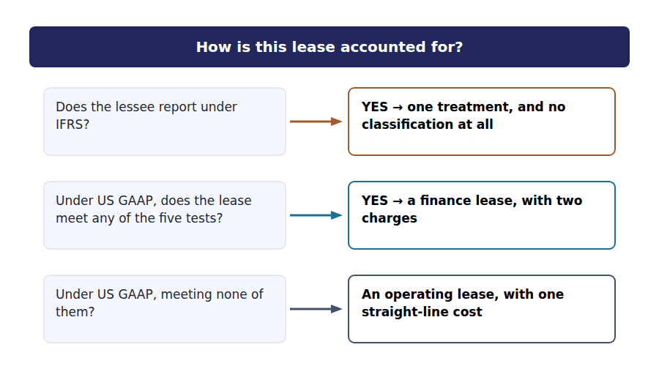
Part 2 · The floor under IFRS the same lease, the other model
Exercise 4B Complete the schedule. The right-of-use asset is given.
OBJECTIVE | Report the warehouse floor lease under the IFRS single model.
YOU WILL NEED | Exercise 4A, and Volume 7 Handout 6 Exercise 6A.
HOW TO START | • Amortise the $103,084 right-of-use asset straight-line over the 3-year term.  • Interest is 8% of the opening liability, which is the same $103,084 the asset was recognised at.  • Add the two. The last row is the US GAAP figure, given so you can see the gap.

Year 1 of the warehouse floor lease under IFRS | Amount
Right-of-use asset recognised | $103,084
Amortisation, $103,084 over 3 years
Interest on the liability at 8%
Total charged to profit
Compared with the single lease cost under US GAAP | $40,000

1 | 2 | 3

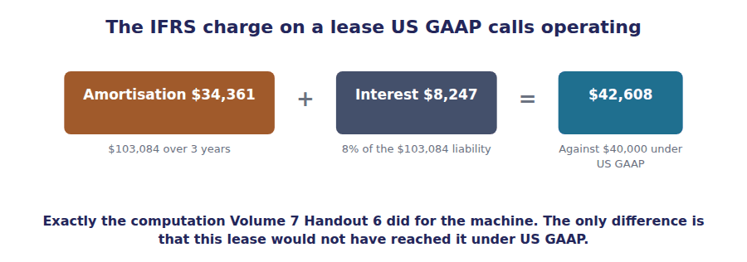
Part 3 · The two patterns three years, both frameworks
Exercise 4C Complete the right-hand column, then check both totals.
OBJECTIVE | Compare the annual charge under the two frameworks.
YOU WILL NEED | Exercise 4B.
HOW TO START | • The US GAAP column is $40,000 in each year, because an operating lease cost is the total payments spread evenly.  • Each IFRS figure is that year’s interest plus $34,361 of amortisation, with $34,362 in the final year.  • Both columns must total $120,000, which is 3 payments of $40,000.

Year | US GAAP, operating lease | IFRS, single model
1 | $40,000
2 | $40,000
3 | $40,000
Total | $120,000

1 | 2 | 3 | 4

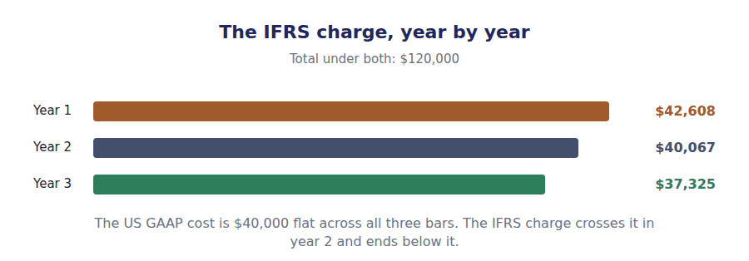
Part 4 · Where each charge lands the statements, line by line
R3 The difference is not only the amount. Under US GAAP the whole lease cost sits in operating expenses and the whole payment in operating cash flow. Under IFRS the interest moves to finance costs and the principal to financing cash flow, which flatters every operating measure.
Exercise 4D Complete the right-hand column.
OBJECTIVE | Say where each charge and each cash flow appears under the two frameworks.
YOU WILL NEED | Exercise 4C, and Volume 7 Handout 6 Exercise 6E.
HOW TO START | • Under US GAAP all five rows have one answer each, and they are given.  • Under IFRS the income statement rows split the $42,608 between two lines.  • The cash flow rows split the $40,000 payment the same way: interest in operating, the rest in financing.

 | US GAAP operating lease | IFRS single model
Income statement | One lease cost, $40,000
Operating expenses | All of the $40,000
Finance costs | Nothing
Operating cash flow | All of the $40,000 paid
Financing cash flow | Nothing

1 | 2 | 3 | 4 | 5

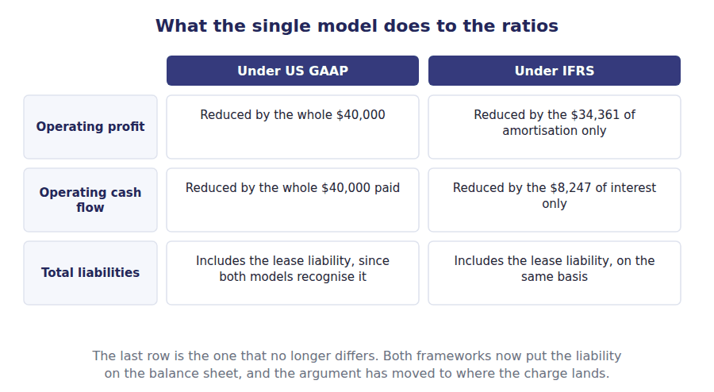
Part 5 · Why the boards could not agree the one question they split on
Exercise 4E Read and complete. Write one word in each space.
OBJECTIVE | Say what the two boards agreed on and what they did not.
YOU WILL NEED | Exercises 4A and 4D.
HOW TO START | • Both boards wanted the liability on the balance sheet, and both got it. Ask what was left to argue about.  • One board held that a lease of a floor for three years is not like buying a building. The other held that the two are the same transaction in different words.  • The last blank is the lessee model IFRS adopted, and the exam uses its proper name.

WORD BANK
differently · first · identically · other · present · single · total
Not every word is used.

R2 The two boards agreed on the balance sheet. Both now require a right-of-use asset and a lease liability at the ⁵ value of the payments, which ended the off-balance-sheet lease.
They split on the income statement. The US board held that renting a floor for 3 years is not economically the same as buying a building, so the two cases should be reported ⁶ and the dual model survived.
The international board held that every lease gives the lessee an asset it has financed, and that classifying leases had produced the abuse the reform was meant to end. It adopted a ⁷ lessee model with no classification at all.
Neither position is unreasonable, and the exam tests the consequence rather than the argument: the same lease produces a flat $40,000 under one framework and a falling charge under the ⁸ .
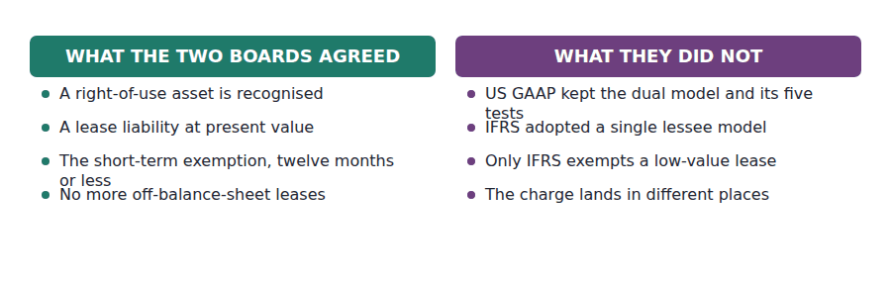
Part 6 · What need not be recognised two exemptions, one shared
Exercise 4F Sort each statement into the framework it describes.
OBJECTIVE | Say which recognition exemptions each framework offers.
YOU WILL NEED | Volume 7 Handout 5 Exercise 5D, on the short-term election.
HOW TO START | • One exemption is available under both frameworks, and it is about the length of the term.  • A low-value lease is the other one, and only one framework has it.  • The other is about the value of the underlying asset and exists under one framework only.  • Two of the six statements are true of both.

Statement | US GAAP | IFRS | BOTH
1. A lease of twelve months or less need not be recognised
2. A lease of a low-value underlying asset need not be recognised
3. A lessee classifies leases as finance or operating
4. Every recognised lease produces amortisation and interest
5. The election is made by class of underlying asset
6. A short lease containing a purchase option cannot use the exemption

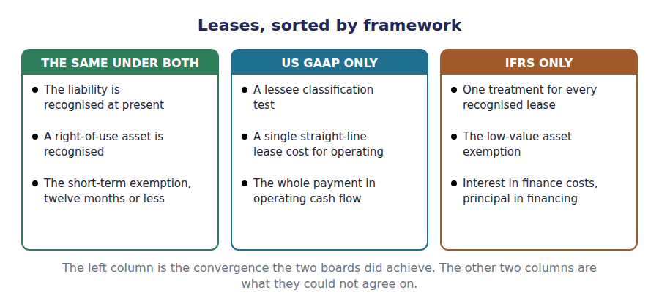
Watch out! The liability is on the balance sheet under both frameworks, so a question about whether an operating lease is off balance sheet has the same answer either way: it is not. The live difference is where the charge lands, not whether the lease is recognised.
Part 7 · Exam pitch the questions as the CMA sets them
1. [Level A] Under IFRS, a lessee classifies a lease as finance or operating:
(A) Using the same five tests as US GAAP
(B) Not at all, because a single model applies to every recognised lease
(C) Only if the term exceeds twelve months
(D) Only for leases of real property
2. [Level A] A lease that US GAAP would classify as operating is reported under IFRS as:
(A) One straight-line lease cost
(B) Amortisation of the right-of-use asset plus interest on the liability
(C) Rent expense equal to the cash paid
(D) Nothing, because the exemption applies
3. [Level B] A 3-year lease with payments of $40,000 a year has a right-of-use asset of $103,084 and an implicit rate of 8%. The first-year charge under IFRS is:
(A) $40,000
(B) $42,608
(C) $34,361
(D) $8,247
4. [Level B] Over the whole lease term, total expense under the two frameworks is:
(A) Higher under IFRS
(B) The same
(C) Higher under US GAAP
(D) Not comparable
5. [Level C] Compared with US GAAP, a company reporting a formerly operating lease under IFRS shows:
(A) Lower operating profit and lower operating cash flow
(B) Higher operating profit and higher operating cash flow
(C) Lower operating profit and higher operating cash flow
(D) No difference in either
6. [Level B] The exemption for leases of low-value underlying assets is available under:
(A) Both frameworks
(B) IFRS only
(C) US GAAP only
(D) Neither
7. [Level C] Under both frameworks, a recognised lease liability is:
(A) Measured at the total of the payments
(B) Measured at the present value of the payments
(C) Disclosed in the notes only
(D) Measured at the fair value of the underlying asset
ADAPTIVE TIP For any lease question that names a framework, ask only one thing: is there a classification to make? Under IFRS there is not, so compute amortisation plus interest and stop. Under US GAAP run the five tests first, because they decide which of two computations you need.

Handout 5 · Long-Lived Assets and Impairment: Revaluation and Reversal
Volume 5 found no impairment on production line B. Under IFRS the same line carries a loss of $60,000, and the reason is one discount rate.
Volume 12 · US GAAP and IFRS · R2 moving to R3
LANGUAGE FOCUS
Register you are working in | R2 for the two models, R3 for the comparison, which the exam sets as a compute-both-ways question.
Say it exactly like this | test an asset for recoverability · discount the future cash flows · compare carrying amount with recoverable amount · recognise an impairment loss · reverse an impairment loss · revalue a class of assets
Words that are not the same | two-step test / one-step test · undiscounted / discounted · fair value / value in use · reversible / permanent
Remember | The IFRS test is not harsher because its standards are stricter. It is harsher because it never compares a carrying amount with an undiscounted figure. An IFRS reversal is not a revaluation. It restores a carrying amount the asset would have had anyway, and no further.

What you will be able to do when this handout is finished
- Say which measurement models each framework permits for property, plant and equipment.
- Describe the two-step US GAAP impairment test.
- Describe the one-step IFRS test and define recoverable amount.
- Compute the loss on the same asset under both frameworks.
- Say whether an impairment loss may be reversed under each.

The line that was not impaired
Volume 5 Handout 4 tested two production lines, each carried at $800,000. Line A failed and line B passed.
Line B passed because its undiscounted future cash flows of $850,000 exceeded the $800,000 it was carried at, so no loss was measured and the $700,000 fair value never came into it.
Discount those same cash flows and they are worth $740,000. Under IFRS that figure is compared with the carrying amount directly, and the line is impaired by $60,000.
Two frameworks, one asset, one set of cash flows, and a $60,000 difference in reported profit.

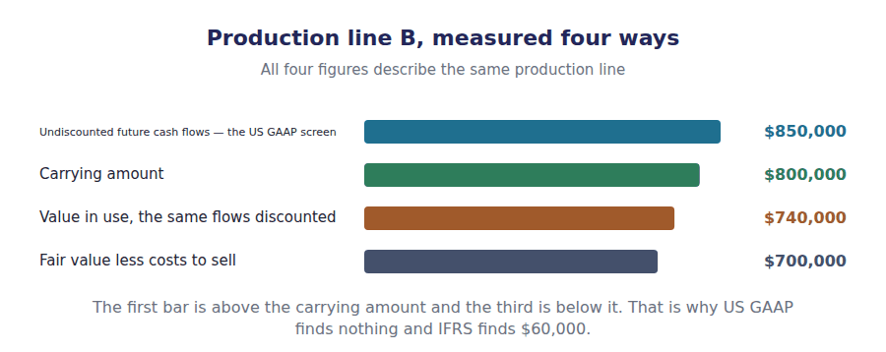
Part 1 · Measuring the asset cost, or revalued
Exercise 5A Complete the right-hand column.
OBJECTIVE | Say which measurement models each framework permits for property, plant and equipment.
YOU WILL NEED | Volume 5 Handout 1, on carrying an asset at cost. · Handout 2 Exercise 2D, on revaluing an intangible.
HOW TO START | • The pattern is the same as it was for intangibles in Handout 2, with one condition relaxed.  • There is no active market requirement here, because property and equipment can usually be valued.  • The last row is the restriction that stops a company revaluing only the assets that have risen.

 | Cost model | Revaluation model
Permitted under US GAAP | Yes
Permitted under IFRS | Yes
An increase in value | Not recognised
Depreciation afterwards | On cost
Applied to | Any asset

1 | 2 | 3 | 4 | 5

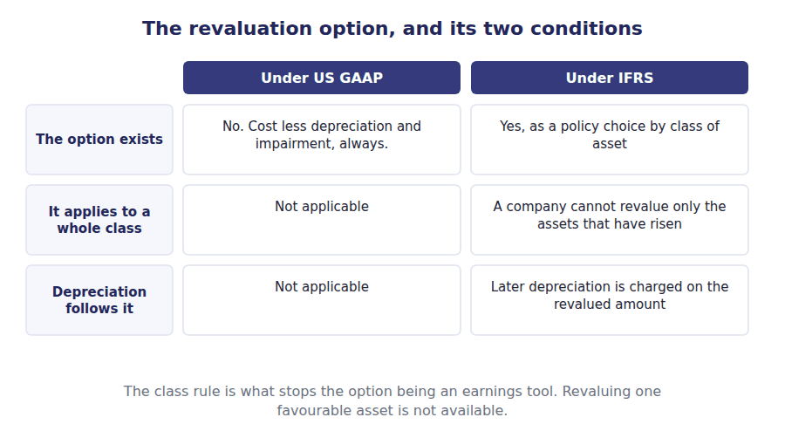
Part 2 · The US GAAP test two steps, and a screen
Exercise 5B Read and complete. Write one word or figure in each space.
OBJECTIVE | Describe the two-step US GAAP impairment test.
YOU WILL NEED | Volume 5 Handout 4, which applied this test to both lines.
HOW TO START | • The first step is a screen rather than a measurement. Ask what it compares, and note that it is not discounted.  • Line B’s $850,000 of undiscounted flows exceeded its $800,000 carrying amount, so the test stopped.  • The last blank is the figure that would have been used had step one failed, and line A shows it.

WORD BANK
carrying · fair · impaired · present · reached · recoverable · undiscounted
Not every word is used.

R2 US GAAP tests an asset held for use in two steps. Step one asks whether the carrying amount is ¹ , by comparing it with the sum of the future cash flows the asset is expected to generate.
Those cash flows are taken ² . That is the whole peculiarity of the test, because an undiscounted total is almost always the largest figure available.
Line B’s undiscounted flows are $850,000 against a carrying amount of $800,000, so step one is passed and the test stops. No loss is measured, and the $700,000 fair value is never ³ .
Had step one failed, as it did for line A, step two measures the loss as carrying amount less ⁴ value: $800,000 less $620,000, or $180,000.
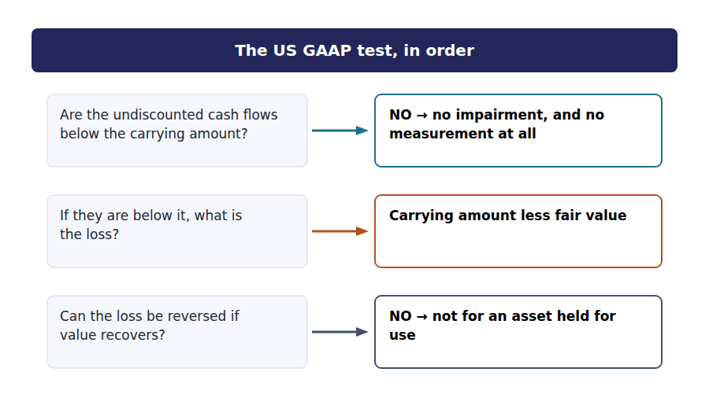
Part 3 · The IFRS test one step, and a discount rate
R2 IFRS compares the carrying amount with recoverable amount directly. Recoverable amount is the higher of fair value less costs to sell and value in use, and value in use is the discounted cash flows. There is no screen, so an asset is written down as soon as the comparison fails.
Exercise 5C Read and complete. Write one word or figure in each space.
OBJECTIVE | Describe the one-step IFRS test and define recoverable amount.
YOU WILL NEED | Exercise 5B, and the paragraph above.
HOW TO START | • Recoverable amount is the higher of two figures. Both are available for line B: $700,000 and $740,000.  • Take the higher, compare it with the $800,000 carrying amount, and the loss is the shortfall.  • The last blank is the level at which the test is applied when a single machine generates no cash flows on its own, and IFRS calls it a cash-generating unit.

WORD BANK
$60,000 · discounted · generating · higher · lower · reported · reporting
Not every word is used.

R2 IFRS has one step. The carrying amount is compared with recoverable amount, which is the ⁵ of fair value less costs to sell and value in use.
Value in use is the same future cash flows the US GAAP screen used, ⁶ to a present value. For line B that gives $740,000 against the $850,000 undiscounted total.
Fair value less costs to sell is $700,000, so recoverable amount is the higher of the two, $740,000. Against a carrying amount of $800,000 the loss is ⁷ .
Where an individual asset generates no cash flows of its own, the test is applied to the smallest group that does, which IFRS calls a cash-⁸ unit.
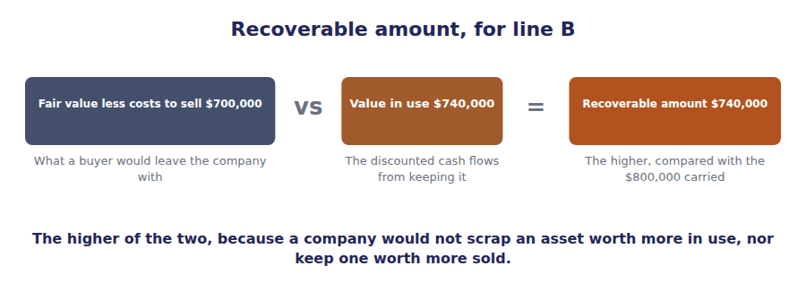
Part 4 · The same line, both ways where the $60,000 comes from
Exercise 5D Complete the grid. Two rows say which figure each framework uses.
OBJECTIVE | Compute the impairment on production line B under both frameworks.
YOU WILL NEED | Exercises 5B and 5C.
HOW TO START | • Each framework uses only some of the four figures, and the rows marked not used are already filled in.  • US GAAP compares the carrying amount with $850,000 and stops; IFRS compares it with $740,000.  • The last row is $0 under one framework and $60,000 under the other, from the same asset and the same cash flows.

Production line B | US GAAP | IFRS
Carrying amount | $800,000 | $800,000
Undiscounted future cash flows | $850,000
Fair value less costs to sell | $700,000 | $700,000
Value in use, the discounted cash flows |  | $740,000
The figure compared with carrying amount
Impairment loss recognised

1 | 2 | 3 | 4 | 5 | 6

 | US GAAP | IFRS
Number of steps
Step one compares carrying amount with
The loss is carrying amount less
Recoverable amount is
May a loss be reversed later?

1 | 2 | 3 | 4 | 5 | 6
7 | 8 | 9

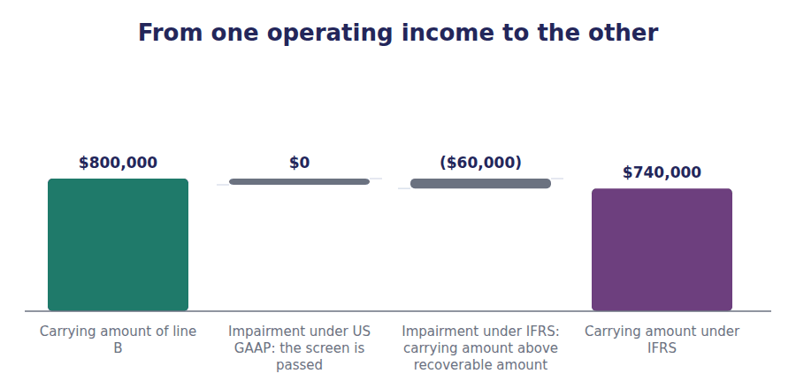
Part 5 · Undoing the loss, and one more difference reversal and component depreciation
Exercise 5E Read and complete. Write one word in each space.
OBJECTIVE | Say whether an impairment loss may be reversed, and name the depreciation difference.
YOU WILL NEED | Exercise 5D, and Handout 3 Exercise 3D on reversing an inventory write-down.
HOW TO START | • The pattern is the same as it was for inventory in Handout 3: one framework reverses and the other does not.  • There is one asset for which neither framework ever reverses, and Volume 5 Handout 5 valued it.  • The last blank is the depreciation practice IFRS requires and US GAAP merely permits.

WORD BANK
component · goodwill · inventory · permanent · reversed · reversible · straight-line
Not every word is used.

R3 Under US GAAP an impairment loss on an asset held for use is ⁹ . The written-down figure becomes the new carrying amount and is depreciated from there, whatever happens to value afterwards.
Under IFRS the loss is ¹⁰ if the circumstances that caused it no longer apply. The reversal is capped at the carrying amount the asset would have had if it had never been impaired.
One asset is excluded from that. An impairment of ¹¹ is never reversed under either framework, because a recovery cannot be distinguished from internally generated goodwill.
A last difference has nothing to do with impairment. IFRS requires the significant parts of an asset to be depreciated separately over their own lives, which is ¹² depreciation; US GAAP permits it and almost nobody elects it.
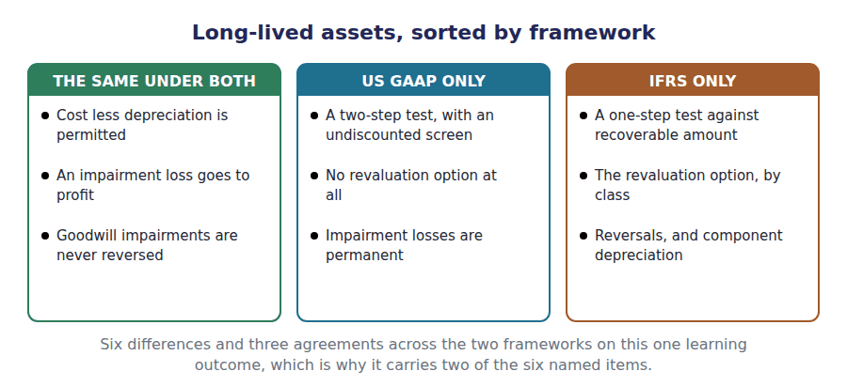
Watch out! Everything on this learning outcome follows from one word. The US GAAP screen is undiscounted and the IFRS comparison is not, so IFRS finds impairments US GAAP does not, and then reverses them when they recover.
Part 6 · Exam pitch the questions as the CMA sets them
1. [Level A] The revaluation model for property, plant and equipment is:
(A) Permitted under both frameworks
(B) Permitted under IFRS only
(C) Permitted under US GAAP only
(D) Prohibited under both
2. [Level A] The first step of the US GAAP impairment test compares the carrying amount with:
(A) Fair value
(B) The sum of the undiscounted future cash flows
(C) The present value of the future cash flows
(D) Replacement cost
3. [Level B] Under IFRS, recoverable amount is:
(A) Fair value less costs to sell
(B) The higher of fair value less costs to sell and value in use
(C) The lower of fair value less costs to sell and value in use
(D) The undiscounted future cash flows
4. [Level B] An asset carried at $800,000 has undiscounted future cash flows of $850,000, a value in use of $740,000 and a fair value less costs to sell of $700,000. The impairment loss under US GAAP is:
(A) $100,000
(B) Nil
(C) $60,000
(D) $60,000
5. [Level C] The impairment loss on the same asset under IFRS is:
(A) Nil
(B) $60,000
(C) $100,000
(D) ($50,000)
6. [Level B] An impairment loss on equipment held for use may be reversed under:
(A) Both frameworks
(B) IFRS only
(C) US GAAP only
(D) Neither
7. [Level C] Depreciating the significant parts of an asset separately over their own useful lives is:
(A) Required under US GAAP and permitted under IFRS
(B) Required under IFRS and permitted under US GAAP
(C) Prohibited under both
(D) Required under both
ADAPTIVE TIP On any impairment question, write the four figures down and then cross out the two the framework does not use. US GAAP uses the undiscounted total and then fair value; IFRS uses the higher of fair value and value in use and nothing else. Most distractors are the right arithmetic on the wrong pair.

Answer Key
Volume 12 · Handouts 1 to 5
Every answer carries the reason for it and the mistake it defeats.

Handout 1 · Expense Recognition: Share-Based Payments and Employee Benefits answers
Completed text and exercises
# | Answer | Why | The trap it defeats
1 | are | One award, or one for each instalment.
2 | straight-line | Permitted, for a service condition only.
3 | front-loaded | Three charges in year one, one in year three.
4 | total | The grant-date fair value, either way. | Students expect the accelerated pattern to cost more. It costs the same and costs it sooner.
Grid 1 | 1 US GAAP 2 IFRS 3 BOTH 4 US GAAP 5 IFRS 6 BOTH | The two BOTH rows are worth as much as the four differences: an exam question often asks what the frameworks agree on.
5 | amortised | Into profit, over remaining service.
6 | never | It stays in equity permanently. | Students expect every amount in other comprehensive income to be recycled. A remeasurement under IFRS is the standard exception.
7 | immediately | In full, in the year of the amendment.
8 | return | One rate, one net balance, no estimate.

Exam-pitch questions
# | Answer | Why | The trap it defeats
1 | (B) With each instalment treated as a separate award over its own vesting period | IFRS requires tranche-by-tranche treatment, which front-loads the charge. (A) is the US GAAP election, which is exactly the difference ff(i) names. | Level A
2 | (B) $165,000 | $90,000 for the first tranche, $45,000 for half the second and $30,000 for a third of the third is $165,000. (A) is the straight-line figure, which is right under US GAAP and wrong here. | Level B
3 | (B) The same | Both spend the grant-date fair value of $270,000; only the pattern differs. (A) is the answer the front-loading suggests and it confuses timing with amount. | Level B
4 | (B) Net interest on the net defined benefit liability at the discount rate | One rate on one net balance. (A) is the US GAAP computation, and the expected return in it is the management estimate IFRS set out to remove. | Level B
5 | (B) $40,000 | US GAAP charges $144,000 less $160,000, or ($16,000); IFRS charges 6% on the $400,000 net liability, or $24,000. The $40,000 gap is the plan assets at the two percentage points between the rates. | Level C
6 | (B) Never reclassified into profit | Remeasurements under IFRS stay in equity permanently, which Volume 9 gave as the exception to recycling. (A) describes the US GAAP treatment, and the pairing is the point of the question. | Level C
7 | (B) $60,000 | IFRS recognises past service cost immediately and in full. (A) is the $6,000 a year US GAAP would amortise over the 10-year remaining service period. | Level B

Exercise 1B · the two expense patterns
Year | US GAAP, straight-line | IFRS, tranche by tranche
1 | $90,000 | $165,000
2 | $90,000 | $75,000
3 | $90,000 | $30,000
Total | $270,000 | $270,000

Exercise 1D · the two pension costs
Net defined benefit cost for 20X4 | US GAAP | IFRS
Service cost for the year | $180,000 | $180,000
Interest on the obligation at 6% | $144,000 | —
Expected return on plan assets at 8% | ($160,000) | —
Net interest on the net liability at 6% | — | $24,000
Past service cost of $60,000 | $6,000 | $60,000
Charged to profit | $170,000 | $264,000

R2 Both option columns total $270,000, because both frameworks spend the grant-date fair value of the award. IFRS reaches it sooner: $165,000 in year one against $90,000, and $30,000 in year three against the same $90,000.
R2 The pension columns do not agree, and the whole of the $94,000 gap is accounted for twice over: $40,000 is the $2,000,000 of plan assets at the two percentage points between the expected return and the discount rate, and $54,000 is the part of the plan amendment US GAAP has not yet amortised.

Handout 2 · Intangibles: Development Costs and Revaluation answers
Completed text and exercises
# | Answer | Why | The trap it defeats
1 | identified | No product yet, no benefit to point at.
2 | capitalised | Required, not permitted, once the criteria are met. | Students treat IFRS capitalisation as an election. Once all six criteria are met it is mandatory.
3 | uncertain | A judgement about a date, made by management.
4 | same | Amortisation gets there in the end.
5 | active | Comparable assets, regularly traded.
6 | unavailable | No market, no fair value, no model. | Students read the IFRS option as freely available. For most intangibles it is not available at all.
7 | prefer | The whole class, not one asset.
8 | earnings | Within equity, never through profit.

Exam-pitch questions
# | Answer | Why | The trap it defeats
1 | (B) Expensed under both frameworks | Research is expensed under both; only development divides them. (A) is the answer the topic’s reputation invites and it moves the difference one phase too early. | Level A
2 | (B) $160,000 | Only the research phase is expensed: $400,000 less $240,000 is $160,000. (A) is the US GAAP figure, which charges the whole amount. | Level B
3 | (B) Required | Required. The six criteria are a test, not an option, and once they are passed the expenditure is an asset. (A) is the most common wrong answer on ff(ii). | Level B
4 | (A) The cost model under US GAAP; the cost or revaluation model under IFRS | US GAAP permits cost alone; IFRS permits either, subject to an active market. (C) is right about US GAAP and wrong about IFRS, which makes it the distractor that catches a half-learned answer. | Level B
5 | (B) In other comprehensive income, as a revaluation surplus | The surplus goes to other comprehensive income and stays in equity. (A) would let a company report profit on an asset it has not sold, which is precisely what the surplus prevents. | Level B
6 | (B) Charged to profit | The surplus is tracked asset by asset, so once that asset’s surplus is exhausted the rest is an expense. (A) is the trap: surpluses are not pooled across a class. | Level C
7 | (B) Must be carried at cost, because there is no active market in comparable assets | The model needs a fair value from an active market, and a design unique to one company has none. (A) is the error of reading a permission without reading its condition. | Level C

Exercise 2C · the two charges
The $400,000 spent on the new sensor | US GAAP | IFRS
Research phase, before feasibility was established | $160,000 | $160,000
Development phase, after the six criteria were met | $240,000 | $240,000
Charged to profit in 20X4 | $400,000 | $160,000
Recognised as an intangible asset | Nil | $240,000

Exercise 2D · the two measurement models
 | Cost model | Revaluation model
Carried at | Cost less amortisation | Fair value less later amortisation
Permitted under US GAAP | Yes | No
Permitted under IFRS | Yes | Yes, if an active market exists
An increase goes to | Nowhere, it is not recognised | Other comprehensive income, as a revaluation surplus
A decrease goes to | Profit, as an impairment | Profit, once any surplus on that asset is used up

R2 The columns of the first grid differ by exactly the $240,000 of development spending. US GAAP charges the whole $400,000 now; IFRS charges $160,000 now and the rest through amortisation over the asset’s life, so the total reaching profit is identical and arrives later.
R2 The second grid is the narrower difference in practice. Northwind cannot use the revaluation model for its sensor under either framework, because there is no active market in comparable designs. The option exists under IFRS and almost never applies to an internally generated intangible.

Handout 3 · Inventories: Costing, Valuation and Write-Downs answers
Completed text and exercises
# | Answer | Why | The trap it defeats
1 | realisable | Selling price less the costs of selling.
2 | replacement | What it would cost to buy today.
3 | margin | Otherwise the write-down creates tomorrow’s profit.
4 | neither | No replacement cost, so no bounds needed. | Students apply the ceiling and floor under IFRS. There is nothing for them to bound.
5 | basis | A new cost, permanently.
6 | reversed | The reason has gone, so the write-down goes.
7 | cost | The cap is cost, not fair value. | Students reverse up to net realisable value. The rule is still the lower of the two figures, so cost is the ceiling.
8 | lower | A write-down that cannot be undone.

Exam-pitch questions
# | Answer | Why | The trap it defeats
1 | (B) Last-in, first-out | LIFO is prohibited under IFRS and permitted under US GAAP. The other three are permitted under both, which makes this the one difference worth memorising outright. | Level A
2 | (B) The lower of cost and net realisable value | One comparison, with no ceiling and floor. (C) is the US GAAP rule for LIFO inventories, and the two wordings are a syllable apart by design. | Level A
3 | (B) $95 | IFRS compares cost with net realisable value alone: $100 against $95, so $95. (A) is the replacement cost, which IFRS never looks at. | Level B
4 | (B) $90 | Market is replacement cost of $90, which falls between the floor of $84.50 and the ceiling of $95, so it stands and is below the $100 cost. The same item is $95 under IFRS, which is the whole point of the pair. | Level B
5 | (B) Not recognised, because the write-down created a new cost basis | A US GAAP write-down is permanent. (D) is close enough to be tempting: the recovery does affect the margin on the eventual sale, and that is not a recognition of the recovery. | Level B
6 | (B) The inventory’s original cost | The rule is still the lower of cost and net realisable value, so cost caps the reversal. (C) is the trap: a recovered net realisable value above cost does not let inventory be carried above cost. | Level C
7 | (B) It must abandon LIFO, and the accumulated tax deferral is recaptured | LIFO is unavailable under IFRS, and in jurisdictions requiring conformity between the books and the return the deferred tax benefit falls in. (A) is the reason this difference is the most contested in the whole of ff(iii). | Level C

Exercise 3C · the four items, both ways
Item | Cost | Under LIFO, the market rule | Under FIFO, net realisable value
A · standard housing | $100 | $90 | $95
B · obsolete sensor | $100 | $84.50 | $95
C · damaged batch | $100 | $92 | $92
D · scarce controller | $100 | $100 | $100

Exercise 3A · the costing methods
Costing method | US GAAP | IFRS
Specific identification | Permitted | Permitted
First-in, first-out | Permitted | Permitted
Weighted average cost | Permitted | Permitted
Last-in, first-out | Permitted | Prohibited
A different method for different classes of inventory | Permitted | Permitted, if the classes genuinely differ

Exercise 3E · the three differences
The three differences | US GAAP | IFRS
Is LIFO available? | Yes | No
The valuation rule | Net realisable value, or market for LIFO | Net realisable value, always
May a write-down be reversed? | No, never | Yes, up to the original cost

R2 Items A and B disagree between the two columns and items C and D agree. A and B are the cases where replacement cost has fallen below net realisable value, which is the only situation in which the market rule bites, and the whole of the first difference lives there.
R2 Item D is worth a second look: replacement cost of $110 is above the $100 cost, so both rules stop at cost. A rising replacement cost never writes inventory up under either framework.

Handout 4 · Leases: the Lessee’s Two Models answers
Completed text and exercises
# | Answer | Why | The trap it defeats
1 | dual | Two classes, two treatments.
2 | irrelevant | Nothing left for them to decide. | Students apply the Volume 7 tests under IFRS. For a lessee there is nothing to classify.
3 | interest | A falling charge on a falling balance.
4 | front-loaded | Heavier early, lighter later.
5 | present | Discounted, under both frameworks.
6 | differently | Two classes, two treatments.
7 | single | One treatment for every recognised lease. | Students name it the single model. The exam writes single lessee model, because the lessor still classifies.
8 | other | Front-loaded, like a finance lease.
Grid 1 | 1 BOTH 2 IFRS 3 US GAAP 4 IFRS 5 BOTH 6 BOTH | Three of the six are shared. The two that are not are the whole of ff(iv): the classification and the low-value exemption.

Exam-pitch questions
# | Answer | Why | The trap it defeats
1 | (B) Not at all, because a single model applies to every recognised lease | There is no lessee classification under IFRS. (A) is the answer Volume 7 prepares a student to give and it is right only under US GAAP. | Level A
2 | (B) Amortisation of the right-of-use asset plus interest on the liability | Every recognised IFRS lease gets the finance lease pattern. (A) is the US GAAP operating treatment, which is exactly the one IFRS removed for lessees. | Level A
3 | (B) $42,608 | $34,361 of amortisation plus $8,247 of interest is $42,608. (A) is the US GAAP single lease cost, which is also the cash paid and so looks like the safe answer. | Level B
4 | (B) The same | Both total the $120,000 of payments; only the pattern differs. (A) is the answer the larger first-year charge suggests, and it mistakes timing for amount. | Level B
5 | (B) Higher operating profit and higher operating cash flow | The interest leaves both operating profit and operating cash flow, so both improve: $34,361 rather than $40,000 charged in operating expenses, and $8,247 rather than $40,000 of operating outflow. (A) and (C) each get one half right. | Level C
6 | (B) IFRS only | IFRS offers it and US GAAP does not. The short-term exemption, by contrast, exists under both, which is why the two are so often confused. | Level B
7 | (B) Measured at the present value of the payments | Present value, under both. This is the convergence the two boards did achieve, and (C) is the pre-2019 treatment the exam still offers to see whether a candidate knows the rules changed. | Level C

Exercise 4B · the lease under the IFRS single model
Year 1 of the warehouse floor lease under IFRS | Amount
Right-of-use asset recognised | $103,084
Amortisation, $103,084 over 3 years | $34,361
Interest on the liability at 8% | $8,247
Total charged to profit | $42,608
Compared with the single lease cost under US GAAP | $40,000

Exercise 4C · the two cost patterns
Year | US GAAP, operating lease | IFRS, single model
1 | $40,000 | $42,608
2 | $40,000 | $40,067
3 | $40,000 | $37,325
Total | $120,000 | $120,000

Exercise 4D · where each amount lands
 | US GAAP operating lease | IFRS single model
Income statement | One lease cost, $40,000 | Amortisation $34,361 and interest $8,247
Operating expenses | All of the $40,000 | The $34,361 of amortisation only
Finance costs | Nothing | The $8,247 of interest
Operating cash flow | All of the $40,000 paid | The $8,247 of interest only
Financing cash flow | Nothing | The rest of the payment, $31,753

R2 Both columns of the second table total $120,000, which is 3 payments of $40,000. The IFRS column starts $2,608 above the US GAAP figure and ends $2,675 below it, and the $103,084 of right-of-use asset is amortised in full either way.
R2 The third table is where the difference matters to a reader. The same $40,000 payment is entirely an operating outflow under US GAAP and only $8,247 of it is under IFRS, so every cash-based operating measure improves on conversion without anything about the lease having changed.

Handout 5 · Long-Lived Assets and Impairment: Revaluation and Reversal answers
Completed text and exercises
# | Answer | Why | The trap it defeats
1 | recoverable | A screen, not a measurement.
2 | undiscounted | The one word that makes the screen generous. | Students discount the step one flows. Discounting them would turn the US GAAP test into the IFRS one.
3 | reached | The test stopped before it.
4 | fair | Fair value, once the screen has failed.
5 | higher | Two figures, and the better of them.
6 | discounted | The single word the whole difference turns on.
7 | $60,000 | $800,000 less $740,000.
8 | generating | The smallest group with its own cash flows. | Students test a single machine. Most machines generate no cash flows alone, and the unit is the level the standard uses.
9 | permanent | A new carrying amount, for good.
10 | reversed | Up to what the asset would otherwise have been worth.
11 | goodwill | Never reversed, under either framework. | Students apply the IFRS reversal to goodwill. It is the one exception, and the exam asks about it.
12 | component | Each significant part over its own life.

Exam-pitch questions
# | Answer | Why | The trap it defeats
1 | (B) Permitted under IFRS only | IFRS offers it by class of asset; US GAAP requires cost less depreciation and impairment. (A) is the answer a student gives who has learned that both permit the cost model. | Level A
2 | (B) The sum of the undiscounted future cash flows | Undiscounted, which is what makes the step a screen rather than a measurement. (C) is the IFRS comparison and the single most consequential confusion in ff(v). | Level A
3 | (B) The higher of fair value less costs to sell and value in use | The higher of the two, because a company would take whichever course leaves it better off. (C) is the trap, and it would impair almost every asset a company owns. | Level B
4 | (B) Nil | The undiscounted flows of $850,000 exceed the $800,000 carrying amount, so step one is passed and nothing is measured. (A) and (C) both skip the screen and measure a loss the test never reaches. | Level B
5 | (B) $60,000 | Recoverable amount is the higher of $700,000 and $740,000, so $740,000, and $800,000 less that is $60,000. (C) uses fair value, which is the lower of the two and so not recoverable amount. | Level C
6 | (B) IFRS only | IFRS reverses up to the carrying amount the asset would otherwise have had; US GAAP treats the write-down as a new cost basis. (D) is right only for goodwill. | Level B
7 | (B) Required under IFRS and permitted under US GAAP | IFRS requires component depreciation and US GAAP permits it. (A) reverses the pair, and in every one of the six named differences in this volume it is IFRS that requires the extra work. | Level C

Exercise 5D · line B under both frameworks
Production line B | US GAAP | IFRS
Carrying amount | $800,000 | $800,000
Undiscounted future cash flows | $850,000 | Not used
Fair value less costs to sell | $700,000 | $700,000
Value in use, the discounted cash flows | Not used | $740,000
The figure compared with carrying amount | $850,000 | $740,000
Impairment loss recognised | $0 | $60,000

Exercise 5D · the two tests compared
 | US GAAP | IFRS
Number of steps | Two | One
Step one compares carrying amount with | Undiscounted future cash flows | Not applicable
The loss is carrying amount less | Fair value, if step one fails | Recoverable amount, always
Recoverable amount is | Not a defined term | The higher of fair value less costs to sell and value in use
May a loss be reversed later? | No, for assets held for use | Yes, except for goodwill

Exercise 5A · the two measurement models
 | Cost model | Revaluation model
Permitted under US GAAP | Yes | No
Permitted under IFRS | Yes | Yes, by class of asset
An increase in value | Not recognised | To other comprehensive income, as a revaluation surplus
Depreciation afterwards | On cost | On the revalued amount
Applied to | Any asset | A whole class, not one asset

R2 The same four figures are in front of both frameworks and each uses two of them. US GAAP compares $800,000 with the undiscounted $850,000, passes, and stops. IFRS compares $800,000 with the higher of $700,000 and $740,000, which is $740,000, and writes the line down by $60,000.
R2 Volume 5 Handout 4 reached the US GAAP answer and was right. Nothing about line B has changed except the framework, and that is the point of this volume: six differences, each of which leaves the facts alone and changes the figure reported.

Glossary
Every term in Volume 12, with the Arabic equivalent and the places it misleads
The third column is for recognition only. In the exam room you work in English.

Term | What it means in CMA English | بالعربية | Careful
cash-generating unit | The smallest group of assets generating cash flows largely independent of other assets. | الوحدة المولدة للنقد | The IFRS level at which impairment is tested when an individual asset generates no cash flows of its own.
component depreciation | Depreciating the significant parts of an asset separately over their own useful lives. | إهلاك المكوّنات | Required under IFRS and merely permitted under US GAAP, where almost nobody elects it.
cost model | Carrying an asset at cost less accumulated amortisation and impairment. | نموذج التكلفة | Permitted under both frameworks, and the only model US GAAP allows.
defined benefit plan | A pension plan in which the employer promises a specified benefit and bears the risk of funding it. | خطة المنافع المحددة | A defined contribution plan is the simple case and is treated the same way under both frameworks.
development | The application of research findings to a plan for a new or substantially improved product or process. | التطوير | The phase where the frameworks part. IFRS capitalises it once six conditions are met; US GAAP charges it to profit.
dual model | The US GAAP approach, under which a lessee classifies a lease as either finance or operating and accounts for each differently. | النموذج المزدوج | Volume 7 Handouts 5 and 6 worked both halves of it. The classification tests exist because the accounting differs.
expected return on plan assets | The return an employer expects to earn on a pension plan’s assets, used in US GAAP to reduce the pension cost. | العائد المتوقع على أصول الخطة | A management estimate, which is exactly why IFRS removed it. It is the whole of the $40,000 difference in this handout.
graded vesting | An award that vests in instalments over several years rather than all at once. | الاستحقاق المتدرج | The condition that produces the whole difference in this handout. An award vesting all at once is treated identically.
last-in, first-out | A cost flow assumption under which the most recently purchased goods are treated as the first sold. | الوارد أخيراً صادر أولاً | Permitted under US GAAP and prohibited under IFRS. The single sharpest difference in this volume.
low-value lease | A lease of an underlying asset of small value, which IFRS allows a lessee not to recognise. | عقد إيجار منخفض القيمة | An IFRS exemption with no US GAAP equivalent. The short-term exemption exists under both.
net interest | The discount rate applied to the net defined benefit liability, which is the IFRS replacement for separate interest and expected return figures. | الفائدة الصافية | One rate on one net balance. No management estimate of a return is needed at all.
net realisable value | The estimated selling price less the costs of completion and sale. | القيمة القابلة للتحقق | The ceiling in the market rule and the whole of the rule under IFRS. Never the gross selling price.
normal profit margin | The margin a company ordinarily earns on an item, used to set the floor in the market rule. | هامش الربح العادي | The floor exists so that a write-down does not create a profit on the later sale.
one-step test | The IFRS impairment test: carrying amount compared directly with recoverable amount. | اختبار الخطوة الواحدة | No screen, so an asset is written down whenever the discounted figure falls below its carrying amount.
past service cost | The increase in a pension obligation caused by amending the plan in favour of employees for their earlier service. | تكلفة الخدمة السابقة | Recognised in profit at once under IFRS and amortised over remaining service under US GAAP. One of the sharpest contrasts in the exam.
recoverable amount | The higher of an asset’s fair value less costs to sell and its value in use. | المبلغ القابل للاسترداد | An IFRS term with no US GAAP equivalent. The higher of two figures, which is what makes the one-step test survivable.
remeasurement | An actuarial gain or loss on a defined benefit obligation or its plan assets. | إعادة القياس | Under IFRS it goes to other comprehensive income permanently. Volume 9 Handout 2 called that the exception to recycling.
replacement cost | What it would cost to buy or make the same item today. | تكلفة الإحلال | The starting point of the US GAAP market rule for LIFO inventories, bounded above and below.
research | Original investigation undertaken to gain new scientific or technical knowledge, with no certainty of a product. | البحث | Charged to profit under both frameworks, without exception. The difference in this handout is about the phase that follows.
revaluation model | Carrying an asset at fair value at the revaluation date, less later amortisation and impairment. | نموذج إعادة التقييم | An IFRS option, and for an intangible only where an active market exists. US GAAP does not permit it at all.
revaluation surplus | The credit in other comprehensive income arising when an asset is revalued upwards. | فائض إعادة التقييم | The item Volume 9 named as never recycled through profit. On disposal it may be transferred within equity.
reversal | Writing inventory back up when the circumstances that caused a write-down no longer apply. | عكس التخفيض | Permitted under IFRS up to original cost, and prohibited outright under US GAAP.
share-based payment | A transaction in which a company receives goods or services and pays for them in its own equity instruments. | الدفع على أساس الأسهم | Measured at the grant-date fair value of the award under both frameworks. Only the spreading of it differs.
single lessee model | The IFRS approach, under which every recognised lease is accounted for the way US GAAP accounts for a finance lease. | نموذج المستأجر الواحد | There is no lessee classification test under IFRS at all, which is why the term operating lease survives only for the lessor.
technical feasibility | Demonstrated ability to complete an asset so that it will be available for use or sale. | الجدوى الفنية | The first of the six criteria, and the one that fixes the date capitalisation may begin.
two-step test | The US GAAP impairment test: a recoverability test on undiscounted cash flows, and then a measurement against fair value. | اختبار الخطوتين | An asset that passes step one is never measured, however far fair value has fallen.
value in use | The present value of the future cash flows expected from an asset. | القيمة من الاستخدام | Discounted. That one word is the whole of the difference this handout turns on.
write-down | A reduction of inventory’s carrying amount to the lower figure the valuation rule requires. | تخفيض القيمة | Charged to cost of goods sold or shown separately, under both frameworks.

