Table of Contents

A2.2 · Unit 2 · Nowhere Near Finished
English Animated · Telling the Story · Ballinmore, west coast of Ireland Student's Book pages 28–49 · 22 pp · ~10 hours

Part 0 · The Big Picture ◆ A · THE WORLD
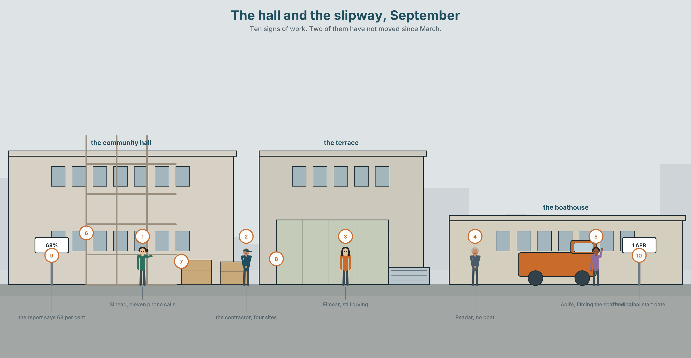{width=6.6in}
The hall and the slipway, September — Ten signs of work. Two of them have not moved since March.

What has been happening?
By the end of this unit you can report eight months of work: what is finished, what is still going on, and what has not started. One hundred words.
◆ A · THE WORLD | A town in the middle of a repair, which is a longer place than people think
◆ B · THE SYSTEM | have been doing and have done · duration adverbs · 23 words for repair and progress · 17 words for how long and how often · been as /bɪn/
◆ C · THE PERFORMANCE | A hundred words of honest progress reporting

0A · Find it
Find ten signs of work in this picture. Two of them have not moved since March.
scaffolding · a skip · a contractor's board · a temporary road surface · a generator · a portable toilet · a stack of plasterboard · a dehumidifier cable · a site fence · a planning notice

0B · Guess it
Three of these jobs have been going on longer than the others. Which, and what tells you?

0C · Say it ⏺
Record thirty seconds. What have you been working on for a long time, and is it nearly finished? You will record it again at the end of this unit.

Part 1 · Vocabulary Lab 1 ◆ B · THE SYSTEM
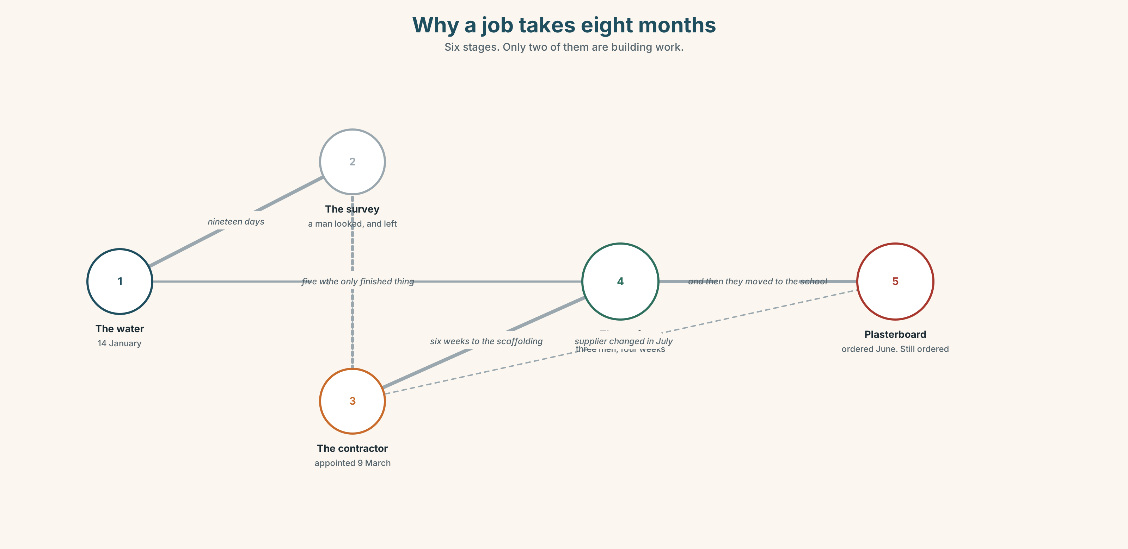{width=6.6in}
Why a job takes eight months — Six stages. Only two of them are building work.

1A · Meet — the words of a long job
Match each word to one place on the map.
repair · rebuild · clear · fix · finish · progress · site · scaffolding · contractor · delay

1B · Sort — finished, going on, or not started?
Three columns, from the picture in Part 0.
the roof · the kitchen floor · the hall windows · the drain · the sea wall survey · the slipway · the plasterboard · the temporary road
One of them is in two columns depending on who you ask. Which?

1C · Meet — three words for how it is going
ongoing · slow · steady
Slow is a complaint. Steady is a defence. Ongoing avoids the question. Which would a contractor use, and which would a resident?
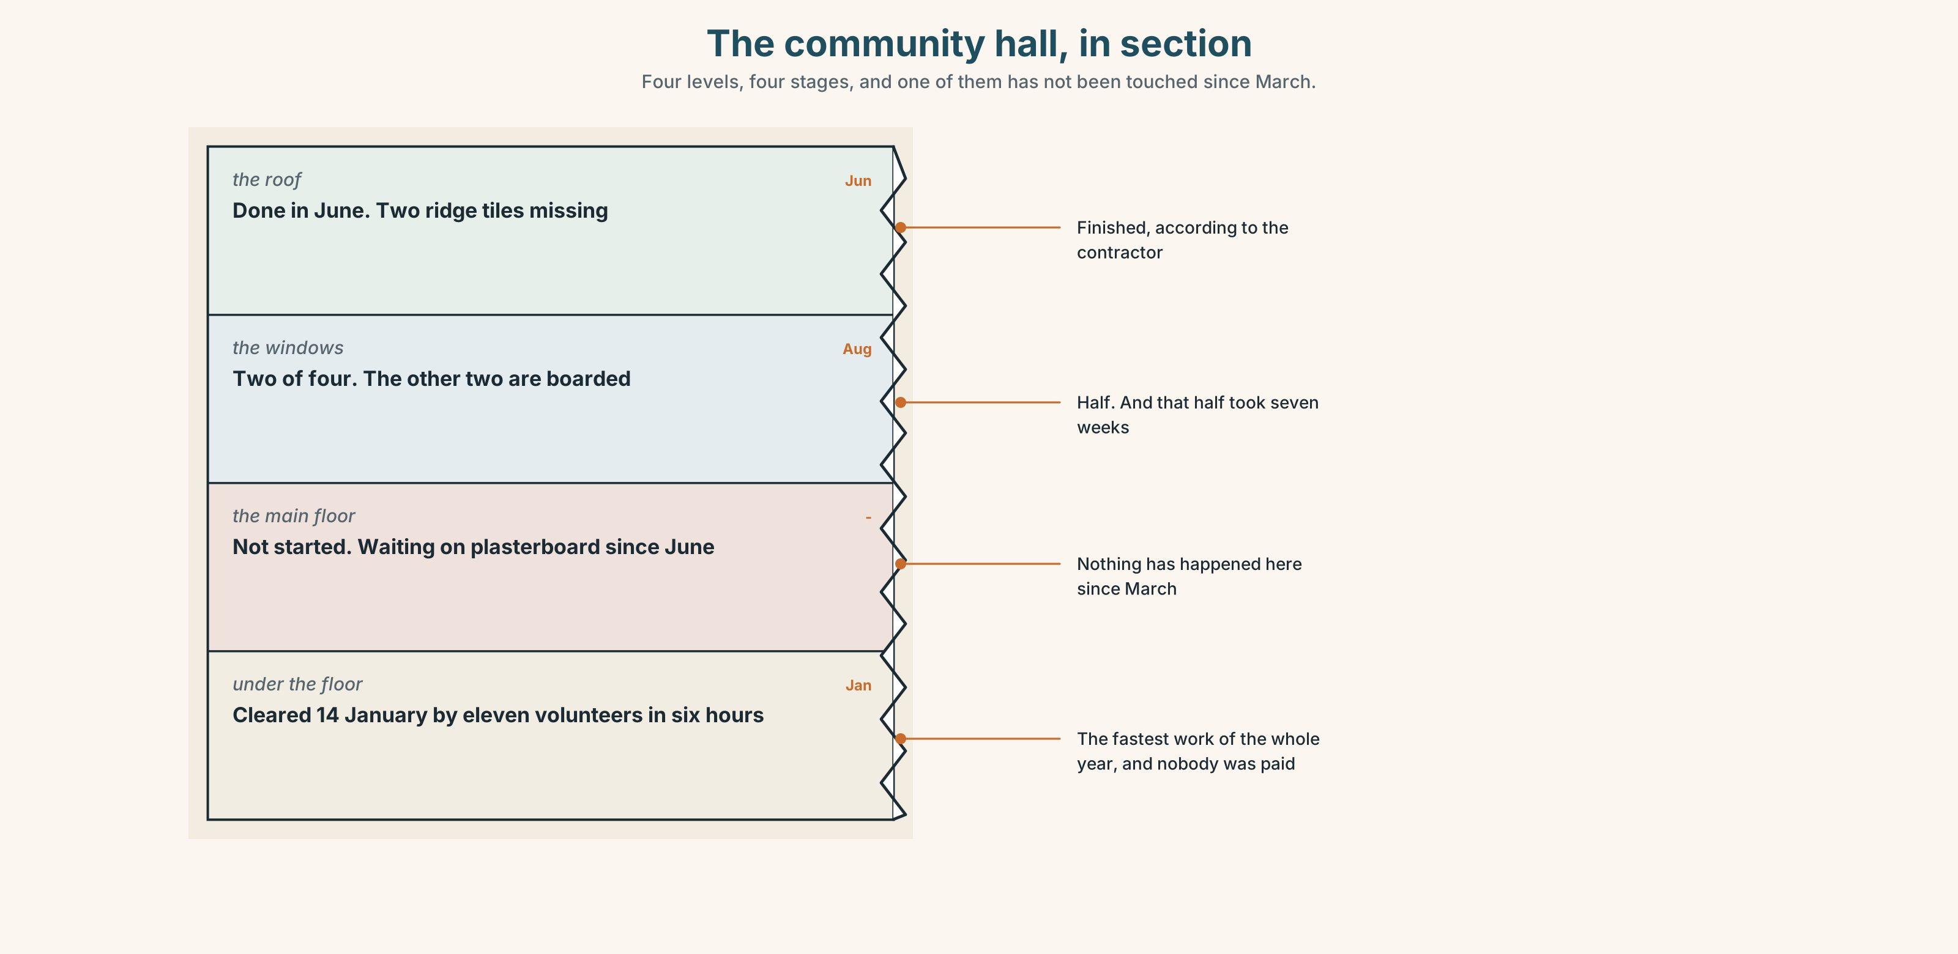{width=6.6in}
The community hall, in section — Four levels, four stages, and one of them has not been touched since March.
Look at the community hall in section. Four levels, four stages of repair. Which level is finished, and which one has not been touched since March?

1D · Stretch — the phrases
Complete each one with one word.
- They've been getting ______ with the back wall since June.
- It's coming along bit by ______ .
- The slipway is nowhere ______ finished.
- The hall is four months behind ______ .
- The plasterboard has held them ______ since the supplier changed.

1E · The saying
f It's getting there.
Three words you will hear forty times in this town.
Say it three times: cheerfully, wearily, and to somebody you do not want to talk to. Which one is true?

1F · Own it
Think of something near you that has been under repair for a long time. Tell a partner three sentences: what it is, how long, and what is actually holding it up.

Part 2 · Listening ◆ A · THE WORLD
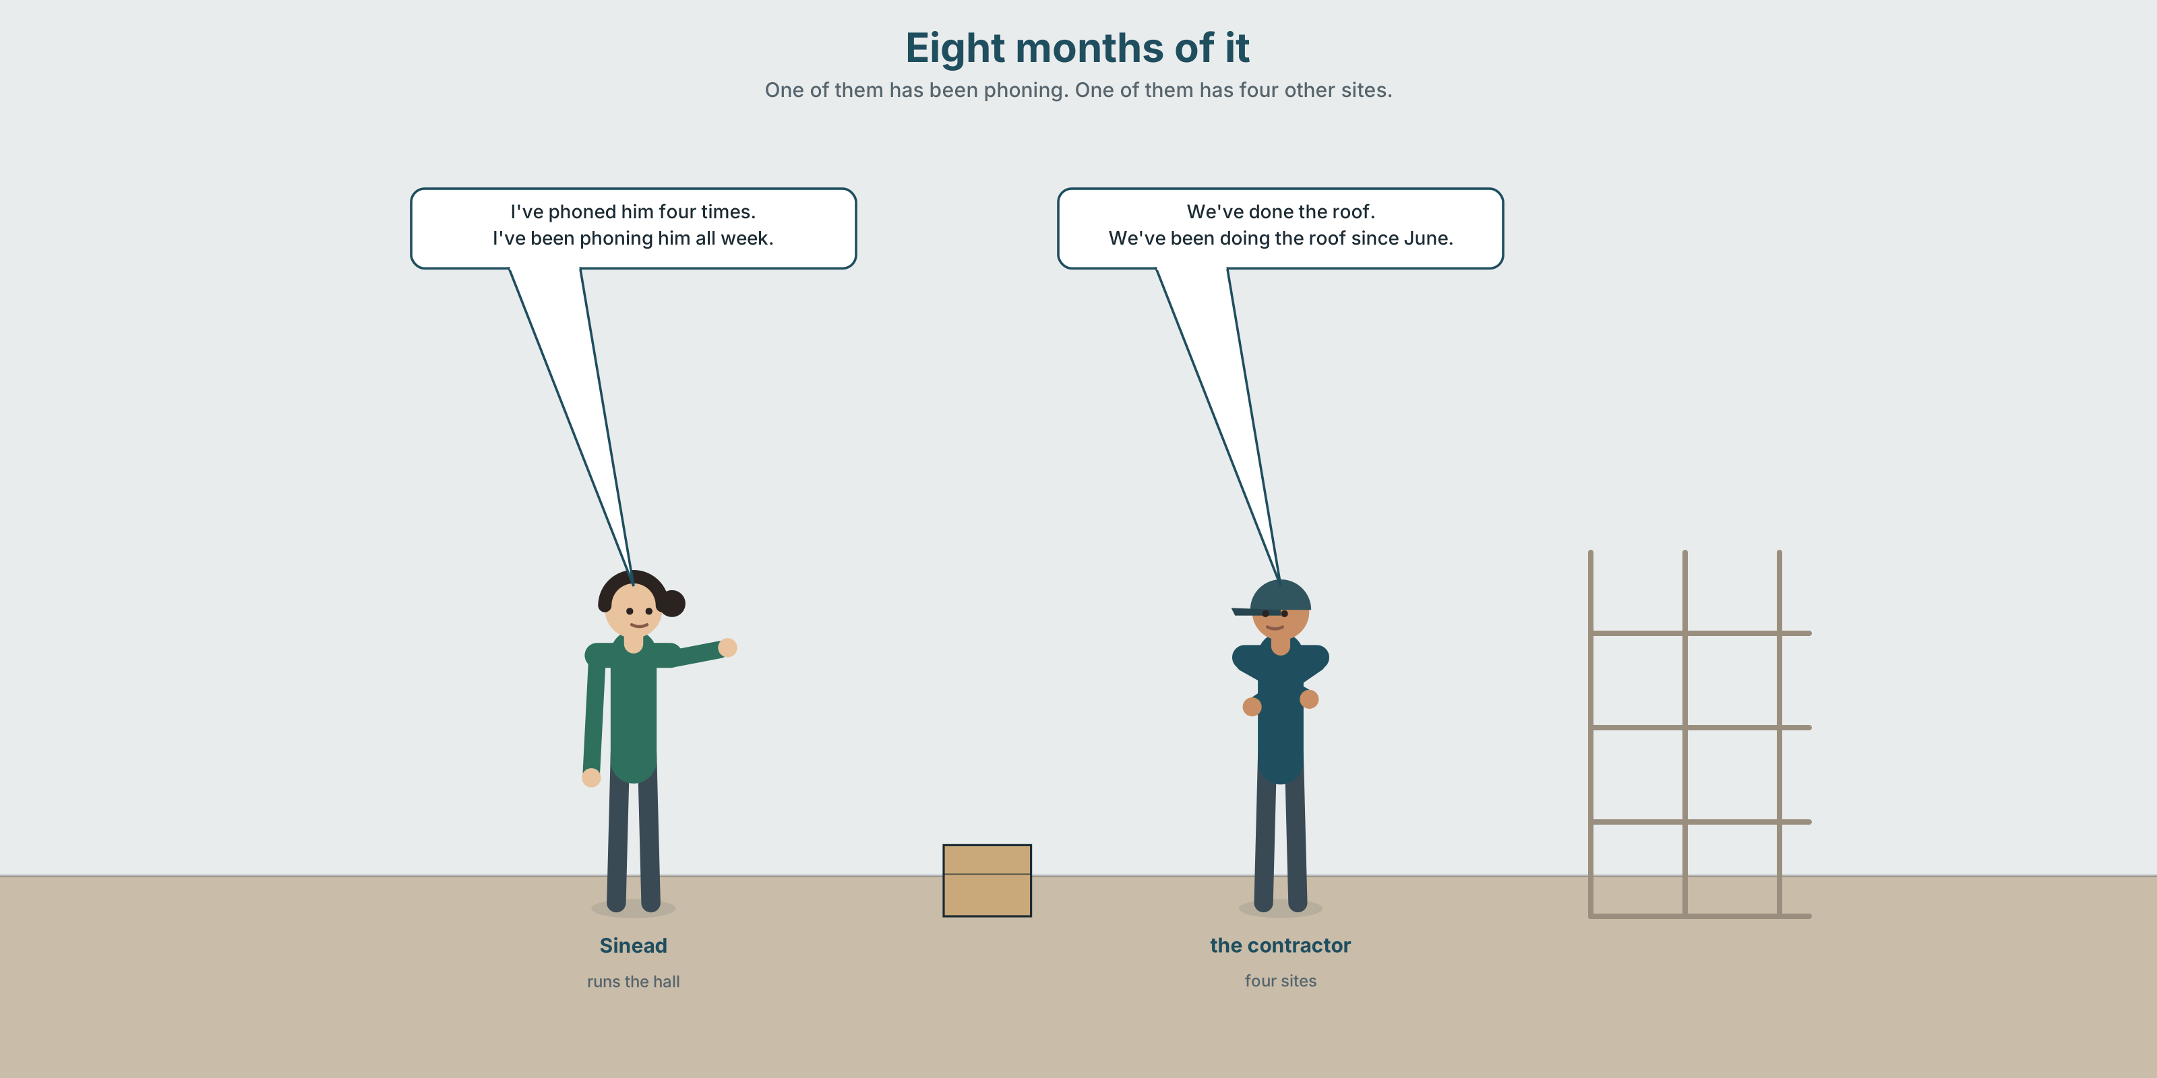{width=6.6in}
Eight months of it — One of them has been phoning. One of them has four other sites.

2A · Eight months of it 🔊 Track 2.1
Before you listen. Sinéad runs the hall. The contractor is four months late. Guess: who is more frustrated, and who sounds it?
Listen once. One question. How many of the six jobs are finished?
Listen again. Complete the table.
Job | Started | Finished? | What is holding it up
the roof
the windows
the floor
Listen again. Choose.
- The roof took three weeks / three months / it is not done.
- They have been waiting for plasterboard since June / since August / all year.
- The contractor has two / three / four other sites.
- Sinéad has been phoning daily / weekly / on and off.
Noticing. Four sentences from the recording.
- We've done the roof.
- We've been doing the roof since June.
- I've phoned him four times.
- I've been phoning him all week.
Two of these are about a result. Two are about the activity. Which are which?

2B · Decoding clinic 🔊 Track 2.2
Twenty-five seconds of Sinéad. Four jobs.
- How many times does she say been?
- Is been loud or quiet? What vowel is in it?
- Catch the two time expressions she uses.
- She says one number twice. Which, and why?
Transcripts, page 151.

Part 3 · Grammar Lab 1 ◆ B · THE SYSTEM

The result, and the activity

3A · Notice
Look at the four sentences in Part 2.
- In sentence 1, is the roof finished? In sentence 2?
- Sentence 3 gives a number. Sentence 4 does not. Which form likes numbers?
- Which pair would you use to complain, and which to report?
- Try "I've been phoning him four times." Why does it sound wrong?
- Try "I've known him since June" and "I've been knowing him since June." Why does one of these not exist?

3B · See
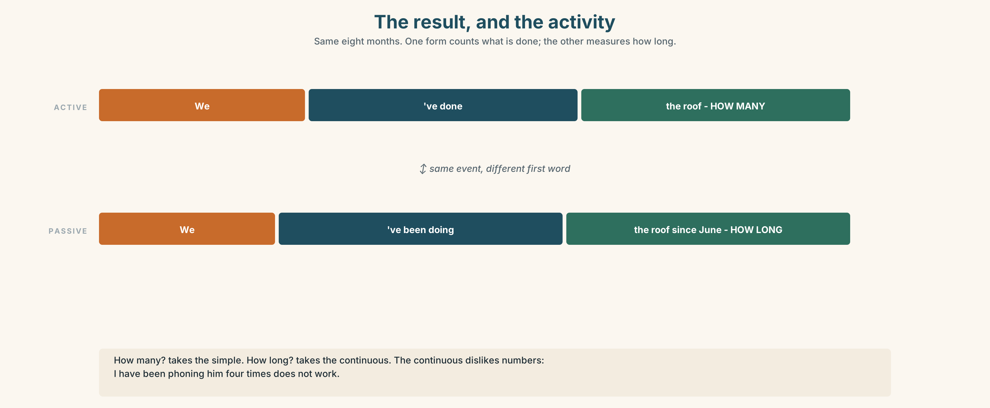{width=6.6in}
The result, and the activity — Same eight months. One form counts what is done; the other measures how long.
Now look at the second picture. The ladder runs from a finished result to an activity with no end in sight. Where does for eight months sit?
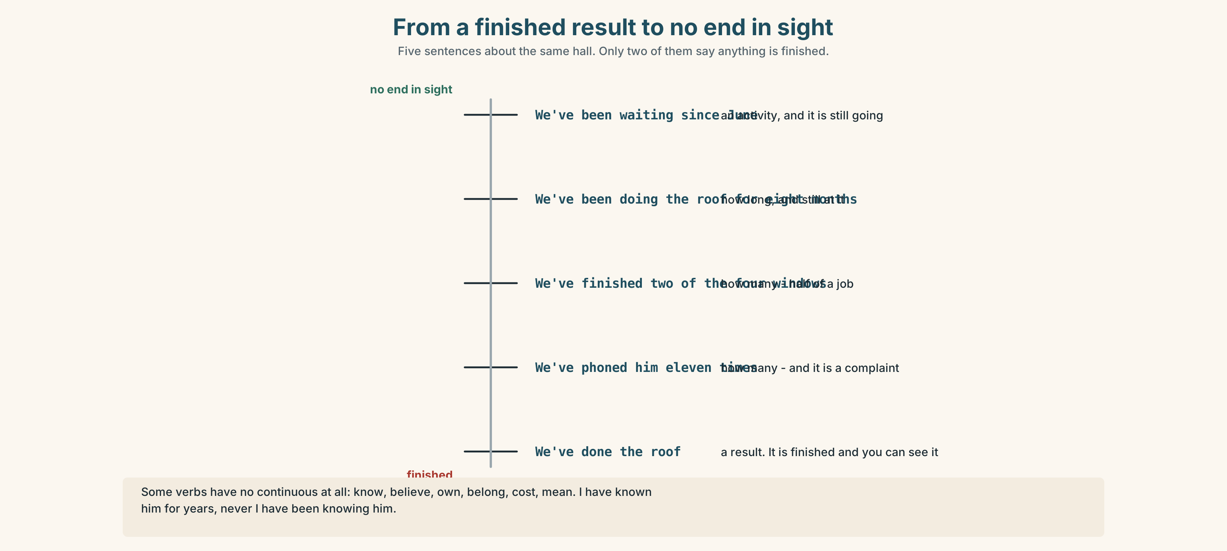{width=6.6in}
From a finished result to no end in sight — Five sentences about the same hall. Only two of them say anything is finished.

3C · Know
 | Shape | Use it for
present perfect simple | have + past participle | the result, and how many · We've done the roof. I've phoned four times.
present perfect continuous | have been + -ing | the activity, and how long · We've been doing the roof since June.
The question each one answers. How many? → simple. How long? → continuous.
Some verbs have no continuous. know, believe, own, belong, cost, mean. ✓ I've known him for years. ✗ I've been knowing him.
Both take for and since. for + a length, since + a point. You met this in A2.1 Unit 1 and it has not changed.
Watch out. The continuous dislikes numbers. ✗ I've been phoning him four times. ✓ I've phoned him four times. · ✓ I've been phoning him all week.

3D · Use — controlled
They (1) __________ (work) on the hall since January. They (2) __________ (finish) the roof and two of the four windows. The floor (3) __________ (not start) yet, because they (4) __________ (wait) for plasterboard since June. Sinéad (5) __________ (phone) the contractor eleven times. She (6) __________ (phone) him constantly all week, and he (7) __________ (not answer) once.

3E · Use — guided
Choose the form. One of them could be either — say why.
- I ______ (write) three emails this morning.
- I ______ (write) emails all morning.
- She ______ (live) here since 2011.
- They ______ (fix) the roof. It's finished.
- They ______ (fix) the roof since June.
- We ______ (know) each other for years.

3F · Use — open
Ask three people: What have you been doing lately that you haven't finished? Then ask: how much of it have you actually done?

3G · Check — six items
- We ______ (wait) since June.
- I ______ (phone) him four times.
- She ______ (work) here all week.
- They ______ (finish) two of the four windows.
- I ______ (know) him for years.
- How long ______ you ______ (live) here?
0–3 → Workbook pp. 10–12. 4–5 → Part 6. 6 → page 41.

Part 4 · Speaking ◆ C · THE PERFORMANCE

4A · Fluency starter — how long, how many
In pairs. One asks How long?, the other answers. Then one asks How many? Thirty seconds each, six rounds. The forms must change with the question.

4B · The functional core — reporting progress
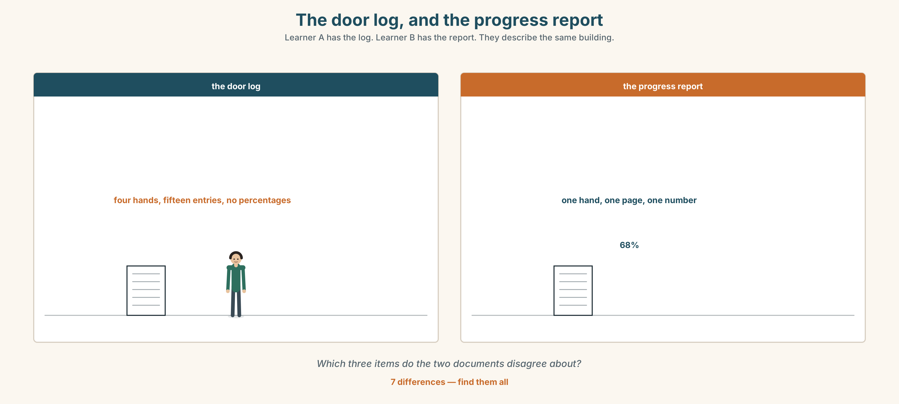{width=6.6in}
The door log, and the progress report — Learner A has the log. Learner B has the report. They describe the same building.
Language Bank
finished | We've done… · That's completed. · Two of the four are in.
going on | We've been working on… · That's ongoing. · It's coming along, bit by bit.
not started | We haven't started the… · That's waiting on…
the honest line | It's nowhere near finished. · We're four months behind schedule.
Role play. Learner A runs a building. Learner B is the contractor. Six minutes. Learner A must get one date. Learner B must not give a date they cannot keep.

4C · The performance — one hundred seconds ⏺
Report eight months of work on something. One hundred seconds. You must give:
what is finished, with a number · what is still going on, with a length · what has not started · what is actually holding it up
Record it.

4D · Observer
One person listens for one thing: was there a number and a length?

4E · Two criteria
☐ Did I use both forms, each for its own job? ☐ Did I name what is holding it up, not just that it is late?

Part 5 · Reading ◆ A · THE WORLD

5A · Predict
An archive document: the hall's own repair log, kept by hand on the back of the door. The title is "Hall — January to September." What do you expect the handwriting to show? One sentence.

5B · Read — one hundred seconds

HALL — JANUARY TO SEPTEMBER (kept on the back of the kitchen door, in four different hands)
14 Jan Water out. Floor up. 11 volunteers, 6 hrs. 19 Jan Electrics isolated. Can't use the kitchen. S. 2 Feb Council survey. Man came, looked, left. No paper yet. 27 Feb Still no paper. 9 Mar Contractor appointed. Start date 1 April. Scaffolding to go up w/c 25 Mar. 25 Mar No scaffolding. 1 Apr No contractor. 14 Apr Scaffolding up. Nobody on it. 6 May Roof started. Three men. Good. 2 Jun Roof done. They have moved to the school. 2 Jun (different hand) Roof is NOT done. Two ridge tiles missing, you can see daylight. 11 Jun Plasterboard ordered. 3 Jul Plasterboard not delivered. Supplier changed. 1 Aug Plasterboard not delivered. 1 Sep Plasterboard not delivered. Windows 2 of 4. Floor not started. 1 Sep (different hand again) We have been at this for eight months and the only thing that is finished is the roof, and the roof is not finished.

5C · Answer
- How many volunteers worked on the first day, and for how long?
- How long was it between the survey and the contractor being appointed?
- What happened on 2 June, twice?
- How long have they been waiting for plasterboard?
- What is the state of the windows and the floor on 1 September?
- Why is the log in four different hands, and what does that tell you?

5D · Vocabulary in context
Guess from the text. Then check.
isolated · w/c · appointed · ridge tiles · 2 of 4

5E · The counter-text
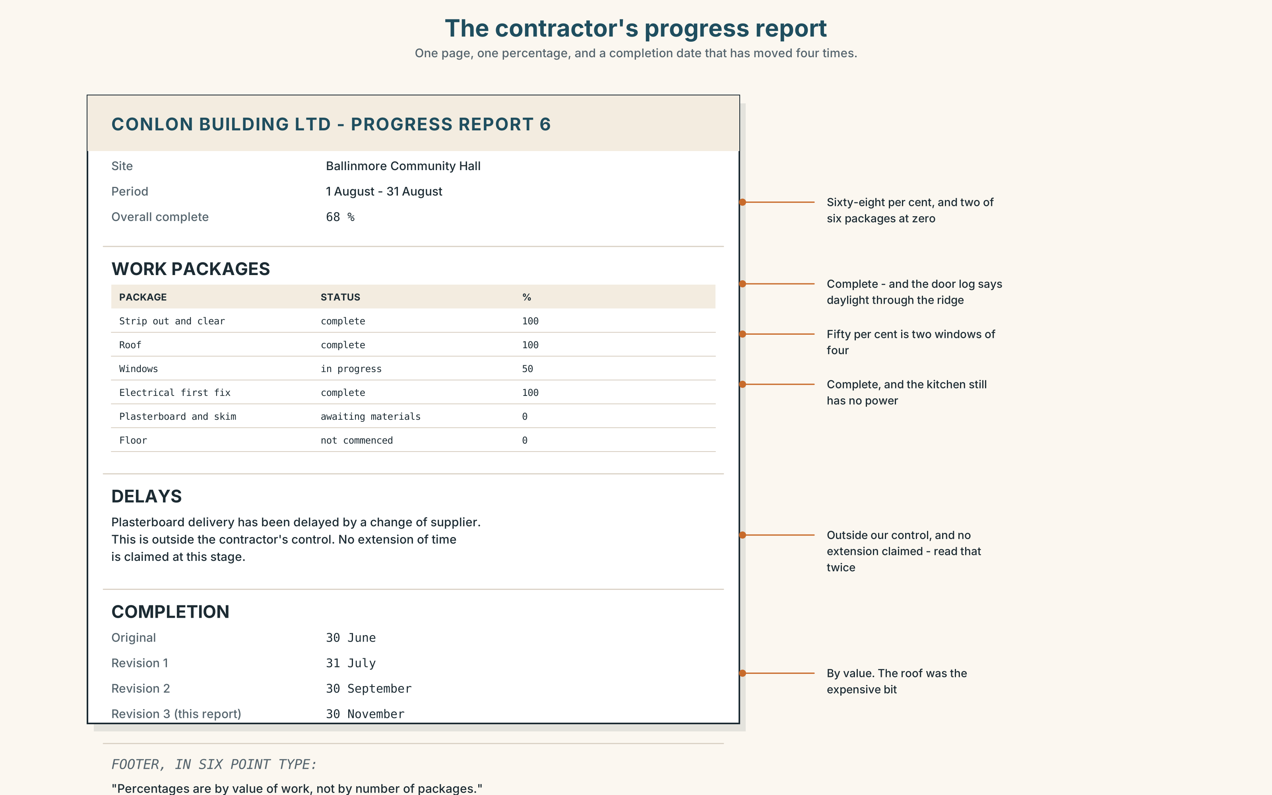{width=6.6in}
The contractor's progress report — One page, one percentage, and a completion date that has moved four times.
Read the contractor's progress report and answer.
- What percentage complete does the report claim?
- How does it describe the plasterboard delay, and whose fault does it say it is?
- Which three items does it mark as "complete" that the door log disputes?
- One line gives a new completion date. What is it, and how many times has it moved?

5F · Two texts
The door log says the only thing finished is the roof, and the roof is not finished. The progress report says 68 per cent complete.
Put those two facts together. How could both be honest? Two sentences.

Part 6 · Vocabulary Lab 2 ◆ B · THE SYSTEM

How long, and how often
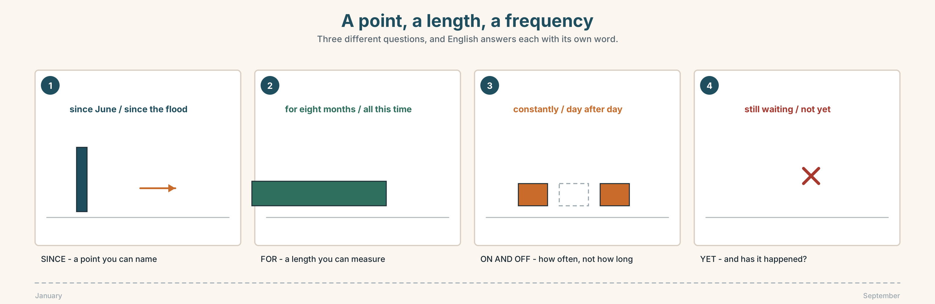{width=6.6in}
A point, a length, a frequency — Three different questions, and English answers each with its own word.

6A · Sort — a point, a length, or a frequency?
Three columns.
since · for · all week · lately · constantly · recently · throughout · on and off · day after day · non-stop · still · yet
A POINT | A LENGTH | HOW OFTEN

6B · Chunk completion
- We've been at it all this ______ .
- He's been on the phone ______ and off since Tuesday.
- They've been promising it day ______ day .
- It's rained ______ the whole month .
- She's ______ waiting — nothing has arrived.
- Has it come ______ ?

6C · Three that are nearly the same
lately · recently · still
Two of these go with the perfect. One of them means something else entirely.
Put one in each, and say why the other two would be wrong.
- Have you seen him ______ ?
- I've been very tired ______ .
- They're ______ waiting for the plasterboard.
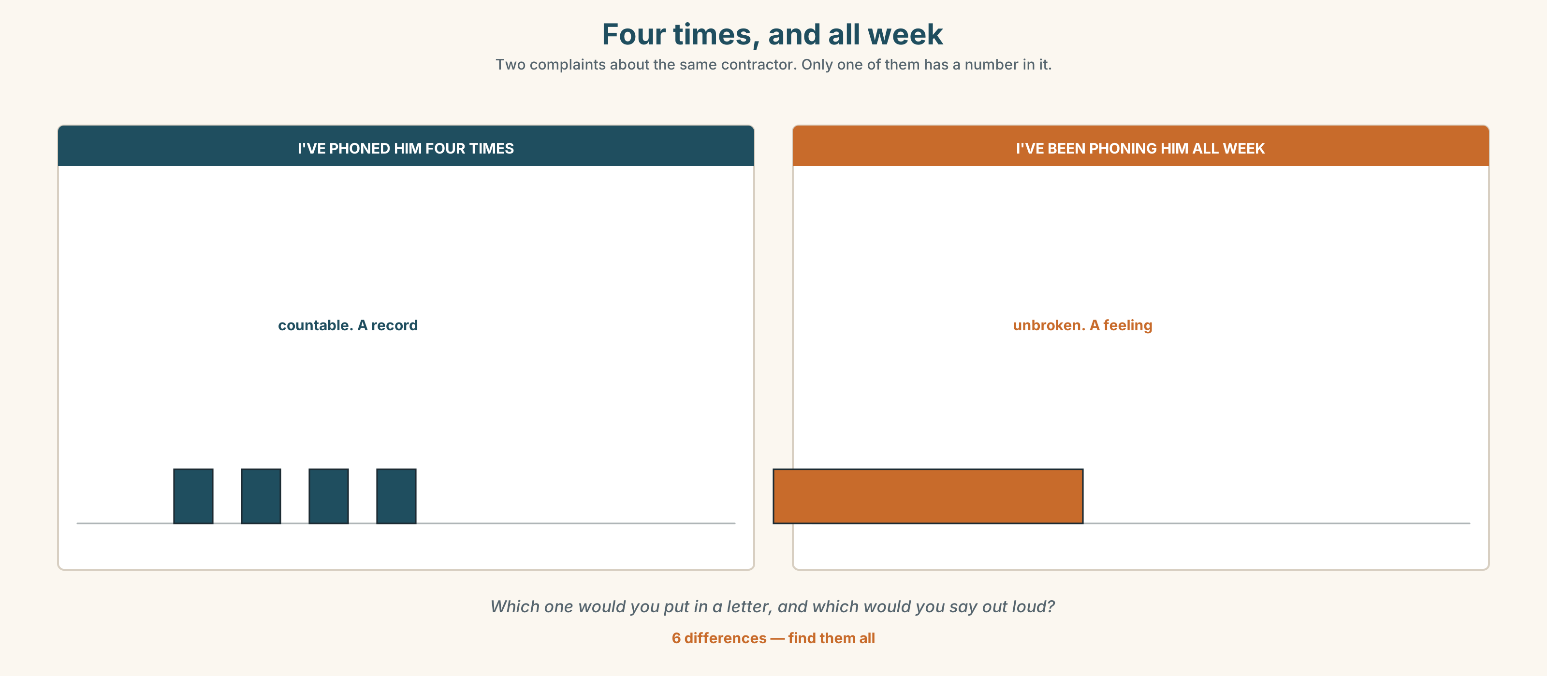{width=6.6in}
Four times, and all week — Two complaints about the same contractor. Only one of them has a number in it.
Six differences. Find them, then answer the question under the picture.

6D · Contrast Clinic — simple or continuous
Six items.
- I ______ (read) that book three times.
- I ______ (read) that book all week.
- They ______ (build) four of the six.
- They ______ (build) it since January.
- We ______ (own) this house for twenty years.
- How many times ______ you ______ (phone) him?

Part 7 · Pronunciation & Fluency Lab ◆ B · THE SYSTEM

The word in the middle
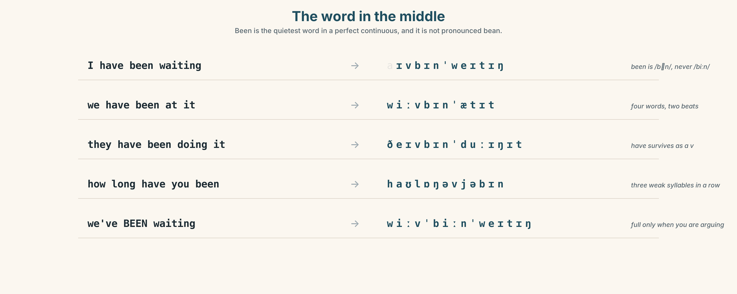{width=6.6in}
The word in the middle — Been is the quietest word in a perfect continuous, and it is not pronounced bean.

7A · Hear 🔊 Track 2.3
I have been waiting → I've been waiting → /aɪvbɪnˈweɪtɪŋ/ we have been at it → /wiːvbɪnˈætɪt/ they have been doing it → /ðeɪvbɪnˈduːɪŋɪt/
been is /bɪn/, not /biːn/. It is the quietest word in the sentence.

7B · Say
Say each one. Then say the sentence three times, faster:
We've been waiting for that plasterboard since June.

7C · Make it mean something
Say these two:
We've BEEN waiting. (and we are still waiting — you are arguing) We've been WAITING. (and that is all we have done)
Which one is a complaint about the other person, and which about the situation?

7D · Fluency 20 ⏺
Twenty seconds: three things you have been doing and three you have finished. Three times, faster.

Part 8 · Writing ◆ C · THE PERFORMANCE

Eight months, honestly · 100 words
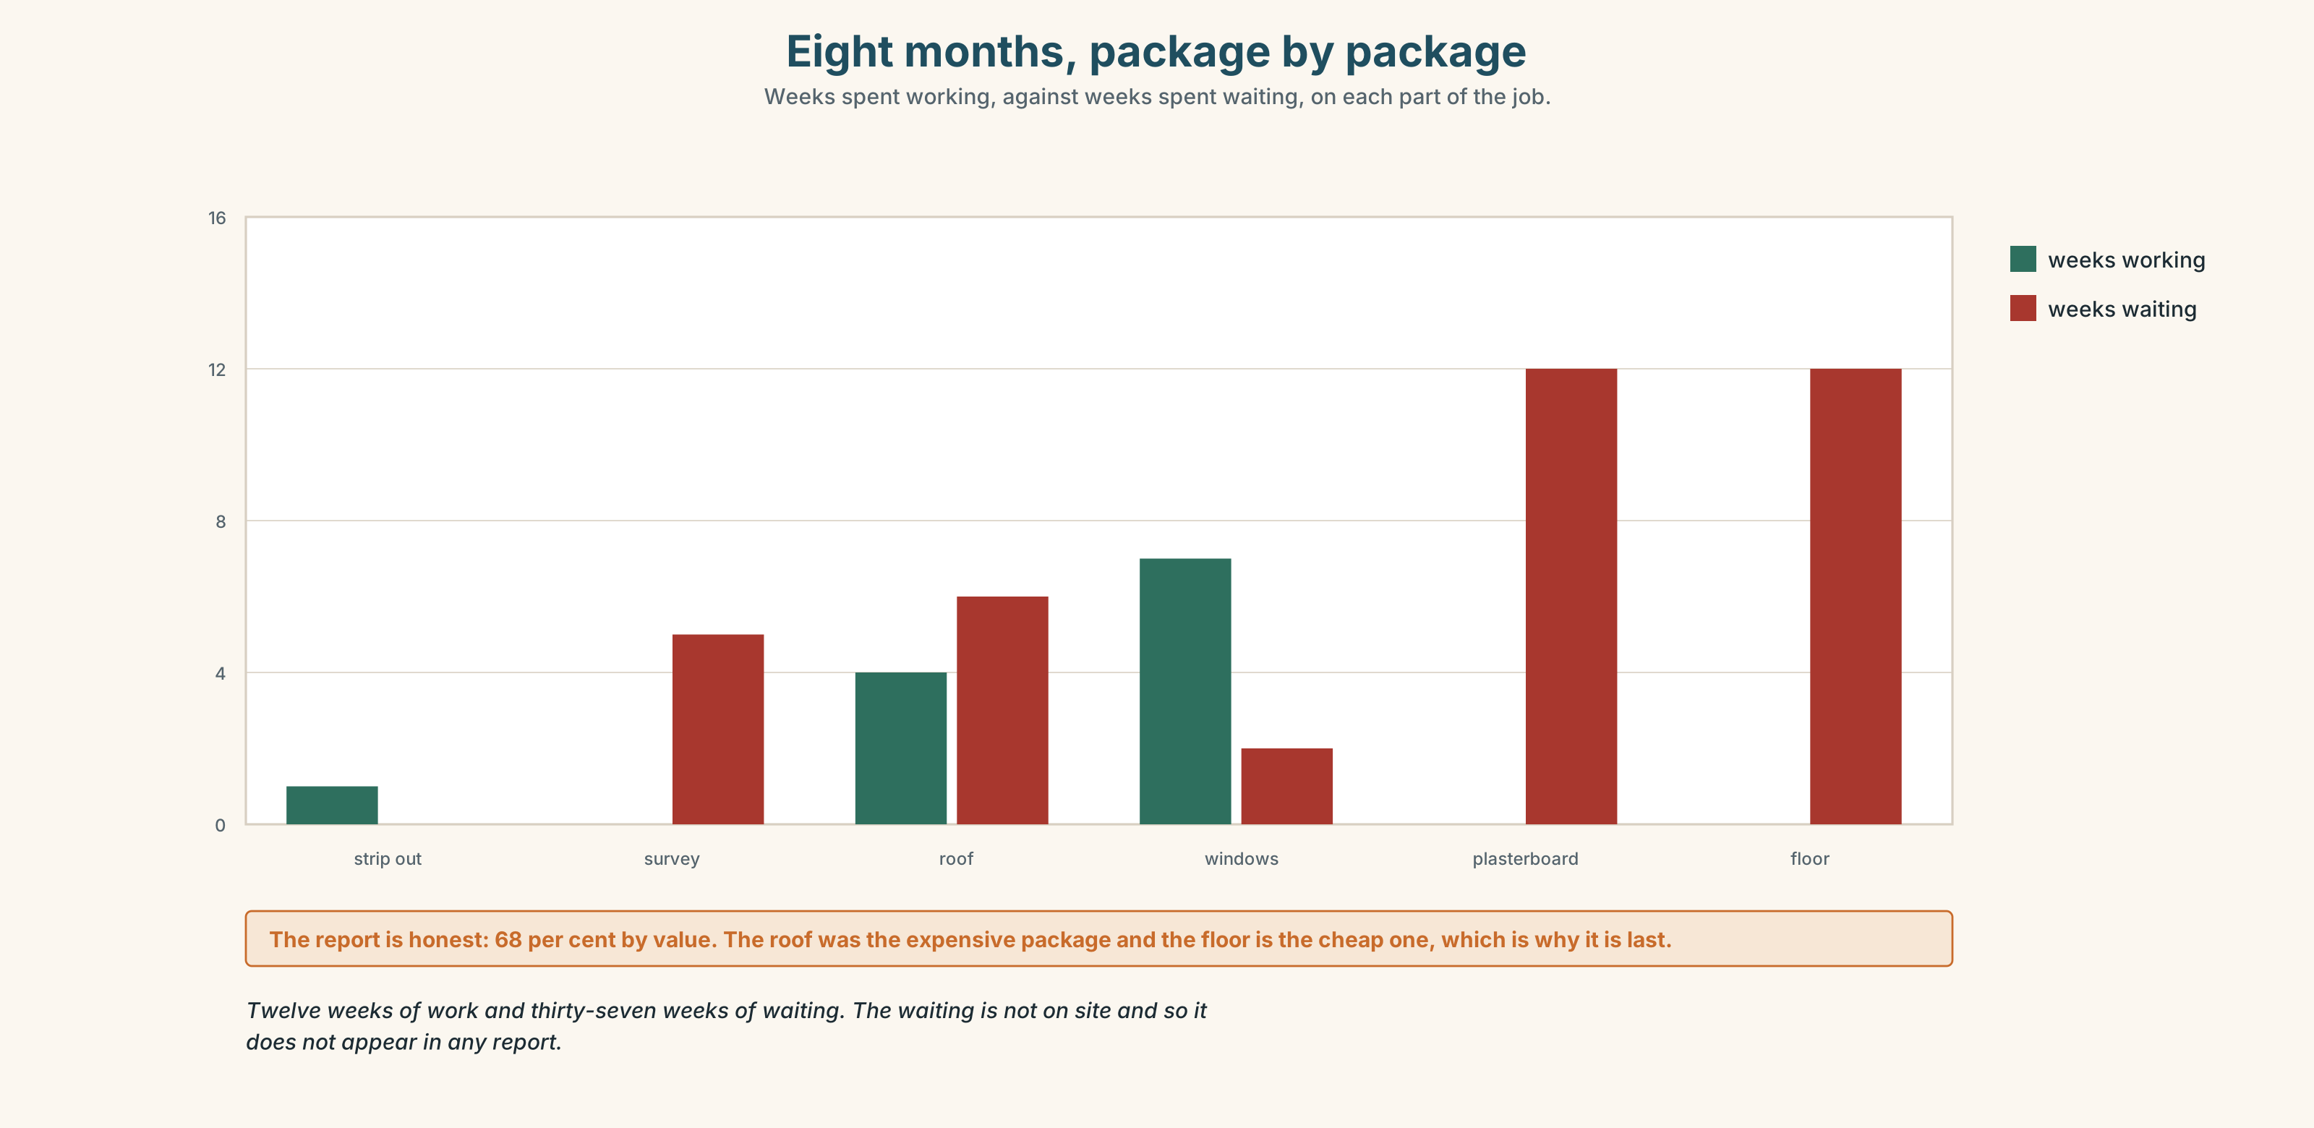{width=6.6in}
Eight months, package by package — Weeks spent working, against weeks spent waiting, on each part of the job.

8A · Read the model
The roof is finished. Two of the four windows are in. [what is done, with numbers — and this comes first, because it is the only part the reader can rely on]
We have been waiting for plasterboard since June, which is twelve weeks. The supplier changed in July and the order has been re-placed twice. [what is ongoing, with a length and the actual cause]
The floor has not started and will not start until the plasterboard arrives, so any date I give you for the floor is a date for the plasterboard. [what has not started, and an unusually honest sentence about estimates]
Questions about the writer's choices:
- The numbers are in the first paragraph and the lengths are in the second. Why that way?
- The last sentence refuses to give a date. Is that unhelpful?

8B · The anti-model
Work is progressing well and we are pleased with how things are going. There have been some delays due to circumstances beyond our control but we are working hard to get back on track and hope to be finished soon.
Correct English, and a reader learns nothing. Name three things it does not say.

8C · Plan
what is finished, with numbers → what is ongoing, with a length and a cause → what has not started → what any date actually depends on

8D · Write — 100 words

8E · Peer review — two criteria
☐ Is there at least one number and one length? ☐ Is the cause of the delay named, not just the delay?

8F · Write it again · 8G · Publish
On the wall, with the door log from Part 5B beside it.

Part 9 · The File ◆ A · THE WORLD + C · THE PERFORMANCE

STUDY FILE · Paraphrase & Citation
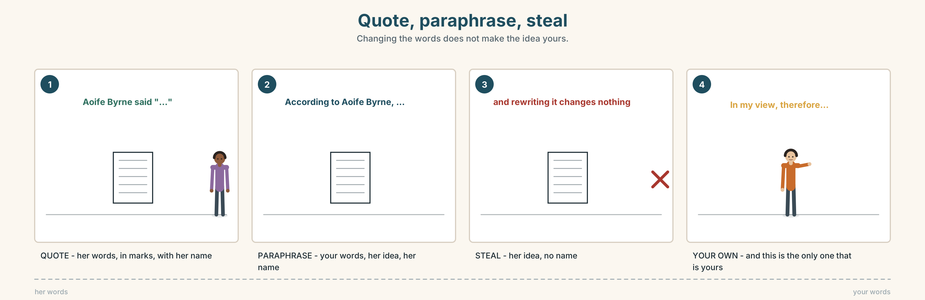{width=6.6in}
Quote, paraphrase, steal — Changing the words does not make the idea yours.

9A · The same sentence, four ways 🔊 Track 2.4
A national news channel has used Aoife's footage. Listen to four people describe what happened.
- Which one quotes her exactly?
- Which one changes the meaning while using her words?
- Which one is an honest paraphrase, and how can you tell?

9B · Quote, paraphrase, or steal
quoting — her words, in quotation marks, with her name paraphrasing — your words, her idea, with her name stealing — her words or her idea, without her name
Match each to one of these.
Aoife Byrne said the water "came up out of the drain, not over the wall". · According to Aoife Byrne, the water rose from the drain rather than coming over the wall. · The water came up out of the drain, not over the wall.

9C · Changing the words is not enough
Rewriting a sentence does not make the idea yours.
Which of these three still needs a name attached?
- The water rose from below rather than over the wall.
- Water entered the houses through the old storm drain.
- In my view, a higher wall would therefore have changed nothing.

9D · Your turn
Take the door log from Part 5B. Write three sentences about it: one quoting, one paraphrasing, one giving your own conclusion. Label each.

9E · Transfer
Find one news story this week that uses somebody's photograph or video. Is the person named? Bring the story.

Part 10 · Mediation & Interaction ◆ C · THE PERFORMANCE
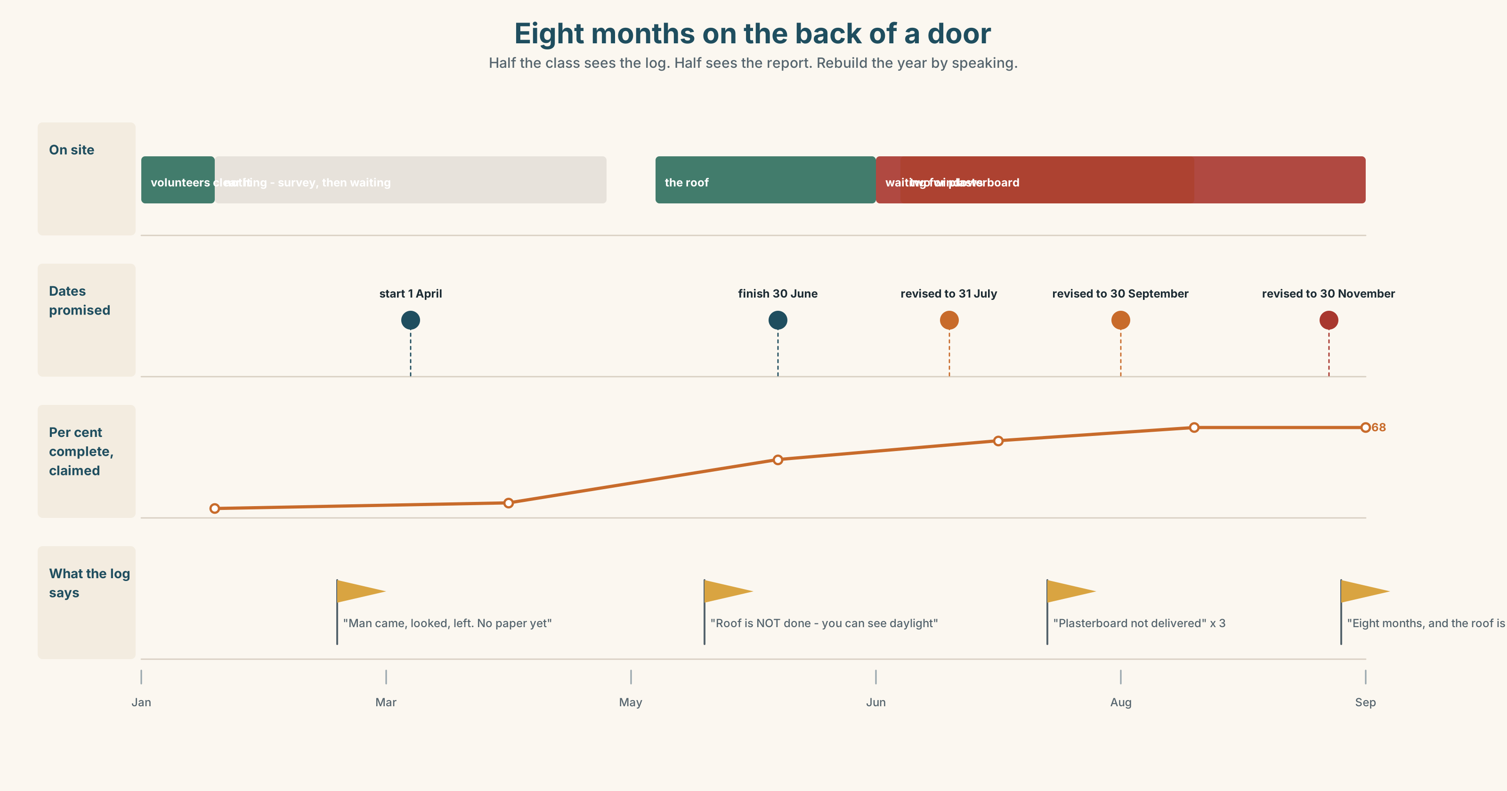{width=6.6in}
Eight months on the back of a door — Half the class sees the log. Half sees the report. Rebuild the year by speaking.

10A · Relay
Half the class sees the door log. Half sees the progress report. Rebuild eight months by speaking. Ten minutes.

10B · Simplify
Explain the contractor's progress report from Part 5E to a volunteer who has been doing the work. Four sentences only.
Plan: what it claims → what is actually done → where the two disagree → what to ask next

10C · Compress
The door log into thirty-five words, for the council.

10D · Online
Write one message to the hall committee: here is what is finished, here is what is waiting on one supplier, and here is the one date you want from the contractor by Friday.

10E · Your language
How does your language distinguish I have done it from I have been doing it? Does it, at all? Show a partner both in your language.

Part 11 · The Decision ◆ C · THE PERFORMANCE

Her footage, their broadcast
A national news channel has been using Aoife's phone footage of the flood for eight months. Nobody asked her. The coverage has brought in about 90,000 in donations to the town.
- Say nothing. The money is real. She is eighteen and does not want a fight.
- Ask for a credit. Her name on the footage. No money. It is still her work.
- Ask to be paid. The channel has a rate card for user footage. It is about 250 a clip, and they have used four.

11A · The evidence
- The progress report from Part 5E — what the donations have actually paid for.
- The chart — donations over the eight months, against each broadcast.
- The voice. Aoife, twenty seconds: "I've been watching it on the television since January. I don't mind. What I mind is that my mother is in one of those clips and nobody asked her either, and she is not eighteen and she did not film anything."

11B · Talk about it
In threes. Everybody says one. Use the frame.
I think Aoife should ______ , because ______ .
Words you can use: fair · her work · donations · credit · ask · permission · progress · funding

11C · Decide
Write two sentences. Choose, and say why.
I think Aoife should ______________________ , because ______________________ .

11D · Model decision
She should ask for the credit and raise her mother separately, in writing, as a different question. Mixing the two makes both easy to refuse: the credit is a small thing a producer can grant in an afternoon, and the consent is a thing a lawyer has to look at. Asked together they will be answered together, which means slowly.

11E · The Reveal
What happened. She asked for the credit by email on a Tuesday and had it by Friday. Her name has been on the footage since.
She raised her mother in a separate letter. That took eleven weeks and three people, and ended with the clip being edited rather than removed, which her mother says she is fine with and Aoife is not sure about.
She has not asked to be paid. She says that if she had asked for money first, she does not think she would have got the credit.
The small ask worked in three days. The important one took eleven weeks and was half met.
Was it the right decision? Say why — and say whether she should ask for the money now.

Part 12 · Landing ◆ all three lines

12A · Recycle — ten items
- We ______ (wait) since June.
- I ______ (phone) him four times.
- It's nowhere ______ finished.
- We're four months behind ______ .
- They've been at it day ______ day .
- (Unit 1) If I ______ you, I wouldn't wait.
- (Unit 1) I'd ______ look foolish than lose a car.
- (A2.1 U1) I've worked here ______ three years.
- (A2.1 U4) The person ______ has the key is the caretaker.
- (A2.1 U7) The hall ______ (build) in 1961.

12B · Consolidate
One hundred words. A long job you know about. What is finished, with numbers; what is ongoing, with a length; what has not started; and what is holding it up.

12C · Can-do, with evidence
I can… | My evidence | Sure?
use the right perfect form for results and for activity | Part 3G score | ◯ ◑ ●
report eight months of work in a hundred seconds | Part 4C recording | ◯ ◑ ●
write a hundred words a committee could act on | Part 8 draft 2 | ◯ ◑ ●
quote, paraphrase and tell the difference | Part 9D sentences | ◯ ◑ ●

12D · Replay ⏺
Find your thirty seconds from Part 0C. Listen. Record it again. One sentence: what is different?

12E · Glossary — forty items, as a map
THE JOB · repair · rebuild · clear · fix · finish · site · scaffolding · contractor · council · funding · volunteer HOW IT IS GOING · progress · ongoing · slow · steady · temporary · get on with · bit by bit · it's getting there WHEN IT IS NOT · delay · nowhere near · behind schedule · hold up HOW LONG · since · for · throughout · all this time · all week · we've been at it HOW OFTEN · constantly · non-stop · on and off · day after day · ever · carry on WHERE IT STANDS · lately · recently · still · finally · yet

12F · Next
Unit 3 · What happened before that?

