Table of Contents

A2.2 · Unit 3 · Who Was Warned, and When
English Animated · Telling the Story · Ballinmore, west coast of Ireland Student's Book pages 50–71 · 22 pp · ~10 hours

Part 0 · The Big Picture ◆ A · THE WORLD
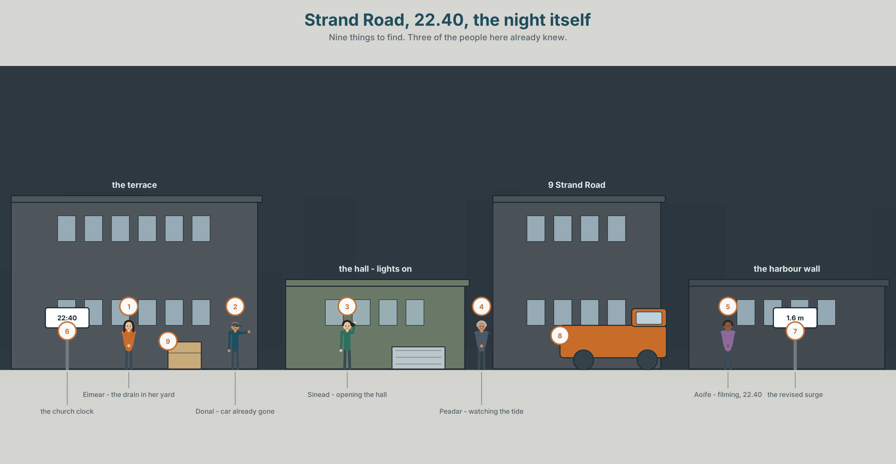{width=6.6in}
Strand Road, 22.40, the night itself — Nine things to find. Three of the people here already knew.

What happened before that?
By the end of this unit you can give a clear account of one night, with the events in the right order. One hundred words.
◆ A · THE WORLD | An inquiry, and the difference between what happened and what was known
◆ B · THE SYSTEM | the past perfect · by the time, already, before · 23 words for cause and blame · 17 words for putting things in order · had as /həd/ and /əd/
◆ C · THE PERFORMANCE | A hundred words that put one night in the right order

0A · Find it
Find nine things in this picture. It is the night, not the morning.
the top road · a car being moved · the drain in the yard · the hall lights on · a phone screen · a torch · the harbour wall · the tide line · the church clock

0B · Guess it
Three of the people in this picture already knew. Which three, and how?

0C · Say it ⏺
Record thirty seconds. Think of something that went wrong. What had happened before it, that nobody connected at the time? You will record it again at the end of this unit.

Part 1 · Vocabulary Lab 1 ◆ B · THE SYSTEM
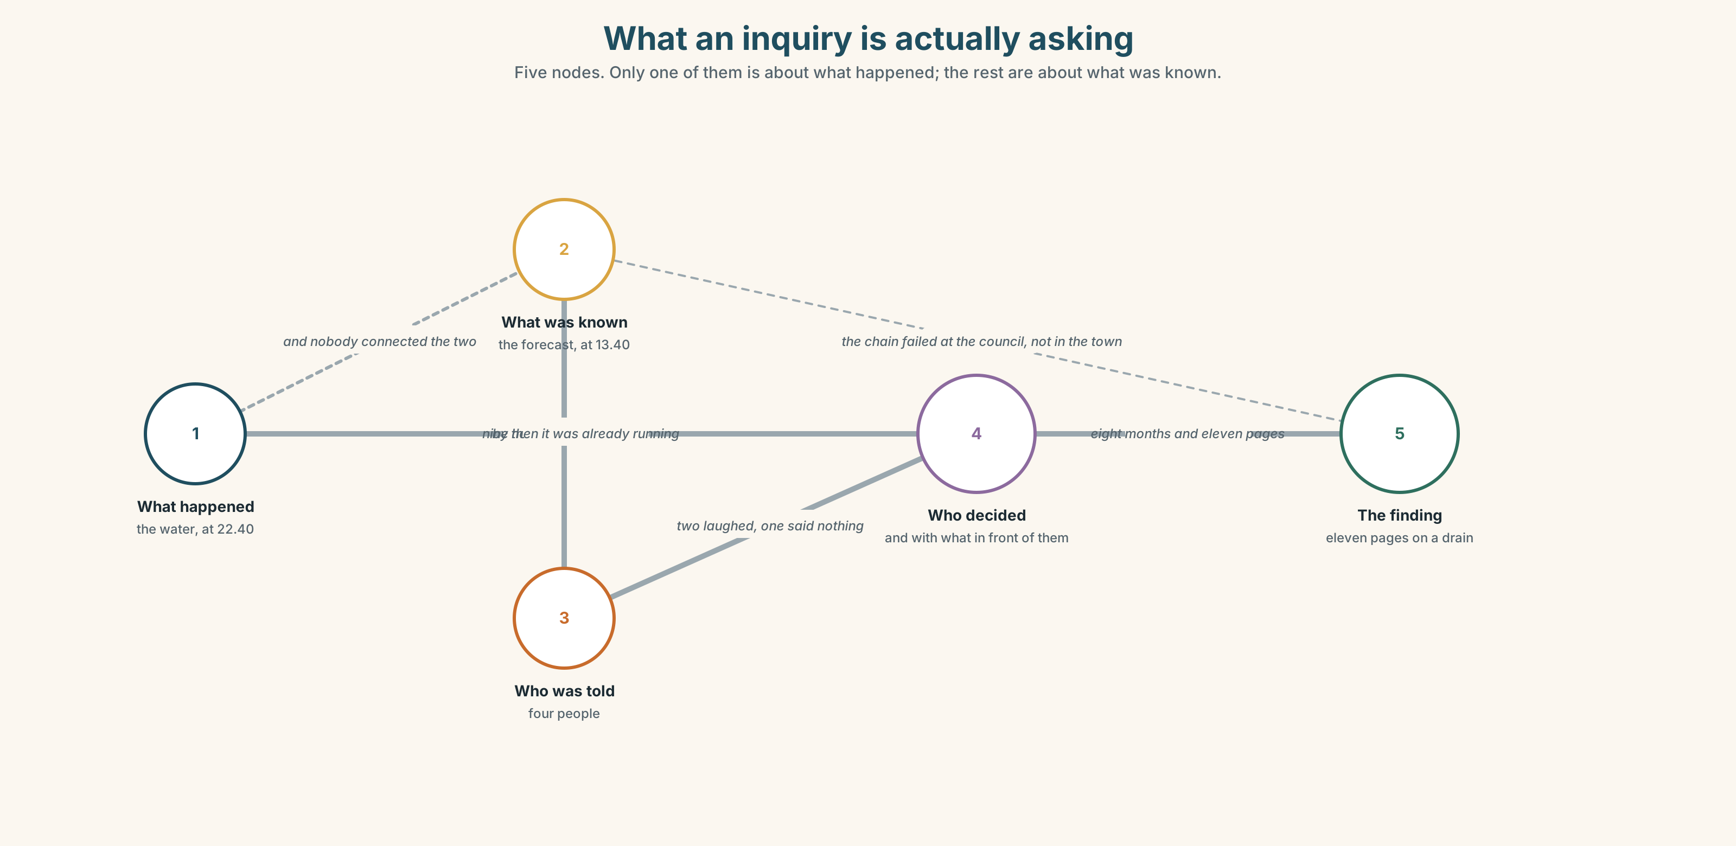{width=6.6in}
What an inquiry is actually asking — Five nodes. Only one of them is about what happened; the rest are about what was known.

1A · Meet — the words of an inquiry
Match each word to one place on the map.
cause · blame · fault · inquiry · evidence · witness · report · record · official · responsible

1B · Sort — a fact, a judgement, or a procedure?
Three columns.
evidence · blame · inquiry · fault · witness · responsible · record · cause · minute · report
One of them moves column the moment somebody writes it down. Which?

1C · Meet — what people did and did not do
warn · ignore · decide · mistake
Warning somebody is not the same as being believed. Which of the four is about the speaker, and which about the listener?
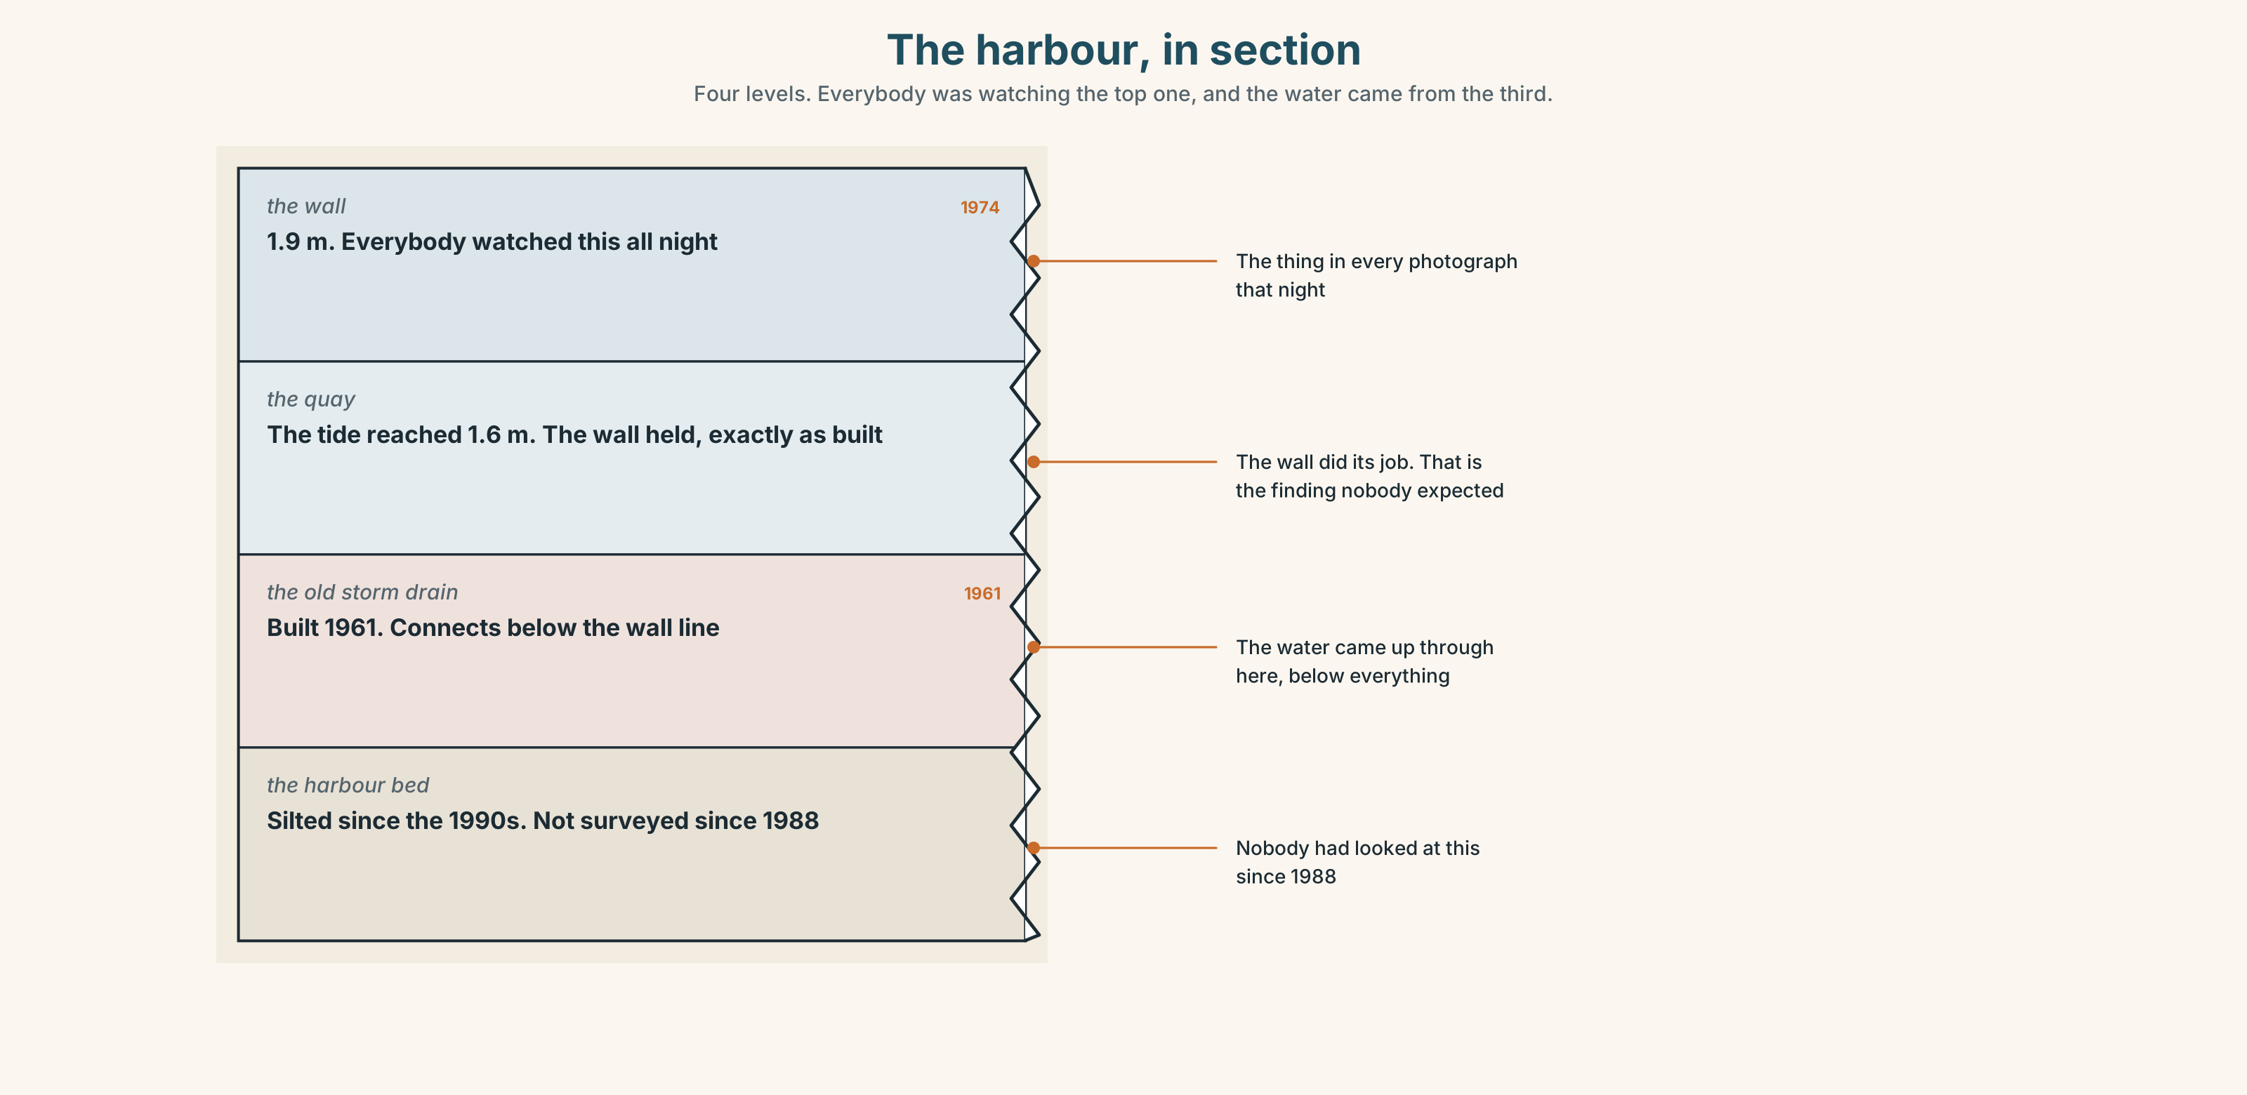{width=6.6in}
The harbour, in section — Four levels. Everybody was watching the top one, and the water came from the third.
Look at the harbour, in section. Four levels, and the water came from one of them. Which one, and which level was everybody watching?

1D · Stretch — the phrases
Complete each one with one word.
- The council has agreed to look ______ it.
- They put it ______ to bad luck, because nobody wanted to say the word drain.
- At the ______ , it looked like an ordinary high tide.
- In ______ , the Thursday forecast was the whole story.
- It took eleven months to find ______ what had actually happened.

1E · The saying
f Nobody saw it coming.
Four words that are almost always false, and almost always said in good faith.
Donal saw it coming. Write the sentence he could say at the inquiry — and then write the reason he might not.

1F · Own it
Think of something that was predicted and ignored where you live. Tell a partner three sentences: who said it, who did not listen, and what happened.

Part 2 · Listening ◆ A · THE WORLD
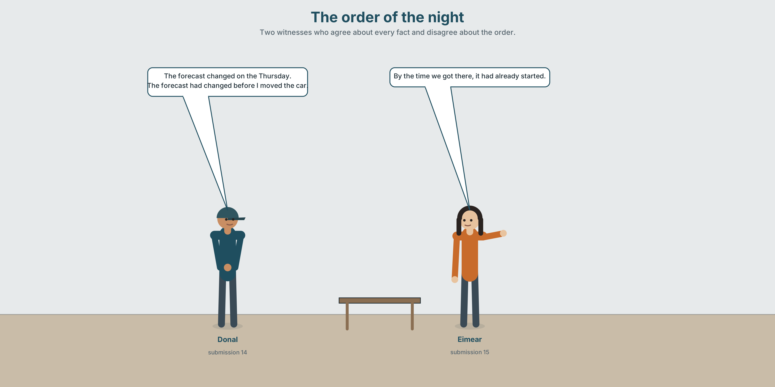{width=6.6in}
The order of the night — Two witnesses who agree about every fact and disagree about the order.

2A · The order of the night 🔊 Track 3.1
Before you listen. The inquiry wants to know who was warned and when. Guess: is the disagreement about the facts or about the order?
Listen once. One question. What time did the drain reverse?
Listen again. Put these in order. Write 1 to 6.
☐ the hall opened · ☐ the drain reversed · ☐ Donal moved his car · ☐ the forecast changed · ☐ the water reached the doors · ☐ Eimear decided not to use the sandbags
Listen again. True or false?
- The forecast had already changed when Donal moved his car. ☐ T ☐ F
- The hall had opened before the water reached the doors. ☐ T ☐ F
- Eimear decided about the sandbags after Donal moved his car. ☐ T ☐ F
- The drain reversed before anybody noticed the tide. ☐ T ☐ F
Noticing. Four sentences from the recording.
- The forecast changed on the Thursday.
- The forecast had changed before he moved the car.
- By the time we got there, it had already started.
- She decided about the sandbags after he had moved it.
One of these is a plain past. Three put one past event before another. Which is which?

2B · Decoding clinic 🔊 Track 3.2
Twenty-five seconds. Four jobs.
- How many times can you hear had?
- In it had already started, is had a full word or a sound on the end of it?
- Catch the two times given.
- One speaker corrects their own order. Where?
Transcripts, page 152.

Part 3 · Grammar Lab 1 ◆ B · THE SYSTEM

The past before the past

3A · Notice
Look at the four sentences in Part 2.
- Sentence 1 and sentence 2 are about the same forecast. What does sentence 2 add?
- In sentence 3, which happened first — arriving, or starting?
- In sentence 4, could you use a plain past? Would anything be lost?
- When do you actually need the past perfect? Try: First he moved the car. Then it flooded.
- Try "By the time we got there, it already started." What is missing?

3B · See
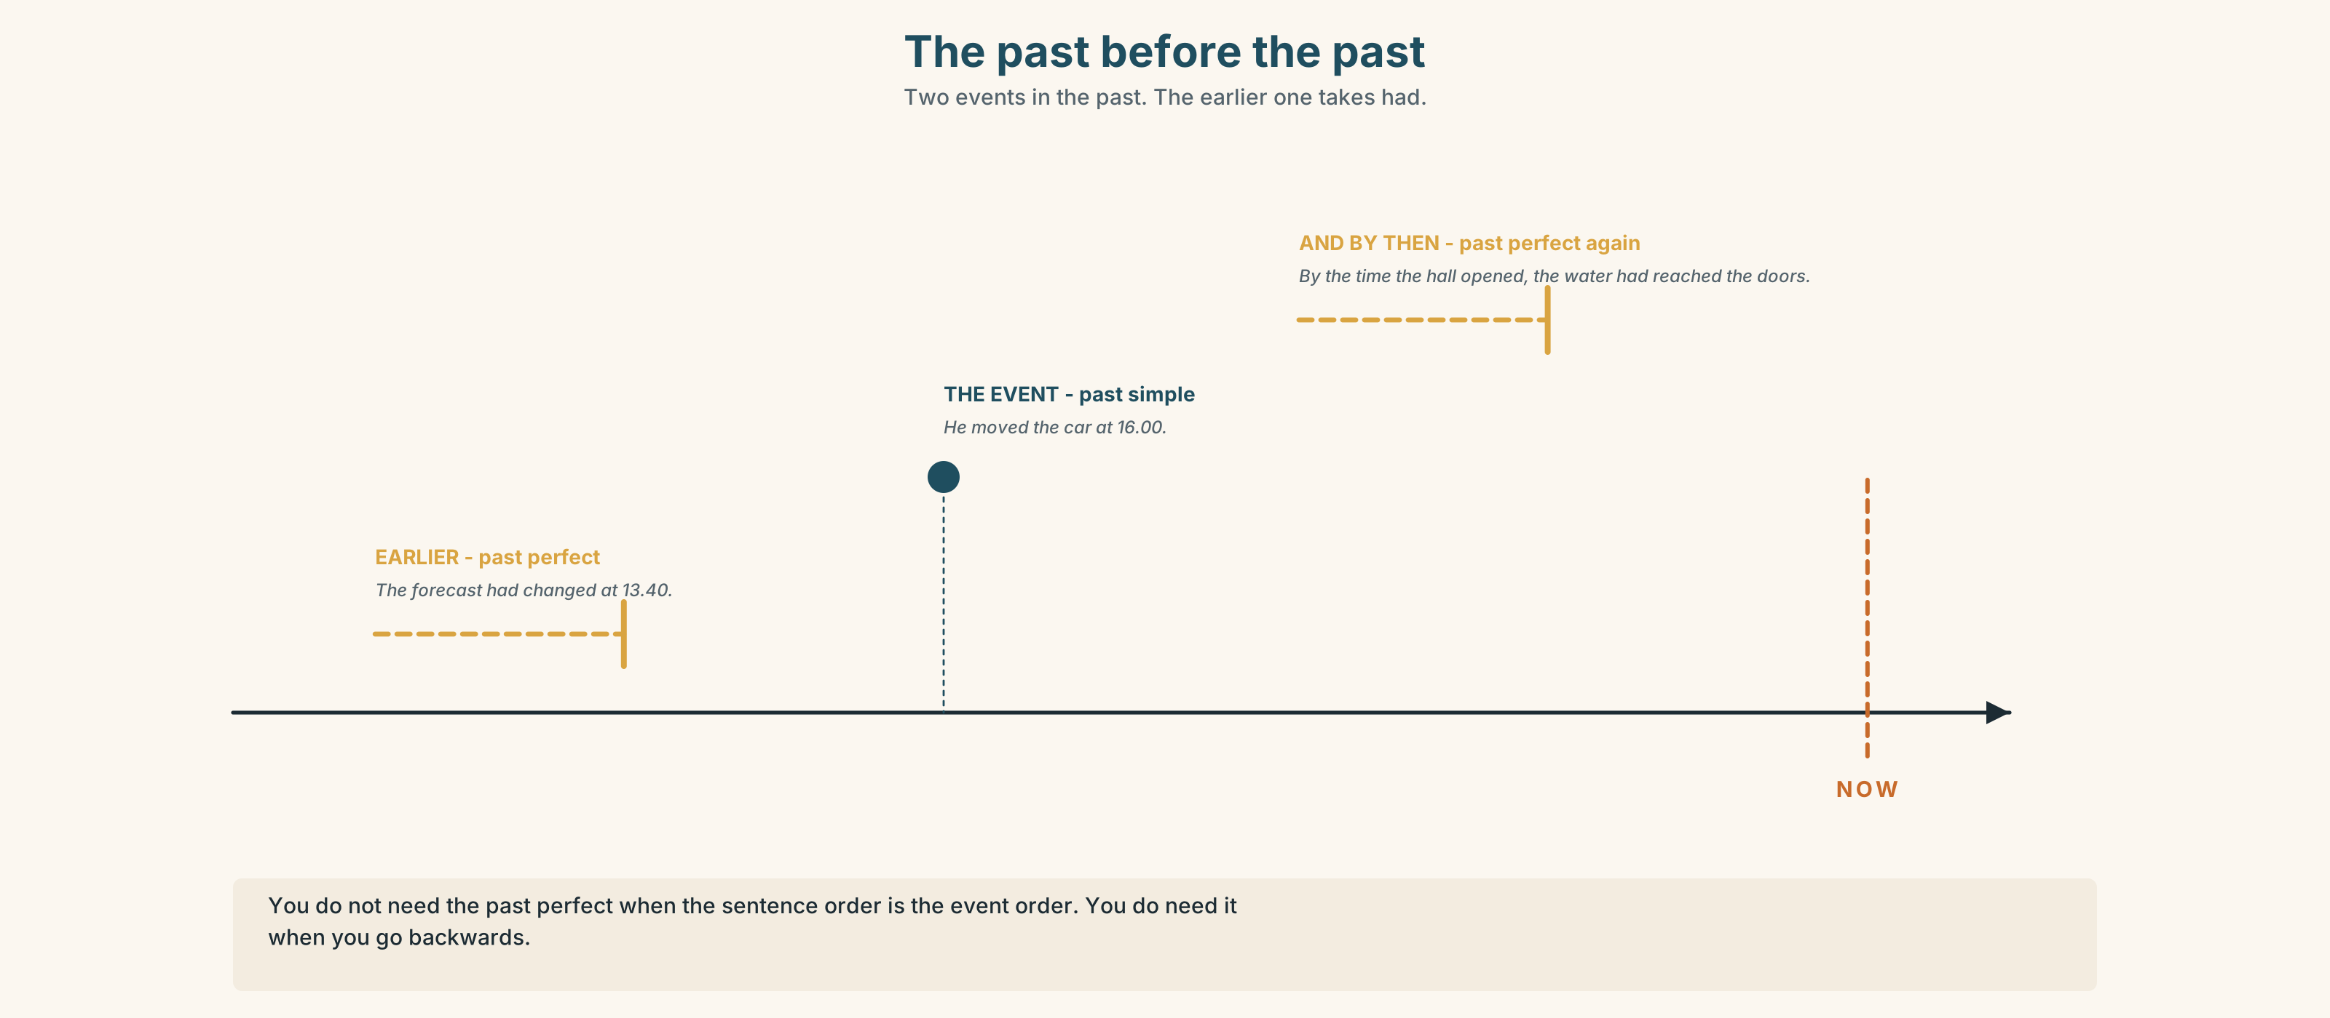{width=6.6in}
The past before the past — Two events in the past. The earlier one takes had.
Now look at the second picture. Two events, one line. Which one gets the had?
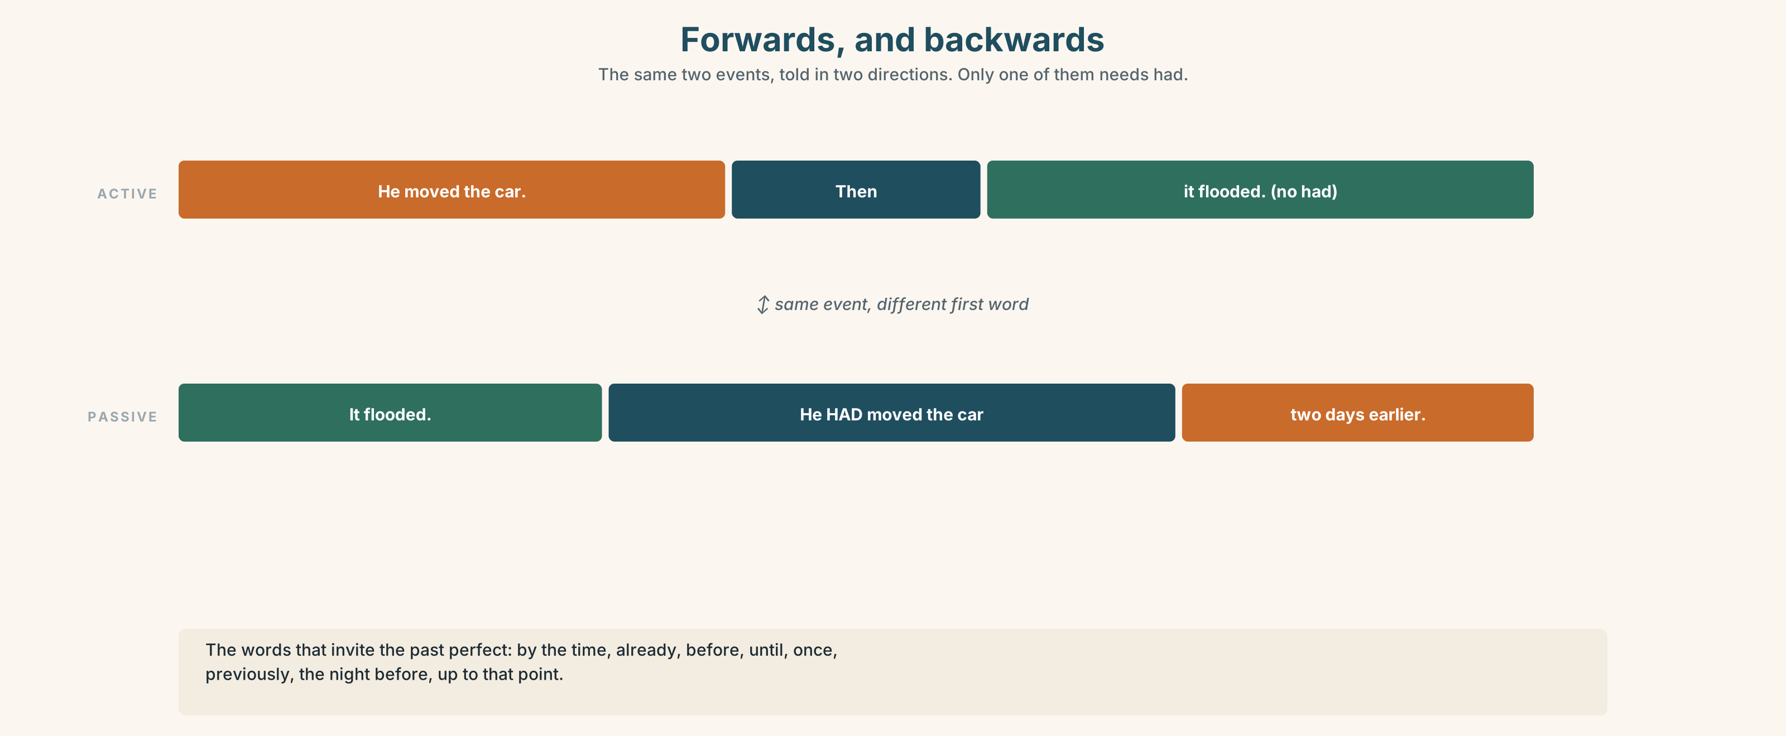{width=6.6in}
Forwards, and backwards — The same two events, told in two directions. Only one of them needs had.

3C · Know
 | Shape | Use it for
past simple | moved, changed, decided | events in the order they happened
past perfect | had + past participle | an event before the one you are already talking about
You do not need it when the order is already clear. ✓ He moved the car. Then it flooded. — the order is the sentence order. You do need it when you go backwards. ✓ It flooded. He had moved the car two days earlier.
The words that invite it: by the time · already · before · until · once · previously · the night before · up to that point
Watch out. had is the auxiliary for everybody. ✗ he hadded ✓ he had moved And in speech it is almost never a full word: it'd already started.
Why it matters. An inquiry is not asking what happened. It is asking what had already happened when each person decided.

3D · Use — controlled
By the time the hall opened, the water (1) __________ (already / reach) the doors. Donal (2) __________ (move) his car on the Thursday, two days before, because the forecast (3) __________ (change) that morning. Eimear (4) __________ (decide) against the sandbags after he (5) __________ (move) it, and she says now that she (6) __________ (not know) the forecast (7) __________ (change) at all.

3E · Use — guided
Join each pair, putting the earlier event in the past perfect.
- The forecast changed. / He moved the car.
- The drain reversed. / Anybody noticed the tide.
- She put the sandbags in the shed in 2019. / The water came in January.
- The hall opened. / The first family arrived.
- He warned four people. / Nobody acted.

3F · Use — open
Tell a partner about something that went wrong — anywhere, any time. Give the event first, then go backwards to what had already happened. Use had three times.

3G · Check — six items
- By the time we arrived, it ______ (already / start).
- He moved the car because the forecast ______ (change).
- She ______ (keep) the sandbags since 2019.
- Up to that point nobody ______ (say) anything.
- Once the drain ______ (reverse), there was nothing to be done.
- The night ______ , he ______ (warn) four people.
0–3 → Workbook pp. 16–18. 4–5 → Part 6. 6 → page 63.

Part 4 · Speaking ◆ C · THE PERFORMANCE

4A · Fluency starter — backwards
One learner names an event. The next must say what had happened before it. The next goes one step further back. Five steps, then stop.
"The hall opened." → "The water had already reached the doors." → "The drain had reversed." → …

4B · The functional core — giving an account
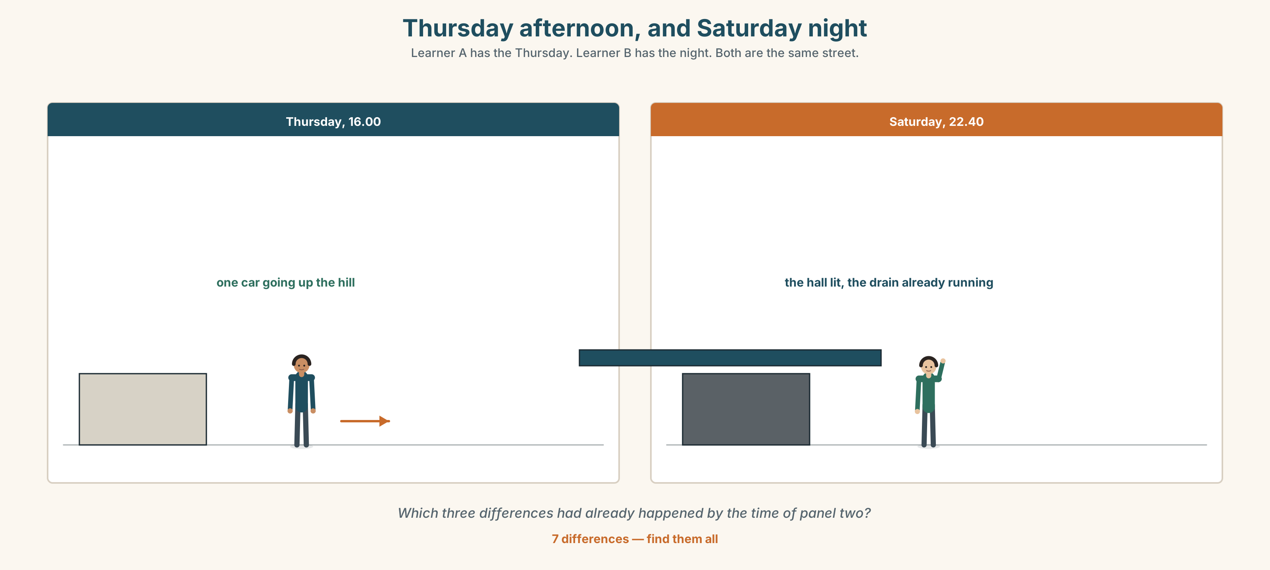{width=6.6in}
Thursday afternoon, and Saturday night — Learner A has the Thursday. Learner B has the night. Both are the same street.
Language Bank
the event | At about ten… · That was when…
before it | By then… · It had already… · The night before…
the order | Before that… · Afterwards… · Up to that point…
the honest gap | I don't know what had happened by then. · I only found out later.
Role play. Learner A is giving evidence. Learner B is asking the questions. Six minutes. Learner B may only ask when and what had happened by then.

4C · The performance — one hundred seconds ⏺
Give an account of one night — real or from the unit. One hundred seconds. You must give:
six events, in order · at least three things that had already happened · one thing you did not know at the time
Record it.

4D · Observer
One person listens for one thing: could they draw the timeline from what they heard?

4E · Two criteria
☐ Did I use the past perfect at least three times? ☐ Is there one thing I did not know at the time, marked as such?

Part 5 · Reading ◆ A · THE WORLD

5A · Predict
Two letters to the inquiry. The title is "Submissions 14 and 15." What do you expect two neighbours to disagree about? One sentence.

5B · Read — one hundred and ten seconds

SUBMISSION 14 — D. Hegarty, 9 Strand Road
I moved my car to the top road at about four on the Thursday afternoon. I did it because the forecast had changed that morning — the surge had gone from 1.1 metres to 1.6 — and because the yard drain had backed up twice in November.
I told four people. I am not going to say which four. Two of them laughed, and I want to be clear that they laughed kindly and that I would have laughed too.
I am not submitting this to blame anybody. I am submitting it because the inquiry has asked whether anybody was warned, and the honest answer is that four people were warned by me and at least eleven were not warned by anybody, and the reason is that I did not want to be the man knocking on doors about a forecast.

SUBMISSION 15 — E. Nolan, 14 Strand Road
I was one of the four.
I did not laugh. I thought about the sandbags and decided against them, and I decided against them partly because of how the other two had reacted.
I want to record that Donal Hegarty was right and was treated as though he were being silly, and that I joined in by saying nothing. That is the part I would like in the record, and I understand that it is not evidence of anything.
I would also like to say that if he had knocked on eleven doors, I do not think it would have made any difference, and I am saying that because I do not want this to become a story about one man who should have done more.

5C · Answer
- Why did Donal move his car? Give both reasons.
- How many people did he tell, and how did two of them react?
- Why does he say he did not knock on more doors?
- What does Eimear say she did, and what does she say she did not do?
- What does she ask to have put in the record, and why does she say it is not evidence?
- What is her last point, and who is it protecting?

5D · Vocabulary in context
Guess from the text. Then check.
surge · backed up · laughed kindly · joined in by saying nothing · would have made any difference

5E · The counter-text
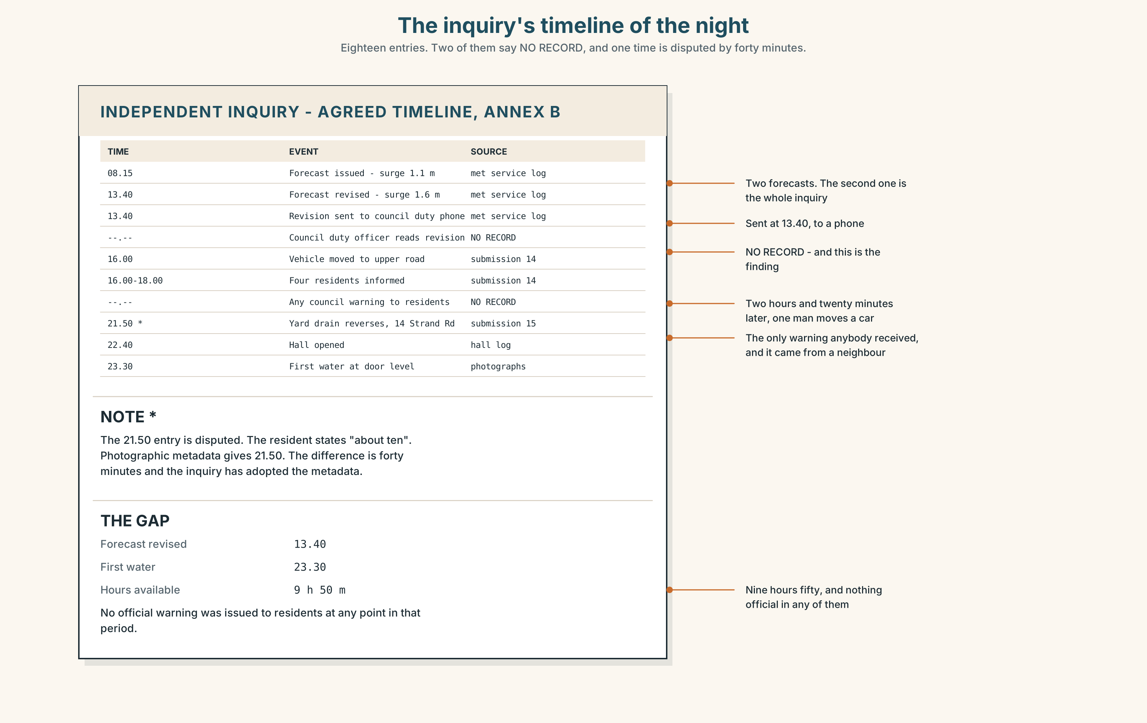{width=6.6in}
The inquiry's timeline of the night — Eighteen entries. Two of them say NO RECORD, and one time is disputed by forty minutes.
Read the inquiry's timeline of the night and answer.
- What time did the forecast change, and what time did the drain reverse?
- How many hours were there between the forecast change and the first water?
- Which two entries are marked "no record"?
- One entry has a footnote saying the time is disputed. Which, and by how much?

5F · Two texts
Donal's submission says the forecast changed that morning. The inquiry timeline records the forecast change at 13.40.
Put those two facts together. Does it matter? Two sentences.

Part 6 · Vocabulary Lab 2 ◆ B · THE SYSTEM

Putting things in order
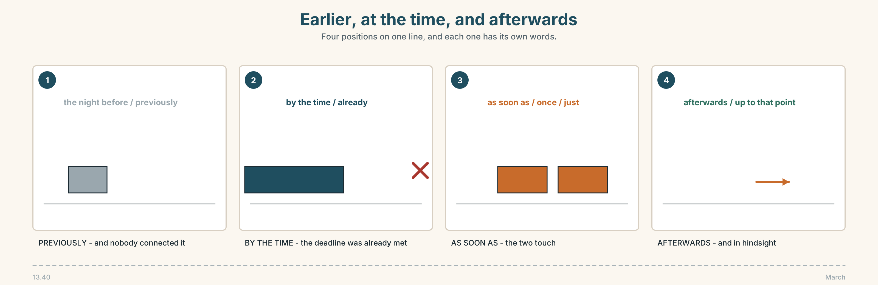{width=6.6in}
Earlier, at the time, and afterwards — Four positions on one line, and each one has its own words.

6A · Sort — earlier, same time, or later?
Three columns.
before · after · already · by the time · previously · once · then · afterwards · the night before · until · just · up to that point

6B · Chunk completion
- By the ______ we got there, it had started.
- As ______ as the drain reversed, he knew.
- He had moved it the night ______ .
- Up to that ______ , nobody had said anything.
- They went back ______ the forecasts for the whole week.
- It had ______ started when the hall opened.

6C · Two that look the same
before and by the time both put one thing earlier. They are not interchangeable.
He moved it before the forecast changed. — one thing, then the other. By the time the forecast changed, he had moved it. — the deadline, and it was already met.
Rewrite these three with by the time.
- He had already left when she phoned.
- The hall was full when the last family arrived.
- Nobody had read the notice when the vote was taken.
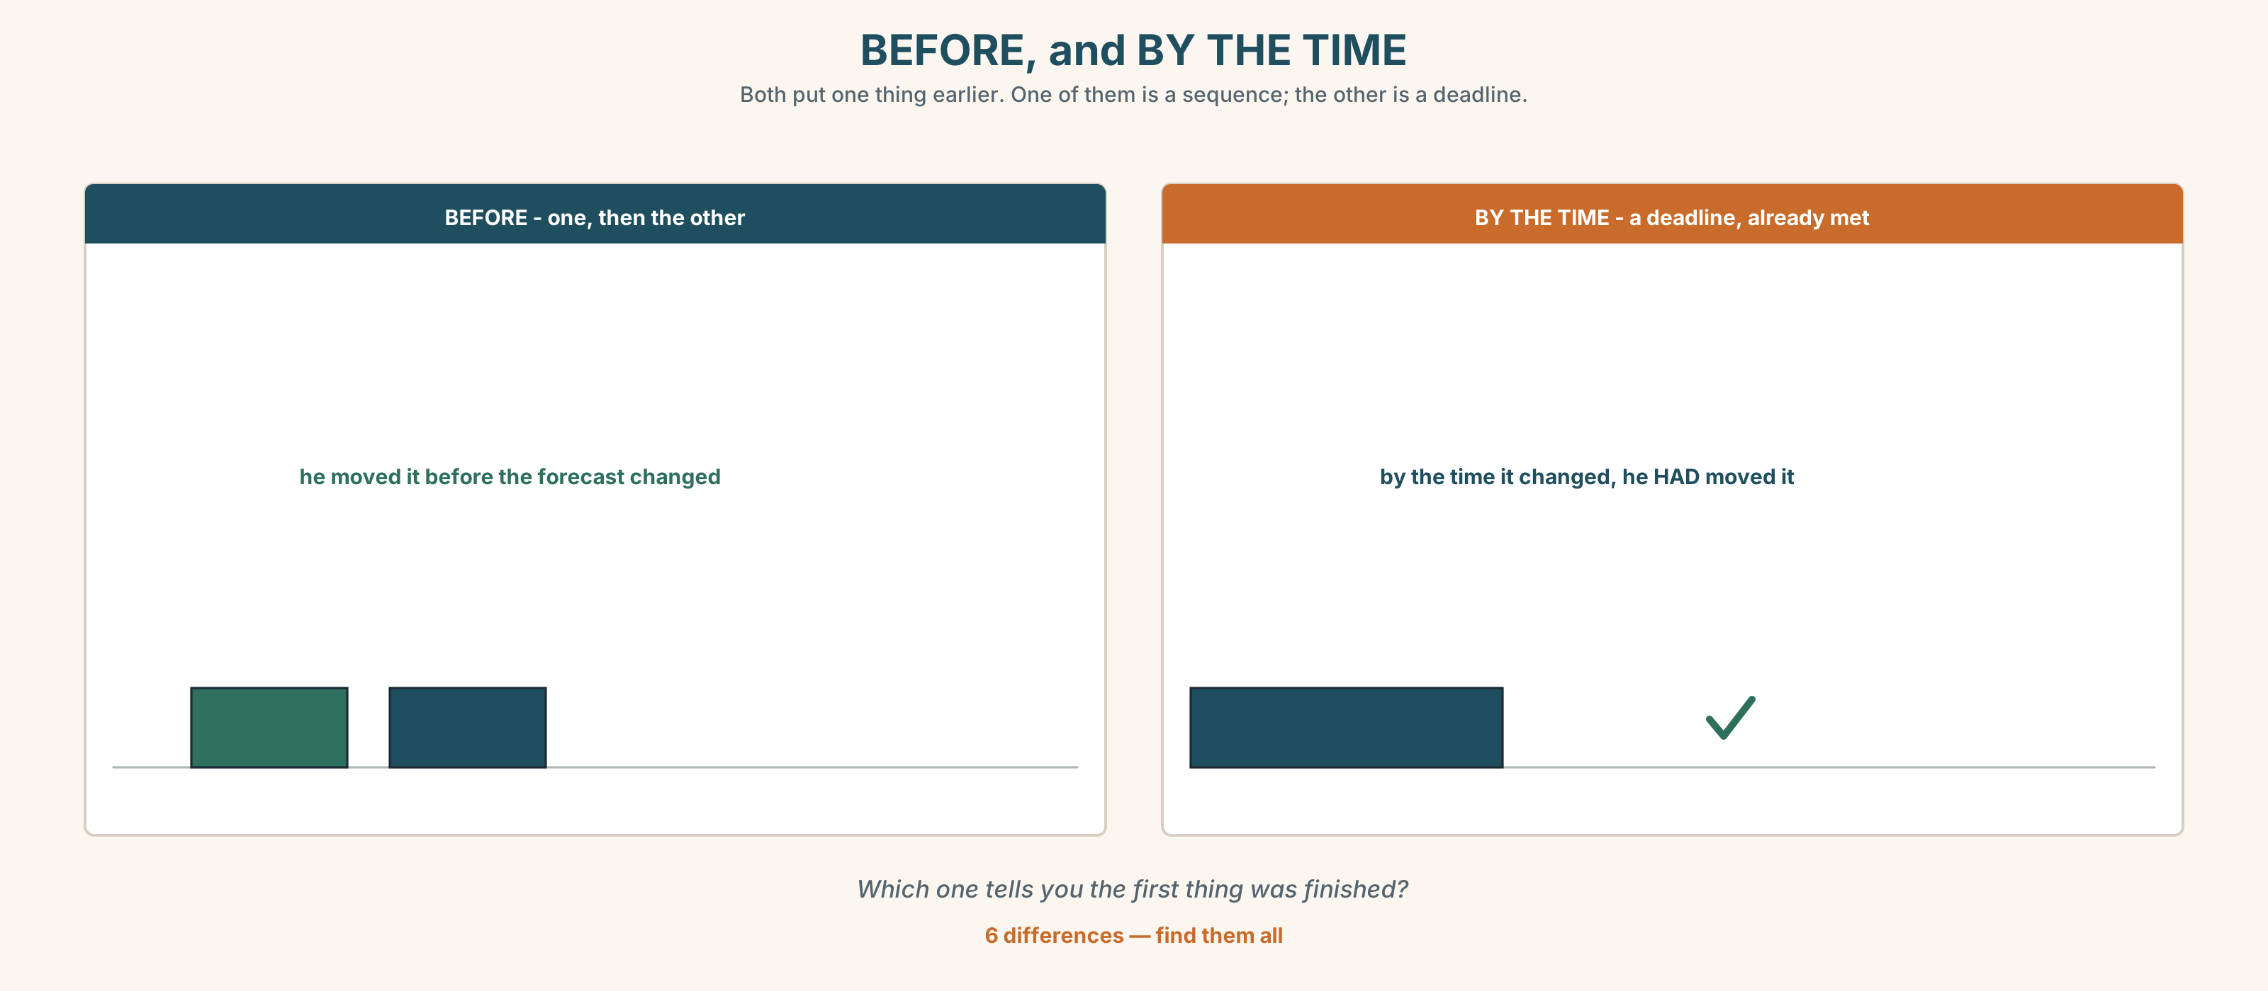{width=6.6in}
BEFORE, and BY THE TIME — Both put one thing earlier. One of them is a sequence; the other is a deadline.
Six differences. Find them, then answer the question under the picture.

6D · Contrast Clinic — past simple or past perfect
Six items. Choose, and say why.
- He ______ (move) the car on Thursday. Then it ______ (flood).
- It ______ (flood) on Saturday. He ______ (move) the car two days earlier.
- By the time we ______ (arrive), they ______ (go).
- She ______ (keep) the sandbags since 2019 and never ______ (use) them.
- Once the drain ______ (reverse), it ______ (be) too late.
- I ______ (not know) the forecast ______ (change).

Part 7 · Pronunciation & Fluency Lab ◆ B · THE SYSTEM

The word that attaches itself
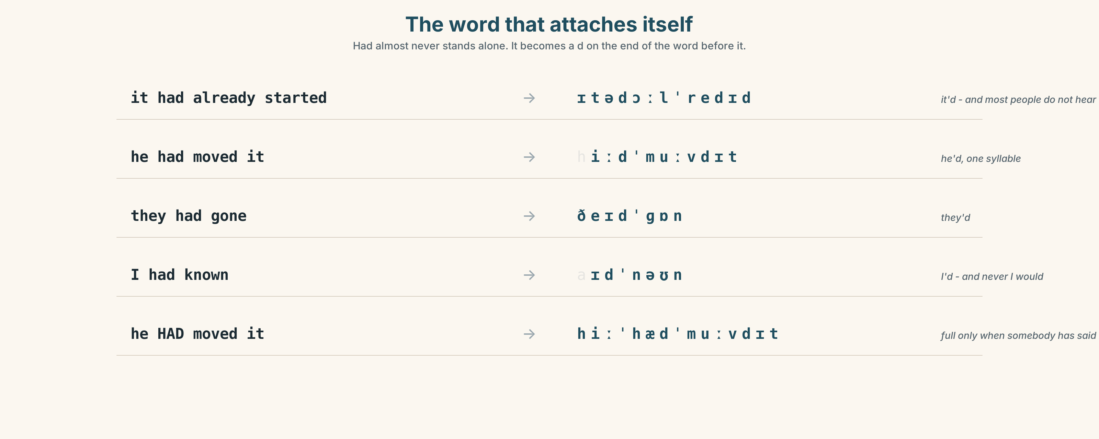{width=6.6in}
The word that attaches itself — Had almost never stands alone. It becomes a d on the end of the word before it.

7A · Hear 🔊 Track 3.3
it had already started → it'd already started → /ɪtədɔːlˈredi/ he had moved it → he'd moved it → /hiːdˈmuːvdɪt/ they had gone → they'd gone → /ðeɪdˈɡɒn/ I had known → I'd known → /aɪdˈnəʊn/

7B · Say
Say each one. Then say the sentence three times, faster:
By the time we got there, it had already started.

7C · Make it mean something
Say these two:
He HAD moved it. (somebody has just said he did not) He'd moved it. (plain — this is just the order of events)
The first one is an argument. Who is it with?

7D · Fluency 20 ⏺
Twenty seconds: three things that had already happened before you got up this morning. Three times, faster.

Part 8 · Writing ◆ C · THE PERFORMANCE

An account of one night · 100 words
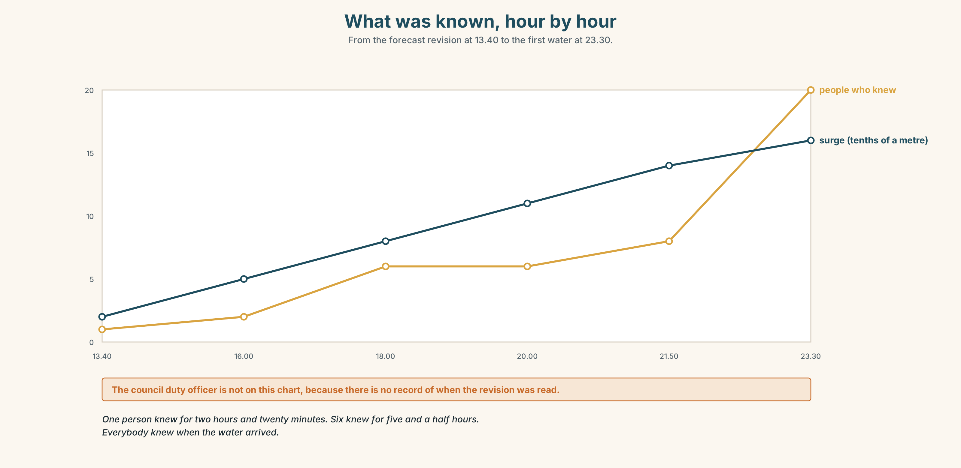{width=6.6in}
What was known, hour by hour — From the forecast revision at 13.40 to the first water at 23.30.

8A · Read the model
At about ten the drain in my yard started running the wrong way. By then the tide had been rising for two hours and the forecast had been revised twice, though I did not know that until March. [the event, then straight backwards — and one thing marked as learned afterwards]
I had kept sandbags in the shed since 2019. I did not put them out. Donal had moved his car two days earlier and two people had laughed, and I had said nothing. [three past perfects in a row, and they are doing the real work of the paragraph]
The water reached the floor at about half past eleven. Everything after that is in the record. [the plain past returns for the main line, and the writer stops]
Questions about the writer's choices:
- The second paragraph is entirely past perfect. What is it for?
- The last line hands the rest over to the record. Why end there?

8B · The anti-model
It was a terrible night. The water came in very quickly and everybody was shocked. We did what we could but there was nothing anybody could have done. Nobody saw it coming.
Correct English. Name two things it does not tell an inquiry — and one thing it quietly claims.

8C · Plan
the event, with a time → what had already happened by then → what you had and had not done → back to the plain past for the end

8D · Write — 100 words

8E · Peer review — two criteria
☐ Could a reader draw the timeline? ☐ Is there one thing the writer learned afterwards, marked as such?

8F · Write it again · 8G · Publish
On the wall, with the inquiry timeline from Part 5E beside it.

Part 9 · The File ◆ A · THE WORLD + C · THE PERFORMANCE

CULTURE FILE · Hospitality and Obligation
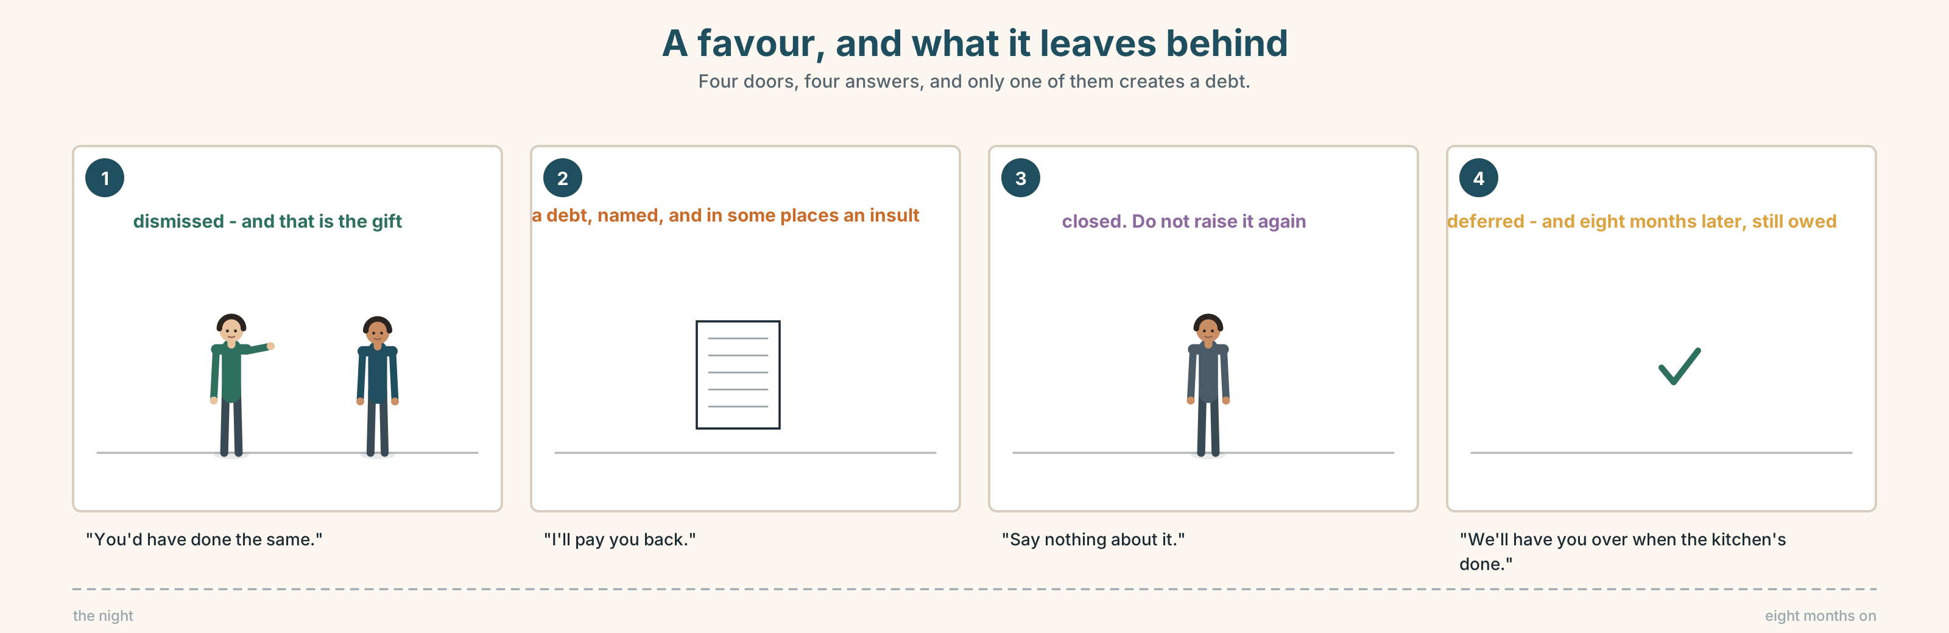{width=6.6in}
A favour, and what it leaves behind — Four doors, four answers, and only one of them creates a debt.

9A · Four doors 🔊 Track 3.4
On the night, four families took other families in. Listen to four of them, eight months later.
- Which one says it was nothing?
- Which one is still slightly uncomfortable?
- Which one has been thanked too much, and what has that done?

9B · What is owed, and when
In some places a favour creates a debt that must be returned. In others, saying so is the insult.
Where do these four sit?
"You'd have done the same." · "I'll pay you back." · "Say nothing about it." · "We'll have you over when the kitchen's done."

9C · Refusing help
Refusing help is also a social act, and it is read.
What does each of these say?
- "We're grand, honestly."
- "There's people worse off."
- "I'd rather not, if you don't mind."
- "Ask Peadar first."

9D · Your turn
In pairs. One of you offers help. The other does not want it but does need it. Four minutes. Neither of you may use the word no. Then swap.

9E · Transfer
In your own culture: how do you thank somebody for something too large to thank them for? Write one sentence. Bring it.

Part 10 · Mediation & Interaction ◆ C · THE PERFORMANCE
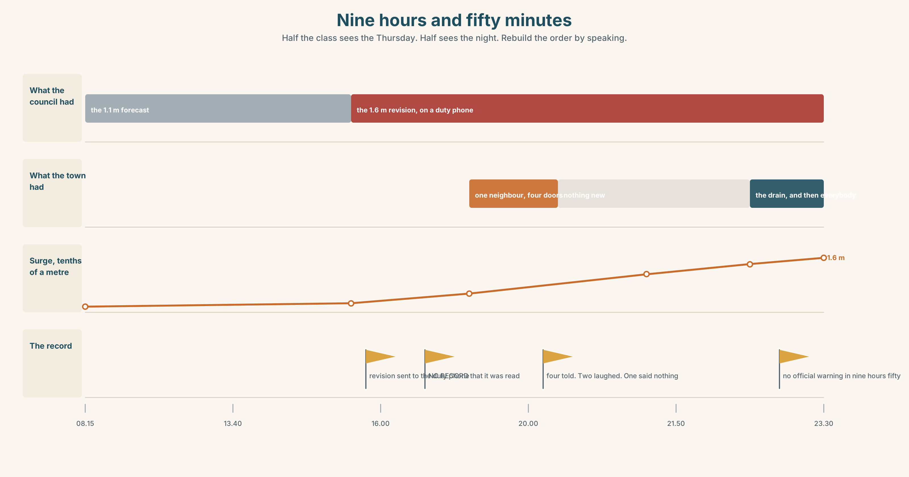{width=6.6in}
Nine hours and fifty minutes — Half the class sees the Thursday. Half sees the night. Rebuild the order by speaking.

10A · Relay
Half the class sees the Thursday. Half sees the Saturday night. Rebuild the order by speaking. Ten minutes.

10B · Simplify
Explain the inquiry timeline from Part 5E to somebody who was not in the town. Four sentences only.
Plan: what changed first → what nobody noticed → when the water came → what is disputed

10C · Compress
Donal's submission into thirty words, without losing the reason he gives.

10D · Online
Write one message to the inquiry's public inbox: you were told, you did nothing, and you want that on the record without it becoming a story about one person.

10E · Your language
How does your language go backwards in time? Is there a tense like the past perfect, or do you use words like before and already? Show a partner both.

Part 11 · The Decision ◆ C · THE PERFORMANCE

Saying it in that room
The inquiry asks: was anybody warned? Donal warned four people. Two of them laughed. The inquiry sits in the community hall, and those two will be in it.
- Say it all. Who he told, and who laughed. It is true and it is what was asked.
- Say he told people. No names, no laughing. The answer is still honest.
- Say nothing. Let the official record say nobody was warned. He has to live here.

11A · The evidence
- The inquiry timeline from Part 5E — and the two entries marked "no record".
- The chart — what was known, by whom, hour by hour.
- The voice. Eimear, twenty seconds: "If he names them, this becomes a story about two people who laughed, and it is not that story. If he names nobody, it becomes a story about nobody knowing, and it is not that either."

11B · Talk about it
In threes. Everybody says one. Use the frame.
I think Donal should ______ , because ______ .
Words you can use: evidence · witness · blame · fault · responsible · record · official · in hindsight

11C · Decide
Write two sentences. Choose, and say why.
I think Donal should ______________________ , because ______________________ .

11D · Model decision
He should say that four people were told and that he will not name them, and say out loud, in the room, that he is not naming them because the question the inquiry is really asking is not about four people. Refusing in public is not the same as hiding. It puts the warning in the record and keeps the inquiry pointed at the drain.

11E · The Reveal
What happened. He said four people were told and declined to name them. The chair accepted it without comment and moved on in under a minute.
One of the two who had laughed stood up at the end and named herself, which nobody had asked for and which Donal says he wishes she had not done, because it made the hall go quiet and because it turned out to be the only part of the day anybody remembered.
The final report found that the warning chain had failed at the council, not in the town. It does not mention Donal. The eleven-page section on the storm drain does not mention anybody.
He kept the names out. Somebody put one back in. And the report was about a drain.
Was it the right decision? Say why — and say what you think of what she did.

Part 12 · Landing ◆ all three lines

12A · Recycle — ten items
- By the time we arrived, it ______ (already / start).
- He moved it because the forecast ______ (change).
- They agreed to look ______ it .
- In ______ , the Thursday forecast was the whole story.
- It took eleven months to find ______ .
- (Unit 2) We ______ (wait) since June.
- (Unit 2) I ______ (phone) him four times.
- (Unit 1) If I ______ you, I wouldn't wait.
- (A2.1 U2) It was raining ______ he left the farm.
- (A2.1 U3) I ______ (use) to live on this road.

12B · Consolidate
One hundred words. One night, in order. Six events, three past perfects, and one thing you only found out afterwards.

12C · Can-do, with evidence
I can… | My evidence | Sure?
put one past event before another | Part 3G score | ◯ ◑ ●
give a clear account of a night in a hundred seconds | Part 4C recording | ◯ ◑ ●
write a hundred words a reader could draw | Part 8 draft 2 | ◯ ◑ ●
offer and refuse help without saying no | Part 9D role play | ◯ ◑ ●

12D · Replay ⏺
Find your thirty seconds from Part 0C. Listen. Record it again. One sentence: what is different?

12E · Glossary — forty items, as a map
THE QUESTION · cause · blame · fault · responsible · mistake · in hindsight THE PROCESS · inquiry · evidence · witness · report · record · minute · official · look into · find out WHAT PEOPLE DID · warn · ignore · decide · at the time · put down to · nobody saw it coming EARLIER · earlier · previous · previously · before · the night before · already · had · it had already started THE MOMENT · by · by the time · as soon as · once · just · until · up to that point AFTER · after · then · afterwards · go back over

12F · Next
Unit 4 · What did they actually say?

