Table of Contents

B2.2 · Unit 4 · Nine Thousand Words and One Hundred and Eighty
English Animated · Holding the Floor · a port and its logistics chain, Rotterdam Student's Book pages 72–93 · 22 pp · ~11 hours

Part 0 · The Big Picture ◆ A · THE WORLD
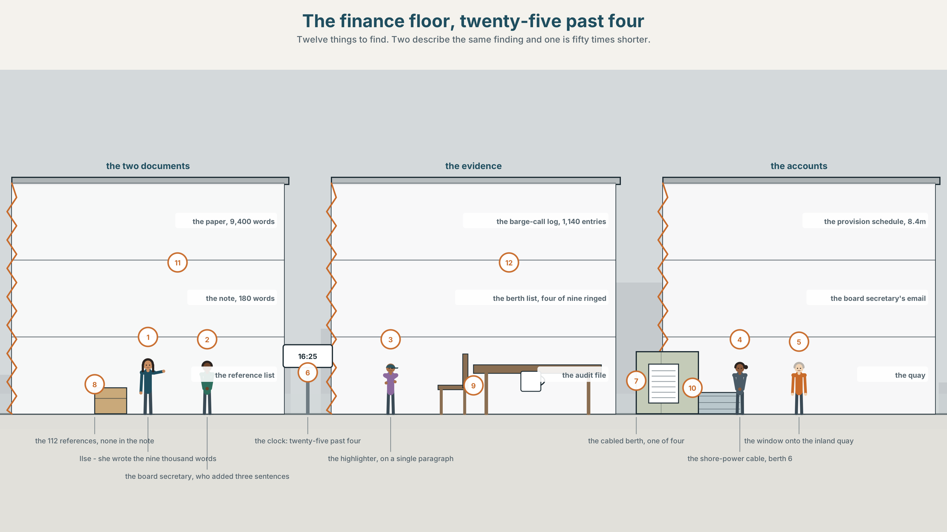{width=6.6in}
The finance floor, twenty-five past four — Twelve things to find. Two describe the same finding and one is fifty times shorter.

How does academic English sound?
By the end of this unit you can write a formal paragraph that carries three clauses and one claim. Two hundred words.
◆ A · THE WORLD | A commissioned study of nine thousand four hundred words, and the hundred and eighty that reached the board
◆ B · THE SYSTEM | relative and participle clauses in formal register · 28 words for research, audit and accounts · 22 formal connectors and frames · the rhythm of a long formal sentence
◆ C · THE PERFORMANCE | Two hundred words that would survive a referee and a reader

0A · Find it
Find twelve things in this picture. Two of them describe the same finding and one of them is fifty times shorter.
the commissioned paper, 9,400 words · the annual report note, 180 words · the shore-power berth, cabled · the berth list, four of nine ringed · the barge-call log, 1,140 entries · the provision schedule, 8.4 million · the audit file, one weakness flagged · a reference list, 112 entries · a highlighter on a single paragraph · a clock at 16.25 · a window onto the inland quay · a printed email from the board secretary

0B · Guess it
Three sentences in the shorter document are not in the longer one. What would you have to do to find them, and why has nobody done it?

0C · Say it ⏺
Record sixty seconds. Explain a finding from your own field as you would say it to a friend, then as you would write it in a report. You will record it again at the end of this unit.

Part 1 · Vocabulary Lab 1 ◆ B · THE SYSTEM
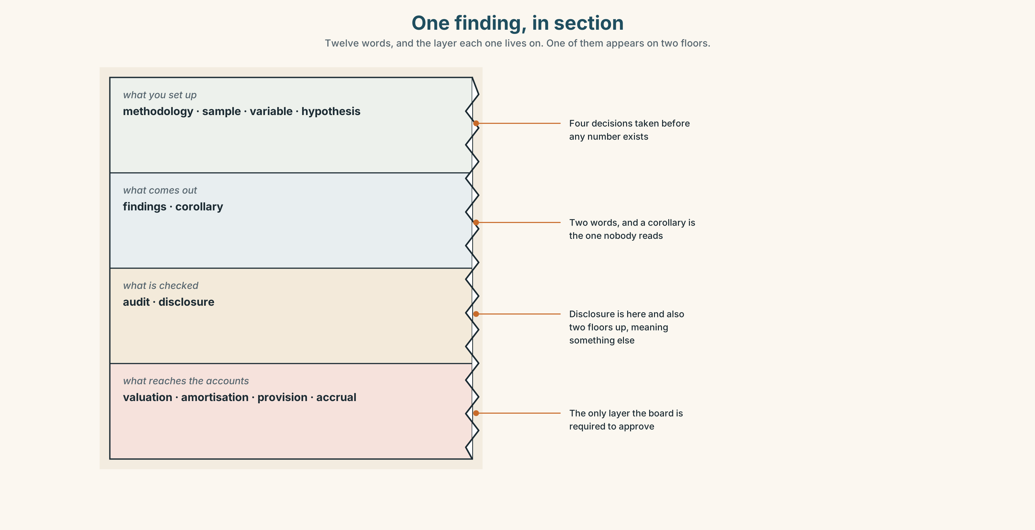{width=6.6in}
One finding, in section — Twelve words, and the layer each one lives on. One of them appears on two floors.

1A · Meet — the words of a study and its accounts
Match each word to one layer of the cutaway.
findings · methodology · sample · variable · hypothesis · corollary · audit · disclosure · valuation · amortisation · provision · accrual

1B · Sort — the study, the examination, or the accounts?
Three columns. One of the twelve belongs in two of them and means something different in each.
methodology · audit · valuation · sample · findings · provision · variable · disclosure · accrual · hypothesis · amortisation · corollary

1C · Meet — the five phrases a paper is built on
the literature suggests | A claim with a hundred and twelve references and no author.
a control group | The part of the design that decides whether anything can be concluded.
statistical power | Whether the study could have found the effect if it was there.
the going concern | Whether the organisation is expected to exist in a year.
a material weakness | A fault big enough to change what a reader would conclude.

1D · Collocation Lab
Complete each one, and say which of the five appears in both documents in this unit.
the balance sheet · an audit trail · year end · a qualified opinion · the notes to the accounts
- The provision of eight point four million appears on ______ ______ ______ and nowhere else.
- ______ ______ ______ runs from the invoice to the ledger and back, and it has one gap in it.
- The figures are struck at ______ ______ , which this year is 31 December.
- ______ ______ ______ ______ is what an auditor issues when something could not be verified.
- The methodology of the study is summarised in ______ ______ ______ ______ ______ , in four lines.

1E · The phrasal verbs, and the three fixed expressions
draw on · set out · bear out
f it should be noted that · f for the avoidance of doubt · f as set out below
One of these fixed expressions always precedes something the writer wishes you would not notice. Which, and how do you know?

1F · Own it
Write one sentence from your own field twice: once as you would say it and once with one relative clause in it.

Part 2 · Listening ◆ A · THE WORLD
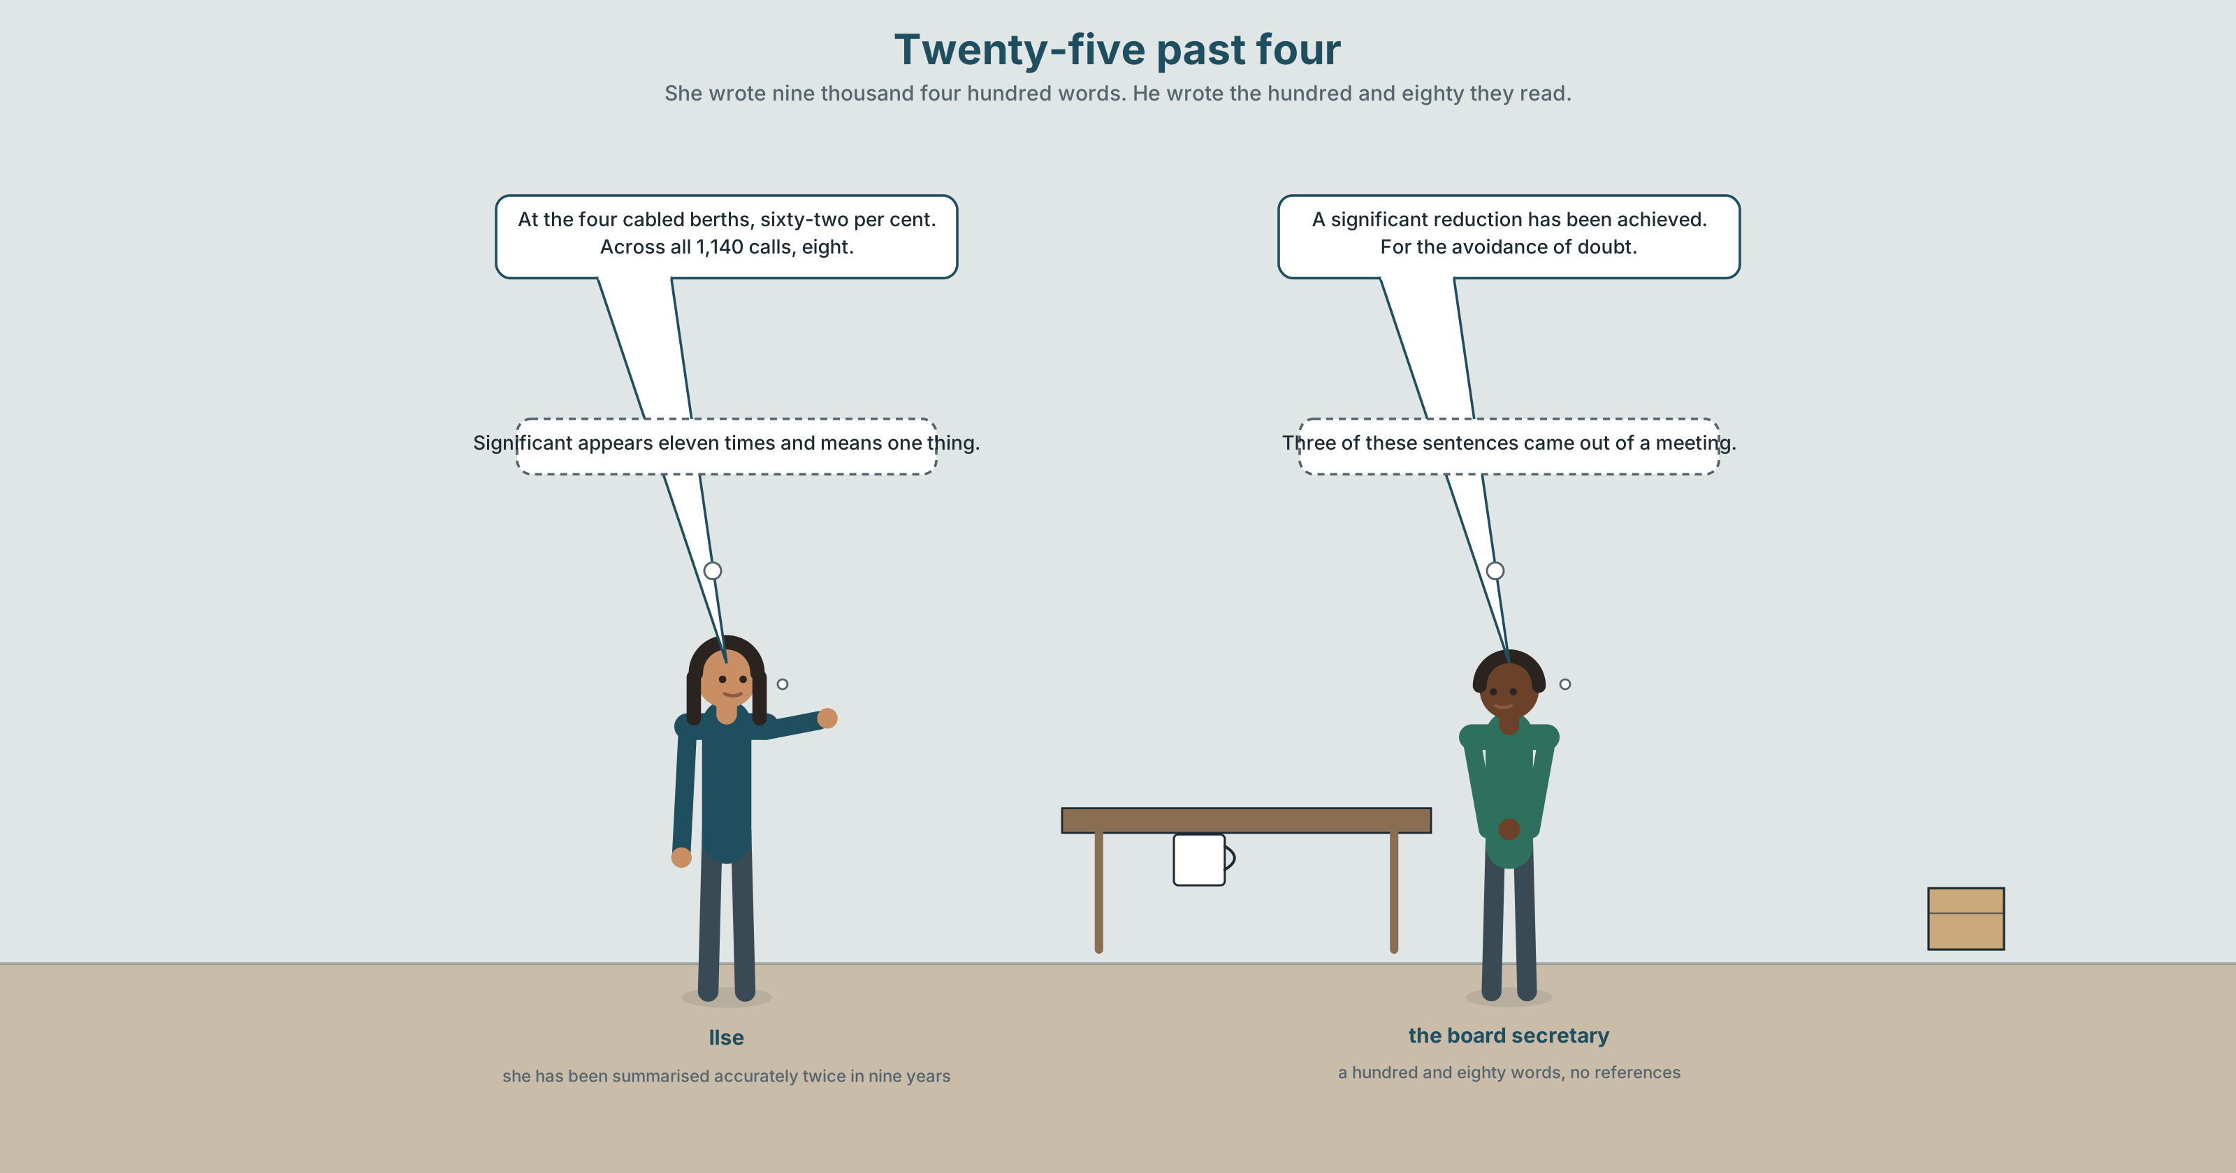{width=6.6in}
Twenty-five past four — She wrote nine thousand four hundred words. He wrote the hundred and eighty they read.

2A · Four twenty-five 🔊 Track 4.1
Before you listen. The study runs to nine thousand four hundred words. The note in the annual report runs to a hundred and eighty. The board has read one of them.
Listen once. What does the study find, and what does the note say?
Listen again. Complete the table.
 | What it says about uptake | What it says about the reduction | What it leaves out
the study
the note
the board's reading
Listen again. True or false?
- Shore power is available at four berths of nine. ☐ T ☐ F
- Uptake is thirty-one per cent where it is available. ☐ T ☐ F
- The fleet-level reduction is sixty-two per cent. ☐ T ☐ F
- The note contains no references. ☐ T ☐ F
Noticing. Six sentences from the recording.
- The berths, which were cabled in 2021, are used on about a third of calls.
- The berths cabled in 2021 are used on about a third of calls.
- The berths, having been cabled in 2021, are used on about a third of calls.
- The berths that were cabled in 2021 are used on about a third of calls.
- Of the nine berths, four, cabled in 2021, are so used.
- The berths referred to above are used on about a third of calls.
Six sentences, four clause types, and two different claims about how many berths are cabled. Find the two, and say which comma makes the difference.

2B · Decoding clinic 🔊 Track 4.2
Thirty seconds at speed. Three jobs.
- One speaker reads a forty-word sentence. Mark the three beats where the voice resets.
- Which clause is said fastest, and why is that the one?
- Somebody says for the avoidance of doubt. What doubt, and whose?

Part 3 · Grammar Lab 1 ◆ B · THE SYSTEM

Clauses that hang off a noun

3A · Notice
Look at the six sentences in Part 2 again.
- Sentences 1 and 4 differ by two commas. How many berths are cabled in each?
- Sentence 2 has no relative pronoun and no verb be. What has been removed, and from where?
- Sentence 3 uses a perfect participle. What does it add that sentence 2 does not?
- Sentence 5 puts the quantity first. What register does that belong to?

3B · See
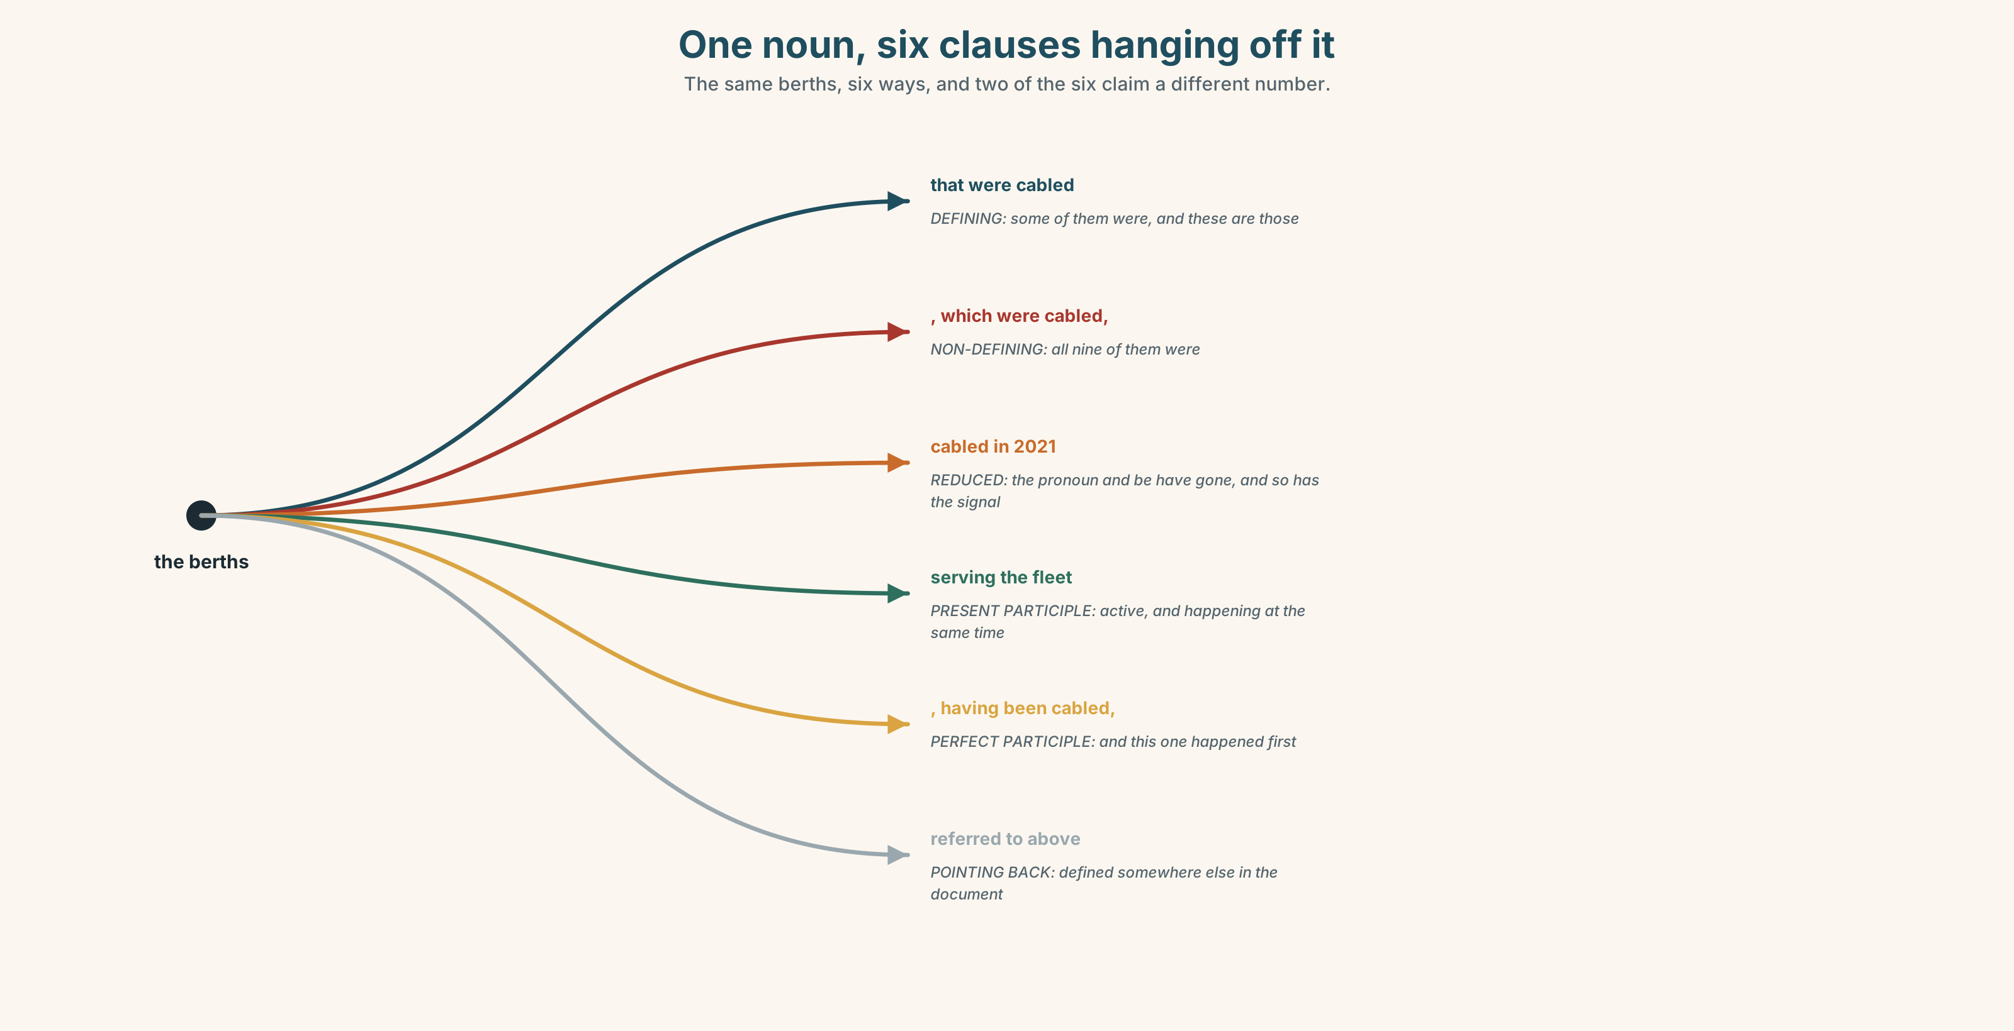{width=6.6in}
One noun, six clauses hanging off it — The same berths, six ways, and two of the six claim a different number.

3C · Know
defining relative | no commas; it tells you which ones | the berths that were cabled in 2021
non-defining relative | commas; it tells you about all of them | the berths, which were cabled in 2021,
reduced relative | the pronoun and be go; the participle stays | the berths cabled in 2021
present participle clause | an active reduced clause | the berths serving the inland fleet
perfect participle clause | and this one happened first | the berths, having been cabled in 2021,
the formal fronting | the quantity goes first, the clause follows | Of the nine berths, four, cabled in 2021,…
A reduced relative is the engine of academic English. The samples which were collected in March becomes the samples collected in March, and a nine-thousand-word paper does it four hundred times. The reader stops noticing; the writer saves four words each time; and the ambiguity is that a reduced clause has lost its commas and therefore its defining or non-defining signal.
Two commas are a claim about quantity. The berths, which were cabled, are used says all of them were cabled. The berths that were cabled are used says some were. In a sentence with a number in it, those two commas are worth five berths.
pointing inside the document | herein · aforementioned · the foregoing · as noted above · see below
pointing at a thing already named | thereof · respective · those referred to above
pointing at a time or an event | hitherto · whereupon
pointing at an authority | pursuant to · as amended · in respect of · with reference to
Why it matters. This is the grammar of every document that decides anything: papers, audits, contracts, regulations. It is learned by reading and almost never produced without being taught, which is why a learner who can build it reads as a professional and one who cannot reads as a student.

3D · Use — controlled
Reduce each relative clause, or say why it cannot be reduced.
The berths which were cabled in 2021 → (1) ______ The barges that use shore power → (2) ______ The provision which the board approved → (3) ______ The study, which was commissioned in 2022, → (4) ______ The sample which had been drawn in March → (5) ______

3E · Use — guided
Rewrite each one in formal register, using the clause type in brackets.
- Four berths are cabled. They are used on a third of calls. (reduced relative)
- The study was commissioned in 2022. It reports a 62 per cent reduction. (non-defining)
- Some barges use shore power. Those barges are newer. (defining relative)
- The cabling was completed first. Then uptake was measured. (perfect participle)
- There are nine berths. Four of them are cabled. (formal fronting)

3F · Use — open
In pairs. One of you says two short sentences from your own field. The other combines them into one formal sentence and names the clause type. Six rounds each.

3G · Error autopsy
✗ The berths, cabled in 2021, which are four of nine, is used on a third of calls. ✗ The samples collecting in March were analysed. ✗ The provision, that the board approved, appears in note 14.
For each, name the rule and say what the writer was reaching for.

3H · Check — eight items
- The berths which were cabled in 2021 → ______ (reduce it)
- The barges that are using shore power → ______ (reduce it)
- The provision which the board approved → ______ (say why it cannot be reduced)
- The cabling was completed, and then uptake was measured. → ______ (perfect participle)
- There are nine berths and four are cabled. → ______ (formal fronting)
- ✗ The samples collecting in March were analysed. → correct it.
- Write the same sentence twice so that it says four berths and then nine.
- Rewrite The study found that uptake was low with one non-defining clause in it.

Part 4 · Speaking ◆ C · THE PERFORMANCE

4A · Fluency starter — join them up
One person says two short sentences. The next joins them with a relative clause. The next reduces it. The fourth person has to say what the reduction lost.

4B · The functional core — writing academically
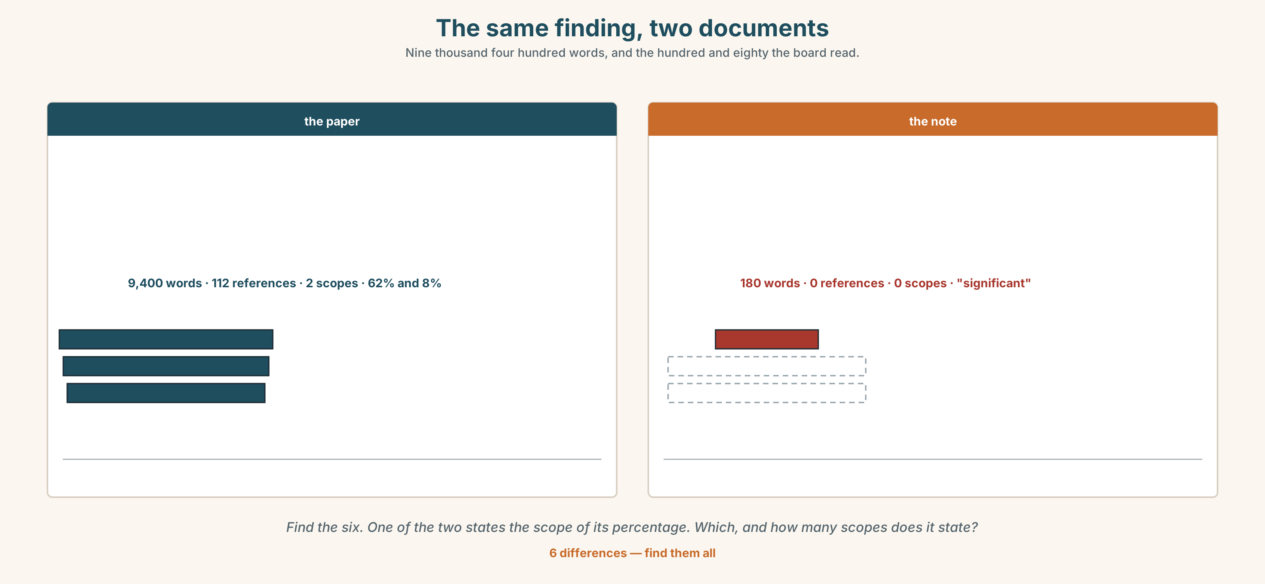{width=6.6in}
The same finding, two documents — Nine thousand four hundred words, and the hundred and eighty the board read.
Language Bank
attaching a clause | which · that · having been · cabled in 2021 · serving the fleet
pointing back | the aforementioned · the foregoing · those referred to above · thereof
anchoring to an authority | pursuant to · as amended · in respect of · with reference to
signposting | it should be noted that · as set out below · see below · as noted above
Information gap. Learner A has the paper's results section. Learner B has the note in the accounts. Find the three sentences in the note that are not in the paper. Ten minutes.

4C · The performance — three minutes ⏺
Present a finding in three minutes in formal register throughout. Your partner counts your relative and participle clauses and tells you which one was doing no work.
Record it.

4D · Observer
One person writes down every clause attached to a noun and marks it defining or non-defining.

4E · Three criteria
☐ Did every reduced clause keep the quantity claim I meant? ☐ Was the register consistent, or did it slip in the middle? ☐ Could my partner restate the finding from my formal version alone?

Part 5 · Reading ◆ A · THE WORLD

5A · Predict
The title is "A significant reduction." What has to be true for a sixty-two per cent reduction and an eight per cent reduction to be the same finding?

5B · Read — two minutes

A significant reduction
The port commissioned a study of shore power at its inland berths. The paper runs to nine thousand four hundred words and carries a hundred and twelve references.
Its finding is in two parts. At the four berths of nine that are cabled, a call using shore power produces sixty-two per cent less at-berth emission than one that does not. Across all eleven hundred and forty calls in the year, including those at the five berths with no cable, the fleet reduction is eight per cent.
The note in the annual report runs to a hundred and eighty words. It says that a significant reduction in at-berth emissions has been achieved and that a provision of eight point four million euros is held in respect of the remaining berths. It carries no references.
The note is accurate. Sixty-two per cent is a significant reduction and it has been achieved. The word significant appears in the paper eleven times, in every case meaning unlikely to be chance, and in the note once, meaning large.
Three sentences in the note correspond to no paragraph of the paper. The board secretary added them, in good faith, from a meeting. They are the three a reader remembers.

5C · Comprehension — eight questions
- How long is the paper, and how many references does it carry?
- What are the two parts of the finding?
- How long is the note, and how many references does it carry?
- What provision is held, and what for?
- How many sentences in the note have no source in the paper?
- Why does the writer say "the note is accurate" before making the next point?
- The word significant is used in two senses. What is the writer showing by counting them?
- "They are the three a reader remembers." Why those three, and what follows from it?

5D · Vocabulary in context
Infer from the text, then check.
is held in respect of · correspond to no paragraph · in good faith · struck at year end · at-berth emission

5E · The counter-text
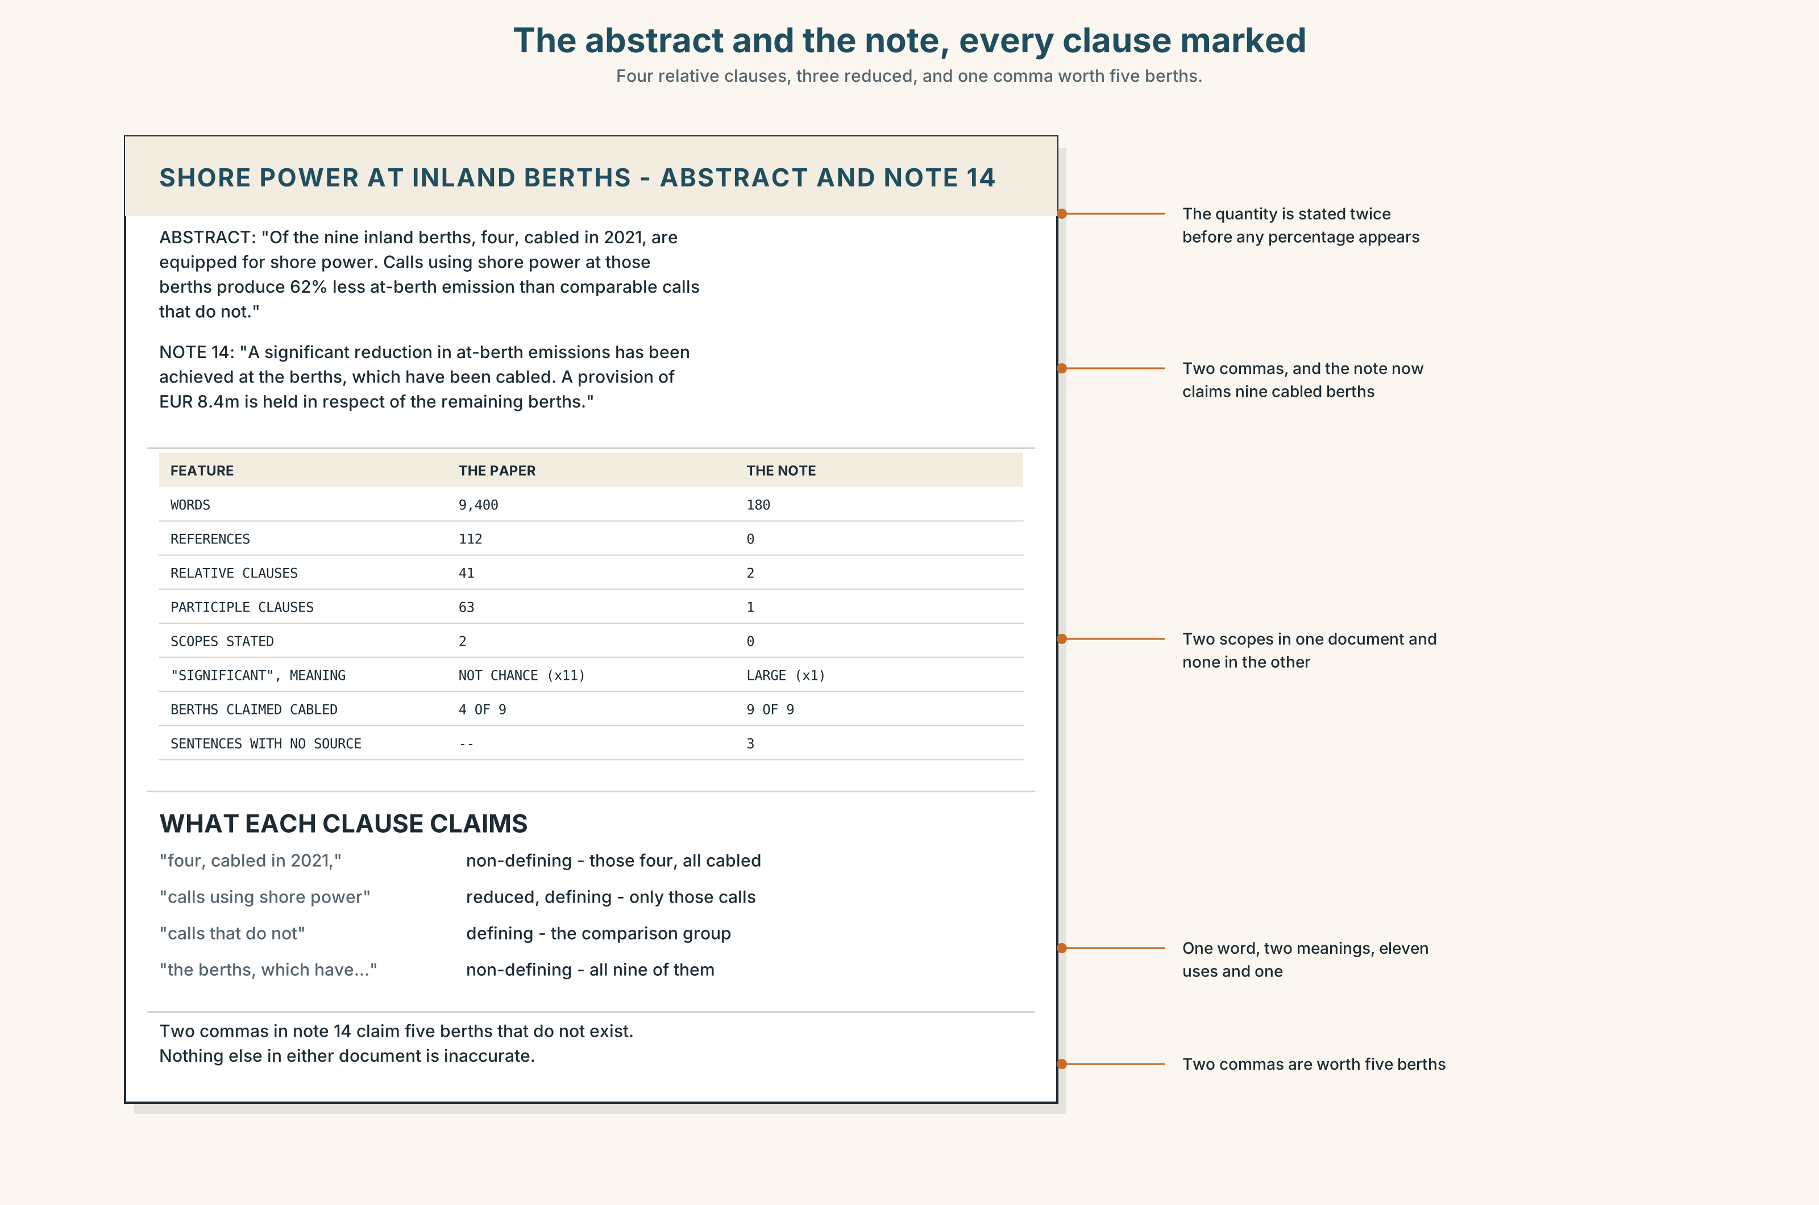{width=6.6in}
The abstract and the note, every clause marked — Four relative clauses, three reduced, and one comma worth five berths.
Read the paper's abstract and the note, and answer.
- How many relative and participle clauses are in the abstract?
- Find every reduced relative clause and say whether it is defining or non-defining.
- The note contains one non-defining clause. What does it claim about quantity?
- Trace each sentence of the note to a paragraph of the paper, and name the three that fail.

5F · Two texts
The paper says a sixty-two per cent reduction at cabled berths. The note says a significant reduction in at-berth emissions has been achieved.
Is the note a summary? Write two sentences, and use the word corollary in one of them.

Part 6 · Vocabulary Lab 2 ◆ B · THE SYSTEM

Words that point somewhere else in the document

6A · Sort — a place in the document, a thing already named, a moment, or an authority?
Four columns.
herein · thereof · hitherto · pursuant · aforementioned · respective · whereupon · foregoing

6B · Chunk completion
- The berths, ______ ______ cabled in 2021, are used on a third of calls. (two words)
- The provision is held ______ ______ ______ the remaining five berths. (three words)
- The study was commissioned ______ ______ ______ the 2022 board resolution. (three words)
- The regulation, ______ ______ , applies from 1 January. (two words)
- The berths ______ ______ ______ are the four with cable. (three words)
- ______ ______ ______ , uptake is thirty-one per cent. (three words — restating)
- The terminal ______ ______ the port authority is not in the sample. (three words)
- The operator is ______ ______ ______ ______ the Netherlands. (four words)

6C · Three that are not interchangeable
in respect of · with reference to · pursuant to
Say which one names a subject, which one names a document, and which one names an authority that required the thing.

6D · The phrasal verbs and the fixed expressions
refer to · relate to · derive from
f the preceding paragraph · f as noted above · f see below
One of these three fixed expressions makes a promise the writer may not keep. Which, and what should a reader do about it?

6E · Contrast Clinic
Eight items. Rewrite each one in the register or clause type the bracket asks for.
- Four berths are cabled, and they are used on a third of calls. (reduced relative)
- The study was commissioned in 2022 and reports a 62 per cent reduction. (non-defining)
- Some barges use shore power, and those ones are newer. (defining relative)
- They cabled the berths and then they measured uptake. (perfect participle)
- There are nine berths and four are cabled. (formal fronting)
- The provision is for the five berths without cable. (a formal three-word frame)
- The board resolution of 2022 required the study. (a formal authority frame)
- We said this earlier in the paper. (two formal variants, one pointing back, one forward)

Part 7 · Pronunciation & Fluency Lab ◆ B · THE SYSTEM
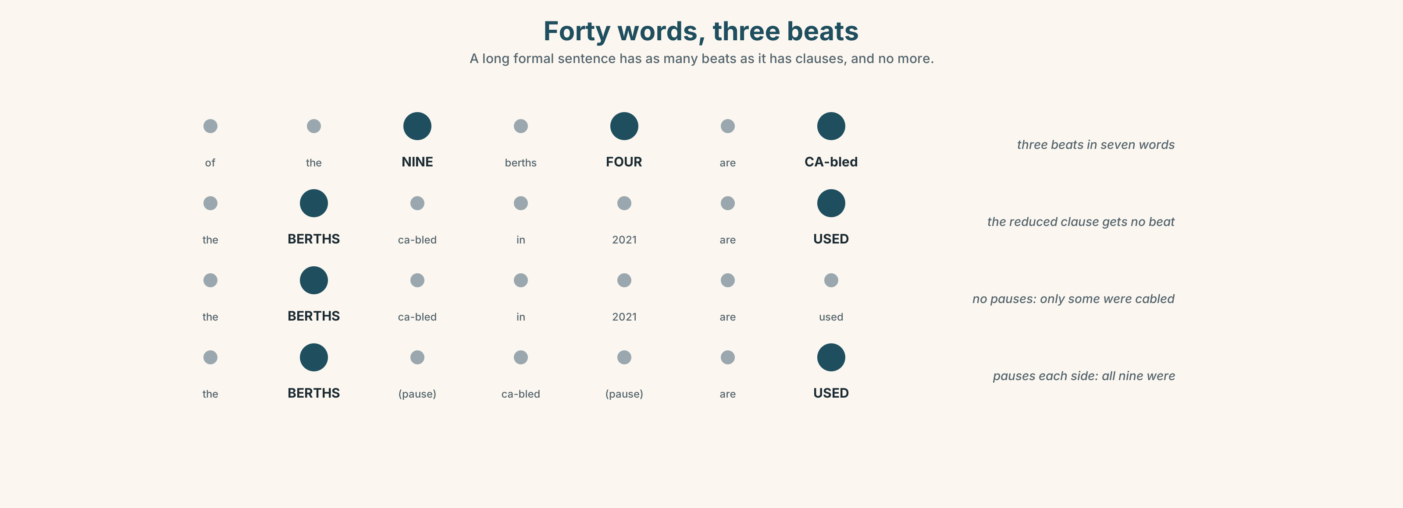{width=6.6in}
Forty words, three beats — A long formal sentence has as many beats as it has clauses, and no more.

A long formal sentence is three beats, not forty

7A · Hear 🔊 Track 4.3
The BERTHS — cabled in twenty twenty-ONE — are used on a THIRD of calls. three beats, two resets, and the middle clause said fastest The PROvision, held in respect of the remaining BERTHS, appears in note FOURteen.

7B · Say
Say both. Then say this forty-word sentence with exactly three beats:
Of the nine inland berths, four, cabled in 2021 and serving the barge fleet referred to above, are used on approximately a third of calls, a proportion which has not changed since the second year of operation.

7C · Make it mean something
Say these two:
The berths, cabled in 2021, are used. — a pause each side: all of them were cabled The berths cabled in 2021 are used. — no pause: only some of them were
Two commas in writing are two pauses in speech, and both of them are a claim about how many. A reduced clause said without the pauses means something different from the same words with them.

7D · Fluency 30 ⏺
Thirty seconds: one forty-word formal sentence, three beats, said three times, each time slightly faster and with the same three resets.

Part 8 · Writing ◆ C · THE PERFORMANCE

A formal paragraph that carries three clauses · 200 words

8A · Read the model
Of the nine inland berths, four, cabled in 2021, are equipped for shore power. [formal fronting, then a reduced relative with commas: the quantity is stated twice and cannot be misread]
Calls using shore power at those berths produce sixty-two per cent less at-berth emission than comparable calls that do not. [a present participle clause and a defining relative in one sentence, and the defining one is what makes the comparison valid]
Across all 1,140 calls in the year, including those at the five berths having no cable, the fleet-level reduction is eight per cent. [a perfect-free participle carrying the exclusion, and the number the board needed]
The provision held in respect of the remaining berths, referred to in note 14, is 8.4 million euros; the foregoing figures are drawn from the commissioned study and not from management accounts. [two reduced relatives, one authority frame, and a pointing-back word doing the work of a whole sentence]
Questions about the writer's choices:
- Sentence one states the quantity twice. Why, when one of them would be grammatical alone?
- Sentence two contains two clause types. What would happen if the defining relative were non-defining?
- The last sentence distinguishes two sources. Why is that worth four words of formality?

8B · The anti-model
It should be noted that a significant reduction in at-berth emissions has been achieved at the berths, which have been cabled, and that a provision has been made, as set out below, for the avoidance of doubt, in respect of the aforementioned.
One sentence, forty-two words, four pointing-back words, one comma that claims nine berths were cabled, and no number. Rewrite it in three sentences with the quantities right.

8C · Plan
formal fronting with the quantity → the comparison, defining → the exclusion, in a participle clause → the authority frame and the pointing-back word

8D · Write — 200 words

8E · Peer review — three criteria
☐ Does every comma around a clause make the quantity claim you meant? ☐ Is each reduced clause recoverable to a full one? ☐ Does each pointing-back word point at exactly one thing?

8F · Write it again · 8G · Publish
Rewrite after review. Publish both, and mark each clause defining or non-defining.

Part 9 · The File ◆ A · THE WORLD + C · THE PERFORMANCE
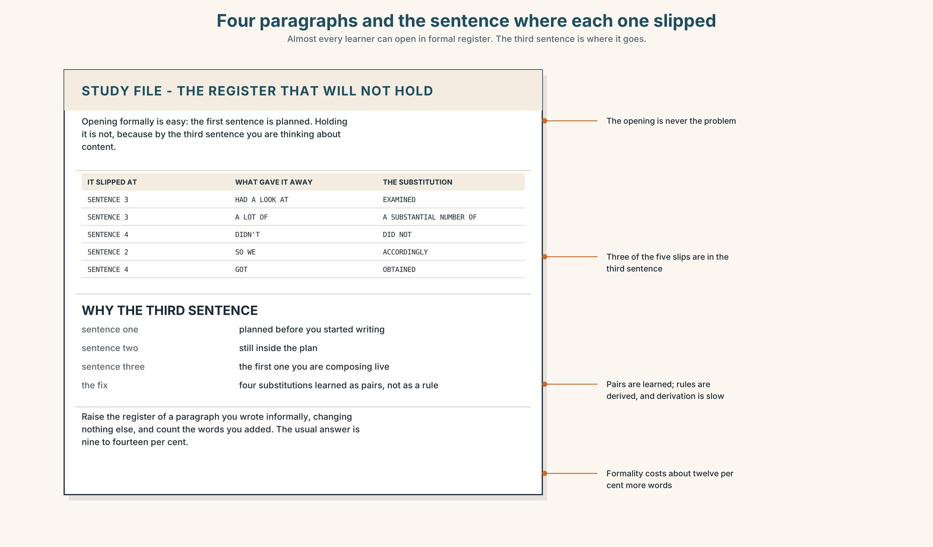{width=6.6in}
Four paragraphs and the sentence where each one slipped — Almost every learner can open in formal register. The third sentence is where it goes.

STUDY FILE · The register that will not hold

9A · Starting formal and ending spoken 🔊 Track 4.4
Almost every learner at this level can open in formal register and almost none can hold it for a paragraph. The first sentence has a reduced relative and a nominalisation; by the fourth, there is a contraction and a phrasal verb, and the reader has noticed the moment it happened.
sentence one | The samples, collected in March, were analysed…
sentence four | …and then we had a look at what came out.
what gives it away | the contraction, the phrasal verb, the vague noun
the fix | a list of four substitutions, memorised, not derived

9B · Hold it for four
Write a four-sentence paragraph in formal register. Give it to somebody and ask them to mark the sentence where it slipped. It is almost always the third.

9C · Role play — the substitution
In pairs. One of you says a sentence informally. The other says it formally, changing exactly one thing. Eight rounds each, and name the thing each time.

9D · The four you need
Most learners need the same four: look at → examine, a lot of → a substantial number of, get → obtain, so → accordingly. Find your own four and learn them as a pair each, not as a rule.

9E · Transfer — before next week
Take a paragraph you wrote informally and raise its register, changing nothing else. Bring both and count the words you added. The usual answer is between nine and fourteen per cent.

Part 10 · Mediation & Interaction ◆ C · THE PERFORMANCE
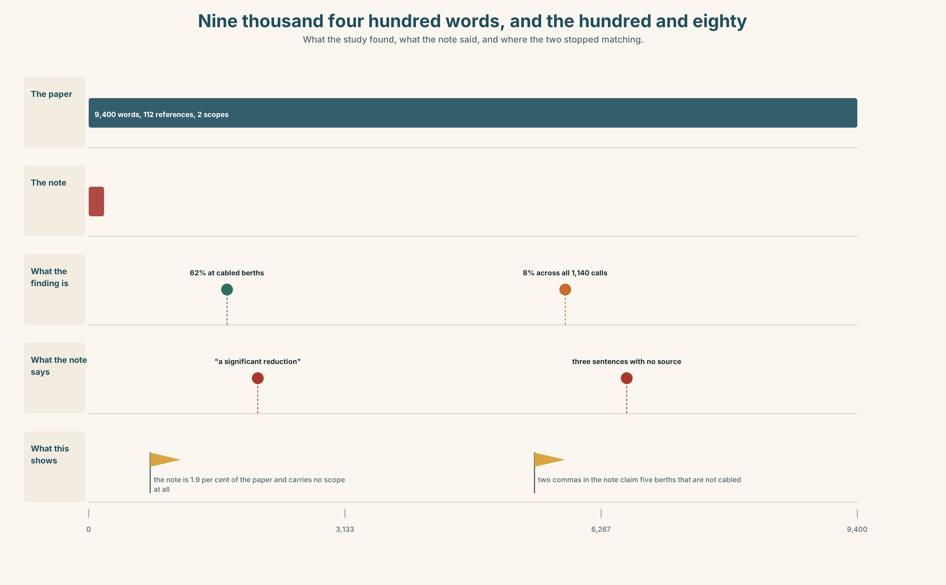{width=6.6in}
Nine thousand four hundred words, and the hundred and eighty — What the study found, what the note said, and where the two stopped matching.

10A · Relay
Half the class has the paper's results. Half has the note. Find the three unsourced sentences, by speaking only. Ten minutes.

10B · Simplify — for one reader
A board member writes: So have emissions fallen by sixty-two per cent or eight? Reply in four sentences, in formal register, with both numbers and their scopes.

10C · Online
Write one message to the board secretary about the three added sentences. Three sentences. Do not suggest that anybody acted in bad faith.

10D · Your language
Does your language reduce relative clauses as English does? Translate all six sentences from Part 2. Which two become identical, and what is lost?

Part 11 · The Decision ◆ C · THE PERFORMANCE

What the port publishes
Option one: publish the summary. The paper is nine thousand four hundred words and will be read by eleven people, four of whom wrote it.
Option two: publish the paper and nothing else. Whoever needs the finding can read it.
Option three: publish both, and require every sentence of the summary to cite the paragraph of the paper it comes from.

11A · The evidence
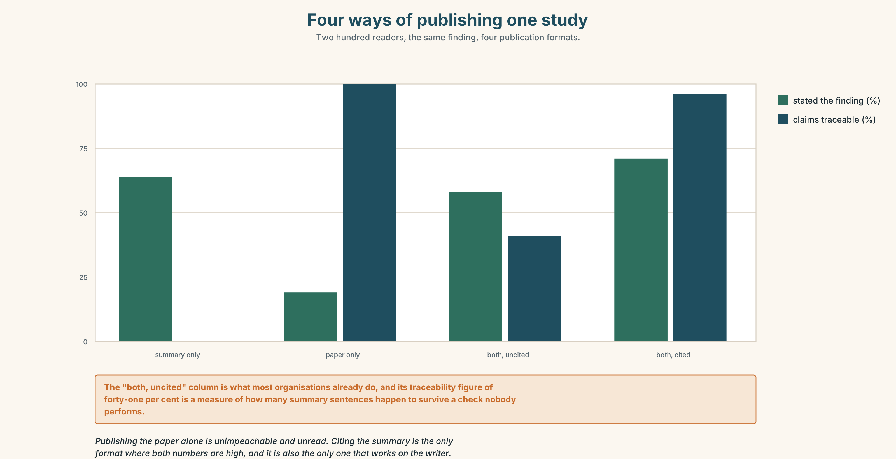{width=6.6in}
Four ways of publishing one study — Two hundred readers, the same finding, four publication formats.
🔊 Track 4.6. Dr Ilse Brandt, who wrote the study, 30 seconds: "I do not mind being summarised. I have been summarised accurately twice in nine years and I remember both. What I mind is a summary with nothing to check it against, because the writer of such a summary has no way of knowing whether they have gone wrong either. The citation is not a leash. It is a mirror."

11B · Talk about it
In threes. Use the frame, and attach one clause to a noun in every turn.
I would ______ , because the reader, ______ , cannot ______ .

11C · Decide
Write three sentences: the decision, the evidence, and one sentence of a summary with its citation.

11D · Model decision
Option three. Publishing the paper alone is a decision to be read by nobody, and publishing the summary alone is what produced the three sentences. The citation costs the summary writer about twenty minutes and it is the only mechanism here that works on the writer rather than on the reader: a sentence that cannot be anchored to a paragraph announces itself while it is being written, which is the only moment at which anybody can do anything about it.

11E · The Reveal
What happened. The port published both, with citations. The summary came back from its first draft with four sentences uncited, three of them the board secretary's and one of them a figure nobody could source at all.
Then something nobody predicted: the summary got longer, from a hundred and eighty words to two hundred and sixty, and the extra eighty words were almost entirely scopes — at cabled berths, across all calls, in the year to December. Nobody had asked for them. They appeared because a sentence being anchored to a paragraph acquires the paragraph's qualifications on the way.
One question. You do not have to answer it out loud.
The citation rule was about where sentences came from. Why did it change what they said?

Part 12 · Landing ◆ all three lines

12A · Recycle — fifteen items
- The berths which were cabled in 2021 → ______ (reduce it)
- The barges that are using shore power → ______ (reduce it)
- The berths, ______ ______ cabled in 2021, are used on a third of calls. (two words)
- The provision is held ______ ______ ______ the remaining berths. (three words)
- The study was commissioned ______ ______ the 2022 resolution. (two words)
- The regulation, ______ ______ , applies from January. (two words)
- The berths ______ ______ ______ are the four with cable. (three words)
- ______ ______ ______ , uptake is thirty-one per cent. (three words)
- The terminal ______ ______ the port authority is not in the sample. (three words)
- The operator is ______ ______ ______ ______ the Netherlands. (four words)
- ______ ______ ______ ______ ______ . (five words — the warning before a qualification)
- ______ ______ ______ ______ ______ ______ . (six words — the warning before a definition)
- The methodology ______ ______ two earlier studies. (two words)
- The results ______ ______ what the operator reported. (two words)
- The provision figure ______ ______ the 2021 valuation. (two words)

12B · Consolidate — one task, everything in it
Write 150 words in formal register containing one defining relative, one non-defining, one reduced clause and one pointing-back word. Mark all four.

12C · Can-do, with evidence
☐ I can use relative and participle clauses in formal register. Evidence: 3H, 8D ☐ I can tell what two commas claim about quantity. Evidence: 5E, 7C ☐ I can hold a formal register for a paragraph. Evidence: 9B, 8D ☐ I can read a long formal sentence in three beats. Evidence: 7B

12D · Replay ⏺
Record 0C again. Compare. Where did the register slip the first time?

12E · Glossary — fifty items, as a map
THE STUDY · methodology · sample · variable · hypothesis · findings · corollary THE EXAMINATION · audit · disclosure THE ACCOUNTS · valuation · amortisation · provision · accrual THE FIVE PHRASES · the literature suggests · a control group · statistical power · the going concern · a material weakness IN THE ACCOUNTS · the balance sheet · an audit trail · year end · a qualified opinion · the notes to the accounts WHAT PAPERS DO · draw on · set out · bear out · refer to · relate to · derive from THE WARNINGS · it should be noted that · for the avoidance of doubt · as set out below THE POINTING WORDS · thereof · herein · aforementioned · respective · pursuant · foregoing · hitherto · whereupon THE FRAMES · having been · which is to say · the terminal operated by · a company registered in · those referred to above · as amended · in respect of · with reference to CROSS-REFERENCES · the preceding paragraph · as noted above · see below

12F · Next
Unit 5 · Is it essential that he be here?

