Table of Contents

B1.3 · Unit 8 · Three People, Three Emails
English Animated · Making the Case · a university campus, Melbourne Student's Book pages 160–181 · 22 pp · ~11 hours

Part 0 · The Big Picture ◆ A · THE WORLD
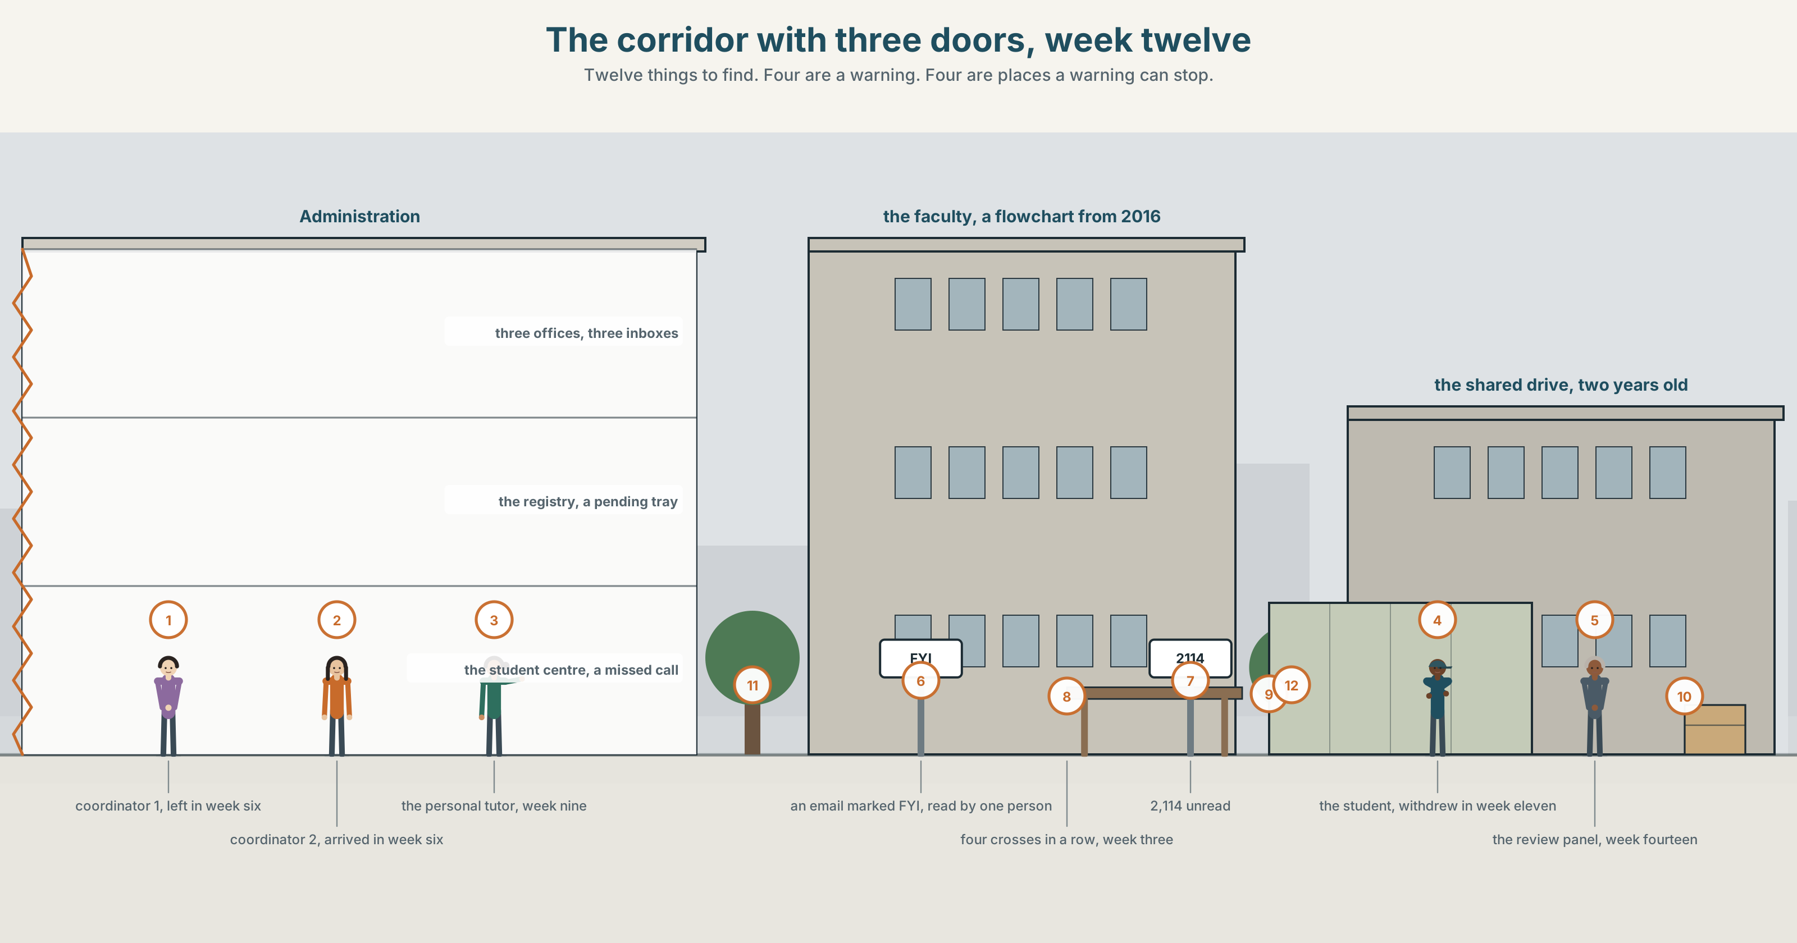{width=6.6in}
The corridor with three doors, week twelve — Twelve things to find. Four are a warning. Four are places a warning can stop.

What should you have done?
By the end of this unit you can write a post-mortem of a decision that went wrong.
◆ A · THE WORLD | A student who failed, and three warnings that each reached one person
◆ B · THE SYSTEM | the hypothetical past: should / could / would / ought to have · 24 words for decisions, hindsight and audit · 21 criticism forms · should've /ʃʊdəv/
◆ C · THE PERFORMANCE | A post-mortem that finds a system fault, not a person to blame

0A · Find it
Find twelve things in this picture. Four of them are a warning. Four are the places a warning can stop.
an inbox with 2,114 unread · a corridor with three office doors · a form half filled in · a shared drive folder dated two years ago · a desk with a tray marked pending · a noticeboard with a flowchart on it · a phone with a missed call · a printed attendance list with four crosses in a row · a whiteboard with a name and a date · a handover note under a keyboard · a meeting that four people are in and five were invited to · an email marked FYI

0B · Guess it
Three of the twelve are the same warning, in three different places. Which, and which of the three was anybody responsible for reading?

0C · Say it ⏺
Record forty-five seconds. Describe something that went wrong around you where everybody did their own job correctly. You will record it again at the end of this unit.

Part 1 · Vocabulary Lab 1 ◆ B · THE SYSTEM
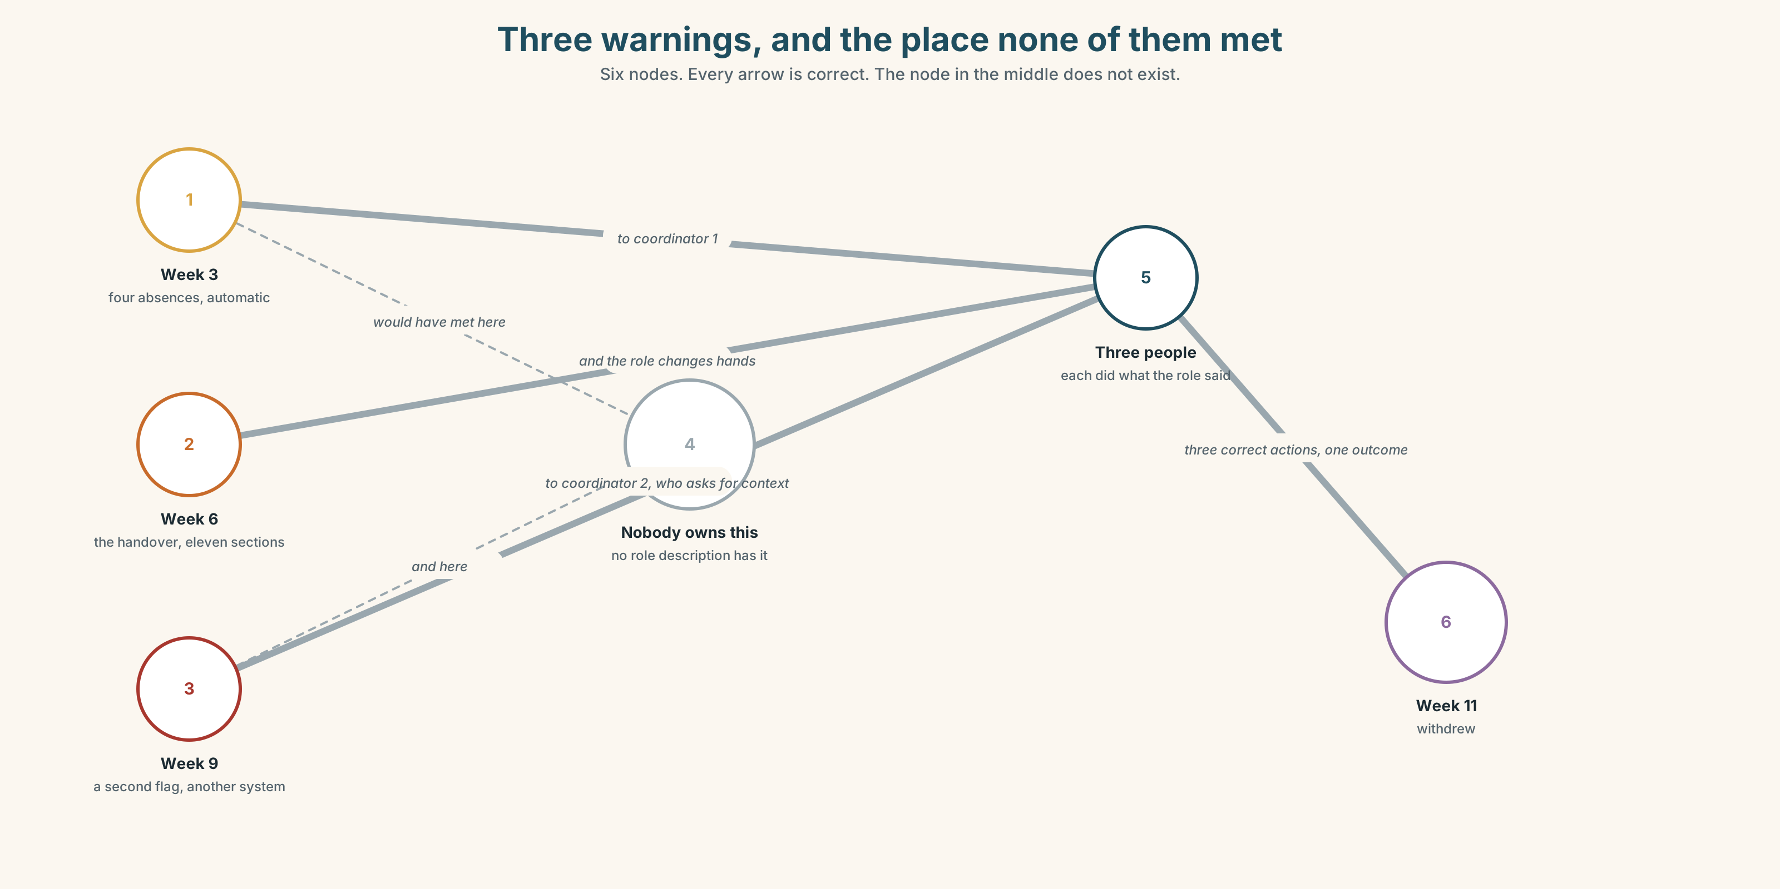{width=6.6in}
Three warnings, and the place none of them met — Six nodes. Every arrow is correct. The node in the middle does not exist.

1A · Meet — the words of a post-mortem
decision · hindsight · audit · threshold · handover · oversight · accountability · omission
- Which two of these are moments, and which two are states?
- Oversight means two opposite things. Give both, and say how you tell them apart.
- What is a threshold, and why does every automatic warning need one?
- Why is a handover the most dangerous five minutes in any process?
An omission is not the same as a mistake. A mistake is a thing done wrongly. An omission is a thing not done, and no log anywhere records it.

1B · Sort — the system, the person, or the aftermath?
escalate · warning · trigger · review · with hindsight · in retrospect · fall through the cracks · flag it up · the duty of care · nobody owned it
Three columns. Two of them belong in more than one. Say which and why.

1C · Meet — the phrase that does most of the work
c nobody owned it
Not nobody did it. Everybody did a piece of it, correctly, and no single person was responsible for the whole.
- Why is this harder to fix than somebody doing something wrong?
- Name one thing in your own life that nobody owns.

1D · Collocation Lab
flag it up | ~ early · ~ to somebody
with hindsight | ~ it was obvious · ~ , we would have
the duty of care | owe ~ · breach ~
fall through the cracks | ~ between two teams · let somebody ~
Which two of these can only be said afterwards?

1E · The fixed expressions
f Three people, three emails. — the shape of the most common institutional failure there is, and it fits in four words. f Somebody should have. — a sentence with no subject, and that is the diagnosis as well as the complaint.
Which one names the fault, and which one performs it?

1F · Own it
The four phrasal verbs of a warning.
pass on · follow up · sign off · take up
- Which two end somebody's responsibility, and which two extend it?
- What exactly do you sign off — the work, or the risk?
- Follow up and check: what does follow up assume that check does not?
- Write one sentence in which somebody passes on a warning and makes it weaker.

Part 2 · Listening ◆ A · THE WORLD
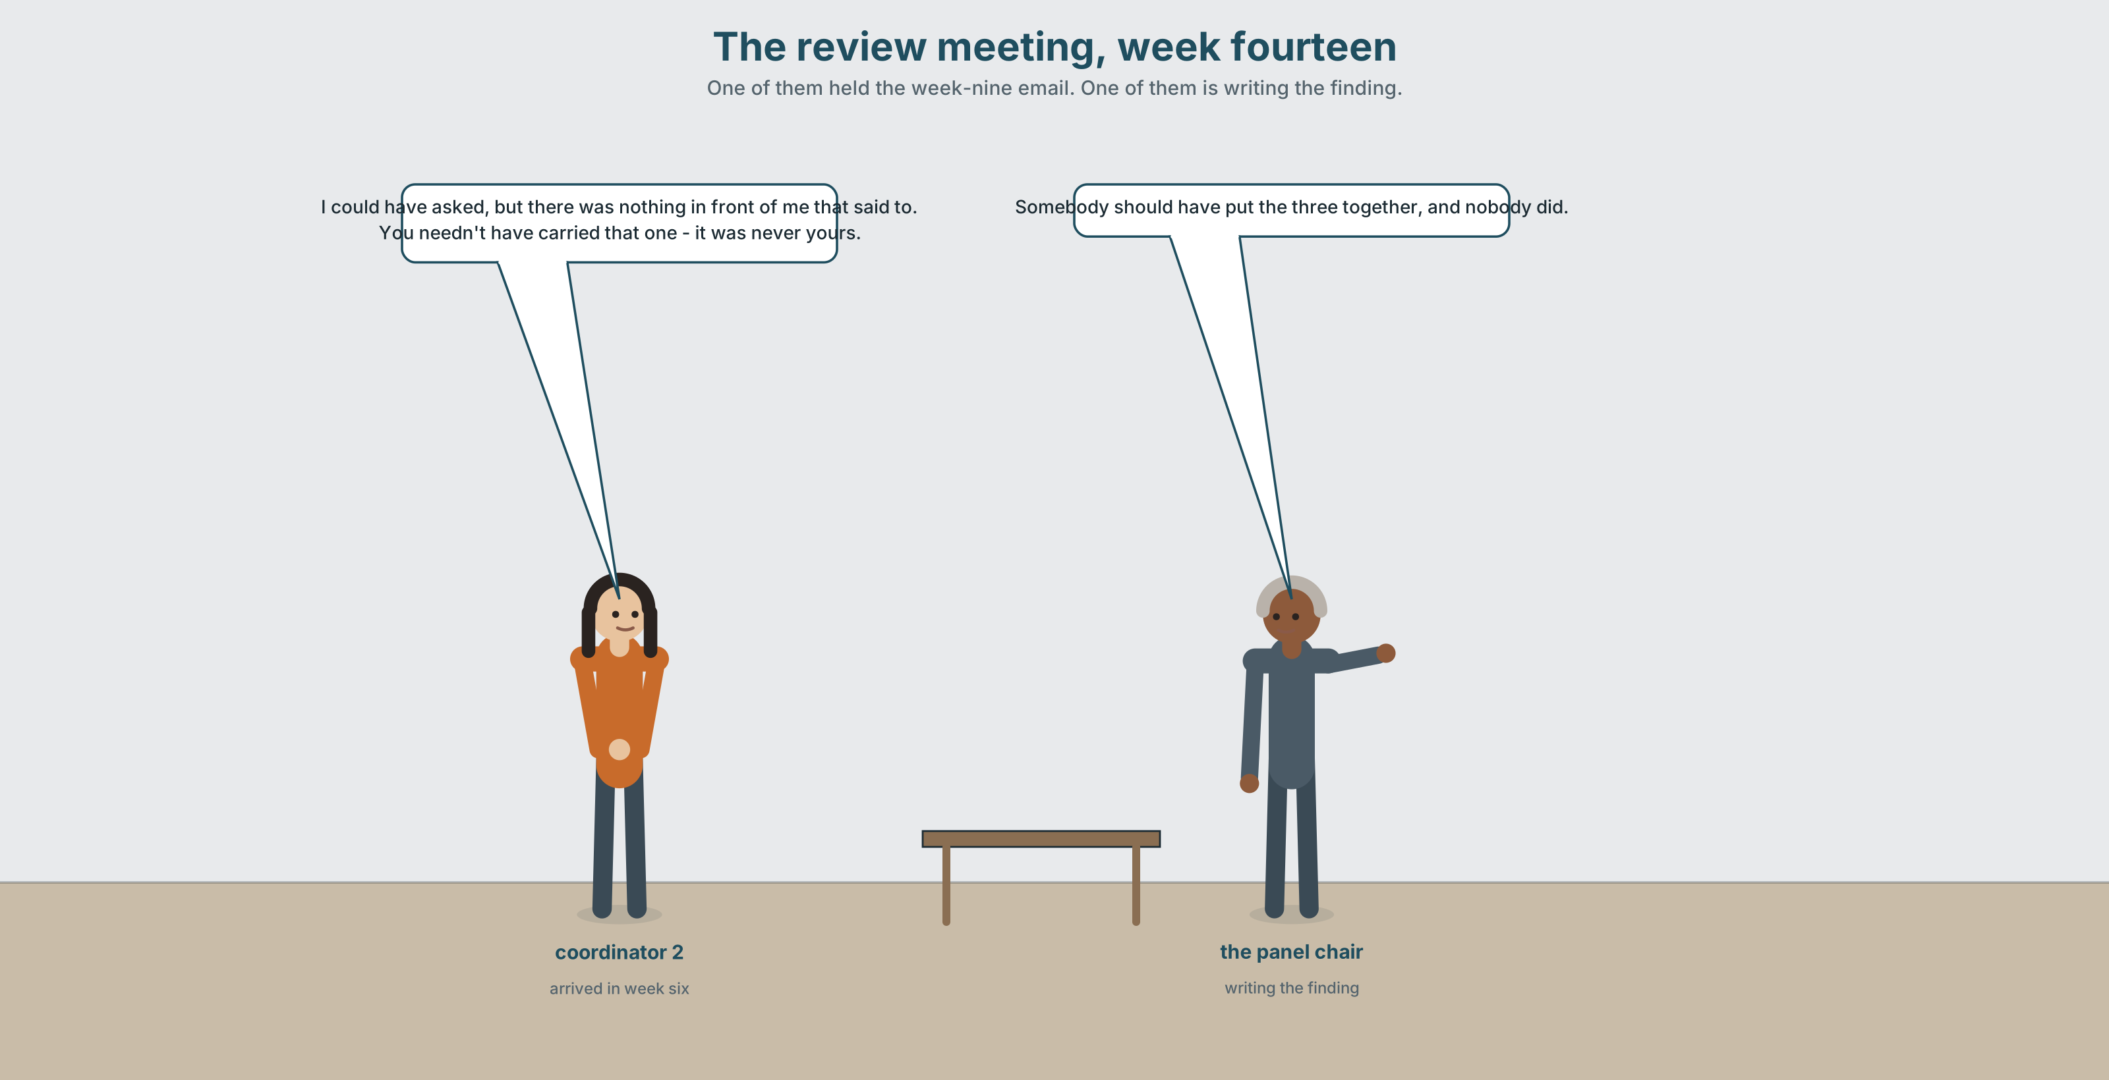{width=6.6in}
The review meeting, week fourteen — One of them held the week-nine email. One of them is writing the finding.

2A · The review meeting 🔊 Track 8.1
Before you listen. A second-year student has failed three units and withdrawn. Three separate warnings were generated in the twelve weeks before. Guess: how many people saw all three?
Listen once. One question. Who generated each warning, and who received it?
Listen again. Complete the table.
 | Warning 1 | Warning 2 | Warning 3
week
triggered by
went to
action taken
Listen again. Choose the best answer.
- The three warnings went to one person / two people / three people.
- The threshold for an automatic alert is three absences / four / six.
- Somebody says it was not my responsibility and is right / and is wrong / and nobody answers.
- The handover happened in week 2 / week 6 / week 9.
Noticing. Four sentences from the recording.
- Somebody should have put the three together, and nobody did.
- I could have asked, but there was nothing in front of me that said to.
- With hindsight the handover ought to have included the open cases.
- You needn't have carried that one — it was never yours.
All four judge a past action. Which one withdraws a criticism?

2B · Decoding clinic 🔊 Track 8.2
Thirty seconds of the review. Four jobs.
- How many have forms can you count?
- In should have put, how is have pronounced?
- Catch the two week numbers.
- One speaker says I could have and means something different from I should have. What?
Transcripts, page 157.

Part 3 · Grammar Lab 1 ◆ B · THE SYSTEM

Judging the past you cannot change

3A · Notice
Look at the four sentences in Part 2.
- In sentence 1, did anybody put them together?
- In sentence 2, was the speaker able to ask? Did they?
- Rewrite sentence 3 with should. Does the meaning change?
- Sentence 4 uses needn't have. Did the person do it or not?
- Try "Somebody should have put the three together, and nobody didn't." What is wrong?

3B · See
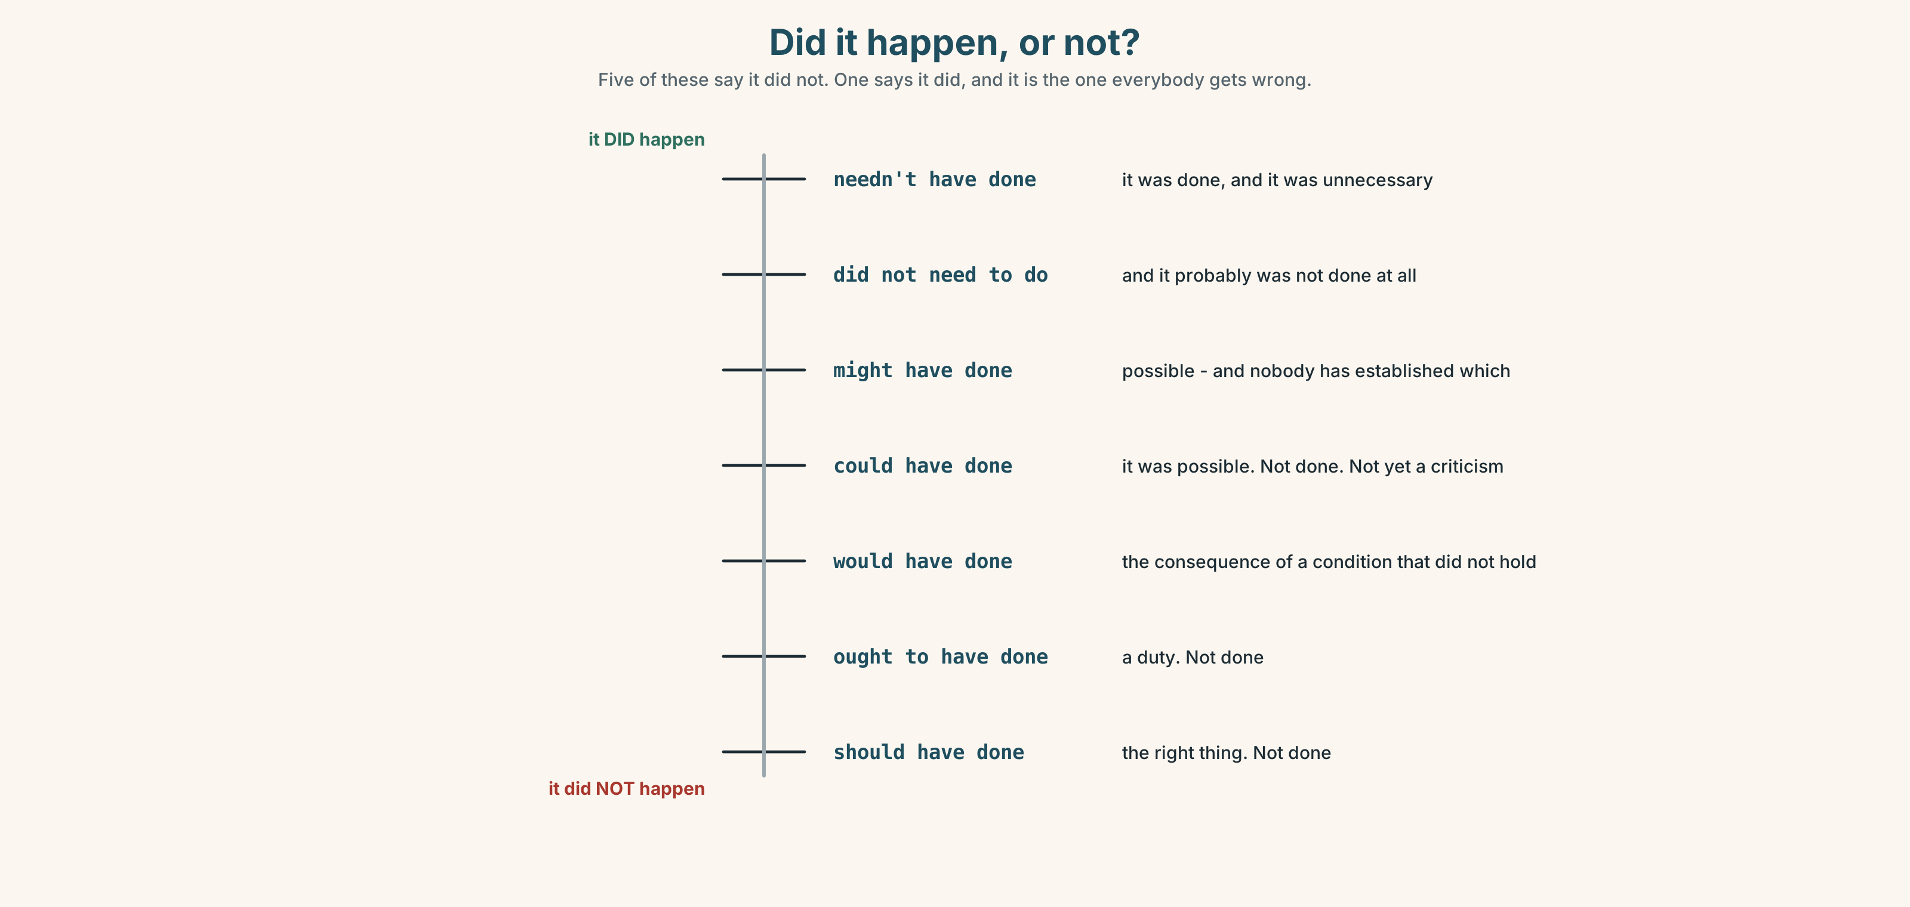{width=6.6in}
Did it happen, or not? — Five of these say it did not. One says it did, and it is the one everybody gets wrong.

3C · Know
Form | Means | Did it happen?
should have + pp | it was the right thing and it did not happen | no
ought to have + pp | the same, slightly more formal, often about duty | no
could have + pp | it was possible and it did not happen | no
would have + pp | it was the consequence of a condition that did not hold | no
might have + pp | it was possible, and we do not know | unknown
needn't have + pp | it happened, and it was unnecessary | yes
The one that catches everybody. Needn't have done means it was done. Did not need to do means it was not. She needn't have come in — she came. She did not need to come in — and probably stayed at home.
could have is not a criticism by itself. I could have asked says it was possible. Whether it is an accusation depends entirely on what follows: I could have asked, but nothing told me to is a defence.
Use otherwise to carry the condition. The threshold should have been four. Otherwise nothing fires until it is too late.
Why it matters. A post-mortem written in should have is a list of accusations. One written in could have and would have is a description of a system, and only the second kind changes anything.

3D · Use — controlled
Three separate warnings were generated. Each one went to one person, and each of those people did exactly what the procedure asked. Somebody (1) __________ have put the three together, and (2) __________ . The tutor (3) __________ have asked, but nothing in front of her said to. With hindsight the handover in week six (4) __________ to have included the open cases. The threshold (5) __________ have been four absences rather than six; (6) __________ nothing fires until the student has already missed a third of the semester. The registry (7) __________ have chased the second form at all — it had already been superseded, and chasing it cost two days that nobody had.

3E · Use — guided
Rewrite each one with the form in brackets.
- It was the right thing to do and nobody did it. (should have)
- It was possible and she did not do it. (could have)
- She did it and it was unnecessary. (needn't have)
- It was her duty and it did not happen. (ought to have)
- If the threshold had been four, it would have fired in week three. (would have)

3F · Use — open
In pairs. Describe something that went wrong, in six sentences, three of which must use a hypothetical past. Your partner's job is to say, after each one, whether it describes a person or a system.

3G · Error autopsy
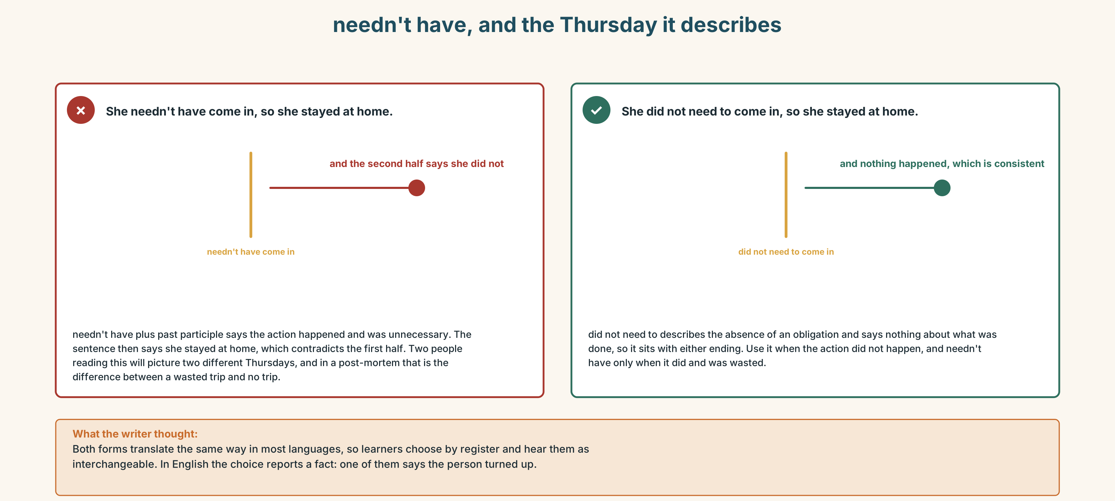{width=6.6in}
needn't have, and the Thursday it describes — needn't have, and the Thursday it describes
Read both versions. Then say whether the person came in or not.

3H · Check — eight items
- Somebody ______ have put the three together. (right thing, did not happen)
- She ______ have asked, but nothing told her to. (possible)
- The handover ______ to have included the open cases. (duty)
- You ______ have carried that one — it was never yours. (it happened, unnecessarily)
- If the threshold had been four, it ______ have fired in week three. (consequence)
- ✗ Somebody should have put them together, and nobody didn't. → correct it.
- The threshold should have been four; ______ , nothing fires in time. (condition carried)
- It ______ well have been missed twice. (possible, unknown)
0–4 → Workbook pp. 34–37. 5–6 → Part 6. 7–8 → page 173.

Part 4 · Speaking ◆ C · THE PERFORMANCE

4A · Fluency starter — person or system
One learner gives a should have sentence. The next rewrites it so that it describes a system rather than a person. The chain breaks when the system version still has a name in it.

4B · The functional core — running a post-mortem
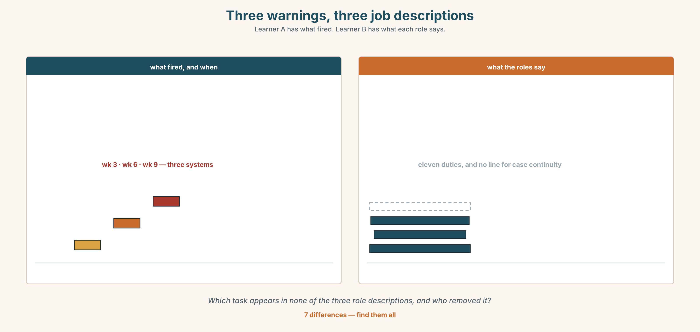{width=6.6in}
Three warnings, three job descriptions — Learner A has what fired. Learner B has what each role says.
Language Bank
the sequence | In week three… · By week six… · Not until week nine…
what was possible | X could have…, but nothing in front of them said to.
the system fault | Nobody owned it. · The threshold was set at six.
the withdrawal | You needn't have… · That one was never yours.
Information gap. Learner A has the three warnings. Learner B has the three job descriptions. Find the task that appears in none of the three.

4C · The performance — three minutes ⏺
Run a post-mortem on something that went wrong. Three minutes. You must include:
the sequence, with dates · what each person could have done and why they did not · the system fault, named without a person in it · one thing you are withdrawing
Record it.

4D · Observer
One person listens for one thing: did any sentence turn a system fault back into a person?

4E · Three criteria
☐ Is the sequence dated? ☐ Is the main fault stated without a name in it? ☐ Did I withdraw at least one criticism that does not survive the evidence?

Part 5 · Reading ◆ A · THE WORLD

5A · Predict
An opinion column, titled "Stop asking who." What do you expect it to propose instead? Two sentences.

5B · Read — two minutes and a quarter

STOP ASKING WHO opinion
Every institutional failure I have read about in twenty years ends the same way: a report, a name, and a sentence beginning should have. And every one of them produces the same two results, which are that one person's career is damaged and the thing happens again within four years.
I want to be careful here, because there is a version of what I am saying that is an excuse for everybody, and that is not it. People are responsible for what they do. The question is whether who is the most useful question to ask first, and I think the evidence is that it is not.
Take the case everybody in this sector knows. A student missed four consecutive classes in week three. An automatic alert fired, because the threshold is four, and it went to the unit coordinator. In week six the coordinator changed, as coordinators do, and the handover document had a section for assessment deadlines and no section for open student cases. In week nine the student's personal tutor received a separate flag, from a different system, and emailed the coordinator — the new one — who replied the same day asking for context she did not have.
Three people. Three emails. Each of them did what their role described. The student withdrew in week eleven.
The report named the second coordinator. With hindsight, it said, she ought to have asked a follow-up question. She ought to have. She also ought to have, in the same week, prepared two hundred and ten exam scripts and run a staff recruitment panel, and if we are listing the things that a reasonable person ought to have done in week nine we are going to be here for some time.
What nobody asked was why a handover template that runs to four pages has no line on it for open cases. That is a fixable sentence in a Word document. It does not require anybody to be braver, or more diligent, or to have more hours in the day, and it would have worked in week six without anybody noticing it had.
Ask who second. Ask it properly, and name people when they have earned it. But ask what first, because what is the only one of the two questions that has an answer you can act on next Tuesday.

5C · Comprehension — eight questions
- What does the writer say every institutional failure report ends with?
- What are the "two results", and what is the time frame on the second?
- What is the version of the argument the writer is careful to reject?
- Describe the three warnings: when, from where, and to whom?
- What was missing from the handover document?
- What does the writer say about "she ought to have asked a follow-up question"?
- What does the writer say nobody asked, and why is it fixable?
- What is the final recommendation, in the writer's own order?

5D · Vocabulary in context
Guess from the text. Then check.
as coordinators do · a separate flag · context she did not have · earned it · act on next Tuesday

5E · The counter-text
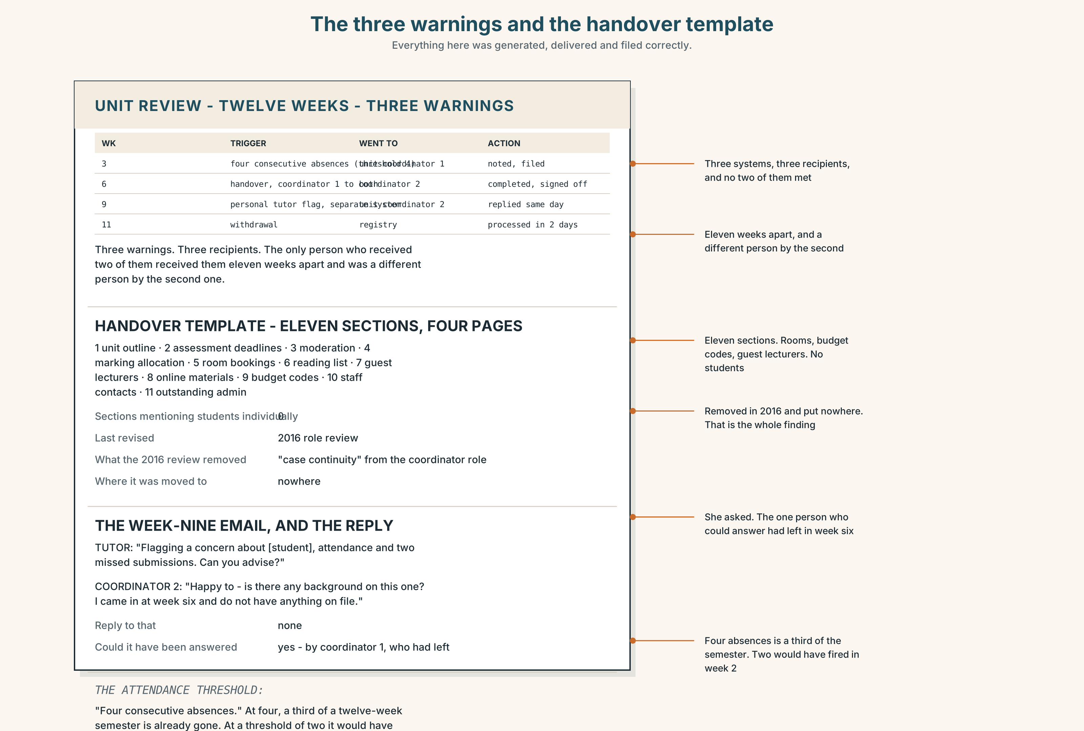{width=6.6in}
The three warnings and the handover template — Everything here was generated, delivered and filed correctly.
Read the three warnings and the handover template, and answer.
- What triggered each of the three warnings, and when?
- Which of the three reached somebody who had seen either of the others?
- What are the eleven sections of the handover template?
- What is the attendance threshold, and what would four have changed?
- One of the three emails has a reply. What does it ask for, and could it have been answered?

5F · Two texts
The column says the handover template has no line for open cases. The template has eleven sections and runs to four pages.
Is that an oversight or a design decision? Three sentences.

Part 6 · Vocabulary Lab 2 ◆ B · THE SYSTEM

Criticising the past precisely

6A · Sort — how certain is each one?
Three columns: certain · probable · possible.
clearly · demonstrably · foreseeably · conceivably · might well have · could have · should have · ought to have

6B · Chunk completion
- ______ have put the three together (right thing, undone)
- ______ have asked, but nothing said to (possible)
- ______ to have included the open cases (duty)
- ______ have carried that one (done, and unnecessary)
- might ______ have been missed twice (possible, unknown)
- in ______ case , the threshold is the fault

6C · Two that sound like evidence
clearly · demonstrably
Clearly is a claim about how obvious something is, and it is often used when nothing has been shown. Demonstrably says somebody has shown it. Only one of them should survive a careful edit of a post-mortem. Which, and why?
Write two sentences about the column in Part 5, one with each.

6D · Two that carry a consequence
c otherwise · c all the more so
The threshold should have been four. Otherwise nothing fires in time. A handover is hard. With two hundred scripts to mark, all the more so.
Otherwise carries the unstated condition. All the more so intensifies a point already made. Write one sentence with each, about week six.

6E · The fixed expressions
f And nobody did.
Three words, placed after a should have, and they turn an accusation into a finding.
Write the sentence before it, twice — once naming a person and once not. Which one works?

6F · Contrast Clinic
Eight items. Four are wrong. Correct them and say what the rule is.
- She needn't have come in — so she stayed at home.
- She needn't have come in, but she did.
- He should have asked, and he didn't.
- He should asked.
- It ought to have included the open cases.
- It ought have included the open cases.
- He might well have been missed twice.
- He could have asked, and nothing told him to, so it is his fault.

Part 7 · Pronunciation & Fluency Lab ◆ B · THE SYSTEM

should've, and why it is not should of
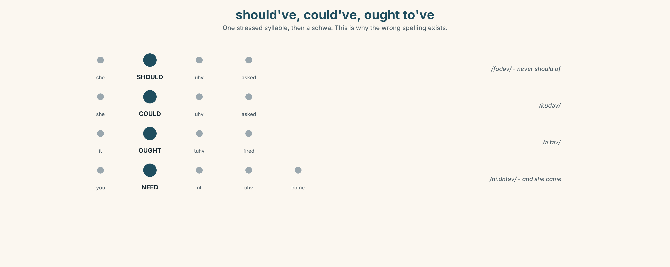{width=6.6in}
should've, could've, ought to've — One stressed syllable, then a schwa. This is why the wrong spelling exists.

7A · Hear 🔊 Track 8.3
She should've asked. /ʃʊdəv/ One weak syllable. It sounds exactly like should of, which is why that spelling exists and why it is wrong.
Listen to the set:
/ʃʊdəv/ · /kʊdəv/ · /wʊdəv/ · /ɔːtəv/ · /maɪtəv/

7B · Say
Say all five. Then say this one three times, faster:
Somebody should've put the three together, and nobody did.

7C · Make it mean something
Say these two:
She needn't have COME in. (she came — and it was wasted) She didn't need to come in. (and she probably did not)
One structure, two Thursdays. Which is which?

7D · Fluency 30 ⏺
Thirty seconds: four hypothetical pasts, all with weak have. Three times, faster, keeping the schwa.

Part 8 · Writing ◆ C · THE PERFORMANCE

A post-mortem · 200 words
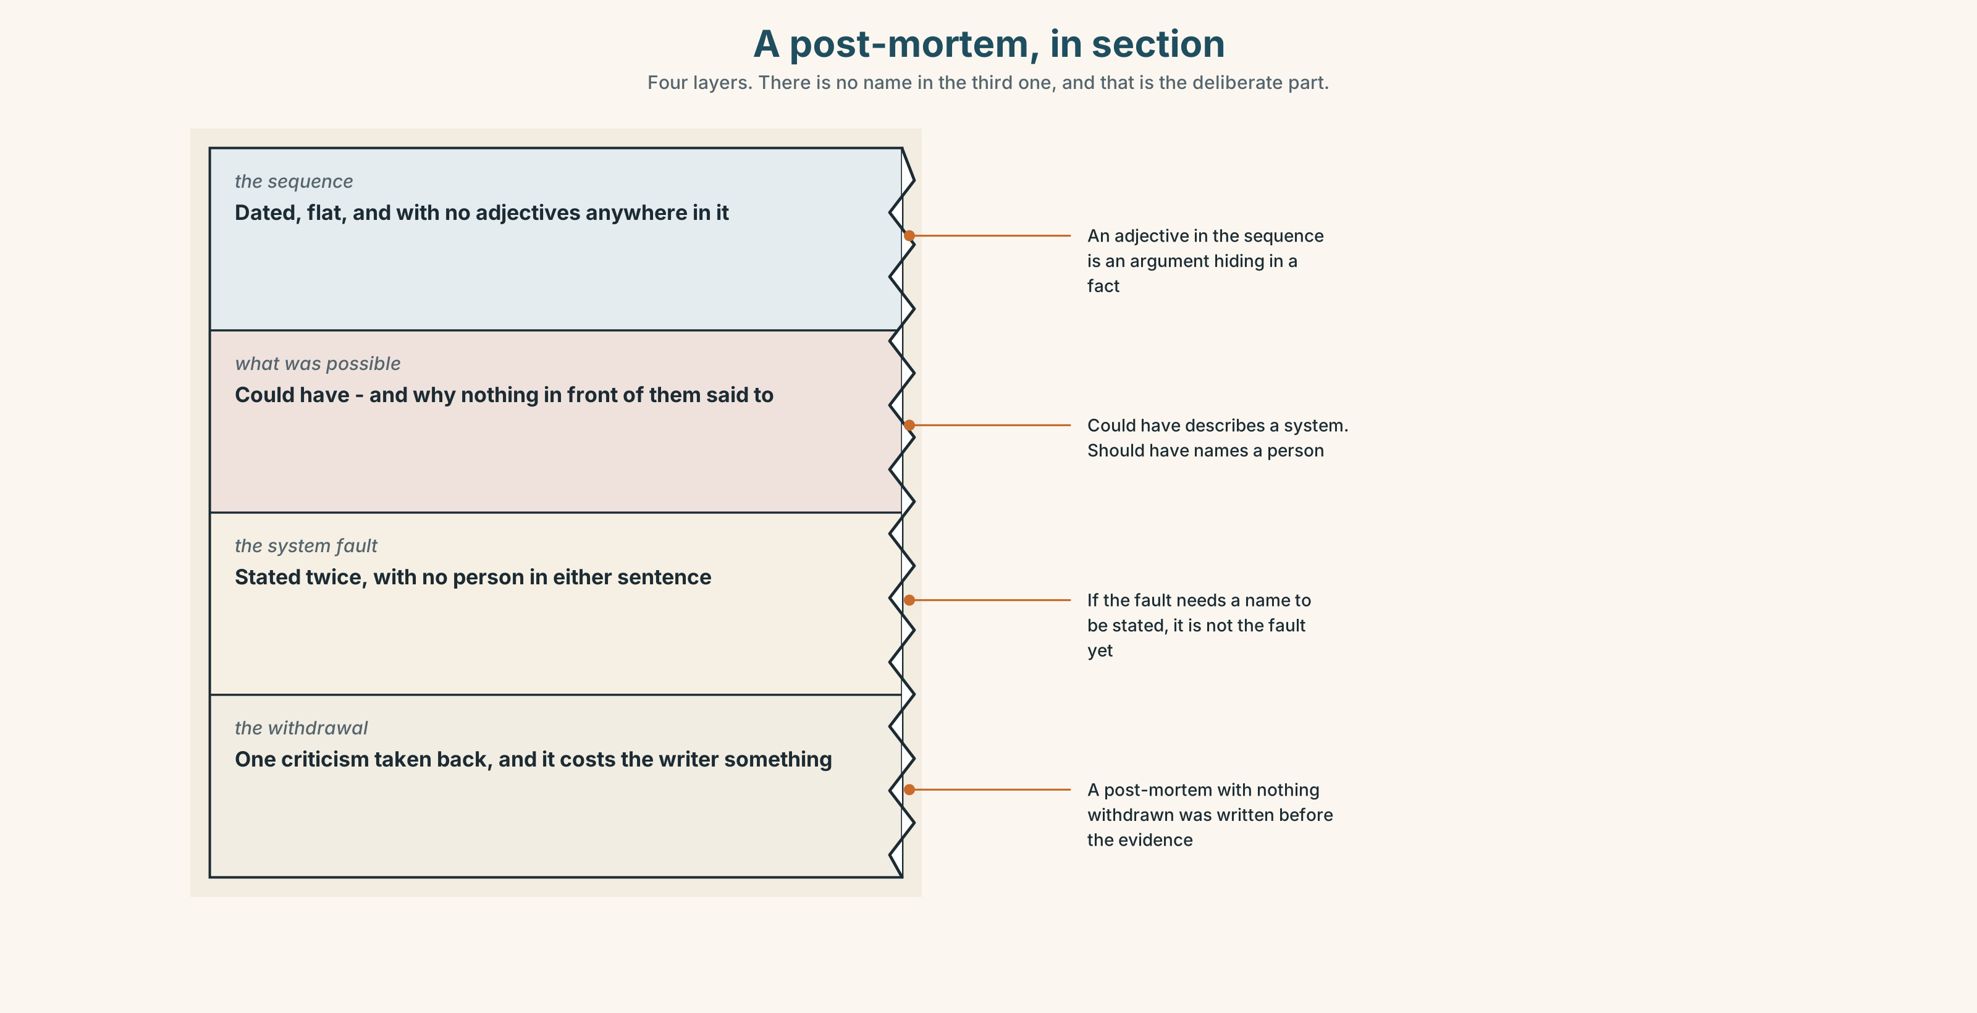{width=6.6in}
A post-mortem, in section — Four layers. There is no name in the third one, and that is the deliberate part.

8A · Read the model
In week three an automatic alert fired after four consecutive absences and went to the unit coordinator. In week six the coordinator changed. In week nine a second flag, from a different system, reached the new coordinator, who asked for context and received none. [the sequence, dated, with no adjectives in it at all]
Each of the three people did what their role described. The second coordinator could have asked a follow-up question, and nothing in front of her indicated that one was outstanding. [what was possible, and why it was not obvious — and this is where could have belongs]
The handover template has eleven sections and none of them is open student cases. Nobody owned the sequence, because no role description contains it. [the system fault, stated twice, with no name in either sentence]
The first coordinator needn't have been named in the draft report. She had left the role eleven weeks before the withdrawal. [the withdrawal, and it costs the writer something]
Questions about the writer's choices:
- The first paragraph has no adjectives. Why not?
- Could have appears once and should have not at all. What does that do?
- The last paragraph withdraws something. What does a post-mortem without one look like?

8B · The anti-model
Unfortunately there was a breakdown in communication and the student fell through the cracks. Lessons have been learned and procedures will be reviewed to ensure that this does not happen again. All staff are reminded of the importance of following up on student welfare concerns.
Correct English, and nothing in it will stop this happening again. Name the three things it has turned into weather, and say what all staff are reminded is a substitute for.

8C · Plan
the sequence, dated and flat → what was possible, and why it was not obvious → the system fault, with no name in it → one withdrawal

8D · Write — 200 words

8E · Peer review — three criteria
☐ Is the sequence dated and free of adjectives? ☐ Is the main fault stated without a person in it? ☐ Is there a withdrawal, and does it cost the writer something?

8F · Write it again · 8G · Publish
Send it to the people named in it, before anybody else. That is the test.

Part 9 · The File ◆ A · THE WORLD + C · THE PERFORMANCE

STUDY FILE · The Literature Review
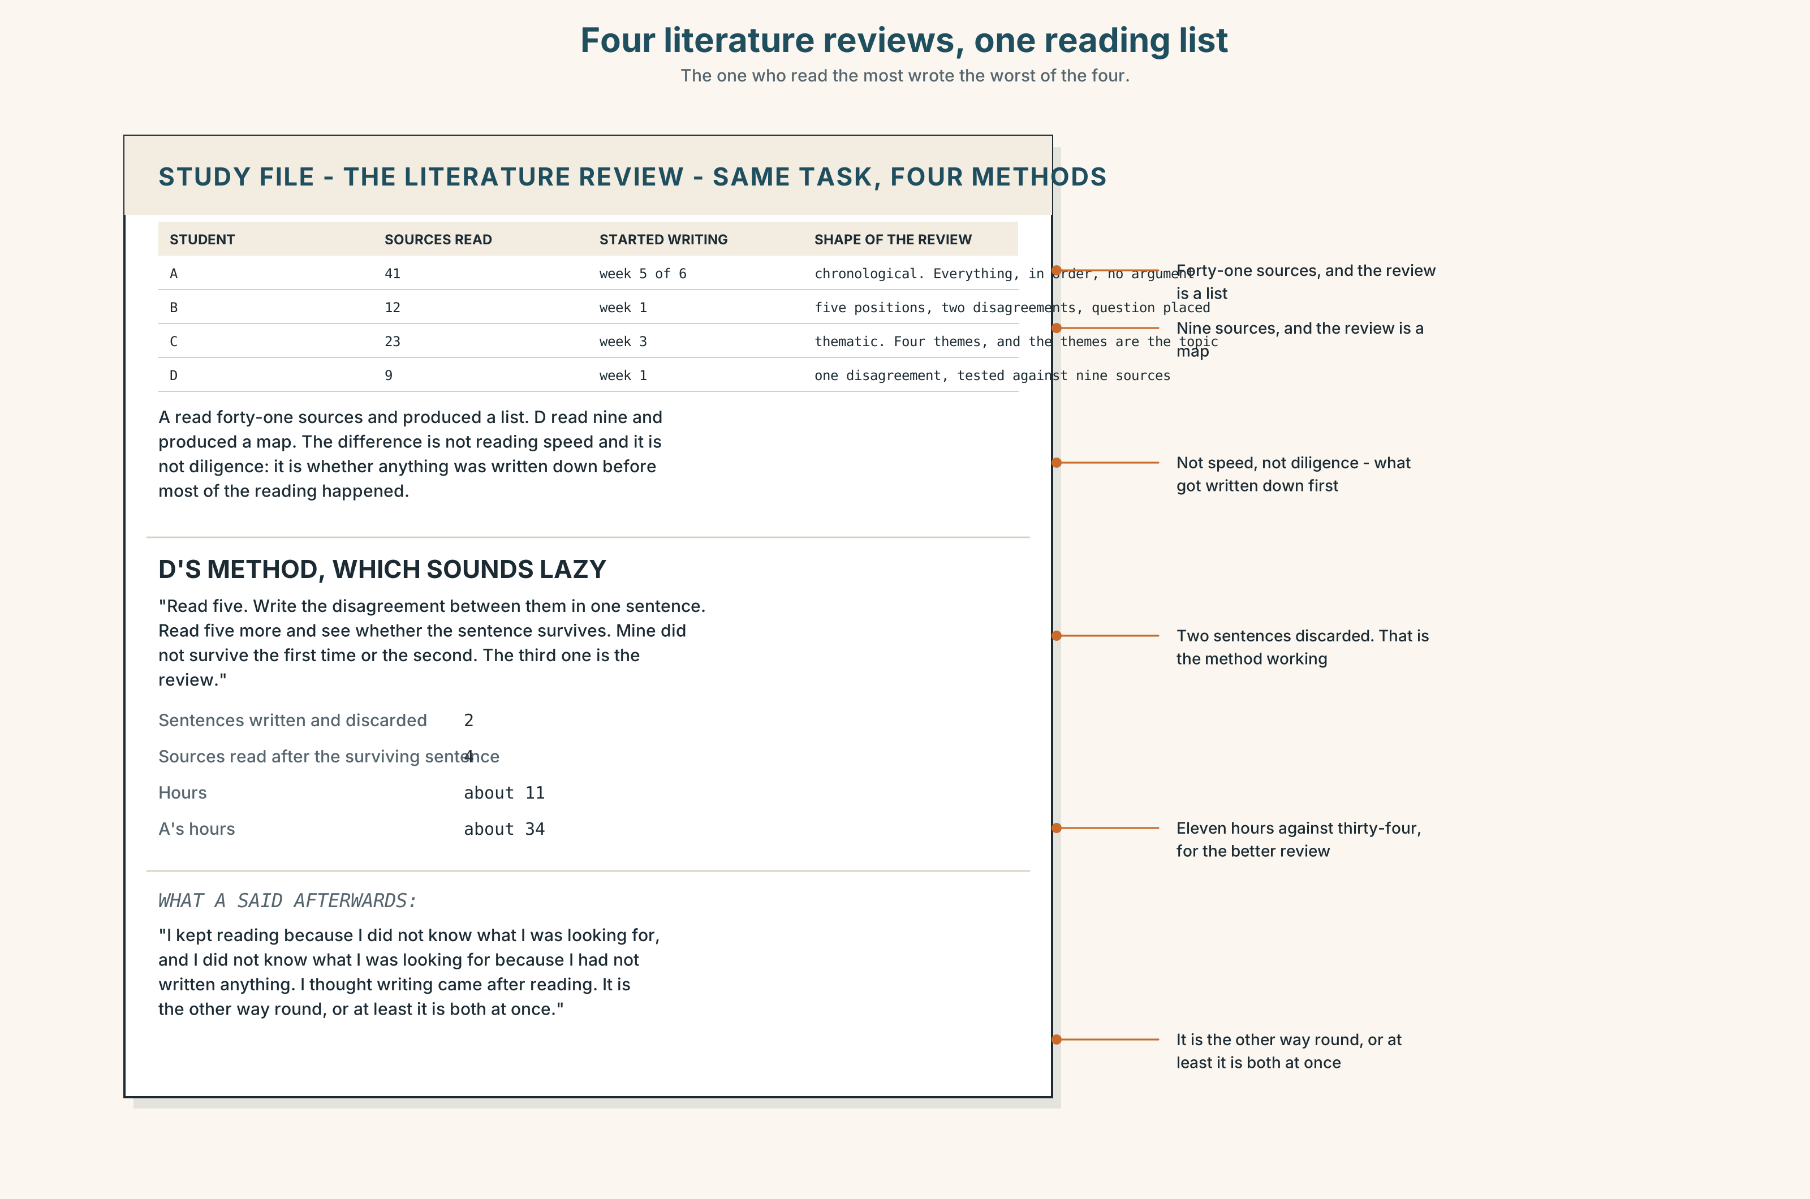{width=6.6in}
Four literature reviews, one reading list — The one who read the most wrote the worst of the four.

9A · Four people describe the same task 🔊 Track 8.4
Four students describe writing a literature review. Listen.
- Which one read the most and wrote the worst one?
- Which one started writing first, and did that help?
- One of them describes a method that sounds lazy and is not. Which?

9B · What a literature review is not
not a list of what everybody said not a chronology not a demonstration that you have read a lot it is a map of where the disagreements are, and where your question sits on it
Which of the three nots is hardest to give up, and why?

9C · The method that sounds lazy
Read five. Then write the disagreement between them in one sentence. Then read five more and see whether the sentence survives. Most do not, and the ones that do are the structure of your review.
Try it with anything you are reading this week.

9D · Your turn
In fours. Twelve minutes. Take any five sources you all know — news articles will do — and write the one-sentence disagreement. Compare the four sentences. Which is a disagreement and which is a topic?

9E · Transfer
Find the literature review in any paper you have to read, and mark the sentence where the writer's own question first appears. How many pages in is it?

Part 10 · Mediation & Interaction ◆ C · THE PERFORMANCE
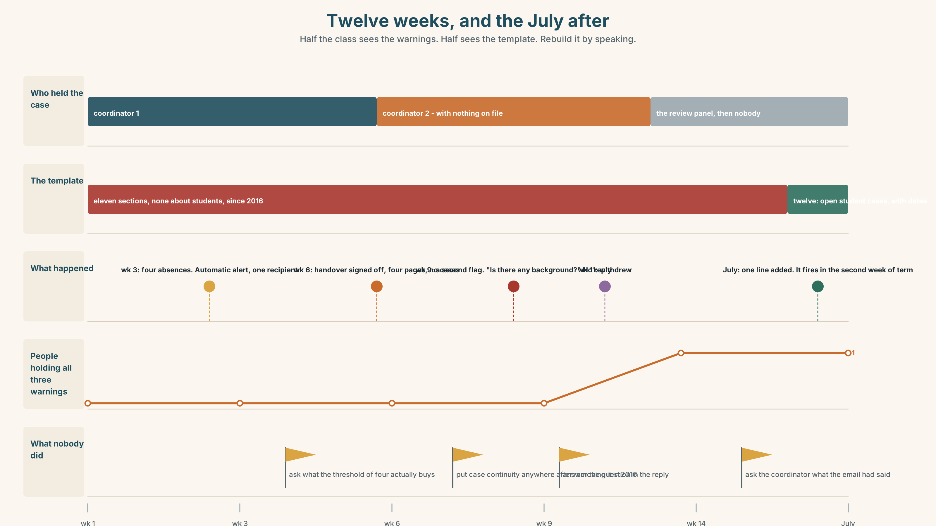{width=6.6in}
Twelve weeks, and the July after — Half the class sees the warnings. Half sees the template. Rebuild it by speaking.

10A · Relay
Half the class sees the three warnings. Half sees the handover template. Rebuild the twelve weeks by speaking. Twelve minutes.

10B · Simplify
Explain the failure to a new coordinator taking over next semester. Five sentences only.
Plan: what fired → where it went → what the handover did not carry → what the threshold is → the one thing to add to the template

10C · Compress
The column in Part 5B into forty words, keeping the recommendation.

10D · Online
Write one message proposing the change to the handover template. One sentence of problem, one of evidence, one of proposal, and the name of the person who has to approve it.

10E · Your language
Does your language separate should have from needn't have the way English does? Say she needn't have come in in both languages. Is it clear in yours whether she came?

Part 11 · The Decision ◆ C · THE PERFORMANCE

Three warnings, three people, one student
A student withdrew in week eleven after failing three units. Three warnings were generated. Each reached one person. Each of those people followed their role description. The review panel has to write a finding.
- Name the second coordinator. She received the week-nine email, asked for context and did not chase it. It is the only point in twelve weeks where one person held enough to act.
- Find no individual fault. Three people, three roles, three correct actions. Record it as a process failure and recommend a template change.
- Name the process and the gap. No individual fault, and a specific, named omission: nobody owns the sequence, because no role description contains it, and that is a decision somebody made in 2016.

11A · The evidence
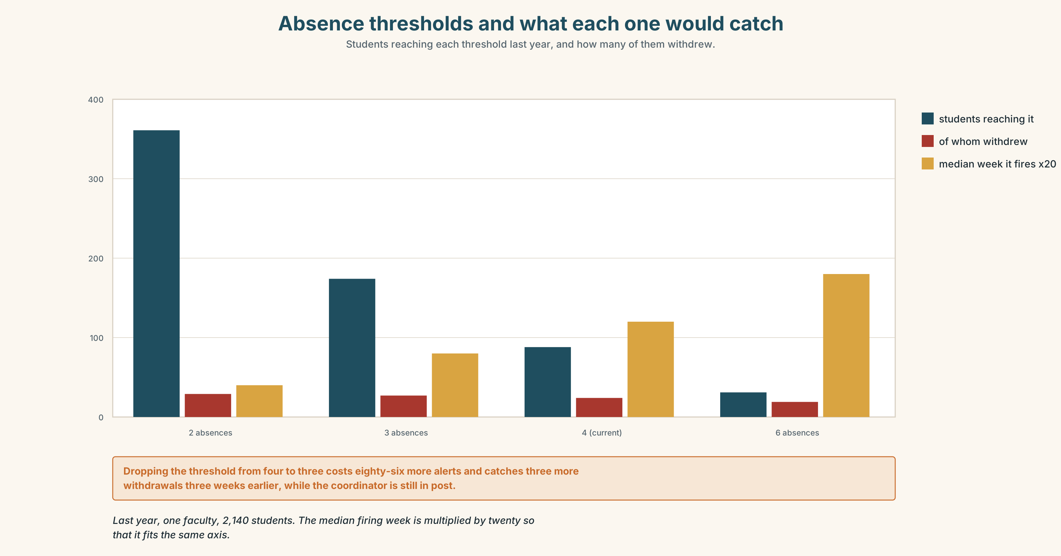{width=6.6in}
Absence thresholds and what each one would catch — Students reaching each threshold last year, and how many of them withdrew.
- The three warnings and the handover template from Part 5E — and the reply that asks for context.
- The chart — how many students hit each attendance threshold, and how many withdrew.
- The voice. The second coordinator, thirty seconds: "I am not going to say I did nothing wrong, because a student withdrew. What I will say is that I asked for context and the system that sent me the flag could have attached it, and in the eleven weeks since, nobody has asked me what the email actually said."

11B · Talk about it
In fours. Everybody speaks twice. Use the frame.
______ should have ______ , and nobody did. ______ could have ______ , but ______ .
Words you can use: threshold · handover · escalate · oversight · accountability · omission · with hindsight · in retrospect · nobody owned it · the duty of care

11C · Decide
Write three sentences. Choose, say why, and name what it costs.
I think the panel should ______________________ , because ______________________ . What this costs is ______________________ .

11D · Model decision
Name the process and the gap, and date the gap. A finding of no individual fault reads as a cover unless it says precisely what was missing and when it went missing, and nobody owned the sequence is only useful if it is followed by because the 2016 role review removed case continuity from the coordinator description and did not put it anywhere else. That sentence has a year in it and a document behind it. It is also the only version of this finding that somebody can act on without waiting for anybody to be braver.

11E · The Reveal
What happened. The panel found no individual fault and recommended a line be added to the handover template. The line was added in the following July: Open student cases, with dates.
It fired for the first time in the second week of the new semester, when a coordinator changing mid-unit listed two open cases, one of which had been open since the previous October. Nobody had done anything wrong about that one either.
The second coordinator was not named in the final report. She left the university eighteen months later and said in her exit interview that the thing which had stayed with her was not the review but the eleven weeks before it, during which four people asked her what had happened and none of them asked to see the email.
One line in a Word document, added in July, found a case that had been open since October. And the only person who was nearly named is the only person anybody remembers.
Was it the right decision? Say why — and say what the panel owed the second coordinator.

Part 12 · Landing ◆ all three lines

12A · Recycle — twelve items
- Somebody ______ have put the three together.
- She ______ have asked, but nothing told her to.
- It ______ to have included the open cases.
- You ______ have carried that one.
- It ______ have fired in week three.
- It ______ well have been missed twice.
- The threshold should have been four; ______ , nothing fires.
- In ______ case, the template is the fault.
- Nobody ______ it up in week three.
- She did not ______ up the second flag.
- He ______ off the handover without reading it.
- Nobody would ______ it up as their own.

12B · Consolidate
Three columns, from memory: forms meaning it did not happen · the one meaning it did · the adverbs of certainty.

12C · Can-do, with evidence
☐ I can write a post-mortem that finds a system fault. Evidence: 4C, 8D ☐ I can use should / could / ought to / needn't have correctly. Evidence: 3H, 6F ☐ I can pronounce should've as one weak syllable. Evidence: 7D ☐ I can withdraw a criticism that does not survive the evidence. Evidence: 8D, 11C

12D · Replay ⏺
Record 0C again. Listen to both. What have you got that you did not have in week one?

12E · Glossary — forty-five items, as a map
THE PROCESS · decision · threshold · handover · trigger · warning · review · audit · escalate THE FAILURE · oversight · omission · accountability · fall through the cracks · nobody owned it · the duty of care AFTERWARDS · hindsight · with hindsight · in retrospect · flag it up · pass on · follow up · sign off · take up WHAT PEOPLE SAY · three people, three emails · somebody should have · and nobody did JUDGING THE PAST · should · could · would · ought · might · needn't · should have · could have · ought to have · needn't have · might well have CERTAINTY · clearly · demonstrably · foreseeably · conceivably CARRYING THE CONDITION · otherwise · in which case · all the more so · see through · act on

12F · Next
Unit 9 · Can you put that another way?

