13.1 Why book income and taxable income differ
Chapter 13 · section 13.1

Fill every gap. Each word list holds one word more than there are gaps.
Chapter 13, section by section
Each stage leads to the next.
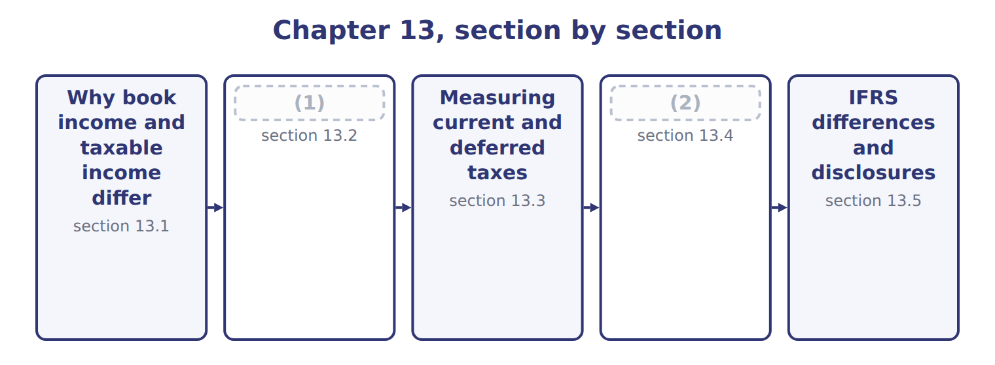
word list
Temporary and permanent differences · IFRS differences and disclosures · Rate changes, valuation allowances, losses and

Summary 1 gaps 3–9
Financial (3) follow U.S. GAAP and are prepared for (4) . Tax (5) follow tax law and are prepared for the (6) . The two sets of rules have (7) goals, so taxable income is (8) not the same as income before income taxes. If a company simply (9) the tax it paid, its tax expense would jump around when the rules timed items differently. Interperiod tax allocation solves this. The company recognizes the tax effects of transactions in the same periods as the transactions themselves, using deferred taxes.
word list
reported · government · returns · statements · usually · periods · investors · different

Orontes Foods Inc. — income tax figures for 2025
Orontes Foods Inc., 2025 (whole USD) | Amount
(10) | 3,958,800
Income tax expense (25% combined federal and state rate) | 989,700
(11) | 889,700
Deferred tax expense (25% of the 400,000 increase in net taxable temporary differences) | 100,000
(12) | 839,700
Deferred tax liability, January 1, 2025 | 900,000
Deferred tax liability, December 31, 2025 (after the 375 tax effect of the OCI loss) | 999,625

word list
Income taxes paid in cash (Chapter 5) · Income before income taxes · Current tax expense (taxes on 2025 taxable income) · Deferred tax liability, January 1, 2025

The English this section uses, and its Arabic
Each term sits against what it means.
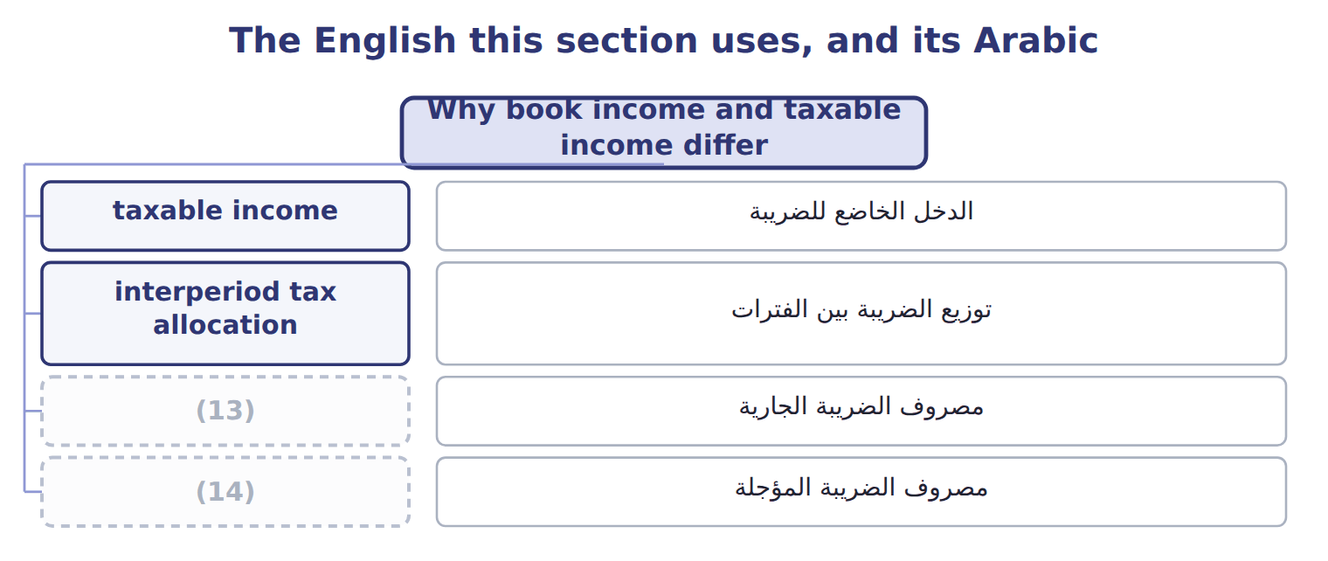
word list
deferred tax asset · deferred tax expense · current tax expense

The English this sheet uses, and its Arabic
English (exam term) | Arabic
taxable income | الدخل الخاضع للضريبة
interperiod tax allocation | توزيع الضريبة بين الفترات
current tax expense | مصروف الضريبة الجارية
deferred tax expense | مصروف الضريبة المؤجلة

Answer key · 13.1 Why book income and taxable income differ

1 Temporary and permanent differences | 8 usually
2 Rate changes, valuation allowances, losses and | 9 reported
3 statements | 10 Income before income taxes
4 investors | 11 Current tax expense (taxes on 2025 taxable income)
5 returns | 12 Income taxes paid in cash (Chapter 5)
6 government | 13 current tax expense
7 different | 14 deferred tax expense

the summaries in full
Summary 1 Financial statements follow U.S. GAAP and are prepared for investors. Tax returns follow tax law and are prepared for the government. The two sets of rules have different goals, so taxable income is usually not the same as income before income taxes. If a company simply reported the tax it paid, its tax expense would jump around when the rules timed items differently. Interperiod tax allocation solves this. The company recognizes the tax effects of transactions in the same periods as the transactions themselves, using deferred taxes.

13.2 Temporary and permanent differences
Chapter 13 · section 13.2

Fill every gap. Each word list holds one word more than there are gaps.
Summary 1 gaps 1–5
A temporary difference arises when the tax basis of an asset or (1) differs from its carrying amount on the balance sheet. It reverses in later years. A taxable temporary difference will increase future taxable income; a (2) temporary difference will reduce it. A permanent difference never reverses. The item is in book income but never in taxable income, or the (3) . (4) municipal bond interest and fines are common examples. Permanent (5) create no deferred tax; they only change the effective tax rate.
word list
increase · deductible · differences · reverse · Tax-exempt · liability

Common temporary and permanent differences
Item | Type of difference | Creates
Tax depreciation faster than book (bonus, MACRS) | (6) | Deferred tax liability
Installment sale: revenue now, taxed when cash is collected | Temporary, taxable | (7)
Warranty or litigation accrual, deductible when paid | Temporary, deductible | (8)
Rent received in advance, taxed when received | (9) | Deferred tax asset
Tax-exempt municipal bond interest | Permanent | (10)
Fines and penalties | Permanent | None
Life insurance premiums when the company is the beneficiary | Permanent | None

word list
None · Deferred tax liability · enacted tax rate · Deferred tax asset · Temporary, deductible · Temporary, taxable

Which way does it go?

Summary 2 gaps 11–13
Tax (11) faster than book: less tax now, more later: deferred tax liability. Warranty accrued now, (12) when paid: more tax now, less later: deferred tax asset. Fines and (13) interest: permanent, no deferred tax.
word list
deferred · depreciation · deductible · municipal

The English this section uses, and its Arabic
Each term sits against what it means.
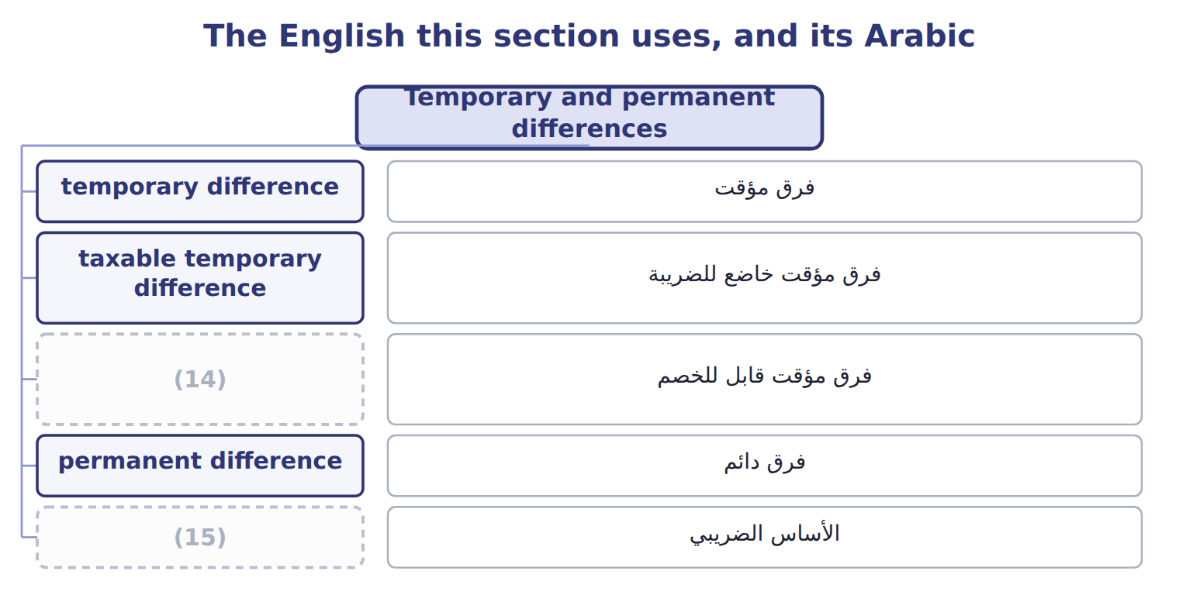
word list
taxable income · tax basis · deductible temporary difference

The English this sheet uses, and its Arabic
English (exam term) | Arabic
temporary difference | فرق مؤقت
taxable temporary difference | فرق مؤقت خاضع للضريبة
deductible temporary difference | فرق مؤقت قابل للخصم
permanent difference | فرق دائم
tax basis | الأساس الضريبي

Answer key · 13.2 Temporary and permanent differences

1 liability | 9 Temporary, deductible
2 deductible | 10 None
3 reverse | 11 depreciation
4 Tax-exempt | 12 deductible
5 differences | 13 municipal
6 Temporary, taxable | 14 deductible temporary difference
7 Deferred tax liability | 15 tax basis
8 Deferred tax asset

the summaries in full
Summary 1 A temporary difference arises when the tax basis of an asset or liability differs from its carrying amount on the balance sheet. It reverses in later years. A taxable temporary difference will increase future taxable income; a deductible temporary difference will reduce it. A permanent difference never reverses. The item is in book income but never in taxable income, or the reverse. Tax-exempt municipal bond interest and fines are common examples. Permanent differences create no deferred tax; they only change the effective tax rate.
Summary 2 Tax depreciation faster than book: less tax now, more later: deferred tax liability. Warranty accrued now, deductible when paid: more tax now, less later: deferred tax asset. Fines and municipal interest: permanent, no deferred tax.

13.3 Measuring current and deferred taxes
Chapter 13 · section 13.3

Fill every gap. Each word list holds one word more than there are gaps.
Summary 1 gaps 1–4
U.S. GAAP uses the balance sheet (1) . (2) tax is taxable income times the tax rate. Deferred tax (3) and assets are the temporary differences times the enacted tax rate that will apply when they reverse. Deferred tax expense is the change in the net deferred tax (4) during the year.
word list
liabilities · liability · approach · because · Current

Worked example: Orontes's 2026 income tax

Summary 2 gaps 5–11
Suppose (5) earns $2,000,000 before tax in 2026. It removes the permanent (6) : municipal interest of $20,000 and a fine of $10,000. New (7) costs $900,000. Tax law (8) 100% bonus depreciation, but book depreciation is $300,000. The difference of $600,000 reduces taxable income now: a taxable (9) difference. The (10) warranty from,000, but only $22,000 of repairs were paid. The $38,000 not yet (11) increases taxable income now. Taxable income is $1,428,000, so current tax is $357,000.
word list
dispenser · permanent · temporary · equipment · differences · deductible · allows · Orontes

Suppose: Orontes's 2026 taxable income and current tax
The bars are drawn to scale.
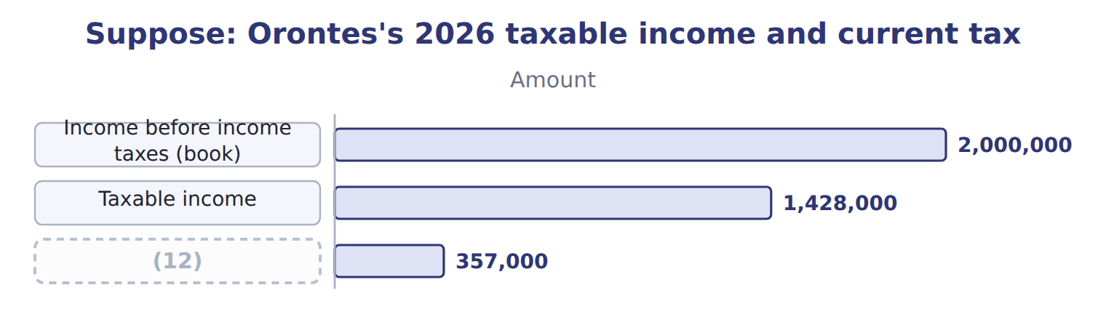
word list
Income before income taxes (book) · Current tax expense at 25%

Summary 3 gaps 13–16
Deferred taxes (13) from the same differences. The (14) creates a deferred tax liability of $150,000, and the warranty a deferred tax asset of $9,500. Deferred tax expense is $140,500, so total income tax expense is $497,500. The (15) tax rate is total tax expense divided by pretax income: 24.875%. It differs from the (16) 25% only because of the permanent differences.
word list
effective · Orontes · statutory · equipment · follow

Suppose: Orontes's 2026 income tax expense and rate reconciliation
Suppose: Orontes, 2026 (whole USD) | Amount | % of pretax income
Current tax expense | 357,000
(17) : 25% × 600,000 | 150,000
(18) : 25% × 38,000 | (9,500)
(19) | 140,500
(20) | 497,500 | 24.875%
Rate reconciliation (ASU 2023-09 style)
Tax at the statutory rate: 25% × 2,000,000 | 500,000 | 25.000%
Nontaxable or nondeductible items: municipal interest | (5,000) | -0.250%
Nontaxable or nondeductible items: fine | 2,500 | 0.125%
Income tax expense and effective tax rate | 497,500 | 24.875%

word list
Deferred tax expense · Nontaxable or nondeductible items · Deferred tax liability created · Deferred tax asset created · Total income tax expense

Classify the differences

Classify the differences (complete the blanks)
Item | Type | Creates
Tax-exempt municipal bond interest | Permanent | (21)
Tax depreciation faster than book depreciation | (22) | DTL
Warranty expense accrued now, deducted for tax when repairs are paid | ________ | ________
Fine for breaking an environmental law | ________ | ________
Rent received in advance, taxed when received | ________ | ________
Equity-method income, taxed only when dividends are received | ________ | ________

word list
None · Taxable income · Temporary, taxable

The English this section uses, and its Arabic
Each term sits against what it means.
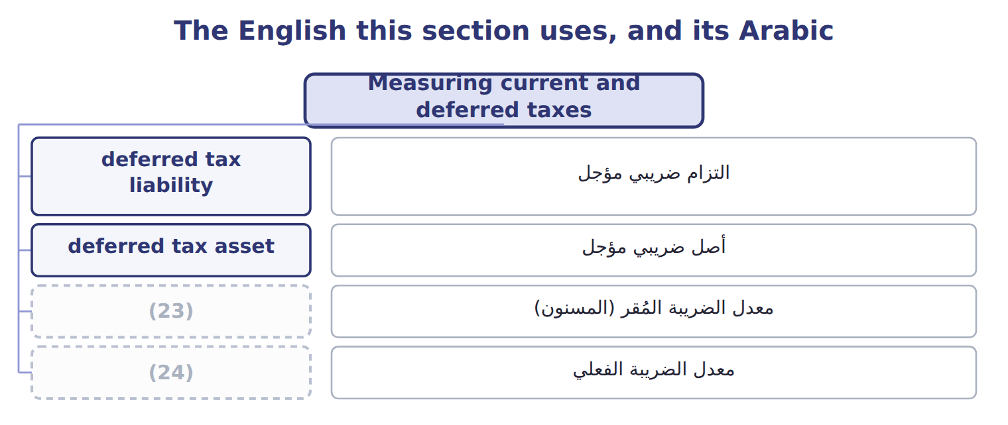
word list
effective tax rate · أصل ضريبي مؤجل · enacted tax rate

The English this sheet uses, and its Arabic
English (exam term) | Arabic
deferred tax liability | التزام ضريبي مؤجل
deferred tax asset | أصل ضريبي مؤجل
enacted tax rate | معدل الضريبة المُقر (المسنون)
effective tax rate | معدل الضريبة الفعلي

Answer key · 13.3 Measuring current and deferred taxes

1 approach | 13 follow
2 Current | 14 equipment
3 liabilities | 15 effective
4 liability | 16 statutory
5 Orontes | 17 Deferred tax liability created
6 differences | 18 Deferred tax asset created
7 equipment | 19 Deferred tax expense
8 allows | 20 Total income tax expense
9 temporary | 21 None
10 dispenser | 22 Temporary, taxable
11 deductible | 23 enacted tax rate
12 Current tax expense at 25% | 24 effective tax rate

the summaries in full
Summary 1 U.S. GAAP uses the balance sheet approach. Current tax is taxable income times the tax rate. Deferred tax liabilities and assets are the temporary differences times the enacted tax rate that will apply when they reverse. Deferred tax expense is the change in the net deferred tax liability during the year.
Summary 2 Suppose Orontes earns $2,000,000 before tax in 2026. It removes the permanent differences: municipal interest of $20,000 and a fine of $10,000. New equipment costs $900,000. Tax law allows 100% bonus depreciation, but book depreciation is $300,000. The difference of $600,000 reduces taxable income now: a taxable temporary difference. The dispenser warranty from,000, but only $22,000 of repairs were paid. The $38,000 not yet deductible increases taxable income now. Taxable income is $1,428,000, so current tax is $357,000.
Summary 3 Deferred taxes follow from the same differences. The equipment creates a deferred tax liability of $150,000, and the warranty a deferred tax asset of $9,500. Deferred tax expense is $140,500, so total income tax expense is $497,500. The effective tax rate is total tax expense divided by pretax income: 24.875%. It differs from the statutory 25% only because of the permanent differences.

13.4 Rate changes, valuation allowances, losses and presentation
Chapter 13 · section 13.4

Fill every gap. Each word list holds one word more than there are gaps.
Summary 1 gaps 1–12
When a new tax law (1) the rate, the company (2) its deferred taxes at once. The whole effect goes to income from (3) operations in the period that includes the (4) date, even if the original item was in OCI. For example, a U.S. tax law signed on July 4, 2025 changed several (5) rules; companies (6) the effects in the quarter that included that date. A deferred tax asset is (7) only if the company will have (8) taxable income to use it. If it is more likely than not that some of the asset will not be (9) , the company records a (10) allowance. A tax loss (11) a net operating loss (12) , which is a deferred tax asset. Under current U.S. federal law, most losses cannot be carried back. They can be carried forward without a time limit, but they can reduce only 80% of taxable income in any year.
word list
valuation · deduction · ignored · remeasures · recorded · carryforward · creates · changes · enough · continuing · useful · enactment · realized

Summary 2 gaps 13–16
All deferred tax assets and (13) are noncurrent. Within one tax (14) they are offset and shown as one net amount. Tax is also allocated within the period: Orontes's OCI loss was shown net of its $375 tax effect, and (15) operations carry their own tax. This is (16) tax allocation.
word list
intraperiod · includes · liabilities · jurisdiction · discontinued

Rate and allowance traps

Summary 3 gaps 17–23
Use enacted rates only; an (17) but unsigned rate is (18) . Record the full (19) of a rate change in (20) operations when the law is enacted. Record the full DTA, then a (21) allowance: do not record only the (22) part. An uncertain tax position is (23) only if it is more likely than not to be accepted by the tax authority. The global minimum tax (Pillar Two) is treated as a current cost in the year it arises, with no deferred taxes.
word list
probable · recognized · ignored · effect · valuation · Orontes's · continuing · announced

The English this section uses, and its Arabic
Each term sits against what it means.
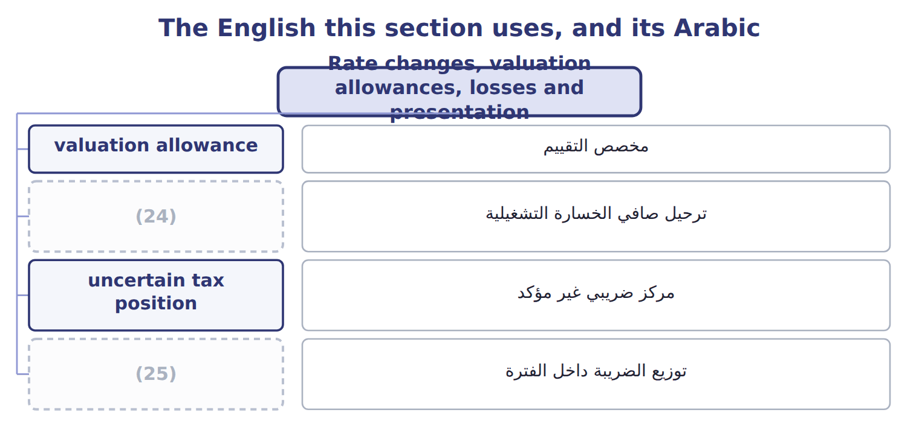
word list
deferred tax asset · intraperiod tax allocation · net operating loss carryforward

The English this sheet uses, and its Arabic
English (exam term) | Arabic
valuation allowance | مخصص التقييم
net operating loss carryforward | ترحيل صافي الخسارة التشغيلية
uncertain tax position | مركز ضريبي غير مؤكد
intraperiod tax allocation | توزيع الضريبة داخل الفترة

Answer key · 13.4 Rate changes, valuation allowances, losses and presentation

1 changes | 14 jurisdiction
2 remeasures | 15 discontinued
3 continuing | 16 intraperiod
4 enactment | 17 announced
5 deduction | 18 ignored
6 recorded | 19 effect
7 useful | 20 continuing
8 enough | 21 valuation
9 realized | 22 probable
10 valuation | 23 recognized
11 creates | 24 net operating loss carryforward
12 carryforward | 25 intraperiod tax allocation
13 liabilities

the summaries in full
Summary 1 When a new tax law changes the rate, the company remeasures its deferred taxes at once. The whole effect goes to income from continuing operations in the period that includes the enactment date, even if the original item was in OCI. For example, a U.S. tax law signed on July 4, 2025 changed several deduction rules; companies recorded the effects in the quarter that included that date. A deferred tax asset is useful only if the company will have enough taxable income to use it. If it is more likely than not that some of the asset will not be realized, the company records a valuation allowance. A tax loss creates a net operating loss carryforward, which is a deferred tax asset. Under current U.S. federal law, most losses cannot be carried back. They can be carried forward without a time limit, but they can reduce only 80% of taxable income in any year.
Summary 2 All deferred tax assets and liabilities are noncurrent. Within one tax jurisdiction they are offset and shown as one net amount. Tax is also allocated within the period: Orontes's OCI loss was shown net of its $375 tax effect, and discontinued operations carry their own tax. This is intraperiod tax allocation.
Summary 3 Use enacted rates only; an announced but unsigned rate is ignored. Record the full effect of a rate change in continuing operations when the law is enacted. Record the full DTA, then a valuation allowance: do not record only the probable part. An uncertain tax position is recognized only if it is more likely than not to be accepted by the tax authority. The global minimum tax (Pillar Two) is treated as a current cost in the year it arises, with no deferred taxes.

13.5 IFRS differences and disclosures
Chapter 13 · section 13.5

Fill every gap. Each word list holds one word more than there are gaps.
Summary 1 gaps 1–3
The biggest one for the exam is the (1) tax asset: IFRS (2) only the amount it is probable to use, while U.S. GAAP records the full asset and a separate (3) allowance.
word list
contra-asset · deferred · recognizes · valuation

Income taxes: U.S. GAAP (ASC 740) and IFRS (IAS 12)
Topic | U.S. GAAP (ASC 740) | IFRS (IAS 12)
Recognizing deferred tax assets | Record the full DTA, then a (4) if realization is not more likely than not | Recognize only the amount for which taxable profit is probable
Tax rate | Enacted rates only | (5)
Initial recognition exemption | (6) | Yes, outside business combinations (narrowed in 2021)
Uncertain tax positions | Two steps: more likely than not, then largest amount over 50% likely | (7)
Balance sheet classification | Noncurrent | (8)
Pillar Two top-up tax | (9) | Mandatory exception; no deferred tax

word list
None in general · Period cost; no deferred tax · Mandatory exception; no deferred tax · IFRIC 23: most likely amount or expected value · valuation allowance · Non-current · Enacted or substantively enacted rates

Summary 2 gaps 10–16
ASU 2023-09 is testable now for public companies. They show a rate (10) in dollars and (11) with eight standard categories, and they list separately any item of at least 5% of pretax income times the statutory rate. They also (12) income taxes paid by federal, state and foreign (13) . For companies that are not public (14) entities, ASU 2023-09 applies to annual periods (15) after December 15, 2025. That (16) is not testable before about January 2027.
word list
percentages · entities · version · reconciliation · business · beginning · jurisdictions · disclose

'Provision for income taxes'

Summary 3 gaps 17–18
U.S. companies often call income tax expense the provision for income taxes. It is an expense, not an IAS 37 provision and not a (17) . The valuation allowance is a (18) , not a liability.
word list
federal · contra-asset · reserve

'Provision for income taxes'
Barada Wholesale, 2027 (whole USD) | Amount / details
Income before income taxes, 2027 | 400,000
Tax-exempt municipal bond interest included in income | 12,000
Fine for a late customs filing (not deductible) | 6,000
Tax depreciation above book depreciation in 2027 | 60,000
Warranty liability at December 31, 2027 (Chapter 12 case); repairs are deductible when paid | 18,000
M1 | The enacted combined tax rate is 25% for 2027 and all later years.
M2 | Barada had no temporary differences at January 1, 2027. All deferred taxes are in one tax (19) .
M3 | Barada has been profitable for many years and expects to stay profitable.

word list
jurisdiction · profitable

Item — Answer
Item | Answer
Warranty expense accrued now | Temporary, deductible: DTA
Fine for breaking the law | (20)
Rent received in advance | Temporary, deductible (taxed now, earned later): DTA
Equity-method income | (21)

word list
Temporary, taxable (taxed later): DTL · Permanent: no deferred tax · Barada Wholesale, 2027 (whole USD)

Item — Category
Item | Category
Municipal bond interest | (22)
Late-filing fine | Permanent difference
Tax depreciation above book | (23)
Warranty liability | (24)
Rent received in advance | Deductible temporary difference (DTA)

word list
Taxable temporary difference (DTL) · Deductible temporary difference (DTA) · Amount / details · Permanent difference

Answer key · 13.5 IFRS differences and disclosures

1 deferred | 13 jurisdictions
2 recognizes | 14 business
3 valuation | 15 beginning
4 valuation allowance | 16 version
5 Enacted or substantively enacted rates | 17 reserve
6 None in general | 18 contra-asset
7 IFRIC 23: most likely amount or expected value | 19 jurisdiction
8 Non-current | 20 Permanent: no deferred tax
9 Period cost; no deferred tax | 21 Temporary, taxable (taxed later): DTL
10 reconciliation | 22 Permanent difference
11 percentages | 23 Taxable temporary difference (DTL)
12 disclose | 24 Deductible temporary difference (DTA)

the summaries in full
Summary 1 The biggest one for the exam is the deferred tax asset: IFRS recognizes only the amount it is probable to use, while U.S. GAAP records the full asset and a separate valuation allowance.
Summary 2 ASU 2023-09 is testable now for public companies. They show a rate reconciliation in dollars and percentages with eight standard categories, and they list separately any item of at least 5% of pretax income times the statutory rate. They also disclose income taxes paid by federal, state and foreign jurisdictions. For companies that are not public business entities, ASU 2023-09 applies to annual periods beginning after December 15, 2025. That version is not testable before about January 2027.
Summary 3 U.S. companies often call income tax expense the provision for income taxes. It is an expense, not an IAS 37 provision and not a reserve. The valuation allowance is a contra-asset, not a liability.

