17.1 (i) Share-based payments and employee benefits
Chapter 17 · section 17.1

Fill every gap. Each word list holds one word more than there are gaps.
Chapter 17, section by section
Each stage leads to the next.
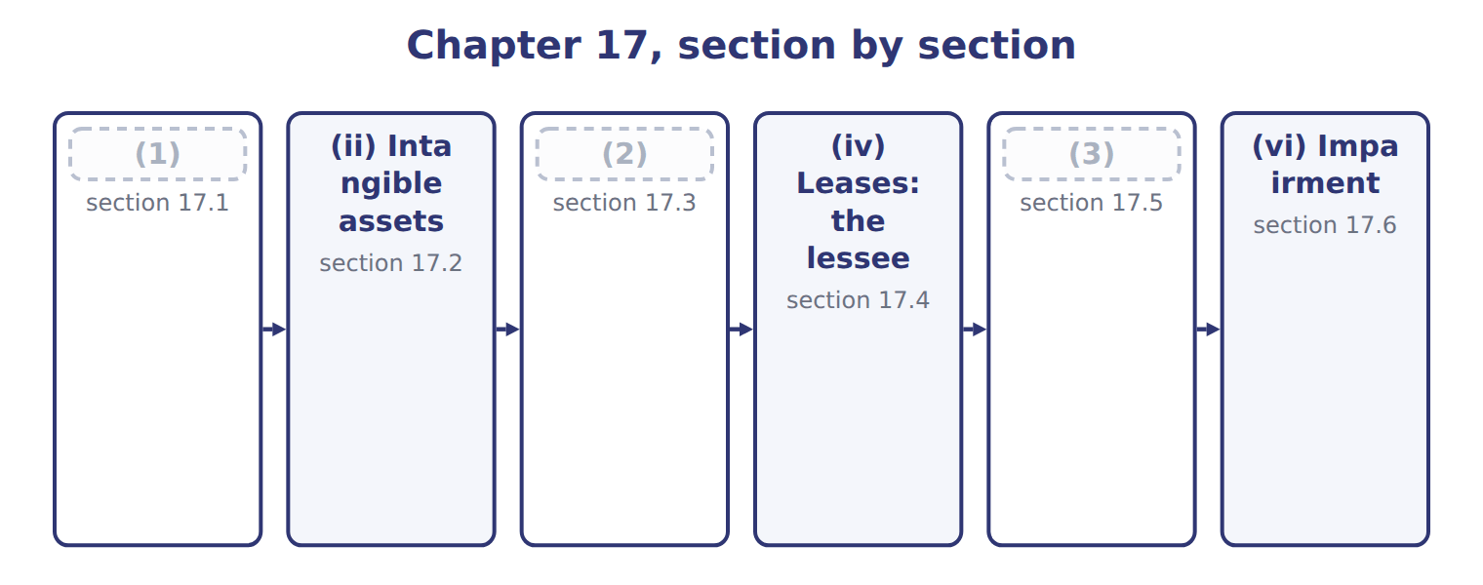
word list
(iii) Inventories · (i) Share-based payments and employee benefits · (vi) Impairment · (v) Long-lived assets

Summary 1 gaps 4–15
For share awards that vest in parts, or graded vesting, U.S. GAAP lets a company recognize the cost (4) over the whole period or tranche by tranche, when the awards have only service (5) . IFRS 2 requires tranche by tranche, which puts more (6) in the early years. U.S. GAAP also allows a policy choice to record (7) as they occur; IFRS 2 requires an (8) . Employer payroll taxes on share awards are (9) when the tax (10) arises under U.S. GAAP, but accrued over the vesting period under IFRS. For a (11) benefit plan, both frameworks put (12) in OCI. U.S. GAAP later amortizes them into net (13) ; IAS 19 never (14) them. (15) amends its plan and creates prior service cost of $50,000: U.S. GAAP amortizes $5,000 a year from OCI, while IAS 19 expenses the whole amount at once.
word list
payroll · Orontes · conditions · reclassifies · expense · income · remeasurements · straight-line · obligation · forfeitures · estimate · recognized · defined

Share-based payments and employee benefits: U.S. GAAP and IFRS
Topic | U.S. GAAP (ASC 718, 715) | IFRS (IFRS 2, IAS 19)
Graded vesting (service condition) | Choice: straight-line over the whole period or tranche by tranche | Tranche by tranche
Forfeitures | (16) : estimate or record as they occur | Estimate
Employer payroll taxes on awards | (17) | Accrued over the vesting period
Pension remeasurements (actuarial gains and losses) | (18) | OCI, never reclassified to profit
Return on plan assets | (19) | Net interest at the discount rate
Prior service cost: Orontes amendment of 50,000 | OCI, amortized over 10 years: 5,000 a year | (20)

word list
Policy choice · component depreciation · Expected return · When the tax obligation arises (exercise or vesting) · OCI, then amortized into net income (corridor) · Expensed at once: 50,000

The English this section uses, and its Arabic
Each term sits against what it means.
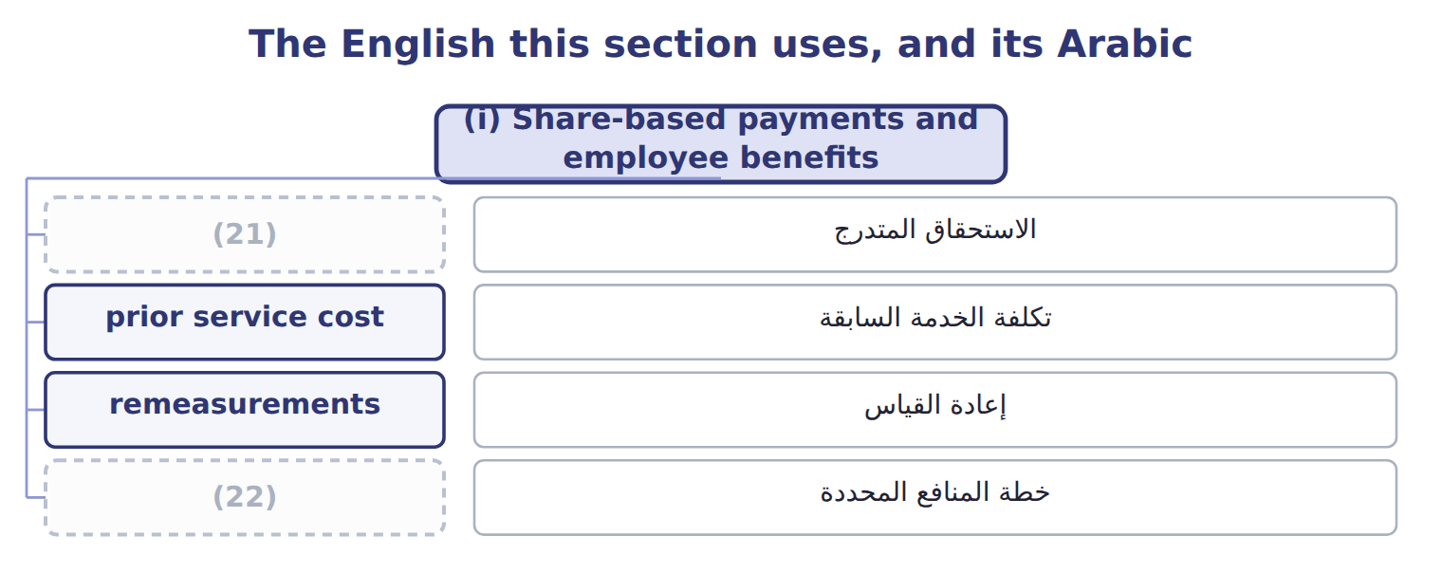
word list
graded vesting · value in use · defined benefit plan

The English this sheet uses, and its Arabic
English (exam term) | Arabic
graded vesting | الاستحقاق المتدرج
prior service cost | تكلفة الخدمة السابقة
remeasurements | إعادة القياس
defined benefit plan | خطة المنافع المحددة

Answer key · 17.1 (i) Share-based payments and employee benefits

1 (i) Share-based payments and employee benefits | 12 remeasurements
2 (iii) Inventories | 13 income
3 (v) Long-lived assets | 14 reclassifies
4 straight-line | 15 Orontes
5 conditions | 16 Policy choice
6 expense | 17 When the tax obligation arises (exercise or vesting)
7 forfeitures | 18 OCI, then amortized into net income (corridor)
8 estimate | 19 Expected return
9 recognized | 20 Expensed at once: 50,000
10 obligation | 21 graded vesting
11 defined | 22 defined benefit plan

the summaries in full
Summary 1 For share awards that vest in parts, or graded vesting, U.S. GAAP lets a company recognize the cost straight-line over the whole period or tranche by tranche, when the awards have only service conditions. IFRS 2 requires tranche by tranche, which puts more expense in the early years. U.S. GAAP also allows a policy choice to record forfeitures as they occur; IFRS 2 requires an estimate. Employer payroll taxes on share awards are recognized when the tax obligation arises under U.S. GAAP, but accrued over the vesting period under IFRS. For a defined benefit plan, both frameworks put remeasurements in OCI. U.S. GAAP later amortizes them into net income; IAS 19 never reclassifies them. Orontes amends its plan and creates prior service cost of $50,000: U.S. GAAP amortizes $5,000 a year from OCI, while IAS 19 expenses the whole amount at once.

17.2 (ii) Intangible assets
Chapter 17 · section 17.2

Fill every gap. Each word list holds one word more than there are gaps.
Summary 1 gaps 1–10
The (1) intangibles (2) is development costs. U.S. GAAP expenses research and development as (3) , with narrow (4) for software. IAS 38 expenses research but (5) development once six criteria are met, such as technical (6) , intention and ability to complete, and a way to generate future benefits. (7) Orontes spends $300,000 developing a new (8) line, and all six criteria are met. Under U.S. GAAP the whole amount is an (9) ; under IFRS it is an (10) asset, amortized once the product is ready. IAS 38 also allows the revaluation model for intangibles, but only where an active market exists, which is rare. U.S. GAAP never revalues intangibles upward. Both frameworks refuse to recognize internally generated brands.
word list
capitalizes · intangible · incurred · exceptions · sparkling-juice · recognize · expense · largest · Suppose · feasibility · difference

Intangible assets: U.S. GAAP and IFRS
The two sides differ only where the rows say.
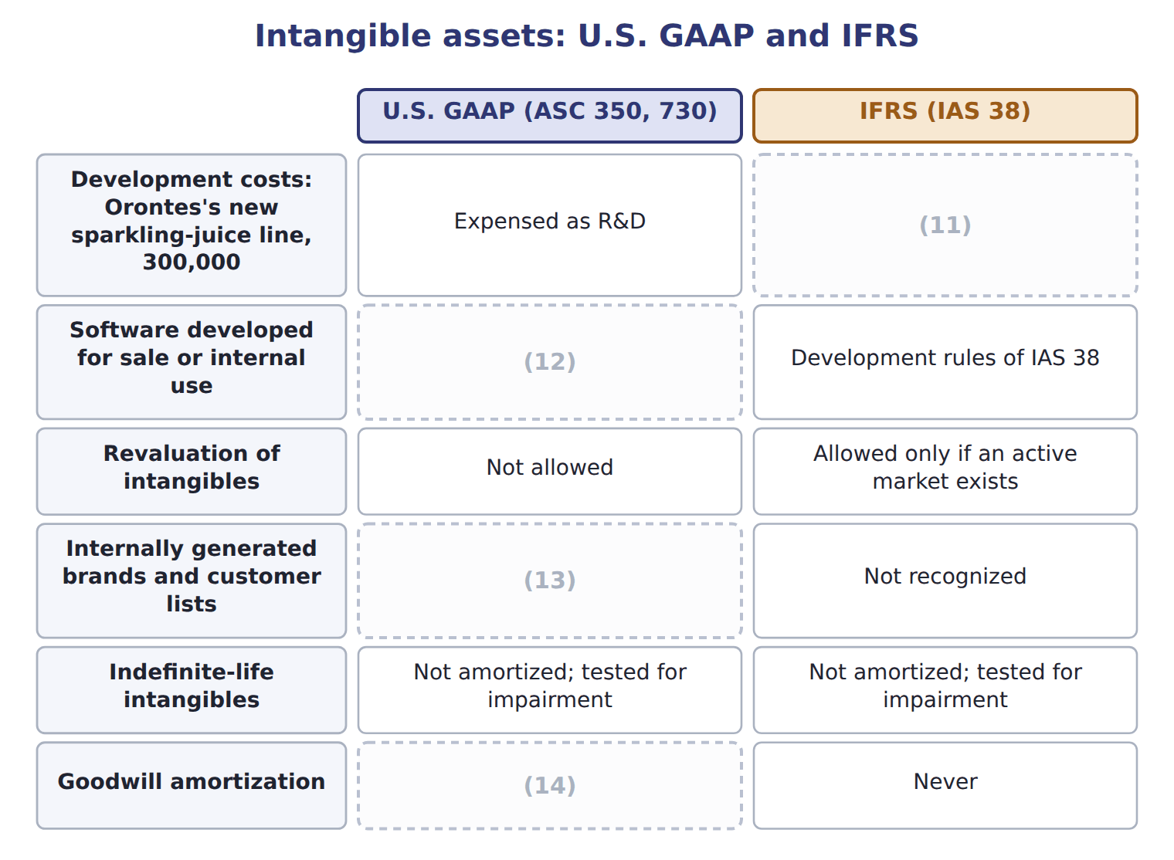
word list
Capitalized: all six IAS 38 criteria are met · Not allowed · Not recognized · Only private companies may elect it · Capitalized only in limited stages (ASC 985-20, 350-40)

Summary 2 gaps 15–17
ASU 2025-06 simplifies when internal-use software costs are capitalized, and ASU 2026-02 creates new rules for (15) credits. Neither is (16) before about January 2029. Private companies may amortize goodwill, but an SEC (17) such as Orontes may not.
word list
environmental · testable · registrant · technical

The English this sheet uses, and its Arabic
English (exam term) | Arabic
development costs | تكاليف التطوير
research and development (R&D) | البحث والتطوير

Answer key · 17.2 (ii) Intangible assets

1 largest | 10 intangible
2 difference | 11 Capitalized: all six IAS 38 criteria are met
3 incurred | 12 Capitalized only in limited stages (ASC 985-20, 350-40)
4 exceptions | 13 Not recognized
5 capitalizes | 14 Only private companies may elect it
6 feasibility | 15 environmental
7 Suppose | 16 testable
8 sparkling-juice | 17 registrant
9 expense

the summaries in full
Summary 1 The largest intangibles difference is development costs. U.S. GAAP expenses research and development as incurred, with narrow exceptions for software. IAS 38 expenses research but capitalizes development once six criteria are met, such as technical feasibility, intention and ability to complete, and a way to generate future benefits. Suppose Orontes spends $300,000 developing a new sparkling-juice line, and all six criteria are met. Under U.S. GAAP the whole amount is an expense; under IFRS it is an intangible asset, amortized once the product is ready. IAS 38 also allows the revaluation model for intangibles, but only where an active market exists, which is rare. U.S. GAAP never revalues intangibles upward. Both frameworks refuse to recognize internally generated brands.
Summary 2 ASU 2025-06 simplifies when internal-use software costs are capitalized, and ASU 2026-02 creates new rules for environmental credits. Neither is testable before about January 2029. Private companies may amortize goodwill, but an SEC registrant such as Orontes may not.

17.3 (iii) Inventories
Chapter 17 · section 17.3

Fill every gap. Each word list holds one word more than there are gaps.
Stocks, provision

Summary 1 gaps 1–2
Both (1) write inventory down when its value falls below cost. The key (2) comes when value recovers.
word list
frameworks · difference · inventory

What each framework says
The two columns are not matched row by row.
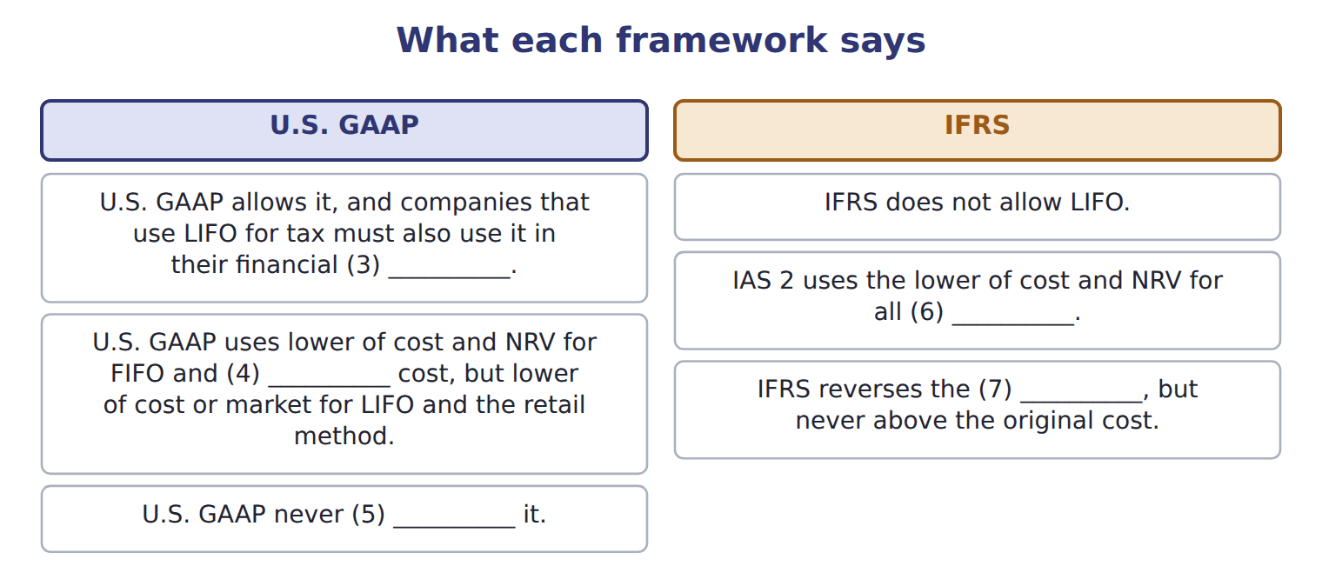
word list
statements · reverses · inventory · remeasurements · average · write-down

Summary 2 gaps 8–9
Not (8) . In U.S. terms, a (9) reduces the inventory itself; do not call it a provision or a reserve.
word list
write-down · depreciation · reduces

The English this sheet uses, and its Arabic
English (exam term) | Arabic
net realizable value (NRV) | صافي القيمة القابلة للتحقق
lower of cost and net realizable value (LCNRV) | التكلفة أو صافي القيمة القابلة للتحقق، أيهما أقل

Answer key · 17.3 (iii) Inventories

1 frameworks | 6 inventory
2 difference | 7 write-down
3 statements | 8 depreciation
4 average | 9 write-down
5 reverses

the summaries in full
Summary 1 Both frameworks write inventory down when its value falls below cost. The key difference comes when value recovers.
Summary 2 Not depreciation. In U.S. terms, a write-down reduces the inventory itself; do not call it a provision or a reserve.

17.4 (iv) Leases: the lessee
Chapter 17 · section 17.4

Fill every gap. Each word list holds one word more than there are gaps.
What each framework says
The two columns are not matched row by row.
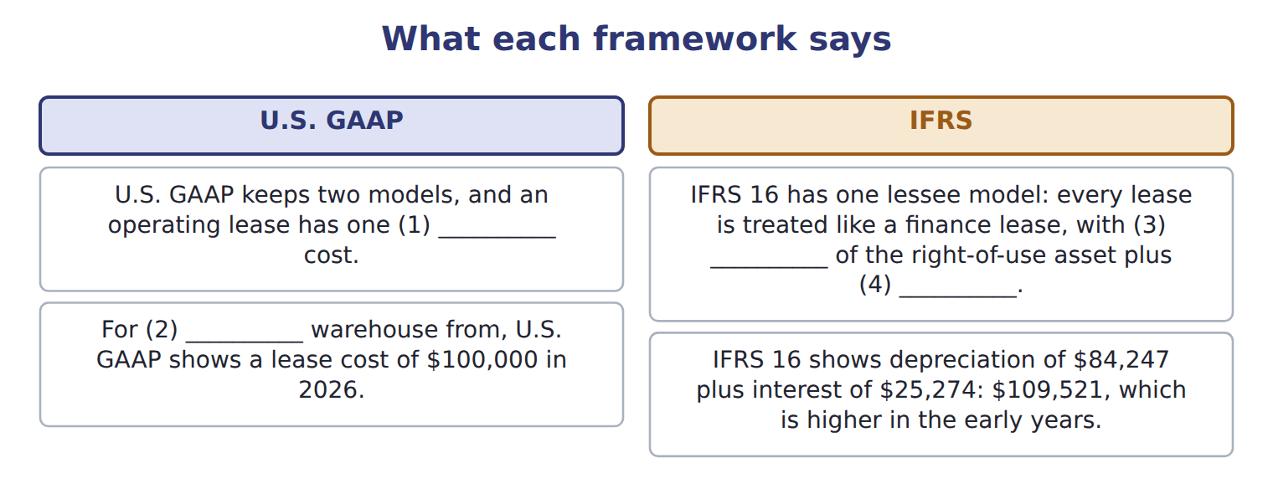
word list
depreciation · interest · Orontes's · remeasurements · straight-line

Summary 1 gaps 5–7
Over the whole lease, total (5) is the same. IFRS 16 also allows an exemption for low-value assets, (6) the liability when an index such as CPI changes, and (7) lease principal as financing.
word list
expense · remeasures · treated · classifies

Lessee accounting: U.S. GAAP and IFRS 16
The two sides differ only where the rows say.
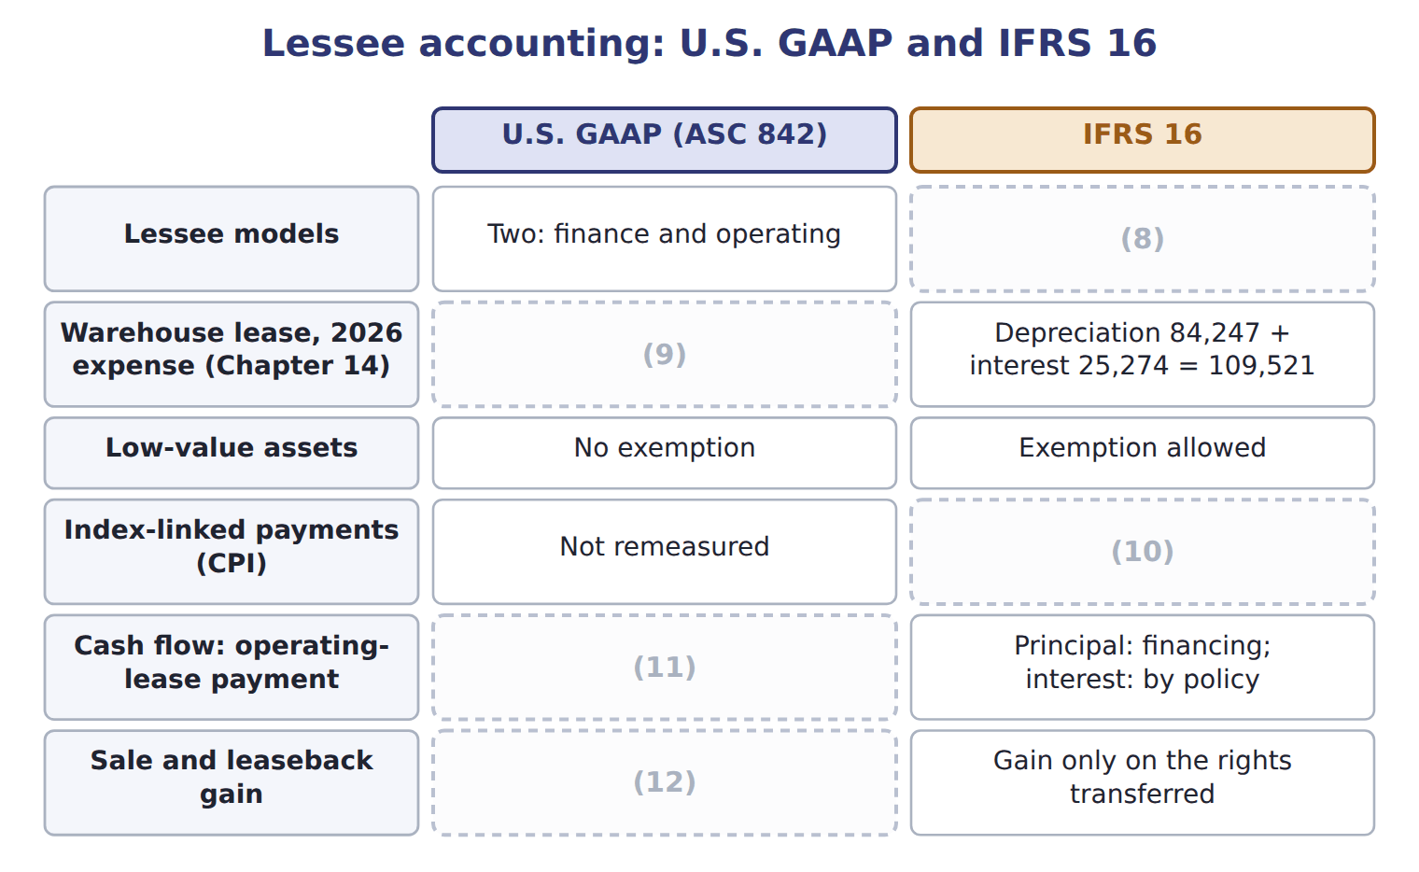
word list
Low-value assets · Full gain if a sale · One: all leases like finance leases · Liability remeasured · Operating · One straight-line lease cost: 100,000

Answer key · 17.4 (iv) Leases: the lessee

1 straight-line | 7 classifies
2 Orontes's | 8 One: all leases like finance leases
3 depreciation | 9 One straight-line lease cost: 100,000
4 interest | 10 Liability remeasured
5 expense | 11 Operating
6 remeasures | 12 Full gain if a sale

the summaries in full
Summary 1 Over the whole lease, total expense is the same. IFRS 16 also allows an exemption for low-value assets, remeasures the liability when an index such as CPI changes, and classifies lease principal as financing.

17.5 (v) Long-lived assets
Chapter 17 · section 17.5

Fill every gap. Each word list holds one word more than there are gaps.
Long-lived assets: U.S. GAAP and IFRS
The two sides differ only where the rows say.
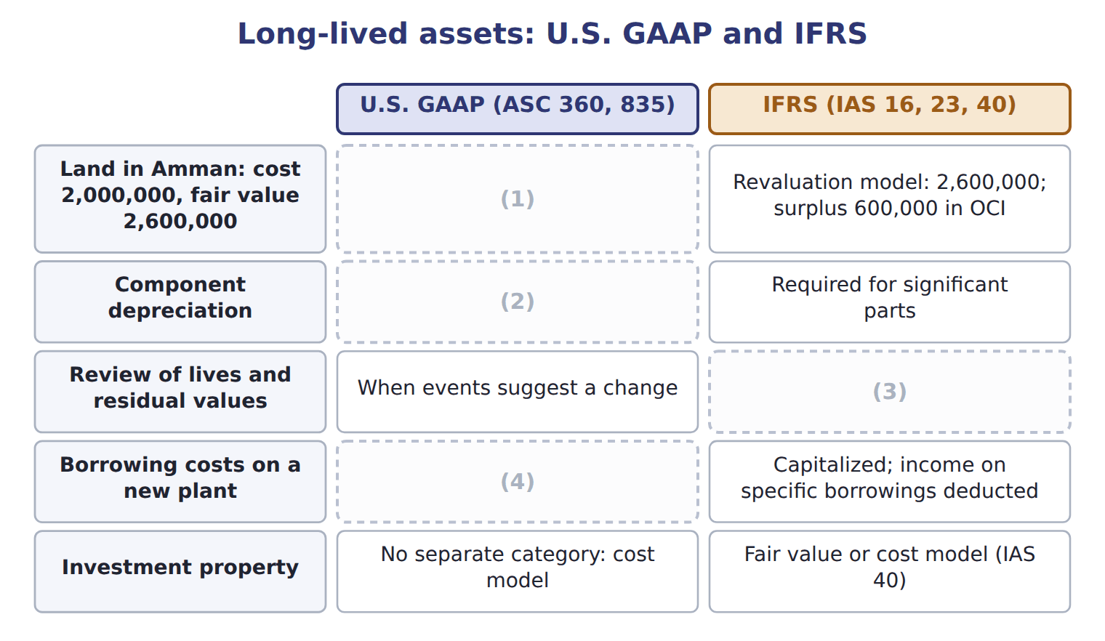
word list
net realizable value (NRV) · Allowed, not required · Capitalized; investment income generally not offset · At least every year · Stays at 2,000,000

Summary 1 gaps 5–9
IAS 16 also allows the revaluation model for a whole class of assets: the assets are (5) at fair value, and (6) go to a revaluation surplus in OCI. Suppose (7) land in Amman cost $2,000,000 and is now worth $2,600,000. IFRS requires component (8) for significant parts with (9) lives; U.S. GAAP allows but does not require it.
word list
carried · significant · increases · Orontes's · different · depreciation

What each framework says
The two columns are not matched row by row.
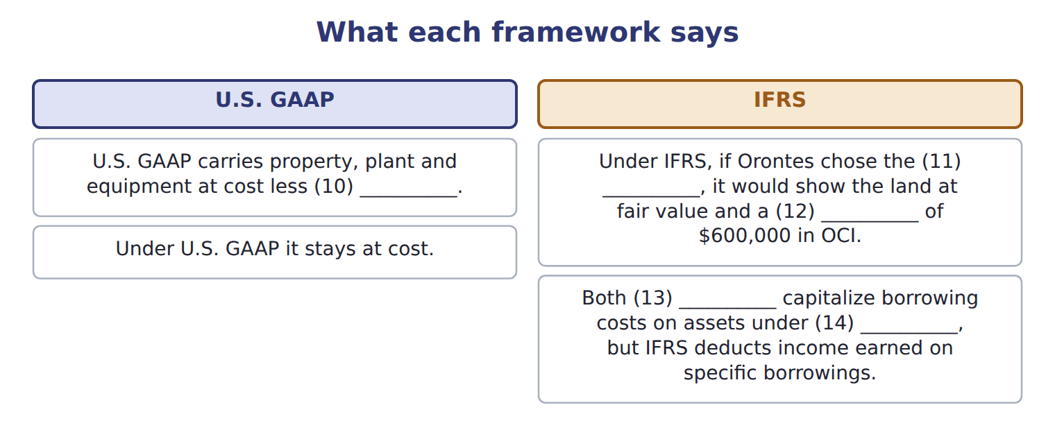
word list
depreciation · frameworks · surplus · construction · revaluation model · recoverable amount

The English this sheet uses, and its Arabic
English (exam term) | Arabic
revaluation model | نموذج إعادة التقييم
revaluation surplus | فائض إعادة التقييم
component depreciation | الإهلاك حسب المكونات

Answer key · 17.5 (v) Long-lived assets

1 Stays at 2,000,000 | 8 depreciation
2 Allowed, not required | 9 different
3 At least every year | 10 depreciation
4 Capitalized; investment income generally not offset | 11 revaluation model
5 carried | 12 surplus
6 increases | 13 frameworks
7 Orontes's | 14 construction

the summaries in full
Summary 1 IAS 16 also allows the revaluation model for a whole class of assets: the assets are carried at fair value, and increases go to a revaluation surplus in OCI. Suppose Orontes's land in Amman cost $2,000,000 and is now worth $2,600,000. IFRS requires component depreciation for significant parts with different lives; U.S. GAAP allows but does not require it.

17.6 (vi) Impairment
Chapter 17 · section 17.6

Fill every gap. Each word list holds one word more than there are gaps.
Summary 1 gaps 1–7
U.S. GAAP tests a held-and-used asset group in two steps. First, it compares the carrying amount with undiscounted (1) cash flows. Only if the carrying amount is higher does it measure a loss, equal to the carrying amount minus fair value. IAS 36 uses one step. It compares the carrying amount of an asset or (2) unit with its recoverable amount: the higher of fair value less costs of disposal and value in use, a (3) cash-flow measure. (4) there is no undiscounted screen, IFRS losses often come (5) . The (6) also differ after the loss. IFRS reverses an impairment when the recoverable amount rises, but not for goodwill and not above the carrying amount (7) the loss. U.S. GAAP never reverses an impairment of a held-and-used asset or of goodwill.
word list
proposal · discounted · without · cash-generating · frameworks · earlier · future · Because

Worked example: the beverage plant

Summary 2 gaps 8–9
Undiscounted cash flows of $4,200,000 are above the carrying amount of $4,000,000: the plant is recoverable, so there is no loss. Recoverable amount is the higher of $3,500,000 and $3,700,000: $3,700,000. The carrying amount is higher, so the loss is $300,000. If the U.S. test had (8) , the loss would have been (9) against fair value: $500,000.
word list
measured · goodwill · failed

Which framework?

Which framework? (complete the blanks)
Every item belongs to exactly one group.
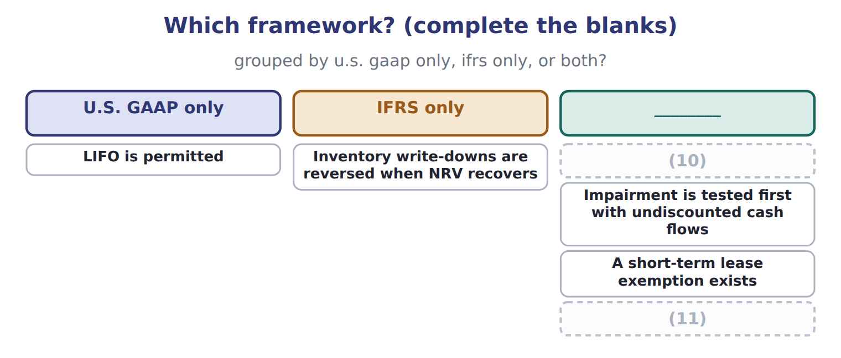
word list
Prior service cost is expensed immediately · Inventory write-downs are reversed when NRV recovers · Development costs are capitalized when criteria are met

Summary 3 gaps 12–13
The IASB is still discussing changes to goodwill impairment (12) after its 2024 exposure draft. Goodwill remains (13) under both frameworks for public companies. Do not treat the proposal as a rule.
word list
impairment-only · discussing · disclosures

Suppose: Levant Distribution LLC, 2027 (USD 000) — Amount / details
Suppose: Levant Distribution LLC, 2027 (USD 000) | Amount / details
Levant's 2027 net income under IFRS (local books) | 1,114
L1 | (14) of a new ordering app capitalized in 2027 under IAS 38: 240. None is amortized yet.
L2 | A 2026 inventory (15) was reversed in 2027 under IAS 2: gain of 30.
L3 | Warehouse land revalued upward by 400; the surplus is in OCI.
L4 | (16) : IAS 36 impairment loss of 50; carrying amount now 450. Undiscounted cash flows are higher than the carrying amount before th
L5 | Truck lease: IFRS 16 expense 78; as a U.S. operating lease, the straight-line cost would be 72.
M1 | Orontes must convert Levant's figures to U.S. GAAP before consolidation (Chapter 16). Ignore tax effects.

word list
write-down · Truck lease · Development costs · Delivery fleet

Item — Answer
Every item belongs to exactly one group.
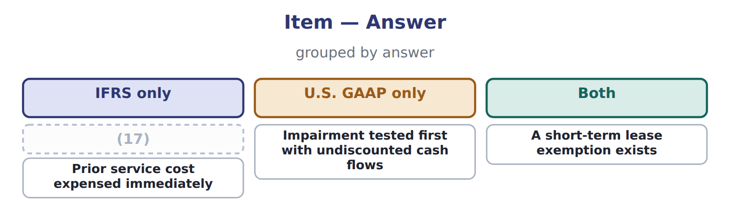
word list
Impairment tested first with undiscounted cash flows · Development costs capitalized when criteria are met

Item — Category
Every item belongs to exactly one group.
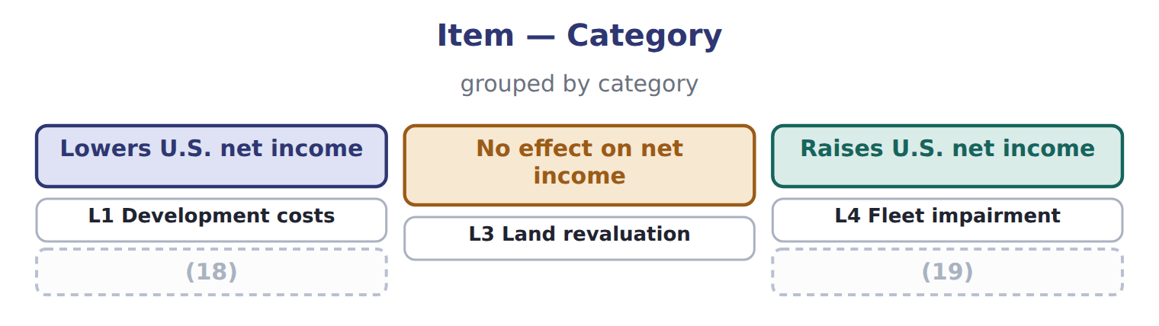
word list
defined benefit plan · L5 Truck lease · L2 Write-down reversal

The English this section uses, and its Arabic
Each term sits against what it means.
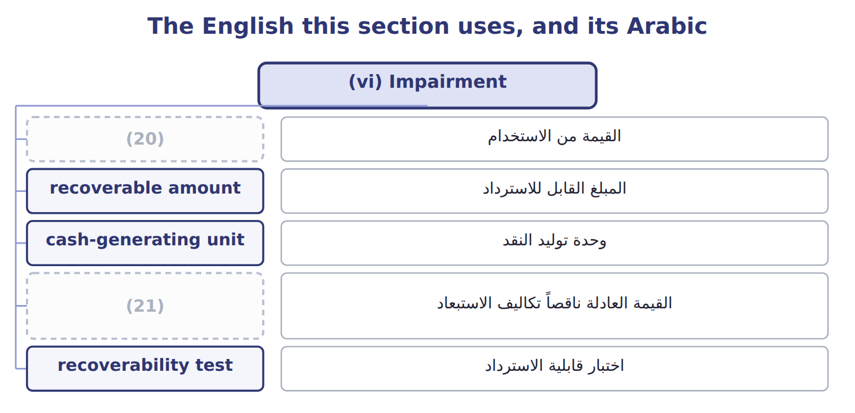
word list
fair value less costs of disposal · research and development (R&D) · value in use

The English this sheet uses, and its Arabic
English (exam term) | Arabic
value in use | القيمة من الاستخدام
recoverable amount | المبلغ القابل للاسترداد
cash-generating unit | وحدة توليد النقد
fair value less costs of disposal | القيمة العادلة ناقصاً تكاليف الاستبعاد
recoverability test | اختبار قابلية الاسترداد

Answer key · 17.6 (vi) Impairment

1 future | 12 disclosures
2 cash-generating | 13 impairment-only
3 discounted | 14 Development costs
4 Because | 15 write-down
5 earlier | 16 Delivery fleet
6 frameworks | 17 Development costs capitalized when criteria are met
7 without | 18 L2 Write-down reversal
8 failed | 19 L5 Truck lease
9 measured | 20 value in use
10 Development costs are capitalized when criteria are met | 21 fair value less costs of disposal
11 Prior service cost is expensed immediately

the summaries in full
Summary 1 U.S. GAAP tests a held-and-used asset group in two steps. First, it compares the carrying amount with undiscounted future cash flows. Only if the carrying amount is higher does it measure a loss, equal to the carrying amount minus fair value. IAS 36 uses one step. It compares the carrying amount of an asset or cash-generating unit with its recoverable amount: the higher of fair value less costs of disposal and value in use, a discounted cash-flow measure. Because there is no undiscounted screen, IFRS losses often come earlier. The frameworks also differ after the loss. IFRS reverses an impairment when the recoverable amount rises, but not for goodwill and not above the carrying amount without the loss. U.S. GAAP never reverses an impairment of a held-and-used asset or of goodwill.
Summary 2 Undiscounted cash flows of $4,200,000 are above the carrying amount of $4,000,000: the plant is recoverable, so there is no loss. Recoverable amount is the higher of $3,500,000 and $3,700,000: $3,700,000. The carrying amount is higher, so the loss is $300,000. If the U.S. test had failed, the loss would have been measured against fair value: $500,000.
Summary 3 The IASB is still discussing changes to goodwill impairment disclosures after its 2024 exposure draft. Goodwill remains impairment-only under both frameworks for public companies. Do not treat the proposal as a rule.

