Table of Contents

A2.2 · Unit 8 · The Only Building Above the Line
English Animated · Telling the Story · Ballinmore, west coast of Ireland Student's Book pages 160–181 · 22 pp · ~10 hours

Part 0 · The Big Picture ◆ A · THE WORLD
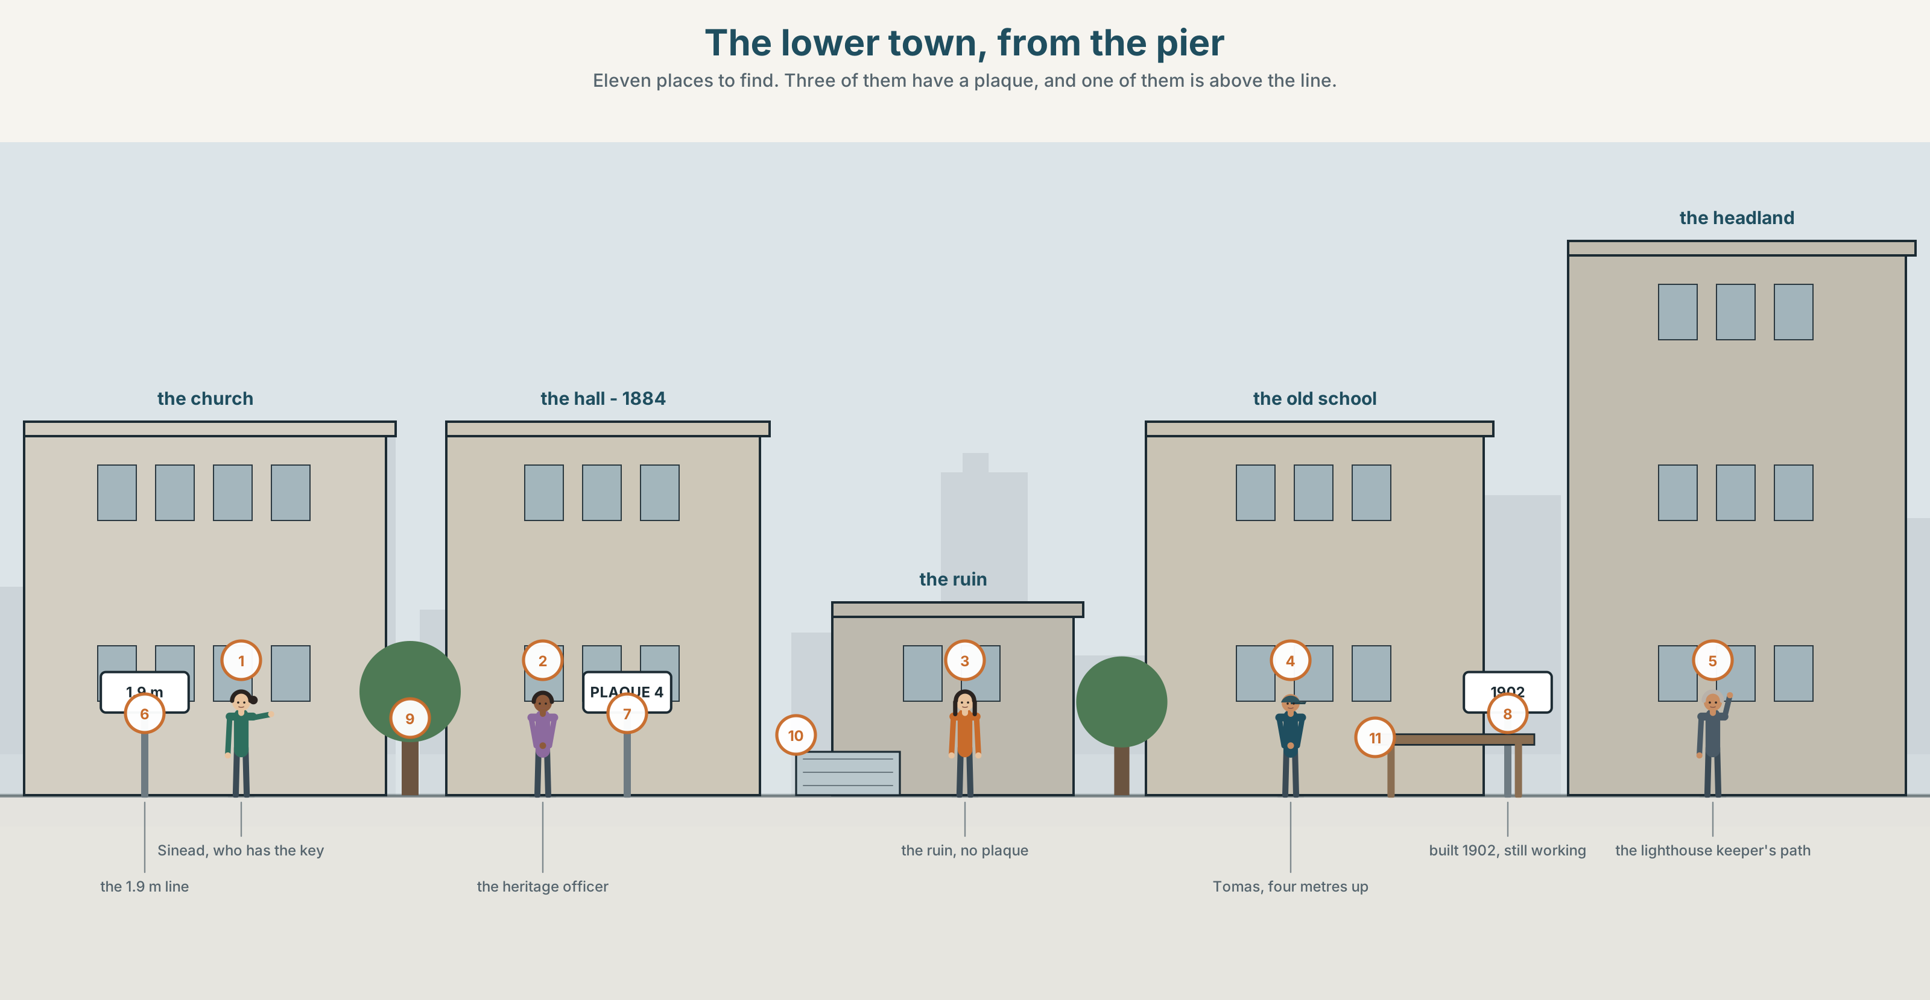{width=6.6in}
The lower town, from the pier — Eleven places to find. Three of them have a plaque, and one of them is above the line.

What do you know about this place?
By the end of this unit you can give a ninety-second tour of a place, adding the background a visitor would not know.
◆ A · THE WORLD | A town with eleven landmarks and one of them is worth money
◆ B · THE SYSTEM | non-defining relative clauses · commas and clause boundaries · 23 words for places and history · 17 words for adding things · the pause, and the pitch reset after it
◆ C · THE PERFORMANCE | Ninety seconds that give a visitor what a sign cannot

0A · Find it
Find eleven places in this picture. Three of them have a plaque.
the harbour · the pier · the headland · the cliff path · the bay · the lighthouse · the hall · the church · the ruin · the old school · the war memorial

0B · Guess it
One building in this picture is above the flood line and one is barely below it. Which, and how can you tell from the drawing?

0C · Say it ⏺
Record thirty seconds. Describe one place near you to somebody who has never been. Give one fact a sign would not tell them. You will record it again at the end of this unit.

Part 1 · Vocabulary Lab 1 ◆ B · THE SYSTEM
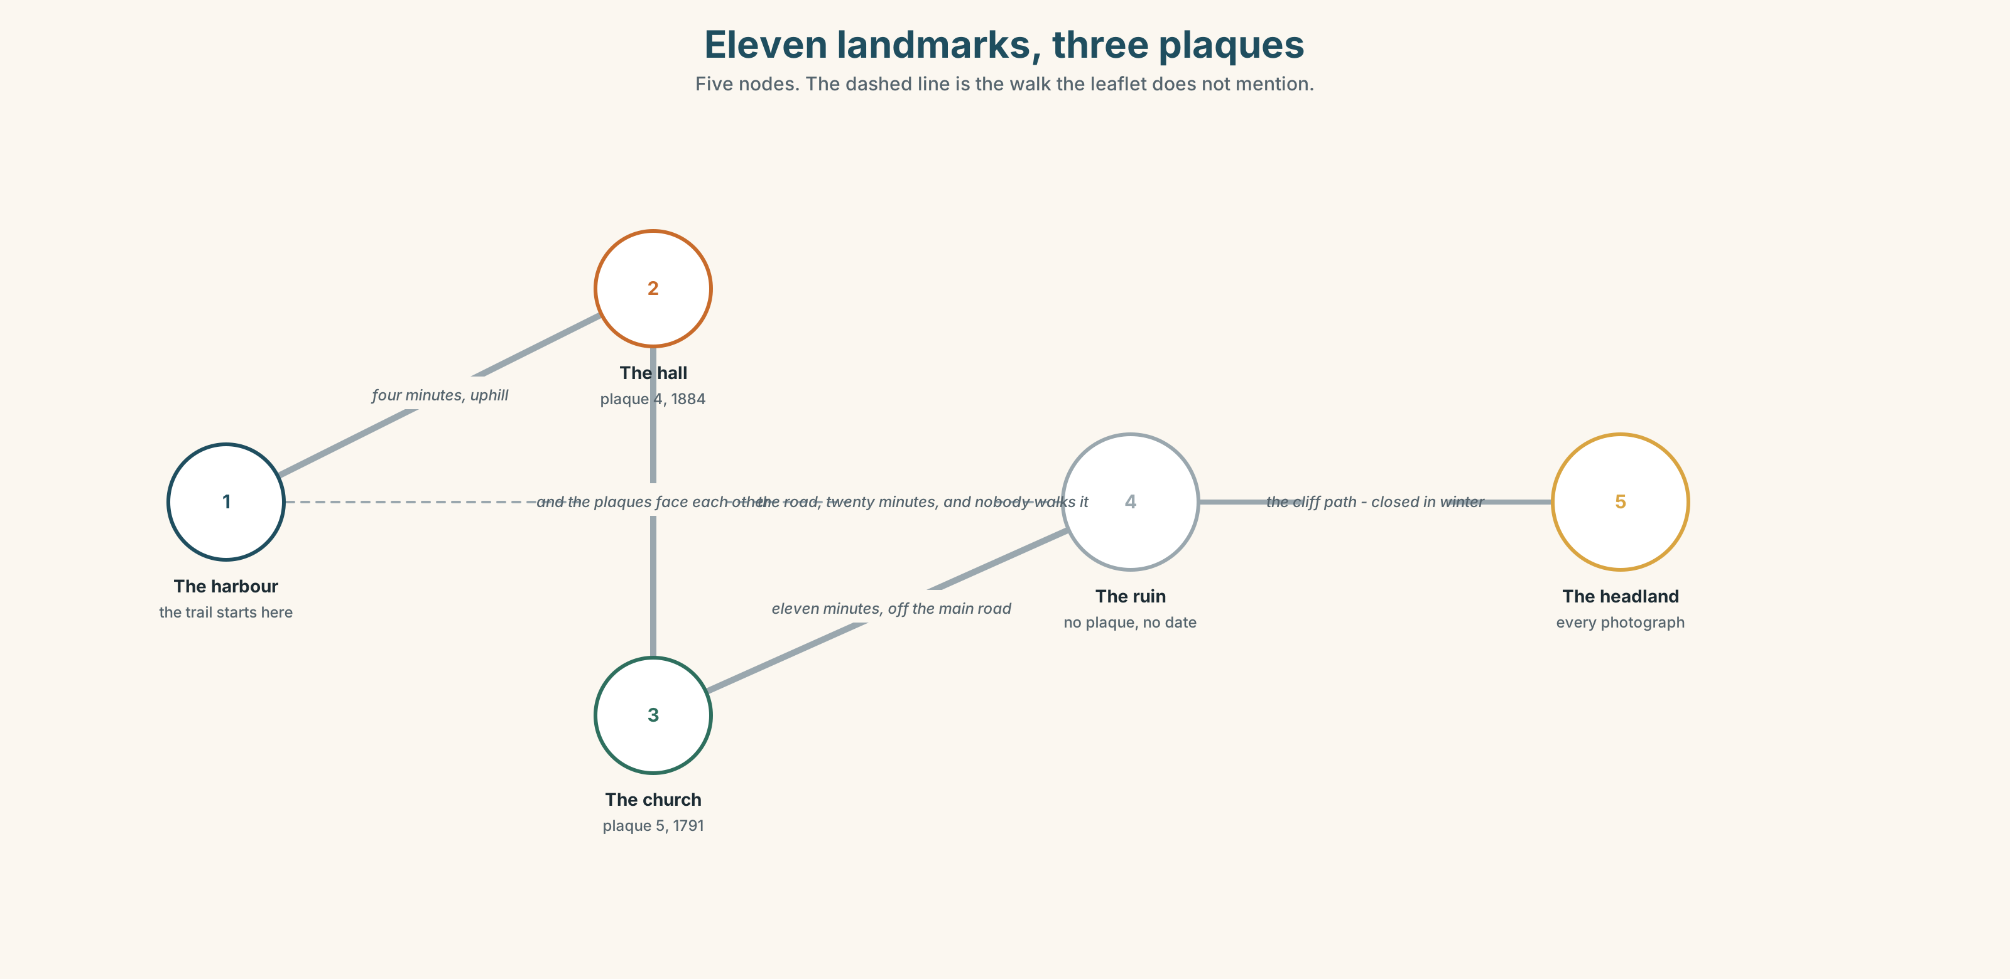{width=6.6in}
Eleven landmarks, three plaques — Five nodes. The dashed line is the walk the leaflet does not mention.

1A · Meet — the shape of a coast
Match each word to one place on the map.
harbour · pier · headland · cliff · bay · lighthouse · ruin · church · hall · landmark

1B · Sort — natural, built, or ruined?
Three columns.
cliff · pier · ruin · bay · church · headland · lighthouse · hall · harbour
One of them is in two columns, and the argument about which is three hundred years old. Which?

1C · Meet — what happened to it
founded · destroyed · restored
A building can be restored to a date that it never actually looked like. Which date would you restore the hall to, and who decides?
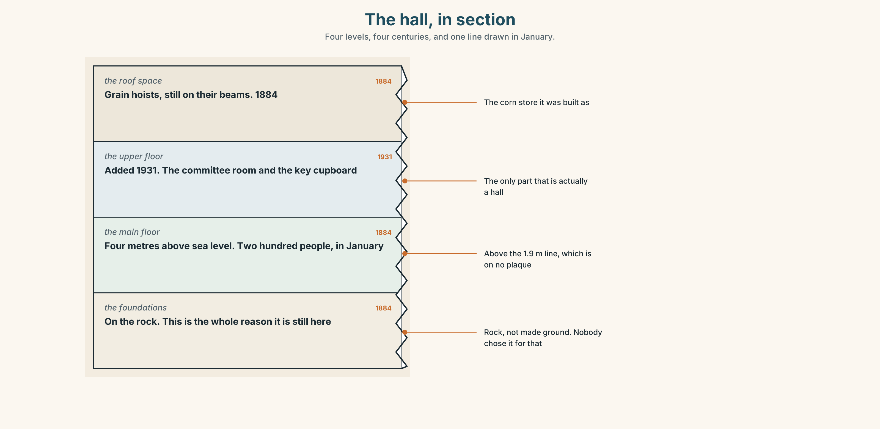{width=6.6in}
The hall, in section — Four levels, four centuries, and one line drawn in January.
Look at the hall, in section. Four levels, four centuries. Which level is the oldest, and which is the only one above the flood line?

1D · Stretch — the phrases
Complete each one with one word.
- The pier dates ______ 1886.
- The headland is named ______ a family that left in 1912.
- The ruin is worth ______ , though there is nothing to read there.
- It is off the main ______ , which is why it is still standing.
- The old school looks ______ over the whole bay.

1E · The saying
f You'd never know.
Three words that a local says and a visitor cannot.
Write three facts about a place you know that a visitor would never know. One of them should be slightly uncomfortable.

1F · Own it
Think of one building near you. Tell a partner three sentences: what it is, what it was, and one thing that is not on any sign.

Part 2 · Listening ◆ A · THE WORLD
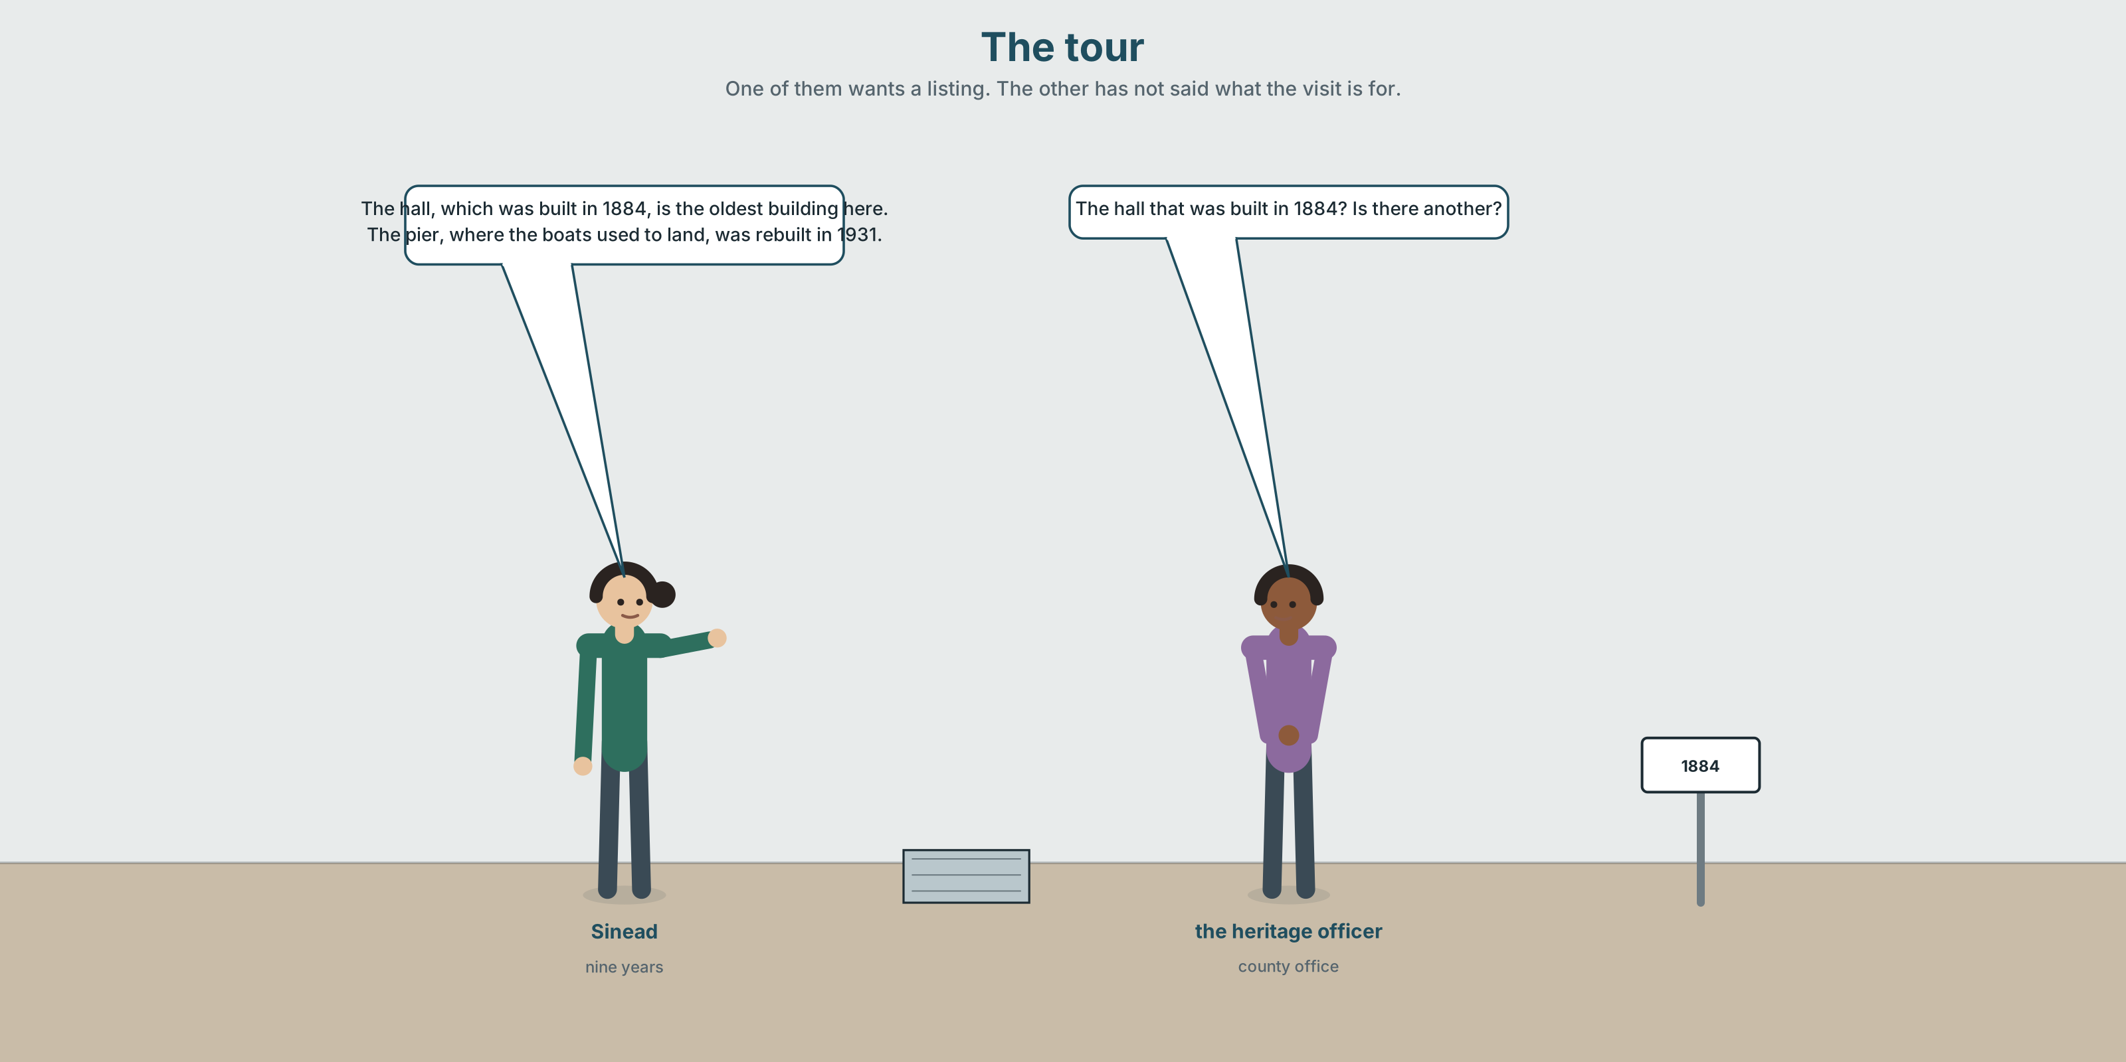{width=6.6in}
The tour — One of them wants a listing. The other has not said what the visit is for.

2A · The tour 🔊 Track 8.1
Before you listen. Sinéad is showing a heritage officer round. There is a reason. Guess what she wants.
Listen once. One question. How old is the hall?
Listen again. Complete the table.
Building | Date | What it was | What is not on the plaque
the hall
the pier
the ruin
Listen again. True or false?
- The hall was built as a church. ☐ T ☐ F
- The pier was destroyed twice. ☐ T ☐ F
- The ruin has a plaque. ☐ T ☐ F
- The hall is the only building above the flood line. ☐ T ☐ F
Noticing. Four sentences from the recording.
- The hall, which was built in 1884, is the oldest building here.
- The hall that was built in 1884 is the oldest building here.
- Sinéad, who has run it for nine years, says it should stay.
- The pier, where the boats used to land, was rebuilt in 1931.
Sentences 1 and 2 look nearly identical. One of them implies there is another hall. Which one, and what does the comma do?

2B · Decoding clinic 🔊 Track 8.2
Twenty-five seconds of Sinéad. Four jobs.
- How many times does she pause in the middle of a sentence?
- After a pause, does her voice start higher or lower?
- Catch the three dates.
- One clause is added as an afterthought. Which, and how do you know?
Transcripts, page 157.

Part 3 · Grammar Lab 1 ◆ B · THE SYSTEM

Adding something, rather than narrowing it

3A · Notice
Look at the four sentences in Part 2.
- In sentence 2, how many halls are there?
- In sentence 1, how many?
- Take which was built in 1884 out of sentence 1. Does the sentence still work?
- Now take that was built in 1884 out of sentence 2. Does it?
- Try "Sinéad, that has run it for nine years, says it should stay." What is wrong?

3B · See
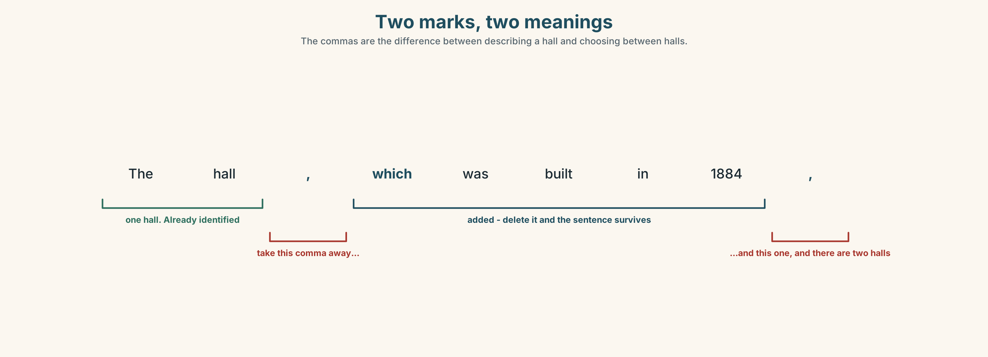{width=6.6in}
Two marks, two meanings — The commas are the difference between describing a hall and choosing between halls.
Now look at the second picture. One sentence, two readings, and the only difference is two marks.
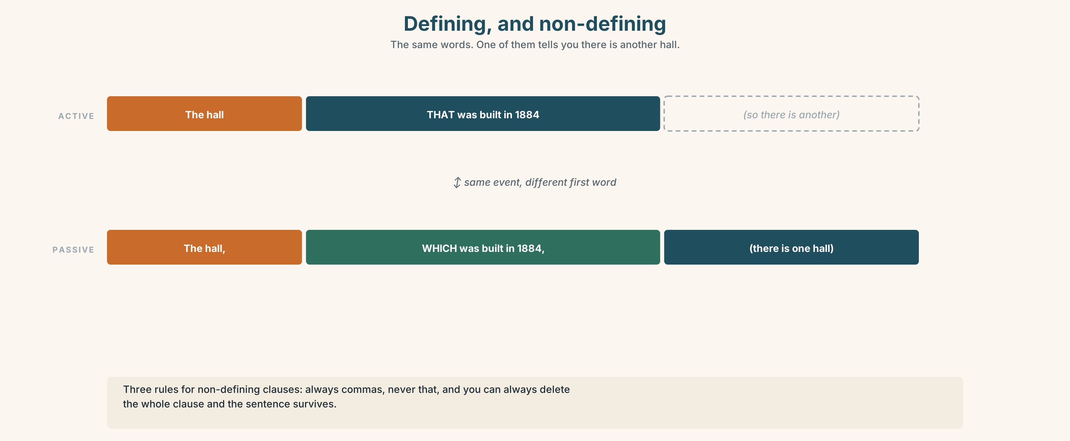{width=6.6in}
Defining, and non-defining — The same words. One of them tells you there is another hall.

3C · Know
defining | no commas · tells you which one | The hall that was built in 1884 (so there is another hall)
non-defining | commas · adds information | The hall, which was built in 1884, (there is one hall)
Three rules for non-defining clauses.
- Always commas — one before and one after, unless the sentence ends.
- Never that. Use which, who, whose, where, when.
- You can always delete the whole clause and the sentence survives.
With a proper name it is almost always non-defining, because a name already identifies. ✓ Sinéad, who has run it for nine years, … ✗ Sinéad who has run it for nine years …
Quantity phrases take of which and of whom. eleven buildings, most of which are below the line · forty-one traders, all of whom were asked
Why it matters. The comma is the difference between describing a place and distinguishing it from another one. On a plaque, that is the whole job.

3D · Use — controlled
The hall, (1) __________ was built in 1884, is the oldest building in the town. Sinéad, (2) __________ has run it for nine years, says it should stay. The pier, (3) __________ the boats used to land, was rebuilt in 1931. There are eleven listed buildings, most (4) __________ are below the flood line. The ruin, the date (5) __________ nobody knows, has no plaque. And the headland, (6) __________ is named after a family that left in 1912, is where every photograph is taken.

3E · Use — guided
Add the information as a non-defining clause. Remember the commas.
- The lighthouse is still working. (It was built in 1902.)
- Tomás has been here four years. (He wrote the survey.)
- The bay fills in forty minutes. (The tide comes in there fastest.)
- There are eleven landmarks. (Three of them have plaques.)
- The old school is empty. (Its roof was replaced last year.)

3F · Use — open
Describe four places near you to a partner, each with one non-defining clause. Your partner must spot the one that is actually defining.

3G · Check — six items
- The hall, ______ was built in 1884, is the oldest.
- Sinéad, ______ runs it, says it should stay.
- The pier, ______ the boats landed, was rebuilt.
- Eleven buildings, most ______ ______ are below the line.
- The ruin, the date ______ nobody knows, has no plaque.
- The hall ______ was built in 1884 is the oldest. (is this right? why / why not)
0–3 → Workbook pp. 46–48. 4–5 → Part 6. 6 → page 173.

Part 4 · Speaking ◆ C · THE PERFORMANCE

4A · Fluency starter — add one thing
One learner names a place. The next adds a non-defining clause. The next adds another to the new sentence. The sentence breaks when somebody uses that.
Four rounds.

4B · The functional core — giving a tour
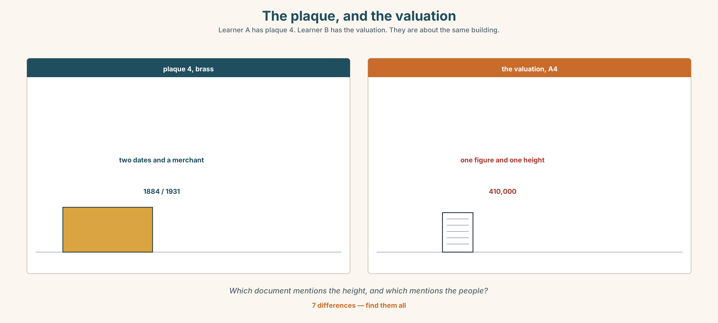{width=6.6in}
The plaque, and the valuation — Learner A has plaque 4. Learner B has the valuation. They are about the same building.
Language Bank
the fact | This is the… · It dates from… · It was founded in…
the addition | …, which was… · …, where they used to… · …, who built it.
the aside | By the way… · Which is why… · Actually…
the thing no sign says | And that's the part nobody mentions. · You'd never know.
Role play. Learner A is showing somebody round. Learner B is a visitor who asks "why?" after every fact. Six minutes.

4C · The performance — ninety seconds ⏺
Give a ninety-second tour of a place you know. You must give:
three landmarks · one non-defining clause for each · one date · one thing not on any sign
Record it.

4D · Observer
One person listens for one thing: was every added clause separated by a real pause?

4E · Two criteria
☐ Did I use three non-defining clauses, none of them with that? ☐ Is there one fact a visitor could not have found alone?

Part 5 · Reading ◆ A · THE WORLD

5A · Predict
A review of the town's new heritage trail. The title is "Eleven plaques and one missing sentence." What do you expect the reviewer to object to? One sentence.

5B · Read — one hundred and ten seconds

Eleven plaques and one missing sentence ★★★☆☆
Ballinmore's heritage trail, which opened in June, is an hour long, properly signposted, and better than most things of its kind. The plaques are brass, which will outlast the funding, and the text on them was written by somebody who has read the parish records rather than the tourist board's previous leaflet.
It is also, in one respect, a lie by omission, and I want to be careful about how I say that, because the omission is not the trail's fault.
Plaque 4 is on the hall, which was built in 1884 as a corn store and became a hall in 1931. The plaque gives both dates and the name of the merchant who paid for it. What it does not say — and what every person in this town knows — is that the hall is the only building in the lower town above the 1.9 metre line, that two hundred people were in it on the night of the storm, and that there is a proposal to sell it.
A heritage plaque is not a news bulletin and nobody expects it to be. But the trail is the only written account of this place that a visitor will ever read, and it stops in 1931.
Three stars, and the third one is for the brass.

5C · Answer
- How long is the trail, and when did it open?
- What two things does the reviewer praise about the plaques?
- What does plaque 4 say about the hall, and what does it leave out?
- How many people were in the hall on the night?
- Why does the reviewer say the omission is not the trail's fault?
- What is the third star for?

5D · Vocabulary in context
Guess from the text. Then check.
signposted · a lie by omission · the parish records · a news bulletin · it stops in 1931

5E · The counter-text
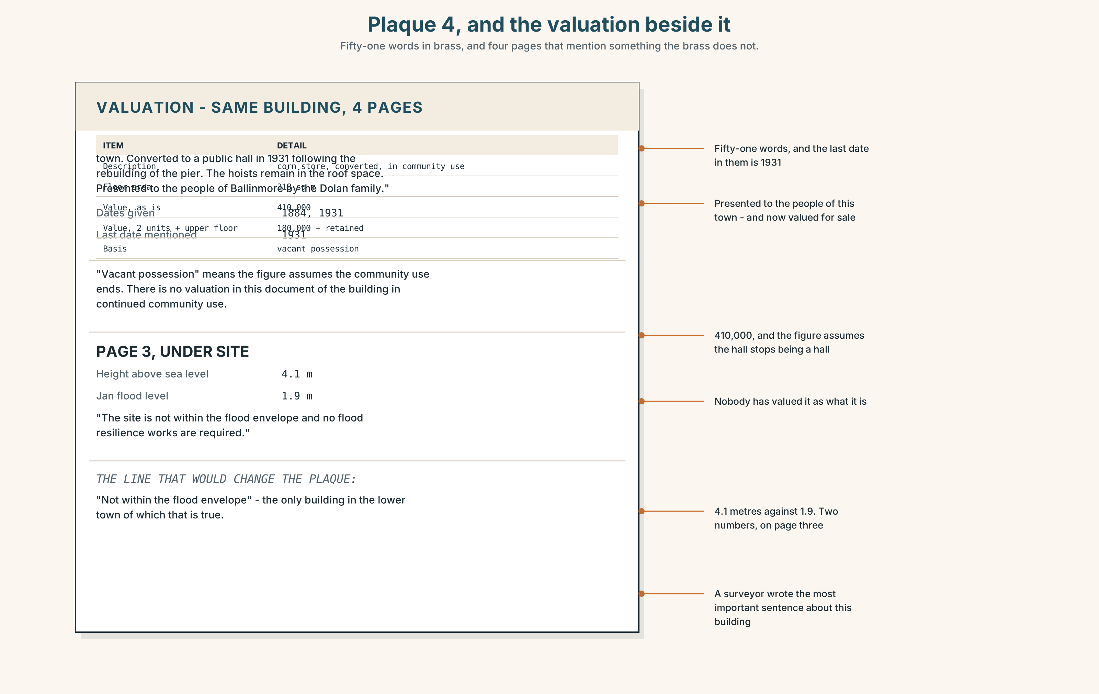{width=6.6in}
Plaque 4, and the valuation beside it — Fifty-one words in brass, and four pages that mention something the brass does not.
Read plaque 4 and the valuation beside it, and answer.
- What two dates does the plaque give, and whose name is on it?
- What is the building valued at, and on what basis?
- What does the valuation say about the building's height above sea level?
- One line of the valuation would change the plaque if it were on it. Which?

5F · Two texts
The plaque says the hall became a hall in 1931. The valuation describes it as "a corn store, converted, in community use".
Put those two facts together. Which document is a sales document? Two sentences.

Part 6 · Vocabulary Lab 2 ◆ B · THE SYSTEM

Adding, and adding carefully
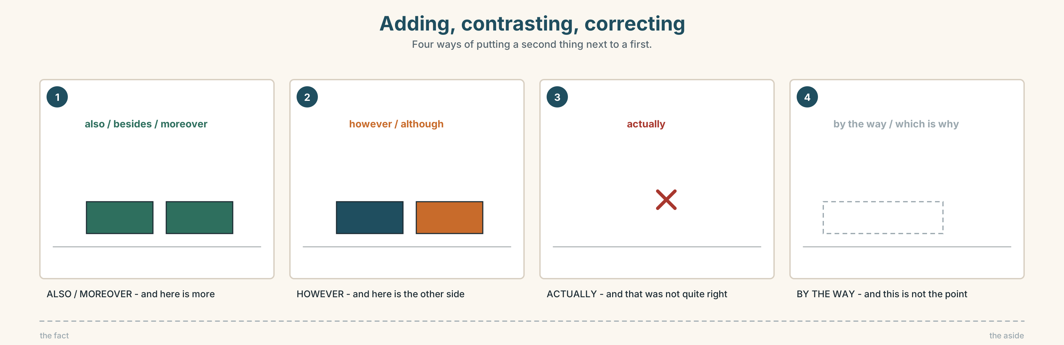{width=6.6in}
Adding, contrasting, correcting — Four ways of putting a second thing next to a first.

6A · Sort — adds, contrasts, or changes the subject?
Three columns.
also · besides · moreover · however · although · by the way · actually · which is why
One of them can do two of the three jobs. Which?

6B · Chunk completion
- Eleven buildings, most ______ which are below the line.
- Forty-one people, all ______ whom were asked.
- By the ______ , the ruin has no plaque at all.
- The tide comes in fastest there, which is ______ nobody swims in that bay.
- I came ______ the parish records in a drawer in the vestry.
- And that's the part nobody ______ .

6C · Three that are not interchangeable
however · although · actually
however joins two sentences. although joins two clauses. actually corrects something.
Put one in each, and say what the other two would do to the sentence.
- The plaque is accurate. ______ , it stops in 1931.
- ______ the plaque is accurate, it stops in 1931.
- It stops in 1931 — ______ , in 1931 and not in 1884.
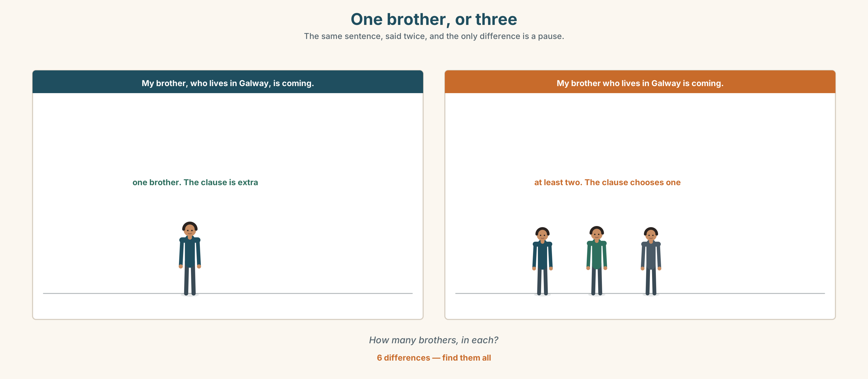{width=6.6in}
One brother, or three — The same sentence, said twice, and the only difference is a pause.
Six differences. Find them, then answer the question under the picture.

6D · Contrast Clinic — commas or no commas
Six items. Add commas where the clause is non-defining, and say what changes.
- The hall which was built in 1884 is the oldest.
- The woman who runs the hall is called Sinéad.
- Sinéad who runs the hall has been here nine years.
- The building where the meeting was held has been sold.
- The pier which was rebuilt in 1931 is closed again.
- The only building that is above the line is the hall.

Part 7 · Pronunciation & Fluency Lab ◆ B · THE SYSTEM

The pause, and what happens after it
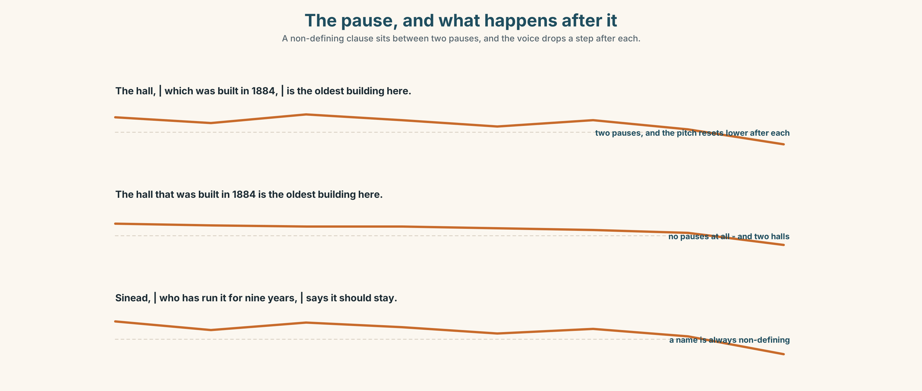{width=6.6in}
The pause, and what happens after it — A non-defining clause sits between two pauses, and the voice drops a step after each.

7A · Hear 🔊 Track 8.3
The hall | which was built in 1884 | is the oldest building here. Two pauses. And after each one the voice starts a little lower.
Now hear the defining version, with no pauses at all:
The hall that was built in 1884 is the oldest building here.

7B · Say
Say both. Then say this one with the pauses and without:
Sinéad, who has run it for nine years, says it should stay.

7C · Make it mean something
Say these two:
My brother, who lives in Galway, is coming. (how many brothers?) My brother who lives in Galway is coming. (how many brothers?)
Say both to a partner and have them hold up fingers. Did they get it from the pause alone?

7D · Fluency 20 ⏺
Twenty seconds: three places, each with a clause between two pauses. Three times, faster, keeping the pauses.

Part 8 · Writing ◆ C · THE PERFORMANCE

A place, with what the sign leaves out · 100 words
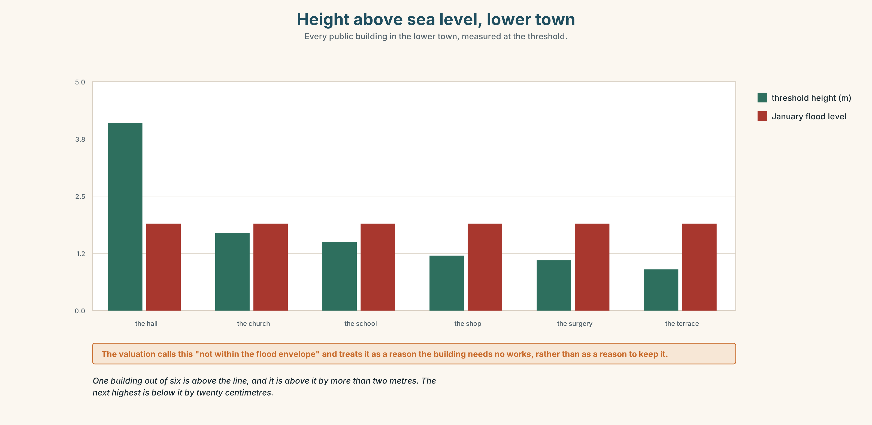{width=6.6in}
Height above sea level, lower town — Every public building in the lower town, measured at the threshold.

8A · Read the model
The hall, which was built as a corn store in 1884, stands eleven metres back from the sea and four metres above it. [the added clause, and then the two numbers that turn out to be the point]
It became a hall in 1931, when the pier was rebuilt and the town briefly had money. The plaque gives both dates and the merchant's name, which was Dolan. [a second clause, and one fact that the plaque does have]
It is also the only building in the lower town that the water did not reach, which is why two hundred people were in it in January, and which is not on the plaque. [the defining clause is deliberate here — there is only one such building, and the sentence is about which one]
Questions about the writer's choices:
- The first paragraph gives two measurements before any history. Why that order?
- The last sentence uses that, not which, and no comma. Is that a mistake?

8B · The anti-model
The hall is a lovely old building with a great deal of history. It has been at the centre of the community for many years and holds a special place in the hearts of local people. It is well worth a visit.
Correct English, and there is no building in it. Name three things it does not contain.

8C · Plan
the place, with one added clause → a date and what it was → one number → one thing no sign says

8D · Write — 100 words

8E · Peer review — two criteria
☐ Are the non-defining clauses punctuated on both sides? ☐ Is there one fact a visitor could not get from a sign?

8F · Write it again · 8G · Publish
On the wall, with plaque 4 from Part 5E beside it.

Part 9 · The File ◆ A · THE WORLD + C · THE PERFORMANCE

STUDY FILE · The Seminar
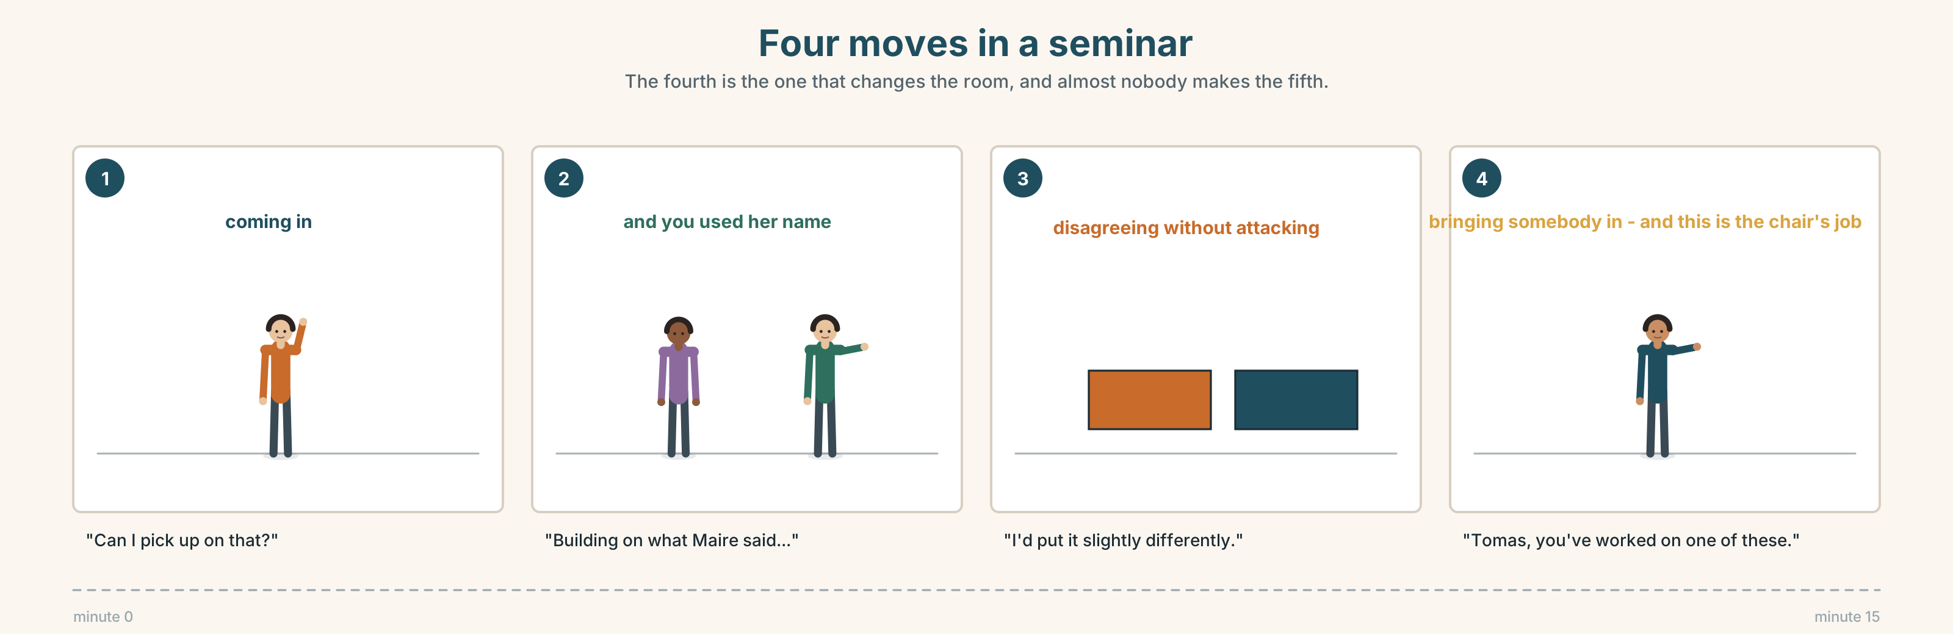{width=6.6in}
Four moves in a seminar — The fourth is the one that changes the room, and almost nobody makes the fifth.

9A · Eight people and one question 🔊 Track 8.4
A seminar at the county heritage office: should a building in use be listed? Listen to the first six minutes.
- Who speaks first, and does that help them?
- What does the chair do when two people start at once?
- Which contribution actually changes somebody's mind, and why?

9B · Four moves in a seminar
coming in · building on somebody · disagreeing without attacking · bringing somebody in
Match each to one phrase.
"Can I pick up on that?" · "Building on what Máire said…" · "I'd put it slightly differently." · "Tomás, you've worked on one of these."

9C · The move that is almost never made
In most seminars nobody ever says: "I've changed my mind."
Write the sentence that would come before it, and the sentence that would come after.

9D · Your turn
Groups of six. Fifteen minutes, one question, from this unit or your own. Rule: you must refer to somebody else by name before you make your own point. At the end, each person says one thing they heard that they had not thought of.

9E · Transfer
In your next class or meeting, use one of the four moves. Write down which, and what happened.

Part 10 · Mediation & Interaction ◆ C · THE PERFORMANCE
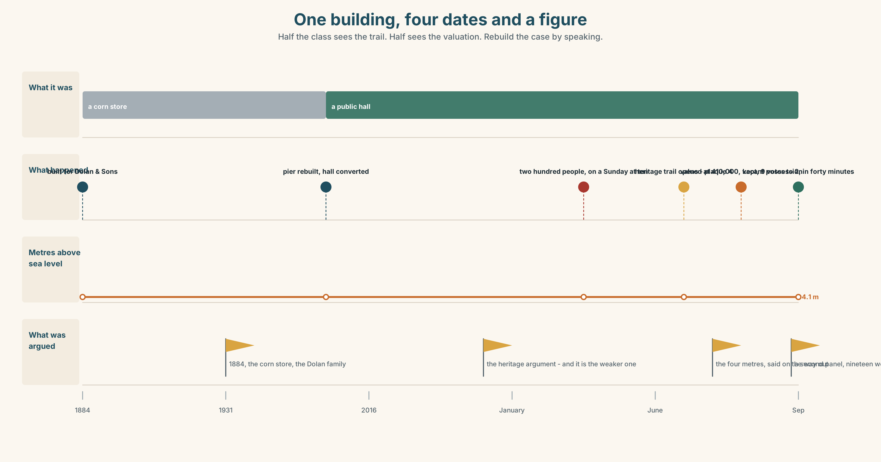{width=6.6in}
One building, four dates and a figure — Half the class sees the trail. Half sees the valuation. Rebuild the case by speaking.

10A · Relay
Half the class sees the heritage trail. Half sees the valuation. Rebuild the whole case for and against selling the hall, by speaking. Ten minutes.

10B · Simplify
Explain the valuation from Part 5E to somebody who has only read the plaque. Four sentences only.
Plan: what the building is → what it is worth → on what basis → what that basis assumes

10C · Compress
The review in Part 5 into thirty-five words, as a line for the trail's leaflet.

10D · Online
Write one message to the heritage office: the trail is good, plaque 4 stops in 1931, and here is the one sentence you want added.

10E · Your language
How does your language add information to a noun? Is there a comma, a pause, or a different word order? Say the hall, which was built in 1884, in both languages.

Part 11 · The Decision ◆ C · THE PERFORMANCE

The hall, or the wall
The hall is the only building in the lower town above the 1.9 metre line. It is valued at 410,000. The sea wall needs 340,000 that nobody has.
- Keep it. It is where two hundred people went in January and the only place they could have gone.
- Sell it. The wall gets built, and the hall committee gets a room in the new school, which is further away and below the line.
- Sell half. Split the building: the upper floor stays community, the ground floor is sold as two units. It raises about 180,000 and complicates everything.

11A · The evidence
- Plaque 4 and the valuation from Part 5E — and the line that would change the plaque.
- The chart — height above sea level of every building in the lower town.
- The voice. Sinéad, twenty seconds: "I opened it at ten on the Sunday because I had the key and it was dry. Nobody asked me to and nobody has thanked me, which is right, because anybody with the key would have done it. What I want to know is who will have the key."

11B · Talk about it
In threes. Everybody says one. Use the frame.
I think they should ______ , because ______ .
Words you can use: landmark · heritage · restored · destroyed · visitor · view · community · worth seeing

11C · Decide
Write two sentences. Choose, and say why.
I think they should ______________________ , because ______________________ .

11D · Model decision
They should keep it and find the 340,000 somewhere else, and they should say in public why: that the hall is not being kept because it is old but because it is four metres up. The heritage argument is the weaker one and it is the one everybody is making, and if the hall is ever sold it will be sold by somebody who has only heard the heritage argument and has correctly decided that it is sentimental.

11E · The Reveal
What happened. They kept it. The decision went 9–2 and took forty minutes, which Sinéad says is the fastest the committee has ever done anything.
The argument that was made in the room was about 1884, the corn store and the Dolan family. Nobody mentioned the four metres until the vote was over, when Tomás said it on the way out and four people stopped walking.
Plaque 4 now has a second brass panel underneath it, added in September. It is nineteen words long and it is about the height.
They made the right decision for the wrong reason, and then somebody fixed the reason.
Was it the right decision? Say why — and say what the nineteen words should be.

Part 12 · Landing ◆ all three lines

12A · Recycle — ten items
- The hall, ______ was built in 1884, is the oldest.
- Sinéad, ______ runs it, says it should stay.
- Eleven buildings, most ______ ______ are below the line.
- The pier dates ______ 1886.
- The headland is named ______ a family that left.
- (Unit 7) This time next year I ______ (live) in Galway.
- (Unit 6) The rope ______ (must / break) in the night.
- (Unit 4) She ______ me that she had checked it. (said / told)
- (Unit 3) By the time we arrived, it ______ (already / start).
- (A2.1 U4) The person ______ has the key is the caretaker.

12B · Consolidate
One hundred words. One place. Three non-defining clauses, one date, one number, and one thing no sign says.

12C · Can-do, with evidence
I can… | My evidence | Sure?
add information to a noun without narrowing it | Part 3G score | ◯ ◑ ●
give a ninety-second tour with real background | Part 4C recording | ◯ ◑ ●
write a hundred words a visitor could use | Part 8 draft 2 | ◯ ◑ ●
come into a seminar and build on somebody | Part 9D group work | ◯ ◑ ●

12D · Replay ⏺
Find your thirty seconds from Part 0C. Listen. Record it again. One sentence: what is different?

12E · Glossary — forty items, as a map
THE COAST · harbour · pier · headland · cliff · bay · lighthouse · view · look out over THE BUILDINGS · hall · church · ruin · landmark · plaque · heritage WHAT HAPPENED TO IT · founded · destroyed · restored · dates from · named after FOR A VISITOR · visitor · worth seeing · off the main road · come across · you'd never know ADDING · which · who · where · whose · when · most of which · all of whom · also · besides · moreover CHANGING TACK · however · although · actually · by the way · which is why · and that's the part nobody mentions

12F · Next
Unit 9 · How much is left?

