Table of Contents

A2.2 · Unit 9 · Four Claims, Enough for Three
English Animated · Telling the Story · Ballinmore, west coast of Ireland Student's Book pages 182–203 · 22 pp · ~10 hours

Part 0 · The Big Picture ◆ A · THE WORLD
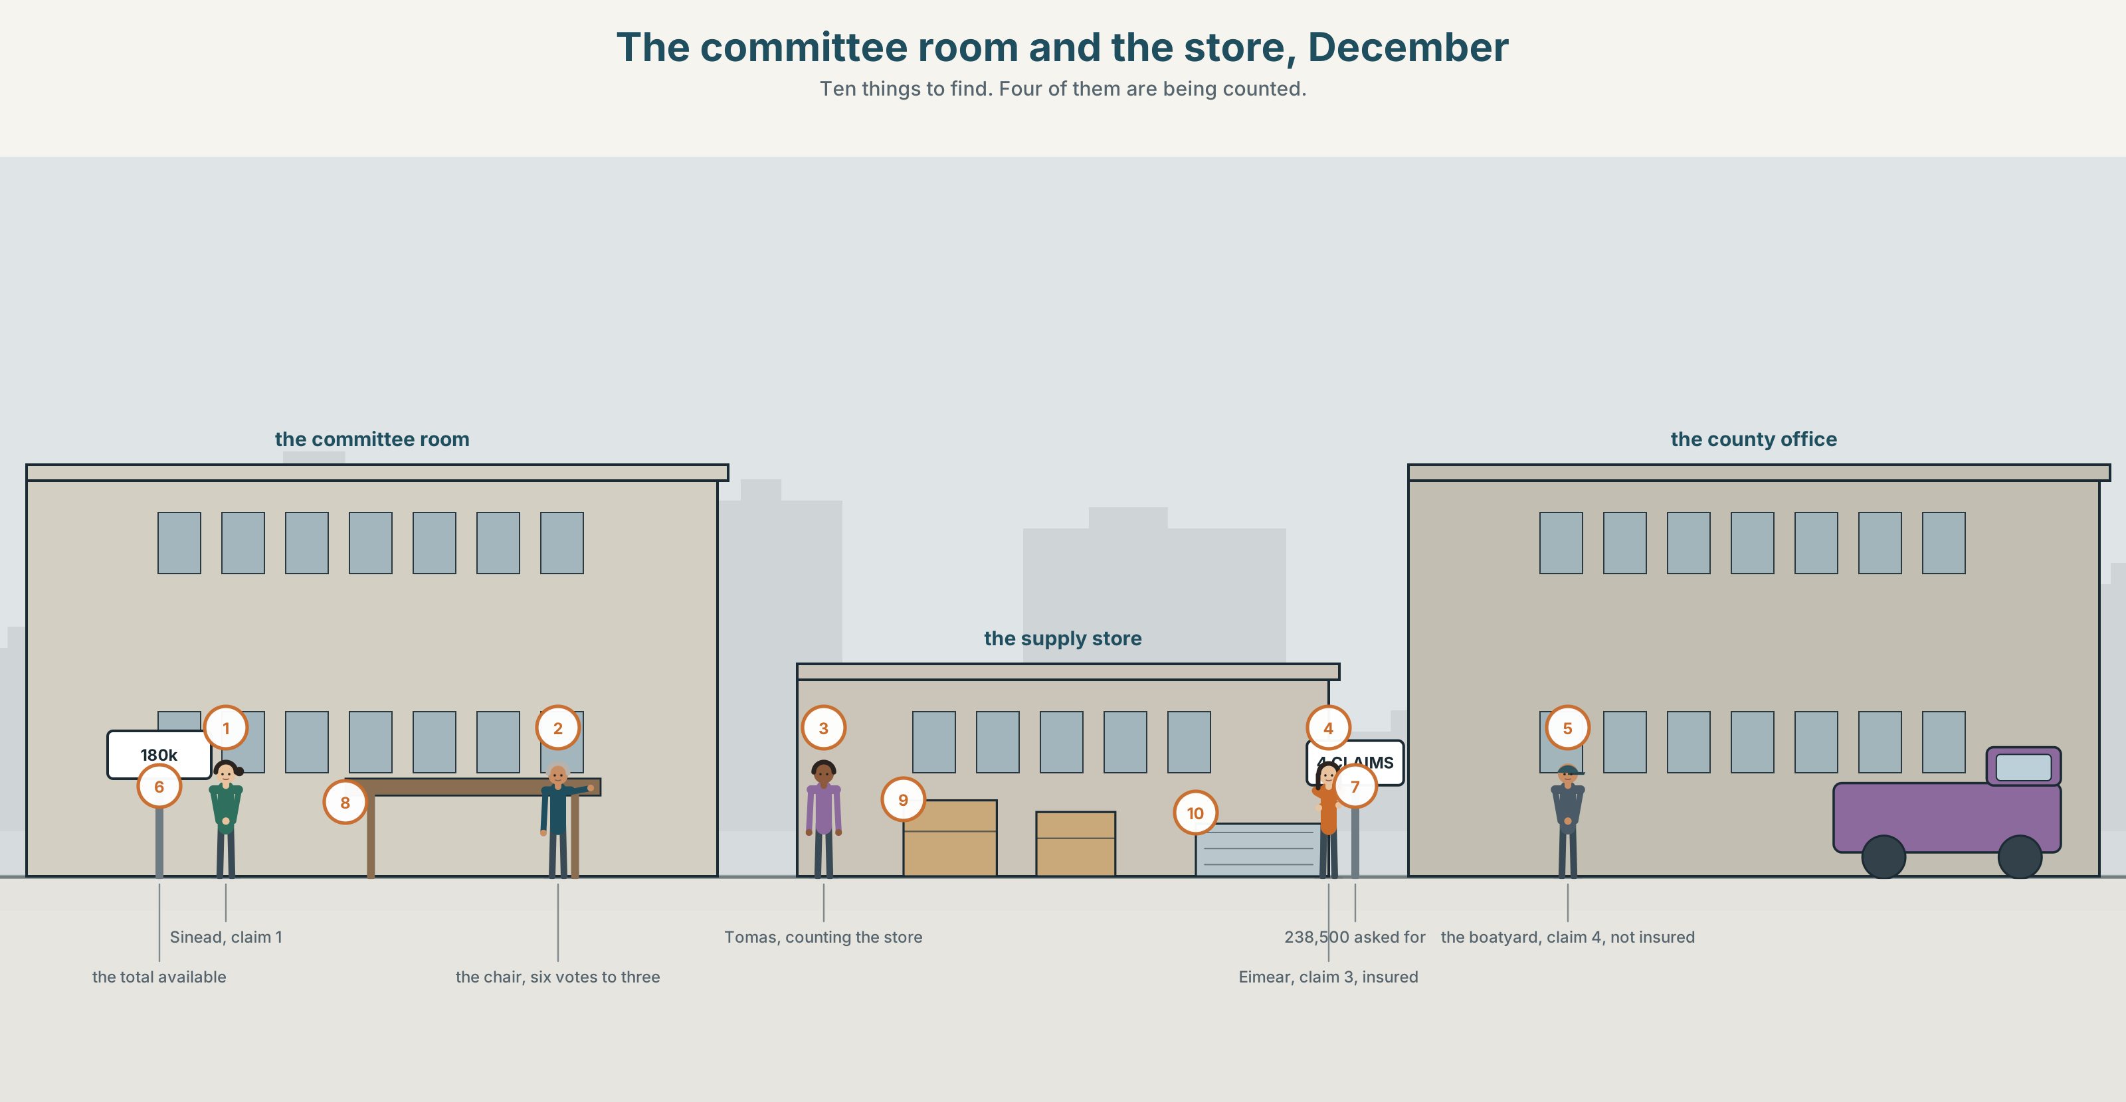{width=6.6in}
The committee room and the store, December — Ten things to find. Four of them are being counted.

How much is left?
By the end of this unit you can report how a limited resource was shared out, precisely. One hundred words.
◆ A · THE WORLD | A room with four honest claims in it and money for three
◆ B · THE SYSTEM | all · most · both · neither · either · none · of structures · 23 words for resources and fairness · 17 words for quantity · stress used for contrast
◆ C · THE PERFORMANCE | An exact account of who got what, and what was left

0A · Find it
Find ten things in this picture. Four of them are being counted.
a cheque · a list on a wall · a cash box · a stack of forms · a calculator · a half-empty store room · a queue · a committee table · a locked cupboard · a sign-up sheet

0B · Guess it
Two people in this picture will not ask for anything. Which two, and why not?

0C · Say it ⏺
Record thirty seconds. Think of something limited that you have had to share out. How did you decide? You will record it again at the end of this unit.

Part 1 · Vocabulary Lab 1 ◆ B · THE SYSTEM
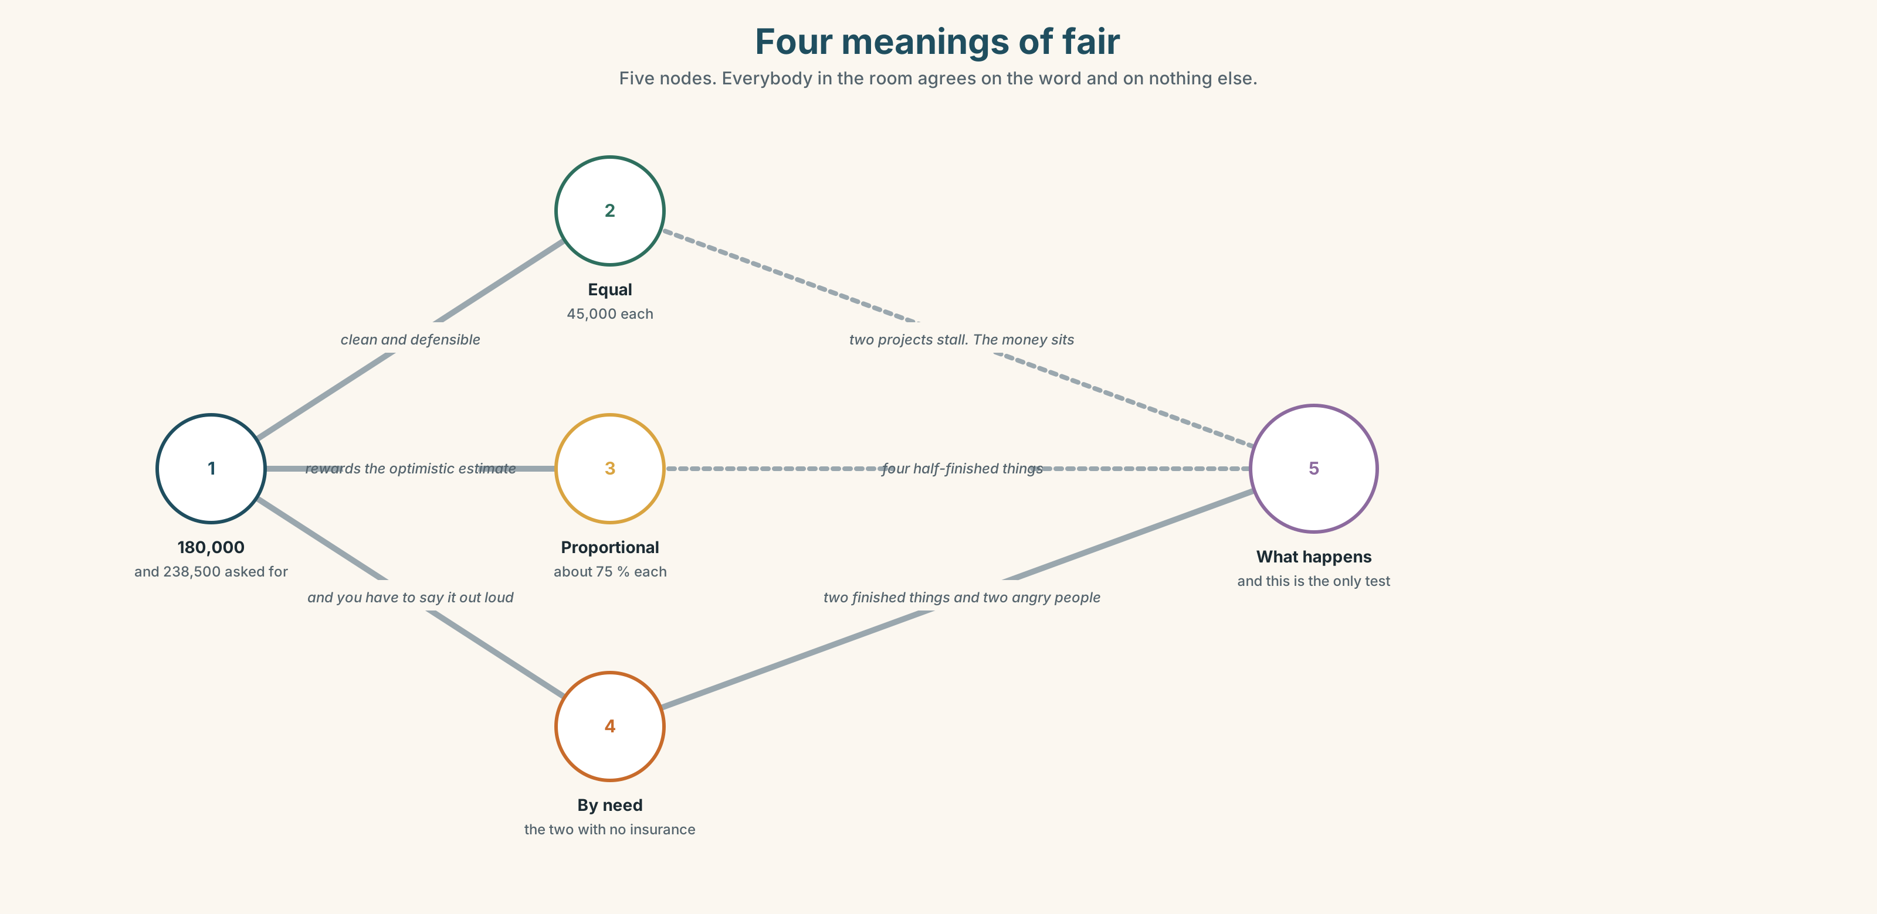{width=6.6in}
Four meanings of fair — Five nodes. Everybody in the room agrees on the word and on nothing else.

1A · Meet — the words of a limited fund
Match each word to one place on the map.
fund · relief · grant · request · allocate · share · priority · shortage · supply · total

1B · Sort — the money, the process, or the judgement?
Three columns.
fund · allocate · fair · grant · priority · equal · request · relief · limited
One of them only becomes a judgement when there is not enough. Which?

1C · Meet — three words for what is left
remaining · spare · enough
Spare implies nobody needs it. Remaining implies somebody might. Which word would a committee use, and which would a claimant?
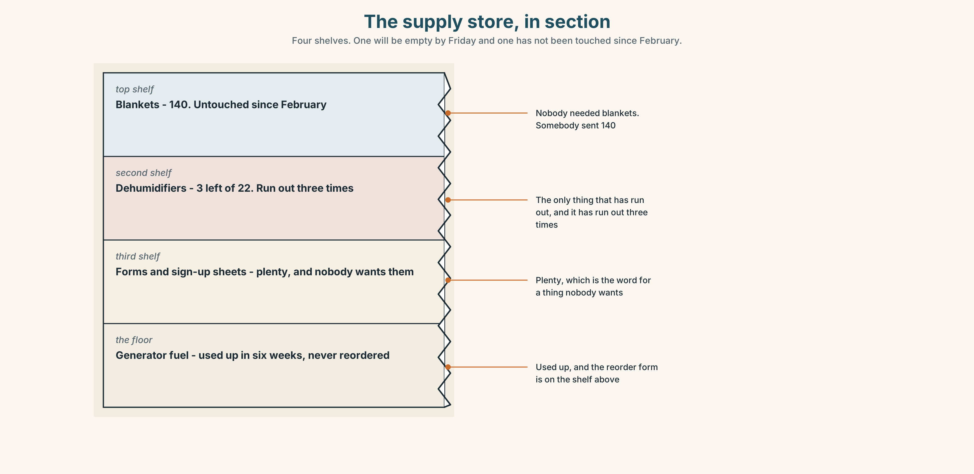{width=6.6in}
The supply store, in section — Four shelves. One will be empty by Friday and one has not been touched since February.
Look at the store room, in section. Four shelves, four supplies. Which shelf will run out first, and which has been untouched since February?

1D · Stretch — the phrases
Complete each one with one word.
- They have run ______ of dehumidifiers for the third time.
- There are forty and sixty people, so it will not go ______ .
- Eight thousand has been set ______ for emergencies and nobody has touched it.
- Everybody keeps saying they want a fair ______ and meaning a different thing by it.
- The fuel for the generators was used ______ in six weeks.

1E · The saying
f There isn't enough to go round.
Seven words that end most conversations about money.
They are almost always true. Write the sentence that should come after them — the one that actually decides something.

1F · Own it
Think of something limited where you live — parking, time, water, money. Tell a partner three sentences: what is short, who decides, and whether you think it is fair.

Part 2 · Listening ◆ A · THE WORLD
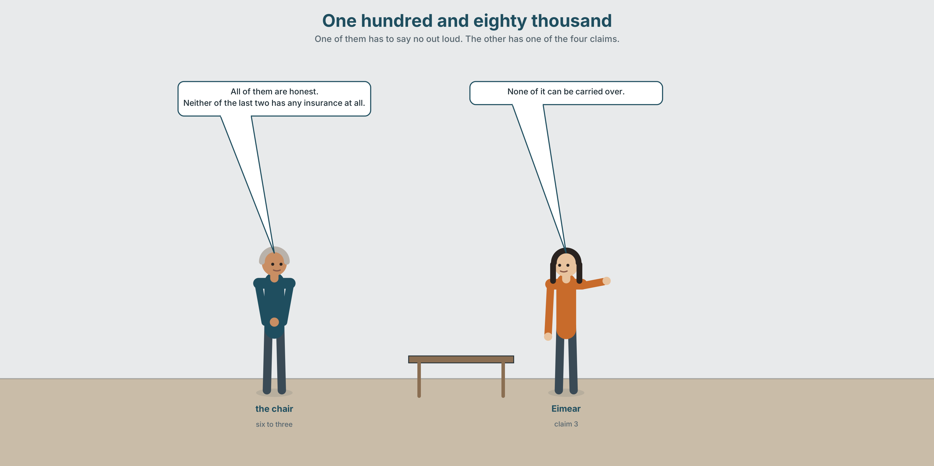{width=6.6in}
One hundred and eighty thousand — One of them has to say no out loud. The other has one of the four claims.

2A · One hundred and eighty thousand 🔊 Track 9.1
Before you listen. There is €180,000 of relief money and four claims. Guess: are any of the claims dishonest?
Listen once. One question. How much is each claim for?
Listen again. Complete the table.
Claim | Amount | For what | Why it is strong
1
2
3
4
Listen again. Choose.
- The four claims total 180,000 / 214,000 / 246,000.
- All / Most / None of the claimants have insurance.
- Both / Neither / Either of the last two claims is for a business.
- The committee can award all four partly / three fully / one fully.
Noticing. Four sentences from the recording.
- All of them are honest.
- Most of them have been waiting since March.
- Neither of the last two has any insurance at all.
- None of it can be carried over to next year.
Three of these are about people. One is about money. Which, and how can you tell from the verb?

2B · Decoding clinic 🔊 Track 9.2
Twenty-five seconds. Four jobs.
- How many times does the speaker say of?
- In all of them, is of loud or quiet?
- Catch the total and the shortfall.
- One word is said with heavy stress to contrast it with another. Which?
Transcripts, page 158.

Part 3 · Grammar Lab 1 ◆ B · THE SYSTEM

Saying how many, exactly

3A · Notice
Look at the four sentences in Part 2.
- In sentence 1, could you say All them are honest? Why not?
- In sentence 3, neither is followed by a singular verb. Why?
- In sentence 4, none of it — not none of them. What does that tell you about the money?
- What is the difference between all the claims and all of the claims?
- Try "Both of the four claims are for businesses." What is wrong?

3B · See
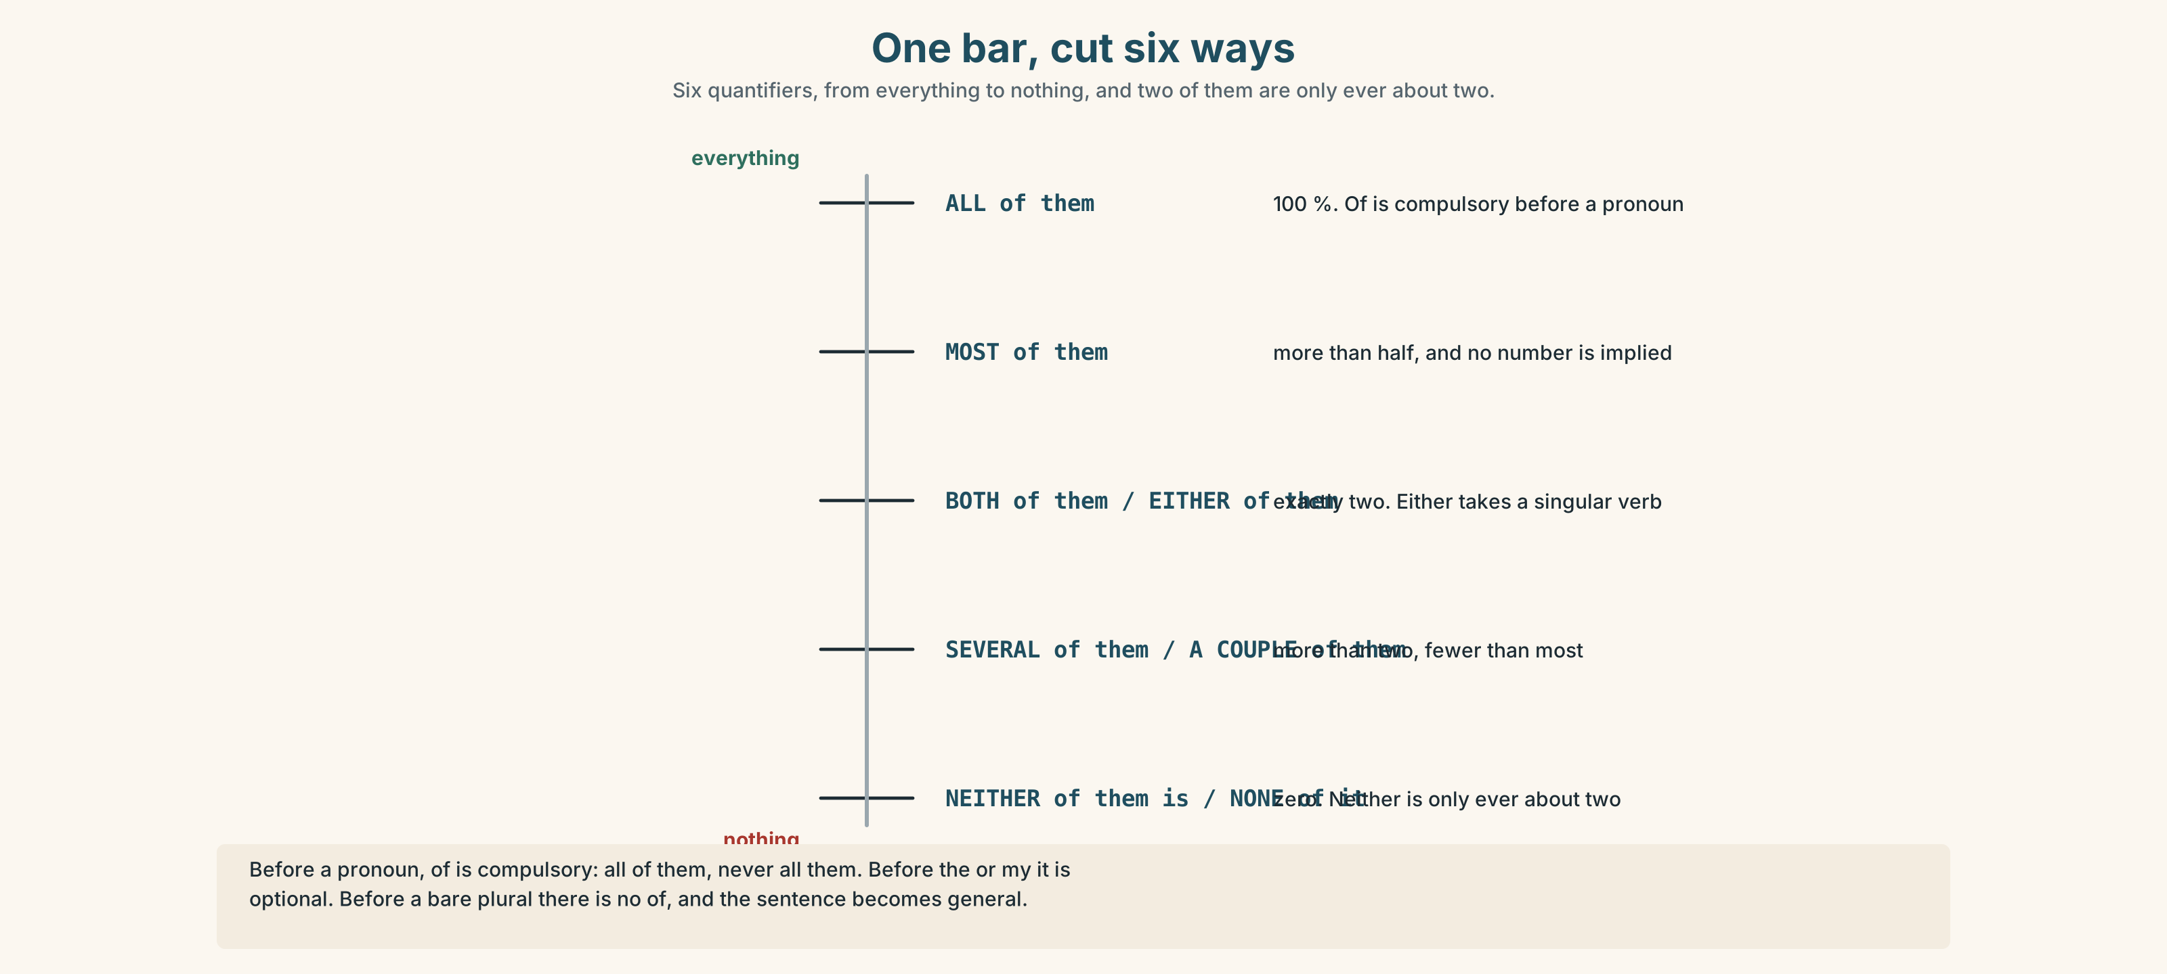{width=6.6in}
One bar, cut six ways — Six quantifiers, from everything to nothing, and two of them are only ever about two.
Now look at the second picture. One bar, cut six ways. Which cut is most, and which is several?
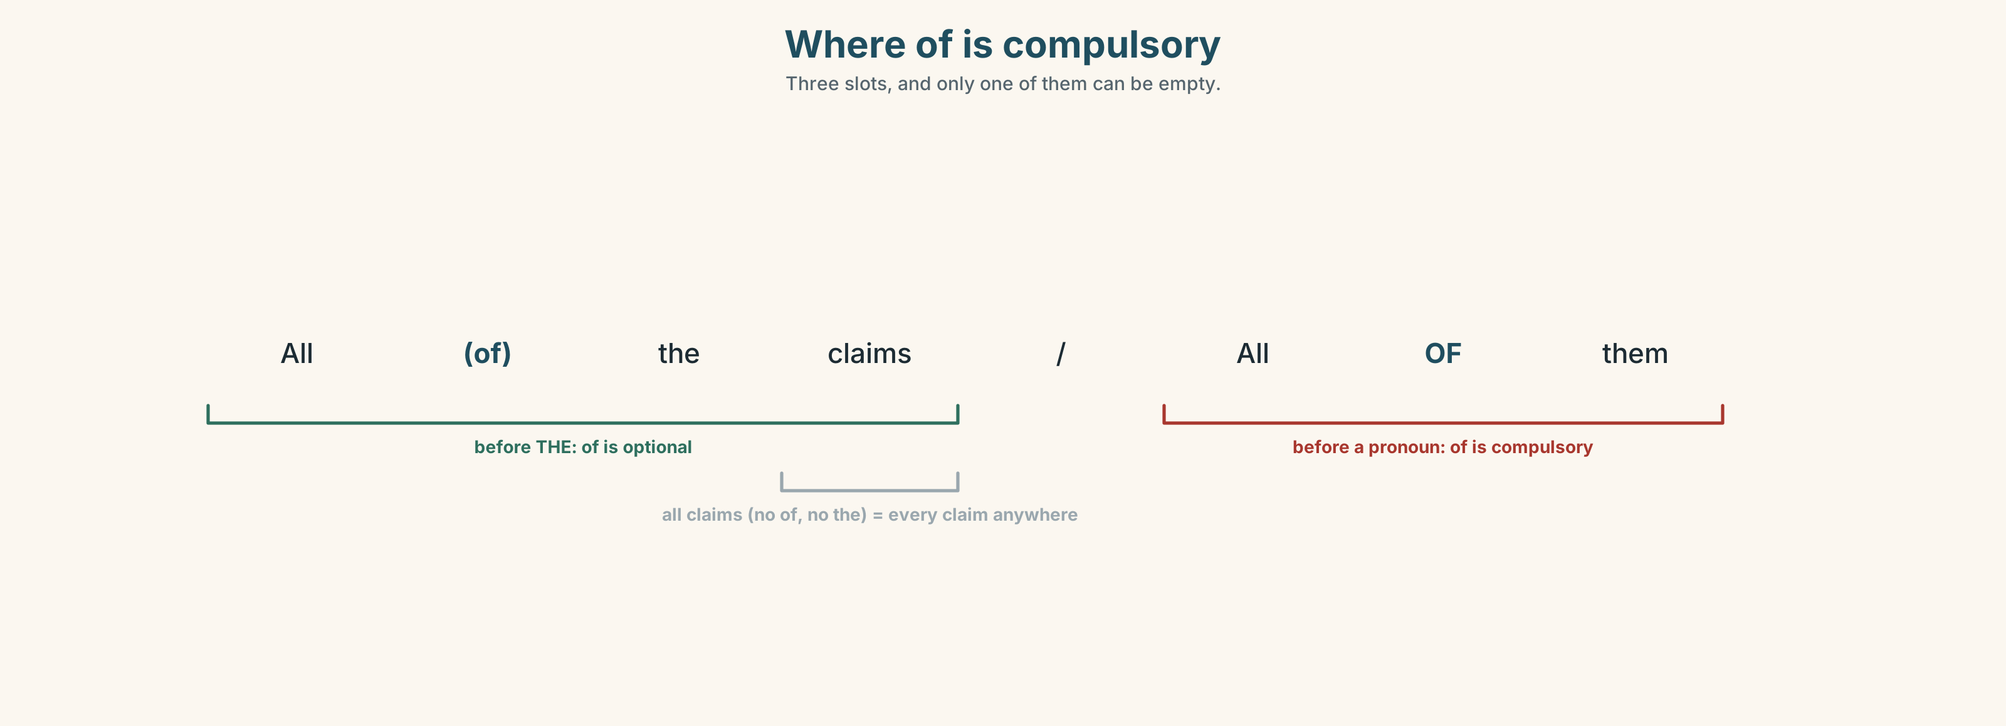{width=6.6in}
Where of is compulsory — Three slots, and only one of them can be empty.

3C · Know
 | How many | Shape
all | 100 % | all the claims · all of them
most | more than half | most of them
half / several / a couple of | in between | half of it · several of them
both | exactly 2 | both of them — only two
either | one of 2 | either of them, singular verb
neither | 0 of 2 | neither of them is — singular verb
none | 0 of any number | none of it / none of them
The of rule. Before a pronoun, of is compulsory: all of them, never all them. Before the or my, of is optional: all (of) the claims. Before a bare plural, there is no of: all claims are honest — and that is a general statement about every claim in the world.
Countable or not. none of them (the claims) · none of it (the money). few and several go with countables. little and much go with uncountables.
Watch out. both, either and neither are only ever about two. ✗ both of the four claims ✓ all four claims

3D · Use — controlled
(1) __________ of the four claims is dishonest. (2) __________ of them have been waiting since March, and (3) __________ of the last two has any insurance. (4) __________ of the money can be carried over to next year, so the committee must spend (5) __________ of it by December. They can fund three fully and (6) __________ of the remaining claim, or (7) __________ four partly.

3E · Use — guided
Choose the right word, and say why the others fail.
- ______ of the four claimants is lying. (zero out of four)
- ______ of the last two has insurance. (zero out of two)
- ______ of them have been waiting since March. (more than half)
- ______ of the money is left. (a bit, but not much)
- ______ of the two is acceptable to the committee. (one or the other)

3F · Use — open
Count something in this room. Tell a partner five facts about it using all, most, both, none and several. One of them must be about something uncountable.

3G · Check — six items
- ______ of them are honest. (every one)
- ______ of the last two has insurance. (zero of two)
- ______ of it can be carried over. (zero, uncountable)
- ______ of them have waited since March. (more than half)
- ______ of the two is acceptable. (one or the other)
- We spoke to all ______ the claimants.
0–3 → Workbook pp. 52–54. 4–5 → Part 6. 6 → page 195.

Part 4 · Speaking ◆ C · THE PERFORMANCE

4A · Fluency starter — the exact fraction
Your teacher makes a statement: "Everybody here has a phone." Each learner must make it more exact: most of us · about half of us · several of us · none of us. Nobody may repeat a quantifier.
Five rounds, five statements.

4B · The functional core — reporting an allocation
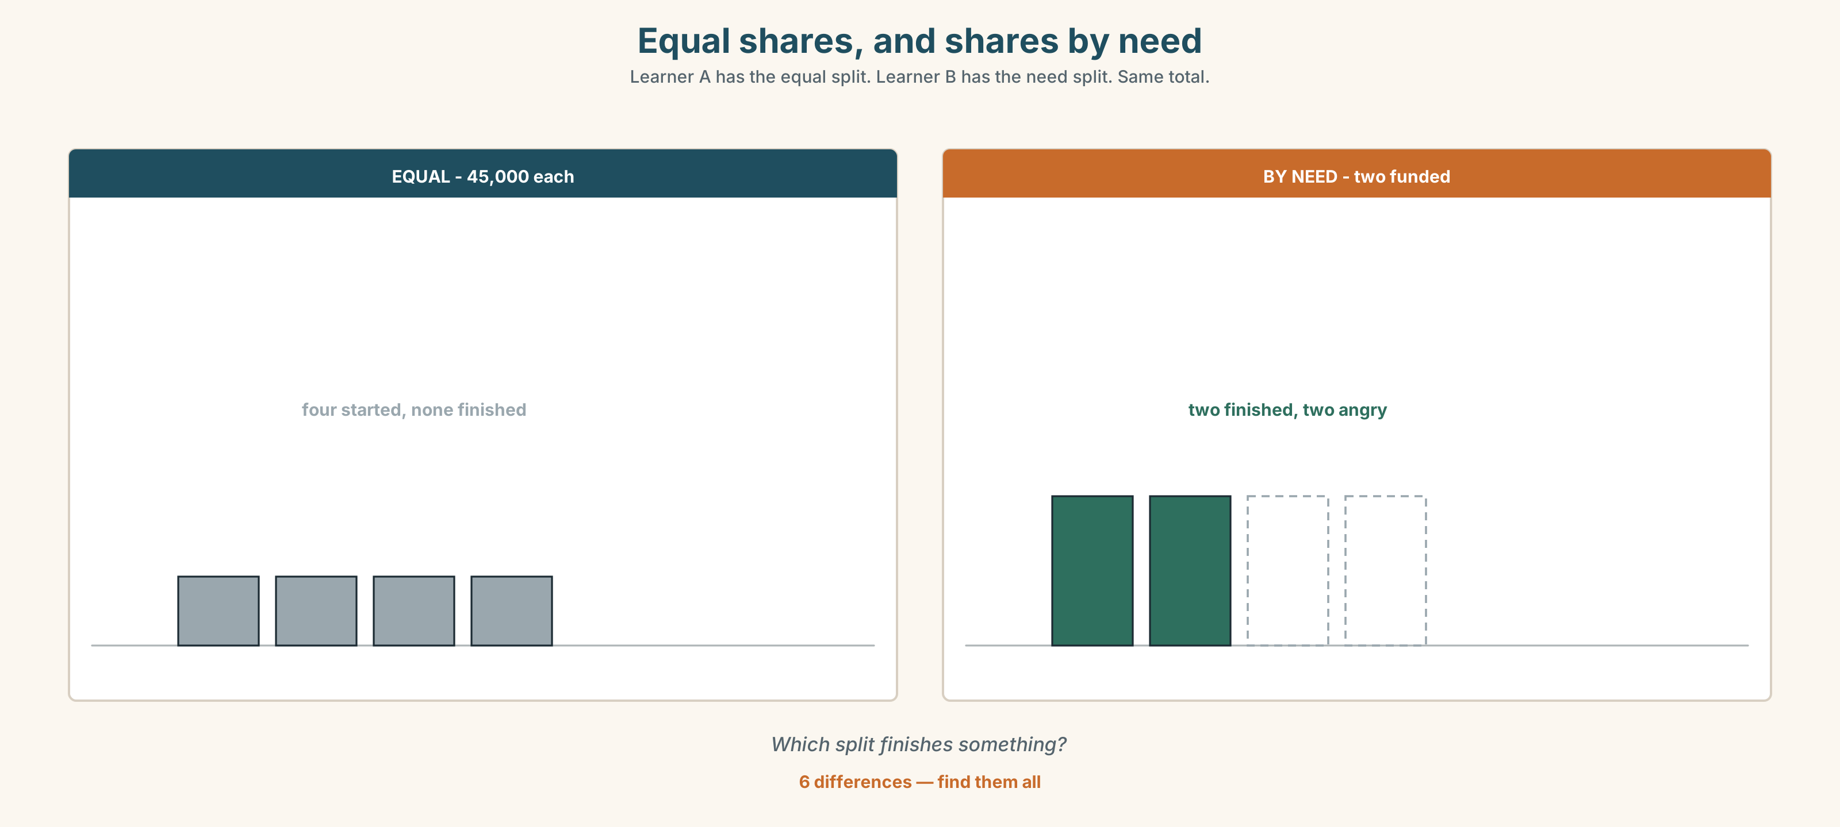{width=6.6in}
Equal shares, and shares by need — Learner A has the equal split. Learner B has the need split. Same total.
Language Bank
the total | There was a total of… · Of that, …
who got what | Three of the four received… · Neither of the last two…
what is left | None of it can be carried over. · The remaining 14,000…
the honest line | It was not enough and we knew that in March.
Role play. Learner A chairs the committee. Learner B has the fourth claim. Six minutes. Learner A must say the word no once, out loud, early.

4C · The performance — one hundred seconds ⏺
Report how something limited was shared out. One hundred seconds. You must give:
the total · who asked for what · who got what · what was left, and what happened to it
Record it.

4D · Observer
One person listens for one thing: did every quantity have a number or a fraction behind it?

4E · Two criteria
☐ Did I use of correctly every time? ☐ Could a listener reconstruct the arithmetic?

Part 5 · Reading ◆ A · THE WORLD

5A · Predict
An opinion column. The title is "Everybody wants a fair share and nobody means the same thing." What three meanings of fair can you think of before you read?

5B · Read — one hundred and ten seconds

Everybody wants a fair share and nobody means the same thing
There is €180,000. There are four claims, totalling €246,000. All four are honest. That is the whole situation and it has no solution, only decisions.
When people in that room say fair, they mean one of four things, and the argument is not about the money. It is about which of the four they are using, and almost nobody says which.
Equal. Forty-five thousand each. Clean, defensible, and it leaves two of them with less than half of what they need, which means neither of those two can start work at all. Equal shares of an insufficient sum can be the least useful way of spending it.
Proportional. Each gets 73 per cent of what they asked for. Slightly worse than equal for the small claims and slightly better for the large ones, and it rewards whoever estimated most optimistically in March.
By need. The two with no insurance get everything. This is the one most people privately believe in and the one nobody proposes out loud, because it requires saying that the other two matter less.
First come. It has already partly happened. Two of the four submitted in March and have been quietly assumed into the budget ever since.
Pick one and defend it. Picking none of them and splitting the difference is also a choice, and it is the only one that nobody will later be able to explain.

5C · Answer
- How much is there, how much was asked for, and how many claims?
- What is the writer's objection to equal shares?
- What does the proportional method reward?
- Why does the writer say nobody proposes "by need" out loud?
- What has already partly happened, and how?
- What does the writer say about splitting the difference?

5D · Vocabulary in context
Guess from the text. Then check.
defensible · an insufficient sum · optimistically · privately believe in · splitting the difference

5E · The counter-text
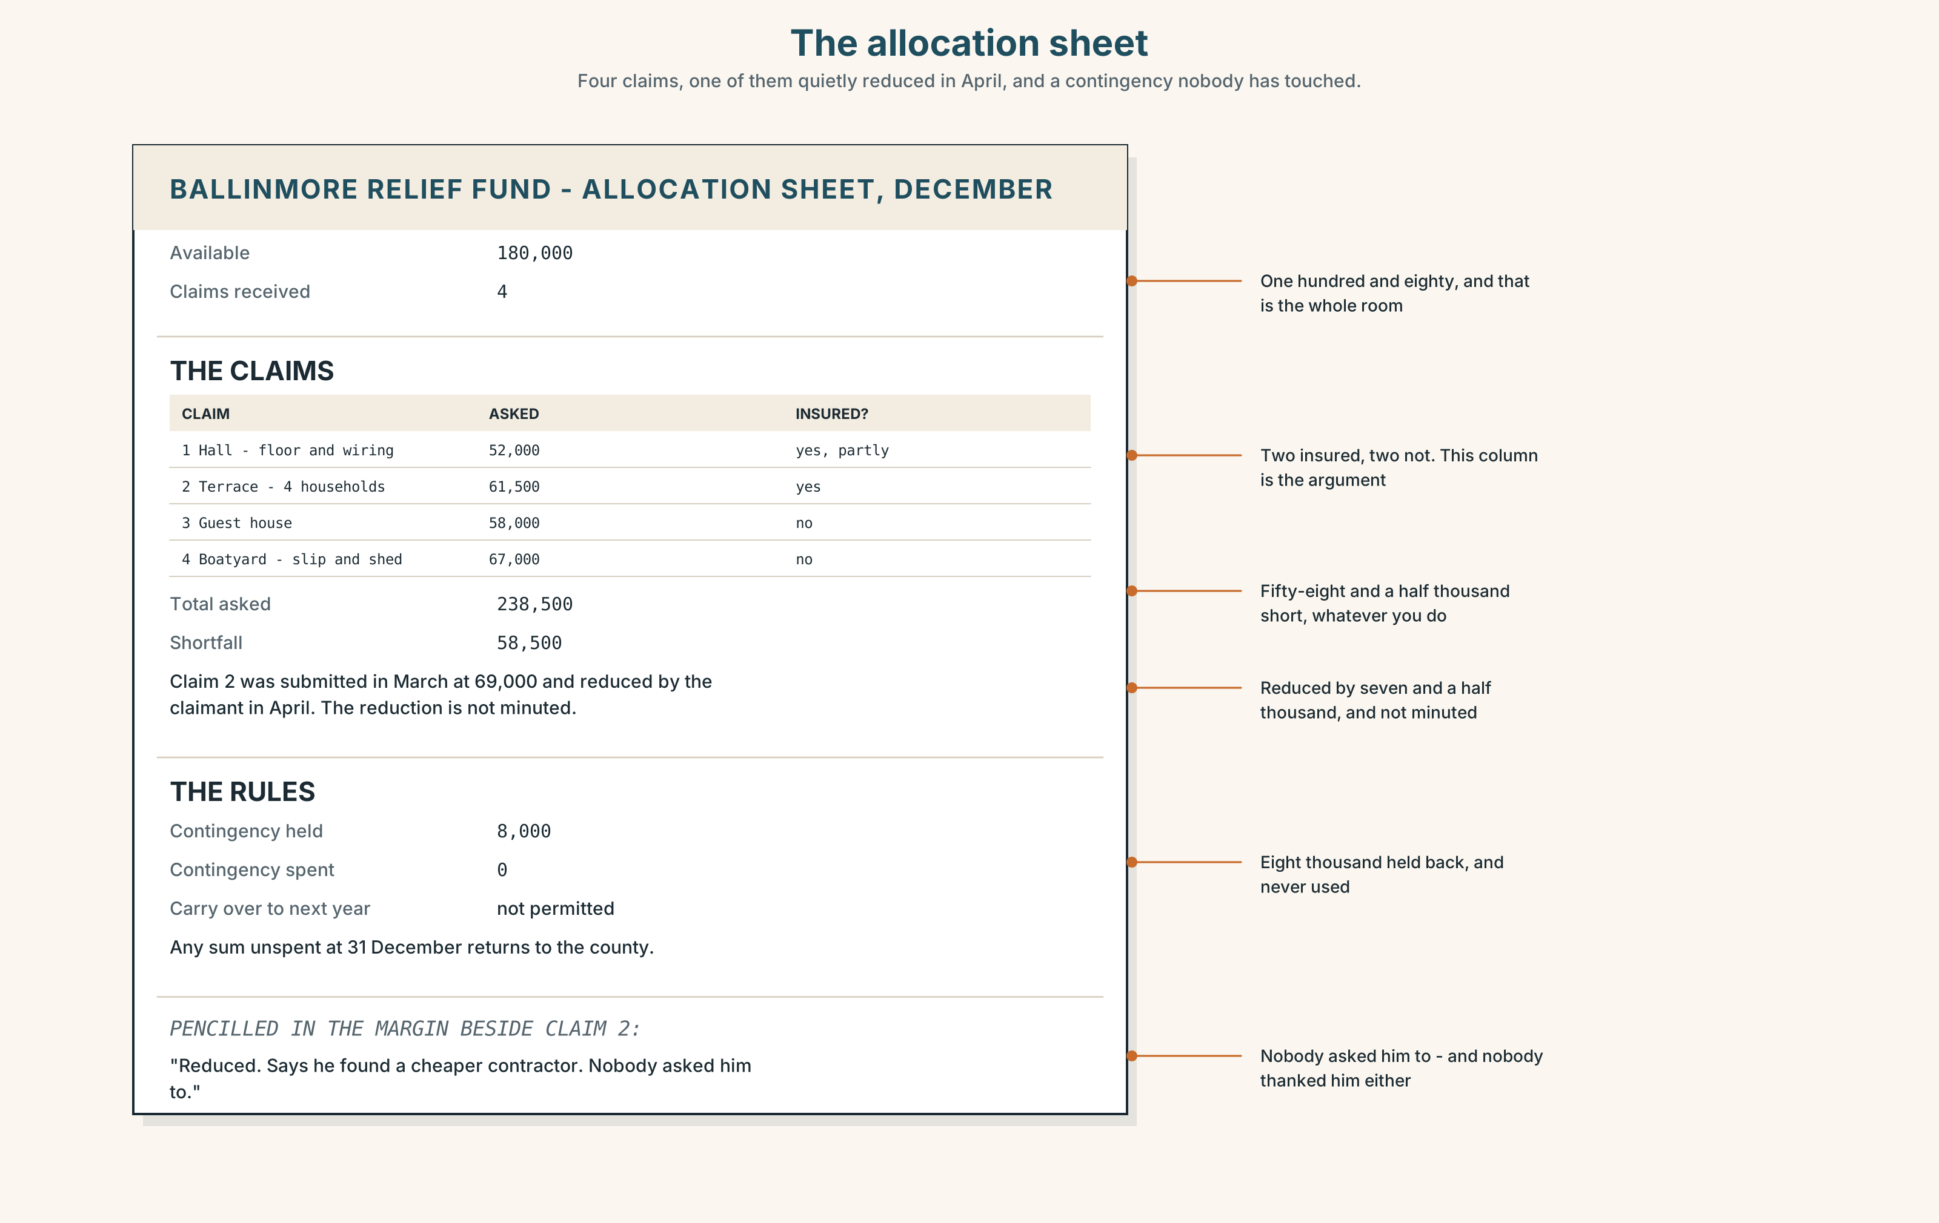{width=6.6in}
The allocation sheet — Four claims, one of them quietly reduced in April, and a contingency nobody has touched.
Read the allocation sheet and answer.
- What are the four claims for, and how much is each?
- Which claim has been reduced by the committee before the meeting, and by how much?
- What is the contingency, and what is the rule on carrying money over?
- One column is headed "insurance". What does it show?

5F · Two texts
The column says the four claims total €246,000. The allocation sheet totals €238,500.
Put those two facts together. What has happened, and who knows? Two sentences.

Part 6 · Vocabulary Lab 2 ◆ B · THE SYSTEM

Counting what cannot be counted
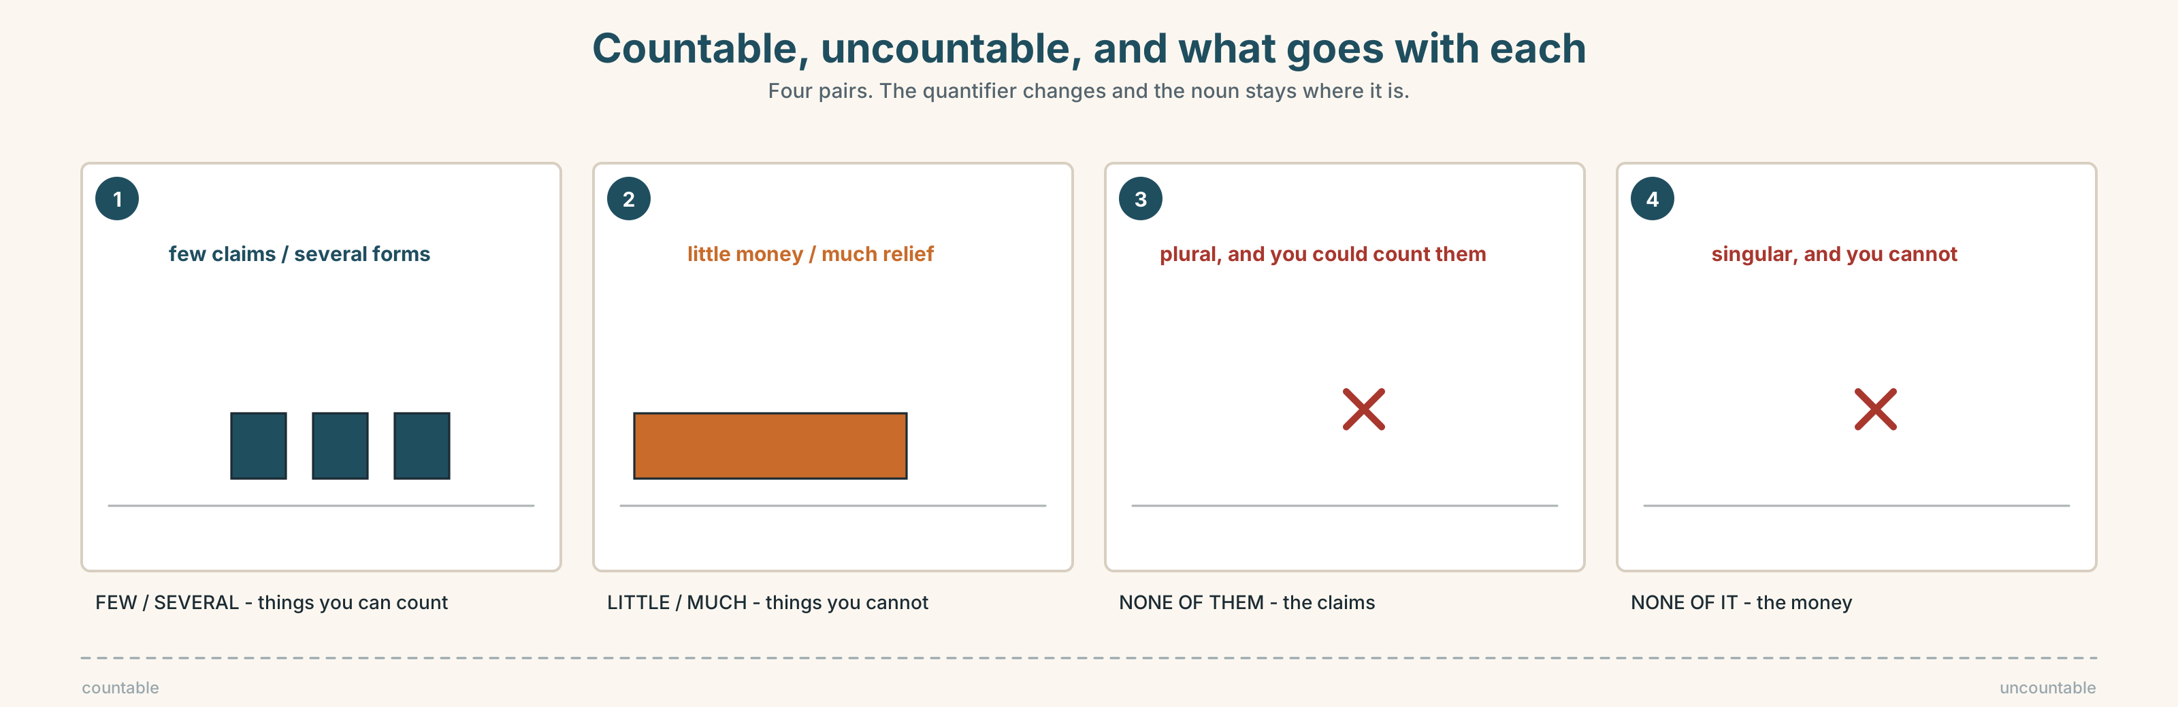{width=6.6in}
Countable, uncountable, and what goes with each — Four pairs. The quantifier changes and the noun stays where it is.

6A · Sort — countable or uncountable?
Two columns, and write the right quantifier beside each.
claims · money · people · relief · forms · supply · dehumidifiers · funding · requests · fuel

6B · Chunk completion
- Most ______ them have been waiting since March.
- None ______ it can be carried over.
- A couple ______ claims came in late.
- The rest ______ the money goes to the contingency.
- The committee split ______ into two groups to decide.
- Some of us, ______ all, think it should go by need.

6C · Three that are only ever about two
both · either · neither
Correct these four sentences. One of them is already correct.
- Both of the four claims are from businesses.
- Neither of the three has insurance.
- Either of the two options is acceptable.
- Neither of them have replied.
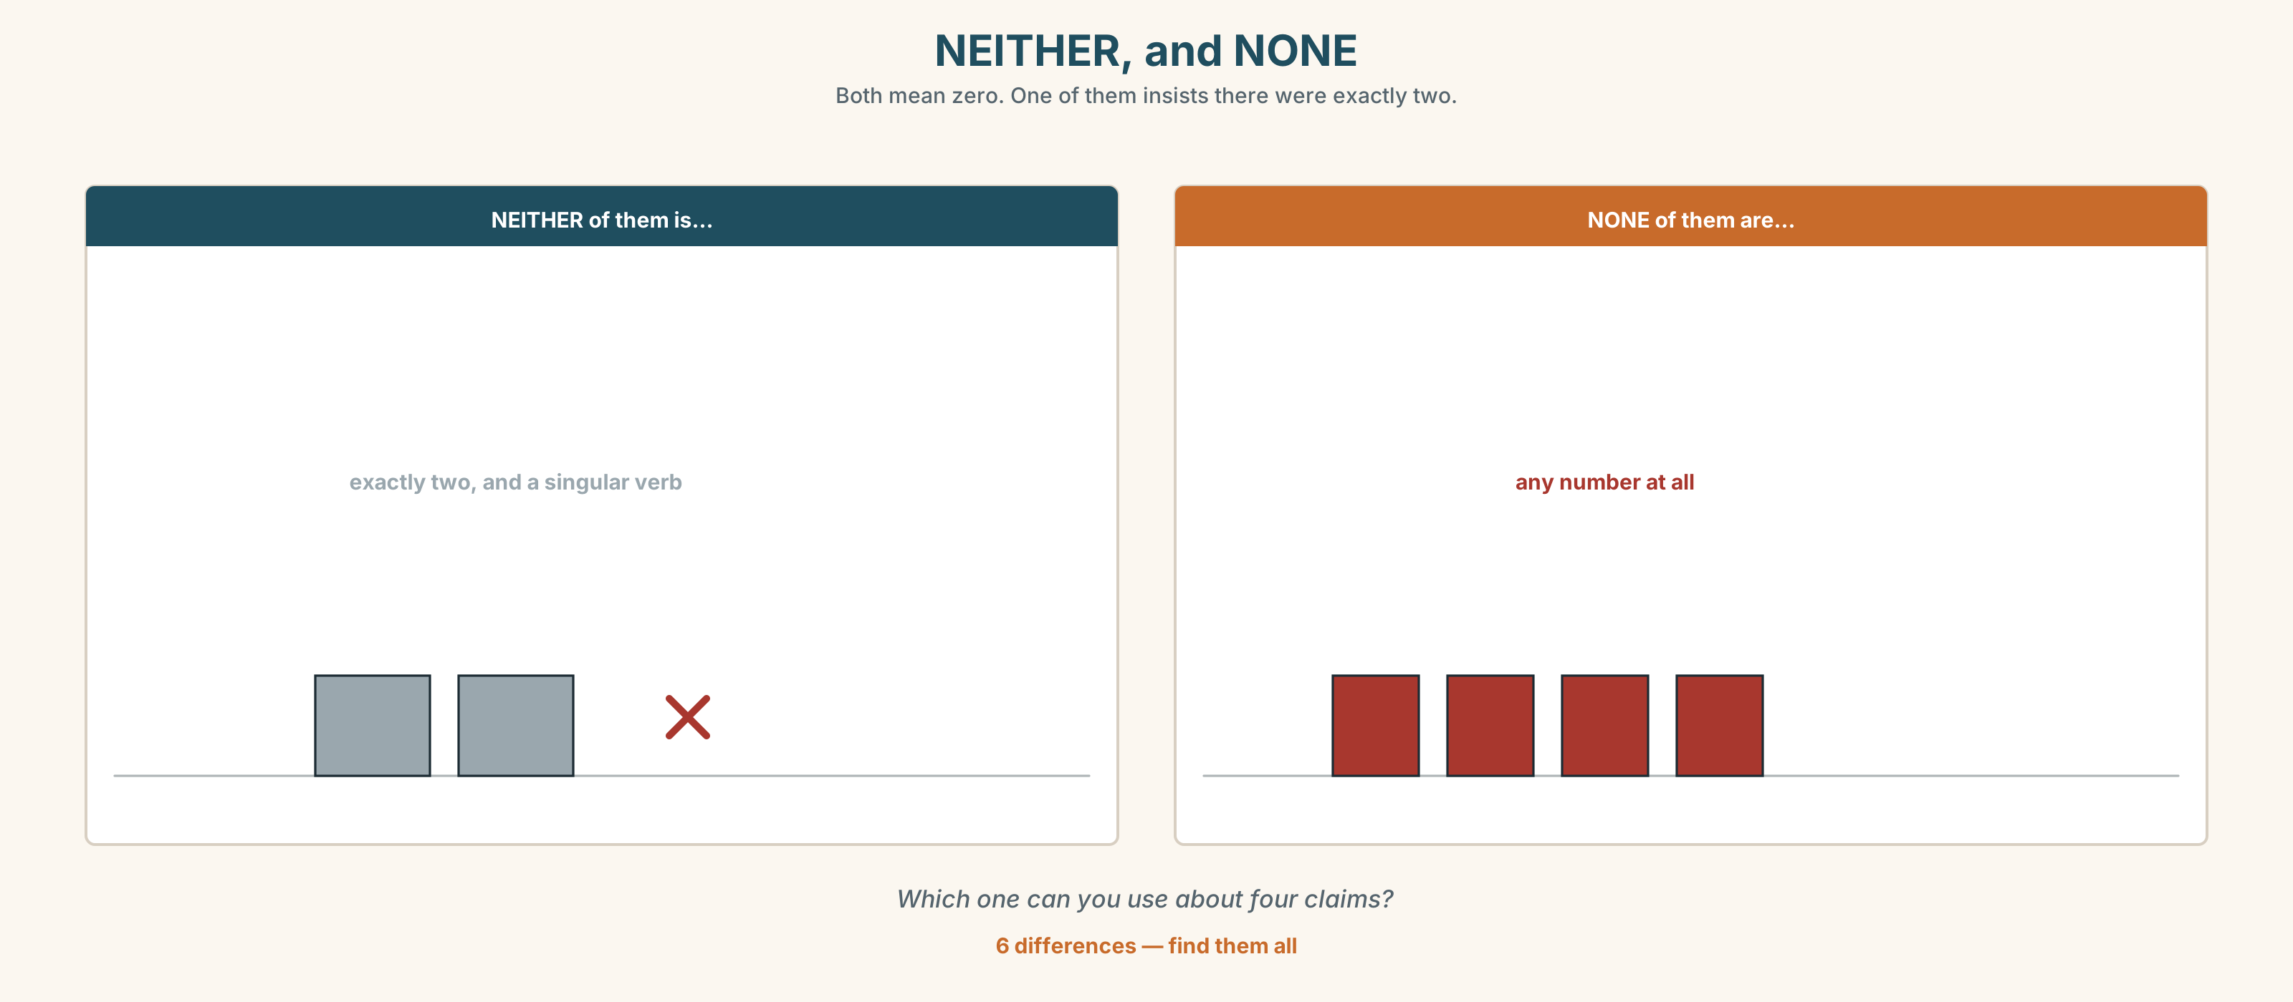{width=6.6in}
NEITHER, and NONE — Both mean zero. One of them insists there were exactly two.
Six differences. Find them, then answer the question under the picture.

6D · Contrast Clinic — which quantifier
Six items.
- ______ of the money is left. (zero)
- ______ of the claimants is lying. (zero of four)
- ______ of the last two has insurance. (zero of two)
- ______ of them have been waiting. (more than half)
- ______ of the two will do. (one or the other)
- We funded ______ four, partly.

Part 7 · Pronunciation & Fluency Lab ◆ B · THE SYSTEM

Stress as an argument
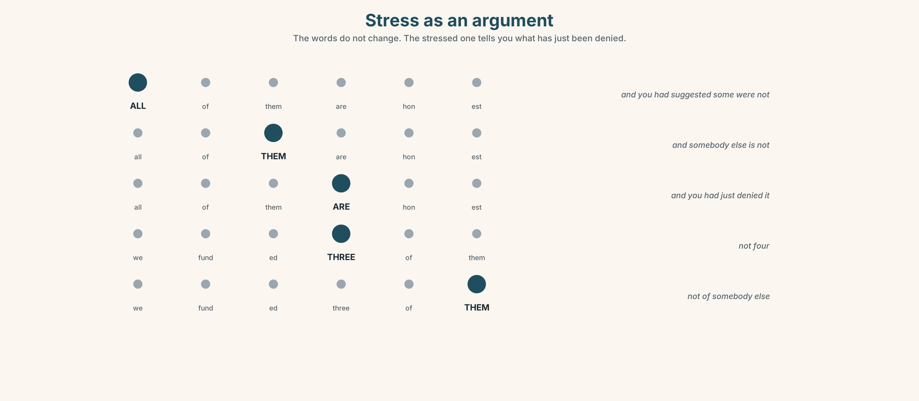{width=6.6in}
Stress as an argument — The words do not change. The stressed one tells you what has just been denied.

7A · Hear 🔊 Track 9.3
ALL of them are honest. — and you had suggested some were not All of THEM are honest. — and somebody else is not All of them ARE honest. — and you had just denied it

7B · Say
Say all three. Then do the same with:
Neither of the last two has insurance.

7C · Make it mean something
Say these two:
We funded THREE of them. (not four) We funded three of THEM. (not of somebody else)
Which one is answering an accusation?

7D · Fluency 20 ⏺
Twenty seconds: three facts about this room, each with a different quantifier and a contrastive stress. Three times, faster.

Part 8 · Writing ◆ C · THE PERFORMANCE

Who got what · 100 words
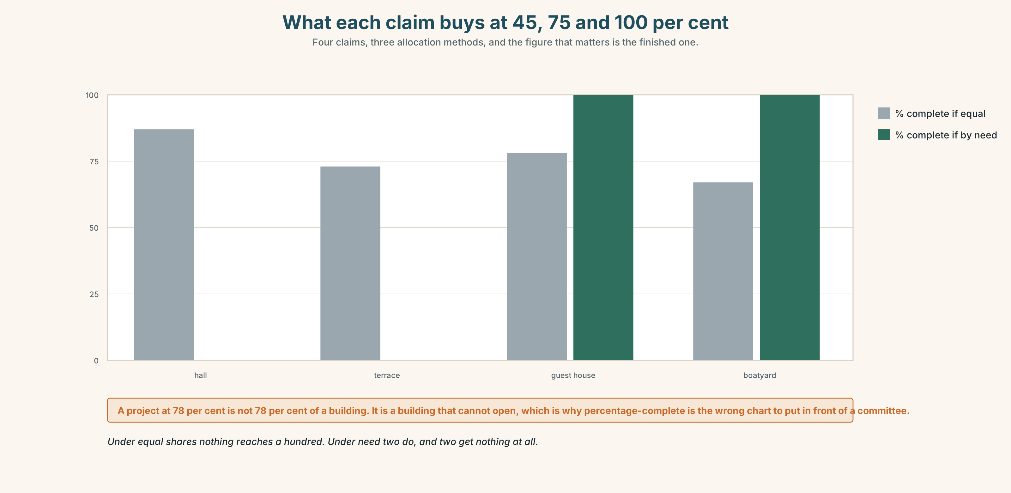{width=6.6in}
What each claim buys at 45, 75 and 100 per cent — Four claims, three allocation methods, and the figure that matters is the finished one.

8A · Read the model
There was €180,000. Four claims were received, totalling €238,500 after one was reduced by the claimant in April. [the total first, and the reduction is named so the arithmetic works]
Three were funded in full. Neither of the remaining two — the guest house and the boatyard — had any insurance, and the committee funded 61 per cent of the boatyard's claim and none of the guest house's. [exactly who got what, and one fact that explains why it was hard]
€4,100 is unspent. It cannot be carried over and will return to the county in December. [what is left, and where it goes, which almost every report leaves out]
Questions about the writer's choices:
- The second paragraph says none of the guest house's rather than the guest house got nothing. Is that cowardly?
- The last paragraph is about €4,100 out of €180,000. Why is it here at all?

8B · The anti-model
The committee considered all the claims very carefully and allocated the available funds as fairly as possible. Unfortunately there was not enough for everyone. We would like to thank everyone for their patience during a difficult process.
Correct English, and no arithmetic. Name three numbers it should contain.

8C · Plan
the total → what was asked for → who got what, exactly → what is left and where it goes

8D · Write — 100 words

8E · Peer review — two criteria
☐ Does the arithmetic work? ☐ Is the leftover accounted for?

8F · Write it again · 8G · Publish
On the wall, with the allocation sheet from Part 5E beside it.

Part 9 · The File ◆ A · THE WORLD + C · THE PERFORMANCE

CULTURE FILE · Silence, Interruption and Turn-taking
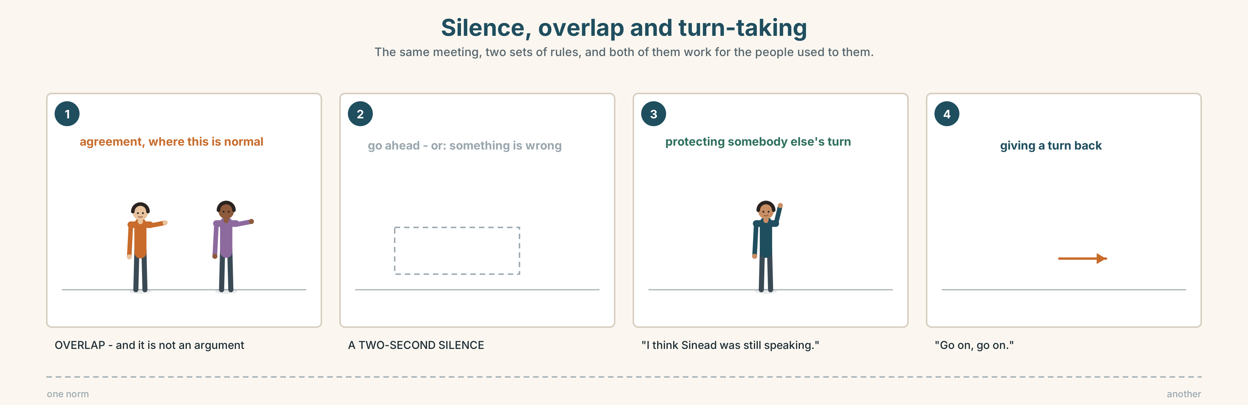{width=6.6in}
Silence, overlap and turn-taking — The same meeting, two sets of rules, and both of them work for the people used to them.

9A · The same meeting, two norms 🔊 Track 9.4
Two recordings of committees deciding the same thing. Listen to both.
- In which one do people overlap, and does it sound like an argument?
- How long is the longest silence in each?
- In which one does the quietest person speak, and what made it possible?

9B · What a silence means
In some places a pause means go ahead. In others it means I am thinking, wait. In others it means something has gone wrong.
Which does a two-second pause mean where you are from? Compare with three other people.

9C · Interrupting without taking over
"Sorry — can I just check one thing?" · "Go on, go on." · "Can I come back to that in a minute?" · "I think Sinéad was still speaking."
Match each to its job.
taking a turn · giving a turn back · parking something · protecting somebody else's turn

9D · Your turn
Groups of five. Ten minutes, one decision. One person is the timekeeper and says nothing except the total speaking time of each person at the end. Then do it again with the quietest person as chair.

9E · Transfer
In your next meeting, count the silences over two seconds. Bring the number and say what each one was doing.

Part 10 · Mediation & Interaction ◆ C · THE PERFORMANCE
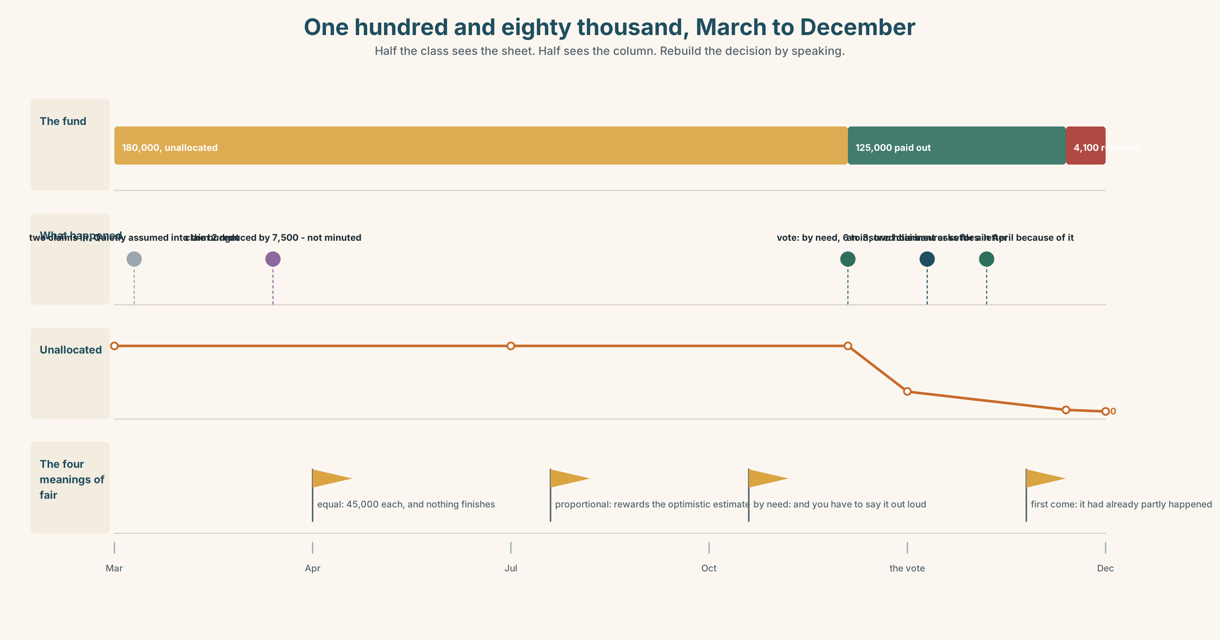{width=6.6in}
One hundred and eighty thousand, March to December — Half the class sees the sheet. Half sees the column. Rebuild the decision by speaking.

10A · Relay
Half the class sees the allocation sheet. Half sees the column. Rebuild the decision by speaking. Ten minutes.

10B · Simplify
Explain the allocation sheet from Part 5E to a claimant who has had nothing. Four sentences only.
Plan: what there was → what was asked → what you got and why → what you can do next

10C · Compress
The column in Part 5 into thirty-five words, keeping all four meanings of fair.

10D · Online
Write one message to the committee: you are the fourth claim, you accept the decision, and you are asking for one thing in writing.

10E · Your language
How does your language say none of them? Is the verb singular or plural? Say neither of the last two has insurance in both languages.

Part 11 · The Decision ◆ C · THE PERFORMANCE

One hundred and eighty thousand
Four claims. €238,500 asked for. €180,000 available. All four honest.
- Equal. €45,000 each. Two of the four cannot start work with that, so two of the four projects do not happen and the money sits.
- By need. The two with no insurance get everything they asked for; the two who are insured get nothing and wait for their insurers.
- Proportional. Everybody gets about 75 per cent. Everybody can start; nobody can finish.

11A · The evidence
- The allocation sheet from Part 5E — and the claim that was quietly reduced.
- The chart — what each claim buys at 45, at 75 and at 100 per cent.
- The voice. One of the insured claimants, twenty seconds: "I'd take nothing. I want that on the record because I will be saying it in the room and I do not want anybody saying afterwards that I was pushed. But I'd want it written down that I took nothing, because my insurer is going to ask me in March whether I was compensated."

11B · Talk about it
In threes. Everybody says one. Use the frame.
I think the money should go ______ , because ______ .
Words you can use: fair · equal · priority · need · shortage · limited · a fair share · go round

11C · Decide
Write two sentences. Choose, and say why.
I think the money should ______________________ , because ______________________ .

11D · Model decision
By need, and the committee should say the word need out loud and vote on it by name. Equal shares of an insufficient sum produce four stalled projects, and proportional shares produce four half-finished ones; need produces two finished things and two angry people, and angry people with insurance have somewhere else to go. The important part is not the choice. It is that whoever is refused is refused in a sentence that can be repeated.

11E · The Reveal
What happened. They went by need. The vote was 6–3 and took two hours, most of which was spent on whether need could be defined without insulting anybody.
The insured claimant who offered to take nothing did take nothing, and asked for the letter. His insurer settled in April, and the letter is the reason: it proved he had not been compensated twice.
€4,100 was left over because one of the two funded claims came in under estimate. It was not carried over. It went back to the county in December and the committee has been asked about it at every meeting since.
Two things were finished. One man got his insurance because he had asked for a letter. And four thousand pounds went back.
Was it the right decision? Say why — and say what should have been done with the €4,100.

Part 12 · Landing ◆ all three lines

12A · Recycle — ten items
- ______ of them are honest. (every one)
- ______ of it can be carried over. (zero, uncountable)
- ______ of the last two has insurance. (zero of two)
- They have run ______ of dehumidifiers.
- It will not go ______ .
- (Unit 8) The hall, ______ was built in 1884, is the oldest.
- (Unit 7) This time next year I ______ (live) in Galway.
- (Unit 6) The rope ______ (must / break) in the night.
- (Unit 4) She ______ me that she had checked it. (said / told)
- (A2.1 U9) There are ______ many forms and nobody reads them.

12B · Consolidate
One hundred words. How something limited was shared out. The total, who got what, four different quantifiers, and what was left.

12C · Can-do, with evidence
I can… | My evidence | Sure?
say exactly how many, with of | Part 3G score | ◯ ◑ ●
report an allocation in a hundred seconds | Part 4C recording | ◯ ◑ ●
write a hundred words whose arithmetic works | Part 8 draft 2 | ◯ ◑ ●
take a turn without taking over | Part 9D group work | ◯ ◑ ●

12D · Replay ⏺
Find your thirty seconds from Part 0C. Listen. Record it again. One sentence: what is different?

12E · Glossary — forty items, as a map
THE MONEY · fund · relief · money · grant · total · supply THE PROCESS · request · allocate · share · priority · set aside · split up WHEN THERE IS NOT ENOUGH · shortage · limited · run out of · go round · use up · there isn't enough to go round WHAT IS LEFT · remaining · spare · enough · the rest of THE JUDGEMENT · fair · equal · a fair share · some of us, not all HOW MANY · all · most · both · neither · either · none · several · few · plenty · half · each · most of them · none of it · a couple of

12F · Next
Unit 10 · Who do you become after?

