Table of Contents

A2.2 · Unit 10 · The Town That Came Back
English Animated · Telling the Story · Ballinmore, west coast of Ireland Student's Book pages 204–225 · 22 pp · ~10 hours

Part 0 · The Big Picture ◆ A · THE WORLD
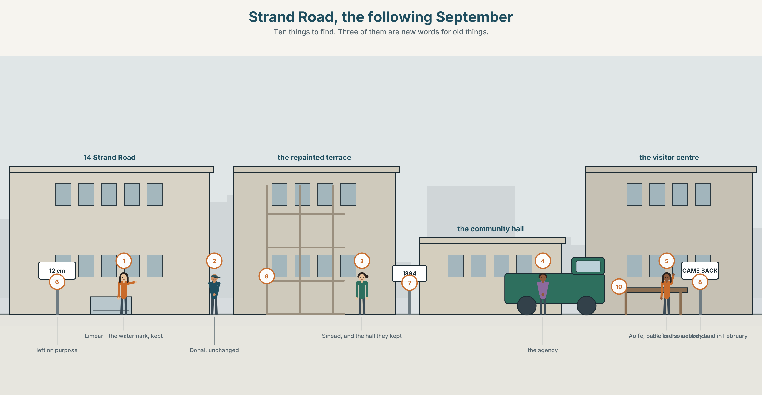{width=6.6in}
Strand Road, the following September — Ten things to find. Three of them are new words for old things.

Who do you become after?
By the end of this unit you can write a reflective piece about how a place — or a person — changed. One hundred and ten words.
◆ A · THE WORLD | A town being offered a story about itself, and asked to agree to it
◆ B · THE SYSTEM | articles and determiners, reviewed · abstract nouns · 23 words for identity and change · 17 determiners · the as /ðə/ and /ðiː/
◆ C · THE PERFORMANCE | A hundred and ten words about what a place has become

0A · Find it
Find ten things in this picture. Three of them are new words for old things.
a new town sign · a repainted shopfront · a visitor centre leaflet · a watermark left on purpose · a plaque · a bus of visitors · a For Sale sign taken down · a scaffold coming off · a camera · a hand-painted notice in a window

0B · Guess it
One thing in this picture has been kept deliberately. Which, and who decided?

0C · Say it ⏺
Record thirty seconds. Think of a place you know that changed. Is the story people tell about it true? You will record it again at the end of this unit.

Part 1 · Vocabulary Lab 1 ◆ B · THE SYSTEM
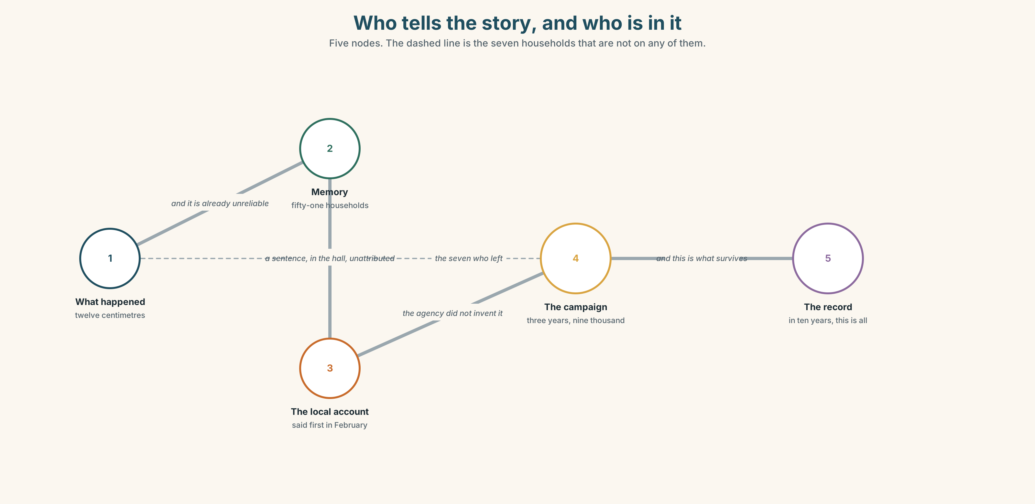{width=6.6in}
Who tells the story, and who is in it — Five nodes. The dashed line is the seven households that are not on any of them.

1A · Meet — the words of who you are now
Match each word to one place on the map.
identity · change · community · memory · story · reputation · local · outsider · newcomer · truth

1B · Sort — about a person, a place, or both?
Three columns.
identity · reputation · community · local · outsider · memory · belong · newcomer
One of them is given to you by other people, always. Which?

1C · Meet — three words about the story
marketing · genuine · truth
Marketing is not the opposite of truth. What is the difference between a true story and a genuine one? Give an example.
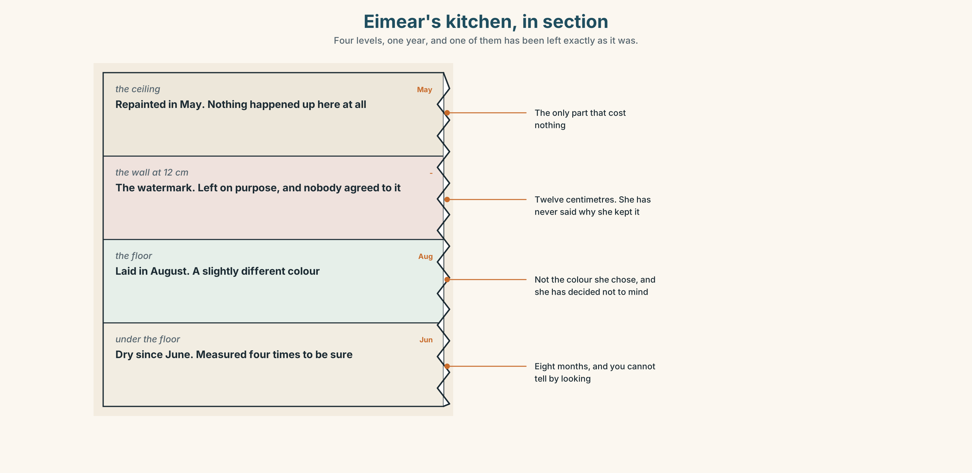{width=6.6in}
Eimear's kitchen, in section — Four levels, one year, and one of them has been left exactly as it was.
Look at Eimear's kitchen, in section. Four levels, one year. Which level has been deliberately left as it was, and why?

1D · Stretch — the phrases
Complete each one with one word.
- Some of them want to put it behind ______ and some do not.
- You cannot move ______ until somebody has said what happened.
- The brochure calls it the town ______ came back.
- She said she would rather tell the ______ and have fewer visitors.
- It took eight months to live ______ the photograph of the kitchen.

1E · The saying
f That's not what happened.
Four words that one person says in every town meeting, and that nobody wants to hear.
Write what comes next — once from somebody who is right, and once from somebody who is wrong but sincere.

1F · Own it
Think of a story people tell about where you are from. Tell a partner three sentences: what the story is, who tells it, and what it leaves out.

Part 2 · Listening ◆ A · THE WORLD
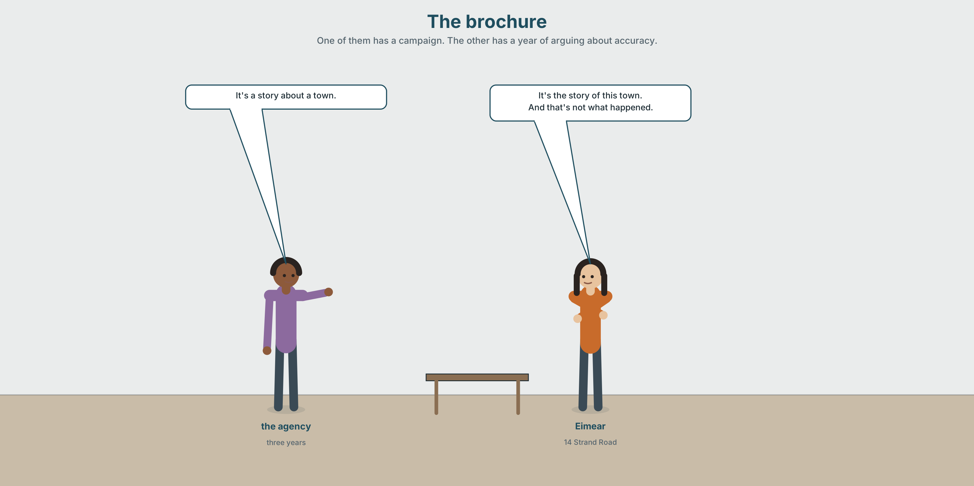{width=6.6in}
The brochure — One of them has a campaign. The other has a year of arguing about accuracy.

2A · The brochure 🔊 Track 10.1
Before you listen. A tourism agency has offered to market the town as the town that came back. Guess: who objects, and on what grounds?
Listen once. One question. What would the campaign be worth, in visitors?
Listen again. Complete the table.
 | What they want | What they are afraid of
the agency
Sinéad
Eimear
Listen again. Choose.
- The campaign would run for one season / three years / indefinitely.
- Eimear objects because the story is false / incomplete / embarrassing.
- The agency offers to change the words / drop the campaign / add a page.
- The decision will be made by the agency / the committee / a public meeting.
Noticing. Four sentences from the recording.
- It's a story about a town.
- It's the story of this town.
- A town came back.
- The town came back.
Two of these are about any town. Two are about this one. Which, and what single word does the work?

2B · Decoding clinic 🔊 Track 10.2
Twenty-five seconds of Eimear. Four jobs.
- How many times does she say the?
- Can you hear the difference between the town and the other?
- Catch the number of visitors.
- She says one word with heavy stress twice. Which?
Transcripts, page 159.

Part 3 · Grammar Lab 1 ◆ B · THE SYSTEM

The small words that decide what you mean

3A · Notice
Look at the four sentences in Part 2.
- Sentences 3 and 4 differ by one word. Which town is each about?
- In sentence 1, a story — why not the story?
- When do you use no article at all? Try: Water came in. / The water came in.
- this town, that town, such a town. What does each one add?
- Try "It's story about the town." What is missing, and does it matter?

3B · See
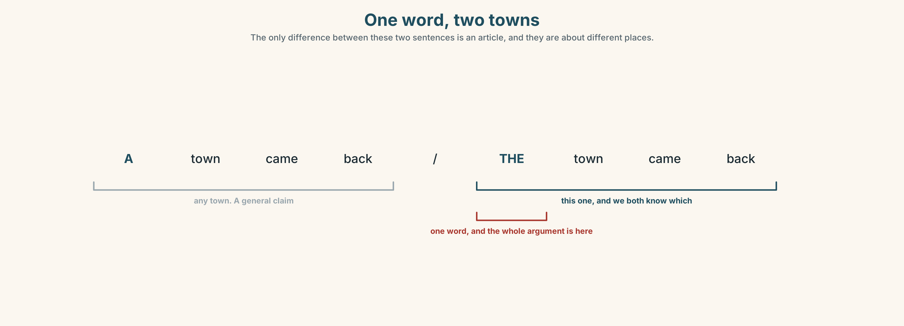{width=6.6in}
One word, two towns — The only difference between these two sentences is an article, and they are about different places.
Now look at the second picture. It runs from no article to the. Where does a thing stop being any example and become this one?
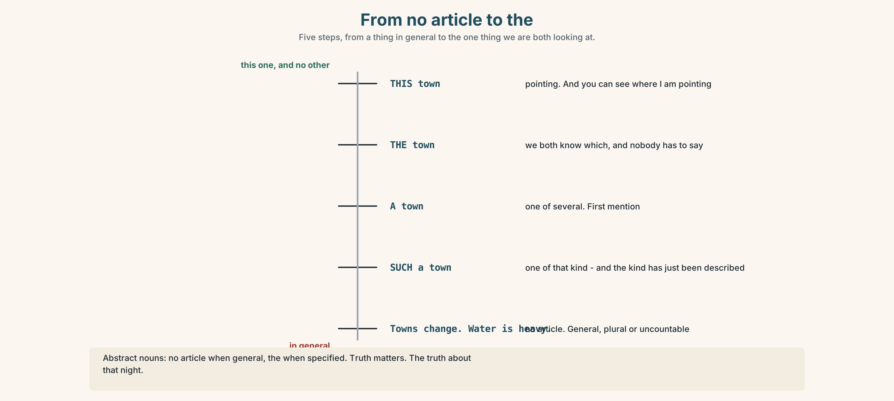{width=6.6in}
From no article to the — Five steps, from a thing in general to the one thing we are both looking at.

3C · Know
 | Use it when | Example
no article | general, plural or uncountable | Water came in. · Towns change.
a / an | one of several, first mention | It's a story about a town.
the | we both know which one | The water came in. · The story of this town.
this / that | pointing, near or far | This town · that winter
such | of that kind | Such a story.
own | emphasising possession | her own kitchen
Abstract nouns are the hard case. Usually no article when general, the when specified. Truth matters. · The truth about that night. · Memory is unreliable. · The memory of it.
First mention takes a; second mention takes the. They have offered a campaign. The campaign would run for three years.
Watch out. Dropping an article is not an informal option in English. It changes the meaning or breaks the sentence. ✗ It's story about town.

3D · Use — controlled
(1) __________ agency has offered (2) __________ campaign. (3) __________ campaign would run for three years and would bring about nine thousand visitors (4) __________ year. Eimear says (5) __________ story is not true. She says (6) __________ truth about that night is more complicated, and that (7) __________ truth is the only thing the town actually owns.

3E · Use — guided
Put a, an, the or nothing in each gap.
- ______ water came in at about ten.
- ______ water is heavier than people think.
- She wrote ______ letter. ______ letter was two pages long.
- ______ truth matters.
- ______ truth about the drain took fourteen months.
- It is ______ story about ______ town, not ______ story of this one.

3F · Use — open
Describe a place to a partner in six sentences. Your partner's job is to catch any article that should not be there, and any that is missing.

3G · Check — six items
- ______ water came in at ten. (we know which water)
- ______ water is heavier than people think. (in general)
- They offered ______ campaign. ______ campaign runs for three years.
- ______ truth matters. (in general)
- ______ truth about that night is complicated.
- It's ______ story about ______ town. (any town)
0–3 → Workbook pp. 58–60. 4–5 → Part 6. 6 → page 217.

Part 4 · Speaking ◆ C · THE PERFORMANCE

4A · Fluency starter — a, the, nothing
Your teacher says a noun: water. Each learner must use it three times — once with no article, once with a, once with the — and all three must be true.
Six nouns. Six rounds.

4B · The functional core — saying what a place has become
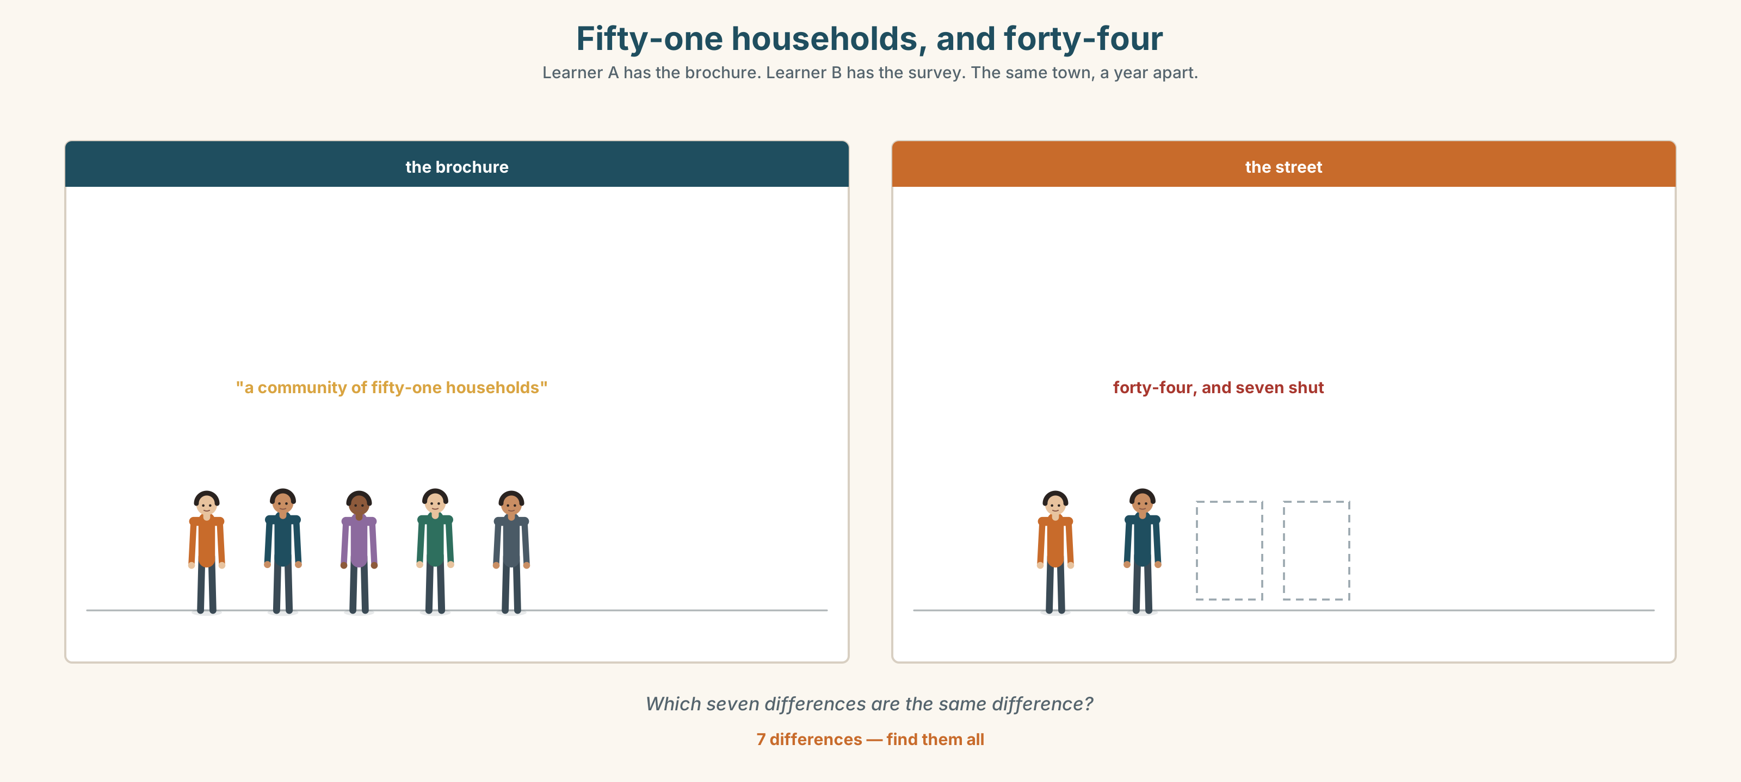{width=6.6in}
Fifty-one households, and forty-four — Learner A has the brochure. Learner B has the survey. The same town, a year apart.
Language Bank
the change | It isn't the place it was. · What's changed is…
the continuity | The same people are still… · Nothing has changed about…
the story | People say it's the town that… · That's the version.
the correction | That's not what happened. · It's more complicated than that.
Role play. Learner A works for the agency. Learner B lives in the town. Six minutes. Neither may say lie.

4C · The performance — one hundred seconds ⏺
Describe how a place or a person changed. One hundred seconds. You must give:
what it was · what it is · what has not changed · the story people tell, and what it leaves out
Record it.

4D · Observer
One person listens for one thing: did the speaker say what had not changed?

4E · Two criteria
☐ Were my articles right where the meaning depended on them? ☐ Is there one thing in my account that the official version leaves out?

Part 5 · Reading ◆ A · THE WORLD

5A · Predict
A feature article. The title is "The town that came back, and the seven people who did not." What do you expect the writer to be doing? One sentence.

5B · Read — one hundred and twenty seconds

The town that came back, and the seven people who did not
The campaign is good. I want to begin there, because the easy piece to write about Ballinmore this autumn is the cynical one and it would also be wrong.
The photographs are of real people doing real things and nobody is pretending the hall is finished. The line — the town that came back — is three years of work by people who were not paid for most of it, and the agency did not invent it. Somebody in the town said it first, in the hall, in February, and nobody wrote down who.
Here is what it leaves out. Of the fifty-one households surveyed, seven have gone. Two sold, two were bought out, and three are simply not here and the houses are shut. Seven out of fifty-one is fourteen per cent, which is the figure that does not appear in the brochure, and I understand why it does not: nobody markets a place with a number like that, and the people who left are not available to be photographed.
The town did come back. It came back smaller, and it is carrying a sea wall decision it has not made and a hall it has decided to keep without quite saying why.
This is not an objection to the campaign. It is a note that the story is true and the story is also an edit, and that a place which has spent a year insisting on accurate times and honest reporting is about to agree to a sentence about itself that it would not have accepted about anybody else.

5C · Answer
- Why does the writer say the cynical piece would be wrong?
- Where did the campaign line come from?
- How many households have gone, and what happened to each group?
- What percentage is that, and why does the writer say it is not in the brochure?
- What does the writer mean by "it came back smaller"?
- What is the writer's last point, and who is it aimed at?

5D · Vocabulary in context
Guess from the text. Then check.
the cynical one · bought out · an edit · insisting on · available to be photographed

5E · The counter-text
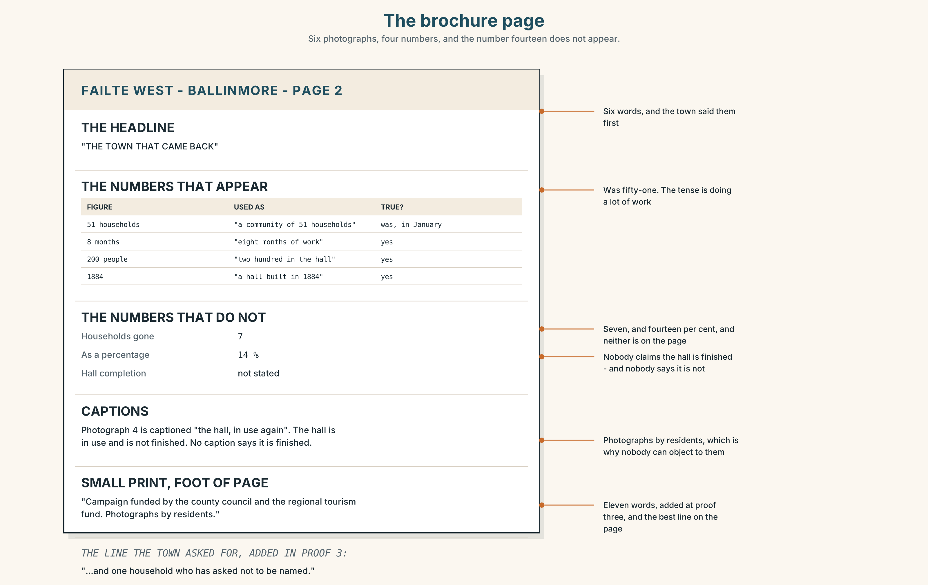{width=6.6in}
The brochure page — Six photographs, four numbers, and the number fourteen does not appear.
Read the brochure page and answer.
- What is the headline, and how many photographs are there?
- Which numbers appear in the brochure, and which do not?
- What does the small print say about who the campaign is funded by?
- One caption describes something that is still unfinished. Which, and how is it worded?

5F · Two texts
The feature says seven of fifty-one households have gone. The brochure says "a community of fifty-one households".
Put those two facts together. Is the brochure lying? Two sentences.

Part 6 · Vocabulary Lab 2 ◆ B · THE SYSTEM

The words you cannot point at
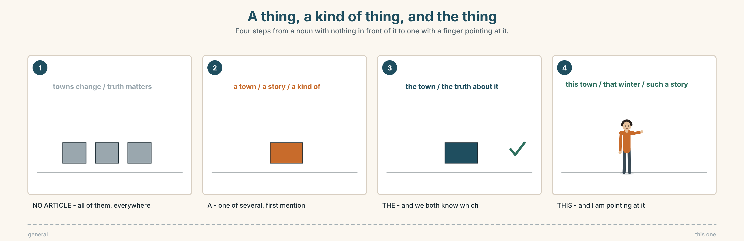{width=6.6in}
A thing, a kind of thing, and the thing — Four steps from a noun with nothing in front of it to one with a finger pointing at it.

6A · Sort — concrete or abstract?
Two columns, and put the right article beside each.
hall · memory · boat · truth · community · pier · identity · reputation · wall · change
Two of the abstract ones can also be concrete. Which, and in what sentence?

6B · Chunk completion
- The whole ______ took fourteen months.
- It is a kind ______ apology, though nobody calls it that.
- The one ______ said it first was never named.
- In the ______ they voted to keep it.
- She can sum ______ the whole year in one sentence, and does.
- It's not ______ simple.

6C · Abstract nouns and the article
Truth matters. — all truth, everywhere. The truth about that night. — one particular truth. A truth that nobody wants. — one of several.
Write the three versions for each of these: memory · change · community.
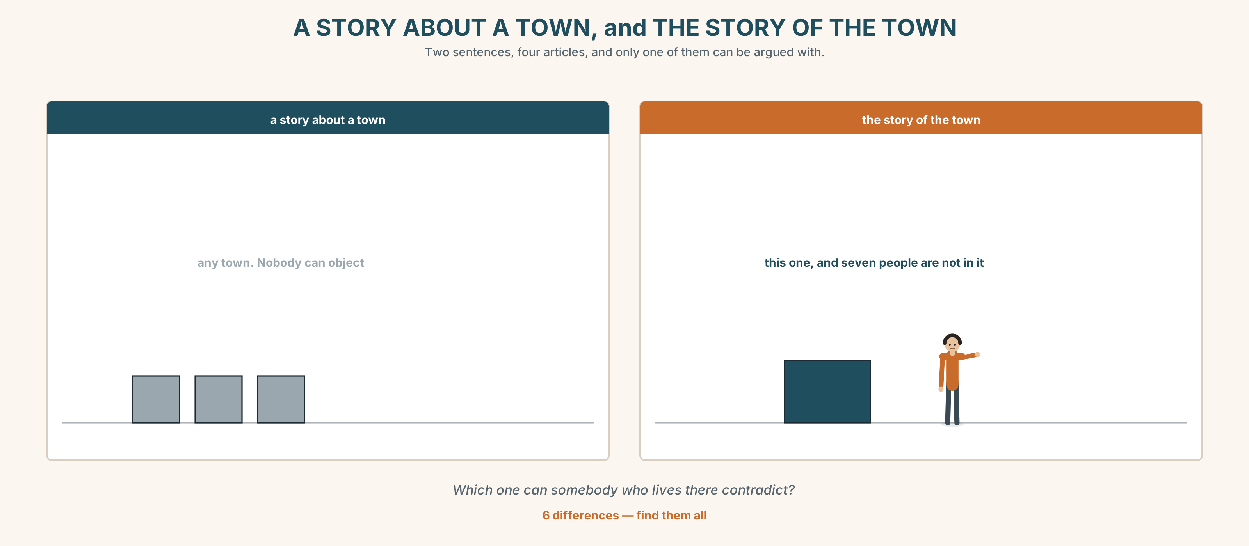{width=6.6in}
A STORY ABOUT A TOWN, and THE STORY OF THE TOWN — Two sentences, four articles, and only one of them can be argued with.
Six differences. Find them, then answer the question under the picture.

6D · Contrast Clinic — a, the, or nothing
Six items.
- ______ water came in at ten.
- ______ water is heavier than people think.
- ______ memory is unreliable.
- ______ memory of that night is unreliable.
- It's ______ story about ______ town.
- It's ______ story of this town.

Part 7 · Pronunciation & Fluency Lab ◆ B · THE SYSTEM

One word, two sounds
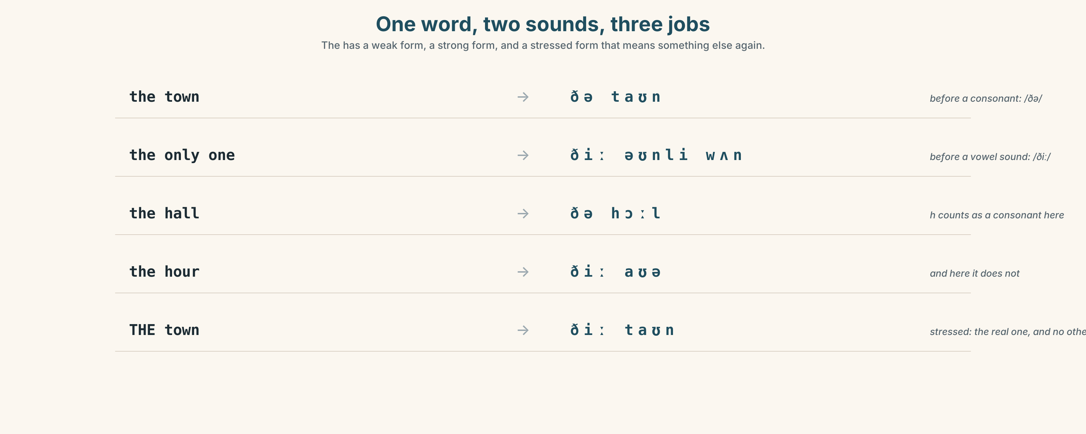{width=6.6in}
One word, two sounds, three jobs — The has a weak form, a strong form, and a stressed form that means something else again.

7A · Hear 🔊 Track 10.3
the town → /ðə taʊn/ — before a consonant the only one → /ðiː əʊnli wʌn/ — before a vowel THE town → /ðiː taʊn/ — stressed, and it now means the real one

7B · Say
Say all three. Then say the sentence three times, faster:
The truth about the only night that matters.

7C · Make it mean something
Say these two:
It's a story about a town. (any town) It's THE story of THE town. (this one, and no other)
The second one is doing something the first cannot. What?

7D · Fluency 20 ⏺
Twenty seconds: three nouns, each said with no article, with a, and with the. Three times, faster.

Part 8 · Writing ◆ C · THE PERFORMANCE

How a place changed · 110 words
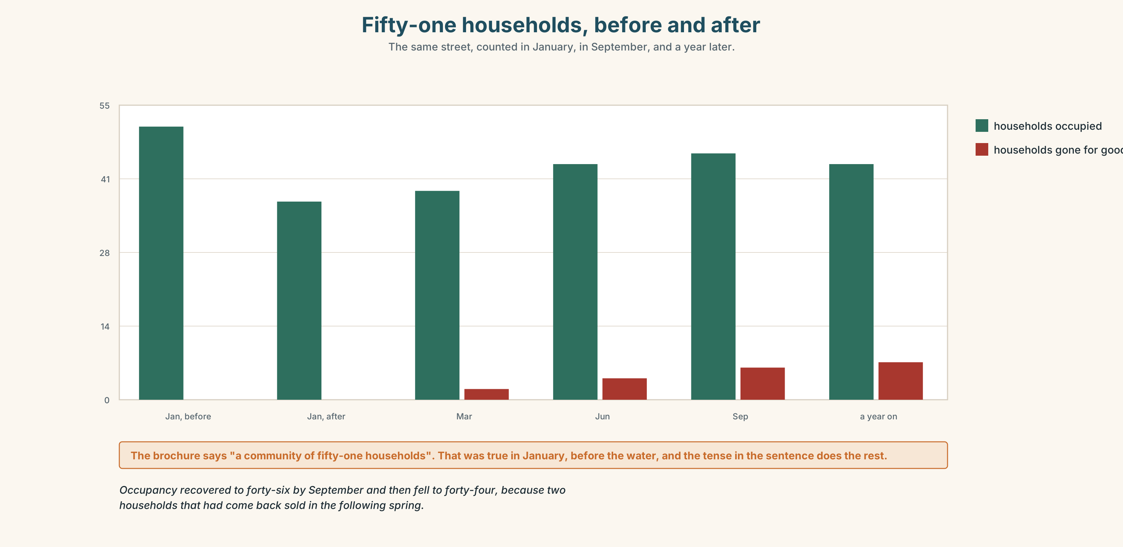{width=6.6in}
Fifty-one households, before and after — The same street, counted in January, in September, and a year later.

8A · Read the model
The kitchen is finished. The floor went down in August, eight months after the water, and it is a slightly different colour from the one that came up, which I did not choose and have decided not to mind. [a concrete thing, a date, and one small refusal of sentiment]
What has not changed is that I still look at the yard drain every time it rains hard. I expect I will do that for the rest of my life and I am fairly relaxed about it. [the continuity, and it is a habit rather than a feeling]
People say we are the town that came back. We are a town that came back smaller, and I would rather be in a true sentence than a good one. [the correction, and the whole argument is in the difference between *the* and *a*]
Questions about the writer's choices:
- The first paragraph is about the colour of a floor. Why not about how she felt?
- The last sentence turns on one article. Point at it, and say what it does.

8B · The anti-model
Our town has been through a difficult time but we have come back stronger than ever. The community spirit here is amazing and everyone has pulled together. We are proof that a town can survive anything.
Correct English, and no town in it. Name three things it does not say — and the one word in it that the feature in Part 5 would object to.

8C · Plan
one concrete thing, with a date → one thing that has not changed → the story people tell → your own sentence, and make the articles do the work

8D · Write — 110 words

8E · Peer review — two criteria
☐ Is there one concrete object with a date attached? ☐ Does one article in the piece carry an argument?

8F · Write it again · 8G · Publish
On the wall, with the brochure page from Part 5E beside it.

Part 9 · The File ◆ A · THE WORLD + C · THE PERFORMANCE

WORK FILE · The Client Problem
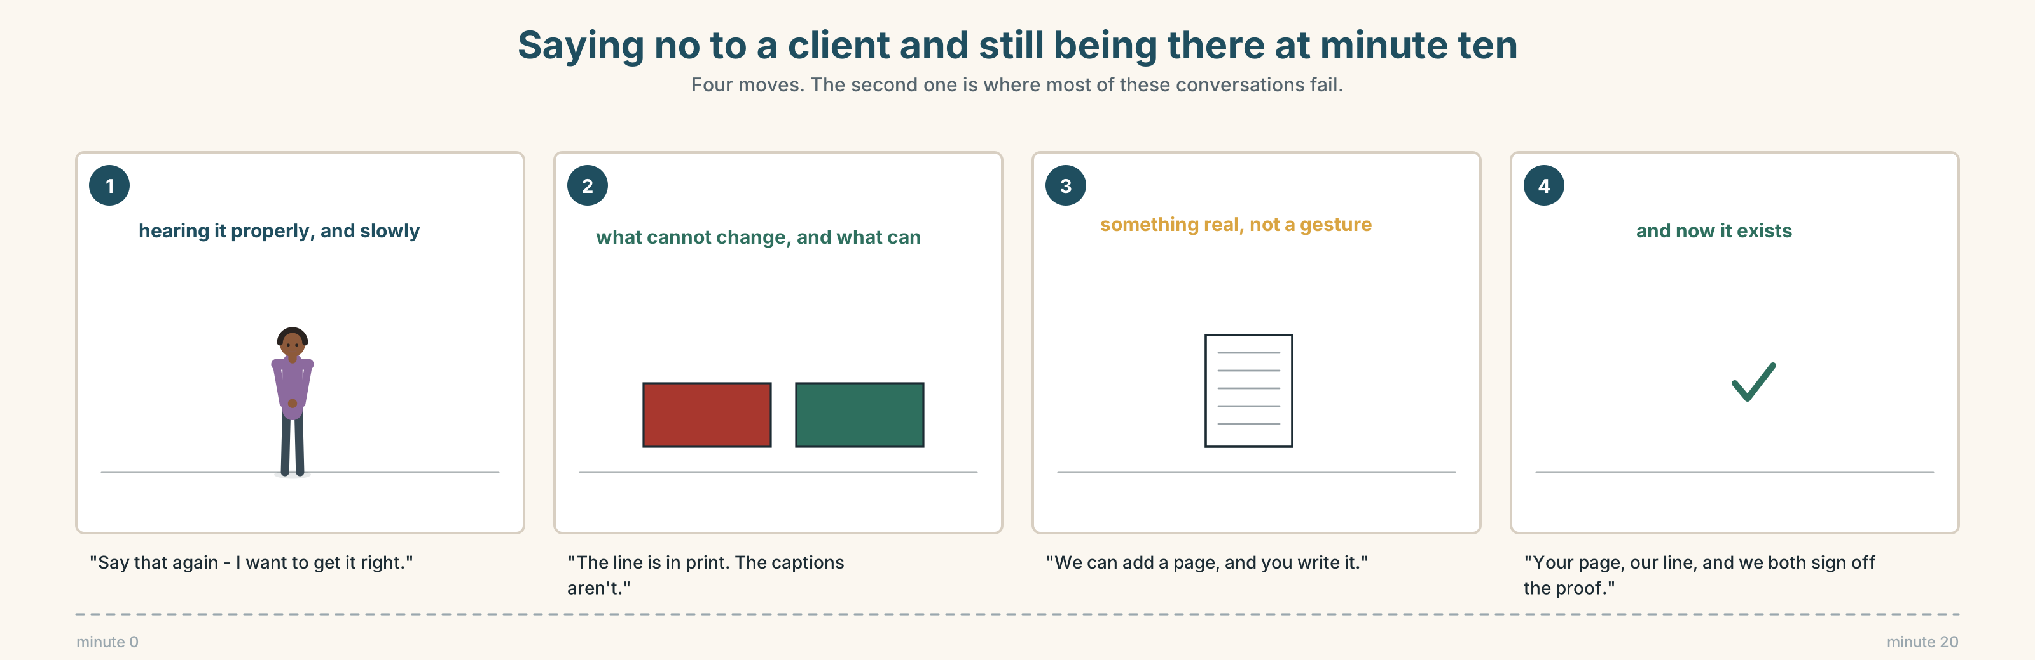{width=6.6in}
Saying no to a client and still being there at minute ten — Four moves. The second one is where most of these conversations fail.

9A · Twenty minutes and a disagreement 🔊 Track 10.4
The agency's account manager meets the committee. Listen.
- What does the agency say it is willing to change?
- What does the committee ask for that the agency cannot give, and why not?
- Who proposes the thing that is eventually agreed?

9B · The four moves
hearing the objection properly · separating what you can and cannot change · offering something real · agreeing what is written down
Match each to one phrase.
"Say that again — I want to get it right." · "The line is in print. The captions aren't." · "We can add a page, and you write it." · "So: your page, our line, and we both sign off the proof."

9C · Saying no to a client without losing them
Which of these four is the strongest, and why?
- "I'm afraid that's not possible."
- "We can't change the line. Here's what we can change."
- "I'll see what I can do."
- "That's a fair point and I don't have an answer today."

9D · Your turn
In pairs. Ten minutes. One of you is a client who wants something you cannot give. You must say no in the first three minutes and still be talking at minute ten.

9E · Transfer
Find one thing this week that you have to refuse. Refuse it, and offer one real alternative. Bring what happened.

Part 10 · Mediation & Interaction ◆ C · THE PERFORMANCE
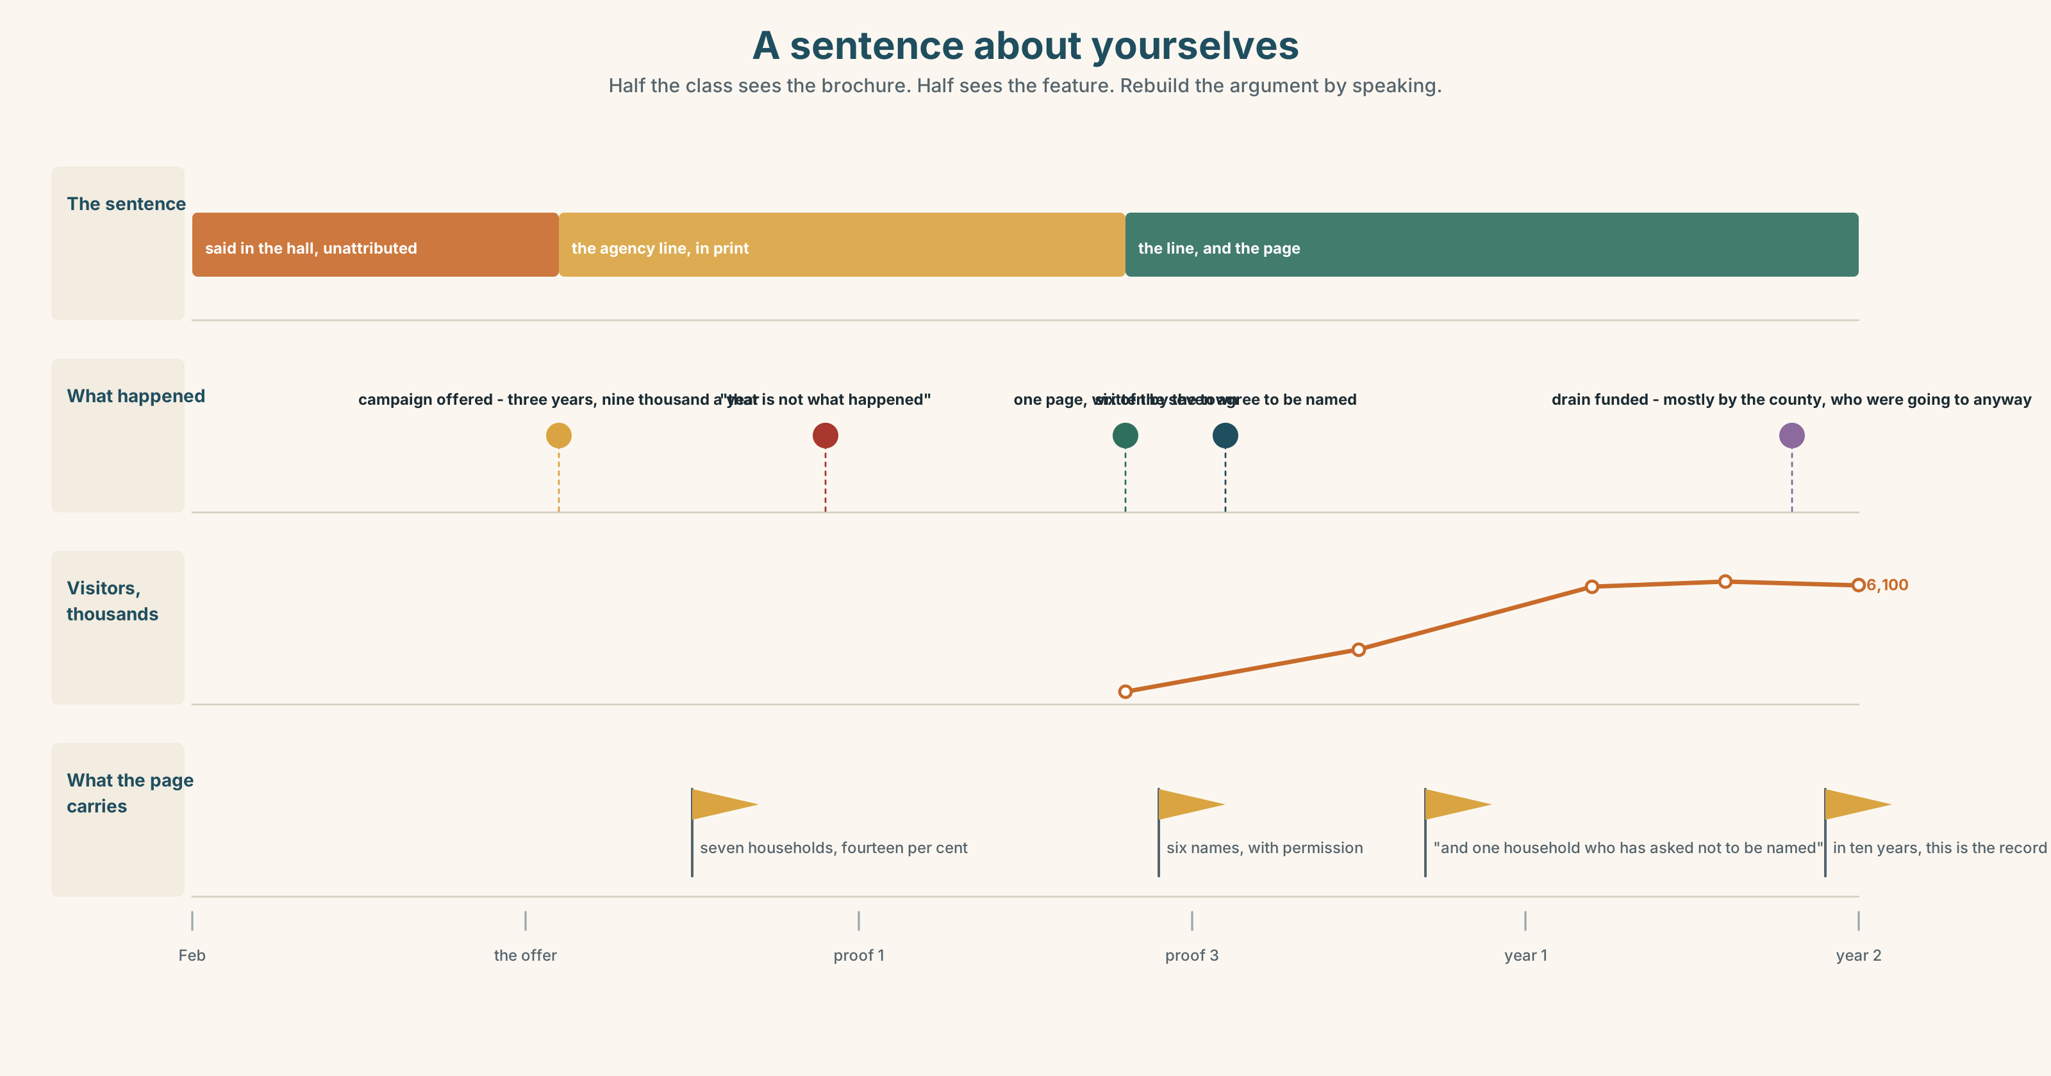{width=6.6in}
A sentence about yourselves — Half the class sees the brochure. Half sees the feature. Rebuild the argument by speaking.

10A · Relay
Half the class sees the brochure. Half sees the feature. Rebuild the whole argument by speaking. Ten minutes.

10B · Simplify
Explain the brochure page from Part 5E to somebody who lived through the flood. Four sentences only.
Plan: what it says → what it does not say → who paid for it → what you can ask for

10C · Compress
The feature in Part 5 into thirty-five words, keeping the last sentence's point.

10D · Online
Write one message to the agency: you support the campaign, you are asking for one page, and here is the sentence you want on it.

10E · Your language
Does your language have articles? If not, how does it say a town and the town? Say it's the story of the town in both languages, and explain to a partner what carries the difference.

Part 11 · The Decision ◆ C · THE PERFORMANCE

A sentence about yourselves
The agency will run the town that came back for three years. It would bring about nine thousand visitors a year. Seven of the fifty-one households have gone.
- Agree. It is true. The town did come back, and the money would pay for the drain.
- Refuse. Eimear says it is a story about what happened to the town told by people it did not happen to, and that the town spent a year insisting on accuracy.
- Agree, with a page. The campaign runs. The town writes one page of the brochure, in its own words, including the seven.

11A · The evidence
- The brochure page from Part 5E — and the numbers that are not on it.
- The chart — households, before, after, and now.
- The voice. One of the seven, by phone, twenty seconds: "I've no objection at all. I'd like to be in it, actually. I'd like somebody to put in writing that we were there, because in about ten years the only record of it will be the brochure, and we are not in the brochure."

11B · Talk about it
In threes. Everybody says one. Use the frame.
I think the town should ______ , because ______ .
Words you can use: identity · truth · story · reputation · community · belong · outsider · genuine

11C · Decide
Write two sentences. Choose, and say why.
I think the town should ______________________ , because ______________________ .

11D · Model decision
Agree, with the page, and put the seven on it by name with their permission. The line is true and refusing it costs the drain; but a town that has spent a year arguing about eleven-minute clocks and forty-one-word notices cannot then accept a sentence about itself without a footnote. The page is the footnote. It also solves the thing the woman on the phone actually asked for, which nobody in that room had thought to ask her about.

11E · The Reveal
What happened. They agreed, with the page. The agency accepted in one meeting and was, by every account, relieved — it had expected a fight about the line itself.
Six of the seven agreed to be named. The seventh asked not to be, and the page says and one household who has asked not to be named, which Eimear says is the best sentence on it.
The campaign ran. Visitor numbers were about six thousand in the first year, not nine. The drain was funded in the second year, partly from visitor levy and mostly from the county, who had been going to fund it anyway and had not said so.
They got the page. The numbers were two thirds of the promise. And the money was coming regardless.
Was it the right decision? Say why — and say what the page is actually for.

Part 12 · Landing ◆ all three lines

12A · Recycle — ten items
- ______ water came in at ten. (we know which)
- ______ truth matters. (in general)
- It's ______ story about ______ town. (any town)
- Some want to put it behind ______ .
- It's not ______ simple.
- (Unit 9) ______ of the last two has insurance. (zero of two)
- (Unit 8) The hall, ______ was built in 1884, is the oldest.
- (Unit 6) The rope ______ (must / break) in the night.
- (Unit 3) By the time we arrived, it ______ (already / start).
- (A2.1 U10) Could you tell me where the office ______ ?

12B · Consolidate
One hundred and ten words. How a place or a person you know has changed. One concrete object with a date, one thing that has not changed, and one sentence where an article carries the argument.

12C · Can-do, with evidence
I can… | My evidence | Sure?
use a, the and no article to mean different things | Part 3G score | ◯ ◑ ●
describe how a place changed in a hundred seconds | Part 4C recording | ◯ ◑ ●
write a hundred and ten reflective words | Part 8 draft 2 | ◯ ◑ ●
refuse something and keep the conversation | Part 9D role play | ◯ ◑ ●

12D · Replay ⏺
Find your thirty seconds from Part 0C. Listen. Record it again. One sentence: what is different?

12E · Glossary — forty items, as a map
WHO YOU ARE · identity · belong · local · outsider · newcomer · community · reputation WHAT CHANGED · change · name · rename · story · memory · truth · genuine · marketing HOW PEOPLE FEEL · proud · ashamed · visitor MOVING ON · put it behind us · move on · live down · the town that · tell the truth · that's not what happened THE SMALL WORDS · the · a · an · some · any · this · that · these · those · such · own PUTTING IT TOGETHER · the whole thing · a kind of · the one who · in the end · sum up · it's not that simple

12F · Next
B1.1 · Taking a Position — Jengo House, Nairobi.

End of A2.2 · Telling the Story
Four hundred active items. Eleven new structures. Ten decisions, and in four of them the honest option cost somebody money.
Look back at your recording from Unit 1, Part 0C. Listen to it once. Then record the same thirty seconds again. One sentence: what is different?

