Handout 1.1
Who the statements are for
Primary users · what makes information useful · five verbs the exam uses precisely
CYCLE A | Who the statements are written for

ORIENT Two minutes, alone, from what you already know.

1. A bank is deciding whether to lend to a company for five years. In one sentence, what is the single question the bank most wants the statements to answer?

2. A company publishes one set of statements that many different readers use at the same time, rather than a separate report for each reader. Those statements are called:
A. general-purpose financial statements
B. special-purpose reports
C. internal management reports
D. regulatory filings

MODEL Read the panel before you answer anything. Do not memorise it — you are about to be asked to take it apart.

Who reads financial statements, and what each reader needs
User | Decision | Key question | Statements used most
Investors (shareholders) — PRIMARY | Buy, hold or sell shares | Will the company create future cash flows and returns? | Income statement, cash flows, balance sheet
Lenders (banks, bondholders) — PRIMARY | Lend, renew or stop a loan | Can the company pay interest and repay the principal on time? | Cash flows, balance sheet
Other creditors (suppliers) — PRIMARY | Sell on credit, set credit terms | Will the company pay its bills when due? | Balance sheet (short-term items), cash flows
Employees and unions | Stay, negotiate pay | Is the company stable and profitable? | Income statement
Customers | Sign long-term contracts | Will the company continue to supply us? | Balance sheet, income statement
Governments and regulators | Tax, oversight, statistics | Does the company follow the rules and pay its taxes? | All statements and notes
Managers (internal) | Plan and control operations | Not a primary user: can use internal reports | Internal management reports
Three of these readers are marked PRIMARY. The rest are users too.
READ THE MODEL Every answer is somewhere in the panel. Find it, do not recall it.

3. How many of the readers in the panel are marked PRIMARY?

4. Which reader’s key question is about being paid when the bills fall due?

5. Which two readers rely most on the statement of cash flows together with the balance sheet?

6. Managers appear in the panel, but not as a primary user. Write the reason the panel itself gives.

7. Every reader in the panel uses the income statement more than any other statement. T / F
TAKE A ROLE | One reader each. Answer only from your reader’s column, then fill the row together.
INVESTOR | LENDER | SUPPLIER | REGULATOR
Why might you still buy shares in a company that made a loss this year? | The company is very profitable but has almost no cash. Do you renew the loan? | You are asked for 90-day credit terms. What do you look at first? | What do you look at that none of the other three reads closely?

INVENT THE RULE Write it in your own words. The book’s wording is in the key — compare afterwards, do not copy first.

8. Using the panel, write the rule that decides who counts as a primary user.
use every one of these words: resources · investors · lenders · creditors
The primary users are , and .
They are primary because they give the company and cannot .

Two readers, one difference
A bank lending for five years | The company’s own finance manager
Reads the published statements. | Reads the published statements too.
Cannot demand a special report. | Can ask for any internal report.
Is it a primary user? | Is it a primary user?
Both read the same statements. Write the one difference that makes only one of them a primary user.

APPLY No help on this move.

9. Which group is a primary user of general-purpose financial statements?
A. The company’s managers | C. The company’s board of directors
B. The company’s internal auditors | D. Existing and potential lenders
10. Under the U.S. conceptual framework, the objective of general-purpose financial reporting is to provide useful information mainly to:
A. the board of directors and senior management
B. government statisticians and tax authorities
C. existing and potential investors, lenders and other creditors
D. the company’s employees and trade unions
11. A bank is deciding whether to renew a five-year loan. Which information will the bank find MOST useful?
A. The highest and lowest share price during the year
B. The company’s ability to generate cash to pay interest and repay principal
C. The number of products the company sells
D. The names of the company’s major shareholders
CHECKPOINT 12. Name the three primary users, and say in one clause why managers are not among them.

If you could not answer it: redo the READ THE MODEL questions of cycle A, with the panel in front of you.

CYCLE B | What makes the information useful

ORIENT One question, from the cycle you have just done.

13. A lender wants to know whether a company can repay a loan. Would a figure for last year’s sales help that decision? Answer yes or no, and add three words saying why.

MODEL One figure. The levels in it are the whole point: two qualities rank above the other four.

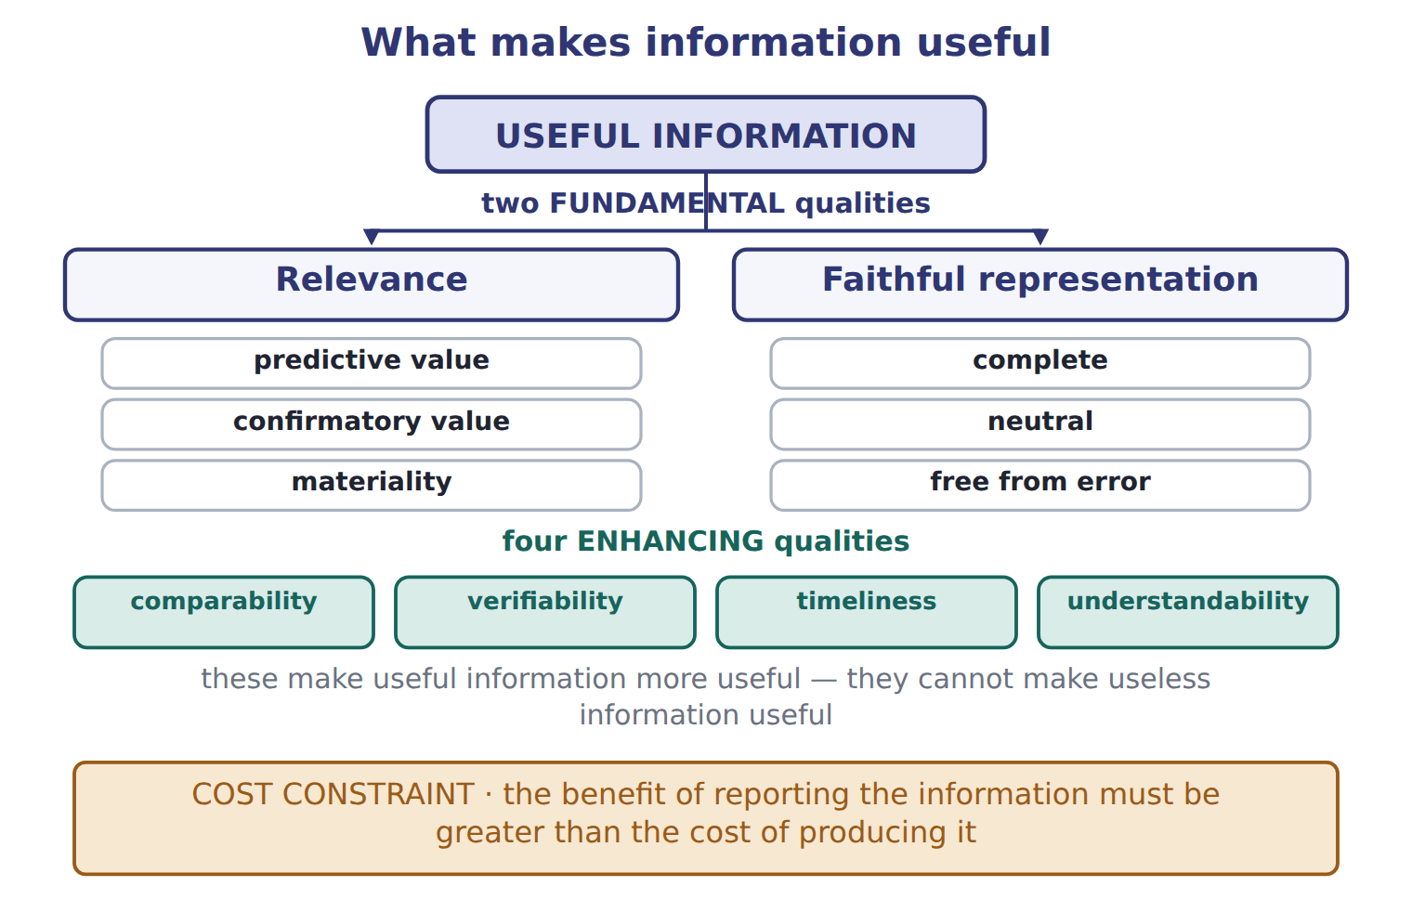
READ THE MODEL All six answers are in the figure.

The two fundamental qualities are and .
16. The figure puts three things under relevance. Name them.

17. The figure puts three things under faithful representation. Name them.

18. How many enhancing qualities does the figure show, and what does the line beneath them say they cannot do?

19. The band at the foot of the figure is not a quality at all. What is it, and what does it weigh against what?

20. Comparability ranks equally with relevance in the figure. T / F
WORK IN PAIRS | Answer the next item alone first, then compare with your partner.
If you disagree: go back to the figure and find the level each word sits on. The level settles it.
INVENT THE RULE

21. Write what each of the two fundamental qualities asks of a number.
use every one of these words: decision · claims · complete · neutral
Relevance asks: could this number change a ?
Faithful representation asks: does this number show what it to show?

One company, two faults
Report A | Report B
Last year’s sales, measured exactly and audited. | A forecast of next year’s cash, written by the sales team to look good.
The reader is deciding whether to lend for five years. | The reader is deciding whether to lend for five years.
Complete, neutral, free from error — but does it bear on the decision? | It bears on the decision — but is it neutral?
Each report fails one of the two fundamental qualities. Name which quality each one fails, and say why neither report is useful on its own.

APPLY

22. Information helps an investor forecast next year’s cash flows. This information has:
A. predictive value | C. comparability
B. verifiability | D. timeliness
23. Two companies use the same accounting methods, so an analyst can compare their results. This quality is called:
A. relevance | C. faithful representation
B. verifiability | D. comparability
24. A company leaves a small amount out of its statements because including it could not change any reader’s decision. Name the idea that permits this, and say which fundamental quality it belongs to.

CHECKPOINT 25. Which two qualities are fundamental, and which four are only enhancing?

If you could not answer it: redo the READ THE MODEL questions of cycle B with the figure open.

CYCLE C | Five verbs the exam uses precisely

ORIENT

26. A company explains its revenue policy in the notes rather than on the face of a statement. Is that policy presented or disclosed?

MODEL One item’s life, in five stages.

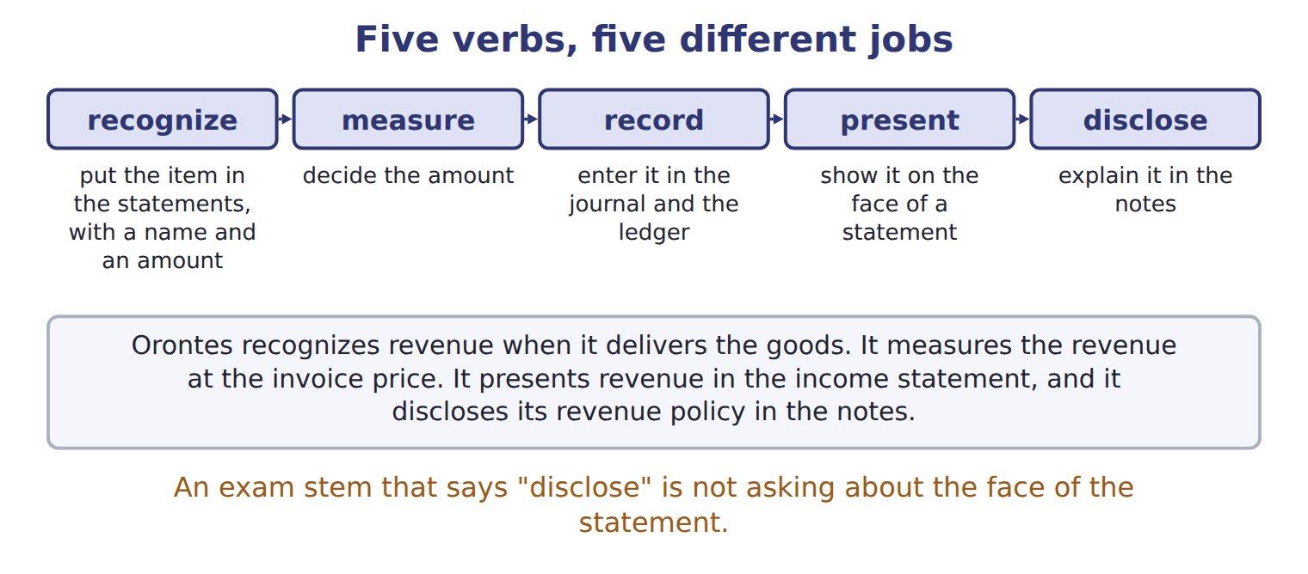
READ THE MODEL

27. Write the letter of the meaning beside each verb.
A decide the amount of the item | D show the item on the face of a statement
B explain the item in the notes to the statements | E enter the item in the accounts, in the journal and the ledger
C include the item in the statements, with a name and an amount

27. recognize
28. measure
29. record
30. present
31. disclose

32. Which one of the five verbs is the only one that does not put anything in the statements themselves?

APPLY

Orontes revenue when it delivers the goods. It the revenue at the invoice price. It revenue in the income statement, and it its revenue policy in the notes.
37. An exam stem asks what a company must DISCLOSE about a policy. The answer must therefore be about:
A. the face of the balance sheet | C. the journal entry
B. the notes to the statements | D. the amount chosen
CHECKPOINT 38. Which verb means to decide the amount, and which means to explain the item in the notes?

If you could not answer it: redo the matching item in cycle C.

FROM MEMORY | Close the earlier pages first.
39. Rebuild the qualities figure. Write the two fundamental qualities, the three parts under each, the four enhancing qualities and the constraint at the foot. Close the earlier pages first.
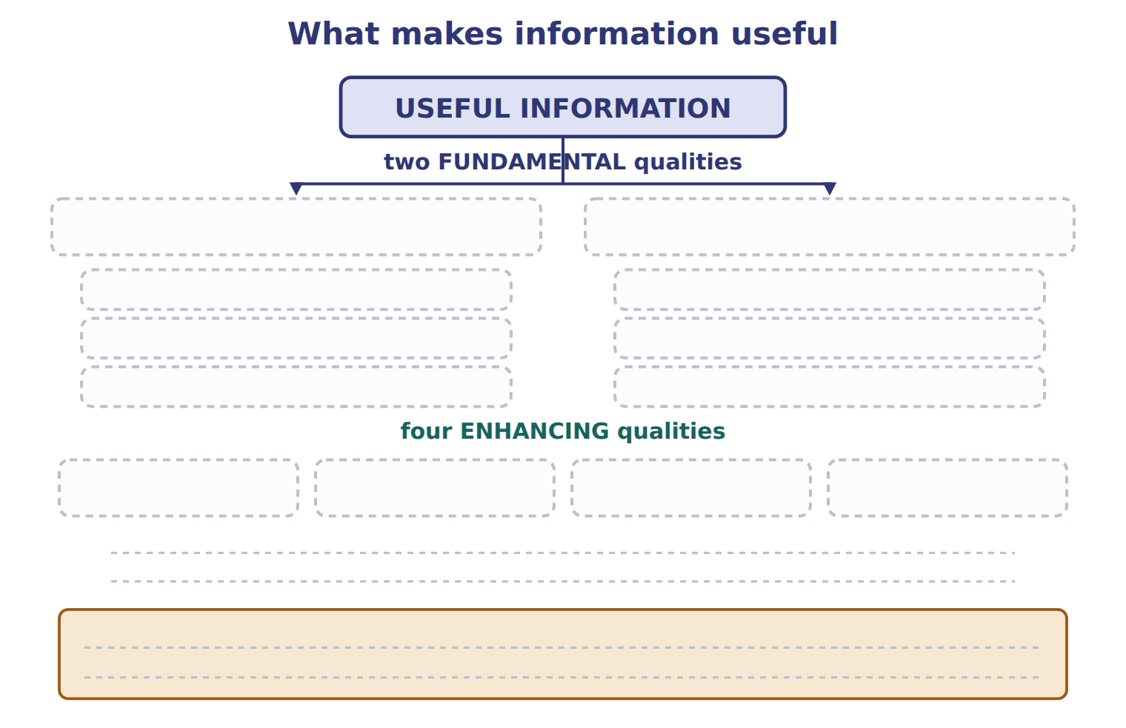
TEACH IT BACK | Write it for a classmate who missed this session — not for the marker.
40. In three or four sentences, explain who general-purpose financial statements are written for, and why the company’s own manager is not one of those readers.
every one of these words must appear: primary users · resources · special reports · management accounting

Answer key · Handout 1.1 · Who the statements are for

1 Can the company generate enough cash to pay the interest and repay the principal on time? | 15 faithful representation | 29 E
2 A | 16 Predictive value, confirmatory value, materiality | 30 D
3 Three | 17 Complete, neutral, free from error | 31 B
4 Other creditors (suppliers) | 18 Four; they cannot make useless information useful | 32 Disclose
5 Lenders, and other creditors (suppliers) | 19 The cost constraint: the benefit of reporting against the cost of producing | 33 recognizes
6 They can use internal reports, so they do not depend on the published statements. | 20 F | 34 measures
7 F | 21 see the key | 35 presents
8 see the key | 22 A | 36 discloses
9 D | 23 D | 37 B
10 C | 24 Materiality, which is part of relevance | 38 Measure decides the amount; disclose explains it in the notes.
11 B | 25 Fundamental: relevance, faithful representation. Enhancing: comparability, verifiability, timeliness, understandability. | 39 relevance (predictive value, confirmatory value, materiality) and faithful representation (complete, neutral, free from error); comparability, verifiability, timeliness, understandability; the cost constraint
12 Investors, lenders and other creditors; managers can obtain internal reports. | 26 Disclosed | 40 Primary users are existing and potential investors, lenders and other creditors, because they give the company resources and cannot demand special reports. Managers can get any internal information they need, so reporting for them is management accounting rather than general-purpose financial reporting.
13 Yes — it helps predict future cash | 27 C
14 relevance | 28 A

8 what the book says
The primary users are existing and potential investors, lenders and other creditors. They give resources (money, goods or credit) to the company. They usually cannot ask the company for special reports, so they depend on the published statements.

21 what the book says
Relevance means the information can make a difference to a decision. Faithful representation means the information shows what it claims to show: it is complete, neutral and free from error.

why
1 A lender’s main question is repayment: can the borrower pay interest and principal on time?
2 General-purpose statements are reports for many readers at the same time, not for one special reader.
3 Investors, lenders and other creditors.
4 Suppliers sell on credit and set credit terms, so their question is whether the bills will be paid when due.
5 Both are judging whether cash will be there to pay them.
6 Managers can get any internal information they need, so they are not primary users of general-purpose statements.
7 The panel gives a different mix of statements for each reader. Lenders and suppliers lean on cash flows and the balance sheet.
9 The primary users are existing and potential investors, lenders and other creditors. The board and the internal auditors can demand internal reports.
10 These are the primary users. They provide resources and cannot demand special reports.
11 Share prices interest investors more than lenders, and neither the product count nor the ownership list answers the repayment question.
13 Information that helps a user predict the future has predictive value, which is part of relevance.
15 The two fundamental qualities are relevance and faithful representation.
16 Relevance means the information can make a difference to a decision: it helps users predict the future or check past predictions, and it includes materiality.
17 Faithful representation means the information shows what it claims to show: complete, neutral and free from error.
18 Comparability, verifiability, timeliness and understandability are enhancing qualities only.
19 The benefit of reporting information should be greater than its cost.
20 Comparability is an enhancing quality. Only relevance and faithful representation are fundamental.
22 Predictive value is part of relevance: the information helps users predict the future. Verifiability means independent people could agree on the amount.
23 Comparability lets users identify similarities and differences between companies or periods.
24 An item is material if leaving it out or stating it wrongly could change users’ decisions.

Handout 1.2
The elements, and the equation
Ten elements · assets = liabilities + equity · what a transaction does to both sides
60 SECONDS | Answer from memory. Do not look anything up.
1. The three primary users are | 4. Materiality belongs under which fundamental quality?
2. The two fundamental qualities are | 5. Is a manager a primary user?
3. Which verb means "explain it in the notes"? | 6. Which quality lets you compare two companies?

CYCLE A | Ten elements, and the line that divides them

ORIENT From what you already know. Two minutes.

1. Orontes sells olive oil, which is its ordinary business. It also sells an old delivery truck, which is not. Both bring money in. Guess: does the book give those two the same name?

MODEL Ten elements. One column is the book’s own definition; read the definitions, not the names.

The ten elements of the FASB conceptual framework
Element | What the book says it is | An example from Orontes
Asset | a present right of an entity to an economic benefit | cash, accounts receivable, inventory, equipment
Liability | a present obligation of an entity to transfer an economic benefit | accounts payable, notes payable, wages payable
Equity | the residual interest in the assets after the liabilities are deducted | the owners’ claim on what is left
Revenue | from the company’s central, ongoing operations | selling olive oil
Expense | from the company’s central, ongoing operations | paying the plant workers
Gain | from peripheral or incidental events | selling an old delivery truck for more than its carrying amount
Loss | from peripheral or incidental events | the same sale at less than the carrying amount
Investments by owners | increase equity | buying new shares
Distributions to owners | decrease equity | a dividend
Comprehensive income | the total change in equity from sources other than owners | met in full in Chapters 3 and 15
Three of these describe the balance sheet at one date. The rest describe changes during a period.
READ THE MODEL

2. Which three elements describe the balance sheet at one date?

3. Two elements share the words "central, ongoing operations". Name them.

4. Two elements share the words "peripheral or incidental". Name them.

5. The definition of equity does not describe a thing the company owns. Copy the four words that say what it is instead.

6. A distribution to owners is one of the ten elements. T / F
INVENT THE RULE

7. Write the test that decides whether money coming in is revenue or a gain.
use every one of these words: central · ongoing · revenue · peripheral
If the money comes from the company’s operations, it is .
If it comes from a or incidental event, it is a .

Two sales by the same company, on the same day
Orontes sells olive oil to a supermarket | Orontes sells its old delivery truck
This is what Orontes exists to do. | Orontes is not in the truck business.
The amount received is 300. | The truck sold for more than its carrying amount.
Revenue, or gain? | Revenue, or gain?
Name each one, and write the single word in the definitions that decides between them.

APPLY

8. Which item is an expense?
A. A cash dividend paid to shareholders
B. Wages paid to plant workers
C. Repayment of a bank loan
D. Purchase of a new bottling line
CHECKPOINT 9. Which two elements come from central, ongoing operations, and which two come from peripheral events?

If you could not answer it: redo the READ THE MODEL questions of cycle A with the panel in front of you.

CYCLE B | The equation that never tips

ORIENT

10. A company has assets of 500 and liabilities of 320. What is left over for the owners?

MODEL One figure. The beam is not decoration: the two pans are the two sides of the equation, and the stack on the right is the point.

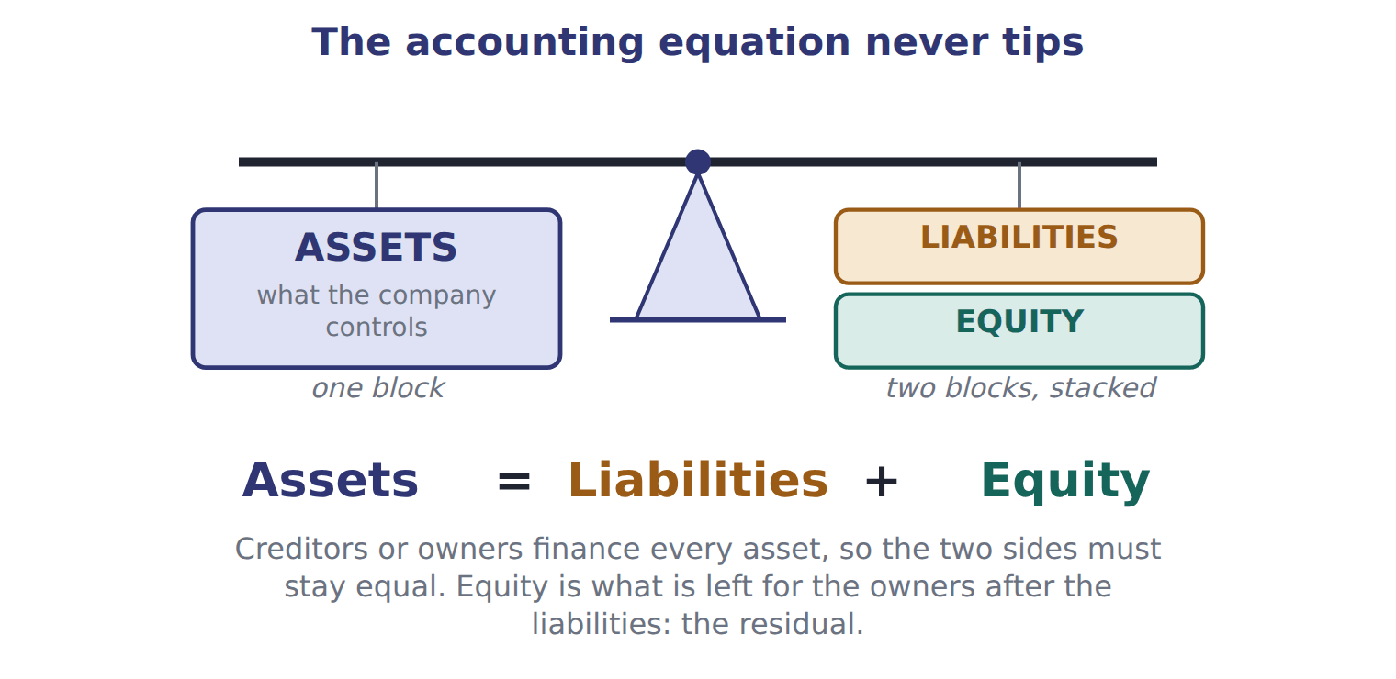
READ THE MODEL

11. How many blocks sit on the left pan, and how many on the right?

The equation under the beam reads: = + .
15. The figure gives a reason why the two sides must stay equal. Write it in your own words.

16. Which word in the figure says that equity is what is left over rather than a thing the company holds?

WORK IN PAIRS | Answer the next item alone, then compare.
If you disagree: rearrange the equation on paper. Whoever can write the rearranged form is right.
INVENT THE RULE

17. Write the equation three ways: solved for each of its three parts.
use every one of these words: assets · liabilities · equity · two
Assets = + Liabilities = − Equity = −
The equation holds after every transaction because every transaction has at least effects.

Two companies, one difference
Levant Foods | Barada Trading | Cedar Imports
Assets 500 | Assets 500 | Assets 500
Liabilities 320 | Liabilities 100 | Liabilities 500
Equity ? | Equity ? | Equity ?
Fill in all three. The assets are identical, so write the one sentence that explains why the owners’ claim is not.

APPLY

18. A company has total assets of 500 and total liabilities of 320. What is its equity?
A. 180 | C. 500
B. 320 | D. 820
19. A company has assets of 900 and liabilities of 350. It then borrows 100 in cash and declares and pays a cash dividend of 40. What is total equity after these transactions?
A. 450 | C. 550
B. 510 | D. 610
CHECKPOINT 20. A company’s assets rise by 800 and its liabilities rise by 800. By how much does equity change?

If you could not answer it: redo the contrasting cases in cycle B.

CYCLE C | What a transaction does to the equation

ORIENT

21. Orontes pays 1,200 cash for a bottling line. Cash falls. Does anything else on the left pan rise?

MODEL Four transactions, worked. The last column is the one to watch.

Four transactions and what each does to the equation
Issue shares for cash 1,500 | assets +1,500 and equity +1,500 — both sides rise
Borrow cash on a note 800 | assets +800 and liabilities +800 — both sides rise
Buy a bottling line for cash 1,200 | assets +1,200 and −1,200 — one asset becomes another, nothing else moves
Pay wages in cash 40 | assets −40 and equity −40 — an expense reduces the owners’ claim

READ THE MODEL

22. Which of the four transactions leaves total assets unchanged?

23. Which of the four changes equity without any cash leaving the owners’ side? Give the transaction and say whether equity rose or fell.

24. Borrowing 800 in cash increases the company’s equity. T / F

PREDICT FIRST | Before you answer the next two items, write what you expect a cash dividend to do to assets and to equity.
what I think will happen | what the figures actually show
A dividend declared but not yet paid moves liabilities and equity, and leaves assets alone until the cash goes out.

APPLY

25. A company issues common stock for cash. What is the effect on the accounting equation?
A. Assets increase and equity increases.
B. Assets increase and revenue increases.
C. Assets increase and liabilities increase.
D. There is no effect on the equation.
26. Which transaction changes total assets but does NOT change total equity?
A. Borrowing cash from a bank
B. Paying wages in cash
C. Selling goods on credit at a profit
D. Buying equipment for cash
CHECKPOINT 27. Name one transaction that changes total assets without changing equity, and one that changes equity without changing total liabilities.

If you could not answer it: redo the worked trace at the start of cycle C and read the right column aloud.

FROM MEMORY | Close the earlier pages first.
28. Rebuild the beam. Label both pans, write the equation underneath, and add the one sentence that says why the two sides must stay equal.
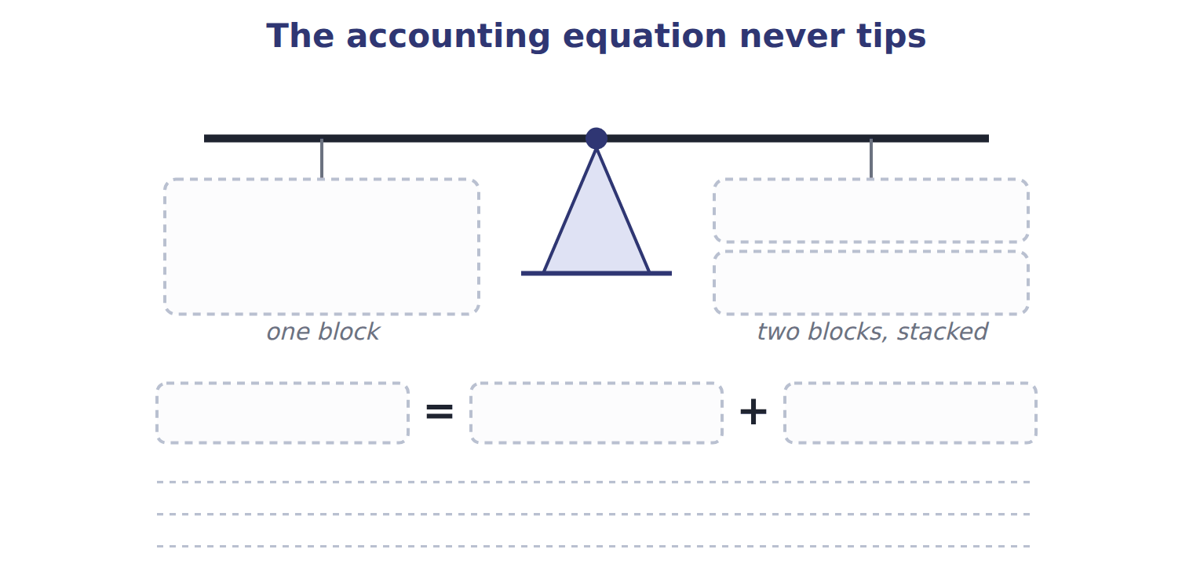
TEACH IT BACK | Write it for a classmate who has just learned the word "equity" — not for the marker.
29. In three or four sentences, explain why equity is called a residual and why the equation can never be out of balance.
every one of these words must appear: residual · assets · liabilities · finance

Answer key · Handout 1.2 · The elements, and the equation

1 No — one is revenue, the other a gain | 11 One on the left, two on the right | 21 Yes — equipment rises by the same 1,200
2 Asset, liability, equity | 12 Assets | 22 Buying the bottling line for cash
3 Revenue and expense | 13 Liabilities | 23 Paying wages — equity fell
4 Gain and loss | 14 Equity | 24 F
5 the residual interest in the assets | 15 Every asset is financed either by a creditor or by an owner. | 25 A
6 T | 16 Residual | 26 A
7 see the key | 17 see the key | 27 Borrowing cash changes assets and liabilities only; paying wages in cash changes assets and equity only.
8 B | 18 A | 28 Left pan: assets. Right pan: liabilities above equity. Assets = Liabilities + Equity, because creditors or owners finance every asset.
9 Revenues and expenses are central and ongoing; gains and losses are peripheral or incidental. | 19 B | 29 Equity is the residual interest in the assets after the liabilities are deducted, so it is measured as what is left rather than counted directly. The equation cannot be out of balance because creditors or owners finance every asset, and every transaction changes at least two of the three parts by matching amounts.
10 180 | 20 By nothing — equity is unchanged.

7 what the book says
Revenues and expenses come from the company’s central, ongoing operations. Gains and losses come from peripheral or incidental events.

17 what the book says
Assets = Liabilities + Equity. The equation always holds, because creditors (liabilities) or owners (equity) finance every asset.

why
1 Revenues come from central, ongoing operations. Gains come from peripheral or incidental events.
2 The other seven describe changes during a period.
5 Equity is what is left after the liabilities are deducted. It is a claim, not a resource.
6 Investments by owners and distributions to owners are both elements. A dividend is a distribution.
8 Wages are a cost of the company’s central operations. A dividend is a distribution to owners; repaying principal reduces a liability and an asset; a bottling line is an asset whose cost becomes an expense later, through depreciation.
10 Equity = assets − liabilities = 500 − 320 = 180.
15 Creditors (liabilities) or owners (equity) finance every asset, so the two sides must stay equal.
18 Equity = assets − liabilities = 500 − 320 = 180. Option D adds the liabilities instead of deducting them.
19 Equity started at 900 − 350 = 550. Borrowing changes assets and liabilities equally and leaves equity alone. The dividend reduces equity by 40, so equity is 510.
21 One asset becomes another asset. Total assets do not change.
22 One asset (cash) becomes another asset (equipment).
23 An expense reduces equity, and the cash goes to the workers, not to the owners.
24 Cash from borrowing is financing. Assets and liabilities both rise by 800 and equity is untouched.
25 Cash from issuing shares is an investment by owners, not revenue and not borrowing.
26 Borrowing raises assets and liabilities together. Paying wages and selling at a profit both move equity; buying equipment for cash leaves total assets unchanged.

Handout 1.3
Inside equity
Contributed capital and retained earnings · the dividend trap · words that look familiar and are not
60 SECONDS | Answer from memory. Do not look anything up.
1. Assets = liabilities + | 4. A gain comes from which kind of event?
2. Equity is the ______ interest in the assets | 5. Name one element that decreases equity
3. Revenue comes from which kind of operations? | 6. Does borrowing cash change equity?

CYCLE A | Equity has two parts, and they fill up differently

ORIENT

1. Two ways money can end up in the owners’ claim: the owners put it in, or the company earns it and keeps it. Which of the two depends on the company trading profitably?

MODEL One figure. Follow the two branches first, then the five arrows on the right.

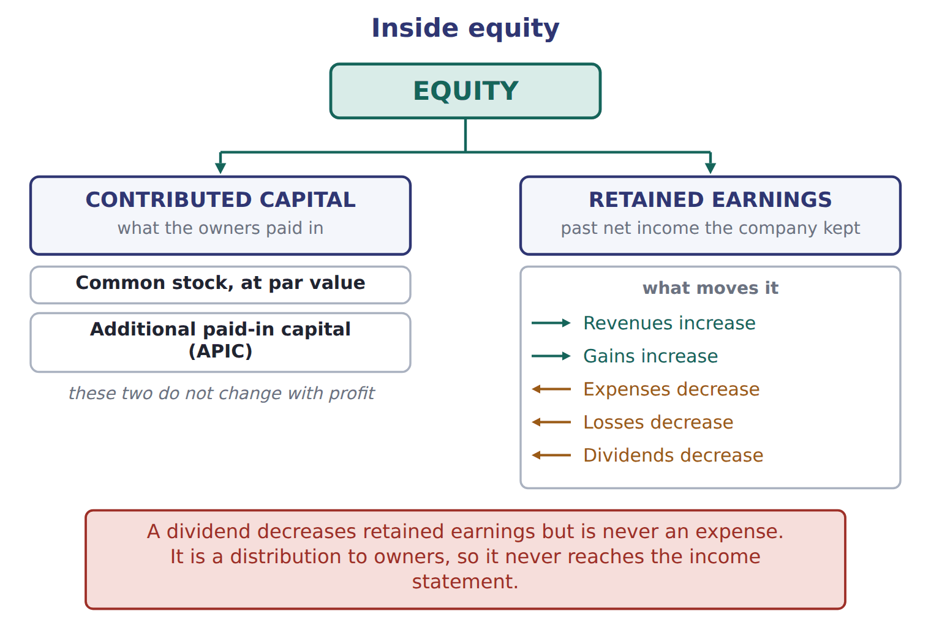
READ THE MODEL

2. Equity splits into two boxes in the figure. Name both.

3. Contributed capital itself holds two accounts. Name them.

4. The figure shows two things that increase retained earnings and three that decrease it. List all five.

5. Which of the five is NOT an expense, even though it reduces retained earnings?

6. A profitable year increases common stock. T / F
INVENT THE RULE

7. Write the test that decides which part of equity an amount belongs to.
use every one of these words: owners · contributed capital · earned · retained earnings
If the amount came from the , it goes to .
If the company it and did not pay it out, it goes to .

Two amounts of 1,400 in the same company
Shares issued above par | A profitable year
Owners paid 15 a share for 1 par shares. | The company earned it by selling olive oil.
The 14 above par, times 100,000 shares. | No dividend was paid out of it.
Which equity account? | Which equity account?
Both amounts sit inside equity. Name the account each belongs to, and write the one question that tells them apart.

APPLY

SORT THEM | Write each item under the equity account it belongs to.
the items: the par value of shares issued · the amount paid above par value · last year’s net income that was kept · a dividend declared · this year’s loss
Common stock | Additional paid-in capital | Retained earnings

CHECKPOINT 11. Which part of equity does a profitable year increase, and which part does issuing shares increase?

If you could not answer it: redo the READ THE MODEL questions of cycle A with the figure in front of you.

CYCLE B | The dividend trap

ORIENT

12. Wages reduce retained earnings. A dividend reduces retained earnings. Only one of the two also reduces net income. Which?

MODEL The board declares a dividend of 50 on January 31, payable on February 15. Here is what happens, and when.

One dividend, two dates
Jan 31 · the board declares 50 | retained earnings fall by 50, and a liability of 50 is created
Jan 31 · net income | unchanged — a dividend is not an expense
Jan 31 · cash | unchanged — nothing has been paid yet
Feb 15 · the dividend is paid | the liability of 50 goes, and cash falls by 50
Feb 15 · retained earnings | unchanged — they already fell in January, on declaration

READ THE MODEL

13. On which of the two dates do retained earnings fall?

14. On which of the two dates does cash fall?

15. What is created on January 31 that did not exist before?

16. Net income for January is 50 lower because of the dividend. T / F
WORK IN PAIRS | Answer the next item alone first, then compare.
If you disagree: find the row in the trace that names the date. The date settles it.
INVENT THE RULE

17. Write why a dividend reduces the owners’ claim without ever being an expense.
use every one of these words: distribution · owners · retained earnings · income statement
A dividend is a to , not a cost of .
So it reduces but never appears in the .

Two payments of 40 and 50, in the same month
Wages of 40 paid to plant workers | A dividend of 50 declared for shareholders
Who receives it? The workers. | Who receives it? The owners.
Is it a cost of earning this year’s revenue? | Is it a cost of earning this year’s revenue?
Does net income change? | Does net income change?
Answer all three rows for both. Then write the single word that separates a cost of earning from a distribution of what was earned.

APPLY

18. The board declares a cash dividend that will be paid next month. What is the effect immediately after the declaration?
A. Expenses increase and net income decreases.
B. Liabilities increase and equity decreases.
C. Assets decrease and equity decreases.
D. There is no effect until the dividend is paid.
19. Paying a dividend that was declared last month reduces retained earnings again. T / F

CHECKPOINT 20. A dividend is declared in January and paid in February. In which month do retained earnings fall, and in which month does cash fall?

If you could not answer it: redo the worked trace at the start of cycle B, reading the dates aloud.

CYCLE C | Words that look familiar and are not

ORIENT

21. In a CMA question, does the word "stock" mean shares or goods held for sale?

MODEL Four traps the book names, and the English the exam expects instead.

Four words that mislead a reader coming from Arabic or French
The familiar word | What it suggests | What the exam means
stock | in French and British English, goods held for sale | shares: common stock, a stock dividend. Goods for sale are inventory
income | Arabic دخل, any money coming in | net income is what remains after expenses; the gross amount from sales is revenue
charges | French charges, meaning expenses | in English, charges usually means fees. Expenses are expenses
balance | French la balance, the trial balance | the balance sheet is a statement of position; the trial balance is a different document

READ THE MODEL

22. Write the letter of the exam term beside each familiar word.
A shares | C what remains after expenses
B expenses | D a statement of position at one date

22. stock
23. income
24. charges
25. balance

26. A question says a company holds 400 of "stock". If it is a CMA question, what is being held?

MODEL The same items under IFRS. The ideas are the same; only the names differ.

The same item, two names
U.S. GAAP (used on the exam) | IFRS
balance sheet | statement of financial position
income statement | statement of profit or loss
common stock | share capital (ordinary shares)
additional paid-in capital | share premium
accounts receivable | trade receivables
net income | profit

APPLY

27. A Jordanian company’s IFRS statements show share premium of 400. Under U.S. GAAP, the same item is called:
A. retained earnings. | C. additional paid-in capital.
B. common stock. | D. treasury stock.
Under IFRS the balance sheet is called the , and net income is called .
CHECKPOINT 30. Give the U.S. GAAP name for share premium, and the IFRS name for the balance sheet.

If you could not answer it: redo the matching item in cycle C and read the two-name panel again.

FROM MEMORY | Close the earlier pages first.
31. Rebuild the equity figure. Show both branches, the two accounts inside contributed capital, and all five arrows into and out of retained earnings.
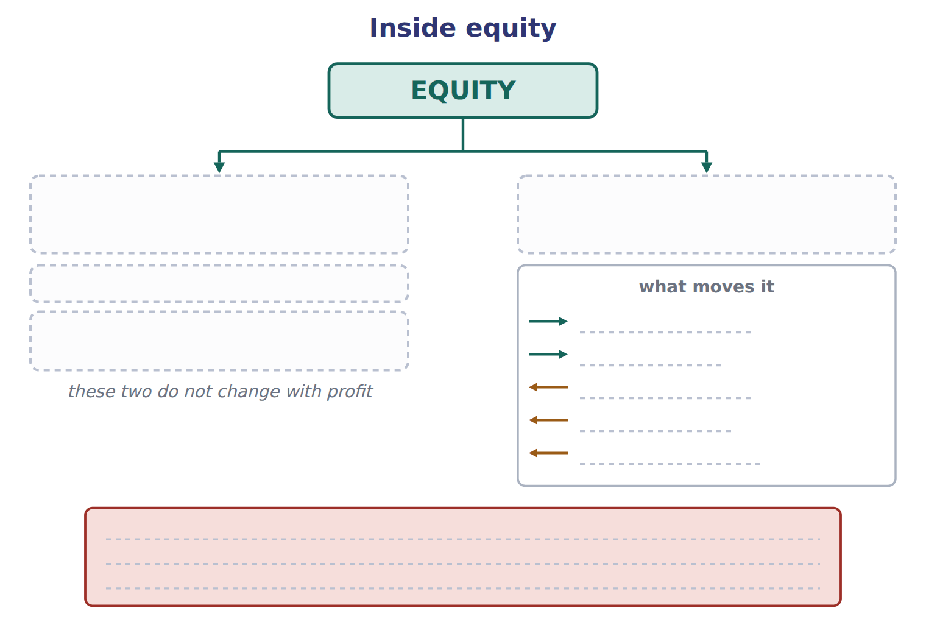
TEACH IT BACK | Write it for a new colleague — not for the marker.
32. In three to five sentences, explain why a cash dividend reduces retained earnings but does not appear in the income statement.
every one of these words must appear: distribution · owners · expense · retained earnings · net income

Answer key · Handout 1.3 · Inside equity

1 The money the company earns and keeps | 12 Wages | 23 C
2 Contributed capital and retained earnings | 13 On January 31, the date of declaration | 24 B
3 Common stock at par value, and additional paid-in capital (APIC) | 14 On February 15, the date of payment | 25 D
4 Increase: revenues, gains. Decrease: expenses, losses, dividends. | 15 A liability — dividends payable of 50 | 26 Shares
5 A dividend | 16 F | 27 C
6 F | 17 see the key | 28 statement of financial position
7 see the key | 18 B | 29 profit
8 common stock: par value of shares issued | 19 F | 30 Share premium is additional paid-in capital; the balance sheet is the statement of financial position.
9 APIC: the amount paid above par | 20 Retained earnings fall in January, on declaration; cash falls in February, on payment. | 31 Equity splits into contributed capital (common stock at par, plus APIC) and retained earnings. Revenues and gains increase retained earnings; expenses, losses and dividends decrease it.
10 retained earnings: income kept, dividends declared, losses | 21 Shares | 32 A dividend is a distribution to owners, not a cost of earning revenue, so it is not an expense. It reduces retained earnings on the date the board declares it, because retained earnings are the past net income the company has kept rather than paid out. Net income is unaffected, so the dividend never appears in the income statement. The payment itself, later, reduces cash and the liability the declaration created.
11 A profitable year increases retained earnings; issuing shares increases contributed capital. | 22 A

7 what the book says
Contributed capital is what owners paid in: common stock at its par value, plus additional paid-in capital (APIC). Retained earnings are the past net income that the company kept instead of paying it out as dividends.

17 what the book says
A dividend is not an expense. It is a distribution to owners, so it reduces retained earnings and never appears in the income statement.

why
1 Retained earnings are past net income the company kept instead of paying it out.
3 Contributed capital is what owners paid in: common stock at its par value, plus additional paid-in capital.
4 Revenues and gains increase retained earnings; expenses and losses decrease it; dividends also decrease it.
5 A dividend is a distribution to owners, so it never appears in the income statement.
6 Profit goes to retained earnings. Common stock and APIC change only when owners put money in.
12 Wages are an expense. A dividend is a distribution to owners and never reaches the income statement.
16 A dividend reduces retained earnings, not net income.
18 Declaring creates a liability and reduces retained earnings. No cash moves and no expense arises, so assets and net income are untouched.
19 Retained earnings fell on the declaration date. Payment reduces the liability and cash.
21 In U.S. English, stock means shares. Goods held for sale are always inventory.
26 In a CMA question, inventory is always called inventory.
27 Share premium is the amount received for shares above their par value, which is additional paid-in capital. Common stock holds only the par value.

Handout 1.4
Debits and credits
Left and right · the normal balance · contra accounts · the road from a document to a statement
60 SECONDS | Answer from memory. Do not look anything up.
1. Equity splits into which two parts? | 4. The IFRS name for additional paid-in capital is
2. Does a dividend reduce net income? | 5. Assets = liabilities +
3. Revenue comes from which kind of operations? | 6. A gain comes from which kind of event?

CYCLE A | Debit is a side, not a verdict

ORIENT

1. Your bank tells you it has credited your account after you paid money in. From the bank’s point of view, what has the bank now got that it did not have before?

MODEL One figure. Read the two columns, then the strip at the foot — the strip is the memory aid that makes the columns unnecessary.

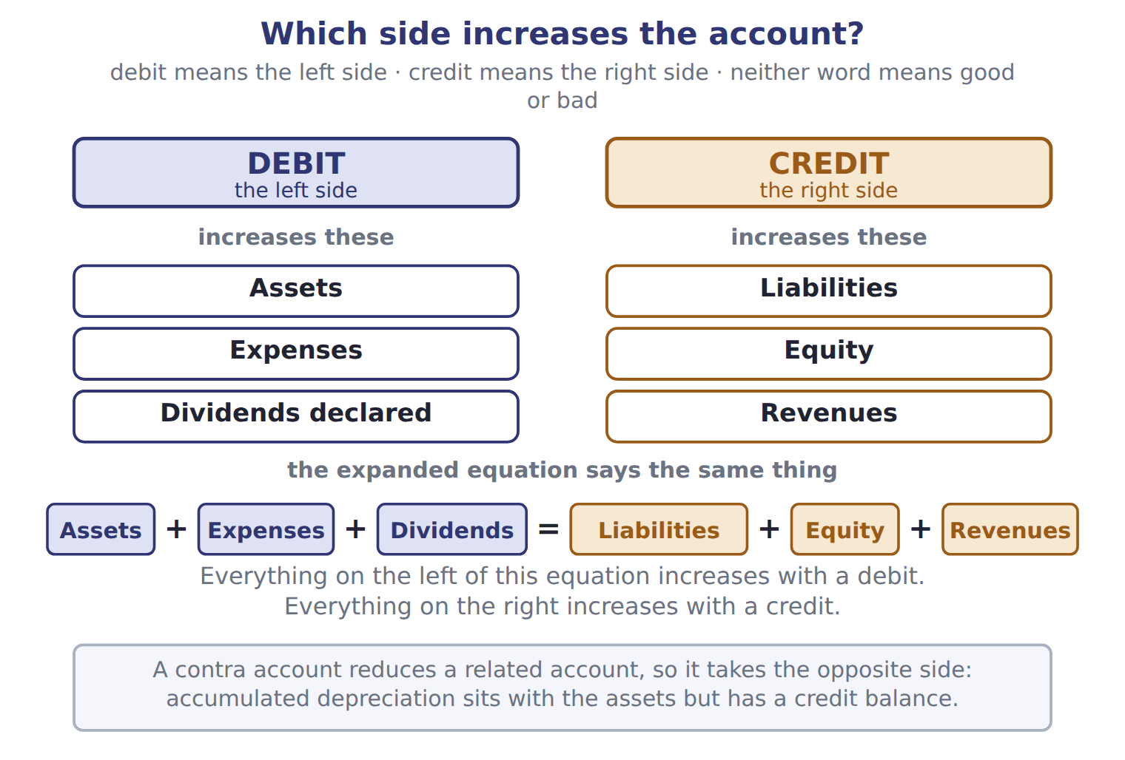
READ THE MODEL

2. Which side does the figure say a debit is, and which side is a credit?

3. The figure lists three account types that increase with a debit. Name all three.

4. And three that increase with a credit. Name all three.

The expanded equation in the figure reads: Assets + + = Liabilities + + .
9. A debit always increases an account. T / F
WORK IN PAIRS | Answer the next item alone, then compare.
If you disagree: write the expanded equation out. Whichever side the account sits on settles it.
INVENT THE RULE

10. Write the one-line rule that the expanded equation gives you, so you never have to memorise six account types.
use every one of these words: left · right · debit · credit
Everything on the of the expanded equation increases with a .
Everything on the of it increases with a .

Two accounts that both go up by 300
Accounts receivable rises by 300 | Sales revenue rises by 300
Which side of the expanded equation is it on? | Which side of the expanded equation is it on?
So which entry raises it? | So which entry raises it?
Both rise in the same transaction. Say which is debited and which is credited, and name the rule that decides.

APPLY

11. Which account normally has a debit balance?
A. Accounts payable | C. Prepaid rent
B. Sales revenue | D. Additional paid-in capital
SORT THEM | Write each account under the side that increases it.
the items: Inventory · Notes payable · Wages expense · Sales revenue · Common stock · Dividends declared
increases with a DEBIT | increases with a CREDIT

CHECKPOINT 14. Which side of the expanded equation increases with a debit, and name one account type on that side that is not an asset.

If you could not answer it: redo the READ THE MODEL questions of cycle A with the figure in front of you.

CYCLE B | The normal balance, and the accounts that invert it

ORIENT

15. Cash is an asset. On which side of a cash account would you expect to find its balance?

MODEL Two accounts, side by side. The shaded half of each is the side that increases it.

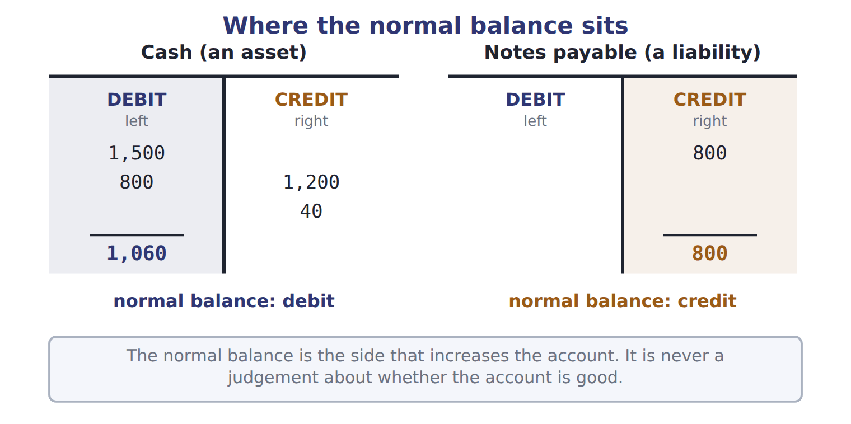
READ THE MODEL

16. The cash account shows 1,500 and 800 on one side and 1,200 and 40 on the other. Which side holds the balance of 1,060, and what is 1,500 + 800 − 1,200 − 40?

17. The notes payable account has its balance on the opposite side from cash. Which side, and why does the figure call that normal?

18. Write the sentence in the figure that says what the normal balance is NOT.

MODEL One more rule, in words rather than a figure: a contra account.

Accounts that sit with one group and behave like the other
Contra account | What it reduces | Its balance | Where it sits
Accumulated depreciation | Equipment | credit | with the assets
Allowance for credit losses | Accounts receivable | credit | with the assets
A contra account reduces a related account, so it takes the opposite normal balance.
INVENT THE RULE

19. Write what makes a contra account different from a liability, given that both carry a credit balance.
use every one of these words: reduces · asset · obligation · outside
A contra account a related account, so it belongs with the it reduces.
A liability is an to transfer an economic benefit to somebody the company.

Two credit balances in the same trial balance
Accumulated depreciation 900 | Notes payable 1,800
What does it reduce? | What does it reduce?
Does the company owe it to anyone? | Does the company owe it to anyone?
Where does it belong? | Where does it belong?
Both have credit balances. Fill in all three rows and then write the question that separates a contra-asset from a liability.

APPLY

20. Which account normally has a credit balance?
A. Prepaid rent | C. Cost of goods sold
B. Accumulated depreciation | D. Dividends declared
21. Accumulated depreciation is BEST described as:
A. a liability for future asset replacement.
B. a contra-asset account with a credit balance.
C. an expense of the current period.
D. a reduction of retained earnings.
CHECKPOINT 22. Name the two contra accounts in this cycle, say what each one reduces, and give the side each one’s balance sits on.

If you could not answer it: redo the contrasting cases in cycle B.

CYCLE C | Where a transaction actually goes

ORIENT

23. A trial balance adds up: total debits equal total credits. Does that prove every entry was put in the right account? Answer yes or no.

MODEL Five stops, in order.

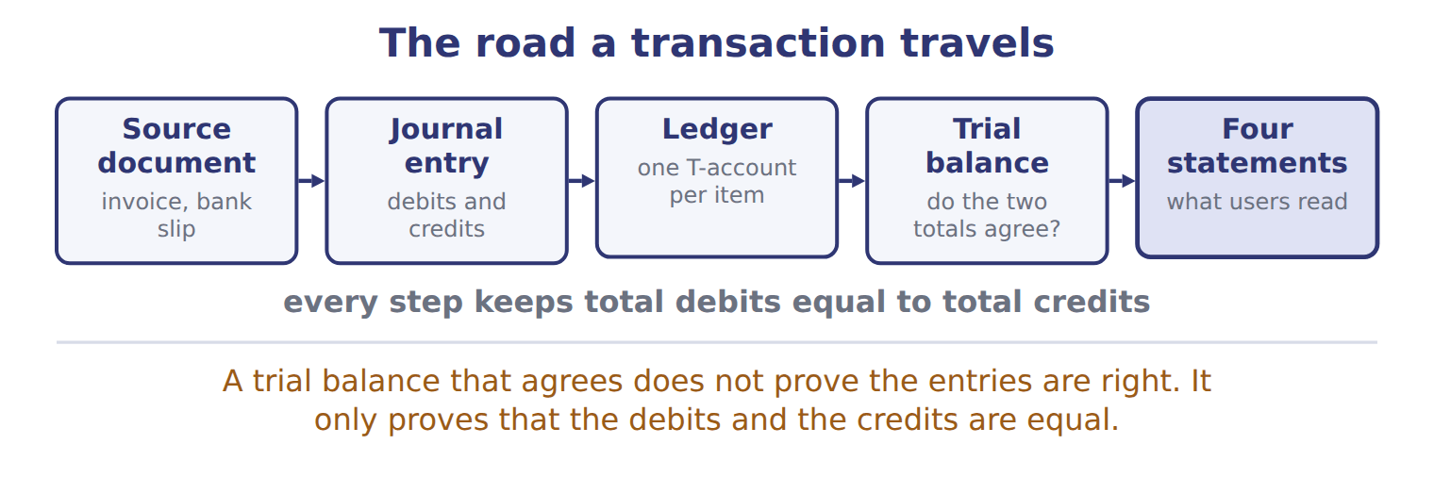
READ THE MODEL

24. Name the five stops in the order the figure gives them.

25. Which stop holds one T-account per item?

26. Copy the warning the figure gives about a trial balance that agrees.

ERROR HUNT | Four statements about the road a transaction travels. Mark each one right, or write what is wrong with it. (items 27 to 30)
the solution as written | right, or what is wrong with it
a | The ledger comes before the journal entry.
b | A trial balance that agrees proves no account was misclassified.
c | Every step keeps total debits equal to total credits.
d | The source document is produced after the statements.

CHECKPOINT 31. Put these in order: ledger, source document, trial balance, journal entry, four statements.

If you could not answer it: redo the READ THE MODEL questions of cycle C.

FROM MEMORY | Close the earlier pages first.
32. Rebuild the debit and credit figure. Write the three account types in each column and the full expanded equation at the foot.
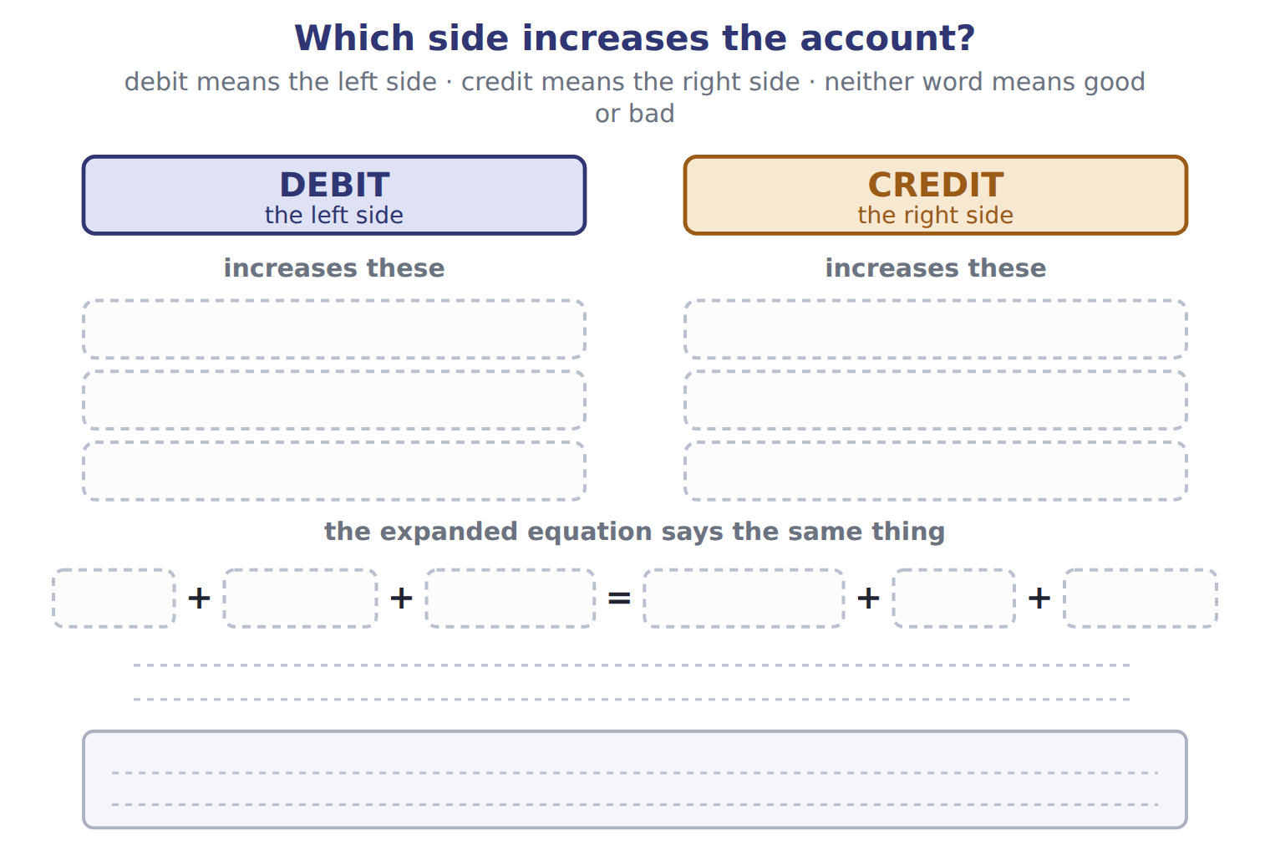
TEACH IT BACK | Write it for a student who thinks debit means "bad" — not for the marker.
33. In three or four sentences, explain what debit and credit actually mean and how to work out which one increases an account.
every one of these words must appear: left · right · normal balance · expanded equation

Answer key · Handout 1.4 · Debits and credits

1 An obligation to you — the bank owes you the money | 12 debit: inventory, wages expense, dividends declared | 23 No
2 Debit is the left side; credit is the right side | 13 credit: notes payable, sales revenue, common stock | 24 Source document, journal entry, ledger, trial balance, four statements
3 Assets, expenses, dividends declared | 14 The left side; expenses (or dividends declared). | 25 The ledger
4 Liabilities, equity, revenues | 15 The left (debit) side | 26 It does not prove the entries are right; it only proves that debits and credits are equal.
5 Expenses | 16 The debit side; 1,060 | 27 wrong — the journal entry comes first, then the ledger
6 Dividends | 17 The credit side, because a liability increases with a credit | 28 wrong — it only proves the two totals are equal
7 Equity | 18 It is never a judgement about whether the account is good | 29 right
8 Revenues | 19 see the key | 30 wrong — the source document is the first stop, not the last
9 F | 20 B | 31 Source document, journal entry, ledger, trial balance, four statements.
10 see the key | 21 B | 32 Debit (left) increases assets, expenses and dividends declared. Credit (right) increases liabilities, equity and revenues. Assets + Expenses + Dividends = Liabilities + Equity + Revenues.
11 C | 22 Accumulated depreciation reduces equipment; the allowance for credit losses reduces accounts receivable. Both carry credit balances. | 33 Debit means the left side of an account and credit means the right side; neither word is a judgement. Each account has a normal balance, the side that increases it. The expanded equation tells you which side that is: everything on its left increases with a debit, everything on its right with a credit.

10 what the book says
Accounts on the left side of the equation (assets, expenses and dividends) increase with a debit. Accounts on the right side (liabilities, equity and revenues) increase with a credit.

19 what the book says
A contra account reduces a related account, so it has the opposite normal balance. For example, accumulated depreciation reduces equipment. It has a credit balance, but it belongs with the assets.

why
1 The bank credits your account because the bank now owes you. That is the bank’s view, not yours. Do not use banking habits to guess the accounting side.
2 Debit simply means the left side of an account, and credit means the right side.
9 Whether a debit increases an account depends on the type of account. Neither word means good or bad, and neither always means increase.
11 Prepaid rent is an asset, and assets sit on the left of the expanded equation. The other three are a liability, a revenue and an equity account, all on the right.
17 Each account has a normal balance: the side that increases it.
18 Neither debit nor credit means good or bad.
20 Accumulated depreciation is a contra-asset account, so it has the opposite (credit) balance to assets. Prepaid rent is an asset, cost of goods sold is an expense, and dividends declared reduce equity: all three are debits.
21 It reduces an asset and carries a credit balance. It is not owed to anyone, so it is not a liability, and it is not itself the period’s expense.
23 It only proves that debits and credits are equal.

Handout 1.5
Six transactions in January
Reading a journal entry · the effect of each one · the three mistakes the exam keeps testing
60 SECONDS | Answer from memory. Do not look anything up.
1. Debit is which side? | 4. What does a trial balance prove?
2. Which side increases a liability? | 5. Dividends declared increase with a debit or a credit?
3. Name one contra-asset account | 6. The first stop on the road is the

CYCLE A | Reading a journal entry

ORIENT

1. A company sells shares with a par value of $1 each for $15 each. How much of the $15 is par, and how much is above par?

MODEL Six entries, as Orontes actually wrote them. Amounts are in USD 000.

Orontes Foods, Inc. — journal entries for January 2025
# | Date | Account | Debit | Credit
1 | Jan 2 | Cash | 1,500
 |  | Common stock |  | 100
 |  | Additional paid-in capital |  | 1,400
2 | Jan 5 | Cash | 800
 |  | Notes payable (long-term) |  | 800
3 | Jan 10 | Equipment | 1,200
 |  | Cash |  | 1,200
4 | Jan 18 | Accounts receivable | 300
 |  | Sales revenue |  | 300
 |  | Cost of goods sold | 180
 |  | Inventory |  | 180
5 | Jan 31 | Wages expense | 40
 |  | Cash |  | 40
6 | Jan 31 | Retained earnings (dividends declared) | 50
 |  | Dividends payable |  | 50
 |  | Totals | 4,070 | 4,070
Check each entry for yourself: the debits equal the credits.

What each entry was for
# | What Orontes did
1 | Issued 100,000 new shares of $1 par common stock for $15 per share, in cash.
2 | Borrowed cash from Levant Commerce Bank on a 5-year note at 6% interest.
3 | Bought a new bottling line for the Amman plant and paid cash.
4 | Sold olive oil to GreenBasket Supermarkets on credit. The goods had cost Orontes less than the selling price.
5 | Paid January wages to plant workers in cash.
6 | The board declared a cash dividend, payable on February 15.

READ THE MODEL

2. Entry 1 credits two accounts. Name both, and give the amount against each.

3. Entry 4 is really two entries at once. Write what each half records.

4. Which entry debits an account that has the word "expense" in its name, and for how much?

5. Entry 6 debits retained earnings. Which account does it credit, and what kind of account is that?

6. What are the two totals at the foot, and what does their being equal tell you?

WORK IN PAIRS | Answer the next item alone, then compare.
If you disagree: add the debit column and the credit column again. The arithmetic settles it.
INVENT THE RULE

7. Write the rule that decides how a share issue above par is split between two equity accounts.
use every one of these words: par · above · additional paid-in capital
Common stock is credited only with the value.
Everything received that goes to .

The same 1,500 of cash, arriving two ways
Entry 1 · shares issued for cash | Entry 2 · cash borrowed on a note
Who gave the cash? The owners. | Who gave the cash? A bank.
Which side of the equation rises? | Which side of the equation rises?
Is any of it revenue? | Is any of it revenue?
Both bring cash in and neither creates revenue. Write the one word that names what both of them are, and say why that word is not "income".

APPLY

8. Orontes buys a bottling line for 1,200 in cash. Which journal entry is correct?
A. Debit Cash 1,200; credit Equipment 1,200
B. Debit Equipment expense 1,200; credit Cash 1,200
C. Debit Equipment 1,200; credit Notes payable 1,200
D. Debit Equipment 1,200; credit Cash 1,200
CHECKPOINT 9. Entry 4 debits accounts receivable 300 and credits sales revenue 300. Why does it also debit cost of goods sold 180?

If you could not answer it: reread entries 4 and 5 in the journal panel of cycle A.

CYCLE B | The same six transactions, as effects

ORIENT

10. Orontes received 1,500 from shareholders and 800 from a bank in January: 2,300 of cash. How much of that 2,300 is revenue?

PREDICT FIRST | Before you turn to the grid: Orontes made a net income of 80 in January. Write what you expect the change in cash to be.
what I think will happen | what the figures actually show
Cash actually rose by 1,060. Net income and the change in cash are very different numbers, and that is the accrual basis at work.

MODEL The same six transactions, with the five totals each one moves.

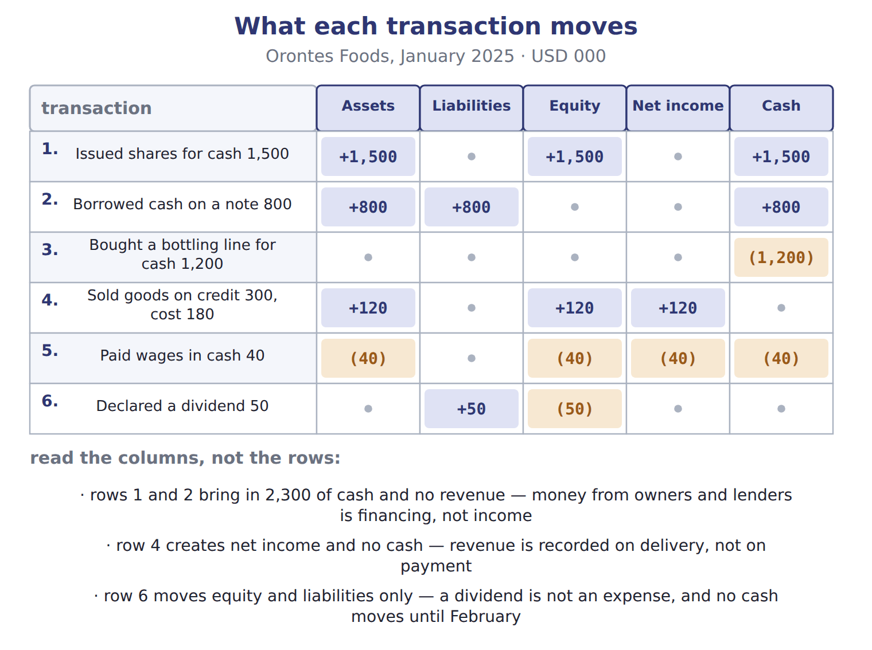
READ THE MODEL

11. Which transactions move cash but create no net income?

12. Which single transaction creates net income but moves no cash, and how much net income?

13. Row 6 moves two of the five columns. Which two, and in which direction?

14. Add the equity column. What is the net change in equity for January?

15. Add the net income column. What was January’s net income?

INVENT THE RULE

16. Write why net income and the change in cash are not the same number.
use every one of these words: hands · earned · incurred · accrual basis
Cash moves when money changes .
Net income moves when revenue is and expenses are , whatever the cash does.

The same company, the same month, two numbers
Net income for January | The change in cash for January
Revenue 300, cost of goods sold 180, wages 40. | An operating outflow, an investing outflow, a financing inflow.
Which events does it count? | Which events does it count?
What is the figure? | What is the figure?
Both describe January. Answer both rows for each, then write the one sentence that explains why two correct numbers differ so far.

APPLY

Complete the grid. Two rows are done; write + , − or 0 in every empty cell, and give the amount where there is one.
Transaction | Assets | Liabilities | Equity | Net income
Borrowed cash on a note 800 | +800 | +800 | 0 | 0
Paid wages in cash 40 | (40) | 0 | (40) | (40)
Issued shares for cash 1,500
Bought a bottling line for cash 1,200
Sold goods on credit 300, cost 180
Declared a dividend 50

CHECKPOINT 21. January’s net income was 80 and cash rose by 1,060. Name the basis of accounting that makes those two numbers differ.

If you could not answer it: reread the three notes under the effect figure in cycle B.

CYCLE C | Three mistakes the exam keeps testing

ORIENT

22. Buying equipment for cash is an expense of the month in which it is bought. T / F

MODEL The three the book names, with the right answer beside each.

Three classic mistakes
The mistake | What is actually true
Treating a dividend as an expense | It reduces retained earnings, not net income.
Treating cash from borrowing or from issuing shares as revenue | It is financing.
Treating equipment bought for cash as an expense today | One asset becomes another. The cost becomes an expense later, through depreciation.

READ THE MODEL The panel above holds the answer to every line below.

ERROR HUNT | A colleague has described January to the owner. Mark each line right, or write what is wrong with it. (items 23 to 27)
the solution as written | right, or what is wrong with it
a | "We took in 2,300 of revenue from the share issue and the bank loan."
b | "The 1,200 bottling line is a January expense, so it reduced our profit."
c | "The 50 dividend reduced our net income for January."
d | "We recorded 300 of revenue even though the customer has not paid."
e | "Wages of 40 reduced both cash and equity."

CHECKPOINT 28. Name the three mistakes, in one clause each.

If you could not answer it: reread the three-mistake panel and redo the error hunt in cycle C.

FROM MEMORY | Close the earlier pages first.
29. Rebuild the effect grid for the six January transactions. Fill every cell with + , − or 0, and give the amounts.
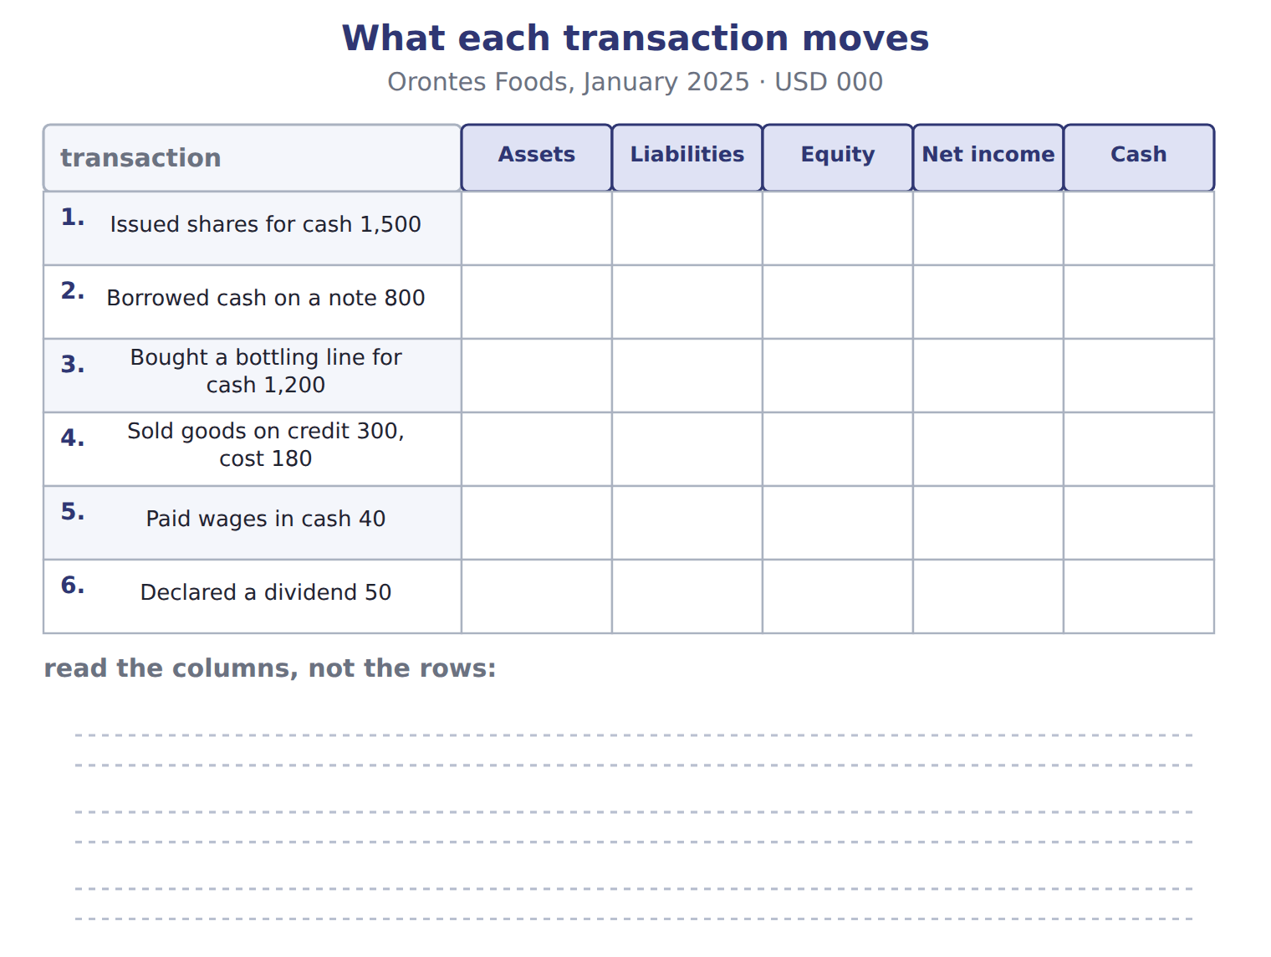
TEACH IT BACK | Write it for the owner of the company, who is not an accountant — not for the marker.
30. In three or four sentences, explain how the company can have made a profit of only 80 while its cash rose by 1,060.
every one of these words must appear: financing · revenue · accrual basis · net income

Answer key · Handout 1.5 · Six transactions in January

1 $1 is par; $14 is above par | 11 1, 2, 3 and 5 move cash; 1, 2 and 3 create no net income | 21 The accrual basis.
2 Common stock 100 and additional paid-in capital 1,400 | 12 Row 4 — net income of 120 | 22 F
3 The sale (receivable 300, revenue 300) and the cost of the goods sold (cost of goods sold 180, inventory 180) | 13 Liabilities up 50 and equity down 50 | 23 wrong — cash from owners and lenders is financing, not revenue
4 Entry 5, wages expense 40 | 14 1,530 | 24 wrong — it is an asset; the cost becomes an expense later through depreciation
5 Dividends payable — a liability | 15 80 | 25 wrong — a dividend reduces retained earnings, never net income
6 4,070 and 4,070 — that total debits equal total credits | 16 see the key | 26 right — revenue is recorded on delivery, not on payment
7 see the key | 17 shares: assets +1,500, liabilities 0, equity +1,500, net income 0 | 27 right — an expense paid in cash reduces both
8 D | 18 bottling line: assets 0, liabilities 0, equity 0, net income 0 | 28 A dividend is not an expense; cash from financing is not revenue; equipment bought for cash is not an expense today.
9 Because the cost of the goods is matched to the sale that earned the revenue, in the same period. | 19 sale: assets +120, liabilities 0, equity +120, net income +120 | 29 Row 1 assets +1,500, equity +1,500, cash +1,500. Row 2 assets +800, liabilities +800, cash +800. Row 3 cash (1,200) only. Row 4 assets +120, equity +120, net income +120. Row 5 all of assets, equity, net income and cash (40). Row 6 liabilities +50, equity (50).
10 None of it | 20 dividend: assets 0, liabilities +50, equity (50), net income 0 | 30 Most of the cash came in from the owners and the bank, and money from financing is not revenue, so it never reaches net income. The sale that did earn revenue brought in no cash at all, because the customer has not paid yet. Under the accrual basis revenue is recorded when the goods are delivered rather than when the cash arrives, so net income of 80 and a cash rise of 1,060 are both correct at the same time.

7 what the book says
Contributed capital is what owners paid in: common stock at its par value, plus additional paid-in capital (APIC).

16 what the book says
Under the accrual basis, a company records revenue when it earns it, that is, when it delivers the goods or services. It records expenses when it incurs them. The timing of the cash does not decide the period.

why
1 Common stock holds only the par value. The rest is additional paid-in capital.
2 100,000 shares at $1 par is 100; the remaining 1,400 is the amount paid above par.
3 Cost of goods sold links directly to each sale, so it is recorded at the same time as the sales revenue.
6 It does not prove the accounts chosen were right.
8 One asset increases and another decreases. The sides are not reversed, the bottling line is not an expense of this period, and Orontes paid cash rather than borrowing.
10 Money from owners and lenders is financing. It is not income.
11 Rows 1 and 2 are financing; row 3 swaps one asset for another.
12 Revenue of 300 less cost of goods sold of 180. The customer has not paid yet.
14 1,500 + 120 − 40 − 50 = 1,530. The totals prove the equation: assets rose 2,380, liabilities 850 and equity 1,530.
15 Revenue 300, less cost of goods sold 180, less wages 40.
17 Cash from owners is financing, never revenue.
18 One asset becomes another, so no total changes.
19 Receivable 300 less inventory 180.
20 A dividend is not an expense, and no cash has moved.
22 One asset (cash) becomes another asset (equipment). The cost becomes an expense later, through depreciation.

Handout 1.6
February, with the scaffolding removed
Three rows worked, three rows yours · the four adjustments the accrual basis creates
60 SECONDS | Answer from memory. Do not look anything up.
1. Cash from a bank loan is revenue: true or false? | 4. Net income for January was
2. A dividend reduces which equity account? | 5. Which entry records the cost of goods sold?
3. Revenue is recorded when the goods are | 6. One asset becoming another changes total assets by

CYCLE A | Three worked, three yours

ORIENT

1. A customer pays you today for goods you will deliver next month. Have you earned revenue today? Answer yes or no.

MODEL Six transactions from February. The first three are worked for you, with the reasoning beside each.

Orontes Foods — February 2025 (USD 000)
# | Date | What happened | Amount
1 | Feb 3 | Paid a supplier for olives bought on credit in January. | 150
2 | Feb 8 | Collected part of the January receivable from GreenBasket Supermarkets. | 200
3 | Feb 10 | Paid 12 months of warehouse rent in advance. | 24
4 | Feb 12 | A Dubai hotel group paid cash in advance for pastries that Orontes will deliver in March. | 60
5 | Feb 15 | Paid the dividend declared on January 31. | 50
6 | Feb 28 | Recorded one month of interest on the bank note. Orontes has not paid it yet. | 4

Rows 1 to 3, worked
Row 1 · Dr Accounts payable 150; Cr Cash 150 | the supplier is paid, so a liability goes and cash goes with it: assets (150), liabilities (150), equity 0, net income 0
Row 2 · Dr Cash 200; Cr Accounts receivable 200 | one asset becomes another, so no total moves: assets 0, liabilities 0, equity 0, net income 0
Row 3 · Dr Prepaid rent 24; Cr Cash 24 | cash is paid before the benefit is used, so it buys an asset: assets 0, liabilities 0, equity 0, net income 0

READ THE MODEL

2. Rows 1, 2 and 3 all move cash, and not one of them changes net income. Write the reason in your own words.

3. Row 3 pays 24 of cash and total assets do not change. What did the 24 of cash become?

4. Row 2 increases Orontes’ revenue by 200. T / F
APPLY Rows 4 to 6 now, with no worked model beside them. Write the entry and the effects for each.

Complete all three rows: the journal entry, then the four effects.
Row | Journal entry | Assets | Liabilities | Equity | Net income
4 · hotel pays 60 in advance
5 · the 50 dividend is paid
6 · interest of 4 is owed

WORK IN PAIRS | Compare your three rows with your partner’s.
If you disagree: the row that differs is the one to argue about. Settle it by asking whether anything was earned or incurred, not by asking where the cash went.
CHECKPOINT 8. Row 4 brings 60 of cash in. Why is none of it revenue in February?

If you could not answer it: redo row 4 of the APPLY grid in cycle A.

CYCLE B | Four adjustments, and the two that get confused

ORIENT

9. Cash paid before the benefit is used creates something on the balance sheet. Is it an asset or a liability?

MODEL Two questions generate all four. Read the column headings and the row headings before you read the boxes.

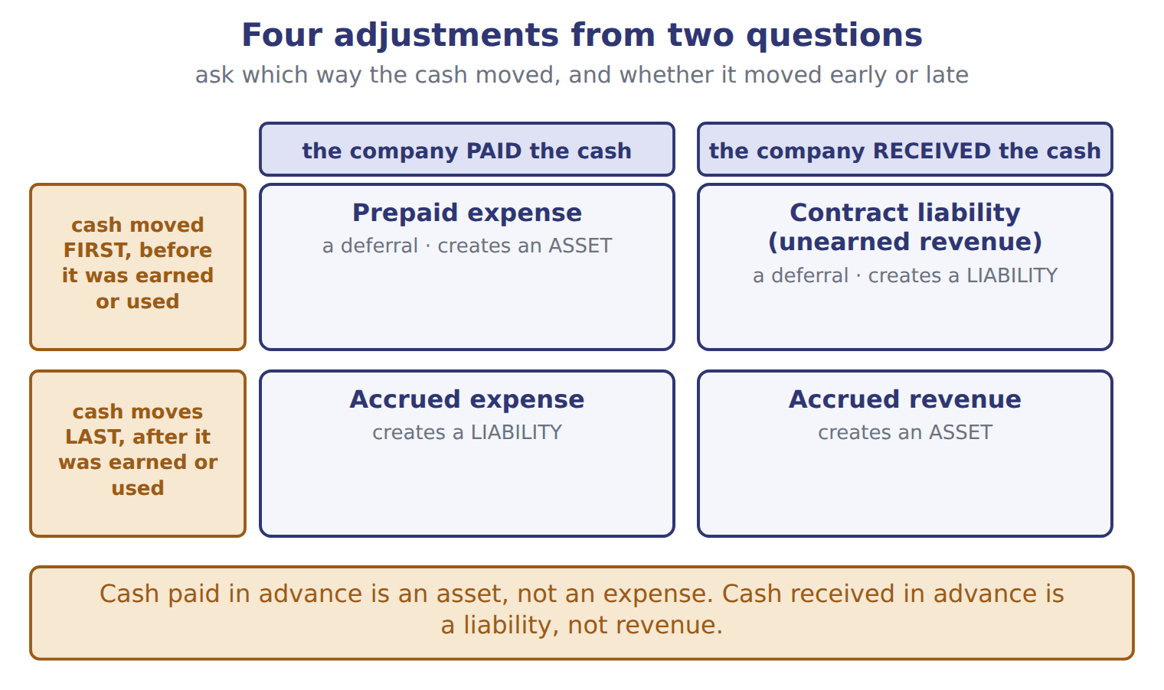
The same four, with the February row each one matches
Type | What happens | The February row it matches | It creates
Prepaid expense (deferral) | Cash is paid before the expense is incurred. | row 3, rent in advance | an asset
Contract liability, or unearned revenue (deferral) | Cash is received before the revenue is earned. | row 4, the hotel pays in advance | a liability
Accrued expense | The expense is incurred before cash is paid. | row 6, interest owed on the bank note | a liability
Accrued revenue | Revenue is earned before cash is received or billed. | none in February — studied in Chapter 11 | an asset

READ THE MODEL

10. Which two of the four create a liability?

11. Which two create an asset?

12. In which two does the cash arrive or leave BEFORE the revenue is earned or the expense incurred?

13. Which of the four has no February example in the panel, and where does the book say it is studied?

INVENT THE RULE

14. Write the test that tells a prepaid expense from a contract liability, given that both begin with cash moving.
use every one of these words: paid · asset · received · liability
If the company the cash, it has bought a future benefit, so it records an .
If the company the cash, it still owes goods or services, so it records a .

Two payments of cash in the same week
Orontes pays 24 for a year of warehouse rent | A hotel pays Orontes 60 for March pastries
Who paid? Orontes. | Who paid? The customer.
What does Orontes now have coming to it? | What does Orontes now owe?
Asset or liability? | Asset or liability?
In both, cash moves before anything is earned or used. Say which each one creates, and write the single question that decides.

APPLY

15. On December 28, a customer pays Orontes 60 for goods that Orontes will deliver in January. What does Orontes report at December 31?
A. A liability of 60
B. Revenue of 60
C. An asset of 60 and revenue of 60
D. Nothing until the goods are delivered
16. On February 10, Orontes pays 24 for 12 months of warehouse rent in advance. How does the payment appear immediately after it is made?
A. As an asset of 24
B. As an expense of 24
C. As a liability of 24
D. It is not recorded until the end of the month.
SORT THEM | Write each one under the balance-sheet item it creates.
the items: rent paid in advance · cash received for goods not yet delivered · interest incurred but not yet paid · revenue earned but not yet billed
creates an ASSET | creates a LIABILITY

CHECKPOINT 19. Cash received in advance is a ______, and cash paid in advance is an ______. Fill both gaps.

If you could not answer it: redo the contrasting cases in cycle B.

FROM MEMORY | Close the earlier pages first.
20. Rebuild the four-adjustment grid. Label both column headings, both row headings, and write in each box what it is called and whether it creates an asset or a liability.
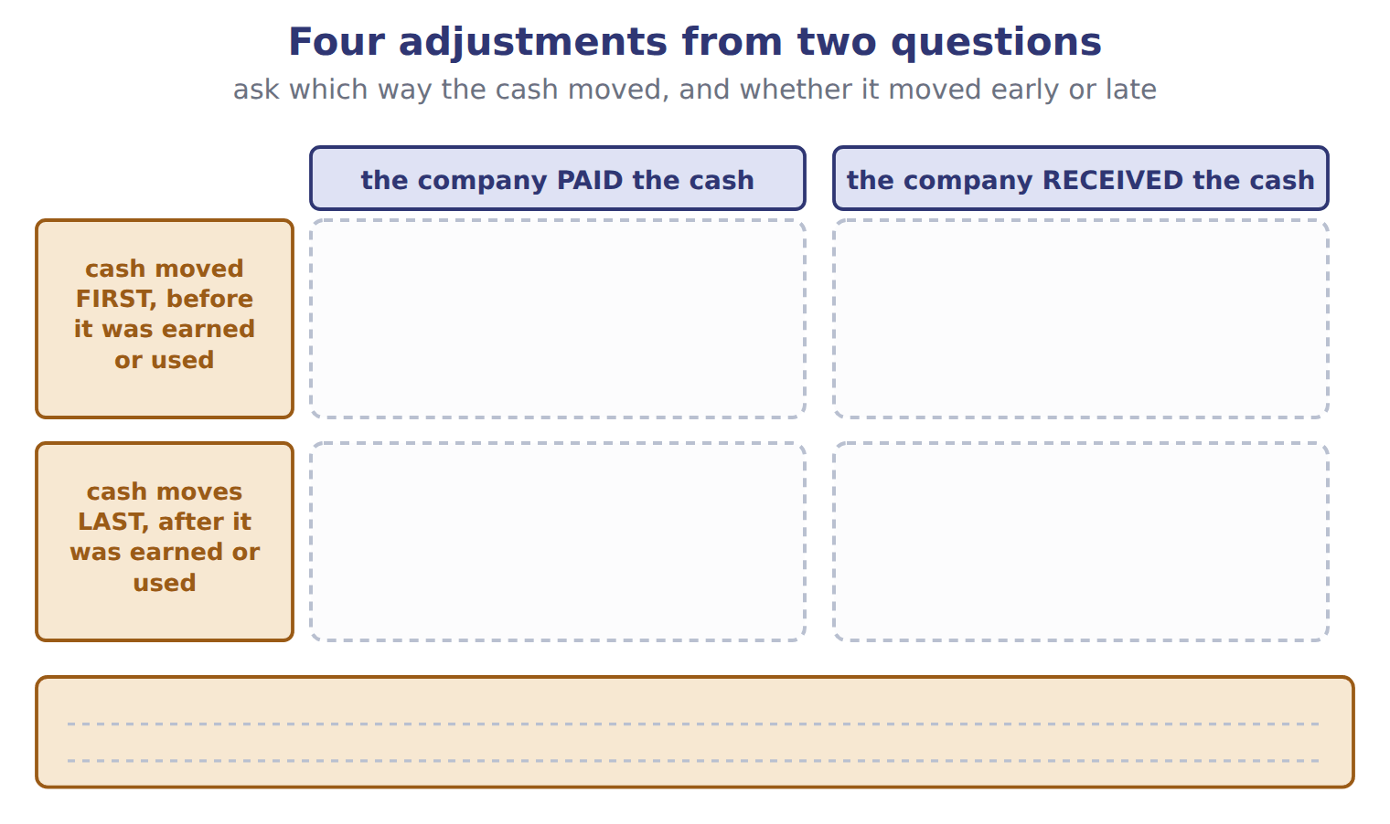
TEACH IT BACK | Write it for a classmate who says "if the cash moved, record it" — not for the marker.
21. In three or four sentences, explain why the movement of cash does not by itself tell you whether to record revenue or an expense.
every one of these words must appear: earned · incurred · deferral · accrual

Answer key · Handout 1.6 · February, with the scaffolding removed

1 No | 8 Because the pastries have not been delivered; the 60 is a contract liability until they are. | 15 A
2 None of them earns revenue or incurs an expense — they settle or swap items already recorded | 9 An asset | 16 A
3 Prepaid rent, which is an asset | 10 Contract liability (unearned revenue) and accrued expense | 17 asset: rent paid in advance; revenue earned but not yet billed
4 F | 11 Prepaid expense and accrued revenue | 18 liability: cash received for goods not yet delivered; interest incurred but not yet paid
5 row 4: Dr Cash 60; Cr Contract liability (unearned revenue) 60 — assets +60, liabilities +60, equity 0, net income 0 | 12 The two deferrals: prepaid expense and contract liability | 19 Cash received in advance is a liability; cash paid in advance is an asset.
6 row 5: Dr Dividends payable 50; Cr Cash 50 — assets (50), liabilities (50), equity 0, net income 0 | 13 Accrued revenue — in Chapter 11 | 20 Columns: the company paid the cash, the company received it. Rows: cash first, cash last. Prepaid expense (asset), contract liability (liability), accrued expense (liability), accrued revenue (asset).
7 row 6: Dr Interest expense 4; Cr Interest payable 4 — assets 0, liabilities +4, equity (4), net income (4) | 14 see the key | 21 Under the accrual basis, revenue is recorded when it is earned and an expense when it is incurred, whatever the cash does. Cash that arrives early creates a deferral: a liability if the company received it, an asset if the company paid it. Cash that arrives late creates an accrual, because the revenue or the expense has already happened. Matching means matching expenses to revenues, not to cash payments.

14 what the book says
A prepaid expense is an asset: the company has paid for a future benefit. A contract liability (unearned revenue) is a liability: the company must still deliver the goods or services.

why
1 Revenue is not earned until the goods are delivered.
2 Paying a supplier settles a liability; collecting a receivable swaps one asset for another; paying rent in advance buys an asset.
4 The revenue was recorded in January, when the goods were delivered. February’s collection only turns a receivable into cash.
5 Row 4 is a liability, not revenue: Orontes must still deliver the pastries.
6 Retained earnings fell in January, when the dividend was declared, so equity does not move again.
7 An accrued expense: interest is an expense of February even though Orontes has not paid it.
9 The company has paid for a future benefit.
15 Cash increases and Orontes owes the customer the goods: a contract liability. Revenue is not earned until January, and the cash has been received, so something must be recorded now.
16 Cash paid in advance is an asset, not an expense. The expense arises as the benefit is used.

Handout 1.7
The accrual basis, and matching
One sale on two bases · three ways to match an expense to a revenue
60 SECONDS | Answer from memory. Do not look anything up.
1. Cash received in advance creates a | 4. Revenue is recorded when the goods are
2. Cash paid in advance creates an | 5. Which basis does U.S. GAAP require?
3. Interest owed but unpaid is which kind of adjustment? | 6. Does paying a supplier change net income?

CYCLE A | One sale, two bases, two different years

ORIENT

1. Orontes delivers goods on December 20 and is paid on January 15. Under which basis of accounting would the sale belong to the later year?

MODEL One sale, drawn on two timelines. The dashed line is the year end.

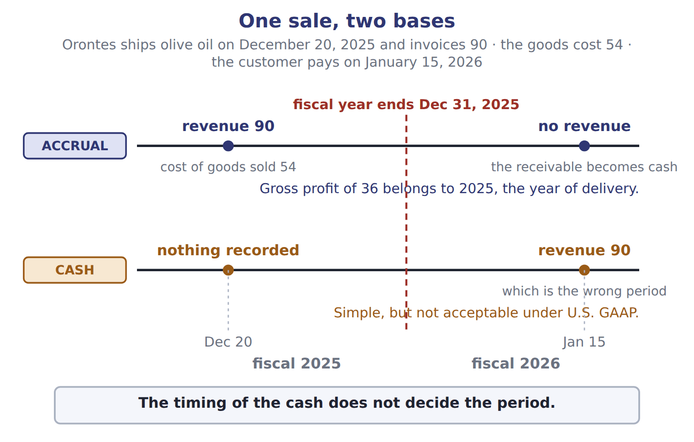
READ THE MODEL

2. On the accrual timeline, what does Orontes record on December 20, and for how much?

3. On the accrual timeline, what does the January 15 payment change?

4. On the cash timeline, in which fiscal year does the revenue of 90 fall, and what does the figure call that year?

5. What gross profit does the accrual basis put in 2025, and how is it worked out?

6. Copy the sentence in the band at the foot of the figure.

WORK IN PAIRS | Answer the next item alone first, then compare.
If you disagree: put a finger on the dashed year-end line and ask which side of it the delivery happened on. The delivery settles it.
INVENT THE RULE

7. Write what the accrual basis uses instead of the cash date to decide the period.
use every one of these words: earns · delivers · incurs · accrual basis
Revenue is recorded when the company it, that is, when it the goods or services.
An expense is recorded when the company it.

The same 90, recorded in two different years
Accrual basis | Cash basis
Delivery: December 20, 2025. | Delivery: December 20, 2025.
Cash: January 15, 2026. | Cash: January 15, 2026.
Which year gets the 90? | Which year gets the 90?
Is it acceptable under U.S. GAAP? | Is it acceptable under U.S. GAAP?
Only one fact differs between the two columns: which event the basis watches. Name that event for each, and answer both questions.

APPLY

8. Orontes ships goods on December 20, 2025 and invoices 90. The goods cost 54. The customer pays on January 15, 2026. The fiscal year ends on December 31. How much revenue does Orontes report for fiscal 2025?
A. 0 | C. 54
B. 36 | D. 90
9. The cash basis is acceptable under U.S. GAAP for published financial statements. T / F
CHECKPOINT 10. Which event does the accrual basis watch to decide the period, and which event does the cash basis watch?

If you could not answer it: redo the READ THE MODEL questions of cycle A with the two timelines in front of you.

CYCLE B | Three ways to match an expense to a revenue

ORIENT

11. A bottling line will be used for years. Can its whole cost sensibly be matched to this year’s sales? Answer yes or no.

MODEL The matching principle, and the three ways the book applies it.

Record expenses in the same period as the revenues they help to produce
The way | When it is used | The Orontes example
Cause and effect | the cost links directly to one sale | cost of goods sold, recorded at the same time as the sales revenue
Systematic and rational allocation | the cost helps many periods | depreciation, spreading a bottling line over the years of use
Immediate recognition | the cost has no clear link to future revenue | most advertising, and office salaries
The three ways differ in how tightly the cost is tied to a particular sale.
READ THE MODEL

12. Write the letter of the way each cost is matched.
A cause and effect | C immediate recognition
B systematic and rational allocation

12. Cost of goods sold
13. Depreciation of the Amman bottling line
14. Advertising for a new product
15. Rent for the head office

16. Which of the three ways ties a cost to one identified sale?

17. Which of the three is used when no link to future revenue can be found at all?

INVENT THE RULE

18. Write what the matching principle matches expenses to — and what it does not match them to.
use every one of these words: revenues · cash payment · matching principle
Expenses are recorded in the same period as the they help to produce.
They are not matched to the that pays for them.

Two costs of 300 in the same year
Goods that cost 300 and were sold in March | Advertising that cost 300, run in March
Can you name the sale this cost helped? | Can you name the sale this cost helped?
Which way of matching? | Which way of matching?
When is it an expense? | When is it an expense?
Fill in all three rows for both. Then write the question that decides between cause and effect, and immediate recognition.

APPLY

19. Which cost is matched to revenue by cause and effect?
A. Depreciation of the Amman bottling line
B. Advertising for a new product
C. Cost of goods sold
D. Rent for the head office
20. Which statement about the matching principle is correct?
A. Expenses are recognized in the period in which they are paid.
B. Revenues are recognized in the period in which cash is received.
C. All costs are capitalized as assets until related revenue is earned.
D. Expenses are recognized in the same period as the revenues they help to produce.
CHECKPOINT 21. Name the three ways of applying the matching principle, and give one example of each.

If you could not answer it: redo the matching item in cycle B with the panel open.

FROM MEMORY | Close the earlier pages first.
22. Rebuild the two timelines. Mark December 20, the year end and January 15, and write on each timeline what is recorded and when.
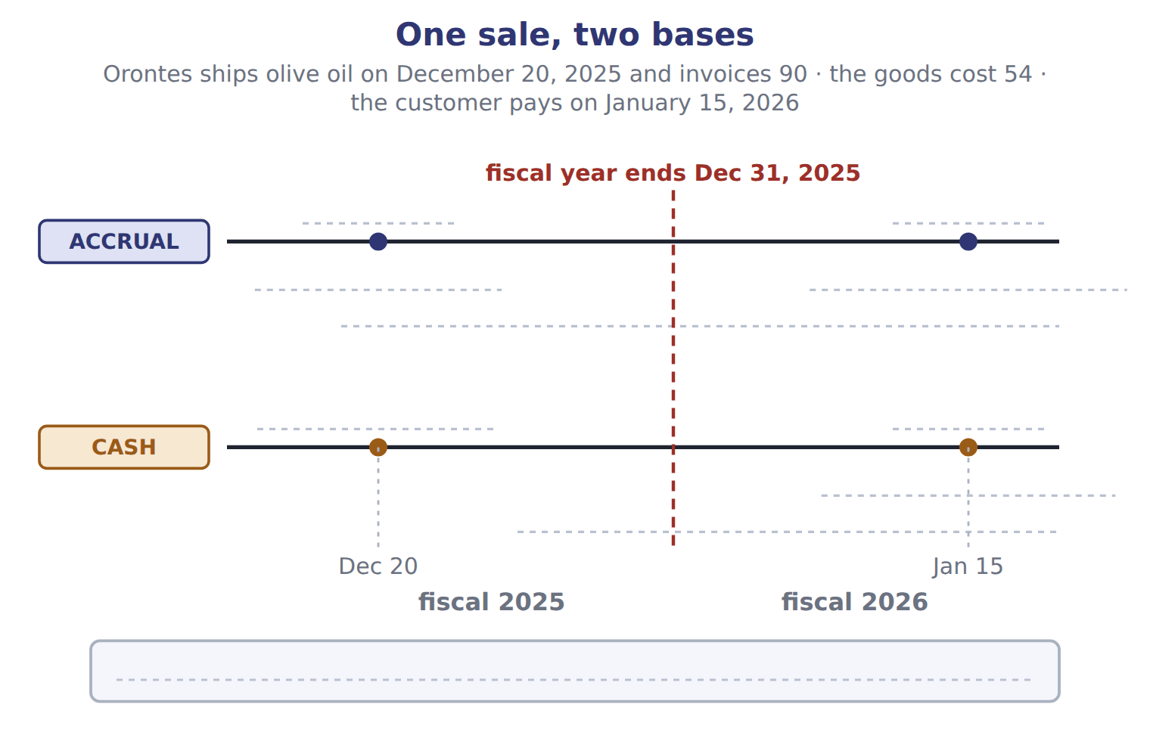
TEACH IT BACK | Write it for a shopkeeper who keeps books on the cash basis — not for the marker.
23. In three or four sentences, explain what would change if the shop moved to the accrual basis, and why U.S. GAAP insists on it.
every one of these words must appear: earned · incurred · period · matching

Answer key · Handout 1.7 · The accrual basis, and matching

1 The cash basis | 9 F | 17 Immediate recognition
2 Revenue of 90, and cost of goods sold of 54 | 10 The accrual basis watches delivery (earning or incurring); the cash basis watches the cash. | 18 see the key
3 Nothing but the form of the asset — the receivable becomes cash | 11 No | 19 C
4 Fiscal 2026 — the wrong period | 12 A | 20 D
5 36, from revenue 90 less cost of goods sold 54 | 13 B | 21 Cause and effect (cost of goods sold); systematic and rational allocation (depreciation); immediate recognition (advertising, office salaries).
6 The timing of the cash does not decide the period. | 14 C | 22 Accrual: revenue 90 and cost of goods sold 54 on December 20; on January 15 the receivable becomes cash and no revenue arises; gross profit of 36 belongs to 2025. Cash basis: nothing on December 20, revenue 90 on January 15, which is the wrong period.
7 see the key | 15 C | 23 On the accrual basis the shop would record a sale when the goods are handed over rather than when the money arrives, and a cost when it is incurred rather than when it is paid. That puts each sale and the costs that produced it in the same period, which is what matching requires. The cash basis can push a December sale into January, which is the wrong period, and U.S. GAAP does not accept it.
8 D | 16 Cause and effect

7 what the book says
Under the accrual basis, a company records revenue when it earns it, that is, when it delivers the goods or services. It records expenses when it incurs them. The timing of the cash does not decide the period.

18 what the book says
The matching principle says: record expenses in the same period as the revenues they help to produce. Matching means matching expenses to revenues, not to cash payments.

why
1 The cash basis records items only when cash is received or paid.
3 The cash receipt only changes one asset into another asset.
8 Revenue is recorded on delivery, so the whole 90 belongs to 2025. 36 is the gross profit and 54 is the cost, not the revenue.
9 The cash basis is simple, but it is not acceptable under U.S. GAAP.
11 A cost that helps many periods is spread over the years of use, through depreciation.
12 Cost of goods sold links directly to each sale, so it is recorded with the sales revenue.
13 Depreciation spreads the cost over the years of use.
14 Advertising has no clear link to specific revenue.
15 Head-office rent is a period cost, recognized immediately.
19 Cost of goods sold links directly to each sale. Depreciation uses systematic and rational allocation; advertising and head-office rent are recognized immediately.
20 The first two make cash the trigger, which the accrual basis rejects. The third would make every cost an asset until a sale, which is not what the three ways of matching do.

Handout 1.8
Who writes the rules
FASB, SEC, PCAOB, IASB · the Codification and how it is amended
60 SECONDS | Answer from memory. Do not look anything up.
1. Which basis does U.S. GAAP require? | 4. Cash paid in advance creates an
2. Matching matches expenses to | 5. Equity is the ______ interest in the assets
3. Depreciation uses which way of matching? | 6. A dividend reduces which equity account?

CYCLE A | Four bodies, four different jobs

ORIENT

1. One of these four bodies does not write accounting rules at all: FASB, SEC, PCAOB, IASB. Guess which, and say in three words what it does instead.

MODEL Two systems, side by side, and one body set apart at the foot.

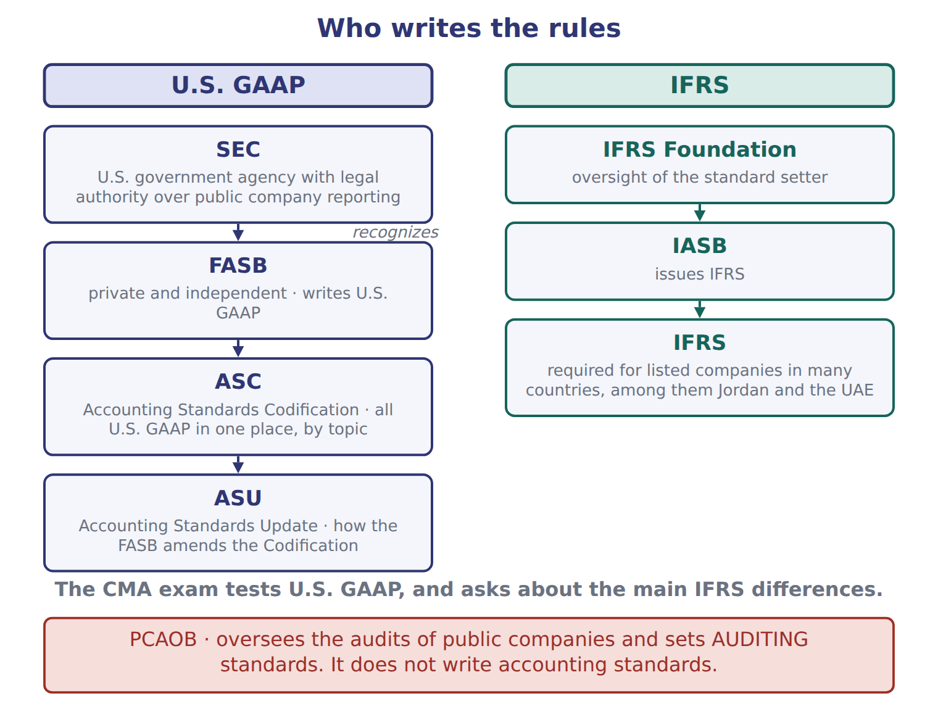
READ THE MODEL

2. Which body writes U.S. GAAP, and where does it keep it?

3. The figure puts the SEC above the FASB. What does the word beside that arrow say the SEC does?

4. What is an ASU, and what does it change?

5. Which body issues IFRS, and which organization oversees it?

6. Copy the sentence in the red band at the foot of the figure.

MODEL The same four bodies, in a sentence each.

Four bodies, four jobs
Body | What it is | What it does
FASB | private and independent | writes U.S. GAAP and keeps it in the Accounting Standards Codification
SEC | a U.S. government agency | has legal authority over the financial reporting of public companies, and recognizes the FASB as the standard setter
PCAOB | an oversight board | oversees the audits of public companies and sets auditing standards — not accounting standards
IASB | the board of the IFRS Foundation | issues IFRS

INVENT THE RULE

7. Write the difference between having the legal authority over reporting and writing the standards.
use every one of these words: SEC · FASB · public · recognizes
The has legal authority over the reporting of companies.
The writes the standards, because the first body it as the standard setter.

Two bodies whose names both contain "board"
FASB | PCAOB
Private or governmental? | Private or governmental?
Writes which kind of standards? | Writes which kind of standards?
Where does its output live? | Where does its output live?
Fill in all three rows for both. Then write the one word that separates what the two of them produce.

APPLY

8. Which organization writes U.S. GAAP?
A. The FASB | C. The PCAOB
B. The SEC | D. The IASB
9. Which statement is TRUE?
A. The PCAOB writes U.S. GAAP for public companies.
B. The IASB writes U.S. GAAP for companies that also report under IFRS.
C. The ASC contains IFRS for U.S. companies.
D. The SEC has legal authority over public company reporting and recognizes the FASB as the standard setter.
SORT THEM | Write each job under the body that does it.
the items: writes U.S. GAAP · issues IFRS · sets auditing standards · legal authority over public company reporting · maintains the Codification · issues Accounting Standards Updates
FASB | SEC | PCAOB | IASB

CHECKPOINT 14. Name the body that writes U.S. GAAP, the body with legal authority over public company reporting, and the body that sets auditing standards.

If you could not answer it: redo the READ THE MODEL questions of cycle A with the figure in front of you.

CYCLE B | The Codification, and what the exam actually tests

ORIENT

15. If every U.S. accounting rule is kept in one place, organized by topic number, what does that one place make easy that a pile of separate standards would not?

MODEL How a U.S. rule is stored, and how it changes.

From a decision to a rule a company must follow
The FASB decides a rule should change | the FASB is the standard setter the SEC recognizes
The FASB issues an Accounting Standards Update (ASU) | an ASU is the instrument that amends the Codification
The Codification is amended | the ASC is the single source of authoritative nongovernmental U.S. GAAP
A company looks the rule up by topic number | ASC 606 covers revenue; ASC 842 covers leases
For a company that reports to the SEC, SEC rules also apply | for SEC registrants, SEC rules are also part of authoritative GAAP

READ THE MODEL

16. Which topic number covers revenue, and which covers leases?

17. What does the trace call the ASC, in five words?

18. An ASU is a separate rulebook that sits beside the Codification. T / F
WORK IN PAIRS | Answer the next item alone, then compare.
If you disagree: find the row in the trace that names the instrument. The row settles it.
MODEL What the exam does with all this.

What the CMA exam tests
The exam tests | U.S. GAAP
The exam also asks about | the main differences between U.S. GAAP and IFRS
Many countries require IFRS for listed companies | among them Jordan and the United Arab Emirates
Both systems rest on | a conceptual framework: the users, the elements and the qualities of useful information

APPLY

19. The IFRS term share premium has the same meaning as the U.S. GAAP term:
A. retained earnings | C. net income
B. common stock | D. additional paid-in capital
The FASB keeps all U.S. GAAP in the , and amends it by issuing an .

CHECKPOINT 22. Which rules does the CMA exam test, and what else does it ask about?

If you could not answer it: reread the panel at the end of cycle B.

FROM MEMORY | Close the earlier pages first.
23. Rebuild the rule-maker figure. Draw both columns in order, and put the fourth body where it belongs, with the reason it is set apart.
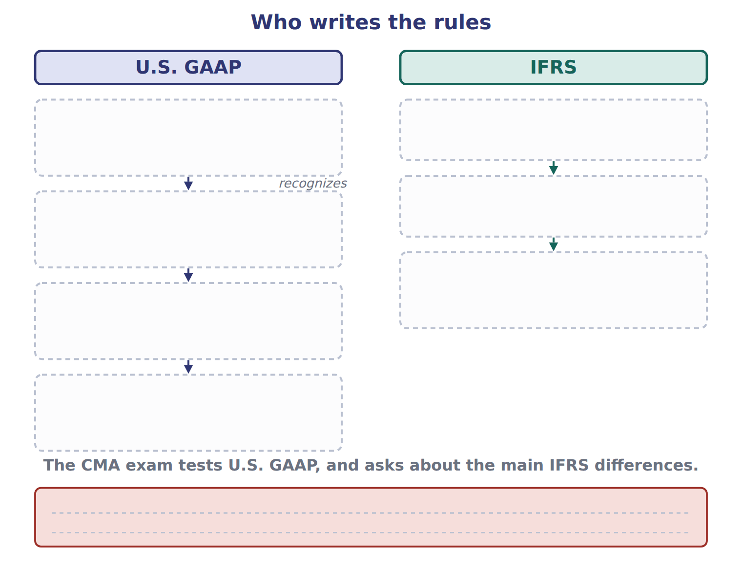
TEACH IT BACK | Write it for a student who has only ever studied IFRS — not for the marker.
24. In three or four sentences, explain which body writes the rules the CMA exam tests, where those rules are kept, and what this means for someone trained on IFRS.
every one of these words must appear: FASB · Codification · IASB · conceptual framework

Answer key · Handout 1.8 · Who writes the rules

1 PCAOB — it sets auditing standards | 9 D | 17 The single source of authoritative nongovernmental U.S. GAAP
2 The FASB, in the Accounting Standards Codification (ASC) | 10 FASB: writes U.S. GAAP, maintains the Codification, issues ASUs | 18 F
3 Recognizes — it recognizes the FASB as the standard setter | 11 SEC: legal authority over public company reporting | 19 D
4 An Accounting Standards Update; it amends the Codification | 12 PCAOB: sets auditing standards | 20 Accounting Standards Codification
5 The IASB, under the IFRS Foundation | 13 IASB: issues IFRS | 21 Accounting Standards Update
6 The PCAOB oversees the audits of public companies and sets auditing standards. It does not write accounting standards. | 14 FASB writes U.S. GAAP; the SEC has legal authority; the PCAOB sets auditing standards. | 22 It tests U.S. GAAP, and asks about the main differences between U.S. GAAP and IFRS.
7 see the key | 15 Finding every rule on one topic in one place | 23 U.S. GAAP: SEC, which recognizes the FASB, which writes U.S. GAAP and maintains the ASC, amended by ASUs. IFRS: the IFRS Foundation, then the IASB, which issues IFRS. Set apart: the PCAOB, which sets auditing standards, not accounting standards.
8 A | 16 ASC 606 covers revenue; ASC 842 covers leases | 24 The FASB writes U.S. GAAP and keeps all of it in the Accounting Standards Codification, which the exam tests; the IASB writes IFRS, which many countries require instead. Someone trained on IFRS already knows most of the ideas, because both systems rest on a conceptual framework with the same users, elements and qualities. What has to be learned is the different names, and the handful of rules that genuinely differ.

7 what the book says
The SEC is a U.S. government agency. It has legal authority over the financial reporting of public companies, and it recognizes the FASB as the standard setter.

why
1 The PCAOB oversees the audits of public companies. It sets auditing standards, not accounting standards.
2 The ASC is the single source of authoritative nongovernmental U.S. GAAP.
8 The FASB writes U.S. GAAP and keeps it in the Codification. The SEC has legal authority but recognizes the FASB; the PCAOB sets auditing standards; the IASB writes IFRS.
9 The PCAOB sets auditing standards, the IASB writes IFRS, and the ASC holds U.S. GAAP rather than IFRS.
15 The ASC keeps all U.S. GAAP in one place, organized by topic numbers.
18 An ASU amends the Codification. It does not sit beside it.
19 Share premium is the amount received for shares above their par value. Retained earnings come from past profits, and common stock holds only the par value.

Handout 1.9
The four statements, and how they link
One at a date, three for a period · net income into retained earnings · the change in cash
60 SECONDS | Answer from memory. Do not look anything up.
1. Which body writes U.S. GAAP? | 4. Revenue is recorded when the goods are
2. What does an ASU amend? | 5. Matching matches expenses to
3. Which body sets auditing standards? | 6. Share premium is the IFRS name for

CYCLE A | Four statements, four questions

ORIENT

1. "What the company owns today" and "what the company earned over the year" are different kinds of fact. Which of the two needs a single date rather than a span of time?

MODEL Four statements. The right-hand column is the one the exam tests hardest.

Each statement answers a different question
Statement | The question it answers | Time
Balance sheet | What does the company have and owe, and what is the owners’ claim? | at a date
Income statement | How did the company perform? | for a period
Statement of changes in equity | Why did each equity account change? | for a period
Statement of cash flows | Where did cash come from, and where did it go? | for a period

READ THE MODEL

2. How many of the four cover a period, and how many report at a single date?

3. Write the letter of the statement that answers each question.
A Balance sheet | C Statement of changes in equity
B Income statement | D Statement of cash flows

3. Where did cash come from, and where did it go?
4. How did the company perform?
5. Why did each equity account change?
6. What does the company have and owe?

7. Which statement would you read to find out why retained earnings are not what they were a year ago?

INVENT THE RULE

8. Write the test that sorts a statement into "at a date" or "for a period".
use every one of these words: has · owes · date · changed · period
If the statement reports what the company and , it is at a .
If it reports what over time, it is for a .

Two statements of the same company, same year
Balance sheet | Statement of cash flows
Cash 1,050. | Net change in cash 1,060.
Is that a total for the period, or a position? | Is that a total for the period, or a position?
At a date, or for a period? | At a date, or for a period?
Both are about cash. Answer both questions for each, and write the one word that separates a position from a flow.

APPLY

9. Which statement reports amounts at a single date?
A. The income statement | C. The statement of changes in equity
B. The balance sheet | D. The statement of cash flows
10. Which statement explains why retained earnings changed during the year?
A. The statement of changes in equity | C. The statement of cash flows
B. The balance sheet | D. The income statement
CHECKPOINT 11. Which single statement reports at a date, and what do the other three have in common?

If you could not answer it: redo the matching item in cycle A with the panel open.

CYCLE B | The two links

ORIENT

12. Net income is the bottom line of one statement. Guess which equity account it ends up inside.

MODEL The four statements again, this time with the two links drawn.

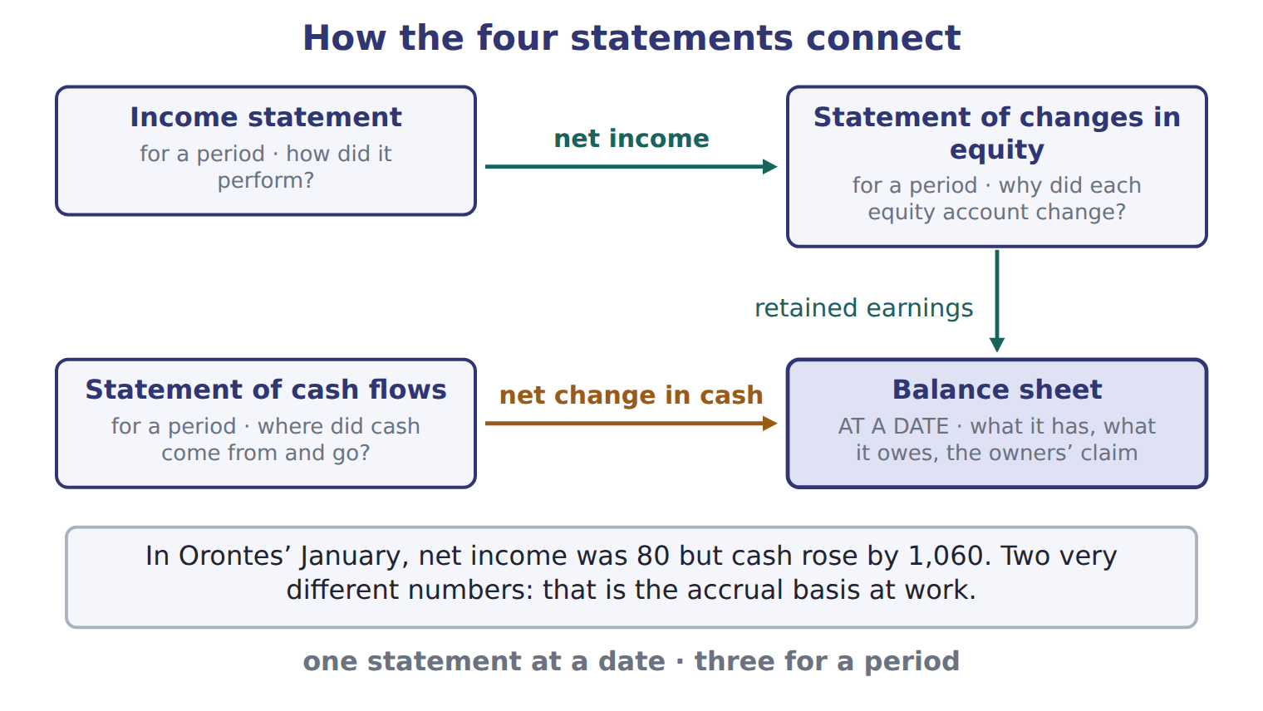
READ THE MODEL

13. The first link carries one figure from the income statement. Name the figure and say where it lands.

14. The second link carries a figure from the statement of cash flows. Name it and say what it explains.

15. Which of the four boxes in the figure is drawn as the one both links arrive at?

16. The band under the figure gives two numbers for the same month. Write both, and say what the difference between them is evidence of.

PREDICT FIRST | Before the next move: January’s net income was 80 and the dividend declared was 50. Write what you expect the change in retained earnings to be.
what I think will happen | what the figures actually show
Retained earnings rose by 30: net income of 80 less the dividend of 50.

INVENT THE RULE

17. Write the two links as two sentences.
use every one of these words: net income · retained earnings · cash
flows into in the statement of changes in equity.
The net change in explains the balance on the balance sheet.

Two figures that both come out of the same January
Net income 80 | Net change in cash 1,060
Which statement reports it? | Which statement reports it?
Which equity account does it end up in? | Which balance sheet line does it explain?
Does it say where the cash went? | Does it say whether the company traded profitably?
Answer all three rows for each, then write the one sentence that says why a reader needs both figures and not just one.

APPLY

18. Net income for the period flows directly into:
A. the cash balance on the balance sheet.
B. retained earnings in the statement of changes in equity.
C. total liabilities.
D. common stock.
Complete the reconciliation of January for Orontes, using the figures given.
Line | Amount
Sales revenue | 300
less cost of goods sold | 180
less wages expense | 40
Net income
less dividend declared | 50
Increase in retained earnings

And the other link. Complete the change in cash for January.
Line | Amount
Operating outflow | (40)
Investing outflow | (1,200)
Financing inflow | 2,300
Increase in cash

CHECKPOINT 22. Name the two links, and say which statement both of them arrive at.

If you could not answer it: redo the READ THE MODEL questions of cycle B with the figure in front of you.

FROM MEMORY | Close the earlier pages first.
23. Rebuild the figure. Draw all four statements, mark which one is at a date, and draw both links with the figure each one carries.
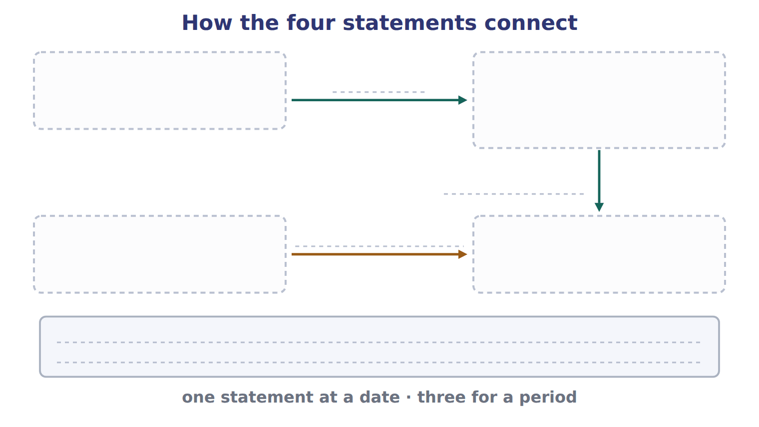
TEACH IT BACK | Write it for an investor who has only ever looked at profit — not for the marker.
24. In three or four sentences, explain why reading the income statement alone is not enough, using Orontes’ January as the example.
every one of these words must appear: net income · cash · balance sheet · period

Answer key · Handout 1.9 · The four statements, and how they link

1 What the company owns today | 9 B | 17 see the key
2 Three cover a period; one reports at a date | 10 A | 18 B
3 D | 11 The balance sheet reports at a date; the other three cover a period. | 19 net income 80
4 B | 12 Retained earnings | 20 increase in retained earnings 30
5 C | 13 Net income, which lands in retained earnings in the statement of changes in equity, and from there on the balance sheet | 21 increase in cash 1,060
6 A | 14 The net change in cash, which explains the cash balance on the balance sheet | 22 Net income into retained earnings, and the net change in cash into the cash balance. Both arrive at the balance sheet.
7 The statement of changes in equity | 15 The balance sheet | 23 Income statement, statement of changes in equity, statement of cash flows (all for a period) and the balance sheet (at a date). Net income runs from the income statement through retained earnings to the balance sheet; the net change in cash runs from the statement of cash flows to the cash balance.
8 see the key | 16 Net income 80 and a cash rise of 1,060 — evidence of the accrual basis | 24 The income statement gives net income for a period, which for Orontes in January was 80, but it says nothing about where the money went. The statement of cash flows shows that cash actually rose by 1,060, almost all of it from owners and lenders rather than from trading. The balance sheet then shows the position at the date the period ended, and both of the other figures have to agree with it.

8 what the book says
The balance sheet shows position at one date. The other statements cover a period.

17 what the book says
Net income flows into retained earnings, and the net change in cash explains the cash balance on the balance sheet.

why
1 The balance sheet shows position at one date. The other statements cover a period.
9 The balance sheet shows position at one date. The other three all cover a period.
10 That statement exists to say why each equity account changed. The balance sheet gives only the closing figure.
18 Net income is accumulated in retained earnings. It does not go into cash, into liabilities, or into common stock, which holds only par value.
19 300 − 180 − 40 = 80.
20 Net income of 80 less the dividend of 50 leaves 30.
21 2,300 − 1,200 − 40 = 1,060, which is the figure the balance sheet’s cash must agree with.

Handout 1.10
Reading a trial balance
Barada Wholesale, Inc. · classify every line, then pull four figures out of it
60 SECONDS | Answer from memory. Do not look anything up.
1. Which statement reports at a date? | 4. A contra account reduces a
2. Net income flows into which equity account? | 5. Dividends declared increase with a debit or a credit?
3. Accumulated depreciation has which normal balance? | 6. What does a trial balance prove?

CYCLE A | Every line has a category

ORIENT

1. Two accounts in a trial balance carry credit balances but are not liabilities and not equity. What are such accounts called?

MODEL A real trial balance. Everything in this handout comes out of it, so keep this page open.

Barada Wholesale, Inc. — trial balance, December 31, 2025 (USD 000)
Account | Debit | Credit
Cash | 1,050
Accounts receivable | 300
Allowance for credit losses |  | 20
Inventory | 420
Prepaid rent | 24
Land | 936
Equipment | 4,200
Accumulated depreciation |  | 900
Accounts payable |  | 380
Dividends payable |  | 50
Notes payable (long-term) |  | 1,800
Common stock |  | 600
Additional paid-in capital |  | 1,900
Retained earnings, January 1 |  | 1,000
Dividends declared | 50
Sales revenue |  | 3,100
Cost of goods sold | 1,860
Wages expense | 520
Depreciation expense | 300
Interest expense | 90
Totals | 9,750 | 9,750
A trial balance lists every account balance and checks that total debits equal total credits.
READ THE MODEL

2. What are the two totals, and what does their agreement prove?

3. Which two accounts in this trial balance are contra-asset accounts?

4. One account name in the list contains a date. Which, and why does the date matter?

5. Which line is an equity account that is reduced rather than increased by its debit balance?

APPLY

SORT THEM | Write each account under its category. Every one of these eight is in the trial balance above.
the items: Prepaid rent · Land · Dividends payable · Additional paid-in capital · Sales revenue · Interest expense · Allowance for credit losses · Accumulated depreciation
Asset | Contra-asset | Liability | Equity | Revenue | Expense

12. Which two accounts in this trial balance are contra-asset accounts?
A. Allowance for credit losses and dividends payable
B. Accumulated depreciation and notes payable
C. Allowance for credit losses and accumulated depreciation
D. Dividends declared and accumulated depreciation
CHECKPOINT 13. Name the two contra-asset accounts in this trial balance and say what each one reduces.

If you could not answer it: redo the sorting item in cycle A with the trial balance open.

CYCLE B | Four figures, with less help each time

ORIENT

14. To find net income from a trial balance, which two kinds of account do you need, and what do you do with them?

MODEL Four jobs a trial balance is used for, and which lines each one takes.

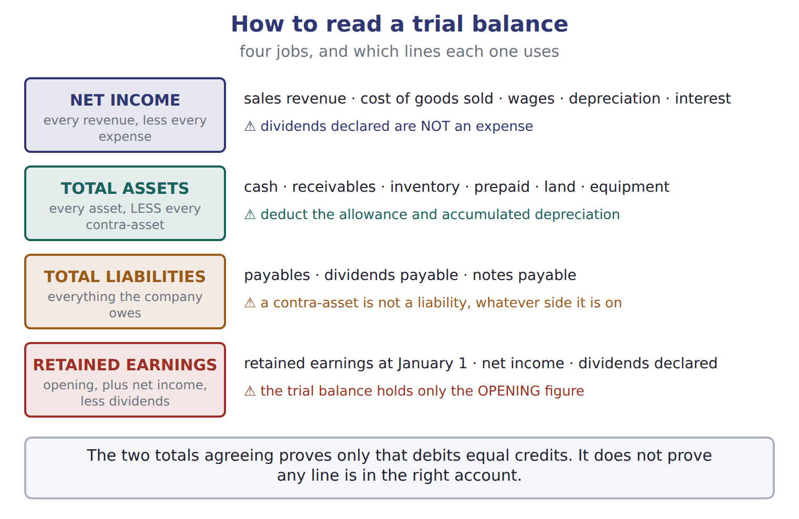
READ THE MODEL

15. Which of the four jobs is the only one that SUBTRACTS some of the lines it uses?

16. Which line does the figure warn is NOT an expense?

17. The figure says the trial balance holds only the OPENING figure for one account. Which account?

MODEL The first job, worked in full, with the reason for each line.

Barada’s net income for 2025 (USD 000)
Sales revenue 3,100 | the only revenue account in the trial balance
less cost of goods sold 1,860 | an expense, matched to those sales by cause and effect
less wages expense 520 | an expense of the period
less depreciation expense 300 | an expense: systematic and rational allocation
less interest expense 90 | an expense of the period
Net income 330 | 3,100 − 1,860 − 520 − 300 − 90. Dividends declared are NOT in this list: a dividend is not an expense

APPLY The second figure, with the lines named but the work left to you.

Complete Barada’s total assets at December 31, 2025. Watch the two lines that are subtracted.
Line | Amount
Cash | 1,050
Accounts receivable | 300
less allowance for credit losses | (20)
Inventory | 420
Prepaid rent | 24
Land | 936
Equipment | 4,200
less accumulated depreciation | (900)
Total assets

WORK IN PAIRS | Compare your total with your partner’s before you go on.
If you disagree: if you differ, check whether both of you deducted the two contra-asset lines. That is where the difference almost always is.
APPLY The last two figures, with no lines given at all.

19. After closing, what are Barada’s retained earnings at December 31, 2025? Show your working.

20. After closing, Barada’s retained earnings at December 31, 2025 are:
A. 330 | C. 1,280
B. 1,000 | D. 1,330
21. What are Barada’s total liabilities at December 31, 2025? Show your working.

22. Check your own work: add total liabilities to total equity and compare with total assets. Write both figures and say whether the equation holds.

CHECKPOINT 23. Which two lines of a trial balance must be SUBTRACTED when you add up total assets?

If you could not answer it: redo the total-assets grid in cycle B, marking the two contra-asset lines before you add.

FROM MEMORY | Close the earlier pages first.
24. Rebuild the four-jobs figure. Name each job, say which lines it uses, and write the trap beside it.
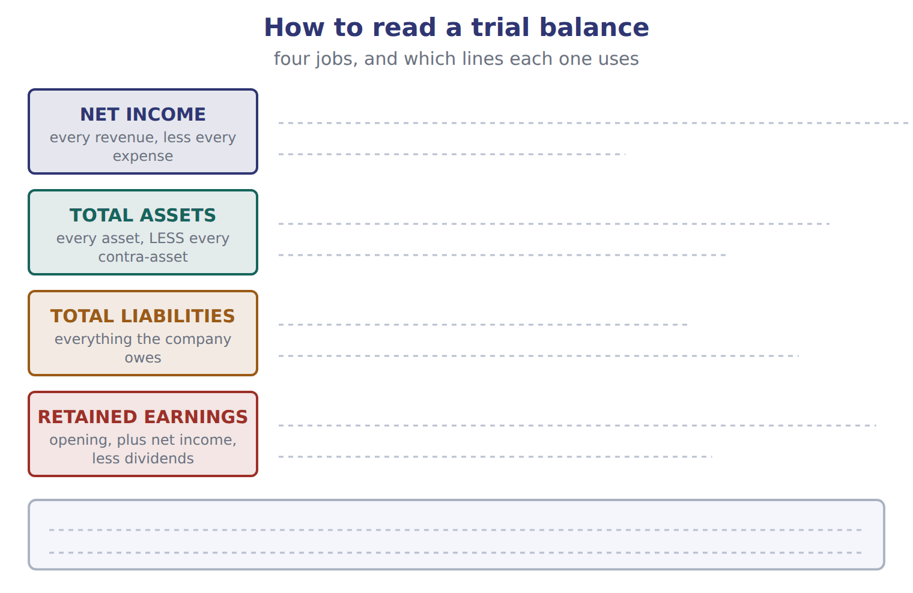
TEACH IT BACK | Write it for a colleague who has to extract figures from a trial balance for the first time — not for the marker.
25. In four or five sentences, explain the order to work in, and the one trap that costs most marks.
every one of these words must appear: revenues · expenses · net income · contra-asset · retained earnings

Answer key · Handout 1.10 · Reading a trial balance

1 Contra-asset accounts | 10 Revenue: sales revenue | 19 1,280
2 9,750 and 9,750 — only that total debits equal total credits | 11 Expense: interest expense | 20 C
3 Allowance for credit losses, and accumulated depreciation | 12 C | 21 2,230
4 Retained earnings, January 1 — it is the opening balance, before this year’s income and dividends | 13 The allowance for credit losses reduces accounts receivable; accumulated depreciation reduces equipment. | 22 2,230 + 3,780 = 6,010, which equals total assets — it holds
5 Dividends declared, 50 | 14 Revenues and expenses — subtract the expenses from the revenues | 23 The allowance for credit losses, and accumulated depreciation.
6 Asset: prepaid rent, land | 15 Total assets — the contra-asset lines are deducted | 24 Net income: every revenue less every expense, and dividends declared are not an expense. Total assets: every asset less every contra-asset. Total liabilities: everything owed, and a contra-asset is not one. Retained earnings: opening plus net income less dividends, and only the opening figure is in the trial balance.
7 Contra-asset: allowance for credit losses, accumulated depreciation | 16 Dividends declared | 25 Work out net income first, by taking every expense away from the revenues, and remember that dividends declared are not an expense. Then take the opening retained earnings, add net income and deduct the dividend to get the closing figure. For total assets, add the asset lines and subtract every contra-asset line, because an allowance or accumulated depreciation reduces an asset even though it carries a credit balance. That subtraction is the trap: adding those two lines instead of deducting them is the commonest error.
8 Liability: dividends payable | 17 Retained earnings
9 Equity: additional paid-in capital | 18 total assets 6,010

why
1 A contra account reduces a related account, so it takes the opposite normal balance.
2 It does not prove that the entries were put in the right accounts.
3 Both reduce an asset — receivables and equipment — and both have credit balances.
12 Both reduce an asset and have credit balances. Dividends payable and notes payable are liabilities, and dividends declared reduces equity rather than an asset.
18 1,050 + 300 − 20 + 420 + 24 + 936 + 4,200 − 900 = 6,010. The two contra-asset accounts are deducted, not added.
19 Retained earnings at January 1 of 1,000, plus net income of 330, less the dividend declared of 50.
20 330 is this year’s net income alone and 1,000 is the opening balance alone. 1,330 forgets to deduct the dividend declared of 50.
21 Accounts payable 380, plus dividends payable 50, plus notes payable 1,800.
22 Equity is common stock 600, plus additional paid-in capital 1,900, plus closing retained earnings 1,280 = 3,780.

Handout 1.11
Reading the question
Four stem words that change the answer · the language of effects · words that mislead
60 SECONDS | Answer from memory. Do not look anything up.
1. Total assets: do you add or deduct accumulated depreciation? | 4. Cash received in advance creates a
2. Net income flows into | 5. A dividend reduces which equity account?
3. Which body sets auditing standards? | 6. Debit is which side?

CYCLE A | Four words that change the answer

ORIENT

1. A question ends "… which of the following is NOT true?". How many of the four options are true?

MODEL Four wordings the exam uses, and what each one is instructing you to do.

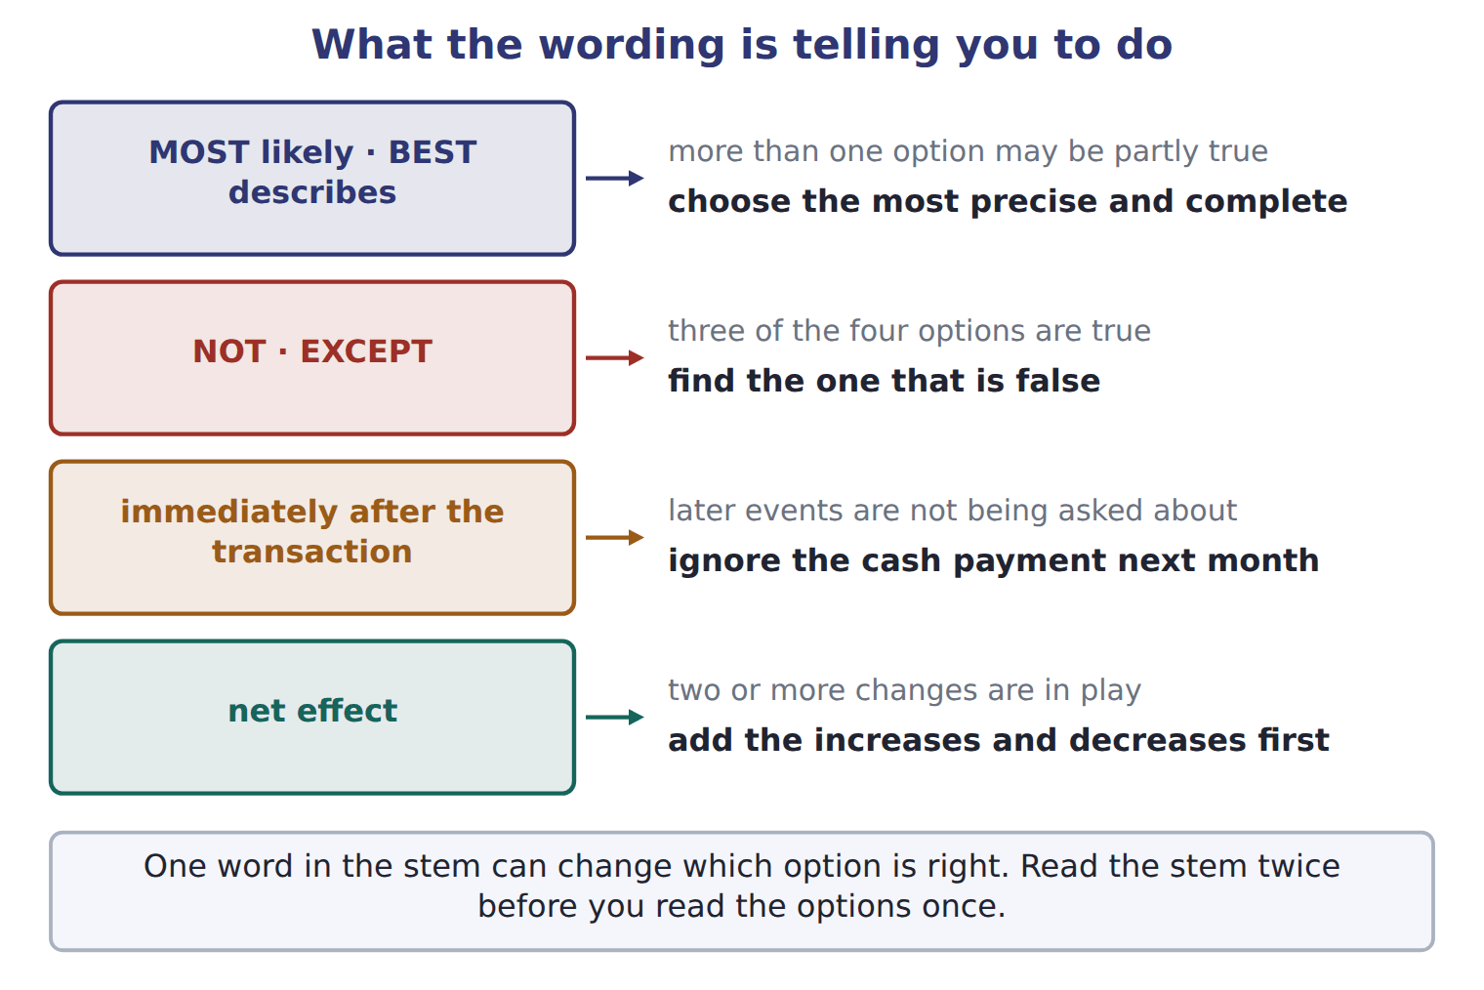

The same four, in a line each
The wording | What it is telling you to do
MOST likely, or BEST describes | more than one option may be partly true — choose the best one
NOT, or EXCEPT | three options are true — find the one that is false
immediately after the transaction | ignore later events, such as the cash payment next month
net effect | add the increases and the decreases together before you answer

READ THE MODEL

2. Write the letter of the instruction beside each wording.
A three options are true; find the false one | C more than one may be partly true; choose the best
B add the increases and decreases together first | D ignore later events

2. MOST likely
3. EXCEPT
4. immediately after the transaction
5. net effect

6. Which of the four wordings tells you that a later cash payment is irrelevant?

APPLY The same facts, asked four ways. Answer all four.

7. The board declares a dividend of 50, payable next month. What is the effect IMMEDIATELY AFTER the declaration on assets?

8. Orontes issues shares for 1,500 and buys equipment for 1,200 in cash. What is the NET EFFECT on total assets?

9. Which of the following is NOT true of a cash dividend declared but not yet paid?
A. It reduces retained earnings.
B. It creates a liability.
C. It reduces net income.
D. It leaves cash unchanged until payment.
10. Accumulated depreciation is BEST described as:
A. an account with a credit balance
B. a contra-asset account with a credit balance
C. an account related to equipment
D. an account in the trial balance
CHECKPOINT 11. A stem says BEST describes and all four options are true. What is the question actually asking you to compare?

If you could not answer it: redo the matching item in cycle A.

CYCLE B | Saying what a transaction did

ORIENT

12. Equity was 1,000 and is now 2,530. Complete both: equity increased BY ______, and increased TO ______.

MODEL Five patterns, with the book’s own examples.

The language of effects
The pattern | An example
debit X, credit Y | Debit Equipment, credit Cash.
X is debited (or credited) for an amount | Cash is debited for 1,500.
an increase IN the item; an increase OF the amount | an increase in assets of 2,380
increase BY the change; increase TO the new total | Equity increased by 1,530.
The effect of this transaction is to increase … and decrease … | the shape most exam stems use

READ THE MODEL

Using the book’s patterns: there was an increase assets 2,380.
15. Rewrite "Cash was debited 1,500" using the pattern the panel gives.

16. "Equity increased to 1,530" and "equity increased by 1,530" mean the same thing. T / F
ERROR HUNT | Five sentences written by a student. Mark each right, or write what is wrong with it. (items 17 to 21)
the solution as written | right, or what is wrong with it
a | Debit Equipment, credit Cash.
b | There was an increase of assets in 2,380.
c | Equity increased to 1,530, from 1,000 to 2,530.
d | Cash is debited for 1,500.
e | The net effect of the share issue and the equipment purchase is to increase assets by 1,500.

CHECKPOINT 22. Fill both gaps: an increase ____ liabilities ____ 850.

If you could not answer it: reread the language-of-effects panel in cycle B.

CYCLE C | Words that mislead a reader coming from Arabic

ORIENT

23. One Arabic word is used for two different accounting items: one that reduces an asset, and one the company owes. Give the English name for each.

MODEL Three habits to unlearn.

Three words that mislead
The word | What it is used for | What to write in English
استهلاك | used in the Gulf for depreciation, but it also means consumption; Levant texts often say اهتلاك and Egyptian texts إهلاك | always depreciation
مخصص | one word for two different things: something that reduces an asset, and something the company owes | an allowance reduces an asset; a provision is a liability
credit, as your bank uses it | your bank credits your account when it receives your money, because the bank now owes you | that is the bank’s view — do not use banking habits to guess the accounting side

READ THE MODEL

24. Whatever the regional spelling, what single English word should always be written for the wearing out of a long-lived asset?

25. Which of the two — an allowance or a provision — sits with the assets?

26. Your bank credits your account when you pay money in. Explain in one sentence why that does not tell you anything about which side to use in your own books.

APPLY

27. A U.S. GAAP answer refers to the amount set aside against receivables that may not be collected. Which name should be used?
A. reserve for bad debts | C. provision for receivables
B. allowance for credit losses | D. depreciation of receivables
SORT THEM | Write each item under what it is.
the items: allowance for credit losses · accumulated depreciation · a provision · dividends payable
reduces an asset | is a liability

CHECKPOINT 30. Give the English the exam wants for an amount that reduces receivables, and say what word must never be used for it.

If you could not answer it: reread the three-words panel in cycle C.

FROM MEMORY | Close the earlier pages first.
31. Rebuild the stem figure. Write all four wordings and, beside each, what it instructs you to do.
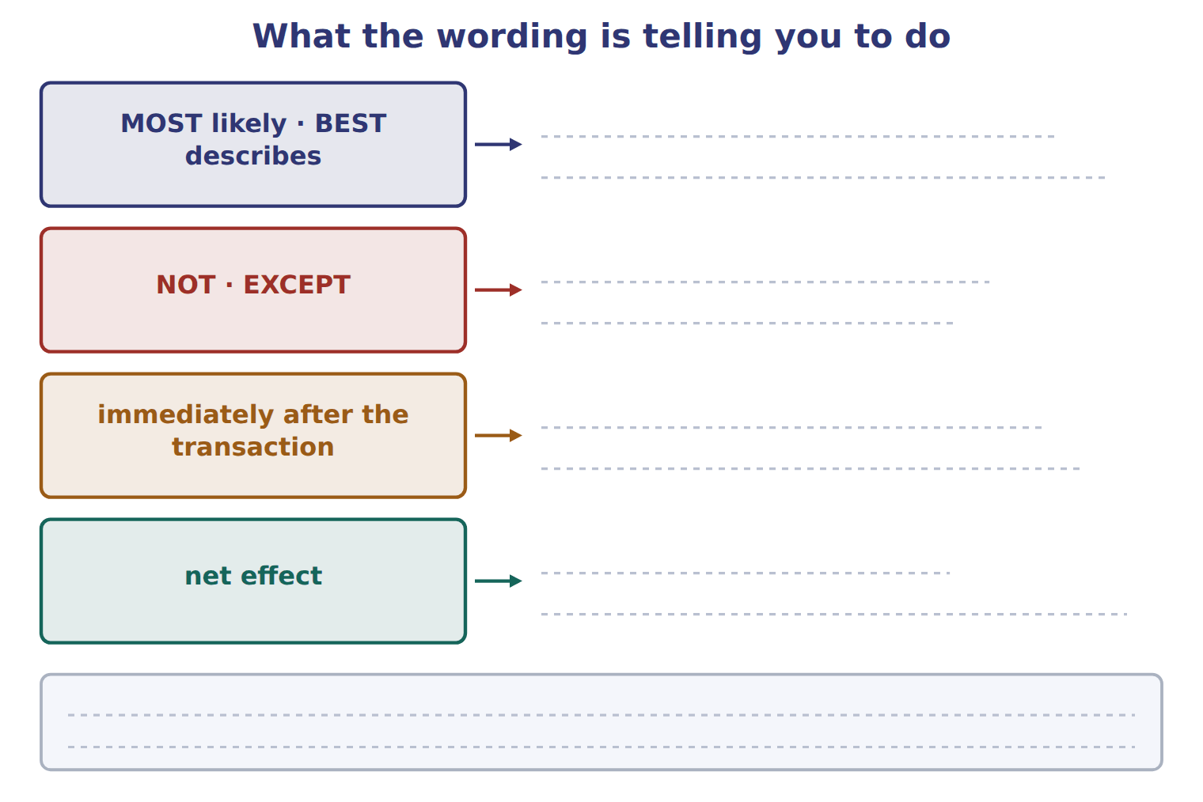
TEACH IT BACK | Write it for a classmate who loses marks on wording rather than on accounting — not for the marker.
32. In three or four sentences, explain what to do when a stem says EXCEPT, what to do when it says immediately after, and why "BEST describes" is not a trick.
every one of these words must appear: EXCEPT · immediately after · BEST · precise

Answer key · Handout 1.11 · Reading the question

1 Three | 12 by 1,530; to 2,530 | 23 An allowance, and a provision
2 C | 13 in | 24 Depreciation
3 A | 14 of | 25 An allowance
4 D | 15 Cash is debited for 1,500 | 26 The bank credits because the bank now owes you — that is the bank’s liability, not yours
5 B | 16 F | 27 B
6 Immediately after the transaction | 17 right | 28 reduces an asset: allowance for credit losses, accumulated depreciation
7 No effect on assets | 18 wrong — an increase IN assets OF 2,380 | 29 is a liability: a provision, dividends payable
8 An increase of 1,500 | 19 wrong — increased BY 1,530, or increased TO 2,530 | 30 Allowance for credit losses; never "reserve for bad debts".
9 C | 20 right | 31 MOST likely or BEST describes: choose the most precise and complete. NOT or EXCEPT: three are true, find the false one. Immediately after the transaction: ignore later events. Net effect: add the increases and decreases first.
10 B | 21 right | 32 When a stem says NOT or EXCEPT, three of the four options are true and the task is to find the false one, so read every option rather than stopping at the first that sounds right. When it says immediately after the transaction, ignore anything that happens later, such as a cash payment next month. BEST describes is not a trick: several options may be partly true, and the task is to pick the most precise and complete one.
11 How precisely and completely each option describes the item — choose the most complete and precise. | 22 an increase IN liabilities OF 850.

why
1 With NOT or EXCEPT, three options are true and you are looking for the false one.
7 Immediately after means before the cash is paid. Liabilities rise by 50 and equity falls by 50.
8 The share issue raises assets by 1,500; buying equipment for cash swaps one asset for another and changes no total.
9 A dividend is a distribution to owners, so it never reaches the income statement. The other three are all true.
10 All four are true. BEST asks for the most complete and precise description, which is the one naming both what it is and which side it sits on.
12 "Increase by" takes the change; "increase to" takes the new total.
13 An increase IN the item, an increase OF the amount.
16 "To" gives the new total; "by" gives the change.
23 An allowance reduces an asset; a provision is a liability.
25 It reduces an asset.
26 Do not use banking habits to guess the accounting side.
27 Never say reserve for bad debts in a U.S. GAAP answer. A provision is a liability, and depreciation applies to long-lived assets.

Handout 1.12
The whole chapter
The map · mixed practice with the topics shuffled · one written explanation
60 SECONDS | Answer from memory. Do not look anything up.
1. The three primary users are | 5. Which body writes U.S. GAAP?
2. Equity = assets − | 6. Which statement reports at a date?
3. Debit increases which three account types? | 7. A dividend reduces which equity account?
4. Which basis does U.S. GAAP require? | 8. Cash received in advance creates a

CYCLE A | How the seven topics depend on each other

ORIENT

1. Everything in this chapter ends at one place. Name it.

MODEL The chapter as a map. The arrows are dependencies: what you have to understand before what.

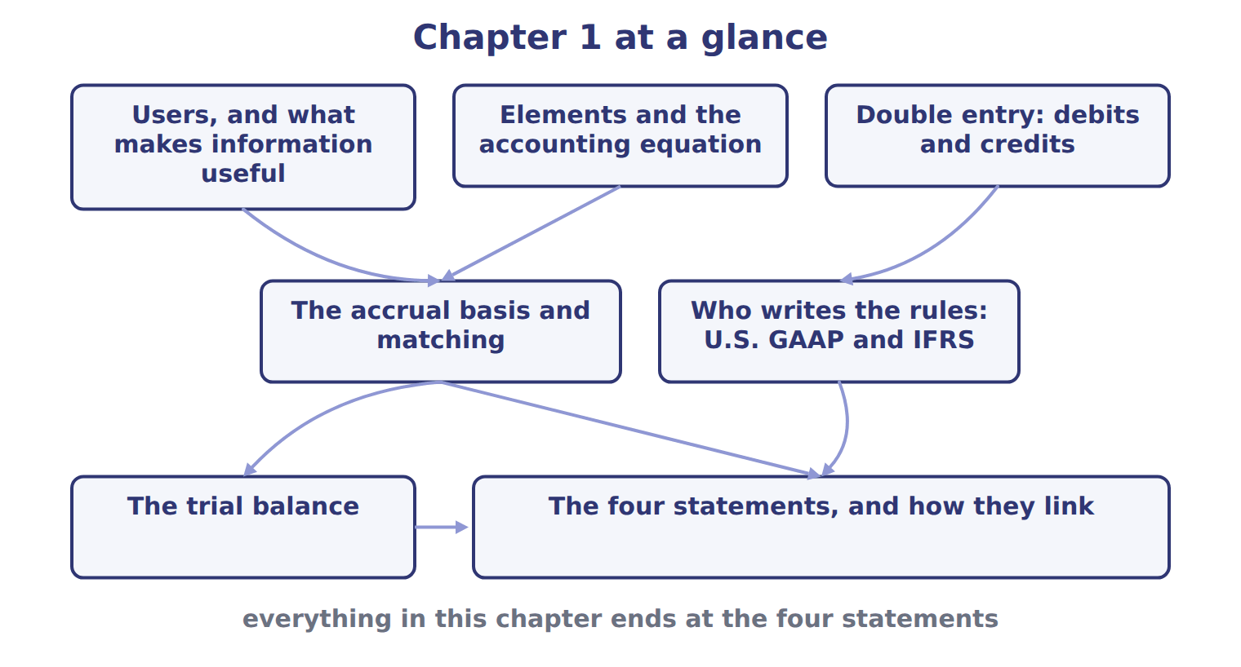
READ THE MODEL

2. Which two topics feed into the accrual basis and matching?

3. Which topic feeds into "who writes the rules"?

4. Which box does the trial balance point into?

5. Pick any one arrow on the map and write, in one sentence, why the topic at its tail has to come first.

The chapter in one worked transaction
Orontes sells olive oil on credit for 300, costing 180 | a revenue and an expense, both from central ongoing operations
Dr Accounts receivable 300; Cr Sales revenue 300 | equal debits and credits, so the equation stays in balance
Dr Cost of goods sold 180; Cr Inventory 180 | the cost is matched to the revenue it produced, by cause and effect
Recorded in the month of delivery, not of payment | the accrual basis decides the period, not the cash
Net income rises by 120, and so does equity | net income flows into retained earnings, which the balance sheet then carries
Cash does not move at all | which is why the statement of cash flows is a separate statement

INVENT THE RULE

6. Write the chapter in two sentences: what the statements are built from, and what decides the period an item falls in.
use every one of these words: elements · accounting equation · accrual · earned · incurred
The statements are built from , which the links as assets = liabilities + equity.
The basis puts revenue in the period it is and an expense in the period it is .

Two topics, and what each one settles
Elements and the accounting equation | The accrual basis and matching
What does it settle? | What does it settle?
Which statement does it describe? | Which statement does it describe?
Does it say anything about WHEN an item is recorded? | Does it say anything about WHEN an item is recorded?
Answer all three rows for each. Then write the one sentence that says why a company needs both and not one or the other.

CHECKPOINT 7. Name the two topics that have to be understood before the accrual basis makes sense.

If you could not answer it: redo the READ THE MODEL questions of cycle A with the map in front of you.

CYCLE B | Mixed practice — the topics deliberately shuffled

ORIENT From here the questions do not come in topic order. Decide what each one is about before you answer it.

8. Write, in two or three words each, the topic that each of the next eight questions will be about once you have read it. Do this after you answer them, as a check.

The six topics these questions are drawn from
Topic | The question it answers
Users and the qualities | who the statements are for, and what makes a number useful
Elements and the equation | what the statements are built from
Double entry | which side of an account increases it
The accrual basis and matching | which period an item falls in
Who writes the rules | which body produces what, and where it is kept
The four statements | what each one reports, and how they join up
Name the topic of each question below before you answer it.
APPLY

9. A company has assets of 900 and liabilities of 350. It then borrows 100 in cash and declares and pays a cash dividend of 40. What is total equity after these transactions?
A. 450 | C. 550
B. 510 | D. 610
10. Which statement explains why retained earnings changed during the year?
A. The statement of changes in equity | C. The statement of cash flows
B. The balance sheet | D. The income statement
11. Comprehensive income is the total change in equity from sources other than owners. T / F
12. Orontes receives 800 in cash from a bank on a five-year note. Immediately after, which pair of totals has risen?
A. assets and equity | C. assets and revenue
B. assets and liabilities | D. liabilities and equity
13. Which of the following is NOT a fundamental quality of useful information?
A. relevance | C. comparability
B. faithful representation | D. materiality
14. A company pays 24 for twelve months of rent in advance. What is the NET EFFECT on total assets immediately after the payment?
A. an increase of 24
B. a decrease of 24
C. no change
D. it depends on when the rent is used
15. Which account would you expect to find with a credit balance in a trial balance?
A. Prepaid rent | C. Inventory
B. Dividends declared | D. Allowance for credit losses
16. Which body’s standards does the CMA exam test, and which body’s does it ask you to compare them with?
A. FASB, and the IASB | C. IASB, and the FASB
B. SEC, and the PCAOB | D. PCAOB, and the SEC
WORK IN PAIRS | Compare all eight answers with your partner before you read any key.
If you disagree: for each one you disagree on, say which topic the question belongs to first. Most disagreements turn out to be about the topic rather than the answer.

CHECKPOINT 17. Of the eight questions you have just answered, which one did you find hardest to place in a topic? Name the topic it belonged to.

If you could not answer it: go back to the MODEL move of cycle A and find the box on the map that the question belonged in.

FROM MEMORY | Close the earlier pages first.
18. Rebuild the chapter map from memory. Draw all seven boxes and the arrows between them.
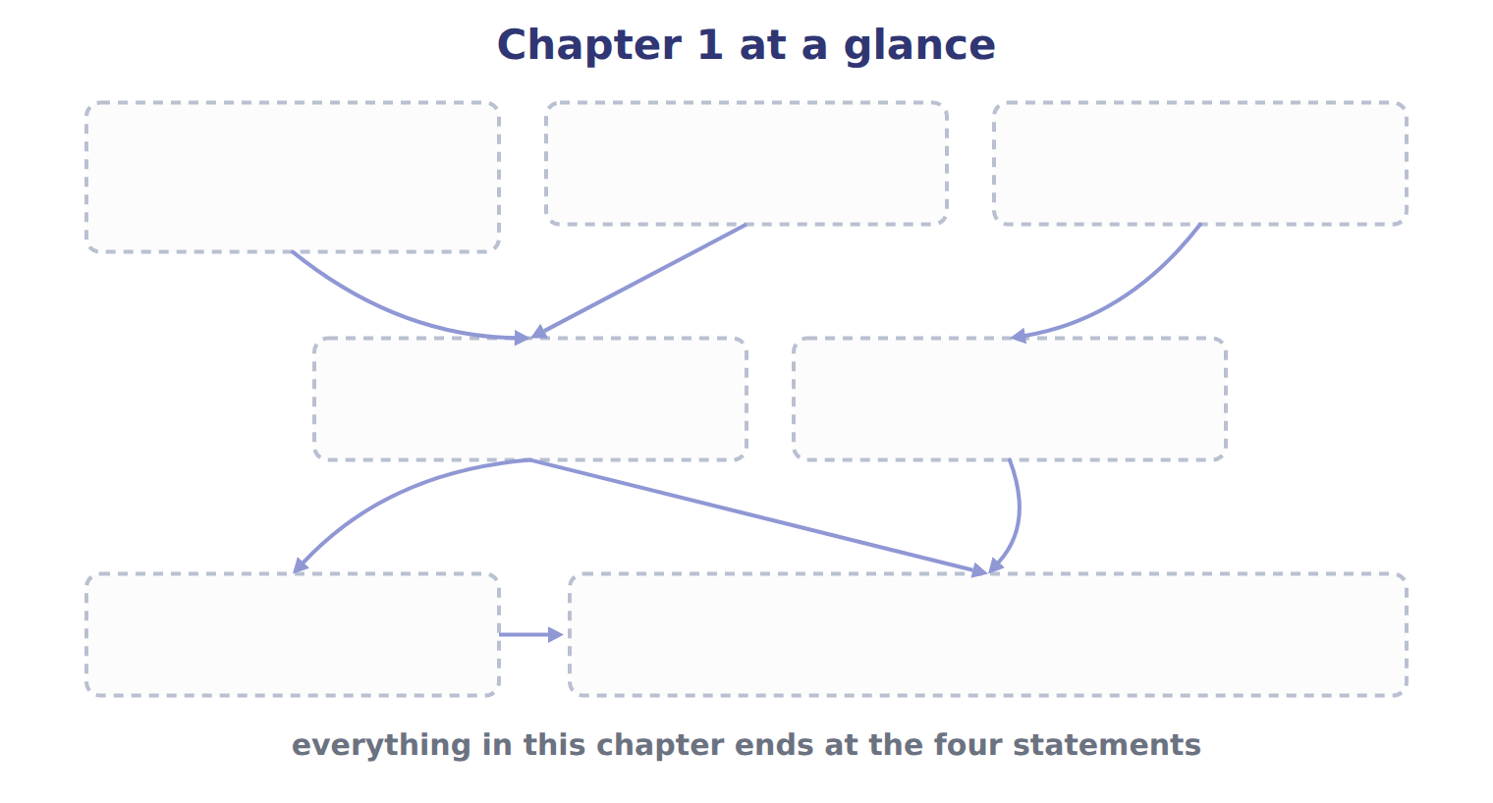
TEACH IT BACK | Write it for a student starting this chapter tomorrow — not for the marker.
19. In five or six sentences, write the whole chapter: who the statements are for, what they are built from, how a transaction is recorded, what decides the period, who writes the rules, and how the four statements join up.
every one of these words must appear: primary users · elements · accounting equation · debits · accrual basis · net income

Answer key · Handout 1.12 · The whole chapter

1 The four statements | 8 Answers will vary; the point is that you can name the topic from the stem | 15 D
2 Users and what makes information useful, and elements and the accounting equation | 9 B | 16 A
3 Double entry: debits and credits | 10 A | 17 Answers will vary; the topic names are users and qualities, elements and the equation, double entry, the accrual basis, the rule makers, and the four statements.
4 The four statements | 11 T | 18 Users and qualities, elements and the equation, and double entry at the top; the accrual basis and matching, and who writes the rules, in the middle; the trial balance and the four statements at the foot, with everything ending at the four statements.
5 Any defensible answer, for example: you cannot classify a transaction into assets and equity until you know what the elements are | 12 B | 19 General-purpose financial statements serve investors, lenders and other creditors, and useful information is relevant and faithfully represented. The statements are built from elements that the accounting equation links: assets equal liabilities plus equity. Every transaction is recorded with equal debits and credits. The accrual basis records revenues when they are earned and expenses when they are incurred, and matches expenses to the revenues they help to produce. The FASB writes U.S. GAAP in the Codification and the IASB writes IFRS; the exam uses U.S. GAAP and tests the main differences. The balance sheet shows one date while the other three statements cover a period, and net income and cash are what link them.
6 see the key | 13 C
7 Users and the qualities of useful information, and the elements with the accounting equation. | 14 C

6 what the book says
The statements are built from elements that the accounting equation links: assets equal liabilities plus equity. Every transaction is recorded with equal debits and credits. The accrual basis records revenues when they are earned and expenses when they are incurred, and it matches expenses to the revenues they help to produce.

why
5 The map records dependencies, not an order of importance.
9 Equity began at 550. Borrowing leaves equity alone; the dividend of 40 reduces it to 510.
10 The balance sheet gives only the closing figure.
11 That is the book’s definition of the element.
12 Cash from borrowing is financing, not revenue, and it does not touch the owners’ claim.
13 Comparability is an enhancing quality. Materiality is part of relevance, which is fundamental.
14 Cash of 24 becomes prepaid rent of 24: one asset becomes another, so no total moves.
15 It is a contra-asset account, so it takes the opposite side to the asset it reduces. The other three are all debits.
16 The exam tests U.S. GAAP, which the FASB writes, and asks about the main differences from IFRS, which the IASB writes.

Handout 7.1
Which goods are ours
Control at the year-end date · goods in transit · consignment · goods held for other people
CYCLE A | The rule is control, not location

ORIENT Two minutes, alone.

1. Goods sit in a company’s own warehouse on December 31. Is that enough to put them in its inventory? Answer yes or no.

2. A manufacturer such as Orontes has three inventory accounts rather than one. Name them.

MODEL Three questions. Work down them for every year-end item an exam question gives you.

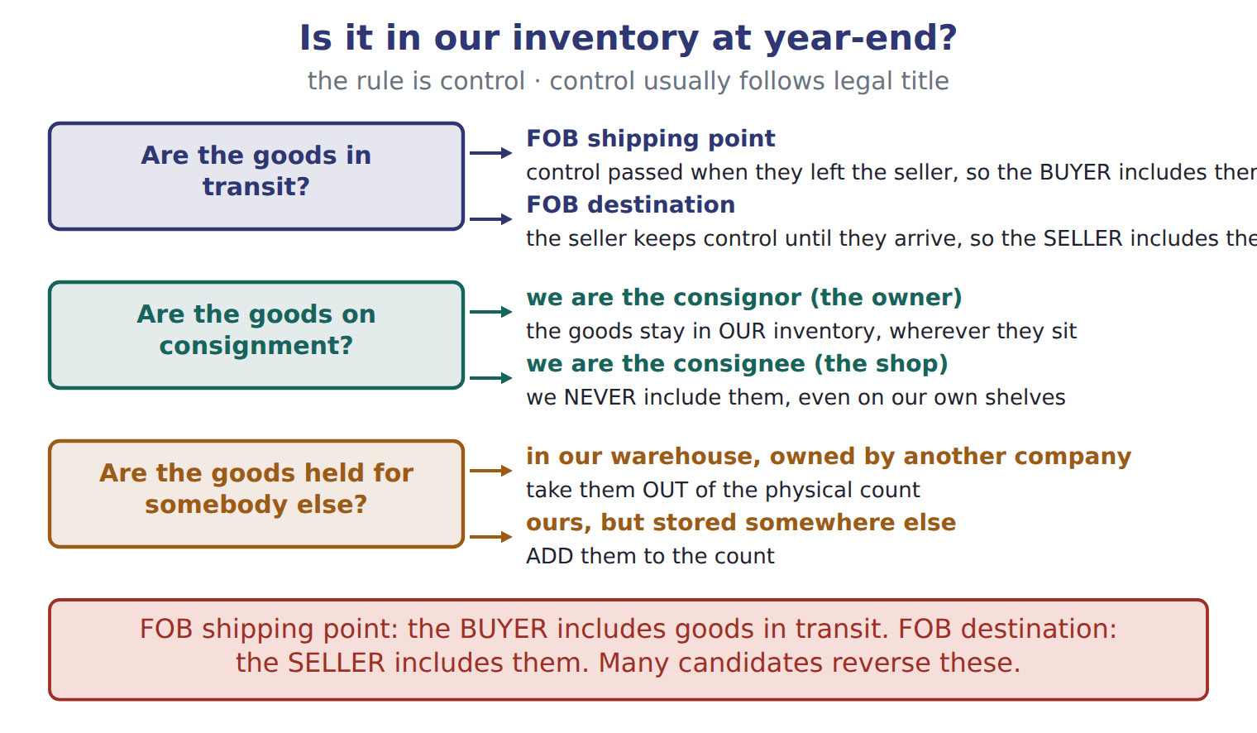
READ THE MODEL

3. Under FOB shipping point, who includes goods that are on a truck at the year end?

4. Under FOB destination, who includes them?

5. In a consignment, which of the two parties includes the goods, and which never does?

6. Goods belonging to another company are sitting in our warehouse and were counted. What must be done to the count?

7. Our goods are stored in somebody else’s building and were not counted. What must be done to the count?

WORK IN PAIRS | Answer the next item alone, then compare.
If you disagree: ask which company controlled the goods on December 31. Control settles it, not where the goods were standing.
INVENT THE RULE

8. Write the single test that answers all three questions in the figure.
use every one of these words: controls · date · title
Include the goods the company on the balance sheet , wherever they are.
Control usually follows legal .

The same truck, two shipping terms
Shipped December 28, FOB shipping point | Shipped December 28, FOB destination
Where are the goods on December 31? On the truck. | Where are the goods on December 31? On the truck.
Who controlled them on December 31? | Who controlled them on December 31?
Whose inventory? | Whose inventory?
Only the shipping term differs. Answer both questions for each, and write the word in the term that tells you where control passes.

APPLY

9. On December 28, a supplier in Türkiye ships glass bottles to Orontes, FOB shipping point. They arrive on January 4. Who includes the bottles in inventory at December 31?
A. The supplier, the seller
B. Neither company until the bottles arrive
C. Both companies, half each
D. Orontes, the buyer
10. Barada Wholesale holds cartons of Orontes tahini on consignment and sells them for a commission. Which statement is correct at year-end?
A. Orontes includes the cartons in inventory; Barada does not.
B. Barada includes the cartons because they are in its warehouse.
C. Both companies include the cartons.
D. Neither company includes the cartons until they are sold.
11. A seller ships goods on December 30, FOB destination. The goods arrive on January 2. At December 31, the goods should be:
A. included in the buyer’s inventory.
B. included in the seller’s inventory, with no sale recorded yet.
C. removed from the seller’s inventory, with a sale recorded.
D. excluded from both companies’ inventories.
CHECKPOINT 12. Under FOB shipping point, who includes goods in transit? And under FOB destination?

If you could not answer it: redo the READ THE MODEL questions of cycle A with the figure in front of you.

CYCLE B | Adjusting a physical count

ORIENT

13. A warehouse count is a count of what is standing in the building. Name one kind of item it will miss, and one it will wrongly include.

MODEL A count, and four memo items. Each memo item moves the count up, down or not at all.

A warehouse count, adjusted
Physical count in the warehouse | what was standing in the building on the count date
Goods bought FOB shipping point, still on the truck | ADD — control passed to us when they left the seller
Goods sold FOB destination, not yet arrived | ADD — we keep control until they arrive
Goods in our warehouse belonging to another company | SUBTRACT — we never controlled them
Our goods sitting with a consignee | ADD — a consignor keeps the goods in its own inventory

READ THE MODEL

SORT THEM | Write each item under what it does to the physical count.
the items: bought FOB shipping point, in transit · sold FOB destination, in transit · held in our warehouse for another company · ours, sitting with a consignee · held by us on consignment for a consignor
Add to the count | Subtract from the count | No adjustment

17. Two of the five items in the trace are ADD because of a shipping term, and one is ADD for a different reason. What is that reason?

APPLY

A warehouse counted 7,500 cartons. Work the four memo items through and give the adjusted count.
Memo item | Cartons | Add, subtract or no change
Physical count | 7,500 | the starting point
Bought December 29, FOB shipping point, on the truck | 1,000
Shipped to a customer December 30, FOB destination | 500
In our warehouse, owned by a Beirut producer, and counted | 800
Ours, placed with a Doha consignee, not counted | 300
Adjusted count

CHECKPOINT 23. Our goods are sitting in a consignee’s shop and were not counted. Add, subtract, or no change?

If you could not answer it: redo the sorting item in cycle B.

FROM MEMORY | Close the earlier pages first.
24. Rebuild the three-question figure. Write both branches of each question and what each branch decides.
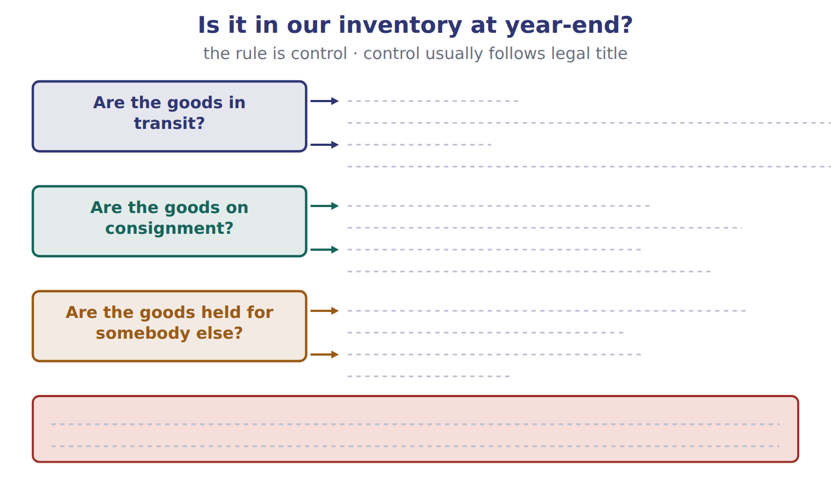
TEACH IT BACK | Write it for a warehouse manager who is about to do the year-end count — not for the marker.
25. In three or four sentences, tell them what the count will get wrong on its own, and what you will need from them to fix it.
every one of these words must appear: control · in transit · consignment · FOB

Answer key · Handout 7.1 · Which goods are ours

1 No | 10 A | 19 add 500
2 Raw materials, work in process, finished goods | 11 B | 20 subtract 800
3 The buyer | 12 FOB shipping point: the buyer. FOB destination: the seller. | 21 add 300
4 The seller | 13 It misses our goods held elsewhere; it wrongly includes other people’s goods held by us | 22 adjusted count 8,500
5 The consignor includes them; the consignee never does | 14 Add: bought FOB shipping point; sold FOB destination; ours with a consignee | 23 Add — a consignor keeps consigned goods in its own inventory.
6 They must be taken out of it | 15 Subtract: held in our warehouse for another company | 24 In transit: FOB shipping point, the buyer includes them; FOB destination, the seller does. On consignment: the consignor includes them, the consignee never does. Held for someone else: other people’s goods come out of the count, our goods held elsewhere go in.
7 They must be added to it | 16 No adjustment: goods we hold as consignee were never ours to count | 25 The count records what is standing in the building, but the rule is control on the year-end date, wherever the goods are. So it will miss goods in transit that are already ours under FOB shipping point, and goods of ours sitting with a consignee. It will also wrongly include anything in the building that belongs to somebody else. What is needed is a memo listing every shipment in transit with its FOB term, and every consignment in either direction.
8 see the key | 17 We are the consignor, so goods with a consignee are still ours
9 D | 18 add 1,000

8 what the book says
The basic rule is simple: include the goods that the company controls on the balance sheet date, wherever they are. Control usually follows legal title.

why
1 The rule is control, wherever the goods are. Goods in the warehouse that belong to another company must be taken out of the count.
2 A retailer has one inventory account; a manufacturer has three.
3 Control passes to the buyer when the goods leave the seller.
4 The seller keeps control until the goods arrive.
5 The goods stay in the consignor’s inventory, even though they sit in the consignee’s shop.
9 Under FOB shipping point, control passes to the buyer when the goods leave the seller. The seller keeps goods in transit only under FOB destination, and goods are never split between two inventories.
10 Orontes is the consignor and still owns the goods. Barada, the consignee, never includes them.
11 Under FOB destination the seller keeps control until arrival, so the goods are still its inventory and no sale has happened.
16 A consignee never includes consigned goods, so if they were counted they come out, and if they were not, nothing changes.
18 Control passed to us when the goods left the seller.
19 Under FOB destination we keep control until they arrive.
20 They were never ours, and they were counted, so they come out.
21 A consignor keeps consigned goods in its own inventory.
22 7,500 + 1,000 + 500 − 800 + 300 = 8,500.

Handout 7.2
Which costs go into the asset
Inventoriable against period · normal capacity · abnormal waste
60 SECONDS | Answer from memory. Do not look anything up.
1. Under FOB shipping point, who includes goods in transit? | 4. Our goods at a consignee: add or subtract from the count?
2. Does a consignee include consigned goods? | 5. A manufacturer has how many inventory accounts?
3. The rule for which goods are ours is | 6. Other people’s goods in our warehouse: add or subtract?

CYCLE A | One test, applied to every cost

ORIENT

1. Freight paid to get goods INTO the warehouse, and freight paid to send them OUT to a customer. Only one of the two helps bring the goods to their present condition and location. Which?

MODEL Two columns. The rule above each column is the only thing worth memorising; the lists follow from it.

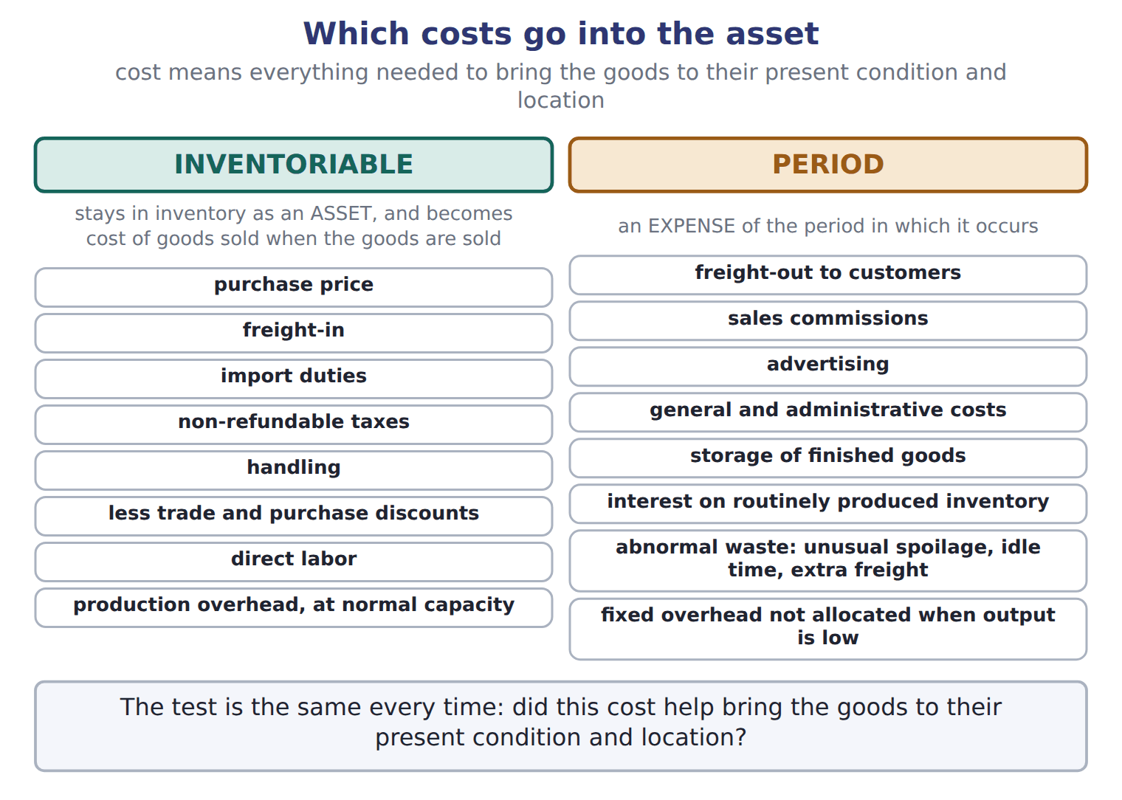
READ THE MODEL

2. Write the test that decides which column a cost goes in.

3. What happens to an inventoriable cost when the goods are sold?

4. The figure lists one item that REDUCES inventory cost rather than adding to it. Which?

5. On what basis is fixed production overhead allocated to units, and what happens to the part that is not allocated?

6. Name the three things the figure counts as abnormal waste.

WORK IN PAIRS | Answer the next item alone, then compare.
If you disagree: ask whether the cost happened before or after the goods were ready for use. That is nearly always what settles it.
INVENT THE RULE

7. Write the rule in one sentence, and say where each kind of cost ends up.
use every one of these words: condition · location · asset · period
A cost is inventoriable if it was needed to bring the goods to their present and .
An inventoriable cost stays as an until the goods are sold. A cost is an expense straight away.

Two kinds of freight, in the same month
Freight-in from the port to the Amman plant | Freight-out when filled bottles go to customers
Does it happen before or after the goods are ready? | Does it happen before or after the goods are ready?
Does it bring them to their present location? | Does it bring them to their present location?
Inventoriable or period? | Inventoriable or period?
Both are freight, and both are paid to a haulier. Answer all three rows for each, and write the one word that tells them apart.

APPLY

8. Which cost is included in the cost of inventory?
A. Freight-out to customers | C. Freight-in on purchased goods
B. Sales commissions | D. Storage of finished goods
9. Which item is a period cost for Orontes?
A. Import duties on sesame seeds | C. Wages of bottling-line workers
B. Freight-in on glass bottles | D. Advertising for a new tahini brand
10. A strike cut production far below normal capacity. How should the fixed production overhead that was not allocated to units be treated?
A. As an expense of the period
B. Added to the cost of the units produced
C. Deferred as an asset to next year
D. Charged directly to retained earnings
CHECKPOINT 11. Give the one test for an inventoriable cost, and name two costs that fail it.

If you could not answer it: redo the READ THE MODEL questions of cycle A with the figure in front of you.

CYCLE B | Costing one shipment, line by line

ORIENT

12. An invoice is $20,000 and the buyer pays early, taking a 2% discount. What is the discount in dollars?

MODEL Orontes imports glass bottles for the Amman plant. Seven lines, each marked.

The cost of imported glass bottles (whole dollars)
Item | Amount | Inventory cost?
Invoice price | 20,000 | Yes
Purchase discount taken | (400) | Yes (reduces cost)
Freight-in from the port to Amman | 1,200 | Yes
Import duty (not refundable) | 900 | Yes
Insurance while the bottles are in transit | 300 | Yes
Freight-out when filled bottles go to customers | 700 | No: selling expense
Storage of finished olive oil | 250 | No: period cost
Cost of the bottles in inventory | 22,000
The last two lines happen after the goods are ready for use.
READ THE MODEL

13. How many of the seven lines are inventoriable, and how many are not?

14. Which line is shown in brackets, and why does it appear with a minus?

15. Add the five inventoriable lines. What is the cost of the bottles in inventory?

16. Write the reason the panel gives for leaving the last two lines out.

ERROR HUNT | A junior has costed the same shipment four ways. Mark each one right, or write what is wrong with it. (items 17 to 20)
the solution as written | right, or what is wrong with it
a | 20,000 + 1,200 + 900 + 300 = 22,400
b | 20,000 − 400 + 1,200 + 900 + 300 = 22,000
c | 20,000 − 400 + 1,200 + 900 + 300 + 700 + 250 = 22,950
d | 20,000 + 1,200 − 400 = 20,800

APPLY

21. Using the glass-bottle panel above, what is the cost of the bottles in inventory (whole USD)?
A. 20,800 | C. 22,400
B. 22,000 | D. 22,950
22. IAS 2 lists the same exclusions as U.S. GAAP for the cost of inventory. Name the one big IFRS difference the chapter warns is coming, and say which section it belongs to.

CHECKPOINT 23. Of these four, which three are inventoriable: import duty, freight-in, sales commission, transit insurance?

If you could not answer it: redo the error hunt in cycle B.

FROM MEMORY | Close the earlier pages first.
24. Rebuild the two-column figure. Write the rule above each column and at least five items under each.
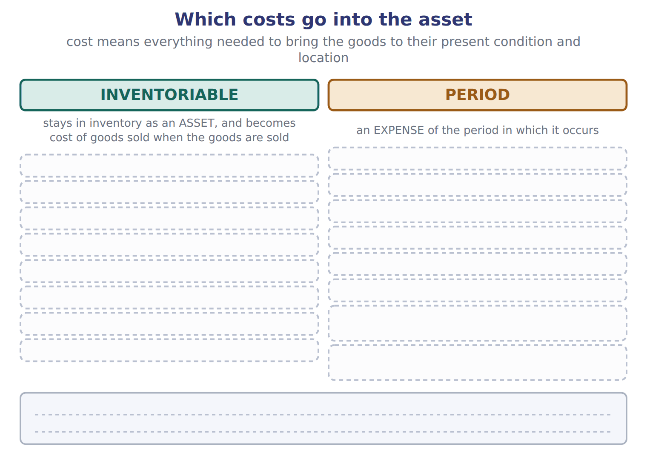
TEACH IT BACK | Write it for a buyer who wants to know why the discount they negotiated does not show up as income — not for the marker.
25. In three or four sentences, explain where a purchase discount goes and why.
every one of these words must appear: cost · inventory · reduces · cost of goods sold

Answer key · Handout 7.2 · Which costs go into the asset

1 Freight-in | 10 A | 19 wrong — freight-out and storage are period costs, not inventory cost
2 Did it help bring the goods to their present condition and location? | 11 Did it bring the goods to their present condition and location? Freight-out and storage of finished goods both fail it. | 20 wrong — the import duty and the transit insurance are missing
3 It becomes cost of goods sold | 12 400 | 21 B
4 Trade and purchase discounts | 13 Five are; two are not | 22 IAS 2 does not allow LIFO — it belongs to the cost flow assumptions
5 On normal capacity; the unallocated part is an expense of the period | 14 The purchase discount taken — it reduces the cost | 23 Import duty, freight-in and transit insurance. The sales commission is a period cost.
6 Unusual spoilage, idle time, extra freight | 15 22,000 | 24 Inventoriable: purchase price, freight-in, import duties, non-refundable taxes, handling, less discounts, direct labour, production overhead at normal capacity. Period: freight-out, sales commissions, advertising, general and administrative costs, storage of finished goods, interest, abnormal waste, unallocated fixed overhead.
7 see the key | 16 They happen after the goods are ready for use, so they do not bring them to their present condition and location | 25 A purchase discount taken is not income; it reduces what the goods cost. Inventory is recorded at the cost of bringing the goods to their present condition and location, and the discount lowers that cost. So it sits in the asset until the goods are sold, and then it shows up as a lower cost of goods sold, which raises gross profit in the period of the sale rather than the period of the purchase.
8 C | 17 wrong — the purchase discount of 400 has been left out
9 D | 18 right

7 what the book says
Cost means all the costs needed to bring the goods to their present condition and location. These are inventoriable costs: they stay in inventory as an asset, and they become cost of goods sold when the goods are sold. Other costs are period costs: they are expenses in the period in which they occur.

why
1 Freight-out happens after the goods are ready, so it is a selling expense.
5 Normal capacity is the output the plant expects on average over several periods. If output is unusually low, the fixed overhead that is not allocated is an expense. It is not added to inventory.
8 Only freight-in helps bring the goods to their present condition and location. The other three all happen after the goods are ready.
9 Advertising has no part in bringing goods to their condition and location. Duties, freight-in and direct labour all do.
10 Fixed overhead is allocated on normal capacity. What is not allocated when output is unusually low is an expense, not inventory cost.
12 2% of 20,000.
15 20,000 − 400 + 1,200 + 900 + 300 = 22,000.
21 20,800 drops the duty and the insurance; 22,400 forgets the discount; 22,950 wrongly adds freight-out and storage.
22 IAS 2 uses the same idea of cost and lists the same exclusions: abnormal waste, storage, administrative overheads and selling costs.

Handout 7.3
Three ways to cut one total
Goods available for sale · specific identification, FIFO, LIFO and the weighted average
60 SECONDS | Answer from memory. Do not look anything up.
1. Which test decides an inventoriable cost? | 4. A purchase discount taken does what to cost?
2. Freight-out is which kind of cost? | 5. Abnormal waste is inventoriable: true or false?
3. Fixed overhead is allocated on which basis? | 6. Under FOB destination, who includes goods in transit?

CYCLE A | One total, and the cut that splits it

ORIENT

1. A company starts the year with goods, buys more, and sells some. Every unit it had is now in one of two places. Name both.

MODEL The whole chapter in one equation. Read the two boxes and where each one is reported.

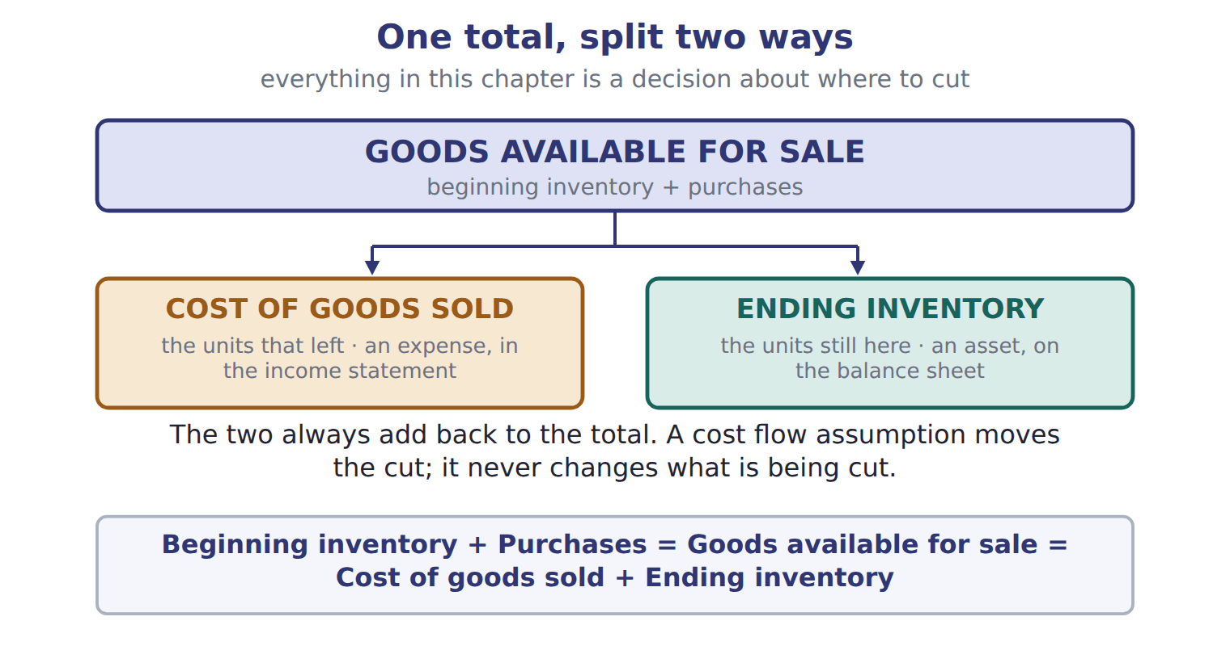
READ THE MODEL

Beginning inventory + = goods available for sale = + .
5. Which of the two halves is an expense, and which is an asset?

6. Write the sentence under the figure that says what a cost flow assumption does and does not do.

7. A cost flow assumption has to match the order in which the goods physically move. T / F

MODEL The four methods, in a line each.

The four cost flow assumptions
Method | What it sends to cost of goods sold
Specific identification | the actual cost of each item — suits unique, expensive items such as cars or jewelry
FIFO (first-in, first-out) | the OLDEST costs, so ending inventory holds the newest
LIFO (last-in, first-out) | the NEWEST costs, so ending inventory holds the oldest
Weighted-average cost | one unit cost for everything: the cost of goods available divided by the units available

INVENT THE RULE

8. Write what FIFO and LIFO leave behind in ending inventory, from what each one sends out.
use every one of these words: oldest · newest
FIFO sends the costs out, so ending inventory holds the costs.
LIFO sends the costs out, so ending inventory holds the costs.

The same 2,000 cases left, priced two ways
FIFO | LIFO
Which costs went out? The oldest. | Which costs went out? The newest.
So which costs are left? | So which costs are left?
At $50 a case, what is ending inventory? | At $40 and $44 a case, what is ending inventory?
The units left are identical. Answer all three rows for each, and write the one sentence that says why the two answers differ.

CHECKPOINT 9. Under LIFO, ending inventory holds which costs — the oldest or the newest?

If you could not answer it: redo the contrasting cases in cycle A.

CYCLE B | The same facts, costed three ways

ORIENT

10. 8,000 cases cost 372,000 in total. What is the average cost of one case?

MODEL Orontes sells premium olive oil in cases of twelve bottles, and prices rose during 2025.

Orontes olive oil, 2025 · a periodic system
Date | What happened | Cases | Unit cost | Total
Jan 1 | Beginning inventory | 1,000 | $40 | 40,000
during the year | Purchase | 2,000 | $44 | 88,000
during the year | Purchase | 3,000 | $48 | 144,000
during the year | Purchase | 2,000 | $50 | 100,000
 | Goods available for sale | 8,000 |  | 372,000
during the year | Sold at $70 | 6,000
Dec 31 | Cases left | 2,000

READ THE MODEL

11. How many cases were available in total, and what did they cost?

12. How many cases were sold, and how many are left?

13. Which purchase was the most expensive per case, and which layer is the oldest?

PREDICT FIRST | Before you see the answers: of FIFO, LIFO and the weighted average, write which you expect to give the HIGHEST ending inventory, and why.
what I think will happen | what the figures actually show
FIFO gives the highest, 100,000, because prices rose and FIFO leaves the newest and dearest costs in inventory.

MODEL The three cuts, drawn on the layers.

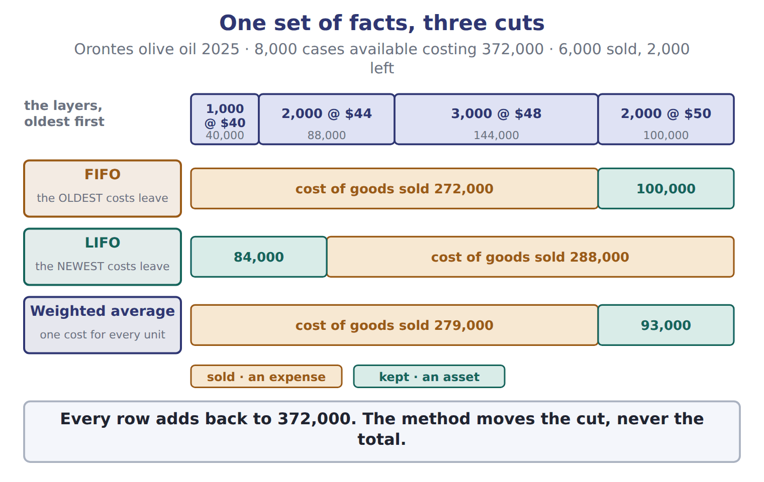
READ THE MODEL

14. Under FIFO, what is ending inventory and what is cost of goods sold?

15. Under LIFO, which two layers make up ending inventory?

16. Add ending inventory and cost of goods sold for each of the three rows. What do you get every time?

APPLY

17. In the Orontes olive-oil example above, what is FIFO cost of goods sold (whole USD)?
A. 100,000 | C. 279,000
B. 272,000 | D. 288,000
18. What is the weighted-average cost per case of olive oil in the example above?
A. $40.00 | C. $46.50
B. $45.50 | D. $50.00
19. Under LIFO, ending inventory consists of:
A. the newest costs.
B. an average of all costs.
C. the actual cost of each unit still on hand.
D. the oldest costs.
20. Specific identification is MOST appropriate for:
A. unique, high-value items such as cars.
B. large volumes of identical glass bottles.
C. any items when prices are rising.
D. perishable food products.
21. Beginning inventory was 100 units at $10. The company bought 200 units at $12 and then 100 units at $15. It sold 250 units. Using periodic LIFO, what is ending inventory?
A. 1,600 | C. 2,100
B. 1,838 | D. 3,300
CHECKPOINT 22. Ending inventory plus cost of goods sold equals what, under every method?

If you could not answer it: redo the READ THE MODEL questions of cycle B with the layers figure in front of you.

FROM MEMORY | Close the earlier pages first.
23. Rebuild the layers figure. Draw the four layers in order, then show where FIFO and where LIFO cut, and write both figures for each.
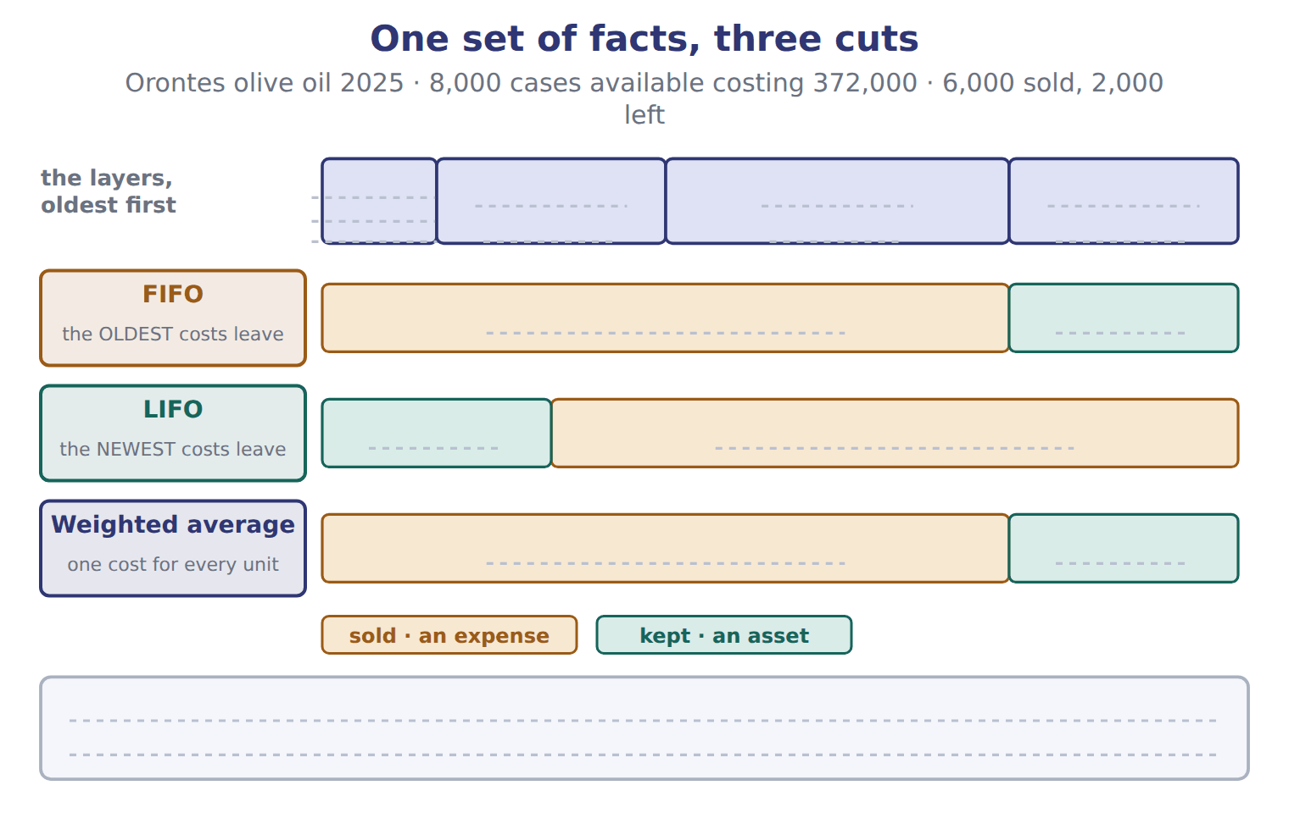
TEACH IT BACK | Write it for a classmate who thinks LIFO means the company ships its newest bottles first — not for the marker.
24. In three or four sentences, explain what a cost flow assumption is actually about.
every one of these words must appear: costs · physical flow · assumption · ending inventory

Answer key · Handout 7.3 · Three ways to cut one total

1 Cost of goods sold, and ending inventory | 9 The oldest. | 17 B
2 purchases | 10 $46.50 | 18 C
3 cost of goods sold | 11 8,000 cases costing 372,000 | 19 D
4 ending inventory | 12 6,000 sold, 2,000 left | 20 A
5 Cost of goods sold is an expense; ending inventory is an asset | 13 The 2,000 at $50 was dearest; the 1,000 at $40 is the oldest | 21 A
6 It moves the cut; it never changes what is being cut | 14 Ending inventory 100,000; cost of goods sold 272,000 | 22 The cost of goods available for sale.
7 F | 15 1,000 at $40 and 1,000 at $44, giving 84,000 | 23 Layers 1,000 at $40, 2,000 at $44, 3,000 at $48, 2,000 at $50. FIFO cuts from the old end: cost of goods sold 272,000, ending inventory 100,000. LIFO cuts from the new end: cost of goods sold 288,000, ending inventory 84,000. Weighted average 279,000 and 93,000.
8 see the key | 16 372,000 | 24 A cost flow assumption is a decision about which costs go to cost of goods sold and which stay in ending inventory. It does not have to match the physical flow of the goods at all: a company can ship its oldest bottles first and still use LIFO for its costs. First-in, first-out describes costs, not cartons.

8 what the book says
FIFO (first-in, first-out) sends the oldest costs to cost of goods sold. Ending inventory holds the newest costs. LIFO (last-in, first-out) sends the newest costs to cost of goods sold. Ending inventory holds the oldest costs.

why
7 It does not need to match the physical flow of the goods. A company can use LIFO even if it ships its oldest bottles first.
10 372,000 ÷ 8,000 = 46.50.
14 The 2,000 cases left are costed at the newest price, $50.
16 In each row, ending inventory plus cost of goods sold equals the cost of goods available. Only the split is different.
17 100,000 is FIFO ending inventory, 279,000 is the weighted average and 288,000 is LIFO.
18 372,000 ÷ 8,000 = 46.50. $40 is the oldest unit cost and $50 the newest.
19 LIFO sends the newest costs out, so the oldest stay. The third option describes specific identification.
20 It tracks the actual cost of each item, which is only practical when the items are few and distinguishable.
21 400 units were available and 250 sold, so 150 are left. LIFO leaves the oldest: 100 at $10 plus 50 at $12 = 1,600. 2,100 is the FIFO answer and 1,838 a weighted average; 3,300 is goods available for sale.

Handout 7.4
Periodic against perpetual
When the system changes the answer · and when it does not · one calculation of your own
60 SECONDS | Answer from memory. Do not look anything up.
1. FIFO leaves which costs in ending inventory? | 4. The weighted average per case in the olive-oil example was
2. LIFO leaves which costs in ending inventory? | 5. Does a cost flow assumption follow the physical flow?
3. Goods available for sale equals beginning inventory plus | 6. Specific identification suits which kind of item?

CYCLE A | Two systems, and when the system matters

ORIENT

1. One system works out cost of goods sold once, at the year end. The other updates it after every sale. Which is which?

MODEL The same Orontes olive oil, run through both systems. Compare the two pairs of columns row by row.

Olive oil: periodic against perpetual (whole USD)
Method | Periodic: ending inventory | Periodic: COGS | Perpetual: ending inventory | Perpetual: COGS
FIFO | 100,000 | 272,000 | 100,000 | 272,000
LIFO | 84,000 | 288,000 | 93,000 | 279,000
Average (weighted / moving) | 93,000 | 279,000 | 97,633 | 274,367
The sales took place in April, August and November.
READ THE MODEL

2. Which of the three methods gives exactly the same answer under both systems?

3. Under LIFO, how much does cost of goods sold differ between the two systems?

4. What is the perpetual version of the weighted average called, and when is a new average worked out?

5. Write the reason LIFO and the average give different answers under the two systems.

WORK IN PAIRS | Answer the next item alone, then compare.
If you disagree: look for the row where the two pairs of columns are identical. That row is the method the system does not touch.

INVENT THE RULE

6. Write why one method is immune to the choice of system and the others are not.
use every one of these words: FIFO · oldest · perpetual · date
gives the same answer either way, because the units are always the ones sold first.
Under a system, every other method can only use the costs that exist on the of the sale.

One method, two systems
Periodic LIFO | Perpetual LIFO
When is cost of goods sold worked out? Once, at the year end. | When is cost of goods sold worked out? At every sale.
Which costs are available to it then? | Which costs are available to it then?
Cost of goods sold = ? | Cost of goods sold = ?
The facts are identical and the method is the same. Answer all three rows for each, and write the one sentence that explains the 9,000 difference.

APPLY

7. Which statement about periodic and perpetual systems is TRUE?
A. LIFO gives the same cost of goods sold under both systems.
B. The moving average always equals the periodic weighted average.
C. FIFO gives the same cost of goods sold under both systems.
D. A perpetual system requires specific identification.
CHECKPOINT 8. Which single method gives the same answer under both systems, and why?

If you could not answer it: redo the READ THE MODEL questions of cycle A with the comparison panel in front of you.

CYCLE B | Your turn: periodic LIFO, worked by you

ORIENT

9. 3,000 trays were available and 2,200 were sold. How many are left?

MODEL The method, worked once on different figures so that the steps are visible. The arithmetic you will do is not this arithmetic.

Periodic LIFO, step by step
1 · Find the cost of goods available for sale | beginning inventory plus every purchase, in both units and dollars
2 · Find how many units are left | units available less units sold
3 · Cost the units LEFT at the OLDEST prices | LIFO sends the newest costs out, so the oldest stay behind
4 · Cost of goods sold is what remains | goods available less ending inventory — never worked out separately
5 · Check | ending inventory plus cost of goods sold must equal goods available

READ THE MODEL

10. At which step of the trace is cost of goods sold worked out, and how?

11. Step 3 costs the units LEFT at the oldest prices. Which step tells you how many units that is?

12. What does step 5 check, and what does a failed check tell you?

APPLY Now two of your own. No worked example beside you this time.

The Dubai plant had 3,000 frozen pastry trays available in 2025, costing 68,000. It sold 2,200 trays. Complete the grid using the periodic WEIGHTED AVERAGE.
Step | Trays | USD
Goods available for sale | 3,000 | 68,000
Cost of one tray
Trays left
Ending inventory
Cost of goods sold
Check: the two add back to goods available

Back to the olive oil, with its four layers of 1,000 at $40, 2,000 at $44, 3,000 at $48 and 2,000 at $50, costing 372,000 in all. This time suppose only 5,000 cases were sold. Complete the grid using periodic LIFO.
Step | Cases | USD
Goods available for sale | 8,000 | 372,000
Cases left
Ending inventory, at the oldest costs
Cost of goods sold

21. Take the same 5,000 cases sold, but under FIFO. Which layers make up ending inventory, and is it higher or lower than under LIFO?

CHECKPOINT 22. Under periodic LIFO, which costs stay in ending inventory, and how is cost of goods sold found?

If you could not answer it: redo the worked trace at the start of cycle B, step by step.

FROM MEMORY | Close the earlier pages first.
23. Rebuild the splitting figure, and write beside each half which of the two you work out first under a periodic system.
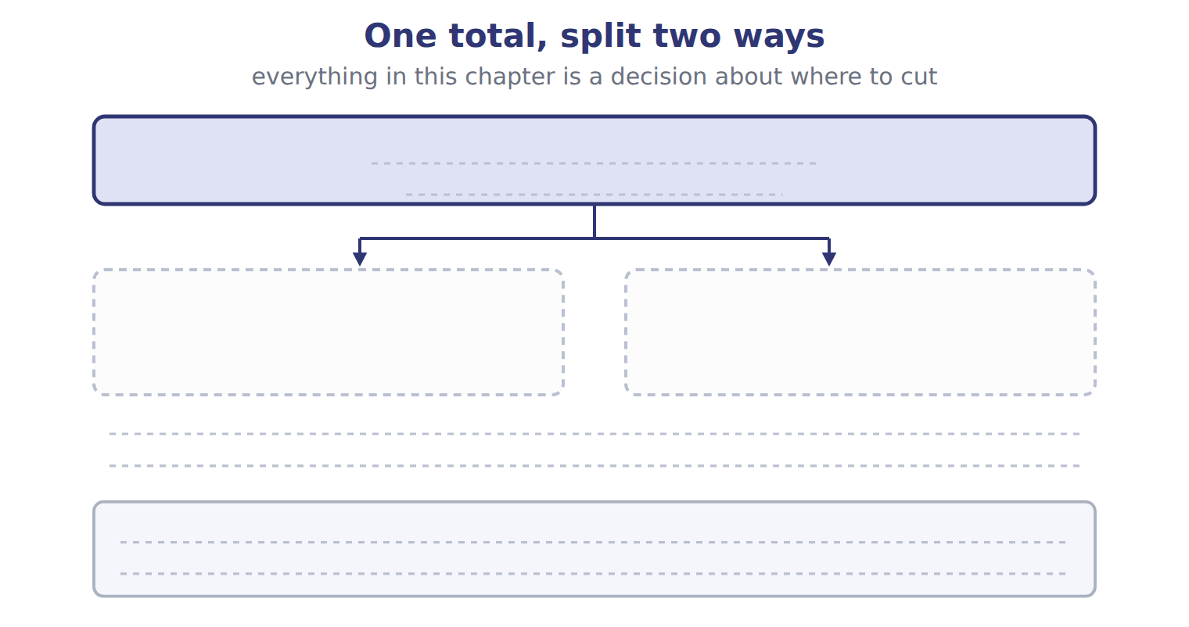
TEACH IT BACK | Write it for a colleague moving from a periodic to a perpetual system — not for the marker.
24. In three or four sentences, tell them which of their inventory figures will change and which will not.
every one of these words must appear: FIFO · LIFO · moving average · date of the sale

Answer key · Handout 7.4 · Periodic against perpetual

1 Periodic once at the year end; perpetual after every sale | 9 800 | 17 check: 18,133 + 49,867 = 68,000
2 FIFO | 10 At step 4, as goods available less ending inventory | 18 cases left 3,000
3 288,000 against 279,000 — a difference of 9,000 | 11 Step 2 — units available less units sold | 19 ending inventory 128,000
4 The moving average — a new average after each purchase | 12 That ending inventory plus cost of goods sold equals goods available — if it fails, one of the two is wrong | 20 cost of goods sold 244,000
5 Under a perpetual system each sale can only use the costs that exist on the date of that sale | 13 cost of one tray 22.667 | 21 2,000 at $50 and 1,000 at $48, giving 148,000 — higher than LIFO
6 see the key | 14 trays left 800 | 22 The oldest costs stay; cost of goods sold is goods available less ending inventory.
7 C | 15 ending inventory 18,133 | 23 Goods available for sale splits into cost of goods sold (an expense) and ending inventory (an asset). Under a periodic system you work out ending inventory first, from the count and the method, and cost of goods sold is the remainder.
8 FIFO, because the oldest units are always the ones treated as sold first, whenever you calculate. | 16 cost of goods sold 49,867 | 24 If they use FIFO, nothing changes: the oldest units are treated as sold first whenever the calculation is done. If they use LIFO or an average, the figures will move, because under a perpetual system each sale can only use the costs that exist on the date of that sale. The average becomes a moving average, recalculated after every purchase.

6 what the book says
FIFO gives the same result in both systems, because the oldest units are always sold first. LIFO and the average method do not: under a perpetual system, each sale can only use the costs that exist on the date of the sale.

why
1 In a periodic system the company counts the goods at year-end and calculates cost of goods sold for the whole period. In a perpetual system it updates inventory and cost of goods sold after every purchase and every sale.
2 FIFO gives the same result in both systems, because the oldest units are always sold first.
7 Only FIFO is immune. LIFO and the average both change, and a perpetual system works with any cost flow assumption.
10 In a periodic system cost of goods sold is the remainder, never calculated layer by layer.
13 68,000 divided by the 3,000 trays available.
14 3,000 available less 2,200 sold.
15 800 trays at 22.667 each.
16 2,200 trays at 22.667, or goods available less ending inventory.
17 If the two do not add back, one of them is wrong.
18 8,000 available less 5,000 sold.
19 LIFO leaves the oldest costs: 1,000 at $40 is 40,000, and 2,000 at $44 is 88,000.
20 372,000 less 128,000. Cost of goods sold is always the remainder in a periodic system.
21 Prices rose through the year, so the newest costs that FIFO leaves behind are the dearest.

Handout 7.5
What the choice does
Rising prices · the LIFO reserve · liquidation and the conformity rule
60 SECONDS | Answer from memory. Do not look anything up.
1. FIFO leaves which costs in ending inventory? | 4. The weighted average per case of olive oil was
2. Which method is immune to the choice of system? | 5. Does IFRS allow LIFO?
3. Goods available less ending inventory equals | 6. A perpetual average is called the

CYCLE A | Rising prices push every figure one way

ORIENT

1. Prices rose all year. FIFO sends the OLDEST costs to cost of goods sold. Will FIFO’s cost of goods sold be the highest or the lowest of the three methods?

MODEL Four figures, three methods. Read a column at a time, not a row.

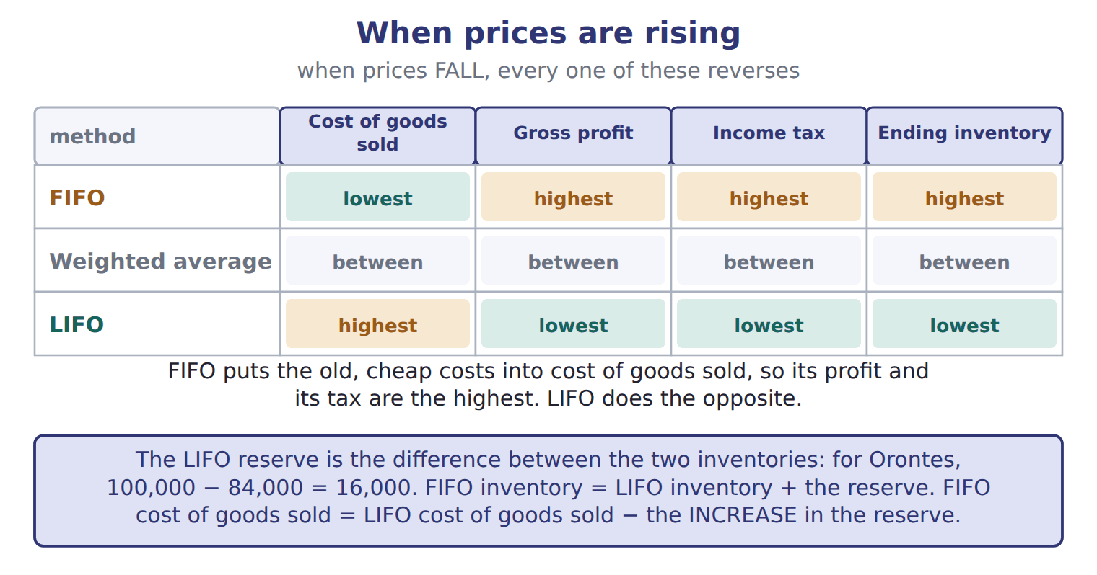
READ THE MODEL

2. Which method gives the highest gross profit when prices are rising, and which gives the lowest?

3. Which method gives the highest ending inventory, and why does that follow from what it sends out?

4. Where does the weighted average sit in every column?

5. What does the subtitle say happens to all four columns when prices FALL?

6. Each method has a strength. Which one puts current costs against current revenues, and which shows inventory close to current cost?

WORK IN PAIRS | Answer the next item alone, then compare.
If you disagree: start from which costs the method sends OUT. Everything else follows from that in one step.
INVENT THE RULE

7. Write the chain that takes you from "which costs leave" to "how much tax".
use every one of these words: oldest · lowest · highest · fall
FIFO sends the costs out, so cost of goods sold is , gross profit is and tax is .
When prices , every one of those reverses.

The same company, two price environments
Prices rising all year | Prices falling all year
Which method gives the higher gross profit, FIFO or LIFO? | Which method gives the higher gross profit, FIFO or LIFO?
Which gives the higher tax? | Which gives the higher tax?
Which gives the higher ending inventory? | Which gives the higher ending inventory?
Only the direction of prices differs. Answer all three rows for each, and write the one sentence that explains why every answer flips.

APPLY

8. Prices are rising. Which method gives the highest net income?
A. FIFO
B. LIFO
C. Weighted average
D. All methods give the same net income.
9. Prices are falling. Which method gives the highest gross profit?
A. FIFO
B. Weighted average
C. LIFO
D. All methods give the same gross profit.
CHECKPOINT 10. Prices are rising. Put FIFO, LIFO and the weighted average in order of ending inventory, highest first.

If you could not answer it: redo the READ THE MODEL questions of cycle A with the figure in front of you.

CYCLE B | The LIFO reserve, and two rules that come with LIFO

ORIENT

11. FIFO ending inventory for Orontes olive oil was 100,000 and LIFO was 84,000. What is the difference?

MODEL How an analyst turns a LIFO company’s figures into FIFO ones.

Orontes olive oil, 2025
LIFO reserve = FIFO inventory − LIFO inventory | 100,000 − 84,000 = 16,000
FIFO inventory = LIFO inventory + the reserve | 84,000 + 16,000 = 100,000
FIFO cost of goods sold = LIFO cost of goods sold − the INCREASE in the reserve | Orontes started the year with no reserve, so the increase is the whole 16,000
288,000 − 16,000 = 272,000 | which is exactly the FIFO cost of goods sold worked out directly
Tax saved by using LIFO this year | at an illustrative rate of 25%, LIFO saved 4,000 of tax

READ THE MODEL

12. Which figure do you SUBTRACT to get FIFO cost of goods sold from LIFO cost of goods sold — the reserve, or the increase in the reserve?

13. Why is the increase equal to the whole reserve for Orontes in 2025?

14. At a 25% rate, how much tax did LIFO save, and on what difference in income?

MODEL Two more rules that only apply to LIFO companies.

LIFO liquidation and the conformity rule
Rule | What it means | Why it matters
LIFO liquidation | a LIFO company sells more units than it buys, so old low-cost layers flow into cost of goods sold | income rises for one year; it is not a lasting improvement, and the company should disclose it if it is material
LIFO conformity rule | a U.S. tax rule: a company that uses LIFO for its tax return must also use LIFO in its financial statements | a company that wants the tax benefit of LIFO must also report lower LIFO profits to investors

APPLY

15. What is the Orontes LIFO reserve for olive oil at the end of 2025 (whole USD)?
A. 4,000 | C. 9,000
B. 7,000 | D. 16,000
16. A company reports LIFO cost of goods sold of 500,000. Its LIFO reserve increased from 30,000 to 45,000 during the year. What would cost of goods sold be under FIFO?
A. 455,000 | C. 515,000
B. 485,000 | D. 545,000
17. Prices are rising, and a LIFO company sells more units than it buys, so old layers are liquidated. What is the effect in that year?
A. Gross profit decreases.
B. Gross profit increases.
C. There is no effect, because costs are historical.
D. A loss arises that must be deferred.
18. The LIFO conformity rule requires that:
A. a company using LIFO for its U.S. tax return also uses LIFO in its financial statements.
B. companies reporting under IFRS use LIFO.
C. a company using LIFO applies it to every inventory in every country.
D. a company using LIFO for its financial statements uses FIFO for tax.
19. The LIFO reserve is a reserve in the equity section of the balance sheet. T / F
CHECKPOINT 20. To convert LIFO cost of goods sold to FIFO, do you add or subtract, and is it the reserve or the increase in the reserve?

If you could not answer it: redo the worked trace at the start of cycle B.

FROM MEMORY | Close the earlier pages first.
21. Rebuild the rising-prices grid. Write all four column headings and fill in every cell for all three methods.
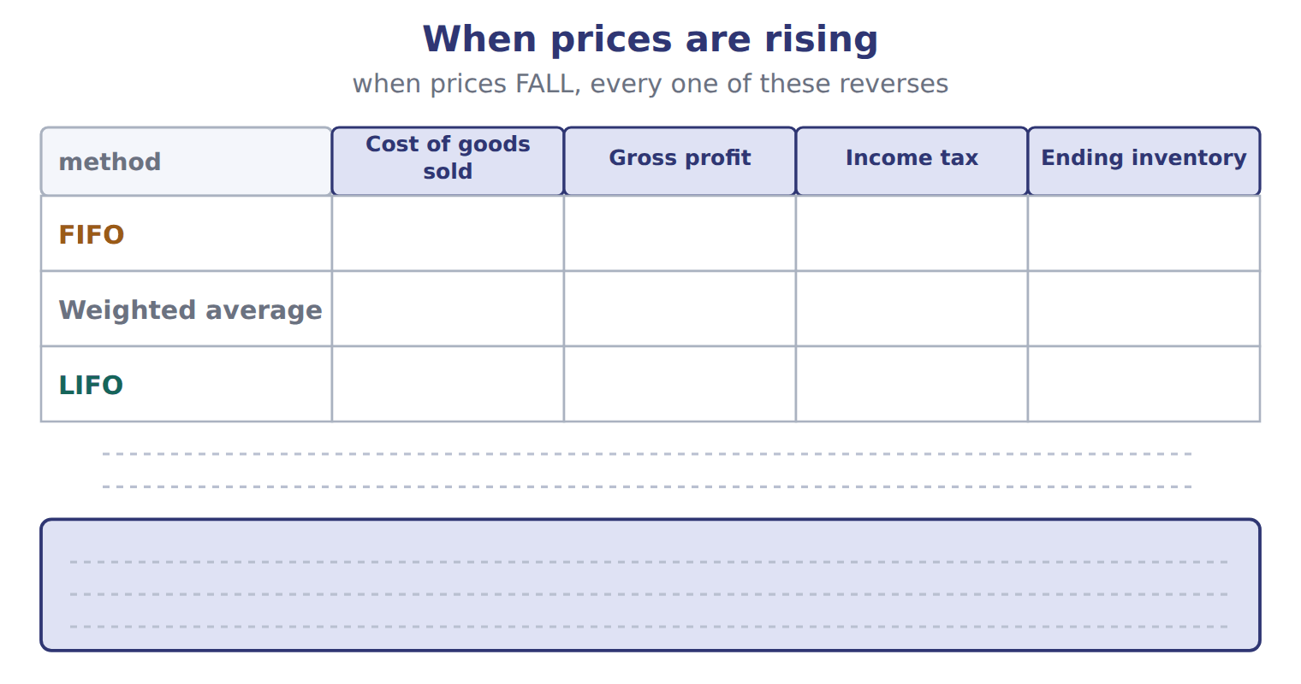
TEACH IT BACK | Write it for the finance director of Orontes — not for the marker.
22. In four to six sentences, advise them. Which method, FIFO or LIFO, gives lower income taxes for olive oil in 2025, and why? And what does the conformity rule mean for the financial statements?
every one of these words must appear: rising prices · cost of goods sold · taxable income · conformity · LIFO reserve

Answer key · Handout 7.5 · What the choice does

1 The lowest | 9 C | 17 B
2 FIFO highest, LIFO lowest | 10 FIFO, weighted average, LIFO. | 18 A
3 FIFO — it sends the oldest costs out, so the newest and dearest stay | 11 16,000 | 19 F
4 Between the other two | 12 The increase in the reserve | 20 Subtract, and it is the increase in the reserve.
5 Every one of them reverses | 13 Because Orontes started the year with no reserve | 21 FIFO: lowest cost of goods sold, highest gross profit, highest tax, highest ending inventory. LIFO: the opposite throughout. Weighted average between the two in every column. Everything reverses when prices fall.
6 LIFO matches current costs with current revenues; FIFO shows inventory close to current cost | 14 4,000, on the 16,000 difference in cost of goods sold | 22 Prices rose during 2025, so LIFO gives lower income taxes. LIFO puts the newest, most expensive costs into cost of goods sold, which lowers gross profit and taxable income; for olive oil, LIFO saves 4,000 compared with FIFO. However, the LIFO conformity rule means that if Orontes uses LIFO on its U.S. tax return, it must also use LIFO in its financial statements, so it will report lower profits to investors too. Ending inventory will also show older, lower costs. Orontes should disclose the LIFO reserve of 16,000 so that readers can compare it with FIFO companies.
7 see the key | 15 D
8 A | 16 B

7 what the book says
FIFO puts the old, cheaper costs into cost of goods sold. So FIFO gives the lowest cost of goods sold, the highest gross profit, the highest income tax and the highest ending inventory. LIFO gives the opposite. When prices are falling, all these relationships reverse.

why
1 FIFO puts the old, cheaper costs into cost of goods sold.
5 When prices are falling, all these relationships reverse.
6 LIFO’s income is closer to current economic reality but its balance sheet shows old costs; FIFO’s income includes gains from holding inventory while prices rise.
8 FIFO puts the cheapest costs into cost of goods sold, so gross profit and net income are highest.
9 When prices fall every relationship reverses, so LIFO now has the cheapest costs in cost of goods sold.
11 That difference is the LIFO reserve.
12 To get FIFO cost of goods sold, subtract the INCREASE in the LIFO reserve from LIFO cost of goods sold.
15 100,000 FIFO inventory less 84,000 LIFO inventory. 4,000 is the tax saved, not the reserve.
16 Subtract the INCREASE of 15,000, not the closing balance of 45,000, and subtract rather than add: 500,000 − 15,000 = 485,000.
17 Old low-cost layers flow into cost of goods sold, so cost of goods sold falls and income rises for one year.
18 IFRS does not allow LIFO at all, and the rule is about tax and the statements agreeing, not about every inventory everywhere.
19 It is only the difference between two inventory amounts. It is sometimes called the LIFO allowance or revaluation to LIFO.

Handout 7.6
When the count is wrong
The error reverses next year · four common errors · what to do when you find one
60 SECONDS | Answer from memory. Do not look anything up.
1. Prices rising: which method gives the highest tax? | 4. A LIFO liquidation does what to income?
2. The LIFO reserve is the difference between | 5. The conformity rule links the tax return to the
3. To get FIFO COGS from LIFO COGS you subtract the | 6. Overstated means too high or too low?

CYCLE A | One wrong count, two wrong years

ORIENT

1. Cost of goods sold is beginning inventory plus purchases minus ending inventory. If ending inventory is counted too HIGH, is cost of goods sold too high or too low?

2. This year’s ending inventory is next year’s what?

MODEL Orontes counted some goods twice at the end of 2025. Follow one column at a time, then compare the last row of each.

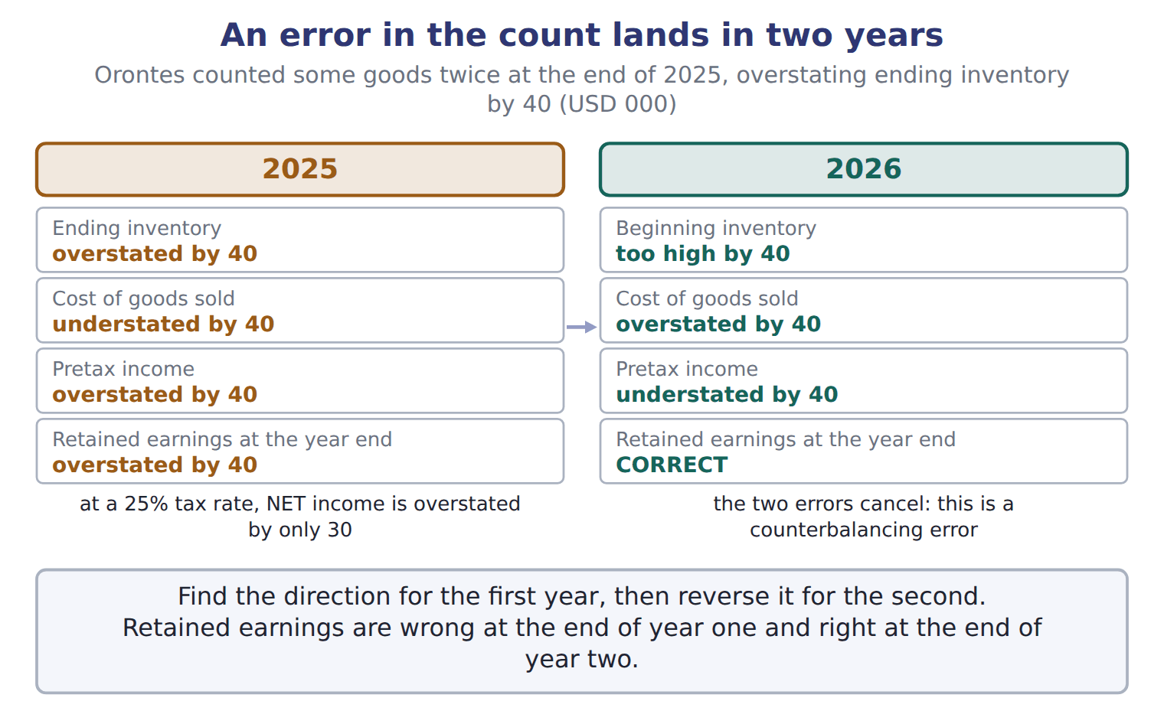
READ THE MODEL

3. In 2025, which way is cost of goods sold wrong, and by how much?

4. In 2026, which way is cost of goods sold wrong?

5. What are retained earnings at the end of 2025, and at the end of 2026?

6. The figure says pretax income was overstated by 40 in 2025, but NET income by only 30. Why?

7. What does the book call an error that cancels itself over two years?

WORK IN PAIRS | Answer the next item alone, then compare.
If you disagree: write the first year’s direction, then reverse it. If you disagree, one of you has not reversed.
INVENT THE RULE

8. Write the two-step method for any inventory error question.
use every one of these words: first · reverse · correct · counterbalancing
Find the direction for the year, then it for the second.
Retained earnings are wrong at the end of year and at the end of year two.

The same size of error, in opposite directions
Ending inventory OVERSTATED by 40 | Ending inventory UNDERSTATED by 40
Y1 cost of goods sold? | Y1 cost of goods sold?
Y1 net income? | Y1 net income?
Y2 net income? | Y2 net income?
Y2 closing retained earnings? | Y2 closing retained earnings?
Fill in all four rows for both. Then write the one row whose answer is the same in both columns, and say why.

APPLY

9. Ending inventory for 2025 was understated. What are the effects on net income?
A. 2025 overstated; 2026 understated | C. No effect in either year
B. 2025 understated; 2026 no effect | D. 2025 understated; 2026 overstated
10. Orontes overstated its 2025 ending inventory by 40 (USD 000). Ignoring taxes, what is the effect on retained earnings at the end of 2026?
A. Overstated by 40 | C. Understated by 40
B. No effect | D. Overstated by 80
11. The tax rate is 25%. Ending inventory was overstated by 40. By how much is net income overstated in that year?
A. 10 | C. 40
B. 30 | D. 50
12. Ending inventory for 2026 is understated by 15. Inventory for 2025 was correct. What is the effect on 2026 cost of goods sold?
A. Understated by 15 | C. Overstated by 15
B. No effect | D. Overstated by 30
CHECKPOINT 13. Ending inventory is overstated in year 1. Say what happens to net income in year 1, in year 2, and to closing retained earnings after two years.

If you could not answer it: redo the READ THE MODEL questions of cycle A with the two-year figure in front of you.

CYCLE B | Four errors, and the one that fools everybody

ORIENT

14. A credit purchase was never recorded AND the goods were never counted. Two things are missing. Guess whether cost of goods sold comes out right or wrong.

MODEL Four errors, with O for overstated and U for understated. Row 3 is the classic exam item.

Effects of four common inventory errors
Error in year 1 | Y1 COGS | Y1 net income | Y1 end RE | Y1 assets | Y2 net income | Y2 end RE
1. Ending inventory overstated | U | O | O | O | U | correct
2. Ending inventory understated | O | U | U | U | O | correct
3. Credit purchase not recorded, and goods not counted | no effect | no effect | no effect | U (and liabilities U) | no effect | correct
4. Credit purchase not recorded, but goods counted | U | O | O | correct (liabilities U) | U | correct
Every row ends the same way: by the close of year 2, retained earnings are correct.
READ THE MODEL

15. Which of the four rows leaves cost of goods sold and net income correct in year 1?

16. In that row, what IS wrong, and by how many items?

17. Row 4 has the same unrecorded purchase, but the goods WERE counted. What is wrong in year 1 now?

18. Read the last column of all four rows. What do they have in common?

ERROR HUNT | A junior has written four notes about inventory errors. Mark each right, or write what is wrong with it. (items 19 to 22)
the solution as written | right, or what is wrong with it
a | "Our ending inventory was too high, so our profit was too low."
b | "The error will still be in retained earnings in two years’ time."
c | "We missed a purchase on credit and never counted the goods, so profit is wrong."
d | "Net income was overstated by 40, so it was overstated TO 40."

APPLY

23. A purchase on account at year-end was not recorded, and the goods were not included in the physical count. What is the effect?
A. Net income is overstated; inventory is correct.
B. Net income is understated; accounts payable are correct.
C. Net income is correct; inventory and accounts payable are both understated.
D. Net income and inventory are both overstated.
24. A company finds an error from a prior year. What does it do, and what happens if the error has already counterbalanced?

CHECKPOINT 25. A credit purchase is unrecorded and the goods are uncounted. Which two figures are wrong, and which two are right?

If you could not answer it: reread row 3 of the four-error panel in cycle B.

FROM MEMORY | Close the earlier pages first.
26. Rebuild the two-year figure for an OVERSTATED ending inventory. Write all four lines for each year, and the note at the foot of each.
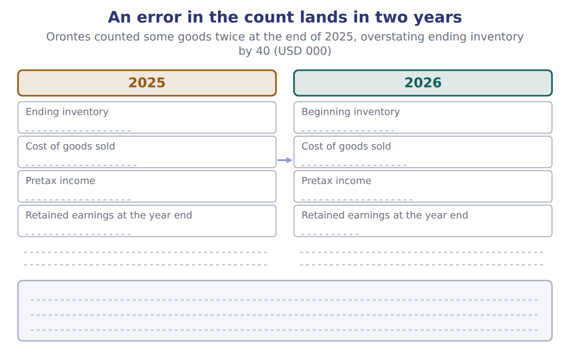
TEACH IT BACK | Write it for an auditor who has just found a miscount in last year’s figures — not for the marker.
27. In three or four sentences, explain what it did to each of the two years and what has to be done about it now.
every one of these words must appear: overstated · counterbalancing · retained earnings · restate

Answer key · Handout 7.6 · When the count is wrong

1 Too low | 10 B | 19 wrong — too high an ending inventory understates cost of goods sold, so profit was too HIGH
2 Beginning inventory | 11 B | 20 wrong — it counterbalances, so retained earnings are correct after two years
3 Understated by 40 | 12 C | 21 wrong — both sides are understated by the same amount, so profit is correct; inventory and payables are understated
4 Overstated by 40 | 13 Overstated in year 1, understated in year 2, and retained earnings are correct after two years. | 22 wrong — overstated BY 40 is the size of the error; overstated TO 40 would be the new total
5 Overstated by 40 at the end of 2025; correct at the end of 2026 | 14 Right | 23 C
6 Because of tax at 25%: 40 less 25% of 40 | 15 Row 3 — the purchase not recorded and the goods not counted | 24 It restates the prior-year statements, adjusting beginning retained earnings; if the error has counterbalanced, retained earnings need no adjustment but the comparative figures are still restated
7 A counterbalancing error | 16 Inventory and accounts payable are both understated | 25 Inventory and accounts payable are understated; cost of goods sold and net income are correct.
8 see the key | 17 Cost of goods sold is understated and net income overstated, with liabilities understated | 26 Year 1: ending inventory overstated by 40, cost of goods sold understated by 40, pretax income overstated by 40, closing retained earnings overstated by 40; at 25% tax, net income is overstated by only 30. Year 2: beginning inventory too high, cost of goods sold overstated, pretax income understated, closing retained earnings correct — a counterbalancing error.
9 D | 18 Retained earnings are correct at the end of year 2 in every case | 27 An overstated count understates cost of goods sold and overstates income in the first year, and does the reverse in the second, so it is a counterbalancing error and retained earnings are correct again by the end of year two. That does not make it harmless: the first year’s income and the first year’s closing balance sheet were both wrong. The company restates the prior-year statements, and if the error has already counterbalanced, retained earnings need no adjustment but the comparative figures still do.

8 what the book says
Over the two years, the two errors cancel. Retained earnings are overstated at the end of 2025 but correct at the end of 2026. This is a counterbalancing error.

why
1 Ending inventory is subtracted, so overstating it understates cost of goods sold.
2 That is why the error moves into the next year too.
6 Remember the tax effect: at a 25% tax rate, net income was overstated by only 30.
9 An understated ending inventory overstates cost of goods sold and understates income in the first year, and the error reverses in the second.
10 The error counterbalances: retained earnings are wrong at the end of 2025 and right at the end of 2026.
11 40 is the pretax overstatement; net income is overstated by 40 less the 25% tax on it.
12 Ending inventory is subtracted in the cost of goods sold calculation, so understating it overstates cost of goods sold by the same amount.
14 Purchases and ending inventory are both understated by the same amount, and they are on opposite sides of the calculation.
16 Cost of goods sold and income are still correct, but inventory and accounts payable are both understated.
23 Purchases and ending inventory are understated by the same amount and cancel in the cost of goods sold calculation, so income is right while the balance sheet is wrong on both sides.
24 The correction is a restatement of the prior-year statements with an adjustment to beginning retained earnings.

Handout 7.7
The tahini case
One exhibit, six questions · the count, three methods and the LIFO reserve
60 SECONDS | Answer from memory. Do not look anything up.
1. Under FOB shipping point, who includes goods in transit? | 4. The LIFO reserve is FIFO inventory less
2. Does a consignor include goods held by a consignee? | 5. Goods available less ending inventory equals
3. FIFO leaves which costs in ending inventory? | 6. An overstated count does what to cost of goods sold?

CYCLE A | Reading the exhibit before answering anything

ORIENT

1. An exam case gives you a count and a memo. Which of the two do you apply to the other?

MODEL Orontes uses a periodic system for tahini. Prices do not change after December 31.

Orontes tahini cartons, 2025
Date / item | Details | Cartons | USD
Jan 1 | Beginning inventory at $30 | 4,000 | 120,000
Feb 14 | Purchase at $31 | 10,000 | 310,000
Jun 3 | Purchase at $33 | 12,000 | 396,000
Sep 21 | Purchase at $34 | 8,000 | 272,000
Dec 18 | Purchase at $35 | 6,000 | 210,000
 | Goods available for sale | 40,000 | 1,308,000
Dec 31 | Physical count in the Amman warehouse | 7,500

The year-end memo
 | Year-end memo from the warehouse manager | Cartons
M1 | Cartons bought on December 29, FOB shipping point, still on the truck on December 31. The purchase is already recorded. | 1,000
M2 | Cartons shipped to a customer on December 30, FOB destination. They arrive on January 3. | 500
M3 | Cartons in the warehouse that belong to a Beirut producer. Orontes sells them on consignment for the producer. They were included in the count. | 800
M4 | Cartons that Orontes has placed on consignment with a retailer in Doha. They were not counted. | 300

READ THE MODEL

2. How many cartons were available for sale, and what did they cost in total?

3. Which layer is the oldest and which the newest, and what is the unit cost of each?

4. What was the physical count, and is it the figure you should use?

5. Which memo item describes goods that were never Orontes’ to count?

APPLY

SORT THEM | For each memo item, decide how Orontes should adjust the physical count.
the items: M1 (FOB shipping point, bought) · M2 (FOB destination, sold) · M3 (held for a Beirut producer) · M4 (at a Doha consignee)
Add to the count | Subtract from the count | No adjustment

9. Enter the correct number of cartons in ending inventory. Show your working.

CHECKPOINT 10. Which single memo item is subtracted from the count, and why?

If you could not answer it: redo the sorting item in cycle A with the memo panel in front of you.

CYCLE B | Four figures out of one exhibit

ORIENT

11. 40,000 cartons were available and 8,500 are left. How many were sold?

MODEL The first figure, worked in full. The three that follow are yours.

FIFO ending inventory on the adjusted count of 8,500
FIFO leaves the NEWEST costs in inventory | so start from the last purchase and work backwards
Dec 18 layer: 6,000 cartons at $35 | 210,000
Still need 2,500 cartons, from the Sep 21 layer at $34 | 85,000
FIFO ending inventory | 210,000 + 85,000 = 295,000
Check | the two layers used total 8,500 cartons, which is the adjusted count

READ THE MODEL

12. Why does the working start at the December 18 purchase rather than at January 1?

13. Why are only 2,500 cartons taken from the September layer, when that layer holds 8,000?

APPLY Three of your own, with no worked model beside them.

14. Enter weighted-average cost of goods sold in USD. Show your working.

15. If Orontes had used the UNADJUSTED count of 7,500, its FIFO cost of goods sold would have been:
A. overstated by $34,000 | C. correct
B. understated by $34,000 | D. overstated by 1,000
16. If Orontes used periodic LIFO for tahini, what would the LIFO reserve be at December 31 (USD)? The beginning layer is the base layer. Show your working.

WORK IN PAIRS | Compare all three answers with your partner before reading any key.
If you disagree: if a figure differs, check first whether both of you used the ADJUSTED count of 8,500. That is where the difference usually is.
The same 8,500 cartons, priced two ways
FIFO | LIFO
Which layers? The newest. | Which layers? The oldest.
Ending inventory = ? | Ending inventory = ?
Is this the higher or the lower of the two? | Is this the higher or the lower of the two?
Answer all three rows for each. Then write what the difference between the two figures is called, and why a company that uses LIFO has to disclose it.

CHECKPOINT 17. The LIFO reserve for tahini is 35,500. Which of the two inventory figures is the larger, and by definition which is subtracted from which?

If you could not answer it: redo the last APPLY item of cycle B, writing both layers out.

FROM MEMORY | Close the earlier pages first.
18. Rebuild the splitting figure and fill it in with the tahini case: write goods available, the adjusted count, and FIFO ending inventory and cost of goods sold.
TEACH IT BACK | Write it for a colleague who is about to answer a case like this one for the first time — not for the marker.
19. In three or four sentences, give them the order to work in and the one step that everything else depends on.
every one of these words must appear: memo · adjusted count · method · goods available

Answer key · Handout 7.7 · The tahini case

1 The memo is applied to the count | 8 No adjustment: none of the four | 15 A
2 40,000 cartons costing 1,308,000 | 9 8,500 | 16 35,500
3 Oldest: 4,000 at $30. Newest: 6,000 at $35 | 10 M3, the cartons belonging to the Beirut producer: Orontes is the consignee and never includes them. | 17 FIFO is the larger; the reserve is FIFO inventory less LIFO inventory.
4 7,500 — no, it has to be adjusted for the memo | 11 31,500 | 18 Goods available 1,308,000 for 40,000 cartons. The adjusted count is 8,500 cartons, FIFO ending inventory 295,000, so FIFO cost of goods sold is 1,308,000 − 295,000 = 1,013,000.
5 M3, the cartons belonging to a Beirut producer | 12 Because FIFO leaves the newest costs in ending inventory | 19 Adjust the count first: work every memo item through the control test before touching any dollar figure, because every later answer depends on the adjusted count. Then take goods available for sale from the exhibit, since every method starts from the same total. Only then apply the method, costing the units that are LEFT and taking cost of goods sold as the remainder. If an answer looks odd, check whether the unadjusted count crept in.
6 Add: M1, M2 and M4 | 13 Because 6,000 of the 8,500 came from the December layer, leaving 2,500 to find
7 Subtract: M3 | 14 1,030,050

why
1 The count records what was in the building; the memo tells you what to add and what to take out.
6 M1 became ours when it left the seller; M2 is still ours until it arrives; M4 is ours at a consignee.
7 M3 belongs to the Beirut producer and was counted.
9 7,500 + 1,000 + 500 − 800 + 300. Adding every memo item gives 10,100, which wrongly includes another company’s goods; reversing the FOB rules gives 5,500; using the count unadjusted gives 7,500.
14 1,308,000 ÷ 40,000 = 32.70 a carton; 31,500 cartons sold × 32.70 = 1,030,050. A simple average of the unit prices gives 1,026,900, and 277,950 is weighted-average ending inventory rather than cost of goods sold.
15 The unadjusted count gives FIFO ending inventory of 261,000 against 295,000, and a lower ending inventory raises cost of goods sold by the same 34,000. "Overstated by 1,000" gives the difference in cartons rather than in dollars.
16 LIFO ending inventory on 8,500 cartons takes the oldest costs: 4,000 at $30 is 120,000, and 4,500 at $31 is 139,500, giving 259,500. The reserve is FIFO less LIFO: 295,000 − 259,500 = 35,500. Subtracting FIFO from LIFO gives the same figure with the wrong sign.

Handout 7.8
The whole chapter
The map · mixed practice with the sections shuffled · two questions that reach back to Chapter 1
60 SECONDS | Answer from memory. Do not look anything up.
1. The rule for which goods are ours is | 5. An overstated count does what to year 1 income?
2. The test for an inventoriable cost is | 6. Does IFRS allow LIFO?
3. FIFO leaves which costs in ending inventory? | 7. The LIFO reserve is FIFO inventory less
4. Prices rising: which method gives the lowest tax? | 8. Which method is the same under both systems?

CYCLE A | Five decisions, in order

ORIENT

1. Every unit a company had is in one of exactly two places at the year end. Name both.

MODEL The chapter as five decisions, each one taken before the next.

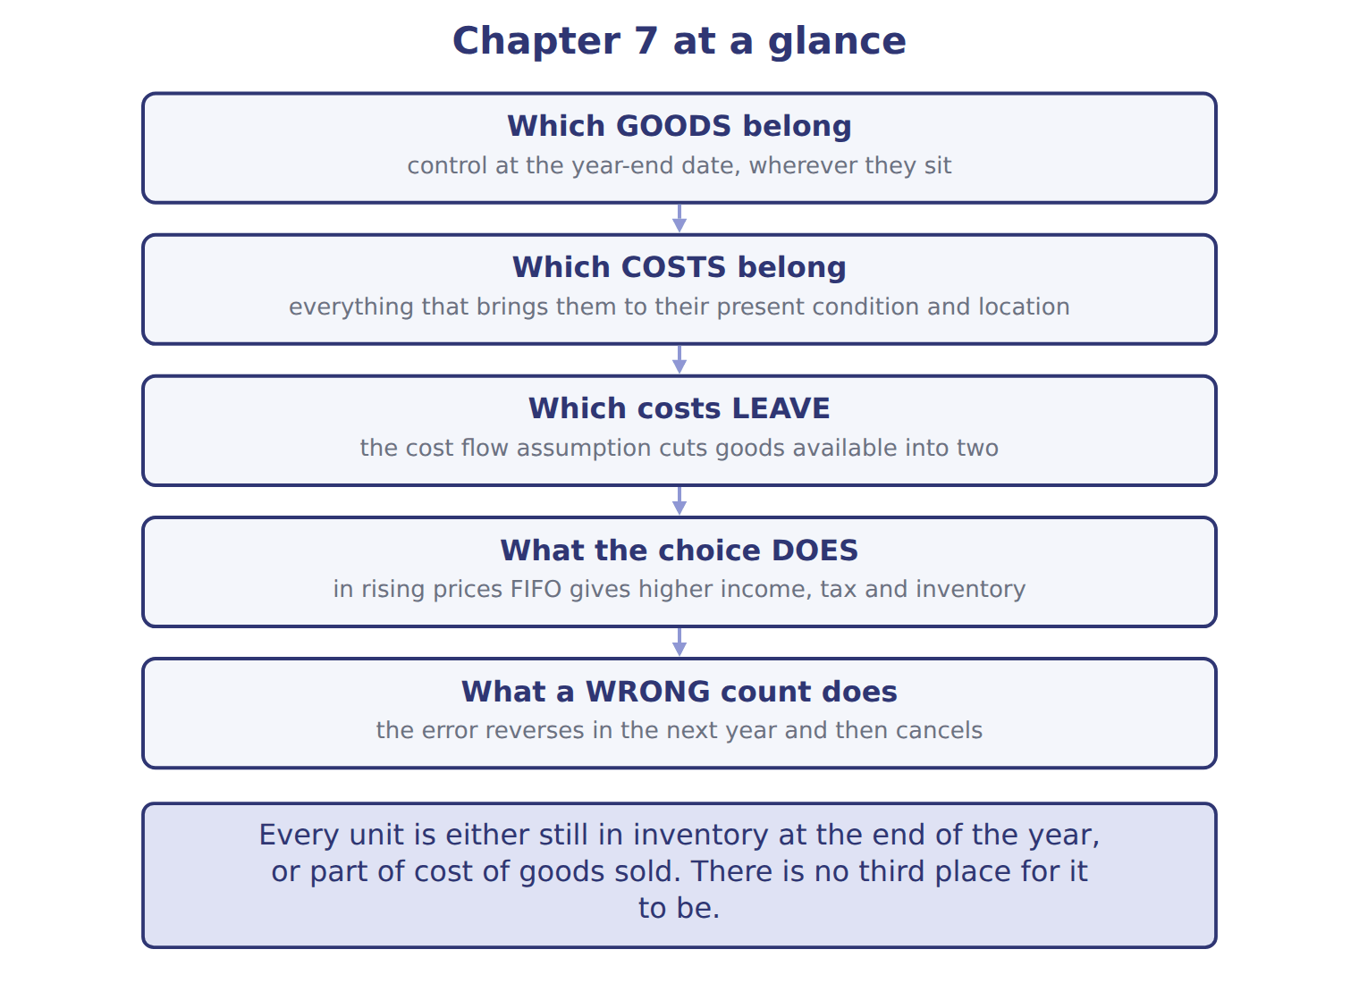
READ THE MODEL

2. Which decision comes first, and what is the single word it turns on?

3. Which decision splits one total into two?

4. The last box is about a wrong count. What does it say happens over two years?

5. Pick any one arrow and write, in one sentence, why the decision at its tail has to be taken first.

What IFRS does differently, in one line
Under IAS 2 | Status
FIFO | allowed
Weighted average | allowed
Specific identification | required for items that are not interchangeable
LIFO | NOT allowed
Cedar Retail, the IFRS company in this book, therefore uses FIFO.
INVENT THE RULE

6. Write the chapter in two sentences: what is split, and what the split decides.
use every one of these words: goods available · ending inventory · FIFO · LIFO
A cost flow assumption splits the cost of between cost of goods sold and .
In rising prices, gives higher income, tax and inventory, and gives lower ones.

Two decisions that both change ending inventory
A carton is wrongly left out of the count | The company switches from FIFO to LIFO
Does goods available for sale change? | Does goods available for sale change?
Does ending inventory change? | Does ending inventory change?
Does cost of goods sold change? | Does cost of goods sold change?
Answer all three rows for each. Then write the one sentence that says why only one of the two is an error.

CHECKPOINT 7. Name the five decisions of this chapter, in order.

If you could not answer it: redo the READ THE MODEL questions of cycle A with the map in front of you.

CYCLE B | Mixed practice, and two from Chapter 1

ORIENT From here the questions do not come in section order, and two of them reach back to Chapter 1.

8. Before you start: name the five sections of this chapter in two or three words each, so you can place each question as you read it.

APPLY

9. Orontes buys olives on account. What is the effect immediately after the purchase?
A. Assets increase and liabilities increase.
B. Expenses increase and net income decreases.
C. Assets increase and equity increases.
D. There is no effect until Orontes pays.
10. Orontes records cost of goods sold at the same time as the related sales revenue. Which approach does this follow?
A. Systematic and rational allocation
B. Matching by cause and effect
C. Immediate recognition
D. Specific identification for unique items
11. A consignee includes consigned goods in its inventory when they sit on its own shelves. T / F
12. Prices are rising. A company wants the LOWEST income tax this year. Which method should it choose, and what must it accept?
A. FIFO, and accept a lower ending inventory
B. LIFO, and accept reporting lower profits to investors
C. The weighted average, and accept a moving average
D. Specific identification, and accept tracking every unit
13. Cedar Retail S.A.L. reports under IFRS. Which method may it NOT use?
A. FIFO
B. Weighted average
C. LIFO
D. Specific identification for unique items
14. Which cost would NOT be included in the cost of inventory?
A. Import duty that cannot be reclaimed
B. Insurance while the goods are in transit
C. Freight paid to deliver goods to a customer
D. Handling on arrival at the plant
15. Ending inventory for the current year is overstated. Which figure is NOT affected this year?
A. Cost of goods sold | C. Total assets
B. Net income | D. Goods available for sale
WORK IN PAIRS | Compare all six answers with your partner before reading any key.
If you disagree: for each one you disagree on, name the section it belongs to first. Most disagreements turn out to be about the section, not the answer.
CHECKPOINT 16. Of the six questions you have just answered, which two did not come from this chapter at all? Name the chapter they came from.

If you could not answer it: go back to the MODEL move of cycle A and check which of the five boxes each of the other four belonged in.

FROM MEMORY | Close the earlier pages first.
17. Rebuild the chapter map from memory. Write all five decisions in order, and the rule that settles each one.
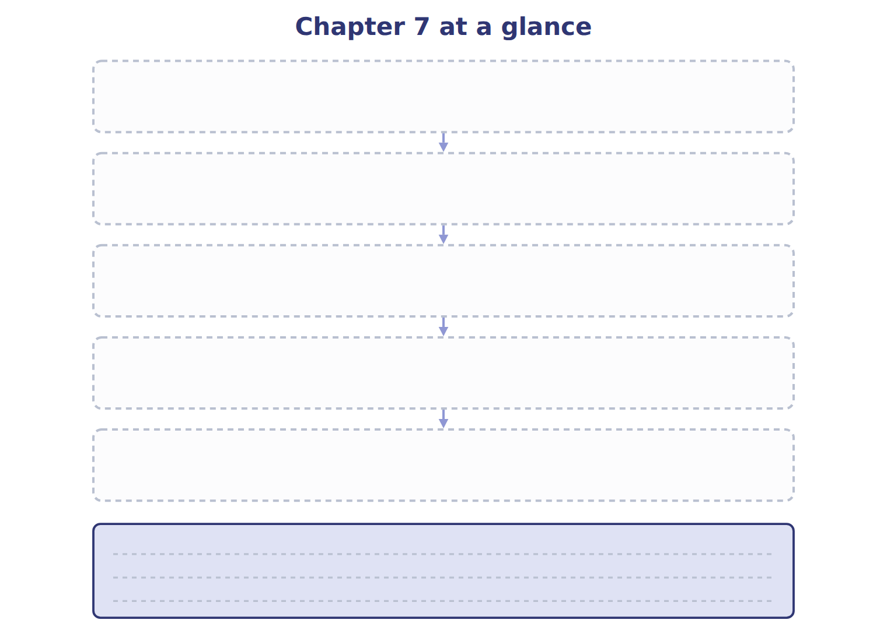
TEACH IT BACK | Write it for a student starting this chapter tomorrow — not for the marker.
18. In five or six sentences, write the whole chapter: which goods, which costs, how the costs split, what the choice does when prices rise, and what happens when the count is wrong.
every one of these words must appear: control · condition and location · goods available · cost of goods sold · LIFO reserve · counterbalancing

Answer key · Handout 7.8 · The whole chapter

1 Still in inventory, or part of cost of goods sold | 7 Which goods belong; which costs belong; which costs leave; what the choice does to income, tax and assets; what a wrong count does. | 13 C
2 Which goods belong — control | 8 Which goods; which costs; cost flow; effects; errors | 14 C
3 Which costs leave — the cost flow assumption | 9 A | 15 D
4 The error reverses in the next year and then cancels | 10 B | 16 The purchase on account and the cost-of-goods-sold matching question, both from Chapter 1.
5 Any defensible answer, for example: you cannot cost the goods until you know which goods are yours | 11 F | 17 Which goods belong: control at the year-end date, wherever they sit. Which costs belong: everything that brings them to their present condition and location. Which costs leave: the cost flow assumption cuts goods available into two. What the choice does: in rising prices FIFO gives higher income, tax and inventory. What a wrong count does: the error reverses next year and then cancels.
6 see the key | 12 B | 18 Inventory includes the goods a company controls at the year-end date, wherever they are, so shipping terms and consignments matter more than where the cartons are standing. Its cost includes everything needed to bring the goods to their present condition and location, but not selling, administrative or abnormal costs. A cost flow assumption then splits the cost of goods available between cost of goods sold and ending inventory, and the split is a decision about costs rather than about physical movement. In rising prices FIFO gives higher income, tax and inventory and LIFO gives lower ones, with the LIFO reserve as the bridge between them. An error in ending inventory reverses in the following year, so it is counterbalancing and retained earnings are correct after two years.

6 what the book says
A cost flow assumption splits the cost of goods available between cost of goods sold and ending inventory. In rising prices, FIFO gives higher income, taxes and inventory, and LIFO gives lower ones; the LIFO reserve connects the two.

why
1 There is no third place for it to be.
5 The map records the order the decisions have to be taken in.
9 Inventory is an asset and the payable is a liability. Buying inventory is not an expense, and the goods are controlled from the moment of purchase.
10 Cost of goods sold links directly to one sale, which is the cause-and-effect way of applying matching.
11 The consignee never includes them. The goods stay in the consignor’s inventory.
12 LIFO gives the lowest taxable income when prices rise, and the conformity rule means the same lower profits must be reported in the financial statements.
13 IAS 2 prohibits LIFO. It allows FIFO and the weighted average, and requires specific identification for items that are not interchangeable.
14 Freight-out happens after the goods are ready, so it is a selling expense. The other three all help bring the goods to their present condition and location.
15 Goods available is beginning inventory plus purchases, and neither of those is touched by a miscount of the closing stock.

