Table of Contents

B1.1 · Unit 7 · Show Me Once
English Animated · Taking a Position · Jengo House, Nairobi Student's Book pages 128–147 · 20 pp · ~11.5 hours

Part 0 · The Big Picture ◆ A · THE WORLD
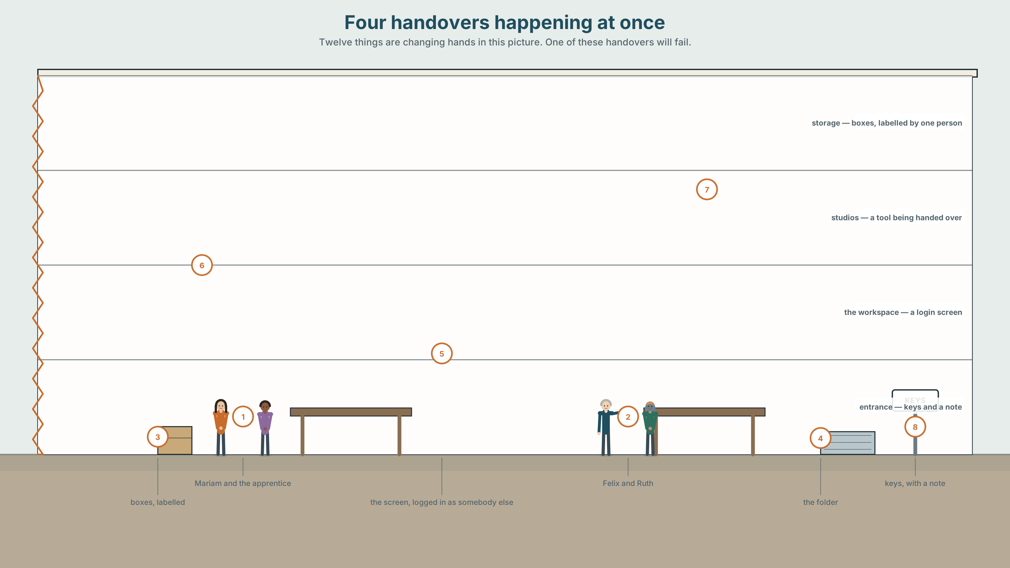{width=6.6in}
Four handovers happening at once — Twelve things are changing hands in this picture. One of these handovers will fail.

What do you want them to do?
By the end of this unit you will teach a skill in five minutes — and then watch the person you taught teach it to somebody else.
◆ A · THE WORLD | How a skill moves from one person to another, and what gets lost on the way
◆ B · THE SYSTEM | Verb + object + infinitive, and verb + object + -ing · verb patterns, returning · 24 words for teaching and persuading · 21 reporting verbs with the patterns they demand · stress inside a three-word verb
◆ C · THE PERFORMANCE | A taught skill, passed on twice, with the losses measured

0A · Find it
Twelve things being handed over in this picture. Four of these sixteen are not there.
a key · a password on paper · a tool · a clipboard · a phone · a folder · a USB stick · a labelled box · a handwritten note · a laminated card · a login screen · a chair · a contract · a certificate · a toolbox · a laptop

0B · Guess it
One of these handovers will fail. Which, and what in the picture tells you?

0C · Say it ⏺
Record thirty seconds. Think of someone who taught you something well. What did they do? Unprepared.

Part 1 · Vocabulary Lab 1 ◆ B · THE SYSTEM
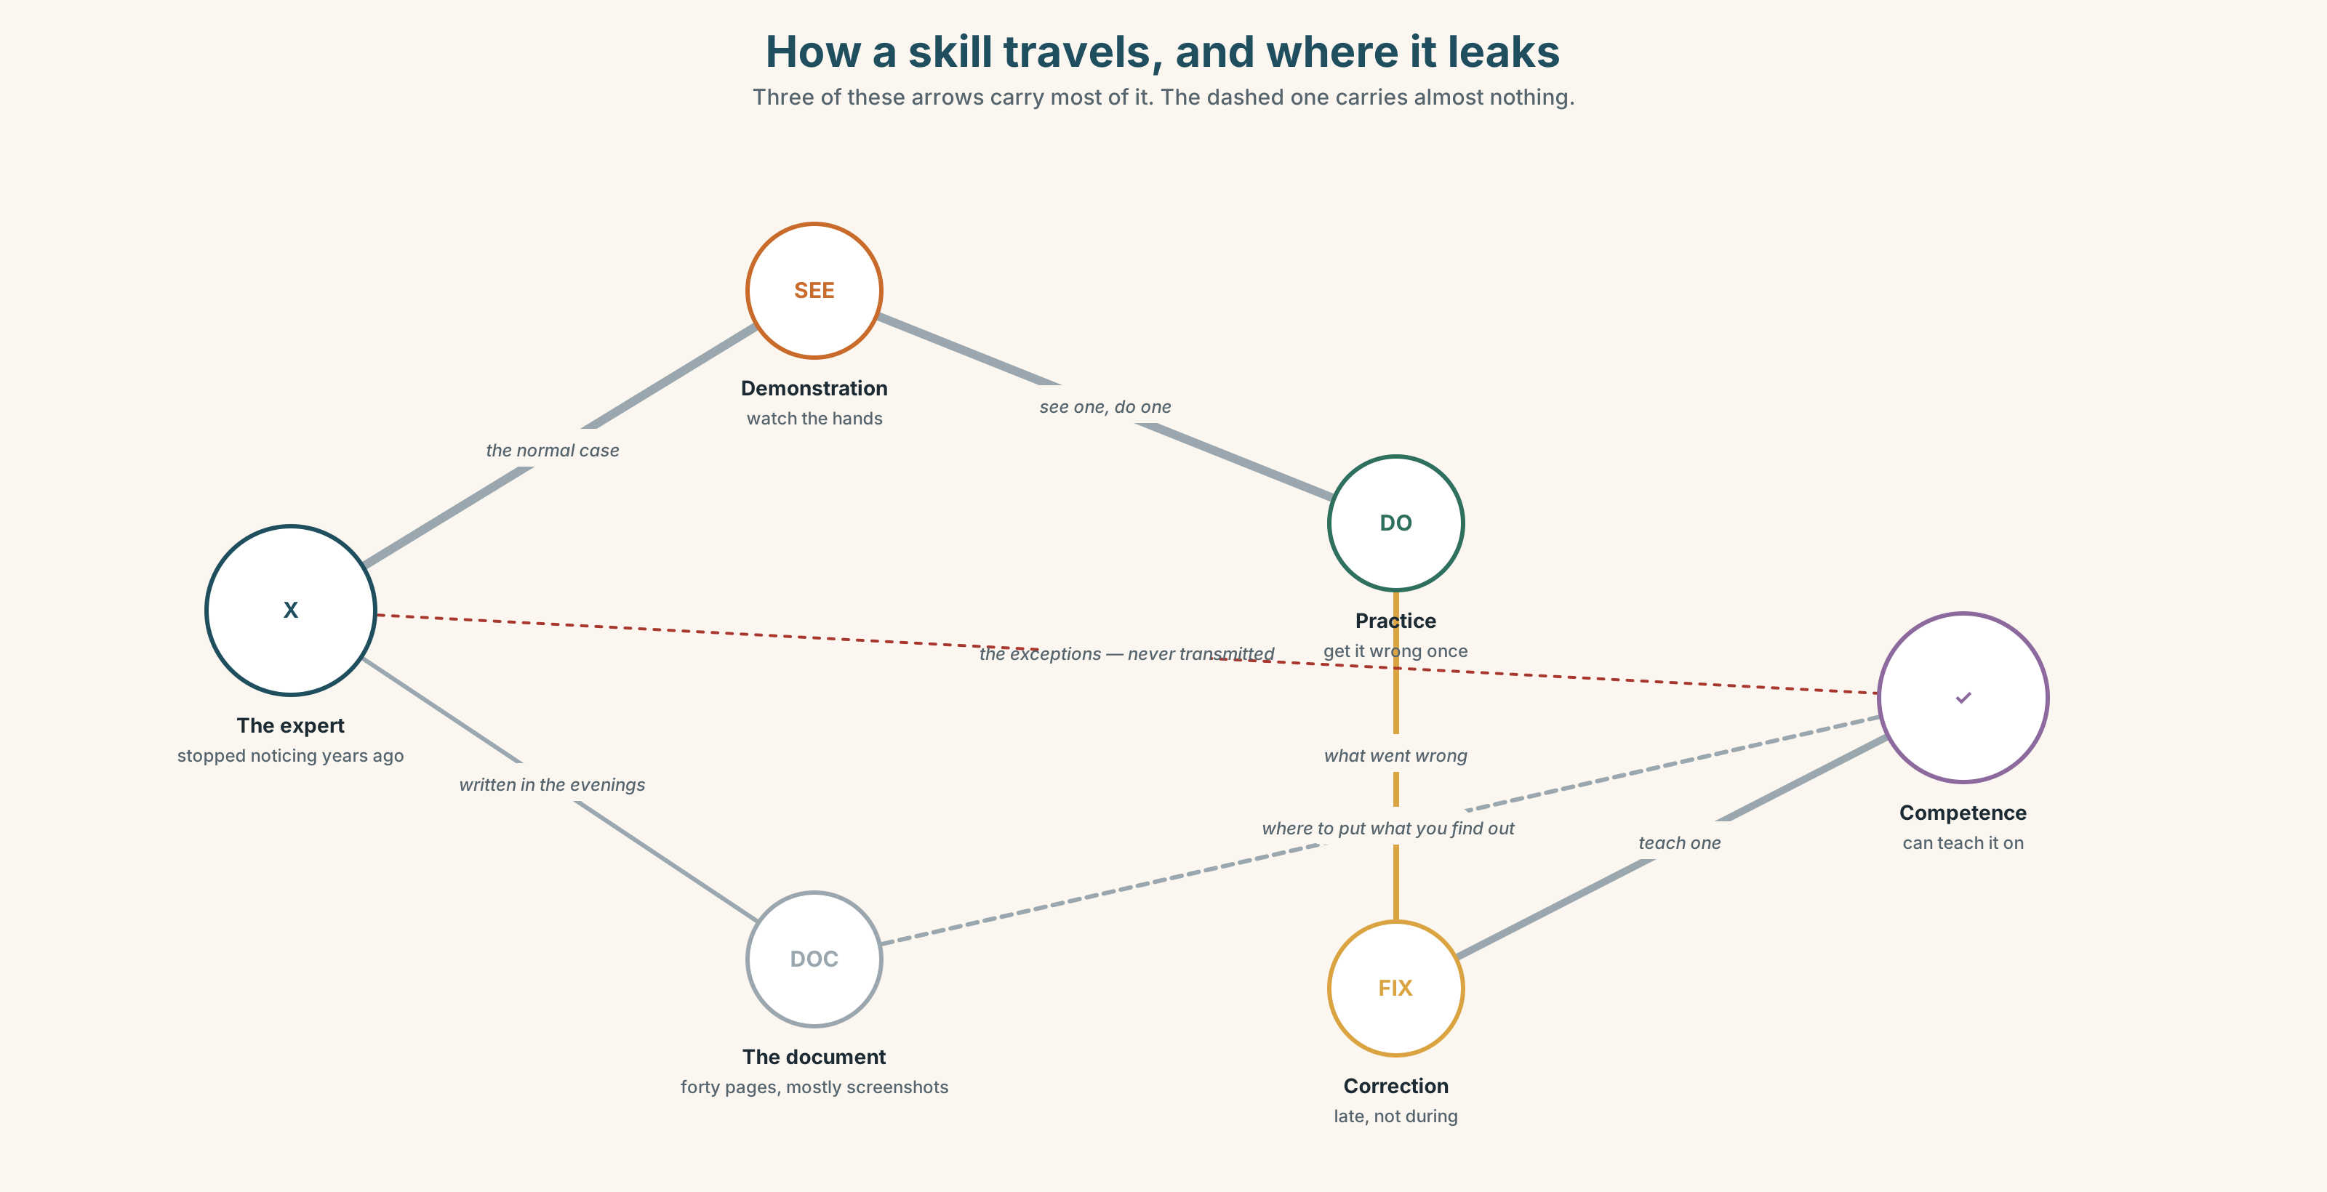{width=6.6in}
How a skill travels, and where it leaks — Three of these arrows carry most of it. The dashed one carries almost nothing.

1A · Meet — how a skill travels
Use the network. Name the word at each stage.
instruct · demonstrate · model · prompt · cue · mentor · apprentice · competence · feedback · correction · retention · rehearse

1B · Sort — cline of control
Order these from most controlled by the teacher to most controlled by the learner.
instruct · demonstrate · model · prompt · cue · stand back
Where does teaching stop and watching start? Mark it. Compare marks.

1C · Sort — odd one out, and why
- instruct · demonstrate · model · rehearse
- prompt · cue · correction · feedback
- mentor · apprentice · competence · retention
- pass on · take in · go over · pick up

1D · Stretch — the phrases
- I'll walk you ______ it once, then you do it.
- Don't tell her — show her ______ to hold it.
- Let him ______ before you correct anything.
- She didn't study it. She picked it ______ by watching.
- It's a hands-______ job; you cannot learn it from a page.
- Most of it was trial and ______.
- He talked me ______ doing it his way, and he was right.

1E · Stretch — four phrasal verbs, one lesson
pass on · take in · go over · pick up
Two describe the teacher, two the learner. Which?

1F · The two sayings
see one, do one, teach one · it's muscle memory
One is a training method used in hospitals. One is an excuse for not explaining. Which is which — and when is each of them right?
Corpus Note Teach somebody to do and teach somebody how to do are both common. Show somebody to do is not English; it must be show somebody how to. The pattern is in the verb, not in the meaning.

1G · Own it
Name one thing you can do that you could not explain. What would you have to do instead of explaining?

Part 2 · Listening ◆ A · THE WORLD
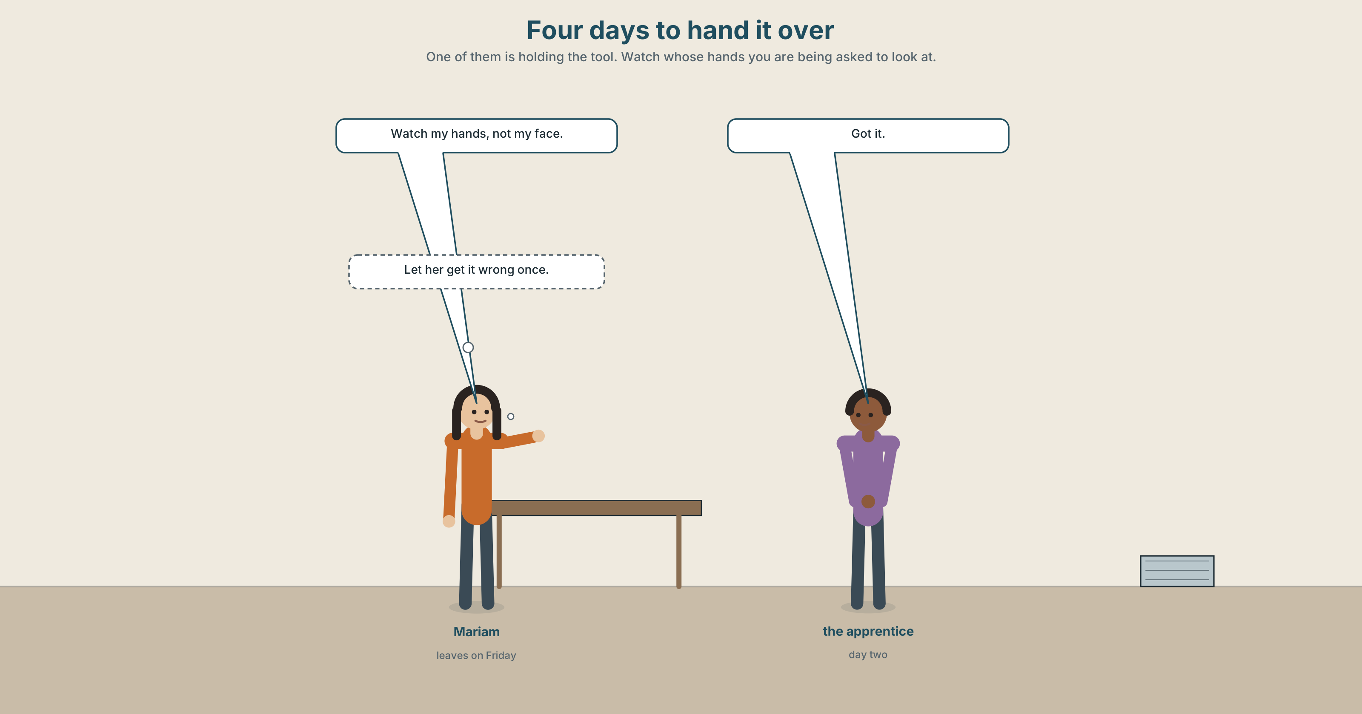{width=6.6in}
Four days to hand it over — One of them is holding the tool. Watch whose hands you are being asked to look at.

2A · Four days to hand over 🔊 Track 7.1
Before you listen. Mariam is training a machinist who starts the week she leaves for a delivery. Who is holding the tool?
Gist — one listen, one question. What does Mariam decide not to explain?
Detail — complete the frame.
 | What she says | What she does
the first time
the second time
the third time
Inference. She says "let her get it wrong once." Who is she saying that to?
Attitude. The apprentice says "got it" twice. One of them is true. Which sound?
Noticing. Six sentences. Sort them by the pattern after the object.
- I want you to hold it like this.
- I'll show you how to hold it.
- Let her try.
- I saw her doing it the wrong way.
- She made me do it again.
- I heard you ask about the tension.
A. object + to + verb · B. object + bare verb · C. object + -ing

2B · Decoding clinic 🔊 Track 7.2
Forty seconds. Four jobs.
- want you to — how many sounds?
- Where does the stress fall in go over it again?
- Catch the two measurements.
- let her — what happens to the /h/?
Transcripts, page 177.

Part 3 · Grammar Lab 1 ◆ B · THE SYSTEM

Three things that can follow an object

3A · Notice
Return to the six sentences.
- Which verbs take to + verb after the object?
- Which two take the bare verb — no to?
- Sentence 4 has -ing. What does it tell you about when she saw it?
- Compare: I saw her do it and I saw her doing it. Which one did you watch all of?
- Try I want you hold it. What is wrong — and what kind of wrong is it?

3B · See
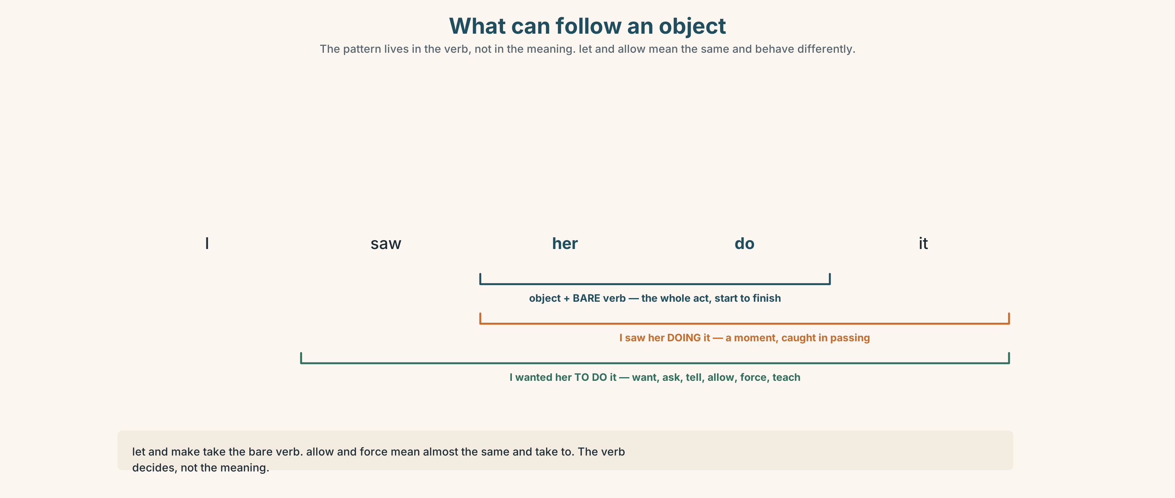{width=6.6in}
What can follow an object — The pattern lives in the verb, not in the meaning. let and allow mean the same and behave differently.

3C · Know
Pattern | Verbs | Example
object + to + verb | want · ask · tell · advise · remind · expect · allow · teach · persuade · encourage · force · invite · enable | I want you to hold it.
object + bare verb | let · make · have · (and help, either way) | Let her try. · She made me do it again.
object + -ing | see · hear · watch · notice · find · catch | I saw her doing it wrong.
object + bare verb, with the senses | see · hear · watch | I saw her do it. — the whole thing, start to finish
Watch out. Let and make take the bare verb. Allow and force mean almost the same and take to. The meaning is not the guide; the verb is.
Why it matters. I saw her doing it describes a moment. I saw her do it describes the whole act — which is what a witness statement needs.

3D · Use — controlled
Mariam wanted the apprentice (1) __________ (hold) the cloth differently, so she made her (2) __________ (do) it three times. She did not let her (3) __________ (use) the big scissors on the first day. On the second day she saw her (4) __________ (cut) against the grain and said nothing, because she expected her (5) __________ (notice) it herself. She did. On the fourth day Mariam heard her (6) __________ (explain) the grain to somebody else, and that is when she knew.

3E · Use — guided
Rewrite each one with the verb in brackets. The pattern will change.
- She let me use the machine. (allow)
- He made us stay late. (force)
- I watched her cut it. (see … -ing)
- They told me to come back. (want)

3F · Use — open
Teach your partner something small, right now, in ninety seconds. Then describe what happened using four of the patterns: I wanted them to… I made them… I let them… I saw them…

3G · Check — six items
- I want you ______ (check) it twice.
- She let me ______ (borrow) it.
- He made us ______ (wait) an hour.
- I saw him ______ (leave) the building — the whole thing, from the lift to the door.
- I saw him ______ (leave) the building as I came round the corner.
- They won't allow us ______ (park) there.
0–3 → Workbook pp. 54–56. 4–5 → Part 6. 6 → p. 139.
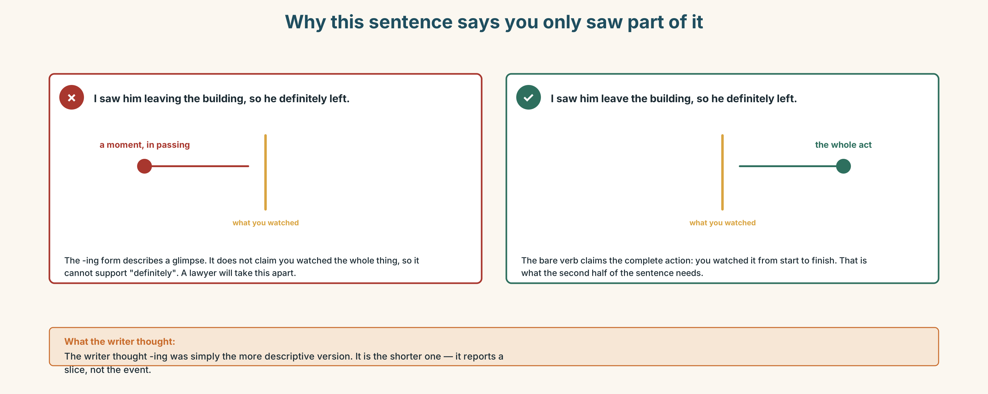{width=6.6in}
Why this sentence says you only saw part of it — Why this sentence says you only saw part of it

Part 4 · Speaking ◆ C · THE PERFORMANCE

4A · Fluency sprint — 4 / 3 / 2
Something you were taught badly. Four minutes, three, two.

4B · The functional core — instructing without taking over
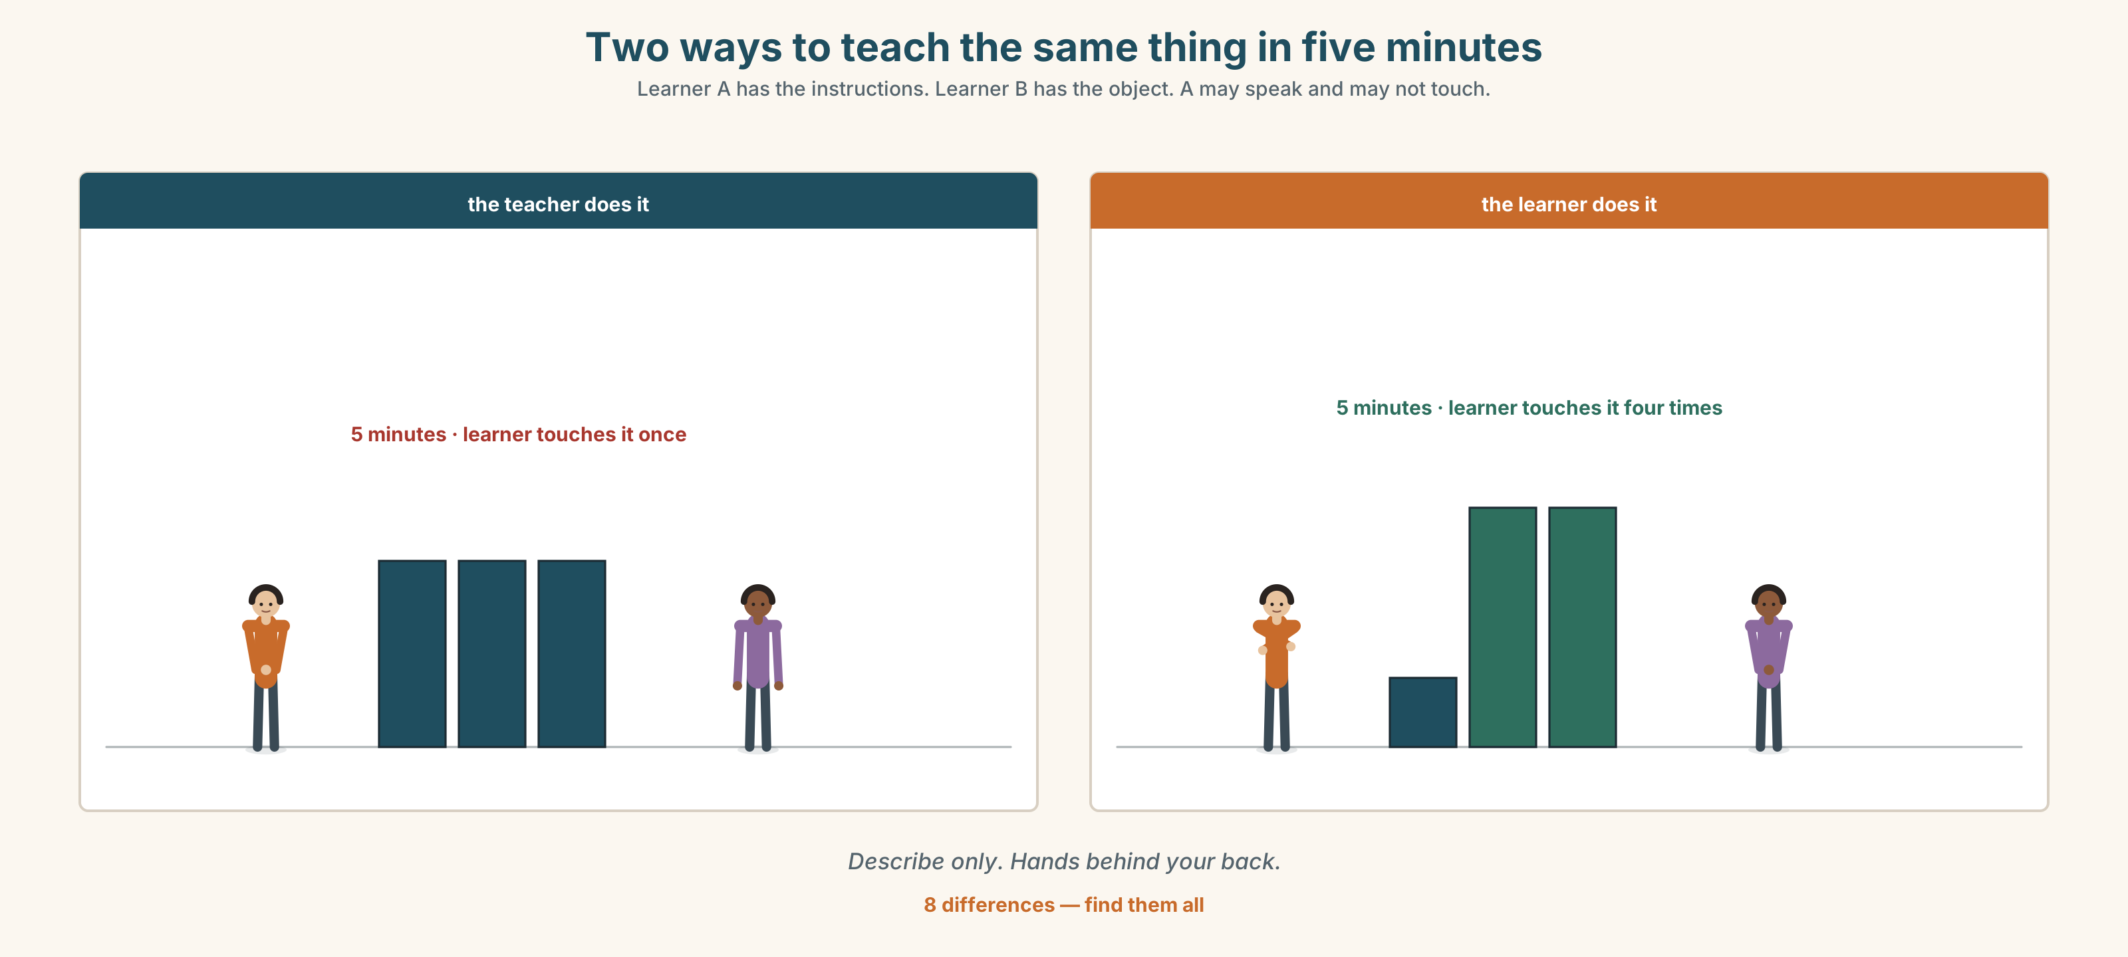{width=6.6in}
Two ways to teach the same thing in five minutes — Learner A has the instructions. Learner B has the object. A may speak and may not touch.
Language Bank
before they try | I'll walk you through it once · watch my hands, not my face
while they try | keep going · that's it · don't look at me
correcting late | try it again and see · what did you notice?
not correcting | (silence) · and again · don't let me stop you
Information gap. Learner A has the written instructions. Learner B has the thing and no instructions. A may speak. A may not touch anything.

4C · The performance — see one, do one, teach one
Three rounds. Teach a small skill in five minutes. Your learner then teaches it to a third person while you watch and say nothing.

4D · Observer
Listen for one thing: what did the second teacher leave out that the first one said?

4E · Two criteria
☐ Did my learner do it without me touching anything? ☐ Did what they taught on survive one more handover?

Part 5 · Reading ◆ A · THE WORLD

5A · Predict
Correspondence: four emails over nine days, between somebody leaving a job and the person replacing them. The first line is:
I've written it all down. I'm attaching the document now so you have the weekend with it.
What do you expect to go wrong? One sentence.

5B · Skim — sixty seconds
Find the email where the tone changes.

Four emails, nine days

1 — Thursday, 17:40 · from Felix
I've written it all down. I'm attaching the document now so you have the weekend with it. It's forty pages but most of it is screenshots. Anything that isn't in there, ask me — I'm around until the 30th and after that I'll still answer, honestly.

2 — Monday, 09:12 · from Ruth
Thanks — read it twice. Two things. The reconciliation on p.19 says "run the usual check". I don't know what the usual check is. And on p.31 there's a note that says "ask Felix about the Tuesday thing" which I think you wrote to yourself?

3 — Monday, 22:50 · from Felix
Ha — yes, that was a note to me. The Tuesday thing is that the figures come in late on Tuesdays so you run it Wednesday. The usual check is you compare the two totals and if they're more than about 2% apart you go back to the source file. It's hard to write down because it depends. I've been doing it for six years so I don't really think about it any more, which I know isn't helpful.

4 — Friday, 16:05 · from Ruth
I've done it four times now and I think I understand, except I had one this week that was 6% apart and I went back to the source file and the source file was fine. I asked Priya and she said that happens when a payment lands between the two pulls and you just wait and run it again Monday. That's not in the document and I don't think you knew, because you'd have been doing it without noticing. I've added it on p.19. Thank you for the forty pages — the forty pages were the only reason I knew p.19 was where to put it.

5C · Close reading
- How long is Felix's document, and what is most of it?
- What two problems does Ruth find on Monday morning?
- What was the note on p.31 actually for?
- Felix says "I don't really think about it any more." What has that done to the handover?
- What did Ruth learn from Priya, and why was it not in the document?
- The last sentence defends the forty pages. On what grounds?

5D · Vocabulary in context
reconciliation · pull (between the two pulls) · land (a payment lands) · the usual check · screenshots · source file

5E · The counter-text
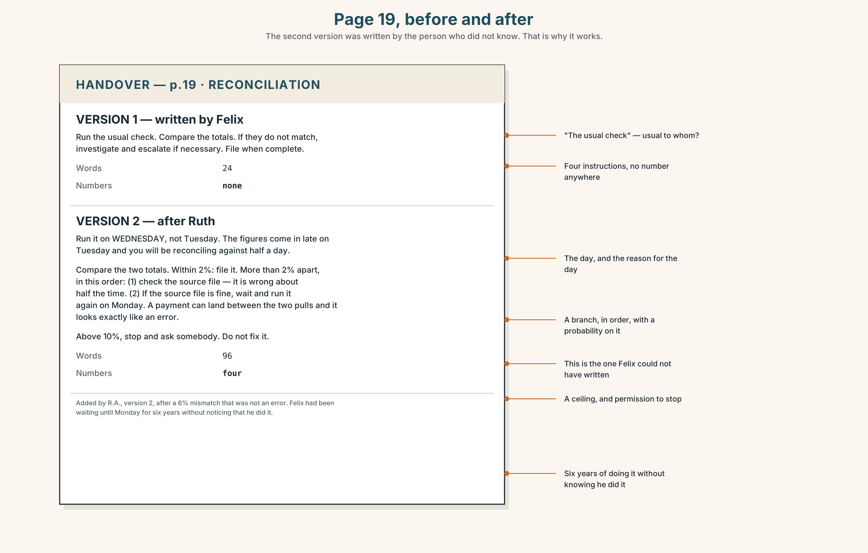{width=6.6in}
Page 19, before and after — The second version was written by the person who did not know. That is why it works.
Read page 19 of the handover document — before and after Ruth's edit.
- What did the original page tell you to do?
- What three things did Ruth add?
- Which of her additions could Felix have written, and which could he not?
- What is the only instruction on the page with a number in it?
- Find the sentence that only makes sense if you already know the answer.

5F · Writer analysis
- Felix writes for somebody who already knows. Ruth writes for somebody who does not.
- The document got better because the wrong person edited it. Is that a method or an accident?

5G · Text against text
The emails say the document failed. Page 19 says it worked. Two sentences on how both are true. The second begins "The forty pages did the thing that…"

Part 6 · Vocabulary Lab 2 ◆ B · THE SYSTEM

Twenty-one verbs that demand a pattern
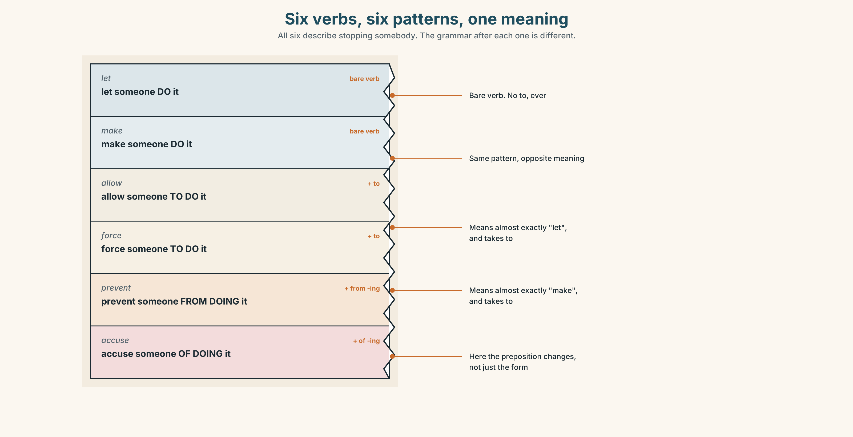{width=6.6in}
Six verbs, six patterns, one meaning — All six describe stopping somebody. The grammar after each one is different.

6A · Sort — which pattern?
Sort all twenty-one into three columns: + to · + from -ing · + of / on / for -ing.
persuade someone to · encourage someone to · urge someone to · warn someone against · advise someone to · remind someone to · allow someone to · expect someone to · want someone to · ask someone to · tell someone to · help someone to · teach someone to · force someone to · invite someone to · enable someone to · prevent someone from · stop someone from · accuse someone of · congratulate someone on · blame someone for · warn someone about

6B · Chunk completion
- She ______ me ______ taking the shortcut, and she was right.
- He ______ me ______ losing the file, which was not fair.
- They ______ her ______ passing after four attempts.
- Nothing ______ you ______ asking.
- The handover document ______ her ______ start on Monday instead of guessing.

6C · The three warnings
warn someone to · warn someone against · warn someone about
Three patterns, three meanings. Write a sentence for each, all about the same machine.

6D · Contrast Clinic — to, bare, and -ing
Six items.
- She let me ______ (go) early.
- She allowed me ______ (go) early.
- I watched him ______ (fit) the whole thing — forty minutes.
- I watched him ______ (fit) it as I walked past.
- They made us ______ (sign) it.
- They forced us ______ (sign) it.
Then: in pairs 1/2 and 5/6, what changed apart from the grammar?

Part 7 · Pronunciation & Fluency Lab ◆ B · THE SYSTEM

Where the stress goes in a three-word verb
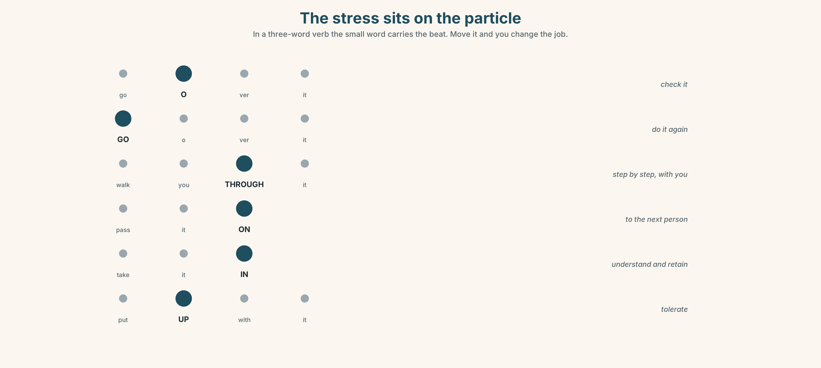{width=6.6in}
The stress sits on the particle — In a three-word verb the small word carries the beat. Move it and you change the job.

7A · Hear 🔊 Track 7.3
go Over it · walk you THROUGH it · pass it ON · take it IN · get ON with it · put UP with it
The stress is on the particle, not the verb. Mark it in six more.

7B · Say
"I'll go over it once, walk you through it, and then you pass it on."

7C · Make it mean something
"Go over it." — stress on go: do it again. "Go over it." — stress on over: check it.
Say both. Your partner says which job you just gave them.

7D · Fluency 20 ⏺
Twenty seconds: teach something, out loud, to nobody. Three times, faster.

Part 8 · Writing ◆ C · THE PERFORMANCE

Instructions that survive one handover · 140 words
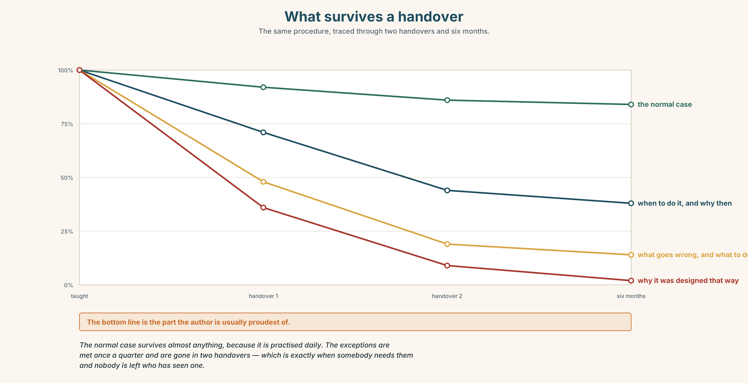{width=6.6in}
What survives a handover — The same procedure, traced through two handovers and six months.

8A · Read the model
Running the Wednesday reconciliation — for whoever does this next
Run it on Wednesday, not Tuesday. The figures come in late on Tuesday and you will reconcile against half a day. [the reason is the thing Felix had stopped noticing]
Compare the two totals. If they are within 2%, file it. If they are more than 2% apart, do these in order: check the source file first, because that is wrong about half the time. If the source file is fine, wait and run it again on Monday — a payment can land between the two pulls, and it looks exactly like an error. [the second branch exists because somebody found it the hard way]
I have never known it be more than 6% apart. If you see double figures, stop and ask somebody rather than fixing it.
The thing I got wrong for two years: I assumed a mismatch meant somebody had made a mistake. Usually it means you ran it on the wrong day. [the author's own error, named]
Questions about the writer's choices:
- Why does the branch about Monday exist, and who put it there?
- The last paragraph admits two years of being wrong. What does that do for the reader?
- One instruction has a number in it and one has "about half the time". Why keep the vague one?

8B · The anti-model
Perform the reconciliation in accordance with the standard process. Investigate any discrepancies and escalate as appropriate. Ensure all checks are completed prior to filing.
Name three decisions a new person still has to make after reading this.

8C · Generate · 8D · Plan
who this is for → when, and why then → the normal case → the branch → the limit, and what to do at it → what you got wrong

8E · Draft 1 — 140 words

8F · Peer review — two criteria
☐ Is there a step where I would have to guess? ☐ Did the writer admit something they got wrong?

8G · Draft 2 · 8H · Test it twice
Give it to somebody. Then give their version to a third person. What survived two handovers?

Part 9 · The File ◆ A · THE WORLD + C · THE PERFORMANCE

WORK FILE · The Handover
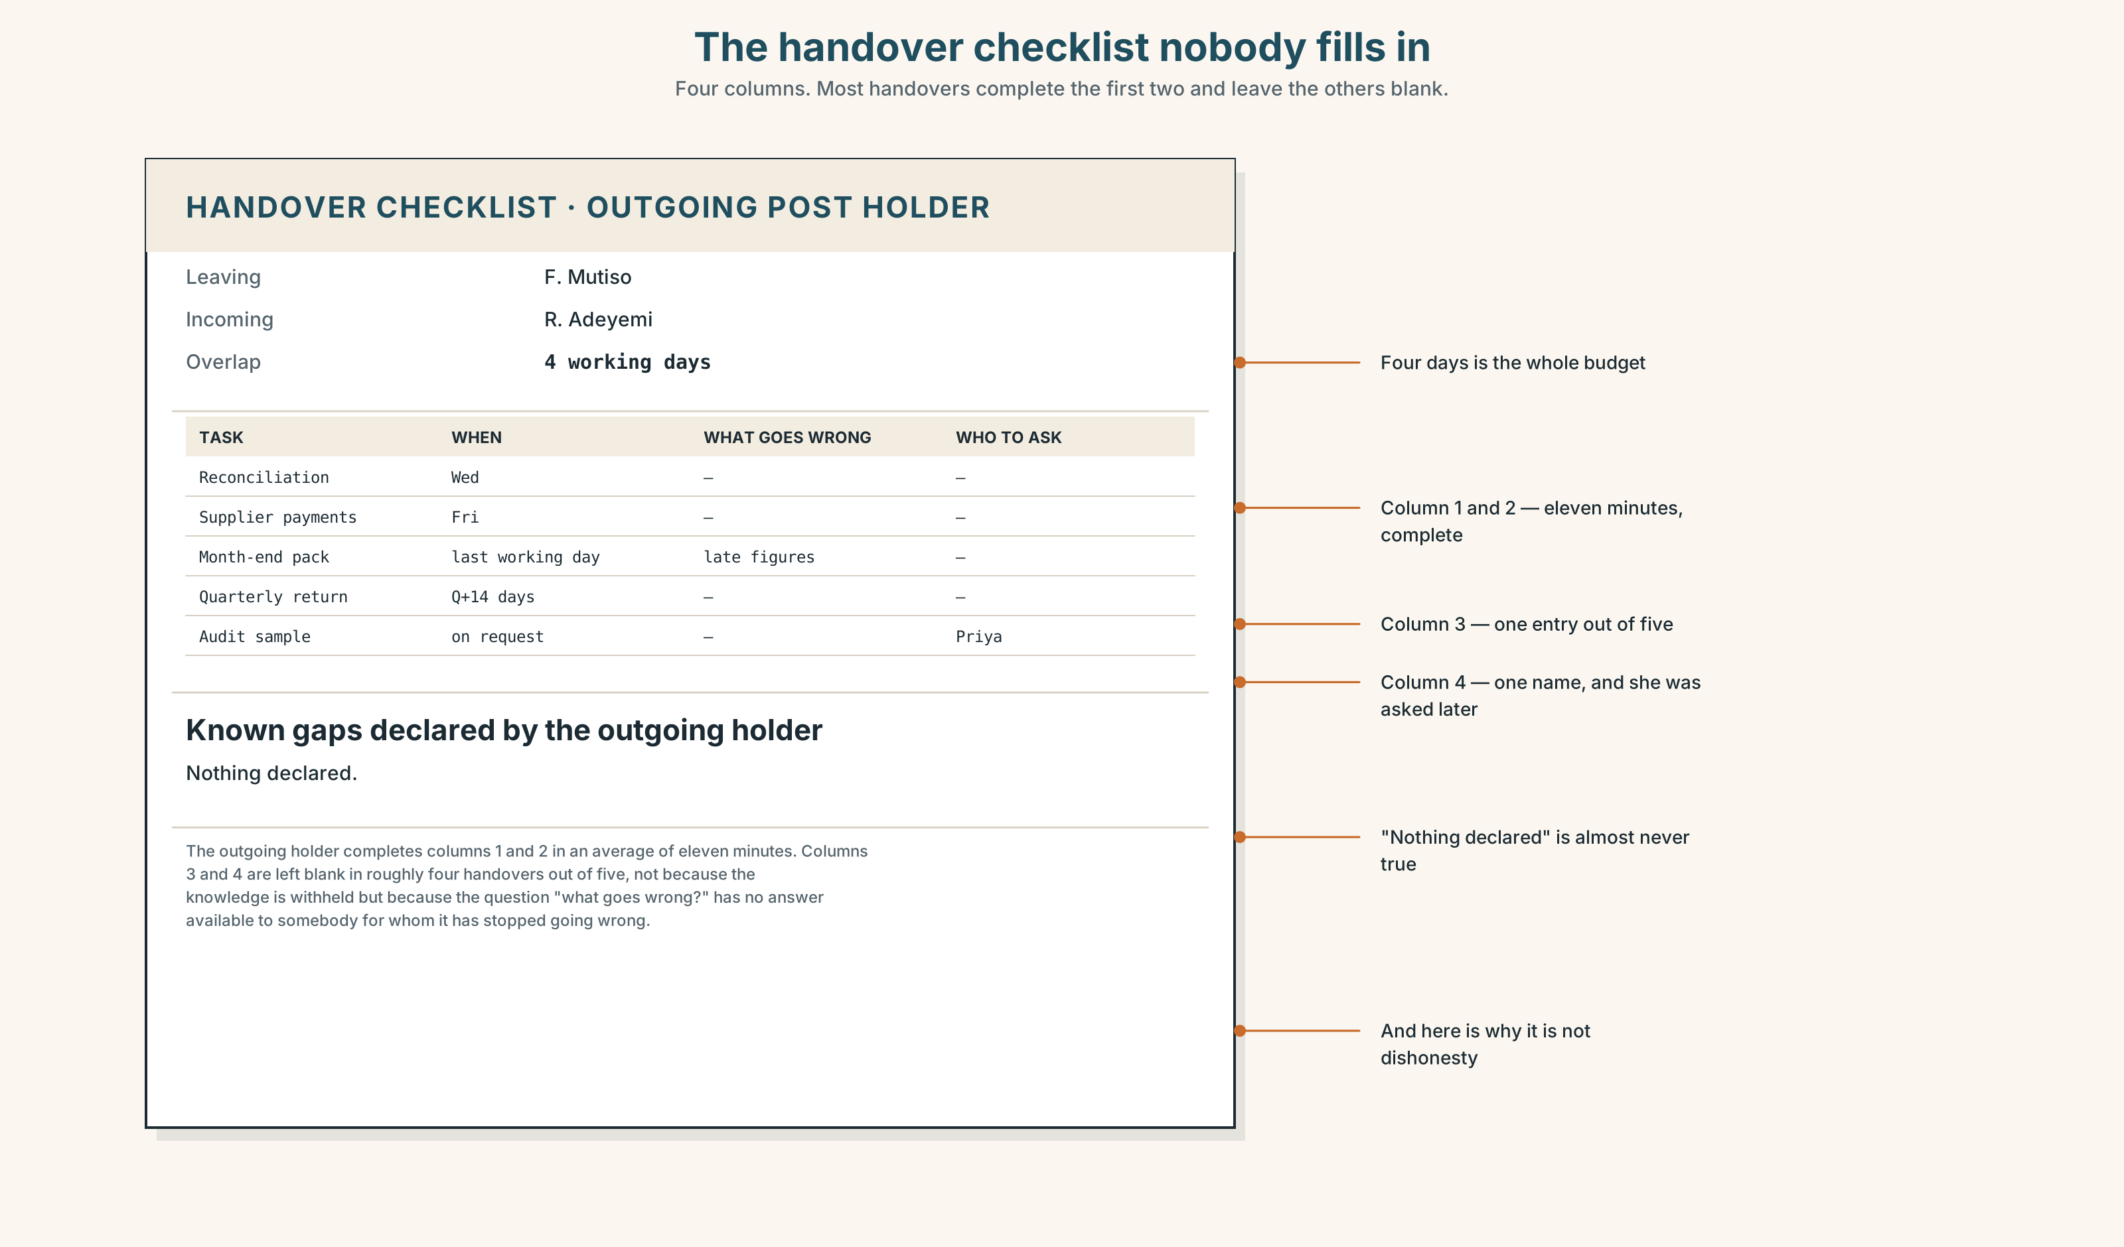{width=6.6in}
The handover checklist nobody fills in — Four columns. Most handovers complete the first two and leave the others blank.

9A · The four things a handover has to carry
Read the handover checklist. Rank the four by how often they are missed.
what you do · when you do it · what goes wrong · who to ask when it does

9B · The invisible knowledge test
List five things you do at work or in your studies that you have never been told and never told anybody. Five minutes. Most people stall at three.

9C · Write the hardest one
Take the one from 9B that is hardest to put into words. Write it in under eighty words, for somebody who has never done it.

9D · The successor's edit
Swap. Read somebody else's. Write the question you would have to ask them. Give it back. They add the answer. That is the handover.

9E · Transfer
Find out one thing this week that nobody told you and that you now do automatically. Write it down before you forget that you ever did not know it.

Part 10 · Mediation & Interaction ◆ C · THE PERFORMANCE
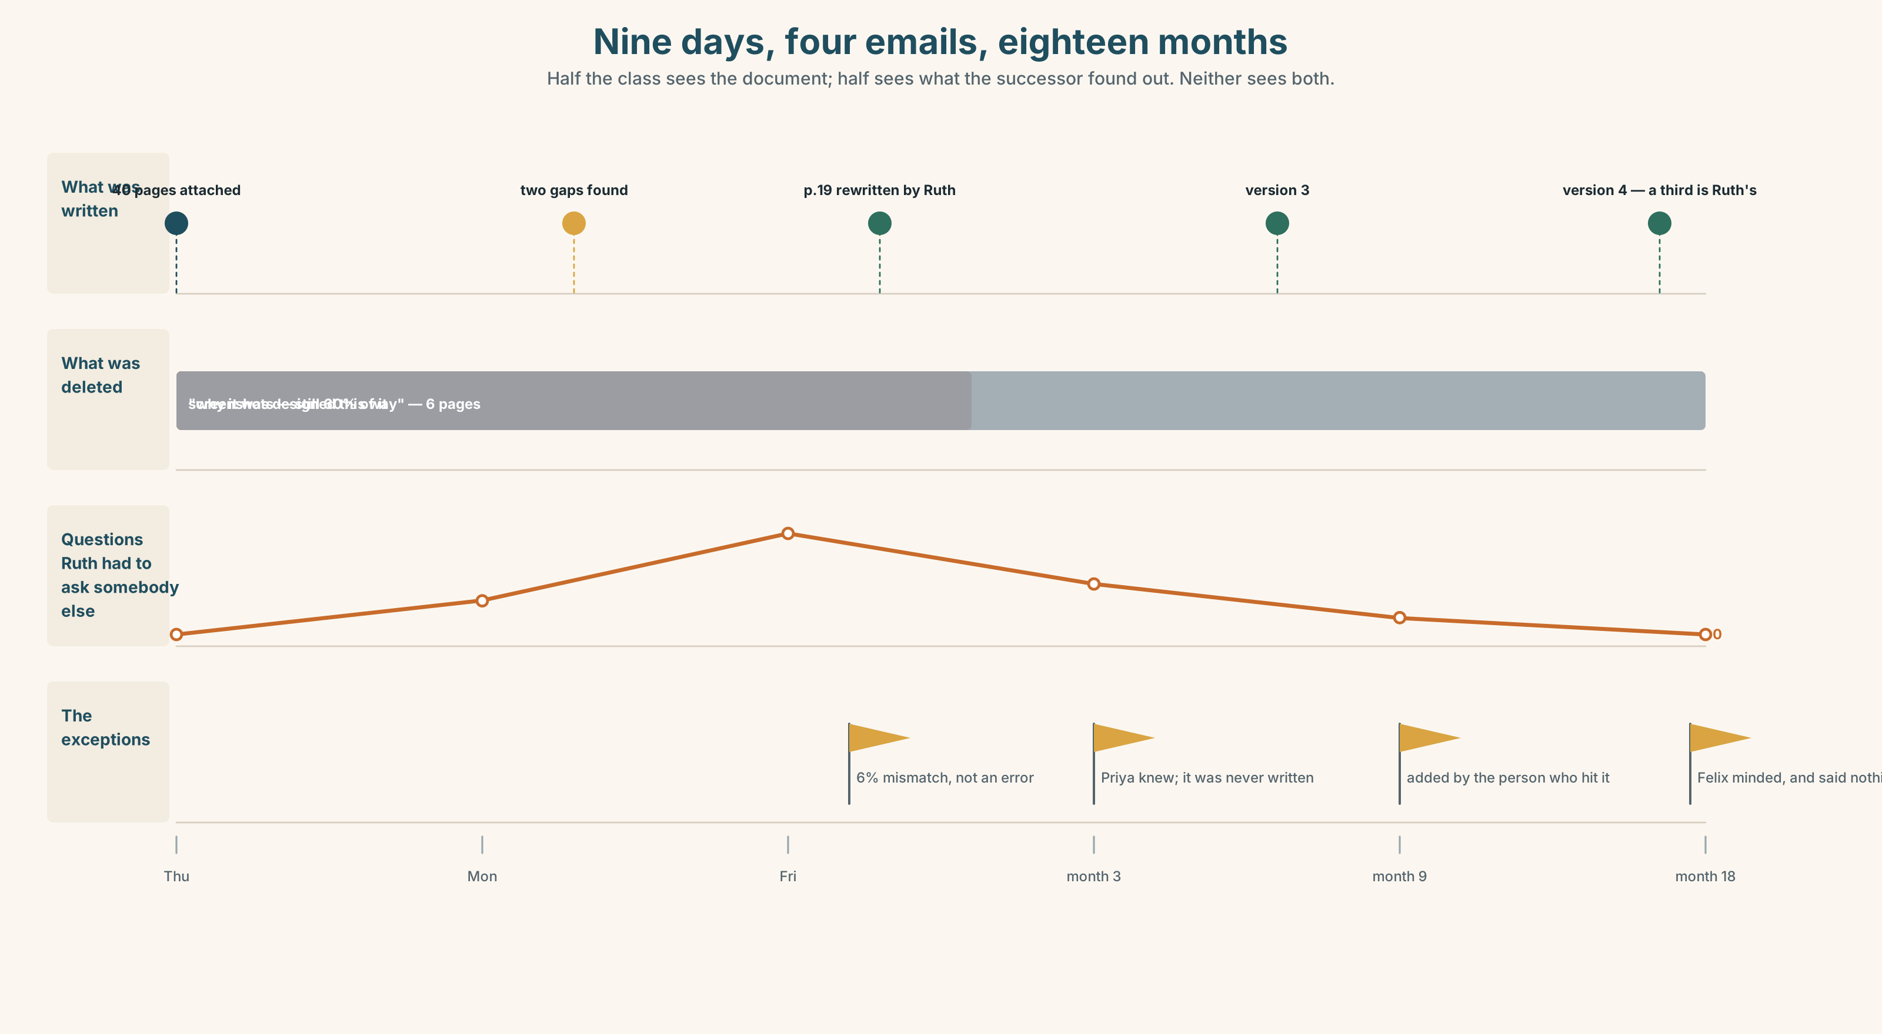{width=6.6in}
Nine days, four emails, eighteen months — Half the class sees the document; half sees what the successor found out. Neither sees both.

10A · Relay
Half the class sees the written document; half sees what the successor found out. Rebuild.

10B · Simplify
Explain the reconciliation to somebody doing it on Wednesday for the first time, in four minutes, on the phone, while they do it.

10C · Compress
The four emails into 60 words for a manager who wants to know whether the handover worked. Defend three cuts.

10D · Online interaction
Write the message to Felix telling him that page 19 was wrong. He wrote forty pages in his own time.

10E · Across languages
Teach a partner one phrase in your language — not by translating it. Only demonstrate. Then: what did you do when demonstrating failed?

Part 11 · The Decision ◆ C · THE PERFORMANCE

Four days, or forty pages
Felix leaves on the 30th. His replacement starts on the 27th. That is four days of overlap, and Felix has eleven days of work left that only he can do.
- Spend the four days teaching. His eleven days become somebody else's problem, and two of them cannot be done by anybody else before March.
- Spend the four days finishing, and write the forty pages in the evenings. He has done this before. The pages are good and the gaps are the things he has stopped noticing.
- Ask for the start date to move. It costs the business three weeks of an empty seat, and he has no standing to ask.

11A · The evidence
- Page 19 from Part 5, before and after.
- The chart: what survives one handover, two handovers, and six months.
- The voice. Ruth, twenty-five seconds: "The forty pages were the only reason I knew where to put the thing I found out."

11B · Steelman
Argue the option you like least. Two minutes.

11C · Deliberate
I think he should ______, because ______. The strongest argument against me is ______, and my answer to it is ______.

11D · Decide — eighty words, two reasons

11E · Model decision
He should write the pages and finish the eleven days, and I think the four days of teaching is the romantic answer.
Teaching in person transmits more per hour than any document — that is not in dispute, and if he had four weeks I would say spend them. He has four days, and four days of sitting beside somebody produces a person who can do the normal case and has met none of the exceptions, because the exceptions do not happen to order. In March she will hit the 6% case and he will be gone either way.
What the forty pages do is different. They are not a teacher; they are a place to put things. Ruth's own sentence is the argument: the pages were why she knew where p.19 was. A document that is wrong in a findable place beats a conversation that was right and is now unrecoverable.
He should spend one of the four days on the exceptions only, and let the normal case go in the document.

11F · The Reveal
What happened. He wrote the pages and worked the eleven days. He gave Ruth one afternoon, not four days, and spent all of it on the things that go wrong.
Eighteen months later the document is on version 4 and about a third of it is Ruth's. The section Felix was proudest of — a long explanation of why the system was designed that way — was deleted in version 2 by Ruth, who said nobody needed it.
He found out, and minded, and said nothing.
The handover worked. The part he most wanted to pass on was the part that did not survive.
Was the reasoning sound? And: was Ruth right to cut it?

Part 12 · Landing ◆ all three lines

12A · Recycle — twelve items
Six from this unit.
- I want you ______ (check) it twice.
- She let me ______ (borrow) it.
- I saw him ______ (leave) — the whole thing.
- She ______ me ______ taking the shortcut.
- It's a hands-______ job.
- He talked me ______ doing it his way.
Four from Units 1–6.
- The rule ______ (bring) in after a fire. (Unit 6)
- If you ______ (press) override, it ______ (log) your name. (Unit 5)
- You ______ prop that door open. (Unit 4)
- I ______ (see) him on Thursday — arranged. (Unit 3)
Two from Making Plans (A2.1).
- The person ______ wrote it had done it for six years. (relative clause)
- She ______ (not / be allowed) to use the big scissors on day one. (obligation range)

12B · Consolidate
120 words, one paragraph. Somebody teaching you something: what they wanted you to do, what they let you do, what they made you do, what they saw you doing. Six items from Part 6.

12C · Can-do, with evidence
I can… | My evidence | Sure?
choose the right pattern after an object without thinking about it | Part 3G score | ◯ ◑ ●
teach a skill so that the person I taught can teach it on | Part 4C, round two | ◯ ◑ ●
write instructions that survive me leaving | Part 8, tested twice | ◯ ◑ ●
decide how to spend time I do not have enough of | Part 11D | ◯ ◑ ●

12D · Replay ⏺
Part 0C again. Compare.

12E · Glossary — forty-five items, as a map
TEACHING · instruct · demonstrate · model · rehearse · mentor · walk someone through · show someone how · let someone try LEARNING · apprentice · competence · retention · pick up · take in · have a go · hands-on · trial and error SHAPING IT · prompt · cue · feedback · correction · go over · pass on THE SAYINGS · see one, do one, teach one · it's muscle memory + TO · persuade · encourage · advise · remind · allow · expect · want · ask · tell · help · teach · force · invite · enable someone to + FROM -ING · prevent · stop someone from + OF / ON / FOR · accuse someone of · congratulate someone on · blame someone for + AGAINST / ABOUT · warn someone against · warn someone about · talk someone into · put someone off · bring someone round

12F · Next
Unit 8 · What grows where you are?

