Table of Contents

B1.1 · Unit 8 · Four Hundred Kilometres
English Animated · Taking a Position · Jengo House, Nairobi Student's Book pages 148–167 · 20 pp · ~11.5 hours

Part 0 · The Big Picture ◆ A · THE WORLD
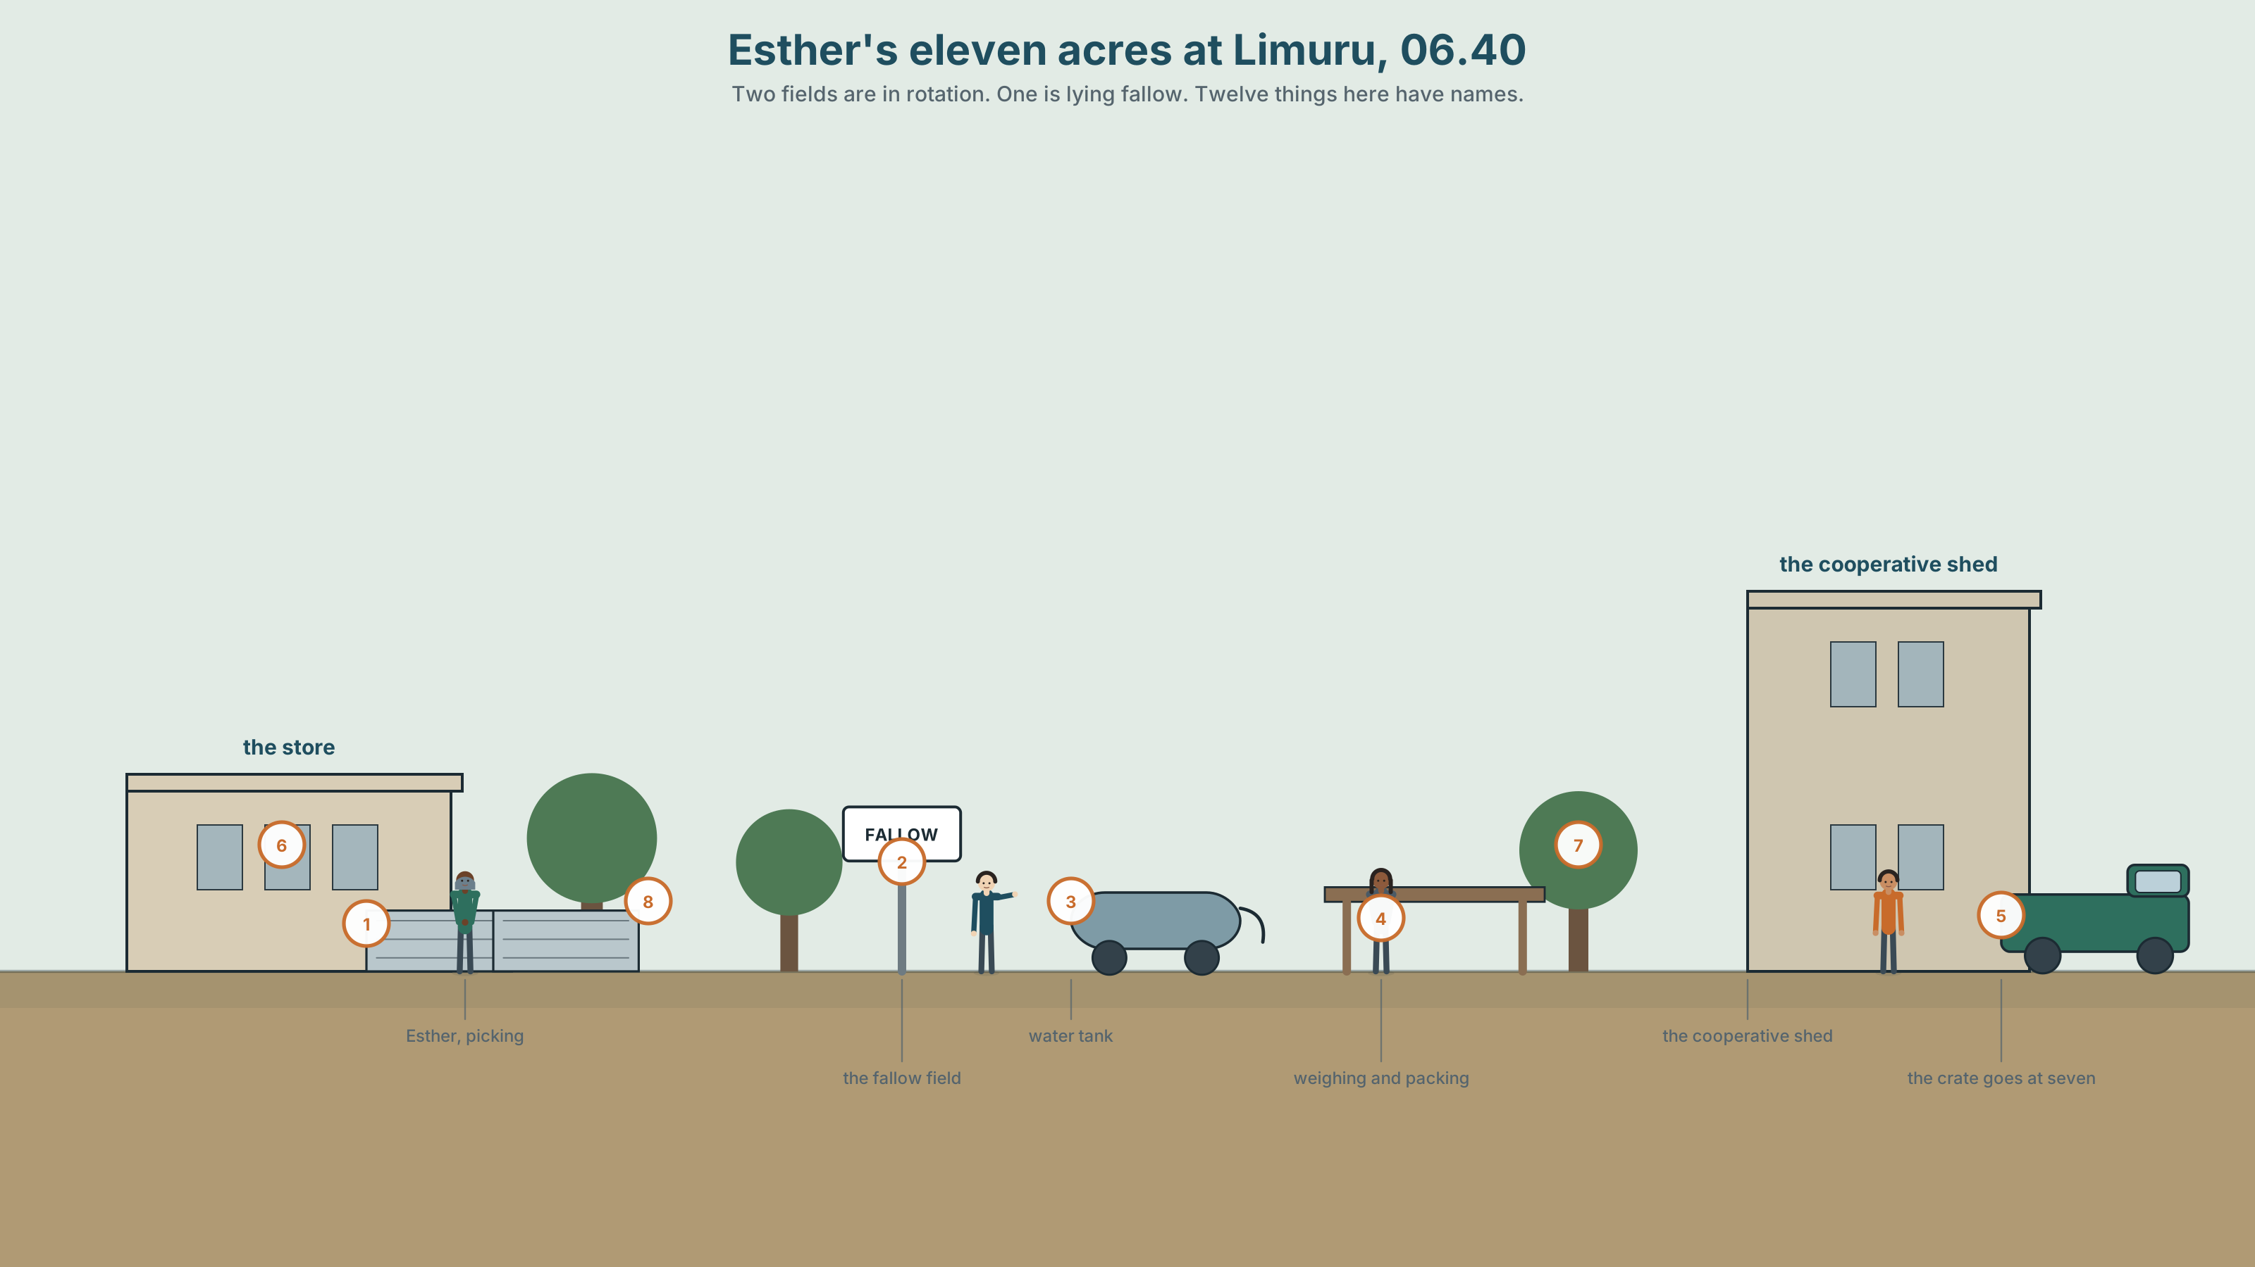{width=6.6in}
Esther's eleven acres at Limuru, 06.40 — Two fields are in rotation. One is lying fallow. Twelve things here have names.

What grows where you are?
By the end of this unit you will give a two-minute presentation on one crop's journey — from the ground it came out of to the hand that paid for it.
◆ A · THE WORLD | Where food comes from, what the distance costs, and who the word local is for
◆ B · THE SYSTEM | Relative clauses reduced, and with prepositions · defining and non-defining, returning · 24 words for land and cultivation · 21 relative structures for formal writing · holding a long noun phrase together
◆ C · THE PERFORMANCE | A presentation that traces one thing from the soil to the shelf

0A · Find it
Twelve things on this smallholding. Four of these sixteen are not there.
furrow · terrace · irrigation line · drip tape · water tank · shade netting · seedbed · compost heap · drying rack · weighing scale · crate stack · boundary hedge · greenhouse · tractor · beehive · windbreak

0B · Guess it
Two of the fields are in rotation and one is lying fallow. Which is fallow, and what is the evidence?

0C · Say it ⏺
Record thirty seconds. What grows where you are? If you do not know, say that. Unprepared.

Part 1 · Vocabulary Lab 1 ◆ B · THE SYSTEM
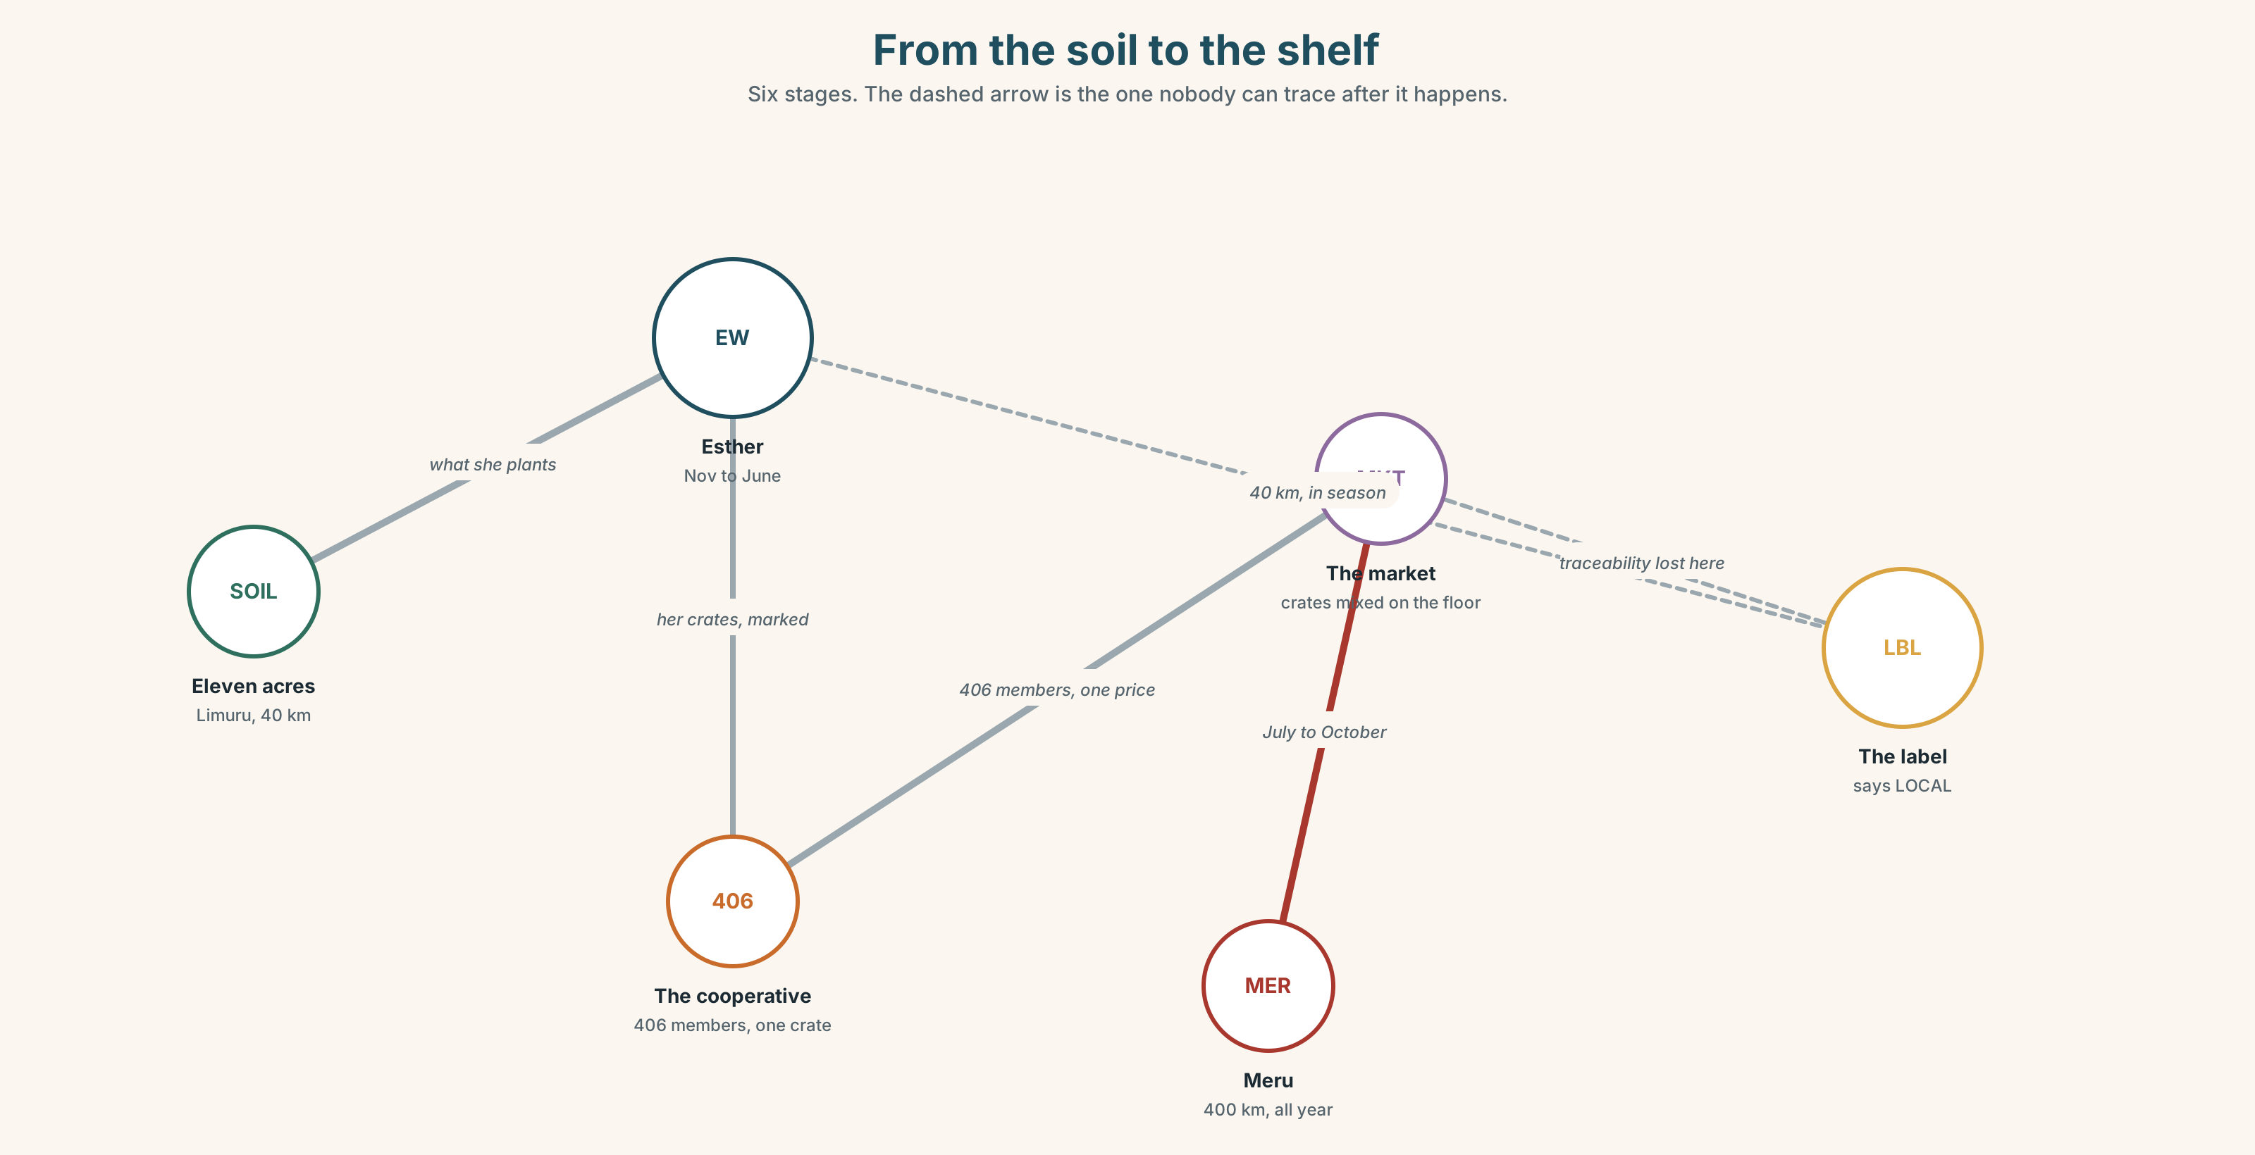{width=6.6in}
From the soil to the shelf — Six stages. The dashed arrow is the one nobody can trace after it happens.

1A · Meet — from the ground up
Use the network. Name the word at each stage.
soil · yield · irrigation · drought · crop · harvest · smallholder · cooperative · rotation · fertiliser · erosion · perennial

1B · Sort — how fast can you change it?
Order from changes in a season to takes a generation.
what you plant · how you irrigate · the soil · who you sell to · the rotation · the terraces
Mark the point where it stops being this year's decision.

1C · Sort — odd one out, and why
- yield · harvest · crop · rotation
- drought · erosion · fertiliser · irrigation
- smallholder · cooperative · perennial · grower
- set aside · die back · turn over · plough back

1D · Stretch — the phrases
- Only a third of it is ______ land; the rest is too steep.
- Coffee is a ______ crop — you cannot eat it and you cannot store it long.
- Two fields are planted and one is left to lie ______.
- Mangoes are cheap in January and absurd in July: they are out of ______.
- The growing ______ is shorter every year by about four days.
- If the rains fail twice, ______ security stops being an abstraction.

1E · Stretch — four phrasal verbs, one field
set aside · die back · turn over · plough back
Two are things a farmer does deliberately. One is something a plant does. One is both.

1F · The two sayings
a bad year · the land knows
One is an explanation and one refuses to be one. Which, and who says each?
Corpus Note Local collocates with produce, economy and supplier. It does not collocate with any distance. English has no agreed number behind the word, which is why it appears on so many labels.

1G · Own it
Name one thing you ate this week. Say how far it travelled, or say that you do not know. Both answers are the task.

Part 2 · Listening ◆ A · THE WORLD
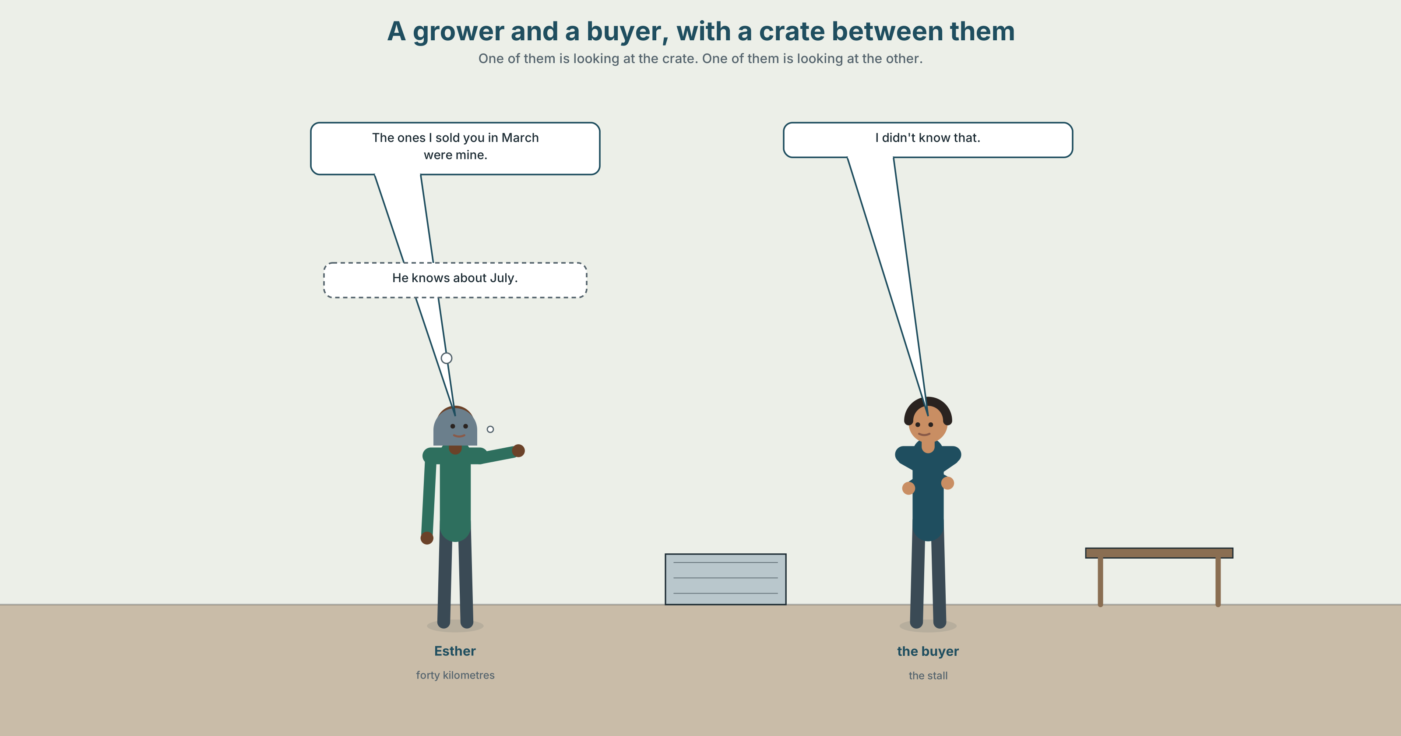{width=6.6in}
A grower and a buyer, with a crate between them — One of them is looking at the crate. One of them is looking at the other.

2A · It says local on the box 🔊 Track 8.1
Before you listen. A grower and a buyer, with a crate between them. Which one is looking at the crate?
Gist — one listen, one question. How far has the produce in the crate actually travelled?
Detail — complete the frame.
 | Distance | Price | Season
the grower's
the other supplier's
Inference. The grower says "the ones I sold you in March were mine." What is she admitting about the ones in July?
Attitude. The buyer says "I didn't know that" — and then does not ask a follow-up. Which sound tells you he is not surprised?
Noticing. Six sentences. Sort them.
- The farm which supplies us is four hundred kilometres away.
- The farm supplying us is four hundred kilometres away.
- The grower who I buy from has eleven acres.
- The grower I buy from has eleven acres.
- The cooperative, of which she is a member, sets the price.
- The cooperative she's a member of sets the price.
A. the full relative clause · B. the same thing, shorter · C. formal, with the preposition moved

2B · Decoding clinic 🔊 Track 8.2
Forty seconds. Four jobs.
- Where does she pause inside the long sentence?
- Catch the three distances.
- the farm supplying us — is there a word missing, and can you hear where?
- of which — what happens to the two words?
Transcripts, page 178.

Part 3 · Grammar Lab 1 ◆ B · THE SYSTEM

Shortening a relative clause, and moving a preposition

3A · Notice
Return to the six sentences.
- Compare 1 and 2. Which two words disappeared?
- Compare 3 and 4. Which word disappeared, and why is it allowed to?
- In 4, could you also remove the words in sentence 1? Try it. What is the rule?
- Compare 5 and 6. The preposition has moved. Which version would you say out loud?
- In 5, why of which and not of that?

3B · See
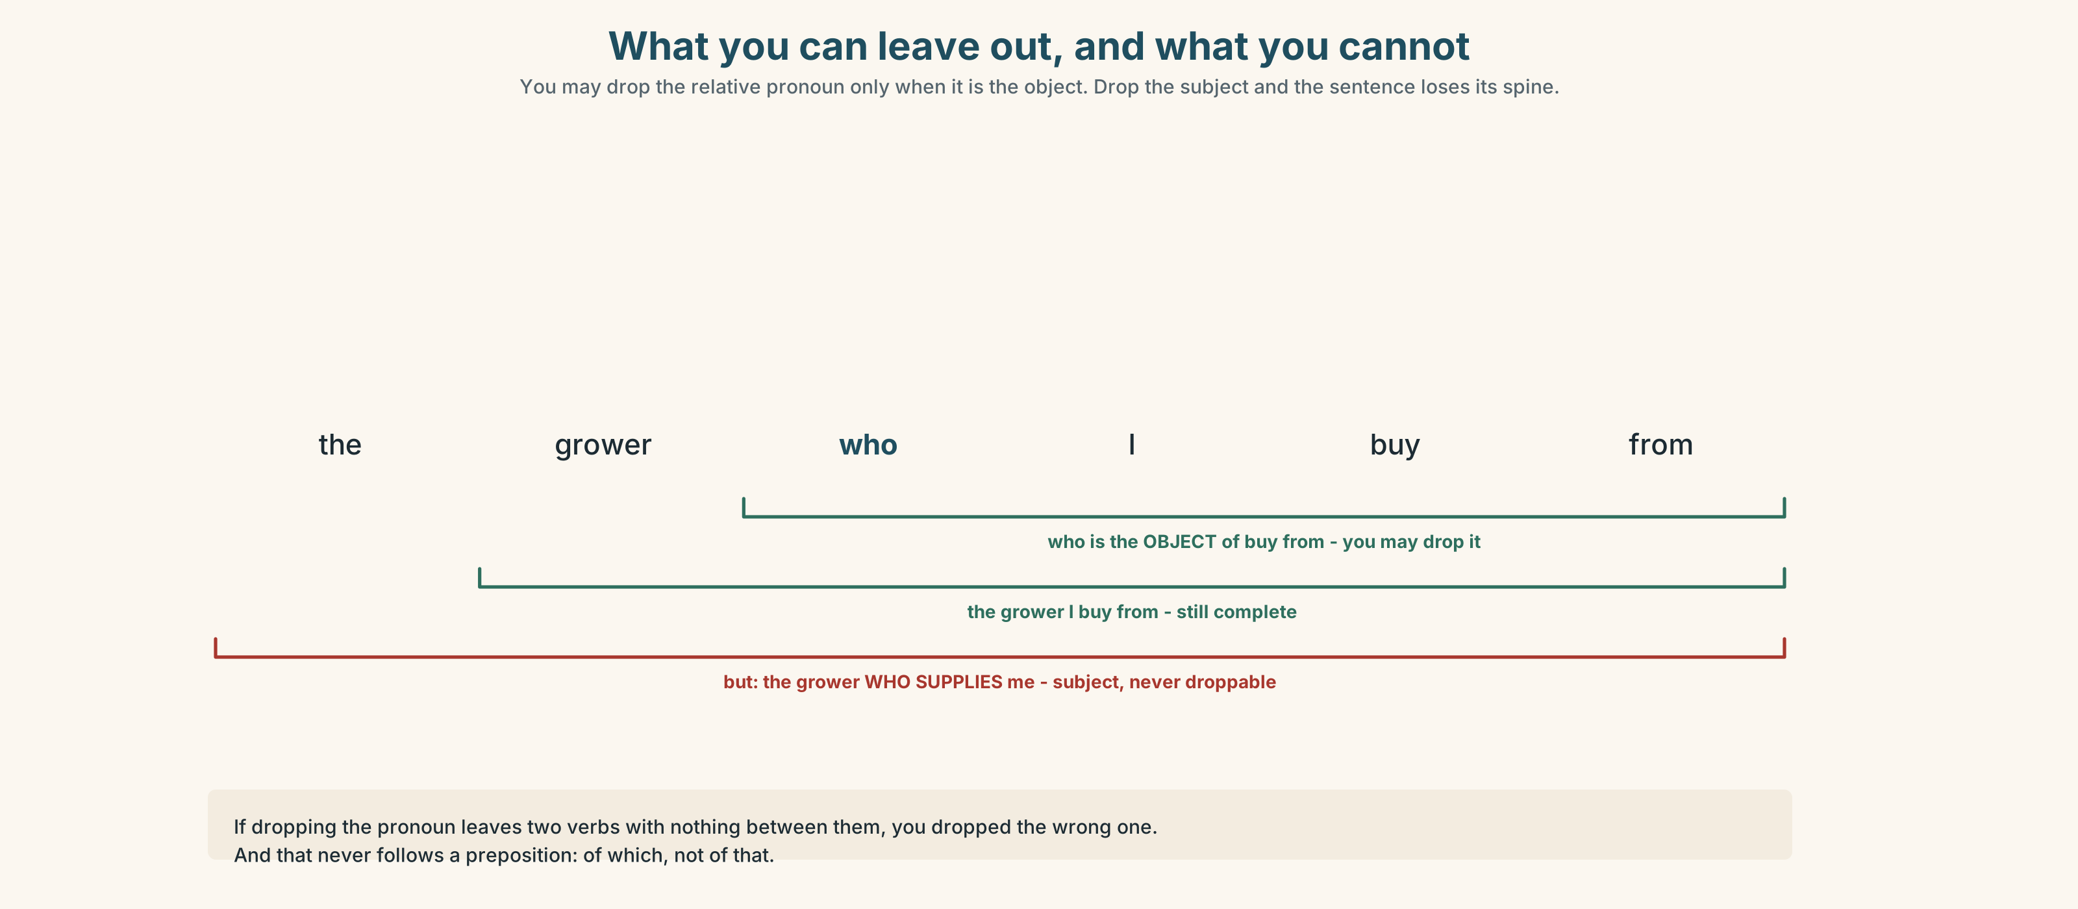{width=6.6in}
What you can leave out, and what you cannot — You may drop the relative pronoun only when it is the object. Drop the subject and the sentence loses its spine.

3C · Know
Reducing a relative clause
Full | Reduced | When you can
the farm which supplies us | the farm supplying us | active verb → -ing
the crates which were packed yesterday | the crates packed yesterday | passive → past participle
the grower who I buy from | the grower I buy from | drop who/which/that when it is the object
the grower who supplies me | ✗ the grower supplies me | never when it is the subject
Moving the preposition
the cooperative she's a member of — normal speech the cooperative of which she is a member — formal writing ✗ the cooperative of that she is a member — that never follows a preposition
Watch out. You can drop the relative pronoun only when it is the object of its clause. If dropping it leaves two verbs with no subject between them, you have dropped the wrong one.
Why it matters. A reduced clause packs more into a sentence, which is what reports and labels do. It also hides things: produce grown locally does not say by whom, or how local.

3D · Use — controlled
Reduce each clause if you can. Two of these cannot be reduced — say why.
- The farm which supplies the market is in the next county.
- The crates which were loaded on Tuesday went out first.
- The grower who I met last year has stopped.
- The cooperative which sets the price has four hundred members.
- The variety which they planted in 2019 needs less water.
- The hedge which was planted to stop erosion is forty years old.

3E · Use — guided
Rewrite each in the formal pattern, moving the preposition.
- The cooperative she's a member of.
- The season we depend on.
- The three growers we buy from.
- The extent to things have changed. (fix it first)

3F · Use — open
Describe three people and three places using one reduced clause each. Your partner's job: say whether each clause could be put back to its full form.

3G · Check — six items
- The woman ______ runs the stall has been there thirty years. (can you drop it?)
- The woman ______ I spoke to has been there thirty years. (can you drop it?)
- The boxes ______ (pack) on Tuesday are the ones to send.
- The cooperative, ______ ______ she is a member, sets the price. (formal)
- The field ______ (lie) fallow this year was planted in 2023.
- The extent ______ ______ the season has shortened is now measurable. (formal)
0–3 → Workbook pp. 62–64. 4–5 → Part 6. 6 → p. 159.
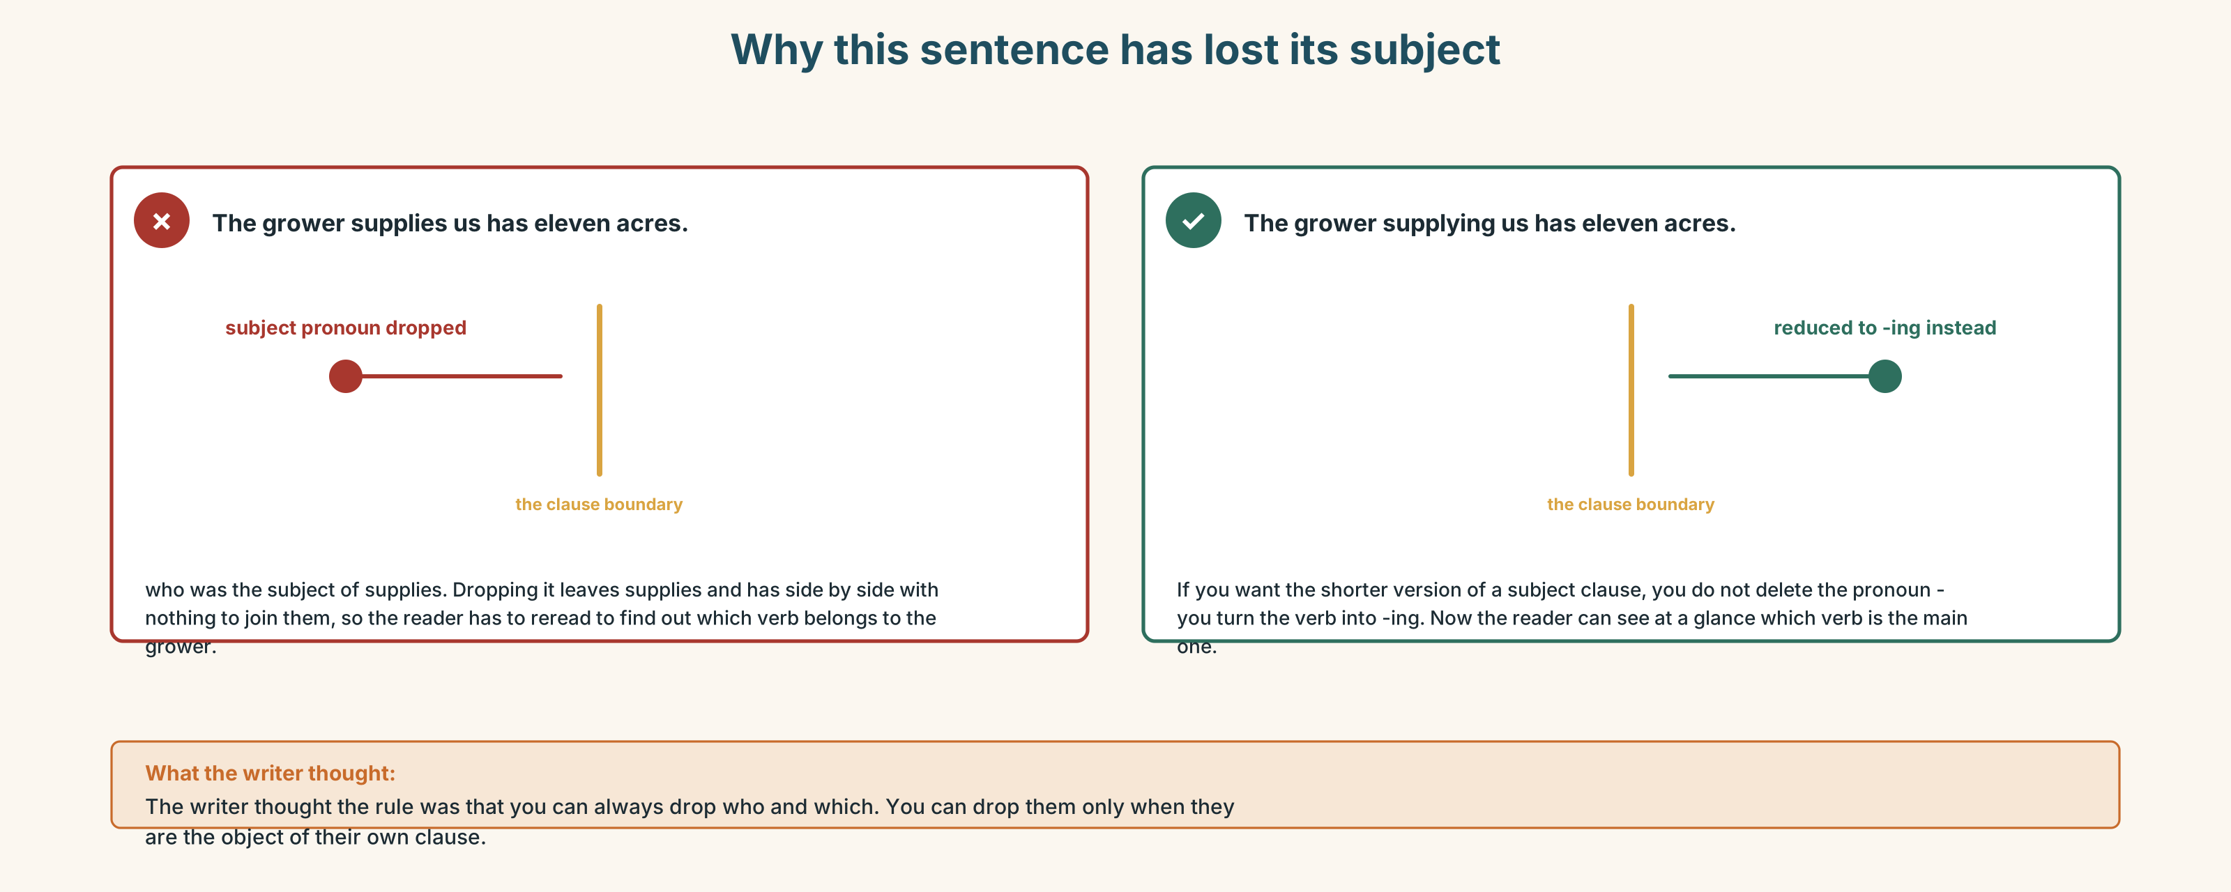{width=6.6in}
Why this sentence has lost its subject — Why this sentence has lost its subject

Part 4 · Speaking ◆ C · THE PERFORMANCE

4A · Fluency sprint — 4 / 3 / 2
Describe a meal, from the shop backwards. Four minutes, three, two.

4B · The functional core — tracing something back
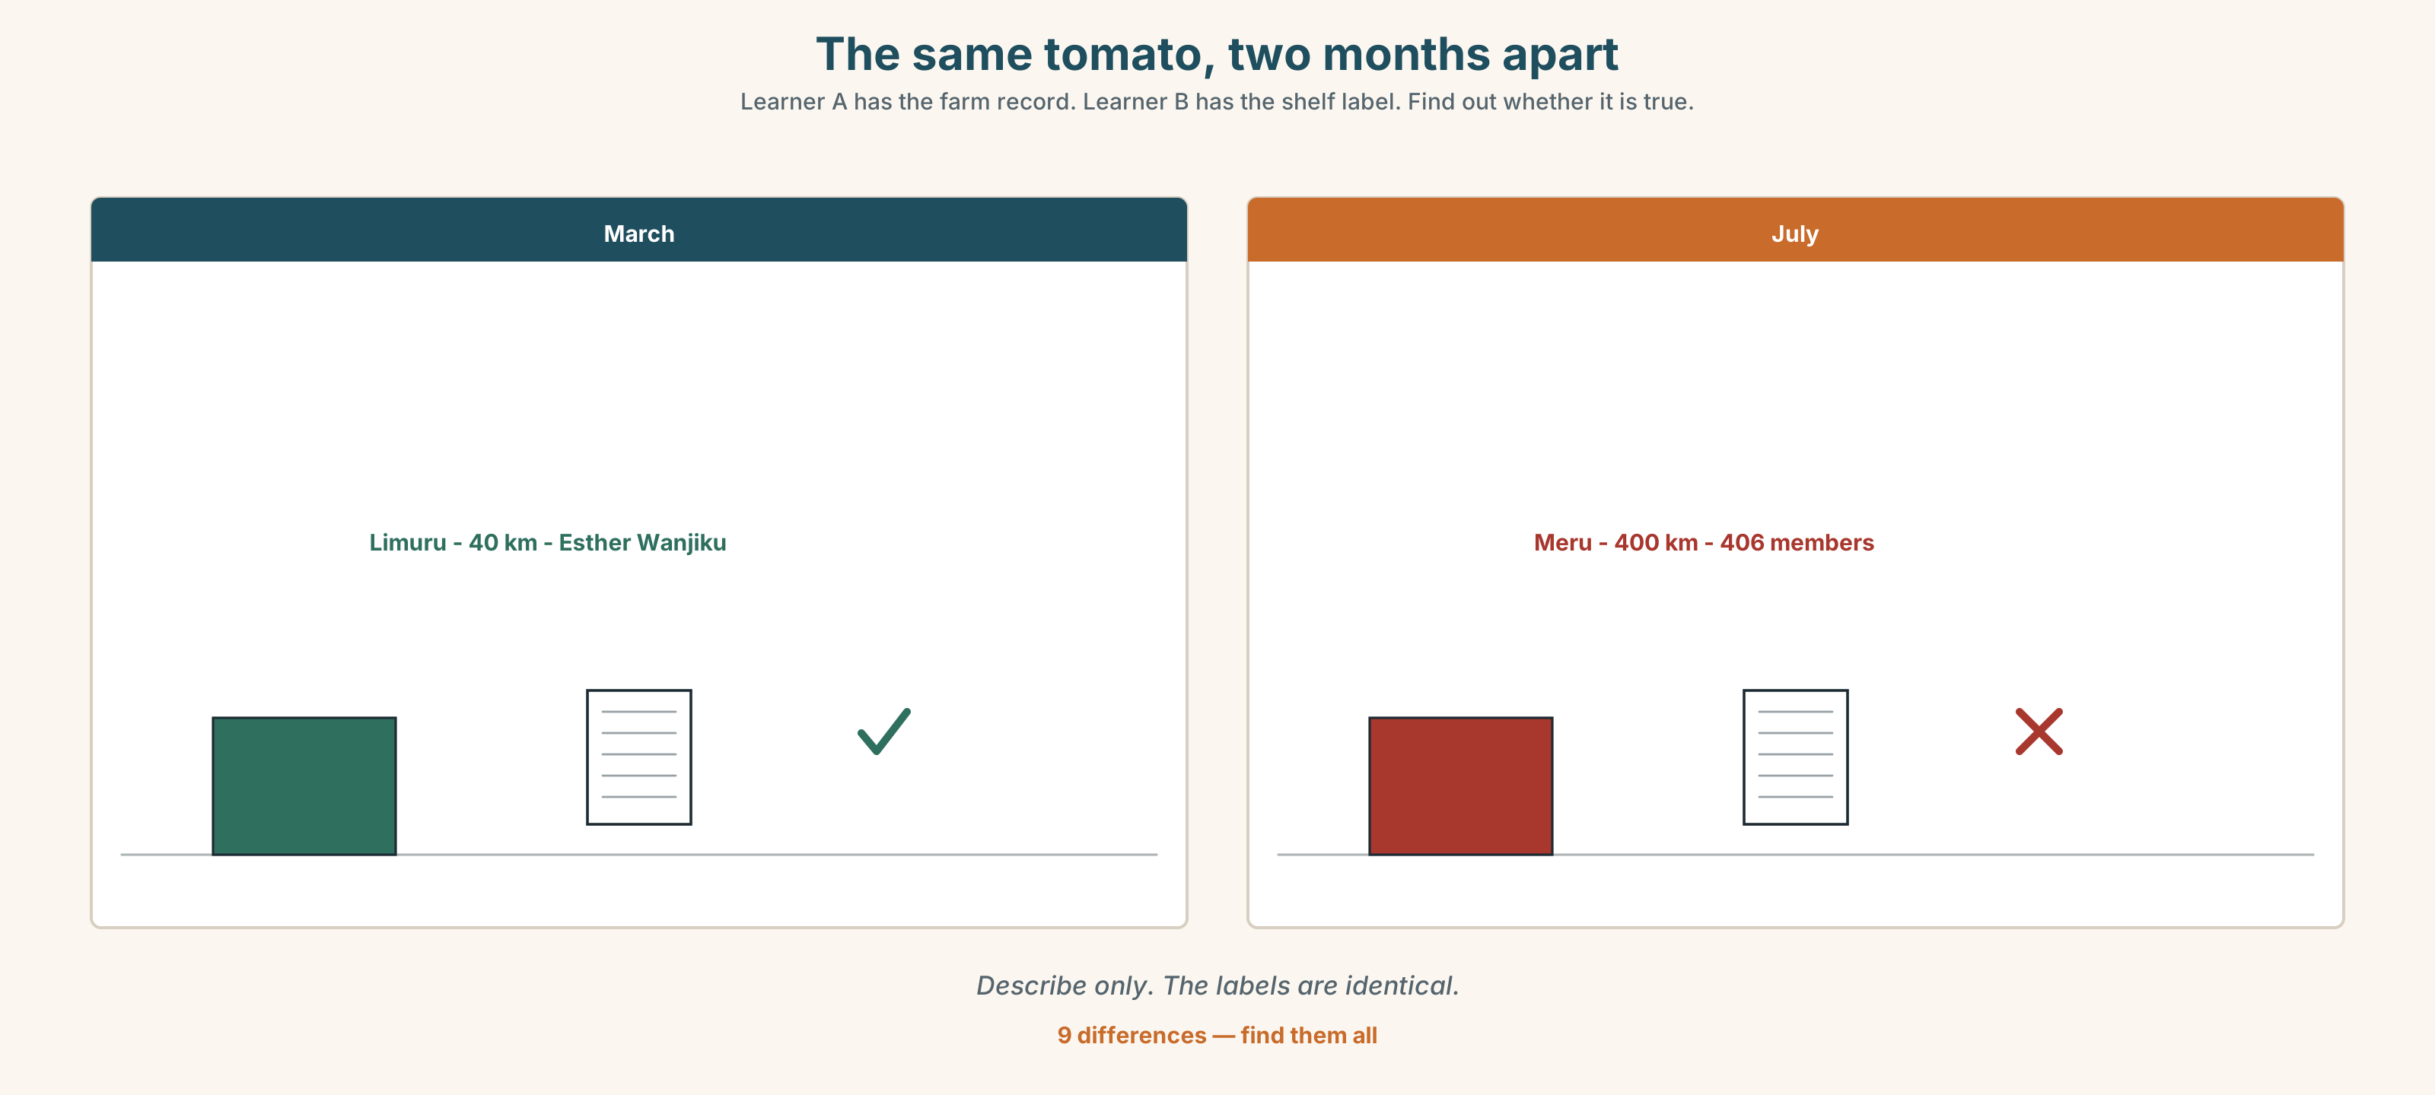{width=6.6in}
The same tomato, two months apart — Learner A has the farm record. Learner B has the shelf label. Find out whether it is true.
Language Bank
tracing | it starts with · from there it goes to · by the time it reaches us
hedging a number | somewhere around · at a rough guess · nobody really knows, but
the gap | what the label doesn't say is · the part nobody counts is
landing it | so the short answer is · which means that when you buy it, you are paying for
Information gap. Learner A has the farm's records. Learner B has the shelf label. Neither sees the other. Find out whether the label is true.

4C · The performance — one crop, two minutes
Trace one thing from soil to shelf. Two minutes, uninterrupted, then two questions you have not seen. You must name one number you are not sure about, and say why.

4D · Observer
Listen for one thing: where did the speaker's chain of custody break?

4E · Two criteria
☐ Did I say where my numbers came from? ☐ Did I name the step I could not account for?

Part 5 · Reading ◆ A · THE WORLD

5A · Predict
An explainer called "What the word local is doing." The first line is:
There is no legal definition of local, which is not an oversight.
What do you expect? One sentence.

5B · Skim — sixty seconds
Find the paragraph that defends the word.

What the word local is doing
There is no legal definition of local, which is not an oversight. Several have been proposed, and each has failed for the same reason: any distance you pick is correct somewhere and absurd somewhere else. Thirty miles is a reasonable radius in a dense country and meaningless in a sparse one. A rule written for one landscape fails in the next valley.
In the absence of a number, the word is doing something other than measuring. It is signalling. When a label says local, the claim it is making is not geographic; it is a claim about the kind of supply chain the buyer is joining — short, visible, and with a person at the end of it who could in principle be visited.
Most of the time this is roughly honest. The produce travelled a distance the buyer would accept if they knew it, and the grower is a person the shop could name. The failure cases are specific. The first is seasonality: a shop that sells a crop twelve months a year is importing for at least part of it, and the label does not usually change in July. The second is aggregation: a cooperative, of which the grower is one of four hundred members, can truthfully describe produce as coming from its members while a given crate has no traceable field at all. The third is processing: a thing grown four hundred kilometres away and packed ten kilometres away is, under several voluntary schemes, locally packed, which on a label looks identical.
The defence of the word is worth stating, because the critique is easy and the alternative is worse. A buyer who knows nothing uses the word as a weak signal and is usually not badly misled by it. A buyer who insists on a number ends up with a certification scheme, and certification costs money, and the growers who cannot afford it are precisely the smallholders the word was supposed to protect. Replace a vague word with a precise one and you have not made the system more honest. You have made it more expensive to enter.
What would help is not a definition but a habit: printing the distance, printing the month, and printing the name of the farm the crate came from. None of those requires a scheme. All of them are harder to write on a label than the word local, which is the actual reason they are not there.

5C · Close reading
- Why has no legal definition of local succeeded?
- What does the writer say the word is claiming, if not a distance?
- Name the three failure cases and give an example of each.
- What is the argument for keeping the vague word?
- Why would a certification scheme hurt smallholders in particular?
- What three things does the writer propose, and what is the stated reason they are absent?

5D · Vocabulary in context
oversight · radius · signalling · aggregation · traceable · voluntary scheme

5E · The counter-text
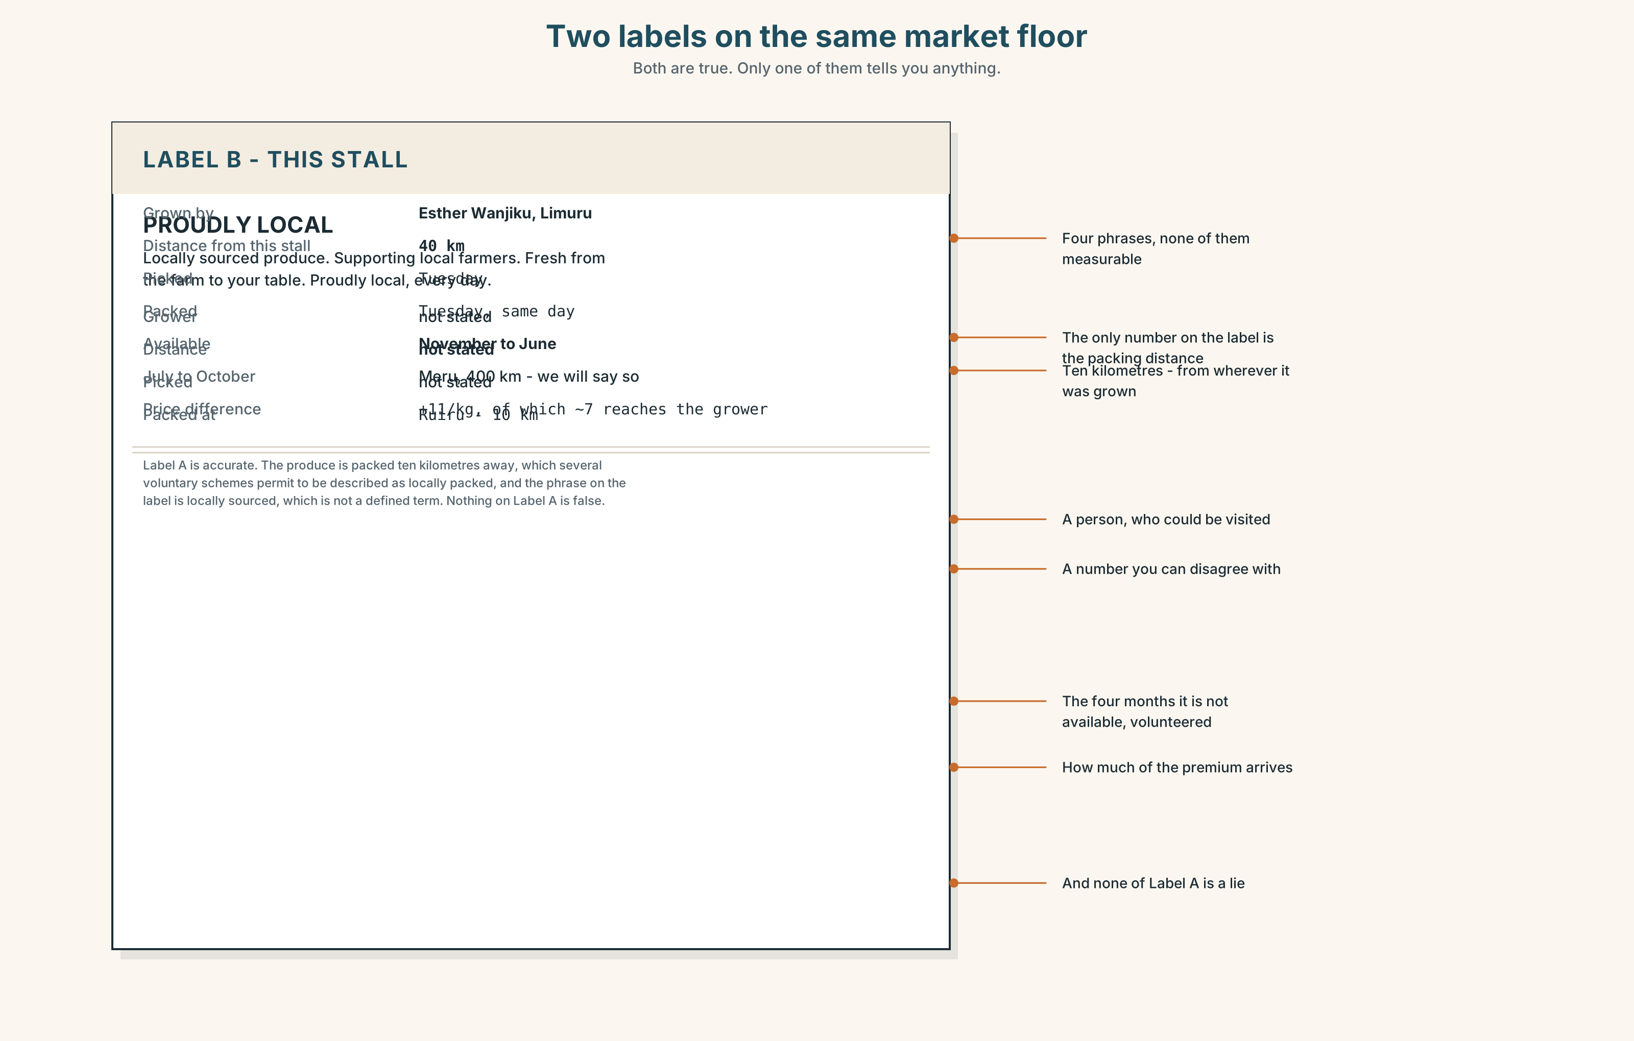{width=6.6in}
Two labels on the same market floor — Both are true. Only one of them tells you anything.
Read the two labels and answer.
- What does each label actually claim?
- Which of the three failure cases does each one fall into?
- One label gives a distance. Is it the distance you would want?
- What is the packing date, and what is missing next to it?
- Which of the two is more honest, and which is more informative? They are not the same label.

5F · Writer analysis
- The explainer concedes before it criticises. Where exactly?
- The last paragraph blames label size. Is that the real reason? What would the writer say if pressed?

5G · Text against text
The explainer says printing the distance would help. One label prints a distance. Two sentences on whether it helped. The second begins "The number is true, and…"

Part 6 · Vocabulary Lab 2 ◆ B · THE SYSTEM

Twenty-one ways to attach a clause formally
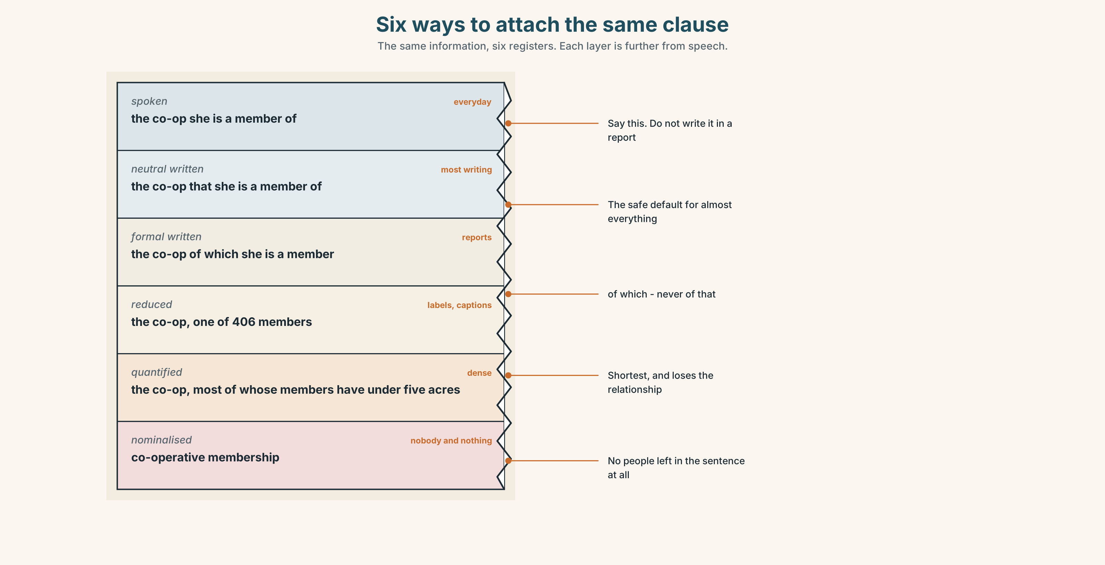{width=6.6in}
Six ways to attach the same clause — The same information, six registers. Each layer is further from speech.

6A · Sort — speech, writing, or both?
Sort all twenty-one. Six belong in both.
whereby · wherein · whose · thereof · respectively · namely · notably · chiefly · largely · partly · solely · in which · of which · of whom · at which point · the extent to which · none of which · most of which · stem from · give rise to · all of which is to say

6B · Chunk completion
- A scheme ______ growers certify each other was tried in 2019.
- The crates, ______ ______ were damaged, were sent back.
- ______ ______ ______ ______ the season has shortened is now measurable.
- The erosion ______ ______ the loss of the hedge.
- Two failures, ______ aggregation and seasonality, account for most of it.

6C · Register sort
Which of these would survive in a label? Which only in a report? Three would appear in neither, and would still be said out loud.

6D · Contrast Clinic — reduce it, or don't
Six items. Reduce where you can; mark where you cannot and say why.
- The grower who supplies us has eleven acres.
- The grower who we buy from has eleven acres.
- The variety which was planted in 2019 needs less water.
- The cooperative which sets the price has four hundred members.
- The hedge which was planted in 1984 is still there.
- The field which lies fallow this year was planted in 2023.

Part 7 · Pronunciation & Fluency Lab ◆ B · THE SYSTEM

Holding a long noun phrase together
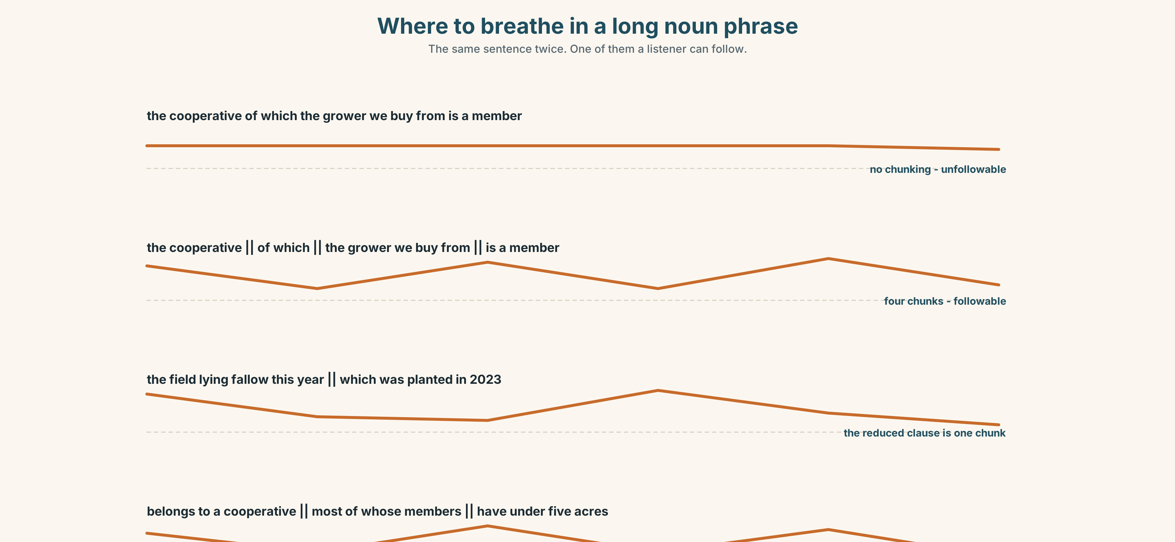{width=6.6in}
Where to breathe in a long noun phrase — The same sentence twice. One of them a listener can follow.

7A · Hear 🔊 Track 8.3
The same long phrase, said two ways. One of them you can follow.
the cooperative of which the grower we buy from is a member

7B · Say
Mark the chunks. Say it with a short pause at each boundary, and no pause anywhere else.
the cooperative ‖ of which ‖ the grower we buy from ‖ is a member

7C · Make it mean something
Read this aloud so a listener could write it down:
The field lying fallow this year, which was planted in 2023 with a variety needing less water, belongs to a cooperative most of whose members have under five acres.
Where did you breathe? Mark it. Compare with three other people.

7D · Fluency 20 ⏺
Twenty seconds: one thing, traced back three steps. Three times, faster.

Part 8 · Writing ◆ C · THE PERFORMANCE

What this is and where it came from · 140 words
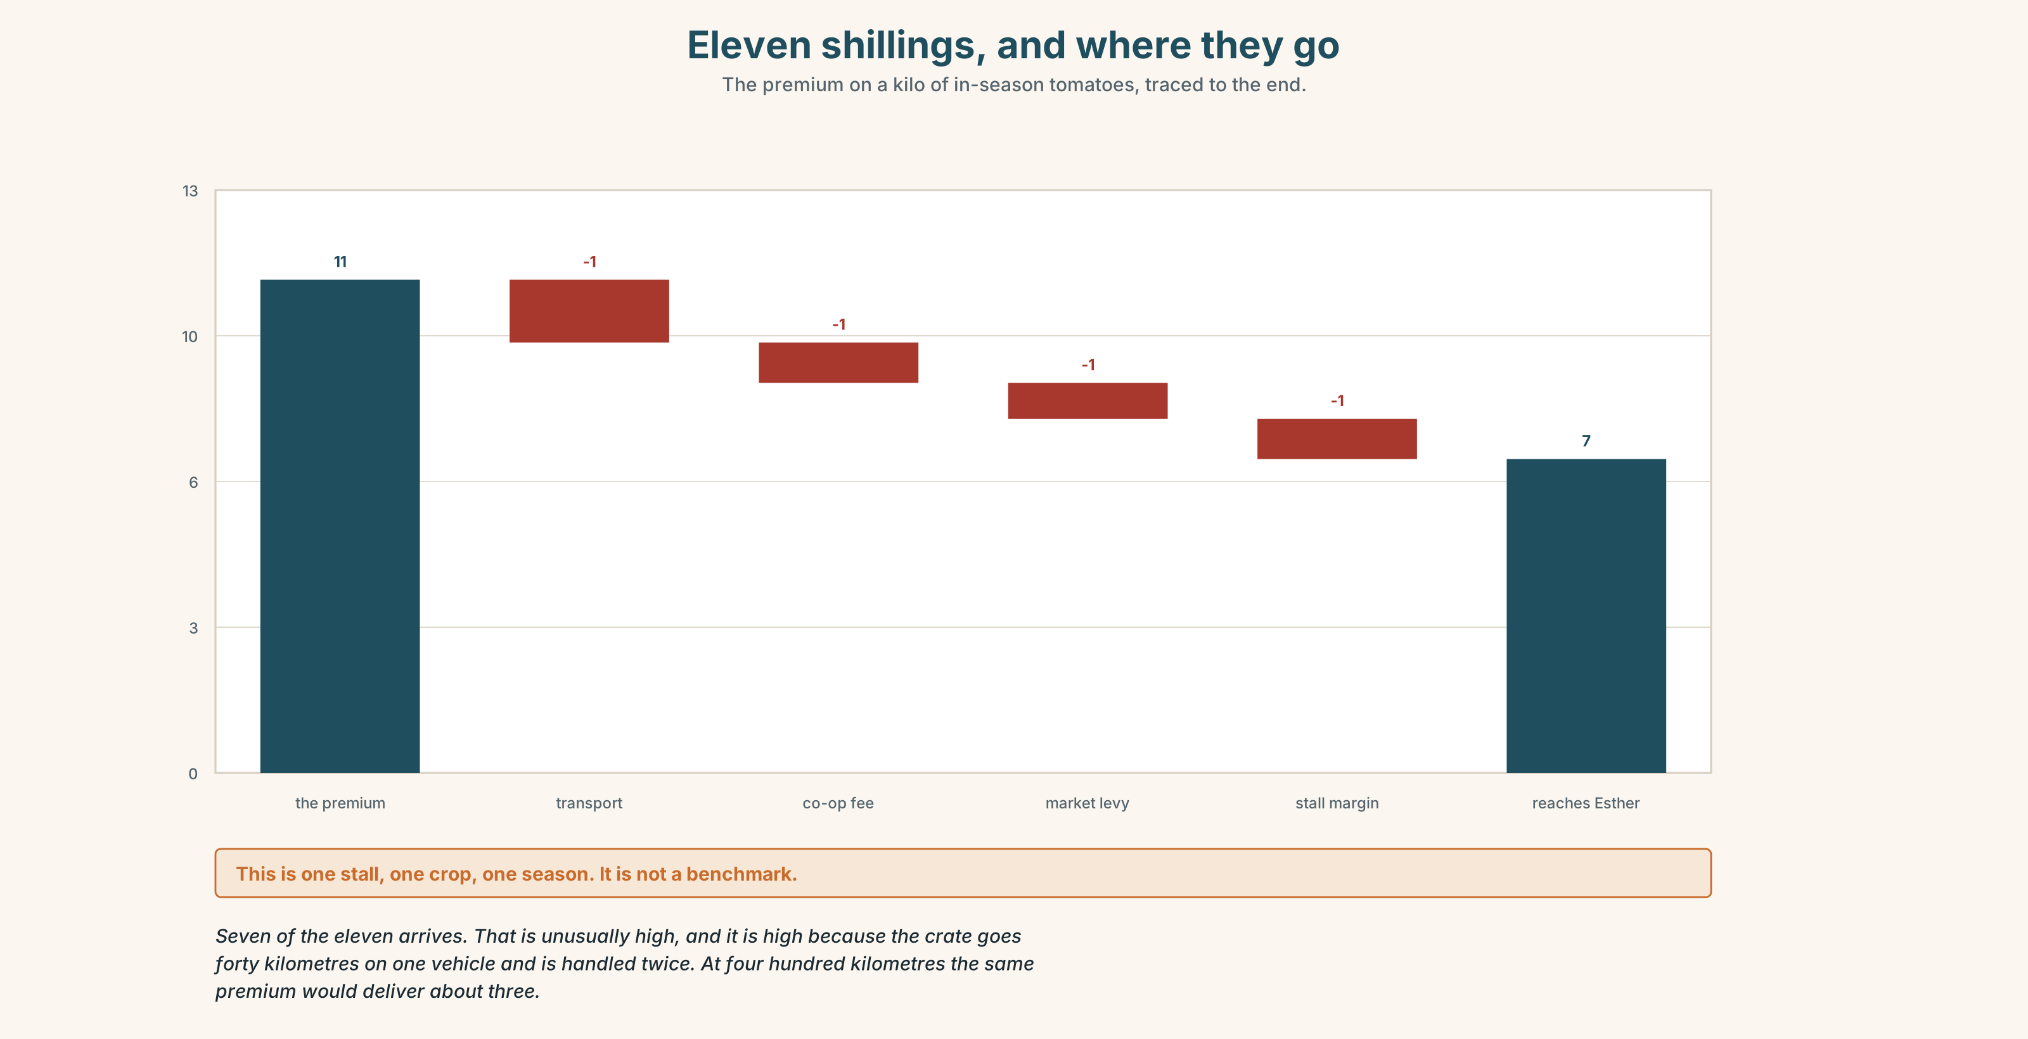{width=6.6in}
Eleven shillings, and where they go — The premium on a kilo of in-season tomatoes, traced to the end.

8A · Read the model
These tomatoes were grown by Esther Wanjiku, whose plot is eleven acres at Limuru, forty kilometres from this stall. [the grower is named in sentence one, and the number is specific]
They were picked on Tuesday and packed the same afternoon in crates belonging to the cooperative she is a member of, which has four hundred and six members and sets a floor price.
From July to October we cannot get them from her, because they do not grow here then. In those months ours come from Meru, four hundred kilometres away, and we will say so on the board. [the honest sentence, given before anybody asks]
They cost more than the imported ones on the next stall. The difference is about eleven shillings a kilo, and roughly seven of that reaches Esther. [the premium is stated, and so is how much actually arrives]
Questions about the writer's choices:
- Why name the grower before anything else?
- The July sentence is volunteered. What does the writer buy with it?
- The last line says how much of the premium reaches the grower. Most sellers do not. Why not?

8B · The anti-model
Locally sourced produce. Supporting local farmers. Fresh from the farm to your table. Proudly local, every day.
Each phrase is defensible. Name three things a buyer still does not know.

8C · Generate · 8D · Plan
what it is → who grew it, named → how far, with a number → when it is not available, and what happens then → what it costs, and where the difference goes

8E · Draft 1 — 140 words

8F · Peer review — two criteria
☐ Could I visit the person who grew this? ☐ Did the writer tell me something they did not have to?

8G · Draft 2 · 8H · Publish
On the stall, at the size a stall can carry.

Part 9 · The File ◆ A · THE WORLD + C · THE PERFORMANCE

STUDY FILE · Note Systems
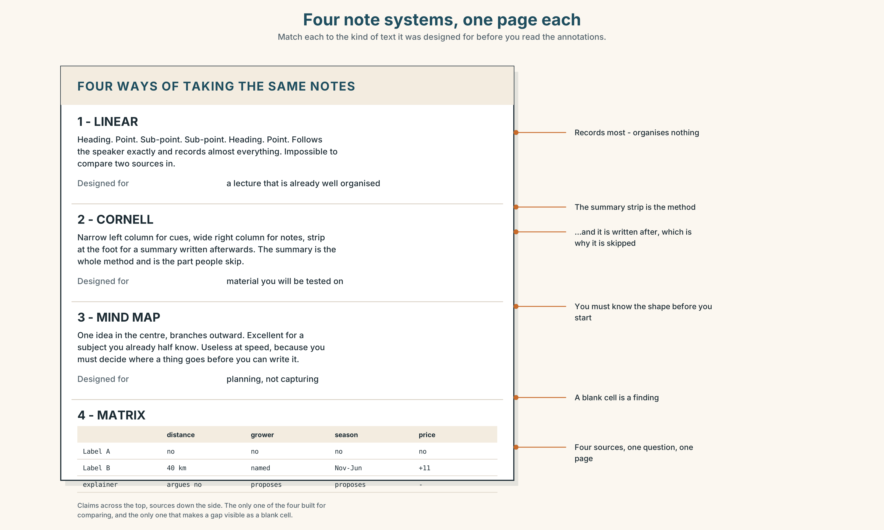{width=6.6in}
Four note systems, one page each — Match each to the kind of text it was designed for before you read the annotations.

9A · Four methods, four texts
Four note systems. Four kinds of text. Match them before you read 9B.
linear · Cornell · mind map · matrix an explainer · a lecture · four sources on one question · a process you have to perform

9B · Test it
Take notes on the Part 5 explainer twice: once linear, once as a matrix. Four minutes each.

9C · The retrieval test
Close the notes. Write down everything you can remember. Then open each set and count what each one recovered.

9D · The method nobody uses
The matrix — claims across the top, sources down the side — is the only one of the four designed for comparing. Which of your four pieces of coursework this term needed comparing?

9E · Transfer
Take notes in a real lecture, meeting or video this week using a method you do not normally use. Bring both the notes and your opinion of them.

Part 10 · Mediation & Interaction ◆ C · THE PERFORMANCE
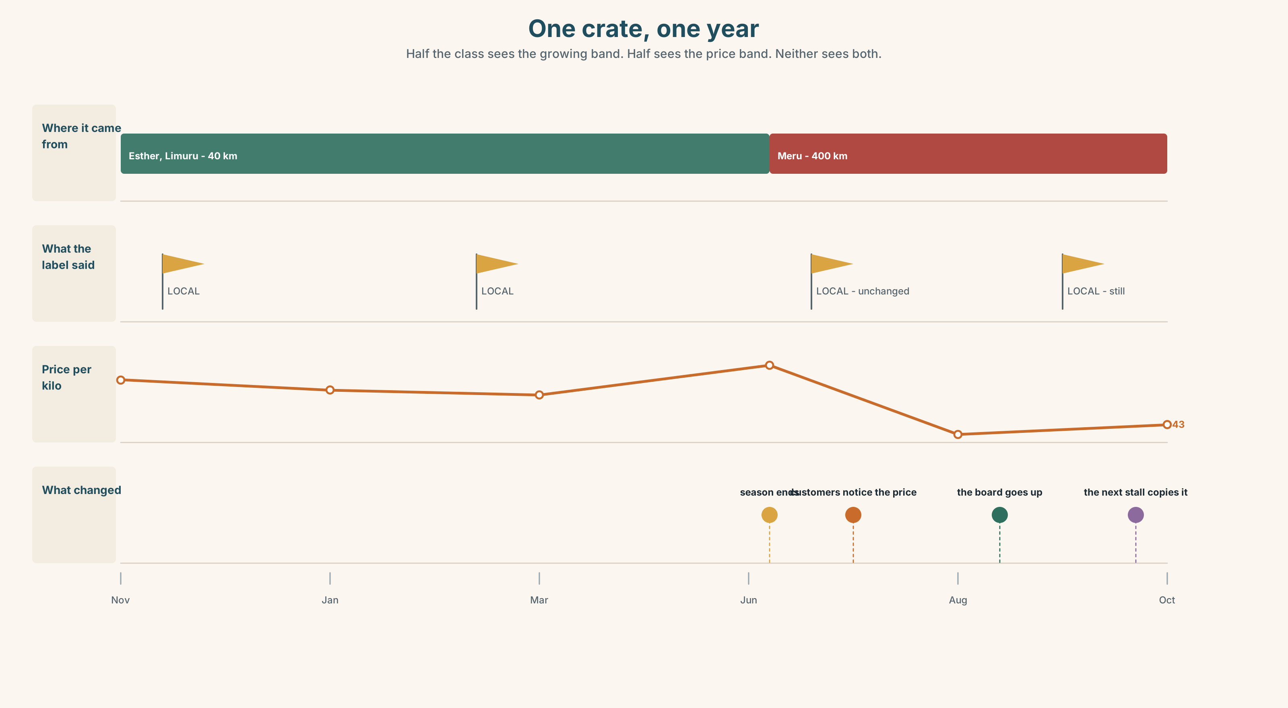{width=6.6in}
One crate, one year — Half the class sees the growing band. Half sees the price band. Neither sees both.

10A · Relay
Half the class sees the growing band; half sees the price band. Rebuild by speaking.

10B · Simplify
Explain the two labels from Part 5 to somebody choosing between them with a queue behind them. Nine seconds, then nine more if they ask.

10C · Compress
The explainer into 60 words for a stallholder who has to decide what to print. Defend three cuts.

10D · Online interaction
Write the post for the stall's page explaining why the price went up in July. The cheaper stall is in the same group.

10E · Across languages
Does your language have a word doing the job of local? Is it as vague? Is the vagueness useful in the same way?

Part 11 · The Decision ◆ C · THE PERFORMANCE

Esther, or Meru
The stall's tomatoes come from Esther at Limuru, forty kilometres away, from November to June. For the other four months she has none, and the stall buys from Meru, four hundred kilometres away, at about two thirds of the price.
The stall next door sells Meru tomatoes all year and is eleven shillings a kilo cheaper. Customers have started saying so.
- Buy from Esther all year — she can grow under netting, but the cost rises and the quality in July is honestly worse.
- Buy from Meru all year and stop saying local. Cheaper, consistent, and Esther loses a third of her income.
- Split it, and say so on the board — Esther in season, Meru out of season, with the distance and the month printed.

11A · The evidence
- The two labels from Part 5.
- The chart: what the price difference is, and how much of it reaches the grower.
- The voice. Esther, thirty seconds: "November to June I can plan. July I do other work. If you take November to June, I don't do other work — I stop."

11B · Steelman
Argue the option you like least. Two minutes.

11C · Deliberate
I think they should ______, because ______. The strongest argument against me is ______, and my answer to it is ______.

11D · Decide — eighty words, two reasons

11E · Model decision
Split it and print the month and the distance on the board.
Buying from Esther all year is the answer I want and I think it is the sentimental one. Netting raises her cost, the July crop is worse, and a stall that sells a bad tomato in July does not get the customer back in November. It also quietly makes her dependent on a single buyer, which is not a kindness.
Going to Meru all year is coherent and it is the one I would defend if the stall were failing. It is not. Eleven shillings a kilo is a real difference and it is not an existential one, and Esther's thirty seconds is the whole argument against it: the eight months are what make the other four survivable.
Printing the month and the distance costs nothing and it is the only option that makes the customer's complaint answerable. "Why is it dearer?" currently has no answer at the stall. It should have one, in writing, before anybody asks.

11F · The Reveal
What happened. They printed it. In the first month three customers said they had not known, and two of them bought the cheaper ones anyway and said so pleasantly.
Takings fell about four per cent over the year. Esther's November-to-June order grew by a fifth, because two restaurants saw the board and asked who she was.
The stall next door copied the board in March and now prints the distance too. Theirs says 400 km every month of the year, and their takings did not move at all.
The honest board cost them four per cent and found Esther two restaurants. And the competitor proved the information changes nothing for people who were never going to pay more.
Was the reasoning sound? And: who was the board actually for?

Part 12 · Landing ◆ all three lines

12A · Recycle — twelve items
Six from this unit.
- The woman ______ I spoke to has been there thirty years. (can you drop it?)
- The boxes ______ (pack) on Tuesday go first.
- The cooperative, ______ ______ she is a member, sets the price.
- Only a third is ______ land.
- One field is left to lie ______.
- ______ ______ ______ ______ the season has shortened is measurable.
Four from Units 1–7.
- I want you ______ (check) it twice. (Unit 7)
- The rule ______ (bring) in after a fire. (Unit 6)
- If you ______ (press) override, it ______ (log) your name. (Unit 5)
- You ______ prop that door open. (Unit 4)
Two from Making Plans (A2.1).
- The grower ______ supplies us has eleven acres. (defining relative)
- The crop ______ (grow) in July comes from Meru. (passive)

12B · Consolidate
120 words, one paragraph. Trace one thing you consumed this week back three steps. Use at least three reduced relative clauses and three items from Part 6.

12C · Can-do, with evidence
I can… | My evidence | Sure?
shorten a relative clause without breaking the sentence | Part 3G score | ◯ ◑ ●
trace something back and say where my chain breaks | Part 4C recording | ◯ ◑ ●
take notes in a form that fits the text in front of me | Part 9C retrieval count | ◯ ◑ ●
decide between a cheaper option and a person | Part 11D | ◯ ◑ ●

12D · Replay ⏺
Part 0C again. Compare.

12E · Glossary — forty-five items, as a map
THE GROUND · soil · erosion · arable land · terraces · lie fallow · rotation · perennial GROWING · crop · yield · harvest · irrigation · fertiliser · the growing season · in season · out of season · the rains WHO · smallholder · cooperative · a cash crop · food security DOING · set aside · die back · turn over · plough back SAYINGS · a bad year · the land knows ATTACHING A CLAUSE · in which · of which · of whom · at which point · the extent to which · none of which · most of which · whereby · wherein · whose · thereof NARROWING · respectively · namely · notably · chiefly · largely · partly · solely CAUSING · stem from · give rise to · all of which is to say

12F · Next
Unit 9 · Who gets to tell it?

