Table of Contents

B1.1 · Unit 9 · Whose Story
English Animated · Taking a Position · Jengo House, Nairobi Student's Book pages 168–187 · 20 pp · ~11.5 hours

Part 0 · The Big Picture ◆ A · THE WORLD
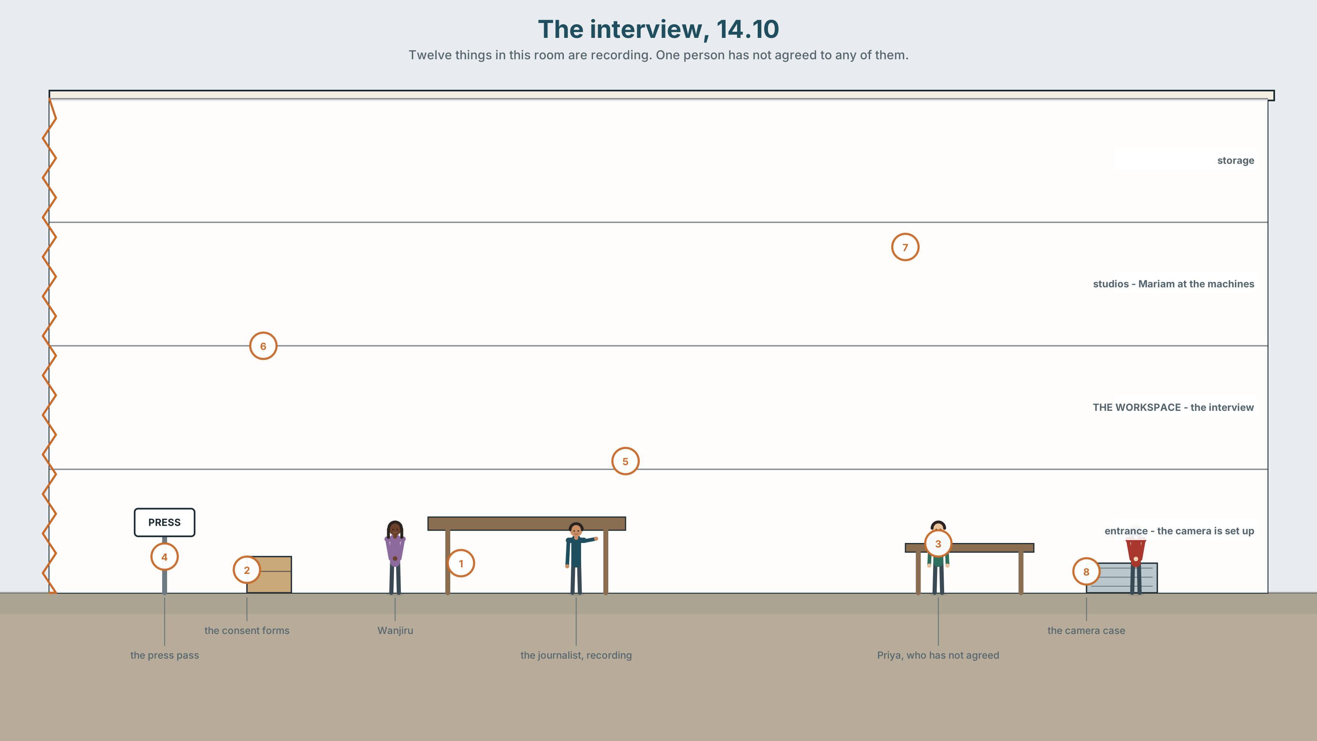{width=6.6in}
The interview, 14.10 — Twelve things in this room are recording. One person has not agreed to any of them.

Who gets to tell it?
By the end of this unit you will report the same event three times, for three audiences — and say which of the three you would put your name to.
◆ A · THE WORLD | How an account becomes a story, and what is lost at every retelling
◆ B · THE SYSTEM | The full range of reporting verbs · reported statements, returning · 24 words for witness and adaptation · 21 verbs that carry a judgement with them · stress on the reporting verb
◆ C · THE PERFORMANCE | Three accounts of one event, and a decision about which one is yours

0A · Find it
Twelve things being recorded in this picture. Four of these sixteen are not there.
a phone on a table · a notebook · a lanyard with a press pass · a voice recorder · a consent form · a camera · a tripod · a laptop · a whiteboard with names · a printed list · a signed release · a clip microphone · a boom pole · a lighting stand · a teleprompter · a studio clock

0B · Guess it
One person in this room has not agreed to be recorded. Which, and what tells you?

0C · Say it ⏺
Record thirty seconds. Think of a story that was told about you. Who told it? Unprepared.

Part 1 · Vocabulary Lab 1 ◆ B · THE SYSTEM
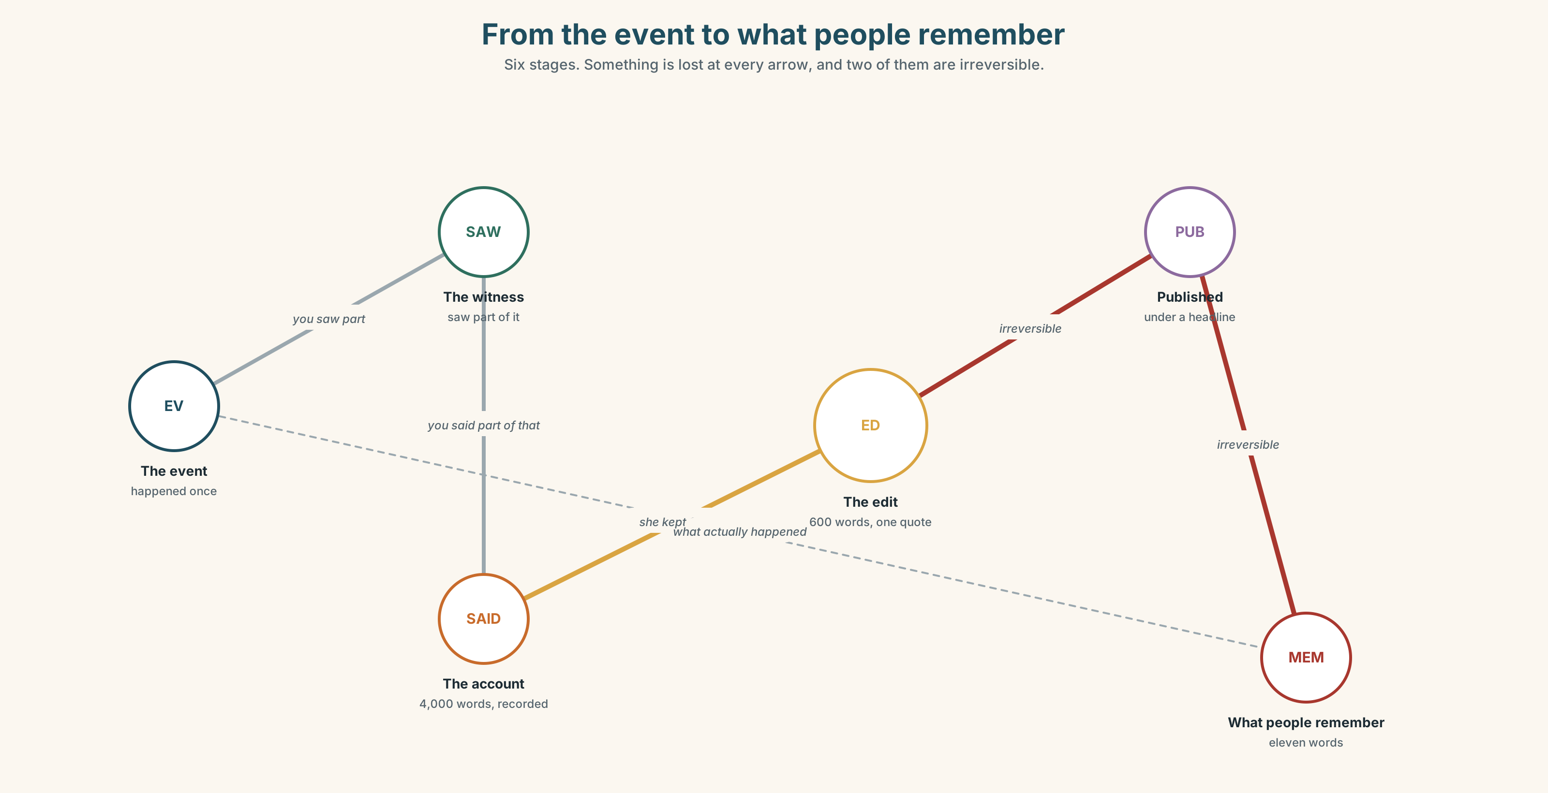{width=6.6in}
From the event to what people remember — Six stages. Something is lost at every arrow, and two of them are irreversible.

1A · Meet — from event to story
Use the network. Name the word at each stage.
witness · account · testimony · version · angle · source · anonymity · adapt · dramatise · composite · disclaimer · hearsay

1B · Sort — cline of distance from the event
Order from closest to furthest.
what happened · what you saw · what you said you saw · what was written down · what was published · what people now remember
Mark where it stops being evidence.

1C · Sort — odd one out, and why
- witness · source · testimony · hearsay
- account · version · angle · composite
- adapt · dramatise · disclaimer · composite
- leave out · play down · write up · track down

1D · Stretch — the phrases
- She said it on the ______, so it can be printed with her name.
- He said it ______ the record, which means you may know it and not use it.
- ______-hand evidence is what you saw yourself.
- The paper gave him a right of ______ before publishing.
- The film says it is based on a ______ story, which is not a claim about accuracy.
- The scene never happened; that is artistic ______.
- Her brother owns the building, which is a ______ of interest.

1E · Stretch — four phrasal verbs, one edit
leave out · play down · write up · track down
Two happen before the story exists. Two happen to it afterwards.

1F · The two sayings
that's not how it happened · whose story is it?
One is a correction. One is a claim of ownership. Which does more damage in a meeting?
Corpus Note Claim and say report the same words. In news writing, claim appears beside a following denial about four times as often as say does. The verb is doing the work before the reader reaches the evidence.

1G · Own it
Describe something that happened to you in two sentences. Then describe it as somebody who dislikes you would. Change no facts.

Part 2 · Listening ◆ A · THE WORLD
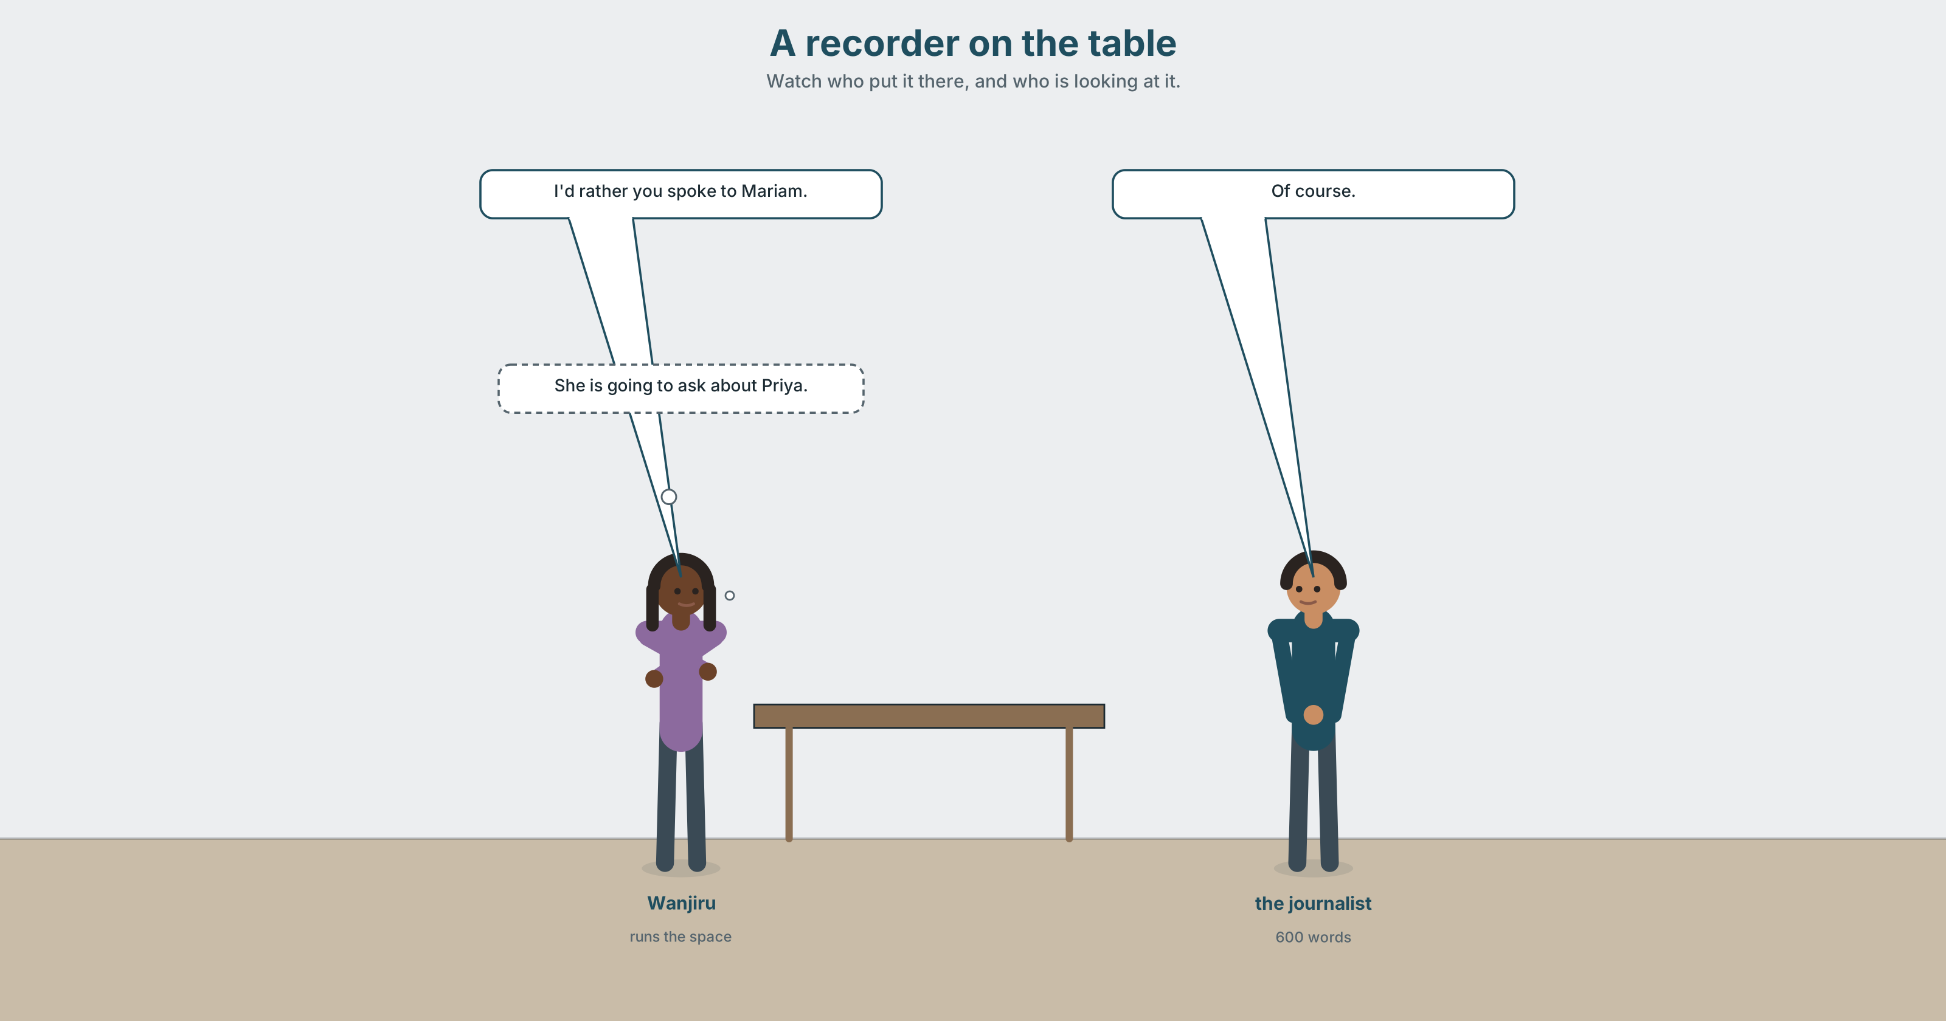{width=6.6in}
A recorder on the table — Watch who put it there, and who is looking at it.

2A · What she's actually here for 🔊 Track 9.1
Before you listen. A journalist and Wanjiru, with a recorder on the table. Who put it there?
Gist — one listen, one question. What story has the journalist already decided to write?
Detail — complete the frame.
 | What she asks about | What she keeps returning to
the first five minutes
the last five minutes
Inference. Wanjiru says "I'd rather you spoke to Mariam." Why is she saying that, and does it work?
Attitude. The journalist says "of course" three times. Which one is agreement?
Noticing. Six sentences. Sort them by what the reporting verb does to the claim.
- She said the landlord had refused.
- She claimed the landlord had refused.
- She admitted the landlord had refused.
- She insisted the landlord had refused.
- She confirmed the landlord had refused.
- She alleged the landlord had refused.
A. neutral · B. the writer doubts it · C. the claim costs the speaker something · D. it was already known

2B · Decoding clinic 🔊 Track 9.2
Forty seconds. Four jobs.
- Count the reporting verbs.
- Which word is stressed in "she CLAIMED she didn't know"?
- Catch the two dates.
- said that — what happens to that?
Transcripts, page 179.

Part 3 · Grammar Lab 1 ◆ B · THE SYSTEM

Choosing the verb that reports

3A · Notice
Return to the six sentences. The reported words are identical in all six.
- Which one is neutral?
- Which two suggest the writer does not believe it?
- In sentence 3, what does admitted tell you about the speaker's position?
- In sentence 5, what does confirmed tell you about what the writer already knew?
- A lawyer would object to one of these in a news report. Which, and why?

3B · See
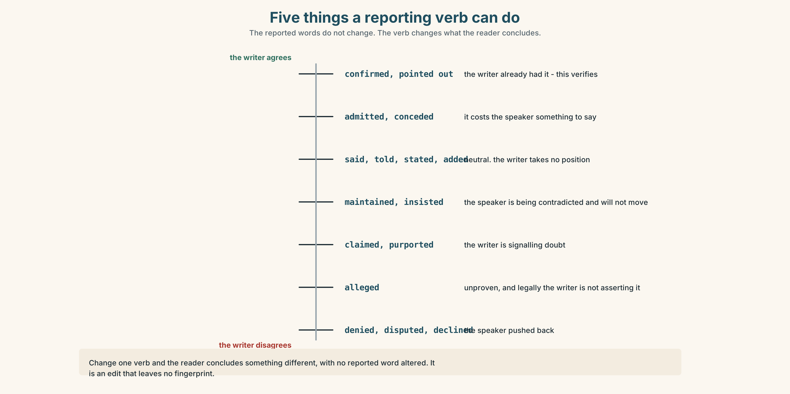{width=6.6in}
Five things a reporting verb can do — The reported words do not change. The verb changes what the reader concludes.

3C · Know
Group | Verbs | What the writer is doing
neutral | say · tell · state · report · add · note | reporting, taking no position
doubting | claim · allege · maintain · purport | signalling distance from the claim
conceding | admit · concede · acknowledge · accept | the speaker said something against their own interest
confirming | confirm · recall · point out · stress | the writer already had it
refusing | deny · refuse · decline to comment · dispute | the speaker pushed back
And the pattern each takes:
admit / deny / recall + -ing or + that · refuse / claim + to + verb or + that · insist / stress / point out + that only
Watch out. Admit makes the speaker's own words costly to them. Using it where say would do is not neutral reporting — it is an edit with no fingerprint on it.
Why it matters. Change one verb and you have changed what the reader thinks, without changing a single reported word. This is the most powerful thing in this book and the hardest to see.

3D · Use — controlled
Choose the reporting verb. More than one works in some; say what each would do.
Wanjiru (1) __________ that the landlord had refused to pay. He (2) __________ ever having been asked. The inspector (3) __________ out that the report had been sent twice. Mariam (4) __________ that she had considered leaving, which she had not said publicly before. The managing agent (5) __________ to comment. The journalist (6) __________ that two tenants had contacted her first.

3E · Use — guided
Rewrite each sentence three times, with a neutral, a doubting and a conceding verb. Then say which you would publish.
- "I didn't know the toilet was an issue."
- "We offered to pay half."
- "Nobody raised it with me."

3F · Use — open
Report the same thing to two people: somebody who will act on it, and somebody who will be upset by it. Your partner says which reporting verbs you used, and what they gave away.

3G · Check — six items
- He ______ (deny) ______ (be) there at all.
- She ______ (admit) that she ______ (not read) it.
- They ______ (refuse) ______ (give) a reason.
- He ______ (point) out that the lease ______ (expire) in March.
- The agent ______ (decline) to comment.
- She ______ (insist) that nobody ______ (tell) her.
0–3 → Workbook pp. 70–72. 4–5 → Part 6. 6 → p. 179.
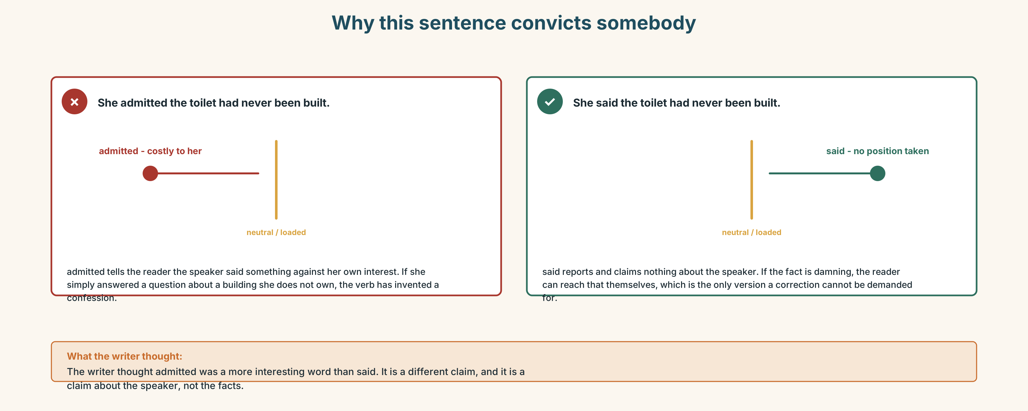{width=6.6in}
Why this sentence convicts somebody — Why this sentence convicts somebody

Part 4 · Speaking ◆ C · THE PERFORMANCE

4A · Fluency sprint — 4 / 3 / 2
A story you have told more than once. Four minutes, three, two. Notice what you have stopped saying.

4B · The functional core — attributing and distancing
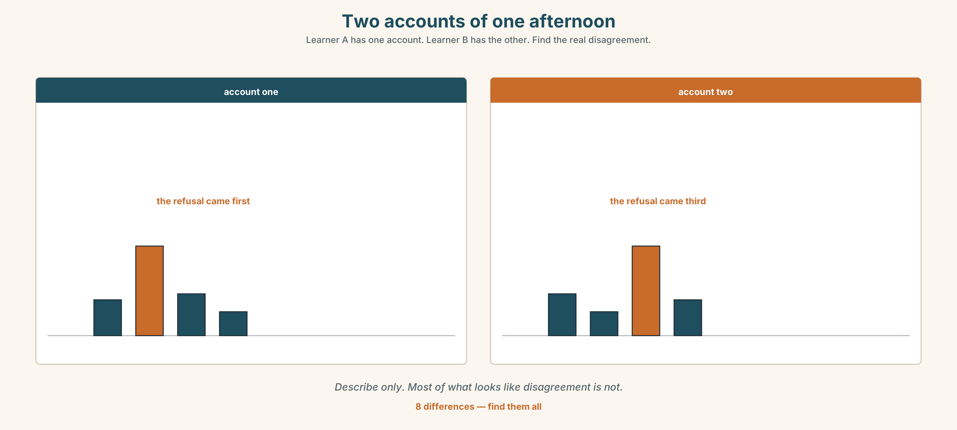{width=6.6in}
Two accounts of one afternoon — Learner A has one account. Learner B has the other. Find the real disagreement.
Language Bank
attributing | according to · she's quoted as saying · in her words
distancing | she claims · it's been suggested that · I can't verify this, but
refusing to pass it on | that's not mine to repeat · you'd have to ask her
correcting | that's not how it happened · the order is the other way round · I'd stress that nobody refused
Information gap. Learner A has what one person said. Learner B has what another said. Neither sees the other. Find out what they disagree about, and what they only appear to disagree about.

4C · The performance — three tellings
Three audiences, two minutes each: a friend · a committee · somebody who was there. Same event. You may not change a fact.

4D · Observer
Listen for one thing: what appeared in two versions and not in the third?

4E · Two criteria
☐ Did I keep every fact the same? ☐ Could the person who was there recognise their own part?

Part 5 · Reading ◆ A · THE WORLD

5A · Predict
A personal essay called "The quote I gave." The first line is:
I said eleven words to a journalist in 2019 and I have been described by them ever since.
What do you expect? One sentence.

5B · Skim — sixty seconds
Find the paragraph where the writer stops blaming the journalist.

The quote I gave
I said eleven words to a journalist in 2019 and I have been described by them ever since. The words were accurate. I said them. They are in my voice on her recording, and if I heard somebody else say them I would think exactly what everybody thought about me.
What I did not say, in the forty minutes either side of them, was the part that made them make sense. She did not leave it out to damage me. She left it out because it took two minutes to explain and the eleven words took four seconds, and she had six hundred words for the whole piece. I have since written to a length limit myself and I know what it does to you.
For about three years I told this story as something that was done to me. I was good at telling it. There is a version with a pause in it that gets a reaction.
The version is not honest, and I worked out why in an argument with somebody who had been in the room. She pointed out that I had chosen the eleven words. Not the edit — the words. I had reached for a phrase that was sharper than what I actually thought, because I was being recorded and because sharp phrases get agreed with. The journalist did not put a performance in my mouth. She printed one I had already given her.
That is a less comfortable story and it has no pause in it.
What I do now is simple and I recommend it without being certain it is right. I say the dull version first. If it is the only thing I say, it is the only thing that can be used. The cost is that I am quoted much less often, and that the people who are quoted instead are the people reaching for the sharp phrase, which is how the sharp phrase became the thing people believe.

5C · Close reading
- How many words did the writer say, and how long was the piece?
- Why does the writer say the journalist left out the context?
- What did the person who had been in the room point out?
- What does the writer mean by "a version with a pause in it"?
- What does the writer do now, and what is the stated cost?
- The last clause is an accusation against nobody in particular. Who is it against?

5D · Vocabulary in context
accurate · length limit · reach for (reached for a phrase) · performance · dull (the dull version) · quoted

5E · The counter-text
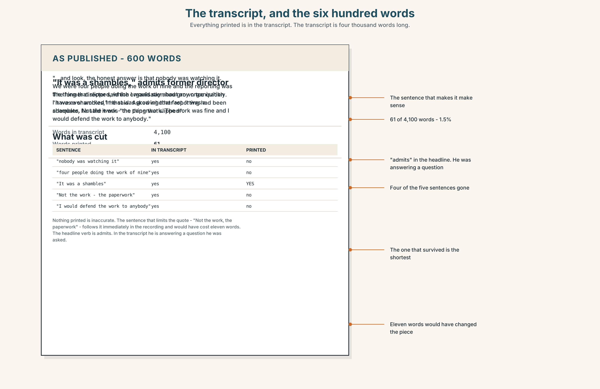{width=6.6in}
The transcript, and the six hundred words — Everything printed is in the transcript. The transcript is four thousand words long.
Read the published piece and the full transcript extract, side by side.
- How many words of the transcript survived into the piece?
- Which sentence in the transcript explains the quote, and where would it have gone?
- What reporting verb did the journalist use?
- Find the sentence in the piece that is not in the transcript at all. Where did it come from?
- Was anything untrue printed?

5F · Writer analysis
- The essay refuses an easy villain. At what cost to the essay?
- The piece is 600 words and the transcript is 4,000. Is the essay's argument an argument against length limits, or against something else?

5G · Text against text
The essay says the journalist printed a performance he had already given. The transcript shows him giving it. Two sentences on whether that settles it. The second begins "What it does not settle is…"

Part 6 · Vocabulary Lab 2 ◆ B · THE SYSTEM

Twenty-one verbs that judge while they report
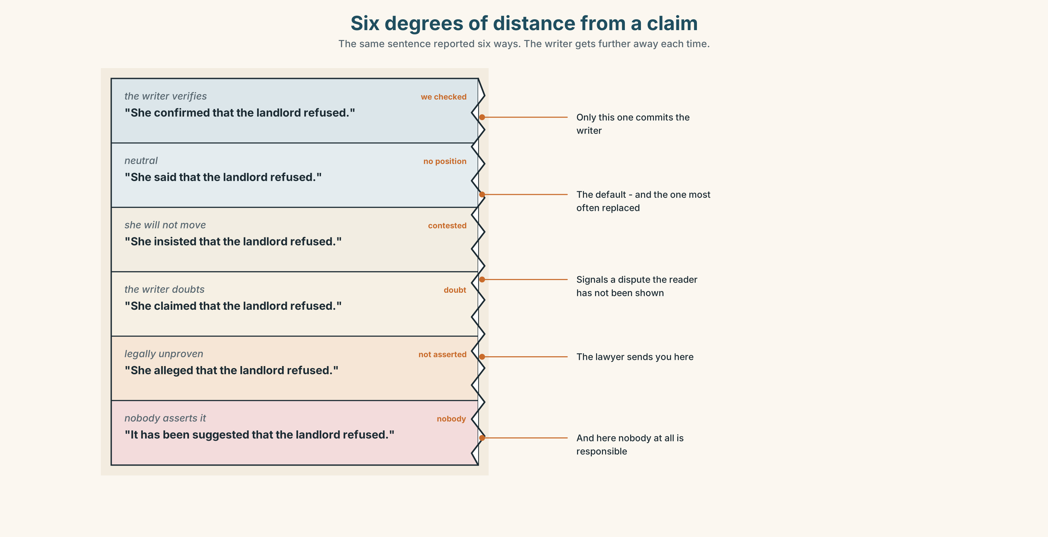{width=6.6in}
Six degrees of distance from a claim — The same sentence reported six ways. The writer gets further away each time.

6A · Sort — what does the verb add?
Sort all twenty-one into five groups: neutral · doubting · conceding · confirming · refusing.
admit · deny · claim · insist · allege · concede · maintain · acknowledge · confirm · refuse · recall · stress · point out · go on to say · be quoted as saying · according to · put it another way · back up · stand by · words to that effect · no comment

6B · Chunk completion
- She ______ ______ her original statement under questioning.
- He ______ it ______, saying the figure was closer to twelve.
- The agent said "______ ______" and put the phone down.
- ______ ______ the inspector, the report was sent twice.
- He said he had been misled, or ______ ______ ______ ______.

6C · Register sort
Which appear in a news report? Which in a court transcript? Which only in speech? Four appear in all three.

6D · Contrast Clinic — one claim, six verbs
Six items. The reported words do not change.
"The landlord refused to pay."
- She ______ that the landlord refused to pay. (neutral)
- She ______ that the landlord refused to pay. (you doubt it)
- She ______ that the landlord refused to pay. (it costs her to say so)
- She ______ that the landlord refused to pay. (you already knew)
- She ______ that the landlord refused to pay. (she is being contradicted and will not move)
- She ______ that the landlord refused to pay. (legally unproven)
Then: which one would a lawyer insist on, and why?

Part 7 · Pronunciation & Fluency Lab ◆ B · THE SYSTEM

Stressing the reporting verb
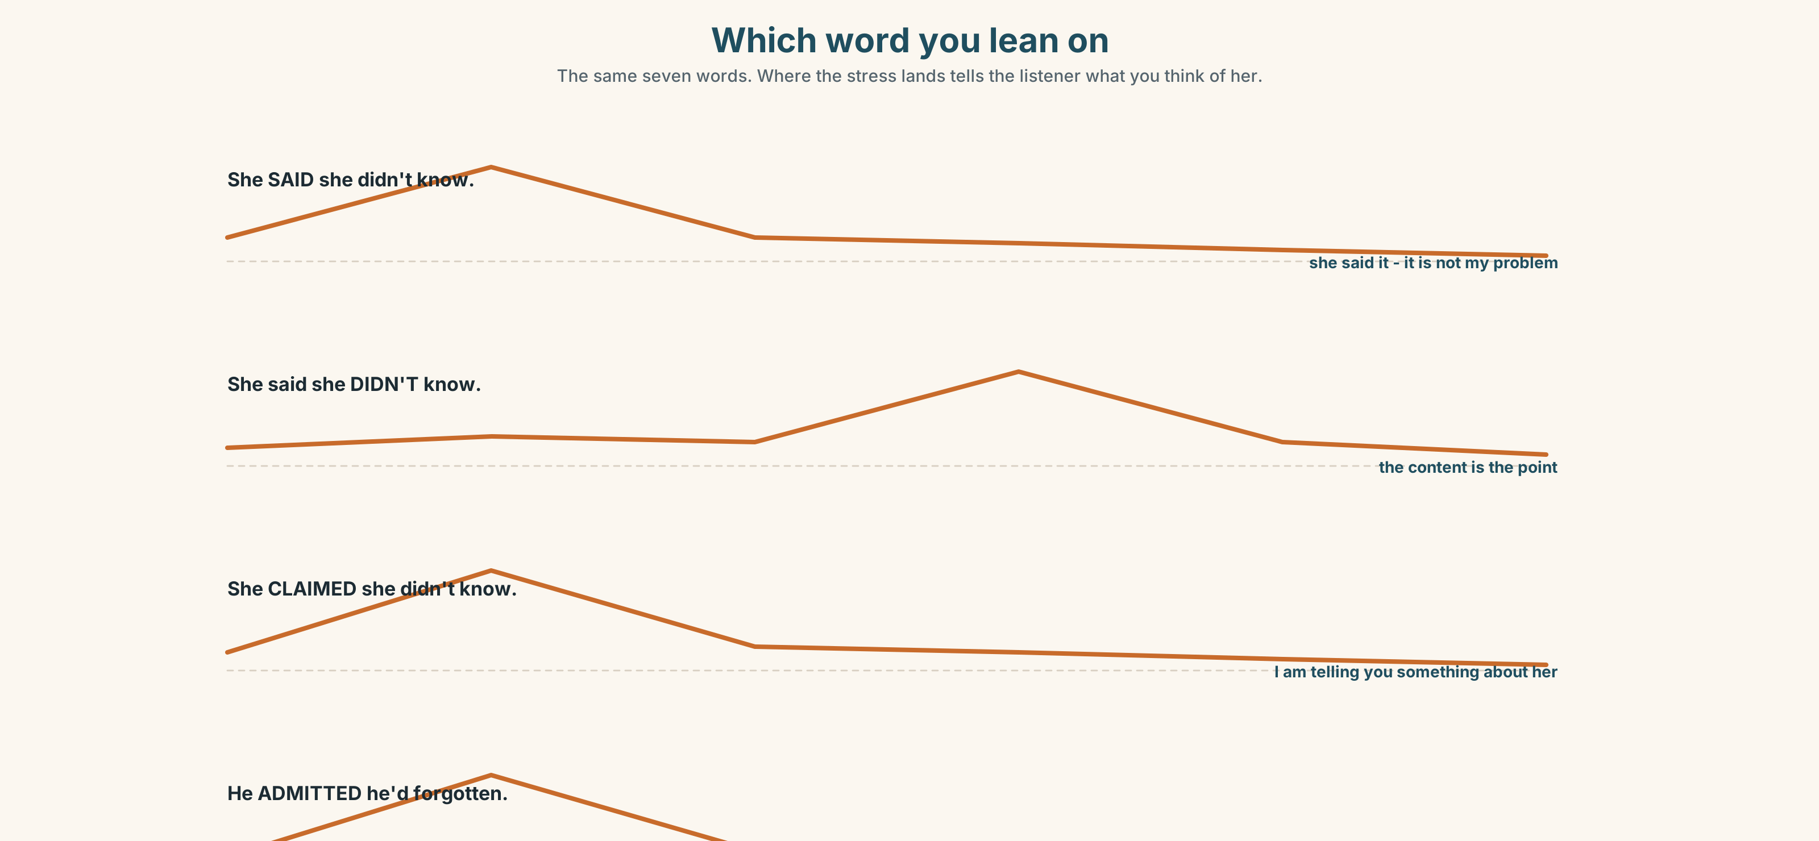{width=6.6in}
Which word you lean on — The same seven words. Where the stress lands tells the listener what you think of her.

7A · Hear 🔊 Track 9.3
She SAID she didn't know. — (she said it; whether it is true is not my problem) She said she DIDN'T know. — (the content is the point) She CLAIMED she didn't know. — (I am telling you something about her)

7B · Say
Say all three. Your partner says what you think of her.

7C · Make it mean something
"He admitted he'd forgotten."
Stress admitted, then forgotten. One is sympathetic. One is not.

7D · Fluency 20 ⏺
Twenty seconds: report one thing three ways — neutral, doubting, conceding. Three times.

Part 8 · Writing ◆ C · THE PERFORMANCE

The same event, for three readers · 140 words
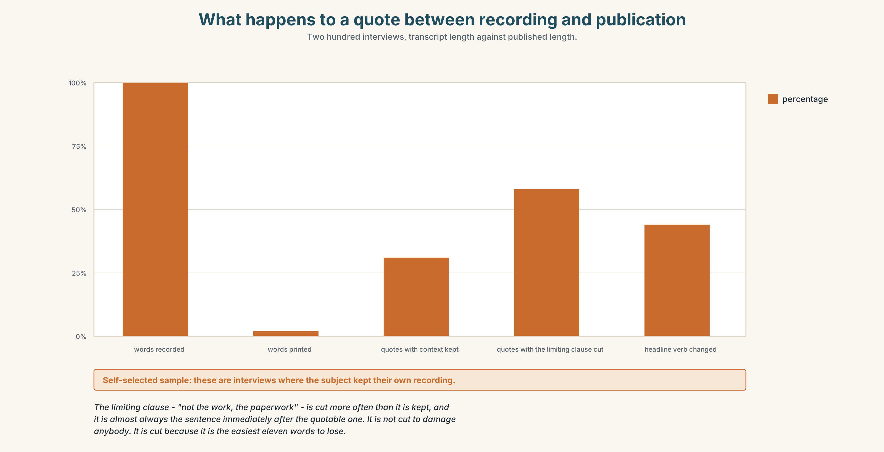{width=6.6in}
What happens to a quote between recording and publication — Two hundred interviews, transcript length against published length.

8A · Read the model — three versions, one event
To a friend: The landlord finally paid half. It took four months, an insurance letter and Priya leaving, and I'm not going to pretend I feel good about it.
To the tenants' meeting: The landlord has agreed to fund fifty per cent, following the insurer's query about the 2019 report. Works are scheduled for January. Obi obtained the quotes; the survey came in at 96,000 against an assumption of 160,000. [names, numbers, sequence. No feelings, and none implied]
To the landlord: Thank you for confirming the fifty per cent. I've attached the quotes and the survey. Obi will coordinate access with your contractor. We'll keep the invoice separate from the service charge, as agreed. [nothing about the four months. Nothing about the insurer]
Questions about the writer's choices:
- All three are true. What is in the first that is in neither of the others?
- The second mentions the insurer. The third does not. Why?
- Which version would you be most comfortable having the other two readers see?

8B · The anti-model
Following extensive discussions, agreement has been reached regarding the accessibility works. All parties have worked constructively and a positive outcome has been achieved for everyone involved.
Who does this version protect, and from what?

8C · Generate · 8D · Plan
the facts, listed · who each reader is · what each one will do with it · what each one does not need · what you would be ashamed to have hidden

8E · Draft — all three versions

8F · Peer review — two criteria
☐ Are all three factually identical? ☐ Is there anything in one that the others needed?

8G · The third criterion
Put your name on one of them. Which, and why that one?

Part 9 · The File ◆ A · THE WORLD + C · THE PERFORMANCE

CULTURE FILE · What's Funny Here?
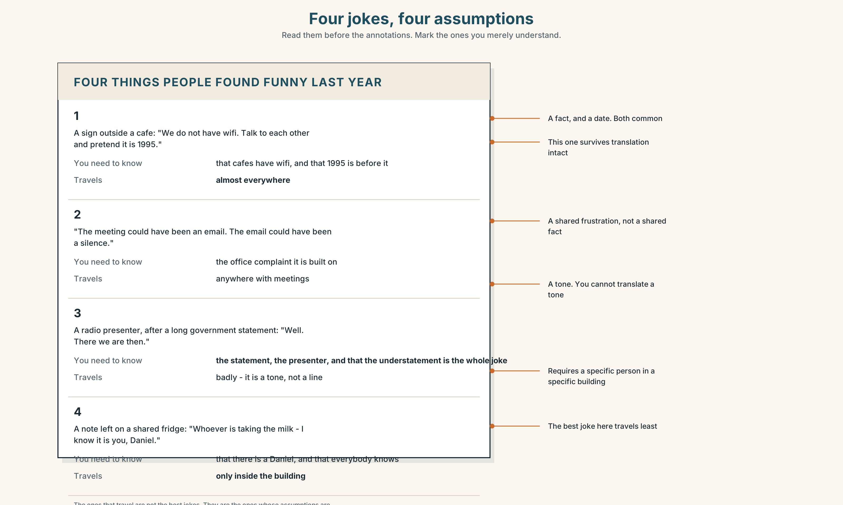{width=6.6in}
Four jokes, four assumptions — Read them before the annotations. Mark the ones you merely understand.

9A · Four jokes
Four short pieces of humour, one from each of four places. Which do you find funny, and which do you merely understand? They are different experiences.

9B · What a joke assumes
For each: what do you have to already know? A fact, a person, a convention, a frustration? The ones that travel are rarely the ones with the best jokes in them.

9C · Your own
Bring something funny from your own language or context. Explain what has to be known. Then: is it still funny once explained?

9D · Humour that is not for you
Some jokes exclude by design. Some exclude by accident. How do you tell, from inside and from outside?

9E · The hard one
A story told about somebody gets a laugh in a meeting. The person is in the room. Write the sentence you would say — or defend saying nothing.

9F · Transfer
Watch something comic in English this week that you do not fully get. Write down the exact moment you lost it. That is the cultural boundary, located.

Part 10 · Mediation & Interaction ◆ C · THE PERFORMANCE
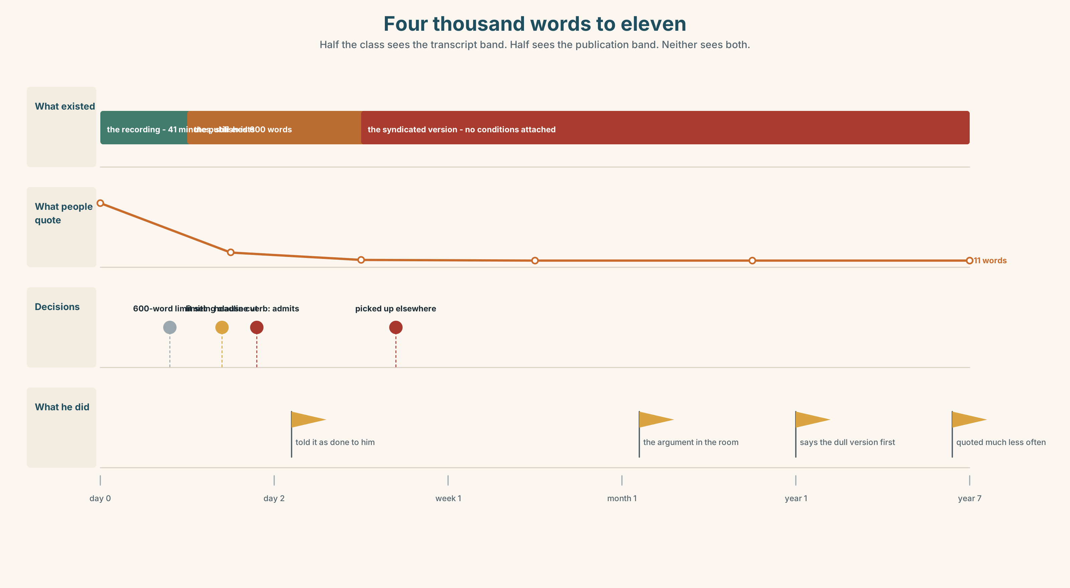{width=6.6in}
Four thousand words to eleven — Half the class sees the transcript band. Half sees the publication band. Neither sees both.

10A · Relay
Half the class sees the transcript band; half sees the published band. Rebuild by speaking.

10B · Simplify
Explain the difference between on the record, off the record and on background to somebody about to speak to a journalist in twenty minutes.

10C · Compress
The essay into 60 words for somebody who has just been quoted badly. Defend three cuts.

10D · Online interaction
Write the reply to a post that has misreported something you said. It has 400 shares.

10E · Across languages
Report the same sentence in your language with a neutral verb and a doubting one. Does your language carry the doubt in the verb, or somewhere else?

Part 11 · The Decision ◆ C · THE PERFORMANCE

The profile
A journalist wants to write about Jengo House. She is good, the piece will be read, and two of the six tenants would benefit from it enormously.
The story she wants is about the accessible toilet: four months, an insurer, a landlord who moved only when his own money was at risk, and a woman who left before it was built.
Priya has not agreed to be named. She has not refused either. She has said "I'd rather not be the reason."
- Do the piece with the story she wants. Priya is central whether or not she is named — in a building of six people, "a tenant" is not anonymity.
- Offer a different story — the workspace, the economics, the survey that came in at 96,000. She will probably decline.
- Refuse. Keep the relationship, lose the coverage, and the story goes untold.

11A · The evidence
- The transcript and the published piece from Part 5.
- The chart: what happens to a quote between recording and publication.
- The voice. Priya, thirty seconds: "I'd rather not be the reason. I'm not saying don't. I'm saying I'd rather not be the reason."

11B · Steelman
Argue the option you like least. Two minutes.

11C · Deliberate
I think they should ______, because ______. The strongest argument against me is ______, and my answer to it is ______.

11D · Decide — eighty words, two reasons

11E · Model decision
Go back to Priya and ask her the actual question, which nobody has asked her.
I am aware this is not one of the three options and that it delays everything by a week. It is the only move that does not decide something about her without her.
"I'd rather not be the reason" is not a refusal and treating it as consent is the thing this whole unit is about. It is also not an invitation to protect her by deciding for her, which is what refusing the piece would be. She is an adult with an interest in the building and in her own privacy, and she is the only person who can weigh them.
The question is not "may we name you". It is: "the piece will exist, you will be identifiable whether or not you are named, and here are the three versions. Which would you rather read about yourself?" That is a harder question and it is the honest one.
If she says no after that, refuse the piece and say why.

11F · The Reveal
What happened. They asked her. She thought about it for four days and said yes, named, on condition that the piece said she had left for a job and not because of the building — which was true, and which she had never said to anybody.
The piece ran. It was fair. Two sentences about her were lifted into a follow-up article elsewhere without the condition attached, and that version is the one that comes up when you search her name.
She has never mentioned it. Wanjiru found it eight months later.
They did the honest thing, and it was honest, and a second publication they had no contact with undid the only condition she asked for.
Was the reasoning sound? And: was there a version of this where that could not have happened?

Part 12 · Landing ◆ all three lines

12A · Recycle — twelve items
Six from this unit.
- He ______ (deny) ______ (be) there at all.
- She ______ out that the lease expired in March.
- The agent ______ to comment.
- She said it ______ the record, so it cannot be printed.
- The film is based on a ______ story.
- Her brother owns the building — a ______ of interest.
Four from Units 1–8.
- The grower ______ I buy from has eleven acres. (Unit 8 — can you drop it?)
- I want you ______ (check) it twice. (Unit 7)
- The rule ______ (bring) in after a fire. (Unit 6)
- If it ______ (be) up to me, I ______ (change) it. (Unit 5)
Two from Making Plans (A2.1).
- She said she ______ (not receive) the letter. (reported speech)
- The piece, ______ ran in March, was fair. (relative clause)

12B · Consolidate
120 words, one paragraph. Report one disputed event using at least six reporting verbs from Part 6, from at least three of the five groups.

12C · Can-do, with evidence
I can… | My evidence | Sure?
choose a reporting verb that says what I actually think of the claim | Part 3G score | ◯ ◑ ●
tell the same true story three ways for three readers | Part 8, all three | ◯ ◑ ●
recognise when humour assumes something I do not have | Part 9B | ◯ ◑ ●
decide about a story that is partly somebody else's | Part 11D | ◯ ◑ ●

12D · Replay ⏺
Part 0C again. Compare.

12E · Glossary — forty-five items, as a map
THE EVENT · witness · account · testimony · first-hand · hearsay · source THE STORY · version · angle · adapt · dramatise · composite · based on a true story · artistic licence THE RULES · on the record · off the record · right of reply · anonymity · a conflict of interest · disclaimer EDITING · leave out · play down · write up · track down NEUTRAL · say · tell · add · note · according to · be quoted as saying · go on to say DOUBTING · claim · allege · maintain CONCEDING · admit · concede · acknowledge CONFIRMING · confirm · recall · point out · stress · back up · stand by REFUSING · deny · refuse · no comment · words to that effect · put it another way SAYINGS · that's not how it happened · whose story is it?

12F · Next
Unit 10 · What is a fair day's work?

