Table of Contents

B1.1 · Unit 10 · A Fair Day
English Animated · Taking a Position · Jengo House, Nairobi Student's Book pages 188–207 · 20 pp · ~11.5 hours

Part 0 · The Big Picture ◆ A · THE WORLD
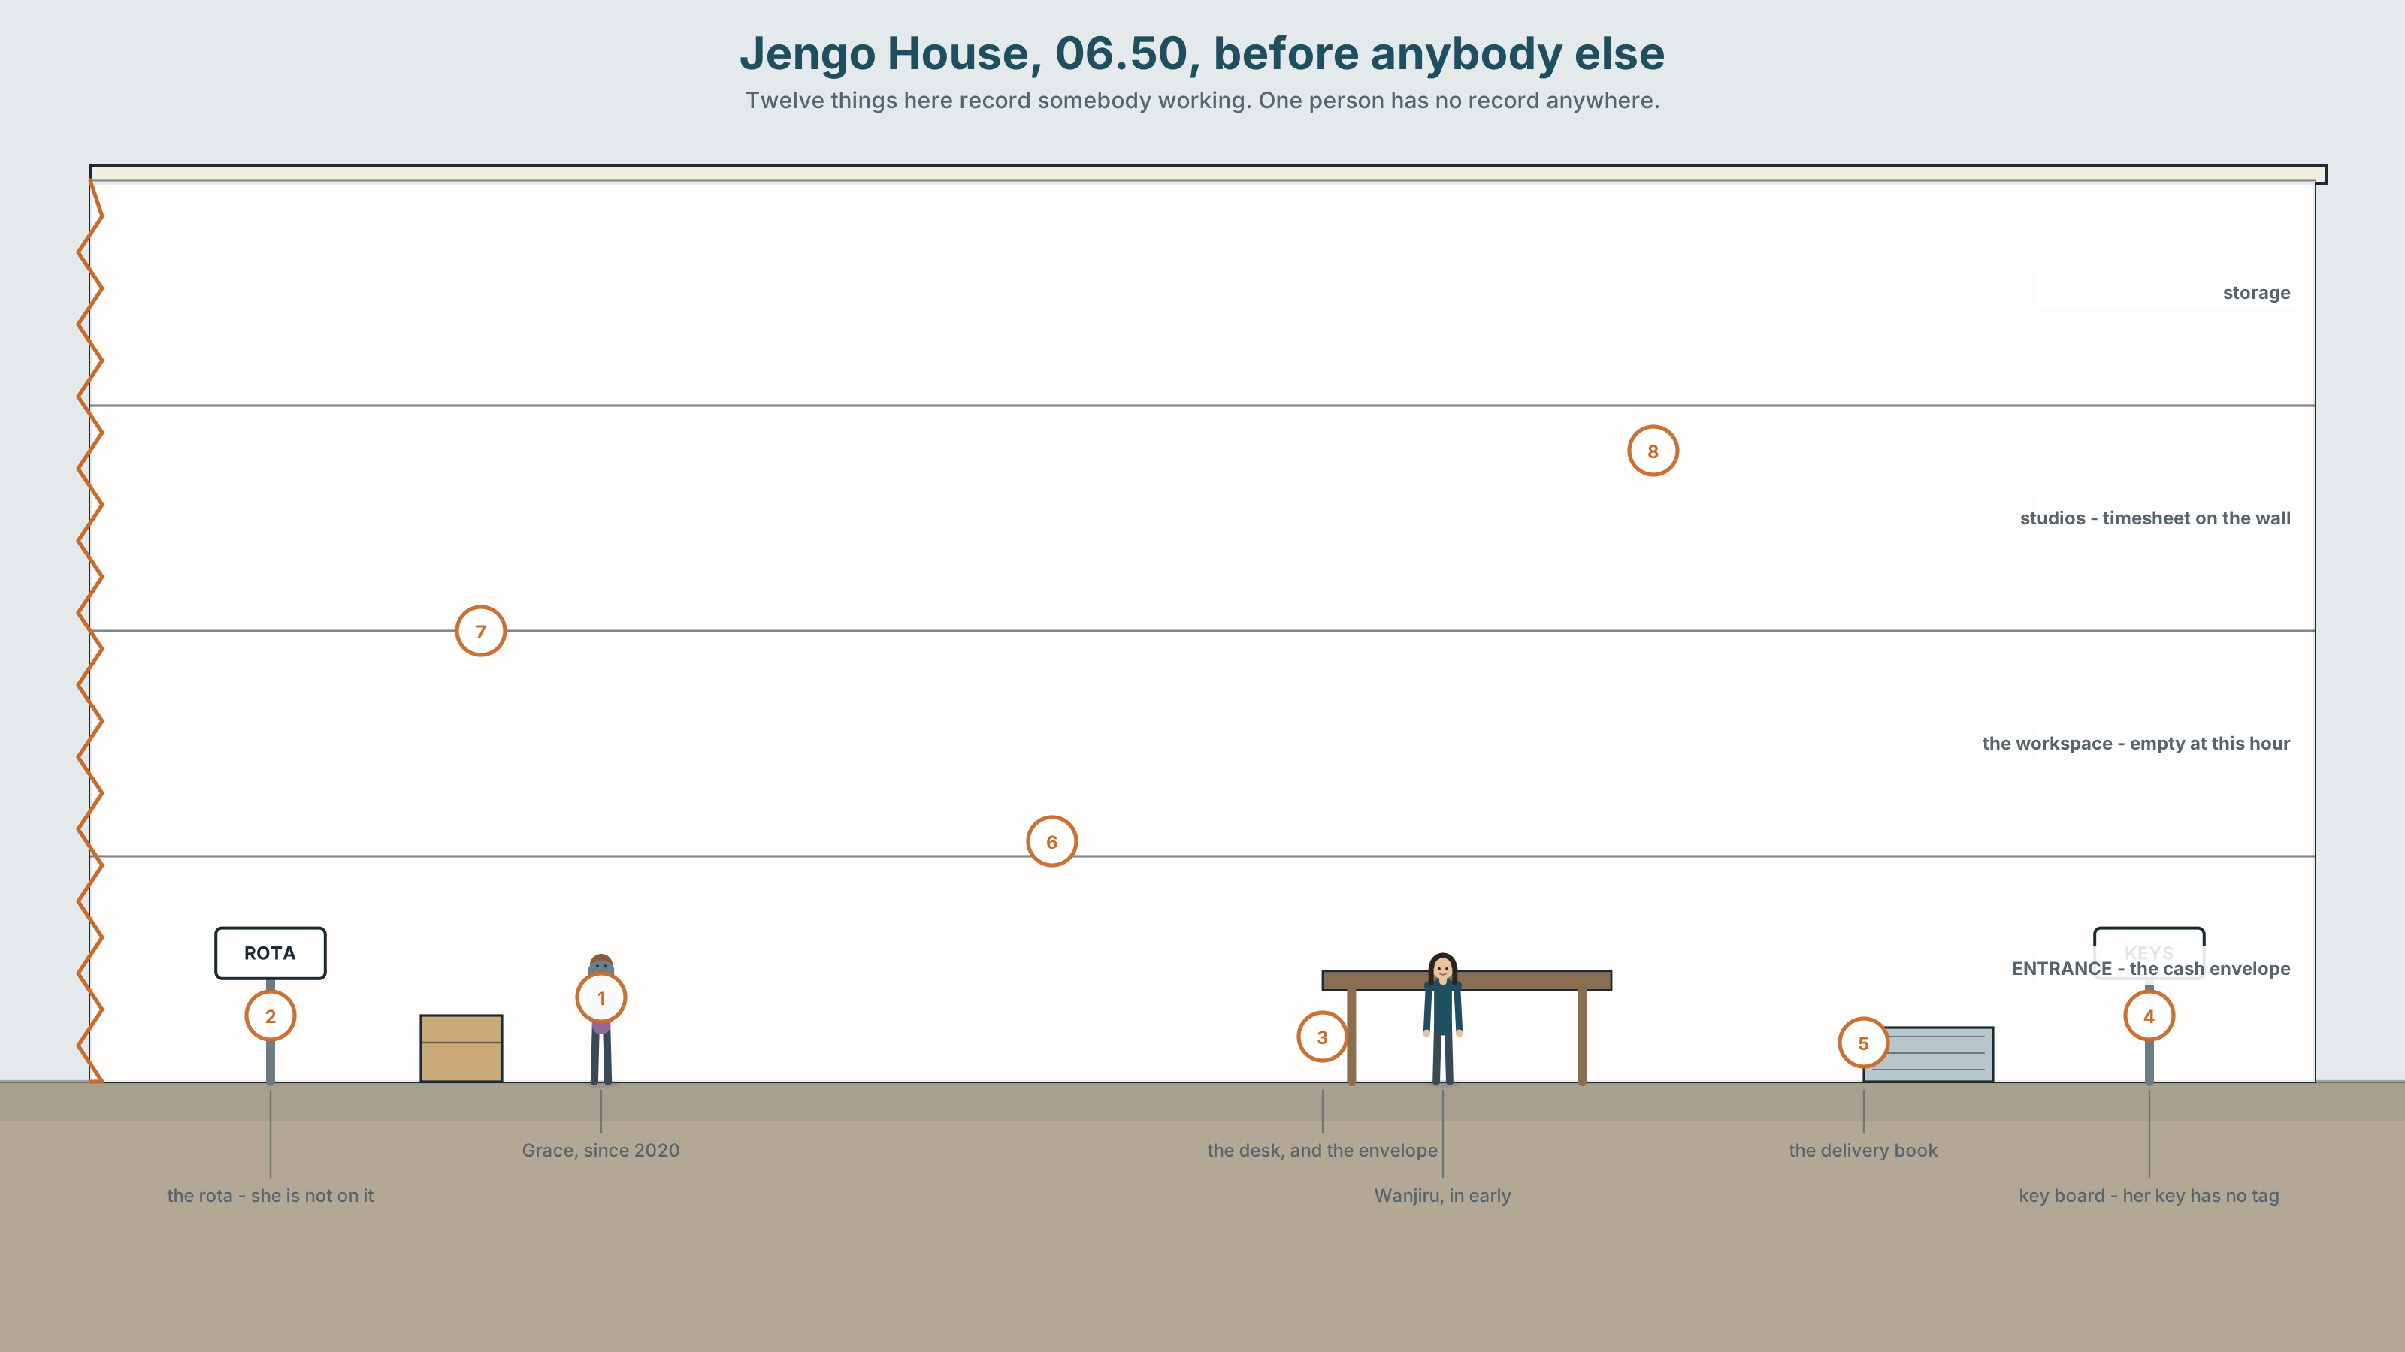{width=6.6in}
Jengo House, 06.50, before anybody else — Twelve things here record somebody working. One person has no record anywhere.

What is a fair day's work?
By the end of this unit you will negotiate a working agreement and write it up — in a form the person it is about would sign.
◆ A · THE WORLD | What work is worth, who sets that, and what six years of goodwill is
◆ B · THE SYSTEM | Degree modifiers · the more … the more · comparatives and superlatives, returning · 24 words for pay and conditions · 21 ways to size a difference · stress on the modifier
◆ C · THE PERFORMANCE | A negotiated agreement, written up, signed by both sides

0A · Find it
Twelve things that record somebody's work. Four of these sixteen are not there.
a timesheet · a rota · a payslip · a contract on a shelf · a handwritten hours book · a swipe card · a cash envelope · a bank transfer screen · a cleaning schedule · a signed-for delivery book · a key with a tag · a staff photo · a pension statement · a union notice · a P45 · a uniform

0B · Guess it
One person in this picture has no written record of their work anywhere in the building. Which, and what is the evidence?

0C · Say it ⏺
Record thirty seconds. What is a fair day's work? Unprepared. This is the last Part 0 of the book, and the last replay is at the end.

Part 1 · Vocabulary Lab 1 ◆ B · THE SYSTEM
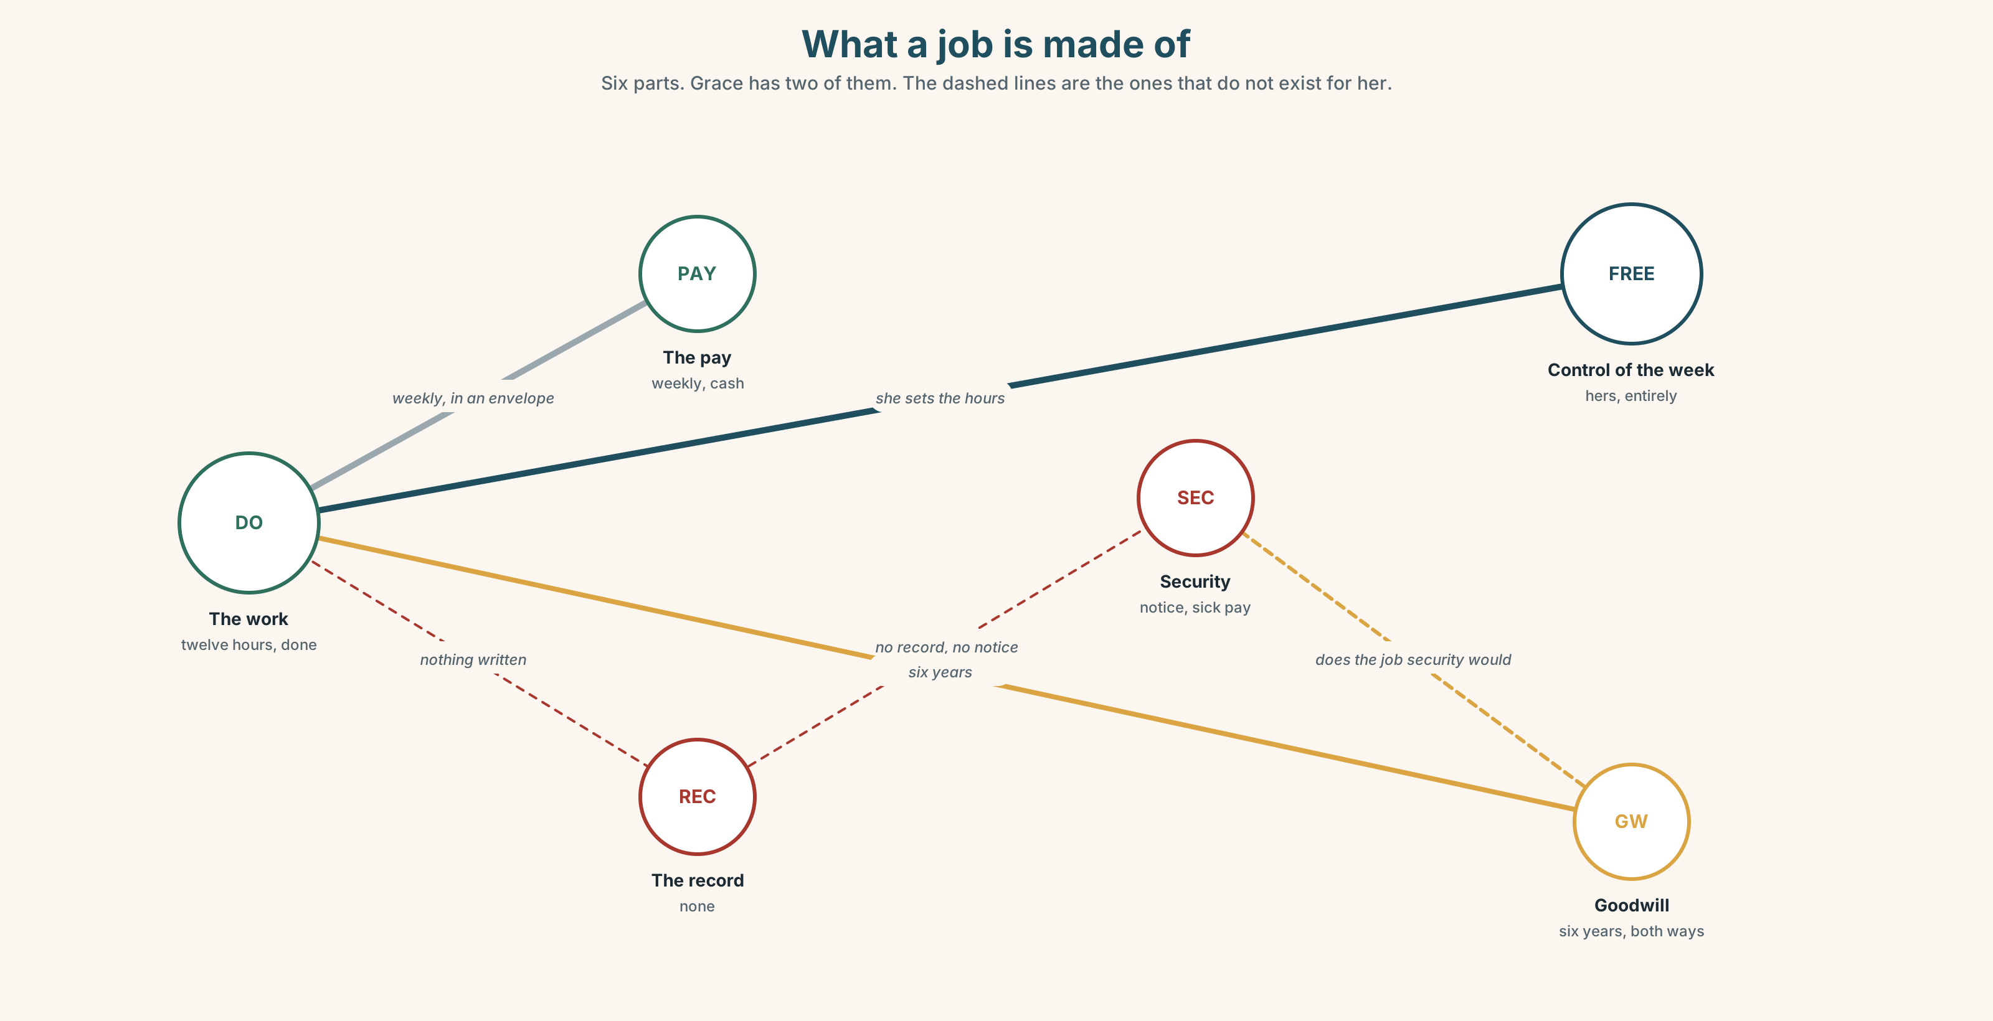{width=6.6in}
What a job is made of — Six parts. Grace has two of them. The dashed lines are the ones that do not exist for her.

1A · Meet — what a job is made of
Use the network. Name the word at each node.
wage · salary · overtime · contract · probation · notice · severance · union · grievance · rota · turnover · headcount

1B · Sort — cline of security
Order from most secure to least.
a permanent contract · a fixed-term contract · a rolling contract · zero-hours · paid in cash · a handshake
Mark where the law stops helping you. Then find out whether you marked it in the right place.

1C · Sort — odd one out, and why
- wage · salary · overtime · turnover
- probation · notice · severance · grievance
- union · rota · headcount · cover
- lay off · take on · clock in · cover for

1D · Stretch — the phrases
- She is on a ______-hours contract, so nothing is guaranteed.
- A ______ wage is what you can actually live on, not what the law requires.
- Saturday is paid at time and a ______.
- He took the hours back as time off in ______.
- She has worked here six years and has never been on the ______.
- Three of the five are paid cash in ______.
- Nights and Sundays are ______ hours, and they are paid as if they were not.

1E · Stretch — four phrasal verbs, one workforce
lay off · take on · clock in · cover for
Two are things the employer does. Two are things the worker does. Which one is sometimes both?

1F · The two sayings
that's the job · nobody does it for the money
Both are used to end a conversation about pay. Who says each, and which one is harder to argue with?
Corpus Note A fair day's work appears in English about forty times more often than a fair day's pay, although the full saying contains both. The half that survived is the half about the worker.

1G · Own it
Describe one job you have done. Say what was written down and what was not.

Part 2 · Listening ◆ A · THE WORLD
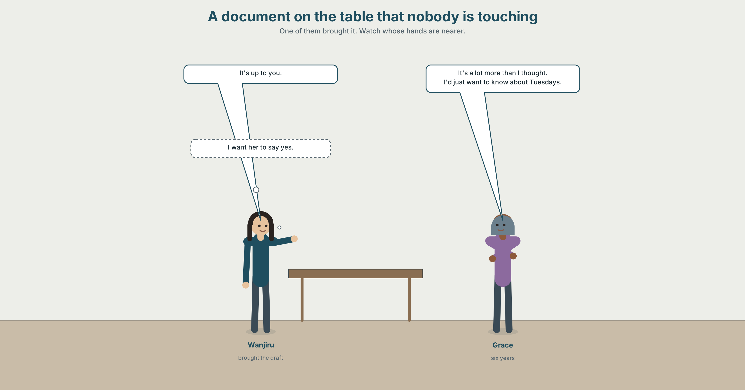{width=6.6in}
A document on the table that nobody is touching — One of them brought it. Watch whose hands are nearer.

2A · Six years 🔊 Track 10.1
Before you listen. Wanjiru and Grace, and a document on the table that nobody is touching. Who brought it?
Gist — one listen, one question. Does Grace want the contract?
Detail — complete the frame.
 | Now | Under the contract
hours
pay
flexibility
Inference. Grace says "it's a lot more than I thought." She is talking about the money. What else is she talking about?
Attitude. Wanjiru says "it's up to you" twice. One of them is true. Which sound?
Noticing. Six sentences. Sort them by how big the difference is.
- It's slightly better than she's on now.
- It's considerably better than she's on now.
- It's nowhere near what she should be on.
- It's not nearly enough.
- It's far more than the going rate.
- The more hours she takes, the less she can choose.
A. a small difference · B. a large one · C. a relationship between two things

2B · Decoding clinic 🔊 Track 10.2
Forty seconds. Four jobs.
- Which word in "a lot more than I thought" is stressed?
- Catch the three amounts.
- considerably — how many syllables does she actually say?
- far more — what happens between the two words?
Transcripts, page 180.

Part 3 · Grammar Lab 1 ◆ B · THE SYSTEM

Saying how much bigger

3A · Notice
Return to the six sentences.
- Which three words make the difference sound small?
- Which three make it sound large?
- In sentence 3, nowhere near — is that bigger or smaller than not nearly?
- Sentence 6 has two halves that move together. What happens to the word order?
- Try "It's very better." Why not?

3B · See
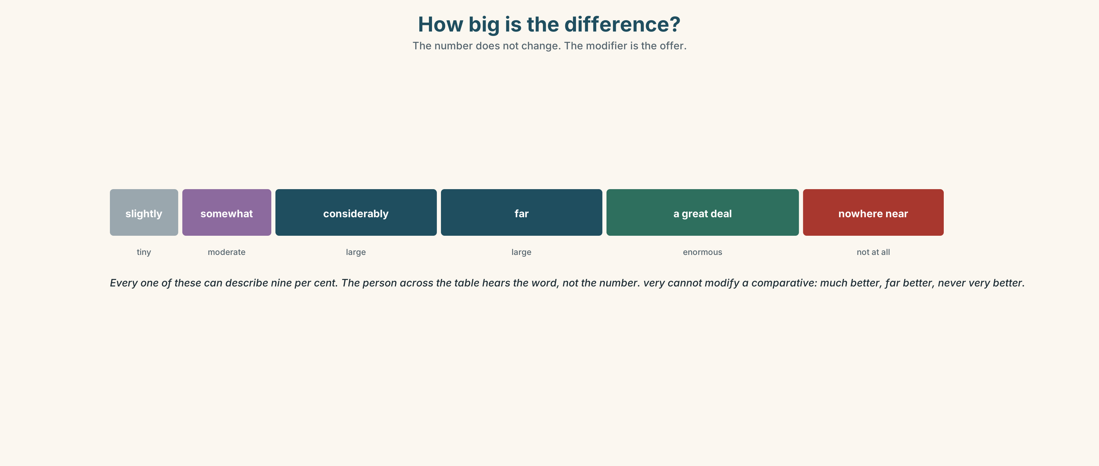{width=6.6in}
How big is the difference? — The number does not change. The modifier is the offer.

3C · Know
Size | Modifier | Example
tiny | slightly · marginally · a little · a bit | slightly better
moderate | somewhat · rather | somewhat better
large | much · far · a lot · considerably · substantially · significantly | far better
enormous | a great deal · infinitely · appreciably | a great deal better
not at all | nowhere near · not nearly · barely | nowhere near enough
equal | just as · every bit as | just as good
The more … the more structure
The more hours she takes, the less she can choose. The sooner we write it down, the better.
Comparative first in each half. No that. The second half is the consequence.
Watch out. Very modifies an adjective; it cannot modify a comparative. Very good ✓ very better ✗. Use much, far or a lot.
Why it matters. In a negotiation, the modifier is the offer. Slightly more and considerably more can describe the same number, and the person across the table hears the word, not the number.

3D · Use — controlled
The contract is (1) __________ better than her current arrangement on paper, and (2) __________ worse on one thing she has not mentioned. The hourly rate is (3) __________ higher — about nine per cent. The hours, however, are fixed: (4) __________ hours she accepts, (5) __________ freedom she has to take the other work she does on Tuesdays. Six years of goodwill is (6) __________ near a legal position, which is the argument for signing something.

3E · Use — guided
Rewrite each one so the difference sounds larger, then smaller. The number does not change.
- It's better than before.
- There's a difference in the hours.
- The rate has gone up.

3F · Use — open
Compare two jobs, two places or two years using four different degree modifiers and one the … the … structure. Your partner says which comparison you were trying to make sound big.

3G · Check — six items
- It's ______ better than last year — about two per cent.
- It's ______ better than last year — nearly double.
- That's ______ near enough.
- ______ more I read it, ______ less I like it.
- It's ______ as good as the other one. (equal)
- She's ______ better paid than she was. (not "very")
0–3 → Workbook pp. 78–80. 4–5 → Part 6. 6 → p. 199.
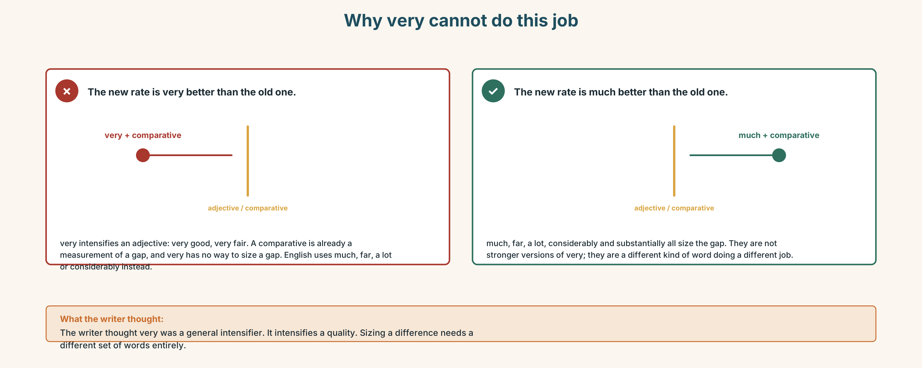{width=6.6in}
Why very cannot do this job — Why very cannot do this job

Part 4 · Speaking ◆ C · THE PERFORMANCE

4A · Fluency sprint — 4 / 3 / 2
The best job you have had, and why. Four minutes, three, two.

4B · The functional core — negotiating
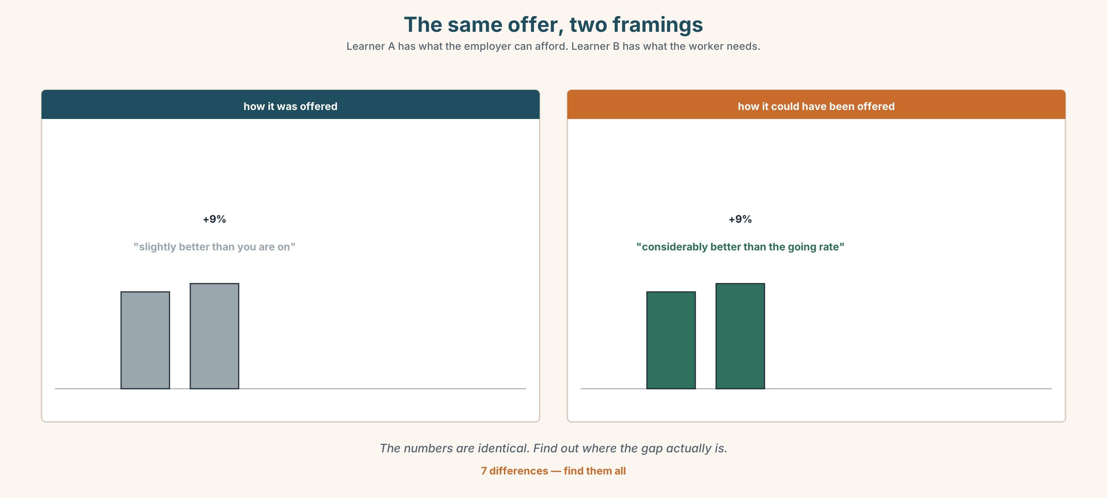{width=6.6in}
The same offer, two framings — Learner A has what the employer can afford. Learner B has what the worker needs.
Language Bank
opening a position | what I'd be looking for is · in principle, yes — with one thing
sizing a gap | that's not far off · we're nowhere near · that's a bigger gap than it looks
trading | I could move on the hours if · that works for me provided
closing | so shall we write that down? · I'd rather we both signed something
when it fails | they knocked it back · not by a long way · we could scale it up later
Information gap. Learner A has what the employer can afford. Learner B has what the worker needs. Neither sees the other. Find out whether an agreement exists.

4C · The performance — the agreement
In pairs, twenty minutes. You must end with something written that both of you sign, or with a written statement of exactly where you stopped and why.

4D · Observer
Listen for one thing: who said a number first, and what happened to it?

4E · Two criteria
☐ Did we write it down while we were still in the room? ☐ Would the other person's version of this conversation match mine?

Part 5 · Reading ◆ A · THE WORLD

5A · Predict
A review of a book about informal work. The first line is:
There is a chapter missing from this otherwise excellent book, and I think I know why.
What do you expect? One sentence.

5B · Skim — sixty seconds
Find the paragraph where the reviewer praises the book most.

The chapter that isn't there
There is a chapter missing from this otherwise excellent book, and I think I know why.
Handshakes is a study of informal work arrangements across four cities, and it is far better than the literature it joins. The fieldwork is exhaustive — four hundred and eighty interviews over three years — and the author resists almost every temptation available to her. She does not romanticise informality, which is the standard failure of the sympathetic account. She does not treat it as simply exploitation waiting to be formalised, which is the standard failure of the policy account. She is considerably better than both camps at holding two things at once: that informal arrangements are often chosen, and that being able to choose them is not the same as having a choice.
The best chapter is the fourth, on what she calls the goodwill ledger. Her argument is that a long informal arrangement accumulates a kind of credit on both sides — the worker who has stayed, the employer who has paid in hard months — and that this credit is real, is valuable, and is destroyed by formalisation. A contract converts six years of mutual obligation into twelve months' notice. That is a far worse deal than it looks, and nobody records it as a loss because it was never recorded as an asset.
What is missing is the chapter on what happens afterwards. The book follows people up to the moment of formalisation and stops. In the two cases where she does follow through, both workers end up marginally better paid and substantially less free, and in one of them the arrangement ends within a year — and the author notes this in a footnote.
A footnote. The most important finding in four hundred and eighty interviews, in a footnote.
I do not think this is carelessness. I think the finding is uncomfortable for everybody who would otherwise agree with her, including the reviewer, and that she knew it and did not want the book to be read as an argument against writing things down. It would have been. It would also have been the honest version, and the book is good enough that it could have carried it.

5C · Close reading
- What is the fieldwork base of the book?
- What are the two standard failures the reviewer says the author avoids?
- Explain the goodwill ledger in your own words.
- What does the reviewer say a contract converts six years into?
- What is in the footnote, and why does the reviewer object to its being there?
- The reviewer says the author knew. What does the reviewer think she was protecting?

5D · Vocabulary in context
exhaustive · romanticise · informality · ledger · accumulate · formalisation

5E · The counter-text
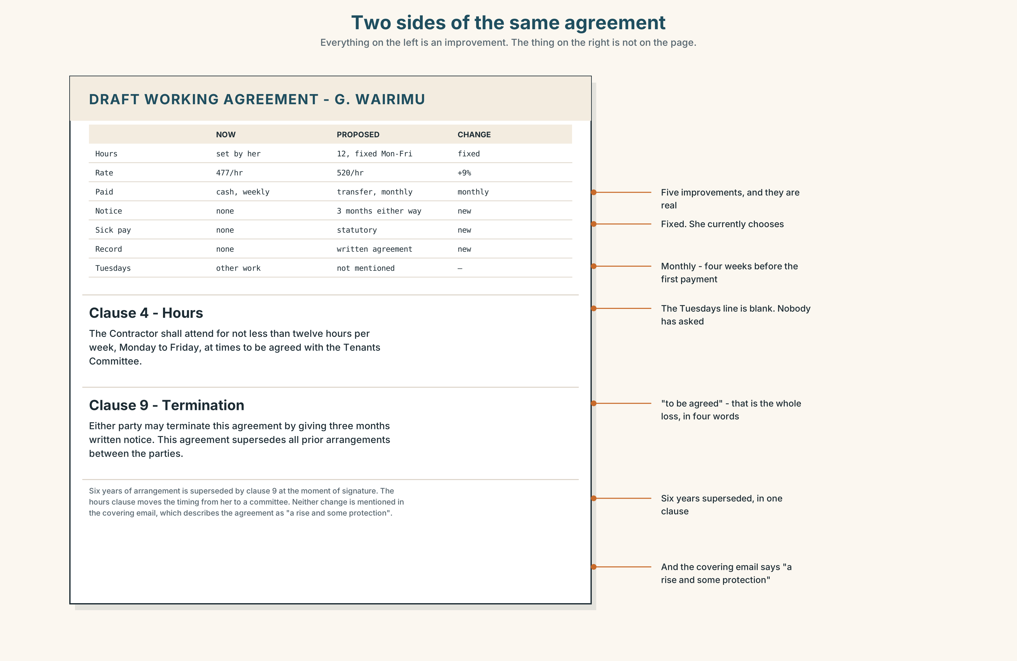{width=6.6in}
Two sides of the same agreement — Everything on the left is an improvement. The thing on the right is not on the page.
Read the two sides of the agreement and answer.
- What is the current hourly rate, and what is the proposed one?
- How many hours a week does the proposal fix, and what does Grace currently do?
- What does the proposal give her that she does not have?
- What does it take away that is not written anywhere on the page?
- Find the notice period. Compare it to six years.

5F · Writer analysis
- The review praises the book for holding two things at once. Does the review do the same?
- "A footnote." Two words as a paragraph. What is it doing that a sentence would not?

5G · Text against text
The review says formalisation destroys the goodwill ledger. The agreement is a page of improvements. Two sentences on whether both are true. The second begins "The improvement is real, and…"

Part 6 · Vocabulary Lab 2 ◆ B · THE SYSTEM

Twenty-one ways to size a difference
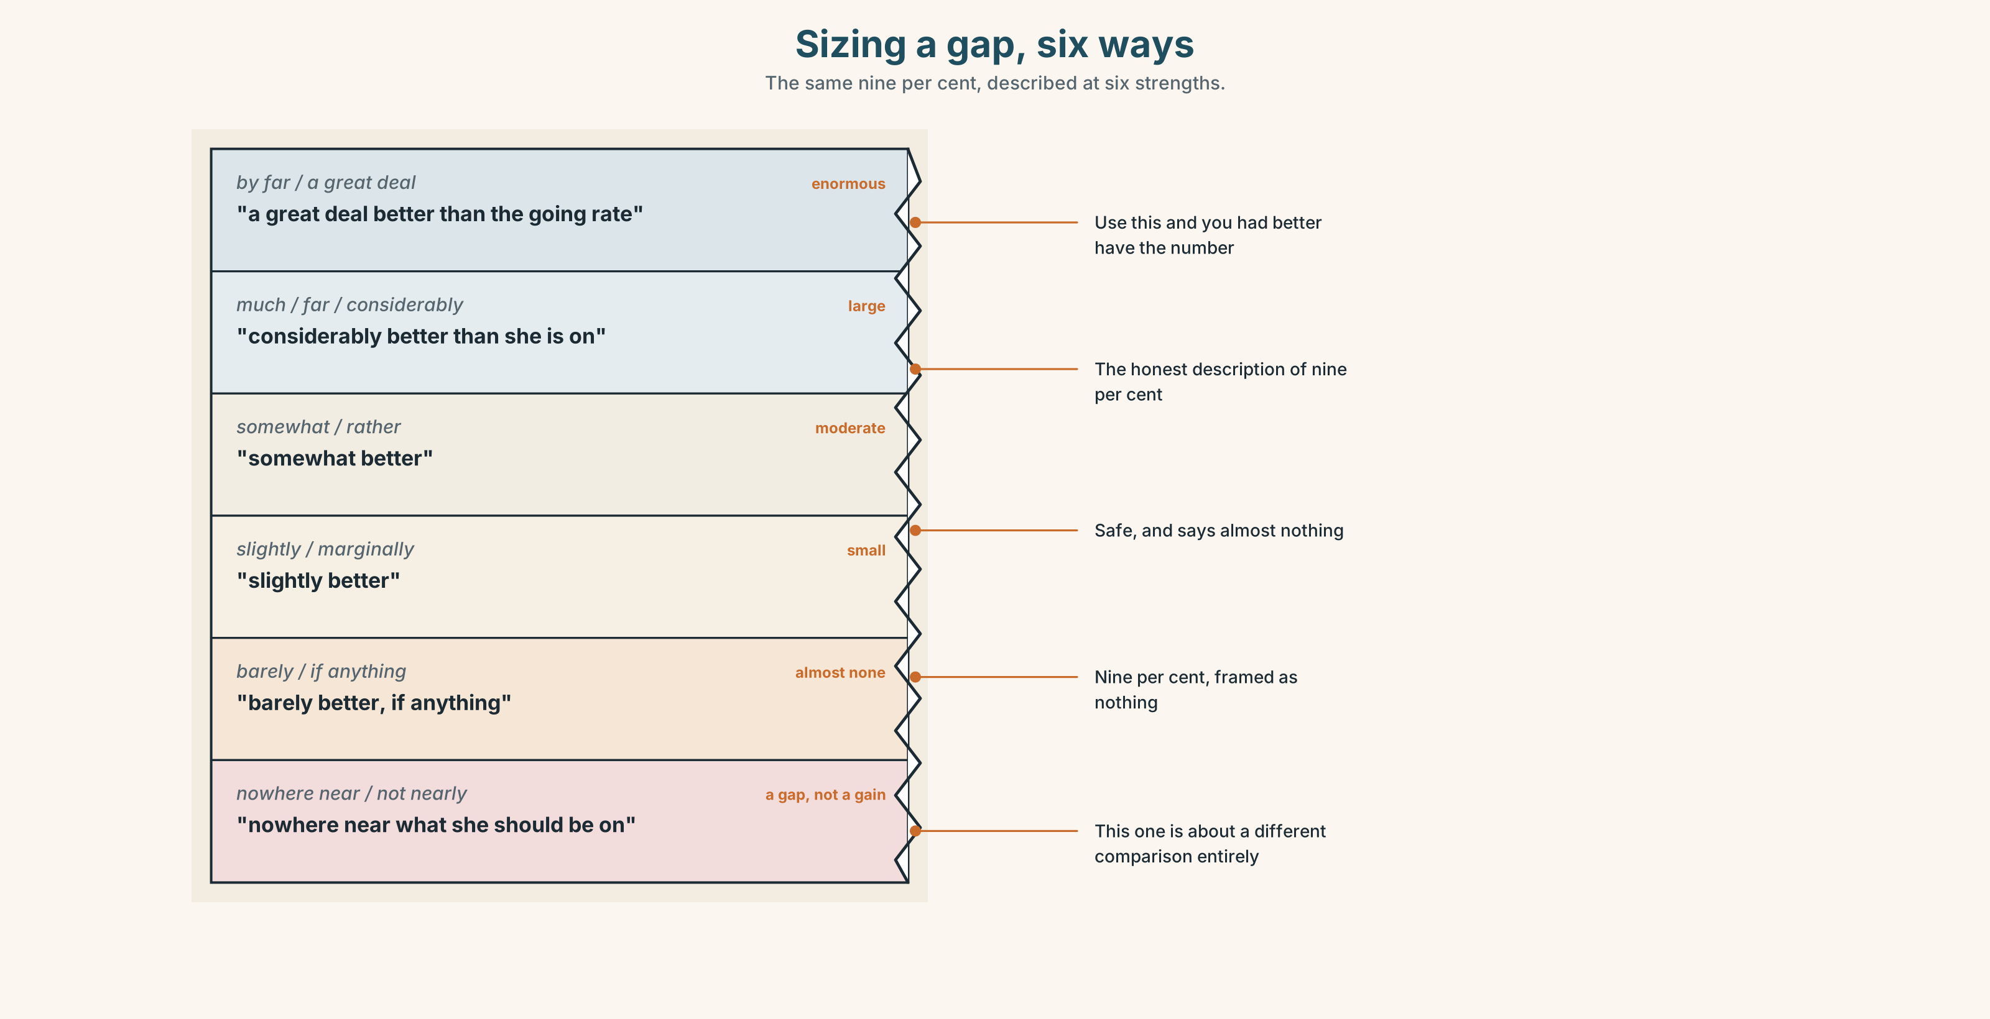{width=6.6in}
Sizing a gap, six ways — The same nine per cent, described at six strengths.

6A · Sort — the scale
Put all twenty-one on a line from no difference to enormous difference.
far · much · slightly · considerably · marginally · substantially · significantly · somewhat · barely · appreciably · infinitely · a great deal · nowhere near · every bit as · just as · not nearly · the more… the more · the sooner… the better · by far · a good deal · if anything
and three that size a change rather than a gap: knock back · scale up · not by a long way

6B · Chunk completion
- It is ______ ______ the hardest job in the building.
- She is ______ ______ as quick as anybody they have hired since.
- ______ ______ , she does more now than she did in 2020.
- ______ ______ we write it down, ______ ______ for both of us.
- It is ______ ______ what she should be on.

6C · Register sort
Which of these would you write in a contract? Which say out loud? Five belong in both, and one appears only in reviews.

6D · Contrast Clinic — the modifier is the offer
Six items. The number is identical in each pair. Only the modifier changes.
- The rate is ______ higher. / The rate is ______ higher. (9% — make it sound small, then large)
- There are ______ more hours. / There are ______ more hours. (four hours)
- It's ______ better than before. / It's ______ better than before. (the same offer)
Then: in a negotiation, who benefits from each version?

Part 7 · Pronunciation & Fluency Lab ◆ B · THE SYSTEM

Stressing the modifier
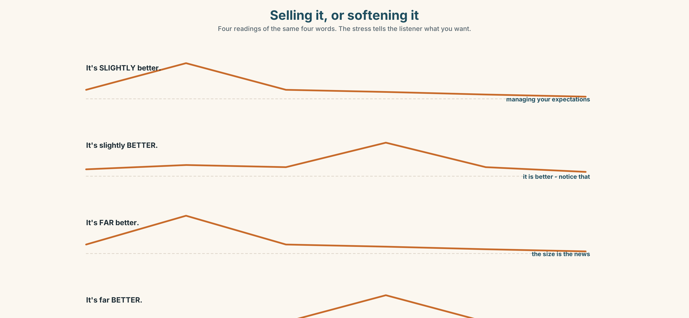{width=6.6in}
Selling it, or softening it — Four readings of the same four words. The stress tells the listener what you want.

7A · Hear 🔊 Track 10.3
It's SLIGHTLY better. — (I am managing your expectations) It's slightly BETTER. — (it is better, and I want you to notice) It's FAR better. — (the size is the news) It's far BETTER. — (the improvement is the news)

7B · Say
All four. Your partner says whether you are selling it or softening it.

7C · Make it mean something
"It's a lot more than I thought."
Say it as relief. Say it as suspicion. Same seven words.

7D · Fluency 20 ⏺
Twenty seconds: two things compared, three different modifiers. Three times, faster.

Part 8 · Writing ◆ C · THE PERFORMANCE

An agreement the other person would sign · 150 words
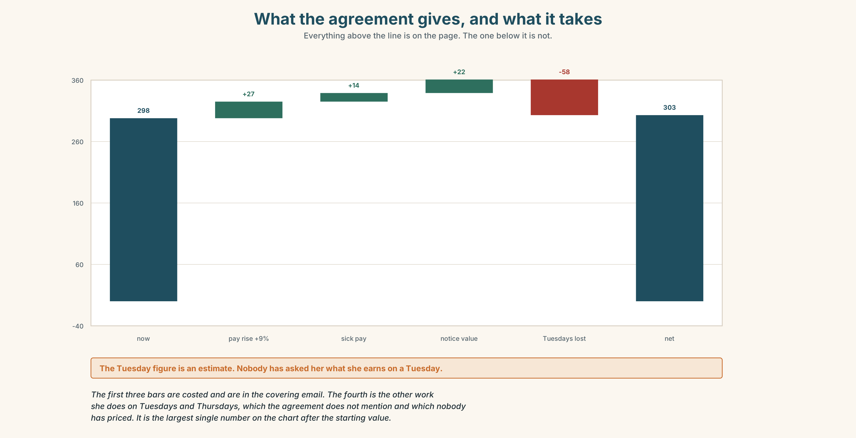{width=6.6in}
What the agreement gives, and what it takes — Everything above the line is on the page. The one below it is not.

8A · Read the model
Working agreement — Grace Wairimu and Jengo House tenants
Grace has cleaned this building since 2020 under an arrangement neither side wrote down. This replaces it. [says what it replaces, and admits there was something]
Hours. Twelve hours a week, Monday to Friday, worked at times Grace sets. Not fixed by us. [the thing she would lose, protected explicitly]
Rate. 520 an hour, reviewed each January against the cost of living, not against our budget. [names the benchmark, which is the whole argument]
Notice. Three months either way. We know six years of goodwill is worth considerably more than three months, and we cannot write six years into a contract. This is the gap, and we are naming it rather than pretending it is not there.
If this is worse for you than what you have, do not sign it. Tell us which clause and we will look at it again.
Questions about the writer's choices:
- Why say "neither side wrote it down" rather than nothing?
- The notice clause admits the agreement is worse in one respect. Why include that?
- The last line invites refusal. What does that buy, and what does it risk?

8B · The anti-model
This agreement sets out the terms of engagement between the parties. The Contractor shall provide cleaning services as reasonably required. Remuneration shall be as per Schedule 1. Either party may terminate on one month's written notice. This agreement supersedes all prior arrangements.
Legally tighter and ethically worse. Name three things it does to the previous six years.

8C · Generate · 8D · Plan
what it replaces → the thing the other person would lose, protected first → the benchmark → the gap you cannot close, named → permission to refuse

8E · Draft 1 — 150 words

8F · Peer review — two criteria
☐ Would the person this is about sign it? ☐ Is there a loss in here that the writer has admitted?

8G · Draft 2 · 8H · Publish
Give it to the person it is about, and do not be in the room while they read it.

Part 9 · The File ◆ A · THE WORLD + C · THE PERFORMANCE

WORK FILE · The Difficult Message
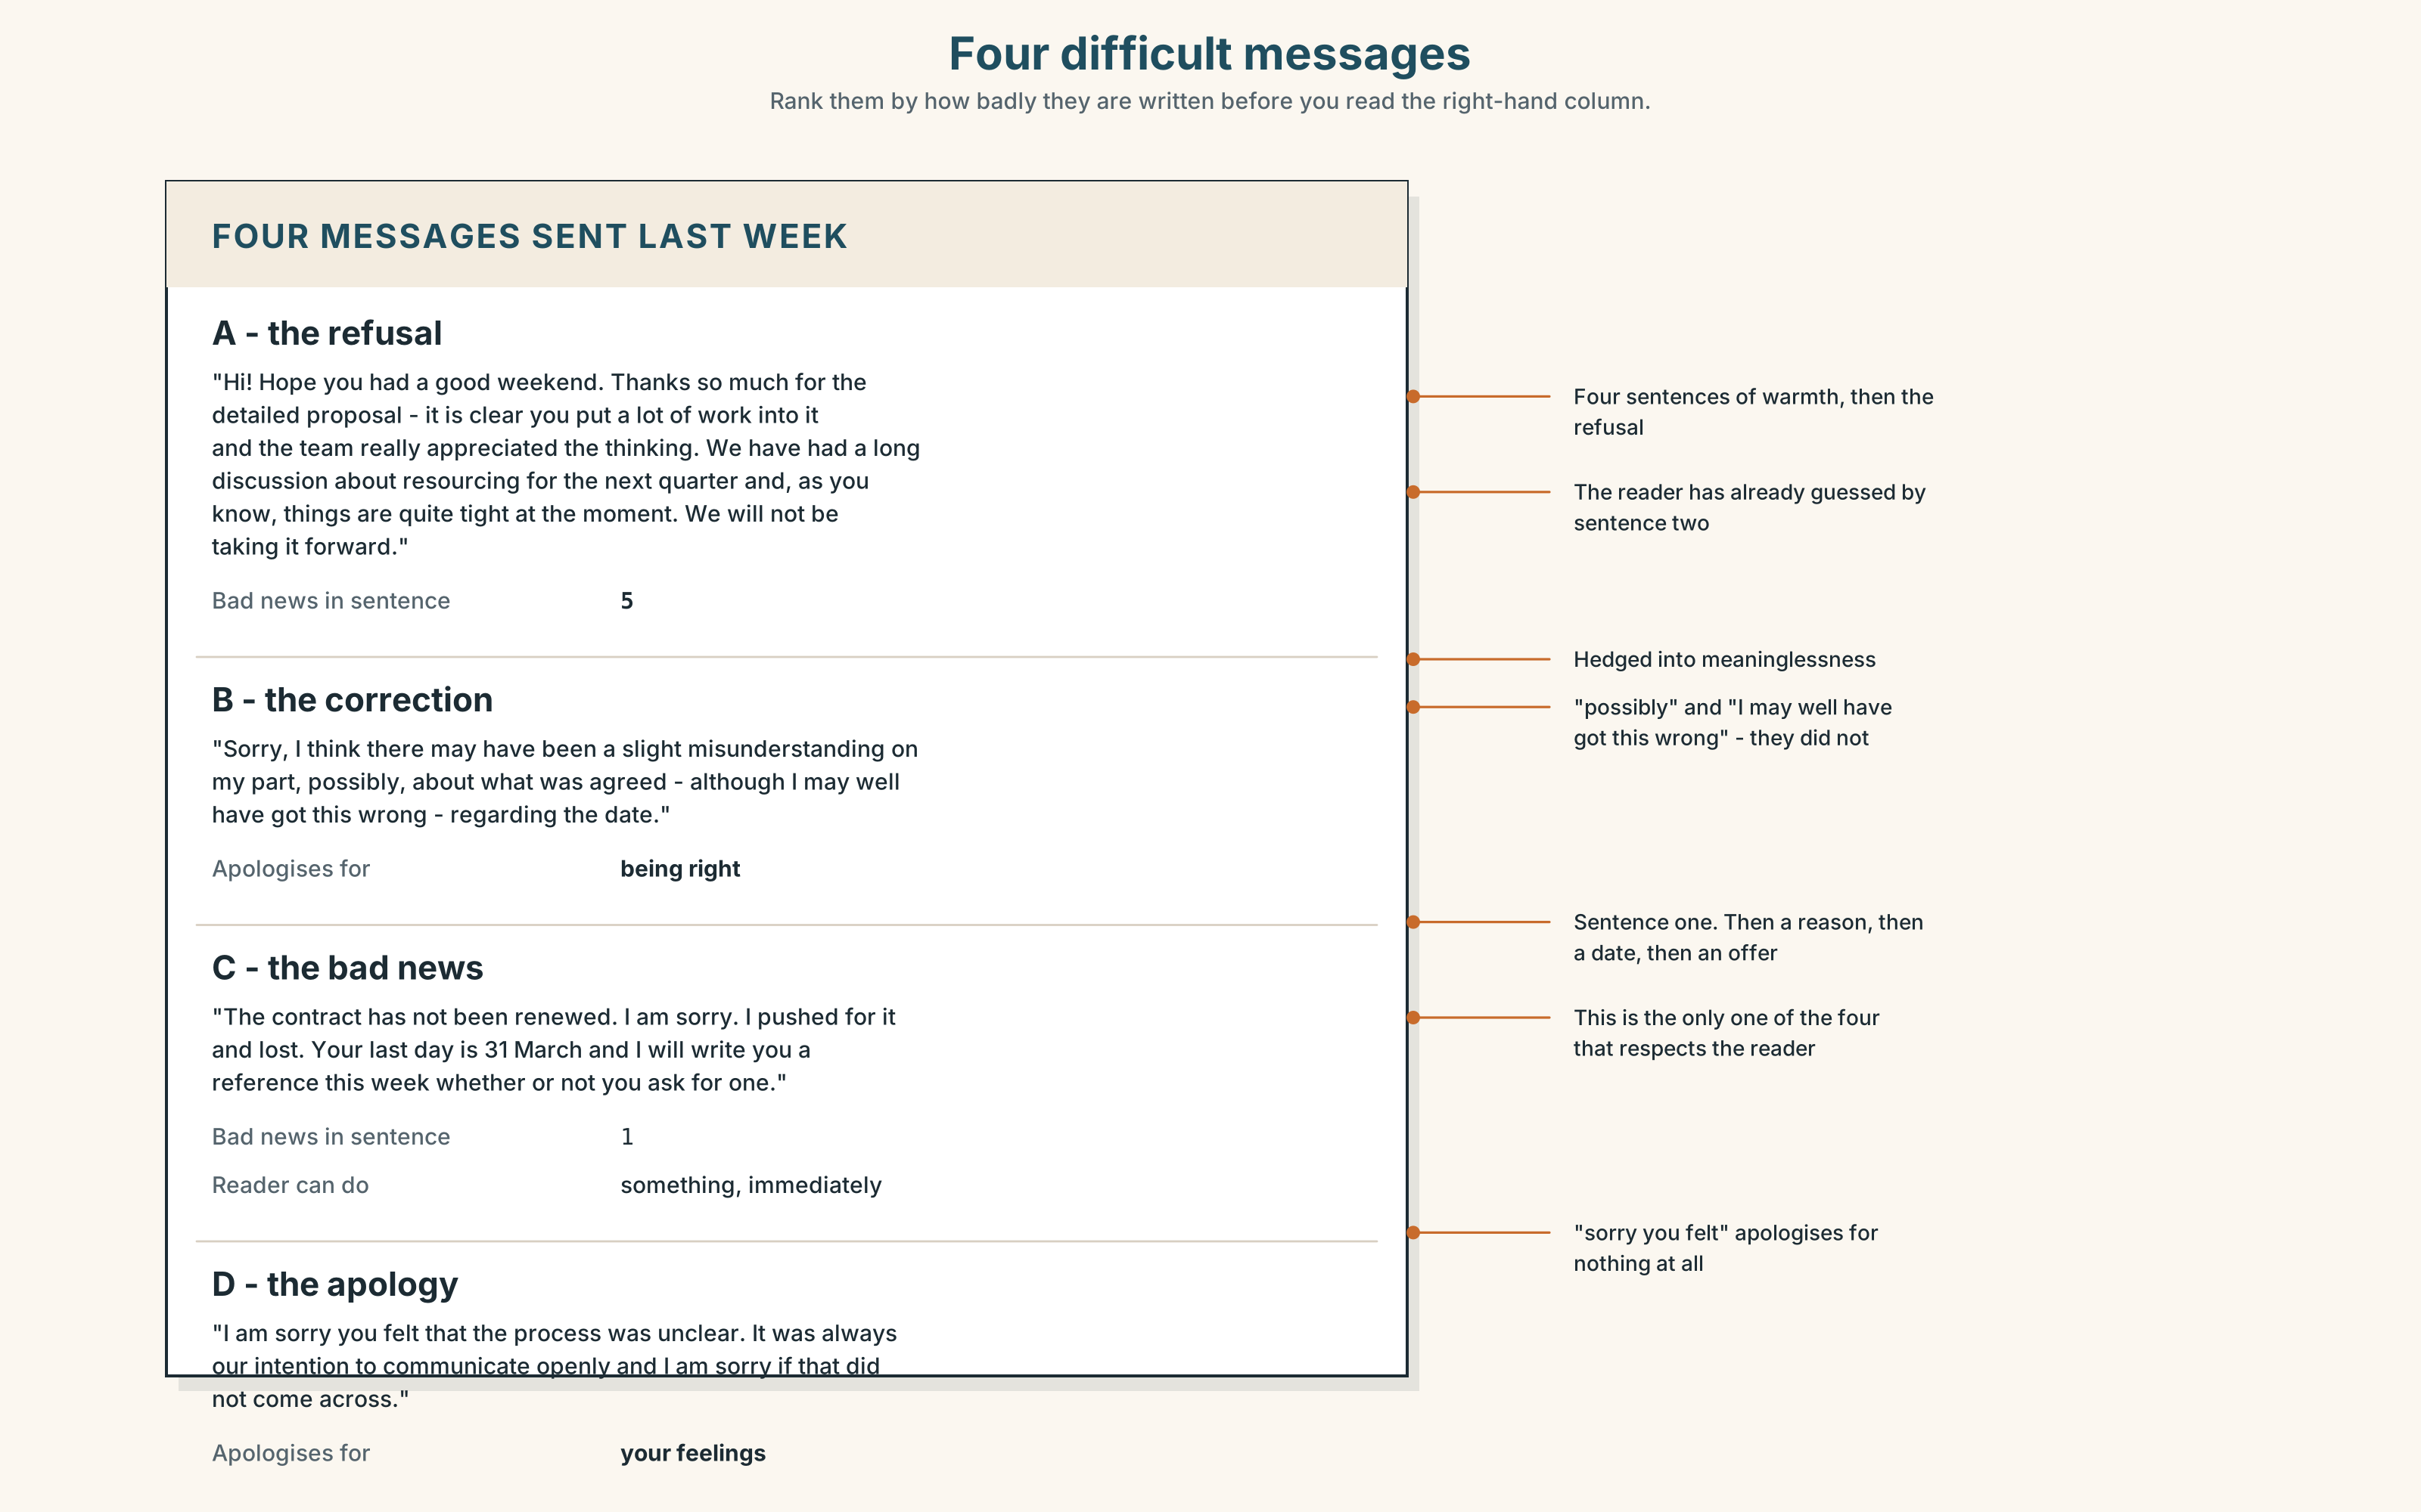{width=6.6in}
Four difficult messages — Rank them by how badly they are written before you read the right-hand column.

9A · Four messages
Four difficult messages: a refusal, a correction, bad news, and an apology. Rank them by how badly each is written, before you read the annotations.

9B · The four failures
Each one fails in a named way: burying it · over-explaining · apologising for the wrong thing · leaving the reader with nothing to do. Match them.

9C · The rule
Bad news goes in the first or second sentence. Never the third.
Test it: rewrite the worst of the four so the news is in sentence one. Is it crueller, or just shorter?

9D · Write one
Pick a real difficult message you have been avoiding. Write it in under eighty words. Bad news by sentence two. One thing the reader can do.

9E · Transfer
Send it. Then write down what actually happened, and compare it with what you expected.

Part 10 · Mediation & Interaction ◆ C · THE PERFORMANCE
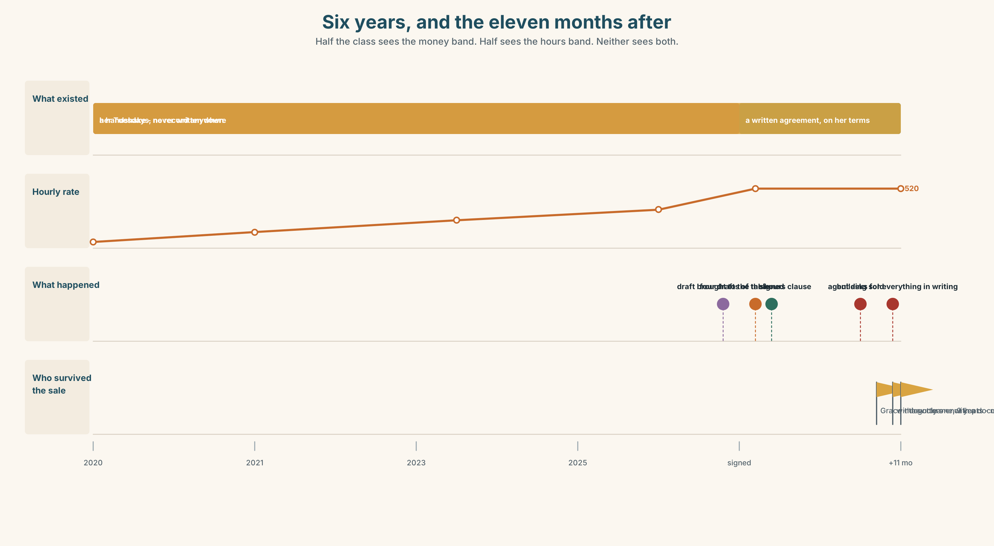{width=6.6in}
Six years, and the eleven months after — Half the class sees the money band. Half sees the hours band. Neither sees both.

10A · Relay
Half the class sees the money band; half sees the hours band. Rebuild by speaking.

10B · Simplify
Explain the proposed agreement to Grace's daughter, who is twenty-two, reads contracts for a living, and will tell her mother what to do.

10C · Compress
The review into 60 words for somebody deciding whether to formalise an arrangement this week.

10D · Online interaction
Write the message to the other five tenants explaining why you are proposing to pay more. Two of them will read it as a criticism of the last six years.

10E · Across languages
How does your language describe an arrangement that is real and not written down? Is there a single word? Is it respectful?

Part 11 · The Decision ◆ C · THE PERFORMANCE

Grace's contract
Grace has cleaned Jengo House for six years. There is no contract. She is paid weekly in cash, sets her own hours, and does other work on Tuesdays and Thursdays that nobody has ever asked about.
The tenants want to put her on a written agreement: twelve fixed hours, nine per cent more an hour, three months' notice, paid by transfer.
- Formalise it as proposed. More money, legal protection, and her Tuesdays become a problem she has to raise.
- Leave it. She has said she is happy. Six years says something. And she has no notice, no record, and nothing if she is ill.
- Formalise it on her terms — she sets the hours, the rate is benchmarked, and the agreement says so in writing. It is harder to administer and two of the six tenants will object.

11A · The evidence
- The two sides of the agreement from Part 5.
- The chart: what she earns now, what she would earn, and what she loses.
- The voice. Grace, thirty seconds: "It's a lot more than I thought. I'd just want to know what happens on a Tuesday, and I don't want to have to ask every week."

11B · Steelman
Argue the option you like least. Two minutes.

11C · Deliberate
I think they should ______, because ______. The strongest argument against me is ______, and my answer to it is ______.

11D · Decide — eighty words, two reasons

11E · Model decision
Formalise it on her terms, and accept that it is harder and that two people will object.
Leaving it is the option that respects her stated view and I think it fails her. Six years with nothing written down is not an arrangement; it is an arrangement that has not yet been tested. The test arrives when somebody is ill, or when the building changes hands, and at that point goodwill is held entirely by people who will have moved on.
Formalising it as proposed is worse than leaving it. It takes the one thing she has — control of her own week — and converts it into a clause she would have to negotiate for, having just been given a rise. Her thirty seconds is explicit about this and it is the only new information anybody has: she did not ask about the money.
The third option costs the tenants administrative effort and costs her nothing. That asymmetry is the argument. The two who object will be objecting to effort, and it is not their Tuesdays.

11F · The Reveal
What happened. They wrote it her way. The hours clause says at times set by Grace, not less than twelve hours weekly, which took four drafts because nobody had written a clause like it before and two of the drafts were worse than no clause at all.
Eleven months later the building changed hands. The new owner's managing agent asked for all service arrangements in writing within fourteen days. Grace's was the only one that existed.
She was kept on. Two of the other arrangements in the building — a window cleaner and a man who did the gutters — were not.
The clause nobody knew how to write was the only thing in the building that survived the sale.
Was the reasoning sound? And: the window cleaner had been there nine years. Whose job was it to write his down?

Part 12 · Landing ◆ all three lines · end of book

12A · Recycle — twelve items
Six from this unit.
- It's ______ better than last year — about two per cent.
- ______ more hours she takes, ______ less she can choose.
- That's ______ near enough.
- Saturday is paid at time and a ______.
- She has never been on the ______.
- Nights and Sundays are ______ hours.
Four from across this book.
- She ______ out that the lease expired in March. (Unit 9)
- The grower ______ I buy from has eleven acres. (Unit 8)
- I want you ______ (check) it twice. (Unit 7)
- The rule ______ (bring) in after a fire. (Unit 6)
Two from Making Plans (A2.1).
- If she ______ (not sign), nothing ______ (change). (first conditional)
- She ______ (work) here since 2020. (present perfect, for/since)

12B · Consolidate
150 words, one paragraph. Compare your work or study now with three years ago. Use four degree modifiers, one the … the … structure, and six items from Part 6.

12C · Can-do, with evidence
I can… | My evidence | Sure?
size a difference deliberately, and hear it when somebody else does | Part 3G score | ◯ ◑ ●
negotiate an agreement and write it down before leaving the room | Part 4C, signed | ◯ ◑ ●
write a difficult message with the news in the first two sentences | Part 9D, sent | ◯ ◑ ●
decide about somebody else's arrangement without deciding for them | Part 11D | ◯ ◑ ●

12D · Replay ⏺ — and the book replay
Listen to your Part 0C from this unit, and record it again.
Then find your Part 0C from Unit 1 — Who is a city built for? — and listen to it. That was 110 hours ago. Record an answer to it now.
Write one sentence about what changed. Not about your English. About what you say.

12E · Glossary — forty-five items, as a map
WHAT YOU ARE PAID · wage · salary · overtime · time and a half · a living wage · cash in hand · on the books THE ARRANGEMENT · contract · probation · notice · severance · zero-hours · a fair day's work THE WORKPLACE · rota · cover · cover for · turnover · headcount · unsocial hours · union · grievance WHAT HAPPENS · lay off · take on · clock in · in lieu SAYINGS · that's the job · nobody does it for the money SMALL · slightly · marginally · barely · somewhat · a little LARGE · far · much · considerably · substantially · significantly · appreciably · a great deal · by far · a good deal · infinitely NOT AT ALL · nowhere near · not nearly EQUAL · just as · every bit as PAIRED · the more… the more · the sooner… the better · if anything

12F · End of Taking a Position
Ten units. Ten decisions, and not one of them had a right answer.
In six of the ten, the reasoning was sound and something was still lost. In two, the person it was about was not in the room when it was decided. In one — Grace's — the thing nobody knew how to write was the only thing that survived.
Next: B1.2 · Weighing It Up — Hospital Regional, Valdivia. Where the decisions are the same shape and the cost of getting them wrong is a person.

