Table of Contents

B1.3 · Unit 1 · The Next Video
English Animated · Making the Case · a university campus, Melbourne Student's Book pages 6–27 · 22 pp · ~11 hours

Part 0 · The Big Picture ◆ A · THE WORLD
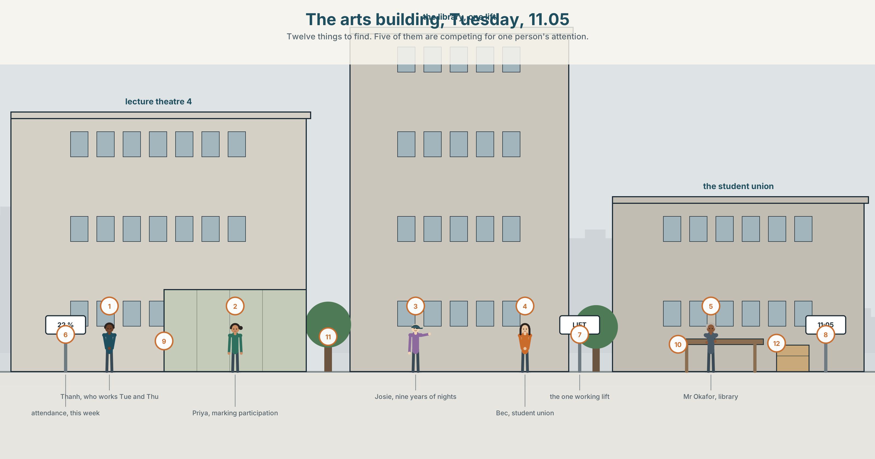{width=6.6in}
The arts building, Tuesday, 11.05 — Twelve things to find. Five of them are competing for one person's attention.

What is attention worth?
By the end of this unit you can analyse how one interface is designed to hold you, and show your evidence. One hundred and eighty words.
◆ A · THE WORLD | A lecture theatre that is half empty, and a recording that is not
◆ B · THE SYSTEM | non-defining relative clauses · of which and of whom · 23 words for attention and design · 22 connectors and relatives · the pitch reset at the clause break
◆ C · THE PERFORMANCE | A hundred and eighty words with the evidence in them

0A · Find it
Find twelve things in this picture. Five of them are competing for the same person's attention.
a lecture theatre half full · a laptop with eleven tabs · a phone face up · a recording light on the ceiling · a screen showing a playlist · a notice about attendance · a library window · a queue for coffee · a bicycle against a rail · a pass rate on a poster · a clock · a lift with a sign on it

0B · Guess it
Two of the twelve exist because of the other ten. Which, and what is the causal chain?

0C · Say it ⏺
Record forty-five seconds. Name one interface you use every day. What is it measuring, and what does it want you to do next? You will record it again at the end of this unit.

Part 1 · Vocabulary Lab 1 ◆ B · THE SYSTEM
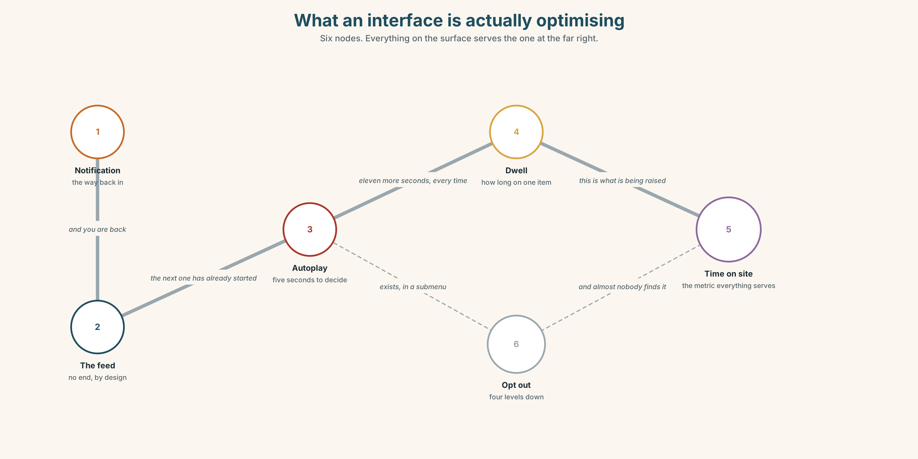{width=6.6in}
What an interface is actually optimising — Six nodes. Everything on the surface serves the one at the far right.

1A · Meet — the words of a designed surface
Match each word to one place on the map.
interface · notification · engagement · retention · feed · metric · dwell · prompt · autoplay · scroll

1B · Sort — what you do, what it does, or what it counts?
Three columns.
scroll · autoplay · engagement · dwell · notification · retention · prompt · metric · feed
Two of them are the same event described from opposite sides. Which pair?

1C · Meet — the word that hides a decision
by default
Everything an interface does without being asked is a decision somebody made and did not announce. Name three defaults on a device you own, and say which of the three you have ever changed.

1D · Collocation Lab
Complete each one with one word.
- The whole thing is engineered to hold your ______ for eleven more seconds.
- Autoplay is on by ______ , and it is the single most effective thing on the page.
- You can ______ out , in a submenu, in two taps that nobody finds.
- The next ______ starts before you have decided whether you wanted it.
- Time on ______ is the metric everything else is built to raise.
- He has learned to ______ off at about eleven and it took him two years.

1E · The fixed expressions
f I only came on to check one thing. f It is designed to do that.
The first sentence is said by a user. The second is said by somebody who has read the documentation.
Write the three sentences between them.

1F · Own it
Think of one application you use. Tell a partner four sentences: what it measures, what it does without asking, what you have turned off, and how long it took you to find the setting.

Part 2 · Listening ◆ A · THE WORLD
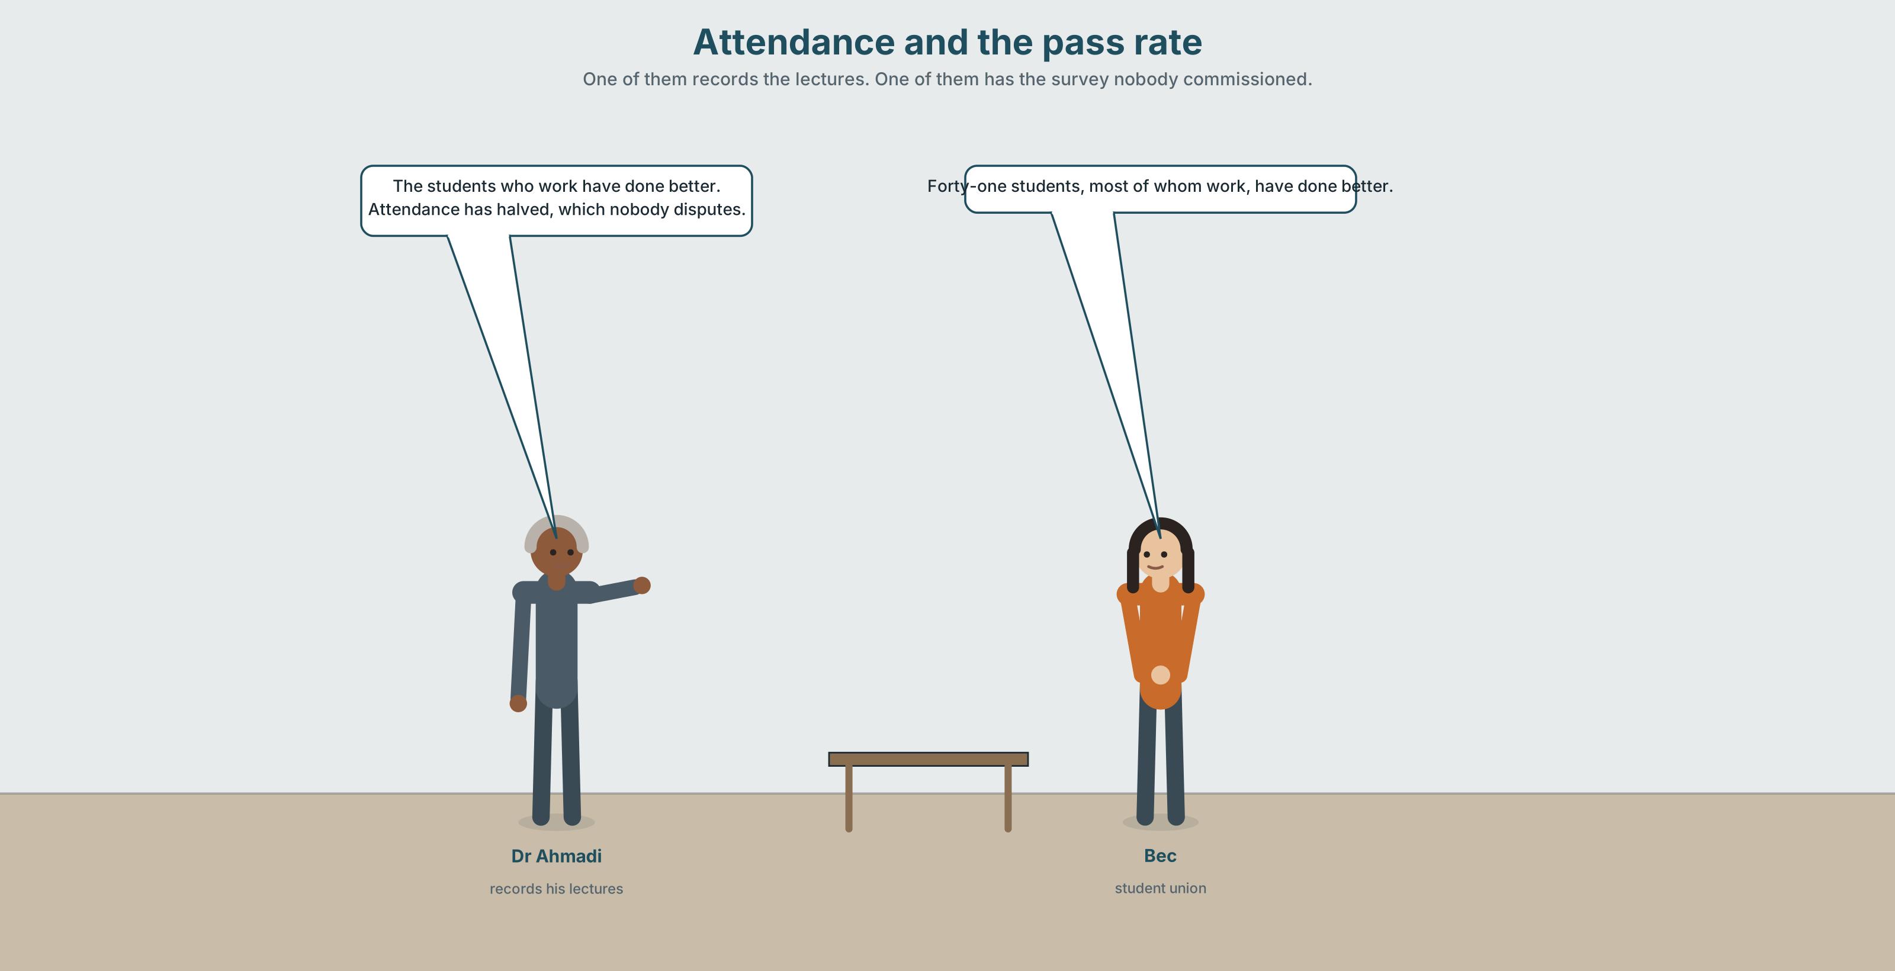{width=6.6in}
Attendance and the pass rate — One of them records the lectures. One of them has the survey nobody commissioned.

2A · Attendance and the pass rate 🔊 Track 1.1
Before you listen. Dr Ahmadi records his lectures. Attendance has halved. The pass rate for students who work has risen. Guess: what is he going to be asked to do?
Listen once. One question. What is the committee's concern?
Listen again. Complete the table.
 | What they have measured | What they conclude | What they have not measured
Dr Ahmadi
the committee
Bec
Listen again. Choose the best answer.
- Attendance has fallen from 80 to 40 / 60 to 30 / 45 to 22 per cent.
- The pass rate for students in paid work has risen by 4 / 11 / 19 points.
- The recordings are watched live / within a week / at two in the morning.
- The committee's objection is about learning / money / the look of the room.
Noticing. Four sentences from the recording.
- The students who work have done better.
- The students, who work, have done better.
- Forty-one students, most of whom work, have done better.
- Attendance has halved, which nobody disputes.
Sentences 1 and 2 differ by two commas and describe different groups. How many students are there in each?

2B · Decoding clinic 🔊 Track 1.2
Thirty seconds of Dr Ahmadi. Four jobs.
- How many non-defining clauses can you hear?
- After each pause, does his pitch start higher or lower?
- Catch the three percentages.
- He uses one clause that refers back to a whole sentence rather than a noun. Which?
Transcripts, page 150.

Part 3 · Grammar Lab 1 ◆ B · THE SYSTEM

Adding a clause without narrowing the noun

3A · Notice
Look at the four sentences in Part 2.
- In sentence 1, how many students are being described? In sentence 2?
- In sentence 3, what does most of whom refer to?
- In sentence 4, what is the antecedent of which? It is not a noun.
- Try putting that into sentence 2. What happens?
- Try "Forty-one students, most of them work, have done better." What is wrong?

3B · See
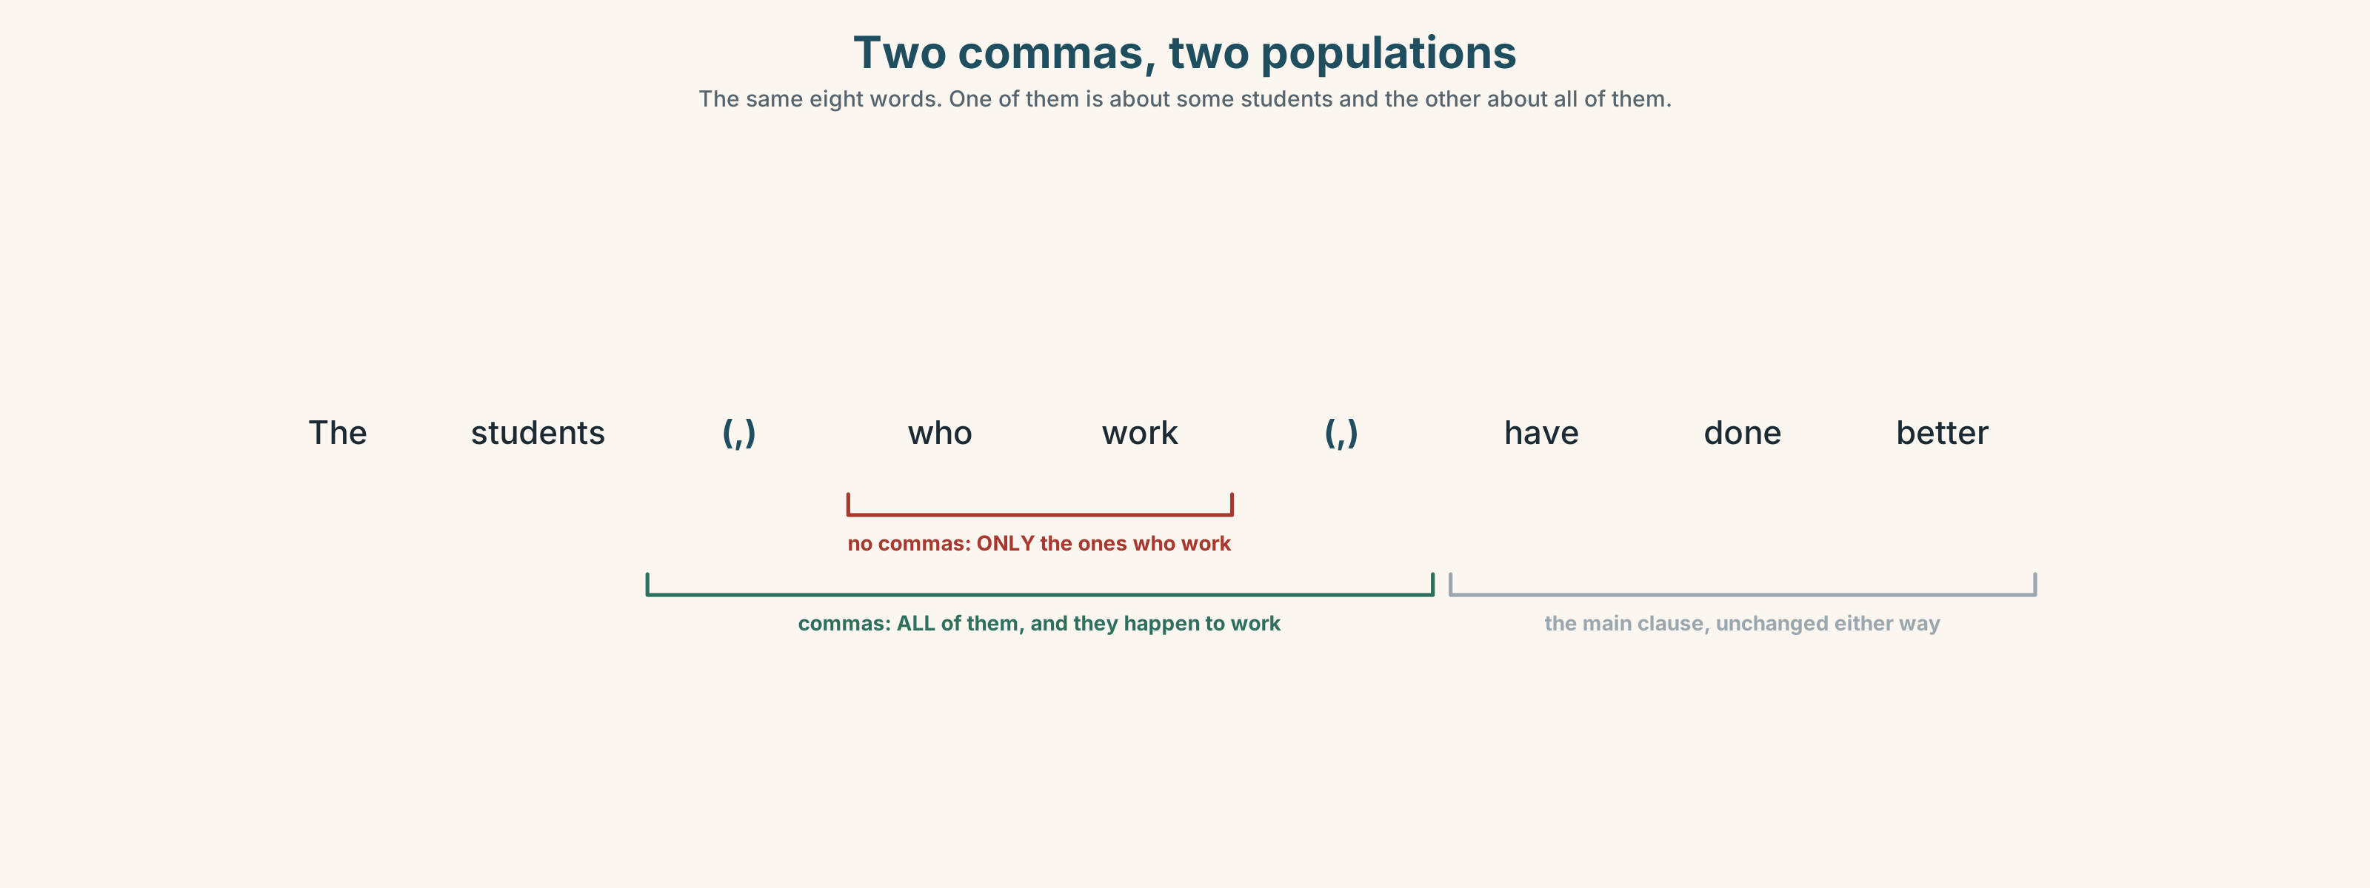{width=6.6in}
Two commas, two populations — The same eight words. One of them is about some students and the other about all of them.

3C · Know
 | Shape
defining | no commas, that allowed | The students who work have done better. — only those ones
non-defining | commas, never that | The students, who work, have done better. — all of them, and by the way they work
quantifier + of which / of whom | most of whom, all of which | 41 students, most of whom work
sentential which | refers to the whole clause | Attendance has halved, which nobody disputes.
Of whom and of which take a verb of their own. ✗ 41 students, most of them work — that is two sentences joined by a comma. ✓ 41 students, most of whom work · ✓ 41 students, and most of them work
Sentential which is the only relative that can point at a whole clause. It cannot be what. ✗ Attendance has halved, what nobody disputes.
In writing, a non-defining clause needs both commas. One is an error that changes the meaning of everything after it.
Why it matters. An audit sentence with the commas in the wrong place reports a different population from the one that was studied, and nobody will notice.

3D · Use — controlled
Forty-one students, most (1) __________ whom are in paid work, completed the unit. The recordings, (2) __________ are watched mainly between eleven at night and two in the morning, have been available since March. Attendance has fallen by half, (3) __________ nobody disputes. The students (4) __________ attend in person are slightly younger, (5) __________ is the only demographic difference anybody has found. There are eleven lectures, four (6) __________ which were not recorded, and the pass rate for those four is the figure (7) __________ the committee has not seen.

3E · Use — guided
Join each pair. Use a non-defining clause, of whom / of which, or sentential which.
- Forty-one students completed the unit. Thirty-one of them work.
- The recordings have been available since March. They are watched at night.
- Attendance has halved. Nobody disputes it.
- There are eleven lectures. Four were not recorded.
- The pass rate rose eleven points. That is the figure in dispute.

3F · Use — open
In pairs. Describe a group you belong to in five sentences, each with a non-defining clause. Your partner's job is to catch any sentence where the commas have changed who you mean.

3G · Error autopsy
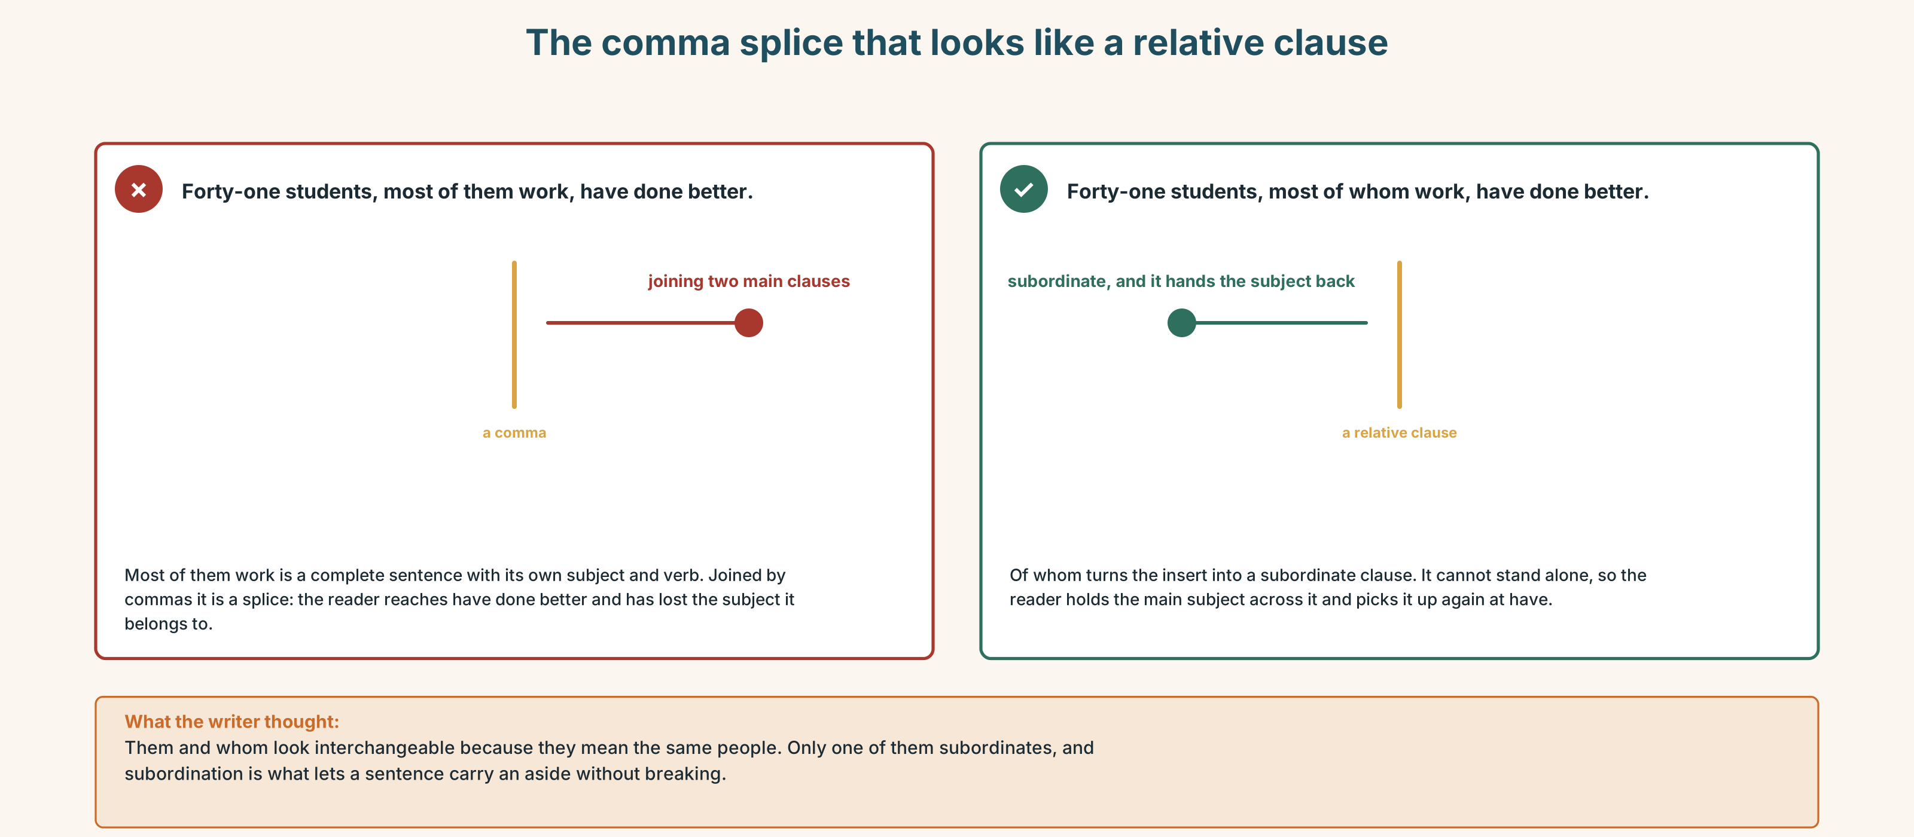{width=6.6in}
The comma splice that looks like a relative clause — The comma splice that looks like a relative clause
Read both versions. Then say how many students each one is about.

3H · Check — eight items
- Forty-one students, most ______ ______ work, passed.
- The recordings, ______ are watched at night, went up in March.
- Attendance has halved, ______ nobody disputes.
- The students ______ attend in person are younger. (only those ones)
- Eleven lectures, four ______ ______ were not recorded.
- Thirty-one students, ______ ______ ______ are in paid work. (all)
- ✗ The students, that work, passed. → correct it.
- ✗ 41 students, most of them work, passed. → correct it two ways.
0–4 → Workbook pp. 4–7. 5–6 → Part 6. 7–8 → page 19.

Part 4 · Speaking ◆ C · THE PERFORMANCE

4A · Fluency starter — the added clause
One learner makes a statement. The next adds a non-defining clause. The next adds a which referring to the whole thing. The chain breaks on a that.

4B · The functional core — showing your evidence
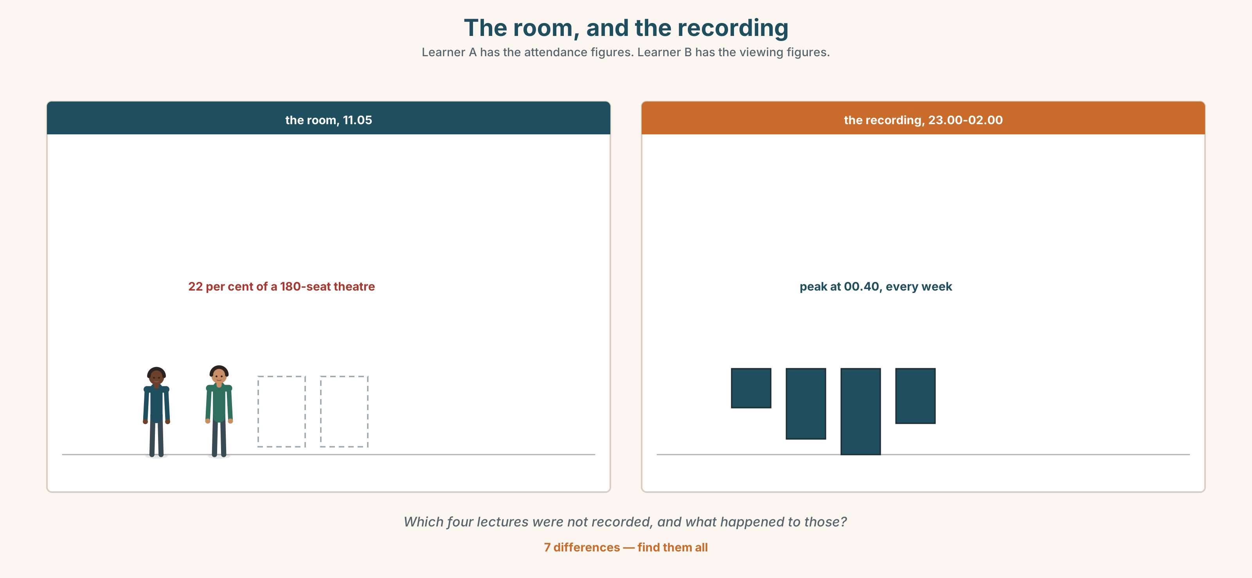{width=6.6in}
The room, and the recording — Learner A has the attendance figures. Learner B has the viewing figures.
Language Bank
the claim | The interface is built to… · What it optimises for is…
the evidence | You can see this in… · The default is…, which means…
the measurement | I counted… · Over two weeks, …
the honest limit | I cannot tell whether… · That is an inference, not an observation.
Information gap. Learner A has the attendance figures. Learner B has the viewing figures. Find the four lectures that were not recorded, and what happened to them.

4C · The performance — three minutes ⏺
Analyse one interface. Three minutes. You must include:
what it measures · one default that you can demonstrate · what you counted, with a number · one thing you are inferring rather than observing
Record it.

4D · Observer
One person listens for one thing: was any inference presented as an observation?

4E · Three criteria
☐ Did I use three non-defining clauses, none with that? ☐ Is there a number I collected myself? ☐ Did I mark my one inference as an inference?

Part 5 · Reading ◆ A · THE WORLD

5A · Predict
An archive document: the minutes of the committee that approved lecture recording, in 2019. The title is "Item 9: lecture capture." What do you expect the 2019 committee to have worried about? Two sentences.

5B · Read — two minutes

MINUTES OF THE TEACHING COMMITTEE — 4 MARCH 2019 Item 9: lecture capture
9.1 The committee considered a proposal to record all lectures and make the recordings available to enrolled students.
9.2 Dr Ahmadi, who had piloted recording in two units, reported that attendance in those units had fallen by about a third and that assessment outcomes had been unchanged.
9.3 Professor Lindqvist said that she would not support a measure which reduced attendance, on the grounds that attendance was itself a form of engagement. Asked whether there was evidence that attendance caused attainment rather than accompanying it, she said that she did not think the question could be answered.
9.4 Ms Oyelaran, the student representative, said that of the eleven students she had consulted, nine were in paid employment, most of whom had at some point missed a lecture for a shift. She asked the committee to record that none of them had chosen between a lecture and leisure.
9.5 The committee approved recording for a two-year trial, subject to review, and agreed that attendance would be monitored.
9.6 ACTION: Review in March 2021. Attendance data to be collected. Ms Oyelaran asked whether employment data would also be collected. The chair said this would be difficult.

Archivist's note, added 2025: the review did not take place in 2021. Attendance data has been collected continuously since 2019. Employment data has never been collected. Recording was made permanent in 2022 by a decision of the Dean, without reference to the committee.

5C · Comprehension — eight questions
- What did Dr Ahmadi report from his pilot?
- What was Professor Lindqvist's objection, and what did she concede when questioned?
- What did Ms Oyelaran report, and what did she ask to have recorded?
- Why does her last sentence matter?
- What was approved, and on what conditions?
- What two kinds of data were discussed in the action?
- What does the archivist's note say happened to each?
- What does the note say about the 2022 decision?

5D · Vocabulary in context
Guess from the text. Then check.
piloted · accompanying it · subject to review · would be difficult · without reference to the committee

5E · The counter-text
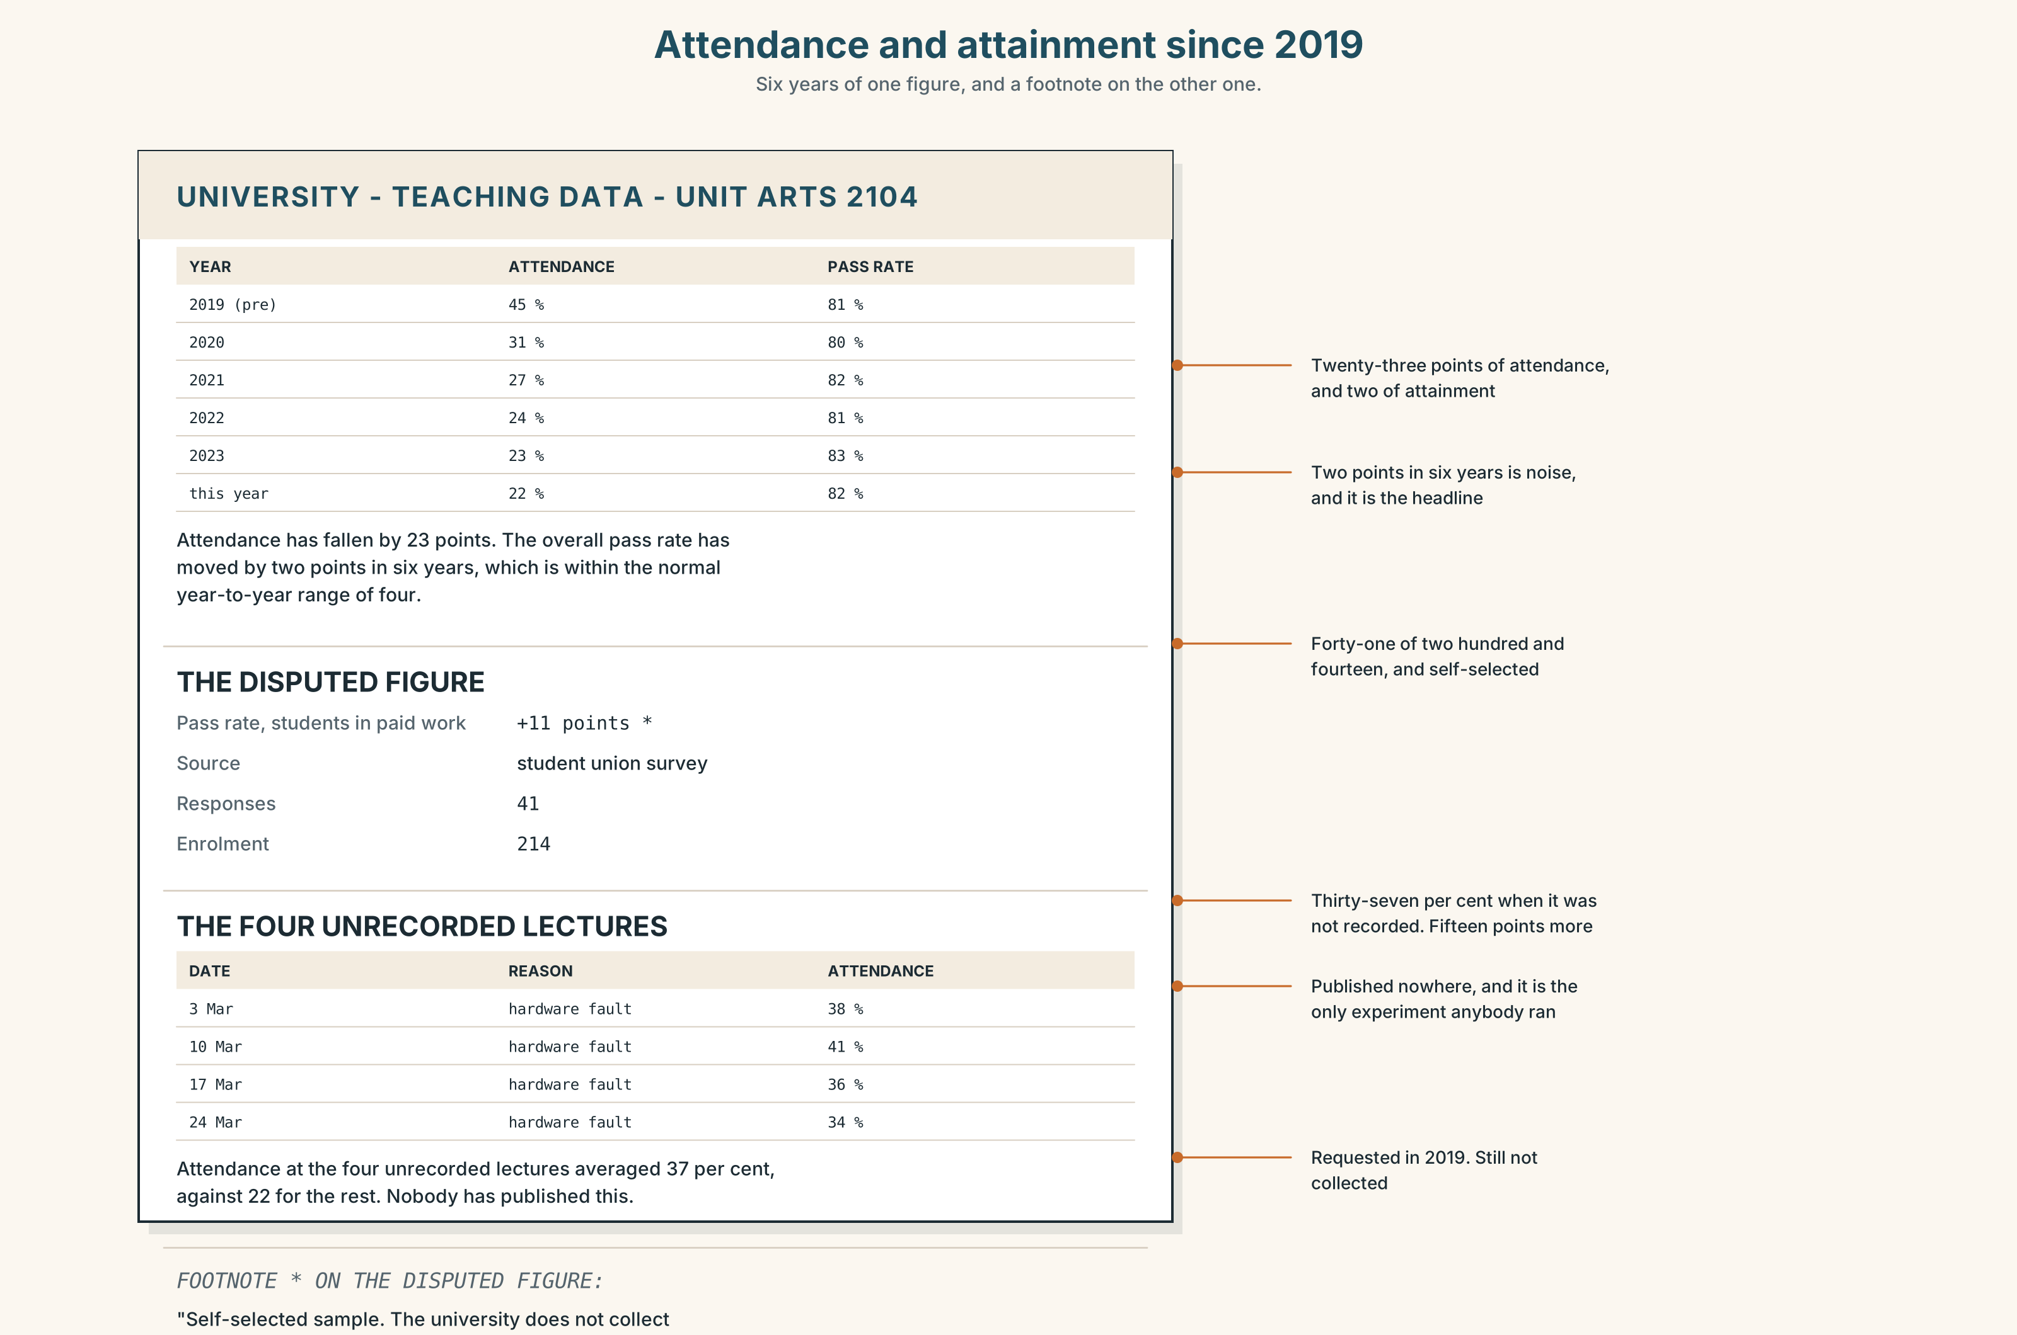{width=6.6in}
Attendance and attainment since 2019 — Six years of one figure, and a footnote on the other one.
Read the current attendance and attainment data, and answer.
- What has happened to attendance since 2019, and over what period?
- What has happened to the pass rate, and what has happened to it for students in paid work?
- How many lectures were not recorded, and what happened to attendance at those?
- What does the data not record?
- One figure has a footnote. Which, and what does the footnote say?

5F · Two texts
The 2019 minutes record a request for employment data. The current pack shows a pass-rate rise concentrated in one group that cannot be identified.
Put those two facts together. What has six years of data collection produced? Three sentences.

Part 6 · Vocabulary Lab 2 ◆ B · THE SYSTEM

Connecting without a comma splice

6A · Sort — adds, contrasts, names, or points back?
Four columns.
moreover · conversely · namely · incidentally · additionally · respectively · likewise · of which · at which point · the latter of which

6B · Chunk completion
- Eleven lectures, four ______ which were not recorded.
- Forty-one students, most ______ whom are in work.
- The figure rose in March, at which ______ the trial was extended.
- Two cohorts, the latter ______ which had recordings from week one.
- The report refers ______ to a 2019 decision it does not quote.
- The two tables cross-______ and neither of them says so.

6C · Three that are not interchangeable
namely · respectively · incidentally
Namely introduces the list you have just promised. Respectively maps two lists onto each other in order. Incidentally announces that what follows is beside the point — and it usually is not.
Which fits each sentence?
- Two groups were compared, ______ those in work and those not.
- The two groups scored 61 and 72 ______ .
- ______ , nobody has looked at the four unrecorded lectures.

6D · The fixed expression
f None of which was mentioned.
A sentence that is only ever written after a list.
Write the list that precedes it, for a meeting you have been in.

6E · Contrast Clinic
Eight items. Defining, non-defining, of which / of whom, or sentential which.
- Only the students in work did better.
- All the students did better, and all of them are in work.
- 41 students. 31 of them work.
- Attendance halved. Nobody disputes this.
- Eleven lectures. Four were not recorded.
- The recordings are watched at night. There are eleven of them.
- Two cohorts. The second had recordings from week one.
- The pass rate rose. That is the disputed figure.

Part 7 · Pronunciation & Fluency Lab ◆ B · THE SYSTEM

The reset after the comma
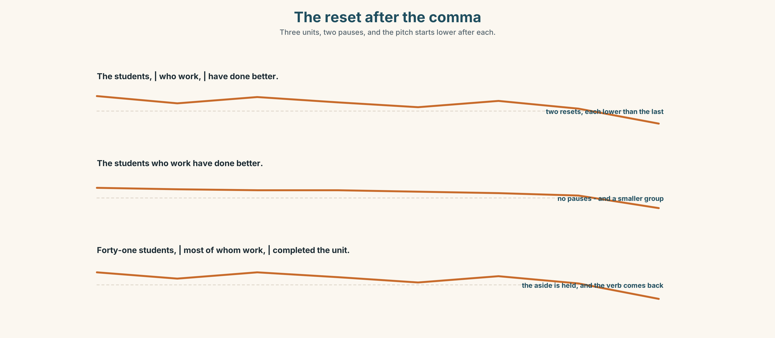{width=6.6in}
The reset after the comma — Three units, two pauses, and the pitch starts lower after each.

7A · Hear 🔊 Track 1.3
The students, | who work, | have done better. Three units. After each pause the pitch resets lower, and the last one carries the verb.
Now the defining version, run together:
The students who work have done better.

7B · Say
Say both. Then say this one with the pauses and without:
Forty-one students, most of whom are in paid work, completed the unit.

7C · Make it mean something
Say these two to a partner who is holding up fingers:
My lecturers, who record their lectures, are popular. (how many lecturers?) My lecturers who record their lectures are popular. (how many?)
Did they get it from the pause alone?

7D · Fluency 30 ⏺
Thirty seconds: three sentences, each with a clause between two pauses. Three times, faster, keeping the reset.

Part 8 · Writing ◆ C · THE PERFORMANCE

How an interface holds you · 180 words
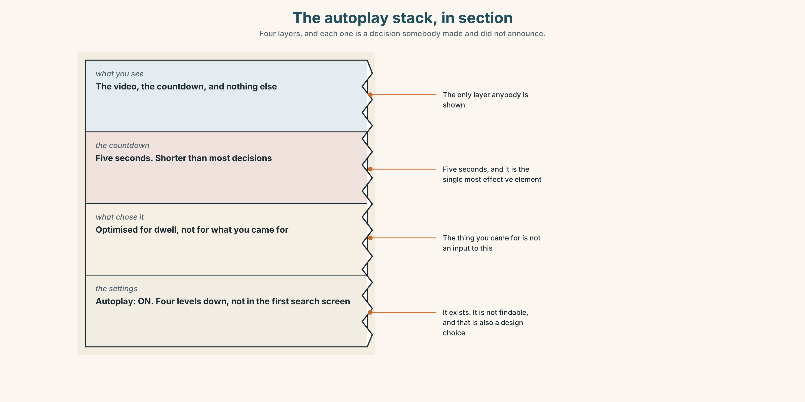{width=6.6in}
The autoplay stack, in section — Four layers, and each one is a decision somebody made and did not announce.

8A · Read the model
The autoplay countdown is five seconds, which is shorter than the time it takes most people to decide anything. [the design feature, with its number, and a non-defining clause doing the argument]
I counted my own sessions for two weeks. Of nineteen sessions, fourteen of which I began with a specific thing to look for, eleven ended more than twenty minutes after I had found it. [evidence the writer collected, with *of which* holding the qualification inside the sentence]
The setting that turns it off exists. It is four levels down and it is not in the first screen of the search, which I take to be deliberate, though I cannot demonstrate that. [one inference, and it is marked as one]
None of this is a complaint about users. It is a description of a surface which is optimised for time on site and does that extremely well. [the conclusion, which refuses the moral framing the reader expects]
Questions about the writer's choices:
- The evidence is nineteen sessions the writer counted. Why is that stronger than a study?
- One sentence says I cannot demonstrate that. What does admitting it buy?
- The last paragraph refuses to blame users. Is that an evasion?

8B · The anti-model
Social media is designed to be addictive. Companies use psychological tricks to keep us hooked and we are all spending far too much time staring at screens. We need to take back control of our attention before it is too late.
Correct English, and no evidence of any kind. Name three things that would make it checkable, and say what psychological tricks is standing in for.

8C · Plan
the feature, with its number → what you counted, with of which → one inference, marked → the conclusion, without the moral framing

8D · Write — 180 words

8E · Peer review — three criteria
☐ Is there a number the writer collected themselves? ☐ Is every inference marked as an inference? ☐ Are the non-defining clauses punctuated on both sides?

8F · Write it again · 8G · Publish
On the wall, with the 2019 minutes from Part 5B beside it.

Part 9 · The File ◆ A · THE WORLD + C · THE PERFORMANCE

WORK FILE · The Remote Problem
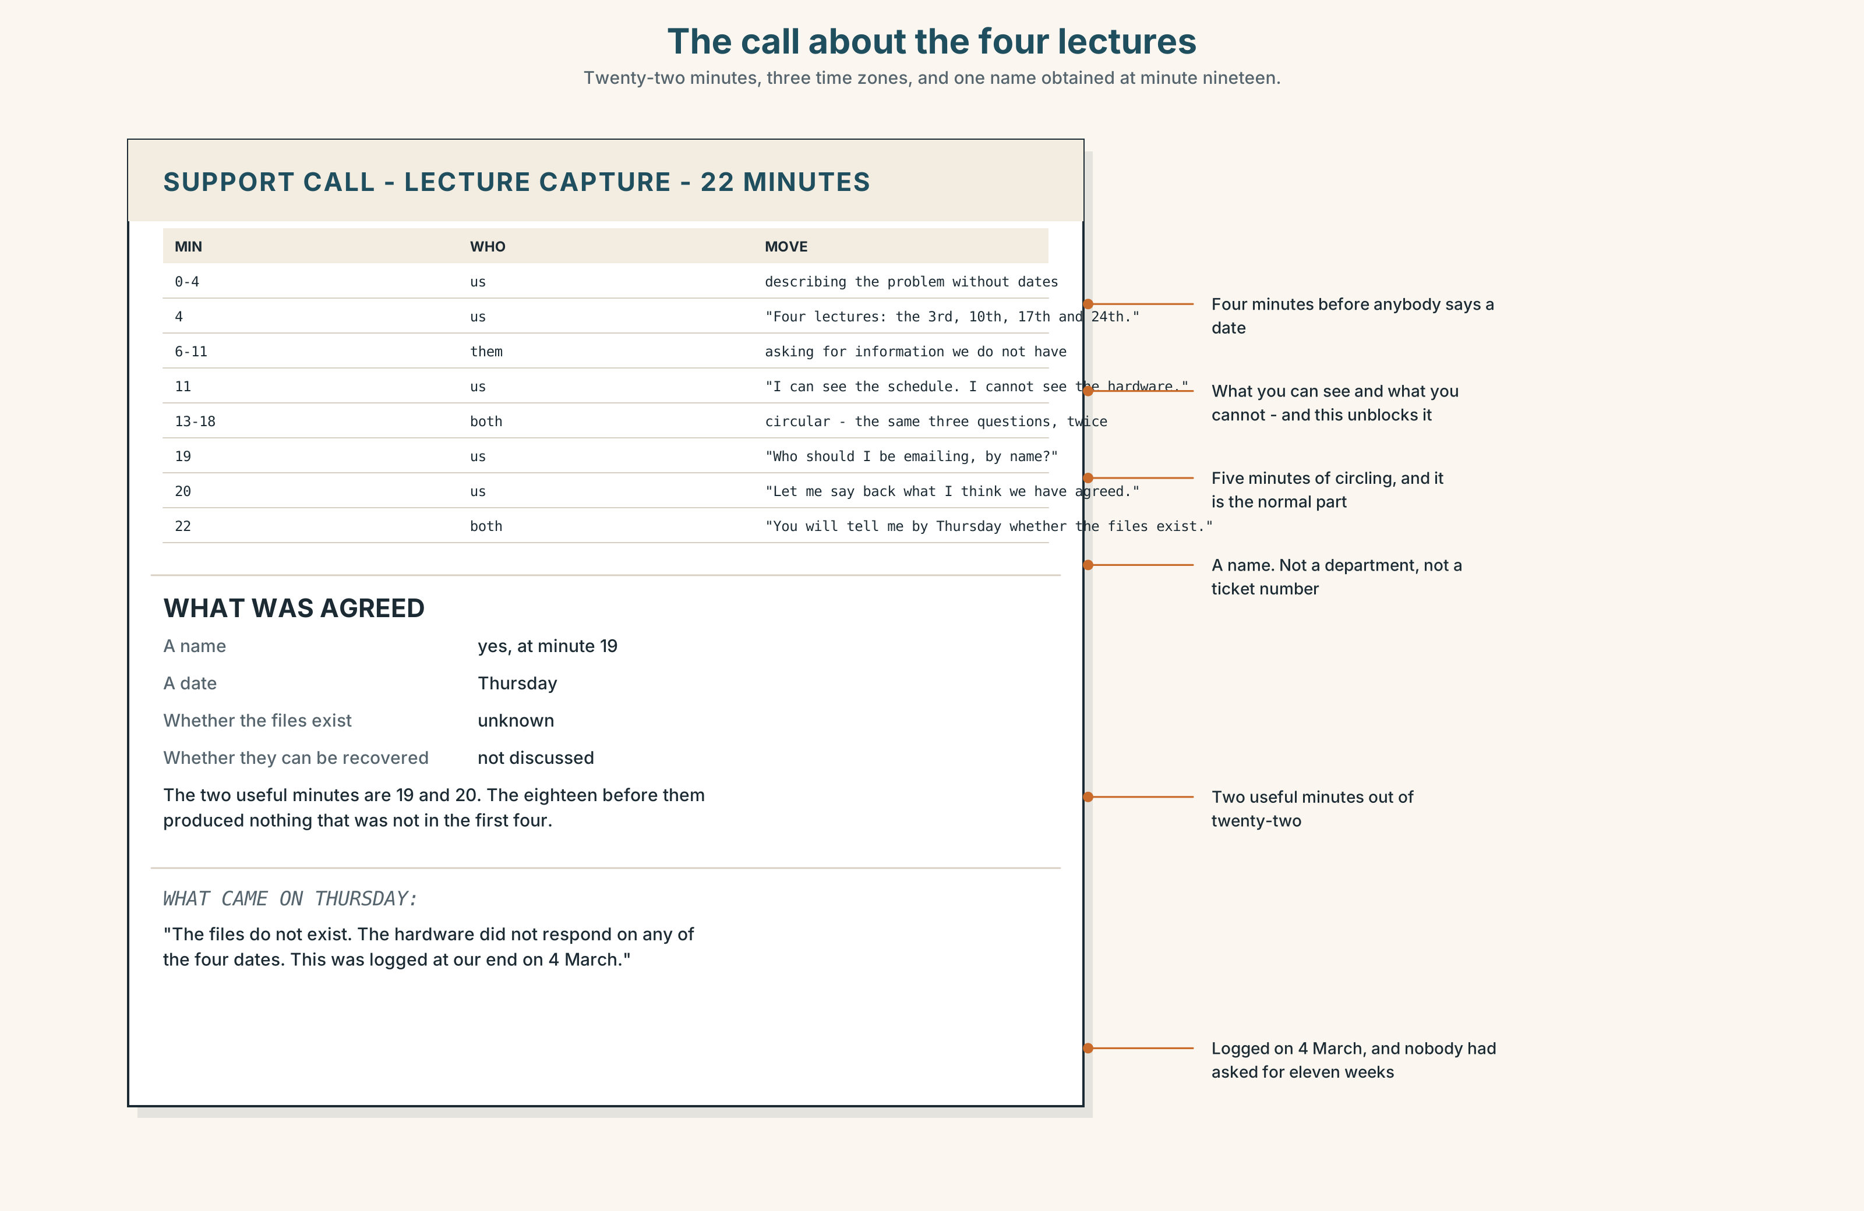{width=6.6in}
The call about the four lectures — Twenty-two minutes, three time zones, and one name obtained at minute nineteen.

9A · A problem nobody is in the room for 🔊 Track 1.4
The recording system has failed on four lectures. The supplier is in another country. Listen to the call.
- How long before anybody states the problem with a date?
- What does the supplier need that nobody on the call has, and who eventually gets it?
- What is agreed, and what is not?

9B · The four moves on a call you cannot escalate
stating the problem with dates · establishing what you can and cannot see · asking for a named person · agreeing what happens by when
Match each to one phrase.
"Four lectures, the 3rd, the 10th, the 17th and the 24th." · "I can see the schedule. I cannot see whether the hardware responded." · "Who should I be emailing about this, by name?" · "So you will tell me by Thursday whether the files exist."

9C · The sentence that ends a circular call
"Let me say back to you what I think we have agreed."
Why does it work? And what has to follow it for it to be more than a stalling move?

9D · Your turn
In pairs, back to back. Twelve minutes. One has a problem; the other works for a supplier and cannot fix it. Both must leave with one named person and one date.

9E · Transfer
Find one unresolved problem you have with an organisation. Write the four sentences from 9B for it. Send one of them.

Part 10 · Mediation & Interaction ◆ C · THE PERFORMANCE
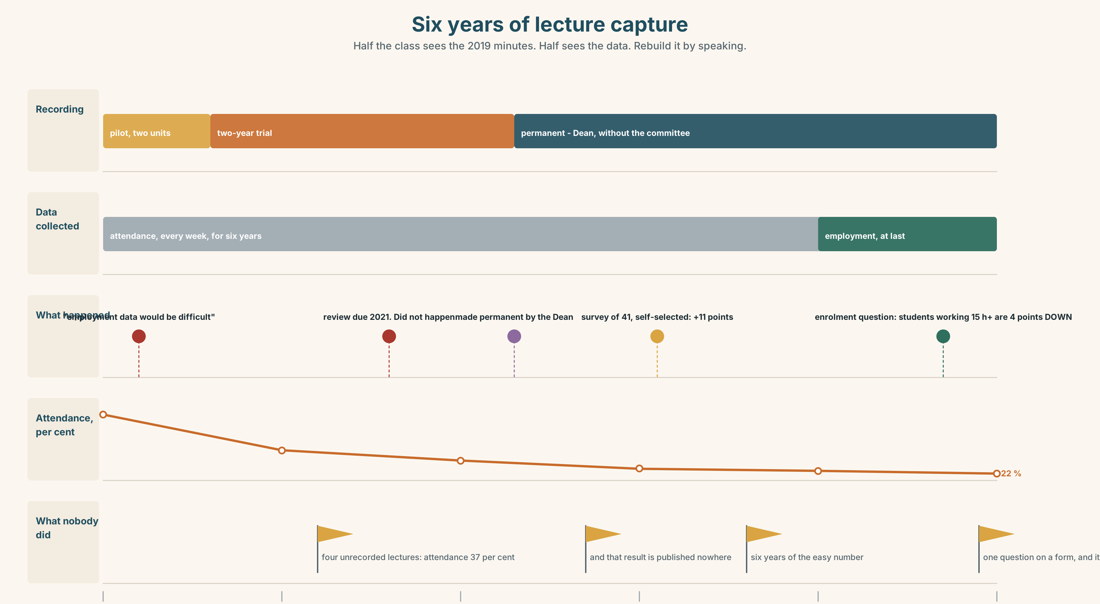{width=6.6in}
Six years of lecture capture — Half the class sees the 2019 minutes. Half sees the data. Rebuild it by speaking.

10A · Relay
Half the class sees the 2019 minutes. Half sees the current data. Rebuild six years by speaking. Twelve minutes.

10B · Simplify
Explain the attendance and attainment data from Part 5E to a student who is deciding whether to come to lectures. Five sentences only.
Plan: what has happened to attendance → what has happened to results → what the data cannot tell you → which group you might be in → what you should actually decide on

10C · Compress
The 2019 minutes into forty words, keeping Ms Oyelaran's last sentence.

10D · Online
Write one message to the teaching committee: you have the attendance data, you have the 2019 action, and you are asking for one specific thing that was agreed in 2019 and never done.

10E · Your language
How does your language add a clause to a noun without narrowing it? Is there a comma, a pause, a different word, or a different position? Say the students, who work, did better in both languages.

Part 11 · The Decision ◆ C · THE PERFORMANCE

Keep recording, or stop
Attendance has halved since 2019. The pass rate overall is unchanged. The pass rate for students in paid employment has risen eleven points — but the university has never collected employment data, so that figure comes from a student survey with 41 responses.
- Keep recording. The evidence that it helps working students is weak and is the only evidence anybody has. The evidence that it harms anybody is weaker.
- Stop recording. Attendance returns, the room looks like a university, and the committee can stop having this argument. Students in work lose the only accommodation they have.
- Keep recording and finally collect the employment data. Two years and a question on enrolment. It would settle it, and it would mean admitting that six years of data were the wrong data.

11A · The evidence
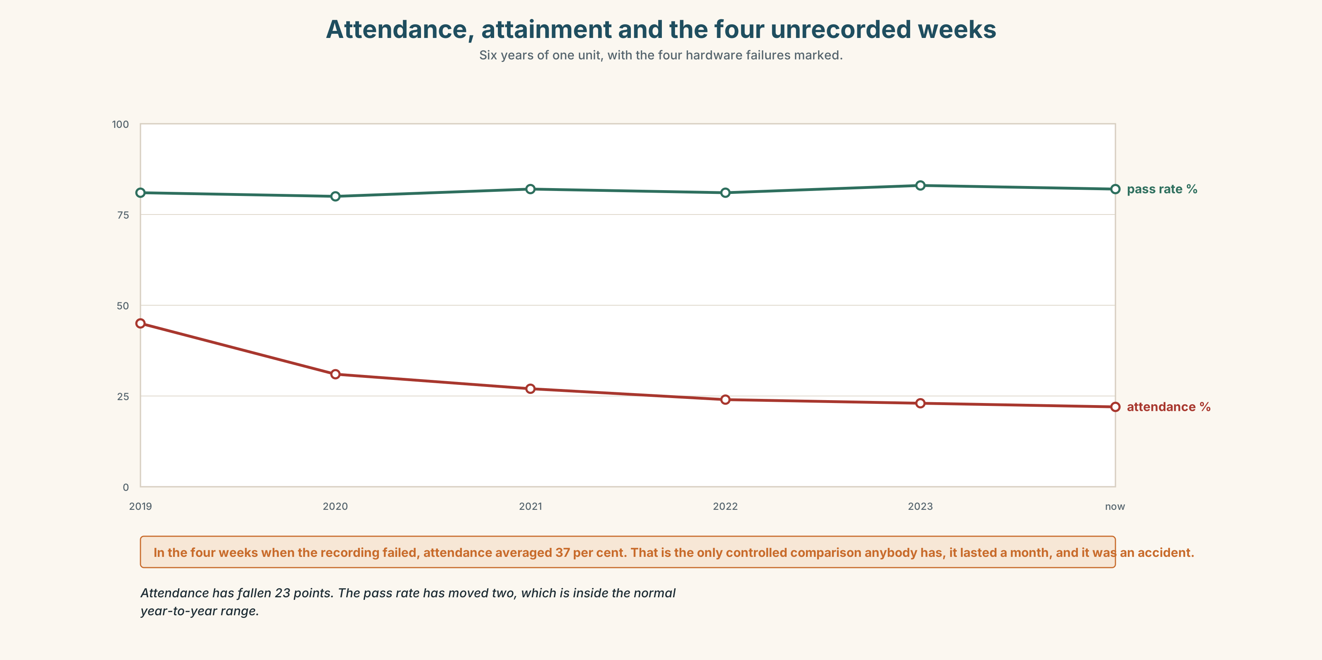{width=6.6in}
Attendance, attainment and the four unrecorded weeks — Six years of one unit, with the four hardware failures marked.
- The 2019 minutes and the current pack from Part 5 — and the footnote.
- The chart — attendance, attainment and the four unrecorded lectures.
- The voice. Thanh, thirty seconds: "I work Tuesday and Thursday nights, which are the two nights this unit is taught, and which I did not choose. I have never been to a lecture in this subject. I got a seventy-eight. I do not know what that proves and I would like somebody to stop telling me it proves I should have come."

11B · Talk about it
In fours. Everybody speaks twice. Use the frame.
The students, most of whom ______ , have ______ , which ______ .
Words you can use: engagement · retention · metric · by default · design · attention · opt out · dwell

11C · Decide
Write three sentences. Choose, say why, and name what it costs.
I think the university should ______________________ , because ______________________ . What this costs is ______________________ .

11D · Model decision
Keep recording and collect the employment data, and say in the minutes that six years of attendance figures were collected because they were easy and the figure that mattered was not collected because it was difficult. The committee's 2019 chair was right that it would be difficult. It was also the only question. An institution that can count a room every week for six years can ask one question on an enrolment form.

11E · The Reveal
What happened. The question went on the enrolment form in the following year: do you undertake paid work during term? If so, how many hours? It is optional and about seventy per cent answer it.
In the first full year the data showed that students working more than fifteen hours a week had a pass rate four points below the cohort, not eleven points above. The eleven-point figure had come from a survey answered mostly by students who were doing well, which is what surveys do.
Recording was kept. The argument for it changed completely: it is now defended as a reasonable adjustment for a group that is doing worse, rather than as something that was working.
They got the number. It said the opposite of what everybody had been arguing. And the recordings stayed.
Was it the right decision? Say why — and say what the first eleven-point figure was actually measuring.

Part 12 · Landing ◆ all three lines

12A · Recycle — twelve items
- Forty-one students, most ______ ______ work, passed.
- The recordings, ______ are watched at night, went up in March.
- Attendance has halved, ______ nobody disputes.
- Autoplay is on by ______ .
- You can ______ out , in a submenu.
- Time on ______ is the metric everything else serves.
- He has learned to ______ off at about eleven.
- Eleven lectures, four ______ ______ were not recorded.
- (B1.2 U8) ______ patients waited 41 days. (this group)
- (B1.2 U9) The majority of patients ______ seen in six weeks. (verb)
- (A2.2 U8) The hall, ______ was built in 1884, is the oldest.
- (A2.1 U4) The person ______ has the key is the manager.

12B · Consolidate
One hundred and eighty words. One interface, analysed. A number you collected, three non-defining clauses, one of which, and one inference marked as an inference.

12C · Can-do, with evidence
I can… | My evidence | Sure?
add a clause to a noun without narrowing it | Part 3H score | ◯ ◑ ●
analyse an interface in three minutes, with evidence | Part 4C recording | ◯ ◑ ●
write 180 words in which inferences are marked | Part 8 draft 2 | ◯ ◑ ●
get a name and a date out of a remote supplier | Part 9D role play | ◯ ◑ ●

12D · Replay ⏺
Find your forty-five seconds from Part 0C. Listen. Record it again. Two sentences: what is different, and what you now know that interface is counting.

12E · Glossary — forty-five items, as a map
THE SURFACE · interface · feed · scroll · prompt · autoplay · notification · design · a design choice WHAT IT COUNTS · metric · engagement · retention · dwell · time on site · attention · hold your attention WHAT IT DOES WITHOUT ASKING · by default · the next video · opt out WHAT YOU DO · log off · switch off · zone out · put down · I only came on to check one thing · it is designed to do that ADDING A CLAUSE · which · whom · whose · where · of which · of whom · most of which · all of whom · the former of which · the latter of which · at which point CONNECTING · likewise · moreover · namely · incidentally · respectively · additionally · conversely · refer back · cross-refer · none of which was mentioned

12F · Next
Unit 2 · Who is left out?

