Table of Contents

A2.1 · Unit 6 · The Chiller or the Phone
English Animated · Making Plans · Pasar Chow Kit, Kuala Lumpur Student's Book pages 116–137 · 22 pp · ~10 hours

Part 0 · The Big Picture ◆ A · THE WORLD
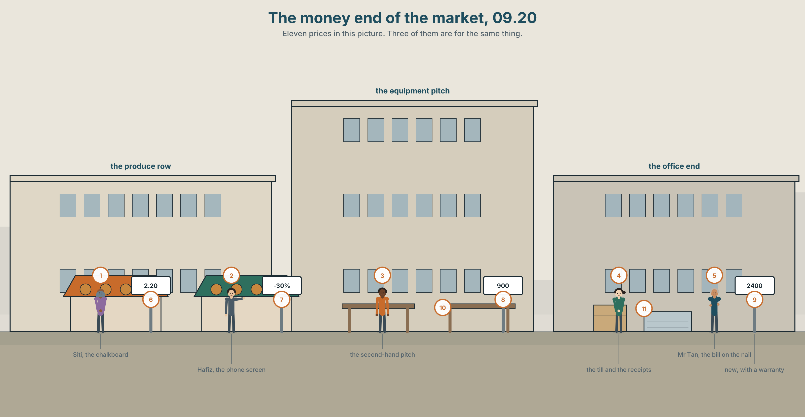{width=6.6in}
The money end of the market, 09.20 — Eleven prices in this picture. Three of them are for the same thing.

What are you willing to pay for?
By the end of this unit you can argue for one thing that is worth paying more for. Ninety words.
◆ A · THE WORLD | What things cost, what they are worth, and why those are different numbers
◆ B · THE SYSTEM | verb + -ing or verb + to · verb + preposition · 21 words for money and value · 19 words for what people decide · where the stress falls in a two-verb phrase
◆ C · THE PERFORMANCE | Ninety words arguing for one expensive thing

0A · Find it
Find eleven prices in this picture. Three of them are for the same thing.
the chalkboard · the handwritten card · the receipt · the discount sticker · the second-hand sign · the phone screen · the till · the bill on the nail

0B · Guess it
One thing in this picture is cheap and bad value. One is expensive and good value. Which, and how can you tell?

0C · Say it ⏺
Record thirty seconds. What is the last thing you paid too much for, and would you do it again? You will record it again at the end of this unit.

Part 1 · Vocabulary Lab 1 ◆ B · THE SYSTEM
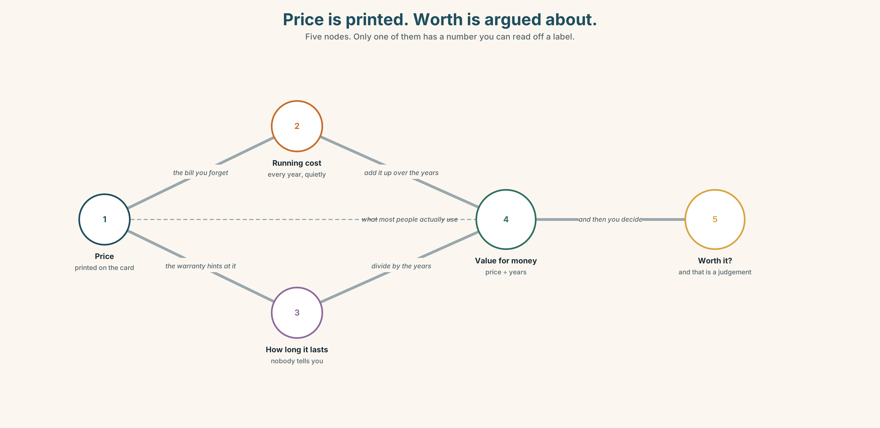{width=6.6in}
Price is printed. Worth is argued about. — Five nodes. Only one of them has a number you can read off a label.

1A · Meet — money in and money out
Match each word to one place on the map.
spend · save · cost · price · bill · receipt · budget · afford · waste · discount

1B · Sort — the number, or the judgement?
Two columns.
price · worth · cost · value · bargain · expensive · cheap · discount
A price is printed. Worth is argued about. Which column is bigger, and why?

1C · Meet — three words that are not the same
cheap · expensive · second-hand
A second-hand chiller costs 900. A new one costs 2,400. Is the second-hand one cheap? You cannot answer that yet. What do you need to know first?
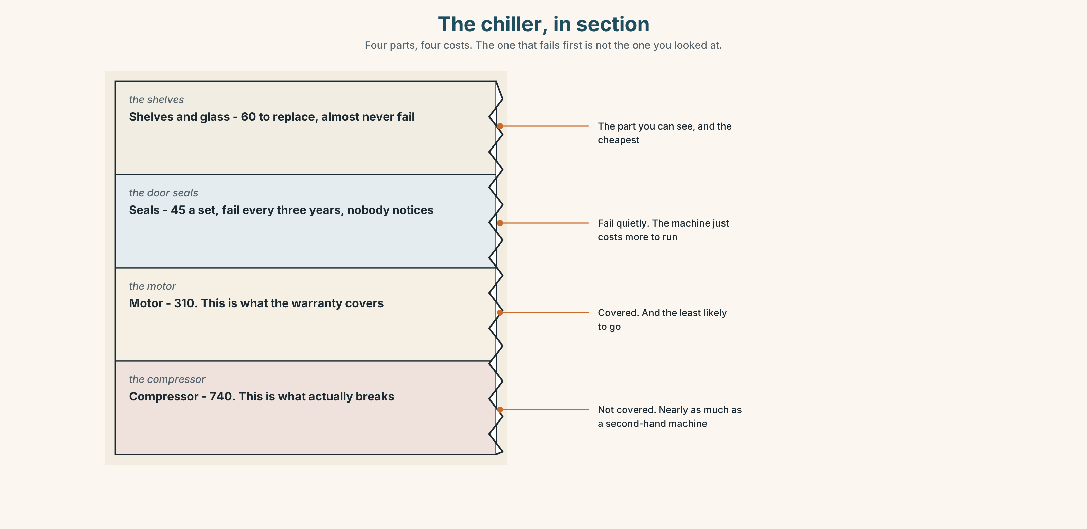{width=6.6in}
The chiller, in section — Four parts, four costs. The one that fails first is not the one you looked at.
Look at the chiller in section. Four parts, four costs. Which part fails first, and what does replacing it cost compared with the whole machine?

1D · Stretch — the phrases
Complete each one with one word.
- Six years for 900. That is value for ______ .
- We used it twice. It was a waste of ______ .
- Every Friday she puts money ______ , before anything else.
- He is saving ______ for a van.
- Forty ringgit to repair a thirty-ringgit fan. It's not ______ it.

1E · The saying
f It's not worth it.
Four words that end a conversation. Finish each exchange with them — and then, for one of them, argue back.
"It's only forty ringgit." — "______" "You'd have to queue for an hour." — "______"

1F · Own it
Think of one thing you own that was expensive. Tell a partner three sentences: what it cost, how long you have had it, and whether it was worth it.

Part 2 · Listening ◆ A · THE WORLD
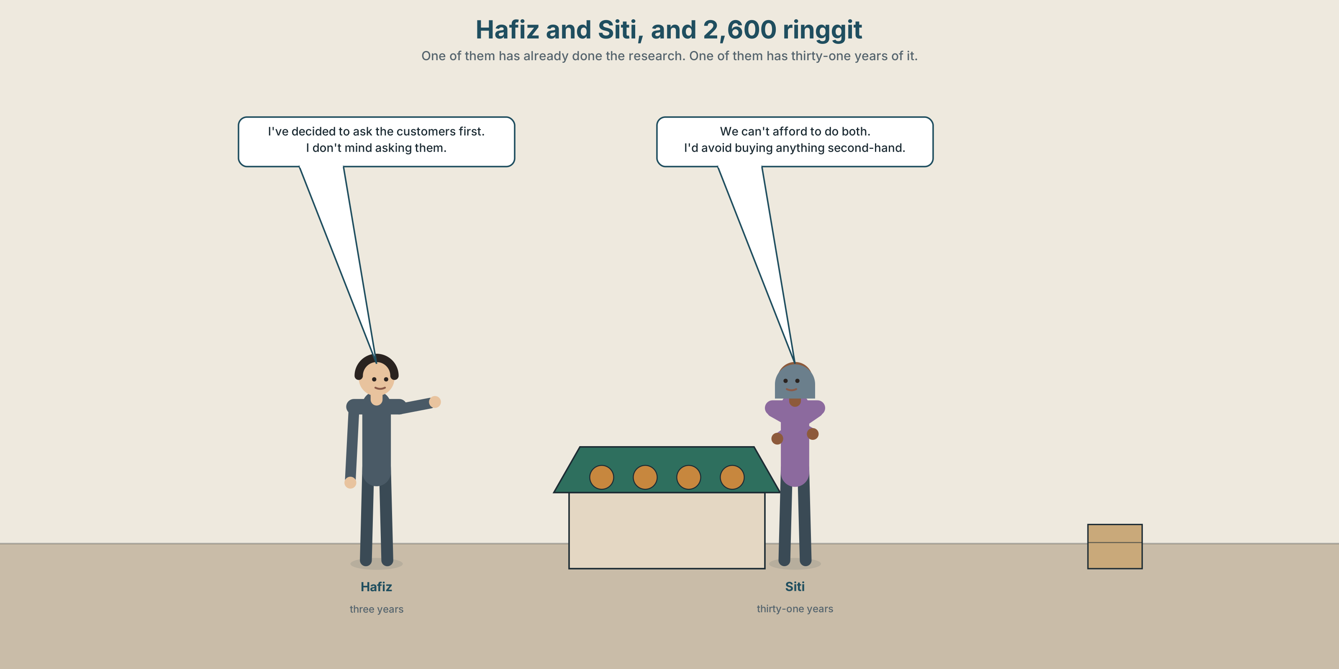{width=6.6in}
Hafiz and Siti, and 2,600 ringgit — One of them has already done the research. One of them has thirty-one years of it.

2A · One machine or one system 🔊 Track 6.1
Before you listen. The stall has 2,600 saved. Hafiz wants one thing, Siti wants another. Guess which of them wants the newer idea.
Listen once. One question. How much is in the savings?
Listen again. Complete the table.
 | What they want | What it costs | What it would save
Hafiz
Siti
Listen again. Choose.
- Hafiz wants to spend the money on a chiller / a phone system / a van.
- Siti says the stall loses produce every day / twice a week / in the hot months.
- Hafiz has already tried it / asked customers / read about it.
- Siti refuses to decide today / to talk about it / to let him do it.
Noticing. Four sentences from the recording.
- I've decided to ask the customers first.
- I don't mind asking them.
- We can't afford to do both.
- I'd avoid buying anything second-hand.
Two of these take to. Two take -ing. Which are which?

2B · Decoding clinic 🔊 Track 6.2
Twenty-five seconds of Hafiz. Four jobs.
- How many numbers does he say?
- In decided to ask, which of the three words is loudest?
- Catch the word he uses instead of expensive.
- He says one sentence that is a question but does not sound like one. Which?
Transcripts, page 155.

Part 3 · Grammar Lab 1 ◆ B · THE SYSTEM

Two verbs in a row

3A · Notice
Look at the four sentences in Part 2.
- In sentence 1, which is the first verb and which is the second?
- Sentence 2 has mind. Try to ask after it. Does it work?
- Sentence 3 has afford. Try doing after it. Does that work?
- Is there a rule you can hear, or do you have to learn the list? Be honest.
- Try "I enjoy to cook." What is wrong?

3B · See
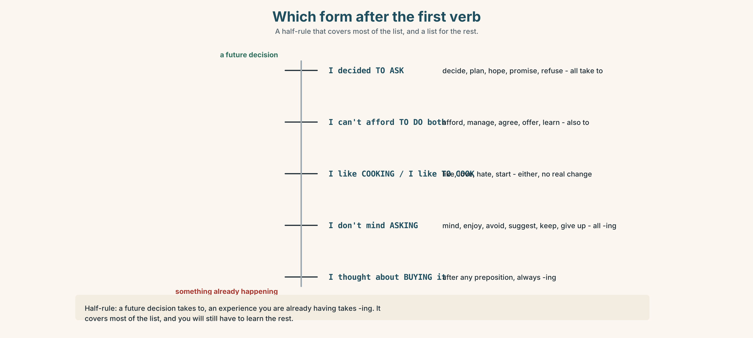{width=6.6in}
Which form after the first verb — A half-rule that covers most of the list, and a list for the rest.
Now look at the second picture. Two sentences, same verbs, different pattern. Which one is about a plan and which about a habit?
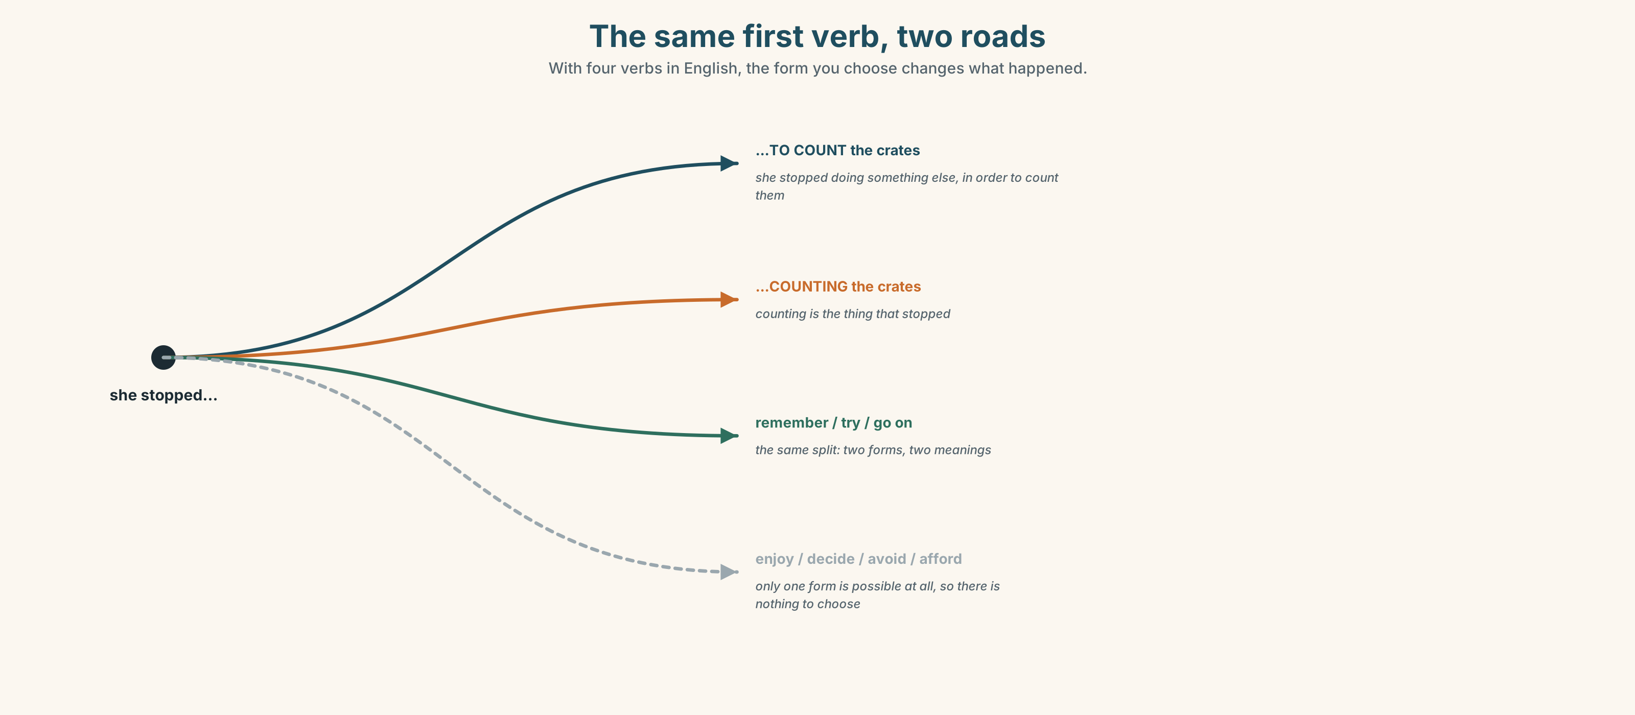{width=6.6in}
The same first verb, two roads — With four verbs in English, the form you choose changes what happened.

3C · Know
First verb | Then | Example
decide, plan, hope, offer, promise, refuse, manage, afford, learn, agree | to + verb | I've decided to ask them.
enjoy, avoid, mind, suggest, finish, keep, give up, practise | verb + -ing | I don't mind asking them.
like, love, hate, start, begin, continue | either, with almost no change | I like cooking / I like to cook.
The useful half-rule. Verbs about a future decision usually take to: decide to, plan to, hope to, promise to, refuse to. Verbs about an experience you are already having usually take -ing: enjoy -ing, avoid -ing, mind -ing, keep -ing. It is a half-rule. It covers most of the list and you will still have to learn the rest.
After a preposition, always -ing. think about buying · good at counting · instead of waiting
Watch out. ✗ I enjoy to cook. ✓ I enjoy cooking. ✗ We can't afford doing both. ✓ We can't afford to do both.

3D · Use — controlled
Hafiz has decided (1) __________ (ask) the customers first. He doesn't mind (2) __________ (spend) a week on it. Siti refuses (3) __________ (decide) before Friday and suggests (4) __________ (wait) until the hot months are over. They have both agreed (5) __________ (look) at the figures, and neither of them enjoys (6) __________ (argue) about money.

3E · Use — guided
Put each verb in the right form.
- I can't afford ______ (buy) it this month.
- Do you mind ______ (wait) ten minutes?
- She's given up ______ (try) to fix it.
- We've decided ______ (sell) the old one.
- He's good at ______ (find) a bargain.
- They promised ______ (deliver) it on Thursday.
- She refused ______ (accept) the discount.
- Would you accept ______ (wait) another week?

3F · Use — open
Ask three people: What have you given up doing? What have you decided to do this year? Report one of each to the class.

3G · Check — six items
- I enjoy ______ (cook) at the weekend.
- We've decided ______ (wait).
- She avoids ______ (buy) anything second-hand.
- Do you mind ______ (open) the window?
- He can't afford ______ (take) a day off.
- I'm thinking about ______ (change) the price.
0–3 → Workbook pp. 34–36. 4–5 → Part 6. 6 → page 129.

Part 4 · Speaking ◆ C · THE PERFORMANCE

4A · Fluency starter — would you pay more?
Your teacher names a thing: coffee. Everybody answers in one sentence: "I'd pay more for ______ , but I wouldn't pay more for ______ ."
Five rounds, five things. No repeating a reason.

4B · The functional core — arguing for the expensive one
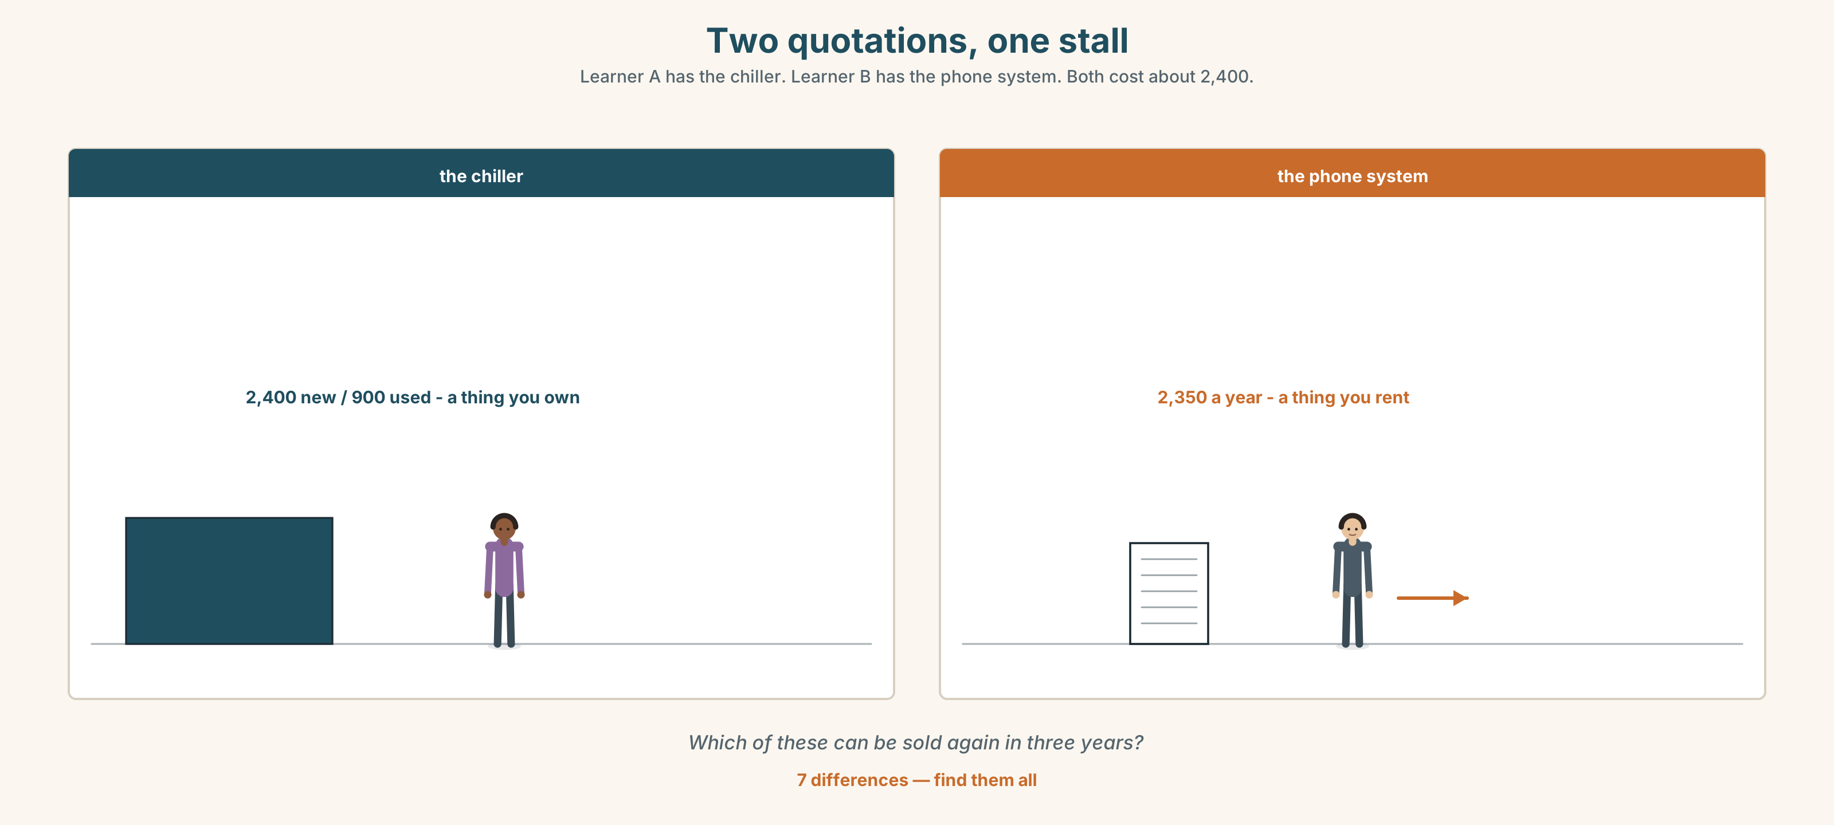{width=6.6in}
Two quotations, one stall — Learner A has the chiller. Learner B has the phone system. Both cost about 2,400.
Language Bank
the claim | It's worth it because… · You get it back in… · It pays for itself.
the concession | Yes, it's expensive, but… · I know it's a lot.
the comparison | Compared with… · The cheap one costs more in the end.
the refusal | I'd rather not. · Not at that price. · That's a waste of money.
Role play. Learner A wants the chiller. Learner B wants the phone system. Six minutes. You must each make one concession.

4C · The performance — ninety seconds ⏺
Argue for one expensive thing that is worth the money. Ninety seconds. You must give:
what it costs · what the cheap version costs · what you get back · one honest disadvantage
Record it.

4D · Observer
One person listens for one thing: did the speaker admit a real disadvantage?

4E · Two criteria
☐ Did I use three verb-plus-verb patterns correctly? ☐ Is there a number in my argument?

Part 5 · Reading ◆ A · THE WORLD

5A · Predict
An opinion column. The title is "The cheapest thing in the shop is never the cheapest." What do you expect the argument to be? One sentence.

5B · Read — one hundred seconds

The cheapest thing in the shop is never the cheapest
I bought a kettle for nineteen ringgit. It lasted five months. Then I bought one for ninety and I have had it eleven years, which means the expensive kettle has cost me about eight ringgit a year and the cheap one cost me forty-five.
Everybody knows this argument. Almost nobody acts on it, and I think I know why. The expensive kettle asks you for ninety ringgit today. The cheap one asks for nineteen today and the rest later, in instalments you do not notice because they arrive as inconvenience rather than as bills.
So the real question is not what does it cost but what does it cost per year, and who pays the difference. If you have ninety ringgit, the expensive kettle is obviously right. If you have thirty, the argument is not just wrong, it is insulting — you cannot buy the cheap-in-the-long-run option with money you do not have.
Which is why I distrust this advice when it is given by people who have never had to choose. The arithmetic is correct. It is also a description of how much easier everything is when you can pay in advance.

5C · Answer
- What did each kettle cost, and how long did each last?
- What is the cost per year of each one?
- Why does the writer say almost nobody acts on the argument?
- What does the writer mean by "instalments you do not notice"?
- In what situation does the writer say the argument is insulting?
- What is the writer's final point about who gives this advice?

5D · Vocabulary in context
Guess from the text. Then check.
last (as a verb) · in instalments · in the long run · distrust · pay in advance

5E · The counter-text
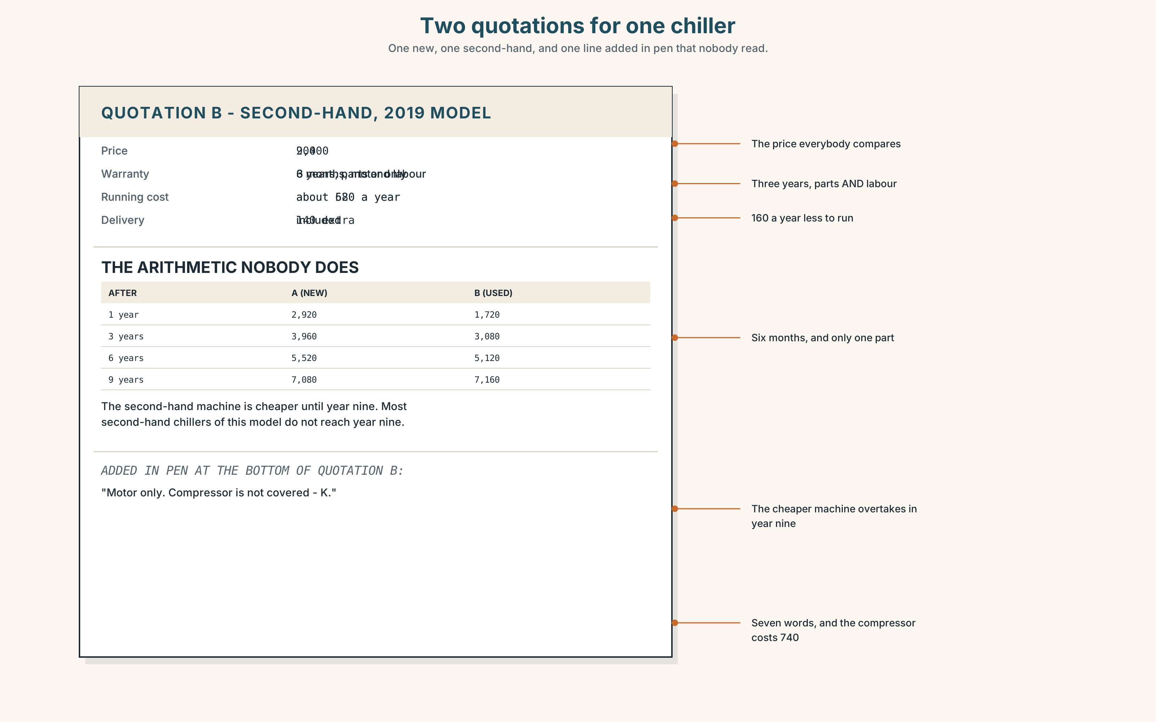{width=6.6in}
Two quotations for one chiller — One new, one second-hand, and one line added in pen that nobody read.
Read the two quotations for a chiller and answer.
- What is the price of each one, and what is the warranty on each?
- What is the annual running cost of each, and after how many years does that reverse the price difference?
- What is excluded from the second-hand quotation?
- One line has been added by the seller in pen. What does it say?

5F · Two texts
The column says the expensive kettle cost eight ringgit a year. The quotations show the new chiller costing more per year to run than the second-hand one.
Put those two facts together. Does the column's argument hold here? Two sentences.

Part 6 · Vocabulary Lab 2 ◆ B · THE SYSTEM

Verbs that decide, and verbs that avoid
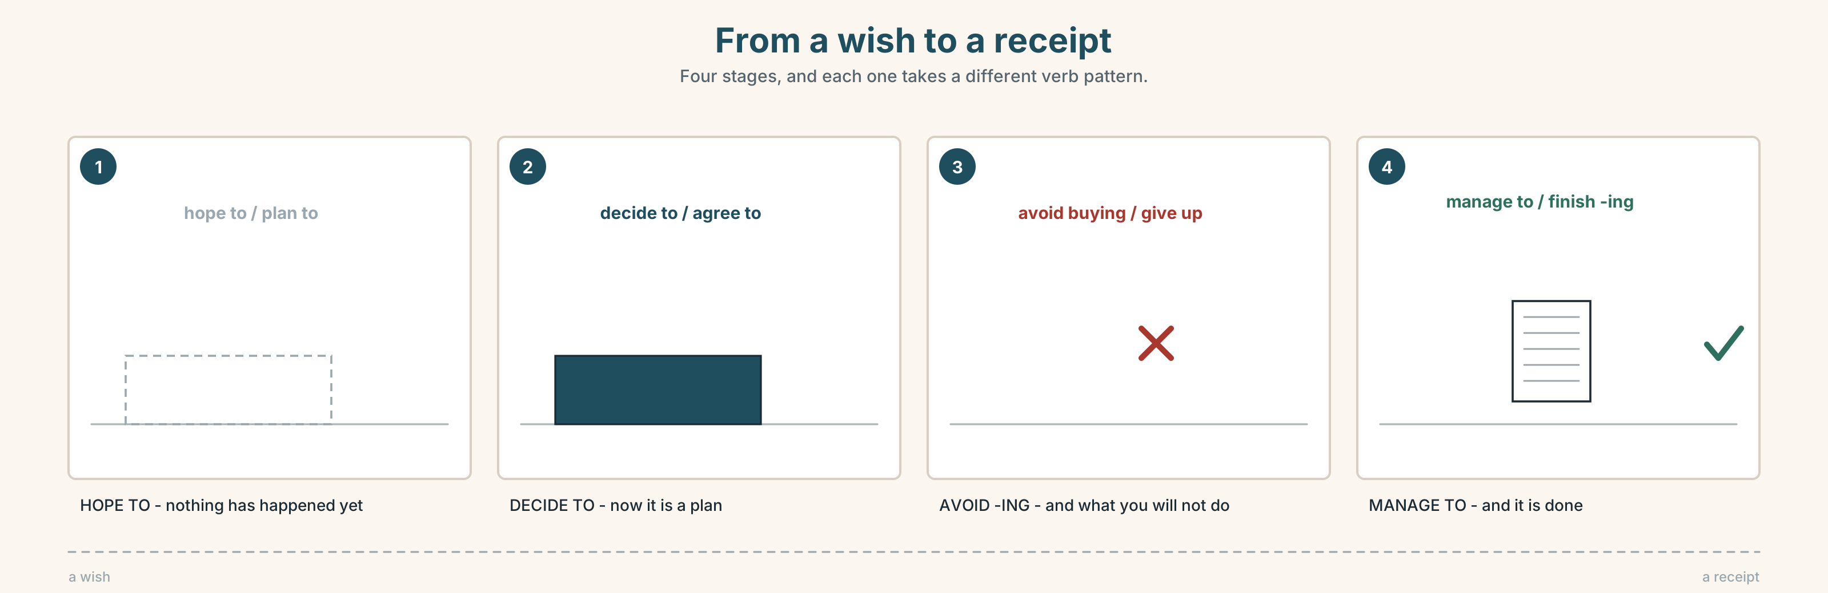{width=6.6in}
From a wish to a receipt — Four stages, and each one takes a different verb pattern.

6A · Sort — to, or -ing?
Two columns. Put each verb where it belongs.
decide · enjoy · refuse · avoid · promise · mind · hope · suggest · manage · plan · offer
+ to | + -ing
One of them is in neither list and changes meaning. Which?

6B · Chunk completion
- I've decided ______ sell it.
- She offered ______ lend me the money.
- I'd avoid ______ anything with no warranty.
- He enjoys ______ for the whole family on a Sunday.
- I'll think ______ it and tell you Friday.

6C · The verbs that need a preposition
think about · good at · instead of · spend on · save for
Fill each gap. Remember what follows a preposition.
- I've been thinking ______ ______ (buy) a second-hand one.
- She's very good ______ ______ (find) things like this.
- We walked ______ ______ (take) a taxi.
- How much do you spend ______ food?
- He's saving ______ a van.
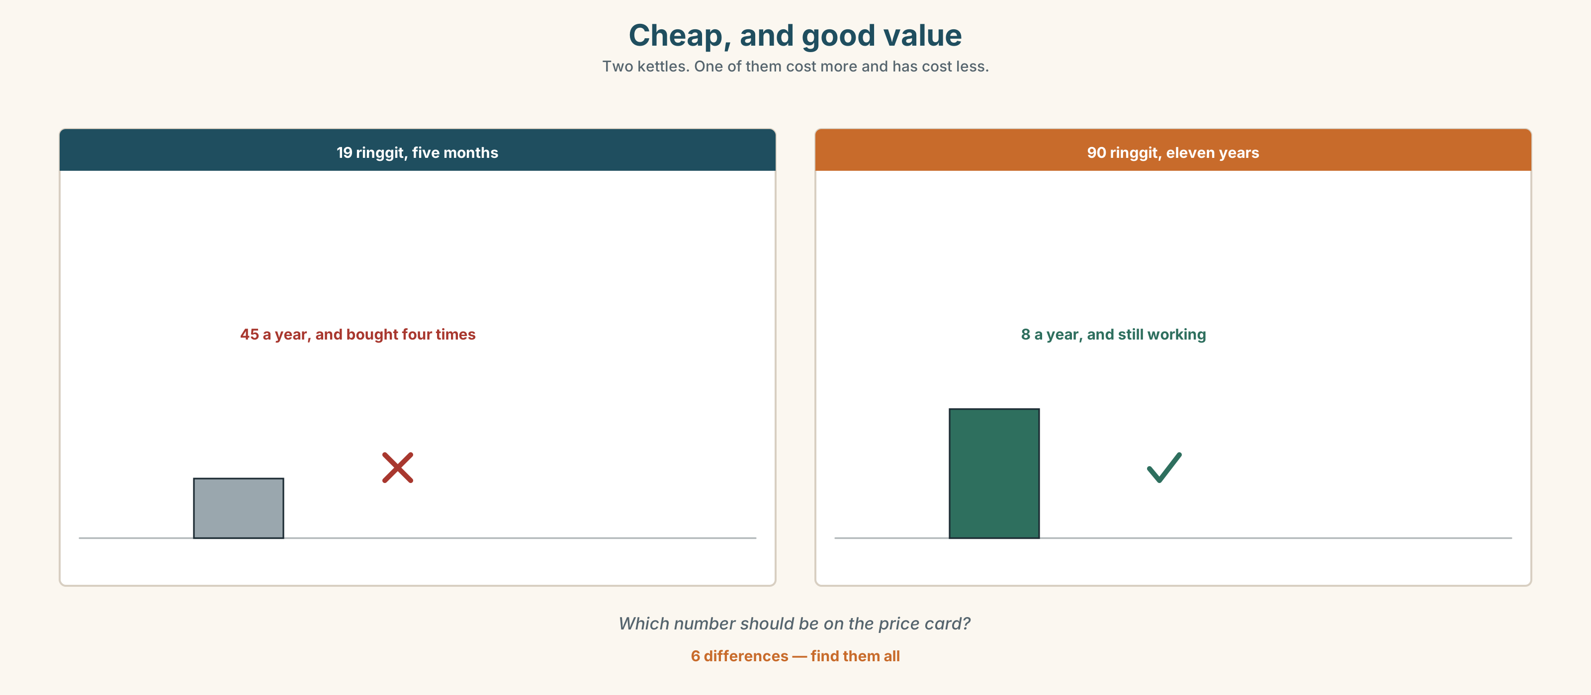{width=6.6in}
Cheap, and good value — Two kettles. One of them cost more and has cost less.
Six differences. Find them, then answer the question under the picture.

6D · Contrast Clinic — which form
Six items.
- I can't afford ______ (replace) it.
- Do you mind ______ (hold) this?
- We've given up ______ (wait) for him.
- They refused ______ (pay) the difference.
- She suggested ______ (sell) it second-hand.
- I managed ______ (get) a discount.

Part 7 · Pronunciation & Fluency Lab ◆ B · THE SYSTEM

Which of the three words is loud
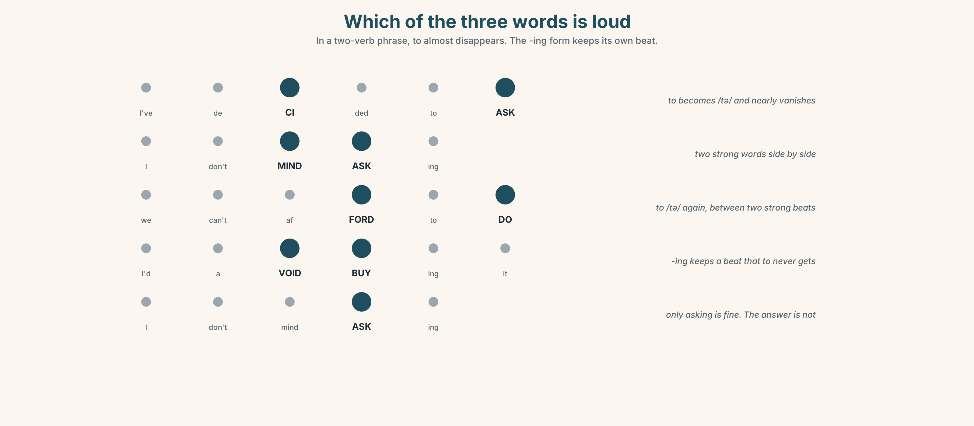{width=6.6in}
Which of the three words is loud — In a two-verb phrase, to almost disappears. The -ing form keeps its own beat.

7A · Hear 🔊 Track 6.3
I've decided to ask — to almost disappears I don't mind asking — two strong words in a row We can't afford to do both — to becomes /tə/

7B · Say
Say each one. Then say the whole sentence three times, faster:
I've decided to ask the customers first.

7C · Make it mean something
Say these two:
I don't MIND asking. (you asked whether it bothers me) I don't mind ASKING. (asking is fine — it is the answer I am worried about)
Which one is the honest version?

7D · Fluency 20 ⏺
Twenty seconds: three things you have decided to do and three you have given up doing. Three times, faster.

Part 8 · Writing ◆ C · THE PERFORMANCE

Worth paying more for · 90 words
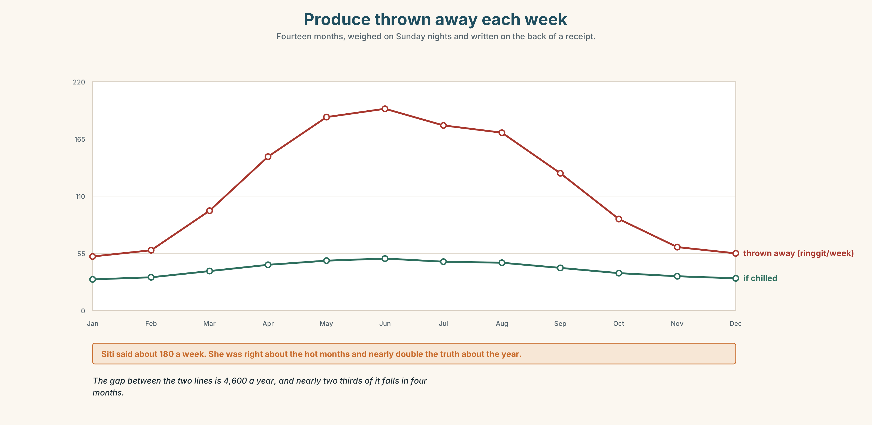{width=6.6in}
Produce thrown away each week — Fourteen months, weighed on Sunday nights and written on the back of a receipt.

8A · Read the model
A good knife costs 180 and a bad one costs 25. I have had mine nine years, so it has cost me twenty ringgit a year. [the number is doing the arguing, not the adjective]
That is not the real reason, though. The real reason is that I stopped dreading the preparation, and I now cook four times a week instead of once. [the honest reason, which is not financial]
I would not buy an expensive pan. The cheap pan does the same job and I can see no difference at all. [one thing the writer will not defend — which makes the rest believable]
Questions about the writer's choices:
- The second paragraph abandons the money argument. Does that weaken it or strengthen it?
- Why name a thing the writer will not spend money on?

8B · The anti-model
I think quality is very important. If you buy cheap things you will have to buy them again. It is better to spend more money and get something good. This is true for everything.
Correct English, and it argues nothing. Name two things it is missing.

8C · Plan
the thing, with both prices → the cost per year → the real reason → one thing you would not pay more for

8D · Write — 90 words

8E · Peer review — two criteria
☐ Is there at least one number? ☐ Is there one thing the writer refuses to defend?

8F · Write it again · 8G · Publish
On the wall, with the two quotations from Part 5E beside it.

Part 9 · The File ◆ A · THE WORLD + C · THE PERFORMANCE

CULTURE FILE · What's Funny Here?
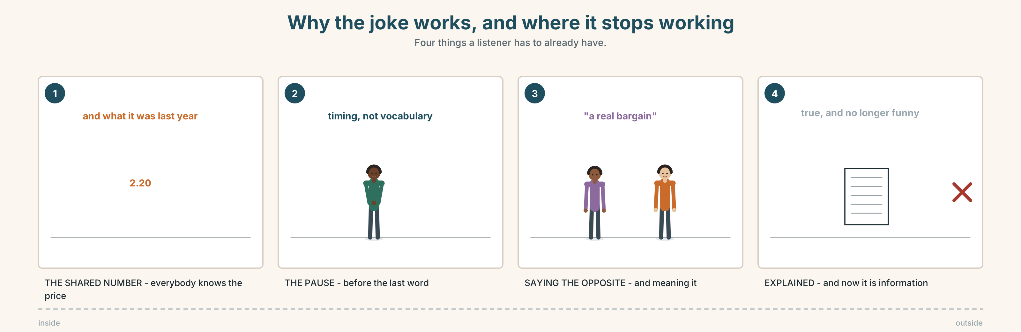{width=6.6in}
Why the joke works, and where it stops working — Four things a listener has to already have.

9A · Three jokes about money 🔊 Track 6.4
Three short exchanges from the market. Listen to each one twice.
- Which one is a complaint that everybody laughs at?
- Which one would be rude in some places and friendly here?
- Which one is funny only if you know the price of fish?

9B · What makes it work
exaggeration · the shared number · saying the opposite · the pause before the last word
Match each to one of the three exchanges. One exchange uses two of them.

9C · When it does not travel
A joke that needs a price, a place, or a person does not cross a border.
Take one of the three exchanges. Rewrite it for somebody who has never been to this market. What do you have to add, and what do you lose by adding it?

9D · Your turn
In pairs. Tell one short funny thing about money from your own place. Your partner's job: say what a stranger would need to know first.

9E · Transfer
Listen for one joke this week — anywhere, any language. Write down what the listener had to already know. Bring it.

Part 10 · Mediation & Interaction ◆ C · THE PERFORMANCE
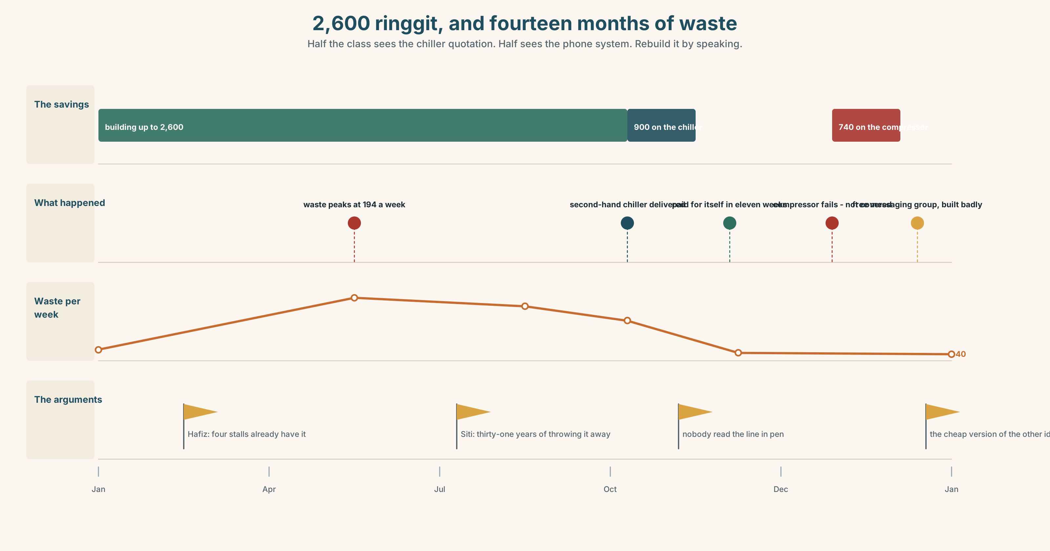{width=6.6in}
2,600 ringgit, and fourteen months of waste — Half the class sees the chiller quotation. Half sees the phone system. Rebuild it by speaking.

10A · Relay
Half the class sees the chiller quotation. Half sees the phone system quotation. Rebuild the whole decision by speaking. Ten minutes.

10B · Simplify
Explain the second-hand quotation from Part 5E to somebody who has never bought equipment. Four sentences only.
Plan: the price → what is covered → what is not → the one question to ask before signing

10C · Compress
The column in Part 5 into thirty words, keeping its sting.

10D · Online
Write one message to a seller: you are interested in the second-hand chiller, you want to know three things, and you are not going to decide this week.

10E · Your language
How does your language say it's not worth it? Is the word in it about money, or about effort? Show a partner, and say which your language reaches for first.

Part 11 · The Decision ◆ C · THE PERFORMANCE

One machine, or one system
The stall has 2,600 saved. There is enough for one of these.
- The chiller. 2,400 new, 900 second-hand. Siti says they throw away about 180 a week in the hot months.
- The phone-order system. 2,350 for the first year. Hafiz says four nearby stalls have one and take orders the night before.
- Neither, yet. Wait six months. Measure the waste properly. Decide in January.

11A · The evidence
- The two quotations from Part 5E — and the line the seller added in pen.
- The chart — produce thrown away each week, over fourteen months.
- The voice. Siti, twenty seconds: "I've been throwing vegetables away for thirty-one years. I don't need a chart to tell me what that costs. I would like to know why I never counted it."

11B · Talk about it
In threes. Everybody says one. Use the frame.
I think they should spend it on ______ , because ______ .
Words you can use: waste · worth · afford · save · value for money · second-hand · bargain

11C · Decide
Write two sentences. Choose, and say why.
I think they should ______________________ , because ______________________ .

11D · Model decision
They should buy the second-hand chiller for 900 and spend four months counting what they throw away, properly, on paper. That leaves 1,700 and an actual number. If the waste turns out to be 180 a week, the chiller pays for itself before Christmas and they can argue about the phone system with something other than opinions.

11E · The Reveal
What happened. They bought the second-hand chiller. The waste fell from about 180 a week to 40, which is more than anybody expected, and the machine paid for itself in eleven weeks.
In March the compressor failed. The repair was 740 — nearly as much again — and the warranty covered the motor but not the compressor, which is the line the seller had added in pen and nobody had read.
Hafiz set up phone orders himself, on a free messaging group, badly, and it now brings in about a tenth of what the paid system promised and costs nothing.
The chiller worked, and then it broke. The cheap version of the other idea worked too.
Was it the right decision? Say why — and say what they should do about the compressor.

Part 12 · Landing ◆ all three lines

12A · Recycle — ten items
- I can't afford ______ (buy) it.
- Do you mind ______ (wait) ?
- We've decided ______ (sell) the old one.
- It was a ______ of money.
- Six years for 900 — that's value for ______ .
- (Unit 5) If it ______ (rain), we'll stay.
- (Unit 5) I'll start as soon as it ______ (arrive).
- (Unit 4) The person ______ has the key is Mr Tan.
- (Unit 2) It was raining ______ he left the farm.
- (Starting Out) How much ______ it cost?

12B · Consolidate
Ninety words, one paragraph. One thing worth paying more for and one thing that is not. Use three verb-plus-verb patterns and at least two numbers.

12C · Can-do, with evidence
I can… | My evidence | Sure?
put the right form after a second verb | Part 3G score | ◯ ◑ ●
argue for an expensive choice in ninety seconds | Part 4C recording | ◯ ◑ ●
write ninety words with a number in them | Part 8 draft 2 | ◯ ◑ ●
say what a stranger needs to know before a joke | Part 9D pair work | ◯ ◑ ●

12D · Replay ⏺
Find your thirty seconds from Part 0C. Listen. Record it again. One sentence: what is different?

12E · Glossary — forty items, as a map
MONEY OUT · spend · cost · price · bill · expensive · afford · waste · a waste of money MONEY IN · save · save up · discount · bargain · cheap · second-hand · put money aside THE JUDGEMENT · worth · value · value for money · budget · receipt · it's not worth it DECIDING · decide · decide to · plan · hope · offer · offer to · promise · accept · manage NOT DECIDING · refuse · avoid · avoid buying · give up · I'd rather not LIVING WITH IT · enjoy · enjoy cooking · mind · suggest · think about

12F · Next
Unit 7 · Where are you from, really?

