Table of Contents

A2.2 · Unit 1 · Twelve Centimetres
English Animated · Telling the Story · Ballinmore, west coast of Ireland Student's Book pages 6–27 · 22 pp · ~10 hours

Part 0 · The Big Picture ◆ A · THE WORLD
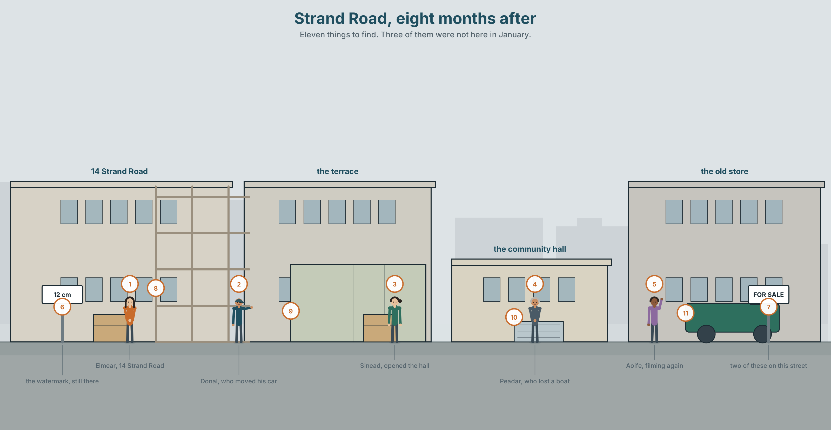{width=6.6in}
Strand Road, eight months after — Eleven things to find. Three of them were not here in January.

What would you do differently?
By the end of this unit you can say what you would do if it happened again, and what you would not. Ninety words.
◆ A · THE WORLD | A town eight months after the water came, and what it has decided about itself
◆ B · THE SYSTEM | the second conditional · would collocations · 23 words for risk and recovery · 17 words for saying it differently · would as /wəd/
◆ C · THE PERFORMANCE | Ninety words on a different decision

0A · Find it
Find eleven things in this picture. Three of them are new since January.
sea wall · slipway · sandbags · the community hall · a skip · a dehumidifier · a watermark on a wall · scaffolding · a boat on a trailer · a new drain · a For Sale sign

0B · Guess it
The water reached a different height in three places on this street. Where was it worst, and why there?

0C · Say it ⏺
Record thirty seconds. Think of one thing that went wrong in your life. If it happened again tomorrow, what would you do differently? You will record it again at the end of this unit.

Part 1 · Vocabulary Lab 1 ◆ B · THE SYSTEM
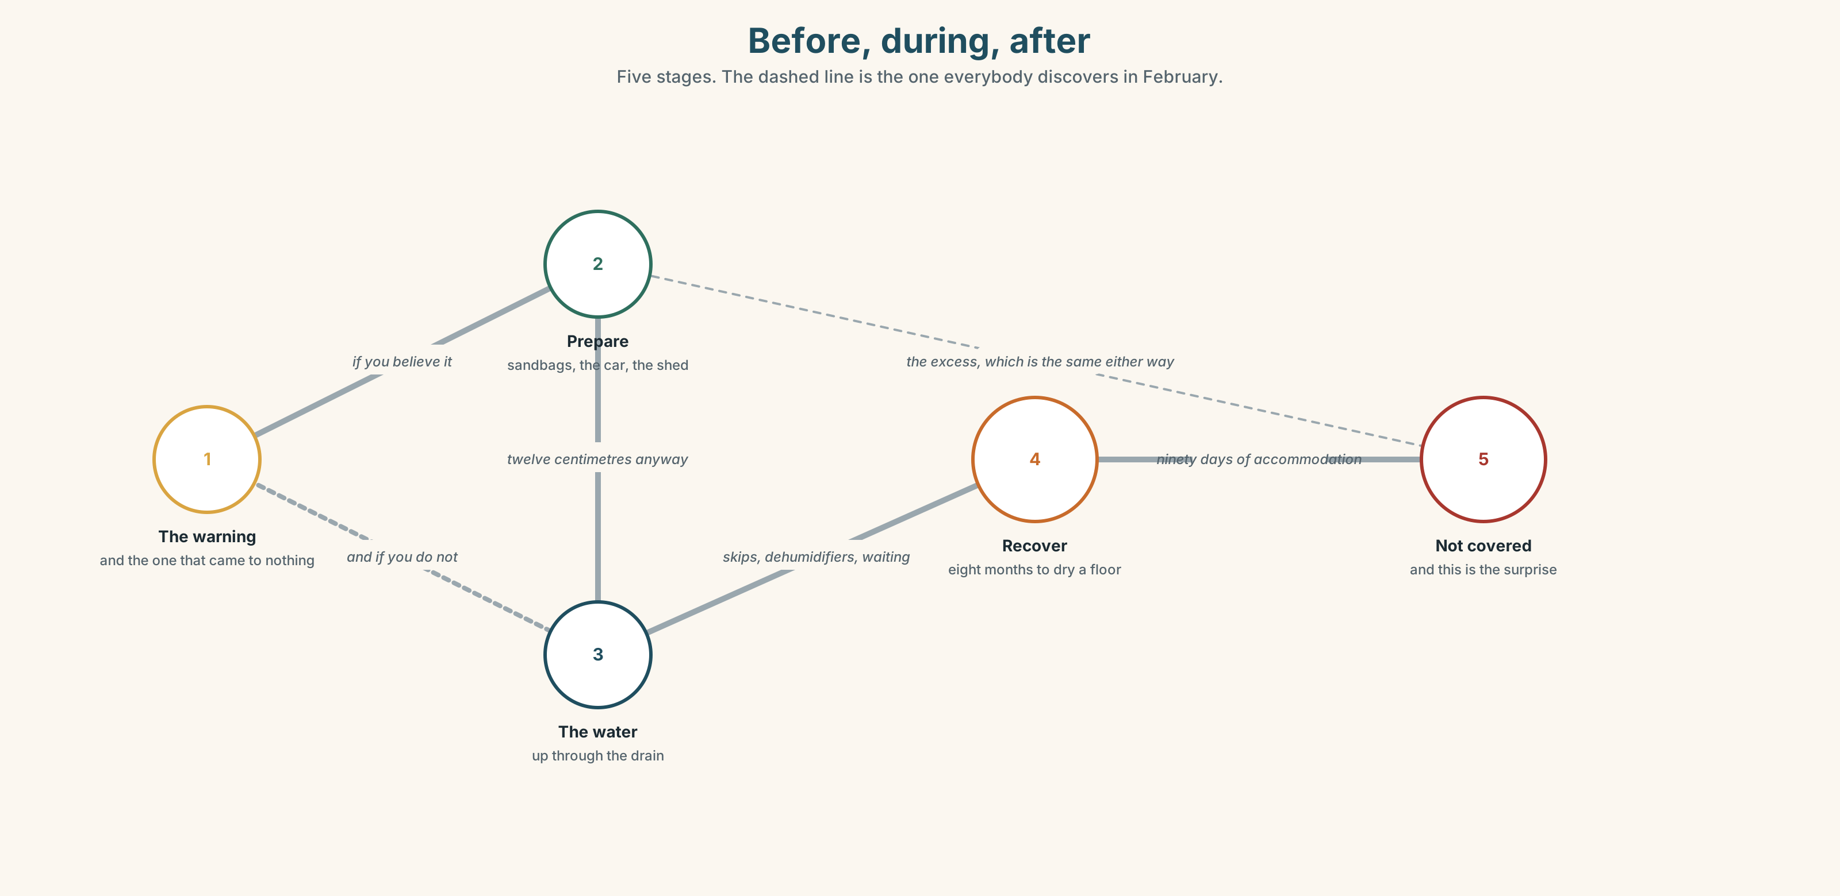{width=6.6in}
Before, during, after — Five stages. The dashed line is the one everybody discovers in February.

1A · Meet — before, during, after
Match each word to one place on the map.
warning · prepare · protect · flood · damage · recover · rubble · shelter · cost · storm

1B · Sort — a thing, an action, or a judgement?
Three columns.
wall · prepare · lucky · damage · protect · foolish · shelter · safe · recover · rubble
Two of them are only ever said afterwards. Which, and why?

1C · Meet — the money words
cover · cost · ready
An insurance policy covers some things and not others. The thing people discover in February is which. What would you expect a flood policy not to cover?
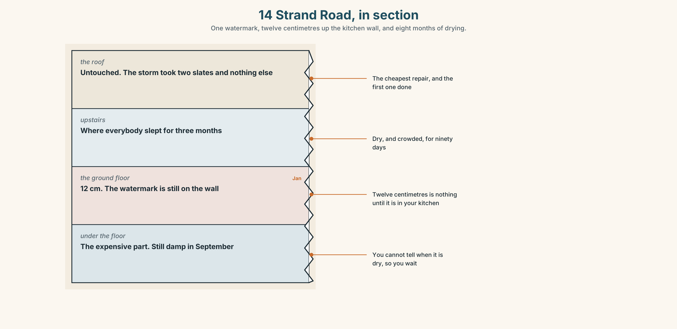{width=6.6in}
14 Strand Road, in section — One watermark, twelve centimetres up the kitchen wall, and eight months of drying.
Look at Eimear's house in section. Four levels, one watermark. Which floor took the water, and which floor is the expensive one to dry?

1D · Stretch — the phrases
Complete each one with one word.
- Three houses on this road are at ______ every winter now.
- He moved the car on Thursday. Everybody said he was taking a ______ with his reputation.
- Sinéad opened the hall in ______ , which is why nobody slept outside.
- The ______ of it was over by two in the morning.
- They have ______ up with a dehumidifier in the kitchen since January.

1E · The saying
f We were lucky.
Three words that almost everybody in this town says, including the ones who lost most.
Why? Write two reasons. One of them should be uncomfortable.

1F · Own it
Think of a time something went wrong where you live. Tell a partner three sentences: what happened, what you did, and one thing you would do differently.

Part 2 · Listening ◆ A · THE WORLD
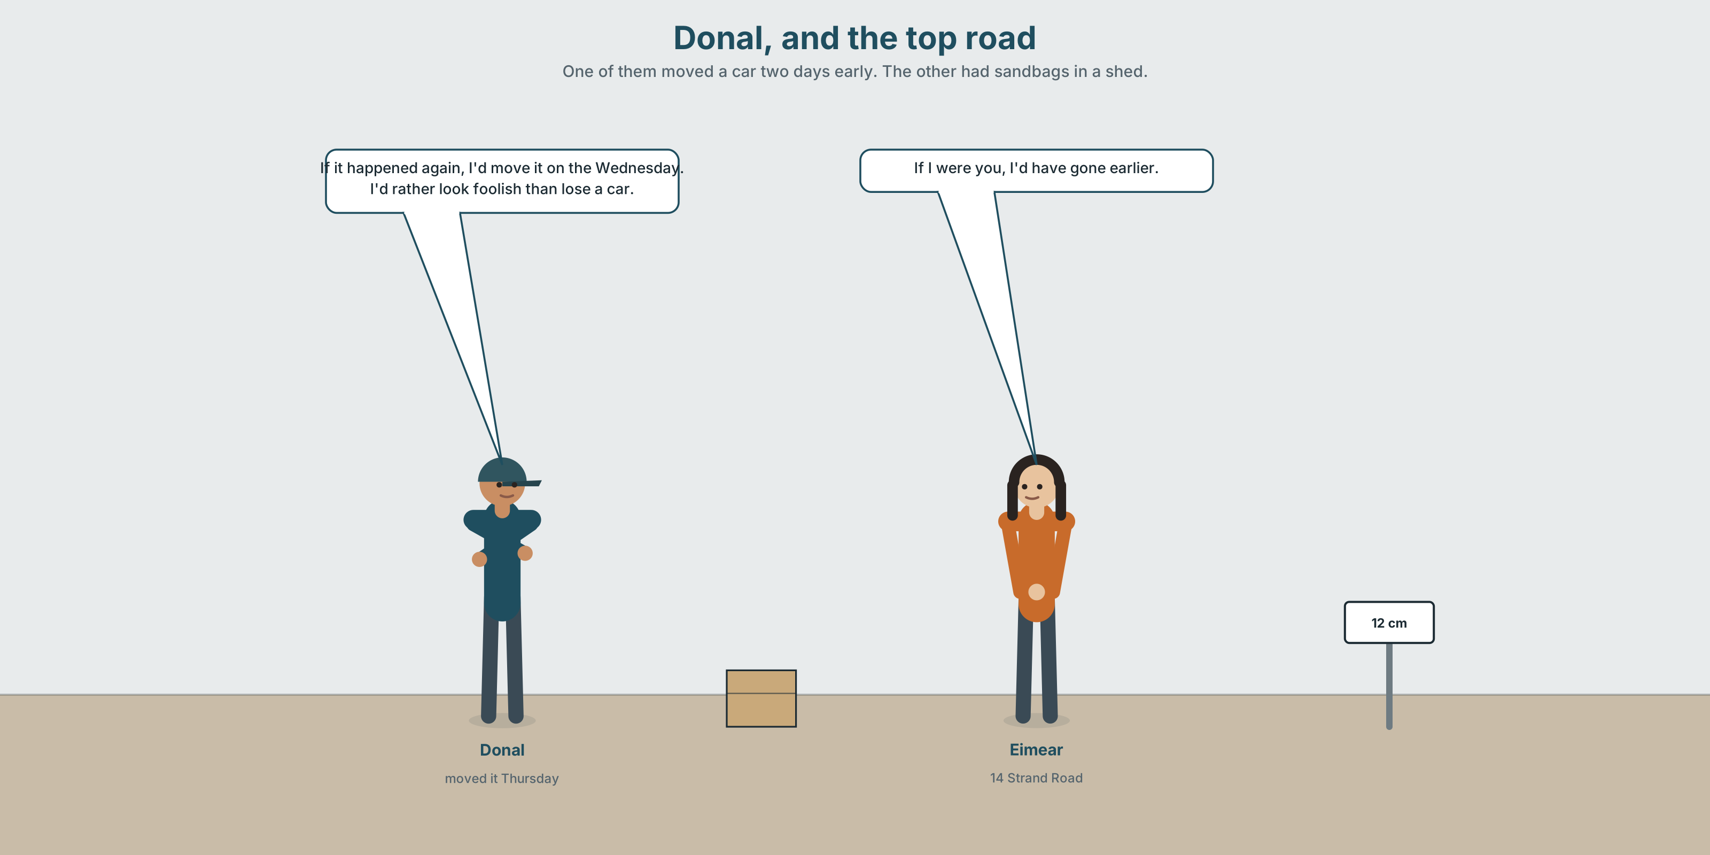{width=6.6in}
Donal, and the top road — One of them moved a car two days early. The other had sandbags in a shed.

2A · Thursday, and the top road 🔊 Track 1.1
Before you listen. Donal moved his car to the top road on the Thursday, two days early, and people laughed. Guess: does he bring it up himself?
Listen once. One question. How many cars were lost on this street?
Listen again. Complete the table.
 | What they did on the Thursday | What they would do now
Donal
Eimear
Sinéad
Listen again. True or false?
- Donal moved his car because of the forecast. ☐ T ☐ F
- Eimear had sandbags but did not use them. ☐ T ☐ F
- Sinéad opened the hall on the Saturday. ☐ T ☐ F
- Donal says he would do the same again. ☐ T ☐ F
Noticing. Four sentences from the recording.
- If it happened again, I'd move it on the Wednesday.
- If I were you, I'd have gone earlier.
- I'd rather look foolish than lose a car.
- I wouldn't do anything differently, honestly.
All four use would. Two are about the future. Two are about the past. Which are which?

2B · Decoding clinic 🔊 Track 1.2
Twenty-five seconds of Donal. Four jobs.
- How many times does he say 'd?
- In I'd rather, can you hear the would at all?
- Catch the two days he names.
- He says one thing and then takes half of it back. Which?
Transcripts, page 150.

Part 3 · Grammar Lab 1 ◆ B · THE SYSTEM

If it happened again

3A · Notice
Look at the four sentences in Part 2.
- In sentence 1, has it happened again? So why is the verb in the past?
- Sentence 2 says if I were you. Not was. Why?
- Sentence 3 compares two bad outcomes. Which does he prefer, and is that a fact or a value?
- First conditional or second? If it rains, we'll move the car. / If it flooded again, we'd move it. What is the difference in how likely each one is?
- Try "If it would happen again, I'd move it." What is wrong?

3B · See
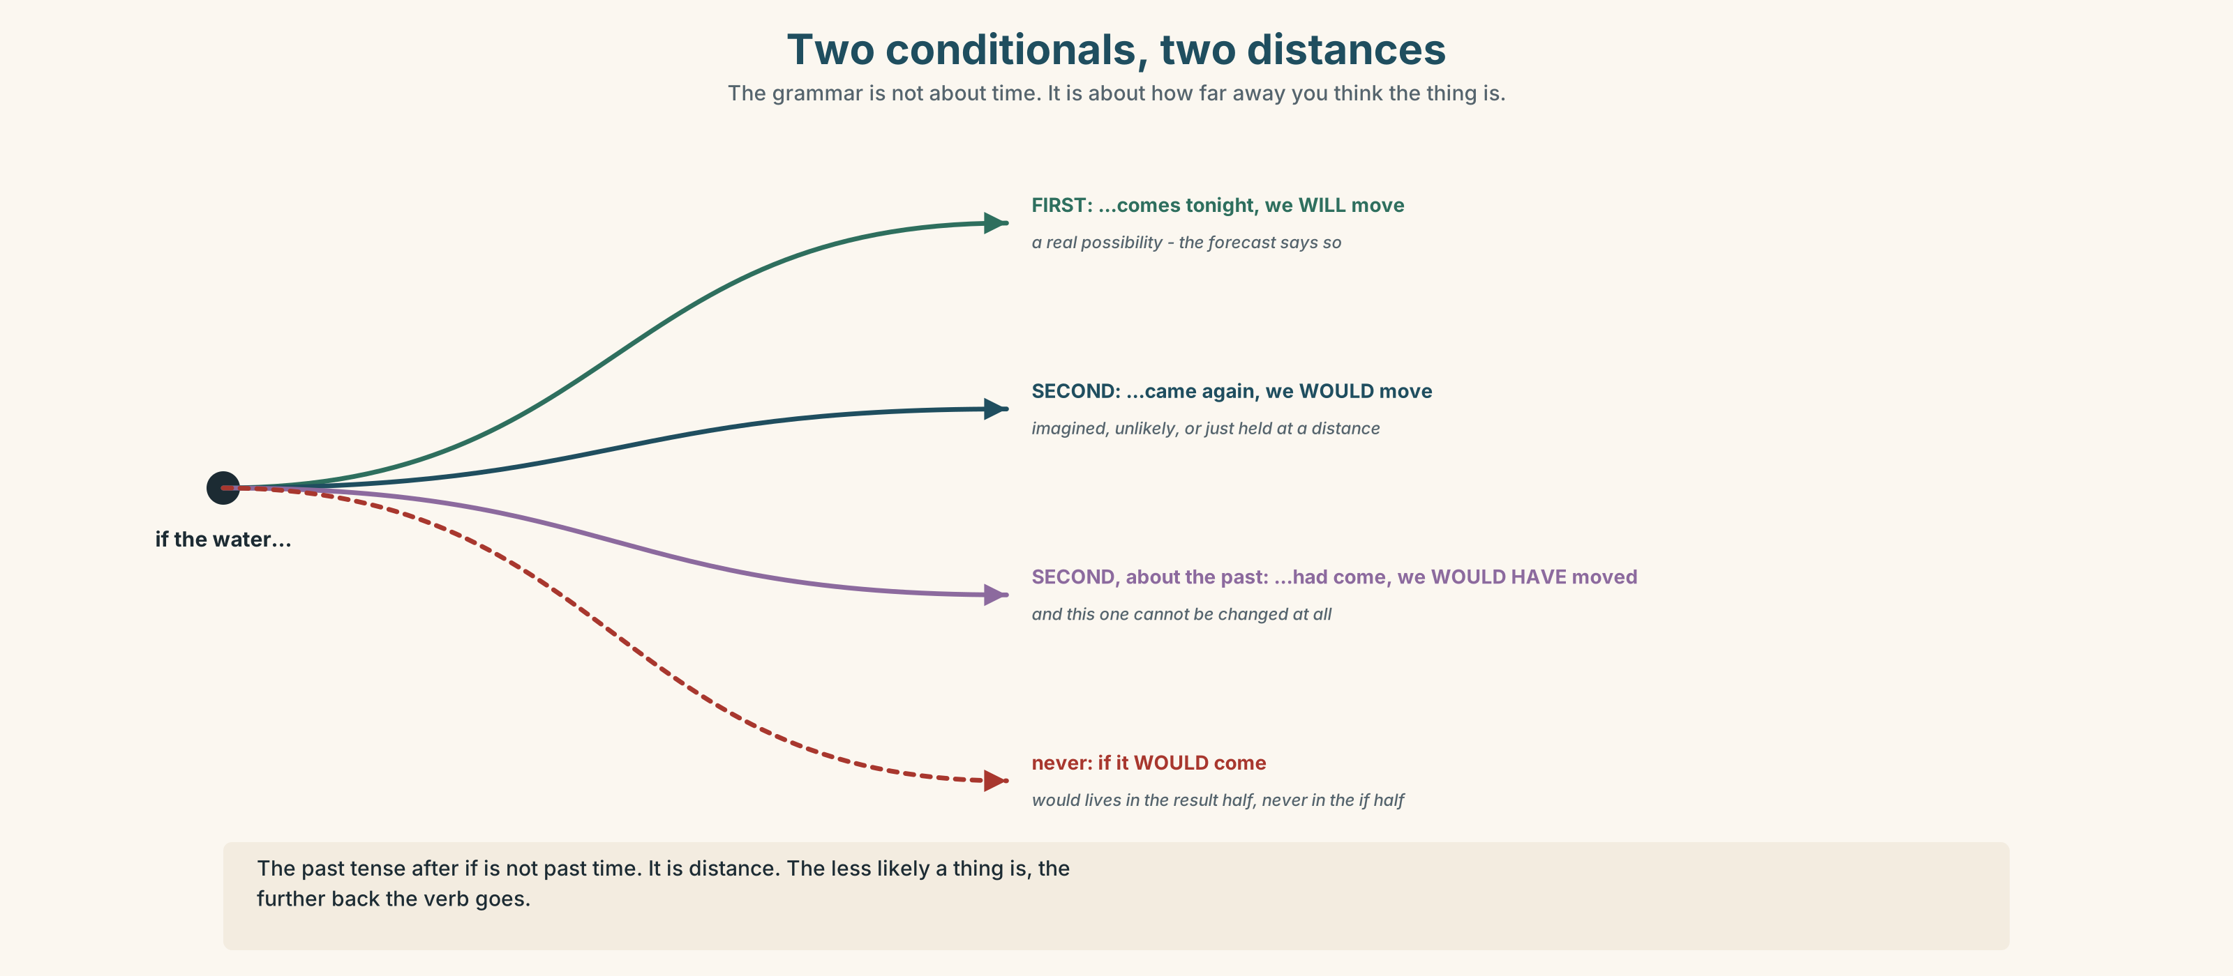{width=6.6in}
Two conditionals, two distances — The grammar is not about time. It is about how far away you think the thing is.
Now look at the second picture. The ladder runs from certain to impossible. Where does the second conditional sit?
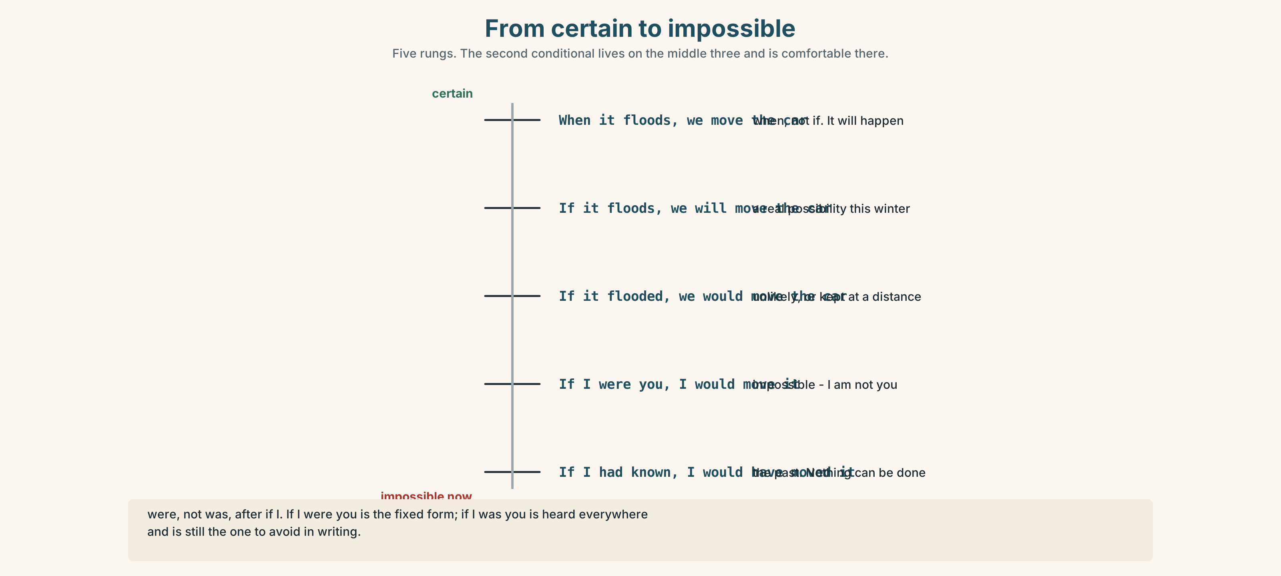{width=6.6in}
From certain to impossible — Five rungs. The second conditional lives on the middle three and is comfortable there.

3C · Know
 | Shape | Use it for
first conditional | if + present , will | a real possibility · If it floods, we'll move.
second conditional | if + past , would | unlikely, imagined, or hypothetical · If it flooded again, we'd move.
The past tense is not about time. It is about distance. The further a thing is from happening, the further back the verb goes.
were, not was, after if I. If I were you is the fixed form. If I was you is heard everywhere and is still the one to avoid in writing.
would in four jobs: I'd move it (result) · I'd rather (preference) · Would you mind (request) · I'd have gone (a past you cannot change)
Watch out. ✗ If it would happen ✓ If it happened would lives in the result half, never in the if half.

3D · Use — controlled
If it (1) __________ (happen) again, Donal (2) __________ (move) the car on the Wednesday. If Eimear (3) __________ (be) ready, she (4) __________ (not lose) the kitchen floor. If I (5) __________ (be) you, I (6) __________ (not wait) for the council. And if the wall (7) __________ (be) two feet higher, none of us (8) __________ (be) having this conversation.

3E · Use — guided
Make each one a second conditional.
- I don't have the money, so I don't move.
- We aren't ready, so we worry.
- He doesn't ask, so nobody helps him.
- The hall isn't open, so people sleep in cars.
- I'm not you, so I can't decide.

3F · Use — open
Ask three people: If you had to leave your home in an hour, what three things would you take? Then ask them why the third one.

3G · Check — six items
- If it ______ (happen) again, I ______ (move) it earlier.
- If I ______ you, I ______ (not wait).
- We ______ (be) safe if the wall ______ (be) higher.
- I ______ rather look foolish than lose a car.
- What ______ you do if the water ______ (come) tonight?
- If she ______ (have) insurance, she ______ (not be) in that house now.
0–3 → Workbook pp. 4–6. 4–5 → Part 6. 6 → page 19.

Part 4 · Speaking ◆ C · THE PERFORMANCE

4A · Fluency starter — one hour
Your teacher says: "You have one hour and a car." Each learner names one thing they would take and one they would leave. No repeating an object.
Three rounds. Each round, the hour gets shorter.

4B · The functional core — saying what you would do
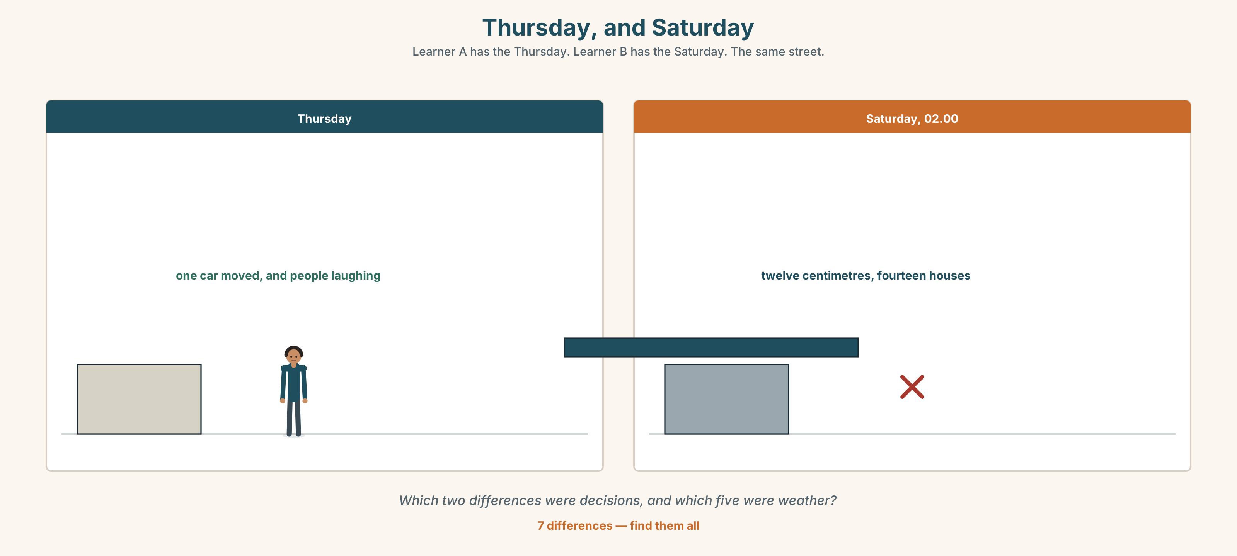{width=6.6in}
Thursday, and Saturday — Learner A has the Thursday. Learner B has the Saturday. The same street.
Language Bank
the imagined | If it happened again, I'd… · I'd probably… · I'd certainly…
the preference | I'd rather… than… · I'd sooner…
the advice | If I were you… · In your place, I'd…
the honest limit | Honestly, I'd do the same. · I'd like to say I would, but…
Role play. Learner A lost something in the flood. Learner B did not and was lucky. Six minutes. Neither of you may use the word should.

4C · The performance — ninety seconds ⏺
Describe one thing you would do differently and one you would not. Ninety seconds. You must give:
what happened · what you would change · what you would keep the same · why that one
Record it.

4D · Observer
One person listens for one thing: was there something the speaker would not change?

4E · Two criteria
☐ Did I use if + past + would at least three times? ☐ Is there one thing I would keep exactly as it was?

Part 5 · Reading ◆ A · THE WORLD

5A · Predict
An interview transcript with a resident. The title is "I had sandbags in the shed since 2019." What do you expect her to say about them? One sentence.

5B · Read — one hundred seconds

"I had sandbags in the shed since 2019" Eimear Nolan, 14 Strand Road
When did you know it was coming in? About ten. The drain in the yard started going the wrong way. That is the thing nobody tells you. It does not come in the door first.
You had sandbags. I had sandbags. I had had them in the shed since 2019, when there was a warning that came to nothing, and on the Thursday I thought about putting them out and I did not, because Donal had moved his car and everyone was being funny about it and I did not want to be the second one.
Would you do it differently? I would put them out. But I want to be careful here, because that is easy to say in September. If you asked me in January, with a forecast and a shed and everybody watching, I honestly do not know that I would.
What would you change, then? I would not wait to see what anybody else did. That is the one. Not the sandbags — the waiting.
And twelve centimetres. Twelve centimetres is nothing until it is in your kitchen. It takes eight months to dry a floor. You cannot put a new one down until it is dry and you cannot tell when it is dry, so you wait, and then you put one down and sometimes you are wrong.

5C · Answer
- How did she know the water was coming in?
- How long had the sandbags been in the shed, and why had she kept them?
- Why did she decide not to put them out on the Thursday?
- What does she say she would change, and what does she say she would not promise?
- Why does it take eight months to dry a floor?
- What is the difference between "the sandbags" and "the waiting"?

5D · Vocabulary in context
Guess from the text. Then check.
came to nothing · being funny about it · the second one · in September (as she uses it) · you cannot tell when it is dry

5E · The counter-text
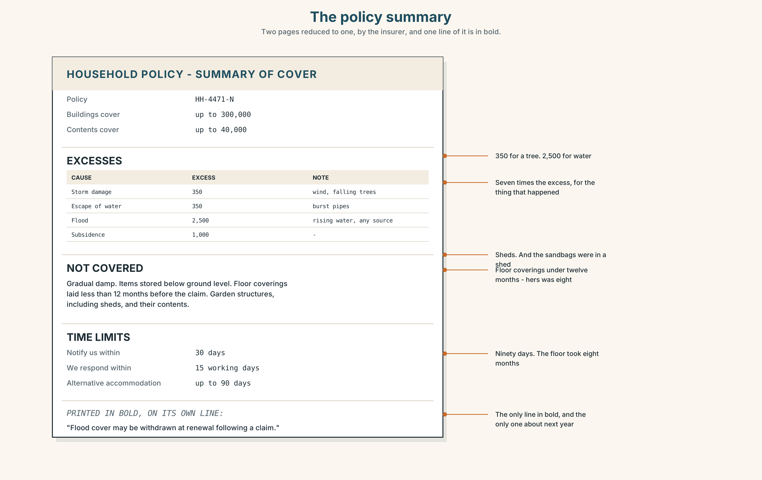{width=6.6in}
The policy summary — Two pages reduced to one, by the insurer, and one line of it is in bold.
Read the insurance policy summary and answer.
- What is the excess for flood, and how does it compare with the excess for storm damage?
- What exactly is not covered, and which of those three things did Eimear lose?
- How long does the insurer have to respond to a claim?
- One line is printed in bold. What does it say, and why that line?

5F · Two texts
The interview says the floor took eight months to dry. The policy covers alternative accommodation for up to 90 days.
Put those two facts together. What happened for the other five months? Two sentences.

Part 6 · Vocabulary Lab 2 ◆ B · THE SYSTEM

Saying it a different way
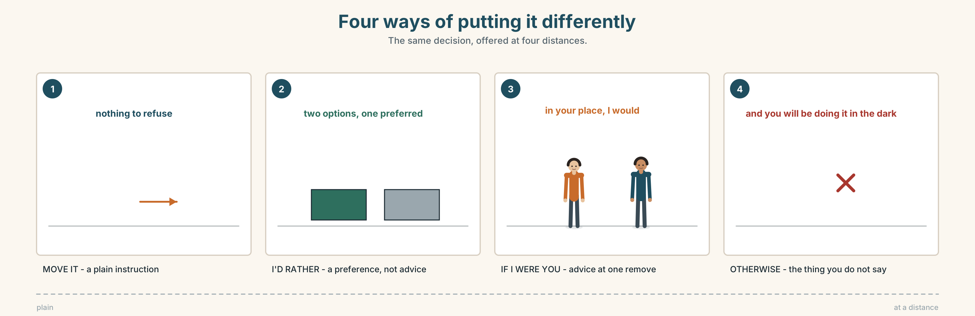{width=6.6in}
Four ways of putting it differently — The same decision, offered at four distances.

6A · Sort — how sure, and how honest?
Put these on a line from most certain to least.
certainly · probably · maybe · supposing · honestly · otherwise
Two of them are not about certainty at all. Which, and what are they doing?

6B · Chunk completion
- If I ______ you , I'd ask for it in writing.
- In your ______ , I would have done exactly the same.
- I would ______ gone, but the road was closed.
- I'd ______ wait than guess.
- Move it now — ______ you'll be doing it in the dark.
- He ______ twice before he said anything in the hall.

6C · Three words that change the whole sentence
instead · otherwise · differently
Put one in each, and then say what each one assumes the listener already knows.
- I didn't wait. I phoned the council ______ .
- Put them out tonight. ______ you'll be carrying sand at midnight.
- If it happened now, I'd do it ______ .
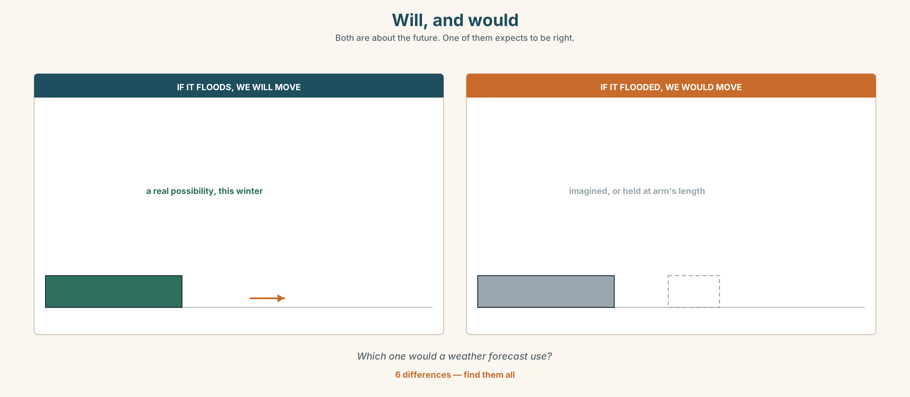{width=6.6in}
Will, and would — Both are about the future. One of them expects to be right.
Six differences. Find them, then answer the question under the picture.

6D · Contrast Clinic — first or second conditional
Six items. Choose the form, and say why that one.
- If it ______ (rain) tomorrow, we ______ (cancel). (the forecast says it will)
- If it ______ (rain) every day for a month, the wall ______ (not hold). (it never has)
- If I ______ (be) you, I ______ (go) now.
- If you ______ (leave) now, you ______ (catch) the four o'clock.
- If the hall ______ (not be) there, where ______ people ______ (go) ?
- If I ______ (see) him, I ______ (tell) him. (I probably will see him)

Part 7 · Pronunciation & Fluency Lab ◆ B · THE SYSTEM

The word that becomes a letter
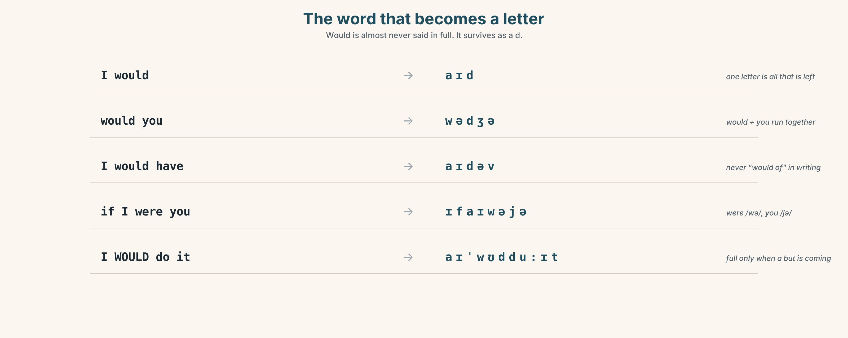{width=6.6in}
The word that becomes a letter — Would is almost never said in full. It survives as a d.

7A · Hear 🔊 Track 1.3
I would → I'd → /aɪd/ would you → /wədʒə/ I would have → I'd've → /aɪdəv/ if I were you → /ɪfaɪwəjə/

7B · Say
Say each one. Then say the sentence three times, faster:
If I were you, I'd have moved it on the Wednesday.

7C · Make it mean something
Say these two:
I WOULD do it. (and something is stopping me) I'd do it. (plain — this is what I would do)
The first one has a but coming. Say the whole sentence.

7D · Fluency 20 ⏺
Twenty seconds: three things you would do and one you would not. Three times, faster, with 'd every time.

Part 8 · Writing ◆ C · THE PERFORMANCE

What I would do differently · 90 words
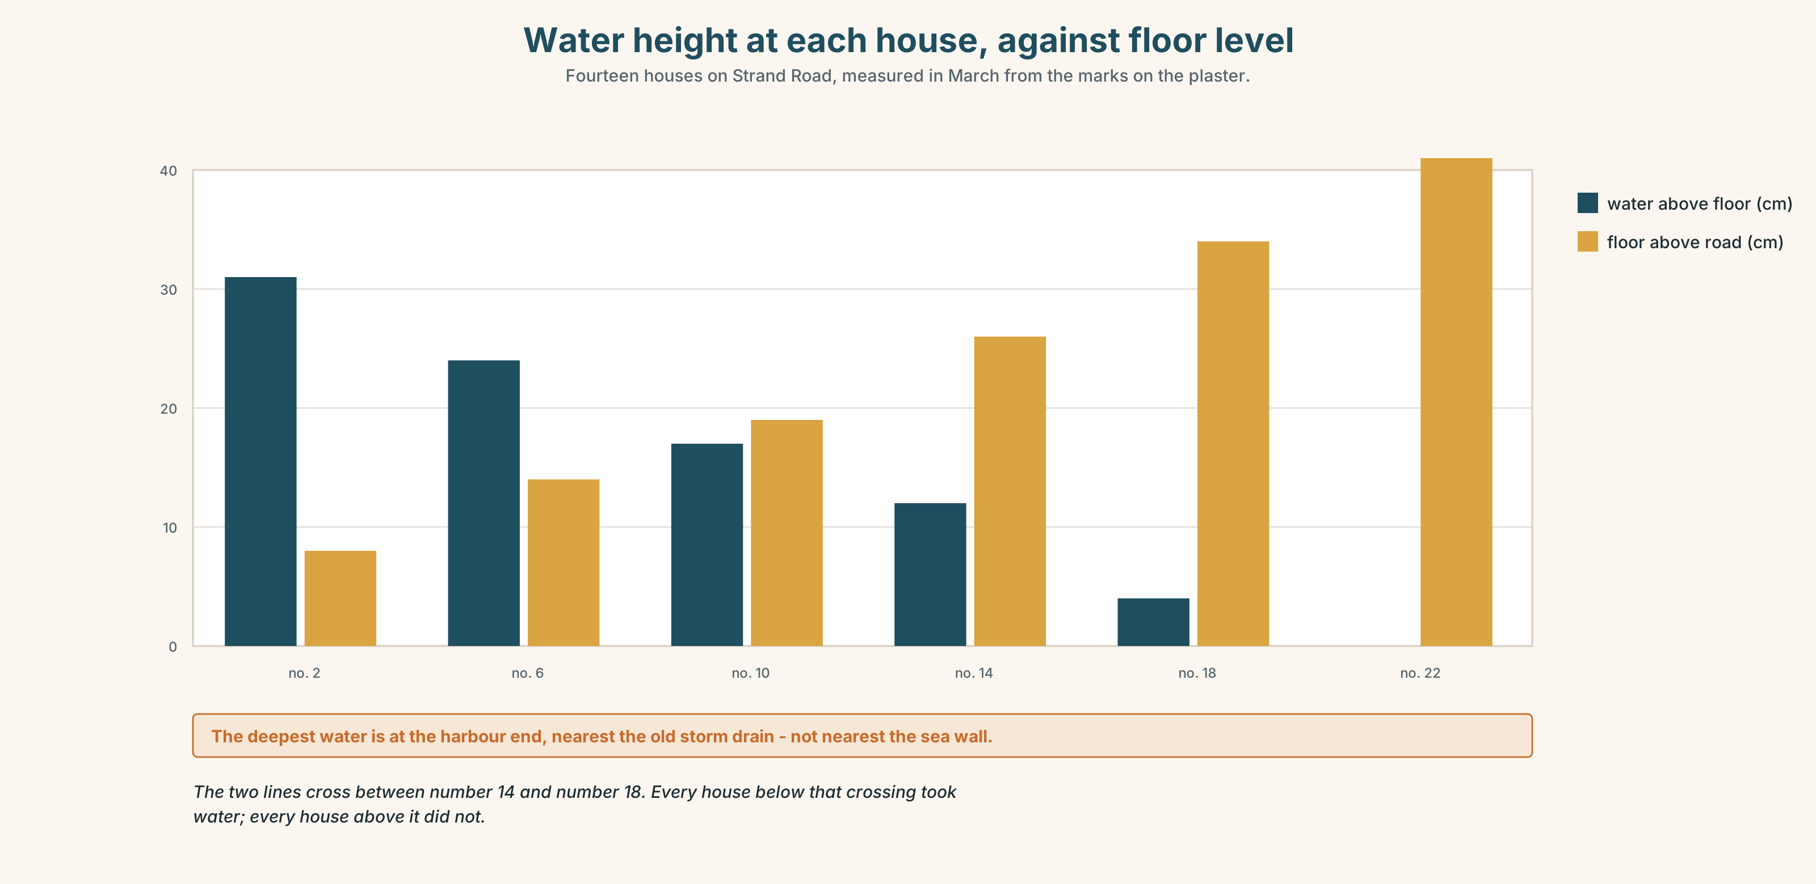{width=6.6in}
Water height at each house, against floor level — Fourteen houses on Strand Road, measured in March from the marks on the plaster.

8A · Read the model
If it happened again I would not wait to see what the neighbours did. That is the only thing I would change and it is not the thing people expect me to say. [the change, named, and the surprise acknowledged]
I would still keep the sandbags in the shed rather than by the door, because the shed is dry and the door is not, and a wet sandbag is a bag of mud. [something kept, with a technical reason, which proves she has thought about it]
I would not promise to be braver. I would promise to be two hours earlier. [the honest limit — and it is specific and achievable]
Questions about the writer's choices:
- The second paragraph defends something she did right. Why include it?
- The last line refuses to promise courage. Is that weakness or precision?

8B · The anti-model
If it happened again I would be much more prepared. I would act faster and I would not make the same mistakes. We have all learned a lot from this experience and we would all do things differently next time.
Correct English, and there is nothing in it. Name two things it does not say.

8C · Plan
what happened, in one line → the one thing you would change → one thing you would keep, with a reason → what you will not promise

8D · Write — 90 words

8E · Peer review — two criteria
☐ Is there one thing kept as well as one thing changed? ☐ Is the change specific enough to do?

8F · Write it again · 8G · Publish
On the wall, with the policy summary from Part 5E beside it.

Part 9 · The File ◆ A · THE WORLD + C · THE PERFORMANCE

WORK FILE · The Pitch
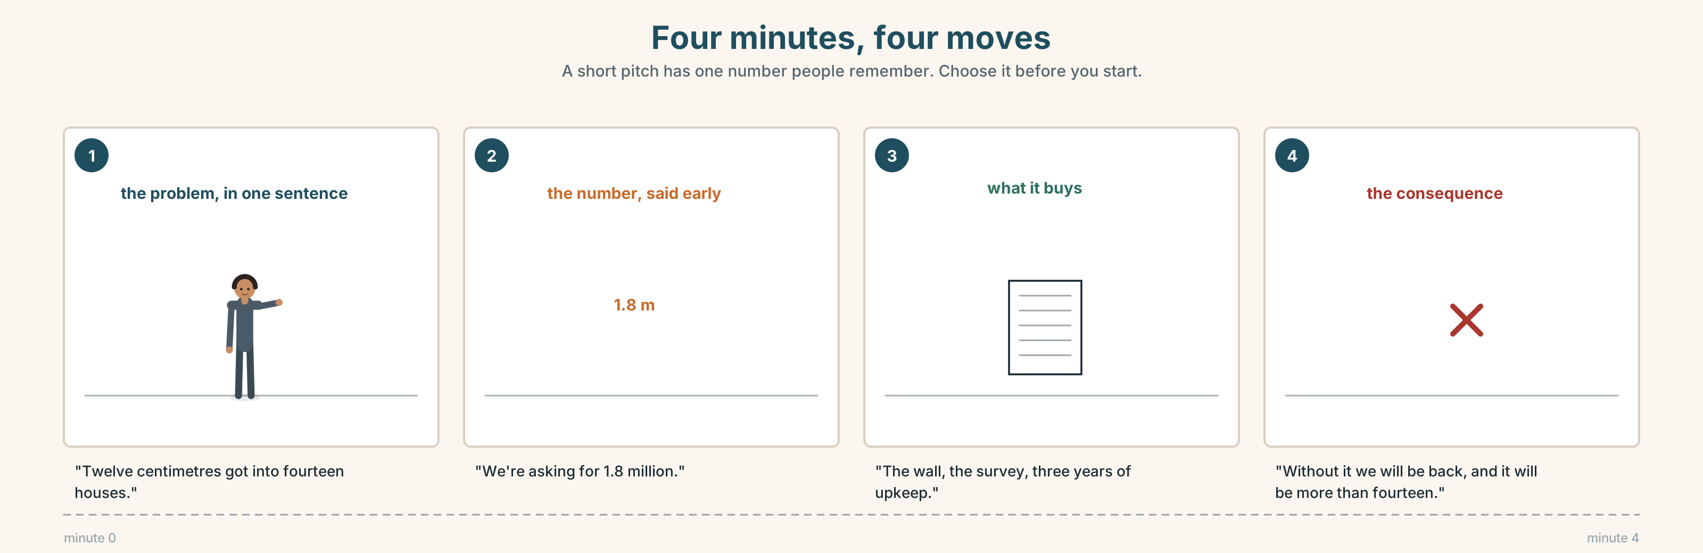{width=6.6in}
Four minutes, four moves — A short pitch has one number people remember. Choose it before you start.

9A · Four minutes and a committee 🔊 Track 1.4
Tomás has four minutes to ask the county for the sea wall money. Listen.
- How does he open, and how long before he says a number?
- What does he ask for, and what does he offer in return?
- One question from the committee catches him out. Which?

9B · The four moves in a short pitch
the problem in one sentence · what you want · what it costs · what happens if you do not get it
Match each to one phrase.
"Twelve centimetres got into fourteen houses." · "We're asking for 1.8 million." · "That's the wall, the survey and three years of maintenance." · "Without it we will be back here, and it will be more than fourteen."

9C · The number you lead with
A pitch has one number people remember. Which of these would you lead with, and why?
1.8 million · fourteen houses · twelve centimetres · eight months · three years

9D · Your turn
In pairs. Four minutes each. Pitch for something real — a change at work, at home, anywhere. One sentence of problem, one number, one cost, one consequence.

9E · Transfer
Find one pitch this week — an advertisement, a request, a politician. Write down the number they led with and ask yourself why that one.

Part 10 · Mediation & Interaction ◆ C · THE PERFORMANCE
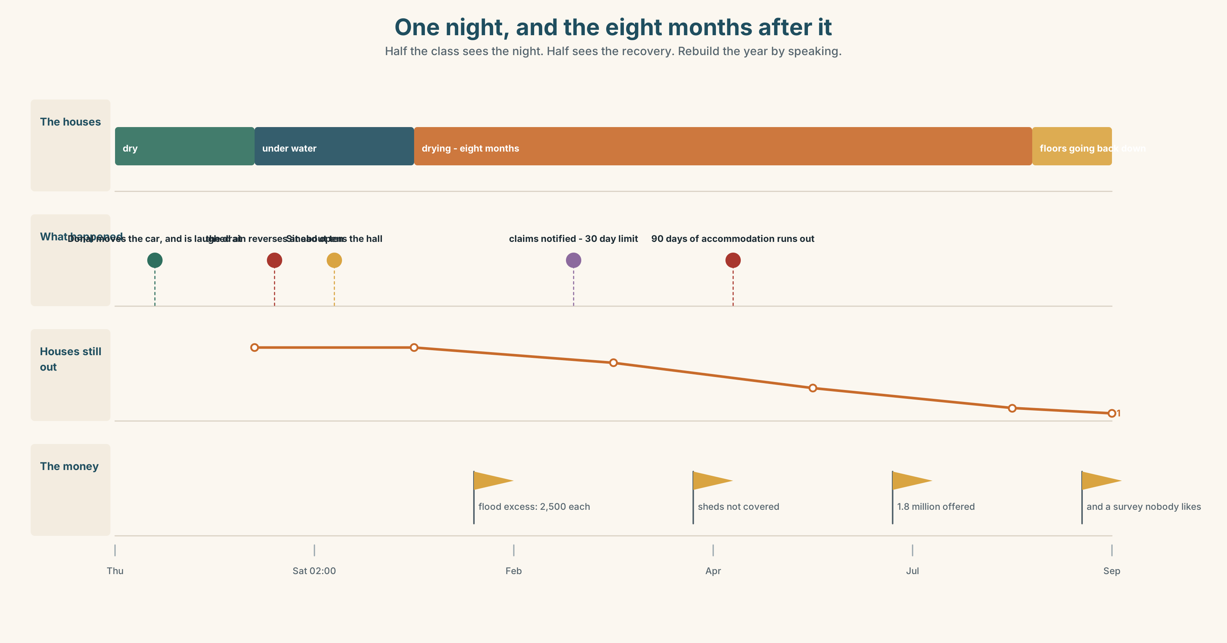{width=6.6in}
One night, and the eight months after it — Half the class sees the night. Half sees the recovery. Rebuild the year by speaking.

10A · Relay
Half the class sees the night of the storm. Half sees the eight months since. Rebuild the whole year by speaking. Ten minutes.

10B · Simplify
Explain the policy summary from Part 5E to somebody who has just been flooded. Four sentences only.
Plan: what you get → what you pay first → what is not covered → what to do today

10C · Compress
The interview in Part 5 into thirty words, for a county report.

10D · Online
Write one message to the town group: the council survey is open for two weeks, you think fourteen households should answer it, and here is the one question that matters.

10E · Your language
How does your language say if I were you? Does it use a past tense for an imagined thing, the way English does? Show a partner both.

Part 11 · The Decision ◆ C · THE PERFORMANCE

The wall, or the three houses
There is 1.8 million. It is enough to build the sea wall badly along its whole length, or to move the three nearest houses and do nothing else.
- The wall. Protects fourteen houses to the standard that failed in January, plus about thirty centimetres.
- The three houses. Buys and demolishes them. The three families are rehoused and the gap becomes a flood meadow. The other eleven houses are no safer than they were.
- Neither, yet. Spend 90,000 on a proper survey and come back in a year with a number that means something.

11A · The evidence
- The policy summary from Part 5E — and what is not covered.
- The chart — water height at each house on the night, against floor level.
- The voice. One of the three, twenty seconds: "I would take the money. I want to be clear that I would take it, because I think people will say afterwards that we were pushed out, and we would not be. We would be glad."

11B · Talk about it
In threes. Everybody says one. Use the frame.
If they built ______ , then ______ . So I think they should ______ .
Words you can use: risk · at risk · damage · protect · recover · cost · safe · in time

11C · Decide
Write two sentences. Choose, and say why.
I think they should ______________________ , because ______________________ .

11D · Model decision
They should do the survey. Both of the other options are being chosen on the basis of one night's water, measured afterwards by people wading through it, and a wall built to the wrong height is worse than no wall because it is believed. Ninety thousand to find out is cheap against 1.8 million to find out you were wrong.

11E · The Reveal
What happened. They did the survey. It took fourteen months rather than twelve and cost 118,000.
It found that the water in January had not come over the wall at all. It had come up through the old storm drain, which was built in 1961 and connects to the harbour below the wall line. A higher wall would have made no difference to eleven of the fourteen houses.
Fixing the drain is costed at 340,000. There is now an argument about what to do with the rest of the money, and two of the three families have said they no longer want to move.
The survey was right. And it cost fourteen months, during which nothing was built.
Was it the right decision? Say why — and say what you would do with the remaining 1.34 million.

Part 12 · Landing ◆ all three lines

12A · Recycle — ten items
- If it ______ (happen) again, I ______ (move) it earlier.
- If I ______ you, I wouldn't wait.
- I'd ______ look foolish than lose a car.
- Three houses are at ______ every winter.
- The worst ______ it was over by two.
- (A2.1 U5) If it ______ (rain), we'll stay in.
- (A2.1 U8) You ______ (not / allowed) park here.
- (A2.1 U7) The house ______ (build) in 1961.
- (A2.1 U2) It was raining ______ he left.
- (A2.1 U1) I've lived here ______ 2019.

12B · Consolidate
Ninety words, one paragraph. One thing you would do differently and one you would keep. Three second conditionals, one I'd rather, one if I were you.

12C · Can-do, with evidence
I can… | My evidence | Sure?
talk about an imagined situation and its result | Part 3G score | ◯ ◑ ●
say what I would and would not change, in ninety seconds | Part 4C recording | ◯ ◑ ●
write ninety words that keep something as well as change something | Part 8 draft 2 | ◯ ◑ ●
make a four-minute pitch with one number | Part 9D pair work | ◯ ◑ ●

12D · Replay ⏺
Find your thirty seconds from Part 0C. Listen. Record it again. One sentence: what is different?

12E · Glossary — forty items, as a map
BEFORE · warning · prepare · protect · ready · at risk · take a risk · in time THE NIGHT · storm · flood · wall · shelter · damage · rubble · the worst of it AFTER · recover · cost · cover · safe · lucky · foolish · put up with · we were lucky THE IMAGINED · would · would have · supposing · maybe · unless · otherwise · instead THE PREFERENCE · rather · I'd rather · if I were you · in your place · think twice HOW SURE · honestly · probably · certainly · differently · what would you do

12F · Next
Unit 2 · What has been happening?

