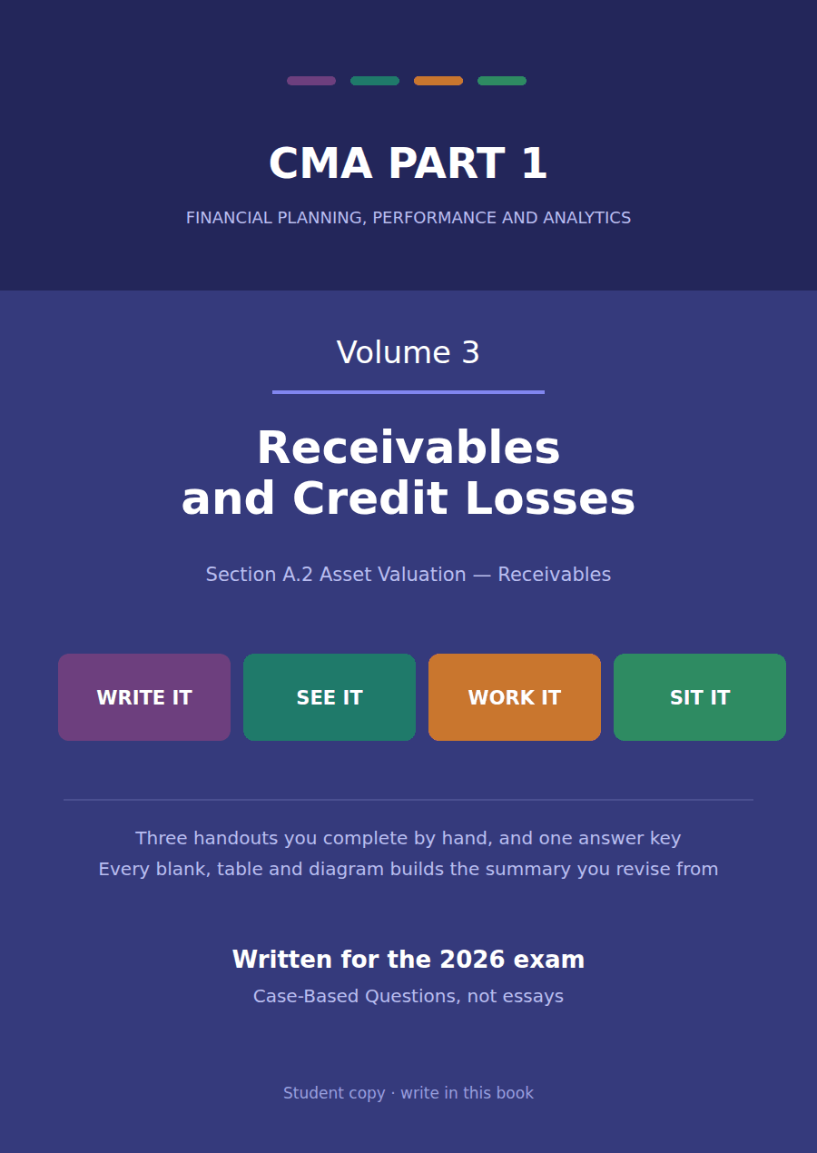

CMA Part 1 · Volume 3
Receivables and Credit Losses
Three handouts, one answer key. When a receivable is recognised, what it is carried at, and what changes when it is sold.
These handouts are not notes to read. You write them. The words you supply are the summary, so a finished handout is a page you can revise from, in your own handwriting.
Work in pen. Do not look at the key until the whole handout is done — the key is written to explain the mistake, and you only get that benefit if you have made it first.
The three handouts
# | Handout | What it gives you
1 | Receivables: When to Recognise, and at What Amount | A receivable appears the moment a sale is earned, not the moment an invoice is typed. The amount is rarely the figure on the invoice.
2 | The Allowance for Credit Losses | Some of what customers owe will never arrive. The company has to say how much before it knows, and say it every year.
3 | Selling the Receivable: With Recourse and Without | A company short of cash can sell what customers owe it. Whether the receivable leaves the balance sheet turns on who still carries the risk.

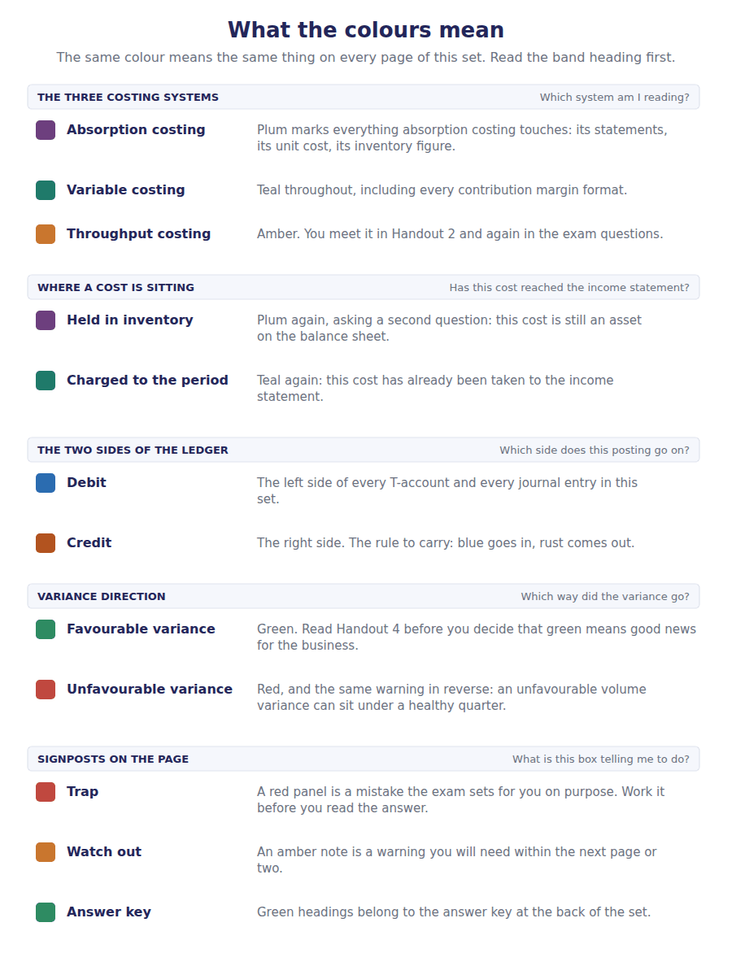
How to read the markers
Marker | Meaning
R1 | Teaching English. Short sentences. This is where a new idea arrives.
R2 | Textbook English. Longer sentences and passive verbs, as a textbook writes them.
R3 | Exam English. Exactly how the CMA exam phrases it, traps included.
Numbered rule | A space you fill in. The number matches the answer key.
Red table | A trap. Read it twice.

Handout 1 · Receivables: When to Recognise, and at What Amount
A receivable appears the moment a sale is earned, not the moment an invoice is typed. The amount is rarely the figure on the invoice.
Volume 3 · Receivables and Credit Losses · R1 moving to R2
LANGUAGE FOCUS
Register you are working in | R1 while the two questions are separated, R2 once discounts and interest arrive.
Say it exactly like this | recognise a receivable · record a sale on credit · offer terms of 2/10, net 30 · take up a cash discount · measure a receivable at · collect an invoice
Words that are not the same | trade discount / cash discount · invoice amount / carrying amount · account receivable / note receivable · recognition / measurement
Remember | A trade discount is never recorded. It is simply not part of the price. A cash discount is recorded, because the customer may or may not take it and the company has to estimate which.

What you will be able to do when this handout is finished
- Say when a receivable is first recognised, and why the invoice date is not the trigger.
- Distinguish a trade discount from a cash discount and say which one is recorded.
- Measure a receivable on initial recognition under both methods of handling cash discounts.
- Distinguish an account receivable from a note receivable.
- Say when a long-dated receivable has to be discounted, and when it does not.

The line you built in Volume 1, opened up
Northwind’s balance sheet reports accounts receivable of $714,000 net of an allowance of $46,000, so customers owe $760,000 in gross invoices.
That one line hides three separate questions. When did each of those receivables first appear? What amount was each one recorded at? And how much of the total will actually be collected?
This handout answers the first two. Handout 2 answers the third, and Handout 3 asks what happens when the company sells the receivable rather than waiting for it.

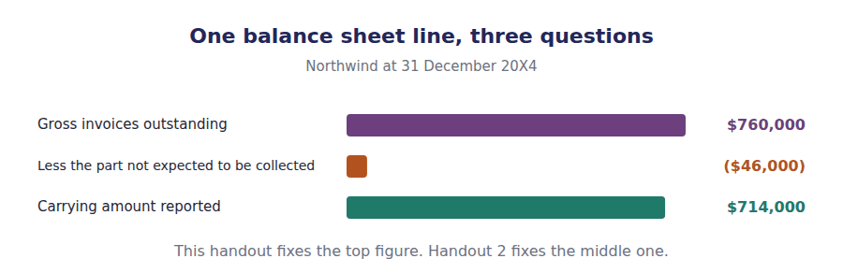
Part 1 · When does a receivable appear? recognition, not invoicing
Exercise 1A Read and complete. Write one word in each space.
OBJECTIVE | Say when a receivable is first recognised, and rule out the events that do not trigger it.
YOU WILL NEED | Nothing — this is the first exercise in the volume.
HOW TO START | • Two of these blanks name events that feel like triggers and are not.  • Blank 3 is the single event that does create the receivable.  • The last blank is the word for an amount the company has an unconditional right to.

WORD BANK
contract · delivery · invoice · order · payment · receivable · unconditional
Not every word is used.

R1 A receivable does not appear when the customer places an ¹ . An order is a promise to buy, and nothing has yet been supplied.
It does not appear when the invoice is typed either. The ² is paperwork, and a company that is slow with its paperwork does not thereby own less.
It appears when the company has performed and the customer’s obligation to pay has become ³ . For Northwind that is the moment the components are delivered and accepted.
The word for that is a ⁴ : a right to consideration where only the passage of time stands between the company and the cash. If anything else stands in the way, the right is a contract asset instead, as Volume 2 showed.
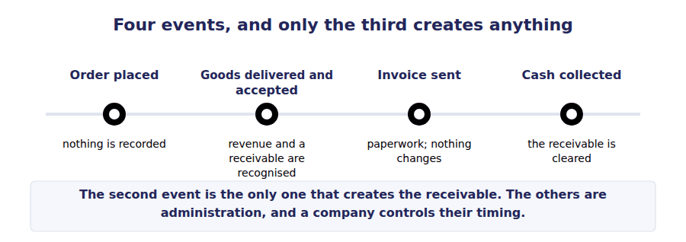
Part 2 · Two kinds of discount one is recorded, one is invisible
R2 The amount at which a receivable is first recorded is rarely the list price, and two different reductions explain why. They look similar in a stem and they are handled completely differently.
R2 A trade discount is a reduction off a list price to arrive at the price actually agreed. A customer buying in bulk pays 20% less than the catalogue says. Nothing about that is an accounting event: the sale is simply recorded at the agreed figure, and the list price is never entered anywhere.
Exercise 1B Complete the journal entry, then answer the question underneath it.
OBJECTIVE | Record a sale net of a trade discount and say why the list price is irrelevant.
YOU WILL NEED | Exercise 1A, and the two paragraphs above.
HOW TO START | • The list price is given to you so that you can ignore it. Work out the agreed price first.  • There is no account called trade discount, and there should not be.  • Both sides of the entry carry the same figure.

J1 Components with a list price of $250,000 sold to a distributor at a 20% trade discount. No account records the discount. The sale is simply the agreed figure.
Account | Debit | Credit
Accounts Receivable
Sales Revenue

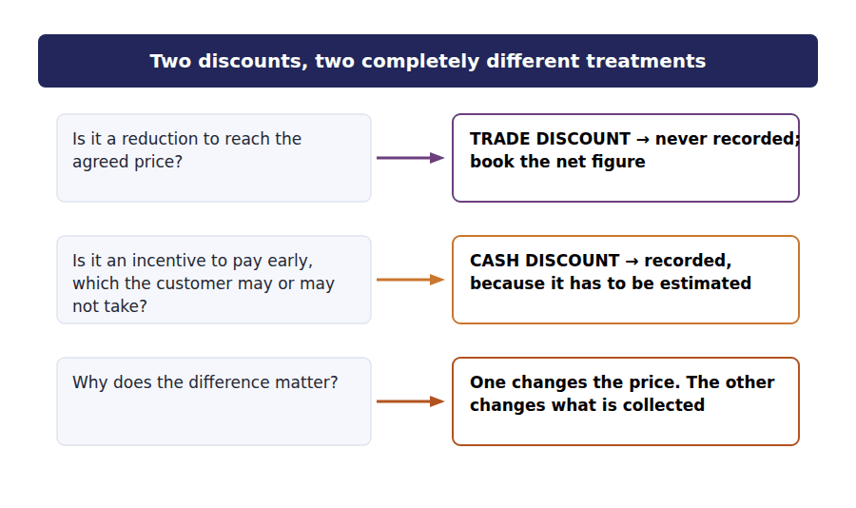
Exercise 1C Complete the table. Write the amount recorded under each method and each outcome.
OBJECTIVE | Measure a receivable under both methods of handling a cash discount.
YOU WILL NEED | Exercise 1B
HOW TO START | • Terms of 2/10, net 30 mean 2% off if paid within 10 days, and the whole amount due in 30.  • Under the gross method the sale goes in at the full figure and the discount is recorded only if it is taken.  • Under the net method the sale goes in at the discounted figure, and failing to take the discount produces a small gain.

Invoice | Terms | If paid within the discount period | If paid after it
$100,000, terms 2/10 net 30 | Gross method | ______________ | ______________
$100,000, terms 2/10 net 30 | Net method | ______________ | ______________

1 | 2 | 3 | 4

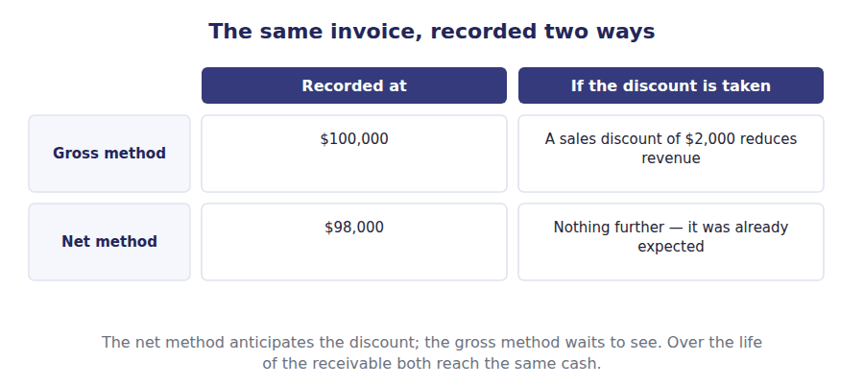
Part 3 · Notes, and the time value of money when a receivable has to be discounted
Exercise 1D Read and complete.
OBJECTIVE | Distinguish an account receivable from a note receivable, and say when discounting is required.
YOU WILL NEED | Exercise 1C
HOW TO START | • Blank 1 is the feature that makes a note a different instrument rather than an overdue invoice.  • Blank 3 is the length of time below which the question of discounting is set aside entirely.  • The last blank is what the interest element becomes if a long-dated receivable is discounted.

WORD BANK
interest · maturity · month · profit · revenue · year
Not every word is used. A word may be used more than once.

R2 An account receivable arises from an ordinary sale on credit. A note receivable is supported by a formal written promise to pay, normally with a stated ⁵ rate and a maturity date, and it is a different instrument rather than an invoice that has gone unpaid for a long time.
Both raise the same question once the term lengthens. An amount payable in three years is not worth its face value today, and recording it at face value would overstate both the asset and the ⁶ recognised on the sale.
In practice the question is set aside for short receivables. Where the period between transfer and payment is one ⁷ or less, the practical expedient from Volume 2 applies and no discounting is required, which covers almost every trade receivable a question will give you.
Where it does apply, the receivable is recorded at its present value, and the difference between that and the cash eventually collected is recognised as ⁸ income over the period rather than as revenue on day one.
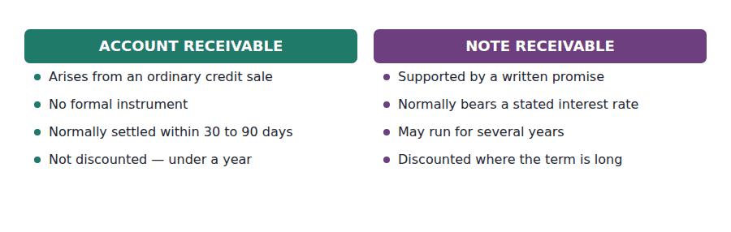
Part 4 · What the balance is made of Northwind at the year end
Exercise 1E Read and complete.
OBJECTIVE | Account for the movement in gross receivables across the year.
YOU WILL NEED | Exercises 1A to 1D
HOW TO START | • Blank 1 is the opening gross figure, which you can read from Volume 1’s comparative column.  • Receivables rise with sales and fall with collections. Both appear.  • The last blank is the handout that deals with the amounts that were never collected at all.

WORD BANK
$4,800,000 · $714,000 · $760,000 · 2 · 3
Not every word is used.

R2 Gross receivables opened the year at $690,000 and closed at ⁹ , an increase of $70,000.
Three things moved the balance. Credit sales of $4,800,000 added to it, cash collections took most of that away again, and amounts judged uncollectible were removed from it altogether.
The first two are this handout’s business, and they are mechanical. The third is a judgement, it came to $31,000 during the year, and it is the whole subject of Handout ¹⁰ .
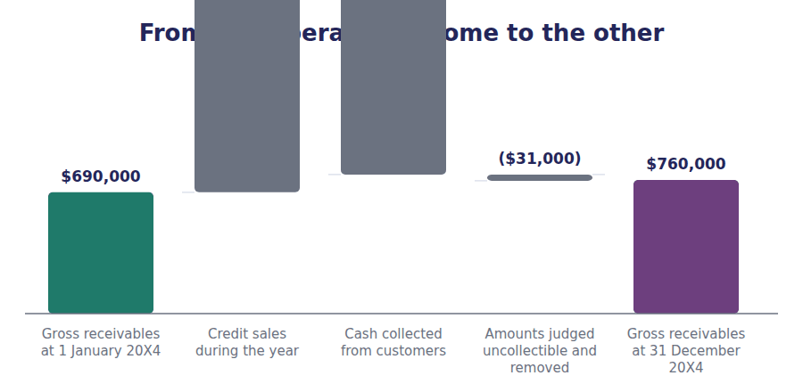
Watch out! Recognition and measurement are two separate questions and the exam asks them separately. When a receivable appears is about performance. What it is recorded at is about discounts, and occasionally about time.
Part 5 · Exam pitch the questions as the CMA sets them
1. [Level B] Goods are delivered and accepted on 28 December. The invoice is raised on 4 January. The receivable should be recognised on:
(A) 4 January, when the invoice was raised
(B) 28 December, when the obligation to pay became unconditional
(C) The date the customer pays
(D) The date the customer placed the order
2. [Level A] A customer buys goods with a list price of $250,000 at a 20% trade discount. The sale is recorded at:
(A) $250,000, with a $50,000 trade discount account
(B) $200,000, with no entry for the discount
(C) $250,000, with the discount disclosed in the notes
(D) $200,000, with a $50,000 reduction of revenue
3. [Level B] An invoice of $100,000 carries terms of 2/10, net 30. Under the net method the receivable is initially recorded at:
(A) $100,000
(B) $98,000
(C) $102,000
(D) $80,000
4. [Level B] Under the gross method, a customer pays within the discount period and takes a $2,000 cash discount. The $2,000 is:
(A) Recorded as interest expense
(B) Recorded as a sales discount, reducing revenue
(C) Added to the estimate of amounts that will not be collected
(D) Not recorded, because the receivable has been settled
5. [Level B] A receivable is due in 90 days. The appropriate measurement on initial recognition is:
(A) Present value, discounted at the market rate
(B) Face value, because the practical expedient applies to periods of one year or less
(C) Face value less an estimated financing component
(D) Fair value as quoted in an active market
6. [Level A] Which of the following distinguishes a note receivable from an account receivable?
(A) A note is always overdue
(B) A note is supported by a formal written promise and normally bears a stated interest rate
(C) A note arises only from sales to related parties
(D) A note is always non-current
7. [Level C] Northwind’s gross receivables rose from $690,000 to $760,000. Which of the following alone could explain the increase?
(A) An increase in the estimate of uncollectible amounts
(B) Credit sales exceeding collections plus amounts removed as uncollectible
(C) An increase in cash collections
(D) A larger removal of uncollectible accounts
ADAPTIVE TIP Separate the two questions in your head before you read the options: when did this receivable appear, and what was it recorded at? Mixing them is what makes discount questions feel harder than they are.

Handout 2 · The Allowance for Credit Losses
Some of what customers owe will never arrive. The company has to say how much before it knows, and say it every year.
Volume 3 · Receivables and Credit Losses · R2 throughout, closing at R3
LANGUAGE FOCUS
Register you are working in | R2 textbook English, rising to R3 where the roll-forward is worked the way an exam asks for it.
Say it exactly like this | estimate expected credit losses · age the receivables ledger · write off a balance · recover an amount previously written off · charge the allowance against income · carry receivables at the amount expected to be collected
Words that are not the same | allowance / write-off · expense / allowance · estimate / event · gross / net
Remember | Writing off a balance does not reduce net income. The expense was charged when the allowance was raised, which was earlier. The allowance is not a fund of money. Nothing is set aside, and there is no cash behind it.

What you will be able to do when this handout is finished
- Explain why an allowance is used rather than waiting for a balance to go bad.
- Estimate the allowance from an aging schedule.
- Record a write-off and a recovery, and say what each does to net income.
- Roll the allowance forward and produce the charge for the year.
- Say why the direct write-off method is not acceptable.

The $46,000 nobody will ever collect
Northwind’s customers owe $760,000. The company does not expect to collect all of it, and it says so on the face of the balance sheet: the receivables line is presented net of an allowance of $46,000.
No particular customer has been identified as the one who will fail. That is the point. The company knows from experience that some proportion of what is owed will not arrive, and it recognises that cost in the year the sales were made rather than waiting.
This handout produces the $46,000, records what happens when a specific balance does fail, and rolls the account forward across the year.

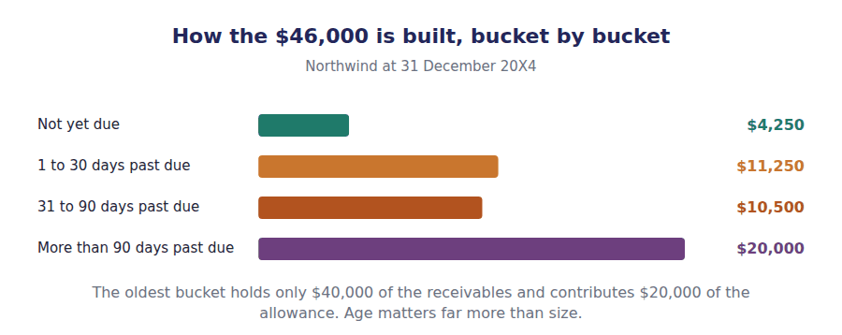
Part 1 · Why an allowance at all? and why waiting is not allowed
Exercise 2A Read and complete. Write one word in each space.
OBJECTIVE | Explain why the cost of uncollectible accounts is recognised before any particular account fails.
YOU WILL NEED | Handout 1, for how receivables arise.
HOW TO START | • Blank 2 is the principle from Volume 2 that decides which year the cost belongs to.  • Blank 3 is the method that waits, and the sentence tells you it is not acceptable.  • The last blank is what receivables would be if no allowance were raised.

WORD BANK
direct · fail · indirect · matching · overstated · succeed · understated
Not every word is used.

R2 Selling on credit carries a cost. Some customers will not pay, and a company that extends credit to a thousand customers knows with near certainty that it is extending credit to a few that will ¹ , even though it cannot say which.
That cost belongs to the year in which the sales were made, because the sales caused it. Charging it in some later year when a particular customer finally collapses would break the ² principle, and it would do so by several years in a bad case.
Charging only when a balance fails is called the ³ write-off method. It is forbidden for financial reporting precisely because it puts the cost in the wrong year, and because in the meantime it leaves receivables ⁴ on the balance sheet at an amount nobody expects to collect.
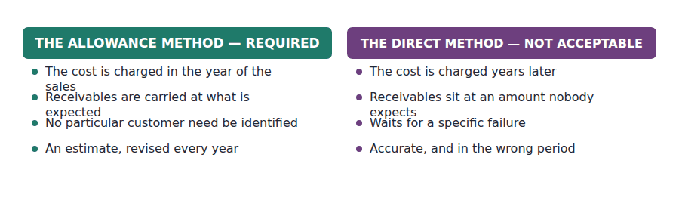
Part 2 · Producing the estimate the aging schedule
R2 The standards call the estimate an expected credit loss, and the adjective is the whole of it. The company is not recording a loss that has happened. It is recording the loss it expects to happen, on sales it has already made, before any customer has defaulted.
Exercise 2B Complete the last column, then total it.
OBJECTIVE | Estimate the required allowance from an aging schedule.
YOU WILL NEED | Exercise 2A
HOW TO START | • Each row is a simple multiplication. Do them one at a time and do not round.  • The amounts must add to gross receivables of $760,000. Check that before you start.  • Your total is the allowance that must stand on the balance sheet at the year end — not the charge for the year. The difference between those two is Part 4.

Age of the balance | Amount | Loss rate | Required allowance
Not yet due | $425,000 | 1%
1 to 30 days past due | $225,000 | 5%
31 to 90 days past due | $70,000 | 15%
More than 90 days past due | $40,000 | 50%
Total | $760,000

1 | 2 | 3 | 4 | 5

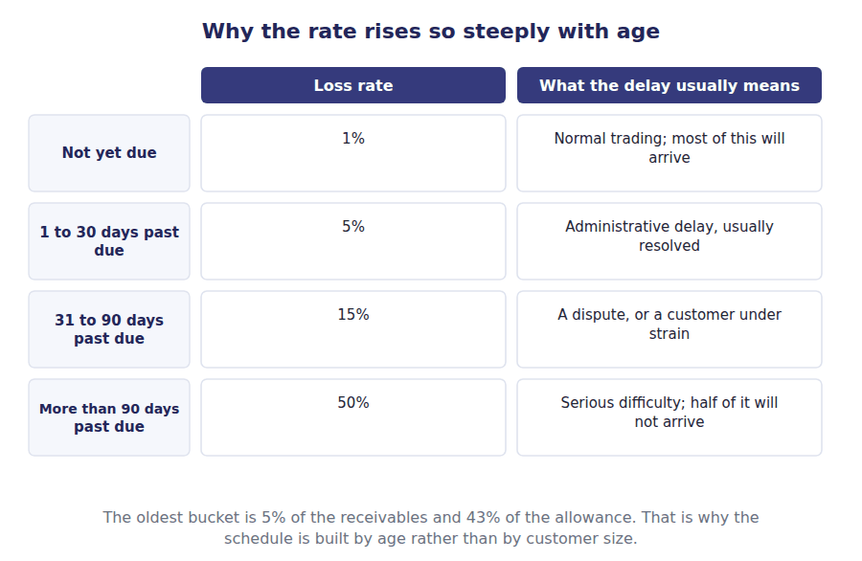
Part 3 · When a balance actually fails write-offs and recoveries
R2 The estimate is made in advance. Eventually a particular customer does fail, and the balance has to come out of the ledger. That event is a write-off, and it is far less dramatic in the accounts than students expect.
R2 A write-off reduces gross receivables and reduces the allowance by the same amount. The carrying amount does not move, and net income does not move either, because the expense was charged when the allowance was raised. The write-off merely records which customer it turned out to be.
Exercise 2C Complete the journal entries. Write the account names and the amounts.
OBJECTIVE | Record a write-off and a recovery, and say what each does to net income.
YOU WILL NEED | Exercise 2B, and the two paragraphs above.
HOW TO START | • J1 touches two accounts and neither of them is an expense. Think about why before you write it.  • A recovery is recorded in two steps, and J2 is the first of them: undo the write-off.  • J3 is then an ordinary collection, exactly as in Handout 1.

J1 A customer balance of $31,000 is judged uncollectible and written off. Net income does not move. The expense was charged earlier.
Account | Debit | Credit
Allowance for Credit Losses
Accounts Receivable
J2 A customer written off earlier pays $4,000. Step one: reinstate the receivable. The write-off is undone before the cash is recorded.
Account | Debit | Credit
Accounts Receivable
Allowance for Credit Losses
J3 Step two: record the cash received.
Account | Debit | Credit
Cash
Accounts Receivable

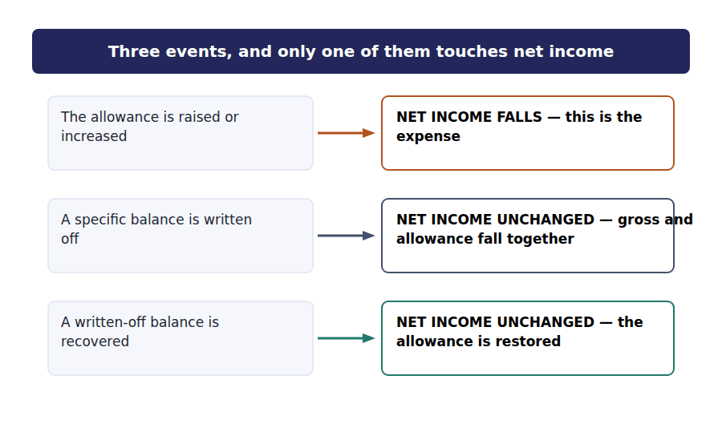
Part 4 · The roll-forward from the estimate to the charge for the year
Exercise 2D Complete the schedule. The closing balance is the figure you produced in Exercise 2B.
OBJECTIVE | Roll the allowance forward and produce the charge for the year.
YOU WILL NEED | Exercises 2B and 2C
HOW TO START | • Four figures move the account and you have three of them. Work out the fourth.  • The charge for the year is what makes the account close on the required balance, not the other way round.  • Write-offs reduce the allowance. Recoveries restore it.

Movement in the allowance during 20X4 | Amount
Allowance at 1 January 20X4 | $38,000
Charge for credit losses for the year | ______________
Less balances written off | ($31,000)
Add recoveries of amounts previously written off | $4,000
Allowance at 31 December 20X4 | $46,000

1

WORD BANK
$31,000 · $35,000 · $46,000 · balance · be · consume · expense
Not every word is used.

R3 The closing allowance is fixed by the aging schedule at $46,000, and the opening balance was $38,000. Write-offs of $31,000 reduced the account during the year and recoveries of $4,000 restored part of it.
The charge for the year is whatever makes those four figures agree, which is ⁵ . It is a balancing figure, and that is the single most important thing to understand about it.
Notice the direction of the reasoning. The company does not decide on a charge and see where the allowance lands. It decides what the allowance must ⁶ , and the charge follows.
That is why a year of unusually heavy write-offs does not by itself produce a large charge. If the allowance was adequate, the write-offs simply ⁷ it, and the charge for the year reflects only what is needed to restore the ⁸ the schedule requires.
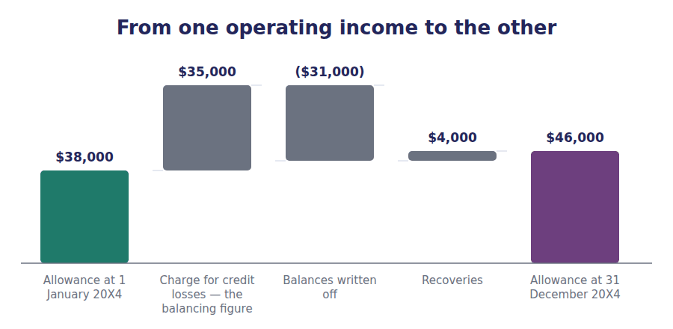
Exercise 2E Sort each statement into the column that says whether it is true.
OBJECTIVE | Say what the allowance does and does not do to the balance sheet.
YOU WILL NEED | Exercise 2D
HOW TO START | • Two of these describe the allowance as something it is not. Both are common beliefs.  • Ask whether any cash is involved anywhere in this account. None is.  • The last one is about which figure a reader of the balance sheet actually sees.

Statement about the allowance | TRUE | FALSE
1. It is a contra asset deducted from gross receivables
2. It is a fund of cash set aside to cover losses
3. Raising it reduces net income
4. It is a liability owed to someone
5. A write-off against it leaves the carrying amount unchanged
6. It is an estimate revised at every reporting date

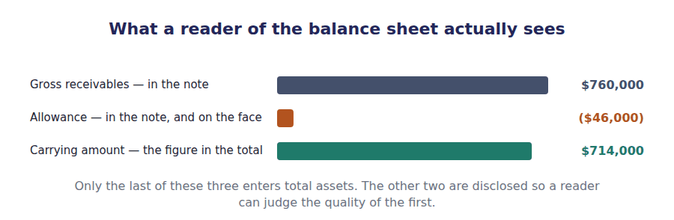
Watch out! A write-off is not an expense. If a question tells you a company wrote off $31,000 and asks for the effect on net income, the answer is none — unless the allowance was inadequate and had to be topped up.
Part 5 · Exam pitch the questions as the CMA sets them
1. [Level B] A company writes off a $12,000 customer balance against an adequate allowance. The effect on net income is:
(A) A decrease of $12,000
(B) An increase of $12,000
(C) No effect
(D) A decrease of $12,000 only if the customer is a related party
2. [Level C] An aging schedule indicates a required allowance of $46,000. The allowance before adjustment stands at $11,000 credit. The charge for credit losses for the year is:
(A) $46,000
(B) $35,000
(C) $81,000
(D) $31,000
3. [Level A] The allowance for credit losses is best described as:
(A) A liability for amounts owed to customers
(B) A contra asset deducted from gross accounts receivable
(C) A reserve of cash set aside to absorb losses
(D) An expense of the current period
4. [Level B] A customer whose balance was written off last year unexpectedly pays $4,000. The correct treatment is to:
(A) Credit $4,000 to other income
(B) Reinstate the receivable by crediting the allowance, then record the cash collection
(C) Credit $4,000 directly to the charge for credit losses
(D) Make no entry, because the balance no longer exists
5. [Level B] Why is the direct write-off method unacceptable for financial reporting?
(A) It is more difficult to apply than the allowance method
(B) It recognises the cost in a later period than the sales that caused it, and leaves receivables overstated in the meantime
(C) It overstates the charge for credit losses
(D) It is acceptable, but only for small companies
6. [Level A] Northwind’s aging schedule shows $40,000 in the oldest bucket at a 50% loss rate. The contribution of that bucket to the allowance is:
(A) $40,000
(B) $20,000
(C) $80,000
(D) $46,000
7. [Level C] A company suffers unusually heavy write-offs during the year but its aging schedule produces the same required allowance as last year. Compared with last year, the charge for credit losses will be:
(A) Unchanged, because the required allowance is unchanged
(B) Higher, because the allowance has to be rebuilt after the write-offs
(C) Lower, because the bad accounts have been removed
(D) Zero, because the write-offs absorbed the allowance
ADAPTIVE TIP Draw the allowance as a four-line roll-forward every single time: opening, charge, write-offs, recoveries, closing. The question will give you four of the five, and the one it withholds is the answer.

Handout 3 · Selling the Receivable: With Recourse and Without
A company short of cash can sell what customers owe it. Whether the receivable leaves the balance sheet turns on who still carries the risk.
Volume 3 · Receivables and Credit Losses · R2 throughout, closing at R3
LANGUAGE FOCUS
Register you are working in | R2 textbook English, rising to R3 for the final comparison, which is written the way an exam sets it.
Say it exactly like this | factor a receivable · sell on a without-recourse basis · retain the credit risk · derecognise a financial asset · account for a transfer as a secured borrowing · withhold a retainer against returns
Words that are not the same | with recourse / without recourse · sale / secured borrowing · derecognise / retain · fee / interest
Remember | Receiving cash from a factor does not by itself mean the receivable has been sold. The accounting depends on who still bears the risk. With recourse does not automatically mean it is a borrowing. It can still be a sale if the transferor has genuinely given up control.

What you will be able to do when this handout is finished
- Say what factoring is and why a company does it.
- Distinguish a transfer with recourse from one without recourse.
- Record a without-recourse sale and compute the loss.
- Record a with-recourse transfer under both outcomes of the sale test.
- Explain what a failed sale test does to the balance sheet, and to every ratio built on it.

Cash now, at a price
Northwind collects most of its invoices within sixty days, but it does not always want to wait. In November it agreed to sell $300,000 of receivables to a finance company.
The factor charges a fee of $9,000, which is 3% of the amount sold, and holds back a further $15,000 until the receivables have been collected. Northwind receives $276,000 in cash immediately.
Those figures are the same under every version of this arrangement. What changes, and changes completely, is whether the $300,000 of receivables leaves Northwind’s balance sheet at all.

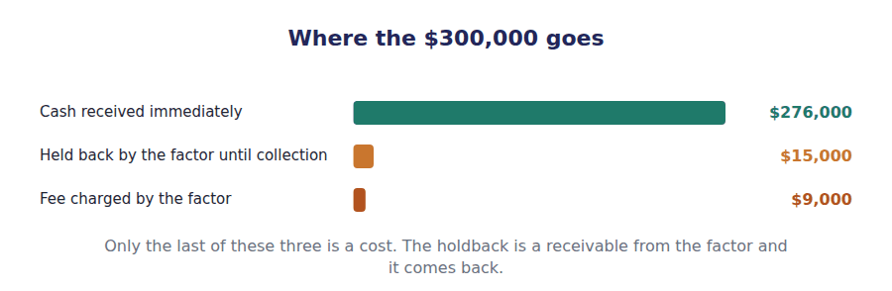
Part 1 · Why sell a receivable at all? and what the fee buys
Exercise 3A Read and complete. Write one word in each space.
OBJECTIVE | Say what factoring is, what the fee pays for, and what the holdback is.
YOU WILL NEED | Handout 1, for how receivables arise. · Handout 2, for who normally bears the loss when a customer fails.
HOW TO START | • Blank 1 is what the company is really buying when it sells a receivable at a discount.  • Blank 3 is the one item in the arrangement that is not a cost at all.  • The last blank is the thing that decides the entire accounting treatment, and it is not the cash.

WORD BANK
cash · fee · holdback · interest · risk · time
Not every word is used.

R2 A receivable is a right to cash at a future date. Selling it converts that right into cash today, and the fee is what the company pays for ¹ . It is a financing decision, taken for the same reasons a company borrows.
Northwind sold $300,000 and paid a fee of $9,000. That fee is a cost and it is charged to income. The ² of $15,000 is different: the factor keeps it until the receivables have been collected, and it then comes back, so it is recorded as a receivable from the factor rather than as a loss.
What decides the accounting is none of these figures. It is the question of who is left carrying the ³ that a customer does not pay — and that is settled by one clause in the agreement.
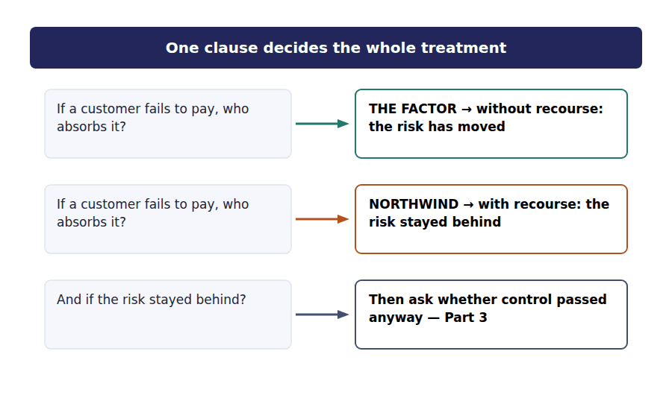
Part 2 · Without recourse the clean case
R2 Where the sale is without recourse, the factor absorbs any loss from a customer who fails to pay. The credit risk has genuinely moved, Northwind has no further involvement, and the transfer is a sale in substance as well as in name.
R2 The receivables are therefore removed from the balance sheet in full. Cash and the holdback come in, the receivables go out, and the difference is a loss on sale. Nothing is left behind and no liability is created.
Exercise 3B Complete the journal entry. Four accounts move.
OBJECTIVE | Record a without-recourse sale and compute the loss.
YOU WILL NEED | Exercise 3A, and the two paragraphs above.
HOW TO START | • Two debits and two credits. The cash and the holdback both come in.  • The receivables go out at their full $300,000, because all of them have been sold.  • The loss is whatever makes the entry balance, and you should be able to say what it is before you compute it.

J1 $300,000 of receivables sold without recourse. Fee $9,000, holdback $15,000. The receivables leave the balance sheet in full.
Account | Debit | Credit
Cash
Due from Factor
Loss on Sale of Receivables
Accounts Receivable

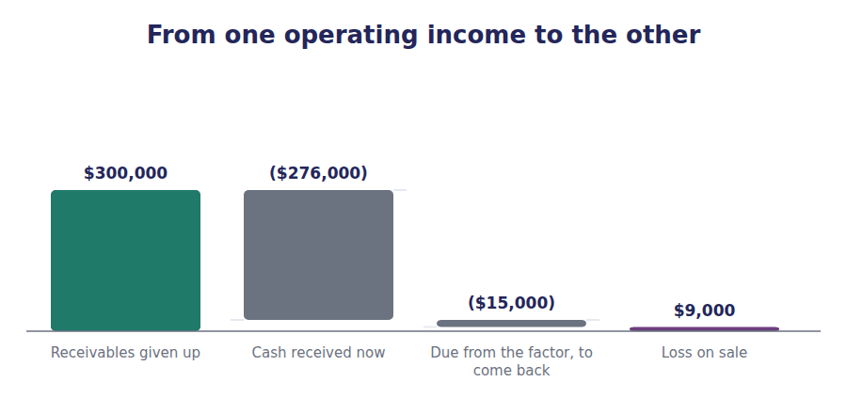
Part 3 · With recourse two possible answers, not one
Exercise 3C Read and complete.
OBJECTIVE | Decide whether a with-recourse transfer is a sale or a borrowing.
YOU WILL NEED | Exercise 3B
HOW TO START | • Blank 1 is what Northwind has promised to do if a customer fails.  • Blank 3 names the three conditions that still allow a sale even though the risk stayed behind.  • The last blank is what the transfer becomes if those conditions are not met.

WORD BANK
borrowing · control · good · recourse · revenue · risk · sale
Not every word is used.

R2 With recourse, Northwind must make ⁴ any receivable the customer fails to pay. The credit risk has not moved, and the obvious conclusion would be that nothing has really been sold.
That conclusion is not automatic. A transfer with recourse is still accounted for as a sale if three things hold: the receivables are isolated beyond the reach of Northwind and its creditors, the factor can pledge or sell them freely, and Northwind keeps no effective ⁵ through an agreement to repurchase them.
Where all three hold, the receivables are derecognised exactly as in Part 2, with one addition: Northwind records a ⁶ obligation of $8,000 for what it expects to have to make good, and the loss on sale rises to $17,000.
Where they do not hold, nothing is sold at all. The transfer is accounted for as a secured ⁷ : the receivables stay on the balance sheet, a liability of $291,000 appears beside them, and the fee is treated as interest over the period rather than as a loss today.
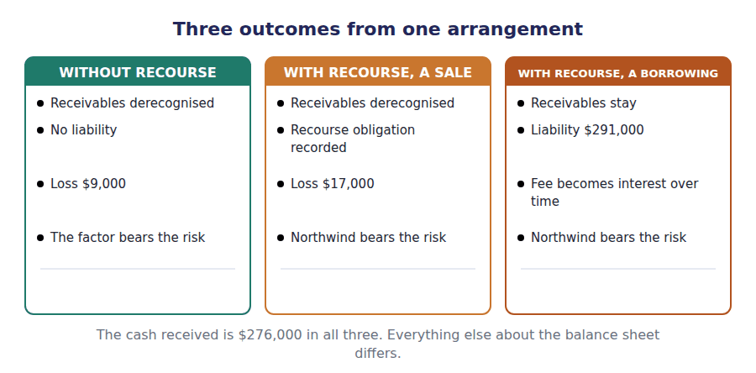
Part 4 · The three side by side and what each does to the balance sheet
Exercise 3D Complete the table. Work down one column at a time.
OBJECTIVE | Compare the three treatments and say what each does to the balance sheet.
YOU WILL NEED | Exercises 3B and 3C
HOW TO START | • The cash row is the same in all three columns. Fill it first and it will stop you confusing the columns.  • Two columns remove the receivables. One does not.  • The last row is the question that produced all the others.

 | Without recourse | With recourse, qualifying as a sale | With recourse, failing the sale test
Receivables removed from the balance sheet?
Cash received now | $276,000 | $276,000 | $276,000
A liability recorded?
Charged to income now
Who bears the credit risk?

1 | 2 | 3 | 4 | 5 | 6
7 | 8 | 9 | 10 | 11 | 12

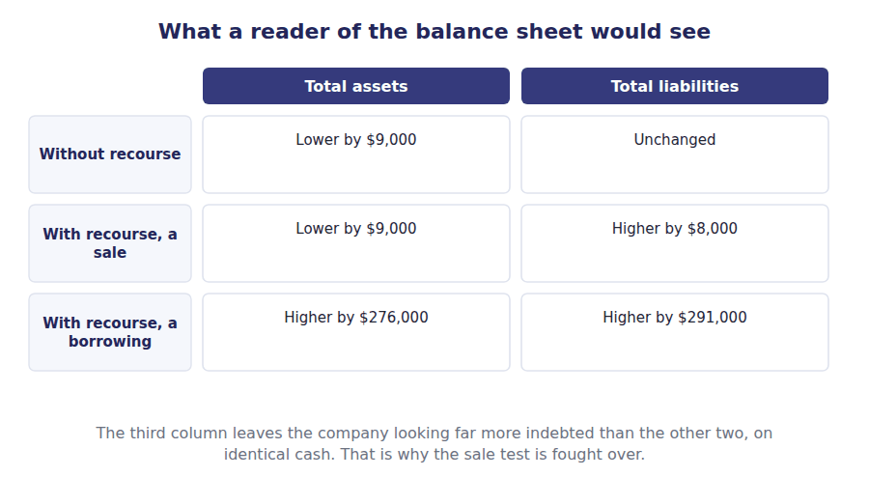
Exercise 3E Read and complete. This passage is written at exam pitch.
OBJECTIVE | Say why the sale test matters to a reader, beyond the accounting.
YOU WILL NEED | Exercise 3D
HOW TO START | • Blank 1 is the ratio most affected by whether a liability appears.  • Blank 3 is what a company gains by arranging a transfer to qualify as a sale.  • The last blank is the reason a reader should look for the note rather than trusting the face of the statement.

WORD BANK
$300,000 · borrowing · margin · notes · ratio · sale · sides
Not every word is used.

R3 The cash is $276,000 in every version. What differs is what the balance sheet says about it, and the difference runs straight into the debt to equity ⁸ : the borrowing treatment adds $291,000 of liabilities that the sale treatment does not.
It also changes total assets. Under the borrowing, the receivables stay and the cash arrives beside them, so the balance sheet grows on both ⁹ . Under either sale treatment it does not.
A company with debt covenants has an evident interest in the transfer qualifying as a ¹⁰ , and the three conditions in Part 3 exist precisely because that interest exists.
None of this is hidden. The treatment and the terms are set out in the ¹¹ , which is where a reader who wants to compare two companies on the same basis has to look.
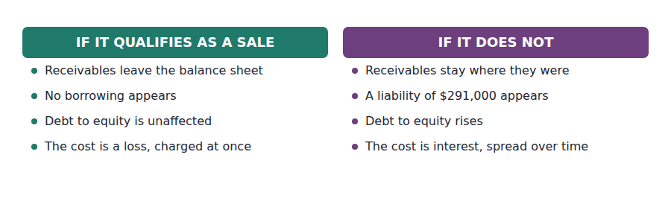
Watch out! With recourse does not automatically mean a borrowing. Read the stem for the three conditions: isolation, the factor’s freedom to pledge or sell, and no repurchase agreement. If the question is silent on all three, it is usually testing whether you know they exist.
Part 5 · Exam pitch the questions as the CMA sets them
1. [Level B] A company sells $300,000 of receivables without recourse. The factor charges a 3% fee and holds back 5% pending collection. Cash received immediately is:
(A) $300,000
(B) $276,000
(C) $291,000
(D) $285,000
2. [Level B] In a without-recourse sale of receivables, the holdback retained by the factor is recorded by the seller as:
(A) Part of the loss on sale
(B) A receivable from the factor
(C) A reduction of the allowance for credit losses
(D) A contingent liability
3. [Level C] A transfer of receivables with recourse fails the conditions for sale accounting. The transferor should:
(A) Remove the receivables and record a loss
(B) Keep the receivables on the balance sheet and record a liability for the proceeds
(C) Remove the receivables and record a recourse obligation
(D) Disclose the arrangement in the notes but make no entry
4. [Level C] Which of the following is NOT one of the conditions for a transfer of receivables to be accounted for as a sale?
(A) The transferred assets are isolated from the transferor and its creditors
(B) The transferee may pledge or exchange the assets
(C) The transferor does not maintain effective control through a repurchase agreement
(D) The transfer is made without recourse
5. [Level B] A company factors receivables with recourse in an arrangement that qualifies as a sale. Compared with an identical without-recourse sale, the loss recognised will be:
(A) The same
(B) Higher, by the estimated recourse obligation
(C) Lower, by the estimated recourse obligation
(D) Nil, because the risk has been retained
6. [Level C] Treating a transfer of receivables as a secured borrowing rather than a sale will:
(A) Reduce total assets and total liabilities
(B) Increase both total assets and total liabilities
(C) Leave the balance sheet unchanged
(D) Increase net income in the year of transfer
7. [Level A] The principal reason a company factors its receivables is to:
(A) Avoid recognising credit losses
(B) Obtain cash earlier than the receivables would otherwise be collected
(C) Increase reported revenue
(D) Reduce the allowance for credit losses
ADAPTIVE TIP Read the recourse clause first and the three conditions second. The cash figure is the same in every version of these questions, so it tells you nothing; the balance sheet is where the answer differs.

Answer Key
Volume 3 · Handouts 1 to 3
Every answer carries the reason for it and the mistake it defeats.

Handout 1 · Receivables: When to Recognise, and at What Amount answers
Completed text and exercises
# | Answer | Why | The trap it defeats
1 | order | A promise to buy is not performance.
2 | invoice | Paperwork, and its timing is largely the seller’s choice.
3 | unconditional | Only time stands in the way.
4 | receivable | Unconditional right: a receivable. | Students date receivables from the invoice, which puts year-end sales in the wrong period whenever invoicing lags despatch.
5 | interest | A stated rate is the hallmark of a note.
6 | revenue | Face value would overstate both sides.
7 | year | One year or less: no discounting needed. | Students discount every receivable in sight. For trade receivables the expedient almost always applies.
8 | interest | A stated rate is the hallmark of a note.
9 | $760,000 | From Volume 1’s balance sheet.
10 | 2 | Uncollectible amounts are the next handout.

Exam-pitch questions
# | Answer | Why | The trap it defeats
1 | (B) 28 December, when the obligation to pay became unconditional | Performance creates the receivable; invoicing is administration whose timing the seller largely controls. (A) is the most common error and it moves year-end sales into the wrong period. (C) is cash accounting and (D) predates any performance. | Level B
2 | (B) $200,000, with no entry for the discount | A trade discount simply arrives at the agreed price; there is no account for it and nothing to disclose. (A) and (D) invent a discount account. (C) treats a pricing decision as though it were an accounting event. | Level A
3 | (B) $98,000 | The net method records the amount expected after the discount, which is $100,000 less 2%. (A) is the gross method. (C) adds the discount. (D) confuses a 2% cash discount with a 20% trade discount. | Level B
4 | (B) Recorded as a sales discount, reducing revenue | Under the gross method the discount is recorded when taken, as a reduction of revenue. (A) misclassifies a price concession as financing. (C) confuses a discount taken with an amount that will never arrive — two different things entirely. | Level B
5 | (B) Face value, because the practical expedient applies to periods of one year or less | The practical expedient removes the discounting question for periods of a year or less, which covers nearly every trade receivable. (A) and (C) do work the standard excuses you from. (D) presumes a market that does not exist for trade receivables. | Level B
6 | (B) A note is supported by a formal written promise and normally bears a stated interest rate | The written instrument and the stated rate are the distinguishing features. (A) is a common misconception — a note is a different instrument, not a late invoice. (D) is false: notes can be short-term. | Level A
7 | (B) Credit sales exceeding collections plus amounts removed as uncollectible | Gross receivables rise when what is added exceeds what is taken away. (A) affects the estimate, which is a contra account and does not touch the gross figure at all. (C) and (D) both reduce gross receivables. | Level C

Exercise 1B · the completed entry
J1 List price $250,000 less a 20% trade discount.
Account | Debit | Credit
Accounts Receivable | $200,000
Sales Revenue |  | $200,000

Exercise 1C · the completed table
Invoice | Terms | If paid within the discount period | If paid after it
$100,000, terms 2/10 net 30 | Gross method | Recorded at $100,000; a $2,000 sales discount is recorded when taken | Recorded at $100,000; the full amount is collected
$100,000, terms 2/10 net 30 | Net method | Recorded at $98,000; nothing further is recorded | Recorded at $98,000; the extra $2,000 collected is other income

Handout 2 · The Allowance for Credit Losses answers
Completed text and exercises
# | Answer | Why | The trap it defeats
1 | fail | Known in aggregate, unknown individually.
2 | matching | The sales caused the loss, so they share its year.
3 | direct | Waiting for the event is the method that is not allowed.
4 | overstated | Carrying an asset at an amount nobody expects to collect. | Students see the direct method as merely simpler. It is wrong in two places at once: the year of the charge and the carrying amount.
5 | $35,000 | $46,000 − $38,000 + $31,000 − $4,000.
6 | be | The required balance drives the charge. | Students compute a charge from a percentage of sales and then treat the allowance as whatever results, which is the reasoning reversed.
7 | consume | The write-offs use the allowance up; they do not create the charge.
8 | balance | Restore the required balance, no more.
Grid 1 | 1 TRUE 2 FALSE 3 TRUE 4 FALSE 5 TRUE 6 TRUE | The two false ones are the two things students most often believe: that it holds money, and that it is owed to somebody.

Exam-pitch questions
# | Answer | Why | The trap it defeats
1 | (C) No effect | Gross receivables and the allowance fall by the same amount, so the carrying amount and net income are both untouched. The expense was charged when the allowance was raised. (A) is the intuitive answer and the wrong one. | Level B
2 | (B) $35,000 | The charge is the amount needed to bring the allowance to the required balance: $46,000 − $11,000 = $35,000. (A) is the required balance itself, which is the most frequently chosen wrong answer because it is the figure the schedule produces. | Level C
3 | (B) A contra asset deducted from gross accounts receivable | It is a contra asset. (A) reverses the direction of the obligation. (C) is the persistent myth — no cash is set aside anywhere. (D) confuses the allowance with the charge that creates it. | Level A
4 | (B) Reinstate the receivable by crediting the allowance, then record the cash collection | The recovery is recorded in two steps: undo the write-off, then record the cash. This restores the allowance rather than crediting income. (A) and (C) both route the amount through income, which double-counts the original charge. | Level B
5 | (B) It recognises the cost in a later period than the sales that caused it, and leaves receivables overstated in the meantime | Two faults, not one: the wrong period for the expense, and an asset carried at an amount nobody expects to collect. (A) is false — it is simpler. (D) describes a tax rule, not a reporting one. | Level B
6 | (B) $20,000 | $40,000 × 50% = $20,000. (A) writes off the whole bucket, which the rate does not say. (D) is the total allowance across all four buckets. | Level A
7 | (B) Higher, because the allowance has to be rebuilt after the write-offs | The write-offs consume the allowance, so a larger charge is needed to restore it to the required balance. (A) confuses the closing balance with the movement, which is exactly what the roll-forward in Part 4 separates. | Level C

Exercise 2B · the completed aging schedule
Age of the balance | Amount | Loss rate | Required allowance
Not yet due | $425,000 | 1% | $4,250
1 to 30 days past due | $225,000 | 5% | $11,250
31 to 90 days past due | $70,000 | 15% | $10,500
More than 90 days past due | $40,000 | 50% | $20,000
Total | $760,000 |  | $46,000

Exercise 2C · the completed entries
J1 A balance judged uncollectible is written off.
Account | Debit | Credit
Allowance for Credit Losses | $31,000
Accounts Receivable |  | $31,000
J2 A written-off balance is reinstated on recovery.
Account | Debit | Credit
Accounts Receivable | $4,000
Allowance for Credit Losses |  | $4,000
J3 The cash is then collected in the ordinary way.
Account | Debit | Credit
Cash | $4,000
Accounts Receivable |  | $4,000

Exercise 2D · the completed roll-forward
Movement in the allowance during 20X4 | Amount
Allowance at 1 January 20X4 | $38,000
Charge for credit losses for the year | $35,000
Less balances written off | ($31,000)
Add recoveries of amounts previously written off | $4,000
Allowance at 31 December 20X4 | $46,000

Handout 3 · Selling the Receivable: With Recourse and Without answers
Completed text and exercises
# | Answer | Why | The trap it defeats
1 | time | Cash now instead of cash later, and the fee is the price.
2 | holdback | Kept back, then returned: an asset, not a cost. | Students treat the holdback as part of the loss, which overstates the charge by the whole retained amount.
3 | risk | Credit risk decides everything that follows.
4 | good | The seller stands behind the receivables.
5 | control | Three conditions, and control is the last of them.
6 | recourse | An extra liability for what will have to be made good.
7 | borrowing | Nothing leaves; a liability arrives. | Students assume with recourse always means a borrowing. It can still be a sale, and the three conditions decide.
8 | ratio | Debt to equity moves on a decision about one clause.
9 | sides | Assets and liabilities both grow.
10 | sale | Covenants give the company a stake in the answer. | Students treat the sale test as a technicality. It is the difference between a clean balance sheet and a geared one.
11 | notes | The face of the statement does not say; the notes do.

Exam-pitch questions
# | Answer | Why | The trap it defeats
1 | (B) $276,000 | $300,000 less the $9,000 fee and the $15,000 holdback leaves $276,000. (C) forgets the holdback and (D) forgets the fee — both are deducted now, although only one of them is a cost. | Level B
2 | (B) A receivable from the factor | The holdback comes back once collections are settled, so it is an asset. (A) is the common error and it overstates the loss by the whole retained amount. (D) reverses the direction: the factor owes Northwind. | Level B
3 | (B) Keep the receivables on the balance sheet and record a liability for the proceeds | A failed sale test makes the transfer a secured borrowing: nothing leaves, and a liability appears. (C) describes the treatment when the test is passed. (D) ignores cash that has actually been received. | Level C
4 | (D) The transfer is made without recourse | Recourse is not itself disqualifying — a with-recourse transfer can still be a sale if the three control conditions hold. This is the single most common misconception in the topic, and the exam sets it directly. | Level C
5 | (B) Higher, by the estimated recourse obligation | The recourse obligation is an additional cost recognised at the time of the transfer, so the loss rises from $9,000 to $17,000. (C) reverses the direction. (D) confuses retaining risk with retaining the asset. | Level B
6 | (B) Increase both total assets and total liabilities | The receivables stay and the cash arrives beside them, so both sides grow. (D) is backwards in a subtle way: no loss is recognised today, but interest is charged over time, so income is higher now and lower later rather than higher overall. | Level C
7 | (B) Obtain cash earlier than the receivables would otherwise be collected | Factoring is a financing decision: cash now rather than cash later, and the fee is the price of the difference. (A) is wrong under a with-recourse arrangement and irrelevant under a without-recourse one. (C) is false — the sale has already been recognised. | Level A

Exercise 3B · the completed entry
J1 $300,000 of receivables sold without recourse.
Account | Debit | Credit
Cash | $276,000
Due from Factor | $15,000
Loss on Sale of Receivables | $9,000
Accounts Receivable |  | $300,000

Exercise 3D · the completed comparison
 | Without recourse | With recourse, qualifying as a sale | With recourse, failing the sale test
Receivables removed from the balance sheet? | Yes — all $300,000 | Yes — all $300,000 | No — they stay
Cash received now | $276,000 | $276,000 | $276,000
A liability recorded? | No | Yes — the recourse obligation, $8,000 | Yes — a borrowing of $291,000
Charged to income now | $9,000 | $17,000 | Nothing — the fee is interest
Who bears the credit risk? | The factor | Northwind | Northwind

- The cash received is $276,000 under all three treatments.
- Two of the three remove the receivables; one leaves them where they were and adds a liability of $291,000.
- With recourse does not decide the answer. The three control conditions do.

Glossary
Every term in Volume 3, with the Arabic equivalent and the places it misleads
The third column is for recognition only. In the exam room you work in English.

Term | What it means in CMA English | بالعربية | Careful
aging schedule | An analysis of receivables by how long each balance has been outstanding. | جدول أعمار الذمم | The commonest basis for the estimate, because the chance of collection falls sharply with age.
allowance for credit losses | A contra account holding the amount of receivables not expected to be collected. | مخصص خسائر الائتمان | A contra asset, not a liability and not a fund. The older name is allowance for doubtful accounts.
cash discount | A reduction offered for paying early, such as 2% for payment within ten days. | خصم نقدي | This one is recorded, because whether the customer takes it is unknown when the sale is made.
derecognise | To remove an asset from the balance sheet. | إلغاء الاعتراف | The question in this handout. Everything else follows from whether derecognition is permitted.
direct write-off method | Charging a loss only when a specific balance fails. | طريقة الشطب المباشر | Not acceptable for financial reporting: it recognises the cost in the wrong period and leaves receivables overstated in the meantime.
expected credit loss | The estimate of amounts that will not be collected, made before any particular account has failed. | خسارة ائتمانية متوقعة | Forward-looking by design. The company does not wait for a customer to default before recognising the cost of lending to them.
factoring | Selling receivables to a finance company for cash before they fall due. | بيع الذمم المدينة | A financing decision rather than a trading one. The company is buying time, and paying for it.
gross method | Recording the sale at the full invoice amount and the discount only if it is taken. | الطريقة الإجمالية | Simpler, and it overstates revenue slightly where discounts are usually taken.
holdback | An amount the factor keeps back until the receivables are collected. | المبلغ المحتجز | A receivable from the factor, not a loss. It comes back once the collections are settled.
net method | Recording the sale at the amount expected after the discount. | الطريقة الصافية | Conceptually better and closer to how variable consideration is handled in Volume 2.
note receivable | A receivable supported by a formal written promise, usually bearing interest. | أوراق القبض | A note is a different instrument, not merely an overdue invoice. It usually carries a stated rate and a maturity date.
recovery | Cash received on a balance that had previously been written off. | تحصيل مبلغ مشطوب | The write-off is reinstated first, then the cash is recorded, so the allowance is restored rather than income being credited.
secured borrowing | A transfer accounted for as a loan, with the receivables pledged as security. | اقتراض مضمون | What a transfer becomes when it fails the sale test. The receivables stay and a liability appears beside them.
trade discount | A reduction off a list price, given to arrive at the actual price. | خصم تجاري | Never recorded anywhere. The sale is simply recorded at the net figure, and the list price is of no accounting interest.
trade receivable | An amount owed by a customer for goods or services already supplied. | الذمم المدينة التجارية | Also called an account receivable. It arises from trading, which is what separates it from a loan the company has made.
with recourse | The seller must make good any receivable the customer fails to pay. | مع حق الرجوع | The credit risk stays behind. Whether the transfer is still a sale depends on the control tests.
without recourse | The buyer of the receivables absorbs any loss if a customer fails to pay. | بدون حق الرجوع | The credit risk has genuinely moved, so the receivables come off the balance sheet.
write-off | Removing a specific balance judged uncollectible from the ledger. | شطب | It reduces gross receivables and the allowance by the same amount, so the carrying amount and net income are both untouched.

