

CMA Part 1 · Volume 6
Investments in Debt and Equity
Three handouts, one answer key. Classification first, because every measurement question in this volume follows from it.
These handouts are not notes to read. You write them. The words you supply are the summary, so a finished handout is a page you can revise from, in your own handwriting.
Work in pen. Do not look at the key until the whole handout is done — the key is written to explain the mistake, and you only get that benefit if you have made it first.
The three handouts
# | Handout | What it gives you
1 | Trading, Available-for-Sale, Held-to-Maturity | Three classifications, decided by what the company intends to do with the security. Everything else in this volume follows from that one choice.
2 | Valuing Debt Securities | Three holdings, one portfolio, and a gain of $32,000 that appears in three different places depending on a word chosen when they were bought.
3 | Valuing Equity Securities | How much of a company you own decides how you account for it, and the three answers have almost nothing in common.

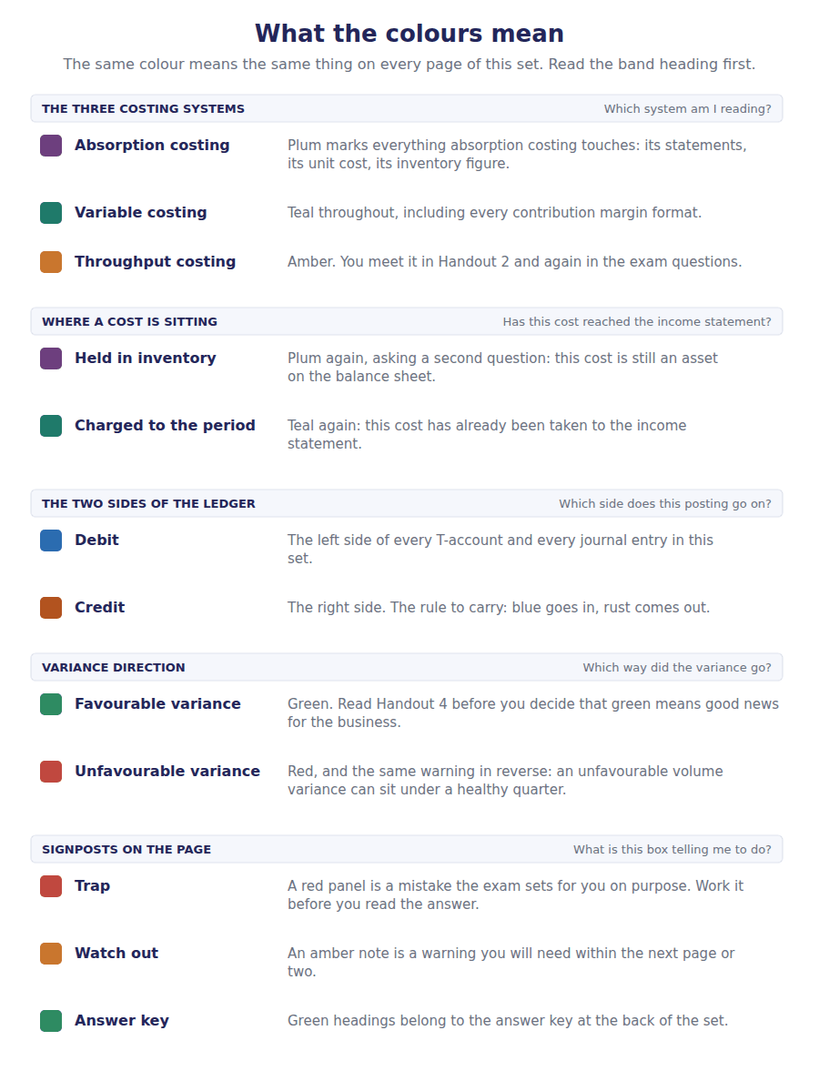
How to read the markers
Marker | Meaning
R1 | Teaching English. Short sentences. This is where a new idea arrives.
R2 | Textbook English. Longer sentences and passive verbs, as a textbook writes them.
R3 | Exam English. Exactly how the CMA exam phrases it, traps included.
Numbered rule | A space you fill in. The number matches the answer key.
Red table | A trap. Read it twice.

Handout 1 · Trading, Available-for-Sale, Held-to-Maturity
Three classifications, decided by what the company intends to do with the security. Everything else in this volume follows from that one choice.
Volume 6 · Investments in Debt and Equity · R1 moving to R2
LANGUAGE FOCUS
Register you are working in | R1 while the three classes are introduced, R2 once the consequences are drawn out.
Say it exactly like this | classify a debt security on acquisition · intend to hold to maturity · carry an investment at fair value · recognise an unrealised gain · take a gain to other comprehensive income · reclassify between categories
Words that are not the same | trading / available for sale · realised / unrealised · fair value / amortised cost · intention / ability
Remember | Held to maturity is not about what a company might do. It requires both the positive intention and the ability to hold. Available for sale is not a decision. It is what a debt security is when it is neither of the other two.

What you will be able to do when this handout is finished
- Name the three classifications of a debt security and the intention behind each.
- Say what each classification is carried at.
- Say where unrealised gains and losses go under each.
- State the two conditions for held-to-maturity classification.
- Explain why equity securities are outside this scheme entirely.

The $390,000 nobody has sold
Northwind’s balance sheet reports investments in debt securities of $390,000. The company paid $358,000 for them.
The difference of $32,000 is a gain on securities the company still owns. No transaction has confirmed it, and Northwind may yet sell them for less.
In Volume 1 that $32,000 appeared in other comprehensive income rather than in net income, and the statement of changes in equity carried it to a separate column. This volume explains why it went there and not somewhere else.
The answer is a single word on the day the securities were bought: their classification.

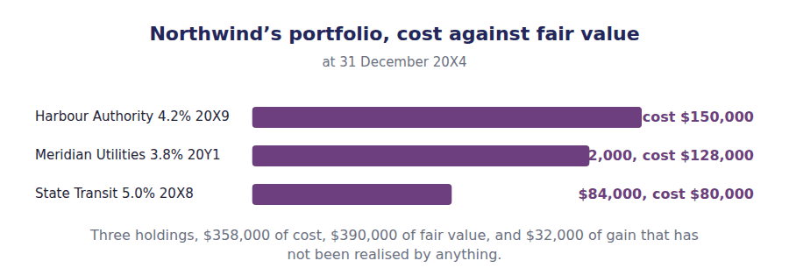
Part 1 · Three intentions and the classification each one produces
Exercise 1A Read and complete. Write one word in each space.
OBJECTIVE | Name the three classifications and the intention behind each.
YOU WILL NEED | Nothing — this is the first exercise in the volume.
HOW TO START | • Each paragraph describes one intention. The blank names the class it produces.  • Blank 3 is the one that requires two things rather than one.  • The last blank is the category a security falls into when neither of the other two applies.

WORD BANK
ability · available · current · equity · held-to-maturity · trading · willingness
Not every word is used.

R1 A debt security is classified on the day it is bought, and the classification depends on what the company means to do with it.
A company that buys a bond meaning to sell it again within weeks is holding a ¹ security. It is carried at fair value, and every movement in that value goes straight to net income, because the company intends to turn it into cash soon.
A company that buys a bond meaning to keep it until the issuer repays it is holding a ² security. That classification requires two things: the positive intention to hold, and the ³ to do so. A company that might need to sell the bond to pay its own bills does not qualify.
Everything else is ⁴ for sale. It is not really a decision at all — it is what a debt security is when it is neither of the other two, and Northwind’s portfolio is in that position.
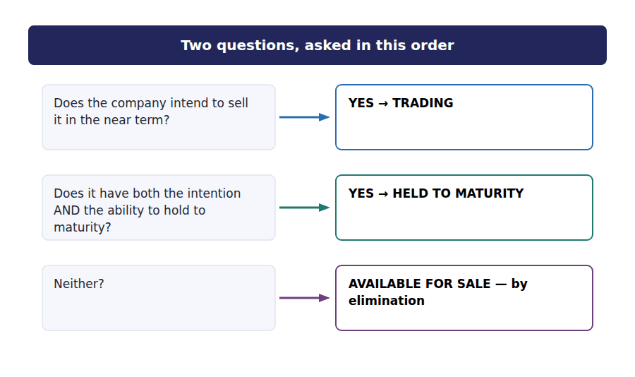
R2 The three names are worth saying in full once, because the exam uses them in full. A trading security is one held for near-term sale; a held-to-maturity security is one the company both intends and is able to keep until the issuer repays it; and an available-for-sale security is any debt security that is neither of those.
Part 2 · What follows from the classification measurement, and where the gains go
R2 The classification is made once and decides three separate things: what the security is carried at, where any unrealised movement is reported, and how the balance sheet classifies it. None of those is a separate choice.
R2 The logic behind the differences is worth seeing. A security the company means to sell soon is carried at what it would fetch, and the movement runs through income because it is nearly realised. A security held to maturity will be repaid at its face amount whatever happens to its price, so its price is irrelevant and is not recognised at all.
Exercise 1B Complete the table. Each column follows from one intention.
OBJECTIVE | Complete the grid of consequences for all three classifications.
YOU WILL NEED | Exercise 1A, and the two paragraphs above.
HOW TO START | • Two of the three columns are carried at fair value and one is not.  • The third row is where the three classes really separate, and it is the row the exam tests.  • The last row is the same for all three columns, and Part 4 explains why.

 | Trading | Available for sale | Held to maturity
The intention
Carried at
Unrealised gains and losses go to
Interest income
Normally classified as
Available for equity securities?

1 | 2 | 3 | 4 | 5 | 6
7 | 8 | 9 | 10 | 11 | 12
13 | 14 | 15 | 16 | 17 | 18

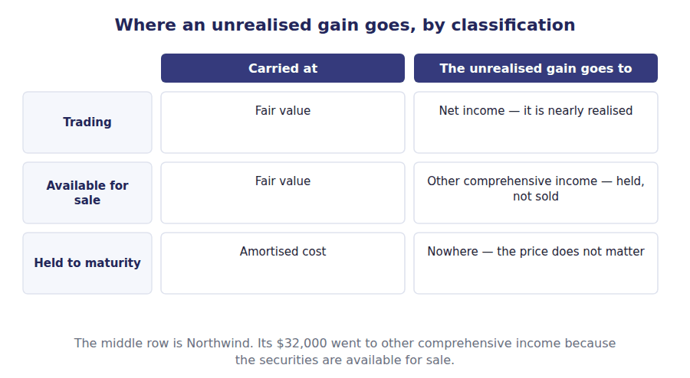
Part 3 · The same bond, three ways what the classification is worth
Exercise 1C Read and complete.
OBJECTIVE | Report the same security under all three classifications.
YOU WILL NEED | Exercise 1B
HOW TO START | • Use a bond bought for $100,000 that is worth $108,000 at the year end.  • The amounts are the same in all three cases. Only the reporting differs.  • The last blank is the figure that appears nowhere at all under one of the three.

WORD BANK
comprehensive · everywhere · net · nowhere · operating · retained
Not every word is used.

R2 Take one bond bought for $100,000 and worth $108,000 at the year end, an unrealised gain of $8,000.
Classified as trading, the bond is carried at $108,000 and the $8,000 is reported in ⁵ income. Reported profit rises, although nothing has been sold.
Classified as available for sale, the bond is carried at the same $108,000, but the gain is reported in other ⁶ income and accumulates in its own equity column. Net income is untouched.
Classified as held to maturity, the bond stays at its amortised cost of $100,000. The gain appears ⁷ in the statements, and the fair value is merely disclosed in the notes, because the company will be repaid the face amount whatever the market does in the meantime.
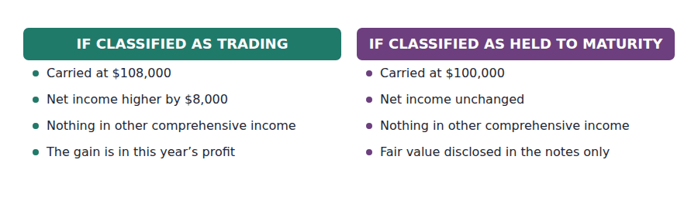
Part 4 · Why equity securities are not here a scheme for debt alone
Exercise 1D Read and complete.
OBJECTIVE | Say why equity securities are outside this classification scheme.
YOU WILL NEED | Exercise 1C
HOW TO START | • Blank 1 is the feature of a bond that an ordinary share does not have.  • Blank 3 is where almost every equity security’s fair value movement now goes.  • The last blank is the handout that deals with equity securities properly.

WORD BANK
2 · 3 · comprehensive · coupon · maturity · net · wrong
Not every word is used.

R2 Held to maturity is a meaningful idea only where there is a ⁸ to hold the security to. A bond is repaid on a fixed date; an ordinary share is never repaid at all.
Equity securities are therefore outside this three-way scheme completely. Under current US GAAP an equity security that does not give the holder significant influence is carried at fair value with every movement reported in ⁹ income — the same treatment as a trading debt security, and the only treatment available.
That is a change from the older rules, under which equity securities could also be classified as available for sale. A question written from an older text may still offer that option, and it is now ¹⁰ .
Where a holding is large enough to give significant influence, a different method applies again, and Handout ¹¹ of this volume covers both cases.
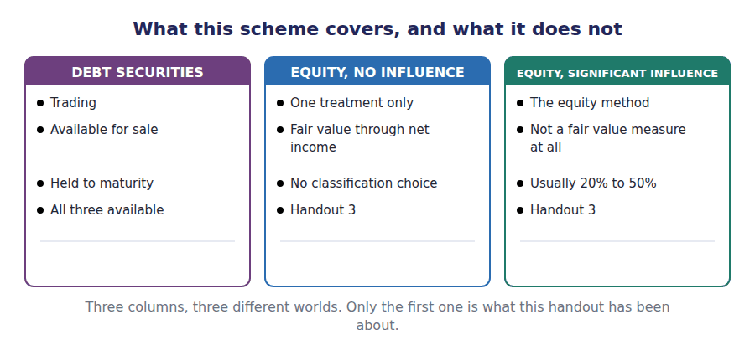
Part 5 · Exam pitch the questions as the CMA sets them
1. [Level A] A debt security classified as available for sale is reported on the balance sheet at:
(A) Amortised cost
(B) Fair value
(C) The lower of cost and fair value
(D) Original cost
2. [Level A] An unrealised gain on a debt security classified as trading is reported in:
(A) Other comprehensive income
(B) Net income
(C) Retained earnings directly
(D) The notes only
3. [Level B] To classify a debt security as held to maturity, a company must have:
(A) The intention to hold it to maturity
(B) Both the positive intention and the ability to hold it to maturity
(C) The ability to hold it to maturity
(D) A maturity date within one year
4. [Level B] A bond costing $110,000 is worth $118,000 at the year end. If it is classified as held to maturity, the carrying amount on the balance sheet is:
(A) $118,000
(B) $110,000
(C) $114,000
(D) $8,000
5. [Level B] Northwind’s debt securities cost $358,000 and are worth $390,000. The $32,000 unrealised gain is reported in other comprehensive income. This tells you the securities are classified as:
(A) Trading
(B) Available for sale
(C) Held to maturity
(D) Equity securities
6. [Level C] Under current US GAAP, an equity security that does not confer significant influence is measured at:
(A) Cost
(B) Fair value, with changes in net income
(C) Fair value, with changes in other comprehensive income
(D) The lower of cost and fair value
7. [Level A] Which classification is NOT available for a debt security?
(A) Trading
(B) Available for sale
(C) Held to maturity
(D) All three are available
ADAPTIVE TIP Every question in this volume starts with one word: the classification. Write it down before you read the numbers, because the numbers are usually the same under all three and only the reporting differs.

Handout 2 · Valuing Debt Securities
Three holdings, one portfolio, and a gain of $32,000 that appears in three different places depending on a word chosen when they were bought.
Volume 6 · Investments in Debt and Equity · R2 throughout, closing at R3
LANGUAGE FOCUS
Register you are working in | R2 textbook English, rising to R3 for the final passage, which ties the portfolio back to Volume 1.
Say it exactly like this | mark a security to fair value · recognise an unrealised holding gain · amortise a premium over the remaining life · present a security net of tax · reclassify an amount out of equity · realise a gain on sale
Words that are not the same | unrealised / realised · carrying amount / fair value · premium / discount · recognised / disclosed
Remember | An unrealised gain is not cash and it is not certain. The company still holds the security and may yet sell it for less. Amortising a premium is not the same as marking to fair value. One follows the contract, the other follows the market.

What you will be able to do when this handout is finished
- Value a portfolio at fair value and compute the unrealised movement.
- Record the adjustment under each of the three classifications.
- Say what a premium or a discount is and how it is treated under held-to-maturity.
- Present the movement net of tax and tie it to accumulated other comprehensive income.
- Say what happens when an available-for-sale security is finally sold.

Three bonds, and one number you have already met
Northwind holds three bonds. It paid $358,000 for them and they are worth $390,000 at the year end.
All three are classified as available for sale, so the whole portfolio is carried at fair value and the $32,000 of unrealised gain goes to other comprehensive income.
That is the $32,000 you first met in Volume 1, where it appeared net of tax as $24,000 and carried accumulated other comprehensive income from $52,000 to $76,000. This handout produces it.

Holding | Amortised cost | Fair value | Unrealised gain
Harbour Authority 4.2% 20X9 | $150,000 | $164,000 | $14,000
Meridian Utilities 3.8% 20Y1 | $128,000 | $142,000 | $14,000
State Transit 5.0% 20X8 | $80,000 | $84,000 | $4,000
Total portfolio | $358,000 | $390,000 | $32,000

Part 1 · Valuing the portfolio and what the adjustment looks like
Exercise 2A Complete the last column of the table above, then read the passage.
OBJECTIVE | Compute the unrealised movement on each holding and on the portfolio.
YOU WILL NEED | Handout 1, for the three classifications.
HOW TO START | • One subtraction per row. Fair value less amortised cost.  • The total column must equal the sum of the three rows above it.  • Compare your total with the figure in Volume 1’s statement of comprehensive income before you go on.

WORD BANK
$32,000 · $358,000 · 2 · 3 · investment · out · valuation
Not every word is used.

R2 Each holding is compared with what it is worth. The portfolio cost $358,000 and is worth $390,000, so the unrealised gain is ¹ .
The adjustment is normally recorded in a separate ² allowance alongside the investment account, rather than by altering the investment account itself. That keeps the original cost visible on the face of the records.
Keeping cost visible matters for a reason that only appears later. When the securities are eventually sold, the gain accumulated in equity has to be taken ³ again and reported in net income, and that cannot be done unless the two components are still separable.
The other side of the entry depends entirely on the classification, and that is Part ⁴ .
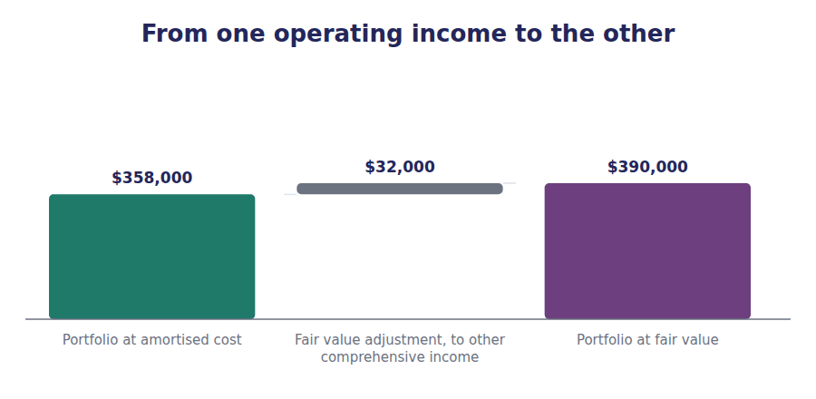
Part 2 · The same portfolio, three ways where the credit goes
Exercise 2B Complete the table. The amounts are the same; only the destinations differ.
OBJECTIVE | Report the same portfolio under all three classifications.
YOU WILL NEED | Exercise 2A
HOW TO START | • The first row has two identical entries and one different one.  • Rows two and three are the heart of it, and between them they always add to the same total.  • The last row is the point: two of the three columns have the same effect on equity by completely different routes.

 | If trading | If available for sale | If held to maturity
Balance sheet carrying amount
Effect on net income, before tax
Effect on other comprehensive income, before tax
Effect on total equity, before tax

1 | 2 | 3 | 4 | 5 | 6
7 | 8 | 9 | 10 | 11 | 12

J1 The portfolio marked to fair value, classified as available for sale. The credit goes to equity, not to income.
Account | Debit | Credit
Valuation Allowance — Securities
Unrealised Gain — Other Comprehensive Income
J2 The same adjustment, had the portfolio been classified as trading. The same debit, and a credit that reaches net income instead.
Account | Debit | Credit
Valuation Allowance — Securities
Unrealised Gain — Net Income

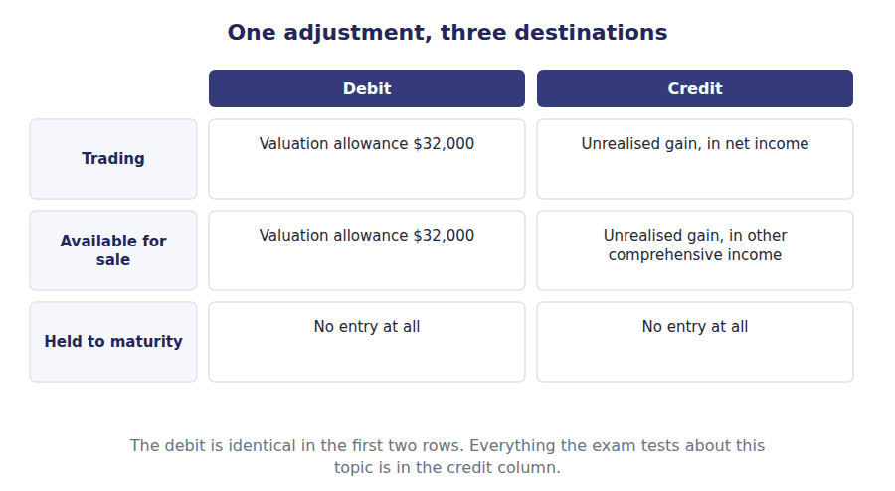
Part 3 · Premium, discount and amortised cost the held-to-maturity measure
R2 A held-to-maturity security is carried at amortised cost, and that phrase needs explaining because it does not mean cost.
R2 A bond paying a coupon above the market rate is worth more than its face amount, so a buyer pays a premium. That premium buys nothing permanent: at maturity the issuer repays only the face amount. So the premium is written off over the remaining life, and the carrying amount walks down to face value by the maturity date.
Exercise 2C Read and complete.
OBJECTIVE | Say what amortised cost is and how a premium or discount is treated.
YOU WILL NEED | Exercise 2B, and the two paragraphs above.
HOW TO START | • Blank 1 is what a buyer pays above face when the coupon is generous.  • Blank 3 is the amount the carrying value walks towards by the maturity date.  • The last blank is the thing amortised cost deliberately ignores.

WORD BANK
amortised · coupon · face · market · maturity · premium · reversed
Not every word is used.

R2 A bond with a coupon above the market rate sells above its face amount, and the excess paid is a ⁵ . A bond with a coupon below the market rate sells below face, and the shortfall is a discount.
Neither survives to maturity, because the issuer repays the face amount and nothing else. Both are therefore ⁶ over the remaining life of the bond, as an adjustment to interest income.
The carrying amount therefore moves every period, and by the maturity date it has arrived exactly at the bond’s ⁷ amount, whatever route it took to get there.
What amortised cost ignores entirely is the ⁸ price. A bond bought at par and now trading at 80 is still carried at par under this measure, because the company will hold it and be repaid in full.
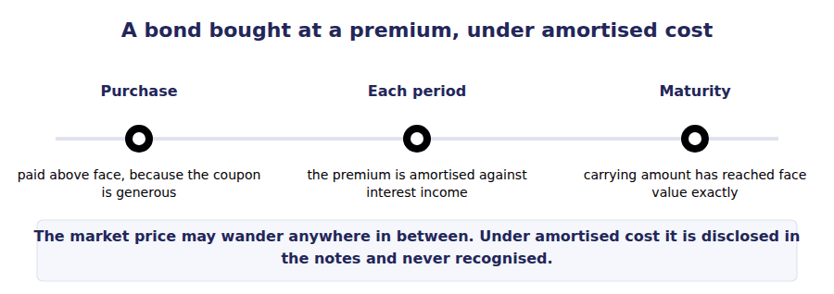
Part 4 · Net of tax, and tying back to Volume 1 where the $32,000 went
Exercise 2D Read and complete. This passage is written at exam pitch.
OBJECTIVE | Present the movement net of tax and tie it to accumulated other comprehensive income.
YOU WILL NEED | Exercise 2C · Volume 1 Handout 3, for other comprehensive income.
HOW TO START | • The gain is $32,000 before tax. Tax at 25% is $8,000.  • Blank 2 is the figure that actually appears in the statement of comprehensive income.  • The last blank is the equity line the amount accumulates in, which you met in Volume 1 Handout 2.

WORD BANK
$24,000 · $390,000 · $8,000 · accumulated · asset · liability · retained
Not every word is used.

R3 The portfolio gained $32,000 before tax. Items of other comprehensive income are presented net of the tax that relates to them, and at 25% that tax is ⁹ .
The figure reported in the statement of comprehensive income is therefore $32,000 less $8,000, which is ¹⁰ — exactly the amount Volume 1 showed below net income.
That net amount is then carried into the statement of changes in equity as its own row, and accumulates in ¹¹ other comprehensive income, which rose from $52,000 to $76,000 during the year.
The tax itself does not disappear. It is credited to the deferred tax ¹² , which is why that balance rose by more than the deferred tax charged in the income statement.
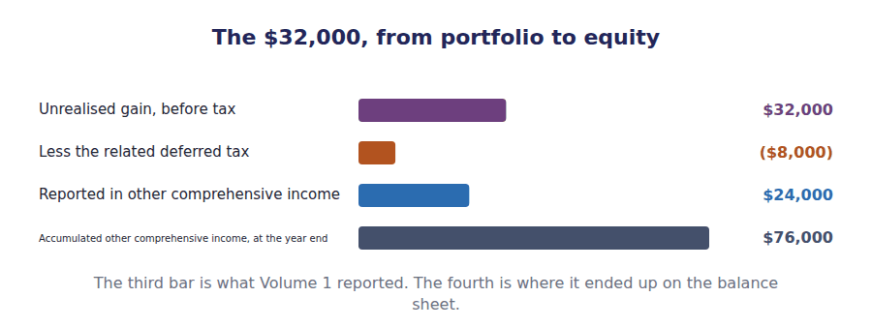
Part 5 · When the securities are finally sold the reclassification adjustment
Exercise 2E Sort each statement into the column that says whether it is true.
OBJECTIVE | Say what happens to an accumulated gain when the security is sold.
YOU WILL NEED | Exercise 2D
HOW TO START | • The gain has already been reported once, in other comprehensive income. Reporting it again without an adjustment would count it twice.  • The entry that prevents that has a name.  • Two of these statements describe double counting as though it were correct.

Statement about selling an available-for-sale security | TRUE | FALSE
1. The accumulated gain is transferred out of equity and into net income
2. The gain is reported in net income and left in equity as well
3. The entry that moves it is a reclassification adjustment
4. Total equity changes when the gain is reclassified
5. Without the adjustment the same gain would be reported twice
6. The gain is reported in other comprehensive income again on sale

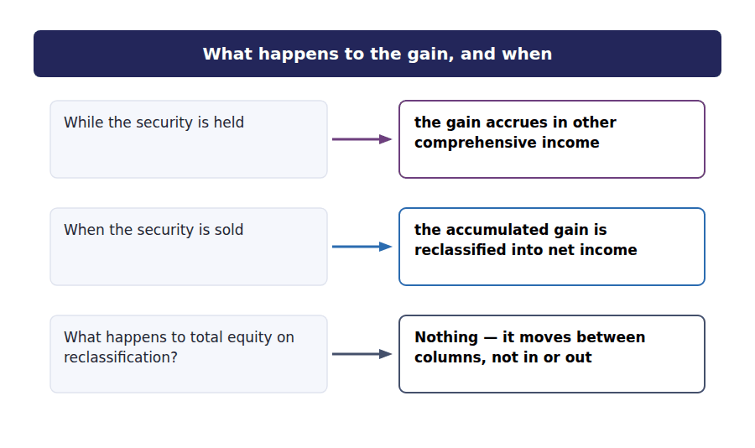
Watch out! A reclassification adjustment changes where a gain is reported and not how much equity there is. If a question asks for the effect on total equity of reclassifying a gain, the answer is nil.
Part 6 · Exam pitch the questions as the CMA sets them
1. [Level B] A portfolio of available-for-sale debt securities cost $358,000 and is worth $390,000 at the year end. The entry records:
(A) A gain of $32,000 in net income
(B) A gain of $32,000 in other comprehensive income
(C) No entry, because the securities have not been sold
(D) A gain of $32,000 in retained earnings
2. [Level B] A held-to-maturity bond bought at par is now trading at 80% of face value. The carrying amount is:
(A) 80% of face value
(B) Face value, as amortised cost
(C) The lower of the two
(D) Face value less an impairment of 20%
3. [Level C] A bond is purchased at a premium and classified as held to maturity. Over the remaining life, the carrying amount will:
(A) Rise to the market price
(B) Fall to the face amount
(C) Stay at the purchase price
(D) Rise to the purchase price plus accrued interest
4. [Level B] An unrealised gain of $32,000 on available-for-sale securities is subject to tax at 25%. The amount reported in other comprehensive income is:
(A) $32,000
(B) $24,000
(C) $8,000
(D) $0
5. [Level B] When an available-for-sale security is sold, the gain previously accumulated in equity is:
(A) Left in equity permanently
(B) Reclassified out of accumulated other comprehensive income and into net income
(C) Reported in other comprehensive income a second time
(D) Credited directly to retained earnings
6. [Level C] What is the effect on TOTAL equity of reclassifying an accumulated gain out of other comprehensive income and into net income on sale?
(A) An increase equal to the gain
(B) A decrease equal to the gain
(C) No effect
(D) An increase equal to the gain net of tax
7. [Level A] A trading security costing $100,000 is worth $108,000 at the year end. The effect on net income is:
(A) Nil, because the security has not been sold
(B) An increase of $8,000
(C) An increase of $8,000 in other comprehensive income
(D) A decrease of $8,000
ADAPTIVE TIP Three questions, in order, for any securities problem: what is the classification, what is the carrying amount, and where does the movement go? The third one is where the marks are, and the first one decides it.

Handout 3 · Valuing Equity Securities
How much of a company you own decides how you account for it, and the three answers have almost nothing in common.
Volume 6 · Investments in Debt and Equity · R2 throughout, closing at R3
LANGUAGE FOCUS
Register you are working in | R2 textbook English, rising to R3 for the final passage, which closes both the volume and Section A’s asset side.
Say it exactly like this | exercise significant influence over an investee · account for an investment by the equity method · pick up a share of the investee’s profit · treat a dividend as a return of the investment · consolidate a subsidiary · rebut the presumption of influence
Words that are not the same | influence / control · investor / investee · dividend income / return of investment · equity method / consolidation
Remember | The percentage is a presumption, not a rule. Evidence of actual influence can override it in either direction. Under the equity method a dividend is not income. It reduces the investment, because the profit was already picked up.

What you will be able to do when this handout is finished
- Say how the size of a holding decides the accounting method.
- Measure a holding that confers no significant influence.
- Apply the equity method, including the treatment of dividends.
- Say why a dividend reduces the investment rather than producing income.
- State when the percentage presumption may be overridden.

Two holdings, two completely different treatments
Northwind holds shares in two other companies, and nothing about their accounting is alike.
The first is a 5% holding in Delta Pumps, bought for $90,000 and worth $97,000 at the year end. Northwind has no influence over it at all.
The second is a 30% holding in Riverbend Valves, bought for $600,000. Northwind has a seat on its board and takes part in its decisions.
The first is carried at fair value and the second is not carried at fair value at all. The difference is influence, and this handout is about where the line falls.

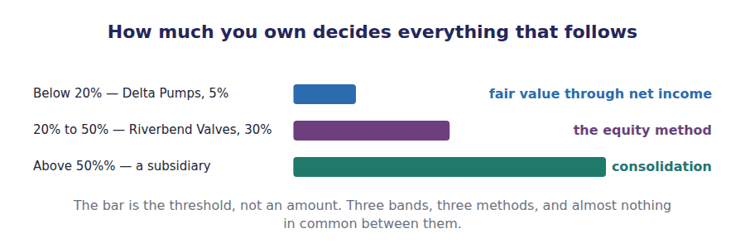
Part 1 · Three bands and why influence is the real test
Exercise 3A Complete the table, then read the passage underneath.
OBJECTIVE | Say how the size of a holding decides the method, and what the percentages really stand for.
YOU WILL NEED | Handout 1, for why equity securities are outside the debt scheme.
HOW TO START | • Three bands and three methods. Fill the table from the opening scene first.  • The last column is the one that matters: what actually reaches the investor’s income statement under each.  • The percentages are presumptions rather than rules, and the passage underneath says why.

Holding | Usual threshold | Method | What reaches income
No significant influence
Significant influence
Control

1 | 2 | 3 | 4 | 5 | 6
7 | 8 | 9

WORD BANK
15% · 60% · control · influence · ownership · presumption · requirement
Not every word is used.

R2 The percentages are not the test. They are a ¹ about the test, which is whether the investor can participate in the investee’s financial and operating policy decisions.
A holding between 20% and 50% is presumed to confer significant ² , and the presumption can be rebutted. A company holding 25% of a business whose other 75% is held by one family, which ignores it, has no influence at all despite the arithmetic.
It works in the other direction too. A company holding 15% with a seat on the board, a technology-sharing agreement and a say in the budget may well have significant influence, and would then use the equity method on a ³ holding.
Above 50% the presumption is of ⁴ , which takes the investment out of this volume entirely and into consolidation — the subject of Volume 10.
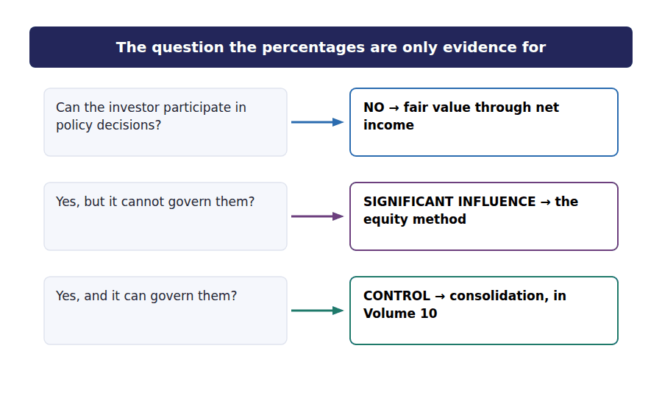
Part 2 · The small holding fair value, and nothing else
Exercise 3B Read and complete.
OBJECTIVE | Measure a holding that confers no significant influence.
YOU WILL NEED | Exercise 3A
HOW TO START | • The holding cost $90,000 and is worth $97,000. One subtraction.  • Blank 2 is where the movement goes, and it is the only destination now available for an equity security.  • The last blank is the treatment that used to be available and no longer is.

WORD BANK
$7,000 · capital · comprehensive · income · net · optional · wrong
Not every word is used.

R2 The 5% holding in Delta Pumps cost $90,000 and is worth $97,000 at the year end, so there is an unrealised gain of ⁵ .
Under current US GAAP that gain goes to ⁶ income. There is no choice in the matter: an equity security without significant influence is measured at fair value through profit, and that is the only treatment available.
Dividends received on such a holding are also ⁷ , recognised when the right to receive them is established. The investor has no claim on the investee’s profits beyond what is actually distributed.
Older texts offer an available-for-sale classification for equity securities as well. That option was removed and is now ⁸ , which is worth remembering because exam questions are sometimes written from older material.
J1 The Delta Pumps holding marked to fair value at the year end. Through net income — the only route available for an equity security without influence.
Account | Debit | Credit
Investment in Delta Pumps
Unrealised Gain — Net Income

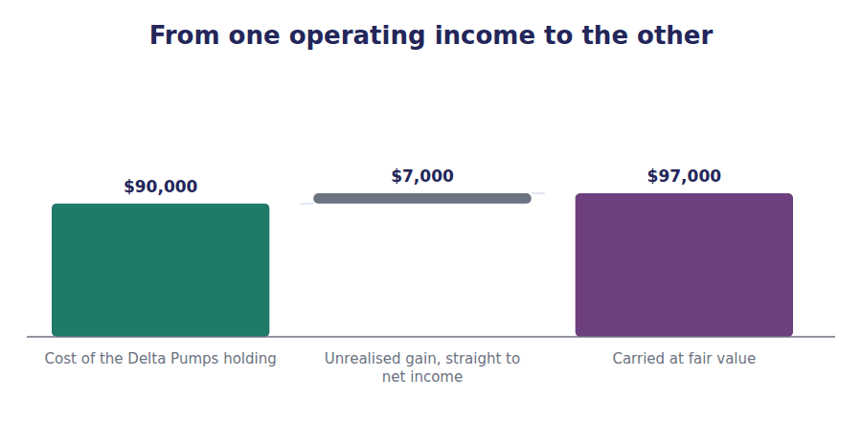
Part 3 · The equity method where fair value stops applying
R2 The 30% holding in Riverbend Valves is accounted for in a way that has nothing to do with its share price. Under the equity method the carrying amount starts at cost and then tracks the investee’s performance.
R2 The reasoning is that an investor with influence is not a passive holder waiting for dividends. It participates in the decisions that produce the profit, so it recognises its share of that profit as the investee earns it, rather than waiting for a distribution it helped to decide on.
Exercise 3C Complete the schedule. Two adjustments to the opening cost.
OBJECTIVE | Apply the equity method and roll the investment forward.
YOU WILL NEED | Exercise 3B, and the two paragraphs above.
HOW TO START | • Riverbend Valves earned $200,000 and paid dividends of $60,000. Northwind owns 30% of it.  • The share of profit increases the investment. Think about which direction the dividend moves it before you write anything.  • The share price of Riverbend Valves appears nowhere in this schedule, and that is the point.

Equity method roll-forward | Amount
Cost of the 30% holding in Riverbend Valves | $600,000
Add the share of Riverbend Valves’s profit for the year
Less the share of dividends received
Carrying amount at the year end

1 | 2 | 3

J2 Northwind’s 30% share of Riverbend Valves’s profit for the year. Recognised as the investee earns it, not when it is paid out.
Account | Debit | Credit
Investment in Riverbend Valves
Share of Profit of Associate
J3 Dividends received from Riverbend Valves. Not income. The profit was already recognised in J2.
Account | Debit | Credit
Cash
Investment in Riverbend Valves

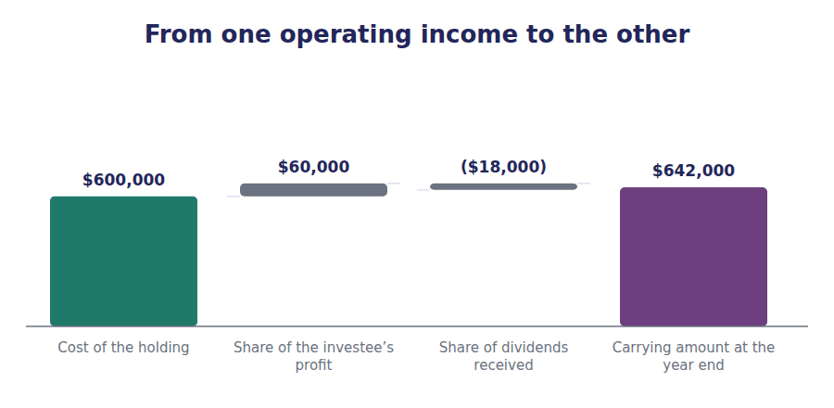
Part 4 · Why a dividend is not income the point of the whole method
Exercise 3D Read and complete.
OBJECTIVE | Explain why a dividend reduces the investment under the equity method.
YOU WILL NEED | Exercise 3C
HOW TO START | • Blank 1 is when the investor recognised its share of the profit.  • Blank 3 is what recognising the dividend as income as well would do.  • The last blank is what a dividend actually is under this method.

WORD BANK
declared · earned · expense · income · nothing · return · twice
Not every word is used.

R2 Northwind recognised $60,000 as its share of Riverbend Valves’s profit when Riverbend Valves ⁹ it, not when anything was paid out.
When the dividend arrives, that profit has already been reported. Treating the $18,000 received as income as well would recognise the same profit ¹⁰ — once as the investee earned it and once as it distributed it.
So the dividend reduces the carrying amount of the investment instead. It is a ¹¹ of investment rather than a return on it: the investee has handed back part of the value Northwind already recognised, and the investment is worth that much less as a result.
This is the single most examined point in the topic, and the reason is that it reverses the ordinary intuition. For every other kind of shareholding a dividend is ¹² ; under the equity method alone it is not.
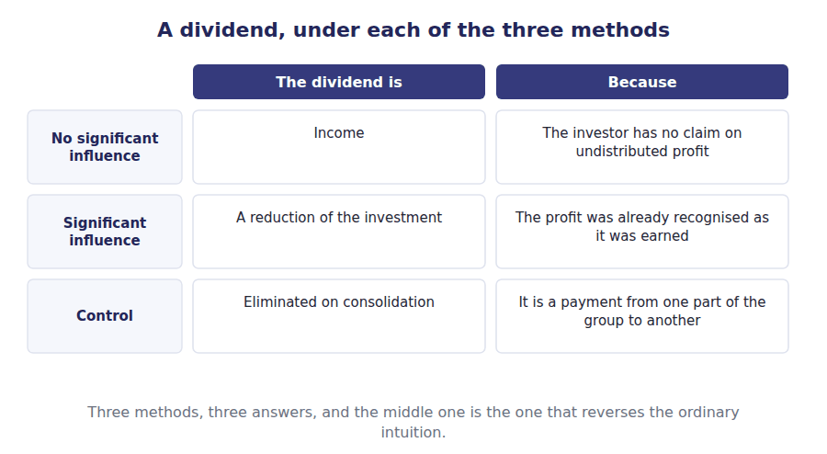
Part 5 · Closing the asset side what Section A’s first six volumes have built
Exercise 3E Read and complete. This passage is written at exam pitch.
OBJECTIVE | State what the equity method is measuring, and what it is not.
YOU WILL NEED | Exercises 3A to 3D
HOW TO START | • Blank 1 is what the carrying amount tracks under the equity method.  • Blank 3 is what it conspicuously does not track.  • The last blank is the test that decided which method applied in the first place.

WORD BANK
$600,000 · control · dividend · influence · performance · share · stake
Not every word is used.

R3 Under the equity method the carrying amount tracks the investee’s ¹³ . It rises when the investee earns and falls when the investee distributes, and after one year of this Riverbend Valves stands at $642,000 rather than the $600,000 Northwind paid.
What it does not track is the investee’s ¹⁴ price. If Riverbend Valves’s market value doubled during the year, nothing in the schedule would move, because the method is not a fair value measure at all.
That is the deeper point of this volume. Northwind’s 5% holding is carried at fair value and its 30% holding is not, although both are ordinary shares, because the two investments are different kinds of thing. One is a bet on a price; the other is a ¹⁵ in a business the investor helps to run.
The method follows that difference, and the test that decides it is neither the amount invested nor the number of shares. It is ¹⁶ .
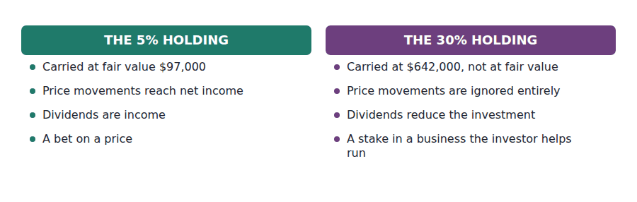
Watch out! Under the equity method the investee’s share price is irrelevant. If a question gives you a market value alongside the investee’s profit and dividends, it is testing whether you know which figures the method actually uses.
Part 6 · Exam pitch the questions as the CMA sets them
1. [Level A] An investor holds 30% of an investee and has a seat on its board. The investment should be accounted for using:
(A) Fair value through net income
(B) The equity method
(C) Consolidation
(D) Amortised cost
2. [Level B] Under the equity method, a dividend received from the investee is:
(A) Recognised as dividend income
(B) Recorded as a reduction of the carrying amount of the investment
(C) Credited to other comprehensive income
(D) Not recorded at all
3. [Level B] An investor buys 30% of a company for $600,000. The investee earns $200,000 and pays dividends of $60,000. The carrying amount at the year end is:
(A) $600,000
(B) $642,000
(C) $660,000
(D) $618,000
4. [Level C] An investor holds 15% of an investee but has a board seat, a technology-sharing agreement and a say in the annual budget. The appropriate method is:
(A) Fair value through net income, because the holding is below 20%
(B) The equity method, because significant influence exists in substance
(C) Consolidation
(D) Either, at the investor’s choice
5. [Level C] Under the equity method, a rise in the market value of the investee’s shares is:
(A) Recognised in net income
(B) Recognised in other comprehensive income
(C) Not recognised — the method does not use fair value
(D) Added to the carrying amount of the investment
6. [Level B] Under current US GAAP, an equity security with no significant influence and a readily determinable fair value is measured at:
(A) Cost
(B) Fair value, with changes in net income
(C) Fair value, with changes in other comprehensive income
(D) The equity method
7. [Level A] An investor holds 60% of another company. The investment is:
(A) Measured at fair value through net income
(B) Accounted for by the equity method
(C) Consolidated, with a non-controlling interest presented
(D) Carried at amortised cost
ADAPTIVE TIP For any equity holding, write one word before you look at the figures: influence. None, significant, or control. The method, the treatment of dividends and the relevance of the share price all follow from that one word.

Answer Key
Volume 6 · Handouts 1 to 3
Every answer carries the reason for it and the mistake it defeats.

Handout 1 · Trading, Available-for-Sale, Held-to-Maturity answers
Completed text and exercises
# | Answer | Why | The trap it defeats
1 | trading | Near-term sale intended.
2 | held-to-maturity | Kept until the issuer repays.
3 | ability | Intention is not enough on its own. | Students classify as held to maturity on intention alone. A company that may have to sell does not qualify.
4 | available | The residual category.
5 | net | Through profit, because sale is intended.
6 | comprehensive | Held rather than sold, so it bypasses profit.
7 | nowhere | Not recognised at all. | Students expect every fair value movement to appear somewhere. Under held to maturity it genuinely does not.
8 | maturity | No maturity, so no holding to it.
9 | net | Fair value through profit, and nothing else. | Students classify an equity holding as available for sale, which the current standards no longer permit.
10 | wrong | An older rule that still appears in older texts.
11 | 3 | Handout 3 covers equity securities.

Exam-pitch questions
# | Answer | Why | The trap it defeats
1 | (B) Fair value | Both trading and available-for-sale securities are carried at fair value; only held-to-maturity securities stay at amortised cost. (C) imports an inventory rule that has no application here. | Level A
2 | (B) Net income | A trading security is held for near-term sale, so the movement runs through net income. (A) is the available-for-sale treatment, and the pairing of these two options is the commonest form this question takes. | Level A
3 | (B) Both the positive intention and the ability to hold it to maturity | Two conditions, and the second is the one that fails in practice: a company that may need to sell the security to meet its own obligations lacks the ability, whatever it intends. | Level B
4 | (B) $110,000 | Held-to-maturity securities stay at amortised cost; the fair value is disclosed and never recognised. (A) is the trap for anyone who assumes every investment is carried at fair value. | Level B
5 | (B) Available for sale | Only available-for-sale debt securities route unrealised movements through other comprehensive income. The reporting location identifies the classification, which is a question the exam likes to ask in reverse. | Level B
6 | (B) Fair value, with changes in net income | Fair value through net income is the only treatment available for such holdings. (C) was permitted under the older rules and still appears in older texts, which is exactly why it is offered here. | Level C
7 | (D) All three are available | All three apply to debt securities; it is equity securities that are excluded from the scheme, because a share has no maturity to be held to. The question tests whether the reader knows which instruments the scheme covers. | Level A

Exercise 1B · the completed grid
 | Trading | Available for sale | Held to maturity
The intention | Sell in the near term | Neither of the other two | Hold until it matures
Carried at | Fair value | Fair value | Amortised cost
Unrealised gains and losses go to | Net income | Other comprehensive income | Nowhere — not recognised
Interest income | Net income | Net income | Net income
Normally classified as | Current | Current or non-current | By maturity date
Available for equity securities? | No | No | No

- Trading: fair value, movements through net income.
- Available for sale: fair value, movements through other comprehensive income.
- Held to maturity: amortised cost, movements not recognised at all.
- Northwind’s portfolio is available for sale, which is why its $32,000 went to other comprehensive income in Volume 1.

Handout 2 · Valuing Debt Securities answers
Completed text and exercises
# | Answer | Why | The trap it defeats
1 | $32,000 | $390,000 − $358,000.
2 | valuation | A separate account, so cost stays visible.
3 | out | It has to be reversed out of equity on sale.
4 | 2 | The credit side depends on the classification.
5 | premium | Paid above face for a generous coupon.
6 | amortised | Written off over the remaining life.
7 | face | It walks to face value by maturity.
8 | market | Deliberately ignored. | Students mark a held-to-maturity bond to market. The whole point of the classification is that the market price does not matter.
9 | $8,000 | $32,000 at 25%.
10 | $24,000 | $32,000 less the tax.
11 | accumulated | Its own equity column.
12 | liability | The tax is deferred, not avoided. | Students report the pre-tax gain in other comprehensive income, and the accumulated balance then fails to close.
Grid 1 | 1 TRUE 2 FALSE 3 TRUE 4 FALSE 5 TRUE 6 FALSE | Total equity does not move on reclassification. The amount simply travels from one equity column to another by way of net income.

Exam-pitch questions
# | Answer | Why | The trap it defeats
1 | (B) A gain of $32,000 in other comprehensive income | Available-for-sale securities are carried at fair value with unrealised movements in other comprehensive income. (A) is the trading treatment. (C) would leave the balance sheet at cost, which the classification does not permit. | Level B
2 | (B) Face value, as amortised cost | Amortised cost ignores the market price entirely, because the company will hold the bond and be repaid in full. The fair value is disclosed in the notes. A credit loss would be a different question with different facts. | Level B
3 | (B) Fall to the face amount | The premium is amortised away, so the carrying amount walks down to face value by the maturity date — which is all the issuer will repay. (A) confuses amortised cost with fair value. | Level C
4 | (B) $24,000 | Items of other comprehensive income are presented net of tax: $32,000 less $8,000 is $24,000. (A) is the pre-tax figure, and reporting it breaks the roll-forward of accumulated other comprehensive income. | Level B
5 | (B) Reclassified out of accumulated other comprehensive income and into net income | The reclassification adjustment moves the amount so that it is reported once in net income and removed from the equity column it accrued in. (A) and (C) would both leave the same gain counted twice. | Level B
6 | (C) No effect | The amount moves between two equity columns by way of net income. Total equity is unchanged, which is the point of the adjustment — it corrects where the gain is reported rather than how much there is. | Level C
7 | (B) An increase of $8,000 | Trading securities are marked to fair value through net income, so the whole unrealised movement reaches profit. (A) is the held-to-maturity treatment and (C) the available-for-sale one — all three classifications appear among the options, which is how this question is usually built. | Level A

Exercise 2B · the completed comparison
 | If trading | If available for sale | If held to maturity
Balance sheet carrying amount | $390,000 | $390,000 | $358,000
Effect on net income, before tax | $32,000 | $0 | $0
Effect on other comprehensive income, before tax | $0 | $32,000 | $0
Effect on total equity, before tax | $32,000 | $32,000 | $0

Exercise 2A · the portfolio
Holding | Amortised cost | Fair value | Unrealised gain
Harbour Authority 4.2% 20X9 | $150,000 | $164,000 | $14,000
Meridian Utilities 3.8% 20Y1 | $128,000 | $142,000 | $14,000
State Transit 5.0% 20X8 | $80,000 | $84,000 | $4,000
Total portfolio | $358,000 | $390,000 | $32,000

- The portfolio cost $358,000 and is worth $390,000, an unrealised gain of $32,000.
- Net of tax at 25%, $24,000 is reported in other comprehensive income.
- That is the amount Volume 1 carried into accumulated other comprehensive income, taking it from $52,000 to $76,000.

Handout 3 · Valuing Equity Securities answers
Completed text and exercises
# | Answer | Why | The trap it defeats
1 | presumption | A presumption, not a rule.
2 | influence | Participation in policy decisions.
3 | 15% | The presumption works in both directions. | Students apply the percentages as hard rules. The standards describe them as rebuttable presumptions.
4 | control | Above 50%, and a different volume.
5 | $7,000 | $97,000 − $90,000.
6 | net | Fair value through profit, and nothing else.
7 | income | An actual distribution, so actual income.
8 | wrong | Removed from the standards. | Students classify an equity holding as available for sale, which the current standards no longer permit.
9 | earned | Recognised as it was earned.
10 | twice | Double counting, which is what the rule prevents.
11 | return | Return OF investment, not ON it. | Students credit dividend income under the equity method, which counts the same profit twice and overstates the investment.
12 | income | Income everywhere else, and not here.
13 | performance | The investee’s results, not its price.
14 | share | The market price is irrelevant here.
15 | stake | A different kind of investment entirely.
16 | influence | Influence decides, and the percentages are evidence of it. | Students look for a percentage. The percentage is evidence of the thing the standard actually tests.

Exam-pitch questions
# | Answer | Why | The trap it defeats
1 | (B) The equity method | A holding of 20% to 50% is presumed to confer significant influence, and the board seat confirms it. (C) would require control, which is presumed above 50%. (D) applies to debt securities only. | Level A
2 | (B) Recorded as a reduction of the carrying amount of the investment | The profit was recognised as the investee earned it, so treating the dividend as income would count it twice. It is a return of investment. (A) is correct for every other kind of holding, which is exactly why this is the most examined point in the topic. | Level B
3 | (B) $642,000 | $600,000 + $60,000 share of profit − $18,000 share of dividends = $642,000. (C) omits the dividend and (A) treats the investment as if it were carried at cost. | Level B
4 | (B) The equity method, because significant influence exists in substance | The percentage is a rebuttable presumption and the evidence here rebuts it. (A) applies the threshold as though it were a rule, which is the error the word presumption exists to prevent. | Level C
5 | (C) Not recognised — the method does not use fair value | The carrying amount tracks the investee’s performance and not its price. A question that supplies a market value alongside profit and dividends is testing precisely whether the reader knows which figures the method uses. | Level C
6 | (B) Fair value, with changes in net income | Fair value through net income is the only treatment available. (C) was permitted under older rules and still appears in older textbooks, which is why it continues to be offered as a distractor. | Level B
7 | (C) Consolidated, with a non-controlling interest presented | Above 50% the presumption is control, and a controlled entity is consolidated line by line rather than carried as an investment at all. Volume 10 of Section A covers consolidation. | Level A

Exercise 3A · the completed table
Holding | Usual threshold | Method | What reaches income
No significant influence | Below 20% | Fair value through net income | Dividends received, and every fair value movement
Significant influence | 20% to 50% | The equity method | A share of the investee’s profit
Control | Above 50% | Consolidation | Every line of the investee, with a non-controlling interest

Exercise 3C · the completed roll-forward
Equity method roll-forward | Amount
Cost of the 30% holding in Riverbend Valves | $600,000
Add the share of Riverbend Valves’s profit for the year | $60,000
Less the share of dividends received | ($18,000)
Carrying amount at the year end | $642,000

Exercises 3B and 3C · the completed entries
J1 The Delta Pumps holding marked to fair value.
Account | Debit | Credit
Investment in Delta Pumps | $7,000
Unrealised Gain — Net Income |  | $7,000
J2 Share of Riverbend Valves’s profit for the year.
Account | Debit | Credit
Investment in Riverbend Valves | $60,000
Share of Profit of Associate |  | $60,000
J3 Dividends received from Riverbend Valves.
Account | Debit | Credit
Cash | $18,000
Investment in Riverbend Valves |  | $18,000

Glossary
Every term in Volume 6, with the Arabic equivalent and the places it misleads
The third column is for recognition only. In the exam room you work in English.

Term | What it means in CMA English | بالعربية | Careful
amortised cost | Cost adjusted for the amortisation of any premium or discount, and not for changes in fair value. | التكلفة المطفأة | The basis for held-to-maturity securities. Fair value is disclosed in the notes and never recognised.
available-for-sale security | A debt security that is neither trading nor held to maturity. | ورقة مالية متاحة للبيع | The residual category. A company does not choose it so much as fail to qualify for the other two.
control | The power to govern the financial and operating policies of another entity. | السيطرة | Presumed above 50%. It takes the investment out of this volume altogether and into consolidation.
debt security | An instrument representing a creditor relationship: a bond, a note, a bill. | أداة دين | The holder is owed money on fixed terms. That is what makes holding it to maturity a meaningful idea.
discount | The shortfall of what was paid for a bond below its face amount. | خصم الإصدار | The mirror image, and it is amortised up to face value by the maturity date.
equity method | Recording an investment at cost and then adjusting it for the investor’s share of the investee’s profits and dividends. | طريقة حقوق الملكية | Not a fair value measure at all. The carrying amount tracks the investee’s performance, not its share price.
equity security | An instrument representing an ownership interest in another entity. | أداة حقوق ملكية | No maturity and no contractual repayment, which is why the debt classifications in Handout 1 have no application to it.
fair value adjustment | The entry that brings a security’s carrying amount to its fair value. | تسوية القيمة العادلة | Usually recorded in a valuation allowance alongside the investment, so that cost and the adjustment remain separately visible.
held-to-maturity security | A debt security the company has both the positive intention and the ability to hold until it matures. | ورقة مالية محتفظ بها حتى الاستحقاق | Two conditions, not one. Intention without ability is not enough, and the exam separates them.
investee | The company that has been invested in. | الشركة المستثمَر فيها | The counterpart to the investor. The exam uses both words and a reader who confuses them will reverse every entry.
premium | The excess of what was paid for a bond over its face amount. | علاوة الإصدار | It arises when the bond’s coupon exceeds the market rate, and it is amortised away over the remaining life.
reclassification adjustment | The entry that moves a gain out of accumulated other comprehensive income and into net income when the security is sold. | تسوية إعادة التصنيف | Without it the same gain would be reported twice: once as it accrued and once when it was realised.
return of investment | A receipt that gives back part of what was invested rather than representing a profit on it. | استرداد لرأس المال | What a dividend is under the equity method, because the profit it came from was already recognised.
significant influence | The power to participate in the financial and operating policy decisions of another entity, without controlling it. | التأثير الجوهري | Presumed between 20% and 50%, and the presumption can be rebutted by evidence either way.
trading security | A debt security held with the intention of selling it in the near term. | ورقة مالية للمتاجرة | Carried at fair value, with every movement through net income, because the company means to realise it soon.
unrealised gain | An increase in the fair value of a security the company still holds. | مكسب غير محقق | Where it is reported is the whole subject of this volume, and it depends entirely on the classification.
valuation allowance | A contra or adjunct account holding the difference between cost and fair value. | حساب تسوية القيمة | It keeps the original cost visible, which matters because the gain has to be reversed out of equity one day.

