Table of Contents

B1.2 · Unit 10 · Where You Are Needed
English Animated · Weighing It Up · Hospital Regional, Valdivia Student's Book pages 204–225 · 22 pp · ~11 hours

Part 0 · The Big Picture ◆ A · THE WORLD
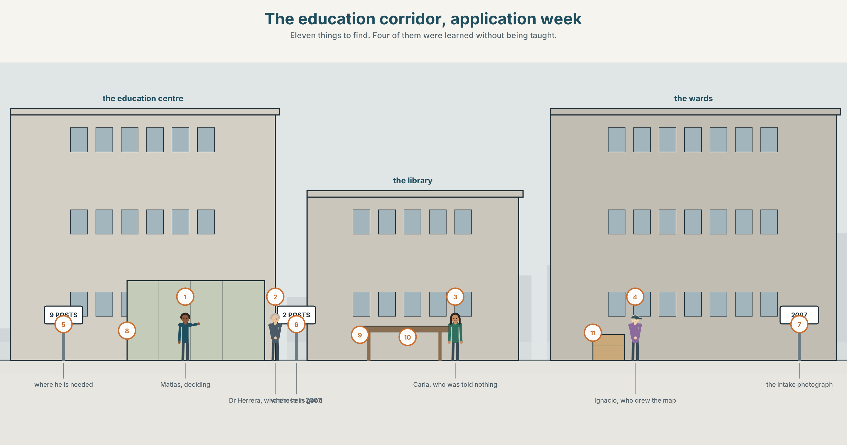{width=6.6in}
The education corridor, application week — Eleven things to find. Four of them were learned without being taught.

What do you wish you knew?
By the end of this unit you can write a 180-word reflective piece about what you wish somebody had taught you.
◆ A · THE WORLD | A fifth-year choosing between where he is needed and where he is good
◆ B · THE SYSTEM | wish and if only, present and past · rather, suppose · 23 words for learning and gaps · 22 words for the hypothetical · the intonation of a wish clause
◆ C · THE PERFORMANCE | A hundred and eighty words on what nobody taught you

0A · Find it
Find eleven things in this picture. Four of them are things somebody learned without being taught.
a rota with a name circled · a specialty application form · a logbook · a reference letter · a noticeboard of vacancies · a coffee cup with a name on it · a handover sheet folded small · a locker with three keys · a lanyard · a map of the building drawn by hand · a photograph of an intake

0B · Guess it
Two of the eleven exist because the official version does not work. Which, and who made them?

0C · Say it ⏺
Record forty-five seconds. Name one thing you wish somebody had taught you, and say what it cost you to learn it the other way. You will record it again at the end of this unit, and at the end of this book.

Part 1 · Vocabulary Lab 1 ◆ B · THE SYSTEM
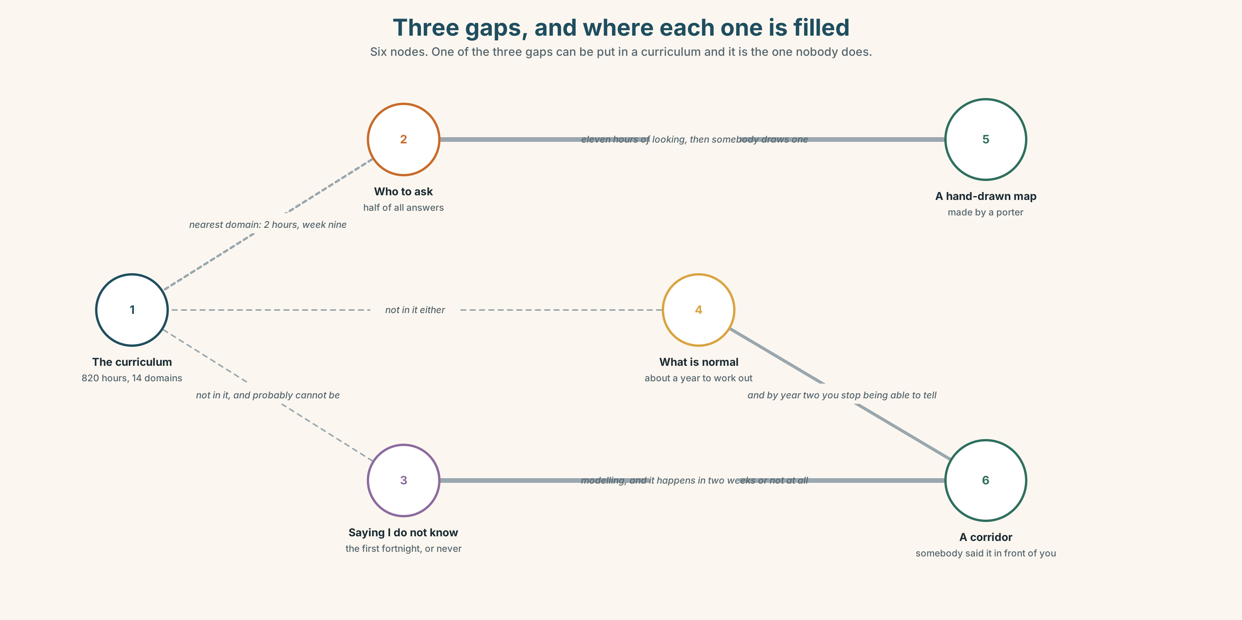{width=6.6in}
Three gaps, and where each one is filled — Six nodes. One of the three gaps can be put in a curriculum and it is the one nobody does.

1A · Meet — the words of a gap
Match each word to one place on the map.
gap · insight · lesson · curriculum · apprenticeship · competence · confidence · feedback · reflection · mentorship

1B · Sort — what you are taught, what you absorb, or what you are left to work out?
Three columns.
curriculum · apprenticeship · blind spot · feedback · mentorship · ignorance · insight · competence · confidence
One of them moves column depending entirely on who your supervisor was. Which?

1C · Meet — the two that come apart
competence · confidence
They are supposed to rise together. In which of the two directions is the mismatch dangerous, and in which is it merely miserable?

1D · Collocation Lab
Complete each one with one word.
- The first six months were a steep learning ______ and everybody says so, which is why nobody plans for it.
- He was out of his ______ for about a year and told nobody.
- You learn almost all of it on the ______ , which is a polite way of saying nobody teaches it.
- With ______ , the signs were in the first week.
- He learned it the hard ______ , which is a phrase people use to make a failure sound like a method.
- She has had to pick ______ most of it and work ______ the rest.

1E · The fixed expressions
f I wish somebody had said. f You learn that in week one or never.
Two sentences about the same gap, from two different people.
Which one is about teaching and which is about culture?

1F · Own it
Think of something you had to work out for yourself. Tell a partner four sentences: what it was, how long it took, what it cost, and whether it could have been taught.

Part 2 · Listening ◆ A · THE WORLD
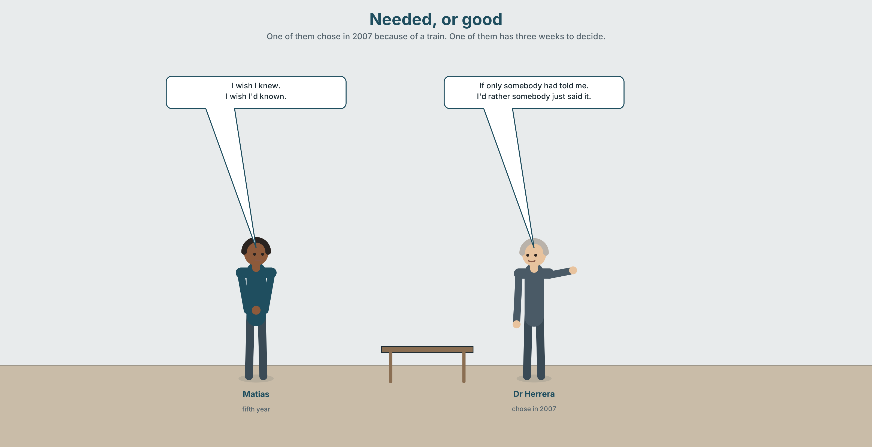{width=6.6in}
Needed, or good — One of them chose in 2007 because of a train. One of them has three weeks to decide.

2A · Needed, or good 🔊 Track 10.1
Before you listen. Matías can specialise in the field where he is needed or the field where he is good. They are not the same field. Guess: which does his supervisor recommend?
Listen once. One question. What are the two specialities?
Listen again. Complete the table.
 | What they say | What they wish | What they will not say
Matías
Dr Herrera
Carla
Listen again. Choose the best answer.
- The shortage speciality has two / nine / twenty-two unfilled posts in the region.
- He is better at the other one by a little / a lot / he does not know.
- His supervisor's advice is clear / deliberately not clear / about something else.
- Carla's contribution is about money / staying / what nobody told her.
Noticing. Four sentences from the recording.
- I wish I knew.
- I wish I'd known.
- If only somebody had told me.
- I'd rather somebody just said it.
Two of these are about now and two are about the past. Which, and how does the verb show it?

2B · Decoding clinic 🔊 Track 10.2
Thirty seconds of Carla. Four jobs.
- How many times does she say wish?
- In I wish I'd known, does her voice rise or fall at the end?
- Catch the two numbers.
- She says one sentence she immediately qualifies. Which?
Transcripts, page 159.

Part 3 · Grammar Lab 1 ◆ B · THE SYSTEM

Wishing about now, and about then

3A · Notice
Look at the four sentences in Part 2.
- In sentence 1, does she know? In sentence 2?
- Why is the verb in the past in sentence 1 when the wish is about now?
- Sentence 3 uses if only. Is it stronger or weaker than I wish?
- In sentence 4, I'd rather somebody said it — why a past tense after would rather?
- Try "I wish I know." Why does English refuse this?

3B · See
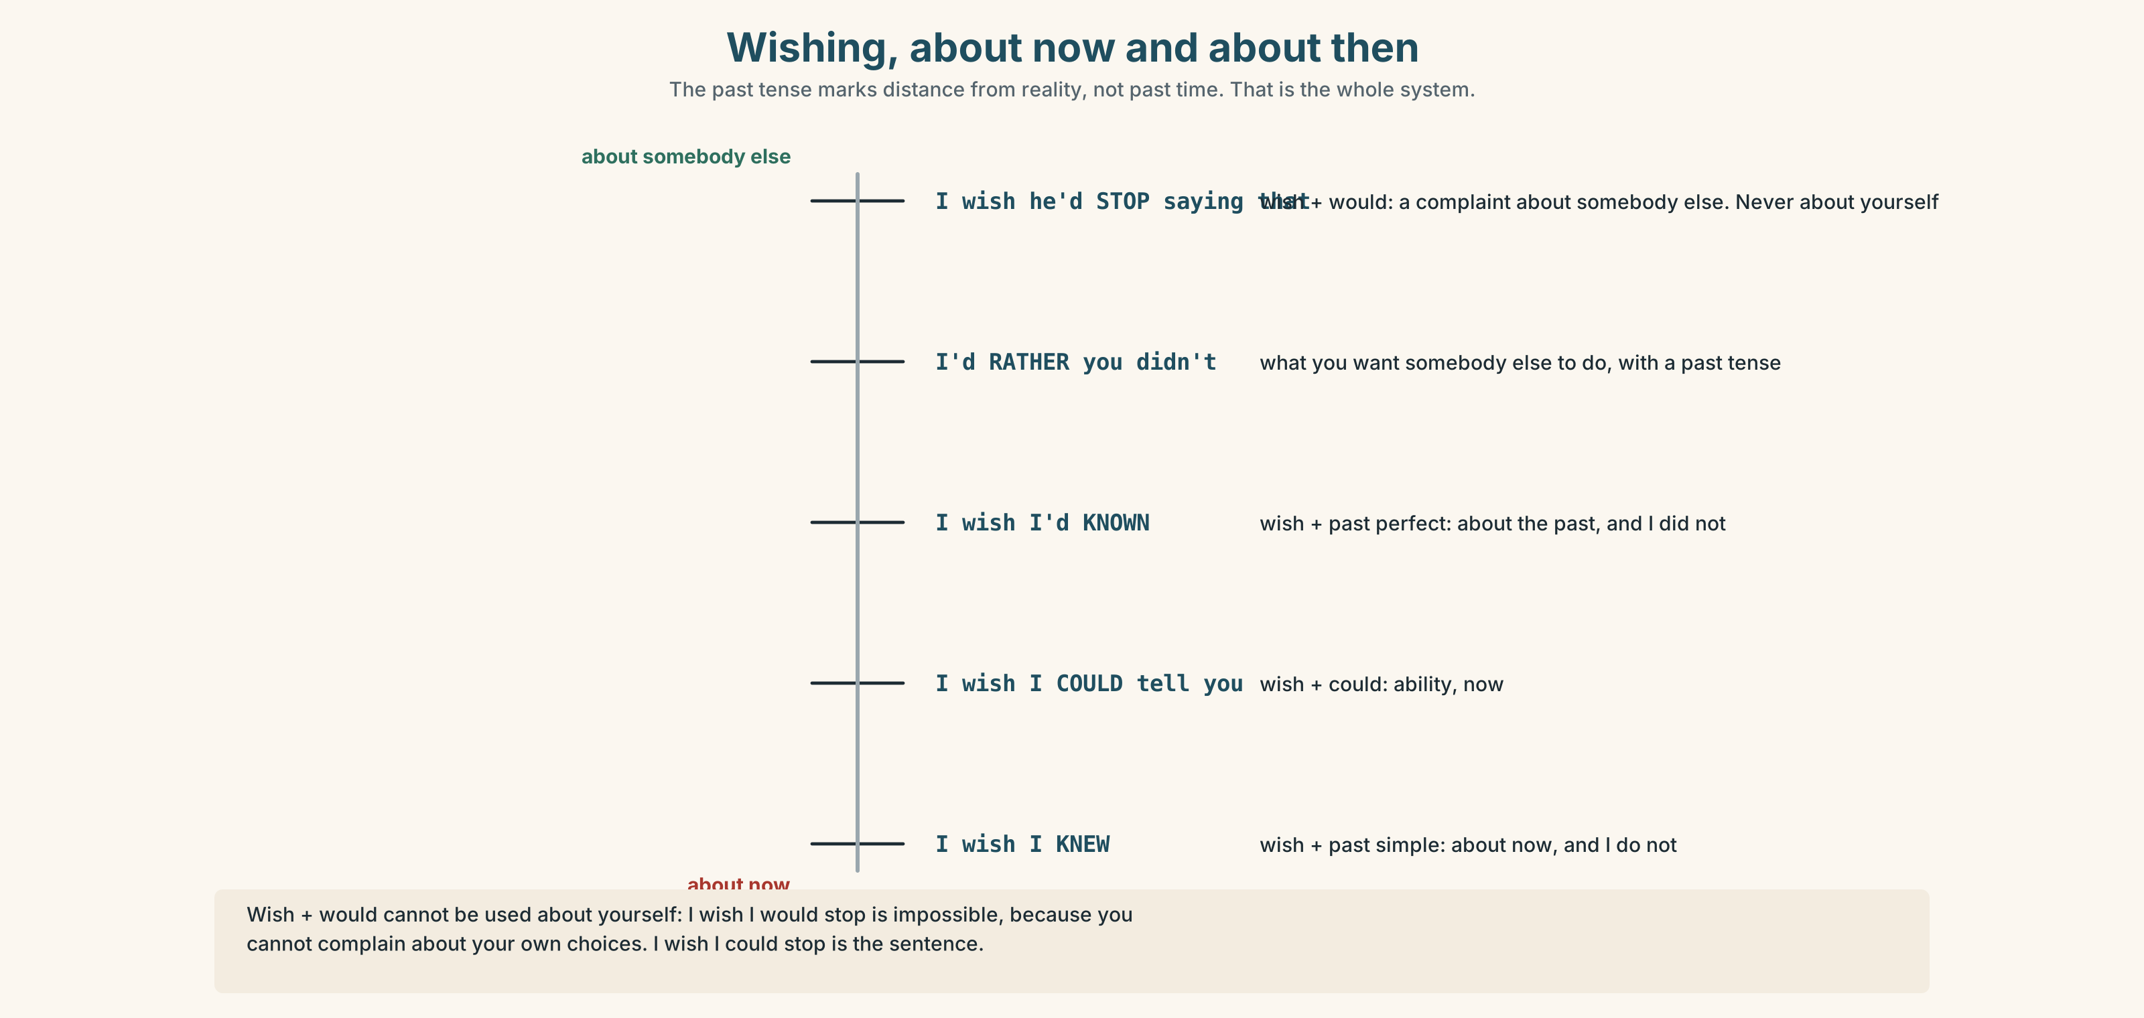{width=6.6in}
Wishing, about now and about then — The past tense marks distance from reality, not past time. That is the whole system.

3C · Know
 | Shape | About
wish + past simple | I wish I knew. | now — and I do not
wish + past perfect | I wish I*'d known**.* | the past — and I did not
wish + would | I wish he*'d stop** saying that.* | somebody else's behaviour, now — a complaint
wish + could | I wish I could tell you. | ability, now
if only | same shapes, more force | If only I'd known.
would rather + past | I'd rather you didn't. | what you want somebody else to do
suppose / supposing | + past, for a hypothesis | Suppose we asked him.
The past tense is doing the same job as in the second conditional: it marks distance from reality, not past time.
wish + would cannot be used about yourself. ✗ I wish I would stop. ✓ I wish I could stop. ✓ I wish he would stop. It is a complaint about somebody else's choices, and you cannot complain about your own.
Watch out. ✗ I wish I know. ✗ I wish I would know. ✓ I wish I knew.

3D · Use — controlled
I wish I (1) __________ (know) which one to choose. I wish somebody (2) __________ (tell) me in the first year, when it would have made a difference. If only the rota (3) __________ (not / change) every February — I wish they (4) __________ (stop) doing that, honestly. I'd rather somebody just (5) __________ (say) it to me. Suppose we (6) __________ (ask) the three people who left: I wish we (7) __________ (can) do that, and I wish I (8) __________ (think) of it two years ago.

3E · Use — guided
Rewrite each one as a wish or an if only.
- I don't know what I want. (now)
- Nobody told me. (the past)
- He keeps saying that. (a complaint)
- I can't tell you. (ability, now)
- I didn't ask her. (the past, with force)

3F · Use — open
In pairs. Name three things you wish you knew now and three you wish you had known then. Your partner's job is to say which of the six could actually have been taught.

3G · Error autopsy
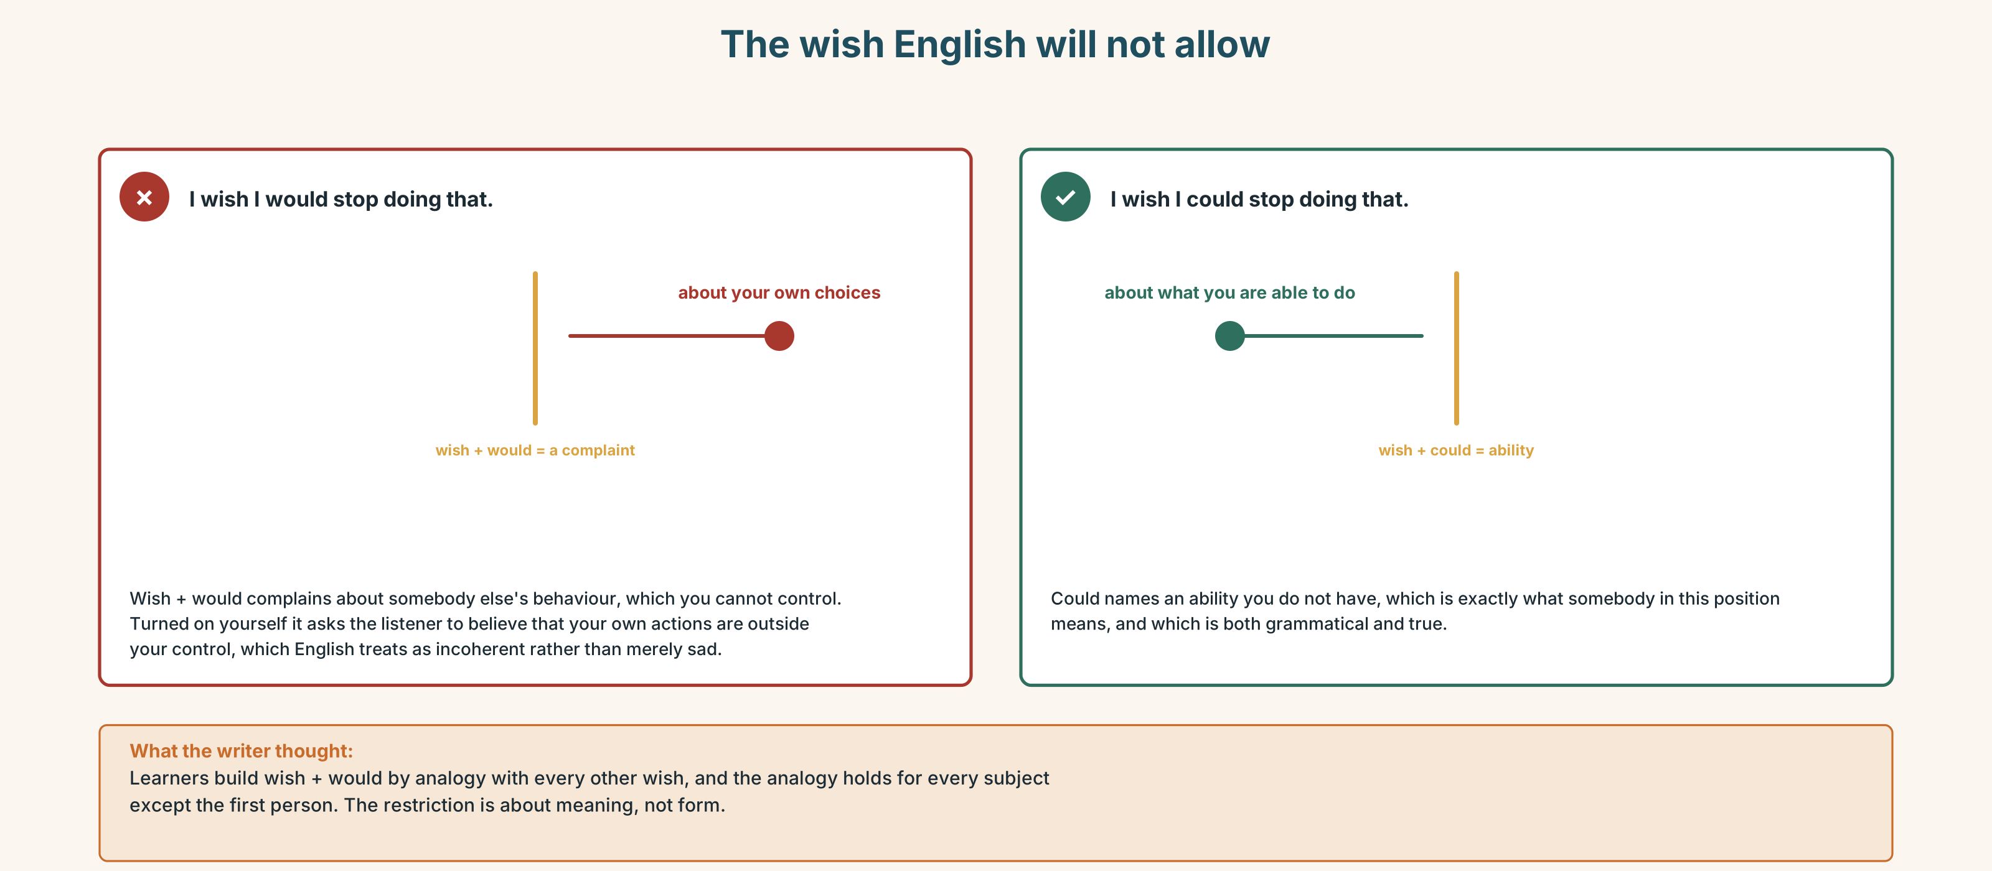{width=6.6in}
The wish English will not allow — The wish English will not allow
Read both versions. Then say why English will not allow the first one.

3H · Check — eight items
- I wish I ______ (know). (now)
- I wish somebody ______ (tell) me. (the past)
- I wish he ______ (stop) saying that. (a complaint)
- I wish I ______ (can) help. (ability, now)
- If only I ______ (ask) her. (the past)
- I'd rather you ______ (not / say) anything.
- Suppose we ______ (ask) the three who left.
- I wish I ______ (not / be) so sure in my first year.
0–4 → Workbook pp. 58–61. 5–6 → Part 6. 7–8 → page 217.

Part 4 · Speaking ◆ C · THE PERFORMANCE

4A · Fluency starter — six wishes
Your teacher names a domain: your first week · your training · your last job. Each learner gives one wish about now and one about then. Nobody may use the same verb twice.

4B · The functional core — naming a gap
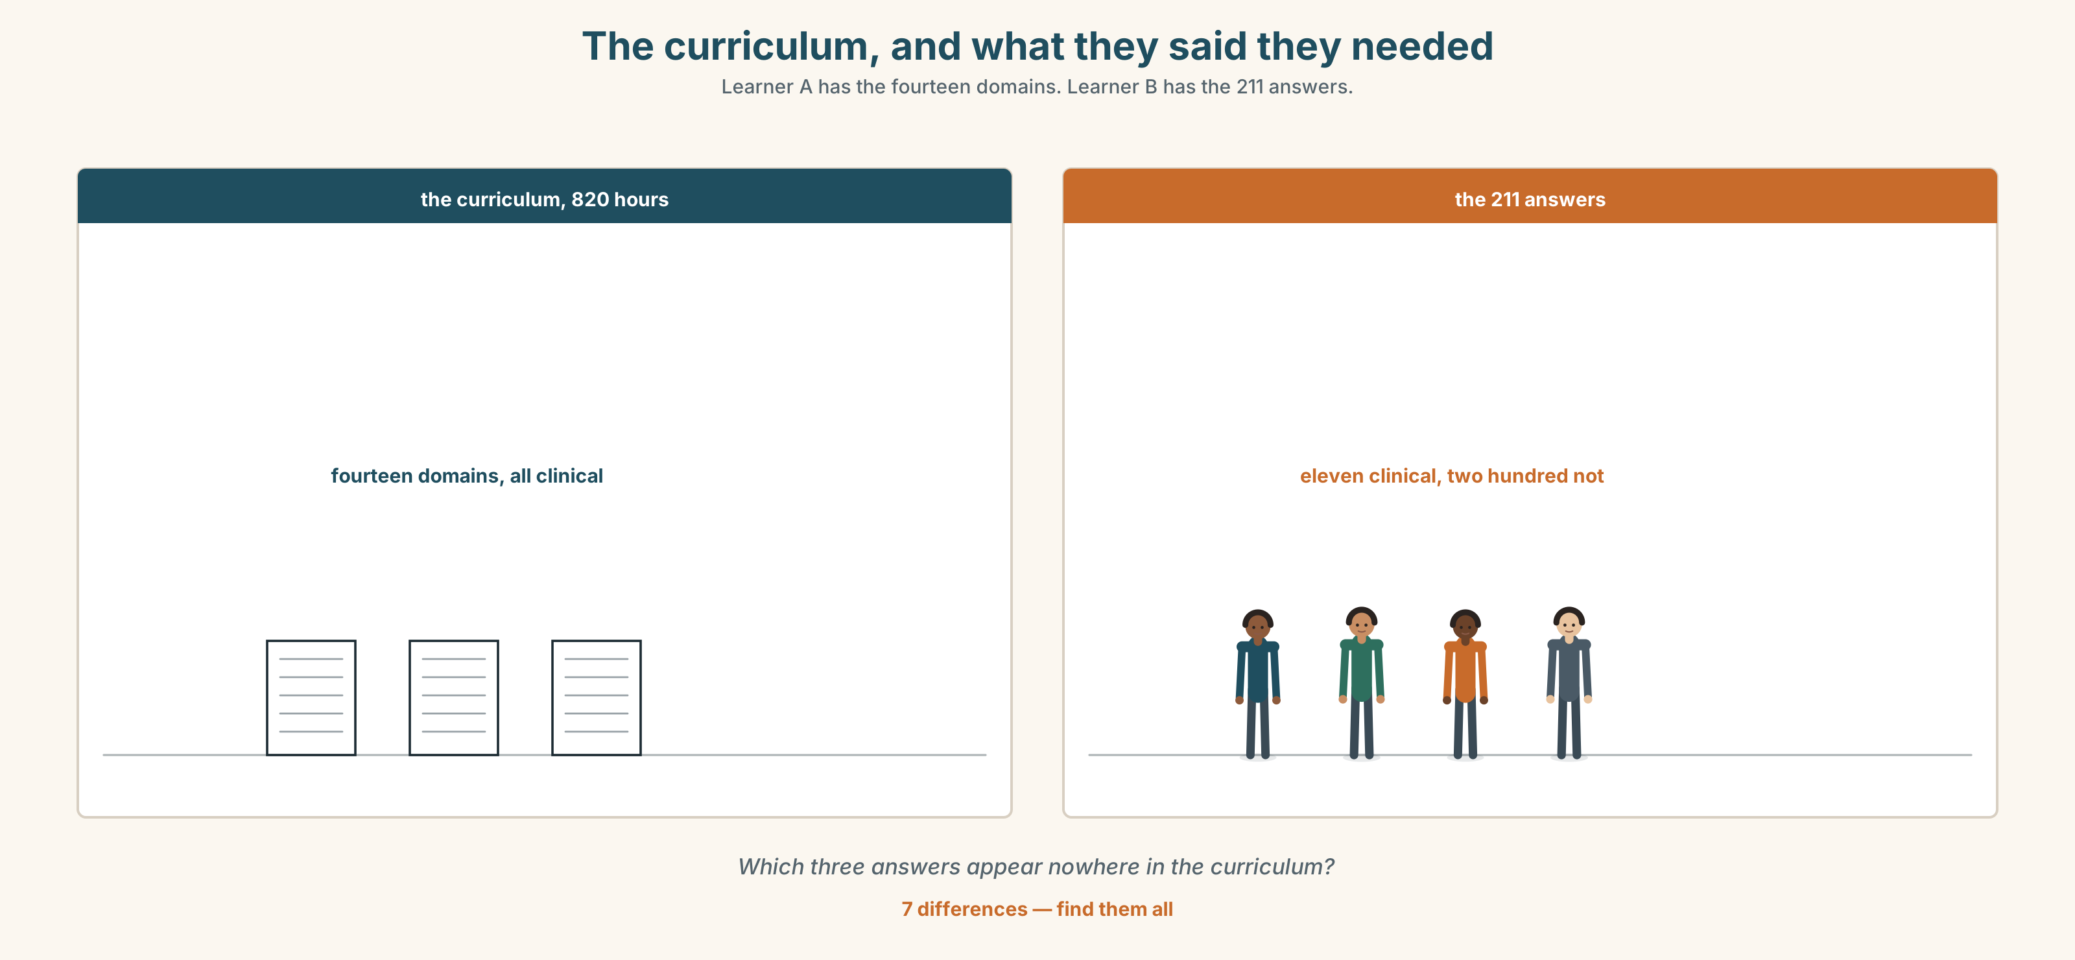{width=6.6in}
The curriculum, and what they said they needed — Learner A has the fourteen domains. Learner B has the 211 answers.
Language Bank
about now | I wish I knew… · I wish I could…
about then | I wish I'd known… · If only somebody had…
about somebody else | I wish they'd stop… · I'd rather they just…
the honest limit | I'm not sure it could have been taught. · You learn that in week one or never.
Information gap. Learner A has what the curriculum covers. Learner B has what the first-year doctors say they needed. Find the three things in neither list.

4C · The performance — three minutes ⏺
Describe a gap in what you were taught. Three minutes. You must include:
what you wish you had known · what it cost you · what you wish you knew now · one thing you think genuinely could not have been taught
Record it.

4D · Observer
One person listens for one thing: did the speaker blame a person or name a gap?

4E · Three criteria
☐ Did I use wish about now and about then, correctly? ☐ Is there a cost attached to the gap? ☐ Did I name one thing that could not have been taught?

Part 5 · Reading ◆ A · THE WORLD

5A · Predict
An extract from a report on first-year doctors. The title is "The curriculum is not the problem." What do you expect the report to say the problem is? Two sentences.

5B · Read — two minutes and a half

THE CURRICULUM IS NOT THE PROBLEM Extract from a review of first-year clinical experience
4.1 We asked 211 doctors in their first year what they wished they had been taught. We expected clinical answers. We received eleven.
4.2 The remaining answers divided into three groups.
4.3 The first group — about half of all answers — concerned who to ask. Not what to do: who to ask. Several respondents described spending between twenty and fifty minutes locating a person who could answer a question that took ninety seconds to answer. One wrote: I wish somebody had drawn me a map of who knows what.
4.4 The second group concerned how to say that you do not know. Respondents described learning this by one of two routes: either a senior colleague said I don't know in front of them in the first fortnight, in which case they could do it from then on, or nobody did, in which case most of them reported still finding it difficult several years later. It appears to be almost entirely a matter of modelling, and the modelling either happens in the first two weeks or does not happen.
4.5 The third group concerned what is normal. Respondents reported being unable to tell, for about a year, whether a thing that felt wrong was wrong or was simply how hospitals are. Several said they had stopped reporting things in their second year, not because they had stopped noticing but because they had stopped being able to tell.
4.6 None of these three is in any curriculum. Two of the three cannot obviously be put in one. The first can, costs almost nothing, and is the one nobody does.
4.7 We note, without comment, that 190 of the 211 responses described something the institution could have provided and did not, and that the institution has asked us three times whether the clinical content is adequate.

5C · Comprehension — eight questions
- How many doctors were asked, and how many gave clinical answers?
- What was the first group of answers about, and what example is given?
- What are the two routes by which the second thing is learned?
- What does paragraph 4.4 conclude about when this can be learned?
- What was the third group about, and what did several respondents say had happened by their second year?
- Which of the three could be put in a curriculum?
- What is the force of paragraph 4.7?
- Why does the report say "without comment"?

5D · Vocabulary in context
Guess from the text. Then check.
locating a person · a matter of modelling · what is normal · stopped being able to tell · without comment

5E · The counter-text
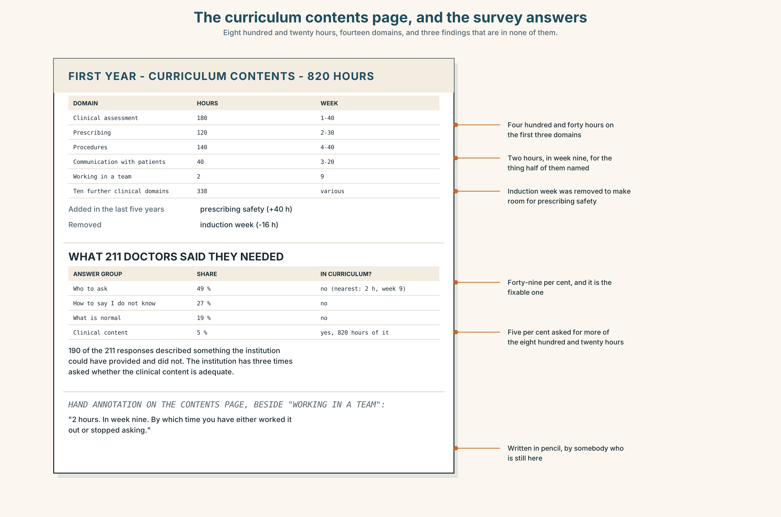{width=6.6in}
The curriculum contents page, and the survey answers — Eight hundred and twenty hours, fourteen domains, and three findings that are in none of them.
Read the curriculum contents page and the survey answers beside it, and answer.
- How many hours does the curriculum allocate, and to how many domains?
- Which three of the survey's answers appear nowhere in the curriculum?
- What does the curriculum call the nearest thing to "who to ask", and how many hours does it get?
- What has been added to the curriculum in the last five years, and what has been removed?
- One line of the contents page has been annotated by hand. What does it say?

5F · Two texts
The report says the first gap costs almost nothing to fix. The curriculum gives the nearest domain two hours, in week nine.
Put those two facts together. What would fixing it actually require? Three sentences.

Part 6 · Vocabulary Lab 2 ◆ B · THE SYSTEM

Supposing, and preferring

6A · Sort — a wish, a preference, or a hypothesis?
Three columns.
wish · rather · suppose · if only · ideally · preferably · hypothetically · supposedly · regrettably · admittedly · frankly
Two of them are not about the future at all and are regularly used as if they were. Which?

6B · Chunk completion
- If ______ somebody had said it in the first week.
- I'd ______ know now than find out in March.
- Suppose ______ asked the three people who left.
- It would be better ______ the rota changed in June.
- In an ideal ______ , somebody would draw the map.
- He has gone ______ over his first year four times trying to date it.

6C · Three that are not hedges
supposedly · admittedly · frankly
Supposedly reports somebody else's claim and doubts it. Admittedly concedes a point against yourself. Frankly announces that what follows is impolite.
Which fits each sentence, and what would the others do?
- ______ , the clinical content is adequate.
- ______ , I did not ask anybody either.
- ______ , the review is about something else.

6D · The fixed expression
f If only somebody had told me.
Write the sentence that follows it, once from somebody who would have listened, and once from somebody who would not.

6E · Contrast Clinic
Eight items. Give the wish, if only, would rather or suppose form.
- I don't know. (now)
- Nobody told me. (the past)
- She keeps changing it. (a complaint)
- I can't help. (ability, now)
- I didn't ask. (with force)
- Please don't say anything. (preference, politely)
- What if we asked them? (hypothesis)
- I was too sure in my first year. (the past, about yourself)

Part 7 · Pronunciation & Fluency Lab ◆ B · THE SYSTEM

The tune of a wish
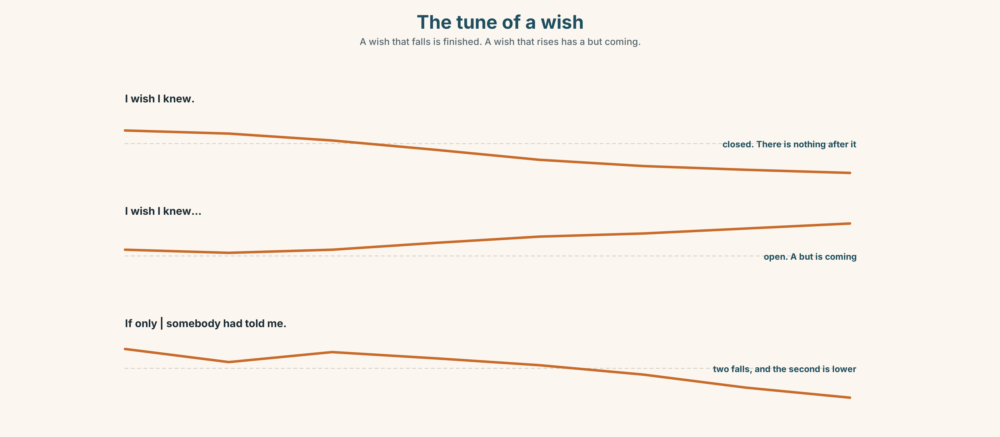{width=6.6in}
The tune of a wish — A wish that falls is finished. A wish that rises has a but coming.

7A · Hear 🔊 Track 10.3
I wish I knew. ↘ — closed, and there is nothing after it I wish I knew… ↗ — open, and a but is coming If only somebody had told me. ↘↘ — two falls, and the second is lower

7B · Say
Say all three. Then say the sentence twice, once closed and once open:
I wish I'd asked her.

7C · Make it mean something
Say these two:
I WISH I'd known. (and somebody has just implied you did) I wish I'd KNOWN. (and the knowing is the thing that was missing)
Which of the two is a defence?

7D · Fluency 30 ⏺
Thirty seconds: three wishes about now and three about then. Three times, faster, with the fall at the end of each.

Part 8 · Writing ◆ C · THE PERFORMANCE

What nobody taught me · 180 words
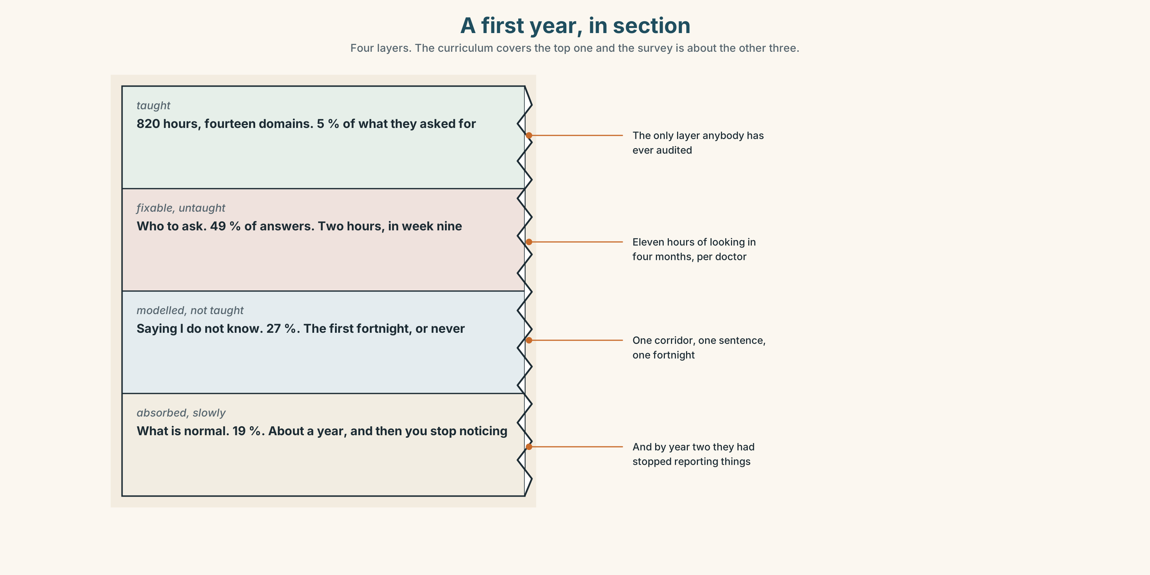{width=6.6in}
A first year, in section — Four layers. The curriculum covers the top one and the survey is about the other three.

8A · Read the model
I wish somebody had told me who to ask. Not what to do — I was taught what to do, at length, and most of it was right. [the gap, and a sentence that protects the curriculum so the reader knows this is not a complaint about teaching]
In my first four months I spent, at a conservative estimate, eleven hours looking for people. I once took forty minutes to find somebody who answered my question in under two. [the cost, in hours, with one specific instance]
I wish I knew whether this is normal. I have asked four people and got four answers, and three of them began by saying that it was different in their day. [a wish about now, which is unresolved, and a detail that shows why]
What I do not think could have been taught is how to say I don't know. I learned it in my second week, from somebody who said it in front of me in a corridor, and I do not think a lecture would have done it. [the honest limit, with the mechanism named]
I would rather have been given a map than another lecture. That is the whole of what I have to say.
Questions about the writer's choices:
- The second sentence defends the curriculum. What does that buy the writer?
- The cost is given in hours. Why not in frustration?
- The fourth paragraph says something could not have been taught. Does that weaken the piece?

8B · The anti-model
Looking back on my first year, it was a steep learning curve and I learned a great deal. There were challenges but they made me the clinician I am today. I would say to anyone starting out: ask for help, be kind to yourself, and remember that everyone feels like this.
Correct English, and nothing in it could be acted on. Name three things that are missing, and say what a steep learning curve is standing in for.

8C · Plan
the gap, named precisely → one sentence that protects what was taught → the cost, with a number → a wish about now that is unresolved → one thing that could not have been taught → what you would rather have had

8D · Write — 180 words

8E · Peer review — three criteria
☐ Is the gap specific enough for somebody to fix it? ☐ Is there a cost with a number in it? ☐ Is there one thing the writer admits could not have been taught?

8F · Write it again · 8G · Publish
On the wall, with the curriculum contents page from Part 5E beside it.

Part 9 · The File ◆ A · THE WORLD + C · THE PERFORMANCE

WORK FILE · The Career Conversation
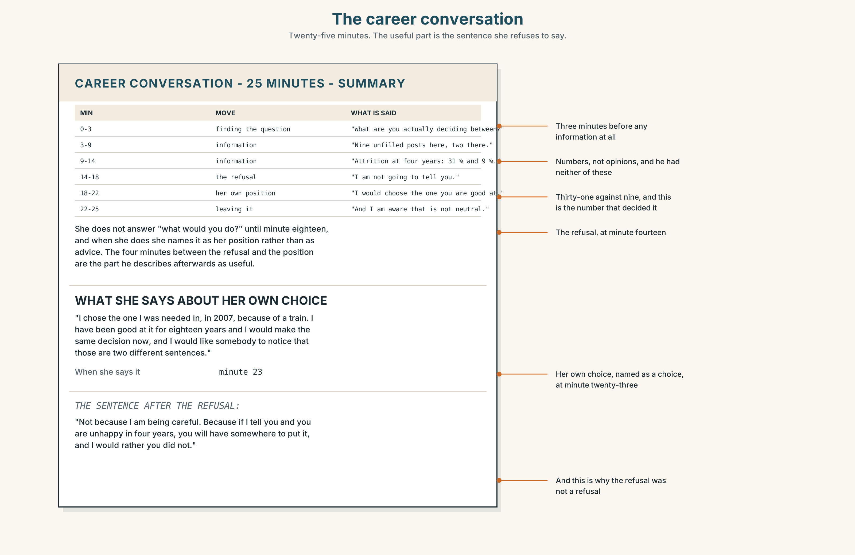{width=6.6in}
The career conversation — Twenty-five minutes. The useful part is the sentence she refuses to say.

9A · Twenty-five minutes 🔊 Track 10.4
Matías and Dr Herrera, on which speciality. Listen to all of it.
- What does she do in the first three minutes, and why does it matter?
- Which question does she refuse to answer, and what does she offer instead?
- What does she say about her own choice, and when?

9B · The four moves
finding out what the question actually is · giving information, not advice · naming your own position · leaving the decision where it belongs
Match each to one phrase.
"What are you actually deciding between?" · "There are nine unfilled posts in the region and two in the other one." · "I would choose the one you are good at, and I am aware that is not neutral." · "I am not going to tell you, and not because I am being careful."

9C · The sentence that is hard for a senior person to say
"I am not going to tell you."
Why is it hard? And what has to come after it for it to be useful rather than a refusal?

9D · Your turn
In pairs. Fifteen minutes. One of you has a real decision. The other may give information and may name their own position, and may not give advice. Then swap, and each of you says what the other did that helped.

9E · Transfer
Find the sentence you wrote in Unit 1, Part 9E — the one you would want said about your work this year. Read it. Write one sentence about whether it has changed.

Part 10 · Mediation & Interaction ◆ C · THE PERFORMANCE
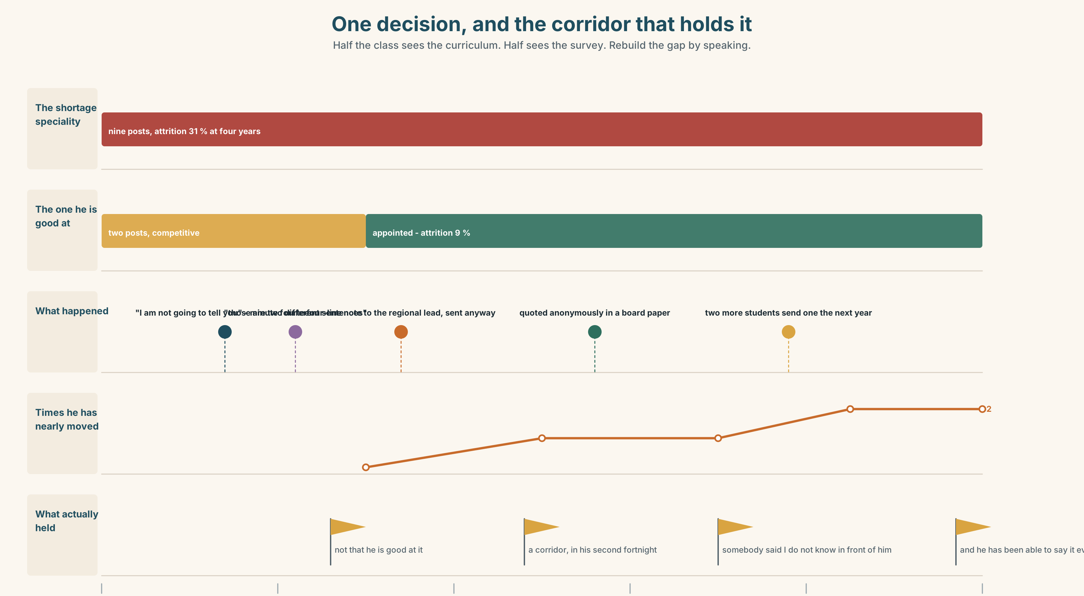{width=6.6in}
One decision, and the corridor that holds it — Half the class sees the curriculum. Half sees the survey. Rebuild the gap by speaking.

10A · Relay
Half the class sees the curriculum. Half sees the survey answers. Rebuild the gap by speaking. Twelve minutes.

10B · Simplify
Explain the survey's three findings to a curriculum committee. Five sentences only, and one of them must name a cost.
Plan: what was asked → what came back → which of the three is fixable → what it would cost → what you want decided

10C · Compress
The report extract in Part 5 into forty words, keeping paragraph 4.7.

10D · Online
Write one message to the education lead: you have the three findings, you are proposing one of them be acted on, and you are naming what it needs and by when.

10E · Your language
How does your language express a wish about the present? Does it use a past tense, a special mood, or a particle? Say I wish I knew and I wish I had known in both languages.

Part 11 · The Decision ◆ C · THE PERFORMANCE

Needed, or good
Matías has to choose a speciality. There are nine unfilled posts in the region in one and two in the other. He is measurably better at the one with two.
- Where he is needed. Nine posts, a job anywhere, a shortage that is somebody's emergency, and work he is competent at and does not love.
- Where he is good. Two posts, a competitive application, and the thing three separate supervisors have independently said he has a feel for.
- Neither yet. A year in a general post, which delays the decision, costs a year of training, and is what about a fifth of his year group does.

11A · The evidence
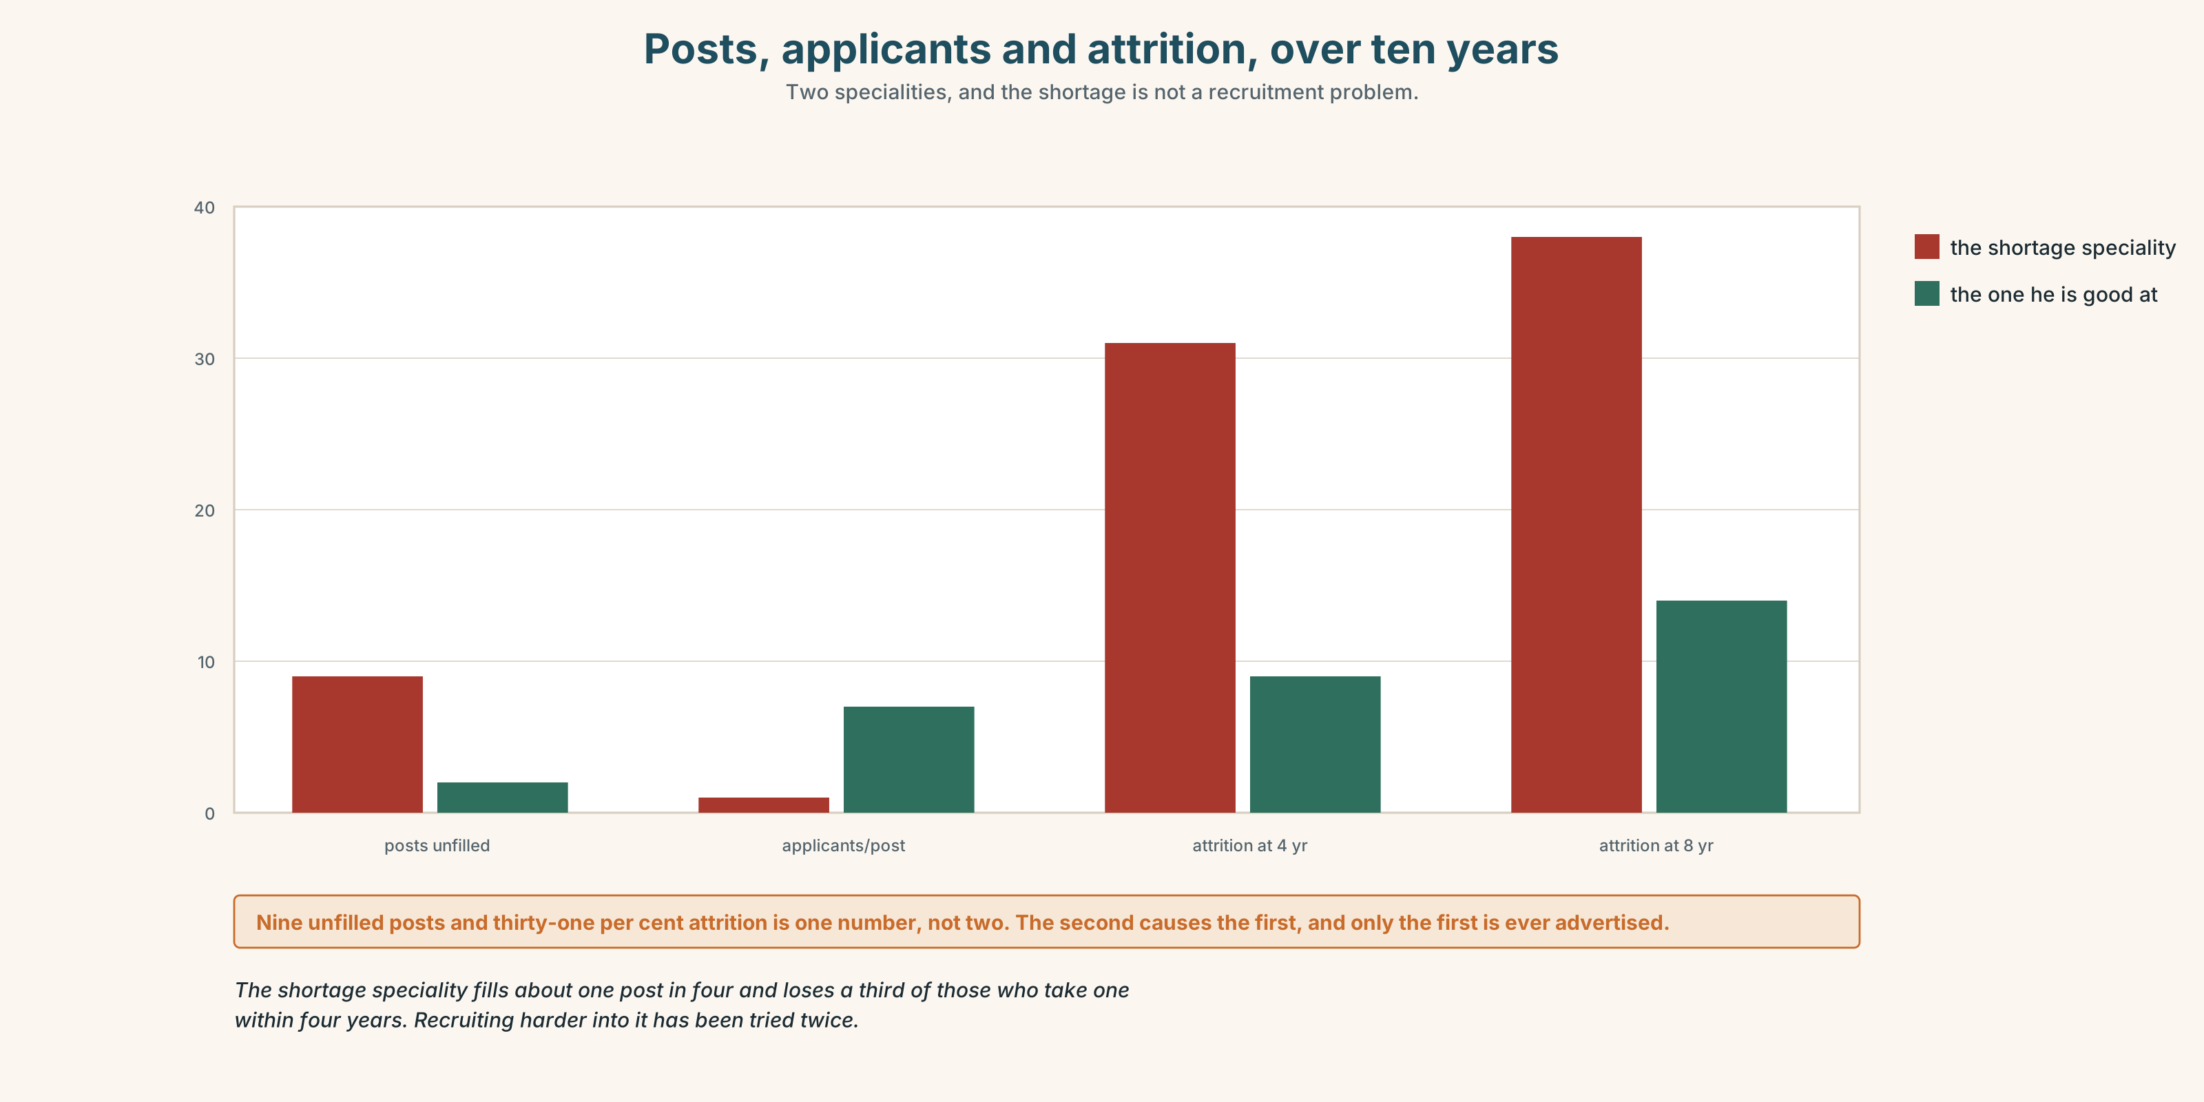{width=6.6in}
Posts, applicants and attrition, over ten years — Two specialities, and the shortage is not a recruitment problem.
- The curriculum and the survey from Part 5E — and the hand annotation.
- The chart — posts, applicants and attrition in each speciality over ten years.
- The voice. Dr Herrera, thirty seconds: "I chose the one I was needed in, in 2007, because of a train. I have been good at it for eighteen years and I would make the same decision now and I would like somebody to notice that those are two different sentences."

11B · Talk about it
In fours. Everybody speaks twice. Use the frame.
I wish ______ . If only ______ . So I think ______ .
Words you can use: gap · insight · competence · confidence · mentorship · out of my depth · on the job · with hindsight · the hard way · a steep learning curve

11C · Decide
Write three sentences. Choose, say why, and name what it costs.
I think Matías should ______________________ , because ______________________ . What this costs is ______________________ .

11D · Model decision
He should take the one he is good at and should say out loud, now, that he is doing it, because the shortage speciality's nine vacancies are a real emergency and the only honest thing is to decline them in public rather than quietly. Shortages are solved by making the work better, not by recruiting people who will be adequate at it and leave in four years, and the attrition figures say exactly that. He owes the region a clear no, which is more than most people give it.

11E · The Reveal
What happened. He took the one he is good at. He wrote a four-line note to the regional training lead explaining why he had not applied to the shortage speciality, which he was told was unnecessary and which he sent anyway.
The training lead quoted it, anonymously, in a paper to the regional board about why the shortage is not a recruitment problem. Two other students sent similar notes the following year.
He is in his third year and has twice been close to moving. He says the thing that keeps him is not that he is good at it but that in his first fortnight somebody said I don't know in front of him in a corridor, and that he has been able to say it ever since, and that he does not think he would have been able to in the other department.
He chose the thing he was good at. The reason he has stayed is something that happened in a corridor in his second week.
Was it the right decision? Say why — and say what the four-line note was actually for.

Part 12 · Landing ◆ all three lines

12A · Recycle — twelve items
- I wish I ______ (know). (now)
- I wish somebody ______ (tell) me. (the past)
- I wish he ______ (stop) saying that. (a complaint)
- If only I ______ (ask) her.
- I'd ______ you didn't say anything.
- He was out of his ______ for a year.
- You learn it on the ______ .
- With ______ , the signs were in the first week.
- (Unit 9) The majority of patients ______ seen in six weeks. (verb)
- (Unit 3) If we ______ (advertise) in March, we ______ (have) somebody now.
- (Unit 2) If I ______ (not / look), she ______ (have) it.
- (A2.2 U1) If I ______ you, I wouldn't wait.

12B · Consolidate
One hundred and eighty words. What you wish somebody had taught you. A gap named precisely, a cost with a number, a wish about now that is unresolved, and one thing that could not have been taught.

12C · Can-do, with evidence
I can… | My evidence | Sure?
wish about the present and the past, correctly | Part 3H score | ◯ ◑ ●
describe a gap in my training in three minutes | Part 4C recording | ◯ ◑ ●
write 180 words somebody could act on | Part 8 draft 2 | ◯ ◑ ●
have a career conversation without giving advice | Part 9D role play | ◯ ◑ ●

12D · Replay ⏺
Find your forty-five seconds from Part 0C. Listen. Record it again. Two sentences: what is different, and whether the thing you wished for could have been taught.

12E · Glossary — forty-five items, as a map
THE GAP · gap · ignorance · blind spot · out of my depth · nobody told me WHAT YOU GET · curriculum · apprenticeship · training · mentorship · feedback · lesson WHAT YOU BUILD · insight · competence · confidence · reflection · pick up · work out · catch up · fall behind HOW IT FEELS · a steep learning curve · on the job · the hard way · with hindsight WHAT PEOPLE SAY · I wish somebody had said · you learn that in week one or never · if only somebody had told me WISHING · wish · if only · I wish I knew · looking back · think back · go over PREFERRING AND SUPPOSING · rather · I'd rather · suppose · suppose we · it would be better if · in an ideal world HEDGING AND CONCEDING · preferably · ideally · hypothetically · regrettably · admittedly · supposedly · frankly · alternatively

12F · Next
B1.3 · Making the Case — a university campus in Melbourne.

End of B1.2 · Weighing It Up
Four hundred and fifty active items. Twelve new structures. Ten decisions, and in seven of them the right answer cost somebody something they could not get back.
Look back at your recording from Unit 1, Part 0C, and at the sentence you wrote in Unit 1, Part 9E. Read both. Then record the Unit 10 prompt again. Three sentences: what has changed, what has not, and what you now know you will not be taught.

