Table of Contents

B1.3 · Unit 7 · Somebody Told Somebody
English Animated · Making the Case · a university campus, Melbourne Student's Book pages 138–159 · 22 pp · ~11 hours

Part 0 · The Big Picture ◆ A · THE WORLD
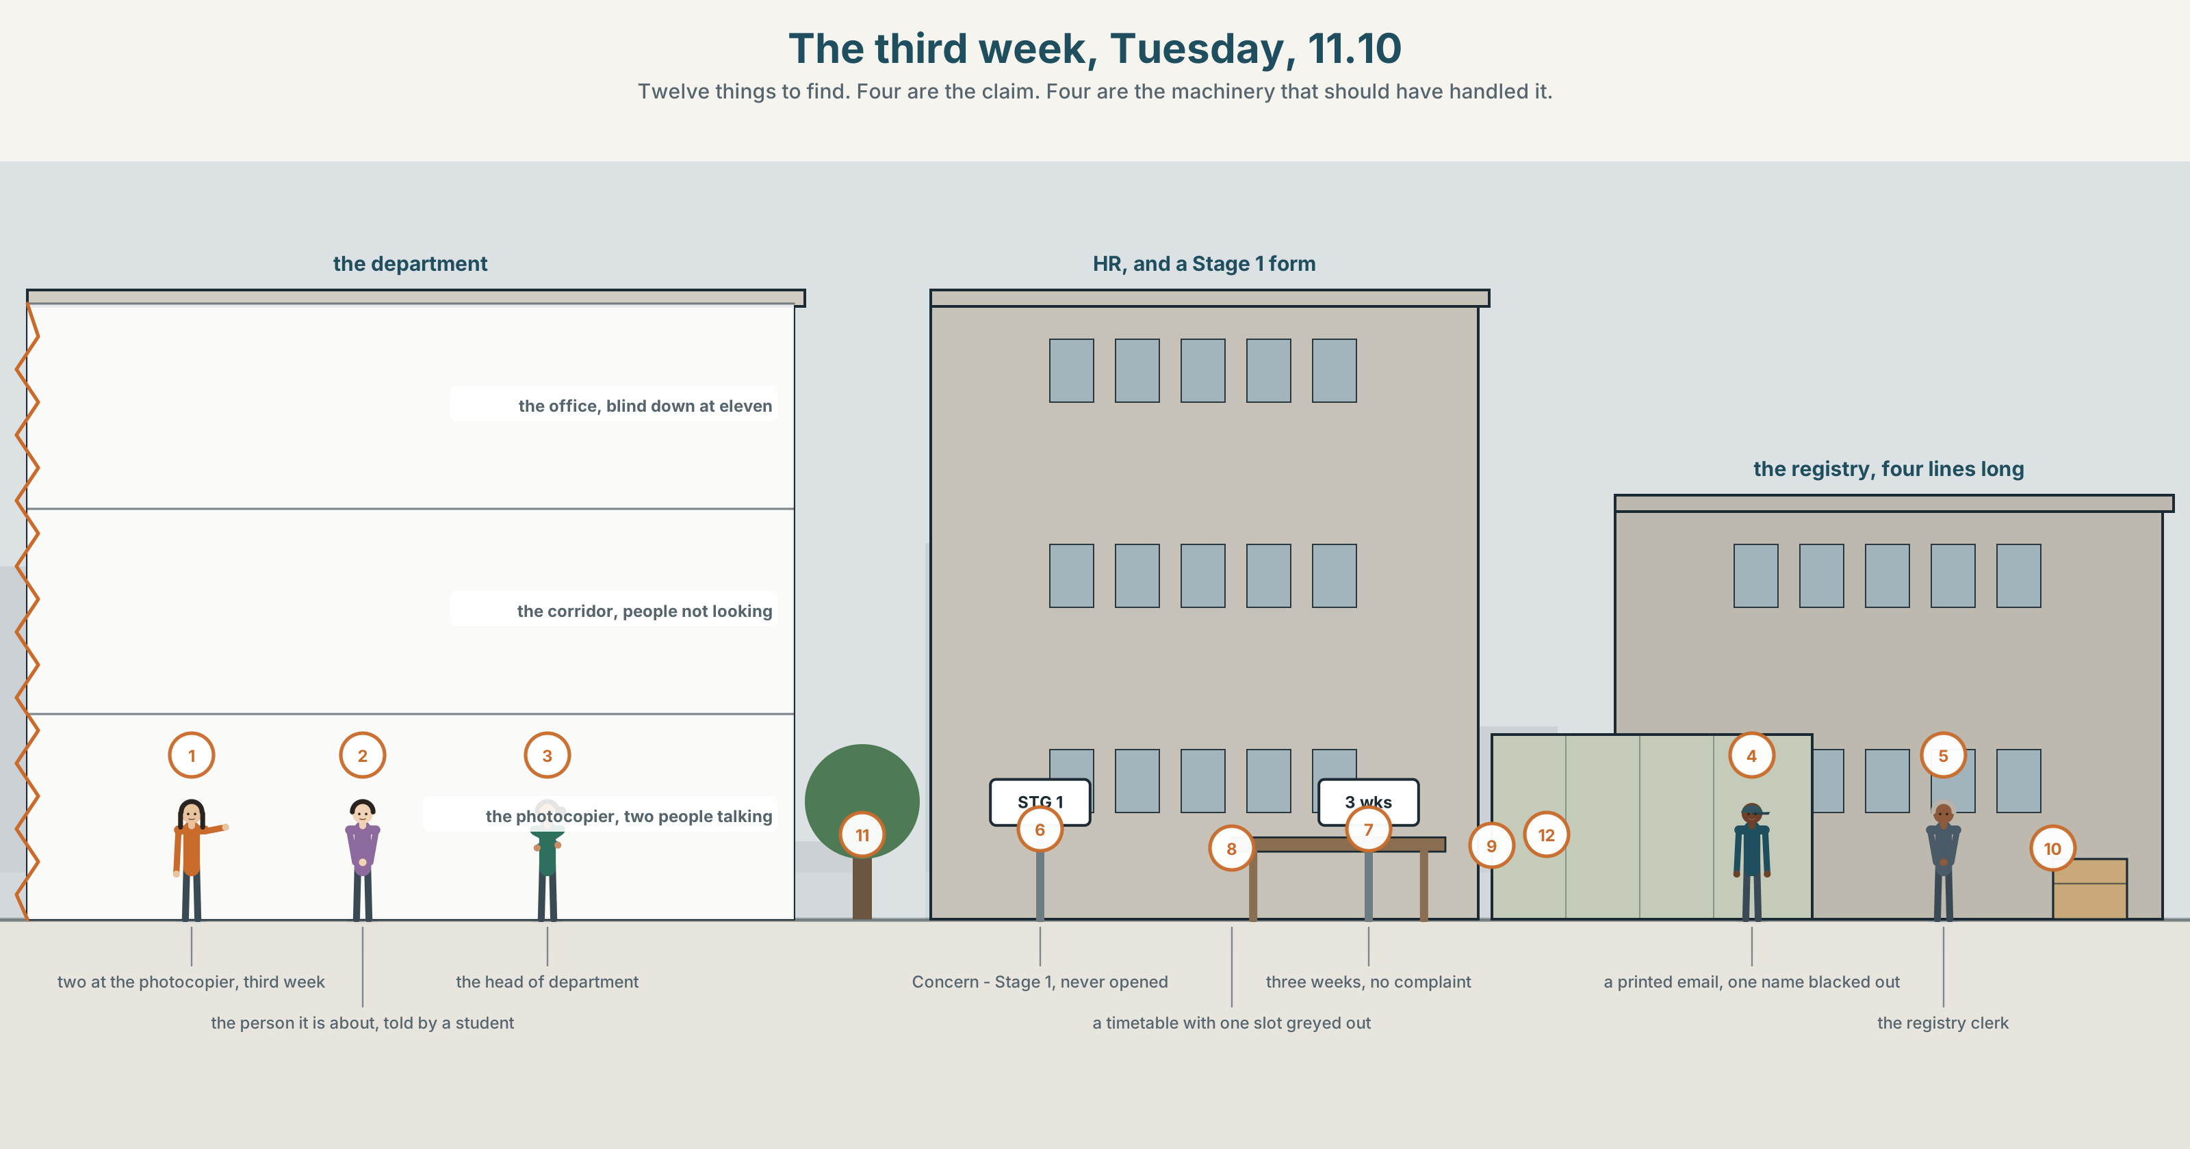{width=6.6in}
The third week, Tuesday, 11.10 — Twelve things to find. Four are the claim. Four are the machinery that should have handled it.

Who says so?
By the end of this unit you can write 190 words that report unverified claims without endorsing them.
◆ A · THE WORLD | Something is going round the department, and nobody can say where it started
◆ B · THE SYSTEM | passive reporting: it is said that · is thought to · 24 words for rumour and evidence · 21 distancing forms · weak forms in passive chains
◆ C · THE PERFORMANCE | A piece of writing that reports a claim and takes no position on it

0A · Find it
Find twelve things in this picture. Four of them are the claim. Four are the machinery that should have handled it.
two people talking at a photocopier · a staff pigeonhole with one envelope in it · a door with the nameplate removed · a timetable with one slot greyed out · a group chat open on a phone · a noticeboard with a procedure pinned to it · an office with the blind down at eleven in the morning · a corridor with people not looking · a meeting room with four chairs and five people · a lanyard on a desk · a form headed Concern — Stage 1 · a printed email with a name blacked out

0B · Guess it
One of the twelve was put there by the procedure, and eleven were not. Which, and what does that tell you?

0C · Say it ⏺
Record forty-five seconds. Describe something you were told about somebody, that you never checked, and that you still half believe. You will record it again at the end of this unit.

Part 1 · Vocabulary Lab 1 ◆ B · THE SYSTEM
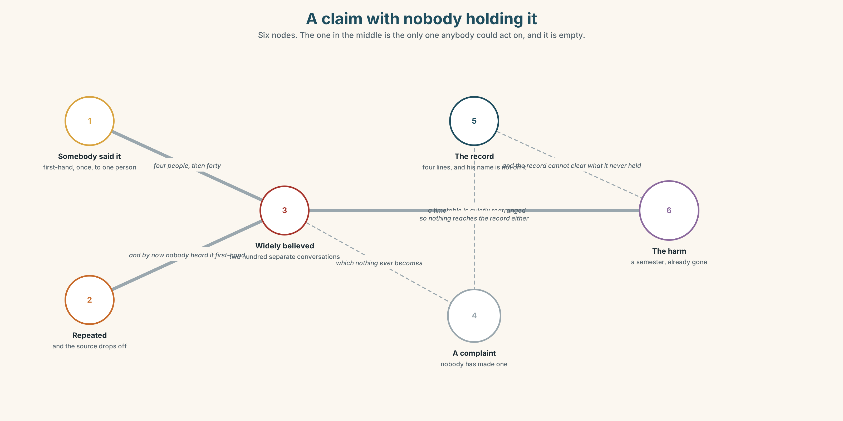{width=6.6in}
A claim with nobody holding it — Six nodes. The one in the middle is the only one anybody could act on, and it is empty.

1A · Meet — the words of an unverified claim
rumour · hearsay · allegation · consensus · corroboration · anonymity · due process · harm
- Which two of these are about who else says it?
- What is the difference between a rumour and an allegation?
- Anonymity protects somebody. Who, and at whose cost?
- Why is due process slow on purpose?
A rumour has no author. That is not a detail about it; it is the definition. The moment somebody will put their name to it, it becomes an allegation and a different set of machinery applies.

1B · Sort — the claim, the checking, or the damage?
circulate · substantiate · unverified · credible · it is said that · widely believed · no evidence that · a matter of record · take it seriously
Three columns. Two of them belong in more than one. Say which and why.

1C · Meet — the phrase that does most of the work
c no evidence that
Not evidence that it is false. The absence of the one and the presence of the other get reported in the same sentence shape, and almost nobody notices.
- Say the difference out loud, in two sentences.
- Which of the two can a one-week investigation produce?

1D · Collocation Lab
take it seriously | ~ without believing it · be seen to ~
look into it | we will ~ · nobody ever did ~
a matter of record | now ~ · not ~
widely believed | ~ and never checked · ~ to be
Which two of these can be true of something false?

1E · The fixed expressions
f There is no smoke without fire. — a proverb that does the work of an investigation without doing any of it. Why is it so hard to answer? f Somebody told somebody. — the whole evidential chain, said out loud, and it collapses the moment you write it down.
Which one would you be ashamed to write in a report, and why is that useful?

1F · Own it
The four phrasal verbs of a rumour.
go round · die down · come forward · hush up
- Which two describe what the claim does, and which what people do?
- What is the difference between a rumour that dies down and one that is resolved?
- Come forward implies a direction. Towards what?
- Write one sentence in which somebody tries to hush up something that is true and harmless.

Part 2 · Listening ◆ A · THE WORLD
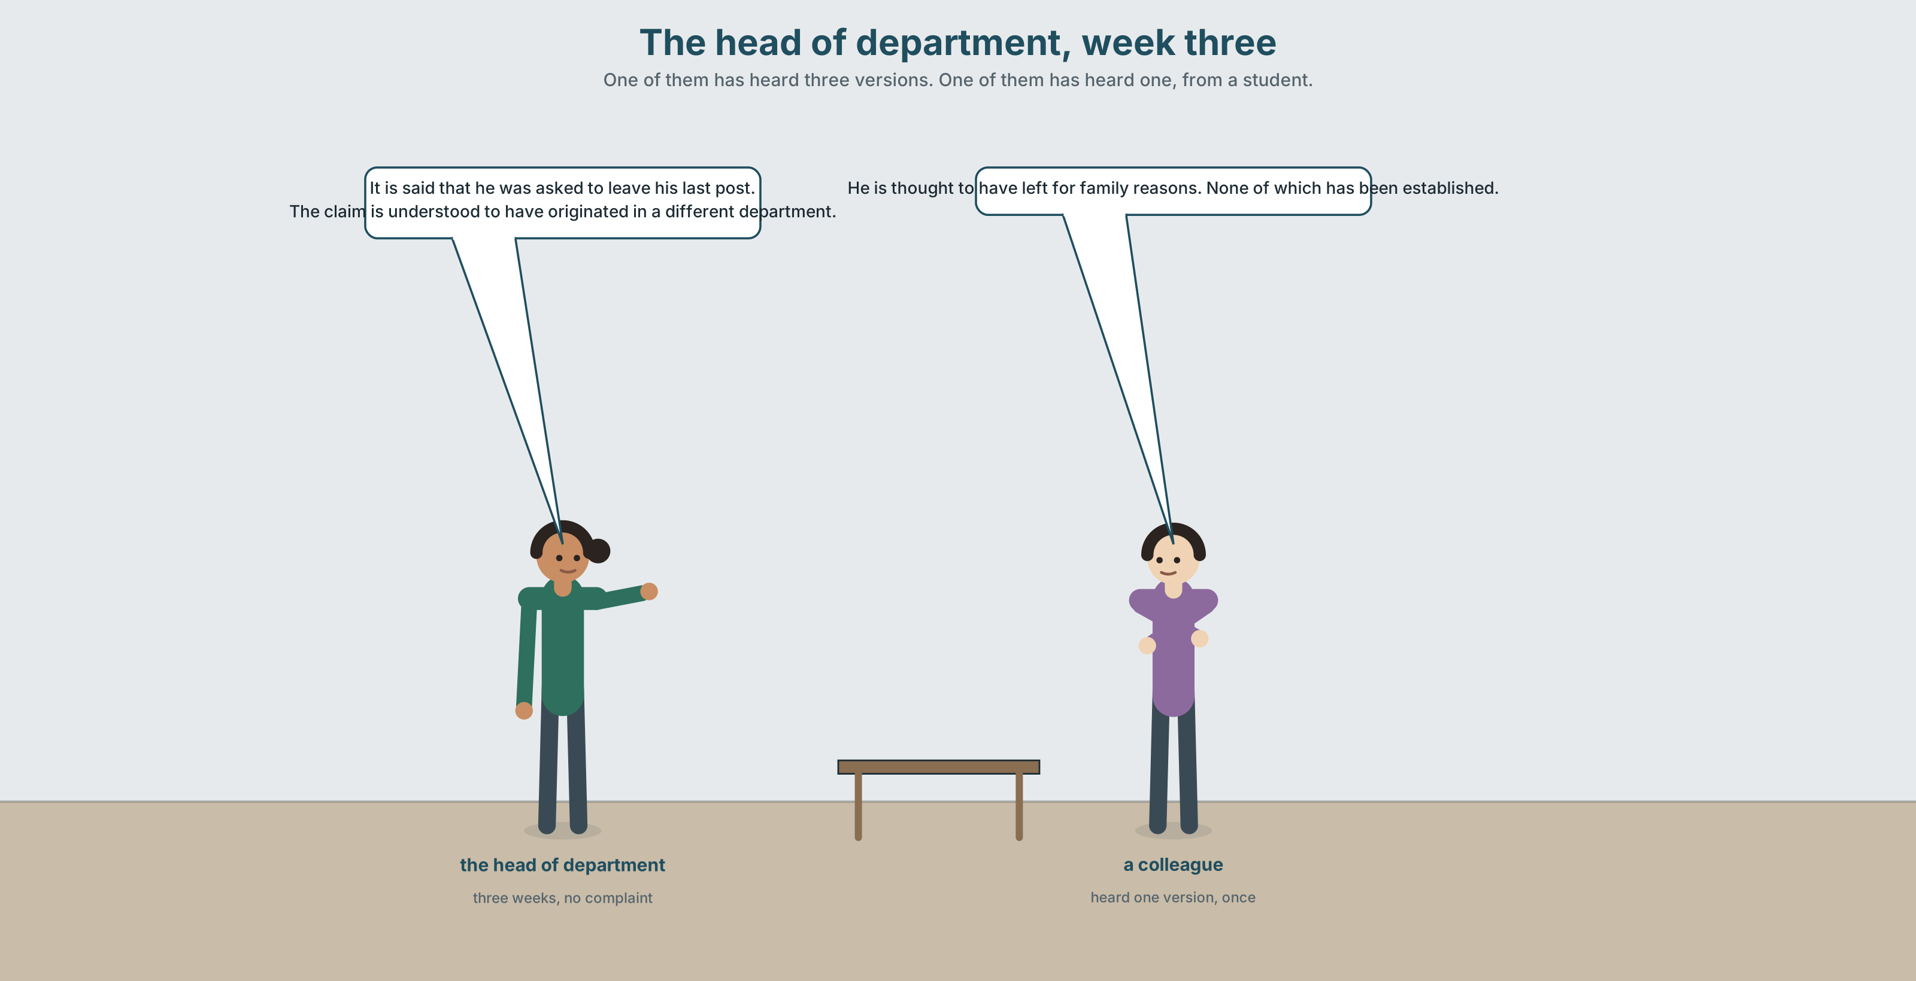{width=6.6in}
The head of department, week three — One of them has heard three versions. One of them has heard one, from a student.

2A · Three weeks in 🔊 Track 7.1
Before you listen. Something has been circulating about a member of staff for three weeks. Nobody has made a complaint. Guess: what does the head of department do?
Listen once. One question. What exactly has been said, and who heard it first?
Listen again. Complete the table.
 | What is claimed | Who says so | Checkable?
version 1
version 2
version 3
Listen again. Choose the best answer.
- The three versions are the same / related / unconnected.
- A formal complaint has been made by one person / by nobody / by the department.
- The head of department wants to act now / wait / find the source.
- Somebody says the phrase due process approvingly / dismissively / twice.
Noticing. Four sentences from the recording.
- It is said that he was asked to leave his last post.
- He is thought to have left for family reasons.
- The claim is understood to have originated in a different department.
- None of which has been established.
All four report without endorsing. Which one does it most completely?

2B · Decoding clinic 🔊 Track 7.2
Thirty seconds of the head of department. Four jobs.
- How many passive reporting structures can you count?
- In is thought to have left, how many of the words are weak?
- Catch the two time periods.
- She says one thing that she would not write down. Which?
Transcripts, page 156.

Part 3 · Grammar Lab 1 ◆ B · THE SYSTEM

Reporting without taking responsibility for it

3A · Notice
Look at the four sentences in Part 2.
- In sentence 1, who says it? Can you tell from the sentence?
- In sentence 2, what is the subject, and where did the claimers go?
- Rewrite sentence 3 starting with It. What is gained and what is lost?
- Sentence 4 is not a sentence. What is it attached to?
- Try "He is said that he left." What is wrong with it?

3B · See
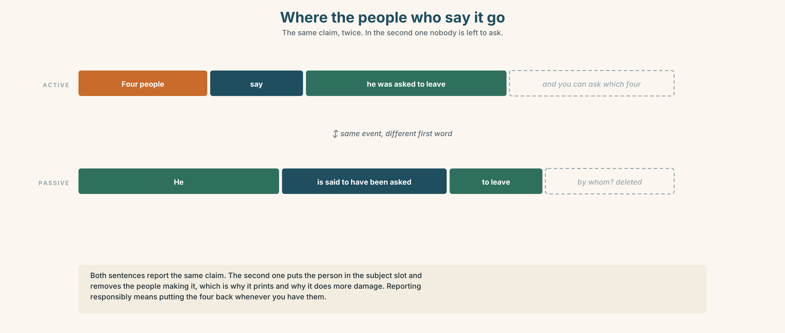{width=6.6in}
Where the people who say it go — The same claim, twice. In the second one nobody is left to ask.

3C · Know
Shape | Example | Where the claimer went
It + passive + that | It is said that he left. | deleted, and the claim is foregrounded
subject + passive + to | He is said to have left. | deleted, and the person is foregrounded
verbs that do this | say · think · believe · understand · allege · report · expect
present | is thought to be | now
past | is thought to have been | then — and the reporting is still now
Two shapes, one meaning, different first words. It is thought that he left and He is thought to have left report the same claim. The second one puts the person in the subject slot, which is why newspapers prefer it and why it does more damage.
to have + past participle moves the claim backwards, not the reporting. is said to be = he is, now. is said to have been = he was, then. The is said stays in the present in both, because the saying is happening now.
The claimer is deleted, and that is the point. These structures exist so that a claim can be printed when nobody will attach their name to it. Reporting responsibly means putting the name back when you have one.
Why it matters. This is the grammar of every sentence you will ever read about something nobody has proved. Learn to see it and you can read a newspaper twice.

3D · Use — controlled
(1) __________ is said that the appointment was rushed. He (2) __________ thought __________ have been interviewed by two people rather than the usual four, although the panel record shows three. He is also (3) __________ to have left his previous post at short notice, which is (4) __________ believed in this department and is (5) __________ a matter of record anywhere. (6) __________ to sources, a complaint was made in 2019. The complaints register for 2019 is three lines long and contains no such entry, (7) __________ of which has been established, and all of which has been repeated.

3E · Use — guided
Rewrite each one as a passive report. Use the shape in brackets.
- People say he was asked to leave. (It…)
- People say he was asked to leave. (He…)
- Everyone believes the appointment was rushed. (It…)
- They understand the claim started elsewhere. (The claim…)
- Nobody has proved any of it. (none of which…)

3F · Use — open
In pairs. Report something going round your institution, in six sentences, four of which must use a passive report. Your partner's job is to ask, after each one, who says so — and to note how many times you cannot answer.

3G · Error autopsy
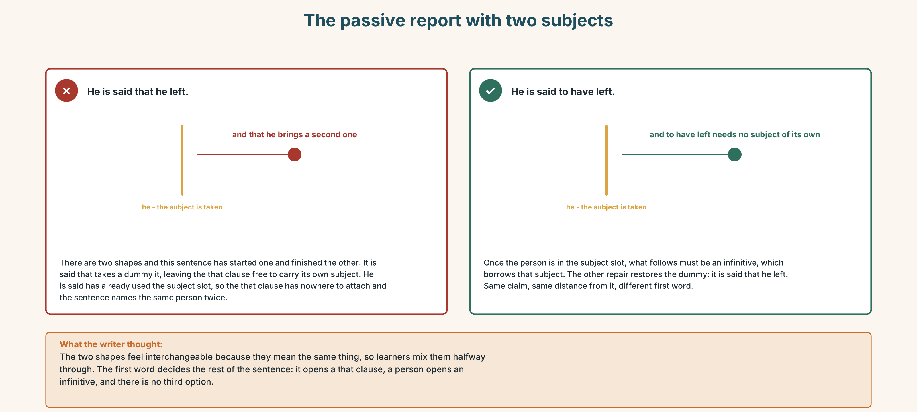{width=6.6in}
The passive report with two subjects — The passive report with two subjects
Read both versions. Then say what the first one claims that the writer did not mean.

3H · Check — eight items
- ______ is said that he left. (It-shape)
- He ______ said ______ have left. (subject-shape, past)
- He is thought ______ be fifty. (present)
- The claim is ______ to have started elsewhere. (understand)
- It is ______ that a complaint was made. (allege)
- ✗ He is said that he left. → correct it.
- ______ to sources, nobody has complained. (preposition phrase)
- ______ of which has been established. (relative)
0–4 → Workbook pp. 30–33. 5–6 → Part 6. 7–8 → page 151.

Part 4 · Speaking ◆ C · THE PERFORMANCE

4A · Fluency starter — who says so
One learner reports a claim passively. The next asks who says so. The chain breaks when somebody can actually answer.

4B · The functional core — reporting what you cannot verify
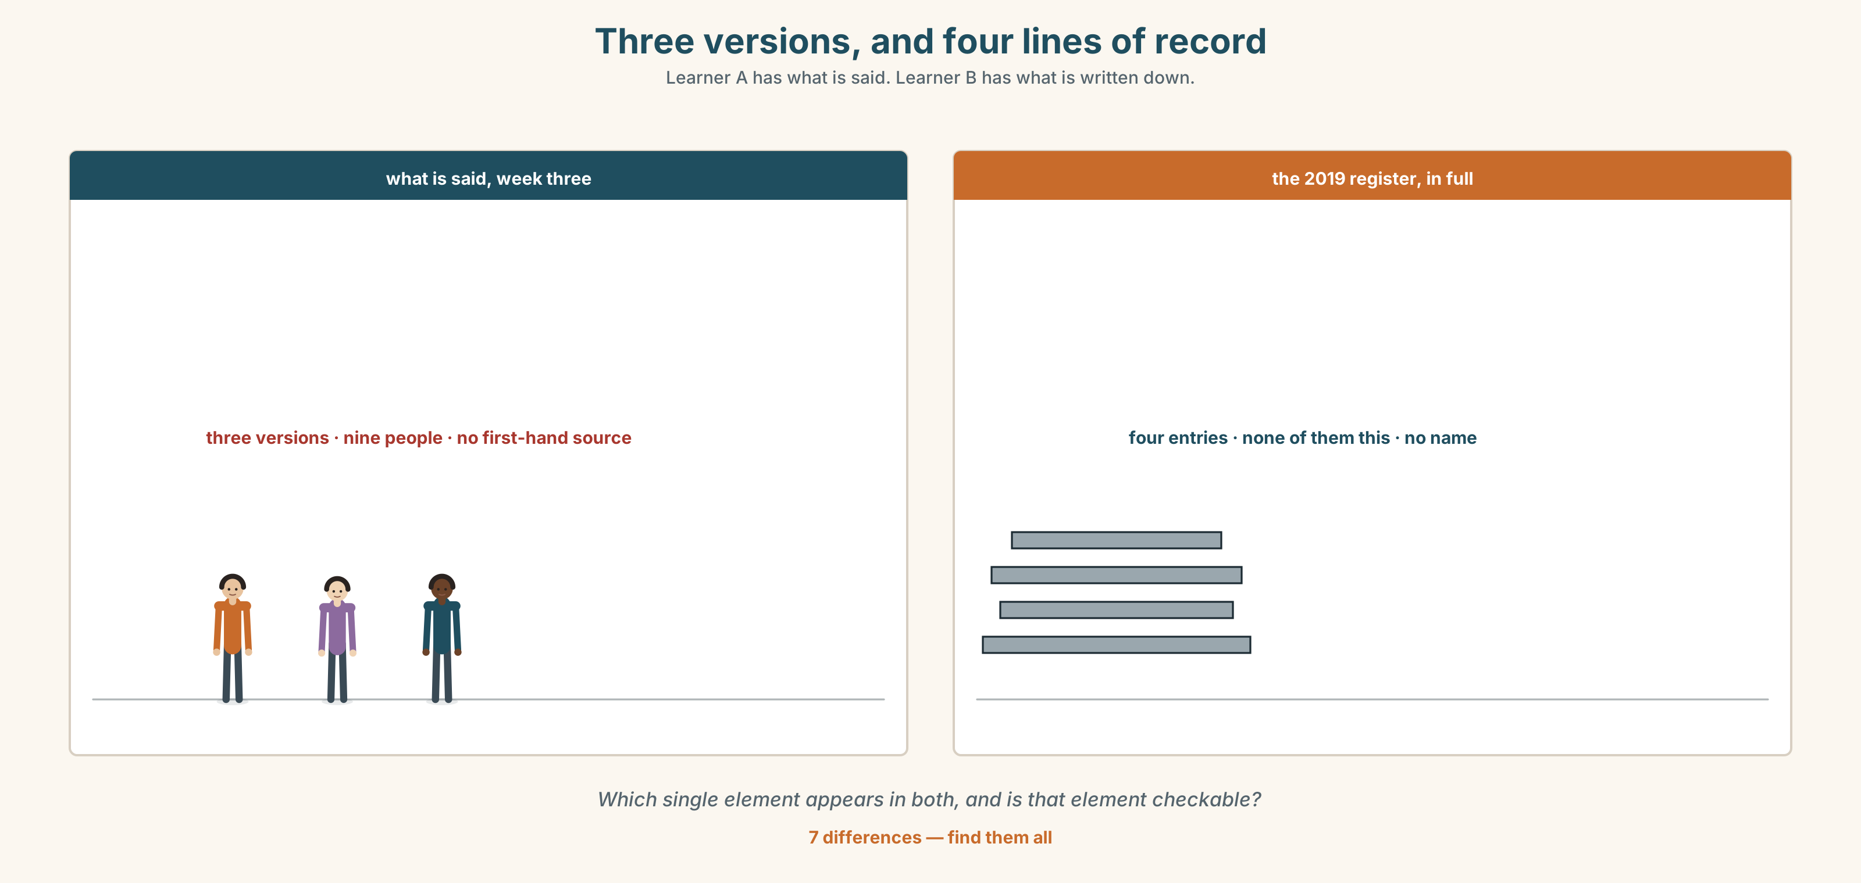{width=6.6in}
Three versions, and four lines of record — Learner A has what is said. Learner B has what is written down.
Language Bank
the claim | It is alleged that… · He is said to have… · Reportedly, …
the status | This is unverified. · None of which has been established.
what is checkable | What is a matter of record is… · As far as we know, …
the harm | Repeating it costs… · The question is who is damaged while we wait.
Information gap. Learner A has the three versions of the rumour. Learner B has the documentary record. Find the one element that appears in both.

4C · The performance — three minutes ⏺
Report something unverified, from your own life or the unit. Three minutes. You must include:
the claim, reported and not endorsed · its status, said plainly · one thing that is checkable, and what the record says · who is harmed while nobody checks
Record it.

4D · Observer
One person listens for one thing: did the speaker ever slip from reporting into endorsing?

4E · Three criteria
☐ Is every unverified claim marked as unverified? ☐ Did I separate what is a matter of record from what is said? ☐ Did I name who is harmed by the delay, and by the repetition?

Part 5 · Reading ◆ A · THE WORLD

5A · Predict
A review, titled "Four Weeks, at the Malthouse." What do you expect the reviewer to say about the ending? Two sentences.

5B · Read — two minutes and a quarter

FOUR WEEKS Malthouse Theatre · a review
Four Weeks is built entirely from documents. There is no invented dialogue in it, which the programme tells you twice, and which you stop noticing about ten minutes in, and then notice again very sharply at the end.
The subject is a school teacher in a regional town, about whom something began to circulate in 2017. The play never tells us what. This is its one structural decision and everything else follows from it: we hear eleven people describe a claim none of them can state, in the form it is said that, apparently, I was told, and, nine times across ninety minutes, there is no smoke without fire.
What the documents establish is this. No complaint was ever made. The teacher was moved to a non-teaching role for what the letter calls a period of review, which lasted four weeks and was then extended twice. He resigned in the eleventh week. The claim was never put to him in writing, because there was nothing to put, and the play's most uncomfortable scene is a nineteen-minute reconstruction of a meeting in which three senior people try to find a form of words for a thing none of them has heard first-hand.
The second act is the town. It is also the weakest part, because the writer cannot resist the chorus, and a chorus implies a collective that in a rumour does not exist — what exists is two hundred separate conversations, each of which thought it was the only one.
The ending is a projection of the complaints register for that year. It is four lines long. It is on screen for ninety seconds, which is far too long and exactly right, and the man's name is not on it.
Go. Then notice, on the way out, how much of what you now believe about him came from a play that was careful to tell you nothing.

5C · Comprehension — eight questions
- What is the play built from, and what does the programme say twice?
- What is the play's "one structural decision"?
- How many people describe the claim, and in what forms?
- What do the documents establish? Give four facts.
- How long was the review period, and when did he resign?
- Why was the claim never put to him in writing?
- What is the reviewer's objection to the second act?
- What is on screen at the end, for how long, and what is not on it?

5D · Vocabulary in context
Guess from the text. Then check.
began to circulate · a period of review · put to him in writing · the writer cannot resist · far too long and exactly right

5E · The counter-text
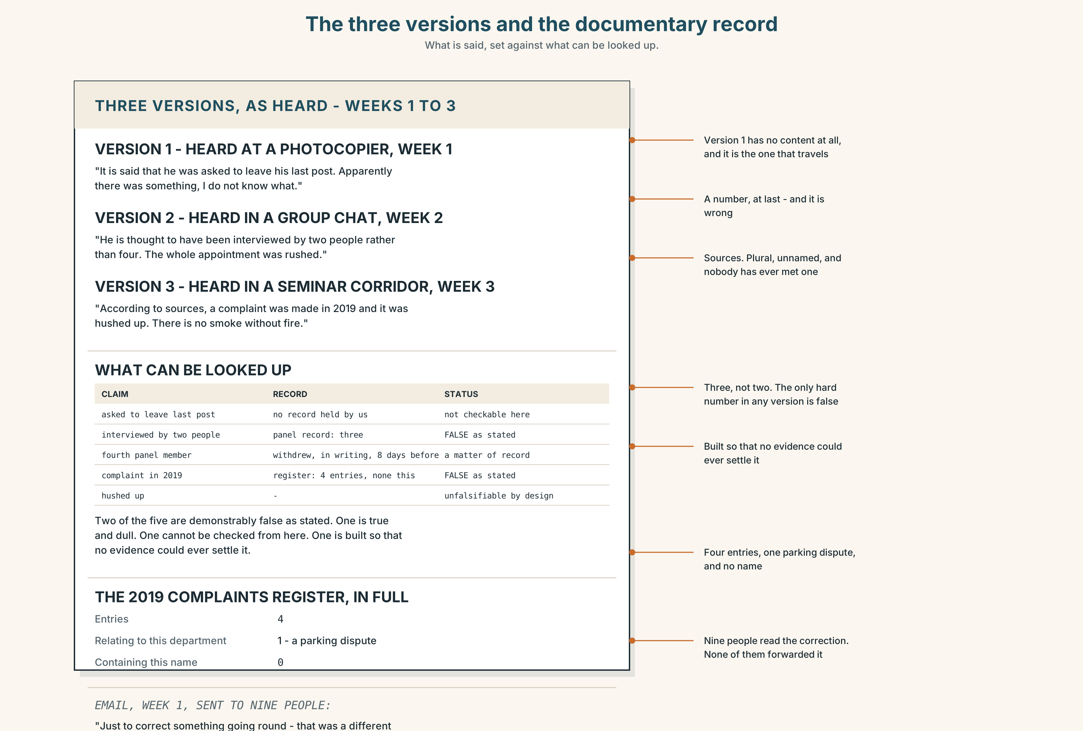{width=6.6in}
The three versions and the documentary record — What is said, set against what can be looked up.
Read the three versions of the claim and the documentary record, and answer.
- What does each of the three versions say?
- Which element appears in all three, and is it checkable?
- What does the panel record show about the interview?
- How many entries are in the 2019 complaints register, and what are they?
- One version contains a detail that is demonstrably false. Which, and how do we know?

5F · Two texts
The rumour says the appointment was rushed. The panel record shows three interviewers where the usual number is four.
Does the record support the rumour? Three sentences.

Part 6 · Vocabulary Lab 2 ◆ B · THE SYSTEM

The adverbs that put a claim at arm's length

6A · Sort — how far away does each one hold it?
Three columns: neutral · doubtful · openly sceptical.
reportedly · allegedly · apparently · supposedly · ostensibly · purportedly · seemingly · arguably · presumably

6B · Chunk completion
- is ______ to have left at short notice (think)
- is ______ to be fifty (say)
- is ______ to have been interviewed twice (believe)
- is ______ to have started elsewhere (understand)
- it is ______ that a complaint was made (allege)
- ______ to sources , nobody has complained

6C · Three that are not neutral at all
supposedly · ostensibly · purportedly
All three signal that the writer does not believe it. Ostensibly adds that the stated reason is a cover for another one. Using any of them is taking a position, which is exactly what the other six do not do.
Write three sentences about the play in Part 5, one with each.

6D · Two verbs for what a claim does
p put about · p stand up
A story was put about that he had been asked to leave. None of it stood up.
Put about names a deliberate act with no named actor. Stand up is what a claim does under checking, and it is almost always negative: did not stand up.
Rewrite two sentences from Part 5B using them.

6E · The fixed expressions
f None of which has been established.
A whole sentence, attached to everything before it. It is the single most useful six words in this unit and the one most often left out.
Write the three sentences it is attached to.

6F · Contrast Clinic
Eight items. Four are wrong. Correct them and say what the rule is.
- He is said that he left.
- It is said that he left.
- He is said to have left.
- He is thought to have been interviewed by two people.
- It is thought him to be fifty.
- He is believed to be fifty.
- According to sources, nobody has complained.
- None of which have been established.

Part 7 · Pronunciation & Fluency Lab ◆ B · THE SYSTEM

Weak forms in a passive chain
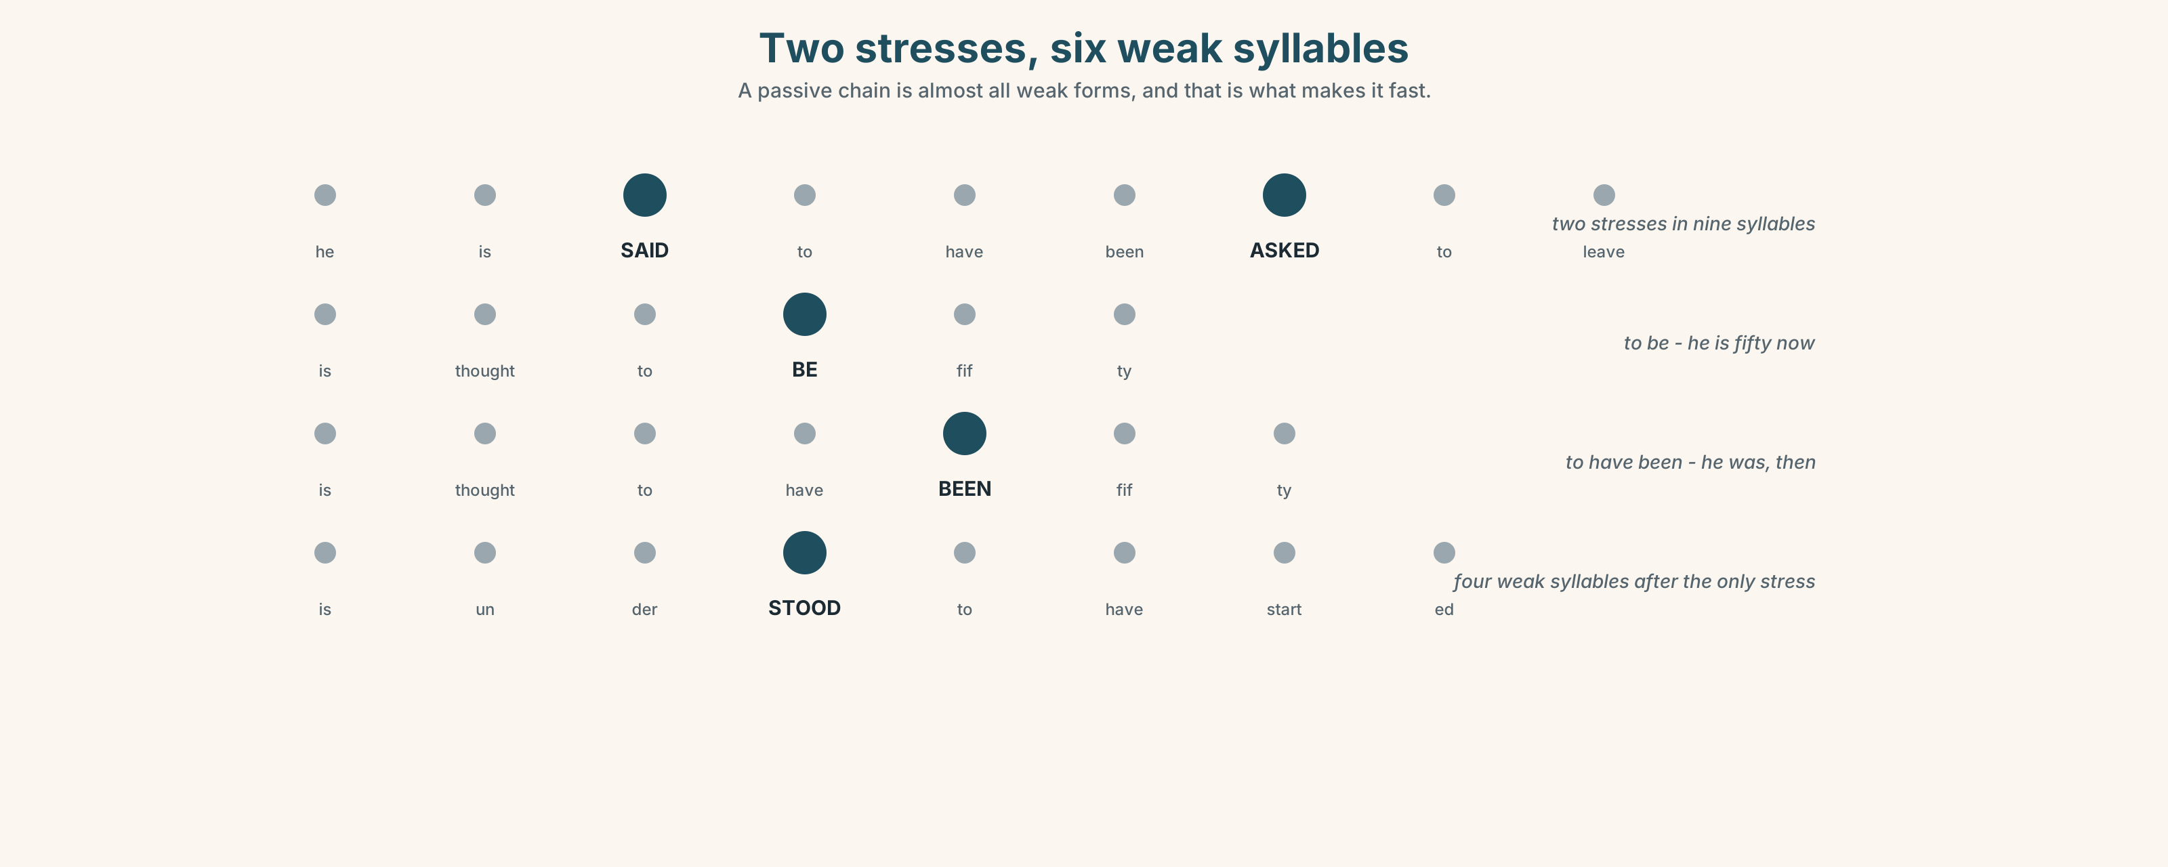{width=6.6in}
Two stresses, six weak syllables — A passive chain is almost all weak forms, and that is what makes it fast.

7A · Hear 🔊 Track 7.3
He is SAID to have been ASKED to leave. Eight words. Two of them are stressed. to have been is one blurred syllable and a half.
Listen again for the shape of it:
/hiz sed təv bin ɑːskt tə liːv/

7B · Say
Say it slowly, then at speed. Then say this one three times, faster:
The claim is understood to have originated in a different department.

7C · Make it mean something
Say these two:
He is said to BE fifty. (now) He is said to have BEEN fifty. (then — and he is older now)
One syllable, twenty years. Which is which?

7D · Fluency 30 ⏺
Thirty seconds: four passive reports, each with the weak forms properly weak. Three times, faster, keeping the two stresses.

Part 8 · Writing ◆ C · THE PERFORMANCE

A report of an unverified claim · 190 words
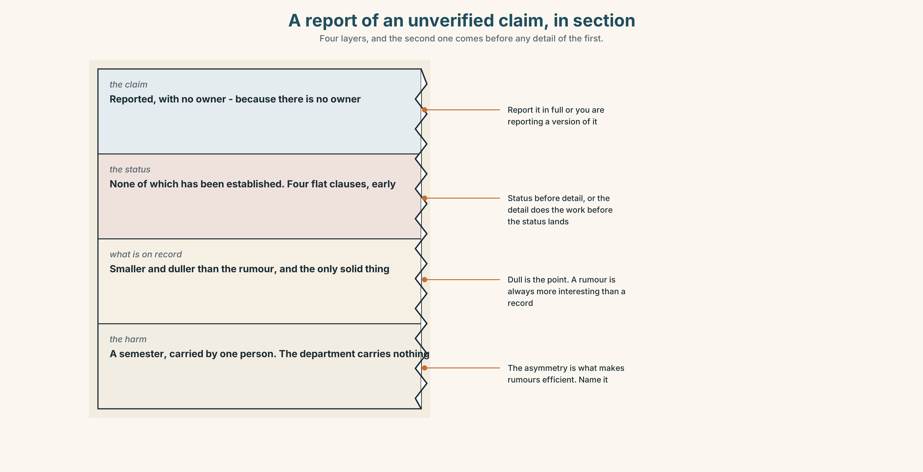{width=6.6in}
A report of an unverified claim, in section — Four layers, and the second one comes before any detail of the first.

8A · Read the model
It is said in the department that the appointment was rushed, and that the person appointed was asked to leave a previous post. [the claim, reported, with no owner — because there is no owner]
None of which has been established. No complaint has been made, no date has been given, and no person has yet repeated it to me who heard it first-hand. [the status, in four flat clauses, before anything else]
What is a matter of record is that the appointment panel had three members rather than the usual four, and that the fourth withdrew eight days before, in writing, citing workload. [the checkable fact, which is smaller and duller than the rumour and is the only solid thing here]
Three weeks of this have cost one person their teaching allocation for the semester and have cost the department nothing, which is the asymmetry that makes rumours efficient. [the harm, named, with the asymmetry stated]
Questions about the writer's choices:
- The status comes before the evidence. Why not after?
- The checkable fact is "smaller and duller". Why include it at all?
- The last paragraph names an asymmetry. What would the report be without it?

8B · The anti-model
There have been some concerns raised about the recent appointment and a number of people have expressed disquiet. While nothing has been proven, it is felt that the matter should be looked into, and it is understood that steps are being taken. Further information will be provided in due course.
Correct English, and it repeats the claim while appearing not to. Find the four structures that have deleted a person, and say what it is felt achieves that I think would not.

8C · Plan
the claim, reported → the status, flat and early → what is a matter of record → the harm, and who carries it

8D · Write — 190 words

8E · Peer review — three criteria
☐ Is the status of the claim given before any detail of it? ☐ Is every checkable fact separated from every reported one? ☐ Is the harm named, with the person who carries it?

8F · Write it again · 8G · Publish
Do not publish this one on the wall. Hand it to one person and ask them one question: would you be comfortable if the subject read it?

Part 9 · The File ◆ A · THE WORLD + C · THE PERFORMANCE

WORK FILE · The Safety Brief
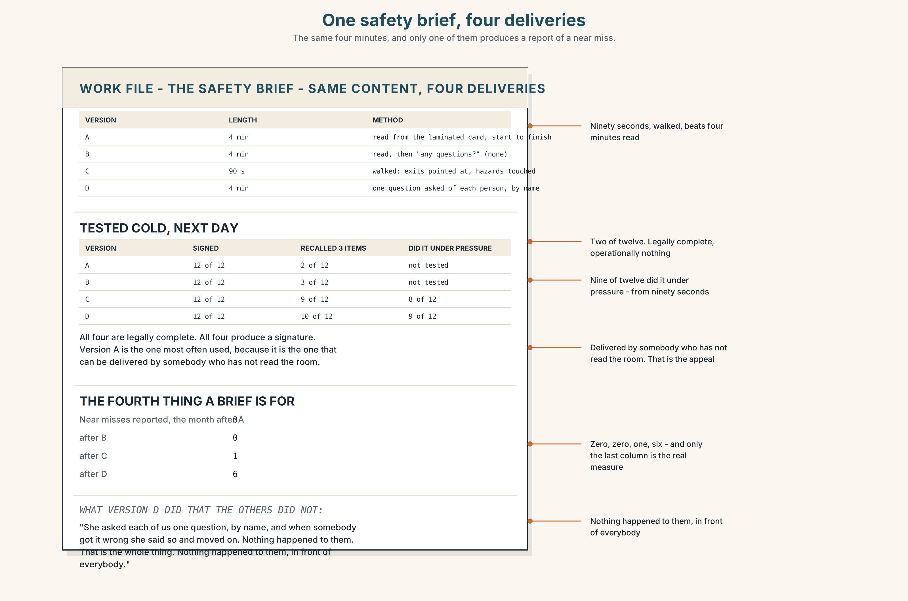{width=6.6in}
One safety brief, four deliveries — The same four minutes, and only one of them produces a report of a near miss.

9A · Four minutes that nobody listens to 🔊 Track 7.4
The same safety brief, delivered four ways. Listen.
- Which one do people remember afterwards, and why?
- Which one is legally complete and operationally useless?
- One of the four asks a question. What does that change?

9B · What a brief is actually for
compliance — it was delivered, and there is a signature recall — people can repeat it tomorrow behaviour — people do the thing, under pressure, without thinking reporting — people tell you when something goes wrong
Which of the four does your institution measure, and which does it need?

9C · The fourth one is the hard one
A brief that produces reporting is a brief after which somebody will tell you about a near miss. That requires people to believe nothing bad happens to the person who comes forward, and no form has ever achieved that.
What would convince you, in a new job, that it was safe to report something?

9D · Your turn
In fours. Twelve minutes. Deliver a sixty-second safety brief for this room: exits, hazards, what to do, who to tell. Then test each other on it from memory, cold.

9E · Transfer
Find the safety notice nearest to where you are sitting. When was it last changed, and can anybody in the room say what it says?

Part 10 · Mediation & Interaction ◆ C · THE PERFORMANCE
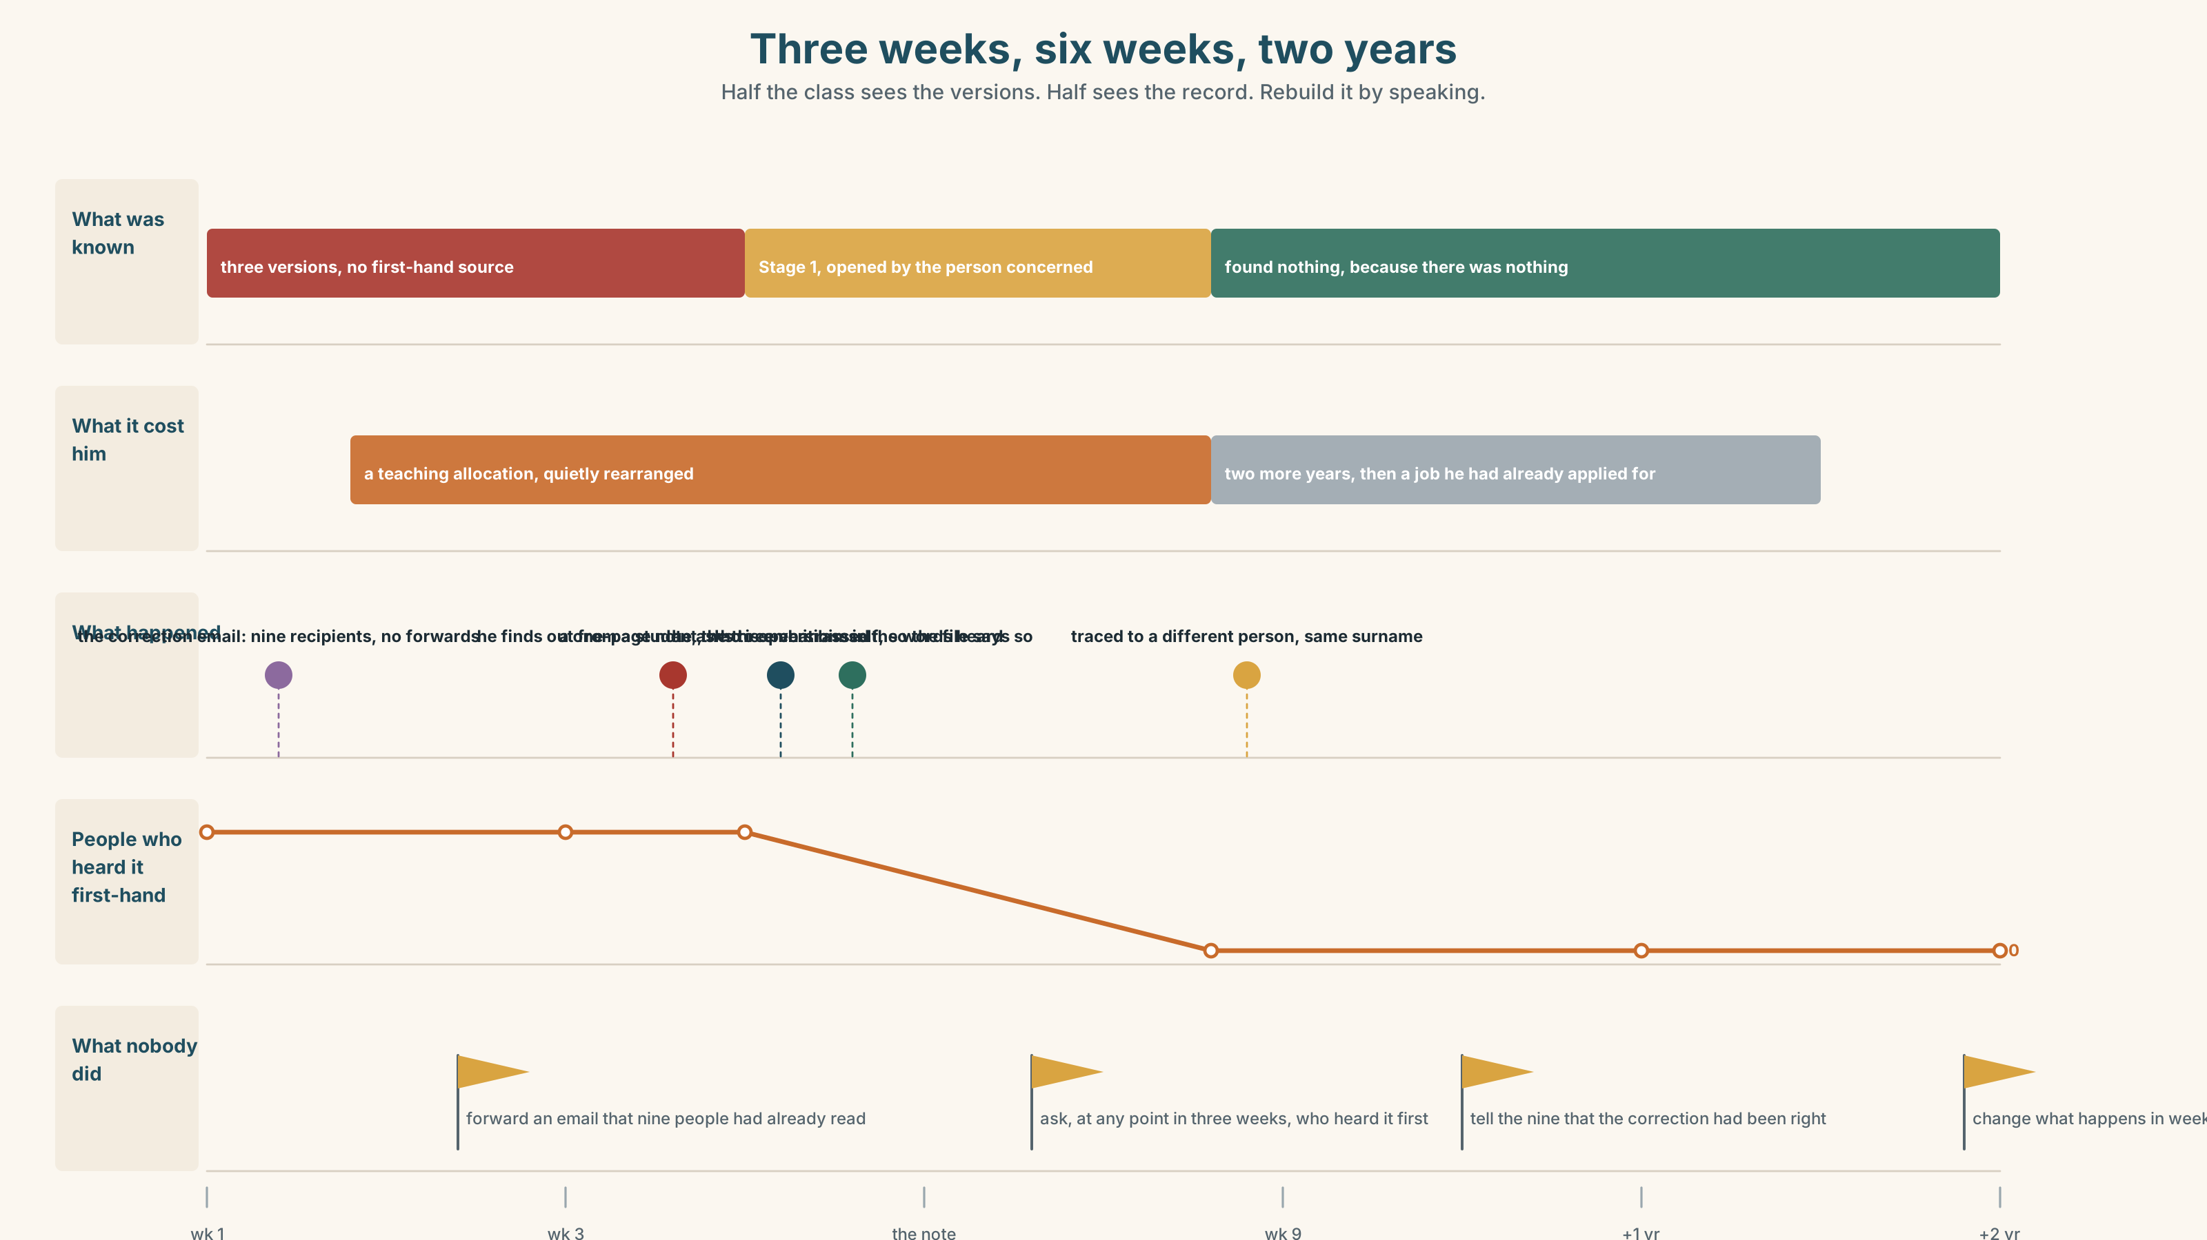{width=6.6in}
Three weeks, six weeks, two years — Half the class sees the versions. Half sees the record. Rebuild it by speaking.

10A · Relay
Half the class sees the three versions. Half sees the documentary record. Rebuild the three weeks by speaking. Twelve minutes.

10B · Simplify
Explain to a new colleague what is known and what is not. Five sentences only.
Plan: what is said → what is on record → what has been established → what has happened to the person → what you would advise them to do

10C · Compress
The review in Part 5B into forty words, keeping the last paragraph's point.

10D · Online
Write one message in a group chat where the rumour has just been repeated. You are not defending anybody, you are asking one question, and you are not going to send a second message.

10E · Your language
Does your language have a reportative form — a verb ending or particle meaning they say? Say he is said to have left in both languages. Which marks it on the verb, and which needs a whole clause?

Part 11 · The Decision ◆ C · THE PERFORMANCE

Three weeks, three versions, no complaint
Something has been going round for three weeks. No complaint has been made. The person has already lost a teaching allocation because a timetable was quietly rearranged. The head of department has to do something or decide not to.
- Investigate. Open a Stage 1 concern, interview the people who have repeated it, and make it a matter of record. It becomes real, with a file, and a file does not close.
- Do nothing formal. Rumours die down. This one has no source and no complainant, and opening a process creates a document where there is currently only talk.
- Go to the person. Tell them exactly what is being said, in writing, today — before any process, so they are not the last to know and can decide for themselves what happens next.

11A · The evidence
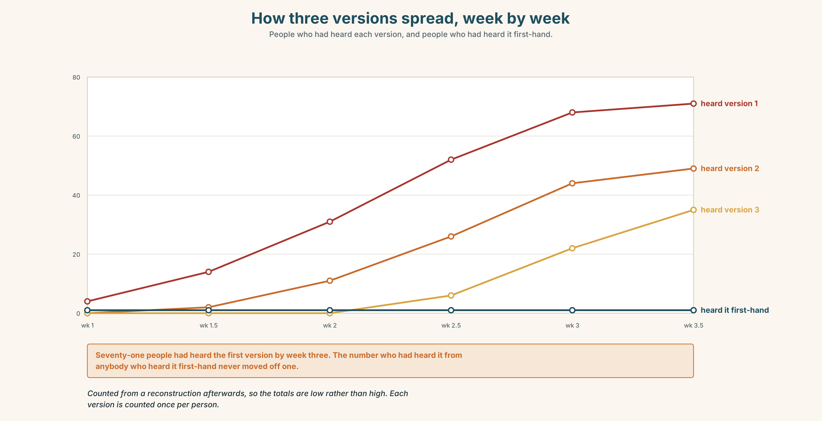{width=6.6in}
How three versions spread, week by week — People who had heard each version, and people who had heard it first-hand.
- The three versions and the record from Part 5E — and the detail that is demonstrably false.
- The chart — how the three versions spread, week by week, and how many people heard each one first-hand.
- The voice. The person concerned, thirty seconds: "I found out in week three from a student. Not a colleague — a student, who was embarrassed. I would have preferred almost any process to that, including one that found against me, because at least I would have been in the room."

11B · Talk about it
In fours. Everybody speaks twice. Use the frame.
It is ______ that ______ , none of which ______ . What is a matter of record is ______ .
Words you can use: rumour · hearsay · allegation · corroboration · anonymity · due process · harm · unverified · credible · substantiate

11C · Decide
Write three sentences. Choose, say why, and name what it costs.
I think the head of department should ______________________ , because ______________________ . What this costs is ______________________ .

11D · Model decision
Go to the person, today, in writing, before anything else. Every version of this problem that begins with an investigation ends with the subject learning about it from somebody who is enjoying it. Telling them first costs the department its control of the timing and gives the person the one thing nobody in a rumour ever has, which is the ability to ask a question of somebody who has to answer. The investigation may still follow. It should not come first.

11E · The Reveal
What happened. She went to him on the Thursday with a one-page note listing the three versions in the words she had heard them. He read it, asked for an hour, and came back with a request: open the Stage 1 himself, as the person concerned, so that the file would say he had asked for it.
The process took six weeks and found nothing, because there was nothing. One of the three versions was traced to a confusion with a different person of the same surname at a different university, which had been corrected in an email in week one — an email that nine people received and none of them forwarded.
He stayed two more years and then left, for a job he had applied for before any of this. Asked afterwards what had helped, he named the note, and said the thing that still bothered him was the nine people, none of whom had done anything wrong, and all of whom had read the correction.
Nobody lied, nobody acted maliciously, and a correction that nine people read reached nobody. The whole thing cost one person a semester and the department a sentence in a file.
Was it the right decision? Say why — and say what should have happened in week one.

Part 12 · Landing ◆ all three lines

12A · Recycle — twelve items
- ______ is said that he left.
- He is said ______ have left.
- He is thought ______ be fifty.
- The claim is ______ to have started elsewhere.
- It is ______ that a complaint was made.
- ______ to sources, nobody has complained.
- ______ of which has been established.
- A story was ______ about.
- None of it ______ up.
- Nobody would ______ forward.
- It did not ______ down for three weeks.
- They tried to ______ it up.

12B · Consolidate
Three columns, from memory: It + passive + that · subject + passive + to · the single-word adverbs.

12C · Can-do, with evidence
☐ I can report an unverified claim without endorsing it. Evidence: 4C, 8D ☐ I can build both passive reporting shapes, present and past. Evidence: 3H, 6F ☐ I can hear and produce the weak forms in a passive chain. Evidence: 7D ☐ I can separate what is on record from what is said. Evidence: 8D, 11C

12D · Replay ⏺
Record 0C again. Listen to both. What have you got that you did not have in week one?

12E · Glossary — forty-five items, as a map
THE CLAIM · rumour · hearsay · allegation · unverified · credible · circulate · go round · put about THE CHECKING · consensus · corroboration · substantiate · stand up · no evidence that · a matter of record · look into it · take it seriously THE PEOPLE · anonymity · due process · harm · come forward · hush up · die down WHAT PEOPLE SAY · it is said that · widely believed · there is no smoke without fire · somebody told somebody AT ARM'S LENGTH · reportedly · allegedly · apparently · supposedly · ostensibly · purportedly · seemingly · arguably · presumably THE STRUCTURES · understood · thought · is thought to · is said to · is believed to · is understood to · it is alleged that · according to sources · as far as we know · none of which has been established

12F · Next
Unit 8 · What should you have done?

