Table of Contents

A1.2 · Unit 7 · Twenty-Two Red Handles
English Animated · Getting Around · The Prairie Line, Toronto to Vancouver Student's Book pages 138–159 · 22 pp · ~9 hours

Part 0 · The Big Picture ◆ A · THE WORLD
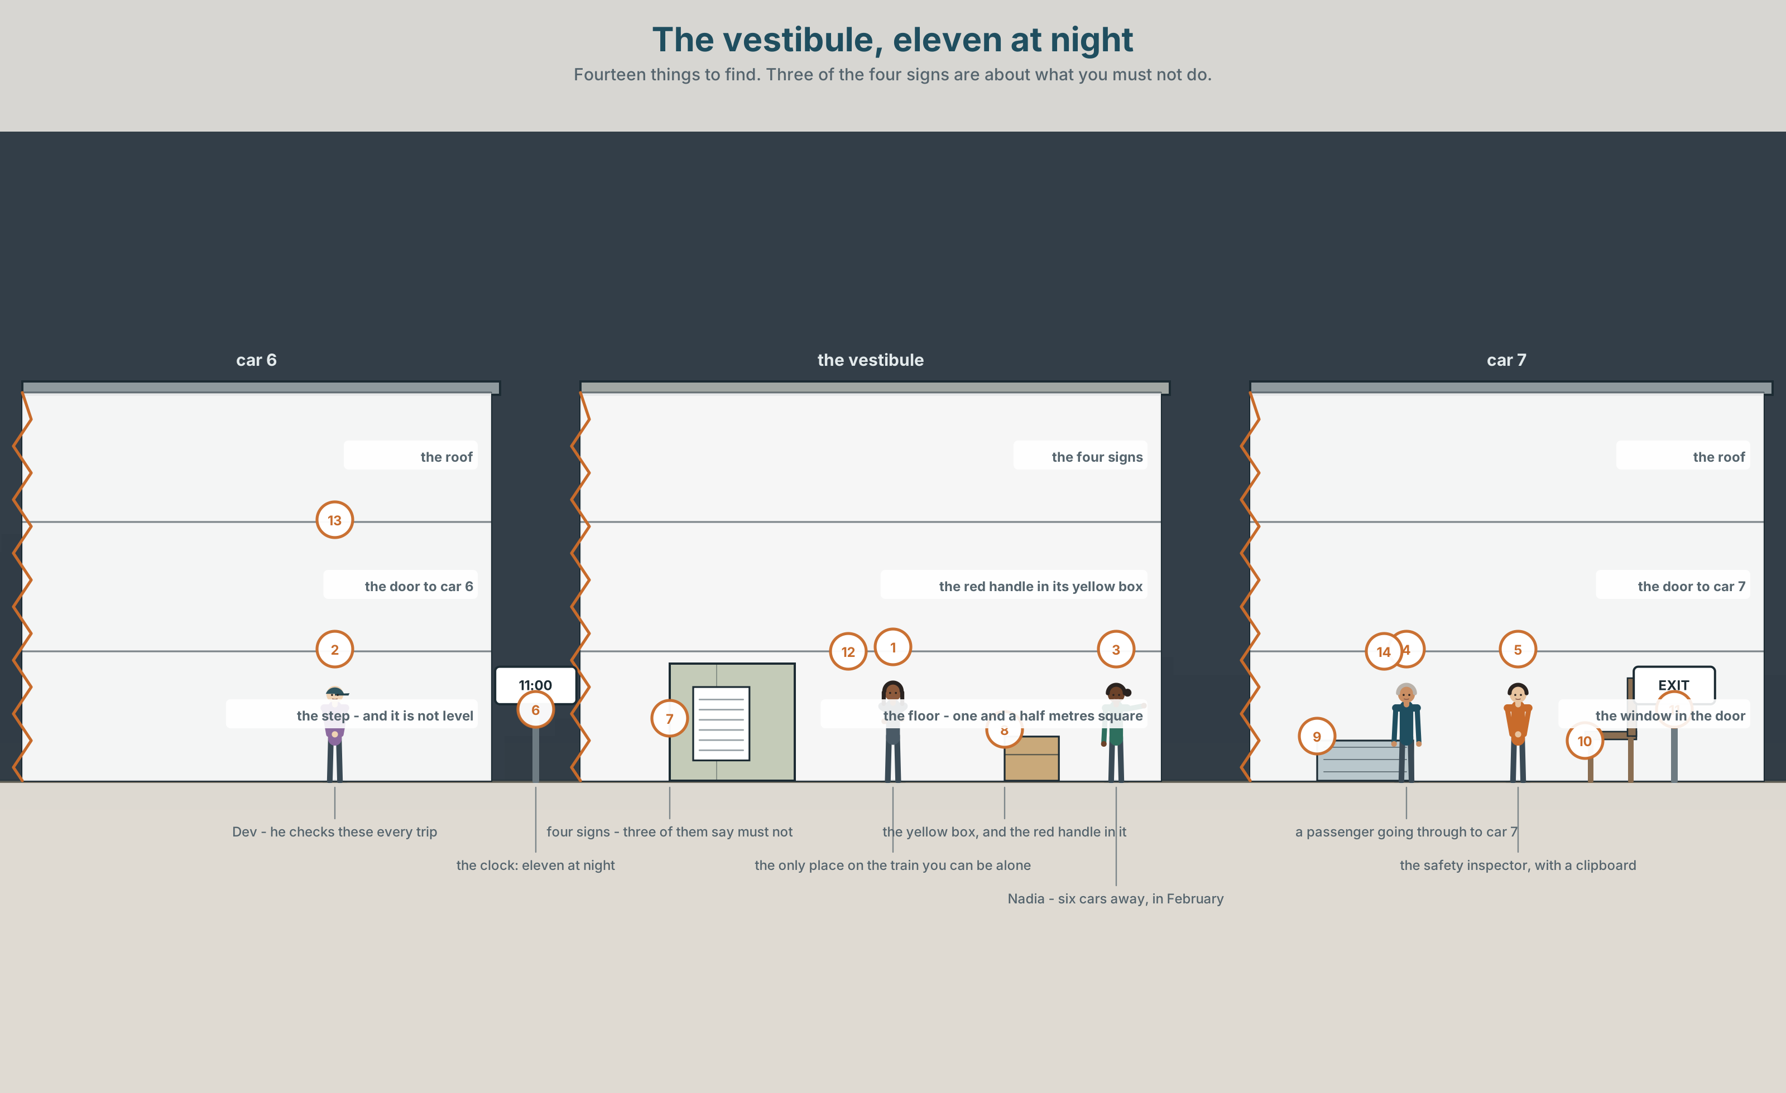{width=6.6in}
The vestibule, eleven at night — Fourteen things to find. Three of the four signs are about what you must not do.

What must everyone do?
By the end of this unit you can say what is compulsory, what is forbidden, and what is neither.
◆ A · THE WORLD | A space one and a half metres square with four rules in it
◆ B · THE SYSTEM | must and mustn't · have to and don't have to · 22 words for law and safety · have to as one word · the difference between a rule and a need
◆ C · THE PERFORMANCE | You write the rules for a place and defend the one nobody will follow

0A · Find it — fourteen things
Find these in the picture. Write the number.
☐ a door ☐ a handle ☐ a sign ☐ a box ☐ a warning ☐ a window ☐ a light ☐ a floor ☐ a step ☐ a notice ☐ a bag ☐ a rail ☐ a lock ☐ a clock
Three of these words are not in the picture. Which three?
a seatbelt · a helmet · a licence

0B · Guess it
Look at the four signs. Which one has been there longest? Say one thing. You can use these words:
sign · old · law · danger · warning

0C · Say it ⏺
Record. Thirty seconds. Do not prepare.
Name one rule where you live that everybody breaks. Why does nobody enforce it?
You will listen to this again on the last page.

Part 1 · Vocabulary Lab 1 ◆ B · THE SYSTEM

1A · Meet — four kinds of rule
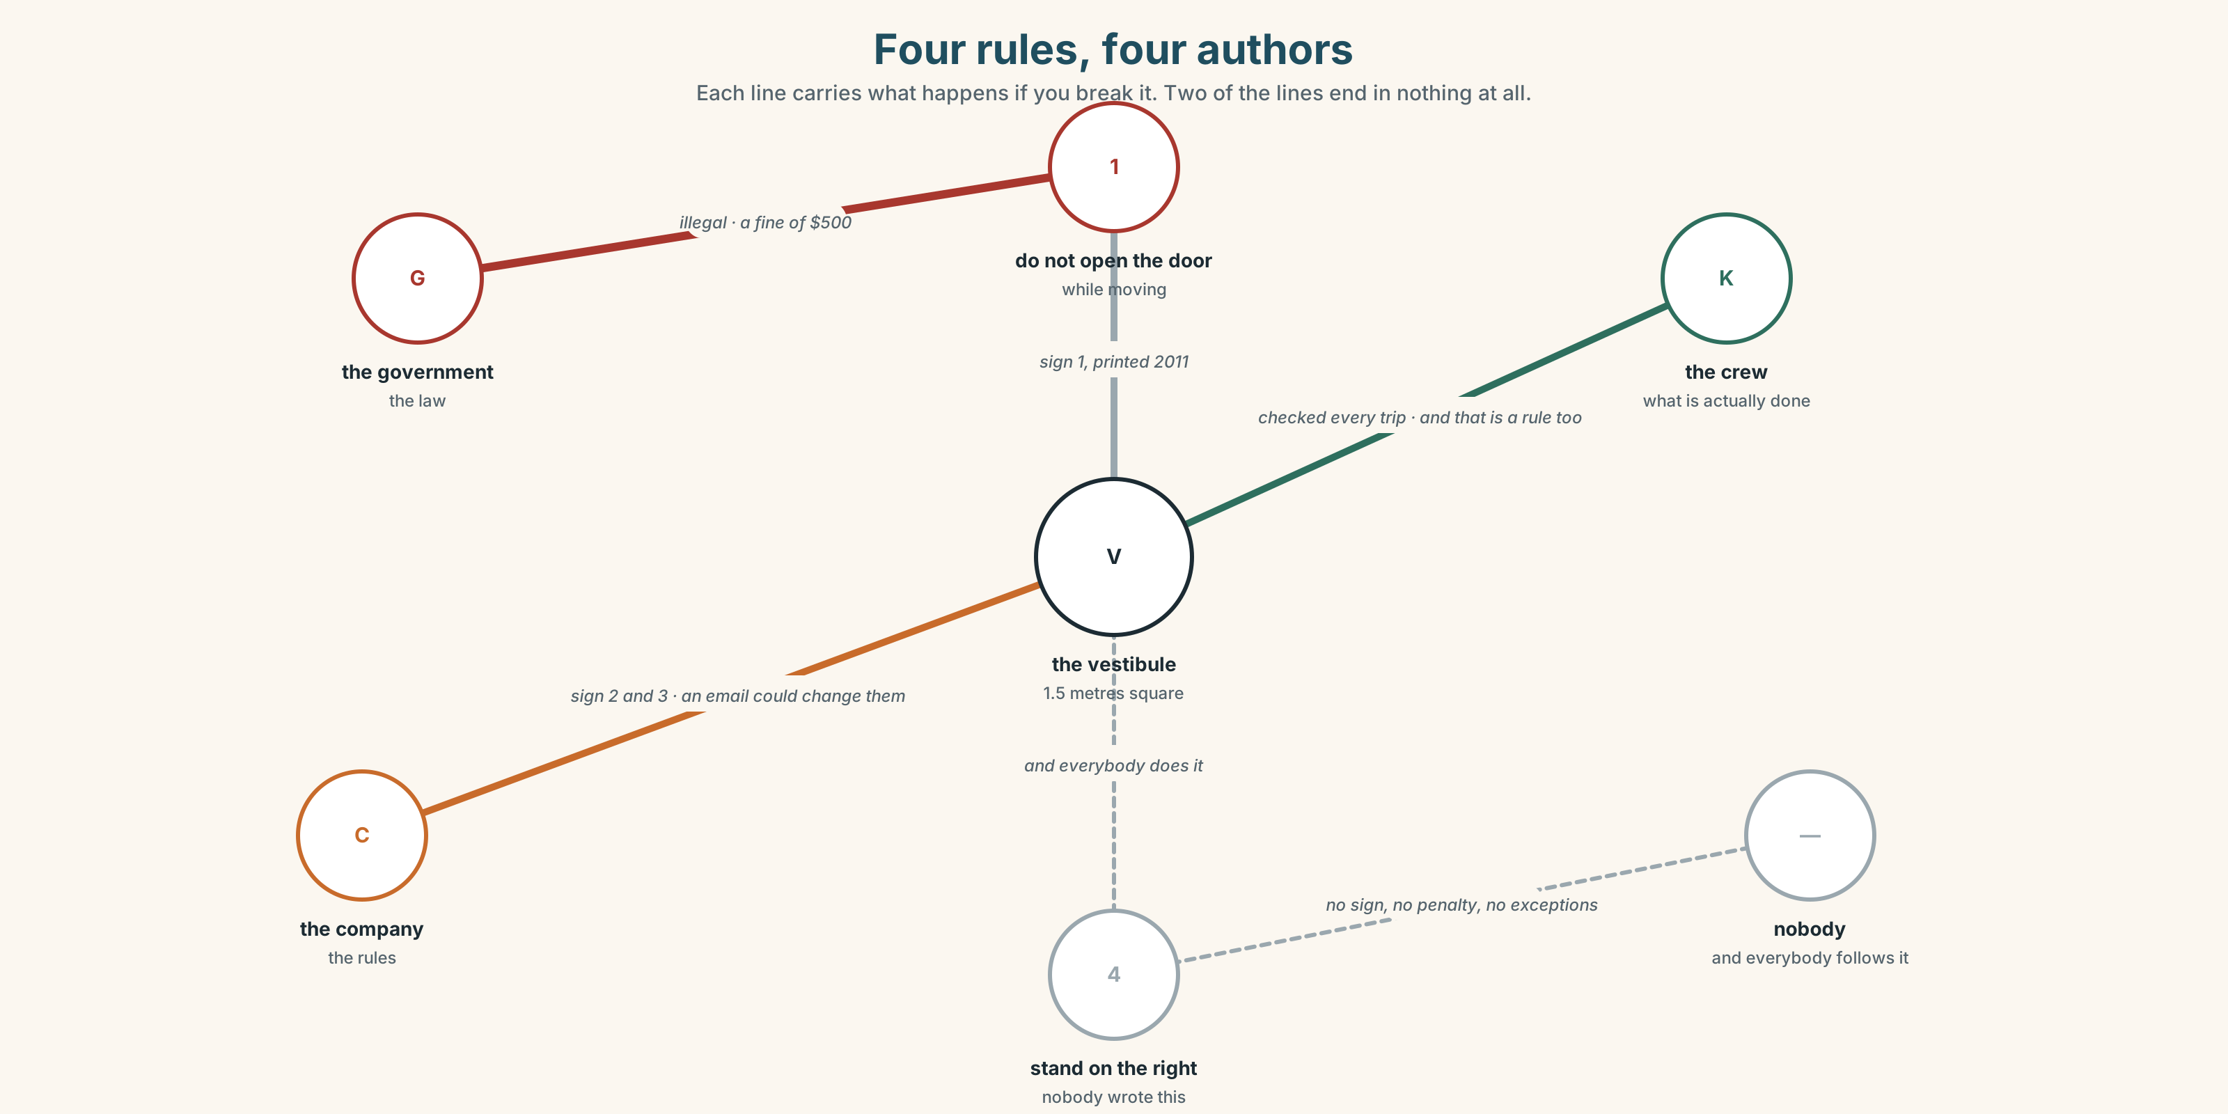{width=6.6in}
Four rules, four authors — Each line carries what happens if you break it. Two of the lines end in nothing at all.
law | Made by a government. The only one with a fine on the end.
rule | Made by a company. It can be changed by an email.
safety | The word that is used to end an argument.
danger | The thing the word safety is about, and it is measured in almost none of the signs.
emergency | About four times a year, and the whole design is for those four.
warning | A sign that tells you something, rather than telling you to do something.

1B · Meet — the words
law · rule · safety · danger · warning · emergency · exit · seatbelt · helmet · speed · fine · licence · permit · allowed · illegal · legal
Write each word under the right picture.
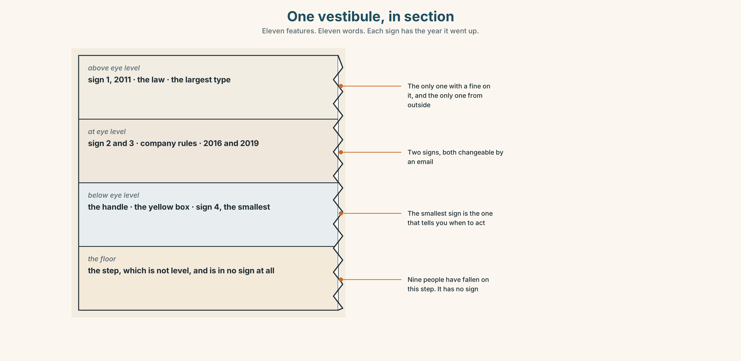{width=6.6in}
One vestibule, in section — Eleven features. Eleven words. Each sign has the year it went up.

1C · Sort — the thing, or the rule about it?
Put each word in the right box. Two of them can go in both. Which two, and why?
exit · illegal · seatbelt · allowed · helmet · legal · speed · warning · licence · safety
A THING YOU CAN SEE | A RULE OR A STATUS | BOTH

1D · What people do with rules
wear a seatbelt | wear, like clothes. English treats it as something you put on.
pay a fine | The only consequence in this unit that has a number.
break the law | break, as if it were an object. Most languages do something similar.
follow the rules | follow, as if they were a path. Also an object metaphor.
fill in | A form. What a rule looks like when it meets a person.
hand over | A document, a key, a licence. The moment a rule becomes real.
Now say them. Four of these six are about paper and two are about the body. Which two, and which of the four is the one that can send you to a court?

1E · Stretch — the phrases you will need today
wear a seatbelt · pay a fine · break the law · follow the rules · fill in
Match each phrase to the moment you need it.
- There is a form and a pen and somebody waiting. → ______
- You are forty kilometres an hour over the limit. → ______
- The letter arrives three weeks later with a number on it. → ______
- You are doing exactly what the sign says and it feels wrong. → ______
- You get into a car. → ______

1F · The hard one
f It's not allowed.
Practise it three times. Three words that answer a question without saying who decided, and that is exactly why people use them.

1G · Own it
Write down one rule you must follow, one you have to follow, and one you don't have to follow but do anyway. Do not write your name. The class guesses which is which.

Part 2 · Listening ◆ A · THE WORLD
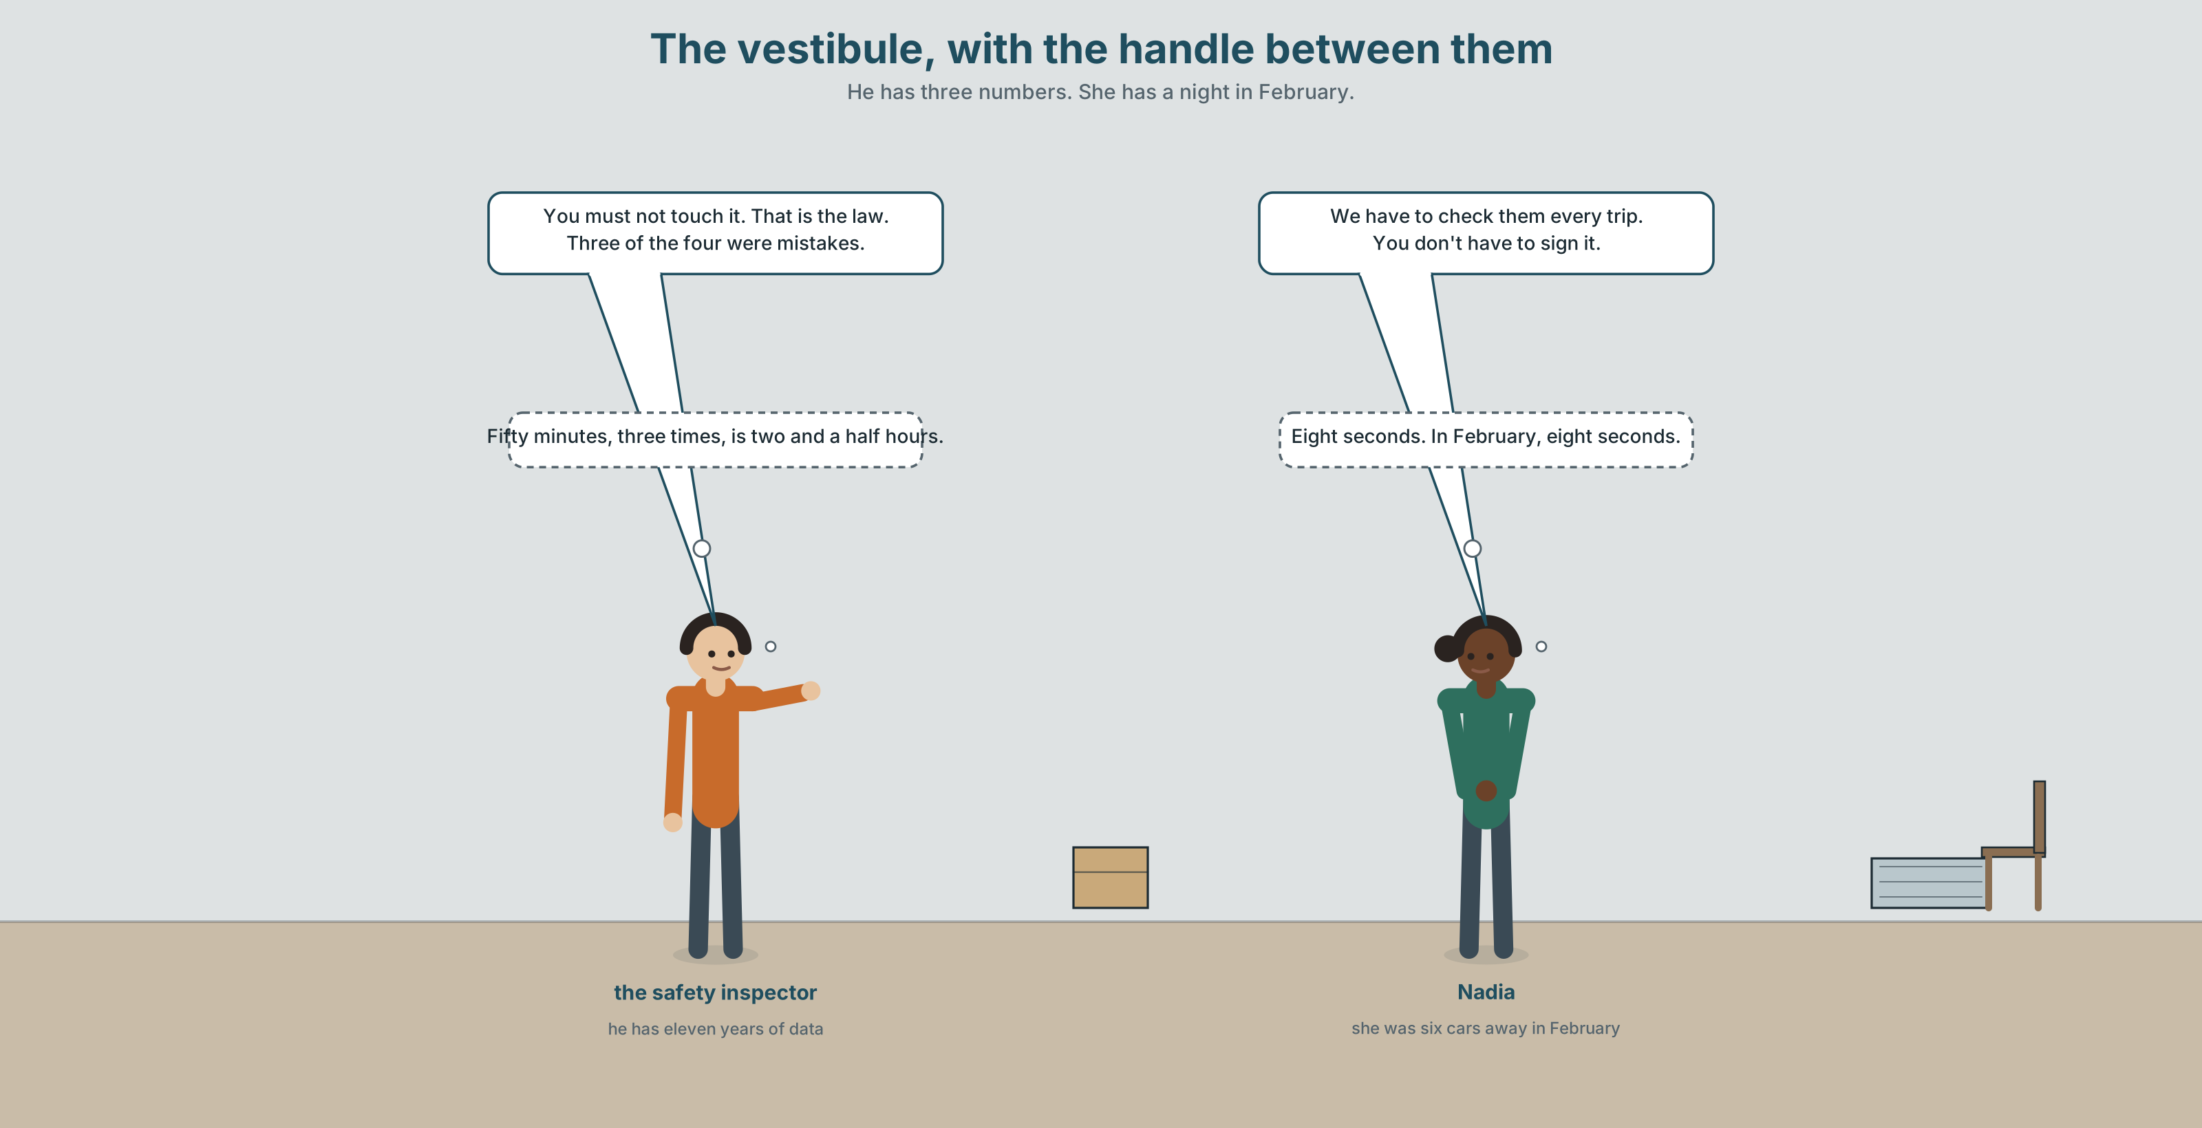{width=6.6in}
The vestibule, with the handle between them — He has three numbers. She has a night in February.

2A · In the vestibule 🔊 Track 7.1
Before you listen. There are twenty-two emergency handles on this train. Four have been used in eleven years. Guess: how many of the four were real?
Listen once. One question. What does the company want to put over the handles?
Listen again. Complete the table.
 | Must | Mustn't | Doesn't have to
the crew
the passengers
Listen again. True or false?
- Passengers must not use the handle. ☐ T ☐ F
- The crew have to check the handles every trip. ☐ T ☐ F
- Three of the four uses were mistakes. ☐ T ☐ F
- The cover is already compulsory. ☐ T ☐ F
Noticing. Four sentences from the recording.
- You must not touch it.
- We have to check them every trip.
- You don't have to sign it.
- It mustn't be locked.
Sentences 1 and 4 forbid. Sentence 3 does not forbid anything. What does it actually say?

2B · Decoding clinic 🔊 Track 7.2
Twenty seconds of the inspector at speed. Three jobs.
- Count how many obligations he states.
- Have to is two words and he says it as one. Write what you hear.
- He says mustn't once. Can you hear the t in the middle?
Transcripts, page 154.

Part 3 · Grammar Lab 1 ◆ B · THE SYSTEM

Compulsory, forbidden, and neither

3A · Notice
Look at the four sentences in Part 2 again.
- Which two mean this is forbidden?
- What does sentence 3 mean — forbidden, or not necessary?
- What is the form of the verb after must and after have to?
- Does have to change for he and she?

3B · See
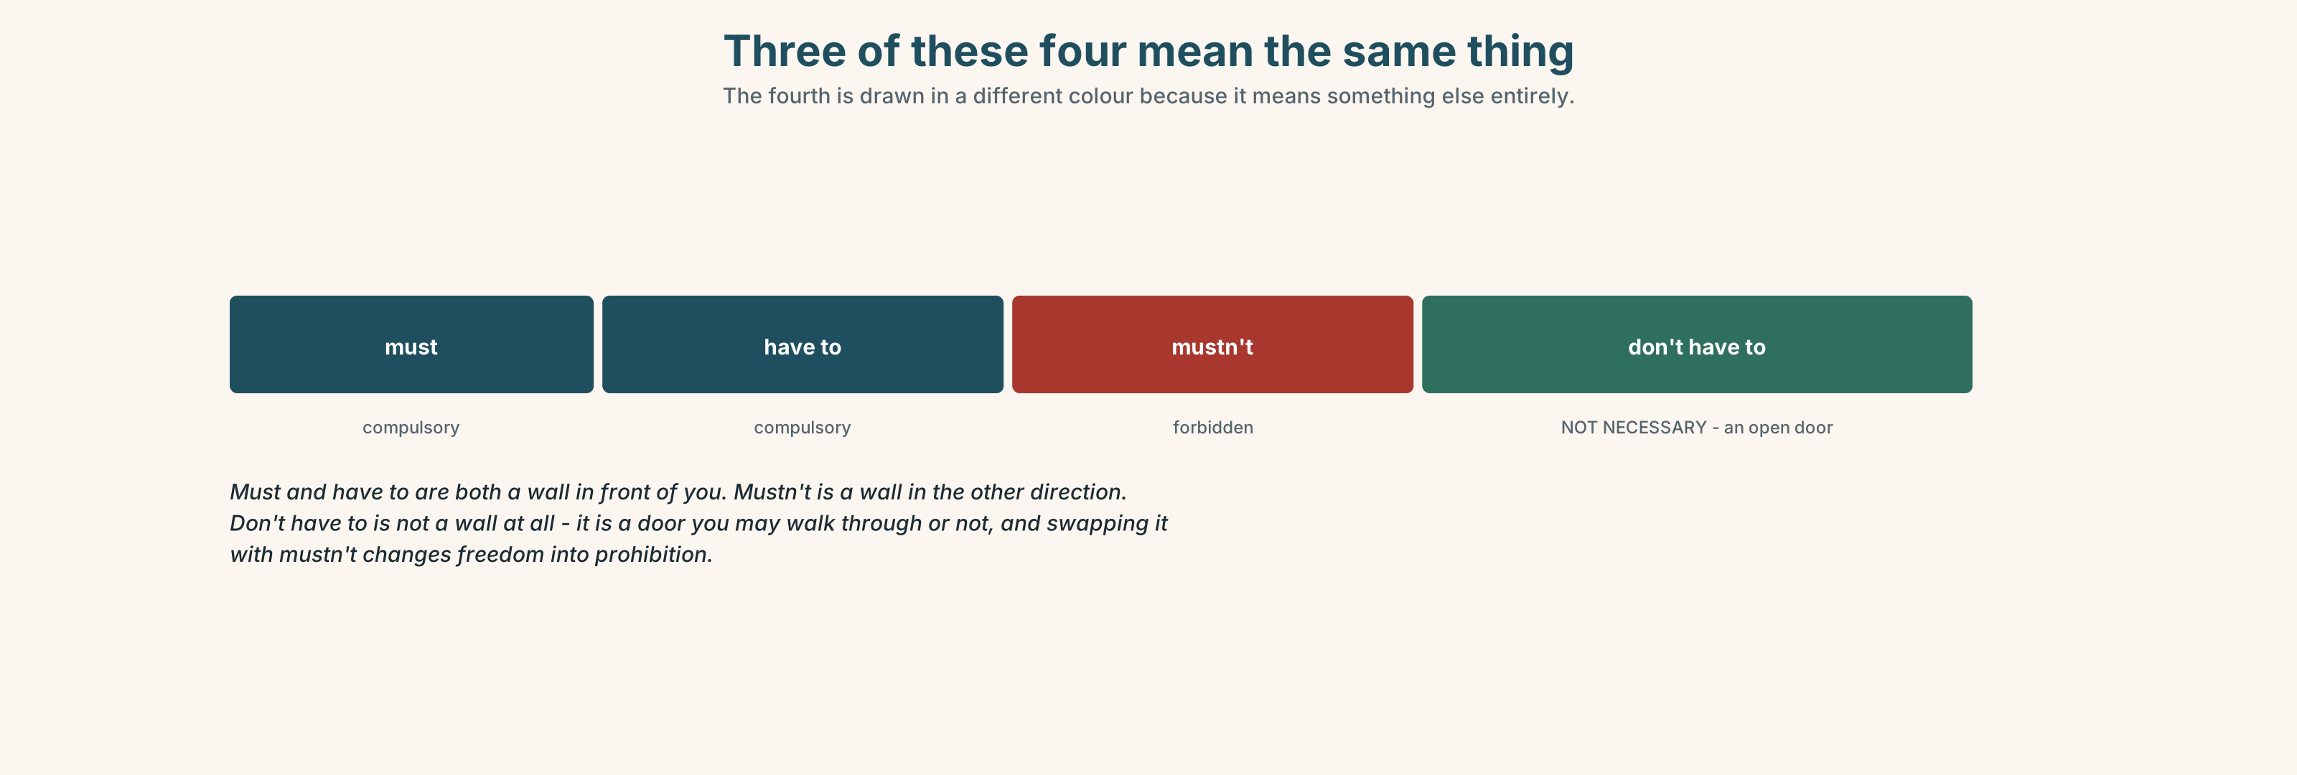{width=6.6in}
Three of these four mean the same thing — The fourth is drawn in a different colour because it means something else entirely.

3C · Know
compulsory | must / have to | You must wear a seatbelt. We have to check them.
forbidden | mustn't | You mustn't touch it. It mustn't be locked.
not necessary | don't have to | You don't have to sign it.
the difference | must is the speaker's rule; have to is somebody else's | I must stop smoking / I have to wear this.
Mustn't and don't have to are not opposites of each other. Mustn't is a wall. Don't have to is an open door that you may walk through or not. Getting these two the wrong way round is the commonest serious error in this unit and it changes the meaning completely.
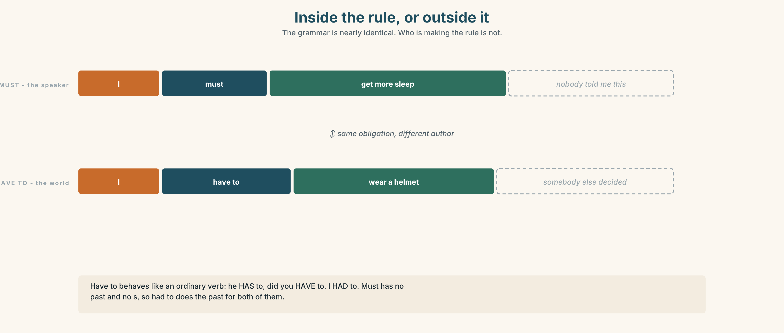{width=6.6in}
Inside the rule, or outside it — The grammar is nearly identical. Who is making the rule is not.
must — from the speaker | I must get more sleep. You must come and see us.
have to — from outside | I have to wear a helmet. She has to fill in the form.
has to | the only one of the four that changes for he and she
no past for must | I had to does the work of both
Why it matters. Every job, every country and every building you enter has a set of these, and knowing which of the four you are being given tells you whether to argue.

3D · Use — controlled
Complete with must, mustn't, have to, has to or don't have to.
You (1) ______ touch the handle. It is for an emergency only. We (2) ______ check them every trip — the inspector requires it. You (3) ______ sign the form. It is optional. She (4) ______ fill in a report every time one is used. I (5) ______ remember to tell the crew about this. (the speaker's own rule)

3E · Use — guided
Say whether each one is compulsory, forbidden or not necessary, then write it with the right form.
- Wearing a seatbelt in a car.
- Touching the emergency handle.
- Signing the visitor book at this school.
- Carrying a licence when you drive.
- Arriving an hour early for a train.

3F · Use — open
In pairs. Describe the rules of a place you know. Five rules, and at least one of each of the three kinds. Your partner must say which kind each one is.

3G · Check — six items, mark your own
- You ______ touch it. (forbidden)
- We ______ ______ check them every trip. (compulsory, from outside)
- You ______ ______ ______ sign it. (not necessary)
- She ______ ______ fill in a report. (compulsory, and watch the form)
- ✗ You don't must touch it. → correct it.
- ✗ She must to wear a helmet. → correct it.
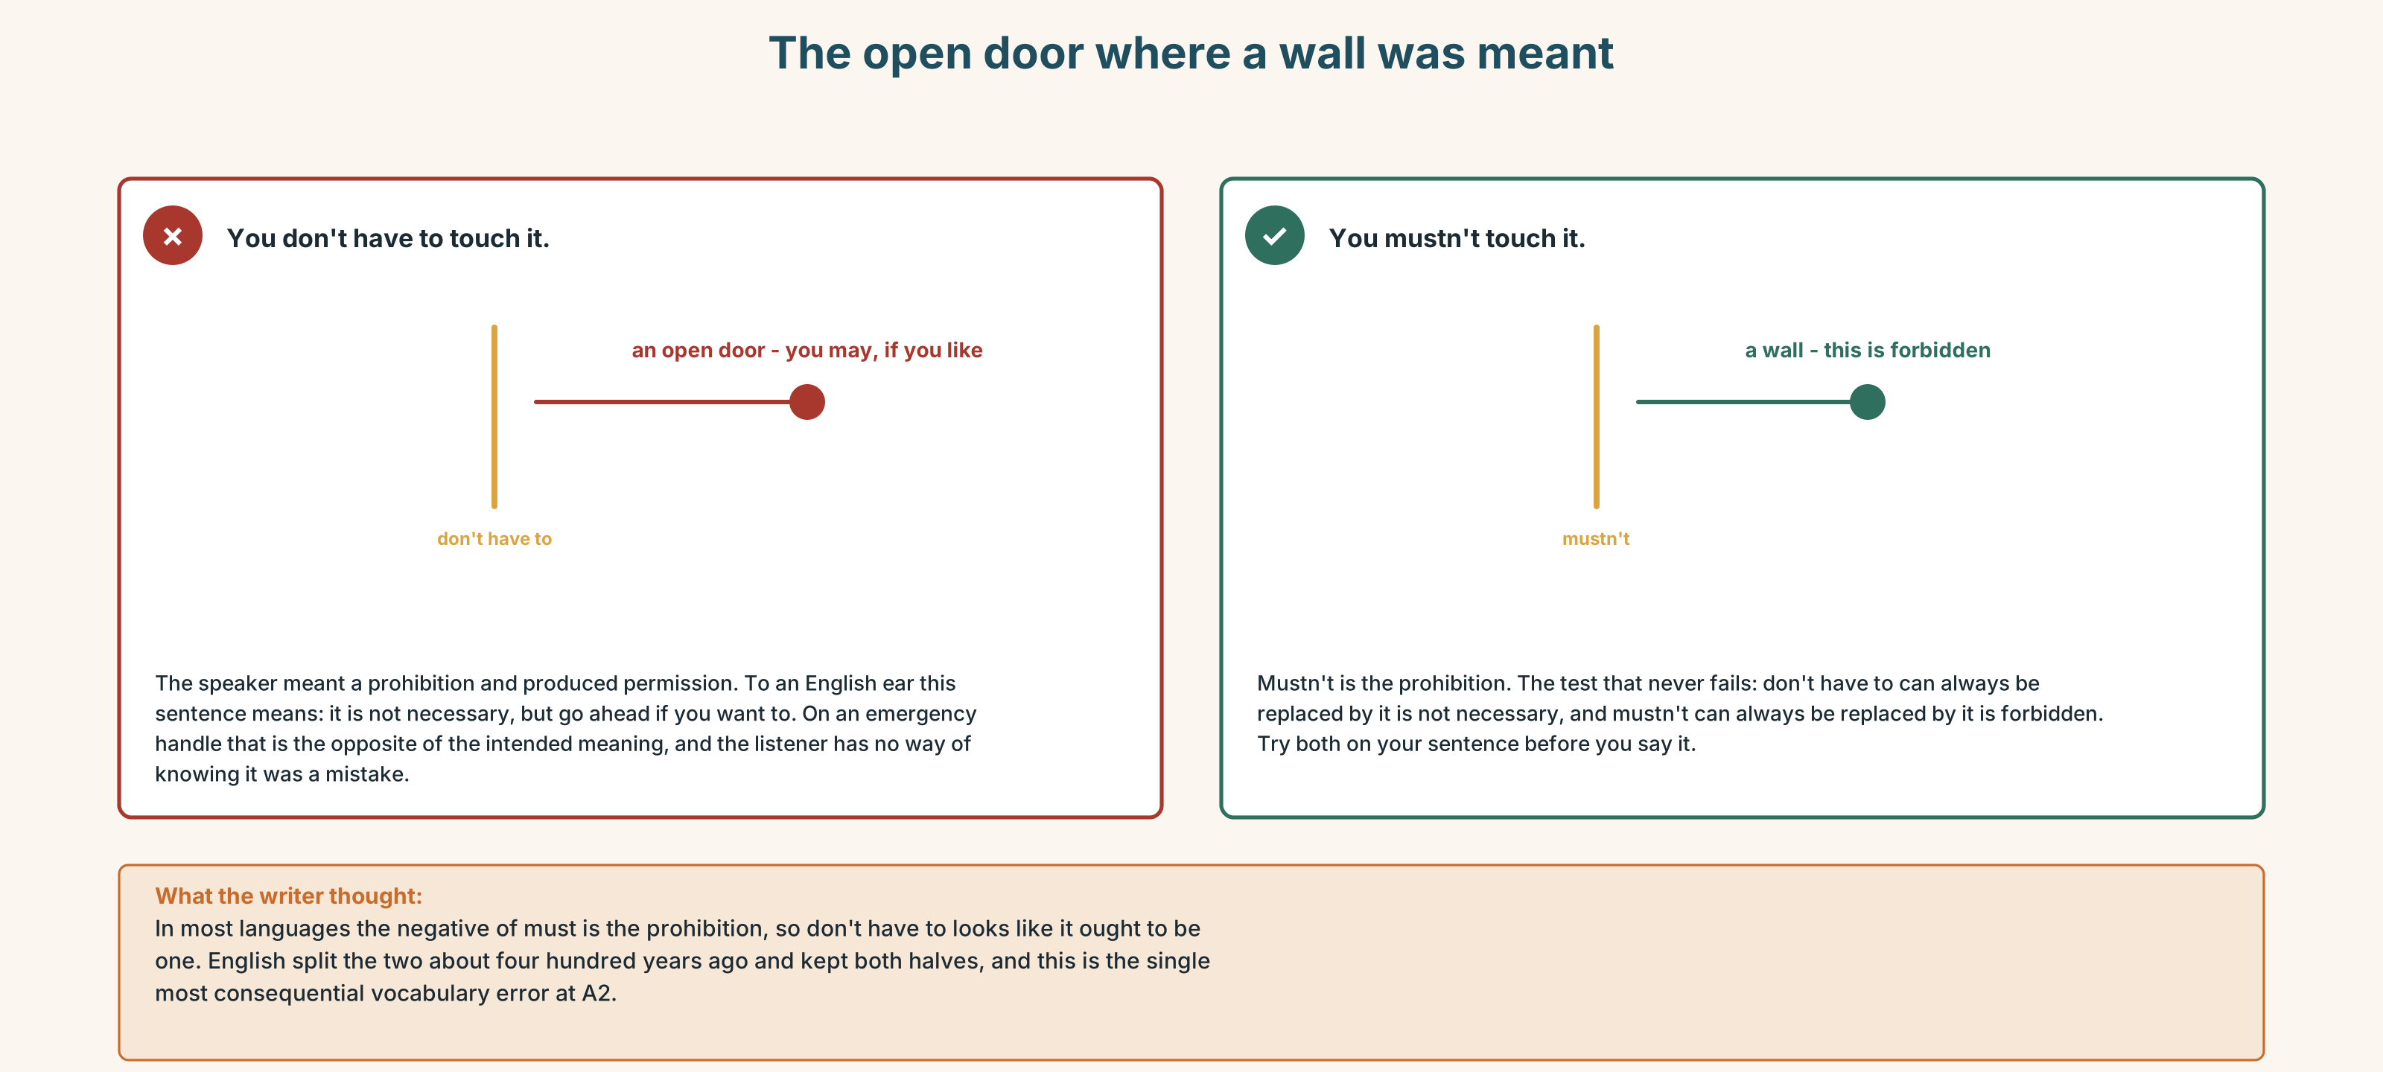{width=6.6in}
The open door where a wall was meant — The open door where a wall was meant
0–3 → Workbook pp. 28–31. 4–5 → Part 6. 6 → page 156.

Part 4 · Speaking ◆ C · THE PERFORMANCE

4A · Fluency starter — three columns
Everybody names one rule from their life and puts it in one of three columns: must, mustn't, don't have to. Nobody may use a column that has already been used twice in a row.

4B · The functional core — stating obligation
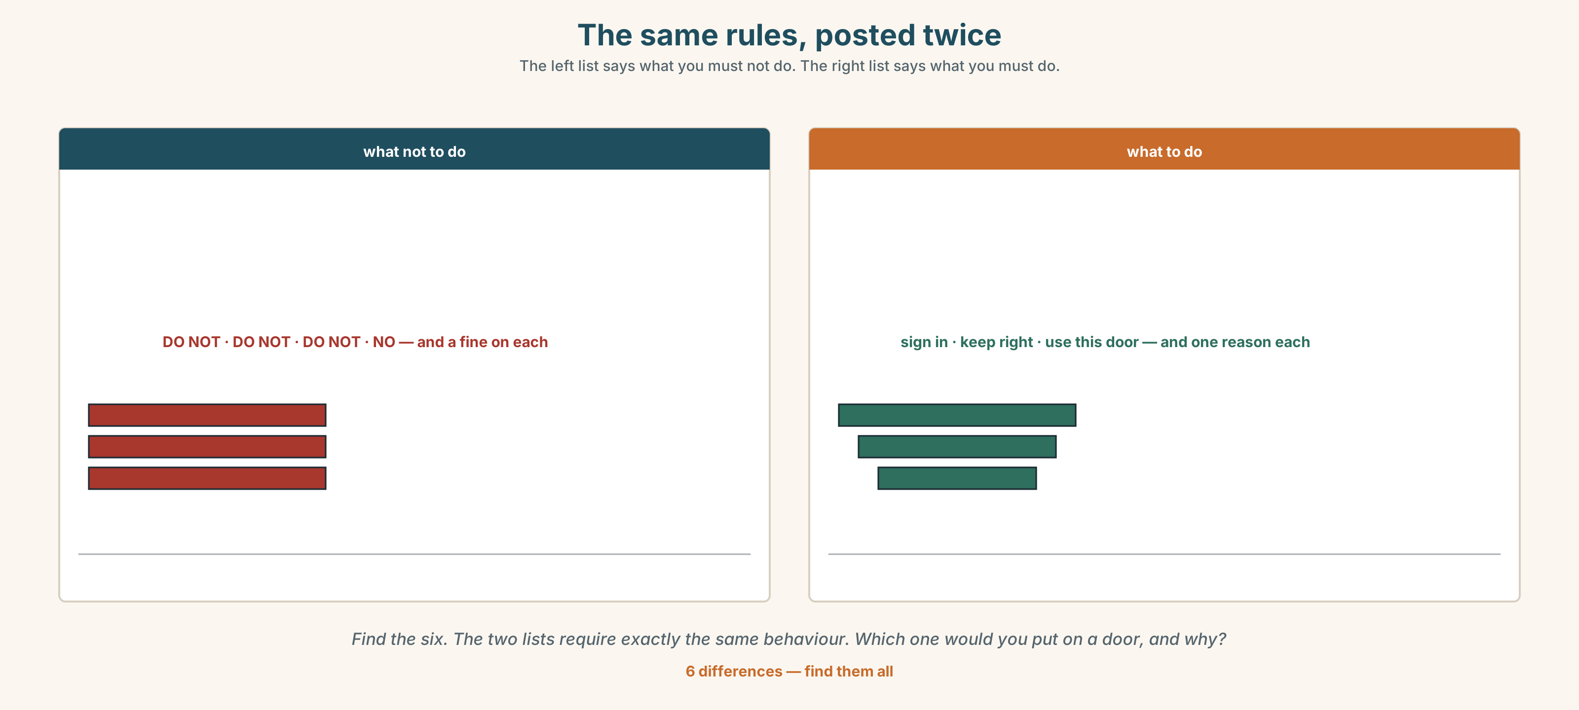{width=6.6in}
The same rules, posted twice — The left list says what you must not do. The right list says what you must do.
Language Bank
compulsory | You must… · You have to… · It's compulsory.
forbidden | You mustn't… · It's not allowed. · It's illegal.
not necessary | You don't have to… · It's not compulsory.
softening it | I'm afraid you have to… · Everybody has to.
Information gap. Learner A has the company's safety rules. Learner B has what the crew actually does. Find the two rules nobody follows and the one thing everybody does that is in no rule.

4C · The performance — the rules of a place ⏺
State the rules of a place you know well. Two minutes. You must:
give one must, one mustn't and one don't have to · say who made each rule · defend the one nobody follows
Record it.

4D · Observer
One person listens for one thing: did anybody use don't have to when they meant mustn't?

4E · Two criteria
☐ Did I use all three kinds, and correctly? ☐ Did I say who made at least two of the rules?

Part 5 · Reading ◆ A · THE WORLD

5A · Predict
The title is "Four times in eleven years." What do you think has happened four times?

5B · Read — sixty seconds

Four times in eleven years
There are twenty-two emergency door handles on this train. In eleven years, four have been pulled.
Three of the four were mistakes. Somebody leaned on one. A child reached one. A passenger thought it was the light switch. Each time, the train stopped, the crew walked the length of it, and about fifty minutes were lost.
The fourth was in February, at two in the morning, when a man in car 7 had a seizure and the nearest crew member was six cars away. A passenger pulled the handle. The train stopped. The crew came. He is alive.
The company wants to put breakable covers over all twenty-two handles. The covers will stop the three. They will also cost about eight seconds, and in February eight seconds would probably not have mattered.
Probably.

5C · Answer
- How many handles are there?
- How many have been pulled?
- How long is lost each time one is pulled by mistake?
- What happened in February?
- Why does the writer end with the word probably on its own?
- The covers stop three problems and create a possible fourth. How would you decide?

5D · Vocabulary in context
Guess from the text. Then check.
leaned on one · the length of it · the nearest crew member · breakable covers · would not have mattered

5E · The counter-text
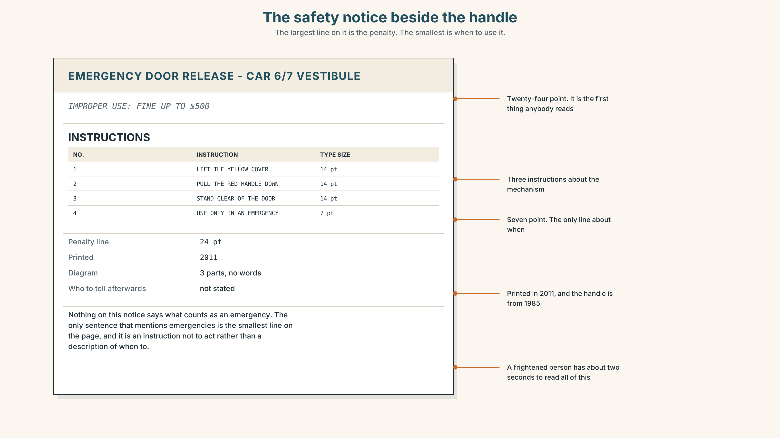{width=6.6in}
The safety notice beside the handle — The largest line on it is the penalty. The smallest is when to use it.
Read the notice and answer.
- How many instructions are there?
- What is the penalty for improper use, and how big is that line?
- What year was the notice printed?
- The largest line is the penalty and the smallest is when to use it. What does that tell you about who the notice was written for?

5F · Two texts
The reading says a passenger pulled the handle in February and a man is alive. The notice says improper use carries a fine of five hundred dollars.
Would the passenger in February have read the notice first? Say one sentence.

Part 6 · Vocabulary Lab 2 ◆ B · THE SYSTEM

Who made the rule
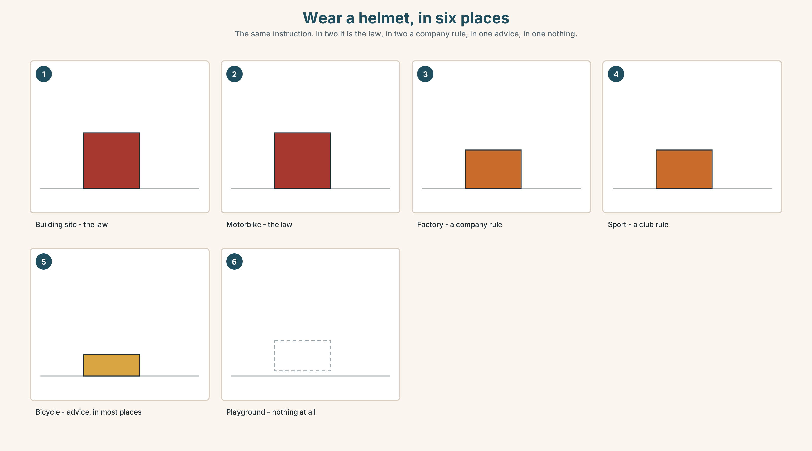{width=6.6in}
Wear a helmet, in six places — The same instruction. In two it is the law, in two a company rule, in one advice, in one nothing.

6A · The ones that catch everybody
must / have to | almost the same; must is the speaker, have to is the world
mustn't / don't have to | opposite meanings, and this is the trap
has to | the only form here that changes for he and she
had to | the past of both must and have to

6B · Say them
must · mustn't · have to · don't have to · obey · necessary · compulsory · duty · responsible

6C · Chunk
- You ______ touch it. (forbidden)
- We ______ ______ check them. (compulsory, from outside)
- You ______ ______ ______ sign it. (not necessary)
- It's not ______ . (three words with it's*, and nobody says who decided)*
- It's ______ . (one word — the law says no)
- Who is ______ for this? (the person who answers for it)

6D · Contrast Clinic
Six items. mustn't or don't have to?
- You ______ touch the emergency handle.
- You ______ sign the visitor book — it's optional.
- You ______ smoke anywhere on the train.
- You ______ arrive an hour early.
- You ______ open the door while the train is moving.
- You ______ bring your own food, but you can.

Part 7 · Pronunciation & Fluency Lab ◆ B · THE SYSTEM

Two words that became one, again
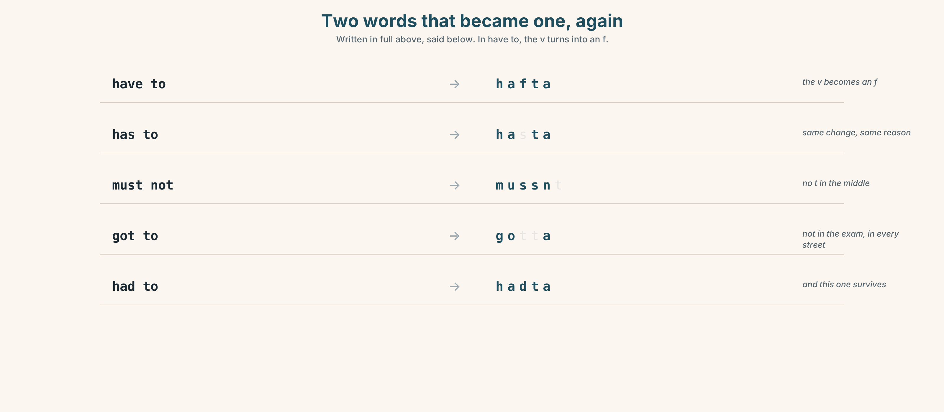{width=6.6in}
Two words that became one, again — Written in full above, said below. In have to, the v turns into an f.

7A · Hear
have to → hafta — and the v becomes an f has to → hasta · mustn't → mussnt, with no t in the middle at all got to → gotta — not in the exam, and in every conversation

7B · Say
Say each one three times. Then say this:
You have to fill it in, but you mustn't sign it. — two obligations, four beats.

7C · Make it mean something
Say these two:
You don't have to come. — you are free, and you are welcome You mustn't come. — you are forbidden, and somebody will be upset
One is kindness and one is a wall. Learners who swap them do not sound less fluent; they sound rude. Which is which?

7D · Fluency 20 ⏺
Twenty seconds: six rules of this building — two must, two mustn't, two don't have to. Three times, faster.

Part 8 · Writing ◆ C · THE PERFORMANCE

The rules of a place · 50–70 words

8A · Read the model
You have to sign in at the desk. That one is the fire service, not us. [the rule, and who made it]
You mustn't prop the back door open. It looks harmless and it is the one that matters. [the prohibition, with the reason]
You don't have to wear the badge upstairs. Nobody does. [the rule that exists and is not enforced, said plainly]
If you are going to break one of these, break the third. [the sentence no official notice ever contains]
Questions about the writer's choices:
- That one is the fire service, not us. Why name the source?
- It looks harmless. Why admit that about a rule you are enforcing?
- The last line tells the reader which rule to break. Does that undermine the other two?

8B · The anti-model
You must sign in. You must wear your badge at all times. You must not prop open any door. You must follow all safety instructions. Thank you for your cooperation.
Correct English, correct rules, and it is on the wall of every building on earth and read by nobody. Rewrite it so that each rule has a source, and one of them admits it is not enforced.

8C · Plan
the rule and who made it → the prohibition and the reason → the one nobody follows → the honest sentence

8D · Write — 50 to 70 words

8E · Peer review — two things only
☐ Is there one must, one mustn't and one don't have to? ☐ Does at least one rule say who made it?

8F · Publish
On the door. Keep it up for a week and mark which rules were followed.

Part 9 · The File ◆ A · THE WORLD + C · THE PERFORMANCE

STUDY FILE · The rules you did not choose
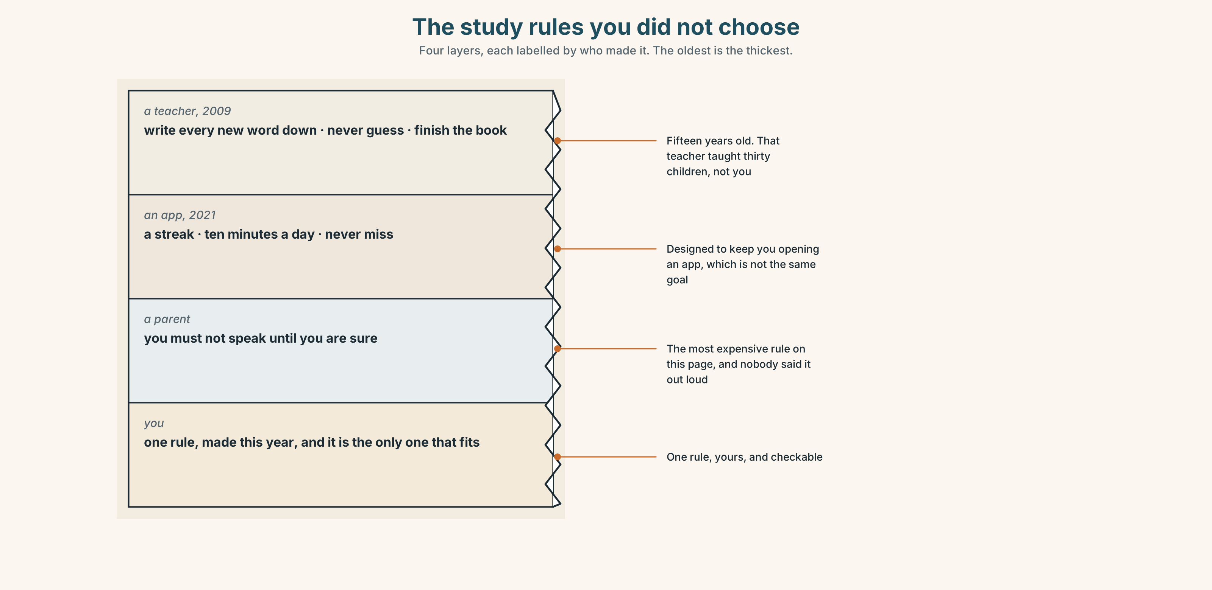{width=6.6in}
The study rules you did not choose — Four layers, each labelled by who made it. The oldest is the thickest.

9A · Four sources, one set of rules
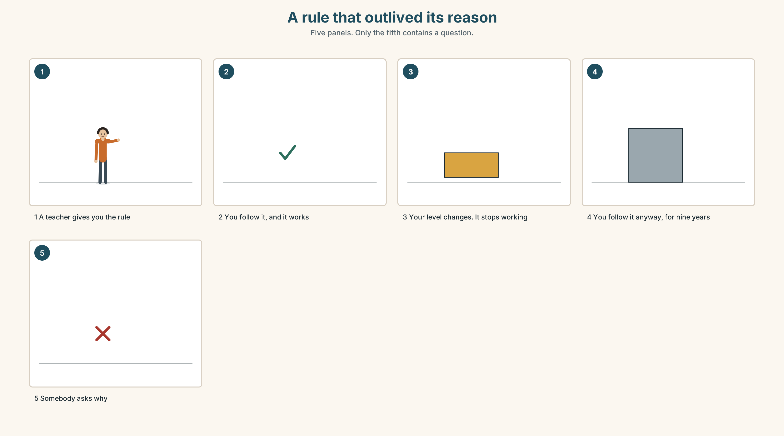{width=6.6in}
A rule that outlived its reason — Five panels. Only the fifth contains a question.
What people say | I must write every new word down
Where it came from | a teacher, usually in childhood
Whether it works | sometimes, for some people, for some kinds of word
Who checks | nobody, ever

9B · Must, have to, or nothing at all
Take three of your own study rules and sort them. Which are must — your own? Which are have to — somebody else's? Which are don't have to and you are doing them anyway?

9C · Role play — the inspector
In pairs. One of you inspects the other's study habits and asks Why? after every answer, four times. The point is to reach a rule whose source nobody can name.

9D · The rule you can drop
Find one study rule you follow that nobody made and nobody checks and that is not working. Drop it this week. Write down what you did with the time.

9E · Transfer — before next week
Write down every English rule you followed this week and who made it. Bring the list. Mark the ones with no name against them.

Part 10 · Mediation & Interaction ◆ C · THE PERFORMANCE
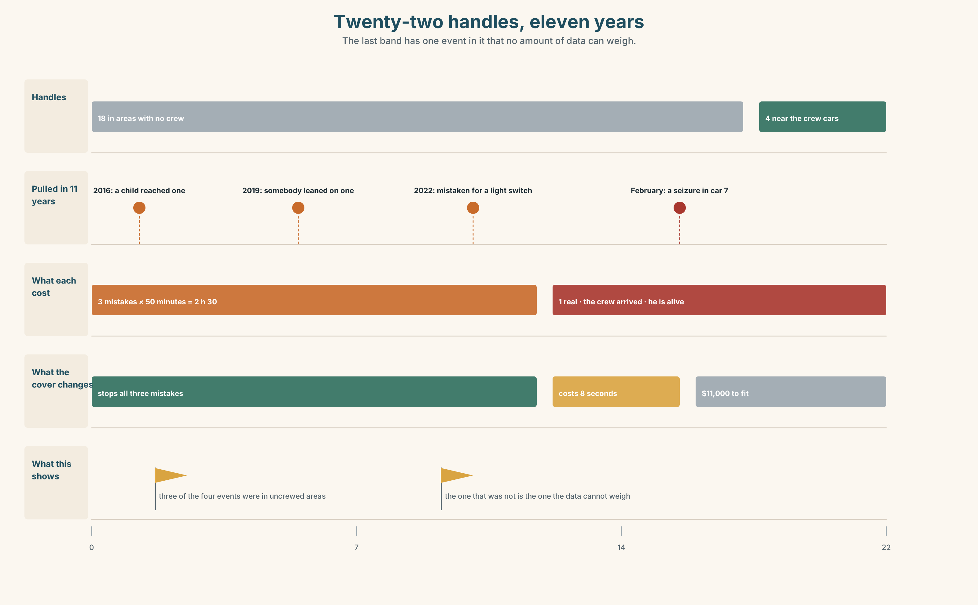{width=6.6in}
Twenty-two handles, eleven years — The last band has one event in it that no amount of data can weigh.

10A · Relay
Half the class has the safety rules. Half has what the crew actually does. Build the real picture by speaking. Ten minutes.

10B · Simplify — for one person
A passenger asks: When am I allowed to pull that handle? Answer in three sentences. They are frightened, and they are asking because of the sign.

10C · Online
Write one message to a classmate about three rules where you work or study. Three sentences. One must, one mustn't, one don't have to.

10D · Your language
Does your language use one word for must and have to? Say I have to work tomorrow and I must stop smoking in your language. Is it the same word?

Part 11 · The Decision ◆ C · THE PERFORMANCE

Twenty-two red handles
Four pulls in eleven years. Three mistakes, costing about fifty minutes each. One real, in February, and a man is alive.
Option one: fit breakable covers on all twenty-two. Stops the three. Costs about eight seconds in a real emergency and eleven thousand dollars to fit.
Option two: leave them. Three false alarms in eleven years is one every four years, and fifty minutes is fifty minutes.
Option three: fit covers on the eighteen handles in areas with no crew presence, and leave the four near the crew cars uncovered.

11A · The evidence
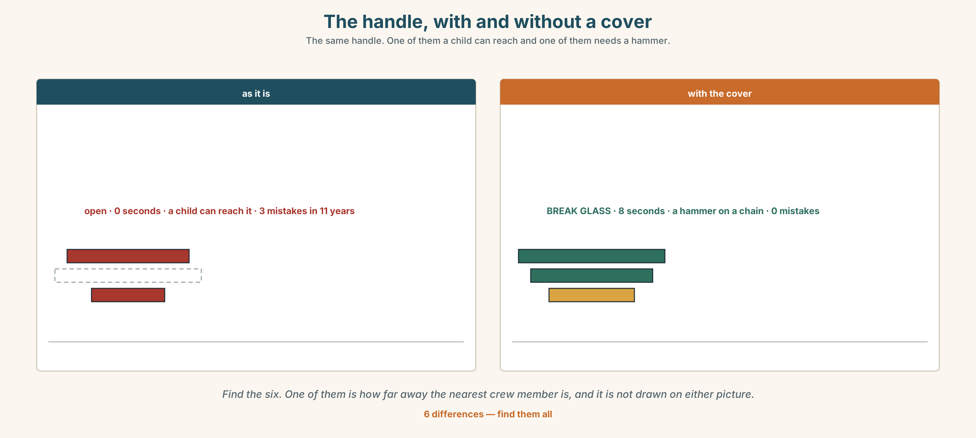{width=6.6in}
The handle, with and without a cover — The same handle. One of them a child can reach and one of them needs a hammer.
🔊 Track 7.6. Nadia, 20 seconds: "In February I was six cars away. Somebody I have never met decided in two seconds to do something that would cost them five hundred dollars if they were wrong. I would like them to be able to keep doing that."

11B · Talk about it
In threes. Use the frame. Everybody says one.
I think the company should ______ , because ______ .
Words you can use: safety · danger · emergency · rule · law · warning · allowed

11C · Decide
Write two sentences. Choose, and say why.
I think the company should ______________________ , because ______________________ .

11D · Model decision
Option three, and take the fine off the notice. The covers belong where nobody is watching. The five-hundred-dollar line belongs nowhere: it is the only part of this system that makes a stranger hesitate for two seconds, and two seconds is the entire thing we are trying to buy.

11E · The Reveal
What happened. The company fitted covers to eighteen handles and reprinted the notice with the penalty line in the smallest type instead of the largest.
Then something nobody expected: in the next four years there were two pulls, both real, and both at covered handles. The eight seconds were spent and nobody noticed them. What had changed was that passengers now believed they were allowed.
One question. You do not have to answer it out loud.
The covers were fitted to stop mistakes. What actually changed the numbers?

Part 12 · Landing ◆ all three lines

12A · Recycle — twelve items
- You ______ touch it. (forbidden)
- We ______ ______ check them every trip. (compulsory, from outside)
- You ______ ______ ______ sign it. (not necessary)
- She ______ ______ fill in a report. (and watch the form)
- It's not ______ .
- It's ______ . (the law says no)
- Who is ______ for this?
- You have to ______ the rules.
- If you drive too fast you will ______ ______ ______ . (three words)
- Please ______ ______ this form. (two words)
- (Unit 6) It will ______ close. (seventy per cent)
- (Unit 5) You ______ lift that. (advice against)

12B · Consolidate — one task, everything in it
Write the rules of a place you know, in six sentences. Two must or have to, two mustn't, one don't have to, and one sentence saying who made a rule.

12C · Can-do, with evidence
☐ I can say what is compulsory and what is forbidden. Evidence: 4C, 8D ☐ I can tell mustn't and don't have to apart. Evidence: 6D ☐ I can say who made a rule. Evidence: 4C ☐ I can hear and say have to as one word. Evidence: 7C

12D · Replay ⏺
Record 0C again. Listen to both. What is different?

12E · Glossary — thirty-five words, as a map
WHO DECIDES · law · rule · permit · licence THE SUBJECT · safety · danger · warning · emergency · exit · speed THE EQUIPMENT · seatbelt · helmet THE STATUS · allowed · illegal · legal · compulsory · necessary THE CONSEQUENCE · fine · pay a fine · break the law WHAT YOU DO · wear a seatbelt · follow the rules · fill in · hand over · obey THE GRAMMAR · must · mustn't · have to · don't have to · need THE PEOPLE · duty · right · responsible SAYING IT · You must not… · It's not allowed.

12F · Next
Unit 8 · What have you tried?

