Table of Contents

A1.2 · Unit 8 · Twenty-Three Years and Two
English Animated · Getting Around · The Prairie Line, Toronto to Vancouver Student's Book pages 160–181 · 22 pp · ~9 hours

Part 0 · The Big Picture ◆ A · THE WORLD
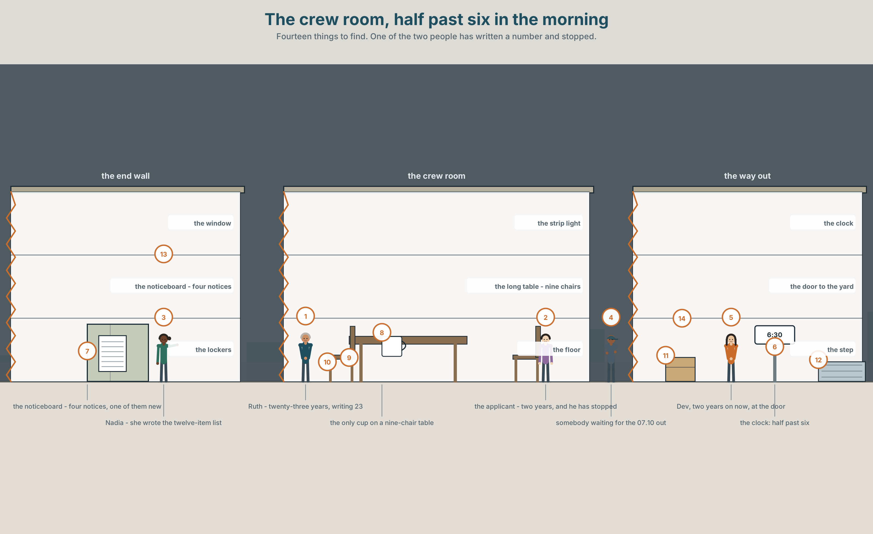{width=6.6in}
The crew room, half past six in the morning — Fourteen things to find. One of the two people has written a number and stopped.

What have you tried?
By the end of this unit you can say what you have done in your life, without saying when.
◆ A · THE WORLD | A form with one box on it, and two people who cannot both be measured by it
◆ B · THE SYSTEM | the present perfect for experience · ever and never · 22 words for skills and firsts · past participles · the have you cannot hear
◆ C · THE PERFORMANCE | You find out three things about somebody that are not on their form

0A · Find it — fourteen things
Find these in the picture. Write the number.
☐ a table ☐ a chair ☐ a form ☐ a pen ☐ a notice ☐ a board ☐ a cup ☐ a bag ☐ a window ☐ a clock ☐ a door ☐ a box ☐ a light ☐ a coat
Three of these words are not in the picture. Which three?
an adventure · a prize · a language

0B · Guess it
Look at the two people filling in the form. Which one has stopped writing? Say one thing. You can use these words:
year · form · write · number · experience

0C · Say it ⏺
Record. Thirty seconds. Do not prepare.
Name three things you have done that are not on any form you have ever filled in.
You will listen to this again on the last page.

Part 1 · Vocabulary Lab 1 ◆ B · THE SYSTEM

1A · Meet — what a form asks and what it misses
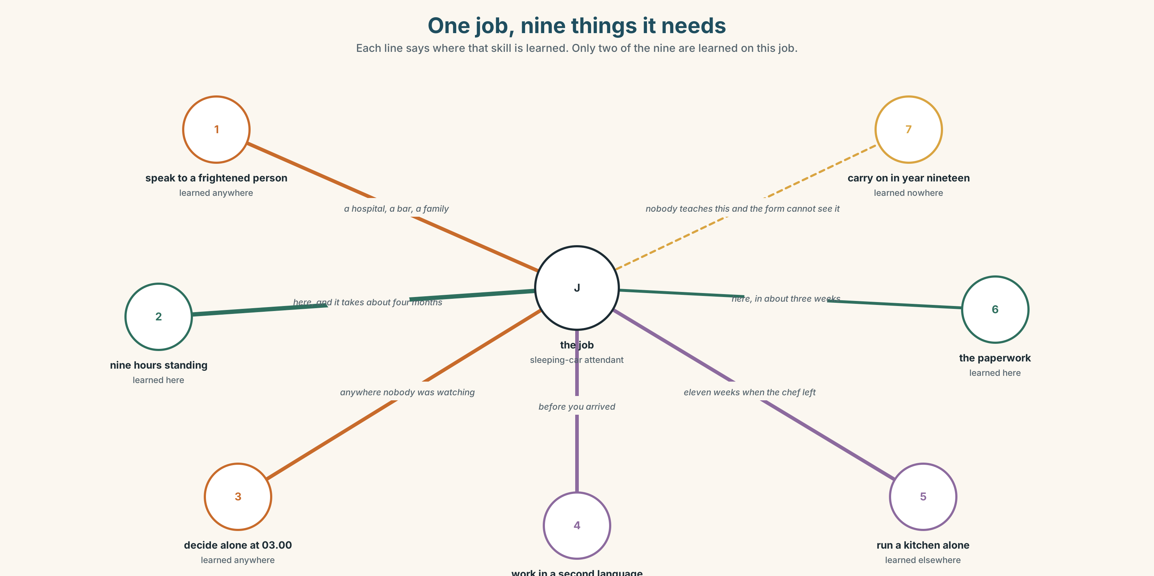{width=6.6in}
One job, nine things it needs — Each line says where that skill is learned. Only two of the nine are learned on this job.
experience | Measured in years, which measures time and not skill.
skill | The thing the years were supposed to stand for.
moment | The unit experience is actually made of.
learn a skill | Something that can be dated. Experience cannot.
try something new | The one activity that produces experience fastest and is nowhere on the form.
carry on | What twenty-three years is made of, and it is not nothing.

1B · Meet — the words
experience · skill · moment · adventure · abroad · foreign · language · swim · drive · cook · fly · climb · sing · ride · win · lose
Write each word under the right picture.
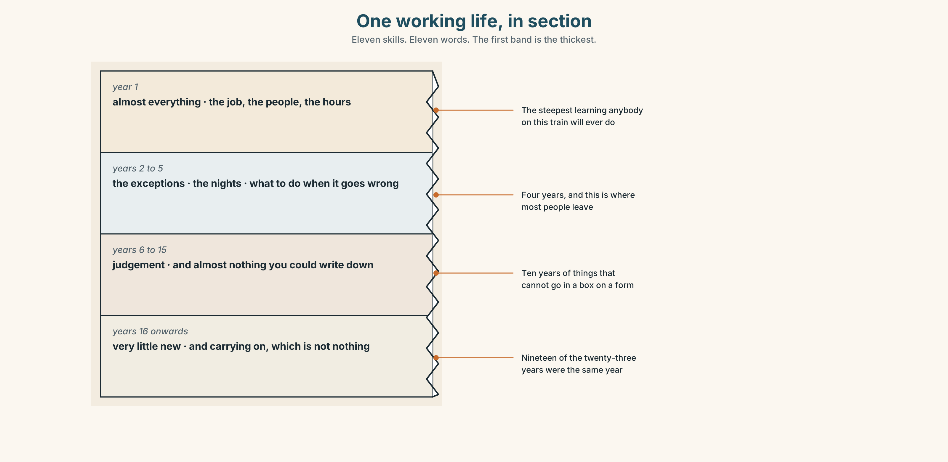{width=6.6in}
One working life, in section — Eleven skills. Eleven words. The first band is the thickest.

1C · Sort — the thing, or the doing of it?
Put each word in the right box. Two of them can go in both. Which two, and why?
skill · swim · experience · drive · adventure · climb · language · win · moment · cook
A THING YOU HAVE | A THING YOU DO | BOTH

1D · What people put on forms
learn a skill | Has a start and an end. You can name the week.
pass a test | Has a date, a number and a certificate.
try something new | Has none of those, and it is the best predictor of the other three.
win a prize | Goes on a form. Means almost nothing about a job.
take up | Begin something and keep doing it.
carry on | Keep doing something after the reason has gone.
Now say them. Three of these six produce a piece of paper and three do not. Which three, and which of the other three would you most want to know about somebody?

1E · Stretch — the phrases you will need today
learn a skill · pass a test · try something new · take up · carry on
Match each phrase to the moment you need it.
- You begin something in January and you are still doing it in June. → ______
- There is a certificate on the wall with a date on it. → ______
- It is week three and you are bad at it and you do not stop. → ______
- You have never done it before and you do it anyway. → ______
- Six weeks, a teacher and a thing you can now do. → ______

1F · The hard one
f Not yet.
Practise it three times. Two words, and they are the difference between no and not so far.

1G · Own it
Write down three things you have done that most people in this room have not. Do not write your name. The class guesses whose they are.

Part 2 · Listening ◆ A · THE WORLD
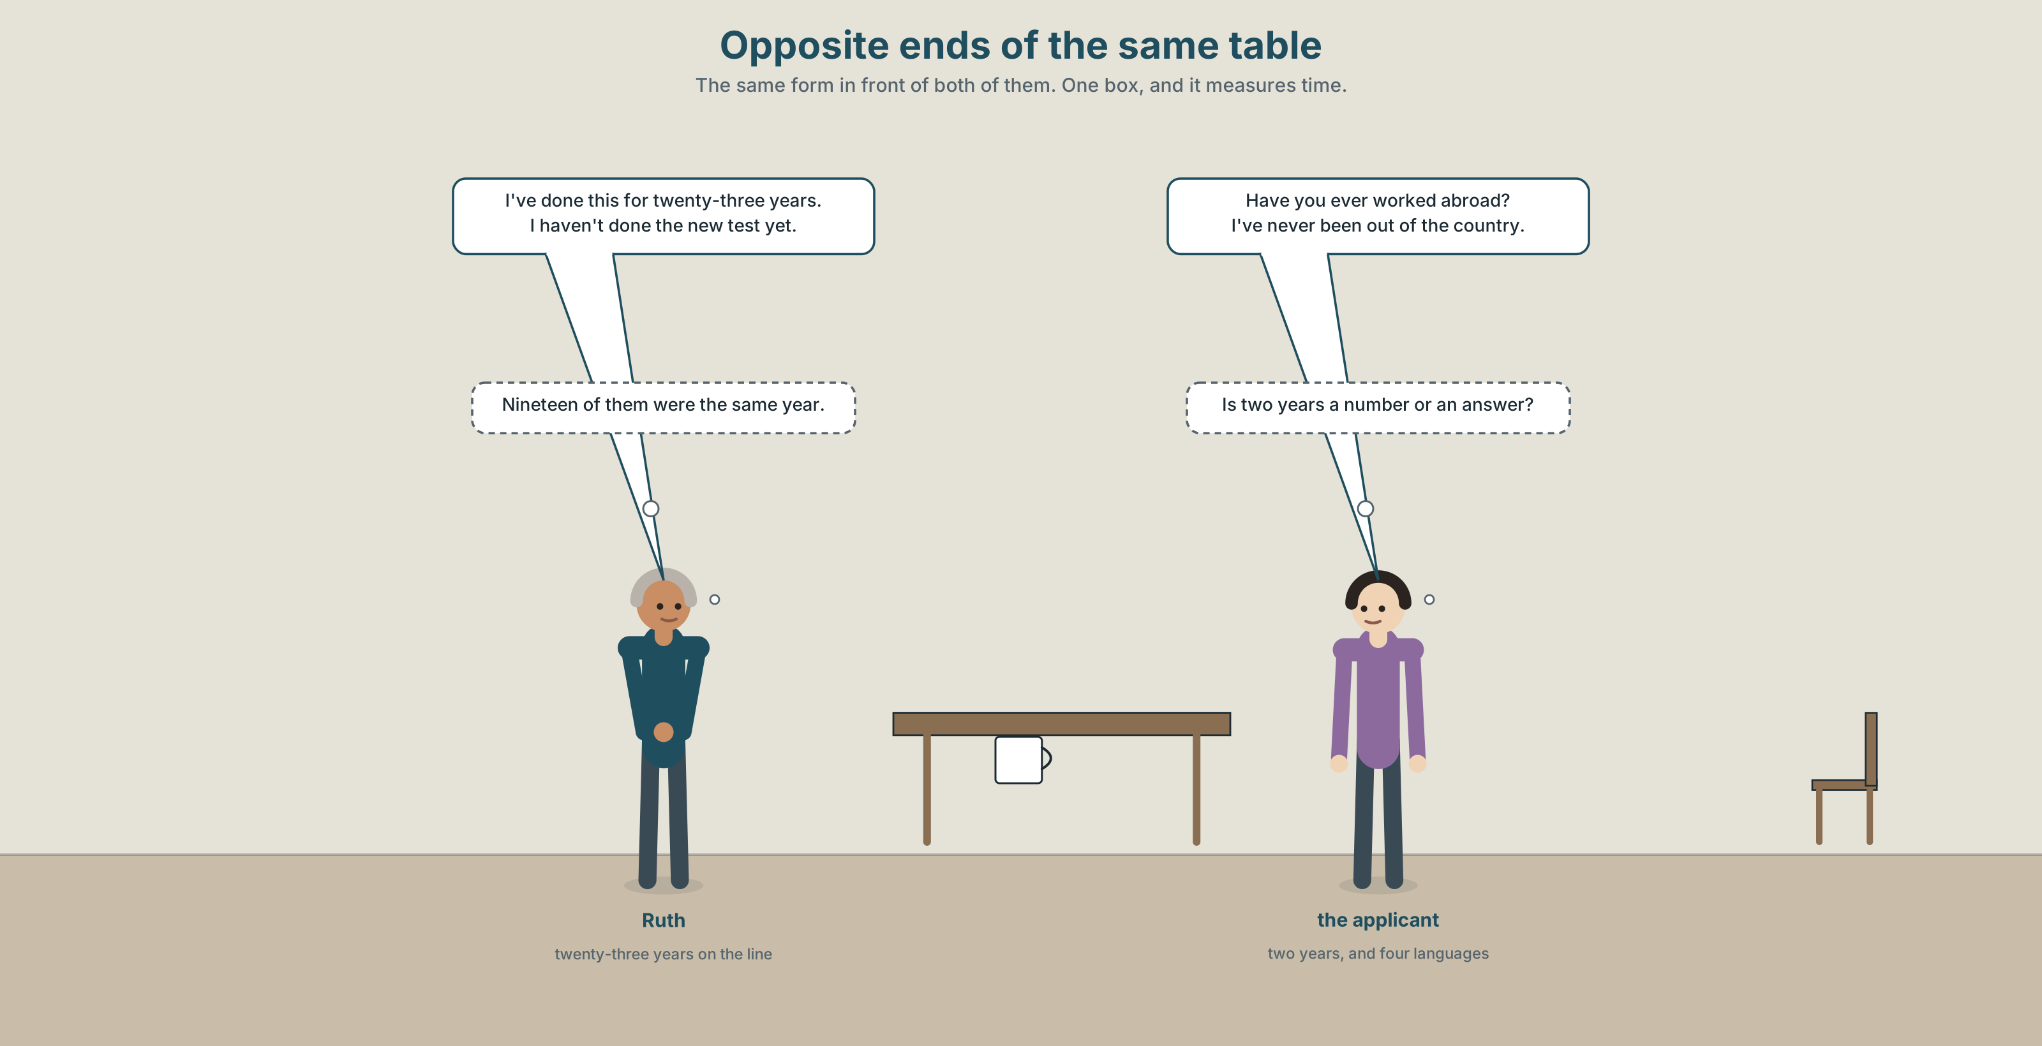{width=6.6in}
Opposite ends of the same table — The same form in front of both of them. One box, and it measures time.

2A · The crew room 🔊 Track 8.1
Before you listen. Both of them are applying for the same promotion. Guess: which box is the biggest on the form?
Listen once. One question. How many years has Ruth been on the line?
Listen again. Complete the table.
 | Ruth | the applicant
years
lived abroad
worked nights
Listen again. True or false?
- The applicant has worked abroad. ☐ T ☐ F
- Ruth has never worked nights. ☐ T ☐ F
- The applicant has already passed the test. ☐ T ☐ F
- Ruth has done this job for twenty-three years. ☐ T ☐ F
Noticing. Four sentences from the recording.
- Have you ever worked abroad?
- I've never been out of the country.
- I haven't done the test yet.
- She's done this for twenty-three years.
None of these four says when. Why would you choose a tense that leaves the date out?

2B · Decoding clinic 🔊 Track 8.2
Twenty seconds of the applicant at speed. Three jobs.
- Count how many times you hear have, has or 've.
- In I've and she's, how long is the have or has sound?
- He says been and gone. Is the person back, in each one?
Transcripts, page 155.

Part 3 · Grammar Lab 1 ◆ B · THE SYSTEM

Saying it happened without saying when

3A · Notice
Look at the four sentences in Part 2 again.
- What two parts make this form of the verb?
- Does any of the four say when it happened?
- Where does ever go? Where does never go?
- What is the difference between I haven't done it and I didn't do it?

3B · See
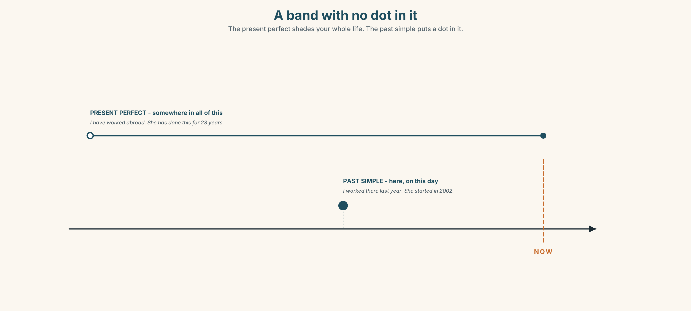{width=6.6in}
A band with no dot in it — The present perfect shades your whole life. The past simple puts a dot in it.

3C · Know
experience | have / has + past participle | I have worked abroad. She has done this for 23 years.
the question | Have you ever…? | Have you ever worked nights?
never | one negative, already | I have never been out of the country.
not yet | it has not happened so far | I haven't done the test yet.
No date, ever. The moment you add a date — last year, in 2019, when I was twenty — you must change to the past simple. The present perfect and a date cannot stand in the same sentence.
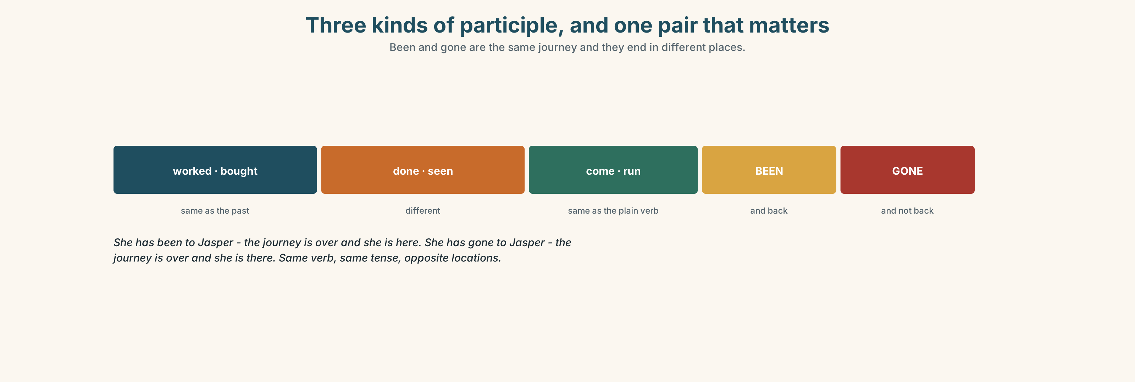{width=6.6in}
Three kinds of participle, and one pair that matters — Been and gone are the same journey and they end in different places.
same as the past | worked · lived · made · bought · had
different | do → did → done · see → saw → seen · go → went → gone
been or gone | She's been to Jasper — she is back · She's gone to Jasper — she is not
already / yet | already in positives, yet in negatives and questions
Why it matters. Every interview, every introduction and every conversation with somebody you have just met runs on this tense, and it is the first tense in this book that has no equivalent in most languages.

3D · Use — controlled
Complete with the present perfect, ever, never, already or yet.
(1) ______ you ______ (work) abroad? — No, I (2) ______ (be) out of the country. I (3) ______ (not do) the test ______ . She (4) ______ (do) this job for twenty-three years. He (5) ______ (pass) the test — last month, in fact.

3E · Use — guided
Turn each one into a question with Have you ever…?, then answer it two ways.
- work nights
- drive a truck
- live abroad
- sing in front of people
- lose something important

3F · Use — open
In pairs. Find five things your partner has done and you have not. Only Have you ever…? questions. You may not ask when.

3G · Check — six items, mark your own
- ______ you ever ______ (work) abroad?
- I've ______ been out of the country.
- I ______ ______ (not do) the test yet.
- She ______ ______ (do) this for twenty-three years.
- ✗ I have worked there last year. → correct it.
- ✗ Have you ever went to Jasper? → correct it.
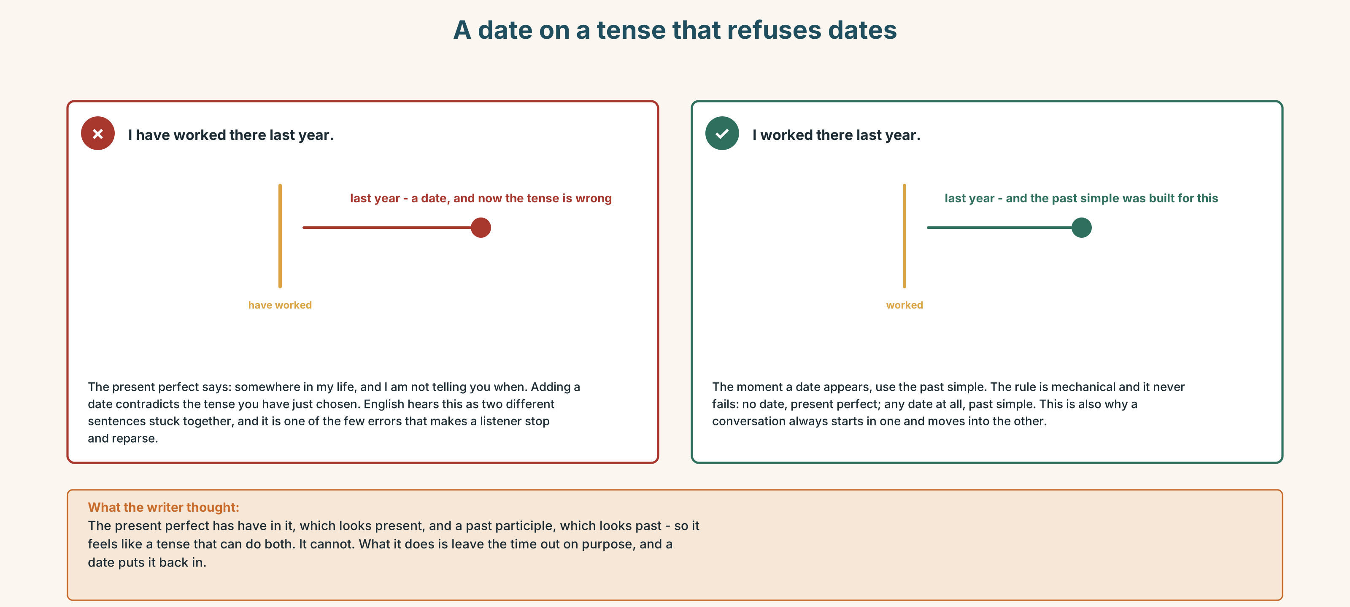{width=6.6in}
A date on a tense that refuses dates — A date on a tense that refuses dates
0–3 → Workbook pp. 32–35. 4–5 → Part 6. 6 → page 178.

Part 4 · Speaking ◆ C · THE PERFORMANCE

4A · Fluency starter — find somebody who
Everybody writes one Have you ever…? question. Ask until you find somebody who says yes. You may not ask the same person twice.

4B · The functional core — talking about experience
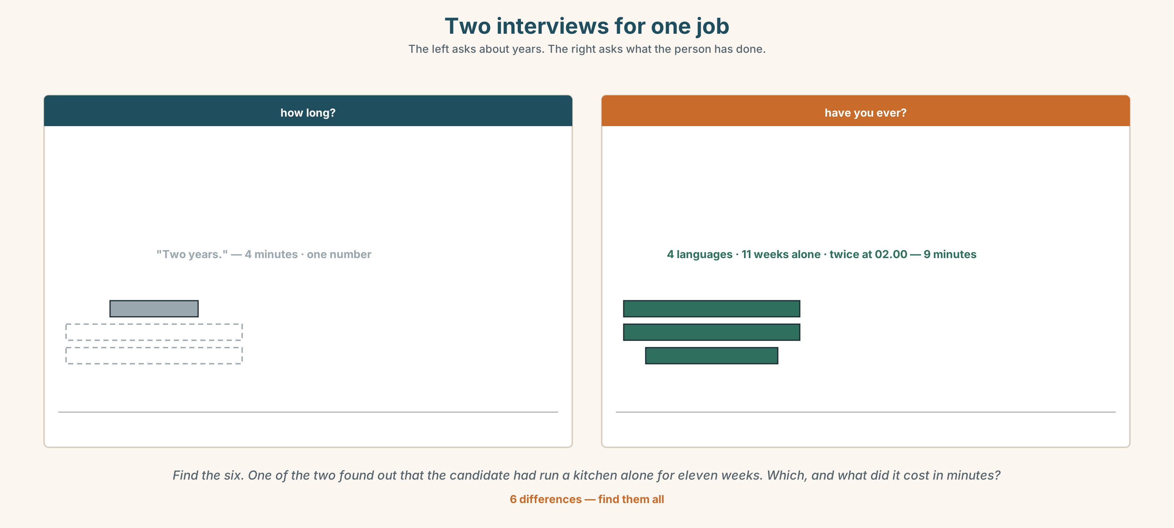{width=6.6in}
Two interviews for one job — The left asks about years. The right asks what the person has done.
Language Bank
asking | Have you ever…? · How long have you…?
saying yes | Yes, once. · Yes, a few times. · Only once.
saying no | No, never. · Not yet. · I've never…
following up | What happened? · When was that? — and now you are in the past simple
Information gap. Learner A has what the application form asks. Learner B has what the job actually requires. Find the three requirements the form cannot see.

4C · The performance — three things not on the form ⏺
Interview a classmate and find three things they have done that no form would ask about. Three minutes. You must:
ask six Have you ever…? questions · follow one of them into the past simple · find one thing nobody else in the room has done
Report in three sentences. Record it.

4D · Observer
One person listens for one thing: did anybody put a date in a present perfect sentence?

4E · Two criteria
☐ Were all my experience questions in the present perfect? ☐ Did I switch to the past simple the moment I asked when?

Part 5 · Reading ◆ A · THE WORLD

5A · Predict
The title is "Years of experience: ___" Why do you think there is a blank in the title?

5B · Read — sixty seconds

Years of experience: ___
The application form has one box about experience. It says: YEARS OF EXPERIENCE. There is a line after it.
Ruth has written 23. The other applicant has written 2 and then stopped writing.
He has worked two years on this line. He has also run a kitchen alone for eleven weeks when the chef left without notice, and he has worked in four languages, and he has twice talked somebody out of getting off a train in the middle of a prairie at two in the morning.
None of that is on the form. There is nowhere to put it. The form does not ask whether you have ever done anything; it asks how long you have been near it.
Ruth has twenty-three years and she has also done all three of those things, more than once. The form cannot tell the difference between them either.

5C · Answer
- What does the box on the form say?
- What has Ruth written?
- What did the other applicant do when the chef left?
- How many languages has he worked in?
- Why did he stop writing?
- The last line says the form cannot tell the difference between them either. What is the form actually measuring?

5D · Vocabulary in context
Guess from the text. Then check.
without notice · talked somebody out of · nowhere to put it · how long you have been near it · more than once

5E · The counter-text
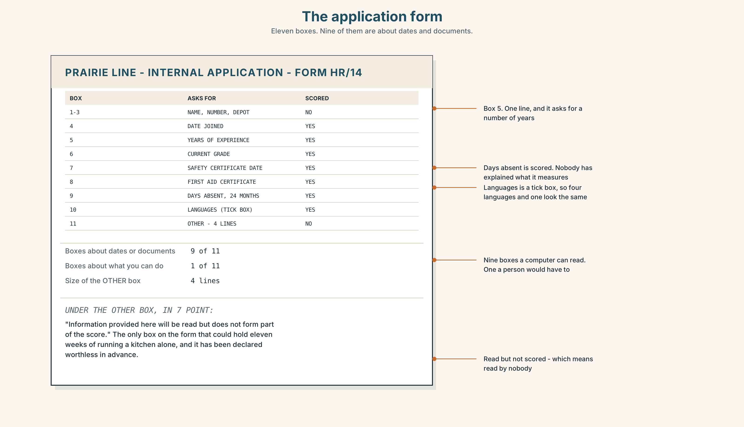{width=6.6in}
The application form — Eleven boxes. Nine of them are about dates and documents.
Read the form and answer.
- How many boxes are there?
- How many are about dates or documents, and how many about what somebody can do?
- How big is the OTHER box?
- What does the line under the OTHER box say, and what does that do to the box above it?

5F · Two texts
The reading says one applicant has run a kitchen alone for eleven weeks. The form has four unscored lines for anything that is not a date.
Where would that go? Say one sentence.

Part 6 · Vocabulary Lab 2 ◆ B · THE SYSTEM

Been, gone, done, seen
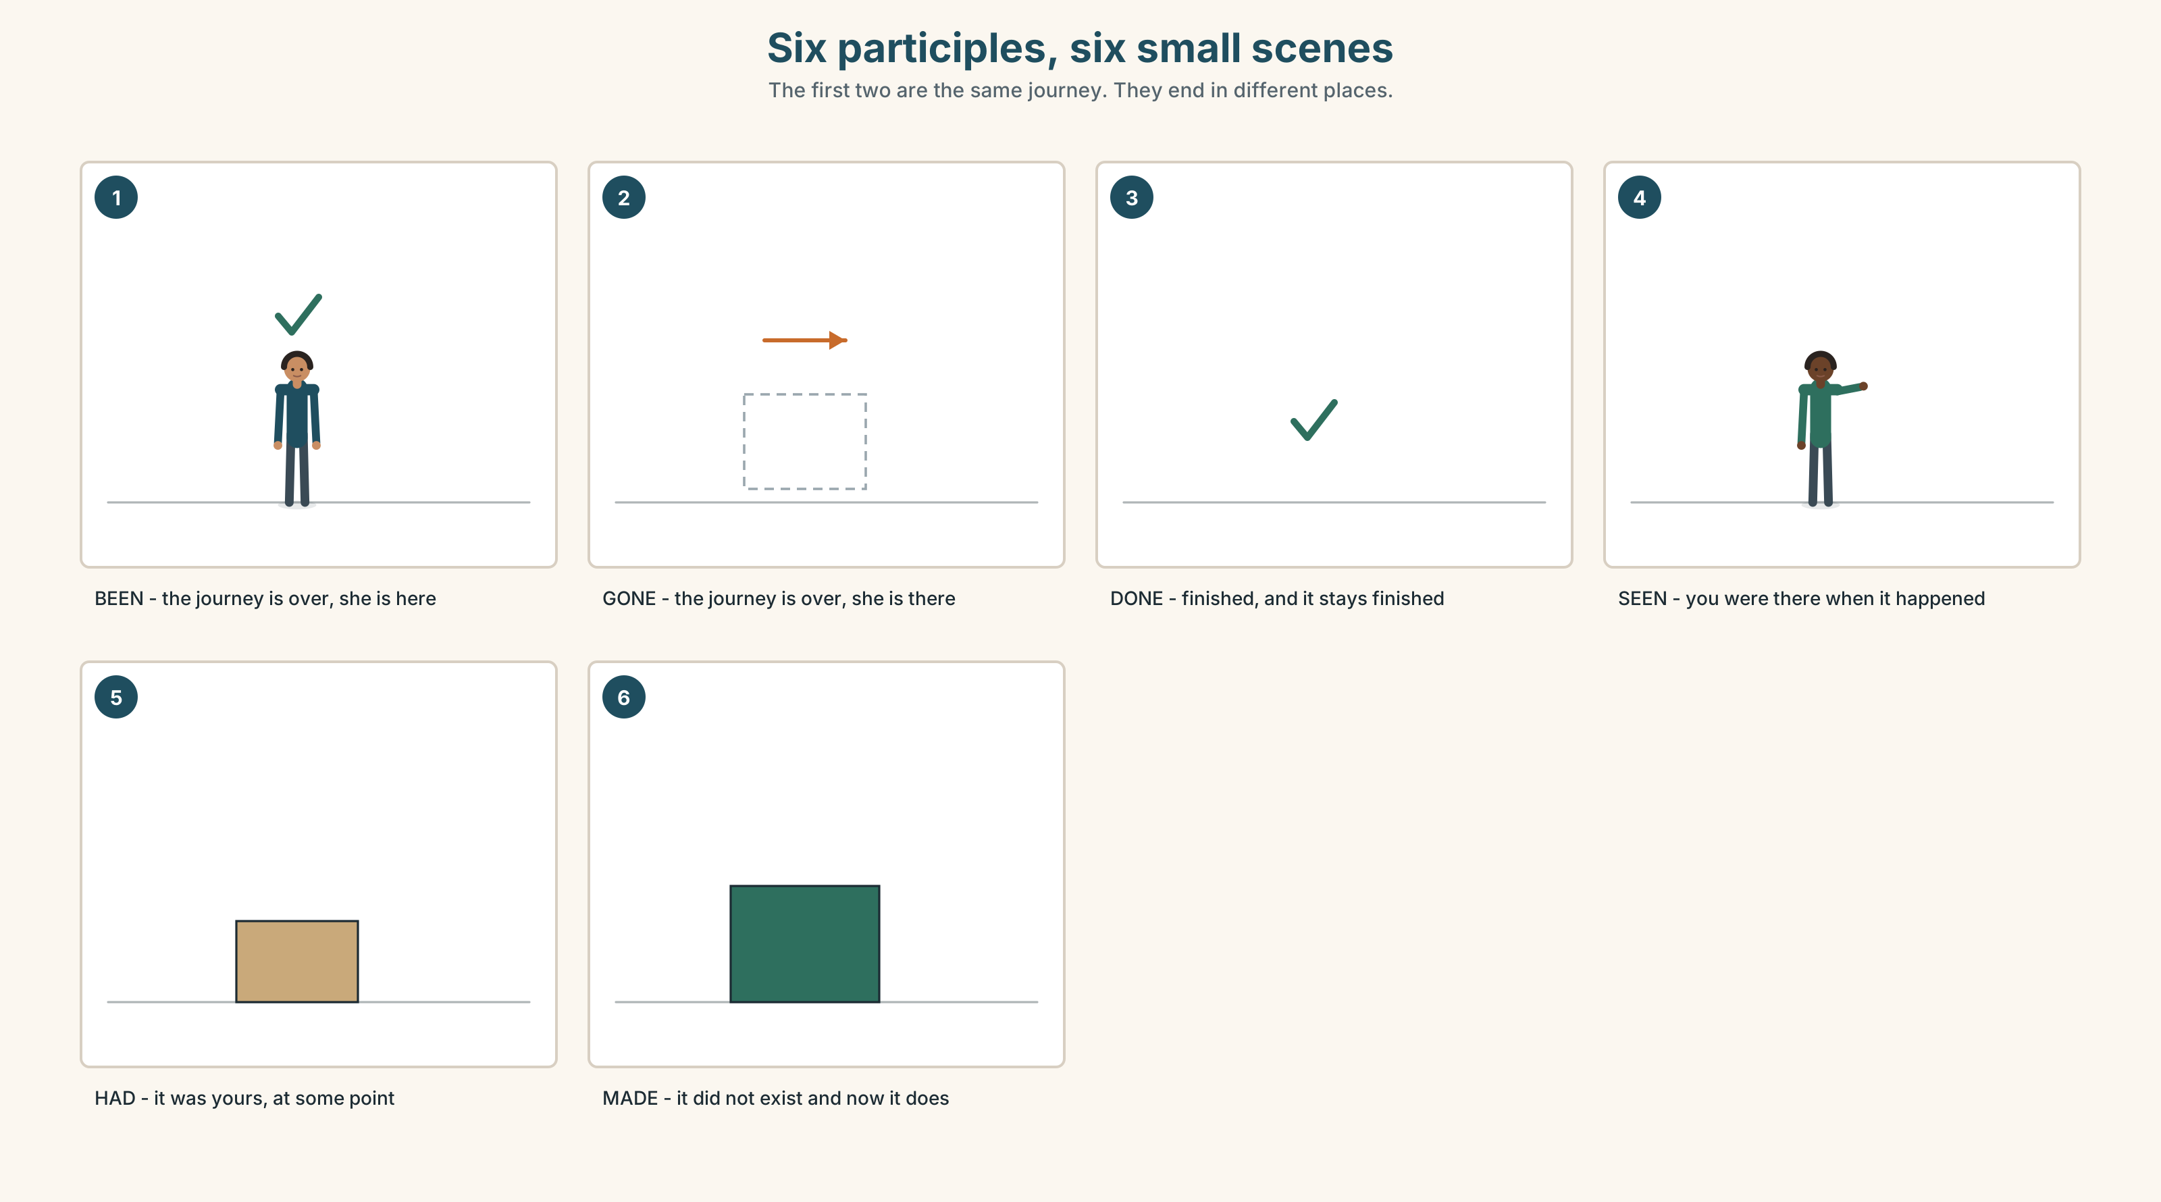{width=6.6in}
Six participles, six small scenes — The first two are the same journey. They end in different places.

6A · The ones that catch everybody
been / gone | been means you came back; gone means you are still there
already / yet | already in positives; yet at the end of negatives and questions
ever | only in questions: Have you ever…? — never in a statement
never | already negative, so no haven't with it

6B · Say them
ever · never · always · already · yet · been · gone · done · seen

6C · Chunk
- ______ you ever been abroad?
- I've ______ been abroad.
- I haven't done it ______ .
- I've ______ done it. (and before you asked)
- ______ ______ . (two words — it has not happened so far)
- ______ ______ . (two words — it happened exactly one time)

6D · Contrast Clinic
Six items. been or gone?
- She's ______ to Jasper — she'll be back on Friday.
- She's ______ to Jasper — she came back last week.
- He's ______ out. He'll be back at six.
- I've ______ to Vancouver three times.
- They've ______ home. The room is empty.
- Have you ever ______ to Winnipeg?

Part 7 · Pronunciation & Fluency Lab ◆ B · THE SYSTEM

The have that is almost not there
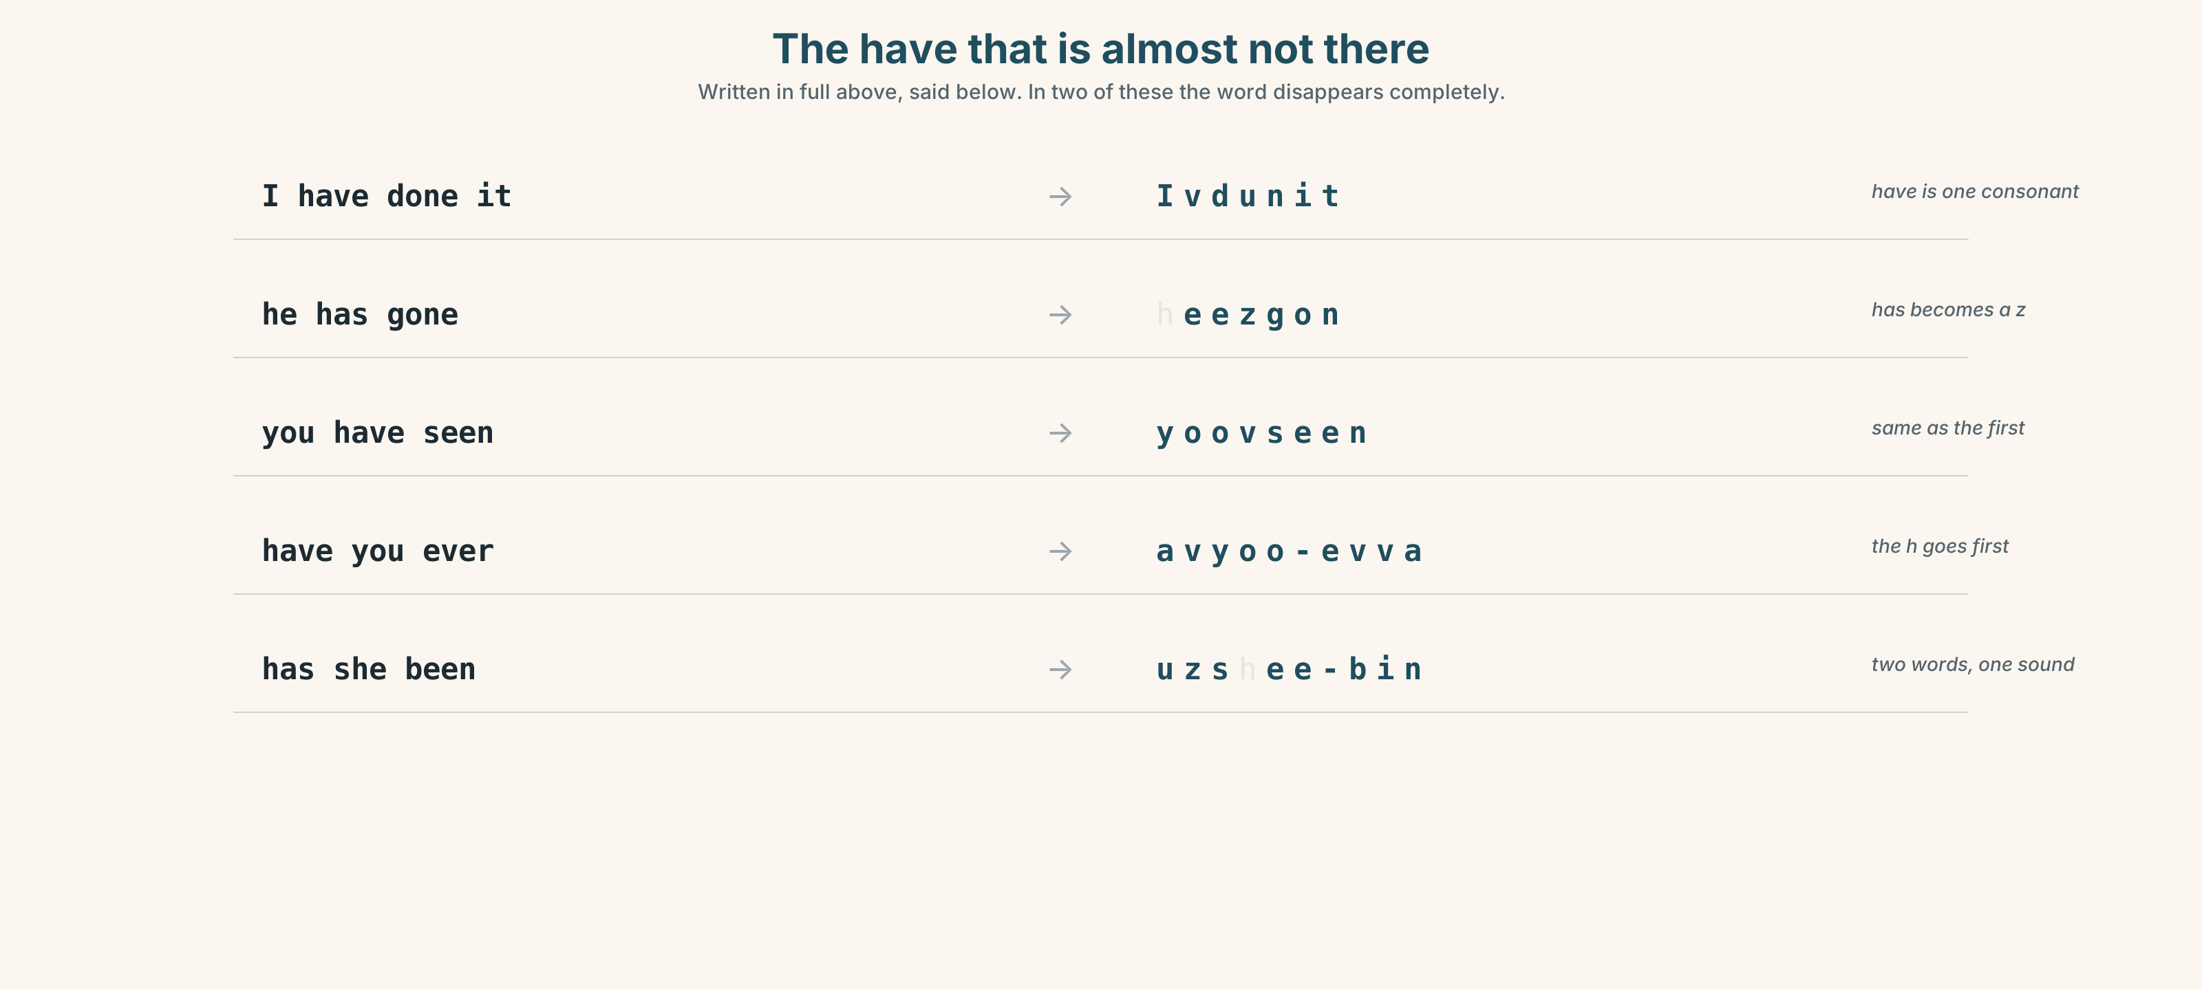{width=6.6in}
The have that is almost not there — Written in full above, said below. In two of these the word disappears completely.

7A · Hear
I have → I've, one sound · he has → he's · you have → you've have you → hav-yuh, and the h almost goes · has she → uz-shee In a statement, have is never stressed. If it is, you are arguing.

7B · Say
Say each one three times. Then say this:
I've never been there, and he's already gone. — two perfects, four beats.

7C · Make it mean something
Say these two:
I've done it. — ordinary. Have has almost no sound at all. I HAVE done it. — you are contradicting somebody who said you had not.
The full form is an argument. Learners who always use the full form sound permanently defensive. Which one would you use to answer a friendly question?

7D · Fluency 20 ⏺
Twenty seconds: six things you have done in your life, no dates. Three times, faster.

Part 8 · Writing ◆ C · THE PERFORMANCE

What you have done · 50–70 words

8A · Read the model
I have worked on this line for two years. [the number the form asks for, got out of the way]
I have also run a kitchen alone for eleven weeks, when the chef left without notice. [the thing the form does not ask about, with the reason it happened]
I have worked in four languages and I have twice talked somebody out of getting off a train at two in the morning. [two more, and the second one is specific]
I have never managed anybody. That is the only thing on this list I have not done. [the honest gap, volunteered]
Questions about the writer's choices:
- The first line gives the number. Why get it out of the way first?
- at two in the morning. Why is the detail the whole sentence?
- The last line admits a gap nobody asked about. What does that buy?

8B · The anti-model
I have two years of experience on this line. I am hard-working and reliable. I have good communication skills. I work well in a team. I am looking for a new challenge.
Correct English, and it is on nine million applications. Rewrite it with three things that have actually happened and one thing you have never done.

8C · Plan
the number they asked for → the thing they did not ask about → two more, one of them specific → the honest gap

8D · Write — 50 to 70 words

8E · Peer review — two things only
☐ Is every sentence in the present perfect, with no dates? ☐ Is there one thing in it nobody else in this room could write?

8F · Publish
On the wall, with no names. The class reads them and marks the one line in each that could not be on a form.

Part 9 · The File ◆ A · THE WORLD + C · THE PERFORMANCE

STUDY FILE · What you have already done
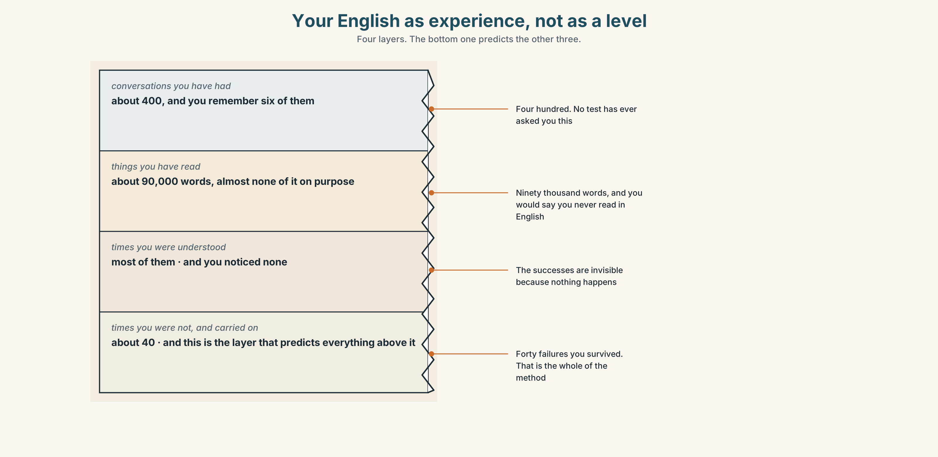{width=6.6in}
Your English as experience, not as a level — Four layers. The bottom one predicts the other three.

9A · The list nobody keeps
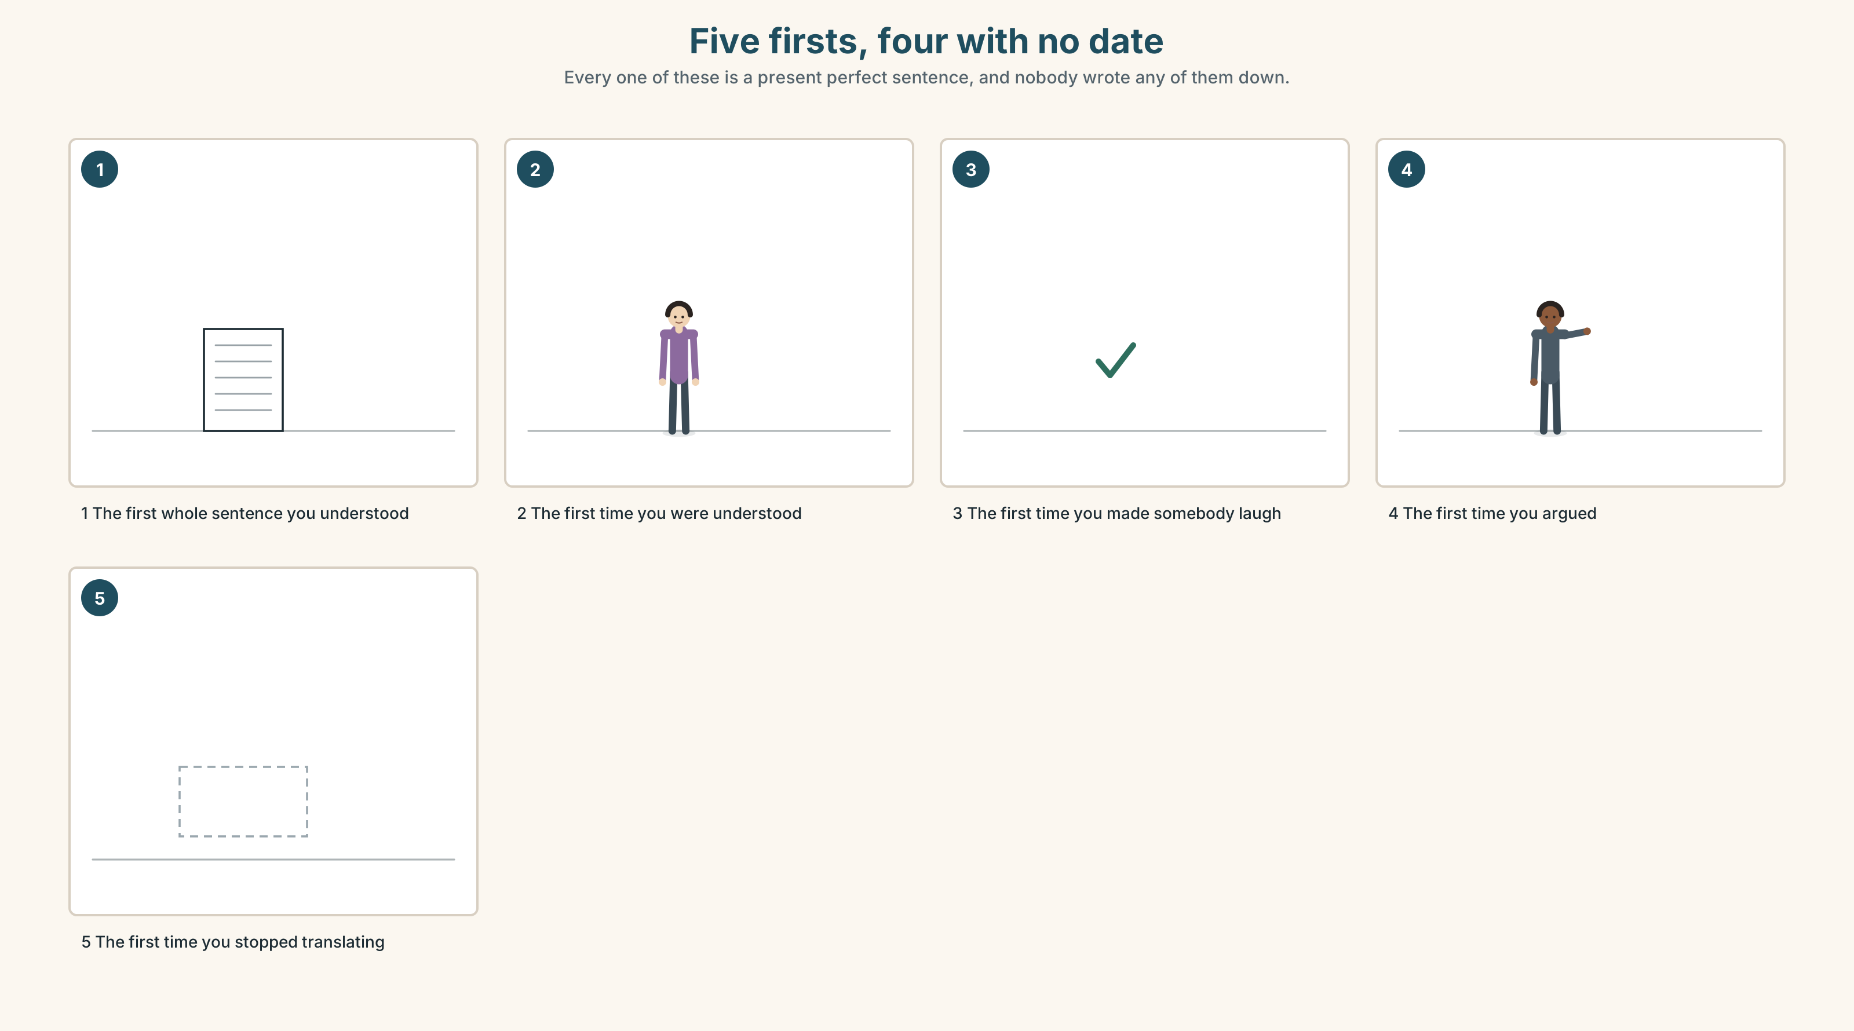{width=6.6in}
Five firsts, four with no date — Every one of these is a present perfect sentence, and nobody wrote any of them down.
What people measure | level, score, hours
What they remember | four or five moments
What the moments are | firsts — and every one of them is a present perfect sentence
What is missing | a list, because nobody ever told anyone to keep one

9B · Your firsts
Write five sentences beginning I have… about English. No dates. First time you understood a film, were understood by a stranger, read a page without stopping, made somebody laugh, had an argument.

9C · Role play — the interview nobody gives
In pairs. Interview your partner about their English with ten Have you ever…? questions. No question may be about a course, a level or a score.

9D · The one you have not done yet
Look at your list of firsts. Name the next one. Write it as I haven't … yet. That sentence is a plan with a date you have not set.

9E · Transfer — before next week
Keep a list of English firsts for seven days. However small. Bring it. Most people find three or four and are surprised by all of them.

Part 10 · Mediation & Interaction ◆ C · THE PERFORMANCE
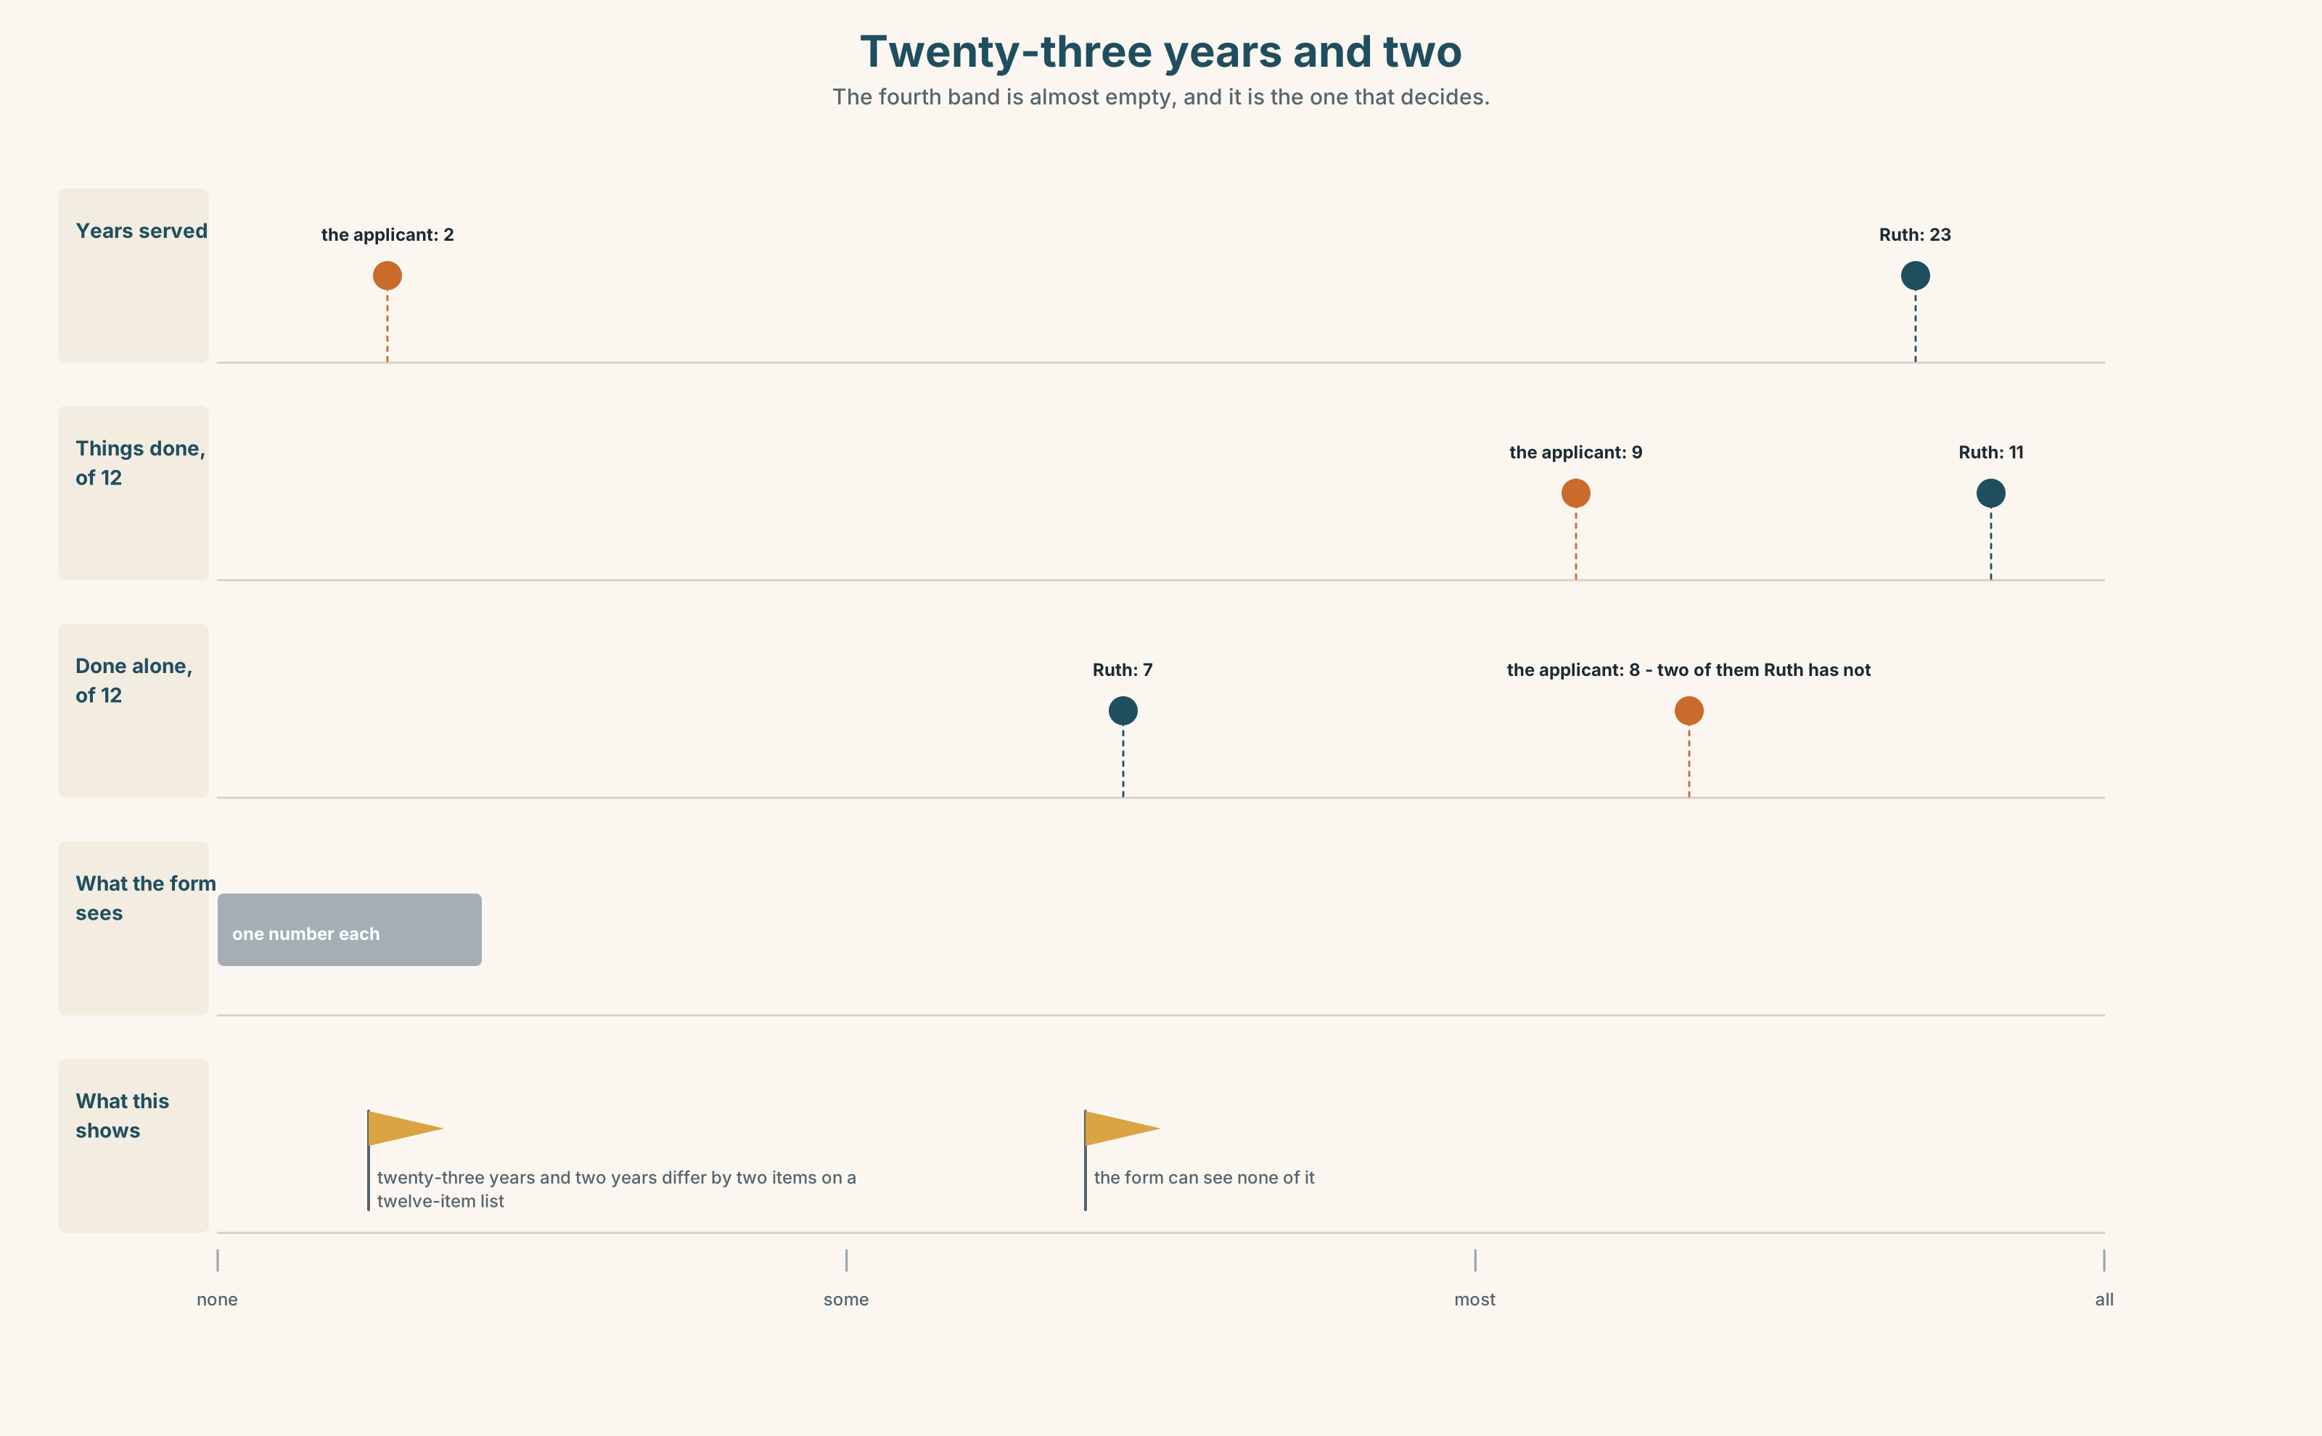{width=6.6in}
Twenty-three years and two — The fourth band is almost empty, and it is the one that decides.

10A · Relay
Half the class has the form. Half has what the job actually needs. Build the real requirement list by speaking. Ten minutes.

10B · Simplify — for one person
Somebody is filling in a form with one experience box and they have done a great deal. Advise them in four sentences. Be practical, not encouraging.

10C · Online
Write one message to a classmate asking about three experiences. Three sentences. Three Have you ever…? questions, and no dates.

10D · Your language
Does your language have a tense for experience without a date? Say I have been to Canada in your language. Does it sound like the past, or like now?

Part 11 · The Decision ◆ C · THE PERFORMANCE

One box on a form
The company promotes about nine sleeping-car attendants a year. The form has one experience box and it asks for years.
Option one: keep it. Years are cheap to check and impossible to argue with.
Option two: replace it with a checklist of twelve things — have you ever run a service alone, have you ever dealt with a medical event, have you ever worked in a language that is not your first. Takes four minutes to fill in and two hours a year to score.
Option three: a day's trial on a real train. Expensive, accurate, and it cannot be done for more than about thirty people a year.

11A · The evidence
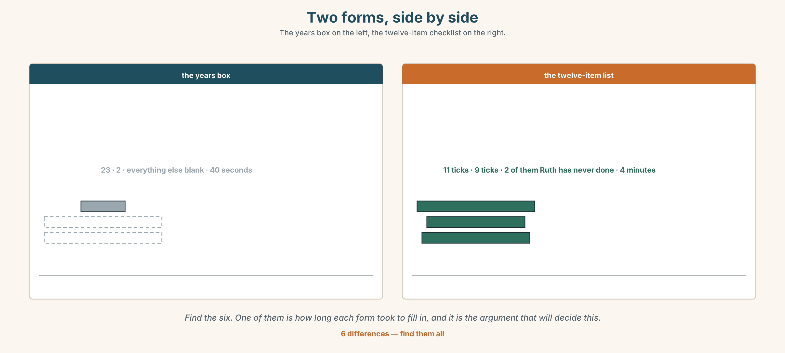{width=6.6in}
Two forms, side by side — The years box on the left, the twelve-item checklist on the right.
🔊 Track 8.6. Ruth, 20 seconds: "I've been here twenty-three years. Nineteen of them were the same year. I'd rather be asked what I've done than how long I've been standing here."

11B · Talk about it
In threes. Use the frame. Everybody says one.
I think the company should ______ , because ______ .
Words you can use: experience · skill · moment · learn a skill · try something new · win · lose

11C · Decide
Write two sentences. Choose, and say why.
I think the company should ______________________ , because ______________________ .

11D · Model decision
The checklist. Two hours a year is nothing and years of experience is not a measurement, it is a proxy for one. The trial is better and it does not scale, and the thing that does not scale is the thing that gets quietly dropped in a bad year.

11E · The Reveal
What happened. The company introduced the twelve-item checklist. In the first year the promotions went to almost the same nine people.
Then something nobody expected: the checklist was being read by the people filling it in. Four attendants asked to be put on night services specifically because there was a line on the form about them, and the company had never once been asked that before.
One question. You do not have to answer it out loud.
The checklist did not change who was promoted. What did it change?

Part 12 · Landing ◆ all three lines

12A · Recycle — twelve items
- ______ you ever ______ (work) abroad?
- I've ______ been out of the country.
- I haven't done it ______ .
- I've ______ done it. (and before you asked)
- She's ______ to Jasper — she's still there.
- She's ______ to Jasper — she's back.
- ______ ______ . (two words — it has not happened so far)
- ______ ______ . (two words — exactly one time)
- I'd like to ______ ______ running. (two words — begin, and keep going)
- You have to ______ ______ when it gets hard. (two words)
- (Unit 7) You ______ touch it. (forbidden)
- (Unit 6) It will ______ close. (seventy per cent)

12B · Consolidate — one task, everything in it
Write six sentences about what one person you know has done. All six in the present perfect, no dates, one with never, one with yet, and one that nobody else in this room could write.

12C · Can-do, with evidence
☐ I can talk about experience without saying when. Evidence: 4C, 8D ☐ I can ask Have you ever…? Evidence: 4A, 3F ☐ I can use been, gone, already and yet. Evidence: 6D ☐ I can say the weak forms of have and has. Evidence: 7C

12D · Replay ⏺
Record 0C again. Listen to both. What is different?

12E · Glossary — thirty-five words, as a map
THE NOUNS · experience · skill · moment · adventure · language WHERE · abroad · foreign THE VERBS · swim · drive · cook · fly · climb · sing · ride · win · lose WHAT GOES ON A FORM · learn a skill · pass a test · win a prize WHAT DOES NOT · try something new · take up · carry on THE GRAMMAR · ever · never · always · already · yet · been · gone · done · seen SAYING IT · Have you ever…? · I've never… · Not yet. · Only once.

12F · Next
Unit 9 · How does weather change a day?

