Unit 1: Hello
In this unit you say hello. You say your name. You count to ten.
Warm Up
W1 Look at Figure 1.1. Tick the words you know.
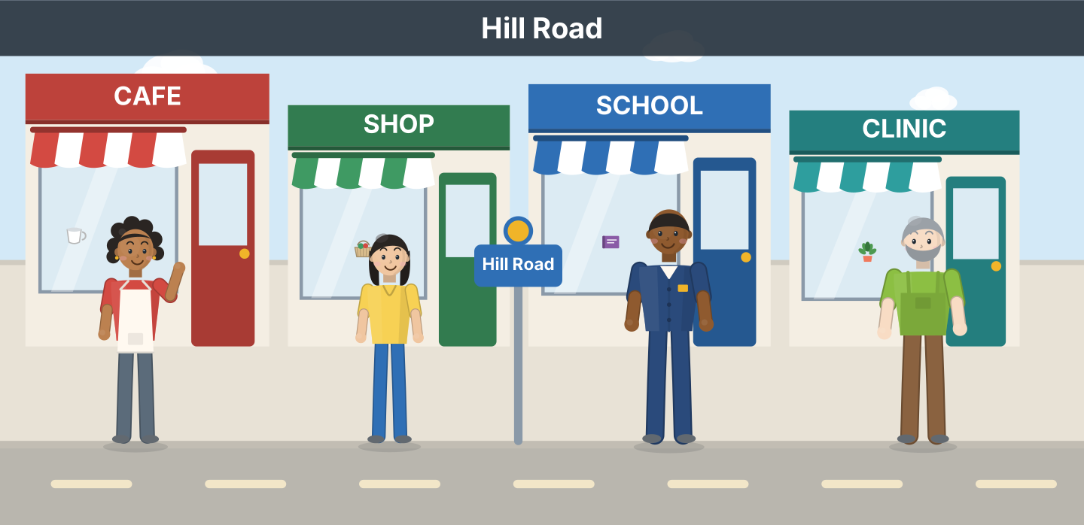
Figure 1.1 · Hill Road.
- a cafe — ✓ (example)
- a shop — ______
- a school — ______
- a clinic — ______
- a bus — ______
W2 Look at Figure 1.2. Write the number: 1, 2 or 3.
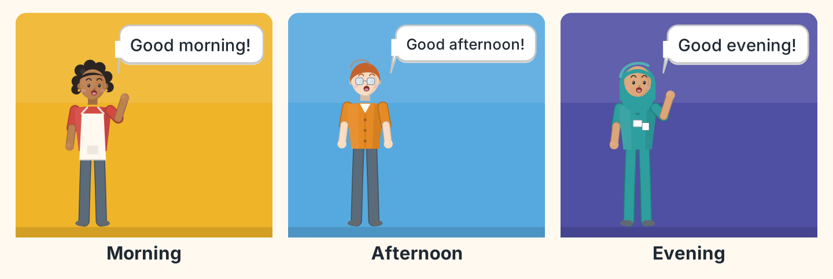
Figure 1.2 · Three times of day.
- Good evening. — 3 (example)
- Good morning. — ______
- Good afternoon. — ______
- Good morning. — ______
W3 Say hello to three people in your class.
- Hello. I’m Lili. (example)
- Say hello.
- Say your name.
- Say goodbye.
Part 1 · Words & Sounds
1A Look at Figure 1.3. Match the person and the job.
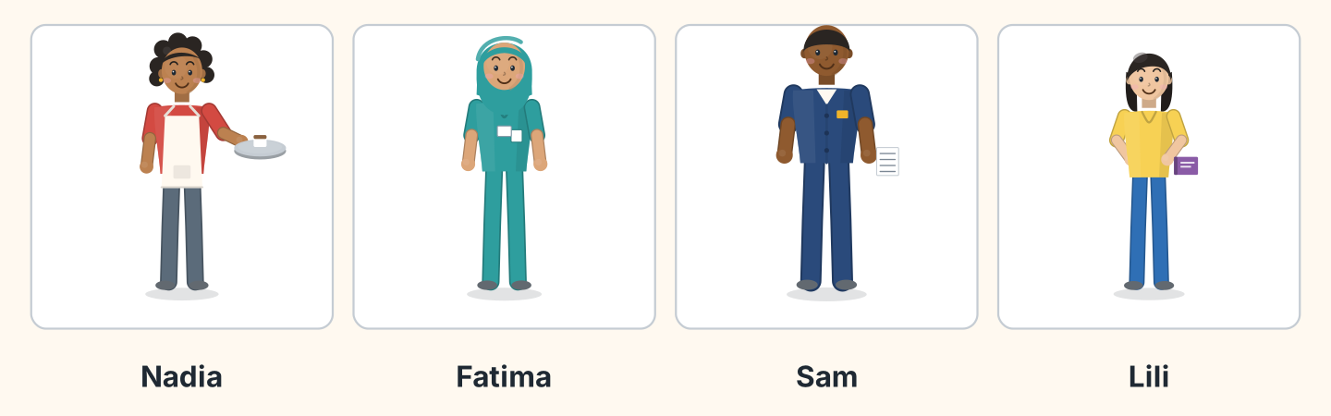
Figure 1.3 · Four people on Hill Road.
Person | Job
1 Nadia | a a student
2 Fatima | b a cook
3 Sam | c a nurse
4 Lili | d a driver
 | e a teacher
One option is not needed.
- 1 — b (example)
- 2 — ______
- 3 — ______
- 4 — ______
1B Look at Figure 1.4. Write the letters in the box.
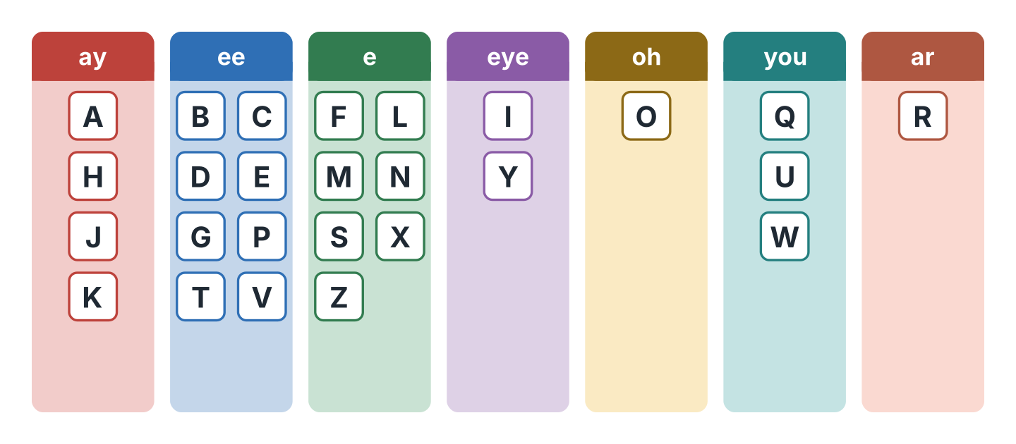
Figure 1.4 · The alphabet in seven sounds.
Words: A · E · I · O · U
- ay — A (example)
- ee — ______
- eye — ______
- oh — ______
- you — ______
1C Listen. Write the letters you hear.
- S-A-M — Sam (example)
- ______________
- ______________
- ______________
- ______________
1D Look at Figure 1.5. Write the word.
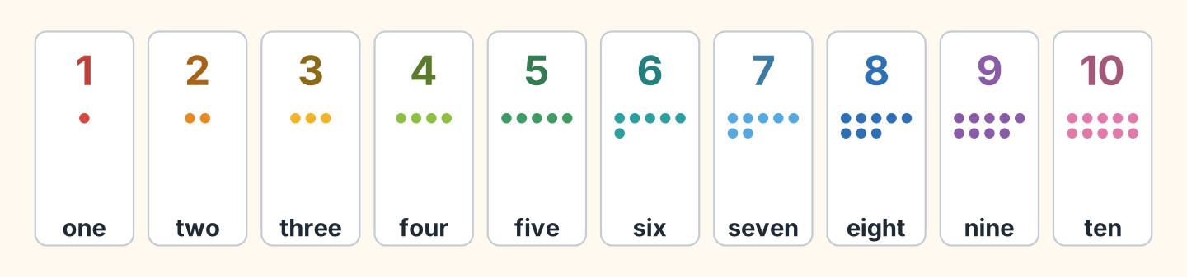
Figure 1.5 · One to ten.
- 2 — two (example)
- 5 — ______________
- 7 — ______________
- 9 — ______________
- 10 — ______________
1E Write the number.
- six — 6 (example)
- three — ______
- eight — ______
- one — ______
- four — ______
1F Say it. Look at Figure 1.6. Say the words.
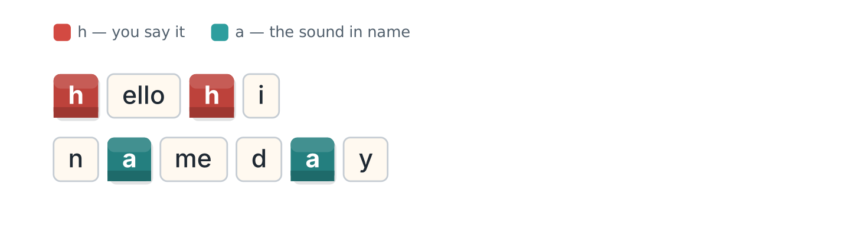
Figure 1.6 · Two sounds in hello and name.
- hello (example)
- hi
- name
- day
- Hello, Hannah.
Part 2 · Grammar
2A Look at Figure 1.7. Complete with am, is or are.
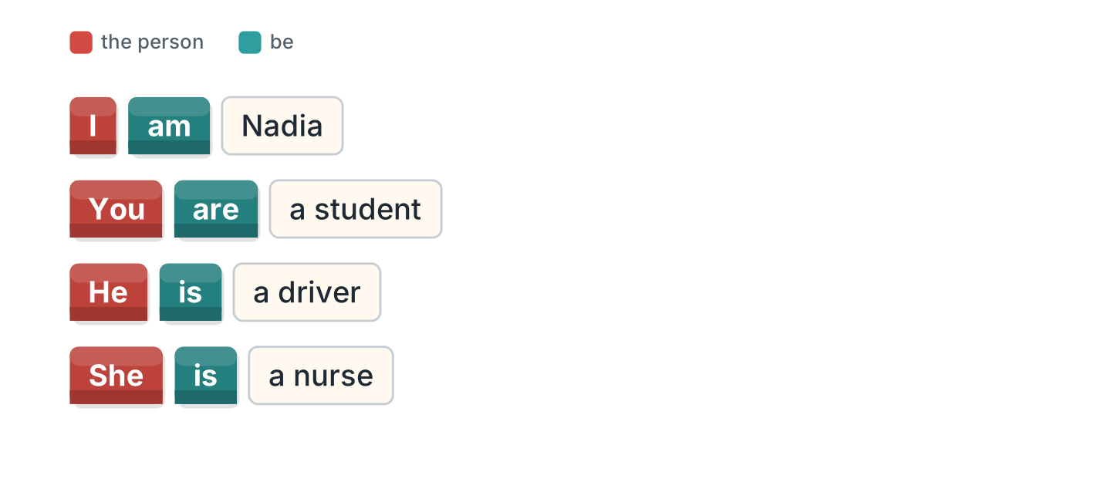
Figure 1.7 · am, is and are.
- I am Nadia. (am) (example)
- She ______ a nurse.
- You ______ a student.
- He ______ a driver.
- I ______ from Egypt.
2B Choose the correct word.
- I (am / is) Lili. — am (example)
- He (am / is) Sam.
- You (is / are) a teacher.
- She (are / is) from Brazil.
- I (am / are) a cook.
2C Look at Figure 1.8. Write the short form.
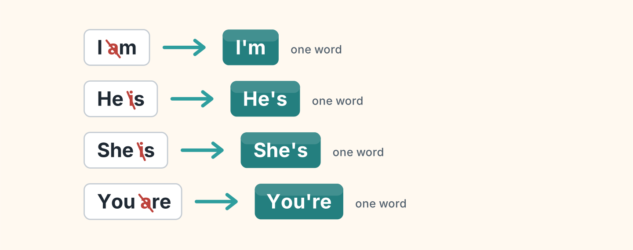
Figure 1.8 · Two words become one.
- I am — I’m (example)
- He is — ______________
- She is — ______________
- You are — ______________
2D Write the long form.
- I’m — I am (example)
- She’s — ______________
- He’s — ______________
- You’re — ______________
2E Look at Figure 1.9. Complete with my, your, his or her.
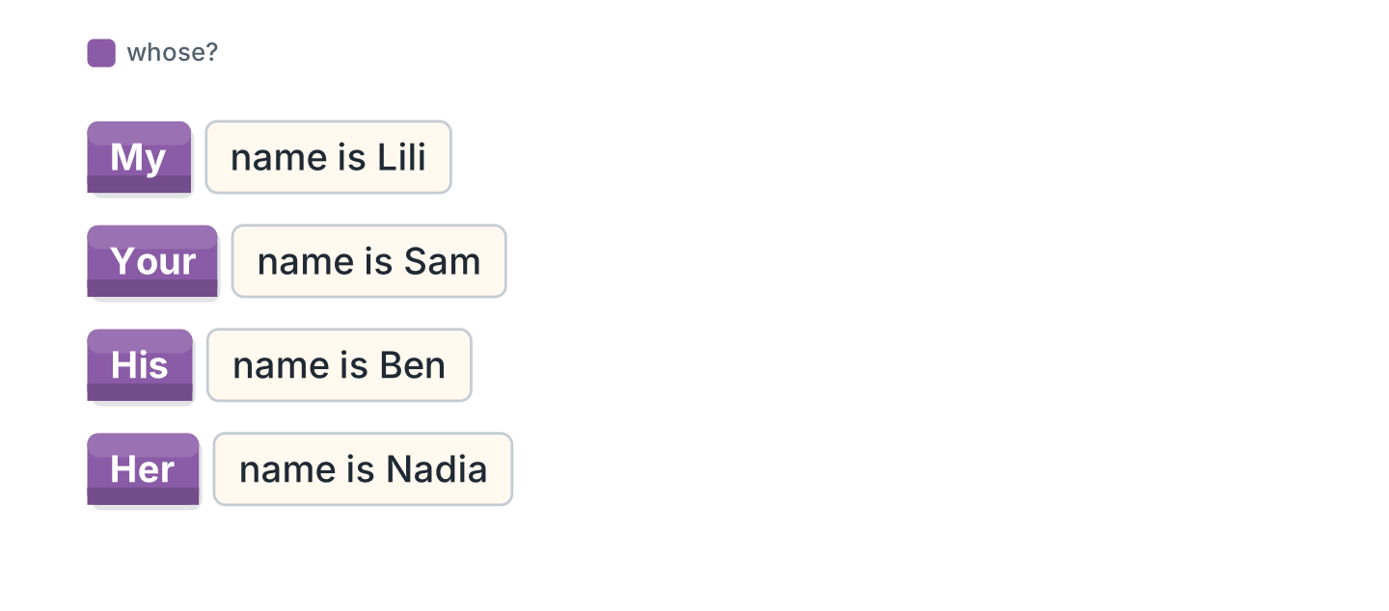
Figure 1.9 · my, your, his and her.
- I’m Lili. My name is Lili. (My) (example)
- He’s Ben. ______ name is Ben.
- She’s Nadia. ______ name is Nadia.
- Hello. What’s ______ name?
- I’m Omar. ______ name is Omar.
2F Find the mistake. Write the correct word.
- I is Sam. — am (example)
- She are a nurse. — ______________
- He am from Poland. — ______________
- You is a student. — ______________
Part 3 · Listening
3A Listen. Look at Figure 1.10. Write the number.
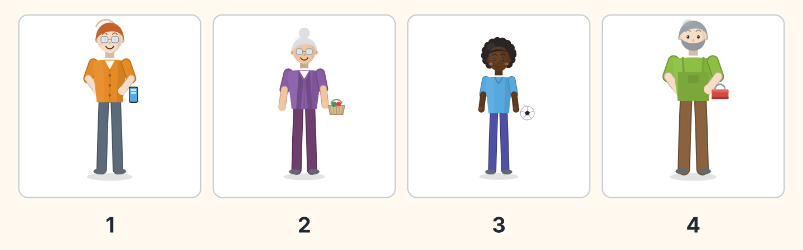
Figure 1.10 · Four voices.
- Ben — 1 (example)
- Rosa — ______
- Omar — ______
- Marek — ______
3B Listen. Look at Figure 1.11. Complete the class list.
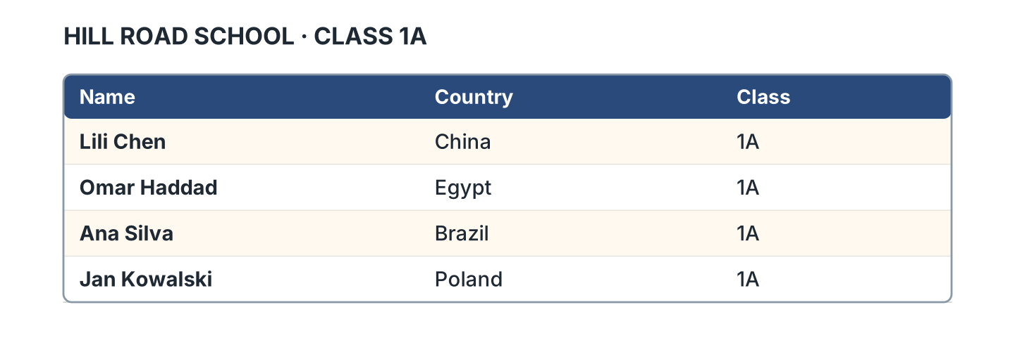
Figure 1.11 · The class list.
- Lili Chen is from China. (China) (example)
- Omar Haddad is from ______________.
- Ana Silva is from ______________.
- Jan Kowalski is from ______________.
3C Listen. Look at Figure 1.12. Tick the country.
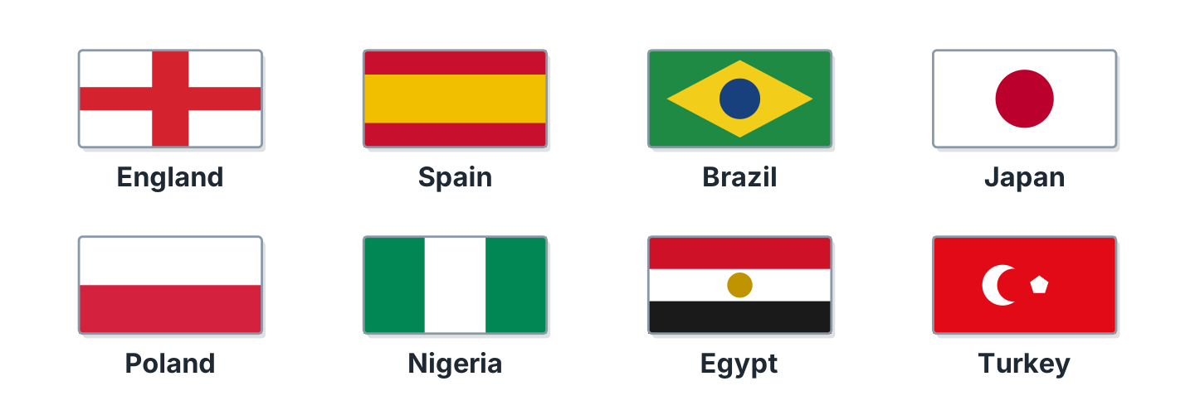
Figure 1.12 · Eight countries.
- Japan ✓ (example)
- Spain — ______
- Turkey — ______
- Nigeria — ______
- England — ______
3D Listen. Write the name.
- B-E-N — Ben (example)
- ______________
- ______________
- ______________
Part 4 · Speaking
4A Look at Figure 1.13. Ask and answer with a friend.
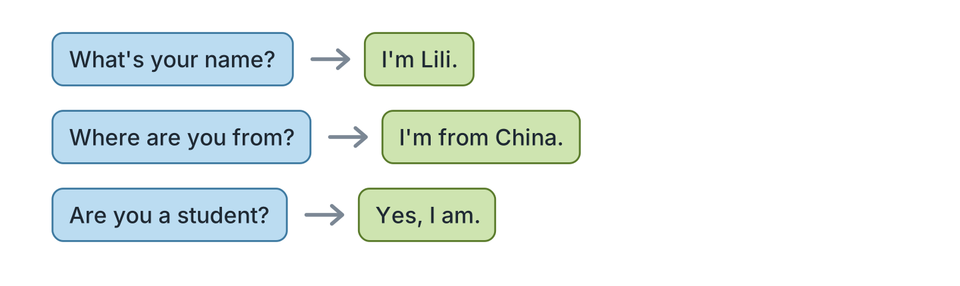
Figure 1.13 · A question and an answer.
- A: What’s your name? B: I’m Lili. (example)
- A: What’s your name? B: ______________
- A: Where are you from? B: ______________
- A: Are you a student? B: ______________
4B Spell your name. Then spell your friend’s name.
- L-I-L-I (example)
- Spell your first name.
- Spell your surname.
- Spell your friend’s first name.
4C Look at Figure 1.14. Introduce a friend.
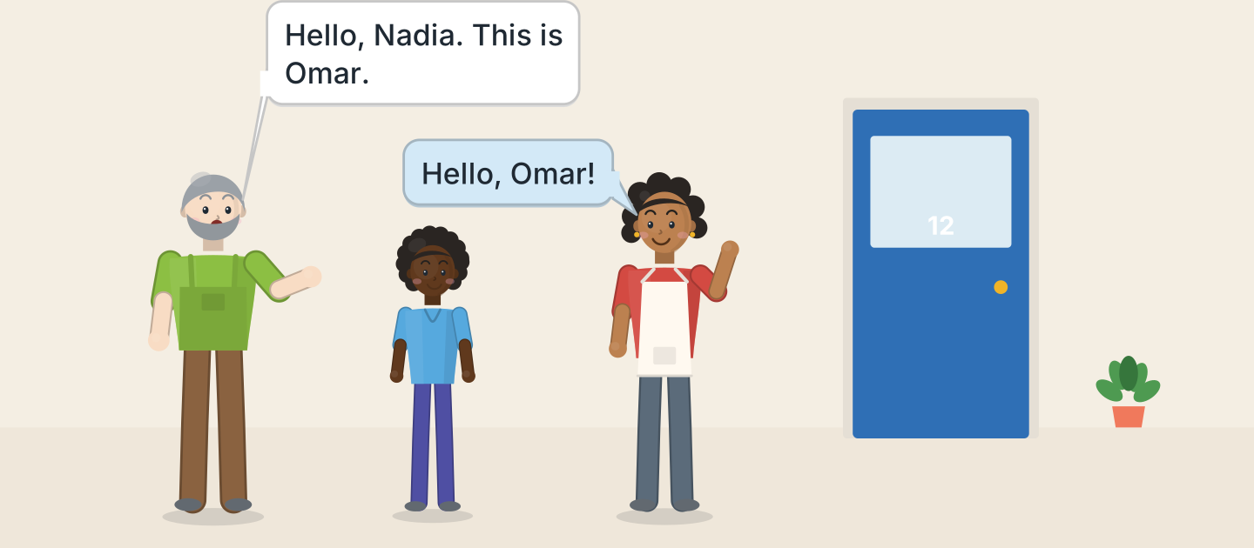
Figure 1.14 · Marek introduces Omar.
- Hello, Nadia. This is Omar. (example)
- Say hello.
- Say your friend’s name.
- Your friend says hello.
4D Say goodbye to three people.
- Goodbye, Sam. (example)
- Goodbye, ______________.
- Bye, ______________.
- Goodbye, ______________.
Part 5 · Reading
5A Look at Figure 1.15. Answer yes or no.
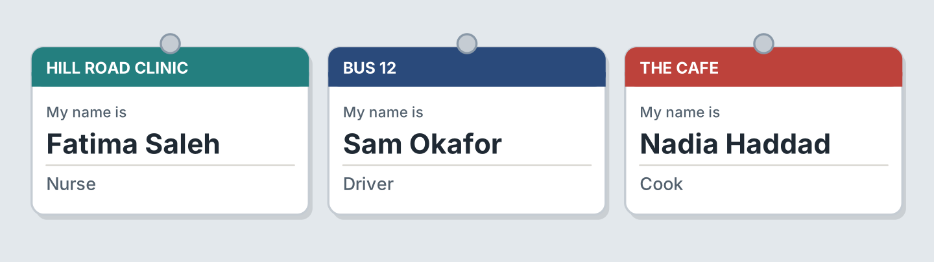
Figure 1.15 · Three name badges.
- Fatima is a nurse. — yes (example)
- Sam is a cook. — ______
- Nadia is at the cafe. — ______
- Fatima is at the clinic. — ______
- Sam is a driver. — ______
5B Look at Figure 1.15. Complete the sentences.
Words: cook · driver · nurse · clinic
- Fatima is a nurse. (nurse) (example)
- Sam is a ______________.
- Nadia is a ______________.
- Fatima is at the ______________.
5C Look at Figure 1.16. Choose the correct answer.
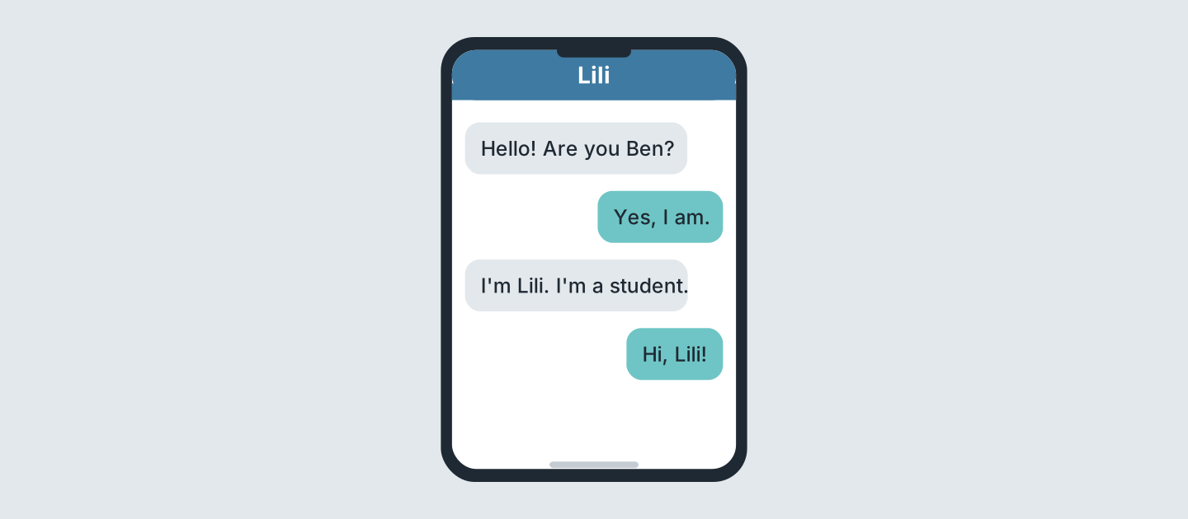
Figure 1.16 · Two messages.
- Who is the student? (a) Ben (b) Lili (c) Sam — b (example)
- Who writes first? (a) Lili (b) Ben (c) Nadia
- Is Ben there? (a) yes (b) no (c) we do not know
- What is Lili? (a) a cook (b) a driver (c) a student
5D Read and correct. Write the correct word.
- Lili is a nurse. — student (example)
- Ben is a student. — ______________
- Fatima is a cook. — ______________
- Sam is a teacher. — ______________
Part 6 · Writing
6A Look at Figure 1.17. Complete the form for you.
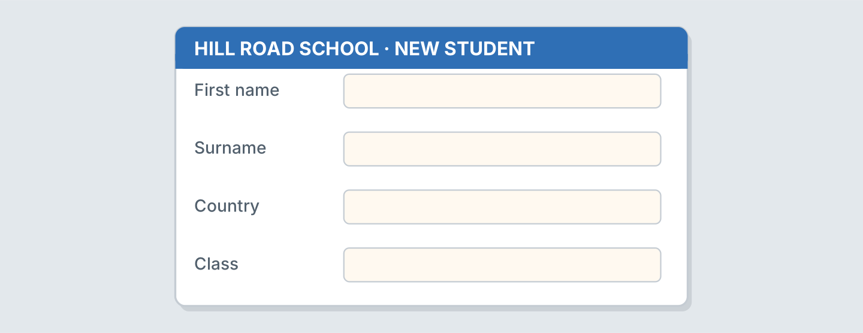
Figure 1.17 · A form for a new student.
- First name: Lili (example)
- First name: ______________
- Surname: ______________
- Country: ______________
6B Look at Figure 1.18. Write three sentences about you.
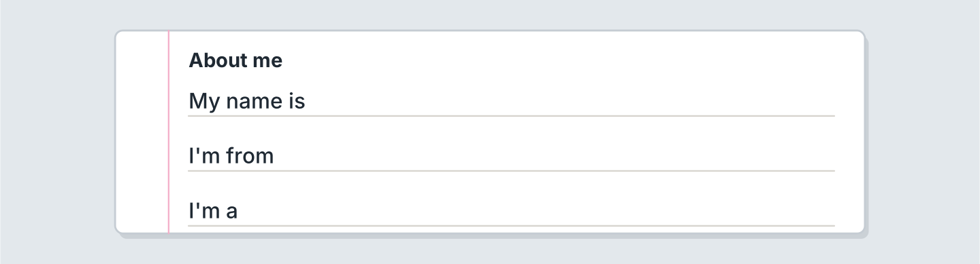
Figure 1.18 · Three lines about you.
- My name is Lili. (example)
- My name is ______________.
- I’m from ______________.
- I’m a ______________.
6C Write a message to a new friend. Write three lines.
- Hello! I’m Lili. (example)
- Say hello.
- Say your name.
- Say your country.
Part 7 · Real-World File
7A Look at Figure 1.19. Answer the questions.
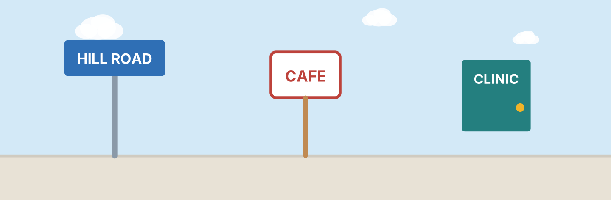
Figure 1.19 · Signs on Hill Road.
- What is the street? — Hill Road (example)
- Where is the coffee? — ______________
- Where is the nurse? — ______________
- What is the number of the bus? — ______________
7B Look at Figure 1.20. Write your name on the badge.

Figure 1.20 · A badge with no name.
- My name is Lili. (example)
- Write your first name.
- Write your surname.
- Write your school.
7C Look at Figure 1.11 again. Complete line 5 for you.
- Name: Lili Chen (example)
- Name: ______________
- Country: ______________
- Class: ______________
Part 8 · Review & Can-Do
8A Look at Figure 1.21. Write the word.
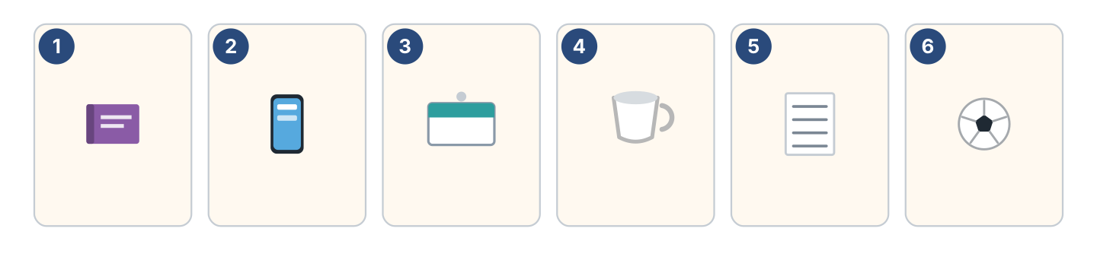
Figure 1.21 · Six things in this unit.
Words: badge · book · cup · phone · ball · list
- 1 — book (example)
- 2 — ______________
- 3 — ______________
- 4 — ______________
- 6 — ______________
8B Complete the conversation.
Words: am · Hello · name · you
- A: Hello. I’m Sam. (Hello) (example)
- B: Hi, Sam. My ______ is Lili.
- A: Are ______ a student?
- B: Yes, I ______.
8C Write the numbers.
- 3 — three (example)
- 6 — ______________
- 8 — ______________
- 10 — ______________
8D Match the person and the country.
Person | Country
1 Lili | a Egypt
2 Omar | b Poland
3 Ana | c China
4 Jan | d Brazil
 | e Japan
One option is not needed.
- 1 — c (example)
- 2 — ______
- 3 — ______
- 4 — ______
8E Look at Figure 1.22. Tick what you can do.
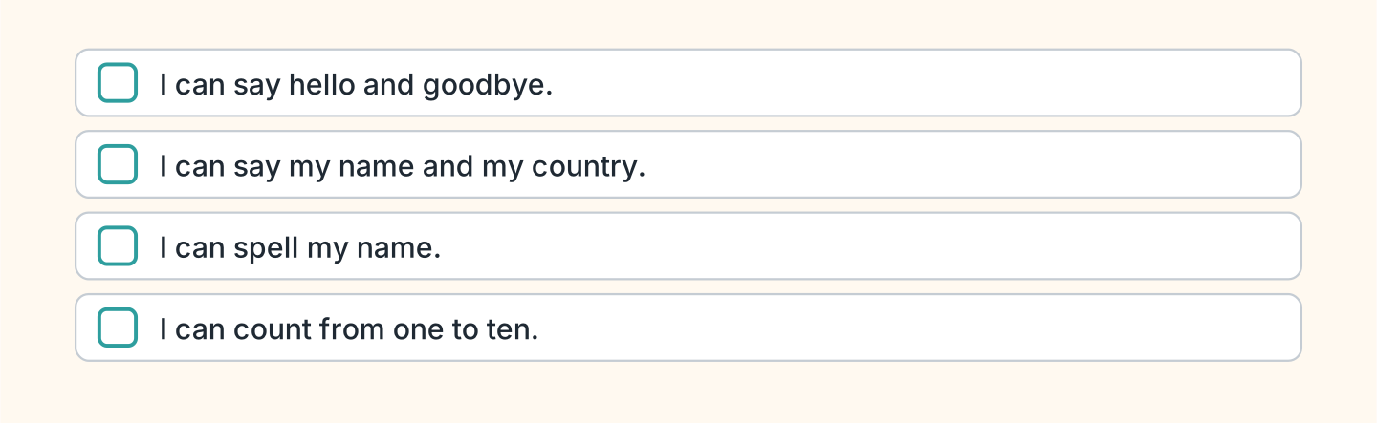
Figure 1.22 · What I can do.
- I can say hello and goodbye. — ✓ (example)
- I can say my name and my country. — ______
- I can spell my name. — ______
- I can count from one to ten. — ______

