Unit 2: In the Class
In this unit you name things in the class. You ask questions. You say no.
Warm Up
W1 Look at Figure 2.1. Tick the things you can see.
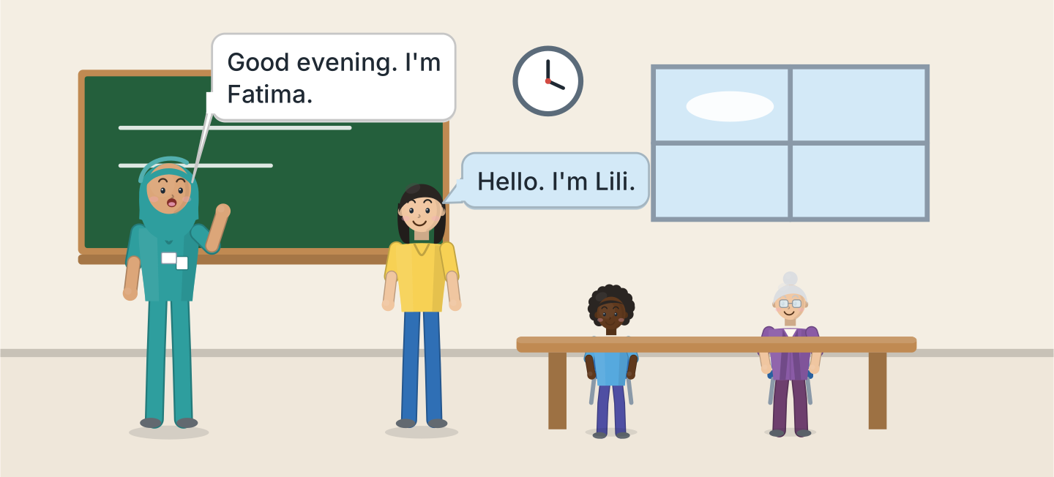
Figure 2.1 · The evening class.
- a board — ✓ (example)
- a window — ______
- a clock — ______
- a desk — ______
- a chair — ______
W2 Look at Figure 2.2. Write the word.
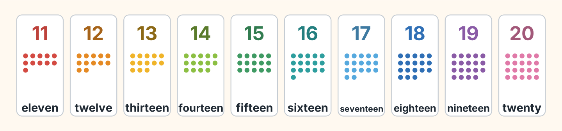
Figure 2.2 · Eleven to twenty.
- 11 — eleven (example)
- 13 — ______________
- 15 — ______________
- 18 — ______________
- 20 — ______________
W3 Count from eleven to twenty with a friend.
- eleven, twelve, thirteen (example)
- Count from 11 to 15.
- Count from 16 to 20.
- Count from 11 to 20.
Part 1 · Words & Sounds
1A Look at Figure 2.3. Write the word.
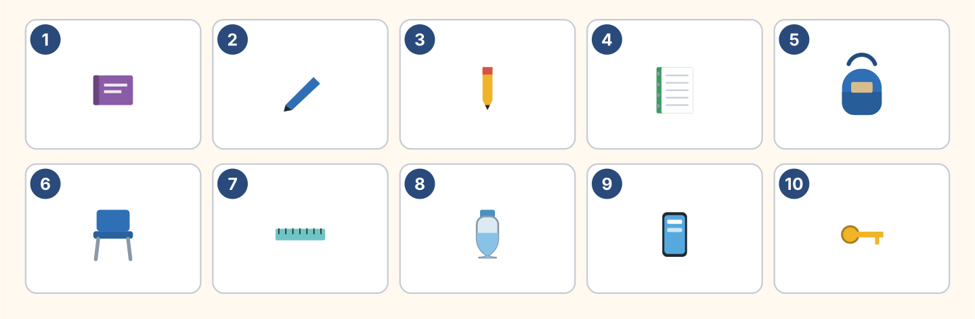
Figure 2.3 · Ten things in the class.
Words: bag · book · bottle · chair · key · notebook · pen · pencil · phone · ruler
- 1 — book (example)
- 2 — ______________
- 3 — ______________
- 6 — ______________
- 10 — ______________
1B Look at Figure 2.4. Write a or an.
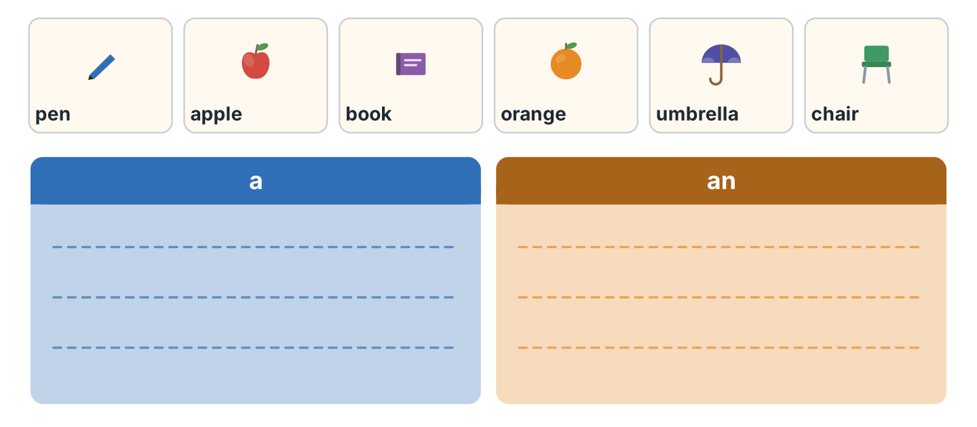
Figure 2.4 · a or an.
- a pen (example)
- ______ apple
- ______ book
- ______ orange
- ______ umbrella
1C Say it. Listen to the first sound. Then say a or an.
- a pen (example)
- an apple
- a chair
- an orange
- an umbrella
1D Look at Figure 2.5. Write this or that.
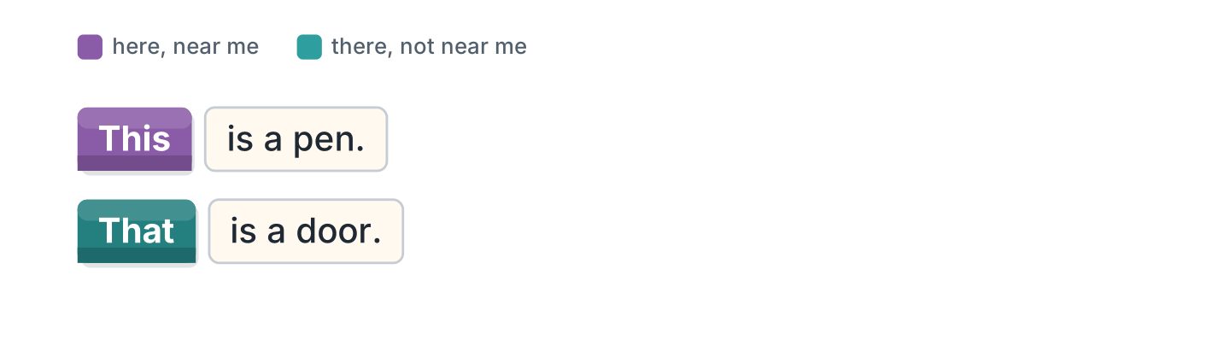
Figure 2.5 · this and that.
- This is a pen. (This) (example)
- ______ is a door.
- ______ is my bag. It is here.
- ______ is the board. It is there.
1E Look at Figure 2.6. Match the job and the place.
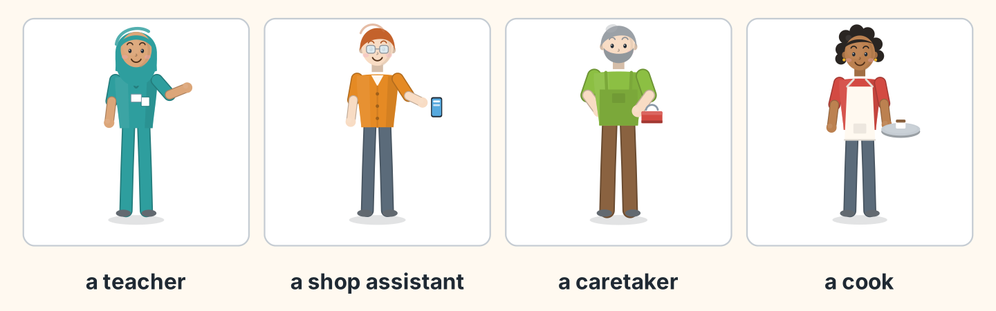
Figure 2.6 · Four jobs.
Job | Place
1 a teacher | a the cafe
2 a shop assistant | b the school
3 a caretaker | c the shop
4 a cook | d the flats
 | e the clinic
One option is not needed.
- 1 — b (example)
- 2 — ______
- 3 — ______
- 4 — ______
1F Write the number.
- fourteen — 14 (example)
- twelve — ______
- seventeen — ______
- nineteen — ______
- twenty — ______
Part 2 · Grammar
2A Look at Figure 2.7. Write the question.
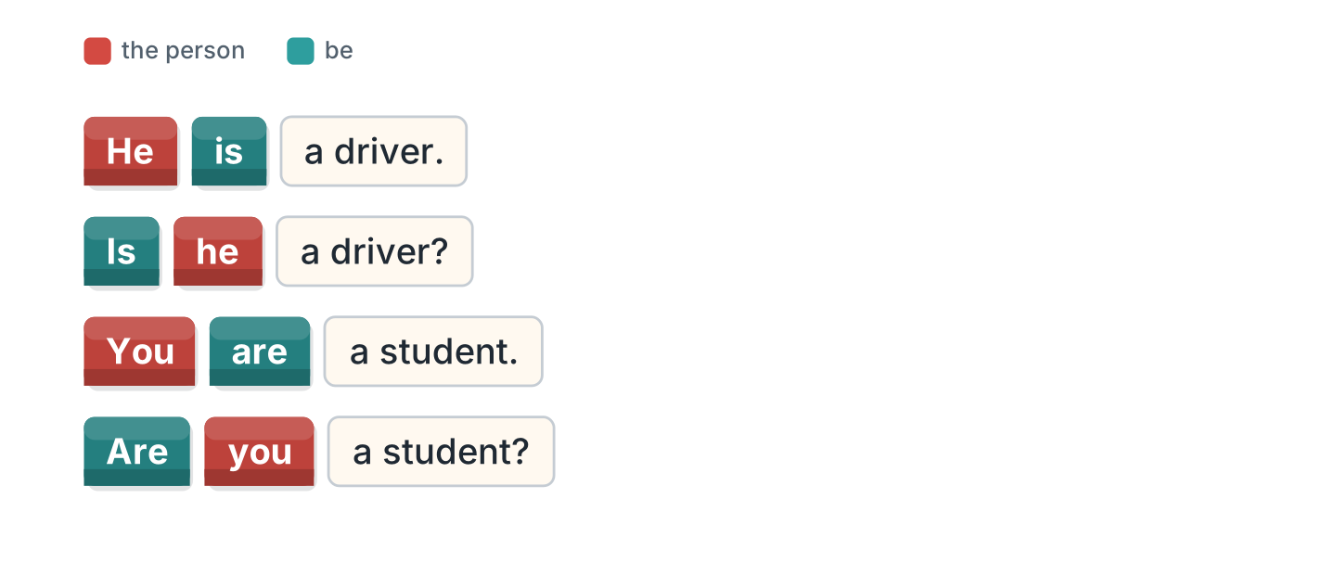
Figure 2.7 · A sentence and a question.
- He is a driver. — Is he a driver? (example)
- She is a nurse. — ______________
- You are a student. — ______________
- It is a pen. — ______________
2B Complete the question with Is or Are.
- Is he a teacher? (Is) (example)
- ______ you from Poland?
- ______ she in Room 11?
- ______ it your bag?
- ______ they students?
2C Look at Figure 2.8. Write the short form.
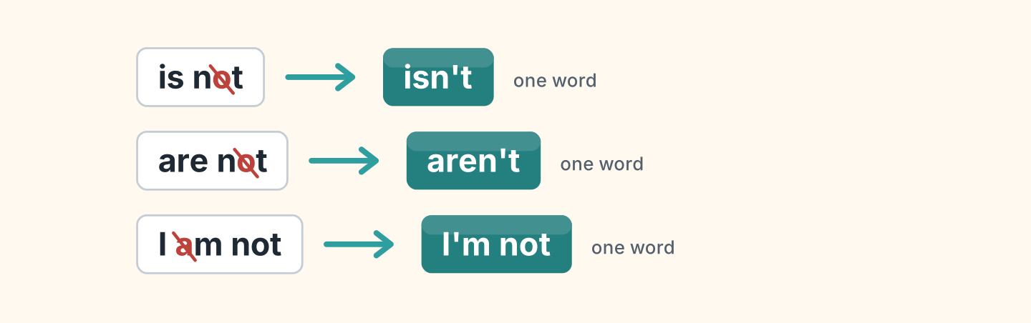
Figure 2.8 · The short negative.
- is not — isn’t (example)
- are not — ______________
- I am not — ______________
2D Complete with isn’t or aren’t.
- He isn’t a cook. (isn’t) (example)
- She ______________ a doctor.
- They ______________ in Room 12.
- It ______________ my pen.
- You ______________ in my class.
2E Look at Figure 2.9. Write the answer.
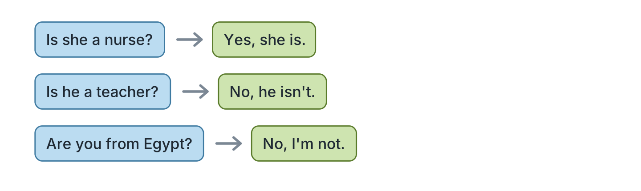
Figure 2.9 · Yes and no answers.
- Is she a nurse? — Yes, she is. (example)
- Is he a teacher? ✗ — ______________
- Are you from Egypt? ✗ — ______________
- Is it your book? ✓ — ______________
2F Find the mistake. Write the correct word.
- Is you a student? — Are (example)
- She not is a teacher. — ______________
- Are he in Room 11? — ______________
- It aren’t my bag. — ______________
Part 3 · Listening
3A Listen. Look at Figure 2.10. Write the number.
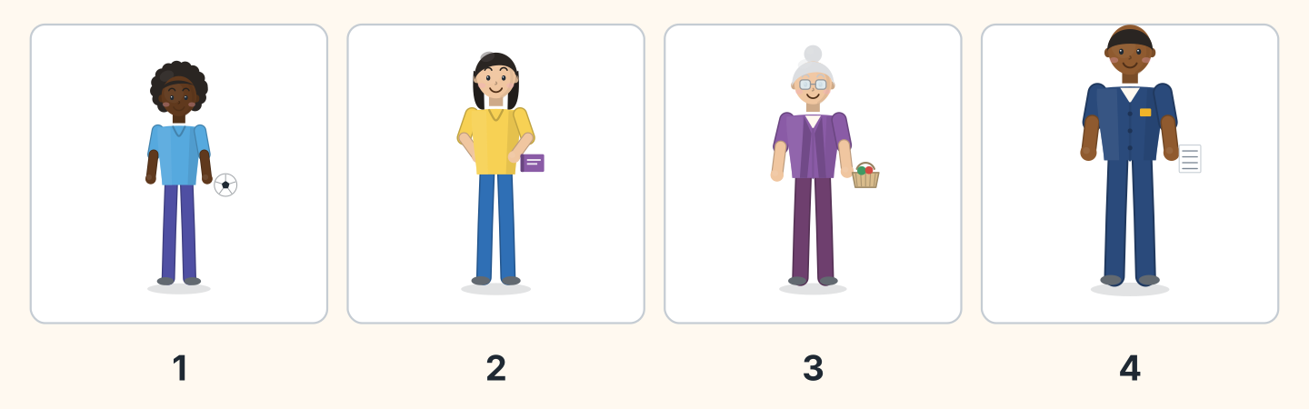
Figure 2.10 · Four people in the class.
- Omar — 1 (example)
- Lili — ______
- Rosa — ______
- Sam — ______
3B Listen. Look at Figure 2.11. Complete the timetable.
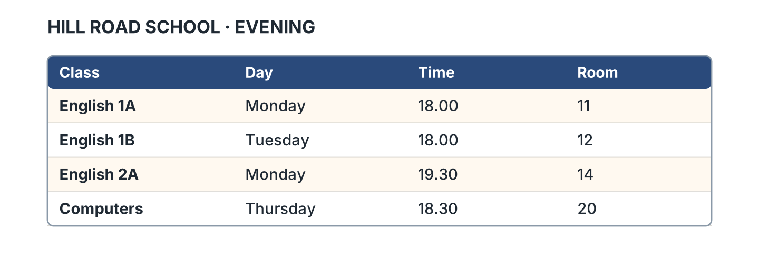
Figure 2.11 · The evening timetable.
- English 1A is on Monday. (Monday) (example)
- English 1B is in Room ______.
- English 2A is at ______________.
- Computers is on ______________.
3C Listen. Look at Figure 2.12. Write the number you hear.
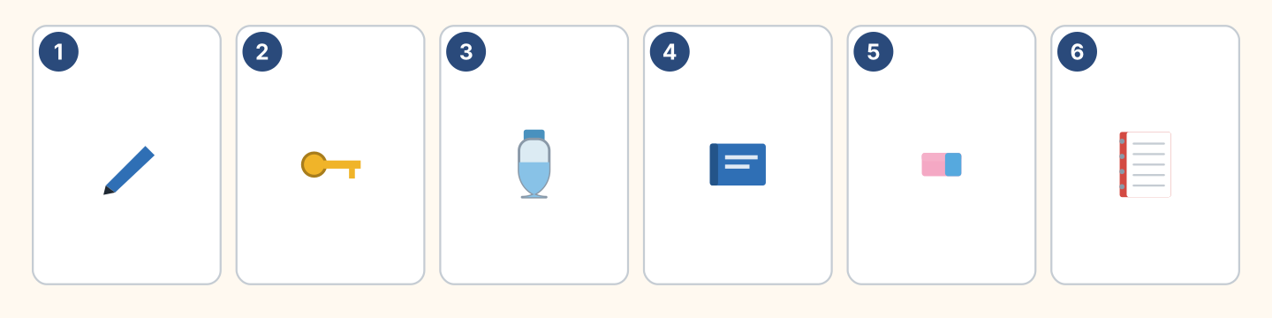
Figure 2.12 · Six things on a desk.
- a pen — 1 (example)
- a bottle — ______
- a book — ______
- a notebook — ______
3D Listen. Write the room number.
- Fatima — Room 11 (example)
- Lili — Room ______
- Omar — Room ______
- Rosa — Room ______
Part 4 · Speaking
4A Look at Figure 2.13. Ask and answer about five things.
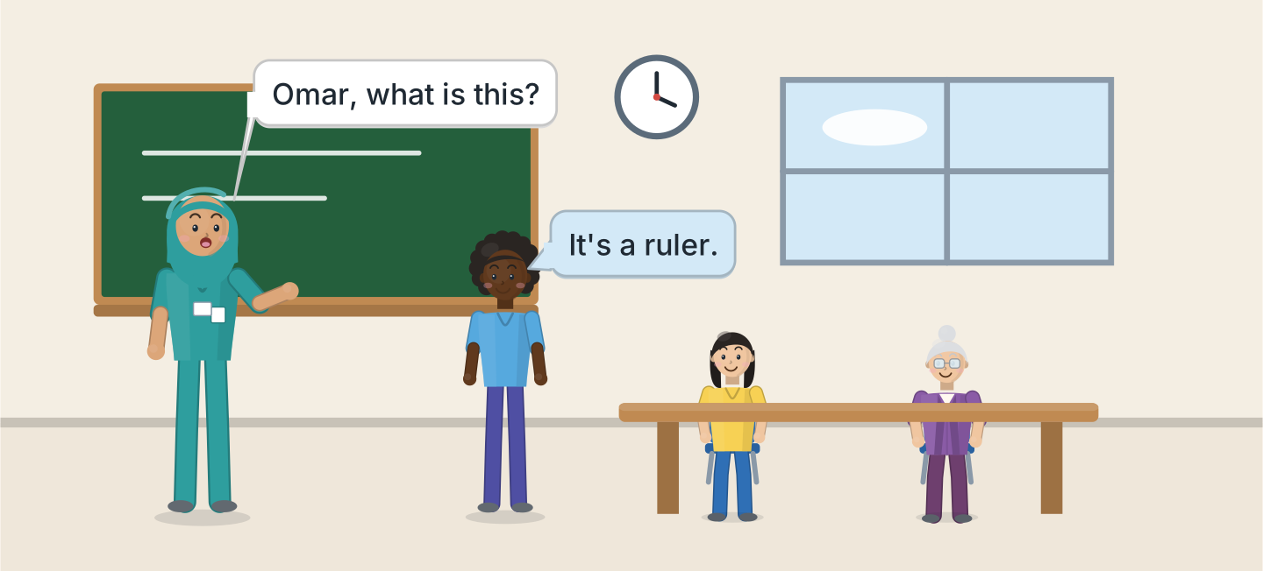
Figure 2.13 · Asking in the class.
- A: What is this? B: It’s a ruler. (example)
- Ask about a pen.
- Ask about a book.
- Ask about a chair.
- Ask about a window.
4B Look at Figure 2.14. Ask and answer with a friend.
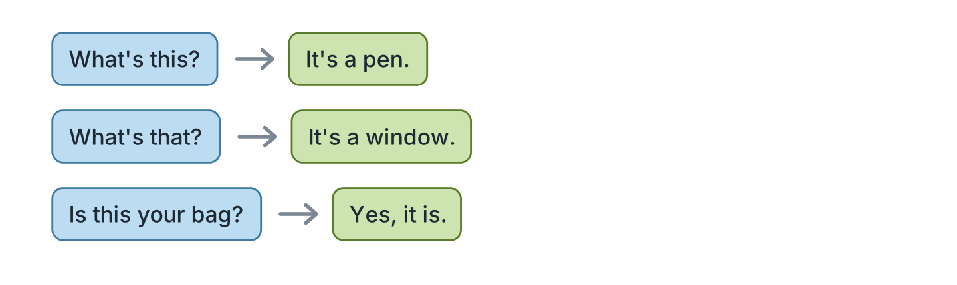
Figure 2.14 · Ask and answer.
- A: What’s this? B: It’s a pen. (example)
- A: What’s that? B: ______________
- A: Is this your bag? B: ______________
- A: Is that your pencil? B: ______________
4C Ask three friends about their class.
- A: Are you in Class 1A? B: Yes, I am. (example)
- Ask about the class.
- Ask about the room.
- Ask about the teacher.
4D Say these things to your teacher.
- Sorry. Again, please. (example)
- Open your book, please.
- What is this in English?
- Thank you.
Part 5 · Reading
5A Look at Figure 2.15. Answer the questions.
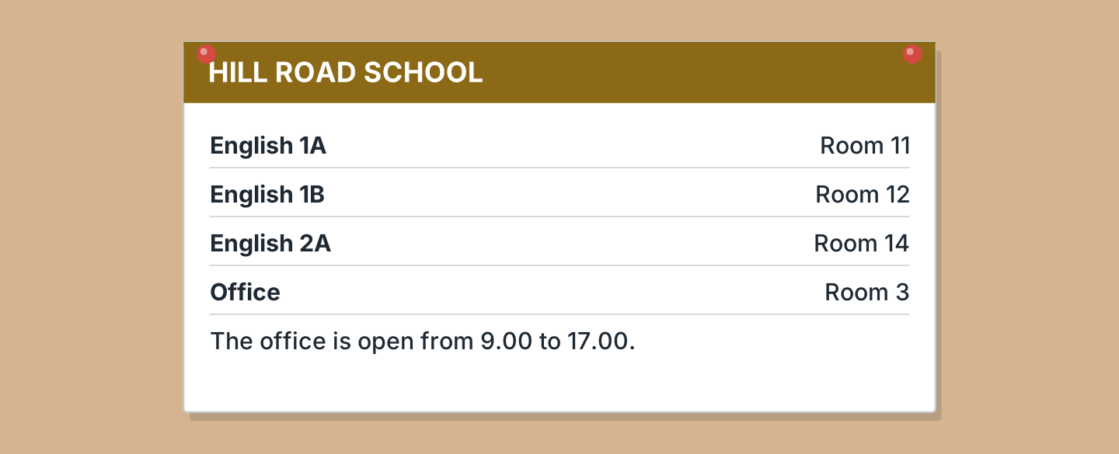
Figure 2.15 · A notice at the school.
- Where is English 1A? — Room 11 (example)
- Where is English 1B? — ______________
- Where is the office? — ______________
- Where is English 2A? — ______________
5B Look at Figure 2.15. Answer yes or no.
- English 1A is in Room 11. — yes (example)
- The office is in Room 14. — ______
- The office is open at 10.00. — ______
- English 2A is in Room 12. — ______
5C Look at Figure 2.16. Choose the correct answer.
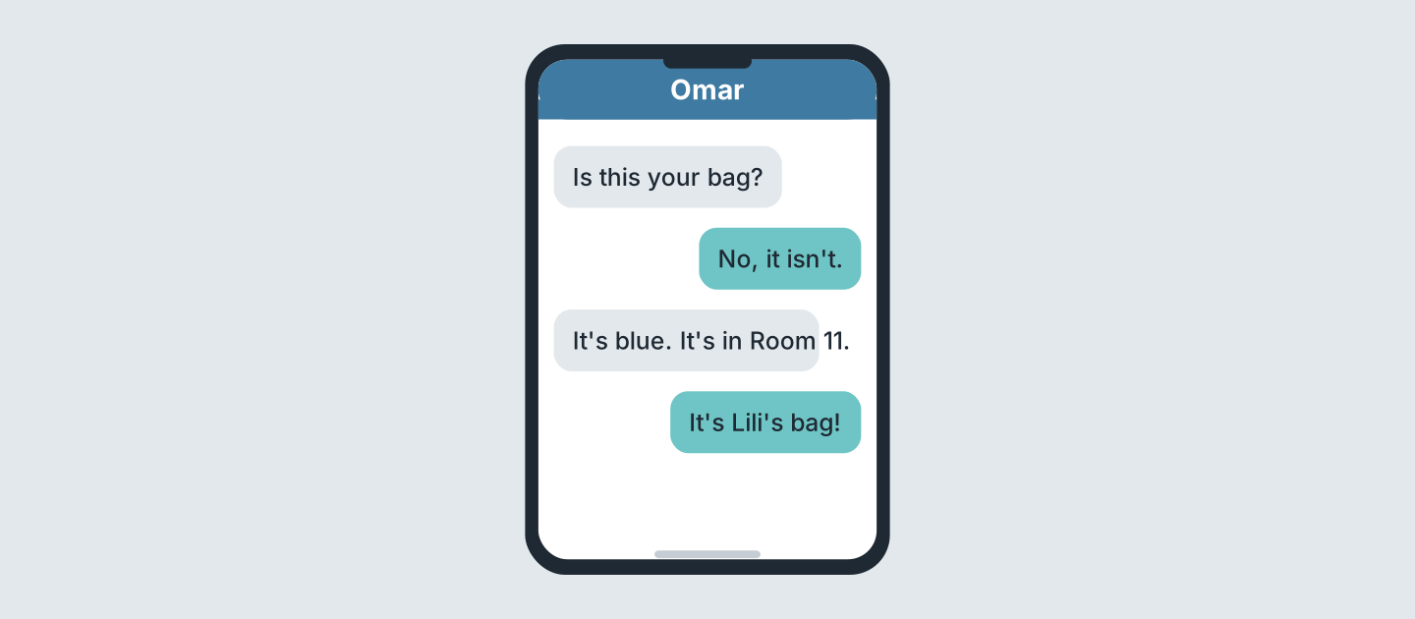
Figure 2.16 · Messages about a bag.
- Who writes first? (a) Omar (b) Lili (c) Rosa — a (example)
- What colour is the bag? (a) red (b) blue (c) black
- Where is the bag? (a) Room 11 (b) Room 12 (c) Room 14
- Whose bag is it? (a) Omar’s (b) Lili’s (c) Rosa’s
5D Read and correct. Write the correct word.
- The bag is red. — blue (example)
- The bag is in Room 14. — ______________
- The office is in Room 11. — ______________
- English 1B is on Monday. — ______________
Part 6 · Writing
6A Look at Figure 2.17. Complete the card for you.
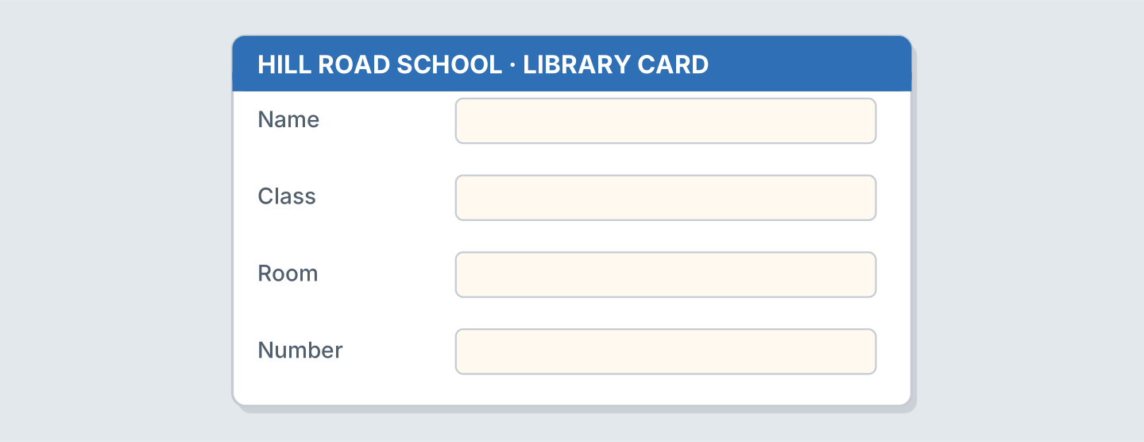
Figure 2.17 · A card for the library.
- Name: Omar Haddad (example)
- Name: ______________
- Class: ______________
- Room: ______________
6B Look at Figure 2.18. Write four lines about your class.
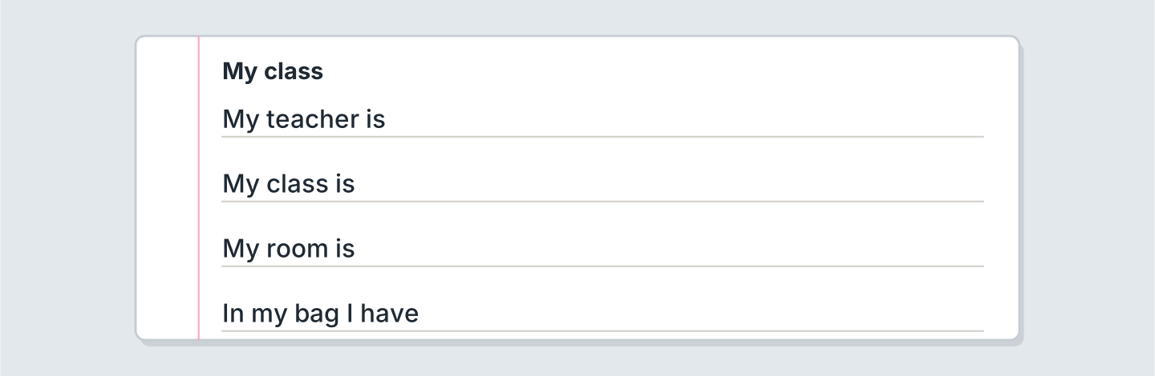
Figure 2.18 · Four lines about your class.
- My teacher is Fatima. (example)
- My teacher is ______________.
- My class is ______________.
- My room is ______________.
6C Write a message about a lost bag. Write three lines.
- Is this your bag? (example)
- Ask about the bag.
- Say the colour.
- Say the room.
Part 7 · Real-World File
7A Look at Figure 2.19. Answer the questions.
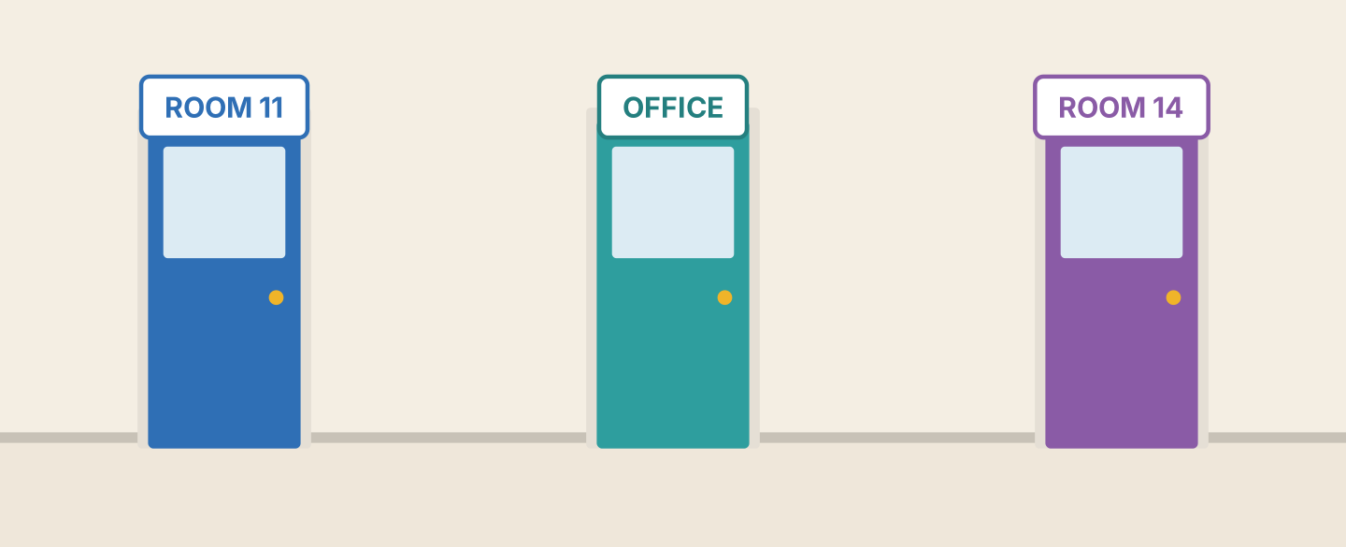
Figure 2.19 · Three doors at the school.
- What is the first room? — Room 11 (example)
- What is the second door? — ______________
- What is the third room? — ______________
- Is Room 12 here? — ______
7B Look at Figure 2.20. Complete the sentences.
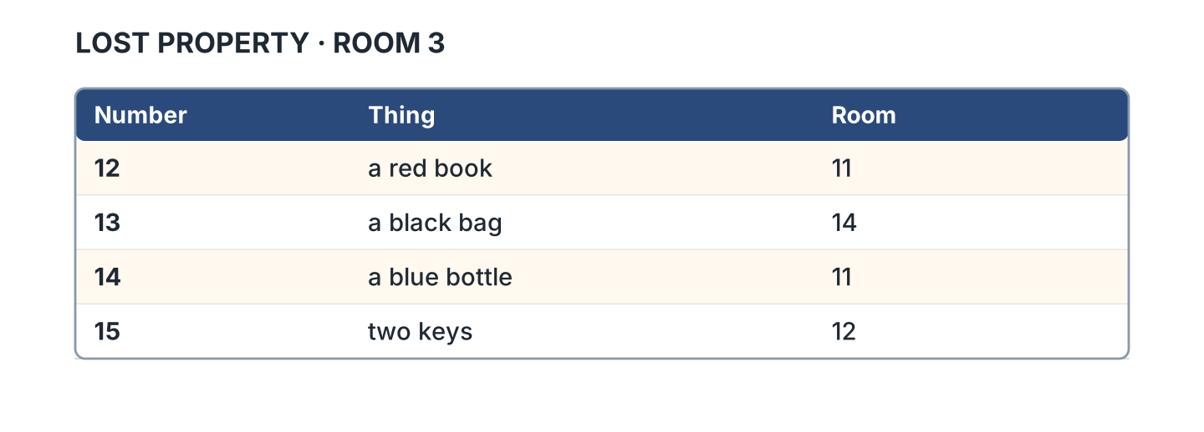
Figure 2.20 · The lost property list.
- Number 12 is a red book. (book) (example)
- Number 13 is a black ______________.
- Number 14 is a blue ______________.
- Number 15 is two ______________.
7C Look at Figure 2.20. Write line 16 for your thing.
- 16 · a green pen · Room 11 (example)
- Number: ______________
- Thing: ______________
- Room: ______________
Part 8 · Review & Can-Do
8A Look at Figure 2.21. Write the word.
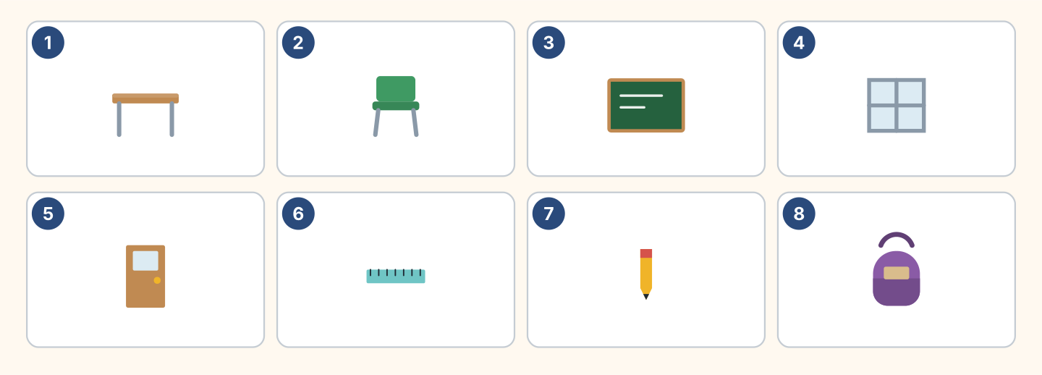
Figure 2.21 · Eight things from this unit.
Words: bag · board · chair · desk · door · pencil · ruler · window
- 1 — desk (example)
- 3 — ______________
- 4 — ______________
- 5 — ______________
- 8 — ______________
8B Complete the conversation.
Words: isn’t · It’s · this · What
- A: What is this? (What) (example)
- B: ______ a ruler.
- A: Is ______ your ruler?
- B: No, it ______. It’s Lili’s.
8C Write the numbers.
- 16 — sixteen (example)
- 11 — ______________
- 14 — ______________
- 19 — ______________
8D Write a or an.
- a desk (example)
- ______ orange
- ______ window
- ______ umbrella
- ______ ruler
8E Look at Figure 2.22. Tick what you can do.
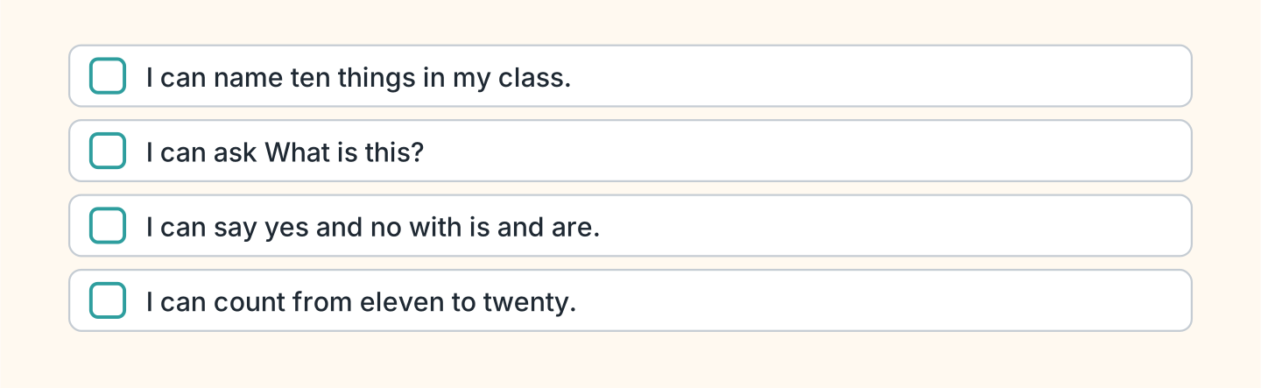
Figure 2.22 · What I can do.
- I can name ten things in my class. — ✓ (example)
- I can ask What is this? — ______
- I can say yes and no with is and are. — ______
- I can count from eleven to twenty. — ______

