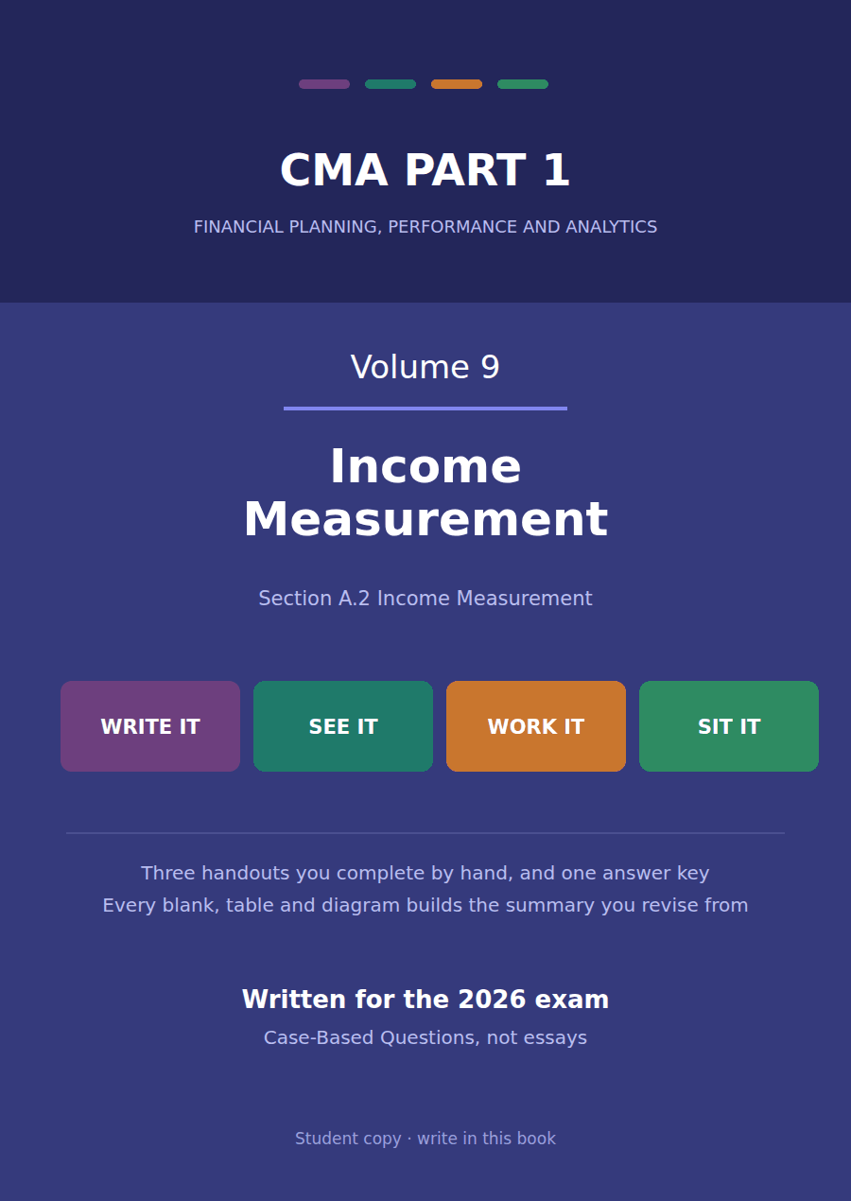

CMA Part 1 · Volume 9
Income Measurement
Three handouts, one answer key. Gains and losses, expense recognition, comprehensive income and discontinued operations.
These handouts are not notes to read. You write them. The words you supply are the summary, so a finished handout is a page you can revise from, in your own handwriting.
Work in pen. Do not look at the key until the whole handout is done — the key is written to explain the mistake, and you only get that benefit if you have made it first.
The three handouts
# | Handout | What it gives you
1 | Gains, Losses and How Expenses Are Recognised | Northwind sold $4,800,000 of components and one machine. Both brought in cash and only one of them is revenue.
2 | Comprehensive Income | Northwind earned $510,000 and its equity grew by $534,000 from performance. The $24,000 in between never went near the income statement.
3 | Discontinued Operations | Northwind leaves the fittings business. The $150,000 it loses in doing so is reported on its own line, below everything else, net of tax.

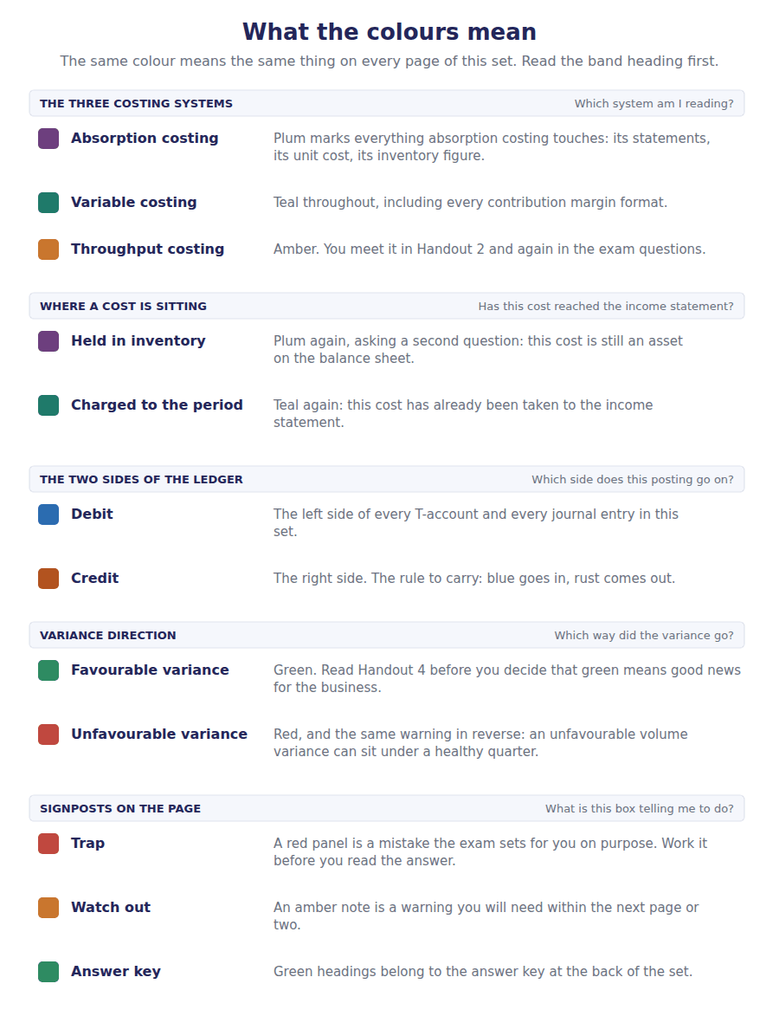
How to read the markers
Marker | Meaning
R1 | Teaching English. Short sentences. This is where a new idea arrives.
R2 | Textbook English. Longer sentences and passive verbs, as a textbook writes them.
R3 | Exam English. Exactly how the CMA exam phrases it, traps included.
Numbered rule | A space you fill in. The number matches the answer key.
Red table | A trap. Read it twice.

Handout 1 · Gains, Losses and How Expenses Are Recognised
Northwind sold $4,800,000 of components and one machine. Both brought in cash and only one of them is revenue.
Volume 9 · Income Measurement · R1 moving to R2
LANGUAGE FOCUS
Register you are working in | R1 while the four elements are being separated, R2 once the recognition bases are being applied.
Say it exactly like this | arise from ongoing major activities · report a gain net of its cost · associate a cost with a revenue · allocate a cost over its useful life · recognise a cost immediately · derecognise a disposed asset
Words that are not the same | revenue / gain · expense / loss · gross / net · ongoing / peripheral
Remember | A gain is not a small revenue. The two differ in what produced them, not in size. Immediate recognition is not a last resort for lazy accounting. It is the right answer where no future benefit can be identified.

What you will be able to do when this handout is finished
- Define revenue, expense, gain and loss and say how each pair differs.
- Classify an item in the income statement as one of the four.
- Compute a gain or loss on a disposal and report it net.
- Name the three bases on which costs are recognised.
- Decide which basis applies to a given cost.

Two sales, two different things
In 20X4 Northwind sold $4,800,000 of components to its customers. It also sold one old machine for $65,000.
Both brought cash in. The first appears in the income statement at its full $4,800,000; the second appears as $30,000, which is the $65,000 received less the $35,000 the machine stood at.
The difference is not the size of the amounts. It is that selling components is what Northwind does and selling machinery is not.
This handout sorts the income statement into its four elements, then asks when a cost belongs to a period at all.

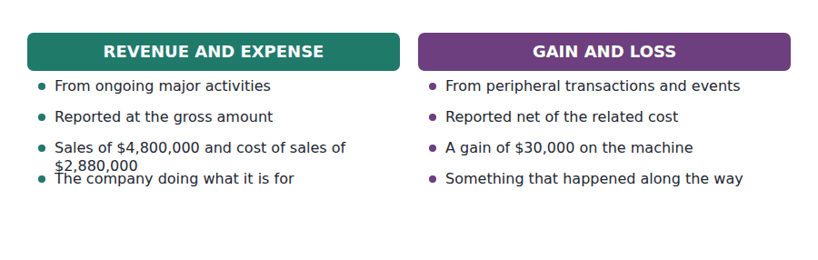
Part 1 · Four elements, two tests what produced it, and gross or net
Exercise 1A Read and complete. Write one word in each space.
OBJECTIVE | Define the four elements of performance and say how each pair differs.
YOU WILL NEED | Volume 1 Handout 2, for the definitions of income and expense.
HOW TO START | • The first test is about the activity: is this what the company is in business to do?  • The second test is about presentation, and the machine sale shows it: $30,000 rather than $65,000 and $35,000.  • The last blank is what a loss can arise from that a revenue never can.

WORD BANK
central · event · gross · invoice · net · peripheral · revenue
Not every word is used.

R1 Two questions sort any item of performance. The first is where it came from. An inflow from the company’s ongoing major activities is revenue; an inflow from anything ¹ to them is a gain.
Northwind sells components, so the $4,800,000 of component sales is revenue. It does not sell machinery, so disposing of a machine produces a gain rather than a ² .
The second question is how much to show. Revenue is reported at its full amount with the related cost shown separately, while a gain is reported ³ : $65,000 received less the $35,000 the machine stood at, so $30,000 on one line.
Expenses and losses divide the same way. An expense arises from the main business; a loss arises from something peripheral, and it can arise from an ⁴ rather than a transaction at all, as a fire does.
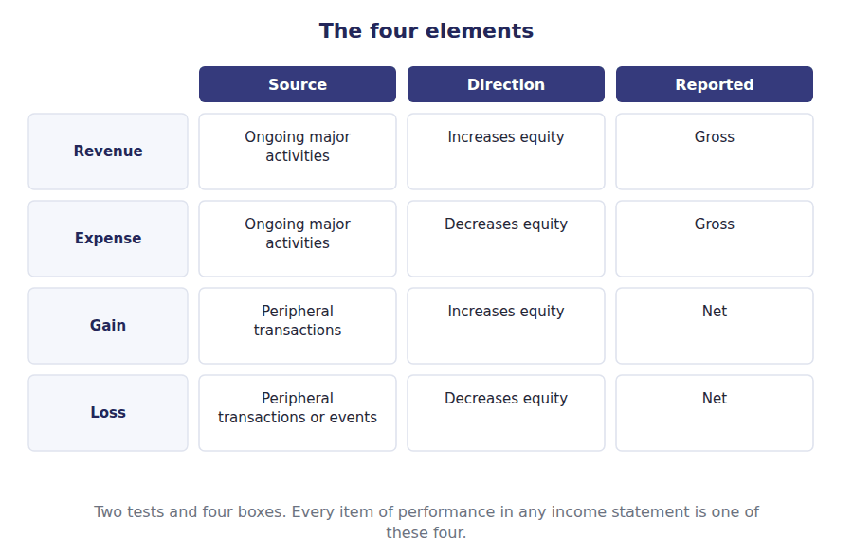
Part 2 · Classifying Northwind’s income statement six lines, sorted
Exercise 1B Complete the right-hand column. Write one word in each cell.
OBJECTIVE | Classify each line of the income statement as one of the four elements.
YOU WILL NEED | Exercise 1A, and Volume 1 Handout 5 for the statement itself.
HOW TO START | • Five of the six lines are part of the main business, and only one is not.  • Interest is a cost of financing rather than of selling, and it is still an expense.  • The amounts are given. Only the classification is asked for.

Item in Northwind’s 20X4 income statement | Amount | Which element
Sales of components to customers | $4,800,000
Cost of goods sold | $2,880,000
Selling and administrative costs | $905,000
Depreciation and amortisation | $275,000
Interest on the long-term debt | $90,000
Sale of a machine for $65,000 that stood at $35,000 | $30,000

1 | 2 | 3 | 4 | 5 | 6

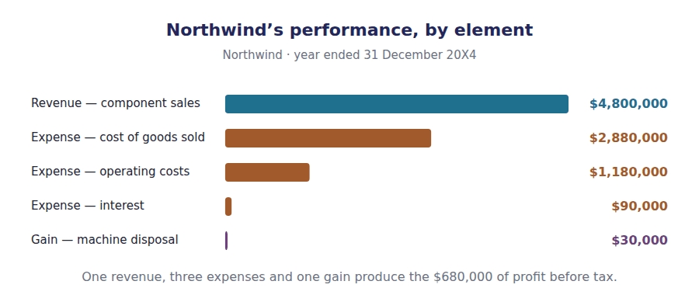
Part 3 · Computing the gain proceeds against carrying amount
R2 A gain or loss on disposal is never the proceeds and never the original cost. It is the proceeds less what the asset stood at in the books on the day it left, and that figure depends on how much depreciation has already been charged.
Exercise 1C Read and complete, then record the entry underneath.
OBJECTIVE | Compute the gain on the disposal and record the asset leaving the books.
YOU WILL NEED | Volume 5 Handout 6, where this disposal was first worked. · The paragraph above.
HOW TO START | • The machine cost $180,000 and $145,000 of depreciation had been charged on it.  • Work out what it stood at before you compare anything with the $65,000 of proceeds.  • Both the cost account and the accumulated depreciation account have to be cleared, which is why the entry has four lines.

WORD BANK
$30,000 · $65,000 · carrying · credited · debited · loss · original
Not every word is used.

R2 The machine cost $180,000 and carried $145,000 of accumulated depreciation, so it stood in the books at $35,000. That figure is its ⁵ amount, and it is the only one the gain is measured against.
Northwind received $65,000 for it. The gain is therefore $65,000 less $35,000, or ⁶ , and that single net figure is what the income statement shows.
Both of the machine’s accounts have to be cleared. The $180,000 of cost is credited away and the $145,000 of accumulated depreciation is ⁷ away, so neither is left behind on a machine the company no longer owns.
Had the proceeds been below $35,000, the same computation would have produced a ⁸ , reported net on one line in exactly the same way.
J1 The machine sold for $65,000, against a carrying amount of $35,000. Four lines, because two accounts have to be emptied.
Account | Debit | Credit
Cash
Accumulated Depreciation
Machinery
Gain on Disposal

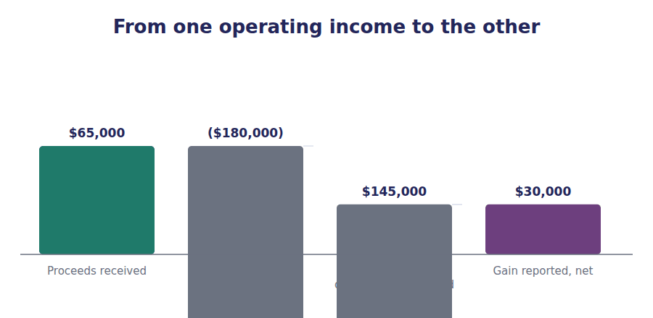
Part 4 · When does a cost become an expense? three bases, in order
R2 A cost is charged against a period on one of three bases, and they are tried in order. If the cost can be traced to a particular revenue it is charged with that revenue. If it cannot, but it clearly benefits several periods, it is spread over them. If neither holds, it is charged at once.
Exercise 1D Read and complete. Write one word in each space.
OBJECTIVE | Name the three bases of expense recognition and say when each applies.
YOU WILL NEED | The paragraph above, and Volume 4 Handout 1 on cost of goods sold.
HOW TO START | • The first basis is the one cost of goods sold uses, and the exam names it after the relationship it relies on.  • The second is the one depreciation uses, and it needs a defensible pattern rather than an exact one.  • The last blank is what the third basis does with a cost that benefits nothing identifiable.

WORD BANK
allocation · effect · estimate · gradually · immediately · revenue · systematic
Not every word is used.

R2 The first basis associates cause and ⁹ . A unit of inventory carries its own cost and that cost is charged in the period the unit is sold, which is why cost of goods sold of $2,880,000 sits directly beneath sales of $4,800,000.
Many costs cannot be traced to any one sale. A machine helps produce everything made over its life, so its cost is spread by systematic and rational ¹⁰ , which is what depreciation of $250,000 is.
The pattern has to be defensible rather than exact. Straight-line is accepted not because it is accurate but because it is ¹¹ and nobody can show a better one.
Where neither basis works, the cost is recognised ¹² . A fine, an advertising campaign of unknown effect and most administrative salaries all fall here.
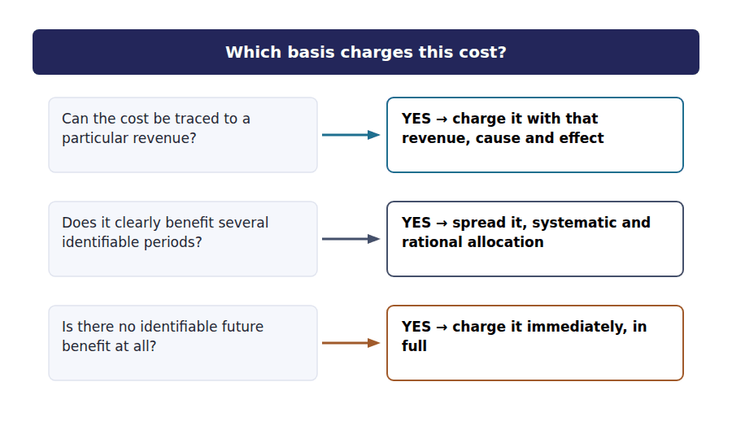
Part 5 · Applying the three bases six of Northwind’s costs
Exercise 1E Complete both right-hand columns. One phrase in each cell.
OBJECTIVE | Decide which recognition basis applies to each of six costs.
YOU WILL NEED | Exercise 1D.
HOW TO START | • Two of the six are traceable to particular sales, and one of those two is a commission.  • Two are spread over periods, and they are the two halves of the $275,000 of depreciation and amortisation.  • Two benefit nothing identifiable, and one of them buys the company nothing at all.

Cost | Which basis | Why
Cost of goods sold, $2,880,000
Depreciation, $250,000
Amortisation, $25,000
Administrative salaries, $345,000
Sales commissions, inside $560,000
A $20,000 fine paid during the year

1 | 2 | 3 | 4 | 5 | 6
7 | 8 | 9 | 10 | 11 | 12

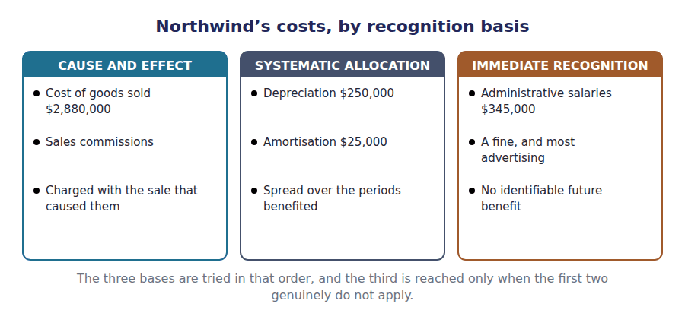
Watch out! Matching is a reason for charging a cost, not a licence to carry one. A cost that benefits no identifiable future period cannot be deferred to improve this year’s result, however neatly deferring it would smooth the profit.
Part 6 · Exam pitch the questions as the CMA sets them
1. [Level A] The difference between a revenue and a gain is that a gain:
(A) Is always smaller
(B) Arises from a transaction peripheral to the company’s main activities and is reported net
(C) Is not taxable
(D) Does not affect equity
2. [Level A] A machine that cost $180,000 with $145,000 of accumulated depreciation is sold for $65,000. The result is:
(A) A loss of $115,000
(B) A gain of $30,000
(C) Revenue of $65,000
(D) No gain or loss
3. [Level B] Depreciation is an example of which basis of expense recognition?
(A) Associating cause and effect
(B) Systematic and rational allocation
(C) Immediate recognition
(D) Realisation
4. [Level B] A company pays $200,000 for an advertising campaign whose effect on future sales cannot be estimated. The cost is:
(A) Capitalised and amortised over three years
(B) Recognised immediately as an expense
(C) Charged against the revenue it generates
(D) Deferred until the campaign ends
5. [Level B] Which of the following is reported net rather than gross?
(A) Sales to customers
(B) The result of selling a delivery van
(C) Cost of goods sold
(D) Interest expense
6. [Level C] A warehouse is destroyed by fire and the uninsured carrying amount is written off. The write-off is:
(A) An expense, because it arose in the course of business
(B) A loss, because it arose from an event peripheral to operations
(C) A reduction of revenue
(D) An adjustment to retained earnings
7. [Level C] Northwind’s $4,800,000 of sales and $30,000 gain on disposal both increased equity. The reason they are presented differently is:
(A) The gain is smaller
(B) Selling components is Northwind’s ongoing major activity and selling machinery is not
(C) The gain is not taxable
(D) The machine was fully depreciated
ADAPTIVE TIP For any item of performance, ask two questions in order: is this what the company is in business to do, and is the figure in front of me gross or net? The first decides revenue against gain, and the second is how you can tell which one a statement has already used.

Handout 2 · Comprehensive Income
Northwind earned $510,000 and its equity grew by $534,000 from performance. The $24,000 in between never went near the income statement.
Volume 9 · Income Measurement · R2
LANGUAGE FOCUS
Register you are working in | R2 throughout, with one R3 classification where the exam asks which items belong in the other half.
Say it exactly like this | bypass the income statement · report an item in other comprehensive income · accumulate a balance in equity · reclassify a gain into profit · present comprehensive income in one statement · realise an unrealised gain
Words that are not the same | net income / comprehensive income · realised / unrealised · profit or loss / other comprehensive income · period amount / accumulated balance
Remember | Other comprehensive income is not a second kind of profit. It is performance that the standards keep out of profit until it is realised. Accumulated other comprehensive income is not an income account. It is a balance inside equity, like retained earnings.

What you will be able to do when this handout is finished
- Define comprehensive income and say what it adds to net income.
- Name the items reported in other comprehensive income.
- Compute other comprehensive income net of its tax.
- Roll the accumulated balance forward.
- Say what happens to an item when it is realised.

Two measures of one year
Northwind’s income statement ends at net income of $510,000. That is the figure every per-share measure is built on.
But the company’s equity grew by $534,000 during the year from its own performance, not $510,000.
The difference of $24,000 is an unrealised gain on securities that the standards require to be kept out of profit until the securities are sold.
This handout reports both measures, and explains what happens to the $24,000 when the gain is finally realised.

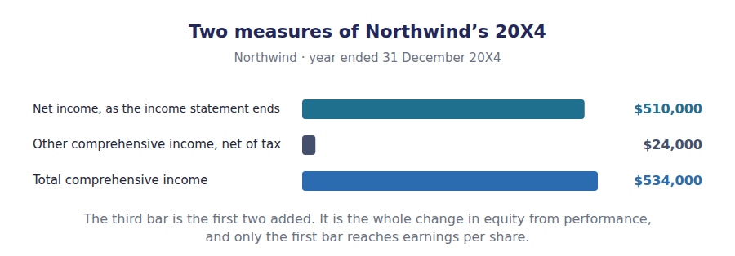
Part 1 · What the wider measure is for performance that bypasses profit
Exercise 2A Read and complete. Write one word in each space.
OBJECTIVE | Define comprehensive income and say why a second measure exists.
YOU WILL NEED | Volume 1 Handout 6, where this statement was first built. · Volume 6 Handout 2, for the securities the gain arose on.
HOW TO START | • Start from the change in equity and take out the one source of change that is not performance.  • Northwind’s gain of $32,000 is real but not completed. Ask what is missing before it could reach profit.  • The last blank is where the amount sits in the meantime, and it is inside equity rather than inside profit.

WORD BANK
$24,000 · customers · realised · reversed · shareholders · sold · unrealised
Not every word is used.

R2 Comprehensive income is the whole change in equity in a period, except for changes caused by transactions with ¹ . Issuing shares and paying dividends are excluded; everything else is performance.
Most performance reaches profit, and net income of $510,000 is the result. A few items do not, because the standards judge them too ² to be reported as earnings yet.
Northwind holds debt securities that rose $32,000 in value. Nothing has been sold, so the gain is reported in other comprehensive income instead, net of the $8,000 of tax that goes with it, giving ³ .
The amount is not lost. It is added to a balance inside equity called accumulated other comprehensive income, where it waits until the securities are ⁴ .
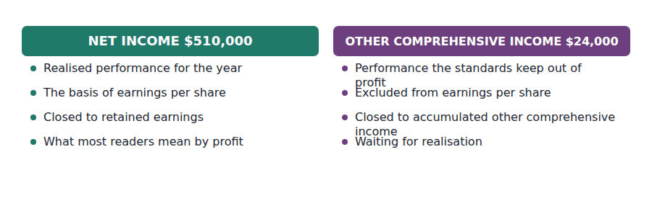
Part 2 · What is in the other half a closed list, not a judgement
Exercise 2B Sort each item into the column it belongs in.
OBJECTIVE | Identify which items are reported in other comprehensive income.
YOU WILL NEED | Exercise 2A.
HOW TO START | • The list is closed. An item is in it because a standard puts it there, and unusual size is never the test.  • Northwind’s own item is the unrealised gain on its available-for-sale debt securities.  • Two of the items look unusual and still belong in profit, and a restructuring charge is one of them.

Item | OTHER COMPREHENSIVE INCOME | PROFIT OR LOSS
1. Unrealised gain on available-for-sale debt securities
2. Foreign currency translation adjustment on a subsidiary
3. Actuarial gains and losses on a defined benefit pension plan
4. The effective portion of a cash flow hedge
5. A large restructuring charge
6. Unrealised gain on equity securities held for trading
7. A loss on the sale of a factory
8. Revaluation surplus on property, under IFRS

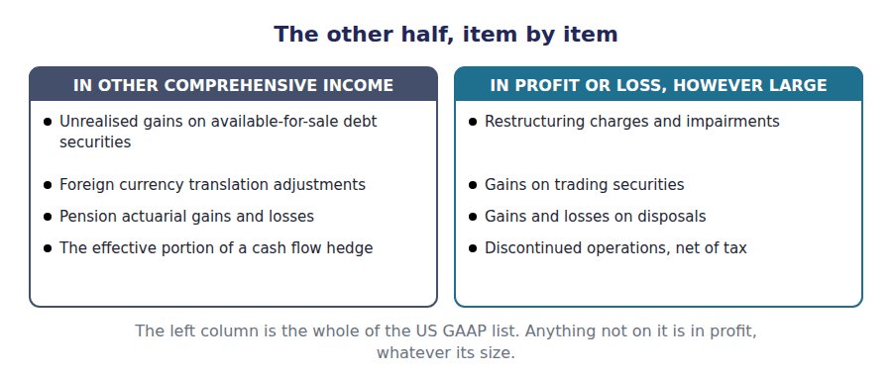
Part 3 · Presenting the two together one statement, or two
R2 The two measures may be shown in a single continuous statement that begins with revenue and ends with total comprehensive income, or in two consecutive statements, the second starting from net income. Either way both figures appear, and components may be shown before or after tax.
Exercise 2C Complete the table, showing the tax on the gain separately.
OBJECTIVE | Complete the statement of comprehensive income.
YOU WILL NEED | Exercise 2A, and Volume 1 Handout 5 for the net income.
HOW TO START | • Start from the $510,000 of net income. It is given.  • The gain before tax is $32,000 and the tax on it is $8,000, which is shown as a deduction.  • The last line is the sum of net income and the net figure above it.

Statement of comprehensive income, 20X4 | Amount
Net income | $510,000
Unrealised gain on available-for-sale debt securities, before tax | $32,000
Income tax on that gain
Other comprehensive income for the year
Total comprehensive income

1 | 2 | 3

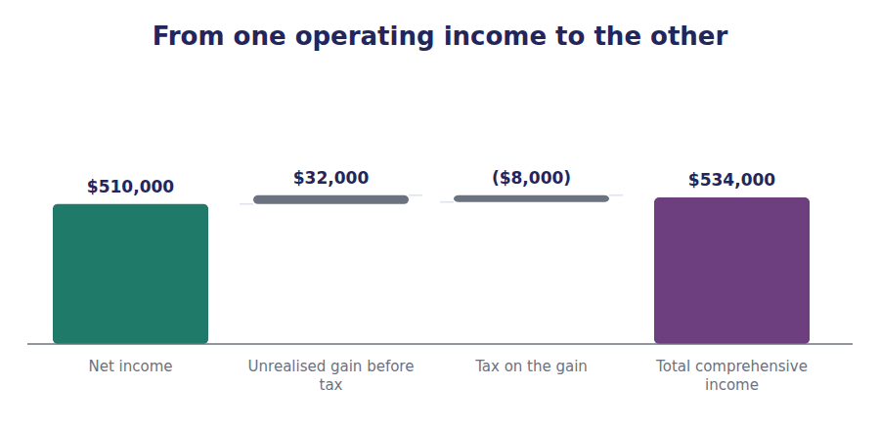
Part 4 · The accumulated balance the flow and the stock
Exercise 2D Complete the schedule. The opening balance is given.
OBJECTIVE | Roll accumulated other comprehensive income forward for the year.
YOU WILL NEED | Exercise 2C, and Volume 8 Handout 1 for the equity section.
HOW TO START | • The relationship is the same as retained earnings and net income: one is the flow and the other is the balance it feeds.  • The opening balance of $52,000 came from earlier years’ unrealised gains.  • The closing balance must be the $76,000 Volume 1 reported in equity.

Accumulated other comprehensive income | Amount
Balance at 1 January 20X4 | $52,000
Other comprehensive income for the year
Balance at 31 December 20X4

1 | 2

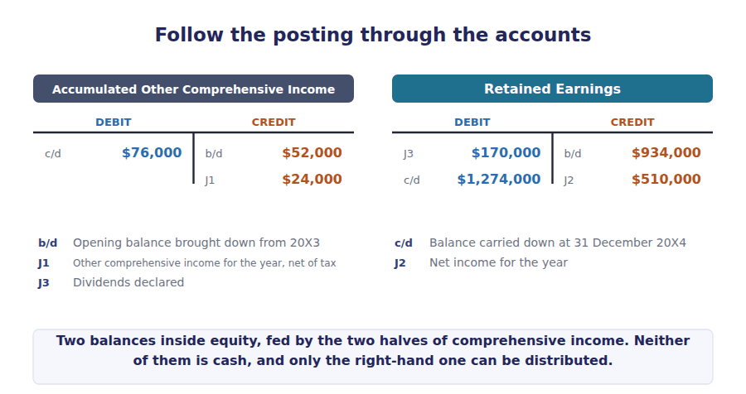
Part 5 · What happens on realisation the reclassification adjustment
Exercise 2E Read and complete. Write one word in each space.
OBJECTIVE | Say what happens to an accumulated amount when the item is realised.
YOU WILL NEED | Exercise 2D, and Volume 6 Handout 3 on selling a security.
HOW TO START | • Suppose Northwind sells the securities next year for exactly their carrying amount.  • The gain has already been reported once, in other comprehensive income. Ask what has to happen so that it is not reported twice.  • The last blank is the net effect of the adjustment on total comprehensive income in the year of sale.

WORD BANK
deferred · doubled · exception · realised · reclassification · revaluation · unaffected
Not every word is used.

R2 When the securities are sold the gain becomes ⁵ , and a realised gain belongs in profit. It has already been reported in other comprehensive income, however, so it cannot simply be recognised again.
The amount is therefore taken out of accumulated other comprehensive income and put into profit, in a transfer called a ⁶ adjustment.
Profit rises by the amount transferred and other comprehensive income for that year falls by the same amount, so total comprehensive income for the year of sale is ⁷ by the transfer itself.
Not every item is recycled this way. A revaluation surplus under IFRS stays in equity permanently, and the exam uses that as its ⁸ to the rule.
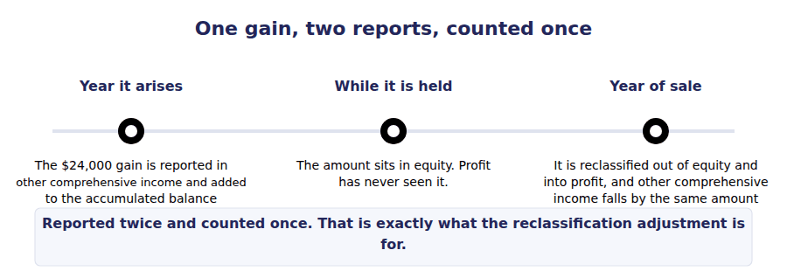
Watch out! Comprehensive income is not used in earnings per share. Every per-share figure is built on net income, which is why a company can report rising comprehensive income and falling earnings per share in the same year.
Part 6 · Exam pitch the questions as the CMA sets them
1. [Level A] Comprehensive income is best described as:
(A) Net income plus dividends
(B) The change in equity from all sources other than transactions with shareholders
(C) Net income before tax
(D) The change in retained earnings
2. [Level A] Which of the following is reported in other comprehensive income?
(A) A gain on the sale of equipment
(B) A foreign currency translation adjustment
(C) A restructuring charge
(D) An unrealised gain on trading securities
3. [Level B] Northwind reports net income of $510,000 and an unrealised gain of $32,000 before $8,000 of tax. Total comprehensive income is:
(A) $542,000
(B) $534,000
(C) $510,000
(D) $502,000
4. [Level B] Accumulated other comprehensive income is reported:
(A) In the income statement, below net income
(B) As a separate component of shareholders’ equity
(C) As a liability until realised
(D) As a note disclosure only
5. [Level C] A company sells available-for-sale debt securities on which it had previously reported a $40,000 unrealised gain in other comprehensive income. In the year of sale:
(A) Comprehensive income increases by $40,000
(B) Profit increases by $40,000 and other comprehensive income decreases by $40,000
(C) Other comprehensive income increases by $40,000
(D) Nothing is recognised, because the gain was already reported
6. [Level C] Which item is reported in other comprehensive income and never reclassified into profit?
(A) An unrealised gain on available-for-sale debt securities
(B) A revaluation surplus on property under IFRS
(C) A foreign currency translation adjustment
(D) The effective portion of a cash flow hedge
7. [Level B] Earnings per share is computed using:
(A) Total comprehensive income
(B) Net income
(C) Net income plus other comprehensive income before tax
(D) The change in accumulated other comprehensive income
ADAPTIVE TIP Two questions settle any item: is it on the closed list, and has it been realised? Only a listed item goes to the other half, and only realisation brings it back. Anything else, however large or unusual, belongs in profit.

Handout 3 · Discontinued Operations
Northwind leaves the fittings business. The $150,000 it loses in doing so is reported on its own line, below everything else, net of tax.
Volume 9 · Income Measurement · R2 moving to R3
LANGUAGE FOCUS
Register you are working in | R2 for the tests and the presentation, R3 for the classification exercise, which uses the standard’s own wording.
Say it exactly like this | dispose of a component · represent a strategic shift · classify a disposal group as held for sale · report net of tax · restate the comparative periods · cease to depreciate a held-for-sale asset
Words that are not the same | continuing / discontinued · component / asset · strategic shift / routine disposal · gross / net of tax
Remember | A discontinued operation is not any large disposal. It has to be a component and it has to be a strategic shift. Reporting an operation as discontinued does not change the total. Net income is the same figure, presented in two parts.

What you will be able to do when this handout is finished
- State the two tests a disposal must meet to be discontinued.
- Apply the tests to a given disposal.
- Present a discontinued operation in the income statement.
- Say why the line is shown net of tax when no other line is.
- Say what changes on the balance sheet and in the comparatives.

Northwind leaves a business
Early in 20X5 Northwind’s board resolves to sell its Fittings division, a separate line of business with its own plant, its own customers and its own reporting.
The division loses $80,000 before tax while it is still being run, and the sale itself produces a further loss of $120,000.
Both losses attract tax relief at 25%, so the $200,000 of pre-tax loss is $150,000 after the $50,000 benefit.
Every dollar of that appears on one line of the income statement, and this handout explains why it gets a line of its own.

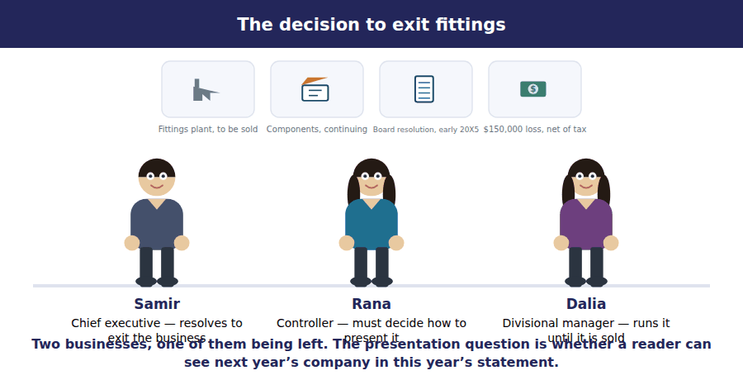
Part 1 · Why the line exists so a reader can see what is left
Exercise 3A Read and complete. Write one word in each space.
OBJECTIVE | Say why a discontinued operation is reported separately.
YOU WILL NEED | Handout 1 Exercise 1A, on the four elements of performance.
HOW TO START | • A reader uses this year’s result to form a view about next year. Ask what the Fittings division will contribute then.  • Both the trading loss of $80,000 and the disposal loss of $120,000 belong to a business that will not be there.  • The last blank is what the separate presentation does to total net income, and the answer is nothing.

WORD BANK
continue · gone · presented · reduced · separately · sold · together
Not every word is used.

R2 A reader of an income statement is trying to work out what the company will earn next year. The $510,000 that continuing operations made is useful for that; the Fittings division’s losses are not, because the division will be ¹ .
So the results of the business being left are stripped out of every line above and gathered on one line of their own. The figures above that line describe the company that will ² .
Both the trading loss of $80,000 and the $120,000 loss on the sale go to that line. They arise from the same decision, so they are reported ³ .
Nothing is hidden and nothing is removed. Net income is still $360,000, and the separate line changes only how that figure is ⁴ .
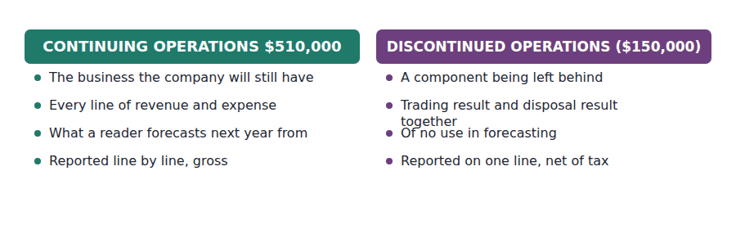
Part 2 · The two tests component, and strategic shift
R2 Two conditions must both be met. The operation must be a component of an entity, which means its operations and cash flows can be clearly distinguished from the rest of the business both in practice and for reporting; and its disposal must represent a strategic shift with a major effect on the company’s operations and results.
Exercise 3B Complete the grid. Write Yes or No in each cell.
OBJECTIVE | Apply the two tests to five disposals and classify each one.
YOU WILL NEED | The paragraph above.
HOW TO START | • Work the first test first: can this operation’s cash flows be separated from the rest of the business?  • A single machine fails the first test, so the second need not be asked at all.  • One of the five is a component and still not discontinued, because closing one office of eleven changes nothing strategically.

Disposal | A component? | A strategic shift? | Discontinued?
The whole Fittings division, a separate line of business
One of eleven regional sales offices
A single machine from the components plant
All operations in a geographical area the company is leaving
An equity-method associate that was a strategic investment

1 | 2 | 3 | 4 | 5 | 6
7 | 8 | 9 | 10 | 11 | 12
13 | 14 | 15

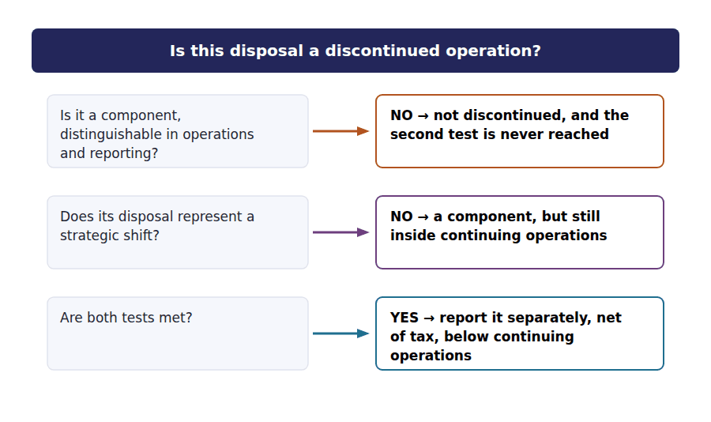
Part 3 · Presenting it one line, net of tax
Exercise 3C Complete the schedule. Both losses are given before tax.
OBJECTIVE | Present the discontinued operation in the income statement.
YOU WILL NEED | Exercises 3A and 3B.
HOW TO START | • The two losses add to $200,000 before tax. The tax benefit is 25% of that.  • A loss reduces taxable income, so the tax effect is a benefit and it is shown as a positive amount.  • Net income is the $510,000 from continuing operations less the net loss below it.

Income statement, year ended 31 December 20X5 | Amount
Income from continuing operations, net of tax | $510,000
Discontinued operations:
Loss from operating the division, before tax | ($80,000)
Loss on disposal of the division, before tax | ($120,000)
Income tax benefit at 25%
Loss from discontinued operations, net of tax
Net income

1 | 2 | 3

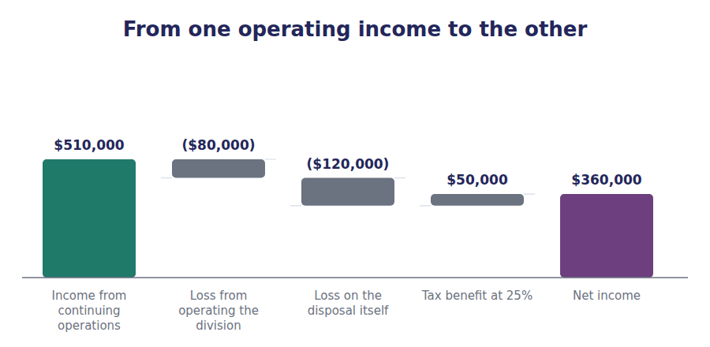
Part 4 · Why this line alone is net of tax intraperiod tax allocation
Exercise 3D Read and complete. Write one word in each space.
OBJECTIVE | Say why a discontinued operation is reported net of its own tax.
YOU WILL NEED | Exercise 3C, and Volume 7 Handout 2 on the tax charge.
HOW TO START | • Every other line of the income statement is before tax, with one tax charge at the end.  • Ask what the income tax expense line would mean if it covered both the continuing and the discontinued results.  • The last blank names the practice, and the exam uses the term without explaining it.

WORD BANK
deferred · gross · interperiod · intraperiod · meaningless · net · together
Not every word is used.

R2 Every line above is reported gross, with a single income tax expense at the foot of continuing operations. A discontinued operation breaks that pattern and is reported ⁵ of its own tax.
The reason is the line above it. If the $50,000 tax benefit on the division’s losses were left in the main tax charge, the tax on continuing operations would be understated and the margin a reader computes from it would be ⁶ .
So the tax is split between the two parts of the statement and each carries its own. The $200,000 of pre-tax loss and the $50,000 of benefit are reported ⁷ , giving $150,000.
Dividing the year’s tax between the parts of the statement that produced it is called ⁸ tax allocation, and the exam contrasts it with the interperiod allocation of Volume 7.
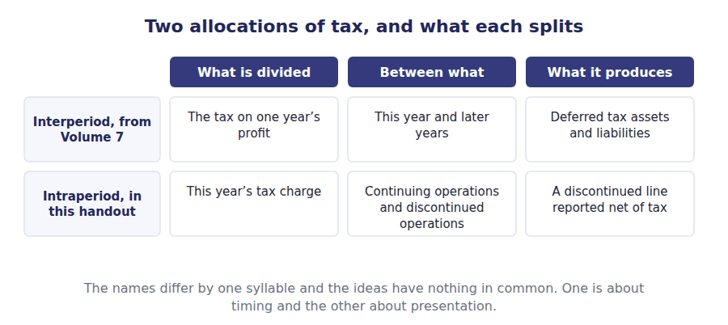
Part 5 · The balance sheet and the comparatives what else changes
Exercise 3E Read and complete. Write one word in each space.
OBJECTIVE | Say what happens on the balance sheet and to the prior year once a component is held for sale.
YOU WILL NEED | Exercise 3B, and Volume 5 Handout 2 on depreciating an asset.
HOW TO START | • The division is classified before it is sold, so something has to happen to its assets in the meantime.  • An asset held for sale is not being used up in the business any more. Ask what charge therefore stops.  • The last blank is what happens to the previous year’s income statement when it is shown alongside this one.

WORD BANK
depreciated · group · held · restated · revalued · sold · unchanged
Not every word is used.

R2 Classification does not wait for the sale. Once the division is available for immediate sale and the sale is highly probable, it is classified as ⁹ for sale and reported as discontinued from that moment.
Its assets and the liabilities that go with them are presented together as a disposal ¹⁰ , in a single line among current assets and a single line among current liabilities.
The group is measured at the lower of carrying amount and fair value less costs to sell, and it is no longer ¹¹ , because it is being sold rather than used.
The comparative income statement is ¹² on the same basis, so both years show the same continuing business and a reader can compare them.
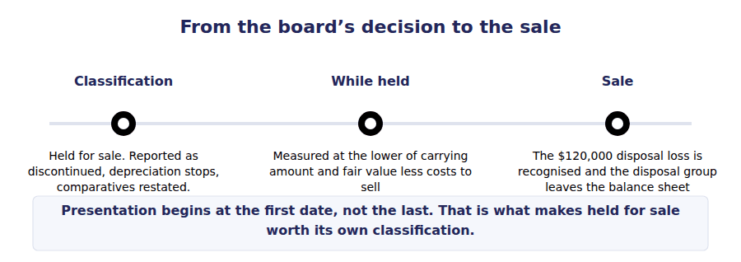
Watch out! Reporting a component as discontinued never changes net income. A question that gives you income from continuing operations and a discontinued loss and asks for net income wants the subtraction, and a question that asks what the reclassification did to net income wants the word nothing.
Part 6 · Exam pitch the questions as the CMA sets them
1. [Level A] To be reported as a discontinued operation, a disposal must:
(A) Be larger than ten per cent of total assets
(B) Be a component of the entity and represent a strategic shift
(C) Result in a loss
(D) Be completed before the year end
2. [Level A] A discontinued operation is reported in the income statement:
(A) Within operating expenses
(B) On a separate line, net of tax, below income from continuing operations
(C) As an extraordinary item
(D) Only in the notes
3. [Level B] A division loses $80,000 from operations and $120,000 on its disposal, both before tax, at a 25% rate. The discontinued operations line shows a loss of:
(A) $200,000
(B) $150,000
(C) $120,000
(D) $80,000
4. [Level B] A company closes one of its eleven regional sales offices. The closure is:
(A) A discontinued operation, because the office is a component
(B) Not a discontinued operation, because it is not a strategic shift
(C) A discontinued operation, if the loss is material
(D) An extraordinary item
5. [Level B] Allocating the year’s income tax between continuing and discontinued operations is called:
(A) Interperiod tax allocation
(B) Intraperiod tax allocation
(C) Deferred tax allocation
(D) Permanent allocation
6. [Level C] A component is classified as held for sale in October and sold the following March. During those five months:
(A) It continues to be depreciated
(B) It is not depreciated, and is measured at the lower of carrying amount and fair value less costs to sell
(C) It is remeasured to fair value with gains recognised
(D) It is removed from the balance sheet
7. [Level C] Northwind reports $510,000 from continuing operations and a $150,000 loss from discontinued operations, net of tax. Had the division not been classified as discontinued, net income would have been:
(A) $510,000
(B) $360,000
(C) $660,000
(D) Not determinable
ADAPTIVE TIP Ask the two tests in order and stop at the first No. Most exam items fail the strategic shift test while passing the component test, so the distractor is almost always a genuine component whose disposal changes nothing about the business.

Answer Key
Volume 9 · Handouts 1 to 3
Every answer carries the reason for it and the mistake it defeats.

Handout 1 · Gains, Losses and How Expenses Are Recognised answers
Completed text and exercises
# | Answer | Why | The trap it defeats
1 | peripheral | Outside what the company is in business to do.
2 | revenue | Same cash, different source.
3 | net | One line, not two. | Students report the $65,000 of proceeds as revenue. That would inflate sales by a transaction the company is not in business to make.
4 | event | No counterparty needed.
5 | carrying | Cost less the depreciation charged to date. | Students measure the gain against the original cost. That ignores every year of depreciation already charged.
6 | $30,000 | $65,000 less $35,000.
7 | debited | A credit balance is cleared by a debit.
8 | loss | The same line, the other way.
9 | effect | The exam’s own phrase for the first basis.
10 | allocation | Spread it, because you cannot trace it.
11 | systematic | Defensible and consistent, not precise.
12 | immediately | No future benefit, no reason to carry it. | Students look for a cost to capitalise. Where no identifiable benefit exists, carrying it forward creates an asset that is not one.

Exam-pitch questions
# | Answer | Why | The trap it defeats
1 | (B) Arises from a transaction peripheral to the company’s main activities and is reported net | Source and presentation, not size. (A) is the intuitive answer and fails on a company that sells a building for more than a year of trading brings in. | Level A
2 | (B) A gain of $30,000 | The carrying amount is $35,000, so $65,000 of proceeds is a $30,000 gain. (A) compares the proceeds with the original cost and ignores the depreciation already charged. | Level A
3 | (B) Systematic and rational allocation | No single sale can be traced to a machine, so its cost is spread on a defensible pattern. (A) is the basis cost of goods sold uses, where the trace to a particular sale does exist. | Level B
4 | (B) Recognised immediately as an expense | With no identifiable future benefit there is nothing to allocate and nothing to trace, so the cost is charged at once. (A) is the answer that creates an asset out of a hope. | Level B
5 | (B) The result of selling a delivery van | A disposal is peripheral, so proceeds and carrying amount are netted into one line. (A) and (C) are both gross and shown separately, which is exactly the presentation a gain avoids. | Level B
6 | (B) A loss, because it arose from an event peripheral to operations | A loss can arise from an event with no counterparty at all, and that is the half of the definition this question tests. (A) misses it: operating in a building is not the same as being in the business of losing one. | Level C
7 | (B) Selling components is Northwind’s ongoing major activity and selling machinery is not | Classification turns on the activity, so the same machine sale would be revenue in the hands of a machinery dealer. (D) is false on the figures as well: $35,000 of the $180,000 cost remained. | Level C

Exercise 1B · the completed classification
Item in Northwind’s 20X4 income statement | Amount | Which element
Sales of components to customers | $4,800,000 | Revenue
Cost of goods sold | $2,880,000 | Expense
Selling and administrative costs | $905,000 | Expense
Depreciation and amortisation | $275,000 | Expense
Interest on the long-term debt | $90,000 | Expense
Sale of a machine for $65,000 that stood at $35,000 | $30,000 | Gain

Exercise 1E · the completed recognition bases
Cost | Which basis | Why
Cost of goods sold, $2,880,000 | Cause and effect | Each unit’s cost is charged when that unit is sold
Depreciation, $250,000 | Systematic allocation | No single sale can be traced to a machine’s cost
Amortisation, $25,000 | Systematic allocation | The same reasoning, over an intangible’s useful life
Administrative salaries, $345,000 | Immediate recognition | No future benefit can be identified or allocated
Sales commissions, inside $560,000 | Cause and effect | Earned on a particular sale and charged with it
A $20,000 fine paid during the year | Immediate recognition | Nothing is received for it in any period

Exercise 1C · the disposal entry, completed
J1 The machine sold for $65,000.
Account | Debit | Credit
Cash | $65,000
Accumulated Depreciation | $145,000
Machinery |  | $180,000
Gain on Disposal |  | $30,000

R2 The entry balances at $210,000 on each side, and only $30,000 of it reaches the income statement. The other three lines move assets about.

Handout 2 · Comprehensive Income answers
Completed text and exercises
# | Answer | Why | The trap it defeats
1 | shareholders | Capital in and dividends out are not performance.
2 | unrealised | No completed transaction yet.
3 | $24,000 | $32,000 less $8,000 of tax.
4 | sold | Realisation is the event that releases it. | Students treat the amount as permanently outside profit. For most items it is only waiting.
Grid 1 | 1 OTHER COMPREHENSIVE INCOME 2 OTHER COMPREHENSIVE INCOME 3 OTHER COMPREHENSIVE INCOME 4 OTHER COMPREHENSIVE INCOME 5 PROFIT OR LOSS 6 PROFIT OR LOSS 7 PROFIT OR LOSS 8 OTHER COMPREHENSIVE INCOME | Four of the eight are the US GAAP list, plus the IFRS revaluation surplus. Unusual size never moves an item out of profit.
5 | realised | A completed transaction at last.
6 | reclassification | The standard’s own name for the transfer.
7 | unaffected | One half up, the other half down. | Students add the reclassified gain to comprehensive income a second time. The transfer moves an amount; it does not create one.
8 | exception | One item that never reaches profit.

Exam-pitch questions
# | Answer | Why | The trap it defeats
1 | (B) The change in equity from all sources other than transactions with shareholders | All performance, with owner transactions excluded. (D) is the commonest wrong answer and omits both the other half and the share transactions. | Level A
2 | (B) A foreign currency translation adjustment | Translation adjustments are on the closed list. (D) is the near miss: trading securities are marked to market through profit, and only the available-for-sale classification goes to the other half. | Level A
3 | (B) $534,000 | $510,000 plus the gain net of its tax, $24,000, is $534,000. (A) adds the gain gross and so reports a tax charge that was never avoided. | Level B
4 | (B) As a separate component of shareholders’ equity | It is a balance inside equity, alongside retained earnings. (A) confuses the balance with the flow that feeds it, which is the distinction the question is testing. | Level B
5 | (B) Profit increases by $40,000 and other comprehensive income decreases by $40,000 | The reclassification moves the amount between the two halves and changes neither total. (A) counts the same gain twice, and (D) leaves a realised gain permanently out of profit. | Level C
6 | (B) A revaluation surplus on property under IFRS | A revaluation surplus stays in equity even on disposal, where it may be transferred to retained earnings but never through profit. The other three are all recycled when the underlying item is realised. | Level C
7 | (B) Net income | Every per-share measure uses net income, which is why a large item in the other half can leave earnings per share untouched. (A) is the answer the wider measure’s name invites. | Level B

Exercise 2C · the completed statement
Statement of comprehensive income, 20X4 | Amount
Net income | $510,000
Unrealised gain on available-for-sale debt securities, before tax | $32,000
Income tax on that gain | ($8,000)
Other comprehensive income for the year | $24,000
Total comprehensive income | $534,000

Exercise 2D · the accumulated balance, rolled forward
Accumulated other comprehensive income | Amount
Balance at 1 January 20X4 | $52,000
Other comprehensive income for the year | $24,000
Balance at 31 December 20X4 | $76,000

R2 The closing balance of $76,000 is the figure in Volume 1’s equity section and in Volume 8 Handout 1. The $24,000 movement is the whole of the year’s other comprehensive income, because nothing was reclassified out during 20X4.
R2 The $8,000 of tax inside the other half is the same $8,000 that Volume 7 Handout 4 traced through the deferred tax liability. Tax follows its item: the gain was reported outside profit, so its tax was charged outside profit too.

Handout 3 · Discontinued Operations answers
Completed text and exercises
# | Answer | Why | The trap it defeats
1 | gone | Next year it contributes nothing.
2 | continue | The company the reader is forecasting.
3 | together | One decision, one line.
4 | presented | Same total, two parts. | Students expect the total to change. The split is presentational, and the exam often asks for the total to check that.
5 | net | The one line that carries its own tax.
6 | meaningless | A tax charge on profits that are not there.
7 | together | One line, after tax.
8 | intraperiod | Within one period, between the parts of the statement. | Students confuse it with interperiod allocation. That one is about which year; this one is about which line.
9 | held | The standard’s own classification.
10 | group | Assets and their liabilities, together.
11 | depreciated | Held for sale, not in use. | Students keep charging depreciation until the sale completes. It stops on classification.
12 | restated | Both years on the same basis, or neither comparison works.

Exam-pitch questions
# | Answer | Why | The trap it defeats
1 | (B) Be a component of the entity and represent a strategic shift | Both tests, and nothing about size or outcome. (A) invents a quantitative threshold the standard does not have, and (D) is wrong because held-for-sale classification is enough. | Level A
2 | (B) On a separate line, net of tax, below income from continuing operations | One line, after tax, below continuing operations. (C) is the category that no longer exists in US GAAP, which makes it the distractor the exam reuses most. | Level A
3 | (B) $150,000 | $200,000 before tax less the $50,000 benefit is $150,000. (A) omits the tax, and the discontinued line is the one line in the statement that must carry its own. | Level B
4 | (B) Not a discontinued operation, because it is not a strategic shift | The office may well be a component, and closing one of eleven changes nothing strategically, so the second test fails. (C) is the size test the standard deliberately does not use. | Level B
5 | (B) Intraperiod tax allocation | Within the period, between the parts of the statement. (A) is the allocation between years that produces deferred tax, and the two names are one syllable apart by design. | Level B
6 | (B) It is not depreciated, and is measured at the lower of carrying amount and fair value less costs to sell | Depreciation stops on classification because the asset is being sold rather than used. (C) is the trap: the measurement is a floor, so losses are recognised and gains above carrying amount are not. | Level C
7 | (B) $360,000 | The classification is presentational, so net income is $360,000 either way. (A) is the error the separate line invites, treating the loss as though the presentation had removed it. | Level C

Exercise 3B · the completed classification grid
Disposal | A component? | A strategic shift? | Discontinued?
The whole Fittings division, a separate line of business | Yes | Yes | Yes
One of eleven regional sales offices | Yes | No | No
A single machine from the components plant | No | No | No
All operations in a geographical area the company is leaving | Yes | Yes | Yes
An equity-method associate that was a strategic investment | Yes | Yes | Yes

Exercise 3C · the completed income statement
Income statement, year ended 31 December 20X5 | Amount
Income from continuing operations, net of tax | $510,000
Discontinued operations:
Loss from operating the division, before tax | ($80,000)
Loss on disposal of the division, before tax | ($120,000)
Income tax benefit at 25% | $50,000
Loss from discontinued operations, net of tax | ($150,000)
Net income | $360,000

R2 The $200,000 of pre-tax loss carries a $50,000 tax benefit at 25%, so the line shows $150,000. Net income is the $510,000 from continuing operations less that figure, or $360,000.
R2 Row 3 of the grid is the one worth re-reading. A single machine is an asset and not a component, so the second test is never reached. Nothing about the size of the machine could change that answer.

Glossary
Every term in Volume 9, with the Arabic equivalent and the places it misleads
The third column is for recognition only. In the exam room you work in English.

Term | What it means in CMA English | بالعربية | Careful
accumulated other comprehensive income | The cumulative total of other comprehensive income not yet reclassified into profit, carried as a line in equity. | الدخل الشامل الآخر المتراكم | The balance to other comprehensive income’s flow, exactly as retained earnings is the balance to net income’s.
component of an entity | An operation and cash flows that can be clearly distinguished from the rest of the business, both for operations and for reporting. | مكوّن من المنشأة | A reportable segment, an operating segment, a reporting unit or a subsidiary can be one. A single asset never is.
comprehensive income | The total change in equity in a period from all sources other than transactions with shareholders. | الدخل الشامل | The widest measure of performance there is. Net income is only part of it.
discontinued operation | A component of an entity that has been disposed of, or is held for sale, and whose disposal represents a strategic shift. | العمليات المتوقفة | Both tests, not either. A large disposal that is business as usual stays in continuing operations.
disposal group | A group of assets and the liabilities directly associated with them that will be disposed of in a single transaction. | مجموعة الاستبعاد | Measured as a whole at the lower of carrying amount and fair value less costs to sell, and no longer depreciated.
gain | An increase in equity from a transaction peripheral to the company’s main activities, reported net. | الربح العارض | Netting is the visible difference: a gain of $30,000 appears where a revenue of $65,000 and a cost of $35,000 would have been.
held for sale | A classification for a disposal group that is available for immediate sale and whose sale is highly probable. | محتفظ به للبيع | Classification starts the presentation: the component is reported as discontinued before it is actually sold.
loss | A decrease in equity from a peripheral transaction or event, reported net. | الخسارة العارضة | The mirror of a gain, and it need not involve a transaction at all: a fire produces a loss.
other comprehensive income | The items of comprehensive income that the standards require to be reported outside profit or loss. | الدخل الشامل الآخر | A closed list. An item is in it because a standard says so, not because it feels unusual.
peripheral | Outside a company’s ongoing major or central operations. | عارض أو هامشي | The test is what the company is in business to do. Selling a machine is peripheral for Northwind and central for a machinery dealer.
reclassification adjustment | The transfer of an amount out of accumulated other comprehensive income and into profit, when the item is realised. | تسوية إعادة التصنيف | Without it the same gain would be counted twice: once as it arose and again when it was sold.
revenue | An inflow arising from a company’s ongoing major activities, reported at its gross amount. | الإيرادات | Gross, and from the main business. Both halves of that matter when an item has to be classified.
strategic shift | A disposal that has, or will have, a major effect on a company’s operations and financial results. | تحول استراتيجي | The second test, and the one that disposes of most exam distractors. Size alone does not make a shift.
systematic and rational allocation | Spreading a cost over the periods it benefits, on a defensible pattern, where no single revenue can be traced to it. | التوزيع المنظم والمنطقي | Depreciation is the example the exam uses. The pattern must be defensible, not precise.
unrealised | Describing a change in value that has not yet been converted into a completed transaction. | غير محقق | The reason most of the other half exists. Realisation is the event that moves an item into profit.

