Unit 1: Introduction to the Computer and the IT Department
English for Cybersecurity Personnel · Level: Upper A2 (the course moves to Low B1 from Unit 6) · Tracks: [OP] Warm-Up + Parts 1–6 · [PR] Parts 7–10
Warm Up
[OP] Operator track · in-class starter
Warm-up: Computer Words and Meanings
Match the computer words with their meanings. One meaning is not needed. Write the letter.
Column A
1. | Computer | ____
2. | Password | ____
3. | Screen | ____
4. | Help desk | ____
5. | File | ____
Column B
a) | a secret word that opens your account
b) | the keyboard you type on
c) | the machine you use to do your work
d) | the part you look at when you work
e) | the team you call when your computer has a problem
f) | a document you save and open again
Warm-up: In the IT Department
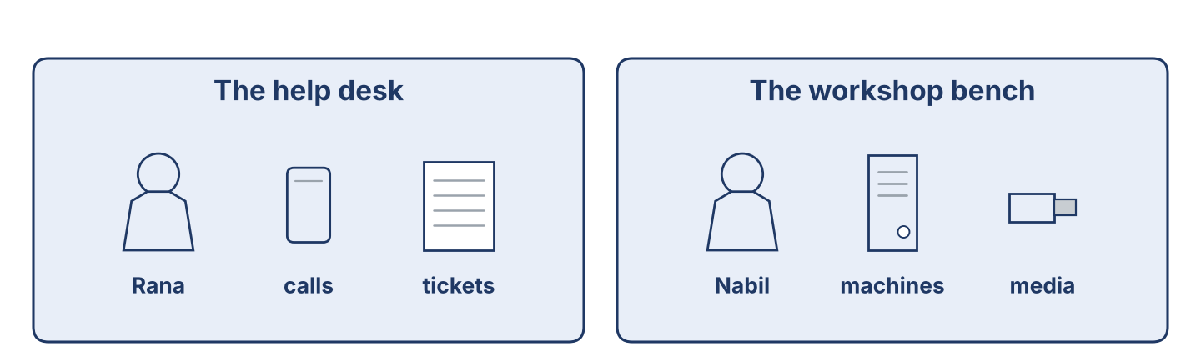
Figure 1.1 · The help desk and the workshop bench at Cham Systems.
Complete the sentences using the words in the word bank.
Word bank: password | help desk | file | screen
1. You type your ____________________ to open your account.
2. Rana works at the ____________________ .
3. Nabil saves the report as a ____________________ .
4. The ____________________ shows your work.
Warm-up: Reading About the IT Department
Read the text and choose the correct answer.
An IT and security department looks after the computers in a company. The user calls the help desk when there is a problem. The help-desk officer writes a ticket. Then a technician checks the machine at the bench. Safe, careful work is very important. A tidy desk and a locked screen keep information safe.
1. Who writes the ticket?
○ A) The user
○ B) The help-desk officer
○ C) The technician
○ D) The manager
2. Why is a locked screen good?
○ A) It keeps information safe
○ B) It is expensive
○ C) It is slow
○ D) It is new
Part 1 · Vocabulary and Terminology
[OP] Operator track · pre-class input
Part 1: Computer and Security Terms
Match the words with their meanings. One meaning is not needed. (0. is done for you.)
0. Help desk → the team you call when your computer has a problem.
Column A
1. | Server | ____
2. | Account | ____
3. | Password | ____
4. | Backup | ____
5. | Update | ____
6. | Ticket | ____
7. | Screen lock | ____
Column B
a) | a copy of your files, kept in a safe place
b) | a new version that fixes problems in a program
c) | a record of a problem and the work done on it
d) | the name the computer knows you by
e) | a big computer that keeps files for many people
f) | a secret word that opens your account
g) | a cable that joins two machines
h) | the step that hides your screen when you leave your desk
Gloss: server = a big computer that keeps files for many people · account = the name the computer knows you by
Gloss: backup = a copy of your files, kept in a safe place · ticket = a record of a problem and the work done on it
Part 1: Pronunciation
🔊 Audio Track 1.1
Listen and practise these words. Say each word aloud and stress the loud syllable (CAPITALS).
computer — com-PU-ter
password — PASS-word
security — se-CU-ri-ty
account — ac-COUNT
backup — BACK-up
update — UP-date
Part 1: People and Places in the Department
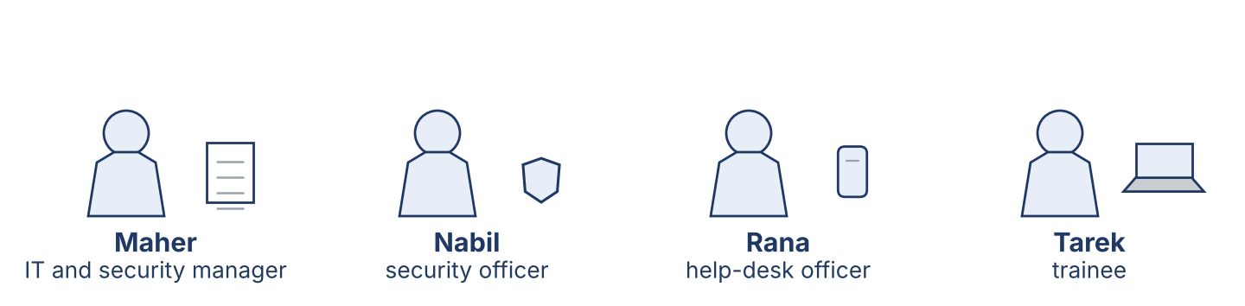
Figure 1.2 · The people in an IT and security department.
Complete the table. Write where each person works and what they do. (0. is done.)
Person | Where | What they do
Help-desk officer | help desk | Answers calls and writes tickets
Security officer
Manager
Trainee

Part 1: Parts of a Computer
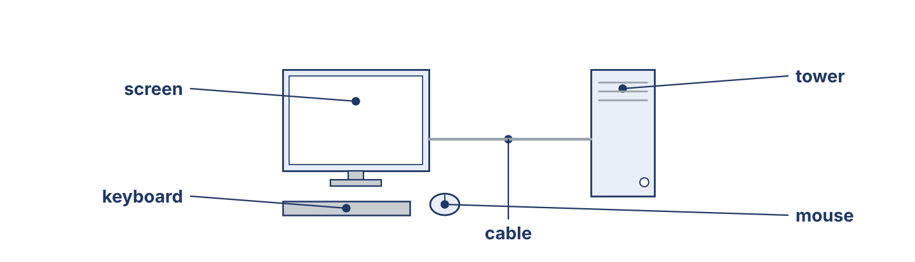
Figure 1.3 · The parts of a computer: screen, keyboard, mouse, tower and cable.
Match the parts of a computer with their descriptions. One description is not needed. Write the letter.
Column A
1. | Screen | ____
2. | Keyboard | ____
3. | Mouse | ____
4. | Tower | ____
5. | Cable | ____
Column B
a) | the box that holds the main parts of the computer
b) | the part you look at when you work
c) | you move it with your hand to point and click
d) | the printer that puts your work on paper
e) | you type on it
f) | it joins the screen to the tower
Part 1: Computers and Security — Multiple Choice
Read and choose the correct answer.
1. What does a backup do?
○ A) It makes the computer faster
○ B) It keeps a copy of your files
○ C) It opens your account
○ D) It cleans the screen
2. Where does a help-desk officer work?
○ A) The workshop bench
○ B) The store
○ C) The help desk
○ D) At home
3. What is a ticket?
○ A) A record of a problem and the work done on it
○ B) A type of cable
○ C) A password
○ D) A printer
Part 1: Vocabulary Fill-in
Complete the sentences with the correct word.
Word bank: server | update | account | ticket
1. Each person has one ____________________ with their own name.
2. The files for the whole office are kept on the ____________________ .
3. Rana writes a ____________________ for every call.
4. An ____________________ fixes problems in a program.
Part 1: Write About Computers (short)
Write two or three sentences about your computer or the IT department. Use three words from this unit.
Model — read this first:
I work at Cham Systems. I use a computer every day. First, I open my account with my password, and then I read the new tickets. Right now, I am writing a short report for my manager. When I leave my desk, I lock the screen.
Part 2 · Grammar — Present Simple vs Present Continuous
[OP] Operator track · pre-class input
Part 2: Notice
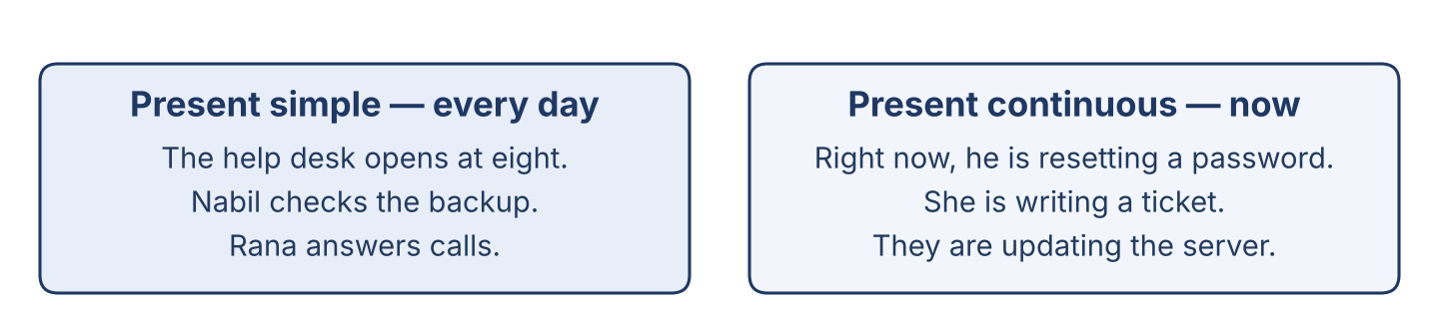
Figure 1.4 · Present simple (every day) and present continuous (now).
Read these lines from the help desk. Underline the verbs. Which are routines, and which are happening now?
Nabil checks the backup. He usually starts at eight. Right now, he is resetting a password for a user. The help desk opens every morning. Today it is answering many calls, because the office is busy.
Part 2: Grammar Focus Box
 | Form | Use | Example
Present simple | I/you check; he checks | routines, facts | The help desk opens every day.
Present continuous | am/is/are + -ing | now, this week | Nabil is resetting a password now.
Remember: every day, usually → present simple. now, this week, at the moment → present continuous.
Watch out! ✗ He check the backup. → ✓ He checks the backup. (add -s for he/she/it). ✗ I resetting now. → ✓ I am resetting now.
Part 2: Controlled Practice
Complete with the present simple or present continuous. (0. is done.)
0. Nabil usually works in the morning. (work)
1. Rana ____________________ (answer) the telephone every day.
2. Look! He ____________________ (change) the password right now.
3. The office ____________________ (open) at eight o’clock.
4. Today, Lina ____________________ (check) the list of accounts.
Part 2: Simple or Continuous?
Choose the correct form.
1. Right now, Tarek ____________________ (watches / is watching) Nabil.
2. Rana usually ____________________ (starts / is starting) at eight.
3. Listen! The server ____________________ (makes / is making) a strange noise.
4. The department ____________________ (checks / is checking) the backups every week.
Part 2: Correct the Sentence
Each sentence has one grammar mistake. Write the correct sentence.
1. The office keep the files on one server. __________________________________
2. Look! Nabil reset the password now. __________________________________
3. She check the backup every morning. __________________________________
4. We are update the program now. __________________________________
Part 2: Freer Practice
Write two sentences about your work or study: one routine (present simple) and one about now (present continuous).
Part 2: Grammar Review
Choose the correct sentence.
1. Which sentence is correct (now)?
○ A) Nabil reset the password.
○ B) Nabil is resetting the password.
○ C) Nabil resetting the password.
○ D) Nabil are resetting the password.
2. Which sentence is correct (routine)?
○ A) The department checks the backups.
○ B) The department checking the backups.
○ C) The department check the backups.
○ D) The department to check the backups.
→ You will see the present simple and present continuous again in the Part 5 reading. Watch for them.
Part 3 · Listening

Part 3: A Security Officer Talks About His Work
🔊 Audio Track 1.2
Before you listen: what does a security officer do first — read the ticket, or open the machine?
Nabil: Hello, my name is Nabil. I am a security officer at Cham Systems. I look after the computers and the accounts. First, I read the new tickets. Then I go to the user’s desk. Right now, I am helping Mr Aboud. He cannot open his account. I work with Rana at the help desk and with Tarek, our new trainee. I like my work, because every day is different.
While you listen: write True, False, or Not Given. (0. is done.)
0. Nabil is a security officer. — True
1. Nabil works in a bank. ____
2. Nabil is helping Mr Aboud right now. ____
3. Nabil works alone. ____
Useful phrases: I look after… · First, I… · Right now, I am…
Part 3: At the Help Desk
🔊 Audio Track 1.3
Before you listen: what does a help-desk officer ask a user first?
Rana: Good morning, Cham Systems help desk. How can I help you?
Mr Aboud: My computer does not open my account.
Rana: Of course. What message do you see?
Mr Aboud: It says the password is wrong, and I am sure it is right.
Rana: I’ll write a ticket. Can you stay at your desk for ten minutes?
Mr Aboud: Yes. When will it be ready?
Rana: This morning. We’ll call you.
While you listen: answer the questions. (0. is done.)
0. Where does Mr Aboud call? — The Cham Systems help desk.
1. What is the problem with his computer?
2. What message does he see?
3. When will it be ready?
Useful phrases: How can I help you? · What message do you see? · We’ll call you.
Part 3: A Day at Cham Systems
🔊 Audio Track 1.4
Before you listen: who works in an IT and security department? Write two jobs.
Maher: Good morning, everyone. Today we are busy. Nabil is helping Mr Aboud with his account. Tarek, you are new here, so you are watching and learning today. Lina is checking the backup from last night. Rana is answering the calls at the help desk. I am reading the new tickets. Please ask me if you are not sure about anything.
While you listen: match each person with what they are doing now. One action is not needed. (0. is done.)
0. Maher → reading the new tickets.
Column A
1. | Nabil | ____
2. | Tarek | ____
3. | Lina | ____
4. | Rana | ____
Column B
a) | answering the calls at the help desk
b) | watching and learning
c) | cleaning the keyboards
d) | helping a user with his account
e) | checking the backup from last night
Part 4 · Speaking
Part 4: Discussing Computers and Work
Work with a partner. Ask and answer these questions.
What computer does your family or your office have?
Do you like working with computers? Why?
What jobs are there in an IT and security department?
Useful language: We have a… · I like… because… · A security officer… · A help-desk officer…
Part 4: Help Desk Role Play
Work in pairs. Read the model, then use the cards.
Model exchange:
A: Good morning, help desk. How can I help you?
B: My computer does not open my account.
A: Of course. What message do you see?
B: It says the password is wrong.
A: I’ll write a ticket. Can you stay at your desk for ten minutes?
Useful language: How can I help you? · What message do you see? · I’ll write a ticket. · When will it be ready?
Card A — Help-desk officer (Rana): greet the user · ask what they need and what message they see · write a ticket · say when it will be ready.
Card B — User (Mr Aboud): greet · say your account does not open · say the message · ask when it will be ready.
Your turn: run the dialogue, then swap roles.
Stretch [PR]: the user needs the account back very quickly, but three people are waiting before him — offer a fair time politely.
Part 4: Mini-Presentation
Prepare a short talk (about one minute). Describe your job, or a computer you know: what it is, its main parts, and what you do with it every day.
Part 5 · Reading

Part 5: What Is an IT and Security Department?
Before you read: what three areas do you think an IT and security department has?
Gloss: help desk = the place users call when something does not work · ticket = a record of a problem and the work done on it · backup = a copy of your files, kept in a safe place
An IT and security department looks after the computers of a company. It has three main areas: the help desk, the workshop bench, and the store. A user calls the help desk, and the help-desk officer writes a ticket. A technician then checks the machine at the bench. The store keeps spare machines, disks and licences. The department also keeps the accounts: it opens an account for every new worker and closes it when a worker leaves. Every night it makes a backup of the files. A good department is tidy, careful and honest. It explains the problem in simple words, and it tells the user the truth about the time the work will take.
Answer the multiple-choice questions. (0. is done.)
0. What does an IT and security department do? — it looks after the computers of a company.
1. What does the help-desk officer write?
○ A) A letter
○ B) A ticket
○ C) A book
○ D) A bill
2. Where does a technician check a machine?
○ A) At the store
○ B) At the user’s home
○ C) At the workshop bench
○ D) At the bank
3. What is a good IT and security department?
○ A) Tidy, careful and honest
○ B) Dark and untidy
○ C) Slow
○ D) Closed
Part 5: Vocabulary in Context
Match each word from the text with its meaning. One meaning is not needed. Write the letter.
Column A
1. | help desk | ____
2. | ticket | ____
3. | store | ____
4. | backup | ____
Column B
a) | the place that keeps spare machines, disks and licences
b) | a record of a problem and the work done on it
c) | a cable for a printer
d) | the place users call when something does not work
e) | a copy of your files, kept in a safe place
Part 5: Computers in Syria
Before you read: why do offices in Syria keep computers for many years?
Gloss: licence = the paper that gives you the right to use a program · power cut = a time when the electricity stops
In Syria, offices keep computers for many years. New machines are expensive and hard to import, so people look after the ones they have. Dust, heat and power cuts are hard on a computer, so the IT department cleans the machines and plans its work around the hours when the electricity is on. Many programs are old, because a new licence is difficult to buy from Damascus. An old machine can still do good work if somebody cares for it: a clean fan, a safe password and a backup every night are worth more than a new computer with none of them.
Write True or False. (0. is done.)
0. Offices in Syria keep computers for many years. — True
1. New machines are cheap and easy to import in Syria. ____
2. Dust, heat and power cuts are hard on a computer. ____
3. An old machine can still do good work with good care. ____
Part 6 · Writing
[OP] Operator track · in-class / homework
Part 6: Describe Your Job or Your Computer (50–70 words)
Write about your job, or a computer you know. Use one present-simple and one present-continuous sentence.
Model — read this first:
I am a help-desk officer at Cham Systems. Every day, I answer the telephone and write tickets for the users. First, I ask what the problem is. Then I write the ticket and send it to a technician. Right now, I am helping a user who cannot open his account. I like my job, because I help people every day.
Plan (fill in, then write): I am a ___. Every day, I ___. First, I ___. Then I ___. Right now, I am ___.
Word bank: I answer / check / write… | every day… | First… Then… | Right now, I am …-ing | I like my job because…
Check before you finish: ☐ one present-simple + one present-continuous sentence? ☐ computer or security words used? ☐ 50–70 words?
Part 6: Why Good Computer Care Matters (50–70 words)
Write why good care of the computers is important. Give reasons.
Model — read this first:
Good care of the computers is important because the whole office stops when they do not work. A clean machine lasts longer, so the company spends less money. A backup every night means we never lose the files. A safe password keeps our information private. Careful work also keeps the users happy, because they trust us with their work.
Word bank: … is important because… | safe | lasts longer | saves money | keeps the users happy
Check before you finish: ☐ a clear opinion? ☐ two or three reasons? ☐ 50–70 words?
Part 6: A Note to the Security Officer (50–70 words)
Write a short note from Rana (help desk) to Nabil (security officer) about a user’s problem.
Model — read this first:
Dear Nabil, Here is ticket 104 from Mr Aboud in the accounts office. His account does not open, and the screen says the password is wrong. He is sure the password is right, so please check the account first. He is at his desk this morning and he needs the computer before twelve. Thank you. Rana.
Plan (fill in, then write): Dear ___, Here is ___. It needs ___. The user says ___, so please ___. Thank you. ___
Check before you finish: ☐ greeting and close? ☐ a clear request? ☐ 50–70 words?
Part 6: Reflection — A Computer I Know (40–60 words)
Write about a computer in your family or one you use at work.
Model — read this first:
We have one computer at home. It is old, and my brother uses it for his studies. It has a screen, a keyboard and a small tower under the desk. Every evening, he writes his work on it. Right now, he is reading a long report for his teacher. We keep it clean and we never share the password.
Check before you finish: ☐ the computer described? ☐ present simple + continuous? ☐ 40–60 words?
Part 7 · Management File — Welcoming a New Trainee
[PR] Practitioner track (optional for beginners) · IT and security manager
7A: Phrase Bank
Match what a manager says with its purpose. One purpose is not needed. Write the letter.
Column A
1. | “Welcome to the team.” | ____
2. | “Let me show you the help desk.” | ____
3. | “Never share your password, not even with me.” | ____
4. | “Ask me if you are not sure.” | ____
Column B
a) | giving a security rule
b) | offering help and support
c) | greeting a new worker
d) | talking about the price
e) | showing someone the department
7B: Manager Dialogue
🔊 Audio Track 1.5
Before you read: what does a manager say to a new trainee on the first day?
Maher: Good morning, Tarek. Welcome to Cham Systems. Nabil: Nice to meet you. Have you worked in an IT department before? Tarek: No, this is my first week. I studied computers at the institute. Maher: Good. This week you are watching and learning. Nabil will show you the help desk and the bench. Nabil: One rule first: never share your password, and never leave your screen open when you go. Tarek: I understand. Maher: And if you are not sure about something, ask. Nobody here is angry about a question.
Answer the questions. (0. is done.)
0. Where does Tarek start work? — At Cham Systems.
1. What is Tarek doing this week?
2. What security rule does Nabil give?
3. What should Tarek do if he is not sure?
7C: Controlled Practice — First-Day Checklist
Put a manager’s first-day steps in order. Number them 1–5. (0. is done.)
0. Say welcome to the new worker. — 1
____ Show the new worker the help desk and the bench.
____ Give the security rules.
____ Introduce the team.
____ Give the first small task.
7D: Role-Play — Briefing the Trainee
In pairs. One is the security officer (Nabil); one is the trainee (Tarek). Use the model and cards.
Model exchange: Nabil: Welcome, Tarek. First, never share your password. — Tarek: OK, Ustaz. — Nabil: Second, lock your screen when you leave the desk. — Tarek: And if I am not sure? — Nabil: Then you ask. Today you are watching me.
Card A — Security officer (Nabil): welcome · give three security rules · say what to do today. Card B — Trainee (Tarek): greet · ask one question about the rules · ask what to do first.
Stretch [PR]: the trainee wants to work on a manager’s computer alone in his first week — say no, and explain why, politely.
7E: Supervisory Writing (50–80 words)
You are Maher. Write a short welcome note to Tarek with his plan for the first week.
Model — read this first:
Dear Tarek, Welcome to Cham Systems. This week you are with Nabil at the help desk, so you can see how we answer a user and write a ticket. On Thursday you will watch a backup. One rule from your first day: never share your password, and lock your screen when you leave your desk. Ask any question you have — that is how we all learned. Maher.
Check before you finish: ☐ a warm welcome? ☐ a clear first-week plan? ☐ one security rule? ☐ 50–80 words?
Part 8 · Global Case Study — A Small Office Gets a Help Desk
[PR] Practitioner track · pre-read / in-class discuss
Before you read: how can a small office with no IT staff start to look after its computers?
Gloss: record = to write something down and keep it · honest = telling the truth and doing fair work · reputation = what people say about your work
In a small town, a company called Sadek Trading had eleven computers and nobody to look after them. When a machine stopped, the staff called a friend, and often nobody could say what had been done to it. Then the owner asked one worker, Sami, to spend two days a week on the computers. Sami did one simple thing first: he wrote down every call in a notebook — the date, the machine, the problem, and the work he did. After three months, the notebook showed him that the same two machines caused half the calls. He repaired them properly, and the calls went down. The staff started to trust him, because he always told them honestly how long a job would take. Today the company has a real help desk with three people, and it still keeps a record of every call.
Answer the questions. (0. is done.)
0. How many computers did the company have? — Eleven.
1. What was the problem before Sami started?
2. What simple thing did Sami do first?
3. Why did the staff start to trust him?
Part 8: Vocabulary in Context
Match each word with its meaning. One meaning is not needed. Write the letter.
Column A
1. | help desk | ____
2. | record | ____
3. | honest | ____
4. | repair | ____
Column B
a) | telling the truth and doing fair work
b) | to write something down and keep it
c) | the place that answers users and keeps their calls
d) | a new computer
e) | to fix something that is broken
Part 8: Discussion
Talk with a partner. Use the frames.
Discussion frames: “This is similar to Syria because…” · “This is different from Syria because…” · “I think the first step should be…” · “In a small office, the most useful record is…”
Part 9 · Local Case Study — Syria in Focus: The First Account List
[PR] Practitioner track · pre-read / in-class decide
Before you read: why is it a problem when several people in an office use the same computer account?
Lina is a young officer in a company in Homs with twenty-two staff. When she started, there were four accounts for twenty-two people. Everybody knew all four passwords, and the passwords were written on a card under the keyboard. Nobody was doing anything wrong: the office had grown slowly, and sharing had always been the quick way to work. But when a file was deleted one Thursday, nobody could say who had deleted it, and the argument lasted a week. Lina asked her manager for two quiet afternoons. She wrote a list of every person and what each one needed to open, and then she made one account for each name. It took longer than she expected, because two people had left the company a year before and still had working accounts. Now every file shows who opened it, and the card under the keyboard is gone.
Answer the questions. (0. is done.)
0. How many staff are there? — Twenty-two.
1. How many accounts were there when Lina started?
2. What happened on the Thursday?
3. What did Lina find when she wrote her list?
Part 9: Decision Task
Lina has two more quiet afternoons this month. Should she (a) write a short rule for new staff, (b) set a date when every password must be changed, or (c) teach the staff how to lock a screen? Choose one and give reasons.
Answer frame: “I think Lina should ___ because ___. Also, ___. This is better than ___ because ___.”
Model — read this first:
I think Lina should write a short rule for new staff, because the office is growing and every new person will start in the right way. Also, a rule on paper does not need her to be in the room. This is better than teaching the screen lock first, because she would have to teach it again for every new worker.
Phrase bank: I think… should… · because… · Also,… · This is better than… · In my opinion…
Part 10 · Review and Can-Do
[OP + PR] · homework / self-study
Part 10: Spiral Review
Complete the review. (0. is done.)
0. The team you call when your computer has a problem is the help desk.
Word bank: ticket | backup | account | present continuous | present simple
1. The record of a problem and the work done on it is a ____________________ .
2. A copy of your files, kept in a safe place, is a ____________________ .
3. The name the computer knows you by is your ____________________ .
4. “Nabil is resetting a password now” uses the ____________________ tense.
5. “The help desk opens every day” uses the ____________________ tense.
Part 10: Can-Do
Can-Do checklist
☐ I can name the main parts of a computer and the people in an IT and security department.
☐ I can use the present simple for routines and the present continuous for now.
☐ I can understand a short talk between a user, a help-desk officer and a technician.
☐ I can describe my job or a computer in 50–70 words.
☐ I can welcome and brief a new worker (Practitioner).
Part 10: Glossary
Unit 1 glossary (10 words)
server · account · password · backup · update · ticket · screen lock · help desk · licence · user

Unit 2: Inside the System — Machines, Accounts and Data
English for Cybersecurity Personnel · Level: Upper A2 (the course moves to Low B1 from Unit 6) · Tracks: [OP] Warm-Up + Parts 1–6 · [PR] Parts 7–10
Warm Up
[OP] Operator track · in-class starter
Warm-up: Machines, Accounts and Data
Match the words with their meanings. One meaning is not needed. Write the letter.
Column A
1. | Machine | ____
2. | Account | ____
3. | File | ____
4. | Disk | ____
5. | Licence | ____
Column B
a) | the paper that gives you the right to use a program
b) | a computer that one person works on
c) | the part that keeps your files when the power is off
d) | the cable that joins the machine to the wall
e) | the name the computer knows you by
f) | a document you save and open again
Warm-up: Checking the System
Complete the sentences using the words in the word bank.
Word bank: account | licence | disk | backup
1. Every worker has one ____________________ with their own name.
2. The office keeps a ____________________ of the files every night.
3. There is a new ____________________ for the accounts program.
4. The old ____________________ is full, so we cannot save anything.
Warm-up: Reading About the System
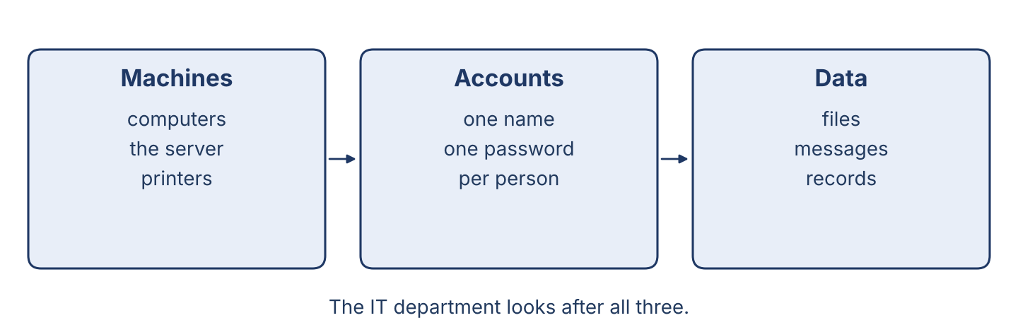
Figure 2.1 · Inside the system: machines, accounts and data.
Read the text and choose the correct answer.
An office system has three parts. There are the machines: the computers, the server and the printers. There are the accounts: one name for every person who works here. And there is the data: the files, the messages and the records. The IT department looks after all three. If there isn’t a backup of the data, a broken disk means the work is gone.
1. What does the IT department look after?
○ A) Only the machines
○ B) Only the accounts
○ C) The machines, the accounts and the data
○ D) Only the printers
2. What can happen if there isn’t a backup?
○ A) The work is gone when a disk breaks
○ B) The computer goes faster
○ C) Nothing happens
○ D) The printer stops
Part 1 · Vocabulary and Terminology
[OP] Operator track · pre-class input
Part 1: System and Data Terms
Match the parts with their meanings. One meaning is not needed. (0. is done for you.)
0. Server → the big computer that keeps files for many people.
Column A
1. | Disk | ____
2. | Memory | ____
3. | Network | ____
4. | Folder | ____
5. | Record | ____
6. | Licence | ____
7. | Printer | ____
Column B
a) | the cables and equipment that join the machines together
b) | a place on a disk where you keep files together
c) | the machine that puts your work on paper
d) | the part that keeps your files when the power is off
e) | one line of information kept about one thing or one person
f) | the paper that gives you the right to use a program
g) | a chair for the help desk
h) | the part the machine uses to work while it is on
Gloss: memory = the part the machine uses to work while it is on · record = one line of information kept about one thing or one person
Part 1: Pronunciation
🔊 Audio Track 2.1
Listen and practise these words. Say each word aloud and stress the loud syllable (CAPITALS).
machine — ma-CHINE
memory — MEM-o-ry
network — NET-work
folder — FOL-der
licence — LI-cence
printer — PRIN-ter
Part 1: Data Table
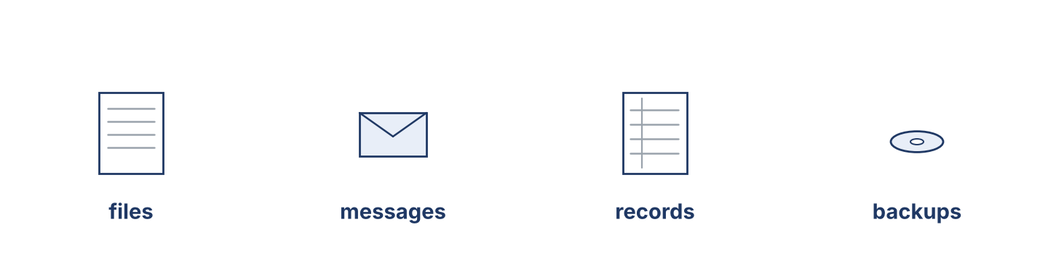
Figure 2.2 · The kinds of data an office keeps.
Complete the table. Write what each kind of data is and where it is kept. (0. is done.)
Data | What it is | Where it is kept
Files | the documents people write | in folders on the server
Messages
Records
Backups
0. Files — the documents people write — in folders on the server.
Part 1: Types of Data
Match each kind of data with what it is. One meaning is not needed. Write the letter.
Column A
1. | File | ____
2. | Message | ____
3. | Record | ____
4. | Backup | ____
5. | Licence | ____
Column B
a) | one line of information about one thing or one person
b) | a document a person writes and saves
c) | a copy of the data, kept in a safe place
d) | a cable for the printer
e) | something one person sends to another
f) | the paper that gives the right to use a program
Part 1: Machines and Data — Multiple Choice
Read and choose the correct answer.
1. What does the memory do?
○ A) It keeps files when the power is off
○ B) It helps the machine work while it is on
○ C) It prints the work
○ D) It cleans the screen
2. What do you use a folder for?
○ A) To start the machine
○ B) To open an account
○ C) To clean the disk
○ D) To keep files together
3. What does a backup do?
○ A) It makes the machine faster
○ B) It keeps a copy of the data in a safe place
○ C) It joins the machines together
○ D) It prints a record
Part 1: Vocabulary Fill-in
Complete the sentences with the correct word.
Word bank: disk | network | folder | licence
1. Save the report in the ____________________ for this month.
2. The ____________________ joins all the machines in the office.
3. The ____________________ is full, so we must clean it.
4. We cannot use the program without a ____________________ .
Part 1: Write About the System (short)
Write two or three sentences about the machines or the data in your office. Use three words from this unit.
Model — read this first:
In our office there are fourteen machines and one server. Every person has an account with their own name, and the files are kept in folders on the server. There isn’t much space left on the old disk, so we are asking for a new one. The backup runs every night at nine o’clock.
Part 2 · Grammar — There is / There are + some / any / much / many
[OP] Operator track · pre-class input
Part 2: Notice
Read these lines from the office. Underline there is / there are. When do we use some, any, much and many?
There is a server in the small room. There are two printers on this floor. There isn’t much space left on the disk. There aren’t many licences for the new program. Is there any coffee? And are there any spare keyboards in the store?
Part 2: Grammar Focus Box
 | Form | Use | Example
There is / There isn’t | + singular or uncountable | one thing, or a quantity | There is a server in the room.
There are / There aren’t | + plural | more than one thing | There are two printers here.
Remember: some → + sentences. any → questions and – sentences. much → uncountable. many → countable.
Watch out! ✗ There are much data. → ✓ There is much data (data is uncountable here). ✗ There is three disks. → ✓ There are three disks.
Part 2: Controlled Practice
Complete with is or are. (0. is done.)
0. There is a server in the small room.
1. There ____________________ two printers on this floor.
2. There ____________________ some space left on the new disk.
3. There ____________________ four machines in the store.
4. There ____________________ a problem with the network.
Part 2: Some, Any, Much or Many?
Choose the correct word.
1. Is there ____________________ space on the disk? (any / some)
2. There aren’t ____________________ spare keyboards. (much / many)
3. There isn’t ____________________ time before the power cut. (much / many)
4. We have ____________________ new licences. (some / any)
Part 2: Correct the Sentence
Each sentence has one grammar mistake. Write the correct sentence.
1. There is two servers in the room.
2. How much machines are there?
3. There are much data on this disk.
4. Is there some space left?
Part 2: Freer Practice
Write two sentences about your office or your desk: one with there is and one with there are.
Part 2: Grammar Review
Choose the correct sentence.
1. Which sentence is correct?
○ A) There are three printers.
○ B) There is three printers.
○ C) There be three printers.
○ D) There am three printers.
2. Which sentence is correct?
○ A) There is many accounts.
○ B) There are many accounts.
○ C) There are much accounts.
○ D) There is much accounts.
→ Harvest: you will see there is / there are and some / any / much / many again in the Part 5 reading.
Part 3 · Listening
[OP] Operator track · pre-class input · scripts printed inline
Part 3: Checking the Machines
🔊 Audio Track 2.2
Before you listen: which thing does a security officer check first on a machine?
Nabil: Right, let’s check this machine. First, I look at the disk. There is some space left, but there isn’t much — only four gigabytes. Then I check the memory: there are eight gigabytes, and that is enough for this work. Next, the licences. There is a licence for the office program, but there isn’t one for the new reader, so I will write that down. Last, I look for the backup. There are two backups from this week, and that is good.
While you listen: write True, False, or Not Given. (0. is done.)
0. Nabil is checking a machine. — True
1. There is a lot of space on the disk. ____
2. There is a licence for the new reader. ____
3. The machine is five years old. ____
Useful phrases: First, I look at… · There is / isn’t much… · There are two…
Part 3: At the Store
🔊 Audio Track 2.3
Before you listen: what does an IT department keep in its store?
Nabil: Tarek, are there any spare keyboards in the store? Tarek: Let me check. Yes, there are three. Nabil: Good. And how many disks are there? Tarek: There aren’t any new ones. There is one old disk, but it is full. Nabil: Then we must order some. How much space do we need? Tarek: For the backup, about two terabytes. Nabil: Write it down, please, and I will give the list to Maher.
While you listen: answer the questions. (0. is done.)
0. What is Tarek checking? — The store.
1. How many spare keyboards are there?
2. Are there any new disks?
3. What must Tarek write down?
Useful phrases: Are there any…? · How much…? · There aren’t any…
Part 3: The Morning Check
🔊 Audio Track 2.4
Before you listen: why does a manager check the system before the day starts?
Maher: Good morning. Before we start, let’s check the system. There are twenty-two accounts, and two of them belong to people who have left, so Nabil will close them. There is a backup from last night — Lina, please open it and see that the files are really there. Tarek, there aren’t any spare keyboards on your list; please count them again in the store. And everyone, there isn’t much space on the old server, so save your work in your own folder.
While you listen: match each person with what they do. One action is not needed. (0. is done.)
0. Maher → leads the morning check.
Column A
1. | Nabil | ____
2. | Tarek | ____
3. | Lina | ____
4. | Everyone | ____
Column B
a) | opens the backup and checks the files
b) | counts the spare keyboards again
c) | buys a new printer
d) | closes the accounts of people who have left
e) | saves their work in their own folder
Part 4 · Speaking
[OP] Operator track · in-class output
Part 4: Discussing Machines and Data
Work with a partner. Ask and answer these questions.
What machines are there in your office? Name three.
What can happen if there isn’t a backup of the data?
How often should an office count what is in its store?
Useful language: An office needs… · There is / are… · If there isn’t enough… · We should…
Part 4: Find the Difference
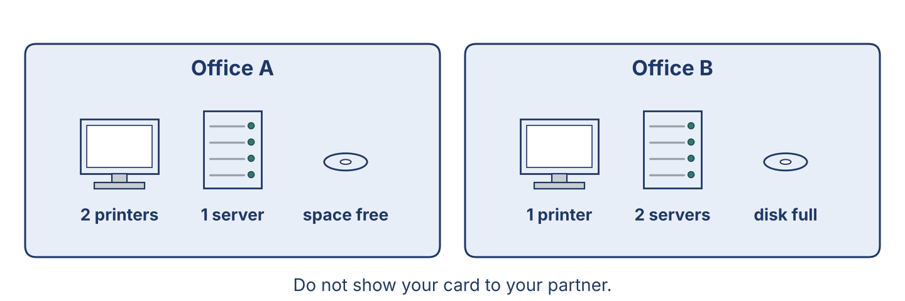
Figure 2.3 · Two offices, two sets of machines.
Work in pairs. Student A looks at Office A; Student B looks at Office B. Ask and answer to find four differences. Do not show your card.
Card A — Office A: there are two printers · there is one server · there aren’t any spare machines · there is a lot of space on the disk.
Card B — Office B: there is one printer · there are two servers · there are three spare machines · there isn’t much space on the disk.
Useful questions: Is there any…? · How much…? · How many…? · In my office there is…
Part 4: Reporting Role Play
Work in pairs. Read the model, then use the cards.
Model exchange: Nabil: There isn’t much space on the server, and there aren’t any spare disks. — Maher: How many do we need? — Nabil: Two, I think. There are twenty-two accounts now, and the backup is growing every week.
Card A — Security officer: report on the machines and the data (use some / any / much / many). Card B — Manager: ask how much and how many, then decide what to order first.
Stretch [PR]: a licence you need cannot be paid for from Damascus — explain the problem to your manager and ask for a decision, politely.
Part 4: Mini-Presentation
Prepare a short talk (about one minute). Say what machines and data there are in your office, and what there isn’t enough of.
Part 5 · Reading
[OP] Operator track · pre-class input
Part 5: The System and Its Data
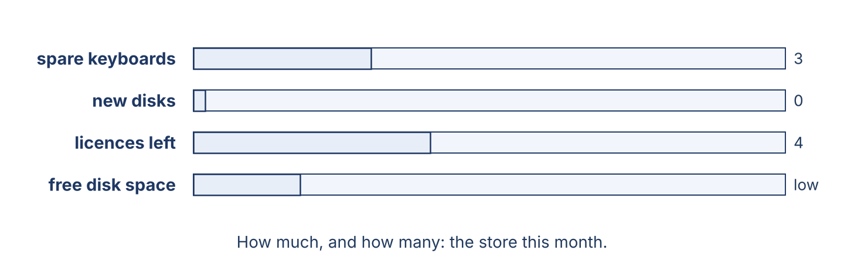
Figure 2.4 · What the store holds this month.
Before you read: which part of the system do you think is the most important to protect?
Gloss: level = how much of something there is · top up = to add more of something · spare = an extra one, kept ready
A system has many parts, and it needs several things to work well. There are the machines, and there is the data that lives on them. The disk keeps the files when the power is off, and the memory helps the machine work while it is on. There is a network that joins everything together, and there are licences that give the office the right to use its programs. The most important part, though, is the one you cannot see on a shelf: the backup. A machine can be replaced in a week, but ten years of records cannot. So a careful officer checks the levels every month — how much space there is on the disk, how many spare machines there are in the store, and how many licences are still good. If there isn’t much space left, the backup will stop, and nobody will notice until the day they need it.
Answer the multiple-choice questions. (0. is done.)
0. What keeps the files when the power is off? — the disk.
1. What does the memory do?
○ A) It keeps the files when the power is off
○ B) It joins the machines together
○ C) It helps the machine work while it is on
○ D) It prints the records
2. Why is the backup the most important part?
○ A) Because it is expensive
○ B) Because a machine can be replaced but old records cannot
○ C) Because it is new
○ D) Because it is fast
3. Why is checking the levels important?
○ A) It is slow and hard
○ B) It makes the machine faster
○ C) It is dangerous
○ D) A full disk stops the backup, and nobody notices
Part 5: Vocabulary in Context
Match each word from the text with its meaning. One meaning is not needed. Write the letter.
Column A
1. | disk | ____
2. | memory | ____
3. | network | ____
4. | spare | ____
Column B
a) | an extra one, kept ready
b) | it keeps the files when the power is off
c) | a tool for opening a machine
d) | the cables and equipment that join the machines
e) | it helps the machine work while it is on
Part 5: Machines and Licences in Syria
Before you read: are new machines and licences always easy to buy where you work?
Gloss: import = to bring from another country · genuine licence = a licence bought from the company that made the program
In Syria, machines and licences are not always easy to buy. New computers are expensive and hard to import, so many offices work with machines that are eight or ten years old. A genuine licence often cannot be paid for from Damascus at all, so an office buys it through a reseller in another country, and waits. Because of this, there are offices with twenty machines and only four licences, and the staff share what there is. A careful manager writes down how many licences there are and when each one ends, so that the office is never surprised. It costs nothing to keep that list, and it saves an argument later.
Write True or False. (0. is done.)
0. New machines are easy to import in Syria. — False
1. A genuine licence can be hard to pay for from Damascus. ____
2. Some offices have more machines than licences. ____
3. Keeping a list of licences is expensive. ____
Part 6 · Writing
[OP] Operator track · in-class / homework
Part 6: What Is in Your System? (50–70 words)
Describe the machines and the data in an office you know. Use there is and there are, with some, any, much and many.
Model — read this first:
In our office there is one server and there are fourteen machines. There are twenty-two accounts, one for every person. There is a backup every night, and there are two copies of it. There isn’t much space left on the old disk, and there aren’t any spare machines in the store. We need some new disks this month.
Plan (fill in, then write): In our office, there is ___. There are ___. There isn’t much ___. There aren’t many ___.
Word bank: there is / there are… | some / any / much / many… | machine | account | disk | backup | licence
Check before you finish: ☐ there is + there are used? ☐ some / any / much / many used? ☐ 50–70 words?
Part 6: Why Backups Matter (50–70 words)
Write why a backup of the data is important. Give reasons.
Model — read this first:
A backup is important because a disk can stop working on any day, with no warning. If there isn’t a copy, the work of many years is gone in a minute. A backup also helps when somebody deletes a file by mistake, which happens in every office. It costs little, and it saves the company from a loss it cannot repair.
Word bank: … is important because… | if there isn’t a copy… | the work is gone | it costs little | it saves…
Check before you finish: ☐ a clear opinion? ☐ two or three reasons? ☐ 50–70 words?
Part 6: A Stock Note (50–70 words)
Write a short note from Nabil (security officer) to Maher (manager) about what the department needs.
Model — read this first:
Dear Maher, I checked the store this morning. There are three spare keyboards, but there aren’t any new disks, and there is only one old disk, which is full. There isn’t much space left on the server either. Please can we order two disks of two terabytes this month? The backup will stop without them. Thank you. Nabil.
Plan (fill in, then write): Dear ___, I checked ___. There is / isn’t ___. There are / aren’t ___. Please can we order ___? Thank you. ___
Check before you finish: ☐ there is/are + some/any/much/many? ☐ a clear request? ☐ 50–70 words?
Part 6: Reflection — A Data Problem (40–60 words)
Write about a time a computer lost some work, or a disk became full.
Model — read this first:
Last year the disk in my brother’s computer stopped working. There wasn’t a backup, and three years of his study notes were gone. He went to two shops, but there wasn’t any way to read the disk. Now he keeps a copy on another disk every week, and he says it is the cheapest thing he has ever bought.
Check before you finish: ☐ the problem described? ☐ there is/are used? ☐ 40–60 words?
Part 7 · Management File — Checking the Stock of Machines and Licences
[PR] Practitioner track (optional for beginners) · IT and security manager
7A: Phrase Bank
Match what a manager says with its purpose. One purpose is not needed. Write the letter.
Column A
1. | “How much space do we have?” | ____
2. | “How many licences are left?” | ____
3. | “Please order some new disks.” | ____
4. | “Without a backup we lose everything.” | ____
Column B
a) | asking about quantity (countable)
b) | explaining why it matters
c) | asking about quantity (uncountable)
d) | talking about the weather
e) | giving an instruction to buy
7B: Manager Dialogue
🔊 Audio Track 2.5
Before you read: what does a manager ask about when checking the stock?
Maher: Nabil, let’s check the stock before the new staff arrive. Nabil: Right. How much space do we have on the server? Maher: That is my question for you. Nabil: About two hundred gigabytes. There isn’t much, and the backup grows every week. Maher: And how many licences are left for the office program? Nabil: Four. There are twenty-two people, so we are sharing. Maher: Then order two disks and ask the reseller about six more licences. Write it down, and I will sign it today.
Answer the questions. (0. is done.)
0. When do they check the stock? — Before the new staff arrive.
1. How much space is there on the server?
2. How many licences are left?
3. What must Nabil order?
7C: Controlled Practice — Completing the Order
Complete with much, many, some, or any.
Word bank: much | many | some | any
1. There isn’t ____________________ space on the server.
2. There aren’t ____________________ licences left.
3. Please order ____________________ new disks.
4. Is there ____________________ room in the store?
7D: Role-Play — The Stock Check
In pairs. One is the manager (Maher); one is the security officer (Nabil). Use the model and the cards.
Model exchange: Maher: How much space do we have? — Nabil: There is about two hundred gigabytes, but there isn’t much free. — Maher: And how many licences? — Nabil: Four, for twenty-two people.
Card A — Manager (Maher): ask how much / how many of three things · decide what to order first. Card B — Security officer (Nabil): answer with some / any / much / many · say what will stop working without it.
Stretch [PR]: money is tight this month — decide whether to buy disks or licences first, and say why to the staff who will keep sharing.
7E: Supervisory Writing (50–80 words)
You are Maher. Write a short order for the supplier. Say what you need and how much or how many.
Model — read this first:
Dear Sir, Please send us the following for Cham Systems, Damascus: two disks of two terabytes, six licences for the office program, and three spare keyboards. We have only four licences for twenty-two staff, so the licences are the most urgent part of this order. Please tell us the price and when you can deliver. Thank you. Maher Khoury, IT and Security Manager.
Check before you finish: ☐ clear quantities (how much / how many)? ☐ what is most urgent? ☐ 50–80 words?
Part 8 · Global Case Study — The Office That Never Lost a Record
[PR] Practitioner track · pre-read / in-class discuss
Before you read: what is the problem if an office keeps its only copy of the records in one place?
Gloss: stock = the things a business keeps ready to use · order = to ask a supplier to send more · restore = to bring the files back from a backup
A medium-sized company kept all of its records on one server in the basement. There was a backup, but nobody had ever opened it. One winter a pipe broke, and the water reached the machines. The company lost the server in one night. When the manager opened the backup, he found that it had stopped working eleven months before: the disk had been full, and the message had gone to an address nobody read. The company rebuilt what it could from paper and from the staff’s own copies, and it took five months. After that, the manager made two rules. First, there must be two backups, and one of them must be in another building. Second, somebody must restore one file from the backup every month and sign a sheet to say it worked. Ten years later the company has never lost a record again, and the sheet is still signed every month.
Answer the questions. (0. is done.)
0. Where were all the records kept? — On one server in the basement.
1. What did the manager find when he opened the backup?
2. How long did the company take to rebuild its records?
3. What two rules did the manager make?
Part 8: Vocabulary in Context
Match each word with its meaning. One meaning is not needed. Write the letter.
Column A
1. | backup | ____
2. | restore | ____
3. | record | ____
4. | rule | ____
Column B
a) | to bring the files back from a copy
b) | a copy of the data, kept in a safe place
c) | something everybody in the office must do
d) | a new computer
e) | one line of information kept about one thing
Part 8: Discussion
Talk with a partner. Use the frames.
Discussion frames: “This is similar to Syria because…” · “This is different from Syria because…” · “The first rule I would make is…” · “A backup nobody tests is…”
Part 9 · Local Case Study — Syria in Focus: Genuine Licence or Cheaper Copy?
[PR] Practitioner track · pre-read / in-class decide
Before you read: when an office needs a program, what two choices does it often have?
A trading company in Aleppo needed an accounts program for six machines. Rana, who looked after the computers, asked for prices. A genuine licence cost a great deal and had to be bought through a reseller in Beirut, with a wait of three weeks. A copy from the market cost almost nothing and could be installed the same afternoon. The owner wanted the cheap copy. Rana explained what he was really buying: the cheap copy came with no updates, so any fault in it would stay for ever; it could not be registered with the Ministry if the company was ever asked; and the shop that sold it would not answer the telephone in six months. In the end they bought two genuine licences for the two machines that held the accounts, and used the free reader on the other four. It was not the cheapest answer, and it was not the most expensive one.
Answer the questions. (0. is done.)
0. How many machines needed the program? — Six.
1. What were the two choices?
2. What three problems did Rana explain?
3. What did the company decide in the end?
Part 9: Decision Task
A manager wants the cheapest copy for every machine in the office, including the one that holds the staff records. Should the officer (a) agree, (b) refuse for every machine, or (c) ask for genuine licences only where the important data is? Choose one and give reasons.
Answer frame: “I think the officer should ___ because ___. For the important machines, ___. This is better than ___ because ___.”
Model — read this first:
I think the officer should ask for genuine licences only where the important data is, because the office cannot pay for everything at once. For the machines that hold the staff records, a licence with updates is worth the money. This is better than refusing for every machine, because the manager would say no to the whole plan, and then nothing would be protected.
Phrase bank: I think… should… · because… · for important data… · This is better than… · In my opinion…
Part 10 · Review and Can-Do
[OP + PR] · homework / self-study
Part 10: Spiral Review
Complete the review. (0. is done.)
0. The big computer that keeps files for many people is the server.
Word bank: disk | backup | are | is | many
1. The part that keeps your files when the power is off is the ____________________ .
2. A copy of the data, kept in a safe place, is a ____________________ .
3. “There ____________________ two printers on this floor.”
4. “There ____________________ some space left on the disk.”
5. much is for uncountable nouns; ____________________ is for countable nouns.
Part 10: Can-Do
Can-Do checklist
☐ I can name the main machines, accounts and kinds of data in an office system.
☐ I can use there is / there are with some, any, much and many.
☐ I can understand a stock check between a manager and a security officer.
☐ I can write a short order or stock note (Practitioner).
☐ I can say what an office has and how much or how many.
Part 10: Glossary
Unit 2 glossary (10 words)
disk · memory · network · folder · record · licence · printer · backup · restore · spare

Unit 3: Safe Working at the Desk — Passwords and Protection
English for Cybersecurity Personnel · Level: Upper A2 (the course moves to Low B1 from Unit 6) · Tracks: [OP] Warm-Up + Parts 1–6 · [PR] Parts 7–10
Warm Up
[OP] Operator track · in-class starter
Warm-up: Protections and Their Uses
Match the protections with their uses. One use is not needed. Write the letter.
Column A
1. | Password | ____
2. | Screen lock | ____
3. | Antivirus | ____
4. | Backup | ____
5. | Update | ____
Column B
a) | it hides your work when you leave your desk
b) | you use it to check the oil level
c) | it keeps a copy of your files in a safe place
d) | a secret word that opens your account
e) | it fixes faults in a program
f) | it watches for bad files on your machine
Warm-up: At Your Desk
Complete the sentences using the words in the word bank.
Word bank: password | screen | backup | tidy
1. Choose a long ____________________ that nobody can guess.
2. Lock your ____________________ before you leave the desk.
3. Check that the ____________________ ran last night.
4. Keep your desk ____________________ , with no notes under the keyboard.
Warm-up: Reading About Safe Working
Read the text and choose the correct answer.
Safe working is the most important rule at a desk. First, choose a long password, and never write it on paper. Then lock your screen every time you stand up, even for a minute. Next, keep your desk tidy: no notes, no open files, no visitors behind you. Finally, if something looks strange on your machine, stop and tell the help desk. Never try to repair it yourself.
1. What must you do first?
○ A) Nothing
○ B) Open your messages
○ C) Choose a long password
○ D) Call the manager
2. When something looks strange on your machine, what must you do?
○ A) Repair it yourself
○ B) Turn the machine off and say nothing
○ C) Stop and tell the help desk
○ D) Ask a visitor
Part 1 · Vocabulary and Terminology
[OP] Operator track · pre-class input
Part 1: Protection and Safe-Working Terms
Match the words with their meanings. One meaning is not needed. (0. is done for you.)
0. Screen lock → the step that hides your work when you leave your desk.
Column A
1. | Antivirus | ____
2. | Update | ____
3. | Passphrase | ____
4. | Clear desk | ____
5. | Visitor | ____
6. | Shoulder surfing | ____
7. | Report | ____
Column B
a) | a long password made of several words
b) | a new version that fixes faults in a program
c) | a rule that leaves no papers or notes on the desk at night
d) | a spanner for the server
e) | somebody from outside who must be met and signed in
f) | it watches for bad files on your machine
g) | to tell the help desk what you have seen
h) | when somebody reads your screen over your shoulder
Gloss: passphrase = a long password made of several words · shoulder surfing = when somebody reads your screen over your shoulder
Part 1: Pronunciation
🔊 Audio Track 3.1
Listen and practise these words. Say each word aloud and stress the loud syllable (CAPITALS).
antivirus — AN-ti-vi-rus
passphrase — PASS-phrase
visitor — VI-si-tor
protect — pro-TECT
safety — SAFE-ty
report — re-PORT
Part 1: The Protections Table
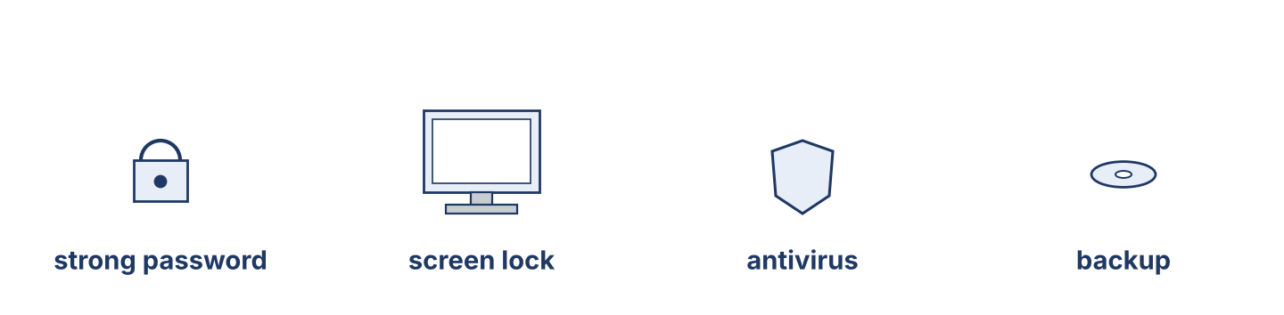
Figure 3.1 · The four protections every desk needs.
Complete the table. Write what each protection does and when to use it. (0. is done.)
Protection | Protects | When to use it
Screen lock | your open work | (example) every time you stand up
Strong password
Antivirus
Backup
0. Screen lock — your open work — every time you stand up.
Part 1: Everyday Protections
Match each protection with what it does. One meaning is not needed. Write the letter.
Column A
1. | Strong password | ____
2. | Screen lock | ____
3. | Antivirus | ____
4. | Clear desk | ____
5. | Backup | ____
Column B
a) | it watches for bad files on your machine
b) | it stops somebody opening your account
c) | it puts out a fire
d) | it keeps a copy of your files in a safe place
e) | it hides your work when you leave
f) | it leaves nothing on the desk for a visitor to read
Part 1: Protection and Safe Working — Multiple Choice
Read and choose the correct answer.
1. What does a passphrase do?
○ A) It cleans the disk
○ B) It makes a password long and hard to guess
○ C) It prints the records
○ D) It cools the machine
2. What is a clear desk for?
○ A) Leaving nothing for a visitor to read
○ B) Turning screws
○ C) Checking the backup
○ D) Storing cables
3. What does shoulder surfing mean?
○ A) Somebody takes your chair
○ B) Somebody cleans your screen
○ C) Somebody carries your machine
○ D) Somebody reads your screen from behind you
Part 1: Vocabulary Fill-in
Complete the sentences with the correct word.
Word bank: antivirus | update | visitor | report
1. Run the ____________________ so the program has no known faults.
2. The ____________________ found a bad file and stopped it.
3. Always meet a ____________________ at the door and sign them in.
4. If you see something strange, ____________________ it to the help desk.
Part 1: Write About Protections (short)
Write two or three sentences about the protections you use at your desk. Use three words from this unit.
Model — read this first:
At my desk I use a long passphrase of four words, and I never write it down. I lock my screen every time I stand up, even to take a cup of tea. The antivirus runs by itself, and the backup runs at night. If I see something strange, I report it to the help desk at once.
Part 2 · Grammar — Imperatives and Sequencers
[OP] Operator track · pre-class input
Part 2: Notice
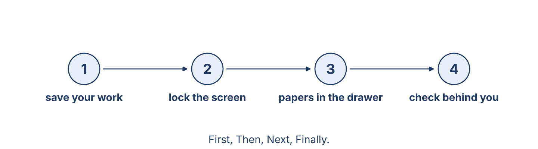
Figure 3.2 · Leaving your desk safely, step by step.
Read these rules from the office. Underline the verbs. Which words show the order of the steps?
First, save your work. Then lock your screen. Next, put your papers in the drawer. Finally, check that nobody is waiting behind you. Never leave your account open. Don’t write your password on paper. If you are not sure, ask the help desk.
Part 2: Grammar Focus Box
 | Form | Use | Example
Imperative | base verb (no subject) | an order, a rule, an instruction | Lock your screen.
Negative imperative | Don’t / Never + verb | a rule about what not to do | Never share your password.
Remember: Negative imperative = Don’t / Never + verb. Use sequencers to show the order: First, Then, Next, Finally.
Watch out! ✗ You lock your screen. (as a rule) → ✓ Lock your screen. ✗ Not share your password. → ✓ Don’t share your password.
Part 2: Controlled Practice
Write the instruction as an imperative. (0. is done.)
0. (lock) your screen. → Lock your screen.
1. (not / write) your password on paper.
2. (save) your work first.
3. (not / open) a file from a message you did not expect.
4. (report) a strange message to the help desk.
Part 2: Put the Steps in Order
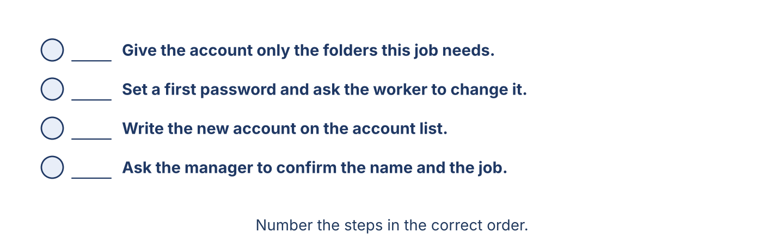
Figure 3.3 · Opening an account for a new worker.
Number these steps to open an account for a new worker. Use the safe order.
0. Ask the manager to confirm the new worker’s name and job. — 1
____ Give the account only the folders this job needs.
____ Set a first password and ask the worker to change it.
____ Write the new account on the account list.
Part 2: Correct the Sentence
Each sentence has one grammar mistake. Write the correct sentence.
1. You lock your screen when you leave.
2. Not open a file from a strange message.
3. First open the account, then ask the manager.
4. Please to report the problem.
Part 2: Freer Practice
Write three desk rules for your office. Use imperatives (and one negative imperative).
Part 2: Grammar Review
Choose the correct answer.
1. Which is a correct instruction?
○ A) Lock your screen.
○ B) You locking your screen.
○ C) To lock your screen.
○ D) Your screen lock.
2. Which order is safe and correct?
○ A) First open the account, then ask the manager.
○ B) First ask the manager, then open the account.
○ C) Open the account and tell nobody.
○ D) Never ask the manager.
→ Harvest: you will see imperatives and sequencers again in the Part 5 reading.
Part 3 · Listening
[OP] Operator track · pre-class input · scripts printed inline
Part 3: A Security Briefing
🔊 Audio Track 3.2
Before you listen: what does a security officer say before new staff start work?
Nabil: Listen, everyone, before we start. First, always lock your screen when you stand up — every time, even for one minute. Second, never share your password, not with me and not with your manager. Third, don’t open a file from a message you did not expect; send it to the help desk and we will look at it. Fourth, keep your desk clear at night: no papers, no notes. And if you are ever not sure, stop and ask. Nobody here is angry about a question.
While you listen: write True, False, or Not Given. (0. is done.)
0. Nabil is giving a security briefing. — True
1. You can share your password with your manager. ____
2. You must lock your screen every time you stand up. ____
3. The briefing happens every Monday. ____
Useful phrases: First, always… · Never… · If you are not sure…
Part 3: Where Is the Rule?
🔊 Audio Track 3.3
Before you listen: where does an office keep its written rules?
Tarek: Ustaz, where is the password rule written? Nabil: It’s on the board by the help desk, and in the folder called Rules on the server. Tarek: And what do I do first with a new machine? Nabil: First, change the first password. Then lock the screen and check it works. Tarek: And before I give the machine to the user? Nabil: Before that, run the update and check the antivirus is on. Never give out a machine without those two.
While you listen: answer the questions. (0. is done.)
0. What is Tarek looking for? — The written rules.
1. Where are the rules kept?
2. What must Tarek do first with a new machine?
3. What must he do before giving the machine to the user?
Useful phrases: Where is…? · It’s on the board / in the folder… · First… Then… Before that…
Part 3: The Office Rules
🔊 Audio Track 3.4
Before you listen: how many desk rules do you think an office needs?
Maher: Welcome to Cham Systems. We have five simple rules, and everybody follows them, including me. Rule one: use a long passphrase and never share it. Rule two: lock your screen every time you stand up. Rule three: don’t open a file you did not expect — send it to the help desk. Rule four: keep your desk clear at night. Rule five: if you are not sure, stop and ask. That is all. Five rules, and we have had no trouble in three years.
While you listen: match each rule with what it says. One is not needed. (0. is done.)
0. Rule 1 → use a long passphrase and never share it.
Column A
1. | Rule 2 | ____
2. | Rule 3 | ____
3. | Rule 4 | ____
4. | Rule 5 | ____
Column B
a) | if you are not sure, stop and ask
b) | lock your screen every time you stand up
c) | buy a new machine every year
d) | keep your desk clear at night
e) | don’t open a file you did not expect
Part 4 · Speaking
[OP] Operator track · in-class output
Part 4: Discussing Safe Working
Work with a partner. Ask and answer these questions.
What protections do you use at your desk?
Why is a clear desk a safer desk?
What are three important desk rules?
Useful language: I use… · Always… · Never… · First… Then… Finally…
Part 4: Find the Difference
Work in pairs. Student A looks at Desk A; Student B looks at Desk B. Ask and answer to find four differences. Do not show your card.
Card A — Desk A: the screen is locked · the desk is clear · there is no password on paper · the drawer is closed.
Card B — Desk B: the screen is open · there are papers on the desk · there is a note under the keyboard · the drawer is open.
Useful questions: Is the screen locked? · Is there a note…? · At my desk, the…
Part 4: Safety Instructions Role Play
Work in pairs. Read the model, then use the cards.
Model exchange: Nabil: First, lock your screen when you stand up. — Tarek: Every time? — Nabil: Every time. Then keep your desk clear at night. And never write your password on paper.
Card A — Security officer: give the desk rules in order (use First, Then, Next, Finally). Card B — New worker: ask one question about each rule, and ask what to do if you are not sure.
Stretch [PR]: the new worker is in a hurry and wants to skip the screen lock — insist, and say why in one short sentence.
Part 4: Mini-Presentation
Prepare a short talk (about one minute). Explain the desk rules of your office, in order, to somebody on their first day.
Part 5 · Reading
[OP] Operator track · pre-class input
Part 5: Safe Working at the Desk
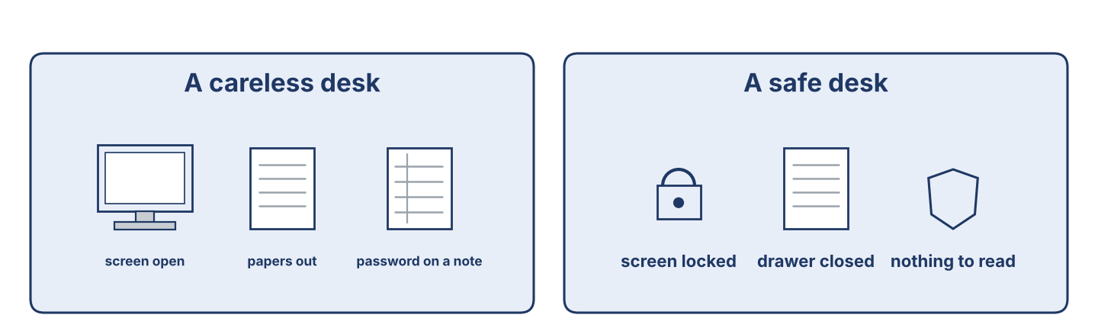
Figure 3.4 · A careless desk and a safe desk.
Before you read: what is the most important desk rule in an office?
Gloss: lock = to close your screen so nobody else can use it · passphrase = a long password made of several words · report = to tell the help desk what you have seen
An office can be a careless place, but good rules keep the work safe. The most important rule is the simplest: lock your screen every time you stand up. A machine left open for two minutes is enough. Next, choose a passphrase of four words instead of a short password, and never write it on paper or share it with anybody — not with a colleague, and not with the manager. Keep your desk clear at night, so that a cleaner or a visitor finds nothing to read. Before you open a file, look at who sent it: if you did not expect it, send it to the help desk first. And when something looks wrong, report it at once. The worst thing a worker can do is stay quiet, because a problem reported in the first hour is small, and the same problem reported in a week is not.
Answer the multiple-choice questions. (0. is done.)
0. What is the most important rule? — lock your screen every time you stand up.
1. Why must you keep your desk clear at night?
○ A) To look nice
○ B) To save money
○ C) So that a cleaner or a visitor finds nothing to read
○ D) Because it is the law
2. What must you do before you open a file?
○ A) Call the manager
○ B) Look at who sent it
○ C) Print it
○ D) Copy it to a disk
3. Why must a problem be reported at once?
○ A) Because a problem reported in the first hour is small
○ B) Because it is polite
○ C) Because the manager likes messages
○ D) Because the machine is new
Part 5: Vocabulary in Context
Match each word from the text with its meaning. One meaning is not needed. Write the letter.
Column A
1. | passphrase | ____
2. | lock | ____
3. | clear desk | ____
4. | report | ____
Column B
a) | to close your screen so nobody else can use it
b) | the rule that leaves nothing on the desk at night
c) | a tool for opening a machine
d) | to tell the help desk what you have seen
e) | a long password made of several words
Part 5: A Family Business in Syria
Before you read: how can a small office make its work safer without spending money?
Gloss: rule board = a board on the wall where the rules are written · habit = something you do the same way every time
In a small street in Damascus, the Khalil family has run a trading office for thirty years. For most of that time there were four machines and one password that everybody knew. Then the eldest son, Samir, came back from two years at a bank in Beirut, where he had learned how a careful office works. He did not change everything at once. In the first month he gave every person their own account and put the rules on a board by the door: five lines, in Arabic and English. In the second month he taught everybody the screen lock, and he locked his own screen in front of them every time he stood up, until it became a habit. In the third month he started the backup. None of it cost money. Samir says the hardest part was not the machines; it was asking his own uncle to stop using his son’s account.
Write True or False. (0. is done.)
0. The Khalil family office is new. — False
1. Samir learned how a careful office works at a bank in Beirut. ____
2. He changed everything in one day. ____
3. The changes cost the office a lot of money. ____
Part 6 · Writing
[OP] Operator track · in-class / homework
Part 6: Desk Rules for the Office (50–70 words)
Write five desk rules for an office. Use imperatives and sequencers.
Model — read this first:
First, choose a passphrase of four words and never write it down. Then lock your screen every time you stand up, even for a minute. Next, don’t open a file from a message you did not expect; send it to the help desk. After that, keep your desk clear at night. Finally, if you are not sure about anything, stop and ask.
Plan (fill in, then write): First, always… Then… Next… After that… Finally…
Word bank: First, Then, Next, Finally | Always… / Never… | Don’t… | lock | report | share
Check before you finish: ☐ imperatives used? ☐ sequencers used? ☐ 50–70 words?
Part 6: Why Safe Working Matters (50–70 words)
Write why safe working is important in an office. Give reasons.
Model — read this first:
Safe working is important because one open screen can cost the company everything it keeps. A shared password means nobody can say who did what, so an honest worker cannot be cleared. A reported problem is small in the first hour and large in a week. The rules take ten seconds each, and they protect the work of the whole office.
Word bank: … is important because… | one open screen… | nobody can say who… | it takes ten seconds | it protects…
Check before you finish: ☐ a clear opinion? ☐ two or three reasons? ☐ 50–70 words?
Part 6: A Desk Notice (40–60 words)
Write a short notice to put on the office wall. Use clear imperatives.
Model — read this first:
BEFORE YOU LEAVE YOUR DESK. Save your work. Lock your screen — every time. Put your papers in the drawer. Take nothing home on a USB stick without asking. If you see something strange on your machine, tell the help desk today, not tomorrow. Thank you. The IT and Security Department.
Check before you finish: ☐ clear imperatives? ☐ easy to read on a wall? ☐ 40–60 words?
Part 6: Reflection — A Time Care Mattered (40–60 words)
Write about a time when care with a password or a file was important, at work or at home.
Model — read this first:
Last winter my cousin opened a file in a message that looked like a delivery note. The machine became slow and strange, and he turned it off. He told the office the same morning, and they cleaned it in one afternoon. If he had said nothing for a week, the whole office would have lost its files.
Check before you finish: ☐ a clear story? ☐ imperatives or past tense used well? ☐ 40–60 words?
Part 7 · Management File — The Desk Induction
[PR] Practitioner track (optional for beginners) · IT and security manager
7A: Phrase Bank
Match what a manager says with its purpose. One purpose is not needed. Write the letter.
Column A
1. | “Always lock your screen.” | ____
2. | “Let me show you where the rules are.” | ____
3. | “Never share your password with anybody.” | ____
4. | “Ask me if you are not sure.” | ____
Column B
a) | showing someone around
b) | giving a strong warning
c) | giving a simple rule
d) | asking about the price
e) | offering help and support
7B: Manager Dialogue
🔊 Audio Track 3.5
Before you read: what does a manager show a new worker on their first day at a desk?
Nabil: Tarek, today is your desk induction. First, this is your account, with your own name on it. Tarek: And the password? Nabil: You set it now, in front of me, and I do not want to know it. Make it four words long. Then lock the screen and check it opens again. Tarek: What do I do after I use a machine at somebody else’s desk? Nabil: Sign out. Always. And never leave a file open on their screen. Tarek: And if I see something strange? Nabil: Stop and tell me. Never try to repair it yourself.
Answer the questions. (0. is done.)
0. What is Tarek’s induction about? — Safe working at his desk.
1. Who sets the password, and who may know it?
2. What must he do after using a machine at another desk?
3. What must he never do?
7C: Controlled Practice — Induction Steps
Put a manager’s induction steps in order. Number them 1–5. (0. is done.)
0. Give the new worker their own account. — 1
____ Show the rule board by the door.
____ Explain how to lock the screen.
____ Show where to report a strange message.
____ Say “ask me if you are not sure.”
7D: Role-Play — Inducting a New Worker
In pairs. One is the security officer (Nabil); one is the new worker (Tarek). Use the model and the cards.
Model exchange: Nabil: First, set your own password — I must not know it. — Tarek: How long? — Nabil: Four words. Then lock your screen, and check it opens again.
Card A — Security officer (Nabil): give the induction in order (account, password, screen lock, reporting). Card B — New worker (Tarek): ask one question at each step, and ask what to do if you are not sure.
Stretch [PR]: the new worker says the last office shared one password and nothing ever happened — answer without criticising the last office.
7E: Supervisory Writing (50–80 words)
You are Maher. Write the office’s desk rules as a short numbered notice for the wall.
Model — read this first:
CHAM SYSTEMS — DESK RULES. 1. Use a passphrase of four words. Never write it down. 2. Lock your screen every time you stand up. 3. Do not open a file you did not expect; send it to the help desk. 4. Keep your desk clear at night. 5. If you are not sure, stop and ask. These five rules apply to everybody, including the manager. Maher Khoury.
Check before you finish: ☐ clear numbered rules? ☐ imperatives used? ☐ 50–80 words?
Part 8 · Global Case Study — The Office with No Shared Passwords
[PR] Practitioner track · pre-read / in-class discuss
Before you read: how can an office stop a problem before it starts?
Gloss: incident = something that goes wrong and must be recorded · rule = an instruction that everybody follows · audit = a careful check of how things are really done
A large company once had too many small incidents. A file was deleted and nobody knew who had deleted it. A payment was changed and three people had used the same account that morning. The new manager did not buy anything. She did two things. First, she put the rules on the wall in every room, in five short lines that a tired person could read. Second, she walked through one department every morning before the staff arrived and wrote down what she saw: an open screen, a password on a card, a drawer left unlocked. She did not name anybody; she wrote numbers, and she put the numbers on the same wall each week. In the first month there were nineteen open screens. By the sixth month there were none. She says good security is not a machine you buy; it is a habit you build, and the only way to build it is to count it.
Answer the questions. (0. is done.)
0. What problem did the company have? — Too many small incidents.
1. What did the manager put on the wall?
2. What did she do every morning?
3. What did she say good security is?
Part 8: Vocabulary in Context
Match each word with its meaning. One meaning is not needed. Write the letter.
Column A
1. | rule | ____
2. | incident | ____
3. | habit | ____
4. | audit | ____
Column B
a) | something that goes wrong and must be recorded
b) | an instruction that everybody follows
c) | a careful check of how things are really done
d) | a new machine
e) | something you do the same way every time
Part 8: Discussion
Talk with a partner. Use the frames.
Discussion frames: “This is similar to my office because…” · “This is different because…” · “The rule I would put on the wall first is…” · “Counting works because…”
Part 9 · Local Case Study — Syria in Focus: Raising a Small Office to Bank Standard
[PR] Practitioner track · pre-read / in-class decide
Before you read: what does a small office need before a bank will work with it?
Maher once visited a small company in Damascus that wanted to do work for a bank. The bank had sent a list of what it required, and the owner thought he needed to buy expensive equipment. Maher read the list and told him that most of it cost nothing. The bank wanted three things first: one account for each person, with no sharing; a written rule that staff follow, kept where anybody can see it; and a record of who may open which files, reviewed twice a year. The owner did all three in six weeks, with no new machines. The bank then asked for two more things that did cost money: a second backup kept in another building, and a proper lock on the server room door. After six months the bank signed the contract. The owner told Maher that the part he had expected to be hardest — the equipment — had been the easy part.
Answer the questions. (0. is done.)
0. What did the small office want to do? — Work for a bank.
1. What did the owner think he needed first?
2. What three things did the bank want that cost nothing?
3. What happened after six months?
Part 9: Decision Task
An office owner has a little money to improve his security. Should he first (a) buy a lock for the server room, (b) give every person their own account, or (c) write the rules on a board? Choose one and give reasons.
Answer frame: “I think the owner should first ___ because ___. Safety is ___. After that, he can ___.”
Model — read this first:
I think the owner should first give every person their own account, because without that nobody can say who did what, and no rule can be checked. Safety is knowing who opened a file. After that, he can write the rules on a board, which costs nothing, and buy the lock when the money is there.
Phrase bank: I think… should first… · because… · Safety is… · After that… · In my opinion…
Part 10 · Review and Can-Do
[OP + PR] · homework / self-study
Part 10: Spiral Review
Complete the review. (0. is done.)
0. You use a passphrase to open your account safely.
Word bank: screen lock | antivirus | Lock | finally | backup
1. The step that hides your work when you leave your desk is the ____________________ .
2. The program that watches for bad files on your machine is the ____________________ .
3. “ ____________________ your screen.” (an instruction)
4. To show the last step, we use the word ____________________ .
5. A copy of the files, kept in a safe place, is a ____________________ .
Part 10: Can-Do
Can-Do checklist
☐ I can name the main protections and safe-working terms for a desk.
☐ I can give instructions and rules using imperatives and sequencers.
☐ I can understand a security briefing and a desk induction.
☐ I can write clear desk rules for an office.
☐ I can induct and brief a new worker (Practitioner).
Part 10: Glossary
Unit 3 glossary (10 words)
passphrase · screen lock · antivirus · update · clear desk · visitor · shoulder surfing · report · incident · habit

Unit 4: Checking, Readings and Diagnosis
English for Cybersecurity Personnel · Level: Upper A2 (the course moves to Low B1 from Unit 6) · Tracks: [OP] Warm-Up + Parts 1–6 · [PR] Parts 7–10
Warm Up
[OP] Operator track · in-class starter
Warm-up: Checking Words
Match the words with their meanings. One meaning is not needed. Write the letter.
Column A
1. | Reading | ____
2. | Log | ____
3. | Report | ____
4. | Alert | ____
5. | Range | ____
Column B
a) | a message the system sends when something is wrong
b) | a strong stand that holds a machine
c) | the numbers that are allowed, from the lowest to the highest
d) | a number you read from a machine or a program
e) | the list the machine writes of everything that happens
f) | a page of numbers that somebody reads every week
Warm-up: Checking the Numbers
Complete the sentences using the words in the word bank.
Word bank: log | reading | alert | report
1. Write the ____________________ from the disk check in the sheet.
2. The ____________________ shows who signed in and when.
3. The system sent an ____________________ at two o’clock this morning.
4. Maher reads the weekly ____________________ every Sunday.
Warm-up: Reading About Checking
Read the text and choose the correct answer.
A good officer checks carefully. He reads the free space on each disk, the age of the last backup, and the number of failed sign-ins. Then he writes the numbers down. A number on its own means very little. A number next to last week’s number means a great deal, because it shows whether the problem is getting better or worse. Every reading has a tolerance: the range that is allowed.
1. What does the officer read on each machine?
○ A) The price
○ B) The colour
○ C) The free space, the backup age and the failed sign-ins
○ D) The name of the user
2. What does ‘tolerance’ mean?
○ A) The colour
○ B) The price
○ C) The weight
○ D) The range that is allowed for a reading
Part 1 · Vocabulary and Terminology
[OP] Operator track · pre-class input
Part 1: Checking and Diagnosis Terms
Match the words with their meanings. One meaning is not needed. (0. is done for you.)
0. Log → the list the machine writes of everything that happens.
Column A
1. | Free space | ____
2. | Backup age | ____
3. | Failed sign-in | ____
4. | Tolerance | ____
5. | Alert | ____
6. | Baseline | ____
7. | Diagnosis | ____
Column B
a) | how long ago the last copy of the files was made
b) | the normal reading, measured when everything is well
c) | finding out what is really wrong
d) | a cable for the printer
e) | how much room is left on a disk
f) | a message the system sends when something is wrong
g) | the range that is allowed for a reading
h) | a try to open an account that did not work
Gloss: tolerance = the range that is allowed for a reading · baseline = the normal reading, measured when everything is well
Part 1: Pronunciation
🔊 Audio Track 4.1
Listen and practise these words. Say each word aloud and stress the loud syllable (CAPITALS).
reading — REA-ding
tolerance — TOL-er-ance
baseline — BASE-line
diagnosis — di-ag-NO-sis
measure — MEA-sure
alert — a-LERT
Part 1: Readings Table

Figure 4.1 · Where the numbers come from.
Complete the table. Write the unit and where you read it for each check. (0. is done.)
Check | Unit | Where you read it
Free disk space | per cent or gigabytes | (example) on the machine itself
Backup age
Failed sign-ins
Missing updates
0. Free disk space — per cent or gigabytes — on the machine itself.
Part 1: Readings and What They Tell You
Match each reading with what it tells you. One meaning is not needed. Write the letter.
Column A
1. | Low free space | ____
2. | Old backup | ____
3. | Many failed sign-ins | ____
4. | Many missing updates | ____
5. | No alert for a week | ____
Column B
a) | somebody is trying passwords, or a user has forgotten theirs
b) | the backup may have stopped and nobody noticed
c) | the machine has known faults nobody has fixed
d) | the printer is out of paper
e) | the copy of the files is too old to be useful
f) | either all is well, or the alerts are not arriving
Part 1: Checking — Multiple Choice
Read and choose the correct answer.
1. What unit is free disk space measured in?
○ A) Millimetres
○ B) Volts
○ C) Per cent or gigabytes
○ D) Degrees
2. What does a baseline do?
○ A) It shows the normal reading, so you can see a change
○ B) It lifts the machine
○ C) It turns the screen off
○ D) It cools the server
3. What is ‘tolerance’?
○ A) A type of cable
○ B) The range that is allowed for a reading
○ C) A machine part
○ D) A program
Part 1: Vocabulary Fill-in
Complete the sentences with the correct word.
Word bank: free space | backup | sign-ins | baseline
1. Check the ____________________ on the server before the weekend.
2. If the ____________________ is three days old, something has stopped.
3. Forty failed ____________________ in one hour is not normal.
4. Measure the ____________________ when everything is working well.
Part 1: Write About Checking (short)
Write two or three sentences about what you check on a machine or a system. Use three words from this unit.
Model — read this first:
Every Monday I check three numbers on the server. First, the free space: this week it is thirty per cent, which is lower than last week. Then the backup age: six hours, and that is good. Last, the failed sign-ins. Forty in one hour is much higher than our baseline, so I wrote it in the report for Maher.
Part 2 · Grammar — Comparatives and Superlatives
[OP] Operator track · pre-class input
Part 2: Notice
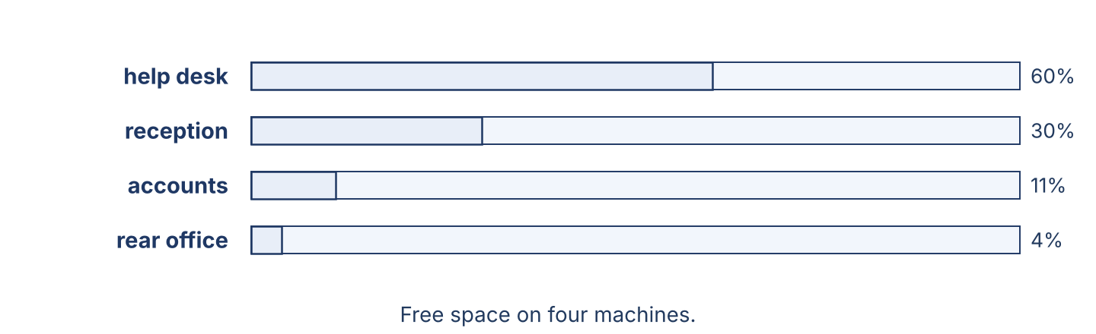
Figure 4.2 · Comparing free space on four machines.
Read these lines from a weekly check. Underline the comparatives and superlatives. Which ones compare two things, and which compare them all?
This machine is slower than that one. The server has more free space than the help-desk machine. The reception machine is the slowest of the four. Today’s reading is lower than yesterday’s. The rear office has the oldest backup in the building, and that is the worst of our problems this week.
Part 2: Grammar Focus Box
 | Form | Use | Example
Comparative | -er + than / more + than | comparing two things | This disk is fuller than that one.
Superlative | the -est / the most | comparing three or more | This is the fullest disk of all.
Remember: Short adjective + -er / -est (low → lower → the lowest). Long adjective + more / the most (more careful).
Watch out! ✗ gooder / more good → ✓ better / the best. ✗ lower as yesterday → ✓ lower than yesterday.
Part 2: Controlled Practice
Write the comparative form. (0. is done.)
0. This disk is fuller than that one. (full)
1. The rear office machine is ___ (slow) than the help-desk machine.
2. Today’s reading is ___ (low) than yesterday’s.
3. A new backup is ___ (good) than an old one.
4. This week’s number is ___ (bad) than last week’s.
Part 2: Superlatives
Write the superlative form. (0. is done.)
0. Of the four machines, the reception one is the slowest. (slow)
1. This is the ___ (low) reading of all.
2. This is the ___ (good) backup we have.
3. That is the ___ (bad) machine in the office.
4. The rear office has the ___ (old) backup of the four.
Part 2: Correct the Sentence
Each sentence has one grammar mistake. Write the correct sentence.
1. This machine is more worse than that one.
2. The reading is lower as yesterday.
3. This is the most low reading.
4. A new backup is gooder than an old one.
Part 2: Freer Practice
Compare two machines or two readings you know. Write one comparative sentence and one superlative sentence.
Part 2: Grammar Review
Choose the correct sentence.
1. Which sentence is correct?
○ A) This disk is fuller that that one.
○ B) This disk is fuller than that one.
○ C) This disk is more full than that one.
○ D) This disk is most full than that one.
2. Which sentence is correct?
○ A) This is the lowest reading.
○ B) This is the most low reading.
○ C) This is the more low reading.
○ D) This is the lower reading of all.
→ Harvest: you will see comparatives and superlatives again in the Part 5 reading.
Part 3 · Listening
[OP] Operator track · pre-class input · scripts printed inline
Part 3: Checking the Machines
🔊 Audio Track 4.2
Before you listen: how does an officer know that a machine needs attention?
Lina: Let me check these four machines. The help-desk machine has good free space — about sixty per cent. The reception machine has less, about thirty. The accounts machine is lower still: eleven per cent, and that is below our tolerance. The rear office machine is the worst of the four. It has four per cent free, and its backup is five days old. That is the one I will take first.
While you listen: write True, False, or Not Given. (0. is done.)
0. Lina is checking four machines. — True
1. The help-desk machine has the least free space. ____
2. The rear office machine has the oldest backup. ____
3. The machines are all five years old. ____
Useful phrases: … has more … than… · the worst of the four · below our tolerance
Part 3: The Weekly Report
🔊 Audio Track 4.3
Before you listen: what numbers does a weekly report give?
Nabil: Lina, what does the report say? Lina: The free space on the server is twenty-two per cent, which is lower than last week. Nabil: And the tolerance? Lina: Twenty per cent. So we are inside it, but only just. Nabil: What about sign-ins? Lina: Forty-one failed sign-ins on Thursday night, all on one account. That is much higher than our baseline of three or four. Nabil: Then Thursday is the thing to look at first, not the disk.
While you listen: answer the questions. (0. is done.)
0. What is Lina reading? — The weekly report.
1. Is the free space higher or lower than last week?
2. What is the tolerance?
3. Which reading is the most unusual?
Useful phrases: lower than last week · inside / outside the tolerance · higher than our baseline
Part 3: Comparing Three Offices
🔊 Audio Track 4.4
Before you listen: how does a manager decide which office to help first?
Maher: We have three offices to check this morning. Let’s compare them. The Damascus office is in the best condition: good free space, a backup from last night, no alerts. The Homs office is older, with less free space and two machines that are missing updates. The Aleppo office is the one I am worried about: its backup is nine days old, which is the worst reading on this page. All three need work, but Aleppo needs it today.
While you listen: match each office with its condition. One is not needed. (0. is done.)
0. The Damascus office → in the best condition.
Column A
1. | The Homs office | ____
2. | The Aleppo office | ____
3. | All three | ____
4. | None of them | ____
Column B
a) | the oldest backup, and the worst reading on the page
b) | older, with less free space and missing updates
c) | a new building with new machines
d) | need work, but not all today
e) | are closed this week
Part 4 · Speaking
[OP] Operator track · in-class output
Part 4: Discussing Readings
Work with a partner. Ask and answer these questions.
What numbers does an officer check on a system?
Why is it important to compare all the machines, not just one?
Why must a reading be inside the tolerance?
Useful language: We check… · … is more … than… · the most / the worst… · inside / outside the tolerance
Part 4: Find the Difference
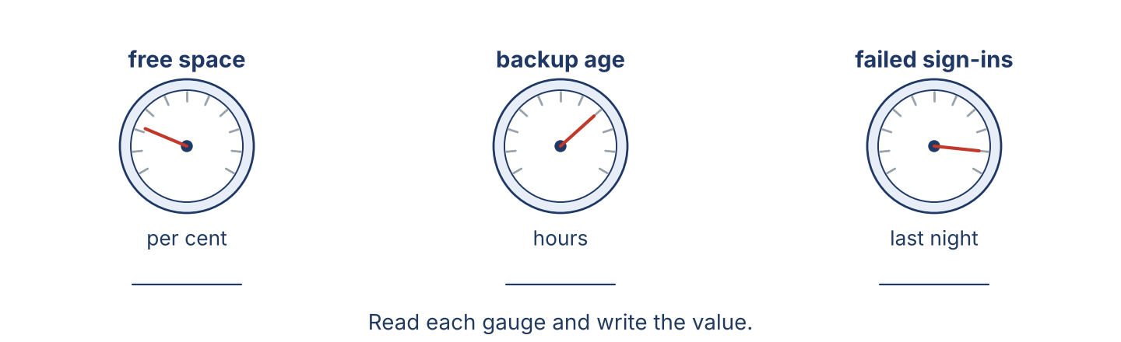
Figure 4.3 · Read each gauge and write the value.
Work in pairs. Student A looks at Office A; Student B looks at Office B. Ask and answer to find which office is in better condition. Do not show your card.
Card A — Office A: free space 55% · backup 6 hours old · 2 machines missing updates · 4 failed sign-ins.
Card B — Office B: free space 18% · backup 4 days old · 7 machines missing updates · 41 failed sign-ins.
Useful questions: How much free space? · Which is older? · Which office is the worst?
Part 4: Reporting Readings Role Play
Work in pairs. Read the model, then use the cards.
Model exchange: Lina: The accounts machine is fuller than the others, and the rear office is the worst of the four. — Nabil: How much free space on the worst one? — Lina: Four per cent. And its backup is five days old.
Card A — Officer: report the free space and the backup age for four machines, and say which is the worst. Card B — Manager: ask which is better, which is the worst, and what you should do first.
Stretch [PR]: two machines need work but there is only time for one before the power goes off — say which, and why, in two sentences.
Part 4: Mini-Presentation
Prepare a short talk (about one minute). Compare two machines or two offices you know, and say which one needs attention first.
Part 5 · Reading
[OP] Operator track · pre-class input
Part 5: Why Numbers Matter in Diagnosis
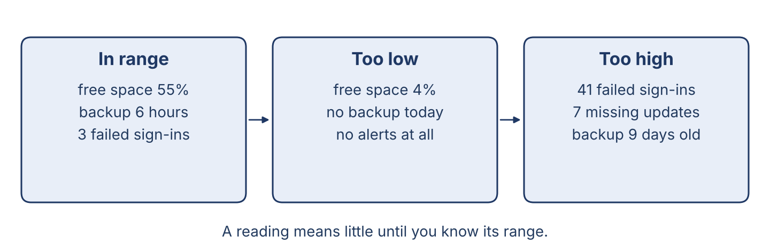
Figure 4.4 · Readings tell the story: in range, too low, too high.
Before you read: is measuring better than guessing? Why?
Gloss: diagnosis = finding out what is really wrong · tolerance = the range that is allowed · baseline = the normal reading, measured when all is well
Modern security work is about numbers. A careful officer does not guess that a machine is slow; she reads the free space and writes it down. She does not guess that the backup is working; she reads its age in hours. Each reading has a tolerance, and a reading inside the tolerance is not news. The important thing is the comparison. One reading on one day tells you very little. The same reading next to last week’s tells you whether the problem is getting better or worse, and the same reading next to the other machines tells you which one is the worst. That is why a good officer keeps a baseline: the normal number, measured when everything was well. Without a baseline, forty-one failed sign-ins looks frightening or ordinary, and nobody can say which. With one, it is plainly much higher than the three or four of a normal night, and it becomes the first thing to look at in the morning.
Answer the multiple-choice questions. (0. is done.)
0. What is modern security work about? — numbers.
1. What does the officer read to check the backup?
○ A) Its colour
○ B) Its price
○ C) Its age in hours
○ D) Its name
2. Why does the officer keep a baseline?
○ A) Because the manager asks for it
○ B) So that an unusual number can be recognised
○ C) To make the machine faster
○ D) To save disk space
3. Why does the officer compare the machines?
○ A) To find which one is the worst
○ B) To clean them
○ C) To sell them
○ D) To move them
Part 5: Vocabulary in Context
Match each word from the text with its meaning. One meaning is not needed. Write the letter.
Column A
1. | reading | ____
2. | tolerance | ____
3. | baseline | ____
4. | worst | ____
Column B
a) | the range that is allowed
b) | a number you read from a machine or a program
c) | a tool for opening a machine
d) | the normal reading, measured when all is well
e) | the least good of them all
Part 5: Checking Systems in Syria
Before you read: why might a system in Syria need checking more often than the book says?
Gloss: rough = hard, with difficult conditions · check interval = how often a check is done
Systems in Syria often work in hard conditions. The power goes off and comes back several times a day, and every time it does, a machine that was writing a file may not finish. Dust gets into fans, so machines run hotter and their disks fail earlier than the maker expects. Connections are slow and shared, so a backup that should take one hour may take six, and may not finish before the office opens. Because of this, a careful officer in Damascus does not simply follow the interval in the book. She reads the free space weekly instead of monthly, and she checks the backup age every morning rather than every Friday. It is more work, but it is far better than finding out in June that the last good copy of the records is from March.
Write True or False. (0. is done.)
0. Systems in Syria always work in easy conditions. — False
1. Dust makes machines run hotter. ____
2. The officer follows the book exactly, with no changes. ____
3. A shorter check interval finds problems earlier. ____
Part 6 · Writing
[OP] Operator track · in-class / homework
Part 6: Compare Two Machines (50–70 words)
Compare two machines, or two offices. Use comparatives and one superlative.
Model — read this first:
The help-desk machine is faster than the accounts machine, and it has more free space: sixty per cent against eleven. Its backup is newer too, six hours against three days. Of the four machines in our office, the rear office one is the worst: it has the least free space and the oldest backup. That is the machine I would repair first.
Plan (fill in, then write): The first machine is ___ than the second. It has more ___. Of the four, ___ is the worst because ___.
Word bank: … is more / -er than… | the most / the -est | free space | backup age | better / worse
Check before you finish: ☐ comparatives used? ☐ at least one superlative? ☐ 50–70 words?
Part 6: Why Measuring Matters (50–70 words)
Write why careful measuring is important in security work. Give reasons.
Model — read this first:
Measuring is important because a guess cannot be checked by anybody else. A number can. When I write that the free space is eleven per cent, my manager sees the same thing I saw, and next week we can tell whether it is better or worse. Measuring also finds the real problem instead of the loudest one, and it saves the time we would spend arguing.
Word bank: … is important because… | find the real problem | better or worse | a guess cannot be checked | it saves time
Check before you finish: ☐ a clear opinion? ☐ two or three reasons? ☐ 50–70 words?
Part 6: A Readings Note (50–70 words)
Write a short note from Lina (officer) to Maher (manager) with this week’s readings.
Model — read this first:
Dear Maher, Here are this week’s readings. Free space on the server is twenty-two per cent, lower than last week’s twenty-six, but still inside our tolerance of twenty. The backup is six hours old, which is good. The one number I do not like is Thursday night: forty-one failed sign-ins on one account, much higher than our baseline of three. Lina.
Plan (fill in, then write): Dear ___, Here are the readings for ___. The ___ is ___, which is ___ than last week. The reading I do not like is ___ because ___.
Check before you finish: ☐ clear readings + comparison? ☐ which one matters most? ☐ 50–70 words?
Part 6: Reflection — Comparing Two Things (40–60 words)
Write about two machines, programs or offices you know well, and compare them.
Model — read this first:
At home we have two computers. The newer one is faster, quieter, and its disk is bigger. The older one is slower, but it is the more useful of the two, because all our photographs are on it and my mother knows how to use it. Of everything in the house, it is the machine I back up most carefully.
Check before you finish: ☐ comparatives + one superlative? ☐ clear and true? ☐ 40–60 words?
Part 7 · Management File — Checking the Weekly Report
[PR] Practitioner track (optional for beginners) · IT and security manager
7A: Phrase Bank
Match what a manager says with its purpose. One purpose is not needed. Write the letter.
Column A
1. | “Which machine is the worst?” | ____
2. | “Is this inside the tolerance?” | ____
3. | “That is lower than last week.” | ____
4. | “Check that one first.” | ____
Column B
a) | comparing two readings
b) | giving an instruction
c) | asking which is the least good of all
d) | asking about the price
e) | asking whether a reading is allowed
7B: Manager Dialogue
🔊 Audio Track 4.5
Before you read: what does a manager check on a weekly report?
Maher: Lina, let’s look at this week’s report together. Lina: The free space on the server is twenty-two per cent. Maher: And the tolerance is twenty, so we are inside it. Is that higher or lower than last week? Lina: Lower. Twenty-six last week, twenty-two now. Maher: Then it will be outside the tolerance in two weeks. What is the worst reading on the page? Lina: Thursday night: forty-one failed sign-ins on Mr Aboud’s account. Maher: Start there. The disk can wait a week; that cannot.
Answer the questions. (0. is done.)
0. What are they looking at? — This week’s report.
1. What is the free space, and is it inside the tolerance?
2. What is the worst reading on the page?
3. What does Maher tell Lina to do?
7C: Controlled Practice — Reading the Table
The free space readings are: help desk 60%, reception 30%, accounts 11%, rear office 4%. Complete the sentences.
Word bank: more | most | least | worse
1. The help desk has ____________________ free space than reception.
2. The rear office has the ____________________ free space of the four.
3. The help desk has the ____________________ free space of all.
4. The accounts machine is ____________________ than reception.
7D: Role-Play — Reviewing the Report
In pairs. One is the manager (Maher); one is the officer (Lina). Use the model and the cards.
Model exchange: Maher: How is the free space? — Lina: Twenty-two per cent, lower than last week but inside the tolerance. — Maher: And the worst reading? — Lina: Forty-one failed sign-ins on Thursday.
Card A — Manager (Maher): ask about the free space and the backup, ask which is worst, and give one instruction. Card B — Officer (Lina): give the readings, compare them with last week, and say which worries you most.
Stretch [PR]: a reading is only a little outside the tolerance and the staff are busy — decide whether to act now or next week, and justify it.
7E: Supervisory Writing (50–80 words)
You are Maher. Write a short summary of this week’s readings for the company director, who is not a technical person.
Model — read this first:
Dear Mr Haddad, The systems were steady this week. Space on the main server has fallen from twenty-six to twenty-two per cent; it is still inside our limit, but we will need a new disk within two months. The backups all ran. One account had forty-one failed sign-ins on Thursday night, far above normal, and we are looking at it today. Nothing was lost. Maher Khoury.
Check before you finish: ☐ clear readings + comparison? ☐ plain words for a non-technical reader? ☐ 50–80 words?
Part 8 · Global Case Study — Why Standard Figures Matter
[PR] Practitioner track · pre-read / in-class discuss
Before you read: why should offices in every country measure the same things in the same way?
Gloss: standard = an agreed correct way for everybody · figure = a number in a report · compare = to put two numbers side by side
A company with offices in six countries once had a problem it could not see. Every office sent a monthly report, and every office wrote it differently. One counted failed sign-ins for the whole month; another counted only the ones after midnight. One measured free space in per cent; another in gigabytes, and a third only wrote “fine”. When the head office tried to compare them, it could not. The director asked for one page, the same for everybody: five numbers, the same units, the same days of the month, and the normal range printed next to each one. The first month was uncomfortable, because two offices that had always written “fine” turned out to be the worst in the group. But by the end of the year the reports took ten minutes to read instead of two days, and the head office could see a problem growing in one office before that office asked for help. The chief engineer said it afterwards: you cannot manage what you do not measure the same way twice.
Answer the questions. (0. is done.)
0. How many countries had offices? — Six.
1. What was the problem before?
2. What did the director ask for?
3. What did the chief engineer say?
Part 8: Vocabulary in Context
Match each word with its meaning. One meaning is not needed. Write the letter.
Column A
1. | standard | ____
2. | figure | ____
3. | report | ____
4. | compare | ____
Column B
a) | the range that is allowed
b) | an agreed correct way for everybody
c) | a number in a report
d) | to put two numbers side by side
e) | a page of numbers somebody reads regularly
Part 8: Discussion
Talk with a partner. Use the frames.
Discussion frames: “Standards are useful because…” · “In my office we measure…” · “The hardest number to agree on is…” · “A report nobody can compare is…”
Part 9 · Local Case Study — Syria in Focus: Adjusting the Backup Interval
[PR] Practitioner track · pre-read / in-class decide
Before you read: should an officer in Syria follow the interval in the book exactly?
Maher looked after a small company whose office was on a street with four power cuts a day. The maker of the backup program recommended one backup each night, which is normal everywhere. But in that office the night backup almost never finished: the power went off at some point between eleven and four, and the copy stopped halfway. For months the sheet said the backup had run, because it had started, and nobody checked whether it had ended. Maher changed two things. He moved the backup to the middle of the morning, when the generator was on and the office was working, and he set it to copy only the files that had changed, so that it took twenty minutes instead of six hours. He also changed the sheet: instead of “backup run”, it now asked for the age of the last finished backup in hours. The first week, that number was ninety-one hours. By the fourth week it was four.
Answer the questions. (0. is done.)
0. How many power cuts a day were there? — Four.
1. What did the maker of the program recommend?
2. Why did the night backup almost never finish?
3. What three things did Maher change?
Part 9: Decision Task
An office has power for only six hours a day. Should it (a) keep the backup at night as the maker says, (b) move it into the hours with power, or (c) back up only once a week? Choose one and give reasons.
Answer frame: “I think the office should ___ because ___. The reading to watch is ___. This is better than ___ because ___.”
Model — read this first:
I think the office should move the backup into the hours with power, because a copy that stops halfway is not a copy at all. The reading to watch is the age of the last finished backup, not whether the backup started. This is better than backing up once a week, because a week of lost work is too much for a small company to rewrite.
Phrase bank: I think… should… · because… · The reading to watch is… · This is better than… · In my opinion…
Part 10 · Review and Can-Do
[OP + PR] · homework / self-study
Part 10: Spiral Review
Complete the review. (0. is done.)
0. A number you read from a machine is a reading.
Word bank: baseline | tolerance | more | most | screen lock
1. The normal reading, measured when all is well, is the ____________________ .
2. The range that is allowed for a reading is the ____________________ .
3. “This disk is ____________________ full than that one.”
4. “This is the ____________________ full disk of all.”
5. The step that hides your work when you leave your desk is the ____________________ .
Part 10: Can-Do
Can-Do checklist
☐ I can name the main readings on a system and where to find them.
☐ I can use comparatives and superlatives to compare machines and readings.
☐ I can understand a weekly report and say which reading matters most.
☐ I can write a clear readings summary (Practitioner).
☐ I can compare offices and decide which needs attention first.
Part 10: Glossary
Unit 4 glossary (10 words)
reading · log · report · alert · free space · backup age · failed sign-in · tolerance · baseline · diagnosis

Unit 5: The Incident Process — From Report to Closure
English for Cybersecurity Personnel · Level: A2 → B1 (bridge: the course steps up to Low B1 from Unit 6) · Tracks: [OP] Warm-Up + Parts 1–6 · [PR] Parts 7–10
Warm Up
[OP] Operator track · in-class starter
Warm-up: Process Steps
Match the steps with their meanings. One meaning is not needed. Write the letter.
Column A
1. | Report | ____
2. | Log | ____
3. | Investigate | ____
4. | Fix | ____
5. | Close | ____
Column B
a) | to look into a problem and find out what happened
b) | to lift the machine onto the bench
c) | to write the problem into the system when it arrives
d) | to tell the help desk that something is wrong
e) | to end a ticket when the work is finished and checked
f) | to repair the problem
Warm-up: The Order of the Work
Complete the sentences using the words in the word bank.
Word bank: logged | investigated | fixed | closed
1. First, the problem is ____________________ by the help desk.
2. Then it is ____________________ to find out what happened.
3. Next, it is ____________________ by a technician.
4. Finally, the ticket is ____________________ and the user is told.
Warm-up: Reading About the Process
Read the text and choose the correct answer.
At an IT department, every problem follows the same process. The user reports it to the help desk, where it is logged and given a number. Then it is investigated: somebody finds out what really happened. After that it is fixed, and the fix is tested. Before the ticket is closed, the user is asked whether the problem is really gone. Nothing is closed because the officer thinks it is finished.
1. Where is a problem logged?
○ A) At the help desk
○ B) At the bench
○ C) In the store
○ D) At home
2. What happens before a ticket is closed?
○ A) It is logged
○ B) It is reported
○ C) The user is asked whether the problem is gone
○ D) It is given a number
Part 1 · Vocabulary and Terminology
[OP] Operator track · pre-class input
Part 1: The Incident Process Terms
Match the words with their meanings. One meaning is not needed. (0. is done for you.)
0. Help desk → the place where a user reports a problem.
Column A
1. | Report | ____
2. | Log | ____
3. | Triage | ____
4. | Investigate | ____
5. | Fix | ____
6. | Test | ____
7. | Close | ____
Column B
a) | to look into a problem and find out what happened
b) | the last step, when the work is finished and checked
c) | to decide how urgent a problem is and who should take it
d) | a cable for the server
e) | to tell the help desk that something is wrong
f) | to try the repair and see that it really works
g) | to write the problem into the system when it arrives
h) | to repair the problem
Gloss: triage = to decide how urgent a problem is and who should take it · close = to end a ticket when the work is finished and checked
Part 1: Pronunciation
🔊 Audio Track 5.1
Listen and practise these words. Say each word aloud and stress the loud syllable (CAPITALS).
report — re-PORT
investigate — in-VES-ti-gate
incident — IN-ci-dent
process — PRO-cess
priority — pri-O-ri-ty
closure — CLO-sure
Part 1: The Places Table

Figure 5.1 · The places an incident passes through.
Complete the table. Write what happens in each place. (0. is done.)
Place | What happens there
The help desk | (example) the problem is reported and logged
The bench
The store
The manager’s desk
0. The help desk — the problem is reported and logged.
Part 1: Places and Their Jobs
Match each place with its job. One job is not needed. Write the letter.
Column A
1. | The user’s desk | ____
2. | The help desk | ____
3. | The bench | ____
4. | The store | ____
5. | The manager’s desk | ____
Column B
a) | where a machine is opened, repaired and tested
b) | where the week’s tickets are read and the work is shared out
c) | where the problem is reported, logged and given a number
d) | where the staff eat their lunch
e) | where spare machines, disks and licences are kept
f) | where the problem is first noticed, and where it must be reported from
Part 1: The Incident Process — Multiple Choice
Read and choose the correct answer.
1. What does ‘triage’ mean?
○ A) To clean the machine
○ B) To decide how urgent a problem is
○ C) To sell the machine
○ D) To close the ticket
2. Where is a machine repaired?
○ A) The help desk
○ B) The bench
○ C) The store
○ D) The car park
3. What is a test?
○ A) A check that the repair really works
○ B) A type of cable
○ C) The first step
○ D) A program
Part 1: Vocabulary Fill-in
Complete the sentences with the correct word.
Word bank: reported | logged | tested | closed
1. The problem is ____________________ by the user.
2. Then it is ____________________ and given a number.
3. After the repair, the fix is ____________________ .
4. Finally, the ticket is ____________________ .
Part 1: Write About the Process (short)
Write two or three sentences about how a problem is handled where you work. Use three words from this unit.
Model — read this first:
In our office a problem is reported to the help desk by telephone or by message. It is logged at once and given a number, so that nobody forgets it. Then it is investigated by an officer. The ticket is only closed when the user says the problem is really gone.
Part 2 · Grammar — Active and Passive
[OP] Operator track · pre-class input
Part 2: Notice
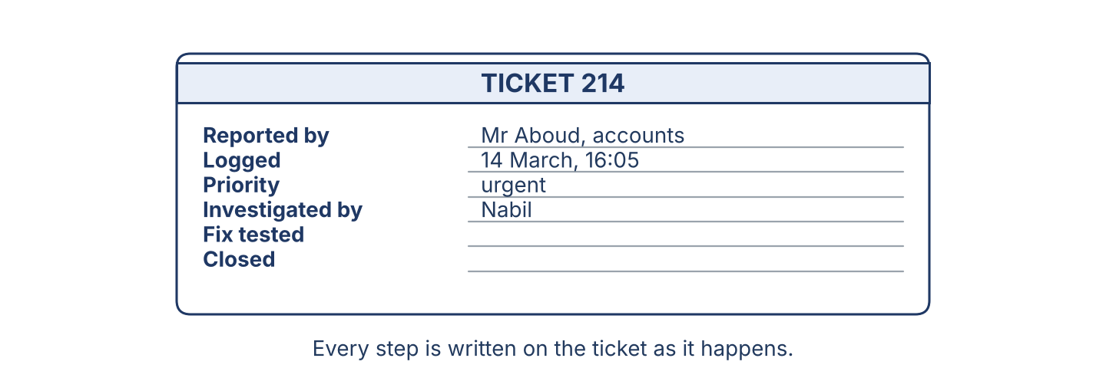
Figure 5.2 · A ticket follows the incident through every step.
Read these pairs. In which sentence is the doer important, and in which is the work important?
Active: The officer investigates the problem. Passive: The problem is investigated. · Active: Rana logs the call. Passive: The call is logged. · Active: The team tests the fix. Passive: The fix is tested before the ticket is closed.
Part 2: Grammar Focus Box
 | Form | Use | Example
Active | subject + verb + object | the doer is important | The officer investigates the problem.
Passive | is / are + past participle | the work is important | The problem is investigated.
Remember: Passive = is / are + past participle (checked, logged, closed). Add by + the doer only when it matters.
Watch out! ✗ The ticket closed. → ✓ The ticket is closed. ✗ The files is checked. → ✓ The files are checked.
Part 2: Controlled Practice
Make each sentence passive. (0. is done.)
0. The officer investigates the problem. → The problem is investigated.
1. The help desk logs the call.
2. The technician tests the fix.
3. The officer closes the ticket.
4. The manager reads the weekly report.
Part 2: Active or Passive?
Choose the correct form.
1. The problem ____________________ at the help desk. (logs / is logged)
2. The officer ____________________ the machine. (checks / is checked)
3. The files ____________________ every night. (back up / are backed up)
4. The team ____________________ the fix. (tests / is tested)
Part 2: Correct the Sentence
Each sentence has one grammar mistake. Write the correct sentence.
1. The ticket closed by the officer.
2. The files is checked every night.
3. The problem investigated this morning.
4. The machine is repair at the bench.
Part 2: Freer Practice
Describe three steps of the incident process. Use the passive in each one.
Part 2: Grammar Review
Choose the correct answer.
1. Which sentence is passive?
○ A) The officer investigates the problem.
○ B) The problem is investigated by the officer.
○ C) The officer is investigating.
○ D) The problem investigates the officer.
2. Which sentence is correct?
○ A) The files are checked.
○ B) The files is checked.
○ C) The files checked.
○ D) The files be checked.
→ Harvest: you will see the passive again in the Part 5 reading.
Part 3 · Listening
[OP] Operator track · pre-class input · scripts printed inline
Part 3: Explaining the Process
🔊 Audio Track 5.2
Before you listen: what is the first step when a user has a problem?
Rana: Let me explain what happens to your problem. First, it is logged here at the help desk and given a number — yours is 214. Then it is read by an officer, who decides how urgent it is. Yours is urgent, because the whole accounts office cannot work. Next, it is investigated at the bench. When a fix is found, it is tested before anybody tells you it is done. Last, I call you, and the ticket is only closed when you say the problem is really gone.
While you listen: write True, False, or Not Given. (0. is done.)
0. Rana is explaining the process. — True
1. The problem is logged at the help desk. ____
2. The ticket is closed before the user is called. ____
3. The fix is tested before the user is told. ____
Useful phrases: First, it is… · Then it is… · It is only closed when…
Part 3: Where Is My Ticket?
🔊 Audio Track 5.3
Before you listen: what does a user ask when the work takes a long time?
Mr Aboud: Hello, is my problem fixed? Rana: Not yet, Mr Aboud. Let me look. Ticket 214 was logged yesterday at four. It was read the same evening and given to Nabil. Mr Aboud: And now? Rana: Now it is being worked on at the bench. The fault was found this morning, and the fix is being tested. Mr Aboud: When will it be ready? Rana: Before twelve, I expect. You will be called, and the ticket is not closed until you tell us it is gone.
While you listen: answer the questions. (0. is done.)
0. What does Mr Aboud want to know? — Whether his problem is fixed.
1. When was the ticket logged?
2. What is happening now?
3. When is the ticket closed?
Useful phrases: It was logged… · now it is… · it is not closed until…
Part 3: Planning the Day
🔊 Audio Track 5.4
Before you listen: how does a manager share out the day’s tickets?
Maher: Good morning. Let’s plan the day. We have eleven tickets. The accounts office problem is the most urgent, so it is taken by Nabil first. The two password resets are quick; they are done by Rana at the desk. The printer in reception is not urgent, so it is left until the afternoon. Every fix is tested before the ticket is closed — every one, with no exceptions. And everything we do today is written on the ticket, not remembered.
While you listen: match each item with what happens to it. One is not needed. (0. is done.)
0. The accounts office problem → taken by Nabil first.
Column A
1. | The password resets | ____
2. | The printer in reception | ____
3. | Every fix | ____
4. | Everything we do | ____
Column B
a) | written on the ticket, not remembered
b) | tested before the ticket is closed
c) | sent to another company
d) | done by Rana at the desk
e) | left until the afternoon
Part 4 · Speaking
[OP] Operator track · in-class output
Part 4: Discussing the Process
Work with a partner. Ask and answer these questions.
What are the main steps of the incident process?
Why is the order of the steps important?
Why is no ticket closed until the user agrees?
Useful language: First, it is… · Then it is… · It is not closed until… · by the officer / by the team
Part 4: Find the Difference
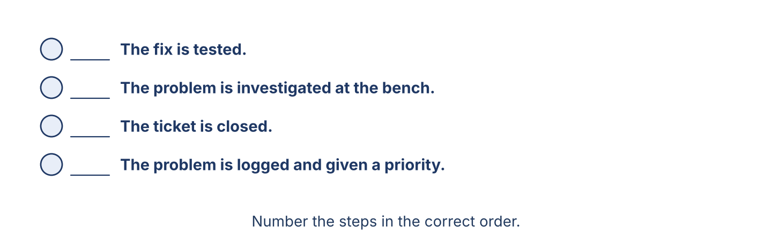
Figure 5.3 · Number the steps of the incident process.
Work in pairs. Student A looks at Ticket A; Student B looks at Ticket B. Ask and answer to find which ticket was handled better. Do not show your card.
Card A — Ticket A: logged at 9:00 · investigated at 9:30 · fixed at 11:00 · tested · user called · closed at 11:40.
Card B — Ticket B: logged at 10:00 · fixed at 10:20 · closed at 10:25 · not tested · user not called · reopened the next day.
Useful questions: When was it logged? · Was it tested? · Why was it reopened?
Part 4: Explaining the Process Role Play
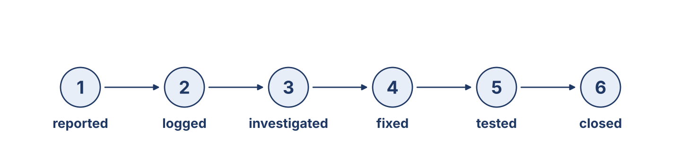
Figure 5.4 · The incident process, step by step.
Work in pairs. Read the model, then use the cards.
Model exchange: Rana: First, your problem is logged and given a number. — Mr Aboud: And then? — Rana: Then it is investigated, and when a fix is found it is tested. You are called before the ticket is closed.
Card A — Help-desk officer: explain the process to a user who is worried. Card B — User: ask what happens at each step, and ask when you will be told.
Stretch [PR]: the user wants the ticket closed now so that his department looks good in the monthly figures — refuse politely, and say why.
Part 4: Mini-Presentation
Prepare a short talk (about one minute). Describe a process you know from start to finish, using the passive.
Part 5 · Reading
[OP] Operator track · pre-class input
Part 5: From Report to Closure
Before you read: why does a problem not go straight to the person who can repair it?
Gloss: ticket = the record that follows a problem through every step · urgent = must be done before other things · closure = the end of a ticket, after the work is checked
When a problem arrives at an IT department, it does not go straight to the bench. It follows a process, and the process has a reason behind every step. First it is logged and given a number, so that it cannot be forgotten in a corridor conversation. Then it is read and given a priority: a whole office that cannot work is urgent; one slow printer is not. Next it is investigated, which is not the same as repaired. Investigating means finding out what really happened, because a problem that is repaired without being understood usually comes back. Then it is fixed, and the fix is tested by somebody who is willing to say that it failed. Finally the user is asked whether the problem is really gone, and only then is the ticket closed. Every step is written on the ticket as it happens, so that in six months anybody can see what was done and why. A department that works this way is slower on the first day and much faster by the end of the month, because the same problem is not solved three times by three people who never spoke to each other.
Answer the multiple-choice questions. (0. is done.)
0. What does a problem follow at an IT department? — a process.
1. Why is a problem given a number?
○ A) So that it cannot be forgotten
○ B) To make it urgent
○ C) To close it faster
○ D) Because the user asks for one
2. What is done before the ticket is closed?
○ A) The machine is sold
○ B) The user is asked whether the problem is gone
○ C) The disk is cleaned
○ D) A new ticket is opened
3. Why is a clear process good?
○ A) It is slow
○ B) It looks nice
○ C) It is cheap
○ D) The same problem is not solved three times by three people
Part 5: Vocabulary in Context
Match each word from the text with its meaning. One meaning is not needed. Write the letter.
Column A
1. | log | ____
2. | ticket | ____
3. | investigate | ____
4. | closure | ____
Column B
a) | the record that follows a problem through every step
b) | to write the problem into the system when it arrives
c) | a tool for opening a machine
d) | to find out what really happened
e) | the end of a ticket, after the work is checked
Part 5: A Big Job in Syria
Before you read: how can a small department handle a very large piece of work?
Gloss: branch = an office of the same company in another city · stage = one part of a long job
One week a company asked Cham Systems to move twenty-two accounts and all their files to a new server at its branch in Homs. The work could not be done in one day, and the branch could not stop working while it was done. So the job was divided into stages and written down as a plan before anything was touched. On the first day the accounts were copied, but nothing was switched over; the old server was left exactly as it was. On the second day four people were moved, and they worked all afternoon on the new system while the rest of the office carried on as before. Only when those four said that everything worked was the rest of the office moved, on the third day. The old server was kept, switched off but untouched, for two more weeks. Nothing was lost, and when one folder was found to be missing on the fourth day, it was simply copied again from the machine that was still sitting there.
Write True or False. (0. is done.)
0. The job was done in one day. — False
1. The accounts were copied before anybody was switched over. ____
2. The whole office was moved on the second day. ____
3. The old server was deleted as soon as the move finished. ____
Part 6 · Writing
[OP] Operator track · in-class / homework
Part 6: Describe the Incident Process (60–80 words)
Describe the incident process from report to closure. Use the passive.
Model — read this first:
First, the problem is reported to the help desk and logged with a number. Then it is read and given a priority, so that the most urgent work is done first. Next it is investigated at the bench, and the real cause is found. After that it is fixed, and the fix is tested by a second person. Finally the user is called, and the ticket is closed only when the user agrees that the problem is gone.
Plan (fill in, then write): First, the problem is ___. Then it is ___. Next it is ___. After that ___. Finally ___.
Word bank: is / are + past participle | reported | logged | investigated | fixed | tested | closed
Check before you finish: ☐ passive used throughout? ☐ steps in order? ☐ 60–80 words?
Part 6: Why a Clear Process Matters (50–70 words)
Write why a clear incident process is important. Give reasons.
Model — read this first:
A clear process is important because nothing is forgotten when every step is written down. The most urgent work is done first instead of the loudest. A problem that is investigated, not only repaired, does not come back next month. And when the same fault appears a year later, anybody can read the ticket and see what was done, even if that officer has left.
Word bank: … is important because… | nothing is forgotten | the most urgent first | it does not come back | anybody can read it
Check before you finish: ☐ a clear opinion? ☐ two or three reasons? ☐ 50–70 words?
Part 6: Explaining the Process to a User (50–70 words)
Write a short note from Rana to a user, explaining what will happen to their problem.
Model — read this first:
Dear Mr Aboud, Your problem has been logged as ticket 214. First, it is read by an officer, who decides how urgent it is. Then it is investigated, and when a fix is found it is tested before anybody tells you it is ready. You will be called this morning, and the ticket will not be closed until you tell us the problem is gone. Rana.
Plan (fill in, then write): Dear ___, First, your ___ is ___. Then it is ___. You will be ___. The ticket is not closed until ___.
Check before you finish: ☐ passive used? ☐ steps in order? ☐ 50–70 words?
Part 6: Reflection — A Process I Know (40–60 words)
Write about a process you know well (at work, at home or at school), using the passive.
Model — read this first:
At my college, an application is handed in at the office and a number is written on it. It is read by two teachers, and a decision is made at the end of the month. The students are told by letter, and no name is given before that day. The process is slow, but it is the same for everybody.
Check before you finish: ☐ steps in order? ☐ passive used? ☐ 40–60 words?
Part 7 · Management File — Planning the Day’s Work
[PR] Practitioner track (optional for beginners) · IT and security manager
7A: Phrase Bank
Match what a manager says with its purpose. One purpose is not needed. Write the letter.
Column A
1. | “Which ticket is the most urgent?” | ____
2. | “That one is taken by Nabil.” | ____
3. | “Every fix is tested before closure.” | ____
4. | “Write it on the ticket, please.” | ____
Column B
a) | saying who does a job
b) | giving an instruction
c) | asking about the price
d) | asking about priority
e) | stating a rule that has no exceptions
7B: Manager Dialogue
🔊 Audio Track 5.5
Before you read: what does a manager plan at the start of the day?
Maher: Nabil, let’s plan today. We have eleven tickets. Nabil: Which is first? Maher: The accounts office. Nobody there can work, so it is taken by you, now. Nabil: And the two password resets? Maher: They are done by Rana at the desk; they take four minutes each. The printer is left until the afternoon. Nabil: And the Homs branch? Maher: That is a project, not a ticket. It is planned for next week, and nothing is touched there until the plan is written. Every fix today is tested before the ticket is closed.
Answer the questions. (0. is done.)
0. What are they planning? — The day’s work.
1. Which ticket is taken first, and by whom?
2. Who does the password resets?
3. What is done to every fix before closure?
7C: Controlled Practice — The Order of the Process
Number the steps of the incident process in order. (0. is done.)
0. The problem is reported. — 1
____ The fix is tested.
____ The problem is investigated at the bench.
____ The ticket is closed.
____ The problem is logged and given a priority.
7D: Role-Play — Planning the Schedule
In pairs. One is the manager (Maher); one is the officer (Nabil). Use the model and the cards.
Model exchange: Maher: Which ticket is first? — Nabil: The accounts office; nobody there can work. — Maher: Then it is taken by you now, and the printer is left until the afternoon.
Card A — Manager (Maher): share out six tickets, say who takes each one and in what order. Card B — Officer (Nabil): ask about priority, say how long each one takes, and ask what is left until tomorrow.
Stretch [PR]: one ticket needs a part that has not arrived — decide what to tell the user today, rather than waiting until the part comes.
7E: Supervisory Writing (50–80 words)
You are Maher. Write the plan for the day for the team.
Model — read this first:
Team, here is today’s plan. The accounts office is first and is taken by Nabil; nobody there can work. The two password resets are done by Rana at the desk. The reception printer is left until after two o’clock. Every fix is tested before the ticket is closed, with no exceptions, and everything you do is written on the ticket as you do it, not at the end of the day. Maher.
Check before you finish: ☐ the order clear? ☐ who does what? ☐ 50–80 words?
Part 8 · Global Case Study — The Team That Cut Waiting Times
[PR] Practitioner track · pre-read / in-class discuss
Before you read: why do users sometimes wait a long time for a small problem?
Gloss: process = a set of steps done in order · queue = the line of work waiting to be done · board = a wall display showing what is where
A help desk in a large hospital had a problem that no amount of hard work could fix: users waited eleven days for small things. The staff were not lazy — they were doing eleven tickets at once and finishing none of them. The new manager changed one rule. Nobody was allowed to start a fourth ticket while three were open. At first this felt wrong, and two officers said so. But because nobody could start new work, the open tickets were actually finished, and the board on the wall showed it: each ticket was moved across four columns — logged, investigated, fixed, closed — and the whole department could see where the work was stuck. The stuck column was always the same one: tickets were being fixed but never tested, so they came back. Within two months the average wait fell from eleven days to two. The manager said afterwards that a good process is not about working faster; it is about finishing what you start before you start something else.
Answer the questions. (0. is done.)
0. How long did users wait at first? — Eleven days.
1. Why was the work not moving well before?
2. What did the board on the wall show?
3. What did the manager say a good process is about?
Part 8: Vocabulary in Context
Match each word with its meaning. One meaning is not needed. Write the letter.
Column A
1. | process | ____
2. | step | ____
3. | queue | ____
4. | priority | ____
Column B
a) | one part of a process
b) | a set of steps done in order
c) | how urgent a piece of work is
d) | a new machine
e) | the line of work waiting to be done
Part 8: Discussion
Talk with a partner. Use the frames.
Discussion frames: “A clear process helps because…” · “In my office the work gets stuck at…” · “The hardest rule to keep would be…” · “Finishing before starting means…”
Part 9 · Local Case Study — Syria in Focus: The Three-Day Job at the Branch
[PR] Practitioner track · pre-read / in-class decide
Before you read: how can a small department do a very large job without stopping the office?
A ministry office in Damascus needed all of its machines moved to a new system, and it could not close for even one day. Cham Systems had three officers and six working hours of electricity a day. Maher refused to do the job in one weekend, which is what the office asked for. Instead the work was divided into three days, and each day had one rule: at the end of it, the office had to be able to work on Monday morning whatever happened. On the first day everything was copied and nothing was switched. On the second, one department of five people was moved and watched all afternoon. On the third, the rest were moved, department by department, with the old system still running beside the new one. The parts needed — two disks and a switch — were checked a week early, because a part that arrives late in Damascus can arrive two months late. Nothing was lost, and the office never stopped.
Answer the questions. (0. is done.)
0. Whose office was it? — A ministry office in Damascus.
1. How many days, and how many officers?
2. What was the rule at the end of each day?
3. What did the department check a week early, and why?
Part 9: Decision Task
A big move is asked for, but the normal tickets still arrive every day. Should the department (a) stop all normal work for a week, (b) do the move in stages over three weeks, or (c) refuse the job? Choose one and give reasons.
Answer frame: “I think the department should ___ because ___. The risk of ___ is ___. This is better than ___ because ___.”
Model — read this first:
I think the department should do the move in stages over three weeks, because the users still need the help desk while the move is happening. The risk of stopping all normal work is that a real emergency arrives on the second day and nobody is free. This is better than refusing the job, because the move has to happen some time, and it will only get harder.
Phrase bank: I think… should… · because… · The risk of… · This is better than… · In my opinion…
Part 10 · Review and Can-Do
[OP + PR] · homework / self-study
Part 10: Spiral Review
Complete the review. (0. is done.)
0. The end of a ticket, after the work is checked, is closure.
Word bank: logged | investigated | is | are | tolerance
1. When a problem arrives, it is ____________________ and given a number.
2. Before it is fixed, it is ____________________ to find the real cause.
3. “The ticket ____________________ closed by the officer.”
4. “The files ____________________ checked every night.”
5. The range that is allowed for a reading is the ____________________ .
Part 10: Can-Do
Can-Do checklist
☐ I can name the steps and the places of the incident process.
☐ I can use the passive (is / are + past participle) to describe a process.
☐ I can understand an explanation given to a user and a day’s plan.
☐ I can explain the incident process to a user.
☐ I can plan a day’s work for a team (Practitioner).
Part 10: Glossary
Unit 5 glossary (10 words)
report · log · triage · investigate · fix · test · close · ticket · priority · closure

Unit 6: Routine Maintenance — Updates, Backups and Checks
English for Cybersecurity Personnel · Level: Low B1 (the course stepped up from Upper A2 at Unit 5) · Tracks: [OP] Warm-Up + Parts 1–6 · [PR] Parts 7–10
Warm Up
[OP] Operator track · in-class starter
Warm-up: Maintenance Words
Match the words with their meanings. One meaning is not needed. Write the letter.
Column A
1. | Update | ____
2. | Restore test | ____
3. | Account review | ____
4. | Disk check | ____
5. | Patch | ____
Column B
a) | a small fix for one known fault in a program
b) | a tool for opening a machine
c) | looking at who can open what, and closing what is not needed
d) | a new version that fixes faults in a program
e) | reading how much room is left and whether the disk is healthy
f) | bringing one file back from the backup, to prove the backup works
Warm-up: Talking to the User
Complete the sentences using the words in the word bank.
Word bank: should | Could | Shall | Would
1. Your machine has not been updated for a year. You ____________________ let us do it today.
2. ____________________ you sign out before you go home, please?
3. ____________________ I run the update for you now?
4. ____________________ you like us to look at the printer as well?
Warm-up: Reading About Maintenance
Read the text and choose the correct answer.
Routine maintenance keeps a system safe and saves money. At every visit, the updates are installed, the backup is tested, and the free space is read. Once a month the accounts are reviewed, closing those of people who have left. A good officer explains what the system really needs, and never asks for work that is not needed. Honest advice builds trust, and trust is what brings a user back to the help desk early, while a problem is still small.
1. What is done at every maintenance visit?
○ A) The machine is repainted
○ B) The desk is moved
○ C) The updates are installed and the backup is tested
○ D) A new machine is bought
2. What does honest advice build?
○ A) Trust
○ B) Noise
○ C) Dust
○ D) Speed
Part 1 · Vocabulary and Terminology
[OP] Operator track · pre-class input
Part 1: Maintenance Terms
Match the words with their meanings. One meaning is not needed. (0. is done for you.)
0. Maintenance → the regular care a system needs to stay safe and working.
Column A
1. | Update | ____
2. | Patch | ____
3. | Restore test | ____
4. | Account review | ____
5. | Retention | ____
6. | Schedule | ____
7. | Interval | ____
Column B
a) | how long old copies are kept before they are deleted
b) | a plan of when each job is done
c) | a small fix for one known fault
d) | a cable for the printer
e) | a new version that fixes faults in a program
f) | the time between one check and the next
g) | bringing one file back, to prove the backup works
h) | looking at who can open what, and closing what is not needed
Gloss: restore test = bringing one file back from the backup, to prove the backup works · retention = how long old copies are kept before they are deleted
Part 1: Pronunciation
🔊 Audio Track 6.1
Listen and practise these words. Say each word aloud and stress the loud syllable (CAPITALS).
schedule — SCHE-dule
interval — IN-ter-val
retention — re-TEN-tion
maintenance — MAIN-te-nance
advise — ad-VISE
routine — rou-TINE
Part 1: Maintenance Jobs Table

Figure 6.1 · The main jobs at a maintenance visit.
Complete the table. Write why we do each job. (0. is done.)
Maintenance job | Why we do it
Install the updates | (example) so that known faults are fixed before they are used
Test the backup
Review the accounts
Check the free space
0. Install the updates — so that known faults are fixed before they are used.
Part 1: Jobs and Why We Do Them
Match each job with its reason. One reason is not needed. Write the letter.
Column A
1. | Install the updates | ____
2. | Test the backup | ____
3. | Review the accounts | ____
4. | Check the free space | ____
5. | Clean the fans | ____
Column B
a) | so that a full disk does not stop the backup
b) | so that a copy that does not work is found before it is needed
c) | to repaint the case
d) | so that people who have left cannot open anything
e) | so that known faults are fixed before they are used
f) | so that the machine does not run hot and fail early
Part 1: Maintenance — Multiple Choice
Read and choose the correct answer.
1. What is a restore test?
○ A) Installing an update
○ B) Cleaning the machine
○ C) Checking a password
○ D) Bringing a file back, to prove the backup works
2. What is a maintenance interval?
○ A) A type of disk
○ B) The time between one check and the next
○ C) A tool
○ D) A fault
3. What does an account review do?
○ A) Cools the machine
○ B) Cleans the air
○ C) Closes what is not needed any more
○ D) Prints the records
Part 1: Vocabulary Fill-in
Complete the sentences with the correct word.
Word bank: updates | backup | accounts | schedule
1. At every visit, the ____________________ are installed.
2. The ____________________ is tested by bringing one file back.
3. The ____________________ of people who have left are closed.
4. The maintenance ____________________ says when each job is done.
Part 1: Write About Maintenance (short)
Write two or three sentences about the routine maintenance you do, or that is done where you work.
Model — read this first:
Every month I do the same three jobs on our server. First I install the updates, because a known fault that nobody has fixed is the easiest way into a system. Then I bring one file back from the backup, to prove that the backup really works. Last, I read the free space and write it in the sheet.
Part 2 · Grammar — Requests, Offers and Advice
[OP] Operator track · pre-class input
Part 2: Notice
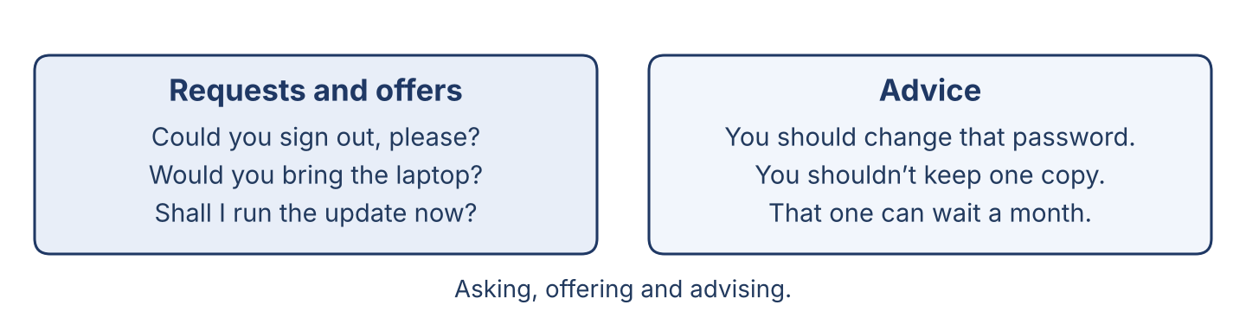
Figure 6.2 · Asking, offering and advising.
Read these lines. Which are requests? Which are offers? Which are advice?
Requests: Can you sign out before you leave? Could you send me the file, please? Would you bring the laptop to the bench? · Offers: Shall I run the update now? Would you like us to look at the printer as well? · Advice: You should change that password today. You shouldn’t keep the only copy on one disk.
Part 2: Grammar Focus Box
 | Form | Use | Example
Requests | Can / Could / Would you… | asking somebody to do something | Could you sign out, please?
Offers and advice | Shall I… / You should… | offering, or saying what is best | Shall I run the update now?
Remember: Could and Would are more polite than Can. After should, use the base verb with no to.
Watch out! ✗ You should to change the password. → ✓ You should change the password. ✗ Shall I to run it? → ✓ Shall I run it?
Part 2: Controlled Practice
Write a request, offer, or advice, as shown. (0. is done.)
0. (request) send the file → Could you send me the file, please?
1. (advice) change that old password
2. (offer) run the update now
3. (request) bring the laptop to the bench
4. (advice) not keep the only copy on one disk
Part 2: Choose the Modal
Choose the correct word.
1. ____________________ I book the update for Tuesday morning? (Shall / Should)
2. You ____________________ test the backup before you trust it. (should / shall)
3. ____________________ you sign the sheet, please? (Could / Shall)
4. You ____________________ open a file you did not expect. (shouldn’t / couldn’t)
Part 2: Correct the Sentence
Each sentence has one grammar mistake. Write the correct sentence.
1. You should to install the updates.
2. Can you to test the backup?
3. Shall I to close the old accounts?
4. You should not opens a strange file.
Part 2: Freer Practice
Write one request, one offer, and one piece of advice that you could really say at work this week.
Part 2: Grammar Review
Choose the correct answer.
1. Which is a polite request?
○ A) Could you sign out, please?
○ B) You sign out.
○ C) Sign out you.
○ D) Out sign please.
2. Which is correct advice?
○ A) You should to test the backup.
○ B) You should test the backup.
○ C) You should testing the backup.
○ D) You should tests the backup.
→ Harvest: you will see requests, offers, and advice again in the Part 5 reading.
Part 3 · Listening
[OP] Operator track · pre-class input · scripts printed inline
Part 3: Advising the User
🔊 Audio Track 6.2
Before you listen: what does an officer say to a user after a maintenance visit?
Rana: Mr Aboud, we’ve finished the maintenance on your machine. Everything is working, but there are two things I should tell you. Your password has not been changed for two years, and you should change it today — I can show you how, it takes a minute. The second thing can wait: the machine is slow because the disk is nearly full, and we would like to move your old files to the server. Shall I book that for next week? It takes an hour, and you can work while we do it.
While you listen: write True, False, or Not Given. (0. is done.)
0. Rana is advising Mr Aboud. — True
1. The password was changed last month. ____
2. Rana offers to move the old files next week. ____
3. Mr Aboud cannot work while the files are moved. ____
Useful phrases: You should… · Shall I…? · The second thing can wait…
Part 3: Booking the Maintenance
🔊 Audio Track 6.3
Before you listen: what does a user say when they telephone to book a visit?
Mr Aboud: Hello, I’d like to book the maintenance for the accounts machines. Rana: Of course. How many machines, and when were they last done? Mr Aboud: Six, and I think it was in March. Rana: Then they are due. Would Tuesday morning suit you? Mr Aboud: Tuesday is our busiest day. Could you make it Wednesday? Rana: Wednesday at nine. And could you ask your staff to sign out on Tuesday evening, so we can start at once? Mr Aboud: Yes. And could you look at the printer while you are there?
While you listen: answer the questions. (0. is done.)
0. What does Mr Aboud want? — To book the maintenance.
1. How many machines, and when were they last done?
2. What day is booked?
3. What does Mr Aboud ask Rana to look at?
Useful phrases: I’d like to book… · Could you…? · Would … suit you?
Part 3: The Maintenance Schedule
🔊 Audio Track 6.4
Before you listen: what is the difference between a weekly job and a yearly job?
Maher: Today I want to talk about the maintenance schedule. A weekly job is small and quick: read the free space, read the backup age, read the alerts. A monthly job takes longer: install the updates, review the accounts, and bring one file back from the backup to prove it works. A yearly job is a real piece of work: we test the whole restore, we check that every licence is still good, and we look again at who can open what. The schedule is based on how important the system is, not on how old it is. And one rule for all of them: we do not sell work the system does not need.
While you listen: match each item with the description. One is not needed. (0. is done.)
0. A weekly job → read the free space, the backup age and the alerts.
Column A
1. | A monthly job | ____
2. | A yearly job | ____
3. | The schedule | ____
4. | Our rule | ____
Column B
a) | is based on how important the system is
b) | test the whole restore and check every licence
c) | buy a new machine every year
d) | we don’t sell work the system does not need
e) | install the updates and review the accounts
Part 4 · Speaking
[OP] Operator track · in-class output
Part 4: Discussing Maintenance
Work with a partner. Ask and answer these questions.
What jobs are done at a monthly maintenance visit?
Why should an officer give honest advice about what is needed?
How do you politely tell a user that their machine is too old?
Useful language: You should… · Shall I…? · Could you…? · It can wait, but…
Part 4: Find the Difference
Work in pairs. Student A looks at Visit A; Student B looks at Visit B. Ask and answer to find four differences. Do not show your card.
Card A — A weekly visit: free space read · backup age read · alerts read · no update installed · no accounts reviewed.
Card B — A monthly visit: free space read · updates installed · accounts reviewed · one file restored from the backup · licences checked.
Useful questions: Are the updates installed? · Is the backup tested? · Which visit is longer?
Part 4: Advising a User Role Play
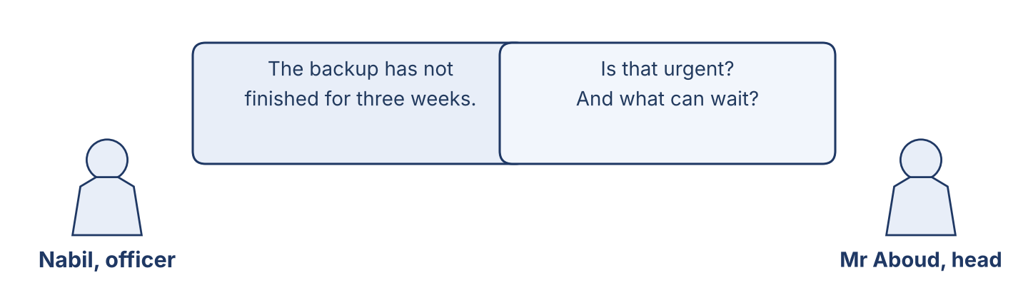
Figure 6.3 · An officer advises a department head.
Work in pairs. Read the model, then use the cards.
Model exchange: Officer: Your password hasn’t been changed for two years; you should change it today. — User: Is it urgent? — Officer: Yes, that one is. The slow disk can wait until next week. Shall I book an hour for it?
Card A — Officer: give advice about two jobs, say which is urgent and which can wait, and offer to book the second. Card B — Department head: ask why, ask how long it takes, and ask whether your staff can work during it.
Stretch [PR]: the user wants only the cheap job done and refuses the urgent one — answer without frightening them and without agreeing.
Part 4: Mini-Presentation
Prepare a short talk (about one minute). Explain the maintenance schedule of a system you know: what is done weekly, monthly and yearly.
Part 5 · Reading
[OP] Operator track · pre-class input
Part 5: Routine Maintenance and Honest Advice
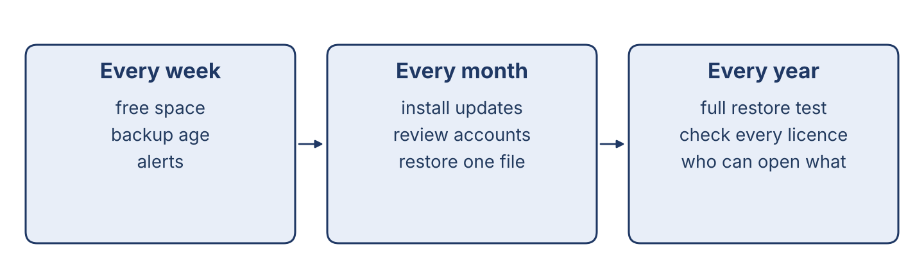
Figure 6.4 · A maintenance schedule: weekly, monthly and yearly.
Before you read: is it more important for an officer to be fast, or to be honest?
Gloss: routine = regular, done again and again at the same interval · due = ready to be done, because the interval has passed · trust = believing that somebody will tell you the truth
Routine maintenance is the regular care that keeps a system safe and working. It is dull work, and that is why it is skipped. The schedule is based on how important the system is, not on how old it is: the machine holding the staff records is checked monthly even if it is new, and the store’s spare twice a year even if it is ancient. At every monthly visit the updates are installed, the accounts are reviewed, and one file is brought back from the backup, because a backup nobody has tested is only a hope. A good officer also knows what not to do. There is always a temptation to sell a new machine when an hour’s work would do, or to ask for a bigger disk when the real problem is ten years of films somebody saved on the server. An officer who says “this does not need replacing yet” is worth a great deal, because the next time that officer says “this does need replacing”, the manager believes it. Honest advice builds trust, and trust is what brings a user to the help desk on the first day of a problem instead of the tenth.
Answer the multiple-choice questions. (0. is done.)
0. What keeps a system safe and working? — routine maintenance.
1. What is the maintenance schedule based on?
○ A) The colour of the machine
○ B) The price
○ C) The user’s age
○ D) How important the system is
2. What does a good officer never do?
○ A) Ask for work the system does not need
○ B) Install updates
○ C) Test the backup
○ D) Give advice
3. What does honest advice build?
○ A) Noise
○ B) Trust
○ C) Dust
○ D) Speed
Part 5: Vocabulary in Context
Match each word from the text with its meaning. One meaning is not needed. Write the letter.
Column A
1. | schedule | ____
2. | due | ____
3. | restore | ____
4. | routine | ____
Column B
a) | ready to be done, because the interval has passed
b) | a plan of when each job is done
c) | a tool for opening a machine
d) | regular, done again and again
e) | to bring the files back from a copy
Part 5: Honest Maintenance in Damascus
Before you read: why is a trusted officer so valuable to a small company?
Gloss: tight = not much (money) · word of mouth = people telling each other about good work
In Damascus, many companies keep the same machines for eight or ten years, because new ones are expensive and hard to import. Money is tight, and every company has heard a story about somebody who was sold three new computers and a server they did not need. Maher’s rule at Cham Systems is simple: recommend only the work the system really needs, and say plainly when something can wait. Last spring a company came to him after another firm had told them their whole system had to be replaced, at a price that would have taken their profit for a year. Lina spent one afternoon with the machines and found the real problem: a failing disk in the server, and a backup that had quietly stopped eleven months before. The disk cost very little. She replaced it, restarted the backup and tested it in front of the owner. Cham Systems earned nothing that day. But that company has sent four other businesses to Maher since, and in Damascus, word of mouth is worth more than any advertisement.
Write True or False. (0. is done.)
0. In Damascus, many companies keep the same machines for years. — True
1. Maher’s rule is to recommend as much work as possible. ____
2. The real problem was one failing disk and a stopped backup. ____
3. Honest work brought Maher more customers. ____
Part 6 · Writing
[OP] Operator track · in-class / homework
Part 6: Advise a User (50–70 words)
Write to a user after a maintenance visit. Give advice, and offer one thing.
Model — read this first:
Dear Mr Aboud, Thank you for your time this morning. The maintenance is finished and everything is working. There is one thing you should do today: your password has not been changed for two years, and I can show you how in a minute. The slow disk can wait. Shall I book an hour next Wednesday to move your old files to the server? Rana.
Plan (fill in, then write): Thank you… The maintenance is… You should… The other thing can… Shall I…?
Word bank: You should… | Shall I…? | Could you…? | it can wait | it takes an hour
Check before you finish: ☐ advice (should) used? ☐ an offer (Shall I) used? ☐ 50–70 words?
Part 6: Why Honest Maintenance Matters (50–70 words)
Write why honest maintenance advice is important. Give reasons.
Model — read this first:
Honest advice is important because a company has only so much money, and it should be spent where it does the most good. If an officer asks for a new server every year, nobody believes him on the day the server really is dying. Saying “this can wait” costs nothing today and is worth a great deal later, when something cannot wait.
Word bank: … is important because… | only the work that is needed | nobody believes… | it costs nothing today | trust
Check before you finish: ☐ a clear opinion? ☐ two or three reasons? ☐ 50–70 words?
Part 6: A Maintenance Note (50–70 words)
Write a short note from the officer to the help desk about what was done and what is still needed.
Model — read this first:
I have finished the monthly maintenance on the six accounts machines. The updates are installed and the accounts have been reviewed; two belonged to people who left last year and are now closed. I restored one file from Tuesday’s backup and it opened correctly. One machine still needs a disk; it is at eight per cent free. Could you add it to next week’s list? Nabil.
Plan (fill in, then write): I have finished ___. The ___ are ___. I tested ___. One machine still needs ___. Could you ___?
Check before you finish: ☐ clear advice + a request? ☐ what was really done? ☐ 50–70 words?
Part 6: Reflection — Honest Advice (40–60 words)
Write about a time somebody gave you honest advice, when it would have been easier not to.
Model — read this first:
When my laptop stopped last year, the shop could have sold me a new one and I would have bought it. Instead the man opened it, cleaned the fan and told me it had three or four years left. He charged me very little. I have been back to him twice since, and I have sent my brother too.
Check before you finish: ☐ a clear story? ☐ modals used? ☐ 40–60 words?
Part 7 · Management File — Approving a Maintenance Quote
[PR] Practitioner track (optional for beginners) · IT and security manager
7A: Phrase Bank
Match what an officer or manager says with its purpose. One purpose is not needed. Write the letter.
Column A
1. | “Your password is two years old; you should change it today.” | ____
2. | “Shall I book an hour next Wednesday?” | ____
3. | “Could you sign the sheet, please?” | ____
4. | “That one can wait until next month.” | ____
Column B
a) | offering to do something
b) | giving honest advice
c) | asking about the price
d) | making a polite request
e) | saying what is not urgent
7B: Manager Dialogue
🔊 Audio Track 6.5
Before you read: how does a manager approve a maintenance quote?
Rana: Mr Aboud, the maintenance is done, but we found two things. Maher: Tell him both. Rana: The first is the backup: it has not finished properly for three weeks. That one should be fixed this week. Mr Aboud: And the second? Rana: Six machines are two years behind on updates; that is a day’s work, and it can wait until month end, but not longer. Mr Aboud: And the price? Maher: For the backup, two hours of Nabil’s time. For the updates, one day. Shall we book the backup for Thursday and put the updates in the month-end plan? Mr Aboud: Yes. Do the backup first.
Answer the questions. (0. is done.)
0. What did they find? — A backup that has not finished, and machines behind on updates.
1. Which job is urgent?
2. Which job can wait, and how long?
3. What does Mr Aboud decide?
7C: Controlled Practice — Talking to the User
Complete with should, Shall, Could, or shouldn’t.
Word bank: should | Shall | Could | shouldn’t
1. The backup has not finished for three weeks. You ____________________ let us fix it this week.
2. ____________________ I book Thursday morning for it?
3. ____________________ you ask your staff to sign out on Wednesday evening?
4. You ____________________ wait another month for the updates.
7D: Role-Play — Approving the Quote
In pairs. One is the officer or manager; one is the department head. Use the model and the cards.
Model exchange: Officer: The backup hasn’t finished for three weeks; that should be fixed this week. — Head: And the updates? — Officer: Real work, about a day. It can wait until month end, but not longer. Shall I book both?
Card A — Officer/Manager: advise which job is urgent and which can wait, give the time each takes, and offer to book them. Card B — Department head: ask why, ask the cost, and say your staff cannot stop on Tuesday.
Stretch [PR]: the department cannot pay for both this month — advise which one to do, and say what the risk of waiting really is.
7E: Supervisory Writing (50–80 words)
You are Maher. Write a short maintenance recommendation for a department head, saying what is urgent and what can wait.
Model — read this first:
Dear Mr Aboud, After this month’s visit we recommend two pieces of work. First, and this week: your backup has not finished properly for three weeks, so there is no usable copy of your files. It is two hours of work. Second, by month end: six machines are two years behind on updates, which is one full day. Nothing else needs doing. Shall we book both? Maher Khoury.
Check before you finish: ☐ what is urgent + what can wait? ☐ the time each takes? ☐ 50–80 words?
Part 8 · Global Case Study — The Maintenance Plan That Kept Customers
[PR] Practitioner track · pre-read / in-class discuss
Before you read: why do some companies only call for help when something has already broken?
Gloss: maintenance plan = paying a fixed price for regular care · unplanned = happening suddenly, with no warning · downtime = time when people cannot work
An IT company once lost many customers, and it could not understand why: its engineers were good and always came quickly. The new manager looked at two years of records and saw the pattern. Every customer they had lost had called them three or four times in a panic, with something badly broken, and had paid a large bill each time. The customers did not blame the engineers; they simply felt that the company only appeared when it was expensive. So the manager offered something new: a maintenance plan at a fixed price each month, which included the updates, a tested backup, an account review, and one visit a quarter whether anything was wrong or not. The first year was harder work for less money. But unplanned downtime among those customers fell by about two thirds, the panic calls nearly stopped, and almost none of them left. The manager said afterwards that they had started selling the thing customers actually wanted, which was not repairs: it was not having to think about it.
Answer the questions. (0. is done.)
0. What did the manager offer? — A maintenance plan at a fixed price.
1. What was the problem before?
2. What did the maintenance plan include?
3. What did the manager say they had started selling?
Part 8: Vocabulary in Context
Match each word with its meaning. One meaning is not needed. Write the letter.
Column A
1. | maintenance plan | ____
2. | schedule | ____
3. | routine | ____
4. | downtime | ____
Column B
a) | a plan of when each job is done
b) | paying a fixed price for regular care
c) | time when people cannot work
d) | a new machine
e) | regular, done again and again
Part 8: Discussion
Talk with a partner. Use the frames.
Discussion frames: “A maintenance plan is good because…” · “In Syria the difficulty would be…” · “Customers really want…” · “A fixed price each month means…”
Part 9 · Local Case Study — Syria in Focus: Only the Work the System Needs
[PR] Practitioner track · pre-read / in-class decide
Before you read: why might a company be worried when it is told its whole system must be replaced?
A young accountant, Samer, runs a small firm in Aleppo with five machines and one old server. Another company told him the server was finished and he needed a new one, three new machines and a new licence for everything — a price that would have taken a year of his profit. He came to Cham Systems expecting to be told the same thing. Lina spent an afternoon with them. The server was not finished: one disk in it had failed, and the machine had been running on the second disk alone for months, which is why it was slow. The backup had stopped at the same time, and nobody had seen the message. She replaced the disk, restarted the backup, restored a file in front of Samer to show that it worked, and told him it had three or four more years in it. The bill was small. Samer has since sent four other businesses to Cham Systems, and has never once asked for a cheaper price.
Answer the questions. (0. is done.)
0. Whose firm was it? — A young accountant, Samer, in Aleppo.
1. What did the other company tell Samer?
2. What did Lina find?
3. Why is honesty good business in Syria?
Part 9: Decision Task
A company’s system has a small, cheap problem, but the manager has already decided to buy everything new. Should the officer (a) do the cheap repair and say so, (b) sell the new system the manager has asked for, or (c) do the repair and offer a plan for replacing the machines slowly? Choose one and give reasons.
Answer frame: “I think the officer should ___ because ___. The manager really needs ___. This is better than ___ because ___.”
Model — read this first:
I think the officer should do the repair and offer a plan for replacing the machines slowly, because the real problem is cheap to fix today, but the machines are old and will need replacing some time. The manager really needs to know what is urgent and what is not. This is better than simply selling the new system, because he would be spending a year of profit for nothing.
Phrase bank: I think… should… · because… · The manager really needs… · This is better than… · In my opinion…
Part 10 · Review and Can-Do
[OP + PR] · homework / self-study
Part 10: Spiral Review
Complete the review. (0. is done.)
0. Bringing one file back to prove the backup works is a restore test.
Word bank: patch | retention | Could | should | logged
1. A small fix for one known fault is a ____________________ .
2. How long old copies are kept before they are deleted is ____________________ .
3. “ ____________________ you sign the sheet, please?”
4. “You ____________________ change that password today.”
5. When a problem arrives at the help desk, it is ____________________ and given a number.
Part 10: Can-Do
Can-Do checklist
☐ I can name the main routine-maintenance jobs and say why we do them.
☐ I can make polite requests and offers, and give advice with should.
☐ I can understand a conversation with a user about what is urgent.
☐ I can advise a user honestly in writing.
☐ I can approve a maintenance quote with a department head (Practitioner).
Part 10: Glossary
Unit 6 glossary (10 words)
update · patch · restore test · account review · retention · schedule · interval · routine · due · downtime

Unit 7: At the Help Desk — Requests, Estimates and Handover
English for Cybersecurity Personnel · Level: Low B1 · Tracks: [OP] Warm-Up + Parts 1–6 · [PR] Parts 7–10
Warm Up
[OP] Operator track · in-class starter
Warm-up: Help Desk Words
Match the words with their meanings. One meaning is not needed. Write the letter.
Column A
1. | Appointment | ____
2. | Estimate | ____
3. | Approval | ____
4. | Handover | ____
5. | Loan machine | ____
Column B
a) | a paper that shows how long the work will take and what it will cost
b) | a tool for opening a machine
c) | giving the machine back and showing the user that it works
d) | a time saved for one user’s work
e) | a machine the department lends while yours is repaired
f) | the user agreeing to the work before it starts
Warm-up: Talking About the Future
Complete the sentences using the words in the word bank.
Word bank: will | going | is | book
1. Your machine ____________________ be ready at four o’clock.
2. We are ____________________ to order the disk this afternoon.
3. The engineer ____________________ coming on Wednesday at ten.
4. Can I ____________________ you in for Thursday morning?
Warm-up: Reading About the Help Desk
Read the text and choose the correct answer.
At the help desk, the officer plans the week and talks to the users. First the user calls and a time is saved for the work. Then the officer writes an estimate, so the user knows the time before anything starts. Nothing begins until the user approves it. While a machine is at the bench, the department can lend a loan machine. At handover, the officer shows the user that the problem is really gone, and gives them the completion note.
1. What does the officer write so the user knows the time?
○ A) A loan machine
○ B) An approval
○ C) A key
○ D) An estimate
2. When does the officer show that the problem is gone?
○ A) Before the appointment
○ B) At handover
○ C) Next year
○ D) Never
Part 1 · Vocabulary and Terminology
[OP] Operator track · pre-class input
Part 1: Help Desk Terms
Match the words with their meanings. One meaning is not needed. (0. is done for you.)
0. Completion note → the paper that shows what was done and when.
Column A
1. | Appointment | ____
2. | Booking | ____
3. | Estimate | ____
4. | Approval | ____
5. | Loan machine | ____
6. | Handover | ____
7. | Slot | ____
Column B
a) | when a time is saved for a user’s work
b) | a time saved for one user’s work
c) | a cable for the printer
d) | a space in the week when the work can be done
e) | a paper showing how long the work will take and what it will cost
f) | the user agreeing to the work before it starts
g) | a machine the department lends while yours is repaired
h) | giving the machine back and showing the user that it works
Gloss: estimate = a paper showing how long the work will take and what it will cost · slot = a space in the week when the work can be done
Part 1: Pronunciation
🔊 Audio Track 7.1
Listen and practise these words. Say each word aloud and stress the loud syllable (CAPITALS).
appointment — ap-POINT-ment
estimate — ES-ti-mate
approval — ap-PRO-val
handover — HAND-o-ver
schedule — SCHE-dule
available — a-VAIL-a-ble
Part 1: Desk Tasks Table
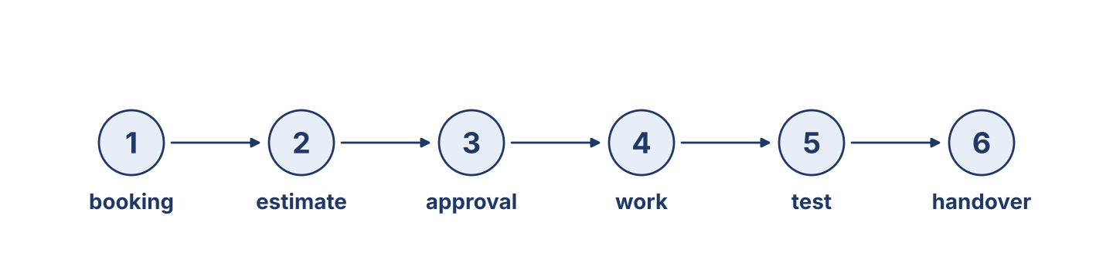
Figure 7.1 · From booking to handover.
Complete the table. Write when each task happens. (0. is done.)
Desk task | When it happens
Make an appointment | (example) before the machine comes to the bench
Write the estimate
Get the user’s approval
Hand the machine over
0. Make an appointment — before the machine comes to the bench.
Part 1: The Steps of a Job
Match each step with what happens. One is not needed. Write the letter.
Column A
1. | Booking | ____
2. | Estimate | ____
3. | Approval | ____
4. | Handover | ____
5. | Completion note | ____
Column B
a) | the user is told how long it will take
b) | the user says yes, and the work starts
c) | a time is saved in the week
d) | the machine is sold to another office
e) | the machine is given back and shown to work
f) | the paper that says what was done and when
Part 1: The Help Desk — Multiple Choice
Read and choose the correct answer.
1. What is an estimate?
○ A) A paper showing how long the work will take and what it will cost
○ B) A tool
○ C) A machine part
○ D) A program
2. What is an approval?
○ A) The final bill
○ B) A loan machine
○ C) The user agreeing before the work starts
○ D) An appointment
3. What is a loan machine?
○ A) A fast machine
○ B) A new machine
○ C) An old machine
○ D) A machine the department lends while yours is repaired
Part 1: Vocabulary Fill-in
Complete the sentences with the correct word.
Word bank: appointment | estimate | approval | handover
1. Please make an ____________________ for Thursday morning.
2. Here is the ____________________ for the work on your machine.
3. Nothing starts without your ____________________ .
4. At ____________________ , we will show you that it works.
Part 1: Write About a Booking (short)
Write two or three sentences about booking work at a help desk. Use three words from this unit.
Model — read this first:
I am going to book the accounts machines for Wednesday morning. I will write an estimate first, so that Mr Aboud knows it is about three hours. Nothing starts without his approval. We are lending him a loan machine for the morning, so his work is not stopped.
Part 2 · Grammar — Future Forms (will / going to / present continuous)
[OP] Operator track · pre-class input
Part 2: Notice
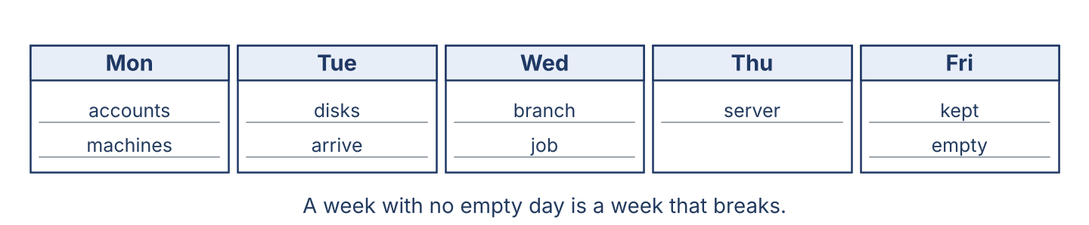
Figure 7.2 · A week planner for the help desk.
Read these lines. Which is a promise? Which is a plan? Which is a fixed arrangement?
Will (a decision now, a promise): I’ll call you as soon as it is ready. I’ll look at it myself this afternoon. · Going to (a plan already made): We’re going to order the disk this week. We’re going to move the accounts at the end of the month. · Present continuous (a fixed arrangement): The engineer is coming on Wednesday at ten. We’re meeting the branch on Thursday.
Part 2: Grammar Focus Box
 | Form | Use | Example
will | ’ll + verb | a decision now, a promise | I’ll call you when it is ready.
going to / -ing | be going to + verb | a plan, or a fixed arrangement | We’re going to order the disk.
Remember: will = decide now / promise. going to = already planned. present continuous = fixed, with a time and a date.
Watch out! ✗ I will to call you. → ✓ I will call you. ✗ We going to order it. → ✓ We are going to order it.
Part 2: Controlled Practice
Choose the correct future form.
1. We ____________________ order the disk this week. (are going to / will)
2. The engineer ____________________ at ten tomorrow. (is arriving / will arrive)
3. OK, I ____________________ book you in for Thursday. (’ll / am going to)
4. The officer ____________________ you as soon as it is ready. (will call / is calling)
Part 2: Will or Going To?
Choose the correct form.
1. I ____________________ call you when it is ready. (will / am going to)
2. We ____________________ replace that disk next month; it is in the plan. (will / are going to)
3. The van ____________________ at ten tomorrow. (arrives / is arriving)
4. OK, I ____________________ do it now, while you wait. (’ll / am going to)
Part 2: Correct the Sentence
Each sentence has one grammar mistake. Write the correct sentence.
1. I will to call you when it is ready.
2. We going to order the disk.
3. The engineer arrive at ten tomorrow.
4. Your machine will ready at four.
Part 2: Freer Practice
Write three sentences to a user: one promise, one plan, and one fixed arrangement.
Part 2: Grammar Review
Choose the correct answer.
1. Which is a promise or a decision made now?
○ A) We are ordering the disk.
○ B) I’ll call you as soon as it is ready.
○ C) The engineer is coming at ten.
○ D) We are going to order it.
2. Which is a fixed arrangement?
○ A) The engineer is coming at ten tomorrow.
○ B) The engineer will come maybe.
○ C) The engineer come at ten.
○ D) The engineer going to ten.
→ Harvest: you will see future forms again in the Part 5 reading.
Part 3 · Listening
[OP] Operator track · pre-class input · scripts printed inline
Part 3: Booking the Work
🔊 Audio Track 7.2
Before you listen: what does an officer ask when a user telephones?
Rana: Cham Systems help desk, good morning. Mr Aboud: Good morning. My machine is very slow, and I can’t work. Rana: I’m sorry. Let me look at the week. I’m afraid Tuesday is full. Could you manage Wednesday morning? Mr Aboud: Wednesday is fine. Rana: Good, I’ll book you in for nine o’clock. It is going to take about three hours, so it will be ready by midday. We’re lending you a loan machine for the morning, so you won’t lose the day. And I’ll call you as soon as it is finished.
While you listen: write True, False, or Not Given. (0. is done.)
0. Mr Aboud is booking some work. — True
1. Rana books him for Tuesday. ____
2. The machine will be ready by midday. ____
3. Rana will call him when it is finished. ____
Useful phrases: I’ll book you in… · It is going to take… · I’ll call you as soon as…
Part 3: The Estimate
🔊 Audio Track 7.3
Before you listen: what does a user want to know before the work starts?
Rana: Mr Aboud, here is the estimate for your machine. The disk is failing, so we are going to replace it. The work is about three hours, and the disk costs what is written at the bottom. Mr Aboud: And how long until you have the disk? Rana: We have one in the store, so we’re starting tomorrow. If it had to be imported it would be three weeks, and I would tell you that now, not later. Mr Aboud: Good. And my files? Rana: They are copied first, before anything is touched. Nothing starts until you sign this.
While you listen: answer the questions. (0. is done.)
0. What does Rana give Mr Aboud? — The estimate.
1. How long is the work?
2. When are they going to start?
3. What happens to his files first?
Useful phrases: We’re going to… · If it had to be imported… · Nothing starts until…
Part 3: Planning the Week
🔊 Audio Track 7.4
Before you listen: how does a manager plan a week with one big job in it?
Maher: Let’s plan the week. On Monday we’re doing the four accounts machines. On Tuesday the disks are arriving from the reseller — they are already paid for, so they will come. On Wednesday Nabil is at the Homs branch all day; nobody is to book anything else for him. On Thursday we’ll start the server, and I’ll be here myself for that one. Friday I am leaving empty on purpose, because something always comes in, and a week with no empty day is a week that breaks.
While you listen: match each day with what happens. One is not needed. (0. is done.)
0. Monday → the four accounts machines.
Column A
1. | Tuesday | ____
2. | Wednesday | ____
3. | Thursday | ____
4. | Friday | ____
Column B
a) | the disks are arriving from the reseller
b) | the server, with Maher there himself
c) | the office is closed
d) | Nabil is at the Homs branch all day
e) | left empty on purpose
Part 4 · Speaking
[OP] Operator track · in-class output
Part 4: Discussing the Help Desk
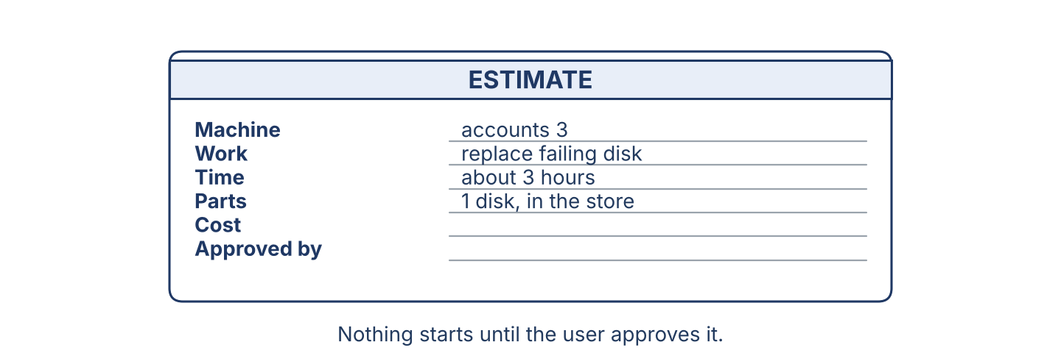
Figure 7.3 · An estimate: the time and the cost before the work.
Work with a partner. Ask and answer these questions.
What happens step by step when a user calls the help desk?
Why is an estimate important before the work starts?
What can a department offer if a job is going to take a long time?
Useful language: I’ll book you in… · It is going to take… · We’re lending you… · I’ll call you as soon as…
Part 4: Find the Difference
Work in pairs. Student A looks at Booking A; Student B looks at Booking B. Ask and answer to find four differences. Do not show your card.
Card A — Booking A: Wednesday at nine · about three hours · disk in the store · loan machine offered · user will be called.
Card B — Booking B: Thursday at two · about one day · disk must be imported · no loan machine · user will not be called.
Useful questions: Which day is the booking? · How long is it going to take? · Is a loan machine offered?
Part 4: Booking Role Play
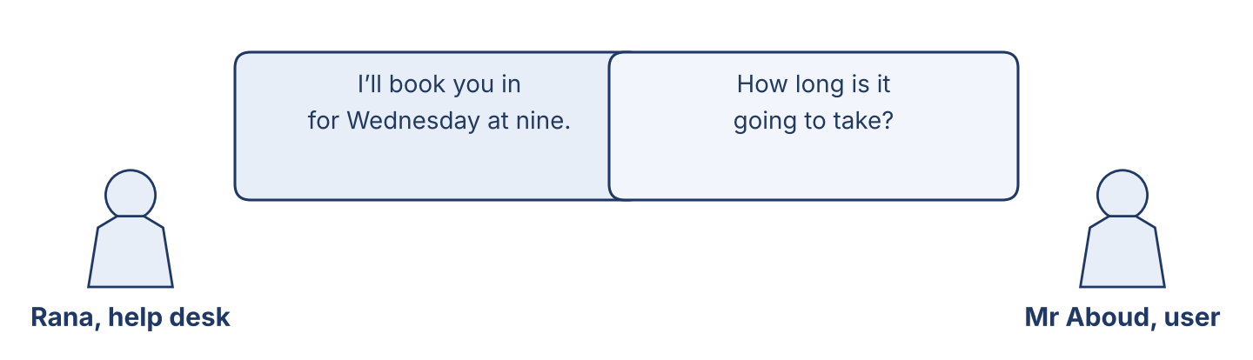
Figure 7.4 · At the help desk.
Work in pairs. Read the model, then use the cards.
Model exchange: Officer: I’ll book you in for Wednesday at nine. — User: How long is it going to take? — Officer: About three hours, so it will be ready by midday. We’re lending you a machine for the morning, and I’ll call you as soon as it is finished.
Card A — Help-desk officer: take the booking, give the time, offer a loan machine, and promise to call. Card B — User: say what is wrong, ask how long it will take, ask about your files, and ask what you should do in the meantime.
Stretch [PR]: the user wants the machine back the same afternoon, but the disk will not arrive until Thursday — offer what you can actually promise.
Part 4: Mini-Presentation
Prepare a short talk (about one minute). Explain to a new colleague how a job travels from the first call to handover.
Part 5 · Reading
[OP] Operator track · pre-class input
Part 5: From Request to Handover
Before you read: why is the help desk the most important desk in an IT department?
Gloss: approve = to agree to the work before it starts · handover = giving the machine back and showing that it works · window = the hours when a job will be done
The help desk is the first place a user meets, and very often the only one. The bench work may be excellent, but a user judges the department by the desk. The process is simple and it is always the same. A request arrives and is given a slot in the week. Before anything begins, the user is told two things: how long it is going to take, and what it is going to cost. That is the estimate, and it exists so that nobody is ever surprised. Then the user approves it, and only then does the work start. While the machine is away, a loan machine is offered if the department has one. At handover the officer opens the machine in front of the user, shows the broken thing working again, and gives the completion note. If the work is going to be late, the user is told on the day it becomes late, not on the day it was promised. A good help desk depends on clear communication far more than on fast repairs, because a user who knows what is happening will wait patiently, and a user who is told nothing will not wait at all.
Answer the multiple-choice questions. (0. is done.)
0. What is the first place a user meets? — the help desk.
1. What does the officer give before any work starts?
○ A) A loan machine
○ B) A completion note
○ C) An estimate
○ D) A key
2. Why should a user never be surprised?
○ A) Because they know the time and the cost from the start
○ B) Because it is free
○ C) Because it is small
○ D) Because it is a gift
3. What does a good help desk depend on?
○ A) Fast machines
○ B) Clear communication
○ C) Cheap disks
○ D) Big offices
Part 5: Vocabulary in Context
Match each word from the text with its meaning. One meaning is not needed. Write the letter.
Column A
1. | booking | ____
2. | estimate | ____
3. | loan machine | ____
4. | handover | ____
Column B
a) | a paper showing the time and the cost before the work
b) | a saved time for a job
c) | a tool for opening a machine
d) | a machine the department lends while yours is away
e) | giving the machine back and showing that it works
Part 5: Late Parts and Power Cuts in Syria
Before you read: what problems can a help desk in Syria have that one in another country does not?
Gloss: import = to bring from another country · reseller = a company that buys from the maker and sells it on · generator = a machine that makes electricity when the power is off
Running a help desk in Syria is not the same as running one anywhere else. A disk that is in a warehouse in another country is not a disk you have; it is a disk you are hoping for. It may come in ten days, or it may come in two months, and the reseller in Beirut honestly does not know which. A licence often cannot be paid for from Damascus at all. And the power goes off on a schedule that everybody knows and nobody can change, so a job that needs four unbroken hours has to be planned around the generator, not around the working day. None of this is the user’s fault, and none of it is the officer’s fault either. What a user cannot forgive is being told that a machine will be ready on Thursday by somebody who already knew on Monday that the part had not left Beirut. The advisor who says “it may be two weeks, and I will tell you the day I know more” is giving a worse answer and a better service, and the users come back to that advisor.
Write True or False. (0. is done.)
0. In Syria, a part is always in the country when it is ordered. — False
1. The officer should be honest about how long a part may take. ____
2. Power cuts can make a long job hard to plan. ____
3. Users do not mind being promised a day that was never possible. ____
Part 6 · Writing
[OP] Operator track · in-class / homework
Part 6: A Booking Message (50–70 words)
Write a message to a user to confirm a booking. Use will, going to and the present continuous.
Model — read this first:
Dear Mr Aboud, I’ve booked your machine in for Wednesday at nine. The work is going to take about three hours, so it will be ready by midday. We’re lending you a loan machine for the morning, and your files will be copied before anything is touched. I’ll call you as soon as it is finished. Rana, Cham Systems help desk.
Plan (fill in, then write): I’ve booked ___ for ___. It is going to take ___. We’re ___. I’ll ___.
Word bank: I’ll… | We’re going to… | It is going to take… | is arriving | as soon as…
Check before you finish: ☐ will used? ☐ going to or present continuous used? ☐ 50–70 words?
Part 6: Why Clear Communication Matters (50–70 words)
Write why clear communication is important at a help desk. Give reasons.
Model — read this first:
Clear communication is important because a user who knows what is happening will wait, and one told nothing will not. A date that was never possible costs more than a late part, because it costs trust. If we say on Monday that the disk may take two weeks, the user can plan. If we say Thursday and the disk arrives in March, the user plans nothing, and blames us.
Word bank: … is important because… | a user who knows… | a date that was never possible… | it costs trust | the user can plan
Check before you finish: ☐ a clear opinion? ☐ two or three reasons? ☐ 50–70 words?
Part 6: A Ready-Time Message (40–60 words)
Write a short message to a user to say the work is finished.
Model — read this first:
Good news — your machine is ready. The old disk has been replaced and all your files are back; I opened three of them myself to be sure. You can collect it from the help desk any time before five, and please bring the loan machine with you. I’ll show you that everything works before you go. Rana.
Plan (fill in, then write): Good news — ___ is ready. We have ___. You can ___. Please ___. I’ll ___.
Check before you finish: ☐ clear and short? ☐ what the user must do? ☐ 40–60 words?
Part 6: Reflection — Waiting for Something (40–60 words)
Write about a time you waited for something to be repaired or delivered.
Model — read this first:
Last year I waited five weeks for a part for our washing machine. The shop never called me; I called them every week and was told it was coming. If they had told me at the start, I would have waited without anger. In the end I was not angry about the part. I was angry about the silence.
Check before you finish: ☐ a clear story? ☐ future or past forms used well? ☐ 40–60 words?
Part 7 · Management File — Handling a Big Job and the Week’s Schedule
[PR] Practitioner track (optional for beginners) · IT and security manager
7A: Phrase Bank
Match what a manager says with its purpose. One purpose is not needed. Write the letter.
Column A
1. | “We’re going to order the disks today.” | ____
2. | “The engineer is coming on Wednesday at ten.” | ____
3. | “I’ll call the user myself.” | ____
4. | “Leave Friday empty.” | ____
Column B
a) | making a promise
b) | a fixed arrangement
c) | asking about the price
d) | a plan already made
e) | giving an instruction about the schedule
7B: Manager Dialogue
🔊 Audio Track 7.5
Before you read: how does a manager plan a week when one big job is coming in?
Maher: Rana, we have a big job this week. The ministry branch is moving twelve machines. Rana: When is it coming in? Maher: Wednesday and Thursday, both days, with Nabil and Lina on it. Nothing else is booked for them. Rana: And the disks? Maher: They are arriving on Tuesday — paid for, so they will come. If they don’t, we tell the branch on Tuesday afternoon, not Wednesday morning. Rana: And the normal tickets? Maher: I am on the desk myself those two days. And the users with bookings that week are going to be called today, so that nobody finds out on the day.
Answer the questions. (0. is done.)
0. What is the big job? — Moving twelve machines at the ministry branch.
1. When is the job coming in, and who is on it?
2. When are the disks arriving?
3. What is Rana going to do today?
7C: Controlled Practice — The Week Plan
Complete with will, going, is, or are.
Word bank: will | going | is | are
1. On Monday, we are ____________________ to finish the accounts machines.
2. The disks ____________________ arriving on Tuesday.
3. I ____________________ call the users myself today.
4. Nabil and Lina ____________________ going to be at the branch all Wednesday.
7D: Role-Play — Scheduling the Week
In pairs. One is the manager (Maher); one is the help-desk officer (Rana). Use the model and the cards.
Model exchange: Maher: The branch job is coming in on Wednesday and Thursday. — Rana: And the normal bookings? — Maher: I am on the desk myself. Call those users today; nobody should find out on the day.
Card A — Manager (Maher): explain the big job, say who is on it and when, and say what happens if the parts are late. Card B — Officer (Rana): ask about the normal bookings, ask who covers the desk, and ask what to tell the users.
Stretch [PR]: a normal user’s booking has to be moved for the big job — decide what to offer them, and when to tell them.
7E: Supervisory Writing (50–80 words)
You are Maher. Write a short update message to the branch about the week ahead.
Model — read this first:
Dear Mr Haddad, Here is the plan for next week. The disks are arriving on Tuesday; they are paid for. Nabil and Lina will be with you on Wednesday and Thursday, both full days, and nothing else is booked for them. We’re going to move four machines on the first day and the rest on the second, so your office is never fully stopped. If the disks are late, I will tell you on Tuesday afternoon. Maher Khoury.
Check before you finish: ☐ a clear plan with days? ☐ what happens if something is late? ☐ 50–80 words?
Part 8 · Global Case Study — The Office You Can See Online
[PR] Practitioner track · pre-read / in-class discuss
Before you read: why do users call the help desk again and again about the same ticket?
Gloss: online = using the internet or a network · status = where a piece of work has got to · chase = to call again and again to ask about something
A modern IT department had a problem it did not expect: its own telephone. The engineers were good and the work was quick, but the desk rang all day with the same question — where is my ticket? Each call took four or five minutes, and there were ninety of them a week. So the department built something very simple: one page that any user could open, showing their own tickets and where each one had got to. Logged. Investigating. Waiting for a part. Ready. That was all; no clever design, no messages, four words. The chasing calls fell by three quarters in a month. What surprised the manager was something else. Users stopped complaining about slow work even when the work was no faster. A ticket that said "waiting for a part since Tuesday" was accepted without a word, where the same wait in silence had produced three angry calls. He said afterwards that people do not really mind waiting. They mind not knowing.
Answer the questions. (0. is done.)
0. What did the department build? — A simple page showing each user’s tickets.
1. What was the problem before?
2. What could a user see on the page?
3. What did the manager say people really mind?
Part 8: Vocabulary in Context
Match each word with its meaning. One meaning is not needed. Write the letter.
Column A
1. | online | ____
2. | status | ____
3. | estimate | ____
4. | chase | ____
Column B
a) | where a piece of work has got to
b) | using the internet or a network
c) | a paper showing the time and the cost
d) | a saved time for a job
e) | to call again and again to ask about something
Part 8: Discussion
Talk with a partner. Use the frames.
Discussion frames: “An online status page is useful because…” · “In our office users ask most about…” · “The four words I would use are…” · “People do not mind waiting when…”
Part 9 · Local Case Study — Syria in Focus: When the Licence Is Late and the Power Is Off
[PR] Practitioner track · pre-read / in-class decide
Before you read: what should an officer say when they honestly do not know how long something will take?
One week was hard at Cham Systems. A company in Damascus needed a licence for its accounts program, and the licence could not be paid for from Syria. It had to go through a reseller in Beirut, who said ten days and meant it, but who had been wrong twice before. At the same time the power schedule changed, and the four hours the team had counted on in the afternoon became two. Rana did not promise a date. She called the company on the Monday and told them exactly what she knew: the licence was ordered, the reseller had said ten days, she did not believe ten days, and she would call every Monday until it came, whether there was news or not. It came on the nineteenth day. She called four times with nothing to report. The company's director told Maher afterwards that those four empty calls were the reason he had renewed the contract — not the licence, which every company could eventually have supplied.
Answer the questions. (0. is done.)
0. Was the licence available in Syria? — No, it had to go through Beirut.
1. Why did Rana not believe the ten days?
2. What did the change in the power schedule do?
3. What did the director say was the reason he renewed?
Part 9: Decision Task
A licence may take ten days or two months, and the user is asking for a date today. Should the officer (a) give the reseller’s date, (b) give a longer date to be safe, or (c) give no date but promise a call every week? Choose one and give reasons.
Answer frame: “I think the officer should ___ because ___. The user really needs ___. This is better than ___ because ___.”
Model — read this first:
I think the officer should give no date but promise a call every week, because any date she gives today would be a guess, and a guess that fails costs more than no date at all. The user really needs to be able to plan, and a weekly call lets them do that. This is better than giving a longer date to be safe, because they would make their own plans around a date we invented.
Phrase bank: I think… should… · because… · The user really needs… · This is better than… · In my opinion…
Part 10 · Review and Can-Do
[OP + PR] · homework / self-study
Part 10: Spiral Review
Complete the review. (0. is done.)
0. A paper showing how long the work will take and what it will cost is an estimate.
Word bank: approval | loan machine | will | is | should
1. The user agreeing before the work starts is the ____________________ .
2. A machine the department lends while yours is away is a ____________________ .
3. “I ____________________ call you as soon as it is ready.”
4. “The engineer ____________________ coming on Wednesday at ten.”
5. “You ____________________ change that password today” gives advice.
Part 10: Can-Do
Can-Do checklist
☐ I can name the steps and words of a help-desk job from request to handover.
☐ I can use will, going to, and the present continuous for the future.
☐ I can understand a booking, an estimate and a week plan.
☐ I can write a booking message or a ready-time message.
☐ I can handle a big job and schedule a week (Practitioner).
Part 10: Glossary
Unit 7 glossary (10 words)
appointment · booking · slot · estimate · approval · loan machine · handover · completion note · status · window

Unit 8: Rules, Standards and the Written Policy
English for Cybersecurity Personnel · Level: Low B1 · Tracks: [OP] Warm-Up + Parts 1–6 · [PR] Parts 7–10
Warm Up
[OP] Operator track · in-class starter
Warm-up: Rules and Policy Words
Match the words with their meanings. One meaning is not needed. Write the letter.
Column A
1. | Policy | ____
2. | Standard | ____
3. | Sign-off | ____
4. | Exception | ____
5. | Audit | ____
Column B
a) | an agreed correct level that everybody works to
b) | a tool for opening a machine
c) | the written rules of a company, that everybody follows
d) | one case where the rule is not followed, written down and approved
e) | a careful check of whether the rules are really being followed
f) | the name of the person who says the work is finished and correct
Warm-up: The Rules of the Policy
Complete the sentences using the words in the word bank.
Word bank: must | mustn’t | have | don’t
1. Every machine ____________________ pass the handover check.
2. You ____________________ give a machine back with the antivirus switched off.
3. Under our policy, we ____________________ to write every exception down.
4. If the machine is clean, you ____________________ have to run the scan again.
Warm-up: Reading About Rules
Read the text and choose the correct answer.
A policy is a promise written down. At a careful department, every machine must pass the same handover check before it goes back to the user: the updates are on, the antivirus is running, the screen lock is set, and the backup is working. The officer must sign the sheet with their own name. Nobody may hide a problem to save time, and nobody may make an exception without writing it down and asking the manager first.
1. What must every machine pass before handover?
○ A) A race
○ B) The same handover check
○ C) A wash
○ D) Nothing
2. What must an officer never do?
○ A) Sign the sheet
○ B) Run the scan
○ C) Hide a problem to save time
○ D) Ask the manager
Part 1 · Vocabulary and Terminology
[OP] Operator track · pre-class input
Part 1: Rules and Policy Terms
Match the words with their meanings. One meaning is not needed. (0. is done for you.)
0. Checklist → a sheet of items that must each be checked and ticked.
Column A
1. | Policy | ____
2. | Standard | ____
3. | Sign-off | ____
4. | Exception | ____
5. | Audit | ____
6. | Guarantee | ____
7. | Evidence | ____
Column B
a) | a careful check of whether the rules are really being followed
b) | an agreed correct level that everybody works to
c) | the promise to put our own work right, free, if it fails
d) | a cable for the printer
e) | the written rules of a company
f) | the record that proves a step was really done
g) | one case where the rule is not followed, written down and approved
h) | the name of the person who says the work is finished and correct
Gloss: exception = one case where the rule is not followed, written down and approved · evidence = the record that proves a step was really done
Part 1: Pronunciation
🔊 Audio Track 8.1
Listen and practise these words. Say each word aloud and stress the loud syllable (CAPITALS).
policy — PO-li-cy
standard — STAN-dard
exception — ex-CEP-tion
evidence — EV-i-dence
guarantee — gua-ran-TEE
approve — ap-PROVE
Part 1: The Handover Check Table

Figure 8.1 · The four things checked before handover.
Complete the table. Write why we do each step. (0. is done.)
Handover step | Why we do it
Check the updates are on | (example) so that known faults are not left open
Check the antivirus is running
Check the screen lock is set
Check the backup is working
0. Check the updates are on — so that known faults are not left open.
Part 1: Rules and Reasons
Match each rule with its reason. One reason is not needed. Write the letter.
Column A
1. | Every machine must pass the handover check | ____
2. | You mustn’t hide a problem | ____
3. | Every exception must be written down | ____
4. | The officer must sign with their own name | ____
5. | The sheet must be kept for a year | ____
Column B
a) | so that somebody can see later who checked it
b) | so that nothing goes back worse than it came
c) | to make the machine faster
d) | because a problem found in a week costs ten times more
e) | so that the manager can see where the rules do not fit
f) | so that an audit can see what was really done
Part 1: Rules and Policy — Multiple Choice
Read and choose the correct answer.
1. What is an exception?
○ A) A good rule
○ B) A new machine
○ C) A case where the rule is not followed, written down and approved
○ D) A tool
2. What is a guarantee?
○ A) The promise to put our own work right, free, if it fails
○ B) A bill
○ C) An approval
○ D) A key
3. What is an audit?
○ A) A telephone call
○ B) A careful check of whether the rules are really being followed
○ C) A handover
○ D) A maintenance visit
Part 1: Vocabulary Fill-in
Complete the sentences with the correct word.
Word bank: policy | exception | evidence | sign-off
1. The ____________________ says what everybody in this company must do.
2. If you cannot follow the rule, write an ____________________ and ask the manager.
3. The ticked sheet is the ____________________ that the check was really done.
4. No machine goes back without a ____________________ from the officer.
Part 1: Write About Rules (short)
Write two or three sentences about the rules where you work. Use three words from this unit.
Model — read this first:
Our policy says that every machine must pass the same four checks before it goes back. The officer has to sign the sheet with their own name, and the sheet is kept for a year. We mustn’t make an exception without writing it down first and asking Maher.
Part 2 · Grammar — Must / Have To / Mustn’t
[OP] Operator track · pre-class input
Part 2: Notice
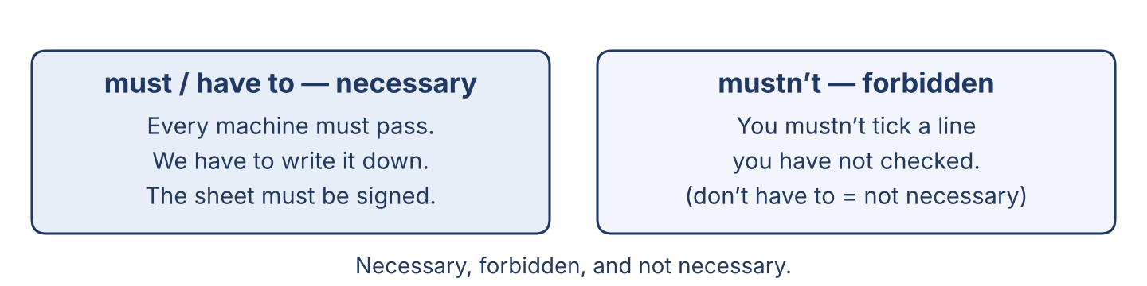
Figure 8.2 · Necessary, forbidden, and not necessary.
Read these lines. Which say ‘it is necessary’? Which say ‘it is forbidden’? Which say ‘it is not necessary’?
Must / have to (necessary): Every machine must pass the handover check. We have to write down every exception. · Mustn’t (forbidden): You mustn’t give a machine back with the antivirus off. You mustn’t share an account, not even with your manager. · Don’t have to (not necessary): If the scan ran this morning, you don’t have to run it again.
Part 2: Grammar Focus Box
 | Form | Use | Example
must / have to | must + verb | it is necessary | Every machine must pass the check.
mustn’t / don’t have to | mustn’t = forbidden | don’t have to = not necessary | You mustn’t hide a problem.
Remember: must and have to are similar. But mustn’t (forbidden) and don’t have to (not necessary) are completely different.
Watch out! ✗ mustn’t = don’t have to → ✓ You mustn’t hide a problem (forbidden). You don’t have to run it twice (not necessary).
Part 2: Controlled Practice
Complete with must or mustn’t. (0. is done.)
0. Every machine must pass the handover check.
1. You ___ give a machine back with the antivirus switched off.
2. Every exception ___ be written down.
3. You ___ hide a problem from the user.
4. The sheet ___ be signed with your own name.
Part 2: Have To or Don’t Have To?
Complete with have to, has to, don’t have to or doesn’t have to.
1. Under our policy, we ____________________ write every exception down.
2. If the scan ran this morning, you ____________________ run it again.
3. Every officer ____________________ sign the sheet personally.
4. The user ____________________ understand the technical part; that is our job.
Part 2: Correct the Sentence
Each sentence has one grammar mistake. Write the correct sentence.
1. You must to pass the handover check.
2. You don’t must hide a problem.
3. We has to use the same checklist.
4. Every machine must passes the check.
Part 2: Freer Practice
Write three rules for an office. Use must, mustn’t, and don’t have to.
Part 2: Grammar Review
Choose the correct answer.
1. Which sentence means ‘it is forbidden’?
○ A) You mustn’t hide a problem.
○ B) You don’t have to hide a problem.
○ C) You have to hide a problem.
○ D) You should hide a problem.
2. Which sentence means ‘it is not necessary’?
○ A) You must run it again.
○ B) You mustn’t run it again.
○ C) You don’t have to run it again.
○ D) You have to run it again.
→ Harvest: you will see must, have to and mustn’t again in the Part 5 reading.
Part 3 · Listening
[OP] Operator track · pre-class input · scripts printed inline
Part 3: The Handover Check
🔊 Audio Track 8.2
Before you listen: what must a machine pass before it goes back to the user?
Nabil: Tarek, before we give this machine back, we have to go through the sheet. Updates? Tarek: On, all of them. Nabil: Antivirus? Tarek: Running. Nabil: Screen lock? Tarek: It is set to five minutes. Nabil: Backup? Tarek: The first one hasn’t run yet. It runs tonight. Nabil: Then we mustn’t tick that line. Write it on the sheet as it is, and we will check it tomorrow before we close the ticket. Every line has to be true, or the sheet is worth nothing.
While you listen: write True, False, or Not Given. (0. is done.)
0. Nabil and Tarek are doing a handover check. — True
1. All the updates are on. ____
2. They can tick the backup line today. ____
3. Every line on the sheet has to be true. ____
Useful phrases: we have to… · we mustn’t… · every line has to be true
Part 3: A Guarantee Question
🔊 Audio Track 8.3
Before you listen: if a repair fails after two weeks, who has to pay?
Mr Aboud: The machine you repaired is doing the same thing again, and it is only twelve days. Rana: Then you don’t have to pay anything. Our guarantee is thirty days on the same fault. Mr Aboud: And if it is a different fault? Rana: Then it is a new job, and I will tell you so honestly before we start. But on the same fault, inside thirty days, we have to put it right free, and we have to use the same quality of part. You mustn’t take it to somebody else first, though, or the guarantee stops.
While you listen: answer the questions. (0. is done.)
0. What is Mr Aboud’s machine doing? — The same thing again.
1. Does Mr Aboud have to pay, if it is the same fault?
2. What must the department do under the guarantee?
3. What mustn’t Mr Aboud do?
Useful phrases: you don’t have to pay… · we have to put it right… · you mustn’t…
Part 3: The Standard
🔊 Audio Track 8.4
Before you listen: why does a company that works for a bank need a written standard?
Maher: Let’s talk about our standard. Because we work for two banks, we follow the same rules they do, and that is not a burden; it is why they chose us. Before handover, every machine must pass the four checks, and the sheet must be signed by name. Under guarantee, we have to put our own work right free, inside thirty days, with no argument. If a rule cannot be followed — and sometimes it cannot — we must write an exception and I must approve it before the work, not after. And nobody, at any level, may tick a line that is not true.
While you listen: match each rule with what it says. One is not needed. (0. is done.)
0. Because we work for two banks → we follow the same rules they do.
Column A
1. | Before handover | ____
2. | Under guarantee | ____
3. | If a rule cannot be followed | ____
4. | Nobody, at any level | ____
Column B
a) | we have to put our own work right free, inside thirty days
b) | every machine must pass the four checks and be signed by name
c) | we buy new machines every year
d) | may tick a line that is not true
e) | we must write an exception and the manager must approve it first
Part 4 · Speaking
[OP] Operator track · in-class output
Part 4: Discussing Rules and Standards
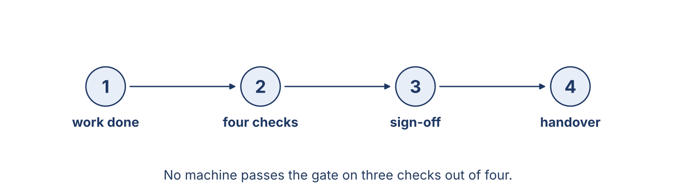
Figure 8.3 · The check before handover is a gate, not a formality.
Work with a partner. Ask and answer these questions.
What must every machine pass before it goes back to the user?
Why mustn’t a department hide a problem?
What does a guarantee mean for the user, and for the department?
Useful language: Every machine must… · You mustn’t… · We have to… · You don’t have to…
Part 4: Find the Difference
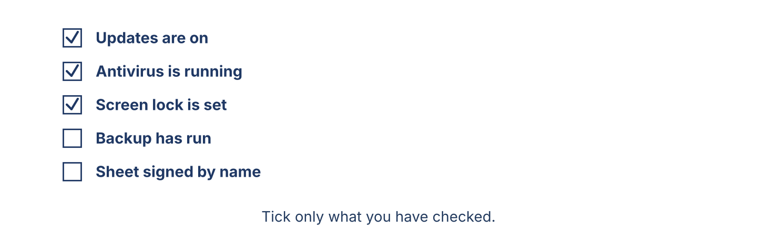
Figure 8.4 · Tick each item on the sheet.
Work in pairs. Student A looks at Machine A; Student B looks at Machine B. Ask and answer to find which machine may be handed over. Do not show your card.
Card A — Machine A: updates on · antivirus running · screen lock set · backup ran last night · sheet signed.
Card B — Machine B: updates on · antivirus switched off · screen lock not set · backup never run · sheet signed anyway.
Useful questions: Is the antivirus running? · Must it be? · Which machine mustn’t go back?
Part 4: Guarantee Role Play
Work in pairs. Read the model, then use the cards.
Model exchange: User: It is doing the same thing again, and it is only twelve days. — Officer: Then you don’t have to pay. On the same fault, inside thirty days, we have to put it right free.
Card A — Officer: explain what the guarantee covers, what it does not cover, and what the user mustn’t do. Card B — User: say what has happened, ask whether you have to pay, and ask what happens if it is a different fault.
Stretch [PR]: a user asks you to tick a line you have not checked, because they are in a hurry — refuse, and keep the user on your side.
Part 4: Mini-Presentation
Prepare a short talk (about one minute). Explain the rules of your office to a new worker: what is necessary, what is forbidden, and what is not necessary.
Part 5 · Reading
[OP] Operator track · pre-class input
Part 5: Why Standards Matter
Before you read: what does ‘quality’ mean in IT work, where nobody can see the result?
Gloss: standard = an agreed correct level that everybody works to · policy = the written rules of a company · disclosure = telling somebody about a problem they would not otherwise see
Quality in IT work is a promise about something the user cannot see. A user can tell whether a machine starts, but not whether its antivirus is running, whether its updates are three years old, or whether last year’s backup still works. Everything a user believes about those things, they believe because they were told. That is why a written standard matters more here than in visible work. Every machine must pass the same checks before it goes back, and the officer must sign by name, so that in a year anybody can see who said it was true. Nobody may tick an unchecked line, because one invented line is worse than no sheet at all: it tells everybody that the sheets mean nothing. A department must also say what it has not done. If the backup could not be tested because the disk had not arrived, that goes on the sheet, and the user is told. This is harder than it sounds. It is always easier to tick the line, and nobody would know. That is exactly why the rule has to be absolute: not "tick only what you checked, unless you are busy", but "tick only what you checked".
Answer the multiple-choice questions. (0. is done.)
0. What is quality in IT work? — a promise about something the user cannot see.
1. Why must the officer sign the sheet by name?
○ A) So that anybody can see later who said it was true
○ B) To make the machine faster
○ C) Because the user asks
○ D) To save paper
2. What is worse than no sheet at all?
○ A) A long sheet
○ B) A sheet with one invented line
○ C) A sheet in English
○ D) A sheet kept for a year
3. What must a department never do?
○ A) Tick a line it has not checked
○ B) Write an exception
○ C) Tell the user
○ D) Follow the standard
Part 5: Vocabulary in Context
Match each word from the text with its meaning. One meaning is not needed. Write the letter.
Column A
1. | standard | ____
2. | policy | ____
3. | sign-off | ____
4. | disclosure | ____
Column B
a) | the written rules of a company
b) | telling somebody about a problem they would not otherwise see
c) | a tool for opening a machine
d) | an agreed correct level that everybody works to
e) | the name of the person who says the work is finished and correct
Part 5: An Honest Guarantee in Syria
Before you read: why does a written guarantee from a small company matter so much in Syria?
Gloss: guarantee = a promise to put work right, free, if it fails · word of mouth = people telling each other about good work
In Syria, a written guarantee from a small company is worth more than it looks, because so few are given and even fewer are honoured. At Cham Systems the rule is one line long: if the same fault comes back within thirty days, the work is put right free, with no argument and no discussion about whose fault it was. Last year a repair failed on the twelfth day. The disk Lina had fitted was faulty from the factory — nothing anybody could have seen — and the customer had lost two days of work. He expected an argument, because he had had one everywhere else. Maher did not argue. He replaced the disk the same afternoon, restored the two days from the backup, charged nothing, and wrote a short note explaining what had failed and why. The whole thing cost Cham Systems a disk and half a day. What it bought cannot be bought any other way: that customer has told the story to every business owner he knows, and he tells it better than any advertisement could.
Write True or False. (0. is done.)
0. In Syria, a written guarantee from a small company is common. — False
1. At Cham Systems, the same fault within thirty days is put right free. ____
2. Maher argued about whose fault the failed disk was. ____
3. An honest guarantee brought the company more customers. ____
Part 6 · Writing
[OP] Operator track · in-class / homework
Part 6: The Office Rules (50–70 words)
Write the rules for an office. Use must, mustn’t and have to.
Model — read this first:
Every machine must pass the four checks before it goes back. The officer has to sign the sheet with their own name, and the sheet must be kept for a year. You mustn’t tick a line you have not checked, and you mustn’t hand a machine back with the antivirus switched off. If a rule cannot be followed, you have to write an exception and ask the manager first.
Plan (fill in, then write): Every ___ must ___. You mustn’t ___. We have to ___. If ___, you have to ___.
Word bank: Every machine must… | You mustn’t… | We have to… | You don’t have to… | sign | exception
Check before you finish: ☐ must / have to used? ☐ mustn’t used correctly? ☐ 50–70 words?
Part 6: Why Standards and Guarantees Matter (50–70 words)
Write why written standards and an honest guarantee are important. Give reasons.
Model — read this first:
Standards matter because a user cannot see most of our work, so they must be able to trust what we tell them. A written rule means every officer does the same thing, even on a bad day. And a guarantee turns a promise into something real: it costs us a little when we are wrong, which is exactly why people believe us when we say we are right.
Word bank: … is important because… | the user cannot see… | every officer does the same… | it costs us when we are wrong | trust
Check before you finish: ☐ a clear opinion? ☐ two or three reasons? ☐ 50–70 words?
Part 6: Explaining a Guarantee (50–70 words)
Write a short note to a user, explaining what your guarantee covers and what it does not.
Model — read this first:
Dear Mr Aboud, Our guarantee covers the same fault for thirty days from handover. If the machine does the same thing again inside that time, we put it right free, with no argument. A different fault is a new job, and we will tell you so honestly before we start. Please bring it to us first; if another company opens it, the guarantee stops. Rana.
Plan (fill in, then write): Our guarantee covers ___ for ___. If ___, we ___. A different fault is ___. Please ___.
Check before you finish: ☐ what is covered + what is not? ☐ must / mustn’t used? ☐ 50–70 words?
Part 6: Reflection — A Promise Kept (40–60 words)
Write about a time a shop or a person kept a promise when it would have been easier not to.
Model — read this first:
My uncle bought a water pump with a six-month guarantee, and it failed in the fifth month. He expected to be told it was his own fault. Instead the shop replaced it the same day and said nothing more about it. He has bought everything there since, and so have both his brothers.
Check before you finish: ☐ a clear story? ☐ must / have to used? ☐ 40–60 words?
Part 7 · Management File — A Policy Check Before Handover
[PR] Practitioner track (optional for beginners) · IT and security manager
7A: Phrase Bank
Match what a manager says with its purpose. One purpose is not needed. Write the letter.
Column A
1. | “You mustn’t tick a line you haven’t checked.” | ____
2. | “Did it pass all four checks?” | ____
3. | “Write the exception and I will approve it.” | ____
4. | “Under our guarantee, we have to put it right free.” | ____
Column B
a) | giving a strong prohibition
b) | checking that the standard was met
c) | asking about the price
d) | stating an obligation
e) | giving the way round a rule that cannot be followed
7B: Manager Dialogue
🔊 Audio Track 8.5
Before you read: what does a manager check before a machine goes back?
Nabil: Maher, this machine is ready for handover. Maher: Did it pass all four checks? Nabil: Three of them. The backup hasn’t run yet; it runs tonight. Maher: Then it doesn’t pass. Did you tick the line? Nabil: No. I wrote it on the sheet as it is. Maher: Good. That is exactly right. We mustn’t hand it over as complete, but we don’t have to keep the machine either. Give it back today, tell the user plainly that the backup starts tonight, and close the ticket tomorrow when you have seen it run. Write that on the sheet too, so the audit sees why.
Answer the questions. (0. is done.)
0. What does Nabil want Maher to do? — Approve a handover.
1. How many checks did the machine pass?
2. What did Nabil do with the line he could not tick?
3. What must Nabil do before the ticket is closed?
7C: Controlled Practice — The Policy
Complete with must, mustn’t, have to or don’t have to.
Word bank: must | mustn’t | have to | don’t have to
1. Every machine ____________________ pass the four checks.
2. You ____________________ tick a line you have not checked.
3. Under our guarantee, we ____________________ put the same fault right free.
4. If the scan ran this morning, you ____________________ run it again.
7D: Role-Play — The Policy Review
In pairs. One is the manager (Maher); one is the officer (Nabil). Use the model and the cards.
Model exchange: Maher: Did it pass all four checks? — Nabil: Three. The backup runs tonight. — Maher: Then it doesn’t pass. Did you tick the line? — Nabil: No, I wrote it as it is.
Card A — Manager (Maher): ask about each check, ask what was written, and decide what may be handed over today. Card B — Officer (Nabil): report honestly, say what could not be done and why, and ask what to tell the user.
Stretch [PR]: the user is waiting in the corridor and the last check will take an hour — decide, and say what you will tell them.
7E: Supervisory Writing (50–80 words)
You are Maher. Write a short policy note for the team about handover.
Model — read this first:
Team, one reminder about handover. Every machine must pass all four checks, and the sheet must be signed with your own name. You mustn’t tick a line you have not checked, for any reason, including a user waiting in the corridor. If a check cannot be done, write on the sheet what is missing and when it will be done, and tell the user plainly. That is not a failure; the invented tick is. Maher.
Check before you finish: ☐ what passes and what does not? ☐ must / mustn’t used? ☐ 50–80 words?
Part 8 · Global Case Study — The Honest Disclosure
[PR] Practitioner track · pre-read / in-class discuss
Before you read: what should a company do when it finds a fault in work it has already delivered?
Gloss: fault = something wrong that needs fixing · disclose = to tell people about a problem they could not see · reputation = what people say about your work
A software company once found a serious fault in a program that four hundred of its customers were already using. The fault was in how the program stored passwords, and it had been there for two years. Nobody outside the company knew, and almost certainly nobody would ever have known. The company had two choices. It could fix the fault quietly in the next ordinary update and say nothing, which is what its lawyers advised. Or it could tell all four hundred customers exactly what had been wrong, for how long, and what each of them should do. The directors argued for a week. In the end they wrote to every customer, published the whole story, and gave each one a tool to check their own records. Eleven customers left. The newspapers were unkind for about four days. But the company is still trading twenty years later, and the thing its customers say about it, over and over, is that it told them the time it did not have to.
Answer the questions. (0. is done.)
0. How many customers were using the program? — Four hundred.
1. What did the company find?
2. What two choices did it have?
3. Why do people trust the company more now?
Part 8: Vocabulary in Context
Match each word with its meaning. One meaning is not needed. Write the letter.
Column A
1. | disclose | ____
2. | fault | ____
3. | reputation | ____
4. | update | ____
Column B
a) | something wrong that needs fixing
b) | to tell people about a problem they could not see
c) | a new version that fixes faults
d) | a new machine
e) | what people say about your work
Part 8: Discussion
Talk with a partner. Use the frames.
Discussion frames: “An honest disclosure is right because…” · “The cost of saying nothing is…” · “In Syria this would be harder because…” · “I would have told the customers when…”
Part 9 · Local Case Study — Syria in Focus: The Guarantee That Kept Its Promise
[PR] Practitioner track · pre-read / in-class decide
Before you read: why might a user expect an argument when a repair fails?
A customer, Mr Khalil, had the disk in his shop computer replaced at Cham Systems, with the usual thirty-day guarantee written on the completion note. Twelve days later the machine stopped in exactly the same way. He came back expecting a difficult conversation, because that is what had happened at the last two places he had used: first they tell you it is a different fault, then they tell you it is something you did. Lina opened the machine while he waited. The new disk had failed — a factory fault, nothing anybody could have predicted, and nothing Mr Khalil had done. She replaced it that afternoon from the store, restored his two lost days from the backup, and charged him nothing. Maher wrote four lines on the note explaining what had failed. Mr Khalil has sent six people to Cham Systems since, and every one of them has mentioned that story when they arrived.
Answer the questions. (0. is done.)
0. What was replaced on Mr Khalil’s machine? — The disk.
1. What guarantee did Mr Khalil have?
2. What happened after twelve days?
3. What did Maher write on the note?
Part 9: Decision Task
A repair fails inside the guarantee, but the officer believes the user caused it. Should the department (a) charge the user, (b) honour the guarantee and say nothing, or (c) honour the guarantee and explain what it believes happened? Choose one and give reasons.
Answer frame: “I think the department should ___ because ___. The user needs ___. This is better than ___ because ___.”
Model — read this first:
I think the department should honour the guarantee and explain what it believes happened, because the guarantee was given without conditions and the officer cannot prove what the user did. The user needs to know how to avoid it next time. This is better than saying nothing, because the same thing will happen again in a month and then nobody will be happy.
Phrase bank: I think… should… · because… · The user needs… · This is better than… · In my opinion…
Part 10 · Review and Can-Do
[OP + PR] · homework / self-study
Part 10: Spiral Review
Complete the review. (0. is done.)
0. The promise to put our own work right, free, if it fails is a guarantee.
Word bank: exception | evidence | must | mustn’t | will
1. A case where the rule is not followed, written down and approved, is an ____________________ .
2. The record that proves a step was really done is the ____________________ .
3. “Every machine ____________________ pass the four checks.”
4. “You ____________________ tick a line you have not checked.”
5. “I ____________________ call you as soon as it is ready.”
Part 10: Can-Do
Can-Do checklist
☐ I can name the main words of a written policy and a guarantee.
☐ I can use must, have to, and mustn’t correctly.
☐ I can understand a handover check and a guarantee conversation.
☐ I can write the rules of an office and explain a guarantee.
☐ I can run a policy check before handover (Practitioner).
Part 10: Glossary
Unit 8 glossary (10 words)
policy · standard · sign-off · checklist · exception · audit · evidence · guarantee · disclose · handover

Unit 9: Incidents, Recovery and Repeat Problems
English for Cybersecurity Personnel · Level: Low B1 · Tracks: [OP] Warm-Up + Parts 1–6 · [PR] Parts 7–10
Warm Up
[OP] Operator track · in-class starter
Warm-up: Diagnosis Words
Match the words with their meanings. One meaning is not needed. Write the letter.
Column A
1. | Symptom | ____
2. | Alert | ____
3. | Root cause | ____
4. | Workaround | ____
5. | Recovery | ____
Column B
a) | a message the system sends when something is wrong
b) | a strong stand that holds a machine
c) | the real reason a problem happened
d) | a sign that something is wrong
e) | bringing the work and the files back after a failure
f) | a temporary way of working while the real fix is waited for
Warm-up: Talking About Repairs
Complete the sentences using the words in the word bank.
Word bank: replaced | Have | has | checked
1. Yesterday, I ____________________ the failing disk in the server.
2. ____________________ you checked the log for last night?
3. The same problem ____________________ come back twice this month.
4. I’ve already ____________________ the backup this morning.
Warm-up: Reading About Finding the Cause
Read the text and choose the correct answer.
When a system has a problem, the officer does not guess. First she looks at the symptoms: what the user saw, and when. Then she reads the log, the only part of the story that cannot forget. Then she tests one thing at a time, until she finds the root cause. Only then does she repair it. A problem that comes back a second time is called a repeat problem, and it usually means the first repair left the cause alone.
1. What does the officer look at first?
○ A) The symptoms
○ B) The price
○ C) The colour
○ D) The keyboard
2. What is a repeat problem?
○ A) A new machine
○ B) A weekly check
○ C) When the same problem comes back a second time
○ D) A guarantee
Part 1 · Vocabulary and Terminology
[OP] Operator track · pre-class input
Part 1: Incident and Recovery Terms
Match the words with their meanings. One meaning is not needed. (0. is done for you.)
0. Incident → something that goes wrong and has to be recorded and handled.
Column A
1. | Symptom | ____
2. | Root cause | ____
3. | Workaround | ____
4. | Recovery | ____
5. | Repeat problem | ____
6. | Rebuild | ____
7. | Post-incident note | ____
Column B
a) | the real reason a problem happened
b) | an old machine set up again from the beginning, clean
c) | a short written record of what happened and what was learned
d) | a cable for the printer
e) | a sign that something is wrong
f) | bringing the work and the files back after a failure
g) | a temporary way of working while the real fix is waited for
h) | when the same problem comes back a second time
Gloss: root cause = the real reason a problem happened · workaround = a temporary way of working while the real fix is waited for
Part 1: Pronunciation
🔊 Audio Track 9.1
Listen and practise these words. Say each word aloud and stress the loud syllable (CAPITALS).
symptom — SYMP-tom
diagnose — DI-ag-nose
recovery — re-CO-ver-y
rebuild — re-BUILD
evidence — EV-i-dence
warning — WARN-ing
Part 1: Fault-Finding Table
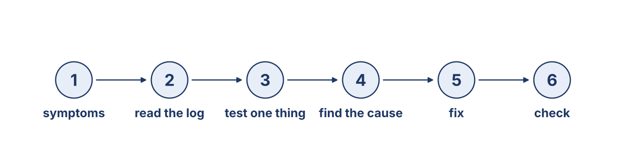
Figure 9.1 · The fault-finding steps, in order.
Complete the table. Write what happens at each step. (0. is done.)
Fault-finding step | What happens
Look at the symptoms | (example) the officer asks what the user saw, and when
Read the log
Test one thing at a time
Fix the root cause
0. Look at the symptoms — the officer asks what the user saw, and when.
Part 1: Fault-Finding Actions
Match each action with its meaning. One meaning is not needed. Write the letter.
Column A
1. | Investigate | ____
2. | Diagnose | ____
3. | Repair | ____
4. | Recover | ____
5. | Rebuild | ____
Column B
a) | to say what the problem really is
b) | to book an appointment
c) | to look into a problem and find out what happened
d) | to put the fault right
e) | to set a machine up again from the beginning, clean
f) | to bring the work and the files back after a failure
Part 1: Incidents and Recovery — Multiple Choice
Read and choose the correct answer.
1. What is a symptom?
○ A) A repair
○ B) A sign that something is wrong
○ C) A new machine
○ D) A tool
2. What is a workaround?
○ A) A broken machine
○ B) A new program
○ C) A cheap disk
○ D) A temporary way of working while the real fix is waited for
3. What does ‘root cause’ mean?
○ A) The real reason a problem happened
○ B) The price of the repair
○ C) The name of the user
○ D) The age of the machine
Part 1: Vocabulary Fill-in
Complete the sentences with the correct word.
Word bank: symptom | root cause | recovery | repeat problem
1. A strange message or a slow machine is a ____________________ .
2. We do not stop until we have found the ____________________ .
3. Bringing the files back after a failure is the ____________________ .
4. The same fault twice in a month is a ____________________ .
Part 1: Write About Fault-Finding (short)
Write two or three sentences about how you find a fault. Use three words from this unit.
Model — read this first:
When something goes wrong, I start with the symptoms: what the user saw, and at what time. Then I read the log, because the machine remembers better than any of us. I test one thing at a time until I find the root cause. I have learned not to repair anything before I can say why it broke.
Part 2 · Grammar — Present Perfect vs Past Simple
[OP] Operator track · pre-class input
Part 2: Notice
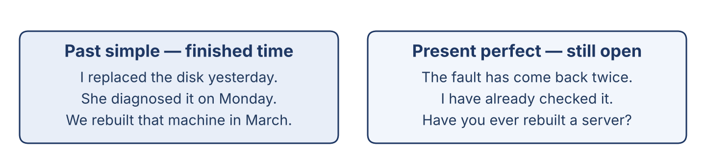
Figure 9.2 · Finished time, and time that is still open.
Read these lines. Which have a finished time? Which are about now, or about experience?
Past simple (finished time): I replaced the disk yesterday. She diagnosed the fault last Monday. We rebuilt that machine in March. · Present perfect (no finished time; still true now): The same problem has come back twice. I have already checked the backup. Have you ever rebuilt a server?
Part 2: Grammar Focus Box
 | Form | Use | Example
Past simple | verb + -ed / irregular | a finished time (yesterday, last week) | I replaced the disk yesterday.
Present perfect | have / has + past participle | no finished time; experience; still true | The problem has come back twice.
Remember: Past simple with a finished time. Present perfect with ever, never, already, yet, and with things that are still true now.
Watch out! ✗ I have replaced it yesterday. → ✓ I replaced it yesterday. ✗ Have you diagnose it? → ✓ Have you diagnosed it?
Part 2: Controlled Practice
Complete with the past simple or present perfect. (0. is done.)
0. I replaced the disk yesterday. (replace)
1. ___ you ever ___ (rebuild) a server?
2. She ___ (diagnose) the fault last Monday.
3. The same problem ___ (come) back twice this month.
4. I ___ (check) the log an hour ago.
Part 2: Choose the Form
Choose the correct form.
1. I ____________________ the disk yesterday. (replaced / have replaced)
2. ____________________ it yet? (Did you test / Have you tested)
3. She ____________________ it last Monday. (fixed / has fixed)
4. We ____________________ three machines this week. (rebuilt / have rebuilt)
Part 2: Correct the Sentence
Each sentence has one grammar mistake. Write the correct sentence.
1. I have replaced the disk yesterday.
2. Have you diagnose the fault?
3. He has fix it last week.
4. Did you ever rebuilt a server?
Part 2: Freer Practice
Write two sentences: one about a repair you made at a finished time, and one about something you have done this week.
Part 2: Grammar Review
Choose the correct answer.
1. Which sentence is correct with ‘yesterday’?
○ A) I have replaced it yesterday.
○ B) I have replace it yesterday.
○ C) I replaced it yesterday.
○ D) I replacing it yesterday.
2. Which sentence is correct for experience?
○ A) Did you ever rebuild a server?
○ B) Have you ever rebuilt a server?
○ C) Have you ever rebuild a server?
○ D) You ever rebuilt a server?
→ Harvest: you will see the present perfect and the past simple again in the Part 5 reading.
Part 3 · Listening
[OP] Operator track · pre-class input · scripts printed inline
Part 3: Finding the Cause
🔊 Audio Track 9.2
Before you listen: what are the first two things an officer looks at?
Nabil: Lina, what’s the symptom? Lina: The accounts machine stops every afternoon, always between two and three. Nabil: Have you read the log? Lina: Yes. There’s a disk error every time, a few seconds before it stops. Nabil: And have you checked the disk itself? Lina: I ran the check this morning. The disk is failing — it isn’t the program at all. I replaced it an hour ago and the machine has been running since. Nabil: Good. Then write the cause on the ticket, not just “replaced disk”. The next person needs to know why.
While you listen: write True, False, or Not Given. (0. is done.)
0. Lina is finding the cause of a fault. — True
1. The machine stops every morning. ____
2. Lina has already replaced the disk. ____
3. The problem was in the program. ____
Useful phrases: Have you read…? · I ran the check this morning · it has been running since
Part 3: A Repeat Problem
🔊 Audio Track 9.3
Before you listen: what does a user say when the same problem comes back?
Mr Aboud: Hello. I brought this machine in last week, and the same thing has started again. Rana: I’m sorry. Let me look at the ticket. Yes — we replaced the disk on the fourteenth. Mr Aboud: And now it is doing exactly the same. Rana: Then you don’t pay anything; it is inside our thirty days. But I am not going to send it straight back to the bench. If the same fault has come back after a new disk, the disk was probably never the cause. Can you leave it with us until tomorrow? I would rather find the real reason than change another disk.
While you listen: answer the questions. (0. is done.)
0. Why is Mr Aboud back? — The same problem has started again.
1. What did the department do last week?
2. Does Mr Aboud have to pay?
3. Why does Rana not want to change another disk?
Useful phrases: the same thing has started again · we replaced it on… · it has come back
Part 3: The Week’s Incidents
🔊 Audio Track 9.4
Before you listen: is a repeat problem always somebody’s mistake?
Maher: Let’s look at this week’s incidents. On Monday Lina diagnosed three machines and found the same disk model failing in all of them, which is useful to know. On Tuesday we rebuilt the reception machine; it has been clean since. Yesterday one came back with the same fault we thought we had fixed, and that is the one I want to talk about — not to blame anybody, but because a repeat problem always teaches us something a first-time fault cannot. This morning Nabil has already written the post-incident note for it, which is exactly right.
While you listen: match each time with what happened. One is not needed. (0. is done.)
0. Monday → Lina diagnosed three machines.
Column A
1. | Tuesday | ____
2. | Yesterday | ____
3. | This morning | ____
4. | Next week | ____
Column B
a) | a machine came back with the same fault
b) | the office is closed
c) | we rebuilt the reception machine
d) | Nabil has already written the post-incident note
e) | the new disks are arriving
Part 4 · Speaking
[OP] Operator track · in-class output
Part 4: Discussing Incidents
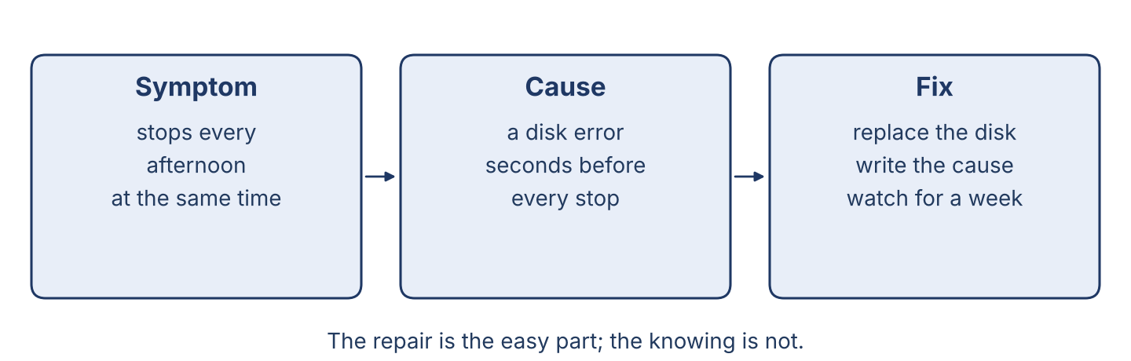
Figure 9.3 · From symptom to cause to fix.
Work with a partner. Ask and answer these questions.
How does an officer find a cause, step by step?
Have you ever fixed something difficult? What was it?
Why must a department take every repeat problem seriously?
Useful language: First, I look at… · Have you ever…? · I replaced it on… · It has come back…
Part 4: Find the Difference

Figure 9.4 · Name each kind of alert.
Work in pairs. Student A looks at Machine A; Student B looks at Machine B. Ask and answer to find which machine has the more serious problem. Do not show your card.
Card A — Machine A: disk alert on Tuesday · repaired Wednesday · no alert since · log is clean.
Card B — Machine B: disk alert on Tuesday · repaired Wednesday · the same alert has returned twice · the log shows the same error each time.
Useful questions: Has the alert come back? · When did you repair it? · Which machine is the worse one?
Part 4: The Repeat Problem Role Play
Work in pairs. Read the model, then use the cards.
Model exchange: User: I brought it in last week and the same thing has started again. — Officer: I’m sorry. We replaced the disk on the fourteenth. If it has come back after a new disk, the disk was probably never the cause. May I keep it until tomorrow?
Card A — User: explain that the same problem has come back, say when you brought it in, and say what it is stopping you doing. Card B — Officer: apologise, say what was done and when, explain why you want to look again, and say what you will do today.
Stretch [PR]: the repeat problem is a different fault that looks the same — explain that honestly without sounding as though you are avoiding the guarantee.
Part 4: Mini-Presentation
Prepare a short talk (about one minute). Describe a problem you have solved: the symptoms, what you tried, and what the cause turned out to be.
Part 5 · Reading
[OP] Operator track · pre-class input
Part 5: Diagnosis, Recovery and Repeat Problems
Before you read: is finding the cause harder than repairing it?
Gloss: cause = the reason a problem happened · rebuild = to set a machine up again from the beginning, clean · evidence = what the log and the records actually show
Finding a cause is like solving a puzzle, and the hardest part is not the repair. The repair is simple once you know what is wrong; the knowing takes the time. A careful officer starts with the symptoms — what the user saw, and exactly when — then reads the log, which remembers what everybody else has forgotten. Then she tests one thing at a time. Changing three things at once and finding that the problem has gone teaches nothing, because next month it will come back and nobody will know which of the three mattered. When the cause is found, there is a second decision: repair or rebuild. A machine that has had five different problems in a year is usually telling you something, and a clean rebuild often costs less than the next three repairs. Finally, every repeat problem must be taken seriously, and taken differently. If the same fault returns after a repair, the first repair almost certainly fixed a symptom and left the cause alone. The right answer then is not another new part. It is to go back to the beginning and ask what the evidence actually showed, including the possibility that the first diagnosis was wrong.
Answer the multiple-choice questions. (0. is done.)
0. What is finding a cause like? — solving a puzzle.
1. What does the officer look at first?
○ A) The symptoms
○ B) The price
○ C) The colour
○ D) The user’s name
2. Why test one thing at a time?
○ A) It is faster
○ B) Changing three things teaches you nothing
○ C) It is cheaper
○ D) The manager asks for it
3. What should a department do after a repeat problem?
○ A) Fit another new part
○ B) Go back to the evidence and ask what it really showed
○ C) Do nothing
○ D) Close the ticket
Part 5: Vocabulary in Context
Match each word from the text with its meaning. One meaning is not needed. Write the letter.
Column A
1. | symptom | ____
2. | cause | ____
3. | rebuild | ____
4. | evidence | ____
Column B
a) | the reason a problem happened
b) | a sign that something is wrong
c) | a tool for opening a machine
d) | what the log and the records actually show
e) | to set a machine up again from the beginning, clean
Part 5: Keeping Old Machines Working in Syria
Before you read: why is the skill to repair worth more in Syria than the money to replace?
Gloss: skilled = very good at a job learned over years · spare part = a piece kept ready to replace a broken one
In Syria, new machines are expensive and hard to import, so most offices are working with equipment that would have been replaced years ago somewhere else. This has produced a generation of technicians who are extremely good at something their colleagues abroad rarely learn: making an old machine work for another year. They repair power supplies that in other countries are simply thrown away. They keep a drawer of parts taken from machines that have finally died, carefully labelled, because the shop may not have that part for six months. They know which disk models fail, because they have seen forty of them. Lina was taught by a man in Aleppo who had kept the same four machines running for eleven years, and she says the most valuable thing he gave her was not a technique at all. It was the habit of asking why a thing had failed, every single time, even when the repair was obvious — because a part that fails twice in one machine is not a bad part, it is a message about something else.
Write True or False. (0. is done.)
0. In Syria, most offices are working with old equipment. — True
1. New machines are always cheap and easy to import in Syria. ____
2. Technicians keep labelled parts from machines that have died. ____
3. Syrian technicians are skilled at keeping old machines working. ____
Part 6 · Writing
[OP] Operator track · in-class / homework
Part 6: Finding and Fixing a Fault (60–80 words)
Describe how you found and fixed a fault. Use the past simple and the present perfect.
Model — read this first:
Last Tuesday the accounts machine stopped every afternoon at the same time. I asked the user what she saw, and then I read the log, which showed a disk error a few seconds before each stop. I ran the disk check and found that it was failing. I replaced it on Wednesday morning, and the machine has run without stopping since. I have written the cause on the ticket, not only the repair.
Plan (fill in, then write): Last ___, the ___ stopped. I asked ___. Then I read ___. I replaced ___ on ___. It has ___ since.
Word bank: Last week, I …ed | I have already… | It has come back… | the log showed… | the root cause was…
Check before you finish: ☐ past simple with a finished time? ☐ present perfect for now? ☐ 60–80 words?
Part 6: Why Every Repeat Problem Matters (50–70 words)
Write why a department must take every repeat problem seriously. Give reasons.
Model — read this first:
A repeat problem must be taken seriously because it is telling us that the first repair was wrong. If the same fault returns after a new part, the part was probably never the cause, and fitting a second one will waste more money and more of the user’s time. A repeat problem is also the cheapest lesson a department ever gets, because the evidence is still there.
Word bank: … must take … seriously | the first repair was wrong | the cause is still there | it wastes… | the cheapest lesson
Check before you finish: ☐ a clear opinion? ☐ two or three reasons? ☐ 50–70 words?
Part 6: A Repair Note (50–70 words)
Write a short note from the officer to the help desk about a repair and its cause.
Model — read this first:
Last Wednesday I replaced the disk in the accounts machine. The log had shown a disk error before every stop, and the disk check confirmed it was failing. The machine has run normally since. One thing for the record: this is the third disk of the same model we have replaced this year, so I have asked Maher whether we should stop buying them. Lina.
Plan (fill in, then write): Last ___ I ___. The log showed ___. It has ___ since. One thing for the record: ___.
Check before you finish: ☐ past simple + present perfect? ☐ the cause, not just the repair? ☐ 50–70 words?
Part 6: Reflection — A Problem I Solved (40–60 words)
Write about a problem you found and solved, at work or at home.
Model — read this first:
Our lamp at home kept going out, and my father changed the bulb three times. I watched it instead and saw that it only went out when somebody walked past. The cable was loose where it met the switch. I have fixed it with ten minutes of work, and it has not gone out since.
Check before you finish: ☐ a clear story? ☐ past simple + present perfect? ☐ 40–60 words?
Part 7 · Management File — Handling a Repeat Problem and a Guarantee Repair
[PR] Practitioner track (optional for beginners) · IT and security manager
7A: Phrase Bank
Match what a manager says with its purpose. One purpose is not needed. Write the letter.
Column A
1. | “Have you found the cause yet?” | ____
2. | “We replaced the disk on the fourteenth.” | ____
3. | “It has come back twice now.” | ____
4. | “Write the post-incident note today.” | ____
Column B
a) | saying what was done (past, finished time)
b) | checking the state of the work now
c) | asking about the price
d) | giving an instruction
e) | reporting something that is still happening
7B: Manager Dialogue
🔊 Audio Track 9.5
Before you read: how does a manager handle a repeat problem without blaming anybody?
Maher: Lina, Mr Aboud’s machine has come back. Lina: I know. We replaced the disk on the fourteenth. Maher: Have you found out why it has come back? Lina: Not yet. But if a new disk failed the same way in ten days, the disk was never the real cause. Maher: I agree. What is your next step? Lina: Read the log from before the first repair. I only read the last two days last time, and the answer may be earlier. Maher: Do that. And nobody is in trouble — if the first diagnosis was wrong, I would rather say so now than fit a third disk.
Answer the questions. (0. is done.)
0. Whose machine has come back? — Mr Aboud’s.
1. What did they do on the fourteenth?
2. Why does Lina doubt the disk was the cause?
3. What will Lina do next?
7C: Controlled Practice — The Repeat Problem
Complete with the past simple or present perfect.
Word bank: replaced | has | Have | found
1. Last week, we ____________________ the disk in that machine.
2. The same fault ____________________ come back twice.
3. ____________________ you read the log from before the first repair?
4. Lina has not ____________________ the real cause yet.
7D: Role-Play — Handling the Repeat Problem
In pairs. One is the manager (Maher); one is the officer (Lina). Use the model and the cards.
Model exchange: Maher: Have you found out why it has come back? — Lina: Not yet. But a new disk failing the same way in ten days says the disk was never the cause. — Maher: Then what is your next step?
Card A — Manager (Maher): ask what was done and when, ask what has happened since, and ask for the next step. Card B — Officer (Lina): report honestly, say what you now doubt about the first diagnosis, and say what you will look at.
Stretch [PR]: the user is angry and wants a new machine rather than a third repair — answer without promising a machine you cannot give.
7E: Supervisory Writing (50–80 words)
You are Maher. Write a short note to the user about the repeat problem and what you are doing.
Model — read this first:
Dear Mr Aboud, Your machine has come back with the same fault, and I am sorry. We replaced the disk on the fourteenth, and it is now clear that the disk was not the real cause, so fitting another one would waste your time. Lina is reading the full log today and will call you before five. There is nothing to pay, and we will keep it until it is genuinely fixed. Maher Khoury.
Check before you finish: ☐ past simple + present perfect? ☐ what you will do, and by when? ☐ 50–80 words?
Part 8 · Global Case Study — The Office That Recovered in a Day
[PR] Practitioner track · pre-read / in-class discuss
Before you read: is it always better to replace a system than to recover it?
Gloss: recover = to bring the work and the files back after a failure · drill = a practice run of something you hope never to need · offsite = kept in another building
Two companies in the same city lost their main server in the same month, to the same kind of failure. The first had a backup and had never tested it. When the day came, the copy was of the wrong folder, and ten months of work was gone; the company took five months to rebuild what it could, and never fully recovered its records. The second company had the same equipment and the same budget, and one habit the first did not: twice a year, on an ordinary working morning, it pretended the server had died and recovered it onto a spare machine while everybody watched. The first drill took eleven hours and found four things that did not work. The second took five hours. By the fourth drill it took under three. When the real failure came, on a Tuesday, the office was working again by that afternoon. The manager said the drills had never once felt like a good use of a morning, and that he would not trade them for anything.
Answer the questions. (0. is done.)
0. How many companies lost their server? — Two.
1. What was wrong with the first company’s backup?
2. What did the second company do twice a year?
3. How long did the first drill take, and the fourth?
Part 8: Vocabulary in Context
Match each word with its meaning. One meaning is not needed. Write the letter.
Column A
1. | recover | ____
2. | drill | ____
3. | offsite | ____
4. | restore | ____
Column B
a) | to bring the files back from a copy
b) | a practice run of something you hope never to need
c) | kept in another building
d) | a new machine
e) | to bring the work and the files back after a failure
Part 8: Discussion
Talk with a partner. Use the frames.
Discussion frames: “A drill is worth the morning because…” · “In our office the first drill would find…” · “An untested backup is…” · “The hardest part would be…”
Part 9 · Local Case Study — Syria in Focus: Rebuild or Replace?
[PR] Practitioner track · pre-read / in-class decide
Before you read: what can an office do when a machine fails and no replacement can be imported?
An old server at a printing works in Homs failed mid-season, and its owner, Abu Firas, could not buy another. The model had not been sold in Syria for six years, and a new one would have come through Beirut at a price he could not meet. Lina looked at it for a day. The machine was sound; the power supply had burned out and taken a disk with it. No new power supply could be had, but a working one came from a dead machine of the same family in the store, and the disk was common. She rebuilt the server from the beginning, not in place: a clean install, the files restored, and the accounts set up properly rather than as they had grown over nine years. It took two days. Abu Firas asked what he should do about next year. She told him: this machine has perhaps two more years, and the time to plan is now, while it still works.
Answer the questions. (0. is done.)
0. What is Abu Firas’s business? — A printing works in Homs.
1. Why could he not simply buy another server?
2. What had actually failed?
3. What did Lina tell him about next year?
Part 9: Decision Task
A machine has failed and a replacement cannot be imported this month. Should the department (a) rebuild it from parts and the backup, (b) move the work to another machine as a workaround, or (c) wait for the import? Choose one and give reasons.
Answer frame: “I think the department should ___ because ___. The risk of ___ is ___. This is better than ___ because ___.”
Model — read this first:
I think the department should rebuild it from parts and the backup, because the office cannot stop for the two months an import may take. The risk of waiting is that the season is lost and the money is lost with it. This is better than a workaround on another machine, because a temporary arrangement that works is never replaced, and in a year nobody will remember how it was built.
Phrase bank: I think… should… · because… · The risk of… · This is better than… · In my opinion…
Part 10 · Review and Can-Do
[OP + PR] · homework / self-study
Part 10: Spiral Review
Complete the review. (0. is done.)
0. A sign that something is wrong is a symptom.
Word bank: root cause | repeat problem | replaced | has | must
1. The real reason a problem happened is the ____________________ .
2. When the same fault comes back a second time, it is a ____________________ .
3. “I ____________________ the disk yesterday.”
4. “The fault ____________________ come back twice this month.”
5. “Every machine ____________________ pass the four checks before handover.”
Part 10: Can-Do
Can-Do checklist
☐ I can name the main fault-finding and recovery words.
☐ I can use the past simple and the present perfect correctly.
☐ I can understand a diagnosis and a repeat-problem conversation.
☐ I can write a repair note or a post-incident note.
☐ I can handle a repeat problem and a guarantee repair (Practitioner).
Part 10: Glossary
Unit 9 glossary (10 words)
symptom · root cause · workaround · recovery · rebuild · repeat problem · drill · offsite · evidence · post-incident note

Unit 10: The User, the Provider and Explaining Security
English for Cybersecurity Personnel · Level: Low B1 · Tracks: [OP] Warm-Up + Parts 1–6 · [PR] Parts 7–10
Warm Up
[OP] Operator track · in-class starter
Warm-up: User and Provider Words
Match the words with their meanings. One meaning is not needed. Write the letter.
Column A
1. | Feedback | ____
2. | Recommend | ____
3. | Advisory | ____
4. | Reminder | ____
5. | Training | ____
Column B
a) | to tell somebody that something is good and worth using
b) | a tool for opening a machine
c) | a note from the provider about a fault and what to do about it
d) | what a user says about the service they were given
e) | learning new skills, because the work keeps changing
f) | a message that something is due to be done
Warm-up: Reporting What People Say
Complete the sentences using the words in the word bank.
Word bank: said | told | asked | that
1. The user ____________________ that the machine was slow again.
2. Maher ____________________ the team to read the new advisory.
3. Rana ____________________ if the update had been installed.
4. Lina said ____________________ she had finished the training.
Warm-up: Reading About the Department
Read the text and choose the correct answer.
A good IT department looks after three relationships. It listens to its users, because daily users see things no report shows. It reads what the provider sends — the advisories about faults, and the updates that fix them. And it talks to itself: once a week the team sits down, and each person reports what they have seen. The manager’s job at that meeting is mostly to listen, and to make sure Tuesday’s lesson does not stay with one person.
1. What does a good department listen to?
○ A) The radio
○ B) Its users
○ C) The traffic
○ D) Nothing
2. What is the manager’s job at the team meeting?
○ A) Mostly to listen
○ B) To sell machines
○ C) To clean
○ D) To read the news
Part 1 · Vocabulary and Terminology
[OP] Operator track · pre-class input
Part 1: User and Provider Terms
Match the words with their meanings. One meaning is not needed. (0. is done for you.)
0. Training → learning new skills, because the work keeps changing.
Column A
1. | User relations | ____
2. | Satisfaction | ____
3. | Advisory | ____
4. | Campaign | ____
5. | Reminder | ____
6. | Provider | ____
7. | Awareness | ____
Column B
a) | the good feeling when a user gets what they were promised
b) | a cable for the printer
c) | the company that makes or supplies a program
d) | how we treat the people who use the system, every day
e) | a plan to fix one thing everywhere, for everybody, at once
f) | a note from the provider about a fault and what to do about it
g) | a message that something is due to be done
h) | the staff knowing what to look out for, and what to report
Gloss: advisory = a note from the provider about a fault and what to do about it · awareness = the staff knowing what to look out for, and what to report
Part 1: Pronunciation
🔊 Audio Track 10.1
Listen and practise these words. Say each word aloud and stress the loud syllable (CAPITALS).
provider — pro-VI-der
satisfaction — sat-is-FAC-tion
advisory — ad-VI-so-ry
feedback — FEED-back
recommend — re-com-MEND
awareness — a-WARE-ness
Part 1: Who Tells Us What Table
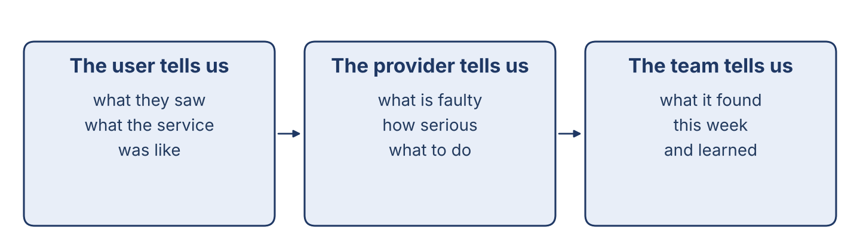
Figure 10.1 · Who tells the department what.
Complete the table. Write what each one tells us. (0. is done.)
Who | What they tell us
The user | (example) what they saw, and what the service was like
The provider
The team
The log
0. The user — what they saw, and what the service was like.
Part 1: Reporting Verbs
Match each verb with its meaning. One meaning is not needed. Write the letter.
Column A
1. | Say | ____
2. | Tell | ____
3. | Ask | ____
4. | Recommend | ____
5. | Warn | ____
Column B
a) | to give information to a person (tell somebody something)
b) | to speak words, without naming the listener
c) | to repair a machine
d) | to put a question
e) | to say that something is good and worth using
f) | to say that something may be dangerous
Part 1: Users and Providers — Multiple Choice
Read and choose the correct answer.
1. What is a reminder?
○ A) A tool
○ B) A fault
○ C) A message that something is due to be done
○ D) A machine part
2. What is user satisfaction?
○ A) The price
○ B) The good feeling when a user gets what they were promised
○ C) A bill
○ D) A tool
3. What is an advisory?
○ A) A user’s machine
○ B) A kind of cable
○ C) A meeting
○ D) A note from the provider about a fault and what to do about it
Part 1: Vocabulary Fill-in
Complete the sentences with the correct word.
Word bank: feedback | campaign | recommend | training
1. We listen to user ____________________ after every big job.
2. The provider started a ____________________ to update every office at once.
3. A satisfied user will ____________________ us to other departments.
4. The team goes on ____________________ twice a year, because the work changes.
Part 1: Write About User Relations (short)
Write two or three sentences about how your department treats its users. Use three words from this unit.
Model — read this first:
We call every user a week after a big job and ask what the service was like. Most of them say the same thing: they do not mind waiting, but they mind not knowing. We read every advisory the provider sends, and we tell the users plainly when one of them affects their machines.
Part 2 · Grammar — Reported Speech
[OP] Operator track · pre-class input
Part 2: Notice
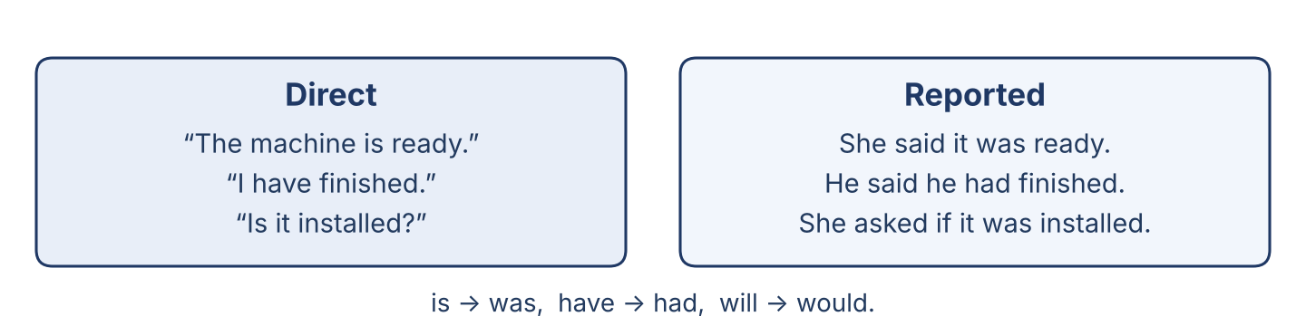
Figure 10.2 · Direct speech, and the same words reported.
Read these pairs. How does the sentence change when we report it?
Direct: “The machine is ready.” → Reported: She said the machine was ready. · Direct: “I have finished the training.” → Reported: He said he had finished the training. · Direct: “Is the update installed?” → Reported: She asked if the update was installed. · Direct: “Read the advisory.” → Reported: He told us to read the advisory.
Part 2: Grammar Focus Box
 | Form | Use | Example
say / tell | said (that) … / told somebody (that) … | reporting a statement | She said the machine was ready.
ask / tell to | asked if … / told somebody to … | reporting a question or an order | He asked if it was ready.
Remember: Backshift: is → was, will → would, have → had. Say something; tell somebody something.
Watch out! ✗ She said me. → ✓ She told me. / She said that… ✗ He asked is it ready. → ✓ He asked if it was ready.
Part 2: Controlled Practice
Report each statement. (0. is done.)
0. “The machine is ready.” → She said the machine was ready.
1. “I have finished the training.” (Lina → Maher)
2. “The disks will arrive tomorrow.” (Rana → the team)
3. “Read the new advisory.” (Maher → the team)
4. “We never share accounts.” (Nabil → the trainee)
Part 2: Report the Question
Report each question. (0. is done.)
0. “Is the machine ready?” (the user → Rana) → The user asked if the machine was ready.
1. “When will it be finished?” (the user → Rana)
2. “Have you found the cause?” (Maher → Lina)
3. “Do you test every backup?” (the bank → Maher)
4. “Is the training finished?” (Maher → Lina)
Part 2: Correct the Sentence
Each sentence has one grammar mistake. Write the correct sentence.
1. She said me the machine was ready.
2. He asked is the update installed.
3. Maher told to read the advisory.
4. Rana said the disks will arrive tomorrow.
Part 2: Freer Practice
Report two things you have really heard this week: one statement and one question.
Part 2: Grammar Review
Choose the correct answer.
1. Which is correct reported speech?
○ A) She said the machine was ready.
○ B) She said me the machine was ready.
○ C) She told the machine was ready.
○ D) She say the machine is ready.
2. Which is a correct reported question?
○ A) He asked is the machine ready.
○ B) He asked the machine was ready.
○ C) He asked if the machine was ready.
○ D) He asked if is the machine ready.
→ Harvest: you will see reported speech again in the Part 5 reading.
Part 3 · Listening
[OP] Operator track · pre-class input · scripts printed inline
Part 3: User Feedback
🔊 Audio Track 10.2
Before you listen: why does a department call a user after the work is finished?
Rana: Maher, I called Mr Aboud for feedback on last week’s job. Maher: What did he say? Rana: He said he was happy with the work, and he told me the machine had not stopped once since. But he also said something I think we should hear: he said he had not understood what we were doing for the first two days, because nobody had explained it in words he knew. Maher: That is worth more than the compliment. Did he ask for anything? Rana: He asked whether we could look at the machines in his other office as well.
While you listen: write True, False, or Not Given. (0. is done.)
0. Rana called Mr Aboud for feedback. — True
1. Mr Aboud said he was unhappy with the work. ____
2. He said he had not understood what was happening at first. ____
3. He asked about his other office. ____
Useful phrases: He said (that)… · He told me… · He asked whether…
Part 3: A Provider Advisory
🔊 Audio Track 10.3
Before you listen: what kind of news does a provider send to the offices that use its program?
Lina: Maher, there’s a new advisory from the provider. Maher: What does it say? Lina: It says there is a fault in the version we are running, and it tells every office to install the update within fourteen days. It also warns that the fault is already being used somewhere, so it is not one we can leave. Maher: Does it say what the fault lets somebody do? Lina: It says it lets an account be opened without the password. It tells us to install the update first and change the passwords afterwards, in that order. Maher: Then we start today. Have you done the provider’s training on this version? Lina: Yes, I finished it last month.
While you listen: answer the questions. (0. is done.)
0. What is the advisory about? — A fault in the version they are running.
1. What did the advisory tell every office to do?
2. Is the update urgent, and why?
3. Has Lina done the training?
Useful phrases: It says (that)… · It tells every office to… · It warns that…
Part 3: The Team Meeting
🔊 Audio Track 10.4
Before you listen: what news does a manager bring to a weekly team meeting?
Maher: Good morning, everyone. Here is the week. The users first: Mr Aboud said he was happy, but he told Rana he had not understood us for two days, so we are going to change how we explain a job. The provider next: the advisory says there is a fault in our version and tells us to update within fourteen days; Nabil starts this afternoon. Training: Lina has finished the new-version course and she will teach the rest of us on Thursday. And one from me: I asked the bank what they would want to see next year, and they said they would want a tested restore every quarter, not every year.
While you listen: match each topic with what was said. One is not needed. (0. is done.)
0. The users → Mr Aboud said he was happy but had not understood us.
Column A
1. | The provider | ____
2. | Training | ____
3. | The bank | ____
4. | Next month | ____
Column B
a) | Lina has finished the course and will teach the others
b) | said they would want a tested restore every quarter
c) | the office is moving to a new building
d) | the advisory tells us to update within fourteen days
e) | two new machines are arriving
Part 4 · Speaking
[OP] Operator track · in-class output
Part 4: Discussing Users and Providers
Work with a partner. Ask and answer these questions.
Why is user feedback important, even when it is uncomfortable?
What kind of news does a provider send, and how urgent is it usually?
Why does a team need training every year?
Useful language: The user said… · He told me… · She asked if… · The advisory tells us to…
Part 4: Find the Difference
Work in pairs. Student A looks at Notes A; Student B looks at Notes B. Ask and answer to find four differences. Do not show your card.
Card A — Notes A: feedback good · the advisory says fourteen days · Lina has finished the training · the bank asked for a quarterly restore.
Card B — Notes B: feedback good but unclear explanations · the advisory says seven days · Lina has not started the training · the bank asked for a yearly restore.
Useful questions: What did the feedback say? · How many days does the advisory give? · Who has finished the training?
Part 4: Reporting Role Play

Figure 10.3 · The security-team meeting.
Work in pairs. Read the model, then use the cards.
Model exchange: Manager: What did the user say? — Officer: He said he was happy with the work, but he told me he had not understood what we were doing for two days. — Manager: Did he ask for anything? — Officer: He asked whether we could look at his other office.
Card A — Manager: ask what the user said, what the advisory says, and who has finished the training. Card B — Officer: report all three, using said, told and asked.
Stretch [PR]: a user gave you different feedback from the one they gave your manager — report both, without taking sides.
Part 4: Mini-Presentation
Prepare a short talk (about one minute). Report what three different people told you this week, and what you did about it.
Part 5 · Reading
[OP] Operator track · pre-class input
Part 5: The User, the Provider and the Team
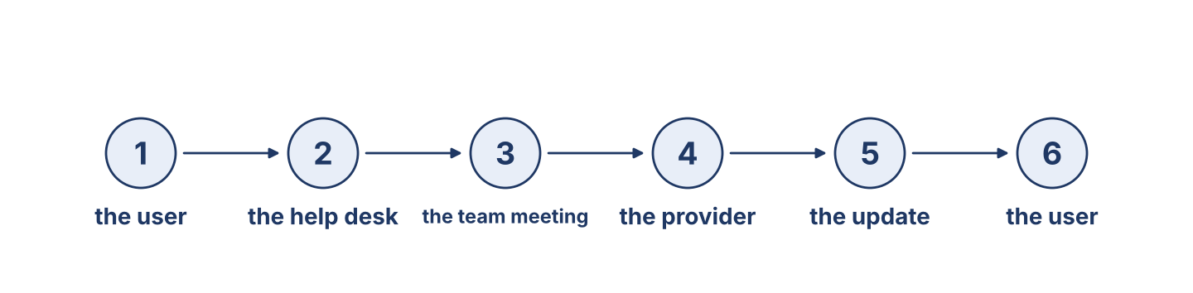
Figure 10.4 · Three groups: the user, the provider and the team.
Before you read: which three groups does an IT department stand between?
Gloss: satisfied = happy, because what was promised was given · advisory = a note from the provider about a fault · awareness = the staff knowing what to look out for
An IT and security department stands between three groups, and it has to speak to all of them in different words. The users come first. They see things no report shows: the machine slow every afternoon, the message that looked wrong, the colleague using somebody else’s account. Most never reaches the department, because people do not know it matters, or fear looking foolish. So a good department asks, regularly and without blame, and thanks the person who reports nothing — because the one thanked for nothing comes back with something. Second, the provider. The provider sends advisories, and those advisories must be read on the day they arrive, not filed. An advisory says what is wrong, how serious, and what to do; a department that reads them late chooses to be surprised. Third, the team itself. The officer who learns something on Tuesday must tell the others by Friday, or the department has one knowledgeable person, not four. That is what the weekly meeting is for, and it is why the manager's job there is mostly to listen. A department that is good at all three is not the one with the newest machines. It is the one where the news travels.
Answer the multiple-choice questions. (0. is done.)
0. Between which three groups does a department stand? — the users, the provider and the team.
1. Why should a department thank somebody who reports nothing?
○ A) Because they will come back with something real
○ B) Because it is polite
○ C) Because the manager asks
○ D) Because it saves money
2. What must be done with an advisory?
○ A) It must be filed for the year end
○ B) It must be read on the day it arrives
○ C) It must be printed
○ D) It must be sent to the users
3. Why does the team meet every week?
○ A) So what one person learned reaches the others
○ B) Because it is fun
○ C) Because it is easy
○ D) For no reason
Part 5: Vocabulary in Context
Match each word from the text with its meaning. One meaning is not needed. Write the letter.
Column A
1. | feedback | ____
2. | recommend | ____
3. | advisory | ____
4. | awareness | ____
Column B
a) | to tell others something is good and worth using
b) | what a user says about the service they were given
c) | a tool for opening a machine
d) | the staff knowing what to look out for
e) | a note from the provider about a fault
Part 5: Carrying a Famous Name and Our Own
Before you read: what does it mean for a Syrian company to work to an international standard?
Gloss: responsibility = a duty; something you must do properly · accredited = officially approved to work to a standard
When an international provider accredited Cham Systems as its partner in Syria, Maher told the team two things on the same morning. The first was that the name on the certificate was not theirs: it belonged to a company in another country that had never met any of them, and it could be taken away in a week. The second was that the name on the door was theirs, and it could not. Being accredited brought real advantages — training, advisories that arrived first, a direct line to the provider's engineers when something was genuinely wrong. It also brought rules: every advisory read within a day, every engineer certified, every restore tested quarterly and recorded. The team followed them, and not only because they had to. A trainer came from abroad in the second year and said afterwards that he had not expected this record-keeping in Damascus. Maher told the team about it that week, and he said it carefully: he was proud, but he wanted them to understand that the trainer's surprise was the trainer's problem and not a compliment. The work was good because they had made it good, not because somebody from outside had been kind enough to notice.
Write True or False. (0. is done.)
0. An international provider accredited Cham Systems. — True
1. Being accredited had no rules attached to it. ____
2. The team read every advisory within a day. ____
3. Maher treated the trainer’s surprise as a compliment. ____
Part 6 · Writing
[OP] Operator track · in-class / homework
Part 6: Report a Conversation (50–70 words)
Report a conversation between a user and an officer. Use said, told and asked.
Model — read this first:
Rana called Mr Aboud on Monday. He said he was happy with the work, and he told her the machine had not stopped once since the repair. He also said he had not understood what we were doing for the first two days. She asked whether anything else was troubling him, and he asked if we could look at the machines in his other office as well.
Plan (fill in, then write): He said ___. He told me ___. He asked if ___. She asked whether ___.
Word bank: He said (that)… | He told me… | She asked if / whether… | backshift: is → was | will → would
Check before you finish: ☐ said / told / asked used correctly? ☐ backshift used? ☐ 50–70 words?
Part 6: Why Good Communication Matters (50–70 words)
Write why good communication is important in an IT department. Give reasons.
Model — read this first:
Good communication matters because almost everything we know arrives as something we were told. A user who is afraid to report a strange message leaves us blind. An advisory read a week late is a week we did not have. And what one officer learns on Tuesday is worth four times as much by Friday, if he has told the others. News that does not travel is not knowledge.
Word bank: … is important because… | a user who is afraid… | read a week late… | news that does not travel… | it is worth four times as much
Check before you finish: ☐ a clear opinion? ☐ two or three reasons? ☐ 50–70 words?
Part 6: Team-Meeting Notes (50–70 words)
Write short notes from a team meeting, reporting what each person said.
Model — read this first:
Team meeting, Monday. Rana said Mr Aboud had been happy with the work but had not understood us at first. Maher told us to change how we explain a job. Lina said the provider’s advisory gave us fourteen days, and Nabil said he would start the updates that afternoon. Maher asked whether anybody had seen the same fault elsewhere. Nobody had.
Plan (fill in, then write): ___ said ___. ___ told us to ___. ___ said ___. ___ asked whether ___.
Check before you finish: ☐ reported speech throughout? ☐ who said what, clearly? ☐ 50–70 words?
Part 6: Reflection — What I Have Learned (40–60 words)
This is the last unit. Write about what you have learned on this course and what you will use first.
Model — read this first:
I have learned a great deal of vocabulary I did not have before, but the thing I will use first is smaller. I have learned how to explain a technical problem to somebody who is not technical, in short sentences, without making them feel foolish. I have used it twice with my own manager, and it worked both times.
Check before you finish: ☐ present perfect used? ☐ one thing you will really use? ☐ 40–60 words?
Part 7 · Management File — The Security-Team Meeting
[PR] Practitioner track (optional for beginners) · IT and security manager
7A: Phrase Bank
Match what a manager says with its purpose. One purpose is not needed. Write the letter.
Column A
1. | “The user said the machine was slow again.” | ____
2. | “Maher told us to update within fourteen days.” | ____
3. | “She asked whether the backup had been tested.” | ____
4. | “Tell the others what you found.” | ____
Column B
a) | reporting an instruction
b) | giving an instruction
c) | asking about the price
d) | reporting a statement
e) | reporting a question
7B: Manager Dialogue
🔊 Audio Track 10.5
Before you read: how does a manager prepare for a weekly team meeting?
Maher: Rana, let’s prepare for the meeting. What did the users say this week? Rana: Mr Aboud said he was happy with the job, but he told me he hadn’t understood us for two days. Maher: Good — that one goes first. What does the advisory say? Rana: It says there is a fault in our version, and it tells every office to update within fourteen days. It warns that the fault is already being used. Maher: And the bank? Rana: They asked whether we tested a restore every quarter. I said we tested it every year, and they said that would not be enough from January.
Answer the questions. (0. is done.)
0. What are they preparing for? — The weekly team meeting.
1. What did Mr Aboud say and tell Rana?
2. What does the advisory tell every office to do?
3. What did the bank ask, and what did they say?
7C: Controlled Practice — Reporting the Week
Complete with said, told, asked, or that.
Word bank: said | told | asked | that
1. Mr Aboud ____________________ me the machine had not stopped since.
2. The advisory ____________________ there was a fault in our version.
3. Maher ____________________ if anybody had seen the same fault elsewhere.
4. Rana said ____________________ the bank wanted a quarterly restore.
7D: Role-Play — Running the Team Meeting
In small groups. One is the manager (Maher); the others report. Use the model and the cards.
Model exchange: Maher: The users first. What did they say? — Rana: Mr Aboud said he was happy, but he told me he had not understood us for two days. — Maher: Then that is the thing we change this week.
Card A — Manager (Maher): run the meeting in four parts — users, provider, training, and one thing of your own. Card B — Officers: report what a user said, what the advisory says, and what you have finished, using said, told and asked.
Stretch [PR]: two pieces of news conflict — the advisory gives fourteen days, the bank wants it done in three — decide, and say what you will tell each of them.
7E: Supervisory Writing (50–80 words)
You are Maher. Write the minutes of the team meeting.
Model — read this first:
Team meeting, Monday 8th. Rana said Mr Aboud had been happy with the work but had not understood us for two days; we agreed to change how we explain a job. Lina said the provider’s advisory gave fourteen days, and Nabil said he would start the updates that afternoon. The bank asked for a tested restore every quarter from January, and I said we would do the first one in December. Maher.
Check before you finish: ☐ reported speech throughout? ☐ decisions as well as reports? ☐ 50–80 words?
Part 8 · Global Case Study — Launching Security for a New System
[PR] Practitioner track · pre-read / in-class discuss
Before you read: why must a department be trained before a new system arrives, not after?
Gloss: launch = when a new system is first used · pilot = a small first group, used to find problems early · rollout = giving the new system to everybody, group by group
When a large organisation replaced the system nine thousand people used daily, the technical work was not the hard part. The hard part was that on the first morning nine thousand people would sign in to something they had never seen, and the help desk would take a year’s calls in a week. So the project did three things before the launch. It trained the help desk three months early on a working copy — not a presentation, but the system itself, with real tasks. It ran a pilot with one department of forty people, chosen for being the most difficult, not the most willing, and fixed what they found. And it wrote in advance the twenty answers the help desk would need, in plain words, on one page. The rollout then went department by department over six weeks, not all at once. The project manager said none of this was clever, and that the only unusual decision was training the help desk before the system was finished, when everybody could see reasons to wait.
Answer the questions. (0. is done.)
0. How many people used the system? — Nine thousand.
1. What did the project do with the help desk three months early?
2. Which department did it choose for the pilot, and why?
3. What did the project manager say was the only unusual decision?
Part 8: Vocabulary in Context
Match each word with its meaning. One meaning is not needed. Write the letter.
Column A
1. | launch | ____
2. | pilot | ____
3. | rollout | ____
4. | training | ____
Column B
a) | a small first group, used to find problems early
b) | when a new system is first used
c) | learning new skills before you need them
d) | a new machine
e) | giving the new system to everybody, group by group
Part 8: Discussion
Talk with a partner. Use the frames.
Discussion frames: “Training before the launch is right because…” · “The hardest department to pilot with would be…” · “In our office the first morning would…” · “Twenty answers on one page would…”
Part 9 · Local Case Study — Syria in Focus: Carrying a Famous Name and Our Own
[PR] Practitioner track · pre-read / in-class decide
Before you read: what does a Syrian company gain, and what does it owe, when it carries an international name?
Cham Systems became the accredited partner of an international provider three years ago. Maher has told the story to every new member of staff since, always the same way. The accreditation brought good things that are hard to get in Syria: proper training, advisories that arrive on the first day rather than the fourth, and a real engineer when something is genuinely beyond them. It also brought obligations costing money and time: every advisory read within a day, every engineer re-certified, every restore tested quarterly and recorded. Some rules make little sense in Damascus, where the power schedule decides what is possible, and the team has written exceptions for two, both approved. What Maher says to new staff is this: the certificate on the wall is borrowed and the work is ours. If the provider withdrew the accreditation tomorrow, every habit it taught us would still be worth keeping, and that is the test of whether a rule was ever really about the certificate.
Answer the questions. (0. is done.)
0. What did Cham Systems become? — The accredited partner of an international provider.
1. What three good things did the accreditation bring?
2. What obligations did it bring?
3. What does Maher say to new staff about the certificate?
Part 9: Decision Task
A department must meet an international standard, but two of its rules cannot be followed in Syria because of the power supply. Should it (a) follow every rule and fail quietly, (b) write exceptions and have them approved, or (c) give up the accreditation? Choose one and give reasons.
Answer frame: “I think the department should ___ because ___. An honest exception is ___. This is better than ___ because ___.”
Model — read this first:
I think the department should write exceptions and have them approved, because a rule that cannot be followed will be broken quietly, and then nobody knows what is really being done. An honest exception is a record of the truth. This is better than failing quietly, because the provider can help with a problem it has been told about, and cannot help with one it has not.
Phrase bank: I think… should… · because… · An honest exception is… · This is better than… · In my opinion…
Part 10 · Review and Can-Do
[OP + PR] · homework / self-study
Part 10: Spiral Review
Complete the review. (0. is done.)
0. What a user says about the service they were given is feedback.
Word bank: advisory | campaign | said | told | has
1. A note from the provider about a fault and what to do about it is an ____________________ .
2. A plan to fix one thing everywhere, for everybody, at once is a ____________________ .
3. “She ____________________ the machine was ready.”
4. “He ____________________ me the update had been installed.”
5. “The fault ____________________ come back twice” uses the present perfect.
Part 10: Can-Do
Can-Do checklist
☐ I can name the main user, provider and training words.
☐ I can use reported speech (said, told, asked) with backshift.
☐ I can understand user feedback and a provider advisory.
☐ I can write team-meeting notes and report a conversation.
☐ I can run a security-team meeting (Practitioner).
Part 10: Glossary
Unit 10 glossary (10 words)
user relations · satisfaction · feedback · recommend · advisory · campaign · reminder · provider · awareness · accredited
End of the Course
Congratulations — you have finished English for Cybersecurity Personnel. You started by naming the parts of a computer, and you have ended by reporting a provider advisory to a team and explaining an exception to a manager. Keep the glossaries: ten words a unit is a hundred words, and they are the hundred you will use. Keep the Can-Do lists too, and be honest with them; the ones you cannot tick yet are simply your next month’s work. The English in this book is not the English of a textbook — it is what is actually said at a help desk, at a bench, and in a meeting on a Monday morning. Use it there.

