Unit 1: People and Routines
English for Daily Life · Level: A2 · Tracks: [CORE] Warm-Up + Parts 1–6 · [PLUS] Parts 7–10
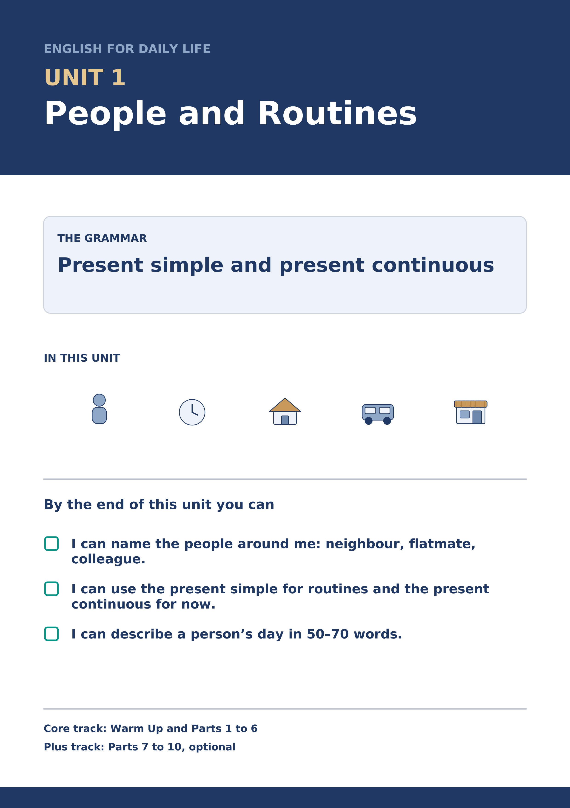
Warm Up
[CORE] Core track · in-class starter
Warm-up: People Words and Meanings
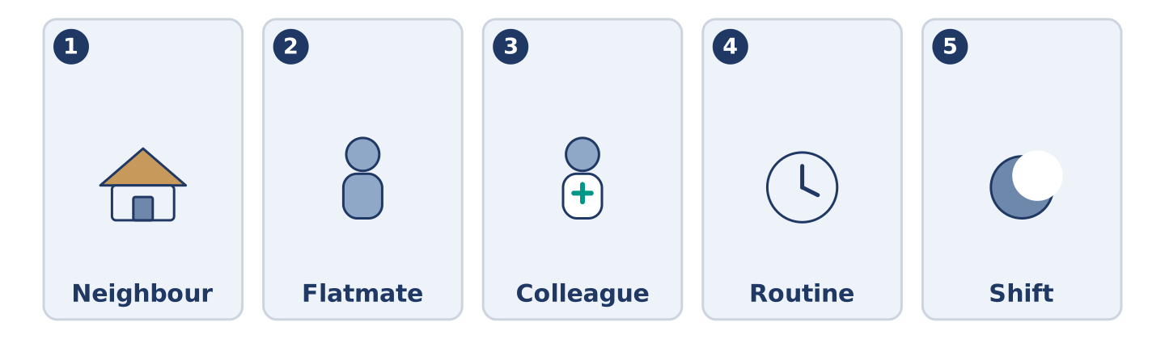
Figure 1.2 · The five warm-up words, and the thing each one means.
Match the words with their meanings. One meaning is not needed. Write the letter.
Column A
1. | Neighbour | ____
2. | Flatmate | ____
3. | Colleague | ____
4. | Routine | ____
5. | Shift | ____
Column B
a) | a person you work with
b) | the hours you work, for example eight at night to eight in the morning
c) | a person who lives near you
d) | a person who pays you every month
e) | the same things you do every day or every week
f) | a person who shares your home
Warm-up: Talking About People
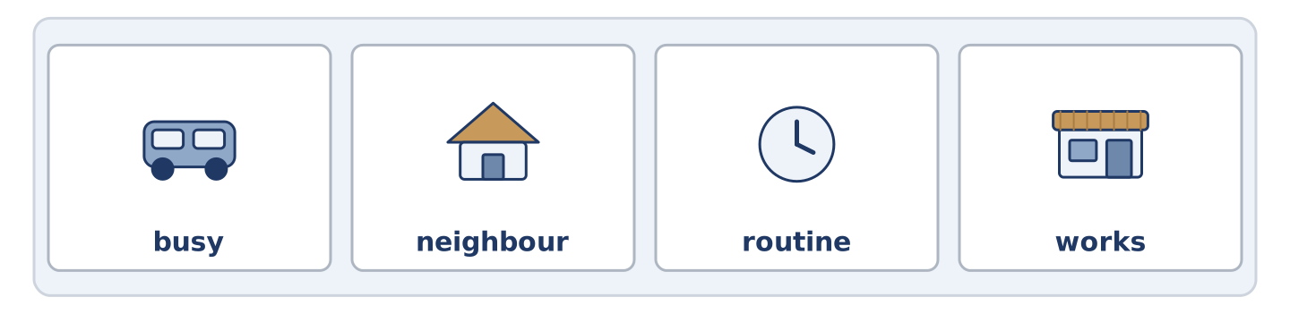
Figure 1.3 · The word bank for this task, in the order it is printed.
Complete the sentences using the words in the word bank.
Word bank: busy | neighbour | routine | works
- Tomas ______________________ at the hospital, often at night.
- Maya has a simple morning ______________________ : coffee, radio, bus.
- Amina is our ______________________ ; her shop is downstairs.
- On Tuesdays Maya is very ______________________ , because she has a class.
Warm-up: A Street of Neighbours
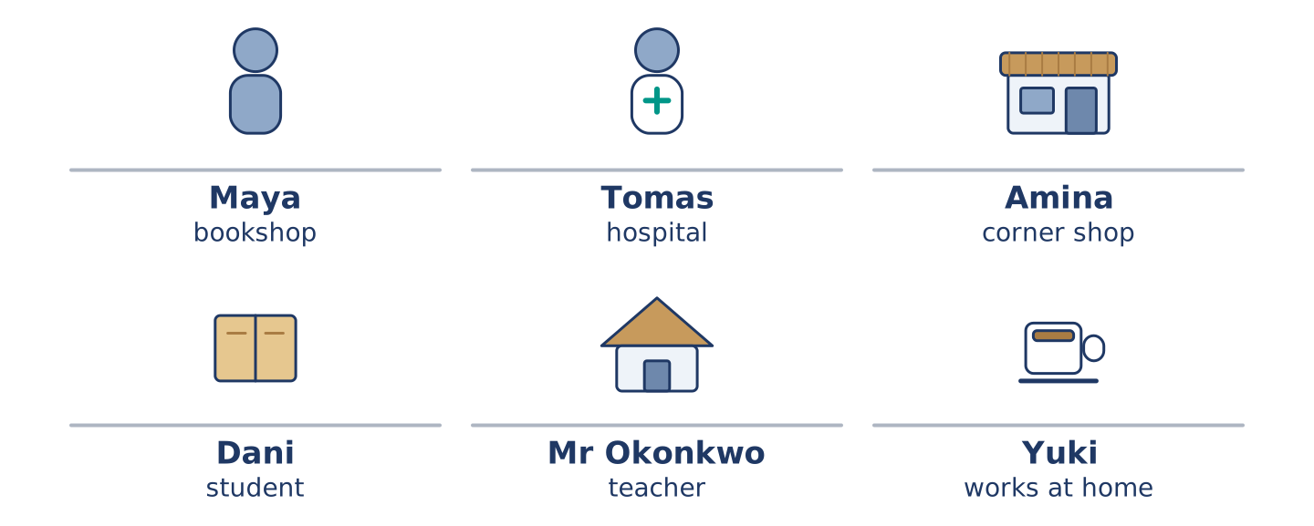
Figure 1.4 · 14 Alder Street at eight in the morning.
Read the text and choose the correct answer.
Six people live at 14 Alder Street. Maya works in a bookshop. Tomas is a nurse, and he often works at night. Amina has the corner shop downstairs. Dani is a student, and he lives on the second floor. Mr Okonkwo is seventy, and he is a retired teacher. Yuki is new here, and she works at home. Every morning the street is busy. Right now, Maya is waiting for the bus, Amina is opening her shop, and Dani is looking for his keys. Mr Okonkwo is at his window, as he is every morning. He knows the street better than anybody.
1. Where do these people live?
○ A) In a hospital
○ B) At 14 Alder Street
○ C) In a bookshop
○ D) In six different cities
2. What is Amina doing right now?
○ A) Opening her shop
○ B) Working at the hospital
○ C) Waiting for the bus
○ D) Sleeping
Part 1 · Vocabulary and Terminology
[CORE] Core track · pre-class input
Part 1: People and Routine Terms
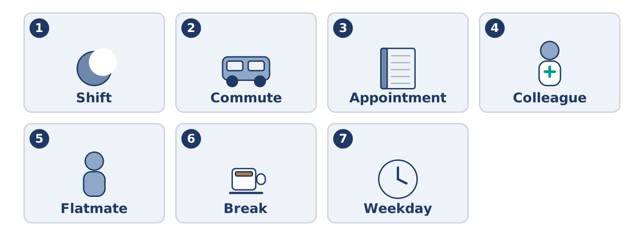
Figure 1.5 · The seven words of Column A, and what each one is.
Match the words with their meanings. One meaning is not needed. (0. is done for you.)
- Routine → the same things you do every day or every week.
Column A
1. | Shift | ____
2. | Commute | ____
3. | Appointment | ____
4. | Colleague | ____
5. | Flatmate | ____
6. | Break | ____
7. | Weekday | ____
Column B
a) | a short rest in the middle of work or study
b) | the journey between your home and your work or school
c) | a time you have arranged to see somebody, for example a doctor
d) | a person you work with
e) | Monday, Tuesday, Wednesday, Thursday or Friday
f) | a person who shares your home
g) | the hours you work, for example two in the afternoon to ten at night
h) | a day when nobody works
Gloss: commute = the journey between home and work · shift = the block of hours you work · appointment = an arranged time to see somebody
Part 1: Pronunciation
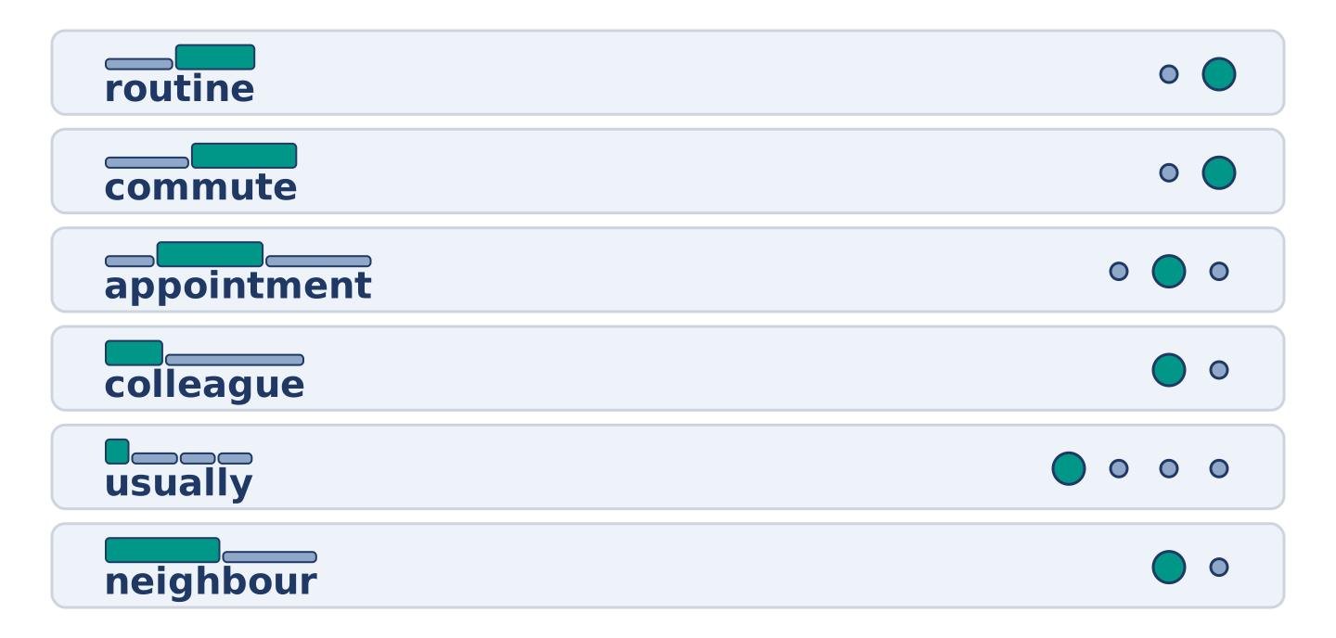
Figure 1.6 · Where the stress falls in six words of this unit.
🔊 Audio Track 1.1
Listen and practise these words. Say each word aloud and stress the loud syllable (CAPITALS).
routine — rou-TINE
commute — com-MUTE
appointment — ap-POINT-ment
colleague — COL-league
usually — U-su-al-ly
neighbour — NEIGH-bour
Then listen again to the -s ending on he, she and it verbs. It has three sounds.
/s/ — he works · he starts · he gets up
/z/ — she lives · he opens · she reads
/ɪz/ — she finishes · he watches · she closes
Say each line twice. The sound depends on the letter before the -s, not on the spelling.
Part 1: Jobs, Places and Hours
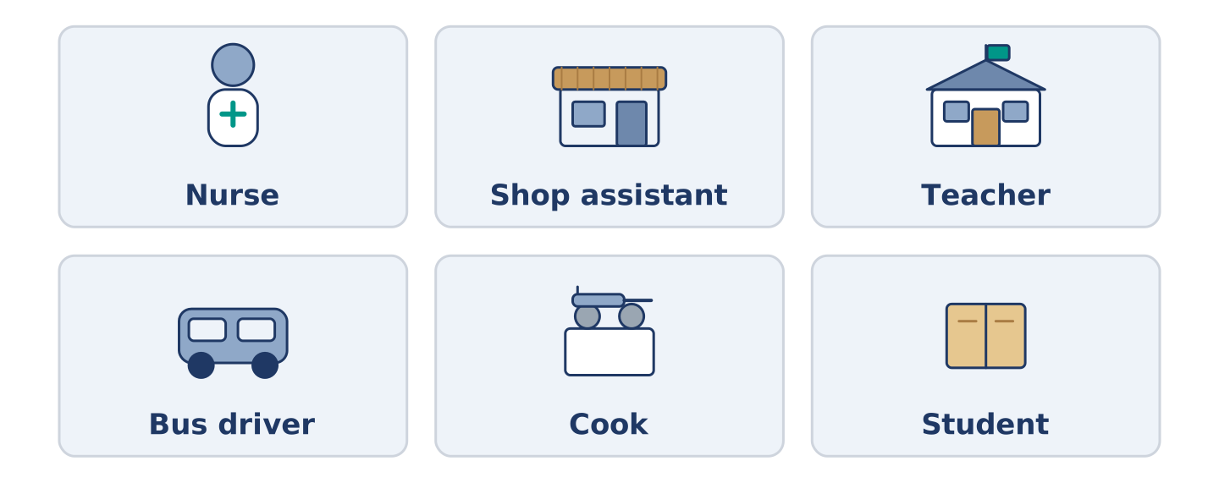
Figure 1.7 · Six jobs and the places people do them.
Complete the table. Write the place where each person works and when they usually work. (0. is done.)
Job | Place | Usual hours
Nurse | a hospital | (example)
Shop assistant
Teacher
Bus driver
- Nurse — a hospital — days, and sometimes nights.
Tomas is the nurse, so row 0 is his. For the other three, think about somebody you know. A bus driver often starts before the city is awake; a teacher works when the children are in school. There is more than one right answer, and you should be ready to say why you chose yours.
Part 1: Parts of a Day

Figure 1.8 · Parts of a day — write the correct word on each line.
Match the parts of a day with their descriptions. One description is not needed. Write the letter.
Column A
1. | Dawn | ____
2. | Midday | ____
3. | Afternoon | ____
4. | Evening | ____
5. | Midnight | ____
Column B
a) | twelve o’clock in the middle of the day
b) | the hours between midday and about six
c) | the first day of the working week
d) | the early time when the sun comes up
e) | twelve o’clock at night
f) | the end of the day, when people come home
Part 1: Daily Life — Multiple Choice
Read and choose the correct answer.
1. A person who lives near you is a…
○ A) colleague
○ B) neighbour
○ C) customer
○ D) flatmate
2. The journey from your home to your work is your…
○ A) break
○ B) shift
○ C) commute
○ D) routine
3. A time you have arranged to see the doctor is an…
○ A) appointment
○ B) weekday
○ C) colleague
○ D) routine
Part 1: Vocabulary Fill-in
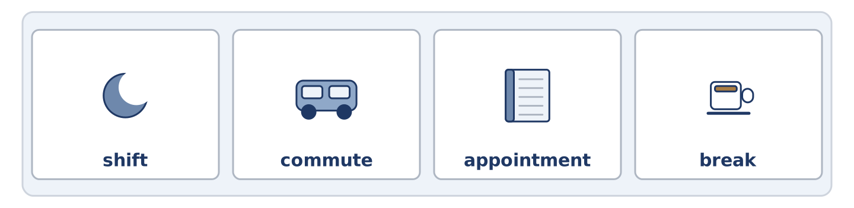
Figure 1.9 · The four words of the bank, in the order the task gives them.
Complete the sentences with the correct word.
Word bank: shift | commute | appointment | break
- Tomas works a night ______________ twice a week.
- Her ______________ takes twenty minutes by bus.
- At eleven o’clock they have a short ______________ .
- Mr Okonkwo has an ______________ at the health centre on Thursday.
Part 1: Write About Your Day (short)
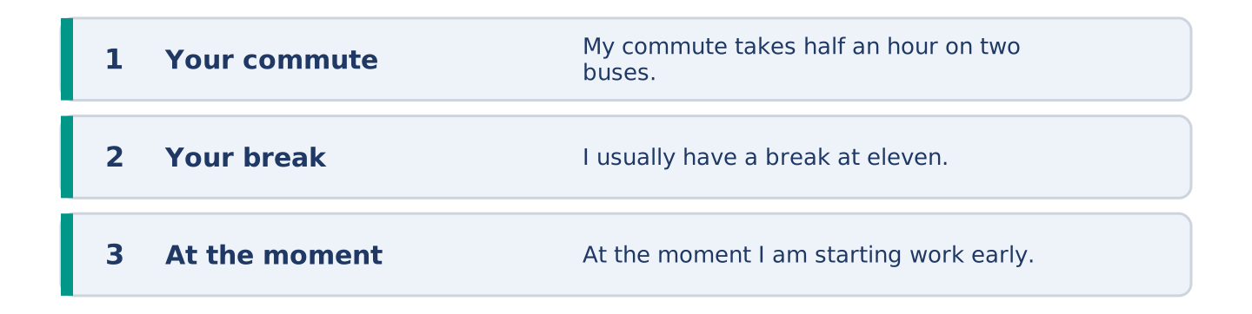
Figure 1.10 · The shape of your two or three sentences, with the model beside each step.
Write two or three sentences about your own day. Use three words from this unit.
Model — read this first:
My commute takes half an hour on two buses. I usually have a break at eleven, and I eat with a colleague from my floor. At the moment I am starting work early, because the mornings are quiet.
Part 2 · Grammar — Present Simple vs Present Continuous
[CORE] Core track · pre-class input
Part 2: Notice
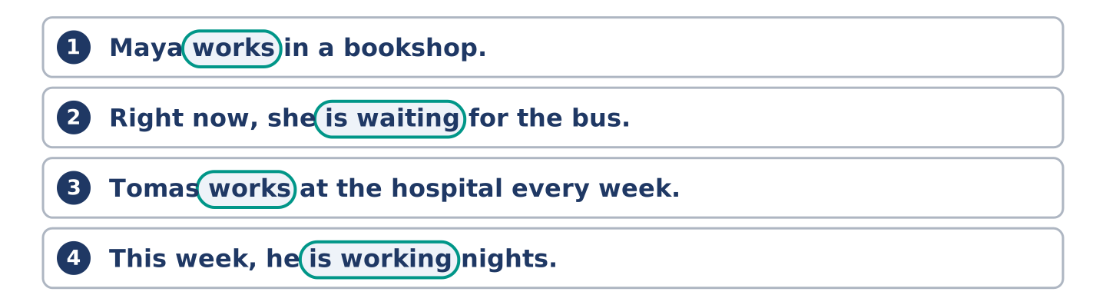
Figure 1.11 · Four lines from the notice, with the verb ringed in each.
Read these lines from Alder Street. Underline the verbs. Which are routines, and which are happening now?
Maya works in a bookshop. She usually starts at nine. Right now, she is waiting for the bus. Tomas works at the hospital every week. This week, he is working nights. Dani studies at the college. He usually cooks on Tuesdays, but today he is eating at his mother’s. Mr Okonkwo reads every afternoon. At the moment he is reading about birds.
Five of these sentences are about a routine, and three are about now. The time words tell you which is which. Usually, every week and every afternoon point one way. Right now, this week, today and at the moment point the other.
Part 2: Grammar Focus Box
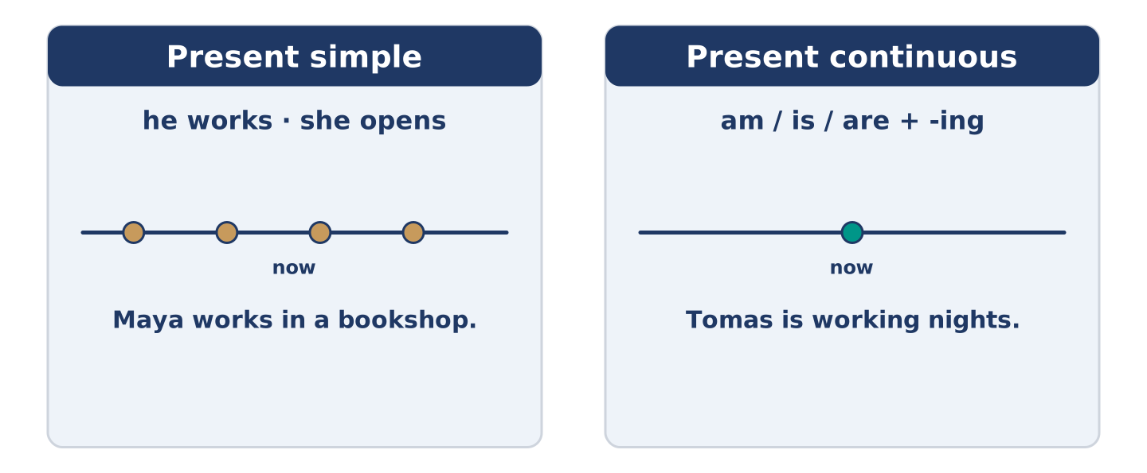
Figure 1.12 · Present simple and present continuous: again and again, or now.
 | Form | Use | Example
Present simple | I/you work; he works | routines, facts | Maya works in a bookshop.
Present continuous | am/is/are + -ing | now, this week | Tomas is working nights.
Remember: every day, usually, often → present simple. now, right now, at the moment, this week → present continuous.
Watch out! ✗ She work in a shop. → ✓ She works in a shop. (add -s for he/she/it). ✗ I waiting now. → ✓ I am waiting now. (don’t drop am/is/are).
Part 2: Controlled Practice
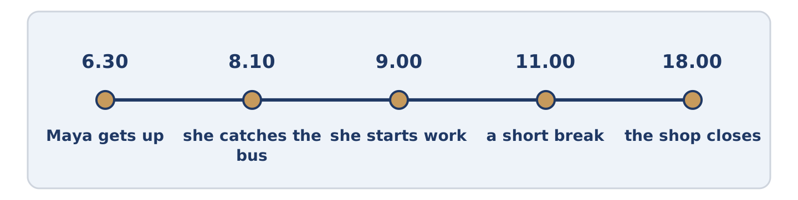
Figure 1.13 · One weekday on a line: the times this unit keeps coming back to.
Complete with the present simple or present continuous. (0. is done.)
- Maya usually starts work at nine. (start)
- Tomas ______________________ (work) at the hospital.
- Listen! Dani ______________________ (cook) in the kitchen.
- Amina ______________________ (open) the shop every morning at seven.
- This week, Yuki ______________________ (paint) her new flat.
Part 2: Simple or Continuous?
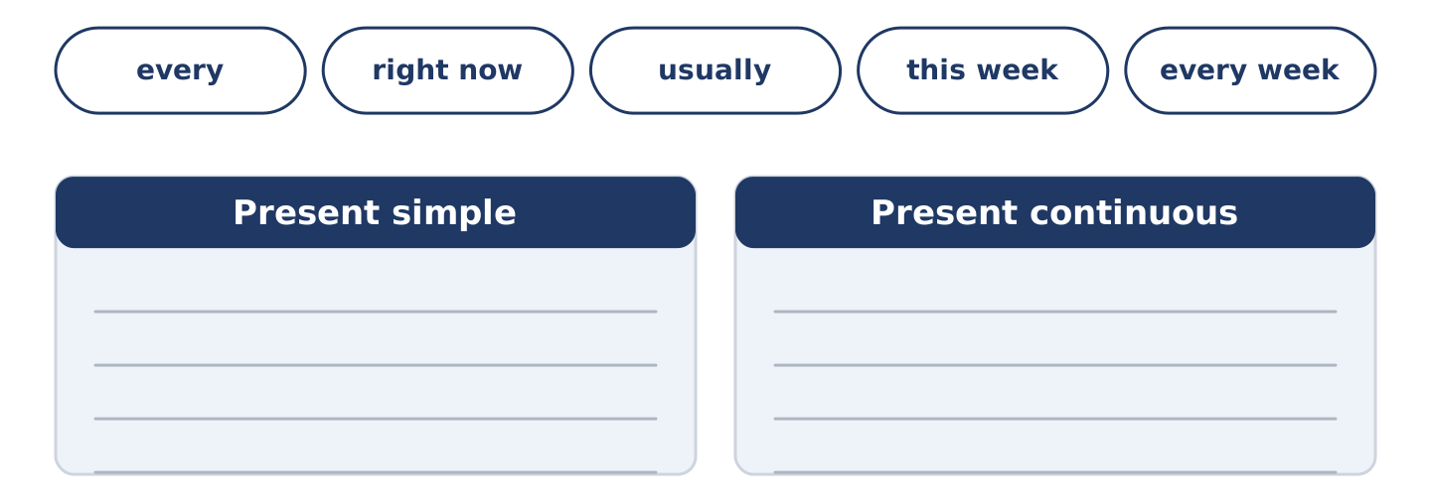
Figure 1.14 · The time words of this unit, and the two bins they sort into.
Choose the correct form. (0. is done.)
- Every morning, the bus leaves at ten past eight. (leaves / is leaving)
- Right now, Maya ______________________ (waits / is waiting) at the bus stop.
- Mr Okonkwo usually ______________________ (reads / is reading) in the afternoon.
- Look! Dani ______________________ (burns / is burning) the rice.
- Tomas ______________________ (works / is working) three nights every week.
Part 2: Correct the Sentence
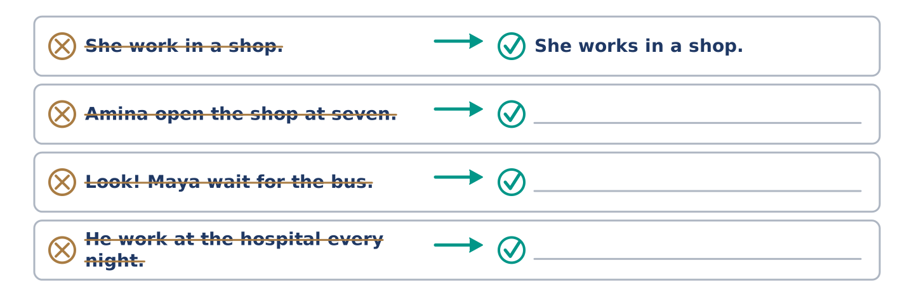
Figure 1.15 · One correction done for you, and three to write.
Each sentence has one grammar mistake. Write the correct sentence.
- Amina open the shop at seven.
- Look! Maya wait for the bus.
- He work at the hospital every night.
- We are study English this week.
Part 2: Freer Practice
Write two sentences about yourself: one routine (present simple) and one about now (present continuous).
Part 2: Grammar Review
Choose the correct sentence.
1. Which sentence is correct (now)?
○ A) Dani cook the rice.
○ B) Dani is cooking the rice.
○ C) Dani cooking the rice.
○ D) Dani are cooking the rice.
2. Which sentence is correct (routine)?
○ A) Maya working in a bookshop.
○ B) Maya work in a bookshop.
○ C) Maya works in a bookshop.
○ D) Maya to work in a bookshop.
→ Harvest: you will see the present simple and present continuous again in the Part 5 reading. Watch for them.
Part 3 · Listening
[CORE] Core track · pre-class input · scripts printed inline
Part 3: A Nurse Talks About His Week
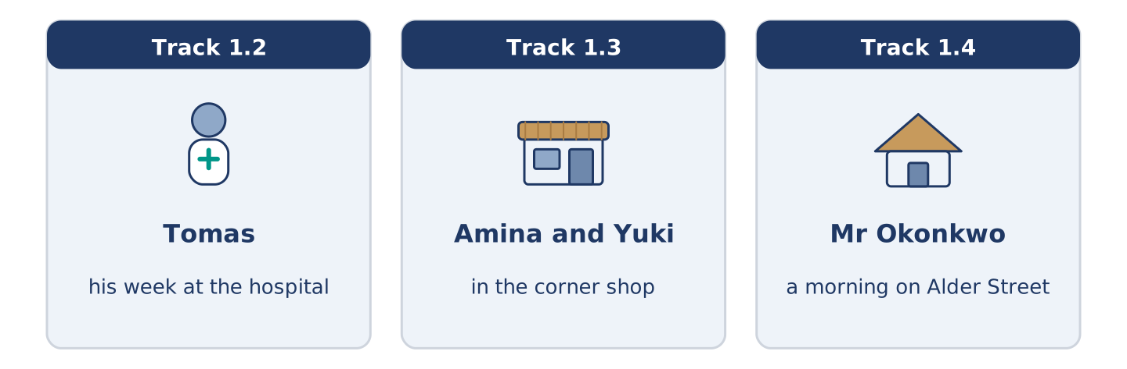
Figure 1.16 · The three listenings: who is speaking, and what about.
🔊 Audio Track 1.2
Before you listen: how many nights a week do you think a nurse works?
Tomas: Hello, I’m Tomas. I’m a nurse, and I live at 14 Alder Street with Maya. I work at the city hospital. Usually I work three days, but some weeks I work nights. This week I’m working nights, so I sleep in the morning and get up at four in the afternoon. It’s strange, but I like the quiet. Right now I’m drinking coffee and waiting for the bus.
While you listen: write True, False, or Not Given. (0. is done.)
- Tomas is a nurse. — True
- Tomas lives alone. ____
- This week Tomas is working nights. ____
- Tomas has worked at the hospital for ten years. ____
Useful phrases: I work… · Usually I… · This week I’m…
Part 3: In the Corner Shop
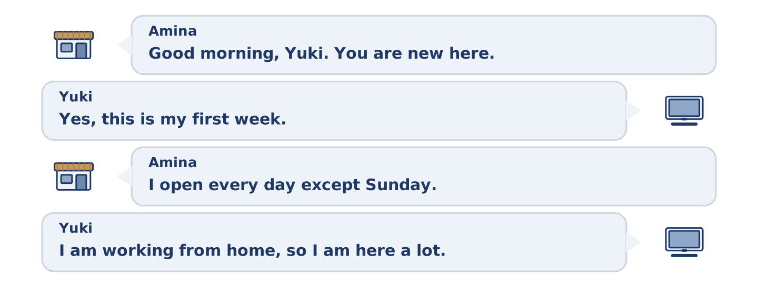
Figure 1.17 · The corner shop conversation, turn by turn.
🔊 Audio Track 1.3
Before you listen: what do people buy in a small shop near their home?
Amina: Good morning, Yuki. You’re new here, aren’t you? Yuki: Yes, this is my first week. Amina: Welcome to Alder Street. What can I get you? Yuki: Some bread and milk, please. Do you open on Sundays? Amina: I open every day except Sunday. On Saturday I close at two. Yuki: Thank you. I’m working from home, so I’m here a lot. Amina: Then I’ll see you often.
While you listen: answer the questions. (0. is done.)
- Where is Yuki? — In the corner shop.
- Why is Yuki in the shop a lot?
- What does Yuki want to buy?
- Which day does Amina close?
Useful phrases: What can I get you? · Do you open on…? · I close at…
Part 3: A Morning on Alder Street
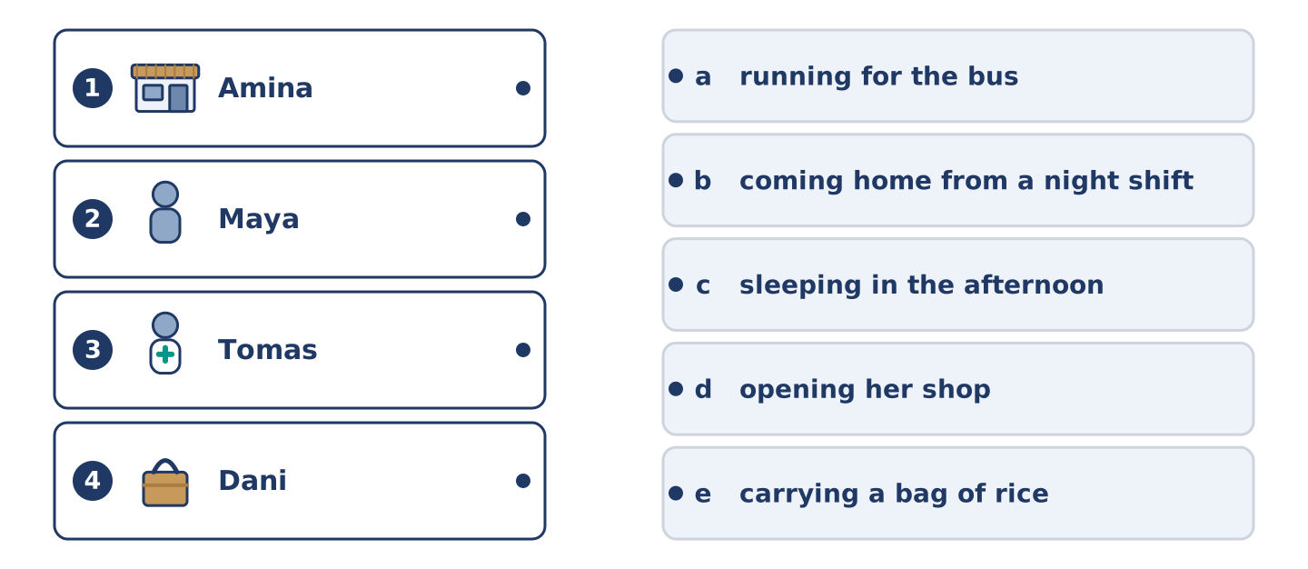
Figure 1.18 · Four people, five actions, and one action nobody is doing.
🔊 Audio Track 1.4
Before you listen: at eight in the morning, what are the people in your street doing?
Mr Okonkwo: It’s eight o’clock, and Alder Street is awake. Amina is opening her shop — she does that every morning at seven, but today she is late. Maya is running for the bus again. Tomas is coming home; he is finishing a night shift. Dani is carrying a very large bag of rice, and I am watching all of it from my window, as usual.
While you listen: match each person with what they are doing now. One action is not needed. (0. is done.)
- Mr Okonkwo → watching from his window.
Column A
1. | Amina | ____
2. | Maya | ____
3. | Tomas | ____
4. | Dani | ____
Column B
a) | running for the bus
b) | coming home from a night shift
c) | sleeping in the afternoon
d) | opening her shop
e) | carrying a bag of rice
Part 4 · Speaking
[CORE] Core track · in-class output
Part 4: Discussing Routines
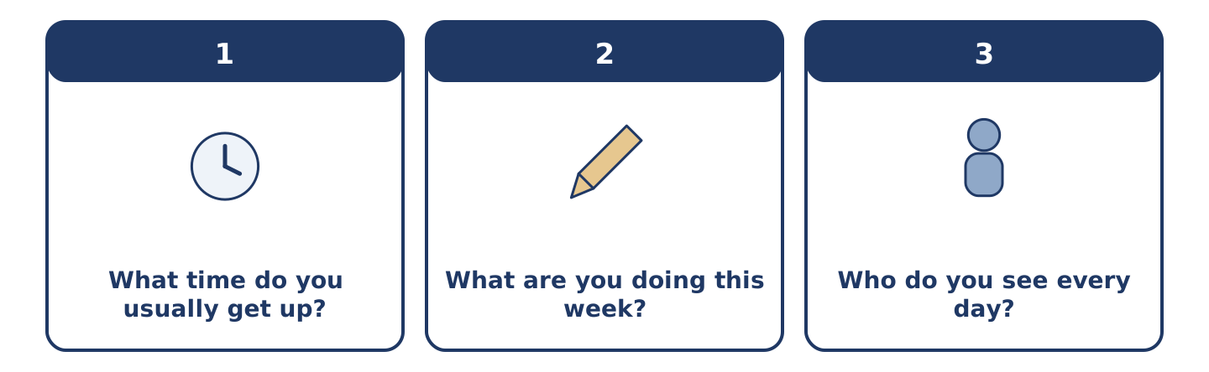
Figure 1.19 · The three questions as cards to take one at a time.
Work with a partner. Ask and answer these questions.
- What time do you usually get up? Is it the same every day?
- What are you doing this week that is not normal for you?
- Who do you see every day — at home, at work, or in your street?
Useful language: I usually… · Every day I… · At the moment I’m… · This week I’m…
Part 4: Find the Difference (pairwork)
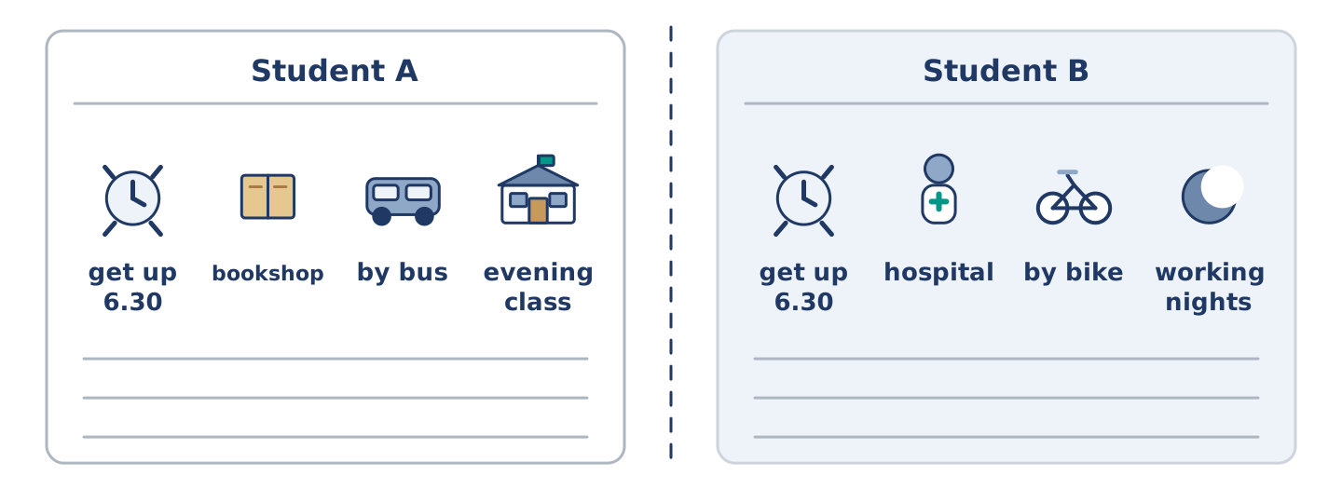
Figure 1.20 · Student A’s routine and Student B’s, with a fold between them.
Student A and Student B each have a daily routine. Ask questions and find three differences.
Useful questions: What time do you get up? · Where do you work? · How do you travel? · What are you doing this week?
Student A — your routine: get up 6.30 · work in a bookshop · travel by bus · this week: evening class.
Student B — your routine: get up 6.30 · work in a hospital · travel by bike · this week: working nights.
Part 4: New Neighbour Role Play
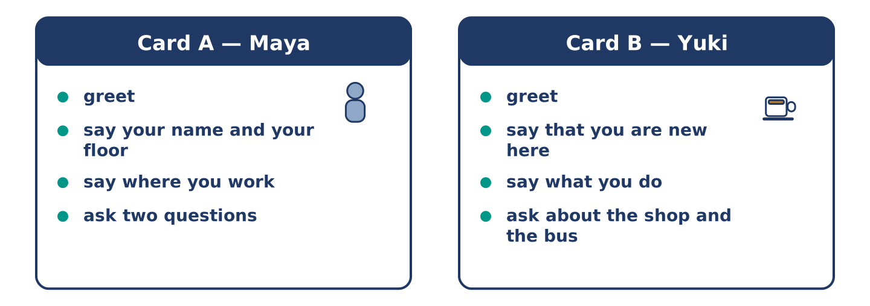
Figure 1.21 · Card A and Card B: what each of you has to say.
Work in pairs. Read the model, then use the cards.
Model exchange:
A: Hello — you’re new here, aren’t you? — B: Yes, this is my first week. — A: Welcome. I’m Maya, from the second floor. — B: I’m Yuki. Nice to meet you. — A: Do you work near here? — B: I work from home, actually. And you? — A: I work in the bookshop on the corner.
Useful language: You’re new here, aren’t you? · This is my first week · I’m… from… · Do you work near here? · Nice to meet you.
Card A — Neighbour (Maya): greet · say your name and your floor · say where you work · ask two questions about their routine.
Card B — New arrival (Yuki): greet · say that you are new here · say what you do · ask about the shop and the bus.
Your turn: run the dialogue, then swap roles.
Stretch [PLUS]: the new neighbour asks a question you cannot answer — say so politely and offer to find out.
Part 4: Mini-Presentation
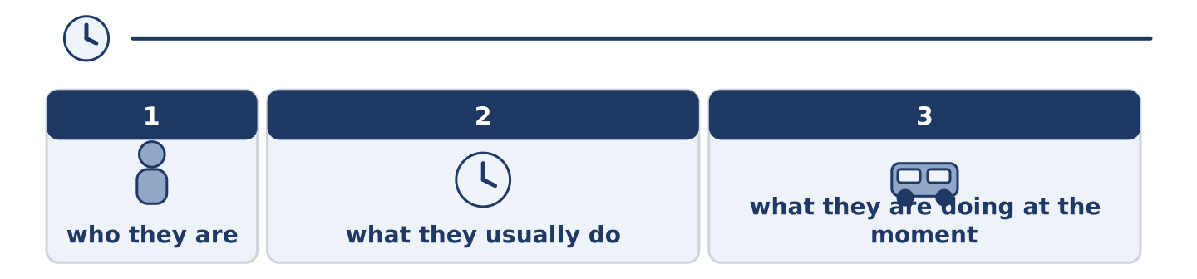
Figure 1.22 · The one-minute talk as three beats, each as wide as its share.
Prepare a short talk (about one minute). Describe one person you see every day: who they are, what they usually do, and what they are doing at the moment.
Part 5 · Reading
[CORE] Core track · pre-class input
Part 5: What Is a Routine?
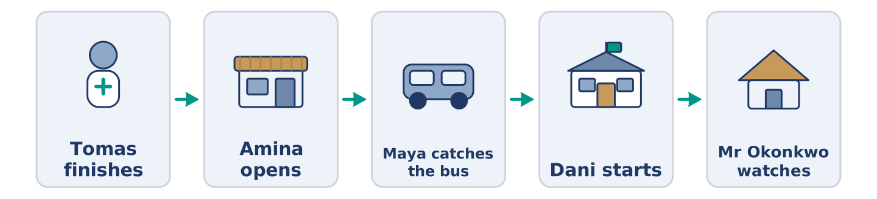
Figure 1.23 · One morning, six people, in order.
Before you read: what three things do you do every single morning?
Gloss: routine = the same things you do every day · commute = the journey between home and work · flexible = easy to change · habit = something you do without thinking
A routine is the set of things a person does again and again. Most people have a morning routine, a work routine, and a weekend routine. Maya gets up at half past six, makes coffee, and listens to the radio. Then she catches the bus. Her commute takes twenty minutes. At the bookshop she opens the till, checks the new books, and makes a list. This is the same almost every weekday. Right now, however, Maya is doing something different: she is studying for an exam, so on Tuesdays she is leaving work early. Routines are useful because they save thinking. A good routine is also flexible. When Tomas works nights, his whole routine changes, and he sleeps while the street is busy. Some people love a fixed routine; others find it boring. Most of us need a little of both: the same breakfast, and a different evening.
Answer the multiple-choice questions. (0. is done.)
- What is a routine? — the set of things a person does again and again.
1. What does Maya do after she makes coffee?
○ A) She catches the bus
○ B) She listens to the radio
○ C) She opens the till
○ D) She studies for an exam
2. Why is Maya leaving work early on Tuesdays?
○ A) Because the shop closes early
○ B) Because she is ill
○ C) Because she works nights
○ D) Because she is studying for an exam
3. Why are routines useful, according to the text?
○ A) They are always the same
○ B) They make people boring
○ C) They save thinking
○ D) They take twenty minutes
Part 5: Vocabulary in Context
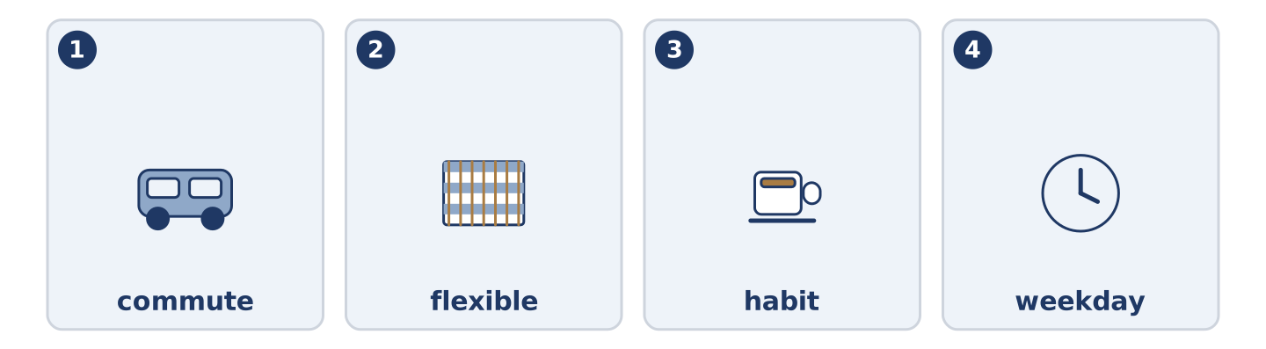
Figure 1.24 · The four words from the reading, drawn.
Match each word from the text with its meaning. One meaning is not needed. Write the letter.
Column A
1. | commute | ____
2. | flexible | ____
3. | habit | ____
4. | weekday | ____
Column B
a) | easy to change
b) | Monday to Friday
c) | the journey between home and work
d) | something you do without thinking
e) | a short rest in the middle of the day
Part 5: Routines Around the World
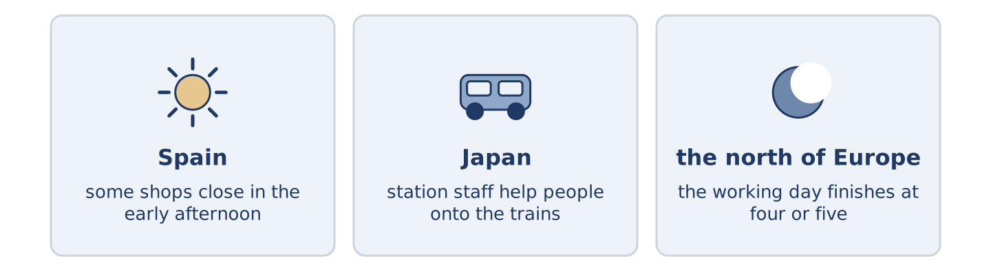
Figure 1.25 · The same day in three places.
Before you read: in your country, what time do people usually eat the evening meal?
Gloss: siesta = a short sleep in the early afternoon · rush hour = the time when many people travel to or from work
Routines are not the same everywhere. In some countries people eat the main meal at midday and rest after it; in others, nobody stops until the evening. In parts of Spain and Latin America, some shops still close for a siesta. In Japan, the morning rush hour is so busy that station staff help people onto the trains. In much of the north of Europe, the working day finishes at four or five, and the evening is long. The clock is the same everywhere. What people do with it is not.
Answer the questions. (0. is done.)
- Are routines the same everywhere? — No, they are not.
- What happens in some shops in Spain and Latin America?
- What do station staff do in Japan?
- In the text, what is the same everywhere?
Part 6 · Writing
[CORE] Core track · in-class / homework
Part 6: Describe a Person’s Day (50–70 words)
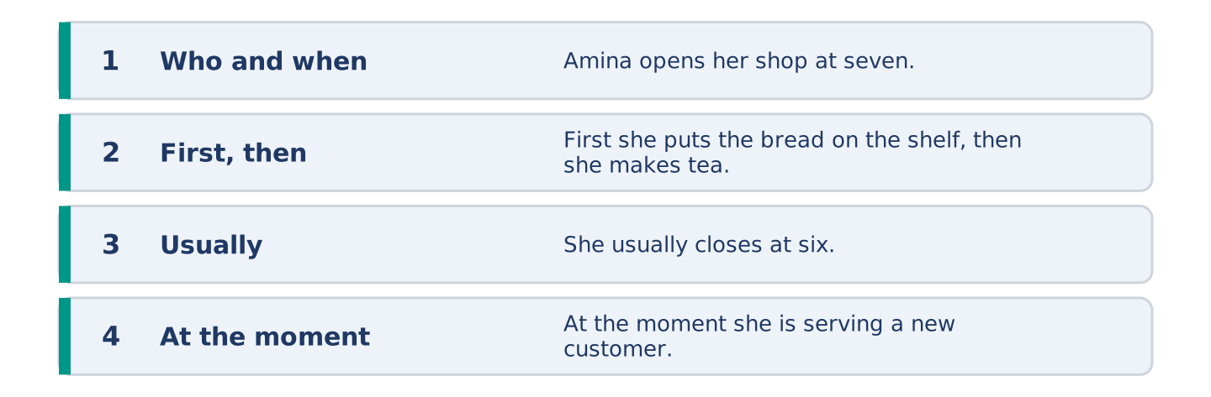
Figure 1.26 · The shape of the paragraph you are about to write.
Write about one person’s normal day. Use the present simple. Add one sentence about what they are doing at the moment.
Model — read this first:
Amina opens her shop at seven o’clock every morning. First she puts the bread on the shelf, then she makes tea. She knows almost everybody in the street, so she talks a lot. She closes at six, but on Saturday she closes at two. At the moment she is serving a new customer, because a woman called Yuki is moving in upstairs. (62 words)
Plan (fill in, then write): ___ gets up at ___. First ___, then ___. ___ usually ___. At the moment, ___ is ___.
Word bank: gets up | first | then | usually | every day | at the moment
Check before you finish: ☐ one present-simple and one present-continuous sentence? ☐ two time words? ☐ 50–70 words? ☐ capitals & full stops?
Part 6: Why Routines Matter (50–70 words)
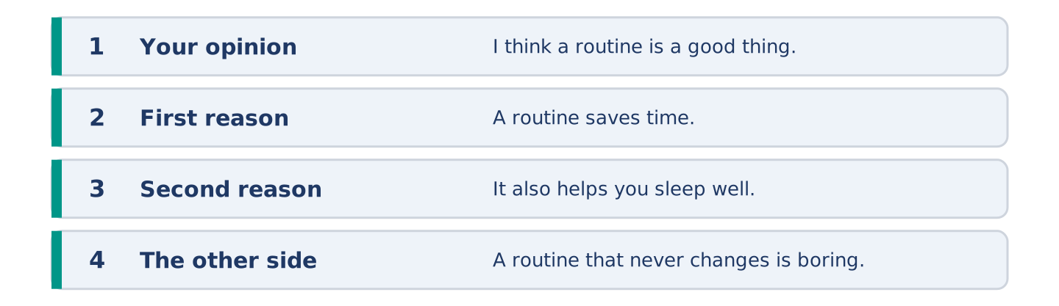
Figure 1.27 · The shape of the opinion paragraph, in four steps.
Do you think a fixed routine is a good thing? Give your opinion and two or three reasons.
Model — read this first:
I think a routine is a good thing, but not a very strict one. A routine saves time, because you do not decide the same things every morning. It also helps you sleep well. However, a routine that never changes is boring, and you stop noticing things. In my opinion the best routine is the same before nine o’clock and free after six. (63 words)
Word bank: I think… because… | it saves time | it helps me… | however | boring | in my opinion
Check before you finish: ☐ a clear opinion? ☐ two or three reasons? ☐ 50–70 words?
Part 6: A Message to a New Neighbour (50–70 words)
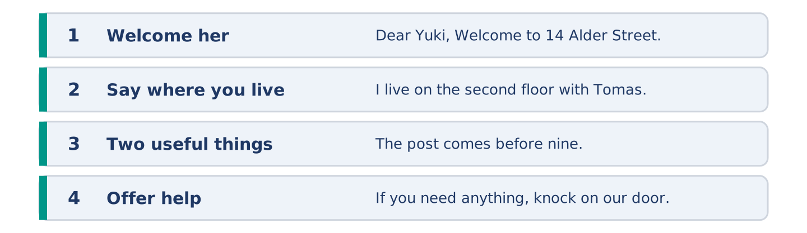
Figure 1.28 · The four moves of the message, with a line of the model for each.
Yuki has just moved into your building. Write her a short message: welcome her, tell her two useful things about the street, and offer help.
Model — read this first:
Dear Yuki, Welcome to 14 Alder Street. I live on the second floor with Tomas. Two useful things: Amina’s shop downstairs opens every day except Sunday, and the number 7 bus goes to the centre every ten minutes. The post comes before nine. If you need anything, knock on our door. See you soon. Maya (55 words)
Plan (fill in, then write): Dear ___, Welcome to ___. I live ___. Two useful things: ___ and ___. If you need ___, ___. ___
Check before you finish: ☐ greeting and close? ☐ two useful facts? ☐ an offer of help? ☐ 50–70 words?
Part 6: Reflection — My Perfect Weekday (40–60 words)
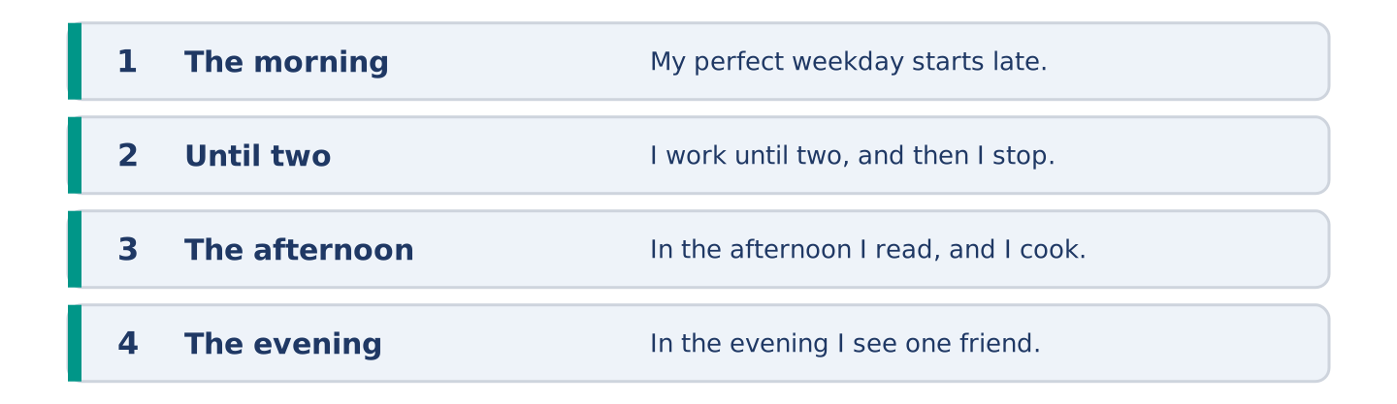
Figure 1.29 · Your perfect weekday, in four times of day.
Describe your perfect weekday. What would you do, and at what times?
Model — read this first:
My perfect weekday starts late. I get up at eight, not at six, and I walk to work instead of taking the bus. I work until two, and then I stop. In the afternoon I read, and I cook something slowly. In the evening I see one friend — not three. (51 words)
Check before you finish: ☐ three or four times of day? ☐ what you do at each? ☐ 40–60 words?
Part 7 · Real-World File — Meeting Someone New
[PLUS] Plus track (optional) · stronger learners
7A: Phrase Bank
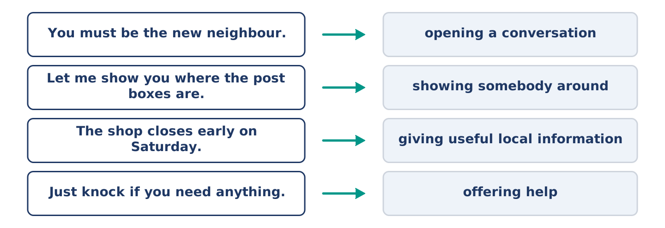
Figure 1.30 · What a neighbour says, and what each thing does.
Match what a person says with its purpose. One purpose is not needed. Write the letter.
Column A
1. | “You must be the new neighbour.” | ____
2. | “Let me show you where the post boxes are.” | ____
3. | “The shop closes early on Saturday.” | ____
4. | “Just knock if you need anything.” | ____
Column B
a) | giving useful local information
b) | offering help
c) | opening a conversation with somebody you have not met
d) | asking for money
e) | showing somebody around
7B: Neighbour Dialogue
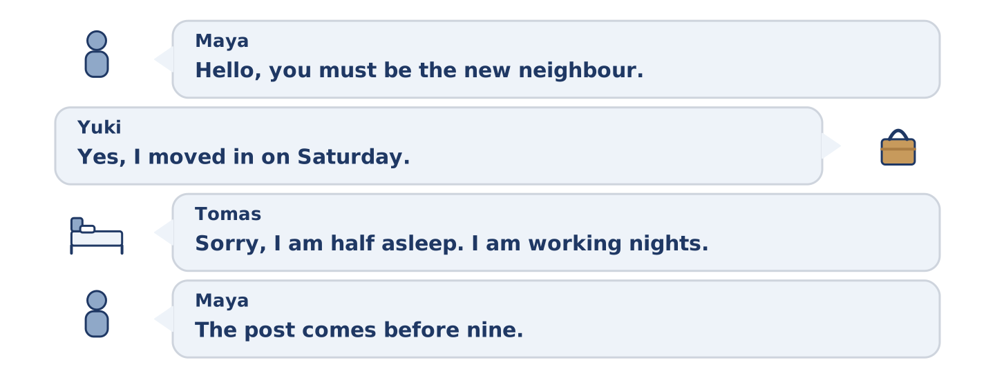
Figure 1.31 · The 7B exchange: four turns, and who takes each one.
🔊 Audio Track 1.5
Before you read: what is the first thing you say to somebody who has just moved in?
Maya: Hello — you must be the new neighbour. Yuki: Yes, I’m Yuki. I moved in on Saturday. Maya: I’m Maya, second floor. This is Tomas. Tomas: Hi. Sorry, I’m half asleep — I’m working nights this week. Yuki: Oh, don’t worry. Maya: Two things you need to know. The post comes before nine, and Amina’s shop is closed on Sundays. Yuki: That’s useful, thank you. Maya: And just knock if you need anything. We’re usually in after seven.
Answer the questions. (0. is done.)
- When did Yuki move in? — On Saturday.
- Why is Tomas tired?
- What two things does Maya tell Yuki?
- When are Maya and Tomas usually at home?
7C: Controlled Practice — Meeting Someone New
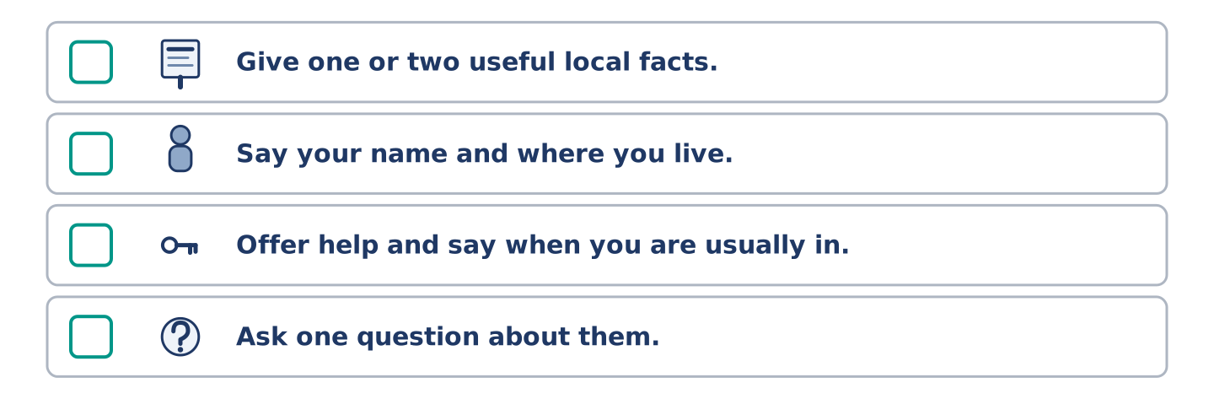
Figure 1.32 · The four steps still to be numbered, as the task prints them.
Put the steps in order. Number them 1–5. (0. is done.)
- Say hello and open the conversation. — 1
____ Give one or two useful local facts.
____ Say your name and where you live.
____ Offer help and say when you are usually in.
____ Ask one question about them.
7D: Role-Play — Welcoming a New Arrival
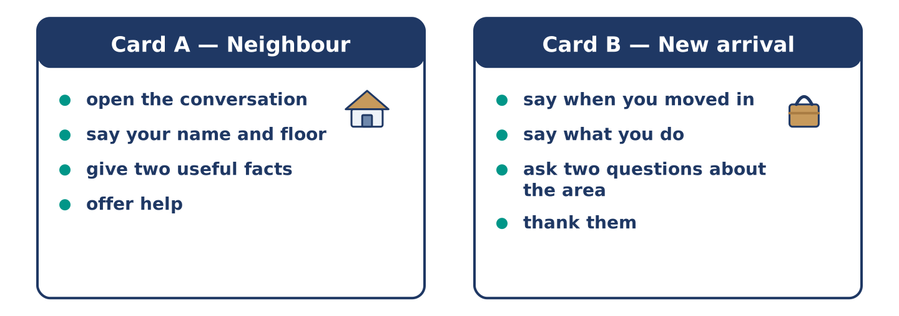
Figure 1.33 · The 7D cards: what each of you has to say.
In pairs. One is the neighbour; one is the new arrival. Use the model and cards.
Model exchange: Maya: Hello — you must be the new neighbour. — Yuki: Yes, I moved in on Saturday. — Maya: I’m Maya, second floor. Do you know the area at all? — Yuki: Not really. Where do people shop? — Maya: Amina’s, downstairs — every day except Sunday. Just knock if you need anything.
Card A — Neighbour: open the conversation · say your name and floor · give two useful facts · offer help.
Card B — New arrival: say when you moved in · say what you do · ask two questions about the area · thank them.
Stretch [PLUS]: the new arrival asks about something noisy or awkward in the building — answer honestly but kindly.
7E: Writing — A Welcome Note (50–80 words)
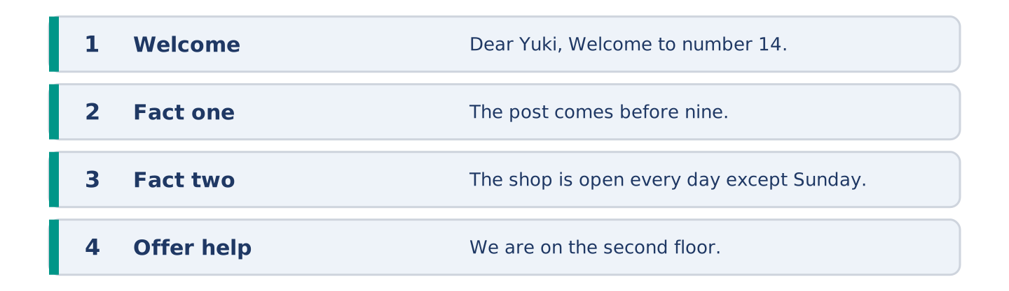
Figure 1.34 · The welcome note in four lines, with the model beside each.
You are Maya. Write a short welcome note to Yuki with three things she needs to know in her first week.
Model — read this first:
Dear Yuki, Welcome to number 14. Three things for your first week. The post comes before nine, and the box for recycling is the blue one by the door. Amina’s shop downstairs is open every day except Sunday, and she knows everything about this street. The hot water is slow in the morning — give it five minutes. We’re on the second floor if you need anything. Maya
Check before you finish: ☐ a warm welcome? ☐ three clear facts? ☐ an offer of help? ☐ 50–80 words?
Part 8 · Global Story — The Man Who Changed His Mornings
[PLUS] Plus track · pre-read / discuss
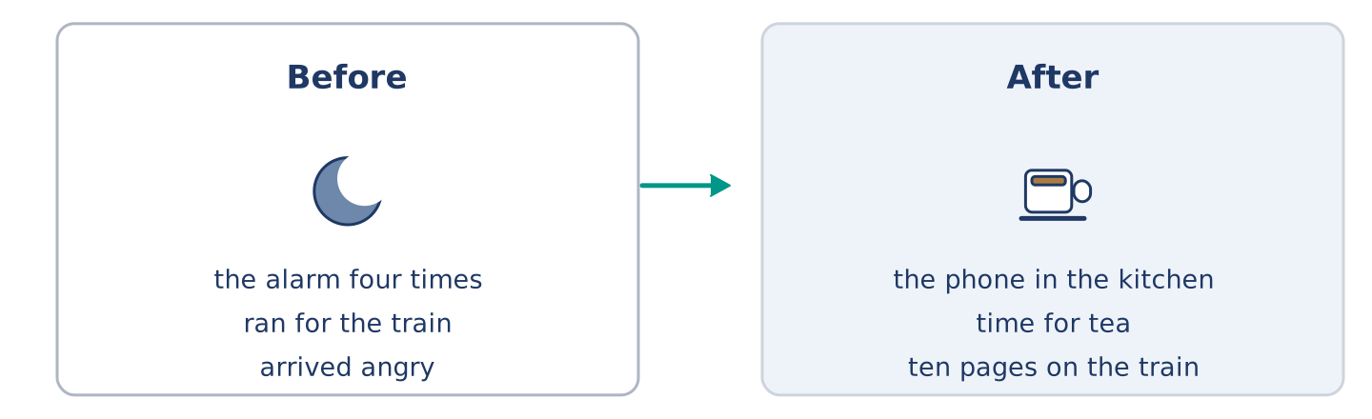
Figure 1.35 · Jun’s mornings before and after one small change.
Before you read: can a small change in the morning change a whole day?
Gloss: alarm = the clock sound that wakes you · swap = to change one thing for another · habit = something you do without thinking about it
In Seoul, a man called Jun worked in an office and hated his mornings. Every day he stopped the alarm four times, then ran for the train, and arrived angry. One winter he made one small change: he put his phone in the kitchen instead of beside his bed. Now, to stop the alarm, he had to stand up and walk. It was a very small thing, and it changed everything. He was awake five minutes earlier, so he had time for tea. With tea, he sat down. Sitting down, he read ten pages. After a year, he had thirty books behind him and he was not angry on the train. Now people ask him: “What is your secret?” He tells them: “I swapped one habit, not twenty.” His brother tried the same thing and hated it. Jun says that is also part of the answer: a routine has to be yours.
Answer the questions. (0. is done.)
- Where does Jun live? — In Seoul.
- What did Jun do every morning before the change?
- What was the one small change?
- What does Jun say about his brother?
Part 8: Vocabulary in Context
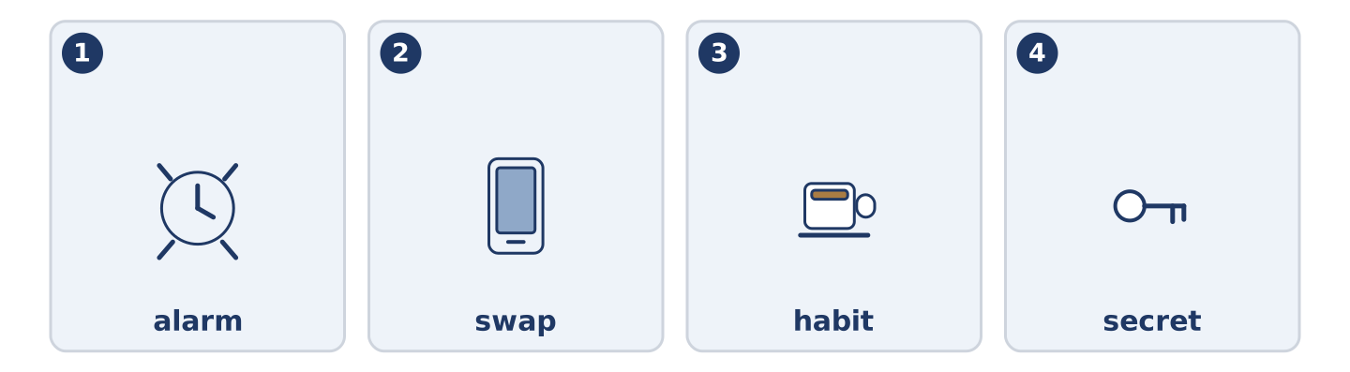
Figure 1.36 · The four story words, drawn.
Match each word with its meaning. One meaning is not needed. Write the letter.
Column A
1. | alarm | ____
2. | swap | ____
3. | habit | ____
4. | secret | ____
Column B
a) | something you do without thinking about it
b) | the clock sound that wakes you
c) | something you do not tell other people
d) | to change one thing for another
e) | a short journey by train
Part 8: Discussion
Talk with a partner. Use the frames.
Discussion frames: “This is similar to where I live because…” · “This is different from where I live because…” · “I think the most important thing is… because…”
Part 9 · Close to Home — A New Arrival on Your Street
[PLUS] Plus track · pre-read / decide
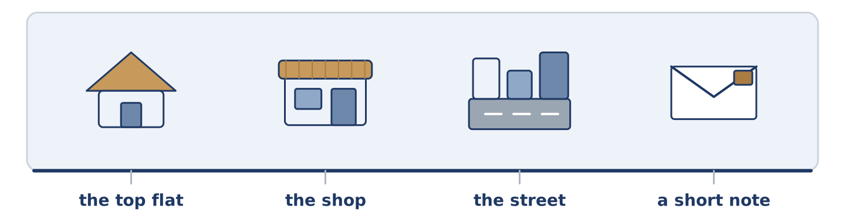
Figure 1.37 · Yuki’s first four days at number 14, along one street.
Before you read: when somebody new moves into your building, who speaks to them first?
Yuki moved into the top flat at 14 Alder Street on a Saturday in March. She did not know anybody in the city. For the first four days she spoke to nobody except Amina in the shop, and only about bread. She worked from home, so she did not meet people at an office. In the evening she heard the building: doors, a television, somebody laughing on the stairs. She did not know any of the voices. After four days, Maya knocked on her door with a short note about the post and the bus. It took two minutes. Yuki says now that those two minutes were the difference between living in a building and living in a street. Three weeks later she knew four of the six people at number 14, and she had started leaving her door open when she cooked.
Answer the questions. (0. is done.)
- Which flat did Yuki move into? — The top flat at 14 Alder Street.
- Why did Yuki not meet people easily?
- What did Maya do after four days?
- What had changed three weeks later?
Part 9: Decision Task
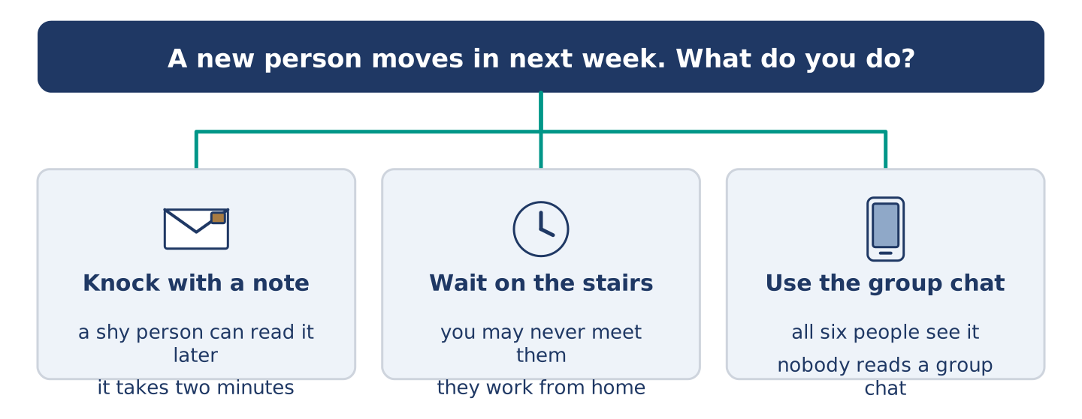
Figure 1.38 · Three ways to meet a new neighbour, and what each one costs.
A new person moves into your building next week. Should you (a) knock on the door with a note, (b) wait until you meet them on the stairs, or (c) put a message in the building’s group chat? Decide and explain. Use the frame.
Answer frame: “I think I should ___ because ___. Also, ___. This is better than ___ because ___.”
Model — read this first:
I think I should knock on the door with a short note, because a note is easy for a shy person to read later. Also, it takes two minutes and it does not ask them to talk straight away. This is better than waiting on the stairs, because you can wait for weeks and never meet somebody who works from home. (61 words)
Phrase bank: I think I should… · because… · Also,… · This is better than… · In my opinion…
Part 10 · Review and Can-Do
[CORE + PLUS] · homework / self-study
Part 10: Spiral Review
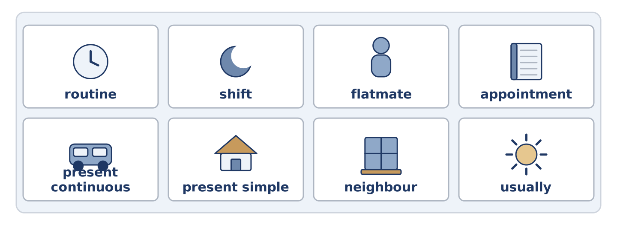
Figure 1.39 · The eight words of the review bank, in bank order.
Complete the review. (0. is done.)
- The journey between your home and your work is your commute.
Word bank: routine | shift | flatmate | appointment | present continuous | present simple | neighbour | usually
- A person who shares your home is your ______________________ .
- A person who lives near you is your ______________________ .
- The same things you do every day are your ______________________ .
- Tomas works a night ______________________ twice a week.
- Maya has an ______________________ at the health centre on Thursday.
- “Maya works in a bookshop” uses the ______________________ tense.
- “Dani is cooking right now” uses the ______________________ tense.
- “She ______________________ gets up at half past six” — the word for a routine.
Part 10: Can-Do
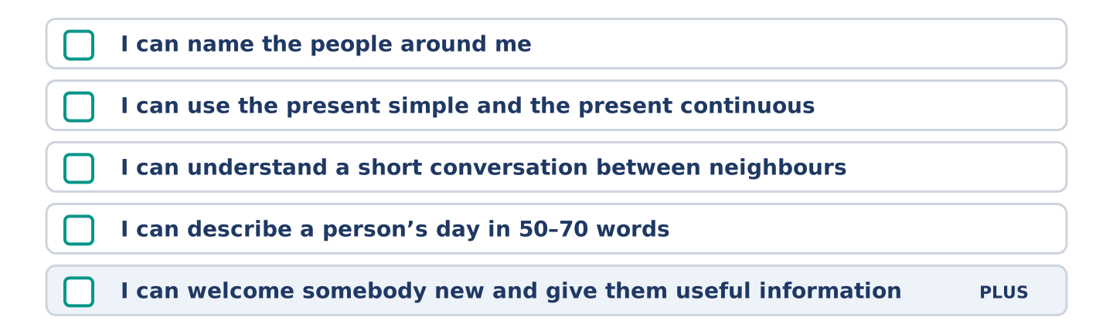
Figure 1.40 · What you can do at the end of this unit.
Can-Do checklist
☐ I can name the people around me: neighbour, flatmate, colleague.
☐ I can use the present simple for routines and the present continuous for now.
☐ I can understand a short conversation between neighbours.
☐ I can describe a person’s day in 50–70 words.
☐ I can welcome somebody new and give them useful information (Plus).
Part 10: Glossary
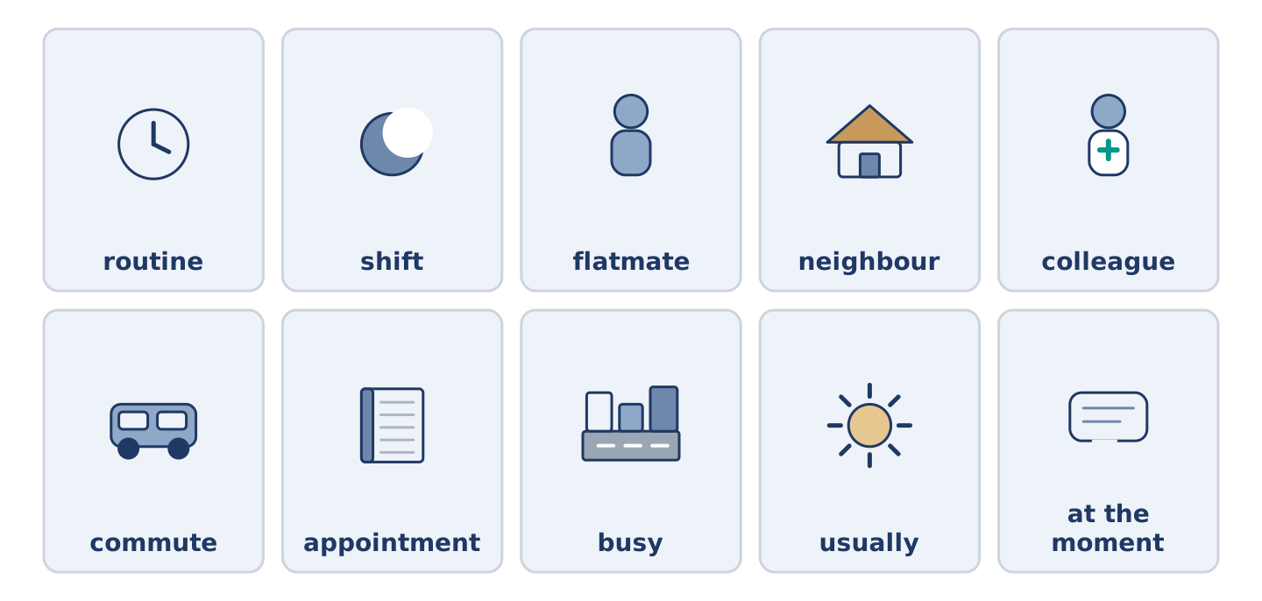
Figure 1.41 · All ten glossary words of Unit 1, one card each.
Unit 1 glossary (10 words)
routine · shift · flatmate · neighbour · colleague · commute · appointment · busy · usually · at the moment

