Unit 2: Home and Neighbourhood
English for Daily Life · Level: A2 · Tracks: [CORE] Warm-Up + Parts 1–6 · [PLUS] Parts 7–10
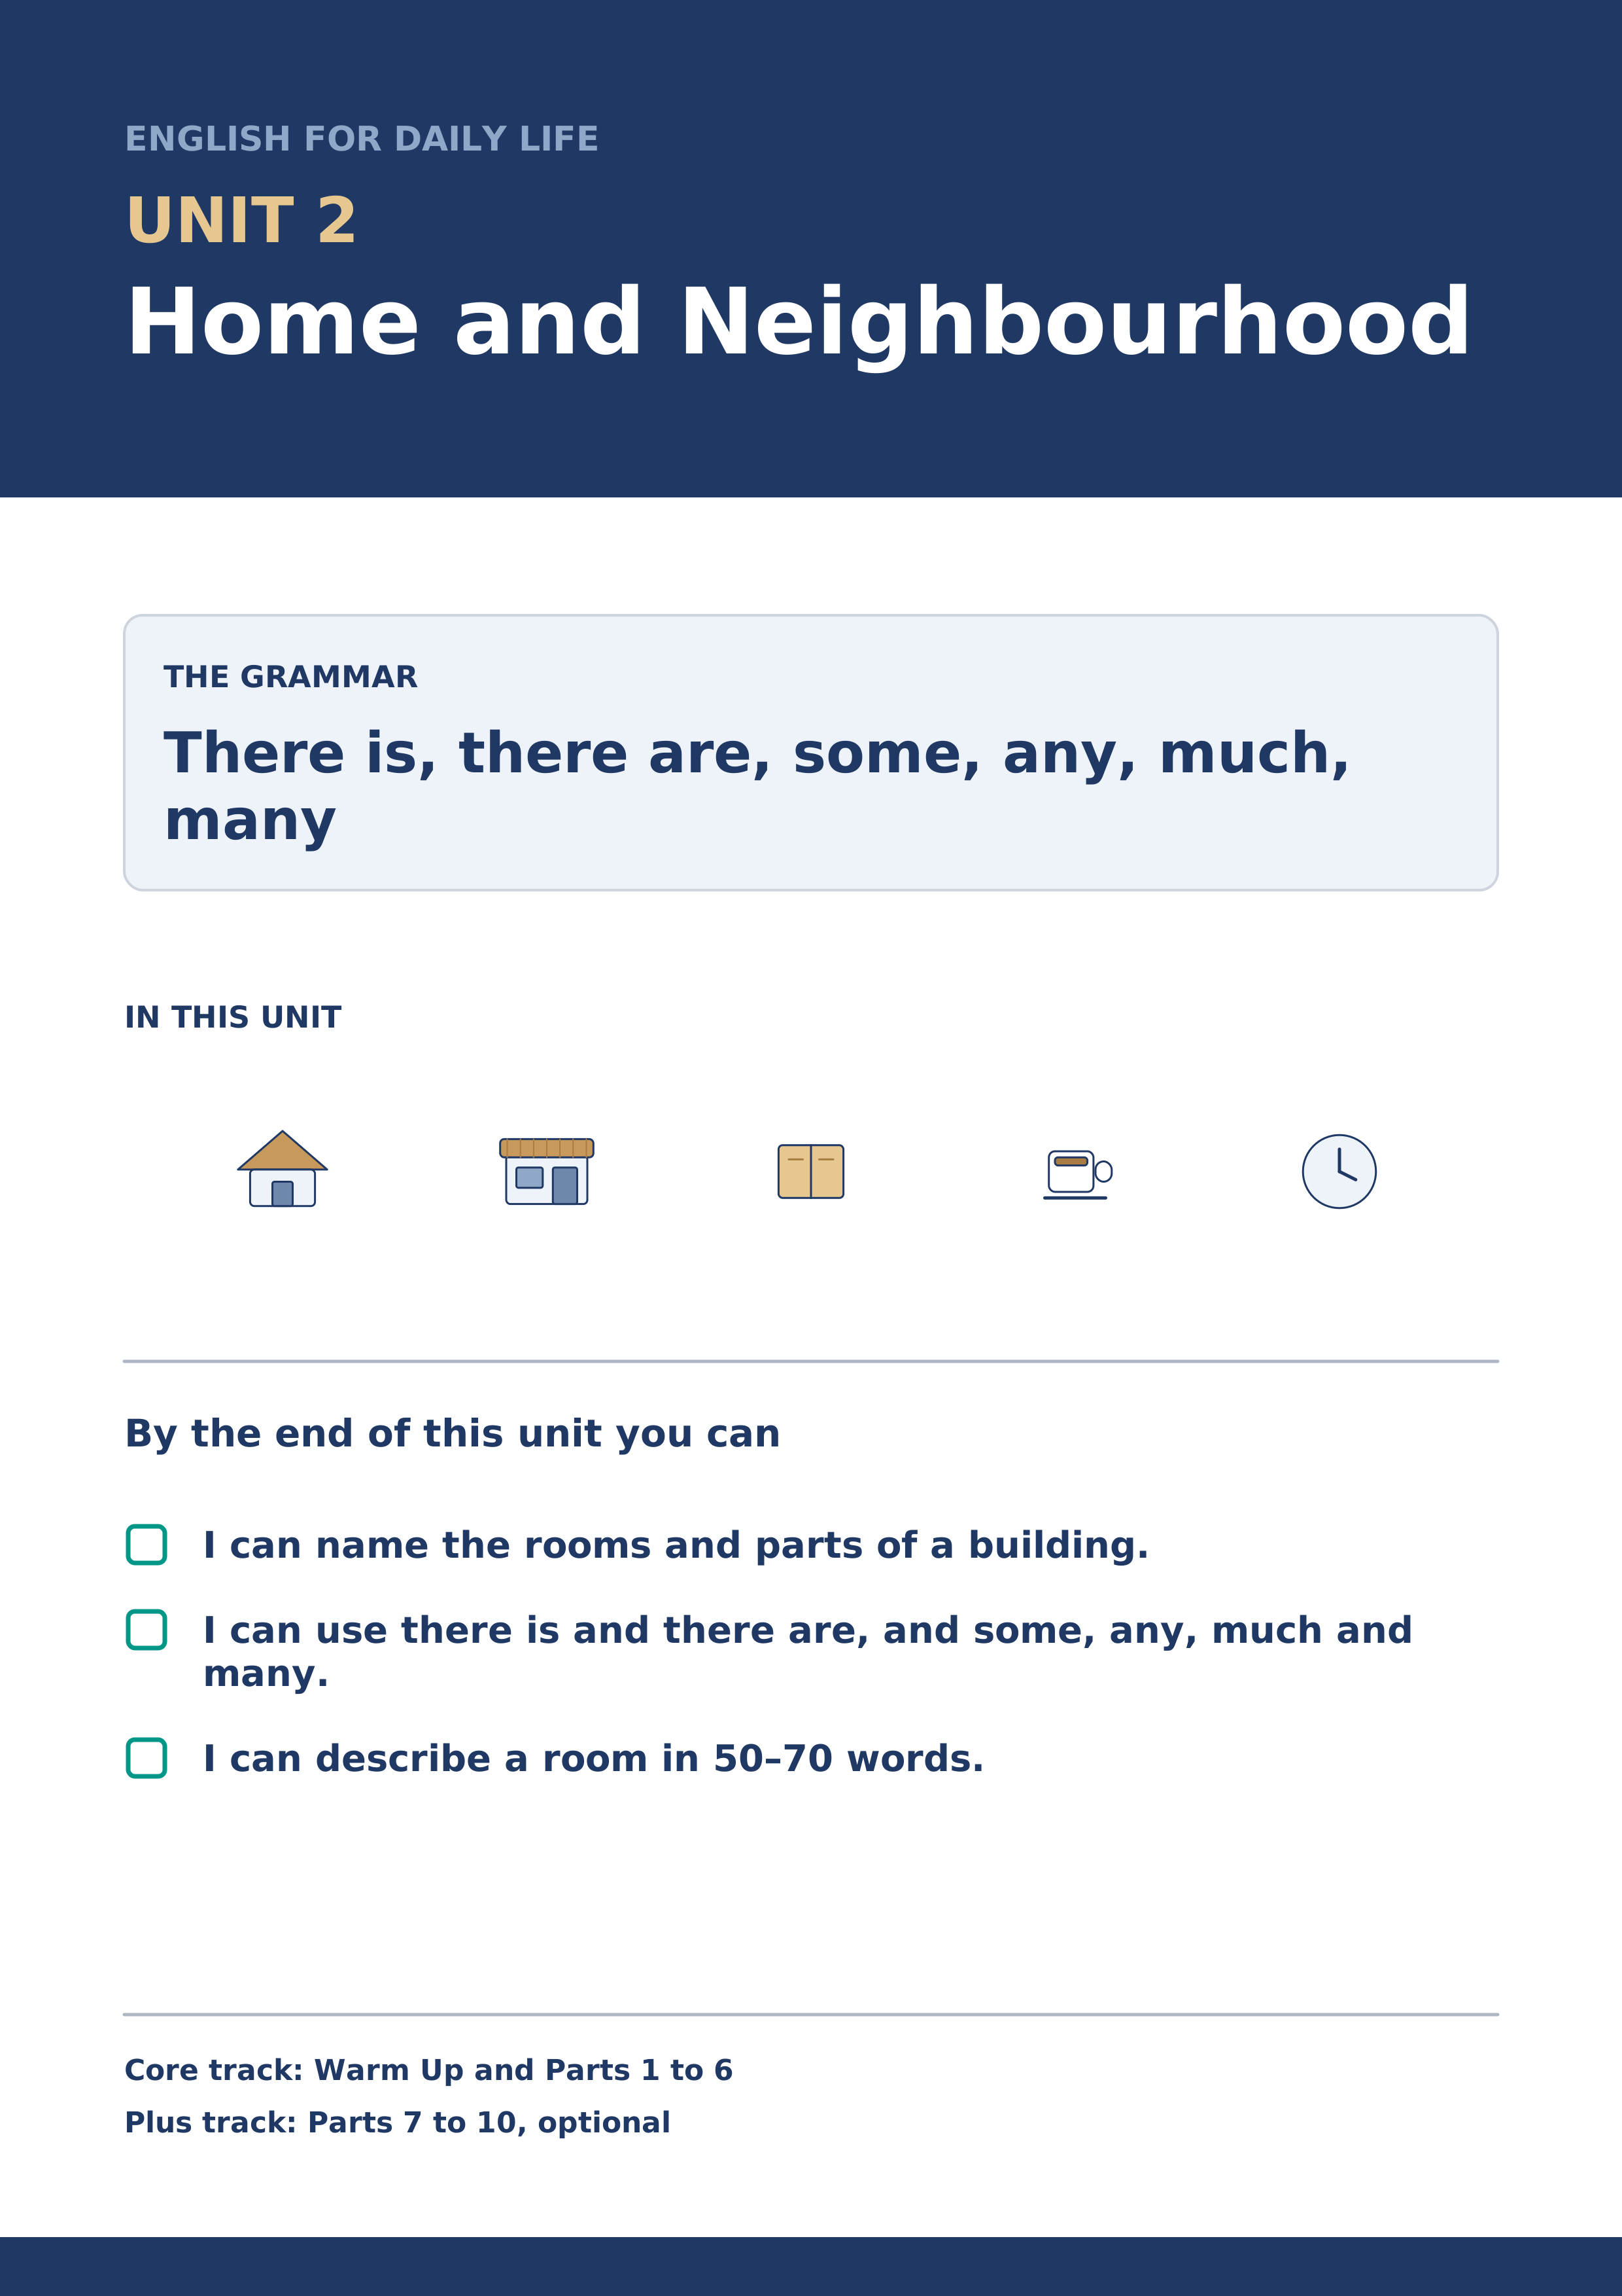
Warm Up
[CORE] Core track · in-class starter
Warm-up: Home Words and Meanings
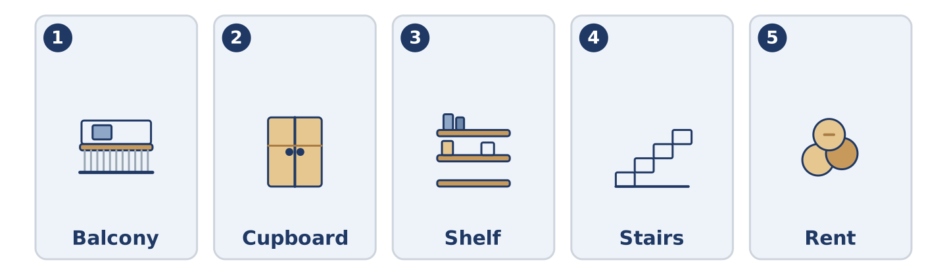
Figure 2.2 · The five warm-up words, and the thing each one means.
Match the words with their meanings. One meaning is not needed. Write the letter.
Column A
1. | Balcony | ____
2. | Cupboard | ____
3. | Shelf | ____
4. | Stairs | ____
5. | Rent | ____
Column B
a) | the money you pay every month to live somewhere
b) | a small outside floor with a wall, outside a window
c) | a long flat board on a wall, for books or cups
d) | the steps between one floor and the next
e) | a room where people sleep
f) | a tall box with doors, for plates, cups and food
Warm-up: Talking About Homes
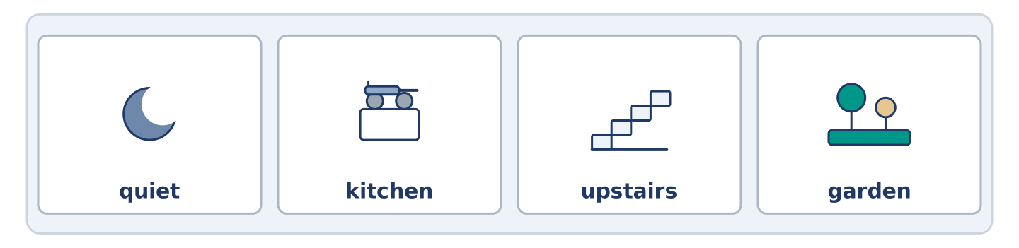
Figure 2.3 · The word bank for this task, in the order it is printed.
Complete the sentences using the words in the word bank.
Word bank: quiet | kitchen | upstairs | garden
- Mr Okonkwo lives ______________________ , on the fourth floor.
- There is a small ______________________ behind the building, with two trees and an old wall.
- Amina cooks in a very small ______________________ at the back of the shop.
- Alder Street is ______________________ after nine o’clock at night.
Warm-up: Inside Number 14
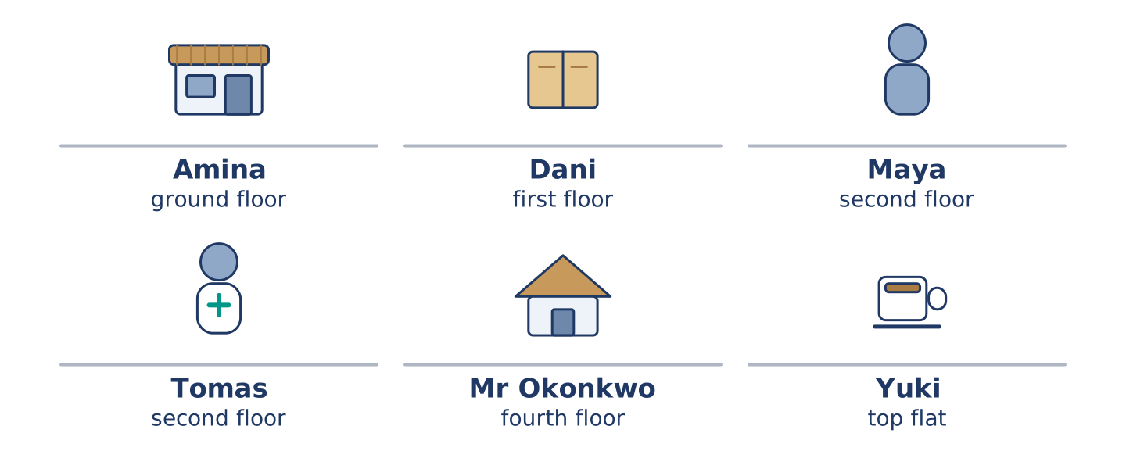
Figure 2.4 · Inside 14 Alder Street: who lives on which floor.
Read the text and choose the correct answer.
Number 14 is an old building with four floors. There is a shop on the ground floor, and there are five flats above it. There is no lift, so everybody uses the stairs. Maya and Tomas live on the second floor. Dani lives on the first floor, next to the empty flat. There is no lift, and the landing outside his door is small. Mr Okonkwo is on the fourth floor, and he has the best view in the street. He knows which stair makes a noise. Yuki has the top flat, with a small balcony and two plants on it.
1. How many floors does the building have?
○ A) Two
○ B) Six
○ C) Four
○ D) Ten
2. What is on the ground floor?
○ A) A garden
○ B) A shop
○ C) Mr Okonkwo’s flat
○ D) A lift
Part 1 · Vocabulary and Terminology
[CORE] Core track · pre-class input
Part 1: Home and Building Terms
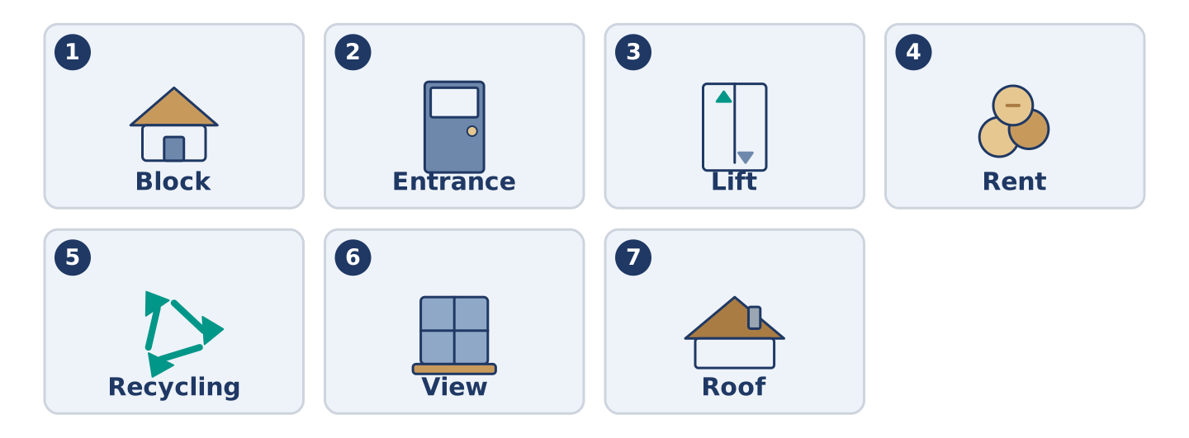
Figure 2.5 · The seven words of Column A, and what each one is.
Match the words with their meanings. One meaning is not needed. (0. is done for you.)
- Landing → the small flat space at the top of the stairs on each floor.
Column A
1. | Block | ____
2. | Entrance | ____
3. | Lift | ____
4. | Rent | ____
5. | Recycling | ____
6. | View | ____
7. | Roof | ____
Column B
a) | the money you pay every month to live somewhere
b) | a big building with many flats in it
c) | glass, paper and plastic that are used again
d) | the door you come in through, at the front
e) | what you can see from a window
f) | a small machine that carries people up and down
g) | the top of a building, over the highest floor
h) | a room with a bath in it
Gloss: block = a big building with many flats · landing = the flat space at the top of the stairs · view = what you can see from a window
Part 1: Pronunciation
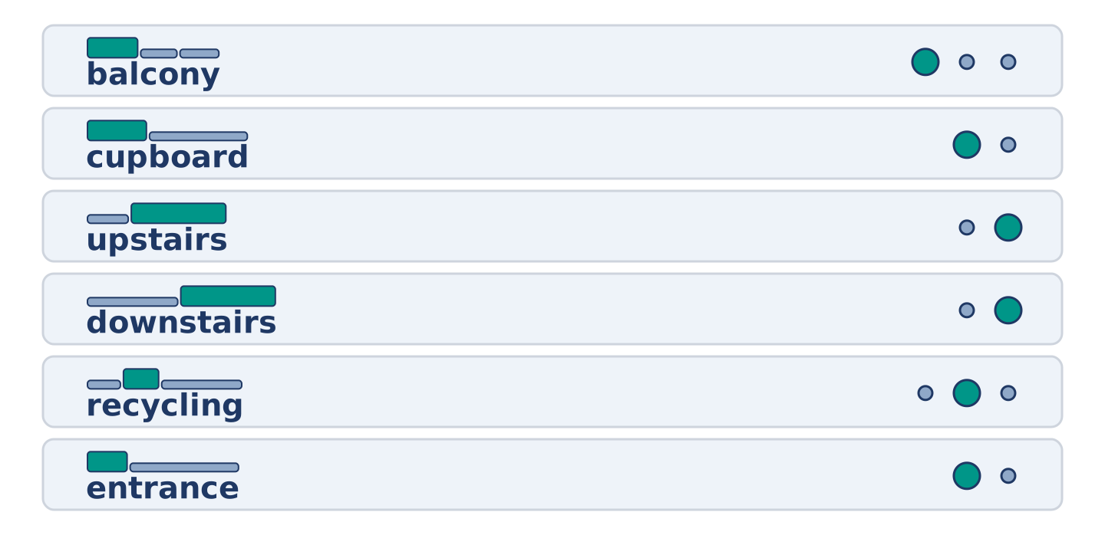
Figure 2.6 · Where the stress falls in six words of this unit.
🔊 Audio Track 2.1
Listen and practise these words. Say each word aloud and stress the loud syllable (CAPITALS).
balcony — BAL-co-ny
cupboard — CUP-board
upstairs — up-STAIRS
downstairs — down-STAIRS
recycling — re-CY-cling
entrance — EN-trance
Then listen again to the words that hide a letter. We write cup-board but we say CUB-berd. We write up-stairs but the two words join into one. English spelling is older than English speech.
Part 1: Rooms, Things and Places
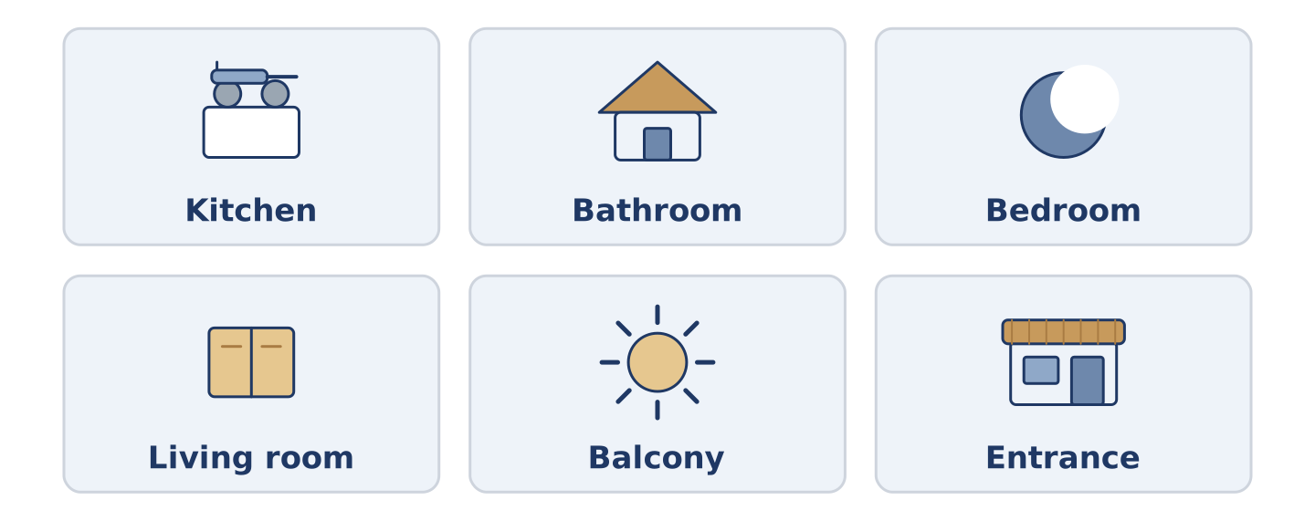
Figure 2.7 · Six rooms and one thing you find in each.
Complete the table. Write one thing you find in each room and say who uses it most. (0. is done.)
Room | One thing in it | Who uses it most
Kitchen | a cupboard | (example)
Bathroom
Bedroom
Living room
- Kitchen — a cupboard — Amina, because she cooks at the back of the shop.
Think about the home you know best. There is more than one right answer, and you should be ready to say why you chose yours.
Part 1: Parts of a Building
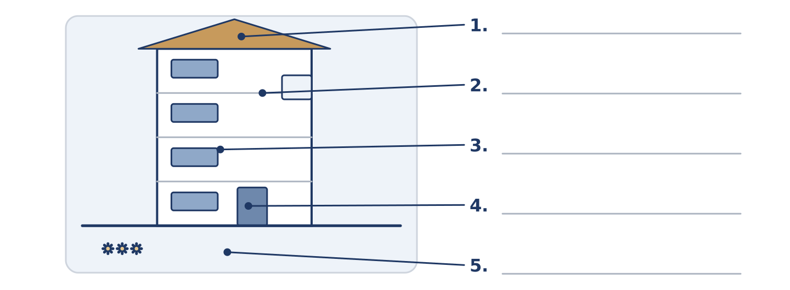
Figure 2.8 · Parts of a building — write the correct word on each line.
Match the parts of a building with their descriptions. One description is not needed. Write the letter.
Column A
1. | Roof | ____
2. | Balcony | ____
3. | Entrance | ____
4. | Stairs | ____
5. | Garden | ____
Column B
a) | the steps between one floor and the next
b) | the top of the building, over the highest floor
c) | a shelf for books and cups
d) | green ground outside, often behind the building
e) | a small outside floor with a wall, outside a window
f) | the door you come in through, at the front
Part 1: Around the Home — Multiple Choice
Read and choose the correct answer.
1. A tall box with doors, for plates and cups, is a…
○ A) shelf
○ B) balcony
○ C) cupboard
○ D) landing
2. The money you pay every month to live somewhere is the…
○ A) rent
○ B) view
○ C) entrance
○ D) roof
3. A building with many flats in it is a…
○ A) garden
○ B) block
○ C) stairs
○ D) cupboard
Part 1: Vocabulary Fill-in
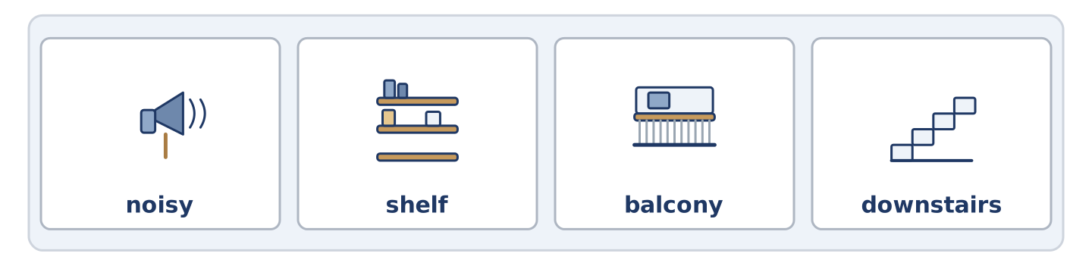
Figure 2.9 · The four words of the bank, in the order the task gives them.
Complete the sentences with the correct word.
Word bank: noisy | shelf | balcony | downstairs
- Yuki keeps two plants on her small ______________________ .
- Amina’s shop is ______________________ , on the ground floor.
- The top ______________________ in the kitchen is too high for Dani.
- Friday night is ______________________ , because the flat above has friends.
Part 1: Write About Your Home (short)
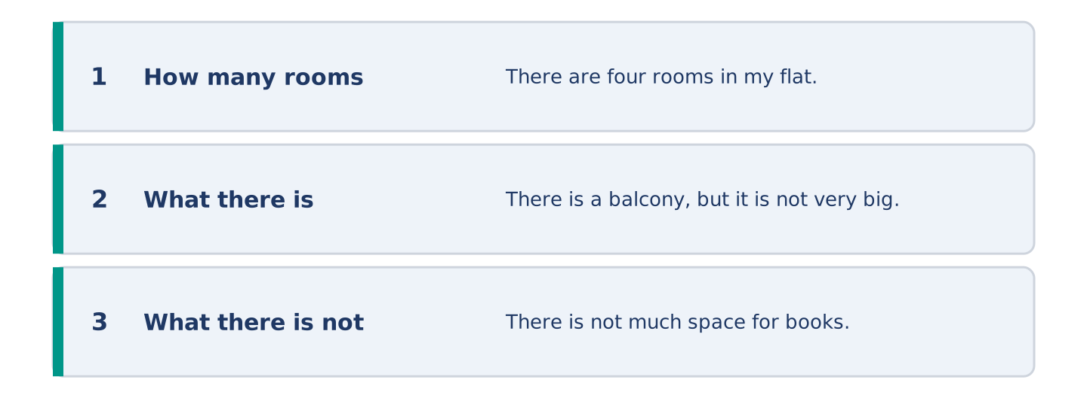
Figure 2.10 · The shape of your two or three sentences, with the model beside each step.
Write two or three sentences about where you live. Use three words from this unit.
Model — read this first:
There are four rooms in my flat, and the kitchen is the smallest. There is a balcony, but it is not very big. There are two shelves in the living room, and there is not much space for books.
Part 2 · Grammar — There Is, There Are, Some, Any, Much, Many
[CORE] Core track · pre-class input
Part 2: Notice
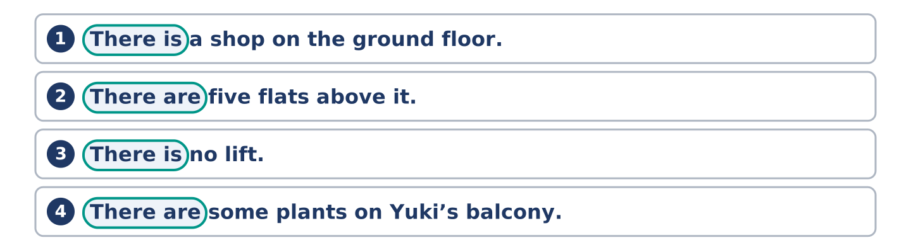
Figure 2.11 · Lines from the notice, with the target form ringed in each.
Read these lines about number 14. Underline there is and there are. Which things can you count?
There is a shop on the ground floor. There are five flats above it. There is no lift. There are some plants on Yuki’s balcony. There is not much space in Amina’s kitchen. There are not many quiet nights in the flat above Dani.
You can count flats, plants and nights: they take are, some and many. You cannot count space: it takes is and much.
Part 2: Grammar Focus Box
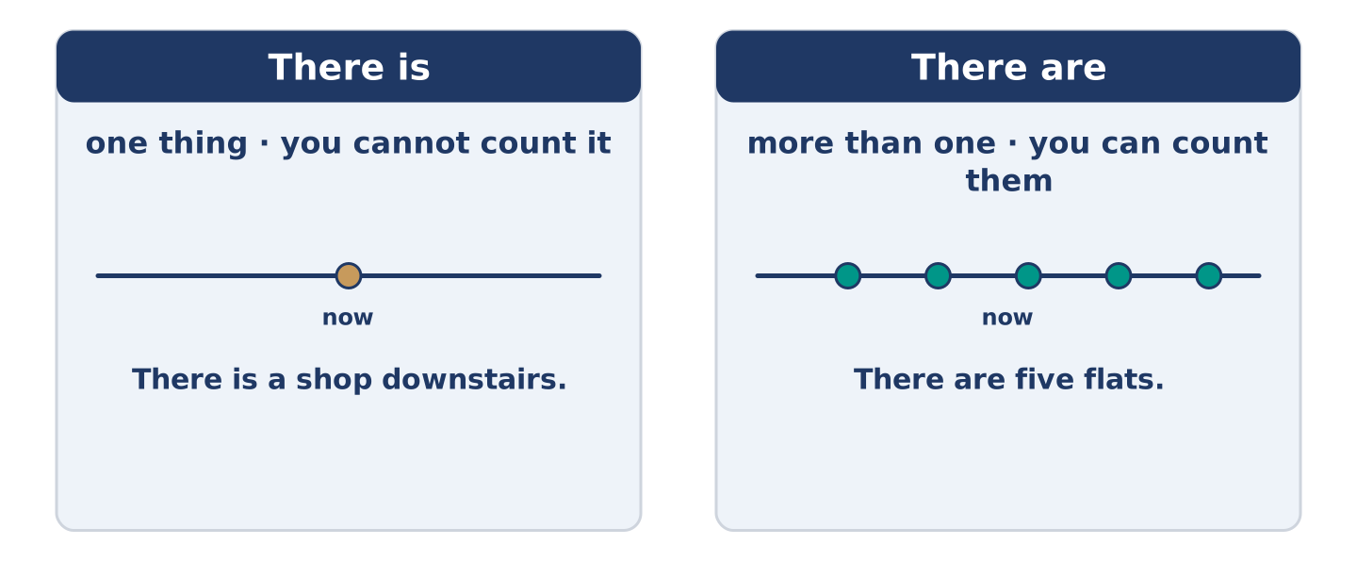
Figure 2.12 · Countable and uncountable: what changes, and what does not.
 | Form | Use | Example
There is | there is + one thing | one thing, or a thing you cannot count | There is a shop downstairs.
There are | there are + things | more than one thing you can count | There are five flats.
some / any | some in +, any in − and ? | things you do not count exactly | There are some plants. Are there any lifts?
much / many | much + uncountable, many + countable | asking or saying how many | not much space · not many nights
Remember: some when you say yes; any when you say no or ask.
Watch out! ✗ There are a shop downstairs. → ✓ There is a shop downstairs. (one thing takes is). ✗ There are not much flats. → ✓ There are not many flats. (you can count flats).
Part 2: Controlled Practice
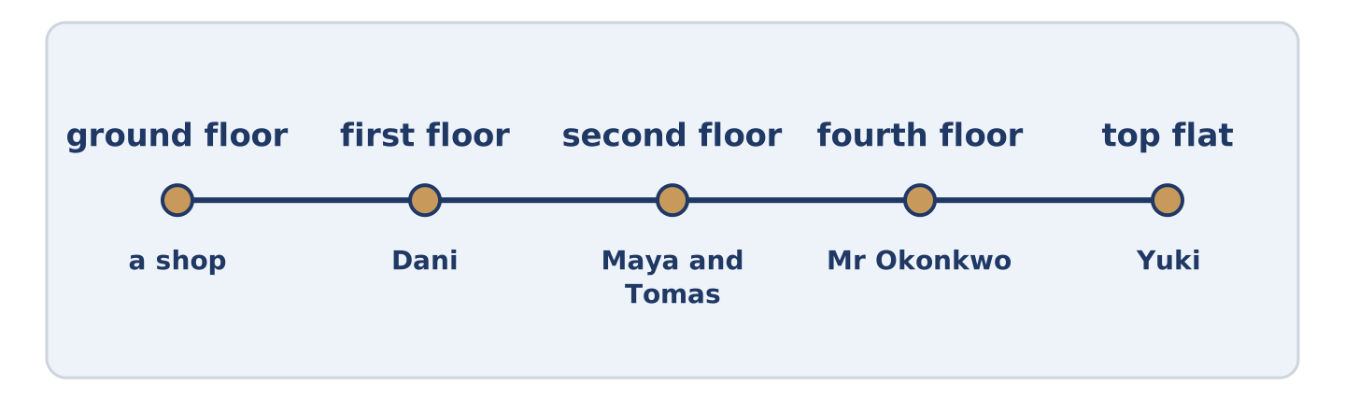
Figure 2.13 · One building, floor by floor: what there is on each.
Complete with there is or there are. (0. is done.)
- There is a shop on the ground floor.
- ______________________ five flats above the shop.
- ______________________ no lift in the building.
- ______________________ two trees in the garden.
- ______________________ a small balcony at the top.
Part 2: Some, Any, Much or Many?
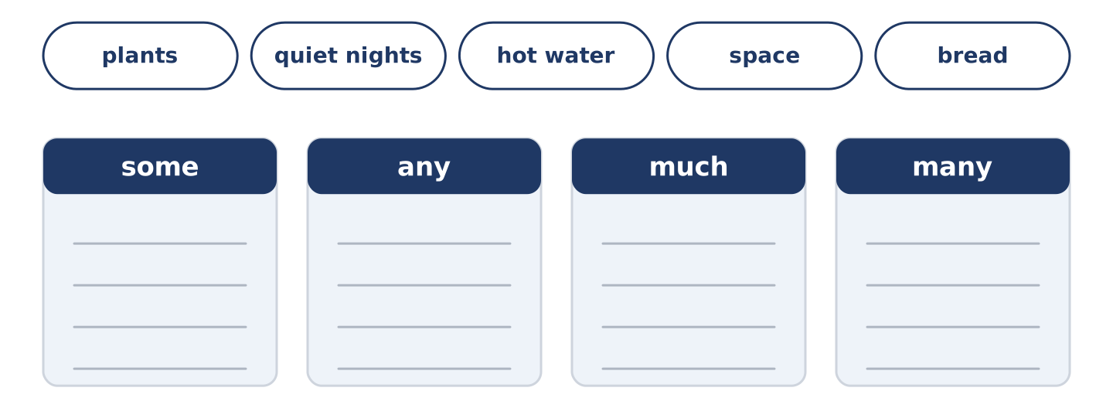
Figure 2.14 · The items of this task, and the bins they sort into.
Choose the correct word. (0. is done.)
- There are some plants on the balcony. (some / any)
- There are not ______________________ (much / many) quiet nights here.
- Is there ______________________ (some / any) hot water in the morning?
- There is not ______________________ (much / many) space in the kitchen.
- Amina has ______________________ (some / any) bread left on Saturday.
Part 2: Correct the Sentence
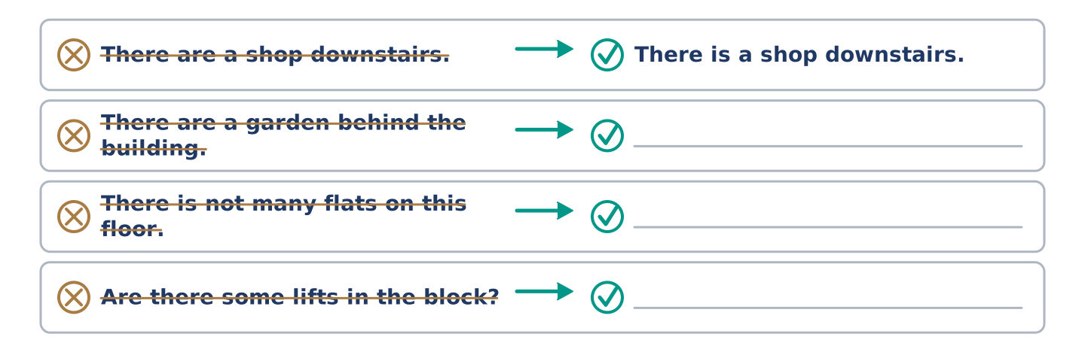
Figure 2.15 · One correction done for you, and the rest to write.
Each sentence has one grammar mistake. Write the correct sentence.
- There are a garden behind the building.
- There is not many flats on this floor.
- Are there some lifts in the block?
- There are not much light in the corridor.
Part 2: Freer Practice
Write two sentences about your own building: one with there is and one with there are.
Part 2: Grammar Review
Choose the correct sentence.
1. Which sentence is correct?
○ A) There are a shop downstairs.
○ B) There is some shop downstairs.
○ C) There is a shop downstairs.
○ D) There are shop downstairs.
2. Which sentence is correct?
○ A) There are not much flats here.
○ B) There is not many flats here.
○ C) There are not many flat here.
○ D) There are not many flats here.
→ Harvest: you will see there is, there are, some and any again in the Part 5 reading. Watch for them.
Part 3 · Listening
[CORE] Core track · pre-class input · scripts printed inline
Part 3: Yuki Looks at the Flat
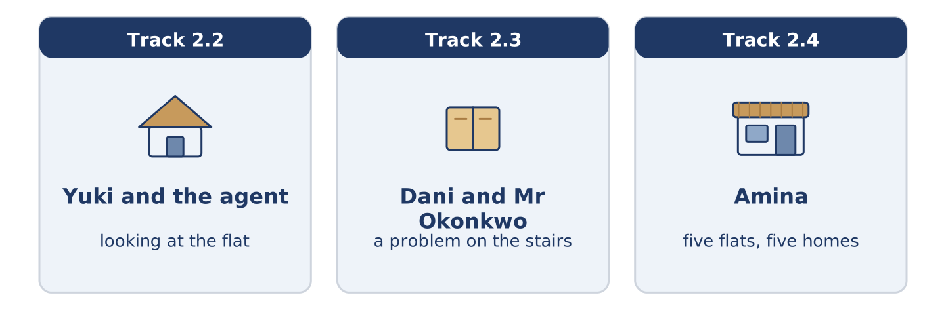
Figure 2.16 · The three listenings: who is speaking, and what about.
🔊 Audio Track 2.2
Before you listen: what do you ask before you take a flat?
Yuki: It is small, but I like it. Is there a lift? Agent: No, there is no lift. It is four floors, I am afraid. Yuki: That is fine. Is there any storage? Agent: There is a cupboard on the landing, and there is a shelf in the hall. Yuki: And the rent? Agent: Six hundred a month, and that includes the water. There are not many flats at that price near here. Yuki: No, there are not. I want it.
While you listen: write True, False, or Not Given. (0. is done.)
- Yuki is looking at a flat. — True
- There is a lift in the building. ____
- The rent includes the water. ____
- Yuki lived in this city before. ____
Useful phrases: Is there…? · There is no… · That includes…
Part 3: A Problem on the Stairs
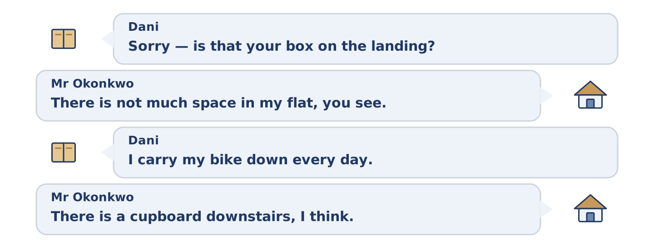
Figure 2.17 · The second listening, turn by turn.
🔊 Audio Track 2.3
Before you listen: what do neighbours argue about?
Dani: Morning. Sorry — is that your box on the landing? Mr Okonkwo: It is. There is not much space in my flat, you see. Dani: I understand, but there is not much space on the landing either. I carry my bike down every day. Mr Okonkwo: Ah. Yes. There is a cupboard downstairs, I think. Dani: There is, and it is empty. Shall I help you? Mr Okonkwo: That is kind. Thank you, Dani.
While you listen: answer the questions. (0. is done.)
- Where is the box? — On the landing.
- Why is the box on the landing?
- What does Dani carry down every day?
- What does Dani offer to do?
Part 3: Five Flats, Five Homes
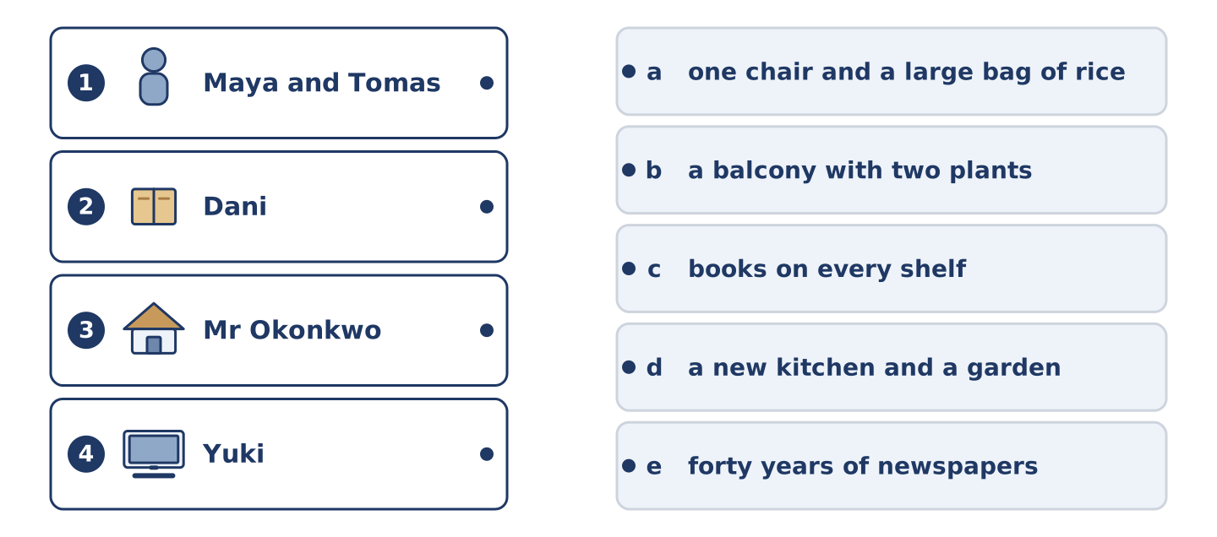
Figure 2.18 · Four on the left, five on the right, and one spare.
🔊 Audio Track 2.4
Before you listen: what is the first thing you notice in somebody else’s home?
Amina: Five flats, five homes. In Maya and Tomas’s flat there are books on every shelf, and there is never any milk. In Dani’s flat there is one chair and a very large bag of rice. In Mr Okonkwo’s there are forty years of newspapers and a window with the best view in the street. In Yuki’s there is almost nothing yet, and a balcony with two plants. And in mine, downstairs, there is bread.
While you listen: match each home with what is in it. One thing is not needed. (0. is done.)
- Amina → bread.
Useful phrases: In ___ there is… · there are… · there is never any…
Column A
1. | Maya and Tomas | ____
2. | Dani | ____
3. | Mr Okonkwo | ____
4. | Yuki | ____
Column B
a) | one chair and a large bag of rice
b) | a balcony with two plants
c) | books on every shelf
d) | a new kitchen and a garden
e) | forty years of newspapers
Part 4 · Speaking
[CORE] Core track · in-class output
Part 4: Describing Where You Live
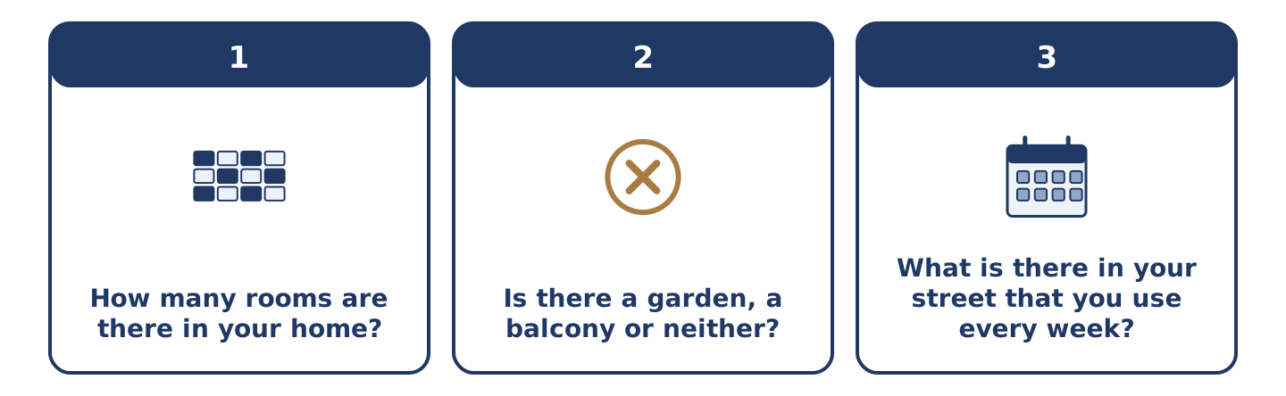
Figure 2.19 · The three questions as cards, to take one at a time.
Work with a partner. Ask and answer these questions.
- How many rooms are there in your home? Which is the biggest?
- Is there a garden, a balcony or neither? What do you keep there?
- What is there in your street that you use every week?
Useful language: There is… · There are… · There is not much… · There are not many… · Is there any…?
Part 4: Find the Difference (pairwork)
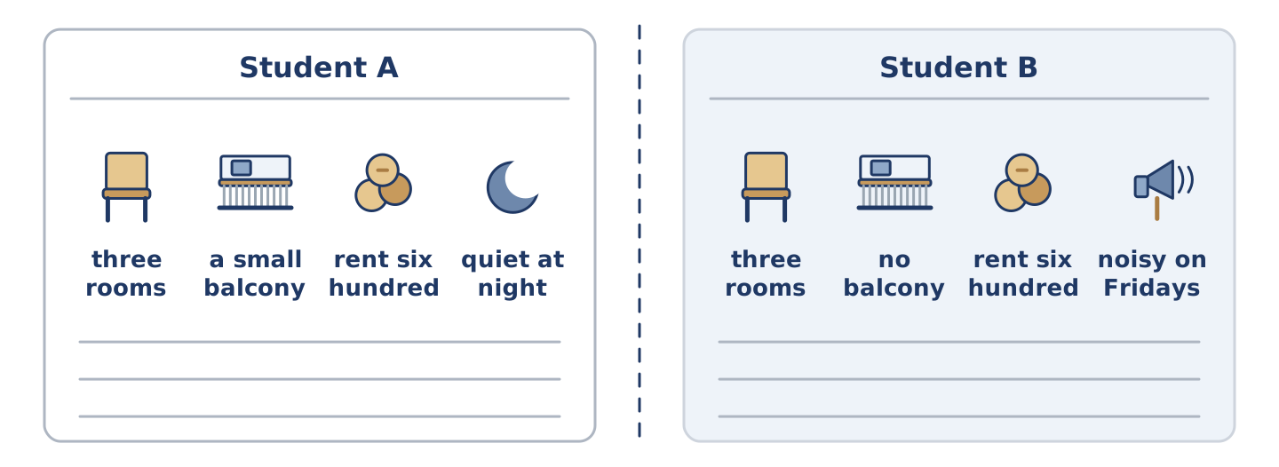
Figure 2.20 · Student A’s facts and Student B’s, with a fold between them.
Student A and Student B each have a flat. Ask questions and find three differences.
Useful questions: How many rooms are there? · Is there a balcony? · How much is the rent? · Is it quiet?
Student A — your flat: three rooms · a small balcony · rent six hundred · quiet at night.
Student B — your flat: three rooms · no balcony · rent six hundred · noisy on Fridays.
Part 4: Showing Somebody the Flat
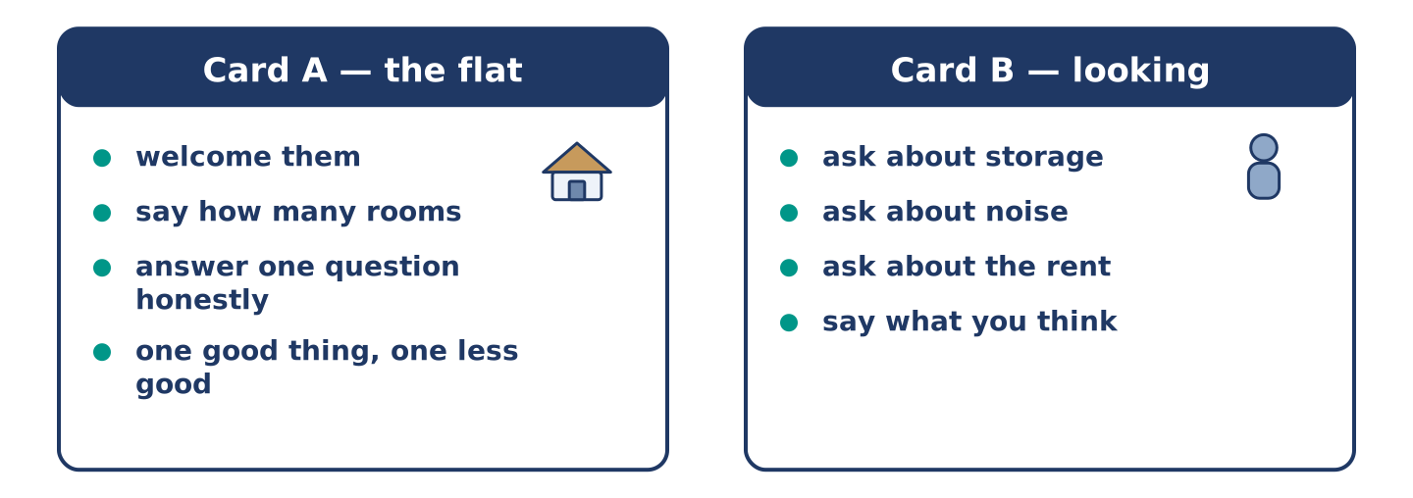
Figure 2.21 · Card A and Card B: what each of you has to say.
Work in pairs. Read the model, then use the cards.
Model exchange:
A: Come in. There are three rooms, and this is the biggest. — B: It is bigger than I thought. Is there any storage? — A: There is a cupboard on the landing. There is not much space, but it is enough for a bike. — B: And is it quiet? — A: Most nights. Not Friday.
Useful language: Come in · There are three… · Is there any…? · There is not much… · Most nights.
Card A — the person showing the flat: welcome them · say how many rooms · answer one question honestly · say one good thing and one less good thing.
Card B — the person looking: ask about storage · ask about noise · ask about the rent · say what you think.
Your turn: run the dialogue, then swap roles.
Stretch [PLUS]: Student B asks about something you would rather not talk about — answer honestly but kindly.
Part 4: Mini-Presentation
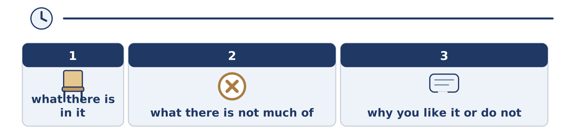
Figure 2.22 · The one-minute talk as three beats, each as wide as its share.
Prepare a short talk (about one minute). Describe one room you know well: what there is in it, what there is not much of, and why you like it or do not.
Part 5 · Reading
[CORE] Core track · pre-class input
Part 5: What Makes a Home?
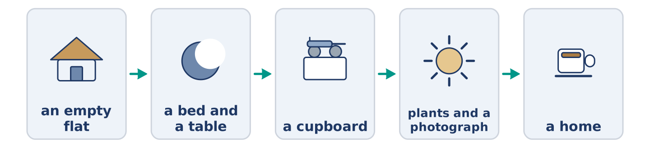
Figure 2.23 · From empty flat to home, step by step.
Before you read: what is the first thing you put in a new home?
Gloss: storage = space to keep things · furniture = tables, chairs, beds and cupboards · settle in = to start to feel at home
An empty flat is not a home. There are walls, there is a floor, and there is nothing else. There is no furniture at all. The view from the window is the only thing in the room. Most people start with the things they need: a bed, a table, two chairs. Dani bought his table first, and he still eats at it. Then they add the things they use: a cupboard, some shelves, a lamp by the chair where they read. Mr Okonkwo says his lamp is the oldest thing he owns, and he would not change it. Furniture is expensive, and the rent takes most of the money anyway. Many people live for months with a kitchen that has almost nothing in it. After the things come the small signs that somebody lives here. There are plants on the balcony. There is a photograph on the shelf and a coat by the entrance. There is bread in the cupboard and somebody’s coat by the door. A home is not the rooms; it is what people put in them and what they do there. Yuki says she knew she had settled in on the day she stopped noticing the stairs.
Answer the multiple-choice questions. (0. is done.)
- What is in an empty flat? — Walls, a floor, and nothing else.
1. What do most people buy first?
○ A) Plants and photographs
○ B) A bed, a table and chairs
○ C) A lamp and some shelves
○ D) Bread and milk
2. Why does it take time to fill a home?
○ A) Because the rooms are small
○ B) Because there is no lift
○ C) Because furniture is expensive
○ D) Because the kitchen is empty
3. When did Yuki know she had settled in?
○ A) When she bought a bed
○ B) When she met the neighbours
○ C) When the balcony had plants
○ D) When she stopped noticing the stairs
Part 5: Vocabulary in Context
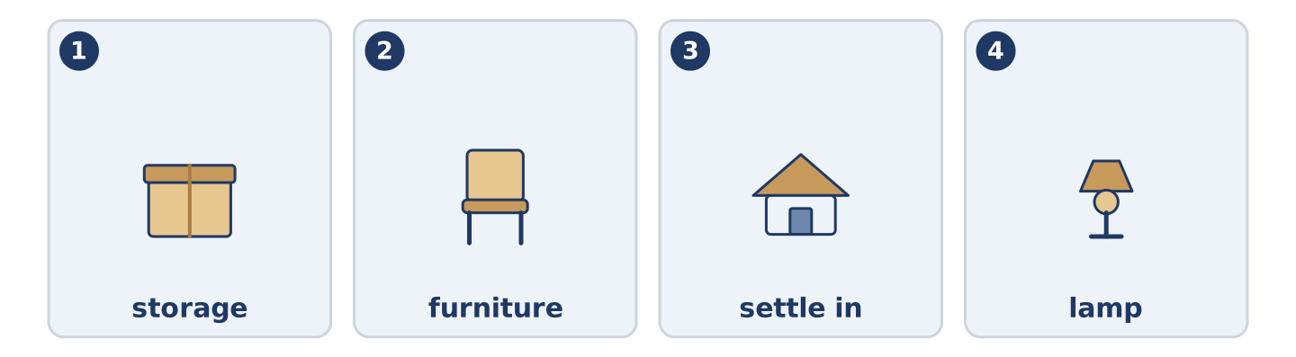
Figure 2.24 · The four words from the reading, drawn.
Match each word from the text with its meaning. One meaning is not needed. Write the letter.
Column A
1. | storage | ____
2. | furniture | ____
3. | settle in | ____
4. | lamp | ____
Column B
a) | tables, chairs, beds and cupboards
b) | a thing that gives light in a room
c) | space to keep things
d) | the money you pay every month
e) | to start to feel at home
Part 5: Homes Around the World
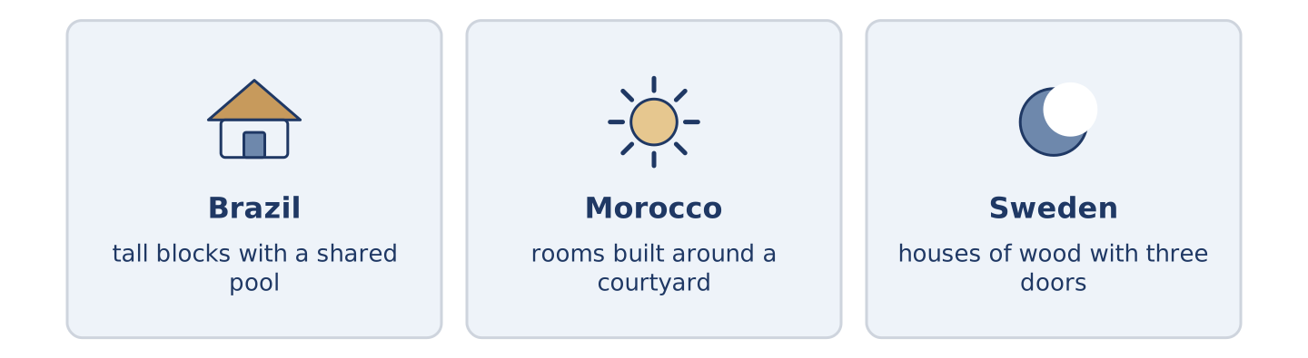
Figure 2.25 · Three homes, three answers to the same question.
Before you read: in your country, do most people live in houses or in flats?
Gloss: courtyard = an open space with walls or rooms around it · shared = used by more than one person or family
A home is not the same shape everywhere. In many cities in Brazil there are tall blocks with a shared pool and a man at the entrance who knows everybody. In parts of Morocco a house stands round a courtyard, so the rooms look inwards and the street sees almost nothing. In the north of Sweden there are houses of wood with three doors, because snow closes one of them for part of the year. There is no best shape. There is only the weather, the street and what a family needs.
Answer the questions. (0. is done.)
- Are homes the same shape everywhere? — No, they are not.
- What is at the entrance of many blocks in Brazil?
- Why do the rooms of a Moroccan house look inwards?
- Why do some Swedish houses have three doors?
Part 6 · Writing
[CORE] Core track · in-class / homework
Part 6: Describe a Room (50–70 words)
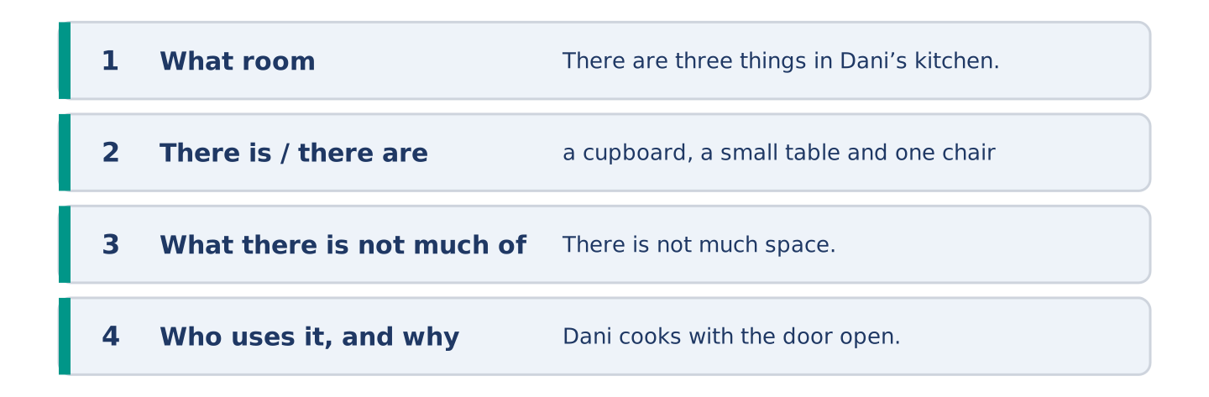
Figure 2.26 · The shape of the paragraph you are about to write.
Describe one room. Say what there is in it, what there is not much of, and who uses it.
Model — read this first:
There are three things in Dani’s kitchen: a cupboard, a small table and one chair. There is not much space, so the bag of rice lives under the table. There are no plants and there is no lamp. Dani says he does not need one, because he cooks with the door open and the light from the landing. (58 words)
Plan (fill in, then write): In ___ there is ___ and there are ___. There is not much ___. ___ uses it most, because ___.
Word bank: there is | there are | there is not much | there are not many | some | any
Check before you finish: ☐ one there is and one there are? ☐ one much or many? ☐ 50–70 words? ☐ capitals & full stops?
Part 6: A Good Place to Live (50–70 words)
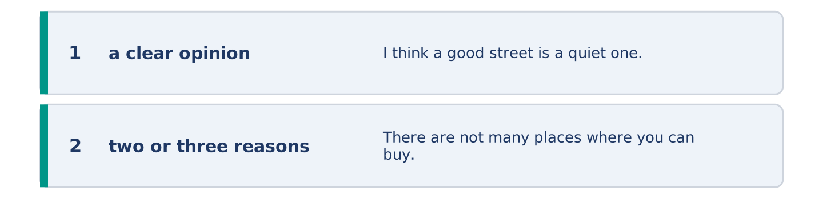
Figure 2.27 · The shape of the opinion paragraph, step by step.
What makes a street a good place to live? Give your opinion and two or three reasons.
Model — read this first:
I think a good street is a quiet one with a shop at the end of it. There are not many places where you can buy bread at seven in the morning, and that one shop changes the whole day. A good street also has somebody who notices when you are away. That is worth more than a balcony. (59 words)
Word bank: I think… because… | there is / there are | not much | not many | in my opinion
Check before you finish: ☐ a clear opinion? ☐ two or three reasons? ☐ 50–70 words?
Part 6: A Message About a Problem (50–70 words)
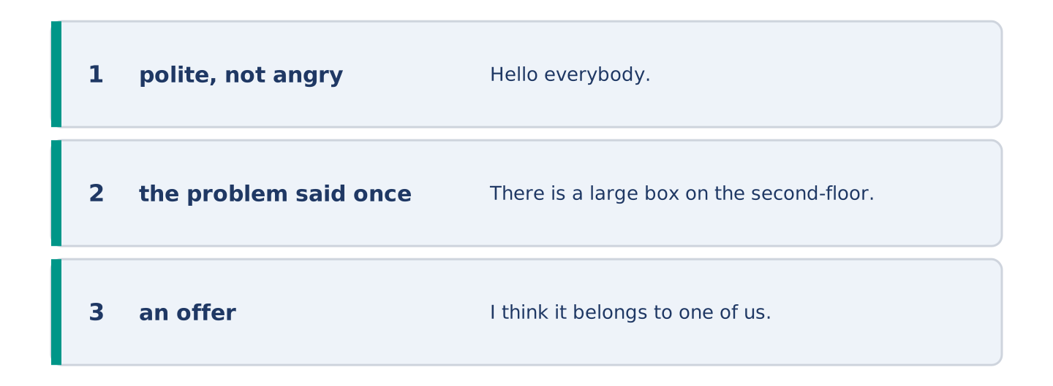
Figure 2.28 · The moves of the message, with a line of the model for each.
Something in your building is broken or in the way. Write a short, polite message to your neighbours about it.
Model — read this first:
Hello everybody. There is a large box on the second-floor landing, and there is not much room to get past it with a bike or a buggy. I think it belongs to one of us. There is an empty cupboard downstairs, and I am happy to help carry it down this evening. Just knock. Dani, flat 3 (57 words)
Plan (fill in, then write): Hello ___. There is ___ on ___. There is not much ___. I am happy to ___. ___
Check before you finish: ☐ polite, not angry? ☐ the problem said once, clearly? ☐ an offer? ☐ 50–70 words?
Part 6: Reflection — My Ideal Home (40–60 words)
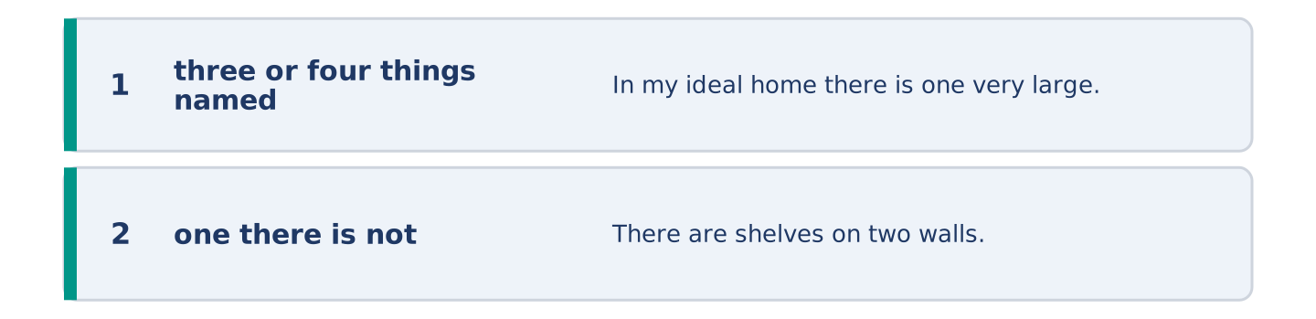
Figure 2.29 · The reflection, step by step.
Describe your ideal home. What is there, and what is there not?
Model — read this first:
In my ideal home there is one very large window and a table under it. There are shelves on two walls and there is a garden with a tree. There is not much furniture, because I do not want to clean it. There are no stairs at all. (48 words)
Check before you finish: ☐ three or four things named? ☐ one there is not? ☐ 40–60 words?
Part 7 · Real-World File — Renting and Repairs
[PLUS] Plus track (optional) · stronger learners
7A: Phrase Bank
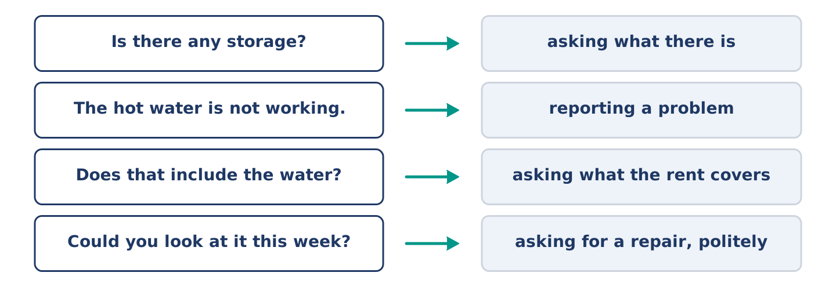
Figure 2.30 · What you say about a home, and what each thing does.
Match what a person says with its purpose. One purpose is not needed. Write the letter.
Column A
1. | “Is there any storage?” | ____
2. | “The hot water is not working.” | ____
3. | “Does that include the water?” | ____
4. | “Could you look at it this week?” | ____
Column B
a) | asking what the rent covers
b) | asking for a repair, politely
c) | asking what there is
d) | offering to pay more
e) | reporting a problem
7B: Reporting a Problem
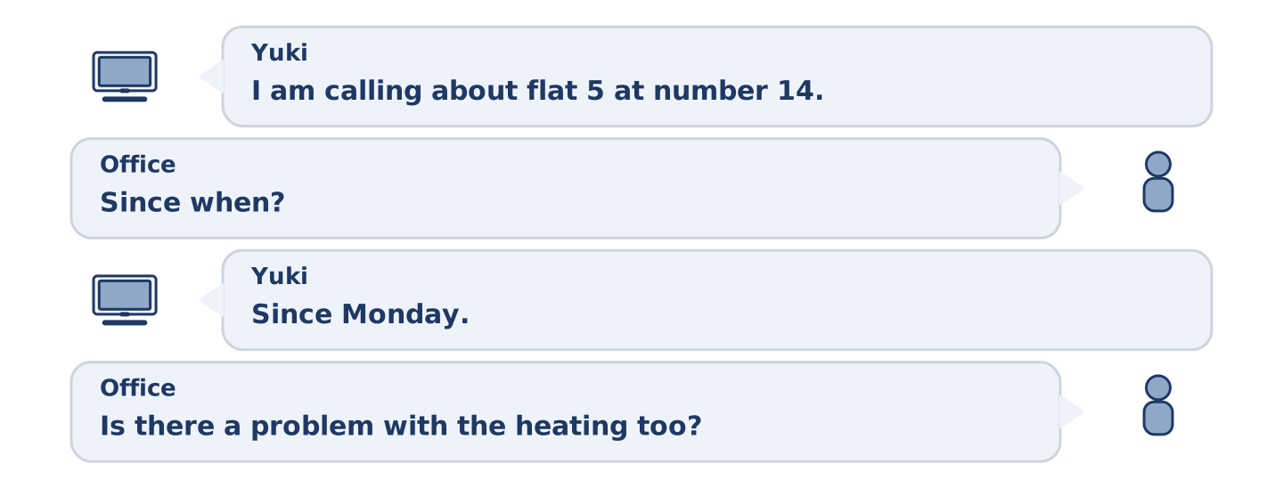
Figure 2.31 · The 7B exchange: who takes each turn.
🔊 Audio Track 2.5
Before you read: what do you say first when you telephone about a repair?
Yuki: Good morning. I am calling about flat 5 at number 14. There is no hot water in the morning. Office: Since when? Yuki: Since Monday. There is hot water in the evening, but there is not much before eight. Office: I see. Is there a problem with the heating too? Yuki: No, the heating is fine. Office: Right. There are two jobs in that street this week. Could somebody come on Thursday? Yuki: Thursday is good. Thank you.
Answer the questions. (0. is done.)
- Which flat is Yuki calling about? — Flat 5 at number 14.
- What is the problem?
- When is there hot water?
- When does somebody come?
7C: Controlled Practice — Reporting a Problem
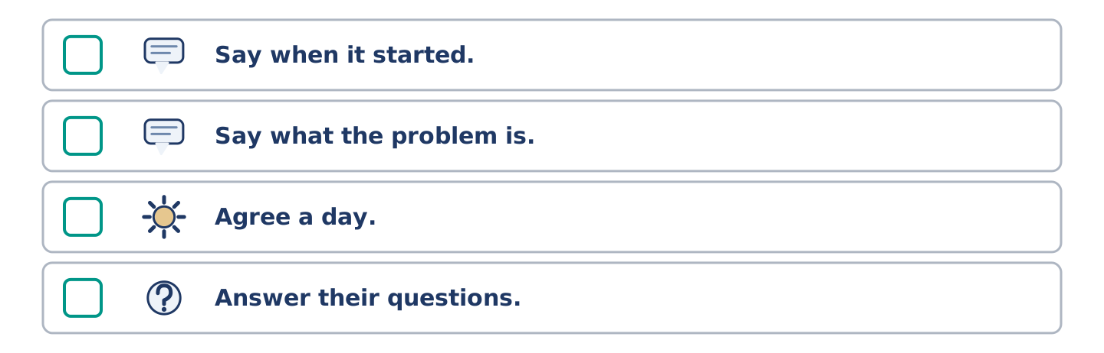
Figure 2.32 · The steps still to be numbered, as the task prints them.
Put the steps in order. Number them 1–5. (0. is done.)
- Say who you are and where you live. — 1
____ Say when it started.
____ Say what the problem is.
____ Agree a day.
____ Answer their questions.
7D: Role-Play — Asking for a Repair
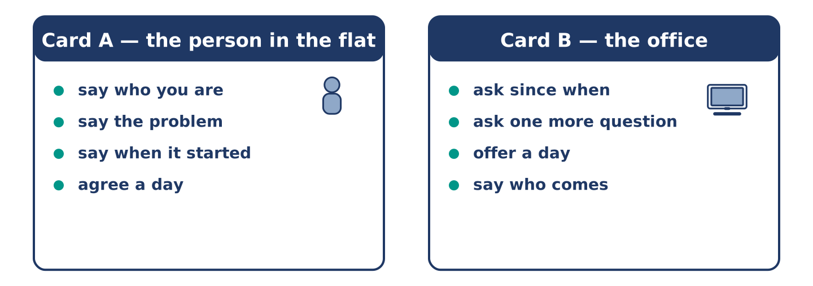
Figure 2.33 · The 7D cards: what each of you has to say.
In pairs. One lives in the flat; one works in the office. Use the model and cards.
Model exchange: A: Good morning. I am calling about flat 3. There is no light on the stairs. — B: Since when? — A: Since Saturday. — B: Is there a problem inside the flat? — A: No, only the stairs. — B: Could somebody come on Wednesday? — A: Wednesday is fine, thank you.
Card A — the person in the flat: say who you are · say the problem · say when it started · agree a day.
Card B — the office: ask since when · ask one more question · offer a day · say who comes.
Stretch [PLUS]: the office offers a day you cannot do — say so and ask for another, without getting angry.
7E: Writing — A Repair Request (50–80 words)
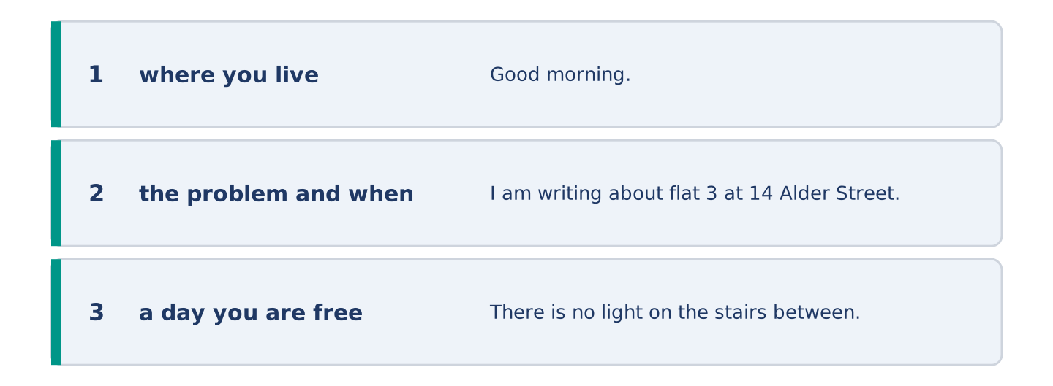
Figure 2.34 · The Part 7 note, with the model beside each line.
Write a short message to the office about something that is broken in your building.
Model — read this first:
Good morning. I am writing about flat 3 at 14 Alder Street. There is no light on the stairs between the first and second floors, and there is none since Saturday. There is not much daylight there even at midday, so it is dark for everybody in the building. Could somebody look at it this week? I am at home on Wednesday. Thank you. Dani Rossi (66 words)
Check before you finish: ☐ where you live? ☐ the problem and when it started? ☐ a day you are free? ☐ 50–80 words?
Part 8 · Global Story — The Street That Built Its Own Square
[PLUS] Plus track · pre-read / discuss
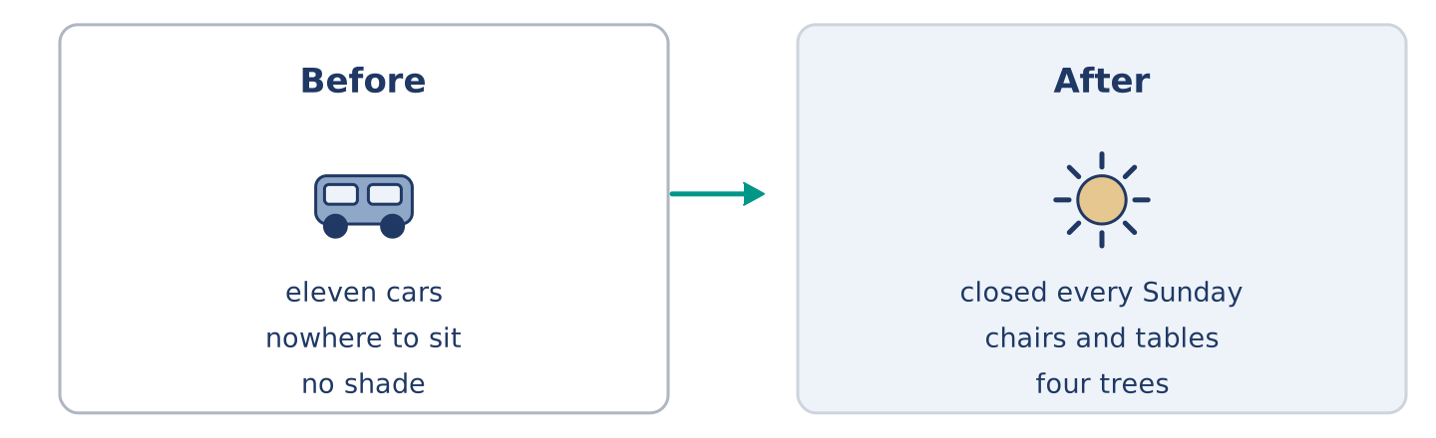
Figure 2.35 · One street in Brazil, before and after.
Before you read: can the people of one street change the street itself?
Gloss: square = an open space in a town with buildings around it · council = the people who run a town · permission = when somebody says you may do something
In a small city in Brazil there was a street with no shade and nowhere to sit. There were cars on both sides and there was not much room for anybody else. One woman, Clara, counted the cars one Sunday: eleven cars and forty-one people. She wrote the two numbers on a piece of paper and put it in every letter box. People started to talk. They asked the council for permission to close one end of the street for one Sunday a month. The council said yes, for three months. On the first Sunday there were chairs, two tables and somebody’s radio. On the third there were ninety people. The street is now closed every Sunday, and there are four trees in it. Clara says the hardest part was not the council. It was the first Sunday, when she carried out two chairs and sat down alone for twenty minutes.
Answer the questions. (0. is done.)
- Where is the street? — In a small city in Brazil.
- What did Clara count, and what were the numbers?
- What did the council agree to?
- What does Clara say was the hardest part?
Part 8: Vocabulary in Context
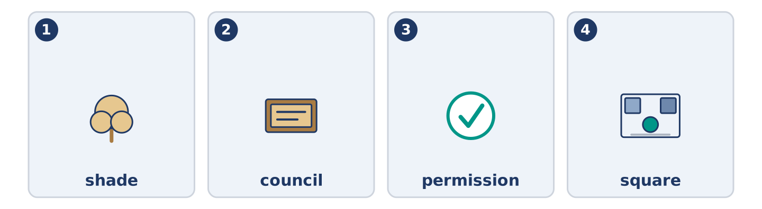
Figure 2.36 · The four words from the global story, drawn.
Match each word with its meaning. One meaning is not needed. Write the letter.
Column A
1. | shade | ____
2. | council | ____
3. | permission | ____
4. | square | ____
Column B
a) | when somebody says you may do something
b) | an open space in a town with buildings around it
c) | the people who run a town
d) | a place out of the sun
e) | the money you pay to live somewhere
Part 8: Discussion
Talk with a partner. Use the frames.
Discussion frames: “This is similar to where I live because…” · “This is different from where I live because…” · “I think the most important thing is… because…”
Part 9 · Close to Home — The Empty Flat
[PLUS] Plus track · pre-read / decide
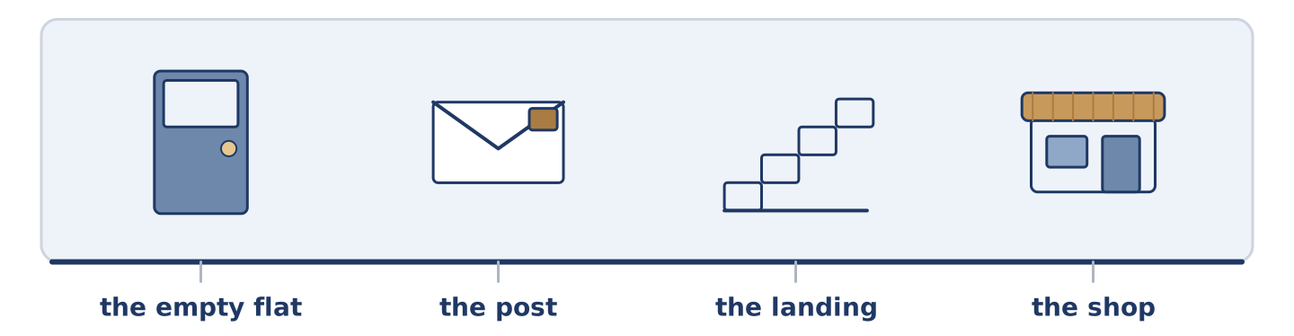
Figure 2.37 · The close-to-home reading, drawn along one street.
Before you read: what happens to a building when one flat stays empty?
There is an empty flat on the first floor of number 14, next to Dani. It was empty in the spring, and it is empty now. There is no furniture in it and there is not much light, because the shutters are closed. For a while nobody thought about it. Then the post began to arrive for somebody who was not there. It sat on the landing in a pile, and the pile grew bigger every week. Mr Okonkwo put a box under the letter boxes so the post had somewhere to go. Dani started to clean that part of the landing. Amina asked twice at the shop whether anybody knew the name. Nobody did. There are five flats at number 14, and one of them is a question. Each of the five homes answers it in its own small way. Nobody ever agreed to.
Answer the questions. (0. is done.)
- Where is the empty flat? — On the first floor, next to Dani.
- Why is there not much light in the flat?
- What did Mr Okonkwo do about the post?
- What does the text say the neighbours never did?
Part 9: Decision Task
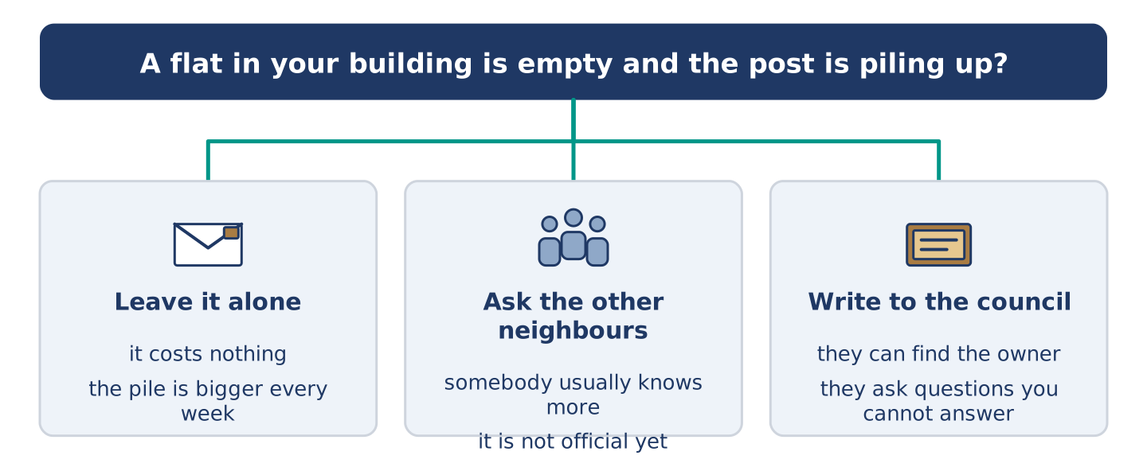
Figure 2.38 · Three ways to decide, and what each one costs.
A flat in your building stood empty all year and the post is piling up. Should you (a) leave it alone, (b) ask the other neighbours what they know, or (c) write to the owner or the council? Decide and explain. Use the frame.
Answer frame: “I think I should ___ because ___. Also, ___. This is better than ___ because ___.”
Model — read this first:
I think I should ask the other neighbours first, because somebody in the building usually knows more than you do. Also, it costs nothing and it does not make a small thing into an official one. This is better than writing to the council, because the council asks questions I cannot answer yet. (53 words)
Phrase bank: I think I should… · because… · Also,… · This is better than… · In my opinion…
Part 10 · Review and Can-Do
[CORE + PLUS] · homework / self-study
Part 10: Spiral Review
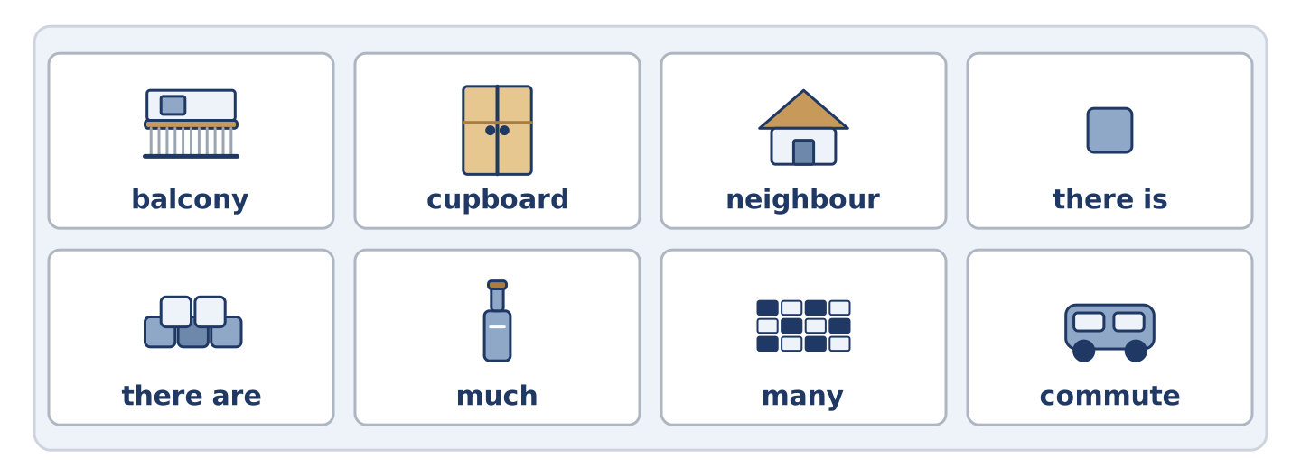
Figure 2.39 · The eight words of the review bank, in bank order.
Complete the review. (0. is done.)
- The money you pay every month to live somewhere is the rent.
Word bank: balcony | cupboard | neighbour | there is | there are | much | many | commute
- A tall box with doors, for plates and cups, is a ______________________ .
- A small outside floor with a wall is a ______________________ .
- A person who lives near you is your ______________________ .
- “______________________ a shop on the ground floor” — one thing.
- “______________________ five flats above it” — more than one.
- There is not ______________________ space in Amina’s kitchen.
- There are not ______________________ quiet nights above Dani.
- (from Unit 1) The journey between your home and your work is your ______________________ .
Part 10: Can-Do
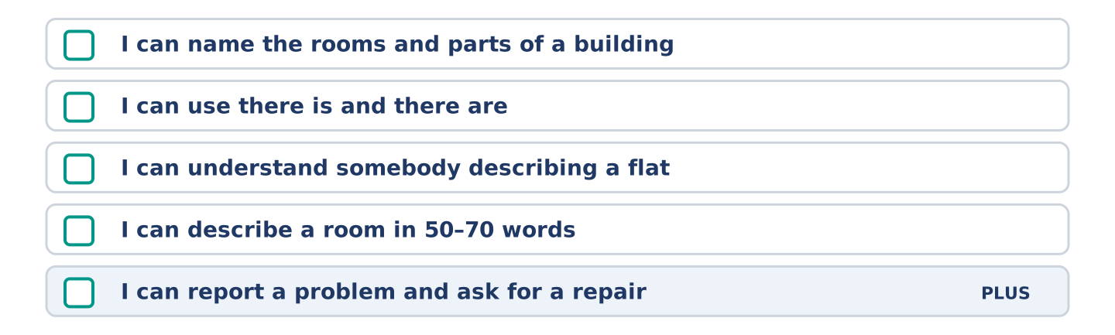
Figure 2.40 · What you can do at the end of this unit.
Can-Do checklist
☐ I can name the rooms and parts of a building.
☐ I can use there is and there are, and some, any, much and many.
☐ I can understand somebody describing a flat.
☐ I can describe a room in 50–70 words.
☐ I can report a problem and ask for a repair (Plus).
Part 10: Glossary
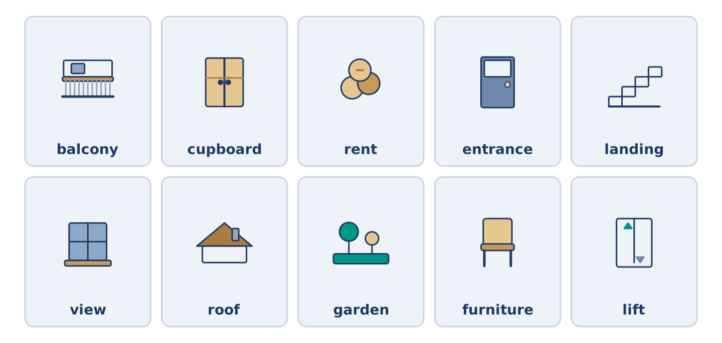
Figure 2.41 · All ten glossary words of Unit 2, one card each.
Unit 2 glossary (10 words)
balcony · cupboard · rent · entrance · landing · view · roof · garden · furniture · lift

