Unit 6: Journeys and Mishaps
English for Daily Life · Level: A2 · Tracks: [CORE] Warm-Up + Parts 1–6 · [PLUS] Parts 7–10
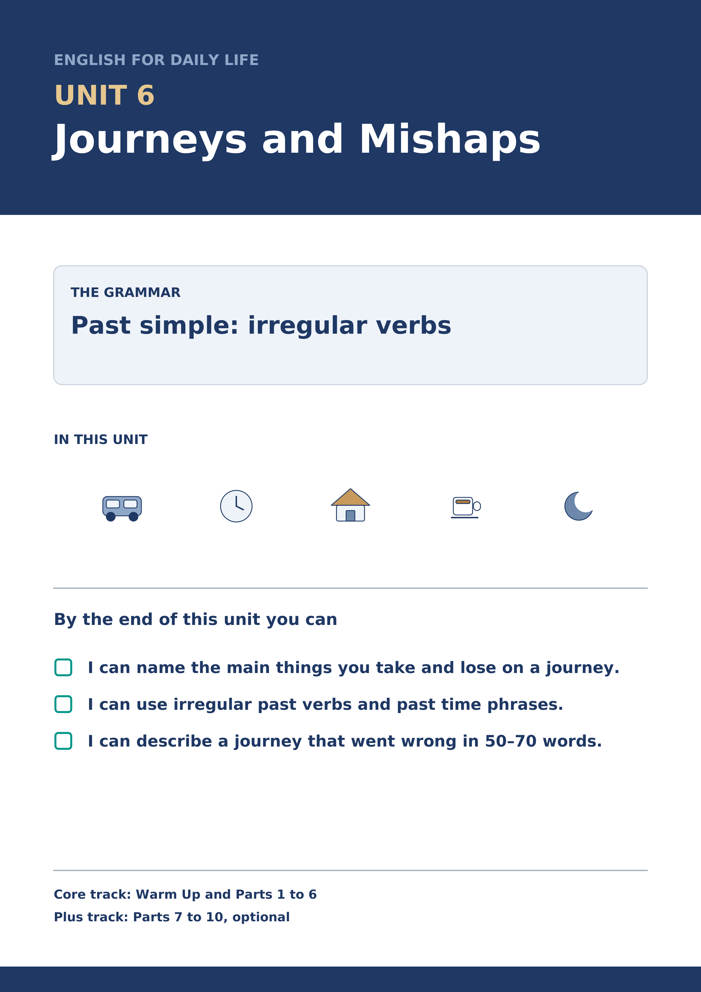
Warm Up
[CORE] Core track · in-class starter
Warm-up: Journey Words and Meanings
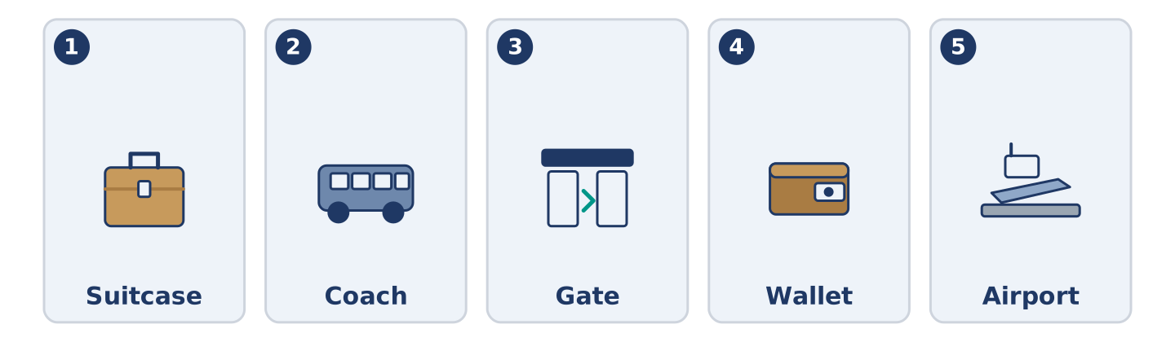
Figure 6.2 · The five warm-up words, and the thing each one means.
Match the words with their meanings. One meaning is not needed. Write the letter.
Column A
1. | Suitcase | ____
2. | Coach | ____
3. | Gate | ____
4. | Wallet | ____
5. | Airport | ____
Column B
a) | a long bus that takes people between cities
b) | the place where planes land and leave from
c) | a small flat case you keep money and cards in
d) | the door you go through to reach your plane
e) | a big case with a handle, for your clothes
f) | a narrow way you walk along
Warm-up: Talking About a Journey
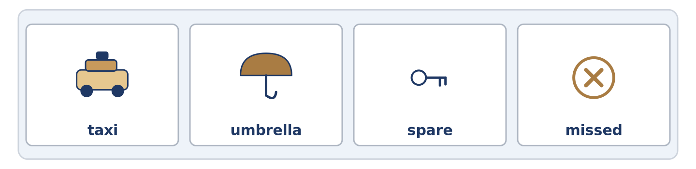
Figure 6.3 · The word bank for this task, in the order it is printed.
Complete the sentences using the words in the word bank.
Word bank: taxi | umbrella | spare | missed
- Dani ______________________ the last coach and walked home in the dark.
- Yuki left her ______________________ on the train and it rained all week.
- Maya keeps a ______________________ key with Amina, for exactly this reason. She is glad she did.
- There was no bus at midnight, so Mr Okonkwo took a ______________________ .
Warm-up: The Journey That Went Wrong
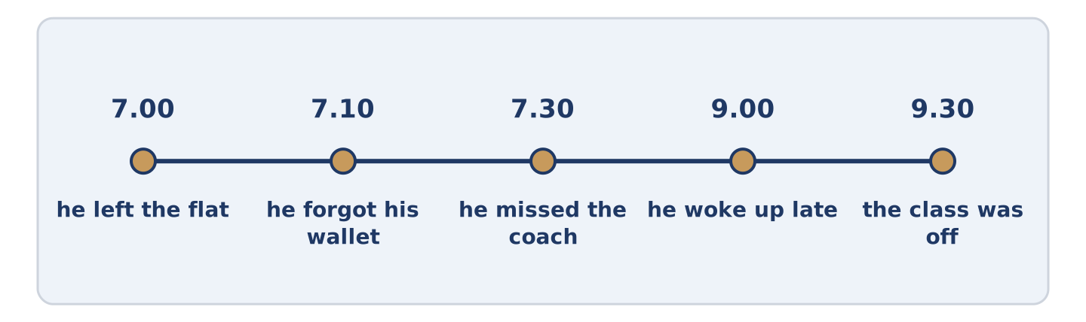
Figure 6.4 · Dani’s Tuesday, from the first mistake to the last.
Read the text and choose the correct answer.
Dani left the flat at seven and forgot his wallet. He went back for it and missed the coach. He caught the next one, fell asleep, and woke up two stops late. Then it rained, and his umbrella was at home with his wallet. He arrived an hour and a half late and found that the class was off. He says it was the best day of his week, because he met somebody at the wrong bus stop and they are now friends.
1. Why did Dani miss the coach?
○ A) He went back for his wallet
○ B) He fell asleep
○ C) It rained
○ D) The class was cancelled
2. What does Dani say about the day?
○ A) It was the worst day
○ B) He will not do it again
○ C) It was the best day of his week
○ D) He lost his umbrella
Part 1 · Vocabulary and Terminology
[CORE] Core track · pre-class input
Part 1: Journey and Mishap Terms
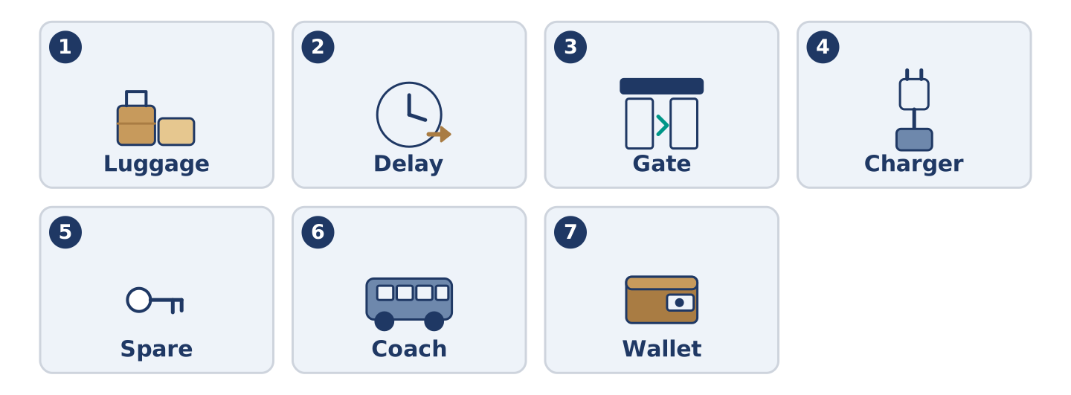
Figure 6.5 · The seven words of Column A, and what each one is.
Match the words with their meanings. One meaning is not needed. (0. is done for you.)
- Mishap → a small thing that goes wrong, and is annoying rather than serious.
Column A
1. | Luggage | ____
2. | Delay | ____
3. | Gate | ____
4. | Charger | ____
5. | Spare | ____
6. | Coach | ____
7. | Wallet | ____
Column B
a) | kept for when the first one is lost or broken
b) | all the bags a person travels with
c) | when something comes later than it should
d) | the door you go through to reach your plane
e) | the wire that puts power back in a telephone
f) | a long bus that takes people between cities
g) | a small flat case you keep money and cards in
h) | a narrow way you walk along
Gloss: luggage = all the bags you travel with · delay = when something comes later than it should · mishap = a small thing that goes wrong · platform = the place beside the train where you stand
Part 1: Pronunciation
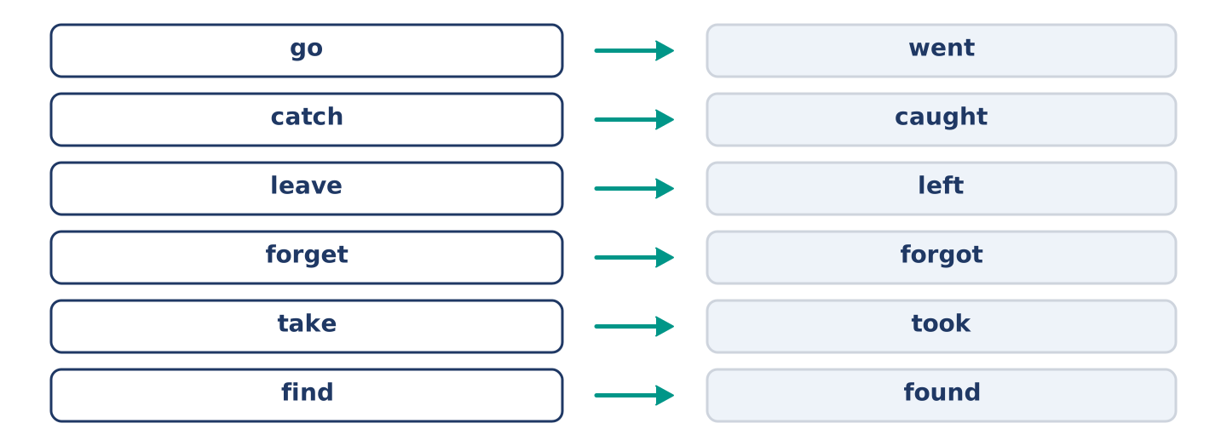
Figure 6.6 · Where the stress falls in six words of this unit.
🔊 Audio Track 6.1
Listen and practise these irregular past forms. Say each pair aloud.
go — went
catch — caught
leave — left
forget — forgot
take — took
find — found
Then listen again. None of these adds -ed; the sound in the middle changes instead. Caught sounds like thought, and the gh says nothing at all. Learn them as pairs, out loud, not as a list on a page.
Part 1: Six Things People Lose
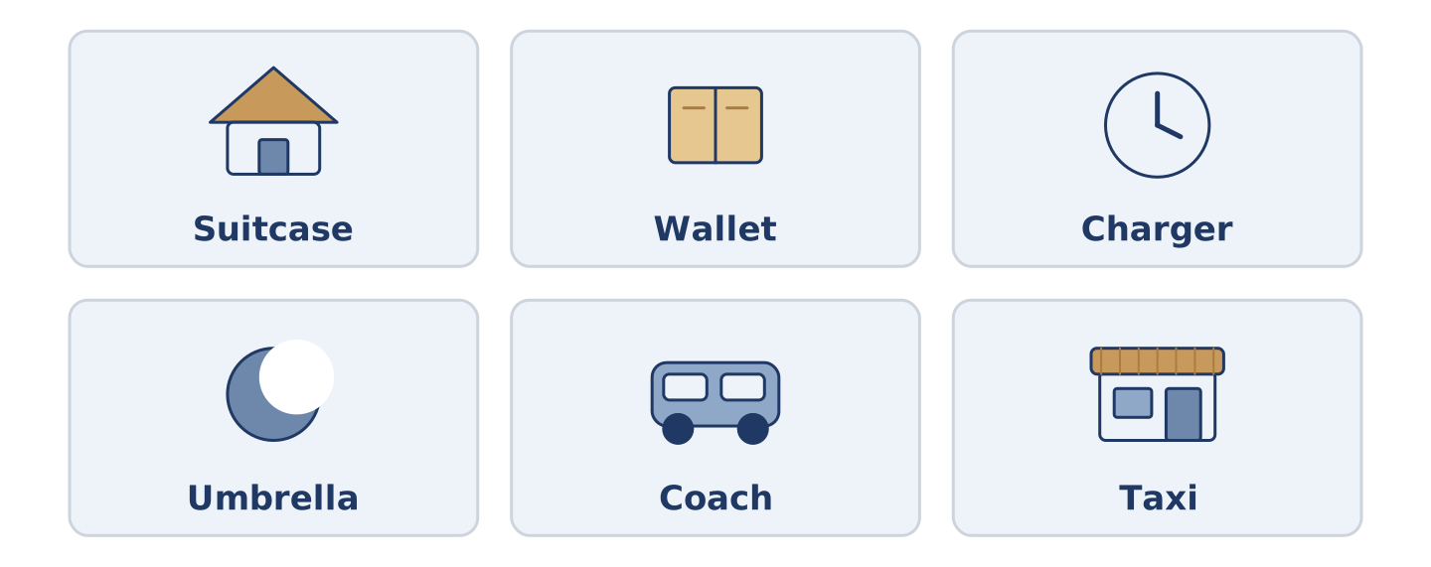
Figure 6.7 · Six things people lose, and where they lose them.
Complete the table. Write where people usually lose it and what you do then. (0. is done.)
Thing | Where people lose it | What you do
Umbrella | on the train | (example)
Wallet
Key
Charger
- Umbrella — on the train — nothing, usually, and you buy another.
Think about the last thing you lost. There is more than one right answer; be ready to say why you chose yours.
Part 1: At the Station
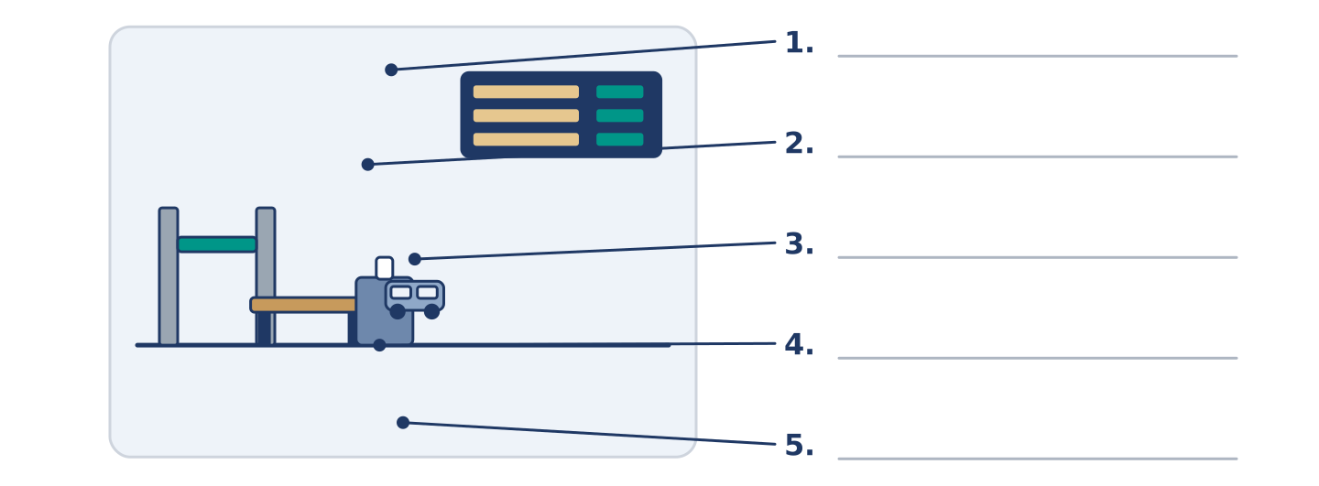
Figure 6.8 · At the station — write the correct word on each line.
Match the things at a station with their descriptions. One description is not needed. Write the letter.
Column A
1. | Gate | ____
2. | Luggage | ____
3. | Seat | ____
4. | Delay | ____
5. | Coach | ____
Column B
a) | all the bags a person travels with
b) | the place you sit for the journey
c) | the door you go through to reach your plane
d) | a long bus between cities
e) | when something comes later than it should
f) | the money you pay for one journey
Part 1: Journeys — Multiple Choice
Read and choose the correct answer.
1. A big case with a handle, for your clothes, is a…
○ A) wallet
○ B) charger
○ C) suitcase
○ D) gate
2. When something comes later than it should, there is a…
○ A) mishap
○ B) delay
○ C) coach
○ D) seat
3. A key you keep in case you lose the first one is a…
○ A) spare key
○ B) gate key
○ C) lost key
○ D) wallet key
Part 1: Vocabulary Fill-in
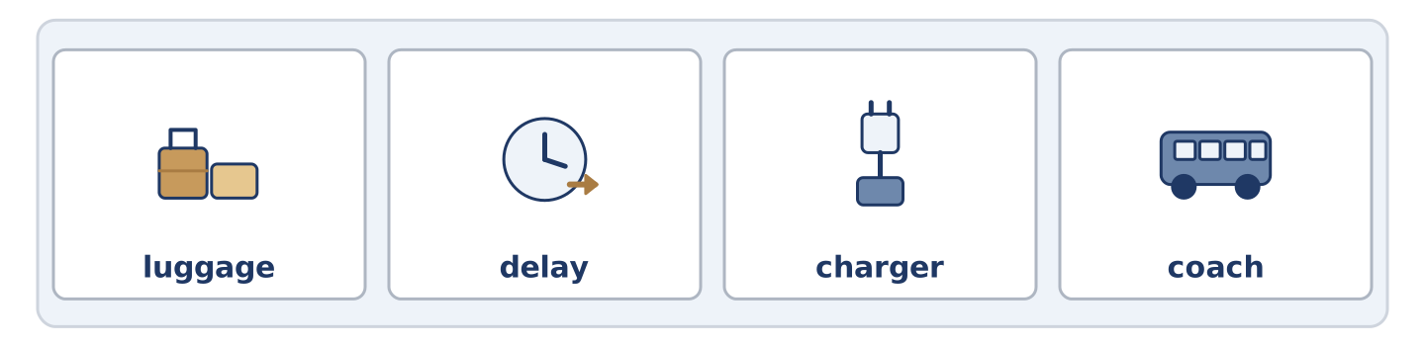
Figure 6.9 · The four words of the bank, in the order the task gives them.
Complete the sentences with the correct word.
Word bank: luggage | delay | charger | coach
- There was a two-hour ______________________ , and nobody told the passengers why.
- Yuki carried her ______________________ up four floors, because there is no lift. A suitcase is heavier at the top.
- The ______________________ to the coast leaves from the back of the station, not from the airport.
- Dani forgot his ______________________ and his telephone died at eleven.
Part 1: Write About a Journey (short)
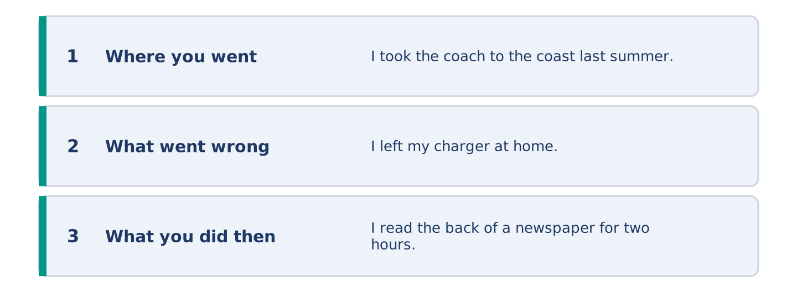
Figure 6.10 · The shape of your two or three sentences, with the model beside each step.
Write two or three sentences about a journey you took. Use three words from this unit.
Model — read this first:
I took the coach to the coast last summer and it was four hours late. I left my charger at home, so my telephone died somewhere in the middle. I read the back of somebody else’s newspaper for two hours and I still do not know how the story ended. (50 words)
Part 2 · Grammar — Past Simple: Irregular Verbs
[CORE] Core track · pre-class input
Part 2: Notice
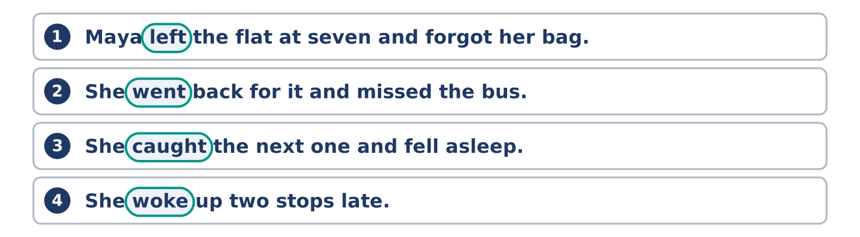
Figure 6.11 · Lines from the notice, with the target form ringed in each.
Read these lines about Maya’s Thursday. Underline the past verbs. Which ones do not end in -ed?
Maya left the flat at seven and forgot her bag. She went back for it and missed the bus. She caught the next one and fell asleep. She woke up two stops late and found that it was raining.
Missed ends in -ed. The others do not: they change in the middle instead, and there is no rule for which way. English has about two hundred of these, and a learner meets the same forty again and again.
Part 2: Grammar Focus Box
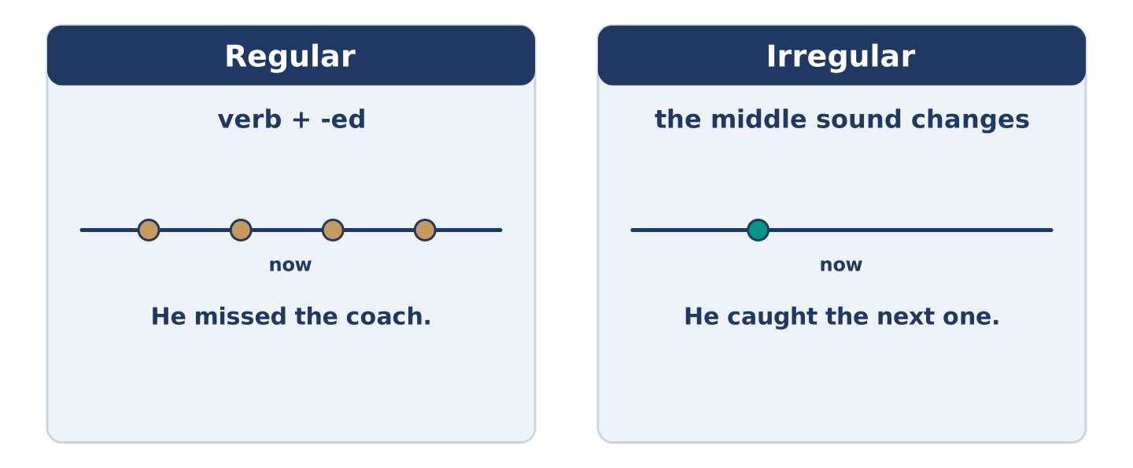
Figure 6.12 · Regular and irregular: two ways back into the past.
 | Form | Use | Example
Regular | verb + -ed | the ordinary way | He missed the coach.
Irregular | the middle sound changes | about forty common verbs | He caught the next one.
Negative | did not + plain verb | the same for both kinds | He did not catch it.
Time phrases | last week · two days ago · in the spring | say when, once, near the start | Last summer I took the coach.
Remember: after did and did not, every verb goes back to its plain form: did he go?, not did he went?
Watch out! ✗ He goed back for it. → ✓ He went back for it. (go is irregular). ✗ Did he went? → ✓ Did he go? (did carries the past).
Part 2: Controlled Practice
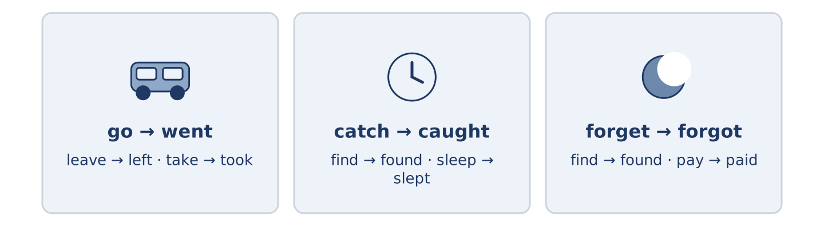
Figure 6.13 · Forty verbs you meet again and again.
Write the past simple. (0. is done.)
- Maya left the flat at seven. (leave)
- She ______________________ (forget) her bag.
- She ______________________ (go) back for it.
- She ______________________ (catch) the next bus.
- She ______________________ (find) that it was raining.
Part 2: Regular or Irregular?
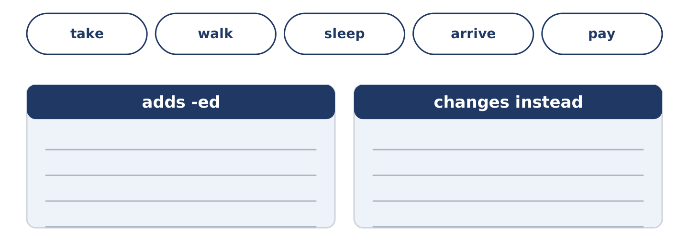
Figure 6.14 · The items of this task, and the bins they sort into.
Choose the correct past form. (0. is done.)
- Yuki took the train to the coast. (took / taked)
- Maya ______________________ (walked / walkt) to the station.
- Dani ______________________ (sleeped / slept) through two stops.
- The coach ______________________ (arrived / arrove) an hour late.
- Mr Okonkwo ______________________ (payed / paid) for the taxi.
Part 2: Correct the Sentence
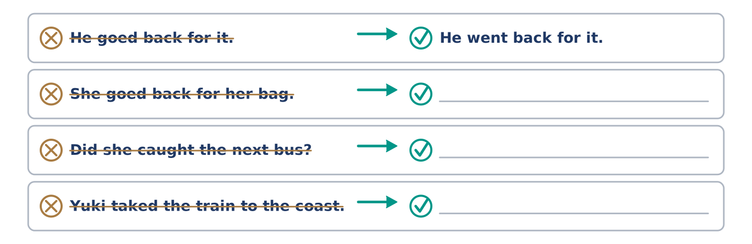
Figure 6.15 · One correction done for you, and the rest to write.
Each sentence has one grammar mistake. Write the correct sentence.
- She goed back for her bag.
- Did she caught the next bus?
- Yuki taked the train to the coast.
- They not found the gate in time.
Part 2: Freer Practice
Write two sentences about a journey you took: one with a regular past verb and one with an irregular one.
Part 2: Grammar Review
Choose the correct past-simple sentence.
1. Which sentence uses the irregular past correctly?
○ A) She goed back for her bag.
○ B) She went back for her bag.
○ C) She did went back for her bag.
○ D) She gone back for her bag.
2. Which question is correct?
○ A) Did she caught the bus?
○ B) Did she catched the bus?
○ C) She did catch the bus?
○ D) Did she catch the bus?
→ Harvest: you will see the irregular past again in the Part 5 reading. Watch for the verbs that do not end in -ed.
Part 3 · Listening
[CORE] Core track · pre-class input · scripts printed inline
Part 3: What Happened to You?
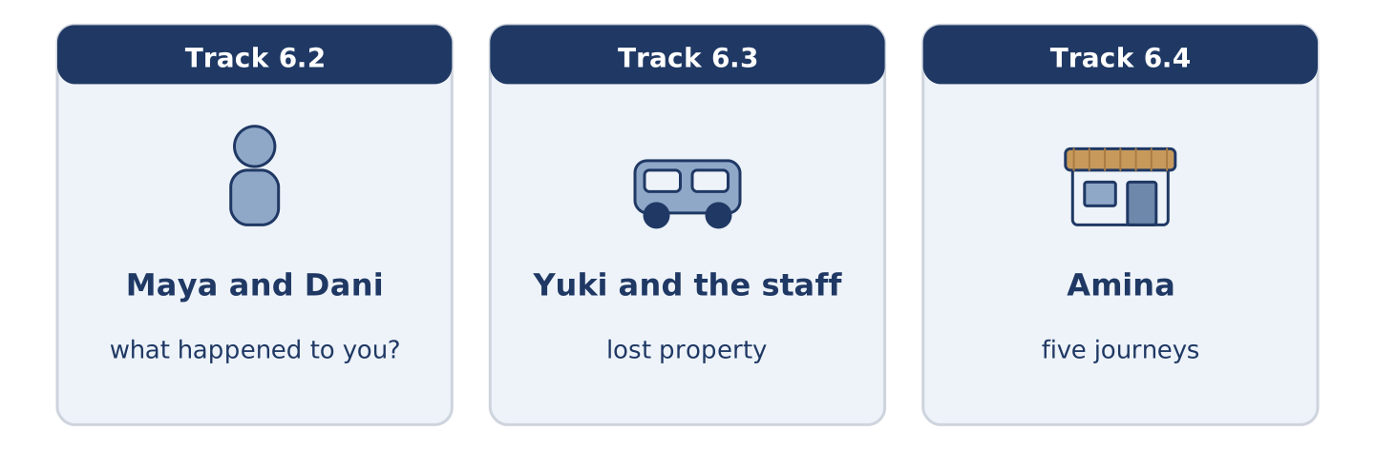
Figure 6.16 · The three listenings: who is speaking, and what about.
🔊 Audio Track 6.2
Before you listen: what is the worst journey you remember?
Maya: You look terrible. What’s happened? Dani: I left at seven and I’d forgotten my wallet. Maya: Oh no. Dani: I went back, missed the coach, caught the next one and slept through two stops. Maya: And then? Dani: Then it rained. My umbrella was at home with my wallet. Maya said hers was free all day. Maya: And the class? Dani: Off. Maya: Dani. Dani: I know, I know. But I met somebody at the wrong stop, so I am calling it a good day.
While you listen: write True, False, or Not Given. (0. is done.)
- Dani forgot his wallet. — True
- Dani caught the first coach. ____
- Dani met somebody at the wrong stop. ____
- Dani is late every week. ____
Useful phrases: What happened? · I left… and forgot… · And then? · I am calling it…
Part 3: Lost Property
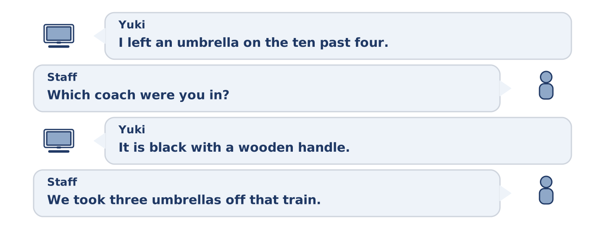
Figure 6.17 · The second listening, turn by turn.
🔊 Audio Track 6.3
Before you listen: what do you say when you leave something on a train?
Yuki: I left an umbrella on the ten past four yesterday. Staff: Which coach were you in? Yuki: The last one, I think. It is black with a wooden handle. Staff: We took three umbrellas off that train. One’s black. Yuki: Was there a wooden handle? Staff: There was. Give me a name and I keep it until Friday. Yuki: Yuki Tanaka. Thank you — my grandmother gave me that umbrella.
Answer the questions. (0. is done.)
- What did Yuki leave on the train? — An umbrella.
- Which coach was she in?
- How many umbrellas did the staff take off the train?
- Until when do they keep it?
Part 3: Five Journeys
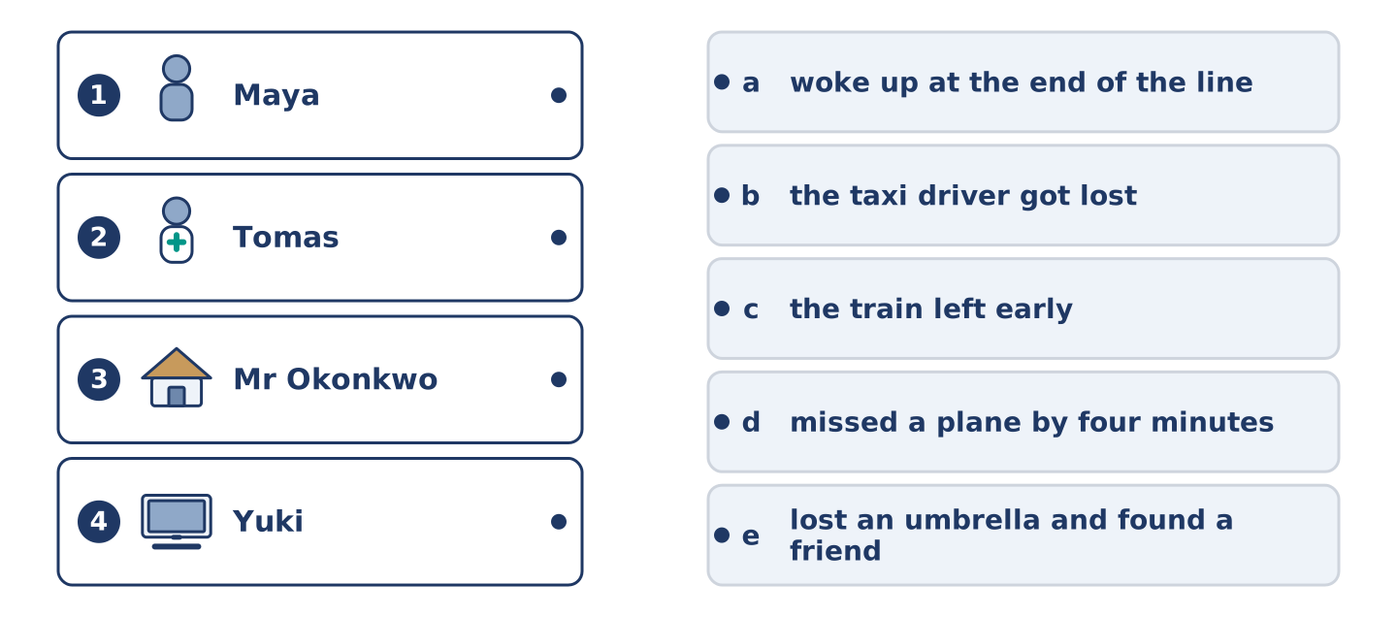
Figure 6.18 · Four on the left, five on the right, and one spare.
🔊 Audio Track 6.4
Before you listen: how many ways can one short journey go wrong?
Amina: Everybody came in with a story this week. Maya walked to the station and the train left early, which it never does. She says she stood there and laughed, then walked back for a coffee. Tomas slept through his stop and woke at the end of the line at six. His sister telephoned him there, and she still mentions it. She mentions it every year. Dani forgot his wallet, which surprised nobody. Amina keeps bread for him on Tuesdays now. Mr Okonkwo took a taxi for the first time in nine years and the driver got lost. She was from his old school and would not take his money. Yuki lost an umbrella and found a friend. She says her week improved from there.
While you listen: match each person with what happened. One thing is not needed. (0. is done.)
- Amina → she heard all five stories.
Useful phrases: ___ walked and… · ___ slept through… · ___ took a taxi and…
Column A
1. | Maya | ____
2. | Tomas | ____
3. | Mr Okonkwo | ____
4. | Yuki | ____
Column B
a) | woke up at the end of the line
b) | the taxi driver got lost
c) | the train left early
d) | missed a plane by four minutes
e) | lost an umbrella and found a friend
Part 4 · Speaking
[CORE] Core track · in-class output
Part 4: Talking About Journeys
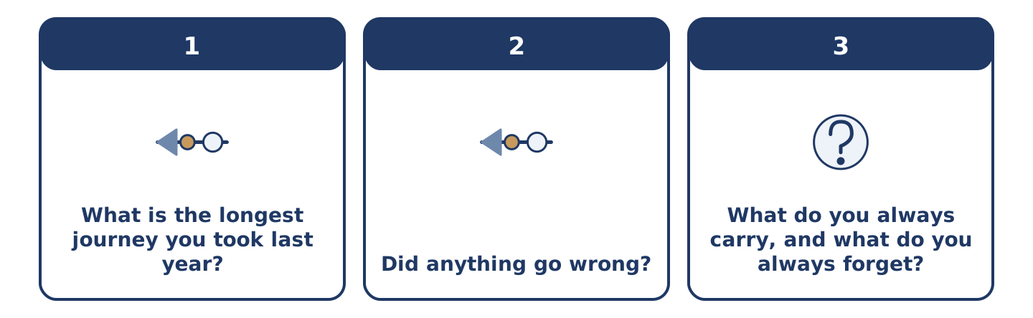
Figure 6.19 · The three questions as cards, to take one at a time.
Work with a partner. Ask and answer these questions.
- What is the longest journey you took last year? How did you travel?
- Did anything go wrong? What did you do?
- What do you always carry, and what do you always forget?
Useful language: I took… · I left… · Then I… · I forgot… · Did you…?
Part 4: Find the Difference (pairwork)
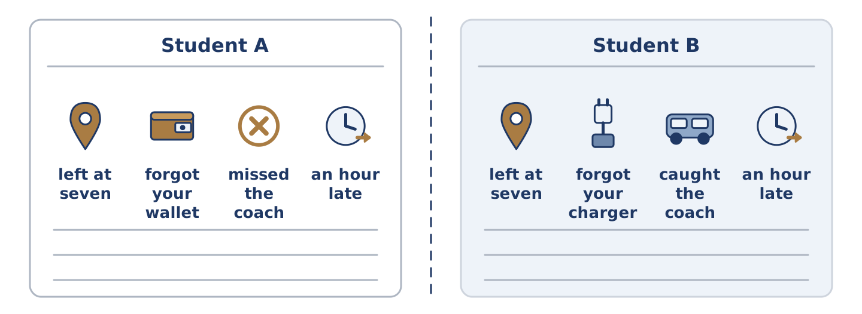
Figure 6.20 · Student A’s facts and Student B’s, with a fold between them.
Student A and Student B each had a bad journey. Ask questions and find three differences.
Useful questions: What time did you leave? · What did you forget? · Did you catch it? · How late were you?
Student A — your journey: left at seven · forgot your wallet · missed the coach · an hour late.
Student B — your journey: left at seven · forgot your charger · caught the coach · an hour late.
Part 4: Telling a Travel Story
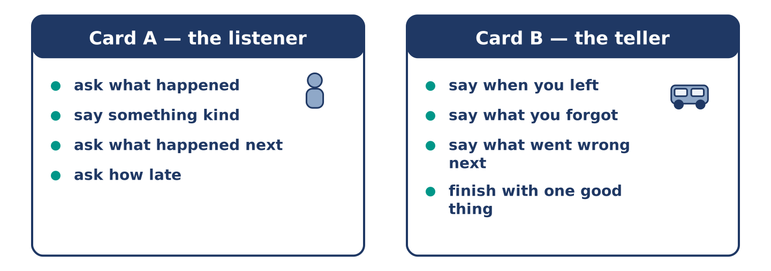
Figure 6.21 · Card A and Card B: what each of you has to say.
Work in pairs. Read the model, then use the cards.
Model exchange:
A: You look terrible. What happened? — B: I left at seven and forgot my wallet. — A: Oh no. And then? — B: I went back, missed the coach and caught the next one. — A: Were you very late? — B: An hour and a half. But I met somebody at the wrong stop.
Useful language: What happened? · I left… · And then? · Were you very late? · But…
Card A — the listener: ask what happened · say something kind · ask what happened next · ask how late.
Card B — the teller: say when you left · say what you forgot · say what went wrong next · finish with one good thing.
Your turn: run the dialogue, then swap roles.
Stretch [PLUS]: nothing at all went wrong on your journey — make the story interesting anyway.
Part 4: Mini-Presentation
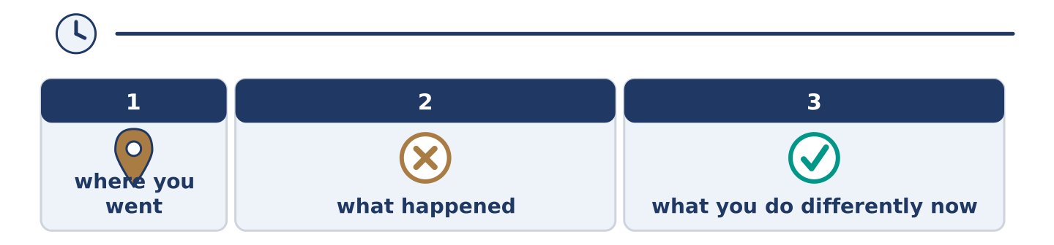
Figure 6.22 · The one-minute talk as three beats, each as wide as its share.
Prepare a short talk (about one minute). Describe a journey that went wrong: where you went, what happened, and what you do differently now.
Part 5 · Reading
[CORE] Core track · pre-class input
Part 5: Why Journeys Go Wrong
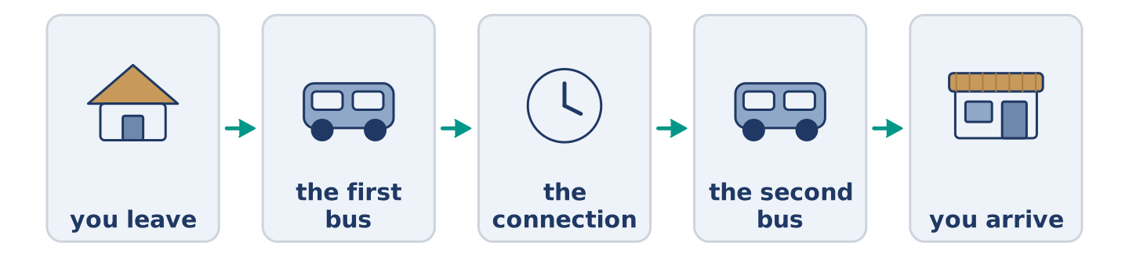
Figure 6.23 · One journey, five places it can break.
Before you read: is a long journey more likely to go wrong than a short one?
Gloss: connection = a second train or bus you need to catch · margin = the spare time between two things · chain = a line of things, each one holding the next · link = one piece of a chain
A journey is a chain, and a chain breaks at its weakest link. The flight is not often the problem. The problem is the forty minutes between the flight and the last train. Or the ten minutes between two buses in a town where the buses do not wait. Travellers usually go wrong at a connection. The reason is almost always the same: there was no margin. Somebody planned the journey as if nothing could be late. Then one thing was. Experienced travellers do the opposite. They build in the boring hour, carry the charger, and leave a spare key with a neighbour. It looks like pessimism. It is really a kind of respect for how much has to go right.
Answer the multiple-choice questions. (0. is done.)
- What does the text compare a journey to? — A chain.
1. Where do travellers usually go wrong?
○ A) On the flight
○ B) At a connection
○ C) At the gate
○ D) At home
2. What is almost always the reason?
○ A) Bad weather
○ B) The wrong ticket
○ C) There was no margin
○ D) The luggage was heavy
3. What do experienced travellers do?
○ A) Travel less
○ B) Carry nothing
○ C) Take taxis
○ D) Build in a boring hour
Part 5: Vocabulary in Context
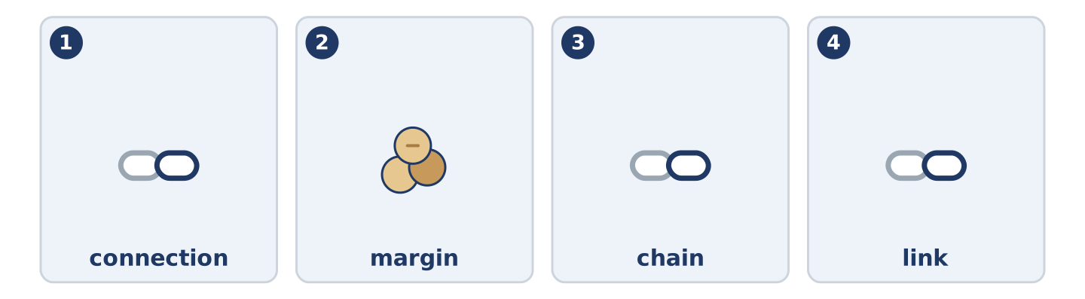
Figure 6.24 · The four words from the reading, drawn.
Match each word from the text with its meaning. One meaning is not needed. Write the letter.
Column A
1. | connection | ____
2. | margin | ____
3. | chain | ____
4. | link | ____
Column B
a) | the spare time between two things
b) | one piece of a chain
c) | a second train or bus you need to catch
d) | a line of things, each one holding the next
e) | all the bags you travel with
Part 5: Journeys Around the World
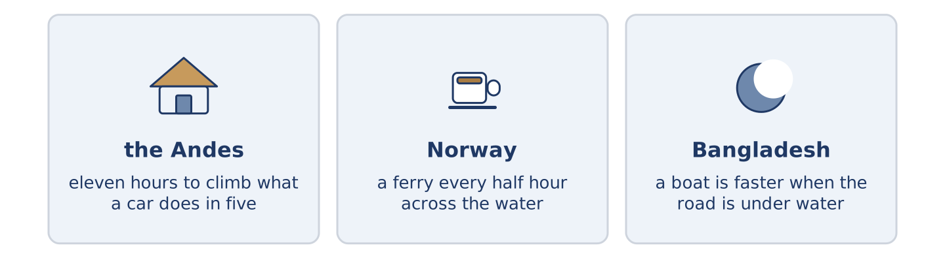
Figure 6.25 · Three journeys that take longer than they look.
Before you read: what is the slowest way to travel that people still choose?
Gloss: ferry = a boat that carries people and cars across water · oxygen = the part of the air we need to breathe
Some journeys take longer than the map says. The train from Lima up into the Andes climbs very high. It covers in eleven hours a distance a car does in five. In the west of Norway a ferry crosses the water every half hour. People argued about a road to replace it for forty years. In Bangladesh in the wet season a boat is sometimes the fastest way between two towns, because the road is under water. The shortest line on a map is not always a line you can travel.
Answer the questions. (0. is done.)
- What does the text say about some journeys? — They take longer than the map says.
- What do staff carry through the carriages in the Andes?
- How often does the ferry cross the fjord in Norway?
- Why is a boat sometimes faster in Bangladesh?
Part 6 · Writing
[CORE] Core track · in-class / homework
Part 6: A Journey That Went Wrong (50–70 words)
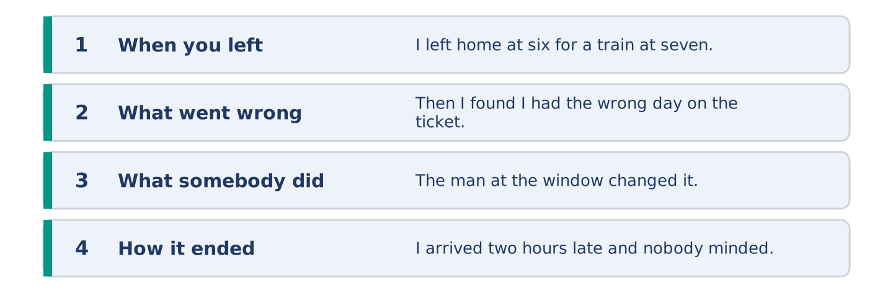
Figure 6.26 · The shape of the paragraph you are about to write.
Describe a journey that went wrong. Say when you left, what happened, and how it ended.
Model — read this first:
I left home at six for a train at seven and I was at the station by twenty past. Then I found that I had the wrong day on the ticket. The woman at the window changed it and charged me nothing, which I did not expect. I caught the nine o’clock and arrived two hours late, and nobody minded at all. (62 words)
Plan (fill in, then write): I left ___ at ___. Then I ___. ___ and I ___. I arrived ___ and ___.
Word bank: left | went | caught | forgot | found | took
Check before you finish: ☐ three irregular past verbs? ☐ one time phrase near the start? ☐ how it ended? ☐ 50–70 words?
Part 6: The Best Way to Travel (50–70 words)
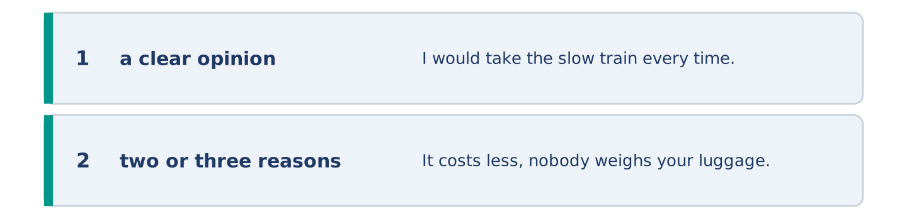
Figure 6.27 · The shape of the opinion paragraph, step by step.
What is the best way to make a long journey? Give your opinion and two or three reasons.
Model — read this first:
I would take the slow train every time. It costs less, nobody weighs your luggage, and you can see the country changing out of the window instead of a cloud. It takes six hours instead of two, but two of those hours were always an airport anyway. The sums are better than people think. (54 words)
Word bank: I think… because… | it costs less | however | in my opinion | instead of
Check before you finish: ☐ a clear opinion? ☐ two or three reasons? ☐ 50–70 words?
Part 6: A Message About Being Late (50–70 words)
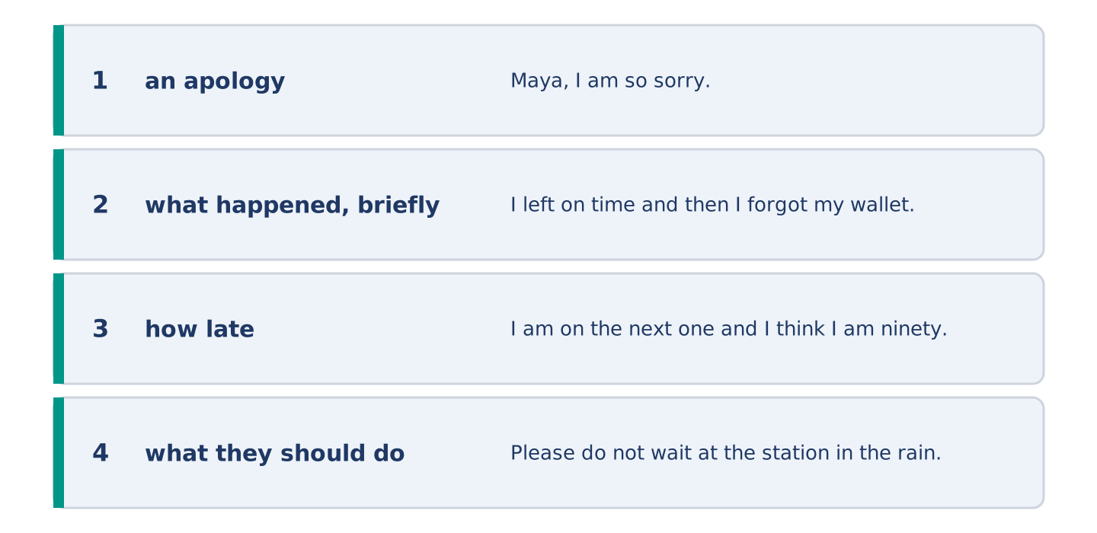
Figure 6.28 · The moves of the message, with a line of the model for each.
You are arriving late. Write a short message to the person who is waiting.
Model — read this first:
Maya, I am so sorry. I left on time and then I forgot my wallet and went back for it, and that cost me the coach. I am on the next one and I think I am ninety minutes behind. Please do not wait at the station in the rain. I know where the café is and I can find you there. Dani (63 words)
Plan (fill in, then write): ___, I am so sorry. I ___ and then I ___. I am ___ and I think I am ___ behind. Please ___. ___
Check before you finish: ☐ an apology? ☐ what happened, briefly? ☐ how late? ☐ what they should do? ☐ 50–70 words?
Part 6: Reflection — Something I Lost (40–60 words)
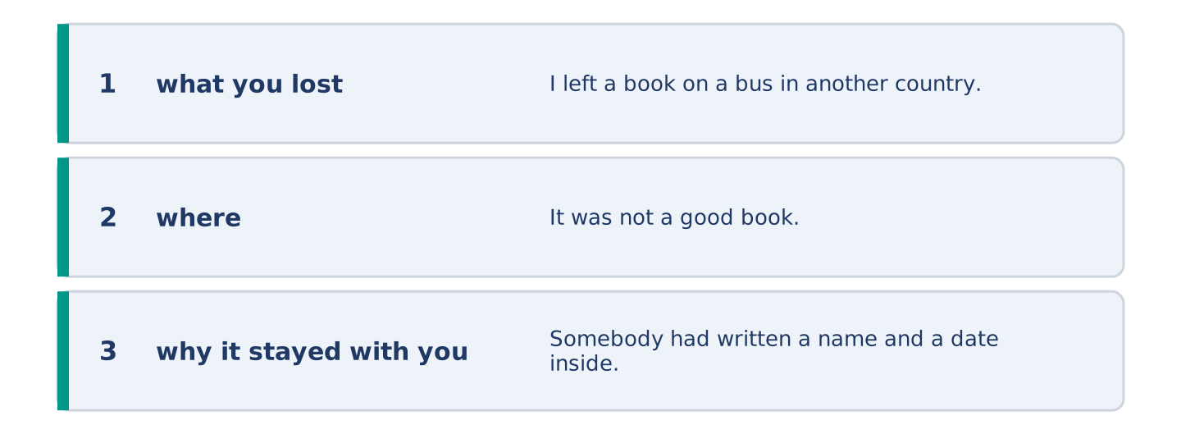
Figure 6.29 · The reflection, step by step.
Write about something you lost on a journey.
Model — read this first:
I left a book on a bus in another country and I think about it more than I think about the country. It was not a good book. Somebody had written a name and a date inside the front cover, and I meant to find out whose it was. (49 words)
Check before you finish: ☐ what you lost? ☐ where? ☐ why it stayed with you? ☐ 40–60 words?
Part 7 · Real-World File — When Things Go Wrong Away From Home
[PLUS] Plus track (optional) · stronger learners
7A: Phrase Bank
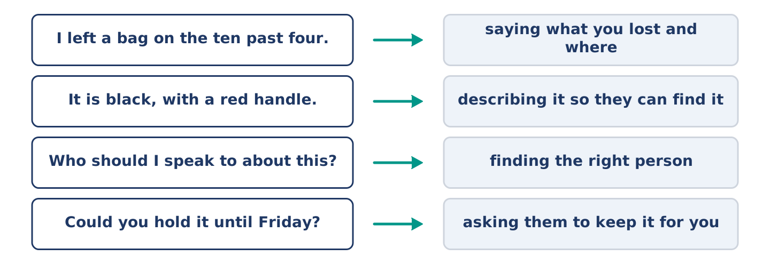
Figure 6.30 · What you say when something is lost, and what each thing does.
Match what a person says with its purpose. One purpose is not needed. Write the letter.
Column A
1. | “I left a bag on the ten past four.” | ____
2. | “It is black, with a red handle.” | ____
3. | “Who do I speak to about this?” | ____
4. | “Could you hold it until Friday?” | ____
Column B
a) | describing it so they can find it
b) | asking them to keep it for you
c) | saying what you lost and where
d) | asking for money back
e) | finding the right person
7B: Reporting a Loss
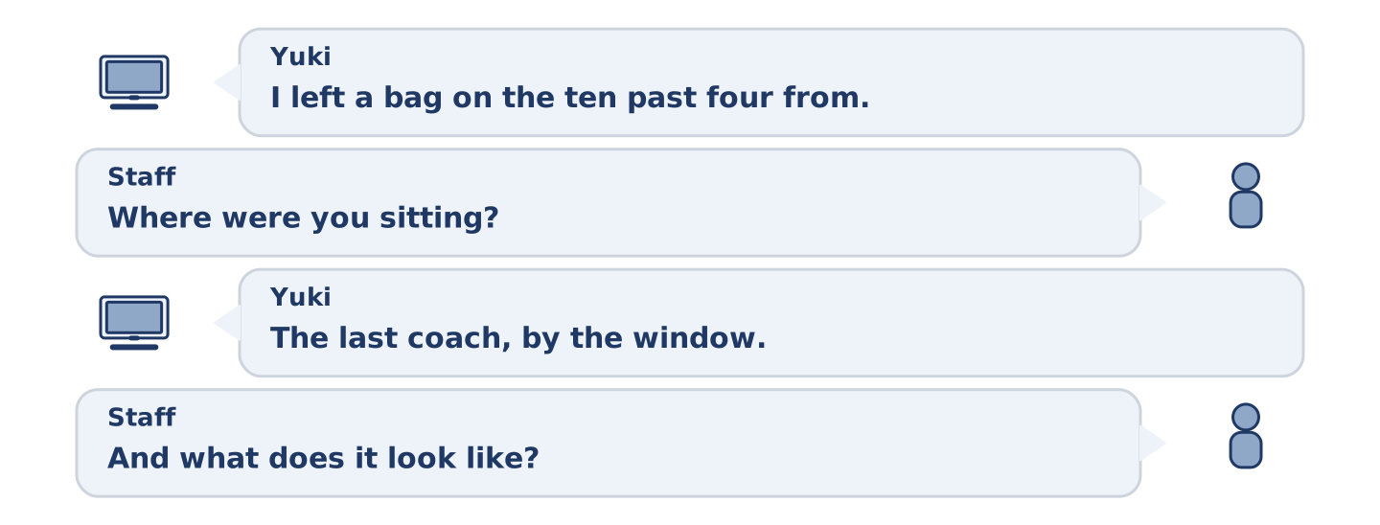
Figure 6.31 · The 7B exchange: who takes each turn.
🔊 Audio Track 6.5
Before you read: what does somebody need to know before they can help you find something?
Yuki: I left a bag on the ten past four from the coast yesterday. Staff: Where were you sitting? Yuki: The last coach, by the window. Staff: And what does it look like? Yuki: Dark green, and open at one corner, with a library card inside with my name. Staff: That’s helpful. Most people just say “a bag”. Who do I speak to if it comes in tomorrow? Yuki: Me, please. Here is my number, and my sister’s. Staff: We hold things for a month. After that they go to a shop for good causes.
Answer the questions. (0. is done.)
- When did Yuki leave the bag? — Yesterday, on the ten past four.
- Where was she sitting?
- What is inside the bag with her name on it?
- How long does the station hold things?
7C: Controlled Practice — Reporting Something Lost
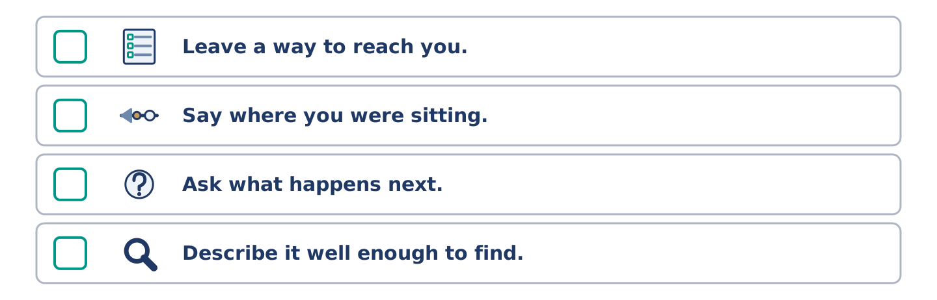
Figure 6.32 · The steps still to be numbered, as the task prints them.
Put the steps in order. Number them 1–5. (0. is done.)
- Say what you lost and when. — 1
____ Leave a way to reach you.
____ Say where you were sitting.
____ Ask what happens next.
____ Describe it well enough to find.
7D: Role-Play — At the Lost Property Desk
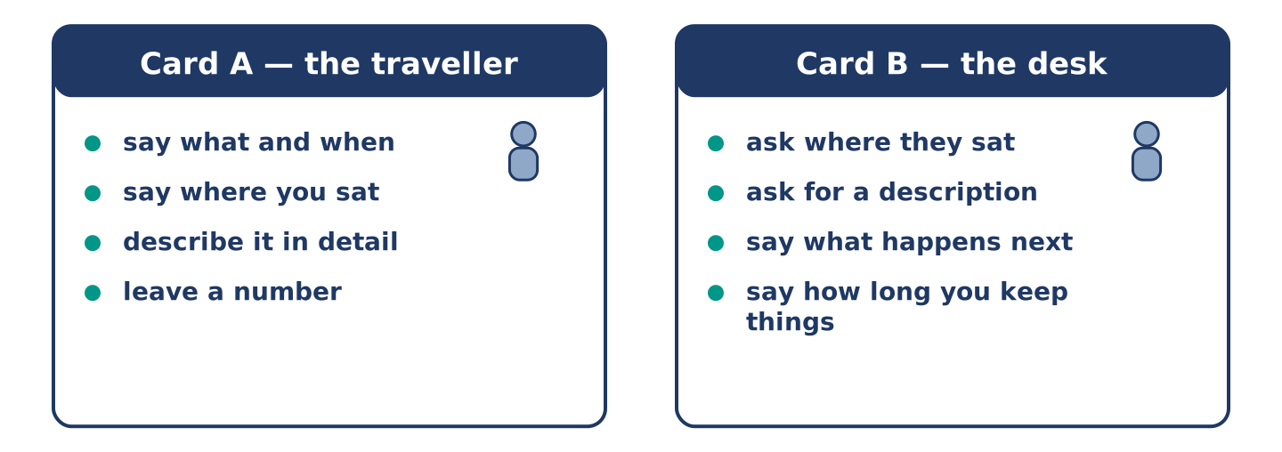
Figure 6.33 · The 7D cards: what each of you has to say.
In pairs. One lost something; one works at the desk. Use the model and cards.
Model exchange: A: I left a bag on the ten past four. — B: Where were you sitting? — A: The last coach, by the window. — B: What does it look like? — A: Dark green, and open at one corner. — B: Leave me a number. We hold things for a month.
Card A — the traveller: say what and when · say where you sat · describe it in detail · leave a number.
Card B — the desk: ask where they sat · ask for a description · say what happens next · say how long you keep things.
Stretch [PLUS]: the bag has something in it that cannot be replaced — say so without making a scene.
7E: Writing — A Lost Property Message (50–80 words)
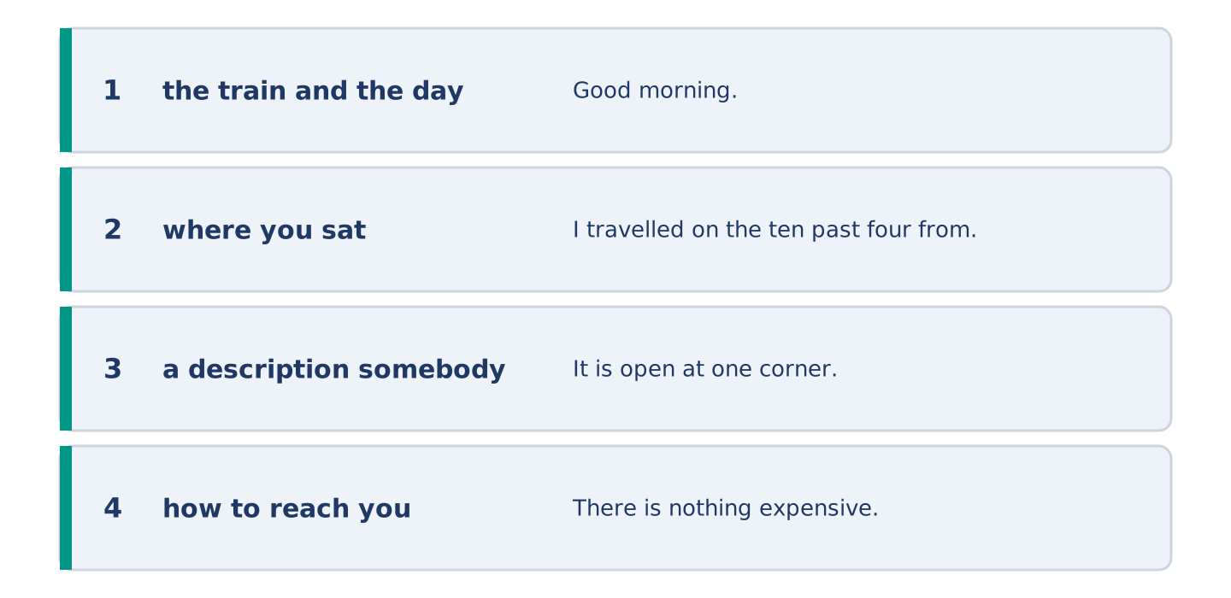
Figure 6.34 · The Part 7 note, with the model beside each line.
Write a short message to a station about something you left on a train.
Model — read this first:
Good morning. I travelled on the ten past four from the coast yesterday and I left a dark green bag in the last coach, by the window. It is open at one corner, and there is a library card inside with my name on it. There is nothing expensive in it, but the notebook matters to me. Could you let me know if it comes in? Thank you. Yuki Tanaka (70 words)
Check before you finish: ☐ the train and the day? ☐ where you sat? ☐ a description somebody could use? ☐ how to reach you? ☐ 50–80 words?
Part 8 · Global Story — The Train That Climbs
[PLUS] Plus track · pre-read / discuss
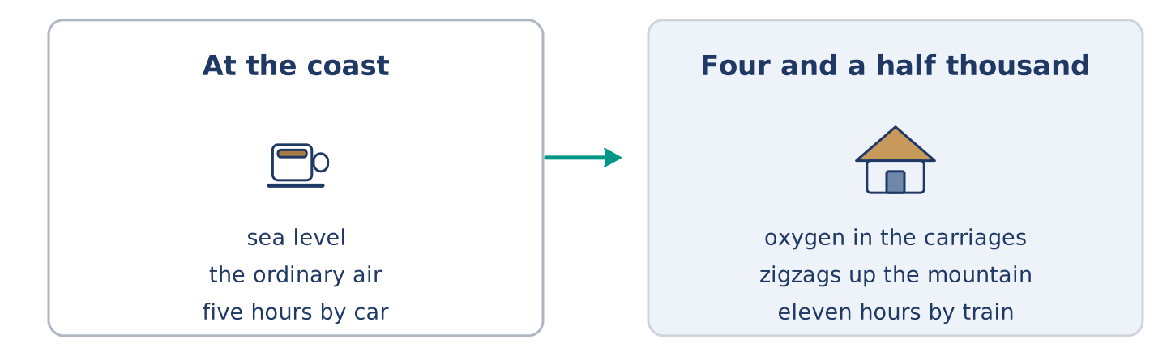
Figure 6.35 · Sea level, and four and a half thousand metres up.
Before you read: what happens to a train when the air gets thin?
Gloss: zigzag = a line that turns sharply left and right to climb · switchback = a place where a train goes forward, stops, and goes back up · carriage = one part of a train, with seats in it
The train line from Lima into the Andes is very old, and it is still one of the highest in the world. It leaves the coast at sea level and reaches four and a half thousand metres. The air up there is thin, and the staff carry a little oxygen for anybody who needs it. The line could not climb that fast straight, so the engineers cut zigzags into the mountain. The train runs forward into a dead end, stops, and goes back up the next section. There are many of these switchbacks. Passengers who do not know about them think something is wrong the first time the train starts to go back. It takes eleven hours to cover a distance a car does in five. Almost everybody who travels it says the eleven hours were the point.
Answer the questions. (0. is done.)
- Where does the railway start? — At the coast, at sea level.
- How high does the line reach?
- Why did the engineers cut zigzags into the mountain?
- What do passengers think the first time the train reverses?
Part 8: Vocabulary in Context
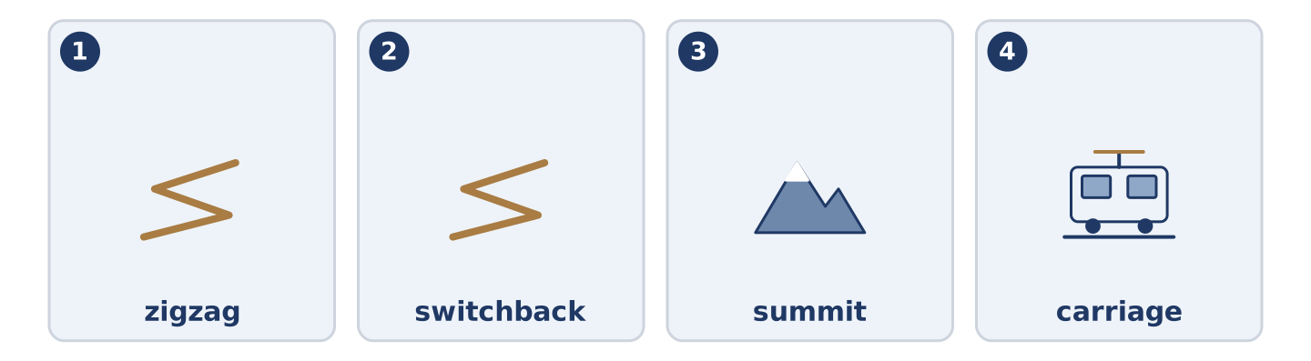
Figure 6.36 · The four words from the global story, drawn.
Match each word with its meaning. One meaning is not needed. Write the letter.
Column A
1. | zigzag | ____
2. | switchback | ____
3. | summit | ____
4. | carriage | ____
Column B
a) | a place where a train reverses to climb
b) | one part of a train, with seats in it
c) | the highest point
d) | a line that turns sharply left and right
e) | the spare time between two things
Part 8: Discussion
Talk with a partner. Use the frames.
Discussion frames: “This is similar to where I live because…” · “This is different from where I live because…” · “I think the most important thing is… because…”
Part 9 · Close to Home — The Spare Key
[PLUS] Plus track · pre-read / decide
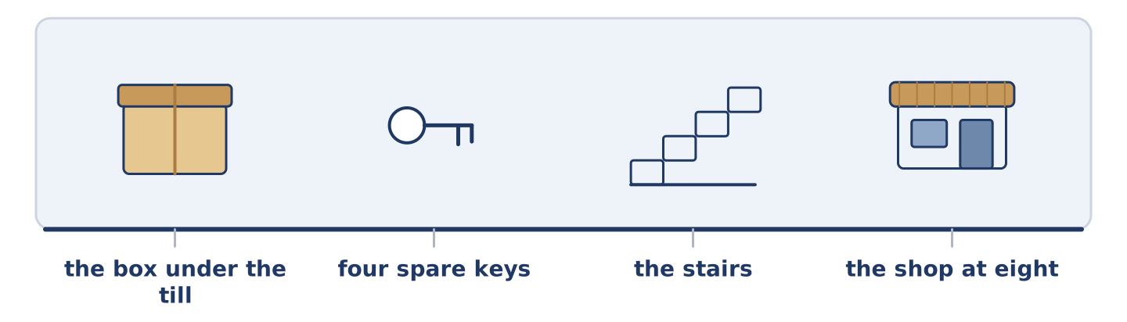
Figure 6.37 · The close-to-home reading, drawn along one street.
Before you read: who has a key to your home, apart from you?
Amina has four spare keys in a box under the till, and each one has a small paper with a flat number on it. Maya left hers there three years ago after she spent a night on the stairs. She says it was the coldest night of her life. Dani left his after he locked himself out twice in one month. Amina says she was not surprised either time, and that she expects a third. Mr Okonkwo left his before anybody asked, and said only that somebody needs one. Yuki left no key. Amina never suggested it, because there is a right moment to ask and it is not the first month. The box is not a security system. Twice a year somebody comes in at eight with the face of a person locked out. Amina reaches under the till and says nothing.
Answer the questions. (0. is done.)
- Where does Amina keep the spare keys? — In a box under the till.
- Why did Maya leave a key?
- What did Mr Okonkwo say when he left his?
- Why did Amina not suggest it to Yuki?
Part 9: Decision Task
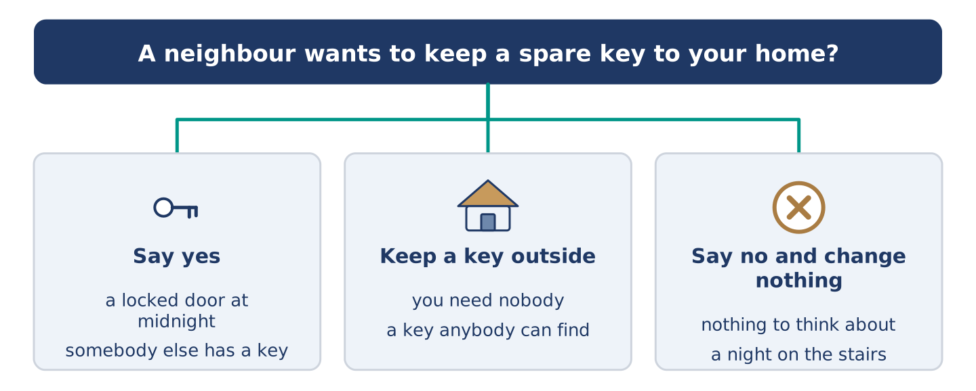
Figure 6.38 · Three ways to decide, and what each one costs.
A neighbour wants to keep a spare key to your home. Should you (a) say yes, (b) say no and keep a key somewhere outside, or (c) say no and change nothing? Decide and explain. Use the frame.
Answer frame: “I think I should ___ because ___. Also, ___. This is better than ___ because ___.”
Model — read this first:
I think I should say yes, because a locked door at midnight is a worse problem than a neighbour with a key. Also, the question means something, and saying no says something back. This is better than hiding a key outside. A key outside is a key anybody can find, and I would never quite stop thinking about it. (59 words)
Phrase bank: I think I should… · because… · Also,… · This is better than… · In my opinion…
Part 10 · Review and Can-Do
[CORE + PLUS] · homework / self-study
Part 10: Spiral Review
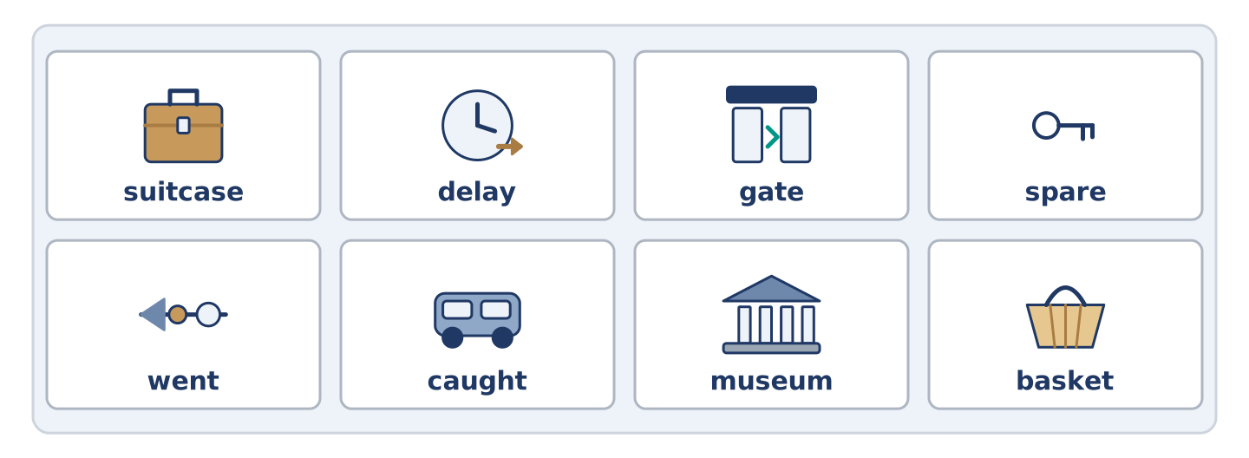
Figure 6.39 · The eight words of the review bank, in bank order.
Complete the review. (0. is done.)
- All the bags a person travels with are their luggage.
Word bank: suitcase | delay | gate | spare | went | caught | museum | basket
- A big case with a handle, for your clothes, is a ______________________ .
- When something comes later than it should, there is a ______________________ .
- The door you go through to reach your plane is the ______________________ .
- A key you keep in case you lose the first one is a ______________________ key.
- He forgot his wallet, so he ______________________ back for it. (go)
- He ______________________ the next coach. (catch)
- (from Unit 5) A building where you look at old or beautiful things is a ______________________ .
- (from Unit 4) A light open bag you fill while you walk round is a ______________________ .
Part 10: Can-Do
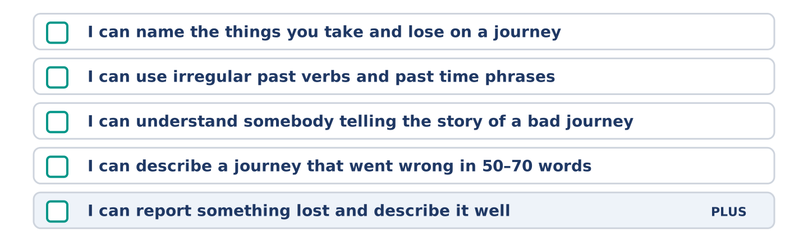
Figure 6.40 · What you can do at the end of this unit.
Can-Do checklist
☐ I can name the main things you take and lose on a journey.
☐ I can use irregular past verbs and past time phrases.
☐ I can understand somebody telling the story of a bad journey.
☐ I can describe a journey that went wrong in 50–70 words.
☐ I can report something lost and describe it well (Plus).
Part 10: Glossary
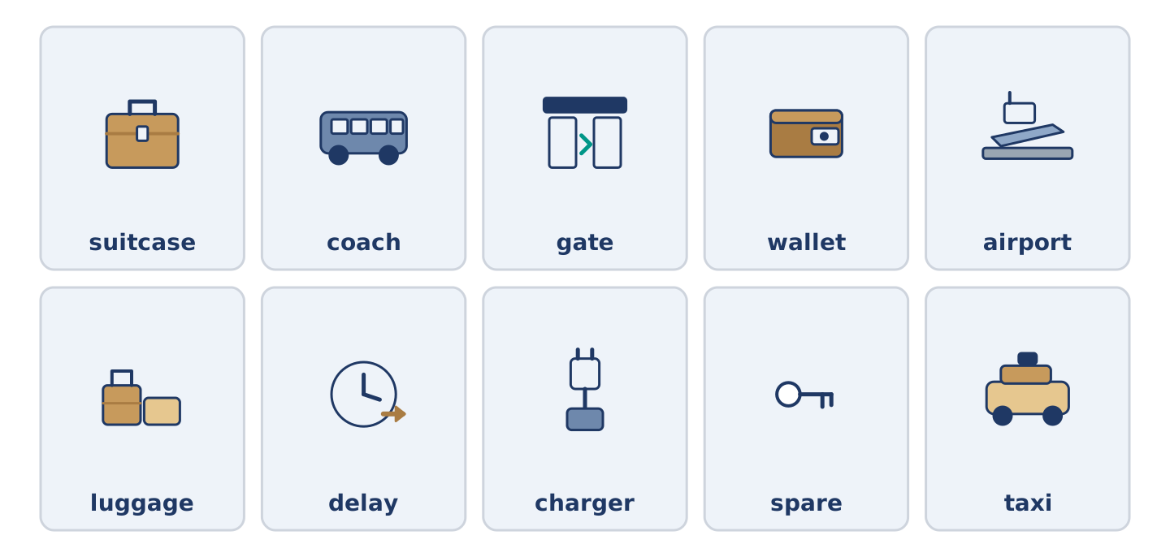
Figure 6.41 · All ten glossary words of Unit 6, one card each.
Unit 6 glossary (10 words)
suitcase · coach · gate · wallet · airport · luggage · delay · charger · spare · taxi

