Unit 7: Choosing and Comparing
English for Daily Life · Level: A2 · Tracks: [CORE] Warm-Up + Parts 1–6 · [PLUS] Parts 7–10
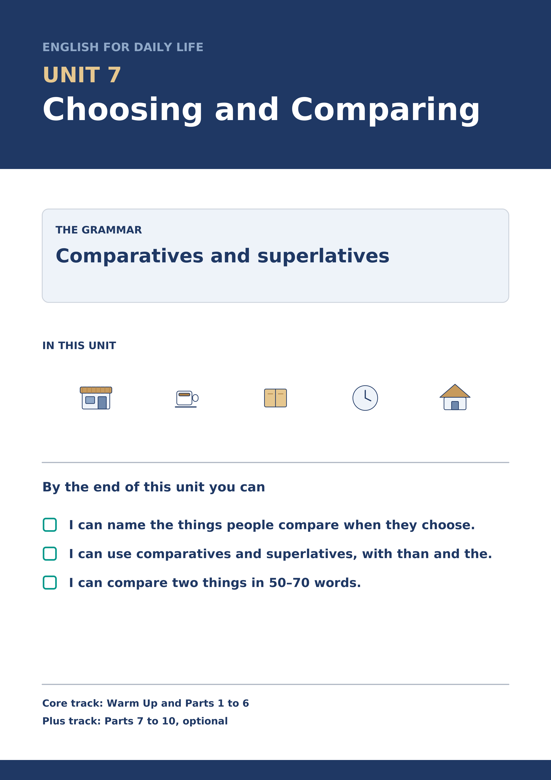
Warm Up
[CORE] Core track · in-class starter
Warm-up: Choosing Words and Meanings
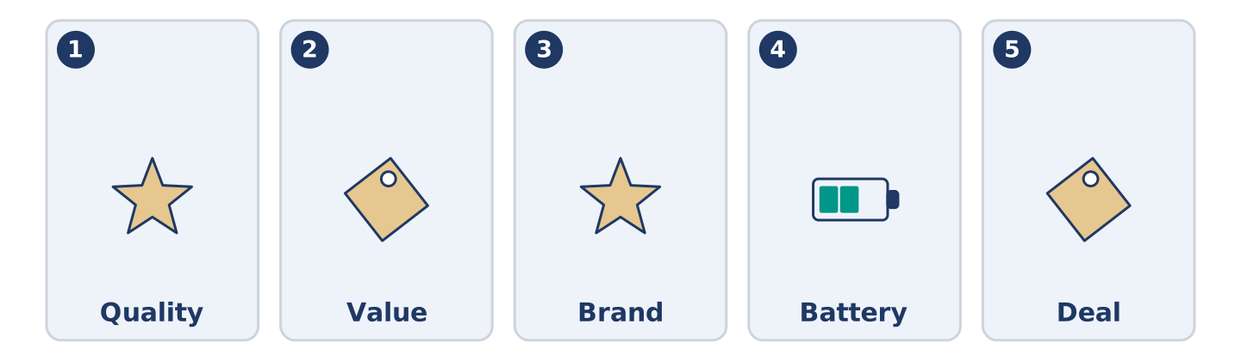
Figure 7.2 · The five warm-up words, and the thing each one means.
Match the words with their meanings. One meaning is not needed. Write the letter.
Column A
1. | Quality | ____
2. | Value | ____
3. | Brand | ____
4. | Battery | ____
5. | Deal | ____
Column B
a) | the name a company puts on the things it makes
b) | how good something is, and how long it lasts
c) | the part that holds the power in a telephone
d) | a price that is better than the usual one
e) | what you get for the money you pay
f) | the paper that shows what you paid
Warm-up: Talking About Things
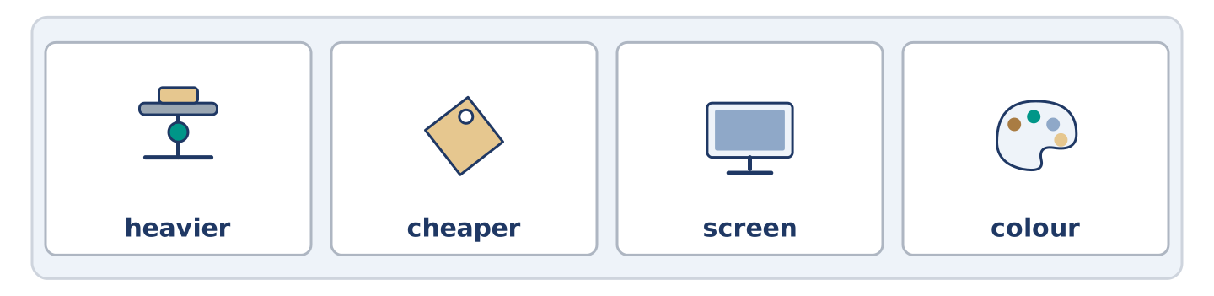
Figure 7.3 · The word bank for this task, in the order it is printed.
Complete the sentences using the words in the word bank.
Word bank: heavier | cheaper | screen | colour
- The small coat is ______________________ than the big one, but it is warmer.
- Dani dropped his telephone and the ______________________ broke.
- Yuki likes the blue one, but the ______________________ is the last thing she decides.
- A full suitcase is ______________________ than you think when there is no lift.
Warm-up: Two Coats
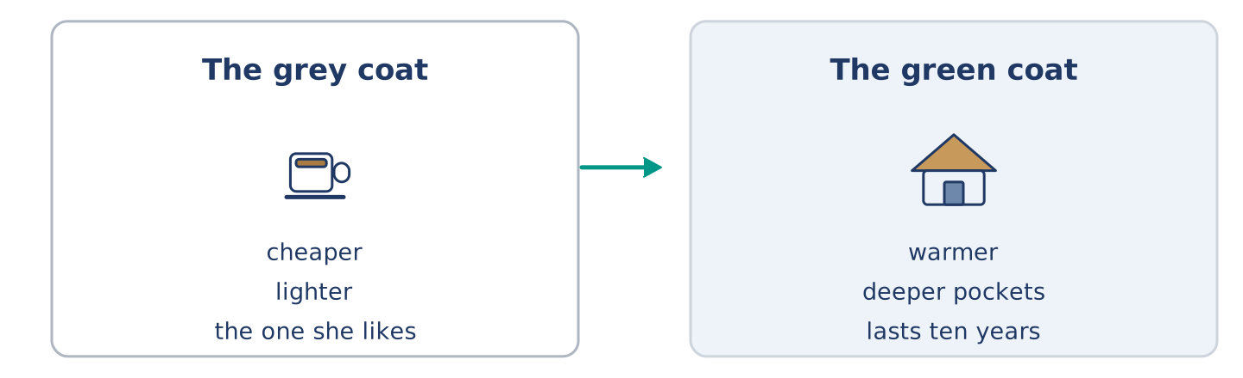
Figure 7.4 · Two coats, side by side.
Read the text and choose the correct answer.
Maya is looking at two coats. The grey one is cheaper and lighter, and it is the one she likes. The green one costs almost twice as much, but it is warmer, the pockets are deeper, and the shop says it lasts ten years. Yuki says the green one is better value. Maya says the grey one is better value today, because today she has no money. They are both right, and the coat is still in the shop.
1. Which coat is cheaper?
○ A) The green one
○ B) The grey one
○ C) They cost the same
○ D) Neither is for sale
2. Why does Maya say the grey one is better value?
○ A) It is warmer
○ B) The pockets are deeper
○ C) It lasts ten years
○ D) She has no money today
Part 1 · Vocabulary and Terminology
[CORE] Core track · pre-class input
Part 1: Comparing and Choosing Terms
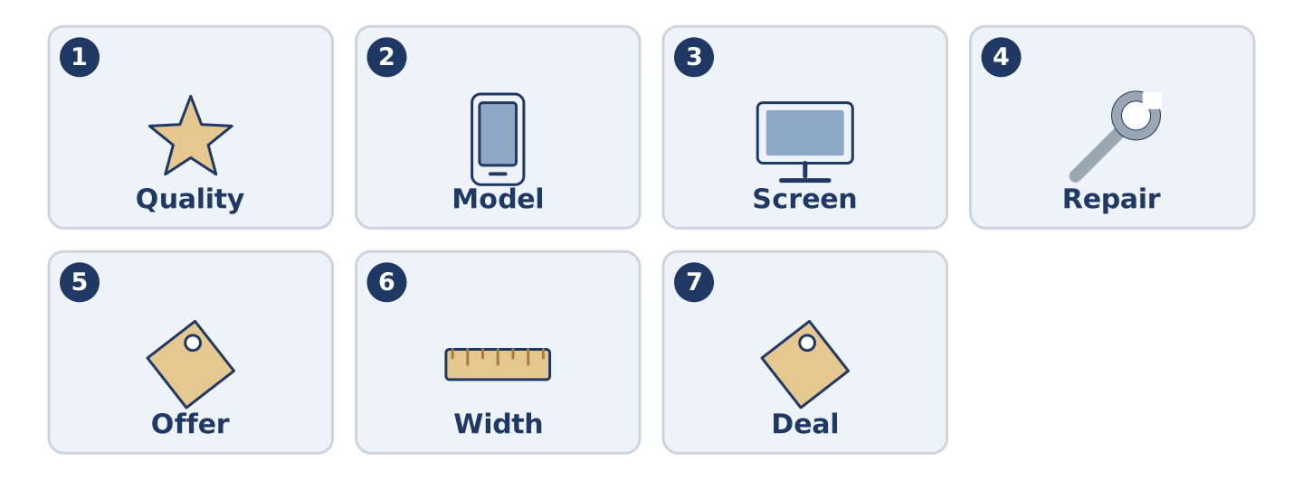
Figure 7.5 · The seven words of Column A, and what each one is.
Match the words with their meanings. One meaning is not needed. (0. is done for you.)
- Second-hand → owned by somebody else before you, and usually cheaper.
Column A
1. | Quality | ____
2. | Model | ____
3. | Screen | ____
4. | Repair | ____
5. | Offer | ____
6. | Width | ____
7. | Deal | ____
Column B
a) | to mend something that is broken
b) | how good something is, and how long it lasts
c) | one particular version of a thing a company makes
d) | the flat glass part of a telephone that lights up
e) | a lower price, for a short time
f) | how wide something is, from side to side
g) | a price that is better than the usual one
h) | a small flat case you keep money in
Gloss: second-hand = owned by somebody before you · model = one version of a thing a company makes · mend = to repair something that is broken
Part 1: Pronunciation
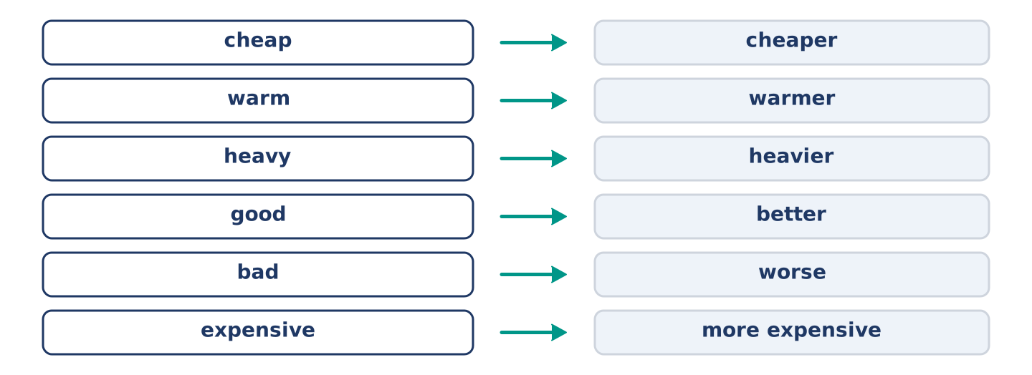
Figure 7.6 · Where the stress falls in five words of this unit.
🔊 Audio Track 7.1
Listen and practise these comparatives. Say each pair aloud.
cheap — cheaper
warm — warmer
heavy — heavier
good — better
bad — worse
expensive — more expensive
Then listen again to the end of each word. The -er ending is weak and short; it is never the loud part. Heavier keeps three beats and more expensive keeps four. Say the pairs. Listen for what does not change: the loud part stays where it was.
Part 1: Six Things and Six Qualities
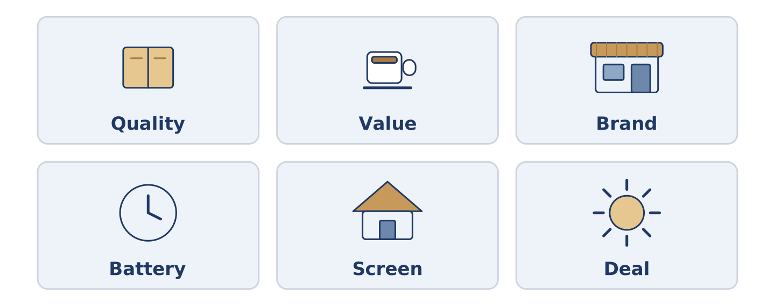
Figure 7.7 · Six things people compare, and what they compare them for.
Complete the table. Write what people compare it for and which matters most. (0. is done.)
Thing | What people compare | What matters most
Coat | warmth, price, pockets | (example)
Telephone
Flat
Bicycle
- Coat — warmth, price, pockets — warmth, because a cold coat is no coat.
Think about the last thing you chose between. There is more than one right answer; be ready to say why you chose yours.
Part 1: Comparing Two Things
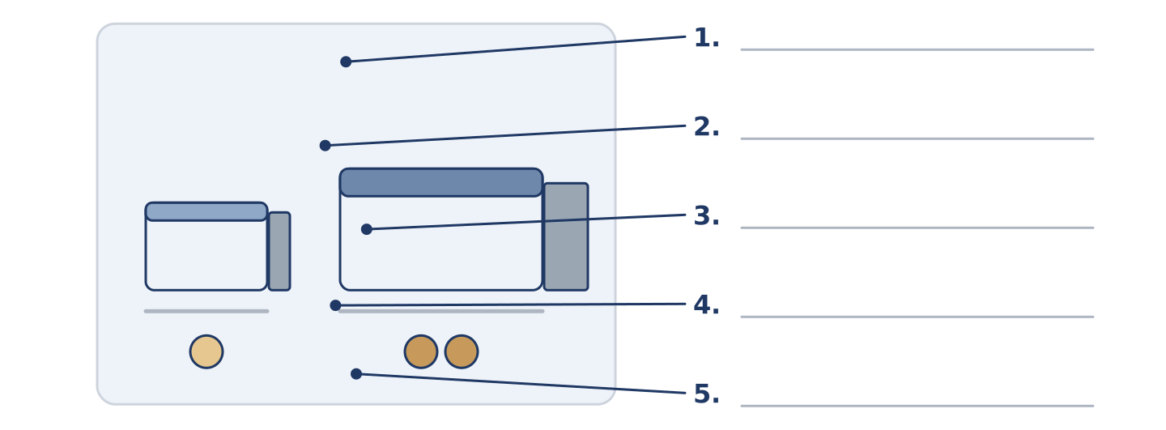
Figure 7.8 · Comparing two things — write the correct word on each line.
Match the words with their descriptions. One description is not needed. Write the letter.
Column A
1. | Wider | ____
2. | Deeper | ____
3. | Thicker | ____
4. | Lighter | ____
5. | Stronger | ____
Column B
a) | going further down than the other one
b) | weighing less than the other one
c) | harder to break than the other one
d) | measuring more from side to side
e) | costing less than the other one
f) | measuring more from front to back
Part 1: Choosing — Multiple Choice
Read and choose the correct answer.
1. A thing owned by somebody before you is…
○ A) second-hand
○ B) better value
○ C) a model
○ D) a deal
2. How good something is, and how long it lasts, is its…
○ A) width
○ B) offer
○ C) quality
○ D) screen
3. A lower price for a short time is an…
○ A) order
○ B) offer
○ C) model
○ D) brand
Part 1: Vocabulary Fill-in
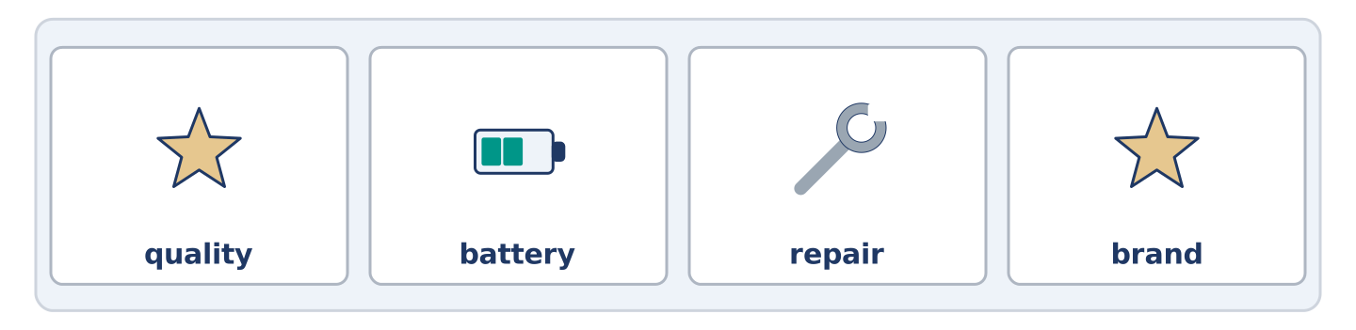
Figure 7.9 · The four words of the bank, in the order the task gives them.
Complete the sentences with the correct word.
Word bank: quality | battery | repair | brand
- The ______________________ in her old telephone lasts four hours.
- The shop can ______________________ it for thirty, or sell her a new one for two hundred.
- Nobody in the street can name the ______________________ of Mr Okonkwo’s coat.
- The ______________________ of the cheap shoes was worse than she expected.
Part 1: Write About a Choice (short)
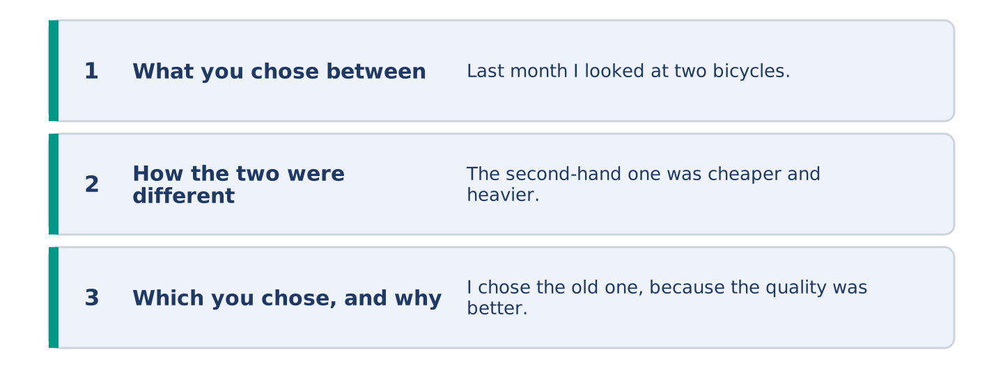
Figure 7.10 · The shape of your two or three sentences, with the model beside each step.
Write two or three sentences about something you chose between. Use three words from this unit.
Model — read this first:
Last month I looked at two bicycles. The second-hand one was cheaper and heavier; the new one was lighter and cost three times as much. I chose the old one, because the quality of the frame was better than anything new at that price. (44 words)
Part 2 · Grammar — Comparatives and Superlatives
[CORE] Core track · pre-class input
Part 2: Notice
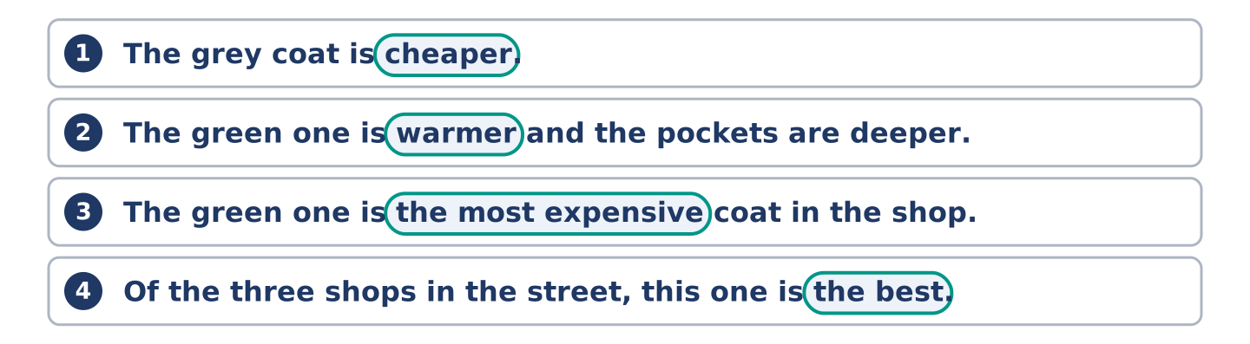
Figure 7.11 · Lines from the notice, with the target form ringed in each.
Underline the comparing words. Which compare two things, and which more?
The grey coat is cheaper. The green one is warmer and the pockets are deeper. The green one is the most expensive coat in the shop, and the grey one is the lightest. Of the three shops in the street, this one is the best.
Cheaper, warmer and deeper compare two. The most expensive, the lightest and the best pick one out of a group.
Part 2: Grammar Focus Box
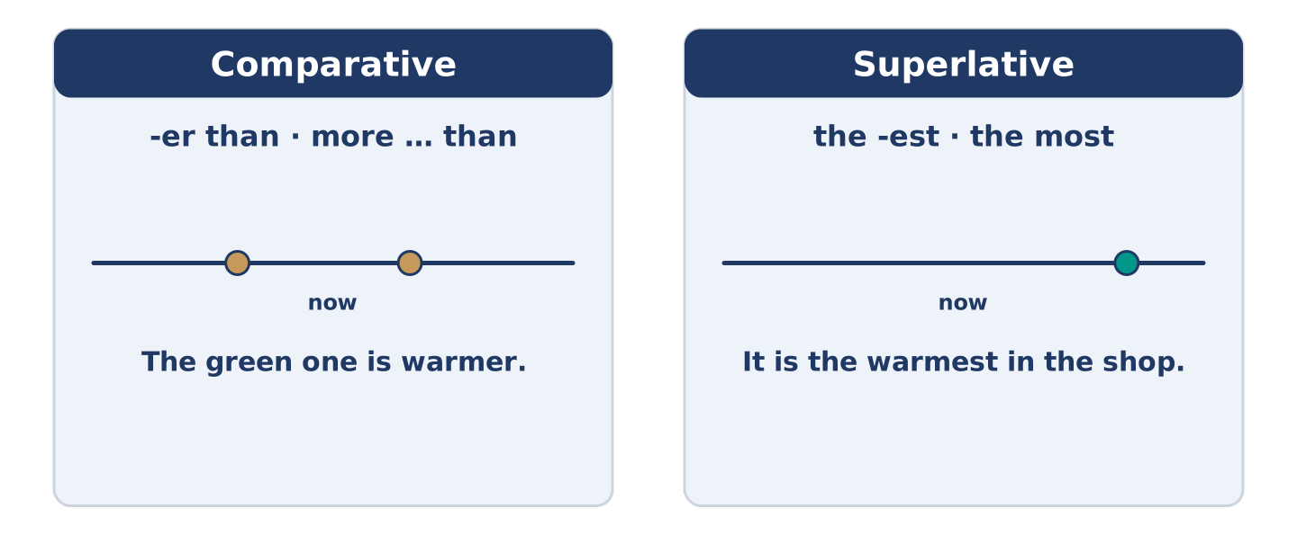
Figure 7.12 · Two things, or one out of many.
 | Form | Use | Example
Short word | + -er · + -est | one or two beats | cheap → cheaper → the cheapest
Long word | more · the most | three beats or more | expensive → more expensive
Irregular | good → better → the best | a short list | bad → worse → the worst
than / in | -er than · the -est in | which goes where | warmer than · the best in the street
Remember: than after a comparative; the before a superlative.
Watch out! ✗ It is more cheaper. → ✓ It is cheaper. (one is enough). ✗ It is the most cheap shop. → ✓ It is the cheapest shop. (cheap is short).
Part 2: Controlled Practice
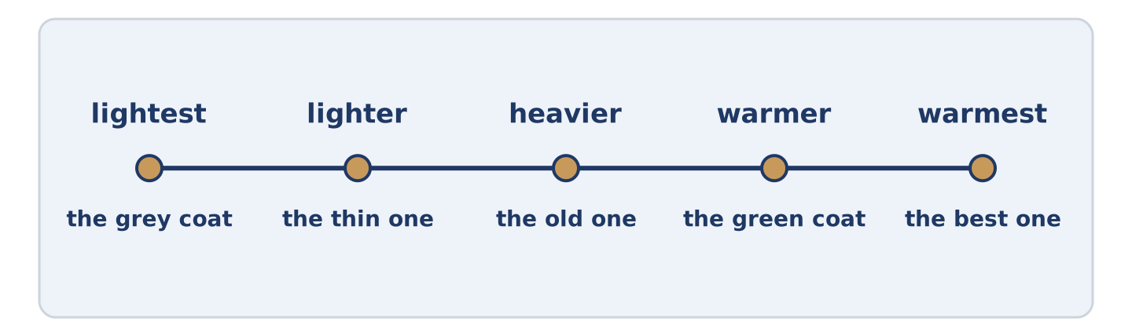
Figure 7.13 · Three coats on one line, from lightest to warmest.
Write the comparative. (0. is done.)
- The grey coat is cheaper than the green one. (cheap)
- The green coat is ______________________ than the grey one. (warm)
- A full suitcase is ______________________ than you think. (heavy)
- This telephone is ______________________ than that one. (expensive)
- The second-hand bicycle was ______________________ than the new one. (good)
Part 2: Comparative or Superlative?
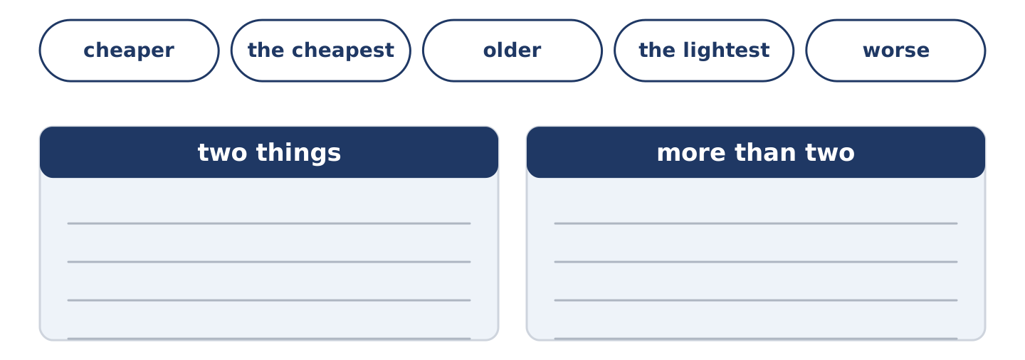
Figure 7.14 · The items of this task, and the bins they sort into.
Choose the correct form. (0. is done.)
- The green coat is the most expensive in the shop. (more expensive / the most expensive)
- This shop is ______________________ (cheaper / the cheapest) in the street.
- Her telephone is ______________________ (older / the oldest) than mine.
- Of all the coats, the grey one is ______________________ (lighter / the lightest).
- The quality is ______________________ (worse / the worst) than she expected.
Part 2: Correct the Sentence
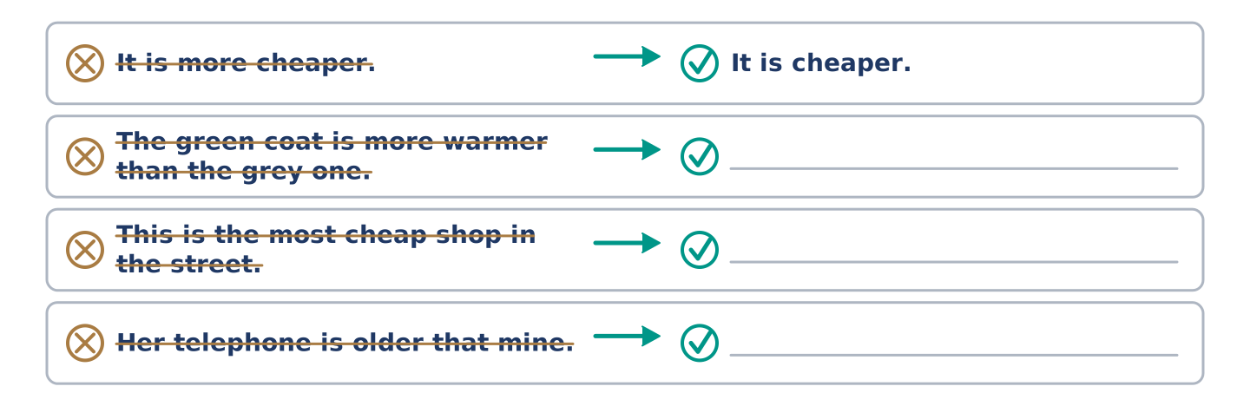
Figure 7.15 · One correction done for you, and the rest to write.
Each sentence has one grammar mistake. Write the correct sentence.
- The green coat is more warmer than the grey one.
- This is the most cheap shop in the street.
- Her telephone is older that mine.
- Of all the coats, the grey one is lighter.
Part 2: Freer Practice
Compare two things you own: one comparative, one superlative.
Part 2: Grammar Review
Choose the correct sentence.
1. Which sentence compares two things correctly?
○ A) The green coat is more warmer.
○ B) The green coat is warmer that the grey one.
○ C) The green coat is warmer than the grey one.
○ D) The green coat is the warmer than the grey one.
2. Which superlative is correct?
○ A) It is the most cheap shop in the street.
○ B) It is the cheapest shop in the street.
○ C) It is cheapest shop in the street.
○ D) It is the more cheap shop in the street.
→ Harvest: you will see comparatives and superlatives again in the Part 5 reading. Watch for than and the.
Part 3 · Listening
[CORE] Core track · pre-class input · scripts printed inline
Part 3: Which One?
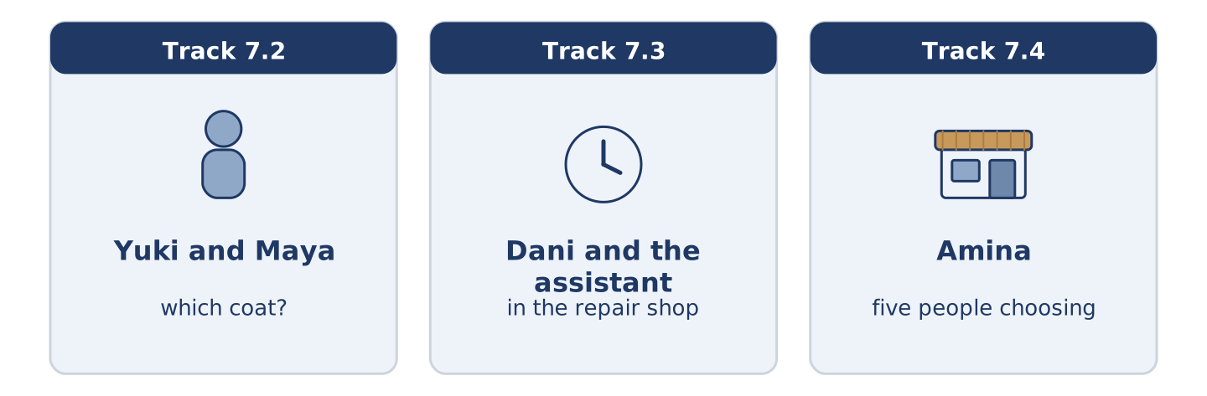
Figure 7.16 · The three listenings: who is speaking, and what about.
🔊 Audio Track 7.2
Before you listen: how long do you take to choose between two things?
Yuki: The green one’s warmer. Maya: It’s also twice the price. Yuki: Yes, but it lasts ten years. Maya: So they say. Yuki: The pockets are deeper too. Maya: I know. I know everything you’re saying and I still want the grey one. Yuki: Then buy the grey one. Maya: But you’re right. Yuki: I’m often right and it never helps.
While you listen: write True, False, or Not Given. (0. is done.)
- The green coat is warmer. — True
- The green coat costs twice as much. ____
- Maya buys the green coat. ____
- Yuki agrees that the grey one is better. ____
Useful phrases: It’s warmer · It’s twice the price · Yes, but… · I still want…
Part 3: In the Repair Shop
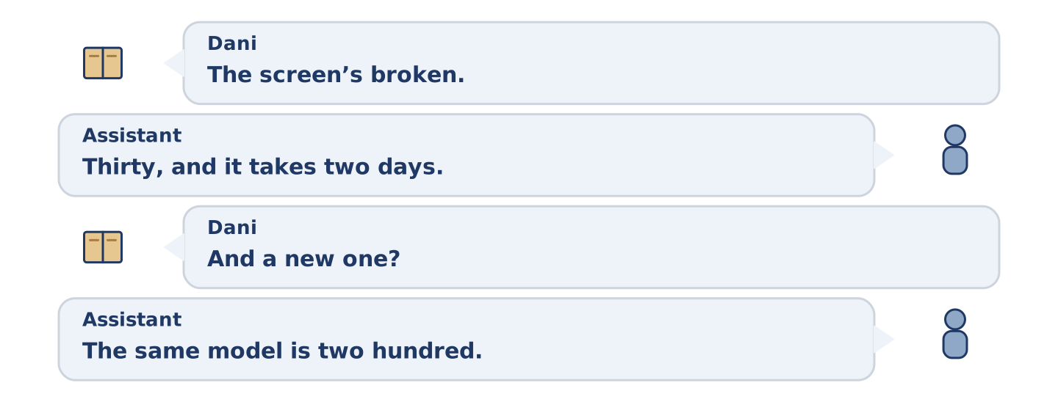
Figure 7.17 · The second listening, turn by turn.
🔊 Audio Track 7.3
Before you listen: is it better to mend a thing or replace it?
Dani: The screen’s broken. Can you repair it? Assistant: I can. Thirty, and it takes two days. Dani: And a new one? Assistant: The same model is two hundred. A newer model is three. Dani: So repairing is much cheaper. Assistant: Much. It’s also a better telephone than the cheap new ones, if you don’t mind the marks. Dani: I don’t mind anything that costs thirty.
Answer the questions. (0. is done.)
- What is broken? — The screen.
- How much is the repair, and how long does it take?
- How much is the same model new?
- What does the assistant say about the cheap new ones?
Part 3: Five Choices
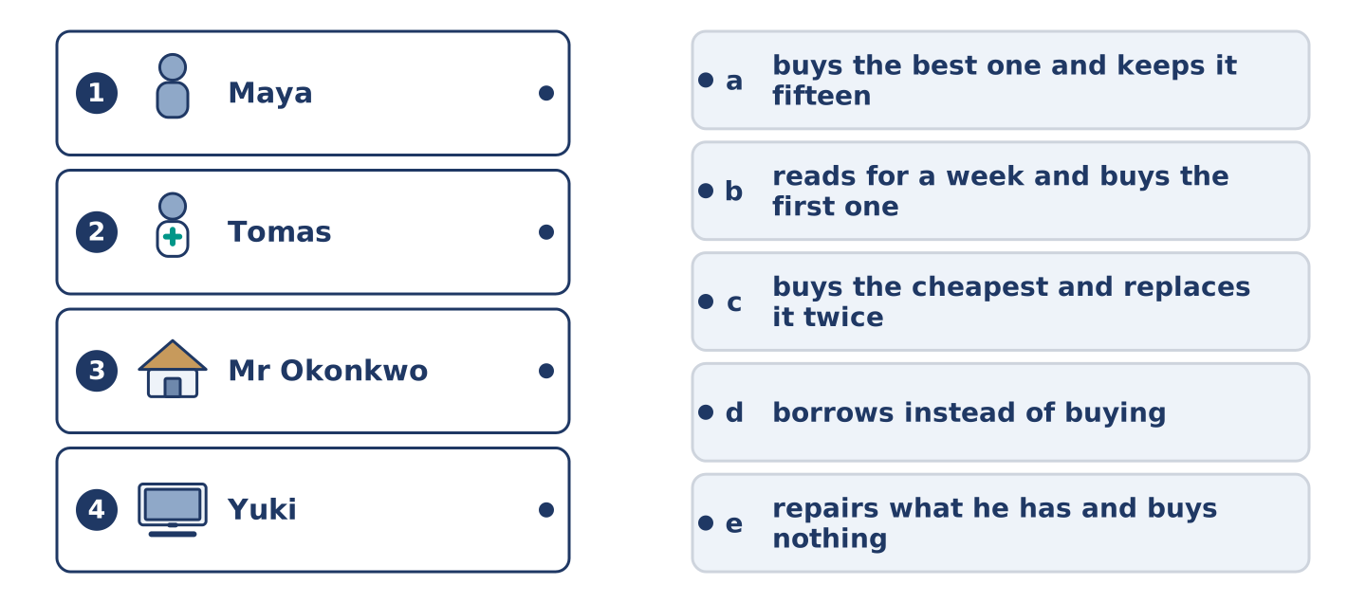
Figure 7.18 · Four on the left, five on the right, and one spare.
🔊 Audio Track 7.4
Before you listen: what do people in one building disagree about?
Amina: Everybody chooses differently. Maya buys the cheapest thing and replaces it twice. Tomas buys the best one and keeps it for fifteen years. Dani buys whatever is nearest, which is usually mine. Mr Okonkwo buys nothing at all and repairs what he has, and his coat is older than Dani. Yuki reads about it for a week, asks four people, and then buys the first one she saw.
While you listen: match each person with how they choose. One way is not needed. (0. is done.)
- Amina → she sells to all of them.
Useful phrases: ___ buys the cheapest · ___ buys the best · ___ repairs what he has
Column A
1. | Maya | ____
2. | Tomas | ____
3. | Mr Okonkwo | ____
4. | Yuki | ____
Column B
a) | buys the best one and keeps it fifteen years
b) | reads for a week and buys the first one she saw
c) | buys the cheapest and replaces it twice
d) | borrows instead of buying
e) | repairs what he has and buys nothing
Part 4 · Speaking
[CORE] Core track · in-class output
Part 4: Comparing Things
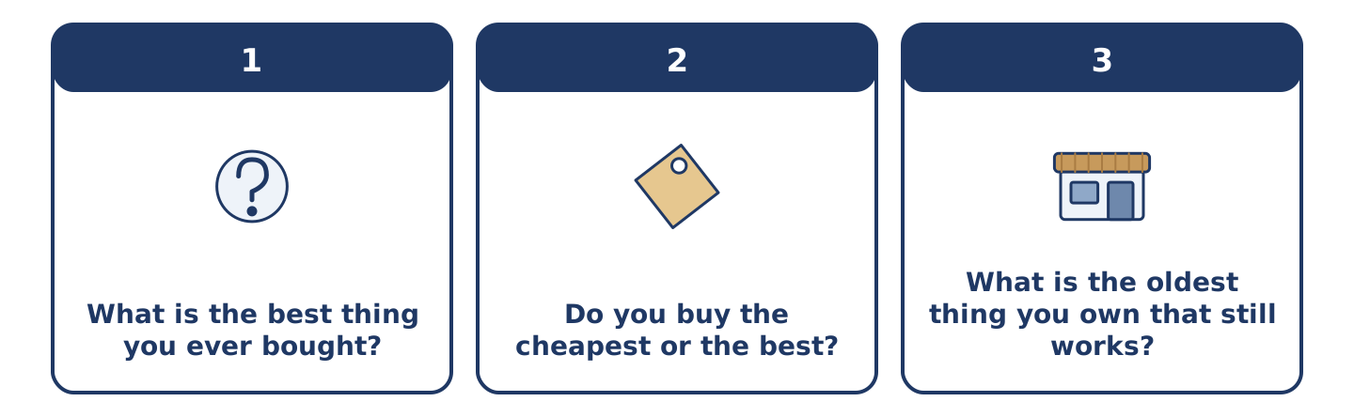
Figure 7.19 · The three questions as cards, to take one at a time.
Work with a partner. Ask and answer these questions.
- What is the best thing you ever bought? What made it better than the others?
- Do you buy the cheapest or the best? Has that changed?
- What is the oldest thing you own that still works?
Useful language: It is cheaper than… · It is the best… in… · better value · worse than I expected
Part 4: Find the Difference (pairwork)
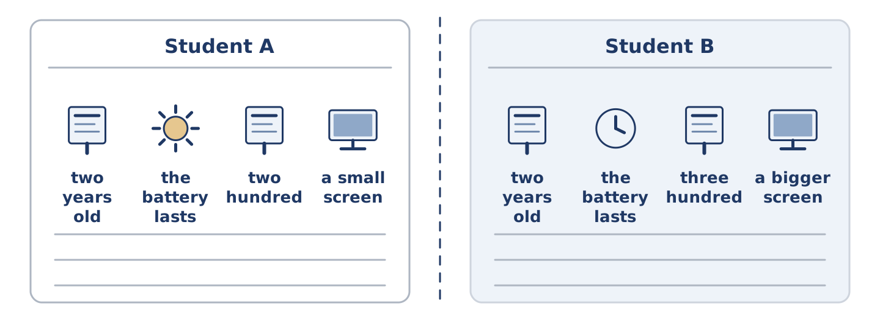
Figure 7.20 · Student A’s facts and Student B’s, with a fold between them.
Student A and Student B each have a telephone. Ask questions and find three differences.
Useful questions: How old is it? · Is the battery good? · How much was it? · Is the screen bigger than mine?
Student A — your telephone: two years old · the battery lasts a day · two hundred · a small screen.
Student B — your telephone: two years old · the battery lasts four hours · three hundred · a bigger screen.
Part 4: Helping Somebody Choose
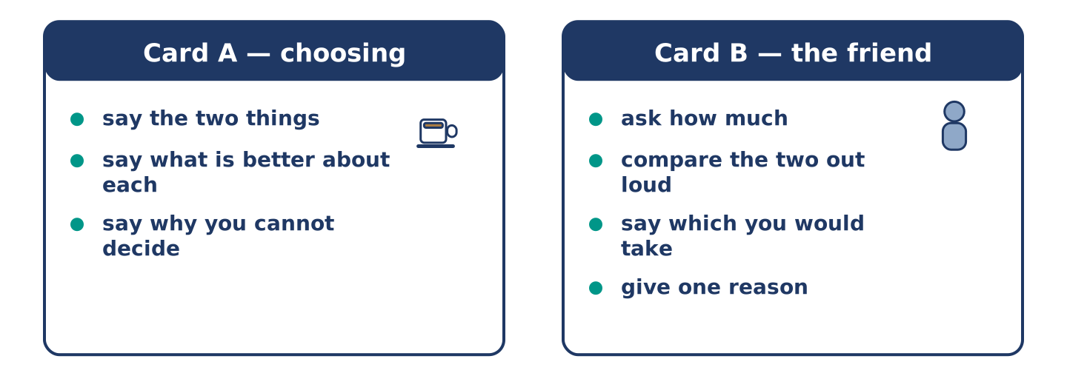
Figure 7.21 · Card A and Card B: what each of you has to say.
Work in pairs. Read the model, then use the cards.
Model exchange:
A: I cannot decide. The grey one is cheaper. — B: How much cheaper? — A: Almost half. — B: And the green one? — A: Warmer, deeper pockets, lasts longer. — B: Then the green one is better value, but the grey one is better today. Which problem is bigger?
Useful language: How much cheaper? · It is warmer than… · better value · Which is bigger…? · I cannot decide.
Card A — the person choosing: say the two things · say what is better about each · say why you cannot decide.
Card B — the friend: ask how much · compare the two out loud · say which you would take · give one reason.
Your turn: run the dialogue, then swap roles.
Stretch [PLUS]: your friend chooses the one you would not — agree with them anyway, and mean it.
Part 4: Mini-Presentation
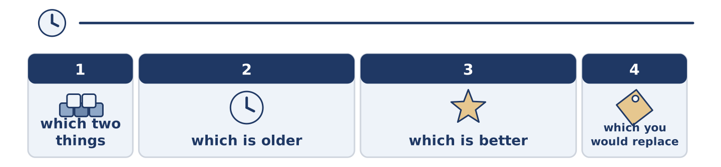
Figure 7.22 · The one-minute talk as three beats, each as wide as its share.
Prepare a short talk (about one minute). Compare two things you use every day: which is older, which is better, and which you would replace first.
Part 5 · Reading
[CORE] Core track · pre-class input
Part 5: The Cheapest Is Not the Cheapest
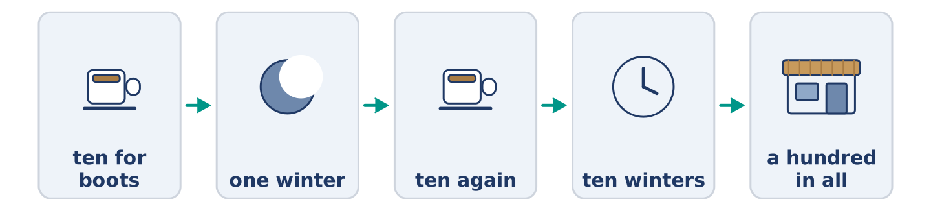
Figure 7.23 · One pair of boots, over ten years.
Before you read: can a cheap thing cost more than an expensive one?
Gloss: boots = strong shoes that cover the ankle · afford = to have enough money for something · sole = the flat bottom of a shoe
There is an old idea about boots. A poor man buys cheap boots for ten and they last one winter. A rich man buys good boots for fifty and they last ten years. After ten years the poor man paid a hundred and his feet are still wet. The rich man paid fifty and his feet are dry. The cheap boots are more expensive than the good ones. The only reason anybody buys them is that ten is what they can afford today. The idea is not really about boots. It is about the difference between a price and a cost, and about how much more expensive it is to be poor.
Answer the multiple-choice questions. (0. is done.)
- How long do the cheap boots last? — One winter.
1. How much does the poor man pay over ten years?
○ A) Fifty
○ B) Ten
○ C) A hundred
○ D) Nothing
2. Why does anybody buy the cheap boots?
○ A) Because they are warmer
○ B) Because ten is what they can afford today
○ C) Because the shop is nearer
○ D) Because they last longer
3. What is the idea really about?
○ A) The difference between a price and a cost
○ B) How to mend boots
○ C) Which shop is best
○ D) Why winters are cold
Part 5: Vocabulary in Context
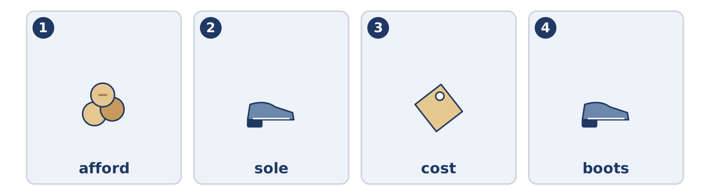
Figure 7.24 · The four words from the reading, drawn.
Match each word from the text with its meaning. One meaning is not needed. Write the letter.
Column A
1. | afford | ____
2. | sole | ____
3. | cost | ____
4. | boots | ____
Column B
a) | strong shoes that cover the ankle
b) | everything you pay in the end, not only today
c) | to have enough money for something
d) | the flat bottom of a shoe
e) | how good something is
Part 5: Repairing Instead of Buying
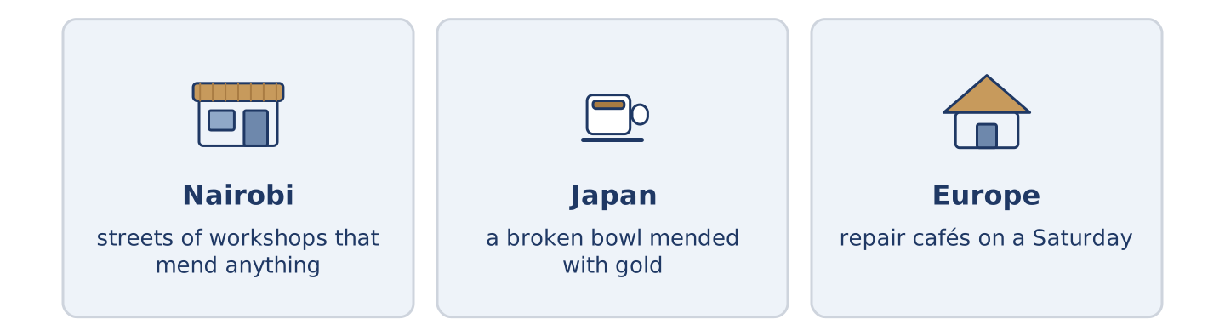
Figure 7.25 · Three places where things get mended.
Before you read: in your town, where do you take a broken thing?
Gloss: workshop = a small place where people make or repair things · gold = the yellow metal rings are made of
In some places people never stopped repairing things. In Nairobi there are whole streets of small workshops. A man repairs a radio, a shoe or a fridge for a tenth of the price of a new one. In Japan there is an old idea called kintsugi. Somebody repairs a broken bowl with gold, so the line of the break is the best part of it. In parts of Europe people now meet in repair cafés on a Saturday to repair each other’s things for nothing. The cheapest thing you can buy is often the thing you already own.
Answer the questions. (0. is done.)
- What does the text say about some places? — People there never stopped repairing things.
- What can a man in Nairobi repair?
- What does a person use to repair a bowl in kintsugi?
- Where do people in parts of Europe meet to mend things?
Part 6 · Writing
[CORE] Core track · in-class / homework
Part 6: Compare Two Things (50–70 words)
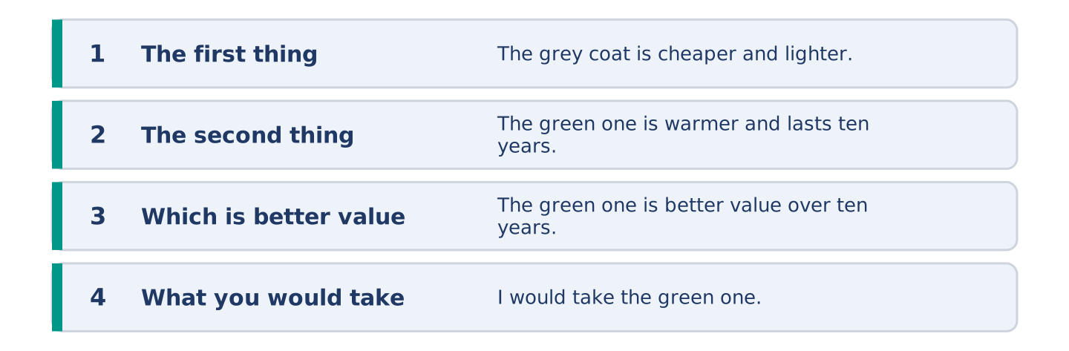
Figure 7.26 · The shape of the paragraph you are about to write.
Compare two things you could buy. Say what is better about each, and which you would take.
Model — read this first:
The grey coat is cheaper and lighter, and I like it more. The green one is warmer, the pockets are deeper, and it lasts ten years instead of two. The green one is better value over ten years and the grey one is better value this month. I would take the green one, if somebody else were paying. (58 words)
Plan (fill in, then write): The ___ is ___ and ___. The ___ is ___ and ___. ___ is better value because ___. I would take ___.
Word bank: cheaper | warmer | better | the best | than | better value
Check before you finish: ☐ two comparatives? ☐ one superlative? ☐ than used correctly? ☐ 50–70 words?
Part 6: Cheap or Good? (50–70 words)
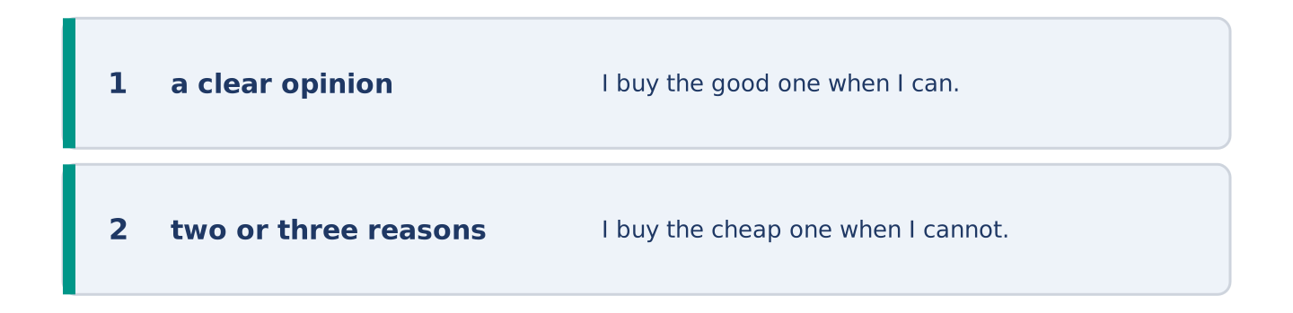
Figure 7.27 · The shape of the opinion paragraph, step by step.
Is it better to buy cheap things often or good things rarely? Give your opinion and two or three reasons.
Model — read this first:
I buy the good one when I can. I buy the cheap one when I cannot, which is most of the time. That is not a plan, it is a bank account. The one thing I never buy cheap is shoes. Bad shoes cost you a day, then a week, then your back. (53 words)
Word bank: I think… because… | better value | however | in my opinion | it depends on
Check before you finish: ☐ a clear opinion? ☐ two or three reasons? ☐ 50–70 words?
Part 6: A Message Recommending Something (50–70 words)
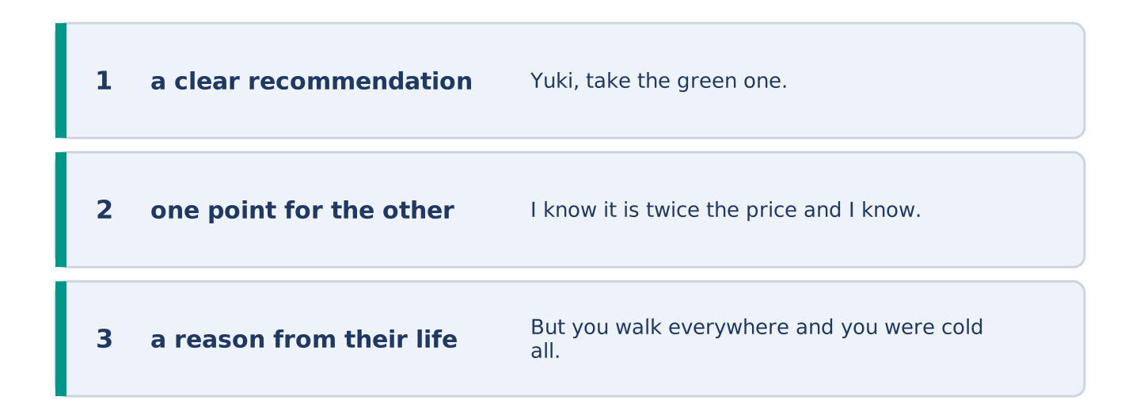
Figure 7.28 · The moves of the message, with a line of the model for each.
A friend is choosing between two things. Write them a short message with your advice.
Model — read this first:
Yuki, take the green one. I know it is twice the price and I know the grey one is nicer. But you walk everywhere and you were cold all last winter, and the grey one does not fix that. If the money is the problem, wait three weeks. The coat is not going anywhere. (54 words)
Plan (fill in, then write): ___, take the ___. I know ___ and I know ___. But ___. If ___, ___.
Check before you finish: ☐ a clear recommendation? ☐ one point for the other side? ☐ a reason from their life? ☐ 50–70 words?
Part 6: Reflection — The Best Thing I Own (40–60 words)
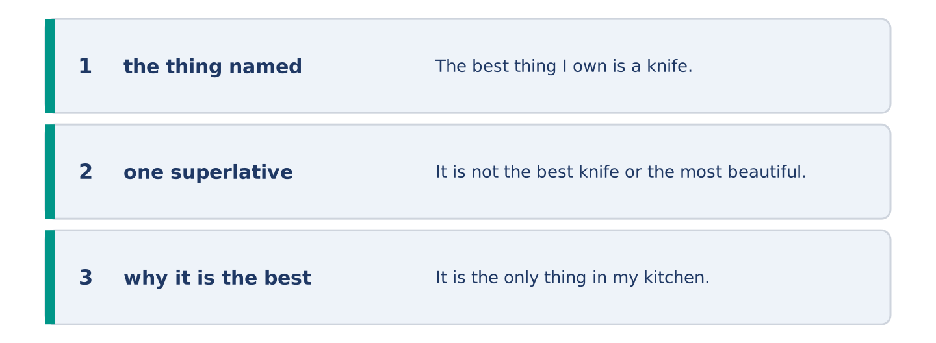
Figure 7.29 · The reflection, step by step.
Write about the best thing you own, and why it is the best.
Model — read this first:
The best thing I own is a knife my grandmother used for forty years. It is not the best knife or the most beautiful. It is the only thing in my kitchen that is older than I am, and it goes to somebody else’s kitchen after me. (47 words)
Check before you finish: ☐ the thing named? ☐ one superlative? ☐ why it is the best? ☐ 40–60 words?
Part 7 · Real-World File — Mending, Returning, Complaining
[PLUS] Plus track (optional) · stronger learners
7A: Phrase Bank
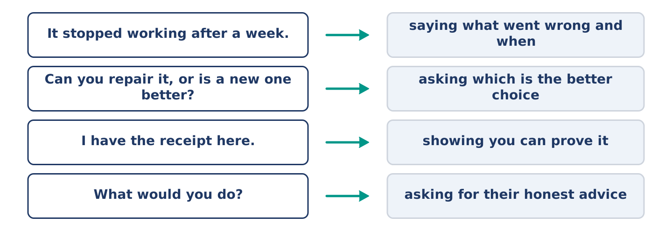
Figure 7.30 · What you say when something is wrong with a thing, and what each does.
Match what a person says with its purpose. One purpose is not needed. Write the letter.
Column A
1. | “It stopped working after a week.” | ____
2. | “Can it be mended, or is it better to replace it?” | ____
3. | “I have the receipt here.” | ____
4. | “What would you do?” | ____
Column B
a) | asking for their honest advice
b) | showing you can prove it
c) | saying what went wrong and when
d) | asking which is the better choice
e) | asking for a cheaper model
7B: Taking Something Back
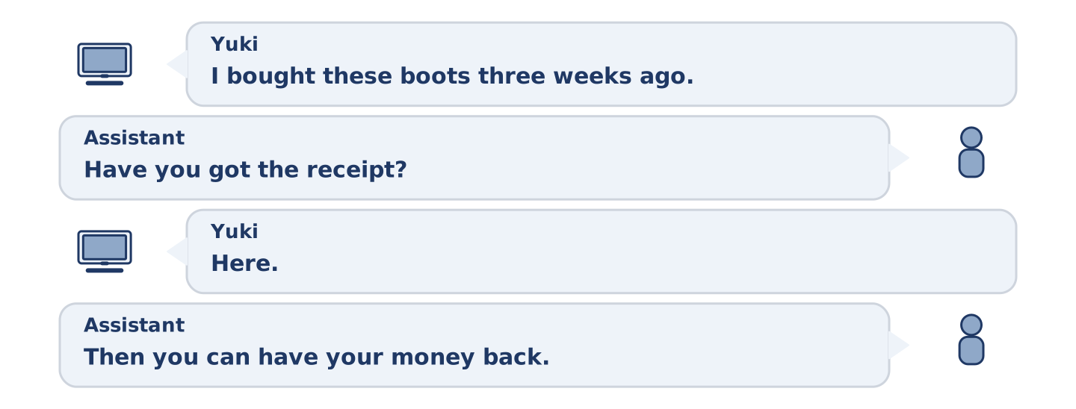
Figure 7.31 · The 7B exchange: who takes each turn.
🔊 Audio Track 7.5
Before you read: what do you need before you take something back to a shop?
Yuki: I bought these boots three weeks ago and the sole came off one of them. Assistant: Three weeks? That shouldn’t happen. Have you got the receipt? Yuki: Here. Assistant: Then you can have your money back, or a new pair. Yuki: Which would you do? Assistant: Honestly? A different pair. These are our cheapest and we see a lot of them back. The pair behind you costs ten more and is much better made. Yuki: Then I pay the ten.
Answer the questions. (0. is done.)
- What is wrong with the boots? — The sole came off one of them.
- How long ago did Yuki buy them?
- What two things does the assistant offer?
- What does the assistant honestly advise?
7C: Controlled Practice — Taking Something Back
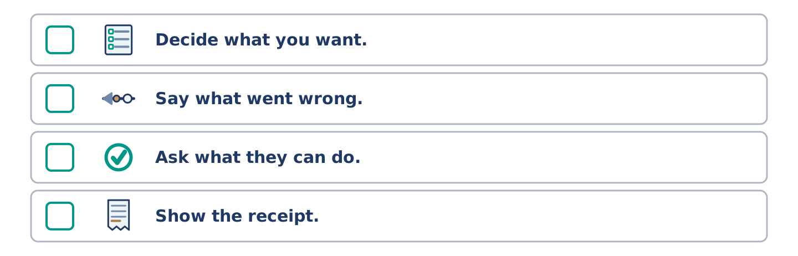
Figure 7.32 · The steps still to be numbered, as the task prints them.
Put the steps in order. Number them 1–5. (0. is done.)
- Say what you bought and when. — 1
____ Decide what you want.
____ Say what went wrong.
____ Ask what they can do.
____ Show the receipt.
7D: Role-Play — At the Counter
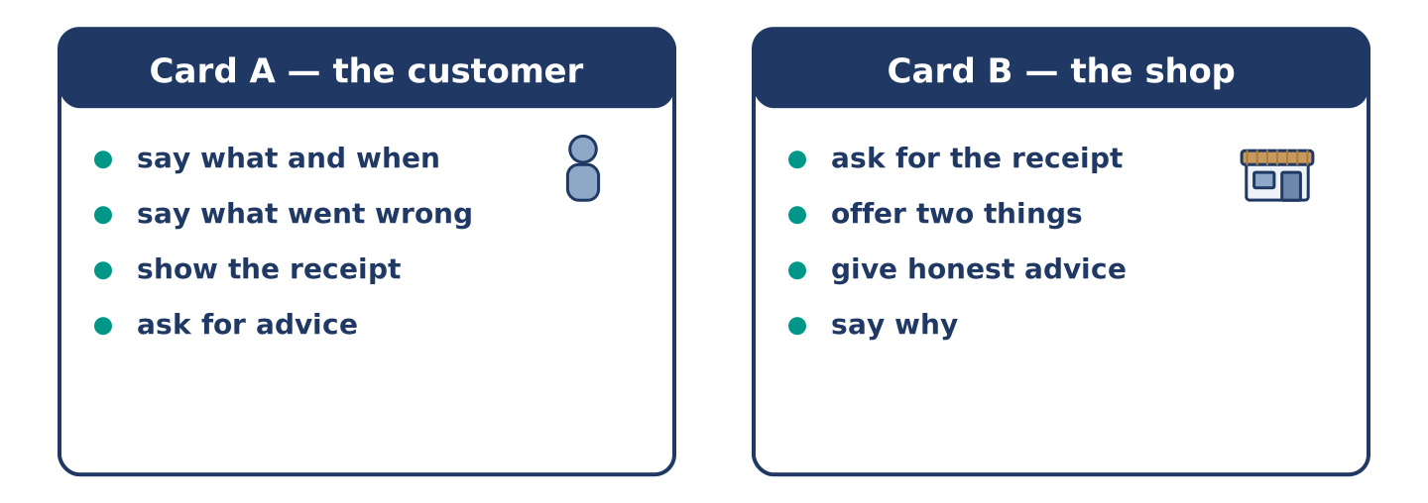
Figure 7.33 · The 7D cards: what each of you has to say.
In pairs. One is the customer; one works in the shop. Use the model and cards.
Model exchange: A: I bought these three weeks ago and the sole came off. — B: That shouldn’t happen. Have you got the receipt? — A: Here. — B: Money back, or a new pair? — A: Which would you do? — B: A different pair. These are our cheapest.
Card A — the customer: say what and when · say what went wrong · show the receipt · ask for advice.
Card B — the shop: ask for the receipt · offer two things · give honest advice · say why.
Stretch [PLUS]: the shop says the fault is yours — disagree without raising your voice.
7E: Writing — A Message About a Fault (50–80 words)
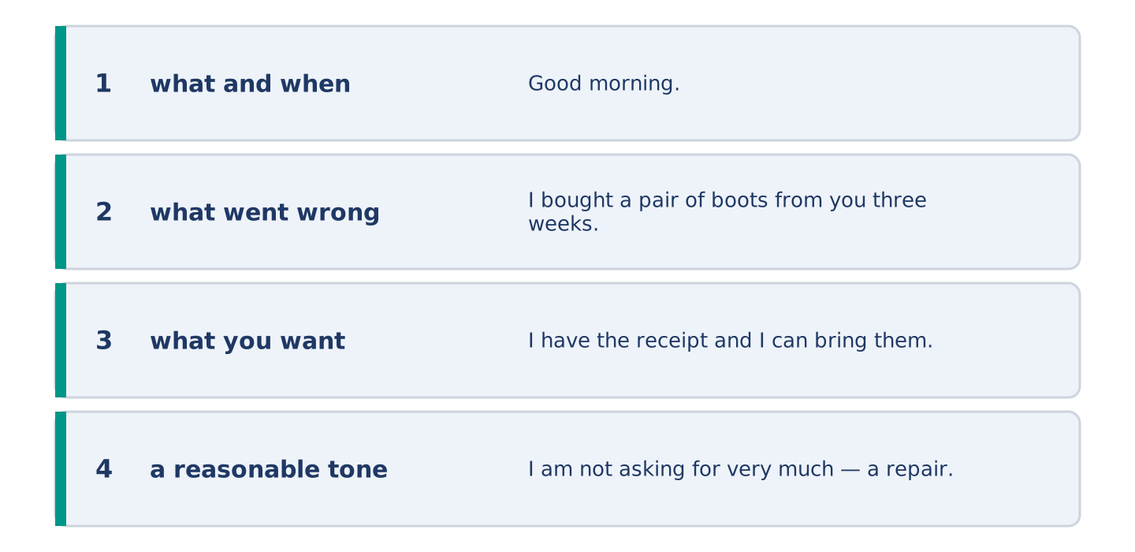
Figure 7.34 · The Part 7 note, with the model beside each line.
Something you bought stopped working. Write a short message to the shop.
Model — read this first:
Good morning. I bought a pair of boots from you three weeks ago and the sole came away from one of them. I have the receipt and I can bring them in any afternoon. I am not asking for very much — a repair would be fine, or a different pair if that is easier for you. Could you let me know which you would prefer? Thank you. Yuki Tanaka (70 words)
Check before you finish: ☐ what and when? ☐ what went wrong? ☐ what you want? ☐ a reasonable tone? ☐ 50–80 words?
Part 8 · Global Story — The Street That Repairs Everything
[PLUS] Plus track · pre-read / discuss
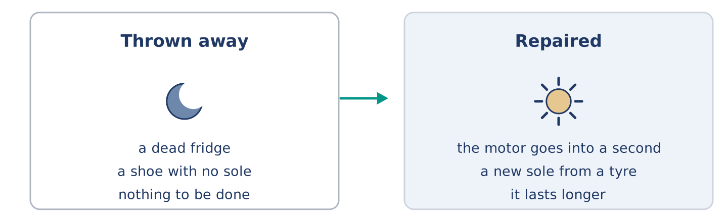
Figure 7.35 · A broken thing, and the two roads out of it.
Before you read: what happens to a broken thing in your town?
Gloss: jua kali = an open-air workshop in Kenya, from the words for hot sun · informal = outside the official system · skill = something you can do well because you learned it · motor = the part that makes a machine go
In Nairobi there is a part of the city where almost nothing is thrown away. People call it jua kali, which means hot sun, because the workshops are in the open air. A man takes the motor out of a dead fridge and puts it into a working one. A woman cuts a new sole for a shoe out of an old tyre. That shoe then lasts longer than the one it came from. There are thousands of these workshops and almost none of them has an office or a sign. Visitors from richer countries often call it poor, and part of it is. But the skill in those streets is real and hard to find. Most of Europe lost it in two generations. The cheapest thing is still the thing you already own; what Nairobi kept is the knowledge of how to keep it.
Answer the questions. (0. is done.)
- What does jua kali mean? — Hot sun.
- Why are the workshops called that?
- What does a woman cut a new sole out of?
- What did most of Europe lose?
Part 8: Vocabulary in Context
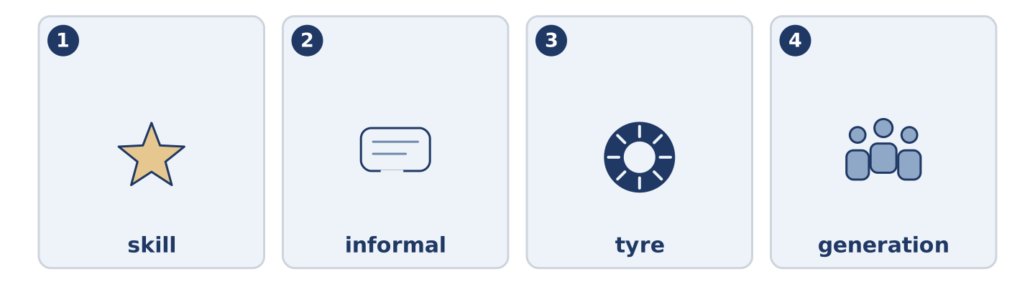
Figure 7.36 · The four words from the global story, drawn.
Match each word with its meaning. One meaning is not needed. Write the letter.
Column A
1. | skill | ____
2. | informal | ____
3. | tyre | ____
4. | generation | ____
Column B
a) | outside the official system
b) | something you can do well because you learned it
c) | all the people born at about the same time
d) | the round rubber part of a wheel
e) | the flat bottom of a shoe
Part 8: Discussion
Talk with a partner. Use the frames.
Discussion frames: “This is similar to where I live because…” · “This is different from where I live because…” · “I think the most important thing is… because…”
Part 9 · Close to Home — Mr Okonkwo’s Coat
[PLUS] Plus track · pre-read / decide
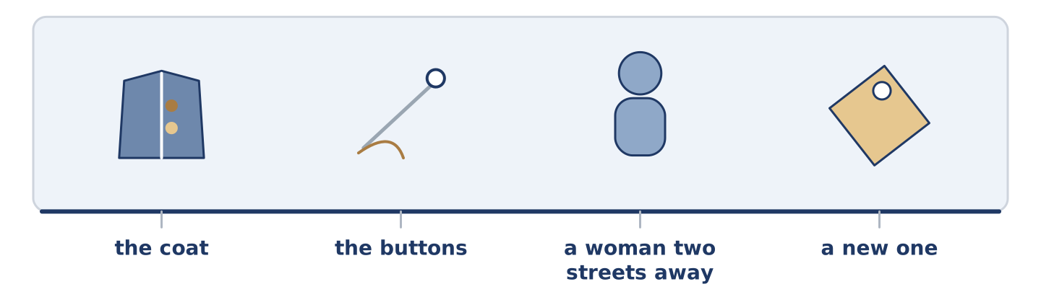
Figure 7.37 · The close-to-home reading, drawn along one street.
Before you read: how old is the oldest thing you wear?
Mr Okonkwo’s coat is older than Dani. It was expensive when he bought it, and he says that was the point. A woman two streets away relined it twice, and she no longer takes new work. The buttons are not the ones it came with. It is not the warmest coat on Alder Street and it is certainly not the lightest. It is the only one anybody ever repaired. Dani asked him once why he did not simply buy a new one. Mr Okonkwo said he could, easily, and that the coat was not really the point either. He did not explain what was. Amina thinks she knows. She never says, because some things get smaller when you say them out loud. She also knew him long before I did.
Answer the questions. (0. is done.)
- How old is Mr Okonkwo’s coat? — Older than Dani.
- What did a woman two streets away do twice?
- What did Dani ask him?
- Why has Amina not said what she thinks?
Part 9: Decision Task
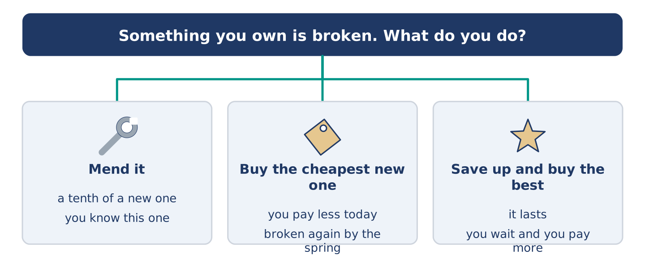
Figure 7.38 · Three ways to decide, and what each one costs.
Something you own is broken. Should you (a) mend it, (b) buy the cheapest new one, or (c) save up and buy the best one? Decide and explain. Use the frame.
Answer frame: “I think I should ___ because ___. Also, ___. This is better than ___ because ___.”
Model — read this first:
I think I should mend it, because a mend costs a tenth of a new one and this one still works otherwise. Also, I know this one, and a new one would be a month of small surprises. This is better than buying the cheapest, because the cheapest would be broken again by the spring. (55 words)
Phrase bank: I think I should… · because… · Also,… · This is better than… · In my opinion…
Part 10 · Review and Can-Do
[CORE + PLUS] · homework / self-study
Part 10: Spiral Review
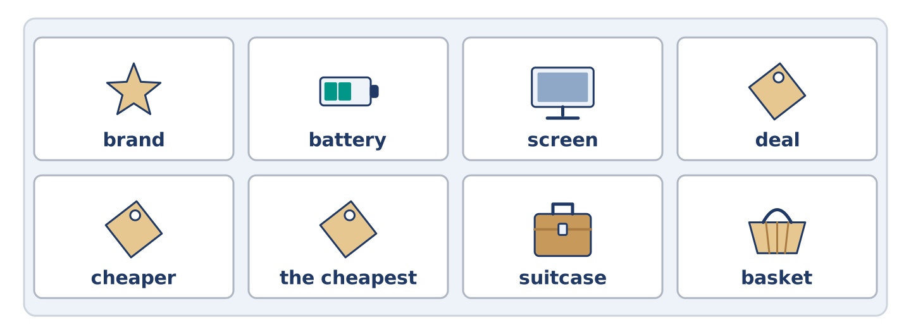
Figure 7.39 · The eight words of the review bank, in bank order.
Complete the review. (0. is done.)
- How good something is, and how long it lasts, is its quality.
Word bank: brand | battery | screen | deal | cheaper | the cheapest | suitcase | basket
- The name a company puts on the things it makes is the ______________________ .
- The part that holds the power in a telephone is the ______________________ .
- The flat glass part that lights up is the ______________________ .
- A price better than the usual one is a ______________________ .
- The grey coat is ______________________ than the green one. (two things)
- This shop is ______________________ in the street. (more than two)
- (from Unit 6) A big case with a handle, for your clothes, is a ______________________ .
- (from Unit 4) A light open bag you fill while you walk round is a ______________________ .
Part 10: Can-Do
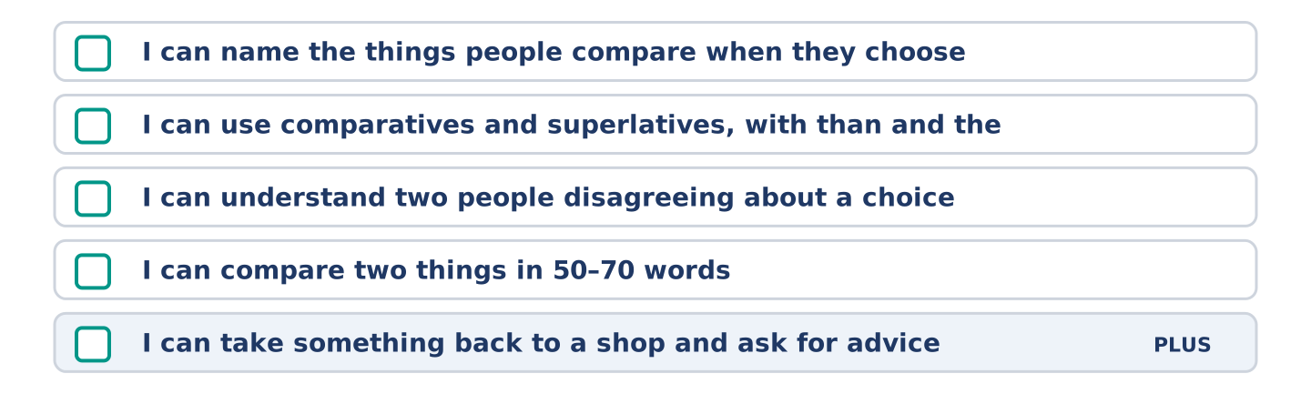
Figure 7.40 · What you can do at the end of this unit.
Can-Do checklist
☐ I can name the things people compare when they choose.
☐ I can use comparatives and superlatives, with than and the.
☐ I can understand two people disagreeing about a choice.
☐ I can compare two things in 50–70 words.
☐ I can take something back to a shop and ask for advice (Plus).
Part 10: Glossary
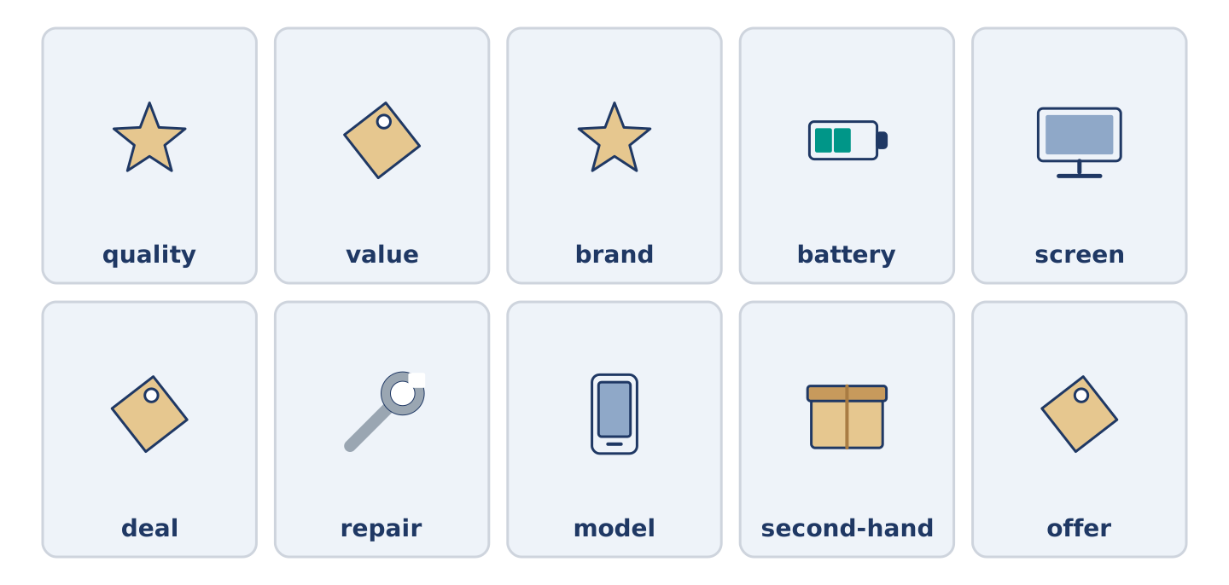
Figure 7.41 · All ten glossary words of Unit 7, one card each.
Unit 7 glossary (10 words)
quality · value · brand · battery · screen · deal · repair · model · second-hand · offer

