Unit 8: Help and Ability
English for Daily Life · Level: A2 · Tracks: [CORE] Warm-Up + Parts 1–6 · [PLUS] Parts 7–10
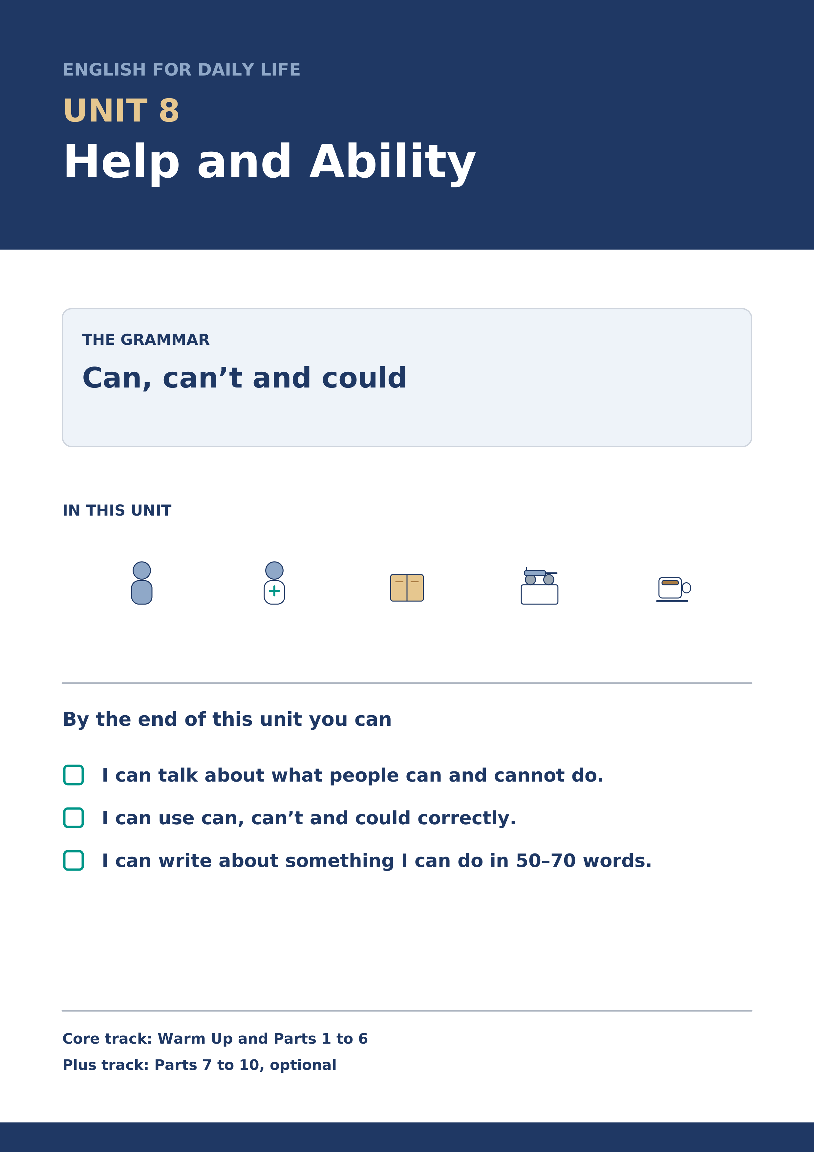
Warm Up
[CORE] Core track · in-class starter
Warm-up: Helping Words and Meanings
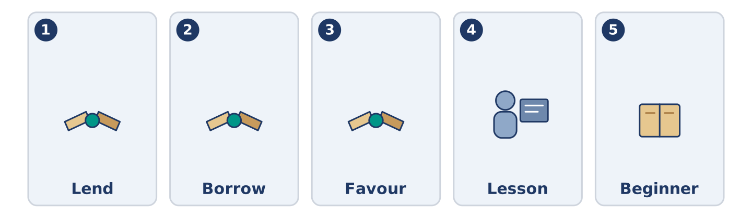
Figure 8.2 · The five warm-up words, and the thing each one means.
Match the words with their meanings. One meaning is not needed. Write the letter.
Column A
1. | Lend | ____
2. | Borrow | ____
3. | Favour | ____
4. | Lesson | ____
5. | Beginner | ____
Column B
a) | somebody who is starting to learn something
b) | to give something to somebody for a short time
c) | a kind thing you do for somebody because they asked
d) | one hour in which somebody teaches you
e) | to take something from somebody for a short time
f) | a price that is better than the usual one
Warm-up: Talking About What You Can Do
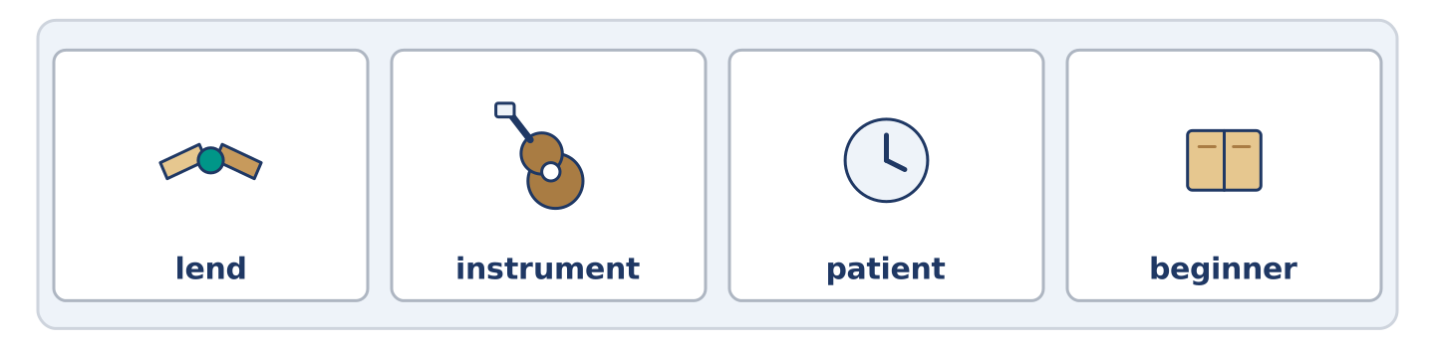
Figure 8.3 · The word bank for this task, in the order it is printed.
Complete the sentences using the words in the word bank.
Word bank: lend | instrument | patient | beginner
- Tomas is very ______________________ when somebody is frightened.
- Mr Okonkwo can play one ______________________ , and he plays it badly.
- Can you ______________________ me a pen? I need one for ten minutes.
- Yuki is a complete ______________________ , and she says so before anybody else can.
Warm-up: Six People, Six Skills
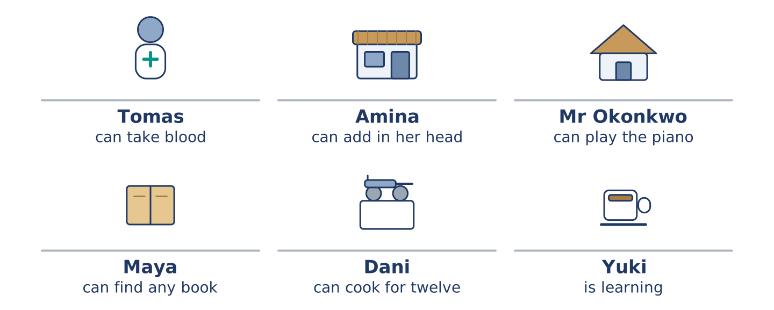
Figure 8.4 · What each of them can do, and what they cannot.
Read the text and choose the correct answer.
Everybody at number 14 can do something the others cannot. Tomas can take blood from an arm without anybody noticing. Amina can add four prices in her head faster than the till. Mr Okonkwo can play the piano, badly, and he says badly is enough. Maya can find any book in under a minute. Dani can cook rice for twelve people with no warning. Yuki cannot do any of these things yet, and she is the only one still learning something new.
1. What can Amina do?
○ A) Play the piano
○ B) Add four prices in her head
○ C) Find any book
○ D) Cook for twelve
2. What is true about Yuki?
○ A) She can play an instrument
○ B) She cooks for twelve
○ C) She is learning something new
○ D) She works at the hospital
Part 1 · Vocabulary and Terminology
[CORE] Core track · pre-class input
Part 1: Ability and Helping Terms
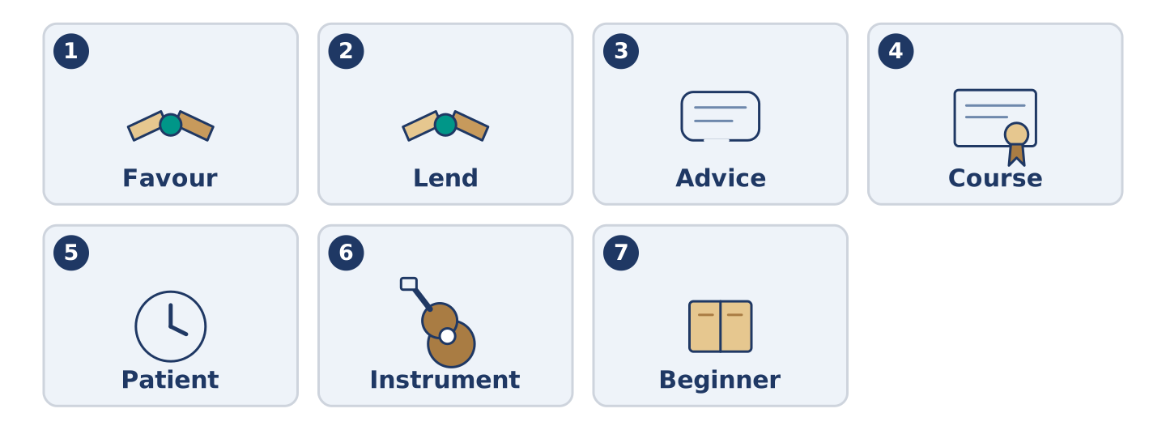
Figure 8.5 · The seven words of Column A, and what each one is.
Match the words with their meanings. One meaning is not needed. (0. is done for you.)
- Able → having the strength, the time or the skill to do something.
Column A
1. | Favour | ____
2. | Lend | ____
3. | Advice | ____
4. | Course | ____
5. | Patient | ____
6. | Instrument | ____
7. | Beginner | ____
Column B
a) | a set of lessons on one subject
b) | a kind thing you do because somebody asked
c) | calm with somebody who is slow or frightened
d) | to give something for a short time
e) | a thing you play music on
f) | what you say to somebody who does not know what to do
g) | somebody who is starting to learn
h) | one version of a thing a company makes
Gloss: favour = a kind thing you do because somebody asked · instrument = a thing you play music on · patient = calm with somebody who is slow
Part 1: Pronunciation
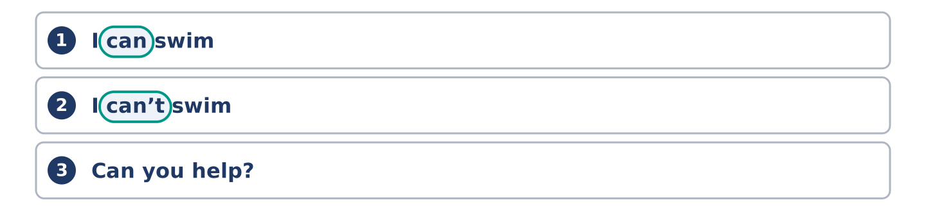
Figure 8.6 · Where the stress falls in 0 words of this unit.
🔊 Audio Track 8.1
Listen to can and can’t. Say each pair aloud.
I can swim — can is short and weak: /kən/
I can’t swim — can’t is long and clear: /kɑːnt/
Can you help? — can is weak again: /kən/
Yes, I can. — at the end it is strong: /kæn/
This is the hardest sound in the unit, and it matters. In the middle of a sentence can almost disappears, and can’t is the one you hear. If a learner says can loudly, an English ear hears can’t, and the answer comes out wrong.
Part 1: Six Skills and Where You Learn Them
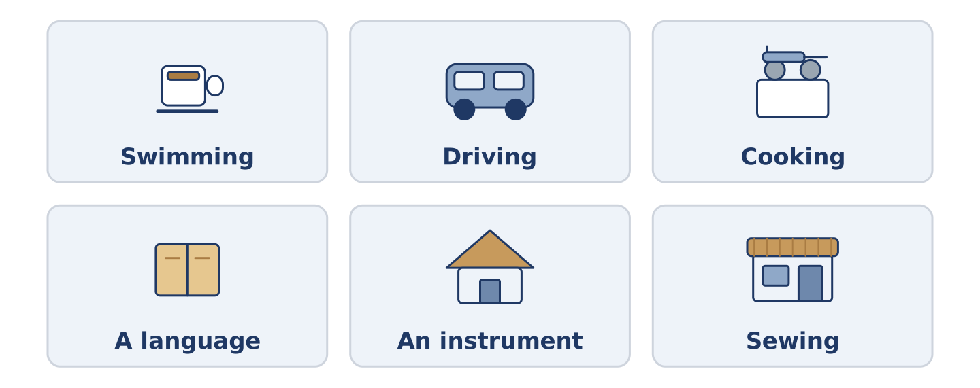
Figure 8.7 · Six things people learn, and where they learn them.
Complete the table. Write where you learn it and how long it takes. (0. is done.)
Skill | Where you learn it | How long it takes
Swimming | a pool, with a teacher | (example)
Driving
Cooking
A language
- Swimming — a pool, with a teacher — a few weeks to float, years to be good.
Think about something you learned as an adult. There is more than one right answer; be ready to say why you chose yours.
Part 1: Asking for Help
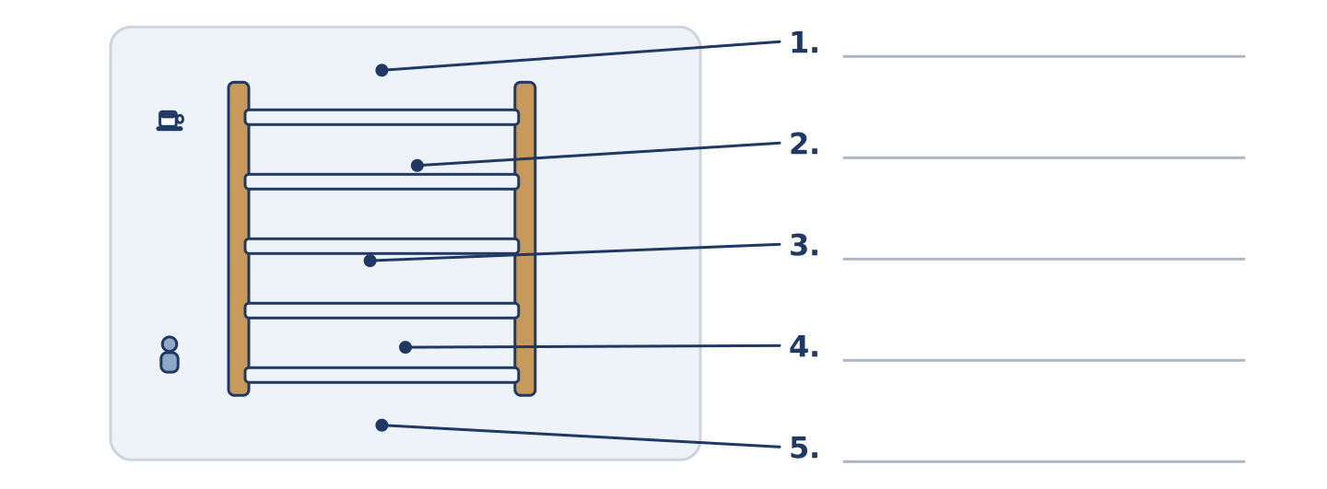
Figure 8.8 · Asking for help — write the correct word on each line.
Match the ways of asking with their descriptions. One description is not needed. Write the letter.
Column A
1. | Can you…? | ____
2. | Could you…? | ____
3. | Would you mind…? | ____
4. | I was wondering… | ____
5. | Give me… | ____
Column B
a) | the politest of all, and the longest
b) | the plainest way, between friends
c) | not a question at all, and rarely polite
d) | a little more polite than can
e) | very polite, and it needs a no to mean yes
f) | asking what somebody is able to do
Part 1: Helping — Multiple Choice
Read and choose the correct answer.
1. Somebody who is starting to learn is a…
○ A) beginner
○ B) course
○ C) favour
○ D) lesson
2. To give something to somebody for a short time is to…
○ A) borrow
○ B) lend
○ C) lift
○ D) learn
3. Calm with somebody who is slow or frightened means…
○ A) patient
○ B) able
○ C) kind
○ D) quiet
Part 1: Vocabulary Fill-in
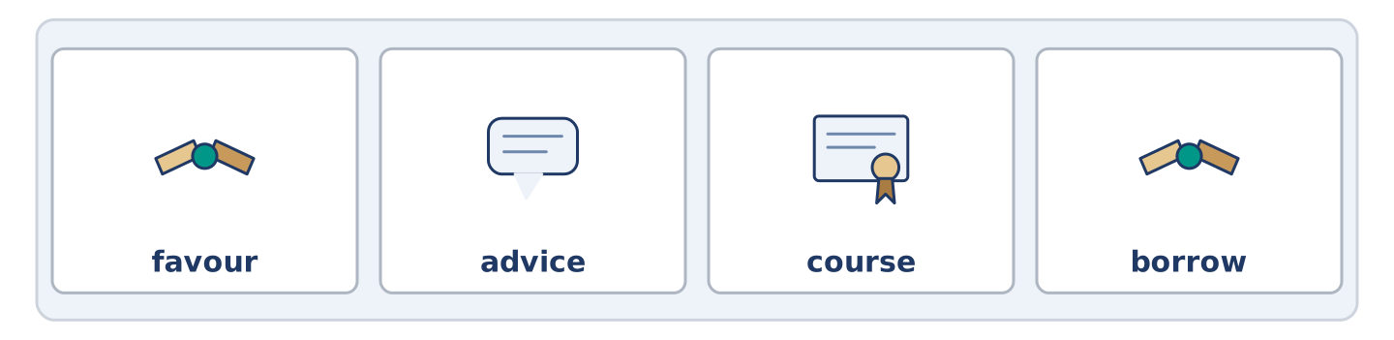
Figure 8.9 · The four words of the bank, in the order the task gives them.
Complete the sentences with the correct word.
Word bank: favour | advice | course | borrow
- Can I ______________________ your bicycle for an hour?
- Yuki is doing a ten-week ______________________ on Thursday evenings.
- Dani asked Amina for ______________________ and then did the opposite.
- Could you do me a ______________________ and watch the shop for ten minutes?
Part 1: Write About What You Can Do (short)
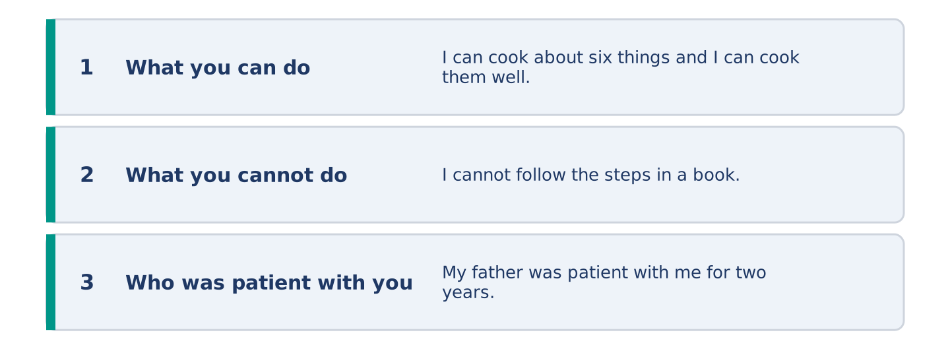
Figure 8.10 · The shape of your two or three sentences, with the model beside each step.
Write two or three sentences about something you can do well. Use three words from this unit.
Model — read this first:
I can cook about six things and I can cook them very well. I cannot follow the steps in a book; I lose my place and I start to make it up. My father was patient with me for two years and then he gave me a pan and left the kitchen. (52 words)
Part 2 · Grammar — Can, Can’t and Could
[CORE] Core track · pre-class input
Part 2: Notice
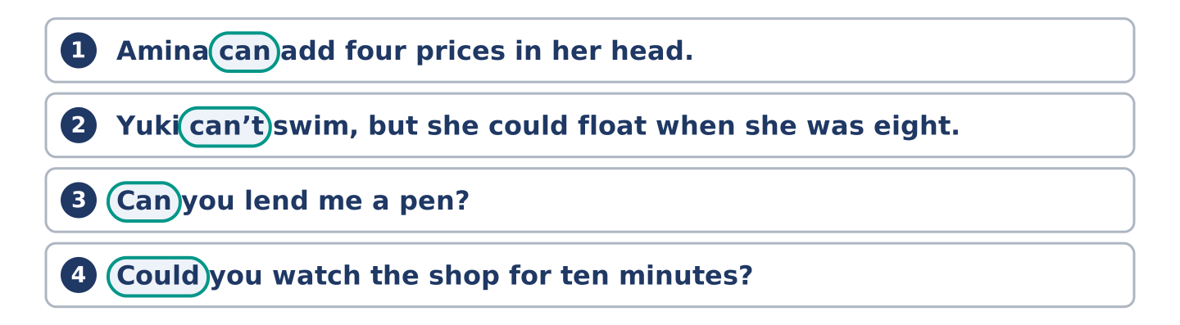
Figure 8.11 · Lines from the notice, with the target form ringed in each.
Read these lines. Underline can, can’t and could. Which ask, and which tell you about ability?
Amina can add four prices in her head. Mr Okonkwo can play the piano, badly. Yuki can’t swim, but she could float when she was eight. Can you lend me a pen? Could you watch the shop for ten minutes? I could carry one box, but I can’t carry four.
Three of these are about ability. Two are requests. One is about the past.
Part 2: Grammar Focus Box
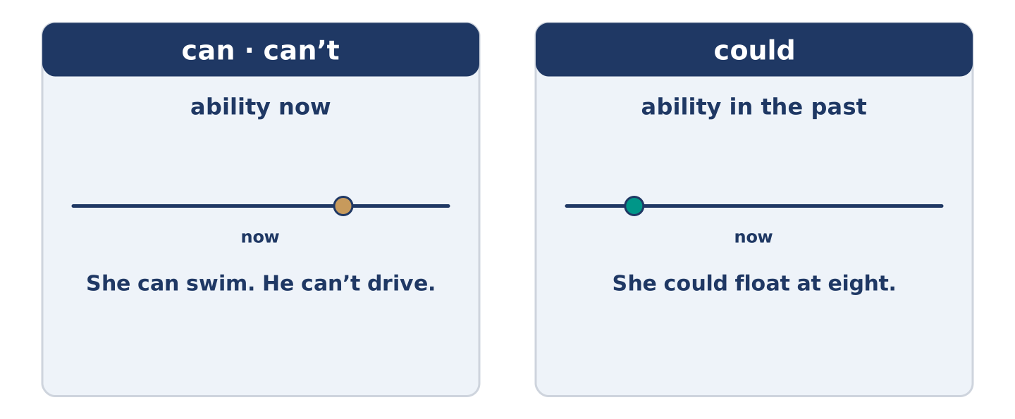
Figure 8.12 · Can and could: what they do, and how polite they are.
 | Form | Use | Example
can / can’t | can + plain verb, every person | ability now | She can swim. He can’t drive.
could | could + plain verb | ability in the past | He could float at eight.
Can you…? | a question, plain | asking a friend | Can you lend me a pen?
Could you…? | a question, softer | asking anybody | Could you watch the shop?
Remember: can and could never take to: I can swim, not I can to swim.
Watch out! ✗ He cans swim. → ✓ He can swim. (can never takes -s). ✗ Can you to help me? → ✓ Can you help me? (no to after can).
Part 2: Controlled Practice
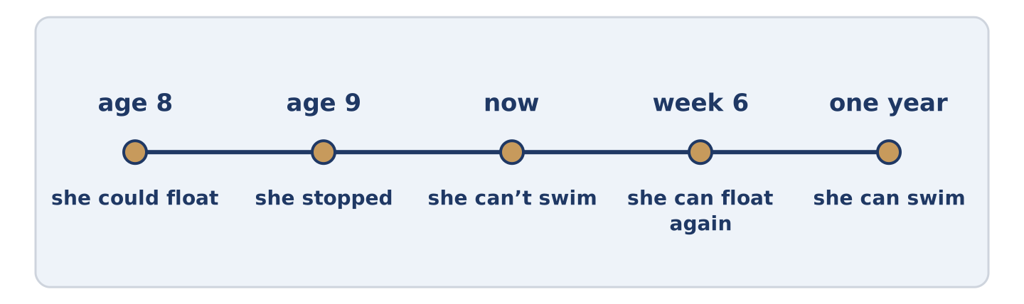
Figure 8.13 · Six people, and what each of them can do.
Complete with can, can’t or could. (0. is done.)
- Amina can add four prices in her head.
- Yuki ______________________ swim, but she wants to learn.
- Mr Okonkwo ______________________ play the piano, badly.
- When she was eight, Yuki ______________________ float.
- ______________________ you watch the shop for ten minutes?
Part 2: Ability or Request?
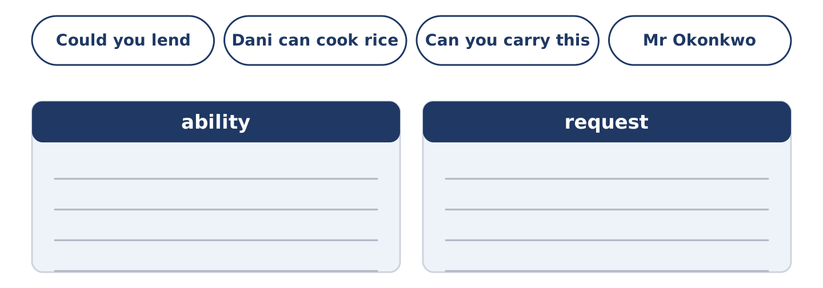
Figure 8.14 · The items of this task, and the bins they sort into.
Write ability or request. (0. is done.)
- Tomas can take blood from an arm. — ability
- Could you lend me a pen? ____________
- Dani can cook rice for twelve people. ____________
- Can you carry this box? ____________
- Mr Okonkwo could run, when he was younger. ____________
Part 2: Correct the Sentence
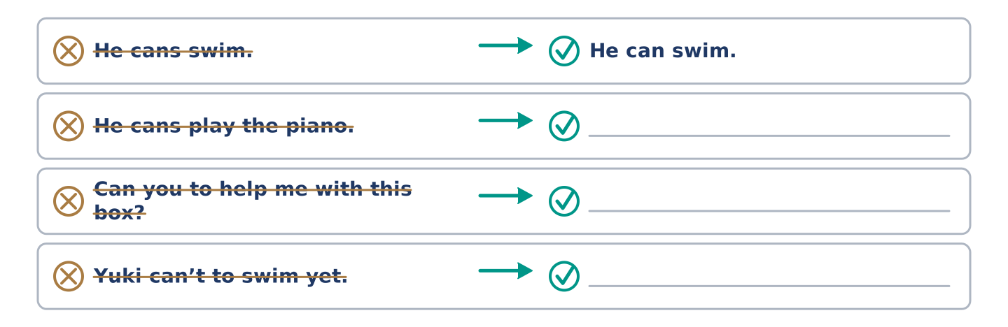
Figure 8.15 · One correction done for you, and the rest to write.
Each sentence has one grammar mistake. Write the correct sentence.
- He cans play the piano.
- Can you to help me with this box?
- Yuki can’t to swim yet.
- When he was young, he can run very fast.
Part 2: Freer Practice
Write two sentences about yourself: one thing you can do, and one thing you could do when you were a child.
Part 2: Grammar Review
Choose the correct sentence.
1. Which sentence about ability is correct?
○ A) He cans swim very well.
○ B) He can to swim very well.
○ C) He can swim very well.
○ D) He can swims very well.
2. Which is the more polite request?
○ A) Give me a pen.
○ B) You lend me a pen.
○ C) Can you lend me a pen, yes?
○ D) Could you lend me a pen?
→ Harvest: you will see can, can’t and could again in the Part 5 reading. Watch for the requests.
Part 3 · Listening
[CORE] Core track · pre-class input · scripts printed inline
Part 3: Asking a Favour
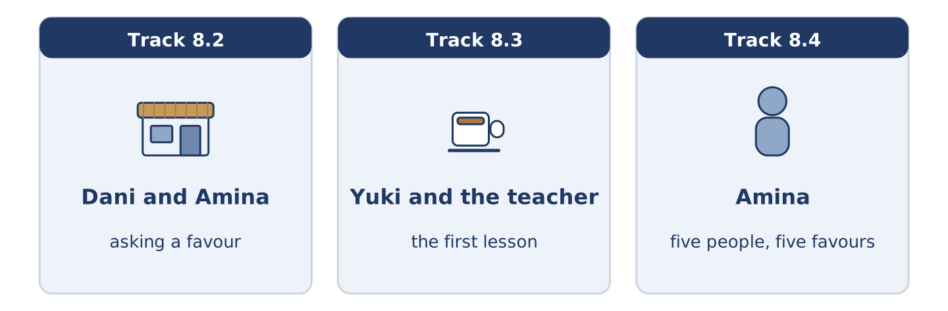
Figure 8.16 · The three listenings: who is speaking, and what about.
🔊 Audio Track 8.2
Before you listen: how do you ask for something you think is too much to ask?
Dani: Amina, could you do me a favour? Amina: That depends entirely on the favour. Dani: Could you watch my bike for an hour? Amina: I can watch it, but I can’t carry it anywhere, so don’t be long. Dani: One hour. Amina: You said one hour last time and I shut at six with a bicycle in front of the door. Dani: I know. I’m sorry. Amina: Go on. One hour.
While you listen: write True, False, or Not Given. (0. is done.)
- Dani asks Amina for a favour. — True
- Amina says she can carry the bike. ____
- Dani was late once before. ____
- Amina charges Dani for watching the bike. ____
Useful phrases: Could you do me a favour? · That depends… · I can… but I can’t… · Go on.
Part 3: The First Lesson
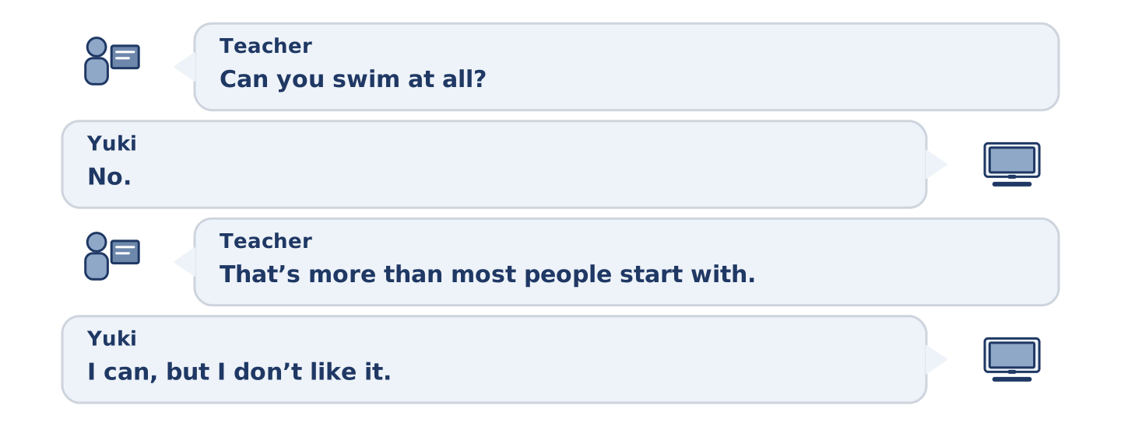
Figure 8.17 · The second listening, turn by turn.
🔊 Audio Track 8.3
Before you listen: what do you say to a teacher on the first day?
Teacher: Can you swim at all? Yuki: No. I could float when I was eight and then I stopped. Teacher: That’s more than most people start with. Can you put your face in the water? Yuki: I can, but I don’t like it. Teacher: Good, that’s the honest answer. We can work with that. You can’t learn this in a month, but you can learn it. Yuki: How long? Teacher: It depends how often you come, and whether you tell me the truth.
Answer the questions. (0. is done.)
- What is Yuki learning? — To swim.
- What could Yuki do when she was eight?
- What can she do, even though she does not like it?
- What two things does the time depend on?
Part 3: Five People, Five Favours
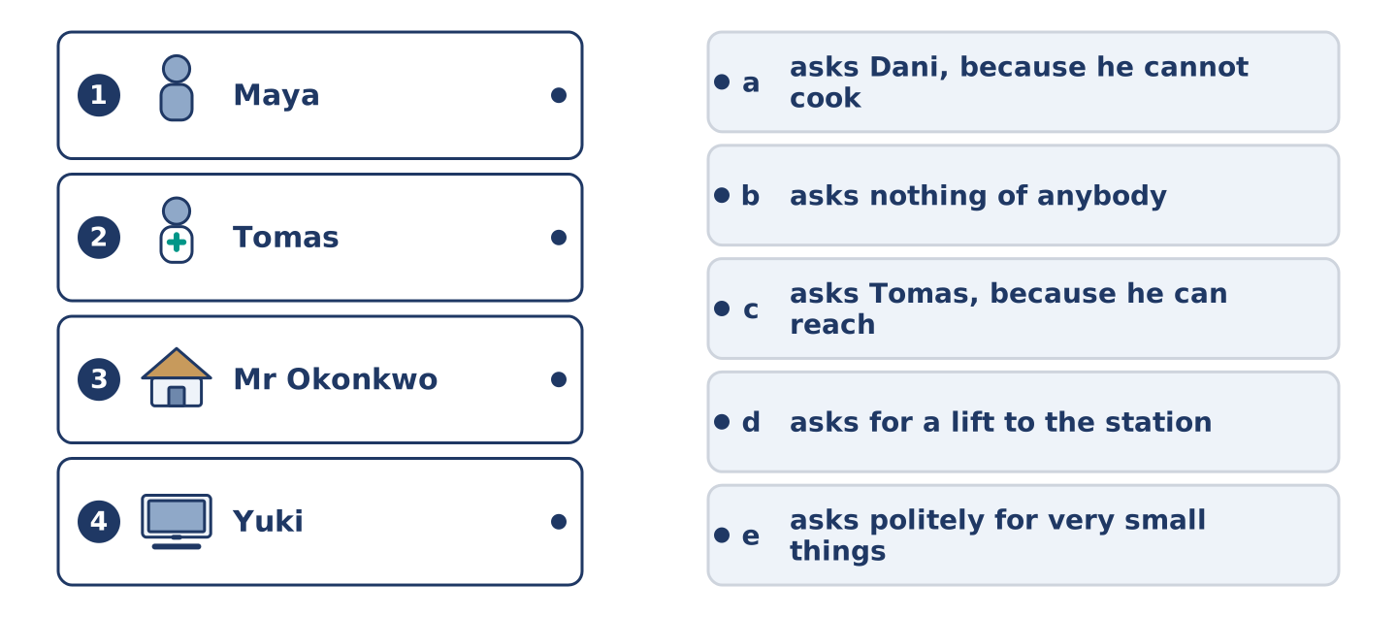
Figure 8.18 · Four on the left, five on the right, and one spare.
🔊 Audio Track 8.4
Before you listen: who do people in your street ask for help?
Amina: They all ask me and they all ask different things. Maya can’t reach the top shelf in her own kitchen, so she asks Tomas. Tomas can’t cook, so he asks Dani, who can. Dani can’t keep money, so he asks nobody and comes to me. Mr Okonkwo can do almost everything and asks for nothing, which is its own kind of problem. Yuki asks very politely for very small things, and I tell her every week that she can ask for more.
While you listen: match each person with their favour. One is not needed. (0. is done.)
- Amina → everybody asks her.
Useful phrases: ___ asks Tomas · ___ asks Dani · ___ asks for very little
Column A
1. | Maya | ____
2. | Tomas | ____
3. | Mr Okonkwo | ____
4. | Yuki | ____
Column B
a) | asks Dani, because he cannot cook
b) | asks nothing of anybody
c) | asks Tomas, because he can reach the top shelf
d) | asks for a lift to the station
e) | asks politely for very small things
Part 4 · Speaking
[CORE] Core track · in-class output
Part 4: Talking About What You Can Do
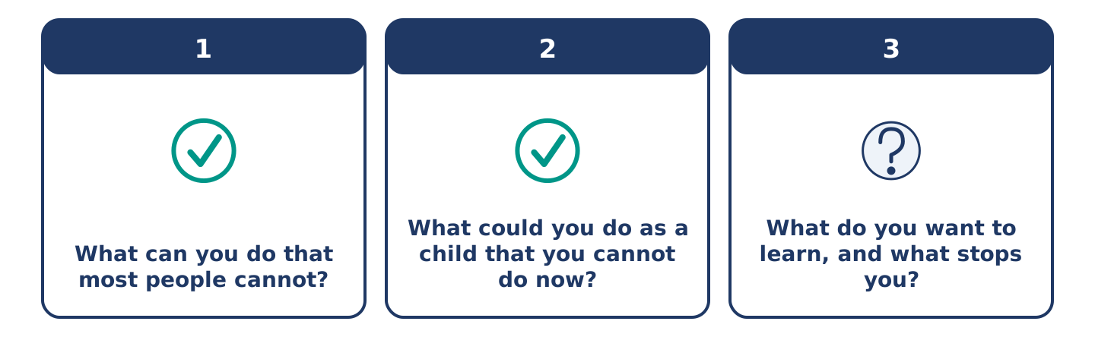
Figure 8.19 · The three questions as cards, to take one at a time.
Work with a partner. Ask and answer these questions.
- What can you do that most people cannot?
- What could you do as a child that you cannot do now?
- What do you want to learn, and what stops you?
Useful language: I can… · I can’t… yet · I could… when I was… · I want to learn…
Part 4: Find the Difference (pairwork)
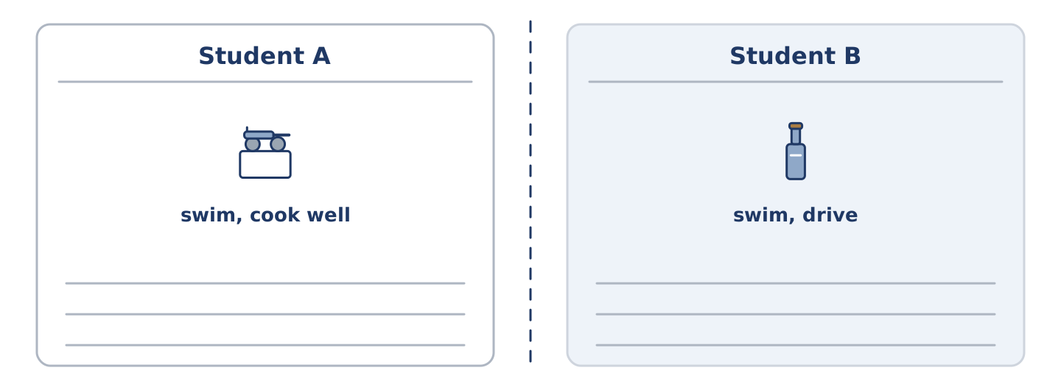
Figure 8.20 · Student A’s facts and Student B’s, with a fold between them.
Student A and Student B each have a list of skills. Ask questions and find three differences.
Useful questions: Can you swim? · Can you drive? · Could you do it as a child? · How well can you cook?
Student A — you can: swim, cook well, play an instrument. You cannot drive.
Student B — you can: swim, drive, cook a little. You cannot play an instrument.
Part 4: Asking for a Favour
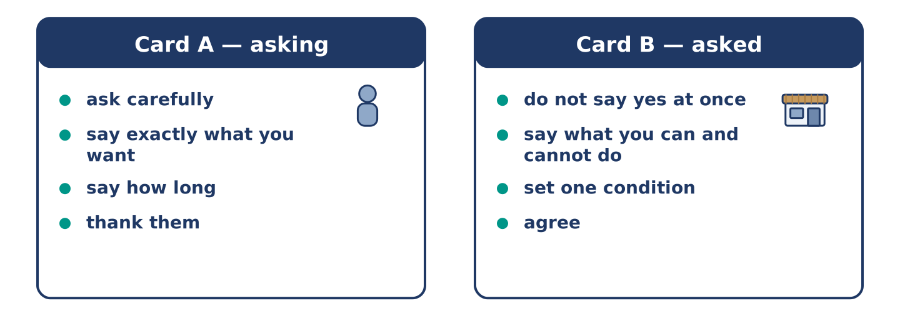
Figure 8.21 · Card A and Card B: what each of you has to say.
Work in pairs. Read the model, then use the cards.
Model exchange:
A: Could you do me a favour? — B: That depends on the favour. — A: Could you watch my bike for an hour? — B: I can watch it, but I can’t move it. — A: That’s fine. — B: And one hour means one hour. — A: One hour. Thank you.
Useful language: Could you do me a favour? · That depends… · I can… but I can’t… · That’s fine.
Card A — asking: ask carefully · say exactly what you want · say how long · thank them.
Card B — asked: do not say yes immediately · say what you can and cannot do · set one condition · agree.
Your turn: run the dialogue, then swap roles.
Stretch [PLUS]: you have to say no — do it in a way that leaves the friendship where it was.
Part 4: Mini-Presentation
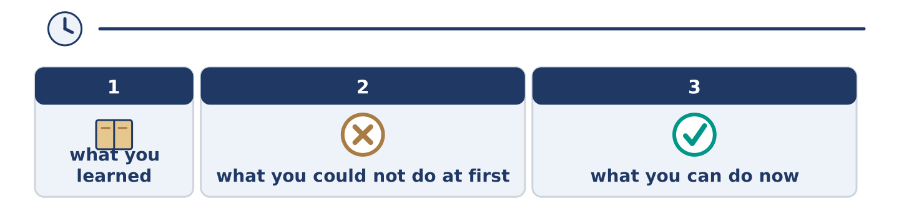
Figure 8.22 · The one-minute talk as two beats, each as wide as its share.
Prepare a short talk (about one minute). Describe something you learned as an adult: what you could not do at first, and what you can do now.
Part 5 · Reading
[CORE] Core track · pre-class input
Part 5: Why Adults Think They Cannot Learn
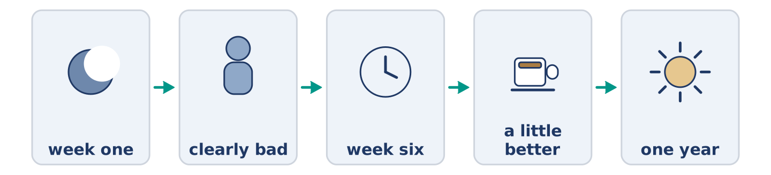
Figure 8.23 · One skill, from the first week to the first year.
Before you read: is it harder to learn something new at forty than at four?
Gloss: adult = a grown-up person · beginner = somebody starting to learn · progress = getting better over time
Adults often say they cannot learn a new skill, and they are almost always wrong. What they mean is that they cannot be a beginner in front of other people. A child of four falls over in a swimming pool and nobody thinks anything of it. An adult of forty falls over and feels it in the back of the neck for an hour. So adults avoid the first six weeks. Those six weeks are the only really unpleasant part. Then they decide they were too old. The research says something different. Adults learn some things faster than children, because they can understand an explanation and a child cannot. What adults cannot do is practise badly in public for long enough. The skill is not the problem. The audience is.
Answer the multiple-choice questions. (0. is done.)
- What do adults often say? — That they cannot learn a new skill.
1. What does the text say adults really mean?
○ A) They have no time
○ B) They cannot be a beginner in front of people
○ C) They are too old
○ D) The lessons cost too much
2. Why do adults sometimes learn faster than children?
○ A) They practise more
○ B) They are stronger
○ C) They can understand an explanation
○ D) They have better teachers
3. What does the text say the real problem is?
○ A) The skill
○ B) The teacher
○ C) The price
○ D) The audience
Part 5: Vocabulary in Context
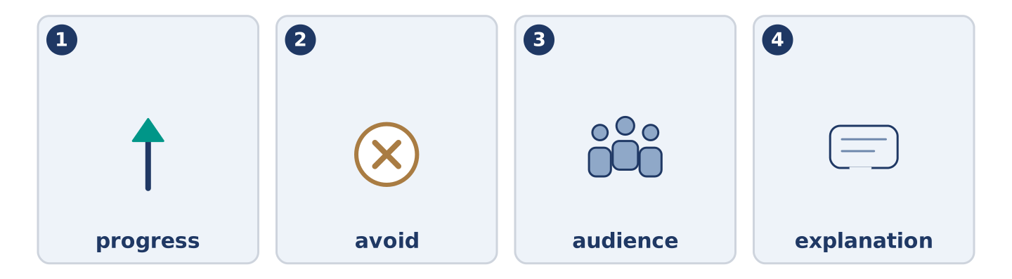
Figure 8.24 · The four words from the reading, drawn.
Match each word from the text with its meaning. One meaning is not needed. Write the letter.
Column A
1. | progress | ____
2. | avoid | ____
3. | audience | ____
4. | explanation | ____
Column B
a) | the others in the room
b) | getting better over time
c) | words that make something clear
d) | to stay away from something on purpose
e) | somebody who is starting to learn
Part 5: Learning Together
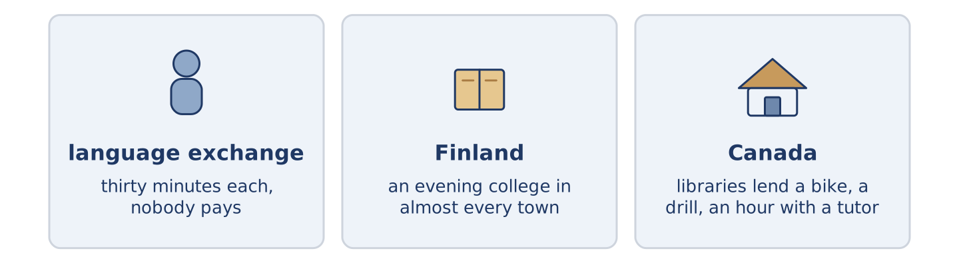
Figure 8.25 · Three places where people teach each other.
Before you read: who taught you the most useful thing you know?
Gloss: exchange = when two people each give something · tutor = somebody who teaches one person at a time
Not all teaching happens in a school. In many cities there are language exchanges. Two people meet for an hour, and each one speaks the other’s language for thirty minutes. Neither of them pays. In Finland almost every town has an evening college. A cook, a driver and an old judge can sit in the same guitar class for beginners, and nobody finds it strange. In Canada libraries have a long tradition of lending more than books. In some cities you can borrow a bike, a drill, or an hour with a tutor. It is the same in every country. If a town makes room for it, people can usually find a teacher they can afford.
Answer the questions. (0. is done.)
- Does all teaching happen in a school? — No, it does not.
- How long does each person speak in a language exchange?
- Who can sit in the same beginners’ class in Finland?
- What can you borrow from some libraries in Canada?
Part 6 · Writing
[CORE] Core track · in-class / homework
Part 6: Something I Can Do (50–70 words)
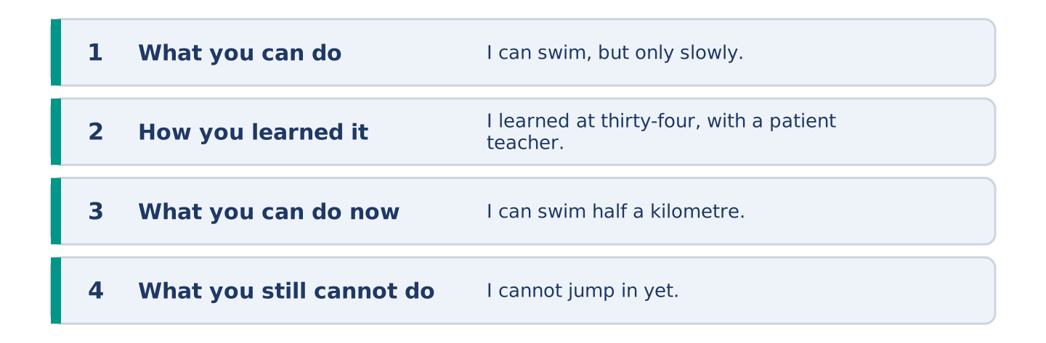
Figure 8.26 · The shape of the paragraph you are about to write.
Write about something you can do. Say how well, how you learned it, and what you still cannot do.
Model — read this first:
I can swim, but only in a straight line and only slowly. I learned at thirty-four, in a pool with six other adults and a very patient teacher. The best advice I got was to come twice a week and stop counting the weeks. I can swim half a kilometre now. I still cannot jump in from the side, and I cannot swim in the sea without thinking about what is under me. (73 words)
Plan (fill in, then write): I can ___, but only ___. I learned ___. I can ___ now. I still cannot ___.
Word bank: I can | I can’t | I could | when I was | still | yet
Check before you finish: ☐ two can sentences? ☐ one cannot? ☐ one could about the past? ☐ 50–70 words?
Part 6: Is It Harder to Learn Later? (50–70 words)
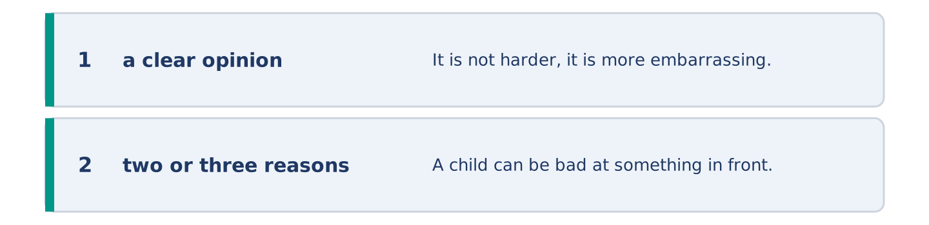
Figure 8.27 · The shape of the opinion paragraph, step by step.
Is it harder to learn something new as an adult? Give your opinion and two or three reasons.
Model — read this first:
It is not harder, it is more embarrassing, and people confuse the two. A child can be bad at something in front of thirty other children and forget it by lunch. An adult remembers it for a week. If you can get past six weeks of being clearly bad, you can learn almost anything. Most people stop in week three. (60 words)
Word bank: I think… because… | harder | however | in my opinion | it depends on
Check before you finish: ☐ a clear opinion? ☐ two or three reasons? ☐ 50–70 words?
Part 6: Asking for Help in Writing (50–70 words)
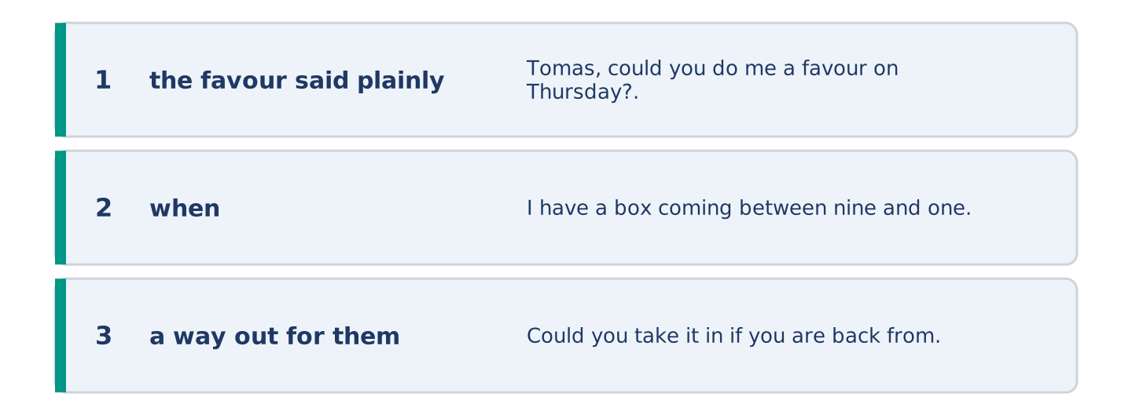
Figure 8.28 · The moves of the message, with a line of the model for each.
You need a favour from a neighbour. Write them a short message asking for it.
Model — read this first:
Tomas, could you do me a favour on Thursday? I have a box coming between nine and one and I cannot be at home. Could you take it in if you are back from your shift? It is one box and it is not heavy. If you are asleep, do not worry at all — I can ask Amina instead. Maya (61 words)
Plan (fill in, then write): ___, could you do me a favour on ___? I ___ and I cannot ___. Could you ___? If ___, ___.
Check before you finish: ☐ the favour said plainly? ☐ when? ☐ a way out for them? ☐ 50–70 words?
Part 6: Reflection — Something I Want to Learn (40–60 words)
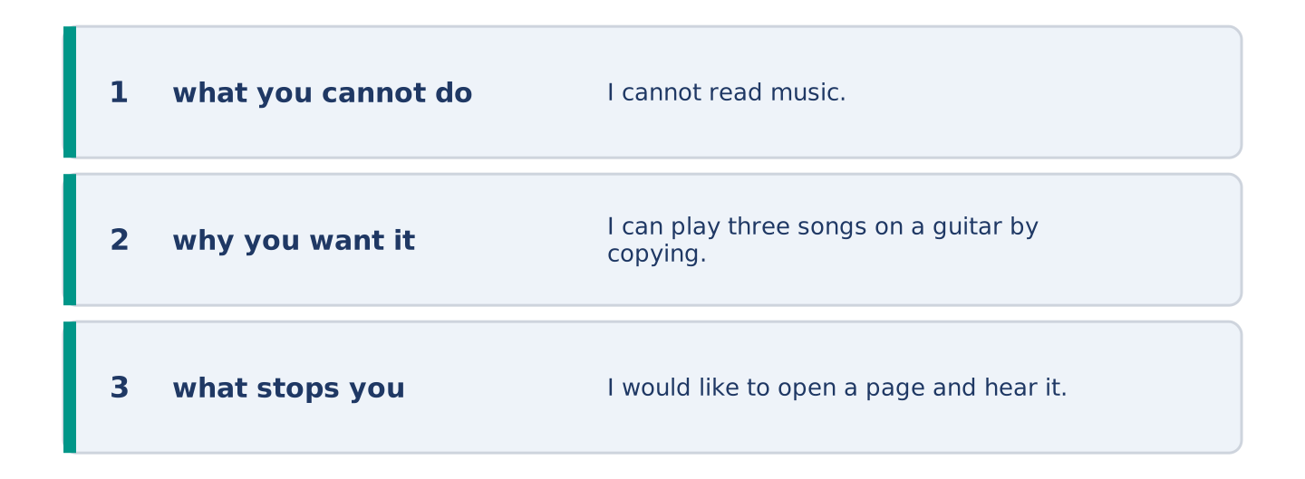
Figure 8.29 · The reflection, step by step.
Write about something you cannot do and want to learn.
Model — read this first:
I cannot read music. I can play three songs on a guitar by copying somebody’s fingers, which is not the same thing. I would like to open a page and hear it. I thought this every year for eleven years and I never found a Tuesday evening for it. (49 words)
Check before you finish: ☐ what you cannot do? ☐ why you want it? ☐ what stops you? ☐ 40–60 words?
Part 7 · Real-World File — Asking, Offering, Refusing
[PLUS] Plus track (optional) · stronger learners
7A: Phrase Bank
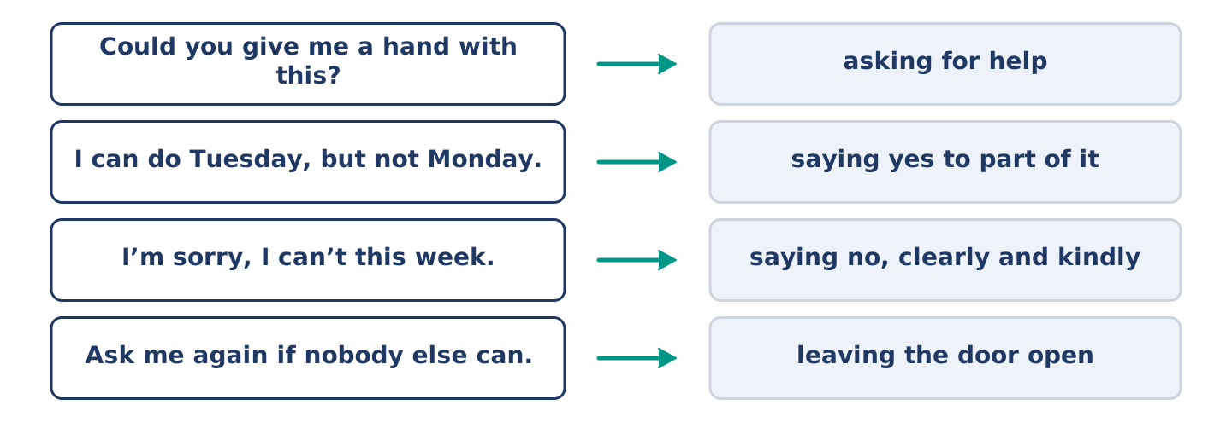
Figure 8.30 · What you say when you ask or refuse, and what each does.
Match what a person says with its purpose. One purpose is not needed. Write the letter.
Column A
1. | “Could you give me a hand with this?” | ____
2. | “I can do Tuesday, but not Monday.” | ____
3. | “I’m sorry, I can’t this week.” | ____
4. | “Ask me again if nobody else can.” | ____
Column B
a) | leaving the door open
b) | saying no, clearly and kindly
c) | asking for help
d) | asking for money
e) | saying yes to part of it
7B: Asking and Being Refused
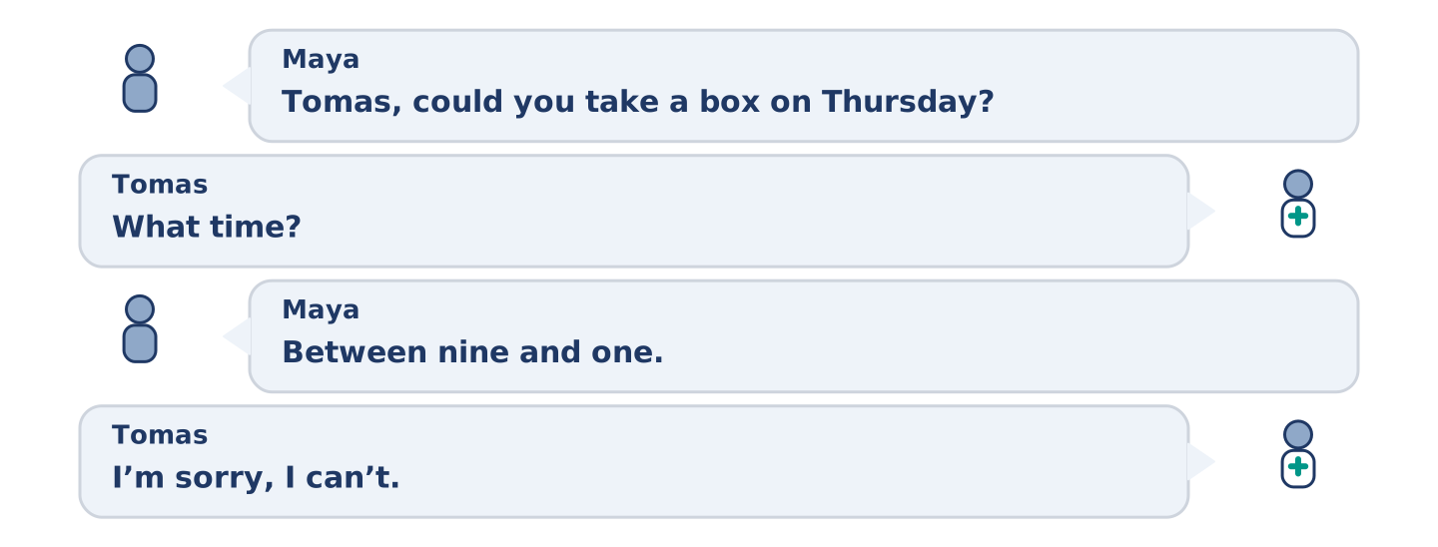
Figure 8.31 · The 7B exchange: who takes each turn.
🔊 Audio Track 8.5
Before you read: how do you say no to somebody you like?
Maya: Tomas, could you take a box on Thursday? Tomas: What time? Maya: Between nine and one. Tomas: I’m sorry, I can’t. I finish at eight and I’d be asleep through all of it. Maya: Of course. I didn’t think. Tomas: Ask Amina — she’s open and she’s thirty seconds away. Maya: I didn’t want to ask her again. Tomas: Maya, she keeps four keys in a box for exactly this. Ask her.
Answer the questions. (0. is done.)
- What does Maya ask Tomas to do? — Take a box on Thursday.
- Why can Tomas not do it?
- Who does Tomas suggest instead?
- Why did Maya not want to ask Amina again?
7C: Controlled Practice — Asking Well
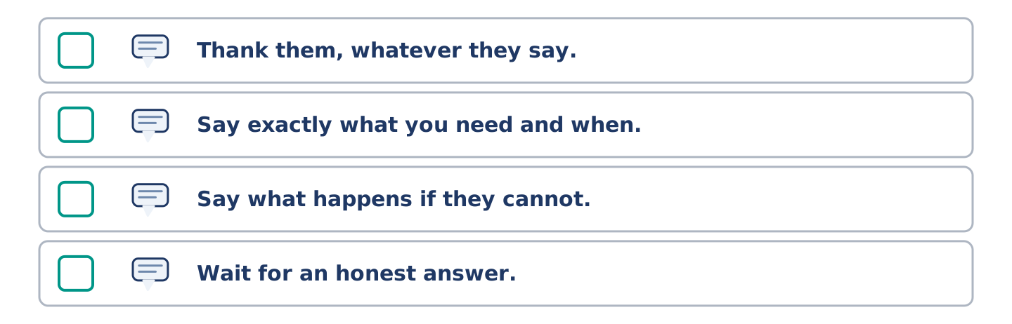
Figure 8.32 · The steps still to be numbered, as the task prints them.
Put the steps in order. Number them 1–5. (0. is done.)
- Ask whether it is possible at all. — 1
____ Thank them, whatever they say.
____ Say exactly what you need and when.
____ Say what happens if they cannot.
____ Wait for an honest answer.
7D: Role-Play — Asking and Refusing
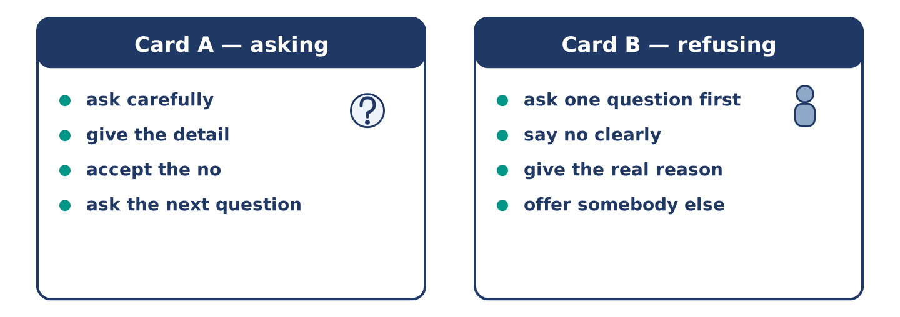
Figure 8.33 · The 7D cards: what each of you has to say.
In pairs. One asks for a favour; one has to say no. Use the model and cards.
Model exchange: A: Could you take a box on Thursday? — B: What time? — A: Between nine and one. — B: I’m sorry, I can’t. I’d be asleep. — A: Of course. — B: Ask Amina. She’s thirty seconds away.
Card A — asking: ask carefully · give the detail · accept the no · ask the next question.
Card B — refusing: ask one question first · say no clearly · give the real reason · offer somebody else.
Stretch [PLUS]: the person asking is in real trouble and you still cannot help — say so without pretending.
7E: Writing — Asking Somebody You Do Not Know Well (50–80 words)
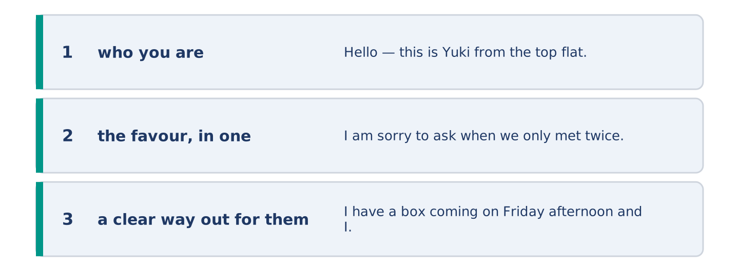
Figure 8.34 · The Part 7 note, with the model beside each line.
Write a short message asking a favour of a neighbour you have only met twice.
Model — read this first:
Hello — this is Yuki from the top flat. I am sorry to ask when we only met twice. I have a box coming on Friday afternoon and I cannot be here. Could you possibly take it in? It is small. If you are out or busy, please do not worry about it at all; we can find another day. Thank you either way. Yuki, flat 5 (67 words)
Check before you finish: ☐ who you are? ☐ the favour, in one sentence? ☐ a clear way out for them? ☐ 50–80 words?
Part 8 · Global Story — The Library That Lends Everything
[PLUS] Plus track · pre-read / discuss
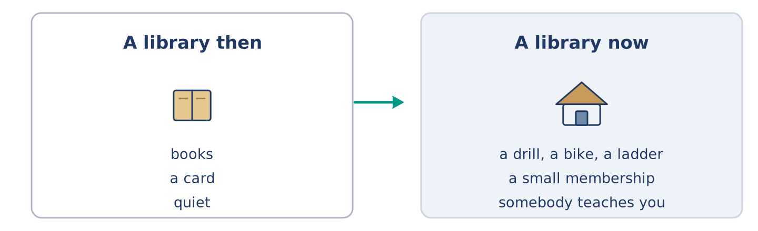
Figure 8.35 · What a library used to lend, and what it lends now.
Before you read: should a library lend you a drill?
Gloss: drill = a tool that makes holes · tool = a thing you use to make or mend something · membership = the right to use something, usually for a year · ladder = steps you carry, for reaching high things · storage = space where things sit and wait
There is a number that people in libraries like to repeat. The average drill in a house does thirteen minutes of work in its whole life. Everything else is storage. Some years ago a library in Toronto took that seriously and started lending tools as well as books. There are now hundreds of these libraries across Canada and beyond. You pay a small membership, or in many cities nothing at all, and you borrow a drill, a bike, a sewing machine, a ladder. The arguments against it were obvious and mostly wrong: people would break things, nobody would bring them back, it would cost a fortune. In practice tools come back, because the next job usually needs the same tool. The libraries say the surprising part is not the lending. It is how many people arrive to borrow a drill and leave knowing how to use one.
Answer the questions. (0. is done.)
- How much work does the average drill do in its whole life? — Thirteen minutes.
- What did a library in Toronto start doing?
- What were the arguments against it?
- What do the libraries say is the surprising part?
Part 8: Vocabulary in Context
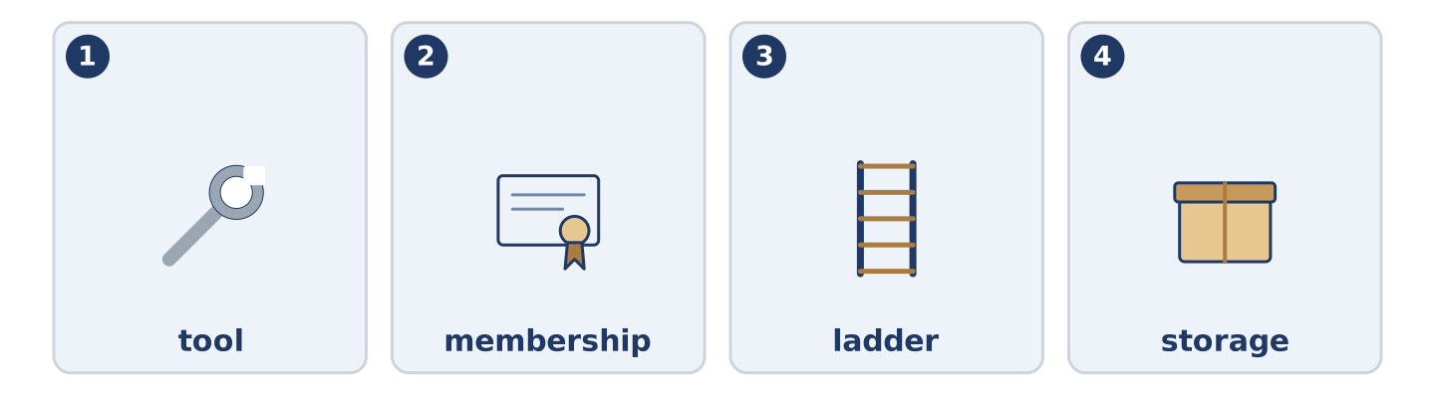
Figure 8.36 · The four words from the global story, drawn.
Match each word with its meaning. One meaning is not needed. Write the letter.
Column A
1. | tool | ____
2. | membership | ____
3. | ladder | ____
4. | storage | ____
Column B
a) | the right to use something, usually for a year
b) | space where things sit and wait
c) | a thing you use to make or mend something
d) | steps you carry, for reaching high things
e) | the others in the room
Part 8: Discussion
Talk with a partner. Use the frames.
Discussion frames: “This is similar to where I live because…” · “This is different from where I live because…” · “I think the most important thing is… because…”
Part 9 · Close to Home — What Mr Okonkwo Cannot Do
[PLUS] Plus track · pre-read / decide
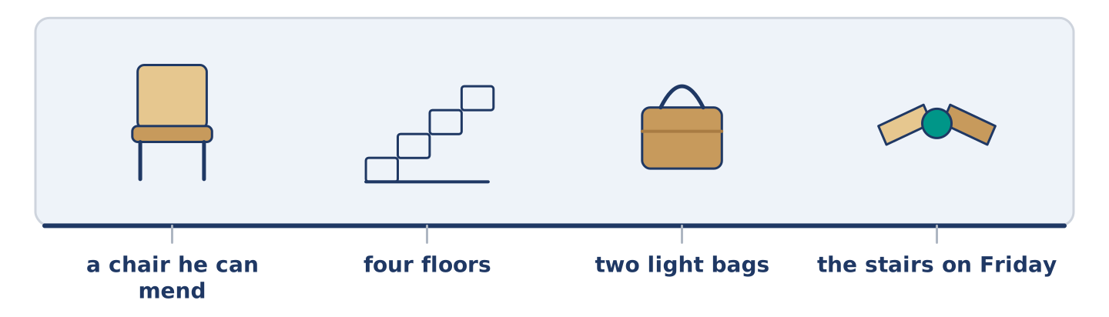
Figure 8.37 · The close-to-home reading, drawn along one street.
Before you read: is it harder to ask for help or to give it?
Mr Okonkwo can mend a chair, reline a coat and teach a child to read in a few months. He cannot, since February, carry a full shopping bag up four floors without stopping twice on the way. Nobody at number 14 mentioned this, and neither did he. Amina started putting his Friday shopping into two light bags instead of one heavy one, and said nothing. Dani began to appear on the stairs at about the right time on Fridays, with a reason. Maya asked him to teach her something, which was true and was also not the point. Mr Okonkwo noticed all three and said nothing either, which is a kind of thank you, and everybody at number 14 understood it perfectly.
Answer the questions. (0. is done.)
- What can Mr Okonkwo do? — Mend a chair, reline a coat and teach a child to read.
- What has he not been able to do since February?
- What did Amina start doing?
- What did Mr Okonkwo do about all three?
Part 9: Decision Task
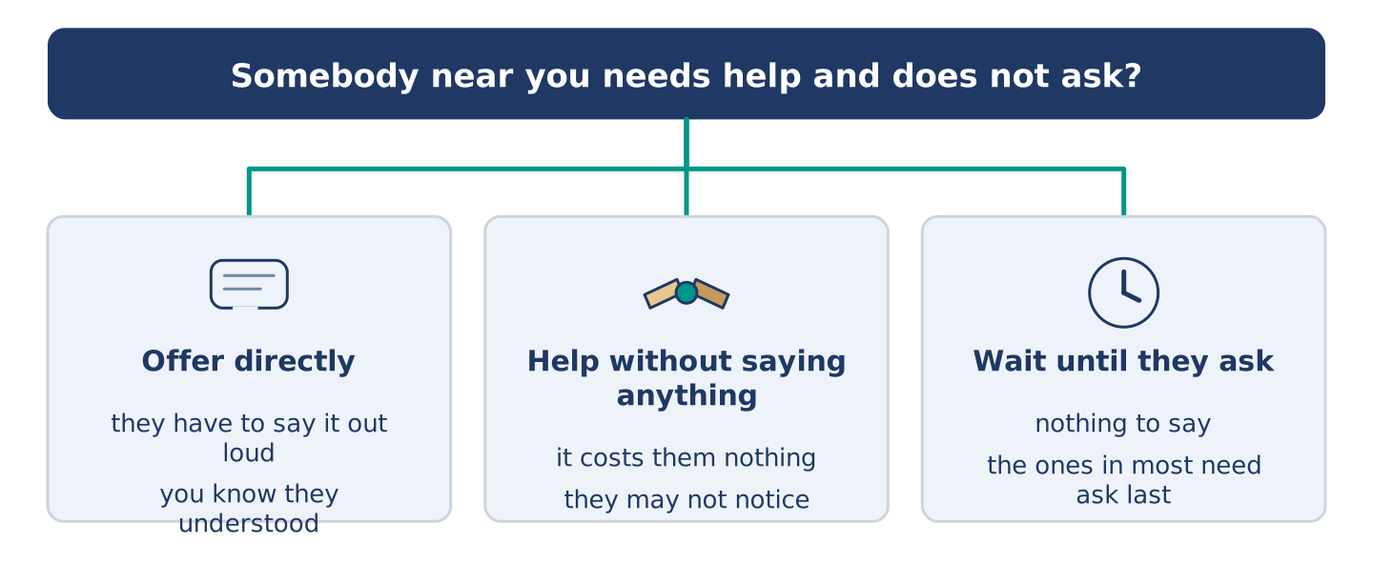
Figure 8.38 · Three ways to decide, and what each one costs.
Somebody near you needs help and does not ask. Should you (a) offer directly, (b) help without saying anything, or (c) wait until they ask? Decide and explain. Use the frame.
Answer frame: “I think I should ___ because ___. Also, ___. This is better than ___ because ___.”
Model — read this first:
I think I should help without saying anything, because an offer makes somebody say out loud that they need help. Saying it out loud is the hard part. Also, a small change nobody mentions costs them nothing. This is better than waiting until they ask, because the ones in most need of help ask last of all. (57 words)
Phrase bank: I think I should… · because… · Also,… · This is better than… · In my opinion…
Part 10 · Review and Can-Do
[CORE + PLUS] · homework / self-study
Part 10: Spiral Review
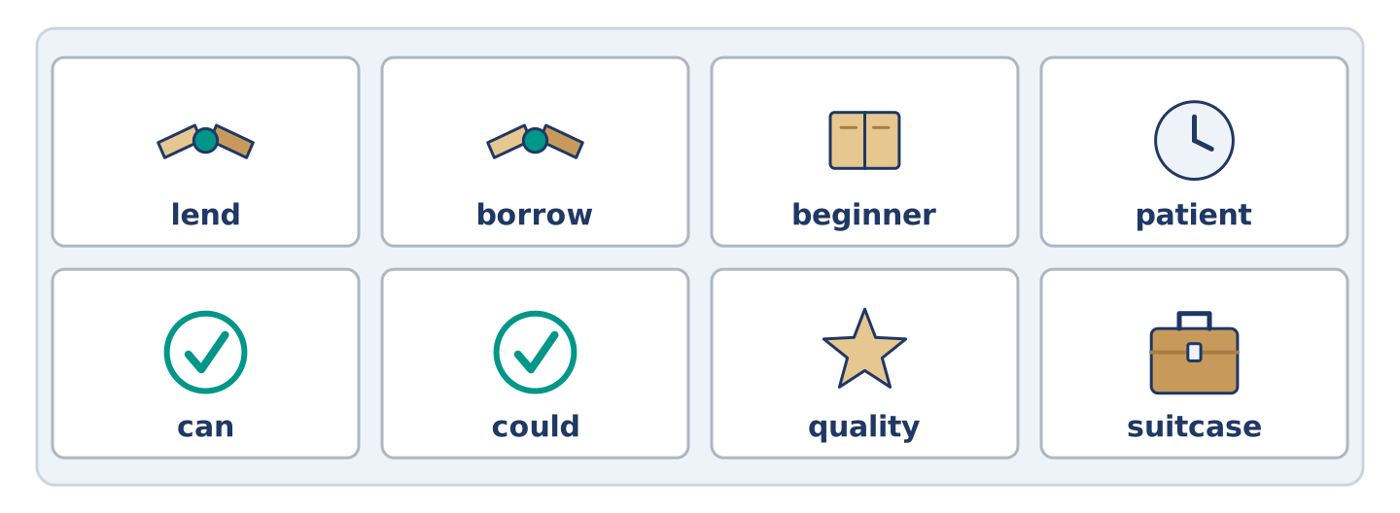
Figure 8.39 · The eight words of the review bank, in bank order.
Complete the review. (0. is done.)
- A kind thing you do because somebody asked is a favour.
Word bank: lend | borrow | beginner | patient | can | could | quality | suitcase
- To give something to somebody for a short time is to ______________________ .
- To take something from somebody for a short time is to ______________________ .
- Somebody who is starting to learn is a ______________________ .
- Calm with somebody who is slow or frightened is ______________________ .
- Amina ______________________ add four prices in her head. (now)
- Yuki ______________________ float when she was eight. (then)
- (from Unit 7) How good something is, and how long it lasts, is its ______________________ .
- (from Unit 6) A big case with a handle, for your clothes, is a ______________________ .
Part 10: Can-Do
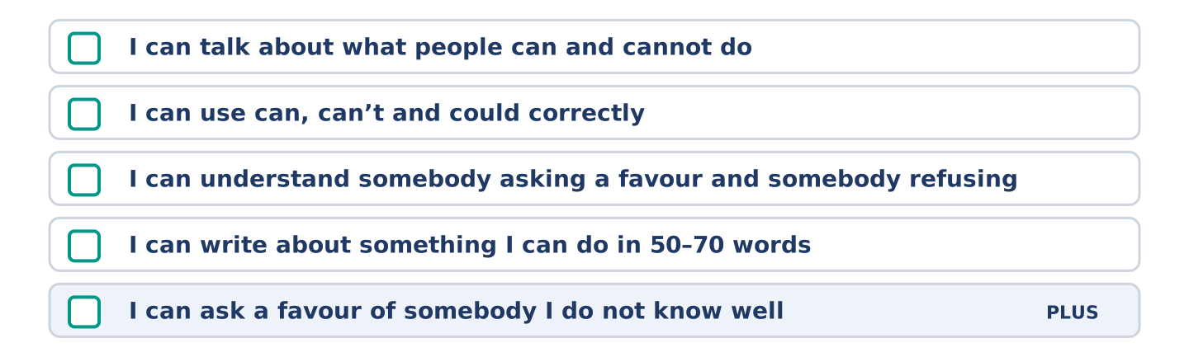
Figure 8.40 · What you can do at the end of this unit.
Can-Do checklist
☐ I can talk about what people can and cannot do.
☐ I can use can, can’t and could correctly.
☐ I can understand somebody asking for a favour and somebody refusing.
☐ I can write about something I can do in 50–70 words.
☐ I can ask a favour of somebody I do not know well (Plus).
Part 10: Glossary
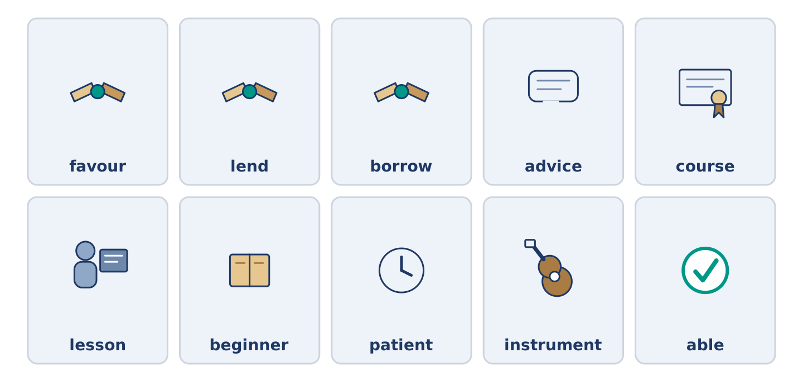
Figure 8.41 · All ten glossary words of Unit 8, one card each.
Unit 8 glossary (10 words)
favour · lend · borrow · advice · course · lesson · beginner · patient · instrument · able

