Unit 9: Finding Your Way
English for Daily Life · Level: A2 · Tracks: [CORE] Warm-Up + Parts 1–6 · [PLUS] Parts 7–10
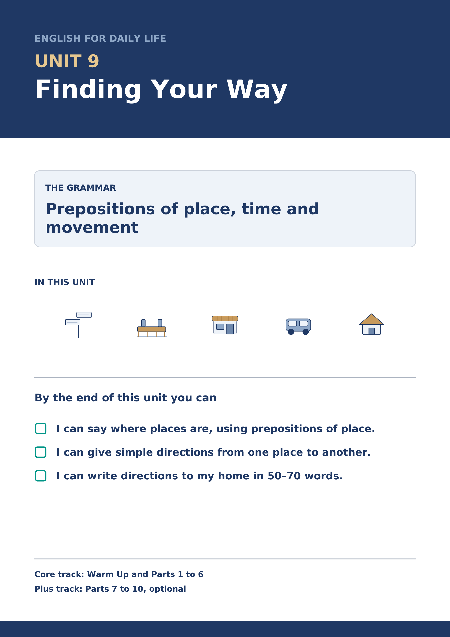
Warm Up
[CORE] Core track · in-class starter
Warm-up: Words for Places and Roads
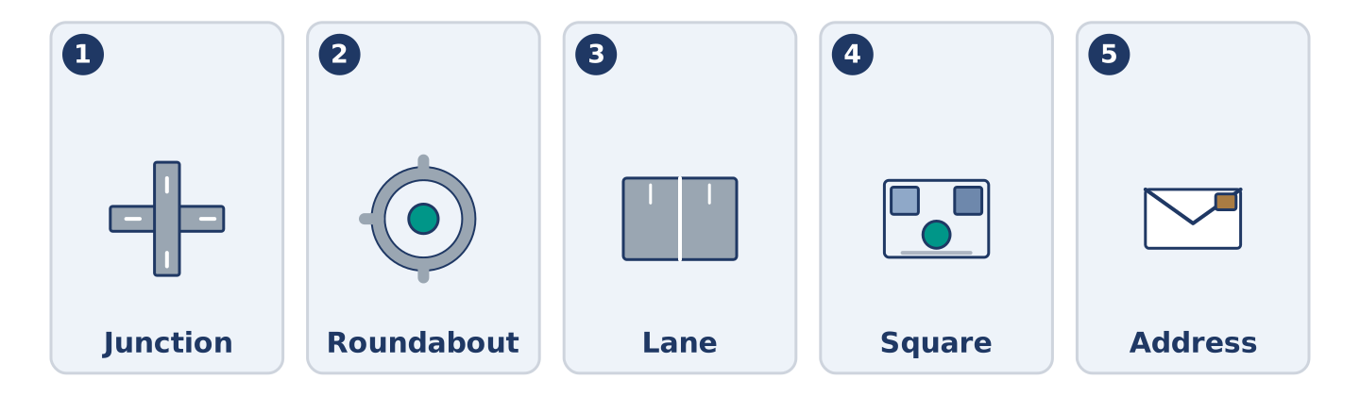
Figure 9.2 · The five warm-up words, and the thing each one means.
Match the words with their meanings. One meaning is not needed. Write the letter.
Column A
1. | Junction | ____
2. | Roundabout | ____
3. | Lane | ____
4. | Square | ____
5. | Address | ____
Column B
a) | the number and the street where somebody lives
b) | a circle of road where cars go round one way
c) | a narrow road between fields or houses
d) | where two or more roads meet
e) | an open space in a town with buildings round it
f) | a wide road that goes round a whole city
Warm-up: Saying Where Things Are
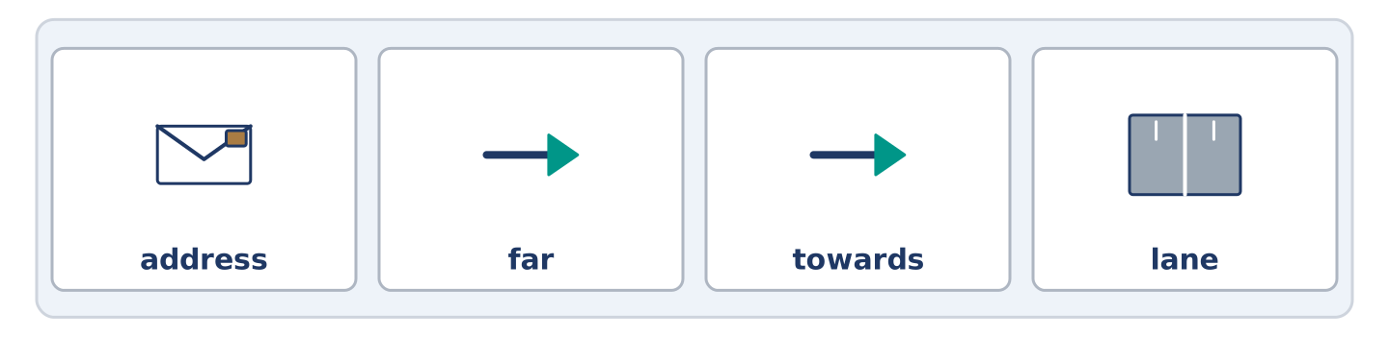
Figure 9.3 · The word bank for this task, in the order it is printed.
Complete the sentences using the words in the word bank.
Word bank: address | far | towards | lane
- Yuki wrote her new ______________________ on a card for Amina.
- The health centre is not ______________________ — about eight minutes on foot.
- Walk ______________________ the bridge and turn left at the bench.
- The shop takes its boxes in from a narrow ______________________ behind the building.
Warm-up: Alder Street from End to End
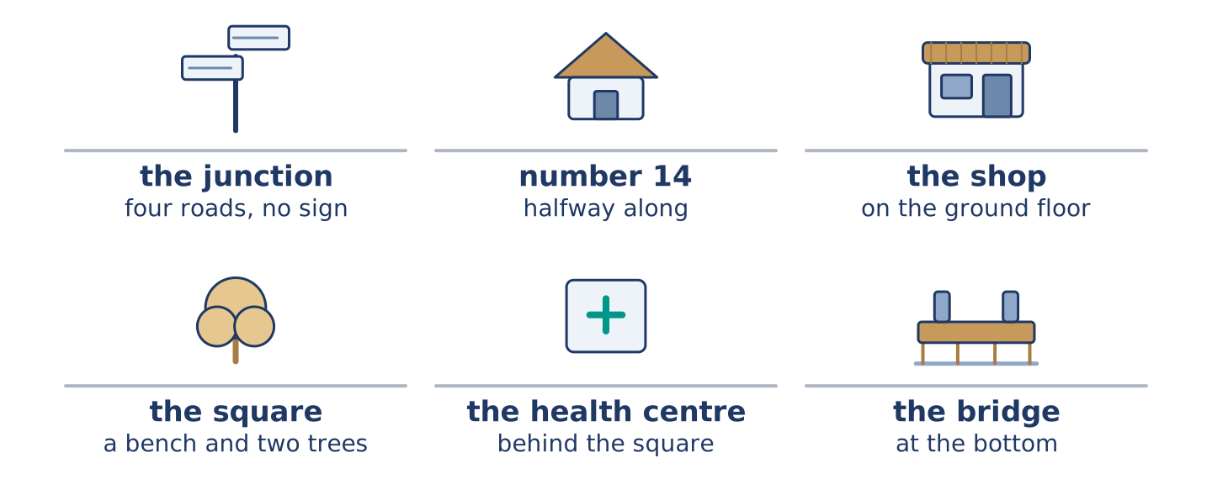
Figure 9.4 · Alder Street from the junction at the top to the square at the bottom.
Read the text and choose the correct answer.
Alder Street runs downhill between the market and the bridge. Number 14 is the tall house halfway along, with the shop on the ground floor. At the top there is a junction with four roads and no sign. At the bottom there is a small square with a bench and two trees. The health centre is behind the square. A first-time visitor usually stops at the junction and rings from there.
1. Where is number 14?
○ A) At the top of the street
○ B) Behind the square
○ C) Next to the bridge
○ D) Halfway along the street
2. What is at the bottom of the street?
○ A) A small square
○ B) A junction with four roads
○ C) The market
○ D) The health centre
Part 1 · Vocabulary and Terminology
[CORE] Core track · pre-class input
Part 1: Words for Finding Your Way
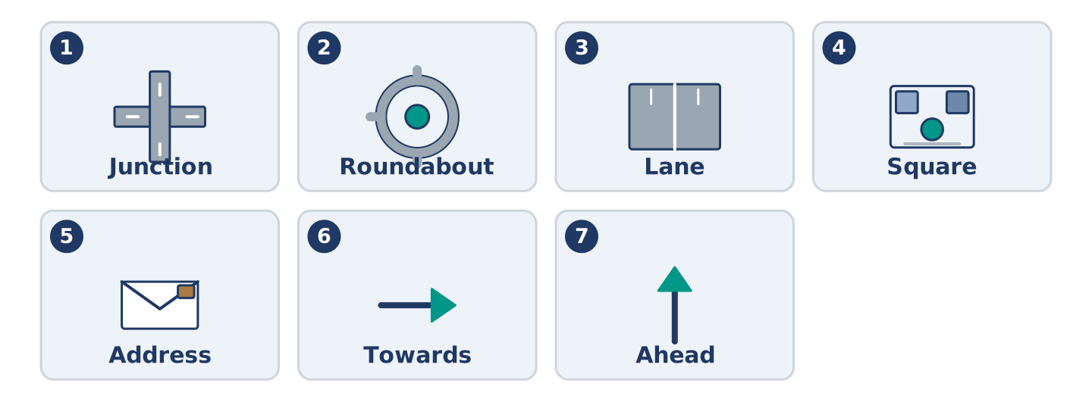
Figure 9.5 · The seven words of Column A, and what each one is.
Match the words with their meanings. One meaning is not needed. (0. is done for you.)
- Block → a group of buildings with streets on all four sides.
Column A
1. | Junction | ____
2. | Roundabout | ____
3. | Lane | ____
4. | Square | ____
5. | Address | ____
6. | Towards | ____
7. | Ahead | ____
Column B
a) | in the direction of something
b) | where two or more roads meet
c) | a circle of road where cars go round one way
d) | in front of you, further along
e) | the number and the street where somebody lives
f) | an open space in a town with buildings round it
g) | a narrow road between fields or houses
h) | the paper that tells you when the bus leaves
Gloss: junction = where two or more roads meet · roundabout = a circle of road where cars go round one way · lane = a narrow road
Part 1: Pronunciation
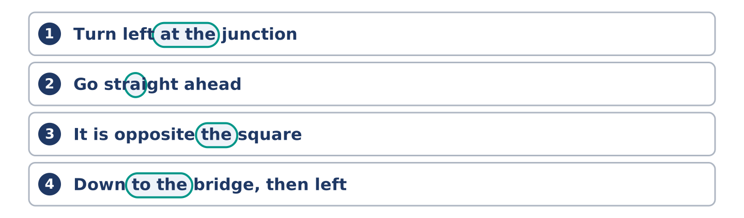
Figure 9.6 · Where the stress falls in 0 words of this unit.
🔊 Audio Track 9.1
Listen to these directions. Say each one aloud, then say it to a partner.
Turn left at the junction — at the is weak and quick: /ətðə/
Go straight ahead — a in ahead almost disappears: /əˈhed/
It is opposite the square — the is weak again: /ðə/
Down to the bridge, then left — to the is one soft sound: /təðə/
Directions carry the sense in the big words: left, junction, ahead, bridge. The small words between are weak and fast. Give them all the same weight and your listener cannot hear which ones matter.
Part 1: Four Kinds of Place
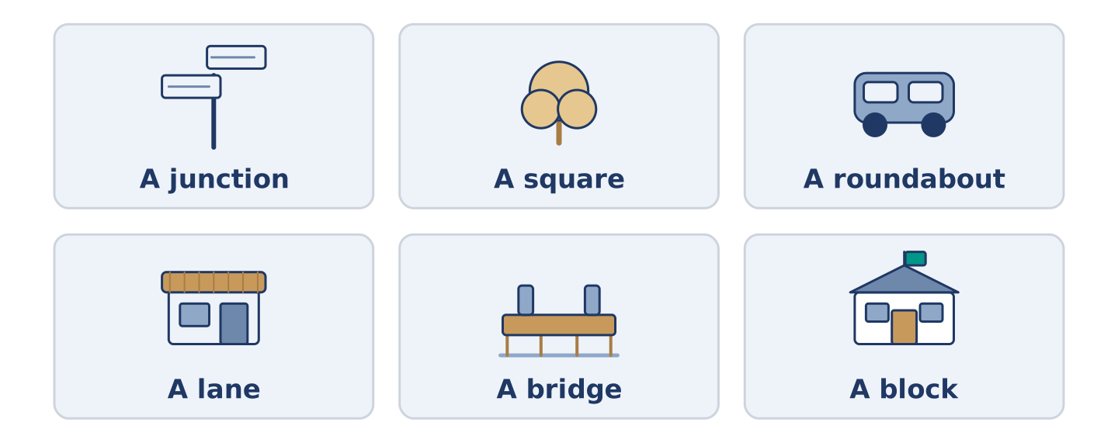
Figure 9.7 · Four kinds of place, and what you see at each one.
Complete the table. Write what you see there and how you say where it is. (0. is done.)
Place | What you see there | How you say where it is
A junction | four roads and no sign | (example)
A square
A roundabout
A lane
- A junction — four roads and no sign — at the junction.
Think about the street you know best. There is more than one right answer; be ready to say why.
Part 1: Where Exactly?
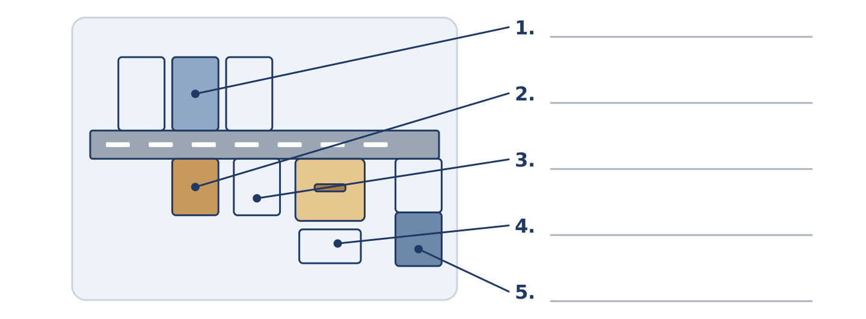
Figure 9.8 · Where exactly — write the correct word on each line.
Match the words with their meanings. One meaning is not needed. Write the letter.
Column A
1. | Opposite | ____
2. | Between | ____
3. | Behind | ____
4. | Below | ____
5. | Next to | ____
Column B
a) | with one thing on each side
b) | under it, on a lower floor
c) | at its side, touching or almost
d) | on the other side of the road from it
e) | further along the same road
f) | on the far side of it, out of sight
Part 1: Finding Your Way — Multiple Choice
Read and choose the correct answer.
1. Where two or more roads meet is a…
○ A) square
○ B) lane
○ C) junction
○ D) block
2. The number and the street where you live is your…
○ A) sign
○ B) map
○ C) direction
○ D) address
3. In front of you, further along, is…
○ A) below
○ B) ahead
○ C) towards
○ D) opposite
Part 1: Vocabulary Fill-in
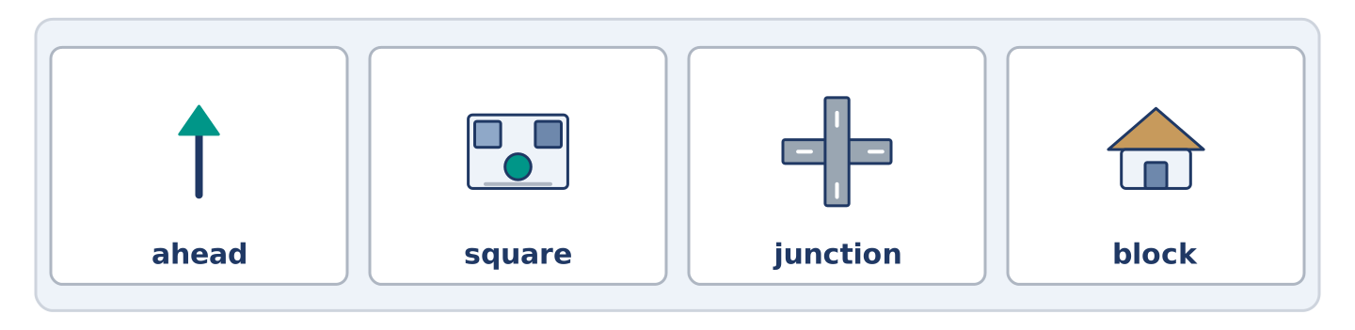
Figure 9.9 · The four words of the bank, in the order the task gives them.
Complete the sentences with the correct word.
Word bank: ahead | square | junction | block
- Walk straight ______________________ for two minutes and you reach the bridge.
- There is a bench and two trees in the ______________________ at the bottom.
- Turn right at the ______________________ and the health centre is on your left.
- The hospital takes up a whole ______________________ near the river.
Part 1: Write Where You Live (short)
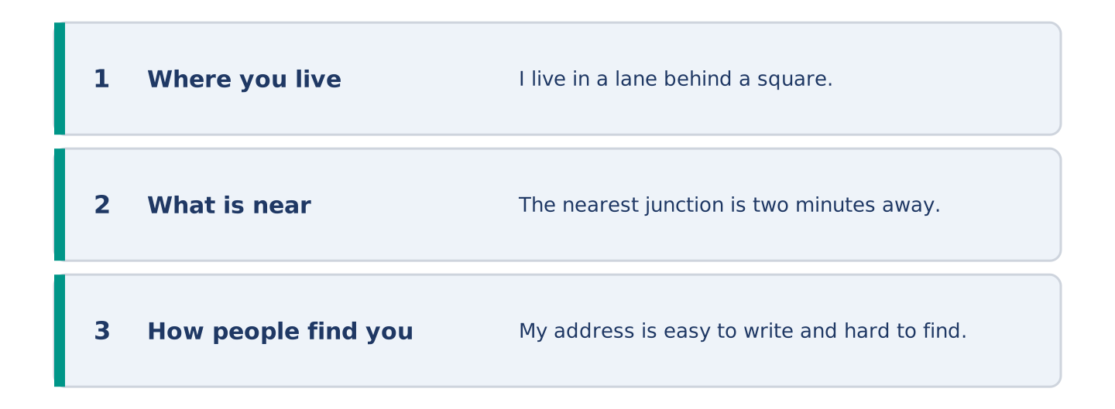
Figure 9.10 · The shape of your two or three sentences, with the model beside each step.
Write two or three sentences saying where you live. Use three words from this unit.
Model — read this first:
I live in a lane behind a square, and the lane has no sign at either end. The nearest junction is two minutes away, and I tell people to wait there. My own address is easy to write and almost impossible to find. (43 words)
Part 2 · Grammar — Prepositions of Place, Time and Movement
[CORE] Core track · pre-class input
Part 2: Notice
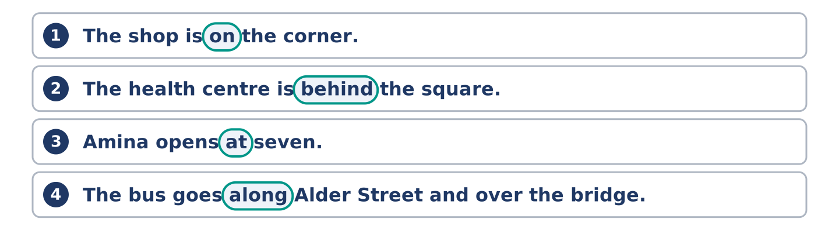
Figure 9.11 · Lines from the notice, with the target form ringed in each.
Read these lines. Underline the prepositions. Which say where, which say when, and which say how?
The shop is on the corner. The health centre is behind the square. Amina opens at seven. The bus goes along Alder Street and over the bridge. Yuki walked towards the junction and stopped. On Saturday the market is in the square. The 7 goes round the roundabout twice.
Three say where. Two say when. Two say how somebody moves.
Part 2: Grammar Focus Box
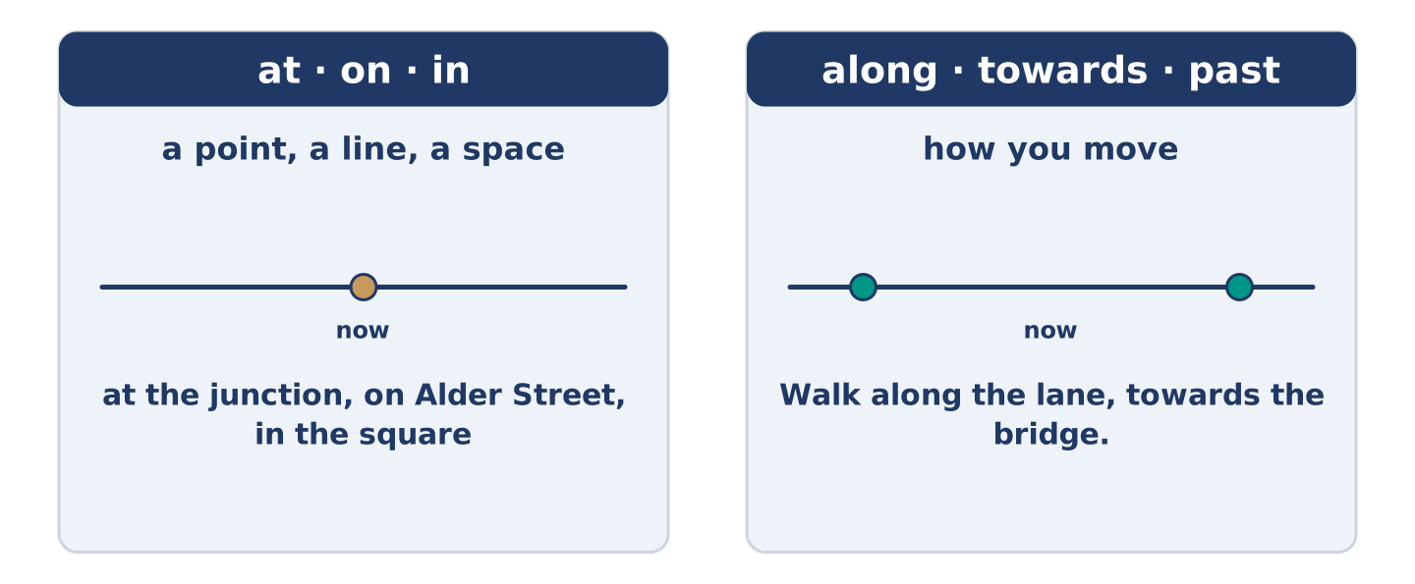
Figure 9.12 · At, on and in: a point, a line and a space.
 | Form | Use | Example
at | + a point | a spot | Wait at the junction.
on | + a line | a street | He lives on Alder Street.
in | + a space | a town | The market is in the square.
along / towards | + a path | movement | Walk along the lane.
above / below | + a thing | position | His flat is above the shop.
Remember: at is for a point, on for a line, in for a space: at the junction, on Alder Street, in the square.
Watch out! ✗ The health centre is behind of the square. → ✓ The health centre is behind the square. (no of after behind). ✗ Walk at the bridge. → ✓ Walk to the bridge. (to for where you end up).
Part 2: Controlled Practice
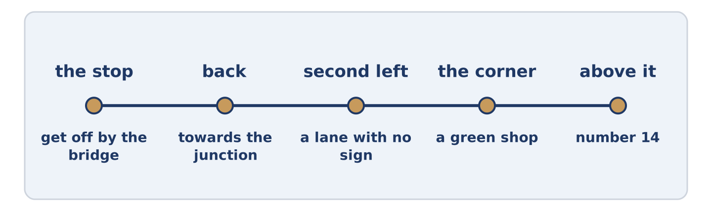
Figure 9.13 · One walk, from the junction to the health centre, step by step.
Complete with at, on, in, along or towards. (0. is done.)
- Amina opens the shop at seven.
- Number 14 is ______________________ Alder Street.
- Walk ______________________ the lane and you come out by the bridge.
- The market is ______________________ the square on Saturday.
- Yuki walked ______________________ the junction and stopped.
Part 2: Where, When or How?
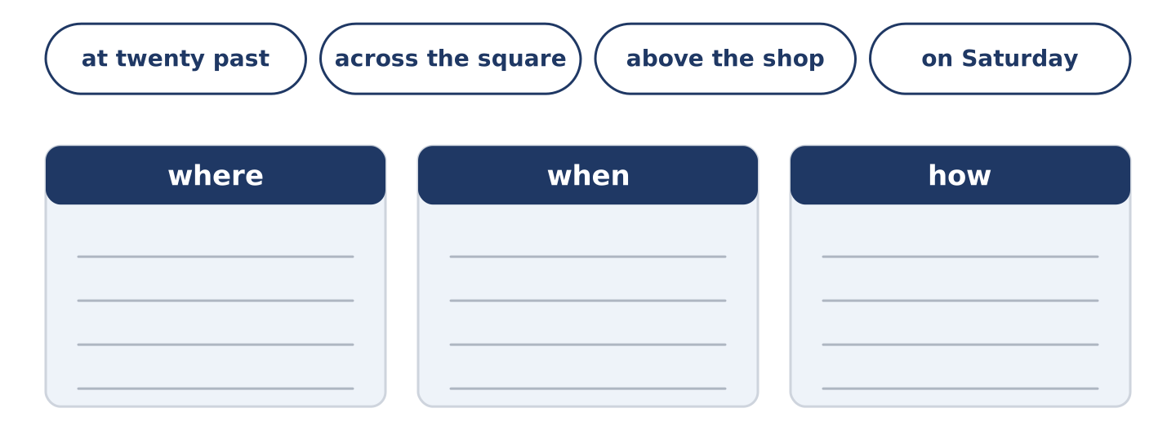
Figure 9.14 · The items of this task, and the bins they sort into.
Write where, when or how. (0. is done.)
- The health centre is behind the square. — where
- The bus leaves at twenty past eight. ____________
- Walk across the square. ____________
- His flat is above the shop. ____________
- On Saturday the market opens early. ____________
Part 2: Correct the Sentence
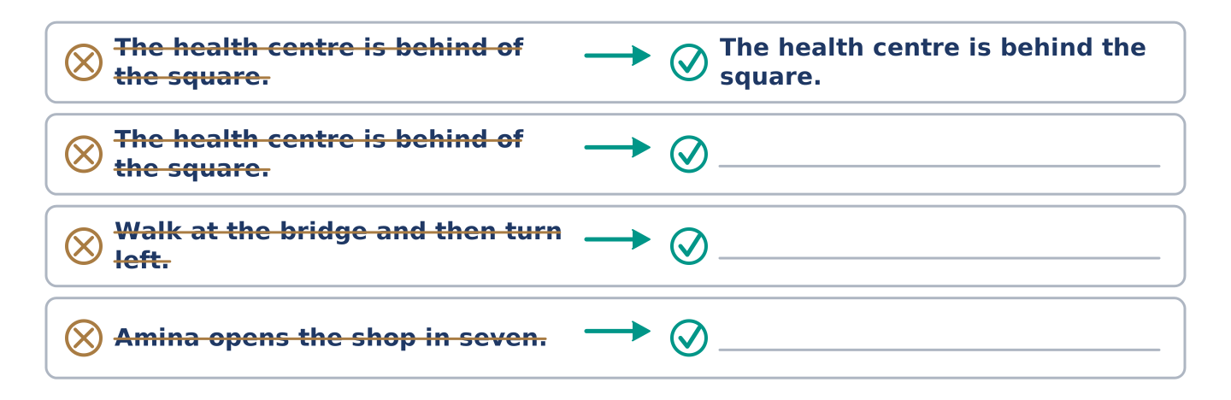
Figure 9.15 · One correction done for you, and the rest to write.
Each sentence has one grammar mistake. Write the correct sentence.
- The health centre is behind of the square.
- Walk at the bridge and then turn left.
- Amina opens the shop in seven.
- Yuki lives at the top flat of number 14.
Part 2: Freer Practice
Write two sentences: one saying where you live, and one saying how a visitor walks to you from the bus stop.
Part 2: Grammar Review
Choose the correct sentence.
1. Which sentence about place is correct?
○ A) The health centre is behind the square.
○ B) The health centre is behind of the square.
○ C) The health centre is behind to the square.
○ D) The health centre is behind at it.
2. Which sentence about movement is right?
○ A) Walk at the bridge, then left.
○ B) Walk in the bridge, then left.
○ C) Walk to the bridge, then left.
○ D) Walk the bridge way, then left.
→ Harvest: you will see these prepositions again in the Part 5 reading. Watch for the words that say where.
Part 3 · Listening
[CORE] Core track · pre-class input · scripts printed inline
Part 3: Asking the Way Next Door
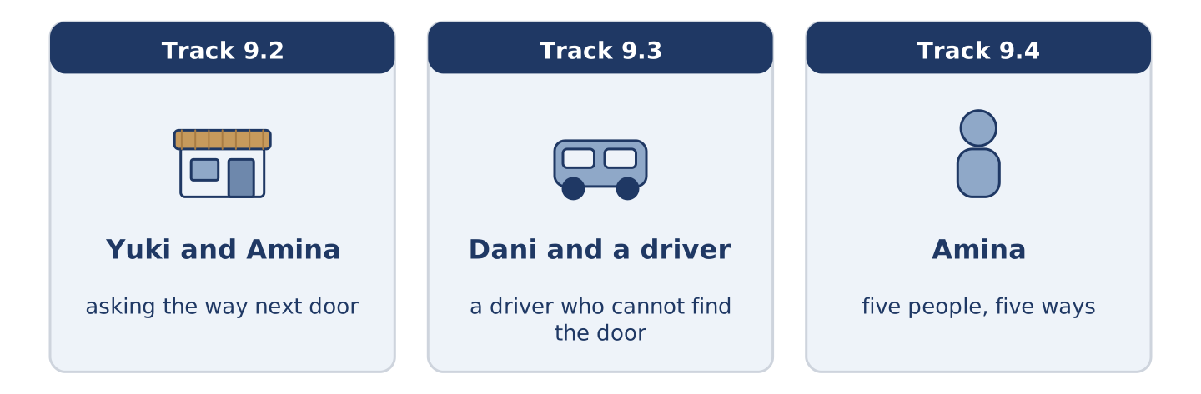
Figure 9.16 · The three listenings: who is speaking, and what about.
🔊 Audio Track 9.2
Before you listen: how do you ask the way in a place you do not know?
Yuki: Amina, how do I get to the health centre? Amina: Out of the door, left, down to the square. Yuki: And then? Amina: You cross the square, you pass the bench, and it’s the low building behind. Yuki: Is it far? Amina: Eight minutes for you. Ten if you stop to read the signs, and I tell you now, they’re no help. Yuki: Why not? Amina: They point at the old one, and the old one closed in the spring.
While you listen: write True, False, or Not Given. (0. is done.)
- Yuki asks the way to the health centre. — True
- Amina says the health centre is behind the square. ____
- The walk takes twenty minutes. ____
- Amina went to the health centre last week. ____
Useful phrases: How do I get to…? · And then? · Is it far? · past the…
Part 3: A Driver Who Cannot Find the Door
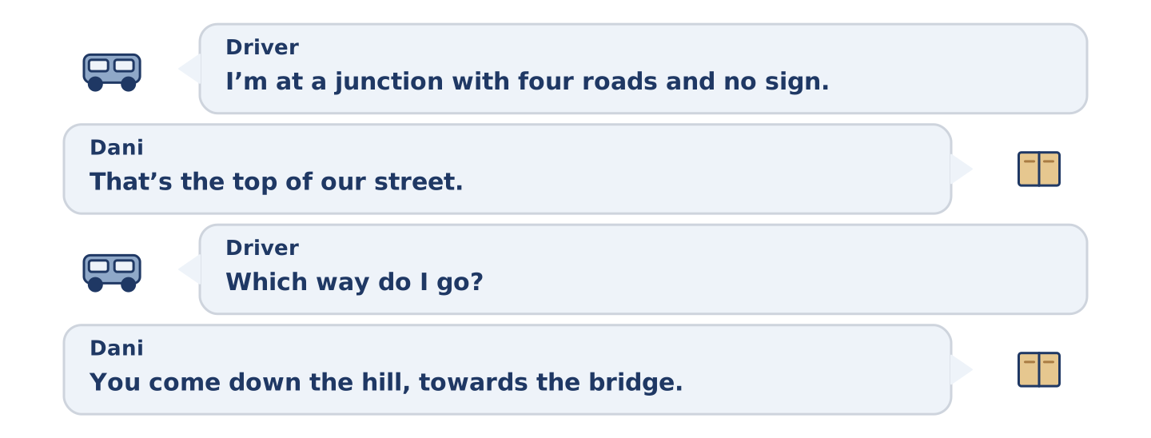
Figure 9.17 · The second listening, turn by turn.
🔊 Audio Track 9.3
Before you listen: what do you say on the phone to somebody who cannot find you?
Driver: I’m at a junction with four roads and no sign. Dani: That’s the top of our street. Driver: Which way do I go? Dani: You come down the hill, towards the bridge. Driver: I can see a shop. Dani: Stop there — we’re on the ground floor behind it. Driver: I can’t see a number. Dani: You never do, in this street. Look for the green one. Driver: Got it.
Answer the questions. (0. is done.)
- Where is the driver? — At a junction with four roads.
- Which way does Dani tell him to come?
- Where in the building does Dani live?
- What does Dani tell him to look for?
Part 3: Five People, Five Ways
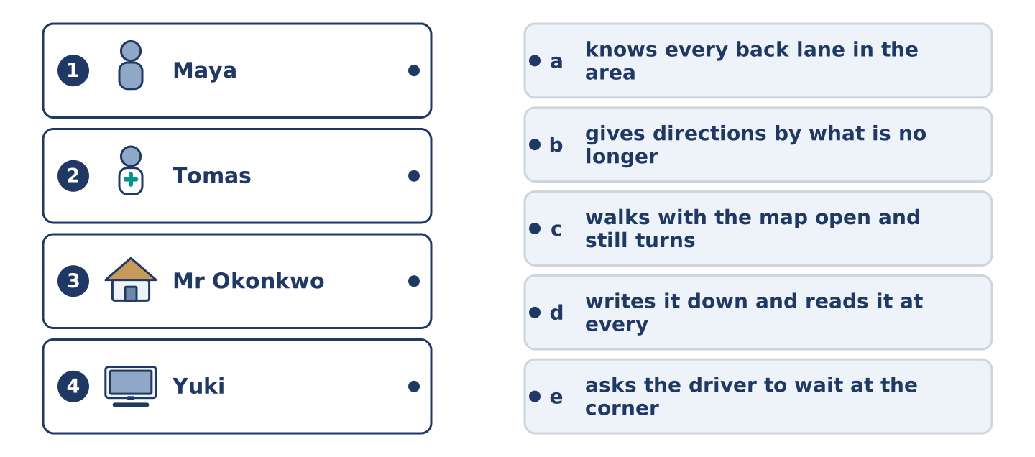
Figure 9.18 · Four on the left, five on the right, and one spare.
🔊 Audio Track 9.4
Before you listen: do you follow a map, a sign or a person?
Amina: I watch them all go past, and every one of them does it differently. Maya walks with her map open and still turns the wrong way. Tomas knows every back lane between us and the hospital. Dani goes by the shops, and he gets there. Mr Okonkwo gives you directions by what used to be on the corner, and those shops closed years ago. Yuki writes it down, and I see her read it again at every junction.
While you listen: match each person with their way of finding it. One is not needed. (0. is done.)
- Amina → she watches them all go past.
Useful phrases: ___ walks with the map · ___ knows the back lanes · ___ writes it down
Column A
1. | Maya | ____
2. | Tomas | ____
3. | Mr Okonkwo | ____
4. | Yuki | ____
Column B
a) | knows every back lane in the area
b) | gives directions by what is no longer there
c) | walks with the map open and still turns the wrong way
d) | writes it down and reads it at every junction
e) | asks the driver to wait at the corner
Part 4 · Speaking
[CORE] Core track · in-class output
Part 4: How You Find Your Way
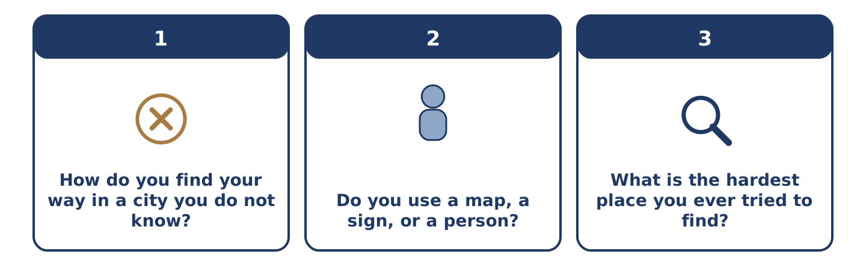
Figure 9.19 · The three questions as cards, to take one at a time.
Work with a partner. Ask and answer these questions.
- How do you find your way in a city you do not know?
- Do you use a map, a sign, or a person?
- What is the hardest place you ever tried to find?
Useful language: I go by… · I look for… · straight ahead · towards the…
Part 4: Find the Difference (pairwork)
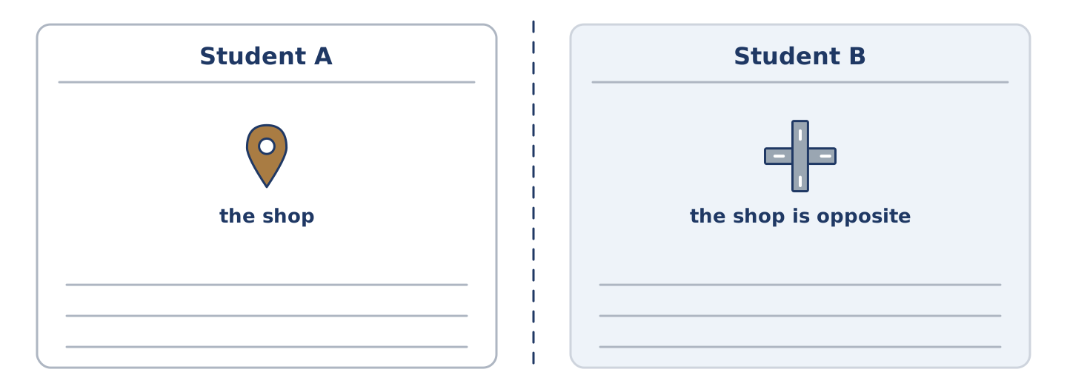
Figure 9.20 · Student A’s facts and Student B’s, with a fold between them.
Student A and Student B each have a map of the same street. Ask questions and find three differences.
Useful questions: Where is the shop? · Is it opposite the square? · What is next to the junction? · How far is the bridge?
Student A — on your map: the shop is on the corner, the bench is in the square, the health centre is behind the square.
Student B — on your map: the shop is opposite the square, the bench is by the junction, the health centre is next to the bridge.
Part 4: Asking the Way
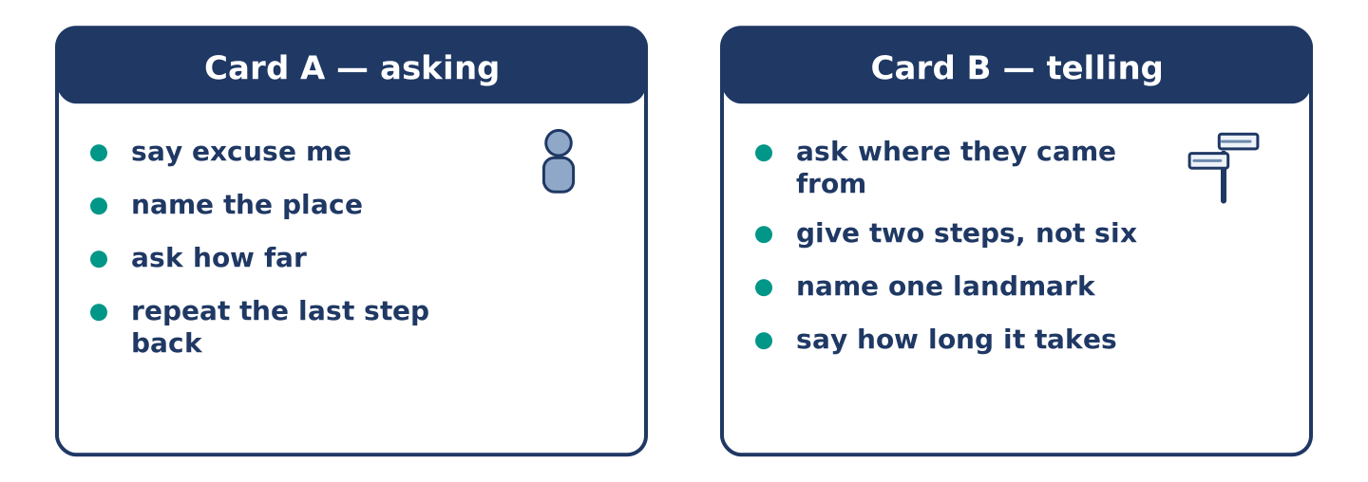
Figure 9.21 · Card A and Card B: what each of you has to say.
Work in pairs. Read the model, then use the cards.
Model exchange:
A: Excuse me, how do I get to the square? — B: Straight ahead, then left at the junction. — A: Is it far? — B: Four minutes. — A: And the health centre? — B: Behind the square, the low building. — A: Thank you.
Useful language: Excuse me… · How do I get to…? · Is it far? · Straight ahead.
Card A — asking: say excuse me · name the place · ask how far · repeat the last step back.
Card B — telling: ask where they came from · give two steps, not six · name one landmark · say how long it takes.
Your turn: run the dialogue, then swap roles.
Stretch [PLUS]: you do not know the way either — say so, and still be useful.
Part 4: Mini-Presentation
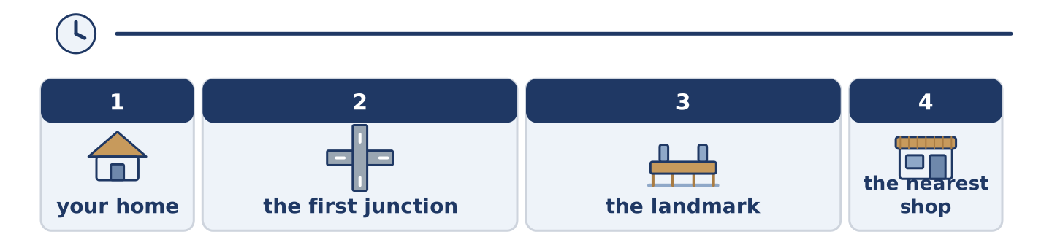
Figure 9.22 · The one-minute talk as 0 beats, each as wide as its share.
Prepare a short talk (about one minute). Describe the way from your home to the nearest shop, in four steps.
Part 5 · Reading
[CORE] Core track · pre-class input
Part 5: Why Some People Cannot Read a Map
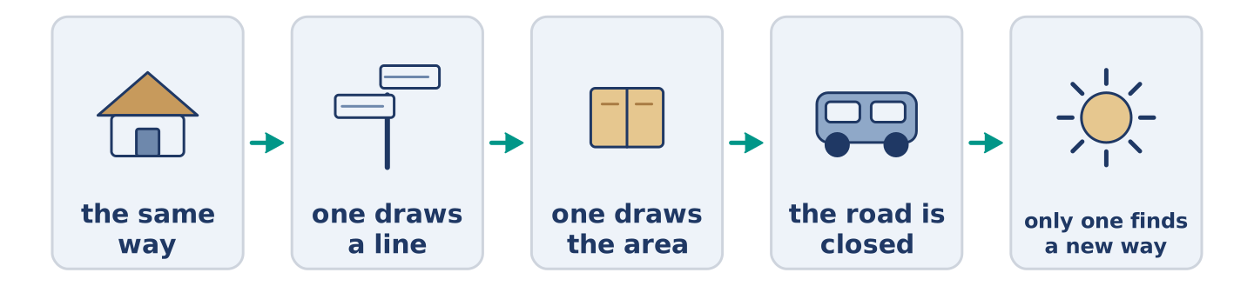
Figure 9.23 · One walk, two ways of knowing it.
Before you read: do you find your way by map or by landmark?
Gloss: landmark = a thing you can see and remember · route = the line you walk from one place to another · survey = a picture of the whole place · facing = looking in that direction
Two people walk the same way home every day for a year. Ask them to draw it. One draws a line with four turns, in the right order. The other draws the whole area, river included. Both of them get home. Only the second one finds a new way when the road is closed. The first kind of knowing is the route: the line you walk. The second is the survey: the picture of the whole place. Most of us stay with the first, because it works. A map helps only when the reader already knows which way they face. That is why a traveller can hold a map, turn it round twice, and walk the wrong way out of a station. The map is not the problem. The direction is.
Answer the multiple-choice questions. (0. is done.)
- What do the two people do every day? — They walk the same way home.
1. What does the first person draw?
○ A) The whole area
○ B) A line with four turns
○ C) The river
○ D) The station
2. Who finds a new way when the road is closed?
○ A) Both of them
○ B) Neither of them
○ C) The first person
○ D) The second person
3. According to the text, what is the thing that really goes wrong?
○ A) The direction you are facing
○ B) The map
○ C) The river
○ D) The road
Part 5: Vocabulary in Context
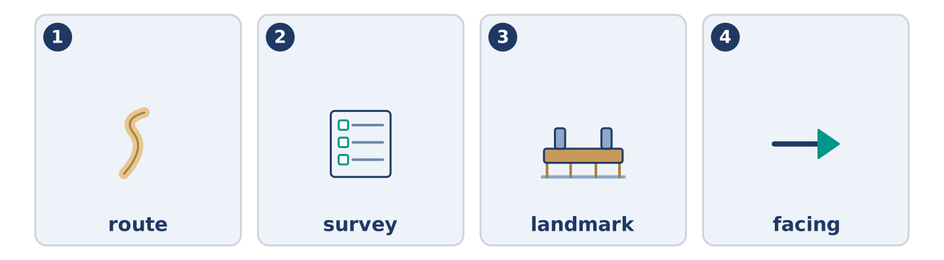
Figure 9.24 · The four words from the reading, drawn.
Match each word from the text with its meaning. One meaning is not needed. Write the letter.
Column A
1. | route | ____
2. | survey | ____
3. | landmark | ____
4. | facing | ____
Column B
a) | a thing you can see and remember
b) | the line you walk from one place to another
c) | looking in that direction
d) | a picture of the whole place
e) | a wide road that goes round a city
Part 5: How Three Cities Tell You Where You Are
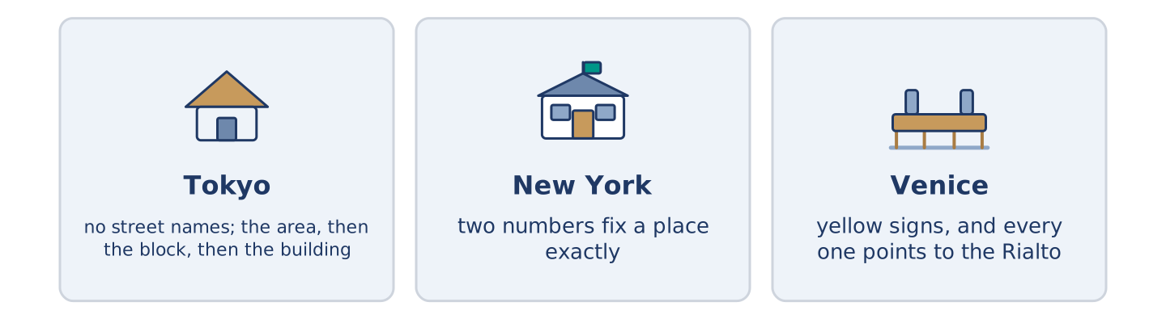
Figure 9.25 · Three cities, three ways of saying where you are.
Before you read: how does your own city tell you where you are?
Gloss: grid = streets that cross each other in straight lines · avenue = a wide street with trees · police box = a very small police station on a corner
Cities answer that very differently. In Tokyo most streets have no name. An address names the area, then the block, then the building, and the buildings run by age, not by position. So people find their way by landmarks, and there is a police box on many corners. In New York the streets run one way in numbers and the avenues run the other way. Two numbers fix a place exactly, and nobody there offers a landmark. In Venice almost nothing carries a useful number. Instead small yellow signs sit high on the walls, and every one points to the Rialto or to San Marco. They never find a stranger’s own street, but nobody stays lost for long.
Answer the questions. (0. is done.)
- Do most streets in Tokyo have names? — No, most of them do not.
- What three things does a Tokyo address give you?
- What do you need to know in New York to know where you stand?
- What do the yellow signs in Venice point to?
Part 6 · Writing
[CORE] Core track · in-class / homework
Part 6: Directions to Your Door (50–70 words)
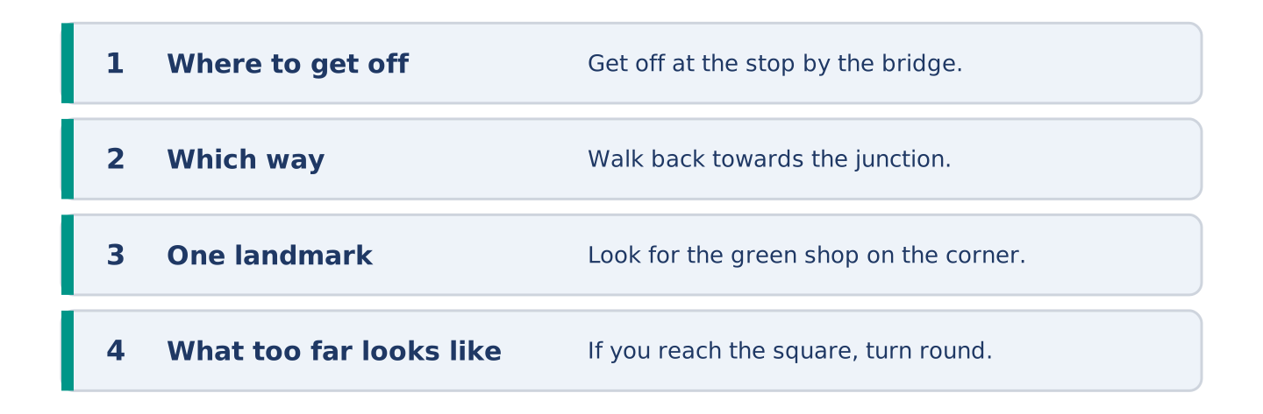
Figure 9.26 · The shape of the directions you are about to write.
A friend is coming to your home for the first time. Write the directions from the nearest bus stop.
Model — read this first:
Get off at the stop by the bridge and walk back towards the junction. Take the second road on your left; it is a narrow lane with no sign. Keep going until you see a green shop on the corner. We are above the shop, at number 14. If you reach the square, turn round — that is too far. (60 words)
Plan (fill in, then write): Get off at ___. Walk towards ___. Take the ___ road on your ___. Look for ___. We are ___.
Word bank: get off | towards | straight ahead | on your left | opposite | until
Check before you finish: ☐ where to get off? ☐ two or three steps only? ☐ one landmark? ☐ 50–70 words?
Part 6: A Map or a Person? (50–70 words)
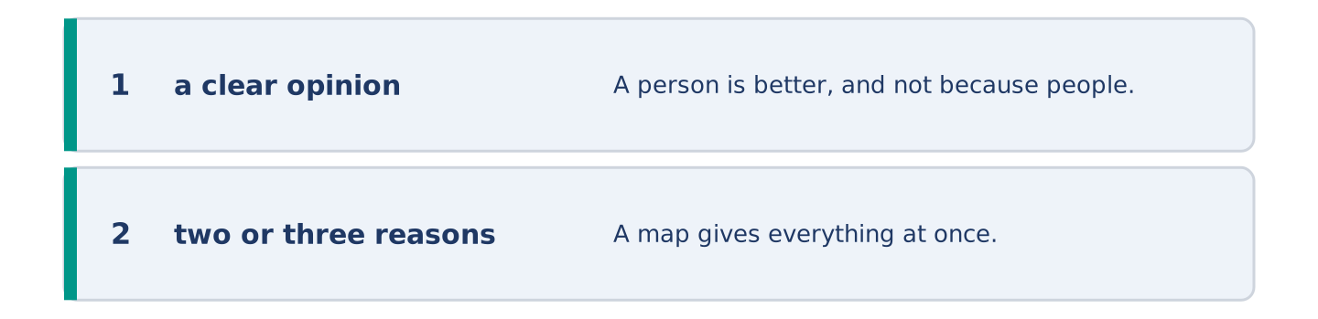
Figure 9.27 · The shape of the opinion paragraph, step by step.
Is it better to ask a person or to look at a map? Give your opinion and two or three reasons.
Model — read this first:
A person is better, and not because people are kinder than maps. A map gives everything at once, and almost none of it is the part you need. A person gives three steps and one landmark, and then stops. The only trouble is that somebody who does not know the way often does not say so. (56 words)
Word bank: I think… because… | better | however | in my opinion | it depends on
Check before you finish: ☐ a clear opinion? ☐ two or three reasons? ☐ 50–70 words?
Part 6: A Place That Is Hard to Find (50–70 words)
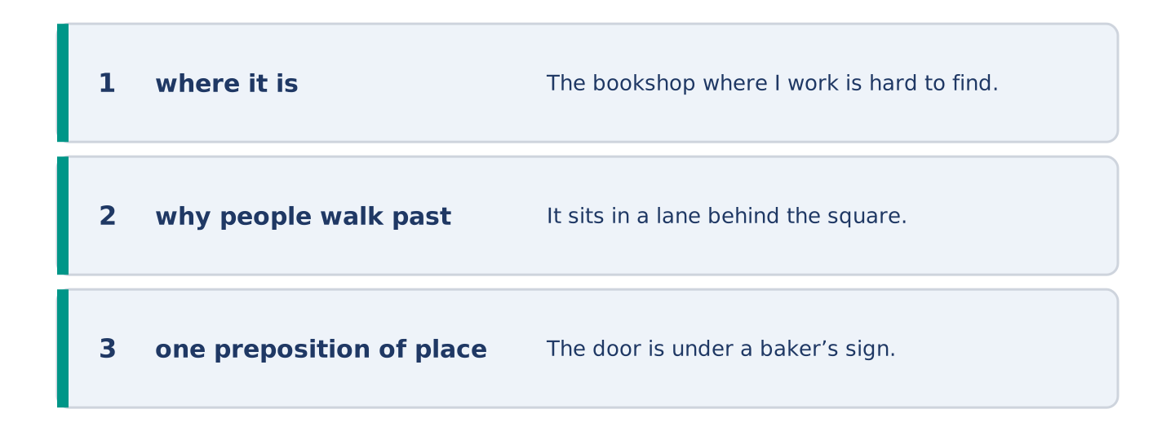
Figure 9.28 · The moves of the message, with a line of the model for each.
Write about a place that is hard to find. Say where it is and why people walk past it.
Model — read this first:
The bookshop where I work is hard to find, and we rather like it that way. It sits in a lane behind the square, below the level of the street. The door is under a baker’s sign that is not ours. People walk past it twice. Then they ask in the baker’s, and the baker sends them back three doors. (60 words)
Plan (fill in, then write): ___ is hard to find. It is ___. The trouble is ___. People usually ___.
Check before you finish: ☐ where it is? ☐ why people walk past? ☐ one preposition of place in each sentence? ☐ 50–70 words?
Part 6: Reflection — The Time I Got Lost (40–60 words)
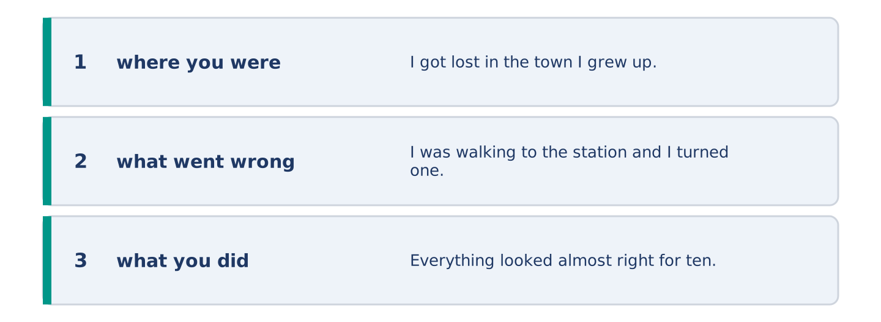
Figure 9.29 · The reflection, step by step.
Write about a time you got lost. Say where you were and what you did.
Model — read this first:
I got lost in the town I grew up in, which is the worst kind. I was walking to the station and I turned one junction early. Everything looked almost right for ten minutes, and that is what kept me walking. In the end I asked a child. (48 words)
Check before you finish: ☐ where you were? ☐ what went wrong? ☐ what you did? ☐ 40–60 words?
Part 7 · Real-World File — Asking the Way and Giving It
[PLUS] Plus track (optional) · stronger learners
7A: Phrase Bank
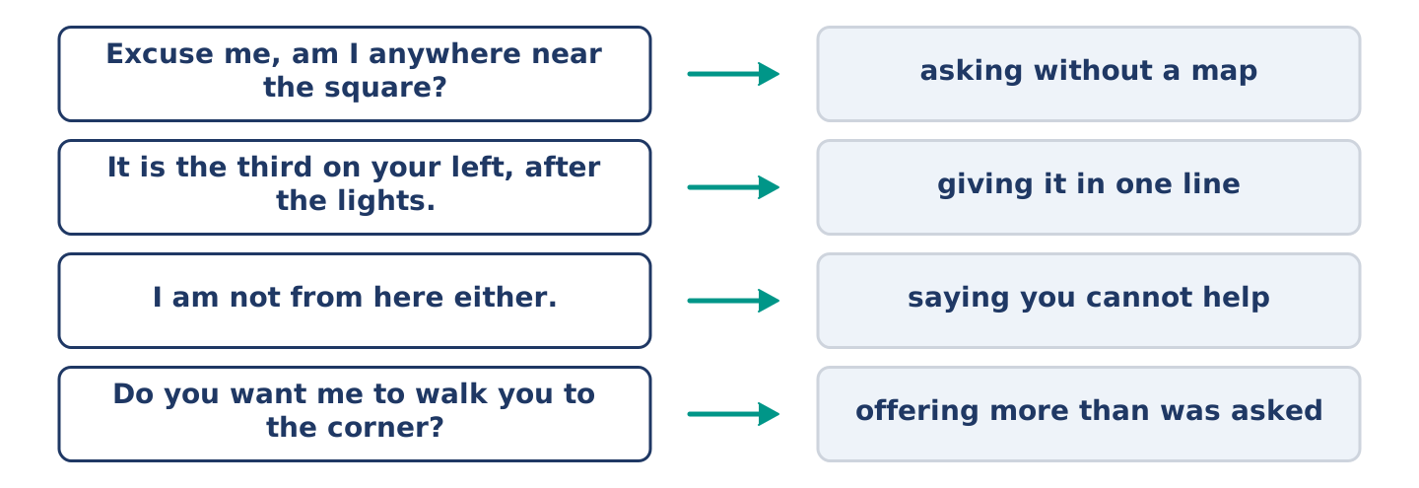
Figure 9.30 · What you say when you ask the way, and what each line does.
Match what a person says with its purpose. One purpose is not needed. Write the letter.
Column A
1. | “Excuse me, am I anywhere near the square?” | ____
2. | “It is the third on your left, after the lights.” | ____
3. | “I am not from here either.” | ____
4. | “Do you want me to walk you to the corner?” | ____
Column B
a) | giving it in one line
b) | offering more than was asked
c) | asking without a map
d) | asking how much the bus costs
e) | saying you cannot help
7B: Asking and Being Sent the Wrong Way
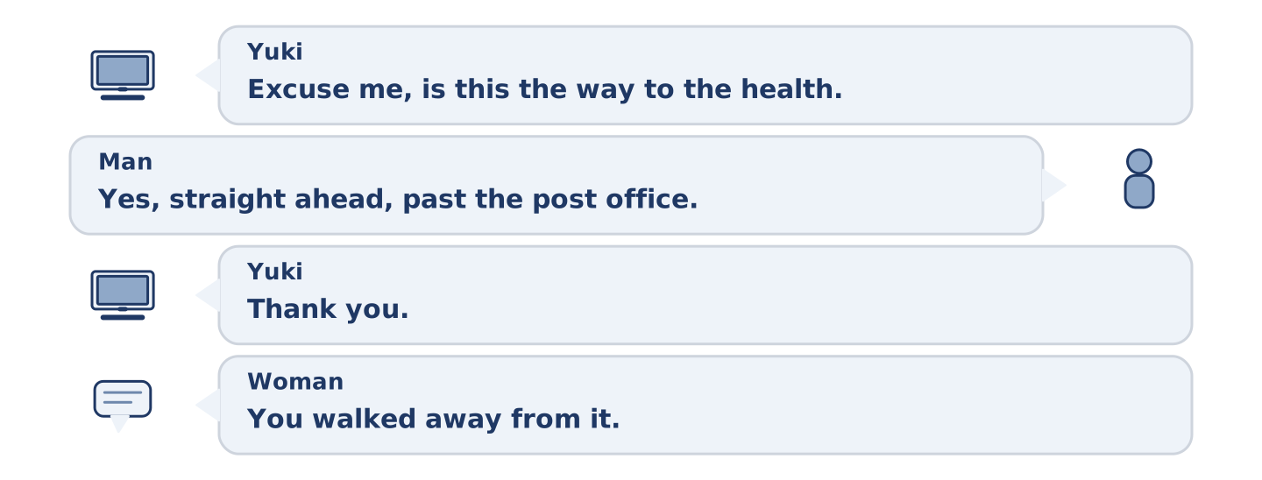
Figure 9.31 · The 7B exchange: who takes each turn.
🔊 Audio Track 9.5
Before you read: did anybody ever send you the wrong way?
Yuki: Excuse me, is this the way to the health centre? Man: Yes, straight ahead, past the post office, then left. Yuki: Thank you. (four minutes later) Yuki: Excuse me — the health centre? Woman: You walked away from it. Yuki: A man sent me straight ahead. Woman: He sent you to the old one. Everybody does. It shut in the spring. Yuki: Why doesn’t anybody move the sign? Woman: Somebody asks me that every week.
Answer the questions. (0. is done.)
- What does Yuki ask the man? — Whether she is on the way to the health centre.
- What did the man tell her to do?
- Why was his answer wrong?
- What does the woman say about the sign?
7C: Controlled Practice — Giving Directions Well
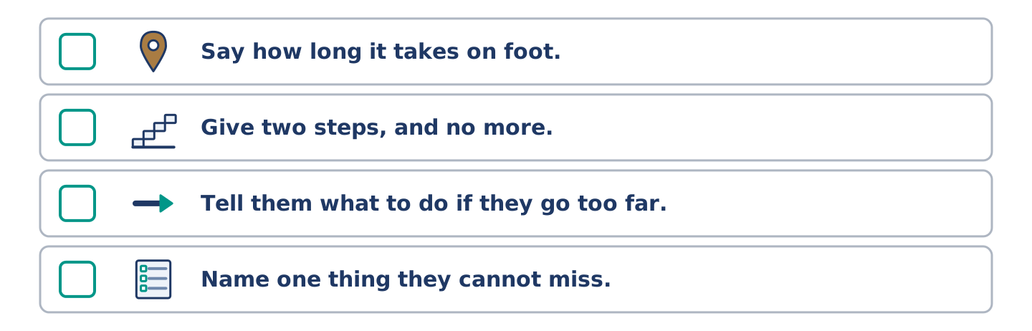
Figure 9.32 · The steps still to be numbered, as the task prints them.
Put the steps in order. Number them 1–5. (0. is done.)
- Ask where the person is standing now. — 1
____ Say how long it takes on foot.
____ Give two steps, and no more.
____ Tell them what to do if they go too far.
____ Name one thing they cannot miss.
7D: Role-Play — Asking the Way
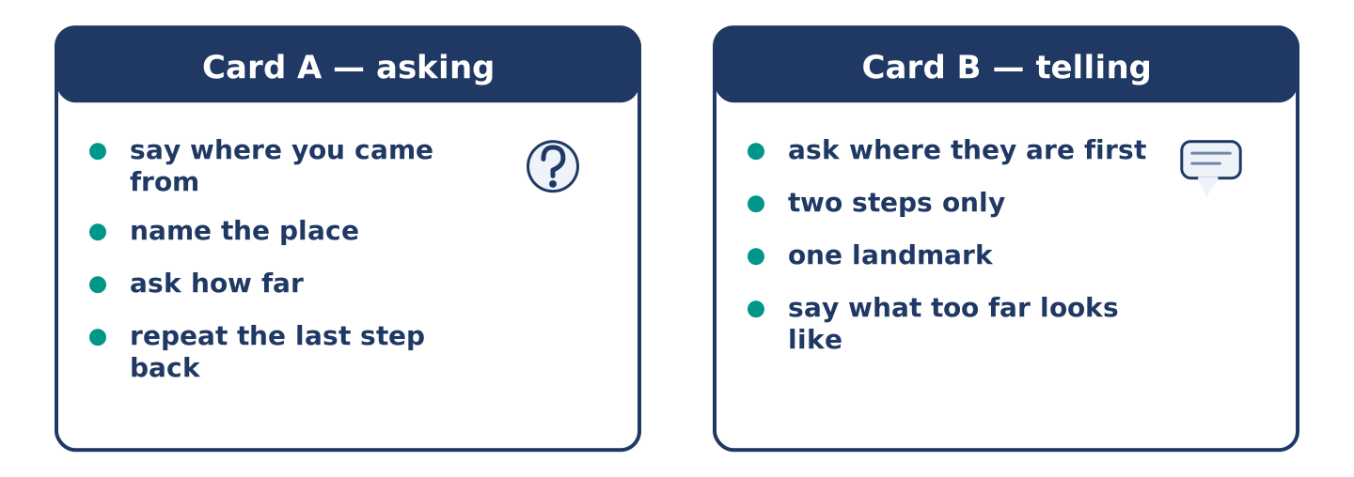
Figure 9.33 · The 7D cards: what each of you has to say.
In pairs. One asks the way; one gives it. Use the model and cards.
Model exchange: A: Excuse me, am I near the square? — B: Which way did you come? — A: From the bridge. — B: Then you are two minutes away. Straight ahead, past the shop. — A: And the health centre? — B: Behind the square, the low building.
Card A — asking: say where you came from · name the place · ask how far · repeat the last step back.
Card B — telling: ask where they are first · two steps only · one landmark · say what too far looks like.
Stretch [PLUS]: the place they are looking for closed last year — tell them, and send them somewhere better.
7E: Writing — Directions for a Driver (50–80 words)
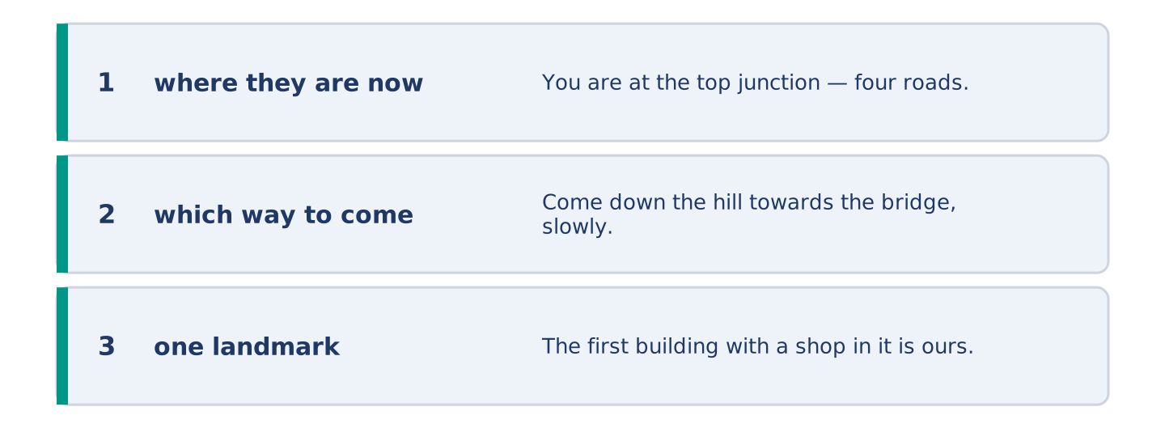
Figure 9.34 · The Part 7 note, with the model beside each line.
A driver cannot find your building. Write the message you send.
Model — read this first:
You are at the top junction — four roads and no sign on any of them. Come down the hill towards the bridge, slowly. The first building with a shop in it is ours. The shop is green; the door beside it is blue. There is no number on it, and no number on any door in this street. Park in the lane behind if the front is full. (69 words)
Check before you finish: ☐ where they are now? ☐ which way to come? ☐ one landmark? ☐ 50–80 words?
Part 8 · Global Story — The Numbers on the Dutch Signs
[PLUS] Plus track · pre-read / discuss
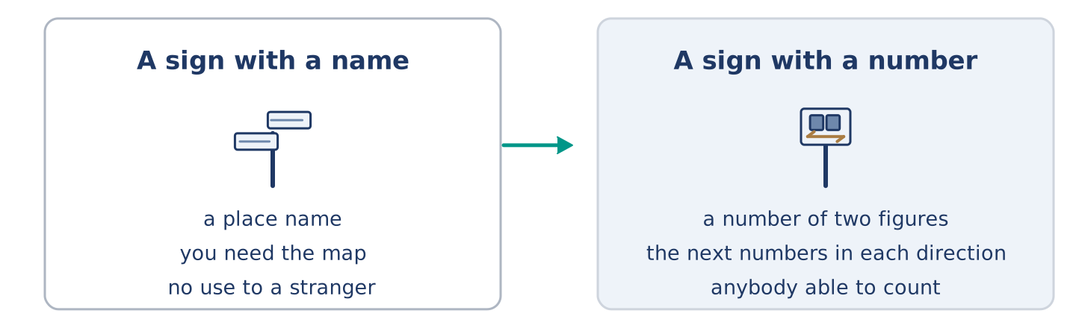
Figure 9.35 · A sign with a place name, and a sign with a number.
Before you read: can a sign tell you the way without naming a single place?
Gloss: network = many paths joined together · pole = a tall thin post · stranger = somebody who does not know the place
In the Netherlands the bike paths do not name where you are going. They give a number. At every junction of the network there is a small green and white sign on a pole. It carries a number of two figures, and the next numbers in each direction. A rider plans the day as a string of numbers: sixty-one, fifty-eight, forty-four, twelve. Then the ride goes from one to the next, and no place name comes into it at all. The idea came from old working paths in Belgium and moved north. The clever part is what it does to a stranger. A place name only helps a rider who already knows the map. A number helps anybody able to count. Children use it. Visitors use it. So do the local families, every week of the year.
Answer the questions. (0. is done.)
- What do the Dutch cycle signs tell you? — A number.
- What else is on the sign besides the number?
- How do you plan a ride?
- Why does a number help a stranger more than a place name?
Part 8: Vocabulary in Context
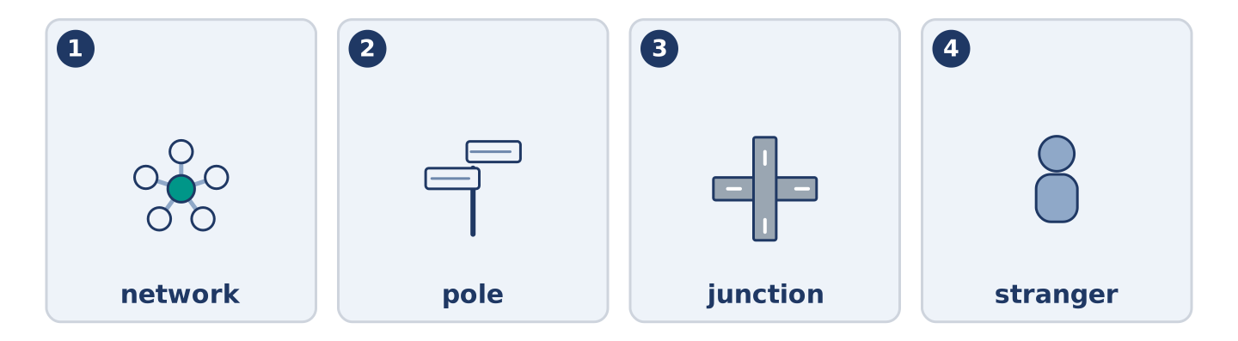
Figure 9.36 · The four words from the global story, drawn.
Match each word with its meaning. One meaning is not needed. Write the letter.
Column A
1. | network | ____
2. | pole | ____
3. | junction | ____
4. | stranger | ____
Column B
a) | a tall thin post
b) | somebody who does not know the place
c) | many paths joined together
d) | where two or more paths meet
e) | a wide street with trees
Part 8: Discussion
Talk with a partner. Use the frames.
Discussion frames: “This is similar to where I live because…” · “This is different from where I live because…” · “I think the most important thing is… because…”
Part 9 · Close to Home — The House With No Number
[PLUS] Plus track · pre-read / decide
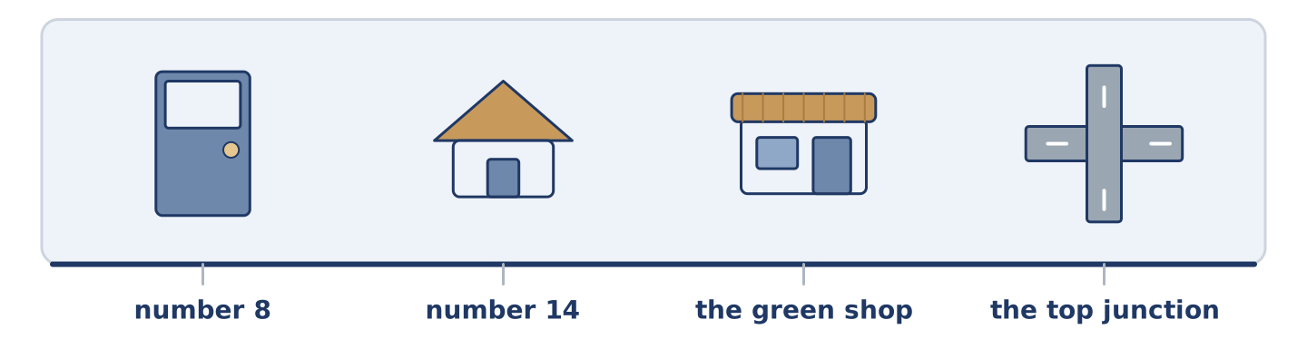
Figure 9.37 · The close-to-home reading, drawn along one street.
Before you read: whose job is it to put a number on a door?
Alder Street has no useful numbers. The old houses at the top came down years ago, and nobody gave the rest new numbers. So number 14 sits between number 8 and number 20. Three doors carry no number at all. Amina gave up and painted GREEN SHOP across her window, which works better than any number. Boxes go to the wrong half of the street twice a week. A car from the health centre once stood at the top junction for eleven minutes. Yuki wrote her address on a card for five drivers in her first month, and three of them still drove past. Maya wants the city to number the street again. Amina points out that the city took eight years to repair one street lamp. Dani painted a 14 on a piece of wood and tied it to the gate. It is still there, upside down.
Answer the questions. (0. is done.)
- Does Alder Street have useful numbers? — No, it does not.
- Why does number 14 sit between 8 and 20?
- What did Amina paint across her window?
- What did Dani tie to the gate?
Part 9: Decision Task
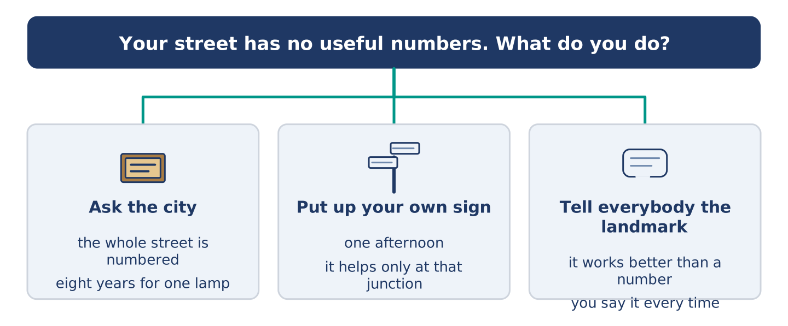
Figure 9.38 · Three ways to decide, and what each one costs.
Your street has no useful numbers. Should you (a) ask the city to number it again, (b) put up your own sign at the junction, or (c) tell everybody the landmark instead? Decide and explain. Use the frame.
Answer frame: “I think I should ___ because ___. Also, ___. This is better than ___ because ___.”
Model — read this first:
I think I should put up my own sign at the junction, because that is where every stranger stops. A number on a door only helps somebody already standing outside it. Also, a sign at the junction costs one afternoon. This is better than waiting for the city, because the city repaired one street lamp in eight years. (58 words)
Phrase bank: I think I should… · because… · Also,… · This is better than… · In my opinion…
Part 10 · Review and Can-Do
[CORE + PLUS] · homework / self-study
Part 10: Spiral Review
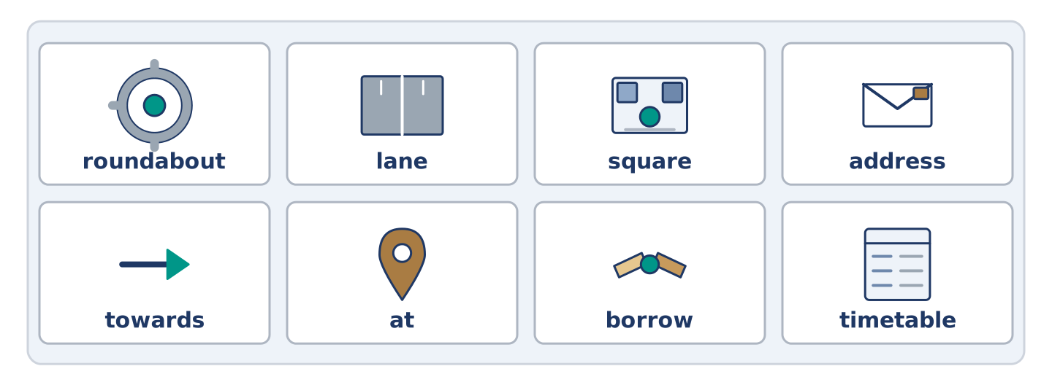
Figure 9.39 · The eight words of the review bank, in bank order.
Complete the review. (0. is done.)
- Where two or more roads meet is a junction.
Word bank: roundabout | lane | square | address | towards | at | borrow | timetable
- A circle of road where cars go round one way is a ______________________ .
- A narrow road between fields or houses is a ______________________ .
- An open space in a town with buildings round it is a ______________________ .
- The number and the street where you live is your ______________________ .
- Walk ______________________ the bridge and turn left at the bench.
- Amina opens the shop ______________________ seven.
- (from Unit 8) To take something from somebody for a short time is to ______________________ .
- (from Unit 3) The paper that tells you when the bus leaves is a ______________________ .
Part 10: Can-Do
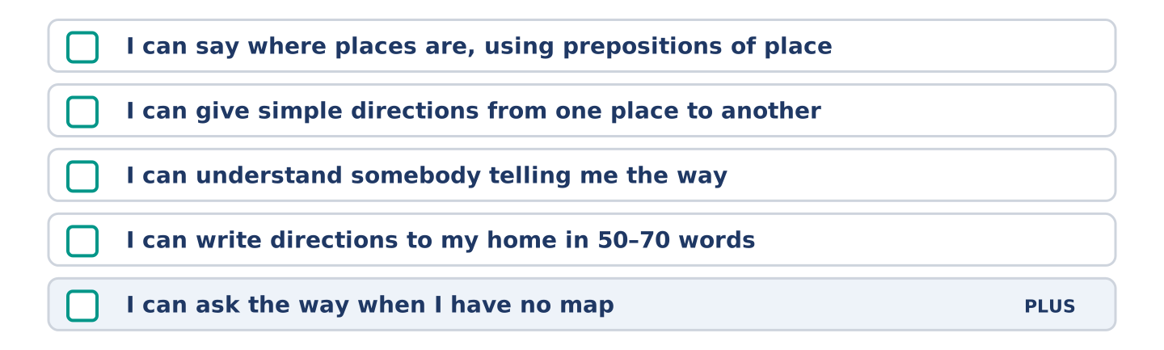
Figure 9.40 · What you can do at the end of this unit.
Can-Do checklist
☐ I can say where places are, using prepositions of place.
☐ I can give simple directions from one place to another.
☐ I can understand somebody telling me the way.
☐ I can write directions to my home in 50–70 words.
☐ I can ask the way when I have no map (Plus).
Part 10: Glossary
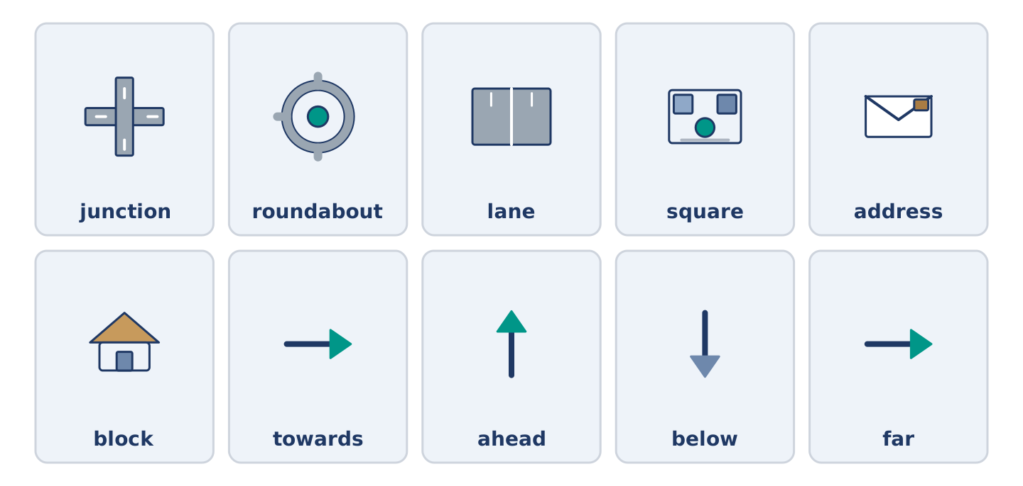
Figure 9.41 · All ten glossary words of Unit 9, one card each.
Unit 9 glossary (10 words)
junction · roundabout · lane · square · address · block · towards · ahead · below · far

