Unit 13: Rules and Places
English for Daily Life · Level: A2 · Tracks: [CORE] Warm-Up + Parts 1–6 · [PLUS] Parts 7–10
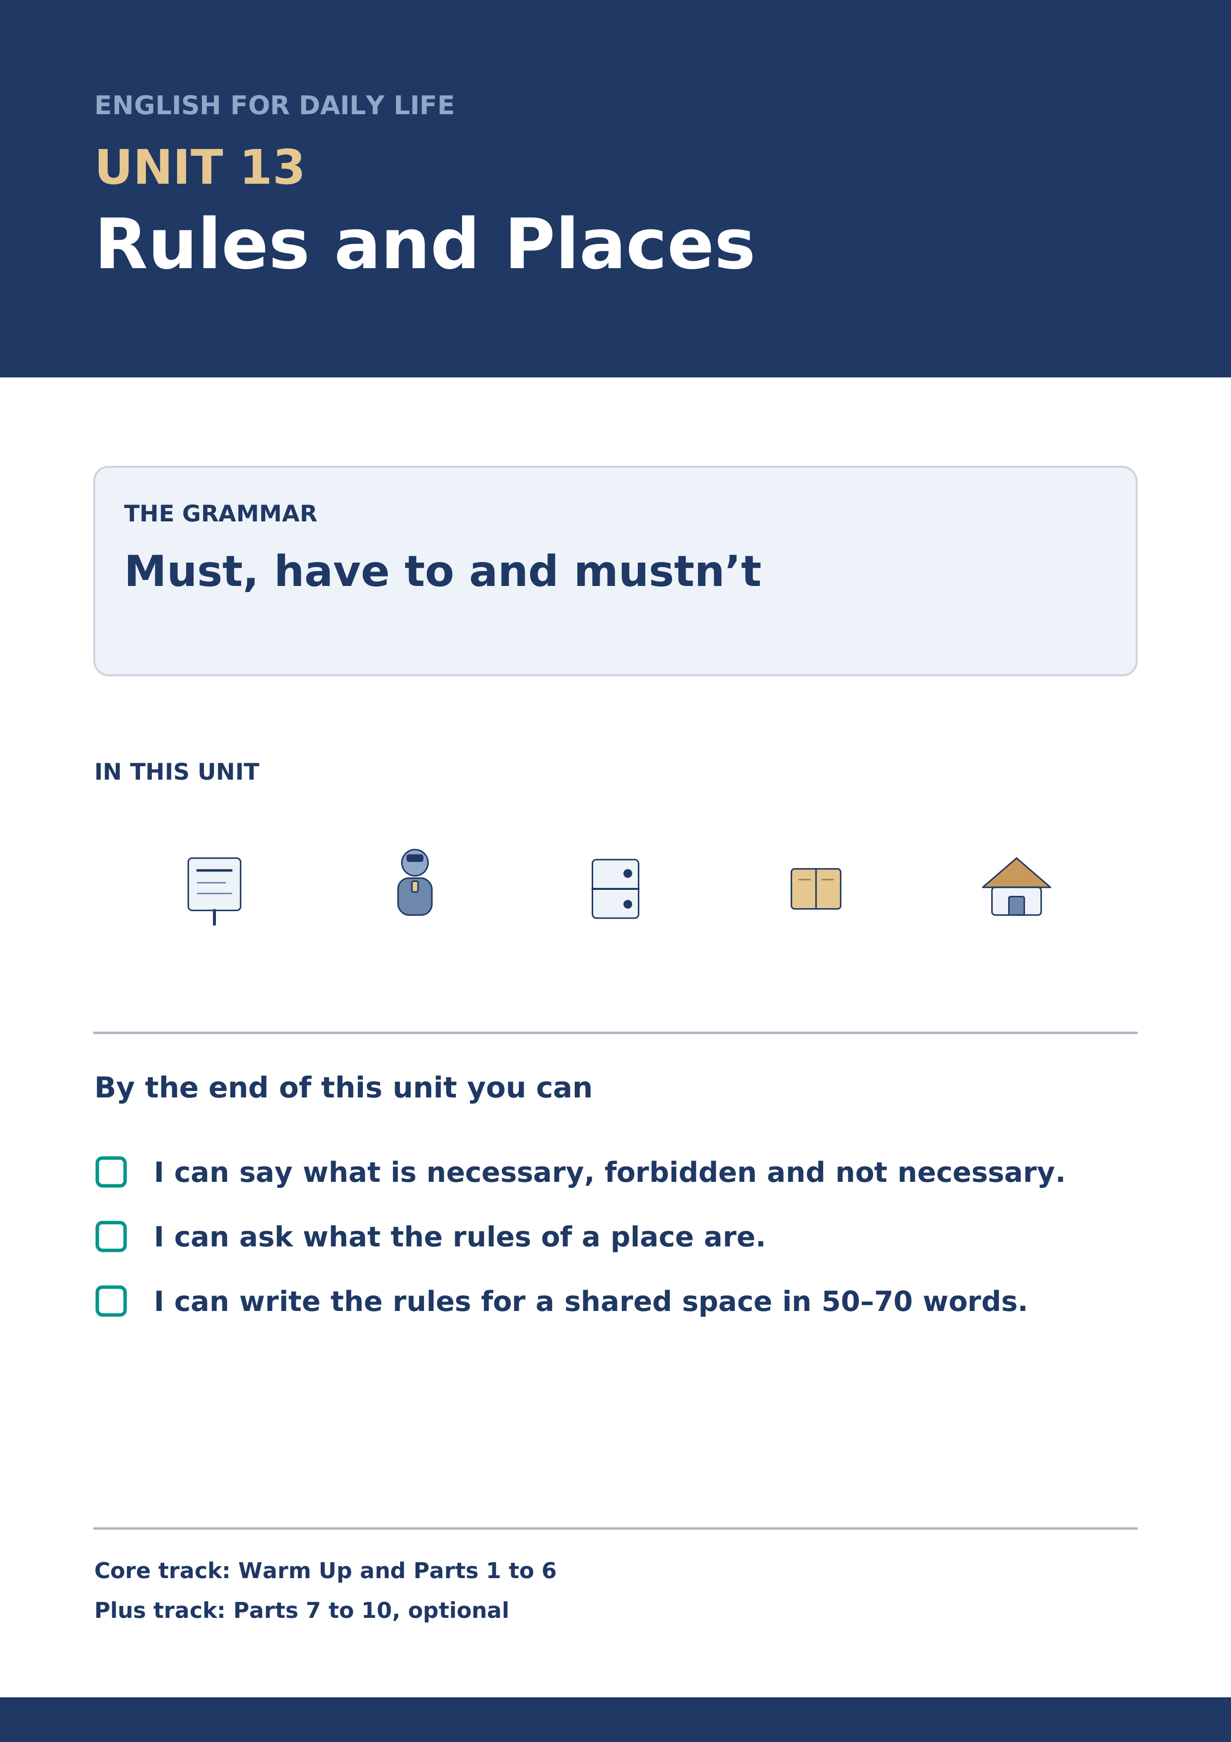
Warm Up
[CORE] Core track · in-class starter
Warm-up: Words for Rules
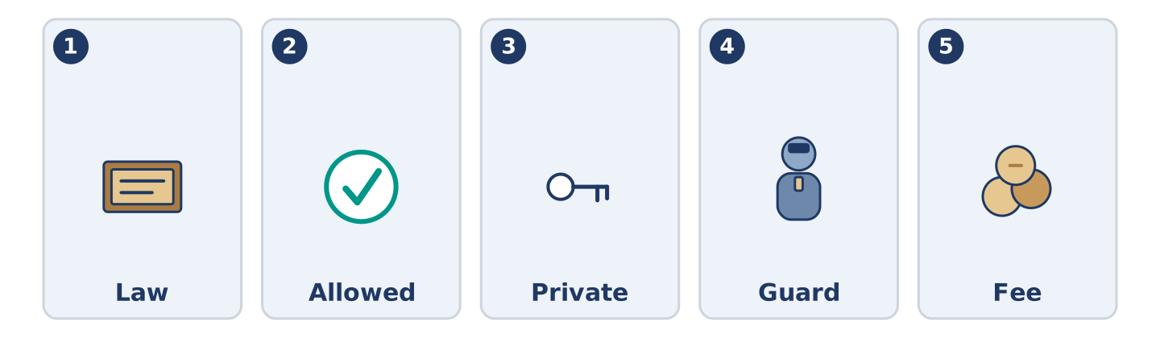
Figure 13.2 · The five warm-up words, and the thing each one means.
Match the words with their meanings. One meaning is not needed. Write the letter.
Column A
1. | Law | ____
2. | Allowed | ____
3. | Private | ____
4. | Guard | ____
5. | Fee | ____
Column B
a) | not for everybody; only for some people
b) | somebody whose job is to watch a place
c) | a rule that the whole country has to keep
d) | the money you pay to go in or to belong
e) | all right to do; nobody stops you
f) | a book where you write what you are doing
Warm-up: Talking About Rules
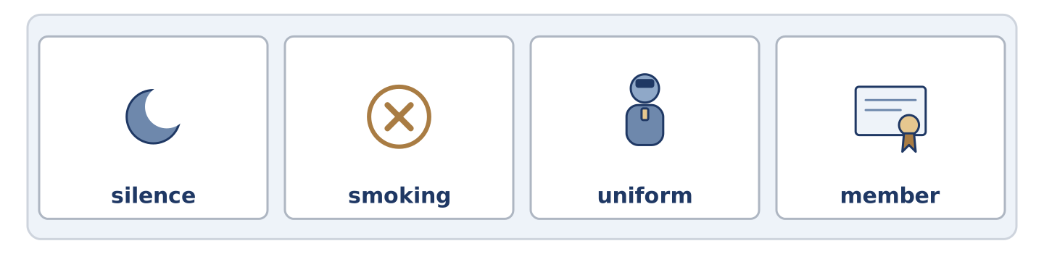
Figure 13.3 · The word bank for this task, in the order it is printed.
Complete the sentences using the words in the word bank.
Word bank: silence | smoking | uniform | member
- There is no ______________________ anywhere in the building, and there never was.
- You have to be a ______________________ to use the room upstairs.
- The sign asks for ______________________ , and the room is never silent.
- The guard at the gallery wears a ______________________ and says almost nothing.
Warm-up: Six People, Six Rules
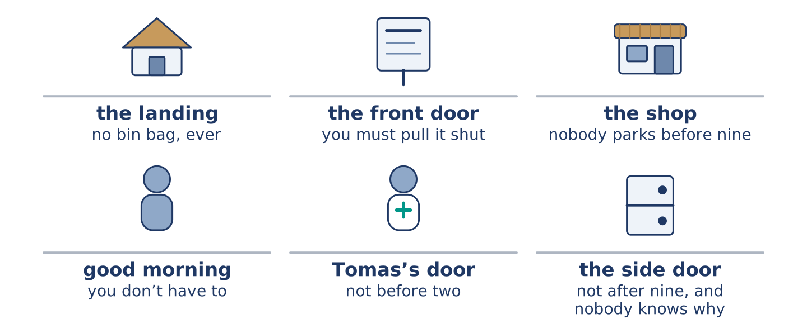
Figure 13.4 · The rules at number 14 that nobody ever wrote down.
Read the text and choose the correct answer.
Number 14 has rules and none of them are written anywhere. You must not put a bin bag on the landing, ever, and everybody knows it. You have to hold the front door for the person behind you, because the lock is slow. You do not have to say good morning, although Amina does. Nobody parks in front of the shop between seven and nine, and nobody ever has to be asked. Mr Okonkwo made that rule twenty years ago, and he never needed a sign for it.
1. What must you not do at number 14?
○ A) Say good morning
○ B) Hold the front door
○ C) Park after nine
○ D) Put a bin bag on the landing
2. What do you not have to do?
○ A) Hold the door
○ B) Say good morning
○ C) Keep the landing clear
○ D) Pay a fee
Part 1 · Vocabulary and Terminology
[CORE] Core track · pre-class input
Part 1: Words for Rules and Places
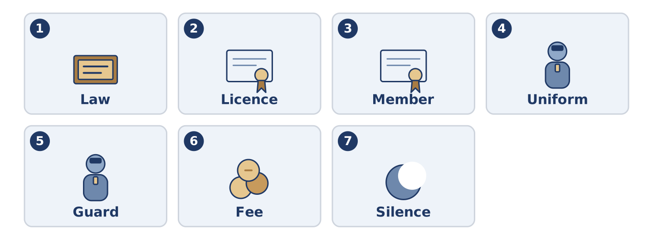
Figure 13.5 · The seven words of Column A, and what each one is.
Match the words with their meanings. One meaning is not needed. (0. is done for you.)
- Notice → a small sign that says what the rule is, in a public or a private place.
Column A
1. | Law | ____
2. | Licence | ____
3. | Member | ____
4. | Uniform | ____
5. | Guard | ____
6. | Fee | ____
7. | Silence | ____
Column B
a) | clothes that say what your job is
b) | a rule the whole country has to keep
c) | somebody who belongs to a club or a library
d) | no sound at all
e) | a paper that says you are allowed to do something
f) | somebody whose job is to watch a place
g) | the money you pay to go in or to belong
h) | a cover you close over a window
Gloss: licence = a paper that says you are allowed to do something · fee = the money you pay to go in or to belong · uniform = clothes that say what your job is · bin = the big box the rubbish goes in
Part 1: Pronunciation
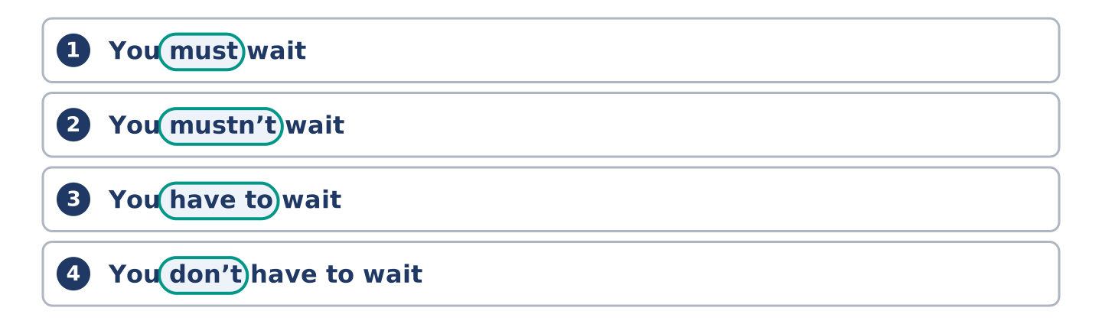
Figure 13.6 · Where the stress falls in 0 words of this unit.
🔊 Audio Track 13.1
Listen to must and mustn’t. Say each pair aloud.
You must wait — must is short and its t is soft
You mustn’t wait — the t in the middle disappears: /ˈmʌsn̩t/
You have to wait — have to is one quick sound: /ˈhæftə/
You don’t have to wait — the same, with don’t: /dəʊnt ˈhæftə/
Two of these four are opposites and sound almost the same. Mustn’t and don’t have to cost learners most, and not because of the sound. It is that nobody tells them the two are not the same.
Part 1: Four Places, Four Rules
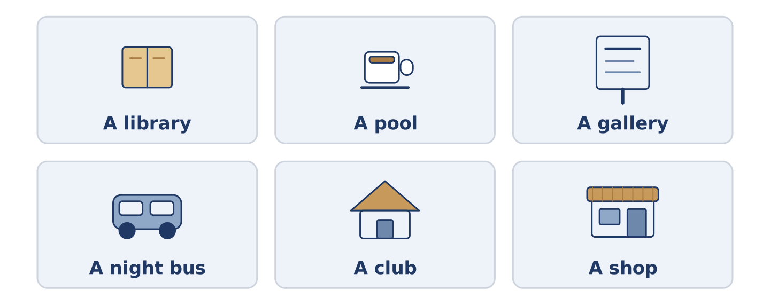
Figure 13.7 · Four places, and the one rule each of them is known for.
Complete the table. Write the rule and who keeps it. (0. is done.)
The place | The rule | Who keeps it
A library | quiet enough | (example)
A swimming pool
A gallery
A night bus
- A library — quiet enough — everybody; the room does it to you.
Think about a place you know. There is more than one right answer; say why.
Part 1: Must, Mustn’t or Do Not Have To?
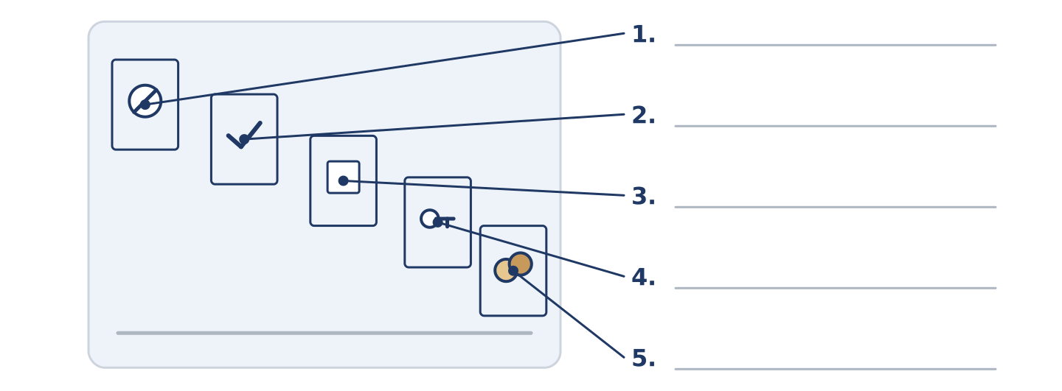
Figure 13.8 · Three kinds of rule — write the correct word on each line.
Match the rules with what they mean. One is not needed. Write the letter.
Column A
1. | You must show your card. | ____
2. | You mustn’t touch the paintings. | ____
3. | You don’t have to pay a fee. | ____
4. | You have to be a member. | ____
5. | You don’t have to be quiet. | ____
Column B
a) | it is forbidden; do not do it
b) | it is necessary; the place requires it
c) | you may make a noise if you want to
d) | it is free; nobody is asking for money
e) | you cannot come in unless you belong
f) | somebody did it and had to leave
Part 1: Rules — Multiple Choice
Read and choose the correct answer.
1. A paper that says you are allowed to do something is a…
○ A) notice
○ B) uniform
○ C) licence
○ D) fee
2. Somebody whose job is to watch a place is a…
○ A) member
○ B) law
○ C) licence
○ D) guard
3. The money you pay to go in or to belong is a…
○ A) uniform
○ B) fee
○ C) silence
○ D) law
Part 1: Vocabulary Fill-in
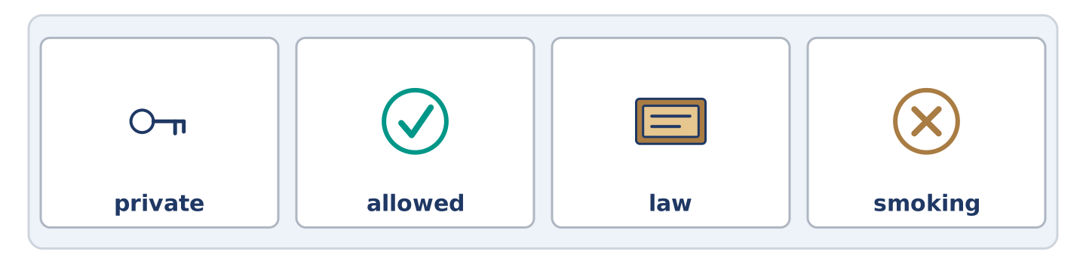
Figure 13.9 · The four words of the bank, in the order the task gives them.
Complete the sentences with the correct word.
Word bank: private | allowed | law | smoking
- That door says ______________________ , and behind it are chairs.
- ______________________ in the entrance stopped years ago and nobody misses it.
- Dogs are not ______________________ in the park after six.
- It is the ______________________ now, not a shop rule.
Part 1: Write About a Rule (short)
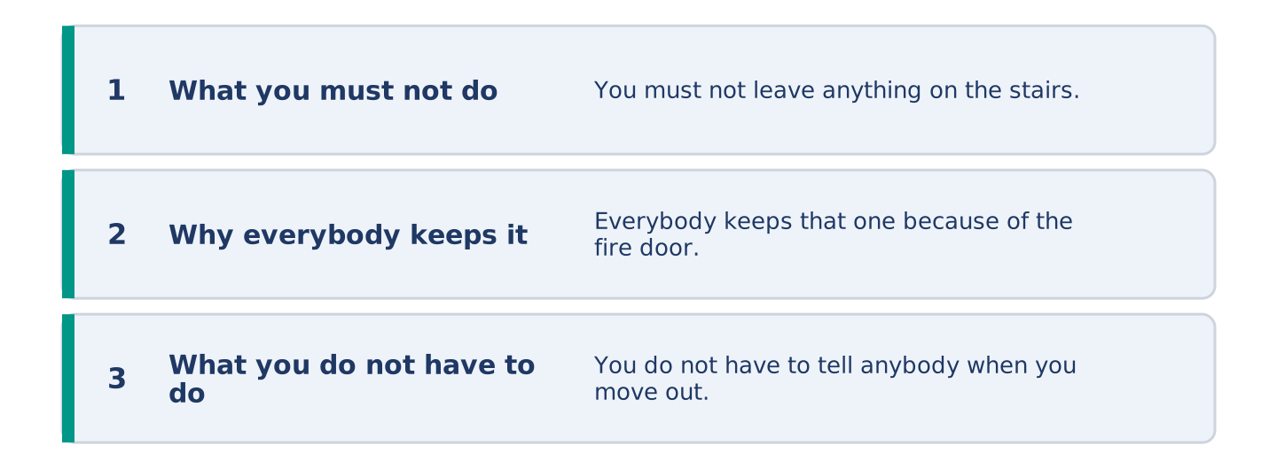
Figure 13.10 · The shape of your two or three sentences, with the model beside each step.
Write two or three sentences about one rule where you live. Use three words from this unit.
Model — read this first:
In our building you must not leave anything on the stairs, and everybody keeps that one because of the fire door. You do not have to tell anybody when you move out. There is no fee for the rubbish bins and no sign about them, and somehow the rubbish bins are fine. (52 words)
Part 2 · Grammar — Must, Have To and Mustn’t
[CORE] Core track · pre-class input
Part 2: Notice
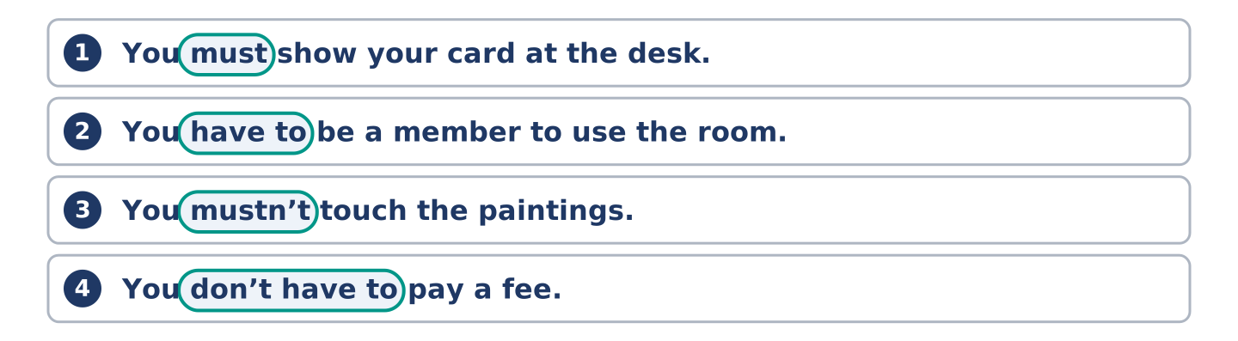
Figure 13.11 · Lines from the notice, with the target form ringed in each.
Read these lines. Underline must, have to, mustn’t and don’t have to. Which say you cannot, and which say you need not?
You must show your card at the desk. You have to be a member to use the room. You mustn’t touch the paintings. You don’t have to pay a fee. You mustn’t smoke anywhere inside. You don’t have to be quiet in the garden.
Two of these say it is necessary. Two say you cannot. Two say you need not.
Part 2: Grammar Focus Box
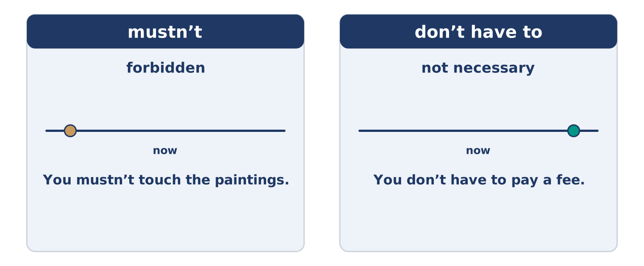
Figure 13.12 · Necessary, forbidden and not necessary: three jobs, four forms.
 | Form | Use | Example
must | must + plain verb | necessary; often the rule itself speaking | You must show your card.
have to | have to + plain verb | necessary; often somebody else’s rule | You have to be a member.
mustn’t | must not + plain verb | forbidden | You mustn’t touch the paintings.
don’t have to | do not have to + verb | not necessary; you may if you like | You don’t have to pay.
Remember: mustn’t and don’t have to are opposites, not the same. One forbids; one frees.
Watch out! ✗ You don’t must touch it. → ✓ You mustn’t touch it. (must makes its own negative). ✗ You mustn’t pay, it is free. → ✓ You don’t have to pay, it is free. (mustn’t pay means paying is forbidden).
Part 2: Controlled Practice
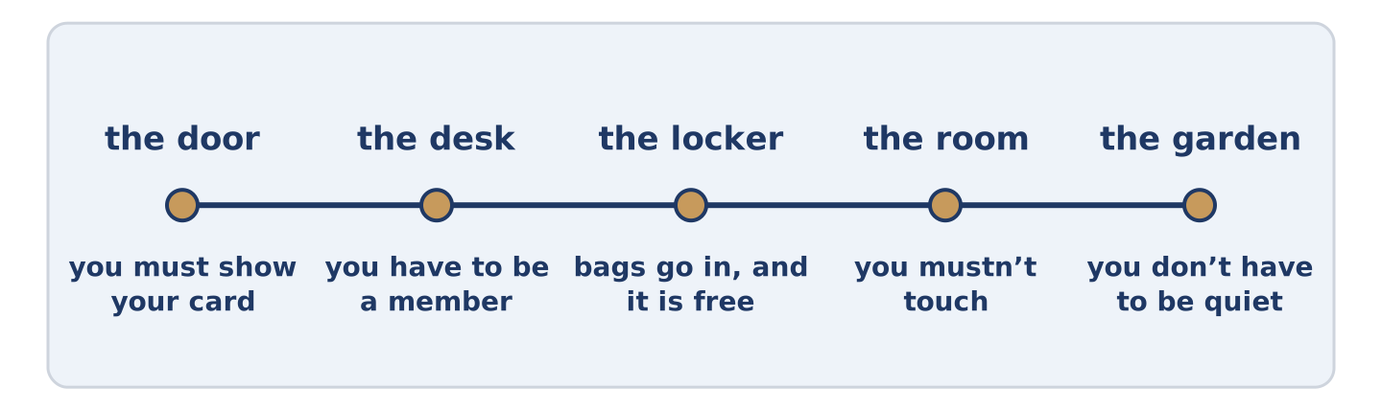
Figure 13.13 · One visit, from the door to the room upstairs.
Complete with must, have to, mustn’t or don’t have to. (0. is done.)
- You must show your card at the desk.
- You ______________________ touch the paintings. (forbidden)
- You ______________________ be a member to use the room. (necessary)
- You ______________________ pay a fee. (not necessary)
- You ______________________ smoke anywhere inside. (forbidden)
Part 2: Necessary, Forbidden or Not Necessary?
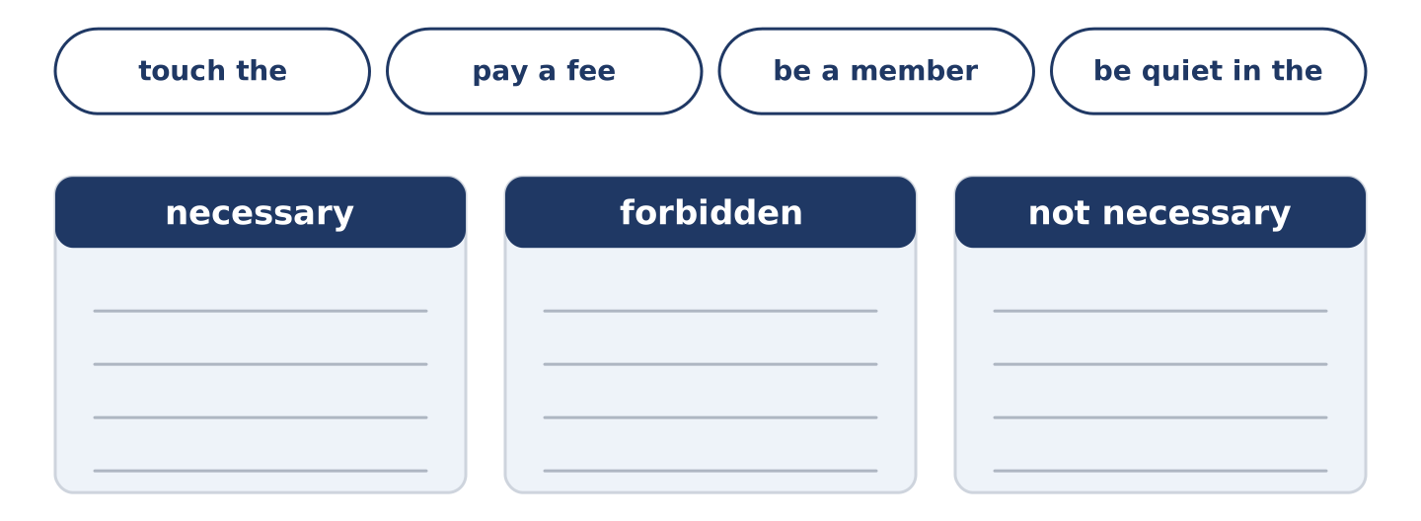
Figure 13.14 · The items of this task, and the bins they sort into.
Write necessary, forbidden or not necessary. (0. is done.)
- You must show your card. — necessary
- You mustn’t touch the paintings. ____________
- You don’t have to pay a fee. ____________
- You have to be a member. ____________
- You don’t have to be quiet in the garden. ____________
Part 2: Correct the Sentence
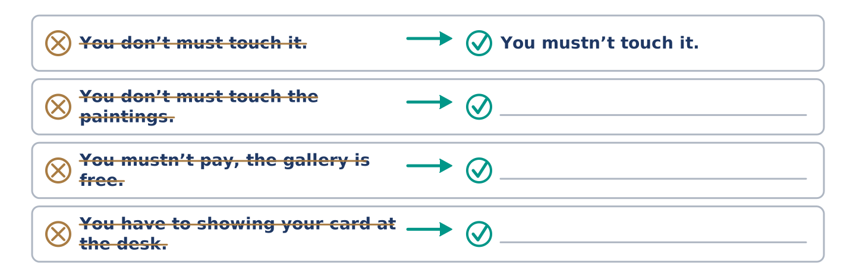
Figure 13.15 · One correction done for you, and the rest to write.
Each sentence has one grammar mistake. Write the correct sentence.
- You don’t must touch the paintings.
- You mustn’t pay, the gallery is free.
- You have to showing your card at the desk.
- You must to be a member.
Part 2: Freer Practice
Write two rules for a place you know: one that forbids something, and one that frees you from something.
Part 2: Grammar Review
Choose the correct sentence.
1. Which sentence says it is forbidden?
○ A) You mustn’t touch the paintings.
○ B) You don’t have to touch the paintings.
○ C) You don’t must touch the paintings.
○ D) You have to touch the paintings.
2. Which sentence says it is free?
○ A) You mustn’t pay a fee.
○ B) You must not pay a fee.
○ C) You don’t have to pay a fee.
○ D) You have to pay a fee.
→ Harvest: you will see these four forms again in the Part 5 reading. Watch for which rules people keep.
Part 3 · Listening
[CORE] Core track · pre-class input · scripts printed inline
Part 3: The Guard and the Bag
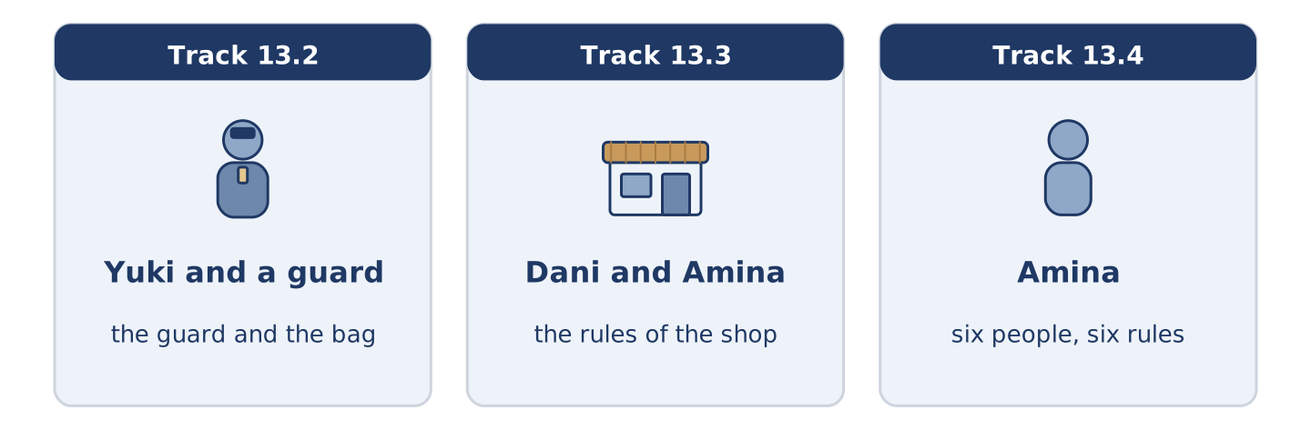
Figure 13.16 · The three listenings: who is speaking, and what about.
🔊 Audio Track 13.2
Before you listen: what do you have to leave at the door of a gallery?
Guard: Bags go in the locker, I’m afraid. Yuki: It’s very small. Guard: It’s the size, not the bag. Anything on your back has to go in. Yuki: Do I have to pay for the locker? Guard: No, it’s free. You don’t have to leave your coat, only the bag. Yuki: And can I take photographs? Guard: You can, but no bright light, and people forget that about four times an hour.
While you listen: write True, False, or Not Given. (0. is done.)
- Yuki has a bag with her. — True
- The locker costs money. ____
- Yuki may take photographs. ____
- The gallery is busy today. ____
Useful phrases: Bags go in… · Do I have to…? · You don’t have to… · you mustn’t…
Part 3: The Rules of the Shop
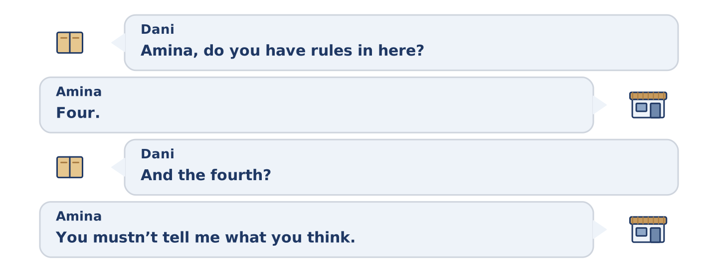
Figure 13.17 · The second listening, turn by turn.
🔊 Audio Track 13.3
Before you listen: does a small shop need written rules?
Dani: Amina, do you have rules in here? Amina: Four. You mustn’t come in with a lit cigarette, which was a problem once. You have to let somebody with two items go in front of you. You don’t have to buy anything to come in out of the rain. Dani: And the fourth? Amina: You mustn’t tell me what you think of the other customers. Dani: That one is for me. Amina: That one is entirely for you.
Answer the questions. (0. is done.)
- How many rules does Amina have? — Four.
- Who has to go in front of you?
- What do you not have to do to come in out of the rain?
- Which rule does Amina say is for Dani?
Part 3: Six People, Six Rules
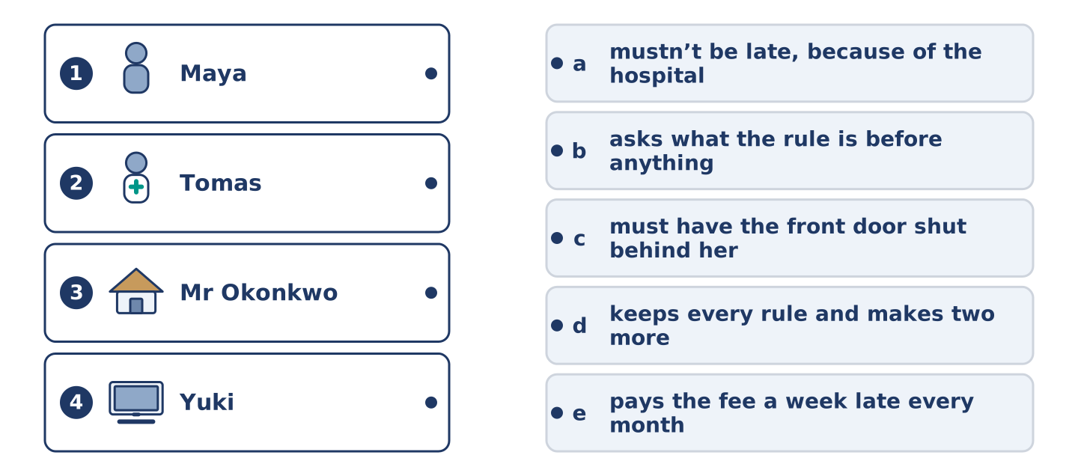
Figure 13.18 · Four on the left, five on the right, and one spare.
🔊 Audio Track 13.4
Before you listen: who in your street keeps every rule, and who keeps none?
Amina: Everybody in this street has one rule they will not break and one they break every week. Maya must have the front door shut behind her and will come back up two floors to check. Tomas mustn’t be late, and he says that is the hospital talking, not him. Dani doesn’t have to do anything, in his own opinion. Mr Okonkwo keeps every rule there is, and then he makes two more of his own. And Yuki asks what the rule is first, which nobody else in this building ever did.
While you listen: match each person with their rule. One is not needed. (0. is done.)
- Amina → she knows all six rules.
Useful phrases: ___ must shut the door · ___ mustn’t be late · ___ asks first
Column A
1. | Maya | ____
2. | Tomas | ____
3. | Mr Okonkwo | ____
4. | Yuki | ____
Column B
a) | mustn’t be late, because of the hospital
b) | asks what the rule is before anything else
c) | must have the front door shut behind her
d) | keeps every rule and makes two more
e) | pays the fee a week late every month
Part 4 · Speaking
[CORE] Core track · in-class output
Part 4: Rules Where You Live
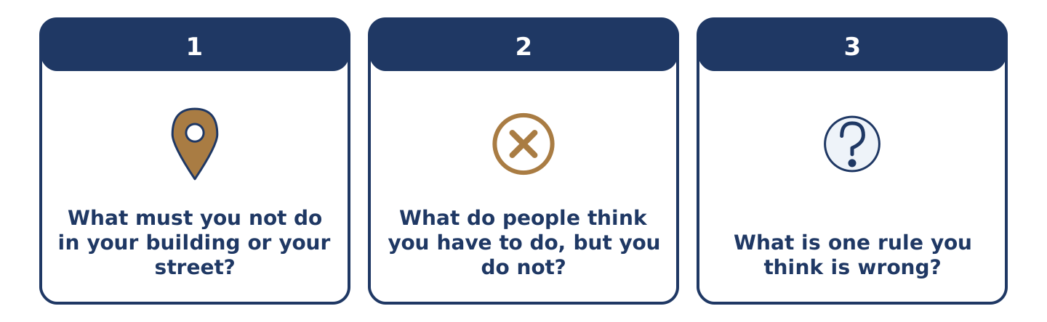
Figure 13.19 · The three questions as cards, to take one at a time.
Work with a partner. Ask and answer these questions.
- What must you not do in your building or your street?
- What do people think you have to do, but you do not?
- What is one rule you think is wrong?
Useful language: You must… · You mustn’t… · You have to… · You don’t have to…
Part 4: Find the Difference (pairwork)
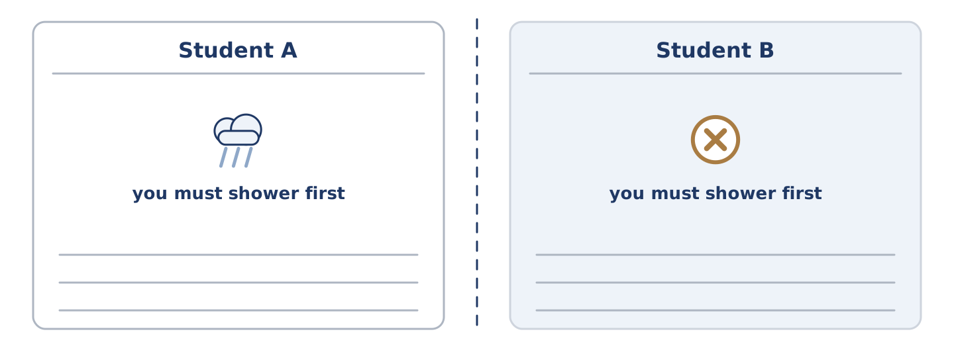
Figure 13.20 · Student A’s facts and Student B’s, with a fold between them.
Student A and Student B each have the rules of a different pool. Ask questions and find three differences.
Useful questions: Do I have to wear a cap? · Can I take a bag in? · Is there a fee? · Must I shower first?
Student A — your pool: you must shower first, you have to wear a cap, bags are allowed, there is no fee.
Student B — your pool: you must shower first, you don’t have to wear a cap, bags go in a locker, the fee is two pounds.
Part 4: Asking What the Rules Are
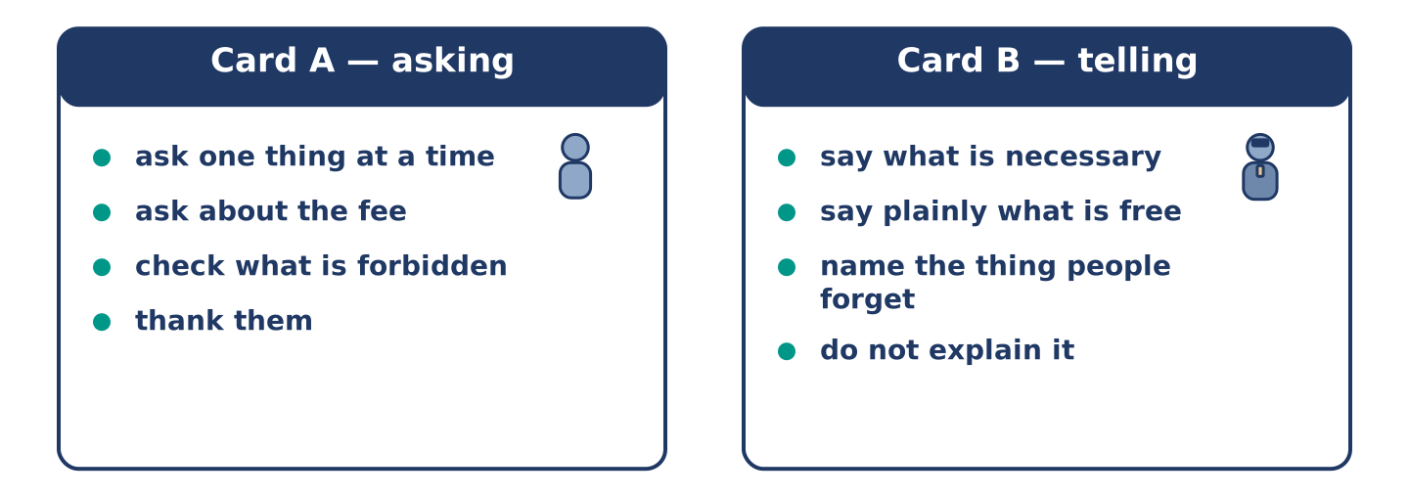
Figure 13.21 · Card A and Card B: what each of you has to say.
Work in pairs. Read the model, then use the cards.
Model exchange:
A: Do I have to leave my bag? — B: Anything on your back, yes. — A: And my coat? — B: You don’t have to leave the coat. — A: Is there a fee for the locker? — B: No, it is free. — A: Can I take photographs? — B: You can, but no bright light.
Useful language: Do I have to…? · You don’t have to… · you mustn’t… · Is there a fee?
Card A — asking: ask about one thing at a time · ask about the fee · check what is forbidden · thank them.
Card B — telling: say what is necessary · say plainly what is free · name the one thing people forget · do not explain the rule.
Your turn: run the dialogue, then swap roles.
Stretch [PLUS]: the rule makes no sense to you and the person telling you did not make it — say so without making it their fault.
Part 4: Mini-Presentation
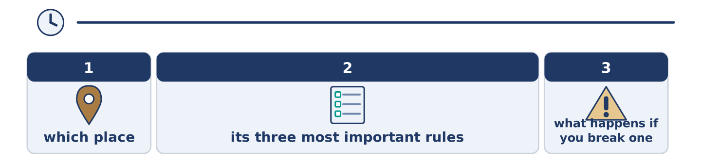
Figure 13.22 · The one-minute talk as 0 beats, each as wide as its share.
Prepare a short talk (about one minute). Describe a place you know and its three most important rules.
Part 5 · Reading
[CORE] Core track · pre-class input
Part 5: Why Some Rules Work and Others Do Not
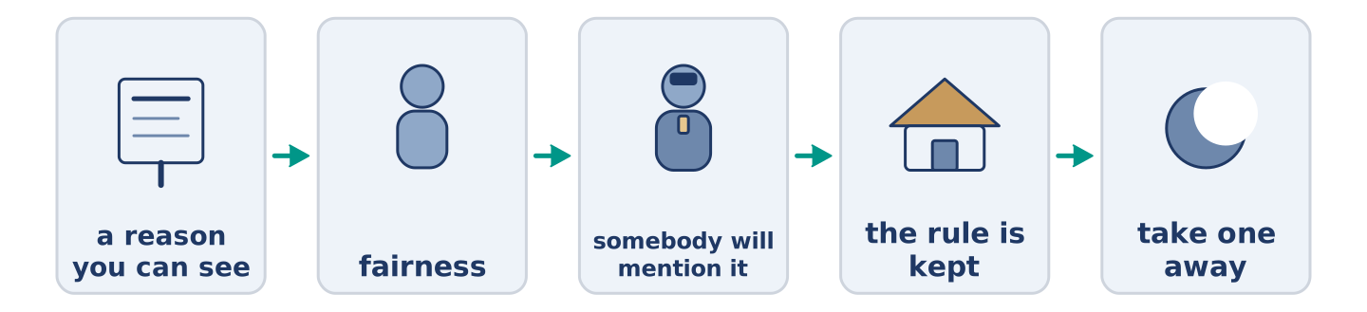
Figure 13.23 · One rule, from the notice to the habit.
Before you read: which rule where you live does everybody ignore?
Gloss: obey = to do what a rule says · enforce = to make people keep a rule · reason = why something is so
A rule that people keep has three things, and a rule that nobody keeps is usually missing one of them. The first is a reason you can see. People put their bags in a locker because they can see why a gallery might ask. Nobody keeps a rule whose reason died years before the notice did. The second is fairness. A rule that one group keeps and another does not is not a rule. It only costs the people with no excuse. The third is somebody who will mention it. Not a guard necessarily, not a fine; somebody willing to say, quietly, that you are standing in the way. Take away any one of the three and the notice stays on the wall and means nothing, which is the state of most notices.
Answer the multiple-choice questions. (0. is done.)
- How many things does a rule that people keep have? — Three.
1. What is the first thing a rule needs?
○ A) A fine
○ B) A reason you can see
○ C) A guard in a uniform
○ D) A notice on the wall
2. What does the text say about an unfair rule?
○ A) It works better than a fair one
○ B) Nobody notices it
○ C) It needs a bigger sign
○ D) It only costs the people with no excuse
3. What is the third thing?
○ A) Somebody willing to mention it
○ B) A law
○ C) A fee
○ D) A locker
Part 5: Vocabulary in Context
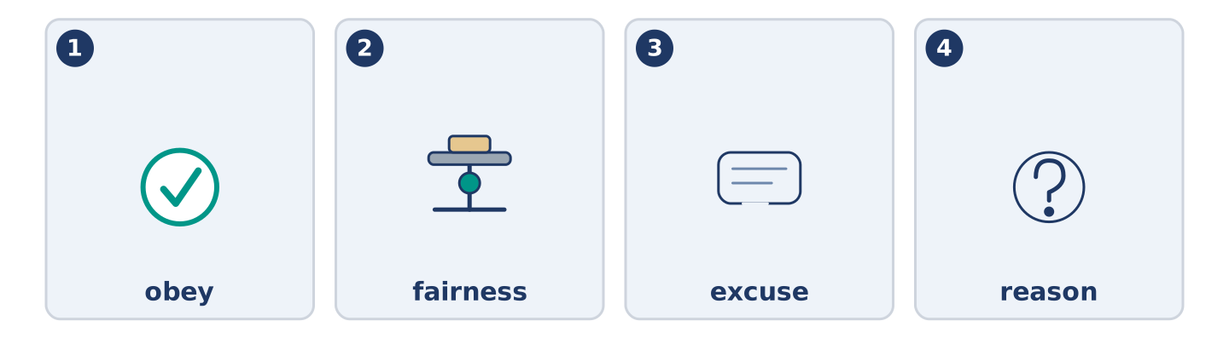
Figure 13.24 · The four words from the reading, drawn.
Match each word from the text with its meaning. One meaning is not needed. Write the letter.
Column A
1. | obey | ____
2. | fairness | ____
3. | excuse | ____
4. | reason | ____
Column B
a) | treating everybody the same way
b) | to do what a rule says
c) | why something is so
d) | what you say so that a rule does not apply to you
e) | no sound at all
Part 5: Three Places and Their One Rule
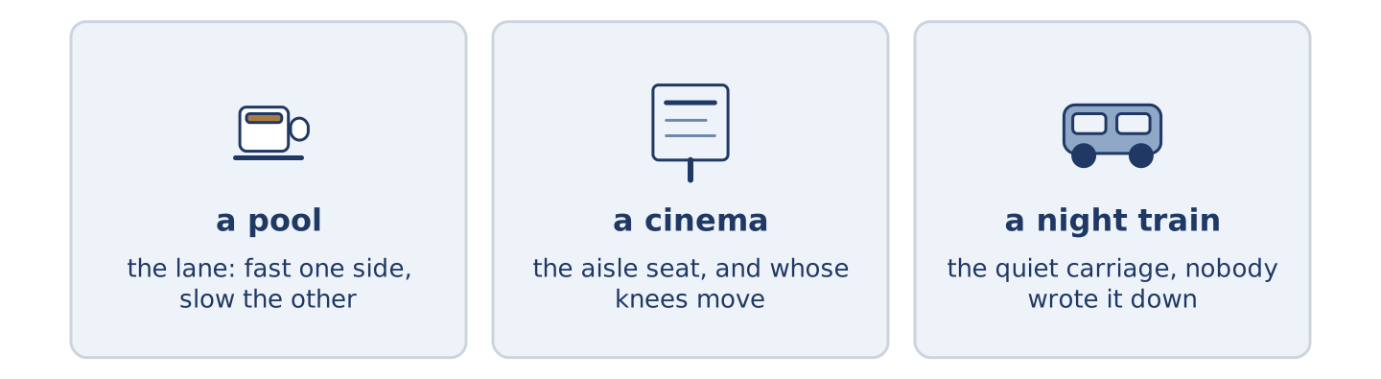
Figure 13.25 · Three places, and the one rule each of them lives by.
Before you read: which place near you has exactly one rule that matters?
Gloss: lane = the part of a pool you swim up and down · aisle = the walkway between seats or shelves · carriage = one part of a train
Some places have one rule and it carries everything. In a swimming pool it is the lane: fast on one side, slow on the other. One swimmer in the wrong lane ruins an hour for twelve people without touching anybody. In a cinema it is the aisle seat. Does the person in it stand up, or turn their knees sideways? That question divides countries and families. On a night train it is the carriage at the end, the quiet one. Nobody wrote that rule down, and everybody keeps it more carefully than the written ones. None of the three needs a guard. All three fall apart the moment one person decides the rule is for other people.
Answer the questions. (0. is done.)
- Do these places have many rules that matter? — No, each has one.
- What is the rule in a swimming pool?
- What is the question in a cinema?
- What happens to all three rules?
Part 6 · Writing
[CORE] Core track · in-class / homework
Part 6: Rules for a Shared Space (50–70 words)
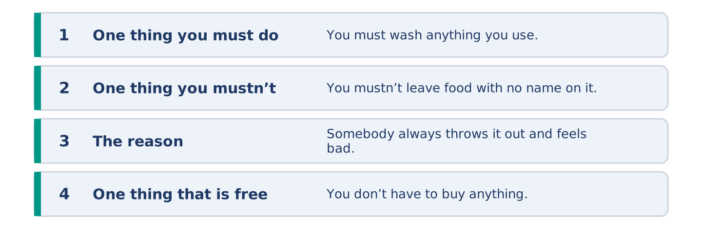
Figure 13.26 · The shape of the rules you are about to write.
Write the rules for a space that several people share. Use must, mustn’t and don’t have to.
Model — read this first:
You must wash anything you use and put it back the same day. You mustn’t leave food in the fridge with no name on it, because somebody always throws it out and then feels bad. You don’t have to buy anything for the kitchen, although nobody stops you. You must shut the window at night. (55 words)
Plan (fill in, then write): You must ___. You mustn’t ___, because ___. You don’t have to ___. ___ must ___.
Word bank: you must | you mustn’t | you don’t have to | because | anything
Check before you finish: ☐ one must? ☐ one mustn’t with a reason? ☐ one don’t have to? ☐ 50–70 words?
Part 6: Is a Rule Better Than a Sign? (50–70 words)
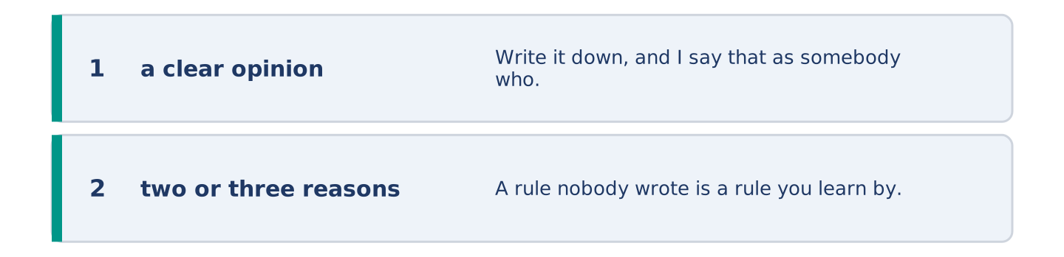
Figure 13.27 · The shape of the opinion paragraph, step by step.
Is it better to write a rule down or to let people learn it? Give your opinion and two or three reasons.
Model — read this first:
Write it down, and I say that as somebody who hates notices. A rule nobody wrote is a rule you learn by breaking it. The newest person in the room always does, three days in and already red in the face. A sign is ugly for everybody and hard on nobody. (51 words)
Word bank: I think… because… | better | however | in my opinion | it depends on
Check before you finish: ☐ a clear opinion? ☐ two or three reasons? ☐ 50–70 words?
Part 6: A Rule You Had to Learn (50–70 words)
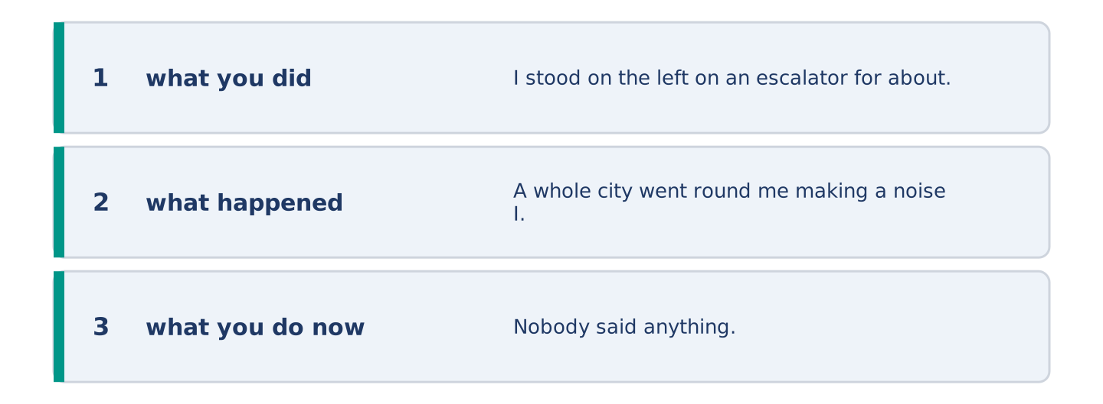
Figure 13.28 · The moves of the message, with a line of the model for each.
Write about a rule you did not know until you broke it. Say what happened.
Model — read this first:
I stood on the left on an escalator for about four seconds in my first week. A whole city went round me making a noise I did not know. Nobody said anything. Nobody had to. I stood on the right ever after, and I still do not know who decided it. (51 words)
Plan (fill in, then write): I ___. Then ___. Nobody ___. Since then I ___.
Check before you finish: ☐ what you did? ☐ what happened? ☐ what you do now? ☐ 50–70 words?
Part 6: Reflection — A Rule I Would Change (40–60 words)
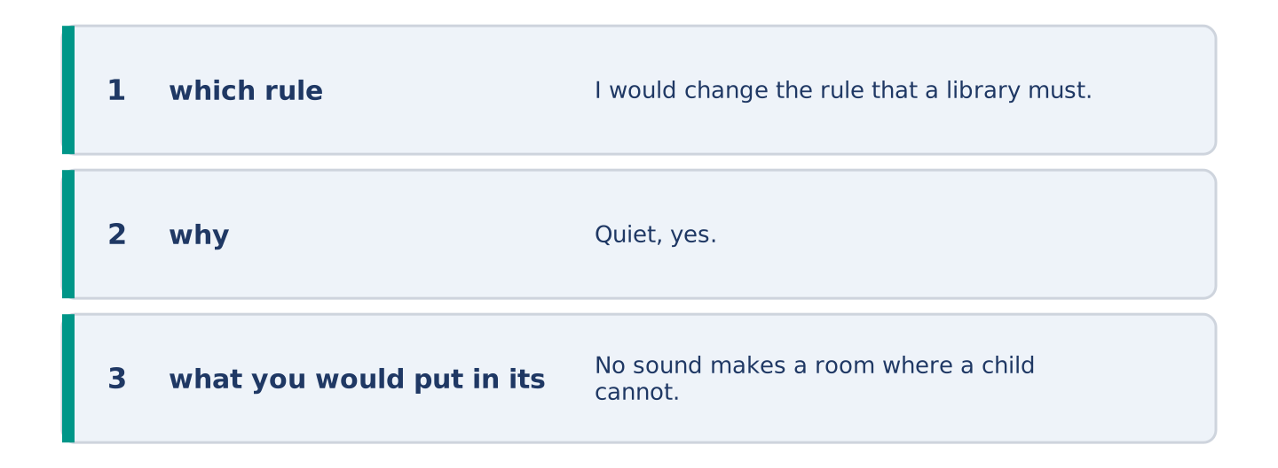
Figure 13.29 · The reflection, step by step.
Write about one rule you would change, and what you would put in its place.
Model — read this first:
I would change the rule that a library must have no sound in it at all. Quiet, yes. No sound makes a room where a child cannot ask a question, and a library with no children in it is only a store room. I would put a sign up that says talk, but talk like this, and then write it quietly. (61 words)
Check before you finish: ☐ which rule? ☐ why? ☐ what you would put in its place? ☐ 40–60 words?
Part 7 · Real-World File — Signs, Notices and Asking
[PLUS] Plus track (optional) · stronger learners
7A: Phrase Bank
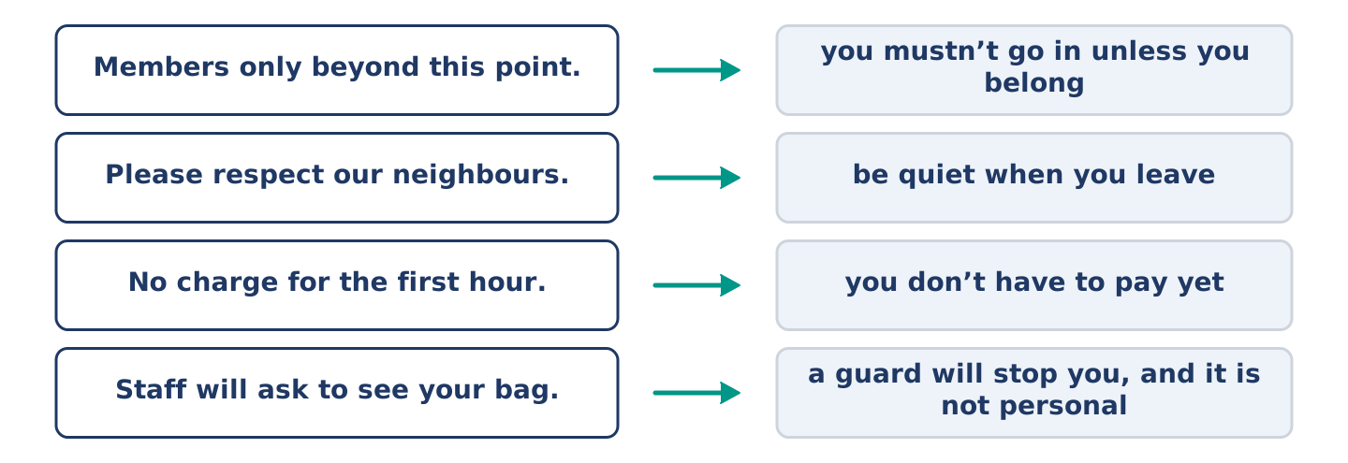
Figure 13.30 · What a sign says, and what it actually means.
Match what the sign says with what it means. One is not needed. Write the letter.
Column A
1. | “Members only beyond this point.” | ____
2. | “Please respect our neighbours.” | ____
3. | “No charge for the first hour.” | ____
4. | “Staff will ask to see your bag.” | ____
Column B
a) | you don’t have to pay yet
b) | be quiet when you leave
c) | a guard will stop you, and it is not personal
d) | how far it is to the station
e) | you mustn’t go in unless you belong
7B: A Rule Nobody Explained
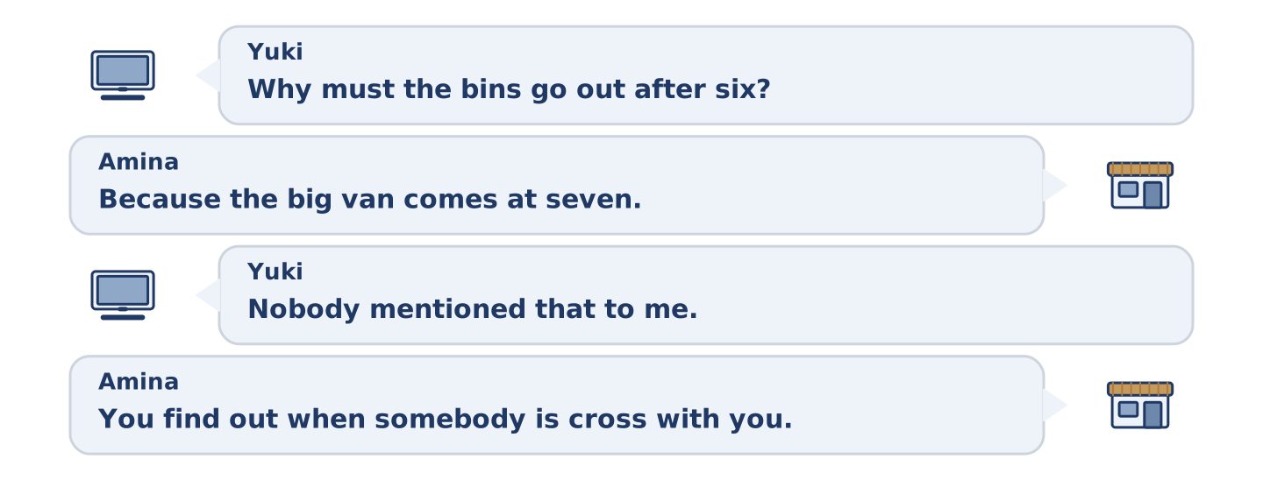
Figure 13.31 · The 7B exchange: who takes each turn.
🔊 Audio Track 13.5
Before you read: have you kept a rule for years without knowing why?
Yuki: Why must the bins go out after six? Amina: Because the big van comes at seven and the street is one car wide. Yuki: Nobody mentioned that to me. Amina: Nobody tells anybody. You find out when somebody is cross with you. Yuki: That is a terrible system. Amina: It is. Thirty years here, and I still do not know why we mustn’t use the side door after nine. Yuki: So there is one for you too. Amina: There is one for everybody.
Answer the questions. (0. is done.)
- When must the rubbish bins go out? — After six.
- Why must they go out then?
- How does Amina say people find out the rules?
- What does Amina still not know?
7C: Controlled Practice — Explaining a Rule Well
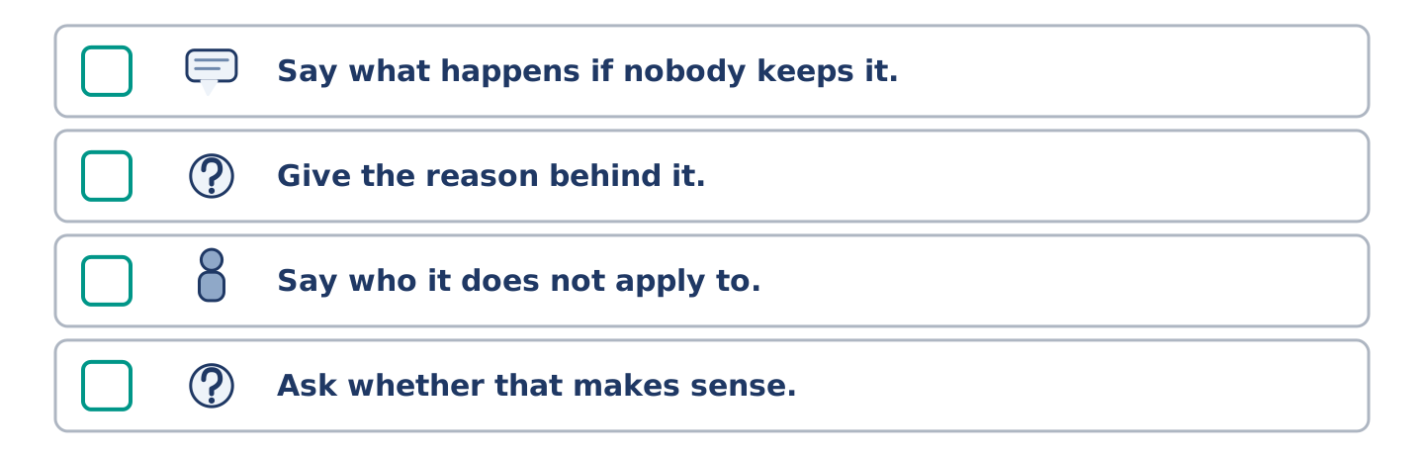
Figure 13.32 · The steps still to be numbered, as the task prints them.
Put the steps in order. Number them 1–5. (0. is done.)
- Say the rule in one sentence. — 1
____ Say what happens if nobody keeps it.
____ Give the reason behind it.
____ Say who it does not apply to.
____ Ask whether that makes sense.
7D: Role-Play — Asking Why the Rule Exists
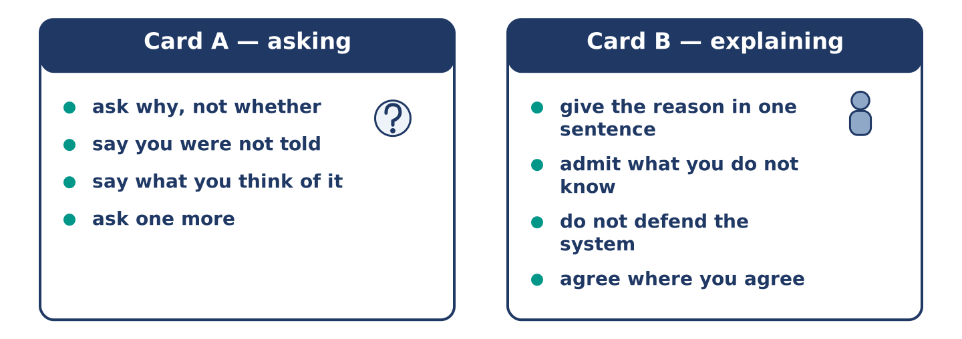
Figure 13.33 · The 7D cards: what each of you has to say.
In pairs. One asks why a rule exists; one explains it. Use the model and cards.
Model exchange: A: Why must the bins go out after six? — B: The big van comes at seven and the street is one car wide. — A: Nobody mentioned it. — B: Nobody tells anybody here. — A: That is a terrible system. — B: It is, and I have no plan to fix it.
Card A — asking: ask why, not whether · say you were not told · say what you think of it · ask one more.
Card B — explaining: give the reason in one sentence · admit what you do not know · do not defend the system · agree where you agree.
Stretch [PLUS]: the rule has no reason left and you both know it — decide out loud whether to keep it anyway.
7E: Writing — A Notice for a Shared Door (50–80 words)
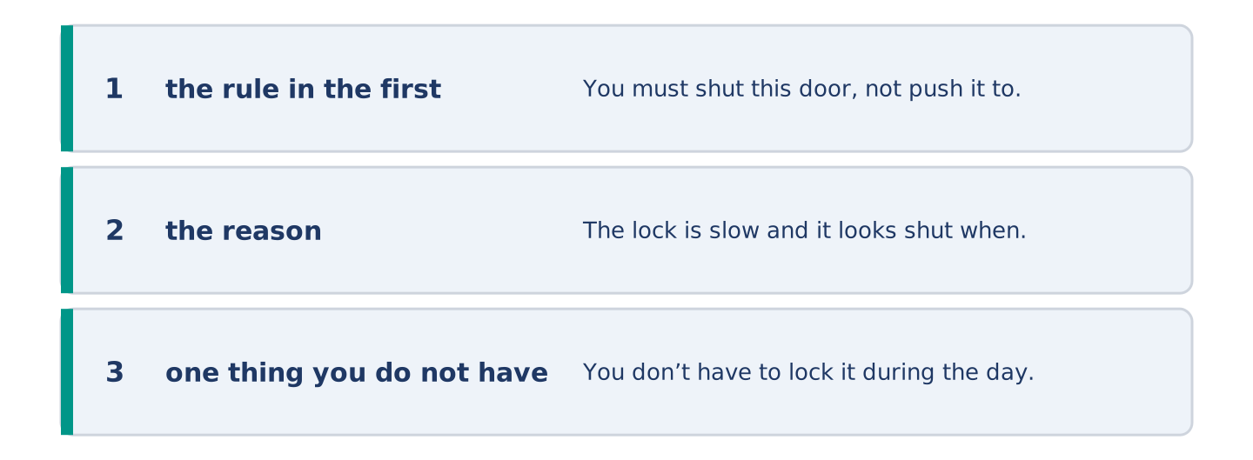
Figure 13.34 · The Part 7 note, with the model beside each line.
Write a notice for a door that several people use.
Model — read this first:
You must shut this door, not push it to. The lock is slow and it looks shut when it is not, and that is how we lost two bikes in the spring. You don’t have to lock it during the day; after nine, please turn the key. Carrying something heavy? Knock, and somebody comes down. The bell works. (58 words)
Check before you finish: ☐ the rule in the first sentence? ☐ the reason? ☐ one thing you do not have to do? ☐ 50–80 words?
Part 8 · Global Story — The Rule Everybody Said Would Fail
[PLUS] Plus track · pre-read / discuss
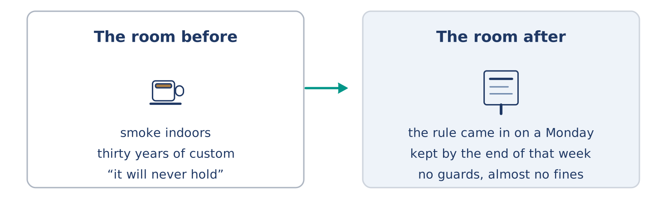
Figure 13.35 · A room before the rule, and the same room after it.
Before you read: can a whole country change a habit in one night?
Gloss: indoors = inside a building · workplace = anywhere people work · custom = what people have always done
Ireland was the first country in the world to stop smoking in every indoor workplace, and almost nobody thought it would hold. The bar was the heart of the thing, and the custom was older than anybody arguing about it. Smoking customers said they would go on smoking. Owners said they would lose everything. The rule came in on a Monday. By the end of that week almost everybody was keeping it, with no guards and almost no fines. What surprised the loudest arguers was how fast the new habit became the normal one. Thirty years of smoke left a room in a weekend. Within a year other countries were copying the law word for word, which nobody had expected on that Monday morning.
Answer the questions. (0. is done.)
- What was Ireland the first country to do? — Stop smoking in every indoor workplace.
- What did the smoking customers say?
- What did the owners say?
- What surprised the loudest arguers?
Part 8: Vocabulary in Context
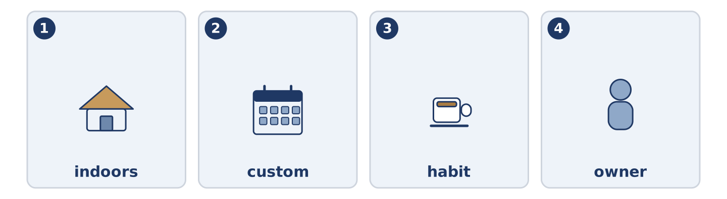
Figure 13.36 · The four words from the global story, drawn.
Match each word with its meaning. One meaning is not needed. Write the letter.
Column A
1. | indoors | ____
2. | custom | ____
3. | habit | ____
4. | owner | ____
Column B
a) | what people have always done
b) | the person the place belongs to
c) | inside a building
d) | something you do without deciding to
e) | the walkway between seats or shelves
Part 8: Discussion
Talk with a partner. Use the frames.
Discussion frames: “This is similar to where I live because…” · “This is different from where I live because…” · “I think the most important thing is… because…”
Part 9 · Close to Home — The Rules Nobody Wrote Down
[PLUS] Plus track · pre-read / decide
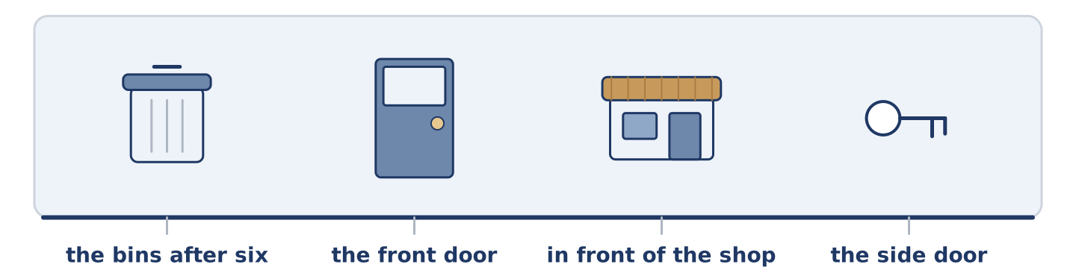
Figure 13.37 · The close-to-home reading, drawn along one street.
Before you read: how does a new person learn the rules of a building?
There is no list of rules at number 14 and there are about eleven of them. The bins go out after six. You must pull the front door shut, not push it to. Nobody parks in front of the shop before nine. You do not knock on Tomas’s door before two in the afternoon, because of his nights. Nobody uses the side door after nine and nobody now alive knows why. Yuki learned nine of the eleven in her first month. She got every one of them wrong first, then heard about it, kindly, from whoever was standing there. The other two she still does not know, and the building decided long ago that she does not need them.
Answer the questions. (0. is done.)
- How many rules are there at number 14? — About eleven.
- Why do you not knock on Tomas’s door before two?
- How did Yuki learn nine of the eleven?
- What has the building decided about the other two?
Part 9: Decision Task
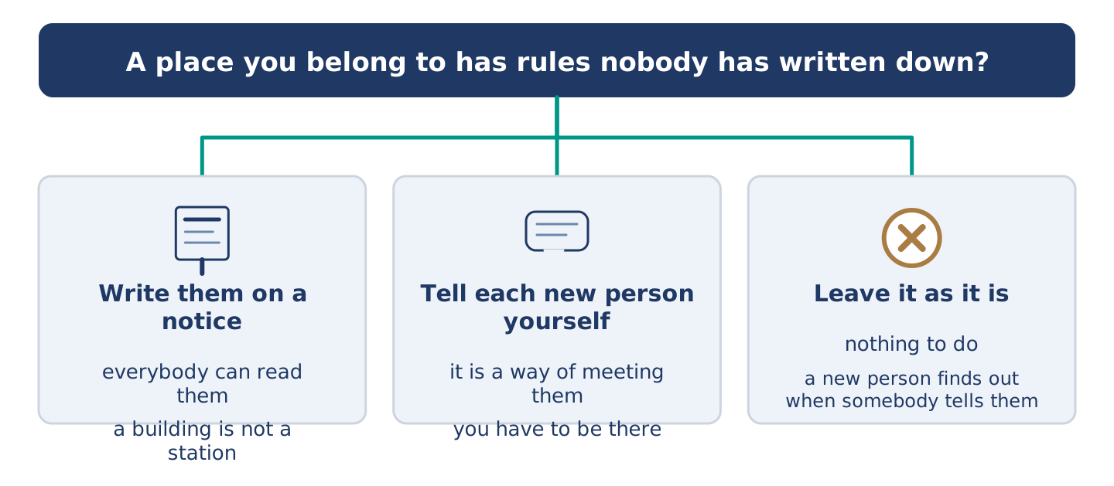
Figure 13.38 · Three ways to decide, and what each one costs.
A place you belong to has rules nobody has written down. Should you (a) write them all on a notice, (b) tell each new person yourself, or (c) leave it as it is? Decide and explain. Use the frame.
Answer frame: “I think I should ___ because ___. Also, ___. This is better than ___ because ___.”
Model — read this first:
I think I should tell each new person myself, because a notice makes a building sound like a station and nobody reads one anyway. Also, telling somebody is a way of meeting them. This is better than leaving it as it is, because the way it is now, a new person finds out when somebody tells them off. (58 words)
Phrase bank: I think I should… · because… · Also,… · This is better than… · In my opinion…
Part 10 · Review and Can-Do
[CORE + PLUS] · homework / self-study
Part 10: Spiral Review
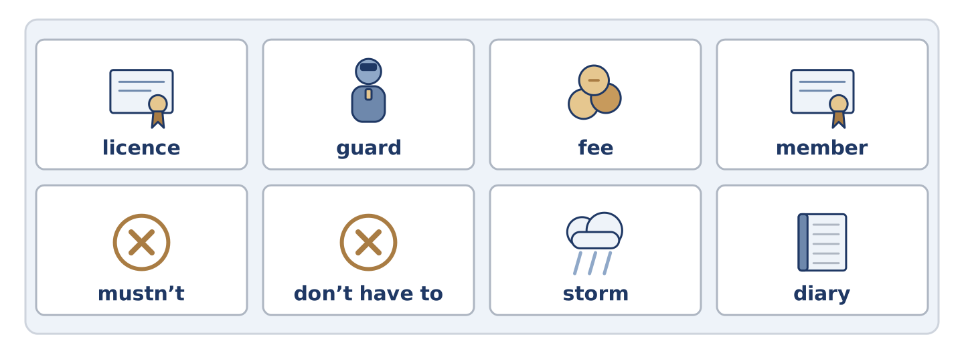
Figure 13.39 · The eight words of the review bank, in bank order.
Complete the review. (0. is done.)
- A rule the whole country has to keep is a law.
Word bank: licence | guard | fee | member | mustn’t | don’t have to | storm | diary
- A paper that says you are allowed to do something is a ______________________ .
- Somebody whose job is to watch a place is a ______________________ .
- The money you pay to go in or to belong is a ______________________ .
- Somebody who belongs to a club or a library is a ______________________ .
- You ______________________ touch the paintings. (forbidden)
- You ______________________ pay a fee. (not necessary)
- (from Unit 12) Strong wind and heavy rain together is a ______________________ .
- (from Unit 11) A book where you write what you are doing is a ______________________ .
Part 10: Can-Do
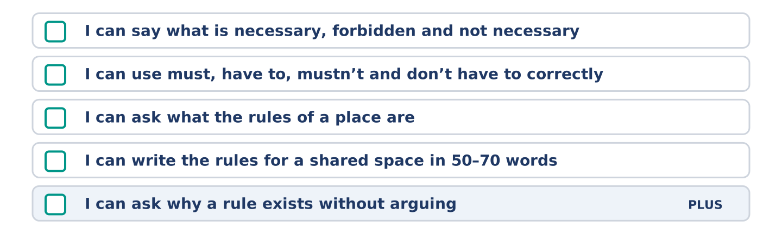
Figure 13.40 · What you can do at the end of this unit.
Can-Do checklist
☐ I can say what is necessary, forbidden and not necessary.
☐ I can use must, have to, mustn’t and don’t have to correctly.
☐ I can ask what the rules of a place are.
☐ I can write the rules for a shared space in 50–70 words.
☐ I can ask why a rule exists without arguing (Plus).
Part 10: Glossary
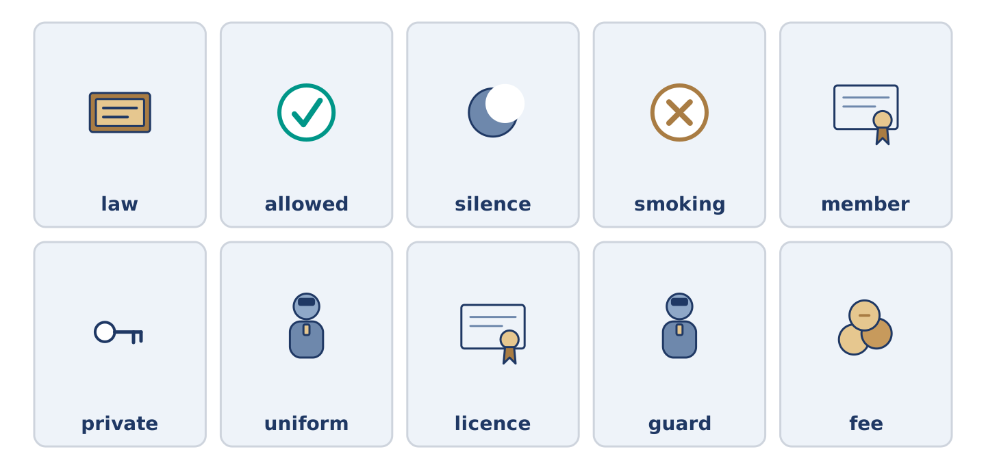
Figure 13.41 · All ten glossary words of Unit 13, one card each.
Unit 13 glossary (10 words)
law · allowed · silence · smoking · member · private · uniform · licence · guard · fee

