Unit 16: Then and Now
English for Daily Life · Level: A2 · Tracks: [CORE] Warm-Up + Parts 1–6 · [PLUS] Parts 7–10
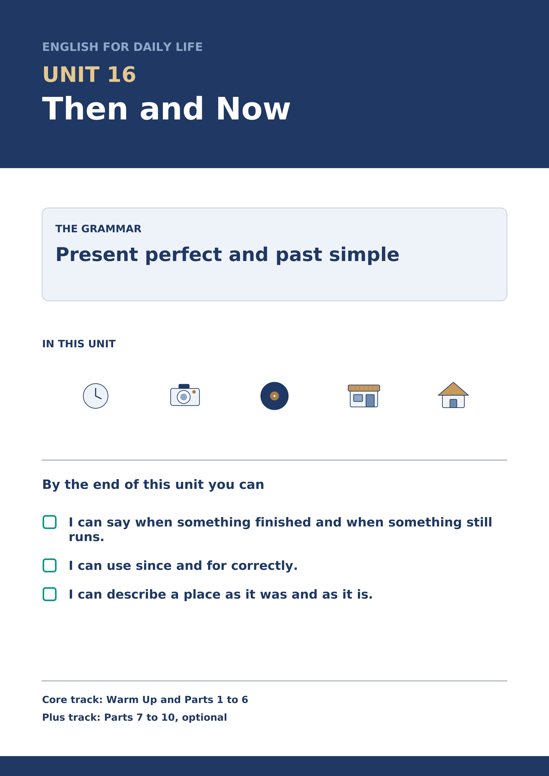
Warm Up
[CORE] Core track · in-class starter
Warm-up: Words for Then and Now
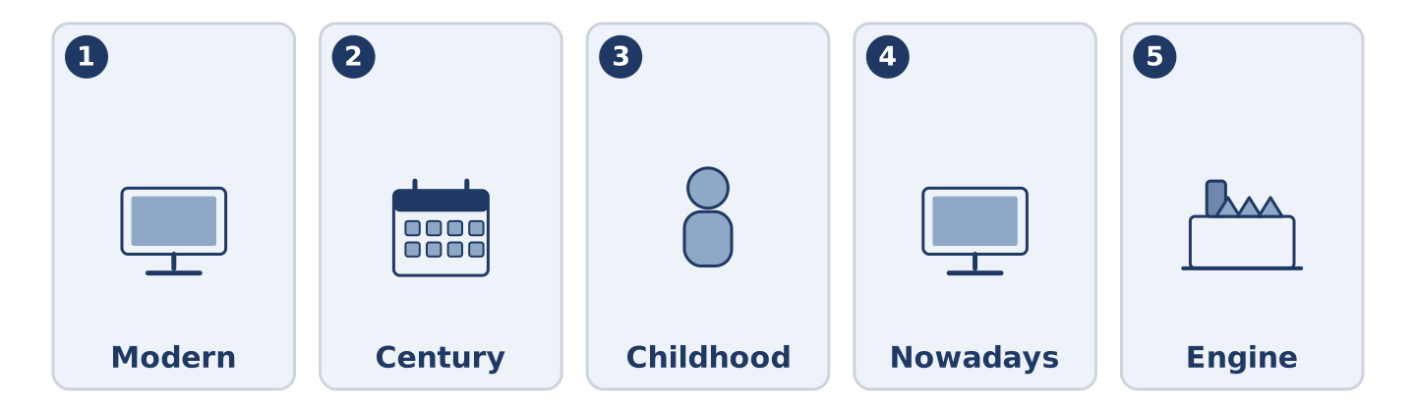
Figure 16.2 · The five warm-up words, and the thing each one means.
Match the words with their meanings. One meaning is not needed. Write the letter.
Column A
1. | Modern | ____
2. | Century | ____
3. | Childhood | ____
4. | Nowadays | ____
5. | Engine | ____
Column B
a) | a hundred years
b) | the part of a machine that makes it move
c) | at the present time, and not before
d) | of the present time, or near it
e) | the years when you were a child
f) | a very dry place where almost nothing grows
Warm-up: Talking About Change

Figure 16.3 · The word bank for this task, in the order it is printed.
Complete the sentences using the words in the word bank.
Word bank: camera | mobile | computer | record
- Amina has had the same ______________________ since her son bought it for her.
- Mr Okonkwo has never owned a ______________________ and does not feel the loss.
- Maya still has a ______________________ that takes film, and still uses it.
- There is one ______________________ in the shop and nobody plays it.
Warm-up: Six People, Six Changes
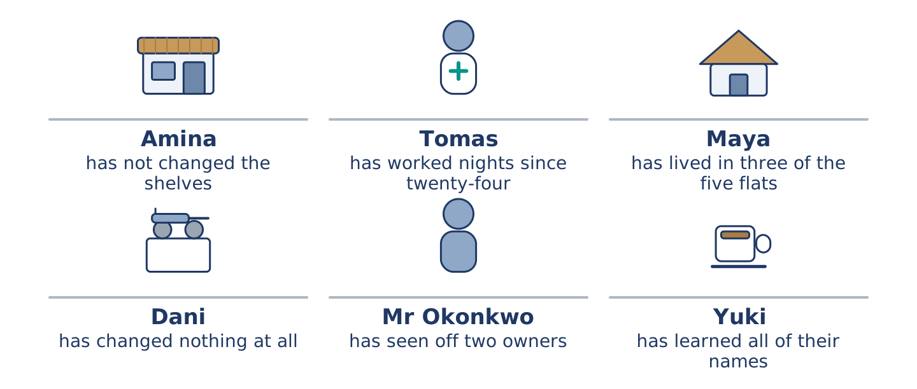
Figure 16.4 · What has changed for each of them, and what has not.
Read the text and choose the correct answer.
Number 14 has changed and the people in it have changed differently. Amina opened the shop eleven years ago and has not changed the shelves since. Tomas started at the hospital at twenty-four and has worked nights ever since. Maya moved in four years ago and has already lived in three of the five flats. Dani came last year and has changed almost nothing, including the light bulb. Mr Okonkwo arrived before any of them and has outlasted two owners. Yuki arrived in March and has learned all of their names.
1. How long has Tomas worked nights?
○ A) Four years
○ B) Since he started at twenty-four
○ C) Eleven years
○ D) Since March
2. What has Maya already done?
○ A) Opened a shop
○ B) Changed the light bulb
○ C) Outlasted two owners
○ D) Lived in three of the five flats
Part 1 · Vocabulary and Terminology
[CORE] Core track · pre-class input
Part 1: Words for Time and Change
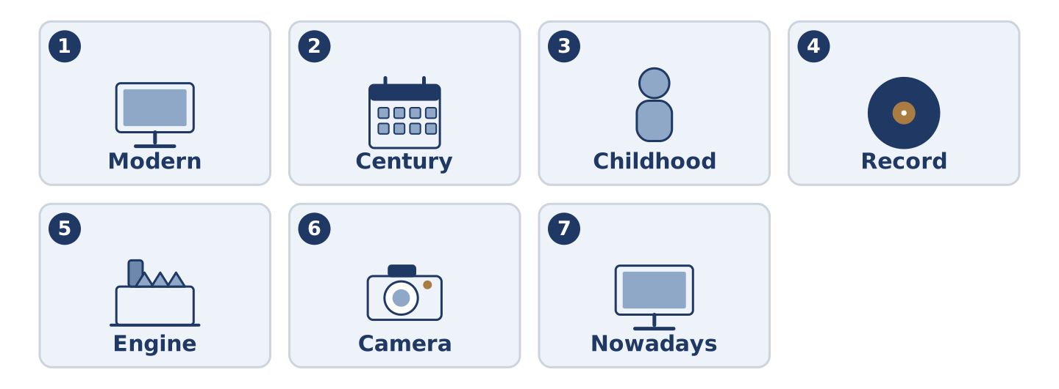
Figure 16.5 · The seven words of Column A, and what each one is.
Match the words with their meanings. One meaning is not needed. (0. is done for you.)
- Gas → what comes through a pipe and burns, for cooking and for heat.
Column A
1. | Modern | ____
2. | Century | ____
3. | Childhood | ____
4. | Record | ____
5. | Engine | ____
6. | Camera | ____
7. | Nowadays | ____
Column B
a) | a flat black circle that plays music
b) | a hundred years
c) | of the present time, or near it
d) | the thing you take photographs with
e) | the years when you were a child
f) | the part of a machine that makes it move
g) | at the present time, and not before
h) | the doctor who looks after your teeth
Gloss: century = a hundred years · record = a flat black circle that plays music · nowadays = at the present time, and not before · tense = the form of a verb that shows when something happened
Part 1: Pronunciation
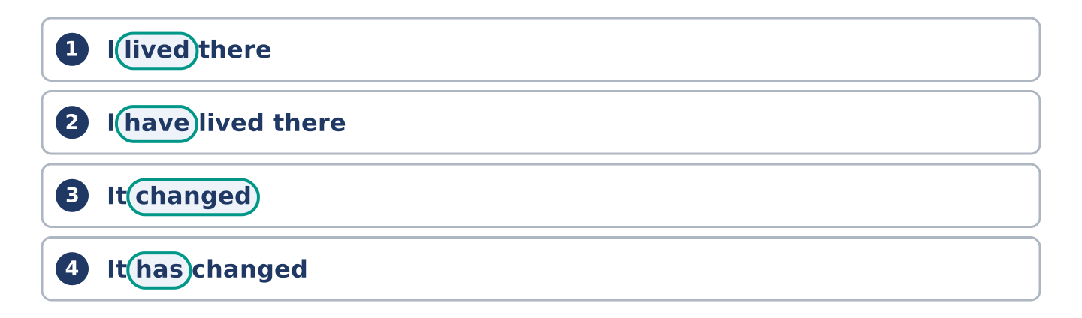
Figure 16.6 · Where the stress falls in 0 words of this unit.
🔊 Audio Track 16.1
Listen to the two past forms. Say each pair aloud.
I lived there — one sound at the end: /lɪvd/
I have lived there — the same ending, with have in front
It changed — the -ed is one sound again: /tʃeɪndʒd/
It has changed — and again the ending does not change
Here is the useful part. The word that changes is never the verb; it is the little word in front of it. Learners listen hard at the end of the verb and hear nothing, because there is nothing to hear. You pick the tense two words earlier.
Part 1: Four Things, Then and Now
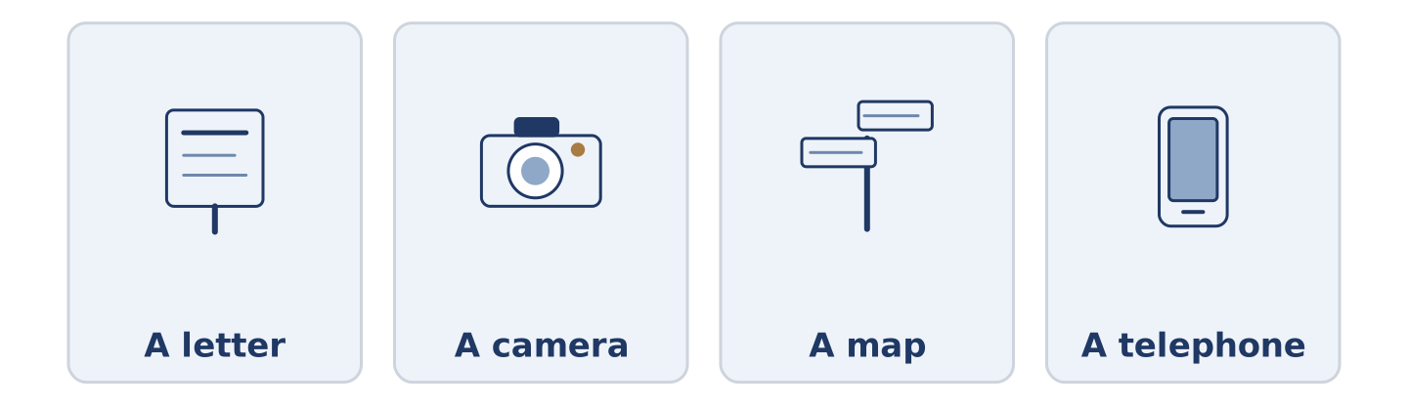
Figure 16.7 · Four things, and what each one became.
Complete the table. Write what it was and what it is now. (0. is done.)
The thing | Then | Now
A letter | days, and a stamp | (example)
A camera
A map
A telephone
- A letter — days, and a stamp — a message that arrives before you put the phone down.
Think about the street you know best. There is more than one right answer.
Part 1: Finished, or Still Going?
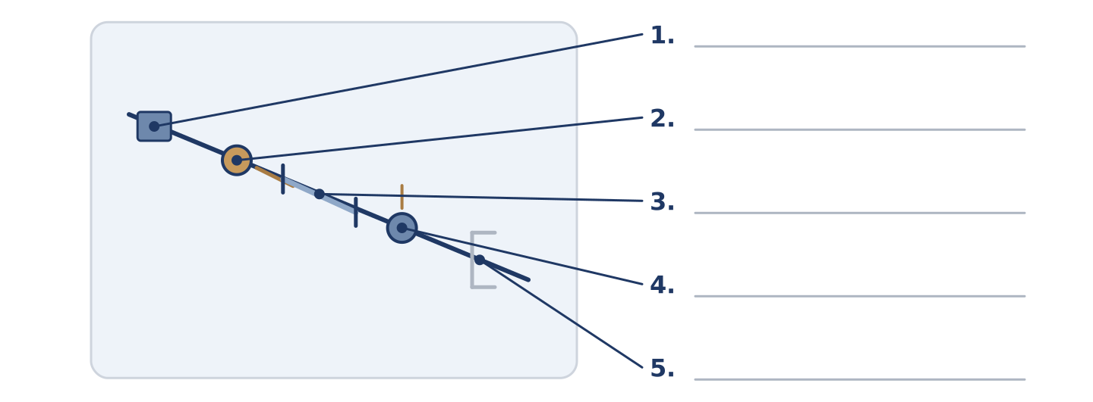
Figure 16.8 · Finished and unfinished time — write the correct word on each line.
Match the time words with what they do. One is not needed. Write the letter.
Column A
1. | in March | ____
2. | since March | ____
3. | for four years | ____
4. | four years ago | ____
5. | this year | ____
Column B
a) | a finished point in the past
b) | a length of time that is still running
c) | a period that has not finished
d) | a starting point, with now at the other end
e) | a finished month
f) | a hundred years
Part 1: Then and Now — Multiple Choice
Read and choose the correct answer.
1. A hundred years is a…
○ A) childhood
○ B) mobile
○ C) century
○ D) engine
2. The part of a machine that makes it move is the…
○ A) engine
○ B) computer
○ C) gas
○ D) camera
3. At the present time, and not before, is…
○ A) modern
○ B) nowadays
○ C) childhood
○ D) already
Part 1: Vocabulary Fill-in
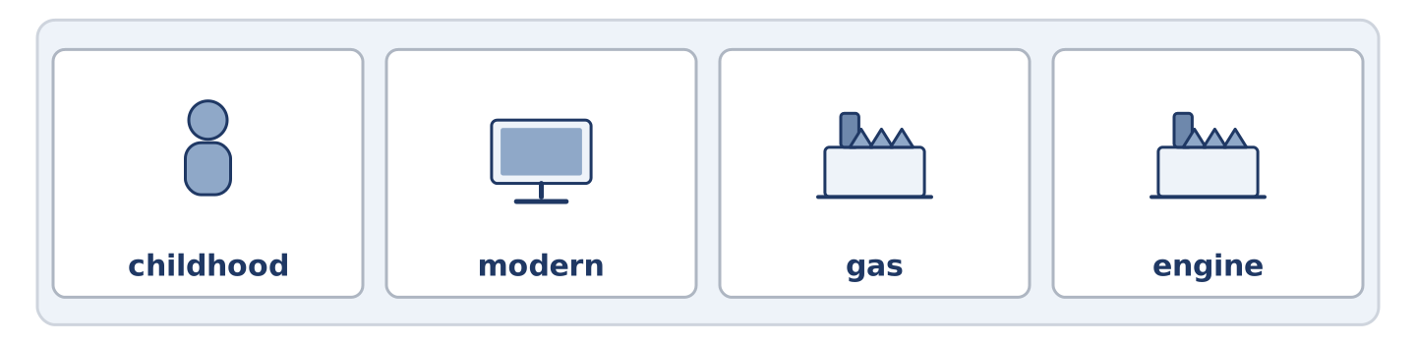
Figure 16.9 · The four words of the bank, in the order the task gives them.
Complete the sentences with the correct word.
Word bank: childhood | modern | gas | engine
- The whole of my ______________________ happened in four streets.
- The building looks ______________________ and is older than the church.
- The ______________________ went off for six hours and the whole street ate bread.
- You can hear the ______________________ from the end of the road, which is how we know he is home.
Part 1: Write About a Change (short)
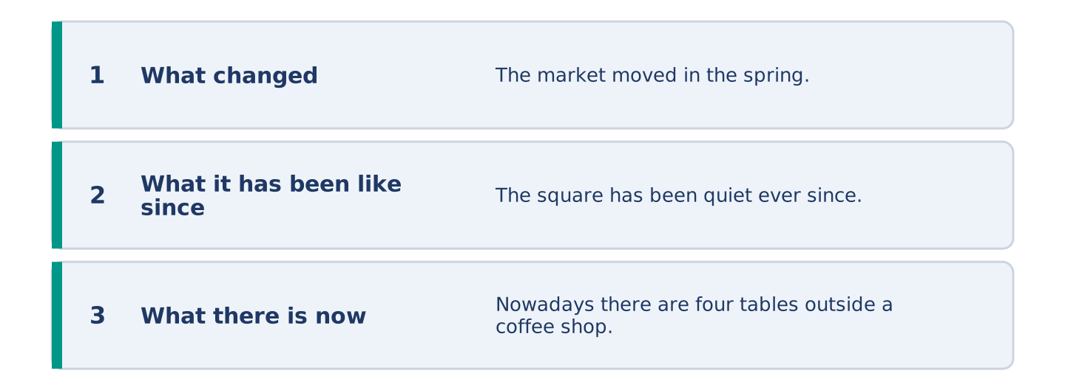
Figure 16.10 · The shape of your two or three sentences, with the model beside each step.
Write two or three sentences about something that has changed where you live. Use three words from this unit.
Model — read this first:
The market moved in the spring and the square has been quiet ever since. Nowadays there are four tables outside a coffee shop and they are usually empty. I grew up two streets away and I have never got used to it. (42 words)
Part 2 · Grammar — Present Perfect and Past Simple
[CORE] Core track · pre-class input
Part 2: Notice
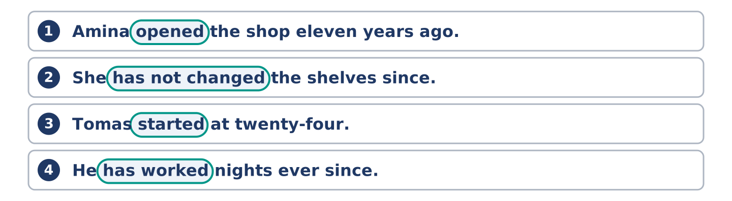
Figure 16.11 · Lines from the notice, with the target form ringed in each.
Read these lines. Underline the verbs. Which have a finished time, and which do not?
Amina opened the shop eleven years ago. She has not changed the shelves since. Tomas started at twenty-four. He has worked nights ever since. The market moved in the spring. It has been quiet ever since.
Three of these name a finished time. Three run from a point in the past up to now.
Part 2: Grammar Focus Box
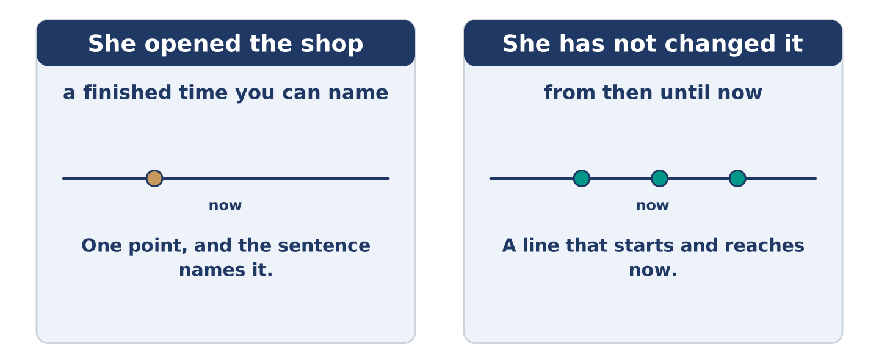
Figure 16.12 · A finished point, and a line that reaches now.
 | Form | Use | Example
past simple | opened, started, moved | a finished time you can name | She opened the shop eleven years ago.
present perfect | has opened, has started | from then until now | She has not changed it since.
since | since + a point | where the line starts | He has worked nights since March.
for | for + a length | how long the line is | He has worked nights for four years.
Remember: since takes a point, for takes a length: since March, for four years.
Watch out! ✗ I have lived here since four years. → ✓ I have lived here for four years. (for takes a length). ✗ She has opened the shop in March. → ✓ She opened the shop in March. (a finished month takes the past simple).
Part 2: Controlled Practice
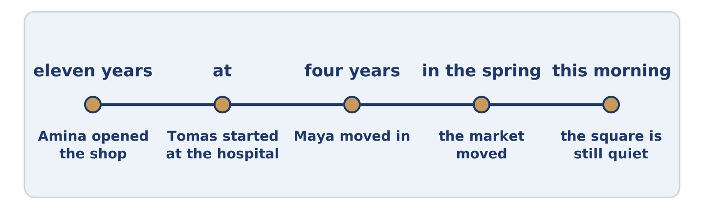
Figure 16.13 · One street, from eleven years ago to this morning.
Complete with the past simple or the present perfect. (0. is done.)
- Amina opened the shop eleven years ago. (open)
- She ______________________ the shelves since. (not change)
- Tomas ______________________ at the hospital at twenty-four. (start)
- He ______________________ nights ever since. (work)
- The market ______________________ in the spring. (move)
Part 2: Finished Time or Up To Now?
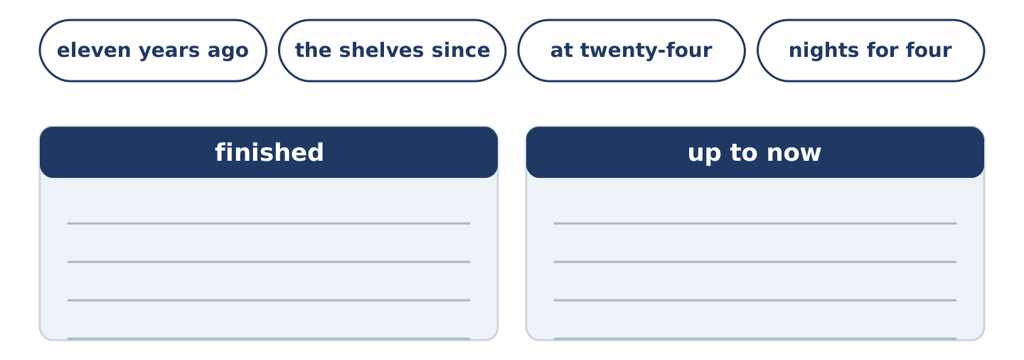
Figure 16.14 · The items of this task, and the bins they sort into.
Write finished or up to now. (0. is done.)
- She opened the shop eleven years ago. — finished
- She has not changed the shelves since. ____________
- He started at twenty-four. ____________
- He has worked nights for four years. ____________
- The market moved in the spring. ____________
Part 2: Correct the Sentence
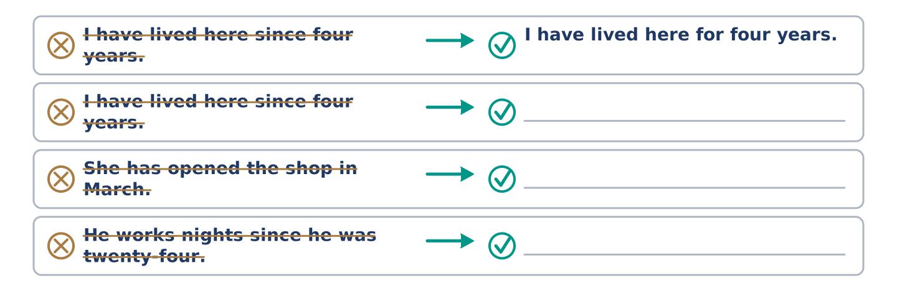
Figure 16.15 · One correction done for you, and the rest to write.
Each sentence has one grammar mistake. Write the correct sentence.
- I have lived here since four years.
- She has opened the shop in March.
- He works nights since he was twenty-four.
- The market has moved in the spring.
Part 2: Freer Practice
Write two sentences about your own street: one with a finished time, and one that runs up to now.
Part 2: Grammar Review
Choose the correct sentence.
1. Which sentence uses for correctly?
○ A) I have lived here since four years.
○ B) I live here since four years.
○ C) I have lived here four years ago.
○ D) I have lived here for four years.
2. Which sentence names a finished time?
○ A) She started here in March.
○ B) She has worked here for years.
○ C) She has not changed it since.
○ D) She has worked here since March.
→ Harvest: you will see both tenses again in the Part 5 reading. Watch for the dates.
Part 3 · Listening
[CORE] Core track · pre-class input · scripts printed inline
Part 3: What the Street Used to Be
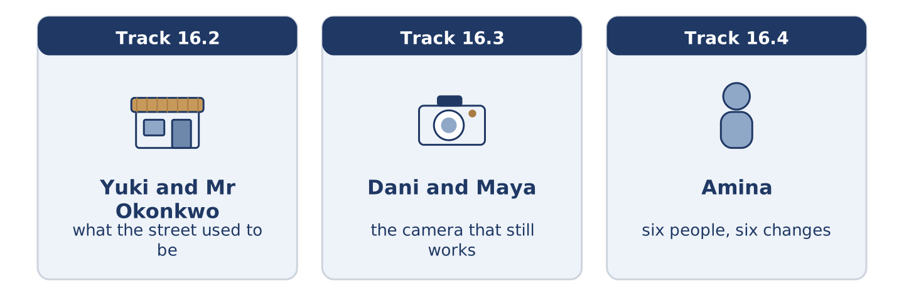
Figure 16.16 · The three listenings: who is speaking, and what about.
🔊 Audio Track 16.2
Before you listen: what was on your street before the thing that is there now?
Yuki: What was here before the coffee shop? Mr Okonkwo: A shoe shop. Before that, a different shoe shop. Yuki: Two shoe shops? That doesn’t sound right. Mr Okonkwo: Alder Street had four at one time, and I have never understood it either. Yuki: And the square? Mr Okonkwo: The market was in the square for ninety years. It moved in the spring, and the square has not been the same since. Yuki: Do you mind? Mr Okonkwo: I have minded for seven months and I have said nothing, which is the local custom.
While you listen: write True, False, or Not Given. (0. is done.)
- There was a shoe shop before the coffee shop. — True
- Alder Street had four shoe shops at one time. ____
- Mr Okonkwo thinks the square is better now. ____
- The market has moved to the car park. ____
Useful phrases: What was here before…? · Before that… · it moved in… · has not been the same since
Part 3: The Camera That Still Works
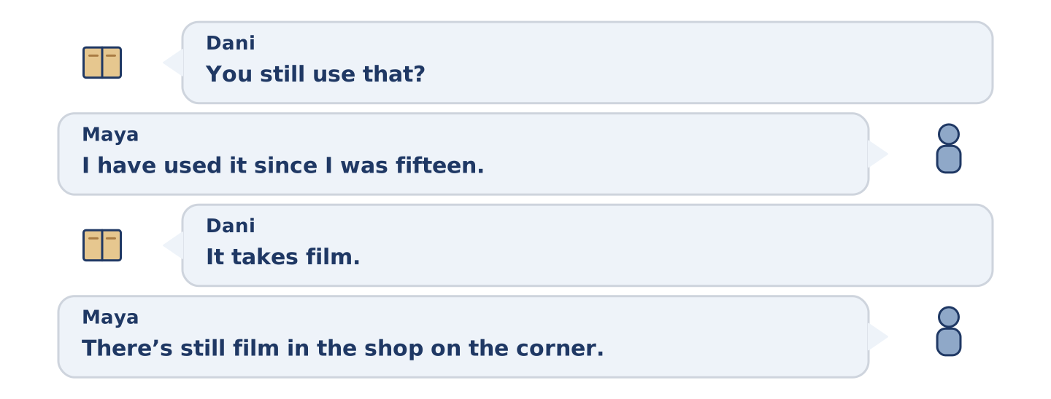
Figure 16.17 · The second listening, turn by turn.
🔊 Audio Track 16.3
Before you listen: do you keep anything that does the same job worse?
Dani: You still use that? Maya: I have used it since I was fifteen. Dani: It takes film. Maya: It does. There’s still film in the shop on the corner. Dani: You have a mobile. Maya: I have a mobile and I have taken nine thousand photographs on it and I have looked at none of them. Dani: And the camera? Maya: Thirty-six at a time, and I have looked at every one. Dani: That’s an argument. Maya: It took me nine thousand photographs to find it.
Answer the questions. (0. is done.)
- How long has Maya used the camera? — Since she was fifteen.
- How many photographs has she taken on her mobile?
- How many of them has she looked at?
- How many does the camera take at a time?
Part 3: Six People, Six Changes
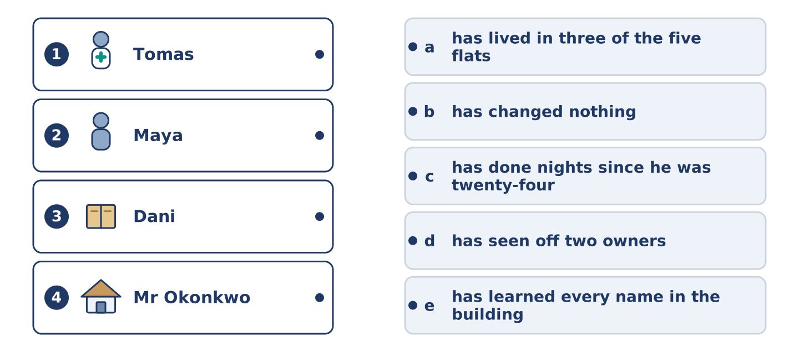
Figure 16.18 · Four on the left, five on the right, and one spare.
🔊 Audio Track 16.4
Before you listen: who do you know who has changed least?
Amina: I have watched this street for eleven years and I can tell you who changes. Tomas started at the hospital at twenty-four and has done nights ever since. Maya has been here four years and has lived in three of the five flats. Dani came last year and has changed nothing, including a light bulb that went in June. Mr Okonkwo was here before any of us and has seen off two owners. Yuki arrived in March and has already learned every name.
While you listen: match each person with their change. One is not needed. (0. is done.)
- Amina → she has watched for eleven years.
Useful phrases: ___ has done nights ever since · ___ has lived in three flats · ___ has changed nothing
Column A
1. | Tomas | ____
2. | Maya | ____
3. | Dani | ____
4. | Mr Okonkwo | ____
Column B
a) | has lived in three of the five flats
b) | has changed nothing, including a light bulb
c) | has done nights since he was twenty-four
d) | has seen off two owners
e) | has learned every name in the building
Part 4 · Speaking
[CORE] Core track · in-class output
Part 4: What Has Changed
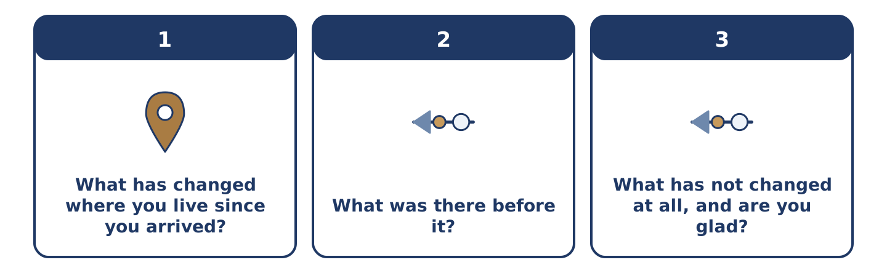
Figure 16.19 · The three questions as cards, to take one at a time.
Work with a partner. Ask and answer these questions.
- What has changed where you live since you arrived?
- What was there before it?
- What has not changed at all, and are you glad?
Useful language: It has changed since… · There used to be… · for ten years · nowadays
Part 4: Find the Difference (pairwork)
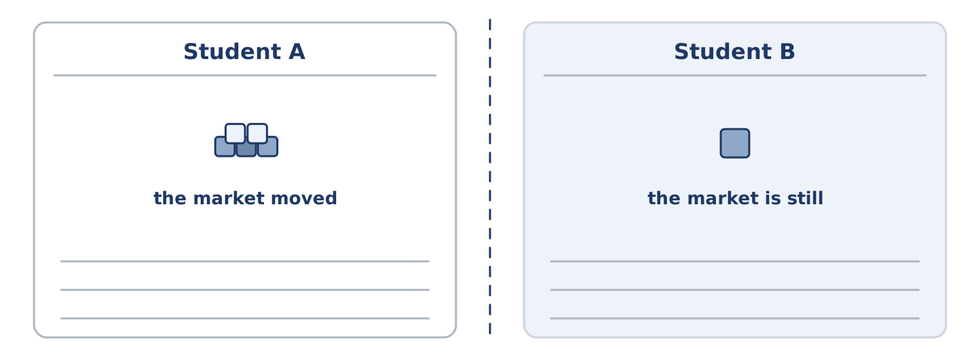
Figure 16.20 · Student A’s facts and Student B’s, with a fold between them.
Student A and Student B each have a street, then and now. Ask questions and find three differences.
Useful questions: What was there before? · How long has it been there? · Has the market moved? · What has not changed?
Student A — your street: the market moved, the shoe shop closed, the school is the same, there are four coffee shops.
Student B — your street: the market is still there, the shoe shop closed, the school is the same, there is one coffee shop.
Part 4: Describing a Change
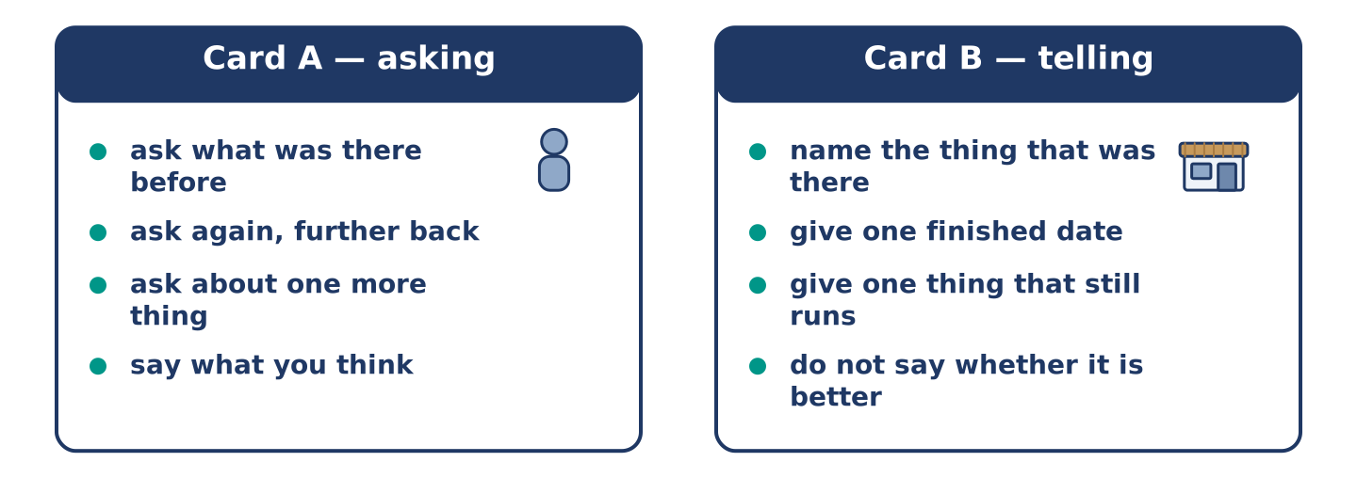
Figure 16.21 · Card A and Card B: what each of you has to say.
Work in pairs. Read the model, then use the cards.
Model exchange:
A: What was here before the coffee shop? — B: A shoe shop. — A: And before that? — B: A different shoe shop. — A: Two? — B: Four, at one time. — A: And the market? — B: It moved in the spring and the square has not been the same since.
Useful language: What was here before…? · And before that? · It moved in… · has not been the same since
Card A — asking: ask what was there before · ask again, further back · ask about one more thing · say what you think.
Card B — telling: name the thing that was there · give one finished date · give one thing that still runs · do not say whether it is better.
Your turn: run the dialogue, then swap roles.
Stretch [PLUS]: the change you are describing was good for you and bad for the person you are talking to — say so honestly.
Part 4: Mini-Presentation
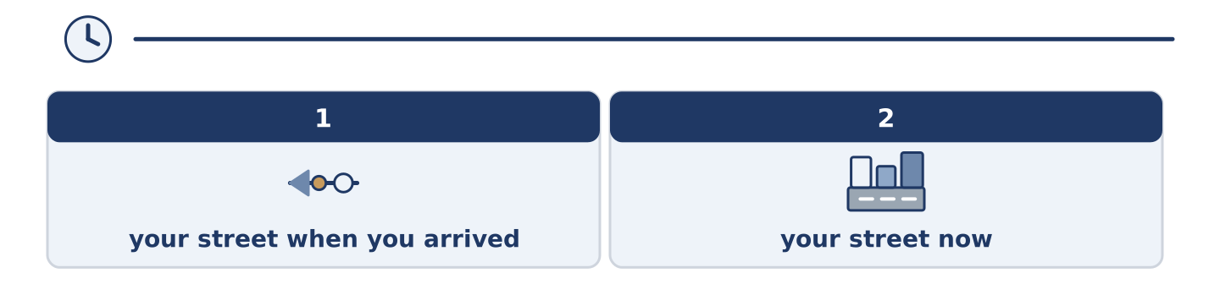
Figure 16.22 · The one-minute talk as 0 beats, each as wide as its share.
Prepare a short talk (about one minute). Describe your street as it was when you arrived and as it is now.
Part 5 · Reading
[CORE] Core track · pre-class input
Part 5: Why Nothing Feels as Old as the Recent Past
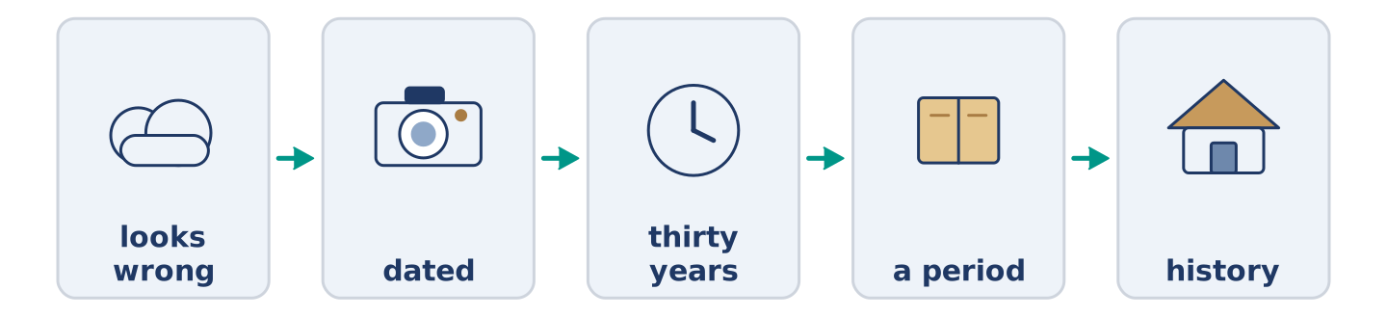
Figure 16.23 · One street, in four pictures.
Before you read: which photograph of your own life looks oldest to you?
Gloss: fashion = what most people wear or like at one time · dated = looking old in a way nobody planned · taste = what a person finds good
A photograph from a hundred years ago looks like history. There is a gas lamp in it, and nobody argues with the lamp. A photograph from twenty years ago looks wrong. The same goes for a ten-year-old computer. This is not about the clothes, or not only. Anything old enough stops arguing with the present and becomes a picture. Anything recent is still close enough to judge against now, and it loses. Anyone who designs things knows this already. A thing looks dated for about thirty years, and then it stops and becomes a period. The same happens to taste, to buildings and to how a street talks about an old shop. Nothing anybody says about a change is honest until the change is older than the person complaining.
Answer the multiple-choice questions. (0. is done.)
- How does a photograph from a hundred years ago look? — Like history.
1. Why does a recent photograph look wrong?
○ A) Because the clothes were worse
○ B) Because the camera was bad
○ C) Because we still judge it against now
○ D) Because nobody kept it
2. How long is a thing dated for?
○ A) Ten years
○ B) About thirty years
○ C) A hundred years
○ D) For ever
3. When does the text say an opinion about a change becomes honest?
○ A) Straight away
○ B) When a newspaper writes about it
○ C) Never
○ D) When the change is older than the person complaining
Part 5: Vocabulary in Context
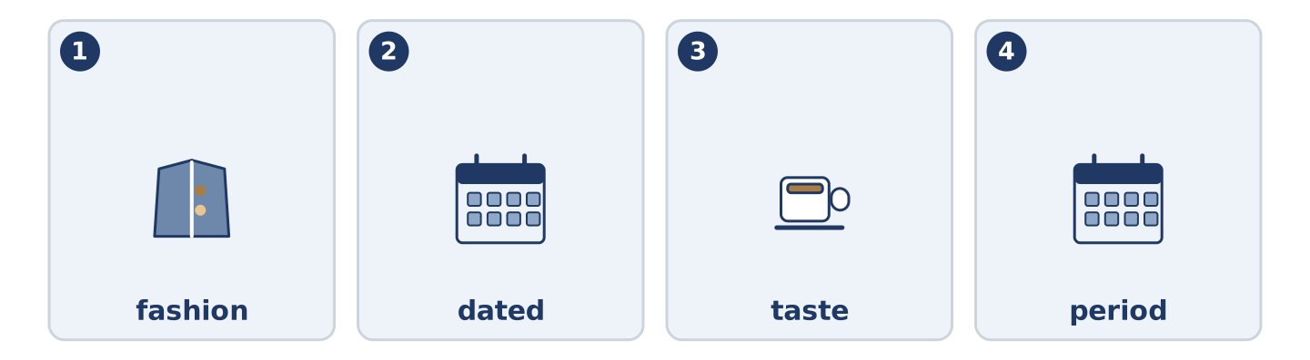
Figure 16.24 · The four words from the reading, drawn.
Match each word from the text with its meaning. One meaning is not needed. Write the letter.
Column A
1. | fashion | ____
2. | dated | ____
3. | taste | ____
4. | period | ____
Column B
a) | a length of time with a character of its own
b) | looking old in a way nobody planned
c) | what a person finds good
d) | what most people wear or like at one time
e) | a hundred years
Part 5: Three Things That Came Back
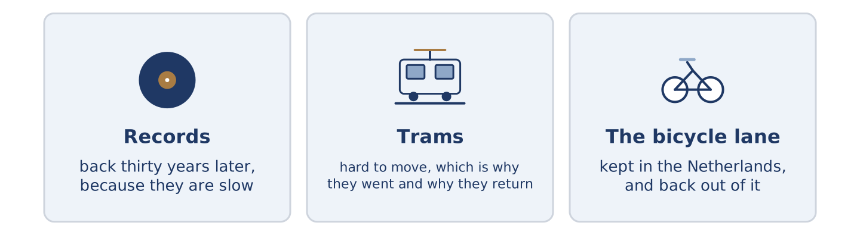
Figure 16.25 · Three things people threw away and then wanted again.
Before you read: has anything you threw away come back into fashion?
Gloss: vinyl = the material old records are made of · tram = a bus on rails in a street · bicycle lane = a part of the road kept for bikes
Some things go away and then return, and the return is never for the first reason. Records went away when the CD arrived. They came back thirty years later, and not because they sound better. They came back because they are slow, and because you have to choose. Trams left the British cities, and several are putting the rails down again. The reason is the old reason turned over: a tram is hard to move. Dutch cities kept the bicycle lane when everybody else tore theirs up. It has travelled back out of the Netherlands to the countries that invented it. Each time, the thing itself did not change. What changed was the problem it answered.
Answer the questions. (0. is done.)
- Is the return always for the first reason? — No, it never is.
- Why did records come back?
- Why are trams being laid again?
- What changed each time?
Part 6 · Writing
[CORE] Core track · in-class / homework
Part 6: A Street, Then and Now (50–70 words)
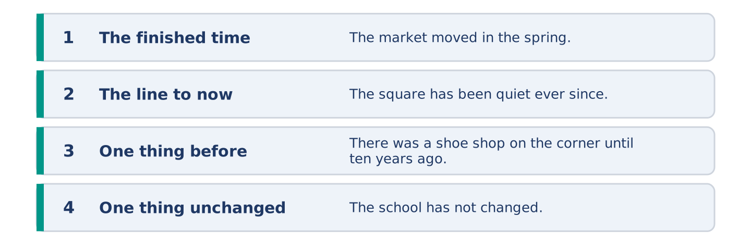
Figure 16.26 · The shape of the piece you are about to write.
Write about a street you know as it was and as it is. Use one finished time and one that runs to now.
Model — read this first:
The market left the square in the spring and the square has been quiet ever since. There was a shoe shop on the corner until ten years ago, and nobody remembers what it was called. The school has not changed. Four coffee shops have opened since I moved here and three have already closed. (54 words)
Plan (fill in, then write): ___ in ___. ___ has ___ ever since. There was ___ until ___. ___ has not changed.
Word bank: has changed | has not changed | since | for | ever since
Check before you finish: ☐ one finished time? ☐ one that runs to now? ☐ one thing unchanged? ☐ 50–70 words?
Part 6: Was Life Better Before? (50–70 words)
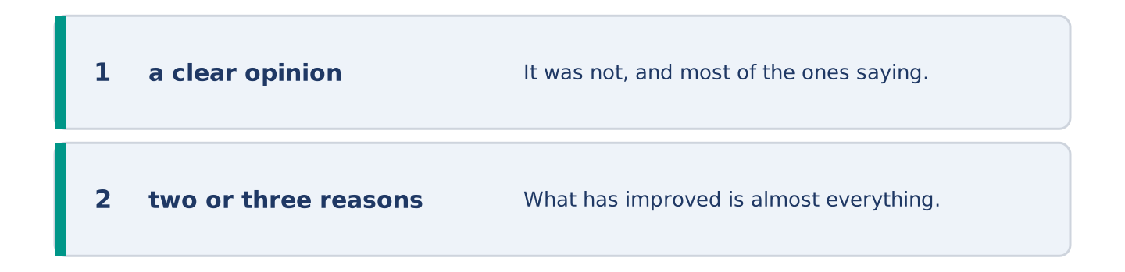
Figure 16.27 · The shape of the opinion paragraph, step by step.
Was life better twenty years ago? Give your opinion and two or three reasons.
Model — read this first:
It was not, and most of the ones saying it was are remembering being younger. What has improved is almost everything medical and almost everything about how far a normal person can go. What has got worse is quieter and harder to name: nobody is ever unreachable, and that was a kind of rest. (54 words)
Word bank: I think… because… | has improved | however | in my opinion | it depends on
Check before you finish: ☐ a clear opinion? ☐ two or three reasons? ☐ 50–70 words?
Part 6: Something That Has Not Changed (50–70 words)
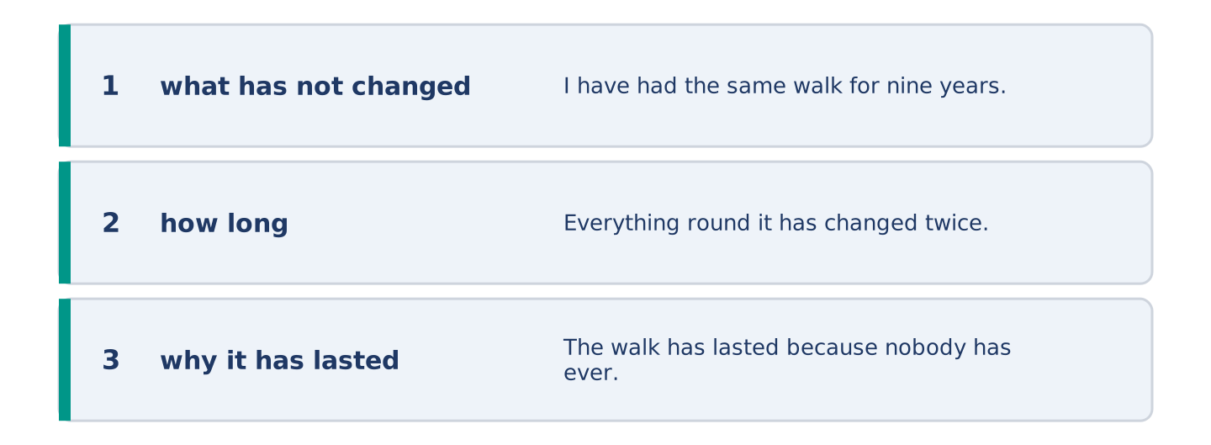
Figure 16.28 · The moves of the message, with a line of the model for each.
Write about one thing that has not changed in your life. Say why you think it has lasted.
Model — read this first:
I have had the same walk for nine years, past the same gate and the same three trees. Everything round it has changed twice. The walk has lasted because nobody has ever had a reason to touch it. That is the only way anything survives — not out of love, but by being in nobody’s way. (56 words)
Plan (fill in, then write): I have had ___ for ___. ___ has changed ___. It has lasted because ___.
Check before you finish: ☐ what has not changed? ☐ how long? ☐ why it has lasted? ☐ 50–70 words?
Part 6: Reflection — A Photograph of Myself (40–60 words)
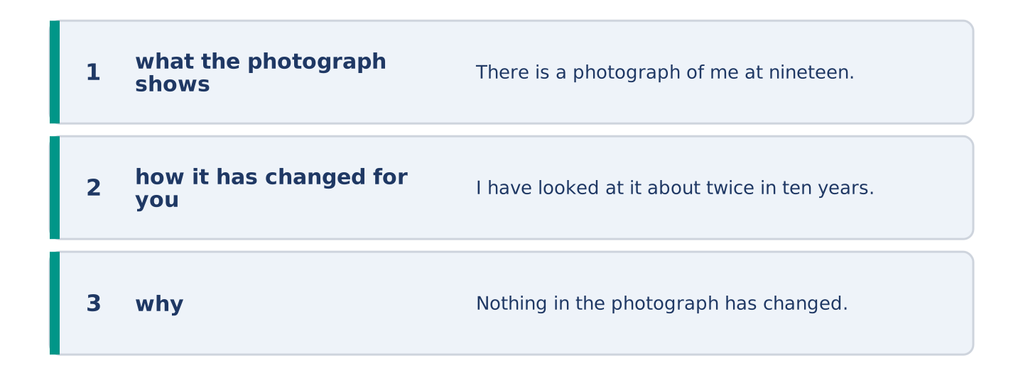
Figure 16.29 · The reflection, step by step.
Write about a photograph of yourself from years ago and what it shows.
Model — read this first:
There is a photograph of me at nineteen in a coat I was proud of. I have looked at it about twice in ten years, and it has gone from fine, to too awful to look at, to interesting. Nothing in the photograph has changed. I have stopped being close enough to it to mind. (55 words)
Check before you finish: ☐ what the photograph shows? ☐ how it has changed for you? ☐ why? ☐ 40–60 words?
Part 7 · Real-World File — Talking About How Things Were
[PLUS] Plus track (optional) · stronger learners
7A: Phrase Bank
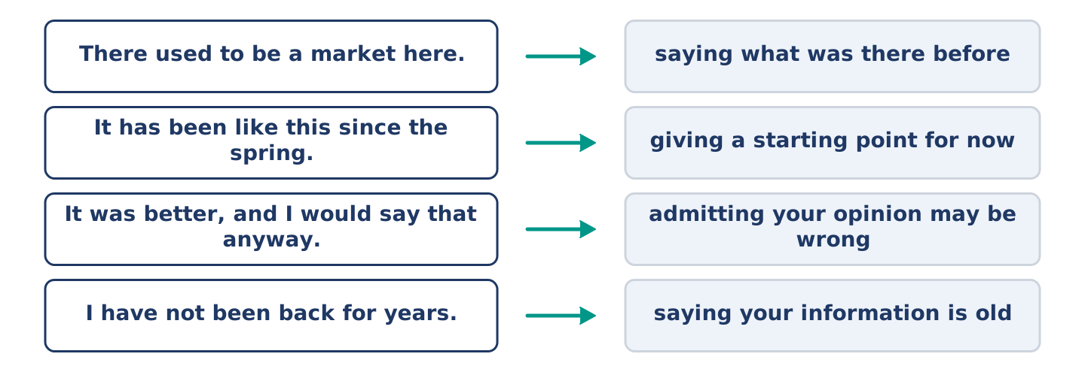
Figure 16.30 · What people say about change, and what each line does.
Match what a person says with its purpose. One purpose is not needed. Write the letter.
Column A
1. | “There used to be a market here.” | ____
2. | “It has been like this since the spring.” | ____
3. | “It was better, and I would say that anyway.” | ____
4. | “I have not been back for years.” | ____
Column B
a) | admitting your opinion may be wrong
b) | giving a starting point for now
c) | how much it will cost
d) | saying what was there before
e) | saying your information is old
7B: The Shop That Everybody Remembers Differently
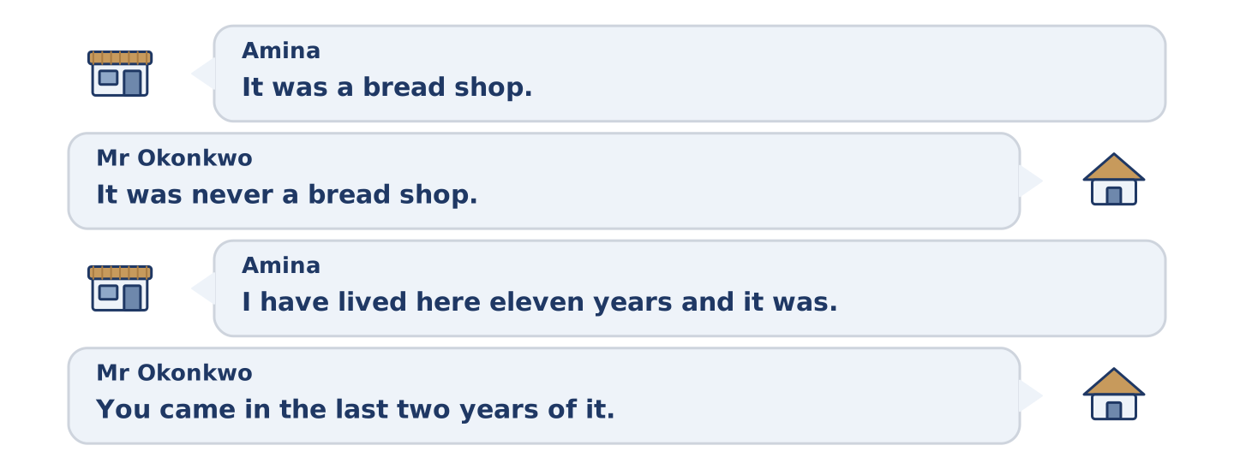
Figure 16.31 · The 7B exchange: who takes each turn.
🔊 Audio Track 16.5
Before you read: do two people ever remember the same shop the same way?
Amina: It was a bread shop. Mr Okonkwo: It was never a bread shop. It sold bread for two years and it was a tool shop for twenty. Amina: I have lived here eleven years and it was a bread shop the whole time. Mr Okonkwo: You came in the last two years of it. Amina: Ah. I didn’t know that. Mr Okonkwo: Everybody remembers the end of a shop, because the end is the part they were there for. Amina: So the bread shop is the end of a tool shop. Mr Okonkwo: The bread shop is the end of a tool shop.
Answer the questions. (0. is done.)
- What does Amina remember the shop as? — A bread shop.
- What does Mr Okonkwo say it was for twenty years?
- How long has Amina lived there?
- What does Mr Okonkwo say everybody remembers?
7C: Controlled Practice — Describing a Change Fairly
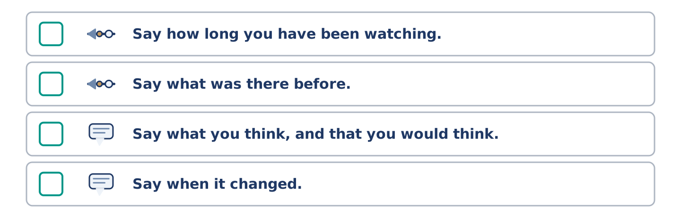
Figure 16.32 · The steps still to be numbered, as the task prints them.
Put the steps in order. Number them 1–5. (0. is done.)
- Say what is there now. — 1
____ Say how long you have been watching.
____ Say what was there before.
____ Say what you think, and that you would think it anyway.
____ Say when it changed.
7D: Role-Play — Two People, One Street
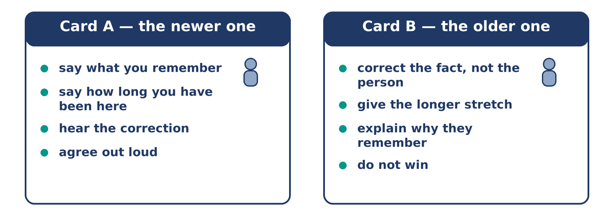
Figure 16.33 · The 7D cards: what each of you has to say.
In pairs. One has been there longer than the other. Use the model and cards.
Model exchange: A: It was a bread shop. — B: It was never a bread shop. — A: I have lived here eleven years. — B: You came in the last two years of it. — A: Ah. — B: Everybody remembers the end of a shop. — A: Because that is the part they were there for.
Card A — the newer one: say what you remember · say how long you have been here · hear the correction · agree out loud.
Card B — the older one: correct the fact, not the person · give the longer stretch · explain why they remember it that way · do not win.
Stretch [PLUS]: you have been there longest and you are the one who is wrong — notice it in the middle of the conversation.
7E: Writing — A Note for Somebody Who Has Been Away (50–80 words)
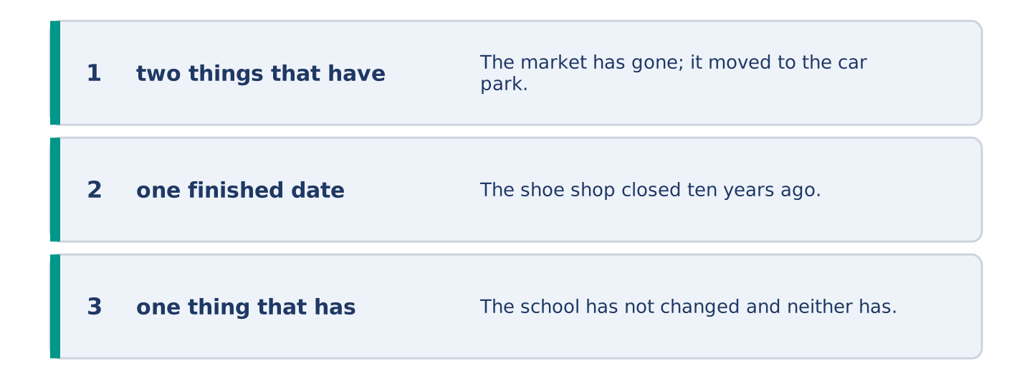
Figure 16.34 · The Part 7 note, with the model beside each line.
Somebody is coming back after ten years away. Write them a note about what has changed.
Model — read this first:
The market has gone; it moved to the car park in the spring and the square is empty now. The shoe shop closed ten years ago and is a coffee shop, and so are two things you remember. The school has not changed and neither has the bus number. Amina is still in the shop and will know you. Nothing you need has moved. (64 words)
Check before you finish: ☐ two things that have changed? ☐ one finished date? ☐ one thing that has not changed? ☐ 50–80 words?
Part 8 · Global Story — The City That Was Rebuilt From Paintings
[PLUS] Plus track · pre-read / discuss
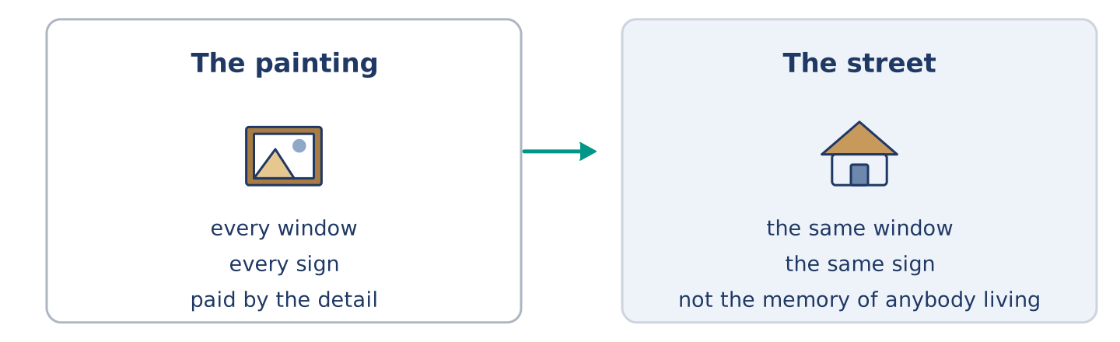
Figure 16.35 · A painting on a wall, and a street built to match it.
Before you read: could you rebuild a street from pictures of it?
Gloss: rebuild = to build again, after something is gone · detail = one small part of something · painting = a picture somebody made with paint
The old centre of Warsaw, in Poland, looks several hundred years old and is not. The war took almost all of it. After the war the country decided to put it back. They used photographs, drawings and a set of paintings of the city from a century and a half earlier. A man from Italy had painted them, and he had put in every window and every sign. He had his own reason for all that care: the city paid him by the detail. The men and women rebuilding the city followed his paintings closely. Where a later owner had changed something, they went back to the painting and not to the memory of anybody living. People have argued about the result ever since, and it is on the world list of places to keep. Both facts are fair.
Answer the questions. (0. is done.)
- How old does the old centre of Warsaw look? — Several hundred years old.
- What three things did they use to put Warsaw back?
- Why had the man from Italy put in every window?
- What did they do where a later owner had changed something?
Part 8: Vocabulary in Context
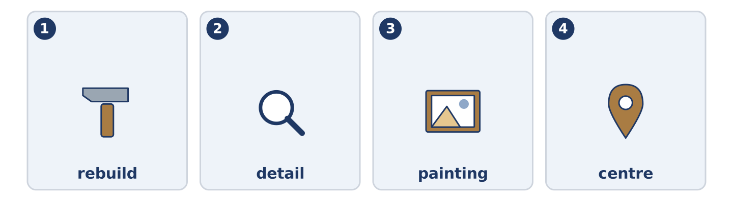
Figure 16.36 · The four words from the global story, drawn.
Match each word with its meaning. One meaning is not needed. Write the letter.
Column A
1. | rebuild | ____
2. | detail | ____
3. | painting | ____
4. | centre | ____
Column B
a) | the middle part of a city
b) | one small part of something
c) | to build again, after something is gone
d) | a picture somebody made with paint
e) | a bus on rails in a street
Part 8: Discussion
Talk with a partner. Use the frames.
Discussion frames: “This is similar to where I live because…” · “This is different from where I live because…” · “I think the most important thing is… because…”
Part 9 · Close to Home — The Shop That Was Four Shops
[PLUS] Plus track · pre-read / decide
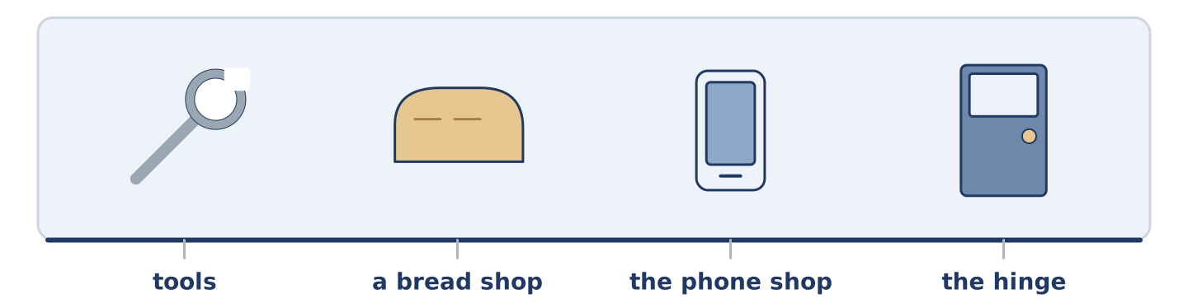
Figure 16.37 · The close-to-home reading, drawn along one street.
Before you read: how long does a place have to be something before it is that thing?
The corner at the end of Alder Street has been four things in thirty years and everybody at number 14 names a different one. Mr Okonkwo says tools, because it was tools for twenty of those years and he bought a hinge there in his first week. Amina says bread shop. It was a bread shop for the two years before she opened her own shop, and she went in every morning. Maya says it has always been the phone shop. Dani has never thought about it at all. Yuki has been here least of all. She asked all five. She now knows more about that corner than anybody except Mr Okonkwo, and he still has the hinge.
Answer the questions. (0. is done.)
- How many things has the corner been in thirty years? — Four.
- Why does Mr Okonkwo say tools?
- Why does Amina say bread shop?
- What did Yuki do?
Part 9: Decision Task
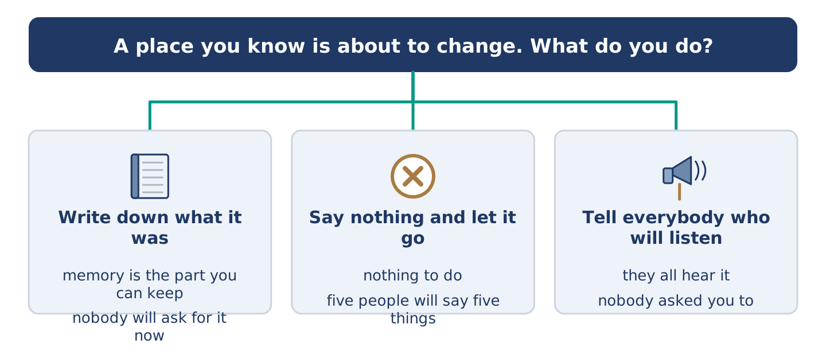
Figure 16.38 · Three ways to decide, and what each one costs.
A place you know is about to change and you cannot stop it. Should you (a) write down what it was, (b) say nothing and let it go, or (c) tell everybody who will listen? Decide and explain. Use the frame.
Answer frame: “I think I should ___ because ___. Also, ___. This is better than ___ because ___.”
Model — read this first:
I think I should write down what it was, because memory is the only part of this I can actually keep. Also, in ten years somebody will ask and five people will say five different things. This is better than telling everybody, because somebody about to lose something does not want a speech about it. (55 words)
Phrase bank: I think I should… · because… · Also,… · This is better than… · In my opinion…
Part 10 · Review and Can-Do
[CORE + PLUS] · homework / self-study
Part 10: Spiral Review
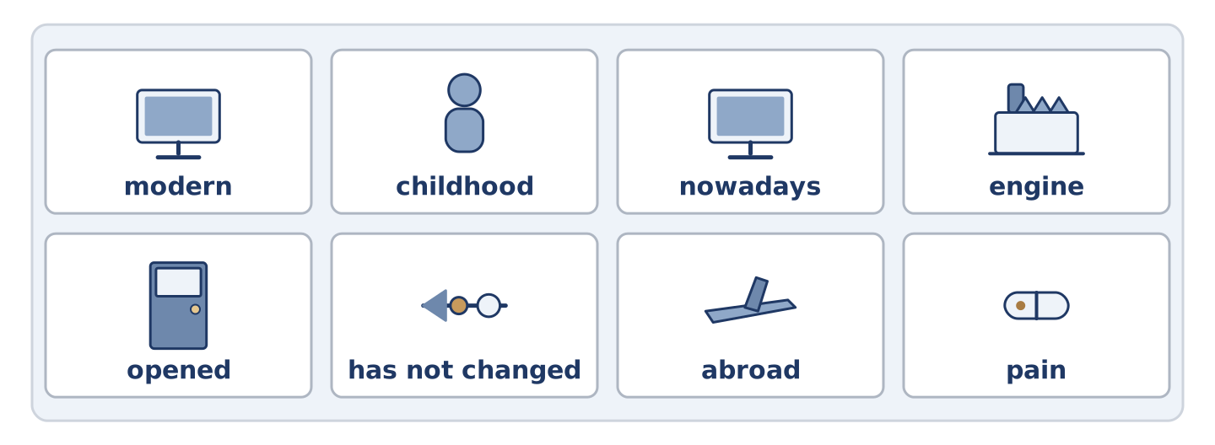
Figure 16.39 · The eight words of the review bank, in bank order.
Complete the review. (0. is done.)
- A hundred years is a century.
Word bank: modern | childhood | nowadays | engine | opened | has not changed | abroad | pain
- Of the present time, or near it, is ______________________ .
- The years when you were a child are your ______________________ .
- At the present time, and not before, is ______________________ .
- The part of a machine that makes it move is the ______________________ .
- Amina ______________________ the shop eleven years ago. (finished)
- She ______________________ the shelves since. (up to now)
- (from Unit 15) In another country is ______________________ .
- (from Unit 14) The feeling when part of you hurts is ______________________ .
Part 10: Can-Do
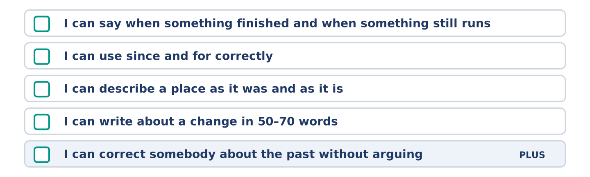
Figure 16.40 · What you can do at the end of this unit.
Can-Do checklist
☐ I can say when something finished and when something still runs.
☐ I can use since and for correctly.
☐ I can describe a place as it was and as it is.
☐ I can write about a change in 50–70 words.
☐ I can correct somebody about the past without arguing (Plus).
Part 10: Glossary
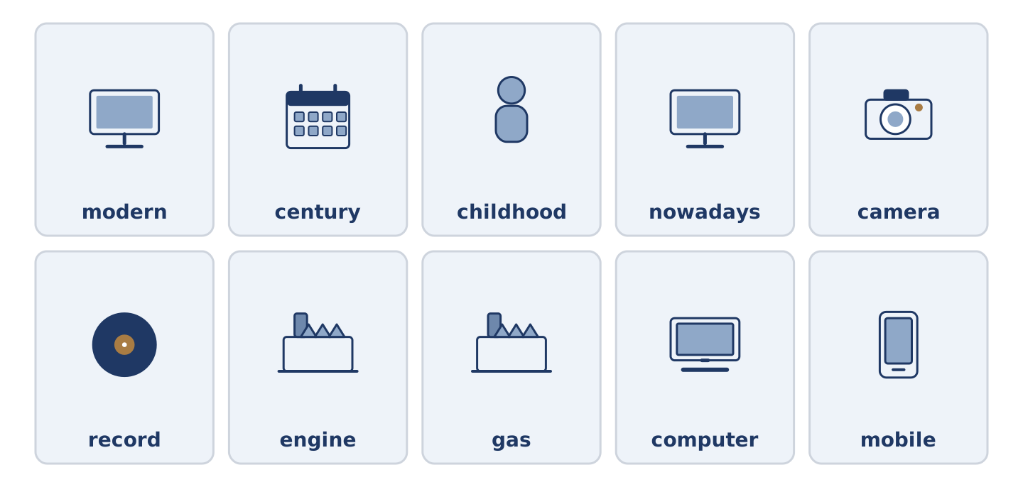
Figure 16.41 · All ten glossary words of Unit 16, one card each.
Unit 16 glossary (10 words)
modern · century · childhood · nowadays · camera · record · engine · gas · computer · mobile

