Unit 17: How Things Are Made
English for Daily Life · Level: A2 · Tracks: [CORE] Warm-Up + Parts 1–6 · [PLUS] Parts 7–10
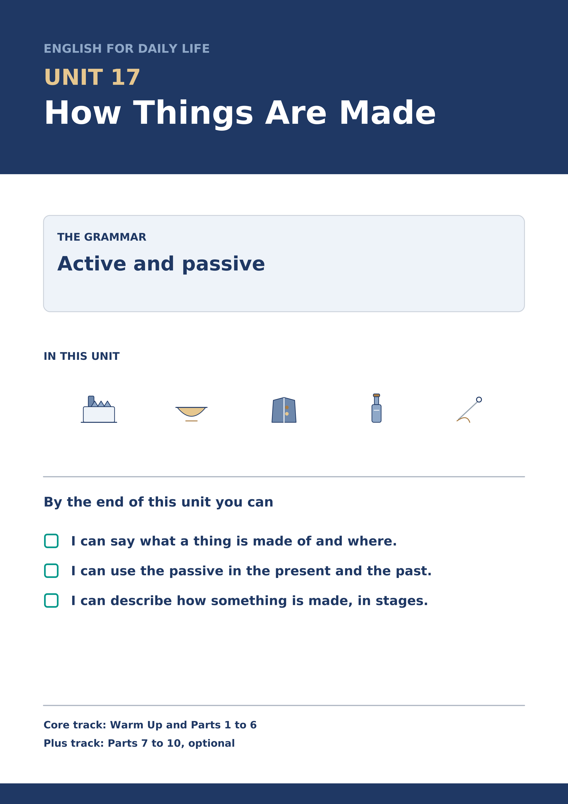
Warm Up
[CORE] Core track · in-class starter
Warm-up: Words for Making Things
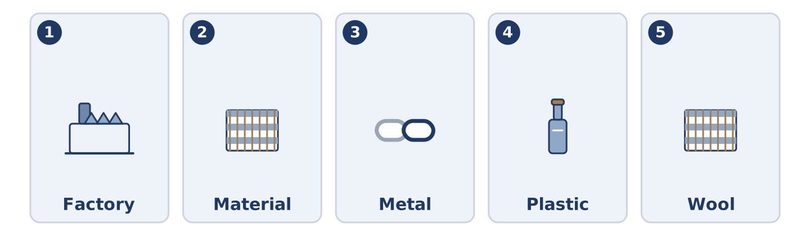
Figure 17.2 · The five warm-up words, and the thing each one means.
Match the words with their meanings. One meaning is not needed. Write the letter.
Column A
1. | Factory | ____
2. | Material | ____
3. | Metal | ____
4. | Plastic | ____
5. | Wool | ____
Column B
a) | what a thing is made of
b) | iron, gold or steel
c) | a light material made from oil
d) | a building where things are made in large numbers
e) | the hair of a sheep, turned into cloth
f) | a room where food is kept cold
Warm-up: Talking About Making
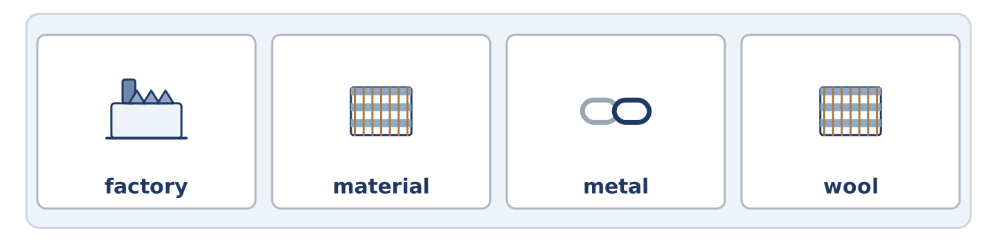
Figure 17.3 · The word bank for this task, in the order it is printed.
Complete the sentences using the words in the word bank.
Word bank: factory | material | metal | wool
- Yuki wants to know what the bowl is made of, and nobody can name the ______________________ .
- Mr Okonkwo’s coat is lined with ______________________ and is warmer than anything newer.
- The buttons are ______________________ , and two of them do not match.
- Everything in Amina’s shop was made in a ______________________ somewhere.
Warm-up: Six People, Six Things
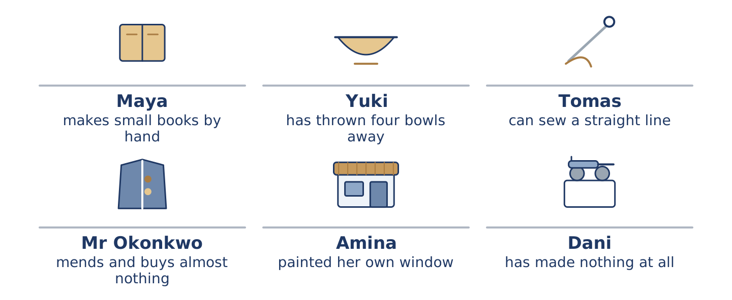
Figure 17.4 · What each of them makes, mends or throws away.
Read the text and choose the correct answer.
Everything at number 14 was made by somebody. Two of them are still making. Maya makes small books by hand, one at a time, and sells about four a year. Yuki is learning to make a bowl and has thrown the first four away. Tomas can sew a straight line, because the work taught him. Mr Okonkwo’s coat has been relined twice and the buttons were changed. Amina painted GREEN SHOP across her own window. Dani has made nothing and has eaten a great deal.
1. What does Maya make?
○ A) Bowls
○ B) Cloth
○ C) Small books by hand
○ D) Buttons
2. Whose coat has been relined twice?
○ A) Mr Okonkwo’s
○ B) Tomas’s
○ C) Yuki’s
○ D) Dani’s
Part 1 · Vocabulary and Terminology
[CORE] Core track · pre-class input
Part 1: Words for Materials
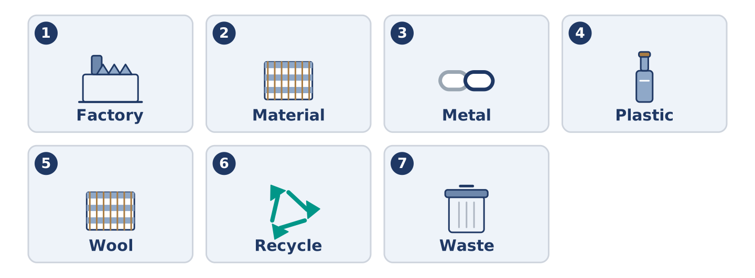
Figure 17.5 · The seven words of Column A, and what each one is.
Match the words with their meanings. One meaning is not needed. (0. is done for you.)
- Glass → the hard clear material windows and bottles are made of.
Column A
1. | Factory | ____
2. | Material | ____
3. | Metal | ____
4. | Plastic | ____
5. | Wool | ____
6. | Recycle | ____
7. | Waste | ____
Column B
a) | a light material made from oil
b) | what is thrown away after a thing is used
c) | the hair of a sheep, turned into cloth
d) | iron, gold or steel
e) | a building where things are made in large numbers
f) | to use a material again instead of throwing it away
g) | what a thing is made of
h) | a small shop that sells bread
Gloss: produce = to make something in large numbers · cloth = material for clothes, made from wool or cotton · waste = what is thrown away after a thing is used · mend = to fix a thing instead of buying a new one · passive = the form that puts the thing first and leaves the maker out
Part 1: Pronunciation
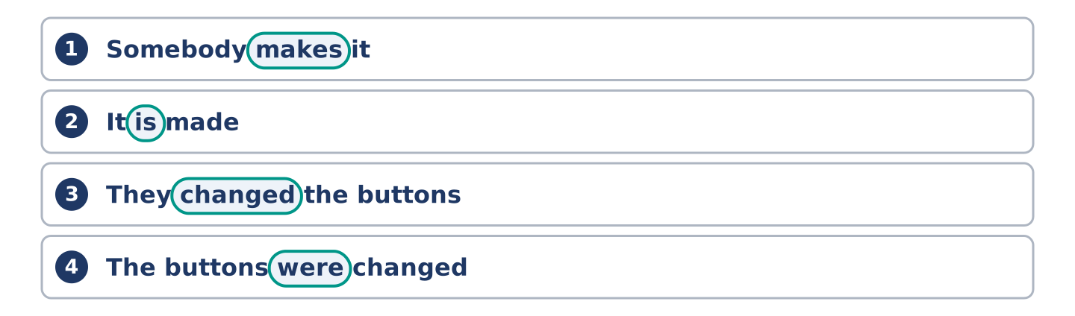
Figure 17.6 · Where the stress falls in 0 words of this unit.
🔊 Audio Track 17.1
Listen to the two forms. Say each pair aloud.
Somebody makes it — the verb carries the weight: /meɪks/
It is made — is almost disappears: /ɪts ˈmeɪd/
They changed the buttons — changed is one sound at the end
The buttons were changed — were goes to a schwa: /wə ˈtʃeɪndʒd/
So here is the trap. The little word is the whole grammar and it is the quietest part of the line. Learners hear it made and write it made. Then they produce the bowl made in Japan and wonder why it is wrong. Listen for the small word before the verb, not for the verb.
Part 1: Four Things and What They Are Made Of
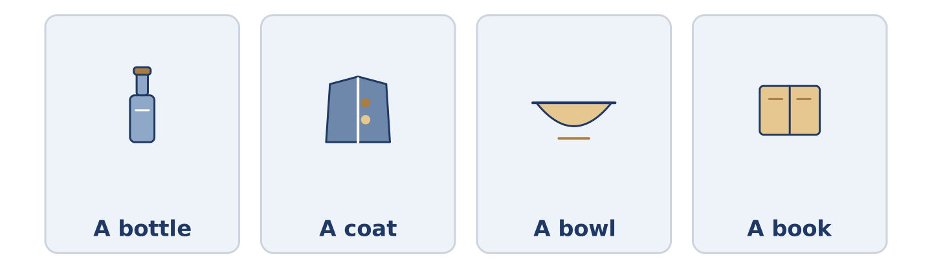
Figure 17.7 · Four things, and the material each one is made of.
Complete the table. Write the material and where it is made. (0. is done.)
The thing | Made of | Made where
A bottle | glass | (example)
A coat
A bowl
A book
- A bottle — glass — in a factory, and then again in another one.
Think about four things in the room you are in now.
Part 1: Who Did It, or Just What Happened?
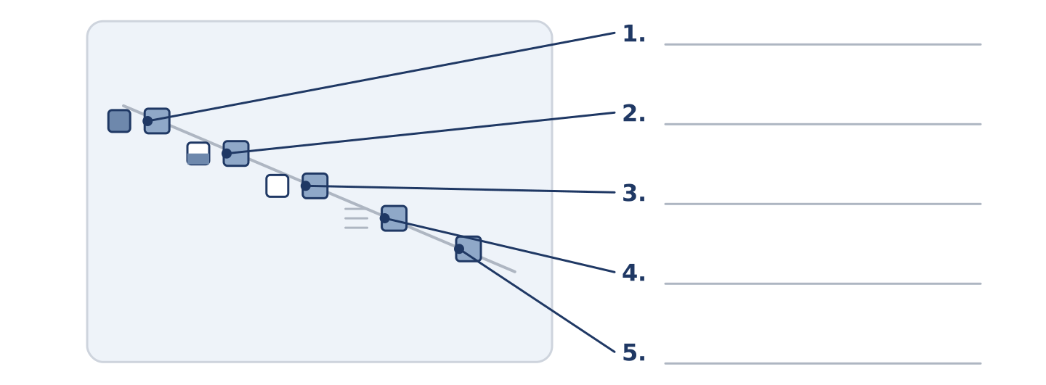
Figure 17.8 · Active and passive — write the correct form on each line.
Match each line with what it does. One purpose is not needed. Write the letter.
Column A
1. | Maya made this book. | ____
2. | This book was made by hand. | ____
3. | Somebody broke the window. | ____
4. | The window was broken. | ____
5. | The bowl is made of clay. | ____
Column B
a) | the maker matters, so the maker goes first
b) | how it was made matters, and the maker does not
c) | we know somebody did it, and we are not saying who
d) | nobody knows who, and nobody is asking
e) | the material is the point
f) | how much the thing cost
Part 1: Materials — Multiple Choice
Read and choose the correct answer.
1. The hair of a sheep is…
○ A) metal
○ B) plastic
○ C) glass
○ D) wool
2. A building where things are made in large numbers is a…
○ A) bowl
○ B) factory
○ C) material
○ D) waste
3. To use a material again instead of throwing it away is to…
○ A) produce
○ B) waste
○ C) recycle
○ D) sew
Part 1: Vocabulary Fill-in
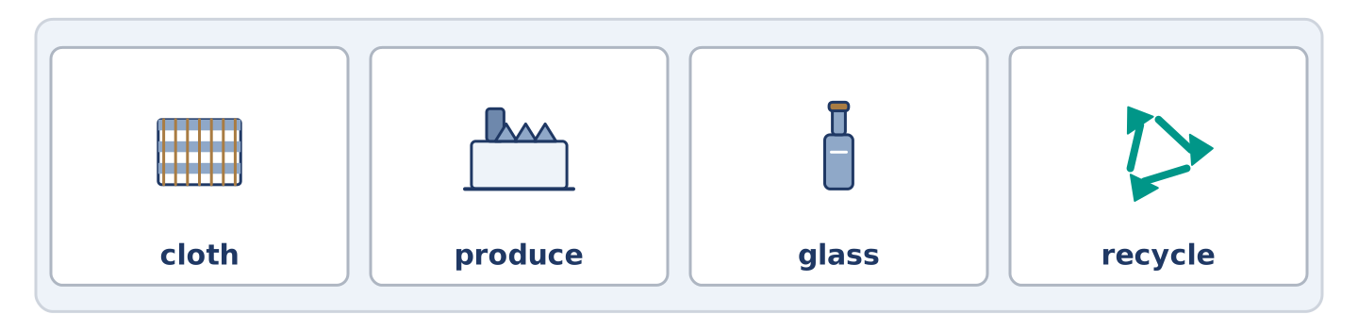
Figure 17.9 · The four words of the bank, in the order the task gives them.
Complete the sentences with the correct word.
Word bank: cloth | produce | glass | recycle
- The coat is lined with a ______________________ nobody makes any more.
- One factory can ______________________ forty thousand bowls in a week.
- Amina keeps the bottles behind the till, because the ______________________ is worth something.
- Everything in this bin can be used again, so please ______________________ it.
Part 1: Write About Something Made (short)
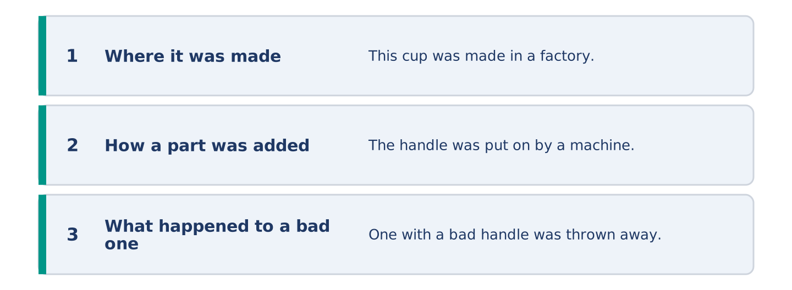
Figure 17.10 · The shape of your two or three sentences, with the model beside each step.
Write two or three sentences about something near you and how it was made. Use three words from this unit.
Model — read this first:
This cup was made in a factory and about a million others were made with it. The handle was put on by a machine. Somewhere there is one with a bad handle, and it was thrown away, and nobody minded. (40 words)
Part 2 · Grammar — Active and Passive
[CORE] Core track · pre-class input
Part 2: Notice
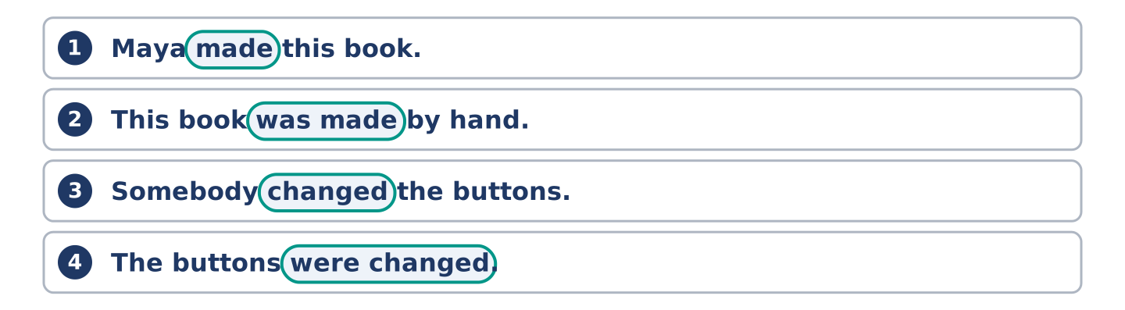
Figure 17.11 · Lines from the notice, with the target form ringed in each.
Read these lines. Underline the verbs. Which ones name the maker, and which ones do not?
Maya made this book. This book was made by hand. Somebody changed the buttons. The buttons were changed. One factory produces forty thousand bowls. Forty thousand bowls are produced in one factory.
Three of these put the maker first. Three put the thing first and leave the maker out.
Part 2: Grammar Focus Box
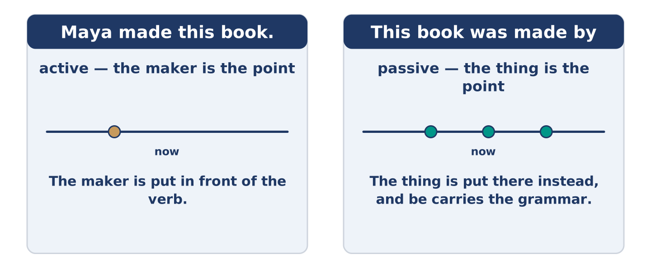
Figure 17.12 · The thing moves to the front, and the maker becomes optional.
 | Form | Use | Example
active | makes, made, produces | the maker is the point | Maya made this book.
passive | is made, was made, are produced | the thing is the point | This book was made by hand.
be + 3rd form | is / was / are / were + made | the form never changes | The buttons were changed.
by + maker | was made by Maya | only when the maker is news | This one was made by Maya.
Remember: the passive is be plus the third form. The third form never changes: made, broken, put, sold.
Watch out! ✗ This book was make by hand. → ✓ This book was made by hand. (the third form, not the first). ✗ The bowl made in a factory. → ✓ The bowl was made in a factory. (be is not optional).
Part 2: Controlled Practice
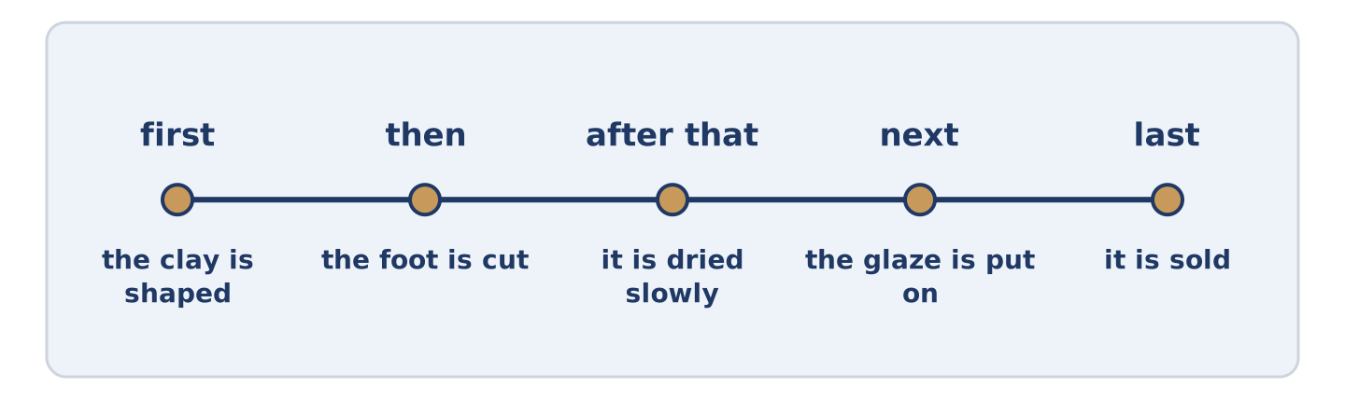
Figure 17.13 · One cup, from the clay to the shelf.
Complete with the active or the passive. (0. is done.)
- Maya made this book by hand. (make)
- The buttons ______________________ twice. (change)
- Forty thousand bowls ______________________ in one week. (produce)
- Somebody ______________________ the window last winter. (break)
- The coat ______________________ with wool. (line)
Part 2: Active or Passive?
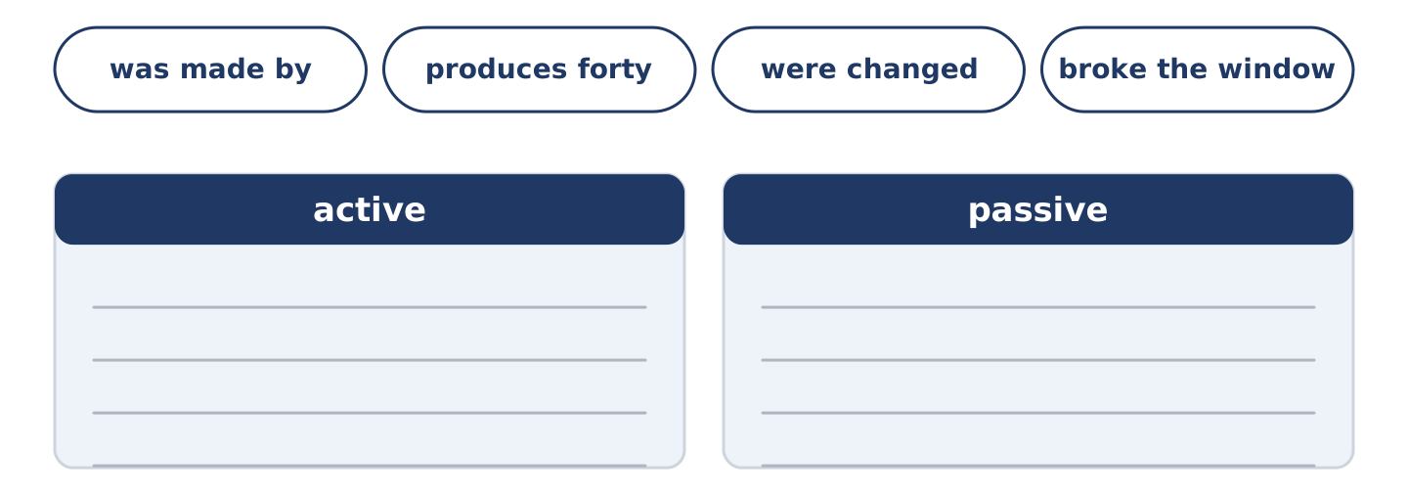
Figure 17.14 · The items of this task, and the bins they sort into.
Write active or passive. (0. is done.)
- Maya made this book. — active
- This book was made by hand. ____________
- One factory produces forty thousand bowls. ____________
- The buttons were changed twice. ____________
- Somebody broke the window. ____________
Part 2: Correct the Sentence
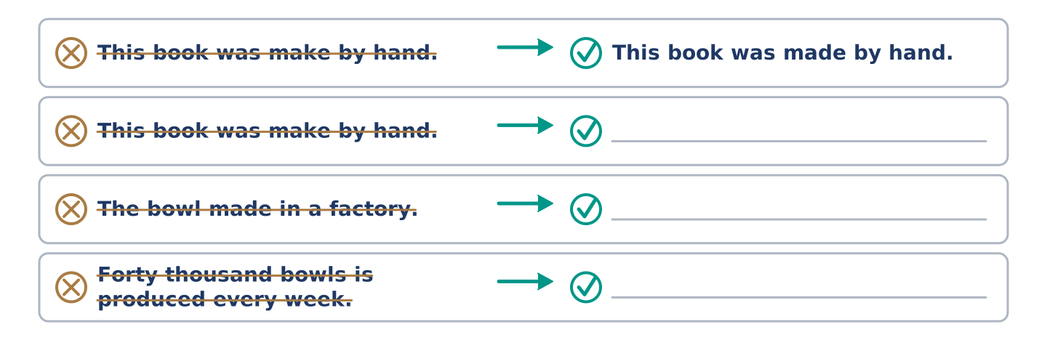
Figure 17.15 · One correction done for you, and the rest to write.
Each sentence has one grammar mistake. Write the correct sentence.
- This book was make by hand.
- The bowl made in a factory.
- Forty thousand bowls is produced every week.
- The window was broke last winter.
Part 2: Freer Practice
Write two sentences about one thing in your home: one active, one passive.
Part 2: Grammar Review
Choose the correct sentence.
1. Which sentence is a correct passive?
○ A) The buttons were changed last year.
○ B) The buttons was changed last year.
○ C) The buttons changed by somebody last year.
○ D) The buttons were change last year.
2. Which sentence leaves the maker out on purpose?
○ A) Maya made this book by hand.
○ B) This book was made by hand.
○ C) Maya makes four books a year.
○ D) Yuki is learning to make a bowl.
→ Harvest: you will meet the passive again in the Part 5 reading. Count how many makers it names.
Part 3 · Listening
[CORE] Core track · pre-class input · scripts printed inline
Part 3: The Four Bowls That Were Thrown Away
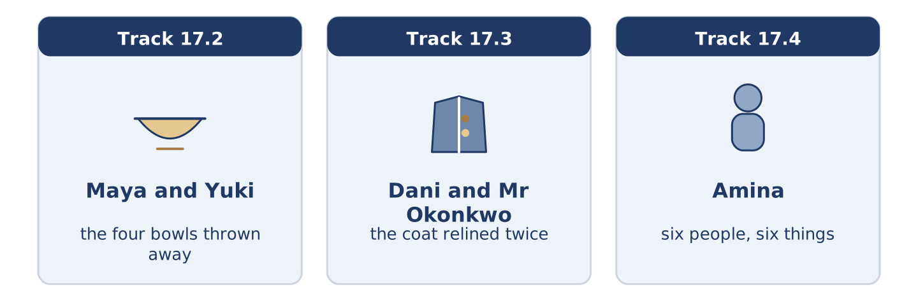
Figure 17.16 · The three listenings: who is speaking, and what about.
🔊 Audio Track 17.2
Before you listen: have you ever thrown away something you made?
Maya: Where are the other bowls? Yuki: They were thrown away. Maya: All four? Yuki: All four. Maya: What was wrong with them? Yuki: Nothing was wrong with the first one. It was thrown away because I could see how it was made. Maya: That isn’t a fault. Yuki: It is in a bowl. Maya: So the new one hides it. Yuki: The new one isn’t finished.
While you listen: write True, False, or Not Given. (0. is done.)
- Four bowls were thrown away. — True
- Yuki could see how the first bowl was made. ____
- The new bowl is finished. ____
- Yuki was taught by somebody at the college. ____
Useful phrases: it was thrown away · nothing was wrong with it · you can see how it was made
Part 3: The Coat That Was Relined Twice
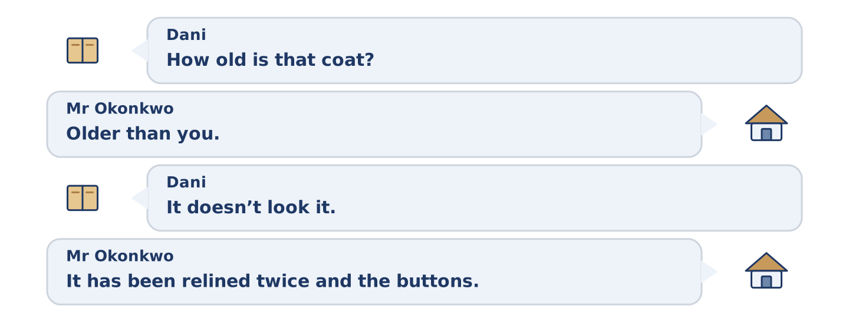
Figure 17.17 · The second listening, turn by turn.
🔊 Audio Track 17.3
Before you listen: how old is the oldest thing you own?
Dani: How old is that coat? Mr Okonkwo: Older than you. Dani: It doesn’t look it. Mr Okonkwo: It has been relined twice and the buttons were changed. Dani: So most of it is new. Mr Okonkwo: None of it is new. It was all made before either of us. Dani: Where was it made? Mr Okonkwo: Here. There was a factory where the station is now.
Answer the questions. (0. is done.)
- How old is the coat? — Older than Dani.
- How many times has the coat been relined?
- What was changed?
- Where was the coat made?
Part 3: Six People, Six Things
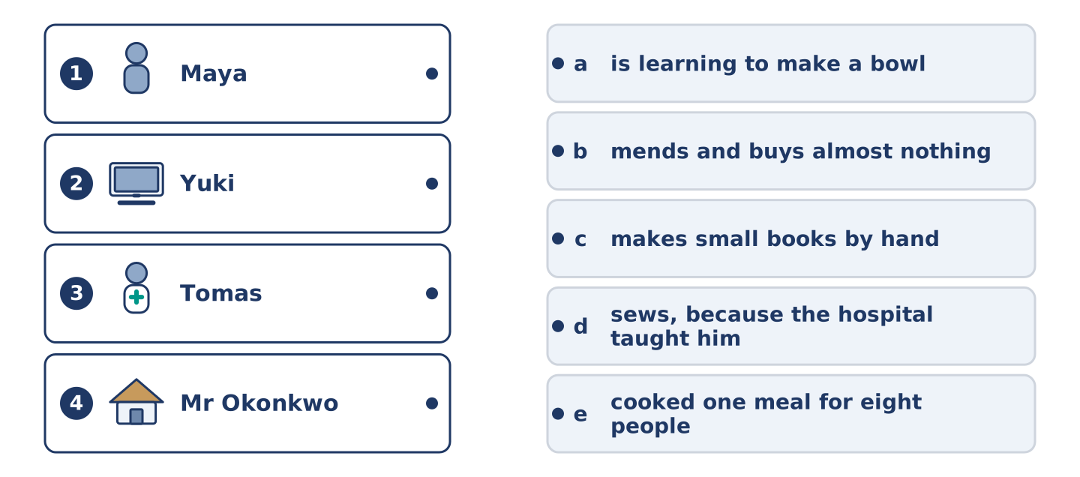
Figure 17.18 · Four on the left, five on the right, and one spare.
🔊 Audio Track 17.4
Before you listen: who do you know who mends things?
Amina: I can tell you who in this building makes and who buys. Maya makes books by hand and gives most of them away. Yuki is learning to make a bowl and has thrown four away. Tomas sews, because the hospital taught him and the hospital is strict about it. Mr Okonkwo mends and has bought almost nothing in forty years. Dani has made one meal for eight people, badly.
While you listen: match each person with what they make. One is not needed. (0. is done.)
- Amina → she knows who makes and who buys.
Useful phrases: ___ makes ___ by hand · ___ is learning to make ___ · ___ mends ___
Column A
1. | Maya | ____
2. | Yuki | ____
3. | Tomas | ____
4. | Mr Okonkwo | ____
Column B
a) | is learning to make a bowl
b) | mends and buys almost nothing
c) | makes small books by hand
d) | sews, because the hospital taught him
e) | cooked one meal for eight people
Part 4 · Speaking
[CORE] Core track · in-class output
Part 4: How It Is Made
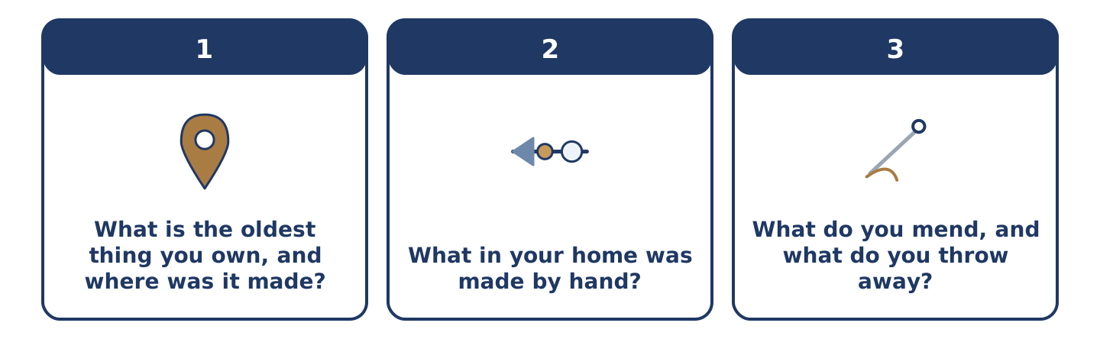
Figure 17.19 · The three questions as cards, to take one at a time.
Work with a partner. Ask and answer these questions.
- What is the oldest thing you own, and where was it made?
- What in your home was made by hand?
- What do you mend, and what do you throw away?
Useful language: It was made in… · It is made of… · by hand · it was thrown away
Part 4: Find the Difference (pairwork)
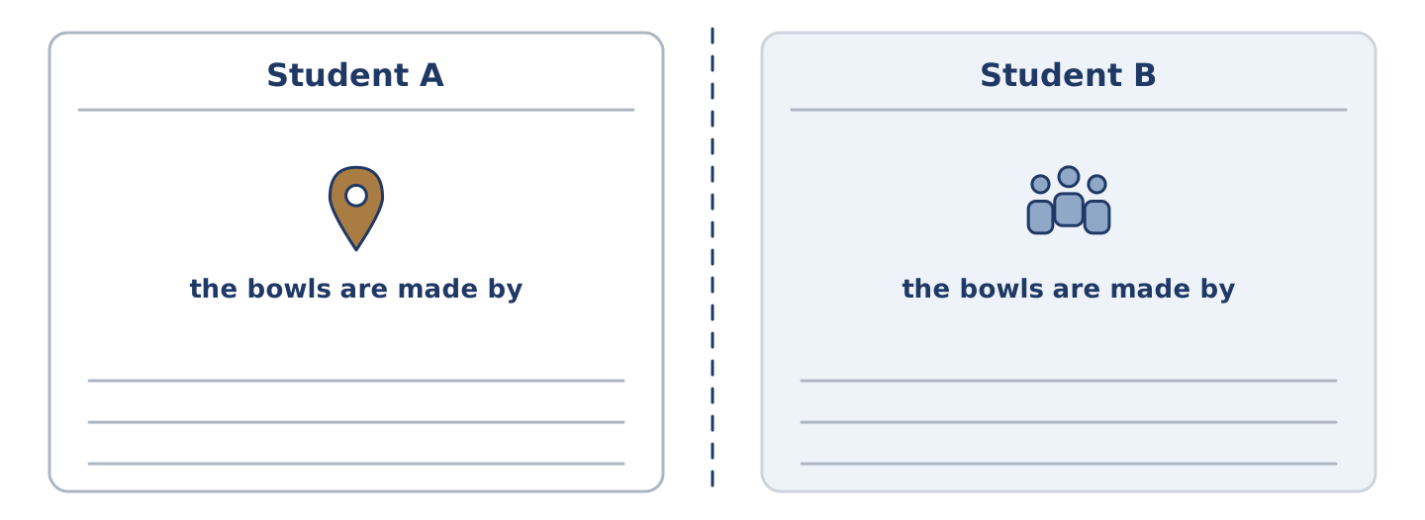
Figure 17.20 · Student A’s facts and Student B’s, with a fold between them.
Student A and Student B each have a workshop. Ask questions and find three differences.
Useful questions: What is it made of? · Where was it made? · Was it made by hand? · How many are produced?
Student A — your workshop: the bowls are made by hand, the cloth is bought in, four people work there, nothing is thrown away.
Student B — your workshop: the bowls are made by hand, the cloth is made there, twelve people work there, nothing is thrown away.
Part 4: Describing How Something Is Made
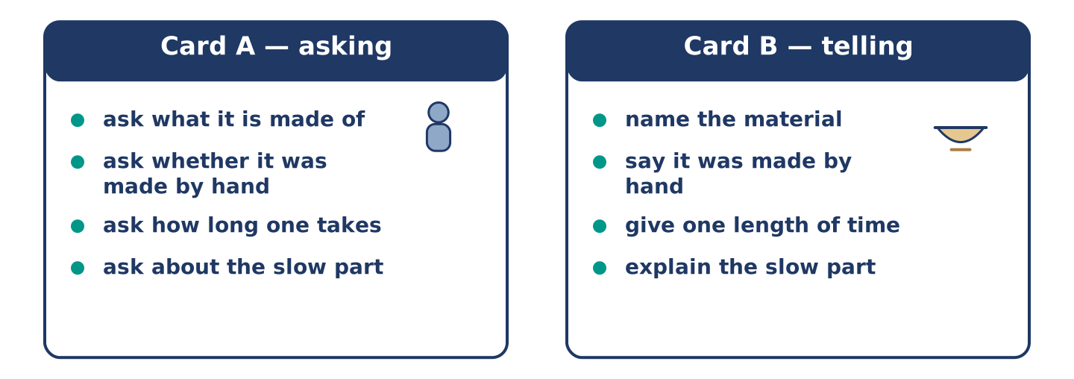
Figure 17.21 · Card A and Card B: what each of you has to say.
Work in pairs. Read the model, then use the cards.
Model exchange:
A: What is it made of? — B: Clay. — A: And it was made by hand? — B: All of it. — A: How long does one take? — B: Three days, and most of that is waiting. — A: Waiting for what? — B: It is dried slowly, or it breaks.
Useful language: What is it made of? · it was made by hand · it is dried slowly · or it breaks
Card A — asking: ask what it is made of · ask whether it was made by hand · ask how long one takes · ask about the slow part.
Card B — telling: name the material · say it was made by hand · give one length of time · explain the slow part.
Your turn: run the dialogue, then swap roles.
Stretch [PLUS]: the thing you are describing was made badly and you made it — say so without apologising twice.
Part 4: Mini-Presentation
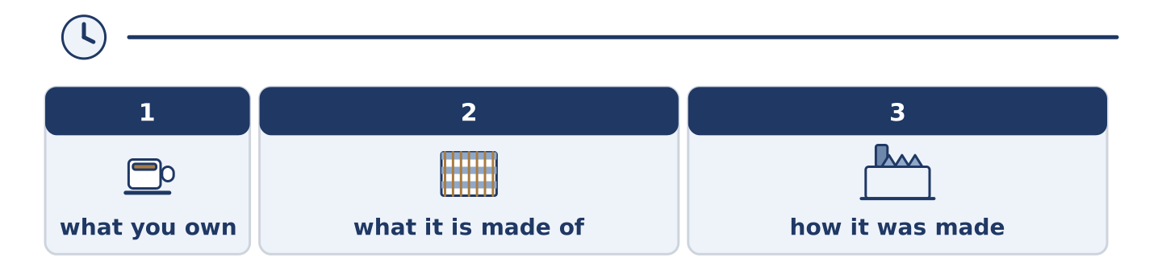
Figure 17.22 · The one-minute talk as 0 beats, each as wide as its share.
Prepare a short talk (about one minute). Describe one thing you own and how it was made.
Part 5 · Reading
[CORE] Core track · pre-class input
Part 5: Why Nobody Knows Who Made Anything
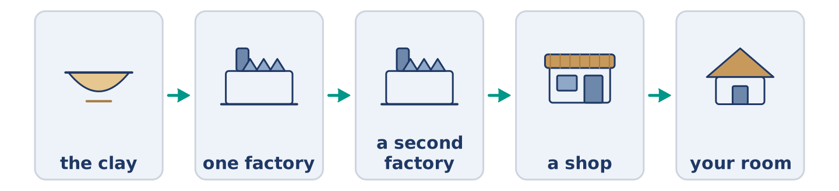
Figure 17.23 · One cup, in five stages.
Before you read: can you name one person who made one thing you own?
Gloss: machine = a thing with moving parts that does work · stage = one step in a long job · hand-made = made by a person and not by a machine
Count the things in your room. Now name the maker of one of them. Most people cannot name one, and this is new. Two hundred years ago almost everything was made within a short walk of where it was used. The maker was somebody you could complain to. Now a cup is made in stages, in two countries, and no single person has held all of it. This is why the passive became so useful. English needed a way to talk about a thing when there is nobody to put in front of the verb. The grammar followed the machines. And it works the other way too: a thing sold as hand-made is sold on the maker, not on the cup.
Answer the multiple-choice questions. (0. is done.)
- Can most people name a person who made something in their room? — No.
1. Why can nobody name the maker of a cup?
○ A) Because the maker is famous
○ B) Because nobody asks
○ C) Because the cup is cheap
○ D) Because it is made in stages, in two countries
2. What does the text say the grammar followed?
○ A) The dictionary
○ B) The school
○ C) The machines
○ D) The newspaper
3. What is a hand-made thing sold on?
○ A) The maker
○ B) The price
○ C) The material
○ D) The weight
Part 5: Vocabulary in Context
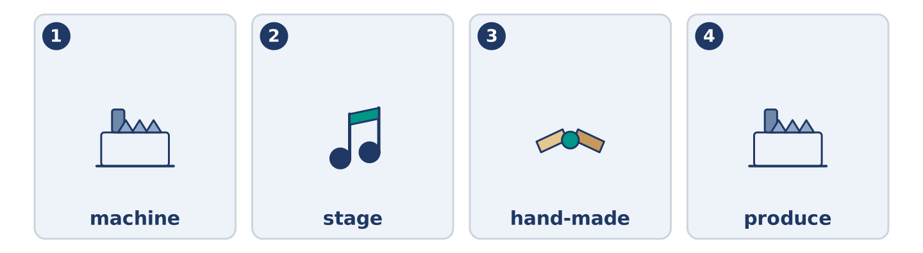
Figure 17.24 · The four words from the reading, drawn.
Match each word from the text with its meaning. One meaning is not needed. Write the letter.
Column A
1. | machine | ____
2. | stage | ____
3. | hand-made | ____
4. | produce | ____
Column B
a) | to make something in large numbers
b) | one step in a long job
c) | a thing with moving parts that does work
d) | made by a person and not by a machine
e) | the hair of a sheep
Part 5: Three Things That Are Made Twice
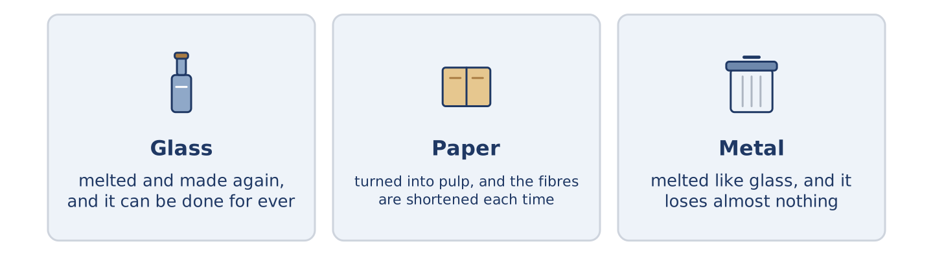
Figure 17.25 · Three materials, and what each one becomes next.
Before you read: what do you throw away that could be used again?
Gloss: melt = to turn a solid into a liquid with heat · pulp = wet paper broken up to be made into paper again · ore = the rock metal is taken out of · aluminium = a light grey metal, used for cans and pans · fibre = one of the tiny threads a material is made of
Three materials are made twice, and each one loses something the second time. Glass is melted and made again, and it can be done for ever, because melting takes nothing out of it. Paper is turned into pulp and made again. The fibres are shortened each time, so after six or seven turns it is only good for boxes. Metal is the strange one. It is melted like glass and loses almost nothing. The saving is enormous: recycled aluminium takes about a twentieth of the power needed to make it from ore. So the material it is most worth recycling is the one people throw away without looking.
Answer the questions. (0. is done.)
- How many of the three materials lose something? — All three, but metal almost nothing.
- Why can glass be made again for ever?
- What happens to paper each time it is made again?
- How much power does recycled aluminium take?
Part 6 · Writing
[CORE] Core track · in-class / homework
Part 6: How Something Is Made (50–70 words)
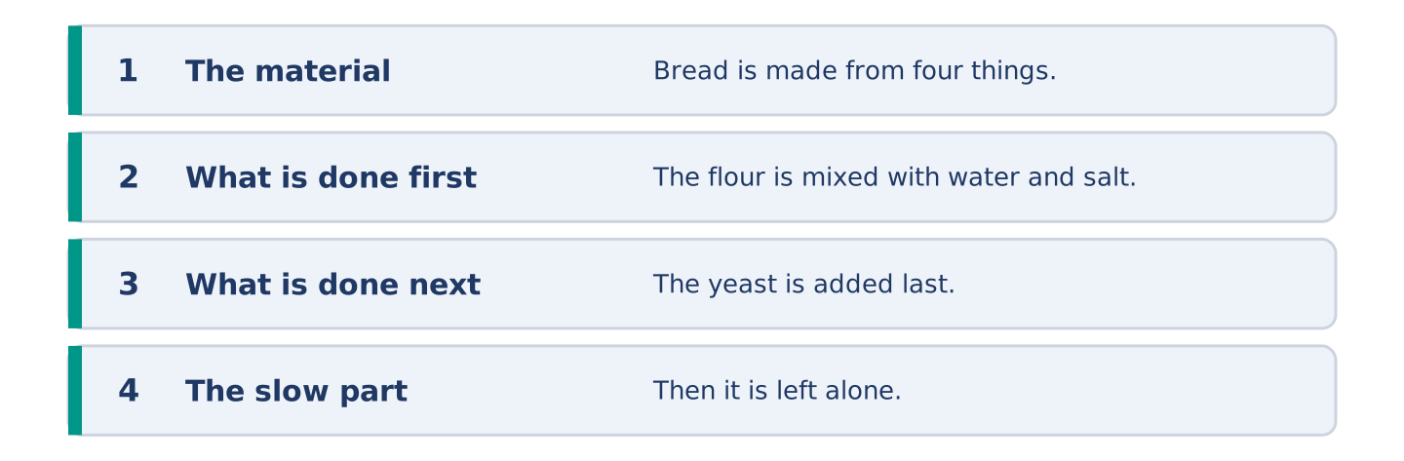
Figure 17.26 · The shape of the piece you are about to write.
Write about how one thing is made. Use the passive at least twice.
Model — read this first:
Bread is made from four things and three of them are free. The flour is mixed with water and salt, and the yeast is added last. Then it is left alone, and nobody ever waits long enough. It is baked for half an hour. Bad bread is almost always bread somebody hurried, and nobody is ever told that. (58 words)
Plan (fill in, then write): ___ is made from ___. The ___ is ___ with ___. Then it is ___. ___ is ___ for ___.
Word bank: is made | is mixed | is added | is left | is baked
Check before you finish: ☐ the passive at least twice? ☐ the stages in order? ☐ one material named? ☐ 50–70 words?
Part 6: Should Things Be Made to Last? (50–70 words)
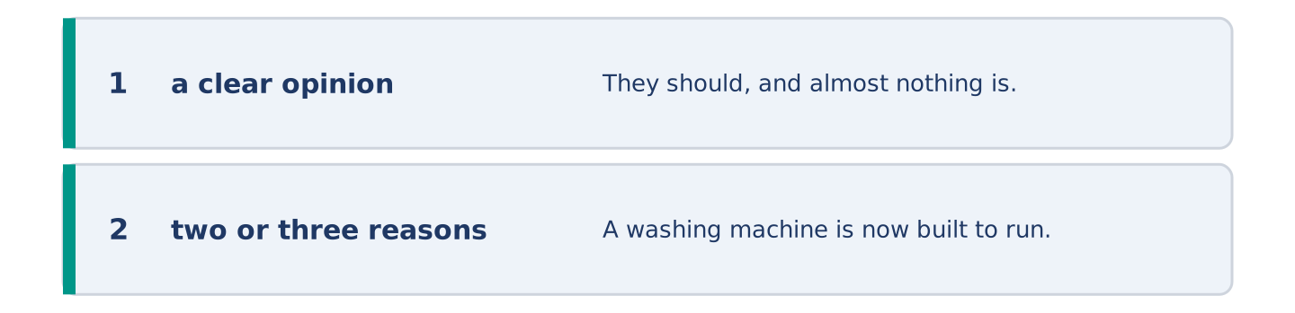
Figure 17.27 · The shape of the opinion paragraph, step by step.
Should things be made to last? Give your opinion and two or three reasons.
Model — read this first:
They should, and almost nothing is. A washing machine is now built to run for about seven years, and the old ones ran for twenty. The answer people give is that the new ones are cheap. They are, and you buy three. What is really being sold is the feeling of a new one, three times. (56 words)
Word bank: I think… because… | is built to | however | in my opinion | it depends on
Check before you finish: ☐ a clear opinion? ☐ two or three reasons? ☐ 50–70 words?
Part 6: Something You Have Made or Mended (50–70 words)
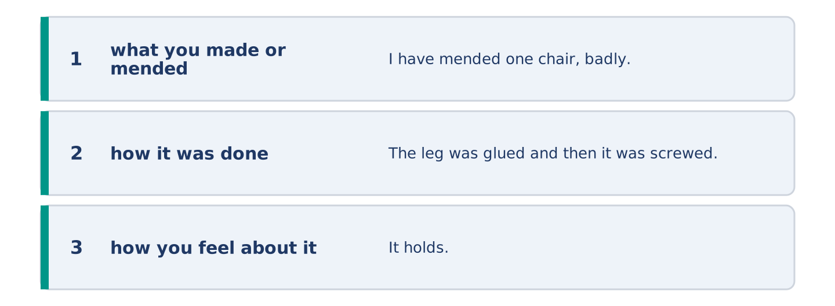
Figure 17.28 · The moves of the message, with a line of the model for each.
Write about one thing you have made or mended. Say how it was done.
Model — read this first:
I have mended one chair, badly, and I sit on it every day. The leg was glued and then it was screwed, in that order, which is the wrong order. It holds. It is not straight and it never will be. I like that chair better than the three good ones. (51 words)
Plan (fill in, then write): I have ___ one ___. The ___ was ___ and then it was ___. It ___.
Check before you finish: ☐ what you made or mended? ☐ how it was done? ☐ how you feel about it? ☐ 50–70 words?
Part 6: Reflection — A Thing You Threw Away (40–60 words)
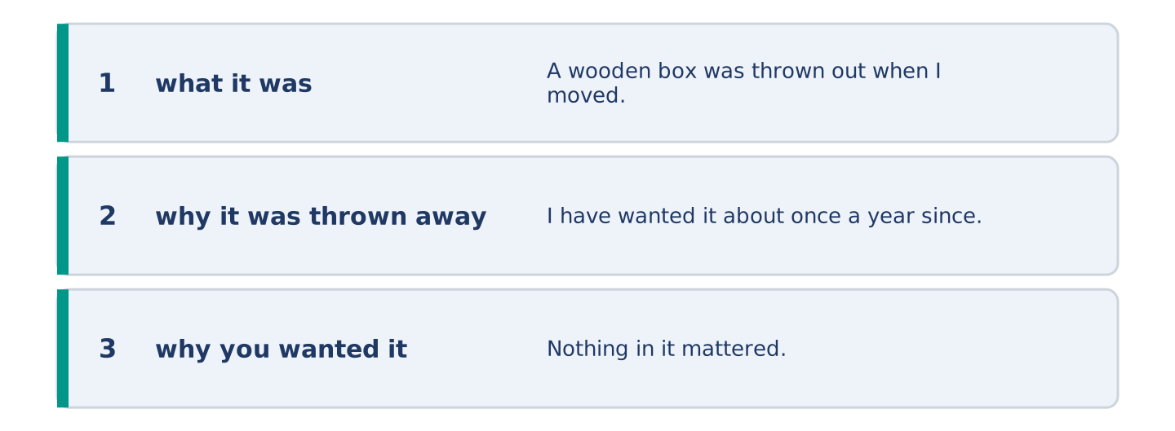
Figure 17.29 · The reflection, step by step.
Write about something you threw away and later wanted.
Model — read this first:
A wooden box was thrown out when I moved, because it was heavy and held nothing. I have wanted it about once a year since. Nothing in it mattered. It was the only thing in my flat older than my grandmother, and I threw it away for weighing too much. (50 words)
Check before you finish: ☐ what it was? ☐ why it was thrown away? ☐ why you wanted it? ☐ 40–60 words?
Part 7 · Real-World File — Talking About How Things Are Made
[PLUS] Plus track (optional) · stronger learners
7A: Phrase Bank
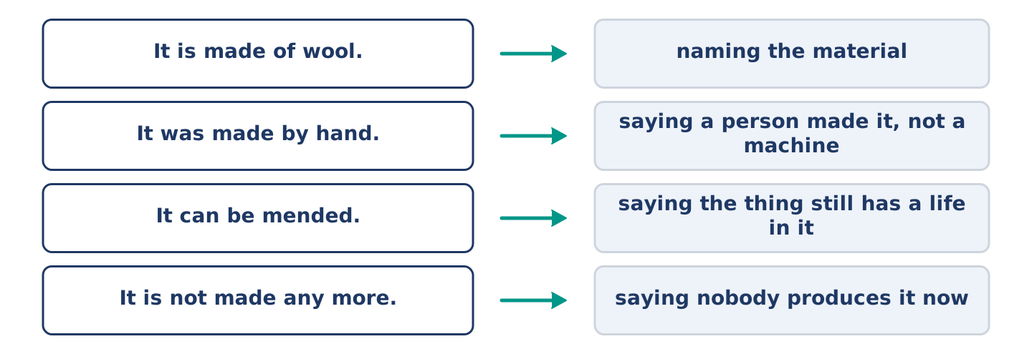
Figure 17.30 · What people say about how a thing was made, and what each line does.
Match what a person says with its purpose. One purpose is not needed. Write the letter.
Column A
1. | “It is made of wool.” | ____
2. | “It was made by hand.” | ____
3. | “It can be mended.” | ____
4. | “It is not made any more.” | ____
Column B
a) | saying the thing still has a life in it
b) | naming the material
c) | how much it will cost
d) | saying nobody produces it now
e) | saying a person made it, not a machine
7B: The Thing That Cannot Be Mended
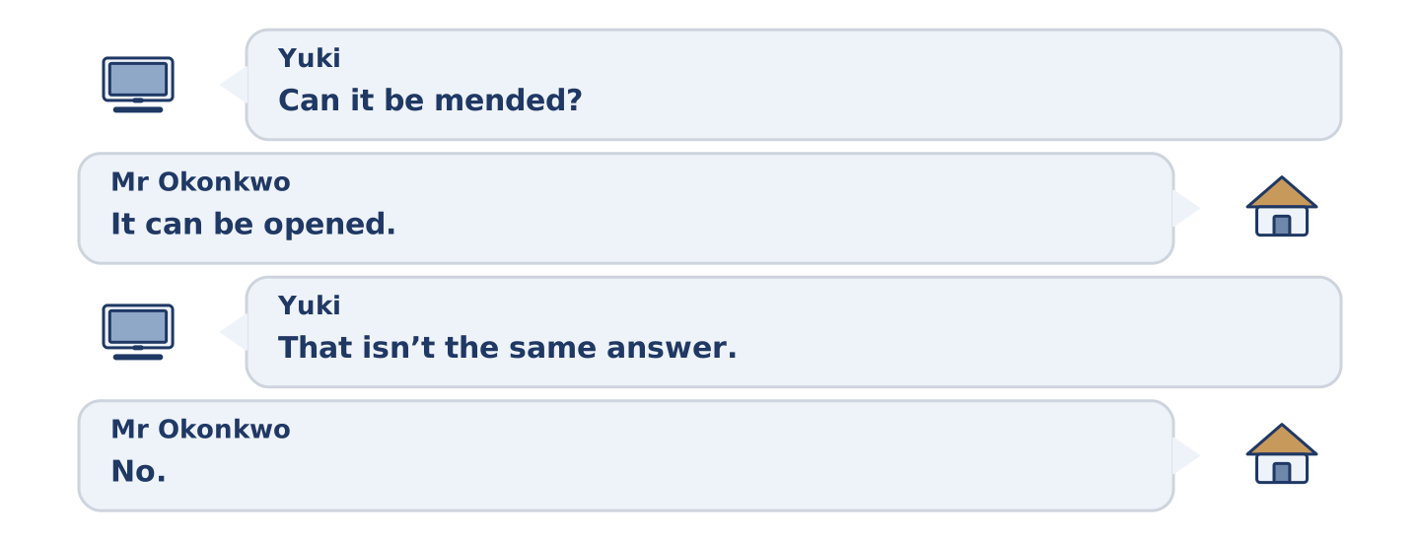
Figure 17.31 · The 7B exchange: who takes each turn.
🔊 Audio Track 17.5
Before you read: has anybody ever told you a thing was not worth mending?
Yuki: Can it be mended? Mr Okonkwo: It can be opened. Yuki: That isn’t the same answer. Mr Okonkwo: No. It is glued shut, so it is opened once and then it is finished. Yuki: Why is it made like that? Mr Okonkwo: Because a thing nobody can open is cheaper to produce. Yuki: And when it breaks? Mr Okonkwo: Another one is produced.
Answer the questions. (0. is done.)
- Can the thing be mended? — No, it can only be opened once.
- What has been done to the thing instead of screwing it?
- Why is it made like that?
- What happens when it breaks?
7C: Controlled Practice — Explaining How a Thing Is Made
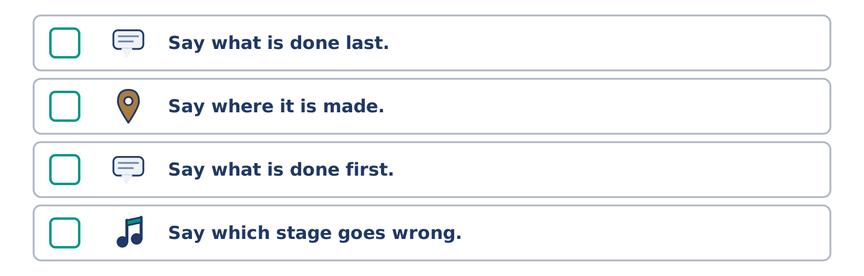
Figure 17.32 · The steps still to be numbered, as the task prints them.
Put the steps in order. Number them 1–5. (0. is done.)
- Name the material. — 1
____ Say what is done last.
____ Say where it is made.
____ Say what is done first.
____ Say which stage goes wrong.
7D: Role-Play — One Thing, Two Prices
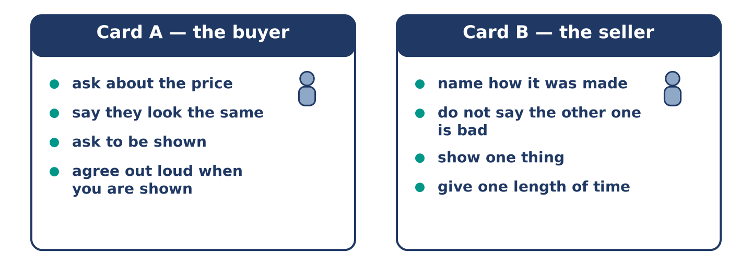
Figure 17.33 · The 7D cards: what each of you has to say.
In pairs. One is selling a hand-made thing. Use the model and cards.
Model exchange: A: Why is this one four times the price? — B: It was made by hand. — A: They look the same. — B: They are not the same inside. — A: Show me. — B: Turn it over. — A: Ah. — B: That part is done by a person, and it takes an hour.
Card A — the buyer: ask about the price · say they look the same · ask to be shown · agree out loud when you are shown.
Card B — the seller: name how it was made · do not say the other one is bad · show one thing · give one length of time.
Stretch [PLUS]: you are selling it and you are not sure it is worth four times the price — be honest and sell it anyway.
7E: Writing — A Note About a Thing Being Mended (50–80 words)
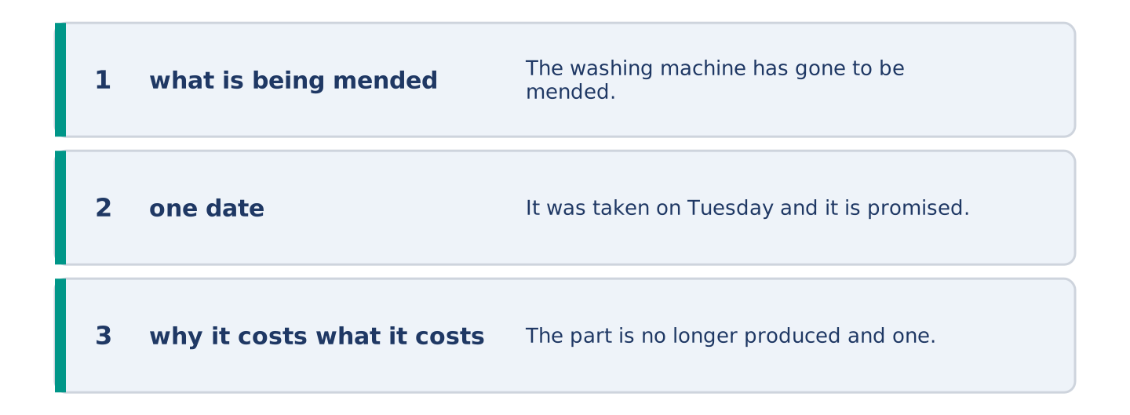
Figure 17.34 · The Part 7 note, with the model beside each line.
Something of yours is being mended and somebody needs to know. Write them a note.
Model — read this first:
The washing machine has gone to be mended, so everything is in the bath instead. It was taken on Tuesday and it is promised back on Friday. The part is no longer produced and one is being made for it, which is why it costs more than a new machine. I know. I want this one. (56 words)
Check before you finish: ☐ what is being mended? ☐ one date? ☐ why it costs what it costs? ☐ 50–80 words?
Part 8 · Global Story — The City That Drinks Its Own Water Twice
[PLUS] Plus track · pre-read / discuss
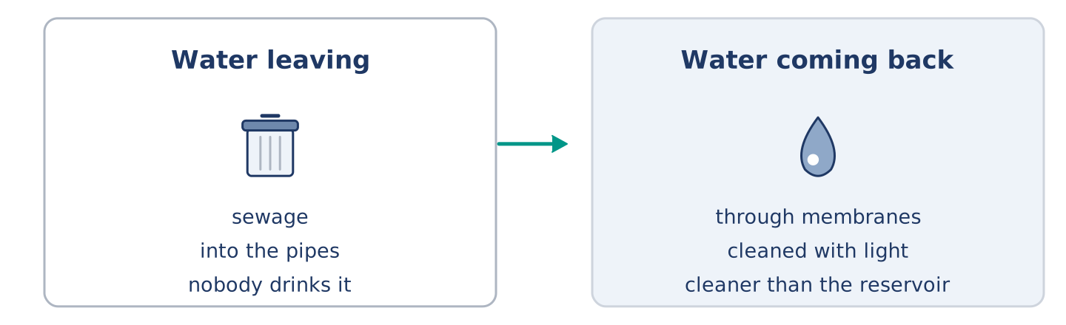
Figure 17.35 · Water leaving a city and the same water coming back.
Before you read: would you drink water that had been used before?
Gloss: sewage = the dirty water that leaves a city through pipes · membrane = a very thin sheet with holes too small to see · reservoir = a lake kept for a city’s water
Singapore has almost no land and no river worth the name, and for years most of its water was bought from Malaysia. So the used water is now taken back. Sewage is carried to a plant, pushed through membranes with holes a bacterium cannot pass, and cleaned again with light. What comes out is cleaner than the water in the reservoir. It is called NEWater, and about two-fifths of the island’s water is now produced this way. Most of it is sold to factories, which need water cleaner than people do. The rest is put into the reservoir first, because a thing is easier to drink after it has been rained on.
Answer the questions. (0. is done.)
- What did Singapore buy from Malaysia? — Most of its water.
- What three things are done to the sewage?
- How much of the island’s water is produced this way?
- Why is some of it put into the reservoir first?
Part 8: Vocabulary in Context
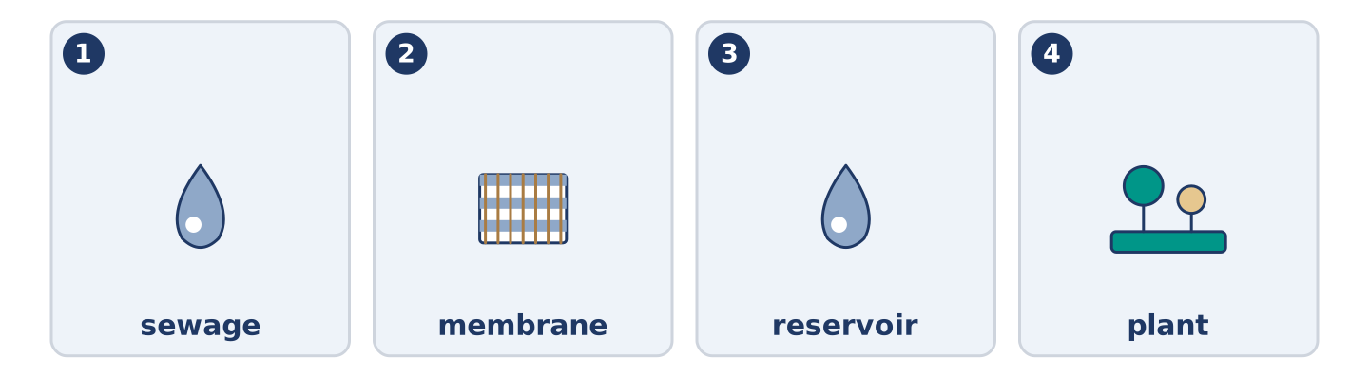
Figure 17.36 · The four words from the global story, drawn.
Match each word with its meaning. One meaning is not needed. Write the letter.
Column A
1. | sewage | ____
2. | membrane | ____
3. | reservoir | ____
4. | plant | ____
Column B
a) | a building where one job is done to a material
b) | a very thin sheet with holes too small to see
c) | the dirty water that leaves a city through pipes
d) | a lake kept for a city’s water
e) | the rock metal is taken out of
Part 8: Discussion
Talk with a partner. Use the frames.
Discussion frames: “This is similar to where I live because…” · “This is different from where I live because…” · “I think the most important thing is… because…”
Part 9 · Close to Home — The Bowl That Was Never Finished
[PLUS] Plus track · pre-read / decide
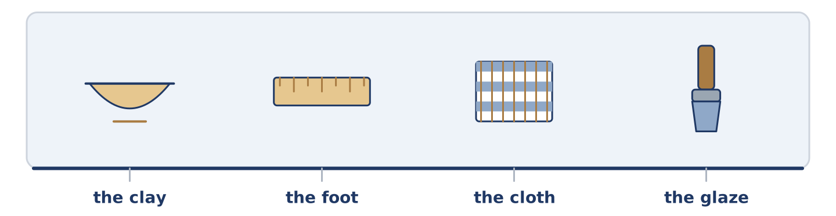
Figure 17.37 · The close-to-home reading, drawn along one street.
Before you read: when is a thing finished?
The newest bowl has been on Yuki’s table since March and it is not finished. The clay was shaped in one evening. The foot was cut the week after. Then it was left, and it has been left ever since, under a cloth, and the cloth is changed when it dries out. Amina has asked about it twice. Maya has offered to fire it. Mr Okonkwo says a thing left under a cloth for six months has been finished for five of them. He says the cloth is now the only part still being worked on. Yuki says the glaze is the part she cannot get right. She is probably correct. That is not why the bowl is still there.
Answer the questions. (0. is done.)
- How long has the newest bowl been on the table? — Since March.
- What was done to the bowl in the first evening?
- What does Mr Okonkwo say about a thing left under a cloth?
- What does Yuki say the hard part is?
Part 9: Decision Task
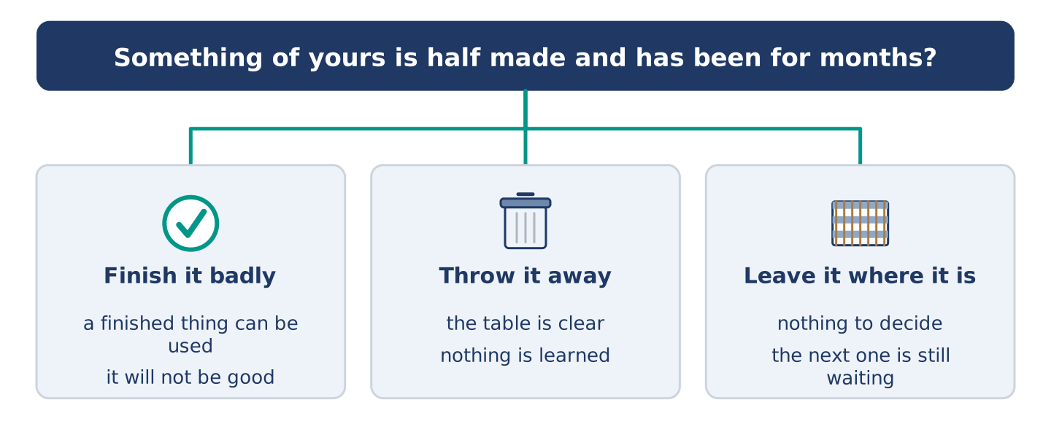
Figure 17.38 · Three ways to decide, and what each one costs.
Something of yours is half made and has been for months. Should you (a) finish it badly, (b) throw it away, or (c) leave it where it is? Decide and explain. Use the frame.
Answer frame: “I think I should ___ because ___. Also, ___. This is better than ___ because ___.”
Model — read this first:
I think I should finish it badly, because a bad finished thing can be used and a good half-made one cannot. Also, the next one is always better and the next one has been waiting for this one. This is better than throwing it away, because nothing is learned by throwing a thing away. (54 words)
Phrase bank: I think I should… · because… · Also,… · This is better than… · In my opinion…
Part 10 · Review and Can-Do
[CORE + PLUS] · homework / self-study
Part 10: Spiral Review
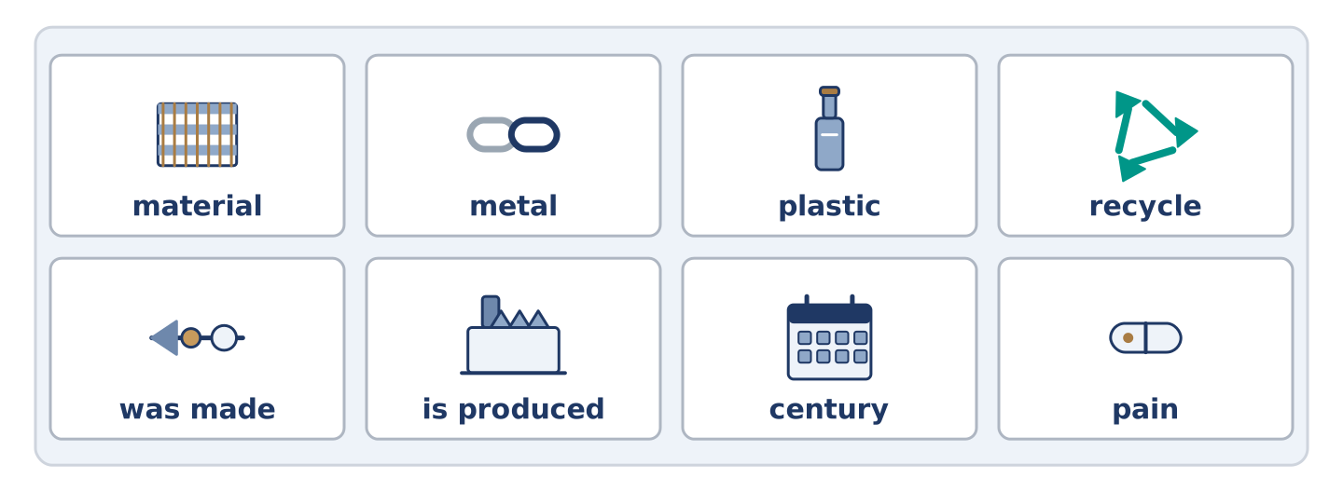
Figure 17.39 · The eight words of the review bank, in bank order.
Complete the review. (0. is done.)
- A building where things are made in large numbers is a factory.
Word bank: material | metal | plastic | recycle | was made | is produced | century | pain
- What a thing is made of is its ______________________ .
- Iron, gold and steel are kinds of ______________________ .
- A light material made from oil is ______________________ .
- To use a material again instead of throwing it away is to ______________________ .
- This book ______________________ by hand. (passive, finished)
- Forty thousand bowls ______________________ every week. (passive, now)
- (from Unit 16) A hundred years is a ______________________ .
- (from Unit 14) The feeling when part of you hurts is ______________________ .
Part 10: Can-Do
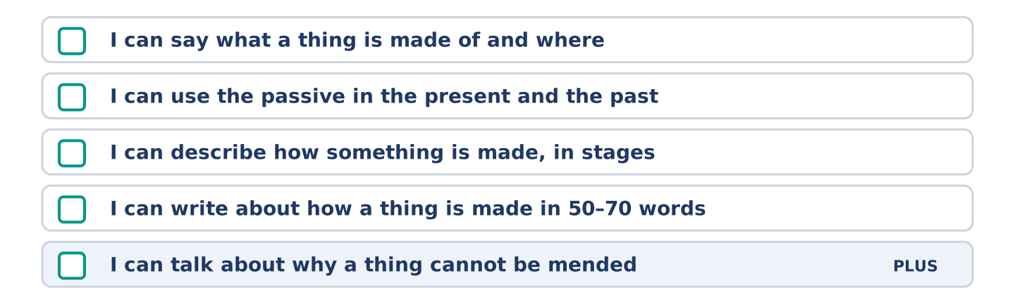
Figure 17.40 · What you can do at the end of this unit.
Can-Do checklist
☐ I can say what a thing is made of and where.
☐ I can use the passive in the present and the past.
☐ I can describe how something is made, in stages.
☐ I can write about how a thing is made in 50–70 words.
☐ I can talk about why a thing cannot be mended (Plus).
Part 10: Glossary
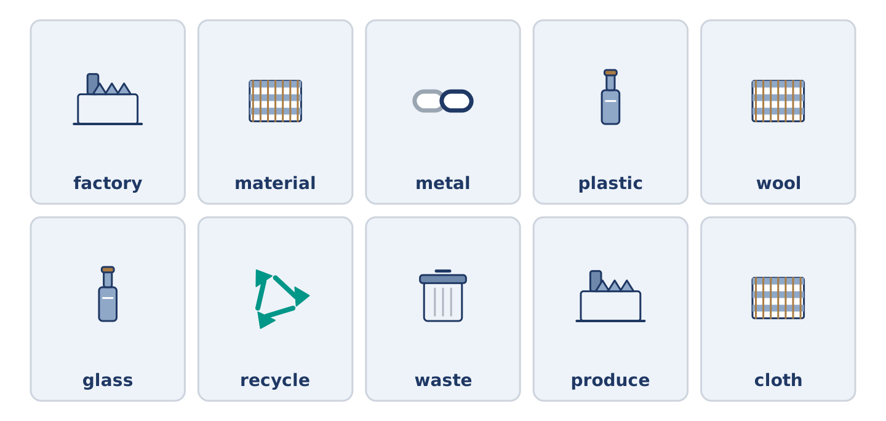
Figure 17.41 · All ten glossary words of Unit 17, one card each.
Unit 17 glossary (10 words)
factory · material · metal · plastic · wool · glass · recycle · waste · produce · cloth

