Unit 18: If and When
English for Daily Life · Level: A2 · Tracks: [CORE] Warm-Up + Parts 1–6 · [PLUS] Parts 7–10
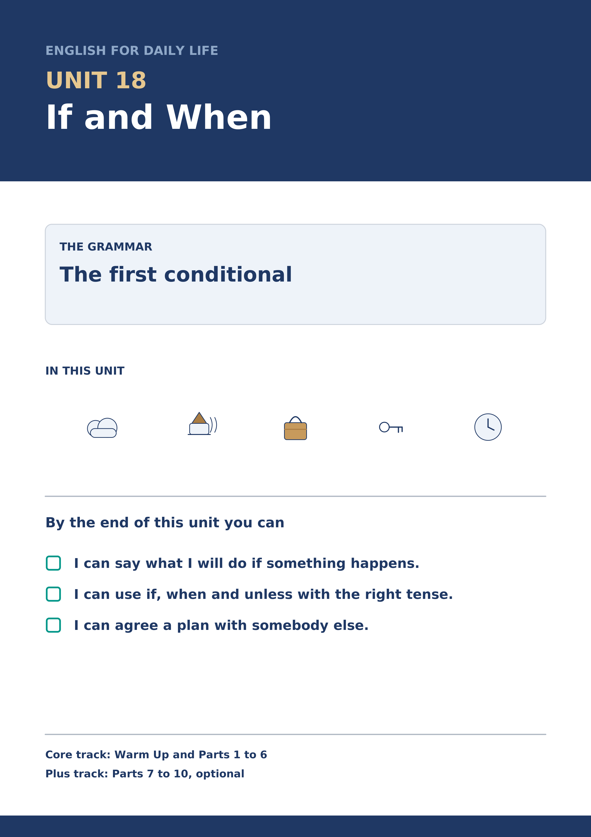
Warm Up
[CORE] Core track · in-class starter
Warm-up: Words for What Might Happen
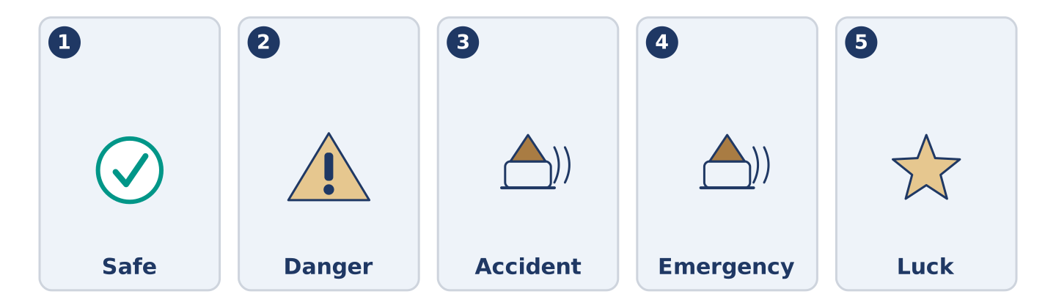
Figure 18.2 · The five warm-up words, and the thing each one means.
Match the words with their meanings. One meaning is not needed. Write the letter.
Column A
1. | Safe | ____
2. | Danger | ____
3. | Accident | ____
4. | Emergency | ____
5. | Luck | ____
Column B
a) | something bad that happens and nobody planned
b) | the chance that something bad will happen
c) | out of reach of anything that could hurt you
d) | something good or bad that happens for no reason
e) | something bad happening now, so somebody must act
f) | a long line of cars that is not moving
Warm-up: Talking About What Might Happen
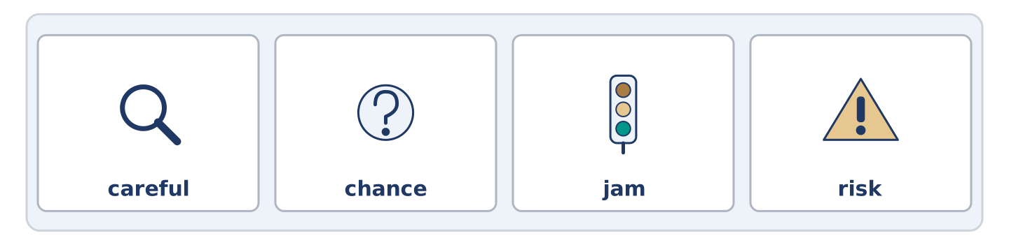
Figure 18.3 · The word bank for this task, in the order it is printed.
Complete the sentences using the words in the word bank.
Word bank: careful | chance | jam | risk
- If you go at seven there is a ______________________ on the bridge.
- Tomas is ______________________ with the pills and counts them twice.
- There is a small ______________________ of rain, so Maya is taking a coat.
- Mr Okonkwo will not take the ______________________ , and he never has.
Warm-up: Six People, Six Plans
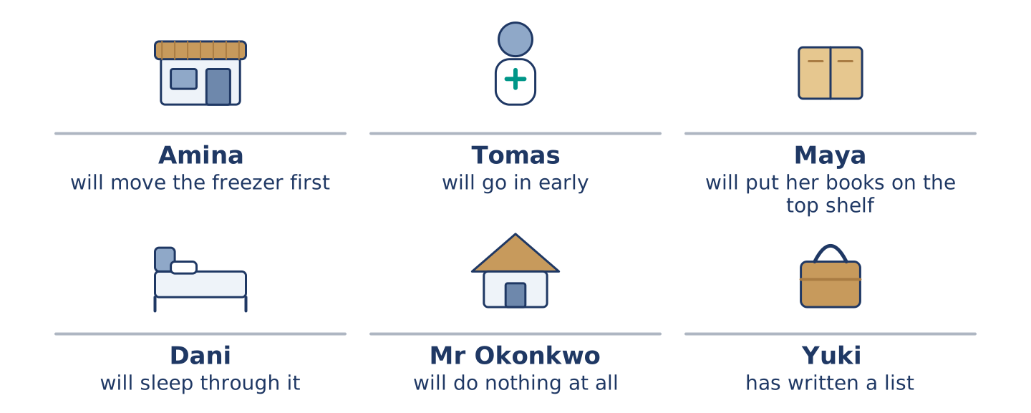
Figure 18.4 · What each of them will do if the weather turns.
Read the text and choose the correct answer.
Nobody at number 14 agrees about what to do if the water comes up again. Amina will move the freezer first, because she lost one in the spring. Tomas will go in early, because the hospital calls him when the roads are bad. Maya will put her books on the top shelf and feel silly if nothing happens. Dani will sleep through it unless somebody wakes him, and Maya says she will. Mr Okonkwo will do nothing at all, and he has been right twice. Yuki has written a list, and she has read it out to nobody.
1. What will Amina move first?
○ A) Her books
○ B) The freezer
○ C) The pills
○ D) Her list
2. What will Dani do?
○ A) Go in early
○ B) Read out a list
○ C) Move the freezer
○ D) Sleep through it
Part 1 · Vocabulary and Terminology
[CORE] Core track · pre-class input
Part 1: Words for Chance and Care
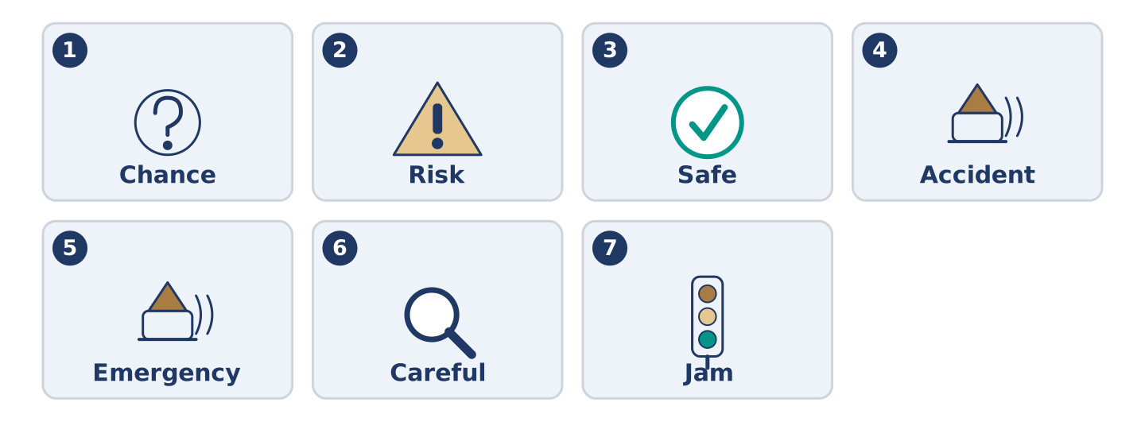
Figure 18.5 · The seven words of Column A, and what each one is.
Match the words with their meanings. One meaning is not needed. (0. is done for you.)
- Unless → if not; except if.
Column A
1. | Chance | ____
2. | Risk | ____
3. | Safe | ____
4. | Accident | ____
5. | Emergency | ____
6. | Careful | ____
7. | Jam | ____
Column B
a) | out of reach of anything that could hurt you
b) | a long line of cars that is not moving
c) | how likely something is
d) | taking care, and going slowly to get it right
e) | the chance that something bad will happen
f) | something bad happening now, so somebody must act
g) | something bad that happens and nobody planned
h) | the hair of a sheep, turned into cloth
Gloss: unless = if not; except if · danger = the chance that something bad will happen · luck = something good or bad that happens for no reason
Part 1: Pronunciation
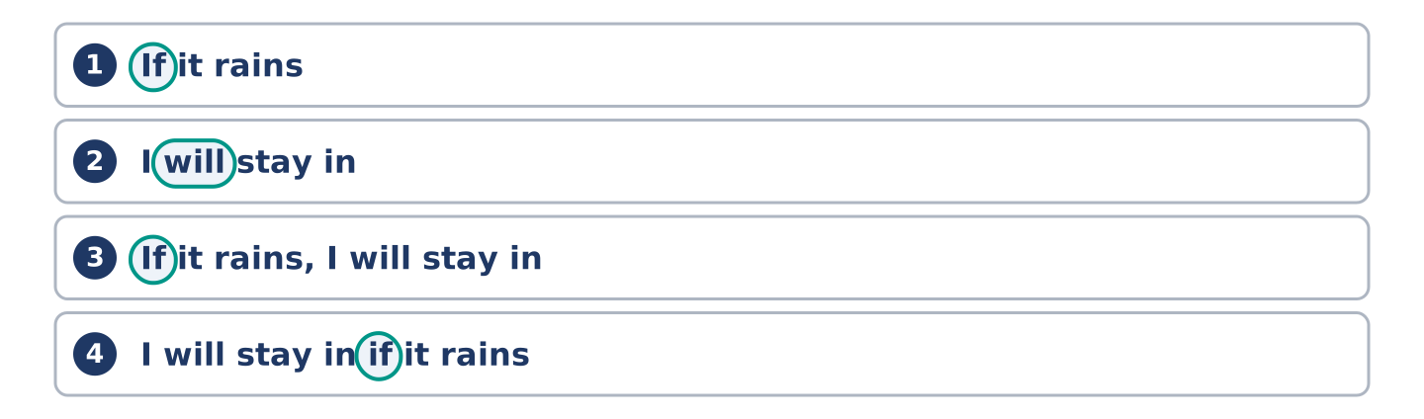
Figure 18.6 · Where the stress falls in 0 words of this unit.
🔊 Audio Track 18.1
Listen to the two halves. Say each one aloud.
If it rains — the voice goes up and waits: /ɪf ɪt ˈreɪnz/
I will stay in — the voice comes down and stops: /aɪl ˈsteɪ ˈɪn/
If it rains, I will stay in — up, wait, down
I will stay in if it rains — one run, no stop
So here is the useful part. The if half is not finished and your voice says so. Learners say both halves flat, and then the listener waits for a sentence that has already ended. When the if half comes second, nothing is written between the halves. Learners taught to write a mark there read the mark out loud.
Part 1: Four Things and What You Will Do
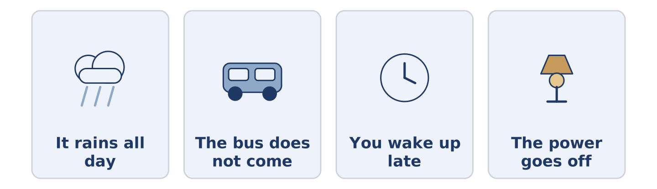
Figure 18.7 · Four things that might happen, and what each person will do.
Complete the table. Write what you will do. (0. is done.)
If this happens | I will…
It rains all day | (example)
The bus does not come
You wake up late
The power goes off
- It rains all day — I will stay in and be glad I have nothing to post.
Think about your own week. More than one answer is right.
Part 1: If, When or Unless?
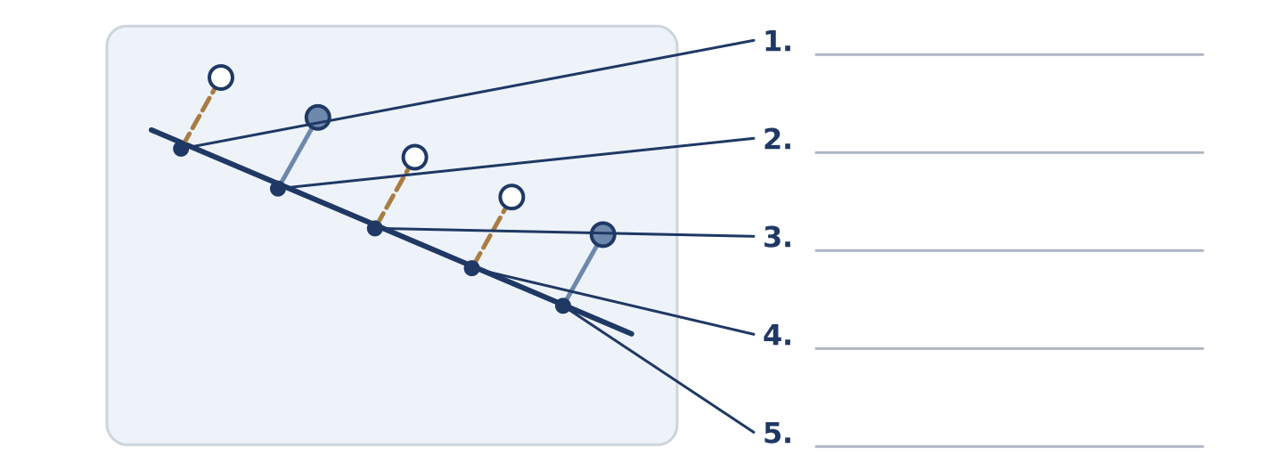
Figure 18.8 · If, when and unless — write the correct word on each line.
Match the words with what they do. One is not needed. Write the letter.
Column A
1. | if | ____
2. | when | ____
3. | unless | ____
4. | as soon as | ____
5. | in case | ____
Column B
a) | it may happen, and it may not
b) | it will happen, and we do not know the hour
c) | the only thing that would stop it
d) | the moment it happens, and not later
e) | before it happens, so that you are ready
f) | a hundred years
Part 1: Chance and Care — Multiple Choice
Read and choose the correct answer.
1. Something bad that happens and nobody planned is an…
○ A) accident
○ B) emergency
○ C) chance
○ D) risk
2. Unless means…
○ A) as soon as
○ B) in case
○ C) if not
○ D) when
3. A long line of cars that is not moving is a…
○ A) risk
○ B) jam
○ C) danger
○ D) chance
Part 1: Vocabulary Fill-in
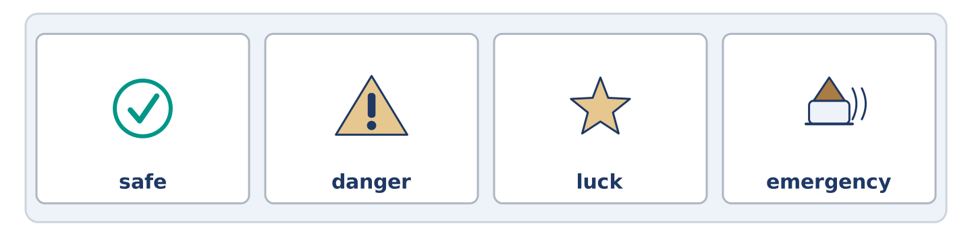
Figure 18.9 · The four words of the bank, in the order the task gives them.
Complete the sentences with the correct word.
Word bank: safe | danger | luck | emergency
- Put the keys somewhere ______________________ and tell one person where.
- There is no ______________________ at all, and Maya has read about it anyway.
- He has had the same ______________________ twice, which is not a plan.
- In an ______________________ , ring the top bell and keep ringing.
Part 1: Write About a Plan (short)
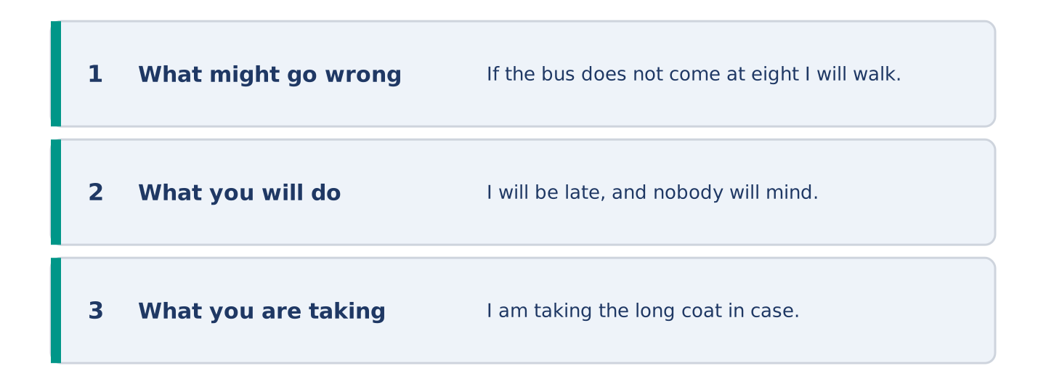
Figure 18.10 · The shape of your two or three sentences, with the model beside each step.
Write two or three sentences about something that might happen this week. Use three words from this unit.
Model — read this first:
If the bus does not come at eight I will walk, and I will be late, and nobody will mind. There is a small chance of rain. I am taking the long coat in case, which means it will not rain. (41 words)
Part 2 · Grammar — The First Conditional
[CORE] Core track · pre-class input
Part 2: Notice
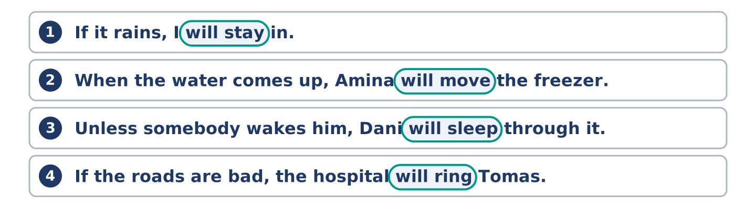
Figure 18.11 · Lines from the notice, with the target form ringed in each.
Read these lines. Underline the two verbs in each. Which half has will in it?
If it rains, I will stay in. When the water comes up, Amina will move the freezer. Unless somebody wakes him, Dani will sleep through it. If the roads are bad, the hospital will ring Tomas.
Will is in the second half of every one, and in none of the first halves.
Part 2: Grammar Focus Box
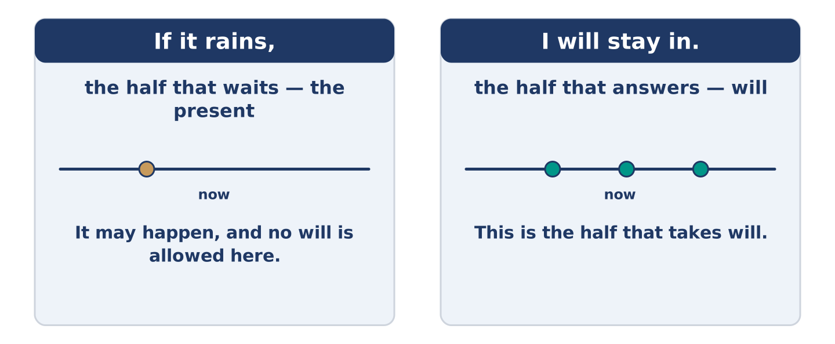
Figure 18.12 · One half waits, the other half answers.
 | Form | Use | Example
if + present | if it rains | it may happen | If it rains, I will stay in.
will + verb | I will stay in | what you will then do | If it rains, I will stay in.
when + present | when it rains | it will happen, time unknown | When it rains, the road floods.
unless + present | unless it rains | the one thing that would stop it | I will walk unless it rains.
Remember: no will after if, when or unless. The present does the work there: if it rains, never if it will rain.
Watch out! ✗ If it will rain, I will stay in. → ✓ If it rains, I will stay in. (no will after if). ✗ Unless it does not rain, I will walk. → ✓ Unless it rains, I will walk. (unless is a negative already).
Part 2: Controlled Practice
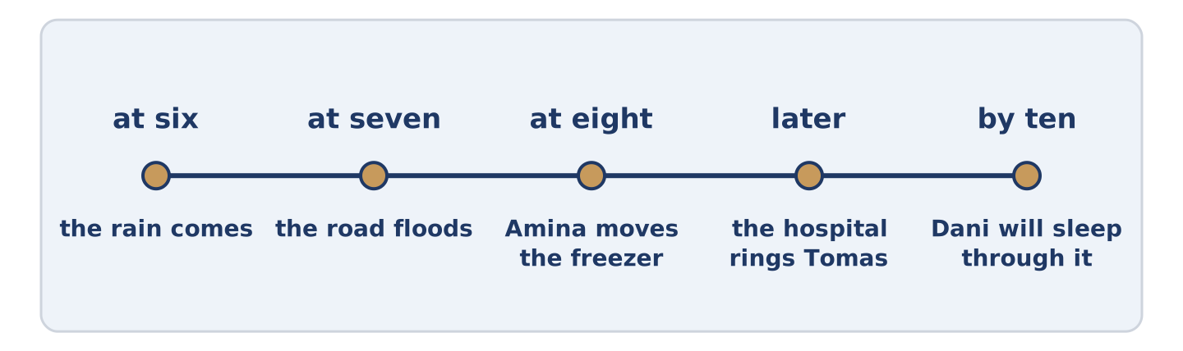
Figure 18.13 · One evening, and what each hour might bring.
Complete with the present simple or will. (0. is done.)
- If it rains, I will stay in. (rain)
- If the water comes up, Amina ______________________ the freezer. (move)
- When the roads are bad, the hospital ______________________ Tomas. (ring)
- Unless somebody ______________________ him, Dani will sleep through it. (wake)
- Maya will put the books back as soon as the rain ______________________ . (stop)
Part 2: Will It or Might It?
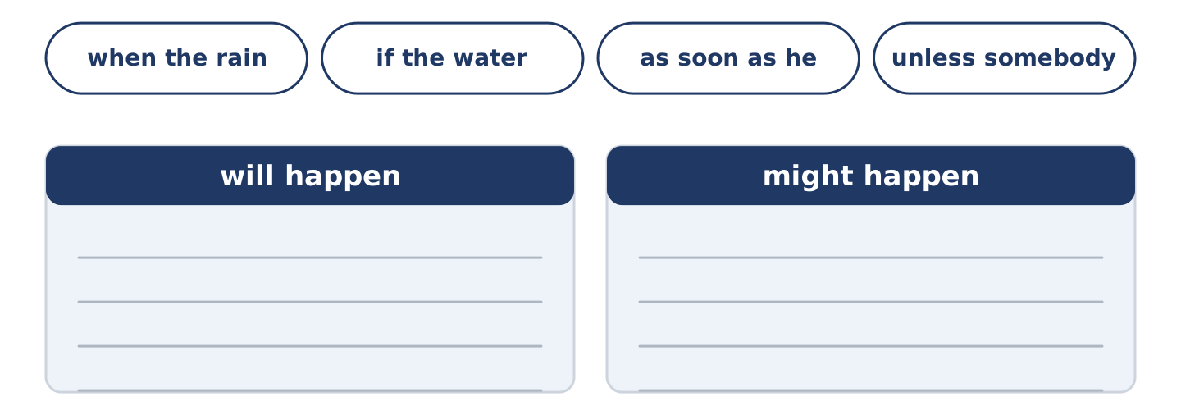
Figure 18.14 · The items of this task, and the bins they sort into.
Write will happen or might happen. (0. is done.)
- When the rain stops. — will happen
- If the water comes up. ____________
- As soon as he gets home. ____________
- Unless somebody wakes him. ____________
- When Tomas finishes his shift. ____________
Part 2: Correct the Sentence
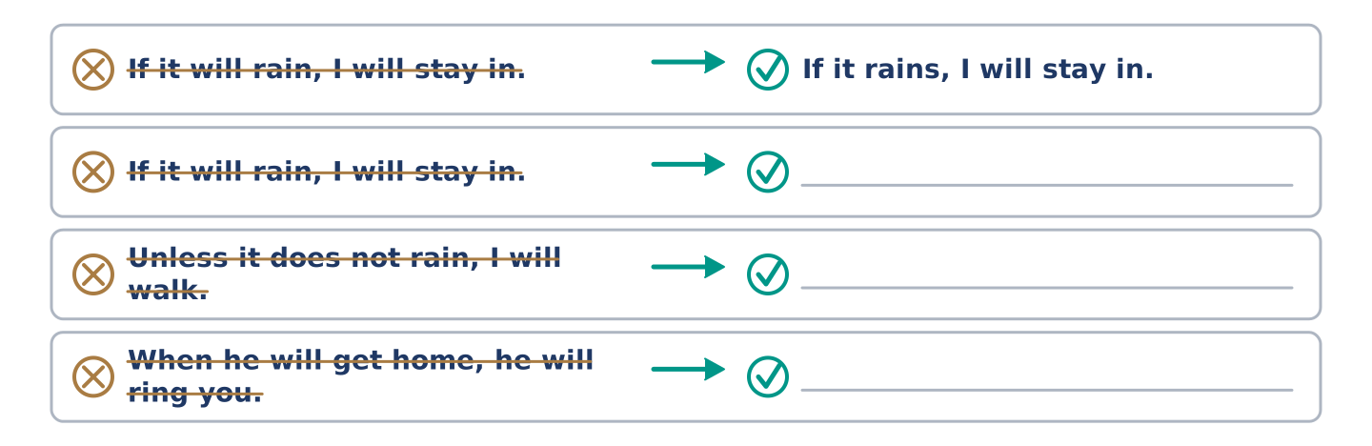
Figure 18.15 · One correction done for you, and the rest to write.
Each sentence has one grammar mistake. Write the correct sentence.
- If it will rain, I will stay in.
- Unless it does not rain, I will walk.
- When he will get home, he will ring you.
- If the water comes up, Amina moves the freezer.
Part 2: Freer Practice
Write two sentences about tomorrow: one with if, one with unless.
Part 2: Grammar Review
Choose the correct sentence.
1. Which sentence uses if correctly?
○ A) If it will rain, I will stay in.
○ B) If it rains, I stay in tomorrow.
○ C) If it would rain, I will stay in.
○ D) If it rains, I will stay in.
2. Which sentence means if it does not rain?
○ A) Unless it does not rain.
○ B) When it rains.
○ C) Unless it rains.
○ D) As soon as it rains.
→ Harvest: you will meet if and when again in the Part 5 reading. Notice which one is used for things that are certain.
Part 3 · Listening
[CORE] Core track · pre-class input · scripts printed inline
Part 3: What We Will Do If the Water Comes Up
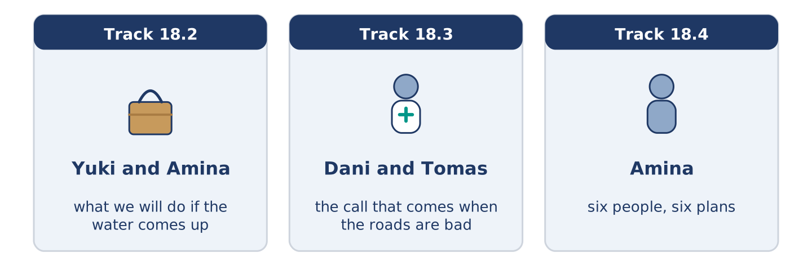
Figure 18.16 · The three listenings: who is speaking, and what about.
🔊 Audio Track 18.2
Before you listen: what would you move first?
Yuki: What happens if it comes up again? Amina: The freezer goes on the crates. Yuki: And if there are no crates? Amina: There’ll be crates. There always are. Yuki: Is there a list anywhere? Amina: There is a list in my head and it has four things on it. Yuki: Could I have it? Amina: If you write it down, nobody will read it. Yuki: I will read it. Amina: Then it is your list.
While you listen: write True, False, or Not Given. (0. is done.)
- Amina will put the freezer on the crates. — True
- Amina’s list has four things on it. ____
- Amina thinks a written list will be read. ____
- The water came up in the spring. ____
Useful phrases: What happens if…? · And if there are no…? · There will be… · Then it is your list
Part 3: The Call That Comes When the Roads Are Bad
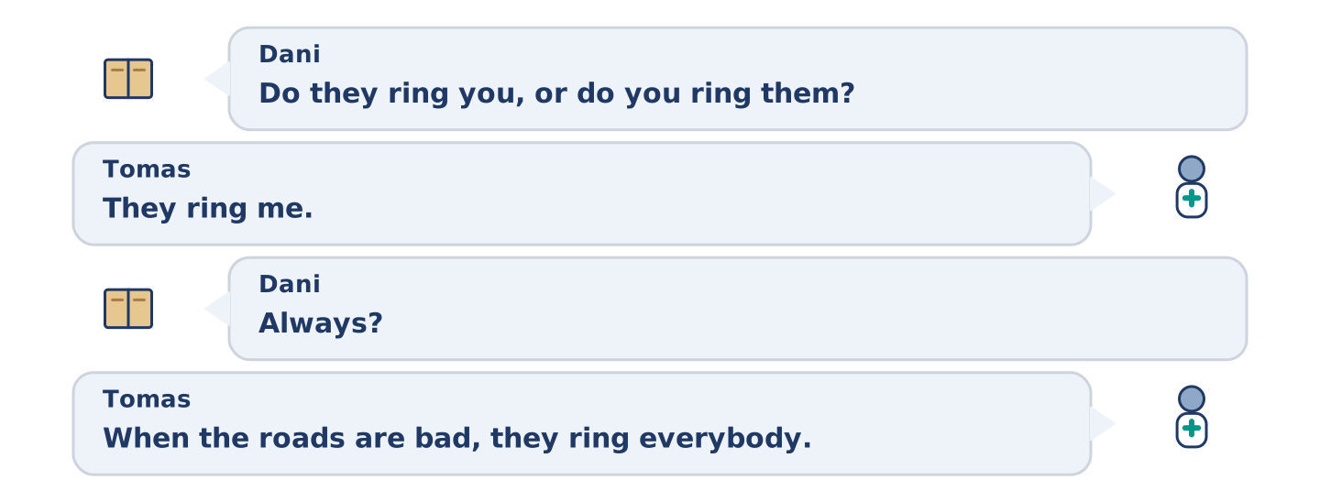
Figure 18.17 · The second listening, turn by turn.
🔊 Audio Track 18.3
Before you listen: has work ever rung you at a bad hour?
Dani: Do they ring you, or do you ring them? Tomas: They ring me. Dani: Always? Tomas: It isn’t a choice. When the roads are bad, they ring everybody. Dani: And if you do not answer? Tomas: They ring the next name. Dani: So you could not answer. Tomas: I could. Dani: But you will. Tomas: If the roads are bad, somebody is coming in whatever I do. It may as well be somebody who slept.
Answer the questions. (0. is done.)
- Who rings whom? — The hospital rings Tomas.
- What happens when the roads are bad?
- What happens if Tomas does not answer?
- Why does Tomas answer?
Part 3: Six People, Six Plans
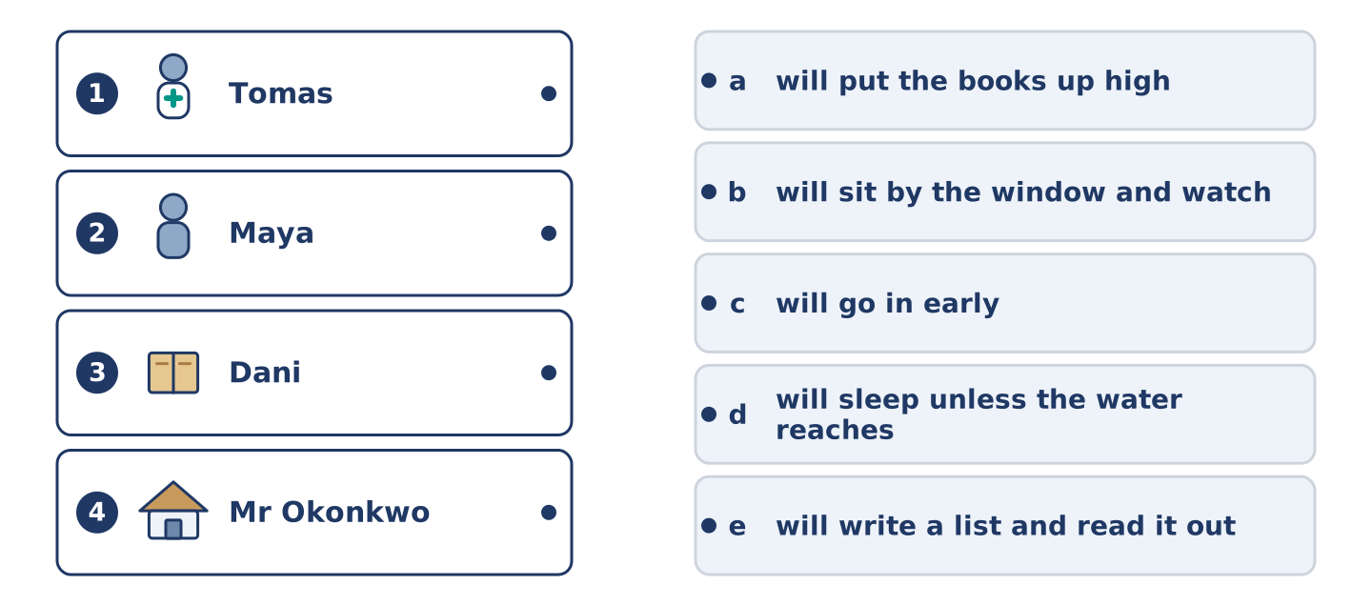
Figure 18.18 · Four on the left, five on the right, and one spare.
🔊 Audio Track 18.4
Before you listen: who do you know who makes a plan for everything?
Amina: I can tell you what each of them will do. I will move the freezer, because I lost one and I am not losing another. Tomas will go in early, because they will ring him and he will say yes. He is careful that way. Maya will put the books up high and then feel silly. Dani will sleep unless the water reaches the bed. And Mr Okonkwo will sit by his window on the fourth floor and watch the rest of us.
While you listen: match each person with their plan. One is not needed. (0. is done.)
- Amina → she will move the freezer.
Useful phrases: ___ will go in early · ___ will put the books up high · ___ will sleep unless ___
Column A
1. | Tomas | ____
2. | Maya | ____
3. | Dani | ____
4. | Mr Okonkwo | ____
Column B
a) | will put the books up high
b) | will sit by the window and watch
c) | will go in early
d) | will sleep unless the water reaches the bed
e) | will write a list and read it out
Part 4 · Speaking
[CORE] Core track · in-class output
Part 4: What Will You Do If…
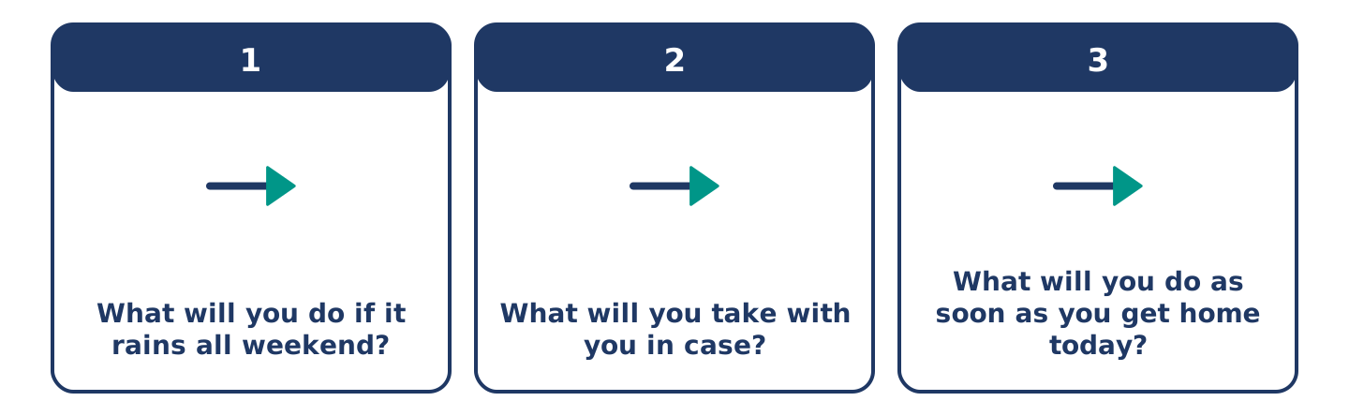
Figure 18.19 · The three questions as cards, to take one at a time.
Work with a partner. Ask and answer these questions.
- What will you do if it rains all weekend?
- What will you take with you in case?
- What will you do as soon as you get home today?
Useful language: If it…, I will… · unless… · in case… · as soon as…
Part 4: Find the Difference (pairwork)
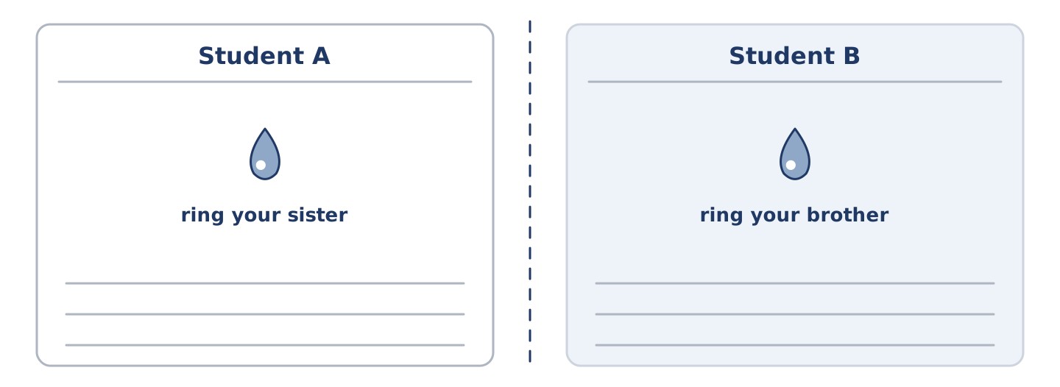
Figure 18.20 · Student A’s facts and Student B’s, with a fold between them.
Student A and Student B each have a plan for one bad evening. Ask questions and find three differences.
Useful questions: What will you do if…? · And if that does not work? · Who will you ring? · What will you take?
Student A — your plan: ring your sister, take the long coat, walk if the bus is late, stay at home if it floods.
Student B — your plan: ring your brother, take the long coat, wait if the bus is late, stay at home if it floods.
Part 4: Agreeing on One Plan
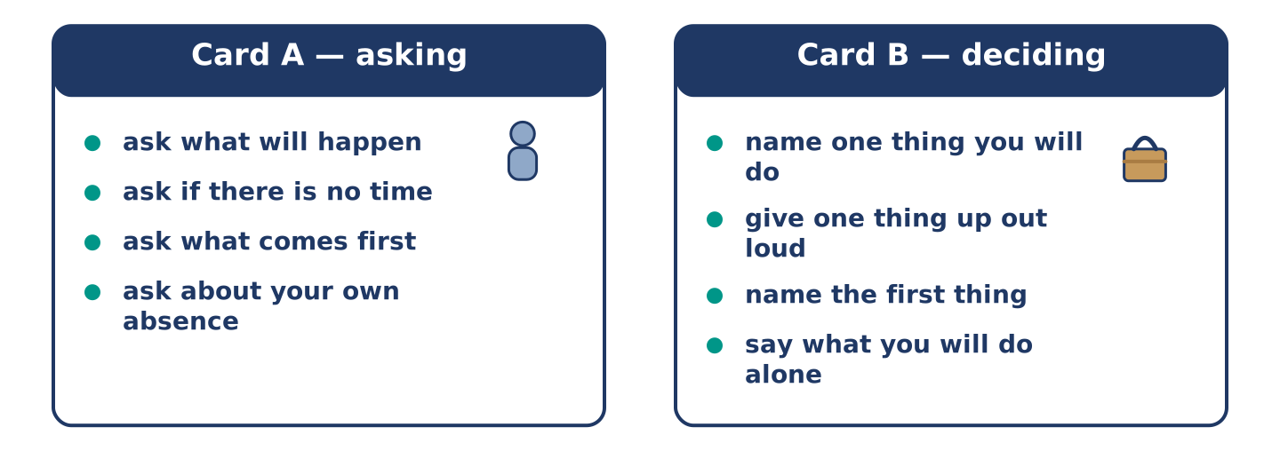
Figure 18.21 · Card A and Card B: what each of you has to say.
Work in pairs. Read the model, then use the cards.
Model exchange:
A: What will we do if it comes up? — B: I will move the freezer. — A: And if there is no time? — B: Then the freezer stays. — A: So what is first? — B: The keys and the papers. They go in a bag now. — A: And if I am out? — B: Then I do it, and you owe me a freezer.
Useful language: What will we do if…? · And if there is no time? · So what is first? · And if I am out?
Card A — asking: ask what will happen · ask about the case where there is no time · ask what comes first · ask about your own absence.
Card B — deciding: name one thing you will do · give one thing up out loud · name the first thing · say what you will do alone.
Your turn: run the dialogue, then swap roles.
Stretch [PLUS]: your partner’s plan is better than yours and you suggested yours first — hand it over in one sentence.
Part 4: Mini-Presentation
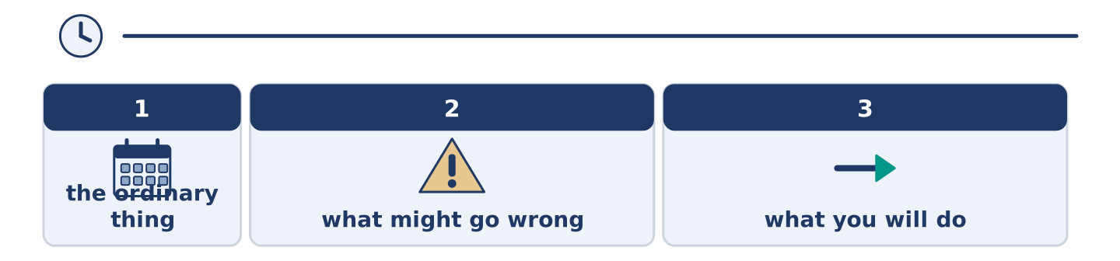
Figure 18.22 · The one-minute talk as 0 beats, each as wide as its share.
Prepare a short talk (about one minute). Say what you will do if one ordinary thing goes wrong this week.
Part 5 · Reading
[CORE] Core track · pre-class input
Part 5: Why Nobody Believes a Warning the First Time
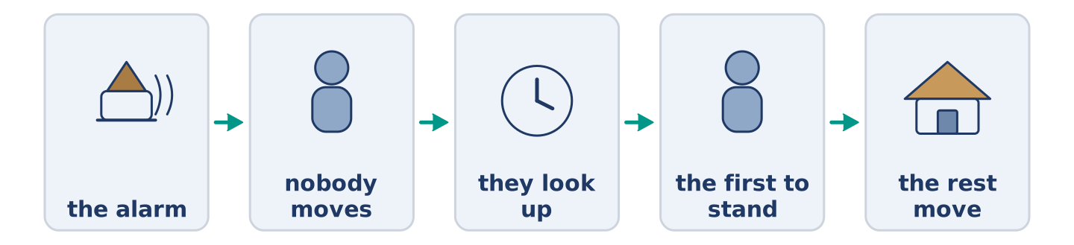
Figure 18.23 · One warning, and what people do in each minute.
Before you read: have you ever ignored a warning and been right?
Gloss: warning = a word or sound that tells you something bad is coming · alarm = a loud sound made on purpose, to warn · drill = a practice for something bad, done when nothing is wrong
If an alarm goes off in a building, almost nobody moves. They look up, then at each other, and the first person to stand decides it for the rest. The same thing has been counted everywhere: people wait to be told twice. The reason is not that people are slow. It is that a first warning costs nothing, and being wrong in front of others is expensive. So a good alarm does two things. It says what is happening, not that something is, and it names what to do. Fire on the third floor. Use the back stairs. Nobody waits for a second opinion about that.
Answer the multiple-choice questions. (0. is done.)
- What does almost nobody do when an alarm goes off? — Move.
1. Who decides it for the rest?
○ A) The first person to stand
○ B) The oldest person there
○ C) The person nearest the door
○ D) Nobody
2. Why do people wait?
○ A) Because they did not hear
○ B) Because the alarm is quiet
○ C) Because they are slow
○ D) Because being wrong in front of others is expensive
3. What does a good alarm name?
○ A) The building
○ B) What to do
○ C) The hour
○ D) The cost
Part 5: Vocabulary in Context
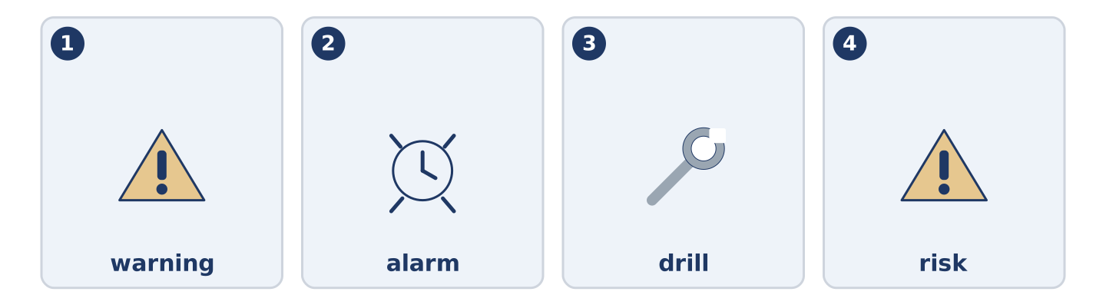
Figure 18.24 · The four words from the reading, drawn.
Match each word from the text with its meaning. One meaning is not needed. Write the letter.
Column A
1. | warning | ____
2. | alarm | ____
3. | drill | ____
4. | risk | ____
Column B
a) | a practice for something bad, done when nothing is wrong
b) | the chance that something bad will happen
c) | a word or sound that tells you something bad is coming
d) | a loud sound made on purpose, to warn
e) | a long line of cars that is not moving
Part 5: Three Warnings That Come Too Late to Be Useful
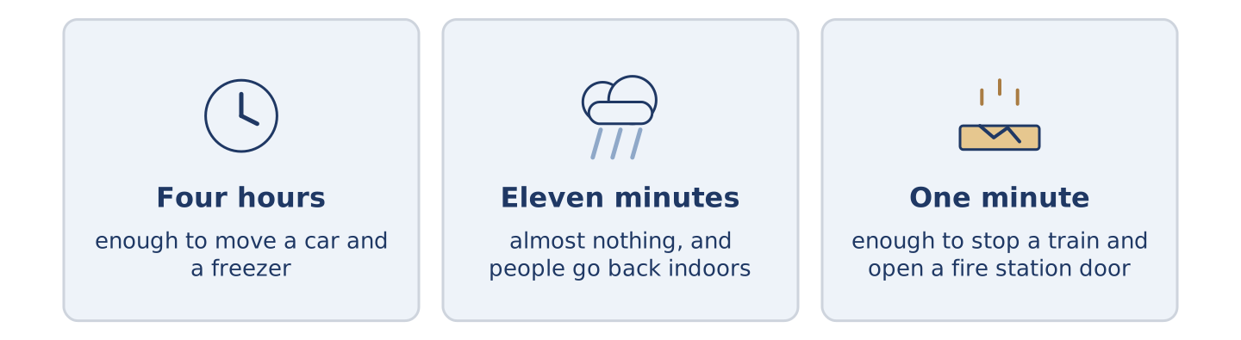
Figure 18.25 · Three warnings, and how long each one gives you.
Before you read: how much warning would be enough?
Gloss: flood = water covering land that is usually dry · sensor = a small machine that notices a change · siren = a very loud sound that carries a long way
A warning is only worth the time it buys. One four hours early empties a street: four hours is enough to move a car and a freezer. One eleven minutes early does almost nothing. In two cities it made things worse: people went back indoors for their papers. An earthquake warning is the strangest. It cannot be early, because nothing happens first. A sensor can feel the first shake and send a siren faster than the ground moves. That buys about a minute. A minute sounds like nothing. It is enough to stop a train and get a surgeon’s hands out of somebody.
Answer the questions. (0. is done.)
- What is a warning worth? — Only the time it buys.
- What does a four-hour flood warning do?
- Why did an eleven-minute warning make things worse?
- Name two things a minute is enough for.
Part 6 · Writing
[CORE] Core track · in-class / homework
Part 6: A Plan for a Bad Day (50–70 words)
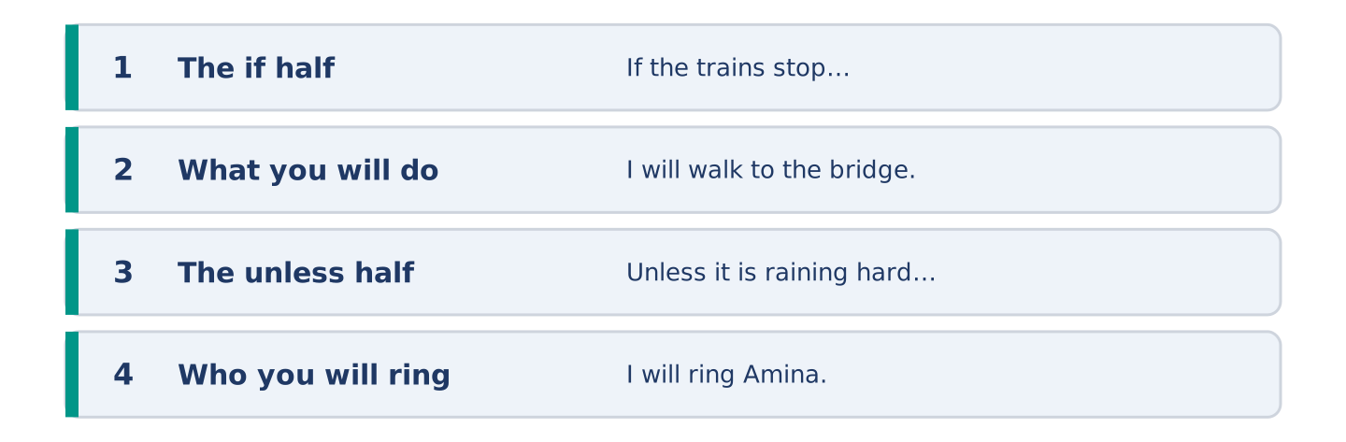
Figure 18.26 · The shape of the piece you are about to write.
Write what you will do if one thing goes wrong tomorrow. Use if and unless.
Model — read this first:
If the trains stop I will walk to the bridge and get the bus there. It takes fifty minutes and I will be late, and being late is allowed. Unless it is raining hard I will not ring anybody. If it is, I will ring Amina. She will say take a taxi, and that is why I will not ring her. (61 words)
Plan (fill in, then write): If ___ , I will ___ . It takes ___ . Unless ___ , I will not ___ . If it is, I will ___ .
Word bank: if | unless | as soon as | in case | I will
Check before you finish: ☐ one if sentence? ☐ one unless sentence? ☐ no will after if? ☐ 50–70 words?
Part 6: Should You Plan for Everything? (50–70 words)
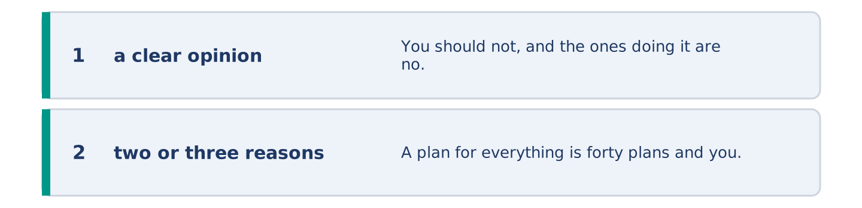
Figure 18.27 · The shape of the opinion paragraph, step by step.
Should you make a plan for every bad thing that might happen? Give your opinion and two or three reasons.
Model — read this first:
You should not, and the ones doing it are no safer for it. A plan for everything is forty plans and you will not remember one of them. Two plans you can say out loud beat forty in a drawer. Keep a bag by the door and know who you will ring. Everything else can be worked out at the time. (58 words)
Word bank: I think… because… | however | in my opinion | it depends on | the main thing is
Check before you finish: ☐ a clear opinion? ☐ two or three reasons? ☐ 50–70 words?
Part 6: A Time You Were Lucky (50–70 words)
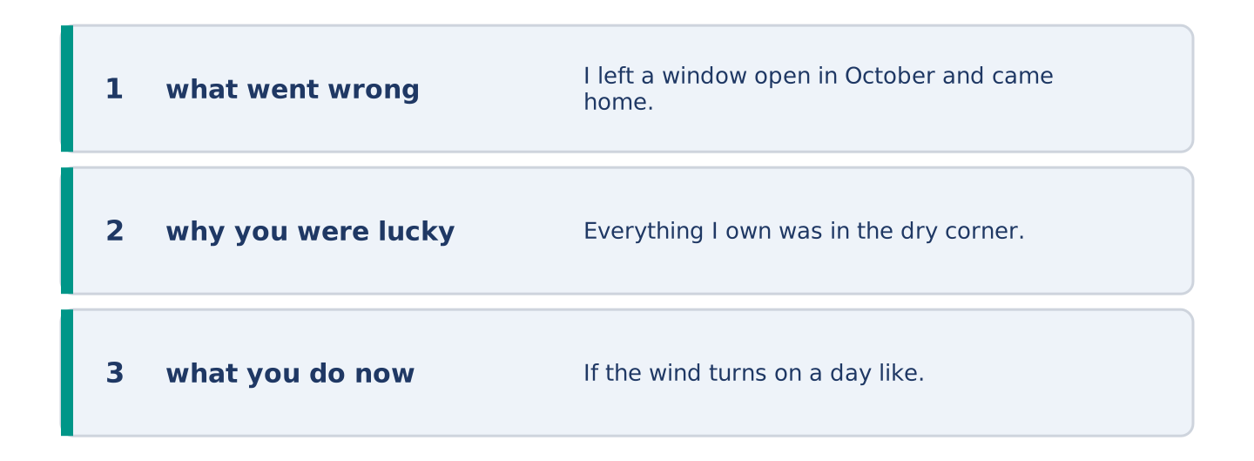
Figure 18.28 · The moves of the message, with a line of the model for each.
Write about a time something went wrong and you were lucky. Say what might have happened.
Model — read this first:
I left a window open in October and came home to a flat full of rain and one dry corner. Everything I own was in the dry corner, for no reason at all. If the wind turns on a day like that, you lose everything you own. I did nothing right. I close that window now before I leave, every time. (56 words)
Plan (fill in, then write): I ___ and ___ . If ___ , ___ . I did ___ . I have ___ since.
Check before you finish: ☐ what went wrong? ☐ why you were lucky? ☐ what you do now? ☐ 50–70 words?
Part 6: Reflection — The Warning You Ignore (40–60 words)
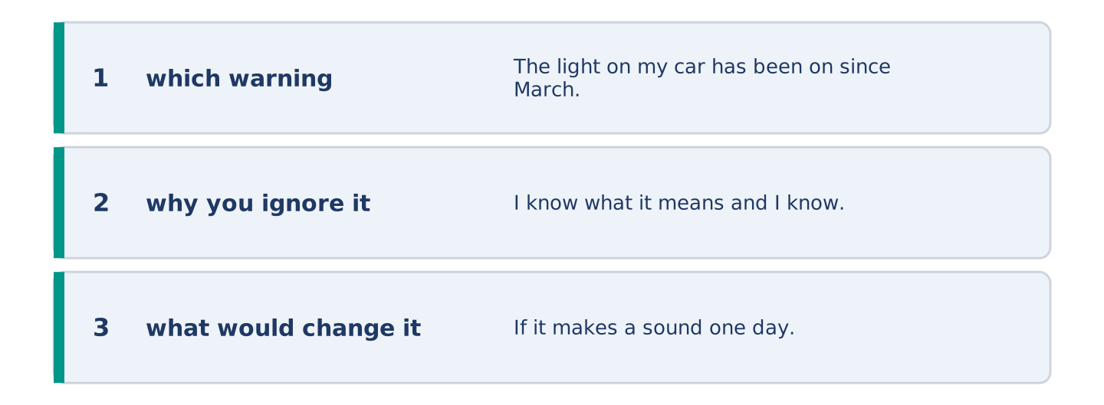
Figure 18.29 · The reflection, step by step.
Write about a warning you ignore, and why.
Model — read this first:
The light on my car has been on since March. I know what it means and I know it is not nothing. If it makes a sound one day, I will deal with it in a week. It is a small orange picture, so I have stopped seeing it, and that is how warnings fail. (54 words)
Check before you finish: ☐ which warning? ☐ why you ignore it? ☐ what would change it? ☐ 40–60 words?
Part 7 · Real-World File — Saying What You Will Do
[PLUS] Plus track (optional) · stronger learners
7A: Phrase Bank
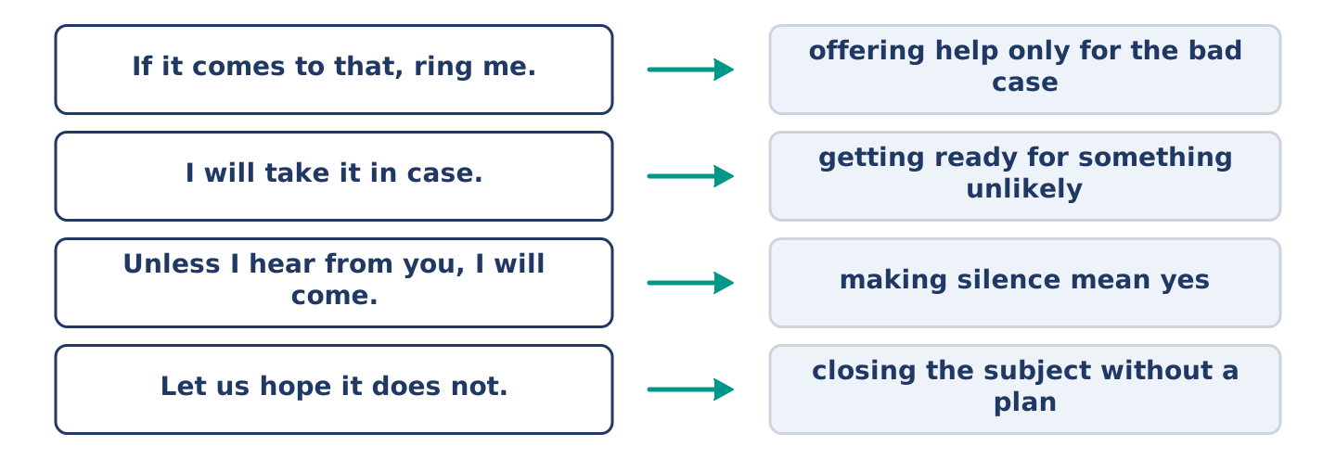
Figure 18.30 · What people say about what might happen, and what each line does.
Match what a person says with its purpose. One purpose is not needed. Write the letter.
Column A
1. | “If it comes to that, ring me.” | ____
2. | “I will take it in case.” | ____
3. | “Unless I hear from you, I will come.” | ____
4. | “Let us hope it does not.” | ____
Column B
a) | getting ready for something unlikely
b) | how much it will cost
c) | offering help only for the bad case
d) | making silence mean yes
e) | closing the subject without a plan
7B: The Plan Nobody Agreed To
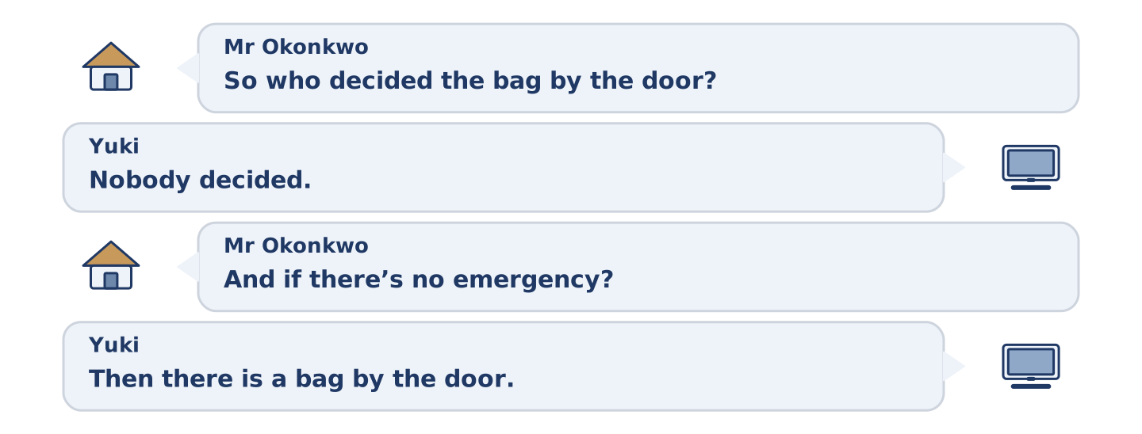
Figure 18.31 · The 7B exchange: who takes each turn.
🔊 Audio Track 18.5
Before you read: has a plan ever been made for you while you said nothing?
Mr Okonkwo: So who decided the bag by the door? Yuki: Nobody decided. I put it there. Mr Okonkwo: And if there’s no emergency? Yuki: Then there is a bag by the door. Mr Okonkwo: For how long? Yuki: Until there is one. Mr Okonkwo: That could be thirty years. Yuki: Then it’s been a very cheap thirty years. Mr Okonkwo: Put my keys in it.
Answer the questions. (0. is done.)
- Who decided about the bag? — Nobody; Yuki put it there.
- How long will the bag stay by the door?
- What does Mr Okonkwo say that could be?
- What does Mr Okonkwo ask for at the end?
7C: Controlled Practice — Making a Plan With Somebody
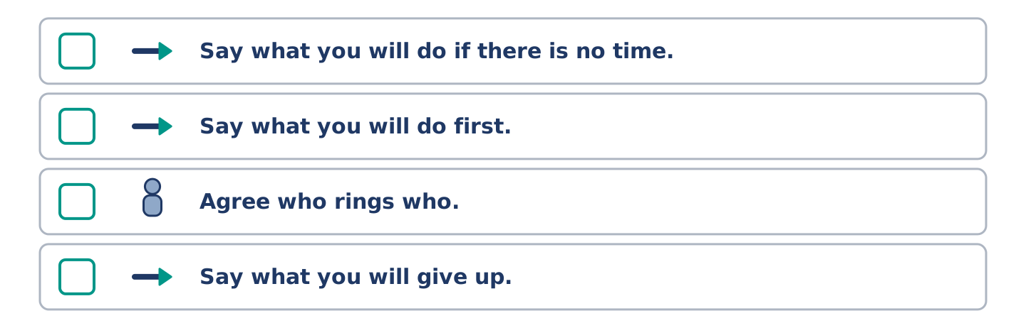
Figure 18.32 · The steps still to be numbered, as the task prints them.
Put the steps in order. Number them 1–5. (0. is done.)
- Name the thing that might happen. — 1
____ Say what you will do if there is no time.
____ Say what you will do first.
____ Agree who rings who.
____ Say what you will give up.
7D: Role-Play — One Bag, Two Opinions
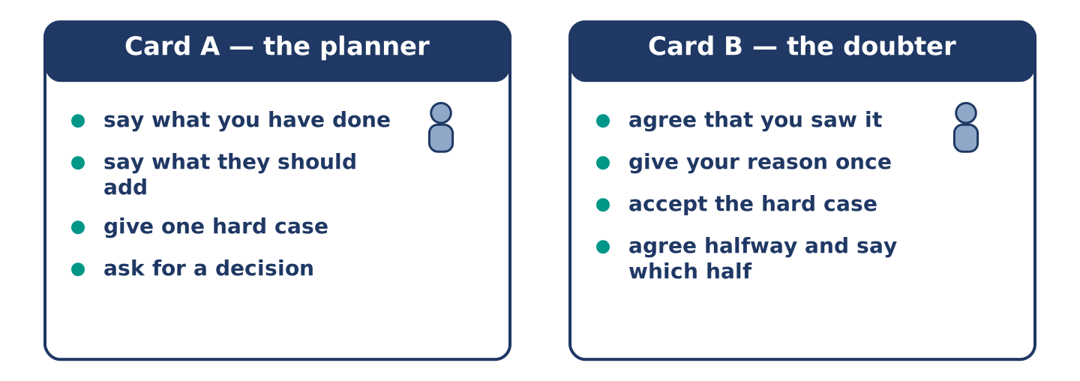
Figure 18.33 · The 7D cards: what each of you has to say.
In pairs. One has made a plan, the other has not. Use the model and cards.
Model exchange: A: There is a bag by the door. — B: I saw it. — A: Your keys should be in it. — B: If I need my keys I will know where they are. — A: Not at four in the morning. — B: That is fair. — A: So shall I put them in? — B: Put the spare ones in. I am keeping mine.
Card A — the planner: say what you have done · say what they should add · give one hard case · ask for a decision.
Card B — the doubter: agree that you saw it · give your reason once · accept the hard case · agree halfway and say which half.
Stretch [PLUS]: you are the planner and you know you have gone too far — keep one part of the plan and drop the rest out loud.
7E: Writing — A Note About What to Do If (50–80 words)
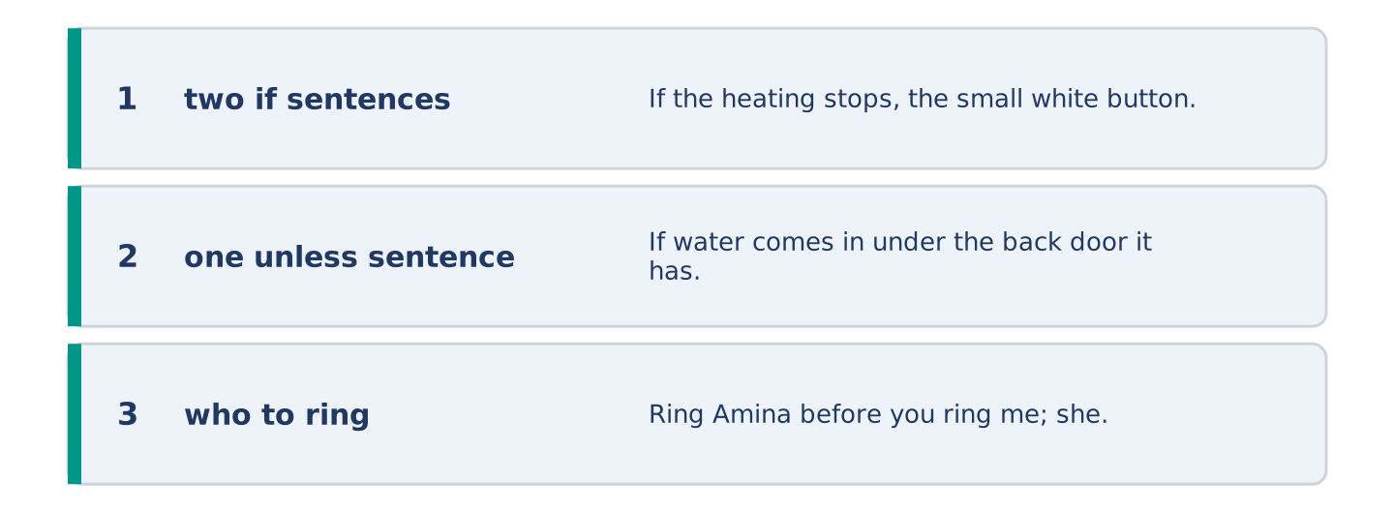
Figure 18.34 · The Part 7 note, with the model beside each line.
You are away for a week. Write a note about what to do if something goes wrong.
Model — read this first:
If the heating stops, the small white button is behind the door in the hall and it wants pressing twice. If water comes in under the back door it has done it before and a towel is enough. Ring Amina before you ring me; she is downstairs and I am four hours away. Unless something is on fire, it can wait until Sunday. (60 words)
Check before you finish: ☐ two if sentences? ☐ one unless sentence? ☐ who to ring? ☐ 50–80 words?
Part 8 · Global Story — The City That Gets a Minute
[PLUS] Plus track · pre-read / discuss
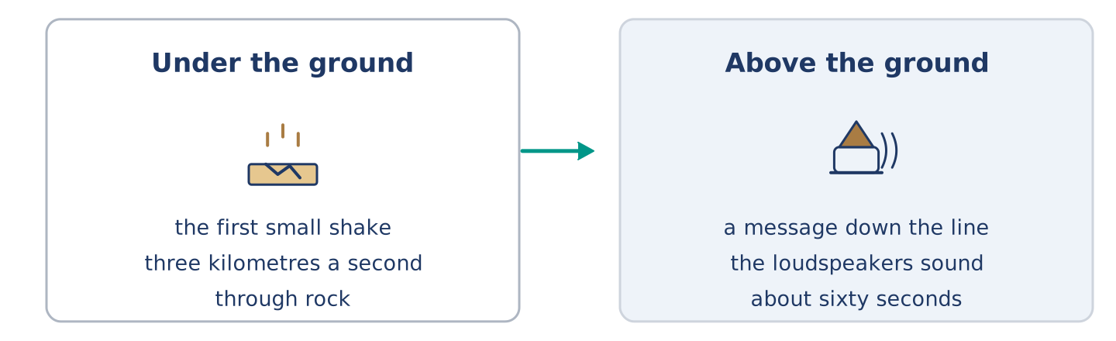
Figure 18.35 · A shake under the ground and a sound above it.
Before you read: what would you do with one minute?
Gloss: earthquake = a shaking of the ground · loudspeaker = a machine that makes a voice loud enough for a street · rehearse = to practise a thing before it is needed
Mexico City sits a long way from the coast where its earthquakes start. That distance is the whole of its luck. Sensors on the coast feel the first small shake. The shake travels through rock at about three kilometres a second; a message down a telephone line travels far faster. So the loudspeakers in the city can sound about sixty seconds before the ground moves. A minute is not enough to leave a building and nobody is told to. It is enough to stop the trains, open the fire station doors and get out of a lift. The city rehearses it every September. If the siren sounds on another day, people do what they did in the drill. That part took thirty years, and it was not the sensors.
Answer the questions. (0. is done.)
- Where do Mexico City’s earthquakes start? — A long way off, near the coast.
- How fast does the shake travel through rock?
- Name two things a minute is enough for.
- What took thirty years?
Part 8: Vocabulary in Context
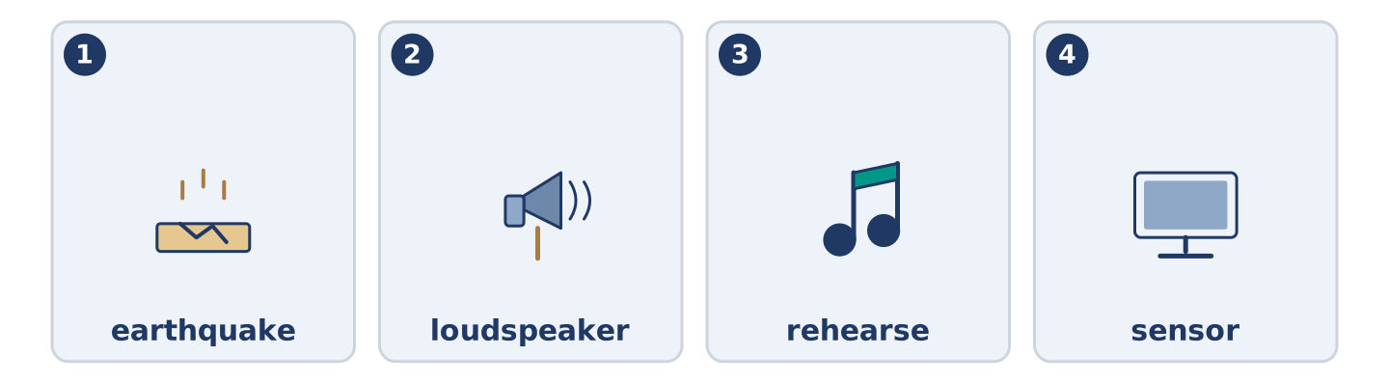
Figure 18.36 · The four words from the global story, drawn.
Match each word with its meaning. One meaning is not needed. Write the letter.
Column A
1. | earthquake | ____
2. | loudspeaker | ____
3. | rehearse | ____
4. | sensor | ____
Column B
a) | a small machine that notices a change
b) | a shaking of the ground
c) | to practise a thing before it is needed
d) | a machine that makes a voice loud enough for a street
e) | water covering land that is usually dry
Part 8: Discussion
Talk with a partner. Use the frames.
Discussion frames: “This is similar to where I live because…” · “This is different from where I live because…” · “I think the most important thing is… because…”
Part 9 · Close to Home — The Bag by the Door
[PLUS] Plus track · pre-read / decide
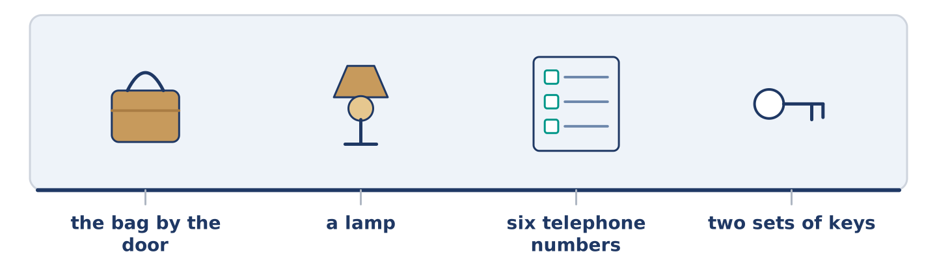
Figure 18.37 · The close-to-home reading, drawn along one street.
Before you read: how long would you keep a bag by the door?
There is a bag by the front door of number 14 and nobody voted for it. Yuki put it there in April, after the water came up in the spring and four of them lost something. She did it on a Saturday and she told nobody first. It holds a lamp, a list of six telephone numbers, two sets of spare keys and a bar of chocolate nobody is allowed to eat. Amina has added nothing and is glad it is there. Tomas has looked inside it twice, professionally. Dani has eaten the chocolate once and replaced it. Mr Okonkwo asked how long it would stay and then put his keys in. If nothing ever happens, the bag was a waste of a Saturday afternoon. If something does, it will be the best Saturday anybody spent that year.
Answer the questions. (0. is done.)
- Who put the bag by the door? — Yuki.
- Name three things in the bag.
- What did Dani do?
- What did Mr Okonkwo do after asking his question?
Part 9: Decision Task
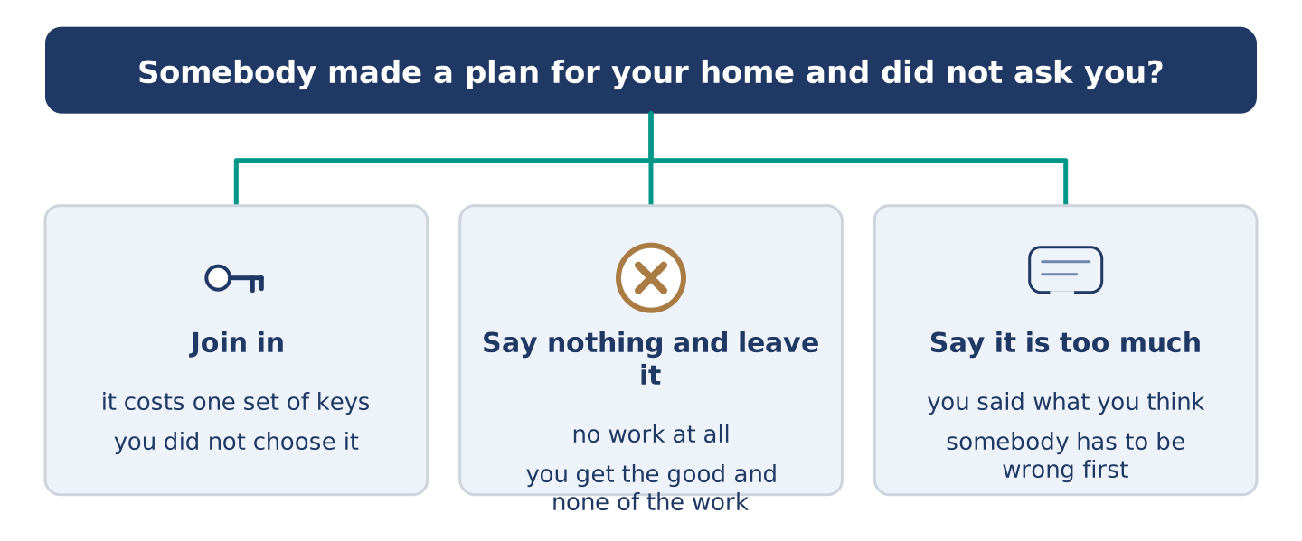
Figure 18.38 · Three ways to decide, and what each one costs.
Somebody has made a plan for your home and did not ask you. Should you (a) join in, (b) say nothing and leave it, or (c) say it is too much? Decide and explain. Use the frame.
Answer frame: “I think I should ___ because ___. Also, ___. This is better than ___ because ___.”
Model — read this first:
I think I should join in, because the plan costs me one set of keys and I will never miss them. Also, if I say nothing I get the good of it and none of the work, and I would know that. This is better than saying it is too much. Somebody has to be wrong first, and it will not be the one with the bag. (65 words)
Phrase bank: I think I should… · because… · Also,… · This is better than… · In my opinion…
Part 10 · Review and Can-Do
[CORE + PLUS] · homework / self-study
Part 10: Spiral Review
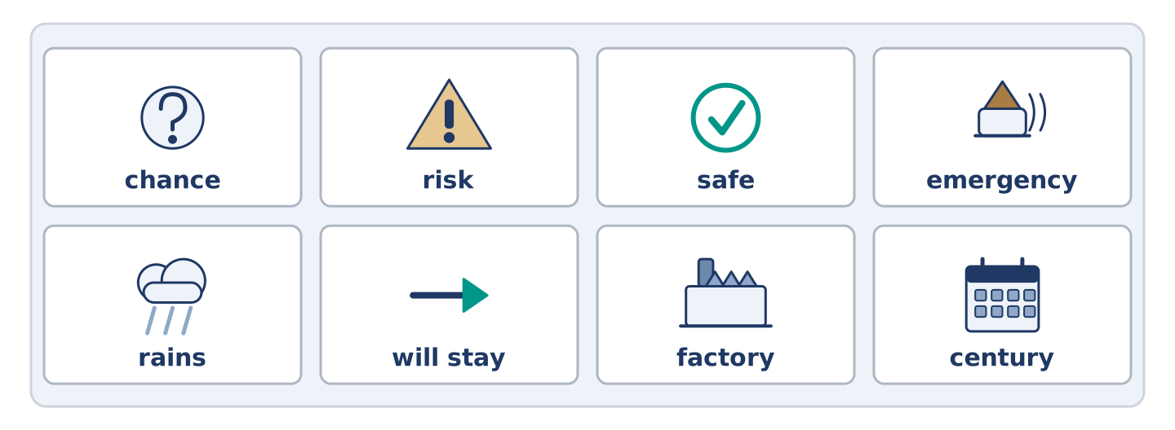
Figure 18.39 · The eight words of the review bank, in bank order.
Complete the review. (0. is done.)
- If not, or except if, is unless.
Word bank: chance | risk | safe | emergency | rains | will stay | factory | century
- How likely something is, is the ______________________ .
- The chance that something bad will happen is the ______________________ .
- Out of reach of anything that could hurt you is ______________________ .
- Something bad happening now, so somebody must act, is an ______________________ .
- If it ______________________ , I will stay in. (present)
- If it rains, I ______________________ in. (will)
- (from Unit 17) A building where things are made in large numbers is a ______________________ .
- (from Unit 16) A hundred years is a ______________________ .
Part 10: Can-Do
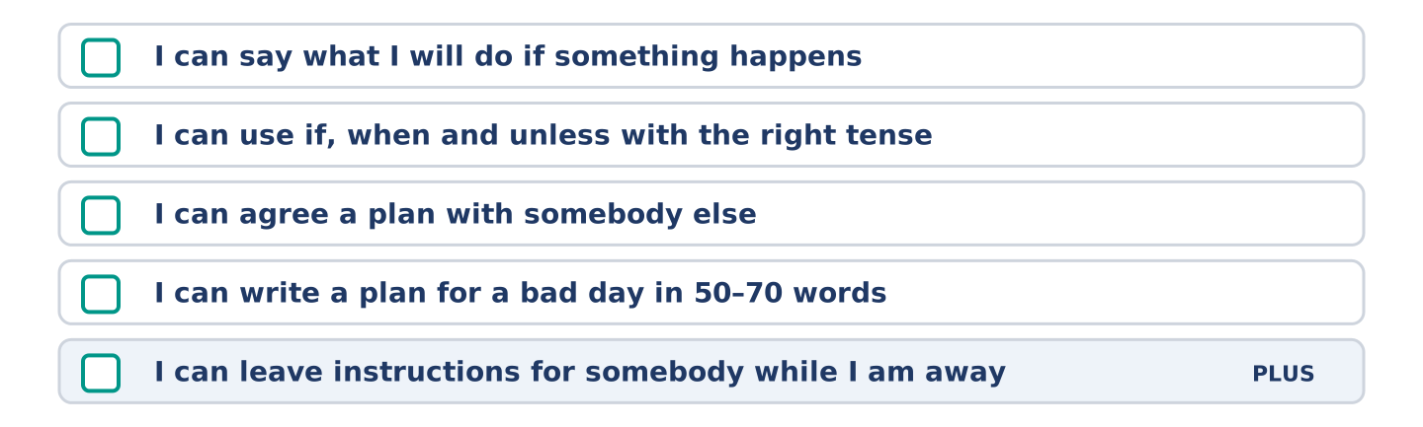
Figure 18.40 · What you can do at the end of this unit.
Can-Do checklist
☐ I can say what I will do if something happens.
☐ I can use if, when and unless with the right tense.
☐ I can agree a plan with somebody else.
☐ I can write a plan for a bad day in 50–70 words.
☐ I can leave instructions for somebody while I am away (Plus).
Part 10: Glossary
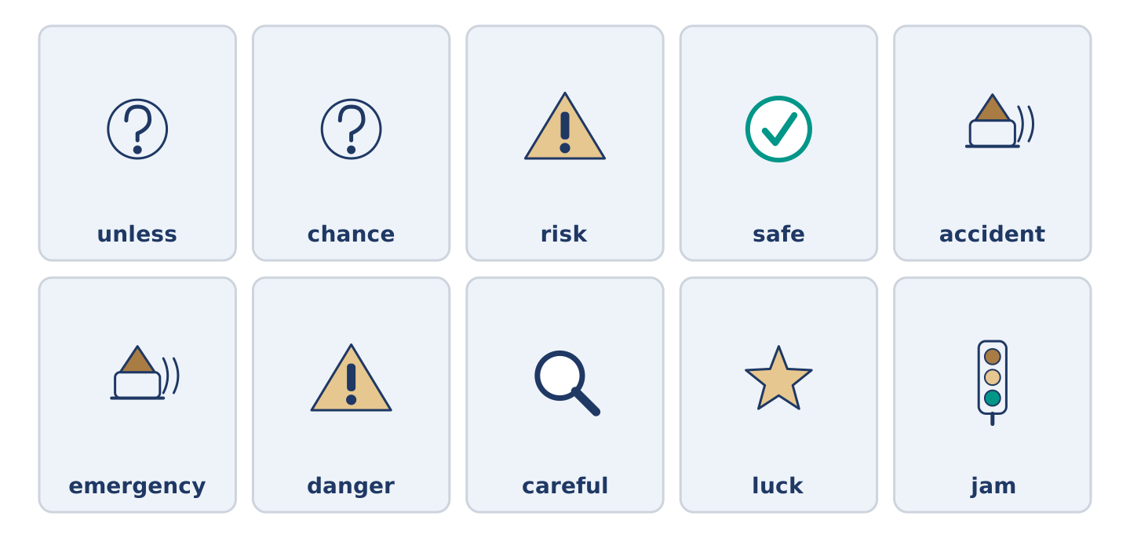
Figure 18.41 · All ten glossary words of Unit 18, one card each.
Unit 18 glossary (10 words)
unless · chance · risk · safe · accident · emergency · danger · careful · luck · jam

