Unit 19: People, Places and Things
English for Daily Life · Level: A2 · Tracks: [CORE] Warm-Up + Parts 1–6 · [PLUS] Parts 7–10
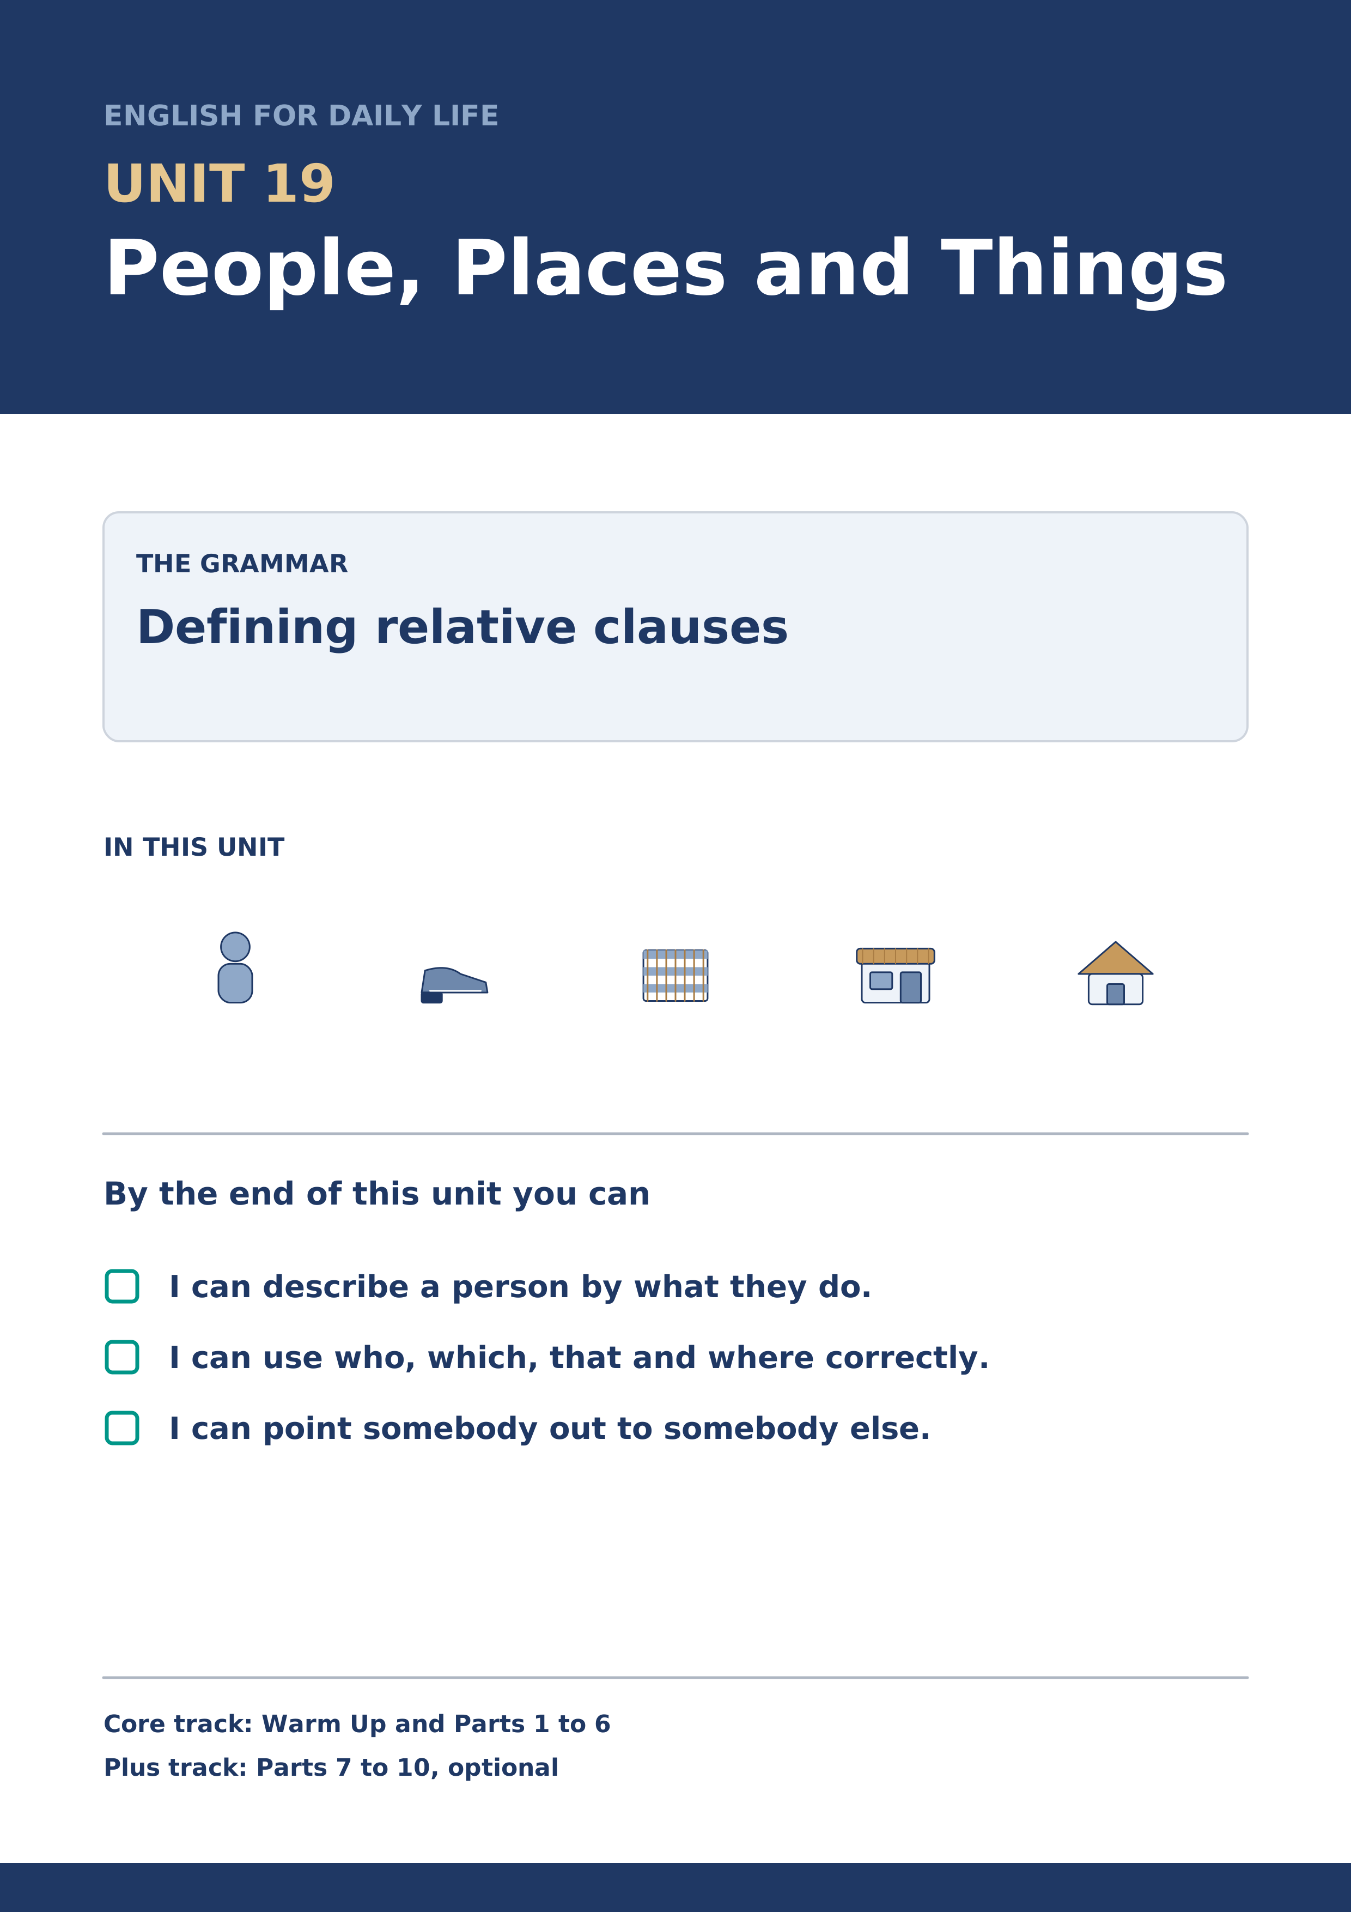
Warm Up
[CORE] Core track · in-class starter
Warm-up: Words for What People Do
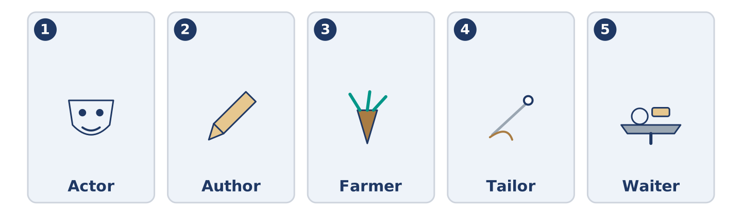
Figure 19.2 · The five warm-up words, and the thing each one means.
Match the words with their meanings. One meaning is not needed. Write the letter.
Column A
1. | Actor | ____
2. | Author | ____
3. | Farmer | ____
4. | Tailor | ____
5. | Waiter | ____
Column B
a) | a person who writes books
b) | a person who grows food or keeps animals
c) | a person who brings food to your table
d) | a person who acts in plays or films
e) | a person who makes and mends clothes
f) | a person who looks after your teeth
Warm-up: Talking About People
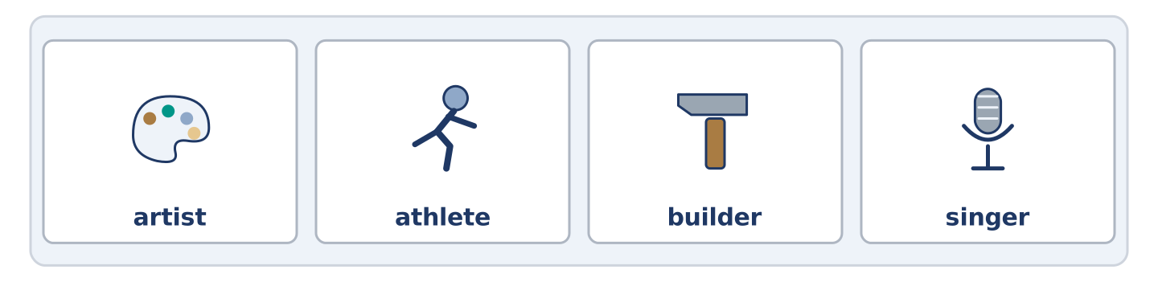
Figure 19.3 · The word bank for this task, in the order it is printed.
Complete the sentences using the words in the word bank.
Word bank: artist | athlete | builder | singer
- The woman in flat 1 is an ______________________ and paints the stairs when nobody asks.
- Dani’s brother is an ______________________ and runs before it is light.
- The man who put the new door on is the ______________________ Amina always uses.
- There is a ______________________ in the top flat of number 12 and nobody minds.
Warm-up: Six People, Six Descriptions
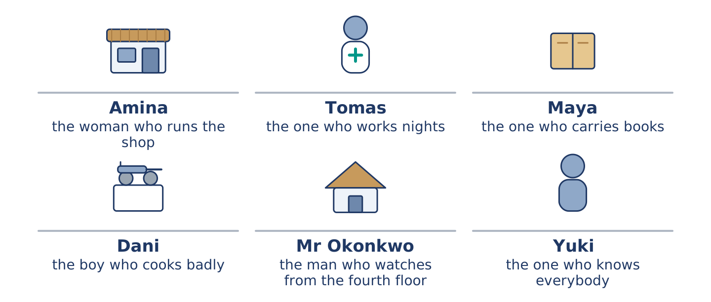
Figure 19.4 · How each of them would be described by somebody who does not know their name.
Read the text and choose the correct answer.
Nobody in the street knows all six names, so people describe each other instead. Amina is the woman who runs the shop. Tomas is the one who works nights. Maya is the one who carries books. Dani is the boy who cooks badly and loudly. Mr Okonkwo is the man who watches from the fourth floor. Yuki is the one who knows everybody’s name, which is the only description in the list nobody chose for themselves.
1. Who is described as the one who works nights?
○ A) Dani
○ B) Maya
○ C) Yuki
○ D) Tomas
2. Which description did nobody choose for themselves?
○ A) Amina’s
○ B) Yuki’s
○ C) Dani’s
○ D) Mr Okonkwo’s
Part 1 · Vocabulary and Terminology
[CORE] Core track · pre-class input
Part 1: Words for Jobs
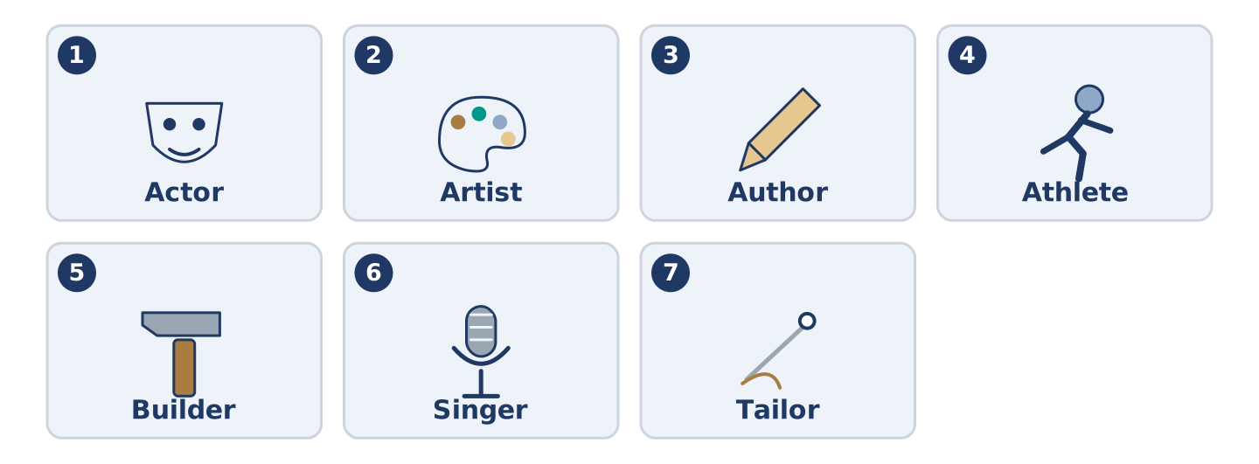
Figure 19.5 · The seven words of Column A, and what each one is.
Match the words with their meanings. One meaning is not needed. (0. is done for you.)
- Painter → a person who paints walls, or pictures.
Column A
1. | Actor | ____
2. | Artist | ____
3. | Author | ____
4. | Athlete | ____
5. | Builder | ____
6. | Singer | ____
7. | Tailor | ____
Column B
a) | a person who makes pictures or other art
b) | a person who writes books
c) | a person who acts in plays or films
d) | a person who makes and mends clothes
e) | a person who runs, swims or plays a sport very well
f) | a person who puts up walls and roofs
g) | a person who sings
h) | a person who brings food to your table
Gloss: athlete = a person who runs, swims or plays a sport very well · tailor = a person who makes and mends clothes · author = a person who writes books · mend = to fix a thing instead of buying a new one · heel = the back part of a shoe, under your foot
Part 1: Pronunciation
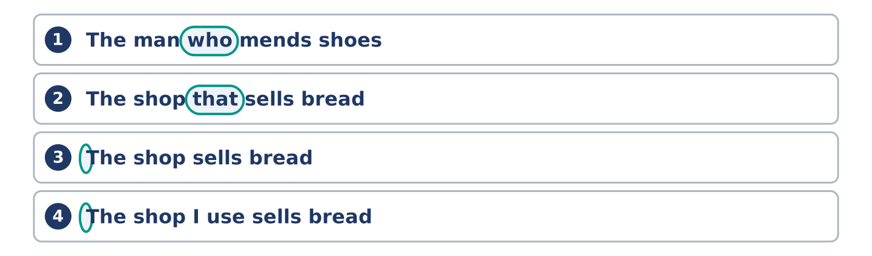
Figure 19.6 · Where the stress falls in 0 words of this unit.
🔊 Audio Track 19.1
Listen to the two forms. Say each one aloud.
The man who mends shoes — who is said quickly and joins to the word in front
The shop that sells bread — that almost disappears: /ðə ʃɒp ðət/
The shop sells bread — no joining word at all
The shop I use sells bread — the joining word is gone and nothing replaces it
So here is the useful part. In speech the joining word is the quietest thing in the sentence, and English often leaves it out completely. Learners who have learned the word listen for it, do not hear it, and then cannot find where one half of the sentence ends.
Part 1: Four People and What They Do
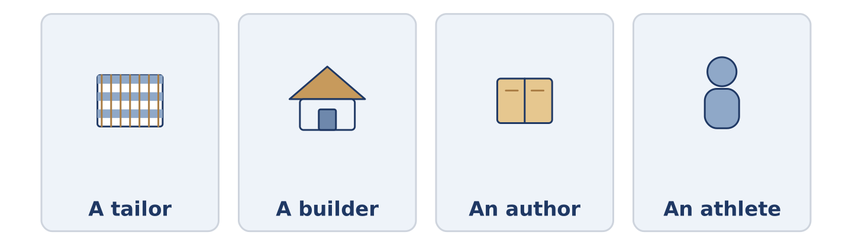
Figure 19.7 · Four jobs, and what each person makes or does.
Complete the table. Write what each person does. (0. is done.)
The person | What they do
A tailor | (example)
A builder
An author
An athlete
- A tailor — a person who makes and mends clothes.
Think about four people you can see from your window.
Part 1: Who, Which or That?
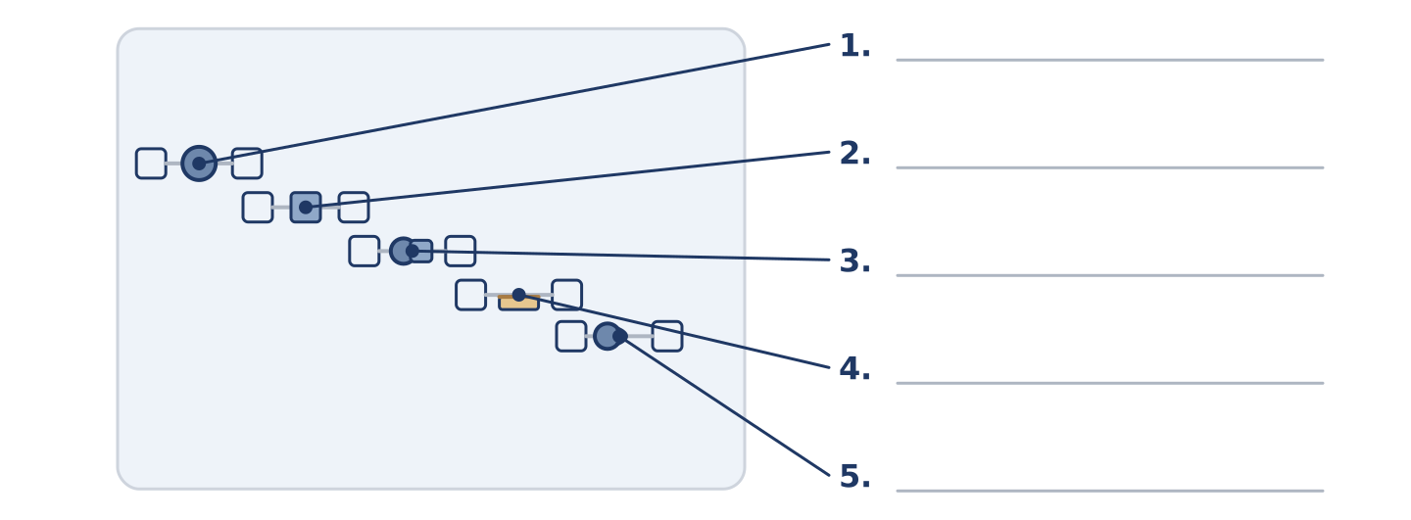
Figure 19.8 · Who, which and that — write the correct word on each line.
Match the joining words with what they join. One is not needed. Write the letter.
Column A
1. | who | ____
2. | which | ____
3. | that | ____
4. | where | ____
5. | whose | ____
Column B
a) | a person, and only a person
b) | a thing, and never a person
c) | a person or a thing, and the one people say
d) | a place
e) | it belongs to them
f) | a hundred years
Part 1: People and Jobs — Multiple Choice
Read and choose the correct answer.
1. A person who makes and mends clothes is a…
○ A) builder
○ B) waiter
○ C) tailor
○ D) singer
2. A person who writes books is an…
○ A) author
○ B) actor
○ C) artist
○ D) athlete
3. Which word can only join a person?
○ A) which
○ B) that
○ C) where
○ D) who
Part 1: Vocabulary Fill-in

Figure 19.9 · The four words of the bank, in the order the task gives them.
Complete the sentences with the correct word.
Word bank: actor | farmer | waiter | artist
- The ______________________ who brought the plates knew Maya’s order already.
- An ______________________ came to the school and read out a part nobody understood.
- The ______________________ at the market has sold Amina potatoes for nine years, and his father was a farmer before him.
- The ______________________ in flat 1 has painted the same staircase twice.
Part 1: Write About a Person (short)
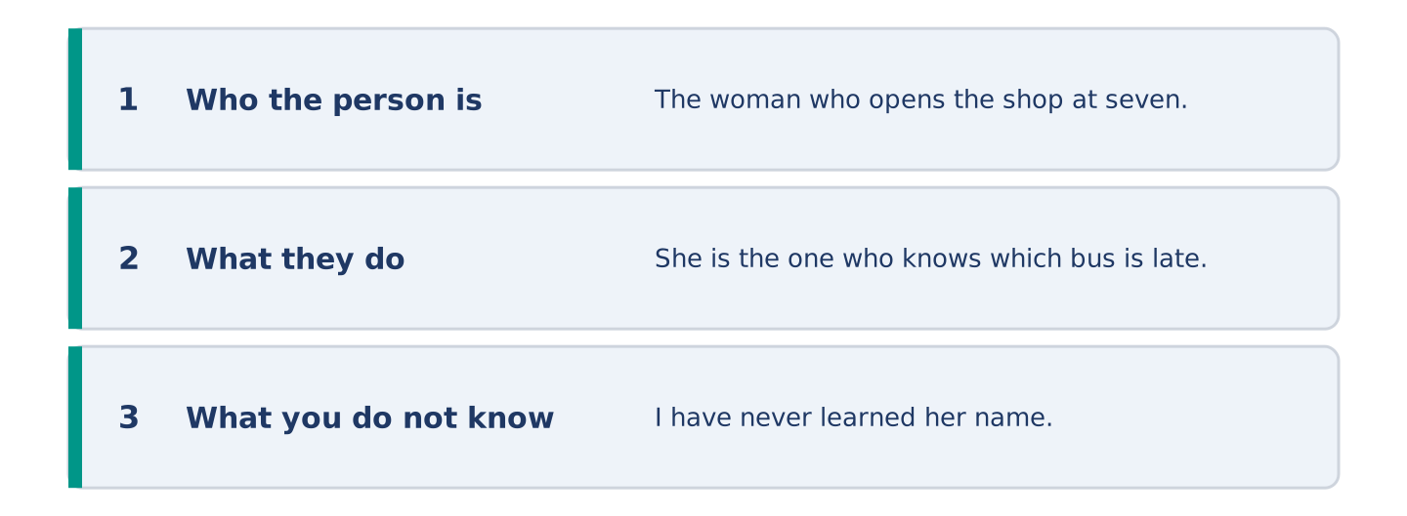
Figure 19.10 · The shape of your two or three sentences, with the model beside each step.
Write two or three sentences about a person near you. Use who or that at least once.
Model — read this first:
The woman who opens the shop at seven is the only person I see before work. She is the one who knows which bus is late. I have never learned her name, which is now too strange to ask about. (40 words)
Part 2 · Grammar — Defining Relative Clauses
[CORE] Core track · pre-class input
Part 2: Notice
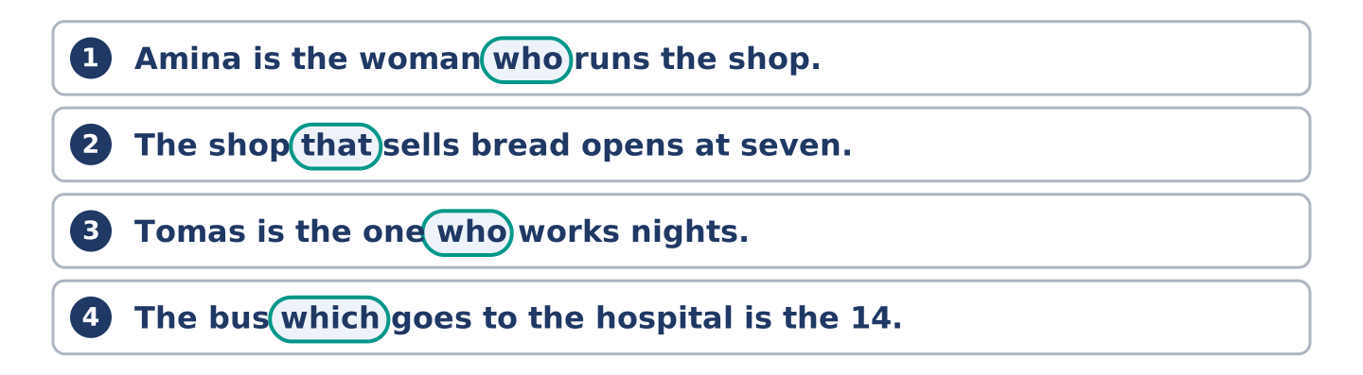
Figure 19.11 · Lines from the notice, with the target form ringed in each.
Read these lines. Underline the joining word. Which ones are about a person?
Amina is the woman who runs the shop. The shop that sells bread opens at seven. Tomas is the one who works nights. The bus which goes to the hospital is the 14. Maya is the one who carries books.
Three of these join a person. Two join a thing. One of the five could drop its joining word and still be good English.
Part 2: Grammar Focus Box
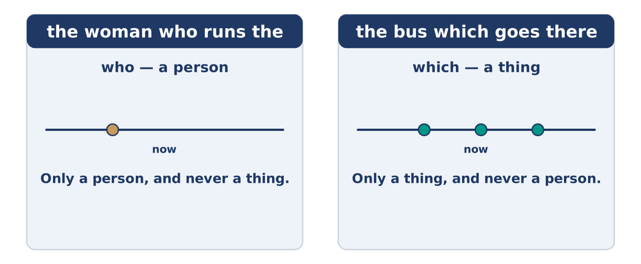
Figure 19.12 · One word joins two halves, and tells you what kind of thing you are talking about.
 | Form | Use | Example
who | the woman who runs the shop | a person | Amina is the woman who runs the shop.
which | the bus which goes there | a thing | The bus which goes there is the 14.
that | the shop that sells bread | a person or a thing | The shop that sells bread opens at seven.
where | the street where I live | a place | This is the street where I live.
Remember: that works for people and things both, and it is what people actually say. Which is for things only, and who is for people only.
Watch out! ✗ The woman which runs the shop. → ✓ The woman who runs the shop. (which cannot take a person). ✗ The shop that it sells bread. → ✓ The shop that sells bread. (the joining word is the subject; do not add another one).
Part 2: Controlled Practice
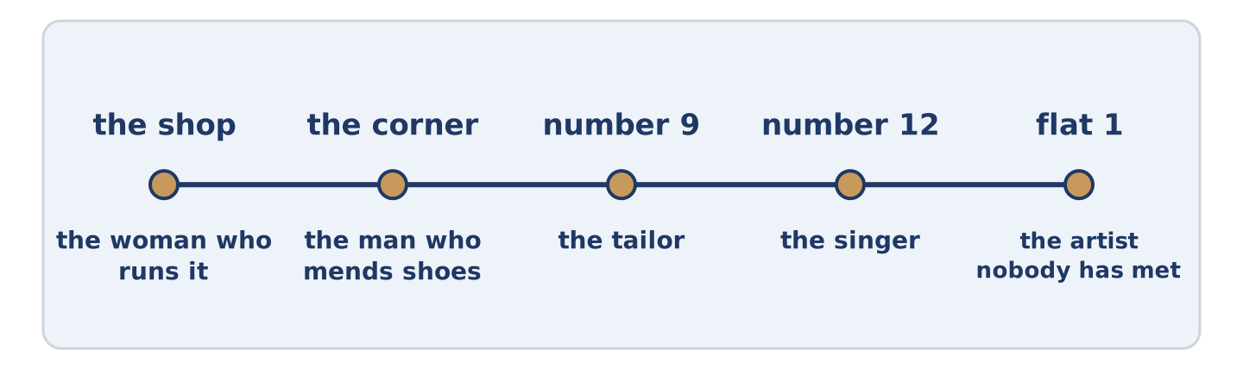
Figure 19.13 · One street, and how each place on it is described.
Complete with who, which, that or where. (0. is done.)
- Amina is the woman who runs the shop.
- The bus ______________________ goes to the hospital is the 14.
- This is the street ______________________ I live.
- Tomas is the one ______________________ works nights.
- The shop ______________________ sells bread opens at seven.
Part 2: Person, Thing or Place?
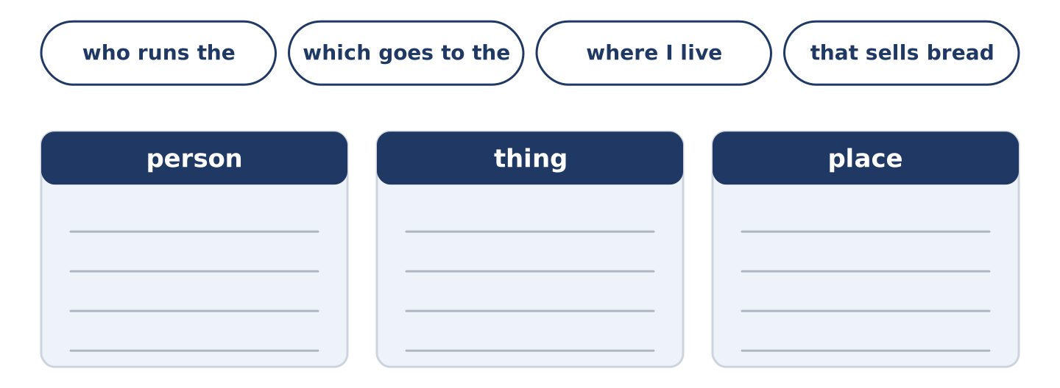
Figure 19.14 · The items of this task, and the bins they sort into.
Write person, thing or place. (0. is done.)
- the woman who runs the shop — person
- the bus which goes to the hospital ____________
- the street where I live ____________
- the one who works nights ____________
- the shop that sells bread ____________
Part 2: Correct the Sentence
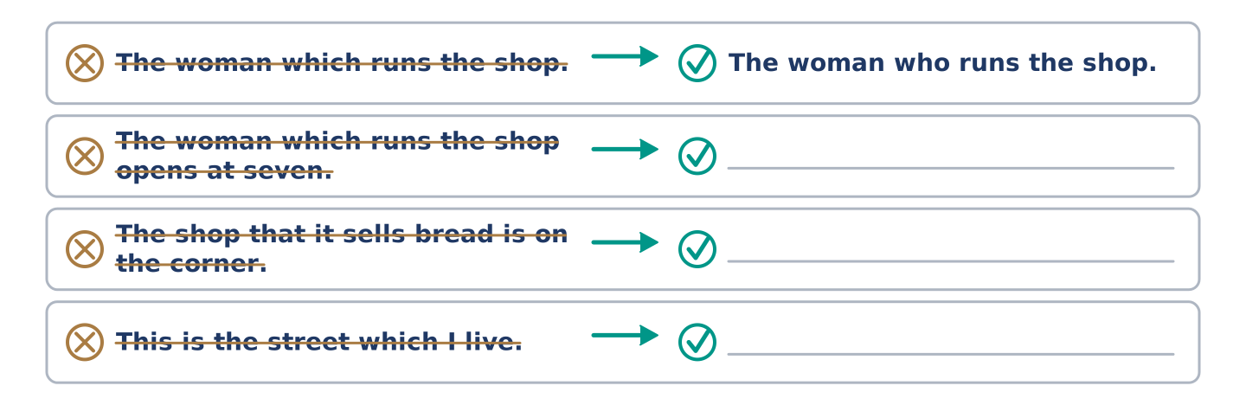
Figure 19.15 · One correction done for you, and the rest to write.
Each sentence has one grammar mistake. Write the correct sentence.
- The woman which runs the shop opens at seven.
- The shop that it sells bread is on the corner.
- This is the street which I live.
- Tomas is the one which works nights.
Part 2: Freer Practice
Write two sentences about your street: one with who, one with where.
Part 2: Grammar Review
Choose the correct sentence.
1. Which sentence joins a person correctly?
○ A) The man which mends shoes.
○ B) The man who mends shoes.
○ C) The man where mends shoes.
○ D) The man who he mends shoes.
2. Which word can join a thing but never a person?
○ A) which
○ B) where
○ C) whose
○ D) who
→ Harvest: you will meet these joining words again in the Part 5 reading. Count how many of them could be left out.
Part 3 · Listening
[CORE] Core track · pre-class input · scripts printed inline
Part 3: The Woman Who Knows Which Bus Is Late
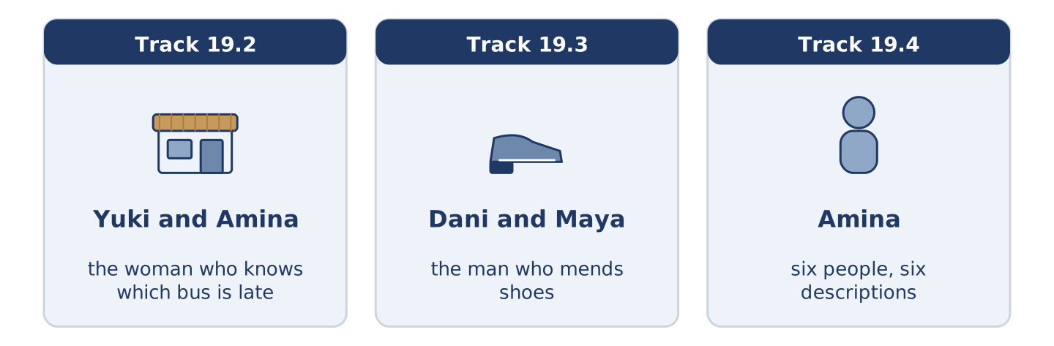
Figure 19.16 · The three listenings: who is speaking, and what about.
🔊 Audio Track 19.2
Before you listen: who in your street knows things nobody told them?
Yuki: How do you know the 14 is late? Amina: Because the people who get the 14 come in for a paper. Yuki: That isn’t knowing. Amina: It’s nine years of it. Yuki: So you do not know, you guess. Amina: I guess the way a doctor guesses. Yuki: Which is knowing. Amina: Which is nine years.
While you listen: write True, False, or Not Given. (0. is done.)
- Amina knows the 14 is late. — True
- Amina has a timetable behind the till. ____
- Amina has had the shop for nine years. ____
- Yuki agrees that guessing can be knowing. ____
Useful phrases: How do you know…? · the people who get the 14 · that is not knowing · nine years of it
Part 3: The Man Who Mends Shoes
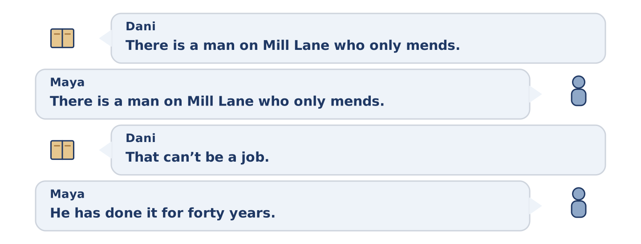
Figure 19.17 · The second listening, turn by turn.
🔊 Audio Track 19.3
Before you listen: is there anybody near you who mends one thing only?
Dani: There is a man on Mill Lane who only mends shoes. Maya: There is a man on Mill Lane who only mends the heels of shoes. Dani: That can’t be a job. Maya: He has done it for forty years. Dani: Then it is a job. Maya: He says a shoe which is mended at the heel will last three more winters. Dani: And is that true? Maya: Everybody on that street walks in the same strange way, so I think it is.
Answer the questions. (0. is done.)
- What does the man on Mill Lane mend? — The heels of shoes.
- How long has he done it?
- What does he say about a shoe mended at the heel?
- Why does Maya think it is true?
Part 3: Six People, Six Descriptions
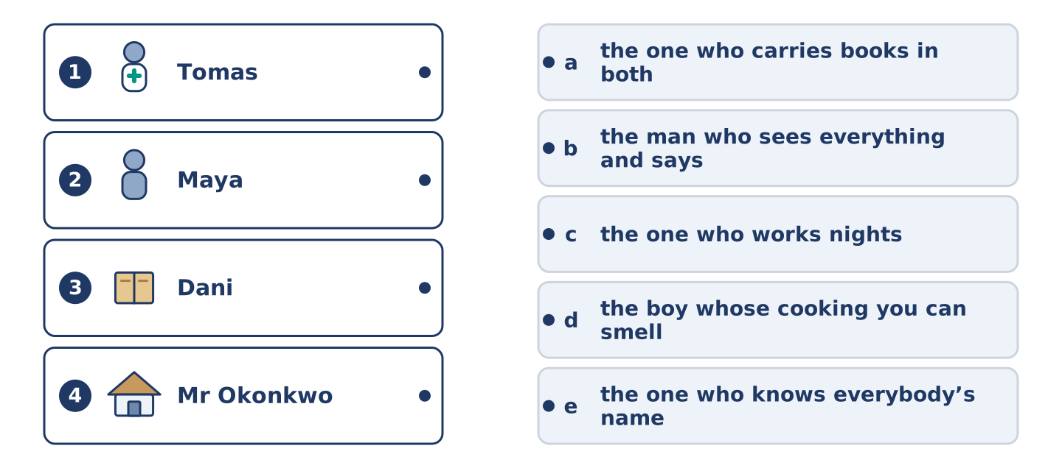
Figure 19.18 · Four on the left, five on the right, and one spare.
🔊 Audio Track 19.4
Before you listen: how would somebody describe you without your name?
Amina: I can tell you how this street describes all six. I am the woman who runs the shop, which is fair. Tomas is the one who works nights. Maya is the one who carries books, and she carries them in both directions, which nobody has asked about. Dani is the boy whose cooking you can smell on the stairs. And Mr Okonkwo is the man who sees everything and says one thing a month.
While you listen: match each person with their description. One is not needed. (0. is done.)
- Amina → the woman who runs the shop.
Useful phrases: the one who ___ · the boy whose ___ · the man who ___
Column A
1. | Tomas | ____
2. | Maya | ____
3. | Dani | ____
4. | Mr Okonkwo | ____
Column B
a) | the one who carries books in both directions
b) | the man who sees everything and says one thing a month
c) | the one who works nights
d) | the boy whose cooking you can smell on the stairs
e) | the one who knows everybody’s name
Part 4 · Speaking
[CORE] Core track · in-class output
Part 4: Describing People Without Names
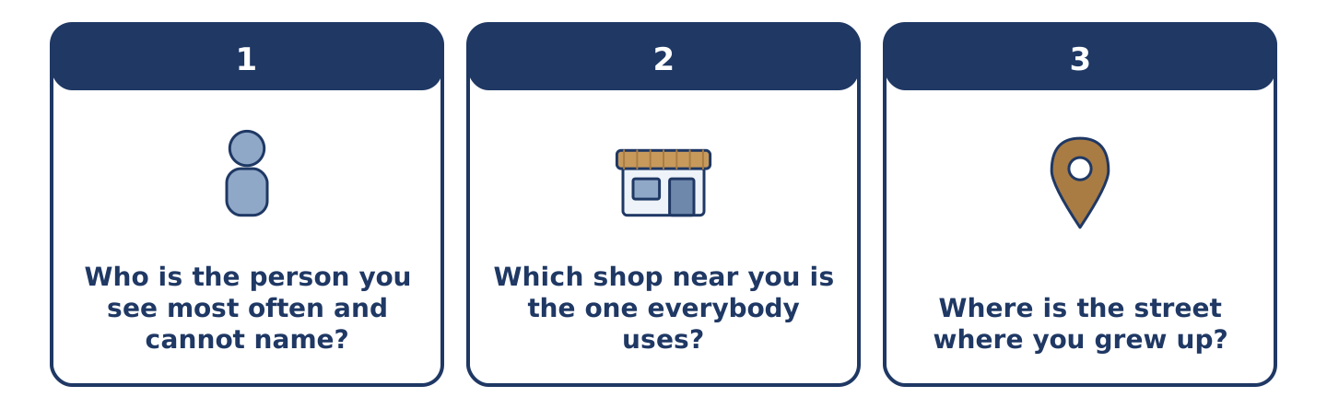
Figure 19.19 · The three questions as cards, to take one at a time.
Work with a partner. Ask and answer these questions.
- Who is the person you see most often and cannot name?
- Which shop near you is the one everybody uses?
- Where is the street where you grew up?
Useful language: the person who… · the shop that… · the street where… · the one who…
Part 4: Find the Difference (pairwork)
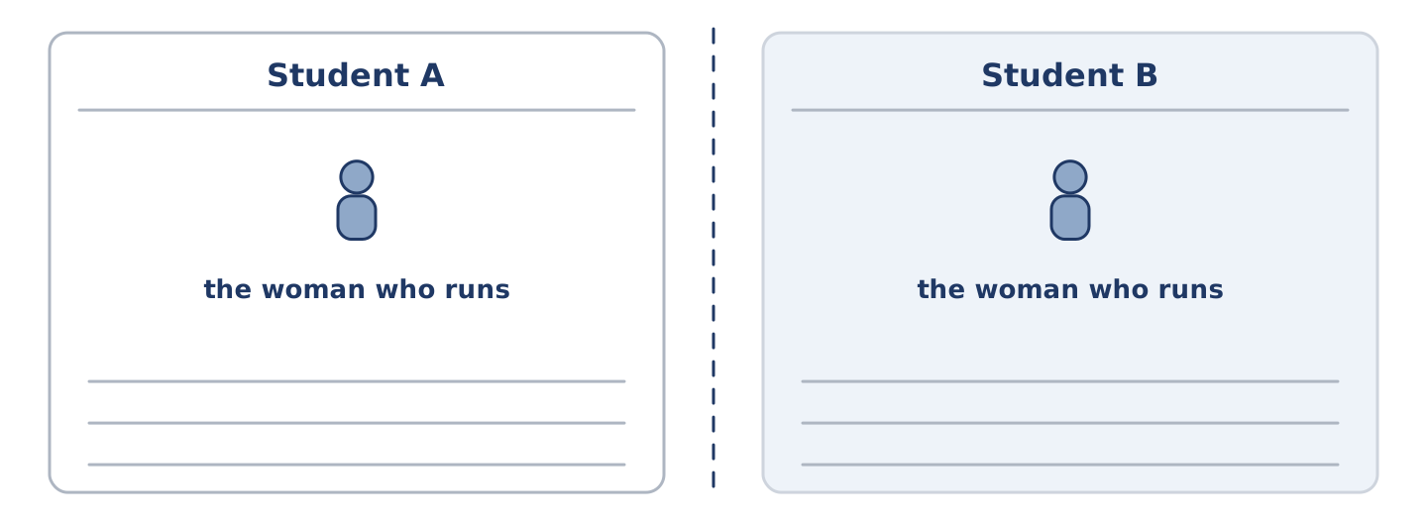
Figure 19.20 · Student A’s facts and Student B’s, with a fold between them.
Student A and Student B each have a street of six people. Ask questions and find three differences.
Useful questions: Who is the one who…? · Which shop is the one that…? · Whose is the…? · Where is the place where…?
Student A — your street: the woman who runs the shop, the man who mends shoes, a tailor at number 9, nobody who sings.
Student B — your street: the woman who runs the shop, the man who mends clocks, a tailor at number 9, a singer at number 12.
Part 4: Describing Somebody to Somebody Else
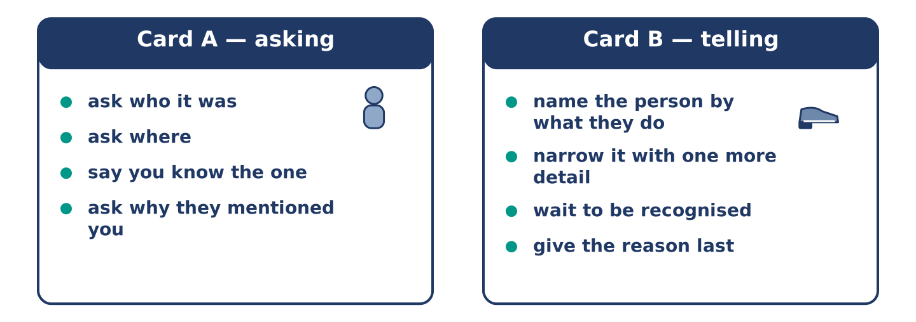
Figure 19.21 · Card A and Card B: what each of you has to say.
Work in pairs. Read the model, then use the cards.
Model exchange:
A: Who was it? — B: The man who mends shoes. — A: On Mill Lane? — B: The one who only does heels. — A: I know the one. — B: He asked after you. — A: After me? — B: You are the person who paid him twice for one pair.
Useful language: the man who… · the one who only… · I know the one · you are the person who…
Card A — asking: ask who it was · ask where · say you know the one · ask why they mentioned you.
Card B — telling: name the person by what they do · narrow it with one more detail · wait to be recognised · give the reason last.
Your turn: run the dialogue, then swap roles.
Stretch [PLUS]: the person you are describing is somebody your partner dislikes — describe them fairly anyway.
Part 4: Mini-Presentation
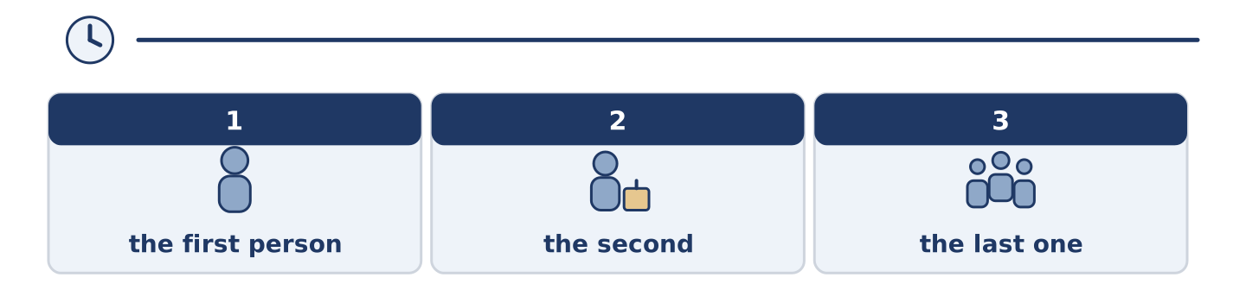
Figure 19.22 · The one-minute talk as 0 beats, each as wide as its share.
Prepare a short talk (about one minute). Describe three people in your street without using any names.
Part 5 · Reading
[CORE] Core track · pre-class input
Part 5: Why Streets Describe People Instead of Naming Them
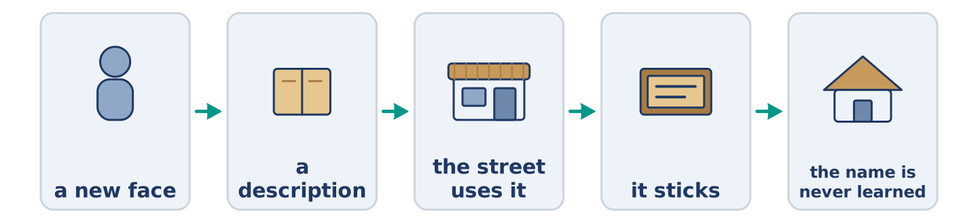
Figure 19.23 · One person, described five ways by five neighbours.
Before you read: how many of your neighbours could you name?
Gloss: neighbour = a person who lives near you · nickname = a name people give you that is not your name · landmark = a thing people give directions by
In a street of forty people, most people know about six names. The rest are held as descriptions: the woman who runs the shop, the man with the two dogs, the one who parks badly. This looks lazy and it is not. A description carries what you need and a name carries nothing. A name has to be learned twice: once as a sound, once as a person. A description is already the person. It is also why a street can hold hundreds of people it has never been introduced to. A new face is described long before it is named. The cost is that a description sticks. A man who parked badly once, years ago, is still the one who parks badly. Nobody on that street has driven with him since.
Answer the multiple-choice questions. (0. is done.)
- How many names does a person in a street of forty usually know? — About six.
1. What does the text say a name has to be learned as?
○ A) A word and a number
○ B) A face and a street
○ C) A sound and a person
○ D) A job and a door
2. Why can a street hold hundreds of people?
○ A) Because it is large
○ B) Because people move often
○ C) Because names are written down
○ D) Because descriptions do not need an introduction
3. What is the cost of a description?
○ A) It is long
○ B) It sticks
○ C) It is rude
○ D) It is forgotten
Part 5: Vocabulary in Context
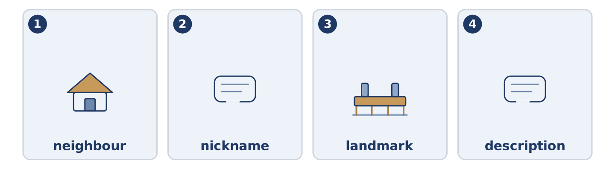
Figure 19.24 · The four words from the reading, drawn.
Match each word from the text with its meaning. One meaning is not needed. Write the letter.
Column A
1. | neighbour | ____
2. | nickname | ____
3. | landmark | ____
4. | description | ____
Column B
a) | words that tell you what somebody or something is like
b) | a thing people give directions by
c) | a person who lives near you
d) | a name people give you that is not your name
e) | a person who writes books
Part 5: Three Places Named After One Person
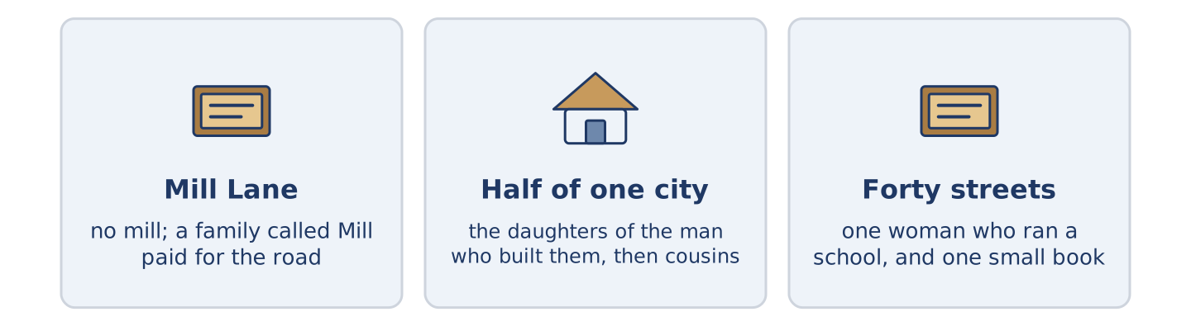
Figure 19.25 · Three places, and the person each one is named after.
Before you read: is anything near you named after a person?
Gloss: monument = a thing built to make people remember somebody · plaque = a small flat sign on a wall, with a name on it · lane = a small street · mill = a building where grain was once ground into flour
A street name says more about who chose it than about the person chosen. Mill Lane in this city has no mill and never had one. It is named after a family called Mill, who paid for the road. Half the roads in one part of Birmingham carry the names of the daughters of the man who built them. There were eleven daughters. He ran out, and then he started on cousins. And there are about forty streets in England named after one woman. She ran a school for children who could not hear. Every one of the forty was chosen by a town office, and every office had read the same small book about her. A plaque is a decision somebody made in an afternoon, and it then lasts longer than everybody who argued about it.
Answer the questions. (0. is done.)
- Is there a mill on Mill Lane? — No, and there never was.
- Who is Mill Lane named after?
- Why did the man in Birmingham start using the names of cousins?
- How long does a plaque last?
Part 6 · Writing
[CORE] Core track · in-class / homework
Part 6: A Person in Your Street (50–70 words)
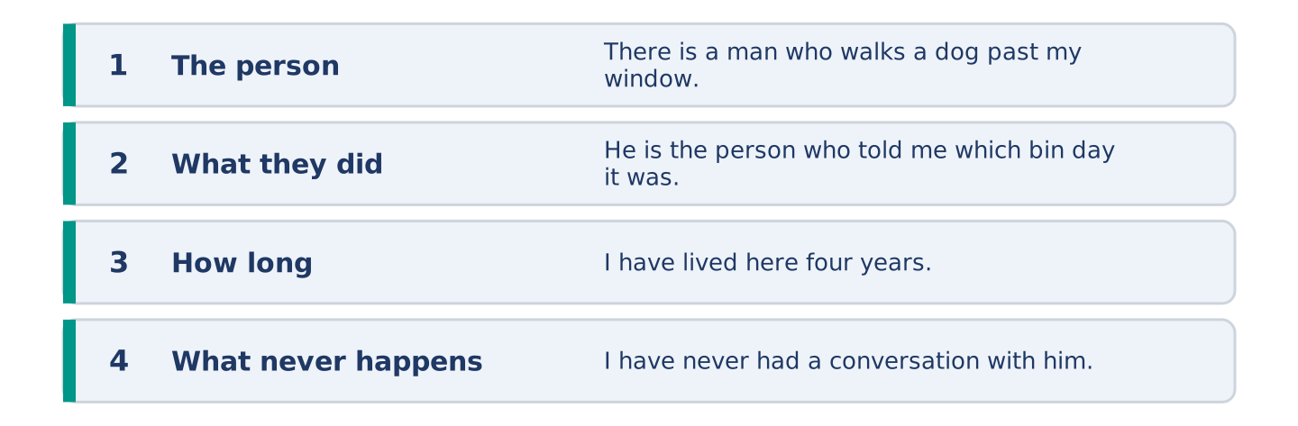
Figure 19.26 · The shape of the piece you are about to write.
Describe one person near you without using their name. Use who or that twice.
Model — read this first:
There is a man who walks a dog past my window at twenty past six, in every weather. He is the person who stopped once in my first week and explained how the street works. I have lived here four years. I have never had a conversation with him that lasted longer than the dog. (55 words)
Plan (fill in, then write): There is a ___ who ___ . He is the one who ___ . I have ___ . I have never ___ .
Word bank: who | that | where | the one who | the person who
Check before you finish: ☐ who or that twice? ☐ no name used? ☐ one thing they did? ☐ 50–70 words?
Part 6: Is It Rude to Describe People by What They Do? (50–70 words)
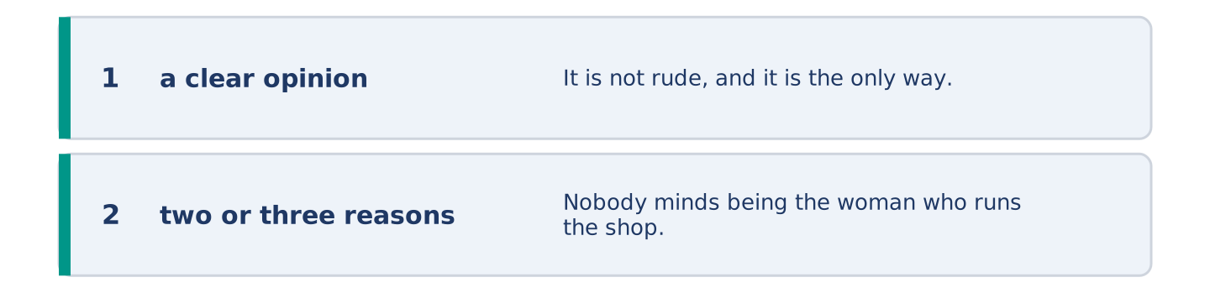
Figure 19.27 · The shape of the opinion paragraph, step by step.
Is it rude? Give your opinion and two or three reasons.
Model — read this first:
It is not rude, and it is the only way a street works. Nobody minds being the woman who runs the shop. She chose it. It turns rude when the description is a thing somebody did once and cannot take back. The man who parks badly has been parking well for ten years and nobody has noticed. (57 words)
Word bank: I think… because… | however | in my opinion | it depends on | the main thing is
Check before you finish: ☐ a clear opinion? ☐ two or three reasons? ☐ 50–70 words?
Part 6: A Place You Know Well (50–70 words)
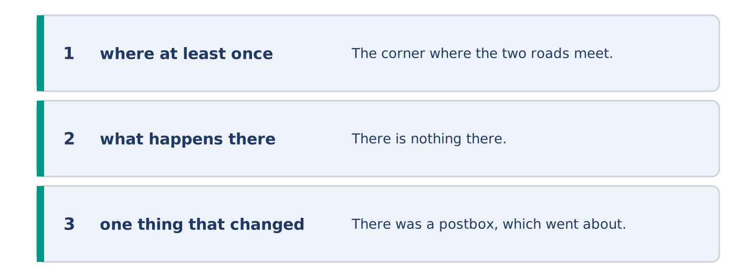
Figure 19.28 · The moves of the message, with a line of the model for each.
Describe a place using where at least once. Say what happens there.
Model — read this first:
The corner where the two roads meet is the place everybody in my family gives directions from. There is nothing there. There was a postbox, which went about twenty-five years ago, and the corner is still called the postbox. My sister’s girl, who is nine, calls it the postbox and has never seen one. (54 words)
Plan (fill in, then write): The ___ where ___ is the place ___ . There is ___ . There was ___ . ___ still calls it ___ .
Check before you finish: ☐ where at least once? ☐ what happens there? ☐ one thing that changed? ☐ 50–70 words?
Part 6: Reflection — How Others Describe You (40–60 words)
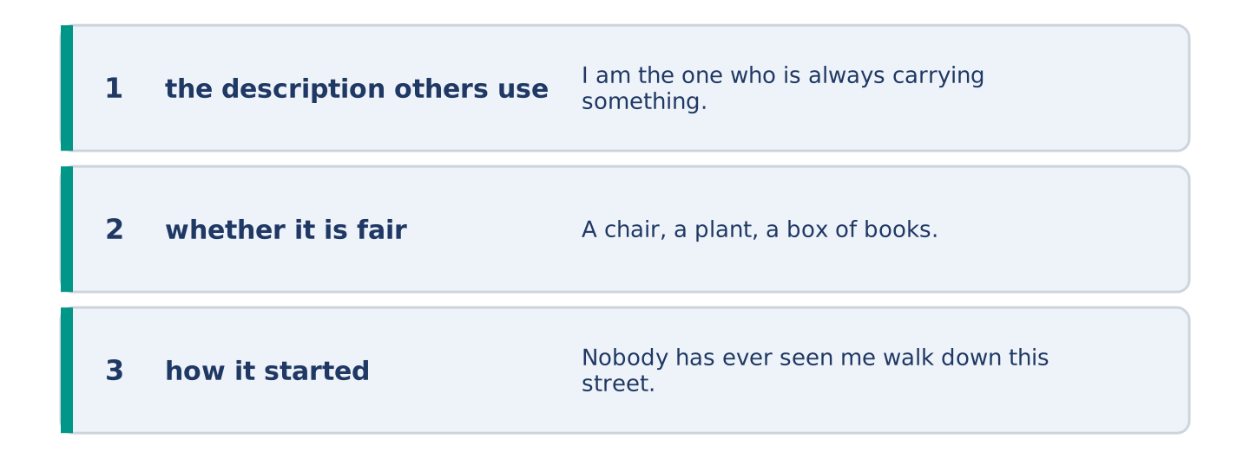
Figure 19.29 · The reflection, step by step.
How do people near you describe you? Write about it.
Model — read this first:
I am the one who is always carrying something big. A chair, a plant, a box of books. Nobody has ever seen me walk down this street with my hands empty, and I do not know how that started. I now carry things a little proudly, which has made it worse. (51 words)
Check before you finish: ☐ the description others use? ☐ whether it is fair? ☐ how it started? ☐ 40–60 words?
Part 7 · Real-World File — Pointing Somebody Out
[PLUS] Plus track (optional) · stronger learners
7A: Phrase Bank
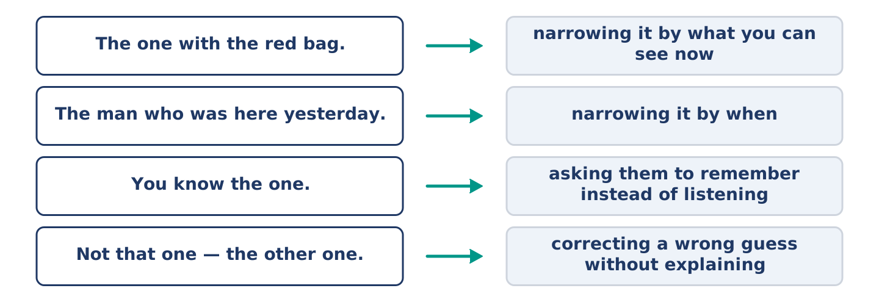
Figure 19.30 · What people say when they point somebody out, and what each line does.
Match what a person says with its purpose. One purpose is not needed. Write the letter.
Column A
1. | “The one with the red bag.” | ____
2. | “The man who was here yesterday.” | ____
3. | “You know the one.” | ____
4. | “Not that one — the other one.” | ____
Column B
a) | how much it will cost
b) | narrowing it by what you can see now
c) | correcting a wrong guess without explaining
d) | narrowing it by when
e) | asking them to remember instead of listening
7B: The Man Everybody Has a Different Name For
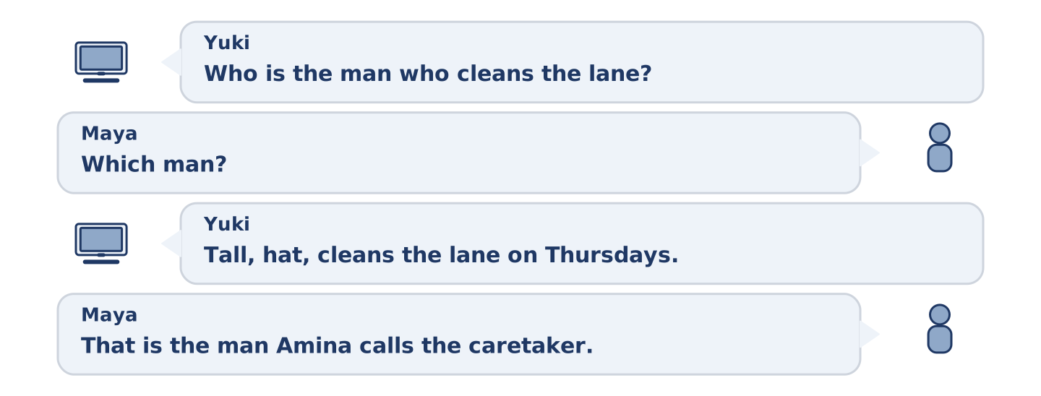
Figure 19.31 · The 7B exchange: who takes each turn.
🔊 Audio Track 19.5
Before you read: does anybody near you have two names?
Yuki: Who is the man who cleans the lane? Maya: Which man? Yuki: Tall, hat, cleans the lane on Thursdays. Maya: That is the man Amina calls the caretaker. Yuki: And what do you call him? Maya: Mr Hall. Yuki: Is that his name? Maya: It is the name on the letters I take in for him. Yuki: So it is his name. Maya: Amina has called him the caretaker for nine years and I am not starting that.
Answer the questions. (0. is done.)
- What does the man do on Thursdays? — He cleans the lane.
- What does Amina call him?
- How does Maya know his name?
- Why has Maya not corrected Amina?
7C: Controlled Practice — Pointing Somebody Out
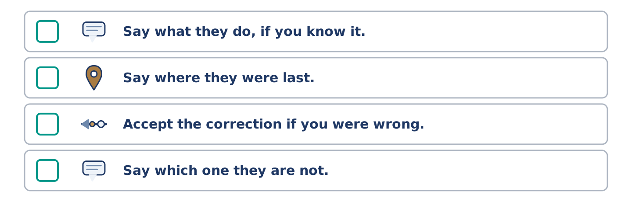
Figure 19.32 · The steps still to be numbered, as the task prints them.
Put the steps in order. Number them 1–5. (0. is done.)
- Say what they are wearing or carrying. — 1
____ Say what they do, if you know it.
____ Say where they were last.
____ Accept the correction if you were wrong.
____ Say which one they are not.
7D: Role-Play — Two Names for One Person
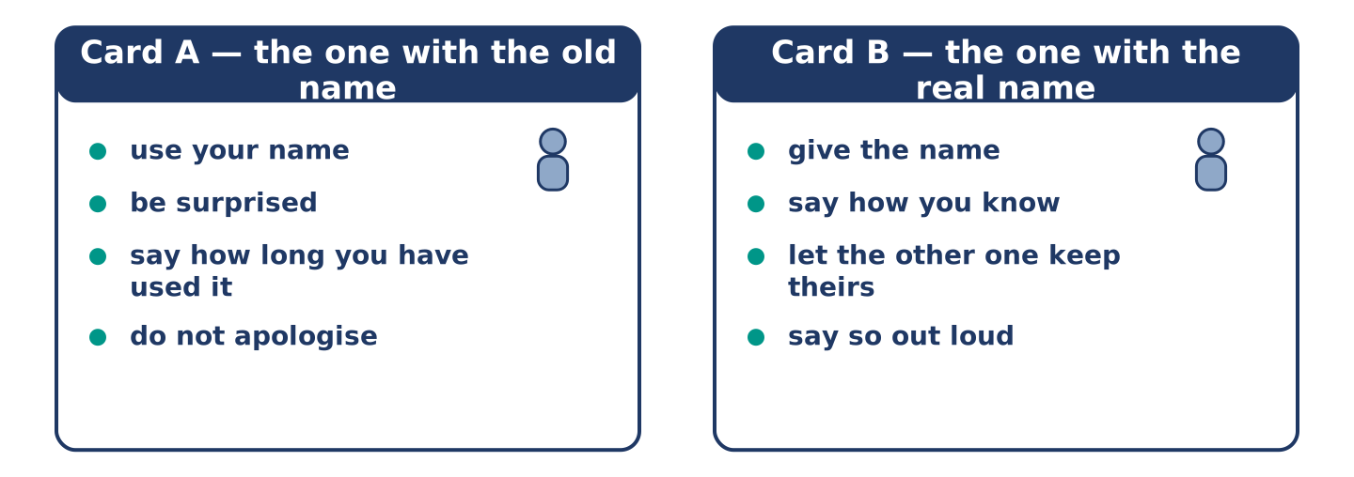
Figure 19.33 · The 7D cards: what each of you has to say.
In pairs. You each call the same person something different. Use the model and cards.
Model exchange: A: The caretaker was asking for you. — B: Mr Hall. — A: Who? — B: The man you call the caretaker. His name is Mr Hall. — A: Since when? — B: Since always. It is on his letters. — A: I have called him the caretaker for nine years. — B: I know. Nobody is asking you to stop.
Card A — the one with the old name: use your name · be surprised · say how long you have used it · do not apologise.
Card B — the one with the real name: give the name · say how you know · let the other one keep theirs · say so out loud.
Stretch [PLUS]: the name you have been using for years is one the person dislikes — say what you will do now.
7E: Writing — A Note Describing Somebody to Expect (50–80 words)
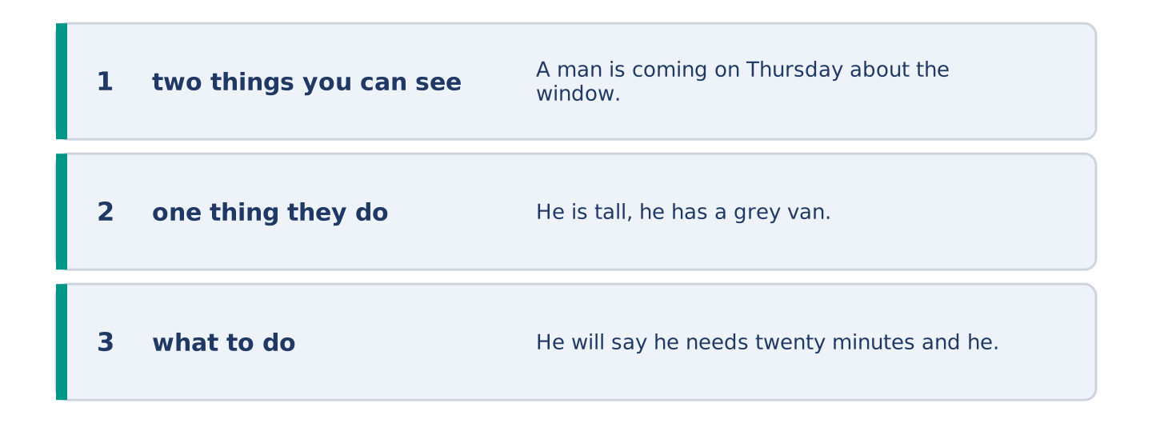
Figure 19.34 · The Part 7 note, with the model beside each line.
Somebody is coming to your door while you are out. Write a note describing them.
Model — read this first:
A man is coming on Thursday about the window. He is tall, he has a grey van, and he is the one who did number 9 last year, so Amina knows him. He will say he needs twenty minutes and he will need an hour. Let him in. If a different man comes, the name is Hall and ask him to say it. (63 words)
Check before you finish: ☐ two things you can see? ☐ one thing they do? ☐ what to do? ☐ 50–80 words?
Part 8 · Global Story — The Town Where Every Cloth Has a Name
[PLUS] Plus track · pre-read / discuss
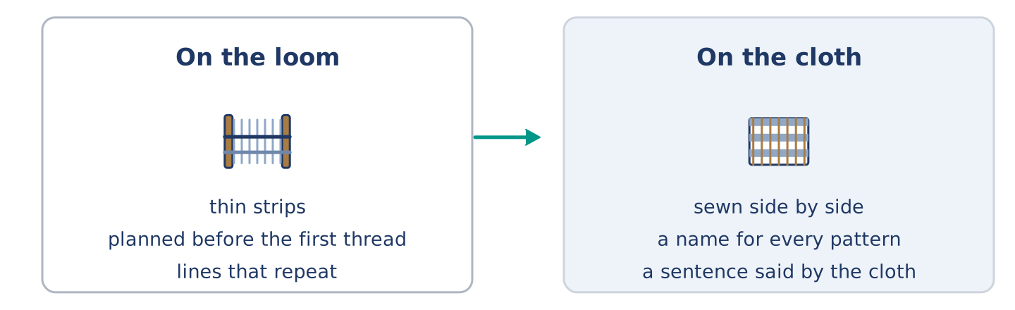
Figure 19.35 · A pattern on a loom and the name it carries.
Before you read: does a pattern mean anything where you live?
Gloss: loom = the frame a cloth is made on · weave = to make cloth by crossing threads · pattern = lines or shapes that repeat · strip = a long thin piece of something · thread = one long thin line of cotton or wool
Bonwire, in Ghana, is the town kente cloth comes from, and every pattern in it has a name. The names are not just for show. A pattern called obaakofoo mmu man means roughly that one person does not rule a nation, and a chief who wore it was saying something. Another is put on only after a parent has died. The cloth is made in thin strips, on a loom a man sits inside. The strips are then sewn together, side by side. So the pattern has to be planned before the first thread goes on. A man who can name two hundred patterns is not showing off. The names are the job. A cloth given to the wrong person is a sentence said by mistake.
Answer the questions. (0. is done.)
- What does kente cloth come from Bonwire with? — A name for every pattern.
- What does one pattern name mean?
- How is the cloth made?
- Why must the pattern be planned first?
Part 8: Vocabulary in Context
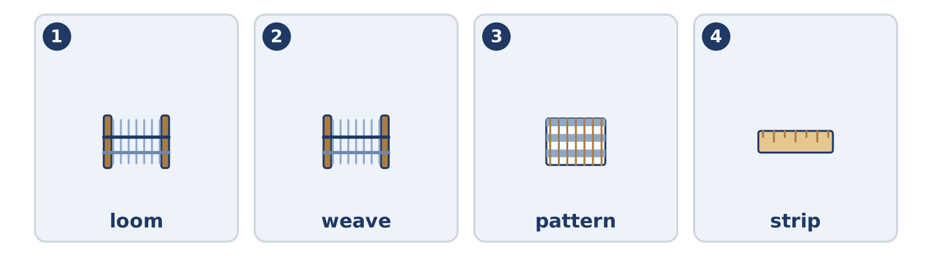
Figure 19.36 · The four words from the global story, drawn.
Match each word with its meaning. One meaning is not needed. Write the letter.
Column A
1. | loom | ____
2. | weave | ____
3. | pattern | ____
4. | strip | ____
Column B
a) | a long narrow piece of something
b) | the frame a cloth is woven on
c) | lines or shapes that repeat
d) | to make cloth by crossing threads
e) | a small flat sign on a wall, with a name on it
Part 8: Discussion
Talk with a partner. Use the frames.
Discussion frames: “This is similar to where I live because…” · “This is different from where I live because…” · “I think the most important thing is… because…”
Part 9 · Close to Home — The Woman in Flat 1 Nobody Has Met
[PLUS] Plus track · pre-read / decide
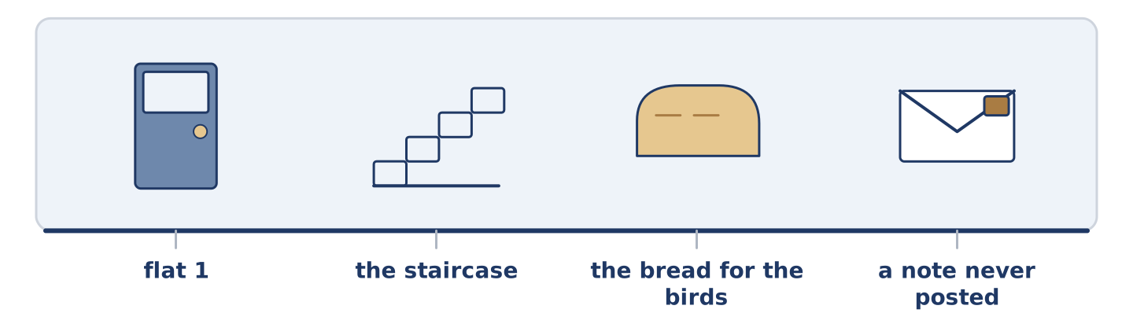
Figure 19.37 · The close-to-home reading, drawn along one street.
Before you read: is there anybody in your building you have never met?
There is a woman in flat 1 and in four years nobody at number 14 has met her. She is an artist, which everybody knows and nobody was told. She painted the staircase one August, both flights, in a grey that is better than the grey it replaced, and she left no note. Amina says she pays for her paper by the month, and that she says four words a year. She has never once said one of them first. Maya has heard her moving furniture at three in the morning, and says she does it quietly, as though she knows. Dani thinks she is the one who leaves the bread out for the birds. Mr Okonkwo says she is the only person in the building who has never asked him anything. He says it as a good thing, and from him it is. Yuki has written her a note twice. She has posted neither, and she keeps them both in her notebook, where she can see them.
Answer the questions. (0. is done.)
- How long has nobody met the woman in flat 1? — Four years.
- What did she do one August?
- What does Amina say about her?
- What has Yuki done twice?
Part 9: Decision Task
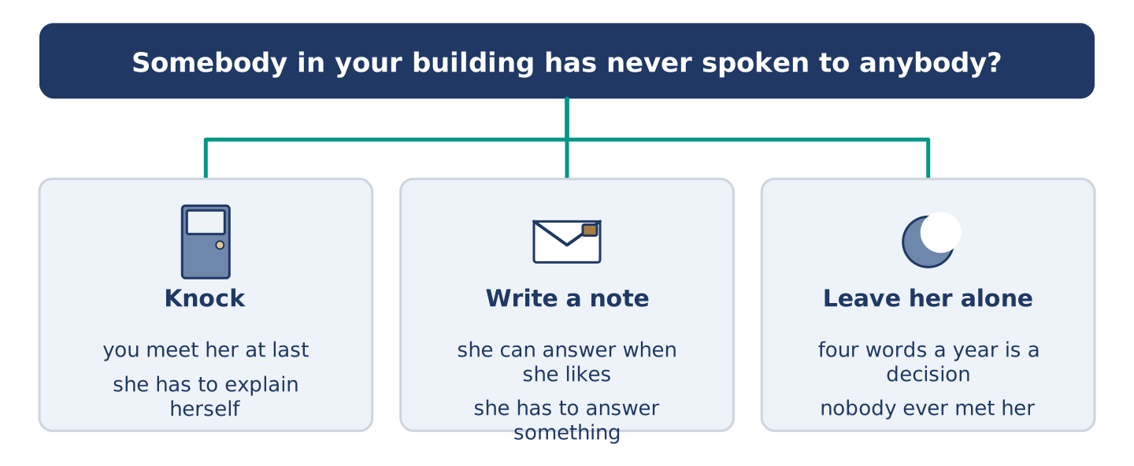
Figure 19.38 · Three ways to decide, and what each one costs.
Somebody in your building has never spoken to anybody. Should you (a) knock, (b) write a note, or (c) leave her alone? Decide and explain. Use the frame.
Answer frame: “I think I should ___ because ___. Also, ___. This is better than ___ because ___.”
Model — read this first:
I think I should leave her alone, because four years of saying four words a year is a decision and not an accident. Also, she painted the staircase for everybody and said nothing, which is a message. This is better than knocking, because a knock asks her to explain herself to a stranger at her own front door. (58 words)
Phrase bank: I think I should… · because… · Also,… · This is better than… · In my opinion…
Part 10 · Review and Can-Do
[CORE + PLUS] · homework / self-study
Part 10: Spiral Review
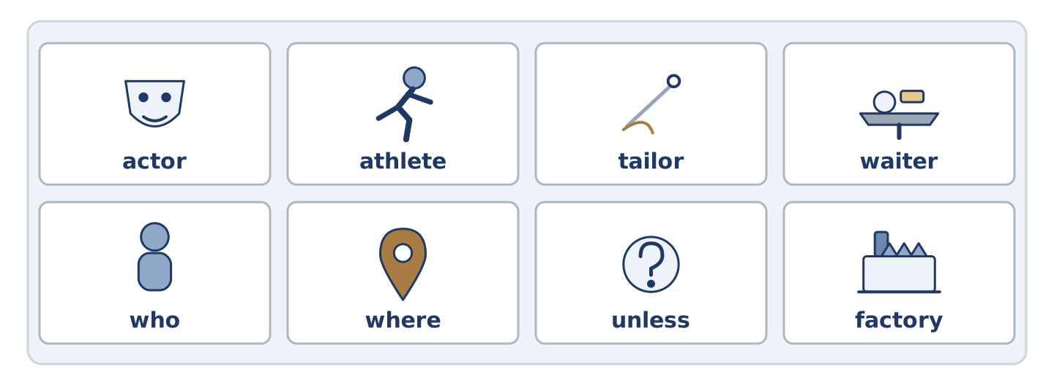
Figure 19.39 · The eight words of the review bank, in bank order.
Complete the review. (0. is done.)
- A person who writes books is an author.
Word bank: actor | athlete | tailor | waiter | who | where | unless | factory
- A person who acts in plays or films is an ______________________ .
- A person who runs, swims or plays a sport very well is an ______________________ .
- A person who makes and mends clothes is a ______________________ .
- A person who brings food to your table is a ______________________ .
- The woman ______________________ runs the shop opens at seven. (person)
- This is the street ______________________ I live. (place)
- (from Unit 18) If not, or except if, is ______________________ .
- (from Unit 17) A building where things are made in large numbers is a ______________________ .
Part 10: Can-Do
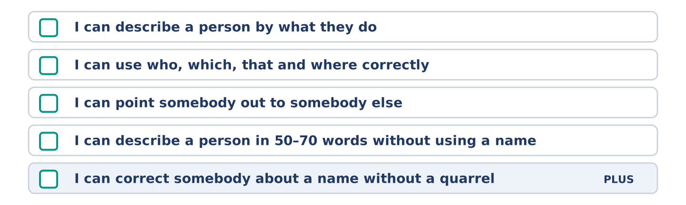
Figure 19.40 · What you can do at the end of this unit.
Can-Do checklist
☐ I can describe a person by what they do.
☐ I can use who, which, that and where correctly.
☐ I can point somebody out to somebody else.
☐ I can describe a person in 50–70 words without using a name.
☐ I can correct somebody about a name without a quarrel (Plus).
Part 10: Glossary
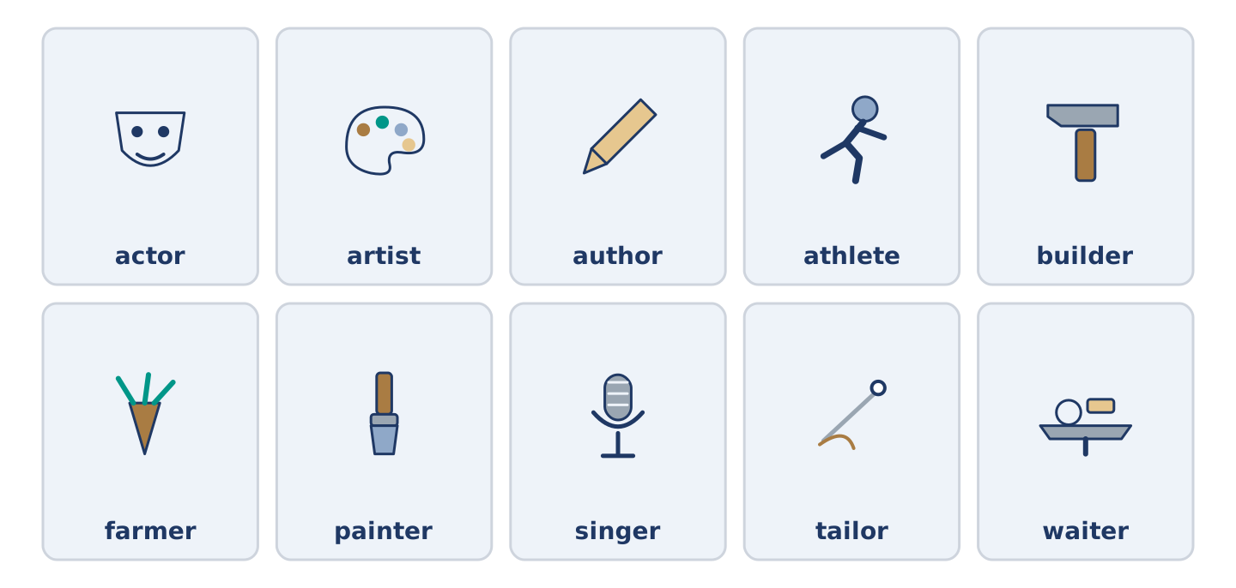
Figure 19.41 · All ten glossary words of Unit 19, one card each.
Unit 19 glossary (10 words)
actor · artist · author · athlete · builder · farmer · painter · singer · tailor · waiter

