Unit 20: News, Stories and Messages
English for Daily Life · Level: A2 · Tracks: [CORE] Warm-Up + Parts 1–6 · [PLUS] Parts 7–10
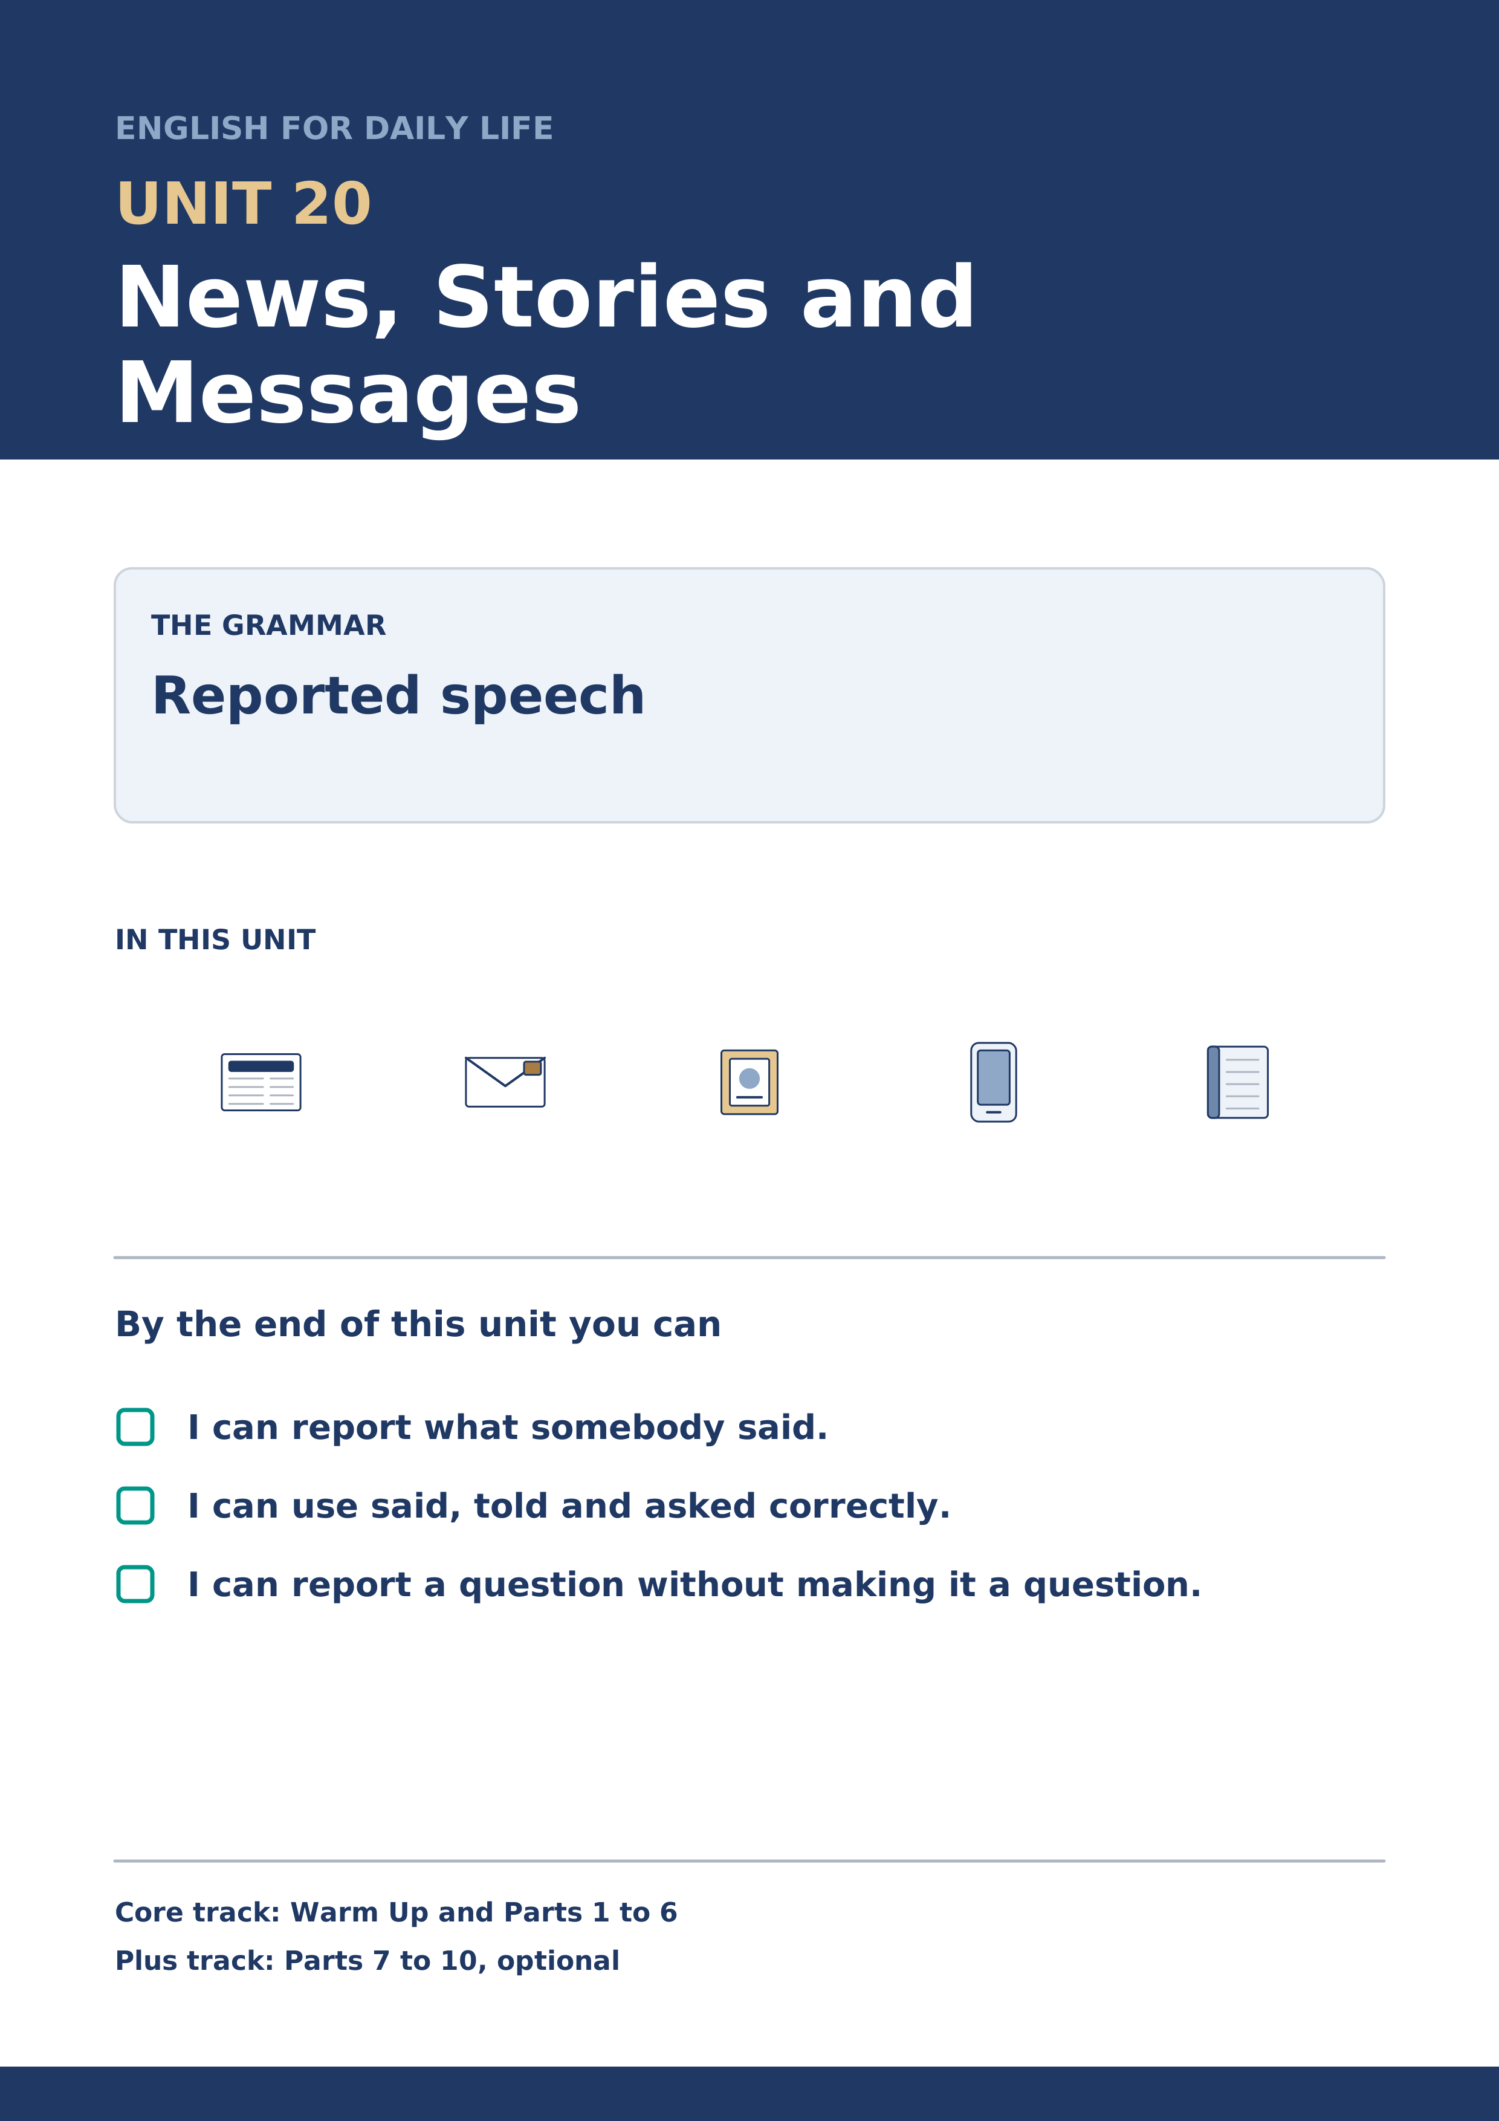
Warm Up
[CORE] Core track · in-class starter
Warm-up: Words for Messages
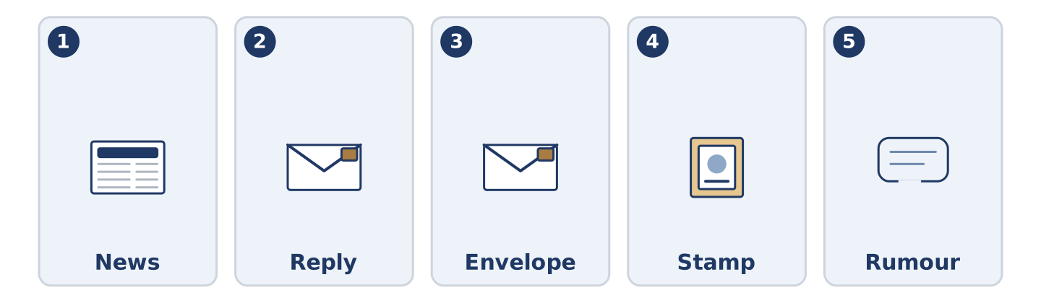
Figure 20.2 · The five warm-up words, and the thing each one means.
Match the words with their meanings. One meaning is not needed. Write the letter.
Column A
1. | News | ____
2. | Reply | ____
3. | Envelope | ____
4. | Stamp | ____
5. | Rumour | ____
Column B
a) | the paper cover a letter goes in
b) | a story going round that may not be true
c) | what has just happened, told to other people
d) | what you send back when somebody writes to you
e) | a small paper square you buy and stick on a letter
f) | a long line of cars that is not moving
Warm-up: Talking About News

Figure 20.3 · The word bank for this task, in the order it is printed.
Complete the sentences using the words in the word bank.
Word bank: text | article | interview | reporter
- Maya sent a ______________________ and then wished she had rung instead.
- There was an ______________________ about Alder Street in the paper and nobody came out of it well.
- A ______________________ stood outside the shop for an hour and got one interview out of it.
- Mr Okonkwo gave an ______________________ to a paper long ago, and has mentioned it ever since.
Warm-up: Six People, Six Versions
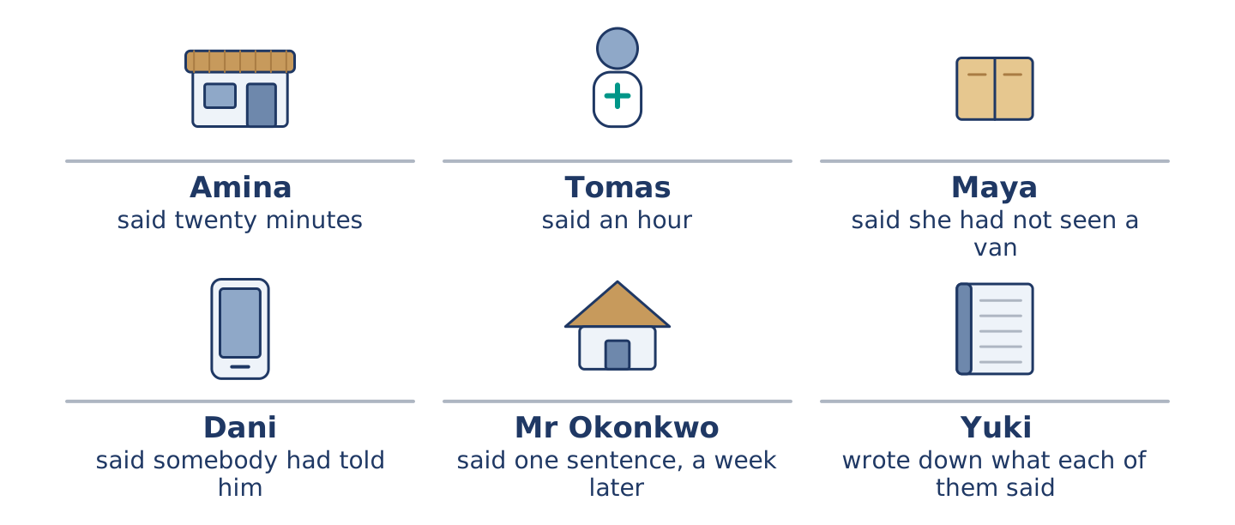
Figure 20.4 · What each of them said had happened.
Read the text and choose the correct answer.
One thing happened on Alder Street in April and there are six accounts of it. Amina said the van had been there twenty minutes. Tomas said it had been there an hour, and he was sure, and he had come in at the end. Maya said she had not seen a van. Dani said somebody told him it was a bigger van. Mr Okonkwo said nothing to anybody for a week and then said one sentence. Yuki wrote down what each of them said on the day, which is why we know they disagree.
1. How long did Tomas say the van had been there?
○ A) An hour
○ B) A week
○ C) Twenty minutes
○ D) He did not say
2. Why do we know the six disagree?
○ A) Because Amina counted
○ B) Because there was an article
○ C) Because Yuki wrote it down on the day
○ D) Because Mr Okonkwo said so
Part 1 · Vocabulary and Terminology
[CORE] Core track · pre-class input
Part 1: Words for News and Messages
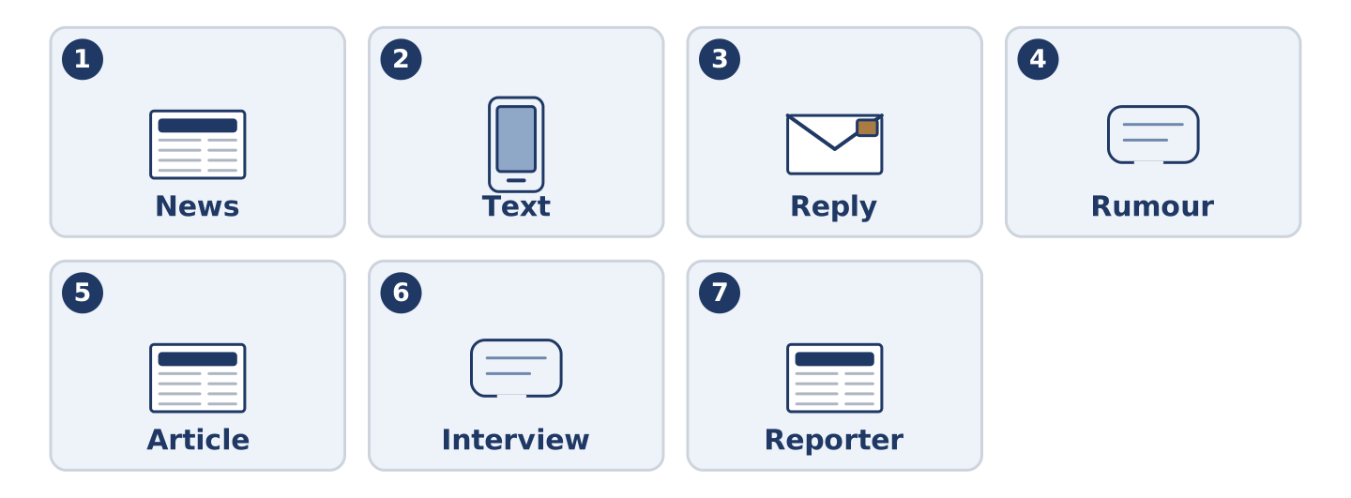
Figure 20.5 · The seven words of Column A, and what each one is.
Match the words with their meanings. One meaning is not needed. (0. is done for you.)
- False → not true.
Column A
1. | News | ____
2. | Text | ____
3. | Reply | ____
4. | Rumour | ____
5. | Article | ____
6. | Interview | ____
7. | Reporter | ____
Column B
a) | a piece of writing in a paper about one thing
b) | what has just happened, told to other people
c) | a person whose work is finding out what happened
d) | a short written message sent from a telephone
e) | a story going round that may not be true
f) | a talk where one person asks and the other answers
g) | what you send back when somebody writes to you
h) | the frame a cloth is woven on
Gloss: rumour = a story going round that may not be true · article = a piece of writing in a paper about one thing · envelope = the paper cover a letter goes in · tense = the form of a verb that shows when something happened
Part 1: Pronunciation
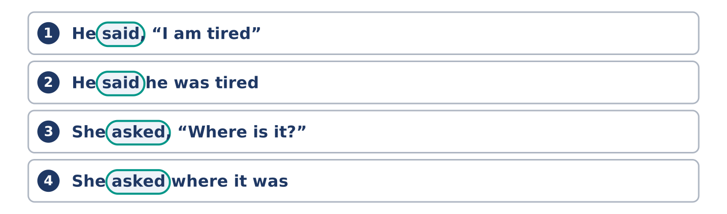
Figure 20.6 · Where the stress falls in 0 words of this unit.
🔊 Audio Track 20.1
Listen to the two forms. Say each one aloud.
He said, “I am tired” — two strong words, and a clear break before I
He said he was tired — one run, no break at all
She asked, “Where is it?” — the voice goes up at the end
She asked where it was — the voice comes down, because it is no longer a question
So here is the useful part. When you report a question, the mark goes and so does the voice going up. Learners keep it going up, and then the listener hears a question and answers it. Say she asked where it was flat, and finish low.
Part 1: Four Things Somebody Said
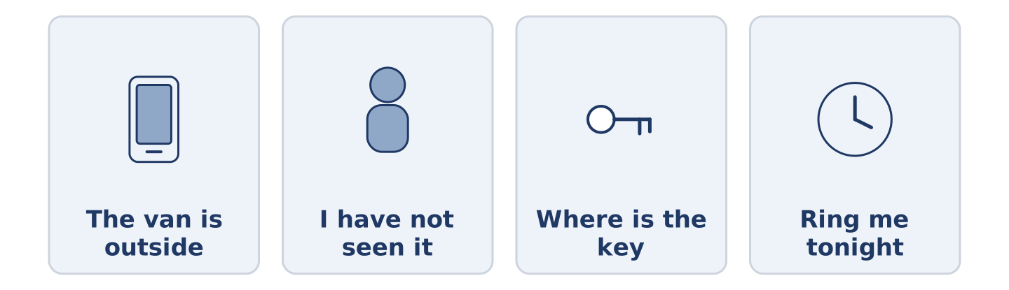
Figure 20.7 · Four short messages, and who sent each one.
Complete the table. Write what each person said. (0. is done.)
The message | What they said
“The van is outside.” | (example)
“I have not seen it.”
“Where is the key?”
“Ring me tonight.”
- “The van is outside.” — She said the van was outside.
Think about a message you were sent this week.
Part 1: Said, Told or Asked?
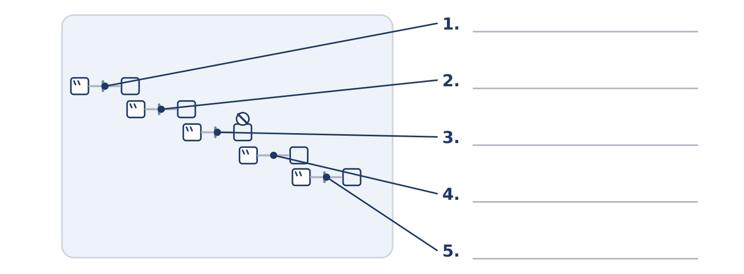
Figure 20.8 · Said, told and asked — write the correct word on each line.
Match the words with what follows them. One is not needed. Write the letter.
Column A
1. | said | ____
2. | told | ____
3. | asked | ____
4. | answered | ____
5. | explained | ____
Column B
a) | nothing in between; the words come straight after
b) | a person first, then the words
c) | a question, with no question mark left
d) | what came back after a question
e) | the reason, not the fact
f) | a hundred years
Part 1: News and Messages — Multiple Choice
Read and choose the correct answer.
1. A story going round that may not be true is a…
○ A) reply
○ B) rumour
○ C) stamp
○ D) text
2. A person whose work is finding out what happened is a…
○ A) singer
○ B) tailor
○ C) builder
○ D) reporter
3. Which word must have a person straight after it?
○ A) told
○ B) asked
○ C) said
○ D) answered
Part 1: Vocabulary Fill-in
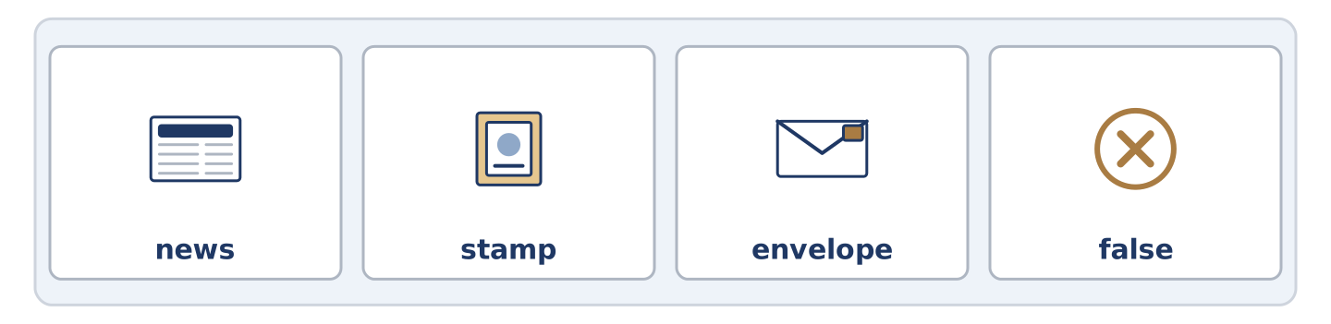
Figure 20.9 · The four words of the bank, in the order the task gives them.
Complete the sentences with the correct word.
Word bank: news | stamp | envelope | false
- The ______________________ came off in the rain and the letter went nowhere.
- There is no ______________________ , which Amina says is the best kind.
- The ______________________ had Mr Okonkwo’s name on it and the wrong number.
- Half of what is going round the street is ______________________ and the other half is late.
Part 1: Write About Something You Were Told (short)
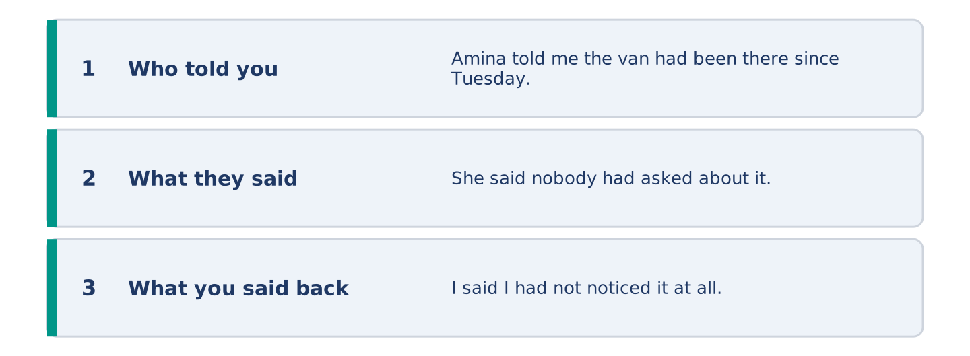
Figure 20.10 · The shape of your two or three sentences, with the model beside each step.
Write two or three sentences about something somebody told you this week. Use said or told.
Model — read this first:
Amina told me the van had been there since Tuesday. She said nobody had asked about it and that she had counted four people walking past it. I said I had not noticed it at all, which she wrote down in her head. (43 words)
Part 2 · Grammar — Reported Speech
[CORE] Core track · pre-class input
Part 2: Notice
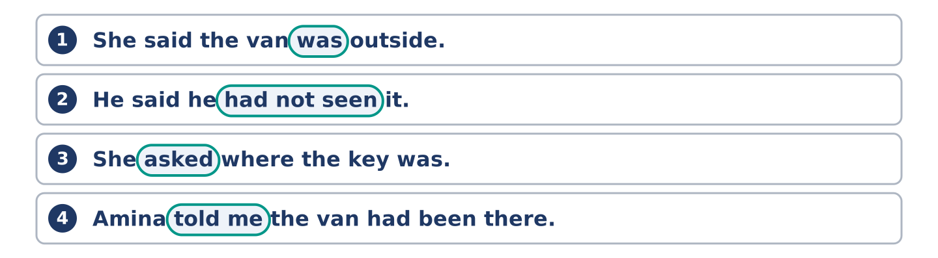
Figure 20.11 · Lines from the notice, with the target form ringed in each.
Read these pairs. What changes in the reported half?
“The van is outside.” → She said the van was outside. “I have not seen it.” → He said he had not seen it. “Where is the key?” → She asked where the key was.
Three things move: the tense goes back a step, the person changes, and a question loses its order.
Part 2: Grammar Focus Box
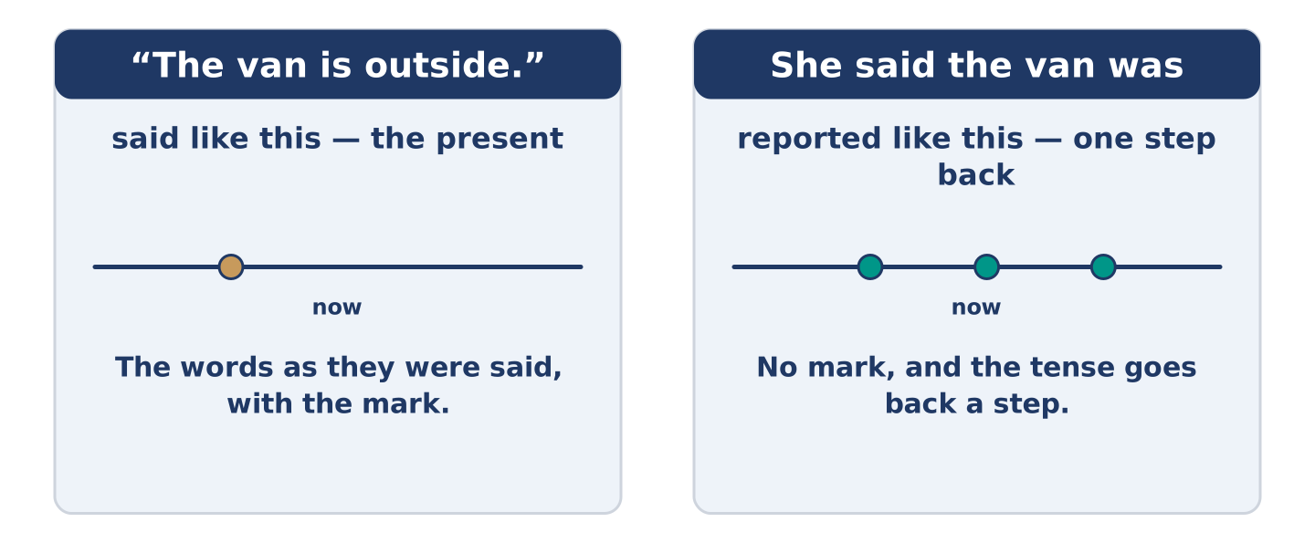
Figure 20.12 · One step back: what each tense becomes.
 | Form | Use | Example
present → past | was, were | for words said in the present | She said the van was outside.
past → past perfect | had seen, had been | for words said in the past | He said he had not seen it.
will → would | would ring | for a promise or a plan | She said she would ring.
question | where it was | no mark, and no question order | She asked where it was.
Remember: said takes no person after it; told must have one. She said the van was outside. She told me the van was outside.
Watch out! ✗ She said me the van was outside. → ✓ She told me the van was outside. (said takes no person). ✗ She asked where was the key. → ✓ She asked where the key was. (a reported question is not a question).
Part 2: Controlled Practice
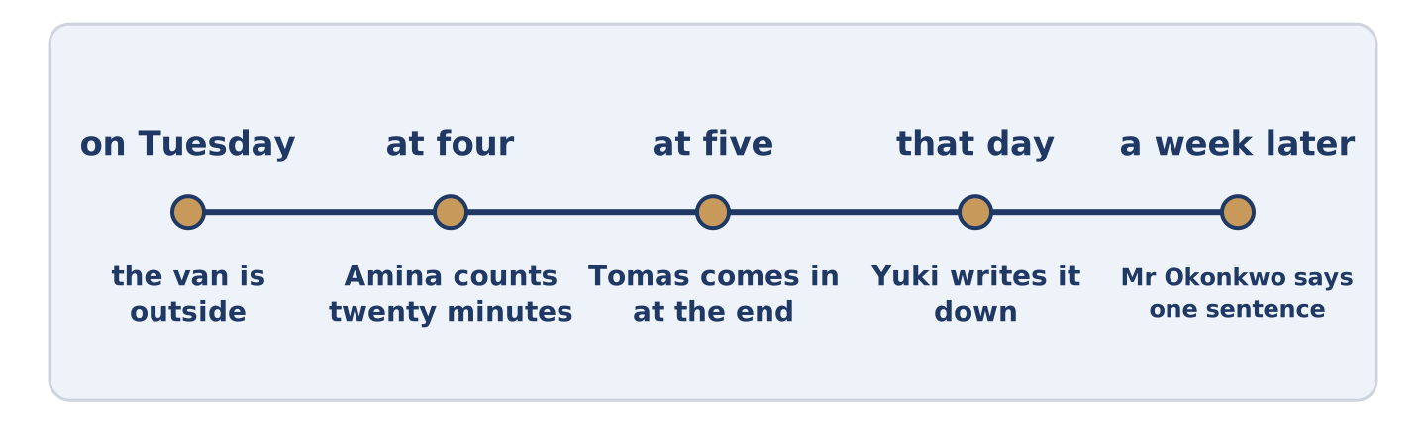
Figure 20.13 · One April afternoon, and how the story moved along the street.
Report what each person said. (0. is done.)
- “The van is outside.” — She said the van was outside. (be)
- “I have not seen it.” — He said he ______________________ seen it. (have)
- “Where is the key?” — She asked where the key ______________________ . (be)
- “I will ring you tonight.” — He said he ______________________ ring me. (will)
- “Ring me tonight.” — She ______________________ me to ring her that night. (tell)
Part 2: Said or Told?
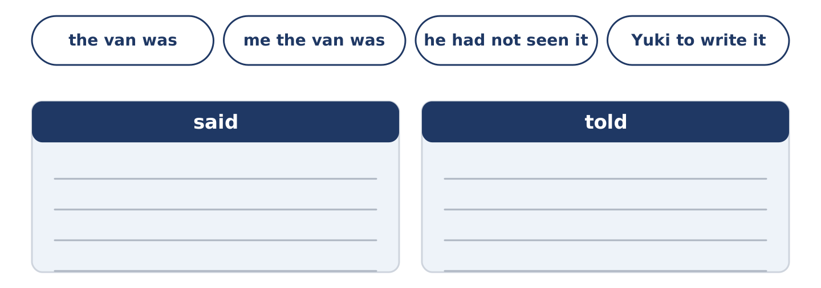
Figure 20.14 · The items of this task, and the bins they sort into.
Write said or told. (0. is done.)
- She ____ the van was outside. — said
- She ____ me the van was outside. ____________
- He ____ he had not seen it. ____________
- Amina ____ Yuki to write it down. ____________
- Mr Okonkwo ____ one sentence. ____________
Part 2: Correct the Sentence
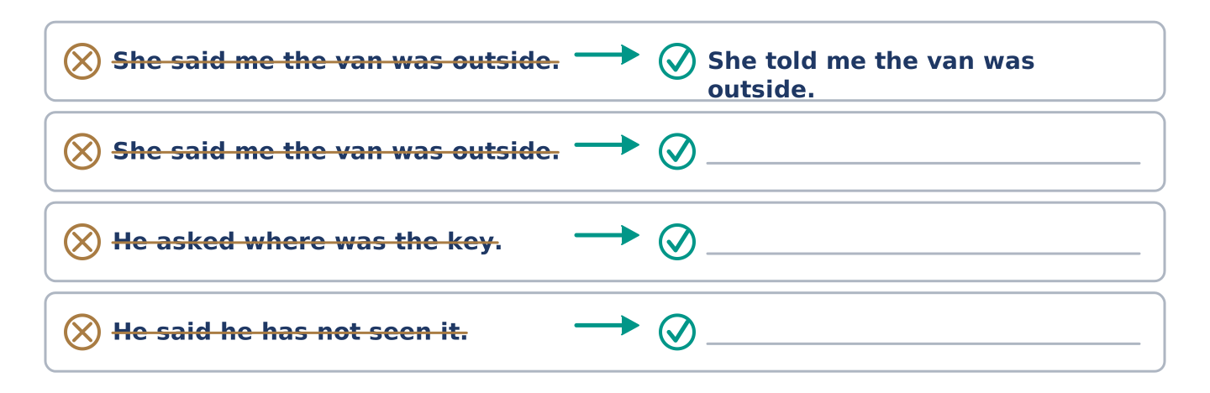
Figure 20.15 · One correction done for you, and the rest to write.
Each sentence has one grammar mistake. Write the correct sentence.
- She said me the van was outside.
- He asked where was the key.
- He said he has not seen it.
- He told that he would ring.
Part 2: Freer Practice
Write two sentences about things you were told this week: one with said, one with told.
Part 2: Grammar Review
Choose the correct sentence.
1. Which sentence reports a question correctly?
○ A) He asked where was the key.
○ B) He asked where is the key.
○ C) He asked where the key was.
○ D) He asked where the key was?
2. Which sentence uses told correctly?
○ A) She told the van was outside.
○ B) She told that the van was outside.
○ C) She told to me the van was outside.
○ D) She told me the van was outside.
→ Harvest: you will meet reported speech again in the Part 5 reading. Count how many people are reported and how many agree.
Part 3 · Listening
[CORE] Core track · pre-class input · scripts printed inline
Part 3: What Amina Said About the Van
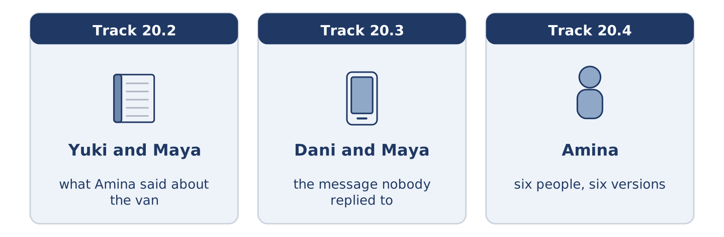
Figure 20.16 · The three listenings: who is speaking, and what about.
🔊 Audio Track 20.2
Before you listen: how does news travel where you live?
Yuki: What did Amina say? Maya: She said it had been there since Tuesday. Yuki: Tomas said Monday. Maya: Tomas wasn’t here on Monday. Yuki: He said he was. Maya: He said he had been, which isn’t the same. Yuki: Is anybody writing this down? Maya: You are, apparently.
While you listen: write True, False, or Not Given. (0. is done.)
- Amina said the van had been there since Tuesday. — True
- Tomas said it had been there since Monday. ____
- Maya thinks Tomas was there on Monday. ____
- Yuki has written it down before. ____
Useful phrases: What did ___ say? · She said it had been… · He said he had been… · which isn’t the same
Part 3: The Message Nobody Replied To
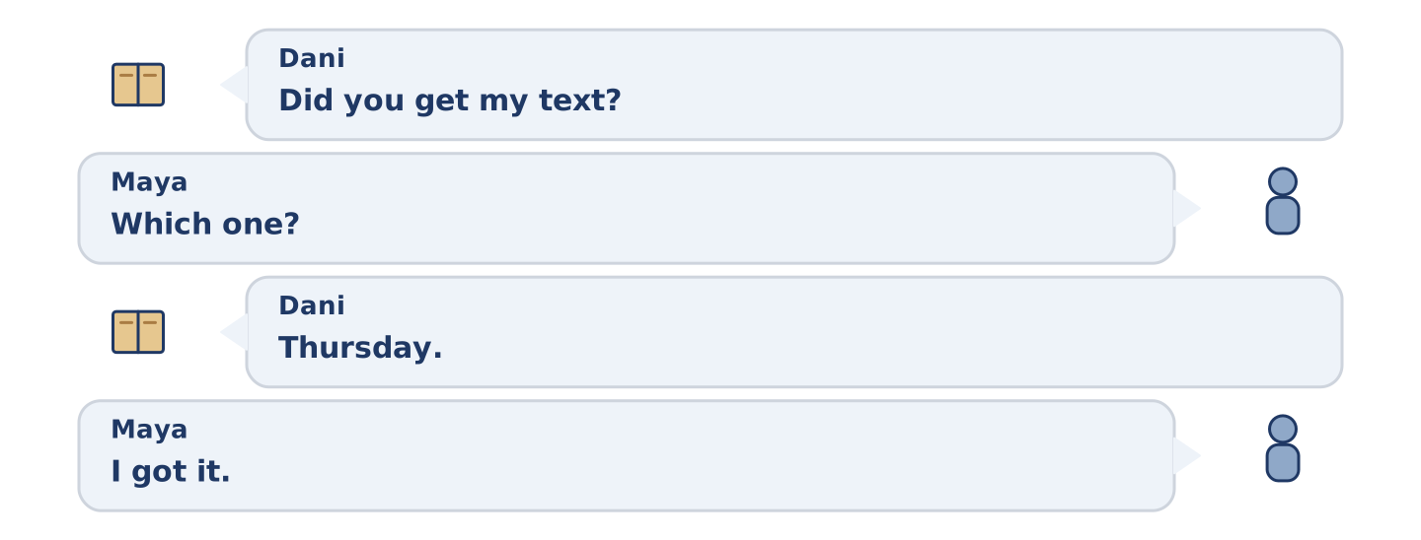
Figure 20.17 · The second listening, turn by turn.
🔊 Audio Track 20.3
Before you listen: have you ever waited four days for a reply?
Dani: Did you get my text? Maya: Which one? Dani: Thursday. Maya: I got it. Dani: You didn’t reply. Maya: You asked whether I was free on Saturday and then you told me what we were doing on Saturday. Dani: So you had nothing to answer. Maya: I had nothing to answer. Dani: I’ll ask properly next time. Maya: Then I’ll reply properly.
Answer the questions. (0. is done.)
- When did Dani send the text? — On Thursday.
- What did Dani ask in the text?
- What did he do straight after asking?
- What will Maya do if he asks properly?
Part 3: Six People, Six Versions
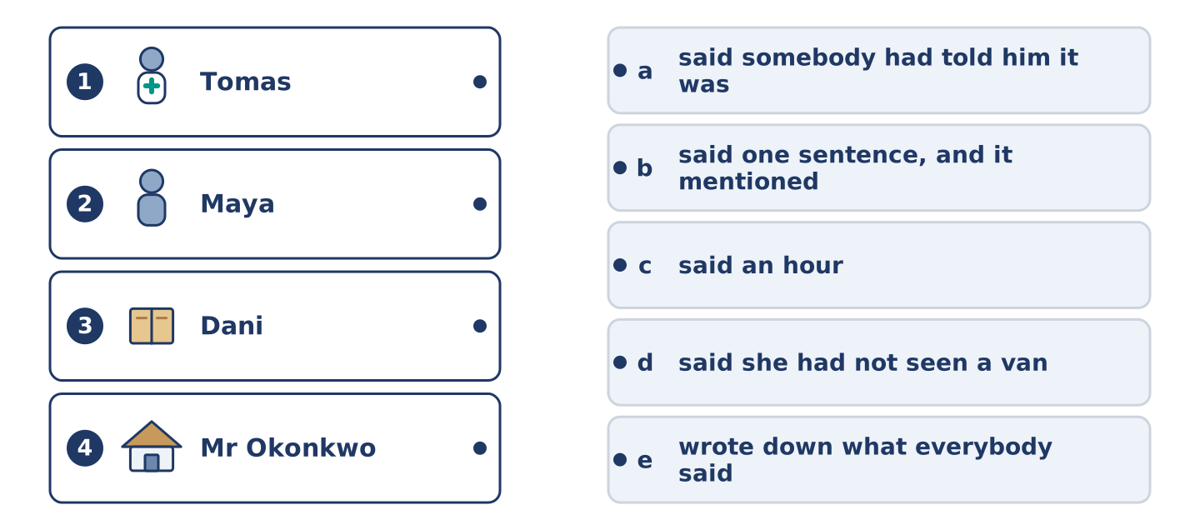
Figure 20.18 · Four on the left, five on the right, and one spare.
🔊 Audio Track 20.4
Before you listen: do two people ever tell the same story the same way?
Amina: I will tell you what each of them said, and then you can decide. I said twenty minutes, and I was looking at it. Tomas said an hour, and he came in at the end. Maya said she had not seen a van, which is true, because she was reading. Dani said somebody had told him it was a bigger van. And Mr Okonkwo said one sentence a week later, and his sentence was the only one that mentioned the driver.
While you listen: match each person with what they said. One is not needed. (0. is done.)
- Amina → she said twenty minutes.
Useful phrases: ___ said ___ · ___ said she had not ___ · ___ said somebody had told him ___
Column A
1. | Tomas | ____
2. | Maya | ____
3. | Dani | ____
4. | Mr Okonkwo | ____
Column B
a) | said somebody had told him it was a bigger van
b) | said one sentence, and it mentioned the driver
c) | said an hour
d) | said she had not seen a van
e) | wrote down what everybody said
Part 4 · Speaking
[CORE] Core track · in-class output
Part 4: Passing On What Somebody Said
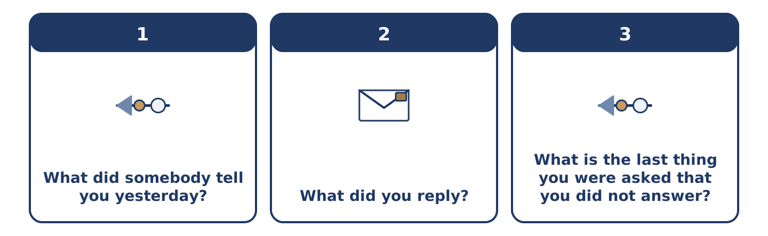
Figure 20.19 · The three questions as cards, to take one at a time.
Work with a partner. Ask and answer these questions.
- What did somebody tell you yesterday?
- What did you reply?
- What is the last thing you were asked that you did not answer?
Useful language: She said… · He told me… · I asked whether… · I replied that…
Part 4: Find the Difference (pairwork)
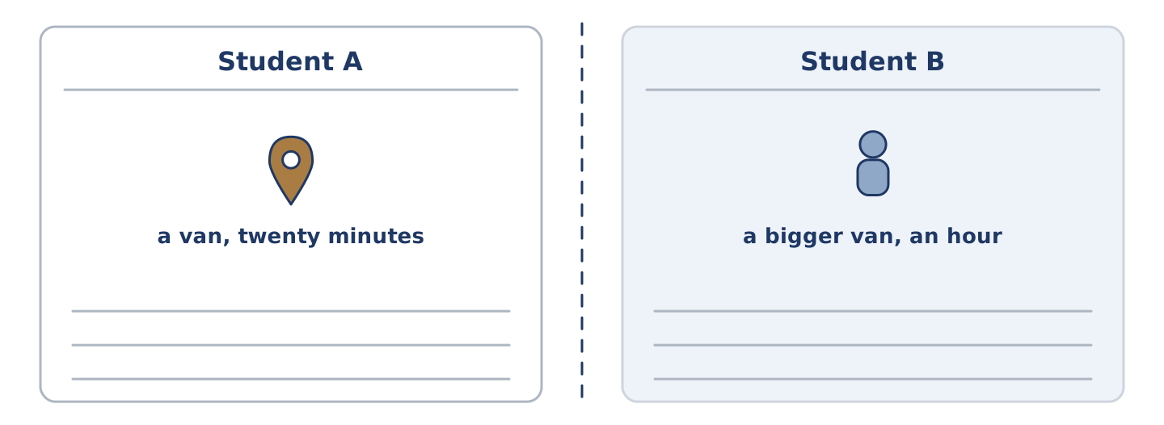
Figure 20.20 · Student A’s facts and Student B’s, with a fold between them.
Student A and Student B each heard the same story from a different person. Ask questions and find three differences.
Useful questions: What did they say? · Who told you that? · Did they say when? · Did anybody mention the driver?
Student A — what you heard: a van, twenty minutes, on Tuesday, nobody mentioned a driver.
Student B — what you heard: a bigger van, an hour, on Tuesday, a driver who asked for directions.
Part 4: Telling Somebody What Was Said
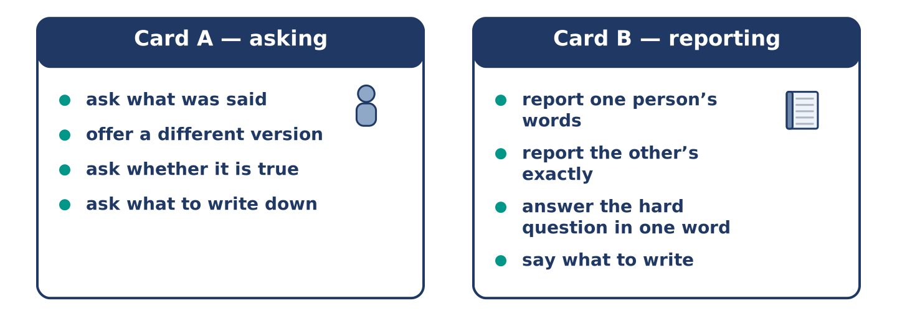
Figure 20.21 · Card A and Card B: what each of you has to say.
Work in pairs. Read the model, then use the cards.
Model exchange:
A: What did she say? — B: She said it had been there since Tuesday. — A: Tomas said Monday. — B: Tomas said he had been here on Monday. — A: And had he? — B: No. — A: So what do we write? — B: Write that two people said different things, and whose.
Useful language: What did she say? · She said… · He said he had… · write that…
Card A — asking: ask what was said · offer a different version · ask whether it is true · ask what to write down.
Card B — reporting: report one person’s words · report the other’s exactly · answer the hard question in one word · say what to write.
Your turn: run the dialogue, then swap roles.
Stretch [PLUS]: the version you reported first was your own and it was wrong — say so in the middle of the conversation.
Part 4: Mini-Presentation
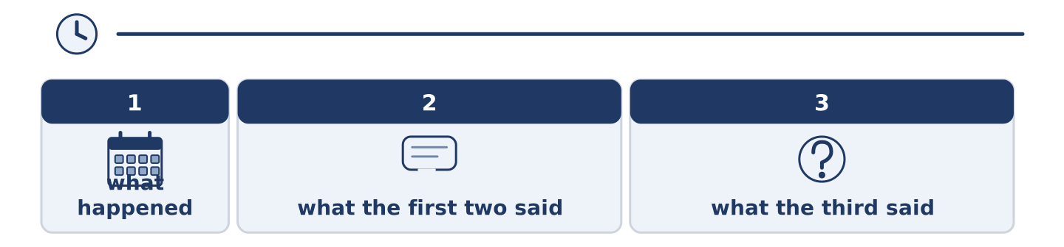
Figure 20.22 · The one-minute talk as 0 beats, each as wide as its share.
Prepare a short talk (about one minute). Report something three different people said about one event.
Part 5 · Reading
[CORE] Core track · pre-class input
Part 5: Why a Story Gets Shorter Every Time It Is Told
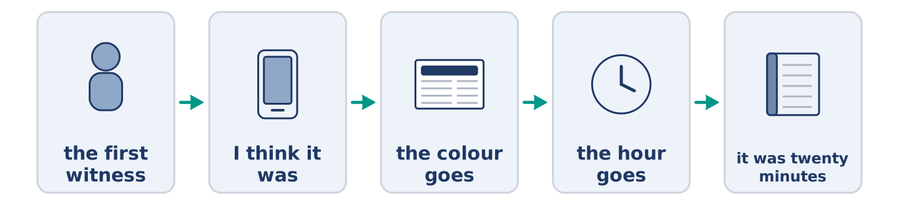
Figure 20.23 · One sentence, passed along five people.
Before you read: what happens to a story on the fourth telling?
Gloss: version = one person’s account of what happened · detail = one small part of something · witness = a person who saw it happen · certainty = being sure, with no doubt left
Pass a story along five people and it comes out shorter and surer. This has been tested many times and always goes the same way. The details that go first are the ones nobody can use: the colour, the hour, the name of the second person. What survives is the shape — somebody did something and somebody minded. And what grows is certainty. The first witness says he thinks it was about twenty minutes. The last person says it was twenty minutes. Nobody lied anywhere along that line. Each of them simply dropped the part of the sentence doing the least work. I think is always that part.
Answer the multiple-choice questions. (0. is done.)
- What happens to a story passed along five people? — It gets shorter and surer.
1. Which details go first?
○ A) The ones about people
○ B) The ones nobody can use
○ C) The ones at the end
○ D) The longest ones
2. What grows as a story is passed on?
○ A) Certainty
○ B) The number of people in it
○ C) Its length
○ D) The number of details
3. What does the text say nobody did?
○ A) Listened
○ B) Wrote it down
○ C) Lied
○ D) Asked
Part 5: Vocabulary in Context
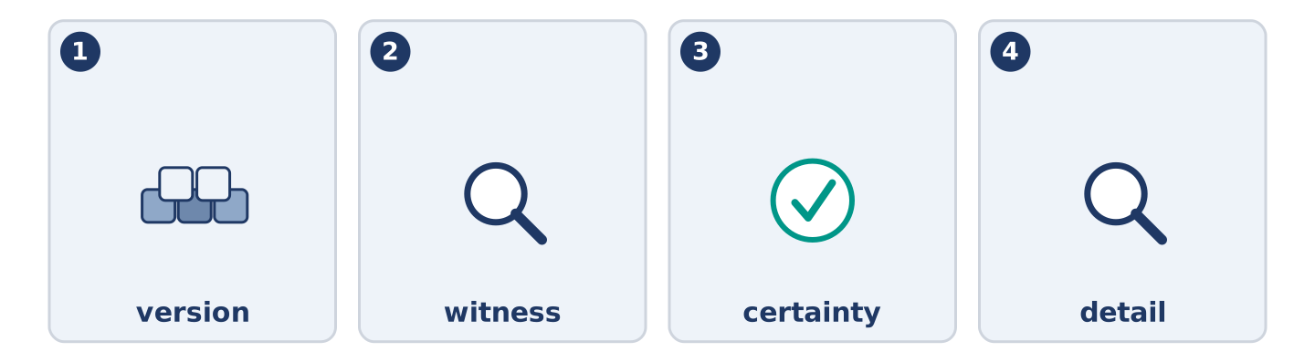
Figure 20.24 · The four words from the reading, drawn.
Match each word from the text with its meaning. One meaning is not needed. Write the letter.
Column A
1. | version | ____
2. | witness | ____
3. | certainty | ____
4. | detail | ____
Column B
a) | one small part of something
b) | being sure, with no doubt left
c) | one person’s account of what happened
d) | a person who saw it happen
e) | the paper cover a letter goes in
Part 5: Three Ways News Used to Travel
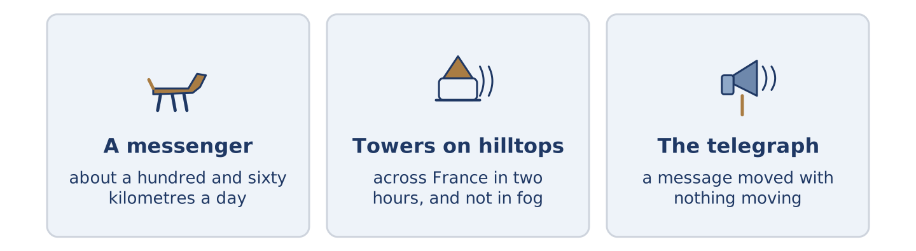
Figure 20.25 · Three old ways of carrying news, and how fast each one was.
Before you read: how long should news take?
Gloss: messenger = a person whose work is carrying messages · signal = a sound or light that carries a short message a long way · telegraph = an old machine that sent words down a wire
Before anybody had a telephone, news moved at the speed of the fastest thing going that way. A messenger on a horse managed about a hundred and sixty kilometres a day. Nothing went faster for three thousand years. Then came signals: towers on hilltops, with arms that could be read from the next hill. They carried a short sentence across France in two hours. They could not work at night, or in fog. Then the telegraph, the real break: it was the first time a message could move without anything moving. What it cost was the detail. A telegraph message was paid for by the word, so people learned to say things in nine words. A hundred years of news reads strangely short.
Answer the questions. (0. is done.)
- How fast did news move before the telephone? — As fast as the fastest thing going that way.
- How far could a messenger go in a day?
- Why could the tower signals not always work?
- Why did people learn to say things in nine words?
Part 6 · Writing
[CORE] Core track · in-class / homework
Part 6: Reporting What Somebody Said (50–70 words)
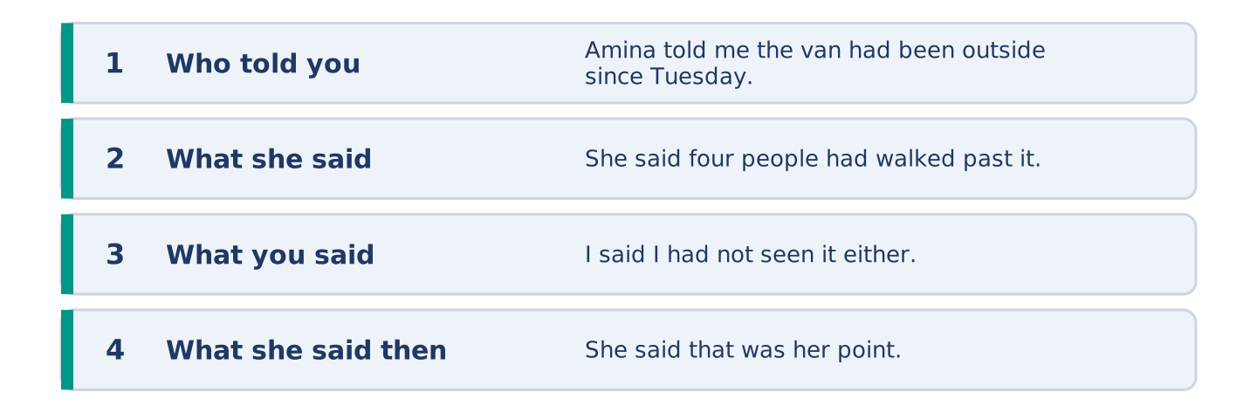
Figure 20.26 · The shape of the piece you are about to write.
Write about something somebody told you. Use said and told once each.
Model — read this first:
Amina told me the van had been outside since Tuesday. She said four people had walked past it and none of them had looked. I said I had not seen it either. She said that was her point. She said she had been making it for eleven years, and that I was the third person to prove it that week. (60 words)
Plan (fill in, then write): ___ told me ___ . She said ___ . I said ___ . She said ___ .
Word bank: said | told me | asked whether | replied | had
Check before you finish: ☐ said once? ☐ told once, with a person? ☐ the tense one step back? ☐ 50–70 words?
Part 6: Should You Pass On What You Hear? (50–70 words)
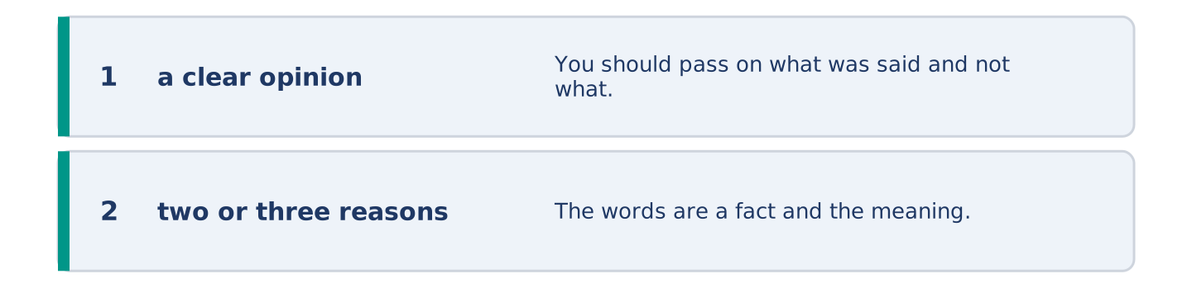
Figure 20.27 · The shape of the opinion paragraph, step by step.
Should you pass on what you hear about people? Give your opinion and two or three reasons.
Model — read this first:
You should pass on what was said and not what it meant. The words are a fact and the meaning is your guess, and the guess is what travels. Say who said it, every time. A story with a name on it stops at the first person who can check, and a story without one goes round the street twice. (60 words)
Word bank: I think… because… | however | in my opinion | it depends on | the main thing is
Check before you finish: ☐ a clear opinion? ☐ two or three reasons? ☐ 50–70 words?
Part 6: A Message You Wish You Had Not Sent (50–70 words)
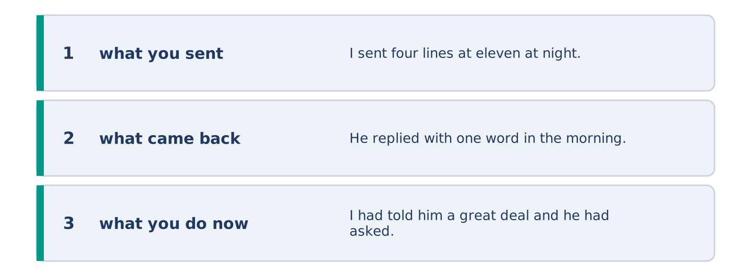
Figure 20.28 · The moves of the message, with a line of the model for each.
Write about a message you regret. Say what you said and what you wish you had said.
Model — read this first:
I sent four lines at eleven at night explaining myself to somebody who had not asked. He replied with one word in the morning and the one word was fine. I had told him a great deal and he had asked me nothing. I now write the four lines and send one of them. (54 words)
Plan (fill in, then write): I sent ___ . He replied ___ . I had told him ___ . I now ___ .
Check before you finish: ☐ what you sent? ☐ what came back? ☐ what you do now? ☐ 50–70 words?
Part 6: Reflection — The Story Your Family Tells About You (40–60 words)
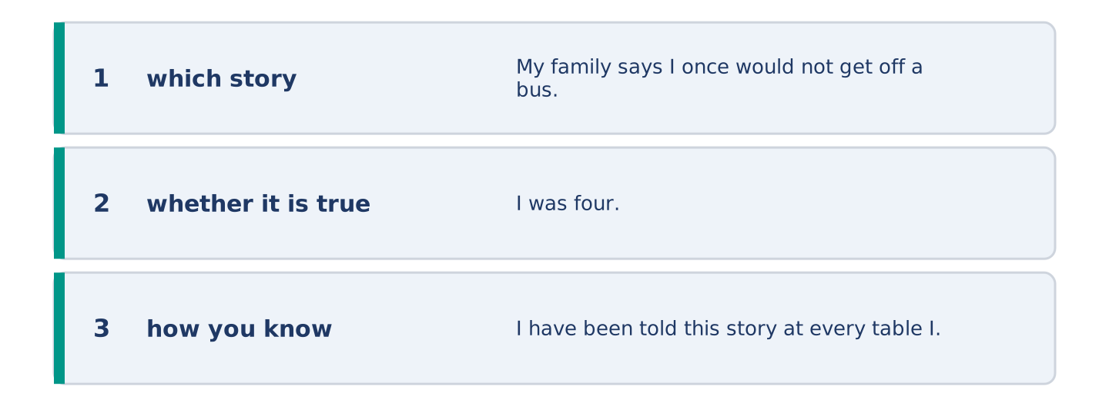
Figure 20.29 · The reflection, step by step.
Write about a story your family tells about you. Say whether it is true.
Model — read this first:
My family says I once would not get off a bus for an hour. I was four. I have been told this story at every table I have sat at with them, and I have no memory of the bus at all. It is true. I know it is true because the versions agree. (54 words)
Check before you finish: ☐ which story? ☐ whether it is true? ☐ how you know? ☐ 40–60 words?
Part 7 · Real-World File — Passing On a Message
[PLUS] Plus track (optional) · stronger learners
7A: Phrase Bank
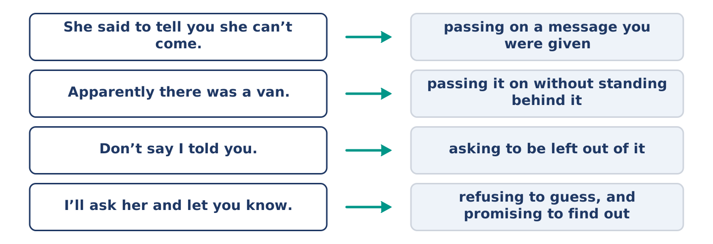
Figure 20.30 · What people say when they pass on a message, and what each line does.
Match what a person says with its purpose. One purpose is not needed. Write the letter.
Column A
1. | “She said to tell you she can’t come.” | ____
2. | “Apparently there was a van.” | ____
3. | “Don’t say I told you.” | ____
4. | “I’ll ask her and let you know.” | ____
Column B
a) | passing it on without standing behind it
b) | how much it will cost
c) | passing on a message you were given to pass on
d) | asking to be left out of it
e) | refusing to guess, and promising to find out
7B: The Sentence Mr Okonkwo Said a Week Later
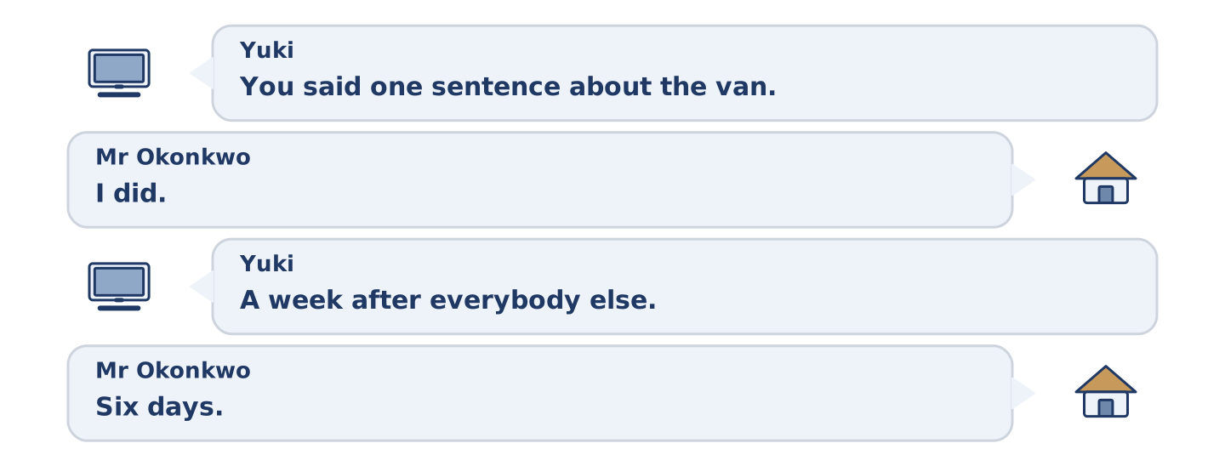
Figure 20.31 · The 7B exchange: who takes each turn.
🔊 Audio Track 20.5
Before you read: is it better to say nothing for a week?
Yuki: You said one sentence about the van. Mr Okonkwo: I did. Yuki: A week after everybody else. Mr Okonkwo: Six days. Yuki: Why wait? Mr Okonkwo: Because by Friday they had all said their piece and none of them had mentioned the driver. Yuki: So you waited until your sentence was the only one left. Mr Okonkwo: I waited until it was worth saying. Yuki: That is the same thing. Mr Okonkwo: It is not, and you know it is not.
Answer the questions. (0. is done.)
- How many sentences did Mr Okonkwo say? — One.
- How long did he wait?
- What had nobody mentioned by Friday?
- What does Yuki say he waited for?
7C: Controlled Practice — Passing On a Message
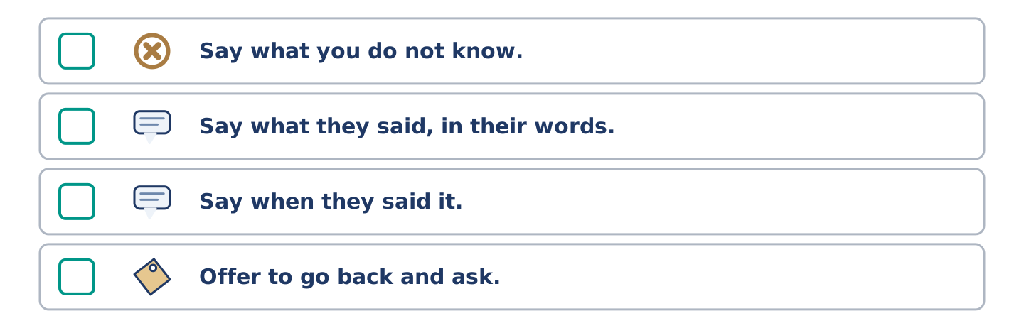
Figure 20.32 · The steps still to be numbered, as the task prints them.
Put the steps in order. Number them 1–5. (0. is done.)
- Say who the message is from. — 1
____ Say what you do not know.
____ Say what they said, in their words.
____ Say when they said it.
____ Offer to go back and ask.
7D: Role-Play — Two Accounts of One Afternoon
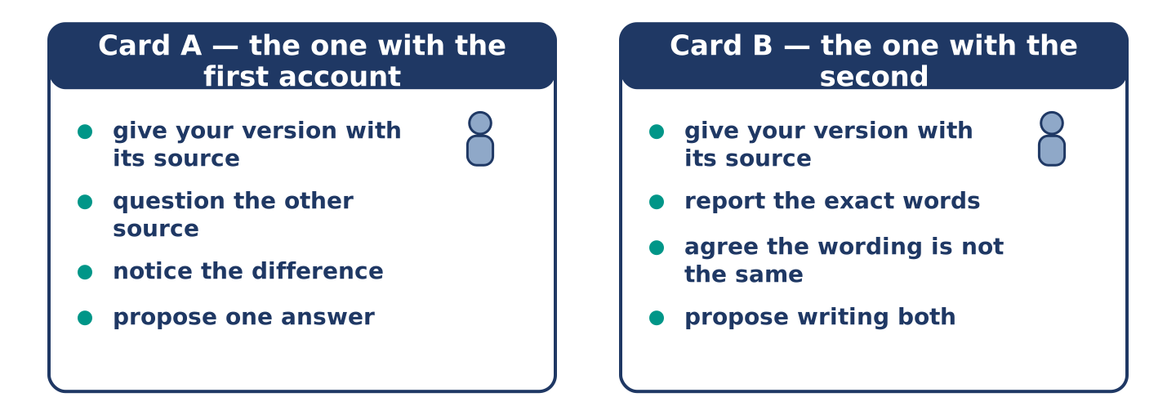
Figure 20.33 · The 7D cards: what each of you has to say.
In pairs. You each heard it from a different person. Use the model and cards.
Model exchange: A: Amina said twenty minutes. — B: Tomas said an hour. — A: Was Tomas there? — B: He said he had been. — A: That is not the same. — B: No. — A: So we write twenty minutes. — B: We write that Amina said twenty and Tomas said an hour, and we say who said which.
Card A — the one with the first account: give your version with its source · question the other source · notice the difference in the wording · propose one answer.
Card B — the one with the second: give your version with its source · report the exact words · agree the wording is not the same · propose writing both.
Stretch [PLUS]: your source was wrong and you have already told four people — say what you will do about the four.
7E: Writing — A Note Passing On a Message (50–80 words)
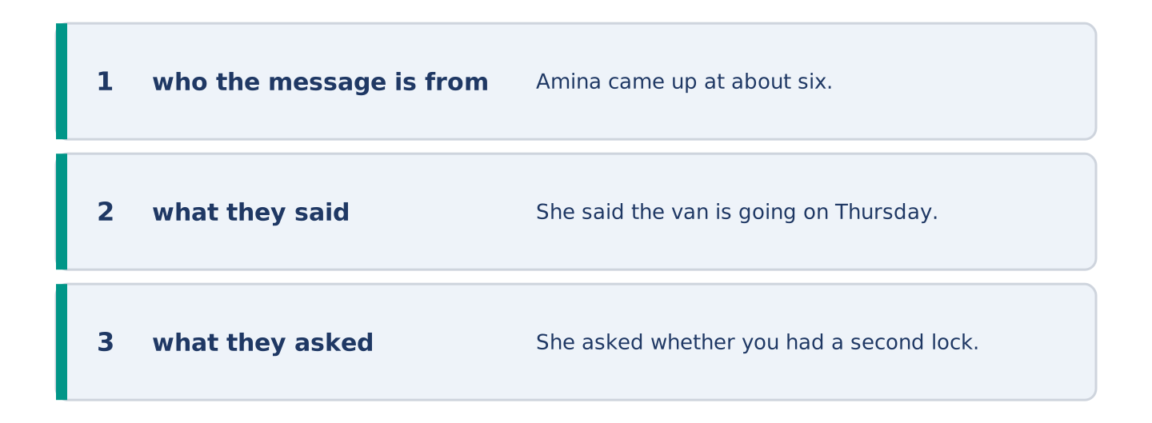
Figure 20.34 · The Part 7 note, with the model beside each line.
Somebody left a message for a person who is out. Write the note.
Model — read this first:
Amina came up at about six. She said the van is going on Thursday and that you should move your bike before Wednesday night or it will be behind it. She asked whether you had a second lock, and I said I did not know. She is in the shop until two tomorrow if you want to ask her yourself. (60 words)
Check before you finish: ☐ who the message is from? ☐ what they said? ☐ what they asked? ☐ 50–80 words?
Part 8 · Global Story — The Street That Reads the News Out Loud
[PLUS] Plus track · pre-read / discuss
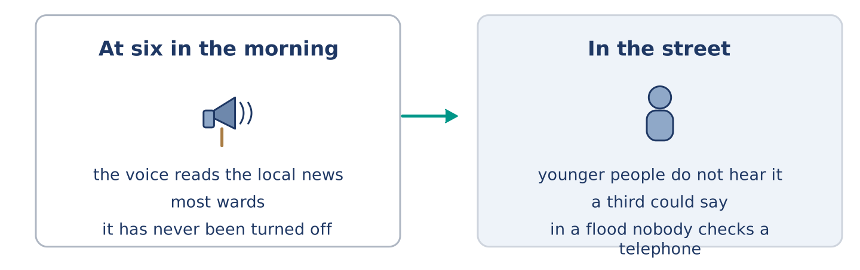
Figure 20.35 · A loudspeaker on a pole and a street that has stopped hearing it.
Before you read: would you like the news read to your street at six?
Gloss: loudspeaker = a machine that makes a voice loud enough for a street · ward = one small part of a city, with its own office · announcement = a thing said out loud to everybody at once
In Hanoi, in Vietnam, most wards still have loudspeakers up on posts. In many of them a voice reads the local news at about six in the morning. It is the oldest working news system in the city and has never been turned off. People will tell you it gave out the end of a war and a water cut in the same week, in the same voice. Younger people mostly say they do not hear it any more. That is not quite the same as saying it is not heard. A survey asked people what the voice had said that morning, and a third of them could say. The city has twice discussed turning the speakers off and twice decided not to. The reason given was that in a flood nobody checks a telephone.
Answer the questions. (0. is done.)
- What time does the voice read the news? — About six in the morning.
- What do younger people mostly say?
- What did a third of the people in a survey do?
- What reason was given for keeping the speakers?
Part 8: Vocabulary in Context
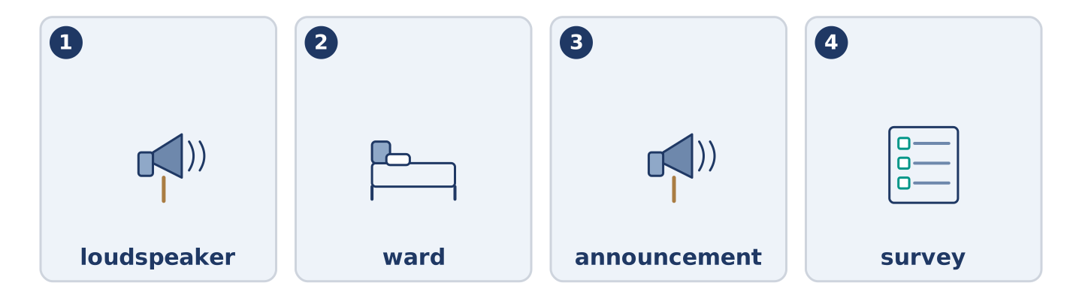
Figure 20.36 · The four words from the global story, drawn.
Match each word with its meaning. One meaning is not needed. Write the letter.
Column A
1. | loudspeaker | ____
2. | ward | ____
3. | announcement | ____
4. | survey | ____
Column B
a) | a set of questions asked of many people
b) | one small part of a city, with its own office
c) | a machine that makes a voice loud enough for a street
d) | a thing said out loud to everybody at once
e) | a person whose work is carrying messages
Part 8: Discussion
Talk with a partner. Use the frames.
Discussion frames: “This is similar to where I live because…” · “This is different from where I live because…” · “I think the most important thing is… because…”
Part 9 · Close to Home — The Notebook Yuki Keeps
[PLUS] Plus track · pre-read / decide
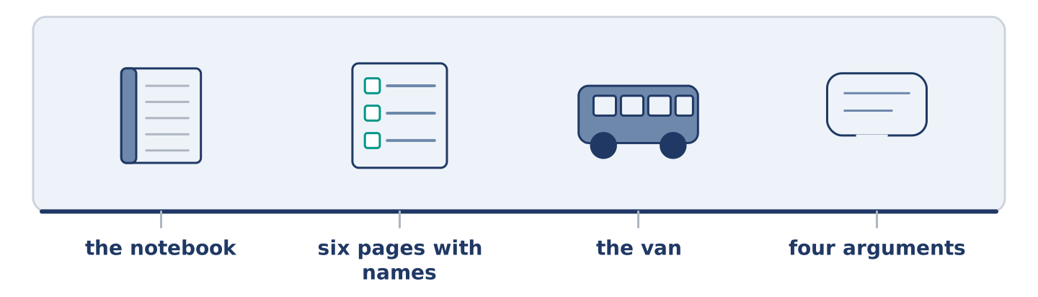
Figure 20.37 · The close-to-home reading, drawn along one street.
Before you read: would you write down what your neighbours said?
Yuki has a notebook and six of the pages have names on them. She started it in her first month, because she could not keep the names and faces together. She has never stopped. It now holds what each of them said about the van, with the day beside it. Amina knows about the notebook and says so, loudly and often. Maya knows and does not like it and has not said so. Dani has asked to read his own page twice, and said nothing about it either time. Mr Okonkwo has never mentioned it. He knows about it, because he knows about everything, and Yuki reads his silence as permission. She may be wrong about that. The notebook has settled four arguments in two years and started none. Yuki knows that this is the kind of thing a person says about their own notebook.
Answer the questions. (0. is done.)
- When did Yuki start the notebook? — In her first month.
- Why did she start it?
- What does Maya think, and what has she said?
- How does Yuki read Mr Okonkwo’s silence?
Part 9: Decision Task
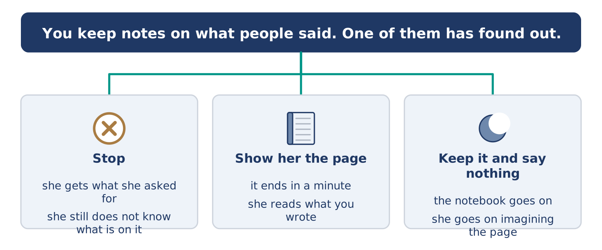
Figure 20.38 · Three ways to decide, and what each one costs.
You keep notes about what people near you said. One of them has found out and does not like it. Should you (a) stop, (b) show them their page, or (c) keep it and say nothing? Decide and explain. Use the frame.
Answer frame: “I think I should ___ because ___. Also, ___. This is better than ___ because ___.”
Model — read this first:
I think I should show her the page. What she is imagining is worse than what is written, and I can end that in a minute. Also, if the page cannot be shown then she is right and I should stop. This is better than stopping quietly, because stopping without showing her leaves her believing I wrote something I could not show. (62 words)
Phrase bank: I think I should… · because… · Also,… · This is better than… · In my opinion…
Part 10 · Review and Can-Do
[CORE + PLUS] · homework / self-study
Part 10: Spiral Review
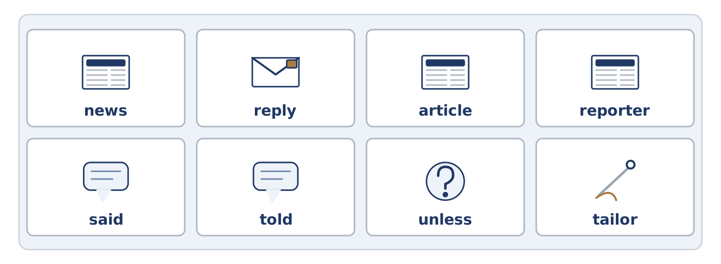
Figure 20.39 · The eight words of the review bank, in bank order.
Complete the review. (0. is done.)
- A story going round that may not be true is a rumour.
Word bank: news | reply | article | reporter | said | told | unless | tailor
- What has just happened, told to other people, is the ______________________ .
- What you send back when somebody writes to you is a ______________________ .
- A piece of writing in a paper about one thing is an ______________________ .
- A person whose work is finding out what happened is a ______________________ .
- She ______________________ the van was outside. (no person after it)
- She ______________________ me the van was outside. (a person after it)
- (from Unit 18) If not, or except if, is ______________________ .
- (from Unit 19) A person who makes and mends clothes is a ______________________ .
Part 10: Can-Do
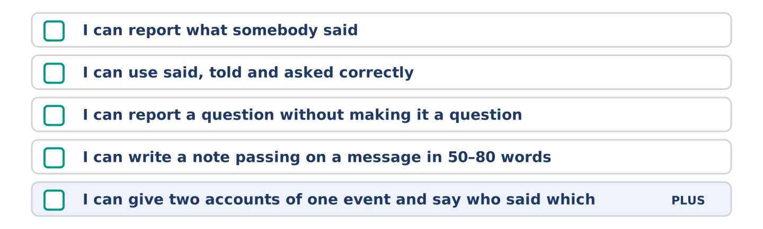
Figure 20.40 · What you can do at the end of this unit.
Can-Do checklist
☐ I can report what somebody said.
☐ I can use said, told and asked correctly.
☐ I can report a question without making it a question.
☐ I can write a note passing on a message in 50–80 words.
☐ I can give two accounts of one event and say who said which (Plus).
Part 10: Glossary
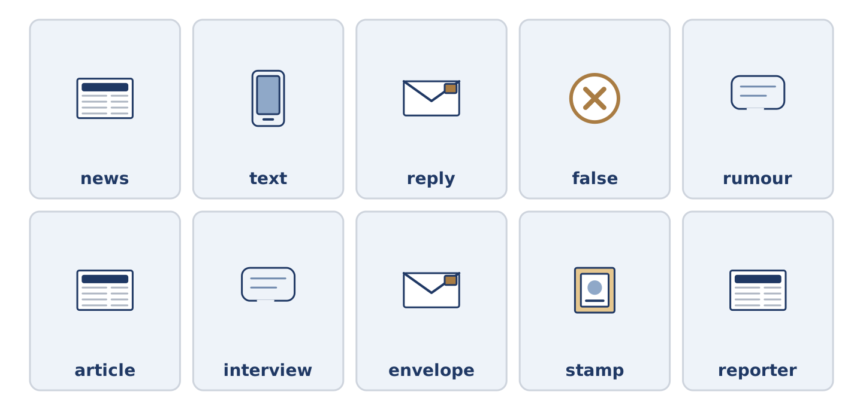
Figure 20.41 · All ten glossary words of Unit 20, one card each.
Unit 20 glossary (10 words)
news · text · reply · false · rumour · article · interview · envelope · stamp · reporter

